
Bahria University Library Islamabad
Source: Pakistan Observer Friday, December 11, 2020

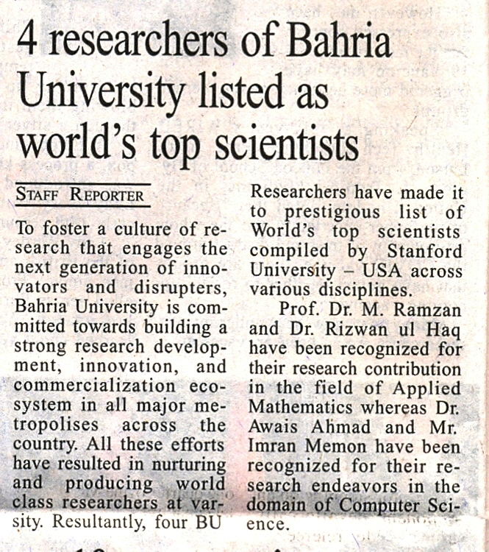

Bahria University Library Islamabad
Source: Jang Friday, December 11, 2020

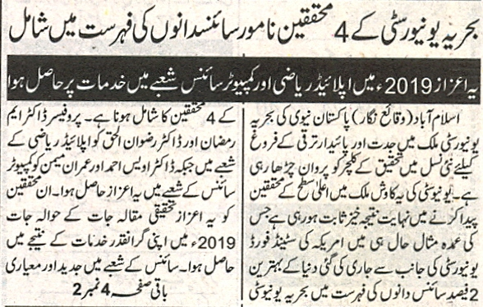

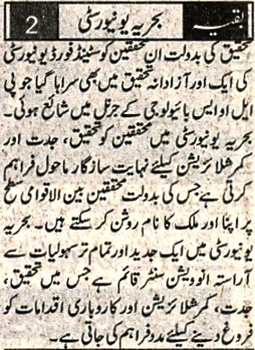

Bahria University Library Islamabad
Source: Dunya Friday, December 11, 2020

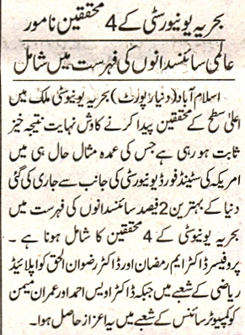

Bahria University Library Islamabad
Source: Nawa-i-Waqt Friday, December 11, 2020

