
Bahria University Library Islamabad
Source: The News Thursday, November 26, 2020

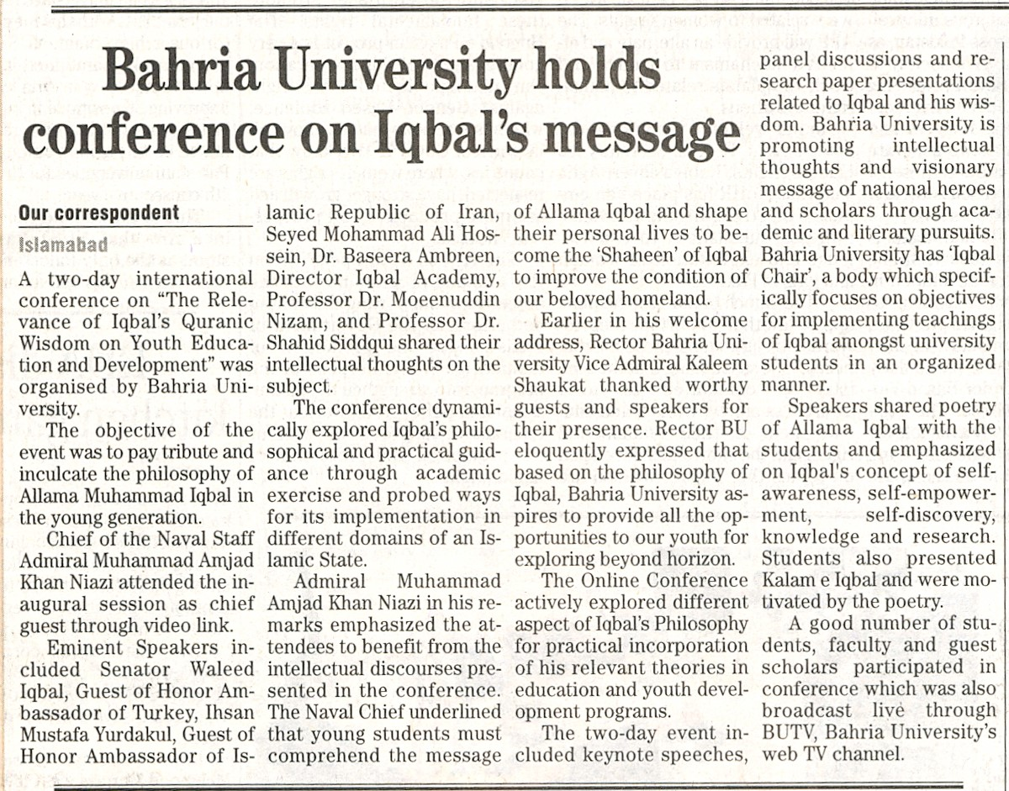

Bahria University Library Islamabad
Source: The Nation Thursday, November 26, 2020

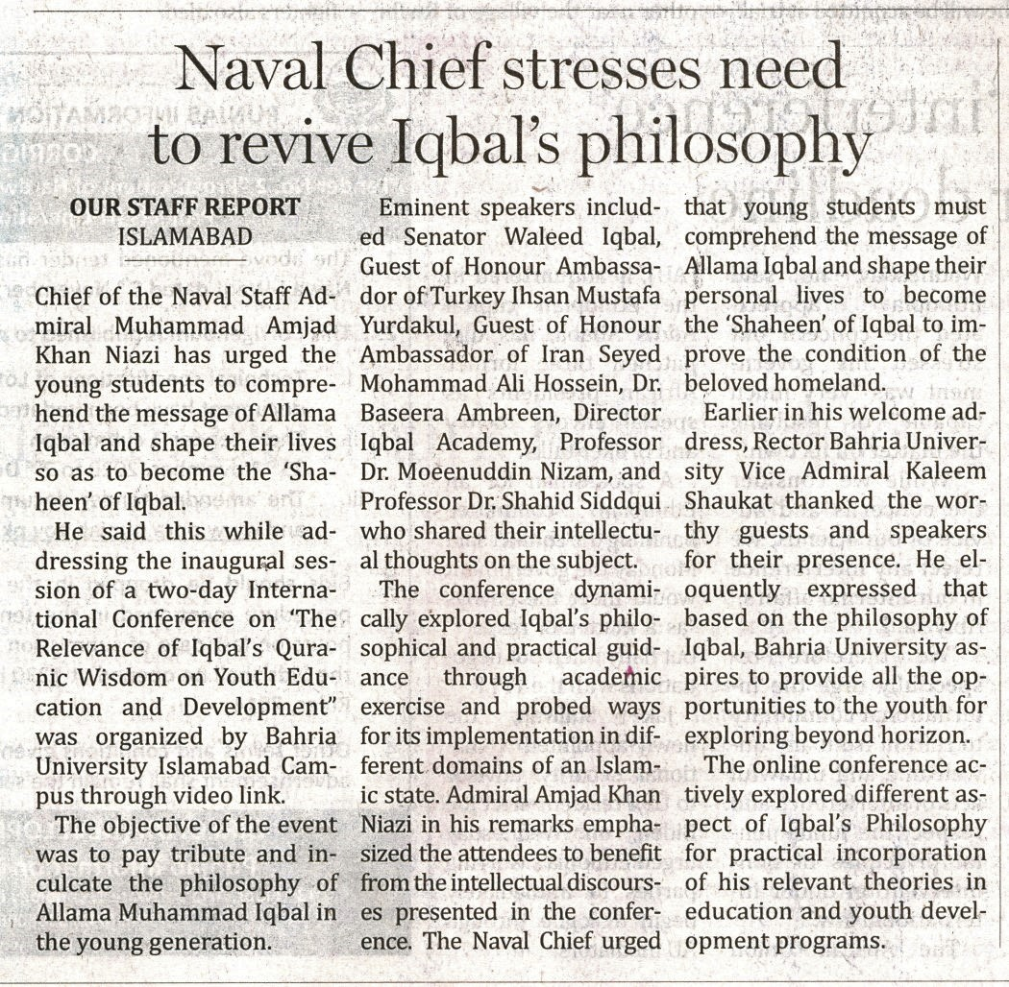

Bahria University Library Islamabad
Source: Pak Observer Thursday, November 26, 2020

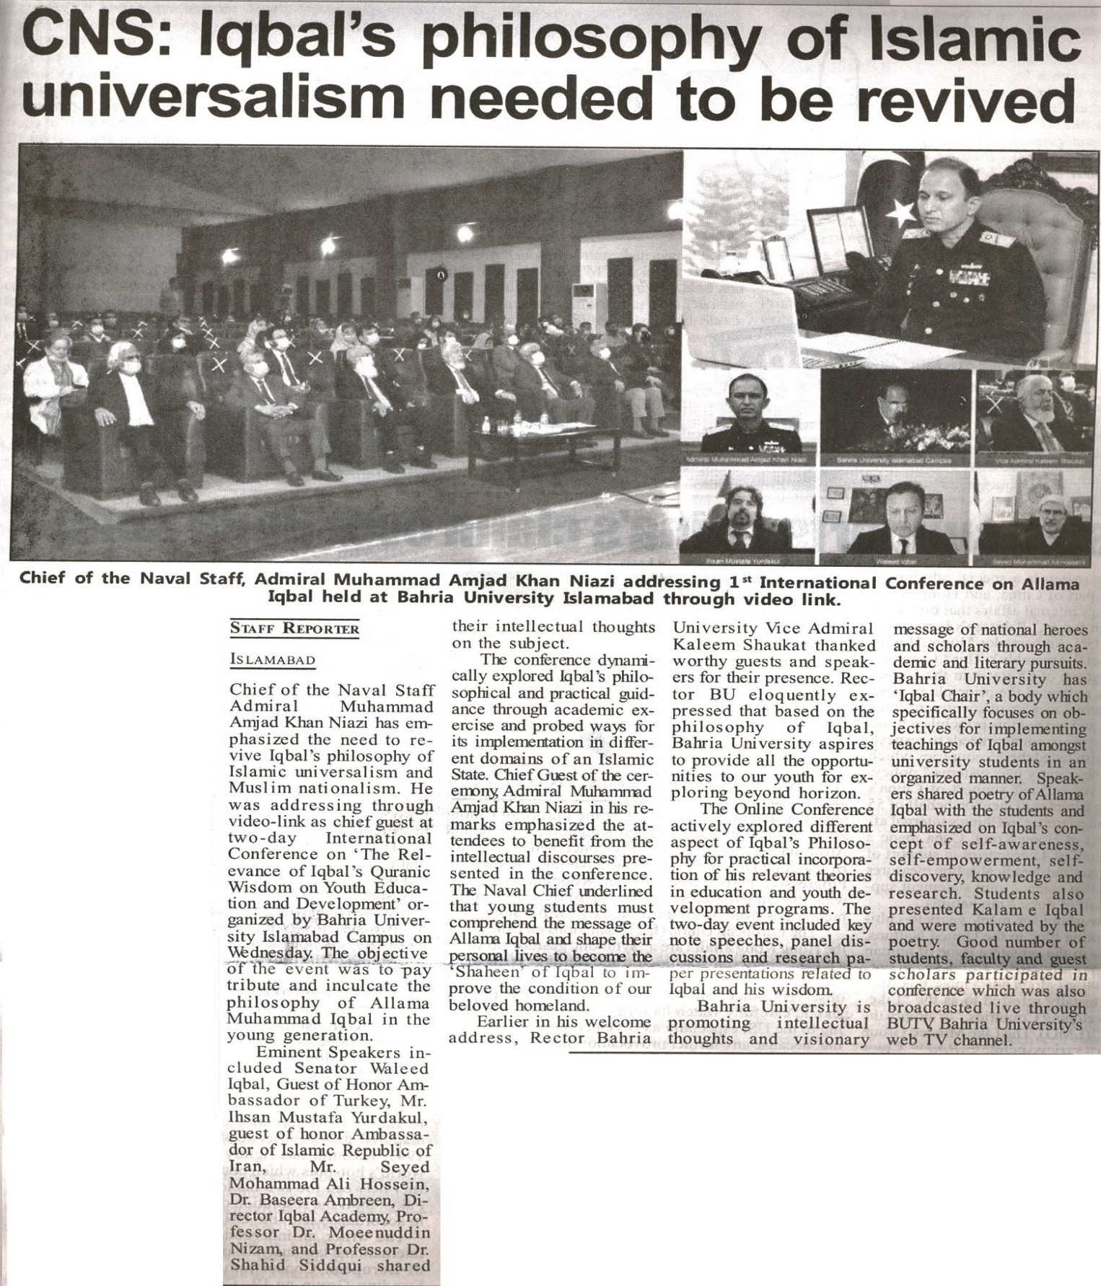

Bahria University Library Islamabad
Source: Jang Thursday, November 26, 2020

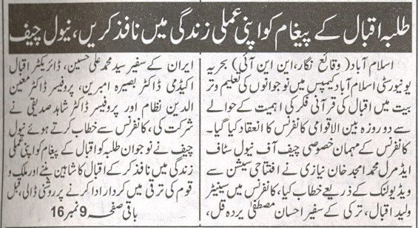
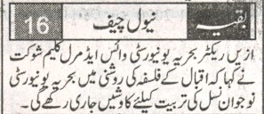

Bahria University Library Islamabad
Source: Duniya Thursday, November 26, 2020

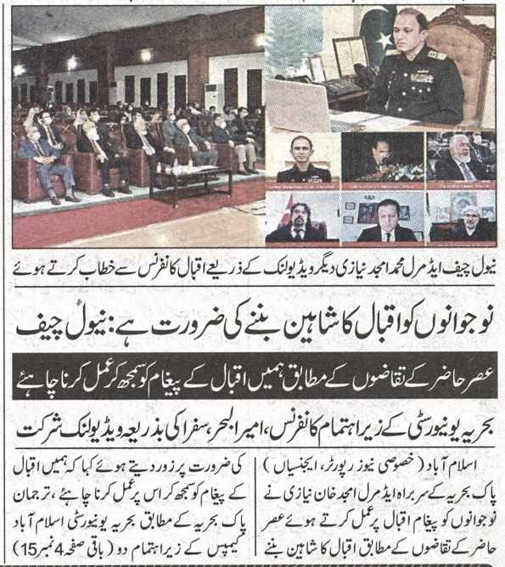
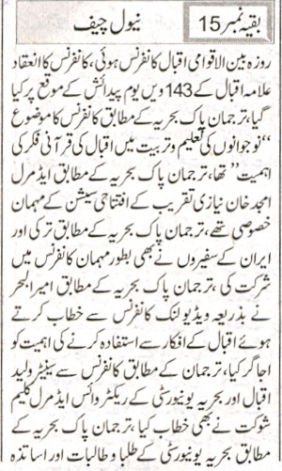
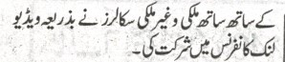

Bahria University Library Islamabad
Source: Nawa-i-Waqt Thursday, November 26, 2020

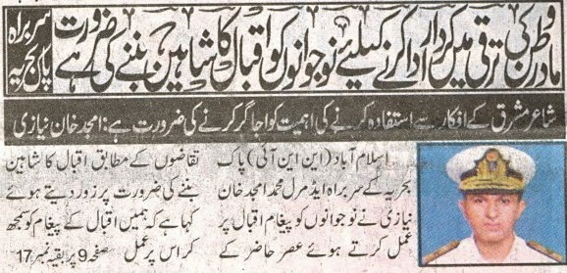
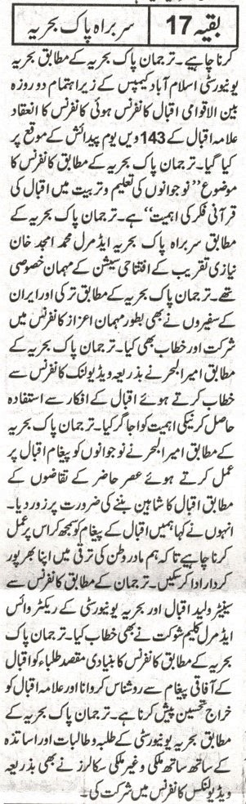

Bahria University Library Islamabad
Source: Nai Baat Thursday, November 26, 2020

