
Bahria University Library Islamabad
Source: The News Thursday, November 19, 2020

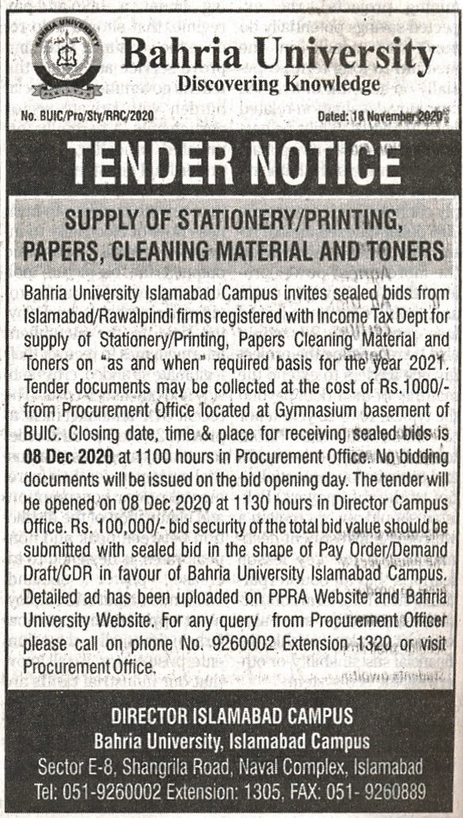

Bahria University Library Islamabad
Source: Jang Thursday, November 19, 2020

