
Bahria University Library Islamabad
Source: The News Wednesday, November 18 2020

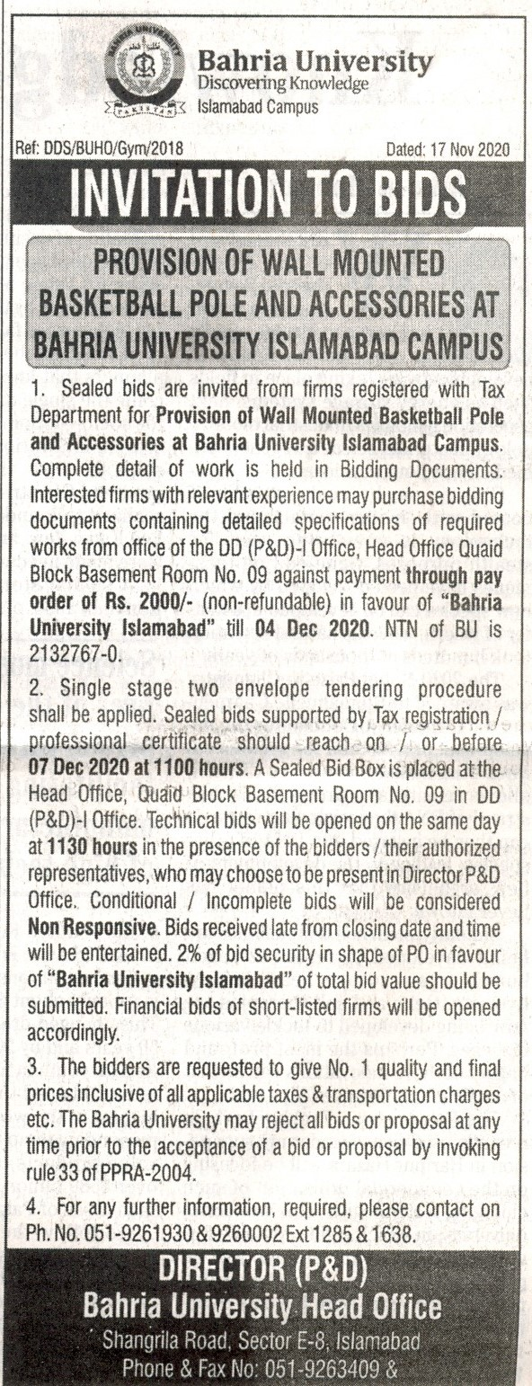

Bahria University Library Islamabad
Source: Jang Wednesday, November 18 2020

