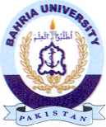
Bahria University Library Islamabad
Source: The News & Jang Sunday, November 15 2020

