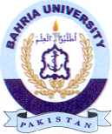
Bahria University Library Islamabad
Source: Dawn Sunday, November 15 2020

