
Bahria University Library Islamabad
Source: The News Thursday, November 12 2020

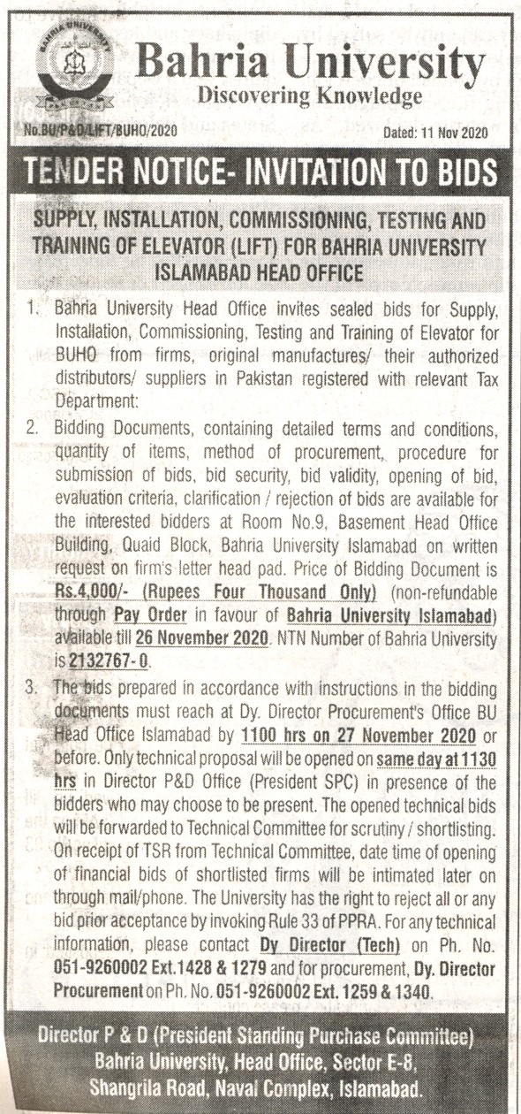

Bahria University Library Islamabad
Source: Jang Thursday, November 12 2020

