Bahria University Library Islamabad
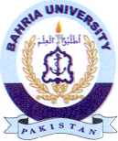
Source: Express Saturday, November 07 2020

