Bahria University Library Islamabad

Source: Jang Thursday, November 05 2020

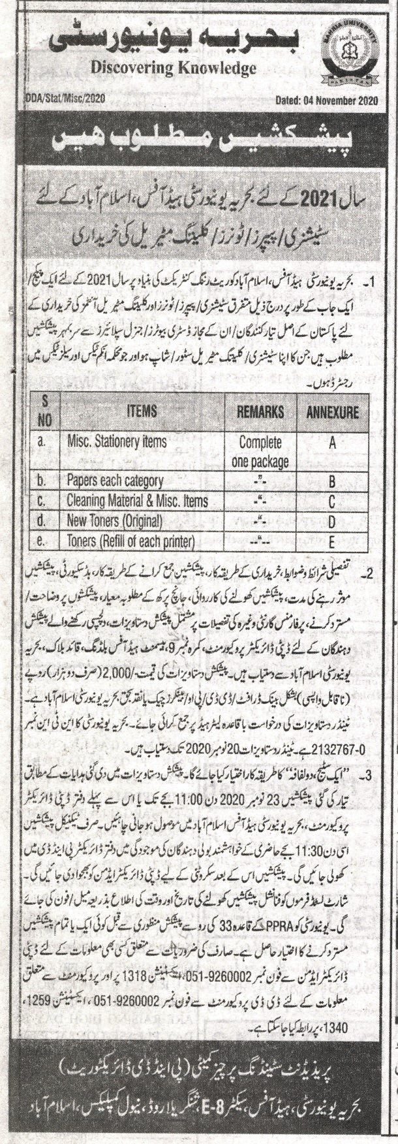

Bahria University Library Islamabad
Source: The News Thursday, November 05 2020

