Bahria University Library Islamabad

Source: The News Sunday, October 25 2020

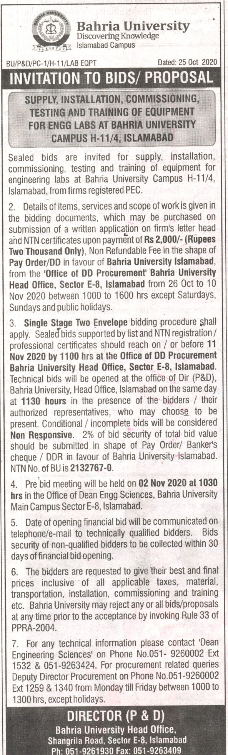

Bahria University Library Islamabad
Source: Jang Sunday, October 25 2020

