Differential Expression of AMACR, p63 and NKX3.1 in Adenocarcinoma and Hyperplasia of Prostate Gland



DR BEENISH HUSSAIN NOMANI
MBBS

BAHRIA UNIVERSITY ISLAMABAD
PAKISTAN
September 2019

DIFFERENTIAL EXPRESSION OF AMACR, p63 and NKX3.1 IN ADENOCARCINOMA AND HYPERPLASIA OF PROSTATE GLAND

BY

DR. BEENISH HUSSAIN NOMANI
MBBS

A thesis presented to Bahria University, Islamabad
in partial fulfillment of the requirement for the degree of
Master of Philosophy in Pathology (Histopathology)

DEPARTMENT OF PATHOLOGY
BAHRIA UNIVERSITY MEDICAL & DENTAL COLLEGE
2019

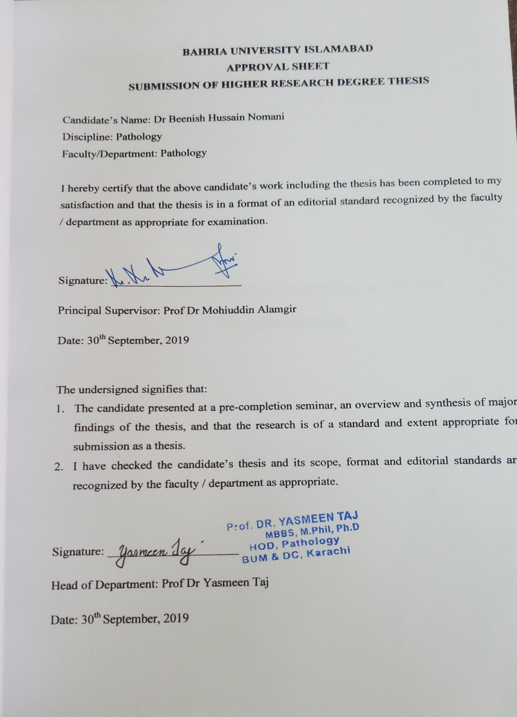Copyright © 2019, Dr. Beenish Hussain Nomani
All rights reserved.

AUTHOR’S DECLARATION

I, Dr Beenish Hussain Nomani hereby state that my MPhil thesis titled “DIFFERENTIAL EXPRESSION OF AMACR, p63 AND NKX3.1 IN ADENOCARCINOMA AND BENIGN HYPERPLASIA OF PROSTATE GLAND”
is my own work and has not been submitted previously by me for taking any degree from this university, The Bahria University or anywhere else in the country/world.
At any time if my statement is found to be incorrect even after my graduation the university has the right to withdraw/cancel my MPhil degree.

Name of student: Dr Beenish Hussain Nomani

Date: 30th September, 2019



I am very thankful to Mr Siam and Ms Alizaeh Agha Khan University Hospital Karachi for assisting me in the work of photography.
I am extremely grateful to my loving husband, my daughter and my son for loving and supporting me unconditionally and being there for me throughout this struggle.

S.No | Title / Chapter | Page No.
 | Abstract | 1
CHAPTER 1
INTRODUCTION
1 | Introduction | 3
1.1 | Epidemiology and prevalence of prostate cancer | 3
1.2 | Risk factors | 4
1.2.1 | Androgens | 4
1.2.2 | Environment | 4
1.2.3 | Acquired somatic mutations | 4
1.2.4 | Dietary factors | 5
1.2.5 | Genetic factors | 5
1.3 | Anatomy ,Embryology and histology | 5
1.4 | Benign lesions of prostate gland | 6
1.4.1 | Clinical Presentation of BPH | 8
1.5 | Prostatic intraepithelial lesion | 8
1.6 | Classification of prostate cancer | 9
1.7 | Pathogenesis of prostate cancer | 10
1.7.1 | Role of Androgens | 10
1.7.2 | Germline mutations in prostate cancer | 11
1.7.3 | Acquired somatic mutations | 11
1.7.4 | Epigenetic Alterations | 11
1.7.5 | PI3-AKTPathway activation in prostate cancer | 12
1.8 | Clinical presentation of prostate cancer | 12
1.9 | Grading of prostate cancer | 13
1.10 | Staging of prostate cancer | 15
1.11 | Screening of prostate cancer | 17
1.12 | Diagnosis of prostate cancer | 18
1.13 | Immunohistochemistry in the diagnosis of prostate cancer | 19
1.13.1 | AMACR | 19
1.13.2 | p63 | 20
1.13.3 | NKX3.1 | 21
1.14 | Hypothesis | 23
1.15 | Objective(s) of research/study | 24
1.16 | Problem statement/Problem of the study | 25
1.17 | Significance of study | 26
1.18 | Operational Definitions | 27
1.18.1 | AMACR | 27
1.18.2 | p63 | 28
1.18.3 | NKX3.1 | 29
CHAPTER 2
LITERATURE REVIEW
2 | Literature review | 30
CHAPTER 3
METHODOLOGY
3.1 | Research design | 38
3.2 | Ethical Approval | 38
3.3 | Setting | 38
3.4 | Inclusion Criteria | 38
3.5 | Exclusion criteria | 38
3.6 | Duration of study | 38
3.7 | Sample size estimation | 39
3.8 | Sampling Technique | 39
3.9 | Materials | 39
3.10 | Parameters of the study | 40
3.11 | Methodology | 40
3.12 | Algorithm of study | 46
3.13 | Interpretation | 47
3.14 | Statistical Analysis | 49
CHAPTER 4
RESULTS
4 | Results | 50
CHAPTER 5
DISCUSSION
5 | Discussion | 103
CHAPTER 6
CONCLUSION
6 | Conclusion | 112
6.1 | Recommendations | 113
6.2 | Strengths of study | 113
6.3 | Limitations of study | 113
CHAPTER 7
REFERENCES AND APPENDICES
7.1 | References | 114
7.2 | Appendices | 132
A | FRC Approval Letter | 133
B | ERC Approval Letter | 134
C | Consent form(English and Urdu) | 135
D | Subject evaluation form | 137
E | Hospital Card | 138
F | TurnitinPlagiarism check report | 139

S.NO | Title | Page no
1.9 | Grading of Prostate cancer according to Gleason’s scoring | 14
1.10 | Staging of Prostate cancer according to the TNM system. | 15
4.1 | Distribution of prostatic specimens according to their type n=74 | 55
4.2 | Age wise distribution of patients with benign prostate hyperplasia n=37 | 57
4.3 | Age Wise Distribution of Patients having Prostate Cancer n=37 | 59
4.4 | Clinical presentation of patients having benign prostate hyperplasia  n=37 | 61
4.5 | Distribution of Patients having Prostate Cancer according to Gleason’s score  n=37 | 63
4.6 | Extent of AMACR immunoreactivity in diagnosed cases of benign prostate hyperplasia n=37 | 65
4.7 | Immunohistochemical staining intensity of AMACR in cases of benign prostate hyperplasia n=37 | 66
4.8 | Extent of AMACR Immunoreactivity in diagnosed cases of Prostate Cancer  n=37 | 67
4.9 | Immunohistochemical staining intensity of AMACR in Prostate cancer  N=37 | 68
4.10 | Co relation of AMACR expression between the benign and malignant lesions of Prostate gland n=74 | 69
4.11 | Association of AMACR staining and Gleason’s Score n=37 | 70
4.12 | Extensiveness of p63 immunohistochemical staining in benign prostate hyperplasia n=37 | 71
4.13 | Immunohistochemical staining intensity of p63 in benign prostate hyperplasia  n=37 | 72
4.14 | Extensiveness of p63 immunohistochemical staining in prostate cancer  n=37 | 73
4.15 | Immunohistochemical staining intensity of p63 in benign prostate hyperplasia  n=37 | 74
4.16 | Co relation of p63 staining between benign and maligant lesions of prostate  gland n =74 | 75
4.17 | Co relation of p63 expression in different grades of prostate cancer n=37 | 76
4.18 | Extensiveness of NKX3.1 immunohistochemical staining in benign prostate hyperplasia n=37 | 77
4.19 | Immunohistochemical staining intensity of NKX3.1 in benign prostate hyperplasia n=37 | 78
4.20 | Extensiveness of NKX3.1 immunohistochemical staining in prostate cancer  n=37 | 79
4.21 | Intensity of NKX3.1 staining in cases of prostate cancer  n=37 | 80
4.22 | Co relation of NKX3.1 expression between the benign and malignant lesions of the Prostate gland n=37 | 81
4.23 | Co relation of NKX3.1 expression in different grades of prostate cancer  n=37 | 82

LIST OF PHOTOMICROGRAPHS
S.NO | TITLE | Page no
1 | Benign prostatic glands on Hand E staining X 20 | 83
2 | Benign prostate hyperplasia cystically dilated glands with double layered epithelium on Hand E staining X 20 | 84
3 | Adenocarcinoma prostate showing Gleason score (4+3) on H and E staining X 20 | 85
4 | Adenocarcinoma prostate gland (5+4) on Hand E staining X 20 | 86
5 | Adenocarcinoma prostate showing Gleason score (4+5) ON H and E X20 | 87
6 | Adenocarcinoma prostate showing a cribriform pattern on Hand E X 20 | 88
7 | Adenocarcinoma prostate showing Gleason score (3+3) on H and E X 20 | 89
8 | Adenocarcinoma prostate showing Gleason score of(4+5)on H and E X 10 | 90
9 | Positive tissue control used for AMACR on IHC X 20 (Normal Kidney) | 91
10 | Adenocarcinoma having Gleason score 5+4 moderate to strong AMACR expression. IHC x 20 | 92
11 | Adenocarcinoma prostate having Gleason score 5+4 strong AMACR expression. IHC x20 | 93
12 | Absence of staining of AMACR in the benign glands of prostate on IHC X20 | 94
13 | Another case of benign prostate hyperplasia that shows absence of expression of AMACR on IHC X 20 | 95
14 | Positive control used for p63 staining on IHC X 20. (Normal skin) | 96
15 | Positive control used for p63 staining on IHC X 20. (Colon) | 97
16 | Positive staining for p63 in the basal cells of benign prostate hyperplasia on IHC X 20 | 98
17 | Lack of staining for p63 Adenoarcinoma of prostate gland on IHC X 20 | 99
18 | Normal prostate gland used as positive control for NKX3.1 on IHC X40 | 100
19 | NKX3.1 expression in adenocarcinoma prostate Gleason score (4+3) on IHC X20 | 101
20 | NKX3.1 expression in adenocarcinoma prostate Gleason score (4+3) on IHC X20 | 102

LIST OF ABBREVIATIONS

PSA | Prostate specific antigen
IHC | Immunohistochemistry
PIN | Prostate intraepithelial neoplasia
LGPIN | Low grade Prostate intraepithelial neoplasia
HGPIN | High Grade Prostate intraepithelial neoplasia
AMACR | Alpha-Methylacyl- CoA- Racemase
UGS | Urogenital sinus
UGE | Urogenital sinus epithelium
BPH | Benign prostate hyperplasia
LUTS | Lower Urinary tract symptoms
AR | Androgen Receptors
DHT | Dihydrotestosterone
PTEN | Phosphatase and tensin homolog
BRCA 1 | Breast Cancer gene 1
SPINK 1 | Serine Peptidase Inhibitor, Kazal Type 1
ng/mL | Nanograms per millilitre
GSTP1 | Glutathione S-transferase pi gene
PI3K | Phosphoinositide 3-Kinase

ABSTRACT
Prostate cancer is the fourth most frequently occurring cancer in men worldwide and the second leading cause of cancer associated mortality. The overall incidence of prostate cancer has been increasing worldwide in recent years; approximately 1.3 million new cases are reported in the year 2018. This trend has been rising even in the Asian countries, where the incidence had been previously low. However, the accuracy of data about incidence and mortality as a result of prostate cancer in some Asian countries is limited. The cause of this increasing tendency is multifactorial, dietary and lifestyle modifications being a major reason for this rise in incidence.
The timely diagnosis of adenocarcinoma prostate is of prime importance because approximately majority of patients with limited cancer had advanced carcinoma on final radical prostatectomy. Under diagnosis of a small focus of prostatic adenocarcinoma might delay early treatment and cause severe adverse consequences for patients. The diagnosis of prostatic cancer is based on a combination of architectural, cytological and ancillary features. Precise tissue diagnosis can be very challenging due to the presence of either a small focus of cancer or due to the presence of several benign lesions that mimic malignancy.
Benign prostatic hyperplasia (BPH) is the most common urological condition among elderly men aﬀecting approximately half of men over 50 years of age. It usually commences as a simple micronodular hyperplasia with a subsequent macroscopic nodular enlargement that may lead to bladder outlet obstruction and the development of lower urinary tract symptoms (LUTS).
Although prostate-specific antigen (PSA) has been widely used as a fundamental marker for the diagnosis of prostatic carcinoma, it has been shown to be present in benign tissue as well as in malignant tissue. Therefore, its specificity to prostate cancer is restricted.PSA testing has been widely utilized as a mass screening test along with imaging studies for prostate cancer. Immunohistochemistry (IHC) is an important auxiliary tool for pathologists in routine diagnostic work as well as in basic and clinical research. Accurate diagnosis on needle core biopsy or transurethral resection of prostate (TURP) specimen is of absolute importance because if diagnosed initially for malignancy, patient is benefited as a result of a lesser invasive procedure.
In our study, we performed immunohistochemistry on 74 cases (37 cases of benign prostate hyperplasia and 37 cases of adenocarcinoma of prostate gland for expression of three immune markers namely AMACR, p63 and NKX3.1 at a tertiary care hospital in Karachi.
AMACR Alpha-Methylacyl- CoA- Racemase (AMACR) plays a vital role in the β-oxidation of branched chain fatty acids and fatty acid derivatives since it catalyzes the conversion of several methyl-branched chain fatty acyl-CoAs to their stereoisomers. Over expression of AMACR prostate cancer and its premalignant lesions aids in the detection of this lesion.
p63 is an analogue of tumor suppressor gene, and plays a vital role in the development of p63 is squamous epithelia. p63 and basal cells help in the development and maintenance of the prostate. The characterizing feature of prostate cancer, however, is the depletion of basal cells.
NKX3.1 is a prostate specific gene encoding a transcription factor that plays an important role in prostate development and carcinogenesis. It plays an important role in normal prostate development, regulating proliferation of glandular epithelium and in the formation of ducts in prostate gland.
Our study revealed a significant corelation of Gleason scoring with AMACR p value=0.001. Statistical analysis of the data also revealed corelation of AMACR, p63 AND NKX3.1 expression in the benign and malignant tissues of the prostate gland. The study therefore, concluded that all the three markers can be used to differentiate between benign and malignant lesions of prostate gland. These markers are also helpful in the determining diagnosis of adenocarcinoma prostate.
Keywords: Adenocarcinoma prostate, Immunohistochemistry, AMACR, p63, NKX3.1

CHAPTER 1

1 INTRODUCTION
1.1 EPIDEMIOLOGY AND PREVELANCE OF PROSTATE CANCER:
Prostate cancer is one of the most frequently occurring malignancies in elderly men and the leading cause of cancer associated mortality around the world. (Hu etal., 2015) Prostate cancer is the most common cancer in men in the United Kingdom (UK) with approximately 40,300 cases reported in the year 2015. Prostate cancer is the second most commonly diagnosed cancer around the globe, constitutes about 15% of all diagnosed male cancers and the sixth leading cause of cancer related mortality in males worldwide. (Bashir et al., 2015)
Prostate, lung & colorectal carcinoma comprise 42% of all cases reported in men with one in every 5 case being that of prostate cancer. Approximately, 164,690 new cases of prostate cancer are reported in the year 2018 in United States of America causing an estimated number of 29,430 deaths in men. In the last 10 years the overall incidence of cancer in men has decreased by 2% annually with a remarkable decline in the incidence of prostatic carcinoma. This decline in prostatic carcinoma is accredited to effective screening measures by monitoring PSA levels in elderly men. (Siegel, Miller & Jamal, 2015)
There are noticeable variations in the incidence and mortality rates of this cancer among various races and different ethnic groups. For instance, there is a three times difference in incidence rates of prostate cancer in the US with the highest incidence seen in the black men. More over mortality owed to prostate cancer is 2.4 times higher among black men in contrast to white race in the United States. (Perner et al., 2018)
Prostate is the second frequent site of cancer among males in large Indian cities like, Delhi, Kolkata, Pune and Thi'puram. It is the third chief cancer in cities like Bangalore and Mumbai and it is among the top ten prominent cancers in the rest of the regions of India. The incidence rate of this cancer has increased consistently in all sectors of India. The cancer projection data suggested that the number of cases might become double by the year 2020 (Jain & Kumar, 2014)
According to the cancer registry report 2016, carried out by the Shaukat Khanum
Memorial Cancer Hospital and Research Centre, prostate carcinoma is the second most commonly occurring malignancy among Pakistani men. (Mahmood, Faraz & Yousaf, 2016)
A total of eight studies were analyzed for evaluating the prevalence of prostate cancer. The overall prevalence of prostate cancer in these studies was approximately in the range of 2 to 8 % and the overall prevalence was found out to be 5%. (Idress et al., 2018)

1.2 RISK FACTORS FOR PROSTATE CANCER:
Several risk factors might be involved in the carcinogenesis of this lesion, these comprise of men above the age of 50 years, androgens, genetic factors, environmental factors, family history, high fat diet, alcohol consumption, cigarette smoking and acquired somatic mutations. (Murphy et al., 2013; Perec-Cornago et al., 2017)
1.2.1 ANDROGENS:
Androgens are of paramount importance, carcinoma of the prostate does not develop in males castrated before puberty, which strongly suggests that androgens somehow provide the “soil” the cellular context, within which prostate cancer develops. (Kumar, Abbas, Fausto, & Aster 2014)
1.2.2 ENVIRONMENT:
Environment more overplays a necessary role as validated by the fact that in Japanese emigrants travelling to United States of America, the incidence of this lesion increases, it is not prevalent within Asian population and is most frequent amid blacks and in the Scandiniavian countries. (Kumar, Abbas, Fausto & Aster, 2014)
1.2.3 ACQUIRED SOMATIC MUTATION:
Acquired somatic mutation, comparable to other carcinomas, is the real driver of cellular transformation. TMPRSS2-ETS fusion genes are found in approximately 50% of prostate carcinomas; it is assumed that the unregulated over expression of ETS transcription factors intervenes in the differentiation of prostatic epithelial cell. (Wang et al., 2017)
1.2.4 DIETARY FACTORS:
Dietary factors include an increased intake of whole milk and dairy products that are associated with aggressive prostate cancer lesions. (Steck et al., 2018) Likewise an increased consumption of high fat diet may lead to the development of prostate cancer. Increased meat consumption has been co related with greater risk of developing this cancer. (Rohrmann et al., 2015)
1.2.5 GENETIC FACTORS:
Genetic factors also play a pivotal role, since there is a greater threat among blood relations of patients suffering from prostate tumor. Men who have a first degree relative (father or brother) with prostate cancer have twice the risk of developing prostate cancer, and those with two first degree relatives affected have a fivefold greater risk when compared with men having no family history (Daniyal et al.,2014). Obesity is associated with an increased risk of prostate cancer mortality and recurrence. (Trivedi et al., 2016)

1.3 ANATOMY, EMBRYOLOGY AND HISTOLOGY:
The prostate derives from epithelial buds that originate from the embroyonic urogenital sinus (UGS). Prostatic development has been studied in many mammalian species. While species-specific details of prostatic development and anatomy have been noted, the developmental process is remarkably similar in all species examined. Prostatic development can be subdivided into different stages:
(a) Pre-bud UGS,
(b) Emergence of solid prostatic epithelial buds from urogenital sinus epithelium (UGE).
(c) Bud elongation and branching,
(d) Canalization of the solid epithelial cords,
(e) Differentiation of luminal and basal epithelial cells,
(f) Secretory cytodiffertiation (Cunha et al., 2018)
The human prostate lies between the bladder neck and the urogenital diaphragm, just anterior to the rectum; it is approximately 3 centimeters long and weighs about 20 grams. It is composed of branched tubular acinar glands with double cell layer, a flat basal cell layer and an overlying columnar cell layer which is secretory in nature. Prostatic epithelium comprises of three different types of cells i.e., luminal epithelial cells, basal epithelial cells and neuroendocrine cells. Luminal and basal prostatic epithelial cells each express a unique set of keratins and other differentiation markers. Neuroendocrine cells, are derived from the neural crest are also present in the human prostate which comprise only a small proportion of total human prostatic epithelial cells.
The prostate can be divided into various biologically distinct regions of which the peripherals and transition zones are of prime importance.
The transition zone surrounds the proximal prostatic urethra and comprises about 5% of the glandular tissue.
The central zone (20%) surrounds the ejaculatory ducts.
The peripheral zone makes up the bulk of the glands (approximately 70%).
The anterior fibromuscularstroma contains no glandular tissue and lies anteriorly.
The different zones of the prostate are important because they tend to be the sites of different pathological process. Almost about 70% to 80% of the carcinomas occur in this peripherals zone, while hyperplastic lesions are most likely to be found in the inner transition zone. (Young, Woodford, & O’Dowd, 2013)

1.4 BENIGN LESIONS OF PROSTATE GLAND:
Diseases of the prostate constitute a significant portion of the cases seen by urologists in males and are substantial sources of morbidity and mortality among adult male population worldwide. Three pathologic processes mainly affect the prostate gland: inflammatory (prostatitis), benign prostatic hyperplasia (BPH), and tumors (premalignant and malignant lesions). Prostatitis may be acute or chronic bacterial prostatitis, chronic abacterial prostatitis or granulomatous prostatitis (Nwafor, Keshinro & Abudu, 2015)
Benign prostatic hyperplasia (BPH) is a nonmalignant enlargement of the prostate caused by cellular hyperplasia. It is a common age-related pathology affecting 70% of men aged 70 years or over. (Dai et al., 2016) It is one of the leading diagnoses affecting men of elderly males. By age of 50 years, about 50% of men are recognized as BPH. Up to 80 years, 90% of men are suffering from this pathology, and the highest occurrence is among men aged 70 to 79 years.(Homma et al., 2011). In BPH, the proliferation of prostatic cells leads to an increase in prostate size, urethral obstruction, and lower urinary tract symptoms.(Skinder, Zacharia, Studin and Covino, 2016)
Inflammation is responsible for augmentation and advancement of BPH as proposed by the evident relationship between BPH and inflammation observed in the various samples attained from biopsies. (Gandaglia et al., 2013) Additionally, inflammatory cytokines are up regulated in the hyperplastic tissue. The underlying cause of this lesion remains ambiguous but there are several hypotheses that may define the cause which includes:
- Counter feedback to destruction of tissue due to clinical infection,
- Response by the autoimmune system (Kramer, Mitteregger, & Marberger, 2007)
BPH signifies a process of unchecked prostate growth of stimulated by wide range of factors that include: oxidative stress, mediators of inflammation and insulin growth factors. Therefore, it is feasible to contemplate that suppression of inflammatory pathways would substantially vitiate the possibility of developing BPH. (Lim, 2017)
Several growth factors and their corresponding receptors have been identified in prostatic epithelium and stroma, which can stimulate or inhibit cell division and differentiation processes. These include epidermal growth factor, fibroblast growth factor, and transforming growth factor-β, but this list is by no means exhaustive. Prostate enlargement is caused by the stimulation of these growth factors alone or in various combinations can lead to stromal cell growth, followed by remarkable tissue remodeling (Lee & Kuo, 2017)

1.4.1 CLINICAL PRESENTATION OF BPH:
Benign prostatic hyperplasia (BPH) is a very frequent pathology affecting aged males, leading to a wide array of symptoms, termed as lower urinary tract symptoms. Approximately 50 percent of men 50 years of age and up to 80 percent of men at age 80 suffer from lower urinary tract symptoms (LUTS) due to this condition (Cunningham & Kadmon, 2013). The severity of symptoms in men who have prostate gland hyperplasia differs, whereas, symptoms tend to progressively exacerbate with the passage of time. Common clinical manifestations of BPH comprise of intermittent or urgent urge to urinate, nocturia, problem in starting and stopping the stream of urination, post micturation dribbling, failure to completely void the bladder . Minor signs and symptoms consist of repeatedly occurring urinary tract infections, anuria and occasionally hematuria. (Egan,2016)
According to the recommendations of the most relevant international guidelines, the basic evaluation of the patients presenting with this lesion should include, appropriate symptom scores, digital rectal examination, maintaining voiding charts , measurement of prostate specific antigen and creatinine, urinalysis and imaging of the urinary tract. (Dias,2012)

1.5 PROSTATIC INTRAEPITHELIAL NEOPLASIA:
PIN is the most established precursor lesion of prostate cancer. The characteristic histological feature for identification of this condition is the presence of prominent nucleoli within an intact duct structure.It consists of structurally benign prostatic acini or ducts lined by cytologically atypical cells and are sub-classified into low-grade PIN (LGPIN) and high-grade PIN (HGPIN). (Epstein & Herawi, 2006)
The distinction between LGPIN and HGPIN is the finding of prominent nucleoli in HGPIN. Laboratory reports should not give remarks on LGPIN. Firstly, pathologists cannot differentiate between LGPIN and benign prostatic tissue. Secondly, when LGPIN is identified on needle biopsy, these patients have an equal chance of having malignancy as men with benign prostatic hyperplasia. (Bostwick & Qian, 2004)
Four different patterns of high-grade PIN (HGPIN) have been identified which include, tufting, micropapillary, cribriform, and flat. Both HGPIN and prostatic carcinoma show identical cytological features, in addition both lesions are correlated with increased incidence and severity with growing age, and with high rates of existence in the peripheral zone of the prostate.(Tavora & Epstein, 2008)
HGPIN and prostate cancer share the same genetic and molecular biomarkers too, with PIN exhibiting a transitional stage between benign epithelium and invasive malignant carcinoma. The clinical significance of HGPIN is that it recognizes patients who are at risk for developing malignancy. With the increased use of extended biopsy protocols, clinicians are more likely to diagnose HGPIN and less credible to miss coexisting carcinoma (Brawer, 2005)

1.6 CLASSIFICATION OF PROSTATE CANCER:
Several histological variants of prostate cancer are identified these include: atrophic, pseudohyperplastic, microcystic, foamy gland, mucinous (colloid), signet ring-like cell, pleomorphic giant cell, and sarcomatoid. The newly recognized variants in the 2016 WHO classification are microcystic and pleomorphic giant cell (Moch et al.,2016) Variants that are challenging to diagnose include benign-looking atrophic, pseudohyperplastic, microcystic, and foamy gland. The signet ring-like cell, pleomorphic giant cell, and sarcomatoid variants are associated with higher mortality than typical acinar adenocarcinomas.(Humphrey,2012; Inamura,2018)

1.7 PATHOGENESIS OF PROSTATE CANCER:
1.7.1 ROLE OF ANDROGENS:
Androgen receptor (AR) signaling is responsible for the normal function and differentiation of normal prostate as well as the growth and advancement of the prostatic cancers. The human AR is encoded by an individual copy of gene situated on the X-chromosome (Xq11.2-q12). It is a protein composed of 919 amino acids in length, but this can be variable since it consists of poly-glutamine, poly-glycine, and poly-proline repeats of various lengths. (Velcheti et al., 2008)
In the absence of androgens, AR is sequestered in the cytoplasm and bound to the heat shock proteins which function to stabilize the structure and prevent it from degradation.
AR activity is mediated by two of its ligands, testosterone and dihydrotestosterone (DHT). Testosterone is produced by the testicular leydig cells and converted in to a more potent metabolite by the action of 5-α- reductase in the prostate. DHT binding to AR receptor promotes the recruitment of several protein kinases, resulting in phosphorylation of several serine residues.
Phosphorylation of AR receptor is responsible for various functions including protection from proteolytic degradation, stabilization and transcriptional activation. In the normal prostate epithelium,there is balance between the rate of cell proliferation and the rate of apoptosis, however in carcinoma this balance is lost, leading to tumor growth.(Tan et al.,2015)
1.7.2 GERMLINE MUTATIONS IN PROSTATE CANCER:
Genetics of prostate cancer have been widely studied and still continue to be explored. Recently, germline mutations in homologous recombination (HR) DNA repair genes have been observed in a significant proportion of men with prostate cancer. Pharmacological targeting of the polyADP ribose polymerase (PARP) enzyme has been analyzed to cause synthetic lethality intumors with HR deficiency.In prostate cancer patients, the discovery and characterization of germ line HR mutations can improve therapeutic choices and lead to better clinical results.(Markowski & Antonarakis, 2018)
Homologous recombination DNA repair gene mutations have been found in both primary hormone-sensitive and metastatic prostate cancer. Men with germline mutations in DNA repair genes tend to have substantially more aggressive prostate cancer (Mateo et al., 2018)

1.7.3 ACQUIRED SOMATIC MUTATIONS:
Acquired somatic mutations, comparable to other carcinomas, are the real drivers of cellular transformation. One principle somatic mutation is gene rearrangements that craft fusion genes consisting of the androgen-regulated promoter of the TMPRSS2 gene and the coding order of ETS family transcription factors. TMPRSS2-ETS fusion genes are found in about 40% to 50% of prostate cancers; it is assumed that the unregulated over expression of ETS transcription factors intervene with the differentiation of prostatic epithelial cell. (Barbieri et al., 2013)
1.7.4 EPIGENETIC ALTERATIONS:
GSTP1(Glutathione S-transferase P) belongs to the GSTs family, a group of enzymes responsible for the detoxification of exogenous substances and it also plays a vital role in the regulation of cell cycle. Its dysregulation correlates with a wide variety of tumors, in particular with prostate cancer. (Baumgart & Haendler, 2017)
GSTP1 appears methylated in prostate cancer and unmethylated in healthy tissue; immunohistochemistry further confirmed that methylation leads to protein underexpression. GSTP1 is highly expressed in basal cell layer and luminal cells in benign glands while in prostatic intraepithelial neoplasia (PIN) it stains only basal cell layer, while malignant glands are totally negative. It is therefore concluded that methylation leads to underexpression of GSTP1. The progressive loss of GSTP1 expression from healthy glands to PIN and to malignant glands underlines its involvement in early carcinogenesis (Martignano et al., 2016)

1.7.5 PI3K-AKT PATHWAYACTIVATION IN PROSTATE CANCER:
Phosphoinositide 3-Kinases (PI3Ks) are a group of lipid kinases that phosphorylate the 30-hydroxyl group of phosphoinositides and phosphatidylinositol and thereby managing the catabolic and anabolic processes being carried out in the cell. (Jamaspishvili et al., 2018)
PI3Ks are divided into three classes on the basis of their chosen substrate and sequence.Class IA is proposed to be the most relevant to human cancer (Crumbaker, Khoja & Joshua, 2017)
Abnormalities in PI3K/AKT/mTOR signaling have been recognized in nearly about 40% of early prostate cancer lesions and 70–100% in metastatic cases. In particular, loss of PTEN causing the activation of the PI3K pathway has been documented in 30% of primary cases of prostate cancer and 60% of castrate-resistant prostate cancers. (Carver et al., 2011)

1.8 CLINICAL PRESENTATION:
Men may present to the physician with the complaints of lower urinary tract symptoms (LUTS) or other genito-urinary symptoms, and are thus further evaluated for prostate cancer. It is also contemplated that there are a significant number of men who go through life and die with undiagnosed prostate cancer; this suspicion is based on the findings of autopsy studies revealing that up to three quarters of men over the age of 85 had neoplastic changes in the prostate, but none of them had been diagnosed prior to their death.(Weight et al.,2013)
LUTS are chiefly divided into three categories i.e, storage, voiding, and post-micturition symptoms. LUTS are generally associated with benign prostatic hyperplasia but might be suspected for possible prostate cancer by clinicians and patients both. (Merriel, Funston & Hamilton, 2018)
Visible hematuria is well established as a high-risk symptom for suspected urological cancer, as well as prostate cancer. (Gan, Harris & Green, 2015; Bruyninckx et al., 2003)
Majority of the symptoms of patients suffering from prostate cancer include increased urinary frequency, nocturia, urinary retention, all of which most likely signify enlargement of the prostate gland. (Sharp et al., 2006)

1.9 GRADING OF PROSTATE CANCER:
International Society for Urological Pathology ISUP consensus recommends adoption of grade grouping in order to determine a better understanding of the pathologic diagnosis to clinicians and patients. (Epstein et al., 2016) The grade groups correspond well with patient prognosis and are rationally easier to adapt, since they are established on Gleason score. Basically, Gleason scores ≤6 are grouped into the grade group illustrating the best overall prognosis (grade group 1).Gleason score 7 is divided in further sub divisions i.e, Gleason 3+4 (grade group 2) and Gleason 4+3 (grade group 3), this demarcation is based on the fact that Gleason 4+3 tumors show significantly poor prognosis when compared to tumors having Gleason 3+4. Gleason score 8 tumors constitute the grade group 4, and Gleason score 9 or 10 are classified into the worst prognostic group (grade group 5).
Translation of Gleason scores 6–10 into grade groups 1–5 clearly signifies that a tumor having Gleason score 6, is a well-differentiated tumor with an overall excellent prognosis. (Mills et al., 2012)
The hope is that a diagnosis of “grade group 1” can prevent overtreatment of Gleason 6 tumors by more clearly communicating the indolent nature of these tumors. It is currently recommended that the Gleason score be reported in combination with the grade group in prostate biopsies and resections. (Sehn, 2018)

GRADING OF PROSTATE CANCER USING THE GLEASON SYSTEM: (Epstein et al., 2016)
GRADE GROUP | Gleason score and histological findings
1 | ≤6(usually 3+3)  Only individual, discrete, well-formed glands
2 | 7(3+4)  Predominantly well-formed glands with a few poorly-formed/fused/cribriform glands
3 | 7(4+3)  Predominantly poorly-formed/fused/cribriform glands with a few well-formed glands
4 | 8(4+4,3+5,5+3)  Predominantly well-formed glands with a few areas lacking glands (or with comedonecrosis);  Predominantly lacking glands (or with comedonecrosis) and a few well-formed glands
5 | 9,10(4+5,5+4,5+5)  Lacking gland formation (or with comedonecrosis) with/without poorly-formed/fused/cribriform glands

1.10 STAGING OF PROSTATE CANCER USING TNM SYSTEM:
TNM Designation | Anatomic Findings
Extent of Primary Tumor (T)
T1 | CLINICALLY INAPPARENT LESION (BY PALPATION/IMAGING STUDIES)
T1a | Involvement of ≤5% of resected tissue
T1b | Involvement of >5% of resected tissue
T1c | Carcinoma present on needle biopsy (following elevated PSA)
T2 | PALPABLE OR VISIBLE CANCER CONFINED TO PROSTATE
T2a | Involvement of ≤5% of one lobe
T2b | Involvement of >5% of one lobe, but unilateral
T2c | Involvement of both lobes
T3 | LOCAL EXTRAPROSTATIC EXTENSION
T3a | Extracapsular extension
T3b | Seminal vesical invasion
T4 | INVASION OF CONTIGUOUS ORGANS AND/OR SUPPORTING STRUCTURES INCLUDING BLADDER NECK, RECTUM, EXTERNAL SPHINCTER, LEVATOR MUSCLES, OR PELVIC FLOOR
Status of Regional Lymph Nodes (N)
N0 | NO REGIONAL NODAL METASTASES
N1 | METASTASIS IN REGIONAL LYMPH NODES
Distant Metastases (M)
M0 | NO DISTANT METASTASES
M1 | DISTANT METASTASES PRESENT
M1a | Metastases to distant lymph nodes
M1b | Bone metastases
M1c | Other distant sites

(Kumar,Abbas, Fausto, & Aster 2014)

1.11 SCREENING OF PROSTATE CANCER:
Prostate specific antigen(PSA) testing was originally introduced as a tumor marker to detect cancer recurrence or disease advancement after receiving treatment, but with the passage of time, by the early 1990s, it became an effective screening tool for prostate cancer. Prostate-specific antigen (PSA) testing has revolutionized prostate cancer screening (Wallace et al., 2014)
Prostate cancer screening comprises of digital rectal examination and usually a change in or an elevated serum PSA. The digital rectal examination targets the increase in the size of prostate gland and its consistency. Majority of the carcinomas arise in the peripheral zone and can be easily palpated on DRE. Carcinomas are instinctively hard, nodular, and irregular. Approximately, 25% of men with an abnormal DRE are diagnosed to have prostate cancer (Walsh et al., 2014).
PSA is a kallikrein-related serine protease which dissolves the seminal coagulum. PSA is made by both normal and malignant epithelial cells and, as such, it is specific for prostate not peculiarfor prostate cancer. Serum PSA levels might become elevated because of a variety of conditions including prostatitis and benign prostatic hyperplasia. Serum levels may increase slightly immediately after a DRE but the performance of cystoscopy or prostate biopsy may increase PSA levels as much as tenfold for up to 10 weeks. (Morlando, Pelullo & Di Giuseppe, 2017)
Prostate cancer incidence has increased while its mortality has decreased in majority of the countries. The reported incidence was higher in countries with advanced socioeconomic development.(Wong et al., 2016)
Several rectifications in the approximation and translation of PSA values have been proposed. These include the ratio between the serum PSA value and volume of prostate gland (PSA density), the rate of change in PSA value with time (PSA velocity), the use of age-specific reference ranges, and the ratio of free and bound PSA in the serum. (Pron et al., 2015)
Men with hyperplastic prostate glands have higher total serum PSA levels as compared to men with normal glands. The measurement of serum PSA density factors out the contribution of benign prostatic tissue to serum PSA levels. It is estimated by dividing the total serum PSA level by the approximated volume of gland (frequently measured by transrectal ultrasound) to evaluate the PSA secreted per gram of prostate tissue. (Tawfik, 2015)
It is therefore believed that as a whole, elderly males tend to have elevated serum PSA levels as compared to younger male individuals. The upper age-specific PSA reference ranges are 2.5 ng/mL for men aged between 40 to 49 years of age, for men aged 50 to 59 years 3.5 ng/mL ,4.5 ng/mL for men aged between 60 to 69 years, and 6.5 ng/mL for men in the age group of 70 to 79 years. Consequently, a serum PSA value of 3.5ng/ml might appear as a normal value, it is an alarming verdict in a man at forty years of age, requiring further work up. (Gilbert et al., 2018; Negoita et al., 2018)

1.12 DIAGNOSIS OF PROSTATE CANCER:
The histological diagnosis of prostate cancer on biopsy specimens is extremely challenging for pathologists. To a certain extent, difficulty arises due to the inadequate amount of tissue accessible for histological evaluation obtained after the needle biopsy, and quite often in biopsy samples only a few glands bearing suspicion of malignancy are present amidst the benign glands. Morphologically, prostate cancer is problematic to diagnose in that the cues leading to the diagnosis of malignancy may be profound, rising more chances of under diagnosis. There are also many benign lesions resembling malignant lesions that can incite the histopathologist to an inaccurate diagnosis of malignancy (Wobker & Epstein., 2016)
Despite the fact that there are a few characteristic histological findings on biopsy which are conclusive for diagnosis of this lesion, which includes perineural invasion, principally the diagnosis is determined on the basis of a variety of architectural, cytological and additional findings. A prominent feature which helps to distinguish between benign and malignant lesions prostate glands is that benign glands contain basal cells whereas they are absent in cancer. Pathologists have utilized this finding, by using various immunohistological markers to label basal cells in order to aid in establishing an accurate diagnosis. (Magi-Galluzzi, 2018)

1.13 IMMUNOHISTOCHEMISTRY IN THE DIAGNOSIS OF PROSTATE CANCER:
1.13.1 AMACR:
The gene for AMACR is located on chromosome 5p13 and encodes a 382 amino acid longprotein that plays a key role in the beta oxidation of branched chain fatty acids and the bile acid intermediates dihydroxycholestanoic acid and trihydroxycholestanoic acid. Subcellular fractionation studies in human liver have demonstrated that AMACR is located in peroxisomes and mitochondria. (Evans, 2003; Jiang et al., 2013)AMACR is also present in salivary glands, hepatocytes, skeletal muscle, gallbladder, kidney tubules, andbrain.Approximately 5 distinct variants of AMACR transcripts from human prostate cancer have been recognized, including the following: (IA, IIA, IIAs, IB and IIB).The version IA is present most commonly in prostate cancer.(Luo et al., 2002)
Jiang et al (2001) proclaimed AMACR as a novel immunohistochemical marker for the diagnosis of adenocarcinoma prostate. A total of 207 cases were included in the study, which comprised of 137 diagnosed cases of prostate carcinoma and 70 cases of benign prostate hyperplasia. All cases were subjected to immunohistochemistry for AMACR. Cytoplasmic granular staining was observed in all cases of prostate carcinomas, irrespective of Gleason scores, >75% of tumor cells were seen in 92% of cases. In contrast, 84% of benign prostate cases were negative for AMACR.
Two branched fatty acids, which include both pristanic acid and phytanic acid, are a chief component of dairy products and red meat, markedly increased AMACR protein expression in prostate cancer when compared with the benign lesions of prostate gland.Mutations in the AMACR gene, associated with reduced enzyme activity, have been implicated in the development of adult onset sensory motor neuropathy. This is thought to be a consequence of sustained rises in plasma branched chain fatty acids, such as pristinic acid. The findings determine a relation between the high consumption of dietary fatty acids and the enhanced expression of AMACR in prostate cancer cells.(Wright et al., 2014; Wilson et al., 2016)
Certain sequence variants of AMACR in germline DNA samples from hereditary prostate carcinoma families suggested that these polymorphisms in AMACR might be associated with prostate cancer risk. (Rogers et al., 2004; Jain et al., 2017)
AMACR expression in adenocarcinomas of prostate and colon and their respective precursor lesions which includes adenoma is of paramount importance since various epidemiologic studies have shown an association between dietary factors and occurrence of prostate and colon cancer. AMACR exhibits a potential part in the initial stage of carcinogenesis and in the consequent conversion to cancer. (Ozgur, Hakverdi &Yaldiz, 2013)
1.13.2p63:
p63 has pleiotropic functions which include cell proliferation, survival, apoptosis, differentiation, senescence, and aging. It is normally expressed in basal cells of epithelial structures, including the prostate epithelium.p63 has been seen to play a vital role in embryonic development, maintenance of epithelial stem cell, and their differentiation (Wu & Kunju, 2013)
p63 expression is necessary for the normal development of the prostate, suggesting that p63 positive basal cells may include prostate stem cells.p63 protein is consistently not present in prostate cancers, therefore, p63 expression may be used in the differential diagnosis between benign and malignant lesions of the prostate. (Kalantari, Jabbari, &Tabrizi, 2014)
Differences in p63 expression are associated with cancer progression or a poor prognosis for several cancer sites, including overexpression in the ovaries and oral squamous cell carcinoma. (Bergholz & Xiao, 2012)
The choices for basal markers for the diagnosis of prostate cancer include high molecular cytokeratins such as 34bE12, which stains the cytoplasm of basal cell and p63, which stains the nuclei of basal cells. The combination of both basal markers as a single ‘‘cocktail’’ Immunostaining is most advantageous as it improves the sensitivity and limits variability compared when either antibody is used independently (Kumaresan et al., 2010)

1.13.3 NKX3.1
NKX3.1 encodes a homeodomain transcription factor whose expression is largely confined to the prostate and regulated by androgen. The gene is located on chromosome 8p21 in a region frequently deleted in early prostate cancers. The human NKX family is comprised of 12 members of whichNKX3.1 is highly prostate specific. (Bowen et al., 2000)
NKX3.1 is expressed from the earliest stages of prostate formation. NKX3.1 controls normal differentiation and protects against oxidative damage by regulating gene expression in conjunction with other transcription factors. NKX3.1 protein is reduced by a number of mechanisms, such as disruption of the gene or by affecting the degradation of the protein. Down-regulation of NKX3.1 protein in turn has profound effects on prostate epithelial cells, affecting their proliferation, differentiation, and polarity. In addition, loss of NKX3.1 increases susceptibility to DNA damage, thereby furthering oncogenic insult, which is a consequence of perturbed expression of proteins that affect oxidative damage, as well as by activation of topoisomerase I.
Most studies have shown that staining on immunohistochemistry for NKX3.1 is positive in the majority of primary prostatic adenocarcinomas, it has been shown to be downregulated in many high-grade prostate cancers, and completely lost in a greater number of metastatic prostate cancers.Loss of 8p appears to be an early event in prostate cancer and the most promising candidate tumour suppressor gene at this site is NKX3.1. (Gurel et al., 2010)
Studies reveal that NKX3.1 enhances the response of DNA repair. It binds to androgen receptor at the ERG gene breakpoint, impeding the juxtaposition of the TMPRSS2 and ERG gene loci and thus, preventing their recombination. NKX3.1 promotes the recruitment of cellular proteins that initiate homology-directed DNA repair. Loss of expression of NKX3.1 results in the recruitment to the ERG gene breakpoint of proteins which leads to error-prone non homologous end-joining. Analysis of prostate cancer tissues reveals the presence of a TMPRSS2–ERG rearrangement is positively associated with loss of NKX3.1 expression.NKX3.1 is seen to be down regulated in majority of high-grade prostate carcinomas and loss of expression is found in approximately 65% to 78% of metastatic prostate carcinomas. (Bowen, Zheng & Gelmann, 2015)

1.14 HYPOTHESIS:

ALTERNATE HYPOTHESIS:
Overexpressionof AMACR and loss of p63 and NKX3.1 expression in prostate gland
adenocarcinoma.

1.15 OBJECTIVES OF RESEARCH/STUDY:
The objective of the study is as follows:
- To analyze the expression of AMACR, p63 NKX3.1 in the samples of benign prostate hyperplasia and adenocarcinoma of prostate gland through immunohistochemistry at a tertiary care hospital in Karachi.
- To determine an effective panel of immunohistochemical markers for the diagnosis of adenocarcinoma of the prostate gland

1.16 PROBLEM STATEMENT:
A wide variety of immunohistochemical markers i.e, basal cell specific markers cytokeratin (34βE12) and nuclear protein p63,PSA (Prostate specific antigen)PSAP (Prostate specific acid phosphatase) thrombomodulin and uroplakin III, are used for the diagnosis of prostate cancer, the reported percentages of these markers have varied in different studies and therefore their diagnostic role still needs to be validated. While, various studies have been conducted using separate immunohistochemical markers,still there is need to carry out further studies by using a combination of various markers, in order to obtain immunemarkers of greater diagnostic utility.

1.17 SIGNIFICANCE OF STUDY:
The aim of our study is to comprehensively evaluate the expression of three immunohistochemical markers AMACR, p63 and NKX3.1 in adenocarcinoma of prostate gland and benign prostatic hyperplasia. The advent of immunohistochemistry has revolutionized the diagnosis of various cancers including prostate. Various immunemarkers have been identified and are being used for the diagnosis of prostate cancer. It is the first study conducted in Pakistan which combined the findings of three immune markers in both benign and malignant lesions of prostate. Moreover, work on NKX3.1 has not been documented in Pakistan; this study will provide baseline findings regarding this immune marker for further studies.

1.18 OPERATIONAL DEFINITIONS:
1.18.1 AMACR:
For both the cases of benign prostate hyperplasia and prostate cancer, the cytoplasmic staining of AMACR by IHC was scored subjectively under light microscope by the researcher and the percentage of stained tumor cells (brown color) was expressed as:
a) 4(+) when the majority of cells (>90%) showed positive staining,
b) 3(+) when 50–90%
c) 2(+) when 11-50% of cells were stained,
d) 1+when 1-10% cells were stained and
e)0 when negative staining was observed
The intensity of staining was graded as:
a)Strong (3+),
b) Moderate (2+)
c) Weak (1+) and
d) No staining (0).
The staining was taken as positive when >10% cells revealed staining with AMACR with moderate to strong intensity of staining. Scores 4(+), 3(+) and 2(+) were considered as positive expression of AMACR. Normal Kidney tissue was used as positive control for AMACR.
Reference: (Baig, Hassan, &Mansoor, 2012; Tabassum, Imtiaz, &Jabeen, 2017

1.18.2p63:
For both the cases of benign prostate hyperplasia& prostate cancer the nuclear staining of p63by IHC was scored subjectively under light microscope by the researcher and the percentage of stained tumor cells (brown color) was expressed as:
a)4(+) when the majority of nuclei (>90%) showed positive staining,
b) 3(+) when 50–90% nuclei showed staining,
c) 2(+) when 11-50% of nuclei were stained,
d)(1+) when 1-10% cells nuclei stained and
e) (0) when negative staining was observed.
The intensity of staining was graded as:
a) Strong (3+),
b) Moderate (2+)
c) Weak (1+) and
d) No staining (0).
Normal Skin and normalcolon were used as positive control for p63.
The staining was taken as positive when >10% cells revealed staining with p63 with moderate to strong staining. Scores 4(+), 3(+) and 2(+) were considered as positive expression.
Reference: (Baig, Hassan, &Mansoor, 2012; Tabassum, Imtiaz & Jabeen, 2017)

1.18.3 NKX3.1
For both the cases of benign prostate hyperplasia prostate cancer and the nuclear staining of NKX3.1by IHC was scored subjectively under light microscope by the researcher and the percentage of stained tumor cells (brown color) was expressed as:
a) 3(+) when >80% of nuclei were stained,
b)2(+) when 26-50% of cells were stained,
c) (1+) when 1-25% cells were stained and
d) (0) when negative staining was observed.
The intensity of staining was graded as:
a) Strong (3+),
b) Moderate (2+)
c) Weak (1+) and
d) No staining (0).
Normal prostate and adenocarcinoma prostate wasused as positive control for NKX3.1.
The staining was taken as positive when >25% nuclei revealed staining with NKX3.1 with moderate to strong staining. Scores 3(+) and 2(+) were considered as positive expression.
Reference: (Irer et al.,2009)

CHAPTER 2

LITERATURE REVIEW
Prostate cancer is one of the most frequently occurring malignancies in elderly males and a prominent cause of cancer associated mortality around the world. There are certain variations in the prevalence and fatality rates among men of Africa, Asia, and Europe affirming the connection of genetic factors. However, there are certain differences between men having the same race and ethnicity who reside in distant countries suggesting the involvement of environmental factors too. Accessibility to diagnostic and health-care services as well as guidance regarding prostate cancer screening differ from country to country which add to the variability in incidence and mortality rates. (Taitt, 2018)
Determining a diagnosis of prostate cancer usually becomes a tremendous matter of dispute for the histopathologists, because the malignant lesions of the prostate gland can mimic benign prostatic lesions, and it is crucial to form a diagnosis on the basis of architectural changes seen in small foci of susceptible glands. The Gleason score and prostate-specific antigen (PSA) level are the most important prognostic factors in prostate cancer. Although, the utilization of prostate specific antigen (PSA) levels, and Gleason scoring have enhanced the screening, diagnosis and determination of prognosis of this lesion, still a greater number of patients diagnosed with higher grade of prostatic adenocarcinoma lose the opportunity of having a radical surgery.(Bax et al., 2018).
Immunohistochemistry (IHC) is an important adjuvant technique for pathologists as it precisely visualizes dissemination and measure of a specific molecule in the tissue specimen utilizing the specific antigen antibody reaction. Recently, the applications of IHC have been explored expansively as more and more molecules which are involved in the pathogenesis, diagnosis, and treatment of diseases are being detected. The unique feature that makes IHC peculiar among various other laboratory tests is that it prevents the destruction of histological architecture, and thus the analysis of an expression pattern of the molecule is achievable in the background of microenvironment.
The major applications of immunohistochemistry in pathology for the diagnosis of prostate tumors include:
(1) Establishing a prostate primary,
(2) To assist the diagnosis of prostate malignancy by markers targeting basal cells or secretory cells, and
(3) To differentiate high-grade prostatic adenocarcinoma from urothelial carcinoma or other highgrade malignancies. (Xiao et al., 2017; Giannico et al., 2017)

Most of the diagnostic problems arise in prostate needle biopsy specimens that are related to small infiltrating malignant glands that are frequently graded as Gleason score 6 (3 + 3). Several factors are responsible for the difficulty in diagnosis of limited prostate cancer in needle biopsy specimens. Firstly, the malignant cells can be confined to a few glands that might remain unnoticed easily. Secondly, there is no single histologic feature specific and adequate for the diagnosis of prostate cancer. The diagnosis is based on the combination of architectural and cytologic features. Thirdly, many benign prostatic conditions such as small, crowded glands; atrophy; inflammatory atypia; and basal cell hyperplasia might mimic prostate cancer histologically. Consequently, the results associated with incorrect diagnosis can be deliberate, resulting in false-positive diagnosis leading to unnecessary treatment or postponed effective treatment attributable to a false-negative diagnosis. (Frame & Cant, 2015; Perdomo, Zapata-Copete & Sanchez, 2018)
A recent study has mentioned the current recommendation given by the International Society of Urologic Pathology which emphasizes the use of Alpha Methylacyl-coenzyme-A racemase and the basal cell markers high–molecular-weight cytokeratin and p63 simultaneously for the detection of prostate cancer (Sanguedolce et al., 2017)
Alpha-methylacyl-CoA racemase (AMACR) is an enzyme involved in peroxisomal beta-oxidation of dietary branched-chained fatty acids. AMACR has been consistently overexpressed in prostate cancer epithelium; therefore, it becomes an important specific biomarker for cancer cells within the prostate gland. The following study was conducted at the John Hopkins University, comprehensively analyzed 20 biomarkers which were chosen after an elaborate and thorough literature search for the diagnosis of prostate carcinoma. Six of them exhibited statistically significant differential expression which included: AMACR, SPINK1, NKX3-1, ERG and androgen receptor. AMACR was seen to be up regulated in about 80% of tissue biopsies of patients with prostatic carcinoma. The study also determined that greater immune expression of these biomarkers was observed in African men when compared with the European men (Yamoah et al., 2015)
In 2001, Jiang et al reported P504S (AMACR) as a new immunemarker for prostate carcinoma. Immunohistochemistry was performed by using a rabbit monoclonal antibody, a total number of 207 clinical cases were studied, which included 137 cases of prostate carcinoma and 70 cases of benign prostate hyperplasia from prostatectomies and transuretheral resection of prostate to identify AMACR expression in these tissue sections.Results of this study revealed that all 137 cases of prostate carcinomas showed strongly positive expression of AMACR irrespective of Gleason grade group (2 to 5). Positive AMACR staining was described as continuous, dark cytoplasmic staining or apical granular staining in the epithelial cells.In contrast with carcinomas, 88% of benign prostate tissue samples, including benign cases and benign prostate tissue adjacent to carcinomas, were completely negative for AMACR, 12% of cases showed only focal and weak positivity .AMACR is a marker with high sensitivity for prostate carcinoma.When used in conjunction with histologic criteria, the AMACR staining pattern should be a useful adjunct in the distinction of benign from malignant glands.
Magi-Galluzzietal (2003) assessed large number of cases i.e. 209 cases of prostate needle biopsy specimens with small foci (<5% of a core) of prostate carcinoma. Of small foci of prostate carcinoma, 88% were positive for AMACR. They found that the sensitivity of AMACR for the malignant lesions to be 80% to 87%. The study concluded that positive staining for AMACR could aid in establishing a definitive malignant diagnosis from the needle biopsy specimen.
The study proposed the over expression of AMACR and increased early PSA level can be considered as poor prognostic factors for of prostatic adenocarcinoma. The study further concluded that AMACR expression can also be utilized as a theranostic marker of hormonal therapy. (El-Kasem et al., 2016)
A study conducted at the Armed Forces Institute of Pathology, Rawalpindi emphasized on the timely diagnosis of prostatic carcinoma in routine practice, since about 40-50% of patients with low grade cancer had moderately advanced carcinoma on final radical prostatectomy. Accurate tissue diagnosis can be very challenging due to the presence of either a small focus of malignancy or due to the presence of many benign mimickers of malignancy. A total of 80 cases were analyzed out of which, 68 (85%) were positive for AMACR while 12 (15%) were found out to be negative. (Tariq et al., 2017)

This observational descriptive study carried out in Department of Pathology, Government Medical College, Kottayam evaluated a total number of 120 cases of prostatic needle biopsies which were processed routinely for H and E staining, and immunohistochemistry was performed. Clinicopathological parameters were also analyzed, association between the levels of serum PSA and histopathological findings were also studied. 93 cases were diagnosed as prostate carcinoma and graded using the Gleason scoring, 85 cases showed positivity for AMACR, 5 cases were found to have a suspicion of malignancy, 4 cases displayed positivity for AMACR and 3 cases were confirmed as PIN of which 2 cases showed over expression of AMACR. Benign prostatic hyperplasia was observed in 19 cases all of which showed negative attaining for AMACR. Sensitivity and specificity of AMACR in prostatic carcinoma were 90% and 100% respectively. The study highlighted an important fact that AMACR aids in determining the diagnosis of prostate cancer in the cases of atypical glands which are suspicious of malignancy. On the contrary, AMACR negativity does not rule out the possibility of carcinoma. So along with positive marker (AMACR), basal cell marker (negative in cancer cells) should also be used so that a precise result could be established. (Kandasam et al., 2017)
A total of 22 studies with 4,385 participants were analyzed in a single study on the basis of definitive inclusion criteria. AMACR on immunohistochemistry was significantly associated with increased diagnosis of prostate cancer. Subgroup-analysis showed that findings didn’t substantially change when only Caucasians or Asians were compared with each other. The study findings provide further validation that the overexpression of AMACR contributes to prostate cancer risk. Low expression was seen in the normal tissues and benign prostatic tissue, therefore it is concluded that AMACR is probably a significant tumor marker for prostate cancer. (Jiang et al., 2013)
p63 is an analogue of the p53 tumor suppressor gene and is necessary for development of squamous epithelia. p63 is essential for differentiation of prostatic basal cells, and basal cells are essential in maintaining normal differentiation of luminal cells and integrity of prostatic ducts. (Yang et al., 2016) Expression of the p63 gene is down-regulated in adenocarcinoma of the prostate as compared with normal prostate and is used as a basal cell marker in the diagnosis of prostate cancer.p63 is basically confined to the basal cells of prostate gland and shows a nuclear staining impression.Nearly, all prostatic carcinomas of low and intermediate grade are negative for p63, whereas, normal or benign hyperplastic prostatic glands exhibit substantial immunoexpressionof p63. (Signoretti et al., 2000)
A study conducted at the ShaukatKhanum Memorial Cancer hospital revealed the role of p63 staining in both benign and malignant lesions of prostate gland. p63 immunohistochemistry staining was performed on 30 cases diagnosed as prostatic carcinoma diagnosed by histopathologist. The prostatic adenocarcinomas were negative for p63 and benign lesions of prostate were positive for p63. Atypical lesions showed positive staining in 77.7% and negative staining in 33.3% of cases. p63 immunohistochemistry staining can be used as a reliable marker to differentiate between benign and malignant lesions of prostate gland.(Baig, Hassan & Mansoor, 2012).
The descriptive cross sectional study carried out at the Urology Ward of Lahore General Hospital, assessed 21 cases of prostatic carcinoma and 39 cases of benign prostatic hyperplasia which were identified on the basis of hematoxylin and eosin staining whereas 39 cases of prostate hyperplasia were stained with monoclonal antibody (p63) by standard heat induced retrieval as well as avidin-biotin method. It was established that p63 was negative in all the cases of carcinoma conversely 39 cases of prostatic hyperplasia displayed positive, nuclear staining. (Nisar et al., 2017)

The study carried out at the Departments of Urology and Pathology, Zagazig University, Egypt investigated a total number of 30 cases of prostate needle biopsy with small foci (≤ 1 mm or less than 5% of needle core tissue) that were diagnosed as prostatic adenocarcinoma and also enrolled 30 cases of benign prostatic hyperplasia on the basis of Hand E staining. A cocktail of positive immunemarkeri.e AMACR and negative immune marker p63 were utilized to confirm the diagnosis of prostatic carcinoma.Appropriate combination of immune markers can aid in determining a diagnosis in cases of minimal prostate cancer in needle biopsy specimens. p63 protein may act as an important component in prostate cancer progression due to its association with cancer cell proliferation and Gleason’s score. (Yamoah et al., 2015)
The study carried out at the Department of Pathology, Armed Forces Medical College, Pune, Maharashtra, India, recruited a large number of cases a total of 470 cases, which included 310 TURP specimens, 157 needle biopsies and 03 radical prostatectomy specimens. All the cases were examined and split into three groups. Benign prostatic hyperplasia comprised of 370 cases, cases with skeptical foci were 40 in number and
definite malignant cases were 60 in number. Immunohistochemistry was performed by using monoclonal AMACR and p63 antibodies in the 40 skeptical cases.This study revealed that AMACR had a high sensitivity of 95%, with a relatively lower specificity of 92.5%, on the parallel; p63 had 90% sensitivity and a very high specificity of 100%. All the 40 doubtful cases were analyzed using a combination of morphology and immunohistochemical expression of p63 and AMACR. In 13 (32.5%) of the 40 suspicious cases there was change of diagnosis based on morphology, clinical details and staining with p63 and AMACR, the diagnosis was rectified from the benign to malignant.
The study further concluded that a combination of p63 and AMACR is of great additional value in combating the morphologically suspicious cases and should be used on case to case basis especially in prostatic needle biopsies and small foci lesions. (Singh et al., 2014)
This study carried out at the Post Graduate Medical Institute, Lahore recruited one hundred biopsies recruited from Lahore General Hospital. 50 cases each of hyperplasia and an equal number of malignant cases were included in this study. Slides were visualized after haematoxylin and eosin staining, AMACR immunostaining was done. On histological examination, Gleason’s Scoring System was used to grade the tumors. None of the cases were well differentiated, 23 cases were reported as poorly differentiated and 27 cases were graded as moderately differentiated. Carcinoma cases mostly presented with high grade cancers. The results of this study revealed that all hyperplasia cases showed no reactivity while all carcinoma cases expressed AMACR. It was therefore, concluded that AMACR is a useful immunomarker for diagnosis of prostatic adenocarcinoma. (Tabassum, Imtiaz &Jabeen2017)
NKX3-1 is located on the chromosome 8p21; it is a tumor suppressor gene, involved in the pathogenesis of prostatic carcinoma. Expression of NKX3-1 protein is seen in primary lesions of prostate cancer, is down regulated in many high-grade prostatic carcinoma, and a complete loss is evident in most of the metastatic lesions of prostate cancer. NKX3.1 enhances expression of genes related to DNA repair. NKX3.1 also plays a pivotal role in the DNA repair after damage by recruiting proteins that are responsible for repair and cause their activation. NKX3.1 mediates the AR transcriptional program, by activating topoisomerase I and localizing AR enhancer binding sites. (Bowen, Zheng & Gelmann, 2015)

A study conducted at the Clinical Research Centre, Tehran recruited a total of 81 prostatic tissue samples including 45 diagnosed cases of prostatic cancers and 36 cases of benign prostatic hyperplasia (BPH) specimens. All samples were subjected to quantitative real time PCR assay; results revealed that expression level of NKX3.1 was down regulated in samples of prostate cancer as compared to benign prostate hyperplasia. Chi square analysis revealed a significant co relation between the expression of NKX3.1 in both benign and carcinoma groups. (Nodouzi et al., 2015)

NKX3.1 is a homeobox gene that is specific for prostate and testis, but may also be present in breast cancer. The research confirmed the crisp nuclear staining pattern and its high rate of positivity in metastases making it a popular diagnostic marker that is already approved by ISUP in their recommendations on diagnostic markers for genito–urinary pathology. In particular, the study validated that the cocktail of NKX3.1 and PSA is auspicious, as the high detection rate of malignant cases was found out to be 100%.
64 cases confirmed prostate cancer lymph node metastases were assessed to test the diagnostic value of immunohistochemical markers for various immunemarkers which included prostate specific antigen (PSA), Prostatic acid phosphatase (PSAP), prostate specific membrane antigen (PSMA), homeobox gene NKX3.1, androgen receptor (AR), HOXB13, and ETS-related gene (ERG). All markers were evaluated semi-quantitatively using Remmele’s immune reactive score. According to the results, the detection rate of prostate origin of metastasis for single markers was found to be 100% for NKX3.1. (Kristiansen et al., 2017)
The study conducted at the department of Pathology, Dokuz Eylul University, Izmir, Turkey determined the role of the NKX3.1 gene in the development of benign prostatic hyperlasia. Normal prostate tissue samples were obtained from prostate biopsies of patients less than 40 years of age who underwent diagnostic cystoscopy for microscopic hematuria. Benign prostatic hyperplasia tissues were obtained from patients who underwent transurethral prostate resection for bladder outlet obstruction. The RNAs isolated from these tissue samples were subjected to polymerase chain reaction; the proteins were analyzed with Western blotting and immunohistochemistry. Immunohistochemistry results indicated that most of the BPH tissues stained diffusely, and there was no BPH tissue that lacked NKX3.1 expression. The study concluded that NKX3.1 expression is elevated in BPH tissues when compared with normal tissues, which may be important in the development of BPH. (Irer et al., 2019)
A recent study carried out at the Seoul St.Marys Hospital, recruited a total of 249 patient ccom An immunohistochemical evaluation of prostatic markers prostate-specific antigen (PSA), prostate-specific membrane antigen PSMA, prostate acid phosphatase PAP, P501s, NKX3.1, and α-methylacyl coenzyme A racemase AMACR and urothelial markers (CK34βE12, p63, thrombomodulin, S100P, and GATA was done. The study revealed that NKX3.1 staining was exceptionally precise and definitive for high-grade prostate cancer when correlated with urothelial cancers of higher grade. These findings suggested that this antibody may provide improved results than formerly tested antibodies in cases of metastatic prostate tumors. Prostate-specific antigen and prostatic-specific acid phosphatase are distinguished biomarkers of prostate cancer, infrequently they may be present in low levels, focally, or absent in poorly differentiated prostatic adenocarcinomas, which make them an effective marker for diagnosis of advanced lesions. (Chung et al., 2016)

CHAPTER 3

3 METHODOLOGY
3.1 RESEARCH DESIGN:
Our study is a cross sectional study based on the analysis of prostatic tissue both benign and malignant received at the Department of Pathology, PNS Shifa Hospital Karachi.
3.2 ETHICAL APPROVAL:
Ethical approval was taken from the ERC (Ethical Review Committee) of the Bahria University of Medical & Dental College (BUMDC).
3.3 SETTING:
Paraffin embedded tissue Samples are collected from PNS Shifa Hospital, Karachi.
3.4 INCLUSION CRITERIA:
- Prostate specimens obtained either by Transuretheral Resection Prostate (TURP) or radical prostatectomy.
- Prostate specimens of male patients over 50 years of age upto 85 years.
- Patients willing to participate in the study.

3.5 EXCLUSION CRITERIA:
- Scanty or inadequate biopsy material.
- Improperly preserved or processed tissue.
- Patients receiving/already received chemotherapy, radiotherapy or hormone therapy.

3.6 DURATION OF STUDY:
(a)Individual study period: 3 to 4 days
(b) Total period of study: 12 months.
3.7 SAMPLE SIZE ESTIMATION:
The sample size was estimated using the method of single proportion on www.openepi.comsoftware with the prevalence of 4.71%, with 5% margin of error & 95% confidence interval we got minimum sample size as 37 ± 10 samples.
N - Z² * P (1-P)
----------------------------- .
D² (N-1) + Z² * P (1-P)

98(3.8416) * 0.0385 (0.9615)
= ---------------------------------------------------- .
(0.0025) (97) + (0.0025) (0.0385) (0.9615)

≈ 37 Cases

Reference: Siegel RL, Miller KD, Jemal A.Cancer statistics,2015.CA Cancer J Clin. 2015 Jan-Feb; 65(1):5-29

3.8 SAMPLING TECHINIQUE:
Non probability convenience sampling

3.9 MATERIALS:
74 samples of prostatic specimens (both TURP and prostatectomy) were included in the study. 37 cases of benign prostate hyperplasia and 37cases of adenocarcinoma prostate were included in the study. All cases were assessed for the histopathological features and immunohistochemical staining was done for a three immunemarkers which includeAMACR, p63 and NKX3.1.
- Relevant clinical and lab data received on the surgical pathology request form.
- Formalin embedded blocks for prospective cases.
- Paraffin embedded blocks for retrospective cases.
- Hematoxylin and eosin slides for all cases.
- Poly lysine coated slides for immunohistochemistry.
- Detection systems.
- Clinical records.
Anti AMACR (clone 13H4) ready to use monoclonal rabbit antibody against AMACR was procured from DAKO Denmark.
Anti p63 (cloneDAK-p63) ready to use monoclonal mouse antibody against p63 was procured from DAKO Denmark.
NKX3.1 (clone EP356) ready to use monoclonal antibody procured from Cell Marque.

3.10 PARAMETERS OF THE STUDY:
- Age of the patient
- Gleason’s Score
- Intensity and extent of immnuhistochemial staining (% of positive c
- ells)
- Clinical presentation in cases of hyperplastic lesions.

3.11 METHODOLOGY/PROTOCOL:
For large biopsies i.e. radical prostatectomy and TURP specimens, detailed gross examination was done. Representative sections were taken from intratumoral, paratumoral, marginal and surrounding normal tissue in cases of radical prostatectomy specimens. All specimens were subjected to automate tissue processor for various tissue processing steps including dehydration, clearing, paraffin impregnation and embedding. Paraffin embedded blocks were made. Two sections of 4-6 µm thickness for H&E staining and one section of 3-5 µm each for AMACR, p63 and NKX3.1 immunostaining was cut from every block with rotary microtome.
H&E Staining: From each block 2 sections were stained with H&E using standard method of Harris haemotoxylin.
Morphological Examination: Microscopic examination of H&E stained slides was performed with the supervisor for the diagnosis of hyperplasia or carcinoma of the prostate and also to assign the histological grades according to Gleason’s scoring system.

METHOD OF STAINING:
HEMATOXYLIN AND EOSIN
Sections were passed through various solutions as follows
- Xylene –I for 10 minutes
- Xylene –II for 10 minutes
- Absolute alcohol for 10 minutes
- 95% alcohol for 5 minutes
- 80% alcohol for 5 minutes
- 70% alcohol for 5 minutes
- Rinsed in tap water for 2 minutes
- Harris hematoxylin for 5-10 minutes
- Acid alcohol 1%, 3-5 dips only and then washed in tap water
- Ammonia water 3-5 quick dips only and then rinsed in tap water for 10 minutes
- Eosin for 2 minutes
- 70% alcohol 5 quick dips
- 80% alcohol 5 quick dips
- 95% alcohol 5 quick dips
- Absolute alcohol two changes 5 minutes each
- Mount in DPX

RESULTS
Nuclei: stained blue
Cytoplasm: stained varying shades of pink.

IMMUNOHISTOCHEMICAL STAINING:
PRIMARY ANTIBODIES:
AMACR:
Anti AMACR (clone 13H4) ready touse monoclonal rabbit antibody against AMACR was procured from DAKO Denmark.
Catalogue no: 307136EFG
Localization: Cytoplasm
Positive Control: Normal kidney tissue was used as positive control.
p63:
Anti p63 (clone DAK-p63) ready to use monoclonal mouse antibody against p63 was procured from DAKO Denmark.
Catalogue no: P02760EFG
Localization: Nuclear
Positive Controls:The positive control used was normal skin and normal colon.
NKX3.1:
NKX3.1 (clone EP356)ready to use monoclonal rabbit antibody procured from Cell Marque.
Catalogue no: CMC4131030
Localization: Nuclear
Positive Controls: The positive control included normal prostate and prostate adenocarcinoma.

DETECTION SYSTEM:
Dako Envision FLEX detection system
FLEX target retrieval solution,
FLEX wash buffer
FLEX DAB + Chromogen
Envision FLEX Substrate Buffer
Cataloge no: P04118EFG

IMMUNOHISTOCHEMISTRY:
DAKO FLEX DETECTION SYSTEM
- Sections were taken from FFPE tumor blocks on 3 to 5µm thickness were pickedon poly-L-lysine coated slides.
- Slides were fixed in oven at 58ºC to 60˚ C for 50 to 60 minutes or at 80º C for 20 to 25 minutes.
- Tissue sections were deparafinized in xylene.
- Hydration was done through a descending alcohol series followed by a thorough wash in running tap water.

ANTIGEN RETRIEVAL:
Coplin jar was filled with sufficient quantity of target retrieval solution. (High pH 9.0 or low pH 6.0)
Preparation of Retrieval Solution
pH 6.0 citrate buffer 10 x
Retreival solution – 2.0 ml
Distilled water --- 98 ml
- Solution was mixed well and was adjusted\ at pH 6.0 with help of 1% NaOH or 1 % HCl.
- Coplin jar was placed in water bath at 98-99 º C for 40 minutes.
- Container was removed from water bath and then cooled at room temperature (15 to 20 minutes).
- Retrieval solution was discarded and section was rinsedatleast two to three times.

Blocking Peroxide
- Endogenous peroxidase was blocked by hydrogen peroxide blocking solution
- On tissue sections one to two drops of hydrogen peroxide blocking solution was applied to cover the entire section.
- Sections were incubated for 10 minutes in humidity chamber at room temperature.
- Tissue sections were washed with washing buffer for 2×3 minutes (Two changes of 5 minutes).
Primary Antibody
- Primary antibody was applied to cover the section
- Dilution was done according to the company prescribed protocol.
- Sections were incubated for 20 to 30 minutes in humidity chamber at room temperature
- Tissue sections were washed with washing buffer for 2×5 minutes.

Secondary HRP Antibody
- Enough HRP antibody applied to cover section
- Incubation was done for 20 to 30 minutes in humidity chamber at room temperature
- Section were washed with washing buffer 2×5 minutes

Substrate Chamber DAB:
- The slides was wiped
- Enough of the DAB substrate Chromogen solution was applied to cover section
- Incubated for 30 sec to 2 minutes
- Sections were washed with distilled water
Preparation of DAB substrate Chromogen solution
1 ml substrate buffer + 1 drop DAB chromogen
Haematoxylin Counter Stain
- Sections were counter stained with haematoxylin 1 to 2 dips
- Rinsed gently in running tap water
- Dehydrated in ascending part of alcohol, clear in xylene and was mounted in DPX.

3.12 ALGORITHM OF STUDY:
PROSTATE CANCER TISSUE SAMPLES & HYPERPLASTIC LESIONS

7

INCLUSION CRITERIA
Prostate specimens obtained either by Transuretheral Resection Prostate (TURP) or radical prostatectomy.
Prostate specimens of male patients over 50 years of ageupto 85 years.
- Patients willing to participate in the study by giving written informed consent.

EXCLUSIOIN CRITERIA
Scantyorinadequate biopsy material.
Improperly preserved or processed tissue
Patients receiving/already received chemotherapy, radiotherapy or hormone therapy
Patients not willing to participate in study

SAMPLE SIZE
n=74
IMMUNOHISTOCHEMISTRY
AMACR, p63 and NKX3.1
COMPILATION OF DATA & STATISTICAL ANALYSIS

3.13 INTERPRETATION
The staining procedure observed was determined to be either positive or negative. Immunoreactivity was scored by taking in to account the percentage of positive tumor cells (Yellow - brown color) and intensity of staining.
The cytoplasmic staining of AMACR by IHC was scored subjectively under light microscope by the observers and the percentage of stained tumor cells (brown color) was expressed as:
a) 4(+) when majority of the cells (>90%) showed positive staining,
b) 3(+) when 50–90%,
c) 2(+) when 11-50% cells were stained and
d) 1+ when 1-10% of the cells stained positive.
The staining was taken as negative when none of the cells revealed staining with AMACR. Staining was considered positive when>10% of cells stained positive. Scores 4(+), 3(+) and 2(+) were considered as positive expression of AMACR. The intensity of AMACR staining was evaluated as:
a) strong (3+),
b) moderate (2+)
c) weak (1+) and
d) no staining (0).
The diagnosed cases have been observed as p63 positive or negative. Immunoreactivity was scored by taking in to account the percentage of positive tumor cells (Yellow - brown color) and intensity of staining.
Reference:(Baig, Hassan, & Mansoor, 2012; Tabassum, Imtiaz, &Jabeen, 2017)

The nuclear staining of p63 by IHC was scored subjectively under light microscope by the observers and the percentage of stained tumor cells (brown color) was expressed as:
a) 4(+) when majority of the cells (>90%) showed positive staining,
b) 3(+) when 50–90%,
c) 2(+) when 11-50% nuclei were stained and
d) 1(+) when 1-10% of the nuclei stained positive.
The staining was taken as negative when none of the cells revealed staining with p63. Staining was considered positive when >10% of cells stained positive. Scores 4(+), 3(+) and 2(+) were considered as positive expression of p63. The intensity of p63 staining was evaluated as:
a) strong (3+),
b) moderate (2+)
c) weak (1+) and
d) no staining (0).
Reference:(Baig, Hassan, &Mansoor, 2012;Tabassum, Imtiaz, &Jabeen, 2017)

For both the cases of benign prostate hyperplasia prostate cancer and the nuclear staining of NKX3.1 by IHC was scored subjectively under light microscope by the researcher and the percentage of stained tumor cells (brown color) was expressed as:
a) 3(+) when >80% of nuclei were stained,
b) 2(+) when 26-50% of cells were stained,
c) (1+) when 1-25% cells were stained and
d) (0) when negative staining was observed.
The staining was taken as positive when >25% nuclei revealed staining with NKX3.1 with moderate to strong staining. Scores 3(+) and 2(+) were considered as positive expression.
Reference:(Irer et al., 2009)
3.14 STATISTICAL ANALYSIS:
Data was entered and analyzed using SPSS version 23.0. Data for age, Gleason’s score, clinical presentation in case of hyperplasic lesions of prostate, type of specimen, was described by using frequency distribution as well as mean ±S.D. Results of immunostaining both extent and intensity of staining of AMACR, p63 and NKX3.1 were all described by frequency and percentage. The association of extent of AMACR,p63 and NKX3.1 staining between adenocarcinoma and hyperplasia groups were assessed by using Chi square test x². A p value ≤ 0.05 was considered as statistically significant.

CHAPTER 4

RESULTS
Table 4.1 explains the distribution of prostatic specimens included in the study. A total of 74 specimens were recruited in the study which included 37 cases of adenocarcinoma prostate and 37 cases of benign prostate hyperplasia.These specimen included both TURP (Transuretheral Resection of Prostate) and prostatectomies. 66 specimens were obtained after TURP (89.81%) and the remaining 8 were prostatectomy specimens(10.19%).
Figure 1 shows the distribution of prostatic specimens according to their type n=74.
Table 4.2 shows the age wise distributionof patients with benign prostate hyperplasia, the patients were in the age range from 50 to 80 years. The mean age was found out to be 64.11±8.75 years. The maximum cases were found in the age group 61-71 years. A total of 16 patients were present in this age group.
Figure 2 shows the age wise distribution of patients having benign prostate hyperplasia n=37
Table 4.3 shows age wise distributionof patients with prostate cancer, the patients were in the age range from 58 to 87 years. The mean age was found out to be 70.0±74 years. The maximum cases were reported in the age group 63-67 years.
Figure 3 shows age wise distributionof patients with prostate cancer n=37
Table 4.4 represents the clinical presentation of patients having benign prostate hyperplasia. Out of the 37 cases included in the study, 25 patients (67.6%) presented with prostate enlargement while the remaining 12 patients (32.4%) exhibited LUTS.
Figure 4 shows the clinical presentation of patients having benign prostate hyperplasia n=37.
Table 4.5 shows the distribution of malignant cases according to the Gleason score. 7 cases were found to have Gleason score of 3+3(18.9%), 7 cases were found to have Gleason score of 3+4(18.9%). 8 cases had a score of 4+3 (21.6%). 3 cases showed Gleason score of 4+4 (8.1%).2 cases exhibited Gleason score of 4+5 ( 5.4%). 8 cases had Gleason score of 5+4(21.6%) , while 2 cases had a Gleason score of 5+5 (5.5%).
Figure 5 shows the distribution of patients with Gleason’s Score n=37.
Table 4.6 shows that among the 37 cases of benign hyperplasia prostate subjected to AMACR immune staining, 35cases (94.59%) showed negative immunoexpression for AMACR, whereas the remaining 2 cases(5.41%) stained <10% for AMACR.

Table 4.7 demonstrates the staining intensity of the hyperplastic lesion stained with AMACR.35cases showed negative staining for AMACR, whereas the remaining 2 cases stained <10% for AMACR showed weak intensity of staining.
Table 4.8 revealed theimmunoexpression of AMACR staining in diagnosed malignant cases of prostate samples. Out of 37 cases of prostate cancer subjected to AMACR staining, 25 cases showed strong staining for AMACR with 9 (24.3%) cases showed reactivity in ˃90% of tumor cells, 16(43.2%) cases showed reaction in almost 51-90% of cells, 12(32.5%) cases exhibited reactivity in 10-50% of tumor cells.
Table 4.9 revealed the intensity AMACR staining in diagnosed malignant cases of prostate cancer Out of 37 cases of prostate cancer 25(67.56%) cases showed strong intensity of staining for AMACR while 12 cases (32.44%) showed moderate staining.
Table 4.10 shows co relation of AMACR expression between benign and malignant lesions of prostate gland. The extent of AMACR staining between prostate adenocarcinoma and benign prostate hyperplasia was found to be statistically significant p value 0.001.
Table 4.11 shows co relation of AMACR expression with Gleason’s score. A significant p value was observed 0.001.
Table 4.12 exhibits the extent of p63 immunostaining in the cases of benign prostate hyperplasia. Out of the 37 cases subjected to p63 immunostaining,15 cases (40.5%) showed more than 90% positive cells while the remaining 22 cases (59.5%) showed 51-90% positive cells.
Table 4.13 exhibits the intensity of p63 immunostaining in the cases of benign prostate hyperplasia. Out of the 37 cases subjected to p63 immunostaining, 16cases (43.2%) showed moderate staining while the remaining 21 cases (56.8%) showed strong staining.
Table 4.14 exhibits the extent of p63 immunostaining in the cases of prostate cancer. Out of the 37 cases subjected to p63 immunostaining, 33 cases (89.2%) showed no reactivity while the remaining 4 cases (10.8%) showed 1-10% positive cells.
Table 4.15 exhibits the intensity of p63 immunostaining in the cases of prostate cancer. Out of the 37 cases subjected to p63 immunostaining, 33 cases (89.2%) showed no reactivity while the remaining 4 cases (10.8%) showed 1-10% positive cells.
Tables 4.16 determine the association of p63 expression between benign and malignant lesions of prostate gland. The extent of p63 staining between prostate adenocarcinoma and benign prostate hyperplasia was found to be statistically significant (p value=0.001) which means that this marker is helpful in order to differentiate between the benign and malignant lesions of prostate gland.
Table4.17 shows the co-relation of p63 expression with the different grades of prostate cancer according to Gleason score. Out of the 33 cases which showed no reactivity in tumor cells, 5 cases were found to have Gleason score 3+3, 7 cases were found to have Gleason score 3+4, 6cases had Gleason score of 4+3, 3 cases had Gleason score of 4+4. 2 cases exhibited Gleason score of 4 +5, 8 cases have 5+4 while 2 cases had 5+5 Gleason score. Out of the 4 cases which stained 1-10% nuclei, 2 had Gleason score of 3+3 and the other 2 had Gleason score of 4+3. Chi square analysis revealed a p value of 0.170 which is not statistically significant.

Table 4.18 reveals the extent of NKX3.1 staining in the benign lesions of prostate gland. 37 cases subjected to NKX3.1 immunostaining, 32 cases showed positive expression, out of these 32 cases; 15 (40.5%) cases showed reactivity in >80% of the nuclei, 14(37.8%) cases stained 51-80% nuclei, the remaining 3 (8.1%) showed reactivity in 26-50% nuclei.
5 cases showed negative expression, of which 2(5.4%) cases showed no reactivity while 3 (8.1%) cases showed reactivity in 1-25%of the nuclei.
Table 4.19 reveals the intensity of NKX3.1 staining in the benign lesions of prostate gland. 37 cases subjected to NKX3.1 immunostaining, 32 cases showed positive expression,out of these 32 cases; 18(48.6%) cases moderate intensity of staining(2+) , the remaining 14 (37.8%) revealed strong intensity of staining(3+).

Table 4.20 reveals the extent of NKX3.1 staining in the adenocarcinoma of prostate gland. 37 cases subjected to NKX3.1 immunostaining, 8 (21.6%) cases showed reactivity in >80% nuclei, 6 cases(16.2%) stained 51-80% of the nuclei, 16 cases(43.2%) revealed reactivity in 26-50% nuclei, while 1 case showed reactivity in 1-25% nuclei.5 cases showed negative expression out of which 2(5.4%) cases showed no reactivity, while 3 (8.1%) cases showed reactivity in 1-25%of the nuclei; the remaining 6 (16.2%) cases were negative for NKX3.1.

Table 4.21 reveals the intensity of NKX3.1 staining in the adenocarcinoma of prostate, 30 cases which showed positive immuneexpression of NKX3.1, 19(48.6%) cases showed moderate intensity (2+) of staining, while 11(21.6%) cases showed strong intensity (3+). 6 cases showed negative staining, while 1 case expressed weak expression.

Table 4.22 shows the corelationof NKX3.1 staining in the benign and malignant lesions of prostate gland. Chi square analysis revealed a significant p value of 0.03.

Table 4.23 shows the co relation of NKX3.1 immunestaining with Gleasons score. Loss of expression of NKX3.1 was seen in cases having high Gleason score. 6 cases showed negative staining with NKX3.1, out of these 6,4 cases had Gleason socre of 5+4; 2 cases had Gleason score of 5+5 .1 case having reactivity in 1-25% nuclei had Gleason score of 5+4 was taken as negative.16 cases showed reactivity in 26-50% of nuclei ,7 cases had Gleason score of 3+3, 2 cases had Gleason score of 3+4; 4 case had Gleason score of 4+3, 2 cases had Gleason score of 4+4 .6 cases showed reactivity in 51-80% of nuclei, 3 cases had Gleason score of 3+4, 2 cases had Gleason score of 4+3; 1 cases had Gleason score of 5+4. 8 cases showed reactivity in .80% of nuclei ,2 cases had Gleason score of 3+4, 2 cases had Gleason score of 4+3, 1 cases had Gleason score of 4+4 ,2 cases showed Gleason score of 4+5 and 2 cases had Gleason score of 5+4. Chi square analysis revealed a non-significant p value of 0.12.

TABLE 4.1
Distribution of prostatic specimens according to their type.
n=74

Type of specimen | Frequency (n) | Percentage(%)
TURP | 66 | 89.81
Prostatectomy | 8 | 10.19
Total | 74 | 100.0

TURP= Transuretheral Resection of Prostate

Figure 1 Distribution of prostatic specimens according to their type n=74

TABLE: 4.2

Age wise distribution of patients with benign prostate hyperplasia
n=37
Age of Patient | Frequency (n) | Mean ± S.D
50-54Years | 7 | 64.11±8.75
55-60Years | 6 | 64.11±8.75
61-65 Years | 8 | 64.11±8.75
66-71Years | 8 | 64.11±8.75
72-76 Years | 5 | 64.11±8.75
77-81 Years | 2 | 64.11±8.75
82-85 Years | 1 | 64.11±8.75
TOTAL | 37 | 64.11±8.75

Figure 2: Age Wise Distribution of Patients Having Benign Prostate Hyperplasia n=37

TABLE 4.3
Age Wise Distribution of Patients having Prostate Cancer
n=37

Age of Patient | Frequency (n) | Mean ± S.D
58-62 Years | 4 | 70.0±7.4
63-67 Years | 14 | 70.0±7.4
68-72 Years | 5 | 70.0±7.4
73-77 Years | 7 | 70.0±7.4
78-82 Years | 6 | 70.0±7.4
83-87 Years | 1 | 70.0±7.4
TOTAL | 37 | 70.0±7.4

Figure3: Age Wise Distribution of Patients with Prostate Cancer

TABLE 4.4
Clinical presentation of patients having benign prostate hyperplasia
n=37
CLINICAL PRESENTATION | FREQUENCY (N) | %
Prostate Enlargement | 25 | 67.6
LUTS | 12 | 32.4
TOTAL | 37 | 100.0

LUTS=lower urinary tract symptoms

FIGURE 4: PRESENTING COMPLAINTS IN HYPERPLASIAn=37

TABLE 4.5
Distribution of Patients having Prostate Cancer according to Gleason’s score
n=37
Gleason Score | Frequency (n) | %
3+3 | 7 | 18.9
3+4 | 7 | 18.9
4+3 | 8 | 21.6
4+4 | 3 | 8.1
4+5 | 2 | 5.4
5+4 | 8 | 21.6
5+5 | 2 | 5.5
TOTAL | 37 | 100.0

Figure 5 Distribution of Malignant Cases According to Gleason Score n=37

TABLE 4.6
Extent of AMACR immunoreactivity in diagnosed cases of benign prostate hyperplasia
n=37
% OF POSITIVE CELLS | FREQUENCY (n) | %
>90% | 0 | 0.0
50 -90% | 0 | 0.0
10-50% | 0 | 0.0
1-10% | 2 | 5.41
0% | 35 | 94.59
TOTAL | 37 | 100.0

0 = no reactivity; 1 = 1-10%; 2 = 10-- 50 %; 3 = 50-90% , 4 = >90%

TABLE 4.7
Immunohistochemical staining intensity of AMACR in benign prostate hyperplasia
n=37
INTENSITY OF STAINING | FREQUENCY (n) | %
Negative(0) | 35 | 94.59
Weak(+1) | 2 | 5.41
Moderate(+2) | 0 | 0.0
Strong(+3) | 0 | 0.0
TOTAL | 37 | 100.0

Intensity of reactivity: 0 = no staining; 1+ = weak staining; 2+ =
Moderate staining, 3+ = strong staining

TABLE 4.8
Extent of AMACRImmunoreactivity in diagnosed cases of Prostate Cancer
n=37

% OF POSITIVE CELLS | FREQUENCY (n) | %
>90% | 9 | 24.3
51 -90% | 16 | 43.2
11-50% | 12 | 32.5
1-10% | 0 | 0.0
0 | 0 | 0.0
TOTAL | 37 | 100.0

0 = no reactivity; 1 = 1-10% ; 2 = 11-- 50 % ; 3 = 51-90% , 4 = >90%

TABLE 4.9
Immunohistochemical staining intensity of AMACR in Prostate cancer
n= 37

EXTENT OF STAINING | FREQUENCY (n) | %
Negative(0) | 0 | 0.0
Weak(+1) | 0 | 0.0
Moderate(+2) | 12 | 32.44
Strong(+3) | 25 | 67.56
TOTAL | 37 | 100.0

Intensity of reactivity: 0 = no staining; 1+ = weak staining; 2+ = moderate staining, 3+ = strong staining

TABLE 4.10
Co relation of AMACR expression between the benign and malignant lesions of the
Prostate gland
n=74
Type of lesion | AMACR EXTENT OF STAINING |  |  |  |  | TOTAL | P value*
Type of lesion | 0% | 1-10% | 11-50 % | 51-90 % | >90% | TOTAL | P value*
Benign | 35 | 2 | 0 | 0 | 0 | 37 | .001*
Malignant | 0 | 0 | 12 | 16 | 9 | 37 | .001*
Total | 32 | 3 | 14 | 16 | 9 | 74 | .001*

TABLE 4.11
Association of AMACR staining and Gleason’s Score
n=37
Gleason Score | AMACR EXTENT OF STAINING |  |  | TOTAL | P value*
Gleason Score | 10-50 % | 51-90 % | >90% | TOTAL | P value*
3+3 | 6 | 1 | 0 | 7 | .001*
3+4 | 0 | 5 | 2 | 7 | .001*
4+3 | 5 | 3 | 0 | 8 | .001*
4+4 | 0 | 3 | 0 | 3 | .001*
4+5 | 0 | 2 | 0 | 2 | .001*
5+4 | 1 | 1 | 6 | 8 | .001*
5+5 | 0 | 1 | 1 | 2 | .001*
TOTAL | 12 | 16 | 9 | 37 | .001*

TABLE 4.12
Extensiveness of p63 immunohistochemical staining in benign prostate hyperplasia
n=37
% OF POSITIVE CELLS | FREQUENCY (n) | %
>90% | 15 | 40.5
51 -90% | 22 | 59.5
11-50% | 0 | 0.0
1-10% | 0 | 0.0
0 | 0 | 0.0
TOTAL | 37 | 100.0
0 = no reactivity; 1 = 1-10%; 2 = 10-- 50 %; 3 = 50-90%, 4 = >90%.

TABLE 4.13
Immunohistochemical staining intensity of p63 in benign prostate hyperplasia
n=37
EXTENT OF STAINING | FREQUENCY (n) | %
Negative(0) | 0 | 0.0
Weak(+1) | 0 | 0.0
Moderate(+2) | 22 | 59.5
Strong(+3) | 15 | 40.5
TOTAL | 37 | 100.0

Intensity of reactivity: 0 = no staining; 1+ = weak staining; 2+ = moderate
staining, 3+ = strong staining

TABLE 4.14
Extensiveness of p63 immunohistochemical staining in prostate cancer
n=37
% OF POSITIVE CELLS | FREQUENCY (n) | %
>90% | 0 | 0.0
51-90% | 0 | 0.0
11-50% | 0 | 0.0
1-10% | 4 | 10.8
0 | 33 | 89.2
TOTAL | 37 | 100.0

0 = no reactivity; 1+=1- 10% of positive nuclei; 2+ = 11-- 50 % positive nuclei;
3+ = 51-90% of positive nuclei, 4 + = >90% of positive nuclei.

TABLE 4.15
Immunohistochemical staining intensity of p63 in benign prostate hyperplasia
n=37
EXTENT OF STAINING | FREQUENCY (n) | %
Negative(0) | 33 | 89.2
Weak(+1) | 4 | 10.8
Moderate(+2) | 0 | 0
Strong(+3) | 0 | 0
TOTAL | 37 | 100.0

Intensity of reactivity: 0 = no staining; 1+ = weak staining; 2+ = moderate
staining, 3+ = strong staining

TABLE 4.16
Co relation of p63 staining between benign and maligant lesions of prostate
gland n =74
Type of lesion | P63 EXTENT OF STAINING |  |  |  |  | TOTAL | p value*
Type of lesion | 0% | 1-10% | 11-50 % | 51-90 % | >90% | TOTAL | p value*
Benign | 0 | 0 | 0 | 22 | 15 | 37 | .001*
Malignant | 33 | 4 | 12 | 0 | 0 | 37 | .001*
Total | 33 | 4 | 12 | 22 | 15 | 74 | .001*

TABLE 4.17
Co relation of p63 expression in different grades of prostate cancer
n=37
Gleason Score | p63 Extent of Stainning |  | Total | p- Value*
Gleason Score | Negative Stainning | 1-10% | Total | p- Value*
3+3 | 5 | 2 | 7 | 0.170
3+4 | 7 | 2 | 7 | 0.170
4+3 | 8 | 0 | 8 | 0.170
4+4 | 3 | 0 | 3 | 0.170
4+5 | 2 | 0 | 2 | 0.170
5+4 | 8 | 0 | 8 | 0.170
5+5 | 2 | 0 | 2 | 0.170
TOTAL | 33 | 4 | 37 | 0.170

TABLE 4.18
Extensiveness of NKX3.1 immunohistochemical staining in benign prostate hyperplasia
n=37
% OF POSITIVE CELLS | FREQUENCY (n) | %
>80% | 15 | 40.5
51 -80% | 14 | 37.9
26-50% | 3 | 8.1
1-25% | 3 | 8.1
0 | 2 | 5.4
TOTAL | 37 | 100.0

0= no reactivity; 1+=1-25% nuclei ; 2+=26-50%nuclei, 3+=51-80% nuclei,
4+=>80 % nuclei

TABLE 4.19
Immunohistochemical staining intensity of NKX3.1 in benign prostate hyperplasia
n=37
EXTENT OF STAINING | FREQUENCY (n) | %
Negative(0) | 2 | 5.4
Weak(+1) | 3 | 8.1
Moderate(+2) | 18 | 48.6
Strong(+3) | 14 | 37.9
TOTAL | 37 | 100.0

Intensity of reactivity: 0 = no staining; 1+ = weak staining; 2+ = moderate staining, 3+
= strong staining

TABLE 4.20
Extensiveness of NKX3.1 immunohistochemical staining in prostate cancer
n=37
% OF STAINED CELLS | FREQUENCY (n) | %
>80 | 8 | 21.6
51-80 | 6 | 16.2
26-50 | 16 | 43.2
1-25 | 1 | 2.7
0 | 6 | 16.3
TOTAL | 37 | 100.0

0= no reactivitiy, 1+=1-25%; 2+=26-50%;3+=51-80% and 4+= >80%

TABLE 4.21
Intensity of NKX3.1 staining in cases of prostate cancer
n=37
EXTENT OF STAINING | FREQUENCY (n) | %
Negative (0) | 6 | 18.9
Weak (+1) | 1 | 10.9
Moderate (+2) | 19 | 48.6
Strong (+3) | 11 | 21.6
TOTAL | 37 | 100.0

Intensity of reactivity: 0 = no staining; 1+ = weak staining; 2+ = moderate staining
3+ = strong staining

TABLE 4.22
Co relation of NKX3.1 expression between the benign and malignant lesions of the Prostate gland
n=37
TYPE OF LESION | NKX3.1 EXTENT OF STAINING |  |  |  |  | TOTAL | P value*
TYPE OF LESION | NEGATIVE | 1-25% | 26-50% | 51-80% | >80% | TOTAL | P value*
BENIGN | 2 | 2 | 3 | 14 | 15 | 37 | 0.03*
MALIGNANT | 6 | 1 | 16 | 6 | 8 | 37 | 0.03*
TOTAL | 8 | 4 | 19 | 20 | 23 | 74 | 0.03*

TABLE 4.23
Co relation of NKX3.1 expression in different grades of prostate cancer
n=37
Gleason Score | NKX3.1 EXTENT OF STAINING |  |  |  |  | TOTAL | p-value*
Gleason Score | NEGATIVE | 1-25% | 26-50% | 51-80% | >80% | TOTAL | p-value*
3+3 | 0 | 0 | 7 | 0 | 0 | 7 | 0.12
3+4 | 0 | 0 | 2 | 3 | 2 | 7 | 0.12
4+3 | 0 | 0 | 4 | 2 | 2 | 8 | 0.12
4+4 | 0 | 0 | 2 | 0 | 1 | 3 | 0.12
4+5 | 0 | 0 | 0 | 0 | 2 | 2 | 0.12
5+4 | 4 | 1 | 0 | 1 | 2 | 8 | 0.12
5+5 | 2 | 0 | 0 | 0 | 0 | 2 | 0.12
TOTAL | 6 | 1 | 16 | 6 | 8 | 37 | 0.12

PHOTOMICROGRAPHS

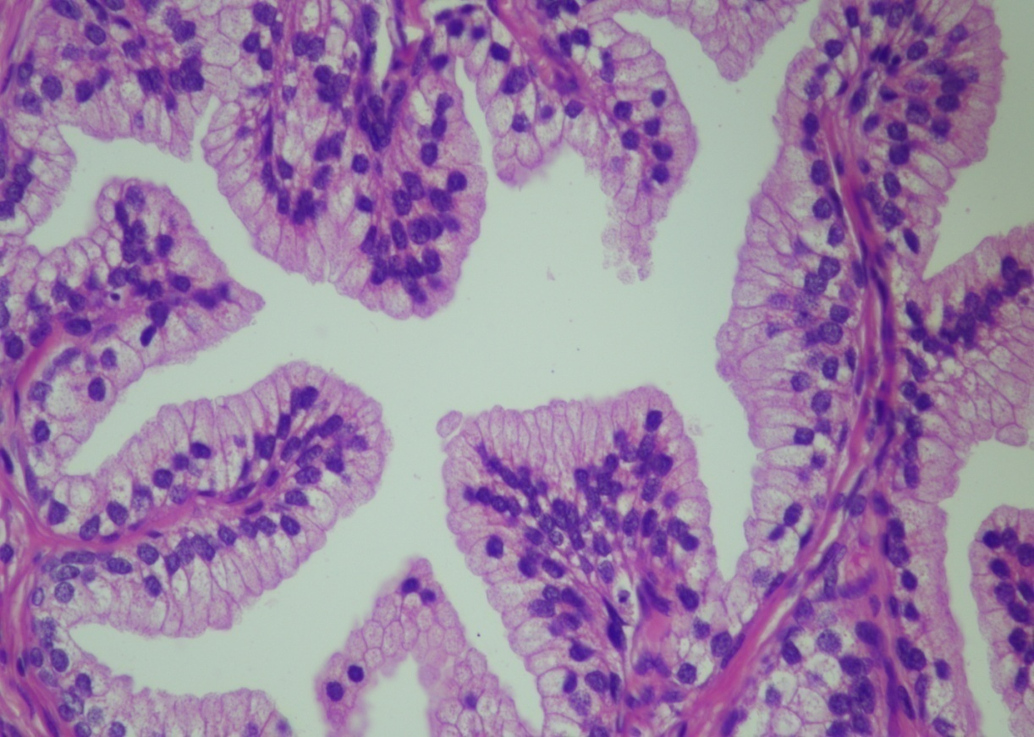

Photomicrograph 1: Benign prostatic glands on Hand E staining X 20

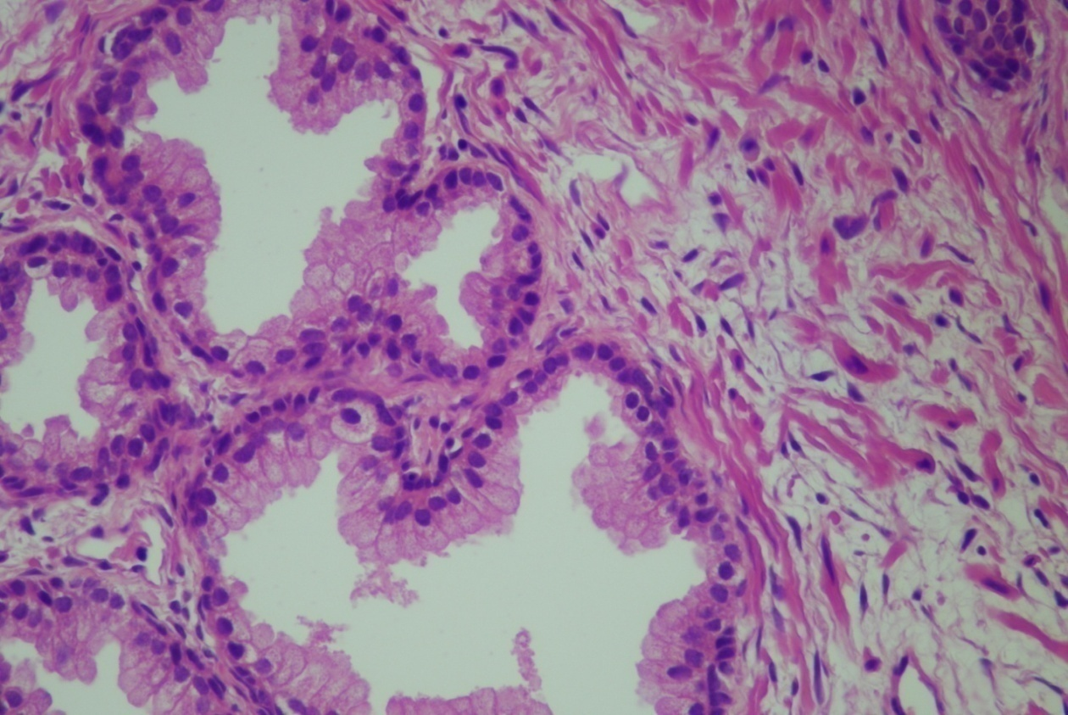

Photomicrograph 2: Benign prostate hyperplasia cystically dilated glands with double layered epithelium on Hand E staining X 20

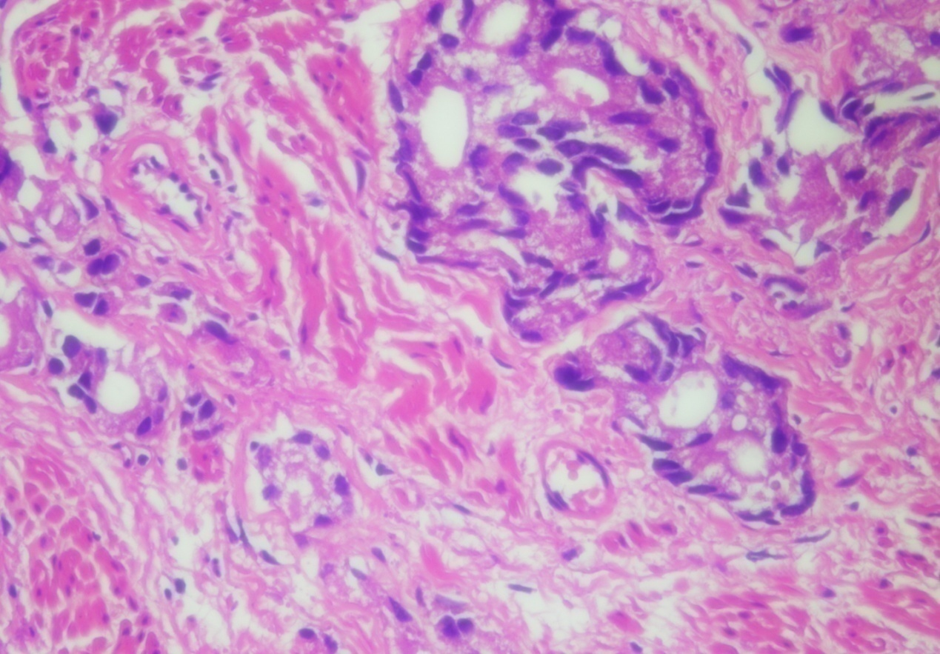

Photomicrograph 3: Adenocarcinoma prostate showing Gleason score (4+3) on H and E staining X 20

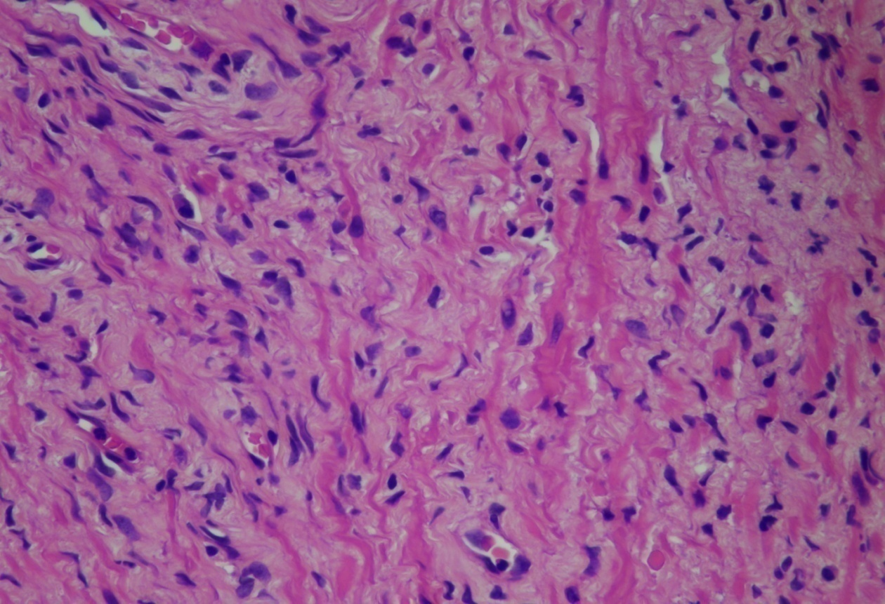

Photomicrograph 4: Adenocarcinoma prostate gland (5+4) on Hand E staining X 20

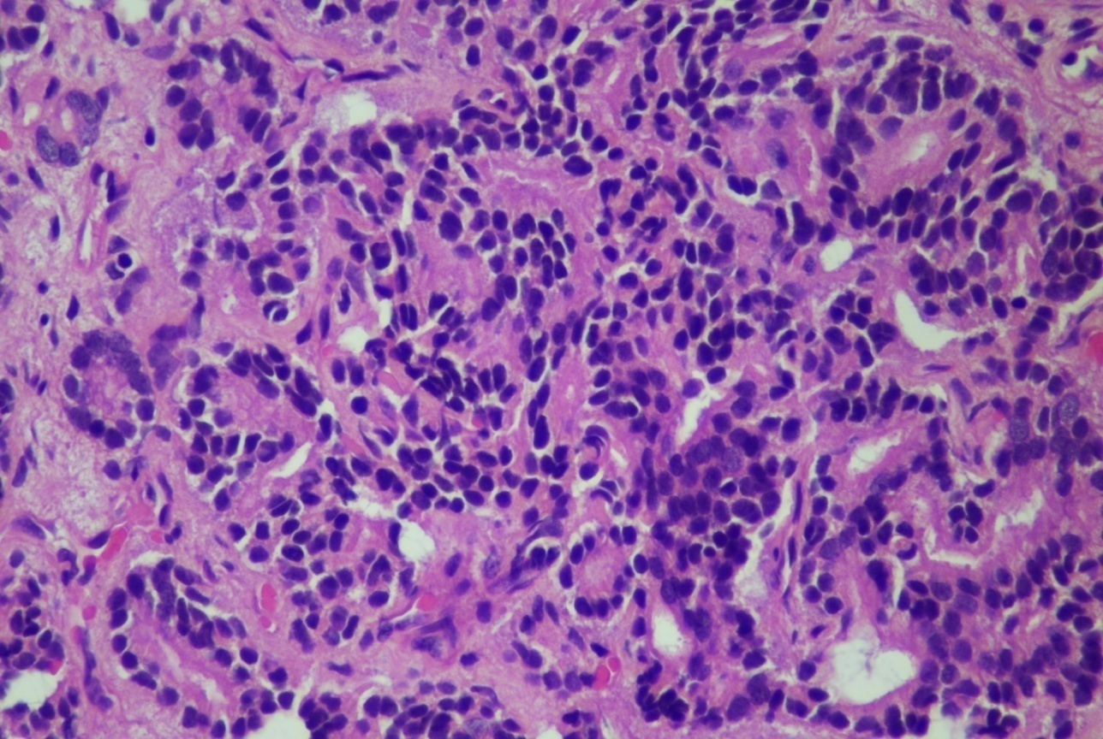

Photomicrograph 5: Adenocarcinoma prostate showing Gleason score (4+5) on H and E X20

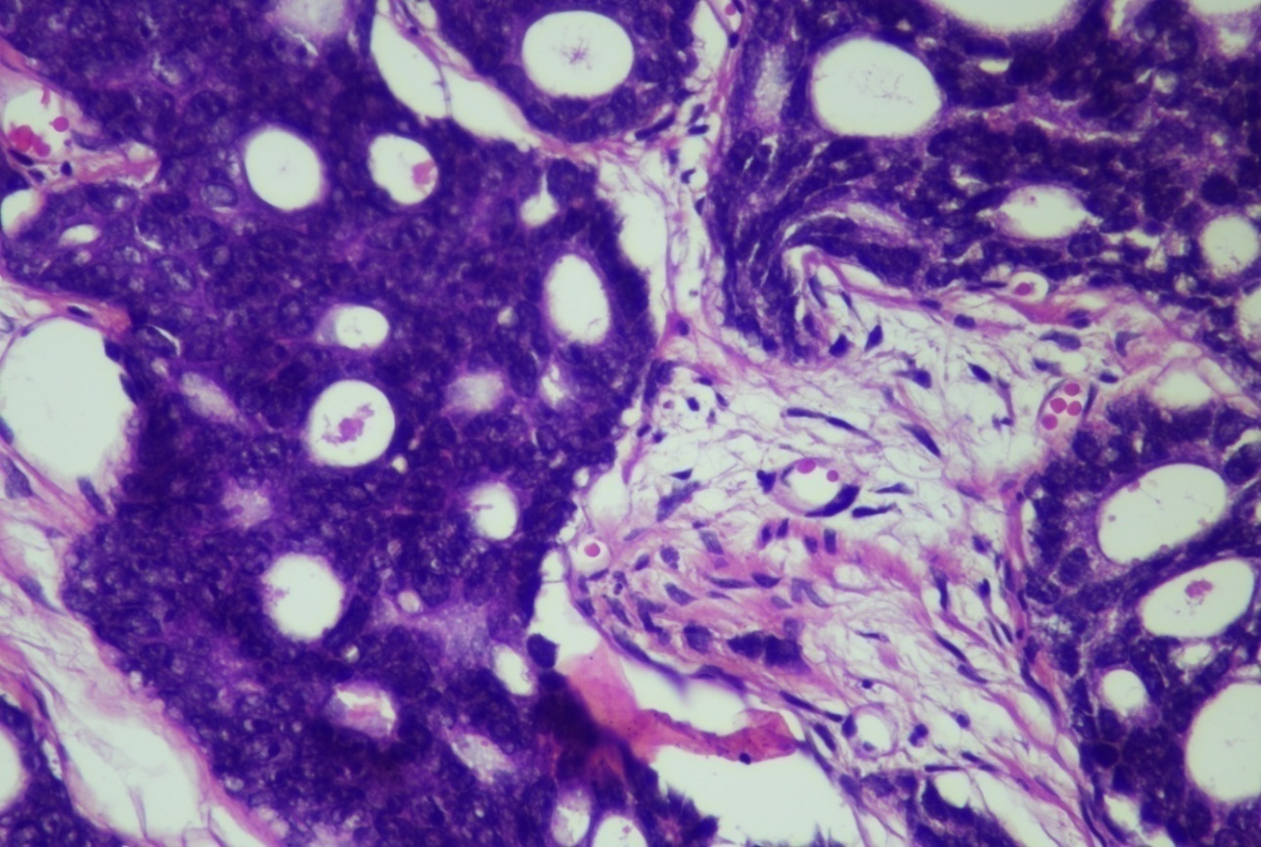

Photomicrograph6: Adenocarcinoma prostate showing a cribriform pattern on Hand E X 20

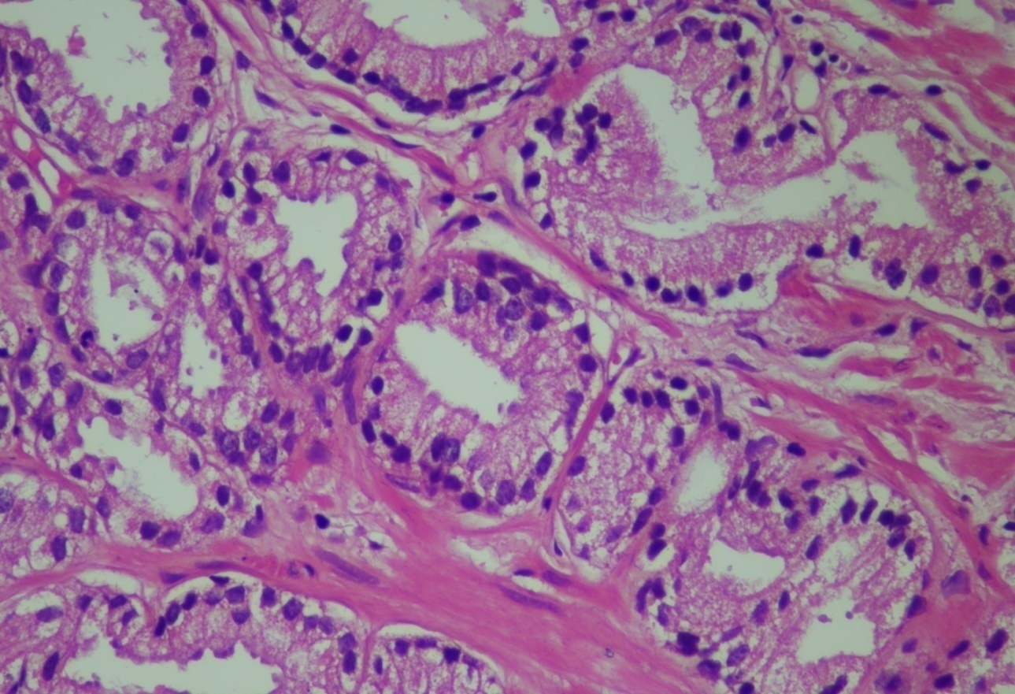

Photomicrograph 7: Adenocarcinoma prostate showing Gleason score (3+3) on H and E X 20

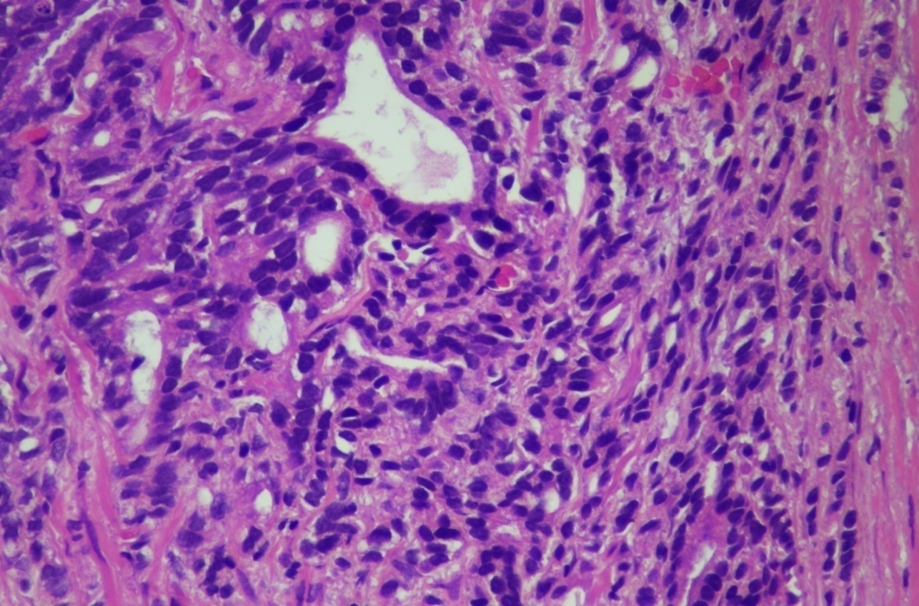

Photomicrograph 8: Adenocarcinoma prostate showing Gleason score of 5+4 on H and E staining x10

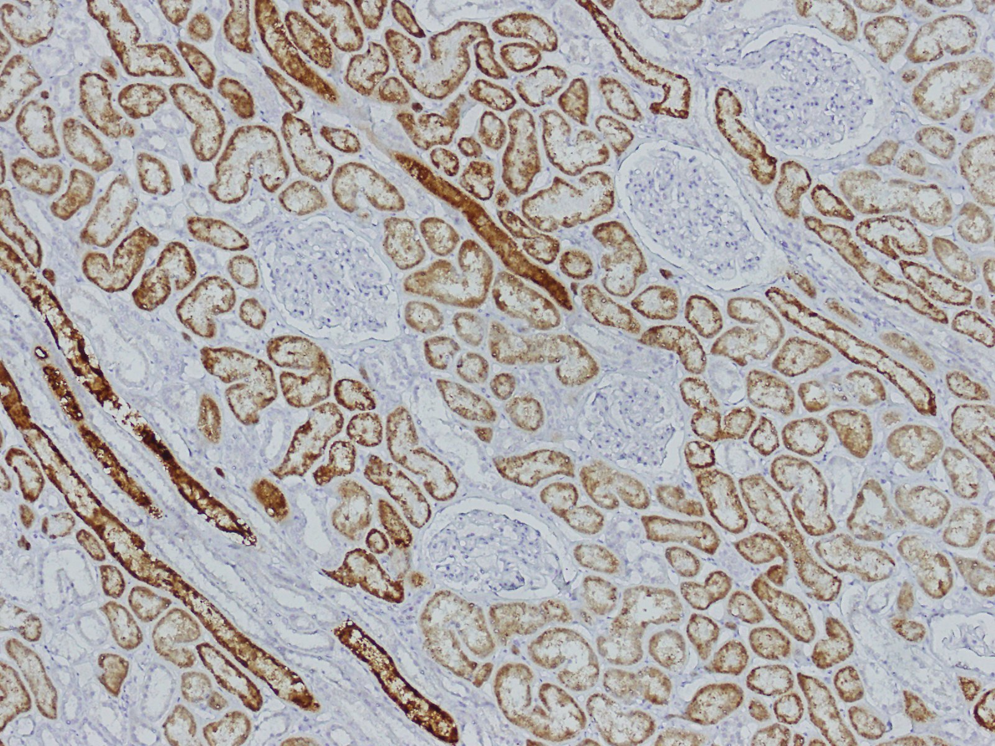
Photomicrograph 9: Positive tissue control used for AMACR on IHC X 20.(Kidney)

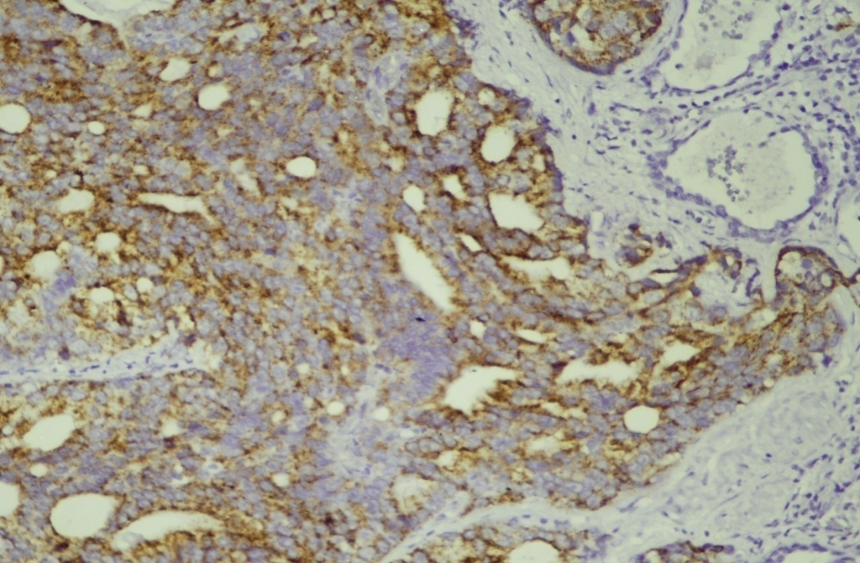

Photomicrograph 10: Adenocarcinoma having Gleason score 5+4 moderate to strong AMACR expression. IHC x 20

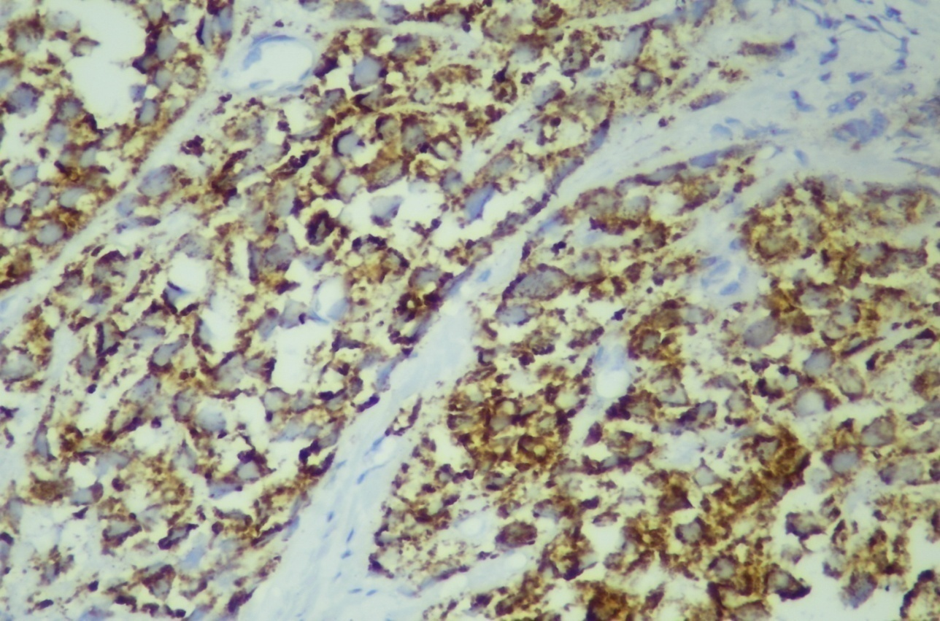

Photomicrograph 11: revealing Adenocarcinoma prostate having Gleason score 5+4 strong AMACR expression. IHC x20

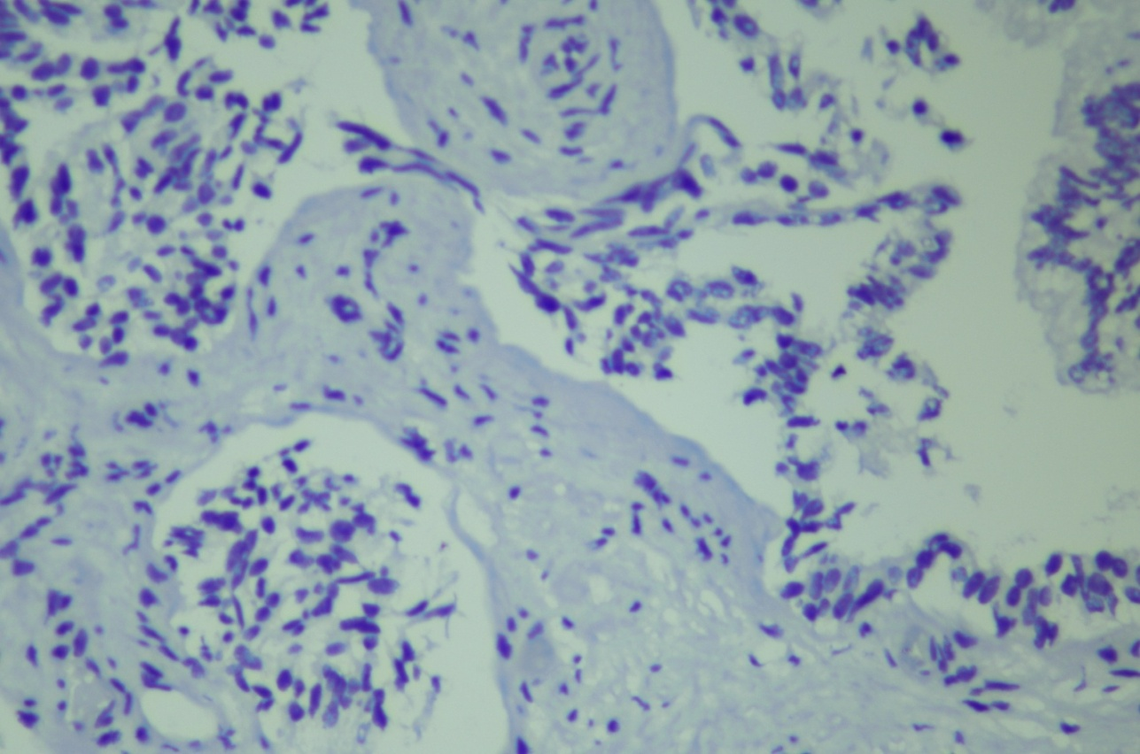

Photomicrograph 12: Absence of staining of AMACR in the benign glands of prostate on IHCX20

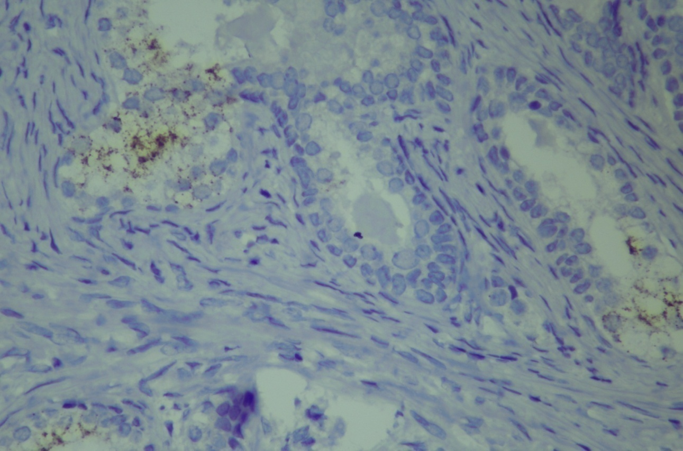

Photomicrograph13: Another case of benign prostate hyperplasia that shows absence of expression of AMACR on IHC X 20

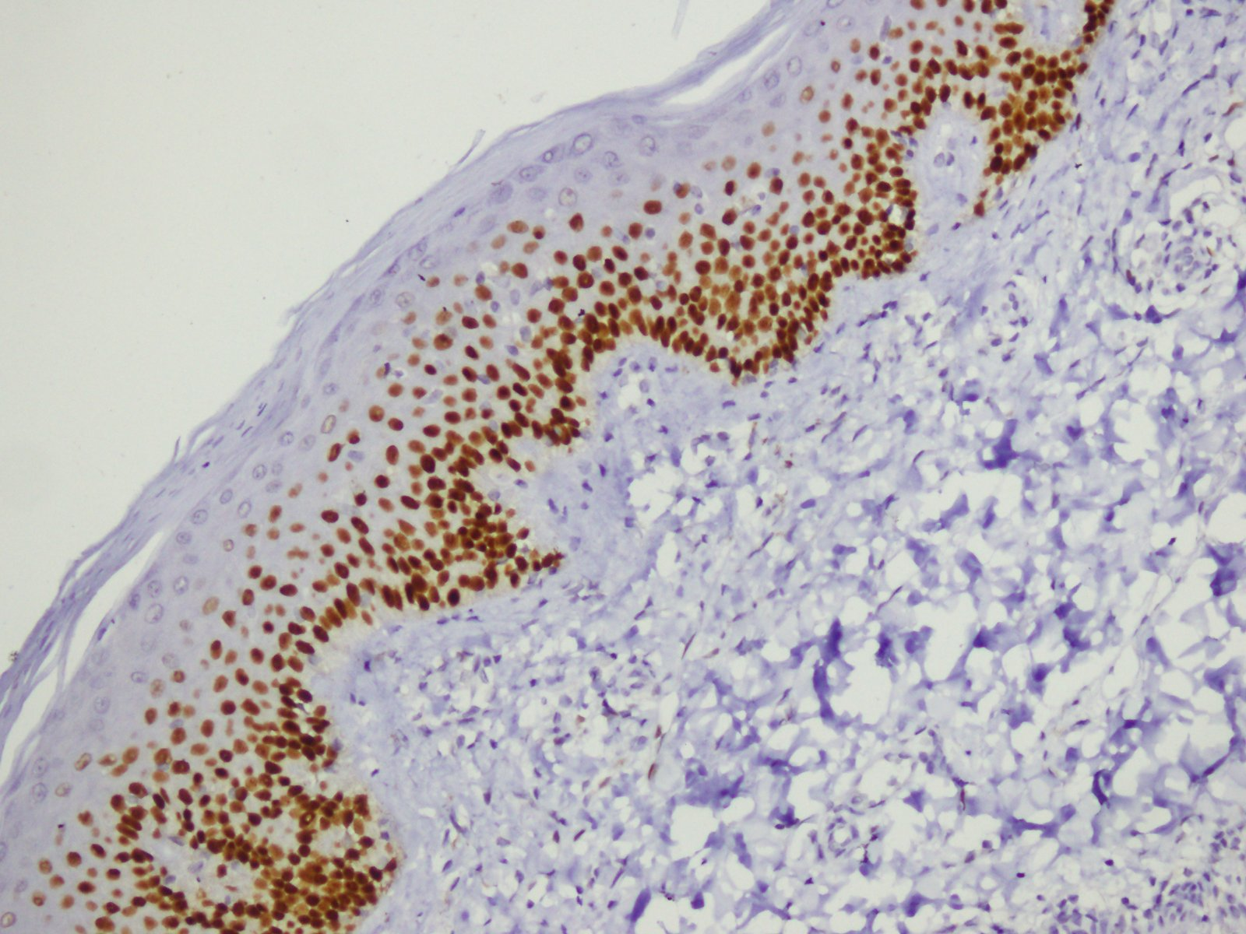

Photomicrograph 14: Positive control used for p63 staining on IHC X 20 (normal skin)

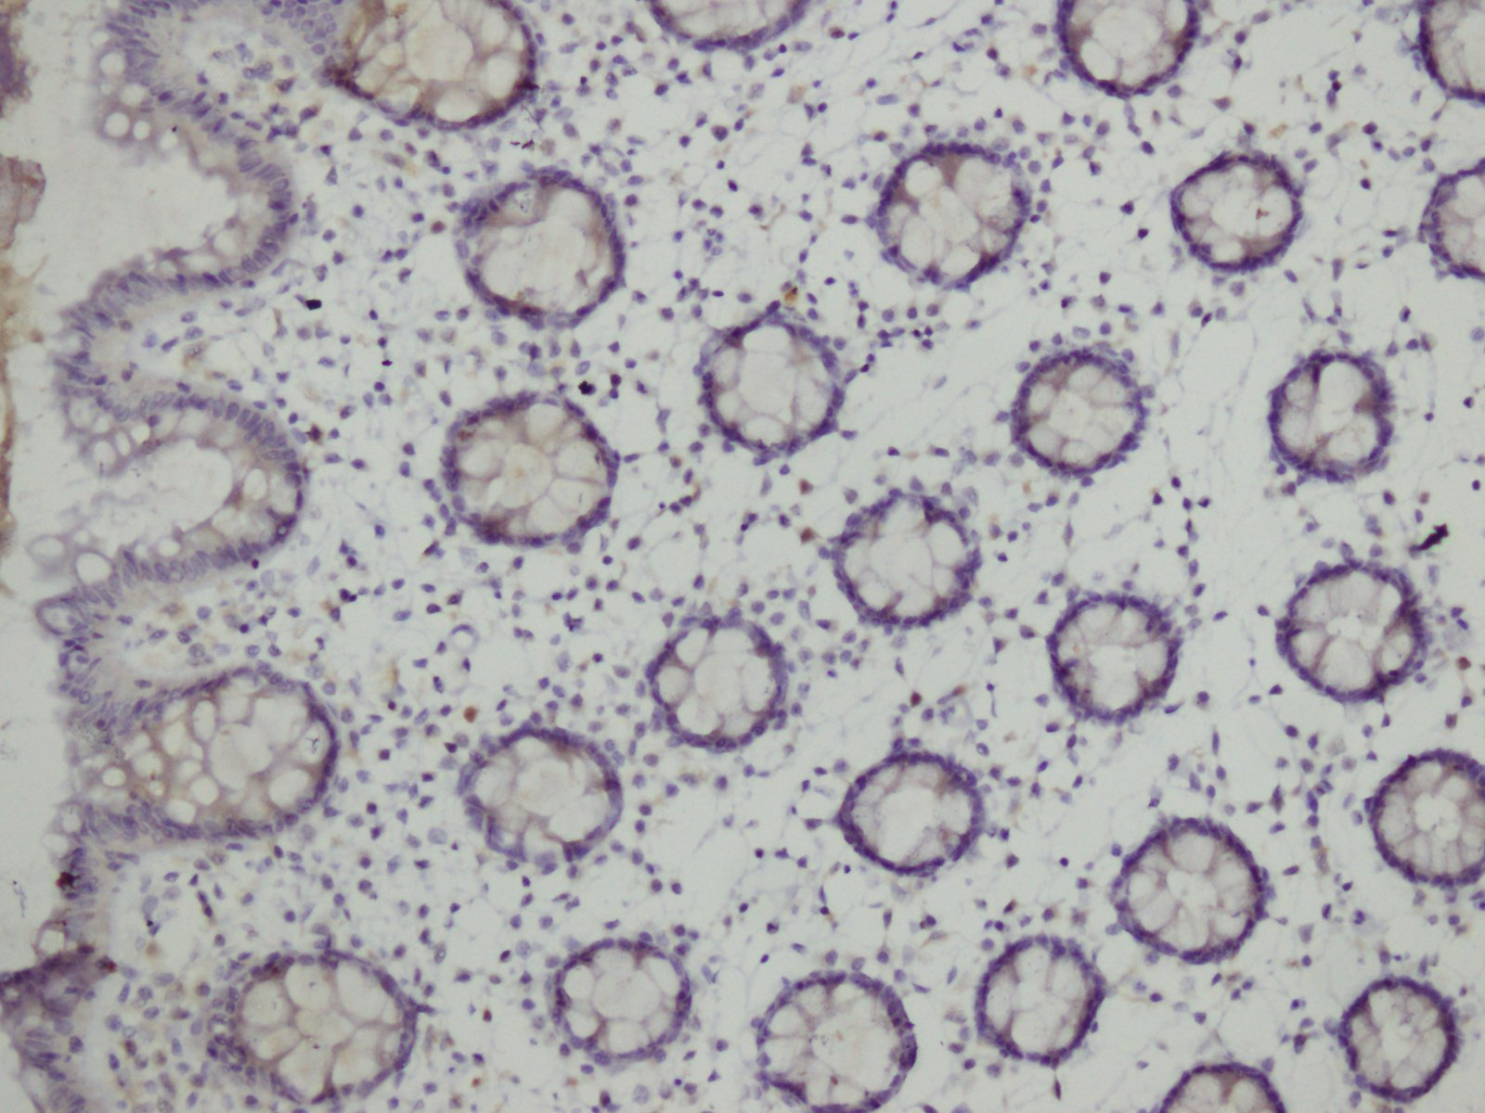

Photomicrograph 15: Positive control used for p63 staining on IHC X 20. (Normal Colon)

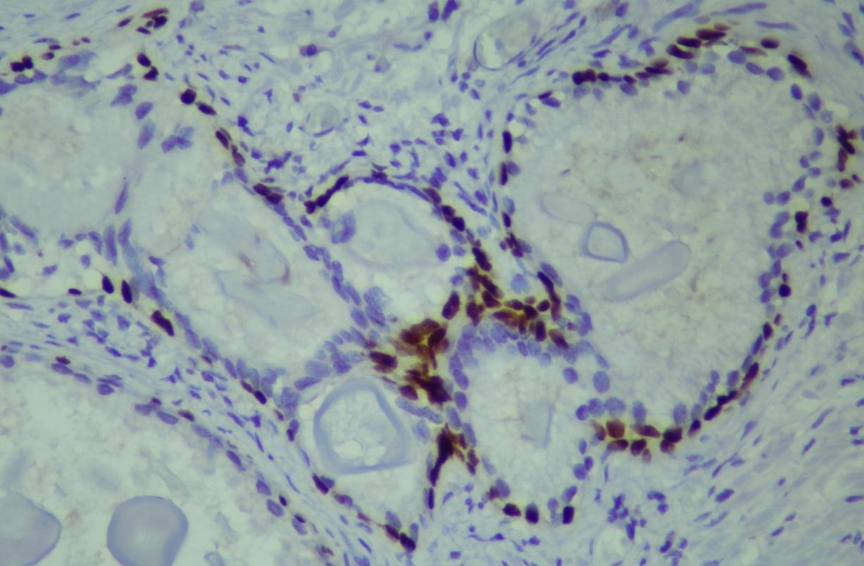

Photomicrograph16: Positive staining for p63 in the basal cells of benign prostate hyperplasia on IHC X 20

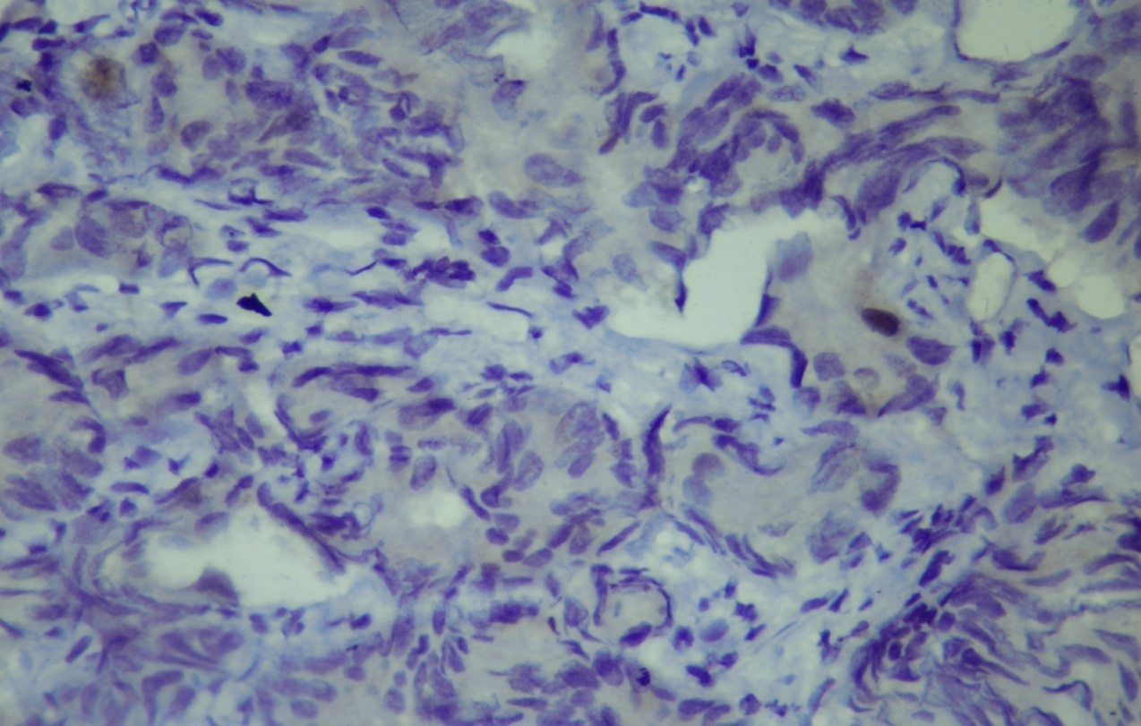
Photomirograph 17: Lack of staining for p63 adenoarcinoma of prostate gland on IHC X 20

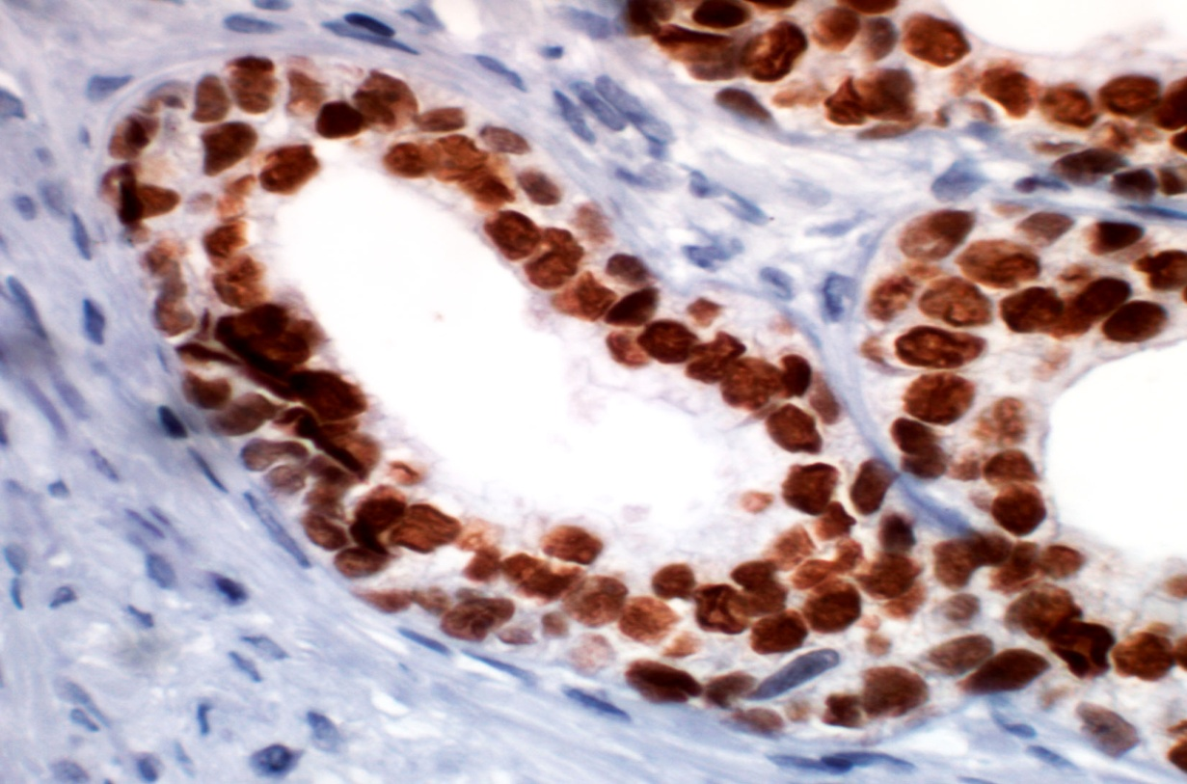
Photomicrograph 18: Normal prostate gland used as positive control for NKX3.1 on IHC X20

.

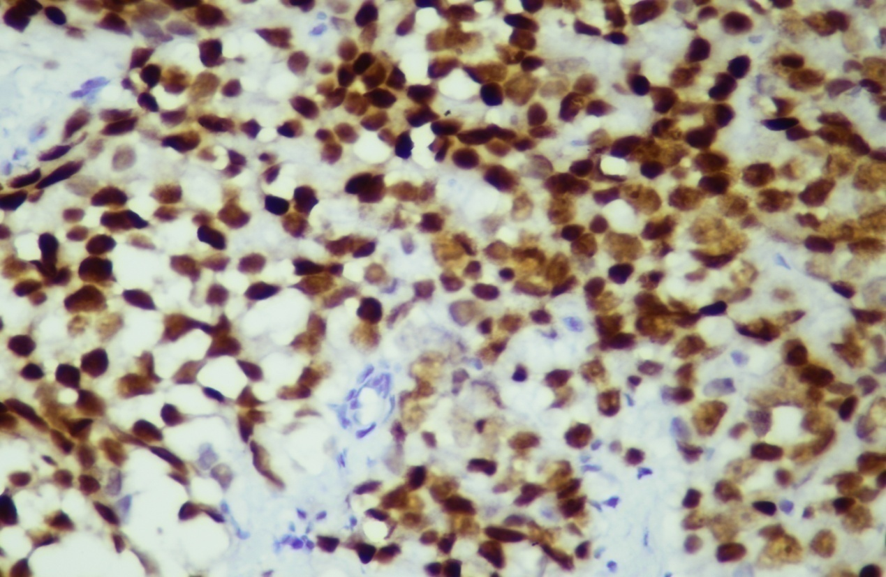
Photomirograph 19: NKX3.1 expression in adenocarcinoma prostate Gleason score (4+3) on IHC X20.

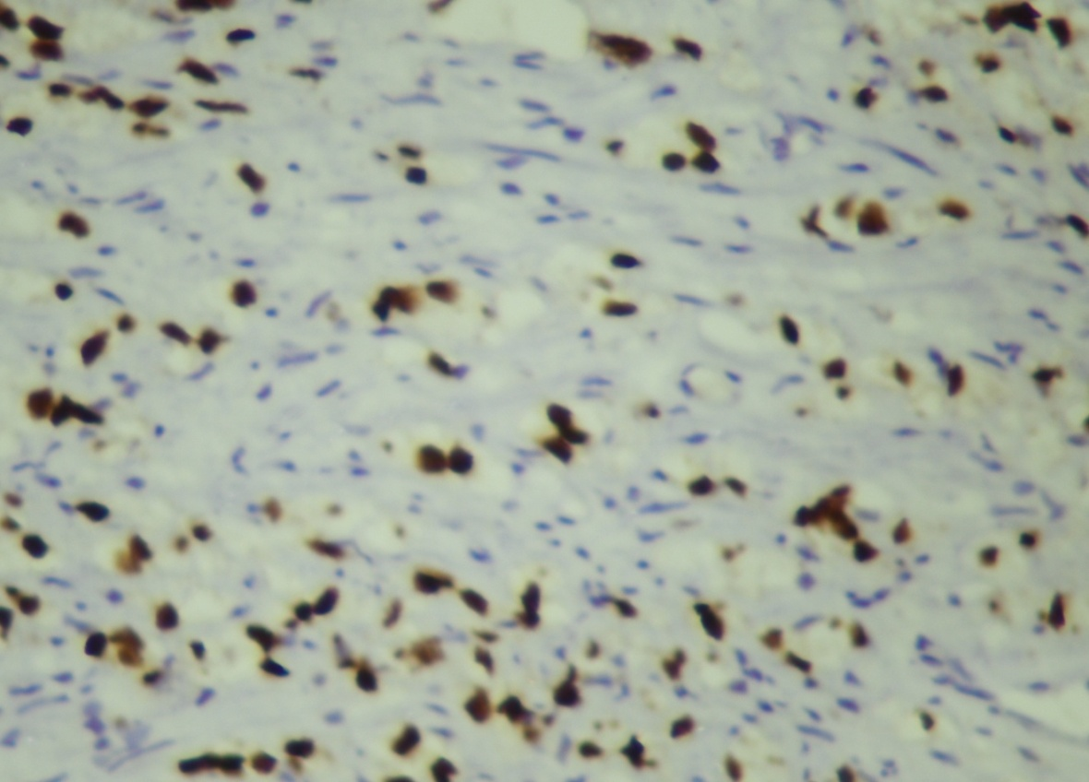
Photomirograph 20: NKX3.1 expression in adenocarcinoma prostate Gleason score (4+3) on IHC X20

CHAPTER 5

5. DISCUSSION
Prostate cancer is the fourth most common cancer in the world and accounts for 9.7% of cancers in men. It is the leading cause of death in men and is second only to lung cancer as a cause of cancer associated mortality in men. (Taitt, 2018) Incidence of prostate cancer in Pakistan is 3 – 7 per 100,000 persons/year. (Idrees et al., 2018)
In Asia, the frequency is estimated three to eleven per 100,000 persons in a single year, whereas incidence among African–Americans is maximum, approximately 185.4 per 100,000 persons per year. (Kimura &Egawa, 2018)
In Karachi, Pakistan, incidence and trend of prostate cancer were reviewed from 1995 to1997 and 1998 to 2002. Prostate cancer was determined in approximately 3.4 percent of males from year 1995till 1997 and ranked eight among all diagnosed cancers. (Nisar et al, 2017)
During the time period from 1998 till 2002, prostate cancer estimated about for 4.6 percent, and rated fourth among all malignancies diagnosed in men . Roughly, there was a 60% increase noted from 1995 and 2002.(Bhurgriet al., 2009)
Although, the diagnosis can usually be determined on the basis of morphologic characteristics such as growth pattern, which consists of diffuse growing tumor cells with either large confluents sheets, single infiltrating cells, or large groups with central necrosis, nuclear atypia and the absence of basal cells, at several occasions it becomes challenging todetermine asubstantial diagnosis by routine histological study. (Merriel, Funston & Hamilton, 2018)
Not only is no single morphologic feature cancer specific, but many benign conditions can mimic prostate cancer. Therefore, the utilization of immunohistochemistry to differentiate prostate cancer from benign mimickers and to endorse the diagnosis becomes beneficial and essential, especially in ambiguous lesions. (Carneiro etal., 2018)
The immunohistochemical diagnosis of prostate cancer predominantly relies on panels of markers because no absolutely specific and sensitive marker for prostate cancer is definitive. These panels usually include at least one basal cell-specific marker and the prostate cancer-specific marker, alpha-methyl-CoA-Racemase (AMACR). (Pentyala et al., 2016)
Despite the fact that various studies have been conducted in Pakistan on the immunohistochemical profile of prostate cancer but still there is a need to validate these facts and to conduct a study by combining various markers altogether in a single study in both benign and malignant lesions. Therefore, our study focuses on the expression of three markers namely AMACR, p63 and NKX3.1 in both benign and malignant glands of prostate. Furthermore, immunohistochemical staining for NKX3.1 has not been done in Pakistan for prostate cancer this study will contribute to the baseline findings for future research to be carried out on NKX3.1 as an immune marker for prostate cancer in Pakistan.
A total of 74 cases were recruited in our study, comprising of both benign and malignant lesions of prostate 66 specimen (89.18%) were of TURP and the remaining 8(10.19%) were prostatectomy specimen. Our study analyzed 37 cases of adenocarcinoma prostate, the patients in the theses cases were in the age range of 58 to 87 years. The mean age in these patients was found out to be 70.0±7.4 years. The maximum cases were found in the age group of 63-67 years. All malignant cases were graded according to Gleason scoring, 7 cases had Gleason score of 3+3(18.9%), 7 cases had Gleason score of 3+4(18.9%), Gleason score of 4+3 was reported in 8 cases(21.6%) , 4+4 Gleason score was reported in 3 cases of prostate cancer(8.1%) .2 cases were seen to have score of 4+5(5.4%), whereas, 8 cases were found to have score of 5+4 (21.6), only 2 cases had Gleason score of 5+5(5.4%). The most frequent Gleason score was 7 and 9.
All these findings are consistent with the study conducted at the Department of Pathology KIST medical college, which recruited 96 prostatic lesions including both benign and malignant lesions. Out of these 96 specimens, 85 (88.54%) comprised of TURP and 11(11.46%) were prostatectomy specimens. The mean age of patients suffering from prostate cancer in this study was 72.9 ± 5.2 years and the majority of the cases had Gleason score of 9. (Bhatta&Hirachan, 2018).
The present study determined the clinical presentation of patients diagnosed as benign prostate hyperplasia. Out of 37 cases, 25 patients (67.6%) presented with LUTS while 12 (32.4%) patients presented with prostate enlargement. These findings correspond with the questionnaire based study carried out at the Department of Surgery, University of Lagos, Nigeria. The study recruited 615 men suffering from benign prostate hyperplasia. The study findings revealed that more than half of the men presented with LUTS (57.4%) and the remaining 42.6% presented with enlarged prostate gland. (Ojewola et al., 2017)
Our study revealed that the patients having benign prostate hyperplasia were in the age range from 50 to 80 years. The mean age was found out to be 64.11±75.The maximum cases were found in the age group 62-66 years. Our research findings correlate with the study carried out in the Department of Radiology and Urology Chandka Medical College, Hospital Larkana. This study analyzed 103 patients suffering from BPH and the study revealed that the mean age of the patients was 62.29 ± 7.67. (Siyal, Abbasi&Shaikh, 2015)
A study conducted at Department of Pathology, M.M Institute of Medical Sciences & Research, Mullana, India assessed a total of 364 consecutive prostatic specimens, which included 285 cases of benign prostate hyperplasia, 117 cases of prostatitis and 72 cases of prostate cancer were included in the study. . Maximum numbers of benign lesions were seen in the age group of 61 to 70 years with an average age at presentation of 68.6 years. The majority of cases in the neoplastic group were found to be present in the age group of 71 to 80 years with a mean age of 68.7 years. (Garg et al., 2013)
In the present study, out of the 37 cases of benign hyperplasia prostate subjected to AMACR immunostaining, 35cases (94.59%) showed negative immunoexpression for AMACR, whereas the remaining 2 cases(5.40%) stained <10% for AMACR with weak intensity of staining.
Out of the 37 cases of prostate cancer subjected to AMACR staining, 25 cases showed strong intensity of staining (+3). Out of these 25 cases, 9 (24.3%) cases showed reactivity in ˃90% of tumor cells, 16(43.2%) cases showed reaction in almost 51-90% of cells, 12(32.4%) cases exhibited reactivity in 10-50% of tumor cells with moderate intensity (+2) of staining.
Chi square analysis revealed a statistically significant co relation of AMACR staining in the benign malignant lesions of prostate gland with a p-value of 0.001
A significant p-value (0.001) was also evaluated between AMACR staining and overall Gleason score.
Similar findings are seen in an observational cross-sectional study which was carried out in the Department of Pathology, RadhaGobindaKar Medical College, and Kolkata. The study recruited a total of 106 cases, 68 cases (64.15%) had confirmed diagnosis of prostatic adenocarcinoma and rest 38 cases (35.85%) were diagnosed as benign hyperplasia of prostate by routine Hematoxylin& Eosin method. Out of the total of 68 cases of prostatic adenocarcinoma, 60 cases (88.23%) showed strong or moderate positive expression of AMACR in neoplastic glands while rest 8 cases (11.77%) show weak or negative expression of AMACR. Out of the total of 38 benign cases, only 2 cases (5.26%) revealed false positive expression of AMACR. (Biswas&Talukdar, 2019)
Our study findings correspond with the study carried out at the Adelaide and Meath hospital, Ireland in which 101 prostatic cases were included. Out of these 101 cases, 57 cases were that of carcinoma while, the remaining 44 cases were diagnosed as benign prostate hyperplasia. Of 57 cancers, 52(91%) showed at least focal positive staining forAMACR strong or moderate staining in at least 1% oftumor glands and 30 (53%) showed diffuse tumor. In the benigncases, the majority of glands were negative for AMACR. In 18(41%) of 44 cases, focal weak apical or cytoplasmicstaining was detected which was easily distinguishable from the malignant pattern of staining.There was a statistically significant correlation between AMACR staining intensity and overall Gleason score. Chi square analysis revealed a significant p value of 0.001 (Murphy et al., 2007)
Our study findings arw similar to the results of a study done at National Centre Institute, Cairo University, in which immunohistochemical staining was performed for AMACR, on tissue specimen of 49 patients with prostatic carcinoma. The study determined AMACR expression in relation to Gleason’s score; the study recorded a high statistically significant co relation between AMACR expression sand Gleason’s score revealing a significant p-value of 0.004.(El-Kasem et al., 2016)
Similar results were reported in the study conducted at Postgraduate Medical institute Lahore, in which a total of one hundred biopsies were collected from Lahore General Hospital, which 50 specimens of benign prostate hyperplasia and 50 cases of malignantlesions. After hematoxylin and eosin staining, all carcinoma cases were graded using Gleason’s Scoring system. Majority of the cases were moderately differentiated 27(54%) while the remaining 23 (46%) were poorly differentiated. After diagnosing on H and E, all cases were subjected to AMACR immunostaining. It was observed that all cases of hyperplasia were negative whereas, all carcinoma cases showed positive AMACR expression. A significant correlation was observed between AMACR staining and Gleason Score. The study concluded that AMACR is a useful immunomarker for diagnosing challenging cases of prostatic adenocarcinoma.(Tabassum, Imtiaz, &Jabeen, 2017)
Similar results were seen in a prospective study carried out at the Department of Pathology Rothak University in which a total of 50 cases were recruited in the study. Out of the 50 cases, 37 cases were malignant lesions and 13 cases comprised of benign prostate hyperplasia. Tumor grade was determined according to Gleason's grading system. AMACR was determined by immunohistochemical staining. The obtained results were analyzed and evaluated using Chi-square statistical test. The results of this study revealed that AMACR was not expressed in any of the 13 cases of benign lesions of the prostate while in malignant lesions of prostate it was expressed in 33 of 37 (89.18%) cases. There was statistically significant difference in expression of AMACR between benign and malignant lesions of the prostate, indicated by a significant p value of 0.001. (Jain et al., 2017)
p63 is recognized as a transcription factor that is necessary for the control of growth and development of several epithelial organs, inclusive of the prostate gland. It bears an identical structure as that of p53. The expression of p63 is confined to basal cells of prostate glands and reveals a nuclear staining pattern. Majority of prostatic cancers are negative for p63, while normal or benign hyperplastic prostatic glands exhibit highly positive and diffuse p63 staining.
Immunohistochemical staining of p63 in both benign and malignant lesion was performed in the present study. Out of the 37 cases diagnosed as benign prostate hyperplasia subjected to p63 staining, 15 cases (40.5%) revealed >90% stained nuclei for p63 exhibiting strong intensity of staining(+3), whereas the remaining 22 cases(59.5%) stained 51-90% nuclei for p63 with moderate intensity of staining(+2).
Out of the 37 cases of prostate cancer subjected to p63 staining, 33 cases (89.2%) showed no reactivity; whereas, 4 cases (10.8%) stained 1-10% nuclei with weak intensity of staining.
Chi square analysis revealed a statistically significant co relation of p63 staining in the benign malignant lesions of prostate gland with a p-value of 0.001.
A non significant p-value of 0.170 was evaluated between p63 staining and overall Gleason score. Our study findings suggested that Immunostaining with p63 escalates the diagnostic yield, consequently it may be used as a valuable tool in differential diagnosis of prostatic carcinoma.
Our study findings regarding p63 immunostaining in both benign and malignant lesions correspond with a study carried out at the Urology ward of Lahore General Hospital, Lahore. Specimens of 60 patients were included in the study. Majority of the biopsies were obtained after TURP 57 specimens and only 3 were radical prostatectomies. Out of the 60 cases, 21 cases (35.0%) were diagnosed as prostatic adenocarcinoma and 39 cases (65.0%) were that of benign prostate hyperplasia. All cases of adenocarcinoma showed negative staining for p63 while 39 cases of BPH exhibited persistent brown nuclear staining.(Nisar et al., 2017)
Our study findings also correlate with a comprehensive study carried out at the Research institute of Fundamental and Clinical Uronephrology of Saratov State Medical University analyzed three prostate specific markers. Histochemical score (Hs) was evaluated by multiplying the percentage of stained cells with the intensity of staining.The study revealed a high histochemical score of p63 in the group of individuals suffering from BPH (Hs=91), whereas in the patients having prostatitis the histochemical score was interpreted as(Hs=83) due to the presence of few basal cells for positive expression of p63,and a very low score for adenocarcinoma of prostate (Hs=17) (Popkov et al., 2013)
Another study carried out at the Shaukat Khanum Memorial Cancer Hospital analyzed 30cases reported as ambiguous on morphological findings and the expression of p63 in these cases. The study revealed that all prostatic adenocarcinomas were negative for p63 and benign lesions of prostate were positive for p63. The study therefore concluded that p63 immunohistochemistry staining can be used as a reliable marker to differentiate between benign from malignant morphologically ambiguous lesions of prostate.(Baig, Hassan & Mansoor, 2012)
Our findings also correlate with the study conducted at the Pathology Department, Ghaem Hospital, Mashhad, Iran. In this cross sectional study, 98 prostate specimens in that were assessed for pathologic diagnosis. Out of 98 cases; 40 cases were prostate adenocarcinomas and 58 were benign diseases. Sampling procedures included transurethral resection (TURP), needle biopsy and radical prostectomies. All BPH cases were immunoreactive for p63 in more than 75% of the basal cells (sensitivity 100%). (Kalantari et al., 2014)
Our study results are in accordance with the study carried out at the Urology and Pathology departments Zagazig University, Egypt. A total of 60 prostate needle biopsy specimens were recruited in the study, including 30 cases of adenocarcinoma prostate and 30 specimens of benign prostate hyperplasia. All cases were immunostained for AMACR and p63. Results of the study revealed that 90% cases of prostate adenocarcinoma expressed AMACR and 83.3% of these malignant lesions expressed >50%positive expression of AMACR.AMACR expression was not seen in the benign glands. The study also exhibited moderate to strong p63 nuclear stain in >80% of the benign gland, while 29 cases of prostate adenocarcinoma showed negative immunestaining for p63. There were significant differences in cytoplasmic p63 expression between benign and malignant lesions of prostate (p<0.001). Negative immune staining of p63 in cases of adenocarcinoma prostate is a clinically useful tool for differentiating benign and malignant lesions of prostate gland. This study further concluded that combined immune staining of AMACR and basal cell specific marker p63 could improve the accuracy of diagnosis of prostate cancer. (Rashed, Hegazy & Ahmed, 2015)
NKX3.1 is an androgen regulated and prostate specific gene that belongs to the homeo box gene family. Literature review revealed that numerous studies of NKX3.1 expression in human prostate cancer have shown conflicting conclusions. One study suggested that NKX3.1 messenger ribonucleic acid (mRNA) expression is increased in prostate cancer.(Korkmaz et al., 2004). In another study, loss of expression of NKX3.1 was reported to be strongly associated with prostate cancer progression and advanced stages (Bowen et al.,2000)
The present study results revealed the extent of NKX3.1 staining in the benign lesions of prostate gland. 37 cases subjected to NKX3.1 immunestaining, 32 cases showed positive expression, out of these 32 cases; 15 (40.5%) cases showed reactivity in>80% of the nuclei, 14(37.8%) cases stained 51-80% nuclei, the remaining 3 (8.1%) showed reactivity in 26-50% nuclei.5 cases showed negative expression, of which 2(5.4%) cases showed no reactivity while 3 (8.1%) cases showed reactivity in 1-25%of the nuclei.

The extent of NKX3.1 staining in the adenocarcinoma of prostate gland was also analysed in our study. 37 cases subjected to NKX3.1 immunestaining, 8 (21.6%) cases showed reactivity in >80% nuclei, 6 cases (16.2%) stained 51-80% of the nuclei, 16 cases(43.2%) revealed reactivity in 26-50% nuclei, while 1 case showed reactivity in 1-25% nuclei. 5 cases showed negative expression, of which 2(5.4%) cases showed no reactivity while 3 (8.1%) cases showed reactivity in 1-25%of the nuclei; the remaining 6 (16.2%) cases were negative for NKX3.1.

Our study findings correlate with a study carried out at the Dokuz Eylul, Izmir which recruited both normal prostate tissue samples and benign prostate hyperplasia samples.4 samples of normal prostate gland and 12 samples of benign prostate hyperplasia were taken from patients above 40 years of age after TURP. Immunohistochemistry, reverse transcription polymerase chain reaction and western blot analysis were carried out to assess the role of NKX3.1 in the development of the benign prostate hyperplasia. Interpretation of immunohistochemistry was done by using a scoring pattern as follows: 0 to 2 according to the intensity and uniformity of nuclear staining in malignant cells.0 indicated no staining,heterogeneous staining +1,and 2+ diffuse staining. Results of the immunohistochemical analysis revealed NKX.1 expression waselevated in benign prostate hyperplasia when compared with normal prostate tissue. (Irer et al., 2009)
Recent studies suggest that the hormonal changes alone are not sufficient enough to explain the pathogenesis of prostate hyperplasia a number of growth factors may be involved in its pathogenesis. Few regulatory genes have been found necessary for the development of normal prostate which includes NKX3.1 & Hobx13.( Mullan et al., 2006) Loss of NKX3.1 results in defects in proteins secretions and ductal morphogenesis. Immunohistochemistry , quantitative RT-PCR & Western blot analysis have all indicated increased NKX3.1 expresssion in benign prostate hyperplasia and therefore may be involved in the pathogenesis of BPH.
Our study results are consistent with an extensive research undertaken at John Hopkins University.The aim of this research was to determine NKX3.1 as a marker of prostatic metastatic adenocarcinoma. Immunohistochemical staining against NKX3.1, PSA, and PSAP was carried done on a tissue microarray (TMA) of metastatic prostate adenocarcinoma specimens from lymph nodes, bone, and soft tissue, primary prostate tumors and normal tissues. In primary prostatic adenocarcinoma specimens, all 40 cases stained positively for NXK3.1 and the mean percent of tumor cells staining positive in their nuclei was 84.7%. Reactivity in more than 25% nuclei with moderate to strong intensity of staining was taken as positive in this study.(Gurel et al., 2010)
Our study findings correspond with the study carried out at the Lombardi Cancer Histopathology Centre, Washington. 61 cases of benign prostate hyperplasia and 30 prostate cancers were recruited in the study. 58 cases of benign prostate hyperplasia showed positive staining with NKX3.1 while the remaining 2 were negative. Neoplastic prostate epithelium was found to display three different patterns of immunostaining for NKX3.1 expression. Many samples stained uniformly for NKX3.1. Some samples stained heterogeneously, with some malignant cells stained and adjacent cellsdid not stain. Some samples displayed no staining for NKX3.1. Association of Gleason score and NKX3.1 staining was assessed by using chi square analysis revealing a non significant p value of 0.611 was reported. The lack of relationship between Gleason score and NKX3.1 indicate that NKX3. Expression decreases with disease severirty. (Bowen et al., 2000)

CHAPTER 6

CONCLUSION
We therefore conclude that mostly the diagnosis of prostate cancer relies on the Hand E criteria, but there are some situations where H and E features fall short for an outright diagnosis of malignancy. IHC plays an important role in the diagnosis of prostatic lesions and helps to differentiate malignant from benign lesions, especially for gray zone lesions which are difficult to be diagnosed on the routine histopathological study. Our study was carried out at a tertiary are hospital in Karachi. A total of 74 cases were recruited in the study which included 37 diagnosed cases of adenocarcinoma prostate and 37 cases of benign prostate hyperplasia. Immunohistochemistry was performed on all these cases for the evaluation of three markers namely AMACR, p63 and NKX3.1.
The study concluded that the patients with hyperplasia usually presented in the sixth decade of life while majority of patients with adenocarcinoma prostate are in their seventh decade of life. This clearly signifies that patients present late with more advanced lesions in our part of the world.
AMACR helps in excluding the benign lesions of prostate and confirming the diagnosis of malignancy by its over expression rather than its absence. p63 on the other hand is a basal cell marker, its expression in benign cases while absence in the malignant cases escalates the diagnostic yield. Appropriate combination of AMACR as a positive marker and p63 as negative basal cell marker is helpful for identifying prostate adenocarinoma especially in ambiguous cases. Immunohistochemical analysis of NKX3.1 reveals that loss of NKX3.1 in high grade carcinomas and lack of relationship between Gleason score and NKX3.1 indicate that NKX3.1 expression decreases with increased disease severity.

RECOMMENDATIONS
- We recommend studies on large scale with greater samples size and molecular analysis for NKX3. 1 should be done in order to validate our results.
- More studies should be carried out to evaluate the expression of NKX3.1 in the benign and malignant lesions of prostate gland.
- NKX3.1 protein staining to a panel of markers, if applied in the appropriate clinicopathologic context, may add diagnostic value in the diagnosis of metastatic lesions of unknown primary origin

STRENGTHS OF STUDY
- Our study is carried out in both benign and malignant lesions of prostate.
- The study provides base line findings on immunohistochemistry of NKX3.1,which can provide baseline findings for future studies.
- The study provides findings for a new marker NKX3.1 in both the benign and malignant lesions of prostate gland.

LIMITATIONS OF STUDY
- Inavailabity of clinical data on the PSA levels, staging of cancer is not available in the study.
- Single centre study with small sample size.

CHAPTER 7

7 REFERENCES:

Aaron, L., Franco, O. E., & Hayward, S. W. (2016). Review of prostate anatomy and embryology and the etiology of benign prostatic hyperplasia. Urologic Clinics, 43(3), 279-288.
Abdulkadir, S. A., Magee, J. A., Peters, T. J., Kaleem, Z., Naughton, C. K., Humphrey, P. A., &Milbrandt, J. (2002). Conditional loss of Nkx3. 1 in adult mice induces prostatic intraepithelial neoplasia. Molecular and cellular biology, 22(5), 1495-1503.
Abeshouse, A., Ahn, J., Akbani, R., Ally, A., Amin, S., Andry, C. D., ...&Auman, J. T. (2015). The molecular taxonomy of primary prostate cancer. Cell, 163(4), 1011-1025.
Allott, E. H., Arab, L., Su, L. J., Farnan, L., Fontham, E. T., Mohler, J. L., ... &Steck, S. E. (2017). Saturated fat intake and prostate cancer aggressiveness: results from the population-based North Carolina-Louisiana Prostate Cancer Project. Prostate cancer and prostatic diseases, 20(1), 48-54.
Asatiani, E., Huang, W. X., Wang, A., Ortner, E. R., Cavalli, L. R., Haddad, B. R., &Gelmann, E. P. (2005). Deletion, methylation, and expression of the NKX3.1 suppressor gene in primary human prostate cancer. Cancer research, 65(4), 1164-1173.
Aslan, G., Irer, B., Tuna, B., Yorukoglu, K., Saatcioglu, F., &Celebi, I. (2006).Analysis of NKX3. 1 expression in prostate cancer tissues and correlation with clinicopathologic features. Pathology-Research and Practice, 202(2), 93-98.
Baig, M. K., Hassan, U., &Mansoor, S. (2012). Role of 63 in differentiating morphologically ambiguous lesions of prostate. Journal of the College of Physicians and Surgeons Pakistan, 22(12), 773-777.
Barthel, S. R., Hays, D. L., Yazawa, E. M., Opperman, M., Walley, K. C., Nimrichter, L., ...& Foster, B. A. (2013). Definition of molecular determinants of prostate cancer cell bone extravasation. Cancer research, 73(2), 942-952.
Bashir, M. N. (2015). Epidemiology of prostate cancer. Asian Pac J Cancer Prev, 16(13), 5137-41.
Bax, C., Taverna, G., Eusebio, L., Sironi, S., Grizzi, F., Guazzoni, G., &Capelli, L. (2018). Innovative diagnostic methods for early prostate cancer detection through urine analysis: a review. Cancers, 10(4), 123-151.
Beer, T. M., Kwon, E. D., Drake, C. G., Fizazi, K., Logothetis, C., Gravis, G,&Piulats, J. M. (2017). Randomized, double-blind, phase III trial of ipilimumab versus placebo in asymptomatic or minimally symptomatic patients with metastatic chemotherapy-naive castration-resistant prostate cancer. J ClinOncol, 35(1), 40-47.
Bhatta, S., &Hirachan, S. (2018). Prostatic lesions: Histopathological study in a tertiary care hospital. Journal of Manmohan Memorial Institute of Health Sciences, 4(1), 12-19.
Bhurgri, Y., Kayani, N., Pervez, S., Ahmed, R., Tahir, I., Afif, M.,.&Hasan, S. H. (2009). Incidence and trends of prostate cancer in Karachi South. Asian Pac J Cancer Prev, 10, 45-8.
Biswas, S., &Talukdar,M. (2019) Diagnostic utility of AMACR expression to differentiate prostate carcinoma from benign hyperplasia pf prostate- a hospital based cross sectional study. prostate(N= 38), 62(8.67), 0-194.
Bowen, C., Bubendorf, L., Voeller, H. J., Slack, R., Willi, N., Sauter, G.,&Kallioniemi, O. P. (2000). Loss of NKX3. 1 expression in human prostate cancers correlates with tumor progression1, 2. Cancer research, 60(21), 6111-6115.
Bowen, C., Zheng, T., &Gelmann, E. P. (2015). NKX3. 1 Suppresses TMPRSS2–ERG Gene Rearrangement and Mediates Repair of Androgen Receptor–Induced DNA Damage. Cancer research, 75(13), 2686-2698.
Brawer, M. K. (2005). Prostatic intraepithelial neoplasia: an overview. Reviews in urology, 7(Suppl 3), S11-S18.
Bruyninckx, R., Buntinx, F., Aertgeerts, B., & Van Casteren, V. (2003). The diagnostic value of macroscopic haematuria for the diagnosis of urological cancer in general practice. Br J Gen Pract, 53(486), 31-35.
Carneiro, A., Barbosa, Á. R. G., Takemura, L. S., Kayano, P. P., Moran, N. K. S., Chen, C. K.,& Machado, M. T. (2018). The role of immunohistochemical analysis as a tool for the diagnosis, prognostic evaluation and treatment of prostate cancer: a systematic review of the literature. Frontiers in oncology, 8, 377-389.
Carver, B. S., Chapinski, C., Wongvipat, J., Hieronymus, H., Chen, Y., Chandarlapaty, S., &Scardino, P. T. (2011). Reciprocal feedback regulation of PI3K and androgen receptor signaling in PTEN-deficient prostate cancer. Cancer cell, 19(5), 575-586.
Chastain, E. C., Oliva, I. V., &Osunkoya, A. O. (2012).Utility of p63 and high molecular weight cytokeratin in the distinction between urothelial carcinoma with prostatic stromal invasion and urothelial carcinoma with colonisation of prostatic ducts and acini. Pathology, 44(3), 199-203.
Chuang, A. Y., DeMarzo, A. M., Veltri, R. W., Sharma, R. B., Bieberich, C. J., & Epstein, J. I. (2007). Immunohistochemical differentiation of high-grade prostate carcinoma from urothelial carcinoma. The American journal of surgical pathology, 31(8), 1246-1255.
Conner, J. R., &Hornick, J. L. (2015). Metastatic carcinoma of unknown primary: diagnostic approach using immunohistochemistry. Advances in anatomic pathology, 22(3), 149-167.
Crumbaker, M., Khoja, L., & Joshua, A. (2017).AR signaling and the PI3K pathway in prostate cancer. Cancers, 9(4), 34-49.
Cunha, G. R., Vezina, C. M., Isaacson, D., Ricke, W. A., Timms, B. G., Cao, M., ...& Baskin, L. S. (2018). Development of the human prostate. Differentiation, 103, 24-45.
Cunningham, G. R., &Kadmon, D. (2013).Clinical manifestations and diagnostic evaluation of benign prostatic hyperplasia. Up-to-date [database on the Internet]. Waltham (MA): Up To Date.https://www.uptodate.com/contents/clinical-manifestations-and-diagnostic-evaluation-of-benign-prostatic-hyperplasia
Dai, X., Fang, X., Ma, Y., &Xianyu, J. (2016). Benign prostatic hyperplasia and the risk of prostate cancer and bladder cancer: a meta-analysis of observational studies. Medicine, 95(18):e3493
Daniyal, Muhammad, Zamir Ali Siddiqui, Muhammad Akram, H. M. Asif, Sabira Sultana, and Asmatullah Khan."Epidemiology, etiology, diagnosis and treatment of prostate cancer." Asian Pac J Cancer Prev 15, no. 22 (2014): 9575-8.
Dhillon, P. K., Barry, M., Stampfer, M. J., Perner, S., Fiorentino, M., Fornari, A., ...&Mucci, L. A. (2009). Aberrant cytoplasmic expression of p63 and prostate cancer mortality. Cancer Epidemiology and Prevention Biomarkers, 18(2), 595-600.
Dias, J. S. (2012). Benign prostatic hyperplasia: clinical manifestations and evaluation. Techniques in vascular and interventional radiology, 15(4), 265-269.
Duraiyan, J., Govindarajan, R., Kaliyappan, K., &Palanisamy, M. (2012).Applications of immunohistochemistry. Journal of pharmacy &bioallied sciences, 4(Suppl 2), S307.
Egan, K. B. (2016). The epidemiology of benign prostatic hyperplasia associated with lower urinary tract symptoms: prevalence and incident rates. Urologic Clinics, 43(3), 289-297.
El-Kasem, F. Abou, I. Abulkheir, N. Sidhom, A. Ismail, H. Habashy, and H. Elsayed. "275. Role of immunohistochemical expression of AMACR as a prognostic and predictive biologic marker in advanced prostatic carcinoma." European Journal of Surgical Oncology 42, no. 9 (2016): S139-45.
Epstein, J. I., &Herawi, M. (2006). Prostate needle biopsies containing prostatic intraepithelial neoplasia or atypical foci suspicious for carcinoma: implications for patient care. The Journal of urology, 175(3), 820-834.
Epstein, J. I., Egevad, L., Amin, M. B., Delahunt, B., Srigley, J. R., & Humphrey, P. A. (2016).The 2014 International Society of Urological Pathology (ISUP) consensus conference on Gleason grading of prostatic carcinoma. The American journal of surgical pathology, 40(2), 244-252.
Epstein, J. I., Zelefsky, M. J., Sjoberg, D. D., Nelson, J. B., Egevad, L., Magi-Galluzzi, C., ... & Eastham, J. A. (2016). A contemporary prostate cancer grading system: a validated alternative to the Gleason score. European urology, 69(3), 428-435.
Evans, A. J. (2003). α-Methylacyl CoA racemase (P504S): overview and potential uses in diagnostic pathology as applied to prostate needle biopsies. Journal of clinical pathology, 56(12), 892-897.
Frame, I., & Cant, S. (2015). Current challenges in prostate cancer in UK. BMC medicine, 13(1), 166-74.
Gan, J. H., Harris, A. C., & Green, J. S. A. (2015).Quantifying the risk of malignancy in patients with visible haematuria presenting to the emergency department. Journal of Clinical Urology, 8(2), 132-138.
Gandaglia, G., Briganti, A., Gontero, P., Mondaini, N., Novara, G., Salonia, A., &Montorsi, F. (2013).The role of chronic prostatic inflammation in the pathogenesis and progression of benign prostatic hyperplasia (BPH). BJU international, 112(4), 432-441.
Garg, M., Kaur, G., Malhotra, V., &Garg, R. (2013).Histopathological spectrum of 364 prostatic specimens including immunohistochemistry with special reference to grey zone lesions. Prostate international, 1(4), 146-151.
Giannico, G. A., Arnold, S. A., Gellert, L. L., &Hameed, O. (2017).New and emerging diagnostic and prognostic immunohistochemical biomarkers in prostate pathology. Advances in anatomic pathology, 24(1), 35-44.
Gilbert, R., Tilling, K., Martin, R. M., Lane, J. A., Davis, M., Hamdy, F. C., ...& Metcalfe, C. (2018). Developing new age-specific prostate-specific antigen thresholds for testing for prostate cancer. Cancer Causes & Control, 29(3), 383-388.
Gurel, B., Ali, T. Z., Montgomery, E. A., Begum, S., Hicks, J., Goggins, M., ...& De Marzo, A. M. (2010). NKX3. 1 as a marker of prostatic origin in metastatic tumors. The American journal of surgical pathology, 34(8), 1097-1105.
Gurioli, G., Martignano, F., Salvi, S., Costantini, M., Gunelli, R., &Casadio, V. (2018). GSTP1 methylation in cancer: a liquid biopsy biomarker?. Clinical Chemistry and Laboratory Medicine (CCLM), 56(5), 702-717.
Hamilton, W., Sharp, D. J., Peters, T. J., & Round, A. P. (2006). Clinical features of prostate cancer before diagnosis: a population-based, case-control study. Br J Gen Pract, 56(531), 756-762.
He, H. L., Lee, Y. E., Chang, M. T., Shiue, Y. L., Chang, S. L., Chen, T. J., & Chiu, C. T. (2018). AMACR overexpression acts as a negative prognostic factor in oral squamous cell carcinoma. International journal of medical sciences, 15(6), 638-644.
Homma, Y., Gotoh, M., Yokoyama, O., Masumori, N., Kawauchi, A., Yamanishi, T., ...&Ozono, S. (2011). Outline of JUA clinical guidelines for benign prostatic hyperplasia. International Journal of Urology, 18(11), 741-756.
Hu, W., Qian, Y., Yu, F., Liu, W., Wu, Y., Fang, X., &Hao, W. (2015). Alternatively activated macrophages are associated with metastasis and poor prognosis in prostate adenocarcinoma. Oncology letters, 10(3), 1390-1396.
Humphrey, P. A. (2012). Histological variants of prostatic carcinoma and their significance. Histopathology, 60(1), 59-74.
Humphrey, P. A., Moch, H., Cubilla, A. L., Ulbright, T. M., & Reuter, V. E. (2016). The 2016 WHO classification of tumours of the urinary system and male genital organs—part B: prostate and bladder tumours. European urology, 70(1), 106-119.
Idrees, R., Fatima, S., Abdul-Ghafar, J., Raheem, A., & Ahmad, Z. (2018). Cancer prevalence in Pakistan: meta-analysis of various published studies to determine variation in cancer figures resulting from marked population heterogeneity in different parts of the country. World journal of surgical oncology, 16(1), 129-140.
Inamura, K. (2018). Prostatic cancers: understanding their molecular pathology and the 2016 WHO classification. Oncotarget, 9(18), 14723-14737.
Irer, B., Toylu, A., Aslan, G., Celebi, I., Yorukoglu, K., &Atabey, N. (2009).Increased expression of NKX3.1 in benign prostatic hyperplasia. Urology, 73(5), 1140-1144.
Jain, D., Gupta, S., Marwah, N., Kalra, R., Gupta, V., Gill, M., ...&Sen, R. (2017). Evaluation of role of alpha-methyl acyl-coenzyme Aracemase/P504S and high molecular weight cytokeratin in diagnosing prostatic lesions. Journal of cancer research and therapeutics, 13(1), 21-7
Jain, S., Saxena, S., & Kumar, A. (2014).Epidemiology of prostate cancer in India. Meta Gene, 2, 596-605.
Jemal, A., Fedewa, S. A., Ma, J., Siegel, R., Lin, C. C., Brawley, O., & Ward, E. M. (2015). Prostate cancer incidence and PSA testing patterns in relation to USPSTF screening recommendations.JAMA, 314(19), 2054–2061.
Jiang, N., Zhu, S., Chen, J., Niu, Y., & Zhou, L. (2013). A-methylacyl-CoA racemase (AMACR) and prostate-cancer risk: a meta-analysis of 4,385 participants. PLoS One, 8(10),.e74386-93
Jiang, Z., Woda, B. A., Rock, K. L., Xu, Y., Savas, L., Khan, A. ...& Reed, S. G. (2001). P504S: a new molecular marker for the detection of prostate carcinoma. The American journal of surgical pathology, 25(11), 1397-1404.
Kalantari, M. R., Anvari, K., Jabbari, H., &Tabrizi, F. V. (2014). p63 is more sensitive and specific than 34βE12 to differentiate adenocarcinoma of prostate from cancer mimickers. Iranian journal of basic medical sciences, 17(7), 497-501.
Kandasamy, S., Pothen, L., Letha, V., Sankar, S., Priya, P. V., Varghese, S., &Jayalakshmy, P. L. (2017). Diagnostic utility of AMACR in prostatic carcinoma. Journal of Evolution of Medical and Dental Sciences, 6(35), 2869-2874.
Kim, S. W., Roh, J., & Park, C. S. (2016). Immunohistochemistry for pathologists: protocols, pitfalls, and tips. Journal of pathology and translational medicine, 50(6), 411-418.
Kimura, T., &Egawa, S. (2018).Epidemiology of prostate cancer in Asian countries. International Journal of Urology, 25(6), 524-531.
Kramer, G., Mitteregger, D., &Marberger, M. (2007). Is benign prostatic hyperplasia (BPH) an immune inflammatory disease?. European urology, 51(5), 1202-1216.
Kristiansen, I., Stephan, C., Jung, K., Dietel, M., Rieger, A., Tolkach, Y., & Kristiansen, G. (2017). Sensitivity of HOXB13 as a diagnostic immunohistochemical marker of prostatic origin in prostate cancer metastases: comparison to PSA, prostein, androgen receptor, ERG, NKX3. 1, PSAP, and PSMA. International journal of molecular sciences, 18(6), 1151-1160.
Kumar, V., Abbas, A. K., Fausto, N., & Aster, J. C. (2014). Robbins and Cotran pathologic basis of disease, professional edition e-book.Elsevier health sciences.
Kumaresan, K., Kakkar, N., Verma, A., Mandal, A. K., Singh, S. K., & Joshi, K. (2010).Diagnostic utility of α-methylacyl CoA racemase (P504S) & HMWCK in morphologically difficult prostate cancer. Diagnostic pathology, 5(1), 83-92 doi:10.1186/1746-1596-5-83.
Le Magnen, C., Virk, R. K., Dutta, A., Kim, J. Y., Panja, S., Lopez-Bujanda, Z. A., ...& Abate-Shen, C. (2018). Cooperation of loss of NKX3.1 and inflammation in prostate cancer initiation. Disease models & mechanisms, 11(11), doi:10.1242/dmm.035139
Lee, C. L., &Kuo, H. C. (2017). Pathophysiology of benign prostate enlargement and lower urinary tract symptoms: Current concepts. Tzu-Chi Medical Journal, 29(2), 79-83.
Lim, K. B. (2017). Epidemiology of clinical benign prostatic hyperplasia. Asian journal of urology, 4(3), 148-151.
Lima, N. G. D., Soares, D. D. F. G., & Rhoden, E. L. (2013). Importance of prostate-specific antigen (PSA) as a predictive factor for concordance between the Gleason scores of prostate biopsies and RADICAL prostatectomy specimens. Clinics, 68(6), 820-824.
Lin, F., & Chen, Z. (2014). Standardization of diagnostic immunohistochemistry: literature review and geisinger experience. Archives of pathology & laboratory medicine, 138(12), 1564-1577.
Lin, P. Y., Cheng, K. L., McGuffin-Cawley, J. D., Shieu, F. S., Samia, A. C., Gupta, S., ... & Liu, C. C. (2012). Detection of alpha-methylacyl-CoA racemase (AMACR), a biomarker of prostate cancer, in patient blood samples using a nanoparticle electrochemical biosensor. Biosensors, 2(4), 377-387.
Lovf, M., Zhao, S., Axcrona, U., Johannessen, B., Bakken, A. C., Carm, K. T., ...&Axcrona, K. (2019). Multifocal primary prostate cancer exhibits high degree of genomic heterogeneity. European urology, 75(3), 498-505.
Luo, J., Zha, S., Gage, W. R., Dunn, T. A., Hicks, J. L., Bennett, C. J., & Trent, J. M. (2002). α-Methylacyl-CoAracemase: a new molecular marker for prostate cancer. Cancer research, 62(8), 2220-2226.
Magi-Galluzzi, C. (2018). Prostate cancer: diagnostic criteria and role of immunohistochemistry. Modern Pathology, 31(S1), S12.
Magi-Galluzzi, C., Luo, J., Isaacs, W. B., Hicks, J. L., De Marzo, A. M., & Epstein, J. I. (2003). α-Methylacyl-CoAracemase: a variably sensitive immunohistochemical marker for the diagnosis of small prostate cancer foci on needle biopsy. The American journal of surgical pathology, 27(8), 1128-1133.
Markowski, M. C., &Antonarakis, E. S. (2018).Germline genetic testing in prostate cancer–further enrichment in variant histologies.Oncoscience, 5(3-4), 62-64
Mateo, J., Cheng, H. H., Beltran, H., Dolling, D., Xu, W., Pritchard, C. C.,& Kolinsky, M. (2018). Clinical outcome of prostate cancer patients with germline DNA repair mutations: retrospective analysis from an international study. European urology, 73(5), 687-693.
Matsuyama, H., Pan, Y., Oba, K., Yoshihiro, S., Matsuda, K., Hägarth, L., & Ekman, P. (2001). Deletions on chromosome 8p22 may predict disease progression as well as pathological staging in prostate cancer. Clinical cancer research, 7(10), 3139-3143.
McKenney, J. K., Wei, W., Hawley, S., Auman, H., Newcomb, L. F., Boyer, H. D., ...&Tretiakova, M. S. (2016). Histologic grading of prostatic adenocarcinoma can be further optimized. The American journal of surgical pathology, 40(11), 1439-1456.
Merriel, S. W., Funston, G., & Hamilton, W. (2018).Prostate cancer in primary care. Advances in therapy, 35(9), 1285-1294.
Mills, S. E., Carter, D., Greenson, J. K., Reuter, V. E., &Stoler, M. H. (2012). Sternberg's diagnostic surgical pathology.Lippincott Williams & Wilkins.
Morlando, M., Pelullo, C. P., & Di Giuseppe, G. (2017). Prostate cancer screening: Knowledge, attitudes and practices in a sample of men in Italy. A survey. PloS one, 12(10), e0186332
Mullan, R. J., Bergstralh, E. J., Farmer, S. A., Jacobson, D. J., Hebbring, S. J., Cunningham, J. M., & Roberts, R. O. (2006). Growth factor, cytokine, and vitamin D receptor polymorphisms and risk of benign prostatic hyperplasia in a community-based cohort of men. Urology, 67(2), 300-305.
Murphy, A. B., Akereyeni, F., Nyame, Y. A., Guy, M. C., Martin, I. K., Hollowell, C. M., .&Ahaghotu, C. (2013). Smokingand prostate cancer in a multiethnic sample. The Prostate, 73(14), 1518-1528.
Negoita, S., Feuer, E. J., Mariotto, A., Cronin, K. A., Petkov, V. I., Hussey, S. K., … Penberthy, L. (2018). Annual Report to the Nation on the Status of Cancer, part II: Recent changes in prostate cancer trends and disease characteristics. Cancer, 124(13), 2801–2814. doi:10.1002/cncr.31549
Nisar, B., Sarwar, N., Sharif, S., Hameed, A., &Naz, S. (2017). Expression of p63 Protein to Differentiate Benign Prostatic Hyperplasia and Carcinoma of Prostate in Pakistani Population. Annals of King Edward Medical University, 23(2). https://doi.org/10.21649/akemu.v23i2.1576
Nodouzi, V., Nowroozi, M., Hashemi, M., Javadi, G., &Mahdian, R. (2015).Concurrent down-regulation of PTEN and NKX3.1 expression in Iranian patients with prostate cancer. International braz j urol, 41(5), 898-905.
Nwafor, C. C., Keshinro, O. S., &Abudu, E. K. (2015). A histopathological study of prostate lesions in Lagos, Nigeria: A private practice experience. Nigerian medical journal: journal of the Nigeria Medical Association, 56(5), 338-343.
Oh, W. J., Chung, A. M., Kim, J. S., Han, J. H., Hong, S. H., Lee, J. Y., & Choi, Y. J. (2016). Differential immunohistochemical profiles for distinguishing prostate carcinoma and urothelial carcinoma. Journal of pathology and translational medicine, 50(5), 345-354.
Ojewola, R. W., Oridota, E. S., Balogun, O. S., Alabi, T. O., Ajayi, A. I., Olajide, T. A., ... &Ogundare, E. O. (2017). Prevalence of clinical benign prostatic hyperplasia amongst community-dwelling men in a South-Western Nigerian rural setting: A cross-sectional study. African Journal of Urology, 23(2), 109-115.
Ozgur, T., Atik, E., Hakverdi, S., &Yaldiz, M. (2013).The expressions of AMACR and iNOS in prostate adenocarcinomas. Pakistan journal of medical sciences, 29(2), 610-613.
Pentyala, S., Whyard, T., Pentyala, S., Muller, J., Pfail, J., Parmar, S.,& Khan, S. (2016). Prostate cancer markers: An update. Biomedical reports, 4(3), 263-268.
Perdomo, H. A. G., Zapata-Copete, J. A., & Sanchez, A. (2018). Molecular alterations associated with prostate cancer. Central European journal of urology, 71(2), 168-176.
Perez-Cornago, A., Key, T. J., Allen, N. E., Fensom, G. K., Bradbury, K. E., Martin, R. M., & Travis, R. C. (2017).Prospective investigation of risk factors for prostate cancer in the UK Biobank cohort study. British journal of cancer, 117(10), 1562-1571.
Pernar, C. H., Ebot, E. M., Wilson, K. M., &Mucci, L. A. (2018).The epidemiology of prostate cancer. Cold Spring Harbor perspectives in medicine, 8(12), a030361.
Pron, G. (2015). Prostate-Specific Antigen (PSA)–based population screening for prostate cancer: an evidence-based analysis. Ontario health technology assessment series, 15(10), 1-64.
Rodrigues, D. N., Butler, L. M., Estelles, D. L., & De Bono, J. S. (2014). Molecular pathology and prostate cancer therapeutics: from biology to bedside. The Journal of pathology, 232(2), 178-184.
Rogers, C. G., Yan, G., Zha, S., Gonzalgo, M. L., Isaacs, W. B., Luo, J., ... &Pavlovich, C. P. (2004).Prostate cancer detection on urinalysis for α methylacyl coenzyme a racemase protein. The Journal of urology, 172(4 Part 1), 1501-1503.
Rohrmann, S., Nimptsch, K., Sinha, R., Willett, W. C., Giovannucci, E. L., Platz, E. A., & Wu, K. (2015). Intake of meat mutagens and risk of prostate cancer in a cohort of US health professionals. Cancer Epidemiology and Prevention Biomarkers, 24(10), 1557-1563.
Sanguedolce, F., Cormio, A., Musci, G., Troiano, F., Carrieri, G., Bufo, P., &Cormio, L. (2017).Typing the atypical: diagnostic issues and predictive markers in suspicious prostate lesions. Critical reviews in clinical laboratory sciences, 54(5), 309-325.
Sehn, J. K. (2018). Prostate Cancer Pathology: Recent Updates and Controversies. Missouri medicine, 115(2), 151.
Signoretti, S., Waltregny, D., Dilks, J., Isaac, B., Lin, D., Garraway, L., &Loda, M. (2000).p63 is a prostate basal cell marker and is required for prostate development. The American journal of pathology, 157(6), 1769-1775.
Singh, V., Manu, V., Malik, A., Dutta, V., Mani, N. S., &Patrikar, S. (2014). Diagnostic utility of p63 and α-methyl acyl Co A racemase in resolving suspicious foci in prostatic needle biopsy and transurethral resection of prostate specimens. Journal of cancer research and therapeutics, 10(3), 686-692.
Skinder, D., Zacharia, I., Studin, J., &Covino, J. (2016). Benign prostatic hyperplasia: A clinical review. Journal of the American Academy of PAs, 29(8), 19-23.
Steck, S. E., Omofuma, O. O., Su, L. J., Maise, A. A., Woloszynska-Read, A., Johnson, C. S., ... & Arab, L. (2018). Calcium, magnesium, and whole-milk intakes and high-aggressive prostate cancer in the North Carolina–Louisiana Prostate Cancer Project (PCaP). The American journal of clinical nutrition, 107(5), 799-807.
Tabassum, T., Imtiaz, A., &Jabeen, R. (2017).A Study to Evaluate α-Methylacyl Co-A Racemase Expression in Hyperplasia and Different Grades of Adenocarcinoma of Prostate. Pakistan Journal Of Medical & Health Sciences, 11(3), 909-914.
Taitt, H. E. (2018). Global trends and prostate cancer: a review of incidence, detection, and mortality as influenced by race, ethnicity, and geographic location. American journal of men's health, 12(6), 1807-1823.
Tariq, H., Ahmed, R., Afzal, S., Hashmi, S. N., &Hamdani, S. N. R. (2017).Immunohistochemical expression of alpha methylacyl-coaracemase (amacr) in carcinoma prostate in pakistani population. Pakistan Armed Forces Medical Journal, 67(6), 1054-57.
Tavora, F., & Epstein, J. I.(2008). High-grade prostatic intraepithelial neoplasialike ductal adenocarcinoma of the prostate: a clinicopathologic study of 28 cases. The American journal of surgical pathology, 32(7), 1060-1067.
Tawfik, A. (2015). Prostate-Specific Antigen (PSA)–Based Population Screening for Prostate Cancer: An Economic Analysis. Ontario health technology assessment series, 15(11), 1.
Trivedi, T., Samson, M., &Orekoya, O. Obesity as a risk factor for prostate cancer: A clinical review.
Velcheti, V., Karnik, S., Bardot, S. F., &Prakash, O. (2008). Pathogenesis of prostate cancer: lessons from basic research. Ochsner Journal, 8(4), 213-218.
Wallace, T. J., Torre, T., Grob, M., Yu, J., Avital, I., Brücher, B., … Man, Y. G. (2014). Current approaches, challenges and future directions for monitoring treatment response in prostate cancer. Journal of Cancer, 5(1), 3–24. doi:10.7150/jca.7709
Walsh, A. L., Considine, S. W., Thomas, A. Z., Lynch, T. H., &Manecksha, R. P. (2014). Digital rectal examination in primary care is important for early detection of prostate cancer: a retrospective cohort analysis study. Br J Gen Pract, 64(629), e783-e787.
Weight, C. J., Kim, S. P., Jacobson, D. J., McGree, M. E., Boorjian, S. A., Thompson, R. H., ... &Sauver, J. S. (2013). The effect of benign lower urinary tract symptoms on subsequent prostate cancer testing and diagnosis. European urology, 63(6), 1021-1027.
Wilson, K. M., Mucci, L. A., Drake, B. F., Preston, M. A., Stampfer, M. J., Giovannucci, E., &Kibel, A. S. (2016).Meat, fish, poultry, and egg intake at diagnosis and risk of prostate cancer progression. Cancer Prevention Research, 9(12), 933-941
Wobker, S. E., & Epstein, J. I. (2016).Differential diagnosis of intraductal lesions of the prostate. The American journal of surgical pathology, 40(6), e67-e82.
Wong, M. C., Goggins, W. B., Wang, H. H., Fung, F. D., Leung, C., Wong, S. Y., ... & Sung, J. J. (2016). Global incidence and mortality for prostate cancer: analysis of temporal patterns and trends in 36 countries. European urology, 70(5), 862-874.
Wright, M. E., Albanes, D., Moser, A. B., Weinstein, S. J., Snyder, K., Männistö, S., & Gann, P. H. (2014). Serum phytanic and pristanic acid levels and prostate cancer risk in Finnish smokers. Cancer medicine, 3(6), 1562-1569.
Xiao, X., Hu, R., Deng, F. M., Shen, S. S., Yang, X. J., & Wu, C. L. (2017). Practical applications of immunohistochemistry in the diagnosis of genitourinary tumors. Archives of pathology & laboratory medicine, 141(9), 1181-1194.
Yamoah, K., Johnson, M. H., Choeurng, V., Faisal, F. A., Yousefi, K., Haddad, Z., ...& Feldman, M. (2015). Novel biomarker signature that may predict aggressive disease in African American men with prostate cancer. Journal of Clinical Oncology, 33(25), 2789-2796.
Yang, K., Wu, W. M., Chen, Y. C., Lo, S. H., & Liao, Y. C. (2016). ΔNp63α transcriptionally regulates the expression of CTEN that is associated with prostate cell adhesion. PloS one, 11(1), e0147542-49
Young, B., Woodford, P., & O'Dowd, G. (2013). Wheater's Functional Histology E-Book: A Text and Colour Atlas. Elsevier Health Sciences.
Yu, C., Tacha, D., Bremer, R., & Haas, T. (2012, February).PSA and NKX3. 1: A Comparative IHC Study of Sensitivity and Specificity in Prostate Cancer. In laboratory Investigation (Vol. 92, pp. 254A-254A). 75 Varick st, 9th floor, NewYork, NY 10013-1917 USA: Nature Publishing Group.

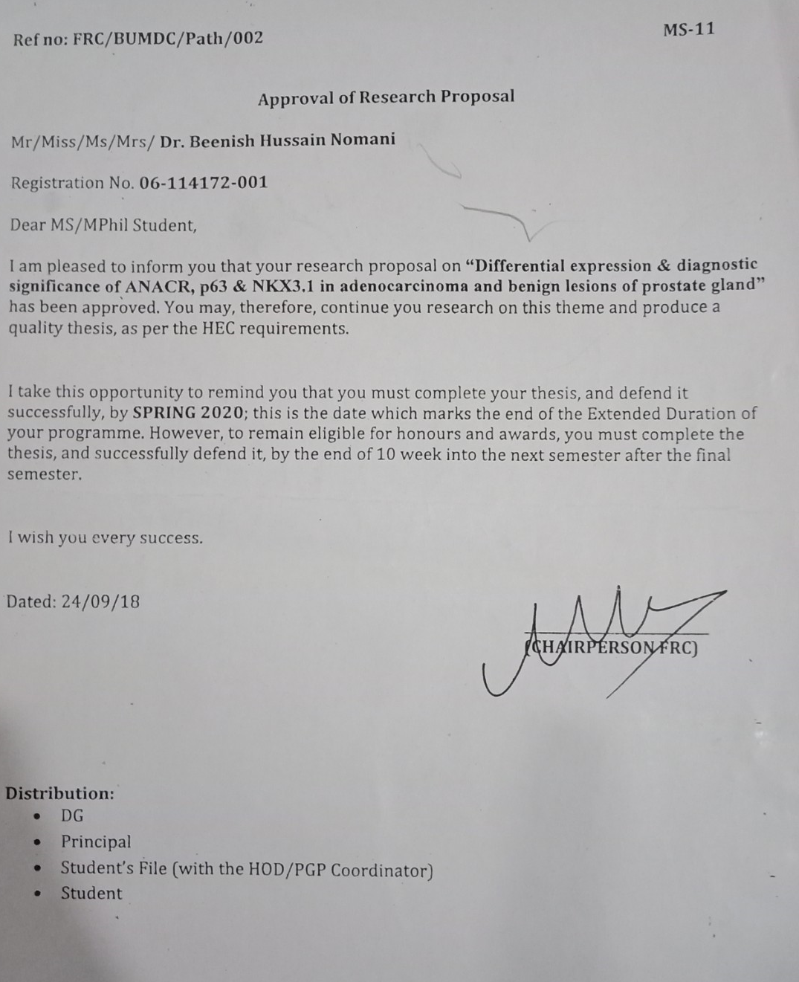

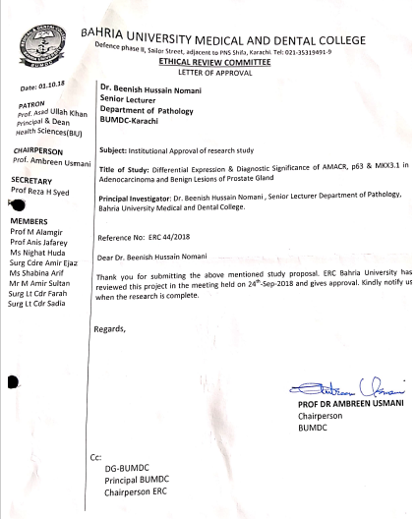

INFORMED CONSENT FORM FOR PATIENT
C) CONSENT FORM ENGLISH

I am giving my consent to participate voluntarily and at my own will in this research project which aim to determine effective tumor markers of prostate cancer.

I have been explained in detail the nature and significance of participating in the project and I understand the provided explanation.
I have been told that findings of my disease and my data will be kept strictly confidential and will be used only for the benefit of community, publications and paper presentations.
I have been explained that tissue specimen will be taken for the purpose of research.I fully agree to give my specimen at the beginning of the study, at the end of study or whenever required in between.
I also agree to give all relevant information needed, in full and to the best of my knowledge to the researcher. It is clarified to me that no incentive will be provided to me for participating in the study, whereas I do have the right to withdraw from the study at any time.
I am advised to contact Dr. BeenishHussainNomani on mobile number: 03350358955or visit PNS Shifa Hospital in case of any query/ emergency related to my disease. In case of any untoward effect resulting from the given drug it will be the responsibility of the researcher to effectively treat the patient at her own expense.

Name of Patient:____________________ Sex (Male, Female) ____________________
S/O, D/O, F/O,M/O______________________________
Signature / Thumb impression of Patient: _________________________
Name of Researcher: _________________________________________
Signature of Researcher: _________________________
Date: _______________

SUBJECT EVALUATION FORM
(D) subject evaluation form
Department of Pathology
PNS Shifa Hospital, Karachi
PROFORMA

Epidemiological Data
S .No.__________ Case. No_____________ Date.______________
Patients Name. _____________ W/O, D/O. _______________
Age.______
Address:-________________________________________________________
Clinical Diagnosis.__________________________________________________

Laboratory Investigations
Type of Biopsy:
1) Prostatic chips
2) Prostatic specimens

Gross Findings:-________________________________________________
_________________________________________________________________
Histopathological Findings:-__________________________________________
_________________________________________________________________

Diagnosis:-______________________________________________________

Tumor Grading :( Gleason score)
1) 2-5
2) 6-7
3) 8-10

HOSPITAL CARD



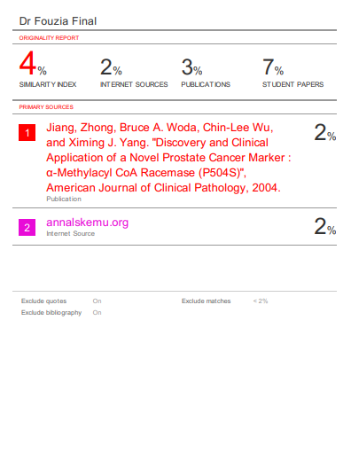137

