Maritime Discourse on "Impact of Coastal Erosion on Coastal Belt of Pakistan"
National Centre for Maritime Policy Research (NCMPR), Karachi Chapter
News Clippings

THE NEWS 14TH February 2018

Call for consolidated plan to control coastal erosion

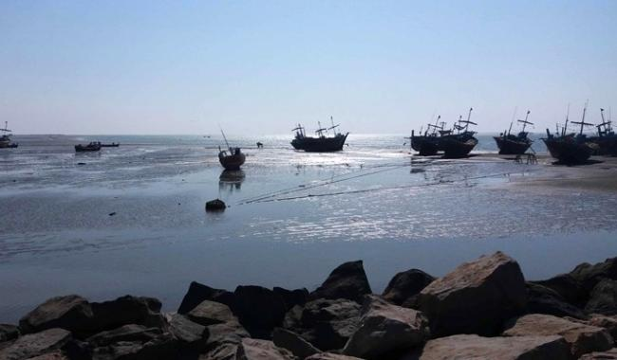
Commander Coastal Rear Admiral Moazzam Ilyas has proposed that a consolidated coastal management plan, with input from all agencies and organisations engaged in activities along the country’s coast, be developed for addressing the issue of coastal erosion.
He was speaking as chief guest at a maritime discourse, titled ‘Impact of Coastal Erosion for Coastal Belt of Pakistan and Mitigation Strategies’, organised by the Karachi chapter of the Institute of Maritime Affairs, National Centre for Maritime Policy Research, at the Fatima Jinnah Hall of Bahria University’s Karachi campus.
Rear Admiral Moazzam Ilyas HI (M) said the situation along the coast demanded a special focus of governmental and private institutions on analysing the present mode of coastal management anew.
He emphasised that the understanding of coastal dynamics, including the identification of sediment sources and their movement directions, were critically important for addressing the erosion issue.
In his talk, Dr Asif Inam, director general of the National Institute of Oceanography, said Pakistan was blessed with a large coastline, which had a variety of coastal features that included deltas, raised terraces and beaches.
He said the part of the Arabian Sea that bordered Pakistan was full of natural resources, which contributed to the national economy. He highlighted that sensitive ecology of land along the coast was under continuous environmental pressures due to various man-made and natural activities such as storms, cyclones and monsoons.
Dr Inam maintained that the man-made infrastructure activities, which included harbours and ports, land reclamation, disposal of waste and sewage into the sea, had made the country’s coast vulnerable to erosion.
The seasonal monsoon system that develops due to a differential heating regime is also a major force that has severe bearings on the coast. Globally, it is a common practice that coastal zones are managed in a scientific manner by conducting hydrodynamic surveys before embarking upon projects which have the potential to influence the coast. This practice contributes to curtailing the adverse effects of activities along the coast and enhances its socio-economic value.
Unfortunately, Dr Inam said, the situation along Pakistan’s coast was quite opposite and was therefore one of the causes of deterioration and erosion. The event was attended by the various prominent dignitaries, serving and retired naval officers, government officials, intellectuals and researchers.

