PETROPHYSICAL ANALYSIS OF
MIANO 10

BY:
WAJAHAT MIR
SARDAR RAHEEB SULTAN
SARDAR OWAIS

Department of Earth & Environmental Sciences
Behria University
Contents
1 INTRODUCTION 7
1.1 INTRODUCTION 7
1.2 OBJECTIVE 8
1.3 PETROLEUM PROSPECT 10
2 GEOLOGY OF THE AREA 12
2.1 REGIONAL GEOLOGY OF THE AREA 12
2.2 Indus Basin 13
2.2.1 Lower Indus Basin: 14
2.3 Structure of the Southern Indus basin: 15
3 STRATIGRAPHY 17
3.1 ALLUVIUM / SIWALIKS 17
3.2 KIRTHAR FORMATION 17
3.2.1 DRAZINDA MEMBER 17
3.2.2 PIRKOH MEMBER 18
3.2.3 SIRKI MEMBER 18
3.2.4 HABIB RAHI MEMBER: 19
3.3 LAKI FORMATION 21
3.3.1 GHAZIJ MEMBER 21
3.3.2 SUI MAIN LIMESTONE MEMBER 21
3.4 RANIKOT FORMATION 22
3.5 GORU FORMATION 23
3.5.1 UPPER GORU MEMBER 23
3.5.2 LOWER GORU MEMBER 24
3.5.3 “D” Interval 25
3.5.4 "C" Interval 26
3.5.5 “B" INTERVAL 26
3.5.6 "A" INTERVAL 27
4 BOREHOLE ENVIRONMENT 29
4.1 BORE HOLE CONDITION 29
4.1.1 BOREHOLE SIZE 29
4.1.2 DRILLING MUD 29
4.1.3 MUD CAKE 30
4.1.4 MUD FILTRATE 30
4.2 INVASION 30
4.2.1 DEPTH OF INVASION 31
4.2.2 INVASION PROFILE 31
4.2.3 INVASION RESISTIVITY PROFILES 33
5 WIRELINE LOGGING 34
5.1 WELL LOGGING 34
5.2 CREATING WELL LOGS 34
5.3 CLASSIFICATION OF LOGGING TOOLS 36
5.3.1 Lithology Logs 36
Examples of lithology logs are 36
5.3.2 Porosity Logs 36
Examples of porosity logs are 36
5.3.3 Saturation (Resistivity) Logs 37
5.4 ELECTRICAL LOGS 37
5.4.1 SPONTANEOUS POTENTIAL LOG. 37
5.4.2 GAMMA RAY LOG 43
5.4.3 SONIC LOG. 46
5.4.4 NEUTRON LOG 49
5.5 DENSITY LOG. 55
5.5.1 Density Porosity Determination 56
5.6 RESISTIVITY LOGS 58
5.7 INDUCTION LOGGING 59
5.8 LATERO LOG 60
6 PETROPHYSICAL ANALYSIS 62
6.1 INTERPRETATION WORK FLOW 62
6.2 PETROPHYSICAL TECHNIQUES 63
6.3 PETROPHYSICAL PARAMETERS 63
6.3.1 POROSITY 63
• Primary Porosity 64
• Secondary Porosity 64
• Effective Porosity 64
6.4 VOLUME OF SHALE 64
6.4.1 DETERMINATION OF VOLUME OF SHALE 65
6.4.2 VOLUME OF SHALE BY GAMMA RAY LOG 65
7 PETROPHYSICAL INTERPERTATION 67
7.1 HYDROCARBON PRODUCTION 67
7.2 INTERPRETATION 67
7.3 INTERPRETATION DATA OF WELL LOGS 68
(a) INTERPRETATION OF ZONE WELL # 10 AT DEPTH OF (3316-3425) 68
8 CONCLUSION 81
9 REFERENCES 82

Figure 2.1: Basins of Pakistan 13
Figure 2.2 Generalized Stratigraphy of Indus basin 16
Figure 3.1: Generalized Stratigraphy of Lower Indus Basin 20
Figure 4.1: Illustrating Invaded Zone 32
Figure 5.1: Logging Operation (after “Well logging basics” by “Baker Hughes INTEQ” 1992) 35
Figure 5.2: SP Circuit Diagram 38
Figure 5.3: Liquid Junction Effect 40
Figure 5.4: Membrane Potential 41
Figure 5.5: Idealized SP Log 42
Figure 5.6: Idealized Gamma Ray Log 45
Figure 5.7: Schematic diagram of a simple sonic log showing sound paths 47
Figure 5.8: Schematic Diagram of CNL 53
Figure 5.9: Idealized Neutron Log 54
Figure 5.10 A typical density logging tool 57
Figure 5.11: Ideal resistivity log 61
Figure 6.1: Work flow chart 62
Figure 7.1 Graphical representation of depth vs shale volume 80
Figure 7.2 Graphical representation of depth vs porosity. 80

Table 1: Boudaries of Lower Indus Basin 14
Table 2: Boudaries of Southern Indus Basin 15
Table 3: Showing the gas % in different formations 67
Table 4: Showing The different parameters of Run 1 68
Table 5: Showing the different parameters of run 2. 72

INTRODUCTION

INTRODUCTION

In the present time, the economy of the world is being controlled by the energy sector. The energy resources and reserves are being used as indicator of economy and political stability of a country. Petroleum and related energy reserves of a country constitute its most important assets. The role of hydrocarbon availability, exploration and development is directly related to the overall development and prosperity of the human being.
The petroleum exploration and its exploitation have gained special importance over the past few decades to meet the increasing demand of the world energy. Due to its importance this field has developed special interests of the scientists and various hydrocarbon agencies and a number of new geophysical techniques and methods have been developed to explore and exploit the hydrocarbon buried in subsurface geological formations. Geophysical well logging is one of the strong tools which are used to evaluate the formation characteristic features having potential for hydrocarbon development. Well logging, also known as borehole logging is the practice of making a detailed record (log) of the geologic formations penetrated by a borehole. The log may be based either on visual inspection of samples brought to the surface (geological logs) or on physical measurements made by instruments lowered into the hole (geophysical logs). Well logging is done when drilling boreholes for oil and gas, groundwater, minerals, and for environmental and geotechnical studies.
The oil and gas industry records rock and fluid properties to find hydrocarbon zones in the geological formations within the Earth's crust. A logging procedure consists of lowering a 'logging tool' on the end of a wireline into an oil well (or hole) to measure the rock and fluid properties of the formation. An interpretation of these measurements is then made to locate and quantify potential depth zones containing oil and gas (hydrocarbons). Logging tools developed over the years measure the electrical, acoustic, radioactive, electromagnetic, and other properties of the rocks and their contained fluids. Logging is usually performed as the logging tools are pulled out of the hole.
This data is recorded to a printed record called a "Well Log" and is normally transmitted digitally to office locations. Well logging usually refers to down hole measurements made via instrumentation that is lowered into the well at the end of a wireline cable. The wireline consists of an outer wire rope and an inner group of wires. The outer rope provides strength for lowering and lifting the heavy instruments and the inner wiring provides for transmission of power to the downhole equipment and for data telemetry uphole to the recording equipment on the surface.

OBJECTIVE

The purpose of study is to find the hydrocarbon potential of well, by evaluating their well logs which include, Porosity calculation, Shale volume calculation, Water saturation calculation , Permeability and to resolve lithology. Geologically Miano is situated with the Mari Kandkot High and Middle Indus Basin of Pakistan. Until today about 08 wells have been drilled for extensive development of the field.
Composite suite of logs comprising gamma ray, spontaneous potential (SP), resistivity log (i.e., induction electric log, dual induction focused log, , micro spherically focused log, microlatrolog, later log etc.), porosity logs (i.e., sonic log, density log, neutron log, combination of neutron-density log) were run in wells (miano 10) are also acquired for log interpretation to estimate the reservoir characteristics.
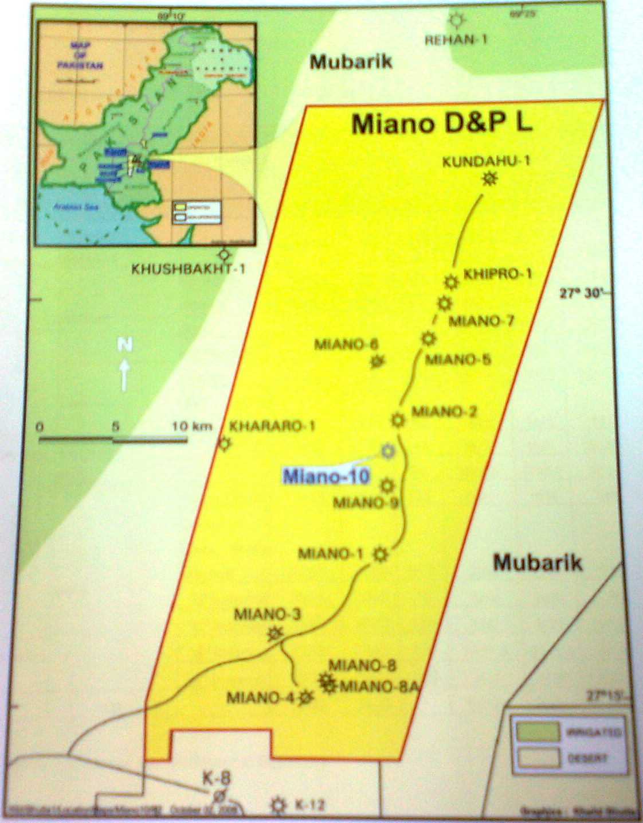
Figure 1.1 Location Map of Miano - 10.

PETROLEUM PROSPECT

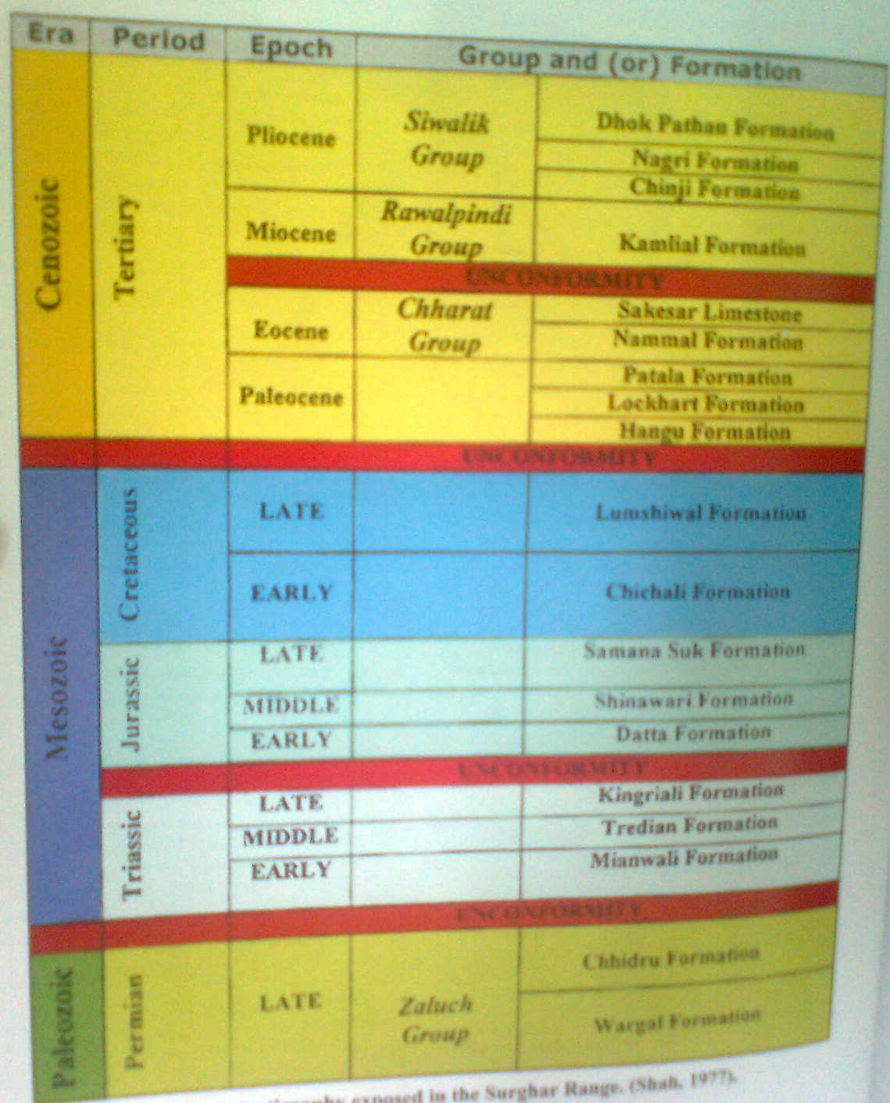
Figure 1.2: Stratigraphic column shows that different rocks act as Source, reservoir and Cap rock.

Source rock is the productive rocks for hydrocarbons. They also initiated the conversion of organic compound into oil and gas form. The Formations, which act as source rocks in the project area are as follows:
Sember Formation is believed to be the source of hydrocarbons in Badin platform field and huge gas accumulation in Sulaiman province. Potential reservoir occurs within the sand stone of formation. Ranikot shale was used to be considering as the main source for all the gas present in that region. The Lower Goru sand act as a good source rock in Sindh Monocline. The trapping configuration for the target reservoir is purely stratigraphic. Towards the northeast and southwest trapping is caused by shaling out of the reservoir. The northwestern limit is defined by a facies controlled deterioration in reservoir quality, which creates an "effective zero reservoir" line. Transgressive shales of the Lower Goru "C" Interval directly, overlying the Sawan reservoir sands, and thick shales and marls of the Lower Goru Member form the regional top seal. Shales and tight sands within the "C" Interval act as lateral and bottom seals. The depositional environment of the Lower Goru "C" Interval sands. The low acoustic impedance together with strong seismic amplitudes indicates the presence of reservoir quality sands. Reservoir quality sands are only present in the depositionally updip, i.e. the shallowest marine part of the low stand wedge, as are found in the Sawan, Miano and Kadanwari Fields.

GEOLOGY OF THE AREA

REGIONAL GEOLOGY OF THE AREA

Miano Block (Sind Province) is the concession area operated by OMV. Miano field is located in Sindh Province. The Miano area is located approximately 62km southeast of Sukkur, Pakistan. The length of the field is approximately 42km along strike. The southernmost wells in the field are less than 10km from the Kadanwari field to the south and 45km from the Sawan field to the southwest. Two of largest gas fields found in Pakistan, the Mari and Sui gas fields productive from the Eocene limestone, are found 75km and 150km to the north respectively. Eight wells have been drilled to appraise the Miano field targeting the Lower Cretaceous-aged Lower Goru Formation. The Miano gas field is located in the Thar Desert 62km southeast of Sukkur province. It is thought to extend from the southern block boundary in a north-northeasterly direction and lies north of the Kadanwari gas field. Latitude and longitude of upper left 27⁰ 36/ 35.9// and 69⁰ 12/ 57.1//,upper right 27⁰ 36/ 35.9// and 69⁰ 27/ 30.4// lower left 27⁰ 14/ 18.4// and 69⁰ 12/ 43//.1 and lower right 27⁰ 14/ 10.1// and 69⁰ 27/ 51.8//. Basins of Pakistan
/
/
/
/
Pakistan is comprised of following Basins these includes (See Fig 2.2)

      - Indus Basin
              - Upper Indus Basin.
              - Lower Indus Basin.
                - Central Indus Basin
                - Southern Indus Basin.
      - Balochistan Basin.
      - Kakar Khorasan Basin (Kadri, 1995).

Indus Basin
The geological history of the Indus Basin goes back to Pre-Cambrian age. The depositional features mark the limit of the basin and it’s divisions. Following is the classification of Indus Basin.
- Upper Indus Basin: Kohat sub-Basin.
Potwar sub-Basin.
- Lower Indus Basin: Central Indus Basin.
Southern Indus Basin (Kadri, 1995).
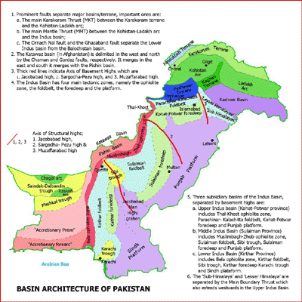
Figure 2.1: Basins of Pakistan

Lower Indus Basin:

Table 1: Boudaries of Lower Indus Basin
Directions | Boundaries
East | Indian Shield
West | Kirthar and Sulaiman Ranges
North | Sargodha High
South | Off Shore

The Lower Indus Basin is further divided into two classes,
  - Central Indus Basin
  - Southern Indus Basin

(b) Southern Indus Basin:
This basin is located just south of the Sukkur Rift which is a divide between the Central and the Southern Indus basin. The oldest rocks encountered in the area are of Triasic age. The Central and the Southern Indus basins were undivided until middle cretaceous when Khair Pur-Jacobabad High became a prominenet feature, this is indicated by homogeneous lithologies of Chiltan Limestone which is of Jurasic age and Sembar Formation which is of lower cretaceous age and lie across the high. This part of the Indus Basin comprises the following four main units
Southern Indus Basin:
(a) Thar Plateform
(b) Karachi Trough
(c) Kirthar Foredeep
(d) Kirthar Fold belt
(e) Offshore Indus
Table 2: Boudaries of Southern Indus Basin
Directions | Boundaries
East | Indian Shield
West | Marginal Zone of The Indian Plate ,Kirthar Range
North | Jacobabad KhairPur High, Mari Khandkot High
South | Off shore, Murray Ridge- Oven Fracture Plate Boundary

Structure of the Southern Indus basin:
Southern indus basin is characterized by passive roof complex-type structure and a passive back thrust along the Kirthar fold belt, a passive roof thrust forming a frontal culmination wall along the margin of the fold belt and the Kirthar depression and out of syncline intra-molasses detachment in the kirthar depression sequence.
The kirthar and Karachi depression contain several large anticlines and domesand some of these contain small gas fields e.g. Sari, Hundi , Mazarani,and Kothar.But in the eastern part of it there are several faults and tilted blocks of Mesozoic rocks which form structural traps containing small oil and gas fields. On the northern side of it there is the Sukkur Rift zone bearing large anticlimax structures and contains the Khandkot and Mari gas fields. The main reservoir rocks in Sindh monocline are cretaceous Lower Goru sand stone.
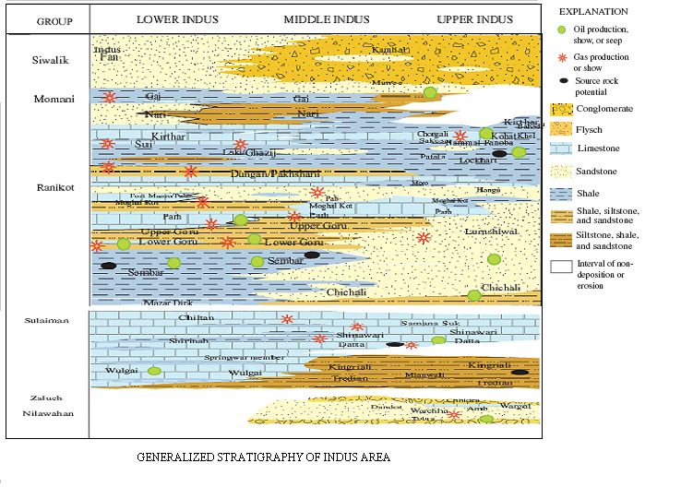
Figure 2.2 Generalized Stratigraphy of Indus basin

STRATIGRAPHY
The following stratigraphy and lithology in Miano-10 is based on the log correlation with the offset wells; Miano-1 and Miano-2 ditch sample description. . All depths are measured below rotary table (BRT).

ALLUVIUM / SIWALIKS
Age: Recent / Pliocene
Lithology:
Sand: Transparent to translucent, light yellowish grey, dominantly loose, occasionally friable, fine to coarse grained, occasional pebbles, angular to subrounded, poorly sorted, occasionally slightly cemented with calcareous cement, abundant lithic fragments, common mica.
Conglomerate: Variegated color, off white, yellowish grey, yellowish brown, dominantly angular to subrounded, quartz and limestone pebbles.
Clay: Pale yellowish brown, soft, amorphous, sticky, washable, slightly calcareous.

KIRTHAR FORMATION
The Kirthar Formation is divided into four distinct members, the Drazinda, Pirkoh, Sirki and Habib Rahi Members.

DRAZINDA MEMBER
Age: Eocene
Upper Boundary: The upper boundary of the Drazinda Member was picked by a change in lithology from sandstone, clay and conglomerate to claystone and limestone.
Lithology:
Limestone: Off white, light greyish yellow, pale yellowish grey, moderately hard to hard, subblocky, microcrystalline, dominantly clean, in parts slight to moderately argillaceous, traces to common disseminated pyrite, traces of carbonaceous matter, traces to common forams.
ClayStone: Light to medium greenish grey, soft to firm, sticky washable. In the basal part, medium to dark greenish grey, olive grey, soft to firm,subblocky in parts amorphous, slightly sticky, washable, calcareous, slightly carbonaceous.
Marl: Light greenish grey, soft to firm, amorphous, sticky, washable, grading to argillaceous limestone

PIRKOH MEMBER

Age: Eocene
Upper Boundary: The upper boundary of the Pirkoh Member was picked by a change in lithology from marl to limestone.
Lithology:
Limestone: Off white, pale yellowish grey to pale yellowish green, firm, subblocky, in parts blocky, chalky, in parts microcrystalline, dominantly clean, in parts slightly argillaceous, traces of pyrite and chart.
Claystone: Medium greenish grey, olive grey, firm. subblocky, in parts amorphous, slightly sticky, washable, slight to moderately calcareous.

SIRKI MEMBER
Age: Eocene
Upper Boundary: The upper boundary of the Sirki Member was picked by a change in lithology from limestone to claystone.

Lithology:
Claystone: Dark bluish green, dark greenish grey, soft to firm, dominantly amorphous, in parts subblocky to subplaty, sticky, washable, slightly calcareous.
Limestone: Off white, light yellowish grey, moderately hard, blocky, microcrystalline, traces to common forams.

HABIB RAHI MEMBER:
Age: Eocene
Upper Boundary: The upper boundary of the Habib Rahi Member was picked by a change in lithology from claystone to limestone.
Lithology:
Limestone: Off white, light yellowish grey, firm to moderately hard, blocky, microcrystalline.
Claystone: Medium to dark greenish grey, olive grey, soft to firm,subplaty, in parts amorphous, sticky, washable, slightly calcareous.

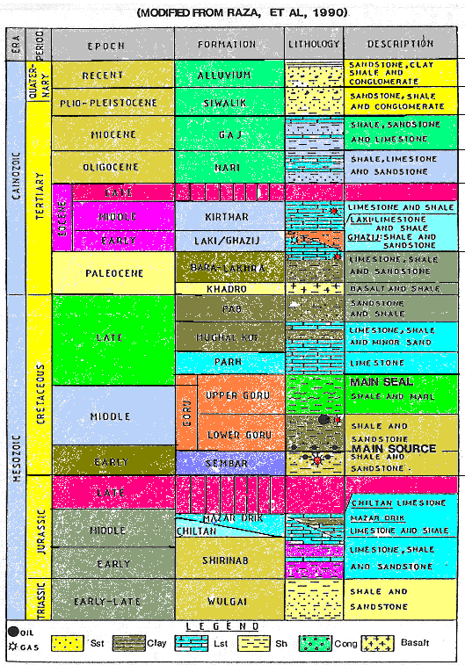
Figure 3.1: Generalized Stratigraphy of Lower Indus Basin

LAKI FORMATION
The Laki Formation is divided into two distinct members, the Ghazij and Sui Main Limestone Members.

GHAZIJ MEMBER
Age: Eocene
Upper Boundary: The upper boundary of the Ghazij Member is marked by a change in lithology from limestone to shale. The GR log shows a sharp increase in GR value.
Shows: The gas first appeared at 587.0 m BRT
Background Gas: 0.02 — 1.3%
Maximum Gas: 1.9% at 1016m BRT
Lithology:
Shale: Light to medium grey, olive grey, soft to firm, subplaty to platy, subfissile, in parts amorphous, sticky, washable, slightly calcareous, in parts slightly carbonaceous, traces of disseminated pyrite, at places traces of calcite, traces of forams. Below 1000 m, dusky greenish grey, brownish grey to brown black, greenish grey, firm to moderately hard, sub blocky to subplaty, subfissile, in parts slightly to noncalcareous, at places slightly silty, traces of pyrite.
Limestone: Off white, light grey, light yellowish grey, dominantly bit crushed, in parts moderately hard, sub blocky to blocky, chalky, in parts microcrystalline, dominantly clean, in parts slightly argillaceous. Below 915 m, light to dark yellowish brown, at places off white, light grey, firm, in parts bit crushed, in parts sub blocky, chalky.

SUI MAIN LIMESTONE MEMBER

Age: Eocene
Upper Boundary: The upper boundary of the Sui Main limestone Member is marked by a change in lithology from shale to limestone. Logs show low GR value associated with high resistivity and higher sonic velocity.
Shows: Background Gas: 0.2 — 0.8%
Maximum Gas: 0.7% at 1163.0m (DD)
Lithology:
Limestone: Light yellowish grey, grey, pale yellowish brown, off white, moderately hard to hard, subblocky to blocky, in parts bit crushed, microcrystalline, traces to common forams, traces of crystalline calcite, pyrite and glauconite, rare traces of chert, no visible porosity.
Shale: Olive grey, olive brown, firm to moderately hard, subplaty, subfissile, moderately calcareous.
Marl: Light grey to light greenish grey, soft to firm, dominantly amorphous, sticky washable, in parts subblocky, traces of forams, light grey, light greenish grey, amorphous, sticky, washable, carbonaceous.
Argillaceous Limestone: Light grey, off white, firm, subblocky, chalky to microcrystalline, traces of forams.

RANIKOT FORMATION
Age: Palaeocene
Upper Boundary: The upper boundary of the Ranikot Formation is marked by a change in lithology from limestone to marl and claystone. Logs show a slight increase in GR value associated with sudden drop in resistivity and sonic velocity.
Shows: Background Gas: 0.1 — 0.35%
Maximum Gas: 1.2% at 1349.0m (DD)
Lithology:
Marl: Light to medium grey, soft to firm, amorphous, in parts firm, subblocky, locally grading to calcareous claystone.
Argillaceous Limestone: Medium grey, brown, slightly silty, rare traces of glauconite, locally grading to marl.
Shale: Medium to dark grey, greyish black, firm to moderately hard, subblocky to subplaty, subfissile to fissile, slight to moderately calcareous, slight to moderately silty, traces of disseminated glauconite, traces of pyrite, traces of calcite.
Siltstone: Light to medium grey, light brownish grey, firm to moderately hard, in parts soft, bit crushed, amorphous, in parts subblocky, slightly to non calcareous, sandy with occasional carbonaceous specks, traces of glauconite, traces of pyrite.
Claystone: Light to medium grey, soft to firm amorphous, sticky, washable, slightly calcareous, silty, grading to siltstone. Below 1630 m (DD), medium brown, medium to dark reddish brown, in parts green, occasionally light yellowish grey, off white, bit crushed, non calcareous, silty, locally grading to siltstone.
Coal: Brownish black to black, firm to moderately hard, subplaty, subvitreous, in parts pyritic.

GORU FORMATION

The Goru Formation is divided into two members, the Upper Goru and the Lower Goru Member. The contact between these members grades from marl to claystone and is also marked by a drop in calcimetry values, and an increase in GR at the top of the Lower Goru Member.

UPPER GORU MEMBER

Age: Upper Cretaceous
Upper Boundary: The upper boundary of the Upper Goru Member is marked by a change in lithology from sandstone and claystone to marl and limestone. Logs show low GR associated with an increase in resistivity and sonic velocity, showing limestone at the top of this member.
Shows: Background Gas: 2444 – 2518 m: 0.18-0.5%, 2518 – 2715.5 m: 1.5 12%
Maximum Gas: 14.77% at 2556 m (DD)
Lithology:
Marl: Light to medium grey, light greenish grey, at places light olive grey, bit crushed, amorphous, slightly sticky, washable, in parts firm to moderately hard, subblocky, silty, in the upper part sandy, traces of disseminated pyrite, at places grading to argillaceous limestone.
Limestone: Medium to dark grey, moderately hard, subblocky, at places bit crushed, microcrystalline, argillaceous, at places grading to marl.
Siltstone: Light grey, bit crushed, soft, in parts moderately hard, subblocky, calcareous.
Shale: Medium to dark grey, moderately hard, subblocky to subplaty, subfissile, moderately calcareous, traces of disseminated pyrite, at places traces of nodular pyrite, traces of crystalline calcite, grading to calcareous claystone.

LOWER GORU MEMBER
Age: Lower — Upper Cretaceous
Upper Boundary: The upper boundary of the Lower Goru Member is marked by a change in lithology from marl to claystone. The GR log shows an increase in GR values.
Shows: Background Gas: 1.5 — 4.5%
Maximum Gas: 14.1% at 2781 m (DD)
Lithology:
Shale: Dark grey, olive black, dark greenish black, firm to moderately hard, sub platy to platy, sub fissile, at places bit crushed, moderately calcareous, at places slight to non calcareous, in parts carbonaceous, silty, traces of disseminated pyrite, locally grading to siltstone.
Siltstone: Light grey, off white, soft, bit crushed, in parts friable, calcareous, rare traces of glauconitic, locally grading to very fine sandstone. Below 2940 m (DD), greenish black, medium to dark grey, medium to dark grey, firm to moderately hard, sub blocky, slightly calcareous, carbonaceous and sandy, traces to common glauconitic, traces of mica, locally grading to very fine sandstone.
Sandstone: Light to medium grey, off white, pale yellowish grey, dark greenish grey, transparent to translucent, friable to moderately hard, very fine grained, angular to sub angular, poor to moderately sorted, well cemented with calcareous cement, argillaceous matrix, common lithic fragments, traces of mica, no visible porosity, no oil shows.
Limestone: Light to medium grey, dominantly bit crushed, in parts moderately hard, sub blocky, microcrystalline, argillaceous.

“D” Interval

Age: Upper Cretaceous
Upper Boundary: The upper boundary of the "D" Interval is marked by the appearance of sandstone following a thick sequence of shale and siltstone. The GR log shows low GR value at the top of the interval below a high radioactive shale and siltstone sequence, associated with an increase in sonic velocity and resistivity.
Shows: Background Gas: 0.1 – 1.0%
Maximum Gas: 10.2% at 3229 m (DD)
Lithology:
Sandstone: Light to medium grey, off white, pale yellowish grey, pale yellowish brown, translucent, friable to moderately hard, very fine to medium grained, rounded to angular, poorly sorted, calcareous cement, argillaceous matrix, abundant lithic fragments, common to abundant limestone frag,ents, traces of pyrite, traces of glauconite, traces of pale green mineral (chlorite?), traces of mica, no visible porosity, no oil shows.
Shale: Greyish black, moderately hard, subplaty to platy, subfissile, silty, calcareous, traces of glauconite.
Siltstone: Medium to dark grey, greenish black, friable, in parts moderately hard, in parts soft. amorphous, in parts subblocky, calcareous, carbonaceous, traces of mica, traces of glauconite.

"C" Interval
Age: Upper Cretaceous
Upper Boundary: The upper boundary of the "C" Interval is marked by the
appearance of sandstone following glauconite/chlorite rich clay. The GR log shows low GR values at the top of this interval, below a very high radioactive peak of the glauconite/chlorite rich transgressivr cloystone
Shows: Background Gas: 0.5-0.9%.
Maximum Gas: 22.9% at 3152 m (DD)
Lithology:
Sandstone: Off white, light grey, dark brownish grey, friable to moderately hard, very fine to fine grained, rarely medium grained, graded to siltstone, well sorted, calcite cement, in parts traces glauconite, abundant argillaceous matrix, nil visible porosity, no fluorescence.
Siltstone: Dark grey, dark brownish grey, firm, occasionally moderately hard to hard, blocky to sub blocky, sub-fissiie, highly argillaceous, calcareous.
Claystone: Light grey to dark brownish grey, soft, blocky to sub-blocky, highly silty, traces glauconite, graded to siltstone.

“B" INTERVAL
Age: Lower Cretaceous
Upper Boundary: The upper boundary of the "B" Interval is marked by the
Appearance of sandstone following glauconite/chlorite rich basal "C" Interval claystone and siltstone.
Shows: Background Gas: 0.01-0.176%.
Maximum Gas: 1.435% at 3433m (DD)
Lithology:
Sandstone: White off white, transparent to translucent, in parts light to medium grey, moderately hard, dominantly coarse to very coarse grains, occasional medium grains, occasional pebbles, subrounded, poor to moderately sorted, moderate to well cement with siliceous cement with associated quartz over growth.
Silty Sandstone: Light medium gray, dark greenish grey, dominantly bit crushed, in parts moderately hard, sub rounded, moderately sorted, Calcareous/argillaceous cement/matrix common pale green mineral no visible porosity.
Siltstone: Greenish black, dark greenish gray, bit crushed, in parts moderately hard, sub blocky, sandy, commonly glauconite and pale green mineral, graded to very fine sandstone
Claystone: Black to greyish black, brownish black, moderately hard in parts bit crushed, carbonaceous, silty, non-calcareous

"A" INTERVAL

Age: Lower Cretaceous
Upper Boundary: The upper boundary of the "A" Interval is marked by the
appearance of sandstone following a thick sequence of claystones and siltstones of the basal "B" Interval.
Shows: Background Gas: 0.005 - 0.081%
Maximum Gas: 0.1087% at 3585m (DD)
Lithology:
Sandstone: Light to medium grey, light grey, moderately hard , very fine to very coarse grained , subrounded to rounded , sub spherical, poorly sorted , moderately cemented with calcareous/ dolomitic cement moderately argillaceous , carbonaceous common pale green mineral.
Claystone: Dark grey, greyish black, hard, sub blocky, carbonaceous, non calcareous, traces of pyrite.

BOREHOLE ENVIRONMENT

When the borehole drilled in a formation, the rock and the fluid in the rock undergoes the alteration in the vicinity of the borehole. All logging measurements are then effected by the borehole and the altered rock around it.
Borehole conditions effecting the log measurements
a) Bore hole size
b) Drilling mud
c) Mud Cake
d) Mud filtrate

BORE HOLE CONDITION

BOREHOLE SIZE
The normal size of the hole is taken to be the outside diameter measurement of the drilling or coring bit used to make the hole. Borehole is seldom perfectly circular; it is usually elliptical due to removal of more material in the direction of least subsurface stress.

DRILLING MUD
The main functions of the drilling mud are
- To carry rock cuttings to the surface
- To prevent the uncontrolled escape of the formation fluids
- To cool and lubricate the drill string and the bit
- To suspend cuttings during times when circulation is stopped.
The hydrocarbon static pressure of the drilling fluid must be greater than the formation fluid pressure, this overbalance system allows the entry of the mud fluid into the pore spaces of the permeable rock, and this entry of the mud is called the invasion of the drilling mud that affects the logging tool response.

MUD CAKE
Mud Cake is formed within the few minutes of the formation being penetrated. Clay particles are caked against the size of the borehole and effectively seal off the formation to further invasion. Invasion takes place continuously as the hole is deepened because the mud cake becomes damaged or is removed by drilling, logging or testing tool. Thick mud cake affects the readings of the shallow investigation of the logging tool. The presence of mud cake is usually a good indication of the permeable rock.

MUD FILTRATE
Fluid which enters permeable zone from the mud is called the mud filtrate. The filtrate is usually the water in the normal mud system and its resistivity is dependant on the original salinity of the mud system. All logging tools are affected to some degree by the mud filtrate.

INVASION
Drilling fluid invasion is a process that occurs in a well being drilled with higher well bore pressure than formation pressure. The liquid component of the drilling fluid (known as the "mud filtrate") continues to "invade" the porous and permeable formation until the solids present in the mud, commonly bentonite, clog enough pores to form a mud cake capable of preventing further invasion. If invasion is severe enough, and reservoir pressures are unable to force the fluid and associated particles out entirely when the well starts producing, the amount of oil and gas a well can produce can be permanently reduced. This is especially true when a process called phase trapping.
This is when a fluid enters a formation that is below its irreducible saturation of that fluid. Once the fluid is present, it is held in place by capillary forces and usually can not be removed. Invasion also has significant implications for well logging. In many cases the "depth of investigation" of a well logging tool is only a few inches (or even less for things like sonic logs), and it is quite possible that drilling fluid has invaded beyond this depth.

DEPTH OF INVASION
The distance from the borehole wall that the mud filtrate has penetrated into the formation. The depth of invasion affects whether a log measures the invaded zone, the undisturbed zone or part of each zone. The term is closely related to the diameter of invasion, the latter being twice the depth of invasion plus the borehole diameter. Depth of invasion is a more appropriate parameter for describing the response of pad and azimuthally focused measurements such as density and microresistivity logs.
The term is well-defined in the case of a step profile of invasion. In the case of an annulus or a transition zone, two depths must be defined, corresponding to the inner and outer limits of the annulus or transition zone. When the invasion model is not specified, the term usually refers to the outer limit of invasion. Depth of invasion depends upon several factors during logging like, filtration characteristics of the drilling mud and the differential pressure between the mud and the reservoir.
Invasion of the mud relates to the porosity, once the cake has started to built, its permeability becomes low relative to that of the average formation so that almost the entire pressure differential is across the mud cake and little is applied to the formation. The mud cake therefore controls the filtration rate. Depth of invasion will be minimum at higher porosity where plenty of the pore space available it is approximately inversely proportional to the porosity. Other things being constant. Invasion depth will double as the porosity reduces from 36% to 9% etc.

INVASION PROFILE
The process of invasion creates an invasion profile extending from the well bore into the formation. Three zones are recognized.
a) Flushed Zone
b) Transition Zone
c) Undisturbed Zone

The invaded zone is that portion of the formation which has been penetrated by the drilling fluids.

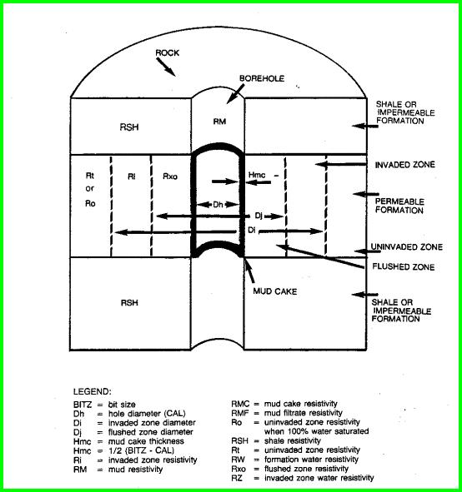
Figure 4.1: Illustrating Invaded Zone

- FLUSHED ZONE
The volume close to the borehole wall in which all of the moveable fluids have been displaced by mud filtrate. The flushed zone contains filtrate and the remaining hydrocarbons, the percentage of the former being the flushed-zone water saturation, S_{xo}.
- TRANSITION ZONE
The volume between the flushed zone and the undisturbed zone in which the mud filtrate has only partially displaced the moveable formation fluids

- UNDISTURBED ZONE
The part of the formation that has not been affected by invasion.

INVASION RESISTIVITY PROFILES
The changes in water saturation combine with the changes in the fluid saturation and resistivities within the invaded zone create the invasion resistivity profile. The fluid distribution within the invaded zone of a porous and permeable formation can be represented by three idealized profiles:
a) Step profile
b) Transition profile or Annulus profile

- STEP PROFILE
With reference to invasion, an abrupt change from the flushed zone to the undisturbed zone, with no transition zone or annulus
- TRANSITION PROFILE OR ANNULUS PROFILE
A realistic profile in which the distribution of fluids in the invaded section beyond the flushed zone varies with increasing distance from the borehole.

WIRELINE LOGGING

WELL LOGGING
Well logging is the process of recording various physical, chemical, electrical, or other properties of the rock/fluid mixtures penetrated by drilling a well into the earth. In its most usual form, an oil well log is a record displayed on a graph with the measured physical property of the rock on one axis and depth (distance from the surface) on the other axis. More than one property may be displayed on the same graph. None of the logs actually measure the physical properties that are of most interest to us, such as how much oil or gas is in the ground, or how much is being produced. Such important knowledge can only be derived, from the measured properties listed above (and others), using a number of assumptions which, if true, will give reasonable estimates of hydrocarbon reserves. Thus, analysis of log data is required. The art and science of log analysis is mainly directed at reducing a large volume of data to more manageable results, and reducing the possible error in the assumptions and in the results based on them. When log analysis is combined with other physical measurements on the rocks, such as core analysis or petrographic data, the work is called petrophysical analysis. The results of the analysis are called mapable reservoir properties. The petrophysical analysis is said to be “calibrated” when the porosity, fluid saturation, and permeability results compare favorably with core analysis data. Further confirmation of petrophysical properties is obtained by production tests of the reservoir intervals.

CREATING WELL LOGS
To perform a logging operation, the measuring instrument, often called a probe or sonde, is lowered into the borehole on the end of an insulated electrical cable. The cable provides power to the down whole equipment. Additional wires in the cable carry the recorded measurement back to the surface. The cable itself is used as the depth measuring device, so that properties measured by the tools can be related to particular depths in the borehole. A logging tool is made up of a sonde and a cartridge. The sonde is the portion of the tool which gives off energy, receives energy, or both.

The cartridge contains the electrical circuitry or computer components needed to control the down hole equipment, and to transmit data to and from the surface. Combination logging tools consist of more than one sonde and cartridge, so that more than one log can be recorded on a single trip into the well bore. Surface equipment is mounted in a logging truck, van, or skid unit from which all logging operations are controlled. The logging unit (Figure 4.1) contains hoisting equipment for lowering and raising the tools in the hole, and electronic or computer equipment for controlling and recording the down hole measurements.
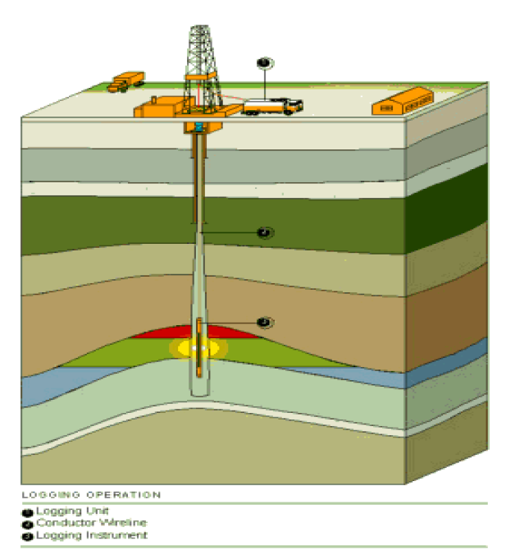
Figure 5.1: Logging Operation (after “Well logging basics” by “Baker Hughes INTEQ” 1992)

CLASSIFICATION OF LOGGING TOOLS

Lithology Logs

These logs are designed to
• Identify permeable formations
• Determine boundaries between permeable and non-permeable formations
• Provide lithology data for correlation with other wells
• Provide a degree of certainty for quantifying the formation lithology

Examples of lithology logs are
• Spontaneous Potential
• Gamma Ray

Porosity Logs

These logs are designed to
• Provide accurate lithologic and porosity determination
• Provide data to distinguish between oil and gas
• Provide porosity data for water saturation determination
Examples of porosity logs are
• Sonic/Acoustic
• Neutron
• Formation Density

Saturation (Resistivity) Logs

These logs are designed to
• Determine the thickness of a formation
• Provide an accurate value for true formation resistivity
• Provide information for correlation purposes
• Provide a quick indication of formation pressure
Examples of saturation logs are
• Normal and Lateral Devices
• Latero logs
• Induction Logs

ELECTRICAL LOGS

SPONTANEOUS POTENTIAL LOG.
HISTORY
- One of the first log measurements made.
- It was discovered as a potential that effected old electric logs.
- It has been in use for over the past 50 years.
APPLICATION
- Correlation from well to well.
- Depth reference for all logging runs.
- Detecting permeable beds.
- Detecting bed boundaries.
- Qualitative indication of shalyness.
- R_{w} determination.
THEORY OF MEASUREMENT
An electrode (usually lead) is lowered down the well and an electrical potential is registered at different points in the hole with respect to surface electrode. Therefore SP is a recording of the difference in potential of a moveable electrode in a borehole and a fixed electrode on the surface. In order to record a potential the hole must contain conductive mud, as it cannot be recorded in air or oil-base mud. Logging rate is approximately 1500m per hour and recordings are continuous.

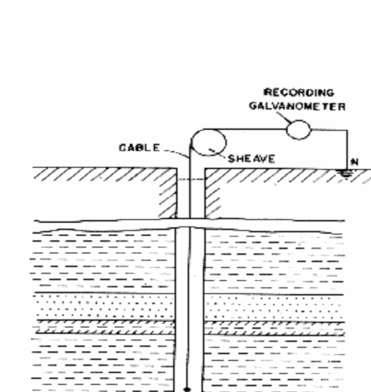
Figure 5.2: SP Circuit Diagram

The SP electrode is built into different logging tools for example:
- Induction log.
- Later log.
- Sonic log.

SP results from electric currents flowing in the drilling mud. There are three sources of the currents, two electrochemical and one electro kinetic. Deflection of SP is caused by the Electrochemical Ec and Electro kinetic Ek actions:
ELECTROCHEMICAL COMPONENT.
E_{c} = E_{lj} + E_{m}
These two effects are the main components of the SP. They are caused as a result of differing salinities in the mud filtrate and the formation water.
E_{lj}: "Liquid Junction Potential"
The ions Na+ and Cl- have different mobilities at the junction of the invaded and virgin zones. The movement of the ions across this boundary generates a current flow and hence a potential. If the salinity of the mud in the borehole is weaker or stronger than that of the formation water the potential generated between the two solutions is known as the Liquid Junction Potential or Elj. The greater the difference between the salinity of the solutions the greater the potential.
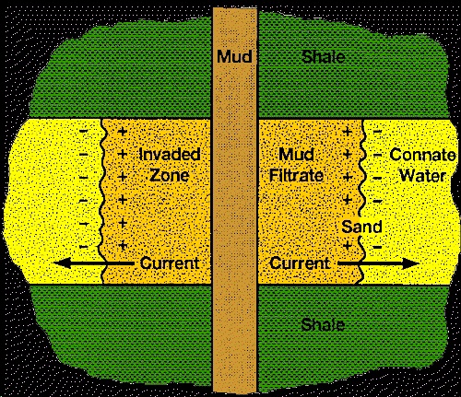
Figure 5.3: Liquid Junction Effect

E_{m}: "Membrane Potential"
Shale’s are permeable to Sodium ions but not to Chlorine ions. Hence there is a movement of charged particles through the shale creating a current and thus a potential. This is known as the membrane potential or Em.
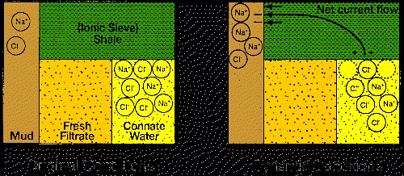
Figure 5.4: Membrane Potential
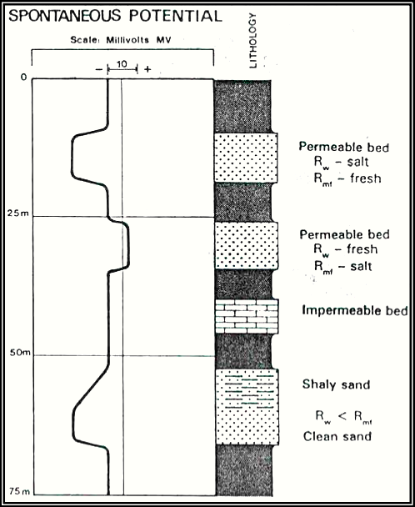
Figure 5.5: Idealized SP Log

GAMMA RAY LOG
APPLICATION
Standard Gamma Ray Applications:
- Primary depth reference for all logging runs.
- Correlation from well to well.
- Lithology identification.
- Identification of organic material, permeable beds and source rocks.
- Fracture identification.
- Calculate clay volumes.
- Mineral analysis.
Natural Gamma Ray Tool (NGT) Applications:
- Detect, identify and evaluate radioactive minerals.
- Identify clay type and calculate clay volumes.
- Provides insight into depositional environment and the diagenetic history.
- Uranium response of NGT is sometimes useful as a moved fluid indicator.
- Permeable beds may have higher Uranium salt content than less permeable beds.
The Gamma Ray log is typically run with most logging runs as a correlation tool since natural Gamma Rays can pass through casing. Production tools and perforating equipment can be accurately positioned using the Gamma Ray as a correlation tool.
THEORY OF MEASUREMENT
There are two types of Gamma Ray measurements used by the wireline logging industry.
Naturally occurring Gamma Rays:
These are Gamma Rays that occur naturally in the formation and have relatively low energy levels. Tools that measure natural Gamma Rays are known as standard and gamma spectrometry tools. Standard Gamma Ray tools measure the occurrence of all Gamma Rays. Spectrometry Gamma Ray tools also measure the Gamma Ray energy levels and therefore determines the concentrations of the three normally present radioactive elements namely Uranium (Ur235/238), Potassium (Isotope 19K40) and Thorium (Th232). These have long half-lives and their radiation energy level is like a material fingerprint that is unique to the material being measured.
Induced Gamma Rays:
Tools such as gamma - gamma logs use a high energy Gamma Ray source to measure other formation parameters.
INTERPRETATION.
The most common naturally occurring radioactive elements are 19K40 isotope, Th232 and Ur235/238. The "average" shale contains 2% potassium, 12-ppm thorium and 6ppm uranium. A high Gamma Ray measurement therefore usually indicates a shale sequence. The Gamma Ray tool is often used as the primary indicator of shale content. The percentage of rock that is considered shale and not rock matrix can be estimated by: -
V_{shale} = (GR_{log} – GR_{clean}) (GR_{shale} - GR_{clean})
The Gamma Ray appearance can be used to help identify different depositional environments and therefore used as a stratigraphic tool. As stated before, the Spectrometry Gamma Ray tool measures not only the number of Gamma Rays returned but also their individual energies. Each energy level is a characteristic of the type of formation being logged. Analysis of the potassium, thorium and uranium energies can help indicate fractures, mineralogy and clay type.
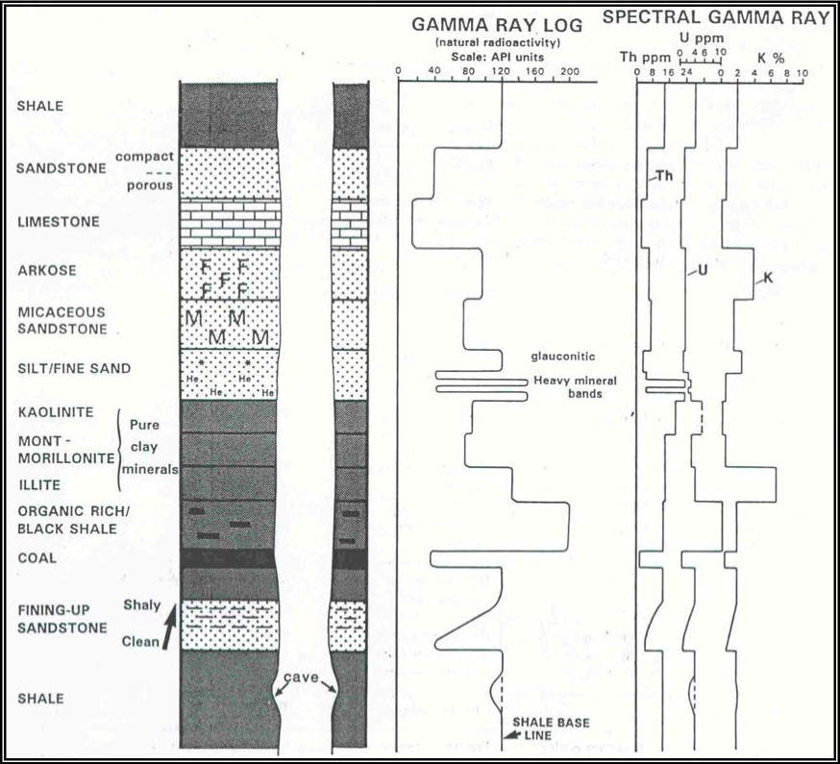
Figure 5.6: Idealized Gamma Ray Log

SONIC LOG.
APPLICATION:
- Porosity PHIS.
- Volume of clay V_{S.}
- Lithology.
- Time-depth relationship.
- Reflection coefficients.
- Mechanical properties.
- VDL/CBL.
By combining sonic and Checkshot data we can calibrate downhole log data with surface seismic data. Mechanical properties can be determined from the shear and compressional waves, fracture identification from shear and Stoneley waves and permeability indication from Stoneley waves.

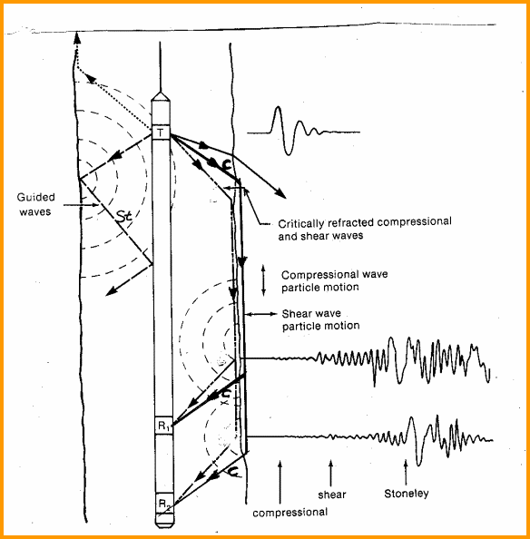
Figure 5.7: Schematic diagram of a simple sonic log showing sound paths

THEORY OF MEASUREMENT:
Transmitter emits sound waves into the formation and measures the time taken to detect at a receiver of known distance from the transmitter.The Sonic tool operates at 20 cycles per second as sounds similar to a pedestrian crossing at a set of traffic lights. The first arrival is the compressional or 'p' waves, which travel adjacent to the borehole as shown in Figure 1. It is this arrival that is used to measure the individual travel times T1, T2, T3, and T4. Two receivers for each transmitter eliminates the borehole signal. The transit time DT is computed from these travel times as shown in the equation below. This particular arrangement of sonic tool transmitters and receivers is known as the standard BHC Sonic tool and compensates for borehole washouts and also for tool tilting in real time while logging.
DT_{LOG} = [(T1 - T2) + (T3 - T4)] / 2
Long Spaced Sonic tools
Long spaced sonic tools have a larger spacing between the transmitter and receiver. Tool spacing are 8ft-10ft and 10ft-12ft. This allows a deeper depth of investigation and improves the tool response in larger boreholes or where mud invasion is affecting the standard tool. The DT measurement requires the 8ft-10ft signals to be memorized until the 10ft-12ft signals are recorded and then a DT can be computed. This is known as Depth Derived Borehole Compensation or DDBHC. The long and short spaced sonic tools can be used in combination to identify swelling shales.
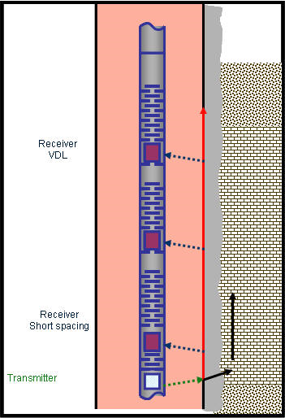

NEUTRON LOG

The neutron log is a measurement of induced formation radiation produced by fast moving neutrons bombarding the formation. The source used to produce neutrons is usually a mixture of Beryllium and Radium. As Radium decays, it emits alpha particles. The Beryllium responds to those alpha particles by emitting neutrons. Other sources include:
- Plutonium - Beryllium: large volume needed to produce neutrons.
- Americium - Beryllium: good source.
Neutrons are electrically neutral, having approximately the same mass as hydrogen. They can penetrate dense matter (sands or limestones) with little loss of energy or velocity. Energy loss is a function of:
- Angle of collision.
- Relative mass of the struck nucleus.
When a neutron collides with a hydrogen nucleus, it will lose about half its energy. After about 20 collisions with hydrogen, the neutron will be captured by one of the various elements in the formation (e.g., chloride, silicon, hydrogen). Those neutrons which are captured (thermal neutrons) emit a secondary gamma ray.

TYPES OF NEUTRIN DETECTORS.
One type of detector measures neutrons just about thermal speed (epithermal). It shows maximum sensitivity to neutrons having energies above the thermal level and minimal sensitivity to gamma rays and thermal neutrons. This reduces those errors which arise from variations in formation chemistry and resolves porosity in areas where lithologies and liquids are mixed. There is a neutron detector which measures the neutron population at thermal energy. It responds to all formation and well parameters that affects neutron density.
- In salt water the count rate is lowered.
- It is influenced by for mation chemistry.

Another detector responds to the gamma rays that are emitted upon neutron capture. Gamma ray emission can occur (1) in the formation, (2) in the wellbore, (3) in the materials that make up the detector, and (4) in the detector crystals. Also the densities of materials will affect the quality of gamma ray transmission.
Neutron Log Response
Neutron logs are basically a measure of the amount of hydrogen contained in the formation. High neutron count rate indicates low porosity, while low neutron count rate indicates high porosity. While there is very little difference between oil and water, the neutron tool will distinguish between gas and oil saturations. When gas is measured, the porosity will appear very low. The neutron log is a very good porosity indicator in limestones.
Borehole Effects on the Neutron Log
  - Hole Diameter - Many neutron are captured in large liquid-filled boreholes causing low count rates. The neutron log loses its resolution ability in well bores greater than ten inches.
  - Mud Resistivity - Salt mud are a medium of high capture.
  - Mud Density - Weight material displaces some water and induces increased count rates. Gas or air drilled wells are difficult to interpret due to unpredictable scattering.
  - Mud Cake Thickness - Being very porous, thick mud cake can lend to optimistic porosity indications.
  - Casing - Iron is an efficient neutron absorber, so is cement which will mask out porosity.
  - Tool Eccentricity - Neutron count rate increases as the tool contacts the borehole wall. It is assumed that the tool is always along the wall.

Factors Dealing with Neutron Log Interpretation
    - Shales show high porosity due to bound water.
    - Because of low concentrations of hydrogen in gas, gas zones will indicate low neutron porosity.
    - Normally run with the Gamma Ray log in Track 1, the neutron curve is recorded on Track 2 and 3 on a linear scale for lithology and porosity determination.
    - Radius of investigation varies with the porosity.
    - Several feet with low porosity formation.
    - Few inches in 30% liquid filled porosity.

APPLICATIONS OF THE NEUTRON LOG
The main use of the neutron log is to assist in the determination of porosity. It has the added application in that it can be run in cased or open hole with any type of drilling fluid. The log response is greatly affected by gas, so it may assist in the detection of gas intervals. It is also used for the correlation of lithologic units from well to well.
Sidewall Neutron Log – SNP
The sidewall neutron tool is similar to the other neutron devices in its operation. The main difference is that the source is mounted on a skid which is expanded against the borehole wall. This allows the neutrons to be focused into formation, eliminating the environmental effects. Porosity can be read directly from the log. It has the ability to detect gas and can assist in determining lithology. The tool can be run in open hole with any fluid and has the added benefit of responding to primary and secondary porosity. The sidewall neutron device cannot be used in cased holes, and, for correct porosity determination, the lithology must be known.
Compensated Neutron Log – CNL
The CNL is a dual spaced thermal - neutron detection instrument. It contains a 16 - curie source which is designed to reduce statistical variation. Many borehole effects are reduced by taking the ratio of two count rates. Porosity may be read directly from the log if the lithology is known. The response will help detect gas and with vendor charts can assist in the determination of lithology. For most consistent evaluation, the CNL should be used with other open hole logs. When used in cased hole logging, the diameter of the open hole before running casing must be known for effective interpretation.
Quality Control of Neutron Logs
- Check the calibration located on the bottom of the log.
- Run 200 feet of repeat log and compare logs. The two should repeat.
- Check depth with the resistivity log.
- Check porosity values in a known lithology.
- Curves should show good detail and be smooth.
- Curves should be identified on the log.

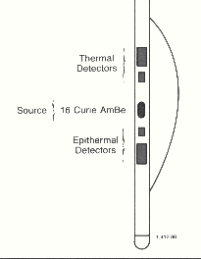
Figure 5.8: Schematic Diagram of CNL

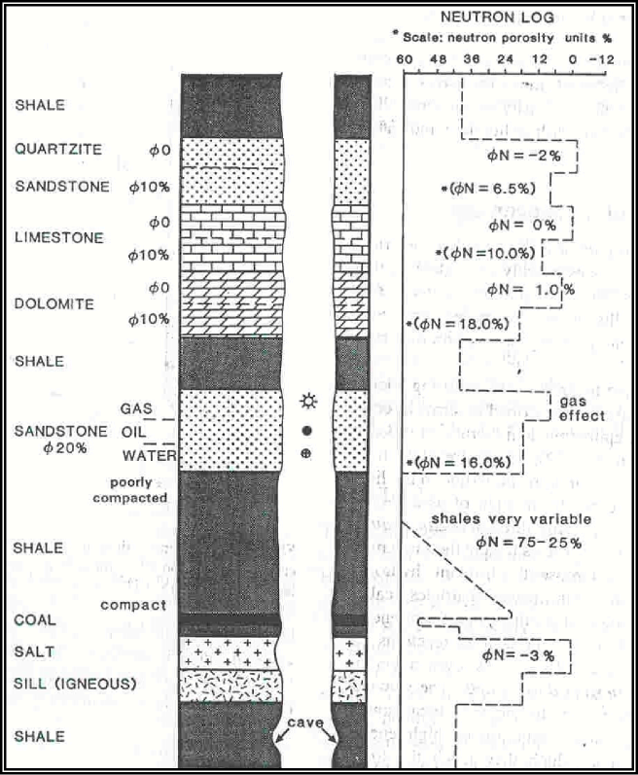
Figure 5.9: Idealized Neutron Log

DENSITY LOG.
APPLICATION
The density tool is used to determine formation density and estimate formation porosity. Together with other tools like the Neutron, the lithology and formation fluid type can also be determined. The density tool can distinguish between oil and gas in the pore space by virtue of their different densities. Modern density tools also measure the photoelectric effect to help distinguish between rock lithologies, recognize presence of heavy minerals, fracture identification when barite is present and additional clay evaluation. In addition the density can be used to determine Vclay and to calculate reflection coefficients to process synthetics. A chemical source bombards gamma rays into the formation. The high-energy gamma rays interact with the electrons of the formation by way of Compton scattering and lose energy in the process. Other processes also occur namely photoelectric absorption and pair production, although pair production only becomes significant at energies above 1MeV. A low number of gamma rays detected through Compton scattering will indicate a high electron density. The bulk density r_{B} has a close relationship to the electron density as shown by the following determined equation: -
RHOB = 1.0704*RHOe - 0.1883
A spectral or litho density tool measures not only the bulk density but also a photoelectric absorption index PEF. The photoelectric effect occurs when the incident gamma ray of low energy is absorbed by the electron and the electron is then ejected from the atom.
PEF = (Z/A)^{3.6}
A=Atomic weight, Z=Atomic number.
The photoelectric effect of absorbed gamma rays is directly related to the Z, the number of electrons per atom, which is fixed for each element. Different values of the PEF curve indicate different types of formation rock being measured and are independent of formation porosity. The Density tool is usually run together with the Neutron tool. The Density has a backup caliper arm to push the pad against the borehole wall and the Neutron uses a bow spring.
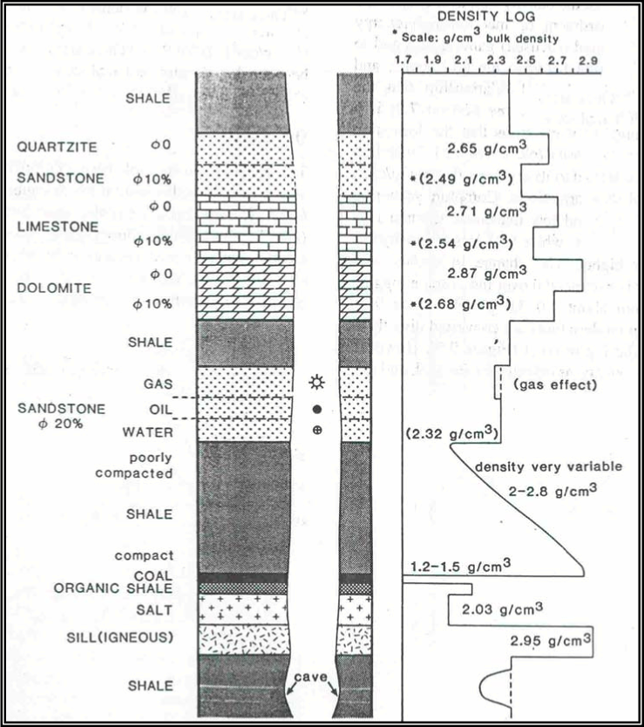

Density Porosity Determination

Since the bulk density (r_{B}) is a measure of the matrix density (rma) and the fluid density (rf) in the pore space, then the amount of pore space or formation porosity can be determined. The rma and rf must however be known.
RHOB = RHOMA(1-PHID) + PHID*RHOF
Or
PHID = (RHOB - RHOMA) / (RHOF-RHOMA)
Where:-
RHOB = Density log reading.
RHOMA = Density Matrix.
RHOF = Density Fluid.
PHID = Density Porosity.
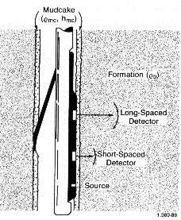
Figure 5.10 A typical density logging tool

RESISTIVITY LOGS

Resistivity logging is a method of well logging that works by characterizing the rock or sediment in a borehole by measuring its electrical resistivity. Resistivity is a fundamental material property which represents how strongly a material opposes the flow of electric current. In these logs, resistivity is measured using 4 electrical probes to eliminate the resistance of the contact leads. The log must run in holes containing electrically conductive mud or water.
Resistivity logging is sometimes used in mineral exploration and water-well drilling, but most commonly for formation evaluation in oil- and gas-well drilling. Most rock materials are essentially insulators, while their enclosed fluids are conductors. Hydrocarbon fluids are an exception, because they are almost infinitely resistive. When a formation is porous and contains salty water, the overall resistivity will be low. When the formation contains hydrocarbon, or contains very low porosity, its resistivity will be high. High resistivity values may indicate a hydrocarbon bearing formation.
Usually when drilling, drilling fluids invade the formation, changes in the resistivity are measured by the tool in the invaded zone. For this reason, several resistivity tools with different investigation lengths are used to measure the formation resistivity. If water based mud is used and oil is displaced, "deeper" resistivity logs (or those of the "virgin zone") will show lower conductivity than the invaded zone. If oil based mud is used and water is displaced, deeper logs will show higher conductivity than the invaded zone. This provides not only an indication of the fluids present, but, at least quantitatively, whether the formation is permeable or not.

Tools Measuring the Uninvaded Zone (Rt)
These tools (deep induction and deep laterolog) essentially measure Rt, and the log value is normally quite close to true Rt, providing the tool is used in the correct environment. To obtain a more precise value for Rt, certain corrections must be applied to the raw values.

Tools Measuring the Invaded zone (Ri)
The actual quantitative value of these readings is not as important as how these readings relate to Rt and Rxo. By comparing them, we can obtain:
- Corrected Rt values.
- Depth of invasion of the mud filtrate.
- An idea of the formation’s permeability.
- An estimate of movable oil.

Tools Measuring the Flushed Zone (Rxo)
Four different Rxo tools are available, the ML, MLL, PL and MSFL. They are intended for different conditions of salinity, mud cake thickness and diameters of invasion.

INDUCTION LOGGING
APPLICATION
The Induction log was introduced to measure the formation resistivity in fresh or oil-based mud and is used to detect the presence of hydrocarbon bearing zones. The tool was developed from mine detector technology developed during the Second World War. By analysing resistivity measurements, we can differentiate between formations containing conductive and non-conductive fluids. Conductive fluids in the formation usually consist of water or mud filtrate and non-conductive fluids consist of oil and gas. Using equations such as the Archie formula shown below, we can establish the relative proportions of hydrocarbons and water resident in the formation: -
Rt = aR_{w} /(PHI^{m} S_{w}²)
Where:-
Rt = Formation Resistivity.
R_{w} = Formation water resistivity.
S_{w} = Percentage of water in pore space (Water Saturation).
F = Formation Factor = a/PHI^{m}
PHI = Formation Porosity.
n = 2, Saturation component.
a and m, experimentally determined constants.

LATERO LOG
APPLICATION
The Laterolog tool was introduced to measure the formation resistivity in salty or high conductive mud and is used to detect the presence of hydrocarbon bearing zones. By analyzing resistivity measurements, we can differentiate between formations containing conductive and non-conductive fluids. Conductive fluids in the formation usually consist of water or mud filtrate and non-conductive fluids consist of oil and gas. Using equations such as the Archie formula shown below, we can establish the relative proportions of hydrocarbons and water resident in the formation:
Rt = aR_{w} /(PHI^{m} S_{w}²)
Where:-
Rt = Formation Resistivity.
R_{w} = Formation water resistivity.
PHI = Formation Porosity.
S_{w} = Percentage of water in pore space(Water Saturation).
n = 2, Saturation component.
a and m, experimentally determined constants
where a is close to 1 and m is close to 2
F = Formation Factor = a/PHI^{m}

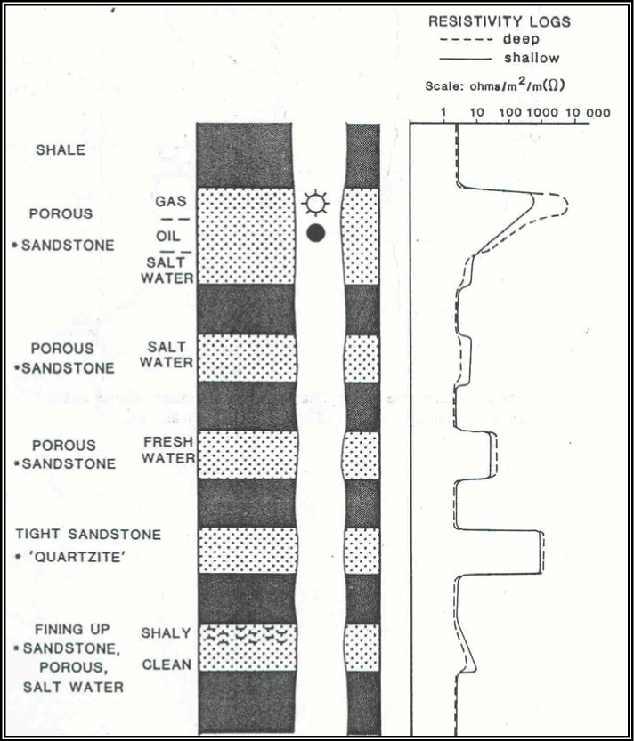
Figure 5.11: Ideal resistivity log

PETROPHYSICAL ANALYSIS

INTERPRETATION WORK FLOW

The parameters are calculated for the saturation of hydrocarbons according to work flow.
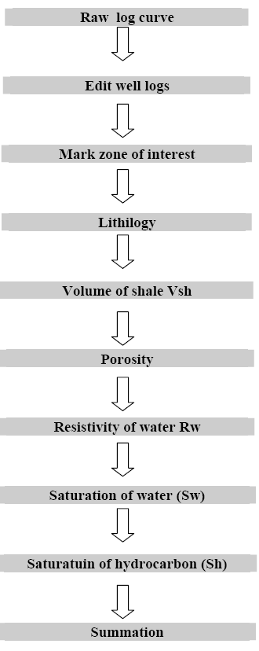
Figure 6.1: Work flow chart

PETROPHYSICAL TECHNIQUES

In general terms the petrophysical techniques that are used to study the parameters a, m, n and R. The techniques all use the relationships defined by the Archie equation:
_{= ×}
₌ F ×
₌

Where: S_{w} is the water saturation
R_{t} is the deep resistively
R_{w} is the resistivity of the formation water
n is the saturation exponent
m is the cementation exponent
a is the tortuosity factor
F is the formation resistivity factor
R₀ is the wet resistivity

PETROPHYSICAL PARAMETERS

POROSITY
It is a measure of the amount of internal space that is capable of holding fluids; a porosity of 1% is equivalent of volume of 77.58 bbl/acre-ft. Quantitatively, the porosity of the rock is the ratio of the void space to the bulk volume. The porosity depends on the shape, surface, texture, angularity, orientation, and degree of cementation and size distribution of the grains, which make up the rock.

Primary Porosity

The spaces between the fragments of the solid material deposited as sediment are the primary porosity.

Secondary Porosity

Secondary porosity is the contribution from vugs fractures, pits and other discontinuities in the bulk volumes of matrix. The contribution of the secondary to the overall bulk porosity is generally small yet it can lead to dramatic increases in bulk permeability.

Effective Porosity

Effective porosity is the only capacity, which can make contribution to the flow. Pores initially present but subsequently seals off by cementation or recrystallization effects are of no interest.

VOLUME OF SHALE
Clay’s shale contributes to formation conductivity. Shale exhibits conductivity because of the electrolyte that it contains and because of an ion-exchange process where by ions move under the influence of impressed electric field between the exchange sites on surface of clay particles. So there will be effect of shale on the other rocks. This effect depends on the amount, type and distribution of shale. The shale influences all logging measurements, and the corrections of shale contents are required.

DETERMINATION OF VOLUME OF SHALE

Volume of shale can be computed by different methods using i.e.
- Gamma rays
- SP NGS tool
- φ_{n} vs. φ_{d} cross plot
- φ_{n} vs. φ_{s} cross plot
We used two methods to compute the volume of shale, which are given below.

VOLUME OF SHALE BY GAMMA RAY LOG

The gamma ray log has been used as one of the important shale indicator in the evaluation of shaly formations. In the quantitative evaluation of shale content, it is assumed that radioactive minerals other than shale are absent.
A gamma ray “shale index” I_{GR}, has been defined as

I_{GR =} GR_{log} – GR _{min}
GR _{max} – GR _{min}
Where
GR_{log} = log response in the zone of interest, API units
GR_{min} = log response in the clean beds, API units
GR_{max} = log response in the shale beds, API units

The gamma ray shale index has been empirically related with the fractional volume of the shale information by the curve such as curve 1 for linear relationship and curve 2, used for formations and it is defined by the formula.

PETROPHYSICAL INTERPERTATION

HYDROCARBON PRODUCTION

Only the gas shows were recorded during the drilling of Lower Gour, A considerable amount of hydrocarbon gases were detected in four intervals. These are Intervals D, C, B and A.
Maximum gas percentage recorded in different formation is given below.

Table 3: Showing the gas % in different formations
Formation | Gas Percentage
Lower Gour | 0.29%
Interval D | 17.08%
Interval C | 22.9%
Interval B | 1.435%
Interval A | 0.1087%

INTERPRETATION
The following parameters are used in interpretation of well logs LDL-CNL-GR, DLL-MSFL-SP-GR, BHC-GR.
- Volume of Shale
- Porosity
- Hydrocarbon

INTERPRETATION DATA OF WELL LOGS

INTERPRETATION OF ZONE WELL # 10 AT DEPTH OF (3316-3425)

Table 4: Showing The different parameters of Run 1
depth | GR | NPHI | PEFL | SP | RHOB | LLD
3316 | 78 | 0.33 | 4.5 | 0 | 2 | 700
3317 | 70 | 0.35 | 3 | 7 | 2 | 21
3318 | 80 | 0.34 | 9 | 4 | 2 | 22
3319 | 35 | 0.13 | 4.5 | 10 | 2.9 | 22
3320 | 90 | 0.08 | 3 | 12 | 2.63 | 5
3321 | 100 | 0.13 | 3 | 13 | 2.3 | 7
3322 | 20 | 0.01 | 2.1 | 20 | 2.55 | 60
3323 | 18 | 0.01 | 2.8 | -78 | 2.57 | 100
3324 | 18 | 0.02 | 2 | -77 | 2.6 | 30
3325 | 15 | 0.02 | 2 | -72 | 2.4 | 19
3326 | 35 | 0.025 | 3 | -70 | 2.38 | 30
3327 | 35 | 0.05 | 3.5 | -72 | 2.59 | 29
3328 | 116 | 0.13 | 3.8 | -77 | 2.63 | 31
3329 | 117 | 0.15 | 3.8 | -80 | 2.65 | 30
3330 | 130 | 0.19 | 2.8 | 20 | 2.64 | 4.5
3331 | 118 | 0.14 | 3.8 | 20 | 2.43 | 20
3332 | 208 | 0.18 | 4 | 19 | 2.65 | 8.5
3333 | 140 | 0.13 | 3.2 | 19 | 2.55 | 6
3334 | 135 | 0.16 | 3.5 | 18 | 2.56 | 7
3335 | 95 | 0.11 | 3.2 | 17 | 2.5 | 28
3336 | 120 | 0.13 | 3.3 | 16 | 2.6 | 31
3337 | 130 | 0.1 | 3.2 | 16 | 2.65 | 32
3338 | 165 | 0.14 | 3.6 | 17 | 2.67 | 10
3339 | 195 | 0.13 | 3 | 17 | 2.55 | 10
3340 | 195 | 0.14 | 3.4 | 17 | 2.5 | 10
3341 | 180 | 0.11 | 3 | 17 | 2.58 | 18
3342 | 76 | 0.11 | 2.5 | 16 | 2.2 | 13
3343 | 108 | 0.1 | 3 | 17 | 2.55 | 19
3344 | 102 | 0.12 | 2.8 | 17 | 2.44 | 7.5
3345 | 75 | 0.11 | 2.7 | 15 | 2.54 | 13
3346 | 62 | 0.08 | 2.5 | 15 | 2.53 | 19
3347 | 82 | 0.07 | 2.8 | 14 | 2.57 | 25
3348 | 80 | 0.1 | 2.8 | 13 | 2.56 | 20
3349 | 86 | 0.09 | 2.5 | 12 | 2.54 | 11
3350 | 83 | 0.11 | 2.7 | 11 | 2.6 | 26
3351 | 79 | 0.1 | 2.7 | 11 | 2.55 | 22
3352 | 95 | 0.11 | 3 | 11 | 2.57 | 18
3353 | 90 | 0.13 | 2.8 | 11 | 2.6 | 16
3354 | 80 | 0.13 | 3 | 11 | 2.55 | 18
3355 | 80 | 0.14 | 3.1 | 11 | 2.53 | 15
3356 | 60 | 0.13 | 2.8 | 11 | 2.52 | 14
3357 | 43 | 0.13 | 3.2 | 11 | 2.45 | 7
3358 | 40 | 0.1 | 3.8 | 11 | 2.62 | 12
3359 | 75 | 0.05 | 3 | 10 | 2.58 | 14
3360 | 80 | 0.06 | 4 | 9 | 2.72 | 40
3361 | 90 | 0.1 | 3.1 | 7 | 2.55 | 10
3362 | 170 | 0.15 | 3.8 | 4 | 2.64 | 25
3363 | 160 | 0.12 | 4 | 1 | 2.69 | 24
3364 | 115 | 0.18 | 3.5 | 1 | 2.8 | 29
3365 | 130 | 0.16 | 4 | 1 | 2.67 | 30
3366 | 122 | 0.15 | 3.6 | 3 | 2.66 | 30
3367 | 80 | 0.17 | 3.8 | 5 | 2.67 | 30
3368 | 100 | 0.15 | 3.5 | 8 | 2.7 | 16
3369 | 35 | 0.16 | 4 | 10 | 2.56 | 9
3370 | 80 | 0.11 | 3.8 | 11 | 2.55 | 10
3371 | 58 | 0.07 | 3 | 11 | 2.57 | 15
3372 | 70 | 0.09 | 3 | 11 | 2.55 | 10
3373 | 92 | 0.12 | 3 | 10 | 2.56 | 17
3374 | 120 | 0.12 | 3 | 8 | 2.55 | 14
3375 | 120 | 0.12 | 3 | 6 | 2.65 | 18
3376 | 163 | 0.12 | 3.3 | 5 | 2.68 | 20
3377 | 130 | 0.12 | 3.5 | 5 | 2.77 | 24
3378 | 95 | 0.09 | 3.1 | 5 | 2.64 | 30
3379 | 101 | 0.07 | 3 | 6 | 2.61 | 30
3380 | 113 | 0.08 | 2.8 | 6 | 2.51 | 39
3381 | 98 | 0.08 | 2.9 | 6 | 2.61 | 35
3382 | 108 | 0.09 | 3.3 | 7 | 2.66 | 34
3383 | 142 | 0.15 | 4.8 | 7 | 2.8 | 29
3384 | 120 | 0.15 | 3.8 | 7 | 2.7 | 22
3385 | 120 | 0.12 | 4.2 | 7 | 2.75 | 22
3386 | 125 | 0.06 | 3.6 | 7 | 2.7 | 40
3387 | 123 | 0.1 | 3.4 | 7 | 2.66 | 39
3388 | 98 | 0.12 | 3.5 | 8 | 2.65 | 31
3389 | 140 | 0.07 | 2.5 | 8 | 2.54 | 40
3390 | 115 | 0.08 | 2.5 | 8 | 2.59 | 40
3391 | 120 | 0.09 | 3.2 | 8 | 2.67 | 45
3392 | 133 | 0.03 | 2.5 | 8 | 2.59 | 60
3393 | 138 | 0.11 | 3 | 8 | 2.56 | 38
3394 | 113 | 0.1 | 3 | 8 | 2.6 | 35
3395 | 140 | 0.11 | 2.5 | 8 | 2.53 | 36
3396 | 140 | 0.12 | 3.2 | 8 | 2.2 | 38
3397 | 140 | 0.1 | 3.1 | 8 | 2.67 | 38
3398 | 140 | 0.12 | 3 | 8 | 2.6 | 34
3399 | 142 | 0.13 | 3 | 8 | 2.61 | 30
3400 | 140 | 0.14 | 3.5 | 8 | 2.5 | 30
3401 | 140 | 0.16 | 3 | 8 | 2.65 | 30
3402 | 145 | 0.17 | 3.5 | 8 | 2.65 | 30
3403 | 140 | 0.16 | 2.9 | 8 | 2.63 | 30
3404 | 140 | 0.16 | 3 | 8 | 2.67 | 30
3405 | 140 | 0.16 | 3 | 8 | 2.65 | 28
3406 | 140 | 0.19 | 3.5 | 8 | 2.68 | 25
3407 | 140 | 0.19 | 3.5 | 8 | 2.69 | 24
3408 | 138 | 0.22 | 3.5 | 8 | 2.67 | 22
3409 | 140 | 0.22 | 3.8 | 8 | 2.64 | 22
3410 | 140 | 0.2 | 3.3 | 8 | 2.65 | 23
3411 | 140 | 0.19 | 3.5 | 8 | 2.64 | 25
3412 | 140 | 0.17 | 3.3 | 8 | 2.65 | 29
3413 | 140 | 0.2 | 3.5 | 8 | 2.65 | 18
3414 | 140 | 0.23 | 3.5 | 8 | 2.65 | 14
3415 | 140 | 0.25 | 3 | 8 | 2.65 | 10
3416 | 140 | 0.23 | 2.9 | 8 | 2.63 | 13
3417 | 140 | 0.28 | 2.9 | 8 | 2.63 | 11
3418 | 140 | 0.25 | 2.9 | 8 | 2.63 | 19
3419 | 140 | 0.33 | 2.9 | 8 | 2.63 | 14
3420 | 140 | 0.25 | 2.9 | 8 | 2.63 | 9
3421 | 140 | 0.21 | 2.9 | 8 | 2.63 | 20
3422 | 140 | 0.21 | 2.9 | 8 | 2.63 | 500
3423 | 140 | 0.22 | 2.9 | 8 | 2.63 | 200
3424 | 138 | 0.21 | 2.9 | 8 | 2.63 | 10
3425 | 138 | 0.21 | 2.9 | 8 | 2.63 | 40

Table 5: Showing the different parameters of run 2.
3427 | 118 | 0.14 | 3 | -74 | 2.42 | 20
3428 | 148 | 0.12 | 3.5 | -71 | 2.45 | 20
3429 | 125 | 0.13 | 3.7 | -69 | 2.25 | 20
3430 | 133 | 0.06 | 2.9 | -68 | 2.45 | 15
3431 | 90 | 0.07 | 4 | -67 | 2.65 | 22
3432 | 115 | 0.1 | 2.9 | -66 | 2.35 | 20
3433 | 120 | 0.14 | 3 | -66 | 2.47 | 20
3434 | 145 | 0.14 | 3.5 | -66 | 2.65 | 18
3435 | 150 | 0.14 | 3.2 | -66 | 2.55 | 15
3436 | 178 | 0.13 | 3.5 | -65 | 2.7 | 25
3437 | 185 | 0.1 | 3.9 | -65 | 2.4 | 12
3438 | 103 | 0.08 | 2.8 | -64 | 2.45 | 15
3439 | 100 | 0.08 | 2.7 | -64 | 2.55 | 18
3440 | 140 | 0.13 | 3 | -66 | 2.55 | 30
3441 | 123 | 0.09 | 3.1 | -69 | 2.57 | 30
3442 | 85 | 0.11 | 3.2 | -70 | 2.3 | 31
3443 | 100 | 0.11 | 3 | -71 | 2.75 | 30
3444 | 110 | 0.13 | 3.1 | 73 | 2.47 | 30
3445 | 130 | 0.12 | 3.9 | -75 | 2.75 | 20
3446 | 120 | 0.11 | 3.7 | -76 | 2.76 | 25
3447 | 117 | 0.09 | 3.2 | -75 | 2.79 | 29
3448 | 123 | 0.09 | 3.1 | -75 | 5.61 | 29
3449 | 101 | 0.07 | 2.5 | -74 | 1.95 | 20
3450 | 90 | 0.08 | 2.6 | -73 | 2.17 | 29
3451 | 85 | 0.1 | 2.8 | -75 | 2.15 | 32
3452 | 95 | 0.07 | 3 | -75 | 2.45 | 30
3453 | 102 | 0.11 | 2.6 | -78 | 2.02 | 25
3454 | 120 | 0.1 | 3.5 | -79 | 2.75 | 32
3455 | 99 | 0.11 | 3.4 | 20 | 2.63 | 32
3456 | 99 | 0.13 | 3 | 19 | 2.56 | 30
3457 | 117 | 0.13 | 3.5 | 18 | 2.69 | 30
3458 | 120 | 0.14 | 3.5 | 15 | 2.7 | 28
3459 | 130 | 0.12 | 3.7 | 14 | 2.71 | 30
3460 | 122 | 0.16 | 3.6 | 13 | 2.74 | 29
3461 | 99 | 0.1 | 5 | 12 | 2.82 | 21
3462 | 140 | 0.1 | 3.5 | 11 | 2.71 | 40
3463 | 100 | 0.12 | 3.1 | 11 | 2.74 | 30
3464 | 122 | 0.13 | 4 | 10 | 2.72 | 30
3465 | 122 | 0.17 | 3.3 | 10 | 2.72 | 29
3466 | 120 | 0.17 | 4 | 9 | 2.72 | 29
3467 | 139 | 0.17 | 3.8 | 8 | 2.67 | 30
3468 | 139 | 0.16 | 3.2 | 8 | 2.67 | 31
3469 | 129 | 0.15 | 3.1 | 8 | 2.69 | 31
3470 | 122 | 0.15 | 3.2 | 8 | 2.68 | 35
3471 | 130 | 0.17 | 3.2 | 8 | 2.67 | 32
3472 | 125 | 0.15 | 3.2 | 8 | 2.68 | 30
3473 | 125 | 0.16 | 3.2 | 8 | 2.7 | 30
3474 | 130 | 0.14 | 3.1 | 8 | 2.68 | 30
3475 | 120 | 0.15 | 3.2 | 8 | 2.7 | 30
3476 | 125 | 0.15 | 3.8 | 9 | 2.68 | 30
3477 | 122 | 0.15 | 3.9 | 9 | 2.72 | 30
3478 | 121 | 0.22 | 3.3 | 9 | 2.7 | 15
3479 | 138 | 0.22 | 3.9 | 9 | 2.73 | 18
3480 | 140 | 0.25 | 3.3 | 9 | 2.7 | 15
3481 | 140 | 0.16 | 5.1 | 9 | 2.74 | 25
3482 | 118 | 0.24 | 4.7 | 10 | 2.72 | 15
3483 | 135 | 0.21 | 4.3 | 10 | 2.75 | 19
3484 | 140 | 0.15 | 3.8 | 10 | 2.75 | 25
3485 | 120 | 0.18 | 3 | 10 | 2.7 | 18
3486 | 138 | 0.18 | 3.8 | 11 | 2.67 | 20
3487 | 130 | 0.2 | 3.7 | 11 | 2.67 | 18
3488 | 138 | 0.16 | 3.5 | 11 | 2.66 | 28
3489 | 120 | 0.15 | 3.3 | 11 | 2.67 | 20
3490 | 130 | 0.19 | 3.5 | 11 | 2.75 | 20
3491 | 125 | 0.2 | 3.7 | 11 | 2.7 | 18
3492 | 123 | 0.29 | 4 | 11 | 2.7 | 18
3493 | 123 | 0.2 | 3.2 | 11 | 2.7 | 20
3494 | 121 | 0.18 | 3.3 | 11 | 2.71 | 30
3495 | 120 | 0.27 | 4.1 | 11 | 2.75 | 12
3496 | 158 | 0.26 | 4 | 11 | 2.68 | 9
3497 | 158 | 0.23 | 3.7 | 11 | 2.67 | 19
3498 | 142 | 0.22 | 4 | 11 | 2.75 | 13
3499 | 140 | 0.24 | 4.5 | 11 | 2.7 | 13
3500 | 139 | 0.22 | 4 | 12 | 2.68 | 14
3501 | 140 | 0.24 | 3.8 | 12 | 2.7 | 12
3502 | 138 | 0.25 | 4 | 12 | 2.68 | 15
3503 | 135 | 0.25 | 3.9 | 13 | 2.68 | 19
3504 | 125 | 0.21 | 3.7 | 13 | 2.65 | 15
3505 | 116 | 0.21 | 3 | 13 | 2.55 | 18
3506 | 130 | 0.26 | 4 | 13 | 2.75 | 11
3507 | 140 | 0.26 | 4 | 14 | 2.7 | 13
3508 | 135 | 0.25 | 3.8 | 15 | 2.7 | 15
3509 | 140 | 0.22 | 3.9 | 16 | 2.71 | 13
3510 | 130 | 0.24 | 4.5 | 17 | 2.72 | 12
3511 | 135 | 0.27 | 3.9 | 18 | 2.72 | 9
3512 | 150 | 0.26 | 3.3 | 19 | 2.65 | 9
3513 | 140 | 0.28 | 10 | -78 | 2.65 | 31
3514 | 102 | 0.27 | 8.9 | -72 | 2.11 | 80
3515 | 101 | 0.27 | 3.3 | -65 | 2.03 | 80
3516 | 50 | 0.24 | 3.2 | -60 | 2.55 | 22
3517 | 39 | 0.15 | 3.6 | -56 | 2.55 | 60
3518 | 35 | 0.08 | 3 | -50 | 2.66 | 9
3519 | 32 | 0.1 | 3.7 | -48 | 2.53 | 70
3520 | 30 | 0.03 | 2.2 | -45 | 2.45 | 5
3521 | 82 | 0.02 | 2.5 | -44 | 2.49 | 50
3522 | 82 | 0.02 | 2.4 | -45 | 2.47 | 3
3523 | 21 | 0.02 | 2 | -45 | 2.35 | .8??
3524 | 23 | 0.02 | 1.9 | -48 | 2.55 | 120
3525 | 45 | 0.02 | 1.9 | -49 | 2.55 | 100
3526 | 25 | 0.02 | 1.9 | -49 | 2.56 | 100
3527 | 38 | 0.03 | 1.9 | -50 | 2.55 | 90
3528 | 30 | 0.04 | 1.8 | -50 | 2.55 | 120
3529 | 36 | 0.05 | 2.1 | -51 | 2.55 | 80
3530 | 30 | 0.04 | 3 | -52 | 2.55 | 100
3531 | 180 | 0.03 | 2 | -53 | 2.62 | 10
3532 | 60 | 0.12 | 2.1 | -54 | 2.47 | 12
3533 | 30 | 0.09 | 2 | -55 | 2.49 | 20
3534 | 25 | 0.08 | 2 | -56 | 2.5 | 50
3535 | 22 | 0.06 | 2 | -57 | 2.45 | 15
3536 | 38 | 0.07 | 2.1 | -55 | 2.45 | 8
3538 | 45 | 0.07 | 2 | -56 | 2.45 | 7
3539 | 43 | 0.14 | 2.1 | -55 | 2.48 | 6
3540 | 40 | 0.13 | 2.1 | -54 | 2.5 | 35
3541 | 23 | 0.09 | 2.2 | -51 | 2.55 | 50
3542 | 39 | 0.07 | 2 | -47 | 2.57 | 20
3543 | 30 | 0.08 | 3.1 | -48 | 25.1 | 50
3544 | 40 | 0.03 | 2.5 | -49 | 2.65 | 70
3545 | 50 | 0.09 | 2.2 | -50 | 2.54 | 15
3546 | 20 | 0.11 | 2 | -52 | 2.5 | 25
3547 | 19 | 0.03 | 1.8 | -53 | 2.53 | 150
3548 | 35 | 0.03 | 2.1 | -55 | 2.6 | 110
3549 | 20 | 0.03 | 3 | -55 | 2.6 | 200
3550 | 20 | 0.01 | 3 | -58 | 2.68 | 70
3551 | 40 | 0.03 | 3 | -59 | 2.72 | 100
3552 | 40 | 0.03 | 3 | -59 | 2.73 | 100
3553 | 78 | 0.04 | 2.10 | -58 | 2.56 | 70
3554 | 50 | 0.03 | 2.1 | -58 | 2.57 | 50
3555 | 41 | 0.02 | 2.8 | -55 | 2.62 | 40
3556 | 35 | 0.03 | 2.9 | -55 | 2.6 | 120
3557 | 38 | 0.06 | 2 | -56 | 2.57 | 40
3558 | 50 | 0.08 | 2.5 | -59 | 2.56 | 70
3559 | 39 | 0.04 | 2.5 | -61 | 2.6 | 30
3560 | 40 | 0.06 | 2.9 | -62 | 2.6 | 150
3561 | 29 | 0.02 | 2.2 | -62 | 2.6 | 160
3562 | 25 | 0.02 | 2 | -63 | 2.58 | 120
3563 | 27 | 0.02 | 2 | -63 | 2.61 | 110
3564 | 22 | 0.02 | 2 | -63 | 2.58 | 100
3565 | 50 | 0.02 | 2 | -63 | 2.6 | 50
3566 | 30 | 0.04 | 2 | -65 | 2.62 | 80
3567 | 67 | 0.03 | 2.9 | -65 | 2.63 | 180
3568 | 78 | 0.03 | 3 | -67 | 2.64 | 100
3569 | 20 | 0.01 | 2 | -68 | 2.55 | 100
3570 | 58 | 0.03 | 2 | -69 | 2.57 | 150
3571 | 80 | 0.07 | 2.9 | -70 | 2.59 | 300
3572 | 109 | 0.04 | 2.1 | -70 | 2.6 | 100
3573 | 62 | 0.09 | 2 | -69 | 2.57 | 200
3574 | 22 | 0.01 | 2 | -69 | 2.56 | 400
3575 | 98 | 0.02 | 2.1 | -70 | 2.57 | 100
3576 | 97 | 0.04 | 2.7 | -70 | 2.6 | 200
3577 | 110 | 0.04 | 2.2 | -70 | 2.6 | 200
3578 | 109 | 0.12 | 3 | -70 | 2.56 | 180
3579 | 121 | 0.12 | 3 | -70 | 2.58 | 300
3580 | 110 | 0.12 | 2.7 | -70 | 2.6 | 120
3581 | 120 | 0.18 | 3 | -70 | 2.55 | 220
3582 | 120 | 0.15 | 2.1 | -70 | 2.55 | 60
3583 | 50 | 0.15 | 1.9 | -70 | 2.51 | 15
3584 | 90 | 0.15 | 2.2 | -70 | 2.6 | 28
3585 | 62 | 0.06 | 2.1 | -70 | 2.54 | 20
3586 | 63 | 0.05 | 2 | -70 | 2.55 | 120
3587 | 80 | 0.05 | 2.3 | -70 | 2.64 | 70
3588 | 80 | 0.06 | 3 | -70 | 2.64 | 50
3589 | 90 | 0.12 | 3 | -70 | 2.65 | 30
3590 | 100 | 0.12 | 7 | -70 | 3.05 | 80
3591 | 118 | 0.14 | 2.6 | -70 | 2.57 | 90
3592 | 121 | 0.06 | 2.8 | -70 | 2.57 | 400
3593 | 117 | 0.03 | 2.6 | -70 | 2.59 | 400
3594 | 115 | 0.06 | 2.2 | -70 | 2.62 | 70
3595 | 117 | 0.07 | 2.1 | -70 | 2.62 | 90
3596 | 110 | 0.09 | 2.5 | -70 | 2.61 | 100
3597 | 116 | 0.1 | 2.5 | -70 | 2.63 | 120
3598 | 113 | 0.07 | 2.4 | -70 | 2.63 | 130
3599 | 111 | 0.05 | 2 | -70 | 2.53 | 90
3600 | 110 | 0.09 | 2 | -70 | 2.5 | 80
3601 | 110 | 0.04 | 2 | -70 | 2.51 | 150
3602 | 110 | 0.04 | 2 | -70 | 2.5 | 180
3603 | 110 | 0.09 | 2 | -70 | 2.51 | 100
3604 | 110 | 0.06 | 2 | -70 | 2.5 | 190
3605 | 110 | 0.04 | 2 | -70 | 2.5 | 100
3606 | 110 | 0.07 | 2.1 | -70 | 2.47 | 35
3607 | 110 | 0.06 | 2.1 | -70 | 2.46 | 30
3608 | 110 | 0.04 | 2.1 | -70 | 2.46 | 30
3609 | 110 | 0.03 | 2.1 | -70 | 2.46 | 32
3610 | 110 | 0.03 | 2.1 | -70 | 2.46 | 20
3611 | 110 | 0.03 | 2.1 | -70 | 2.46 | 30
3612 | 110 | 0.05 | 2.1 | -70 | 2.46 | 39
3613 | 110 | 0.04 | 2.1 | -70 | 2.46 | 35
3614 | 110 | 0.05 | 2.1 | -70 | 2.46 | 30
3615 | 110 | 0.05 | 2.1 | -70 | 2.46 | 35
3616 | 110 | 0.05 | 2.1 | -70 | 2.46 | 35
3617 | 110 | 0.05 | 2.1 | -70 | 2.46 | 35

Figure 7.1 Graphical representation of depth vs shale volume
Figure 7.2 Graphical representation of depth vs porosity.

CONCLUSION

Miano is a part of Lower Indus Basin and is characterized by the extensional regimes and gas window. Miano Gas was discovered in Lower Cretaceous-aged and targeting Lower Goru Formation. On the basis of well log curves there are two Zones of interest, which are from 3316-3425m, 3425 -3616m. Porosity calculated from Neutron Density ranges from 0.687% to 7.98%. The Miano Gas Field has great potential to serve the future gas requirements of Pakistan.

REFERENCES
- Akbar. A., Exploration Geological study report, 2000.
- Bryant, T. M., and Gage, T. D., “API test pit calibration of MWD gamma ray tools,” Transactions, SPWLA, 29th Annual logging Symposium, San Antonio, Texas, June 5-8, 1988.
- Coope D. E., and Yearsley, E. N., “Formation evaluation using EWR log,” SPE Paper 14062, 1986.
- Coope, D. F., and Hendricks, W. “Formation evaluation using measurements recorded while drilling,” Transactions, SPWLA, 25th Annual Logging Symposium, New Orleans, La. June 10-13, 1984.
- Ellis, D. V., Well logging for Earth Scientists, Elsevier Science Publishing Co., Inc., New York,1987.
- EXLOG, DLWD Data Book, Sacramento, Calif, 1988.
- Evans, H. B., Personal Communication, Applied Petrophysics 1987.
- Evans H. B., Brooks, A. G., Meisner, J. E., and Squire, R. E., “A focused current resistivity logging system for MWD,” SPE Paper 16757, Presented a the 62nd Annual Technical Conference and Exhibition, Dallas, Texas, Sept. 27-30, 1987.
- Evans; ibid,1998
- Evans, H. B., “GRAPE—A device for continuous determination of material density and porosity,” Transactions, SPWLA, Sixth Annual Logging Symposium, Dallas, Texas, May 4-7, 1965.
- Gondouin M., “Experimentally determined resistivity profile in invaded oil and water sands for linear flow,” Journal of Petroleum Technology, March 1964.
- Holbrook, P., “The effect of mud filtrate invasion on the EWR log: A case history,” Transactions, SPWLA, 26th Annual Logging Symposium, Dallas, Texas, June 17-20, 1985.
- Hussaini. S.M.S., Reservoir Development study report, 1997.
- Iqbal, M. W. A, and Shah, S.M.I., A guide to the stratigraphy of Pakistan. Geol. Surv. Pak., Rec. 53, 1980.
- Khan. M.N., Introduction to wire line log interpretation, 1989.
- Marsh, J. L., Fraser, E. C., and Holt, A. L., “Measurements-while-drilling mud pulse detection process: an investigation of matched filter responses to simulated and real mud pressure pulses,” SPE paper 17787, 1988.
- Mathis, G. L. and Gearhart, D., “Characterization of vertical resolution for Pef and density logging,” Transactions, SPWLA, 29th Annual Logging Symposium, San Antonio, Texas, June 5-8, 1988.
- Paske, W. C., Roesler, R. F. Barnett, W. C., and t Rodney, P. E, “Formation Density Logging | While Drilling,” SPE Paper 16756 Presented at the I 62nd Annual Conference and Exhibition, Dallas, b TX, Sept. 27-30, 1987.
- Rao, M. V., “Recent advances in measurements while-drilling” Proc. 34th Annual Short Course, Lubbock, Texas l'D8.
- Serra, O., Fundamentals of Well Log Interpretation, v 1, Elsevier, New York, 1984.
- Serra, O., Fundamentals of Well Log Interpretation, v II, Elsevier, New York 1985.
- Serra.O., Fundamentals of well log interpretation, 1984.
- Shah. M.S., Stratigraphy of Pakistan, V. 12., 1977.
- Kazmi. Jan., Stratigraphy of Pakistan

