PETROPHYSICAL ANALYSIS OF PIRKOH WELL#20, CENTRAL INDUS BASIN PAKISTAN
By
MALIK WAQAS
01-161062-018

A THESIS SUBMITTED IN FULFILLMENT
OF REQUIREMENTS FOR THE DEGREE
OF
BACHELOR OF SCIENCE
IN
GEOLOGY
FACULTY OF EARTH AND ENVIRONMENTAL SCIENCES,
BAHRIA UNIVERSITY, ISLAMABAD
CHAPTER | TABLE OF CONTENTS | PAGE NUMBER
 | Acknowledgement | I
 | List of figures | II
 | List of tables | III
 | Abstract | IV
CHAPTER-1  (Introduction) | Introduction | 10
CHAPTER-1  (Introduction) | Location | 10
CHAPTER-1  (Introduction) | Objective | 10
CHAPTER-1  (Introduction) | Data Used | 11
CHAPTER-1  (Introduction) | Accessibility | 11
CHAPTER-1  (Introduction) | Petroleum Play | 13
CHAPTER-2  (General Geology) | General Geology | 15
CHAPTER-2  (General Geology) | Tectonic Zones of Pakistan | 16
CHAPTER-2  (General Geology) | Tectonics of area | 16
CHAPTER-2  (General Geology) | Structure | 18
CHAPTER-3  (Stratigraphy) | Stratigraphy | 21
CHAPTER-3  (Stratigraphy) | Mughal kot formation | 21
CHAPTER-3  (Stratigraphy) | Pab sandstone | 21
CHAPTER-3  (Stratigraphy) | Ranikot formation | 22
CHAPTER-3  (Stratigraphy) | Lower Ranikot formation | 22
CHAPTER-3  (Stratigraphy) | Upper Ranikot formation | 22
CHAPTER-3  (Stratigraphy) | Dungan formation | 22-23
CHAPTER-3  (Stratigraphy) | Ghazij formation | 23
CHAPTER-3  (Stratigraphy) | Kirthar formation | 23
CHAPTER-3  (Stratigraphy) | Habib Rahi Limestone member | 24
CHAPTER-3  (Stratigraphy) | Sirki Member | 24
CHAPTER-3  (Stratigraphy) | Pirkoh Limestone | 24
CHAPTER-3  (Stratigraphy) | Siwalik Group | 24-25
CHAPTER-3  (Stratigraphy) | Environment of Deposition | 25
CHAPTER-4  (Wireline Logging) | Wireline Logging | 28
CHAPTER-4  (Wireline Logging) | Creating Wireline Logs | 28
CHAPTER-4  (Wireline Logging) | Borehole Environment | 30
CHAPTER-4  (Wireline Logging) | Borehole size | 31
CHAPTER-4  (Wireline Logging) | Drilling Mud | 31
CHAPTER-4  (Wireline Logging) | Mud Cake | 31
CHAPTER-4  (Wireline Logging) | Mud Filtrate | 32
CHAPTER-4  (Wireline Logging) | Invasion | 32
CHAPTER-4  (Wireline Logging) | Invasion Profile | 32-33
CHAPTER-5  (Logging Tools and Principals) | Gamma Ray | 35
CHAPTER-5  (Logging Tools and Principals) | Sonic Log | 38
CHAPTER-5  (Logging Tools and Principals) | Neutron Log | 40
CHAPTER-5  (Logging Tools and Principals) | Density Log | 44
CHAPTER-5  (Logging Tools and Principals) | Resistivity Log | 47
CHAPTER-5  (Logging Tools and Principals) | Latero Log | 48
CHAPTER-6  (Petrophysical analysis) | Petrophysics | 51
CHAPTER-6  (Petrophysical analysis) | Methodology Adapted | 51
CHAPTER-6  (Petrophysical analysis) | Wireline Logs | 53
CHAPTER-6  (Petrophysical analysis) | Lithology | 53
CHAPTER-6  (Petrophysical analysis) | Volume of Shale | 54
CHAPTER-6  (Petrophysical analysis) | Porosity | 54
CHAPTER-6  (Petrophysical analysis) | Porosity calculation using Sonic log | 54-55
CHAPTER-6  (Petrophysical analysis) | Porosity calculation using Neutron log | 55
CHAPTER-6  (Petrophysical analysis) | Porosity calculation using density log | 56
CHAPTER-6  (Petrophysical analysis) | Porosity from neutron & density log | 56
CHAPTER-6  (Petrophysical analysis) | Resistivity of Water | 57
CHAPTER-6  (Petrophysical analysis) | Saturation of Water | 57
CHAPTER-6  (Petrophysical analysis) | Saturation of Hydrocarbon | 58
CONCLUSION |  | 67
APPENDIX-I |  | 68-69
APPENDIX-II |  | 70-71
REFERENCES |  | 72-73

ACKNOWLEDGEMENT
In the name of Allah, the most Beneficent, the most Merciful. All praises to Almighty Allah, the creator of universe. I bear witness that Holy Prophet Hazrat Muhammad (P.B.U.H) is the last messenger, whose life is a perfect model for the whole mankind till the Day of Judgment. Allah blessed me with knowledge related to earth. I am enabled to complete my work. Without the blessing of Allah, I could not be able to complete my work as well as to be at such a place.
I am especially indebted to my supervisor Mr. Fahad Arif for giving me an initiative to this study. His inspiring guidance, dynamic supervision and constructive criticism, helped me to complete this work in time. Special thanks to MR. Saeed Aslam Malik for his help in preparation and understanding of my work.
I pay my thanks to whole faculty of my department especially my internal supervisor Mr. Mohsin Munir whose valuable knowledge, assistance, cooperation and guidance enabled me to take initiative, develop and furnishing my academic carrier.
I also acknowledge the help, the encouragement, endless love, support and prayers of my family, which have always been a source of inspiration and guidance for me all the way.

LIST OF FIGURES

Figure 1.1: Map showing Pirkoh field | 4
Figure 2: Tectonic map of Pakistan | 9
Figure2.1: Basin architecture of Pakistan | 11
Figure 3: Stratigraphic column of the field area | 18
Figure 4.1: Logging operation | 21
Figure 4.2: Borehole environment | 22
Figure 5.1: Idealized GR log | 29
Figure 5.2: Schematic diagram of a simple sonic log | 30
Figure 5.3: Showing Sonic tool | 32
Figure 5.4: Idealized Neutron log | 35
Figure 5.5: Idealize density log | 37
Figure 5.6: Ideal resisitivity log | 41
Depth vs Vsh | 51
Depth vs Sonic | 52
Depth vs Neutron | 53
Depth vs Density | 54
Depth vs PhiND | 55
Depth vs SW | 56
Depth vs Sh | 57
Depth vs Vsh , Sonic , Neutron , Density, PhiND, SW ,Sh | 58

LIST OF TABLES
Table 1 showing different values from depth 2150 to 2230 | 60-61
Table 2 showing different results from depth 2150 to 2230 | 62-63

ABSTRACT

For the hydrocarbon exploration of the study area the petrophysical study has been carried out in Pirkoh well # 20, in this study we applied technique, i.e. wireline logging.

In this study the Pab and Lower Ranikot are evaluated, which have potential reserves. These two zones were focused for the evaluation purpose. Eight distinct lithological layers are identify through petrophysical analysis.

The reservoir quality of Pab formation was much better as compared to lower Ranikot in terms of clean sand, water saturation and permeability.

CHAPTER 01

INTRODUCTION

INTRODUCTION

Pirkoh gas field is one of the proven gas reserves of Pakistan. The Pirkoh gas field was discovered with the drilling of the Pirkoh-01 well in October, 1975 through December, 1977. From 1982 through 1988, 25 wells were drilled, since 1988, development drilling has increased the total well count to 58. Forty seven wells are tied-in and 20 wells are currently producing. The Pirkoh gas field is an expansion drive, dry gas reservoir with an initial pressure of 2,260 psia at 1,100 metres subsea with a reservoir temperature of 267 degrees Fahrenheit.

1.1 LOCATION

- The Pirkoh Well#20 is located in Pirkoh Field as mentioned above and Pirkoh Field is present about 650 kilometres south-west of Islamabad in the Baluchistan province at an elevation of about 1,115 metres above mean sea-level in central indus basin.
- The Pirkoh Well#20 has latitude of 29,08,37.24 N, and longitude of 69,04,10.63 E.
The entrapment structure is gas bearing in clastics of Paleocene and Upper Cretaceous age. Gas from different reservoirs contains 10% to 46% Methane and 55% to 85% Nitrogen.

1.2 OBJECTIVES

- The purpose of study is to evaluate the hydrocarbon potential of Pirkoh well#20, by using wireline logs from which we calculate Porosity, Shale volume, Water saturation.
- To Resolve The Lithology of Area.

1.3 DATA USED
- Data included the
  - GR log values in API unit
  - Resistivity Logs
    - Micro-Spherically Focused Log values(MSFL) in Ohmm unit
    - Shallow Later log values (LLs) in Ohmm unit
    - Deep Later log values (LLd) in Ohmm unit
  - Neutron log values in V/V unit
  - Density Logs in G/C3 unit

1.4 ACCESSIBILITY

The data for the analysis of Pirkoh Well #20 is taken from Landmark Resources (LMKR).


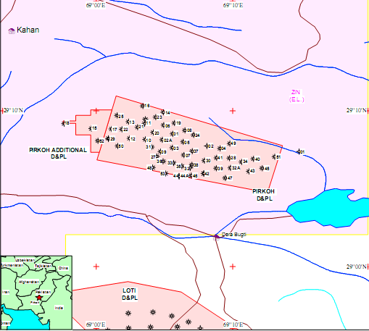

Figure 1.1; Map showing the wells in Pirkoh field including the Pirkoh well#20

1.5 PETROLEUM PLAY

In geology, a petroleum play, or simply a play, is a group of petroleum fields or prospects in the same region that are controlled by the same set of geological circumstances. A particular stratigraphic or structural geologic setting is also often known as a play.
The normal steps in the play cycle are:
- Source rock
- Cap Rock
- Reservoir rock
- Trap
- Migration

1.5.1Source rock

- Sember shales of Cretaceous age are the main source for hydrocarbons in the Pirkoh well#20. Ghazij shales of Eocene lying deeper in the basin may also have some potential.

1.5.2Cap Rock

    - Ghazij shales act as a cap rock in Pirkoh Well#20.

1.5.3Reservoir rock

- Pab sandstone of Cretaceous and lower Ranikot formation of Paleocene respectively are two proven reservoir.

1.5.4Trap

- The Pirkoh structure is a huge asymmetrical anticline which is disturbed by a series of reverse faults. This Faulted Anticline is acting as Fault bounded Trap in the study area.

1.5.5Migration

  - Hydrocarbon (oil/gas) moved along the faults from the source to the reservoir, then in the reservoir secondary Migration is done through Microfractures and Pore connected to one another until the sealing phenomena done.

CHAPTER 02

GENERAL GEOLOGY.

2.1 GENERAL GEOLOGICAL SETTING OF THE AREA.

The sediments ranging in age from infra Cambrian to recent were deposited intra-continental and marine environments. The overall simple structure of Punjab Monocline is altered by movement of infra Cambrian evaporites of Salt Range formation producing several gentle anticlines in the overlying rock sequence. Sedimentation has been virtually continuous in this area from late Paleozoic until the end of Mesozoic. During the late Cretaceous/Paleocene, unwrapping, local doming, faulting and erosion occurred, probably related to first phases of continental collision between Indo-Pak and Laurasia. Sedimentation during the Eocene led to thick sequences of shales and carbonates (Ghazij/Kirther formation). Since the Miocene, upto 4500 m of orogenic molasses sediments (siwalik group) flooded the foredeep areas, and finally in the main phase of the Himalayan orogeny, sediments were folded in an arcuate belt around the deep molasses through of late terteriary clastics. A system of parallel en-echelon folds with relief faulting and overthrusting resulted. Trap development at Pirkoh field may have commenced in the late cretaceous, although with present well and seismic coverage restricted to the area of uplift the role of syn-depositional structuration is difficult to quantify. Regional studies have indicated that Eocene Ghazij shales lying deeper in the basin may have formed the main source of gas, although potential exists for a number of even deeper source rocks horizons within the Cretaceous or the Jurassic. It has been suggested that oil has been flushed regionally updip by gas migration from these deeper horizons, and that most oil has escaped to surface, some remnants forming seeps at present. Two proven productive horizons are present in the Pirkoh field.

2.2 TECTONIC ZONES OF PAKISTAN

Pakistan can be divided into eight tectonic zones, which are
as follows (Kazmi & Jan, 1997).
    - Indus platform and foredeep.
    - East Balochistan fold and thrust belt.
    - Northwest Himalayan fold and thrust belts.
    - Kohistan-Ladakh magmatic arc.
    - Karakoram block.
    - Kakar Khorasan flysch basin and Makran accretionary zone.
    - Chagai magmatic arc.
    - Pakistan Offshore.

2.3 TECTONICS OF AREA

My study area lies in the Indus platform and foredeep tectonic zone and situated on the northwestern margin of the Indian plate, the Sulaiman sub basin displays array of features arising from collision of the Indian and Eurasian plates. The Sulaiman alongwith other basins located in the Indian plate was affected by the global tectonic events (Powell, 1979). Fragmentation of Gondwana resulted in separation of the Indian and African segment during Jurassic period. Since then Indian plate is moving northward. The present tectonic features of the sulaiman and its folds and faults came into existence during post cretaceous orogenic events. The Pre Cretaceous history of the sub basin in marked by non orogenic movement. The sub basin is bounded on the east by Indian shield and on the west by the marginal zone of the Indian plate. On the north lie Sargodha high and pezu uplift while its southern frontier is marked by Sukkur rift.
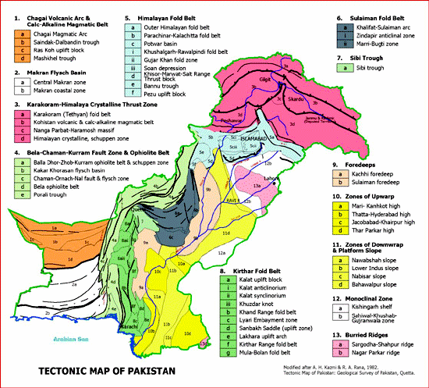

Figure 2: Tectonic map of Pakistan(www.gsp.gov.pk)

2.4 STRUCTURE

The geological structural interpretation adjusted according to formation reservoir tops identified from well control.
The Pirkoh structure is a doubly plunging huge asymmetrical anticline at the level of Lower Ranikot of Paleocene and Pab of Cretaceous age. Dips on northern flank are gentle while southern flank is quite steep. This anticlinal structure is disturbed by a series of reverse faults which are running in an east-west direction. Structure is further complicated by a number of normal faults, particularly in the crestal part. These normal faults appear to be older than the thrust faults. Throws of these faults range from few to tens of meters. The dip directions of reverse faults are towards south. The regional trend of thrust faulting is from north indicates that it is a local faulting system or might be back thrust region.

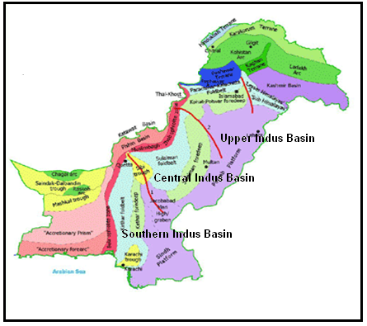

Figure2.1: Basin architecture of Pakistan (www.gsp.com.pk)

CHAPTER 03

STRATIGRAPHY OF THE AREA.

STRATIGRAPHY.

Stratigraphy of the area comprises with the rocks ranging from Mughal Kot Fm (Cretaceous) to Siwaliks (Miocene). There are three major unconformities throughout the sequence. The brief description of the stratigraphy is given below:

3.1 MUGHAL KOT FORMATION

The term Mughal kot formation was applied by Williams (1959). The formation comprises of mainly limestone whitish grey to grey, brownish grey, compact, hard, argillaceous, pyritic, fossiliferous with shale light grey to grey, brownish grey, greenish grey, indurated, calcareous, pyritic, fossiliferous. The contact with underlying formation is uncertain because Mughalkot was not penetrated to base. Williams (1959) reported Omphalocycius sp and assigned Maestrichtain age to the formation. Marks (1962) reported Siderolites cf. Calcitrapoides and assigned the late to middle Cretaceous age.

3.2 PAB SANDSTONE

The term Pab sandstone was introduced by Vredenburg (1907) for the formation typically consist of quartose sandstone white to dirty white, reddish brown, Greenish grey, hard, compact, fine to medium Grained, at places gritty, sub angular to sub rounded, fairly sorted to well sorted, well cemented, quartzose with sugary texture, slightly calcareous to non calcareous, bituminous, pyritic, leminitic, locally dolomitic, chalcopyritic with shale greenish grey, reddish brown, light grey to grey indurated, laminated, fissile, bituminous, slightly carbonaceous, silty, locally with calcite veins, pyretic and siltstone Grey to light grey, reddish grey, greenish grey, compact, pyritic. The contact with the underlying Mughalkot formation is normal. Vredenburg (1907) reported Lepidorbitoides. Williams (1959) recorded a mix benthonic pelagic assemblage of foraminifers. The age of Pab sandstone is Upper Cretaceous (Hunting survey corporation 1961). This is the target horizonin the well under study. This is the main producing reservoir here and having thickness of about 250 meters.

3.3 RANIKOT FORMATION

Blanford (1876) was the first to use the name “Ranikot Group”. Blanford’s redefined “Ranikot group”, was subdivided in to lower Ranikot (sandstone) and upper Ranikot (limestone) by Vredenburg (1909). The contact with underlying Pab sandstone formation is unconformable. A Paleocene age has been designed to the formation on the basis of fossils present in upper and lower Ranikot formation.

3.3.1 Lower Ranikot formation

The lower Rnaikot formation consist of dominant sandstone light grey to grey, greenish grey, medium hard, medium to very fine grained, some time grading to siltstone, sub-angular to subrounded, fairly sorted, argillaceous, slightly calcareous to noncalcareous, pyretic with shale greenish grey to dark grey, indurated, arenaceous, silty, slightly calcareous, pyritic and limestone brownish grey to whitish grey, hard compact, composed of corals and shells. The contact with underlying Pab sandstone formation is unconformable. No fossils have been found except some oysters, reptile remains. Nagappa (1960) has mentioned the presence of rare arenaceous foraminifera. Vredenburg (1928) on the basis of Ostraea talpur give the formation middle Paleocene age.

3.3.2 Upper Ranikot formation

The upper Ranikot formation consist of dominantly limestone light grey to dark grey, brown, hard crystalline, fossiliferous, argillaceous with marl light grey to dark grey, brown, medium hard and shale Greenish grey, light grey to dark grey, splintery, laminated, locally fissiliferous slightly calcareous. The contact with underlying lower Ranikot formation is gradual and normal. Lexique (1956) has recorded presence of rich assemblage of foraminifers (Davies, 1927; Nuttall, 1931), corals (Duncan, 1980), molluses (Vredenburg, 1909). Iqbal (1972) confirms late Paleocene age to upper Ranikot formation.

3.4 DUNGAN FORMATION

The Dungan formation (Williams 1959) dominantly consists of nodular to massive limestone with subordinate shale, marl, sandstone and Limestone conglomerate. Limestone is dark grey to brown, cremy white weathering brown, brownish grey, hard, compact, crystalline and fossiliferous. Shale with greenish grey, dark grey, indurated, slightly calcareous, silty, marl is grey, soft to medium hard, plastic. The contact with upper Ranikot formation is gradual and normal and lower contact of Dungan formation is unconformable in most of the localities and marks one of the major unconformities (Williams 1959). The upper contact with the Ghazij Group is conformable. A rich fossil assemblage including foraminifers, gastropods, bivalves and algae are recorded by (Davies 1941, Khan and Haque 1956, Hunting survey corporation 1961). Lockhartia tipperi indicate Paleocene to early Eocene age.

3.5 GHAZIJ FORMATION

The Ghazij group of Odham (1890) was redefined as Ghazij formation by Williams (1959). Ghazij formation consists of shale with limestone and marl. Shales are Olive green to light greenish grey, moderately indurated, laminated, fossiliferous, splintery fissile, slightly carbonaceous. Limestone is Whitish grey to grey, brownish grey, hard to very hard, dense, compact, crystalline, fossiliferous, argillaceous. Marl is light grey, brownish grey, greenish grey, soft to medium hard, plastic, pyritic. The formation conformably overlies the Dungan formation. The fossil fauna includes foraminifers, gastropods, bivalves, algae (Eames 1952, Hunting survey corporation 1961, Latif 1964, Iqbal 1969). The formation is assigned as early Eocene age. These shales have a potential for hydrocarbon and also acting as Cap rock for Pirkoh reserves.

3.6 KIRTHAR FORMATION.

Kirthar formation (Shah 1999) defined as predominantly limestone with some shale and minor marl. The limestone is light grey cream coloured or chalky white and weathering in grey, brown or cream colours. It is thick-bedded to massive in places nodular and occasionally contains algal and corraline structures. The shale is olive, orange, yellow, grey, calcareous, soft and earthy, however in some parts of kirthar province the upper half of the unit is exclusively cliff-forming massive limestone. In some parts of the Sulaiman Province, milky white gypsum beds up to 6-meter thick are also present. The Kirthar formation transitionally overlies the Ghazij formation and its chronostratigraphic equivalent the Laki formation. The formation is richly fossiliferous and represents different ages in various parts of distribution. The age of formation ranges from middle to late Eocene. The Oligocene fauna from the Kirthar range are reported by the (Hunting survey corporation 1961) includes Lepidocyclina Dilatata, Nummulites fichteli, Assilina laminose. In addition to the fauna abundant Foraminifers, Gastropods, Echinoids and Vertibrate remains have been reported by Odlham (1890), Pilgrim (1961), Latif (1964) and Iqbal (1969). The kirthar formation is divisible in to four easily distinguishable members in parts of the eastern Sulaiman Province. Following are descriptions of the member’s.

3.6.1 Habib Rahi Limestone member

Habib Rahi limestone is formalized by the Stratigraphic committee of Pakistan. It consists of limestone with streaks of marl and shale. Limestone is Greenish grey, creamy to yellowish, white to light grey, hard to very hard, compact, Crystalline, fossiliferous, slightly argillaceous, cherty some time dolomitic. Marl is light grey, soft to medium hard, plastic. Shales are White, light grey to dark grey, olive green, soft, plastic, calcareous. The lower contact with underlaying Baska shale is transitional. The age of Habib Rahi limestone is early to middle Eocene.

3.6.2 Sirki Member

Sirki member after sirki Paila (Stratigraphic committee of Pakistan) has middle Eocene age. The contact with underlying Habib Rahi limestone is conformable. Main lithology is Shale with alabaster and streaks of limestone and marl. Shale is greenish grey to brownish grey, slightly Indurated, fissile, fossiliferous, pyritic. Alabaster with milky white to dirty white, translucid soft, massive, amorphous to microcrystalline. Limestone is light grey to creamy yellow, medium hard, compact, crystalline, fossiliferous, dolomite. Marl is greenish grey, soft, plastic, shallow marine

3.6.3 Pirkoh limestone

The “Pirkoh Limestone member” was introduced by Hemphill and Kidwai (1973) with “White marl band” of (Eames 1952) which has been reffered to as Pirkoh limestone in unpublished report of oil companies. The age of Pirkoh limestone is middle Eocene. The contact with underlying Sirki member is normal. This member consist of limestone White, creamy, grey to yellowish grey, Hard to very hard, massive to very thick bedded, Crystalline, highly foraminiferal with calcite veins. Marl Grey to greenish grey, soft to medium hard, Plastic and shales greenish grey, chocolate brown, slightly indurated, foliated to non foliated, fossiliferous, and Calcareous.

3.7 Siwalik Group
The Stratigraphic Committee of Pakistan following Danilchik and Shah (1967) established the Siwaliks Group for the “Siwaliks series system” comprising the following formations, in descending order; Soan formation, Dhok Pathan formation, Nagri formation and Chinji formation. According to Danilchik and Shah (1967), the group mainly composed of alternating beds of sandstone and argillaceous material. The lithology typically consists of red clay with subordinate sandstone at the base, which is overlain by thick sandstone with minor clay. The group has yielded an abundant vertebrate fauna consisting of nearly all types of mammals together with varieties of reptiles, fish and birds. The vertebrate fauna indicates Middle Miocene to early Pleistocene age.

3.8 ENVIRONMENT OF DEPOSITION

The general setting of deposition for Pab-Lower Ranikot Formation in the Pirkoh field is in between fluvial deposits emanating from the Indian shield in the east and open marine shale and limestone located in the west. The Pab-Lower Ranikot sequence deposited in tidal-wave dominated deltaic environment while the Upper Ranikot deposited in marine environment. The construction and destruction stage of delta were operated side by side, forming a complex set of lithofacies. The sediments of prograding delta were distributed and redeposited by wave-tide action, forming small barriers of sandstones with coarsening upward sequence. Tidal shoal deposits are of massive, cross-stratified sandstone and minor inter-bedded shale. The deposits of tidal flat are mudstone, fine-grained sandstones and inter-bedded siltstones. Many tidal channels cut across the tidal flat and deposited conglomerate of mud clasts with fining upward sequence.

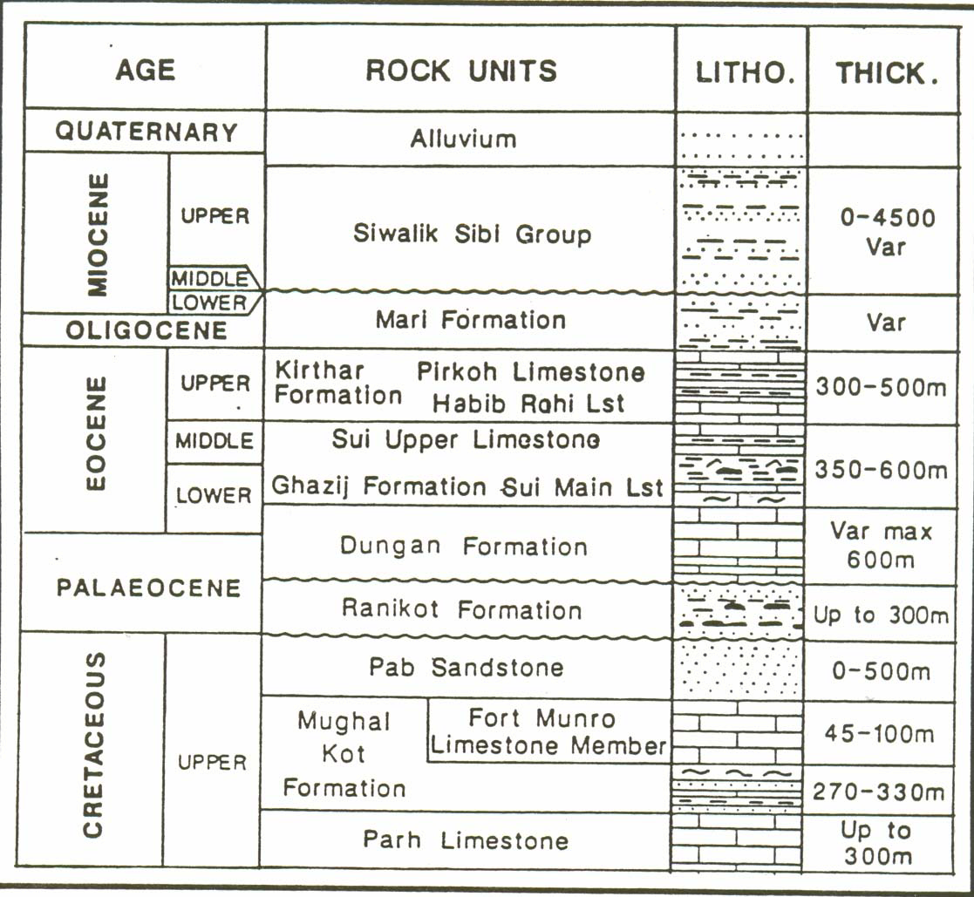
Reservoirss
Cap rock
L.rk
U.rk
Figure 3: Stratigraphic column of the field area showing different formation with thickness( after Alam 1983).

CHAPTER 4

WIRELINE LOGGING

WIRELINE LOGGING.

Wireline logging, also known as borehole logging/Geophysics, to develop a detailed record of the geologic formations penetrated in a borehole. The log/records may be based either on visual inspection of samples brought to the surface (geological logs) or on physical measurements made by instruments lowered into the hole (geophysical logs). Wireline logs are made by Geophysical methods.
Although the most common uses of logs are for correlation of geological strata and location of hydrocarbon zones, there are many other important subsurface parameters that need to be detected or measured by using these logs. Also, different borehole and formation conditions can require different tools to measure the same basic property. In petroleum engineering, logs are used to: identify potential reservoir rock; determine bed thickness; determine porosity; estimate permeability; locate hydrocarbons; estimate water salinity; quantify amount of hydrocarbons; estimate type and rate of fluid production; estimate formation pressure; identify fracture zones; measure borehole inclination and azimuth; measure hole diameter; aid in setting casing; evaluate quality of cement bonding; locate entry, rate, and type of fluid into borehole; and trace material injected into formations (such as artificial fractures).

4.1 CREATING WIRELINE LOGS.

To perform a logging operation, the measuring instrument, often called a probe or sonde, is lowered into the borehole on the end of an insulated electrical cable. The cable provides power to the downhole equipment. Additional wires in the cable carry the recorded measurement back to the surface. The cable itself is used as the depth measuring device, so that properties measured by the tools can be related to particular depths in the borehole. A logging tool is made up of a sonde and a cartridge. The sonde is the portion of the tool which gives off energy, receives energy, or both. The cartridge contains the electrical circuitry or computer components needed to control the downhole equipment, and to transmit data to and from the surface. Combination logging tools consist of more than one sonde and cartridge, so that more than one log can be recorded on a single trip into the wellbore. Surface equipment is mounted in a logging truck, van, or skid unit from which all logging operations are controlled. The logging unit contains hoisting equipment for lowering and raising the tools in the hole, and electronic or computer equipment for controlling and recording the downhole measurements.

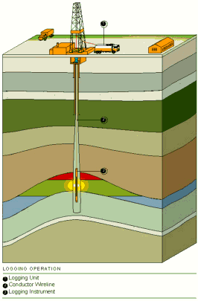
Figure 4.1: LOGGING OPERATION(“Well logging basics” by “Baker Hughes
INTEQ” 1992)

4.2 BORE HOLE ENVIRONMENT.
Where a hole is drilled into a formation, the rock and the fluid in the rock undergoes the alteration in the vicinity of the borehole. The borehole and the rock surrounding it are contaminated by the drilling mud, which affects logging measurements.
Borehole conditions effecting the log measurements.
- Borehole size.
- Drilling mud.
- Mud cake.
- Mud filtrate.
- Invasion.
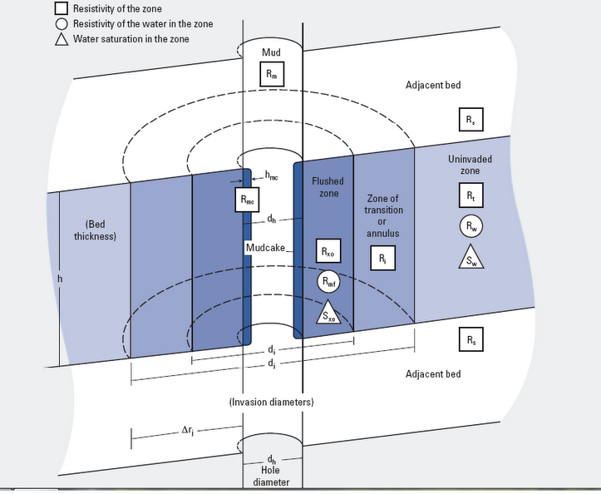
Figure 4.2: Borehole environment

4.3 Borehole size.
The Borehole size is determined by the outside diameter of the drill bit. The normal size of the hole is taken to be the outside diameter measurement of the drilling or coring bit used to make the hole. Borehole is seldom perfectly circular, it is usually elliptical due to removal of more material in the direction of least subsurface stress.
4.4 Drilling mud.
- The main functions of drilling mud are.
- Remove cuttings from well.
- Suspend and release cuttings.
- Control formation pressures.
- Seal permeable formations.
- Maintain wellbore stability.
- Minimizing formation damage.
- Cool, lubricate, and support the bit and drilling assembly.
- Ensure adequate formation evaluation.
- Facilitate cementing and completion.
- Minimize impact on environment.
The hydrocarbon static pressure of the drilling fluid must be greater than the formation fluid pressure, this overbalance system allows the entry of the mud fluid in to the pore spaces of the permeable rock, and this entry of the mud is called invasion of the drilling mud that affects the logging tool response.
4.5 Mud cake.
Mud cake is formed within the few minutes of the formation being penetrated. Clay particles are caked against the size of the borehole and effectively seal off the formation to further invasion. Invasion take place continuously as the hole is dependent because the mud cake becomes damaged or is removed by drilling, logging or testing tool. The presence of the mud cake is usually a good indication of the permeable rock.

4.6 Mud filtrate.
Fluid which enters permeable zone from the mud is called mud filtrate. The filtrate is usually the water in the normal mud system and its resistivity is dependent on the original salinity of the mud system. All logging tools are affected to some degree by mud filtrate.
4.7 INVASION.
Drilling fluid invasion is a process that occurs in a well being drilled with well bore pressure than formation pressure. The liquid component of the drilling fluid continues to invade the porous and permeable formation until the solids present in the mud.
4.8 Invasion Profile.
The process of invasion creates an invasion profile extending from the well bore in to the formation. Three zones are recognized
- Flushed zone
- Transition zone
- Uninvaded zone
The invaded zone is that portion of the formation which has been penetrated in the drilling fluids.
- Flushed zone.
The flushed zone extends only a few inches from the wellbore and is part of the invaded zone. The volume close to the borehole wall in which all the moveable fluids have been displaced by mud filtrate. The flushed zone contains filtrate and the remaining hydrocarbons.
- Transition zone.
The zone where the formation’s fluid and mud filtrate are mixed. The volume between the flushed zone and the undisturbed zone in which the mud filtrate has only partially displaced the moveable formation fluids.

- Uninvaded zone.
The part of the formation that has not been affected by invasion. The uninvaded zone is located beyond the invaded zone. Pores in the uninvaded zone are uncontaminated by mud filtrate.

CHAPTER 5

LOGGING TOOLS AND PRINCIPALS

5.1 GAMMA RAY LOG.
5.1.1APPLICATION
Standard Gamma Ray Applications:
  - Primary depth reference for all logging runs.
  - Correlation from well to well.
  - Lithology identification.
  - Identification of organic material, permeable beds and source rocks.
  - Fracture identification.
  - Calculate clay volumes.
Natural Gamma Ray Tool (NGT) Applications:
  - Detect, identify and evaluate radioactive minerals.
  - Identify clay type and calculate clay volumes.
  - Provides insight into depositional environment and the diagenetic history.
  - Uranium response of NGT is sometimes useful as a moved fluid indicator.
  - Permeable beds may have higher Uranium salt content than less permeable beds.
The Gamma Ray log is typically run with most logging runs as a correlation tool since natural Gamma Rays can pass through casing. Production tools and perforating equipment can be accurately positioned using the Gamma Ray as a correlation tool. Slim hole Gamma Ray tools, 1 11/16", 1 7/16" and 1" in diameter for example, can be run through tubing to correlate TCP (Tubing Conveyed Perforation) guns on depth. A Gamma Ray tool can be run in boreholes with up to 20,000psi, 350degF and less than 24 inch hole diameter.
5.1.2 THEORY OF MEASUREMENT
There are two types of Gamma Ray measurements used by the wireline logging industry.

Naturally occurring Gamma Rays:
These are Gamma Rays that occur naturally in the formation and have relatively low energy levels. Tools that measure natural Gamma Rays are known as standard and gamma spectrometry tools. Standard Gamma Ray tools measure the occurrence of all Gamma Rays. Spectrometry Gamma Ray tools also measure the Gamma Ray energy levels and therefore determines the concentrations of the three normally present radioactive elements namely Uranium (Ur235/238), Potassium (Isotope 19K40) and Thorium (Th232). These have long half-lives and their radiation energy level is like a material fingerprint that is unique to the material being measured.
Induced Gamma Rays:
Tools such as gamma - gamma logs use a high energy Gamma Ray source to measure other formation parameters.
5.1.3 INTERPRETATION.
The most common naturally occurring radioactive elements are 19K40 isotope, Th232 and Ur235/238. The "average" shale contains 2% potassium, 12-ppm thorium and 6ppm uranium. A high Gamma Ray measurement therefore usually indicates a shale sequence. The Gamma Ray tool is often used as the primary indicator of shale content. The percentage of rock that is considered shale and not rock matrix can be estimated by: -
V_{shale} = (GR_{log} – GR_{clean})
(GR_{shale} - GR_{clean})
The Gamma Ray appearance can be used to help identify different depositional environments and therefore used as a stratigraphic tool. As stated before, the Spectrometry Gamma Ray tool measures not only the number of Gamma Rays returned but also their individual energies. Each energy level is a characteristic of the type of formation being logged. Analysis of the potassium, thorium and uranium energies can help indicate fractures, mineralogy and clay type.
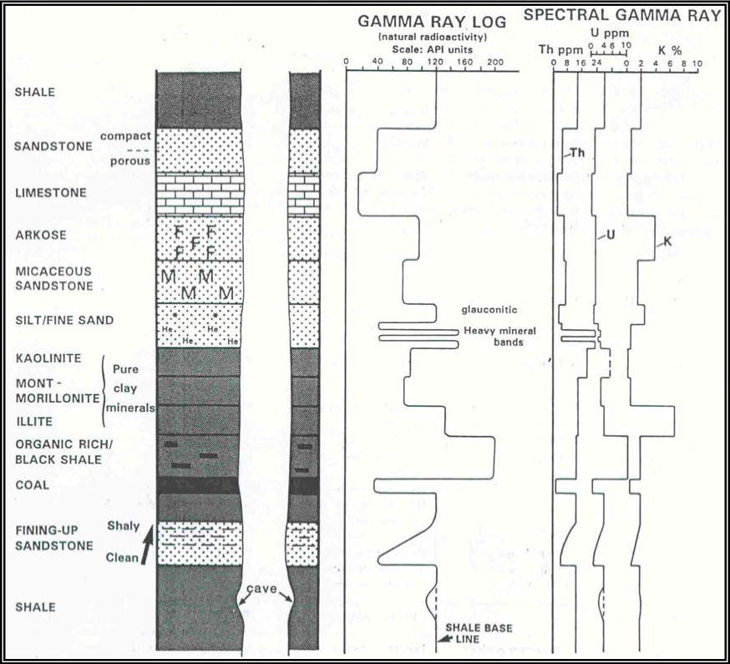
Figure 5.1: Idealized GR log (after “Well logging basics” by“Baker Hughes INTEQ” 1992)

5.2 SONIC LOG.
5.2.1 APPLICATION:
  - Porosity PHIS.
  - Volume of clay V_{S.}
  - Lithology.
  - Time-depth relationship.
  - Reflection coefficients.
  - Mechanical properties.

By combining sonic and Checkshot data we can calibrate downhole log data with surface seismic data. Mechanical properties can be determined from the shear and compressional waves, fracture identification from shear and Stoneley waves and permeability indication from Stoneley waves.
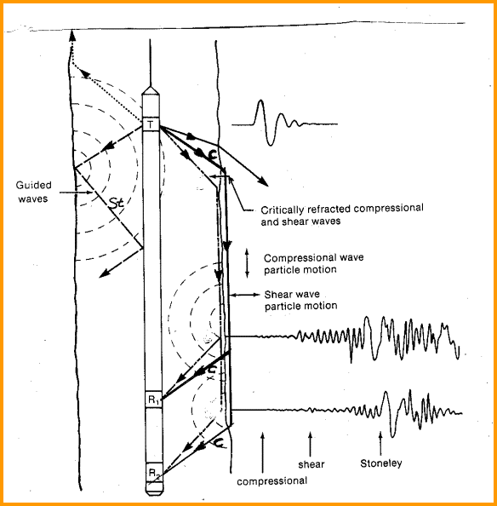 Figure 5.2: (Schematic diagram of a simple sonic log showing sound paths).

5.2.2 THEORY OF MEASUREMENT:
Transmitter emits sound waves into the formation and measures the time taken to detect at a receiver of known distance from the transmitter.The Sonic tool operates at 20 cycles per second as sounds similar to a pedestrian crossing at a set of traffic lights. The first arrival is the compressional or 'p' waves, which travel adjacent to the borehole as shown in Figure 1. It is this arrival that is used to measure the individual travel times T1, T2, T3, and T4. Two receivers for each transmitter eliminates the borehole signal. The transit time DT is computed from these travel times as shown in the equation below. This particular arrangement of sonic tool transmitters and receivers is known as the standard BHC Sonic tool and compensates for borehole washouts and also for tool tilting in real time while logging.
DT_{LOG} = [(T1 - T2) + (T3 - T4)] / 2
Long Spaced Sonic tools
Long spaced sonic tools have a larger spacing between the transmitter and receiver. Tool spacing are 8ft-10ft and 10ft-12ft. This allows a deeper depth of investigation and improves the tool response in larger boreholes or where mud invasion is affecting the standard tool. The DT measurement requires the 8ft-10ft signals to be memorized until the 10ft-12ft signals are recorded and then a DT can be computed. This is known as Depth Derived Borehole Compensation or DDBHC. The long and short spaced sonic tools can be used in combination to identify swelling shales.
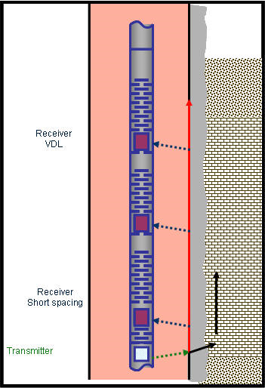
Figure 5.3: Showing Sonic tool(www.ldeo.columbia.edu)

5.3 NEUTRON LOG

The neutron log is a measurement of induced formation radiation produced by fast moving neutrons bombarding the formation. The source used to produce neutrons is usually a mixture of Beryllium and Radium. As Radium decays, it emits alpha particles. The Beryllium responds to those alpha particles by emitting neutrons. Other sources include:

- Plutonium - Beryllium: large volume needed to produce neutrons.
- Americium - Beryllium: good source.

Neutrons are electrically neutral, having approximately the same mass as hydrogen. They can penetrate dense matter (sands or limestones) with little loss of energy or velocity. Energy loss is a function of:

- Angle of collision.
- Relative mass of the struck nucleus.

When a neutron collides with a hydrogen nucleus, it will lose about half its energy. After about 20 collisions with hydrogen, the neutron will be captured by one of the various elements in the formation (e.g., chloride, silicon, hydrogen). Those neutrons which are captured (thermal neutrons) emit a secondary gamma ray.

5.3.1 TYPES OF NEUTRIN DETECTORS.

One type of detector measures neutrons just about thermal speed (epithermal). It shows maximum sensitivity to neutrons having energies above the thermal level and minimal sensitivity to gamma rays and thermal neutrons. This reduces those errors which arise from variations in formation chemistry and resolves porosity in areas where lithologies and liquids are mixed. There is a neutron detector which measures the neutron population at thermal energy. It responds to all formation and well parameters that affects neutron density.
- In salt water the count rate is lowered.
- It is influenced by for mation chemistry.

Another detector responds to the gamma rays that are emitted upon neutron capture. Gamma ray emission can occur (1) in the formation, (2) in the wellbore, (3) in the materials that make up the detector, and (4) in the detector crystals. Also the densities of materials will affect the quality of gamma ray transmission.

Neutron Log Response

Neutron logs are basically a measure of the amount of hydrogen contained in the formation. High neutron count rate indicates low porosity, while low neutron count rate indicates high porosity. While there is very little difference between oil and water, the neutron tool will distinguish between gas and oil saturations. When gas is measured, the porosity will appear very low. The neutron log is a very good porosity indicator in limestones.

5.3.2 APPLICATIONS OF THE NEUTRON LOG

The main use of the neutron log is to assist in the determination of porosity. It has the added application in that it can be run in cased or open hole with any type of drilling fluid. The log response is greatly affected by gas, so it may assist in the detection of gas intervals. It is also used for the correlation of lithologic units from well to well.

Sidewall Neutron Log – SNP

The sidewall neutron tool is similar to the other neutron devices in its operation. The main difference is that the source is mounted on a skid which is expanded against the borehole wall. This allows the neutrons to be focused into formation, eliminating the environmental effects. Porosity can be read directly from the log. It has the ability to detect gas and can assist in determining lithology. The tool can be run in open hole with any fluid and has the added benefit of responding to primary and secondary porosity. The sidewall neutron device cannot be used in cased holes, and, for correct porosity determination, the lithology must be known.

Compensated Neutron Log – CNL

The CNL is a dual spaced thermal - neutron detection instrument. It contains a 16 - curie source which is designed to reduce statistical variation. Many borehole effects are reduced by taking the ratio of two count rates. Porosity may be read directly from the log if the lithology is known. The response will help detect gas and with vendor charts can assist in the determination of lithology. For most consistent evaluation, the CNL should be used with other open hole logs. When used in cased hole logging, the diameter of the open hole before running casing must be known for effective interpretation.

5.3.3 Quality Control of Neutron Logs

- Check the calibration located on the bottom of the log.
- Run 200 feet of repeat log and compare logs. The two should repeat.
- Check depth with the resistivity log.
- Check porosity values in a known lithology.
- Curves should show good detail and be smooth.
- Curves should be identified on the log.

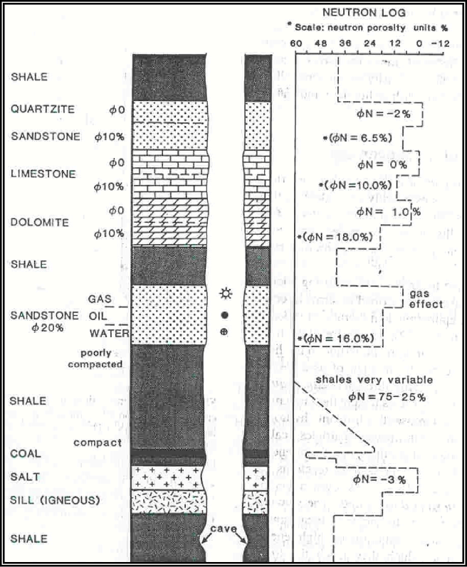
Figure 5.4: Idealized Neutron log (after “Well logging basics” by “Baker HughesINTEQ” 1992)

5.4 DENSITY LOG.
5.4.1 APPLICATION
The density tool is used to determine formation density and estimate formation porosity. Together with other tools like the Neutron, the lithology and formation fluid type can also be determined. The density tool can distinguish between oil and gas in the pore space by virtue of their different densities. Modern density tools also measure the photoelectric effect to help distinguish between rock lithologies, recognize presence of heavy minerals, fracture identification when barite is present and additional clay evaluation. In addition the density can be used to determine Vclay and to calculate reflection coefficients to process synthetics. A chemical source bombards gamma rays into the formation. The high-energy gamma rays interact with the electrons of the formation by way of Compton scattering and lose energy in the process. Other processes also occur namely photoelectric absorption and pair production, although pair production only becomes significant at energies above 1MeV. A low number of gamma rays detected through Compton scattering will indicate a high electron density. The bulk density r_{B} has a close relationship to the electron density as shown by the following determined equation: -
RHOB = 1.0704*RHOe - 0.1883
A spectral or litho density tool measures not only the bulk density but also a photoelectric absorption index PEF. The photoelectric effect occurs when the incident gamma ray of low energy is absorbed by the electron and the electron is then ejected from the atom.
PEF = (Z/A)^{3.6}
A=Atomic weight, Z=Atomic number.
The photoelectric effect of absorbed gamma rays is directly related to the Z, the number of electrons per atom, which is fixed for each element. Different values of the PEF curve indicate different types of formation rock being measured and are independent of formation porosity. The Density tool is usually run together with the Neutron tool. The Density has a backup caliper arm to push the pad against the borehole wall and the Neutron uses a bow spring.
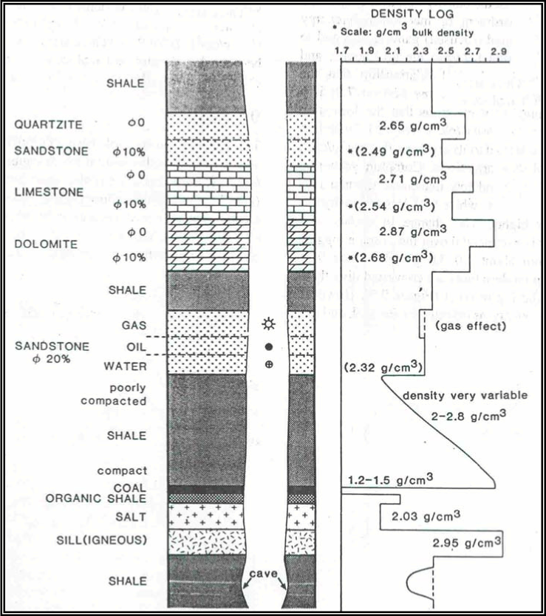

Figure 5.5: Idealize density log (after “Well logging basics” by “Baker HughesINTEQ” 1992)

5.4.2 Density Porosity Determination
Since the bulk density (r_{B}) is a measure of the matrix density (rma) and the fluid density (rf) in the pore space, then the amount of pore space or formation porosity can be determined. The rma and rf must however be known.

RHOB = RHOMA(1-PHID) + PHID*RHOF
Or
PHID = (RHOB - RHOMA) / (RHOF- RHOMA)

Where:-
RHOB = Density log reading.
RHOMA = Density Matrix.
RHOF = Density Fluid.
PHID = Density Porosity.

5.5 RESISTIVITY LOGS

Resistivity logging is a method of well logging that works by characterizing the rock or sediment in a borehole by measuring its electrical resistivity. Resistivity is a fundamental material property which represents how strongly a material opposes the flow of electric current. In these logs, resistivity is measured using 4 electrical probes to eliminate the resistance of the contact leads. The log must run in holes containing electrically conductive mud or water.
Resistivity logging is sometimes used in mineral exploration and water-well drilling, but most commonly for formation evaluation in oil- and gas-well drilling. Most rock materials are essentially insulators, while their enclosed fluids are conductors. Hydrocarbon fluids are an exception, because they are almost infinitely resistive. When a formation is porous and contains salty water, the overall resistivity will be low. When the formation contains hydrocarbon, or contains very low porosity, its resistivity will be high. High resistivity values may indicate a hydrocarbon bearing formation.
Usually when drilling, drilling fluids invade the formation, changes in the resistivity are measured by the tool in the invaded zone. For this reason, several resistivity tools with different investigation lengths are used to measure the formation resistivity. If water based mud is used and oil is displaced, "deeper" resistivity logs (or those of the "virgin zone") will show lower conductivity than the invaded zone. If oil based mud is used and water is displaced, deeper logs will show higher conductivity than the invaded zone. This provides not only an indication of the fluids present, but, at least quantitatively, whether the formation is permeable or not.

5.5.1 Tools Measuring the Uninvaded Zone (Rt)

These tools (deep induction and deep laterolog) essentially measure Rt, and the log value is normally quite close to true Rt, providing the tool is used in the correct environment. To obtain a more precise value for Rt, certain corrections must be applied to the raw values.

5.5.2 Tools Measuring the Invaded zone (Ri)

The actual quantitative value of these readings is not as important as how these readings relate to Rt and Rxo. By comparing them, we can obtain:
  - Corrected Rt values.
  - Depth of invasion of the mud filtrate.
  - An idea of the formation’s permeability.

5.5.3 Tools Measuring the Flushed Zone (Rxo)

Four different Rxo tools are available, the ML, MLL, PL and MSFL. They are intended for different conditions of salinity, mud cake thickness and diameters of invasion.

5.6 LATERO LOG
5.6.1 APPLICATION
The Laterolog tool was introduced to measure the formation resistivity in salty or high conductive mud and is used to detect the presence of hydrocarbon bearing zones. By analyzing resistivity measurements, we can differentiate between formations containing conductive and non-conductive fluids. Conductive fluids in the formation usually consist of water or mud filtrate and non-conductive fluids consist of oil and gas. Using equations such as the Archie formula shown below, we can establish the relative proportions of hydrocarbons and water resident in the formation:
Rt = aR_{w} /(PHI^{m} S_{w}²)
Where:-
Rt = Formation Resistivity.
R_{w} = Formation water resistivity.
PHI = Formation Porosity.
S_{w}= (Water Saturation).
n = 2, Saturation component.
a and m, experimentally determined constants
where a is close to 1 and m is close to 2
F = Formation Factor = a/PHI^{m}

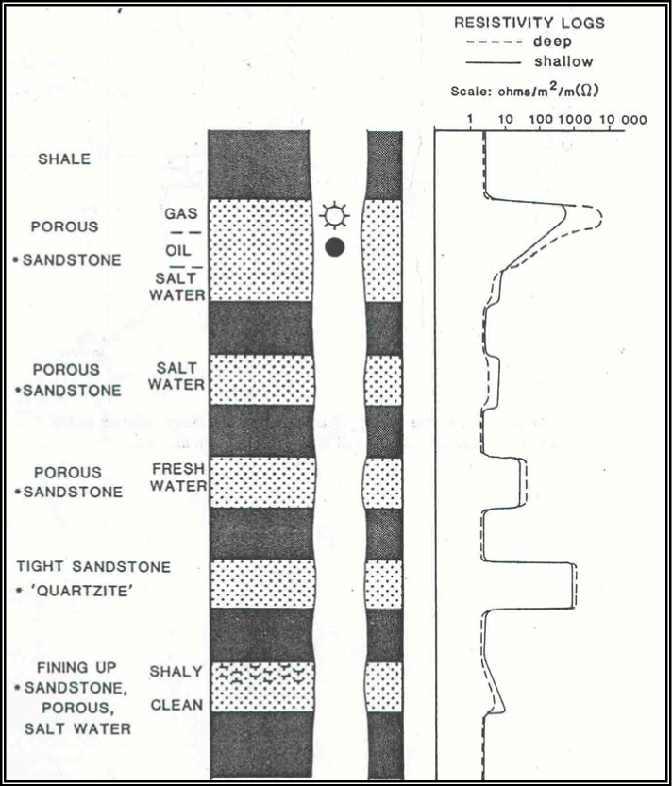
Figure 5.6: Ideal resisitivity log (after “Well logging basics” by “Baker Hughes INTEQ” 1992).

CHAPTER 6

PETROPHYSICAL ANALYSIS

6.1 PETROPHYSICS
Petrophysics is the study of the physical and chemical properties that describe the occurrence and behavior of rocks, soils and fluids. Petrophysics mainly studies reservoirs of resources, including ore deposits and oil or natural gas reservoirs. Some of the key properties studied in Petrophysics are lithology, porosity, water saturation, permeability, density, solid mechanics, magnetization, electrical conductivity, thermal conductivity and radioactivity.

6.2 METHODOLOGY ADAPTED
Logs available for this study have been analyzed to measure the parameters by using different wireline logs. Following Flow chart show all the parameters,

METHODOLOGY.
RAW LOG CURVE

LITHOLOGY IDENTIFICATION (PEF)

VOLUME OF SHALE Vsh (GR log)

POROSITY (Sonic, Neutron, Density, Neutron & Density)

RESISTIVITY OF WATER Rw (Resistivity log)

SATURATION OF WATER (Sw)

SATURATION OF HYDROCARBON (Sh)

6.3 WIRELINE LOGS
- Data included the
  - GR log values in API unit
  - Resistivity Logs
    - Micro-Spherically Focused Log values(MSFL) in Ohmm unit
    - Shallow Later log values (LLs) in Ohmm unit
    - Deep Later log values (LLd) in Ohmm unit
  - Neutron log values in V/V unit
  - Density Logs in G/C3 unit
- Raw log curves included all the log curves, which are given to study and find out the values of all parameters. Each log curve gives values of parameters at different depths.

6.4 LITHOLOGY
Lithology is determined by Photoelectric effect log (PEF) at different depths.

6.5 VOLUME OS SHALE
Gamma ray log is most widely used method for shale determination. In quantitative evaluation of shale content, it is assumed that radioactive minerals are absent in clean rocks and are compare to shaly rocks.
Vsh = (GR log – GR min)
(GR max – GR min)
where;
V_{sh} = volume of shale (%)
GR_{log} = GR log reading at specific point (API Unit)
GR_{min} = Gamma Ray minimum across interval (API Unit) i.e.10
GR_{max} = Gamma Ray maximum across interval (API Unit) i.e.210

6.6 POROSITY
Porosity can be defined as the ratio of voids to the total volume of rock. It is represented as a decimal fraction or as a percentage and is usually represented by the greek letter phi.
Porosity = volumes of pores
Total volume of rock

6.6.1 Porosity calculation using Sonic log
- The porosity from the sonic slowness is different than that from the density or neutron tools.
- A sonic log is a recording against the depth of the travel time of high frequency acoustic pulses through formation close to the borehole.

- The basic equation for sonic porosity is the Wyllie Time Average:

Where
- ∆t = Zone Transit Time
- Ø = porosity
- ∆tma = Matrix Transit Time
i.e. 51 µ sec/ft
- ∆tfl = Pore Fluid Transit Time
i.e. 189 µ sec/ft

6.6.2 Porosity calculation using Neutron log
- We can read direct porosity from neutron log.
- Neutron log is a response primarily related to hydrogen concentration but also affected by mineralogy and borehole effects.
- Neutron log is useful to ascertain the presence of gas and determine shaliness.

6.6.3 Porosity calculation using density log
There are two inputs into the porosity equation:
- The matrix density and the fluid density.
- The fluid density is that of the mud filtrate
- The density log reading (ρ_{b}) is interpreted in terms of porosity (ø) of the formation using the following expression:

- ρ_{ma} = Density of the Matrix Material i.e. 2.65
- ρ_{f} = Pore Fluid Density i.e. 1

6.6.4 POROSITY FROM NEUTRON & DENSITY LOG
- The combination of density and neutron logs is used commonly as a means to determine porosity that is largely free of lithology effects.
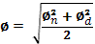

- Where and are neutron and density porosities.

6.7 RESISTIVITY OF WATER
Resistivity of water in the reservoir zone is an essential factor to calculate. From the value of Rw we can find the value of saturation of water in the virgin zone. So Laterolog deep resistivity is used to find the value of Neutron Phi.
Rw = (PHIE)² Rt
Where the value of Ø is 0.27 and the value of true resistivity (Rt) of formation is taken from a deep Laterolog (LLD) is 1.13 then the above mentioned equation becomes
Rw = (0.27)² * (1.13)
Rw = 0.082 Ohmm

6.8 SATURATION OF WATER
The fraction of pore spacing contain water is termed as water saturation, denoted Sw. Saturation of water gives information about the presence of hydrocarbon in reservoir. If saturation of water is less, then saturation of hydrocarbon’s are high, but if Sw is 100% that indicates hydrocarbon’s are absent in that zone.
Archie equation is the most basic formula to calculate Sw
Sw = √Rw * a / Фm * Rt
The formation Rt is calculated from LLD and Rw from formula.

6.9 SATURATION OF HYDROCARBON
Calculation of saturation of hydrocarbon is very important step, because in every reservoir potential to produce hydrocarbon’s checked. If hydrocarbon’s are present in excess amount then the next process begins, if Saturation of hydrocarbon is less drilling should be stopped and declared the well dry.
Formula:
Total fluid = Hydrocarbon + Water
SH + Sw = 1
Sh = 1 – Sw

Graphs:
Depth vs Vsh

- Above graph showing Vsh on y-axis and depth on x-axis, the maximum value that 0.63 is encountered at depth 2173 and minimum value 0.07 is at 2196 and the average value is 0.30.

Depth vs Sonic

- Above graph showing Phis on y-axis and depth on x-axis, the maximum value that is 0.26 at depth 2160 and 2166 and minimum value 0.08 at depth 2168 and 2171. The average value is 0.15.

Depth vs Neutron

- Above graph showing NPHI on y-axis and depth on x-axis, the maximum value that 0.6 at depth 2200 and minimum value 0.02 at 2196. The average value is 0.17.

Depth vs Density

- Above graph showing density value which are mostly lies at 1.6 against the depth interval of well.

Depth vs PhiND

- Above graph showing PhiND on y-axis and depth on x-axis, the maximum value that is 1.15 and minimum value of 0.07 is encountered at different depths.

Depth vs SW

- Above graph showing Sw on y-axis and depth on x-axis, the maximum value that is 0.9 and minimum value 0.09 is encountered at 2200.

Depth vs Sh

- Above graph showing Sh on y-axis and depth on x-axis, the maximum value that is 0.9 at depth 2200 and minimum value 0.09 is encountered at depths 2170 and 2178.

Depth vs Vsh,Phis,PhiN,PhiD,PhiND,SW,SH

CONCLUSION
By utilizing the available data following petrophysical analysis has been conducted in this study:

- Porosity of formation is calculated from different methods
  - Porosity from Neutron Log (5 to 25%) with average porosity of 17%
  - Porosity from Sonic Log (10 to 30%) with average porosity of 15%

- The Average Value of Vshale lies below 35%, So the formation i.e lower Ranikot and Pab-Sandstone consider as clean formation.

- Resistivity of water has been computed through Archie Equation Method i.e. 0.082 ohmm.

- The average Water Saturation is below then 30% so it is considered as good reservoir.

- During my study I have found above mentioned values in my study zone and applying the cutoff parameters of Shale volume, Porosity, Water Saturation, the details of cutoff parameters are as under:
- Cutoff of Vshale <35%
- Cutoff of Porosity >8%
- Cutoff of Water Saturation <30%

APPENDIX-I
Depth |  | GR | DT |  | DRHO | PEF |  | LLD | Nphi |  | RHOB
2150 | 100 |  | 80 | -0.01 |  | 2.2 | 5 |  |  | 0.27
2151 | 100 |  | 70 | 0.05 |  | 1.9 | 6 |  |  | 0.21
2152 | 110 |  | 78 | 0.02 |  | 2.5 | 3.5 |  |  | 0.25 | 2.62
2153 | 95 |  | 70 | 0.09 |  | 2.8 | 6 |  |  | 0.19
2154 | 85 |  | 79 | 0.04 |  | 2.2 | 6 |  |  | 0.36 | 2.83
2155 | 110 |  | 82.5 | 0 |  | 2.4 | 5 |  |  | 0.26 | 2.75
2156 | 120 |  | 80 | 0.15 |  | 2.6 | 3.1 |  |  | 0.32
2157 | 90 |  | 77 | 0 |  | 2 | 5 |  |  | 0.24
2158 | 102 |  | 80 | 0.08 |  | 2.9 | 4 |  |  | 0.24
2159 | 90 |  | 67 | 0.12 |  | 2.5 | 12 |  |  | 0.12
2160 | 95 |  | 88 | 0 |  | 2 | 4 |  |  | 0.35 | 2.55
2161 | 80 |  | 83 | 0.01 |  | 2 | 6 |  |  | 0.28 | 2.64
2162 | 80 |  | 70 | 0 |  | 1.5 | 10 |  |  | 0.22
2163 | 60 |  | 75 | 0.1 |  | 2.9 | 20 |  |  | 0.13
2164 | 50 |  | 70 | 0.12 |  | 3 | 35 |  |  | 0.1
2165 | 130 |  | 82 | 0.05 |  | 2.2 | 4 |  |  | 0.4
2166 | 110 |  | 88 | 0 |  | 2 | 6 |  |  | 0.27 | 2.2
2167 | 42 |  | 64 | 0 |  | 2.7 | 80 |  |  | 0.04 | 3.56
2168 | 30 |  | 63 | 0 |  | 2.6 | 70 |  |  | 0.06 | 2.45
2169 | 70 |  | 70 | 0.2 |  | 2.2 | 10 |  |  | 0.08
2170 | 45 |  | 70 | 0.01 |  | 2.4 | 40 |  |  | 0.05 | 2.5
2171 | 42 |  | 63 | 0.014 |  | 2.9 | 50 |  |  | 0.06 | 2.5
2172 | 60 |  | 74 | 0.06 |  | 2.3 | 10 |  |  | 0.22
2173 | 135 |  | 83 | 0.25 |  | 2 | 4 |  |  | 0.28
2174 | 125 |  | 80 | 0.01 |  | 1.6 | 5 |  |  | 0.3
2175 | 90 |  | 68 | 0.01 |  | 1.6 | 7 |  |  | 0.26 | 2.51
2176 | 65 |  | 75 | -0.02 |  | 2.6 | 10 |  |  | 0.12 | 2.96
2177 | 45 |  | 69 | 0 |  | 2.2 | 18 |  |  | 0.09 | 2.35
2178 | 32 |  | 68 | 0 |  | 2.2 | 40 |  |  | 0.05 | 2.45
2179 | 35 |  | 70 | 0 |  | 2.2 | 40 |  |  | 0.07 | 2.44
2180 | 42 |  | 65 | 0 |  | 2.5 | 50 |  |  | 0.06 | 2.5
2181 | 60 |  | 67 | 0 |  | 2.5 | 40 |  |  | 0.06 | 2.47
2182 | 35 |  | 65 | 0 |  | 2.6 | 50 |  |  | 0.06 | 2.51
2183 | 40 |  | 67 | 0.02 |  | 2.5 | 50 |  |  | 0.06 | 2.51
2184 | 95 |  | 65 | 0.1 |  | 2.5 | 18 |  |  | 0.16
2185 | 72 |  | 67.5 | 0.1 |  | 2.4 | 16 |  |  | 0.13
2186 | 85 |  | 68 | 0.24 |  | 2 | 40 |  |  | 0.06
2187 | 70 |  | 70 | 0.05 |  | 1.8 | 7 |  |  | 0.27
2188 | 78 |  | 73 | 0.2 |  | 2 | 20 |  |  | 0.14
2189 | 40 |  | 68 | 0.05 |  | 1.8 | 25 |  |  | 0.18
2190 | 80 |  | 76 | 0.1 |  | 2.1 | 10 |  |  | 0.19
2191 | 75 |  | 85 | 0 |  | 1.8 | 8 |  |  | 0.21
2192 | 75 |  | 68 | -0.02 |  | 1.7 | 8 |  |  | 0.07 | 2.45
2193 | 62 |  | 77 | -0.03 |  | 1.4 | 6 |  |  | 0.21 | 2.38
2194 | 55 |  | 70 | 0 |  | 2.3 | 18 |  |  | 0.09 | 3.48
2195 | 30 |  | 72 | 0 |  | 2.3 | 19 |  |  | 0.09 | 2.45
2196 | 25 |  | 65 | 0.02 |  | 2.3 | 70 |  |  | 0.02 | 2.49
2197 | 45 |  | 66 | 0.1 |  | 2.3 | 9 |  |  | 0.12
2198 | 60 |  | 75 | 0.05 |  | 2.5 | 10 |  |  | 0.11
2199 | 50 |  | 70 | 0 |  | 2.6 | 20 |  |  | 0.1 | 2.49
2200 | 42 |  | 70 | 0.04 |  | 2.5 | 25 |  |  | 0.6 | 2.46
2201 | 57 |  | 63 | 0.02 |  | 2.5 | 40 |  |  | 0.09 | 2.56
2202 | 62 |  | 71 | 0.02 |  | 2.6 | 18 |  |  | 0.1 | 2.47
2203 | 77 |  | 70 | 0.03 |  | 2.5 | 12 |  |  | 0.1 | 2.35
2204 | 135 |  | 76 | 0.05 |  | 1.9 | 7 |  |  | 0.15
2205 | 50 |  | 73 | 0.01 |  | 2 | 15 |  |  | 0.08 | 2.44
2206 | 42 |  | 70 | 0.02 |  | 2 | 22 |  |  | 0.05 | 2.47
2207 | 58 |  | 71 | 0.08 |  | 2 | 20 |  |  | 0.08
2208 | 70 |  | 70 | 0 |  | 2.5 | 12 |  |  | 0.13 | 2.38
2209 | 40 |  | 71 | 0.01 |  | 2.1 | 20 |  |  | 0.09 | 2.43
2210 | 38 |  | 70 | 0.02 |  | 2.2 | 30 |  |  | 0.02
2211 | 90 |  | 70 | 0.25 |  | 2.3 | 10 |  |  | 0.1
2212 | 60 |  | 70 | 0.25 |  | 2.2 | 15 |  |  | 0.08
2213 | 55 |  | 65 | 0.03 |  | 2.2 | 60 |  |  | 0.04
2214 | 60 |  | 75 | 0.15 |  | 2 | 20 |  |  | 0.03
2215 | 55 |  | 63 | 0.2 |  | 2 | 100 |  |  | 0.01
2216 | 25 |  | 62 | 0 |  | 2 | 80 |  |  | 0.01 | 2.51
2217 | 30 |  | 61 | 0.1 |  | 2 | 120 |  |  | 0.01
2218 | 35 |  | 60 | 0.16 |  | 2 | 120 |  |  | 0.02
2219 | 90 |  | 69 | 0.1 |  | 2 | 30 |  |  | 0.03
2220 | 40 |  | 65 | 0.25 |  | 2 | 90 |  |  | 0.02
2221 | 60 |  | 67 | 0.05 |  | 2 | 40 |  |  | 0.06
2222 | 25 |  | 61 | -0.01 |  | 2 | 150 |  |  | 0.01 | 2.5
2223 | 30 |  | 59 | -0.01 |  | 2 | 180 |  |  | 0.01 | 2.53
2224 | 35 |  | 64 | 0.16 |  | 2 | 25 |  |  | 0.06
2225 | 25 |  | 70 | 0 |  | 2.2 | 15 |  |  | 0.1 | 2.37
2226 | 60 |  | 75 | 0.2 |  | 2 | 15 |  |  | 0.09
2227 | 38 |  | 66 | 0.01 |  | 2.2 | 40 |  |  | 0.05 | 2.45
2228 | 140 |  | 69 | 0.02 |  | 2.2 | 6 |  |  | 0.19
2229 | 150 |  | 65 | 0.11 |  | 2.1 | 8 |  |  | 0.15
2230 | 40 |  | 60 | 0 |  | 2 | 90 |  |  | 0.01 | 2.54
Table 1: Showing different values from depth 2150 to 2230

APPENDIX-II
PHID | PHIND |  |  | PHIS | ρ_{MA} |  | Vsh | GR  Max | SW | SH |  | GR  Min
1.606061 |  | 1.151593 | 0.210145 |  | 2.65 | 0.45 |  | 210 | 0.474305 |  | 0.525695 | 10
1.606061 |  | 1.145323 | 0.137681 |  | 2.65 | 0.45 |  | 210 | 0.556688 |  | 0.443312 | 10
0.018182 |  | 0.177244 | 0.195652 |  | 2.65 | 0.5 |  | 210 | 0.612256 |  | 0.387744 | 10
1.606061 |  | 1.143576 | 0.137681 |  | 2.65 | 0.425 |  | 210 | 0.615287 |  | 0.384713 | 10
-0.10909 |  | 0.265989 | 0.202899 |  | 2.65 | 0.375 |  | 210 | 0.324735 |  | 0.675265 | 10
-0.06061 |  | 0.188776 | 0.228261 |  | 2.65 | 0.5 |  | 210 | 0.492548 |  | 0.507452 | 10
1.606061 |  | 1.157979 | 0.210145 |  | 2.65 | 0.55 |  | 210 | 0.508248 |  | 0.491752 | 10
1.606061 |  | 1.148266 | 0.188406 |  | 2.65 | 0.4 |  | 210 | 0.533594 |  | 0.466406 | 10
1.606061 |  | 1.148266 | 0.210145 |  | 2.65 | 0.46 |  | 210 | 0.596576 |  | 0.403424 | 10
1.606061 |  | 1.138822 | 0.115942 |  | 2.65 | 0.4 |  | 210 | 0.688866 |  | 0.311134 | 10
0.060606 |  | 0.25117 | 0.268116 |  | 2.65 | 0.425 |  | 210 | 0.409081 |  | 0.590919 | 10
0.006061 |  | 0.198036 | 0.231884 |  | 2.65 | 0.35 |  | 210 | 0.417516 |  | 0.582484 | 10
1.606061 |  | 1.146261 | 0.137681 |  | 2.65 | 0.35 |  | 210 | 0.411608 |  | 0.588392 | 10
1.606061 |  | 1.139371 | 0.173913 |  | 2.65 | 0.25 |  | 210 | 0.492548 |  | 0.507452 | 10
1.606061 |  | 1.137856 | 0.137681 |  | 2.65 | 0.2 |  | 210 | 0.484031 |  | 0.515969 | 10
1.606061 |  | 1.170348 | 0.224638 |  | 2.65 | 0.6 |  | 210 | 0.357946 |  | 0.642054 | 10
0.272727 |  | 0.271367 | 0.268116 |  | 2.65 | 0.5 |  | 210 | 0.43298 |  | 0.56702 | 10
-0.55152 |  | 0.391004 | 0.094203 |  | 2.65 | 0.16 |  | 210 | 0.800391 |  | 0.199609 | 10
0.121212 |  | 0.095636 | 0.086957 |  | 2.65 | 0.1 |  | 210 | 0.570436 |  | 0.429564 | 10
1.606061 |  | 1.137064 | 0.137681 |  | 2.65 | 0.3 |  | 210 | 1.131923 |  | -0.13192 | 10
0.090909 |  | 0.073364 | 0.137681 |  | 2.65 | 0.175 |  | 210 | 0.905539 |  | 0.094461 | 10
0.090909 |  | 0.077021 | 0.086957 |  | 2.65 | 0.16 |  | 210 | 0.674949 |  | 0.325051 | 10
1.606061 |  | 1.146261 | 0.166667 |  | 2.65 | 0.25 |  | 210 | 0.411608 |  | 0.588392 | 10
1.606061 |  | 1.152786 | 0.231884 |  | 2.65 | 0.625 |  | 210 | 0.511351 |  | 0.488649 | 10
1.606061 |  | 1.155299 | 0.210145 |  | 2.65 | 0.575 |  | 210 | 0.426875 |  | 0.573125 | 10
0.084848 |  | 0.19339 | 0.123188 |  | 2.65 | 0.4 |  | 210 | 0.416279 |  | 0.583721 | 10
-0.18788 |  | 0.157636 | 0.173913 |  | 2.65 | 0.275 |  | 210 | 0.754615 |  | 0.245385 | 10
0.181818 |  | 0.143454 | 0.130435 |  | 2.65 | 0.175 |  | 210 | 0.749943 |  | 0.250057 | 10
0.121212 |  | 0.092716 | 0.123188 |  | 2.65 | 0.11 |  | 210 | 0.905539 |  | 0.094461 | 10
0.127273 |  | 0.102709 | 0.137681 |  | 2.65 | 0.125 |  | 210 | 0.646813 |  | 0.353187 | 10
0.090909 |  | 0.077021 | 0.101449 |  | 2.65 | 0.16 |  | 210 | 0.674949 |  | 0.325051 | 10
0.109091 |  | 0.088036 | 0.115942 |  | 2.65 | 0.25 |  | 210 | 0.754615 |  | 0.245385 | 10
0.084848 |  | 0.073482 | 0.101449 |  | 2.65 | 0.125 |  | 210 | 0.674949 |  | 0.325051 | 10
0.084848 |  | 0.073482 | 0.115942 |  | 2.65 | 0.15 |  | 210 | 0.674949 |  | 0.325051 | 10
1.606061 |  | 1.141278 | 0.101449 |  | 2.65 | 0.425 |  | 210 | 0.421843 |  | 0.578157 | 10
1.606061 |  | 1.139371 | 0.119565 |  | 2.65 | 0.31 |  | 210 | 0.550685 |  | 0.449315 | 10
1.606061 |  | 1.136449 | 0.123188 |  | 2.65 | 0.375 |  | 210 | 0.754615 |  | 0.245385 | 10
1.606061 |  | 1.151593 | 0.137681 |  | 2.65 | 0.3 |  | 210 | 0.400861 |  | 0.599139 | 10
1.606061 |  | 1.139963 | 0.15942 |  | 2.65 | 0.34 |  | 210 | 0.457366 |  | 0.542634 | 10
1.606061 |  | 1.142767 | 0.123188 |  | 2.65 | 0.15 |  | 210 | 0.318174 |  | 0.681826 | 10
1.606061 |  | 1.143576 | 0.181159 |  | 2.65 | 0.35 |  | 210 | 0.476599 |  | 0.523401 | 10
1.606061 |  | 1.145323 | 0.246377 |  |  | 0.325 |  |  | 0.482106 |  | 0.517894
0.121212 |  | 0.098976 | 0.123188 |  |  | 0.325 |  |  | 1.446318 |  | -0.44632
0.163636 |  | 0.188251 | 0.188406 |  |  | 0.26 |  |  | 0.556688 |  | 0.443312
-0.50303 |  | 0.361344 | 0.137681 |  |  | 0.225 |  |  | 0.749943 |  | 0.250057
0.121212 |  | 0.106753 | 0.152174 |  |  | 0.1 |  |  | 0.729941 |  | 0.270059
0.09697 |  | 0.070011 | 0.101449 |  |  | 0.075 |  |  | 1.711307 |  | -0.71131
1.606061 |  | 1.138822 | 0.108696 |  |  | 0.175 |  |  | 0.795435 |  | 0.204565
1.606061 |  | 1.138317 | 0.173913 |  |  | 0.25 |  |  | 0.823217 |  | 0.176783
0.09697 |  | 0.098497 | 0.137681 |  |  | 0.2 |  |  | 0.640312 |  | 0.359688
0.115152 |  | 0.432007 | 0.137681 |  |  | 0.16 |  |  | 0.095452 |  | 0.904548
0.054545 |  | 0.074415 | 0.086957 |  |  | 0.235 |  |  | 0.503077 |  | 0.496923
0.109091 |  | 0.104644 | 0.144928 |  |  | 0.26 |  |  | 0.674949 |  | 0.325051
0.181818 |  | 0.146727 | 0.137681 |  |  | 0.335 |  |  | 0.82664 |  | 0.17336
1.606061 |  | 1.140599 | 0.181159 |  |  | 0.625 |  |  | 0.72155 |  | 0.27845
0.127273 |  | 0.106298 | 0.15942 |  |  | 0.2 |  |  | 0.924211 |  | 0.075789
0.109091 |  | 0.084855 | 0.137681 |  |  | 0.16 |  |  | 1.221028 |  | -0.22103
1.606061 |  | 1.137064 | 0.144928 |  |  | 0.24 |  |  | 0.800391 |  | 0.199609
0.163636 |  | 0.147778 | 0.137681 |  |  | 0.3 |  |  | 0.635877 |  | 0.364123
0.133333 |  | 0.113749 | 0.144928 |  |  | 0.15 |  |  | 0.711458 |  | 0.288542
1.606061 |  | 1.135744 | 0.137681 |  |  | 0.14 |  |  | 2.614065 |  | -1.61406
1.606061 |  | 1.137856 | 0.137681 |  |  | 0.4 |  |  | 0.905539 |  | 0.094461
1.606061 |  | 1.137064 | 0.137681 |  |  | 0.25 |  |  | 0.924211 |  | 0.075789
1.606061 |  | 1.136009 | 0.101449 |  |  | 0.225 |  |  | 0.924211 |  | 0.075789
1.606061 |  | 1.135854 | 0.173913 |  |  | 0.25 |  |  | 2.134375 |  | -1.13437
1.606061 |  | 1.135678 | 0.086957 |  |  | 0.225 |  |  | 2.863564 |  | -1.86356
0.084848 |  | 0.060412 | 0.07971 |  |  | 0.075 |  |  | 3.201562 |  | -2.20156
1.606061 |  | 1.135678 | 0.072464 |  |  | 0.1 |  |  | 2.614065 |  | -1.61406
1.606061 |  | 1.135744 | 0.065217 |  |  | 0.125 |  |  | 1.307032 |  | -0.30703
1.606061 |  | 1.135854 | 0.130435 |  |  | 0.4 |  |  | 1.74271 |  | -0.74271
1.606061 |  | 1.135744 | 0.101449 |  |  | 0.15 |  |  | 1.509231 |  | -0.50923
1.606061 |  | 1.136449 | 0.115942 |  |  | 0.25 |  |  | 0.754615 |  | 0.245385
0.090909 |  | 0.06467 | 0.072464 |  |  | 0.075 |  |  | 2.33809 |  | -1.33809
0.072727 |  | 0.05191 | 0.057971 |  |  | 0.1 |  |  | 2.134375 |  | -1.13437
1.606061 |  | 1.136449 | 0.094203 |  |  | 0.125 |  |  | 0.954521 |  | 0.045479
0.169697 |  | 0.139279 | 0.137681 |  |  | 0.075 |  |  | 0.739369 |  | 0.260631
1.606061 |  | 1.137438 | 0.173913 |  |  | 0.25 |  |  | 0.821521 |  | 0.178479
0.121212 |  | 0.092716 | 0.108696 |  |  | 0.14 |  |  | 0.905539 |  | 0.094461
1.606061 |  | 1.143576 | 0.130435 |  |  | 0.65 |  |  | 0.615287 |  | 0.384713
1.606061 |  | 1.140599 | 0.101449 |  |  | 0.7 |  |  | 0.674949 |  | 0.325051
0.066667 |  | 0.047668 | 0.065217 |  |  | 0.15 |  |  | 3.018462 |  | -2.01846
Table 2: Showing different results from depth 2150 to 2230

References.
- Shah. M.S., 1977, Stratigraphy of Pakistan, V. 12

- Akbar. A., 2000, Exploration Geological study report.

- Awan. A., 1999, Environment of Deposition and Sedimentological study report.

- Iqbal, M. W. A, and Shah, S.M.I., 1980: A guide to the stratigraphy of Pakistan. Geol. Surv. Pak., Rec. 53.

- Serra, O., Fundamentals of Well Log Interpretation, v 1, Elsevier, New York, 1984.

- Serra, O., Fundamentals of Well Log Interpretation, v II, Elsevier, New York1985.

- Serra. O, 1984, Fundamentals of well log interpretation.

- Asquith B. George, (october 1982) Basic Well Log Analysis, published by “The American Association of Petroleum Geologists.

- Stratigraphy of Pakistan, GSP Mem., vol. 22

- A report by the DeGolyer and MacNaughton Canada Limited in 2004.

- Blanford, W.T., 1876, on the geology of Sindh : Ibid., v. 9., pp, 8-22

- Danilchik, W., and Shah, S.M. I., 1967, Stratigraphy and coal resources of formations in Trans-Indus Mountains, Mianwali Districts, West Pakistan : U.S Geol. Surv., Proj. Report (IR) PK-33, 45 p.

- Davies, L.M, 1927, The Ranikot beds of Thal (Northwest Frontier Province of India): Geol. Soc. London, Quart. Jour., v. 83, pp. 260-290.
- Davies, L.M, 1941, The “Dunghan” limestone and Ranikot beds in Baluchistan :Ibid., v. 78, pp 316-317

- Eames,F.E,1952, A contribution to the study of Eocene in western Pakistan and western India, Part A., The geology of standard sections in the western Punjab and in the Kohat District : Geol. Soc, London, Quart. Jour., v 107, pt.2, pp 159-172.

- Hemphill, W.R., and Kidwai, A.H., 1973. Stratigraphy of the Bannu and Dera Ismail Khan areas, Pakistan: U.S. Geol Surv., pp 36.

- Hunting Survey corporation 1961, Reconnaissance geology of part of West Pakistan: pp 1-550

- Iqbal, M.W.A., 1973, Biostartigraphy of the Tiyon formation (Middle Eocene) of Sindh, Pakistan: Ibid., Recs., v . 22, 40 p.

- Marks, P., 1962, Variation and evolution in Orbitoides of the cretaceous of Rakhi Nala, West Pakistan: Punjab Univ., Geol. Null., no,2, pp.15-29.

- Williams, M. D., 1959, Stratigraphy of the Lower Indus basin, West Pakistan: World Petroleum Cong., 5th, New York, Proc., sac, 1 paper 19, pp.377-390.

- Vredenburg, E. W., 1908, The cretaceous Orbitoids of India: Ibid, Recs., v.36, pp.171-213.

- Vredenburg, E. W., 1928, A supplement to the mollusca of the Ranikot series., Palaeont. Indica, New series, v. 10, no. 4, 75 p

- Nuttall, W.L.F.,1931, The stratigraphy of the Upper Ranikot series(lower Eocene) of Sind, India: India Geol, Suev., Recs, v. 65, pp 306-313.

