MAROOF INTERNATIONA HOSPITAL’S
PATIENT CARE SYSTEM



SUBMITTED BY:
AMMAR AHMAD 01-133062-080
KHURRAM SHEHZAD 01-133062-093

SUPERVISOR
SIR SHAKEEL AKHTER
(HOD APCOMS)

Department of Computer Science & Engineering
Bahria University Islamabad
Final Approval
This is to certify that we have read the project report submitted by the students Ammar Ahmad and Khurram Shehzad and it is our judgment that this report is of sufficient standard to warrant its acceptance by Bahria University, Islamabad BS Degree.
Supervisor : Internal Examiner:
Mr. Shakeel Akhter

-------------------- -----------------------

External Examiner: Head of Department
Mr. Jehanzeb Ahmed

---------------------- ------------------------

DEDICATION

THIS REPORT

IS

DEDICATED

TO OUR

BELOVED PARENTS

THE BEACONS OF

LOVE

COURAGE

&

GENEROSITY

ACKNOWLEGMENT

All praises for almighty Allah having the most beautiful names who guided humanity in darkness through Holly Prophet (P.B.U.H) with Holly Quran.
We would like to thank our project supervisor Sir Shakeel Akhter, as without guidance and support; we would not have been able to deliver project that would be somewhat different and fair piece of work. We are very thankful to our parents as they support us from all aspects in completion of this project and our degree.
No doubt we have faced many problems during this project but thanks to our teachers and fellow students. It was an experience to learn and we have learned from the mistakes, which we have done during this project.
We also thank our friends and fellow students, which give full support to us in making this project. There was the time when we feel that we will not be able to complete this project in time but thanks to our teachers and friends who give us full support and courage for completion of this project.
In this we hope that you people will appreciate our hard work for the completion of this project.

PROJECT IN BRIEF

Project Title Maroof Internation Hospital’s Patient Care System

Organization Bahria University - Islamabad
Objectives Hospital’s Patient System
Developed By Ammar Ahmad
Khurram Shehzad
Supervised By Professor Shakeel Akhter
Tools Used Designing and Developing:
Oracle 10g Express edition
Oracle 10g Developer Suit
Documentation:
MS Word 2003/2007
MS Visio
PowerPoint

Operating System Windows 7
System Used Dual core,2.1

ABSTRACT
In this project, the purpose of this Application is to build a Patient Care System for mahroof International Hospital Islamabad.
The goal of making this application is to handle all types of problems which is related to the patient when he/she admitted in the hospital till he dischared.
Our Goal is to improve our skills in Oracle developer suit and oracle database because it has huge demand in international and national market.
Every possible effort has been made to make the system user friendly, flexible and efficient. As there is huge data spanning over many years, so Oracle databases has been selected for managing database. The input screens have been developed using Oracle 10g developer suit due to rapid application capability and elegant graphic user interface. The system provides a user friendly interface to insertion, deletion and updating of the record.
We wish to express our profound and sincere gratitude to Sir Shakeel Akhter for his constant guidance, encouragement and dedication.

MISSION STATEMENT OF BAHRIA UNVIERSITY ISLAMABAD
Bahria University is a multi-campus institution of higher education, which will remain committed to the attainment of highest standards in teaching, learning and research. The scholars and professionals it produces will be encouraged to pursue truth, civility and integrity. In pursuing this mission, the University has following objectives:
- Establish Campuses, Research Institutes, Schools and Colleges across the length and breadth of Pakistan to turn the rapidly increasing population into knowledge based force.
- Prepare the younger generation to become future leaders and managers for a prosperous and educated Pakistan, through development of their physical, mental, moral and professional strengths.
- Ensure academic excellence through quality education in disciplined and peaceful learning environments.
- To offer students the benefits of intellectual challenge, and to nurture skills and qualities they need for their professional careers ahead and to enable them to achieve full potential as individuals.
- Constantly monitor and upgrade facilities and update the curricula to keep pace with the emerging trends and technologies.
- Coordinate and provide facilities for exchange of knowledge and applied research in the newly emerging fields in collaboration with national and international Universities and Research Institutions.

CONTENTS
CHAPTER 1
- Introduction………………………………………………………………………………2

  - Purpose………………………………………………………………………………..2
  - Scope……………………………………………………………………………………2
  - Reference……………………………………………………………………………..3
  - Overview………………………………………………………………………………3

CHAPTER 2
2. Overall Description…………………………………………………………………………..5
2.1 Product Perspective…………………………………………………………………..5
2.2 Product Functions…………………………………………………………………….5
2.3 User Characteristics…………………………………………………………………..7
2.4 General Constraints………………………………………………………………….7
2.5 Assumption And Dependencies……………………………………………….8
Chapter 3
- Specific Requirements………………………………………………………………10

  - Function Requirements………………………………………………….10
  - Design Constraint……………………………………………………………12
  - Non Functional Requirements…………………………………………12
  - Performance Requirements……………………………………………..13
  - Maintainability…………………………………………………………………13
  - Reliability………………………………………………………………………..14
  - Use cases…………………………………………………………………………14

3.7.1 Admissions …………………………………………………………..14
3.7.2 Doctor Appointments……………………………………………..14
3.7.3 Tests Appointments………………………………………………..14
3.7.4 Bed Allotment…………………………………………………………14
3.7.5 Undergo Operation………………………………………………….15
3.7.6 Login…………………………………………………………………….15
3.7.7 Draw Salary…………………………………………………………..15
3.7.8 Add Doctor/Staff ……………………………………………………15
3.7.9 Delete Doctor/Staff…………………………………………………15
3.7.10 Edit Doctor/Staff……………………………………………………15
3.7.11 Prescribe Tests………………………………………………………15
3.7.12 Ward Wise Bed Status……………………………………………15
3.7.13 Admission/Discharge Reports ………………………………16
3.7.14 Patient Information ………………………………………………16
Chapter 4
- Design Introduction…………………………………………………………………..
  - Goals and Objectives………………………………………………………..18
  - Project Scope………………………………………………………………….18
  - Software Context……………………………………………………………21
  - Major Constraints…………………………………………………………21
Chapter 5
- Data design………………………………………………………………………………

5.1 Internal Data Structure………………………………………………………23
5.2 Global Data Structure…………………………………………………………28
5.3 Temporary Data Structures………………………………………………..28
5.4 Database Description…………………………………………………………29
Chapter 6
6. Architectural and Component-Level Design………………………………………
6.1 Program Structure…………………………………………………………………………31
6.1.1 Architecture Diagram………………………………………………………….31
6.1.2 Engine State Transition Diagram…………………………………………31
6.1.3 Engine Data Flow Diagram…………………………………………………31
6.1.4 Entity-Relationship Diagram………………………………………………38

6.2 Class Diagram……………………………………………………………………..39
6.3 Sequence Diagram………………………………………………………………40

Chapter 7
7. User Interface Design…………………………………………………………………………
7.1 Description…………………………………………………………………………..55
7.2 Screen Images………………………………………………………………………55
7.3 Interface Design Rule…………………………………………………………. …….65

Chapter 8
8. Restrictions Limitation and constraints…………………………………………………67

Chapter 9
9. Testing Issues……………………………………………………………………………………69

Chapter 10
10. Future enhancement………………………………………………………………………71

Chapter 11
11. Feasibility study………………………………………………………………………………73

Chapter 12
12. Test Plan……………………………………………………………………………………..
12.1. Introduction………………………………………………………………………………79
12.1. Test Plan Objectives……………………………………………………………………79
12.2. Scope………………………………………………………………………………………..79
12.2.1. Data Entry……………………………………………………………………………….79
12.2.2. ReportsFile Transfer ……………………………………………………………….79
12.2.3. File Transfer………………………………………………………………………………80
12.2.4. Security…………………………………………………………………………………80
12.3. Test Strategy………………………………………………………………………………80
12.3.1. System Test………………………………………………………………………………80
12.3.2. Performance Test…………………………………………………………………….80
12.3.3. Security Test………………………………………………………………………………80
12.3.4. Automated Test…………………………………………………………………………80
12.3.5. Stress and Volume Test………………………………………………………………81
12.3.6. Recovery Test……………………………………………………………………………81
12.3.7. Documentation Test …………………………………………………………………81
12.3.8. Beta Test…………………………………………………………………………………..81
12.3.9. User Acceptance Test……………………………………………………………….81
12.4. Environment Requirements……………………………………………………… 82
12.4.1. Data Entry workstations…………………………………………………………82
12.4.2MainFrame………………………………………………………………………………82
12.5. Test Schedule………………………………………………………………………………82
12.6. Control Procedures…………………………………………………………………….82
12.6.1Reviews……………………………………………………………………………………83
12.6.2Bug Review meetings…………………………………………………………………83
12.6.3Change Request…………………………………………………………………………83
12.6.4Defect Reporting………………………………………………………………………83
12.7. Functions To Be Tested………………………………………………………………83
12.8. Test Cases…………………………………………………………………………………84
12.9 Resources and Responsibilities…………………………………………………..90
12.9.1 Resources………………………………………………………………………………90
12.9.2. Responsibilities………………………………………………………………………90
12.10 Deliverables………………………………………………………………………………91
12.11. Suspension / Exit Criteria…………………………………………………………94
12.12. Resumption Criteria………………………………………………………………..94
12.13. Dependencies …………………………………………………………………………94
12.13.1 Personnel Dependencies……………………………………………………… 94
12.13.2 Software Dependencies………………………………………………………..94
12.13.3 Hardware Dependencies……………………………………………………... 94
12.14.4 Test Data & Database……………………………………………………………....94
12.15. Risks…………………………………………………………………………………….. 94
12.15.1. Schedule………………………………………………………………………………94
12.15.2. Technical……………………………………………………………………………. 95
12.15.3. Management………………………………………………………………………...95
12.15.4. Personnel…………………………………………………………………………………95
12.15.5. Requirements……………………………………………………………………….95
Conclusion
References
Appendix

CHAPTER 1

INTRODUCTION

Preface
This document contains the Software Requirements Specification (SRS) of MAROOF INTERNATIONAL HOSPITAL PATIENT CARE SYSTEM Project, which is to record information of a patient during his visit to hospital. MAROOF INTERNATIONAL HOSPITAL PATIENT CARE SYSTEM Project SRS is prepared according to IEEE STD 830-1998, IEEE Standards for Software Requirements Specifications. This document includes the product perspective, functions, user characteristics, requirements, system assumption and constraints.

Introduction
The following subsections are an overview of the entire Software Requirements Specification (SRS) document.

Purpose
This document provides the technical description of all software requirements of MAROOF INTERNATIONAL HOSPITAL PATIENT CARE.
The document will not only define the product functions, user characteristics, constraints, and specific requirements of the system, but also serve as a basis for the Software Design Document that will be prepared according to IEEE Std 1016-1998.
This SRS is prepared to establish a communication between the acquirers (Institute Associate Director, Institute Secretaries), users, sub-contractors, and the software development team.

Scope
- Patient care system is a computer-based patient record system where in all the information of patient is store during his visit to hospital.
- The type of information stored during his visit to hospital.e.g patient medical symptoms, perceptions, daily health record.
- Till the patient discharged from the hospital. The system allowing permanent storage of data from all centers where patient congregate.
The objectives of the project are:
- To record patient information during his visit to hospital.
- To record information which ranges from patient medical symptoms, diagnosis, perception, daily health record etc.
- To allow permanent storage of data.
- To store data at all centers where patients congregate.

1.3 References
[1] IEEE Std 1016-1998, Recommended Practice for Software Design Descriptions
[2] IEEE Std 830-1998, IEEE Recommended Practice for Software Requirements
Specifications.
[3] IEEE Std 1058-1998, IEEE Standard for Software Project Management Plans.
[4] Pressman, Roger S., Software Engineering “A Practitioner’ s Approach”, Fifth Edition, McGraw-Hill, 2000.

1.4 Overview
This document is prepared in accordance with the IEEE Std 830-1998.
Section 2.0 of this document gives a general description of the project. It also provides product perspectives, product functions, user characteristics, general constraints, and assumptions and dependencies of the system. Section 3.0 contains all the details for creating a design according to the IEEE Std. 830-1998 Annex A, Template A.3. It will contain functional and performance requirements, design constraints, attributes and external interface requirements for the project.

CHAPTER 2
Overall Description

2 Overall Description
This section describes the general factors that affect the project and its requirements. In order to be easily understandable, this part of SRS provides a background for the requirements. The detailed definitions can be found in Section 3
of the SRS.

2.1 Product Perspective
The Patient care system provide facility to all the staff of the hospital to record and
maintain all type of information which is related to patient, and also keep track of
patients and doctors. To keep the permanent storage of data. It should be
compatible to all versions of windows .It should also minimize the gap between the
patient and all other staff who are available in the hospital. It is the desktop
application.

2.2) Product Functions
The system functions can be described as follows:
Login: First of all there is a login form on which the system administrator first login by entering the user name and password .
Patient-in: When a patient comes in to the hospital, the front desk person check whether he/she is registered or not by checking the Patient id. If he is not registered then he/she will be registered and is been allocated by the patient id .There is also the information like name, date of birth ,marital status and blood group and all other basic information are stored in the system
Patient out: When the patient is treated then he/she will have to discharge form the hospital. He/she will be given out code.
Doctor: There is a doctor module in the system here all the information about the doctor is stored, like his name speciality,fee and all other basic information.
Perception: There is a module which is known as the perception. here all the information about the drugs in stores .
Admission: There is a module admission,in which all the patient are registered.
Billing: It contains the billing information.
Patient alert: Here all the alerts related to the patient are generated.
Room: This module contains all the information related to rooms, its capacity, and charges etc.
Employee: Here it contains all the information related to employee, who are working in the hospital.
Report Generation: The system will also generates various reports related to the patient
Data security: There is also a security.
Main menu: It can summarize the whole system and can boost the system efficiency.
Patient queue: It helps the doctor to keep track on the patient queue that how many patients are there in a queue.
Advance search: With The help of this we can search the patient.
Schedular: It helps in making the appointments .The nurse can also make appointments of patient to the doctor.
Doctor Tracking: It helps us to keep track on doctors register with the system. To keep track on the doctor appoint and his visit to clinic and other hospitals can also be tracked.
Perception writer: This will help us to generate the perception for the patient and it is very important. After doctor treated patient he should generate perception using this module and it contain the list of all drug.
Discharge: After the patient is treated he should discharge from the hospital using this module.
Bed management: This module helps us in seeing the availability of the bed.

2.3 User Characteristics
The user who is going to use this system must be in the hospital. The user may be doctors, nurses and administrator staff. They should have their own user name and password to access the system
Administrators:
They should under stand the system and have the knowledge of the system. They should conduct different modules in the system like accounting, admission etc.
Nurses:
They have to make appointments to the patients and should have the basic knowledge of the system.
Doctors:
All doctors must computer literate. and they should make appointments and see the queue and also makes the perceptions for the patient.
2.4 General Constraints

1) The system must be delivered by 16 August.
2) The system is according to IEEE standard.
3) The system must be user-friendly.

2.5 Assumptions and Dependencies

- The minimum education must be bachelor.
- The hospital must have trained staff to use the system.

Chapter 3
Specific Requirements

3.1 Functional Requirements

3.1.1Registration
SRS001 Add patients
This will add new patient. And register it in the system and assign him the new Id.
SRS002 Assign Room
The nurses allocate the available room in the hospital to

the new patients.
SRS003 Waiting List
If there is no room he is assign to the waiting list.

3.1.2Treatment system

SRS004 Doctor’s appointment
the administrator should appoint the patient to the doctor using this system.
SRS005 Queue
The doctor will treat the patient by seeing the queue

SRS006 Perception
After the doctor made the check and on the basis of given diagnosis the patient is given the perception.

Discharge
SRS007 Patient record
The patient record is saved for the future use and treatment.
SRS08 Bed availability
After patient is treated his bed will be free and use by any other patient.
Report Generation
There are various reports related to patient and his treatment and medical history and perception should be generated .

Database
SRS009 Patient Information
In the database there is a detail information of the patient like his name, sex, address ect.
SRS010 Update Patient Information
The system should update the patient information
SRS011 Search Patient
The system should search the patient by entering the medical record number,
SRS012 Staff Information
There is also the staff information in the system like name, address, and phone number etc
SRS013 Update Staff Information
The system should update the staff information
SRS014 Employee Information
The system search for the employee information by entering the id.
SRS015 Ward Information
It has the information of the available rooms
SRS016 Doctor Information

There is a information related to the doctor.
SRS017 Billing Information
There is a information related to billing.

3.2 Design Constraints

SRS018 Database
The system shall use the oracle 10 g Database, which is open source and free.
SRS019 Operating System
The Development environment shall be Windows vista.
SRS020 Web-Based
The system shall be a Web-based application.

3.3 Non-Functional Requirements

3.3.1 Security

SRS021 Patient Identification
The system requires the patient to identify himself /herself using patient id
SRS022 Logon ID
Any user who uses the system shall have a Logon ID and Password.
SRS023 Modification
Modification can only be done by the administrartor
SRS024 front Desk staffs Rights
Front Desk staff shall be able to view all information in Pcs, add new patients to pcs but shall not be able to modify any information in it.
SRS025 Administrators' Rights
Administrators shall be able to view and modify all information in PCS
SRS026 Nurses' Rights
Nurses should only make appointments to the patient.
SRS027 Doctors Rights
Doctors shall only be able to view his appointed patient.

3.4 Performance Requirements

SRS028 Response Time
The system shall give responses in 1 second after checking the patient’s information.
SRS029 Capacity
The System must support 1000 people at a time.
SRS030 User-interface
The user-interface screen shall respond within 5 seconds.
SRS031 Conformity
The systems must conform to the Microsoft Accessibility guidelines

3.5 Maintainability

SRS032 Back Up
The system shall provide the capability to back-up the Data
SRS033 Errors
The system shall keep a log of all the errors.

3.5 Reliability

SRS034 Availability
The system shall be available all the time.
3.6 Use Cases

3.7.1 Admissions
This Module helps in registering information about patients and handles patient’s query. A unique ID is generated for each patient after registration. This helps in implementing customer relationship management and also maintains medical history of the patient.
3.7.2 Doctor Appointments
This Module Deals with, when the ID is generated the patient receives the Appointment time & number from the Receptionist and accordingly visit the doctor. TESTS APPOINTMENTS: This Module Deals with, when the ID is generated the patient receives the Appointment time & number from the Receptionist and accordingly undergoes the tests.
3.7.3 Tests Appointments
This Module Deals with, when the ID is generated the patient receives the Appointment time & number from the Receptionist and accordingly undergoes the tests.
3.7.4 Bed Allotment
This Module handles with allotting the Bed to various patients by checking their ID
3.7.5 Undergo Operation
This Module handling with undergoes the various operations by diagnosing the patients
3.7.6 Login
This Module checks whether the person is a Doctor/Staff and handles various activities such as draw Salary and give Salary
3.7.7 Draw Salary
This Module checks whether the person is a Doctor/Staff and draws salary based on the information.
3.7.8 Add Doctor/Staff
This Module handles the activities such as adding Doctor/Staff information into the database
3.7.9 Delete Doctor/Staff
This Module handles the activities such as deleting Doctor/Staff information into the database
3.7.10 Edit Doctor/Staff
This Module handles the activities such as editing Doctor/Staff information into the database.
3.7.11 Prescribe Tests
This Module handles various activities such as Doctor Diagnoses the patient, gives treatment & gives suggestions to the patients, & prescribes laboratory tests & medicines.
3.7.12 Ward Wise Bed Status
This Module takes care of medical equipment, doctor visit, vitals
recording, patient case sheet, diet ordering, blood requisition, transfer intimation and
discharge intimation etc. It also deals with the maintenance of the wards, inter- and intra-ward transfers.
3.7.13 Admission/Discharge Reports
This Module helps in generating patient’s discharge summary,
which includes patient’s health at the time of discharge, medical history, various
diagnosis and drug prescriptions, history of present illness and course in hospital.
3.7.14 Patient Information
This Module helps in generating the patient information which is provided by doctor.
Use Case Diagram:
System
admissions
doctor appointments
tests appointments
bed allotment
undergo operation
login
Draw Salary
Add Doctor/Staff
Delete Doctor/Staff
Edit Doctor/Staff Info
Prescribe Tests
Receptionist
Staff/Nurses
Inhouse
Consultants
Doctors
Income
Finance Management System
Expenditure
Records System
Information System
WardWise Bed Status
Admission/Discharge Reports
Patient Information
<<extend>>
<<extend>>

Chapter 4
Design Introduction

4.1 Goals and Objectives
Maroof international hospital’s patient care system is a real time system used with in the hospital by hospital employee to do different operation related to patient which is being admitted in the hospital.
- Planned approach towards working: -
The working in the organization will be well planned and organized. The data will be stored properly in data stores, which will help in retrieval of information as well as its storage.
- Accuracy: -
The level of accuracy in the proposed system will be higher. Alloperation would be done correctly and it ensures that whatever information is coming from the center is accurate.
- Reliability: -
The reliability of the proposed system will be high due to the above stated reasons. The reason for the increased reliability of the system is that now there would be proper storage of information.
- No Redundancy: -
In the proposed system utmost care would be that no information is repeated anywhere, in storage or otherwise. This would assure economic use of storage space and consistency in the data stored.
- Immediate retrieval of information: -
The main objective of proposed
system is to provide for a quick and efficient retrieval of information. Any type of information would be available whenever the user requires.
- Easy to Operate-:
The system should be easy to operate and should be such
that it can be developed within a short period of time and fit in the limited budge of the user.

4.2 Project Scope
Patient care system which is the real time system used in the maroof international hospital islamabad. It will be installed in the system which is in the staff room.User with limited computer application knowledge will be able to use all the features of data processing, largely reduce paper work and filing if not eliminating completely.
A Hospital is a place where Patients come up for general diseases. Hospitals provide
Facilities like:-
1. Consultation by Doctors on Diseases.
2. Diagnosis for diseases.
3. Providing treatment facility.
4. Facility for admitting Patients (providing beds, nursing, medicines etc.)
5. Immunization for Patients/Children.
Various operational works that are done in a Hospital are:-
1. Recording information about the Patients that come.
2. Generating bills.
3. Recording information related to diagnosis given to Patients.
4. Keeping record of the Immunization provided to children/patients.
5. Keeping information about various diseases and medicines available to curethem.
6. These are the various jobs that need to be done in a Hospital by the operational staff and
7. Doctors. All these works are done on papers.
8. The work is done as follows:-
1) Information about Patients is done by just writing the Patients name, age and gender. Whenever the Patient comes up his information is stored .
2) Bills are generated by recording price for each facility provided to Patient on a separate sheet and at last they all are summed up.
3) Diagnosis information to patients is generally recorded on the document, which contains Patient information. It is destroyed after some time period to decreasethe paper load in the office.
4) Immunization records of children are maintained in pre-formatted sheets, which are kept in a file.
5) Information about various diseases is not kept as any document. Doctors themselves do this job by remembering various medicines.
6) All this work is done manually by the receptionist and other operational staff and lot of
7) Papers are needed to be handled and taken care of. Doctors have to remember various
8) Medicines available for diagnosis and sometimes miss better alternatives as they can’t remember them at that time
INPUTS:
THE Project has various inputs:
- Patient
    - Patient information
    - Patient Prisception
    - Drugs
    - Examination
    - Discharge patient
    - Reports
    - Rooms

- Doctor Information
    - Specialty
    - Fees
    - Timing
    - name

- Employee
    - Information
    - Status
Functionalities:
The patient care system can do the following functionality

- Data Processing
    - Open a record
    - Close a record
    - Edit a record
    - Save a record
    - Search Record
    - Delete recorf
- Receiving Requests

- Alerting

Out Puts:

The patient care system will do the following outputs:

      - Patient Objects
      - Doctor Objects
      - Employee objects
      - Perception object
      - Rooms
      - Examination
      - Database Files

4.3 Software Context
Oracle 10g developer suit is used as a front end and oracle 10 g express edition as a back end.Beacuse of its reliability and ability it is very useful in creating these types of projects.
Patient care system will be installed in the medical ward. And proper training will be given to the staff to make use of this system effectively.

4.1 Major Constraints
4.1.1 Operating System Limitations:
Patient care system is design to run on windows operating system, with 2000 MHz processor,1 gb ram,Patient care system requires oracle 10g developer suit and oracle 10g express edition to run.

4.1.2 Management and Technical Constraints
The whole project should be finished within 120 days. In other words, we emphasize an extremely short development cycle.

Chapter 5:
Data Design

5.1 Internal Data Structures
1. Patient
1.1 Patient-IN information
PATID
PATNAME
LASTNAME
BDAY DATE
ADDRESS
GENDER
AGE
TELEPHNNO
STATUS
NATIONALITY
BLOOD
WARDID
1.2Patient-OUT Information
OUTCODE

FNAME
LNAME
GENDER
STATUS
ADDRESS
PHONE
AGE
BDAY
RELIGION
NATIONALITY
WARD
PHYNAME
2. Doctor
DOCTORID
DOCTORNAME
ADDRESS
STATUS
SPECIALIZATION
FEE
TELEPHONE
3. Accounts
SLIPID
PATID
DOCID
ROOMID
ADDFEE
ROOMRATE
DOCFEE
DRUGCOST
EXAMFEE
CNO
CTYPE
EXAMDATE
4. Admissions
PATID
DATEADMITTED
DOCID
TIMEADMITTED
ROOMNO
PATNAME
5. Appointments
APPID
APPDAT
CURRDATE
PATID
DOCID
APPOINTMENTDES
6. Presception
DRUGCODE
DRUGNAME
CURRDATE
DOCNAME
PATID
DRUGCOST
SLIPID
7 .Employee
EMPID
EMPNAME
EMPPHONE
EMPADDRESS
DATEOFBIRTH
DATEOFJOIN
EMPLEVEL
CAST
QUALIFICATION
SALARY
EMPWARD
STATUS
MSTATUS
EMPLAST
HINS
8. Out Bill
SLIPNO
PTYPE
WARDFEE
DOCFEE
CAREFEE
EXAMFEE
OTHERFEE
INSURANCENO
INSURACECOMPANY
CHENO
CHEDATE
CHENAME
CCARDTYPE
CARDNO
EXDATE
OUTCODE
9 Patient Alert
SLIPNO
PTYPE
WARDFEE
DOCFEE
CAREFEE
EXAMFEE
OTHERFEE
INSURANCENO
INSURACECOMPANY
CHENO
CHEDATE
CHENAME
CCARDTYPE
CARDNO
EXDATE
OUTCODE
10. Room
ROOMID
ROOMNAME
ROOMTYPE
STATUS
CAPACITY
VACANT
OCCUPIED
11. Ward
WARDID
WARDNAME
5.2 Global Data Structures:
5.2.1 Object Handlers:
1. Patient Handler – handle array of patient objects
2. Request Handler – handle array of request objects
3. Emergency Handler – handle array of emergency objects
4. Staff Handler – handle array of staff objects
5. Security Handler – handle login events
5.3 Temporary Data Structures:
No temporary data structures are created.
5.4Database Description
The database which is used in the system is oracle, which is oracle 10g express edition.

Chapter 6
Architectural and Component-Level Design

6.1 Program Structure
6.1.1 Architecture Diagram
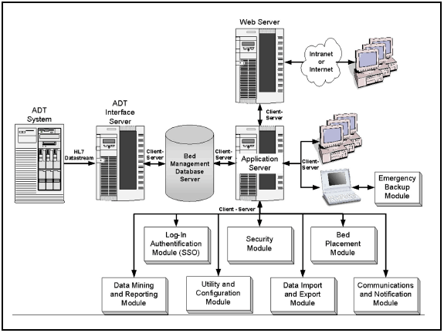
6.1.2 Engine State Transition Diagram
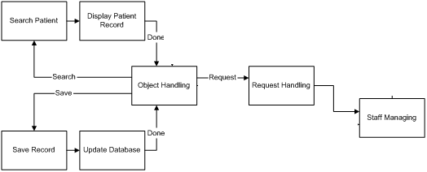
6.1.3 Engine Data Flow Diagram

Data Flow Diagram level-0
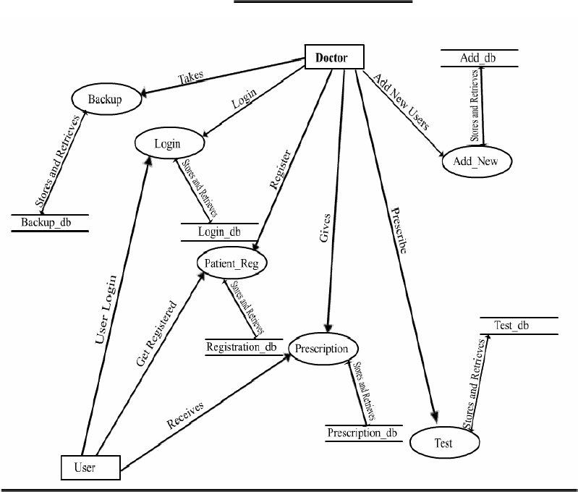

Data Flow Diagram level-1
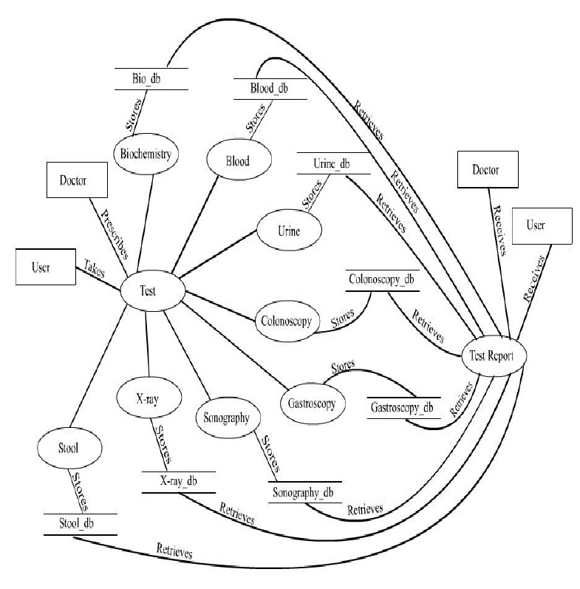

Data Flow Diagram Level-2

Data Flow Diagram Level-3

Processes

Login Process

Invalid Login

Log-out Process

Configuration of Equipments
Status Monitor

Record Editing

6.1.4 Entity-Relationship Diagram
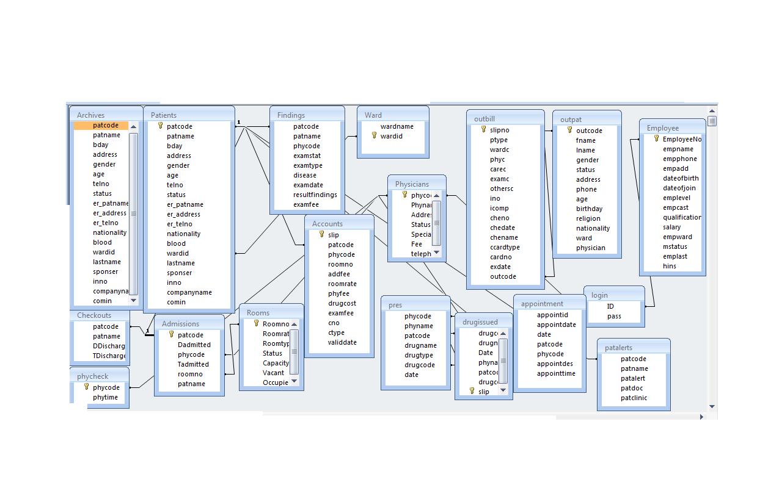

  - Class Diagram

6.3 Sequence Diagramme
ADMISSIONS:

DOCTOR APPOINTMENTS:

TESTS APPOINTMENTS:

BED ALLOTMENT

UNDERGO OPERATION:

LOGIN:

DRAW SALARY:

ADD DOCTOR/STAFF:

DELETE DOCTOR/STAFF:

EDIT DOCTOR/STAFF

PRESCRIBE TESTS:

WARDWISE BED STATUS

ADMISSION/DISCHARGE REPORTS:

PATIENT INFORMATION:

Chapter 7
User Interface Design

7.1 Description
The user interface is defined as below through the images. There is a login page, where user enters login and password. After the Password is correct, the screen goes to main menu, where there is menu and button, form where we can go on different forms.
7.2 Screen Images
Login Page
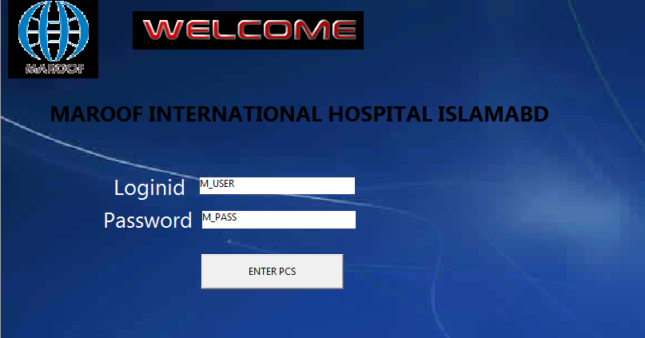
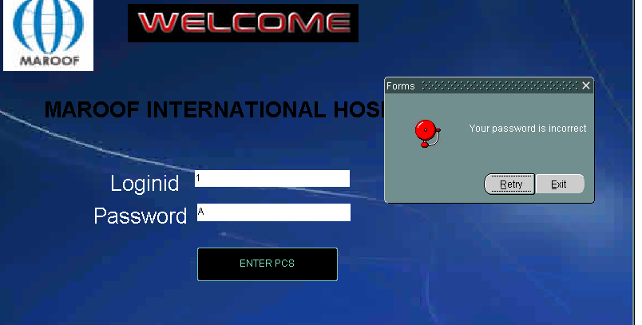
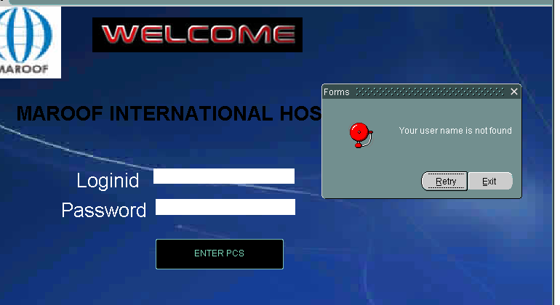
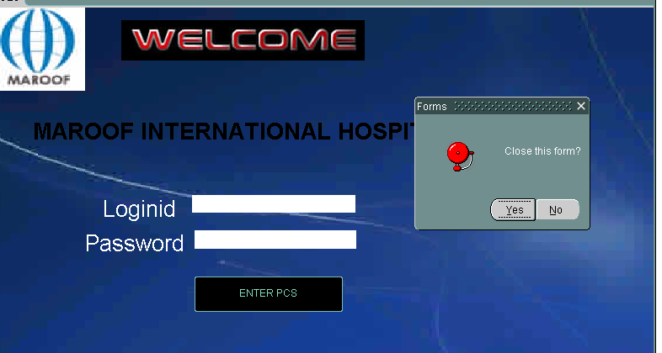
Main Menu
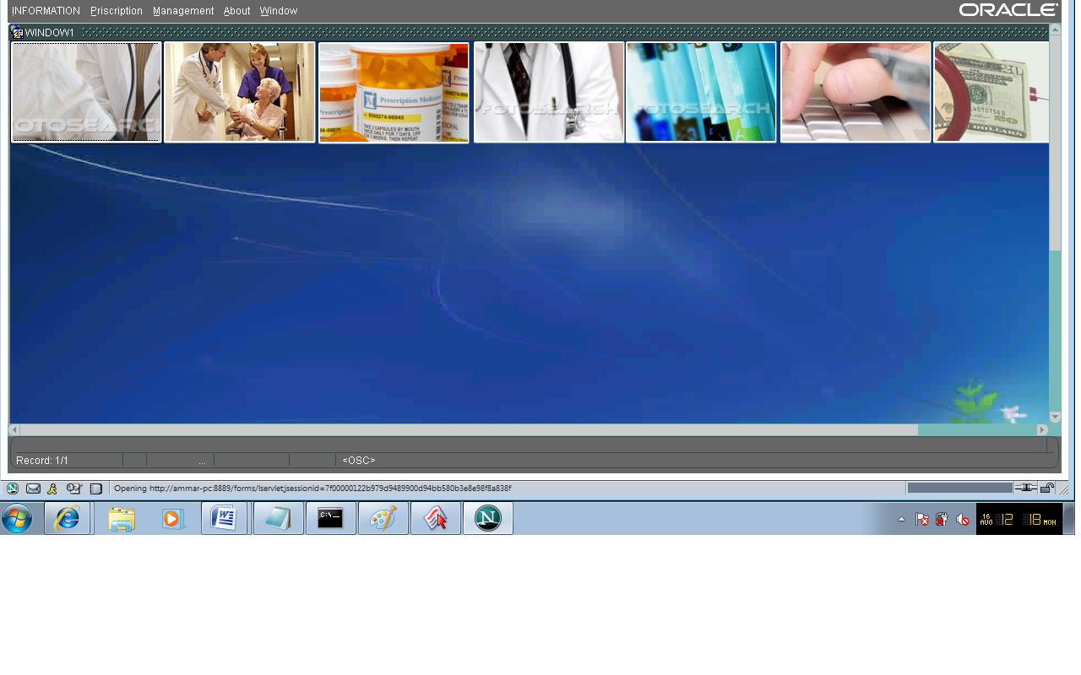
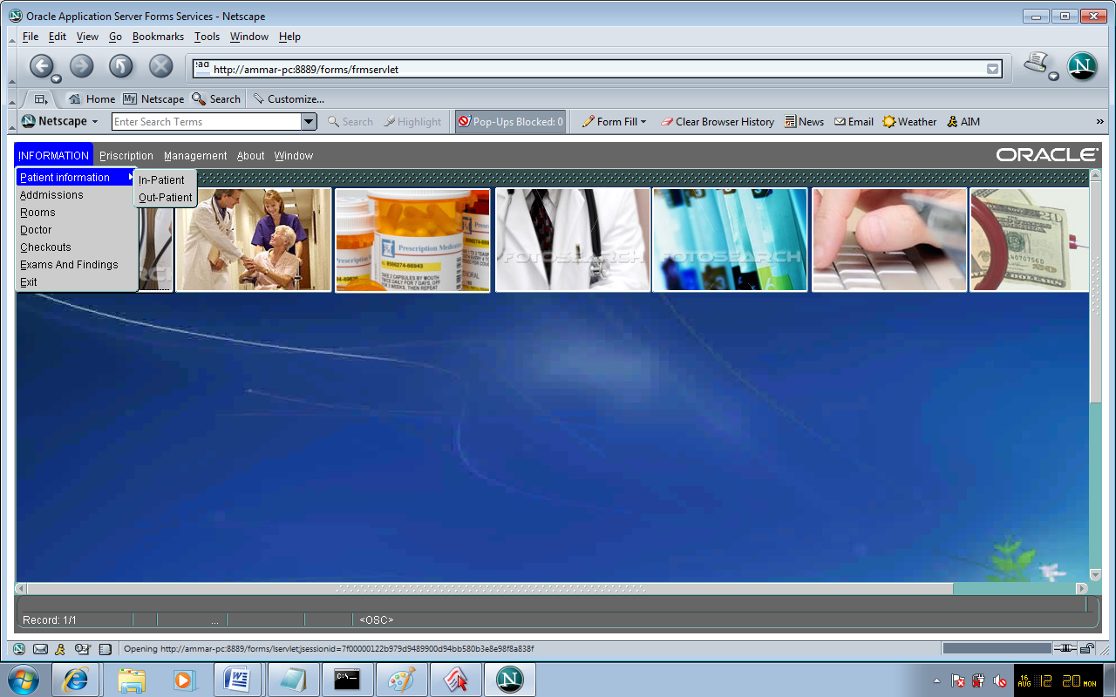
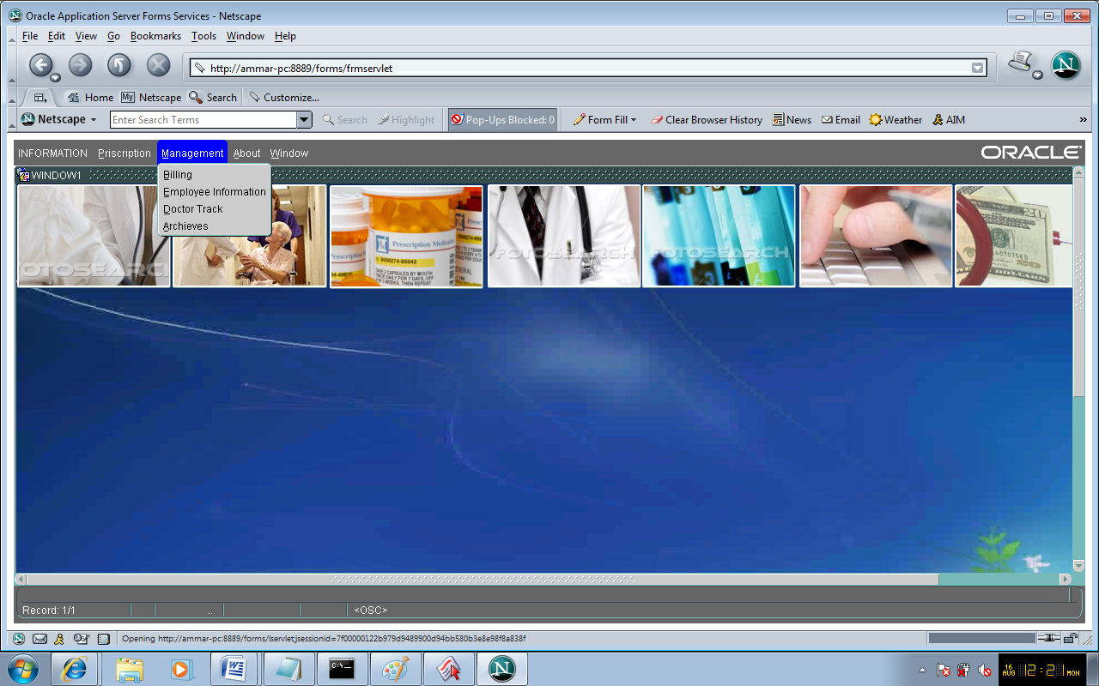
Patient –in Form
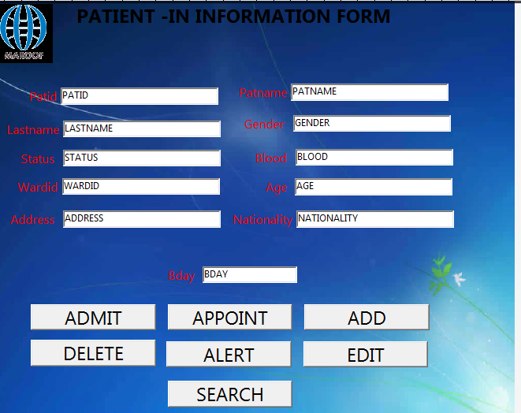

Patient Out Form
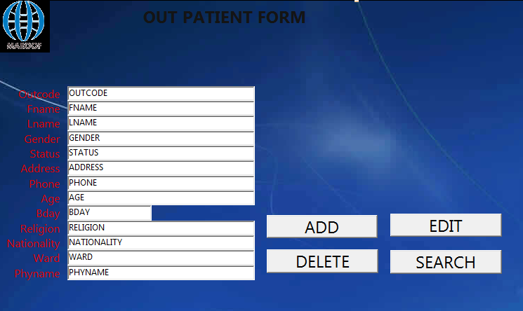
ADMISSION FORMS
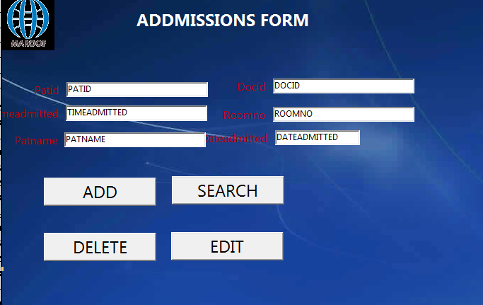

Doctor Form
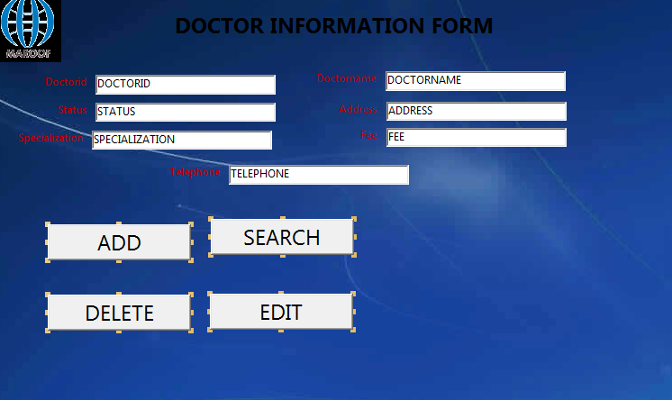
Employee form
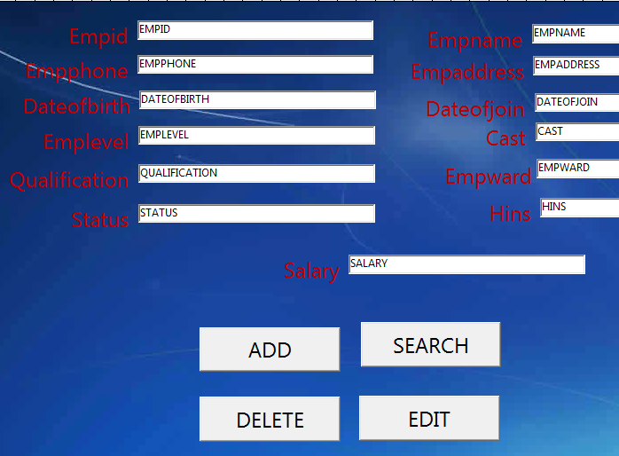
Patient Alert form
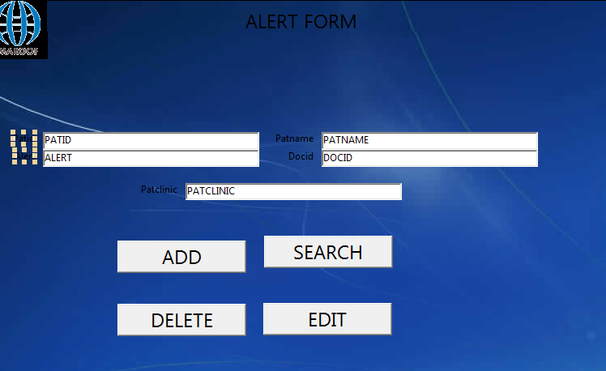
About Maroof International
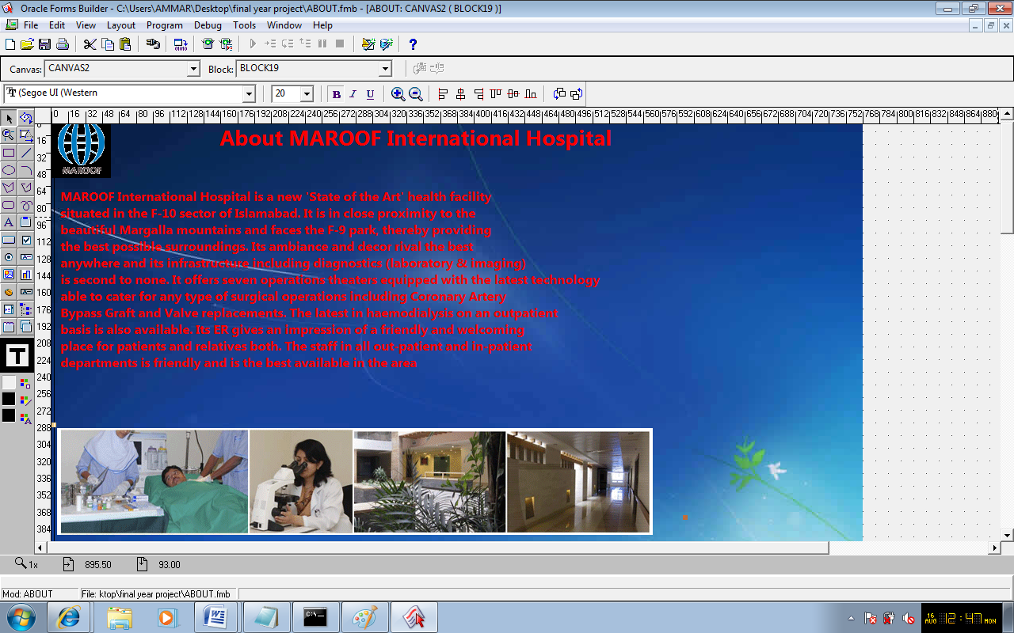
Appointment Form
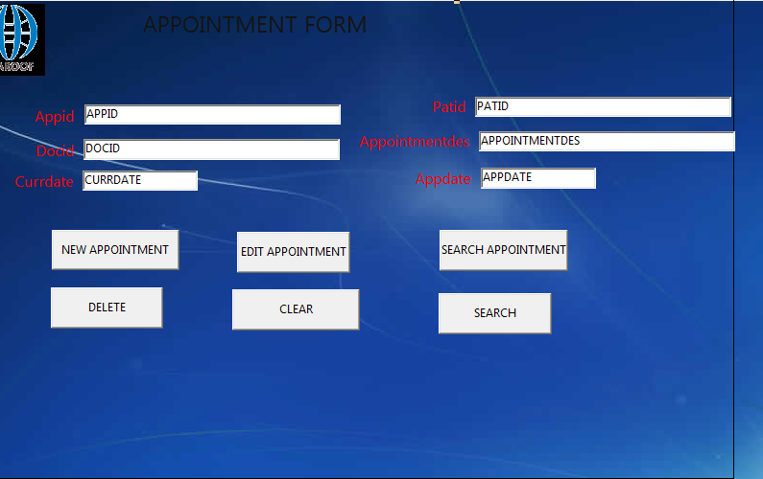
Doctor Track
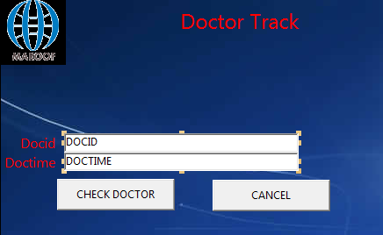
Finding and Examination
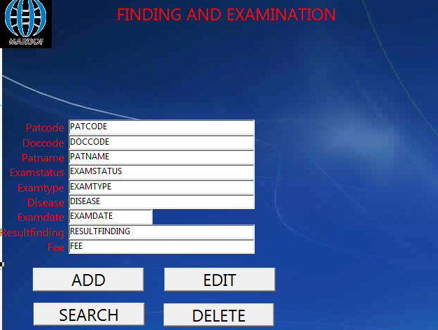
Prescription List form
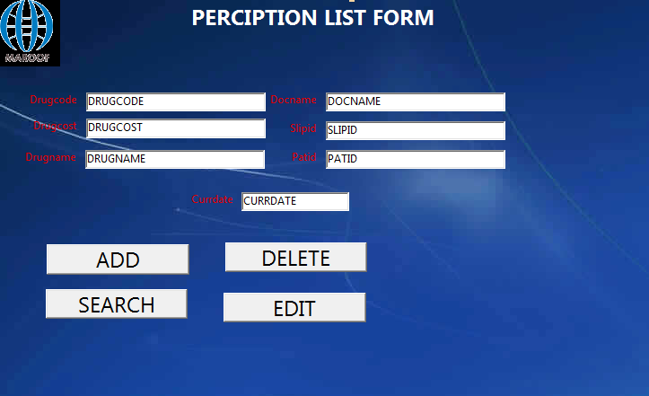

7.3 Interface Design Rule
Golden Rules of Dialog Design

1. Strive of consistency
2. Strive of efficiency
3. Short cuts for frequent function buttons
4. Easy to use

Data Display Guidelines

1. Consistency of display
2. Efficient assimilation of information
3. Compatibility between data entry and display
4. Minimize memory load

Menu Guidelines

1. Shallow, wide menus preferred over short menus.
2. User has access to most relevant items without referencing a manual
3. Don’t assume the user will notice cutes like color or boarder changes
4. Ensure consistent navigation

Screen Formatting Guidelines

1. Focus on readability and user acceptability
2. Choose pleasing color combinations
3. Keep relevant info on screen

Chapter 8
Restrictions Limitation and constraints

8.1 Operating System Limitations

        - Patient care system run on windows
        - PCS require oracle10 express edition and oracle 10 g developer suit.

8.2 Program Limitation

- Patient Care System supports only limited mouse and keyboard supports.
- Patient Care System can support all types of resolution.

Chapter 9
Testing Issues

Unit Testing

Individual engine components will be tested separately. All components can be tested through the Object Handler.
The interface will be unit tested in different parts:
  - Main Control Window
  - forms
All unit tests will be done in White Box fashion.
Integration Testing
Combined engine components will be tested as a whole. To maintain maximum control over the testing criteria, all data files will be made specifically for testing purposes.
The Patient Window will be tested to ensure proper communication between the interface and the database.

High-Order Testing
The High-Order testing will be performed on the complete, integrated system. Patient Care System staff will attempt to construct fully functional system.
Public Beta Testing
University students will be asked to help to help with the final testing phase. Each beta tester will be given a copy of the software, and the preliminary help files. Beta testers will be expected to submit bug reports and any opinions they may have concerning the software.

Chapter 10
Future enhancement

1. Improved Manual System:-
One of the alternative solutions is the improvement of the manual system.
Anything, which can be done by using automated methods, can be done
manually. But the question arises how to perform thing manually in a sound
manner. Following are some suggestions, which can be useful in the manual
system.
A more sophisticate register maintenance for various Patient Information, Doctor
diary, Immunization Details and a good system for writing bill amount
employees and stock availed for the customers can be maintained at central place.
Adequate staff may be maintained so that updations are made at the very moment
at the same time. Proper person for proper work should be made responsible so
that a better efficiency could be achieved. This needs a lot of work force.
2. Batch System:-
Another alternative solution can be used of computer based batch system for
maintaining the information regarding purchase details, customers and
employees. A batch system refers to a system in which data is processed in a
periodical basis.
The batch system is able to achieve most of the goals and sub goals. But a batch
system data is processed in sequential basis. Therefore batch system is not
suggested.
3. Online System:-
This system (PCS) provides online storage/ updations and retrieval facility. This
system promises very less or no paper work and also provides help to Doctor and
operational staff.
In this system everything is stored electronically so very less amount of paper
work is required and information can be retrieved very easily without searching
here and there into registers. This system is been discussed.

Chapter 11
Feasibility study

11.FEASIBILITY STUDY
Depending on the results of the initial investigation the survey is now expanded to a
more detailed feasibility study. “FEASIBILITY STUDY” is a test of system proposal
according to its workability, impact of the organization, ability to meet needs and
effective use of the resources. It focuses on these major questions:
1. What are the user’s demonstrable needs and how does a candidate system
meet them?
2. What resources are available for given candidate system?
3. What are the likely impacts of the candidate system on the organization?
4. Whether it is worth to solve the problem?
During feasibility analysis for this project, following primary areas of interest are to be
considered. Investigation and generating ideas about a new system does this.
Steps in feasibility analysis
Eight steps involved in the feasibility analysis are:
- Form a project team and appoint a project leader.
- Prepare system flowcharts.
- Enumerate potential proposed system.
- Define and identify characteristics of proposed system.
- Determine and evaluate performance and cost effective of each proposed system.
- Weight system performance and cost data.
- Select the best-proposed system.
- Prepare and report final project directive to management.
11.1 Technical feasibility
A study of resource availability that may affect the ability to achieve an acceptable system. This evaluation determines whether the technology needed for the proposed
system is available or not.
• Can the work for the project be done with current equipment existing software
technology & available personal?
• Can the system be upgraded if developed?
• If new technology is needed then what can be developed?
This is concerned with specifying equipment and software that will successfully satisfy the user requirement. The technical needs of the system may include:
11.2 Front-end and back-end selection
An important issue for the development of a project is the selection of suitable front-end and back-end. When we decided to develop the project we went through an extensive study to determine the most suitable platform that suits the needs of the organization as well as helps in development of the project.
The aspects of our study included the following factors.

11.2.1 Front-End Selection:
1. It must have a graphical user interface that assists employees that are not from IT
background.
2. Scalability and extensibility.
3. Flexibility.
4. Robustness.
5. According to the organization requirement and the culture.
6. Must provide excellent reporting features with good printing support.
7. Platform independent.
8. Easy to debug and maintain.
9. Event driven programming facility.
10. Front end must support some popular back end like Ms Access.
According to the above stated features we selected VB6.0 as the front-end for
developing our project.
11.2.2 Back-end Selection:
1. Multiple user support.
2. Efficient data handling.
3. Provide inherent features for security.
4. Efficient data retrieval and maintenance.
5. Stored procedures.
6. Popularity.
7. Operating System compatible.
8. Easy to install.
9. Various drivers must be available.
10. Easy to implant with the Front-end.
According to above stated features we selected Oracle 10g express edition as the backend. The technical feasibility is frequently the most difficult area encountered at this stage. It is essential that the process of analysis and definition be conducted in parallel with an assessment to technical feasibility. It centers on the existing computer system (hardware, software etc.) and to what extent it can support the proposed system.
11.3 Economical feasibility
Economic justification is generally the “Bottom Line” consideration for most systems.Economic justification includes a broad range of concerns that includes cost benefit analysis. In this we weight the cost and the benefits associated with the candidate system and if it suits the basic purpose of the organization i.e. profit making, the project is making to the analysis and design phase. The financial and the economic questions during the preliminary investigation are verified to estimate the following:
• The cost to conduct a full system investigation.
• The cost of hardware and software for the class of application being considered.
• The benefits in the form of reduced cost.
• The proposed system will give the minute information, as a result the performance is improved which in turn may be expected to provide increased profits.
• This feasibility checks whether the system can be developed with the available
Funds. The Patient care system does not require enormous amount of money to be developed. This can be done economically if planned judicially, so it is economically feasible. The cost of project depends upon the number of man hours Required.
11.4 Operational Feasibility
It is mainly related to human organizations and political aspects. The points to beconsidered are:
• What changes will be brought with the system?
• What organization structures are disturbed?
• What new skills will be required? Do the existing staff members have these
skills? If not, can they be trained in due course of time?
The system is operationally feasible as it very easy for the End users to operate it. It
only needs basic information about Windows platform.
11.5 Schedule feasibility
Time evaluation is the most important consideration in the development of project. The time schedule required for the developed of this project is very important since more development time effect machine time, cost and cause delay in the development of other systems.A reliable Patient care System can be developed in the considerable amount of time.

Chapter 12
Testing

12.1 Introduction
Maroof International Hospital Patient Care system is a system design to facilitate the patient. There is a test plan which helps system to be error free and be more useful for the hospital staff.
The system will do the following:
- Provide the users with menus, directions & error messages to direct him/her on the various options.
- Handle the update/addition of patient, employee, doctor and all other information related to the patient.
- Print various reports.
- Run on windows operating system.

12.1 Test Plan Objectives
This Test Plan for Patient care system supports the following objectives.
- Define the activities required to prepare for and conduct System, Beta and User Acceptance testing.
- Communicate to all responsible parties the System Test strategy.
- Define deliverables and responsible parties.
- Communicate to all responsible parties the various Dependencies and Risks

12.2 Scope
12.2.1 Data Entry
The patient care system will help to enter various information about the patient and will run on windows. The system will be menu driven and will provide error messages to help direct the user of the system through various options.
12.2.2 ReportsFile Transfer
The system allow to print different types of reports. These reports are:
- Patient admission report
- Doctor report
- Patient Examination report.
- Patient billing report
12.2.3. File Transfer
There is a facility of file transfer through lan.

12.2.4 Security
There is a security to use the system .The user will given the username and password.The user can enter in to the system by login .The password can be change after 30 days.
12.2.4 Test Stratigy

The test strategy consists of a series of different tests that will fully exercise patient care

system. The primary purpose of these tests is to uncover the systems limitations and

measure its full capabilities. A list of the various planned tests and a brief explanation

follows below.

12.3.1 System Test
The System tests will focus on the behavior of the patient care system. User scenarios will be executed against the system as well as screen mapping and error message testing. Overall, the system tests will test the integrated system and verify that it meets the requirements defined in the requirements document.

12.3.2 Performance Test
Performance test will be conducted to ensure that the patient care system’s response times meet the user expectations and does not exceed the specified performance criteria. During these tests, response times will be measured under heavy stress and volume.

12.3.3 Security Test
Security tests will determine how secure patient care system is. The tests will verify that unauthorized user access to confidential data is prevented.

12.3.4 Automated Test
A suite of automated tests will be developed to test the basic functionality of the patient care system and perform regression testing on areas of the systems that previously had critical/major defects. The tool will also assist us by executing user scenarios there by emulating several users.

12.3.5 Stress and Volume Test
We will subject the patient care system to high input conditions and a high volume of data during the peak times. The System will be stress tested using twice (20 users) the number of expected users.

12.3.6. Recovery Test
Recovery tests will force the system to fail in a various ways and verify the recovery and is properly performed. It is vitally important that all patient data is recovered after a system failure & no corruption of the data occurred.

12.3.7. Documentation Test
Tests will be conducted to check the accuracy of the user documentation. These tests will ensure that no features are missing, and the contents can be easily understood.

12.3.8. Beta Test
The Maroof Internation Hospital will beta tests the patient care system and will report any defects they find. This will subject the system to tests that could not be performed in our test environment.

12.3.9. User Acceptance Test
Once the patient care system is ready for implementation, the hospital will perform User Acceptance Testing. The purpose of these tests is to confirm that the system is developed according to the specified user requirements and is ready for operational use.

12.4. Environment Requirements

12.4.1. Data Entry workstations
- PC
- 2000 processor (minimum)
- 512 RAM
- 500 mb Hard Drive
- A Network attached printer
- 20 user ids and passwords (10 will be used by the automation tool to emulate payroll clerks).

12.4.2 MainFrame
- Attached to network
- Access to a test database (to store patient information transferred from LAN patient care system)

12.5 Test Schedule
- Ramp up / System familiarization 6/01/2010 - 6/15/2010 to
- System Test 6/16/2010 - 6/26/2010 to
- Beta Test 6/28/2010 - 7/15/2010 to
- User Acceptance Test 7/16/2010 - 8/2/2010 t o

12.6. Control Procedures

12.6.1 Reviews
The project team will perform reviews for each Phase. (i.e. Requirements Review, Design Review, Code Review, Test Plan Review, Test Case Review and Final Test Summary Review). A meeting notice, with related documents, will be emailed to each participant.

12.6.2 Bug Review meetings
Regular weekly meeting will be held to discuss reported defects. The project supervisor will provide status/updates on all defects reported . All member of the project team will participate.

12.6.3 Change Request
Once testing begins, changes to the patient care system are discouraged. If functional changes are required, these proposed changes will be discussed with the project supervisor. The supervisor will determine the impact of the change and if/when it should be implemented.

12.6.4 Defect Reporting
When defects are found, the testers will complete a defect report on the defect tracking system. The defect tracking Systems is accessible by testers, developers & all members of the project team. When a defect has been fixed or more information is needed, the developer will change the status of the defect to indicate the current state. Once a defect is verified as FIXED by the testers, the testers will close the defect report.

12.7. Functions To Be Tested
The following is a list of functions that will be tested:
- Add/update patient information
- Search / Lookup patient information
- Escape to return to Main Menu
- Security features
- Scaling to 200 patient records
- Error messages
- Report Printing
- Creation of reports
- Transfer of reports to the mainframe
- Screen mappings (GUI flow). Includes default settings
- Billing
- Doctor module checking
- All other module checking

12.8 Test Cases
Test Case id= 1
Test Case name= Validate Login
Test case description= To verify that correct username and password has successfully signed In the User.

Test Steps:
Step | Expected | Actual
- Enter correct login name and password. | Login is successful. | It directs user to the particular page.

Test case status = Design
Test Status (P/F)= (a) Pass
Test priority= (a) High

Test Case id= 2

Test Case name= Validate Login
Test case description= To verify that incorrect user name and password will show appropriate message.

Test Steps:
Step | Expected | Actual
- Enter incorrect login name and password. | Login is unsuccessful. | An appropriate message is displayed.  Message: Incorrect username or password.

Test case status = Design
Test Status (P/F)= (a) Pass
Test priority= (a) High

Test Case id= 3
Test Case name= Validate Login
Test case description= To verify empty username and password will show an appropriate message.

Test Steps:
Step | Expected | Actual
- without entering loginname. | Message: “Please enter the login” | It shows a Pop-up window showing a message.  Message: “Please enter the login”
- without entering password | Message: “Please enter the password” | It shows a Pop-up window showing a message.  Message: “Please enter the password”

Test case status = Design
Test Status (P/F)= (a) Pass
(b) Pass
Test priority= (a) High
(b) High

Test Case id= 4
Test Case name= Validate Login
Test case description= To verify that user account is activated or deactivated.

Test Steps:
Step | Expected | Actual
- Enter deactivated username and password | Message: “Your account has been deactivated” | It login successfully rather than showing message: “Your account has been deactivated”
- Enter activated username and password. | Login is successful. | It will direct user to the particular page.

Test case status = Design
Test Status (P/F)= (a) Fail
(b) Pass
Test priority= (a) High
(b) High

Rework: (a) is reworked and analyzed. After careful analysis we found some conditional error in coding. After correcting error module is working according to requirement.

Test Case id= 5
Test Case name= Validate Login
Test case description= To verify that successful login will direct user to the respective page.

Test Steps:
Step | Expected | Actual
- Enter Administrator correct passwerd. | Go to the main menu page | It go to the main menu page where  There are different forms

Test case status = Design
Test Status (P/F)= (a) Pass

Test priority= (a) High

Test Case id= 6
Test Case name= Insert record
Test case description= To verify whether record inserted or not

Test Steps:
Step | Expected | Actual
- Insert record from form on to database | Insert Record on the form | It shows the record inserted in database

Test case status = Design
Test Status (P/F)= (a) Pass
Test priority= (a) High

Test Case id= 7
Test Case name= delete
Test case description= To verify that record has been deleted

Test Steps:
Step | Expected | Actual
- Delete the record | To verify whether record deleted or not | It delete the entire records

Test case status = Design
Test Status (P/F)= (a) Pass
Test priority= (a) Medium

Test Case id= 8
Test Case name=update record
Test case description= To verify record updated or not

Test Steps:
Step | Expected | Actual
- It verify that record updated or not | It verify that record updated or not | The record will be updated

Test case status = Design
Test Status (P/F)= (a) Pass

Test Case id= 9
Test Case name=Search
Test case description= To verify that it search record or not.
Test Steps:
Step | Expected | Actual
- Click the search button. | It should show the search record | IThe record search will be shown.
Test case status = Design
Test Status(P/F)= (a) Pass
Test priority= (a) High

Test Case id= 10
Test Case name=Verify records
Test case description= To verify all the functions of modules

Test Steps:
Step | Expected | Actual
- System work in good manner | To verify whether system work in good manner or not | The system works efficiently.

Test case status = Design
Test Status (P/F)= (a) Pass
Test priority= (a) High

Test Case id= 11
Test Case name= Logout user.
Test case description= To verify that the user logout and move to login page.
Test Steps:
Step | Expected | Actual
- The user will click the logout tab. | Login page must be displayed after logout. | Logout successful and moved to the login page.

Test case status = Design
Test Status(P/F)= (a) Pass
Test priority= (a) High

12.9 Resources and Responsibilities
The project members and Project supervisor will determine when system test will start and end. The Test lead will also be responsible for coordinating schedules, equipment, & tools for the testing as well as writing/updating the Test Plan, Weekly Test Status reports and Final Test Summary report. The team members will be responsible for writing the test cases and executing the tests. With the help of the Test Lead, the Maroof International Hospital will be responsible for the Beta and User Acceptance tests.

12.9.1 Resources
The test team will consist of:
- Supervisor
- Team Members
- Maroof International Hospital IT(head)
- Administrator

Responsibilities
Supervisor | Responsible for Project schedules and the overall success of the project.
Lead Developer | Serve as a primary contact/liaison between the development department and the project team.
Test Lead | Ensures the overall success of the test cycles. He will coordinate weekly meetings and will communicate the testing status to the project team.
Testers | Responsible for performing the actual system testing.
Hospital IT(head) | Serves as Liaison between hospital and project team. He will help coordinate the Beta and User Acceptance testing efforts.
Administrator | Will assist in performing the Beta and User Acceptance testing.

12.10Deliverables
Deliverable | Responsibility | Completion Date
Develop Test cases | Testers | 6/11/2010
Test Case Review | Test Lead, Dev. Lead, Testers | 6/12/2010
Develop Automated test suites | Testers | 7/01/2010
Requirements Validation Matrix | Test Lead | 6/16/2010
Obtain User ids and Passwords for patient care system/database | Test Lead | 5/27/2010
Execute manual and automated tests | Testers & Test Lead | 5/26/2010
Complete Defect Reports | Everyone testing the product | On-going
Document and communicate test status/coverage | Test Lead | Weekly
Execute Beta tests | Administrator | 6/28/2010
Document and communicate Beta test status/coverage | Hospital IT (Head) | 7/5/2010
Execute User Acceptance tests | Administrator | 7/16/2010
Document and communicate Acceptance test status/coverage | Hospital IT(Head) | 7/23/2010
Final Test Summary Report | Test Lead | 8/05/2010

12.11 Suspension / Exit Criteria
If any defects are found which seriously impact the test progress, the supervisor may choose to
Suspend testing. Criteria that will justify test suspension are:
- Hardware/software is not available at the times indicated in the project schedule.
- Source code contains one or more critical defects, which seriously prevents or limits testing progress.
- Assigned test resources are not available when needed by the test team.

12.12 Resumption Criteria
If testing is suspended, resumption will only occur when the problem(s) that caused the suspension has been resolved. When a critical defect is the cause of the suspension, the “FIX” must be verified by the test department before testing is resumed.

12.13 Dependencies

12.13.1 Personnel Dependencies
The test team requires experience testers to develop, perform and validate tests. These The test team will also need the following resources available: Application developers and administrator.

12.13.2 Software Dependencies
The source code must be unit tested and provided within the scheduled time outlined in the Project Schedule.

12.13.3 Hardware Dependencies
The Mainframe, 10 PCs (with specified hardware/software) as well as the LAN environment need to be available during normal working hours. Any downtime will affect the test schedule.

12.13.4 Test Data & Database
Test data (Patient employee information) & database should also be made available to the testers for use during testing.

12.14Risks

12.14.1. Schedule
The schedule for each phase is very aggressive and could affect testing. A slip in the schedule in one of the other phases could result in a subsequent slip in the test phase. Close project management is crucial to meeting the forecasted completion date.

12.14.2. Technical
Since this is a patient care system. We will run our test in parallel with the production system so that there is no downtime of the current system.

12.14.3. Management
Management support is required so when the project falls behind, the test schedule does not get squeezed to make up for the delay. Management can reduce the risk of delays by supporting the test team throughout the testing phase and assigning people to this project with the required skills set.

12.14.4. Personnel
Due to the aggressive schedule, it is very important to have experienced testers on this project. Unexpected turnovers can impact the schedule. If attrition does happen, all efforts must be made to replace the experienced individual

12.14.5 Requirements
The test plan and test schedule are based on the current Requirements Document. Any changes to the requirements could affect the test schedule and will need to be approved by the project supervisor.

Conclusion
The project Patient Care System is for computerizing the working in a hospital. The
software takes care of all the requirements of an average hospital and is
capable to provide easy and effective storage of information related to patients that
come up to the hospital.
It generates test reports; provide prescription details including various tests, diet advice,
and medicines prescribed to patient and doctor. It also provides injection details and
billing facility on the basis of patient’s status whether it is an indoor or outdoor patient.
The system also provides the facility of backup as per the requirement.

References:
www.w3schools.com
www.iselfschooling.com
http://www.scribd.com/document_downloads/direct/2909442?extension=pdf&ft=1289422765&lt=1289426375&uahk=2huEBbNle2vLh+kqLP6Km3x+wIg
http://www.scribd.com/document_downloads/2909442?secret_password=&extension=pdf
http://www.dtpt.com/esimMR-HMS.pdf
http://www.iisjaipur.org/iiim-current-08/MCA_IV_Sem_Pro_Eva/09.Project-Hospital%20management%20system.pdf
http://www.dtpt.com/esimMR-HMS.pdf
http://www.3icare.com/files/Chowdhury-RFIDHPMS.pdf
http://www.cs.tcu.edu/people/professors/asanchez/cosc30603/normalization.ppt
Wikipedia.com

