‘Open Accounts’
Accounts management software for small
&
Medium-sized businesses



Project member:
Muhammad Waqas (01-133062-101)

CERTIFICATE
I hereby accept that the work and material contained in this project report is my own and as confirming to the required standard for the partial fulfillment of degree of BSE.

Head of Department
(Mr. Jahanzeb Ahmed)

Supervisor
(Mr. Raja M Sulaiman)

Internal Examiner

External Examiner

Dedication
This project is dedicated to my beloved parents because without their support, care and love I wouldn`t be able to complete this Degree, just because of them I am able to stand where I am, right now.
And this project is also dedicated to my supervisor Mr. Raja M Sulaiman, who gave me outstanding ideas, taught me the right way to work and motivated me to carry out each and every task of this project. Without my supervisor, this project might not be as superior as it is right now.

Abstract
This product is basically audit and monitors the company financial data. This software helps the organization in different ways e.g. in sales invoice, in purchase invoice, in debit memo, in credit memo, in Administration etc. This software records each of these activities.
This software identifies all of the above activities by using three components
- Business documents are used to record the occurrences the business activities. For example, when a credit sale is made, a document called the sales invoice is created to record the sale.
- For any business activity that involves a change in the financial position of a business, a transaction record captures the changes. For example, when a credit sale is made, changes to the customer accounts, the sales account, the sales tax account, the inventory account and the cost of goods sold account are captured in a transaction record.
- Accounts are the records that keep track of the accumulated effects of all the transactions have on the financial positions of a business.

TABLE OF CONTENTS
1. INTRODUCTION 12
1.1 WHY OPEN ACCOUNT? 12
2 ANALYSIS PHASE 13
2.1 METHODOLOGIES 13
2.1.1 REQUIREMENTS GATHERING TECHNIQUES 13
2.2 TOOLS & RESOURCES 13
2.3 WORK PLANE & SCHEDULING 13
2.3.1 WORK PLANE 13
2.3.2 SCHEDULE 14
Table 2-1 [Schedule] 15
3 SOFTWARE REQUIRNMENTS SPECIFICATIONS 16
3.1 PURPOSE 16
3.2 OVERVIEW 16
3.3 OVERALL DESCRIPTION 16
3.4 PRODUCT FUNCTIONS 17
3.4.1 SETTING UP 17
3.4.2 SALES PROCESSING 17
3.4.3 PURCHASE PROCESSING 17
3.4.4 CASH MANAGEMENT 17
3.4.5 ITEMS MANAGEMENT 17
3.4.6 REPORTS 18
3.4.7 ADMINISTRATION 18
3.4.8 AUTHENTICATIONS 18
3.5 USER CHARACTERISTICS 18
Table 3-1 [User Characteristics] 19
3.6 SPECIFIC REQUIREMENTS 19
3.6.1 EXTERNAL INTERFACE REQUIREMENTS 19
3.6.1.1 USER INTERFACE REQUIREMENTS 19
3.6.1.1.1 SETTING UP EMPLOYEE DETAILS 19
3.6.1.1.2 SETTING UP CREDIT TERMS 19
3.6.1.1.3 SETTING UP PAYMENT METHOD 20
3.6.1.1.4 SETTING UP CUSTOMER DETAILS 20
3.6.1.1.5 SETTING UP VENDOR DETAILS 21
3.6.1.1.6 SALES INVOICE 21
3.6.1.1.7 CREDIT MEMO 22
3.6.1.1.8 CASH SALES 22
3.6.1.1.9 PURCHASE INVOICE 23
3.6.1.1.10 DEBIT MEMO 24
3.6.1.1.11 CASH PURCHASE 24
3.6.1.1.12 CASH RECEIPT 25
3.6.1.1.13 CASH DISBURSEMENT 25
3.6.1.1.14 ITEM 26
3.6.1.1.15 PRICE GROUP 26
3.6.1.1.16 LOGIN 26
3.6.1.1.17 LOGOUT 26
3.6.1.1.18 CREATE NEW USER 26
3.7 USE CASES 28
3.7.1 USE CASE 1 28
Administrator 28
3.7.2 USE CASE 2 29
Managers 29
3.7.3 USE CASE 3 30
Accountant 30
4 DESIGN PHASE 31
4.1 PURPOSE AND SCOPE 31
4.2 DATA DICTIONARY 31
4.2.1 OBJECTS 31
4.2.1.1 EMPLOYEE OBJECT 31
4.2.1.2 ITEM OBJECT 31
4.2.1.3 TERMS OBJECT 31
4.2.1.4 PAYMENT OBJECT 31
4.2.1.5 PRICE GROUP 32
4.2.1.6 CASH RECEIPT OBJECT 32
4.2.1.7 CASH DISBURSEMENT OBJECT 32
4.2.1.8 PURCHASE INVOICE 32
4.2.1.9 DEBIT MEMO OBJECT 32
4.2.1.10 CASH PURCHASE OBJECT 33
4.2.1.11 VENDOR OBJECT 33
4.2.1.12 SALE INVOICE OBJECT 33
4.2.1.13 CREDIT MEMO OBJECT 33
4.2.1.14 CASH SALE OBJECT 33
4.2.1.15 CUSTOMER OBJECT 34
4.2.1.16 ADMINISTRATION OBJECT 34
4.3 ARCHITECTURAL DESIGN 34
4.3.1.1 SALES MODULE 34
4.3.1.2 PURCHASE MODULE 34
4.3.1.3 CASH MODULE 34
4.3.1.4 ITEM MODULE 35
4.3.1.5 REPORTS MODULE 35
4.3.1.6 ADMINISTRATOR MODULE 35
4.4 DATA DESIGN 36
Figure 4-1 [EER-1 Diagram] 36
4.4.1 DATA TABLES 37
Figure 4-2 [Employee] 37
Figure 4-3 [Customer Account] 37
Figure 4-4 [Terms] 38
Figure 4-5 [Payment Method] 38
Figure 4-6 [Vendor Account] 38
Figure 4-7 [Cash Distribution] 39
Figure 4-8 [Cash Purchase] 39
Figure 4-9 [Cash Receipt] 40
Figure 4-10 [Cash Sales] 41
Figure 4-11 [Credit Memo] 42
Figure 4-12 [Debt Memo] 42
Figure 4-13 [Item Account] 43
Figure 4-14 [Procurement Inventory] 44
Figure 4-15 [Sales Price Group] 44
Figure 4-16 [Sales Inventory] 45
Figure 4-17 [Login] 45
4.5 USER INTERFACE 46
4.5.1 LOGIN PAGE 46
4.5.1.1 EMPLOYEE 46
4.5.1.2 ADMINISTRATOR 46
Figure 4-18 [Login Page] 46
4.5.2 MAIN WINDOW FOR ADMINISTRATOR 47
Figure 4-19 [Administrator Main Window] 47
4.5.3 MAIN WINDOW FOR EMPLOYEE 48
Figure 4-20 [Employee Main Window] 48
4.5.4 SALE MODULE 49
Figure 4-21 [Sale Module] 49
4.5.4.1 CASH SALE 50
Figure 4-22 [Cash Sale] 50
4.5.4.2 CASH SALE 51
Figure 4-23 [Cash Sale] 51
4.5.4.3 CREDIT MEMO 52
Figure 4-24 [Credit Memo] 52
Figure 4-25 [Credit Memo] 53
4.5.4.4 CUSTOMER 54
Figure 4-26 [Customer] 54
4.5.4.5 CUSTOMER 55
Figure 4-27 [Customer] 55
4.5.4.6 SALE INVOICE 56
Figure 4-28 [Sale Invoice] 56
4.5.4.7 SALE INVOICE 57
Figure 4-29 [Sale Invoice] 57
4.5.5 PURCHASE MODULE 58
Figure 4-30 [Purchase Module] 58
4.5.5.1 CASH PURCHASE 59
Figure 4-31 [Cash Purchase] 59
4.5.5.2 CASH PURCHASE 60
Figure 4-32 [Cash Purchase] 60
4.5.5.3 DEBIT MEMO 61
Figure 4-33 [Debt Memo] 61
4.5.5.4 DEBIT MEMO 62
Figure 4-34 [Debt Memo] 62
4.5.5.5 PURCHASE INVOICE 63
Figure 4-35 [Purchase Invoice] 63
4.5.5.6 PURCHASE INVOICE 64
Figure 4-36 [Purchase Invoice] 64
4.5.5.7 VENDOR 65
Figure 4-37 [Vendor] 65
4.5.5.8 VENDOR 66
Figure 4-38 [Vendor] 66
4.5.6 CASH MODULE 67
Figure 4-39 [Cash Module] 67
4.5.7 CASH RECEIPT 68
Figure 4-40 [Cash Receipt] 68
4.5.7.1 CASH RECEIPT 69
Figure 4-41 [Cash Receipt] 69
4.5.7.2 CASH DISBURSEMENT 70
Figure 4-42 [Cash Distribution] 70
4.5.7.3 CASH DISBURSEMENT 71
Figure 4-43 [Cash Distribution] 71
4.5.8 ITEM MODULE 72
Figure 4-44 [Item Module] 72
4.5.8.1 ITEMS 73
Figure 4-45 [Items] 73
4.5.8.2 ITEMS 74
Figure 4-46 [Items] 74
4.5.8.3 PRICE GROUP 75
Figure 4-47 [Price Group] 75
4.5.8.4 PRICE GROUP 76
Figure 4-48 [Price Group] 76
4.5.9 REPORTS MODULE 77
Figure 4-49 [Reports Module] 77
4.5.10 ADMIN MODULE 78
Figure 4-50 [Admin Module] 78
4.5.10.1 EMPLOYEE 79
Figure 4-51 [Employee] 79
4.5.10.2 EMPLOYEE 80
Figure 4-52 [Employee] 80
4.5.10.3 PAYMENT METHOD 81
Figure 4-53 [Payment Method] 81
4.5.10.4 PAYMENT METHOD 82
Figure 4-54 [Payment Method] 82
4.5.10.5 CREDIT TERMS 83
Figure 4-55 [Credit Terms] 83
4.5.10.6 CREDIT TERMS 84
Figure 4-56 [Credit Terms] 84
4.5.10.7 CREATE NEW USER 85
Figure 4-57 [Create New User] 85
TESTING 86
5 TEST PLAN 86
5.1 INTRODUCTION 86
5.1.1 SETTING UP 86
5.1.2 SALES PROCESSING 86
5.1.3 PURCHASE PROCESSING 86
5.1.4 CASH MANAGEMENT 87
5.1.5 ITEMS MANAGEMENT 87
5.1.6 REPORTS 87
5.1.7 ADMINISTRATION 87
5.1.8 AUTHENTICATIONS 87
5.2 TEST STRATEGY 87
5.2.1 SYSTEM TEST 87
5.2.2 PERFORMANCE TEST 88
5.2.3 SECURITY TEST 88
5.2.4 USER ACCEPTANCE TEST 88
5.3 FUNCTIONS TO BE TESTED 88
5.3.1 SALES PROCESSING 88
5.3.2 PURCHASE PROCESSING 88
5.3.3 CASH MANAGEMENT 88
5.3.4 ITEMS MANAGEMENT 89
5.3.5 REPORTS 89
5.3.6 ADMINISTRATION 89
5.3.7 AUTHENTICATIONS 89
5.4 TEST CASES 89
5.4.1 LOGIN & LOGOUT/DASHBOARD 89
Table 5-1 [Test Cases-Login and Logout] 90
5.4.2 SALE INVOICE 90
Table 5-2 [Sale Invoice] 91
5.4.3 CREDIT MEMO 91
Table 5-3 [Credit Memo] 91
5.4.4 CASH SALE 91
Table 5-4 [Cash Sale] 92
5.4.5 CUSTOMER 92
Table 5-5 [Customer] 93
5.4.6 VENDOR 93
Table 5-6 [Vendor] 93
5.4.7 PURCHASE INVOICE 94
Table 5-7 [Purchase Invoice] 94
5.4.8 CASH PURCHASE 94
Table 5-8 [Cash Purchase] 95
5.4.9 DEBIT MEMO 95
Table 5-9 [Debt Memo] 96
5.4.10 ITEM 96
Table 5-10 [Item] 96
5.4.11 PRICE GROUP 96
Table 5-11 [Price Group] 97
5.4.12 CASH RECEIPT 98
Table 5-12 [Cash Receipt] 98
5.4.13 CASH DISBURSEMENT 98
Table 5-13 [Cash Distribution] 99
5.4.14 EMPLOYEE 99
Table 5-14 [Employee] 99
5.4.15 PAYMENT METHOD 100
Table 5-15 [Payment Method] 100
5.4.16 ADMIN LOGIN AND USER ACCOUNT CREATION 100
Table 5-16 [Admin and Used Account Creation] 100
5.5 CONTROL PROCEDURE 100
5.5.1 REVIEWS 100
5.5.2 DEFECT REPORTING 101
5.5.3 DEPENDENCIESs 101
5.5.3.1 PERSONAL DEPENDENCIES 101
5.5.3.2 SOFTWARE DEPENDENCIES 101
5.5.3.3 TEST DATA & DATABASE 101
5.5.4 RISKS 101
5.5.4.1 SCHEDULE 101
5.5.4.2 TECHNICAL 101
5.5.4.3 REQUIREMENT 102
6 CONCLUSION & FUTURE ENHANCEMENT 103
6.1 CONCLUSION 103
6.2 FUTURE ENHANCEMENTS 104

CHAPTER ONE

INTRODUCTION
Open Account is Accounts management software for small and medium-sized businesses. It assists you in managing your business by automating many accounting functions transparently. Most of the companies in Pakistan relay on manual accounting system for their business needs. This type of business is very risky since paper work is not efficient and there is always a chance of losing data because of any unforeseen events. In order to improve the performance and efficiency of a company, major tasks should be automated.
This project looks into the possibility of automating the accounting process of the company. The goal is to achieve performance improvement and secure data transaction by using the power of computers.

WHY OPEN ACCOUNT?
So far there are many Accounting tools like Peach Tree, Quick Books, SAP etc; but all of them are highly paid/expensive software and thus out of reach for a small business-man. Where-as Open Accounts is a free-ware and open source software as the name states. This will be reachable to all small scale companies.
Who so ever is the user of this Open Accounts Software needs some necessary training as-well. The Accountants and the Administrators will be trained in the following:
- Basic 7 Modules of the open Accounts
- How to use the software
- Weekly/Monthly Database backup
- Backup the settings daily
- And recovery in the case of Un-Foreseen disasters to the central database
The goal is to achieve performance improvement and secure data transaction by using the power of computers.

CHAPTER TWO

ANALYSIS PHASE

METHODOLOGIES

REQUIREMENTS GATHERING TECHNIQUES
After studying about the project in depth, I am going to do the requirement gathering and analysis task. The project ‘Open Accounts’ is basically targeted for those people who on manual accounting system for their business needs.
The following techniques are used in the requirement gathering process.
- Interviewing personnel of the various organizations i.e. Account Officers, Data entry person, Managers.
- Interviewing Shabir Tiles and Ceramics, information providers.
- Interviewing Shabir Tiles and Ceramics, Accountant and SAP Users
- Interviewing Your Engineering Solutions, Account Officer.
After gathering requirements, I tried to identify the most important needs of them and will start the implementation of this project in Seven (7) main modules.

TOOLS & RESOURCES
- Microsoft Visual Studio 2008 (C#.Net).
- Microsoft SQL Server.
- Microsoft SQL Server Reporting.
- Adobe Photoshop CS3/CS4 (for web designing).

WORK PLANE & SCHEDULING

WORK PLANE
Each and every phase of this project will be completely planned but I will also look forward to add additional and new features in this system as work progresses.

SCHEDULE
I have scheduled initially the main Seven (7) phases yet. Schedule will also be provided with SRS document.
Tasks | Estimated Days | Start | End
- Setting Up New Company | 30(days) | 15/02/2010 | 15/03/2010
Employee Details | 5
Credit Terms | 5
Payment Methods | 5
Items | 5
Customers | 5
Vendors | 5
- Sales Processing | 45(days) | 16/03/2010 | 06/05/2010
Sales Invoice | 12
Credit Memo | 12
Cash Sales | 12
Customer | 13
- Purchase Processing | 30(days) | 07/05/2010 | 10/06/2010
Purchase Invoice | 7
Debit Memo | 8
Cash Purchase | 8
Vendor | 7
- Cash Management | 20(days) | 11/06/2010 | 03/07/2010
Cash Receipt | 10
Cash Disbursement | 10
- Items Management | 20(days) | 05/07/2010 | 29/07/2010
Item | 15
Price Group | 05
- Reports | 20(days) | 30/07/2010 | 23/08/2010
Sale Invoice | 2
Purchase Invoice | 3
Cash Sale | 2
Purchase Sale | 3
Credit Memo | 3
Debit Memo | 3
Customers | 2
Vendors | 2
- Administration | 10(days) | 23/08/2010 | 03/09/2010
Employee | 2
Terms | 3
Payment Method | 2
Registration | 3
- Authentications | 7(days) | 04/09/2010 | 11/09/2010
Login | 5
Logout | 2
Table 2-1 [Schedule]

CHAPTER THREE

SOFTWARE REQUIRNMENTS SPECIFICATIONS

PURPOSE
The purpose of this document is to define project requirements in order to obtain signoff of the customer and the software developer. The developers use this document while working through the different phases of the SDLC.
- Scope
- Sales Processing
- Purchase Processing
- Cash Management
- Items Management
- Reports
- Administration
- Authentications

OVERVIEW
Most of the companies in Pakistan relay on manual accounting system for their business needs. This type of business is very risky since paper work is not efficient and there is always a chance of losing data because of any unforeseen events. In order to improve the performance and efficiency of a company, major tasks should be automated.
This project looks into the possibility of automating the accounting process of the company. The goal is to achieve performance improvement and secure data transaction by using the power of computers.

OVERALL DESCRIPTION
This product is basically a data base which records the company data. This software helps the organization in different ways e.g. in sales order, in purchase order, in delivery order, in purchase invoice, in quotations etc. This software records each of these activities.
This software identifies all of the above activities by using three components
Business documents are used to record the occurrences the business activities. For example, when a credit sale is made, a document called the sales invoice is created to record the sale.
For any business activity that involves a change in the financial position of a business, a transaction record captures the changes. For example, when a credit sale is made, changes to the customer accounts, the sales account, the sales tax account, the inventory account and the cost of goods sold account are captured in a transaction record.
Accounts are the records that keep track of the accumulated effects of all the transactions have on the financial positions of a business.

PRODUCT FUNCTIONS

SETTING UP
- Employee Details
- Credit Terms
- Payment Methods
- Customers
- Vendors

SALES PROCESSING
- Sales Invoice
- Credit Memo
- Cash Sales
- Customer

PURCHASE PROCESSING
- Purchase Invoice
- Debit Memo
- Cash Purchase
- Vendor

CASH MANAGEMENT
- Cash Receipt
- Cash Disbursement

ITEMS MANAGEMENT
- Item
- Price Group

REPORTS
- Sale Invoice
- Purchase Invoice
- Debit Memo
- Credit Memo
- Cash Sale
- Cash Purchase
- Customer
- Vendor

ADMINISTRATION
- Employee
- Terms
- Payment Method
- Create User

AUTHENTICATIONS
- Login
- Logout

USER CHARACTERISTICS
Name | Type | Responsibility | Success Criteria
Administrator | Regular user | New Registration | Easy to create User
Administrator | Regular user | View the reports e.g. Sale Invoice, Purchase Invoice etc. | Easy to view the reports.
Administrator | Regular user | View the customer, employee, company record | Easy to view the records.
Administrator | Regular user | Make changes in the customer, employee, company record | Easily make the changes.
Manager | Casual user | View the reports e.g. Sale Invoice, Purchase Invoice etc. | Easy to view the reports
Manager | Casual user | View and make the customer, employee, company record | Easily view and make the changes
Manager | Casual user | Make the reports, invoices etc. | Easily make the reports, invoices etc.
Accountant | Casual user | Make the Invoices e.g. purchase, sale | Easily make the Invoice.
Accountant | Casual user | Make the credit memo, debit memo. | Easily make the memos.
Accountant | Casual user | View and make the terms. | Easily view and make the terms.
Accountant | Casual user | make and view the items Record and price group | Easily view and make the Items Record and price group.
Accountant | Casual user | Make the reports | Easily make the reports.
Data entry | Casual user | Enter the data in the quotations, in order forms etc. | Easily enter the data in system.
Table 3-1 [User Characteristics]

SPECIFIC REQUIREMENTS

EXTERNAL INTERFACE REQUIREMENTS

USER INTERFACE REQUIREMENTS
User interface is used to provide communication between users and system. I have different user interfaces as follow

SETTING UP EMPLOYEE DETAILS
If you want to tag the name of your sales representatives to your sales documents like sales order, sales invoice etc. then user needs to enter the following data i.e.
- First name of the employee.
- Phone number.
- Last name.
- NIC Number.
- Status of employee that the employee is still active or not.

SETTING UP CREDIT TERMS
There are three types of credit terms i.e.
Cash on delivery.
- Due on number of days.
- Payment through check.
- If the credit terms of customer is “cash on delivery” then user need to enter the following data i.e.
- Name of credit terms.
- Description.
- Type of credit terms.
In “due in number of days” user need to enter the following data i.e.
- Name of the term.
- Description.
- Type of credit term.
- Discount on early payment if the company give this offer to customer.
- Due date of payment and number of days by which the payment must be received to qualify for the discount.
In “payment through check” user need to enter the following data i.e.
- Name of the term.
- Description.
- Type of credit term.
- Customer name.
- Check number.
- Name of the bank in which the customer has account.

SETTING UP PAYMENT METHOD
There are three types of payment method i.e.
- Pay by cash.
- Pay by check.
- Pay in number of days.
User need to enter the following data i.e. name of payment method, description and type of account to which the payment is allocated.

SETTING UP CUSTOMER DETAILS
To set up the customer detail user needs to enter the following data i.e.
- Name of the customer.
- Phone number.
- Fax number.
- Ship address.
- Bill address.
- Type of account.
- Enter credit limit of the customer.
- Credit terms.
- Tax.
- Name of the sale representative.
- Price group.

SETTING UP VENDOR DETAILS
To set up the vendor detail user needs to enter the following data i.e.
- Name of the vendor.
- Phone number.
- Fax number.
- Address of the vendor.
- Type of account.
- Enter credit limit of the customer.
- Credit terms.
- Tax.
- Tax registration/NIC number.

SALES INVOICE
A sales invoice is sent to the customer to bill him for the goods and services you have delivered.
User needs to enter the following data i.e.
- The customer’s account and name.
- Date of the invoice.
- The reference number for the invoice.
- The customer’s billing address.
- The customer’s ship-to address.
- The name of the sales person preparing the sales invoice.
- The credit terms.
- If your customer requires that the goods be shipped by a particular date you can enter the date in the required field.
- The method of transportation.
- Enter the item you want to include in the invoice.
- Description of the item.
- The number of units.
- The price per unit.
- The amount that the customer has deposited for this invoice.
- Tax Rate
- Taxable Total

CREDIT MEMO
Sometimes, your customers sent back the goods you have sent him because of damages or other reasons and to compensate your customers you either reduce the credit amount you have extended to the customer or refund him with cash. To record the compensation you create a credit memo.
User needs to enter the following data i.e.
- The customer’s account and name.
- Date of the credit memo.
- The reference number for the credit memo.
- The customer’s address.
- Indicates whether the credit memo is to credit the customer account or is it a cash refund to the customer.
- If the credit memo is cash refund to the customer user must set this field to the account from which the cash refund is paid out.
- The name of the sales person preparing the credit memo.
- The method of payment.
- The payment’s reference numbers for example, the check number, the visa card number, etc.
- Enter the item you want to include in the memo.
- Description of the item.
- The number of units.
- The price per unit.
- The total amount of the credit memo.
- Tax Rate
- Taxable Total

CASH SALES
To record sales when payment is received at the point of sales user needs to enter the following data i.e.
- Customer’s account and name
- Date of the cash sales
- The reference number of the sales
- The customer’s billing address
- Customer’s ship-to address
- The method of payment for example, cash or check, etc
- The name of the sales person conducting the cash sales
- The method of transportation
- User enter the item you want to include in the sales
- Description of the item
- The number of units
- The price per unit
- The total amount of the cash sale
- Tax Rate
- Taxable Total
- Set the account type in which deposit the money received on the cash sales.

PURCHASE INVOICE
Purchase invoice is for you to record the invoice you received from your suppliers for the goods and services they have supplied you with. So user needs to enter following information in the invoice i.e.
- Vendor’s account and name.
- Date of the invoice.
- The reference number for the invoice
- The vendor’s address
- The address company want your vendor to ship the goods to
- Vendor’s tax registration or ID number
- The credit terms
- The date on which the goods are received
- The method of transportation
- Enter the item user want to include in the invoice
- Description of the item
- The number of units
- The price per unit
- The total amount of the invoice
- Tax Rate
- Taxable Total

DEBIT MEMO
Sometimes, user is unsatisfied with the goods or services user received from your vendors, for example the goods are damaged, and user asks your vendor for a refund in credit or in cash. So user uses a debit memo and enters the following information i.e.
- The vendor’s account and name
- Date of the debit memo
- The reference number for the debit memo
- The vendor’s address
- Indicate whether the debit memo is to debit the vendor account or it is a cash refund from the vendor.
- If the debit memo is a cash refund from the vendor, user set this field to the account to which the cash refund is deposited.
- The method of payment
- Enter the item you want to include in the memo
- Description of the item
- The number of units
- The price per unit
- The total amount of the debit memo
- Tax Rate
- Taxable Total

CASH PURCHASE
To record purchases that you make payment at the point of purchase, user uses the cash purchase and enters the following information i.e.
- The vendor’s account and name
- Date of the cash purchase.
- The reference number for the cash purchase
- The vendor’s address
- The address company want your vendor to ship the goods to
- Vendor’s tax registration or ID number
- The method of payment e.g., cash or check, etc.
- The date on which the goods are to be shipped
- The method of transportation
- Enter the item user want to include in the purchase form
- Description of the item
- The number of units
- The price per unit
- The total amount of the cash purchase
- Tax Rate
- Taxable Total

CASH RECEIPT
To record payments you received either from your customers for outstanding invoices or from other parties, user uses the cash receipt and enters the following information i.e.
The type of account which the payment is received from
- Date of the receipt
- The reference number of the receipt
- The account from which the payment is received
- The balance of the account from which the payment is received
- The amount received on receipt.
- The name of the company/person from whom the payment received
- Description of the receipt if any
- The method of payment e.g., cash or check, etc.

CASH DISBURSEMENT
When you make a payment, it could be to your vendor for settling the amount of your outstanding invoices or it could be to some other parties. So the user needs to enter the following data i.e.
- Account type in which the payment is made.
- Date of the payment.
- The reference number of the disbursement.
- The company/person this payment is paid to.
- The amount paid in this payment.
- Description of the payment if any.
- The method of payment. For example, cash or check, etc.
- The account from which the money for the payment is withdrawn.

ITEM
User creates item records using the item option by entering the following data i.e.
- The name or code that uniquely identifies the item.
- Indicates whether the item is still active.
- The description of the item.
- Sale price of item.
- Cost price of item.
- To indicate whether this is a taxable item.
- Name of vendor
- The minimum quantity of the item to be maintained.

PRICE GROUP
User needs to set up custom pricing by assigning customers to different price groups and defining different sales prices for these price groups in the Sales Price Tables by entering the following data i.e.
- Name of customer
- Description

LOGIN
Before user access the data and functions, user need to first log in to the system by entering
- Username.
- Password.

LOGOUT
If user wants to logout from the system, user needs to select logout option.

CREATE NEW USER
Administrator will have the authority to create new user. Admin need to enter the following data i.e.
- Name of user
- Password of user.
- Type of user i.e. Employee Or Administrator

USE CASES

USE CASE 1
Password

Sale Invoice Report

Purchase Invoice Report

Cash Sale Report
Administrator
Cash Purchase Report

Debit Memo Report

Customer Report

Credit Memo Report
Vendor Report

Payment methods
Terms

USE CASE 2
Sale processing

Company
Employee

Customers

Invoices
Cash Sale Report

Sale Invoice Report

Purchase Invoice Report

Managers
Debit Memo Report

Vendor Report

Purchase processing

USE CASE 3
Quotations
Sale order
Purchase order

Delivery order

Invoices

Terms
Reports
Debit memo
Credit memo
Accountant
Maintain salary
Maintain accounts

CHAPTER FOUR

DESIGN PHASE

PURPOSE AND SCOPE
The purpose of this Design Document is to present the system design at a level that can be directly traced to the specific system objective along with providing more detailed data, functional, and behavioral requirements. This Design Document will verify that the current design meets all of the explicit requirements contained in the system model as well as the implicit requirements desired by the customer.

DATA DICTIONARY

OBJECTS

EMPLOYEE OBJECT
This object contains the information such as employee name, employee id, employee last name, employee NIC #, employee contact. The employee id serves as a primary key.
This object is used in sale invoice, credit memo, cash sale and in customer account.

ITEM OBJECT
This object contains the information such as item id, item name, item type, item description, item sale price, item cost price, preferred vendor, item category, item subcategory and this object also contain the posting account information such as sales account, sales return account and purchase account.
This object is used in sales price table, purchase invoice, debit memo, cash purchases.

TERMS OBJECT
This object contains the information such as term id, term name, term description and term type.
This object is used in sale invoice, customer account, purchase invoice, vendor account.

PAYMENT OBJECT
This object contains the information such as pay id, name, description and posting account.
This object is used in credit memo, cash sales, debit memo, purchase sale, cash receipt and cash disbursement.

PRICE GROUP
This object contains the information such as price group id, name and description.
This object is used in and customer.

CASH RECEIPT OBJECT
This object contains the information such as cash receipt id, date, receipt no, posting account, balance, Amount, payment method, payment reference #, receivable person name, description of that person, deposit account type, discount account type, closed or not.
This object also contains the information of outstanding invoice and credit memos.
This object is used in customer account.

CASH DISBURSEMENT OBJECT
This object contains the information such as cash disbursement id, date, disbursement no, posting account, balance, Amount, payment method, payment reference #, receivable person name, description of that person, deposit account type, discount account type, closed or not.
This object also contains the information of outstanding invoice and credit memos.
This object is used in vendor account.

PURCHASE INVOICE
This object contains the information such as purchase invoice id, vendor account or vendor name, date, invoice #, forward or submit address, ship address, tax reg #, company reference number, terms, ship date, transport method, item name, description, quantity, unit price, amount, tax type and total. Purchase invoice id serves as a primary key.
This object is used in debit memos and cash purchase.

DEBIT MEMO OBJECT
This object contains the information such as debit memo id, vendor account or vendor name, date, reference number, remits address, select account type i.e. debit account and cash refund, tax reg no, company reference number, payment method, payment reference number, deposit account type, item, description, quantity, unit price, amount, tax type and total. Debit memo id serves as a primary key.

CASH PURCHASE OBJECT
This object contains the information such as cash purchase id, vendor account or vendor name, date, reference number, remits address, ship address, tax registration number, payment method, payment reference number, ship date, transportation method, item, description, quantity, unit price, amount, tax type, total and pay from account.
Cash purchase id serves as primary key.

VENDOR OBJECT
This object contains the information such as vendor id, vendor name, vendor printed name, contact person name, phone, fax, address, active or not, control account type, credit limit, terms type, tax type, tax reg number and balance.
Vendor ID serves as a primary key. This object is used in item, purchase invoice, debit memo and cash purchase.

SALE INVOICE OBJECT
This object contains the information such as sale invoice id, customer account or customer name, date, invoice number, billing address, ship address, customer reference number, company reference number, sale representative name, terms type, ship date, transportation method, item, description, quantity, unit price, amount, tax type, total and deposit total.
Sale invoice id serves as primary key.

CREDIT MEMO OBJECT
This object contains the information such as credit memo id, customer account or customer name, date, memo number, billing address, account type, sale representative name, payment method, payment reference number, from which account payment is done, closed or not, item, description, quantity, unit price, amount, tax type, total.
Credit memo id serves as a primary key.

CASH SALE OBJECT
This object contains the information such as cash sale id, customer account or customer name, date, invoice number, billing address, ship address, payment method, payment reference number, sale representative name, ship date, transportation method, item, description, quantity, unit price, amount, tax type, total, deposit account.
Cash sale id serves as primary key.

CUSTOMER OBJECT
This object contains the information such as customer id, customer name, customer printed name, contact person name, phone, fax, billing address, ship address, active or not, control account type, credit limit, terms type, tax type, tax registration number, balance, sale representative name and price group. Customer id serves as a primary key.
This object is used in sale invoice, credit memo, cash sales.

ADMINISTRATION OBJECT
This object contains the information such as id, username and password.
An administrator will assign the roles and job for them and have the authority to change the password.

ARCHITECTURAL DESIGN
This software will do all the processes required in the company. This can be explained by different steps.

SALES MODULE
In sale module system will generate sale invoices, credit memos, cash sale, and customer accounts.
If the system need changes in sale module the update option is there.
If the system wants to delete something from sale module the delete option is there.

PURCHASE MODULE
In purchase module system will generate purchase invoices, debit memos, cash purchase, and vendor accounts.
If the system need changes in purchase module the update option is available.
If the system wants to delete something from purchase module the delete option is available.

CASH MODULE
In cash module system will generate the cash receipt and cash disbursement.
If the system need changes in cash module the update option is available.
If the system wants to delete something from cash module the delete option is available.

ITEM MODULE
In item module system will generate the items records and price groups.
If the system need changes in item module the update option is available.
If the system wants to delete something from item module the delete option is available.

REPORTS MODULE
In reports module system will generate the Sale Invoice, Purchase Invoice, Debit Memo, Credit Memo, Cash Sale, Cash Purchase, Customer, and Vendor
If the system need changes in reports module the update option is available.
If the system wants to delete something from reports module the delete option is available.

ADMINISTRATOR MODULE
In Administration module system will set up the employee, credit terms, payment method and new users records.
If the system need changes in Administration module the update option is available.
If the system wants to delete something from Administration module the delete option is available.

DATA DESIGN
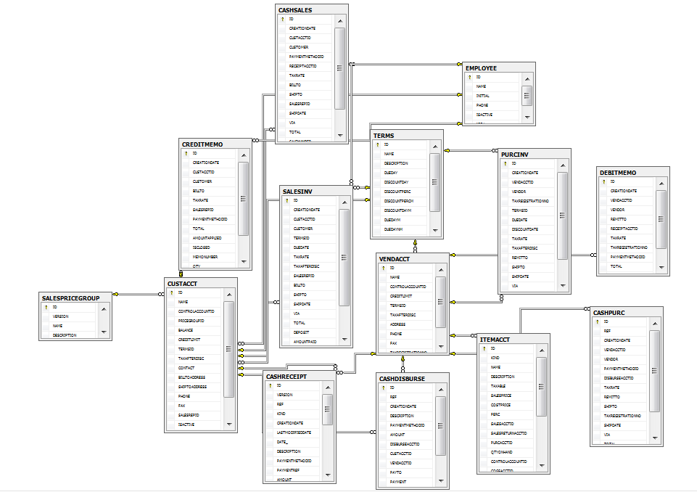
Figure 4-1 [EER-1 Diagram]

DATA TABLES
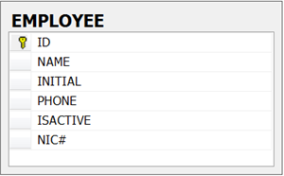
Figure 4-2 [Employee]
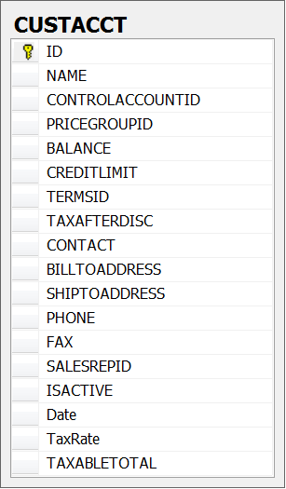
Figure 4-3 [Customer Account]
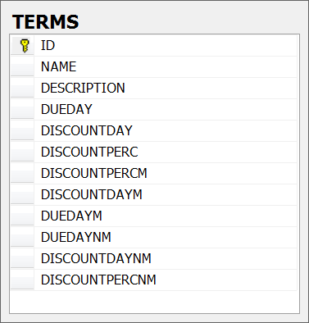
Figure 4-4 [Terms]

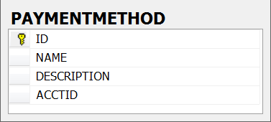
Figure 4-5 [Payment Method]
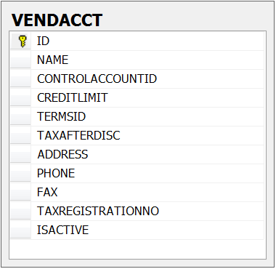
Figure 4-6 [Vendor Account]
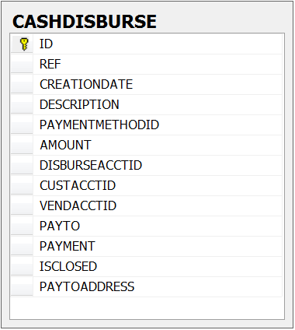
Figure 4-7 [Cash Distribution]

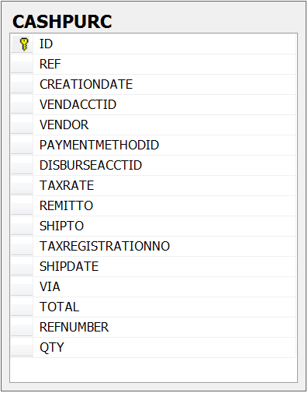
Figure 4-8 [Cash Purchase]
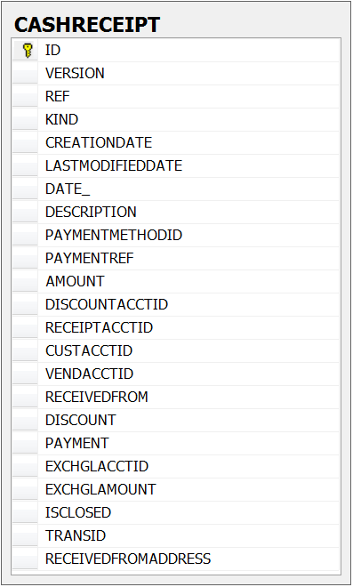
Figure 4-9 [Cash Receipt]
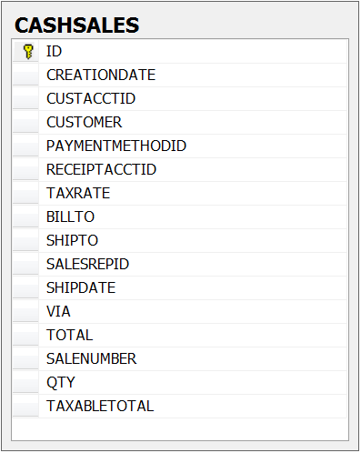
Figure 4-10 [Cash Sales]

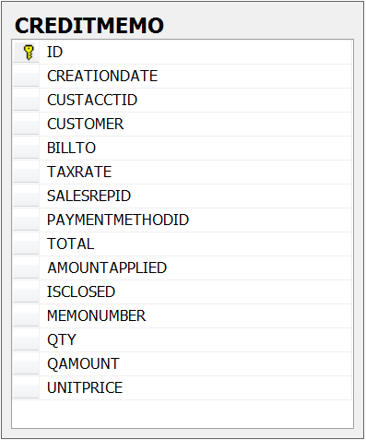
Figure 4-11 [Credit Memo]

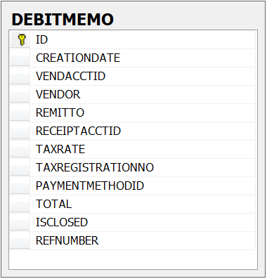
Figure 4-12 [Debt Memo]
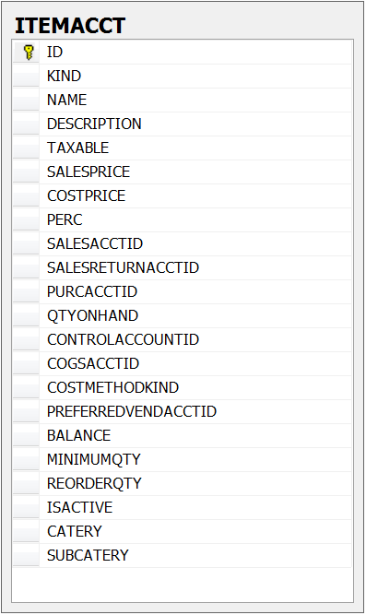
Figure 4-13 [Item Account]
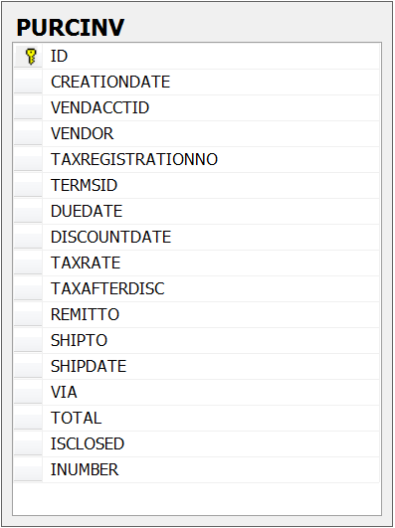
Figure 4-14 [Procurement Inventory]
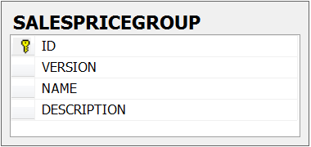
Figure 4-15 [Sales Price Group]
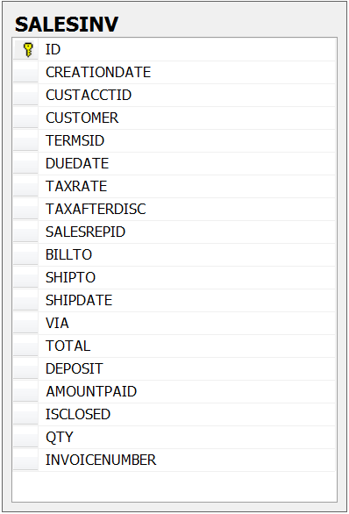
Figure 4-16 [Sales Inventory]
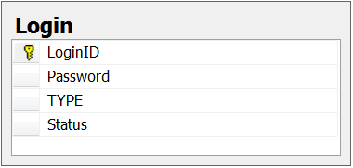
Figure 4-17 [Login]

USER INTERFACE

LOGIN PAGE

EMPLOYEE
An Employee will be required to login to Open Accounts system software; an error message will be shown when invalid ‘employee login’ or ‘employee password’ will be entered. When the employee login into software, admin module will not be visible by employee.

ADMINISTRATOR
An administrator will be required to login to Open Accounts system software. An error message will be shown when invalid ‘admin login’ or ‘admin password’ will be entered.
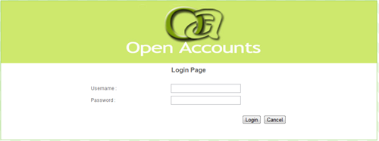
Figure 4-18 [Login Page]

MAIN WINDOW FOR ADMINISTRATOR
After successful login, admin will enter his/her main window; main window will have menu bar, admin login name, logout option, calendar for date and also display the other modules
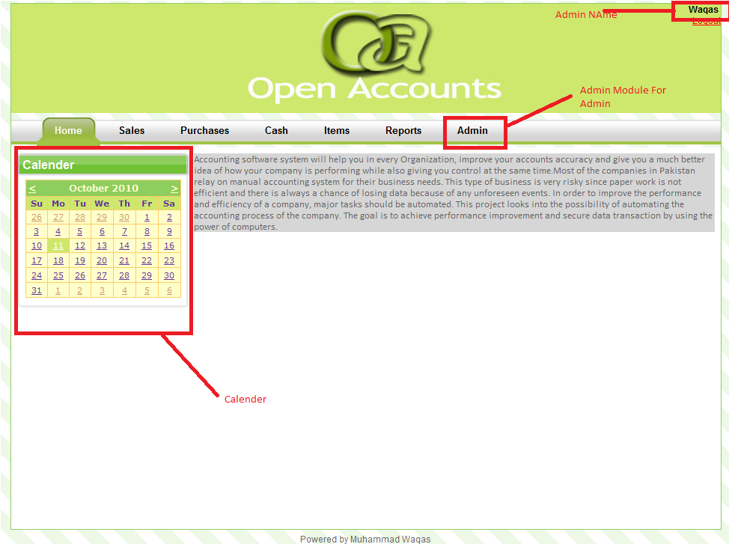
Figure 4-19 [Administrator Main Window]

MAIN WINDOW FOR EMPLOYEE
In employee main window the admin module will not be included. And the remaining options will be same.
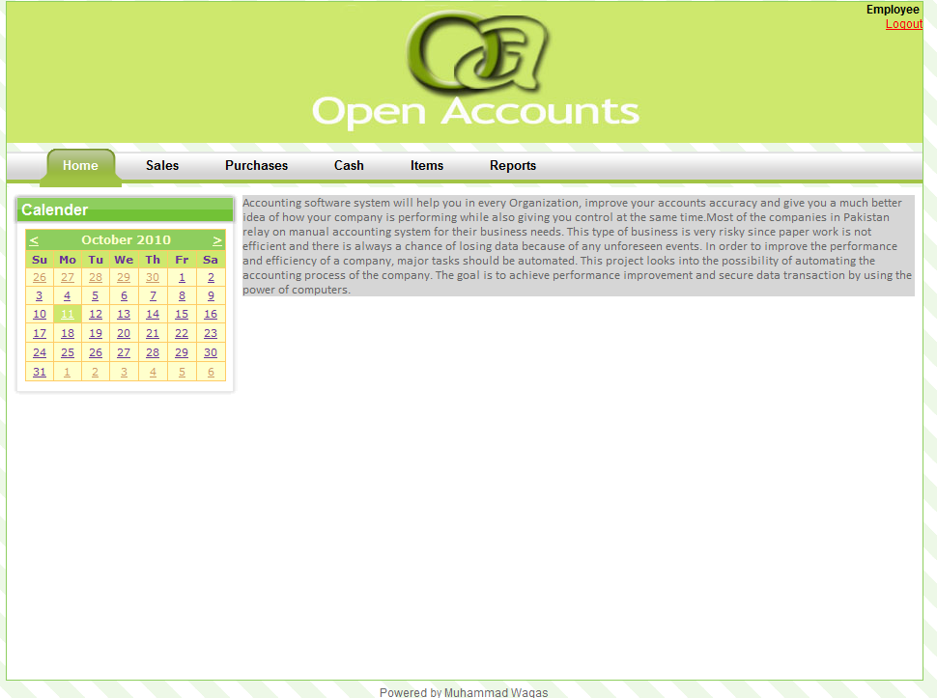
Figure 4-20 [Employee Main Window]

SALE MODULE
In the sale dashboard, there are four options i.e. cash sale, credit memo, customer and sale invoice. Recent updates are also available.
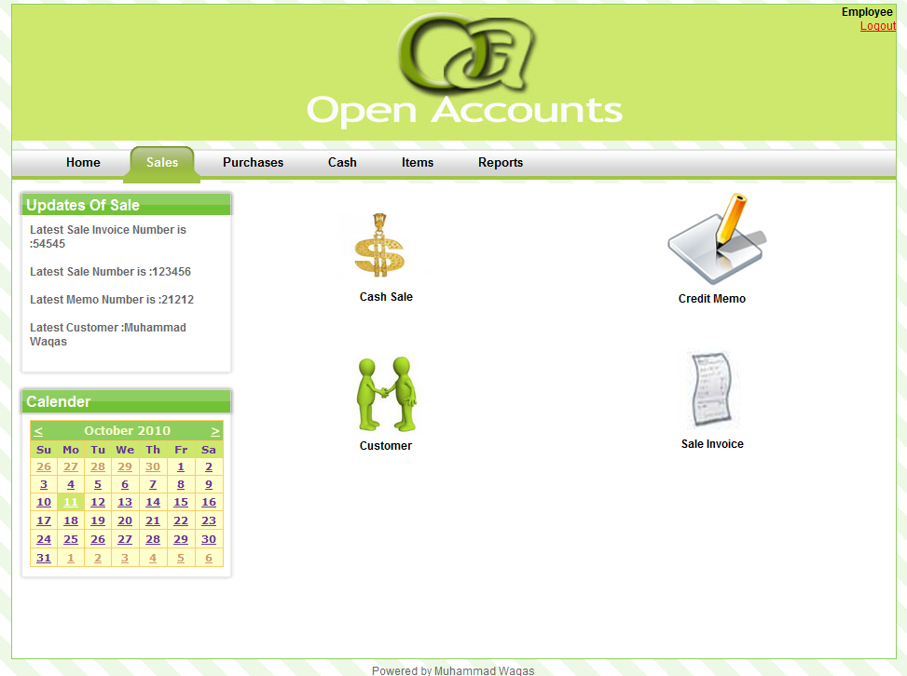
Figure 4-21 [Sale Module]

CASH SALE
Details of the cash sale will show in main body. There is option of editing and deleting the record. For new record user will click on Insert link.
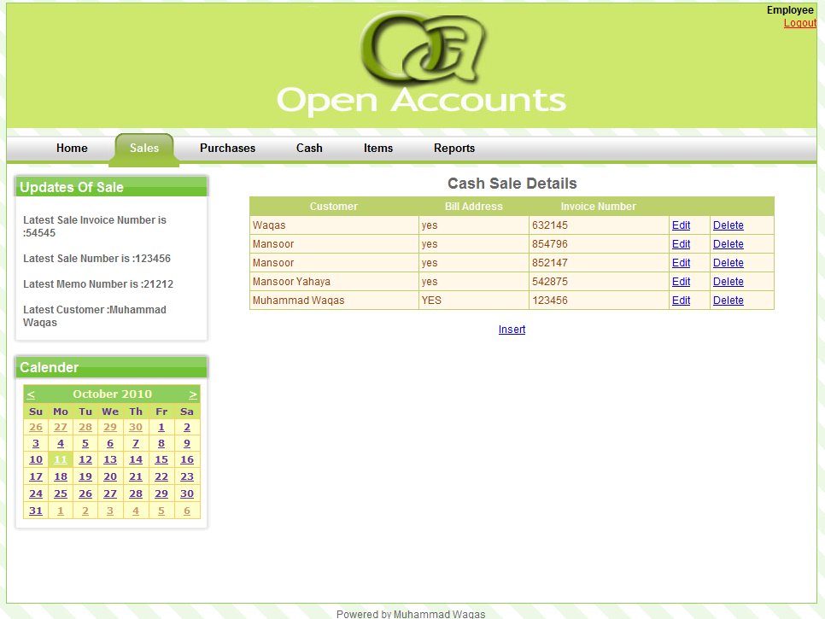
Figure 4-22 [Cash Sale]

CASH SALE
For new record user must fill the required fields.
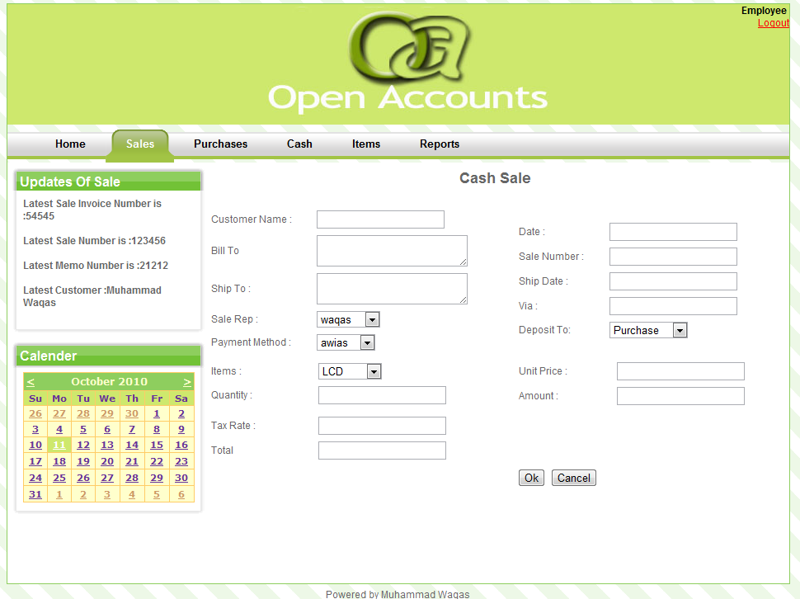
Figure 4-23 [Cash Sale]

CREDIT MEMO
Details of the credit memo will show in main body. There is option of editing and deleting the record. For new record user will click on Insert link.
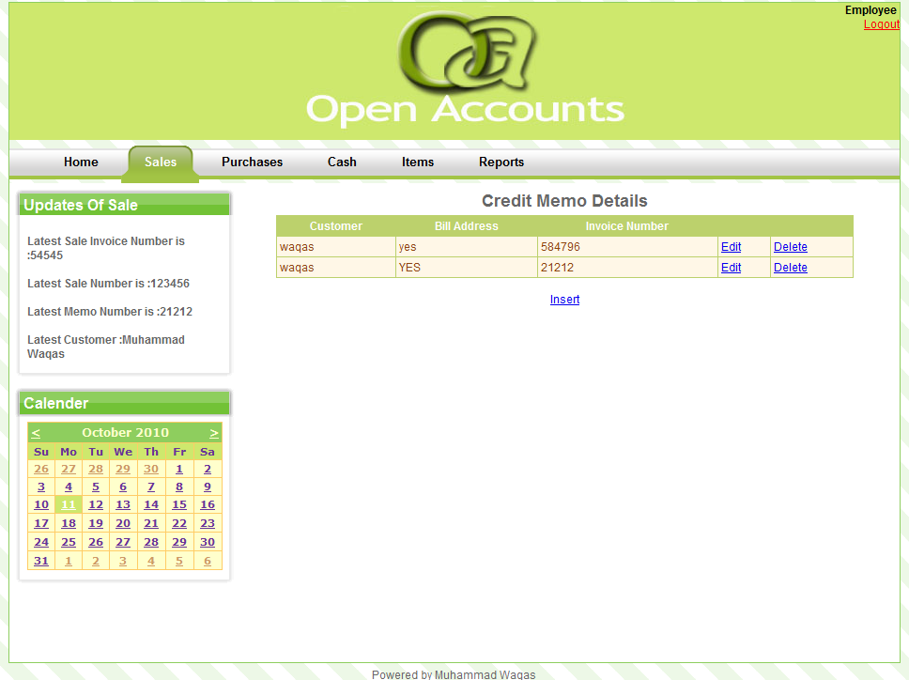
Figure 4-24 [Credit Memo]

4.7.4.4. Credit Memo
For new record user must fill the required fields.
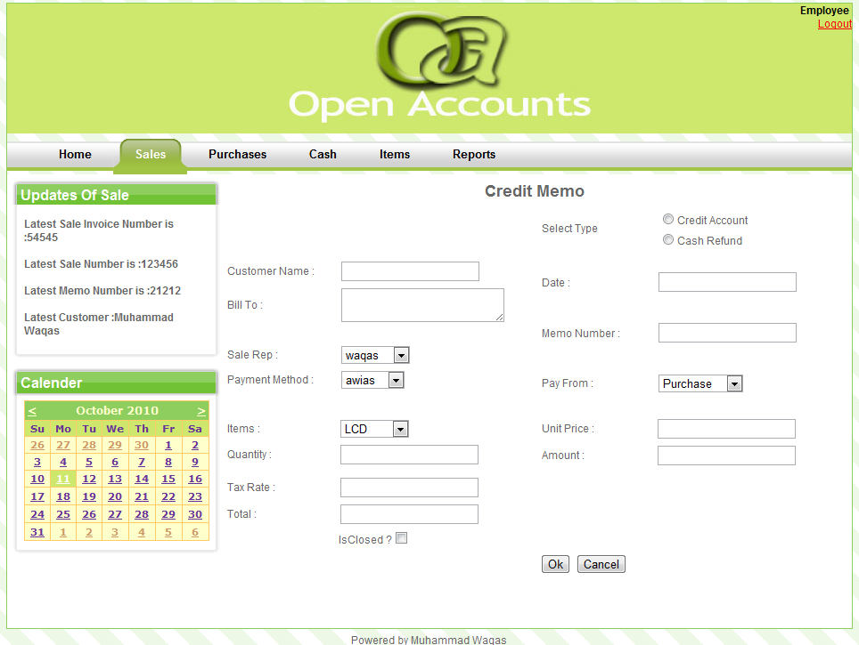
Figure 4-25 [Credit Memo]

CUSTOMER
Details of the customer will show in main body. There is option of editing and deleting the record. For new record user will click on Insert link.
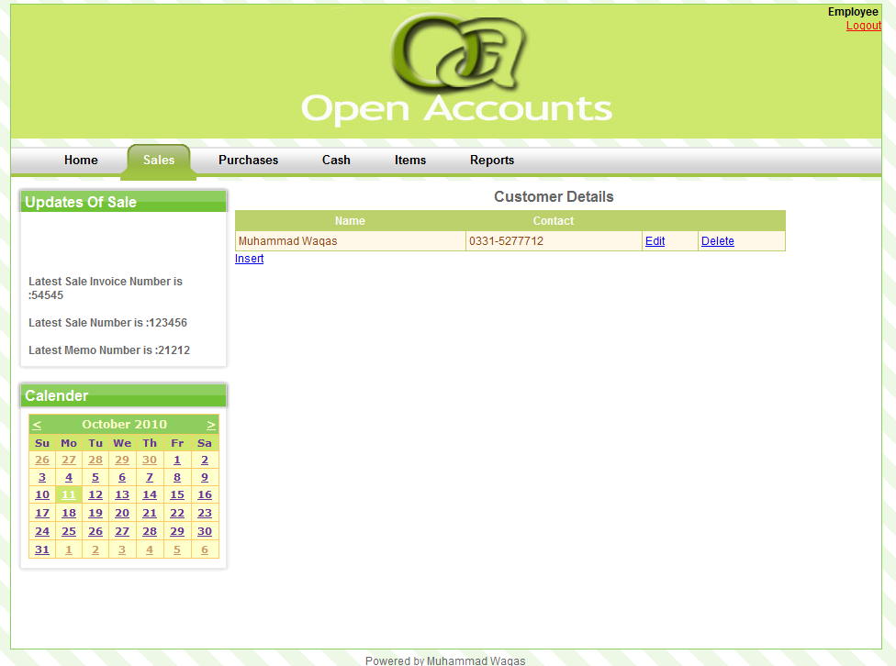
Figure 4-26 [Customer]

CUSTOMER
For new record user must fill the required fields.
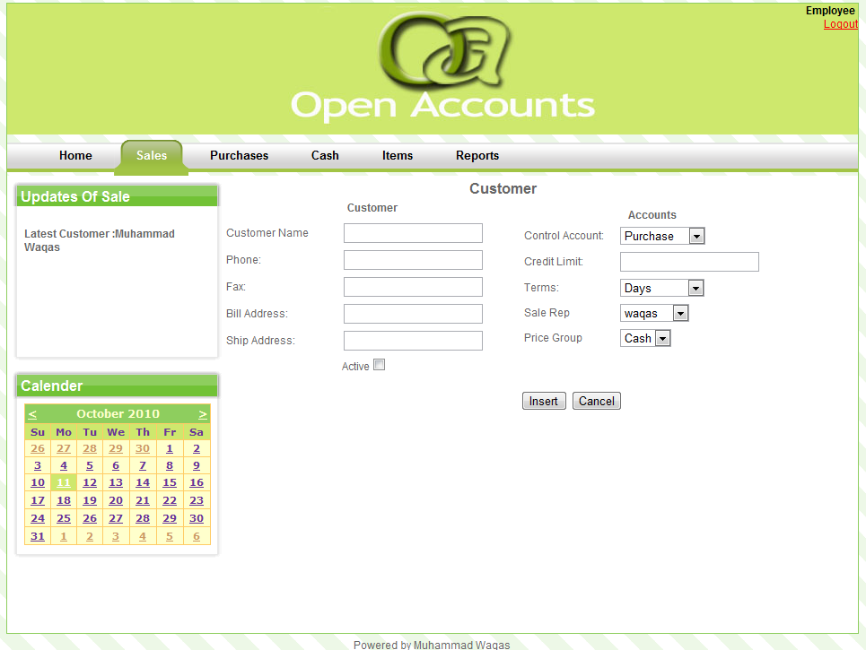
Figure 4-27 [Customer]

SALE INVOICE
Details of the sale invoice will show in main body. There is option of editing and deleting the record. For new record user will click on Insert link.
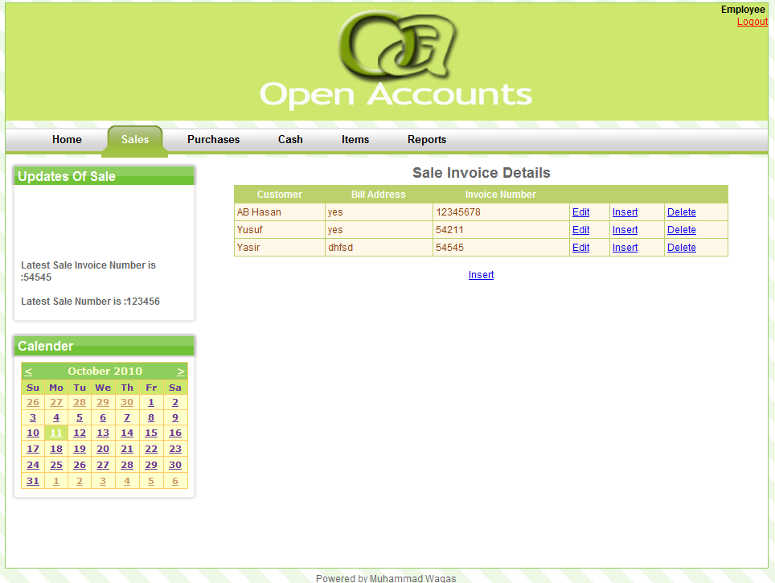
Figure 4-28 [Sale Invoice]

SALE INVOICE
For new record user must fill the required fields.
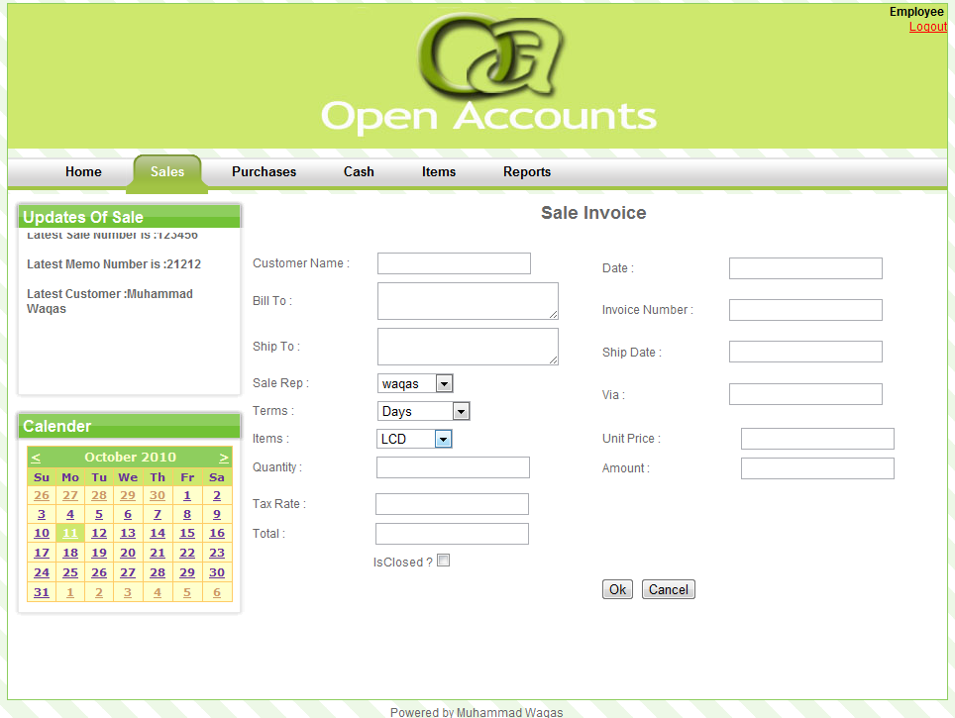
Figure 4-29 [Sale Invoice]

PURCHASE MODULE
In the Purchase dashboard, there are four options i.e. cash purchase, debit memo, vendor and purchase invoice. Recent updates are also available.
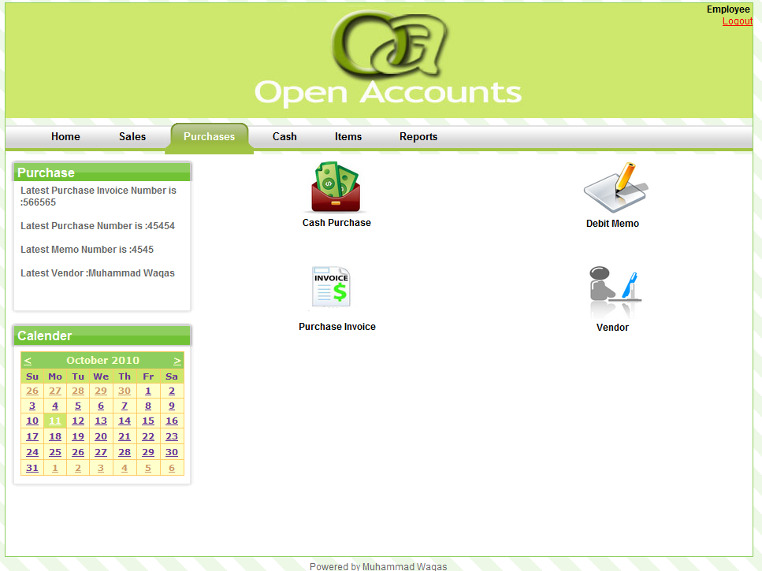
Figure 4-30 [Purchase Module]

CASH PURCHASE
Details of the cash purchase will show in main body. There is option of editing and deleting the record. For new record user will click on Insert link.
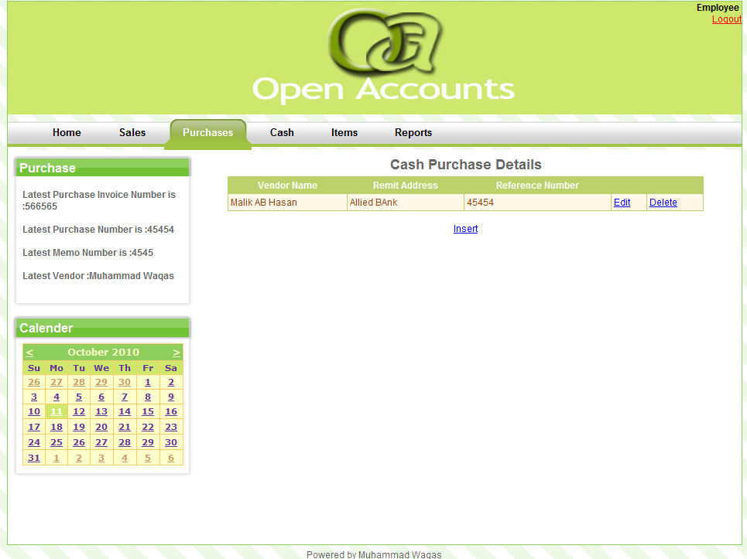
Figure 4-31 [Cash Purchase]

CASH PURCHASE
For new record user must fill the required fields.
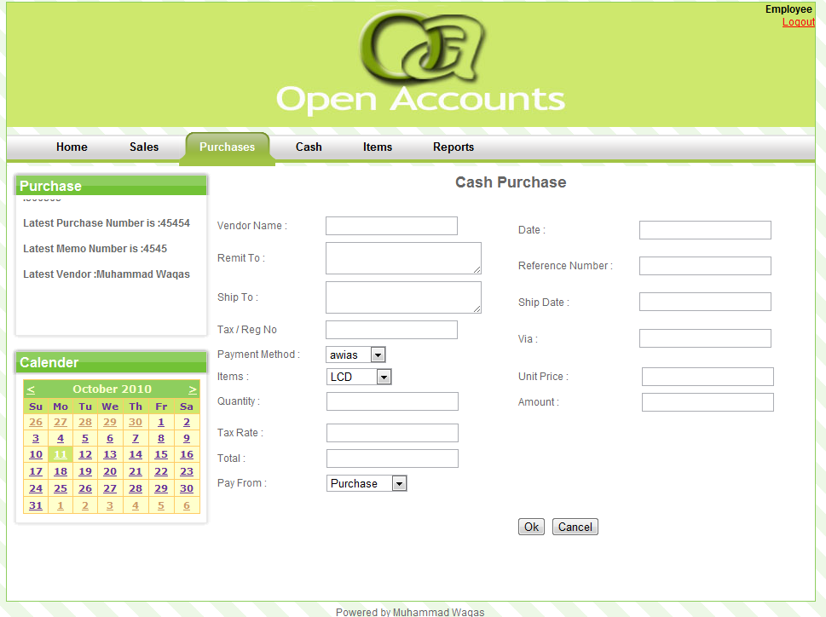
Figure 4-32 [Cash Purchase]

DEBIT MEMO
Details of the Debit Memo will show in main body. There is option of editing and deleting the record. For new record user will click on Insert link.
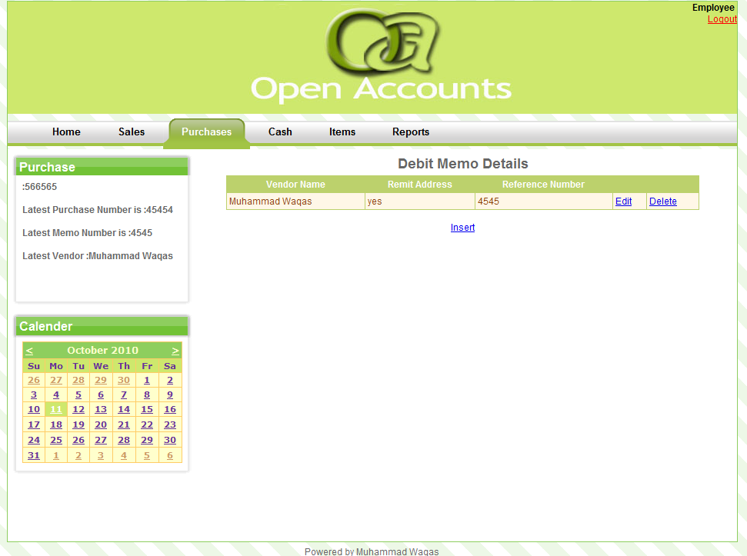
Figure 4-33 [Debt Memo]

DEBIT MEMO
For new record user must fill the required fields.
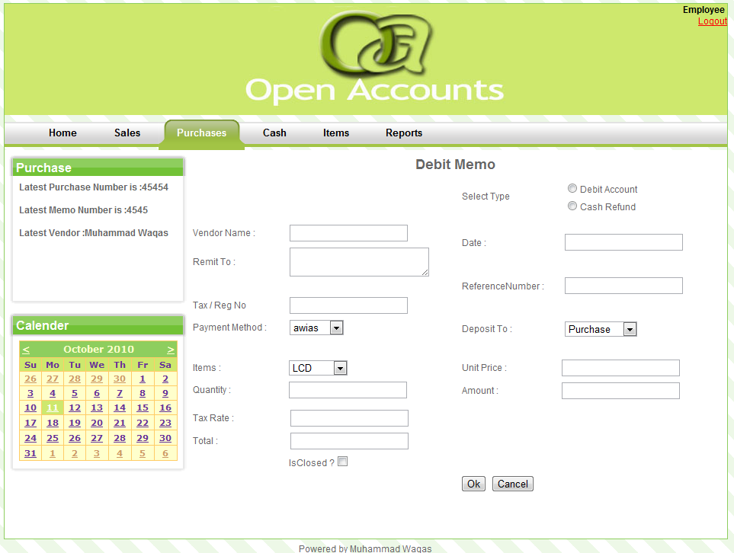
Figure 4-34 [Debt Memo]

PURCHASE INVOICE
Details of the Purchase Invoice will show in main body. There is option of editing and deleting the record. For new record user will click on Insert link.
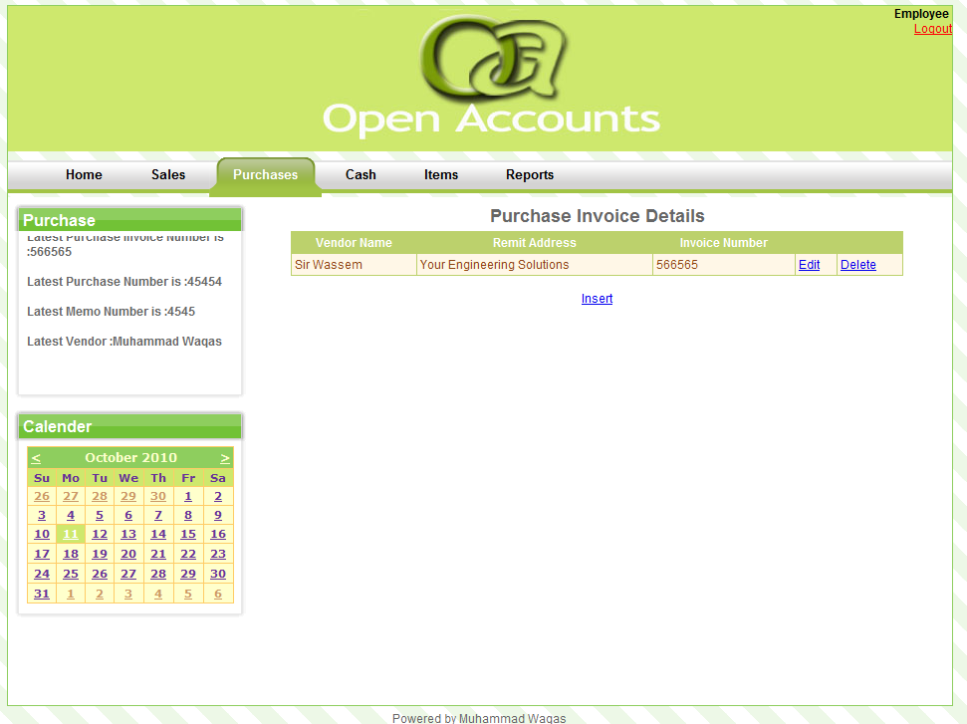
Figure 4-35 [Purchase Invoice]

PURCHASE INVOICE
For new record user must fill the required fields.
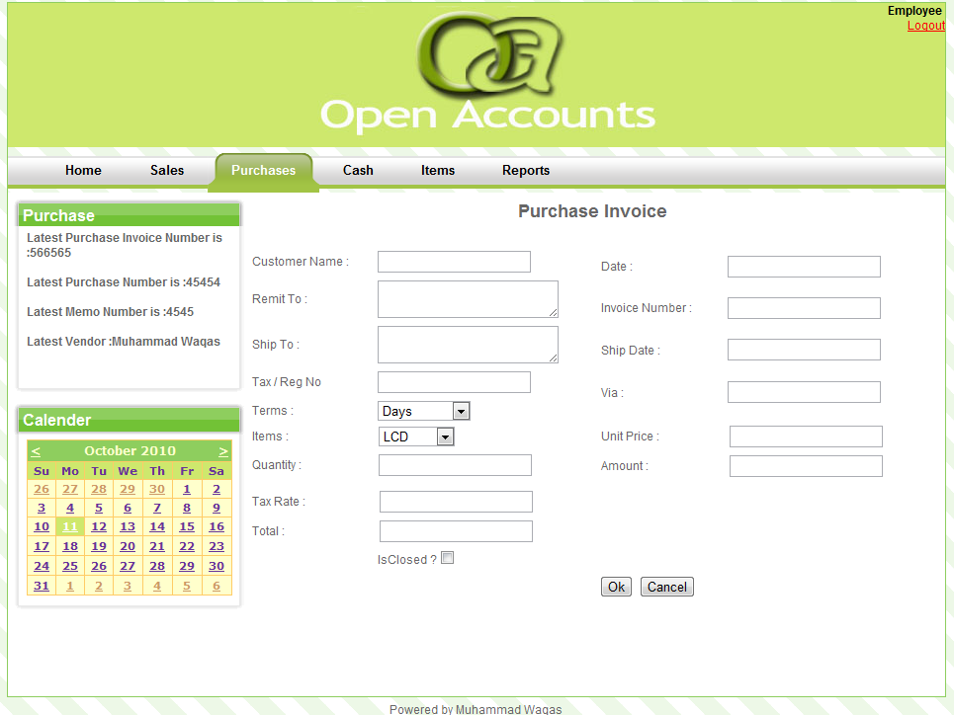
Figure 4-36 [Purchase Invoice]

VENDOR
Details of the Vendor will show in main body. There is option of editing and deleting the record. For new record user will click on Insert link.
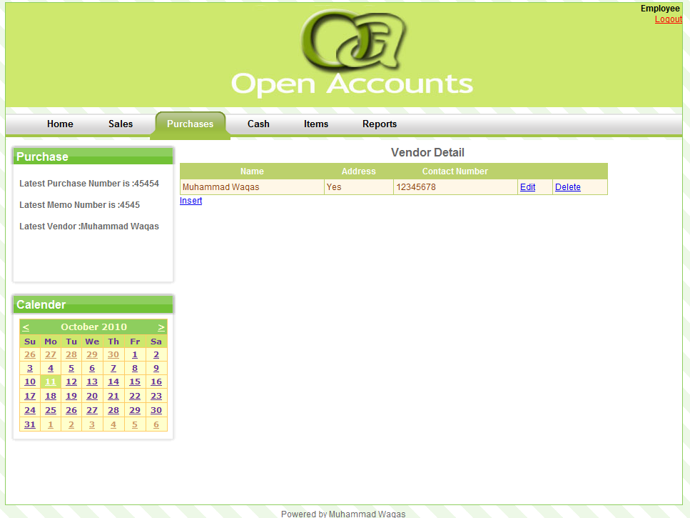
Figure 4-37 [Vendor]

VENDOR
For new record user must fill the required fields.
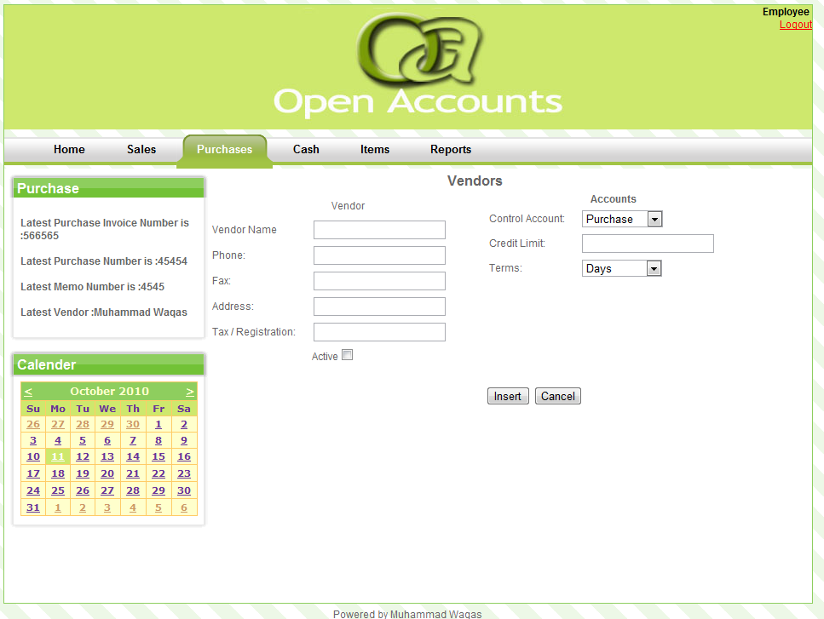
Figure 4-38 [Vendor]

CASH MODULE
In the Cash dashboard, there are two options i.e. cash receipt and cash disbursement. Recent updates are also available.
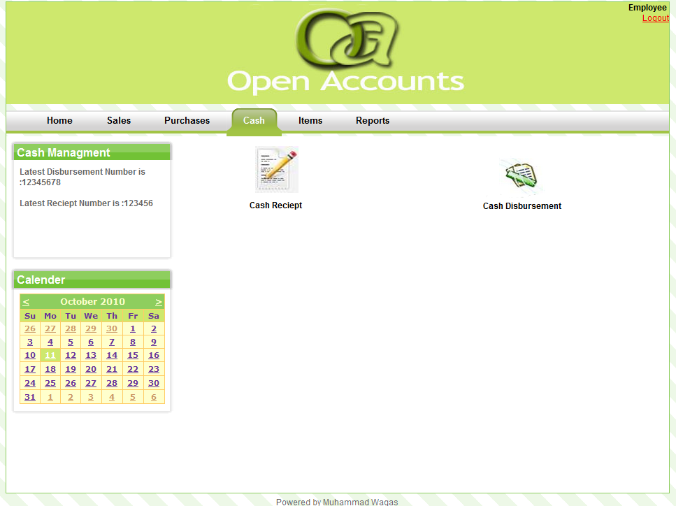
Figure 4-39 [Cash Module]

CASH RECEIPT
Details of the Cash Receipt will show in main body. There is option of editing and deleting the record. For new record user will click on Insert link.
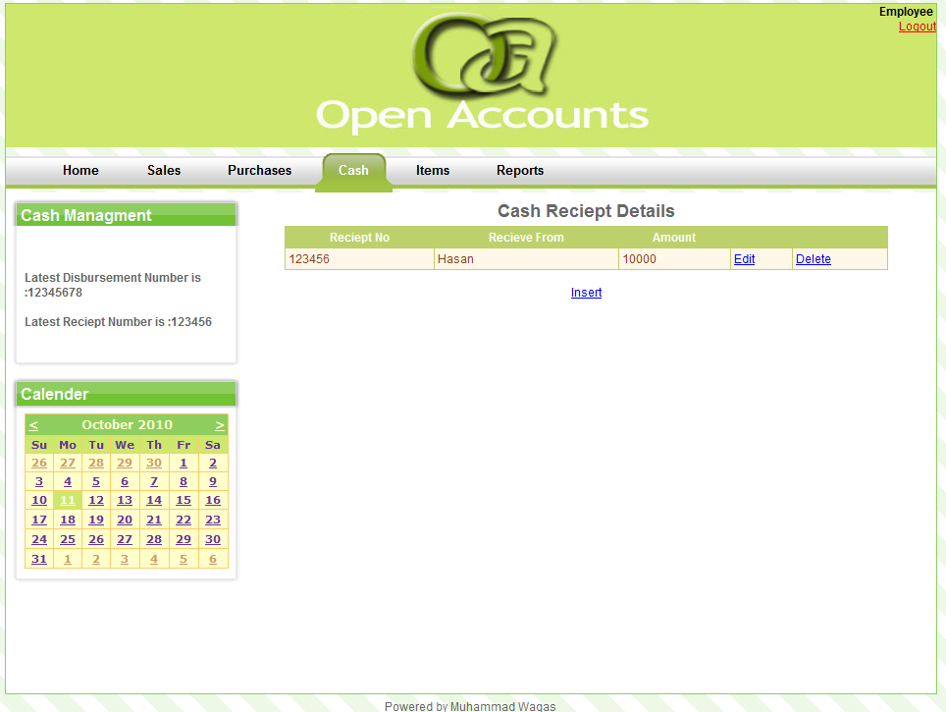
Figure 4-40 [Cash Receipt]

CASH RECEIPT
For new record user must fill the required fields.
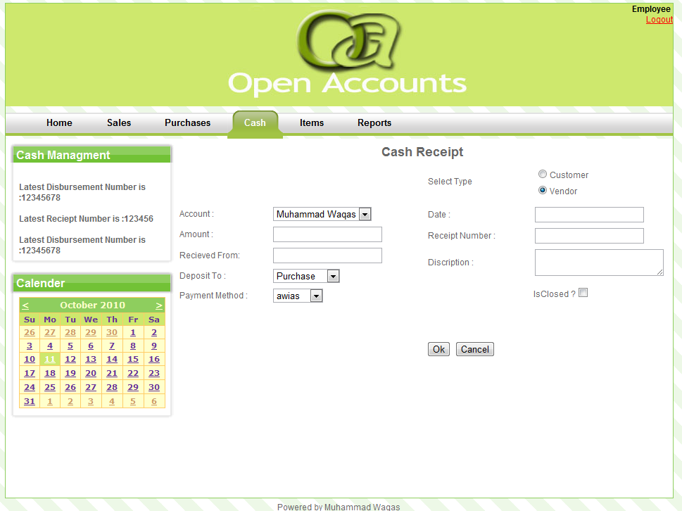
Figure 4-41 [Cash Receipt]

CASH DISBURSEMENT
Details of the Cash Disbursement will show in main body. There is option of editing and deleting the record. For new record user will click on Insert link.
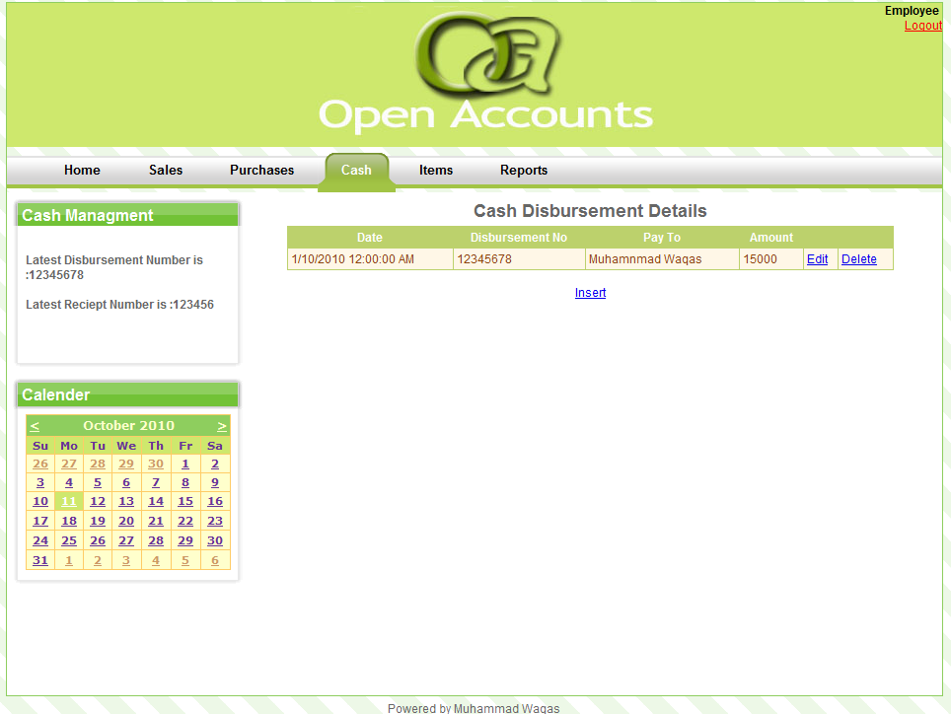
Figure 4-42 [Cash Distribution]

CASH DISBURSEMENT
For new record user must fill the required fields.
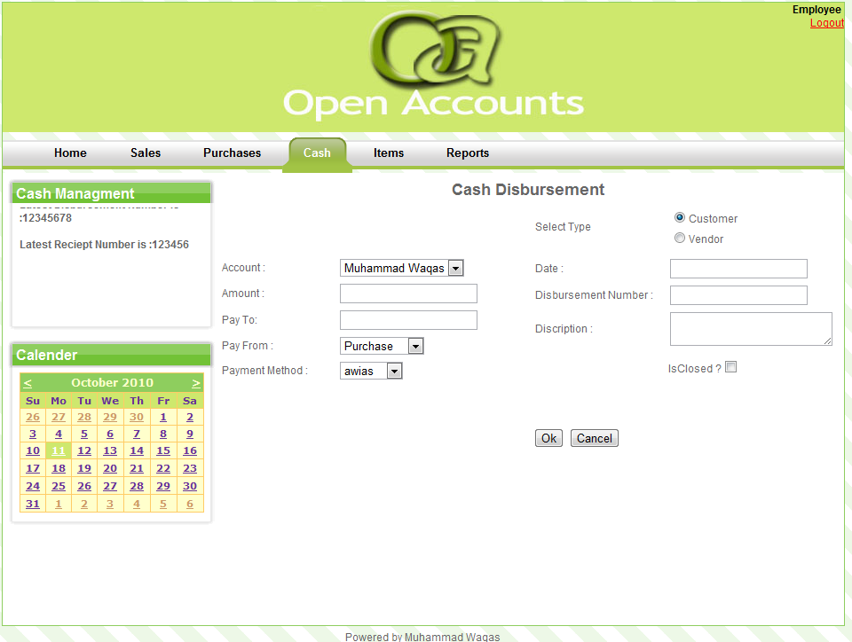
Figure 4-43 [Cash Distribution]

ITEM MODULE
In the Item dashboard, there are two options i.e. items and Price group. Recent updates are also available.
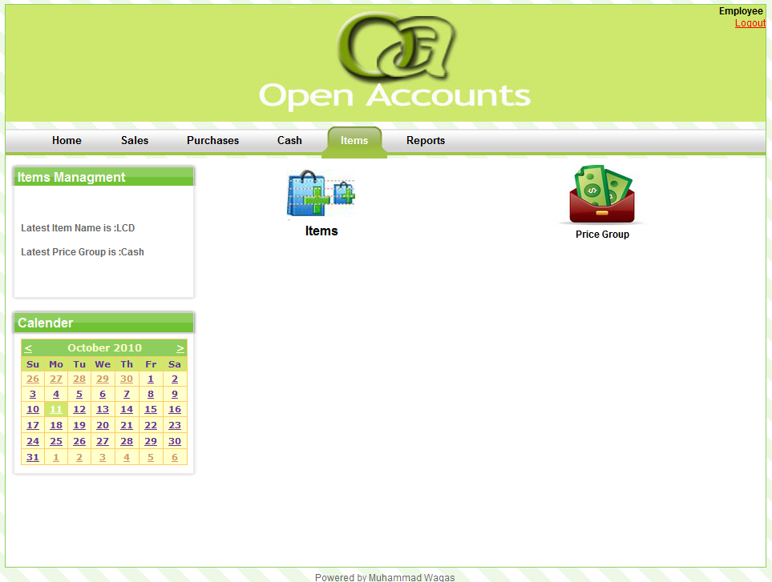
Figure 4-44 [Item Module]

ITEMS
Details of the Items will show in main body. There is option of editing and deleting the record. For new record user will click on Insert link.
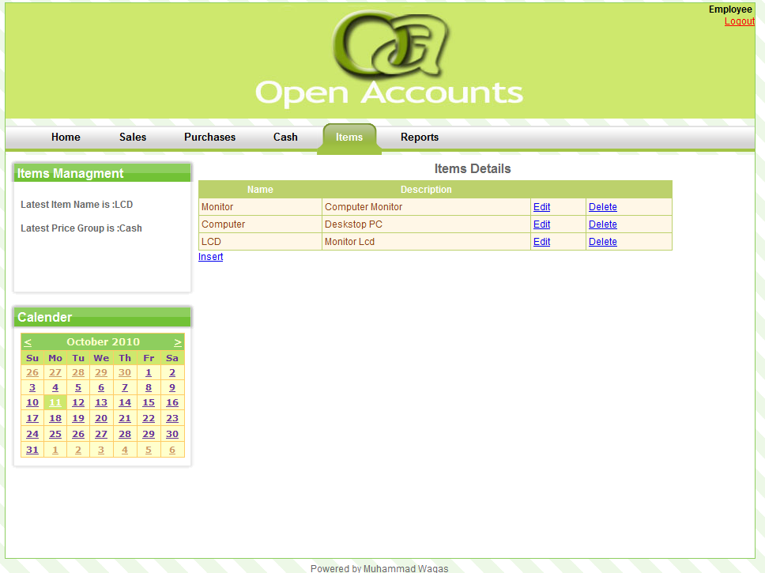
Figure 4-45 [Items]

ITEMS
For new record user must fill the required fields.
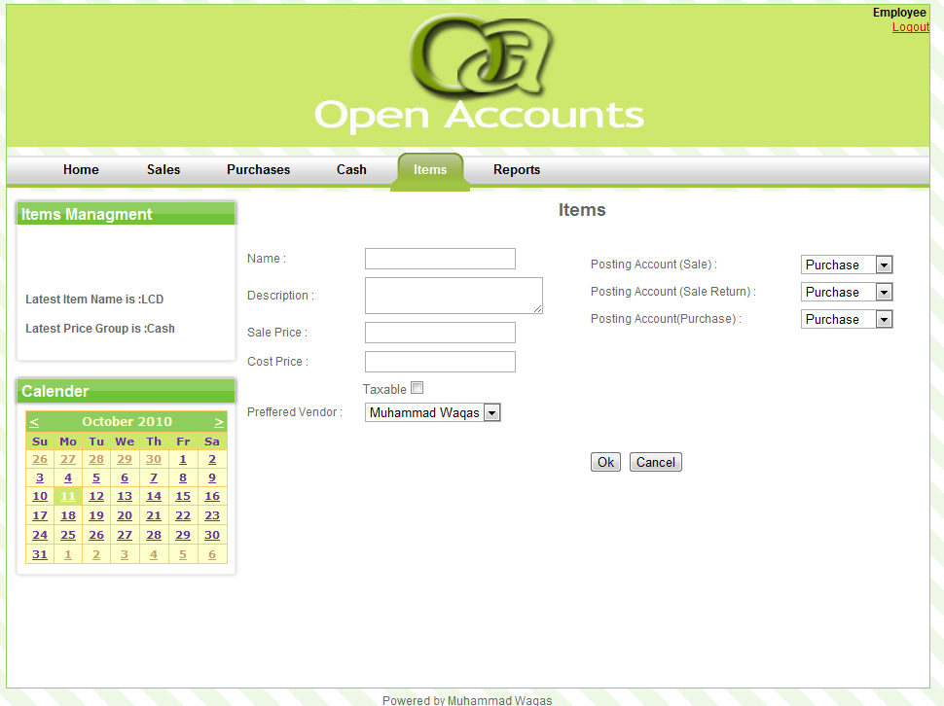
Figure 4-46 [Items]

PRICE GROUP
Details of the Price group will show in main body. There is option of editing and deleting the record. For new record user will click on Insert link.
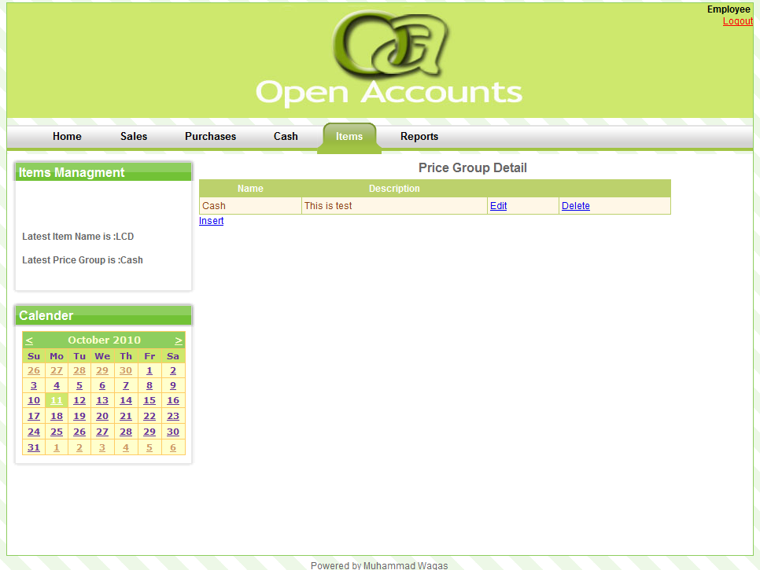
Figure 4-47 [Price Group]

PRICE GROUP
For new record user must fill the required fields.
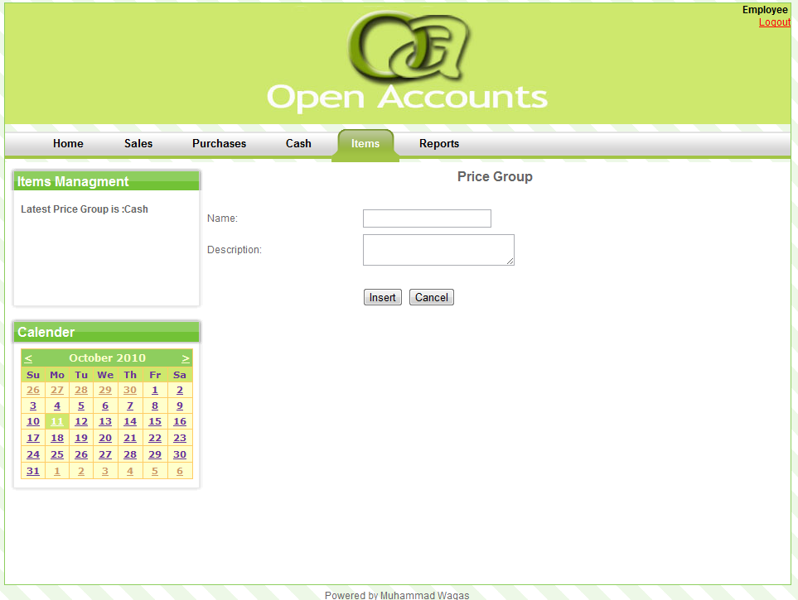
Figure 4-48 [Price Group]

REPORTS MODULE
In reports module user will generate the Sale Invoice, Purchase Invoice, Debit Memo, Credit Memo, Cash Sale, Cash Purchase, Customer, and Vendor
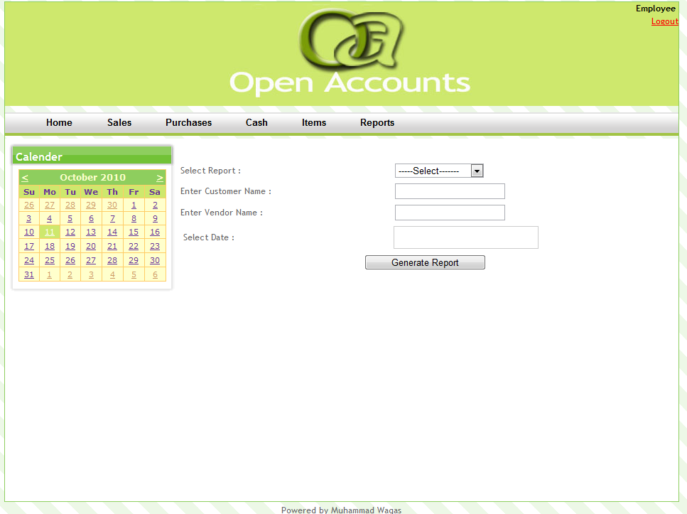
Figure 4-49 [Reports Module]

ADMIN MODULE
In the Admin dashboard, there are four options i.e. Employee, Payment Method, Credit terms and create new user. Recent updates are also available.
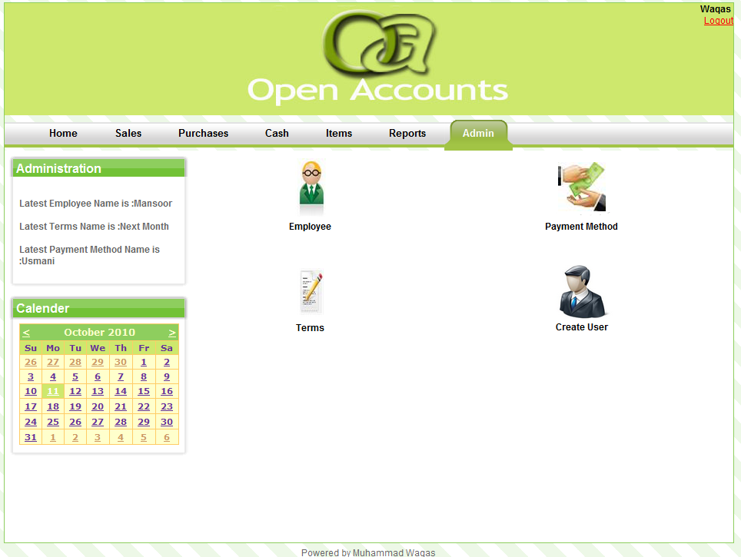
Figure 4-50 [Admin Module]

EMPLOYEE
Details of the Employees will show in main body. There is option of editing and deleting the record. For new record user will click on Insert link.
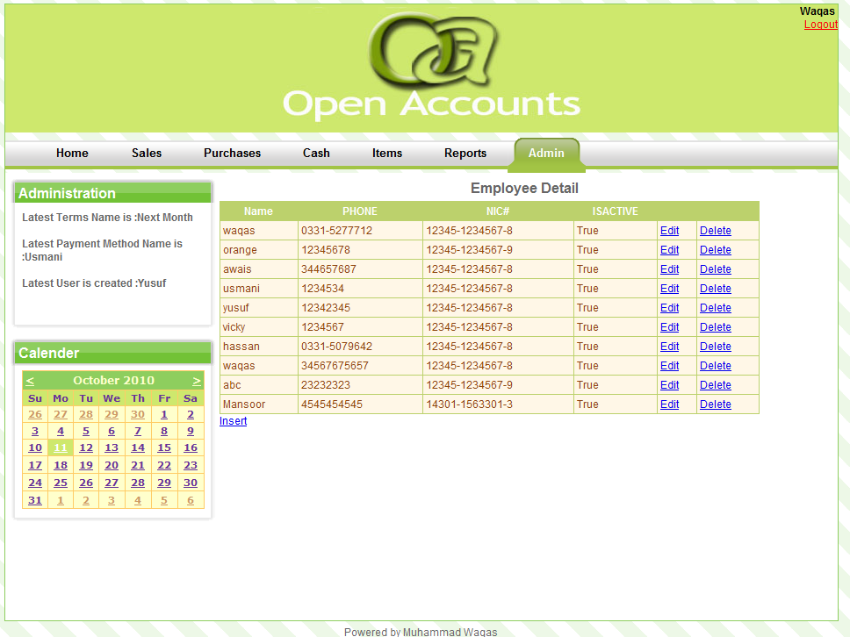
Figure 4-51 [Employee]

EMPLOYEE
For new record user must fill the required fields.
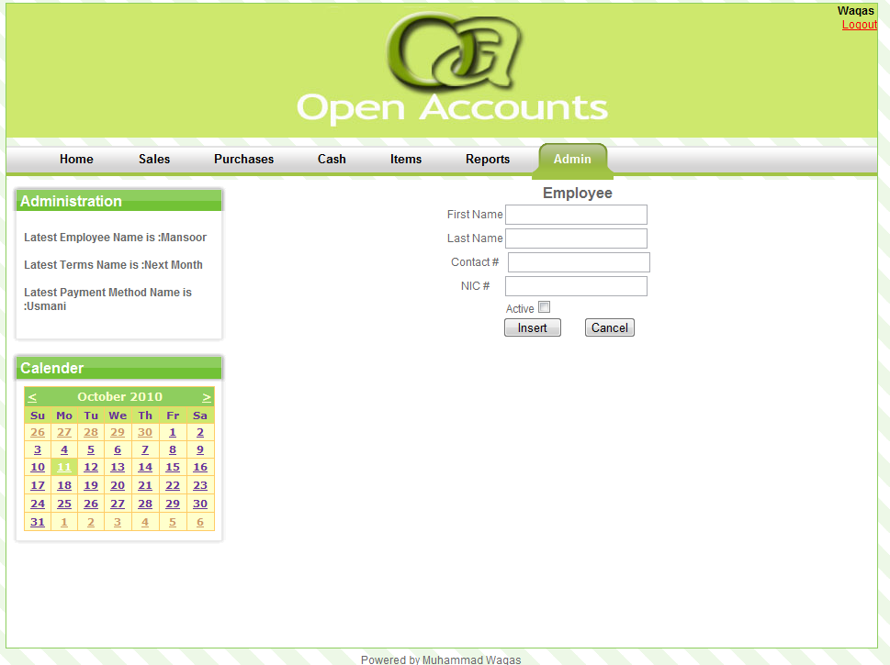
Figure 4-52 [Employee]

PAYMENT METHOD
Details of the Payment method will show in main body. There is option of editing and deleting the record. For new record user will click on Insert link.
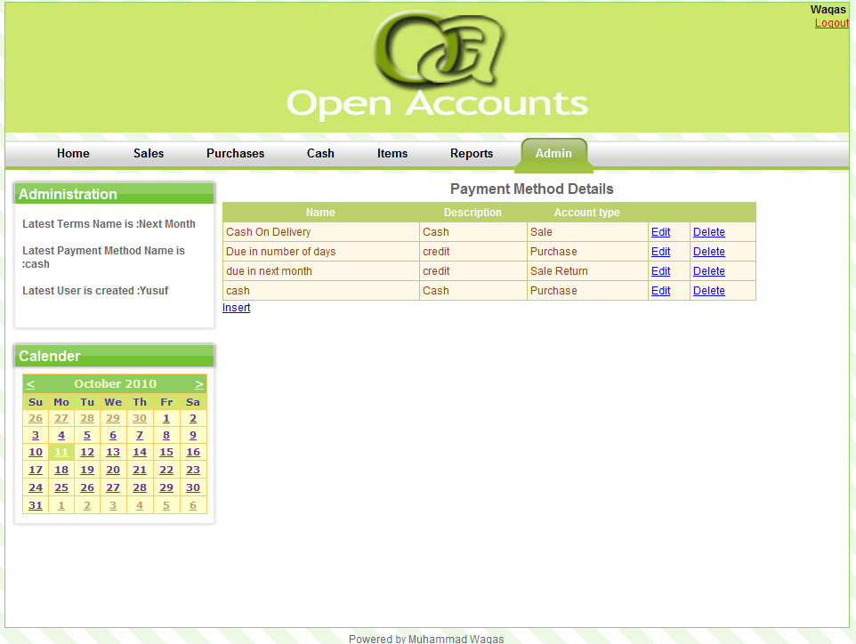
Figure 4-53 [Payment Method]

PAYMENT METHOD
For new record user must fill the required fields.
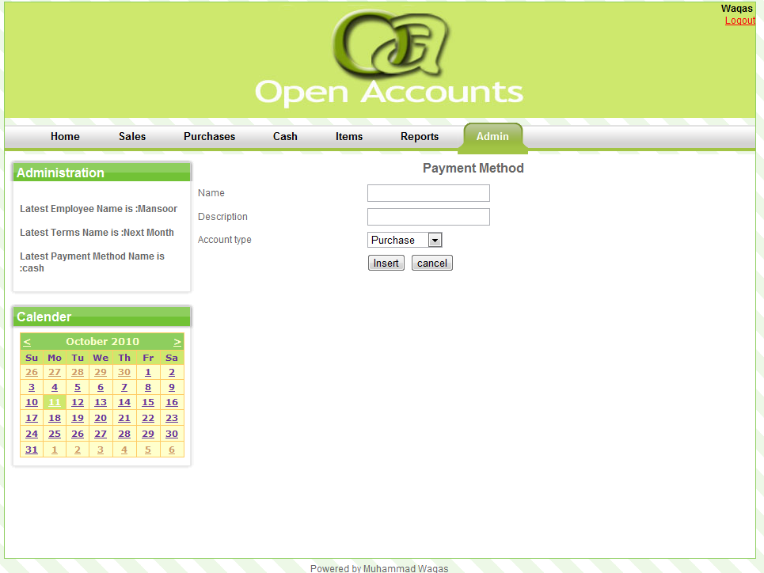
Figure 4-54 [Payment Method]

CREDIT TERMS
Details of the Credit Terms will show in main body. There is option of editing and deleting the record. For new record user will click on Insert link.
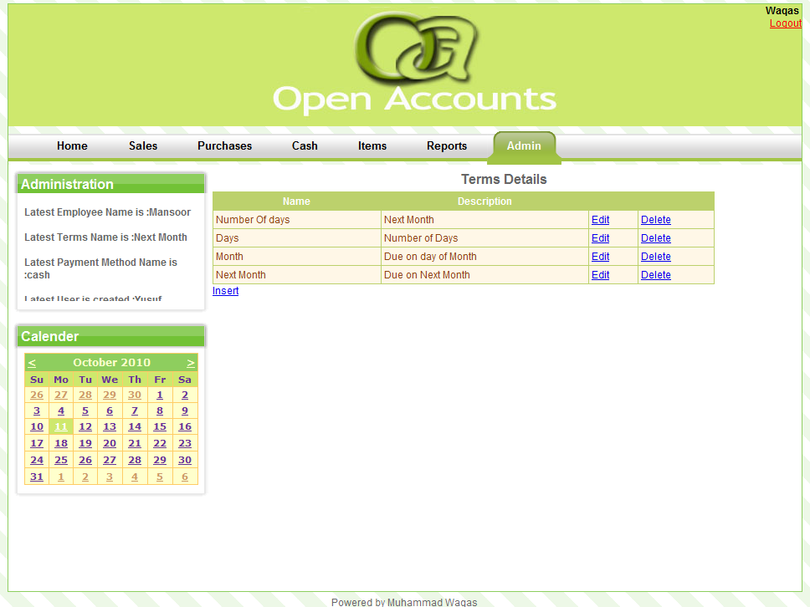
Figure 4-55 [Credit Terms]

CREDIT TERMS
For new record user must fill the required fields.
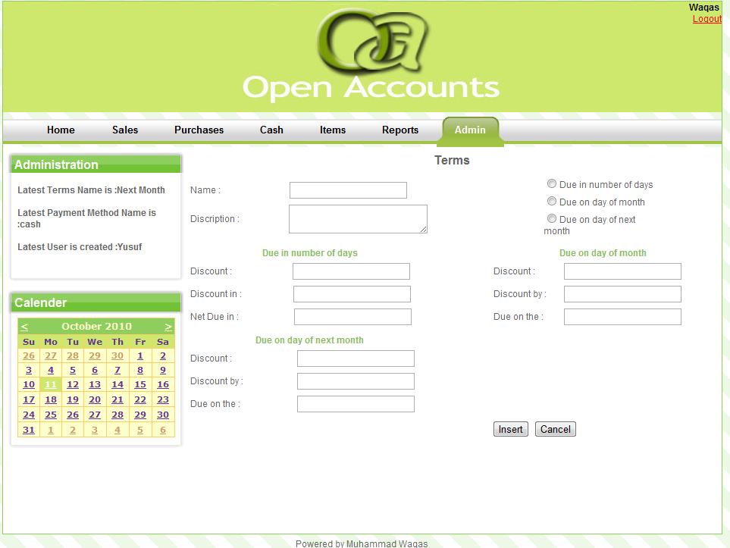
Figure 4-56 [Credit Terms]

CREATE NEW USER
In this section of Admin module the admin will create new users
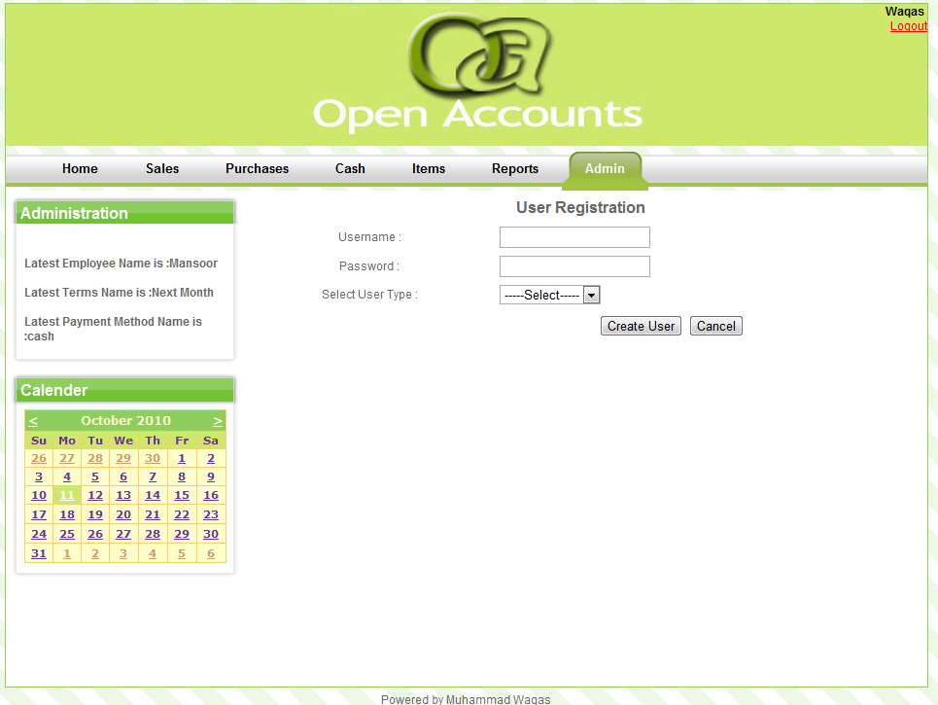
Figure 4-57 [Create New User]

CHAPTER FIVE

TESTING

TEST PLAN

INTRODUCTION
This project looks into the possibility of automating the accounting process of the company. The goal is to achieve performance improvement and secure data transaction by using the power of computers.
This Website will perform the following tasks:

SETTING UP
- Employee Details
- Credit Terms
- Payment Methods
- Customers
- Vendors

SALES PROCESSING
- Sales Invoice
- Credit Memo
- Cash Sales
- Customer

PURCHASE PROCESSING
- Purchase Invoice
- Debit Memo
- Cash Purchase
- Vendor

CASH MANAGEMENT
- Cash Receipt
- Cash Disbursement

ITEMS MANAGEMENT
- Item
- Price Group

REPORTS
- Sale Invoice
- Purchase Invoice
- Debit Memo
- Credit Memo
- Cash Sale
- Cash Purchase
- Customer
- Vendor

ADMINISTRATION
- Employee
- Terms
- Payment Method
- Create User

AUTHENTICATIONS
- Login
- Logout

TEST STRATEGY
To get a knowhow of the systems best performance as well as its limitations, different test strategies have been designed.

SYSTEM TEST
Firstly the web-end, system software, server windows service and SQL server reporting services were tested independently. After achieving satisfactory results they were tested as a whole along with a master database and performed as expected, giving the desired results.

PERFORMANCE TEST
The system was tested successfully with 10 users and then verifying the result successfully.

SECURITY TEST
Security features of the system were tested by providing incorrect login details at the web-end for users and for the admin.

USER ACCEPTANCE TEST
Valid users were logged in successfully in to their accounts, also valid admin successfully logged in to their account.

FUNCTIONS TO BE TESTED
The following functions will be tested

SALES PROCESSING
- Sales Invoice
- Credit Memo
- Cash Sales
- Customer

PURCHASE PROCESSING
- Purchase Invoice
- Debit Memo
- Cash Purchase
- Vendor

CASH MANAGEMENT
- Cash Receipt
- Cash Disbursement

ITEMS MANAGEMENT
- Item
- Price Group

REPORTS
- Sale Invoice
- Purchase Invoice
- Debit Memo
- Credit Memo
- Cash Sale
- Cash Purchase
- Customer
- Vendor

ADMINISTRATION
- Employee
- Terms
- Payment Method
- Create User

AUTHENTICATIONS
- Login
- Logout

TEST CASES

LOGIN & LOGOUT/DASHBOARD
Test Case # | Test Case Description | Expected Result | Actual Result | Pass/Fail
1 | Enter correct Username and password and click on Login | Make sure user is logged in | Main Window Display the Data successfully. | Pass
2 | Click On logout Button/Link | Make sure successful logout | User return to Login Page | Pass
3 | Enter invalid Username in the username field and click on login | Should prompt for username | Error message displays “Invalid Username/Password | Pass
4 | Without providing a username, and click on login | Error message for Username should be provided | Error message displays as: ‘Please Fill The Fields’ | Pass
5 | Enter invalid Username and password combination and click on login | Error message for invalid details should be provided | Error message displays “Invalid Username/Password” | Pass
6 | Enter invalid password and click on login | Error message for Password should be provided | Error message displays “Invalid Username/Password” | Pass
7 | Without providing a password, try to login | Should prompt for password | Error message displays: ‘Please Fill The Fields’ | Pass
Table 5-1 [Test Cases-Login and Logout]

SALE INVOICE
Test Case # | Test Case Description | Expected Result | Actual Result | Pass/Fail
1 | In Sale Invoice fill the specific fields | Make sure the details get submitted successfully. | Information is submitted successfully, with a confirmation message. | Pass
2 | Leave “Name” field empty and click the Submit button | Information should not be submitted. With appropriate error message | Cursor focus to Name field | Pass
3 | Leave “Date” field empty and click the Submit button | Information should not be submitted. With appropriate error message | Cursor focus to Name field | Pass
4 | Leave “Invoice” field empty and click the Submit button | Information should not be submitted. With appropriate error message | Cursor focus to Name field | Pass
5 | Leave “Ship Date” field empty and click the Submit button | Information should not get submitted | Cursor focus to Name field | Pass
6 | Leave “Via” field empty and click the Submit button | Information should not be submitted. With appropriate error message | Cursor focus to Name field | Pass
Table 5-2 [Sale Invoice]

CREDIT MEMO
Test Case # | Test Case Description | Expected Result | Actual Result | Pass/Fail
1 | In Credit Memo fill the specific fields | Make sure the details get submitted successfully. | Information is submitted successfully, with a confirmation message. | Pass
2 | Leave “Name” field empty and click the Submit button | Information should not be submitted. With appropriate error message | Cursor focus to Name field | Pass
3 | Leave “Date” field empty and click the Submit button | Information should not be submitted. With appropriate error message | Cursor focus to Name field | Pass
4 | Leave “Memo number” field empty and click the Submit button | Information should not be submitted. With appropriate error message | Cursor focus to Name field | Pass
5 | Leave “Sale Representative” field empty and click the Submit button | Information should not get submitted | Cursor focus to Name field | Pass
Table 5-3 [Credit Memo]

CASH SALE
Test Case # | Test Case Description | Expected Result | Actual Result | Pass/Fail
1 | In Cash Sale fill the specific fields | Make sure the details get submitted successfully. | Information is submitted successfully, with a confirmation message. | Pass
2 | Leave “Name” field empty and click the Submit button | Information should not be submitted. With appropriate error message | Cursor focus to Name field | Pass
3 | Leave “Date” field empty and click the Submit button | Information should not be submitted. With appropriate error message | Cursor focus to Name field | Pass
4 | Leave “Sale number” field empty and click the Submit button | Information should not be submitted. With appropriate error message | Cursor focus to Name field | Pass
5 | Leave “Ship Date” field empty and click the Submit button | Information should not get submitted | Cursor focus to Name field | Pass
6 | Leave “Via” field empty and click the Submit button | Information should not be submitted. With appropriate error message | Cursor focus to Name field | Pass
Table 5-4 [Cash Sale]

CUSTOMER
Test Case # | Test Case Description | Expected Result | Actual Result | Pass/Fail
1 | In Customer fill the specific fields | Make sure the details get submitted successfully. | Information is submitted successfully, with a confirmation message. | Pass
2 | Leave “Name” field empty and click the Submit button | Information should not be submitted. With appropriate error message | Cursor focus to Name field | Pass
3 | Leave “Phone” field empty and click the Submit button | Information should not be submitted. With appropriate error message | Cursor focus to Name field | Pass
4 | Leave “Control Account” field empty and click the Submit button | Information should not be submitted. With appropriate error message | Cursor focus to Name field | Pass
5 | Leave “Credit Limit” field empty and click the Submit button | Information should not get submitted | Cursor focus to Name field | Pass
Table 5-5 [Customer]

VENDOR
Test Case # | Test Case Description | Expected Result | Actual Result | Pass/Fail
1 | In vendor fill the specific fields | Make sure the details get submitted successfully. | Information is submitted successfully, with a confirmation message. | Pass
2 | Leave “Name” field empty and click the Submit button | Information should not be submitted. With appropriate error message | Cursor focus to Name field | Pass
3 | Leave “Phone” field empty and click the Submit button | Information should not be submitted. With appropriate error message | Cursor focus to Name field | Pass
4 | Leave “Control Account” field empty and click the Submit button | Information should not be submitted. With appropriate error message | Cursor focus to Name field | Pass
5 | Leave “Credit Limit” field empty and click the Submit button | Information should not get submitted | Cursor focus to Name field | Pass
Table 5-6 [Vendor]

PURCHASE INVOICE
Test Case # | Test Case Description | Expected Result | Actual Result | Pass/Fail
1 | In Purchase Invoice fill the specific fields | Make sure the details get submitted successfully. | Information is submitted successfully, with a confirmation message. | Pass
2 | Leave “Name” field empty and click the Submit button | Information should not be submitted. With appropriate error message | Cursor focus to Name field | Pass
3 | Leave “Date” field empty and click the Submit button | Information should not be submitted. With appropriate error message | Cursor focus to Name field | Pass
4 | Leave “Invoice number” field empty and click the Submit button | Information should not be submitted. With appropriate error message | Cursor focus to Name field | Pass
5 | Leave “Ship Date” field empty and click the Submit button | Information should not get submitted | Cursor focus to Name field | Pass
6 | Leave “Via” field empty and click the Submit button | Information should not be submitted. With appropriate error message | Cursor focus to Name field | Pass
Table 5-7 [Purchase Invoice]

CASH PURCHASE
Test Case # | Test Case Description | Expected Result | Actual Result | Pass/Fail
1 | In Cash Purchase fill the specific fields | Make sure the details get submitted successfully. | Information is submitted successfully, with a confirmation message. | Pass
2 | Leave “Name” field empty and click the Submit button | Information should not be submitted. With appropriate error message | Cursor focus to Name field | Pass
3 | Leave “Date” field empty and click the Submit button | Information should not be submitted. With appropriate error message | Cursor focus to Name field | Pass
4 | Leave “Reference number” field empty and click the Submit button | Information should not be submitted. With appropriate error message | Cursor focus to Name field | Pass
5 | Leave “Ship Date” field empty and click the Submit button | Information should not get submitted | Cursor focus to Name field | Pass
6 | Leave “Via” field empty and click the Submit button | Information should not be submitted. With appropriate error message | Cursor focus to Name field | Pass
Table 5-8 [Cash Purchase]

DEBIT MEMO
Test Case # | Test Case Description | Expected Result | Actual Result | Pass/Fail
1 | In Cash Purchase fill the specific fields | Make sure the details get submitted successfully. | Information is submitted successfully, with a confirmation message. | Pass
2 | Leave “Name” field empty and click the Submit button | Information should not be submitted. With appropriate error message | Cursor focus to Name field | Pass
3 | Leave “Date” field empty and click the Submit button | Information should not be submitted. With appropriate error message | Cursor focus to Name field | Pass
4 | Leave “Reference number” field empty and click the Submit button | Information should not be submitted. With appropriate error message | Cursor focus to Name field | Pass
5 | Leave “Quantity” field empty and click the Submit button | Information should not get submitted | Cursor focus to Name field | Pass
6 | Leave “Payment Method” field empty and click the Submit button | Information should not be submitted. With appropriate error message | Cursor focus to Name field | Pass
Table 5-9 [Debt Memo]

ITEM
Test Case # | Test Case Description | Expected Result | Actual Result | Pass/Fail
1 | In Items fill the specific fields | Make sure the details get submitted successfully. | Information is submitted successfully, with a confirmation message. | Pass
2 | Leave “Name” field empty and click the Submit button | Information should not be submitted. With appropriate error message | Cursor focus to Name field | Pass
3 | Leave “Sale Price” field empty and click the Submit button | Information should not be submitted. With appropriate error message | Cursor focus to Name field | Pass
4 | Leave “Cost Price” field empty and click the Submit button | Information should not be submitted. With appropriate error message | Cursor focus to Name field | Pass
Table 5-10 [Item]

PRICE GROUP
Test Case # | Test Case Description | Expected Result | Actual Result | Pass/Fail
1 | In Price group fill the specific fields | Make sure the details get submitted successfully. | Information is submitted successfully, with a confirmation message. | Pass
2 | Leave “Name” field empty and click the Submit button | Information should not be submitted. With appropriate error message | Cursor focus to Name field | Pass
Table 5-11 [Price Group]

CASH RECEIPT
Test Case # | Test Case Description | Expected Result | Actual Result | Pass/Fail
1 | In Cash Receipt fill the specific fields | Make sure the details get submitted successfully. | Information is submitted successfully, with a confirmation message. | Pass
2 | Leave “Amount” field empty and click the Submit button | Information should not be submitted. With appropriate error message | Cursor focus to Name field | Pass
3 | Leave “Received From” field empty and click the Submit button | Information should not be submitted. With appropriate error message | Cursor focus to Name field | Pass
4 | Leave “Receipt Number” field empty and click the Submit button | Information should not be submitted. With appropriate error message | Cursor focus to Name field | Pass
5 | Leave “Date” field empty and click the Submit button | Information should not get submitted | Cursor focus to Name field | Pass
Table 5-12 [Cash Receipt]

CASH DISBURSEMENT
Test Case # | Test Case Description | Expected Result | Actual Result | Pass/Fail
1 | In Cash Disbursement fill the specific fields | Make sure the details get submitted successfully. | Information is submitted successfully, with a confirmation message. | Pass
2 | Leave “Amount” field empty and click the Submit button | Information should not be submitted. With appropriate error message | Cursor focus to Name field | Pass
3 | Leave “Received From” field empty and click the Submit button | Information should not be submitted. With appropriate error message | Cursor focus to Name field | Pass
4 | Leave “Receipt Number” field empty and click the Submit button | Information should not be submitted. With appropriate error message | Cursor focus to Name field | Pass
5 | Leave “Date” field empty and click the Submit button | Information should not get submitted | Cursor focus to Name field | Pass
Table 5-13 [Cash Distribution]

EMPLOYEE
Test Case # | Test Case Description | Expected Result | Actual Result | Pass/Fail
1 | In Employee fill the specific fields | Make sure the details get submitted successfully. | Information is submitted successfully, with a confirmation message. | Pass
2 | Leave “First Name” field empty and click the Submit button | Information should not be submitted. With appropriate error message | Cursor focus to Name field | Pass
3 | Leave “Last Name” field empty and click the Submit button | Information should not be submitted. With appropriate error message | Cursor focus to Name field | Pass
4 | Leave “Contact Number” field empty and click the Submit button | Information should not be submitted. With appropriate error message | Cursor focus to Name field | Pass
5 | Leave “NIC” field empty and click the Submit button | Information should not get submitted | Cursor focus to Name field | Pass
Table 5-14 [Employee]

PAYMENT METHOD
Test Case # | Test Case Description | Expected Result | Actual Result | Pass/Fail
1 | In Payment Method fill the specific fields | Make sure the details get submitted successfully. | Information is submitted successfully, with a confirmation message. | Pass
2 | Leave “Name” field empty and click the Submit button | Information should not be submitted. With appropriate error message | Cursor focus to Name field | Pass
3 | Leave “Description” field empty and click the Submit button | Information should not be submitted. With appropriate error message | Cursor focus to Name field | Pass
Table 5-15 [Payment Method]

ADMIN LOGIN AND USER ACCOUNT CREATION
Test Case # | Test Case Description | Expected Result | Actual Result | Pass/Fail
1 | Enter correct user password, and New username and password | Account should be created | Message displayed ”Account has been successfully created” | Pass
2 | Enter Incorrect Master Admin password, and New username and password | Error message should be displayed | Error message displayed ”Please enter correct password” Field is highlighted | Pass
3 | Enter invalid Username in the username field and click on login | Should not Login | Cursor focus to Name field | Pass
Table 5-16 [Admin and Used Account Creation]

CONTROL PROCEDURE

REVIEWS
I will perform reviews for each phase. i.e.
- Requirements Review
- Design Review
- Code Review
- Test Plan Review
- Test Case Review
- Final Test Summary Review

DEFECT REPORTING
Defects need to be found before the product can be delivered. These defects will be dealt with in order to achieve a defect free product, so that the product can be delivered.

DEPENDENCIESs

PERSONAL DEPENDENCIES
To develop, perform and validate test cases require experience tester.

SOFTWARE DEPENDENCIES
The source code must be unit tested and must be done within the scheduled time stated in the project schedule.

TEST DATA & DATABASE
Test data & database should be readily available during testing.

RISKS

SCHEDULE
The schedule for each phase is very aggressive and could affect testing. A slip in the schedule in one of the other phases could result in a subsequent slip in the test phase. Close project management is crucial to meeting desired result.

TECHNICAL
Any hardware failure could result in a delay in the overall testing process, so extra resources should be readily available throughout the testing time period.

REQUIREMENT
The test plan and test schedule are based on the Requirements Document. Any changes to the requirements could affect the test schedule and will need to be approved by the main authority.

CHAPTER SIX

CONCLUSION & FUTURE ENHANCEMENT

CONCLUSION
The Idea Struck to me when I was doing internship in one of a local software house to fulfill my degree requirements. Due to some reasons I can not disclose the name of the Software House as it would bring a bad name to their repute otherwise. There during my internship I observed following key points regarding their financial details/logs.
They didn’t have any particularly software to log/monitor their expenses and incomes hence they were unable to look at their Monthly/Annual achievements/shortcomings.
I am not saying that they were not aware of the above mentioned facts, and in order to rule out these issues they tried much software’s but couldn’t manage as the related help was not available; furthermore they were all paid software’s.
So that’s why I select this project. I implement the following features in this project i.e.
- Generating sale invoice, credit memo, customer info, cash sale.
- Generating purchase invoice, debit memo, vendor info, purchase sale.
- Generating cash disbursement, cash receipt.
- Insert new item details.
- Generating reports.
There are so many things which are included in this project in future i.e.
  - Quotation, sale order, delivery order in Sale module.
  - Good Receive Note and purchase order in Purchase Module.
  - Event Calendar.
  - Detail General Ledger Accounts.
  - Detail Reports.
The goal is to achieve performance improvement and secure data transaction by using the power of computers. And a system entirely different to all existing accounting systems with respect to the features and functionalities.

FUTURE ENHANCEMENTS
  - Quotation, sale order, delivery order in Sale module.
  - Good Receive Note and purchase order in Purchase Module.
  - Event Calendar.
  - Detail General Ledger Accounts.
  - Detail Reports.

