List of Tables

- Marriage Bureau Definitions, Acronyms and Abbreviations 14

- Marriage Bureau Registration Test Case 46

- Marriage Bureau Login Test Case 47

- Marriage Bureau Validate Password Test Case 47

- Marriage Bureau Recover Account Test Case 48

- Marriage Bureau Logout Test Case 48

- Marriage Bureau Search Partner Test Case 49

- Marriage Bureau Edit User Test Case 49

- Marriage Bureau Delete User Test Case 50

- Marriage Bureau Book a Hall Test Case 51

- Marriage Bureau Book Service in a Saloon Test Case 52

- Marriage Bureau Book a photographer Test Case 53

- Marriage Bureau shopping in a boutique Test Case 54

- Marriage Bureau shopping in a jewelry shop Test Case 55

- Marriage Bureau shopping of matrimonial accessories Test Case 56

- Marriage Bureau shopping of invitation cards Test Case 57

- Marriage Bureau Testing Schedule 58

List of Figures

1 Marriage Bureau Business Model 9
- Marriage Bureau Development Process Model 10
3 Marriage Bureau User Registration 19
- Marriage Bureau Search Partner 20
- Marriage Bureau Shopping from Boutiques 21
- Marriage Bureau Booking in Hotels 22
- Marriage Bureau Booking in Saloons 23
- Marriage Bureau User Account Updates 24
- Marriage Bureau Architectural Design 27
- Marriage Bureau Data Flow Diagram 28
- Marriage Bureau User Registration Form Screen Shot 30
- Marriage Bureau Search Partner Screen Shot 31
- Marriage Bureau shopping Form 32
- Marriage Bureau Booking Form Screen Shot 35
- Marriage Bureau class diagram 39
- Marriage Bureau master database diagram 40

Contents

Certificate i
Acknowledgement ii
Abstract iii
Chapter 1

1. Introduction

1.1 Introduction 8
1.2 Motivation 8
1.3 Business Model 9
1.4 Brief Iintroduction to tools and techologies 10
1.5 Development Process Model 10
1.6 Project Overview 11

Chapter 2

2. Requirement Specification
2.1 Purpose 13
2.2 Project Scope 13
2.3 Definitions, acronyms, abberivatio 14
2.4 Software Interfaces 15
2.4.1. Home Page 15
2.4.2. User Registration 15
2.4.3. Search Partner 15
2.4.4.Booking of Hotels, saloons and Photographystudios 15
2.4.5. Shopping from Boutiques, Jewelry shops, Matrimonial Accessories
and Cards 16
2.4.6. Privacy Policy 17
2.4.7. Admin Panel 17
2.5 Use cases 18
2.6. Tool and Technologies 23
2.7. Software Attributes 24

Chapter 3

3. Design
3.1 Architecture Design 27
3.2 Data FlowDigram 28
3.3 User Interfaces of Design 29
3.3.1. User Registration 29
3.3.2. Search Partner 30
3.3.3. Shopping from Butiques, Jewelry shops, Matrimonial Accessories 31
3.3.4. Booking Of Hotels,Saloons 34
3.3.5. Admin Panel 36

Chapter 4

4. Implementation
4.1 Implementation Strategy 38
4.2 Coding Standards 38
4.3 Class Diagrams 39
4.4 Master Database Diagrams 40

Chapter 5

5. Testing
5.1 Introduction 42
5.2. Testing Strategies 42
5.2.1. Black Box Testing 42
5.2.2. White Box Testing 42
5.2.3. Unit Testing 43
5.2.4. Regression Testing 43
5.2.5. System Testing 43
5.2.6. Acceptance Testing 43
5.2.7. Interface Testing 43
5.2.8. Compatibility Testing 44
5.2.9. Security Testing 44
5.2.10 Documentation Testing 44
5.3 Functions to be tested 44

5.4 Test cases 45
5.5 Testing schedule 57
5.6 Control Procedure 57
5.6.1 Reviews 57
5.6.2 Defect Reporting 57
    - Bug Review Meetings 58
5.7 Resources and Responsibilities 58
5.8 Dependencies 58
5.8.1 Human Dependencies 58
5.8.2 Software Dependencies 58
5.8.3 Hardware Dependencies 58
5.9 Risks 59
5.9.1 Schedule Slips 59
5.9.2 Technical Risk 59
5.9.3 Change in Requirements 59

Chapter 6
6. User Manual
Introduction 61
Contents 62
Conclusion | 78
Future Enhancements | 79
References | 80
Appendices
Appendix A - General Flow of System | 81

Chapter 1
Introduction

1.1 Introduction
Wedding portal is a comprehensive resource for people who are seeking information and services to help plan their weddings and is the first site in Pakistan which will facilitate people through its different wedding services online. First of all families and youngsters seek a partner for themselves or for their relatives, which can be made easy through our wedding portal matrimonial module.

The sentimental things such as wedding arrangements require special attention. There are many things to prepare before that special day arrives. People must also work hard to get a hall booked for their wedding day, different accessories, dresses, shoes and so much more.

Our wedding web portal specializes in providing information regarding different hotels to reserve a hall online, different boutiques and jewelry shops to do online shopping, different saloons and photography studios to book a day and time to avail their services. Different matrimonial accessories and invitation card designs will be provided by the site which follows the same procedure of buying these items. All of these facilities will be provided on one platform, which no other site provides in Pakistan.

1.2 Motivation
The motivation for developing this project was developed in us by our supervisor who guided us about the different ways and resources of promoting and advertising a business and to earn money online.

Nowadays online technologies are very popular, so it is a way of motivation for people who want to promote their business through our portal. The web network is not only a place to entertain people but it is also a place to make money for one’s business. To be presentable on the Internet, one need’s a site to survive in today’s world so that he/she can make people familiar of his/her business. In other words to grow a business by its advertisement, people must take advantage of modern technologies.

1.3 Business Model
Before the development of our site the following things were kept in mind to make our website work as a business also.
- Theme: The objective of the website was to choose a theme or a concept.
- Intended Audience: Must have knowledge about the audience.
- Competitors/ Threats: Must have knowledge about the competitor’s strengths and weaknesses.
- Goals: Set long and short term goals and make them achievable.

Business
Model

Wedding Portal

Search Engines
Generate Email

Online Booking

Commercial Photography
Online Shopping

Figure 1: Marriage Bureau Business Model

1.4 Brief Introduction of the Tools and Technologies Used
In our project we have used PHP (Hypertext Preprocessor), which is a server-side scripting language for the creation of dynamic web pages and it is an open source and cross platform based technology. The database functionality for Wedding Portal will be provided by MySQL to maintain user’s information and records. MySQL is also an open source that allows us to create a relational database structure on the web-server. Xampp and Dreamweaver CS5 are the tools used for the database creation, designing and functionality implementation.

1.5 Waterfall Model

Requirements Definition

System & software Design

Implementation & Unit testing

Integration & System Testing

Operation & Maintenance

Figure 2: Marriage Bureau Development Process Model

1.6 Project Overview
The system is designed and developed keeping in view that it should be user friendly, Navigation should be easy and user’s DB would be maintained with efficient retrieval and manipulation of data. The Interface of the system is developed keeping in mind that it should be good looking, attract at first sight, easy to understand and self-explanatory.

Chapter 2
Requirement Specification

2.1 Purpose

This document describes the software requirements and specifications for a complete Marriage Bureau (Portal).
- The document is intended for individuals, couples and families seeking information and services to help and also plan their weddings. Also find a partner along with matrimonial factor.
- The main purpose of this portal is online arrangement of wedding from beginning to end of marriage.
- To enhance the business of Hotels, Saloons, Boutiques, Jewelry shops and Photography studios.
- This website will be a great source of information about any things related to wedding with in Islamabad or Rawalpindi.

2.2 Project Scope
Today’s competitive world people want to consume time efficiently because every body is too busy, so using our portal you can find a match for your daughters and sons with in minutes, And arrange their wedding within few days .
It will also be helpful for hotels, shopping malls, saloons, etc to grow their business and the owners can improve their current business by knowing the requirements of people because people has different ideas regarding their wedding.
It will assure the availability of the right information at the right time along with the e-commerce factor.

2.3 Definitions, Acronyms and Abbreviations

Words | Definitions
MB | Marriage Bureau, name of project
CSS | Cascading Style Sheets
IEEE | Institute of Electrical and Electronics Engineering.
XAMP | X (meaning cross-platform), Apache HTTP Server, MySQL, PHP and Perl programming language.
HTML | Hyper Text Markup Language
Database | A database is a structured collection of records or data that is stored in a Computer system.
Functional Requirements | What functions a system should perform.
Non-Functional Requirements | Additional functions perform by system
Boutiques | French word for shop contains fashionable items.
Saloons
E-Commerce | It is an on-line booking system, through which people can register themselves for hotels, Malls, transport, photography
Precondition | The condition which should be fulfilled before starting the function.
Post-condition | The result obtained after the execution of the function.
Mehandi | Henna function happen before wedding, this day girl decorate her hand with henna designs
Barrat | In the marriage procession the groom’s family members and friends accompany him to the wedding venue.
Walima | Function arranged after marriage ceremony.
Marriott, Serena, PC and Holiday Inn. | Name of hotels of Islamabad and Rawalpindi.

Table 1: Marriage Bureau Definitions, Acronyms and Abbreviations

2.4 Software interfaces
- User Registration
- Search Partner
- Booking of Hotels, Saloons and Photography studios
- Online Shopping from Boutiques, Jewelry shops, Matrimonial Accessories and Invitation cards
- Admin Panel

2.4.1 Home Page:
The home page of WB site contains a menu bar with Home, About us, Contact and Login. Other main menus are Boutiques, Saloons, Hotels, Jewelry Shops, Photography Studios, Invitation cards and matrimonial accessories and also registration option at the center of Home page. You can also search for a partner from home page.

2.4.2 User Registration:
User Log in is very important for Booking of Hotels, Saloons and online shopping. This interface provides you a form which submits information of customer in the database.

2.4.3 Search Partner:
The most interesting things of WB is search for your partner. User registration gets information from user and maintains its record in its database. And when you can search for a partner by cast and by age the system gives you result from database.

2.4.4 Booking of Hotels, Saloons and Photography studios:
In this interface you can book hotel’s halls for different marriage functions, book saloons and photography studios by filling a form and customer get a confirmation mail on provided email address.

- Hotels Booking:
In this interface there are four hotels of Islamabad and Rawalpindi Marriott, Serena, PC and Holiday Inn. There are further two interfaces of each hotel for booking and event selection. For booking you have to select the required event like Barat, Mehandi, Valima and Party. Then you have to select hall according to your choice. By clicking book now button you are provided with a form after filling the form you will get the conformation mail of your booking. You can also see the menu of dishes.

- Saloons:
There are four saloons of Islamabad and Rawalpindi you can select any saloon of your choice to avail their services. All saloons has further three interfaces of Services, Terms and Booking. Services include different makeup types and treatments, you can select any service for its further explanation and price. For booking you have to login first then fill the booking form any make up.

- Photography Studios:
Two Photography studios of Rawalpindi and Islamabad namely Fakir Studio and Cut studio both have menus of contact, features, gallery, packages and booking menus. You can select any studio for further services.

2.4.5 Online shopping:
Online shopping includes buying of gifts from matrimonial accessories, jewelry, invitation cards and dresses from different boutiques.

- Boutiques:
Four different boutiques of Islamabad and Rawalpindi. Further four interfaces of boutiques are bridals wears, casual wears, party wears and new arrival dresses which contain newly fashion dresses. For online shopping of dresses you first you have to select the dress then click on buy now button which provides you online shopping form.

- Jewelry Shops:
There are different jewelry shops of Islamabad and Rawalpindi. This contains further four interfaces of rings, necklaces, bracelets and earrings. If you want to buy any jewelry you have to click on required jewelry after selection of jewelry you have to click on buy now button, a form will appear, after filling this form you will get confirmation email of your shopping.

- Matrimonial Accessories:
This interface contains different gifts related to wedding like rest watches, shoes, perfumes, candles, photo frames and jewelry. You can select any of required gifts and buy it online.

- Invitation Cards:
You can buy invitation card from our site by fill form which will appear after clicking on buy now button.

2.4.6 Privacy Policy:
If you click on privacy policy on bottom bar you will know about our privacy. Mostly pictures of WB are taken from internet with out permission, because It’s a university project after final presentation of our project WB will be remove from domain and will not be in commercial use.

2.2.7 Admin Panel:
One of the most important interfaces of our project is admin panel to control the Wedding Bureau. It is totally in hands of administration.

- Admin Login :
A Log In panel with ‘Admin login’ and ‘Password’ and ‘Login’ button is used to enter Admin panel login credentials for the access to authorized screen after verification from database.

- Edit or Delete Account:
Admin has full right of edit r delete any user account by clicking edit or delete link.

- Delete any FAQs:
Admin can delete any question and comment from WB by clicking on delete link.

- Account Recovery:
Admin can recover any user account. First you can search his/her account by email id after having his/her account you can recover or edit.

2.5 Use Cases

Application: MB
Use Case #: 1

Use Case Elements | Description
Use Case Name | User Registration
Use Case Description | This use case describes how a user can register to Wedding Bureau.
Primary Actor | Any user.
Precondition | User must have access to Wedding Bureau site.
Basic Flow | - This use case starts when the user wants to register for WB portal.  - The user has to fill all entries of registration form.  - After filling the form user information is stored in database.
Post Condition | The use is register for WB.

Figure 3: Marriage Bureau User Registration
Use Case # 2
Use Case Name | Search Partner
Use Case Description | This use case will allow user to search a partner of his/her age and also the cast he wants his/her partner to be.
Primary Actor | Any user
Precondition | Users must have register to WB site.
Basic Flow | This use case starts when user wants to search a partner and fill the required fields.
Post Condition | The system will show the information of his /her partner if there is match of his/her cast and age.
Figure 4: Marriage Bureau Search Partner
Use Case #: 3
Use Case Name | Online Shopping of Dresses
Use Case Description | This user case will allow for buying dress from any boutiques.
Primary Actor | User
Precondition | User must be register to WB site
Basic Flow | - Click on boutiques on home page  - Select any boutique to his/her choice then any from dress party wears casual wears, Bridal wears and new arrivals.  - After selecting dress click on buy now button and fill the form.
Post Condition | Will get confirmation mail on provided email address working.

Figure 5: Marriage Bureau Shopping from Boutiques

Use Case #: 4
Use Case Name | Online Booking of Hotels.
UseCase Description | This use case describes how a user can book hotel’s hall for any wedding function.
Primary Actor | Any user.
Precondition | Users must have an account on WB site.
Basic Flow | This use case starts when the user select any theme of any function from any hotel. After selecting any function theme click on book now button and fill the booking form.
Post Condition | If the use case is successful user will get confirmation mail.
Figure 6: Marriage Bureau Booking in Hotels

Use Case # 5
Use Case Name | Booking of Saloons
Use Case Description | This use case describes that how a user can take appointment of a saloon.
Primary Actor | Any user
Precondition | User must have account of WB site.
Basic Flow | This use case starts when the user selects any saloon and clic on booking for which he/she has to log in the he is provided with booking form.
Post Condition | If the use case is successful user will get the conformation mail.
Figure 7: Marriage Bureau Booking in Saloons

Use Case #: 6
Use Case Name | User Accounts updating.
Use Case Description | Admin has full right of delete or edit any user account.
Primary Actor | Administrator.
Precondition | Must have Admin login and password.
Basic Flow | This use case starts when administrator wants to delete or edit any user account.  Login through admin panel then go to accounts.  Perform required action of delete or edit account.
Post Condition | If the use case is successful for delete account, the system will delete the account of user. If admin has edit user account the system will show the edited account of user.

Figure 8: Marriage Bureau User Account Updates

  - Technology and Tools
The main tools used in MB are XAMPP and Dreamweaver (include CSS and PHP).

XAMP:
- X stands for any operating system
- A stands for Apache
- M stands for MYSQL
- P stands for PHP
- P stands for Perl programming language.
XAMPP is an open platform web server, contains the Apache HTTP server, MYSQL database and font written in PHP and Perl programming language.

CSS:
CSS stands for Cascading Style Sheet. A style sheet that is mostly used in the designing phase to keep a basic design of all web pages so that, that sheet ca be used again and again for designing other web pages as well.

HTML:
Hyper Text Markup Language is a markup language for web pages. Some of our pages are in HTML.

Java Scripting:
Java scripting is used for giving animation affects.

Ms. Office 2007:
- Ms. Word 2007 for documentation.
- Ms. Office Visio 2007 for data flow diagrams.

2.7 Software System Attributes
The software system attributes given below that serves as non functional requirements.

Availability:
The website is uploaded at web server and database at database server.

Security:
Only authenticated user can use and Certain encryption techniques are used in order protect data.

Maintainability:
In order to maintain the interfaces, it is made sure that support team is having Microsoft C# available.

Portability:
Site can easily work on Microsoft Windows XP, Vista, and Seven.

Chapter 3
Design

3.1 Architectural Design
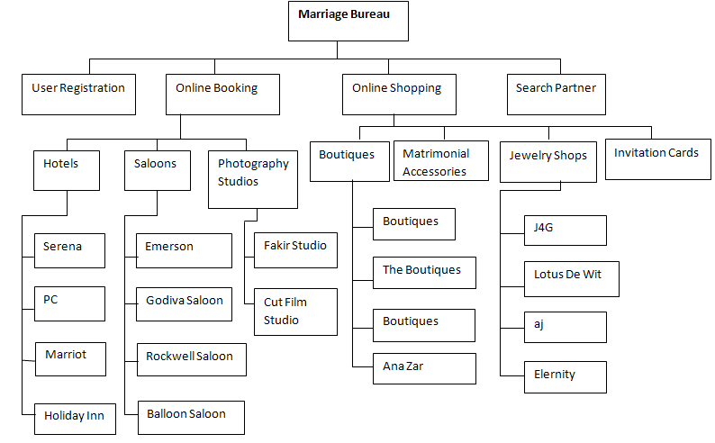

Figure 9: Marriage Bureau Architectural Design

3.2. Data Flow Digram

This diagram shows the over all flow of data of MB.

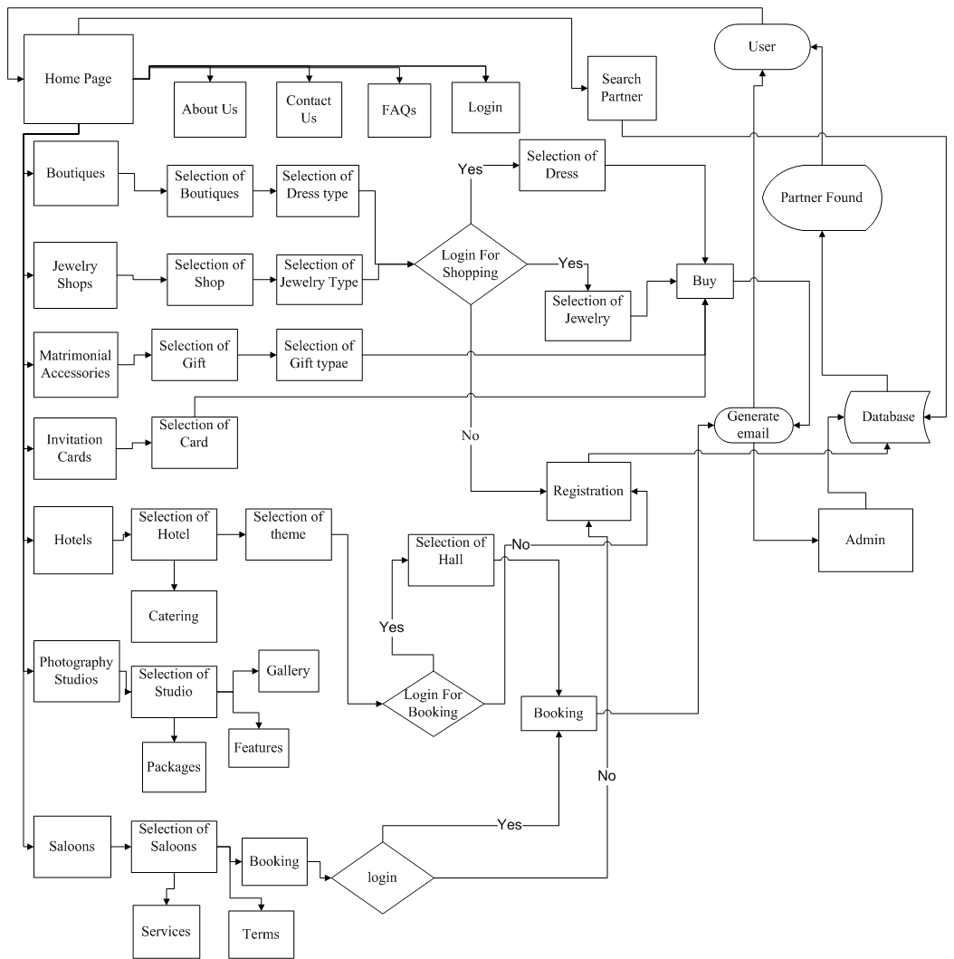

Figure 10: Marriage Bureau Data Flow Diagram

3.3 User Interface Design

Main interfaces of WB site are:
- User Registration.
- Search Partner.
- Online Shopping from Boutiques, Jewelry shops, Matrimonial Accessories and Invitation cards
- Booking of Hotels, Saloons and Photography studios.
- Admin Panel

3.3.1 User Registration
This interface let you to register for MB. If you click on ‘Register Now’ on the home page registration form will open. Once you have fill the, and click on save button you are registered for MB and your information is stored in our database. The form contains your basic information. Once you are registered you can do online shopping and any online booking of hotels and saloons. Administrations have full right of delete or edit your account
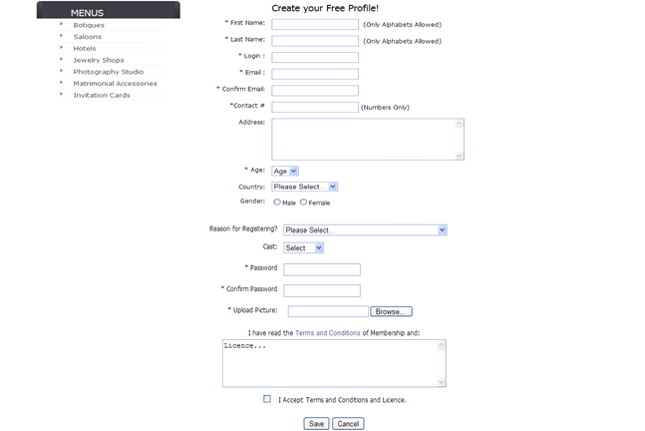

Figure 11: Marriage Bureau User Registration Form

3.3.2. Search Partner.
This interface lets the user to search a partner from MB by just clicking on ‘Search Partner’. The following interface will appear:

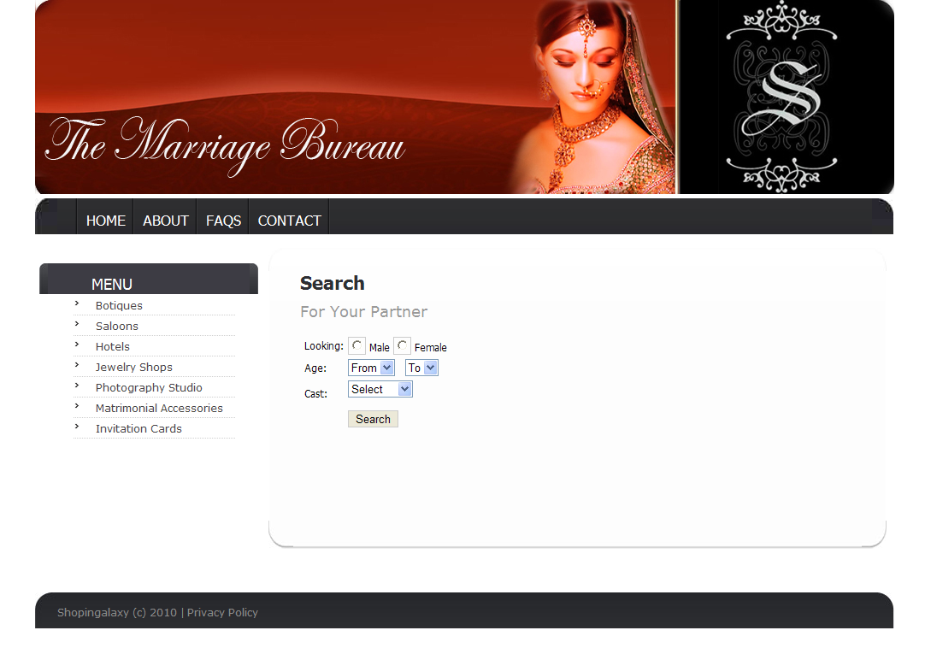
Figure 12: Marriage Bureau Search Partner Screen Shot

3.3.3. Online Shopping from Boutiques, Jewelry shops, Matrimonial Accessories
and invitation cards

- Boutiques:
Boutiques Home Page:
This page contains four different boutiques, Fashion Boutique, Boutique exchange, the Boutique and Ana Zar fashion botique .

Boutique’s Page:
All Boutiques has same interface which contains party wears, casual wears, bridal wears and new arrivals.

Selection of dresses:
You can select any dress of your choice all wears have same interface but different six dresses. Before selecting any wear you have to login first.If you are not registered for MB you have to register from the home page then you can buy any dress because it asks for login when you buy a dress.

Online shopping form of dresses:
For on line shopping you have to click on ‘buy now’ button and fill the form. Once you fill the form and saved it you will get a confirmation mail.

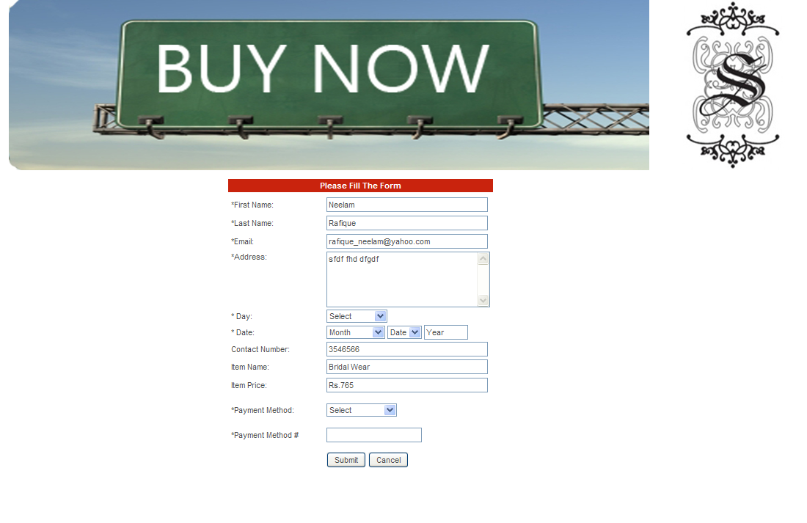
Figure 13: Marriage Bureau shopping form

b). Jewelry Shops:

Jewelry Home Page:
Jewelry home page contains four different jewelry shops. All of four shops contain the same interface.

Jewelry Shop Page:
All Jewelry shops contain the same interface of Rings, Bracelets, Necklaces and Earring

Selection of Jewelry:
You can select any jewelry all of the four jewelry shops have same interface with six jewelry items each. Login for online shopping is must for jewelry selection. Suppose you click on rings interface we will get the following interface of rings.

Online shopping form of Jewelry:
After selecting the desired jewelry, you have to click on buy button and fill the online form. After filling the form you will get an email notification about shopping a particular jewelry.

c) .Matrimonial Accessories:

Matrimonial Accessories Home page:
This interface contains different gifts related to wedding like wrist watches, shoes, perfumes, candles, photo frames and jewelry.
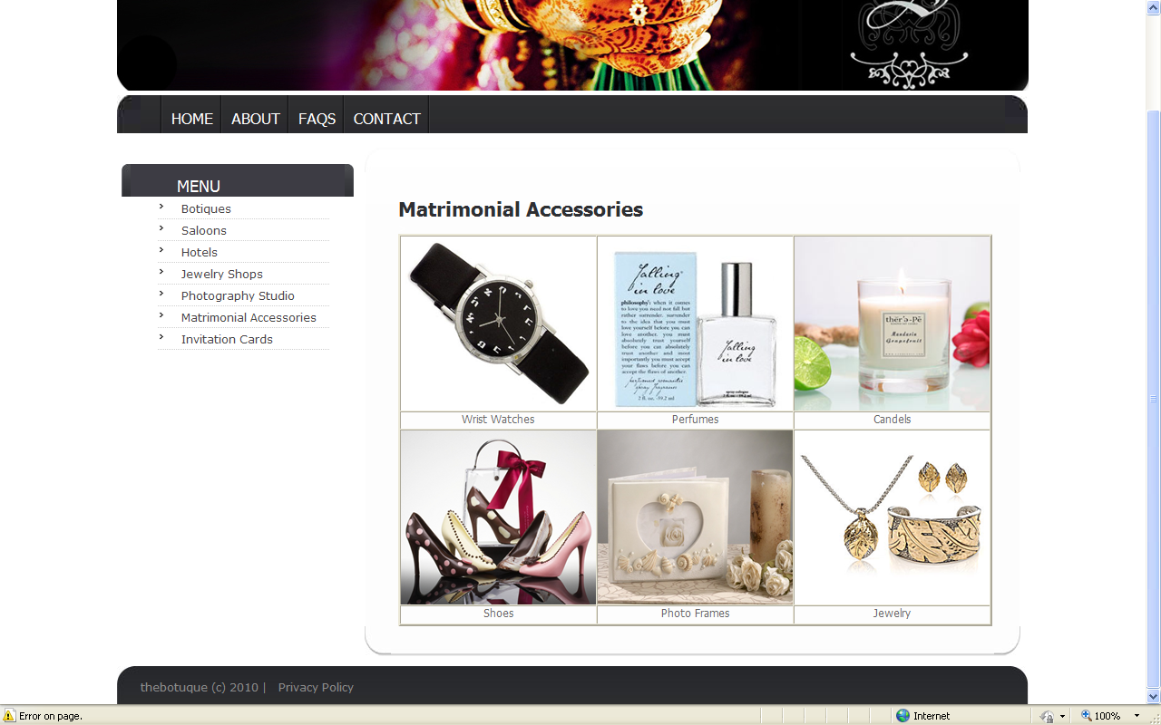
Selection of gifts:
You can select any of required gifts and buy it online. All gifts has same interface. Suppose you select candles you will have following interface.

Online Shopping of Gifts:
After selection of gift you have to fill the online shopping form and you will get a confirmation mail of your online sopping.

d). Invitation Cards:
This interface contains invitation cards of wedding ceremonies. You can buy a card by filling the form which will appear after clicking on ‘buy now’ button.

3.3.4. Booking of Hotels, Saloons and Photography studios.
a). Hotels:

Hotel’s Home Page:
This interface contains four hotels of Islamabad and Rawalpindi namely PC, Serena, Marriott and Holiday Inn.

Hotel’s Page:
All four hotels has same interface with Home, Catering and Theme menus.

Selection of Function’s Theme:
You can select the theme for any wedding function like barrat, mehandi, valima and party.

Hall Selection:
For booking of any hall you have to click on any required theme and select the hall. For booking of hall you have to login first. If you have no account on our site you have to register from home page then you can book any hall.

Online booking of Hall:
For online booking you have to click on Book Now button and fill the online form.

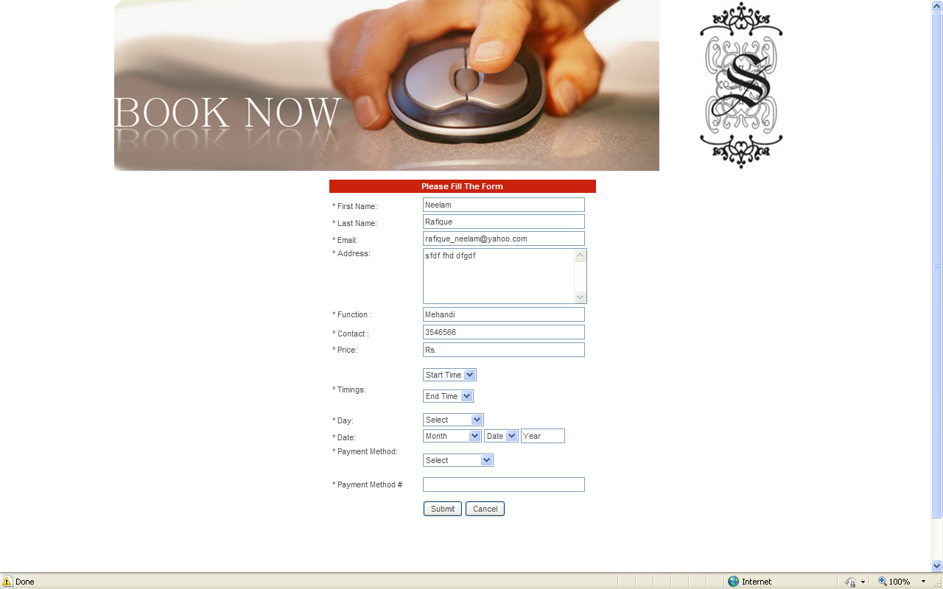
Figure 14: Marriage Bureau online Booking form

b). Saloons:
Saloons Home Page:
Saloons page contains four saloons namely Govdi Saloon, Emers Saloon, Rockwell Saloon and Ballon Saloon.

Saloons Page:
All four saloons are of the same design and contain menus of Services, Terms and Booking.

Online Booking of Saloons:
For online booking of saloons you have to click on booking button. System will show you login interface, without login you can not book any saloon. If you have no account you have to register for our site then you can book any saloon. After login you have to fill form then you will get email for confirmation of your booking.

c) Photography Studios Home Page:
This interface contains two photography studios namely Fakir Studio and Cut Film Studio.

Photography Studio’s Page:
Both Fakir and Cut Film studio contain same menus of contact, features, gallery, packages and booking of Studios.

3.3.5. Admin Panel
Admin Panel:
The most important interfaces of our project is admin panel to control the Wedding Bureau site.

a). Admin Login :
A Login panel with ‘Admin login’ and ‘Password’ and ‘Login’ button is used to enter Admin panel login credentials for the access to authorized screen after verification from database.

b). Edit or Delete Account:
Admin has full right of edit r delete any user account by clicking edit or delete link.

c). Delete FAQs:
Admin can delete any question and comment from WB site by clicking delete link.

d). Account Recovery:
Admin can recover any user account. First you can search his/her account by email id after having his/her account you can recover.

Chapter 4
Implementation

After the design phase, the proposed system is transformed into code using the flow of the architecture, class diagram and the database design. While the development process, the design should not be affected by coding standards and techniques applied.

4.1 Implementation Strategy
The implementation strategy used for our project is pair programming in which both the team members (programmers) worked together at one work place. The over all work was done in such a way that one programmer used to write the code first and the other programmer used to review the code line wise and vice versa. Also failing unit test cases were written by each of the two observers and the other programmer used to modify the code to pass the test (ping pong pair programming).

4.2 Coding Standards
Coding standards, which apply to the function names, the look of the code and coding consistency must be followed in order to develop a reliable, efficient and a quality system. Some of the coding standards which were followed during the implementation phase include indenting and white spacing, operators that came between two values were given a space before and after the operator for readability, casting was done, included parentheses when class constructors were called with no arguments, used a space between the dot and the concatenated parts to improve readability and wrote comments on the coding files to make the code easier to understand for any other user who views the code.

4.3 Class diagram

Figure 15: Marriage Bureau Class Diagram

4.4 Master database diagram

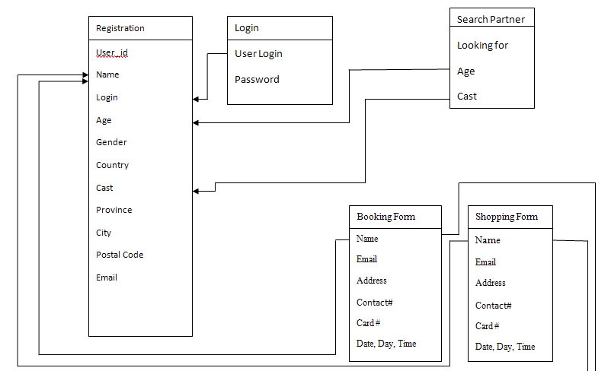
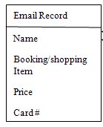

Figure 16: Marriage Bureau Master Database Diagram

Chapter 5
Testing

5.1 Introduction

Testing is an essential step for the development of reliable and error free system. It is the process of executing a problem with the explicit intention of finding errors i.e. making the problem fail and test cases are devised to check proper working of the site.

5.2 Testing Strategies
The different strategies that are used for testing the” wedding portal” are as follows:
5.2.1) Black Box Testing
5.2.2) White Box Testing
5.2.3) Unit Testing
5.2.4) Regression Testing
5.2.5) System Testing
5.2.6) Acceptance Testing
    - Interface Testing
    - Compatibility Testing
    - Security Testing
    - Documentation Testing

A brief description of each of the above strategies is given below:

5.2.1 Black Box Testing
Black box testing is done to check the functionality of the system with out any regard to the code written. The functionality which was expected from each component is provided which means that black box testing is completed.

5.2.2 White Box Testing
In white box testing the internal code written in every component was tested, it was checked that the code written is efficient in utilizing various sources of the system.

5.2.3 Unit Testing
In unit testing we checked that all the individual components were working properly. Before integration of the entire components, unit testing is essential because it gives a confidence that all the components individually, are working fine and are ready to be integrated with other ones.

5.2.4 Regression Testing
In regression testing the software was tested against the boundary conditions. After any modification in the software, various input fields were tested against abnormal values to check that the software does not behave abnormally at anytime.

5.2.5 System Testing
When all the units were working properly and unit test was performed then came the time for system testing where we checked all the integrated components as a whole and looking for possible discrepancies, which could have arisen after the integration.

5.2.6 Acceptance Testing
In acceptance testing the software was checked for its completeness, either each and every module of the site is working according to the requirements of the software.

5.2.7 Interface Testing

Interface testing is done to check that all the interactions between the servers (Web server and application server interface, Application server and Database server interface) are executed properly and are free from errors.

5.2.8 Compatibility Testing
Compatibility testing is done to check the browser compatibility for the system.

5.2.9 Security Testing

Security testing is done to check the system reaction on all invalid inputs. An unauthorized user is unable to search a partner and book any thing for him/her self.

5.2.10 Documentation Testing
Tests have been conducted to check the standard and accuracy of the user documentation.

5.3 Functions to be tested

The following functions are tested:
- User Registration
- User Login/ Logout
- Admin Dashboard Monitoring
- Edit User
- Delete User
- Account Recovery
- Search Partner
- Hotel Booking and Email Notification
- Saloon Booking and Email Notification
- Photography Studio Booking and Email Notification
- Boutiques Shopping and Email Notification
- Jewelry Shopping and Email Notification
- Matrimonial Accessories Shopping and Email Notification
- Invitation Cards Shopping and Email Notification

5.4 Test Cases

Test case : 01_Registration |  |  | Testers : Neelam , Farhana
User enters particular information in the registration form to get registered with wedding portal. |  |  | Date : 25/08/2010
S. No | Scenario | Expected output |  | System Output | Status/Comments
1 | User enters some faulty information or any of the registration form fields is left blank. | Displays corresponding error or tells some field has been left blank. |  | Error is displayed according to the case. | Information entered is invalid or some field is left empty.
2 | User enters correct information in the registration form as per to the instructions and no field is left blank. | User is successfully registered. |  | User is registered and home page screen is displayed. | No Error

Table 2: Marriage Bureau Registration Test Case

Test case : 02_Login |  |  | Testers: Neelam, Farhana
User enters username and password in wedding portal to login. |  |  | Date : 25/08/2010
S. No | Scenario | Expected output |  | System Output | Error Description
1 | User enters invalid user name and password to login. | Error message of User name and password entered is invalid. |  | Error message is displayed “Invalid username and password”. | Username or password entered is invalid.
2 | User enters valid username and password. | User successfully logins. |  | User is displayed to the home page | No Error

Table 3: Marriage Bureau Login Test Case

Test case : 03_Validate Password |  |  | Testers: Neelam, Farhana
To verify that Password on login page must be greater and equal to 6 characters. |  |  | Date : 25/08/2010
S. No | Scenario | Expected output |  | System Output | Error Description
1 | User enters less than 6 characters. | An error message of password too short. |  | Gives error message “password too short”. | Password too short
2 | User enters 6 or more than 6 characters. | Gives no error and leads to the desired page. |  | Leads to the page containing people’s detail. | No Error

Table 4: Marriage Bureau Validate Password Test Case

Test case : 04_ Recover account |  |  | Testers: Neelam, Farhana
User wants to logout. |  |  | Date : 25/08/2010
S. No | Scenario | Expected output |  | System Output | Error Description
1 | Click Recover Account of the admin panel. | Leads to the recover account page. |  | Leads to the account recovery page. | No error
2 | Enter the email id and press the search button. | Gives the password of the user. |  | Gives the full detail of the user along with the password. The admin then sends the password to the user. | No error

Table 5: Marriage Bureau Recover Account Test Case

Test case : 05_Logout |  |  | Testers: Neelam, Farhana
User wants to logout. |  |  | Date : 25/08/2010
S. No | Scenario | Expected output |  | System Output | Error Description
1 | Click Logout | Leads to the home page of the site. |  | Logout successful and system leads to the home page of site | No error

Table 6: Marriage Bureau Logout Test Case

Test case : 06_Search partner |  |  | Testers: Neelam, Farhana
User wants to search a partner for him/her self |  |  | Date : 25/08/2010
S. No | Scenario | Expected output |  | System Output | Error Description
1 | User leaves any field of the search partner form unfilled while searching a partner. | System tells that some field has been left empty. |  | System gives message of “Search again”. | All information is not provided by the user to match the corresponding results.
2 | User enters all the fields. | Gives corresponding results. |  | Displays the list of corresponding results. | No Error

Table 7: Marriage Bureau Search Partner Test Case

Test case : 07_Edit User |  |  | Testers: Neelam, Farhana
Admin can edit the detail of a user on the user’s request. |  |  | Date : 25/08/2010
S. No | Scenario | Expected output |  | System Output | Error Description
1 | Go to the admin panel and click accounts. | System leads to the page where all user account details can be viewed. |  | System leads to all users’ accounts detail. | No Error
2 | Admin can edit the detail on user’s request. | Detail edited. |  | Requested detail is edited by the admin. | No Error

Table 8: Marriage Bureau Edit User Test Case

Test case : 08_Delete User |  |  | Testers: Neelam, Farhana
Admin has the right to delete a user’s account and admin can also delete a user’s account on the request of a user. |  |  | Date : 25/08/2010
S. No | Scenario | Expected output |  | System Output | Error Description
1 | Go to admin panel and click accounts. | System leads to the page where all user account details can be viewed. |  | System leads to all users’ accounts detail. | No Error.
2 | Click delete to delete a user’s account. | Account deleted. |  | System deletes the desired account. | No Error

Table 9: Marriage Bureau Delete User Test Case

Test case : 09_ Book a hall |  |  | Testers: Neelam, Farhana
User wants to book a hall in a hotel. |  |  | Date : 25/08/2010
S. No | Scenario | Expected output |  | System Output | Error Description
1 | User logins to book a hall in a hotel in hotels module. | Leads to the booking form of hotel. |  | System leads to the hotel’s booking form page. | No error
2 | User fills all the fields of the booking form incorrectly or leaves any compulsory field unfilled. | Gives an error message. |  | Gives an error message to fill all the compulsory fields and enter correct information | Gives error message to fill the necessary fields if left unfilled and to enter correct information if wrong information is entered.
3 | User fills all the fields of the booking form correctly. | User gets a mail notification of that booking. |  | An email notification is generated to the user’s Id. | No error.

Table 10: Marriage Bureau Book a Hall Test Case

Test case : 10_ Book a service in a saloon |  |  | Testers: Neelam, Farhana
User wants to book time for a service in a saloon. |  |  | Date : 25/08/2010
S. No | Scenario | Expected output |  | System Output | Error Description
1 | User logins to book a service in a saloons module. | Leads to the booking form of saloon. |  | System leads to the booking form page. | No error
2 | User fills all the fields of the booking form incorrectly or leaves any compulsory field unfilled. | Gives an error message. |  | Gives an error message to fill all the compulsory fields and enter correct information | Gives error message to fill the necessary fields if left unfilled and to enter correct information if wrong information is entered.
3 | User fills all the fields of the booking form correctly. | User gets a mail notification of that booking. |  | An email notification is generated to the user’s Id. | No error.

Table 11: Marriage Bureau Book Service in a Saloon Test Case

Test case : 11_ Book a photographer |  |  | Testers: Neelam, Farhana
User wants to book a photographer in photography studio. |  |  | Date : 25/08/2010
S. No | Scenario | Expected output |  | System Output | Error Description
1 | User logins to book a photographer in photography studios module. | Leads to the booking form of photography studio. |  | System leads to the booking form page. | No error
2 | User fills all the fields of the booking form incorrectly or leaves any compulsory field unfilled. | Gives an error message. |  | Gives an error message to fill all the compulsory fields and enter correct information | Gives error message to fill the necessary fields if left unfilled and to enter correct information if wrong information is entered.
3 | User fills all the fields of the booking form correctly. | User gets a mail notification of that booking. |  | An email notification is generated to the user’s Id. | No error.

Table 12: Marriage Bureau Book a photographer Test Case

Test case : 12_Shopping in a boutique |  |  | Testers: Neelam, Farhana
User wants to do shopping in a boutique. |  |  | Date : 25/08/2010
S. No | Scenario | Expected output |  | System Output | Error Description
1 | User logins to do shopping in a boutiques module. | Leads to the booking form of the boutique. |  | System leads to the booking form page. | No error
2 | User fills all the fields of the booking form incorrectly or leaves any compulsory field unfilled. | Gives an error message. |  | Gives an error message to fill all the compulsory fields and enter correct information | Gives error message to fill the necessary fields if left unfilled and to enter correct information if wrong information is entered.
3 | User fills all the fields of the booking form correctly. | User gets a mail notification of that booking. |  | An email notification is generated to the user’s Id. | No error.

Table 13: Marriage Bureau shopping in a boutique Test Case

Test case : 13_Shopping in a jewelry shop |  |  | Testers: Neelam, Farhana
User wants to do shopping in a jewelry shop. |  |  | Date : 25/08/2010
S. No | Scenario | Expected output |  | System Output | Error Description
1 | User logins to do shopping in jewelry shops module. | Leads to the booking form of jewelry shop. |  | System leads to the booking form page. | No error
2 | User fills all the fields of the booking form incorrectly or leaves any compulsory field unfilled. | Gives an error message. |  | Gives an error message to fill all the compulsory fields and enter correct information | Gives error message to fill the necessary fields if left unfilled and to enter correct information if wrong information is entered.
3 | User fills all the fields of the booking form correctly. | User gets a mail notification of that booking. |  | An email notification is generated to the user’s Id. | No error.

Table 14: Marriage Bureau shopping in a jewelry shop Test Case

Test case : 14_ Shopping of matrimonial accessories |  |  | Testers: Neelam, Farhana
User wants to do shopping of matrimonial accessories. |  |  | Date : 25/08/2010
S. No | Scenario | Expected output |  | System Output | Error Description
1 | User logins to do shopping in matrimonial accessories module. | Leads to the booking form of the selected matrimonial accessory. |  | System leads to the booking form page of the selected accessory. | No error
2 | User fills all the fields of the booking form incorrectly or leaves any compulsory field unfilled. | Gives an error message. |  | Gives an error message to fill all the compulsory fields and enter correct information | Gives error message to fill the necessary fields if left unfilled and to enter correct information if wrong information is entered.
3 | User fills all the fields of the booking form correctly. | User gets a mail notification of that booking. |  | An email notification is generated to the user’s Id. | No error.

Table 15: Marriage Bureau shopping of matrimonial accessories Test Case

Test case : 15_ Shopping of invitation cards |  |  | Testers: Neelam, Farhana
User wants to do shopping of invitation cards. |  |  | Date : 25/08/2010
S. No | Scenario | Expected output |  | System Output | Error Description
1 | User logins to buy a card in invitation cards module. | Leads to the booking form of cards. |  | System leads to the booking form page. | No error
2 | User fills all the fields of the booking form incorrectly or leaves any compulsory field unfilled. | Gives an error message. |  | Gives an error message to fill all the compulsory fields and enter correct information | Gives error message to fill the necessary fields if left unfilled and to enter correct information if wrong information is entered.
3 | User fills all the fields of the booking form correctly. | User gets a mail notification of that booking. |  | An email notification is generated to the user’s Id. | No error.

Table 16: Marriage Bureau shopping of invitation cards Test Case

5.5 Testing schedule

Process | Start Date | End Date
System adjustment/formalization | 07/05/2010 | 08/10/2010
System test | 08/12/2010 | 08/16/2010
Beta test | 08/18/2010 | 08/24/2010
Acceptance test | 08/25/2010 | 08/29/2010

Table 17: Marriage Bureau Testing Schedule

5.6 Control Procedure

5.6.1 Reviews:

The project team members will perform reviews for each of the following phases:
- Requirements Review
- Design Review
- Code (Implementation) Review
- Test Plan Review
- Test Case Review
- Final Test Summary Review

5.6.2 Defect Reporting:

Defects need to be found before the delivery of the final product, so that these defects can be handled in a proper manner and within time.

5.6.3 Bug Review Meetings:

Meetings for the reported defects were held on weekly basis with the supervisor to find the appropriate solutions for these defects.

5.7 Resources and Responsibilities
The team members (Neelam and Farhana) being the human resources of the project are responsible for the project schedule, design and tools, development, testing and its deliverables. Being a scheduler it is necessary to start the project on time and to finish it before or on the deadline time allotted by the university. Being a designer it is our responsibility to design the software in such a way that it makes users appealing towards itself, it should be eye catchy and attractive and being a tester it is our core duty to check the site properly using appropriate test cases.

5.8 Dependencies
5.8.1 Human Dependencies:

The verification and validation and development of test cases require experienced tester’s knowledge. Our supervisor was a constant support during the testing phase of the site, who guided us throughout the end of testing session.

5.8.2 Software Dependencies:

Unit testing of the source code must be done within the mentioned scheduled time in the project schedule.

5.8.3 Hardware Dependencies:

A pc/laptop and LAN environment must be made available while using the software.

5.9 Risks

5.9.1 Schedule Slips:

Some times it was difficult to manage time according to the schedule of every phase of the project, which would result in schedule slips in some of the phases and it could have been led to the delay of testing phase and the cancelation of the project if the deadline of the project delivery was not met.

5.9.2 Technical Risk:

Any failure in hardware leads to the risk of functionality and performance which could result in a delay of the overall testing process, so extra resources should be made available throughout the testing phase.

5.9.3 Change in Requirements:

Any changes in the requirements could affect the overall progress of the software and hence the testing schedule, which can cause a delay in the delivery of the software.

Chapter 6
User Manual

Introduction

Our wedding Bureau specializes in providing information regarding different hotels to reserve a hall online, different boutiques and jewelry shops to do online shopping, different saloons and photography studios to book a day and time to avail their services. Different matrimonial accessories and invitation card designs will be provided by the site which follows the same procedure of buying these items. All these facilities will be provided on one platform, which no other site provides in Pakistan.
This user guide is designed to show user how to use the Wedding Bureau to gain information regarding to wedding. We hope users will find the guidelines interesting and informative and that they meet their intended objective.

Contents
6.1). Using MB | 63
Getting started with the website  6.2). Menu Bar  6.3).Registration  6.4). Main Menus of MB  a). Boutiques:  b). Saloons  c). Hotels.  d).Jewelry Shops  e). Photography Studios.  f). Matrimonial Accessories  g). Invitation Cards  6.5).Search Partner | 63  63  64  65  65  67  69  71  73  75  76  77

6.1 Using the MB
Anyone can easily view or use MB website he/she should have a computer (any brand or operating system) and an internet connection and web browser is needed.

Getting started with the website:
To get the MB site you have to type www.homedepopk.com in your address bar. You will the following home page of our site.

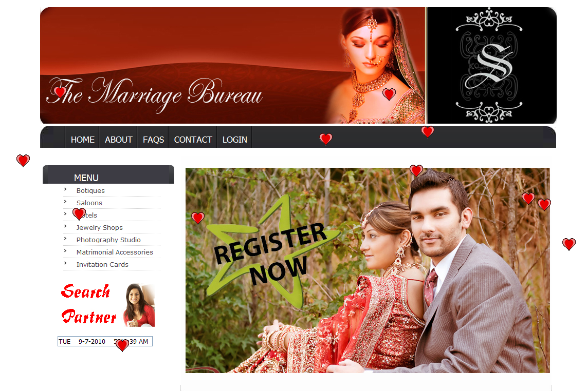

6.2 Menu Bar
There are five menus (Home, about us, FAQS, Contact and Login) on bar you can visit any of menu by a simply click.

6.3 Registration
You can create your account on MB by clicking ‘Register Now’ which provides you a form of registration.
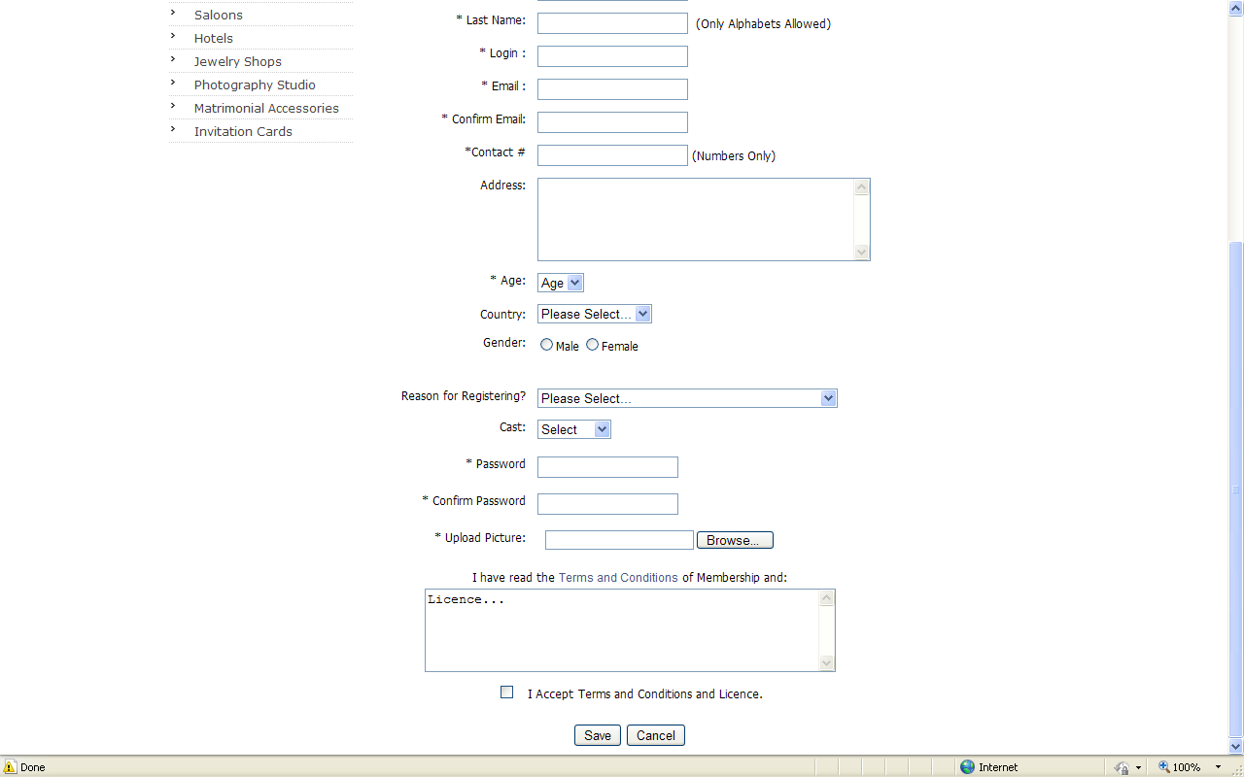
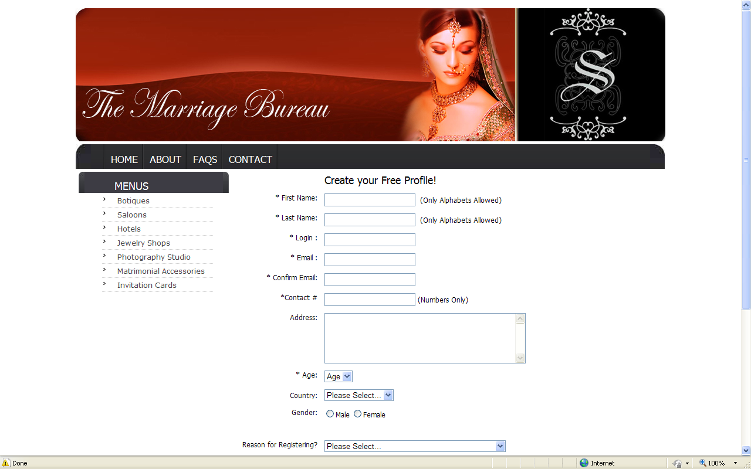

6.4 Main Menus of MB
The main menus of site are:

a). Boutiques:
When you click on Boutiques you will go to boutique’s home which contains four different boutiques logos.
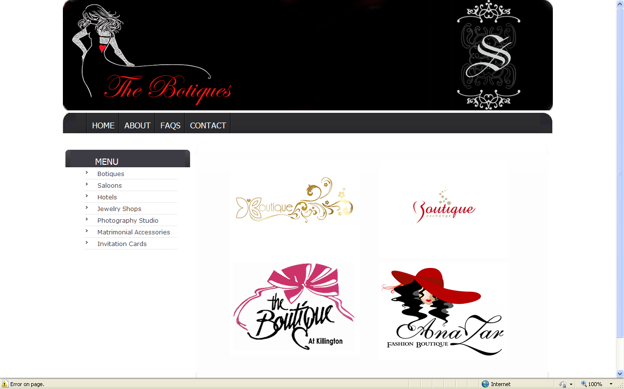
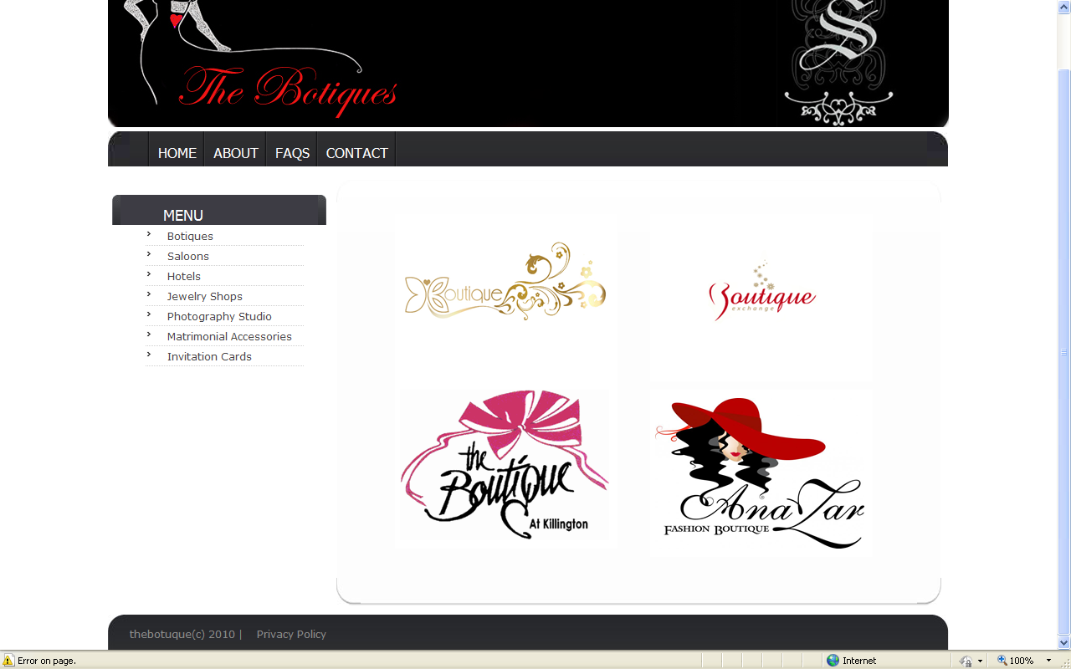

Boutique’s Home Page:
If you want to visit any boutique you have to click on boutique’s logo. All of four Boutiques has same interface which contains party wears, casual wears, bridal wears and new arrivals. You can see all wears by a simple click on any wears. One of the boutique page is as follows:

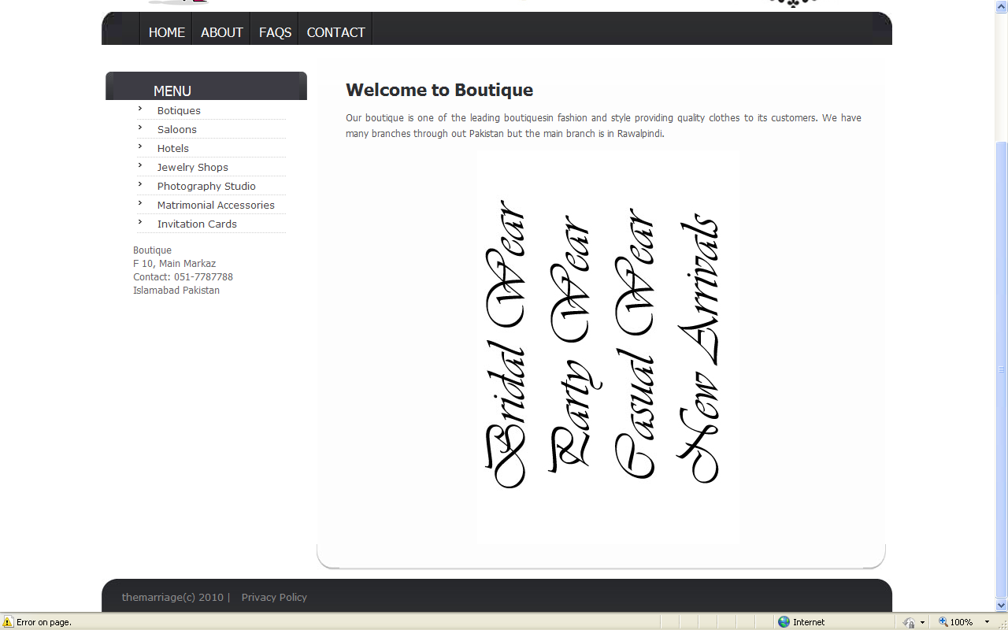
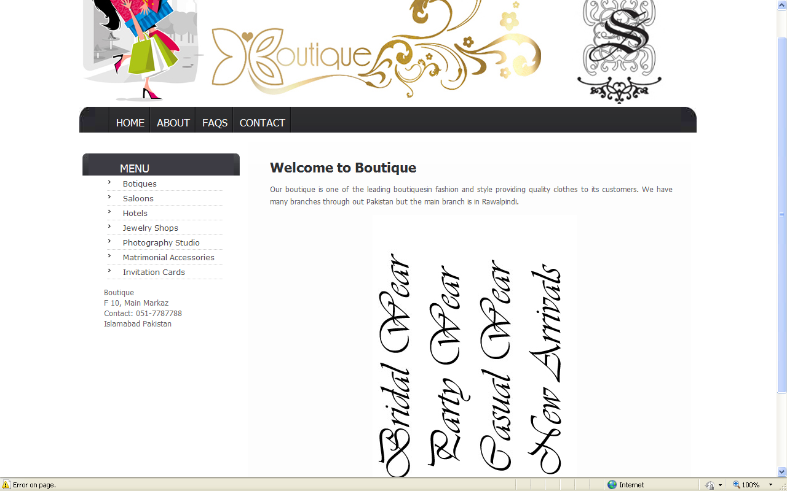

b). Saloons:
Saloons page contains the four logos of saloons namely Govdi Saloon, Emers Saloon, Rockwell Saloon and Ballon Saloon.

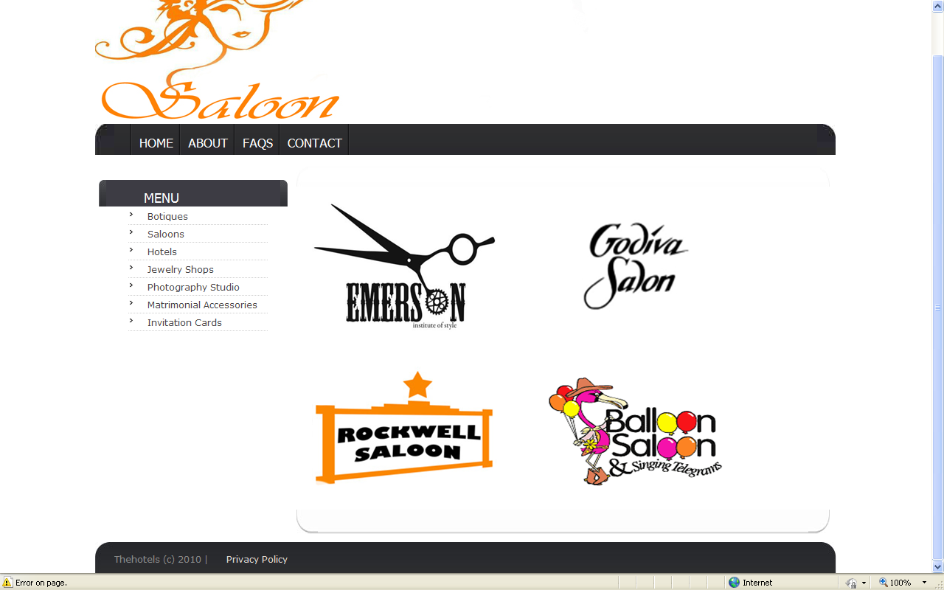
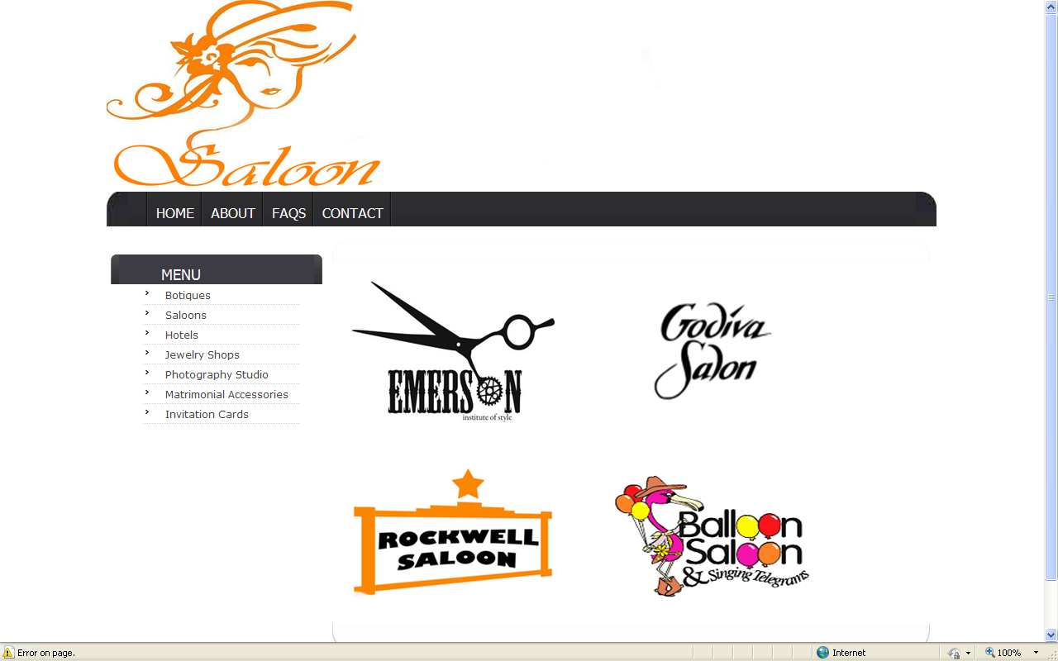

Saloon’s Home Page:
You can visit any saloon by clicking any saloon’s logo. All four saloons pages of same design and contains menus of Services, Terms and Booking.

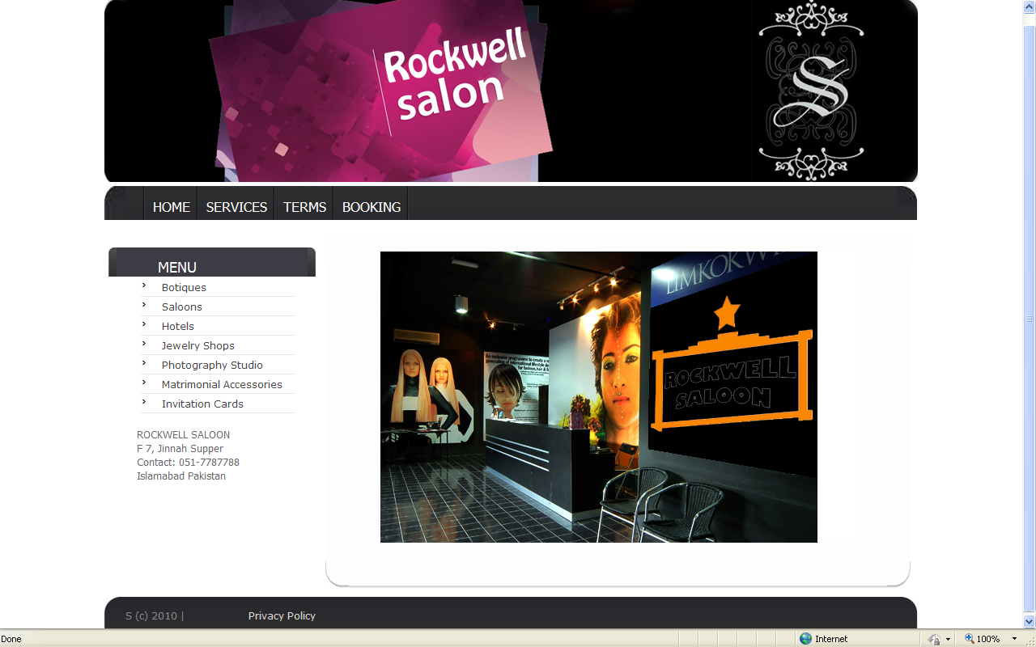

c). Hotels:
If you click on hotels you will go to hotel’s home page. There are four hotel’s logos of Islamabad and Rawalpindi namely PC, Serena, Marriott and Holiday Inn.

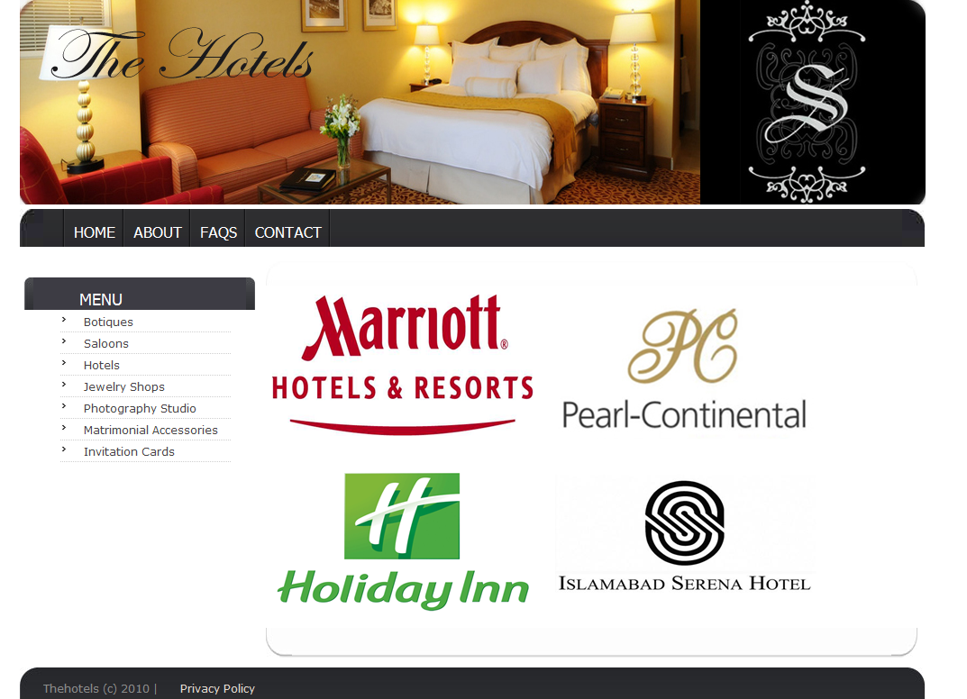

Hotels Page:
All four hotels have same design with menus of Home, Catering and Theme. The home page of Serena is.
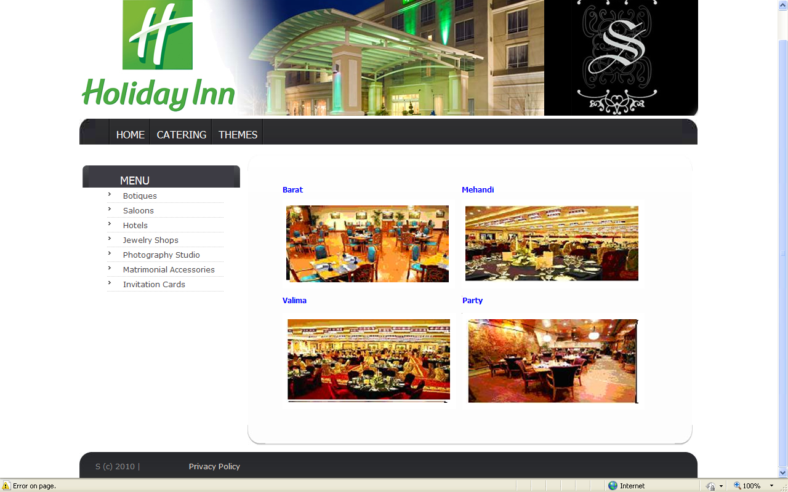
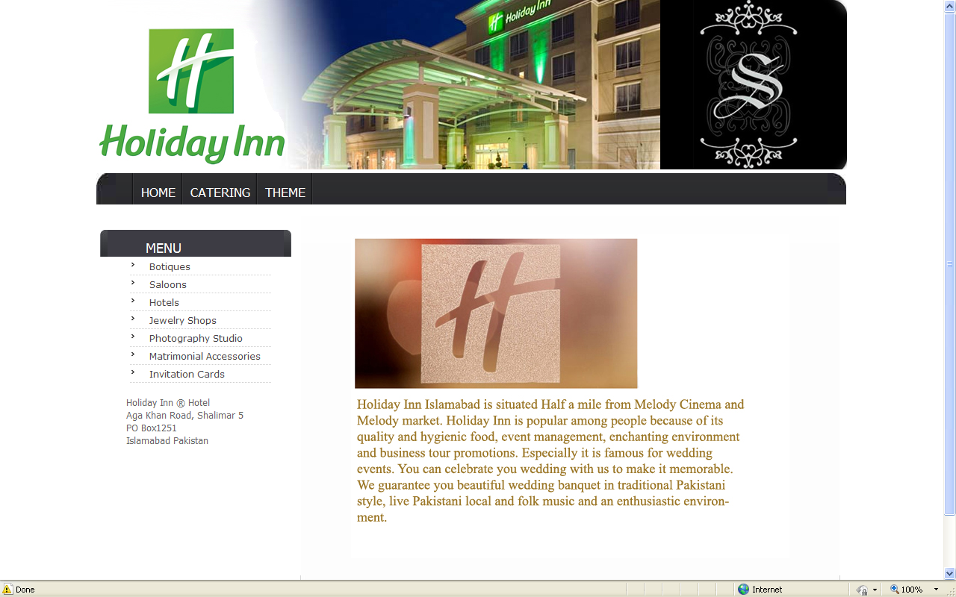

d).Jewelry Shops:
If you click on jewelry shop module you will go to jewelry shop’s home page where there are four different jewelry shops.

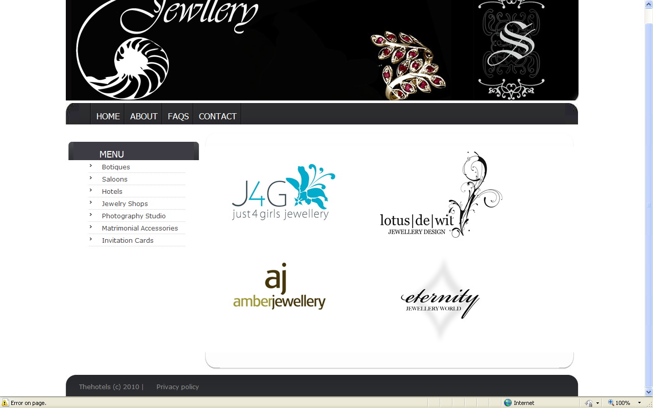

Jewelry’s Home Page:
If you want to visit any shop you have to click on any logo. All Jewelry shops contains further same interface four interfaces of Rings, Bracelets, Necklaces and Earrings. One of the home pages of Jewelry shop is given below.

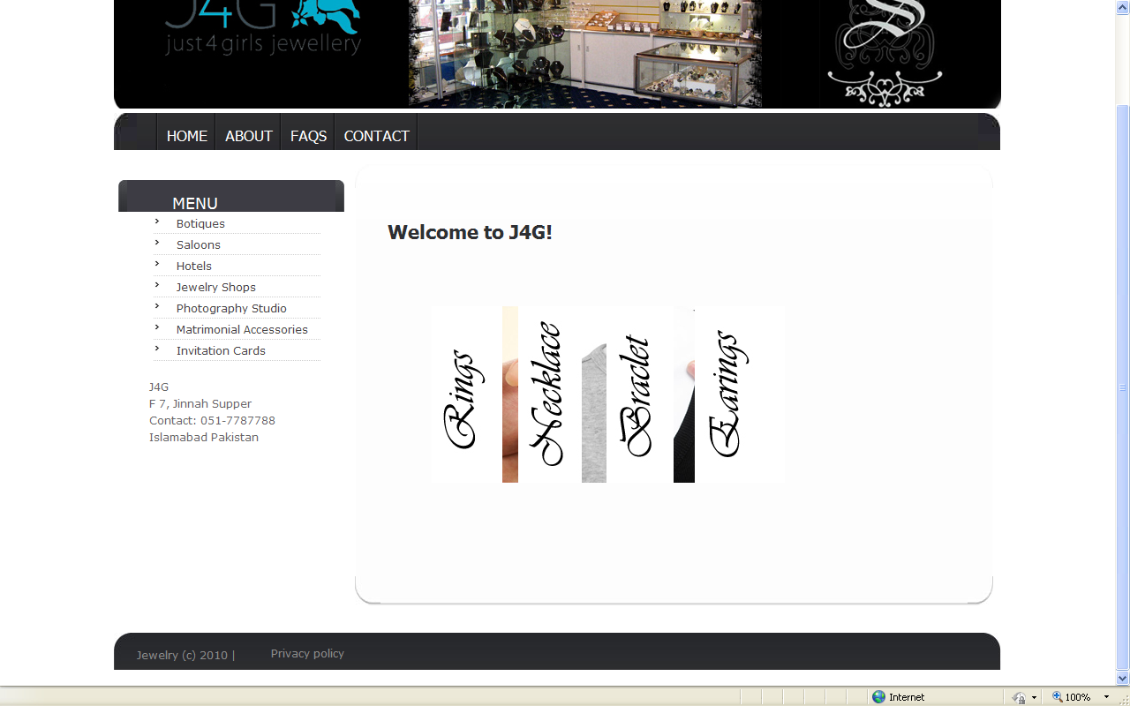
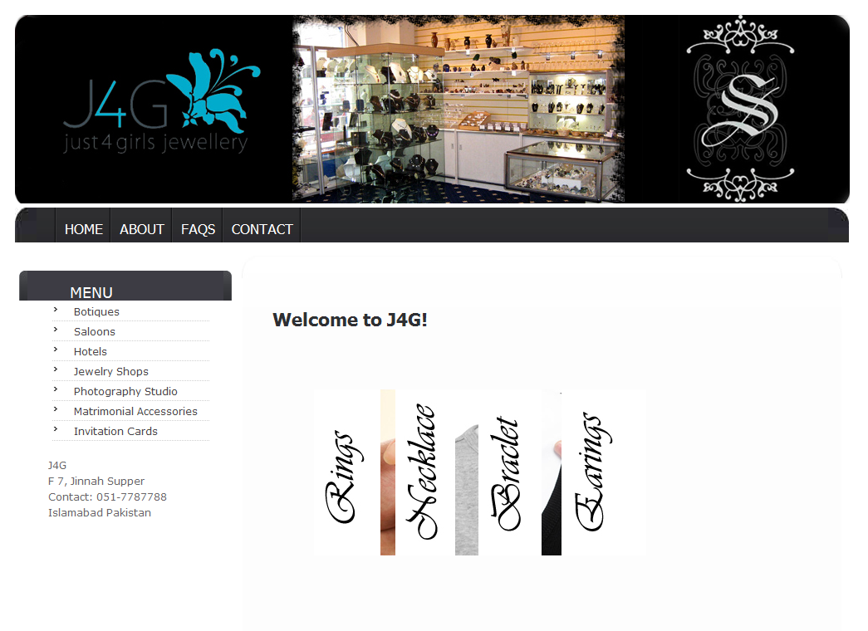

e). Photography Studios:
When you click on photography studios you will go to photography studio’s home page. Which contains two logos of photography studios namely Fakir studio and Cut Film Studio.

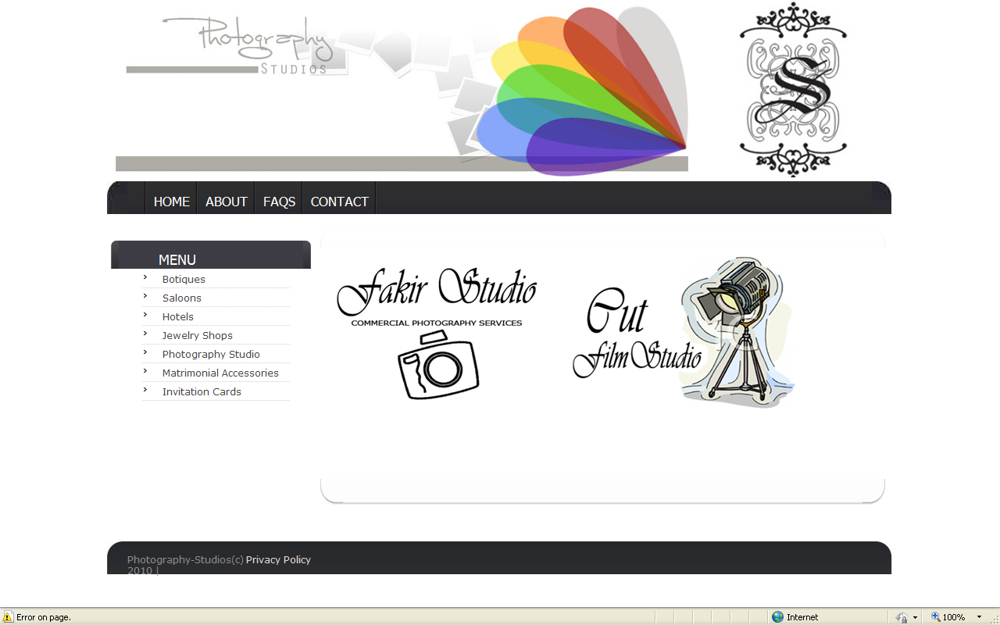

Photography Studio’s Home Page:

When click on any of studio you will go studios home page. Both Fakir and Cut studio contains same menus of contact, features, gallery, packages and booking. The snap short of one studio is:
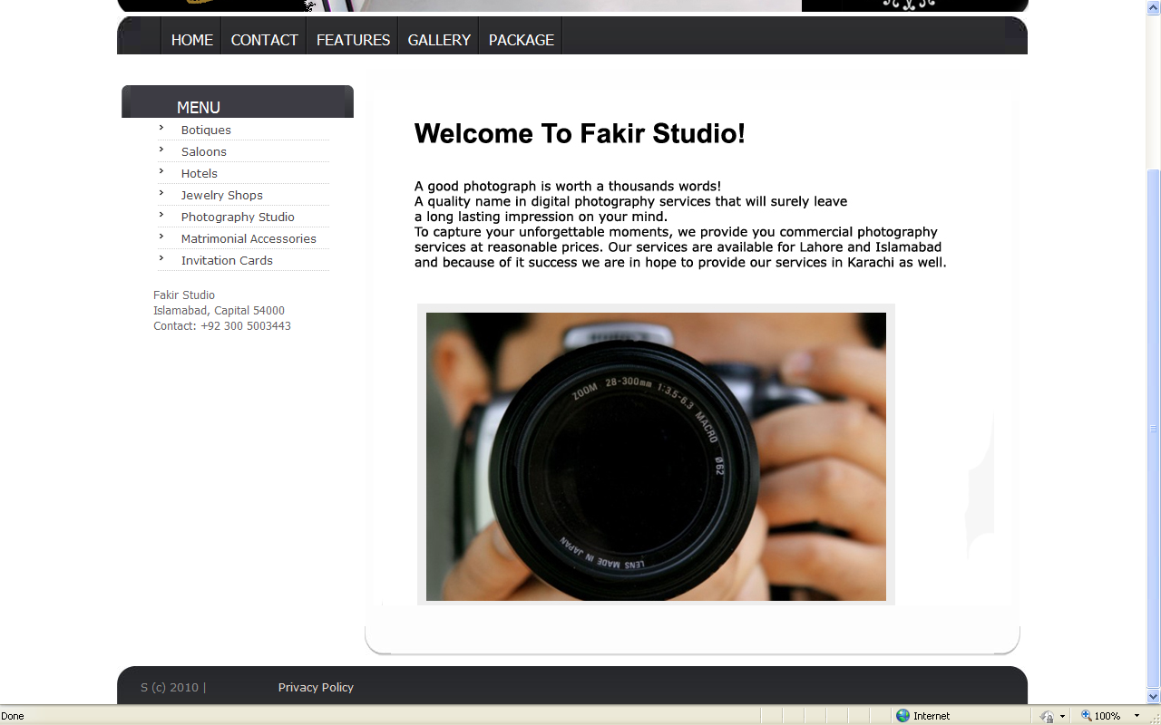
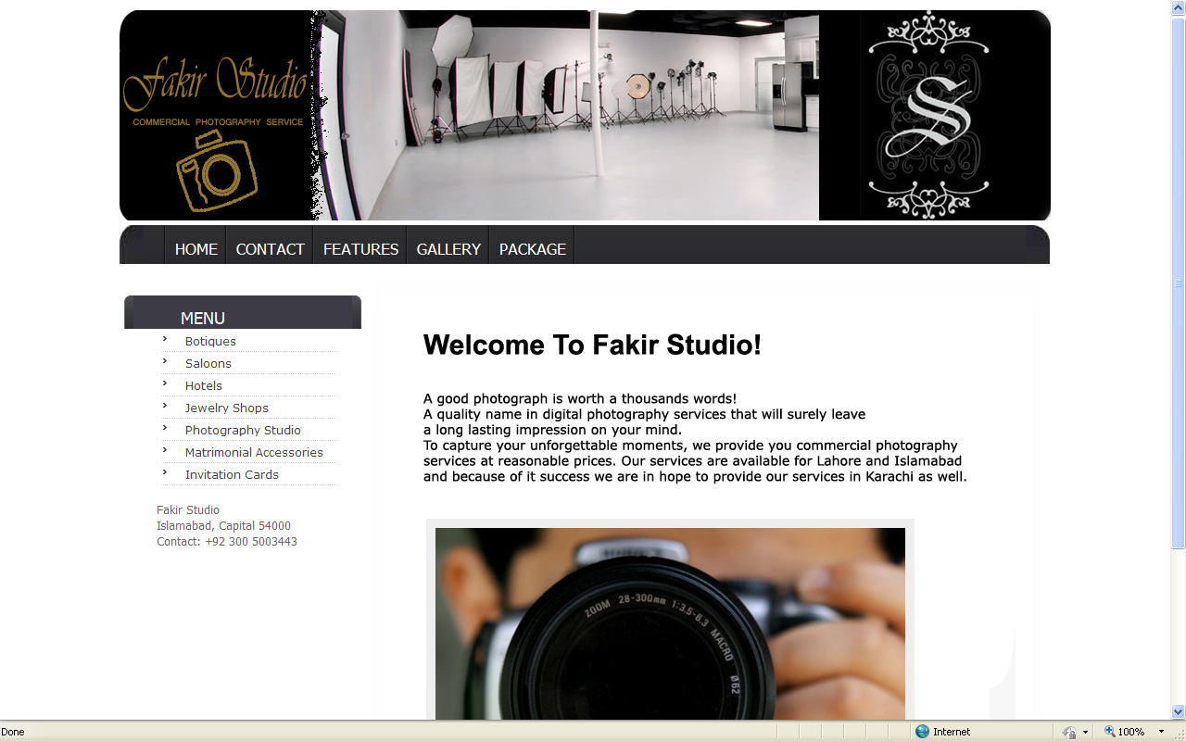

f).Matrimonial Accessories:
This interface contains different gifts related to wedding like rest watches, shoes, perfumes, candles, photo frames and jewelry.

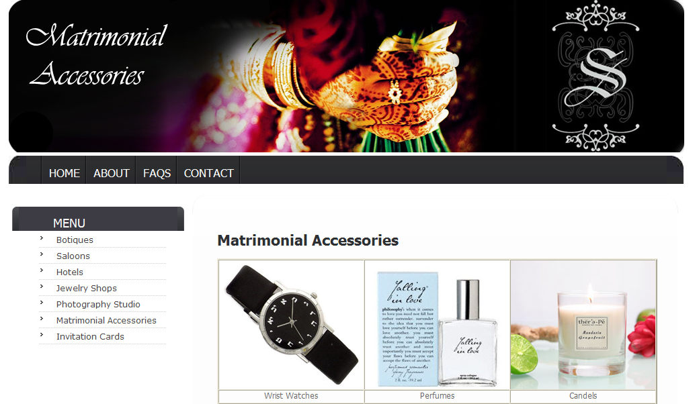

g). Invitation Cards:
When you click on invitation cards, a page with wedding invitation cards will open. You can buy any card by clicking buy now button.

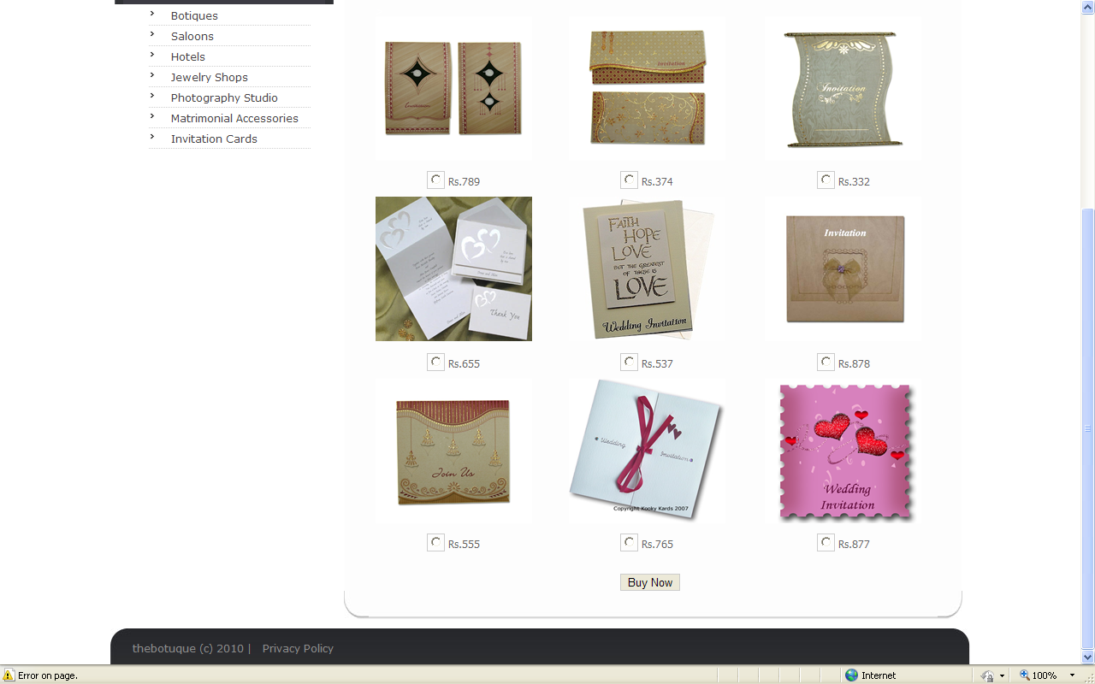

6.5 Search Partner
When you click on ‘Search Partner’ a new page will open as follows through which you can find a partner.

Conclusion:

This was our final year project of Software Engineering. We learnt a lot during this project and it also developed more interest in us for web development. It also gave us a chance of learning more aspects regarding web designing and development.

We feel very proud after developing this project because our project facilitates people with the online wedding function arrangements such as booking of halls, saloons and photographers and shopping from boutiques, jewelry shops, matrimonial accessories and invitation cards. It also helps people to find a life partner by our search partner module.

Future Enhancements:

Although Marriage bureau provides many functionalities according to the required specifications but there is always a chance of improvement. Following are the areas that should be addressed in future to keep the pace and performance according to the fast changing world.
- One of most prominent feature which can be enhanced is chat box. This feature can be very good for this project, which will increase its charming effect and provide another facility to the user to share views through live chat and get to know each other.
- Many other modules can be added in this project, as it was a starting step which can be further enhanced by providing may other facilities such as transport, honey moon packages, bakery items and many more, which will be also beneficial for business oriented people.

References:

Books:
[1]. Software Engineering (by Ian Somerville)
[2]. Applying UML and Patterns (By Craig Larman)

Internet Resources:
[1]. http://atlas.kennesaw.edu/~dbraun/csis4650/A&D/UML_tutorial/class.htm

[2]. http://sourcemaking.com/uml/modeling-it-systems/structural-view/class-diagram

[3]. http://en.wikipedia.org/wiki/Pair_programming

[4]. http://freeradius.org/radiusd/doc/coding-methods.txt

[5]. http://drupal.org/coding-standards

[6]. http://www.robabdul.com/Data-Management-System-Software-Development-Cycle.asp

Standards:

[1]. IEEE STD 830-1998 IEEE Recommended Practice for Software Requirements Specifications.

Appendix A - General Flow of System

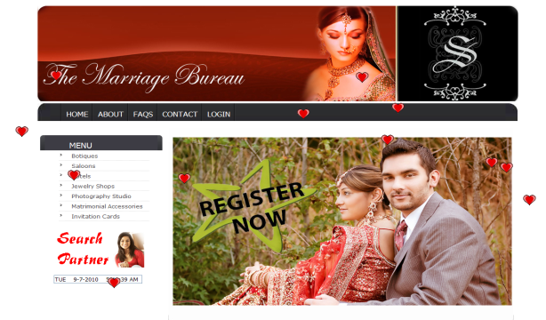
User types the URLwww.homedepopk.com
into the browser to visit our portal

Booking searching a partner shopping

Filling Booking form filling the searching form filling shopping form

Verification Verification
Mail notification
to the user

Database

Web server

Database verifies all the corresponding values and displays the result

