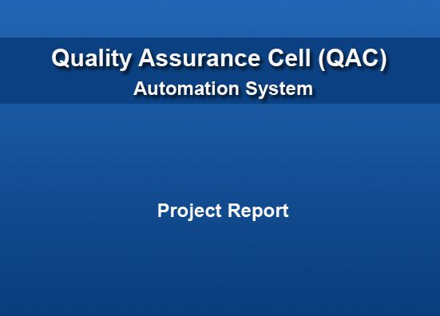

Certificate
We hereby accept that the work and material contained in this project report as confirming to the required standard for partial fulfillment of degree of BSE

Head of Department ________________________________
(Mr. Jahanzeb Ahmed)

Supervisor _________________________________
(Mr. Rashid Kareem)

Internal Examiner __________________________________

External Examiner __________________________________

Acknowledgement
This project is dedicated to our beloved parents because with their support and love we are able to stand where we are. To our supervisor Mr. Rashid Karim who actually motivated and helped us to carry out each and every task with great efforts. Last but not least this project is also dedicated to our friends who gave us the great support to this project.

Abstract
Bahria University today is a multi-campus university with its headquarters at Islamabad. The constituent units of the university are spread at Karachi, Lahore and Islamabad. These include the Pakistan Naval Academy Karachi, PN War College Lahore, Bahria Institutes of Management and Computer Sciences at Karachi and Islamabad, the Institute of Earth and Environmental Sciences at Islamabad, the Institute of Professional Psychology at PNS SHIFA Karachi and Bahria Colleges at Karachi and Islamabad. Bahria University Islambad has a QAC cell that checks the teacher’s performance. The problem with the Quality Assurance Cell is that with the current system if QAC wants to evaluate or check a teacher performance they have to go through their folder manually which time is consuming. And also it is difficult for QAC members to keep track teacher performance on daily basis. The information that is provided by the teacher in the folder is not verified by the students or CR of the class. The Higher Authorities cannot check the performance of the teacher because it is not possible for them to check the folders manually. The QAC Automation System provides teachers to maintain their folder online. Each teacher will be provided their own Login Password to make their information secured. This system will maintain the quizzes, assignments and result lists of the students automatically. It also maintain the daily activities like attendance,course cover, uploading notes, giving comments and daily notifications etc. It also facilitates the CR and students to check the information updated by the teacher of a particular class. QAC will see or check the daily activities of all the teachers. The major benefit of this system is that QAC will get evaluation of the teachers automatically. It also provides opportunity to Higher Authorities (H.O.D) to check the performance of the teacher.

Contents

Chapter 1. INTRODUCTION 12
Chapter 2. REQUIREMENT SPECIFICATION 15
Document Information 16
Definition of Terms, Acronyms and Abbreviations 17
2.1 Purpose 18
2.2 Project Overview 18
2.3 Current System 18
2.4 Proposed System 19
2.4.1 Main Objectives 20
2.4.2 Client, Customer and other stakeholders. 20
2.4.3 Users 20
2.5 Requirement Grading 21
2.6 Functional Requirements 21
2.6.1 Teacher 21
2.6.2 Student 23
2.6.3 QAC Members and High Authorities 24
2.6.4 Personal Assistant 24
2.6.5 Administrator 25
2.7 Use Cases 26
2.7.1 Login 26
2.7.2 Select Course 27
Teacher 28
2.7.3 Uploading Lecture Plan 28
2.7.4 Updating Course Covered 29
2.7.5 Updating Attendance 30
2.7.6 Uploading Time Table 31
2.7.7 Uploading Assignment 32
2.7.8 Uploading Quizzes 33
2.7.9 Uploading Notes 34
2.7.10 Updating Results 35
2.7.11 Sending Notice to Students 36
2.7.12 Downloading Notification 37
Student 38
2.7.13 View or Download Lecture Plan 38
2.7.14 View Attendance 39
2.7.15 Download Notes 40
2.7.16 Download Assignment 41
2.7.17 Download Quizzes 42
2.7.18 View Result 43
2.7.19 Sending Notice to Teacher 44
PA to HOD 45
2.7.20 Uploading Notification 45
2.7.21 Download/Remove Notification 46
2.7.22 Sending Notices to Student/Teacher 47
Administrator 48
2.7.23 Creating an Account 48
2.7.24 Deactivating an Account 49
QAC Members 50
2.7.25 Select Teacher 50
2.7.26 View Statistics 51
2.8 Acceptance Criteria 52
2.9 Relevant Facts and Assumptions 52
2.10 Non functional Requirement 52
2.10.1 Performance Requirements 52
2.10.2 Operational Requirements 52
2.10.3 Security Requirements 53
2.11 System Constraints and Limitations 53
2.12 Risk Analysis 54
2.13 Future Requirements 54
2.14 References 54
Chapter 3. SQA(Software Quality Assurance) Plan 55
3.1 Purpose 56
3.2 Reference Documents 56
3.3 Management 56
3.3.1 Organization 56
3.3.2 Responsibilities 57
3.3.3 Tasks 57
3.4 Documentation 57
3.5 Standards, Practices, Conventions, and Metrics 58
3.6 Reviews and Audits 58
3.7 Test and Problem Reporting 58
3.8 Tools, Techniques and Methodologies 58
3.9 Records collection, Maintenance, and Retention 59
3.10 Deliverables 59
Chapter 4. Project Design 61
4.1 Architectural Diagram 62
4.2 ERD Diagram 63
4.3 DFD (Data Flow Diagram) 64
4.3.1 Teacher 64
4.3.2 Student 66
4.3.3 QAC Members 67
4.3.4 Personal Assistant 68
4.4 Class Diagram 69
4.5 Sequence Diagram 70
4.6 Database Design 74
4.6.1 Teacher 74
4.6 .2 Time_Table 74
4.6.3 Course_Offered 74
4.6.4 paper_assignment 75
4.6.5 paper_quiz 75
4.6.6 paper_notes 75
4.6.7 courses 76
4.6.8 classes 76
4.6.9 teacher_course_offered 76
4.6.10 classes_course_offered 77
4.6.11 course_covered 77
4.6.12 lecture_plan 77
4.6.13 students 78
4.6.14 attendance_summary 78
4.6.15 attendance 78
4.6.16 course_register 79
4.6.17 login 79
4.6.18 news 80
4.6.19 notices 80
4.6.20 pa_notices 80
4.2.21 paper_projects 80
4.6.22 qac_members 81
4.6.23 report_dates 81
4.6.24 student_comment 81
4.6.25 teacher_comment 82
4.6.26 paper_mids 82
4.7 SDLC (Software Development Life Cycle) 83
Chapter 5. Implementation 84
5.1 Screen Shots 85
Chapter 6. Testing 96
6.1 Introduction 97
6.2 Test Strategy 97
6.2.1. System Test 97
6.2.2 Performance Test 97
6.2.3. Security Test 97
6.2.4. Stress and Volume 97
6.2.5. Recovery Test 97
6.2.6. Documentation Test 97
6.2.7. Beta Test 97
6.2.8. User Acceptance Test 98
6.3. Functions to be tested 98
6.4 Test Cases 99
6.5 Test schedule 110
6.5 Control Procedure 110
6.5.1 Reviews 110
6.5.2 Bug review meeting 110
6.5.3 Change Request 110
6.5.4 Defect Reporting 110
6.6 Resource and Responsibilities 111
6.6.1 Resources 111
6.6.2 Responsibilities 111
6.7. Dependencies 112
6.7.1 Personal Dependencies 112
6.7.2 Software Dependencies 112
6.7.3 Hardware Dependencies 112
6.7.4 Test Date & Database 112
6.8 Risks 112
6.8.1 Schedule 112
6.8.2 Management 112
6.8.3 Personal 113
6.8.4 Requirement 113
Chapter 7. User Manual 114
Chapter 1. Introduction 115
1.1 Outline 115
1.1.1 Admin. 115
1.1.2 Teachers. 115
1.1.3 Students. 115
1.1.4 QAC members. 115
Chapter 2. Getting Started 115
Chapter 3. Users 117
3.1 Administrator 117
3.2 Teachers 117
3.2.1 Attendance 119
3.2.2 Course Content Covered. 121
3.2.3 Upload , Download and Remove files. 122
3.2.4 Comment Box. 124
3.3 Students 124
Note: Student has only right to download or view file. 125
3.3.1 Download file. 125
3.3.2 View file. 126
3.4 QAC members or High Authorities. 126
3.4.1 To view statistical data. 127
Conclusion 129
References 130
Appendix 131
a) Database: qac_database 131
Table: attendance 131
Table: attendance_summary 131
Table: class_course_offered 131
Table: classes 131
Table: course_covered 131
Table: course_offered 131
Table: course_register 131
Table: courses 131
Table: lecture_plan 132
Table: login 132
Table: news 132
Table: notices 132
Table: pa_notices 132
Table: paper_assignment 132
Table: paper_mids 132
Table: paper_notes 132
Table: paper_projects 132
Table: paper_quiz 133
Table: qac_members 133
Table: report_dates 133
Table: student_comment 133
Table: students 133
Table: teacher 133
Table: teacher_comment 133
Table: teacher_course_offered 133
Table: teacher_students_notification 133
Table: time_table 134

Chapter 1. INTRODUCTION

- Introduction

Bahria University is one of the leading university in the field of engineering and management sciences in Pakistan. Bahria University Islamabad has a QAC cell that evaluates the teacher’s performance. The QAC Automation System provides teachers to maintain their folder online. This system will maintain the quizzes, assignments and result lists of the students automatically. It also maintains the daily basis activities between the students and teacher i.e. uploading/downloading notes, giving comments and daily notifications etc. It also facilitates the CR to verify the information updated by the teacher of a particular class. QAC will see or check the daily activities of all the teachers. The major benefit of this system is that QAC will get evaluation of the teachers automatically. It also provides opportunity to Higher Authorities (H.O.D) to check the performance of the teacher.
Quality Assurance Cell
Quality Assurance Cell is recently created in Bahria University. The primary purpose of this cell is to keep track the Faculty (Permanent and Visiting) performance. Initially this cell is created for CS & E department but may be in future it will be implemented for whole university. This cell includes five members. These all members are from the permanent faculty.
Working Criteria
The working criterion of this cell is that members evaluate teacher’s performance thrice in a semester. 1st evaluation is after two weeks of starting semester. 2nd after mid and last before final. QAC member collect teachers folders from HOD office and evaluate it.
Evaluation Criteria
An evaluation criterion is defined on the basis of different phases of evaluation.
- 1st evaluation Criteria
After two weeks of starting of semester QAC members check either teacher attach lecture plan, time table and updated course covered document in there folder.
- 2nd evaluation Criteria
2nd evaluation is done after mid. In this evaluation QAC members check either teacher attach lecture plan, time table, updated course covered, minimum two quizzes, minimum four assignments, all assignments and quizzes marks are attached and midterm paper is attached.

- 3rd evaluation Criteria
3rd and last evaluation is done before final term. In this evaluation QAC members check either teacher attach lecture plan, time table, updated course covered, minimum four quizzes, minimum four assignments in case of project given otherwise eight assignments, all assignments and quizzes marks are attached, 50% marks are posted and midterm paper is attached. After evaluation QAC members develop a final report of teacher performance and submit to HOD office.

Chapter 2. REQUIREMENT SPECIFICATION

Document Information

Category | Information
Customer | Bahria University
Project | QAC Automation System
Document | SRS
Document Version | 1.0
Identifier
Status | Proposed
Author(s) | Ahmed Hussain  Syed Ali Raza Naqvi  Ch Ali Saeed
Approver(s) | Supervisor
Issue Date | 12-04-2010
Document Location | Bahria University
Distribution | - Project Approval Committee

Definition of Terms, Acronyms and Abbreviations

This section should provide the definitions of all terms, acronyms, and abbreviations required to interpret these terms properly. This information may be provided by reference to the project Glossary.

Term | Description
QAC | Quality Assurance Cell
BU | Bahria University
H.O.D | Head Of Department
SRS | System Requirement Specification
SDLC | Software Development Life Cycle
P.A | Personal Assistant
D.B.A | Database Administrator
R.S | Requirement Specification

  - Purpose

The purpose of this document is to define project requirements in order to obtain signoff of the customer and the software developer. The developers use this document while working through the different phases of the SDLC. This Document will be the basis of the Design Document. Documenting and controlling the customer requirements (RS) is a prerequisite for using them as the basis for planning, performing and tracking the software project’s activities throughout the software life cycle.

  - Project Overview
QAC Automation System provides login and password to Teachers, QAC members and students. This system will facilitate the teachers so that they can maintain their folders online. This system will also help QAC members to evaluate the teachers effectively. Using this system the students can keep in touch with teachers and they can also verify the daily activities of the teachers. By using their Login and password the Higher Authorities can check the performance of the teacher at any time.

  - Current System
In Bahria University, teachers maintain their folders on daily basis activities. This folder includes the
following things

- Lecture Plan
This document contains the contents that a teacher will cover during the entire semester.
- Timetable
This document contains the classes schedule of teacher for entire semester.
- Course Covered
This document contains the description of course covered during each lecture.
- Assignments
The teacher attaches hardcopy of the each assignment given.
- Quizzes
The teacher attaches hardcopy of the each quiz given.
- Attendance
In this document the teacher marks the attendance of their respective students.

- Result
This document contains the result of students of entire semester. It includes quizzes, assignments, project, midterm and final marks.
- Notification
Folder contains the hardcopy of notifications that are sent by the H.O.D

All the faculty members should have to complete their folder by attaching all above documents.
The problem with current system is that every teacher maintains their folder manually and at the end of the lecture the teacher has to submit this folder to the H.O.D office which is time consuming activity.
This system also create problem for Quality Assurance Cell that if QAC wants to evaluate or check a teacher performance they have to go through their folder manually which is time consuming. And also Higher Authorities cannot check the performance of the teacher because it is not possible for them to check folders manually.

  - Proposed System
Quality Assurance Cell (QAC) Automation System for Bahria University provides teachers to maintain their folder online. Each teacher will be provided their own Login Password to make their information secured. This system will maintain all the activities of teacher’s folder online. This system record folder activities for the evaluation procedure.
Online Folder Activities
The folder’s activities which are described above in current system will be work in following manner in our system.
- Lecture Plan
This document contains the contents that a teacher will cover during the entire semester will be uploaded by the teacher.
- Timetable
This document contains the classes’ schedule of teacher for entire semester and this will be uploaded by the teacher.
- Course Covered
This document contains the description of course covered during each lecture and this will be updated by the teacher.
- Assignments
The teacher uploads softcopies of the each assignment given.
- Quizzes
The teacher uploads softcopies of the each quiz given.
- Attendance
Teacher will mark the attendance of their students online.

- Result
Teacher post the result of students of entire semester. It includes quizzes, assignments, project, midterm and final marks.
- Notification
Softcopies of notifications will be available in online teacher’s folder.

QAC Evaluation procedure
Evaluation dates will be set by the administrator in the system. On the specific date evaluation of teacher will be done automatically and report will be generated.
QAC members have also right to view the online folder of teacher but with read only rights.

    - Main Objectives
The main objective of QAC Automation System is to automate the evaluation procedure of Quality Assurance Cell.

    - Client, Customer and other stakeholders.
- QAC Members
- Higher Authorities(H.O.D, Director etc)

    - Users
- QAC Members
- Teachers
- Students
- Higher Authorities(H.O.D, Director etc)
- Personal Assistant.
- Administrator

  - Requirement Grading
Set after negotiation and review by the project management team.

Proposed | Used to describe requirements that are under discussion but have not yet been reviewed.
Approved | Requirements that are feasible and have been approved.
Pending | Requirements pending to be finalized later.
Rejected | Requirements rejected by the client.

  - Functional Requirements

Overall system is divided in to four modules which are teachers, students, QAC members or Higher Authorities and P.A to H.O.D. Functional Requirements are divided on the basis of these four modules.
    - Teacher
Sr. No | Requirement |  | Source of Information |  | Status
 | Lecture Plan  In Lecture Plan the teachers will upload the lecture plans with their respective courses. Teachers can also download and remove their lecture plans. |  | QAC members |  | Approved
Dependencies: availability of internet connection and soft copy of lecture plan.
1.1 | Course Covered  The teacher will maintain the record of the course covered and can also edit and view the previous records. Searching of previous record is based on that particular date. |  | QAC members |  | Approved
Dependencies: availability of internet connection.
 | Attendance  Online attendance will be marked by the teachers on the basis of a course. Attendance system works accordingly with the current attendance system of the university. |  | QAC members |  | Approved
Dependencies: availability of internet connection and attendance list.
 | Timetable  Teacher will upload/download/remove the timetable |  | QAC members |  | Approved
Dependencies: availability of internet connection and soft copy of timetable.
4. |  | Notification  Higher Authority’s P.A will upload the notices which will be available to all teachers accounts | Teacher |  | Approved
Dependencies: availability of internet connection, soft copy of notice.
5. |  | Quizzes  Soft copy of Quiz will be uploaded by teachers. Teacher will also download/remove the quizzes.  Time and Date will be attached automatically. | QAC members |  | Approved
Dependencies: availability of internet connection, soft copy of quizzes.
6. |  | Assignment  Soft copy of assignment will be uploaded by the teacher with respect to the classes. Teacher will also download/remove the assignment.  Time and date will be attached automatically. | QAC members |  | Approved
7 |  | Notes  Notes will be uploaded by the teacher that will be available in the student interfaces. | QAC members |  | Approved
Dependencies: availability of internet connection and soft copy of notes
8. |  | Results  Result will be updated by the teacher manually with respect to each course. Result list will be automatically generated from the university registration system. | QAC members |  | Proposed
Dependencies: availability of internet connection and soft copy of result list.
9. |  | Student Notification  Teacher will write the notices i.e. make up classes etc to students and these notices can be seen by each student in their interfaces. | QAC members |  | Proposed
Dependencies: availability of internet connection.
10. |  | News  Teacher will view the news about the university. | QAC members |  | Proposed
Dependencies: availability of internet connection.
11. |  | Notices  Teacher will view the notices that will be updated by the PA e.g. All the teachers are requested to submit their midterm paper as soon as possible. | QAC members |  | Proposed
Dependencies: availability of internet connection.
12. |  | Project  Teacher will upload the soft copy of semester project with respect to each course. | QAC members |  | Approved
Dependencies: availability of internet connection, soft copy of Project.
13. |  | Midterm Paper  Teacher will upload the soft copy of midterm paper with respect to each course. |  | QAC members | Proposed
Dependencies: availability of internet connection, soft copy of Midterm Paper.

2.6.2 Student
The students have only read only access.
Sr. No | Requirement |  | Source of Information | Status
1. | Lecture Plan  In Lecture Plan the student can download the lecture plan of their respective course. |  | QAC members | Approved
Dependencies: availability of internet connection.
2 | Attendance  Student can see only his/her own attendance with respect to each course |  | QAC members | Proposed
Dependencies: availability of internet connection.
3 |  | Notes  Student can download the notes with respect to courses that is uploaded by the teacher. | Students | Proposed
Dependencies: availability of internet connection.
4. |  | View Results  Student can see only his/her result i.e. assignments, quizzes, mid, project and final marks. | Student | Proposed
Dependencies: availability of internet connection.
5. |  | Notices  Student can see the notices that will be updated by the PA e.g. ” All the student are requested to do teacher evaluation as soon as possible.” | Student | Proposed
Dependencies: availability of internet connection.
6. |  | News  Student will view the news about the university. | Student | Approved
Dependencies: availability of internet connection.
7. |  | Project  Student will download the project copy that will be uploaded by the teacher with respect to each course | Student | Approved
Dependencies: availability of internet connection.

2.6.3 QAC Members and High Authorities
Both have read only access to system
Sr. No | Requirement | Source of Information | Status
1. | View Folder  Both have privileged to view any teacher’s folder which is maintained online. | QAC members | proposed
Dependencies: availability of internet connection.
2 | Statistical Data  Just a single click the QAC members can see the overall performance of the teacher on the basis of evaluation criteria that is defined by the QAC members. | QAC members | proposed
Dependencies: availability of internet connection.
3 | Warning Messages  Warning Emails will be send to the teachers under following condition:  - If the teacher upload the Quiz but did not enter the marks of Quiz.  - If the teacher upload the Assignment but did not enter the marks of Assignment.  - Mid result is not entered after two weeks of completion of mid. | QAC members | Proposed
Dependencies: availability of internet connection.

    - Personal Assistant

Sr. No | Requirement |  | Source of Information | Status
1. | Uploading Notification  P.A will get the signed notice from H.O.D and then scan it and upload it . |  | Teacher | proposed
Dependencies: availability of internet connection, soft copy notice from H.O.D.
2. |  | Notices  PA will send the notices to teacher e.g. All the teachers are requested to submit their midterm paper as soon as possible and to the student e.g. All the student are requested to do teacher evaluation as soon as possible. | Teacher | Approved
Dependencies: availability of internet connection

    - Administrator
Sr. No | Requirement | Source of Information | Status
1. | System Maintaining  Administrator will maintain the overall system activities. | QAC members | proposed
Dependencies: availability of internet connection.

  - Use Cases

2.7.1 Login
Use case Ref ID |  |  | 1
Name |  |  | Login
Description |  |  | Login
Actors |  |  | Teacher/Students/QAC members/PA to H.O.D /Administrator
Related Use Cases |  |  | Login
Overview |  |  | User will enter username and password and will be directed to related interface.
Flow of Events
 | User Actions |  |  |  |  | System Responses
1. | This use case begins when the user wants to Logon to the system. |  |  |  | 2. | System will display a new window in which Login interface will be shown.
3. | The user will enter username and password and will click Login button. |  |  |  | 4. | System will redirect the user according to their related interface along with welcome message.
Alternate Courses |  | Step#3 If user will enter wrong username and password.  Step#4 Will be omitted and the system will generate an error message.

Diagram
System

USER
Login

2.7.2 Select Course
Use case Ref ID |  |  | 2
Name |  |  | Selection of Course
Description |  |  | To select the course
Actors |  |  | Teacher/Students/QAC members
Related Use Cases |  |  | Login
Overview |  |  | Teacher/Students/QAC member will select the course and will enter their respective interface.
Flow of Events
 | User Actions |  |  |  |  | System Responses
1. | This use case begins when the teacher wants to select the course. |  |  |  | 2. | System will display a new window in which different courses list is available.
3. | The user will select the required course. |  |  |  | 4. | System will redirect the user according to their related interface.
Alternate Courses

Diagram
System
Login

USER
< Include >
Select Course

Teacher

2.7.3 Uploading Lecture Plan

Use case Ref ID |  |  | 3
Name |  |  | Uploading Lecture Plan
Description |  |  | To upload the lecture plan of course
Actors |  |  | Teacher
Related Use Cases |  |  | Login and selecting the related course
Overview |  |  | Teacher will click the lecture plan tab and upload the lecture plan there of respective course
Flow of Events
 | User Actions |  |  |  |  | System Responses
1. | This use case begins when the teacher wants to upload the lecture plan.  Teacher will find the lecture plan tab and will click on it. |  |  |  | 2. | System will display a new window in which uploading of lecture plan link will be available.
3. | Teacher will click on Browse button. |  |  |  | 4. | System will show list of files to be uploaded.
5. | Teacher will select the file and will click the upload button. |  |  |  | 6. | System will attach the time and date of the uploading file and will show the conformation message.
Alternate Courses |  | Step#5: Teacher can upload wrong file i.e. wrong format then Step#6 will be omitted and error message will be generated.

System
Diagram
Login

< Include >
< Include >
Upload Lecture Plan

Teacher
Select Course

2.7.4 Updating Course Covered
Use case Ref ID |  |  | 4
Name |  |  | Updating Course Covered
Description |  |  | To update the course covered by the teacher
Actors |  |  | Teacher
Related Use Cases |  |  | Login and selecting the related course.
Overview |  |  | Teacher will click the course covered tab and update the course covered there of respective course.
Flow of Events
 | User Actions |  |  |  |  | System Responses
1. | This use case begins when the teacher wants to update the course covered.  Teacher will find the course covered tab and will click on it. |  |  |  | 2. | System will display a new window in which updating of course covered link will be available.
3. | Teacher will enter the course covered content and will click Enter. |  |  |  | 4. | System will show list the course covered content.
5. | Teacher can edit/delete the contents on the basis of date. Teacher will search the content on the basis of date |  |  |  | 6. | System will show the content.
Alternate Courses |  | Step#5: Teacher can search the content with wrong date.  Step#6 will be omitted and no record will be shown.

System
Diagram
Login

< Include >
Teacher
Select Course

< Include >
Update course covered

2.7.5 Updating Attendance
Use case Ref ID |  |  | 5
Name |  |  | Updating Course Attendance
Description |  |  | To update the course attendance
Actors |  |  | Teacher
Related Use Cases |  |  | Login and selecting the related.
Overview |  |  | Teacher will click the Attendance tab.
Flow of Events
 | User Actions |  |  |  |  | System Responses
1. | Teacher will select the date, class type, No of Hours, Time In, Time Out with respect to particular course and will mark the attendance and will click on Update button. |  |  |  | 2. | System will display list of students with their attendance status recently updated.
3. | Teacher can view/edit the attendance by clicking view/edit attendance. |  |  |  | 4. | System will show list of attendance marked along with dates.
5. | Teacher can also view summary of the attendance by clicking the summary tab. |  |  |  | 6. | System will show the summary page.
Alternate Courses |  | Step#1: Teacher can select wrong Time In Time Out.  Step#2: will be omitted and error message will be generated by the system.
Diagram |  | System  < Include >  Select Course  Login
< Include >
Mark Attendance

Teacher

2.7.6 Uploading Time Table
Use case Ref ID |  |  | 6
Name |  |  | Uploading Time Table
Description |  |  | To upload the time table
Actors |  |  | Teacher
Related Use Cases |  |  | Login, selecting the teacher name.
Overview |  |  | Teacher will click the time table tab and then upload the time table.
Flow of Events
 | User Actions |  |  |  |  | System Responses
1. | This use case begins when the teacher wants to upload the time table.  Teacher will find the time table tab and will click on it. |  |  |  | 2. | System will display a new window in which uploading of time table link will be available.
3. | Teacher will click on Upload time table tab. |  |  |  | 4. | System will show list of files to be uploaded.
5. | Teacher will select the file and will click the upload button |  |  |  | 6. | System will attach the time and date of the uploading file and will show the confirmation message.
Alternate Courses |  | Step#5: Teacher can upload wrong file i.e. wrong format then Step#6 Will be omitted and error message will be generated.
 |  | System
Diagram
Login

< Include >
Select Course

< Include >
Teacher
Update Time Table

2.7.7 Uploading Assignment
Use case Ref ID |  |  | 7
Name |  |  | Uploading Assignment
Description |  |  | To upload the assignment of course
Actors |  |  | Teacher
Related Use Cases |  |  | Login and selecting the related course
Overview |  |  | Teacher will click the assignment tab and upload the assignment there of respective course
Flow of Events
 | User Actions |  |  |  |  | System Responses
1. | This use case begins when the teacher wants to upload the Assignment.  Teacher will find the assignment tab and will click on it. |  |  |  | 2. | System will display a new window in which uploading of assignment link will be available.
3. | Teacher will click on upload assignment and Browse the file. |  |  |  | 4. | System will show list of files to be uploaded.
5. | Teacher will select the file and will click the upload button |  |  |  | 6. | System will attach the time and date of the uploading file and will show the confirmation message.
Alternate Courses |  | Step#5: Teacher can upload wrong file i.e. wrong format then Step#6 will be omitted and error message will be generated.

System

Diagram
Login

< Include >
Select Course

< Include >
Teacher
Upload Assignments

2.7.8 Uploading Quizzes
Use case Ref ID |  |  | 8
Name |  |  | Uploading Quiz
Description |  |  | To upload the Quiz of course
Actors |  |  | Teacher
Related Use Cases |  |  | Login and selecting the related course
Overview |  |  | Teacher will click the Quiz tab and upload the Quiz there of respective course
Flow of Events
 | User Actions |  |  |  |  | System Responses
1. | This use case begins when the teacher wants to upload the Quiz.  Teacher will find the Quiz tab and will click on it. |  |  |  | 2. | System will display a new window in which uploading of Quiz link will be available.
3. | Teacher will click on upload Quiz tab and Browse the file. |  |  |  | 4. | System will show list of files to be uploaded.
5. | Teacher will select the file and will click the upload button |  |  |  | 6. | System will attach the time and date of the uploading file and will show the confirmation message.
Alternate Courses |  | Step#5: Teacher can upload wrong file i.e. wrong format then Step#6 will be omitted and error message will be generated.
Diagram |  | System  < Include >  Login  Select Course
Teacher
< Include >
Update quizzes

2.7.9 Uploading Notes
Use case Ref ID |  |  | 9
Name |  |  | Uploading Notes
Description |  |  | To upload the notes by the teacher
Actors |  |  | Teacher
Related Use Cases |  |  | Login and selecting the related class
Overview |  |  | Teacher will click the Notes tab and upload the notes there of respective course
Flow of Events
 | User Actions |  |  |  |  | System Responses
1. | This use case begins when the teacher wants to upload the notes.  Teacher will find the Notes tab and will click on it. |  |  |  | 2. | System will display a new window in which uploading of notes link will be available.
3. | Teacher will click on Browse button. |  |  |  | 4. | System will show list of files to be uploaded.
5. | Teacher will select the file and will click the upload button |  |  |  | 6. | System will upload the file and will show the conformation message.
Alternate Courses |  | Step#5: Teacher can upload wrong file i.e. wrong format then Step#6 will be omitted and error message will be generated.
Diagram  Teacher |  | System  Login  < Include >
< Include >
Update course covered

Select Course

2.7.10 Updating Results
Use case Ref ID |  |  | 10
Name |  |  | Updating Result List
Description |  |  | To update the result list of student
Actors |  |  | Teacher
Related Use Cases |  |  | Login, selecting the related course
Overview |  |  | Teacher will click the Result tab and then click on Update Result button and will update the marks of the student.
Flow of Events
 | User Actions |  |  |  |  | System Responses
1. | This use case begins when the teacher wants to update the Result.  Teacher will find the Result tab and will click on it. |  |  |  | 2. | System will display a new window in which result sheet of student will be shown.
3. | Teacher will enter the marks of quizzes/assignments/midterm/finals with respect to each student and then he/she will click Enter button. |  |  |  | 4. | System will update the marks of each student and will show the updated list.
Alternate Courses |  | Step#3: Teacher can enter wrong marks of the quizzes/assignments/midterm /finals.  Step#4 Will be omitted and the system will show error message.

System
Diagram
Login

< Include >
Select Course

< Include >
Teacher
Update Results

2.7.11 Sending Notice to Students
Use case Ref ID |  |  | 11
Name |  |  | Sending Notice to Students
Description |  |  | To send notice to student
Actors |  |  | Teacher
Related Use Cases |  |  | Login and selecting the related course.
Overview |  |  | Teacher will write the notice on the text area and submit it and the related student will see it.
Flow of Events
 | User Actions |  |  |  |  | System Responses
1. | This use case begins when the teacher wants to send notice to students.  Teacher will find the Text area for writing Notification.
2. | Teacher will write the notification to student with respect to his/her course. |  |  |  | 3. | System will activate the Submit button.
4. | After writing the notification the teacher will click on Submit button. |  |  |  | 5. | System will save the notification and send it to the related students.
Alternate Courses
Diagram  Login  Teacher |  | < Include >  System  < Include >  Select Course
Send notice to students

2.7.12 Downloading Notification
Use case Ref ID |  |  | 12
Name |  |  | Downloading Notification
Description |  |  | To download the notification uploaded by the PA
Actors |  |  | Teacher
Related Use Cases |  |  | Login and selecting the related curse
Overview |  |  | Teacher will click the Notification tab and download the notification there of respective course
Flow of Events
 | User Actions |  |  |  |  | System Responses
1. | This use case begins when the teacher wants to download the notes.  Teacher will find the Notification tab and will click on it. |  |  |  | 2. | System will display a new window in which list of notices will be shown with respect to the date
3. | Teacher will click the respect link |  |  |  | 4. | System will download the notification.
Alternate Courses

System
Diagram
Login

< Include >
Select Course

< Include >
Teacher
Download Notification

Student

2.7.13 View or Download Lecture Plan

Use case Ref ID |  |  | 13
Name |  |  | View or Download Lecture Plan
Description |  |  | To View or Download Lecture Plan
Actors |  |  | Student
Related Use Cases |  |  | Login and selecting the related course
Overview |  |  | Student will click the Lecture Plan tab, from there he can download the lecture Plan.
Flow of Events
 | User Actions |  |  |  |  | System Responses
1. | This use case begins when the student wants to download the lecture plan.  Student will find the Lecture Plan tab and will click on it. |  |  |  | 2. | System will display a new window in which a Lecture plan of related course is available for download.
3. | Student click on the download button. |  |  |  | 4. | System will show download the document and will show it.
Alternate Courses |  | Step#1: If teacher did not upload the lecture plan then system will generate an error message.

System
Diagram
Login

< Include >
Select Course

< Include >
Student
Download Lecture Plan

2.7.14 View Attendance
Use case Ref ID |  |  | 14
Name |  |  | Viewing Attendance
Description |  |  | To view his/her own attendance only.
Actors |  |  | Student
Related Use Cases |  |  | Login and selecting the related course
Overview |  |  | Student will click the Attendance tab and then he/she will see his/her own attendance.
Flow of Events
 | User Actions |  |  |  |  | System Responses
1. | This use case begins when the student wants to see the attendance.  Student will find the Attendance tab and will click on it. |  |  |  | 2. | System will display a new window in which attendance of student will be displayed.
3. | After viewing the attendance the student will click on OK button. |  |  |  | 4. | System will close this window and directed the student to his/her main window.
Alternate Courses

System
Diagram
Login

< Include >
Select Course

< Include >
Student
View Attendance

2.7.15 Download Notes
Use case Ref ID |  |  | 15
Name |  |  | Download Notes
Description |  |  | To Download Notes
Actors |  |  | Student
Related Use Cases |  |  | Login and selecting the related course
Overview |  |  | Student will click the Notes tab, from there he can download the Notes.
Flow of Events
 | User Actions |  |  |  |  | System Responses
1. | This use case begins when the student wants to download the notes.  Student will find the Notes tab and will click on it. |  |  |  | 2. | System will display a new window in which Notes of related course is available for download.
3. | Student click on the download button. |  |  |  | 4. | System will show list of file to be downloaded.
6. | Student will click the respective file to be downloaded. |  |  |  | 6. | System will download the file and will show it.
Alternate Courses |  | Step#1: If teacher did not upload the notes then system will generate an error message.

System
Diagram
Login

< Include >
Select Course

< Include >
Student
Download Notes

2.7.16 Download Assignment
Use case Ref ID |  |  | 16
Name |  |  | Download Assignment
Description |  |  | To Download Assignment
Actors |  |  | Student
Related Use Cases |  |  | Login and selecting the related course
Overview |  |  | Student will click the Assignment tab, from there he can download the lecture Plan.
Flow of Events
 | User Actions |  |  |  |  | System Responses
1. | This use case begins when the student wants to download the Assignment.  Student will find the Assignment tab and will click on it. |  |  |  | 2. | System will display a new window in which Assignment of related course is available for download.
3. | Student click on the download button. |  |  |  | 4. | System will show list of file to be downloaded.
6. | Student will click the respective file to be downloaded. |  |  |  | 6. | System will download the file and will show it.
Alternate Courses |  | Step#1: If teacher did not upload the Assignment then system will generate an error message.

System
Diagram
Login

< Include >
Select Course

< Include >
Student
Download Notification

2.7.17 Download Quizzes
Use case Ref ID |  |  | 17
Name |  |  | Download Quizzes
Description |  |  | To Download Quizzes
Actors |  |  | Student
Related Use Cases |  |  | Login and selecting the related course
Overview |  |  | Student will click the Quizzes tab, from there he can download the Quizzes.
Flow of Events
 | User Actions |  |  |  |  | System Responses
1. | This use case begins when the student wants to download the Quizzes.  Student will find the Quizzes tab and will click on it. |  |  |  | 2. | System will display a new window in which Quizzes of related course is available for download.
3. | Student click on the download button. |  |  |  | 4. | System will show list of file to be downloaded.
6. | Student will click the respective file to be downloaded. |  |  |  | 6. | System will download the file and will show it.
Alternate Courses |  | Step#1: If teacher did not upload the Quizzes then system will generate an error message.
Diagram  Student |  | < Include >  < Include >  System  Login  Select Course  Download Quizzes

2.7.18 View Result
Use case Ref ID |  |  | 18
Name |  |  | Viewing Result
Description |  |  | To view his/her own result only.
Actors |  |  | Student
Related Use Cases |  |  | Login and selecting the related courses.
Overview |  |  | Student will click the Result tab and then he/she will see his/her own result.
Flow of Events
 | User Actions |  |  |  |  | System Responses
1. | This use case begins when the student wants to see the result.  Student will find the Result tab and will click on it. |  |  |  | 2. | System will display a new window in which result of individual student will be displayed.
3. | After viewing the result the student will click on OK button. |  |  |  | 4. | System will close this window and directed the student to his/her main window.
Alternate Courses

System
Diagram
Login

< Include >
Select Course

< Include >
Student
View Results

2.7.19 Sending Notice to Teacher
Use case Ref ID |  |  | 19
Name |  |  | Sending Notice to Teacher
Description |  |  | To send notice to Teacher
Actors |  |  | Student
Related Use Cases |  |  | Login and selecting the related course.
Overview |  |  | Student will write the notice on the text area and submit it and the related teacher will see it.
Flow of Events
 | User Actions |  |  |  |  | System Responses
1. | This use case begins when the student wants to send notice to teacher.  Student will find the Text area for writing Notification.
2. | Student will write the notification to student with respect to his/her course. |  |  |  | 3. | System will activate the Submit button.
4. | After writing the notification the student will click on Submit button. |  |  |  | 5. | System will save the notification and send it to the related teacher.
Alternate Courses

System
Diagram
Login

< Include >
Select Course

< Include >
Student
Send Notice to teacher

PA to HOD

2.7.20 Uploading Notification

Use case Ref ID |  |  | 20
Name |  |  | Uploading Notification
Description |  |  | To upload the Notification from Higher Authorities in the teacher folders
Actors |  |  | P.A to Higher Authorities
Related Use Cases |  |  | Login
Overview |  |  | P.A will enter the login and password then he select the upload tab and upload the notification given by higher authorities.
Flow of Events
 | User Actions |  |  |  |  | System Responses
1. | This use case begins when the P.A wants to upload the notification  P.A will enter his login and password. |  |  |  | 2. | System will display a new window in which uploading of notice link will be available.
3. | P.A will click on Upload notification tab. |  |  |  | 4. | System will show list of files to be uploaded.
5. | P.A will select the notice and click the upload button. |  |  |  | 6. | System will attach this notice automatically in the folders of all teachers.
Alternate Courses |  | Step#5: P.A can upload wrong file i.e. wrong format then Step#6 will be omitted and error message will be generated.

System
Diagram
Login

< Include >
P.A
Send Notice to teacher

2.7.21 Download/Remove Notification
Use case Ref ID |  |  | 21
Name |  |  | Download/Remove Notification
Description |  |  | Download/Remove Notification
Actors |  |  | P.A to Higher Authorities
Related Use Cases |  |  | Login
Overview |  |  | P.A will enter the login and password then he select the download/remove tab and download/remove the notification.
Flow of Events
 | User Actions |  |  |  |  | System Responses
1. | This use case begins when the PA wants to download/remove the Notification.  Student will find the download/remove Notification tab and will click on it. |  |  |  | 2. | System will display a new window in which list of uploaded notification will be shown.
3. | PA can click on the download/remove link with the specified file. |  |  |  | 4. | System will download/remove that file.
Alternate Courses |  | Step#1: If PA did not upload the Notification then system will generate an error message.

Diagram
System
Login

P.A
< Include >
Download/remove notification

2.7.22 Sending Notices to Student/Teacher
Use case Ref ID |  |  | 22
Name |  |  | Sending Notice to Student/Teacher
Description |  |  | Sending Notice to Student/Teacher
Actors |  |  | P.A to Higher Authorities
Related Use Cases |  |  | Login
Overview |  |  | P.A will enter the login and password then he select the user i.e Teacher/Student then write message and send it.
Flow of Events
 | User Actions |  |  |  |  | System Responses
1. | This use case begins when the PA wants to send the notice to the student/teacher.
2. | PA will select the user type i.e. Teacher/Student and write the message and then he/she will click on Submit button. |  |  |  | 3. | System will store the notice and send the respective teacher/student.
Alternate Courses |  | Step#3 will, not perform if PA click submit button without writing notice in the text box, then the system will generate an error message.

Diagram
System
Login

< Include >
P.A
Send Notice to teacher/student

Administrator

2.7.23 Creating an Account

Use case Ref ID |  |  | 23
Name |  |  | Creating an Account
Description |  |  | Creating an Account
Actors |  |  | Administrator
Related Use Cases |  |  | Login
Overview |  |  | Administrator will login first then he/she will click on create account link and will select the type of user to whom he/she will create the account and will enter username and password and then click on Create button.
Flow of Events
 | User Actions |  |  |  |  | System Responses
1. | This use case begins when the Administrator wants to create an account.  Administrator will click on Create Account link |  |  |  | 2. | System will show a new window for creating account.
3. | Administrator will then select the Account type i.e. Student/Teacher/QAC Members and then he/she will enter login and password and then click on Create Account. |  |  |  | 4. | System will show the successful message and will create the account.
Alternate Courses |  | Step#3 If Administrator don not enter Login and Password.  Step#4 will be omitted and system will generate an error message.

Diagram
System
Login

Administrator
< Include >
Send Notice to teacher

2.7.24 Deactivating an Account

Use case Ref ID |  |  | 24
Name |  |  | Deactivating an Account
Description |  |  | Deactivating an Account
Actors |  |  | Administrator
Related Use Cases |  |  | Login
Overview |  |  | Administrator will login first then he/she will click on deactivate account link and will select the type of user to whom he/she will deactivate the account and will enter username and password and then click on deactivate button.
Flow of Events
 | User Actions |  |  |  |  | System Responses
1. | This use case begins when the Administrator wants to deactivate an account.  Administrator will click on Deactivate Account link |  |  |  | 2. | System will show a new window for deactivate account.
3. | Administrator will then select the Account type i.e. Student/Teacher/QAC Members and then he/she will enter login and then click on deactivate Account. |  |  |  | 4. | System will show the successful message and will deactivate the account.
Alternate Courses |  | Step#3 If Administrator don not enter Login.  Step#4 will be omitted and system will generate an error message.

Diagram
System

Login

< Include >
Administrator
Deactivate Account

QAC Members

2.7.25 Select Teacher
Use case Ref ID |  |  | 25
Name |  |  | Selection of Teacher
Description |  |  | To select the teacher
Actors |  |  | QAC members
Related Use Cases |  |  | Login
Overview |  |  | QAC member will select the teacher and will enter the selected teacher’s interface
Flow of Events
 | User Actions |  |  |  |  | System Responses
1. | This use case begins when the QAC members wants to select the teacher. |  |  |  | 2. | System will display a new window in which list of different teachers will be available.
3. | The QAC member will select the required teacher. |  |  |  | 4. | System will redirect the user according to their related interface.
Alternate Courses

Diagram
System

Login

QAC
member
< Include >
Select Teacher

2.7.26 View Statistics

Use case Ref ID |  |  | 26
Name |  |  | View Statistic
Description |  |  | To view the statistic of teacher
Actors |  |  | QAC members
Related Use Cases |  |  | Login/Selection of Teacher
Overview |  |  | QAC member will click on view statistic button and will see the statistical data of teacher.
Flow of Events
 | User Actions |  |  |  |  | System Responses
1. | This use case begins when the QAC members wants to view the statistical data of any teacher.  QAC member will click on View Statistic tab/button |  |  |  | 2. | System will display a new window in which statistical data of the teacher will be shown.
Alternate Courses

System
Diagram
Login

< Include >
Select Teacher

QAC Member
< Include >
Select Course

< Include >
View Statistics

Acceptance Criteria

The acceptance criteria are that our system is fast and efficient and facilitates the users by providing friendly environment. This system is secured because every user has his /her own Login and password. Users can not see the other user’s information i.e. student can see his/her result, attendance etc only. This system will exactly represent the manual folder of a teacher.

Relevant Facts and Assumptions

- Internet connection to each user.
- Web site administrator will always be there to help the customers
- Administrator will update the website regularly.

Non functional Requirement

Performance Requirements

- The product must be capable of handling at least 500 users at a time.
- The response time of any link on website should not be greater than 8 seconds
- The data base must be able to store more than 5 thousand users
- The product must provide security to each user’s account

Operational Requirements

- Bahria University has its own server
- Server must have at least CPU speed more than 3.0 GHz, RAM 1GB, HDD more than 80 GB.
- Windows NT 2000 Server should be installed on server
- Windows XP Professional should be installed on each workstation PC.
- Every user must have Mozilla Firefox internet browser for better performance.

Security Requirements

- The server should have firewall to protect the database from hacking.
- The product must be capable to handle bugs/errors.
- System Administrator will have his own username and password to make changes in the system

System Constraints and Limitations
System constrains, for example:

- Internet must be available to access/use the product
- All data must be updated regularly
- Portability from one Operating System to another
- Configuration of one Server is different from another server
- Compatibility from one workstation to another
- Availability of power supply constantly
- The product will have only one language
- The web site should not have any religious logo
- Web site must have a legal agreement with www or any other domain
- The product should be running in a temperature not more than 250C for server room.
- User Friendly Interface
- The color scheme should be intermediate

Risk Analysis

- If more than 5 hundred user login at a time the server might be slow in response.
- If the server crashed for any unpredicted conditions the data will be lost.

2.13 Future Requirements
The system will be modified that within 10 minutes of class started the teacher should have to mark the attendance otherwise the system will not allow the teacher to mark attendance after 10mins.

2.14 References

Mr.Rasheed Karim QAC member
Mr Fazal Wahab Teacher
Mr. Mansoor Naseer QAC member

Chapter 3. SQA(Software Quality Assurance) Plan

3.1 Purpose

The purpose of Software Quality Assurance Plan is to provide management with appropriate visibility into the process being used by the software project and of the products being built. Software Quality Assurance involves reviewing and auditing the software products and activities to verify that they comply with the applicable procedures and standards and providing the software project and other appropriate managers with the results of these reviews and audits.

3.2 Reference Documents
IEEE Standard Guide for Software Quality Assurance Plan

3.3 Management

3.3.1 Organization
The organization consists of supervisory committee, major professor, developer and two
formal technical inspectors.

Supervisory Committee:
Sir Rasheed Karim
Sir Fazal Wahab
Mrs Irum Jamsheed

Major Professor:
Sir Rasheed Karim

Developer:
Syed Ali Raza Naqvi
Ahmed Hussain
Ali Saeed

Formal Technical Inspectors:
Syed Ali Raza Naqvi
Ahmed Hussain

3.3.2 Responsibilities

Supervisory Committee:
The committee will be responsible for attending the presentations and reviews at the end of each phase. After each presentation, the committee will provide feedback and
suggestions regarding the software.

Major Professor
The major professor will be responsible for supervisory committee duties as well as
supervise and evaluate the work and progress done by the developer on a weekly basis.

Developer
The developer is responsible for all the documentation and software development tasks of QAC Automation System. Also, developer will meet the major professor on a weekly basis to report progress.

Formal Technical Inspectors
The formal technical inspectors are responsible for a technical review of the architecture
design artifacts and the formal requirements specifications.

3.3.3 Tasks
All tasks performed are documented in the requirement document. This is reviewed after the first phase to incorporate any changes.

3.4 Documentation
The documentation consists of a software requirement document, software quality assurance plan, architecture design, test plan, user manual, component design, source code, references, and formal technical inspection. The committee members will review all documentation for final approval.

Standards, Practices, Conventions, and Metrics

Documentation Standard
The IEEE standards are used as a guideline for all documentation of the project.

Coding Standard
The project follows the guidelines in the Php coding standards and style guide.

Commentary Standards
- Comments are used in the project to give a brief description of the code, focusing on the functionality and purpose of commented areas.
• Each block of statements are well commented.
• Each routine must has a comment consisting of one or two lines, which is placed above that particular routine, describing the purpose and limitations of the routine in picture.

Reviews and Audits
The purpose of reviews and audits is to provide a means of focusing the attention on the quality of the application as it develops. Besides reviews and audits all documents shall undergo an inspection in order to ensure the quality of the document. With these inspections we can ensure consistency and completeness of the documents. The developer gives three formal presentations. The committee members conduct reviews as well as evaluation of the developer’s work at each phase. After each presentation, the committee members provide comments on the software prototype demonstration as well as suggestions for any changes or addition to the requirements specification. The two formal technical inspectors assess the architecture design artifacts.

Test and Problem Reporting
The developer will utilize a test plan, which will outline all test activities. All tests, along with their results, will be evaluated and documented. Unresolved problems will be reported directly to the committee members.

Tools, Techniques and Methodologies
The following are the tools, techniques and methodologies that will be used to develop the project.

Coding | Testing | Documentation | Other tools
PHP | WAPT 7.0 | MS Word | Microsoft Visio
HTML |  |  | Adobe PhotoShop CS3
Java Script |  |  | MySql Front-End
CSS Style Sheet |  |  | DreamWeaver 8
 |  |  | Apache Server

- PHP- for coding
- JavaScript – for coding
- HTML – for coding
- CSS Style Sheet– for coding
- Apache Server – for web server
- MySql – for database server
- MS Word – for documentation
- Microsoft Visio – for database designing
- Adobe PhotoShop CS3- for designing
- WAPT 7.0 – for testing
- DreamWeaver 8- for Coding

Records collection, Maintenance, and Retention
Three copies of the final report are to be produced. One will be kept in the University library, one with the Major Professor, and one with the developer. The entire source code, documentation, and web pages for the project website will also be submitted to the Major Professor in the form of a CD. A CD copy will also be kept with the developer.

Deliverables
The following set of deliverables will be submitted at the end of each phase:

Phase I
Software Requirement Specification
Software Quality Assurance Plan

Phase II
Architecture Design
Test Plan
Formal Technical Inspection
Executable Architecture Prototype

Phase III
User Manual
Component Design
Source Code
Assessment Evaluation
Project Evaluation
Test Results
References
Formal Technical Inspection.

Chapter 4. Project Design

4.1 Architectural Diagram

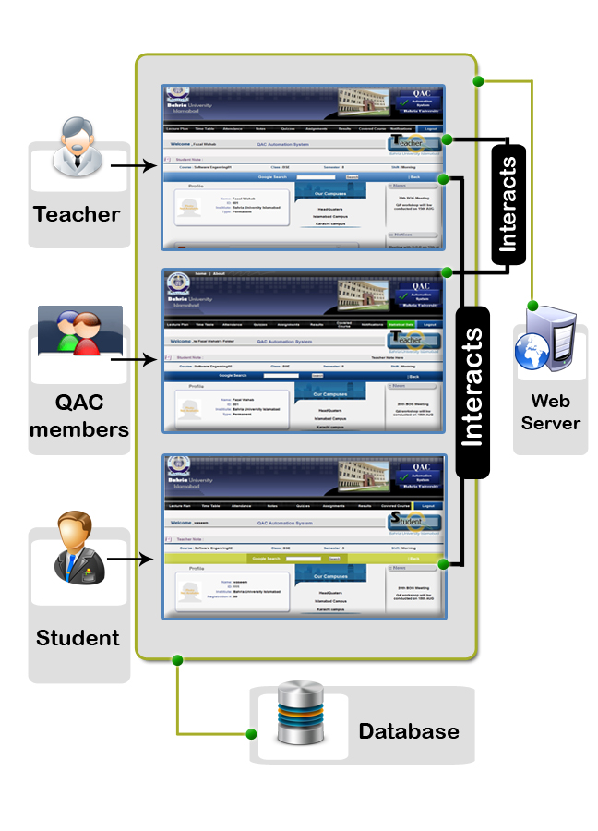

4.2 ERD Diagram

4.3 DFD (Data Flow Diagram)

4.3.1 Teacher

Database
Quizzes
Assignments
Upload
Download
“Store”
“Retrieve”
Retrieve
“Store”
Download
Notes
“message”
“Store”
Yes
“ message”
Yes
Noo
Course Select
Upload
Main Page
Lecture Plan
Time Table
User
Verify
Login & Password
“Error message”
Noo
“Verify”
Yes
Sign In
Download / Remove
If already
uploaded
Upload
Lecture plan
Upload
If already
uploaded
Upload
Time Table
Noo
Upload
Download / Remove
“Retrieve”
Upload
“Store”
“Retrieve”

Update
No
No
“Update”
“Store”
“error message”
Yes
Notification

Database
Download
“Retrieve”
Course Covered
View
“Store”
Search by Date
Update/Enter Course Covered
Edit
Result
Exists
Noo
View/Update
Overall
Result
Result
“Update”
Select Best Quizzes
Quiz Result
If Quizzes
> 3
Update
Select Best Assignments
Assignment Result
If Assign
> 3

Database
View/Edit
Summary
Attendance Update
Attendance Mark
“Update”
Comment
Write comment for student
Submit fostudent
Signout
yes
yes

4.3.2 Student

Database
Sign Out
Course Select
Main Page
Lecture Plan
Send Notices
Notes
Download
User
Sign In
Verify
Login & Password
“Error message”
Noo
“Verify”
Quizzes
Assignment
Results
Course Covered
Attendance
Comment
Download
Download
Download
Download
Download
Download
Download
Write Comment
Submit
“Store”

Yes

4.3.3 QAC Members
Noo
Yes
View Report 1, 2 or 3

Database
Download/View
Assignment
Results
Course Covered
Attendance
Statistics
Sign Out
Download/View
Download
Download
“Retrieve”
Lecture Plan
Time Table
Notes
Quizzes
Download/View
Download/View
Download/View
Download/View
User
Sign In
Select teacher
Select Course
Verify
Login & Password
“Error message”
“Verify”
Main Page
If report date 1, 2 0r 3 satisfy
If teacher fulfill condition
Send alert
Yes
Noo

4.3.4 Personal Assistant
User
Sign In
Main Page
Upload Notices
Upload/Remove
Notices
Send Notices
Sign Out
Verify
Login & Password

Database
Submit
“Error message”
Noo
“Store”
“Retrieve”
“Store”
“Verify”
Yes

4.4 Class Diagram
1…*

Offered

1

1…*

1

1…*

1…*

Register

Course
Register
Student ID()
Course Offered ID()
Get Register()
Send Notice()
Upload Notice()

Courses
ID
Name
Department
Credit Hours
Get Course Detail()

1

Student
ID
Regnumber
Name
Email
Address
Shift
Sction
Semester
Download Lecture Plan()
Download Time Table()
View Attendance();
View Result()
Download Document()
View Course Covered()

Register

Course
Offered
Course ID()
Session
Teacher Course Offer()

1…*

Data Access
Connection string
mySql_Connect()
mysql_select_db()
mySql_error()

QAC Members
ID
Email
Name
View document()
View Attendance Summary()
View Result Summary()
View Covered Course()
View Statistics()
Generate Alert()

Personal Assistant
(P.A)
ID
Name
Send Notice()
Upload Notice()

Teacher
ID
Regnumber
Name
Email
Address
Shift
Sction
Semester
Download Lecture Plan()
Download Time Table()
View Attendance();
View Result()
Download Document()
View Course Covered()

Offered

4.5 Sequence Diagram

Administrator

Teacher

Personal Assistant

QAC Members

4.6 Database Design

4.6.1 Teacher
Teacher
Sno | Key | Field | Type | Length | Null | Lookup Table
1 | PK | Tch_ID | Varchar | 15 | No
2 |  | Tch_Name | Varchar | 30 | No
3 |  | Tch_Type | Varchar | 10 | No
4 |  | Tch_Dept | Varchar | 15 | No
5 |  | Tch_Email | Varchar | 30 | Yes
6 |  | Tch_Phnum | Varchar | 20 | Yes

4.6 .2 Time_Table
Time Table
Sno | Key | Field | Type | Length | Null | Lookup Table
1 | PK,FK | Tt_Tch_ID | Varchar | 15 | No | teacher
2 |  | Tt_Date | DateTime |  | No
3 |  | Tt_Filename | Varchar | 50 | No
4 |  | Tt_Filelocation | Varchar | 30 | No

4.6.3 Course_Offered
Course_Offered
Sno | Key | Field | Type | Length | Null | Lookup Table
1 | PK | Co_ID | int | 5 | No
2 |  | Co_Course_ID | Varchar | 10 | No
3 |  | Co_Session | Varchar | 10 | No

4.6.4 paper_assignment
paper_assignment
Sno | Key | Field | Type | Length | Null | Lookup Table
1 | PK,FK | Pa_Tch_ID | Varchar | 15 | No | teacher
2 | PK | Pa_Assignnum | int | 5 | No
3 |  | Pa_Date | Date | 15 | No
4 | PK,FK | Pa_Co_ID | int | 5 | No | course_offered
5 |  | Pa_Filename | Varchar | 50 | No
6 |  | Pa_Filelocation | Varchar | 30 | No

4.6.5 paper_quiz
paper_quiz
Sno | key | Field | Type | Length | Null | Lookup Table
1 | PK,FK | Pq_Tch_ID | Varchar | 15 | No | teacher
2 | PK | Pq_Quiznum | int | 5 | No
3 |  | Pq_Date | Date | 15 | No
4 | PK,FK | Pq_Co_ID | int | 5 | No | course_offered
5 |  | Pq_Filename | Varchar | 50 | No
6 |  | Pq_Filelocation | Varchar | 30 | No

4.6.6 paper_notes
paper_notes
Sno | Key | Field | Type | Length | Null | Lookup Table
1 | PK,FK | Pn_Tch_ID | Varchar | 15 | No | teacher
2 | PK | Pn_Notenum | int | 5 | No
3 |  | Pn_Date | Date | 15 | No
4 | PK,FK | Pn_Co_ID | int | 5 | No | course_offered
5 |  | Pn_Filename | Varchar | 50 | No
6 |  | Pn_Filelocation | Varchar | 30 | No

4.6.7 courses
courses
Sno | Key | Field | Type | Length | Null | Lookup Table
1 | PK | Course_ID | Varchar | 10 | No
2 |  | Course_Name | Varchar | 25 | No
3 |  | Course_Dept | Varchar | 15 | No
4 |  | Course_Credit_Hours | int | 10 | No

4.6.8 classes
Classes
Sno | Key | Field | Type | Length | Null | Lookup Table
1 | PK | Class_Name | Varchar | 10 | No
2 | PK | Class_Semester | int | 4 | No
3 | PK | Class_Shift | Varchar | 10 | No
4 | PK | Class_Section | Varchar | 5 | No

4.6.9 teacher_course_offered
teacher_course_offered
Sno | Key | Field | Type | Length | Null | Lookup Table
1 | PK,FK | Tco_Tch_ID | Varchar | 15 | No | teacher
2 | PK,FK | Tco_Co_ID | int | 5 | No | course_offered

4.6.10 classes_course_offered
classes_course_offered
Sno | Key | Field | Type | Length | Null | Lookup Table
1 | PK,FK | Cco_Class_Name | Varchar | 10 | No | classes
2 | PK,FK | Cco_Class_Semester | Int | 4 | No | classes
3 | PK,FK | Cco_Class_Shift | Varchar | 10 | No | classes
4 | PK,FK | Cco_Class_Section | Varchar | 5 | No | classes
5 | PK,FK | Cco_Co_ID | Int | 5 | No | course_offered
6 | FK | Cco_Tch_ID | Varchar | 15 | No | teacher

4.6.11 course_covered
course_covered
Sno | Key | Field | Type | Length | Null | Lookup Table
1 | PK | Cc_ID | Int | 5 | No
2 |  | Cc_Co_ID | Int | 5 | No
3 |  | Cc_Date | Date |  | No
4 |  | Cc_Contentcovered | Varchar | 100 | No
5 |  | Cc_Timein | Varchar | 20 | No
6 |  | Cc_Timeout | Varchar | 20 | No

4.6.12 lecture_plan
lecture_plan
Sno | Key | Field | Type | Length | Null | Lookup Table
1 | PK | Lp_ID | int | 5 | No
2 | FK | Lp_Co_ID | int | 5 | No | course_offered
3 |  | Lp_Date | DateTime |  | No
4 |  | Lp_Filename | Varchar | 50 | No
5 |  | Lp_Filelocation | Varchar | 30 | No

4.6.13 students
Students
Sno | Key | Field | Type | Length | Null | Lookup Table
1 | PK | Stu_ID | varchar | 15 | No
2 |  | Stu_Regnum | varchar | 10 | No
3 |  | Stu_Name | Varchar | 30 | No
4 |  | Stu_Email | Varchar | 30 | Yes
5 |  | Stu_Address | Varchar | 60 | Yes
6 | FK | Std_Class_Name | Varchar | 10 | No | classes
7 | FK | Std_Class_Semester | int | 4 | No | classes
8 | FK | Std_Class_Shift | Varchar | 10 | No | classes
9 | FK | Std_Class_Section | Varchar | 5 | No | classes

4.6.14 attendance_summary
attendance_summary
Sno | Key | Field | Type | Length | Null | Lookup Table
1 | PK | Att_Sum_ID | int | 11 | No
2 | FK | Att_Sum_Co_ID | int | 10 | No | course_offered
3 |  | Att_Sum_Class_Type | varchar | 20 | No
4 |  | Att_Sum_Hours | int | 10 | No
5 |  | Att_Sum_TimeIn | Varchar | 20 | No
6 |  | Att_Sum_TimeOut | Varchar | 20 | No
7 |  | Att_Sum_Date | Date |  | No

4.6.15 attendance
attendance
Sno | Key | Field | Type | Length | Null | Lookup Table
1 | PK | Att_ID | int | 10 | No
2 | FK | Att_Std_ID | varchar | 15 | No | students
3 |  | Att_Status | varchar | 10 | No
4 | FK | Att_Sum_ID | int | 11 | No | attendance_summary
5 | FK | Att_Co_ID | int | 10 | No | course_offered

4.6.16 course_register
course_register
Sno | Key | Field | Type | Length | Null | Lookup Table
1 | PK,FK | Cr_Std_ID | varchar | 15 | No | students
2 | PK,FK | Cr_Co_ID | int | 10 | No | course_offered
3 |  | Cr_Quiz1 | float | 10,2 | Yes
4 |  | Cr_Quiz2 | float | 10,2 | Yes
5 |  | Cr_Quiz3 | float | 10,2 | Yes
6 |  | Cr_Quiz4 | float | 10,2 | Yes
7 |  | Cr_Quiz5 | float | 10,2 | Yes
8 |  | Cr_Quiz6 | float | 10,2 | Yes
9 |  | Cr_Assign1 | float | 10,2 | Yes
10 |  | Cr_Assign2 | float | 10,2 | Yes
11 |  | Cr_Assign3 | float | 10,2 | Yes
12 |  | Cr_Assign4 | float | 10,2 | Yes
13 |  | Cr_Assign5 | float | 10,2 | Yes
14 |  | Cr_Assign6 | float | 10,2 | Yes
15 |  | Cr_Assign7 | float | 10,2 | Yes
16 |  | Cr_Assign8 | float | 10,2 | Yes
17 |  | Cr_Assign9 | float | 10,2 | Yes
18 |  | Cr_Assign10 | float | 10,2 | Yes
19 |  | Cr_Labs | float | 10,2 | Yes
20 |  | Cr_Mid | float | 10,2 | Yes
21 |  | Cr_Proj_Pres | float | 10,2 | Yes
22 |  | Cr_Final | float | 10,2 | Yes
23 |  | Cr_GTotal_Quizess | float | 10,2 | Yes
24 |  | Cr_GTotal_Assignments | float | 10,2 | Yes
25 |  | Cr_GTotal_Marks | float | 10,2 | Yes
26 |  | Cr_Final_Grades | float | 10,2 | Yes

4.6.17 login
Login
Sno | Key | Field | Type | Length | Null | Lookup Table
1 | PK | Login_ID | varchar | 20 | No
2 | PK | Login_Password | varchar | 20 | No
3 |  | Login_Type | varchar | 15 | No
4 |  | Login_Status | tinyint | 1 | No

4.6.18 news
News
Sno | Key | Field | Type | Length | Null | Lookup Table
1 | PK | nw_ID | int | 11 | No
2 |  | nw_news | varchar | 200 | No

4.6.19 notices
Notices
Sno | Key | Field | Type | Length | Null | Lookup Table
1 | PK | nt_ID | int | 11 | No
2 |  | Nt_Notices | varchar | 200 | No
3 |  | Nt_Type | varchar | 15 | No
4 |  | Nt_Date | Date |  | No

4.6.20 pa_notices
pa_notices
Sno | Key | Field | Type | Length | Null | Lookup Table
1 | PK | Pan_Id | int | 11 | No
2 |  | Pan_PaID | varchar | 15 | No
3 |  | Pan_Date | Date |  | No
4 |  | Pan_Filename | Varchar | 50 | No
5 |  | Pan_Filelocation | Varchar | 30 | No

4.2.21 paper_projects
paper_projects
Sno | Key | Field | Type | Length | Null | Lookup Table
1 | PK | Pp_ID | Int | 10 | No
2 | FK | Pp_Co_ID | Int | 10 | No | course_offered
3 |  | Pp_Date | Date |  | No
4 |  | Pp_Filename | varchar | 50 | No
5 |  | Pp_Filelocation | varchar | 30 | No

4.6.22 qac_members
qac_members
Sno | Key | Field | Type | Length | Null | Lookup Table
1 | PK | Qac_Member_ID | varchar | 15 | No
2 |  | Qac_Members_Name | varchar | 30 | No
3 |  | Qac_Members_Email | varchar | 30 | Yes

4.6.23 report_dates
report_dates
Sno | Key | Field | Type | Length | Null | Lookup Table
1 | PK | Report_Dates_ID | int | 10 | No
2 |  | Report_Dates_StartDate | Date |  | No
3 |  | Report_Dates_EndDate | Date |  | No

4.6.24 student_comment
report_dates
Sno | Key | Field | Type | Length | Null | Lookup Table
1 | PK | Sm_ID | Int | 11 | No
2 | FK | Sm_Std_ID | Varchar | 15 | No | students
3 | FK | Sm_Co_ID | Int | 10 | No | course_offered
4 |  | Sm_Date | Date |  | No
5 |  | Sm_Comments | Varchar | 200 | No

4.6.25 teacher_comment
teacher_comment
Sno | Key | Field | Type | Length | Null | Lookup Table
1 | PK | Tc_ID | Int | 11 | No
2 | FK | Tc_Tch_ID | Varchar | 15 | No | teacher
3 | FK | Tc_Co_ID | Int | 10 | No | course_offered
4 |  | Tc_Date | Date |  | No
5 |  | Tc_Comments | Varchar | 200 | No

4.6.26 paper_mids
paper_mids
Sno | Key | Field | Type | Length | Null | Lookup Table
1 | PK | Pm_ID | Int | 10 | No
2 | FK | Pm_Co_ID | Int | 10 | No | course_offered
3 |  | Pm_Date | Date |  | No
4 |  | Lp_Filename | Varchar | 50 | No
5 |  | Lp_Filelocation | Varchar | 30 | No

4.7 SDLC (Software Development Life Cycle)

Modified Water Fall Model
Maintenance

Testing
Development & Coding
Requirements

Design & Architecture

We selected this model because it involves VALIDATION or VERIFICATION between the phases, so any deviations can be corrected immediately, providing the customer satisfaction, also in our system the requirements are changing very quickly, so if we are in design phase and if the requirements have changed the we can switch to the requirements phase and can tackle the requirement over there.

Chapter 5. Implementation

5.1 Screen Shots
Login Page
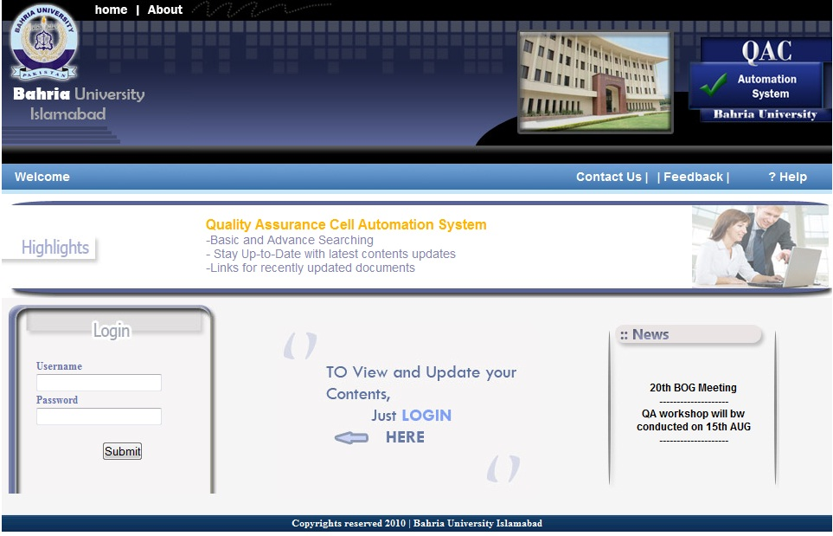
Teacher Course Select
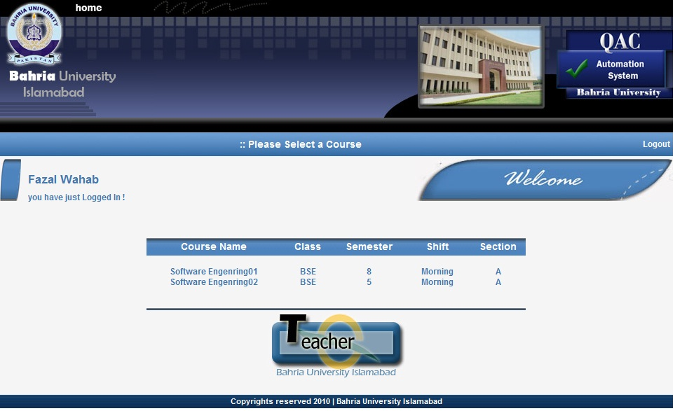
Teacher’s Page
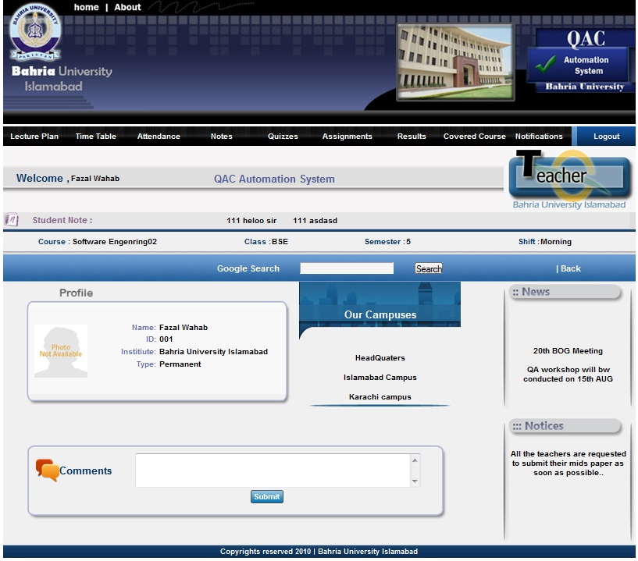
Upload File
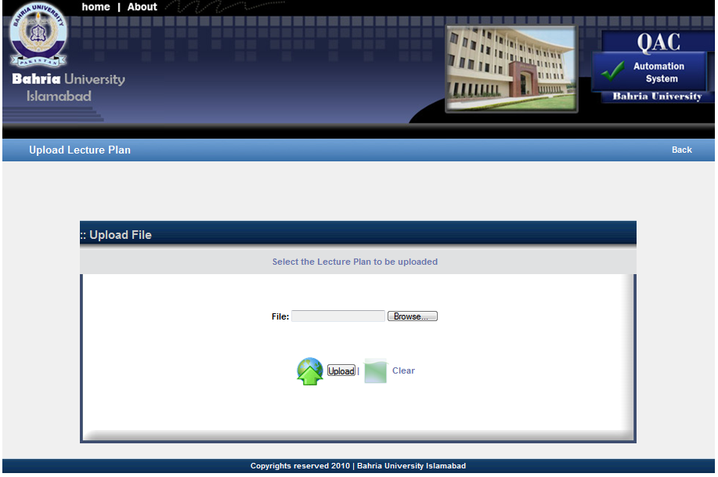
Download File
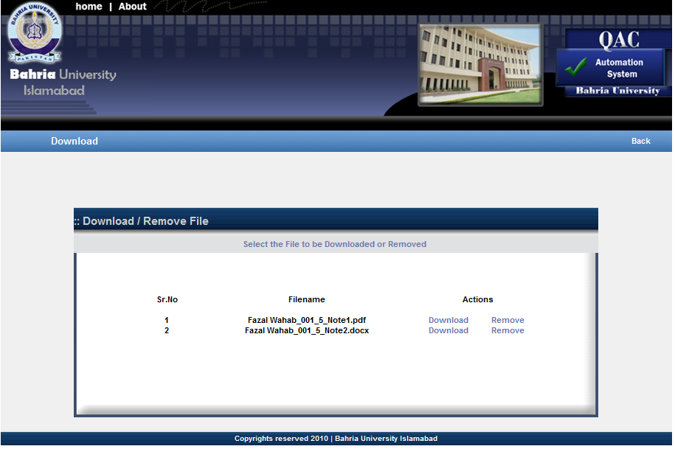
Mark Attendance
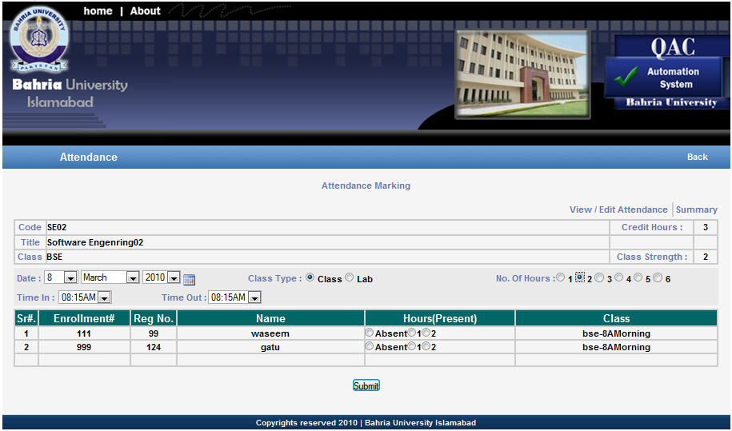

View / Edit Attendance
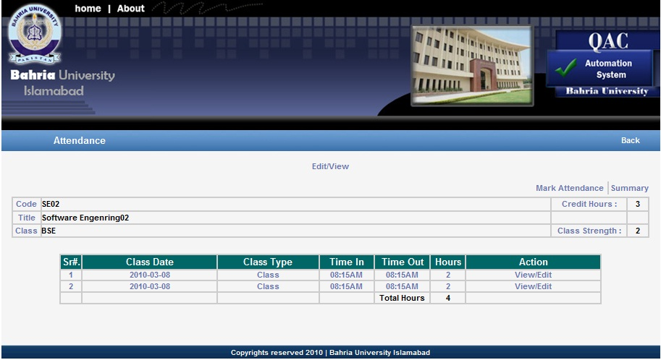
Attendance Summary
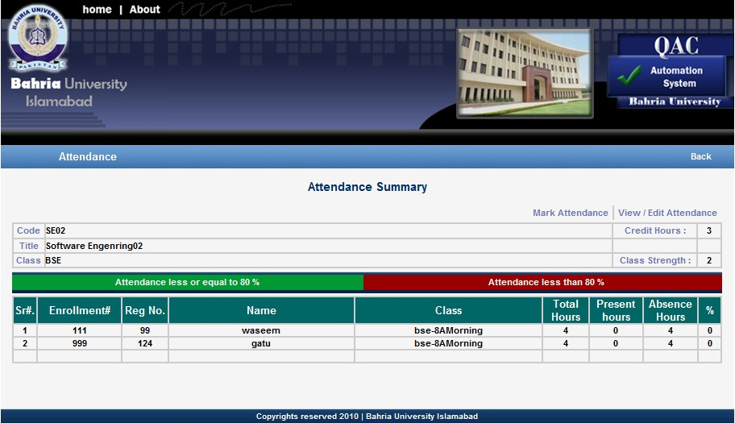

Result
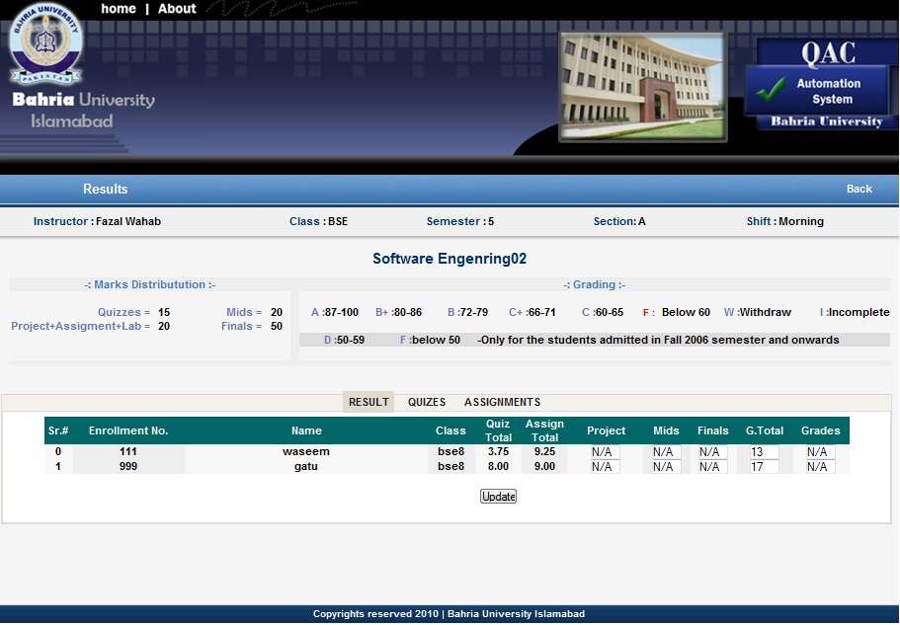
Course Covered
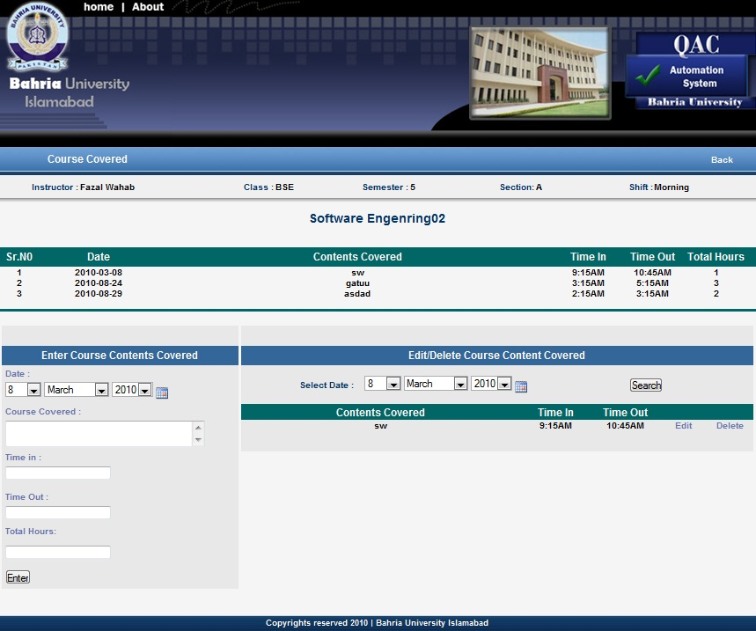
Student Course Select
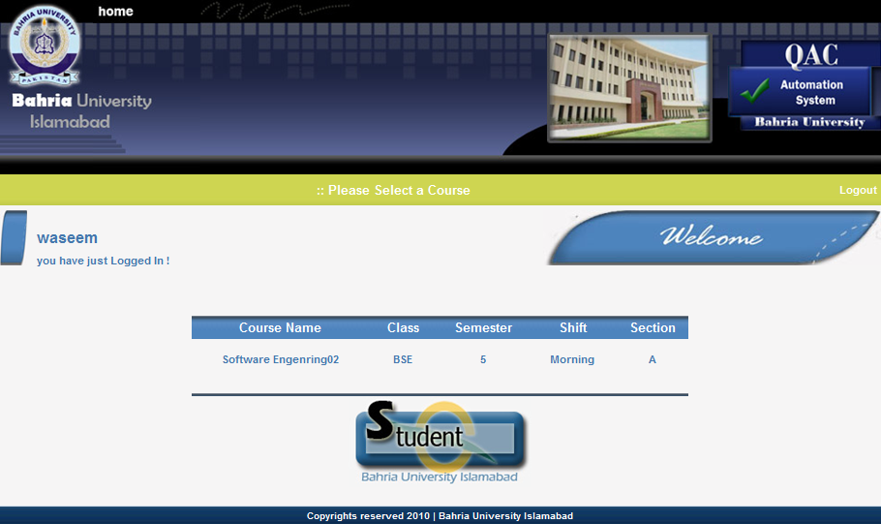
Student Main Page
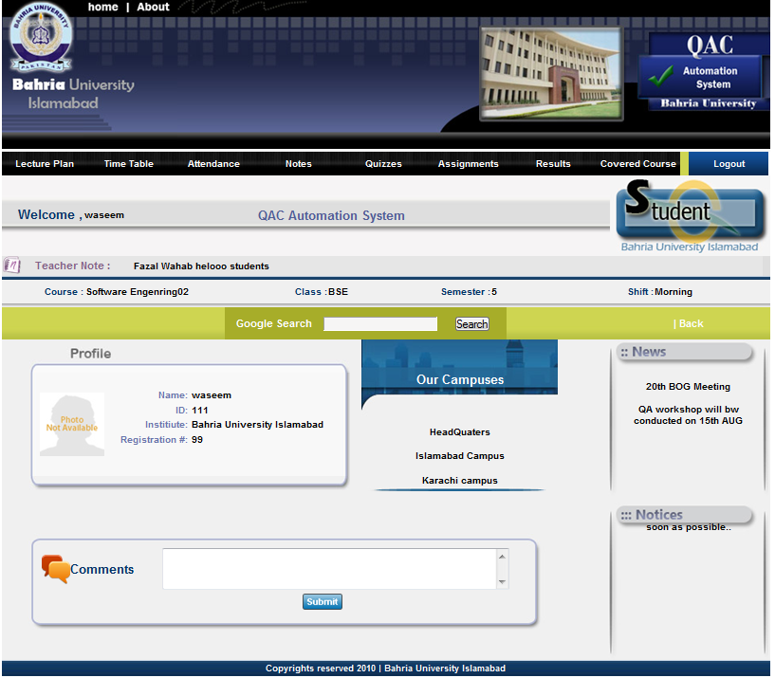

QAC Teacher Select
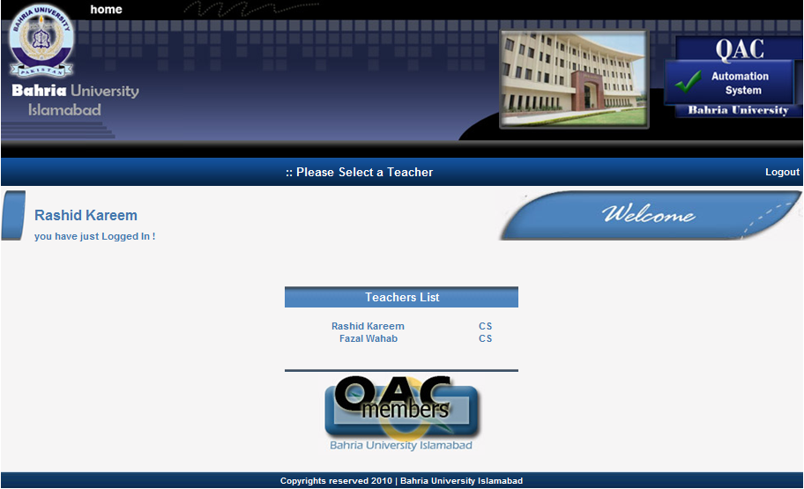
QAC Main Page
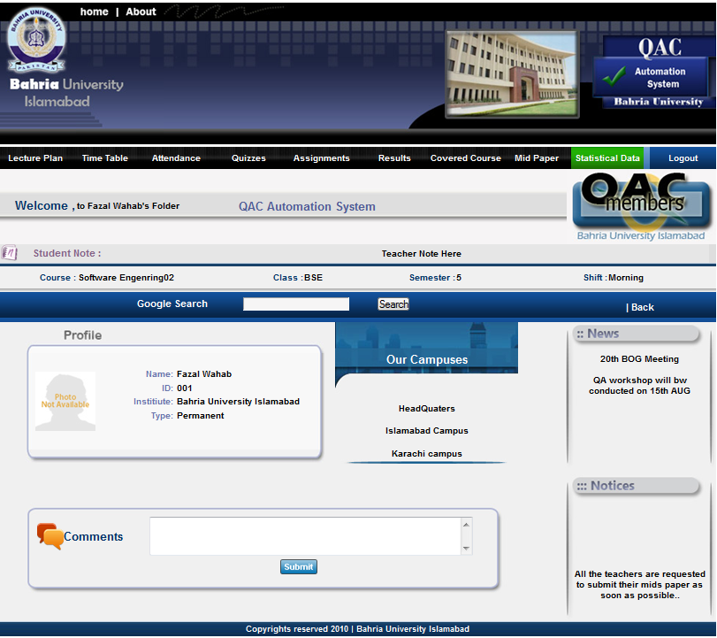
QAC Statistical Data
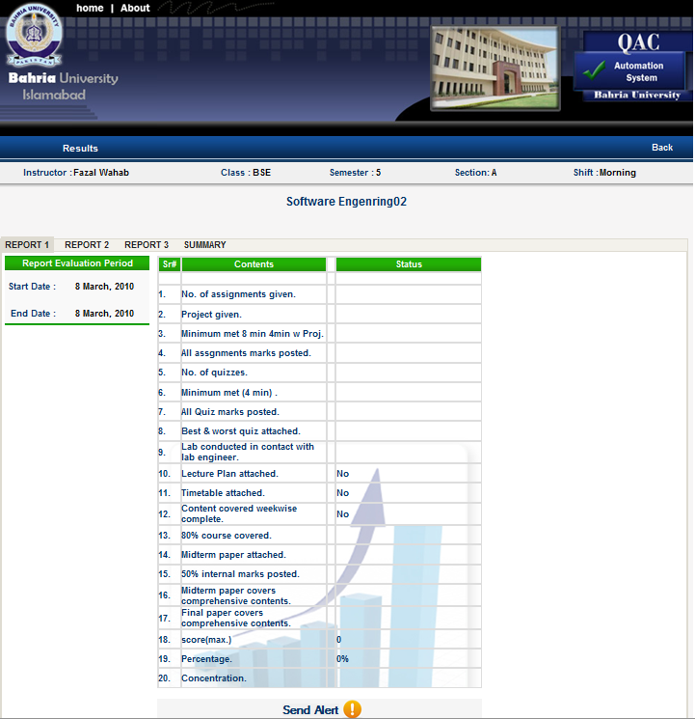

Personal Assistant
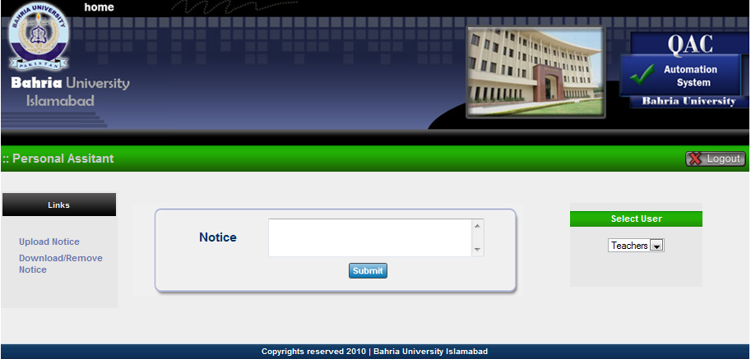

Administrator
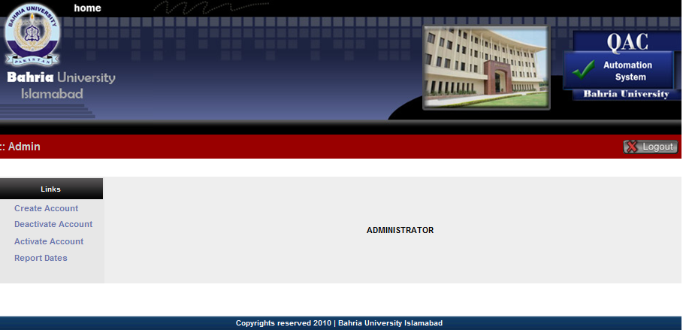
Admin Create Account
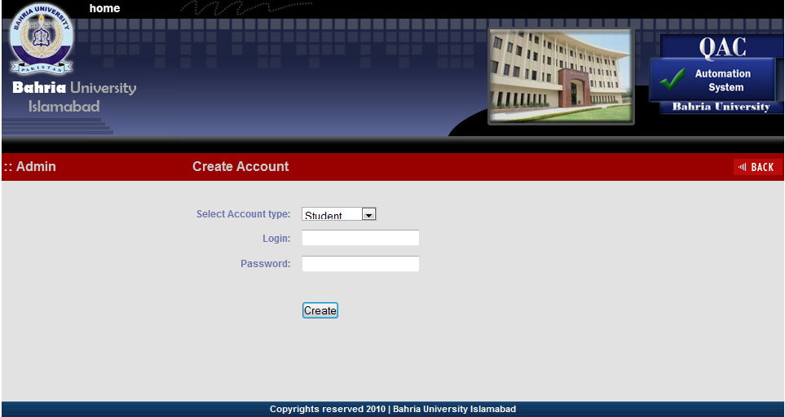

Admin Deactivate Account
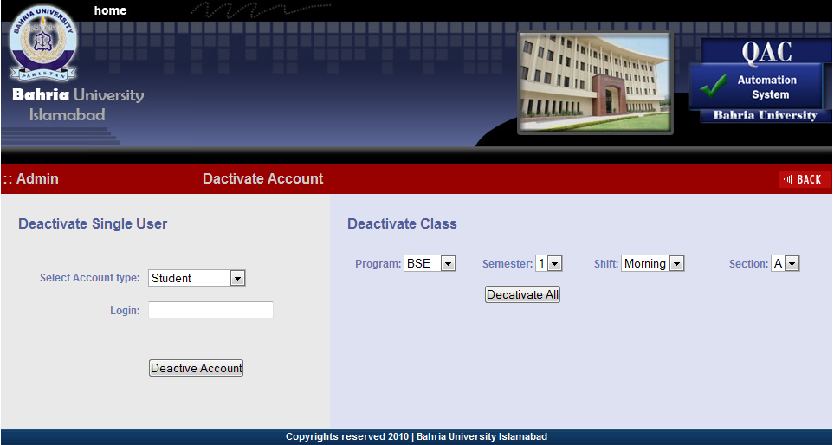
Admin Report Dates
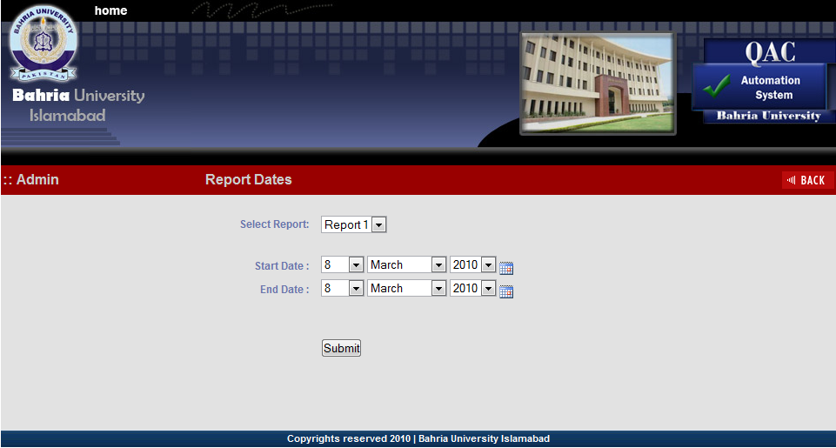

Chapter 6. Testing

6.1 Introduction
Quality Assurance Cell (QAC) Automation System for Bahria University provides teachers to maintain their folder online. Each teacher will be provided their own Login Password to make their information secured. This system will maintain the quizzes, assignments and result lists of the students automatically. It also maintain the daily basis activities between the students and teacher i.e uploading/downloading notes, giving comments and daily notifications etc QAC members will see or check the daily activities of all the teachers. The major benefit of this system is that QAC members will get evaluation of the teachers automatically. It also provides opportunity to Higher Authorities (H.O.D, Director etc) to check the performance of the teacher.

6.2 Test Strategy
Different testing strategies are exercised to check QAC Automation System. The primary purpose of these tests is to uncover the systems limitations and measure in its full capabilities. A list of the various planned tests and a brief explanation is given below.

6.2.1. System Test
The system test is done to focus on the behavior of the QAC Automation System user scenarios are be executed against the system as well as interface system checking and error message testing. Basically the system tests will test the all the functionality of the system which are mentioned in the requirement specification document.

6.2.2 Performance Test
Performance test is conducted to ensure that QAC Automation System’s response time meet the user expectation and does not exceed the specified performance criteria. During these tests response times will be measured under heavy stress and volume.

6.2.3. Security Test
Security test will determine how secure the QAC Automation System is. The test will verify that unauthorized user access to confidential data is provided.

6.2.4. Stress and Volume
We will subject the system to high input conditions and high volume of data during the peak times. For this we will use the WAPT (Web Application Test) tool to check the load on the system and its response.

6.2.5. Recovery Test
Recovery tests will force the system to fail in a various ways and verify that recovery is properly performed. It is vitally important that all system data is recovered after a system failure& no corruption of the data occurred.

6.2.6. Documentation Test
Test will be conducted to check the accuracy of the user documentation. These tests will ensure that no features are missing, and the contents can be easily understood.

6.2.7. Beta Test
The user of this system will beta tests the system and will report any defect they find. This will subject the system to tests that could not be performed in our test environment.

6.2.8. User Acceptance Test
Once the system is ready for implementation, the QAC department will perform User Acceptance Testing. The purpose of these tests is to conform that the system is developed according to the specified QAC Automation System requirements and it is ready for operational use.

6.3. Functions to be tested
All the following list of function will be tested
- User login/logout
- Teacher module
  - Selection of course
  - Uploading/downloading lecture plan, timetable, notes, quizzes and assignments
  - Updating attendance
  - Updating content covered
  - Updating result
  - Sending notices to the student
- Student module
  - Selection of course
  - Downloading lecture plan, timetable, notes, assignments and quizzes
  - Viewing attendance
  - Viewing content covered
  - Viewing result
  - Sending notices to the teacher
- QAC members module
  - Selection of teacher and course
  - Downloading/viewing lecture plan, timetable, notes, assignments and quizzes
  - Viewing attendance, result and content covered
  - View statistic of the teacher
- Administrator module
  - Create account
  - Deactivate account
  - Activate account
  - Reports dates
- Personal Assistance module
  - Sending general notices
  - Upload notice for the teachers
  - Download/remove notices

6.4 Test Cases
Test Case id= 1
Test Case name= Validate Login
Test case description= To verify that correct username and password has successfully signed In the User.

Test Steps:
Step | Expected | Actual
- Enter correct login name and password. | Login is successful. | It directs user to the particular page.

Test case status = Design
Test Status (P/F)= (a) Pass
Test priority= (a) High

Test Case id= 2

Test Case name= Validate Login
Test case description= To verify that incorrect user name and password will show appropriate message.

Test Steps:
Step | Expected | Actual
- Enter incorrect login name and password. | Login is unsuccessful. | An appropriate message is displayed.  Message: Incorrect username or password.

Test case status = Design
Test Status (P/F)= (a) Pass
Test priority= (a) High

Test Case id= 3
Test Case name= Validate Login
Test case description= To verify empty username and password will show an appropriate message.

Test Steps:
Step | Expected | Actual
- without entering loginname. | Message: “Please enter the login” | It shows a Pop-up window showing a message.  Message: “Please enter the login”
- without entering password | Message: “Please enter the password” | It shows a Pop-up window showing a message.  Message: “Please enter the password”

Test case status = Design
Test Status (P/F)= (a) Pass
(b) Pass
Test priority= (a) High
(b) High

Test Case id= 4
Test Case name= Validate Login
Test case description= To verify that user account is activated or deactivated.

Test Steps:
Step | Expected | Actual
- Enter deactivated username and password | Message: “Your account has been deactivated” | It login successfully rather than showing message: “Your account has been deactivated”
- Enter activated username and password. | Login is successful. | It will direct user to the particular page.

Test case status = Design
Test Status (P/F)= (a) Fail
(b) Pass
Test priority= (a) High
(b) High

Rework: (a) is reworked and analyzed. After careful analysis we found some conditional error in coding. After correcting error module is working according to requirement.

Test Case id= 5
Test Case name= Validate Login
Test case description= To verify that successful login will direct user to the respective page.

Test Steps:
Step | Expected | Actual
- Enter teacher’s correct username and password. | Select course page with their respective courses will be displayed including classname, semester ,shift, section. | It shows Select course page with their respective courses information including classname, semester ,shift, section.
- Enter student’s correct username and password. | Select course page with their respective courses will be displayed including classname, semester ,shift, section. | It shows Select course page with their respective courses information including classname, semester ,shift, section.
- Enter QAC members and Higher authorities correct username and password. | Select teacher page will be displayed showing teachers name with their department. | It shows teacher page will be displayed showing teachers name with their department.
- Enter administrator’s correct username and password. | It will direct administrator to its home page. | It shows administrators Home Page.
- Enter Personal Assistant’s correct username and password. | It will direct to the PA’s home page. | It will show the PA’s home page.

Test case status = Design
Test Status (P/F)= (a) Pass
(b) Pass
(c) Pass
(d) Pass
(e) Pass

Test priority= (a) High
(b) High
(c) High
(d) High
(e) High

Test Case id= 6
Test Case name= uploading files.
Test case description= To verify that files has been uploaded correctly by the teacher.

Test Steps:
Step | Expected | Actual
- from the teacher’s home page,teacher will click the respected upload file tab from the menu bar. | Upload file page will be displayed with browse and upload option. | It shows the upload file page.
- Select the related file to be uploaded and click upload button.  Format: doc. , docx. , ppt. , PDF. | File will be upload correctly to its respective folder. | It uploads the file correctly.

Test case status = Design
Test Status (P/F)= (a) Pass
(b) Pass
Test priority= (a) High
(b) High

Test Case id= 7
Test Case name= download or remove files.
Test case description= To verify that files has been downloaded and removed correctly by the teacher.

Test Steps:
Step | Expected | Actual
- from the teacher’s home page,teacher will click the respected download/delete file tab from the menu bar. | Download/Remove file page will be displayed with list of respected files and download/remove options. | It shows the Download/Delete file page with list of files and download/remove options.
- Select the related file to be downloaded or removed and click respective button. | File will be downloaded or removed correctly. | It download or remove the file correctly.

Test case status = Design
Test Status (P/F)= (a) Pass
(b) Pass
Test priority= (a) Medium
(b) High

Test Case id= 8
Test Case name=Validate Lecture Plan and Time Table
Test case description= To verify that only one lecture plan per course and one time table per semester will be uploaded by the teacher.

Test Steps:
Step | Expected | Actual
- from the upload file page click the upload button to upload lecture plan or time table. | If file is already uploaded display a message :”File is already uploaded” | It display a message :”File is already uploaded”

Test case status = Design
Test Status (P/F)= (a) Pass

Test priority= (a) High

Test Case id= 9
Test Case name=Update course Covered
Test case description= To verify that the course content covered has been updated.
Test Steps:
Step | Expected | Actual
- in course covered page select date, enter course content covered, time in, time out, total hours and click enter. | Updated content covered will be updated and displayed in the above content covered table. | It shows the Updated content covered will be updated and displayed in the above content covered table.
Test case status = Design
Test Status(P/F)= (a) Pass
Test priority= (a) High

Test Case id= 10
Test Case name=Edit Course Covered Content
Test case description= To verify that the course content covered will be generated on the basis of that particular date.

Test Steps:
Step | Expected | Actual
- in course covered page select date and click search button. | List of records will br displayed with respect to that date. | It will show the content covered list related to that date in a separate table.

Test case status = Design
Test Status (P/F)= (a) Pass
Test priority= (a) High
Test Case id= 11
Test Case name=Teacher comments.
Test case description= To verify that the teacher comments will be displayed on the student’s home page.

Test Steps:
Step | Expected | Actual
- Teacher enters comment in comment box | Comments will be displayed to the student’s home page | Teacher’s comments are not shown on the student’s home page

Test case status = Design
Test Status (P/F)= (a) Fail
Test priority= (a) High
Rework: Code has been reviewed and after handling problem the Teacher’s comments will be shown on the Student’s home page.

Test Case id= 12
Test Case name= Student download files.
Test case description= To verify that the students download the lecture plan, timetable, notes, quizzes, and assignments successfully.

Test Steps:
Step | Expected | Actual
- Student will go the lecture plan tab and will click the download link. | The Lecture plan will be downloaded. | The lecture plan is downloaded successfully.
- Student will go the timetable tab and will click the download link. | The timetable will be downloaded. | The timetable is downloaded successfully.
- Student will go the notes tab and will click the download link . | The notes will be downloaded. | The note is downloaded successfully.
- Student will go the quizzes tab and will click the download link . | The quizzes will be downloaded. | The quiz is downloaded successfully.
- Student will go the assignment tab and will click the download link . | The assignment will be downloaded. | The assignment is downloaded successfully.

Test case status = Design
Test Status (P/F)= (a) Pass
(b) Pass
(c) Pass
(d) Pass
(e) Pass
Test priority= (a) Medium
(b) Medium
(c) Medium
(d) Medium
(e) Medium
Rework: Code has been reviewed and after handling problem the grades will be shown according criteria.
Test Case id= 13
Test Case name= Student view result.
Test case description= To verify that the exact result of student has been shown.
Test Steps:
Step | Expected | Actual
- Student will go the result tab and will be directed to the result page. | The student will be directed to the result page. | The student is directed to the result page successfully.
- Student will look for the grades calculated on the result page. | The grades shown will be calculated according to the university criteria. | The grades are not calculated according to university criteria.

Test case status = Design
Test Status(P/F)= (a) Pass
(b) Fail
Test priority= (a) High
(b) High
Rework: Code has been reviewed and after handling problem the grades will be shown according to university criteria.

Test Case id= 14
Test Case name=Student comments.
Test case description= To verify that the student comments will be displayed on the teacher’s home page.

Test Steps:
Step | Expected | Actual
- Student enters comment in comment box | Comments will be displayed to the teacher’s home page | Student’s comments are not shown on the teacher’s home page

Test case status = Design
Test Status (P/F)= (a) Fail
Test priority= (a) High
Rework: Code has been reviewed and after handling problem the Student’s comments will be shown on the Teacher’s home page.

Test Case id= 15
Test Case name=Student view attendance.
Test case description= To verify that the exact attendance of the student will be shown.
Test Steps:
Step | Expected | Actual
- Student will go to the attendance tab and will be directed to the attendance page. | The attendance page will be shown. | Attendance page is shown.
- Student will check the total hours present. | The total hours present will be shown according to the number of classes attend by the student. | Exact hours are not shown.

Test case status = Design
Test Status(P/F)= (a) Fail
Test priority= (a) High
Rework: Code has been reviewed and after handling problem the exact hours of the student has been shown.
Test Case id= 16
Test Case name= Logout user.
Test case description= To verify that the user logout and move to login page.
Test Steps:
Step | Expected | Actual
- The user will click the logout tab. | Login page must be displayed after logout. | Logout successful and moved to the login page.

Test case status = Design
Test Status(P/F)= (a) Pass
Test priority= (a) High

6.5 Test schedule

- System adjustment/formalization 10-06-2010 - 20-06-2010
- System test 21-06-2010 - 26-06-2010
- Beta test 27-06-2010 - 01-07-2010
- Acceptance test 02-07-2010 - 07-07-2010

6.5 Control Procedure

6.5.1 Reviews
The project team will perform reviews for each phase i.e.
- Requirement Review
- Design Review
- Code Review
- Test Plan Review
- Test Plan Review
- Final Test Summary Review

6.5.2 Bug review meeting
All the report defects will be discussed on weekly basis. All members of the project will participate. The developers will provide updates on all defects reported simultaneously and tester will provide addition defects information if needed.

6.5.3 Change Request
Once testing begins changes to the QAC Automation System are discouraged. In case of any functional changes required changes to the system will be discussed with the main authority either it should be implemented or not.

6.5.4 Defect Reporting
Defects are found, once they are verified with the requirement, they are reported to the developer for fixing those defects. Once a defect is verified as fixed, status of defects will change to indicate the current state.

6.6 Resource and Responsibilities

The Test group head and Project Manager will determine when system test will start and end. The Test group will also be responsible for coordinating schedules, equipment and tools for the testers as well as writing /updating the Test Plan, weekly Test Status reports and finally Test Summary report. The tester will be responsible for writing the test cases and executing the tests. With the help of the Test group head and the QAC Automation System users will be responsible for the Beta and User Acceptance tests.

6.6.1 Resources
Team consists of
- A project manager
- Developers
- A Test group head
- Three Testers
- QAC Automation System users

6.6.2 Responsibilities

Project Manager Responsible for Project schedules and the overall success of the project.
Developers Responsible for developing the product.
Test group Head Basically ensures the overall success of the test cycles. Will coordinate weekly meetings and communicate the testing status to the project team.
Testers Responsible for performing the actual system testing.
QAC Automation System users Will assist in performing the Beta and User Acceptance testing.
Deliverable | Responsibility | Completion Date
Develop test cases | Testers
Test case review | Test group head, Developers, Testers
Requirement validation | Test group head
Obtain user ids and password for QAC Automation System/database | Test group head
Execute manual tests | Testers and Test group head
Complete defect report | Everyone testing the product all involved | On-going
Document and communicate test status/coverage | Test group head | Weekly
Execute beta tests | QAC Automation System users
Document and communicate Beta test status/coverage | Manager
Execute user Acceptance test | QAC Automation System users
Document and communicate Acceptance test status/coverage | Manager
Final test summary report | Test group head

6.7. Dependencies

6.7.1 Personal Dependencies
To develop, perform and validate test cases require experience testers.

6.7.2 Software Dependencies
The source code must be unit tested and must be done within the scheduled time state in the project schedule.

6.7.3 Hardware Dependencies
3 PCs (with specified hardware/software) as well as internet should be available during normal working hours. Any problem in the internet will affect the test schedule.

6.7.4 Test Date & Database
Test data and database should also be made available to the testers for use during testing.

6.8 Risks

6.8.1 Schedule
The schedule for each phase is very aggressive and could affect testing. A slip in the schedule in one of the other phase could result in a subsequent slip in the test phase. Close project management is crucial to meeting the forecasted completion date.

6.8.2 Management
Proper management is required so that when the internet connection gets down the schedule for testing does not get interrupted. Management can reduce the risk of delays by supporting the test team throughout the testing phase and assigning the task to the team members according to their skills set.

6.8.3 Personal
Due to the aggressive schedule, it is very important to have experienced testers on this project. Unexpected turnovers can impact the schedule.

6.8.4 Requirement
The test plan and test schedule are based on the Requirement Document. Any changes to the requirements could affect the test schedule and will need to be approved by the main authority.

Chapter 7. User Manual

Chapter 1. Introduction

What is QAC Automation System?
Automation System of Quality Assurance Cell (QAC) of Bahria University maintains the records of the daily activities of the teachers with respect to the students and provides the interaction between the students and the teachers. It also facilitates the Quality Assurance Cell to evaluate teacher’s performance.

Outline

Admin.
Administrator is allowed to create and deactivate accounts of the teachers, students and QAC members. Report dates are set by the administrator.

Teachers.
Teachers is provided the facility to update their latest contents with respect to their courses. Teacher interacts with the students according to their assigned courses.

Students.
Students are provided the facility to view or download the files and to interact with the teacher.

QAC members.
QAC members are allowed to view the teacher’s folder and to evaluate the performance of the teachers.

Chapter 2. Getting Started

What you need?

- Internet explorer.
- Windows operating system.
In your browser access the link : http://localhost/qac/signup.php . It will direct the user to the login page.

Login Page:
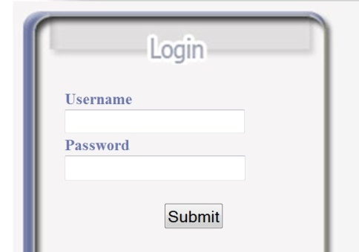
Enter your username (provided by the administrator)
Enter your Password (provided by the administrator)
After entering username and password click submit button

If the user enters wrong username and password, the message will appear on the login screen
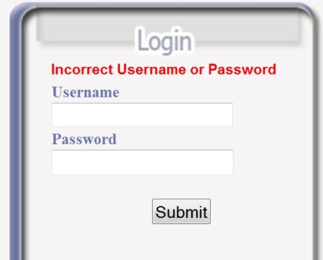
*Incorrect username or password

How to get Username and password?

Username and password is to be get from the administrator of the university *

*Terms and conditions.
User of this software must be the actor of the Bahria University.

Chapter 3. Users

The users of this software are:

- Administrator.
- Teacher.
- Student.
- QAC members/high authorities.
- Personal assistant to H.O.D

3.1 Administrator
Administrator has the authority to create account, deactivate account, activate account and to set the dates of the reports that will be generated for the teachers.
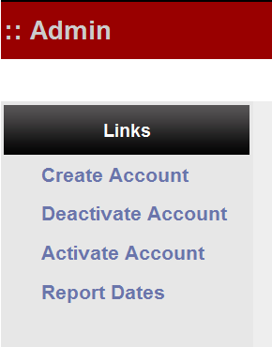
Click the above provided links to perform the selected task.
Create account : administrator will select the account type , enters the login and password.click create button to create account.

Deactivate Account : Admin can deactivate the single user or can deactivate the whole class.

Activate Account : Admin can activate the single user or can activate the whole class.

Reports Dates : Admin will select Report number and will select the Start Date and ending Date of that report and will click on submit button.

3.2 Teachers
After the teacher has logged in he/she will be directed to the course select page. The teacher will select the course.
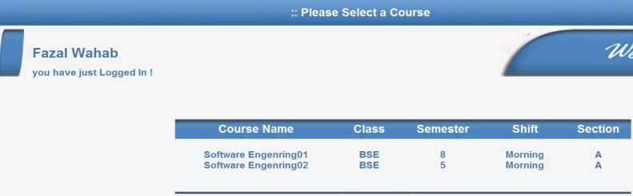
Select course from a list
Teacher’s name
Selecting course will direct the teacher to the home page with respect to that course.

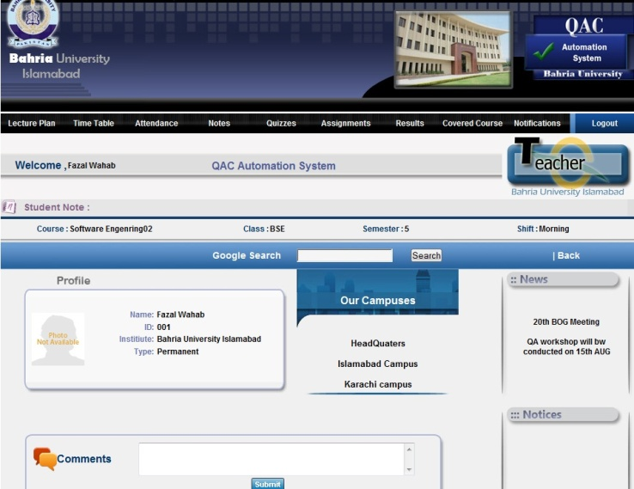
6
4
5
2
1
3

Student Note: any note by the student can be viewed. here.
4
1
Menu Bar: contains the menus and submenus.
Profile: contains the information about the teacher.
Comment box: Comments to be submitted by the teacher for the students to be viewed on student homepage.
3
2
6
Notices: any notice from High Authority is viewed here.
5
News: News about the university are displayed here.
Profile: contains the information about the teacher.
4
Notices: any notice from High Authority is viewed here.
1
5
News: News about the university are displayed here.
4
Student Note: any note by the student can be viewed. here.
Menu Bar: contains the menus and submenus.
3
Comment box: Comments to be submitted by the teacher for the students to be viewed on student homepage.
2

3.2.1 Attendance
For attendance marking, teacher will go to the attendance tab from a menu bar and will click on the link mark attendance. It will direct user to the mark attendance page.
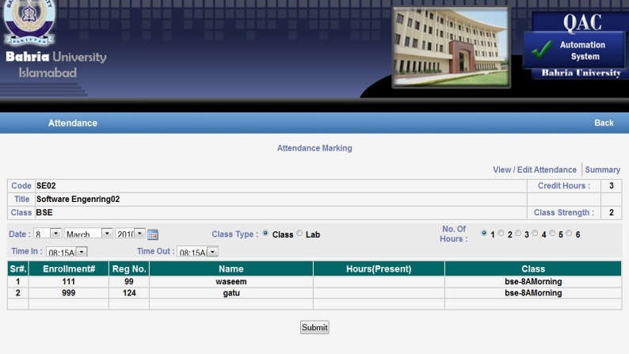
4
5
3
2
1
Status table: contains the current status information of course.
1

x
3
List: contains list of student enrolled in this particular course.
Option bar: Options to be selected.
2

Submit: submit button to be clicked after taking attendance
5
4
Links: view/Edit attendance and Summary link.

View / Edit Attendance: Click the link to view or edit attendance of the students with respect to that course. It will direct teacher to view / Edit page where list of attendance marked is shown with their dates.
View /edit link is provided in front of every attendance. Click to edit or view that attendance.
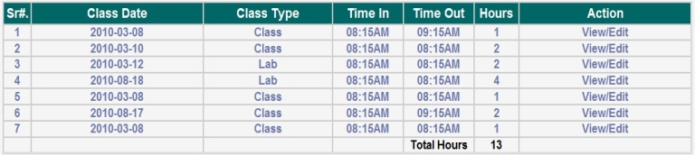
View / Edit action link list to be clicked for view and edit against that attendance.

Summary : Click Summary link to view the whole summary of attendance. This will also tell which students are with short of attendance, how many hours did each student attended and percentage.

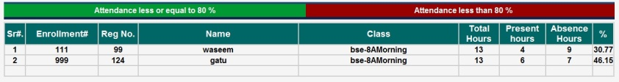

3.2.2 Course Content Covered.
Course content covered is use to update the course content covered by the teachers and maintaining the record according to the dates.
To update, from homepage click update / View link drop from a covered course tab on a menu bar. Course content covered page will be shown.
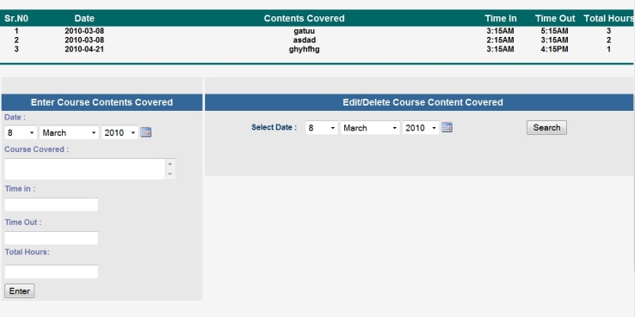
3
2
1
2
Edit/ delete option: Choose date and click search button.
2
Entering contents: fill the boxes as required and enter to save record.
Record table:
Shows the list of covered contents with dates.
1

Edit / Delete Course Covered Contents:
To edit / delete the content covered select the date(refer 2) and click search. New table will be shown below that containing the list or single record of the content covered already saved. it brings the record from the above record table.

New table will be like this:
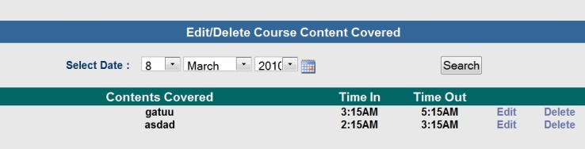

In new appeared table edit and delete options are attached with each record. To edit or delete any record use these links.

Delete option deletes the record permanently from the record table and edit option will copy related record content to the empty text boxes in table 2.Edit and enter to resave the record.

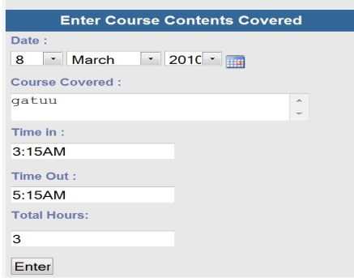
Edit record: edit the record and click enter to save to record table

3.2.3 Upload , Download and Remove files.
(Lecture Plan, Time table, Notes, Quizzes and Assignments)
To download / upload / Remove files click any one of the tabs mention above. A drop menu appears containing Upload and download options.
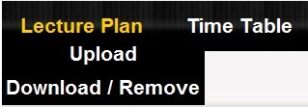
Upload link: It directs to the upload page. Click browse, choose file and click upload to upload a file.
Download link: It directs to the download page. List is provided of the files to be downloaded with remove option also. Click download to download file and remove to remove files permanently. (See figures)

Upload File:
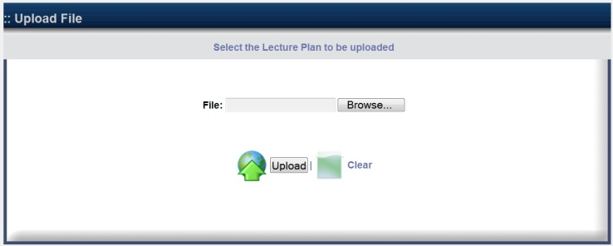
Click Browse and Choose file here
Upload Button

Download / Remove File:
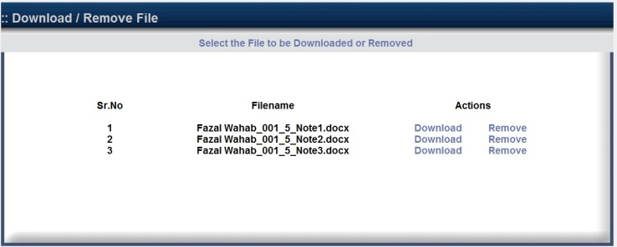
Files List to be downloaded/Remove
Download / Remove Options

3.2.4 Comment Box.
Comments are to be made by the teacher to the student to whom teacher is currently interacting.
Teacher is to write comment in the comment box and click submit to show that comment on students homepage.

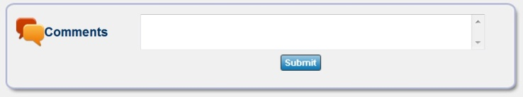
Comment area.
Submit Button

3.3 Students
First student logs in using its username and password provided by the administrator. It directs user to the course select page he/she may have registered. Select the course and move to the homepage.
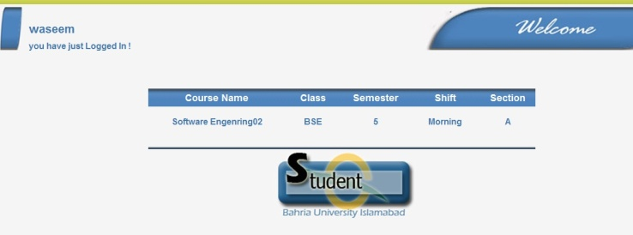
Select course from this table
Student name who has logged in.

Select course and it then directs user to his/her homepage.
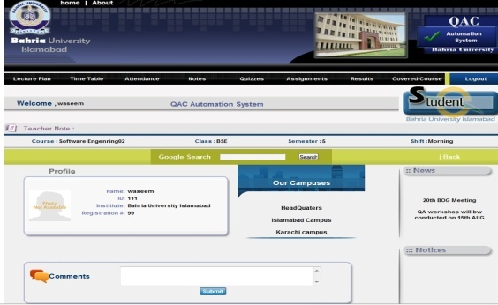

Note: Student has only right to download or view file.

3.3.1 Download file.
To download a file ,move the cursor to any of the required tabs of the menu bar and select the option from the drop down menu Download as set.
Example: For downloading a file.
- Click on a particular tab.

- Click a download link which directs to the download file page.
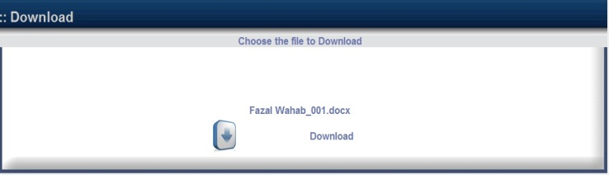
Download link
File to be downloaded

Note : File will only appear in a case if the teacher has uploaded that file.

3.3.2 View file.
To view a file, move the cursor to any of the required tabs of the menu bar and select the option from the drop down menu View as set.
Example : For viewing a file.
- Click on a particular tab.

- Click on View link which directs to the view page to view the contents
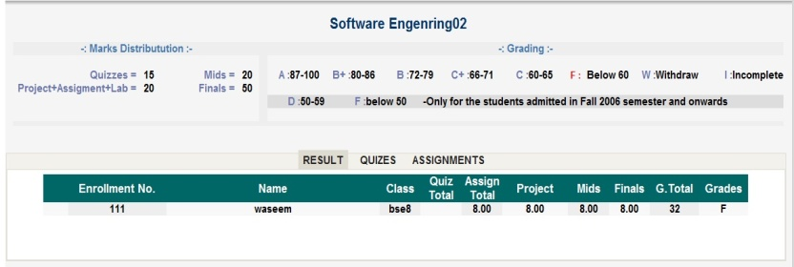

This above picture shows the result of a student.

3.4 QAC members or High Authorities.
QAC members or high authorities can view the status of each teacher at any stage. They will evaluate the teacher’s performance using the records generated in the form of statistical data.

Enter your username and password to log in which directs to the select teacher’s page. Choose teacher with their department to view his/her performance.
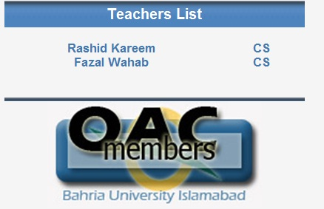
List of teachers. Select one.

After choosing the teacher , select Course page will be viewed with respect to that teacher. List of courses will be provided enrolled with that teacher. Select course which directs to the home page.

3.4.1 To view statistical data.
Click Statistical Data tab on menu bar displayed on a home page.
Statistical data will be displayed in the form of the tabs containing Report 1, Report 2, Report 3 and Summary.
With each report the report evaluation dates are mentioned that includes the start date and the end date.
At the end of the table Alert option is given. This is to send an alert to the teacher to give them a warning that some of their contents to be uploaded are missing.
Refer the next picture.

Tab list. By default report 1 is selected

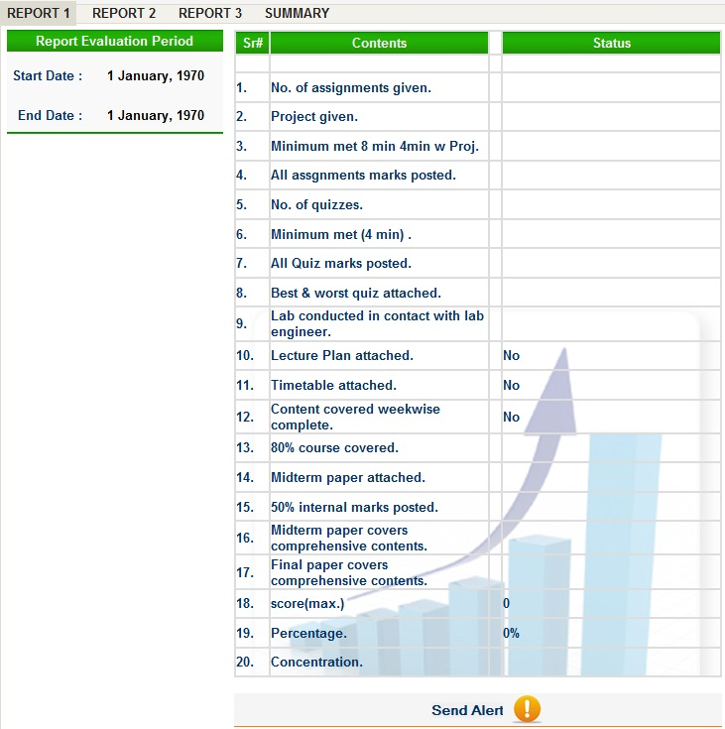
Report contents and status.
Report evaluation period table
Send Alert Link

Conclusion
QAC Automation System has been deployed to the Bahria University and is in use of various actors (teachers, students, QAC members) of the university but system is not yet approve for its proper launch. All the modules of the system are working properly. Project is evolving to improve it further. More and more enhancements are made day by day in order to make the system that will fulfill the requirements of the user.

References
- http://www.bahria.edu.pk/
- http://www.php.net/manual/en/
- http://www.best-php-scripts.com/
- http://forums.digitalpoint.com/showthread.php?t=416988
- http://www.tizag.com/phpT/
- http://www.tutorialized.com/tutorials/Dreamweaver/1
- http://www.brainbell.com/tutorials/MySQL/Using_Different_Join_Types.htm
- http://en.wikipedia.org/w/index.php?title=Test_case
- http://www.objectmentor.com/resources/articles/usecases.pdf
- http://javascript.internet.com/forms/val-time.html
- http://www.plus2net.com/sql_tutorial/date-lastweek.php
- http://www.finalwebsites.com/forums/topic/php-file-download
- http://www.w3schools.com
- http://ieeexplore.ieee.org/iel4/5841/15571/00720574.pdf

Appendix
- Database: qac_database

Table: attendance
Att_ID | Att_Std_ID | Att_Status | Att_Sum_ID | Att_Co_ID

Table: attendance_summary
Att_Sum_ID | Att_Sum_Co_ID | Att_Sum_Class_Type | Att_Sum_Hours | Att_Sum_TimeIn | Att_Sum_TimeOut | Att_Sum_Date

Table: class_course_offered
Cco_Class_Name | Cco_Class_Semester | Cco_Class_Shift | Cco_Class_Section | Cco_Co_ID | Cco_Tch_ID

Table: classes
Class_Name | Class_Semester | Class_Shift | Class_Section

Table: course_covered
Cc_ID | Cc_Co_ID | Cc_Date | Cc_Contentcovered | Cc_Timein | Cc_Timeout | Cc_TotalTime

Table: course_offered
Co_ID | Co_Course_ID | Co_Session

Table: course_register
Cr_Std_ID | Cr_Co_ID | Cr_Quiz1 | Cr_Quiz2 | Cr_Quiz3 | Cr_Quiz4 | Cr_Quiz5 | Cr_Quiz6 | Cr_Assign1 | Cr_Assign2 | Cr_Assign3 | Cr_Assign4 | Cr_Assign5 | Cr_Assign6 | Cr_Labs | Cr_Mid | Cr_Final | Cr_Proj_Pres | Cr_GTotal_Quizess | Cr_GTotal_Assignments | Cr_GTotal_Marks | Cr_Final_Grades | Cr_Assign7 | Cr_Assign8

Table: courses
Course_ID | Course_Name | Course_Dept | Course_Credit_Hours

Table: lecture_plan
Lp_ID | Lp_Co_ID | Lp_Date | Lp_Filelocation | Lp_Filename

Table: login
Login_ID | Login_Password | Login_Type | Login_Status

Table: news
nw_Id | nw_news

Table: notices
Nt_Id | Nt_Notices | Nt_Type | Nt_Date

Table: pa_notices
Pan_Id | Pan_PaID | Pan_Date | Pan_Filelocation | Pan_Filename

Table: paper_assignment
Pa_Tch_ID | Pa_Co_ID | Pa_Assignnum | Pa_Date | Pa_Filelocation | Pa_Filename

Table: paper_mids
Pm_ID | Pm_Co_ID | Pm_Date | Pm_Filelocation | Pm_Filename

Table: paper_notes
Pn_Tch_ID | Pn_Notenum | Pn_Co_ID | Pn_Date | Pn_Filelocation | Pn_Filename

Table: paper_projects
Pp_ID | Pp_Co_ID | Pp_Date | Pp_Filename | Pp_Filelocation

Table: paper_quiz
Pq_Tch_ID | Pq_Quiznum | Pq_Date | Pq_Co_ID | Pq_Filelocation | Pq_Filename | Pp_Filelocation

Table: qac_members
Qac_Member_ID | Qac_Members_Name | Qac_Members_Email

Table: report_dates
Report_Dates_ID | Report_Dates_StartDate | Report_Dates_EndDate

Table: student_comment
Sm_ID | Sm_Std_ID | Sm_Co_ID | Sm_Date | Sm_Comments

Table: students
Std_ID | Std_Regnum | Std_Name | Std_Class_Name | Std_Email | Std_Address | Std_Class_Shift | Std_Class_Section | Std_Class_Semester

Table: teacher
Tch_ID | Tch_Name | Tch_Type | Tch_Dept | Tch_Email | Tch_Phnum

Table: teacher_comment
Tc_ID | Tc_Tch_ID | Tc_Co_ID | Tc_Date | Tc_Comments

Table: teacher_course_offered
Tco_Tch_ID | Tco_Co_ID

Table: teacher_students_notification
Tsn_ID | Tsn_Tch_ID | Tsn_Co_ID | Tsn_Date | Tsn_Notice

Table: time_table
Tt_Tch_ID | Tt_Date | Tt_FileLocation | Tt_Filename

- Database Script
CREATE TABLE `attendance` (
`Att_ID` int(10) NOT NULL auto_increment,
`Att_Std_ID` varchar(15) NOT NULL,
`Att_Status` varchar(10) NOT NULL,
`Att_Sum_ID` int(11) NOT NULL default '0',
`Att_Co_ID` int(10) NOT NULL default '0',
PRIMARY KEY (`Att_ID`)
)
-- Table structure for table `attendance_summary`
CREATE TABLE `attendance_summary` (
`Att_Sum_ID` int(11) NOT NULL auto_increment,
`Att_Sum_Co_ID` int(10) NOT NULL default '0',
`Att_Sum_Class_Type` varchar(20) NOT NULL,
`Att_Sum_Hours` int(10) NOT NULL default '0',
`Att_Sum_TimeIn` varchar(20) NOT NULL,
`Att_Sum_TimeOut` varchar(20) NOT NULL,
`Att_Sum_Date` date NOT NULL,
PRIMARY KEY (`Att_Sum_ID`)
)
-- Table structure for table `class_course_offered`
CREATE TABLE `class_course_offered` (
`Cco_Class_Name` varchar(10) NOT NULL,
`Cco_Class_Semester` int(4) NOT NULL default '0',
`Cco_Class_Shift` varchar(10) NOT NULL,
`Cco_Class_Section` varchar(10) NOT NULL,
`Cco_Co_ID` int(10) NOT NULL default '0',
`Cco_Tch_ID` varchar(15) NOT NULL,
PRIMARY KEY (`Cco_Class_Name`,`Cco_Class_Semester`,`Cco_Class_Shift`,`Cco_Class_Section`,`Cco_Co_ID`)
)
-- Table structure for table `classes`
CREATE TABLE `classes` (
`Class_Name` varchar(10) NOT NULL,
`Class_Semester` int(4) NOT NULL default '0',
`Class_Shift` varchar(10) NOT NULL,
`Class_Section` varchar(5) NOT NULL,
PRIMARY KEY (`Class_Name`,`Class_Semester`,`Class_Shift`,`Class_Section`)
)
-- Table structure for table `course_covered`
CREATE TABLE `course_covered` (
`Cc_ID` int(10) NOT NULL auto_increment,
`Cc_Co_ID` int(10) NOT NULL default '0',
`Cc_Date` date NOT NULL,
`Cc_Contentcovered` varchar(100) NOT NULL,
`Cc_Timein` varchar(20) NOT NULL,
`Cc_Timeout` varchar(20) NOT NULL,
`Cc_TotalTime` int(10) NOT NULL default '0',
PRIMARY KEY (`Cc_ID`)
)
-- Table structure for table `course_offered`
CREATE TABLE `course_offered` (
`Co_ID` int(10) NOT NULL auto_increment,
`Co_Course_ID` varchar(10) NOT NULL,
`Co_Session` varchar(10) NOT NULL,
PRIMARY KEY (`Co_ID`)
)
-- Table structure for table `course_register`
CREATE TABLE `course_register` (
`Cr_Std_ID` varchar(15) NOT NULL,
`Cr_Co_ID` int(10) NOT NULL default '0',
`Cr_Quiz1` float(10,2) default '-1.00',
`Cr_Quiz2` float(10,2) default '-1.00',
`Cr_Quiz3` float(10,2) default '-1.00',
`Cr_Quiz4` float(10,2) default '-1.00',
`Cr_Quiz5` float(10,2) default '-1.00',
`Cr_Quiz6` int(10) default '0',
`Cr_Assign1` float(10,2) default '-1.00',
`Cr_Assign2` float(10,2) default '-1.00',
`Cr_Assign3` float(10,2) default '-1.00',
`Cr_Assign4` float(10,2) default '-1.00',
`Cr_Assign5` float(10,2) default '-1.00',
`Cr_Assign6` float(10,2) default '-1.00',
`Cr_Labs` int(10) default NULL,
`Cr_Mid` float(10,2) default '-1.00',
`Cr_Final` float(10,2) default '-1.00',
`Cr_Proj_Pres` float(10,2) default '-1.00',
`Cr_GTotal_Quizess` float(10,2) default '-1.00',
`Cr_GTotal_Assignments` float(10,2) default '-1.00',
`Cr_GTotal_Marks` float(10,2) default '-1.00',
`Cr_Final_Grades` varchar(4) default NULL,
`Cr_Assign7` float(10,2) default '-1.00',
`Cr_Assign8` float(10,2) default '-1.00',
PRIMARY KEY (`Cr_Std_ID`,`Cr_Co_ID`)
)
-- Table structure for table `courses`
CREATE TABLE `courses` (
`Course_ID` varchar(10) NOT NULL,
`Course_Name` varchar(25) NOT NULL,
`Course_Dept` varchar(15) NOT NULL,
`Course_Credit_Hours` int(10) NOT NULL default '0',
PRIMARY KEY (`Course_ID`)
)
-- Table structure for table `lecture_plan`
CREATE TABLE `lecture_plan` (
`Lp_ID` int(10) NOT NULL auto_increment,
`Lp_Co_ID` int(10) NOT NULL default '0',
`Lp_Date` datetime NOT NULL,
`Lp_Filelocation` varchar(50) NOT NULL,
`Lp_Filename` varchar(50) NOT NULL,
PRIMARY KEY (`Lp_ID`)
)
-- Table structure for table `login`
CREATE TABLE `login` (
`Login_ID` varchar(20) NOT NULL,
`Login_Password` varchar(20) NOT NULL,
`Login_Type` varchar(15) NOT NULL,
`Login_Status` tinyint(1) NOT NULL default '1',
PRIMARY KEY (`Login_ID`,`Login_Password`)
)
-- Table structure for table `news`
CREATE TABLE `news` (
`nw_Id` int(11) NOT NULL auto_increment,
`nw_news` varchar(200) NOT NULL,
PRIMARY KEY (`nw_Id`)
)
-- Table structure for table `notices`
CREATE TABLE `notices` (
`Nt_Id` int(11) NOT NULL auto_increment,
`Nt_Notices` varchar(200) NOT NULL,
`Nt_Type` varchar(15) NOT NULL,
`Nt_Date` date NOT NULL,
PRIMARY KEY (`Nt_Id`)
)
-- Table structure for table `pa_notices`
CREATE TABLE `pa_notices` (
`Pan_Id` int(11) NOT NULL auto_increment,
`Pan_PaID` varchar(15) NOT NULL,
`Pan_Date` date NOT NULL,
`Pan_Filelocation` varchar(50) NOT NULL,
`Pan_Filename` varchar(50) NOT NULL,
PRIMARY KEY (`Pan_Id`)
)
-- Table structure for table `paper_assignment`
CREATE TABLE `paper_assignment` (
`Pa_Tch_ID` varchar(15) NOT NULL,
`Pa_Co_ID` int(10) NOT NULL default '0',
`Pa_Assignnum` int(10) NOT NULL default '0',
`Pa_Date` date NOT NULL,
`Pa_Filelocation` varchar(30) NOT NULL,
`Pa_Filename` varchar(50) NOT NULL,
PRIMARY KEY (`Pa_Tch_ID`,`Pa_Co_ID`,`Pa_Assignnum`)
)
-- Table structure for table `paper_mids`
CREATE TABLE `paper_mids` (
`Pm_ID` int(10) NOT NULL auto_increment,
`Pm_Co_ID` int(10) NOT NULL default '0',
`Pm_Date` date NOT NULL,
`Pm_Filelocation` varchar(50) NOT NULL,
`Pm_Filename` varchar(50) NOT NULL,
PRIMARY KEY (`Pm_ID`)
)
-- Table structure for table `paper_notes`
CREATE TABLE `paper_notes` (
`Pn_Tch_ID` varchar(15) NOT NULL,
`Pn_Notenum` int(10) NOT NULL default '0',
`Pn_Co_ID` int(10) NOT NULL default '0',
`Pn_Date` date NOT NULL,
`Pn_Filelocation` varchar(30) NOT NULL,
`Pn_Filename` varchar(50) NOT NULL default '0',
PRIMARY KEY (`Pn_Tch_ID`,`Pn_Notenum`,`Pn_Co_ID`)
)
-- Table structure for table `paper_projects`
CREATE TABLE `paper_projects` (
`Pp_ID` int(10) NOT NULL auto_increment,
`Pp_Co_ID` int(10) NOT NULL default '0',
`Pp_Date` date NOT NULL,
`Pp_Filename` varchar(50) NOT NULL,
`Pp_Filelocation` varchar(50) NOT NULL,
PRIMARY KEY (`Pp_ID`)
)

-- Table structure for table `paper_quiz`
CREATE TABLE `paper_quiz` (
`Pq_Tch_ID` varchar(15) NOT NULL,
`Pq_Quiznum` int(10) NOT NULL default '0',
`Pq_Date` date NOT NULL,
`Pq_Co_ID` int(10) NOT NULL default '0',
`Pq_Filelocation` varchar(30) NOT NULL,
`Pq_Filename` varchar(50) NOT NULL,
`Pp_Filelocation` varchar(50) NOT NULL,
PRIMARY KEY (`Pq_Tch_ID`,`Pq_Quiznum`,`Pq_Co_ID`)
)
-- Table structure for table `qac_members`
CREATE TABLE `qac_members` (
`Qac_Member_ID` varchar(15) NOT NULL,
`Qac_Members_Name` varchar(30) NOT NULL,
`Qac_Members_Email` varchar(30) default NULL,
PRIMARY KEY (`Qac_Member_ID`)
)
-- Table structure for table `report_dates`
CREATE TABLE `report_dates` (
`Report_Dates_ID` int(10) NOT NULL default '0',
`Report_Dates_StartDate` date NOT NULL,
`Report_Dates_EndDate` date NOT NULL,
PRIMARY KEY (`Report_Dates_ID`)
)
-- Table structure for table `student_comment`
CREATE TABLE `student_comment` (
`Sm_ID` int(11) NOT NULL auto_increment,
`Sm_Std_ID` varchar(15) NOT NULL,
`Sm_Co_ID` int(10) NOT NULL default '0',
`Sm_Date` date NOT NULL,
`Sm_Comments` varchar(200) NOT NULL,
PRIMARY KEY (`Sm_ID`)
)
-- Table structure for table `students`
CREATE TABLE `students` (
`Std_ID` varchar(15) NOT NULL,
`Std_Regnum` varchar(10) NOT NULL,
`Std_Name` varchar(30) NOT NULL,
`Std_Class_Name` varchar(15) NOT NULL,
`Std_Email` varchar(30) default NULL,
`Std_Address` varchar(60) default NULL,
`Std_Class_Shift` varchar(10) NOT NULL,
`Std_Class_Section` varchar(5) NOT NULL,
`Std_Class_Semester` int(4) NOT NULL default '0',
PRIMARY KEY (`Std_ID`)
)
-- Table structure for table `teacher`
CREATE TABLE `teacher` (
`Tch_ID` varchar(15) NOT NULL,
`Tch_Name` varchar(30) NOT NULL,
`Tch_Type` varchar(10) NOT NULL,
`Tch_Dept` varchar(15) NOT NULL,
`Tch_Email` varchar(30) default NULL,
`Tch_Phnum` varchar(20) default NULL,
PRIMARY KEY (`Tch_ID`)
)
-- Table structure for table `teacher_comment`
CREATE TABLE `teacher_comment` (
`Tc_ID` int(11) NOT NULL auto_increment,
`Tc_Tch_ID` varchar(15) NOT NULL,
`Tc_Co_ID` int(10) NOT NULL default '0',
`Tc_Date` date NOT NULL,
`Tc_Comments` varchar(200) NOT NULL,
PRIMARY KEY (`Tc_ID`)
)
-- Table structure for table `teacher_course_offered`
CREATE TABLE `teacher_course_offered` (
`Tco_Tch_ID` varchar(15) NOT NULL,
`Tco_Co_ID` int(10) NOT NULL default '0',
PRIMARY KEY (`Tco_Tch_ID`,`Tco_Co_ID`)
)
-- Table structure for table `teacher_students_notification`
CREATE TABLE `teacher_students_notification` (
`Tsn_ID` int(10) NOT NULL auto_increment,
`Tsn_Tch_ID` varchar(15) NOT NULL,
`Tsn_Co_ID` int(10) NOT NULL default '0',
`Tsn_Date` date NOT NULL,
`Tsn_Notice` varchar(200) NOT NULL,
PRIMARY KEY (`Tsn_ID`)
)
-- Table structure for table `time_table`
CREATE TABLE `time_table` (
`Tt_Tch_ID` varchar(15) NOT NULL,
`Tt_Date` datetime NOT NULL,
`Tt_FileLocation` varchar(30) NOT NULL,
`Tt_Filename` varchar(50) default NULL,
PRIMARY KEY (`Tt_Tch_ID`)
)

- FAQ’s
Sr.No | Frequently Asked Questions | Answers
01 | How to access QAC System? | Go to address bar and enter: http://localhost/qac
02 | My login and password is correct but still I am not logging into system. Why? | Your account may be deactivated by administrator. Please concern to administrator.
03 | Why Attendance list is not available during the start of semester? | As registration process takes one or two weeks. So after this time period list will be available.
04 | How I will get informal notices from H.O.D offices? | These notices will be displayed on the sliding notice bar area of main page.
05 | How to change report dates? | These dates can only be changed by administrator on the request of QAC members.
06 | I have upload incorrect lecture plan and now I want to upload new correct lecture plan but system give error message. Why? | 1st you have to remove previous lecture plan then upload new one.
07 | How to get login and password? | Administrator can issue login and password.
08 | Is this system is secure enough so that record cannot be changed by unauthorized person (students)? | Students have read only rights.

