Table of Contents
Chapter # 1 3
Introduction 3
- Broad problem area 3
- What is impulse buying? 3
- Stages of the Consumer Buying Process 4
- The 6 stages are: 4
- Problem statement 5
- Research questions 5
- Objectives of the study 5
- Significance and scope of the study 5
- Limitations of the study 6
- Rationale of the study 6
- Conceptual framework 6
- Keywords 7
Chapter #2 8
Literature Review 8
- Four type of consumer buying behaviors 10
- Types of Consumer Purchase Decisions 11
- Categories that Effect the Consumer Buying Decision Process 11
- 2. Psychological factors 12
- 3. Social Factors 12
- Psychological impulses and impulsive behavior 12
- A Critical Review of Impulse Buying Research 13
- The Impulse Mix 16
- Nine major influences in impulse buying. 17
- Significant outcomes which can be drawn of impulse buying 19
Chapter # 3 20
Methodology 20
- Type of research 20
- Type of data 20
- Primary Data 20
- Secondary Data 20
- Sample type 20
- Sample size 20
- Research instruments 20
- Statistical instruments 20
Chapter # 4 21
Analysis 21
Chapter # 5 37
Conclusion 37
Recommendations 37
References/Bibliography 39
- Text Source: 39
- URLs: 40

Chapter # 1

Introduction

Broad problem area

The area of focus in this particular project is Consumer Behavior with respect to impulse buying. With the growing competition in marketing and selling activities it is very much desired that all the key purchase patterns are available with the sellers to compete. Targeting the costumer’s impulses has always been a key for attracting more and more customers. In order to raise such impulses some important elements are to be targeted. Once the marketer/seller is aware of these elements he can successfully raise the sales volume.

What is impulse buying?

An impulse purchase or impulse buy is an unplanned or otherwise spontaneous purchase. One who tends to make such purchases is referred to as an impulse purchaser or impulse buyer.
Marketers and retailers tend to exploit these impulses which are tied to the basic want for instant gratification. For example, a shopper in a supermarket might not specifically be shopping for confectionary. However, candy, gum, mints and chocolate are prominently displayed at the checkout aisles to trigger impulse buyers to buy what they might not have otherwise considered. Alternatively, impulse buying can occur when a potential consumer spots something related to a product that stirs a particular passion in them, such as seeing a certain country's flag on the cover of a certain DVD. Sale items are displayed in much the same fashion.
Impulse buying can also extend to so-called "big ticket" items such as automobiles and home appliances. Automobiles in particular are as much an emotional purchase as a rational one. This in turn leads auto dealers all over the world to market their products in a rapid-fire, almost carnival-like manner designed to appeal to emotion over reason.
Impulse buying disrupts the normal decision making models in consumers' brains. The logical sequence of the consumers' actions is replaced with an irrational moment of self gratification. Impulse items appeal to the emotional side of consumers. Some items bought on impulse are not considered functional or necessary in the consumers' lives.

Stages of the Consumer Buying Process

There are Six Stages to the Consumer Buying Decision Process (For complex decisions). Actual purchasing is only one stage of the process. Not all decision processes lead to a purchase. All consumer decisions do not always include all 6 stages, determined by the degree of complexity.

The 6 stages are:
- Problem Recognition (awareness of need)--difference between the desired state and the actual condition. Deficit in assortment of products. Hunger--Food. Hunger stimulates the need to eat. Can be stimulated by the marketer through product information--did not know you were deficient? i.e., see a commercial for a new pair of shoes, stimulates your recognition that you need a new pair of shoes.
- Information search
  - Internal search, memory.
  - External search if more information is needed. Friends and relatives (word of mouth). Marketer dominated sources; comparison shopping; public sources etc.
A successful information search leaves a buyer with possible alternatives, the evoked set.
- Evaluation of Alternatives need to establish criteria for evaluation, features the buyer wants or does not want. Rank/weight alternatives or resume search. May decide that one wants to eat something spicy, Indian gets highest rank etc.
- If not satisfied with the choice then returns to the search phase. One can think of another restaurant? Look in the yellow pages etc. Information from different sources may be treated differently. Marketers try to influence by "framing" alternatives.
- Purchase decision-Choose buying alternative, includes product, package, store, method of purchase etc.
- Purchase-May differs from decision, time lapse between 4 & 5, product availability.
- Post-Purchase Evaluation-outcome: Satisfaction or Dissatisfaction. Cognitive Dissonance, have you made the right decision. This can be reduced by warranties, after sales communication etc.After eating an Indian meal, may think that really you wanted a Chinese meal instead.

Problem statement

The impulse buying is very imperative in consumer decision making process. Impulse buying process involves low level of involvement of the decider in the product but still we cannot ignore the decision process based on impulse buying. It is being observed that most of the impulse buying decisions have been made by the females because in our society they are responsible for every purchase decision of the home. This study is focused on finding out the “Decision consideration of house wives in impulse buying”.

Research questions

Q#1: Do house wives of upper middle strata indulge in impulse buying?
Q#2: Which products/services do house wives buy on impulse?
Q#3: What factors lead to impulse buying?

Objectives of the study

The objective of the study is to measure the decision considerations of consumers (upper middle strata house wives in this study) regarding impulsive buying within Islamabad. This will help in proper understanding of the purchase process model and its practical application. Along with the facts it will also highlight the important elements which are influential towards impulsive purchase.

Significance and scope of the study

Consumer Buying Behavior refers to the buying behavior of the ultimate consumer. A firm needs to analyze buying behavior for:
- Buyer’s reactions to a firms marketing strategy has a great impact on the firms’ success.
- The marketing concept stresses that a firm should create a Marketing Mix (MM) that satisfies (gives utility to) customers, therefore need to analyze the what, where, when and how customer will buy.
- Marketers can better predict how consumers will respond to marketing strategies.
For marketers it is important to understand how consumers treat the purchase decisions they face. If a company is targeting customers who feel a purchase decision is difficult (i.e., Major New Purchase), their marketing strategy may vary greatly from a company targeting customers who view the purchase decision as routine. In fact, the same company may face both situations at the same time; for some the product is new, while other customers see the purchase as routine. The implication of buying behavior for marketers is that different buying situations require different marketing efforts.

Limitations of the study
Short time frame and a healthy feedback from the respondents is termed to be a limitation for the study as there is limited time available to conduct the research work and the sample size is also limited. Apart from these limitations geographic constraint has limitized this research work.

Rationale of the study

Motivation for research project
- To understand more about the process of purchase decision consideration.
- To examine upper middle housewives attitude towards impulse buying.
- To analyze the model for buying process.
- To start planning an action plan to integrate key purchase consideration elements in marketing and selling activities.

Importance of the proposed work/why the project is worth doing
To emphasize that how companies can create an effective and attractive marketing and sales strategy for their products & can target their specific market through targeting their impulsive behavior patterns.

Conceptual framework

In general, impulse buying is related to ease of buying. The purchase of an item involves the expenditure of a number of resources: money, for the item itself and for any costs incurred in going to and coming from the store; time, in going to or from the place of purchase; physical effort, such as walking or driving to or from the place of purchase; and finally, mental effort, of scheduling the trip to the store and budgeting for the purchase. When the act of buying requires a relatively heavy expenditure of these resources, then the buying becomes more difficult and the purchase is subjected to more thoughtful consideration and planning. Conversely, when buying is easy-that is, when the expenditure of money, time, physical effort, or mental effort is small-there is a greater likelihood that the purchase will be an impulse purchase.

Keywords
  - Buying process
  - Buying decisions
  - Factors affecting purchase decision
  - Impulse buying

Chapter #2

Literature Review
Marketing and consumer researchers over the period of forty years have tried to grasp the concept of impulse buying and defined this terminology in their own perspectives, for which some research findings are discussed here.
In a research conducted by Cobb and Hoyer (1986), impulse buying was defined as an unplanned purchase and this definition can also be found in the research of Kollat and Willett (1967). In another research by Rook (1987) reported that impulse buying usually takes place, when a consumer feels a forceful motivation that turns into a desire to purchase a commodity instantly. Beatty and Ferrell (1998) defined impulse buying as instantaneous purchase having no previous aim or objective to purchase the commodity. Stern (1962) found that products bought on impulse are usually cheap.

Shopping lifestyle is defined as the behavior exhibited by purchaser with regard to the series of personal responses and opinions about purchase of the products as reported by Cobb and Hoyer (1986). They find that shopping life style and impulse buying behavior are closely related but only in the case of impulse buyers. The study also states that impulse purchasers fell in the middle as of the measurement tools used by the researchers, indicated that purchasers will not pick the first brand they spotted in the shopping mall.
In researches conducted by Cha (2001); Han et al., (1991); Ko (1993) it is reported that impulse buying behavior regarding fashion products are associated with patterns like chaste, repeated emotions as well as fashion-oriented impulse buying behaviors. These facts were also quoted by Park et al. (2006). The definition of fashion involvement basically relates to apparel associated with fashionable outfits. The findings of Han et al. (1991) quoted in response to fashion involvement of consumers, that it might enhance fashion-oriented impulse buying behaviors among those who habitually wear fashion outfits. Fairhurst et al. (1989) and Seo et al. (2001) found a direct association among fashion involvement and apparels purchase. Positive emotions are defined as affects and moods, which determine intensity of consumer decision-making reported by Watson and Tellegen (1985). Park (2006) found a positive relationship of positive emotions, fashion involvement and fashion-oriented impulse buying with the overall impulse buying behavior of the consumers. Ko (1993) reported that positive emotions may result into fashion related impulse purchase. The researches of Beatty and Ferrell (1998); Husman (2000); Rook and Gardner (1993); Youn and Faber, (2000) found that emotions strongly influence buying behaviors, which result into consumer impulse buying. Babin and Babin (2001) found that in stores consumer’s purchasing intentions and spending can largely be influenced by emotions. These emotions may be specific to certain things for example, the features of the items, customer self interest, consumer’s gauge of evaluating items and the importance they give to their purchasing at a store.

Piron (1993) found that the total of nine items, a combination of pre-decision and post-decision stages indicators, resulted into high significant differences and the values of correlations for unplanned purchases done by consumers resulted into higher value as compared to purchases done by consumers on impulse. Their study indicated that out of total questionnaires distributed which were 361, 53 were unplanned purchasers and 145 were impulse buyers (total= 198).

Bellenger et al. (1978); Du Pont (1965); Kollat and Willett (1967), Prasad (1975); Williams and Dardis (1972). In Pakistan there are four types of price indices; Consumer Price Index (CPI), Whole sales Price Index (WPI), Sensitive Price Index (SPI) and GDP Deflator, which are used to calculate inflation
Among these indicators, the major emphasis is on CPI as a measure of inflation, which covers 375 items in 71 markets of 35 cities of the country (Economic Survey, 2006-07). The average CPI value in the period (1990-00) was 9.71 and it was 5.8 in (2000-07). It is also seen that the inflation rate in lowest income group was 8.3 with the income ranging from below 3,000 up to 5,000 Rupees as compared to the inflation rate of 7.3 in the upper income brackets having income of more than 12,000 Rupees. Hence, we can say with confidence that the purchasing capacities of households lying in upper income bracket in Pakistan have increased as compared to lower income groups. Here it is essential to quote the percentage shares of the income groups mentioned above. The 20% lower income group in Pakistan holds 9.65 percent of the total income share and the 20% of the highest income group in Pakistan holds 41.72% of the total income share where as rest goes to middle income group which is 48.63% comprising 60% of the total income group (Federal Bureau of Statistics, 2004-05).
These figures are quoted here to build a framework in which we further extend this study. Now, the figures presented earlier demonstrated that there is a tendency of impulse buying in higher income group in Pakistan as their income level clearly indicates this trend. In this study more than 80 percent of the respondents were related to the higher income bracket having income greater than 12,000 Rupees per month. Increased disposable income as well as credit availability has resulted in increased impulse buying habit among consumers in the retail environment as reported by Dittmar and Drury (2000). In order to tap this behaviour of impulse buying in the consumer, we have selected areas of Rawalpindi and Islamabad to initiate our research. We are intending to investigate that whether higher income group having income greater than 12,000 Rupees have planned or unplanned buying behaviour.

Four type of consumer buying behaviors
- Routine Response/Programmed Behavior--buying low involvement frequently purchased low cost items; need very little search and decision effort; purchased almost automatically. Examples include soft drinks, snack foods, milk etc.
- Limited Decision Making--buying product occasionally. When you need to obtain information about unfamiliar brand in a familiar product category, perhaps. Requires a moderate amount of time for information gathering. Examples include Clothes--know product class but not the brand.
- Extensive Decision Making/Complex high involvement, unfamiliar, expensive and/or infrequently bought products. High degree of economic/performance/psychological risk. Examples include cars, homes, computers, education. Spend a lot of time seeking information and deciding.
Information from the companies MM; friends and relatives, store personnel etc. Go through all six stages of the buying process.
- Impulse buying, no conscious planning. (Kroeber-Riel 1980).

Types of Consumer Purchase Decisions
Consumers are faced with purchase decisions nearly every day. But not all decisions are treated the same. Some decisions are more complex than others and thus require more effort by the consumer. Other decisions are fairly routine and require little effort. In general, consumers face four types of purchase decisions:
- Minor New Purchases – these purchases represent something new to a consumer but in the customer’s mind is not a very important purchase in terms of need, money or other reason (e.g., status within a group).
- Minor Re-Purchases – these are the most routine of all purchases and often the consumer returns to purchase the same product without giving much thought to other product options (i.e., consumer is brand loyalty).
- Major New Purchases – these purchases are the most difficult of all purchases because the product being purchased is important to the consumer but the consumer has little or no previous experience making these decisions. The consumer’s lack of confidence in making this type of decision often (but not always) requires the consumer to engage in an extensive decision-making process.
- Major Re-Purchase - these purchase decisions are also important to the consumer but the consumer feels confident in making these decisions since they have previous experience purchasing the product. (Paul Christ :Know this marketing basic book)

Categories that Effect the Consumer Buying Decision Process
A consumer, making a purchase decision will be affected by the following three factors:
- Personal
- Psychological
- Social
The marketer must be aware of these factors in order to develop an appropriate MM for its target market.
1. Personal
Unique to a particular person. Demographic Factors. Sex, Race, Age etc.
Who in the family is responsible for the decision making?
Young people purchase things for different reasons than older people.

2. Psychological factors
Psychological factors include:

Motives

Perception

Ability and Knowledge

Attitudes
- Personality

Lifestyles

3. Social Factors
Consumer wants, learning, motives etc. are influenced by opinion leaders, person's family, reference groups, social class and culture. (Wiki/Impulse buying)

Psychological impulses and impulsive behavior

Much human activity is driven by impulses that are biochemically and psychologically stimulated. The former function neurophysiologically as waves of active change that continue along a nerve fiber and trigger a particular somatic or mental response. The latter function as psychologically stimulating and motivating agents that originates from both conscious and unconscious activity (Wolman 1973). One authoritative and comprehensive definition of a psychological impulse describes it as: "a strong, sometimes irresistible urge; a sudden inclination to act without deliberation" (Goldenson 1984, p. 37). An impulse is not consciously planned, but arises immediately upon confrontation with a certain stimulus (Wolman 1973). The onset of a psychological impulse occurs suddenly and spontaneously. Once triggered, an impulse encourages immediate action, and the urge may be powerful and persistent. Impulses sometimes prove irresistible. However, a behavior is not impulsive simply because it occurs swiftly. Habitual behavior, for example, is relatively automatic but not necessarily impulsive. Also, in emergencies individuals are apt to act immediately, but this may be more an instinctive than an impulsive response. In a general sense, impulsive behavior has been a target of philosophical discussion for many years. It is a central theme of the legend of Adam and Eve (Ainslee 1975), and the focal point of fables such as "The Grass- hopper and the Ant." From a more formal perspective, economists have long observed people who sharply and foolishly discount the future (Jevons 1871/19 11; Mill *Dennis W. Rook is a Research Associate with DDB Needham Worldwide, 303 E. Wacker Drive, Chicago, IL 60601-5282. The author would like to thank Bobette Adler Levy and Gary Frazier for many helpful comments on early drafts of this article. In addition, the suggestions of three anonymous reviewers are gratefully acknowledged.
Consumers' buying impulses
Although impulsive behavior can occur in any setting, consumer impulse buying is an extensive everyday context for it. In the modern marketplace, spontaneous urges to buy and consume often compete with the practical necessity to delay the immediate gratification that buying provides. Market researchers have had a longstanding interest in this pervasive phenomenon, but many questions about impulsive purchase behavior still remain unanswered.

A Critical Review of Impulse Buying Research
Extensive research on impulse buying began in the early 1950s and sought to investigate those purchase decisions that are made after the consumer enters a retail environment. The DuPont Consumer Buying Habits Studies (1948-1965), and also studies sponsored by the Point-of-Purchase Advertising Institute (e.g., Patterson 1963), gave an impetus to impulse buying research during this period. The DuPont studies provided the paradigm for most early research and defined impulse buying as an "unplanned" purchase. This definition was typically operationalized as the difference between a consumer's total purchases at the completion of a shopping trip, and those that were listed as intended purchases prior to entering a store. Numerous studies subsequently investigated the frequencies of unplanned "impulse" buying across various product categories (Applebaum 1951; Clover 1950; Katona and Mueller 1955; West 195 1), and in different retail settings (Clover 1950; Consumer Buying Habits Studies 1965). Impulse buying research proliferated and extended to investigations of how merchandising stimuli such as retail shelf location (Patterson 1963) and amount of shelf space (Cox 1964) affected impulse buying. Other studies discovered the types of circumstances in which consumers buy things without prior planning (Stern 1962) and examined the relationships between consumers' demographic and lifestyle characteristics and their impulse buying susceptibility (Kollat and Willett 1967). As impulse buying research grew more extensive, it also came under widespread theoretical and methodological attacks. Two problems emerged to cloud the findings of these earlier studies. First, the taxonomical research approach that classified products into impulse and nonimpulse categories tends to obscure the fact that almost anything can be purchased on impulse (Kollat and Willett 1969; Shapiro 1973; Stern 1962). Today, impulse buying is still widely discussed in terms of which products are and are not impulse items (Assael 1985; Bellengeret al. 1978). A taxonomical approach can be useful, but it tends to divert attention from the internal motivation and its expression that are crucial to the impulsive purchase. It is people, not products, who experience consuming impulses (Rook and Hoch 1985). Also, the taxonomical orientation commonly conceives of impulse buying as involving only the purchase of low-priced, low-involvement goods (Assael 1985). Impulse buying's product dimensions extend well beyond snack items and gossip magazines to the outer limits of one's cash and credit. An extra TV set, a VCR, a larger microwave oven, an important piece of furniture, and a vacation cruise can all be impulse purchases as can a package of potato chips or a candy bar.
A second problem afflicting impulse buying research is the absence of an adequate theoretical framework to guide empirical work. Some time ago Nesbitt (1959) argued that some shopping behavior that is characterized as unplanned, or impulse buying, may actually be a form of in store planning that a shopper uses to finalize his/her intentions. Planning is a relative term; consumers' plans are sometimes contingent and altered by environmental circumstance. Stern (1962) and Kollat and Willett (1969) both criticized the "unplanned purchase" definition as too vague and as encompassing too many different types of behavior. The operational procedures used to measure "unplanned" impulse buying are also problematic (Pollay 1968). When defined as the difference between actually concluded and previously planned acquisitions, impulse buying is difficult to measure accurately because consumers may be unable or unwilling to fully articulate their prepurchase intentions (Kollat and Willett 1969). Estimates of impulse purchases are likely to be exaggerated when a particular shopper uses the retail store itself as a memory cue. Remembering that one needs a gallon of milk or some toilet paper does not commonly involve truly impulsive behavior (Stern 1962). Not all unplanned purchases are impulsively decided. On the other hand, impulse purchase estimates will be attenuated when a product item is on the planning list, but the actual brand purchase was made on impulse. Despite all of this criticism, impulse buying is still widely characterized as "unplanned" purchase behavior
(Bellenger et al. 1978; Cobb and Hoyer 1986; Engel, Blackwell, and Kollat 1978), although there have been some recent attempts to reexamine the impulse buying concept (Kroeber-Riel 1980; Rook and Hoch 1985; Weinberg and Gottwald 1982). Discussion has not yet offered a behavioral model that explains impulse buying by linking it to other types of impulsive behavior. Nor has the extant research provided a comprehensive, descriptive account of impulse buying's psychological contents. Most research has been conducted without the theoretical grounding that descriptive, phenomenological analyses often yield (Anderson 1983; Deshpande 1983; Glaser and Strauss 1967). As a result, we really know very little about what happens when consumers experience the impulse to buy. In a general sense, most large-scale models of consumer behavior have failed to account explicitly for impulse buying behavior. Impulse buying is reactive behavior and often involves an immediate action response to a stimulus (Kroeber-Riel 1980). In most models, arousal and purchase are linked indirectly and depicted as mediated by "perceptual bias," "information re- called," and "intention" (Howard and Sheth 1969) or by "overt search" and "long-term memory" (Howard 1977). These models do not explain situations where arousal leads directly to action. Engel, Kollat, and Blackwell (1968) depict this as occurring as a result’s of "unanticipated circumstances," but this category is too broad.
(Source: The Buying Impulse Author(s): Dennis W. Rook Source: The Journal of Consumer Research, Vol. 14, No. 2, (Sep., 1987), pp. 189-199 Published by: The University of Chicago Press A Reconceptualization of Impulse Buying )
The term "impulse buying" refers to a narrower and more specific range of phenomena than "unplanned purchasing" does. More importantly, it identifies a psychologically distinctive type of behavior that differs dramatically from contemplative modes of consumer choice. This article defines impulse buying in the following way:
Impulse buying occurs when a consumer experiences a sudden, often powerful and persistent urge to buy some-thing immediately .The impulse to buy is hedonically complex and may stimulate emotional conflict. Also, impulse buying is prone to occur with diminished regard for its consequences.
Impulse buying is relatively extraordinary and exciting; contemplative buying is more ordinary and tranquil (Weinberg and Gottwald 1982). Buying impulses are often forceful and urgent; contemplative purchasing is less so. Also, impulse buying is a fast experience, not a slow one. It is more likely to involve grabbing a product than choosing one. Impulsive behavior is more spontaneous than cautious. A buying impulse tends to disrupt the consumer's behavior stream, while a contemplative purchase is more likely to be a part of one's regular routine. Impulse buying is more emotional than rational, and it is more likely to be perceived as "bad" than "good." Finally, the consumer is more likely to feel out-of-control when buying impulsively than when making contemplative purchases. This interpretation is close in spirit to the "pure impulse" behavior that Stern (1962) identified but failed to elaborate with much detail, and it is consistent with most behavioral science approaches to explaining impulsive human behavior. Also, it corresponds with popular everyday characterizations of impulsive urges to buy and consume, such as the imaginary one depicted in Gary Larsen's cartoon. (Dennis W. Rook Source: The Journal of Consumer Research, Vol. 14, No. 2, (Sep., 1987), pp. 189-199Published by: The University of Chicago Press Stable URL: http://www.jstor.org/stable/2489410)
As used today, the term "impulse buying" is generally considered to be synonymous with "unplanned buying"-that is, it describes any purchase which a shopper makes but has not planned in advance. This use of the term, although accurate, is not very descriptive, and one of the purposes of this article is to refine this definition. According to studies on shopper behavior, an increasing number of consumer purchases are being made without advance planning. Probably the most comprehensive of these studies is a periodic survey by the Film Division of the Dupont Company of supermarket purchases. Shoppers are queried upon entering the store as to what they intend to buy, and are checked again before leaving to learn what they actually did buy. All items purchased but not mentioned in the first interview are listed as unplanned or impulse purchases. These surveys show that an increasing percentage of shopper purchases are made on impulse.

The Impulse Mix
Impulse buying is influenced by a variety of economic, personality, time, location, and even cultural factors. These vary not only among different shoppers considering purchase of the same item, but also for the same shopper buying the same item but under different buying situations. This results in a "mix" of different kinds of impulse buying. Four broad classifications of impulse buying can be identified.

1. Pure Impulse Buying. The most easily distinguished kind of impulse buying is the pure impulse purchase. This is truly impulsive buying, the novelty or escape purchase which breaks a normal buying pattern. It is probable that pure impulse buying accounts for a relatively small number of impulse purchases, since housewives tend to develop strong habits in budgeting, in where and when to shop, and in the preplanning of the shopping trip. This reliance upon habit tends to make the housewife a more efficient shopper, but also eliminates much of the whimsy or impulsiveness from her buying.
2. Reminder Impulse Buying. Reminder impulse buying occurs when a shopper sees an item and remembers that the stock at home is exhausted or low, or recalls an advertisement or other information about the item and a previous decision to buy. The key factor is remembered prior experience with the product, or knowledge of it, which "sparks" the impulse purchase.
3. Suggestion Impulse Buying. Suggestion buying occurs when a shopper sees a product for the first time and visualizes a need for it, even though she has no previous knowledge of the item. Suggestion buying is distinguished from reminder buying in that the shopper has no prior knowledge of the product to assist her in the purchase. Product quality, function, and the like must be evaluated at the point of sale. The distinction between suggestion buying and pure impulse buying is that items purchased on suggestion impulse can also be entirely rational or functional purchases, as opposed to the emotional appeal which sparks pure impulse purchases.
4. Planned Impulse Buying. Although "planned impulse buying" may seem anomalous, it is ac- curate. Planned impulse buying occurs when the shopper enters the store with some specific purchases in mind, but with the expectation and intention to make other purchases that depend on price specials, coupon offers, and the like. It is a recently developed consumer buying trait and likely to be a most significant one. On the surface, it appears to indict female shopping habits. But this may be an unfair and unrealistic indictment. Earl Puckett, Chairman of the Allied chain of department stores is quoted as saying: "Women spend money like conservative trustees in charge of somebody else's money."' It has also been said that "one of the harshest canards of our time is that women are impulsive buyers with an almost neurotic compulsion to squander their household money on any bauble that chances to catch their fancy."

Nine major influences in impulse buying.

1. Low Price. Of several factors influencing impulse buying, price probably exerts the most direct control. It automatically eliminates most shopping goods, such as automobiles, as impulse purchased items. Price also influences impulse purchasing of convenience goods; for instance, if a shopper plans to buy two bars of soap at a price of around 25 cents each but finds soap on special sale at three bars for 69 cents, she might well buy the 3-bar special. The special price converts the additional bar into an impulse item. Price also affects pure impulse buying. The impulse which encourages the shopper to pick up an appealing toy or kitchen gadget for which "you can't go wrong at 49 cents," might well be curbed if the price were $1.49. At just what price level an item becomes an impulse item cannot be precisely determined. Rack jobbers handling nonfood items in food stores- which are generally considered to be impulse items in these outlets-claim that most of their me which might be considered a broad impulse price range as well. Additionally, vending-machine operators have trouble moving items priced at over a dollar. This may be caused by the fact that up until recently vending machines accepted only coins, but it might also be that consumer planning for purchases commences at around a dollar.
2. Marginal Need for Item. The degree of consumer need for an item is an influence on whether or not it is an impulse item. Some consumer convenience goods, such as staples in the food store- bread, milk, meat, and the like-or packaged health aids and medications in the drug store, are necessities for which the shopper must schedule regular trips to the store. Many convenience goods, how- ever, are in the no necessity category. These are marginal need items, in that the shopper can post- pone their purchase until it is convenient to buy them. Since these items are not the central purpose of a shopping trip, and the need for them is not urgent, they are less likely to be planned purchases and more likely to be impulse items.
3. Mass Distribution. The more numerous the outlets in which an item is available, the more opportunities the consumer has to find and buy it. Since she is not shopping specifically for the item, it should be made available to her in as many places where she does shop as possible.
4. Self-Service. Certainly self-service permits the shopper to buy more quickly and with greater freedom than does clerk-service operation. Because so many more items are readily available to the self-service shopper, there is increased opportunity for impulse buying.
5. Mass Advertising. Much of impulse buying, such as reminder or planned impulse buying is predicated on a high degree of consumer knowledge about the item. This knowledge is gained from prior experience with the item, or from advertising. Although the primary purpose of mass advertising is to create preplanned purchases (prefer- ably brand purchases), the reminder benefit of this advertising should assume greater importance as the incidence of impulse buying increases.
6. Prominent Store Display. Since, by definition, the shopper is not specifically looking for impulse items in the store, prominent display of these items is necessary to increase the opportunity for consumer impulse buying. Display here includes favorable shelf position, special in-store promotions, and distinctive packaging.
7. Short Product Life. An item which is either perishable, or for some other reason has a short product life, obviously is subject to purchase more frequently than a longer-lived product. With the exception of necessities which might also be perish-able or short-lived, the shorter the buying cycle for an item, the more likely it is to be purchased incandesce falls into the $.19 to $3.00 price range, The Significance of Impulse Buying Today 61 impulse. The fact that the shopper purchases the 62 Journal of Marketing, April, 1962 item frequently reduces her need to plan for it. She is more likely to rely on encountering it at the store and buying it on impulse.
8. Small Size or Light Weight. Quite apart from price, size or weight of an item influences impulse buying. For instance, if a shopper notes a particularly good buy on a garden hose at her neighborhood drug store, she may curb her impulse to buy if the hose is either too heavy or too awkward to carry home. The weight or size problems connected with the item oblige the shopper to do some special planning and thus reduce her impulse buying. On the other hand, small, light, easily trans- ported items present no such problems and are more likely to be impulse items.
9. Ease of Storage. The problem of where to put the item once the shopper gets it home also influences impulse buying. For instance, a shopper may want to buy bulk ice cream on impulse, but remembers she has no room for it in the freezer. Conversely, those items which present no storage problems are more likely to be impulse items. (http://www.knowthis.com/tutorials/principles-of-marketing/consumer-buying-behavior/types-of-purchase-decisions.htm)

Significant outcomes which can be drawn of impulse buying

1. Impulse buying, despite certain connotations attached to the term, has become in the majority of cases an efficient and sensible way to buy goods.
2. The incidence of impulse buying is growing, largely because consumers have quickly accepted and adapted methods of buying to certain merchandising innovations. Because of this interrelationship of buying to merchandising, impulse buying will continue to grow in significance.
3. As the nature of impulse buying changes, manufacturers should re-examine their merchandising strategies toward this type of buying. Al-though factors such as product size or price maybe difficult, if not impossible, to modify, impulse buying can be favorably influenced through distribution, advertising, and store promotions. One relatively simple tactic, for example, is the establishment of a close tie-in between at-home and in-store advertising, to encourage reminder impulse buying.
4. The tone of in-store advertising may change in the light of increased impulse buying. Signs, pole cards, and the like may serve less as attention attracters and more to provide information and explanation.
5. Retailers can capitalize on the trend to more impulse buying by creating new impulse buying centers to supplement the heavily trafficked checkout stand. Such impulse centers should be comparatively easy to establish through new techniques of rack merchandising and use of floor stands.
6. Probably the most significant feature of impulse buying is conceptual. Marketers should dispense with the idea that this type of buying is basically irrational and, therefore, impossible to influence.
(Source: The Significance of Impulse Buying Today Author(s): Hawkins Stern Source: Journal of Marketing, Vol. 26, No. 2, (Apr., 1962), pp. 59-62 Published by: American Marketing Association)

Chapter # 3

Methodology

Type of research

This research is a descriptive study. It is beneficial for those marketers and sellers who want to create an impulse wave in their targeted customers.

Type of data
An intensive data collection method was adopted to achieve a greater level of accuracy for the report. For this purpose primary and secondary sources were consulted.

Primary Data
The primary data was collected from the questionnaires which were filled by housewives of the targeted sample.

Secondary Data
The secondary data included the information from internet, books, articles, journals and newspapers.

Sample type
Stratified Random sample type has been chosen for this study (i-e upper middle class house wives)

Sample size
The sample size comprised of 120 respondents from the upper strata.

Research instruments
Questionnaires were utilized as a research tool for data collection. Along with the questionnaires, observation and certain other general interactions with the respondents helped in analysis.

Statistical instruments
Ms Excel was utilized for calculation of frequencies and tabulation of the data. It is a well known tool for this purpose.

Chapter # 4

Analysis

In this chapter we discussed Consumer Behavior with respect to impulse buying. Now a day’s competition in marketing and selling activities it is very much desired that all the key purchase patterns are available with the sellers to compete. Researcher has to analyze with the help of these questionnaire that what are the main factors and element which can force consumer for impulse buying. In this questionnaire the researcher focused some element and analyzes those elements in a real time. Once the marketer/seller is aware of these elements he can successfully raise the sales volume.
Main focus in this analysis is based on the decision considerations of consumers (upper middle strata house wives) regarding impulsive buying with in Islamabad. This will help in proper understanding of the purchase process model and its practical application. Along with the facts it will also highlight the important elements which are influential towards impulsive purchase.

Table 4.1: How frequently do you go for shopping?
Shopping Frequency
Options | Total | Percentage
Often | 76 | 63%
Seldom | 49 | 40%
Never | 5 | 4%

(Source: Field Data)
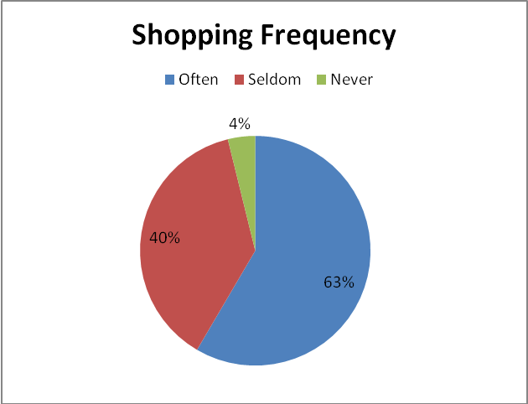

Figure 4.1: Frequency distribution of going for shopping?
(Source: Generated from Field Data)

The result shows that a large number (63%) of housewives of the upper middle strata go for shopping oftenly, which also indicates that they are more likely to indulge in impulse buying behavior. Next to them is the number of those who seldom go for shopping by themselves which shows they seek others services in this regard.

You Enjoy Shopping
Options | Total | Percentage
Often | 81 | 67%
Seldom | 40 | 33%
Never | 10 | 8%
Table 4.2: Do you enjoy shopping?

(Source: Field data)
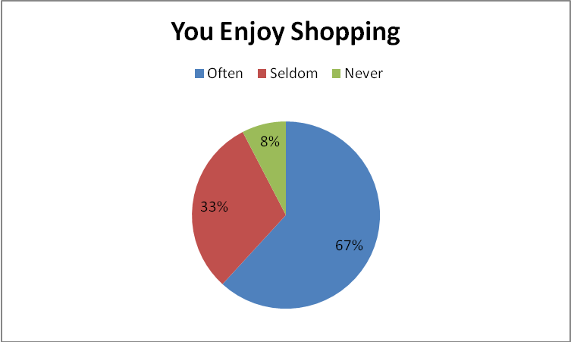

Figure 4.2: Frequency distributions enjoy shopping?
(Source: Generated from Field Data)

From the result it is obvious that a large number (67%) of the house wives enjoy shopping. This supports the research question that housewives of upper strata indulge in impulse buying, as the more one enjoys the shopping the more is the likely hood of indulging in impulsive buying behavior.

Table 4.3: How frequently you purchase products without planning?
Without Plan Product Purchase
Options | Total | Percentage
Often | 72 | 60%
Seldom | 41 | 34%
Never | 23 | 19%

(Source: Field data)
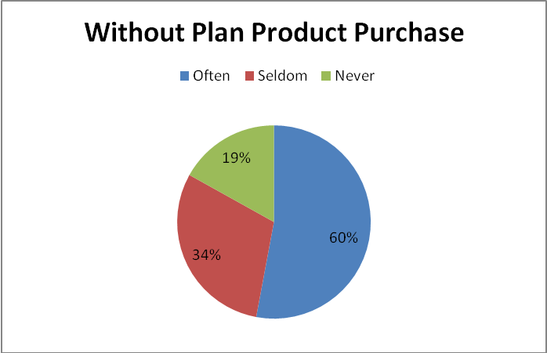

Figure 4.3: Frequency distribution of purchased product without planning?
(Source: Generated from Field Data)

The results proves that majority (60%) of the house wives go for unplanned shopping, which also supports the research question that upper strata housewives indulge in the impulse purchase activity. Impulse purchase by itself is an unplanned buying which tells that housewives do indulge in this activity at large.

Complete Product Information Before Purchase
Options | Total | Percentage
Often | 41 | 34%
Seldom | 66 | 55%
Never | 24 | 20%
Table 4.4: You obtain complete product information before purchase?

(Source: Field data)

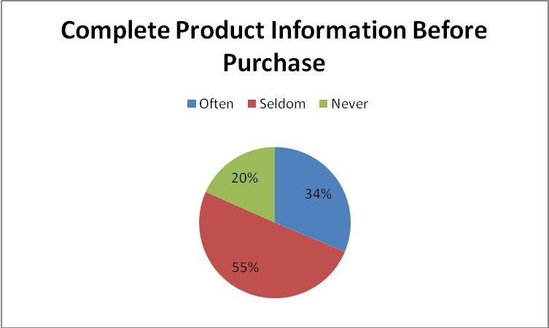

Figure 4.4: Frequency distribution to obtain complete product information before purchase?
(Source: Generated from Field Data)

The result shows that a major proportion of the housewives (55%) seldom get complete product information before purchase. This is also an indication of impulse purchase when the individual gets attracted by any particular feature or sometimes for no reason at all. The result also shows that 34% of the respondents often seek complete product information before making a purchase. But this does not mean that they may not indulge in impulse buying. In fact this need for information results from being attracted to a product that the respondent is compelled to buy.

Spontaneous Purchase Decision
Options | Total | Percentage
Often | 78 | 65%
Seldom | 40 | 33%
Never | 8 | 6%
Table 4.5: You make spontaneous (on the spot) purchase decisions?

(Source: Field data)
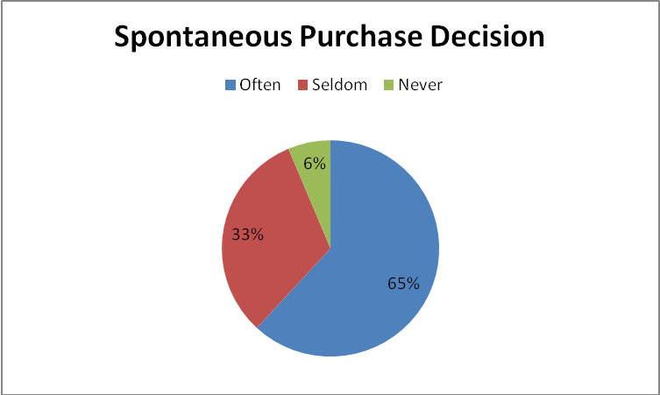

Figure 4.5: Frequency distribution spontaneous purchase decision?
(Source: Generated from Field Data)

The result shows that a large number (65%) of the house wives of the upper strata make spontaneous purchase decisions which support the research question that the housewives indulge in impulsive purchase. It also supports the fact that the impulsive purchase decisions are mostly spontaneous.

Table 4.6: You consider others (friends/relatives) opinion in shopping decisions?

Others Opinion In Shopping
Options | Total | Percentage
Often | 47 | 39%
Seldom | 68 | 57%
Never | 17 | 14%

(Source: Field data)

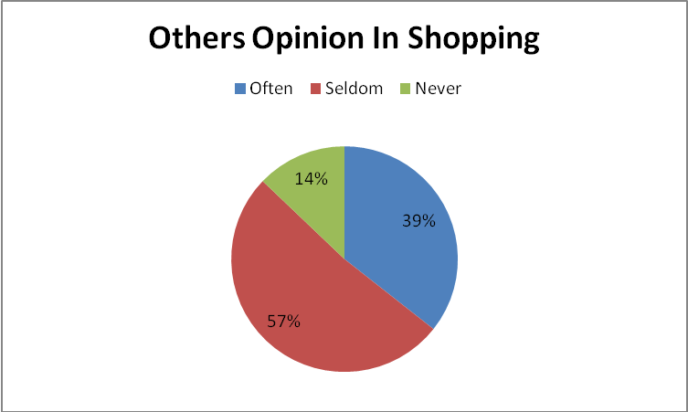

Figure 4.6: Frequency distribution to consider others opinion in shopping?
(Source: Generated from Field Data)
The result shows that a large number (57%) of respondents seldom take others opinion in shopping. As impulse purchase is a spontaneous process and is more driven by person mood, therefore the individuals rarely take others opinion. There is also a good number of respondents who often take others opinion in shopping. These individuals are less likely to indulge in impulsive activity as they are influenced by others opinion as compared to their own.

Table 4.7: Do you have a fixed budget for shopping?

Fixed Budget For Shopping
Options | Total | Percentage
Often | 35 | 29%
Seldom | 59 | 49%
Never | 33 | 27%

(Source: Field data)

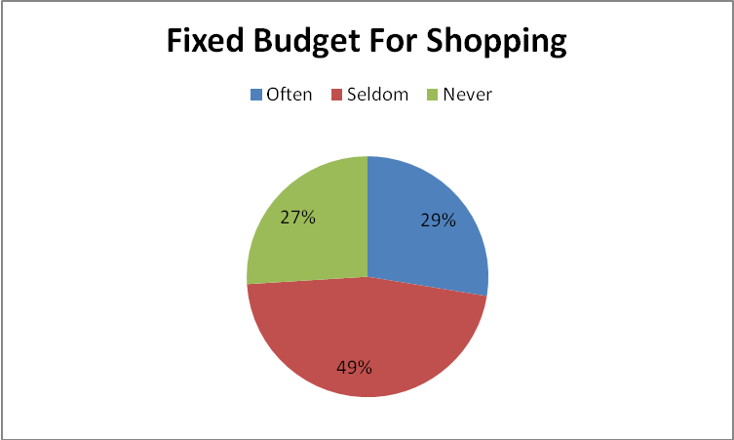

Figure 4.7: Frequency distribution of fixed budget for shopping?
(Source: Generated from Field Data)
The result shows that a majority of the respondents seldom have a fixed budget for shopping. As impulse buyers are spontaneous shoppers therefore they don’t set prior shopping budget, instead they make their own decisions on the spot. And the amount of shopping would depend upon the availability of funds at that particular moment.

Table 4.8: What is your disposable income range?
Disposable Income Range
Options | Total | Percentage
50,000--100,000 | 30 | 25%
100,000--150,000 | 36 | 30%
150,000--200,000 | 39 | 32%
Above 200,000 | 27 | 23%

(Source: Field data)

Figure 4.1: Frequency distribution of disposable income?
(Source: Generated from Field Data)

The result indicates that a majority of the respondents have a disposable income range between 150,000—200,000.this supports the fact that individuals with higher disposable income range are more likely to indulge in impulsive purchase. As people with higher disposable income have a higher purchasing power. Thus they go for self satisfaction or for the satisfaction of their mood or lifestyle.

Food Items Purchased On Impulse
Options | Total | Percentage
Fruits | 52 | 43%
Bakery Items | 71 | 59%
Beverages | 41 | 34%
Table 4.9.1: Which of the following items you buy on impulse?

(Source: Field data)
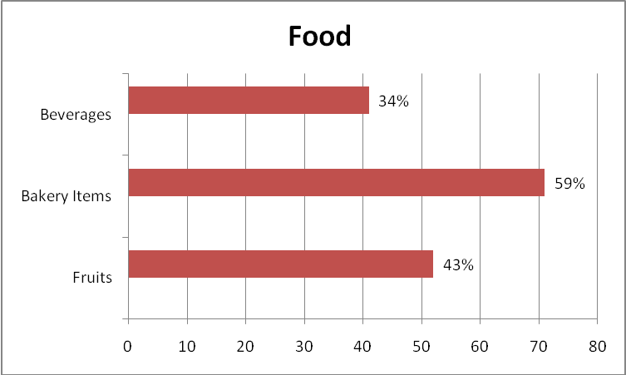

Figure 4.1: Frequency distribution item buy on impulse?
(Source: Generated from Field Data)

The result shows that among the items of impulsive purchase under the category of food, bakery items have the higher proportion (59%) where as fruits are second in proportion (43%). This can be due to the fact that bakery items have a good presentation and an appetizing smell which attracts the individuals. Impulsive buyers are normally attracted by outlook and appealing features of the products which is present in the bakery items .Similarly fruit items appeal the impulses because of their fragrance and freshness

Table 4.9.2
Candies & Bars
Options | Total | Percentage
Chew Gums | 27 | 22%
Chocolates | 46 | 38%
Chips | 51 | 43%
Candies | 30 | 25%

(Source: Field data)
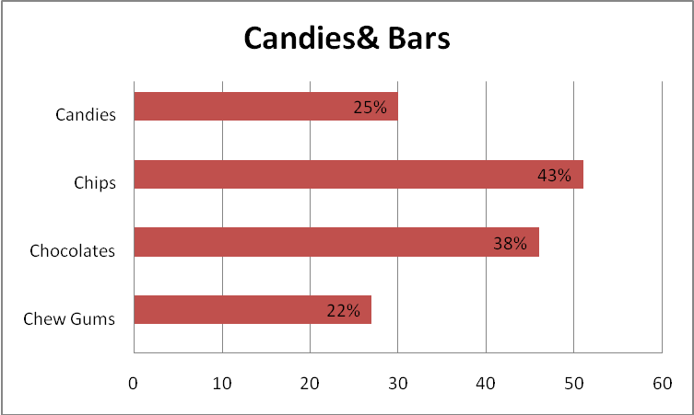

Figure 4.9.2 (Source: Generated from Field Data)

The results indicate that among the category of candies & bars house wives purchase chips and chocolates more at large. As the product packaging and imaging enhances the likely hood of impulse purchase and both these features are present in chips and chocolates.
Table 4.9.3
Home Accessories
Options | Total | Percentage
Decorations | 51 | 42%
Household & Linen | 33 | 27%
Bathroom Accessories | 35 | 29%
Kitchen Accessories | 34 | 28%
Garden Accessories | 25 | 21%

(Source: Field data)
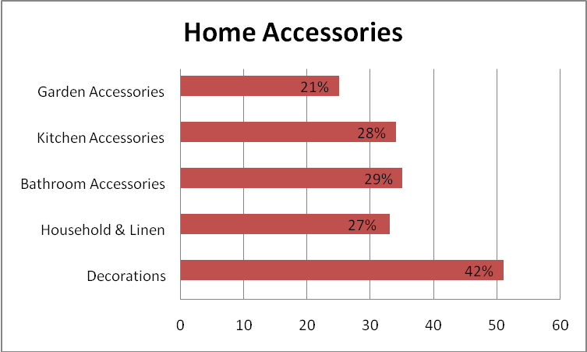

Figure 4.9.3 (Source: Generated from Field Data)

The result shows that among all the items under the category of households, housewives majorly go for decorations. As the impulsive buyers are more attracted by product outlooks and features which appeals them. In this case decoration items are the one which normally satisfy the criterion. As decorations satisfy the mood and lifestyle of individuals therefore they get attracted towards them. Next to decorations are bathroom and kitchen accessories which are also chosen on the basis of product outlooks and features.
Table 4.9.4
Jewellery
Options | Total | Percentage
Artificial | 60 | 50%
Gold | 34 | 28%
Silver | 44 | 37%

(Source: Field data)

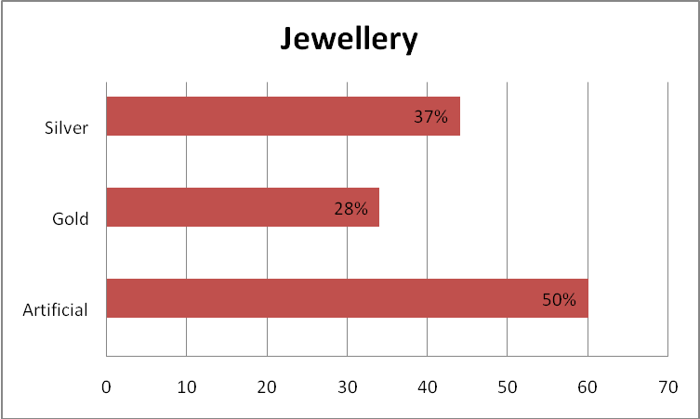

Figure 4.9.4 (Source: Generated from Field Data)

The result shows that among the jewellery items upper strata purchase artificial jewellery at large (50%).there is because there is a great deal of variety available in artificial jewellery.Artificial jewellery is more attractive and appealing, which is the main reason for its higher purchase rate. Jewellery also relates with self image, ego boosting, which in turn is linked with the individual’s mood.

Table 4.9.5

Clothing
Options | Total | Percentage
Ladies Ware | 76 | 63%
Gents Ware | 42 | 35%
Children Ware | 46 | 38%

(Source: Field data)
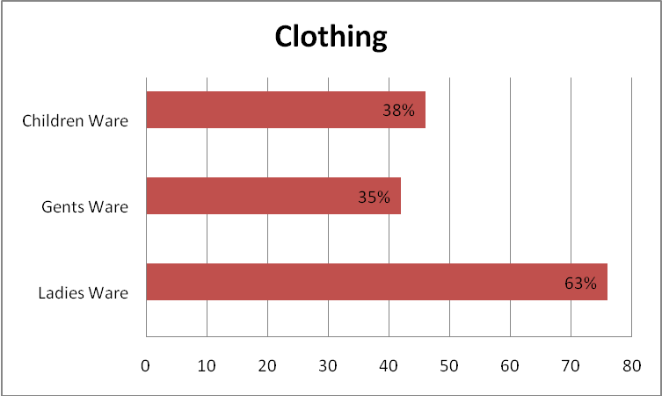

Figure 4.9.5 (Source: Generated from Field Data)

The result shows that the upper class house wives purchase ladies ware under impulse at large (63%).As clothing plays a vital role in personal image and upper strata house wives are more conscious about their status and personal appearance. They are drive by their mood and lifestyle to have a huge variety of clothing, in order to maintain their status and self contentment.

Cause To Indulge In Impulse Buying
Options | Total | Percentage
Mood | 57 | 48%
Self Image | 24 | 20%
Life Style | 57 | 48%
Product Outlook/Features | 29 | 24%
Product Packaging | 16 | 13%
Product Window Display | 20 | 17%
Point Of Sale Advertising | 21 | 18%
Discounts/Special Offers | 31 | 26%
Seller's Behavior/Attitude | 16 | 13%
Table 4.10: Do you indulge in impulse buying because of?

(Source: Field data)

Figure 4.10: Frequency distribution of indulge in impulse buying because of?
(Source: Generated from Field Data)
The result shows that among the different causes of impulsive purchase, upper strata housewives are majorly influenced by their lifestyle and mood. As on the upper level the purchasing power is high therefore the individuals go for the satisfaction of their mood. Discounts and special offers are next in the category which indicates materialistic approach of upper strata buyers. Product’s outlook and features also serve as an influencing force in impulsive purchase. As due to these outlooks and features impulsive shoppers feel a sense of uniqueness, which ultimately gives them inner satisfaction or self contentment.

Chapter # 5

Conclusion

From the results obtained it is clear that upper middle house wives do indulge in impulsive purchase on a massive scale. This impulsiveness is mainly concerned with their mood and life style. A majority of the housewives purchase such items which enhance their personality and life style image. The facts also show that appearance of the products does play a vital role in provoking the appeasement towards them. House wives do give immense importance to product’s shape, packaging and features. While purchasing them seldom gives importance to others opinion and the extent of their purchase depends on the amount they have with them at that point in time.
This impulse purchase is not specified to a single item. It ranges from personal use commodities to domestically used items. But whatever the type of commodity it is, the main focus is on the outlooks. This also shows that for impulsive purchases aesthetic sense plays a vital role.

Recommendations

Keeping in view all the results of the study following are some important suggestions which can help the marketer’s to gain an edge.
- In order to attract the customers the presentation of the product matters a lot. A good window display and a good product packaging attract a customer towards itself. As product imaging is one of the major factors to generate an impulsive wave.
- As the customers are also influenced by some special offers/discounts, therefore the marketers should develop such schemes which are irresistible for the consumers. These schemes could be of seasonal /non seasonal products.
- Customers always get attracted by the brand having a lot much variety and attractive features in it. Marketers should specially focus on product’s outlook and features.
- Consumers have more interest in eye catching materials, for this reason these items are purchased spontaneously and without inquiring complete product information. A strong image building campaign can thus help the marketers to get benefit from this weakness (of customer).

References/Bibliography

Text Source:

[1] The Significance of Impulse Buying Today Author(s): Hawkins Stern Source: Journal of Marketing, Vol. 26, No. 2, (Apr., 1962), pp. 59-62 Published by: American Marketing Association
[2] Beatty, S. E. and Ferrell, M. E. (1998), “Impulse buying: modeling its precursors”, Journal of Retailing, Vol. 74 No. 2, pp. 169-191.

[3] Bellenger, D. D., Robertson, D. and Hirschman, E. (1978), “Impulse Buying Varies by Product,” Journal of Advertising Research, 18 (December), 15-18.

[4] Cha, J. (2001),”Planning and Unplanned apparel purchase typology and related variables”, unpublished thesis, Seoul National University, Seoul (consult Park link).

[5] Cobb, C. J. and Hoyer, W. D. (1986),”Planned Versus Impulse Purchase Behavior”, Journal of Retailing, Vol. 62 No.4, pp. 384-409. Retrieved, May 16, 2007, from http://web.ebscohost.com

[6] Dittmar, H. and Drury, J. (2000), “Self-image – is it bag? A qualitative comparison between ordinary and excessive consumers”, Journal of Economic Psychology, Vol. 21 No. 2, pp. 109-
142.

[7] Du Pont, D. N and Company. (1965), Consumer Buying Habits Studies, Wilmington, DE Du
Pont De Nemours and Company.

[8] Economic Survey of Pakistan, (2006-07). “Inflation,” Chapter no 08, (pp. 119-144). Retrieved, June 17, 2007, from http://www.finance.gov.pk

[9] Fairhurst, A. E., Good, L. K. and Gentry, J. W. (1989), “Fashion involvement: an instrument validation procedure”, Clothing and Textiles Research Journal, Vol. 7 No3, pp. 10-14.

[10] Federal Bureau of Statistics, Table of House Hold Income Distribution in Pakistan. Retrieved, June 17, 2007, from http://www.pakistan.gov.pk/statistics-division/index.jsp

[11] Freud, S. (1956), “Formulations on the Two Principles of Mental Functioning,” in The
Standard Edition of the complete Psychological Works of Sigmund and A. Freud, eds. London:
Hogarth.
[12] Han, Y. K., Morgan, G. A., Kotsiopulos, A. and Kang, P. J. (1991), “Impulse buying behaviour of apparel purchases”, Clothing and Textile Research Journal, Vol.9 No. 3, pp. 15-21.

[13] Hausman, A. (2000), “A multi-method investigation of consumer motivations in impulse buying behavior”, Journal of Consumer Marketing, Vol.17 No. 15, pp. 403-419.

[14] Kacen, J. J., and Lee, J. A. (2002), “The Influence of Culture on Consumer Impulse Buying
Behavior,” Journal of Consumer Impulse Buying Behavior, Vol. 12 (2), pp. 163-176.

[15] Ko, S. (1993), “The study of impulse buying of clothing products”, unpublished Master’s thesis, Seoul National University, Seoul. (Consult Park link)

[16] Kollat, D. T, and Willett, Ronald. P. (1967), “Customer Impulse Purchasing Behavior,” Journal of Marketing Research, 4 (February), pp. 21-31.

[17] Mai, N. T. T., Jung, K., Lantz, G. and Loeb, S. G. (2003), “An Exploratory Investigation into Impulse Buying Behavior in a Transitional Economy: A Study of Urban Consumers in
Vietnam,” Journal of International Marketing, Vol. 11 No.2, pp. 13-35.

[18] Park, E. J., Kim, E. Y. and Forney, J. C. (2006),”A Structural model of Fashion-oriented
Impulse Buying Behavior”, Journal of Fashion Marketing and Management, Vol. 10 No. 4, pp.
433-446. Retrieved, May 16, 2007, from http://www.emeraldinsight.com/1361-2026.htm

[19] Piron, F. (1993), “A Comparison of Emotional Reactions Experienced by Planned, Unplanned and Impulse Purchasers”, Advances in Consumer Research, Vol. 20, 341-344. Retrieved, May 16, 2007, from http://web.ebscohost.com

[20] Prasad, K. (1975),”Unplanned Buying in Two Retail Setting,” Journal of Retailing, 51 (Fall), pp. 3-12.

[21] Journal of Consumer Research, Vol. 22 (3), pp. 305-413.

[22] Babin, B. J. and Babin, L. (2001), “Seeking something different? A model of schema typically, consumer affects. Purchase intentions and perceived shopping value”, Journal of Business research, Vol. 54 No.2, pp. 89-96.

URLs:
- http://www.jstor.orgThe Buying Impulse Author(s): Dennis W. Rook Source: The Journal of Consumer Research, Vol. 14, No. 2, (Sep., 1987), pp. 189-199Published by: The University of Chicago Press Stable URL: http://www.jstor.org/stable/2489410
- http://en.wikipedia.org/wiki/Impulse_buying
- http://www.knowthis.com/tutorials/principles-of-marketing/consumer-buying-behavior/types-of-purchase-decisions.htm

