

“The Impact of Customer Relationship Marketing On Market Performance of Telenor Pakistan”

Supervised By:
Sir Zafar Ullah Sidiqui

Submitted By:
Hayder Ali (01-221091-050)
Mubashir Hassan Khan (01-221091-056)
Husnain Arshad (01-221091-043)

MBA

Dedicated to our Parents

Acknowledgements
Our sincere gratitude to Allah.

We have learned a lot and really enjoyed while working on this project. We would like to sincerely thank all those who have helped us with their valuable support during the entire process of the project.

We would like to thank our supervisor, Professor Zafar Ullah Sidiqui for his helpful guidance, support and contribution.

We also thank the faculty members of Bahria University Islamabad they all gave us the honor of attaining the Master Degree.

Table of Content
Acknowledgements 2
CHAPTER 1 6
1. INTRODUCTION 6
1.1 Why Relationship Marketing 6
1.2 Problem Statement 7
1.2.1 Problem Discussion 7
1.3 Objectives 7
1.4 Scope 8
CHAPTER 2 9
2. LITERATURE REVIEW 9
2.1 Relationship Marketing 9
2.1.1 Relationship Marketing Formulation 9
2.1.2 Concept 9
2.2 Relationship Marketing in Service Industry 10
2.3 Value Creation in Services 10
2.4 Customer Retention in Services 11
2.4.1 Customer Attraction 11
2.4.2 Service Quality 12
2.4.3 Customer Loyalty 12
2.4.4 Interaction 13
2.5 Performance 13
2.6 Image 15
CHAPTER 3 16
3. Telecommunication 16
3.1 Telecom in Pakistan 16
3.1.1 Foreign Direct Investment in Telecom Sector 17
3.1.2 Mobile Phone Operators in Pakistan 17
3.1.3 Cellular Subscribers in Telecom Sector 18
3.2 TELENOR PAKISTAN 19
3.2.1 Culture 20
3.2.2 Vision and Values 20
3.2.3 Mission Statement 20
3.2.4 Major Competitors 21
3.2.5 Market Share 23
3.3 Important Facts 23
CHAPTER 4 24
4.1 Research Method and Research Design 24
4.1.1 Exploratory/Descriptive/Explanatory 24
4.2 Research Approach 25
4.3 Cross-sectional and Longitudinal 26
4.4 Research Framework 26
4.5 Selection of Respondent 27
Customer satisfaction 27
4.6 Research Instrument 28
4.6.1 Questionnaire Response 28
Satisfaction 28
Frequency 28
Percent 28
4.6.2 Pie Chart Representation 29
4.6.3 Questionnaire Response 29
4.6.4 Analysis on Questionnaire Response 34
CHAPTER 5 35
5. Recommendations and Action Plan 35
5.1 Market Focus 35
5.2 Customer Perceived Quality 35
5.3 Monitoring Customer Satisfaction 36
5.4 Service Competition 38
5.5 Future Research Opportunities 39
5.6 Practical Implication 39
5.7 Conclusion 41
References 42
Website References 44
APENDIX A 45
QUESTIONAIRE 45

CHAPTER 1

1. INTRODUCTION
Telecommunication sector is an important economic sector in World economy. It also has growing impact on our lives as individuals and on businesses. Today after the technological breakthrough of electronic telecommunication facilities, dynamic business environment and global usage of information exchange, telecommunication has become indispensable service not only in business but also in our individual life.
Result of technological advances, growing competitors service providers need to provide more compelling service experience to the customer by offering blend of superior value services. Current dynamic are forcing communication service provider to device strategies to deal with new realities of market while ensuring long term successful relationship. Traditional marketing strategies that were based on 4P’s is now into a paradigm to new relationship oriented marketing that is based on market driven strategies customer focused relationship. Telecommunication industry is facing radical changes, generating new opportunities and challenges for service providers. With the increase of production of mobile devices and services as international market in recent years, global telecommunication market is growing and changing (ITU Publication 2005.
The Global System of Mobile Communication (GSM) technology that originated from Europe after its launch ten years back has been standardized for the entire leading telecom service provider through out the World. It is expected that the number of the subscriber of this technology Worldwide would be approximately 4 billion (ITU Publication).

1.1 Why Relationship Marketing

Building relationship with the customer and suppliers has become necessary for the companies during the past few years. This is the only way company could obtain competitive advantage and a result that ensures its survival and growth. It implies that relationship building is considered to be a key factor to success (Jorgensen, 2001).

According to a marketing fact that customer retention is five times more important than attracting new customer, companies are adopting relationship marketing principles and designing strategies to develop close and long-lasting relationships with the most profitable customers. The long term-orientation relationship which emphasizes commitment to customers is extremely important. (Sheth and parvatiyar, 1995).
In order to create relationship with both individual customers and business customers we should attract them, to develop this relationship we should make them satisfied and to maintain this relationship we should retain them and at last we will make more profit from them, so Building, Developing and Maintaining Relationship with their customers should be their main goal. (Izquierdo, 2005)
There are numerous studies that mainly focus on the performance implementation problems but whole area of how performance measures could be used to create lasting relationship with the customers has attracted less attention.

1.2 Problem Statement

“Leverage customer satisfaction through improved customer relationship marketing program to enhance overall customer experience to improve market performance of Telenor Pakistan”.

1.2.1 Problem Discussion

Despite different type of relationship marketing and business relationships, we want to distinguish if there is a significant relationship between the marketing relationship programs and customer satisfaction from the prospective of Telenor (Pakistan). There is relatively less attention paid on use of customer relationship management and the value that the organization could generate through it.

1.3 Objectives

The objective of this research work is to investigate:

- Telenor Pakistan customer satisfaction level.
- Factors influencing customer satisfaction.
- The link between customer relationship marketing and customer satisfaction.
- To device relationship marketing strategies that could improve market performance of Telenor Pakistan.
To fulfill this purpose following research questions should be addressed:
- Is the customer satisfied with current services provided by Telenor Pakistan?
- Is there a significant relationship between the network quality and customer satisfaction?
- There is relationship between customer services and customer satisfaction?
- Is there a significant relationship between complaints’ and customers perception about a firm?
- Is there a significant relationship between customer satisfaction and customer perception about a firm?
- Is there a relationship between customer satisfaction and market position of a firm?
- Is there a significant relationship between attraction activities and customer satisfaction?
- Is there a significant relationship between attraction activities and customer perception about a firm?
- Is there a relationship between customer satisfaction and customer retention?
- Is there a relationship between customer loyalty and market performance?

1.4 Scope

This research will give opportunity to Telenor Pakistan to understanding the link between customer satisfaction and the affect of customer relationship marketing program to improver their market performance.

CHAPTER 2

2. LITERATURE REVIEW

2.1 Relationship Marketing

There has been lots of contribution by different authors in the field of relationship marketing theory, attraction and loyalty programs as an important factor of relationship marketing but least has been contributed towards its impact on overall market performance. This study will be focused on relationships between different Customer relationship factors and the impact of relationship marketing on market performance of Telenor Pakistan.

2.1.1 Relationship Marketing Formulation

Berry was the first person who used the term relationship marketing in 1983.There is two ways to present day relationship marketing. The first way to realize the importance and role of relationship in service marketing. The second way is the how relationship marketing helps in transformation of business in general in the dynamic business environment. This dynamic business environment changes are resulting in an emphasis by organizations on close contact with the customers. According to Gronroos 1994 there was a paradigm shift in service marketing and the Shift was from transaction-oriented “marketing mix” view of exchanges to relationship based marketing.

2.1.2 Concept

The term marketing has evolved over time. Marketing is no more just providing the core product or service to the customer but is about providing continuous benefit over the period of time to the changing needs and demand of the customers.
Traditional marketing that was based on transactional approach is entering into a new paradigm of marketing that is based on keeping long term valuable relationship. The concept of customer time value (CLV) has also gained importance with time as competition became fiercer and number of competitors was

Entering the market, number of alternatives available to the customer was available and consequently people started showing switching behavior looking for value as they became more knowledgeable. Gronoos, 1994 came up with this relationship oriented definition according to him Relationship Marketing is the process of value creation by exchange of relationship between all the stakeholders specially customer in long term.

2.2 Relationship Marketing in Service Industry

The simplest form of relationship marketing in services is when the customer has purchased from the same service provider at least twice (in marketing terms we call it resonance). In simplest words customer has willingness to continue the services with the firm. The customer could show positive or negative behavior towards the services. The result of the customer who is not satisfied with services provided will create negative behavior towards the organization and such behavior could consequently result in the reaction as discontinuation of services and negative viral marketing which could create negative image of the service provider (Liljander and Strandvik, 1995).
The main objective of relationship marketing is 'customer retention' that is likely to impact every company (Gronroos, 1995).

2.3 Value Creation in Services

Customer Relationship marketing goal is to provide increased value to the customer and resultantly raising customer life time value for the service provider. The value perceived by the customer can be defined as the total cost incurred by the customer to purchase the goods or services and the assessment of what is received in return for what is given (Zeithaml, 1988).
In past research studies four feature of the telecom mobile service has been highlighted as the key drivers of the customer value: Quality of the network, Price paid for the service, Customer services(After sale services) and benefits provided to the customer (Booz, Allen & Hamilton, 1995, Danaher & Rust, 1996).

- Quality of network refers to the ability of service provider to provide the applications of the service up to the promised level.
- Price refers to the quantity of payment or compensation paid against the services.

- Customer service refers to the series of activities involved to improve the level of customer satisfaction.

- Benefit refers to a valuable service feature associated with the core product that will enhance customer satisfaction.
The core of relationship marketing to cater the needs and requirements of the customer, interpreting them in to the possible services, creating strong bonding with the customer and nourishing the relationship by creating value for the customer.

2.4 Customer Retention in Services

Customer retention starts from the day when the customer for the first time purchase the good or service and goes through out the life time until it stays with the company. Every company has two important role to play to attract the new customer and to retain its existing customer and the company ability to attain that depend on the way it service it customer. Customer retention is more than what customer is expecting. Here we have to understand the concept that in relationship marketing the purpose is to create maximum customer value than creating maximum profitability.

2.4.1 Customer Attraction

Attraction is one of the important components of organization commitment to provide their customers with something that makes the customer interested in their service. Attraction can be based on financial, technology or social constructs. Indeed,
Understanding the role of attraction in a customer commitment decision could help in increasing the loyalty and resonance of the existing customer and also in attracting new customers.

2.4.2 Service Quality

Building a close relationship with customers and attaining a competitive advantage require creating strong customer-focused relationships and understanding the needs of specific customers and the firm's success lies in meeting these needs. Delivering more effective service quality than others is one of the ways that a firm can be a successful in achieving today's business environment. The level of the customer satisfaction or dissatisfaction depends on the user experience from the usage of the service (Gronroos and Parasuraman et al.1988). According to Parasuraman (1988), quality of the service can be accessed by measuring the score of expectation and the score of the customer perception. If the gap will be greater would be the level of dissatisfaction. Companies need to assure that the gap should lowest and that should be done by observing the feedbacks of the service quality provided and service quality expected by the customers.

2.4.3 Customer Loyalty

Customer loyalty can simply be defined as repeat purchase behavior of the customer. Customer loyalty would also result in positive word of mouth, good rating and reviews that could help in leveraging the image of company. This is the chain process which never ends and just expands with the passage of time. Lot of common techniques are used for achieving customer loyalty i-e providing a quality goods or services, discounts, rebates, incentives(buy one get one free), coupons, guarantees and warranties for a longer period than normal, free gifts, free trial periods etc.
Providing excellent customer services to the customers also leads to customer loyalty. For example if customer comes up with a problem and company listen to him and provide timely solution to the customer problem by exceeding the customer expectations the customer will be a satisfied and loyal customer.
Customer loyalty can be calculated as the amount of money generated or linked with the loyal customers. Providing brilliant services with exceeding customer expectations and having such a strategy which focuses on solving customer

oriented problems is the key. As this marketing strategy will leads to better and close relationship between the company and customer. The focus of company should be on retaining the current and existing customers by providing them the special incentives such as discounts or free gifts rather than spending all their energy and finances on getting new customers. Starting loyalty programs and giving such benefits to the customers is a part of the marketing strategy which in the longer term creates strong bond (resonance) between the company and the client and also helps in generating extra cash inflow and the company’s profitability (Izquierdo et al., 2005).

2.4.4 Interaction

Interaction can be the process of contacting customers, answering adequately to their complaints, enhancing personal and friendly relations with them and customizing services. The activities of contacting customers in order to remind them of future offering is Contact with customers, to find out if they are satisfied or finding the reason if are satisfied with the services provided and getting feedback from the customers(Izquierdo et al., 2005).The amount of communication with the customer can stimulate consumer behavior towards the service and could also contribute to the value that customer brings back to the company in the future by their positive suggestion and creating an image that their sound is heard(Kumar and Petersen, 2005).

2.5 Performance

Different performance measurement is used in different literature but there has been consensus on this notion that performance directly impacts the profitability. In this study of the emphasis was on the Market performance, which referred to: the companies’ market position improvement that i-e

building awareness about products and penetration in the market; "shaping customers' perceptions of the organization and their products" cited by Izquierdo et al., 2005; "and the rise in customer loyalty and retention" (Mary W. Sullivan, 1993;

Cited by Izquierdo et al., 2005): Previous researchers of Market Orientation only confirm the relationship between market orientation and performance for a number of SBUs in a limited number of firms. Nevertheless, since the theory establishes a clear link between the market orientation of firms and their achievement of their objectives or profit, it is anticipated that this relationship should also extend to Whole company, in other industries, and in different countries and cultures. Ittner and Larcker (2003) suggest that performance measurement is used to:
- Help direct the allocation of resources.
- Assess and communicate progress towards strategic objectives.
- Evaluate managerial performance.
The impact of Performance measurement shows us a way of introducing individual strategic extend targets; and ensures that when the business performance is fading, corporate management knows when to move. The need for organizations to establish their strategies align with their performance measurement systems is well established in the literature (Dyson, 2000, McAdam and Bailie, 2002; cited by Izquierdo et al., 2005).
The impact of organizational characteristics and the nature of sector, within which organizations operate, have been addressed in the literature concerning strategic planning. However, limited published research has been conducted on the influence on performance measurement (Reicheld F. 1996).
According to measures of marketing output, we can propose that the value created by relationship marketing with customers is reflected into the aspect of:
- Market Performance
Market performance is the firm's market position improvement that is, building product awareness and market penetrations also shaping customers' perceptions of the organization and their products and the rise in customer loyalty and retention (Izquierdo et al., 2005)

2.6 Image

In the service marketing literature, corporate image plays an important role in the evaluation of the services provided by the company (Gronroos, 1984; Gronroos, 1988; Cited by Andreassen et al., 1998).
Except that image can be considered as the major factor for re-purchase of the services by the customer some other functions such as advertising, direct marketing in order to attract new and maintain existing customers also improve the image of the company. Image is one of dominant factor that will leave image on customer perception about the firm. According to Izquierdo et al(2005).
There are three types of image used in their study also the customers’ perception in this study will be measured with four variables:
- Expert image, that refers to the perception of good reputation in the market, workers' skills and the quality of the service
- Convenience image, which consists of "the proximity to the customer", "rapid answer to the customer's needs" and "being respectful and polite to the customers.
- Promotional image, refers to the perception of a firm that performs activities such as advertising, promotion and price reduction (Izquierdo et al.)Promotion strategy in other Words which consists of planning, implementing, and controlling an organization's communications to its customers and other target audiences. Izquierdo et al. (2005) stated that achieving management's preferred communications objectives with each audience is the purpose of promotion in the marketing program.

CHAPTER 3
3. Telecommunication
In today's world telecommunication services has become a necessity rather than a need. And now telecommunication services are not just limited to developed countries, it has witnessed a remarkable growth in developing countries such as Pakistan. Telecommunication is pivotal in the progress and the development of a country as it brings lot of foreign investment; create jobs and most importantly helping the people to communicate with each other in a better way. With the effective use of telecommunication, society and Country can help itself as telecommunication provides a way for growing, developing and modernizing the economy. Telecommunication is the one of the few sectors in which lot of new players have entered over the years such as Mobilink, Ufone, Telenor Pakistan, Warid and now the latest addition of Zong which is Chinese investment.
So we can imagine that in this competitive market it is quite difficult to maintain and retain your loyal customers because of intense competition, high customer switching and turnover.

3.1 Telecom in Pakistan

PTA (Pakistan telecommunication authority) is the governing body operating in Pakistan with the purpose of controlling and maintaining the telecommunication decision in Pakistan. PTA under the new economic policy of government has successfully able to deregulate and liberalized the telecom sector for the rapid telecom growth. Now telecommunication has been given the status of industry in Pakistan and lot of new initiatives have been taken by PTA to promote telecom as some new companies who deals in 3G technology have been given the licenses.
Although the Pakistani economy is going through the toughest times due to terrorism and recession, but telecom sector still able to show positive indicators as revenues and the subscriber’s bas e have increased to 35% and 39% respectively during 2007-08.

According to PTA the telecom sector alone generated 84ooo direct jobs and five hundred thousand indirect jobs were created by the telecom sector.

3.1.1 Foreign Direct Investment in Telecom Sector

The role of Telecom sector in terms of foreign direct investment is really important as this sector has brought more foreign direct investment than any other industry of Pakistan. Over the past four years, the Pakistani telecom sector has attracted more than $9 billion in foreign investments. The investment in this particular sector for the year 2007-08 has been $ 1.60 Billion which is 30% of the total FDI of Pakistan.
(http://en.wikipedia.org/wiki/Economy_of_Pakistan)
Foreign Direct Investment in Telecom Sector
(US $ million)

Years | Total FDI | FDI in Telecom Sector | Contribution in  Total FDI (%)
2001-02 | 484.7 | 6.1 | 1.26
2002-03 | 798 | 13.5 | 1.69
2003-04 | 979.9 | 207.1 | 21.13
2004-05 | 1524 | 494.4 | 32.44
2005-06 | 3521.0 | 1905.1 | 54.11
2006-07 | 5124.9 | 1824.3 | 35.60
2007-08 | 5152.80 | 1438.60 | 27.92

(www.pta.gov.pk)

3.1.2 Mobile Phone Operators in Pakistan

Company | Parent Company | Location
Mobilink | Orascom Telecom Holding | Egypt
Ufone | PTCL Etisalat | Pakistan/UAE
Telenor Pakistan | Telenor Pakistan Norway | Norway
Warid | Abu Dhabi Group/Sing Tel | UAE/Singapore
Zong | China Mobile | China
(http://en.wikipedia.org/wiki/Economy_of_Pakistan)

3.1.3 Cellular Subscribers in Telecom Sector
According to PTA these are the total number of cellular subscribers of different telecom companies operating in Pakistan in DECEMBER 2009.
Company | Cellular Subscribers
Mobilink | 30,800,354
Ufone | 185,101,75
Zong | 6,920,234
Telenor Pakistan | 22,500,789
Warid | 18,847,315

SO if you go in the details of the above table you will observe that mobilink enjoys the largest base of cellular subscribers with 30,800,354 customers. After mobilink it’s Telenor Pakistan who has been able to capture the largest no of cellular subscribers with 22, 50,789 customers. With the magnificent growth Telenor Pakistan has shown in acquiring and grabbing its customers, Telenor Pakistan is successfully capturing the market slowly. Telenor Pakistan HR has been said as one of the best HR among all the telecom companies.
(www.pta.gov.pk)

3.2 TELENOR PAKISTAN
Telenor Pakistan is one of the pioneers in the World mobile communications service business. It is a Norway based company and has also entered in to other international markets like Hungary, Malaysia, Ukraine, Thailand, Bangladesh and Pakistan.
Telenor Pakistan is 100% owned by Telenor Pakistan. Telenor started its operation on 15th march 2005 in Pakistan. Telenor Pakistan makes it focus by adapting and bringing user friendly products that can improve the service quality and reduce the cost.
Telenor Pakistan is the largest telecommunication company in Norway. Because of increased and stiff competition from their domestic and international arena they had split into four groups which are: mobile operation, Telenor Pakistan fixed, Telenor Pakistan broadcast and other activities. Telenor Pakistan has started its operation in Pakistan in March 2005. This was the largest single investment by any European company in Pakistan in the telecom sector. Telenor Pakistan has been very successful in this competitive telecom sector of Pakistan by their visionary approach and good policies. Telenor Pakistan is growing day by day because of their strong bonding with their customer by providing them excellent network coverage and brilliant services across all areas of Pakistan either it's the northern hilly areas or the deserts of south they are everywhere. Telenor Pakistan aims to invest heavily for further network expansion into rural areas and for the rollout for the third generation of mobile technology 3G in Pakistan.
Telenor has been very successful when you talk it from the jobs creation point of view. The matter of fact is that telenor has successfully helped the Pakistani economy and especially the youth of Pakistan by creating more than twenty five thousand (25,000) direct and indirect job opportunities. They have a huge network with their presence in nearly all parts of Pakistan; telenor have twenty three (23) owned sales and service centers, the growth strategy is based on franchising system as they have more than two hundred (200) franchisees and more that 100,000 retail outlets all over Pakistan.
http://www.Telenor Pakistan.com.pk/about/history.php

3.2.1 Culture
They have a flat structure organization system where employees are free to express and share their ideas, opinions and suggestions. This openness leads to creative and more innovative ideas.

3.2.2 Vision and Values

Vision of Telenor Pakistan is very customer oriented it is “we are here to help”. They are trying to claim here that they have come here to bridge the communication gap between the people of Pakistan and improve their daily life efficiency. The core values of Telenor Pakistan are;
Make it Easy: Don’t complicate things. Bring those products and services which are easier to use.
Keep Promises: Action speaks louder than words this is their philosophy o working.
Be Inspiring: Telenor Pakistan is inspiring as they are creative, produce things which look modern, fresh and good.
Be Respectful: They believe in respecting local cultures of the country wherever they are operating worldwide.

3.2.3 Mission Statement

A Telenor Pakistan Group vision is to helping the customer by providing them the content solutions and products that can positively change their life and simplify their life as well. Telenor mission is to provide their customers the latest means of communication in their daily lives.
Telenor Pakistan has been a pioneer when it comes to the development of the most modern and advanced telecommunications. Telenor has not restricted them to the demanding domestic market

only, they have entered in the international arena with the advanced and innovative solutions in the field of satellite and mobile

3.2.4 Major Competitors

- Mobilink
- Ufone
- Zong
- Warid
- PTCL (fixed lines)
Ufone
Ufone is a subsidiary of Pakistan telecommunication limited known as PTCL. Ufone started its operations in Pakistan on January 29, 2001 under the brand name of Ufone. The purpose of starting their operations is to provide telephony services to the customers. Now 26% of the shares of Ufone has been acquired by Emirates Telecommunication Corporation known as ETISALAT, as PTCL started the process of Privatization of the Ufone. Not only the share has been transferred to Etisalat but all the management working in the Ufone has been handed over to Etisalat. Ufone is giving extremely tough competition to their competitors in all aspects of telecommunication as they are rapidly expanding their operations and coverage as well in the different cities of Pakistan. Till now they are having their network coverage in more than 750 cities.
Warid
Warid launched their services in Pakistan on 23 May, 2005. They got a tremendous response from the Pakistani people as less than a year time they have able to get 86 million people as their customers and start operating in more than 710 cities of Pakistan. Their goal is to provide quality services to their customers as they invest heavily in their research and development sector for extraordinary quality services.
Warid is being backed up by the one of the strongest groups of Middle East known as Abu Dhabi group. Till now Abu Dhabi group

made the largest foreign direct investment in Pakistan. They have conglomerate businesses with the expertise of qualified human resources and strong financial resources which helped them growing immensely. The majors businesses they are dealing in are; Oil & Gas Exploration, Automobile Industries, Property Development, Hospitality Services and Telecommunications.
Telenor Pakistan
They started their operations in Pakistan on 15 March, 2005. Retired Gen Pervez Musharaf was the guest of honor in the opening ceremony of Telenor Pakistan. Telenor Pakistan with its innovative solutions in the market has able to get the second spot after the mobilink. Telenor feel proud as they helped the telecommunication sector by building mobile communication infrastructure in Pakistan. Their headquarters are located in Islamabad whereas the regional offices are located in Lahore and Karachi.
Mobilink
Mobilink started their operation in 1994. And now they are the market leaders in the telecom sectors with the largest subscribers’ base, largest revenues earned and highest market share as well. They are the first who started the GSM mobile services in Pakistan. Their headquarters are located in Islamabad.
ZONG
In 1991, it was Paktel Company who started the first ever mobile services in Pakistan when people are not so used to the mobile technology. The mobile phones are thought of as luxury and not everyone can afford or buy it. But later Zong purchased Paktel and now Zong with it cheap calling rates and very affordable packages is becoming very popular among Pakistani people. With in a short span of time, they have a subscriber’s base of over 5 million. They are operating in more than 300 cities of Pakistan and they have a plan to expand further with the passage of time.

3.2.5 Market Share

Presently, mobilink are the market leaders and Telenor Pakistan is lagging behind them at the second spot. Telenor has the ability to increase their market share and customer base as they have the second largest GPRS, GSM and EDGE coverage in Pakistan. The market share is very near to that of Ufone. Mobilink are currently the market leaders and the race is on for the number one spot from the market share point of view. As you can see in the chart that Telenor Pakistan with its 22% market share currently falls at number two spot in the market share chart.

http://telecompk.net/2009/06/17/mobilink-vs-Telenor Pakistan-the-race-is-on/comment-page-1/

3.3 Important Facts

Total subscribers of PTCL fixed line is 3378495 in march 2009. (www.pta.gov.pk)

CHAPTER 4
4.1 Research Method and Research Design
To investigate the desired objectives we choose to apply explanatory method of research and the technique that was used for collection of data we used questionnaire survey method which was self constructed. The three main factors; Attraction (creating relationships, Loyalty (developing relationships), Interaction (maintaining relationships with customer satisfaction and customer retention.
The other questions were on factors used to assess quality of network, customer attractions and customer service. Their implications on the customer satisfaction were accessed.

4.1.1 Exploratory/Descriptive/Explanatory

Researches are classified in terms of their purpose. There are three type of research which are, exploratory research, descriptive and explanatory research that are explained below.
Exploratory Research
Exploratory research is characterized by its flexibility. When a problem is broad and not specifically defined, the researchers use exploratory research as a beginning step. By an exploratory research we mean a study of a new phenomenon.
Exploratory studies are a valuable means of understanding what is happening; to seek new insights; to ask questions and to assess phenomenon in a new light.
This type of research (Exploratory) helps in understanding more precisely, clarifying concepts, gaining insight and eliminating impractical ideas.
Descriptive Research
Descriptive research in contrast with exploratory research has defined parameters and it usually demarcates questions and impact lives of the people around. We can say that it includes questions like who, what, where, when, why and even at times how the different aspects of the research has to be carried out.

The benefit of such research is that the person can make changes prior to the start of the research.
Explanatory Research
When the focus is on cause-effect relationships, the study can be explanatory explaining which causes produce which effects. Our concern in casual analysis is how one factor or variable affects, or is "responsible for," changes in another factor or variable. The stricter interpretation of causation is that some external factor "produces" a change in the dependent factor or variable.
Exploratory research goes beyond description and attempts to explain the reasons for the phenomenon that descriptive study only observes. In an explanatory study, the researchers make use of theories to represent the forces that caused the certain phenomenon to occur.

4.2 Research Approach

Based on study two approaches or methods qualitative and quantitative are available to the researchers. The choice of the research approach naturally depends on the defined research problems and the data needed for solving these problems.
The qualitative approach emphasizes on processes and meanings that are not measured in terms of quantity, amount, intensity or frequency. The qualitative approach provides a deeper understanding of the phenomenon within its context.
On the other hand, quantitative researchers emphasize on the measurement and analysis based on the frequency and numbers. Differences between qualitative and quantitative research to the distinction is that explanatory (qualitative) and confirmatory (quantitative) analysis.
After comparing the two approached qualitative approach has been chosen. We are trying to explain the link between customer relationship activities and market performances which are qualitative and for the accurate analysis qualitative approach would be suitable.

Several research strategies could be employed such as: experiment, Survey, case study grounded theory and action research. The most important step is that the appropriate strategy for the research question(s) and objectives be chosen. Some of these strategies are described in brief here. The method that was chosen by us was survey. Survey is the popular method and common strategy in business research. In surveys, collection of large amount of Data from a sizeable population in a high economical way is collected. Based most often on questionnaire, data are standardized and comparison is easy. In this study, survey method would be used to find the relationship between customer relationship marketing programs and market performance of Telenor Pakistan which provide services and to see what is the impact of these programs on market performance of Telenor Pakistan and different factors influencing them.

4.3 Cross-sectional and Longitudinal

Research designs, independent from which strategy is taken can be cross-sectional or longitudinal according to the time perspective. When the research is like a "snapshot" taken at a particular time it is cross-sectional.
Most research projects undertaken for academic courses are time constrained, so this strategy is employed by us. In these studies usually survey is employed. The appropriate sample should be selected. The sample selection of this study is mentioned in chapter one.

4.4 Research Framework

The purpose of this study is to investigate satisfactory level of Telenor Pakistan customers and how customer relationship marketing can help in improving market performance of Telenor Pakistan. If we look at the previous studies in the Telecom mobile services they suggest that factors like quality of the network and the price charged for the services were two of the most important factors. Hence we will not only be employing these factors as a part of our research but also how these

factor with enhanced customer relationship marketing program can help in satisfying the demands of the customers.
Research Framework

Mobile Industry
- Customer Attraction
- Customer Loyalty
- Customer Interaction
- Network Quality
- Pricing
- Customer Service

Customer satisfaction

Customer Relationship

Market Performance

The objective of this study was to inquire and deduce Telenor Pakistan market performance and factors that can influence in the satisfaction of the customers.

4.5 Selection of Respondent

Questionnaires were administered at two cities. Since we were not provided with any type of listings by Telenor Pakistan because of the privacy policy so we choose to have a random sample of respondent. These respondents belong to different social backgrounds.

Secondly in these two cities we are able to conduct our questionnaire from different people who are working for different professions and trade.
A total number of 200 people were interviewed for this study. This size will provide us with good representation of the population to investigate the subject. Questionnaires were filled by the people from all races of life.

4.6 Research Instrument

We will be using questionnaire as a research instrument for our study.

4.6.1 Questionnaire Response

Satisfaction | Frequency | Percent
Yes | 88 | 44
No | 112 | 56

The above results are showing the level of customer satisfaction with Telenor Pakistan from the questionnaire conducted (frequency distribution in percentage).
1.

4.6.2 Pie Chart Representation

This result demonstrates that 44% of the respondents marked yes they were satisfied with the services by Telenor Pakistan. While 56% the respondents marked no they were not satisfied with the services by Telenor Pakistan. We can conclude from this result that customer experience needs to be improved by Telenor Pakistan to improve their market performance.

4.6.3 Questionnaire Response

2.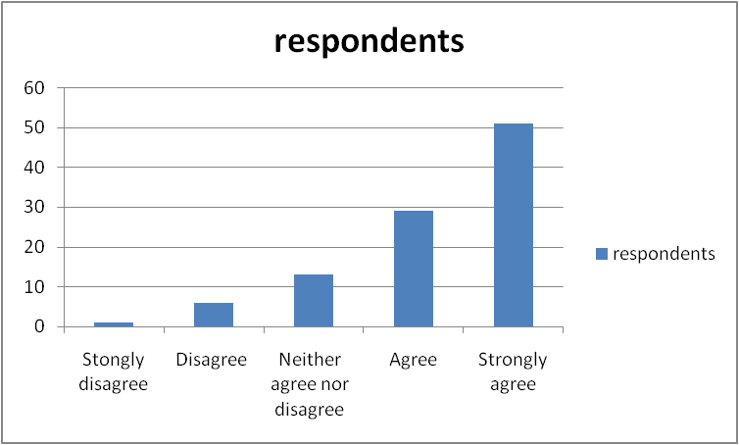

Questionnaire Response
3.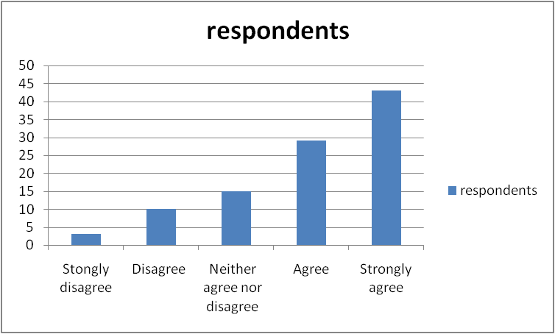

4.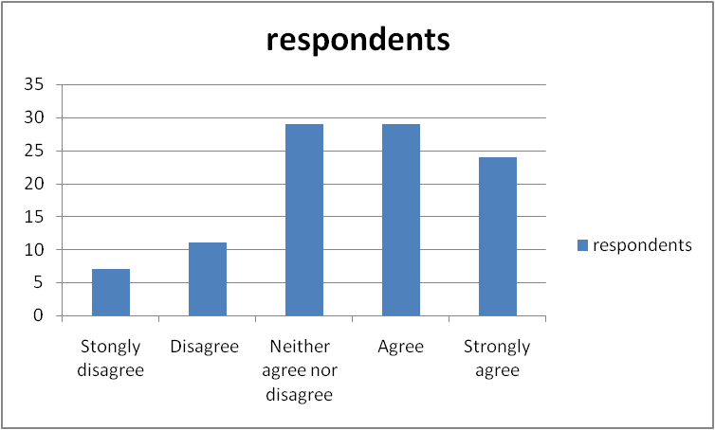

Questionnaire Response
5.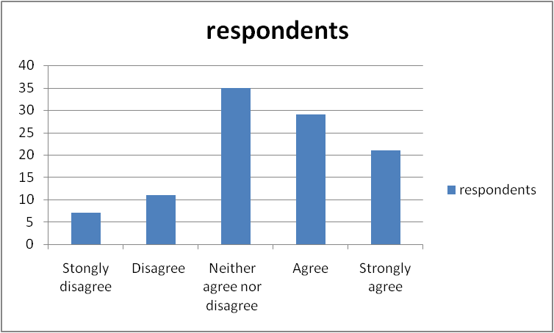

6.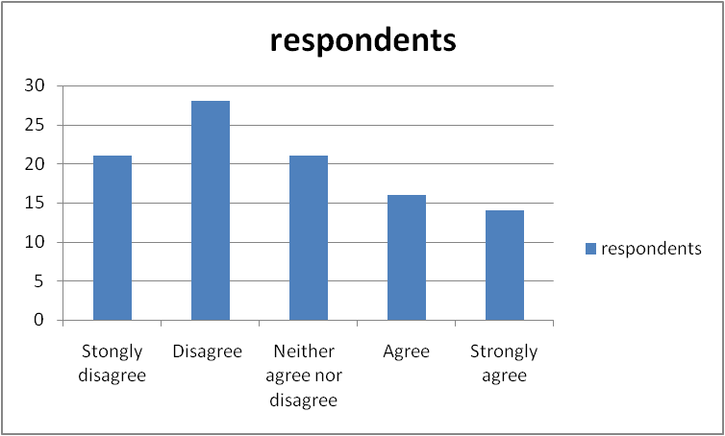

Questionnaire Response
7.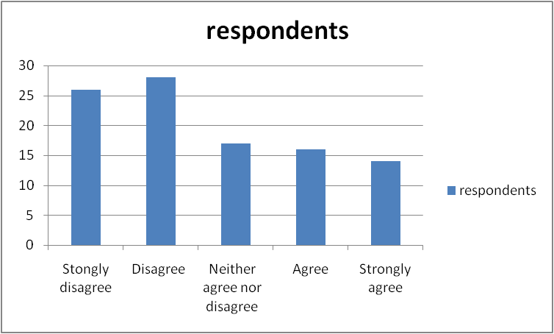

8.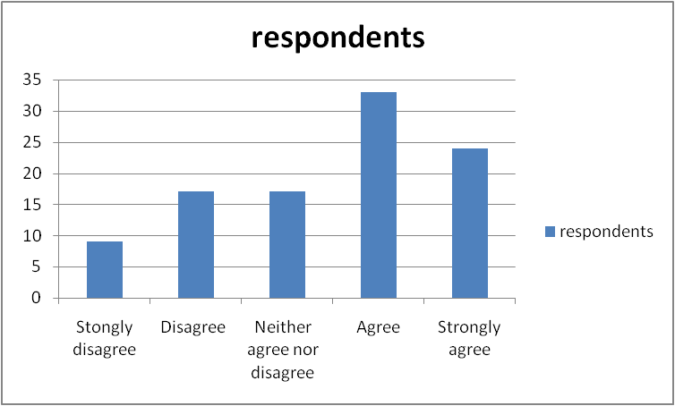

Questionnaire Response
9.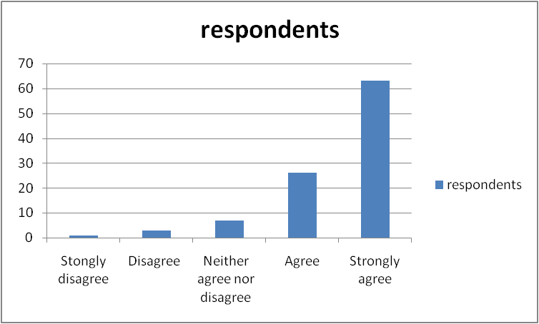

10.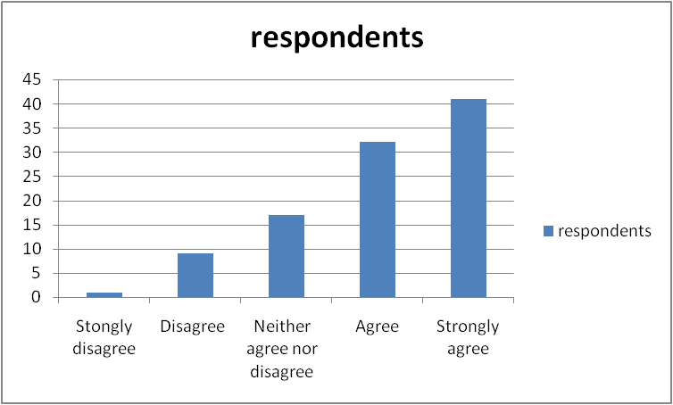

4.6.4 Analysis on Questionnaire Response

The aim of this study was to investigate and evaluate the market performance of Telenor Pakistan and factor influencing market performance. We also wanted to investigate how customer relationship marketing program can enhance the market performance of Telenor Pakistan. Customer satisfaction is the key to success and objective of any organization. We have explored how different service attributes have an affect on the customer satisfaction and could have an impact on the market performance. Quality has shown strong relationship with the customer satisfaction with the services. Other factors like customer services (care), customer attraction and interaction and customer loyalty has also shown relationship with the overall customer satisfaction. The conclusion of questionnaire shows that there is opportunity for Telenor Pakistan to enhance their market performance through customer relationship marketing program and improve the customer experience of Telenor Pakistan customer.

CHAPTER 5

5. Recommendations and Action Plan

5.1 Market Focus

In todays’ markets Individuals have gain importance and every single customer has to be treated in yet different way because he comes up with different needs (requirements). That’s why companies are making customized solutions for their customers. Targeting mass markets which normally happens in a transaction type strategy would not be a suitable strategy to pursue. Over the period of time relationship marketing strategy has gain importance which is an interactive process where customer contact will determine the future path for the company.
Increased competition and customer knowledge has pushed companies like Telenor Pakistan to offer superior service and more valuable service to meet the desire of their existing and attracting new customers. Most of the firms which pursued a relationship marketing strategy have been successfully able to deliver and create more value for its customers. These firms create a strong bond and tighter ties with the customers over the time. For example the ties can be technological or benefits based. So the conclusion is that relationship marketing makes customers less price sensitive.
So Telenor Pakistan which is growing day by day should pursue a relationship strategy to have better understanding about their customer desires and by following this strategy with the help of other marketing variable will support in their customer retention.

5.2 Customer Perceived Quality

In this competitive market, there are many telecom operators which are fighting for getting the competitive advantage by providing their customers a superior and better quality services. It’s a game of playing with the psychology or perception of the customer as quality is something which cannot be measured or quantified. So perceived quality can be the perception by a customer.

Every person thinks in a different way that’s why they perceive the product or services quality in a different way. A product or service is comprises of many performance attributes or characteristics for example the price, network coverage, variety in packages etc (these factors are often called as reliability and performance factors). So perceived quality is attached to these factors called as reliability and performance factors. As relationship marketing puts a great focus on the retention of the current and existing customers with a long term relationship, so fulfilling or exceeding the expectations of the current customers is of great importance otherwise they will become dissatisfied with the services and start seeking for other telecom operator services.
Customer perceived quality is fundamentally a function of the customer perception of two dimensions; first dimension called as “technical quality” can be defined as the impact of the outcome or the technical solution and other impact is created when a customer interacts with the firm which is the second dimension and called as the “functional quality”.
In relationship marketing it is entirely a different and opposite situation. The customer interface is broader, and the firm has opportunities to provide its customers with added quality services of various types for example technological.
As there are lots of companies which are competing directly with each other and providing the same technical quality Telenor Pakistan could have the opportunity by providing superior technological services and differentiate it self to gain competitive advantage.

5.3 Monitoring Customer Satisfaction

Market share and ad hoc customer satisfaction surveys are common ways of monitoring customer satisfaction and success. Actually the purpose of a survey is to find out the gap that exists between the customer expectations and the level of services actually being provided to him. A good and properly conducted market research can let you know many things such as latest trends and needs of the customers, their expectations and it will also tells you those factors and reasons that leads to dissatisfaction with the current product, If the company’s

market share is on the rise it means that customers are satisfied with the services and rising market share means a success in the market. When the customer base remains constant, market share is a good measurement of satisfaction. However, companies most of the times unable to find out whether they are going with a stable customer base, or company is loosing its reasonable share of its customers whom are replaced by the new customers by aggressive marketing and sales. In such situation it is not a good way to measure the success by following market share statistics as it will give you a wrong calculation and false impression. As the number of ex- customers and unsatisfied customers are increasing and they are deteriorating the image of the company.
Firms who are dealing in consumer packaged goods often go with the transactional type strategy, there is absolutely no way of continuously measuring market success other than monitoring market share. On the other hand Telenor Pakistan who is a service firm could simply practice a relationship marketing strategy, because they need to maintain some level of interaction with almost every single, even if they serve mass markets this would help in customer retention. Thus customer satisfaction can be monitored directly. Every multinational firm such as Telenor if apply relationship type strategy can monitor customer satisfaction by directly managing its customer data bases. Managing the customer base means that a firm has a some kind of knowledge and information about their customers and how satisfied they are. The management of these firms will think in terms of people with personal reactions and opinions instead of thinking in terms of market share or anonymous numbers. Managing it is not very simple as the employees will constantly remain in touch with the customers contacts in gathering and collecting the feedback from the customer on everyday basis. If you combine these factors which are market share statistics and an intelligence system which helps in focusing customer needs, customer satisfaction, their wants and desires which collectively make a valuable source of information for effective decision making.
Consequently, what really companies can do in relationship marketing is to make an effective, real time online information system. This will help the company management in getting the continuously updated databases about their customers and level

of satisfaction and dissatisfaction prevailing among the customers. So the tools like information system and databases of the customers can be vey helpful and useful in evaluating the customer responses.
As a company you cannot improve customer satisfaction by only monitoring customer services. Along with the monitoring you also have to provide solutions to the customers to improve the level of customer service and also implements those suggestions and recommendation which are given by the customers. In the monitoring phase, find out the areas of concern where improvements can be made and then make the changes and adjustments for better customer convenience.

5.4 Service Competition

There are two factors which measures the success of a company in a services industry. The firm pursues and follow a transaction type strategy is successful. And the other one is to pursue and follow and move to the right on the marketing strategy is other factor that determines the success. This particular strategy is called as relationship marketing or relationship building in which company helps the customer, providing him the valuable solutions, helping them in the installation procedures and provide them all technical support related to products or services for the effective relationship building. If you combine all these factors you will be going to observe a much more profitable and close relationship between company and customer in this unending relationship. All such type of elements is different types of services. The more the firm adapts to a relationship marketing strategy, the more it has to know how to manage these service elements of its market offer. Relationship marketing strategy requires a better and in-depth understating of how to deal with service competition and also a better understanding of their customers. Telenor Pakistan should also differentiate it self by offering better customer service or technological support with attractive packages rather than just replicating their competitors’ strategy.

5.5 Future Research Opportunities

The coordination and synchronization between the stakeholders such as Telecom operators and academic bodies is extremely important for bringing new and innovative ideas which can satisfy the customer in a better way and enhance customer experience with service providers. This topic is so broad that it provides lot of future research opportunities for other students in the future. The research can be done on those factors which positively or negatively influence the customer’s loyalty and their satisfaction with the particular mobile operator. And how a mobile operator can get edge, outclass and outperform the other mobile operators by focusing and providing and a large emphasis on customer relationship.

5.6 Practical Implication
The findings of the study could be used by the manager of Telenor Pakistan for developing strategies. These findings will help corporations understand the effectiveness of relational exchange from the firm's perspective, and develop appropriate relationship marketing strategies accordingly. The instrument used in this research is available for management to measure their relationship marketing activities and market performance. Although the analysis focuses on the telecommunication service sector, our results would have implications to other services that have similar characteristics, such as high involvement, high degree of professionalism. According to the literature that focus on customer retention as a more profitable approach than attracting new ones, we can be conclusive about that; our findings simply conducting loyalty and interaction programs with the customers have a great impact on market performance. Service providers should put their efforts into offering price reduction, customized services and free consultancy also they should meet deadline and estimated costs to be sure of having satisfied customers and they should put their efforts into reducing the number of complaints and handling properly those that will occur complain rather than improving service quality to obtain market performance. Due to the technical characteristic of the equipments in today's Pakistan telecom market , service quality should be more

significant in this sector, but the results show that interaction between customers and providers is more influential in the awareness, penetration and shaping customers' perception and at last more customers stay loyal with the company, So top managers in telecommunication companies should be more eager on continuing their loyalty and interaction programs with existing customers to be sure of having future market performance and having loyal customers.
In spites of the findings, positive impact of customer perception, loyalty and interaction programs on the extent to which customers are loyal about the company has been confirmed. For this reason, service providers should prioritize appropriate actions to get loyal customers.
Customers are playing the most important role in company’s success. This statement is the heart of marketing thinking and drives research into relationship marketing. In telecommunication industry of Pakistan the marketing concept didn't always dominate organizational thinking. Indeed many firms emphasis on organizational efficiency and the use of relationship marketing strategies to persuade.
Relationship marketing provides us with a short cut to formalize our relationship with the customers we serve rather than standing above these markets. Nowadays Pakistan's telecom market becomes dynamic. the reason is the rapid growth of the mobile technologies and presence of second and recently the third operators .Hence this has involved too many actors in its network such as general contractors and many subcontractors, vendors .The most important factor that should not be ignored is the fact that one of the main customers are operators, due to the form and number of participation, there is a large number of buyers the transaction is buy side. The most important factor affecting decision making for choosing a supplier depends on price they offer. Price is the most important factor in Pakistan in recent years. The cheaper is the more suitable this is true even thought proved in some cases that the price will prevailed quality but this fact cannot be ignored that in Pakistan, relationship is also over take the price, we can assume

all the telecommunication companies as a network they all have different types of relationship with each other this will emphasize our finding in this research that the customer's perception about the firm has a great impact on the loyalty. Trust and relationship between mangers are part of measures used for customers' perception. This is a sensible fact in Pakistan's telecom market.

5.7 Conclusion

The aim of this study was to investigate and evaluate the market performance of Telenor Pakistan and factor influencing market performance. Customer satisfaction is the key to success and objective of any organization and they should not only rely on business performance as an indicator of customer satisfaction. We have explored how different service attributes have an affect on the customer satisfaction and could have an impact on the market performance. The conclusion of the study is that Telenor Pakistan should enhance their market performance through customer relationship marketing program and improve the customer experience of Telenor Pakistan customer. Telenor can enhance customer experience by offering valuable and customized services, superior consultancy and problem resolving solutions to their clients, also they should meet deadline and estimated costs to be sure of having satisfied customers and they should put their efforts into reducing the number of complaints (Specially complaint time) for improving service quality to obtain better market performance.

References
- Booz , Allen, Hamilton and Danaher-Mobilefunk/M:INK.
- Danaher and Rust R.T (1996) Indirect Benefits from service quality. Quality Management Journal, 3(2), PP.63-75.
- Gronroos,C.(1994), "From Marketing Mix to Relationship Marketing: Towards a Paradigm Shift in Marketing ", Management Decision, Vol. 32 No. 2.
- Gronroos, C. (2000), Service Management and Marketing A Customer Relationship Management Approach, Wiley, New York, NY.
- Gronroos.C. (2001), "The perceived service quality concept a mistake?” Managing Service Quality, Vol.11, No. 3
- Ittner, C.D. And Larcker, D.F. (2003), "Coming up short on non financial performance measurement", Harvard Business Review, Vol. 81 No. 1.
- ITU publication, (2005), International telecommunication union, <http://www.ITU.net>
- Izquierdo (2005),"Impact of customer relationship marketing on firm performance: Spanish Case", Journal of Services Marketing 19/4 - 234-244.
- Jorgenen, N. (2001). “A contingency model for the company’s use of relationship building", 17 the IMP Conference.
- Kumar, Peterson, (2005) “Using customer-Level marketing strategy to enhance Firm performance: A Review of theoretical model and empirical evidence”, Journal of Marketing Science.4(4),507-516
- Levitt, T. (1983), ‘‘After the Sale Is Over . . . ,’’ Harvard Business Review, 61, 87–93.
- Liljander,V. Strandvik,T., (1995) "The Nature of Customer Relationships in Services”, Volume 4, London: JAI Press Inc.
- Parasuraman, A., Zeithaml VA and Berry, LL (1988)” Servqual model: A scale for measuring the consumer perceptions of service quality” Journal of Retailing Vol. 64, spring , PP 2-40
- Reichheld, F. (1996). 'Learning from customer defections', Harvard Business Review, 74(2), pp. 56-70.

- Sheth, J, Parvatiyar, A.”Handbook of Relationship Marketing”, sage publication, third printing, ISBN: 81-7829-104-5(PB)
- Zeithaml, VA (1988). “ The perception of customer about the price, quality and value”, Journal of Marketing, Vol. 52,July,PP. 19-30

Website References
- http://en.wikipedia.org/wiki/Economy_of_Pakistan
- www.pta.gov.pk
- http://en.wikipedia.org/wiki/Economy_of_Pakistan
- http://www.telenorpakistan.com.pk/about/history.php
- http://telecompk.net/2009/06/17/mobilink-vs-Telenor Pakistan-the-race-is-on/comment-page-1/

APENDIX A

QUESTIONAIRE
CUSTOMER SATISFACTION SURVEY
This research work has been carried out to measure the level of satisfaction and how well Telenor Pakistan is satisfying the needs of its’ customer. Your cooperation is appreciated. Thank you.
Instruction:
Please mark your answer.
- Is the customer satisfied with the current services provided by Telenor Pakistan?
Yes
No

- Is there a significant relationship between the network quality and customer satisfaction?
Strongly Disagree
Disagree
Neither Agree nor Disagree
Agree
Strongly Agree
- There is a relationship between customer services and customer satisfaction?
Strongly Disagree
Disagree
Neither Agree nor Disagree
Agree
Strongly Agree

- There is a significant relationship between complaints’ and customers perception about a firm?
Strongly Disagree
Disagree
Neither Agree nor Disagree
Agree
Strongly Agree
- There is a significant relationship between customer satisfaction and customer perception about a firm?
Strongly Disagree
Disagree
Neither Agree nor Disagree
Agree
Strongly Agree
- There is a relationship between customer satisfaction and market position of a firm?
Strongly Disagree
Disagree
Neither Agree nor Disagree
Agree
Strongly Agree
- Is there is a significant relationship between attraction activities and customer satisfaction?
Strongly Disagree
Disagree
Neither Agree nor Disagree
Agree
Strongly Agree

- There is a significant relationship between attraction activities and customer perception about a firm?
Strongly Disagree
Disagree
Neither Agree nor Disagree
Agree
Strongly Agree
- There is a relationship between customer satisfaction and customer retention?
Strongly Disagree
Disagree
Neither Agree nor Disagree
Agree
Strongly Agree
- There is a relationship between customer loyalty and market performance?
Strongly Disagree
Disagree
Neither Agree nor Disagree
Agree
Strongly Agree

