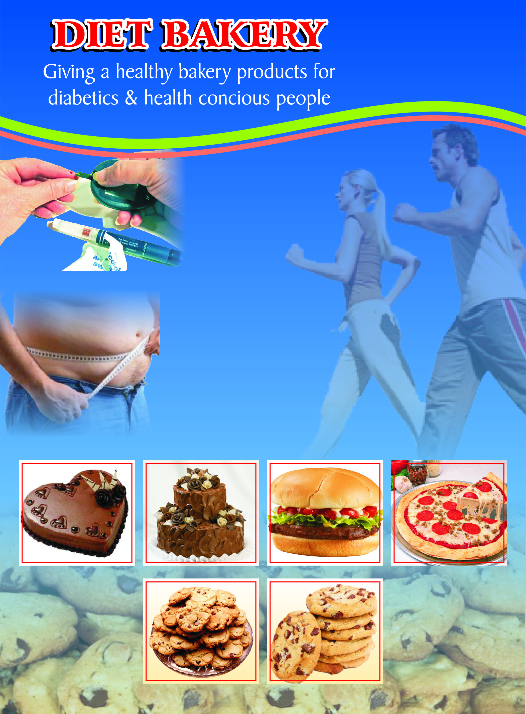

Group members:

MUHAMMAD UMAR FAROOQ (01-122072-092)
ZUHAIR ASHRAF (01-122072-175)
HASSAAN AMJAD KHAN (01-122081-131)

Project supervisor:

SIR IJLAL HAIDER

Abstract

Health, the most important part of lives. In the study project the research is discussing low calories bakery products that are not well established in country but in abroad people are well aware of it and they are using it since long. The Study is targeting the diabetic patients and health conscious people of our society. The research target market consists of middle and upper class people.
The research project is covering the special diet products which will be;
- Low in Carbohydrates.
- Gluten-free Foods.
- Foods have sugar substitutes.
The research will be visiting end consumers as well as bakery owner in project. The study shall also conduct interviews and will get questionnaires filled from people of various age group, taste and genders.

Acknowledgement

All praise and gratitude is due to ALLAH ALMIGHTY who created man in His own image and enabled him to travel on the earth and enter into an analytical study of Universe for spiritual appreciation of ALLAH’S unity and His attribute as well as for harnessing the material manifestation of the world to the mankind’s profitable utilization. In the first place, therefore we express our utmost thanks to ALLAH.

At the next stage we offer our gratitude to our Apostle and prospector Prophet Muhammad (P.B.U.H) for his golden saying “Gain knowledge be in China”

DEDICATIONS

- To our parents whose unconditional love & support helped us in making this project.

- To our teachers for their corporation and assistance.

Table of contents

Chapter no 1 | 7
1.1 Introduction | 8
1.2 Background | 10
1.3 Problem statement | 12
1.4 Project objectives | 13
1.5 Research methodology | 14
1.6 Procedures | 14
1.7 Sample | 14
1.8 Population | 14
1.9 Measurement | 16
1.9.1 Nutrition awareness | 16
1.9.2 Diet consciousness | 16
1.9.3 Status consciousness | 16
1.9.4 Health and fitness | 16
1.10 Rationale of study | 17
1.11 Scope and limitations | 19
1.12 Sources of data | 20
CHAPTER NO 2 | 21
2.1 Contemporary research/ literature review | 22
CHAPTER NO 3 | 28
3.1 Industrial analysis | 29
3.2 Diet products | 30
3.2.1 Cakes | 30
3.2.2 Low fat bread | 30
3.2.3 No sugar carbonated drinks | 31
3.2.4 Salad | 31
3.2.5 Survey results | 32
3.2.6 Analysis | 34
CHAPTER NO 4 | 35
4.1 Project life cycle | 36
4.1.1 Initiation phase | 36
4.1.2 Planning phase | 36
4.1.3 Execution phase | 37
4.1.4 Close out phase | 37
4.2 Map of bakery | 48
4.3 Segmentation | 50
4.4 Competive advantage | 50
4.5 Marketing strategies | 51
4.6 Swot analysis | 53
4.7Location of office | 54
CHAPTER NO 5 | 62
5.1Recommendations for bakery owners | 63
5.2 Recommendations for users of products | 64
References | 66
Questionnaire | 69

Chapter No.1

INTRODUCTION
1.1 INTRODUCTION

Dieting means that taking enough food in such a way to control weight and maintain body posture in a regular and fit position. Usually dieting is done along with some physical exercises to loose weight. To loose weight diet is divided in to four categories they are low fat, low calorie, low carbohydrates and very low calorie foods.

It means that taking proper diet so that one maintains a healthy life and is not affected by diseases like obesity and diabetes. Health in a human’s life is most important for him as without health he cannot perform any task and human body is like machinery which needs good and reasonable diet which acts as a fuel for the body and maintains it fit.

The energy which a person takes in the form of food depends on the digestion and also on its usage. It depends on the type of food which is eaten and its utilization largely depends on some factors like a person’ body weight and his hormones.

A person’s weight plays a very important role in analyzing that how fit he is and it is very important to maintain some weight which is ideal for him with respect to the body structure and his height.

Some research has been made according to which obesity is the main cause of death in the United States and people who adopt dieting in their life leads to reduction in their ability to defend diseases and which leads to serious problems. To reduce weight most effective method is to use low carbohydrate foods. There are some diseases like the celiac disease and to abide by this disease special attention has been paid in the countries of Europe and in United states and gluten free foods are manufactured which have acute amount of carbohydrates and fats in it and which is very useful to avoid by celiac diseases. Gluten free starch materials for example maize is used for preparing bread, biscuit and special kind of food processing is used in manufacturing these products.

It is very important to have a healthy and balanced diet and healthy eating practices should be adopted from the very early age and proper exercises should be done because most of the children who are fat in their childhood become fat adults and this leads to blockage of coronary heart and in result heart attacks and people dying in young age. Young kids as well as young people must exercise daily and education about fitness as not to eat too much fast foods and food containing fatty foods like chocolates and ice creams. These things lead to obesity. One must eat very little fat, sugar and salt. Fat contains much more calories than proteins and carbohydrates.

It is very important to have a proper bakery diet which is helpful for the body and which helps in maintaining weight to a proper level and not letting it to increase.

1.2 BACKGROUND

There was always different kind of foods which were considered to be low carbohydrate and people used them as a tool to decrease their fatness and obesity. Some people started dieting that is not eating food for quite long just to decrease their weight. This thing is very common amongst women who want to look smart.

Foods which provide less than 20% of energy from food of 100 grams is considered to be low carbohydrate food. People who are fat use those carbohydrate food which was low carbohydrates for example non starchy vegetables, fruits and whole grain products. People who are mostly over weight are due to the too much fat tissue. Every one who eats too much is usually obese. People who are over weight are usually diabetes patient along with they have high level of cholesterol and high blood pressure. On the other hand these diseases are very low in thin people.

They also are affected in their back, hips and knees and find difficult to exercise. Fatness usually occurs in the childhood and it is because of eating too much and fat children then become the inactive adults and death rate in fat people is very high and they usually do not reach to the old age as they die at very young age because of heart diseases and this practice is very common among the obese people. Exercise is a very good practice for such people to loose weight and this could also be achieved by reducing the amount of calories to be consumed. The foods and drinks that are high in calories are the ones most people like. The best, most effective, and safest way to lose weight is by reducing the amount of food, specially carbohydrates and fats.

Obesity means having too much fat. Body mass index is used by doctors and nurses as a measure of obesity. It is calculated by dividing weight in kilograms by height in meters.

Calorie is a unit of energy and every person needs energy to live and to move. They act as a fuel for the body. If a person is healthy and fit than he needs a lesser amount of calories to burn. Body needs different kind of salts, mineral and calcium and it depends purely on the type of activities a person has.

  - Problem statement

The basic aim of the study is to conduct a research on various aspects of the diet food that will benefit the patients of diabetes, obesity, allergy and diet conscious people.

1.4 Project Objectives

- To elaborate what our local bakeries are serving to help a better food for diabetics and health conscious people.

- To focus the aspects which have been overlooked by the local producers.

- To put forward another step in dietary products.

- To convey a concrete solution of the problem if formulated after conducting the research.
- To provide a set of recommendations for the assistance of the manufacturers.

1.5 Research Methodology

Two different surveys would be conducted to find the reasons for the unmet standards in dietary products. High awareness quality dietary products was projected but our local bakeries have failed to provide variety products in diet food. First survey would be conducted with the target audience; the related industries with quality standard targets and the second survey would be conducted with the current and the potential users of dietary products. The gathered data and facts will be compared to the relative growth in this industry.

1.6 Procedures: The primary data i.e. face to face interviews and questionnaires would be used to gather information for analyzing the current situation of the trends going in our bakery industry and then develop possible gateways for the effective penetration and hence benefit the end consumer.

1.7 Sample: As the research would not be limited to any bakery, the population sample would consist of representatives in the related industries and the potential consumers from different segments. This would help us in understanding the different demands of the consumers and also to know about who is providing this kind of food already.

1.8 Population
This is descriptive, quantitative, and analytical hypothesis testing study conducted on nutrition awareness ,diet consciousness ,status consciousness and health & fitness which leads to increase in the dietary products usage.

A total of 60 respondents were contacted. The rate of response was more than 75%. The sample is taken from representatives from different companies in the related industries and the potential consumers from different segments.

1.9 Measurements:

In this study we focused on the dietary products growth in Pakistan, including following facts; nutrition awareness, diet consciousness, status consciousness, health & fitness. These concepts were measured as follows

1.9.1 Nutrition Awareness:
Nutrition awareness perspective mainly focuses on the knowledge and education about nutrition to the public so that they may come to know what is suitable diet for them.

1.9.2 Diet Consciousness:
Diet consciousness mainly focuses on people who are very conscious about their body weight and structure. This will guide them how to maintain ideal weight, smart body and flat tummy.

1.9.3 Status Consciousness:
People having strong financial base are very choosy, can go for what ever they want, care for their health and go for diet products. However, people of the middle class also adopt conscious living due to the increasing rate of diabetic patients.

1.9.4 Health & Fitness:
Those people who are conscious from certain specific category of fatness elements like fats, cholesterol, it means they are not allergic from food but indirectly from these nutrients and want to remain health and fit.

1.10 Rationale of the Study:

Diet bakery is a new bakery specializing in gluten wheat dietary products. There has been significant increase in demand for these bakery products. Diet bakery will introduce modified products according to the need and desire of customers.

Pakistan has a very developed bakery market but the concept of diet bakers is completely new for our competitors. The bakers in Pakistan are offering diet products but a no one is giving the idea of broad based diet products. The concept of offering a complete range of dietary products would be a distinctive competitive advantage for us.

People having strong financial base are very choosy, can go for what ever they want, care for their health and go for diet products. However, people of the middle class also adopt conscious living due to the increasing rate of diabetic patients.

Diet bakery will focus on two distinct segments.
- Allergy groups. (people who are conscious from certain specific category of fatness elements like fats, cholesterol it means they are not allergic from food but indirectly from these nutrients)
- Dietary group

This segment is typically making modifications to their diet based on their desire to lose weight. Dietary groups includes our teen-age society and above them. Mostly girls are calories conscious.

In short, it will target the people, who are diet conscious, status conscious, diabetic patients, and weight watcher.

1.11 Scope and limitations

Being the pioneer of diet food bakery products in Pakistan it has a very good scope. Pakistan is a very big market for the bakery industry because bakery items are used at a large scale in Pakistan. As there is no other diet bakery in market therefore it will bring a new revolution in bakery industry. It will not only provide good & tasty food to the people but it will also help them to keep themselves fit. It will aid diabetic and obese patients to keep a balanced check on their diet and to eat variety of food which they wish to eat but their disease prevents them to do so. The raw material availability and the high prices are its limitations.

1.12 Sources of Data:

The data for this study (including Primary and Secondary data) will be gathered in following phases.

● The targeted dietary food analysis was done by going through the research articles on net regarding overall dynamics and aspects regarding dietary food sector. Next step was exploring from Web sites of diet bakeries and carefully reviewed information about what customer based facilities that are currently available.
● Questionnaire and interview sheets were prepared in order to collect primary data.
● Observation used as another source of collecting primary data
● Research article were carefully reviewed for further insight.

Chapter No. 2

Contemporary Research

(Literature Review)
2.1 Literature review:

The problem of obesity and diabetes is increasing and is dangerous at an alarming rate. The world is adopting a Western lifestyle. Never before has there been a greater need to spread awareness of the risk factors associated with the diseases and to coordinate medical progress with cultural modification. The continuous exploration of the biological mechanisms underlying illnesses, researchers can hope to offer, in the near future, new treatment and prevention strategies for these prevalent disease states. The diabetes and obesity have stimulated research to assess the benefits and potential risks of low-carbohydrate diets. Carbohydrate consists of less than 45% of calories in carbohydrate-restricted diets, but very low carbohydrate diets may restrict carbohydrate to 20 g initially with variability in the carbohydrate level subsequently. Some research suggests that low-carbohydrate diets may achieve better early weight loss than comparison diets higher in carbohydrate. Limited research has been conducted to evaluate low-carbohydrate diets in managing type two diabetes. Although science continues to advance in this field, current research suggests that low-carbohydrate diets can be a viable option for achieving weight loss and may have beneficial effects on control of cholesterol levels. Evolution of carbohydrate restriction is to manage obesity and diabetes. The American Academy of Family Physicians has defined low-carbohydrate diets in the following manner:“Low-carbohydrate diets restrict caloric intake by reducing the consumption of carbohydrates to 20 to 60 g/d (typically less than 20% of the daily caloric intake). The consumption of protein and fat is increased to compensate for part of the calories that formerly came from carbohydrates”.

Since 1970s our knowledge of the relationship between diet, health, and the risk of disease, especially chronic diseases has increased tremendously. However, the application of this knowledge to clinical practice and to public health has not been as thorough. This has taught us the essentials of what people need to eat for optimal health. Based on this information we can summarize the essential features of a healthy diet, meaning one that assists in achieving optimal health and minimizes risk of chronic disease.( Norman J. Temple)

Health assessments of young children has identified several nutrition-related concerns including: childhood obesity and excessive sugar intake (Murphy, Youatt, Hoerr, Sawyer, &Andrews, 1995; Zemel, Brokaw, Huntsinger, &McMichael, 1993; and Wolfe & Campbell, 1991). These dietary weaknesses can contribute to dental disease and some types of chronic diseases such as heart disease and cancer. Published recommendations have suggested limiting the amount of calories from added sugars to a small percent of the total diet (World Health Organization,1991). Choosing nutritionally modified foods (e.g.,sugar-free or reduced sugar products) is one way to balance the total diet. The American Dietetic Association recognizes the appropriate use of artificial sweeteners when they are consumed in moderation and within the context of a balanced diet (Franz & Maryniuk, 1993).

Nutrient-modified foods that use artificial sweeteners can maintain the nutrient density of the diet because refined sugar is removed, but the other food ingredients remain the same (Morreale & Schwartz, 1995).

In the United States, three artificial sweeteners (Sweet'N Low | Equal | and Sweet One | are approved by the United States Food and Drug Administration (FDA). New government guidelines for public and private school food service programs call for a reduction in the amount of sugar and fat served to children (Mullah,Holton, & Vickers, 1996). In support of these objectives, sugar can be used as a replacement for sugar and still provides a product that young children will find acceptable. Excess body weight is the sixth most important risk factor contributing to the overall burden of disease worldwide and about 110 million of children are now classified as overweight or obese. American children are eating high amount of carbohydrates. (Ramo´n Can˜ete)

Diets can be divided into those that reduce fat or carbohydrate. For that one needs to Drink adequate amounts of water, tea, coffee, and non-calorically sweetened beverages & Reduce intake of calorie-sweetened soft drinks and fruit drinks. Low-calorie diets produce significantly more weight loss than control diets. Controlling calorie intake with foods that measure the energy for the client have been useful.

The American Diabetes Association (ADA) have published nutrition guidelines for patients with diabetes that includes Energy Balance: A moderate decrease in caloric intake(500–1000kcal/day) will result in slow but progressive weight loss. In order to lose weight, fat is the most important nutrient to restrict. The recommended range of carbohydrate intake is 45–65% of total calories. Foods containing carbohydrates from whole grains, fruits, vegetables, and low-fat milk should be included in the diet. Like the general population, patients with diabetes are encouraged to consume fiber-containing foods (such as whole grains, fruits, and vegetables) because they provide vitamins, minerals, fiber, and other substances important for good health. The recommended range of fat intake is 30–35% of total calories. One of the primary dietary fat goals in patients with diabetes is to limit saturated fat intake. Many studies have shown that diets low in saturated fat decrease cholesterol and reduce cardiovascular disease. Therefore, it is recommended in patients with diabetes to reduce dietary saturated fats less to than 10% of energy intake. The recommended protein intake in patients with diabetes is 15–20% of energy intake.ADA food pyramid divides food into five groups as shown in figure below. The largest group (breads, grains, and other starches) is on the bottom. This means that one should eat more servings of grains, beans, and starchy vegetables than of any of the other groups. The smallest group (fats, oils, sweeteners, and alcohol) is at the top of pyramid which means that only few servings from this group are recommended.

Bread, Grains, and Other Starches At the base of the pyramid are bread, cereal, rice, and pasta. These foods contain mostly carbohydrates. The foods in this group are made mostly of grains, such as wheat, rye, and oats. Starchy vegetables (like potatoes, peas, and corn) and dry beans also belong to this group because they have about as much carbohydrates in one serving as a slice of bread. Starchy vegetables and dry beans also provide vegetable proteins. All grains and starches contain carbohydrates. However, their glycemic index (a measure of the glycemic effect of the type of carbohydrate) may be different.Five servings of fruits or vegetables are recommended each day in patients with diabetes. Most vegetables are naturally low in fat and are good choices to include often in meals or to have as a low-calorie snack. Vegetables are full of vitamins, minerals, and fiber. This group includes spinach, cabbage, carrots, tomatoes,cucumbers, etc. Fruits have plenty of vitamins, minerals, and fiber. They also contain carbohydrates. This group includes blackberries, strawberries, oranges, apples, bananas, peaches, pears, apricots, grapes, etc.

Milk products contain a lot of protein and calcium as well as many other vitamins. Non-fat or low-fat dairy products (milk, yoghurt, etc.) should be chosen to reduce saturated fat. Meat, Meat Substitutes includes beef, chicken, fish, eggs, cheese and cottage cheese. Meat and meat substitutes are good sources of protein and many vitamins and minerals. The fattest meat such as mutton and beef should be limited because they are rich in saturated fat; lean meat such as chicken would be preferred. Two or three servings of fish per week are recommended because fish provides proteins. Cheese provides protein and calcium but is rich in saturated fat. Thus, it is recommended to limit the amount and to choose low-fat cheese. The amount of fat should be limited in order to lose weight or to maintain a healthy weight. Instead of butter, skimmed cream could be used. Moreover a good choice for cooking should be olive or groundnut oils. Foods like potato chips, candy, cookies, cakes, crackers, pastries, and many ready-cooked dishes contain excessive amounts of fat or sugar, so they must be limited to small servings and saved for a special treat!

Sweet products are not recommended in patients with diabetes. Sodas and some concentrated fruit juices can be very rich in sugar. It is possible to substitute sodas with diet drinks, and concentrated fruit juices with pure fruit juices with no sugar added. Non-nutritive sweeteners may be used to replace sugar. It is also possible to add spices to increase the flavor in addition to reducing the amount of sugar in the recipes. ( B. Vergès-Patois and B. Vergès)

Several gluten-free grains exist, such as the pseudocereals amaranth, quinoa and buckwheat. These seeds are also characterised by an excellent nutrients. Besides being important energy sources due to their starch content, amaranth, quinoa and buckwheat provide good-quality protein, dietary fibre.Moreover, they contain adequate levels of important micronutrients, such as minerals and vitamins. A recent trend by researchers has focused on their use in the formulation of high-quality healthy gluten-free products, such as bread and pasta.

Chapter No. 3

Industrial Analysis
3.1 INDUSTRIAL ANALYSIS:
Our project is based on the diet food sector focusing particularly on specializing in gluten wheat dietary products. This project aims to introduce modified products according to dietary base desires. The project is being formulated to facilitate the people, who are diet conscious, status conscious, diabetic patients, and weight watcher. The objective is to create such an atmosphere where customer feel comfortable and becomes the permanent customer for the diet food.

We have all indirect competitors, as there is no bakery in Pakistan that is providing such a wide range of diet products. Our indirect competitors are
- Nirala sweets
- Sufi Bakers
- United bakery
- Rahat bakery

Rahat bakers, Nirala sweets, sufi bakers and united bakers are among the most famous bakeries of Pakistan. They are offering number of delighted items which attract people of every age. These items include wide range of cakes, pastries, ice creams, pizza, biscuits, different bakery items, beverages etc. their main focus is on the taste of the products. They keep in mind what is the priority of the customer and what they like and dislike. They try to fullfill the needs of customers of all age. They are providing some food related to the diet food but they lack in providing all kinds of diet food and their portfolio in this case is very limited.

.

3.2 DIET PRODUCTS:

Following are the different products proposed by Rahat bakers, Nirala sweets, sufi bakers and united bakers for the diet patient customers:

- 3.2.1 CAKES:

Special cakes are offered for the sugar patients, which are especially labeled as “no sugar” cakes. These cakes are not made originally by ordinary sugar, rather they are made of special kind of low calorie and low fat sugar which is not harmful for the patients of sugar and is very useful for those who are on diet.

- 3.2.2 LOW FAT BREAD:

Special low fat or no sugar breads are offered by these bakeries for the sugar patients. It includes the brown bread and special bread items with low or no fat and sugar for the sugar patients.

- 3.3.2 NO SUGAR CARBONATED DRINKS:

Bakeries keep some carbonated drink items as well in their bakeries. But for the sugar and diet patients, they keep diet coke, 7up, Miranda and other carbonated drinks. They are kept especially for the diet patients.

- 3.2.4 SALAD:

Salads are very healthy for the life. They are very helpful in maintaining the blood sugar level. Because fresh fruits and vegetables regulate the digestive system and clean the blood which in turns maintain the sugar level.

RESEARCH METHODOLOGY:

Our research methodology is the survey type.

SAMPLE:

We distributed close ended questionnaires among the elite class so that an in depth research over the need of diet bakery could be achieved. Our research focuses the people who are diet conscious, status conscious, diabetic conscious and weight watchers.

3.2.5 SURVEY RESULTS

Question no. 1: Question no. 2:

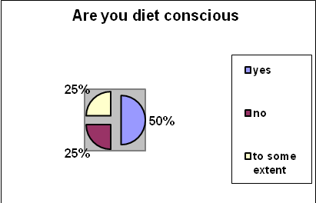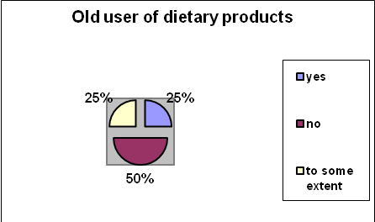

Question no. 3: Question no. 4:

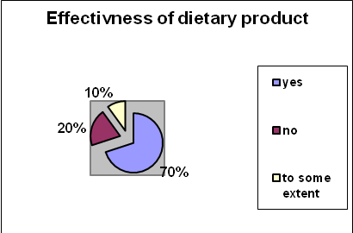
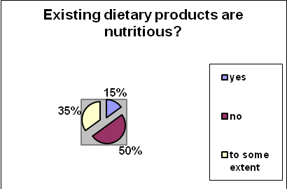

Question no. 5: Question no. 6:

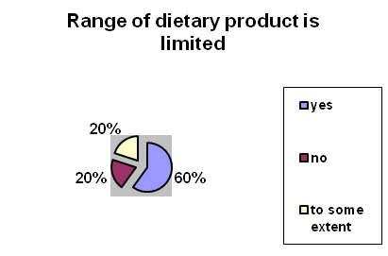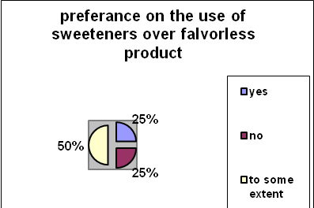

Question no. 7: Question no. 8:

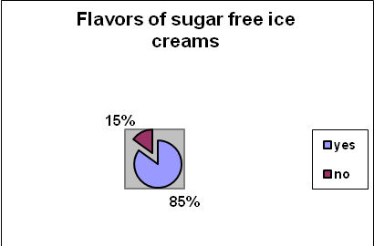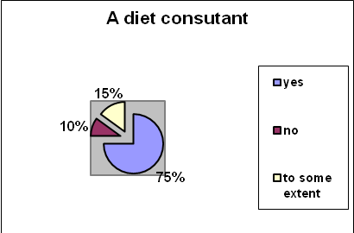

Question no. 9: Question no. 10:

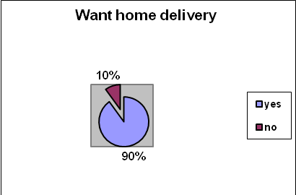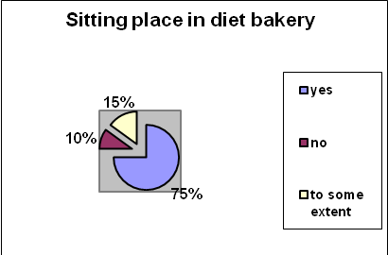

3.2.6 ANALYSIS:

Our research proved fruitful as we became aware that our business selection would fetch us heavy profits. The idea of introducing a diet bakery is found very appealing by our customers. About 75% of the sample is in favor of the idea. We even have some competitive advantage, as there is no particular diet bakery in Pakistan.
Most of the people say that they cannot access a wide variety of dietary products. Our research also highlighted the fact the people are looking for a complete range of dietary products. To make an effort to attract majority customers we are offering the services of a diet consultant positively responded by people i.e.75%.Based on the results of our survey, we conclude that a diet bakery in Pakistan would be very much welcomed.

Chapter No 4

Organizational overview

4.1 PROJECT LIFE CYCLE

4.1.1 Initiation Phase:

In this first phase the need of the establishment of a diet bakery is identified by conducting a survey and visiting the local bakeries to gather the information so that it is clear whether they are making any diet products or not. The survey will make us clearly understand the need of a diet bakery. The major deliverables of the project are the nutritious dietary products. In addition to this the requirement document is also prepare in this phase to save the time of any hurdles in the future.

4.1.2 Planning Phase:

In this phase, the work breakdown structure is developed to estimate the cost that can incur during the project and the total time that will be consumed to complete the project.

The project is a partnership among 3 persons namely

Muhammad Umar Farooq
Hassaan Amjad Khan
Zuhair Ashraf

Necessary documentation will be made and then the suitable place for the establishment of the bakery will be sighted. After this, the next step will be to obtain the NOC for the proposed location. The decoration of the shop will be done and the order for the required machinery will be placed. In addition to this, the suppliers for the raw materials will be finalized.

In addition to this, the products that will be baked will be finalized and their prices will be fixed as well.

4.1.3 Execution Phase:

During this phase, the decoration will be complete under the watchful eye of the project manager and the machinery that had been ordered will be fixed as well. After this, the suppliers will be ordered the raw material and then the electricity work is checked for the last time.

The next step now will be to hire the relevant experts required to run the bakery, their pay packages will be finalized, and their contracts will be signed.

4.1.4 Close Out Phase:

The bakery is completed and the deliveries for the raw materials are received. Now the bakery will be inaugurated and after this formal inauguration, the bakery will sell its goods free on the first day. The response of the customer will be taken into account to know what their satisfaction level is.

STRATEGY

The strategy is to focus on saving a niche market with variety and quality goods. The project is determined to become an important and integral part of its target community.

To achieve these goals Diet Bakery will provide:

- Friendly, neighborhood atmosphere
- Quality baked goods
- Special diet menu
- Dining area
- Home delivery
- Services of a diet consultant

CURRENT PORTFOLIO

Presently the focus remains on the native city Rawalpindi and Islamabad. The strategies, which have been formulated, are going to help Diet Bites expand horizons beyond these two cities.

FUTURE PORTFOLIO

The project members wish to land on international grounds one day for this. Diet bakery need to progress smoothly and steadily. Customers are going to be diet bakery’s priority as they are the one who will support its flight.

PROJECT REQUIREMENTS:

Suppliers:
We have several reputed suppliers in our focus. Some of them are listed and the modes of communication are narrated.
- K&N’s will supply chicken to our bakery. Communication on daily basis for the stock will be done through telephone.
- ABC Warehouse will supply packing material, dry ration, bulbs, broom etc. to diet bakery. The communication will be on weekly basis on telephone and through e-mail.
- XYZ Bakery will supply buns, cheese, mayonnaise etc. They will be communicated on daily basis through phone and e-mail.
- Transportation of all products will be carried out through company vehicles.

Financial Institution:

CITY bank is the financial institution of diet bakery. Daily sales record will be submitted in CITY bank via phone and e-mails.

MODES OF COMMUNICATION:

- Email
- Telephone
- CEO’s suggestions Box
- Pamphlets and Handouts
- Advertisements on Local Cable Networks,
- Newspapers
- Multimedia Projectors to entertain customers e.g. telecasting Cricket matches, wrestling matches, etc.
- Pictorial Menu Display on every table and walls around cashier counters

- SITE:

The bakery is going to be situated in the B-block of blue area Islamabad, right behind D-Watson medical store and Shaheen Chemists.

The purpose of choosing this location is that the area is commercial and most of the Islamabad population came there for buying medicine on these well-known stores. The people who are coming for the medicines will definitely attracted towards the Diet bakery items.

- CUSTOMERS

The prime customers of Diet Bites are high-class people seeking for actualization needs as they can easily fulfill their other basic needs i.e. psychological, social, self-esteem and we have an objective to go international. These customers will help do so. The elite or rich class will come to diet bakery for fulfilling their dietary needs and they would fall in the category of the current customers and our potential customers might be the middle class who have the liking or desire for the dietary products but their ratio would be very small comparatively because of their weak financial position.

- INTERNAL ENVIRONMENT

The project will let the employees know that they are here to promote this business to high levels by providing well services. We have to share the news with our employees. We as owners, should know what our employees feel like even though there may not be a single secret as it is very important to keep the employees informed about issues that may arise even if they are not directly involved in them.

LEGAL DOCUMENTATIONS

For the purpose of legal documentation when starting the new business the law and rule is taken into mind at every case with the will of people starting the business.

For the diet bakery business the essential documents will be;

Partnership deed agreement

A partnership agreement/deed in between the three partners in the bakery business.

The deed will be a stamp paper worth of Rs.100, which will be attested by the magistrate.

The deed will contain all the details about the partners like address, contact number, residences, professions if any other, etc

All the business capital invested by three partners with equal or different share is going to be mentioned on the partnership deed/agreement.

The deed will contain the distribution of profits according to partnership share.
This is the only legal document, which is required to tell about the partnership rules and regulations details between the partners.

Employee’s agreement:

The second possible essential document will be a stamp paper worth of Rs.50, which will be for the purpose agreement of employees with the owners.

The bakers, cooks, driver, guard, accountant, helpers, counter boys, and the cashier will be liable to sign the contract according to the agreement time with the owners. The document is essential because the owner will come to know about the packages paid to the employees, their job timing, the extra amount spent in shape of medical or rewards.

The sweepers are not liable to sign the contract for the job.

DIET BAKERY REQUIREMENTS

- PRODUCTS:

- Cakes
- Biscuits
- Pastries
- Doughnuts
- Patties
- Pizza
- Bread
- Sandwiches
- Vegetables meat chicken rolls
- Soft drinks
- Sweets
- Burgers

LITTLE DESCRIPTION OF CERTAIN INGREDIENTS USED

By using menstruated oil, as they are more stable (olive oil, canola, peanuts oil) than common vegetables oil and help to reduce toxic oxidation and free radical damage in body.

Eggs are great source of protein where yolk’s are very high in fat’s & cholesterol, heart association’s recommend limiting cholesterol. That’s why we are using egg’s white instead of yolk as it’s fat free and cholesterol free and great source of protein.

PACKAGING:

Our products should be a feast to eyes, so that no one is able to resist using it to ensure this, we would be innovative in our production. Customer attraction will be our focus. For successful packaging, we are including smaller-size packs, new zipper bag technology providing longer storage life, key word labeling of products to promote health benefits, re-branding use of characters to appeal to weight watchers.

SAMPLES OF BAKERY PACKING:

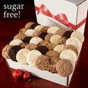

PRODUCT QUALITY:

We would take special care of hygiene so that our products are healthy. Our baking strategy would also define so that we are able to manufacture fresh products daily. Quality would be ensuring besides, qualified bakers will be employed.

SERVICES:

We are offering citing place with relax environment within the bakery as well as coffee and ice cream bars and you can take packed order’s with you and enjoy it at your home ( as the customer wish) or home delivery.
PRICES:

High prices will be charged i.e. skimming, as we have to generate high revenues and our target market is the elite class.

CAKES price
Pineapple 200
Almond 150
Black Forest 250
Strawberry 300
Chocolate 250

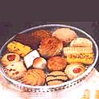BISCIUTS price

Zeera 200
Coconut 300
Wheat 400

PASTERIES 50 to 100

Fresh Butter Cream Pastries
Date Pastries
Assorted Pastries
Chocolate Forest Pastries
Checkmate Cream Pastries
Orange cream pastries
Strawberry Cream Pastries

PIZZA price

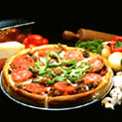Chicken fajita 200
Vegetable 195
Chicken Tika 225
Beef 300

BREAD 40 to 100

DRINKS: price

Diet Pepsi 60
Orange 50
Grapes 50
Pomegranates 50
Mango 50
Salty lemon 50
Diet coffee 85

ICE -CREAMS rs 80 per scoop
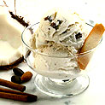
Vanilla
Orange
Mango
Chocolate
Tutti Fruiti

SWEETS RS 500 PER KG
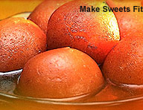
Rasmalai, Gulab Jaman, Barfi,
Chum Chum, Rus gulay, Pateesa

BURGERS 200 to 350
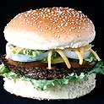

“diet bakery” would also provide our customers with experts dietitian’s opinion so that they are satisfied convinced while using our products. We would promote our bakery using all possible means e.g. Billboard, print media, and electronic media.

4.2 THE MAP OF DIET-BAKERY

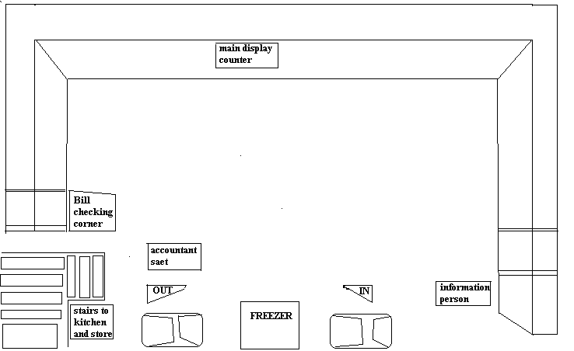

The map description:

Two entrance doors, right side for entry and left side for exit.
At the left side of the entrance door is an ice cream freezer and on the right side is the cold drink tower freezer.
Straight in front of the door there is counter that is starting from the left side and ending at the right side of the bakery.
The left corner of the counter is for the accountant who is going to cash the bills and the credit cards machine is situated there.
The left most corner of the shop is for the person who is going to verify the paid bill by stamping them.
The counter display is for the diet bakery items and the shelves behind the counters in the wall are for the general use items.
There are stairs inside the bakery, which are going upward to the first floor on which two rooms are made. First room is for the kitchen purpose and the second for the storeroom purpose.

4.3 SEGMENTATION

Demographic Segmentation has been done. Diet bakery will focus on two distinct segments.

- Allergy groups (people who are conscious from certain specific category of fatness elements like fats, cholesterol…, it means they are not allergic from food but indirectly from these nutrients.
- Dietary group

This segment is typically making modifications to their diet based on their desire to lose weight. Dietary groups includes our teen-age society and above them. Mostly girls are calories conscious so if we were able to hold them as our customers it would boost our business.

4.4 COMPETITIVE ADVANTAGE

Pakistan has a very developed bakery market but the concept of diet bakers is completely new for our competitors. The bakers in Pakistan are offering diet products however a complete range of diet products is yet to be founded. The concept of offering a complete range of dietary products serves as a distinctive competitive advantage.

Besides we want to win our customers confidence so we are offering the services of dietary consultant so that they are satisfied at a maximum level while using our product. We are enclosing a nutritional fact file making our customers aware of their diet.

Generally, the trend of a sitting area with a bakery has not been observed .To facilitate our customers we are offering a complete dinning facility.

4.5 MARKETING STRATEGIES
Promotion
Diet bakery will conduct an opening ceremony for its outlet featuring top personalities or stars. Free samples of the products will be distributed containing information about different products manufactured by the company. The campaigns will be started before the openings of the outlets. The opening ceremonies will also feature concerts and funfairs for children.

Advertising
The advertising will include banners, posters and broachers. They will contain information about different products and will be displayed and distributed in localities where the outlet is present. These advertisements will also be published in local magazines and newspapers as well.

Media
The print media will be used for advertising purpose. Radio channels will also be used as a medium for advertisement. The teaser campaigns will be aired before the launch of outlet and after the launch there will be comprehensive advertisement program for one month for various products.

Cable:
We will advertise through the medium of cable networks. We will target most of the posh areas of Islamabad and Rawalpindi. Through this advertisement we will create awareness about our product and its benefits

Billboards:
Billboards are the main source of capturing the local audience. Our ad became more known through billboards. It is a very effective marketing tool to market your product in each and every class. People some time unintentionally look at the billboard and get interested or attracted.

Buy Two Get One Free:
It's also a tempting way to appeal the public.

Through Pamphlets:
We can also market our product by publishing pamphlets regarding our products features and all different tastes. These pamphlets should be given to the shop owners so that they will display it in their shops and in this way making your marketing campaign more effective.

4.6 SWOT ANALYSIS

STRENGTH:

We are offering the wide range of diet products all over Pakistan, no other bakery provide such offers:

- Special organic flours are used
- Menstruated oils are used (olive oil, peanuts oil, canola) as they are cholesterol and fat free.
- Well educated and friendly staff
- Highly skilled Managerial Staff who is always aware of the opportunities and keeps the top-level management well informed.
- Large number of young customers
- Useful media campaign
- Well accommodating car parking even in the main markets

WEAKNESSES

Transportation costs are very high as different raw materials are not available everywhere and at the very start of our business this cost might reduce our profits.

- Time consuming delivery of order

OPPORTUNITIES:

The Diet & Bakery team would consist of dedicated professionals such as food technologists who will always be in quest of exceeding customer’s expectations.

- More innovative advertisement strategies could be adopted
- Lowering our prices can attract more customers.
- Involvement in social projects for the country can attract people towards diet bakery.
- Mobile Unit Service can be expanded in different cities

THREATS:

- We may face the problem of high price payment towards suppliers,
- There are few suppliers of the dietary materials in Pakistan.
- The entry of competitor in the particular field might drain diet bakery products.

4.7 LOCATION OF OFFICE:

We met MR. AHMAD MALIK who is the owner of a building. There would be an agreement with him for 5 years by paying him 6 months advance. Electricity and gas are already available there.
Security PKR 100,000
Six months advance PKR 270,000
One month rent45000
Location of office:
Building # 5, plot # 36(B BLOCK) opposite to city bank, blue area ISLAMABAD.
Owner contact # 0332-5575087

FURNITURE FOR OFFICE:

We need following items of furniture
1 sofa set complete RS 24,000
1 Doctor table & chairs RS 28,000
1 Counter & chairs RS 30,000
2 Chairs RS 2800

We will purchase above mentioned furniture from the following address
Five star furniture house, Near haroon chowk, kurri road,
Rawalpindi.

DOCTOR AND DIETITION

We will appoint a doctor and and a dietitian who will suggest food to the people and than we will make food for those people and will deliver them at their homes and offices if necessary. They will make a complete diet plan and would suggest to the patients and will advise them about their health. This would certainly provide them best of consultation and diet under one roof.

EQUIPMENT OF OFFICE:

We need a lot of equipment for out office. In order to provide our services more effectively and efficiently we need to purchase many other equipment and the the list of such equipment are as follows.

Mitsubishi split AC 1.5 TON (Model# MS-18) 52,900
Mitsubishi split AC 1.0 TON (Model# MS-13) 42,900
AC fitting cost 6,000
LCD TV (SAMSUNG “42” ) 70,000
Orient water dispenser 9,500
Orient vaccum cleaner 72,00
Computer system (DEL 3.2 MHZ) 9600
Lcd del “15” 7500
Key board and mouse 400
Power cable of PC 100
Freezer (dawlance) 24100
Oven (dawlance) 9700
2 Insect killer(X- On Germany) 3700
4 Telephone sets 4200
6 Emergency lights 5100 TOTAL 197,700

MEMBERSHIP
Initially we will give free membership but after starting the business we will have following categories of membership

Initially free membership up to 2500=free
Membership fee till first six months=RS 5,000
Membership fee after six months onward=RS 12,000

Members of our bakery would enjoy free medical chekup, free diet recommendations and also 10% discount on meal.

Salaries of staff member:

We will hire following staff members and their salary is also mentioned below

1 doctor with salary RS 25,000
1 dietient with salary RS 25,000
2 Guards with salary RS 16,000
1 Driver with salary RS 10,000
3 Cook with salary RS 45,000
1 Sweeper with salary RS 6500
1 Supervisor with salary RS 20,000
1 Accountant with salary RS 15,000
2 Deliverer boys with salary RS 20,000

GRAND TOTAL EXPENDITURE:

Crokery items RS 30,000
Kitchen items RS 63,000
Furniture RS 84,000
Security RS 100,000
Two small vans(reconditioned ) RS 10,00,000
Office equipment RS 197,700
Total marketing expenses RS 300,000
Total expenses RS 17,747,00

COST OF RAW MATERIAL;

The cost of monthly raw material will cost near about RS 2,00,00

FIRST MONTH EXPENSES:
FIXED EXPENSES:

Building rent RS 45,000
4 Delivery boy salary RS 40,000
1 Supervisor with salary RS 20,000
1 Guards with salary RS 8,000
1 sweeper with salary RS 6500
3 cook with salary RS 45,000
1 van driver salary RS 12,000
TOTAL FIXED EXPENSES RS 176,500

VARIABLE EXPENSES:

5000 Disposable plates RS 2,000
5000 Disposable cups RS 2500
Cost of food(raw material) RS 200,000
Electricity/gas bill RS 45,000
Printing & stationery RS 2500
TOTAL EXPENSES RS 252,000

TOTAL EXPENSES = 176,500+ 252,000
= RS 428,500

TOTAL REVENUE OF FIRST MONTH:

Membership fee(2500 free members)(20 new members*5000)RS100,000

Estimated Sales RS 420,000
Gross profit= 520,000- 428,500
= RS 91,500

FIRST MONTH EXPENSES:
SECOND MONTH
FIXED EXPENSES:

Building rent RS 45,000
Side building rent RS 10,000
4 Delivery boy salary RS 40,000
1 Supervisor with salary RS 20,000
1 Guards with salary RS 8,000
1 sweeper with salary RS 6500
3 cook with salary RS 45,000
1 van driver salary RS 12,000
TOTAL FIXED EXPENSES RS 186,500

VARIABLE EXPENSES:

In second month cost of food items and no of disposable stuff would increase so variable cost will also increase .
Estimated variable cost would be RS 310,000.

TOTAL EXPENSES = 186,500+ 310,000
= RS 496,500

TOTAL REVENUE OF SECOND MONTH:
Membership fee (40 members*5000) RS 200,000
Estimated Sales RS 500,000
Gross profit= 700,000- 496,500
= RS 203,500

THIRD MONTH
FIXED EXPENSES:

Building rent RS 45,000
Side building rent RS 10,000
4 Delivery boy salary RS 40,000
1 Supervisor with salary RS 20,000
1 Guards with salary RS 8,000
1 sweeper with salary RS 6500
3 cook with salary RS 45,000
1 van driver salary RS 12,000
TOTAL FIXED EXPENSES RS 186,500

VARIABLE EXPENSES:

In third month cost of food items and no of disposable stuff would increase so variable cost will also increase .
Estimated variable cost would be RS 350,000
TOTAL EXPENSES = 186,500+ 350,000
= RS 536,500

TOTAL REVENUE OF THIRD MONTH:

Membership fee (80 New members*5000) RS 400,000
Estimated Sales RS 550,000
Gross profit= 9,50,000- 536,500
= RS 413,500

Chapter 5

Recommendations

5.1 Recommendations for bakery owners
weight-loss diet is the very low-carbohydrate diet and there is a great demand of the dietary products so they must introduce new dietary products with a wide range of variety. This thing would not only help patients and customers but it would also bring huge amounts of profits for them. They would also be a part of eliminating diseases from the society which would bring a good name for them. Pakistan has a huge number of population and people are very conscious about their health and they want to have some kind of food which is good for their health. So these bakery owners must start providing low calorie products which are made with low fats, low carbohydrates and things which are made with gluten free maize. They can provide a dietiean as well who will provide advises to the people who come there and shop for their products. This thing would definitely bring profits for them. Some of the diet advises are listed below.

5.2 Recommendations for diet users:

EAT A VARIETY OF FOOD:

There are forty nutrients known and there are many yet to be known which are needed for a healthy body. No single food can provide all the essential nutrients in the amount which are required by the body. The greater the variety of foods used the less likely a person is to develop deficiency or an excess of any single nutrient used. One way to ensure variety of food and to make your diet balance is to select foods each day from all the major food groups.

MAINTAIN IDEAL WEIGHT:

Excess fatness is linked with some chronic disorders such as hypertention and diabetes which in turn relate to heart disease. The ideal weight however must be maintained individually because there are many factors involved in body compostion, genetics and physical activities.

AVOID TOO MUCH FATS AND CHOLESTROl:

People who are food lovers usually consume a high fat diet. This excess of fats leads to high level of blood fats and cholesterol carried in lipo protein compounds. Increase of fats and cholesterol are associated with a higher risk of heart diseases. Thus it is wise to cut down the level of cholesterol and fats and to use them in moderation.

AVOID TOO MUCH SUGAR:

The major health hazard from eating too much sugar is tooth decay(dental). Too much sugar itself does not causes diabetes but it can contribute to poor control of diabetes in persons who have inherited the disease. Again here moderation is the solution.

AVOID TOO MUCH SODIUM:

Excess sodium is not healthy for anyone, specially who have high blood pressure.

SELF ANALYSIS:

We advise our customers to make a record of what they eat and drink. Keep a small pocket diary with you and make write it down what ever you eat and drink through out the day and evening. Take it in consideration that what you eat and in what quantity. This thing will help you asses yourself that what food is not causing harm and what is not going good with you body. Than start avoiding things which are hazardous and which does not get fit with you.

DAILY WALK & EXERCISE:

You must make a habit of walk and exercise on daily basis. Take a brisk walk for at least half an hour and also start some exercise to make yourself fit and smart.

References:
- The Development of Diabetes Mellitus in Wistar Rats Kept on a High-Fat/Low-Carbohydrate Diet for Long Periods Yuan Wang,1 Pei-Yu Wang,2 Li-Qiang Qin,2 Ganmaa Davaasambuu,2 Takashi Kaneko,2 Jiaying Xu,2 Shin-ichi Murata,3 Ryohei Katoh,3 and Akio Sato4

- Low-Carbohydrate Diets:An Update on Current Research Judith Wylie-Rosett, EdD, RD, and Nichola J. Davis, MD, MS

- Obesity and Diabetes The Historical Events Marking the Evolution of the Understanding of the Pathophysiology
and Treatment of Two Related Diseases George
Karanastasis, M~and Cbristos S. Mantzoros

- Review of Low-carbohydrate Ketogenic Diets Eric C. Westman, MD, MHS, John Mavropoulos, MPH, William S. Yancy, Jr., MD, MHS, and Jeff S. Volek.

- From Nutritional Science to Food Guides Norman J. Temple

- The Role of Sweeteners in the Diet of Young Children
LuAnn Soliah, 1'4 Janelle Walter, 1 Thomas Parks, 2 Kathleen Bevill, 3 and Bernadette Haschke

- Investigation of the Effect of High Dairy Diet on Body Mass Index and Body Fat in Overweight and Obese Children Majid Ghayour-Mobarhan1, 2, Amirhossein Sahebkar1, Rahim Vakili3, Mohammad Safarian2, Mohsen

- Nematy2, Elham Lotfian1, Mona Khorashadizadeh1, Shima Tavallaie1, Monireh Dahri1 and Gordon Ferns4

- Low-Carbohydrate Diets Angela P. Makris, PhD, RD, and Gary D. Foster, PhD

- Nutrition Counseling for Diabetic Patients Bénédicte Vergès-Patois and Bruno Vergès

- A reappraisal of the impact of dairy foods and milk
fat on cardiovascular disease risk J. Bruce German Æ Robert A. Gibson Æ Ronald M. Krauss Æ Paul Nestel ÆBenoıˆt Lamarche Æ Wija A. van Staveren Æ Jan M. Steijns Æ Lisette C. P. G. M. de Groot Æ Adam L. Lock Æ Fre´de´ric Destaillats
- Gluten-Free Diet Normalizes Mouth-to-Cecum Transit of a Caloric Meal in Adult Patients with Celiac Disease
GIUSEPPE CHIARIONI, MD, GABRIO BASSOTTI, MD, PhD, UGO
GERMANI, MD, EDDA BATTAGLIA, MD, MARIA TERESA
BRENTEGANI, MT, ANTONIO MORELLI, MD,and ITALO VANTINI

- Effect of low lactose dairy powder addition on the properties of gluten-free batters and bread quality
Maria Helena B. Nunes Æ L. A. M. Ryan Æ
Elke K. Arendt

- S. Størsrud · I. Malmheden Yman · R. A. Lenner Gluten contamination in oat products and products
naturally free from gluten

- Diet, Weight Loss, and Cardiovascular Disease Prevention George A. Bray, MD Donna H. Ryan, MD David W. Harsha, PhD

- Baking properties and microstructure of pseudocereal Xours in gluten-free bread formulations Laura Alvarez-Jubete · Mark Auty · Elke K. Arendt Eimear Gallagher

- Investigation of the Effect of High Dairy Diet on Body
Mass Index and Body Fat in Overweight and Obese
Children Majid Ghayour-Mobarhan1, 2, Amirhossein
Sahebkar1, Rahim Vakili3, Mohammad Safarian2, Mohsen
Nematy2, Elham Lotfian1, Mona Khorashadizadeh1, Shima
Tavallaie1, Monireh Dahri1 and Gordon Ferns

- STORAGE TIME STUDY OF SUGAR-FREE AND REDUCED CALORIE MILK CHOCOLATES LAURO LUÍS MARTINS MEDEIROS DE MELO1,3, HELENA MARIA ANDRÉ BOLINI1 and PRISCILLA EFRAIM

QUESTIONARE

- Are you diet conscious?
a)Yes b) no c) to some extent

- Are you already a diet product user?

a)Yes b) no c) to some extent

- Do you think dietry product has positive effects?
a)Yes b) no c) to some extent

- Are existing dietry products nutritious?

a)Yes b) no c) to some extent

- Don’t you think range of existing dietry products is limited?

a)Yes b) no c) to some extent

- Do you prefer use of sweetness over flavorless product?

a)Yes b) no c) to some extent

- Do you want to have different flavored sugar free ice cream?

a)Yes b) no c) to some extent

- Do you consult you diet with some diet consultant?
a)Yes b) no c) to some extent

- Are you aware of the dietry products that will help you not to gain wheight and also to keep you healthy?

a)Yes b) no c) to some extent

- Would you like to have home deliver facility?

a)Yes b) no c) to some extent

- You want some sitting place in the diet bakery?
a)Yes b) no c) to some extent

- Would you like to have wide range of dietry products?
a)Yes b) no c) to some extent

