RECOMMENDED INNOVATIVE RETAIL PRACTICES FOR PAKISTAN.

Supervised By:  Sir Shahid Haq | Submitted By:  Maham Hussain  01-122081-049  Samyah Bintee Noor  01-120082-065  Waqar Khalid  01-122081-114

A Project submitted as a partial requirement/fulfillment
for the award of Degree of Master of Business
Administration (MBA).

Department of Management Sciences
Bahria Institute of Management & Computer Sciences
Bahria University Islamabad 2010
Bahria Institute Of Management And Computer Sciences Department Of Management Sciences.

Final Thesis Approval Sheet
Viva-voice Examination

Topic Of Research:

Recommended Innovative Retail Practices For Pakistan

Name Of Students:
Maham Hussain
01-122081-049
Samyah Bintee Noor
01-120082-065
Waqar Khalid
01-122081-114
Class: MBA

Approved By:

SHAHID HAQ.
Thesis Supervisor

KASHIF AHMED
Internal Examiner

SARA SALAHUDDIN
External Examiner

KASHIF AHMED.
Research Coordinator

Khalid Mumtaz.
Head Of Department Management Sciences

We would like to dedicate this thesis to our parents, who have supported and encouraged us a great deal throughout the course of our education.

CERTIFICATION
It is certified that the Masters thesis titled “Recommended Innovative Retail Practices For Pakistan” by Samyah Bintee Noor, Maham Hussain and Waqar Khalid has been approved for the submission to Bahria Institute of Management & Computer Sciences.

________________________
Mr. Shahid Haq
Project Supervisor

ACNOWLEDGMENTS

In the name of Allah, the most beneficent and merciful

The first and foremost thanks are for Allah for giving us the strength and courage to undertake and complete this research paper.

We would like to express our deep gratitude for the employees from the respective retail sectors (Cosmo, Metro, medi-plus, hyperstar and HKB) for taking the time out from their busy schedule and providing us with valuable information that was very helpful in the completion of this project. We would also take out the opportunity to thank Mr. Shahid Haq, my thesis supervisor for providing us the guidance and support that was invaluable to the completion of this paper.

In the end, we would also like to thank our family especially parents for cooperating with us and putting up with u during this time.

ABSTRACT

Innovation is generally anticipated as the major opportunity towards value creation beyond price in the retail sector. Innovation is a main tool for adding value in retail sector. Particularly, in services arena innovation could have a big impact in customer’s satisfaction. In order to plan new services that will be accepted by consumers, retail stores must take into account consumer’s point of view. Existing retail practices include lots of innovative customer services and technology-based methods. Yet, some of these innovations give obvious consumer advantages and have attained high levels of customer acceptance. We conduct a study in order to create, plan and lastly evaluate innovative retail practices and consumer services that create value in the retail context. Using a methodology a customer survey with 50 retail customers are taken in to consideration to create an attitude towards these services. The findings suggest that innovation and technology can improve the shopping experience and increase the perceived value, but the design and applications should be modified according to the unique requirements of customer.

TABLE OF CONTENTS
1. INTRODUCTION 1
1.1. Broad Problem Area/ Background: 2
1.2. Problem Statement 3
1.3. Objectives of the study 3
2. Research Methodology 5
2.1. Subjects and Sample Size 5
2.2. Type of Study & PROCEDURE 5
2.3. NATURE OF RESEARCH 5
2.4. Rationale Behind Use Of Quantitative Method 6
2.5. Rationale Behind Use Of Qualitative Method 7
2.5.1. A Mixed Methodology 8
2.6. RESEARCH APPROACH 9
2.7. INSTRUMENTS AND MEASURES 9
2.7.1. INTERVIEWS 10
2.7.2. QUESTIONNAIRES 11
2.8. DATA TREATMENT 11
2.9. LIMITATIONS 12
3. LITERATURE REVIEW 14
4. TRENDS IN RETAIL STORE PRACTICE (Industry Analysis) 21
4.1. Retail Store Practices – Global Perspective 21
4.2. Retail Store Practices in Pakistan: 24
4.2.1. Small Retailers: 25
4.2.2. Large Retailers/Wholesale Retail Stores: 25
4.2.3. Department Stores: 26
4.2.4. Super Markets: 26
4.2.5. Street Vendors/Vending Machines: 27
4.2.6. Utility Stores: 27
4.2.7. Cooperative Stores: 28
4.2.8. Jumma/Mangal/Itwar Bazaars: 28
4.3. Inventory management in Pakistan: 29
4.3.2. Inventory Process: 29
4.3.3. Inventory checks: 29
4.3.4. Inventory Control: 30
4.4. Major Industry Players: 32
4.4.1. Western Retail Stores 32
4.4.2. Pakistani Retail Stores 34
5. RETAILSTORE OPERATION 37
5.1. Modern Retail Store: 37
5.2. Customer Services 38
5.2.1. Nature of Customer Services 39
5.2.2. Objective of Customer Services 39
5.2.3. Types of Customer Services 39
5.3. Retail Store Special Features 40
5.3.1. Parking Lots: 40
5.3.2. Cleanliness: 40
5.3.3. Lighting and Color: 41
5.3.4. Air-Conditioning: 41
5.3.5. Automatic Doors: 41
5.3.6. Music: 42
5.3.7. Rest Rooms and Lounges: 42
5.3.8. Store Layout: 42
5.3.9. Shopping Carts: 42
5.4. Courtesy: 43
5.4.1. Check Cashing: 43
5.4.2. Redeeming Coupons: 44
5.4.3. Merchandise Return and Customer Complaints: 44
5.4.4. Miscellaneous Services: 44
5.5. Merchandising Services: 45
5.5.1. Price: 45
5.5.2. Displays: 45
5.5.3. Grouping of Related Items: 45
5.5.4. Quality: 46
5.5.5. Variety: 46
5.5.6. Special Promotions: 46
5.5.7. Aids for Locating Merchandise: 46
5.6. CHECKOUT SERVICES 47
5.6.1. System: 47
5.6.2. Trained Employees: 48
5.6.3. Express Checkout Lanes: 48
6. IDENTIFICATION OF ISSUES 49
7. RECOMMENDATIONS 61
7.1. Implications: 61
7.1.1. Wider variety of products: 61
7.1.2. More services under one roof: 62
7.1.3. Promotional schemes 64
7.1.4. Flexible timings: 64
7.1.5. Availability and reliability: 65
7.1.6. Trained and friendly employees: 65
7.1.7. Encourage feedback: 65
7.1.8. Improved store layout and visual appeal: 66
7.1.9. Store ambiance: 66
7.1.10. Store Layout: 66
7.2. Conclusion 71
8. Appendixes 72
8.1. Good Layouts: 72
8.1.1. Layout No. 1: 72
8.1.2. Layout No. 2: 73
8.1.3. Layout No. 3: 74
8.1.4. Layout No. 4: 75
8.1.5. Layout No. 5: 76
8.1.6. Layout No. 6: 77
8.2. Questionnaire: 78
9. REFERENCES: 81

INTRODUCTION

The bond among creativeness and retailing has not always been a strong one. Creativeness has been very obvious in the items sold by retailers, rather than in the retailers themselves, and the capability to bring new items and services to the market has become an increasingly important success factor. Fashion trends are identified more promptly to set up the latest clothing designs in store. Food retailing has become more alert to customer request, providing new tastes and experiences from all over the world, and more environmentally conscious sourcing and packaging. New cosmetics and toiletries items ranges keep on expanding the concepts of health and beauty.

Yet, creativeness held a great importance for retailing. As more retailers have made their brand, so creativeness has become more of a necessary organizational resource and a desirable core competence. The “store as brand” speaks about looks and uniqueness to core brand strength. Moreover, customers have become component of the retailers’ value creation process.

In times of tough rivalry and changing consumer interest, investors in the grocery retail trade should also value consumers’ views of the variety of shopping designs available to them. Furthermore, to create primary store status for grocery shoppers, retailers should recognize the comprehensive factors that influence customer taste and decision-making in grocery purchasing. The stereotype of an ideal retail store design is to be a hygienic, dirt free store, supplied with premium fruits, vegetables and fresh meats.

Current shopping experiences engage more consumers to purchase the products. They also include apparently tangential experiences of purchasing products resulting from the generally defined shopping environment, such as an elaborate store design, educational events, recreation and entertainment.

Shopping is mostly viewed as an entertaining activity and an experiential escape from everyday life rather than a transactional activity used to accomplish material requirements. Shopping has become much like a game in which the leading role is played by the customer indulging in the shopping experience. Customers mostly go around and surf for hours for the sake of fun and aim for emotional satisfaction to lessen the ‘‘pain’’ of everyday life (like a hectic day or bad mood). A frantic life or an upsetting day can easily be turned into a pleasant experience with the help of a new pair of jeans, or a handbag that goes with an outfit.

Broad Problem Area/ Background:
This paper will discuss the retail practices of supermarkets to boost their performance and to make the experience more attractive and desirable. An analysis has been done across Western countries and Pakistan. Where the Canadian retail sector is a world leader because of its highly efficient practices, Pakistan’s FMCG retail sector is still of a very primitive nature. Many new retail practices are being recently introduced by some Multinational Store Chains in Pakistan. This project will discuss how far these practices can be implemented in Pakistani retail market. Most importantly, the universal application of new retail practices resulting in increased and more efficient sales will be discussed with reference to their application in Pakistan and whether they can be extended to the still backward retail sectors of other third world countries. Following a literature review of the efficient retail practices of Western supermarkets, primary research will be carried out in Pakistan to determine the viewpoint of the personnel at both new and old stores and the verdict of the consumer will also be analyzed. The benefits in the short as well as long run through by its retail sector will also be determined. In this regard, primary research will be conducted from top chains such as Metro, Makro and Hyperstar. Following that a comparison will be drawn between the potential effectiveness of new retail practices in these new market leaders and their application in smaller local retail stores. Furthermore, suggestions will be designed on how to increase the efficiency of Pakistan’s retail sector through a form of practices more suited to local needs. Towards this end, factors determining the performance of the practices will be identified and a final model that can be applied to Pakistan will be presented.

Problem Statement
Pakistani retail practices are primitive in nature as compared to the developed world which is following innovative and modern practices. There is an immense need for improvement in this particular sector. Our problem statement therefore will be

“How retailers in Pakistan can improve their retail practices by incorporating new and innovative retail practices while keeping the local needs and scenario in mind?”

Objectives of the study
This project will improve the marketing strategies of retailers in Pakistan. But it is obvious that not all practices can be adopted from West as there is a major difference in many factors including technology, expertise and the education level of both the retailer and customer. However this research will definitely help increase sales and customer loyalty amongst Pakistani retail stores. It will also help retailers to give a more wholesome shopping experience to customers. Customers would also get to know as to how to take full advantage of the new and improved retail practices.

Research Methodology

Subjects and Sample Size

The samples are drawn randomly from a population in which the data is normally distributed. The subjects for this research paper belong to the retail sector of Lahore, Rawalpindi and Islamabad. The study was carried out for 3 most popular retail stores namely Metro, Cosmo and Hyper Star. In order to assess the customer believes that which innovative practices can improve the retail practices, the total of 50 customers of these superstores completed a survey. The key aim of having a sample selection was to take a homogeneous group of customers, who frequently shop in the store. University students were also chosen as the general sampling frame. Apart from that four interviews were conducted of the mangers on the Retail stores so as to take their view regarding innovative retail practices. The researcher was on site in each retail store to administer the surveys and to answer questions. Respondents were promised confidentiality by the researcher in order to minimize bias.

Type of Study & PROCEDURE
The procedure for carrying out the research is given as under

NATURE OF RESEARCH
This research paper deals with the views of customers regarding innovative retail practices. In order to analyze customers’ perspective regarding innovative retail practices, quantitative as well as qualitative analysis is done. Quantitative analysis measures how many people feel or think in a particular way. However, qualitative analysis is in order to get the general perception that either customer will be comfortable with these new practices.

Rationale Behind Use Of Quantitative Method
The quantitative aspect of the research allows flexibility in the treatment of data, in terms of comparative analyses and repeatability of data collection in order to verify reliability. Other benefits are:

- Quantitative methodologies are appropriate to measure evident behavior.
- Quantitative data is more efficient,
- It seeks precise measurement & analysis of target concepts
- It is less time consuming
- Offers flexibility as far as locations and timing in concerned
- It is also strong in measuring descriptive aspects, such as the employee commitment levels
- Quantitative methodologies allow comparison and replication.
- Reliability and validity may be determined more objectively.

According to Reason, P., & Rowan, J. (1981), these strengths conversely, are not the only prerogative of quantitative designs. Indeed, lots of arguments for the use of quantitative research, particularly in an academic climate where resources are restricted, have realistic origins in terms of permitting big scale data collection and analysis at affordable cost and effort, plus providing statistical "proof". The weaknesses of such quantitative research designs lie mainly in their failure to determine deeper underlying meanings and explanations of customer behavior, even when it is significant, reliable and valid. The quantitative assumption regarding behavior is that people can be reduced to a set of variables which are somehow equivalent across persons and across situations. Reason, P., & Rowan, J. (1981) further explained that quantitative research is strong in measuring such variables, and, if this measurement is the focus of the research, then a quantitative approach may be justified. Even though quantitative techniques can be utilized to quantify such factors, their appropriateness in explaining them in depth is more restricted. An additional fault of qualitative approaches lies in their tendencies to take a "snapshot" of a condition that is to measure variables at a specific moment in time.

Rationale Behind Use Of Qualitative Method
This is where qualitative research comes in. Qualitative research designs are those that are related with interpretative techniques, from the informants' point of view, instead of measuring discrete, observable behavior. Creswell, J. (1994) told that qualitative methodologies are best in those areas that have been identified as likely weaknesses in the quantitative approach, e.g. the use of interviews and observations to provide a deep, rather than broad, set of knowledge about a particular phenomenon. This depth permits the researcher to attain empathetic understanding. Creswell, J. (1994) explained that this concept is the basis for a critique of quantitative research designs, and their empiricist emphasis. The advantages of a qualitative methodology can be summarized as follows.

- Qualitative methodologies allow the cognitive and affective components explored in greater depth than quantitative methodologies.
- The flexibility of qualitative methodologies is suitable for research that possibly exploratory in nature.

Reasons for incorporating the qualitative research element in this project thus include becoming more experienced with the phenomenon, to achieve a deeper understanding of the issue and to generate detailed information, analyze the data and generalize it across the industry.

A Mixed Methodology
The vital aspect in justifying a mixed methodology research design is that both single methodology approaches (qualitative only and quantitative only) have strengths and weaknesses. The mixture of methodologies, in contrast, can focus on their related strengths. The aim is to achieve the situation where blending qualitative and quantitative methods of research can produce a final product which can highlight the significant contributions of both where qualitative data can support and elucidate the meaning of quantitative research. By adopting the following assumptions, it will be ensured that the final product maximizes the strengths of a mixed methods approach.

- Qualitative methods, particularly observation, or unstructured interviews permit the researcher to create a general "picture" of the subject under investigation. This might direct the early phases of the research.
- Quantitative analysis may be more appropriate to assess behavioral or descriptive components.
- The descriptive analysis might let a representative sample to be selected for the qualitative analysis. The mixed methodology will direct us in validating that sample has some representativeness of the overall population.
- The use of qualitative techniques permits for unexpected developments that might occur as part of such research.

Jayaratne, T. (1993) purpose is not to suggest that a mixed methodology is the only suitable research design for this topic, rather that it is an appropriate, and at times desirable design. A mixed methodology however, has a number of advantages within customer behavior research, as well as other social science disciplines, and may be able to enhance the quality of such work in such ways as have been outlined.

RESEARCH APPROACH
The following approach has been used

- Problem Statement
- Data collection to Analyze the problem
- Analysis of data with interpretation
- Arguments tied to evidences to support the project
- Convincing conclusion using evidence to support a stance on the issue
- Search (and research) for evidence only to logically support the argument
- Sustain the argument throughout the paper
- Convince and reach definite closure on the issue

INSTRUMENTS AND MEASURES
The source for the analysis of the study is based on Secondary and Primary data.

Secondary data includes:

- Past research journals, articles etc both available online and in the libraries.
- Course books related to Marketing.

Primary data mainly consists of interviews and the questionnaire filed by the Retail store customers and university students. The prevailing form of data collection associated with quantitative inquiry which is used in this paper is structured questionnaires. Open ended interviews were also conducted, in order to obtain the information about the retail practices that can be incorporated in Pakistani market. The reason for conducting personal interviews was that, they improved data quality. Personal interviews attain highest response rate. Moreover face to face interview motivate the respondent to answer fully and accurately, thus improving the quality of data.

INTERVIEWS
The questions selected for the interviews were kept easy, simple and relevant so as to collect the desired information through the interviewees’ response. Since questions included in an interview are majorly open-ended, given the nature of the project, therefore information was then deciphered so as to get the desired information. The types of interview conducted were structured interviews namely:

- Telephonic interviews conducted with a few managers by asking questions over the phone and penning down their responses.

- Face to face interviews where mainly open ended questions were asked as it was necessary to elicit a more in-depth response from the respondents being interviewed.

Following are the key persons who were interviewed and are of great help:

- Mr. Malik Jawad Sohrab - owner of COSMO retail store
- Mr. Atif Riaz - owner of Medi-plus.

QUESTIONNAIRES
The survey based approach has been adopted to assist in gauging responses for the quantitative part of the research. Fifty customers belonging mainly to the middle and upper middle tier have been asked to fill out the close ended questionnaire and the data collected has then been analyzed to gauge results. The questionnaire distributed among the customers is given in Appendix 8.3.

DATA TREATMENT

The data once collected through the surveys has been analyzed through statistical measures. The data has been tabulated and means were calculated. A self-administered questionnaire was used to collect data from people who visit retail stores often during the winter of 2010. The Principal Researcher carried out all of the questionnaire distribution in person in lecture halls across the University campus and potential customers in Lahore, Islamabad and Rawalpindi. The questionnaire was designed to gather various types of information. First, a screening question was designed to make sure that the person had shopped in big retail stores like Metro, Cosmo, or Hyper Star during the past 6 months with the intention of buying products for themselves. People were then asked to answer the rest of the survey questions with respect to their most recent shopping experience. People who pointed out that they had not shopped in any of these big retailers’ stores in the past 6 months were excluded from our study. Secondly, people were asked for information related to their insight of the utilitarian and hedonic shopping value provided by their most recent shopping experience. Finally, they were asked to rank the special features they wanted in the retail scores according to their preference.

LIMITATIONS

Some limitations faced during conduction of research and carrying out the project are given as under:

- Retail practices are a broad topic therefore only few elements are taken under consideration and the most important one is marketing.
- Because of limitation of time only few retail stores are taken under consideration.
- Only few Retail stores are taken for this research paper, which might lead to less accuracy of the results.
- Concern people from the organized retail stores were reluctant to reveal the true facts as the data involve strategic secrets.
- Sample size is small, thus resulting in less precision of the analysis
- Since the research is based mainly on interviews and questionnaires, it was difficult to get complete responses as not all customers being surveyed.
- There was also some difficulty in finding secondary data related to the topic.
- Individuals have their own opinion and as in questionnaires, opinion of few customers is considered, it might lead to a slight diversion in the analysis.
- Unsatisfied customers gave bias opinions.
- The time span and the resources for such a study were not sufficient, thus challenging the effectiveness of the research.
- Limitation of available finances needed to invest to bring recommend innovation in retail practices.

LITERATURE REVIEW

Supermarkets are in every part of the world especially in developing countries and are there from around half-century. For instance, Holton (1953), Galbraith & Holton (1965) conducted a research about developing retail stores in Puerto Rico in the year 1950s and 1960s. Goldman (1974) noticed the appearance of local retail store chains in lot of countries because of different customer requirement related issues such as rising pay scale, urbanization, growing opportunity cost). However, this was a very restricted trend – restricted mostly to large cities, upper middle or rich customer segments, and a matter almost solely of domestic-capital chains.

There are periodically lots of forms of retail stores formats in the US and other economically advanced economies. The creation of modern looking retail store first happened primarily in the United States. James M. Hagen (2002) noticed that retailing outlets in the US might be viewed as started its revolution in the start of 20th century, with up to date retail outlets (self-serve along with shopping carts and numerous checkouts) becoming evident around the country in the year 1920s. Full line stores, called "combination" retail stores are present from about 1920 to the nearly 1930s, still the majority of these stores were "traditional" with respect to offering such features like use of credit card, home delivery, and clerk-service.

James M. Hagen (2002) explained further that the renewal of retailing sector might be considered as logical modification which is because of advancements that are both technical and institutional. Examples of the types are scanners, packaging techniques, inventory management, and market research. Institutional advancements consist of self-service, collection of goods, number of goods stocked, ambiance, lightening, layout, restrooms and development of distribution centers. As both the classes of innovation are interconnected (e.g., the institution of self-service would not be possible without packaging technology), therefore they are known as retail innovation.

According to Steve Burt & José Carralero-Encinas (2000) the prime cause of competitive benefit for retailers is hidden in the value added services given to consumers, by the process of tasks or activities. This value added should be definitely based on purchaser requirements and values, and might include both functional and symbolic things. The capability to give potential customers a source of uniqueness in giving added value is a key factor in international success. But shopping is less an impulsive and self-regarding behavior since option is determined by the notion of care, the concern of others and the integrity of family. Shopping and the provision of food are normally an ordinary, unremarkable and a frequent activity that erases the difference between everyday life and consumption (Warde 2002).

There are certain past developments in retailing that have made special techniques related to the field of retailing. The importance of controlling bodily behavior was preceded by basic amendments in the retailing in the early 20th century, which decomposed the direct social connection among the salesman and the shopper. According to Arne Dulsrud, Eivind Jacobsen (2007), initially, the business of the retail store was radically altered by the sales clerk. Woolworth’s, retail store stopped constructing storage shelves behind counters and moved all goods to counter-tops where shoppers can get them without asking a sales clerk for any assistance this self-service helps to reduce labor costs. Moreover, the change to self service allowed a development in floorage and enlarged selling space, increasing the range of alternative without significantly increasing costs. The mixture of placing on open shelves and limited service made it easier in numerous ways for ladies to shop. They could move freely between the shelves with no social interfering throughout the buying process. (Jacobsen,2007).

The beginning of self-service meant that clerks no longer were there to influence selling during face-to-face communication at the time of purchase. In their absence, employees/staff members were left between the aisles outside the sight of managers. In the absence of the seller, other strategies were set upped to make customer interested in the products. Environment related features of retail shopping activities involved lightning, sound, temperature and colors in different methods so that they might have expected results of customer purchasing activities (Harrell et al 1980).

The Store environment basically enhances the mood of customer to do shopping. In store, temperature is attuned to external conditions – in chilly weathers shoppers like a wall of warm air to make a “relaxed state of mind”. In supermarkets, fruit shelves are present at the entrance or exit to create a connection between freshness and weakness, the bakery a little far to evoke appetite and so on. Jam pack situation has to be avoided, as a high crowed environment not only creates pain but also to produce “stimulus overload from inappropriate or strange social contact” (Harrel et al 1980:45). Books on retailing strategies have never-ending lists of suggestions related to architectural styles – stretching from flooring to wall textures – assumed to have a certain influx on the state of mind of the shoppers increasing the enthusiasm of customer to purchase (Berman and Evans 2004).

There another very important factor called time related to retail store environment. If environment is good then customers will spend as much time as possible inside the shop and this will attract them to purchase more things. Shopping assumed some level of self-control between customers, not to smell at goods or unlock lids and packages. “Banality and repetition” should be evaded to get the concentration of the customer and make a “mood for shopping”. This might be achieved by a pre-arrangement of time and a distribution of activities into successive parts. Parking space, shopping carts and many checkout rows symbolizes a disintegration of the composite parts of shopping. These arrangements of activities made easier for the customers to enter and exit the stores, “it took longer to escape the supermarkets totalizing environment” (Zukin 2004:79).

Nowadays retail stores are often providing a large range of goods and services such as prescription drugs, dry cleaning, flowers, liquor, and retail banking, as well as postal, catering, and carry out ready-to-eat meals. There are supermarket chains, organic and health food stores, drug stores, dollar/discount stores, super centers, warehouse stores, neighborhood convenience stores, and local co-ops. Traditional retail stores and small-scale stores faced more and intense competition with both value-based retailers such as superstores and warehouse clubs, and the appearance of new rivals such as drug stores, dollar stores, and independents that are more focused on ethnic food offerings (Chamil and McTaggart, 2008). The four most important qualities of retail-stores that affect the temporal ease it gives to customers are: one-stop-shop, working time, easily accessible/reach (Reimers and Clulow, 2009). The one-stop-shop means that the very esoteric of buying requirements might be fulfilled in particular shop, at the same time (Kaufman, 1996). Because customers are mostly going for shopping for many reasons (Arentze et al., 2005), customers are expected to support retail shops that give one-stop-shop (Kaufman, 1996). However, regardless of this fact, there have been little observed studies on the significance of one-stop-shop. This is amazing to know that retail researches have constantly identified the wider quality of goods selection as a most important determinant of patronage behavior (Frasquet et al., 2001; Anselmsson, 2006).

Talking about quality and inventory, Torotla and Axtman say in their research that to the customer the variety, availability and quality of merchandise has become the basis of choosing one supermarket over the other. Boyer further quotes that due to such demands of the customer the retailers respond by significantly increasing the stock available for sale. Axtman further notices that over the past 5 years or so the number of items stocked on shelves has doubled for items like produce. This development is anticipated to go on.

There are a number of ways to manage inventory in a supermarket. The ways depend on the size, culture and location of the store. Economic Order Quantity and Reorder Point have to be analyzed to find out how much inventory has to be ordered and when to reorder it. Even after this the store still has to keep track of stock levels so they are aware that the Reorder Point is reached. Many inventory systems can be used starting with the very old-fashioned to the most advanced.

The first and most basic method is physical counts which literally mean physically counting your inventory to know when reorder point is reached.

The second method is two-bin system which uses technology to determine when it’s time to re-order. Two bins are used for inventory, when one is empty one has to re-order.

The third method is a demand driven and is known as perpetual tracking. One counts the number of items sold. This method is ideal if the store has a computerized sales system as it requires minimal effort.

The two advanced methods of inventory management are Universal Product Code and radio frequency ID. Universal Product Code deals with having barcodes on all items which are scanned at the checkout counter. This gives the amount that has to be paid by customers and also tracks the movement of the inventory.

RFID checks stock from a remote location automatically. This means shrinkage, that is lost stock, is also accounted for in addition of calculating when inventory has to be reordered.
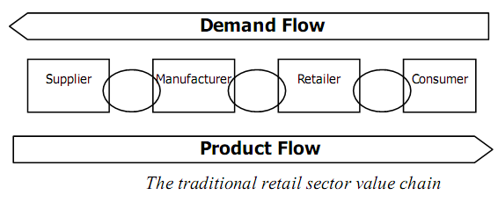

Figure 1

Different inventory systems are suitable for different stores. Apart from inventory systems in the store the distribution network is also important (see Figure 1). According to Hopp and Wallance, supply chains can be called the chain of interconnected actions in charge for the flow of supplies from the points of supply of raw materials to the delivery of finished products to the consumers. Also profitability, if not survivability has seen to be directly linked to how well a store is run and administered.

TRENDS IN RETAIL STORE PRACTICE (Industry Analysis)

Retail Store Practices – Global Perspective

Retailing is a focused marketing endeavor. It encompasses all business activities concerned with the sale of goods and services, directly to the final consumer for personal, family, household or non-business use. Retailing is the very last stage in a channel of distribution. The ultimate objective of all marketing activities is to get to the ultimate consumer with the product he needs at the right time and at the price which suits him. (Jacobsen,2007).

For many years, in the old times, most goods were sold in market places or by peddling. In Pakistan, India, Africa and most of the developing countries including South and Latin America, hawkers still walk around the streets of cities and towns carrying their merchandise, on a cycle or motor cycle from street to street or village to village. Even, in most developed countries peddlers are still seen selling their wares.

It is a normal spectacle in Pakistani cities, towns and villages that vendors sell all kinds of day to day consumer goods and services either on bicycles, tricycles, or on animal driven carts. The commodities range from cloth to pots and pans and milk to meat and eggs. These vendors are not limited to products but also sell services. The popular ones include hairdressers, knife & scissors repairers and sharpeners, plumbers which are usually seen on bicycles. The product or service remains the same and the only advancement is in the mode of transport. For example, milkmen and postmen have switched from walking to riding a bicycle and from using a bicycle to riding a motorcycle. Some of them are even using motor carriers these days. Despite the presence of door to door vendor or sellers the market place still remains the prime form of retail selling.

Jacobsen (2007) says that the history of chain retail stores is known to have been functioning in China a number of centuries before Christ. Chain stores, as they are known in much of the world today, are however generally believed to begin from the founding of the Great Atlantic and Pacific Tea Company (A&P) in New York City in 1859.

The prototype or model of present day departmental stores was present in Japan as early as the 17th century. The horse-drawn buses encouraged the growth of central business districts and allowed departmental stores to appear in the western world. "Au Bon March" in Paris made from a big specialty-store to a retail store in the year 1860.

However, Small independent retailers, still form the majority of retailers in all countries of the world. Till the disintegration of the USSR, most retail stores in all the communist countries were nationalized and still remain so in most countries. However in some countries, particularly Central Asian States, the trend is gradually changing. Now the emergence of self-owned and privately owned retail stores is encouraged are coming up.

Supermarkets started to develop in the United States in 1930s when Michael Cullin opened the first unit of what eventually became the King Kullen chain of super markets. Consumer cooperatives are retail stores are designed in such a way that they are owned and operated by consumers for their mutual benefit. Most cooperatives adopt the principles and philosophy of the first cooperative store established in Rochelle, England in 1954.

The three major types of non-store retailers are catalog houses, itinerant (roving) retailers and vending machines operators. The largest catalog houses in the world are Sears, Roebuck & company and Montgomery Ward & company. These were founded in the United States during the second half of the 19th century. Following World War II, mail order specialists grew speedily in highly industrialized regions. (Jacobsen,2007).

Many types of retail outlets each fulfilling a particular rationale in the distributive process can be identified. The retailer reaches the customer in one or more of following four methods:

a. Through stores
b. House to house selling
c. Through mail
d. Automatic Vending machines

It is the kind and variety of merchandise, which determine the type of organization of retail stores. The distinctions are as under:

a. Small retailer and small chains
b. The large chain or multiple
c. The department store
d. The cooperative store
e. The mail order
f. Automatic vending machines

To do a good job, which means the complete and entire satisfaction of customers and running a profitable business, the retailer must perform many important functions. Some of the functions are:

a. Appropriate choice of locating and layout
b. Intelligent selection of merchandise
c. Selection of the sources of supply
d. Timing the availability of goods and services
e. Recruitment, training and motivation of sale personnel
f. Making most efficient use of capital and other resources
g. Planning and control of promotional campaigns
h. Maintaining proper records
i. Management of credit business
j. Handling complaints
k. Handling purchases and sales returns
l. Improving customer relations
m. Developing inventory control techniques

Retail Store Practices in Pakistan:
Retailing in Pakistan, and for that matter in most of the developing nations, has conventionally been on a small scale. It was primarily meant for small and less or uneducated entrepreneurs. Till the late sixties, large scale retailing institutions like Super Markets, Departmental Stores and Discount Houses were not seen in Pakistan. (Durrani, 2002)

However, utility stores and canteen stores, a type of mini supermarkets, are functioning in Pakistan since the time of independence. But these stores were mutual benefit stores for the service of government officers and defense services personnel. Durrani (2002) says in the late sixties a super market chain with the name of COOP stores was introduced in the city of Lahore. The CSD still remains a mutual benefit store but utility stores have been opened up for the general public. The chain of COOP store was later taken over by Utility Stores Corporation of Pakistan.

In the countryside or rural areas of Pakistan, retailing practices still follow the same traditional "Hutti system. This means small shops which supply very essential daily use items to the villagers from available stores. These days almost all grocery items, cosmetics, ghee and oil, and other necessary things including shelf medicines are offered at hutties. This trend has changed as till the late sixties very limited items could be procured from these hutties.

Durrani (2002) says that in the metropolitan or urban areas of Pakistan, almost all kinds and types of outlets exist. The introduction of sector wise planned markets in the newly designed modern city of Islamabad the capital, gave new dimensions to modern retailing in Pakistan. Thereafter almost in all other cities and new towns of Pakistan, where ever a new residential area had to be developed, special emphasis was given to plan proper retail markets. The major types of retail urban outlets are:

Small Retailers:
These are very similar to hutties found in the countryside of the country. Normally these sorts of stores are located in the suburbs of the cities and towns and take care of the demands and necessities of the people living in that area.

Large Retailers/Wholesale Retail Stores:
These are not many in number as compared to the small retail stores. In Karachi, these are the kinds of stores which were originally found in the areas of Jodia Bazaar and Joona Market only. Almost all the retailers in the city used to gather supplies from them till mid seventies. However, with the development of the city these types of stores were opened in the areas of Liaqatabad (Lalukhet), Nazimabad, Landhi, Malir Colony, Shah Faisal Colony, New Karachi, North Karachi, Korangi, Orangi, Federal B area (Water Pump) and North Nazimabad.

Department Stores:
A department store is a large retailer employing approximately 25 or more people and usually selling a wide-ranging line of clothing for the family, household linens and dry goods and furniture, home appliances, radios, and televisions. It is organized into separate departments for purpose of buying, promotion, service and control.

In Pakistan, we do have department stores, but these stores do not qualify for discussion under large scale retailing. The people who handle these stores are generally the owners or family members of the owners who run the stores without any training or formal education. However, with the time more and more literate people are entering the retail business.

Super Markets:
A supermarket is a departmentalized food store. Pakistan entered the super market era at a time when some western European countries were moving from super market to Hypermarkets. Pakistan’s first supermarket was opened at Karachi in 1968. After this time quite a few of them have opened up, but most of these are more like mini super markets rather than full fledged supermarkets with wide variety of intensive and extensive product mix. Even food items like meat, chicken, fresh fruits and vegetables, are not available with many of them.

Street Vendors/Vending Machines:
Door to door selling is a very common in Pakistan. Sales of products and services by street vendors ranges from milk, bakery items, fish, vegetables, fruits, clothes and garments, crockery, linen, Sauces and pickles and other traditional special homemade eatables. Services that are provided door to door are haircutting, gardening, house-making & cleaning, plumbing and tailoring services.

At times, the sellers book orders by showing samples but that is not done every often. Usually credit facilities are not provided by door to door vendors; although at times depending on the relations, credit is given by the salesperson for a limited time period. The milkman and the newspaper suppliers and at times even the vegetable vendors give monthly bills therefore in some cases a month's credit is provided to customers.

To date, cities like Islamabad, Karachi and Lahore operative vending machines. These machines are usually attended by a salesperson, thus the element of self service is not present.

Utility Stores:
Initially, utility stores were opened to provide goods on subsidized prices to government servants only. However, later to ensure regular provision of essential commodities to general public at reasonable prices, the doors of utilities stores were opened for commoners too. Utilities stores stock and sell daily use items at lower prices compared to general market. According to Ghani (1996), the utility stores corporation of Pakistan, a government controlled autonomous body is a limited company and has several hundred branches all over the country. As per reported figures, the corporation by now has a chain of about 1000 stores, which are located in all major cities and towns.

Cooperative Stores:
These kinds of stores have not been very successful in Pakistan. Examples of such stores are PIA coop store and a few others. The COOP was started in the 1960s in Lahore, which has now been taken over by utility stores corporation. The downfall of such stores is due to disinterest of the members and a lack of education, training and knowledge on the part of the store operators or retailers.

Jumma/Mangal/Itwar Bazaars:
The foundation of these Bazaars can be described as a step towards consumerism in Pakistan. In these markets (bazaars) all everyday use projects are offered. Such bazaars can also be called discount houses as they claim that the merchandise is available at much cheaper prices. This is because there is no wholesaler or middle person involved in this process and the suppliers sell directly consumer. (Ghani, 1996)
The drawback of these weekly markets is that people usually complain that they sell sub standard or low quality products at lower prices. Although this fact cannot be completely denied, it can be seen that these market places have to pay very nominal rents and license fee to the government. They save the high overheads and rents that other retailers have to pay which makes them cheaper.

Inventory management in Pakistan:

    - Inventory reordering and Recording:
The process of reordering a product starts at the salesman level. On finding a shelf half depleted, the salesman checks the inventory for that product in the stock room. If there is nothing stored, he writes a purchase order which is then given to the to the department head. The department head gathers all such orders from his department and gives them to the store purchaser. The store purchaser then groups all purchase orders from various departments into 'Store' and 'Market' purchases. Store purchases are conducted via telephone and are delivered directly to the store by the manufacturer, while market purchases are made by a market purchaser. Clever purchases of this team results in high profit items being purchased. (Durrani, 2002)

Inventory Process:
Purchase documentation is handled by the accounts staff. When a purchase batch reaches the store, it is checked against the invoice. Supplies received from local suppliers are returned if found damaged, but defected imported items have to be thrown away and the loss borne. Pricing and labeling of price tags is down in a back room and the products are stored in a stock room with only a part of the items displayed in shelves.

Inventory checks:
These are done on an annual basis except for high cost products which are checked on a regular basis. Despite these annual inventory checks some of the stock is unaccounted for. The salespeople do the job of security cameras and keep a vigilant eye on customers to prevent shoplifting.

Inventory Control:
In 1996, Ghani said that the criteria for promotions and discounts on particular products are on the basis of the approaching expiry dates, especially if there is a large amount already in stock. Sometimes the store is stuck with merchandise due to changes in fashion or trends. Such slow moving items are displayed or placed in such a manner on shelves or windows so that they attract the attention of customers. There is, however, no standard system to check the amount of sales of a particular product.
Computers are not usually used for inventory management even in the large retail stores. Instead hand written receipts are given to customers a copy is kept for the stores own record. This is due to the fact that retailers are not very literate and are comfortable in their own ways plus they are happy with their clientele.
Globalization has many implications, but one the most important ones is modern retailing or the emergence up of supermarkets. Starting in the 1990s, there has been an extraordinary growth of supermarkets in developing countries (Reardon and Berdegue, 2006). A key factor in this rapid growth has been FDI. The dominant players in FDI are five companies, Carrefour, Wal-Mart, Ahold, Metro and Tesco, which together have $600 billion in sales. Out of these, Metro already has supermarkets in Karachi, Lahore and Islamabad, and Carrefour has recently been opened up in Lahore. These global players not only plan to spread out their retailing activities in the developing countries, but also amalgamate these countries into their global supply chain.
According to Gronow and Warde, (2002) the increase in supermarkets has taken place in waves. India is a third-wave country with the process starting in 2004 and Pakistan seems to be part of the fourth emerging wave. In the second-wave countries, the supermarkets’ share of the retail market went from 5-10% in 1990 to 30-50% in early 2000s (ibid). Figure 2, which plots the share of supermarkets in retail food against the level income of a country, shows that the share rises very sharply between incomes of 2000 and 5000 Purchasing Power Parity (PPP) dollars. Pakistan’s per capita GDP today is around 2500 PPP dollars and on that basis, according to the fitted curve, supermarkets should account for about 20% of the retail food trade, but currently their share in Pakistan is almost negligible. What that means is that once supermarkets begin to increase in Pakistan, their share will expand quickly and one can expect that by 2015 supermarkets will be major players in the retail market in the country.
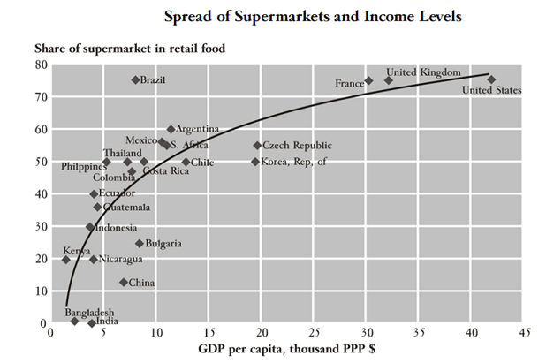

Figure 2

Major Industry Players:

The Pakistani retail sector has been grown over the last five years. With respect to geographical expansion, Islamabad/Rawalpindi, Karachi and Lahore are considered the main regions as the top companies have rated the spending potential of consumers in these areas. Companies like the HKB, Al-Fata, Metro etc have shown the way for other to enter.

Western Retail Stores
- Metro Cash & Carry:
METRO Cash & Carry is a global self-service wholesale retailer. It functions all over Europe and in few countries of Asia and Northern Africa. METRO Cash & Carry is dissimilar from other retail stores like Walmart, Carrefour or Tesco in that its business idea is more towards expert consumers rather than end consumers.

The cash-and-carry model is all about self-service and mass purchasing. Core consumer groups are hotels, restaurants, caterers, traders and other business professionals. METRO is now functioning in Pakistan as well and total 5 branches. It is running its branches in Lahore, Islamabad, Faisalabad and Karachi.

- WAL-MART
Wal-Mart superstore is an American company that has a chain of huge, discount retail stores. It is the world's biggest company with respect to income (2008 Fortune Global 500). It is the largest private company and the biggest retail store in the US. Moreover it possesses and runs the Sam's Club warehouses in North America.
It functions in Mexico as Walmex, in the UK as Asda and in India as Best Price. Wal-Mart's started its business outside North America and had varied results: its functions in the UK, South America and China are extremely successful, while it had to finish it operations from Germany and South Korea when businesses there were failed.
- TARGET
Target stores are offering lots of stuff to its customers including clothing, shoes, ornaments, beauty products, electronics, bedcovers kitchen equipments, sport goods, toys, pet supplies and hardware supplies. They also hold goods according to season and festivals such as patio furniture in summer and Christmas ornaments in November and December. Numerous stores might also have Target Optical, a studio, and a garden center and mainly all new places made after 2004 have Target Photoshop, Pharmacy, and Coffee-shop, besides "Food Avenue".

The initial Target stores had leased shops as well as wide range of goods, which after a passage of time was a common practice by all retail stores as they attempted to provide a one-stop-shop facility to consumers.

- SHOPKO
The SHOPKO runs 135 retail-stores situated in thirteen states big cities include Northern California, Michigan's Upper Peninsula, Nebraska, Utah, Washington, and Wisconsin. These retail-stores are situated in small to mid-sized societies and have multi-department functions. Shopko, with corporation from Green Bay, Bellin Health and some domestic hospitals, also functions walk-in hospitals within their retail-stores known as FastCare. Majority of Shopko retail-stores are situated in strip centers, shopping centers, or freestanding places.

Pakistani Retail Stores
- COSMO:
Cosmo is one of the Pakistan’s biggest countrywide one-stop shopping store; offering the customers with more range of goods while simultaneously making sure that they earn more, thriving to do more each day.

COSMO takes care of huge range of consumers, which comprise of: Wholesalers, persons, superstore chains, one unit retailers, restaurants/hotels. Cosmo’s clientele might choose their products in the amount they require either for cash or non-cash; offering clients with greatest possible flexibility so that the clients might instantly transport it all back to wherever it is needed. All product groups are given on a permanent basis and in different amount, large or small, based on whatever the customer wishes to buy. The product variety includes:
- Food Products.
- Bakery.
- Fresh Fruits and Vegetables.
- Frozen Food.
- Household Goods.
- Cosmetics and Toiletries.
- Electricals.
- Stationery.
- Sports Goods.

- HKB:
HKB stands for Haji. Karim Buksh (Pvt) Ltd and started its operations in 1952 with the honor of being the first retail store of the Lahore city. The HKB retail-stores have two main retail-stores and both of these big retail-stores are operating in Pakistan’s cultural capital, Lahore. HKB has more than 400 devoted team members; it benefits from the faith and confidence of over 7 million consumers yearly. These retail-stores have many departments like:
  - Branded items.
  - Groceries.
  - Cosmetics.
  - Fabrics.
  - Garments.
  - Toys.
  - House Hold items.
  - Crockery.
  - Traveling Goods.
  - Gifts section.

- ARY Cash & Carry:
ARY Cash N Carry provides a unique way of shopping; it offers its customer with comfort of quality branded products with reasonable price. ARY Members can take advantage of Rewards Program by utilizing their Sahulat Card and this might help the members to change their spending into earning. Their New Rewards Program is yet another charming offer which will make people spend more. This program gives an opportunity of saving supreme gift items from ARY Stores, and can participate in ARY shows, concerts, mega events and much more. ARY Cash N Carry provides its customer the facility to shop from debit or credit card. With the help of these cards customers can avail the following facilities:

- Shop at Cash n Carry Stores.
- ARY Jewelers.
- Merchant outlets.
- Pay your Utility Bills.
- Buy Air Blue tickets.
- Buy GSM Prepaid e-pins.

RETAILSTORE OPERATION

Many changes have taken place in retailing sector in the last 55 years. In 1912, the Atlantic and Pacific Tea Company made the first large group of "economy stores" based on cash-and-carry technique and depending for their profit on quick revenue at low markup. In 1916, Clarence Saunders made the first "self-service" grocery store. Both of these developments significantly affected retailing sector, but neither could be described as a revolution in itself. (Jacobsen, 2007)

The supermarket idea was successful from the start. Consumer acceptance of packaged and branded products aided the improvement of self-service merchandising. The extensive use of the vehicles and better roads extended the superstore trading area, thus increasing purchaser traffic and giving the volume required for successful operation. The big swing to superstore operation started in 1946.

Modern Retail Store:

Today's retail stores symbolize the last word in modernization of the nation's largest industry--the food industry. It is housed in a modern building designed particularly for retailing purpose, along with parking lot. Buyers coming in the stores go through an automatic door which opens "magically" without physical effort, or through the newer air curtain door. The interior of the store, including fixtures, has a light decor. Low gondolas and broad, spacious aisles create all parts of the store easily accessible. (Boyer, 2006)

Electrical and refrigerated equipment has been set up for the ease of consumers and the preservation and presentation of different frozen products such as meat cases, dairy cases, K&Ns, Ice-cream, Drinks cases and so on. Frozen food cases are there to fulfill the changing style of food retailing which is going through the cycle from fresh and canned foods to convenience foods which contain frozen vegetables, fruits, juices, dinners and so on. Fluorescent fighting and spot lights are used to light up the store to a pleasant brightness and enhance the products appeal.

There is no refusal that each passing year discovers the retail stores more deserving of the title, "one-stop shopping center." Not only the amount of items is increased but also the kinds of items have been added to provide more variety of items to their customers. Some of the retail stores are presenting an entire retail store stock, while others offer selected products to attract potential customers.

Customer Services

The major role performed by a retail store is the delivering of goods and services to potential customers. Customer services are defined as all the things a retail store does, deliberately or un-deliberately, which passes on value, ease, happiness or pleasure to customers. The key competitive methods of the early retail stores were lower prices and bigger product range. Today, with increased rivalry between retail stores, prices have reached a leveling point. Other factors are becoming more significant as a means of encouraging buyers to select one store over another. Many retail stores came to know that superior customer services are very important feature of this new competition.

Nature of Customer Services

Customer services consist of innovations for instance the setting up of air curtain doors; simple courtesies like thanking buyers on their way out of the store. Customer services might be appreciated and acknowledged by customers such as providing shopping carts. Customer services might be intangible somewhat expressed as "good will," or it can be as tangible as air-conditioning and a parking lot.

Objective of Customer Services
Each customer service must make customer shopping tour less boring and more pleasant. The wish on the part of food companies is to provide their customers a more amusing place to shop is not completely altruistic in nature. Customers who get pleasure from their shopping tours might be encouraged to visit a particular retail store more often and spend more time in each visit, resulting in more sales.

Types of Customer Services
Lots of customer services are offered in retail stores nowadays, but no single retail store is giving all the customer services being offered by the industry. Each retail store offers the types of facilities to their customer which its management thinks are reasonable and are necessary to attract potential customer.

Retail Store Special Features

The customers are mostly interested in the physical features of the modern retail stores which are as follows:

- Parking lots.
- Cleanliness.
- Lighting and color.
- Air conditioning.
- Music.
- Rest rooms and lounges.
- Store layout and fixtures.

Parking Lots:
Retail stores operators now introduced the adequate parking facilities. The old fashioned grocery stores were constructed in the jam-packed areas or in the middle of city. Previously most of the customers live near these stores and therefore, parking facilities were not considered a necessary customer service. But now the conditions and circumstances have changed. Customers buy grocery items once a week or month for major purchases thus making the parking lot a major factor since most customers are not capable to carry their luggage to their home because they live far enough and hence has to use automobiles to shop. Therefore, sufficient parking facilities are one of the most essential and desirable services a supermarket can offer to its customers.

Cleanliness:
The old saying is “cleanliness is next to Godliness” is as true today as ever, particularly where food is under consideration. Parking lot and the outside of the building, including the entry/exit door of a store should also remain clean. Often the least attractive place in retail store is the entrance where that very first image is formed. The cleanliness and personal hygiene of the stores' staff is just as important as the cleanliness of the selling spot.

Lighting and Color:
Even though lighting and color have always been used in retail stores but now this service is considered very important. Improved lighting facilities give today's retailers and customers with better clarification, less glare, and a better allocation of light, thus making the products more gorgeous.

Air-Conditioning:
Air-conditioning was always considered to be a luxury item. But soon retail stores came to realize that the loss of sales amount and increased spoilage of unpreserved foods items during summer seasons are resulting from lack of air-conditioning. As a result, air-conditioning is now standard equipment in retail stores.

Automatic Doors:
Opening and closing the door for every shopper is a courtesy and a service. The customer feels please by knowing that somebody is there for him/her every time he/she goes in and leaves the store. This service is specially loved by the customer who has lots of groceries. Nowadays most shoppers have an image that the retail stores have automatic doors and they are surprised when they couldn’t find it. The ease of entering and exiting makes a positive store image.

Music:
Lots of retail stores offer slight continuous background music designed to create shopping more pleasant and maybe to help detract concentration from the total price of a shopping cart full of goods. Carefully chosen melody proves very successful in making an enjoyable, comfortable ambiance in which to shop.

Rest Rooms and Lounges:
Two fairly new features are the setting up of rest rooms and lounges in retail stores for customers' convenience. Many customers feel that rest rooms are important service which is very much cherished by customers, particularly those who bring children with them.

Store Layout:
Many customer services are first designed on the drawing boards of the designers, architects, and layout experts who plan the retail store. These experts know that management has to be aware of the expenditure incurred in constructing a retail store. Within this agenda, however, the whole thing is prepared to offer the customer with the most up-to-date and comfortable structure as much as possible.

Shopping Carts:
Shopping carts are also very important in operating a modern retail stores as the majority of customers purchase far more products than they are able to carry in their arms or in hand baskets. Also shopping carts are also used by customers to carry their purchased items to their vehicles, thus reducing the amount of carry-out service needed.

Courtesy:

Courtesy booths are found to be a big advantage for super market operators. For handling of customer services these booths are kept inside the supermarkets. Courtesy booths are used for the following purposes:

- Handle bottle returns
- Cash checks.
- Redeem coupons.
- Handle return merchandise and customer complaints.

Check Cashing:
For any supermarket operation check cashing has become an important part. The traveler’s checks, government checks, personal checks and payroll checks are cashed by supermarkets operators. In many countries a supermarket works like a medium bank in many ways. The heavy use of this facility exceeds sales volume. Some chains in England handles hundred thousand checks a year, because of the heavy use of these some companies say that there should be fee on each collection. Because of the bad checks and interest the companies consider it an expensive service. On the basis of earning 1.3 per cent net profit, a store would have to sell $2,300 worth of merchandise to make up for the loss on a $30 bad check. Some companies use protective devices to avoid the bad checks. Customers have to pay a ten cent charge on each check. But in some areas this service has been discontinued and not been widely used. Though it costs seven cents to handle each check but it’s not worth the customer satisfaction. Customers spend more money where they have this facility. This facility drives the customers to buy something in the store even when the purpose for coming to the store is to cash the check. A few supermarket operators have made preparations with employers with large payrolls located near their stores to take the checks directly to the company and receive one check for the total. It reduces the check cashing fee for store as well as for the employers. This facility is now a highly desirable for all the customers. (Axtman, 2006)

Redeeming Coupons:
Redeeming coupons are premium offers made to gain consumer support. The major problem in this procedure is the slow time management. The Grocery Manufacturers of America has conducted a study of the cost to retailers of handling coupons. Overall cost per coupon ranged from 1.2 to 2.7 cents depending on the wage rate. For promotion it is a healthy activity as they force consumers to buy coupon items. Coupons will continue to be a prime promotional trick as the consumer redemption rate remains high. (Tortola,2005)

Merchandise Return and Customer Complaints:
Handling the customer complaints is not an easy task. The person who is handling this must avoid the strict behavior and should not adopt the irritating response. For customer good-will this method of handling customer complaints plays an important role. If the customer is irritated, they will no longer shop in the store so there is little to be gained by making an adjustment at this point. If a person wants to improve his or her store image they should be courteous and efficient.

Miscellaneous Services:
Some other services can be added to gain the customer loyalty such as collecting utility bills, film developing and day cares. These customer services play an important role in creation of profits.

Merchandising Services:

For the betterment of customer services the retailers plan the merchandising activity. It is designed to implement the presentation of goods to consumers. Factors that play an important role in it are:

- Price
- Displays
- Grouping of related items
- Quality
- Variety
- Special promotions

Price:
Often consumer prefers those stores which offer low prices as compare to others. The retailers should not offer low prices at every item.

Displays:
Special displays promote a store personality, likely to break the shopping repetitiveness, and are an effective force in selling merchandise. There are different types of displays, among these shelf display and mass display are important.

Grouping of Related Items:
Customers appreciate any assistant which the retailer offers them in locating merchandise: grouping all cake mixes together, grouping all the products of one company, or grouping related items such as cake and frosting mixes in the same display. The grouping should be logical for the customers as they appreciate if the retailer has done it in a good manner.

Quality:
The most important thing in retailing is the quality, for which the retailer should not compromise. They can lose their customers if any mishaps found in it. To be effective, the merchandiser must at all time offer the consumer a "value," i.e., the merchandise must be in line with the price a good value for the money. (Hagen,2002)

Variety:
In addition to self-service merchandise methods, the modern supermarket offers its customers a large variety of items. One-stop shopping is an appreciated convenience.

Special Promotions:
For development of sales the retailers can offer many promotions that can be carried on within the supermarket. A special promotion may be a simple weekend traffic builder, a seasonal promotion, a manufacturer's promotion, or promotions designed to introduce a new store to the community.

Aids for Locating Merchandise:
Locating a specific item is a major headache for customers. This psychological effect can be reduced by indicating the proper signs. An important customer aid is a well-trained and courteous staff willing to help customers in a friendly and intelligent manner.

CHECKOUT SERVICES

Checkout services are considered as an important operation in retail industry. A minor mistake at the checkout can finish all the efforts that have been put into satisfying a customer throughout the store. Customers don’t want to wait at this point. Zukin(2004) says that surveys have shown that the check stand is the customer's greatest source of dissatisfaction in spite of the fact that more thought, careful planning and effort have gone into the check stands than almost any other part of the store.

Currently the trend is toward fewer check stands more fully staff; thereby economizing on space, and eliminating one of the customer's greatest disturbances: standing in line while check stands are idle. In some supermarkets as many as six employees per check stand are used during peak period--bask art unloaded, cashier, change maker, two baggers, and a carry-out boy. The use of additional people adds little speed and increases the cost. (Hagen,2002)

Many factors help to make the checkout operation of the modern supermarket more efficient and faster. The main factors are:

- System.
- Trained employees
- Express checkout lanes

System:
The customer's entire shopping trip should be made as comfortable as possible. Buying merchandise in a modern store may be pleasant, but paying the bill is not. Large amounts of cash, coupons, trading stamps, and merchandise must be handled in checkout operations; the objective is to provide customers with the quickest service possible.

Trained Employees:
Trained personnel show the efficient checkout operations. The better the training given employees of a supermarket, the better they will be able to service the customers. This is especially true in regard to checkout operations where dexterity and courtesy are essential. Managers, assistant managers, and head cashiers should be trained to supervise the checkout operations. They should be trained to spot defects and make adjustments before they become serious. These responsible people should know when to open additional check stands, when to add bag-boys, and how to take additional measures to prevent the checkout lines from becoming long.

Express Checkout Lanes:
Some retail stores provide express checkout lanes for the use of customers who purchase a small number of items during rush period.

IDENTIFICATION OF ISSUES

In this study the analysis was carried out using the Statistical Package for Social Sciences (SPSS version 13.0), which was used to analyze both quantitative and qualitative data. Among its many features few of them are: modules for statistical data analysis, including descriptive statistics such as plot, frequencies, charts, and categorical data analysis. SPSS was used in this project because it is a well suited tool to analyze survey researches. In order to ensure statistically reliable results, a questionnaire was distributed among Customers of different retail stores to gain knowledge on their thoughts and attitudes towards different retail practices and to assess the way headed for better quality services aimed at higher performance.

- Current Stores in Pakistan have modern looking equipment and fixtures along with visually appealing facilities.

Table 1
Sample Size N= 50

Total | No | Yes
100% | 60% | 40%

Figure 3
Figures in table 1.1 prove that of the 50 sampled respondents, 40% think that the current Pakistani stores have modern looking equipment and fixtures along with visually appealing facilities. 60% of them think that Pakistani stores are not visually appealing. This confirms that because of changing trend in customer shopping habits the customer’s requirements for stores physical appearance is also changing.

- Pakistani Store Layout makes it easy for the customers to find what they need.

Table 2
N=50
Total | No | Yes
100% | 68% | 32%

Figure 4
Out of 50 respondents, 68% of the respondents find it difficult to locate things in the superstores of Pakistan and only 32% respondents can easily find the things in large superstores. The result confirmed that majority of the customers are not happy with the current Pakistani store layouts because the layouts make it difficult to find things what they are looking for in large retail stores.

- Pakistani Superstores employees are very helpful and have all the skills and knowledge to satisfy their customers.

Table 3
N= 50
Total | No | Yes
100% | 60% | 40%

Figure 5
Employees of retail stores are there to guide the customers. They are there to help the customers to find their required items and try to respond to their queries as soon as possible. Out of 50 respondents 60% of the customers are not satisfied with the employee’s attitudes, skills and knowledge in Pakistani retail stores and only 40% are satisfied.

- Pakistani store give major facilities to their customers like credit cards etc

Table 4
N= 50
Total | No | Yes
100% | 56% | 44%

Figure 6
Of the 50 sampled respondents, the result revealed that 44 agree that the Pakistani Retail stores are providing adequate facilities to their customers such as different types of credit cards, Return/Exchange policies and so on. 56% of the respondents totally disagree with this. They think that the current system of Pakistani retail store needs to be improved and should provide additional facilities.

- Exterior Facility
Table 5
N = 50
Maximum = 5
Facilities | Mean
Window Displays | 3.08
Parking Lots | 3.68
Spacious Entrance | 2.64
Surrounding Stores | 2.8
Congestion | 2.72

Figure 7

Customers were asked to rank different types of exterior facilities from being the most important to least important, where 1 represent least important and 5 represent most important. The above graph shows that most of the customers perceive Parking lot facility to be the most important type of exterior facilities. In contrast, Spacious Entrance is not considered that important as compared to other types of facilities. The reason might be, because this research is carried out in the retail sector of Pakistan and mostly people face car parking problems.

- Preferred General Interior

Table 6
N = 50
Maximum = 10

Facilities | Mean
Store Maps | 3.92
Product & Price Displays | 5.72
Scents Or Odors | 4.48
Cleanliness | 5.72
Rest Rooms & Lounges | 6.04
New Technology | 5.4
Music | 5.76
Wide Aisle Width | 5.08
Lightning | 6.12
Ac/Heating | 6.76

Figure 8

Customers were asked to rank different types of interior facilities from being the most important to least important, where 1 represent least important and 10 represent most important. The above graph shows that most of the customers perceive Air conditioning and heating facility to be the most important type of Interior facilities. In contrast, Store Maps is not considered that important as compared to other types of facilities. The reason might be, because Pakistani customers want a relaxing and comfortable environment while shopping. Most of Pakistani customers don’t like to read maps they want a sale person to assist them if they find any problem.

- Preferred Facilities of Store Layout:

Table 7
N = 50
Maximum = 10

Facilities | Mean
Directional Signs | 5.16
Labeling and Packaging Methods | 6.8
Waiting Queues | 7.24
Grouping of Products | 6.36
Promotional Displays | 5.04
Price identification Tech | 4.96
Waiting Areas | 5.88
Departments Arrangement | 4.48
Cash register Placement | 2.84
Product Placement | 6.2

Figure 9
Customers were asked to rank different types of layout facilities from being the most important to least important, where 1 represent least important and 10 represent most important. The above graph shows that most of the customers perceive Waiting Queues facility to be the most important type of store layout facilities. In contrast, Cash register is not considered that important as compared to other types of facilities. The reason might be, because customers having less than 10 items have to stand in the same row as those of having 50 plus items. So customers having less than 10 items have to wait longer for their turn and hence might get frustrated. They wish to have another counter for customers purchasing less than 10 items.

- Preferred Other Dimensions:

Table 8
N = 50
Maximum = 7

Facilities | Mean
Self Service | 2.44
Employee Uniform | 2.76
Trained employees | 4.8
Variety Of Products | 4.64
Crowding | 3.28
Product Quality | 5.68
Product Availability | 4.4

Figure 10

50 Customers were asked to rank different types of facilities from being the most important to least important, where 1 represent least important and 7 represent most important. The above graph shows that most of the customers ranked Product Quality to be the most important among all the other facilities. In contrast, self service is not considered that important as compared to other types of facilities. The reason might be, because customers are now well aware of the fact that most of the stores are providing inferior quality products which might be harmful. So customers are willing to pay more for high quality product.

RECOMMENDATIONS

Implications:

Customers make their buying decisions based on a numerous factors which are already discussed in “identification of issues”. Beside the price of the items, factors such as look, ease, and apparent quality determine the decisions made in the marketplace.

In light of public demand around the world it is important for marketers to understand the shopping needs and new market trends of the consumers. Those supermarkets that can best meet the needs of their customers can get the advantage and can become the largest and most affluent in the marketplace. After analyzing the market trend of Pakistani market, Following are some recommendation for retail stores who are planning to open their branches. After analyzing the customer view point it is better that they should incorporate the following practices in their retail stores.

Wider variety of products:
A supermarket should not just limit itself to being a grocery store. They should be able to offer more than just everyday grocery items. In Pakistan, supermarkets don’t even offer a complete range of grocery items. For example, Harolds offers a multitude of grocery items but does not keep fresh fruits and vegetables and meat wasn’t offered until recently either. Besides offering a complete range of grocery items supermarkets should keep different categories of products like crockery, clothes and garments, electronics and furniture and other household items. All such items would be related to a household and the customer would probably be buying these items from another store for daily use. Introducing a variety of product categories would not only be convenient for the customer as everything would be available under one roof, but also benefit the retailer as it would result in increased sales.

More services under one roof:
According to the primary research conducted through questionnaires it is seen that customers would want to have a number of services available at a supermarket. Among the most wanted one is a clean and hygienic restroom which is not optional but a necessity. People usually take a long time at a supermarket and would want to use the restroom in that time. This is especially true for children and older people. The bathroom should have modern fixtures and should be cleaned regularly. It is recommend that if it’s in a big supermarket then there should be at least one bathroom on every floor and directional signs should be present. The restrooms should be separate from the try rooms or fitting rooms where people try on the clothes they are thinking of buying.

Another service that people would desire to have in a supermarket is a pharmacy. Pharmacies are popular in Pakistan and they are not just limited to medicines but also keep cosmetics and other daily use items like soaps, toothpaste, shampoos and baby products. Some of the famous pharmacies are D Watson and Shaheen, located in Rawalpindi and Islamabad. Instead of going separately to pharmacies people would appreciate it if they are available inside a supermarket as that would save the hassle of taking out time and going to the pharmacy at another time. It is very common that one has to get some kind of daily medicines on a regular basis, E.g. vitamins or cold and flu remedies.

Yet another desirable service that people want in a supermarket is Wi-Fi. The world has become so dependent on the internet that it has become a necessity. From a supermarkets point of view, having a Wi-Fi connection would kill the time of husbands who are waiting for their wives to finish shopping and children would also be happy playing their online games on new gadgets like PSP and DSi. An internet café would also be a good idea as everyone cannot carry their laptop with them. Especially in Pakistan people are not that technologically advanced and everyone does not own their own laptops so having an internet café with desktops that have internet would also be excellent plan.

Even better result can be attained if internet café is combined with a plan where one can sit and have snacks and drinks. Supermarkets’ customers do get hungry and thirsty while shopping and would be grateful for a little refreshment. Snacks like burgers, pizza, shawarma, salads etc. would be suitable. Drinks that can be offered will be tea, coffee, milkshakes etc. The retailer would obviously benefit from this too as it would increase sales and earnings. Children can sit and eat a snack while their parents shop and also whole families can eat if lunch time comes in between their shopping spree. Another idea which would work and is also adopted by foreign supermarket chains like Wal-Mart is to have a fast food restaurant like McDonalds insides the supermarket. This would be ideal as it is so popular and would never be ignored by families, especially children. Imagine families planning their shopping trips at meal times so that they can eat at that popular fast food restaurant!

Promotional schemes
Promotion of the store as a whole as well as an individual product is essential for its success. Promotional schemes like membership loyalty cards should be offered as it makes customers part of the store’s big family and gives them some kind of incentive to shop from there. This incentive can be in the form of discounts (E.g. a 5% discount on the total bill) or points can be accumulated which can ultimately be used to buy products at the supermarket.

Beside such a scheme which would bring unity among all shoppers informing them of new items available and new promotional schemes and upcoming sales, other promotions must be incorporated to encourage buyers to purchase products. Examples of such promotions can be a buy- one-get- one-free offer, lucky draws, and special discounts on particular items on a particular day. These would motivate customers to buy as it makes the products look more attractive as it has a little something more to offer to customers.

Flexible timings:
Gradually the atmosphere is changing in Pakistan. Now it is very common for both the partners to be earning and going out to work 9-5. This change means that the supermarket timings must be changed accordingly to suit their lifestyles. If the customer is busy during the day the supermarkets must be open for a longer period of time in the evening. It is not recommend that the supermarket should be open 24/7 as there would be very little customers coming in at very late timings as security is also a major issue in Pakistan. However, it would be recommended for stores to be open till around 2 AM at night, especially on weekends. This would give busy families enough time to come and shop.

Availability and reliability:
When a customer goes to a store he or she should be confident that the products he wants are available at that store and he would not be going out to other stores in search for them. Therefore in order to make customers believe in your store it is important to always have all products available and in stock. Reliability and availability is a key to a supermarkets’ success.

Trained and friendly employees:
Supermarkets should give proper training to their employees. They should not be mere helpers who are not properly aware of their surroundings and are not very helpful. Instead employees need to be well trained; they should be familiar about every nook and corner of the store and should be courteous, friendly, welcoming and always ready to lend a hand to customers. Also, they should have proper uniforms so that they can be identified easily.

Encourage feedback:
The customers are the kings of the retail business. It’s because of them that so many superstores are doing so well. Therefore it is vital to know what they think about the services provided and what additional elements they would want to have in the store. It should be easy to give suggestions and make complaints. Suggestions and complaint boxes should be found commonly around the vicinity of the store. Also, the cashiers who are the customers’ last contact point should ask the customers if they are satisfied with the store’s current service, if anything they wanted was not available and also what improvement they would like to see there.

Improved store layout and visual appeal:
Stores in Pakistan are not visually appealing. They must be attractive enough in order to lure customers to make purchases. An improved layout with proper product displays, good category management and product grouping would motivate customers to buy more. If everything is placed properly and in order it would be easier to find things and go about the store. Not only would those products look more tempting and sales would definitely go up due to this factor. A store map and other directional signs would help customers find their way around and avoid inconvenience. Product groups like Toiletries, Drinks, and Frozen Foods should be allotted separate aisles and the labels should be clear and readable from a distance. Besides this the pricing should also be placed out in the open and easy to see to avoid any sort of uncertainty. Aisle width must also be wide enough for two customers with shopping carts to pass by easily.

Store ambiance:
The internal environment of the store should be welcoming for the customers. The lighting, scent and odor, color of the walls, cleanliness and hygiene, air conditioning or heating must all be ideal and pleasing so that customers feel relaxed and comfortable.

Store Layout:
Attracting consumers to a retail store is the job of advertiser and market researcher. Once the consumers arrived at the door, the layout of the retail store turns out to be one of the most important elements in enhancing the shopping experience for the consumer. While each retail store is distinctive, there are a few suggestions that can be applied by nearly every retail stores to improve their customers' ease.

- Decompression zone: There should be an area in-front of the entrance door where there is no product display. This area of maybe 12 or 14 feet square which is known as "decompression zone". The decompression zone helps the customers to adjust themselves to the store’s environment. The decompression zone “welcomes" the customers and helps them to have their first judgments about the retail store.

- Shopping Patterns: Aisles and walkways should be broad enough to accommodate sound foot traffic and carts. Customer service and checkout counters should be placed within the visual field of shoppers entering and exiting the retail store. The general layout should help customers to navigate the aisles with ease, placing the services they desire and need most in accessible places.

- Eye-Level Visual Appeal: Complementary color schemes for products displays, steady lighting etc can make an integrated shopping environment. Organized lines of sight can present the store a clean look as well as make it easier to detect shoplifters.

- Product Placement: Retail stores place the most money-making products at eye level and in easy reach of customers. Retail stores should alter this principle by placing slow-selling items in prominent displays to increase impulse buying. The Retail store owners should resist the temptation to stock products to the ceiling, which might overwhelm the purchaser. A better strategy is to display adequate products to let the purchaser know what is in store.

- General Ambiance: The store owners should keep a check that their store displays have not become outdated. Shopkeepers should have a close look at magazines and other media to keep their stores up-to-date. The background music which relates to the products and appeals to the customer can improve the environment of the retail store.

- Keeping the Local Scenario in mind: While it is essential to incorporate retailing methods from developed countries it is also important to keep local needs and trends in mind. Pakistan is a country with a very low literacy rate; even the big retailers usually have not had any formal higher education. Retail stores are passed on to generations and it is a common practice to make the sons of the family to sit at the shop from a very early age, acquainting them to their traditional practices. This literally means that the retailers believe there is little or no need for changes or improvements in the retail environment. This fact does not entirely on the downside. It is necessary to keep some of our traditional practices so that Pakistani customers are not alienated and remain in their comfort zone. Too much advancement would go beyond their understanding. Also, Pakistani family sizes and patterns are different from the West and other developed countries. In Pakistan people go for shopping as a whole family and the average family size is also much larger than developed countries. On top of that the trend is to live in joint families so there is more than one family living under one roof. Purchasing patterns also differ from other countries. Pakistani customers do not believe in weekend shopping as most women are only housewives and do not work. Also, in Pakistan people cook fresh food everyday and are not practical like people in advanced countries who make their food once and freeze it for the rest for the week. People in Pakistan want to have freshly cut meat and poultry, cut according to their needs unlike the West where this has to be done at home. Fruits and vegetables are also preferred fresh instead of frozen packets. Cooking and eating is a big part of the Pakistani culture and there is no compromise with the freshness of eatables. Customers like to feel and smell ingredients before buying them. This is one of the reasons why products like spices, rice, lentils and flour are still sold in open packets. Other traditional practices that must remain are the concept of helping to carry shopping bags to the car as well as providing credit facilities.

There are several types of shop layouts including free flow, grid and spine layouts. Each has its own advantages and disadvantages. One of the layouts is shown as follows and for rest see appendix 8.2.

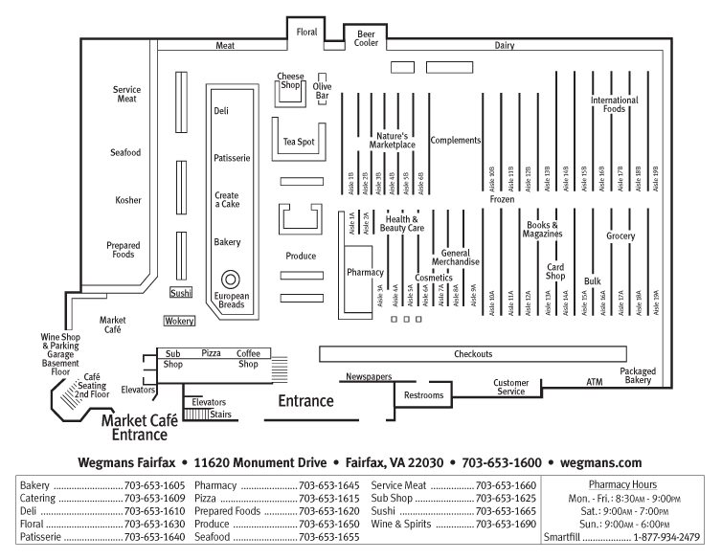

Figure 11

It is necessary to keep in mind some very important points when planning the layout of the store. Some of them are lighting, store front design, the smell and scents, color and interior design. Each of these has been discussed in detail above in this article. The point is to use the area in the best and most practical way possible while creating visual appeal for the customers. The directional and category signs must be present at the right places where they can be seen easily and provide useful information. Aisle width should be just enough for two shopping carts going in the opposite direction to pass by easily. The play area should be preferably in the beginning of the store where parents can leave their children and pick them up at the end of their shopping trip. Rest rooms must be clean, hygienic and in easy to locate locations. The coffee shop must be at the spot where customers would be tired enough to take a break and sit down and eat something. All these common sense points must be kept in mind so that the stores different departments are conveniently accessible to customers.

Conclusion

This project has summed up all the new and innovative practices that can be incorporated in the retail sector of Pakistan to give a better shopping experience. While it would be encouraged to learn from developed countries it’s advisable to keep the local scenario and trends in mind. The culture, traditions and people of Pakistan are different from any other and the practices that are to be incorporated must be suitable to the environment. There must be a balanced blend of new innovative practices and traditional practices so that full advantage of the new retailing methods can be taken without alienating the customer.

Appendixes

Good Layouts:

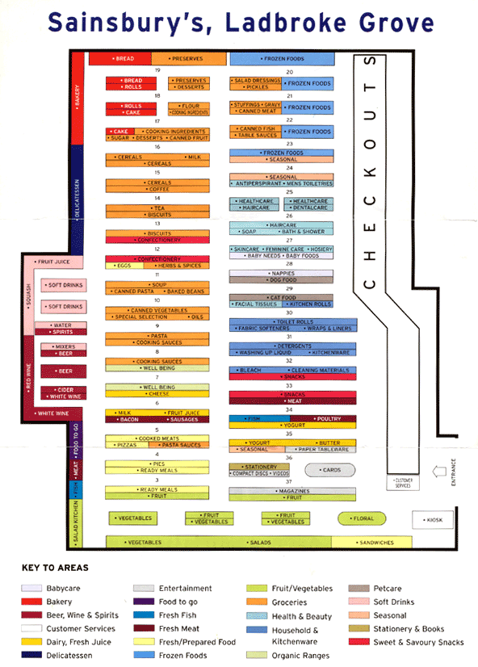
Layout No. 1:

Layout No. 2:
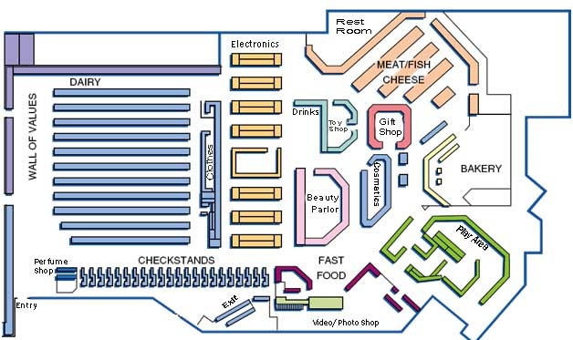

Layout No. 3:
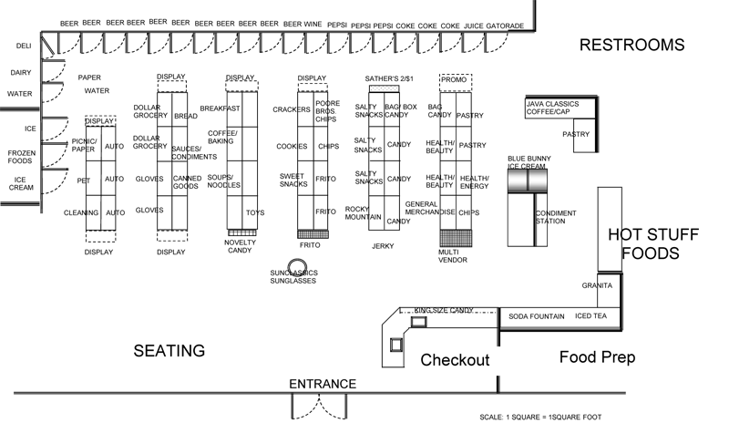

Layout No. 4:

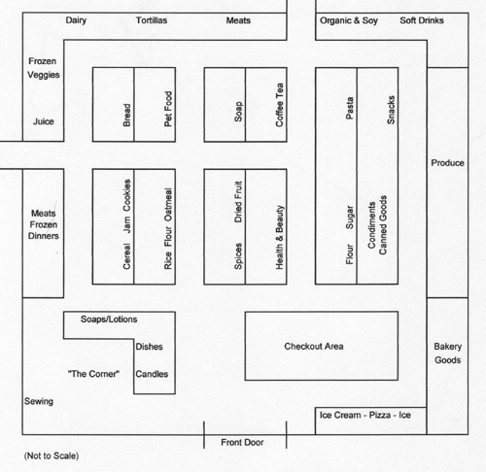

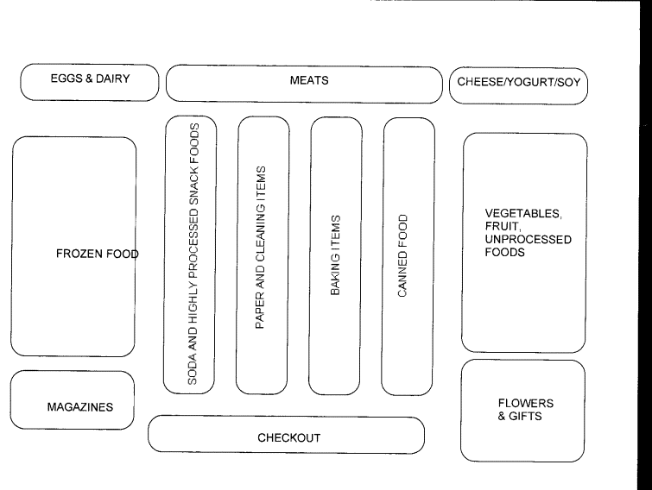
Layout No. 5:

Layout No. 6:

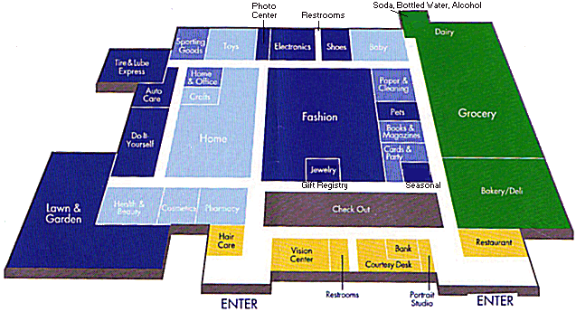

Questionnaire:

Questionnaire on Your Supermarket Experience
Please share your shopping experience in Pakistan and help us improve it by introducing new Western retail practices.

About You (optional)
Name ______________________________ Occupation_____________________________

Income Level________________________ Age_____________________
Have you ever visited any Western supermarket? □ Yes □ No

If yes, where? _________________________________________________________________

Choose The Appropriate Choices.

- If a product is out of stock in a supermarket I would substitute rather than go to another store to get it.  - I would rather shop in a large supermarket than a small supermarket.  - If small cafes were available, I would buy hot, ready-to-eat foods (e.g., pizza, chicken) in a supermarket.  - Too many products are out of stock when I shop  - The way supermarkets are laid out makes it easy to find the products I need.  - I have been buying less convenience food to cut back on my grocery spending.  - Computerized checkout scanners benefit shoppers.  - I normally buy some products on my grocery shopping trip that I hadn't planned to.  - Pakistani stores have modern-looking equipment and fixtures.  - The physical facilities at Pakistani stores are visually appealing.  - Materials associated with Pakistani stores’ service (such as shopping bags, catalogs, or statements) are visually appealing.  - The store layout makes it easy for customers to find what they need.  - This store has products available when the customers want it.  - Stores insist on error-free sales transactions and records.  - Employees in Pakistani superstores have the knowledge to answer customers' questions.  - The behavior of employees in the store instills confidence in customers.  - Employees in the store give prompt service to customers  - Employees are consistently courteous with customers.  - The Pakistani stores willingly handle returns and exchanges.  - When a customer has a problem, the stores show a sincere interest in solving it.  - The stores offer high quality products.  - The stores provide plenty of convenient parking for customers  - The stores have operating hours convenient to all their customers.  - The stores accept most major credit cards.  - The stores exchange and return policy are up to standard | □ Yes □ No  □ Yes □ No  □ Yes □ No  □ Yes □ No  □ Yes □ No  □ Yes □ No  □ Yes □ No  □ Yes □ No  □ Yes □ No  □ Yes □ No  □ Yes □ No  □ Yes □ No  □ Yes □ No  □ Yes □ No  □ Yes □ No  □ Yes □ No  □ Yes □ No  □ Yes □ No  □ Yes □ No  □ Yes □ No  □ Yes □ No  □ Yes □ No  □ Yes □ No  □ Yes □ No  □ Yes □ No

Rank the following store facilities according to preference 1 being lowest.

Exterior Facilities: (Rank in order of priority between 1 to 5)
NOTE: If window displays is most preferred then rank it 5 and please don’t use 5 again.

Window Displays
Parking Lots
Spacious Entrance
Surrounding stores
Congestion
General interior (Rank in order of priority between 1 to 10)

Air conditioning/heating
Lighting
Width of aisles
Music
Modern Technology
Rest Rooms and Lounges
Cleanliness
Scents or odors
Product and Price Displays
Store Maps.
Store layout (Rank in order of priority between 1 to 10)

Placement of products
Placement of cash register
Arrangement of departments
Waiting areas
Price Identification Techniques
Promotional Displays
Grouping of products
Waiting queues
Labeling and Packaging Methods
Directional Signs

Other Dimensions (Rank in order of priority between 1 to 7)

Self service
Employee uniforms
Trained Employees
Variety of products
Crowding
Quality of products
Availability of products

Would You Want Any Of The Following Modern Facilities In A Super Market?

- Rest Rooms □ Yes □ No
- Salon □ Yes □ No
- Photo center □ Yes □ No
- Day Care Centers □ Yes □ No
- Snack Bar □ Yes □ No
- ATM machines □ Yes □ No
- Pharmacy □ Yes □ No
- Post office □ Yes □ No
- Internet Café/ Wi-Fi □ Yes □ No
- Promotional Schemes (e.g. Lucky Draws □ Yes □ No
- Raffles, buy-one-get-one-free, gift vouchers)

Additional Comments:__________________________________________________________
___________________________________________________________________________________________________________________________________________________________

REFERENCES:

- Anselmsson, J. (2006), “Sources of customer satisfaction with shopping malls: a comparative study of different customer segments”, International Review of Retail, Distribution and Consumer Research, Vol. 16 No. 1, pp. 115-38.

- Arentze, T. and Timmermans, H. (2005), “An analysis of context and constraints-dependent shopping behavior using qualitative decision principles”, Urban Studies, Vol. 42 No. 3, pp. 435-48.

- Arentze, T., Oppewal, H. and Timmermans, H. (2005), “A multipurpose shopping trip model to assess retail agglomeration effects”, Journal of Marketing Research, Vol. 42 No. 1, pp. 109-15.

- Arne Dulsrud, Eivind Jacobsen (2007). Modern Retailing and the Meaning of Body as a Technique of Disipline. Research Conference 2007.

- Axtman, B. 2006. Ripe opportunities. Progressive Grocer 85(4)76–80.

- Berman, Barry and Evans, Joel E. (2004) Retail Management: A Strategic Approach Ninth Edition, Upper Saddle River: Pearson/Prentice Hall.

- Boyer, M. 2006.Lostin SKUs. ProgressiveGrocer85 (7)118–121.

- Creswell, J. (1994). Research design: Qualitative and quantitative approaches. London: Sage. Retrieved October 20, 2008

- Durrani, W.K. (2002), Retailing-concepts and practices, Page Annual Outlook 2002.

- Fitzmaurice, J. and Comegys, C. (2006), “Materialism and social consumption”, Journal of Marketing Theory and Practice, Vol. 14 No. 4, pp. 287-98.

- Frasquet, M., Gil, I. and Molla, A. (2001), “Shopping-centre selection modelling: a segmentation approach”, International Review of Retail, Distribution & Consumer Research, Vol. 11 No. 1, pp. 23-38.

- Galbraith, J.K. and R.H. Holton. 1965. Marketing Efficiency in Puerto Rico. Cambridge, MA: Harvard University Press.

- Ghani, Jawaid. (1996), Current Practices in Retail Inventory Management, Centre for Management and Economic Research, Lahore University of Management Sciences.

- Goldman, A. 1974. “Outreach of Consumers and the Modernization of Urban Food Retailing in Developing Countries,” Journal of Marketing, 38 (4), October: 8-16.

- Gronow, Jukka and Warde, Alan (2002) “Introduction” i Gronow, Jukka and Warde, Alan (red) Ordinary Consumption London: Routledge pp.1-9.

- Hagen M. James (2002) Causes and Consequences of Food Retailing Innovation in Developing Countries: Supermarkets in Vietnam

- Harrell, Gilbert D, Hutt, Michael D and Anderson, James C (1980) “Path Analysis of Buyer Behaviour Under Conditions of Crowding” Journal of Marketing Research, Vol.XVII (February 1980) pp.45-51.

- Holton, R.H. (1953). Marketing Structure and Economic Development. Quarterly Journal of Economics 67, August, 344-61.

- Hopp, Wallace J. and Spearman, Mark L., Factory Physics Second Edition, Irwin McGraw-Hill, New York (2001)

- Jayaratne, T. (1993). Quantitative methodology and feminist research. In M. Hammersley (Ed.), Social research: Philosophy, politics and practice (pp. 109-123). London: Sage Retrieved October 20, 2008.

- Kaltcheva, V. and Weitz, B. (2007), “When should a retailer create an exciting store environment?”, Journal of Marketing, Vol. 70, January, pp. 107-18.

- Kaufman, C. (1996), “A new look at one stop shopping: a TIMES model approach to matching store hours and shopping schedules”, Journal of Consumer Marketing, Vol. 13 No. 1, pp. 4-25.

- Mehrabian A and Russel JA (1974) An Approach to Environmental Psychology Cambridge (MA): MIT Press.

- Muhammad Wali Khan Durrani (2002) Retailing — Concepts And Practices.

- Reason, P., & Rowan, J. (1981). Human inquiry: A sourcebook of new paradigm research. Chichester: John Wiley and Sons Retrieved October 20, 2008.

- Reimers, V. and Clulow, V. (2008), “Retail centre convenience: its’ influence over consumer patronage behaviour” (in press).

- Searching for shop layouts Accessed on 12 February, 2010 Available at: www.flickr.com/photos/erixfolio/4227462080/

- Searching for shop layouts Accessed on 12 February, 2010 Available at: www.mycoldwater.com/walmart_map.gif

- Searching for shop layouts Accessed on 12 February, 2010 Available at: www.theproducewagon.com/portal/Portals/0/StoreLayout2.JPG
- Searching for shop layouts Accessed on 12 February, 2010 Available at: www.cityofsound.typepad.com/blog/images/sainsburys.gif

- Searching for shop layouts Accessed on 12 February, 2010 Available at: www.doylessheehan.com/images/store_layout.gif

- Searching for shop layouts Accessed on 12 February, 2010 Available at: www.pattymemorial.org/AutFoodGroceryStore.gif
- Steve Burt & José Carralero-Encinas (2000) The Role Of Store Image In Retail Internationalisation.

- Tortola, J. 2005. Loss leader. Progressive Grocer 84(7)14–15.

- Zukin, Sharon (2004). Point of Purchase. How Shopping Changed American Culture. New York: Routledge.

http://cityofsound.typepad.com/blog/images/sainsburys.gif

