
BSCS-S22-010
03-134191-007 | Hamza Saleem
03-134191-012 | Fahad Akram

Publisher’s Paramount

In partial fulfilment of the requirements for the degree of
Bachelor of Science in Computer Science
Supervisor: Nadeem Sarwar
Department of Computer Sciences
Bahria University, Lahore Campus
January 2023

© Bahria University, 2023

Certificate

We accept the work contained in the report titled
“Publisher’s Paramount”
Written by
Hamza Saleem
Fahad Akram
As a confirmation to the required standard for the partial fulfilment of the degree of
Bachelor of Science in Computer Science.

Approved by:
Supervisor: Nadeem Sarwar
(Signature)

January 10, 2023

DECLARATION

We hereby declare that this project report is based on our original work except for citations and quotations which have been duly acknowledged. We also declare that it has not been previously and concurrently submitted for any other degree or award at Bahria University or other institutions.

Enrolment | Name | Signature
03-134191-007 | Hamza Saleem
03-134191-012 | Fahad Akram

Date : January 10, 2023

Specially dedicated to
my beloved mother and father
(Hamza Saleem)
my beloved mother and father
(Fahad Akram)

ACKNOWLEDGEMENTS

We would like to thank everyone who had contributed to the successful completion of this project. We would like to express our gratitude to my research supervisor, Mr Nadeem Sarwar for his invaluable advice, guidance and his enormous patience throughout the development of the research.

In addition, we would also like to express my gratitude to our loving parent and friends who had helped and given me encouragement.

Hamza Saleem
Fahad Akram

Publisher’s Paramount

ABSTRACT

Journal management is a difficult and time-consuming operation, especially if no automation is used. During the publishing cycle, authors and other personnel participating in the journal management process, such as editor in chiefs, editors, reviewers and publishers, encounter plenty of issues. Finding appropriate persons to peer-review their articles is a difficulty for authors, as is the fact that they must rely on third parties to check for plagiarism.
To ensure quality during the publishing process, the author must communicate with each party separately. The author must check the title duplication of their article manually. Similarly, editors, reviewers, and publishers have similar issues, such as having to manually manage all their pending work. However, we provide a single, easy-to-use platform which will resolve all these concerns. Editors, publishers, and reviewers may all access articles for reviews, changes, and the publication process using the same features.
Project, Publisher’s Paramount uses our self-built logics and designs to automate the hectic with no productivity work and let all the personnel focus on the real job. We are using Python’s Framework, Django which is acting as the project’s main logic and for the frontend technology we are using JavaScript’s Framework ReactJs which will help the user to interact with our application.
By using our system, all the personnel including authors will have a better and consistent control over their respective jobs and they will be able to get updates easily with just click of buttons. In this way, they can easily save their time and focus on other real time situations and get the assigned job done.

TABLE OF CONTENTS

DECLARATION ii
ACKNOWLEDGEMENTS iv
ABSTRACT v
TABLE OF CONTENTS vi
LIST OF TABLES x
LIST OF FIGURES xi

CHAPTERS
1 INTRODUCTION 1
1.1 Background 1
1.2 Problem Statements 3
1.3 Aims and Objectives 3
1.4 Scope of Project 4
1.5 Optional Scope 4
2 LITERATURE REVIEW 5
2.1 Product Perspective 5
2.2 User Classes and Characteristics 5
2.2.1 Admin Panel 6
2.2.2 Editor in Chief Panel 6
2.2.3 Editor Panel 6
2.2.4 Reviewer Panel 6
2.2.5 Author Panel 7
2.3 Objectives 7
2.4 Operating Environment 7
2.5 Design and Implementation Constraints 7
2.6 Assumptions and Dependencies 8
3 DESIGN AND METHODOLOGY 9
3.1 Methodology 9
3.1.1 Requirements 10
3.1.2 Design 10
3.1.3 Implementation 17
3.1.4 Testing and Evaluation 17
3.2 Feasibility Plan 18
3.2.1 Resource Requirement 18
3.3 Risk Involved 18
3.4 Domain Model Diagram 19
3.5 Class Diagram 20
3.6 System Use Cases 21
3.6.1 Use Case Diagrams 21
3.6.2 Use Case name and Identifiers 24
3.7 Sequence Diagram 32
3.7.1 Login 32
3.7.2 Registration 32
3.7.3 Editor in Chief Panel 33
3.7.4 Editor 34
3.7.5 Reviewer 35
3.7.6 Author 35
3.8 Collaboration Diagram 36
3.8.1 Editor in Chief 36
3.8.2 Editor 37
3.8.3 Reviewer 38
3.8.4 Author 38
3.9 Entity Relationship diagram 39
3.10 Operation Contracts 40
3.10.1 Operation Contracts: Registration 40
3.10.2 Operation Contracts: Login 40
3.10.3 Operation Contracts: Submit Manuscript 40
3.10.4 Operation Contracts: Save Manuscript 41
3.10.5 Operation Contracts: Delete Manuscript 41
3.10.6 Operation Contracts: Assign Manuscript to Editor 41
3.10.7 Operation Contracts: Assign Manuscript to Reviewer 42
3.10.8 Operation Contracts: Comments on Manuscript by Reviewer 42
3.10.9 Operation Contracts: Accept/Reject Manuscript by Editor 43
4 IMPLMENTATION 44
4.1 Frontend Testing: 44
4.1.1 Cross-browser Compatibility: 44
4.1.2 End-to-End Checks: 50
4.1.3 Image analysis testing: 50
4.2 Backend Testing: 51
4.2.1 API Testing: 51
4.2.2 Load Testing: 57
5 USER MANUAL 59
5.1 User Manual 59
5.1.1 Home screen 59
5.1.2 Journal List 63
5.1.3 A-Z Journal 64
5.1.4 About Page 65
5.1.5 Sign in Page 66
5.1.6 Sign up Page 66
5.1.7 Author Dashboard Home 67
5.1.8 Author Manuscript Page 68
5.1.9 Author Submit Manuscript Page 69
5.1.10 Reviewer Dashboard Home 70
5.1.11 Reviewer Assigned Manuscript 71
5.1.12 Editor Dashboard Home 72
5.1.13 Editor Add Reviewer 72
5.1.14 Editor Manuscript 73
6 CONCLUSION AND RECOMMENDATIONS 75
6.1 Conclusion: 75
6.2 Recommendation: 75
REFERENCES 76
APPENDICE 77

LIST OF TABLES

TABLE TITLE PAGE
Table 3. 1: Registration Use Case 24
Table 3. 2: Login Use Case 25
Table 3. 3 : Manage Editor Use Case 26
Table 3. 4: Manage Editor in Chief Use Case 27
Table 3. 5: Manage Profile Use Case 28
Table 3. 6: Manage Reviewers Use Case 29
Table 3. 7: View Reviewer's Review Use Case 30
Table 3. 8 : Add Comment Use Case 31

Table 4. 1: Login API Testing Results 52
Table 4. 2: Registration API Testing Results 52
Table 4. 3: Save Manuscript API Test Result 53
Table 4. 4: Session User details API Test Result 54
Table 4. 5: Reset-Password API Test Result 55
Table 4. 6: Session user Manuscripts API Test Result 56

LIST OF FIGURES

FIGURE TITLE PAGE
Figure 1.1: Web Workflow 2

Figure 3. 1: Feature Driven Development Phases 9
Figure 3. 2: Home Screen 11
Figure 3. 3: A to Z Journals 12
Figure 3. 4: Journals List 13
Figure 3. 5: Dashboard 14
Figure 3. 6: Submit Manuscript 15
Figure 3. 7: Change Details 15
Figure 3. 8: Manuscript Page 16
Figure 3. 9: Sign in page 16
Figure 3. 10: Sign up page 17
Figure 3. 11: Domain model diagram 19
Figure 3. 12: Class diagram 20
Figure 3. 13: Admin Use Case Diagram 21
Figure 3. 14: Editor in chief use case diagram 22
Figure 3. 15: Editor Use case diagram 22
Figure 3. 16: Reviewer use case diagram 23
Figure 3. 17: Author use case diagram 23
Figure 3. 18: Log in sequence diagram 32
Figure 3. 19: Registration sequence diagram 32
Figure 3. 20: Editor in chief sequence diagram 33
Figure 3. 21: Editor Sequence diagram 34
Figure 3. 22: Reviewer sequence diagram 35
Figure 3. 23: Author sequence diagram 35
Figure 3. 24: Editor in chief collaboration diagram 36
Figure 3. 25: Editor Collaboration diagram 37
Figure 3. 26: Reviewer collaboration diagram 38
Figure 3. 27: Author collaboration diagram 38
Figure 3. 28: Entity Relationship diagram (ERD) 39

Figure 4. 1: Home screen on google 45
Figure 4. 2: Dashboard screen on google 46
Figure 4. 3: Home screen on Firefox 47
Figure 4. 4: Dashboard screen on Firefox 48
Figure 4. 5: Home screen on Microsoft edge 49
Figure 4. 6: Dashboard screen Microsoft edge 50
Figure 4. 7: Resources load time analysis on frontend 50
Figure 4. 8: Login API test 52
Figure 4. 9: Registration API test 53
Figure 4. 10: Save manuscript API test 53
Figure 4. 11: Session user details API test 54
Figure 4. 12: Reset password API test 55
Figure 4. 13: Session user manuscript API test 56
Figure 4. 14: Login response time graph 57
Figure 4. 15: Registration response time graph 57
Figure 4. 16: Manuscript data response time graph 58

Figure 5. 1: User guide home screen 59
Figure 5. 2: User guide journal by subject section 60
Figure 5. 3: User guide recent publications section 61
Figure 5. 4: User guide footer section 61
Figure 5. 5: User guide journals list screen 63
Figure 5. 6: User guide A to Z journals screen 64
Figure 5. 7: User guide about us screen 65
Figure 5. 8: User guide sign in screen 66
Figure 5. 9: User guide sign up screen 67
Figure 5. 10: User guide author dashboard screen 67
Figure 5. 11: User guide author manuscript screen 68
Figure 5. 12: User guide author submit manuscript screen 69
Figure 5. 13: User guide reviewer dashboard screen 70
Figure 5.14: User guide assigned manuscript to reviewer screen 71
Figure 5. 15: User guide editor dashboard screen 72
Figure 5. 16: User guide add reviewer screen 73
Figure 5. 17: User guide manuscript assigned to editor screen 73

INTRODUCTION

Background

Journal management requires exchange of information between all participants in the publishing process which includes people like authors, reviewers, and editors. Publishers Paramount is a web-based information system for the management of scientific electronic journals which provides features like publishing articles, article tracking system, plagiarism checker, title Duplicate Checker and review system, existing journal filtering. We are presenting a web-based system which will provide support to all the participants in the publishing process. A good journal management system requires database with the support of triggers and transactions. These are necessary to provide high-level data integrity. There is also reader role in our system who can visit our web-based system and search for journals and articles. Our system will be implemented as a server-side application which will be developed with the help of Python - Django scripting language. A good internet and a web browser are required to use our management system and no other applications will be installed on the machine.
Our Journal Management system will consist of three tiers. Following are the tiers: The presentation tier, the business logic tier, and the data tier. The Data tier is meant by the Database Management System which will handle the Data queries of our journal management system. We will use MySQL or PostgreSQL as per our need. PostgreSQL is a free and open-source relational database management system. Whereas MySQL is a relational database management system developed by Oracle that is based on structured query language. Both systems are heavily designed to manage the integrity of the data and can help us to avoid any possible conflict. The business logic tier will work between the data tier and presentation tier. In other words, we can say that the business logic tier will be the backend of our system. We have planned to use Django as our business logic tier. Where Python is the core language and Django is its framework which we will use in our system. Django will be a good choice because it is highly compatible to create web applications which are non-standard customized projects. We have chosen MySQL or PostgreSQL because both the database systems are easy to integrate and will handle our complex queries in an efficient way. Now here comes the Presentation tier, this tier will be shown to the users and the presentation tier will constantly interact with the business tier and the business tier will be interacting with the data tier. In the presentation tier we will use HTML, CSS, JavaScript, React.js. This will be our frontend of the website and will be based on these technologies.

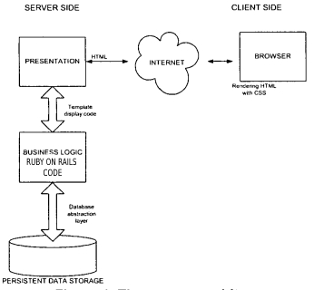
Figure 1.1: Web Workflow

Problem Statements

Academic writers and those who have difficulties in publishing their articles or manuscripts can easily publish their articles/manuscripts using our journal management system. When someone want to publish a paper, they must go through publishing cycle, which is a time taking task. Our system will provide all the features through which authors can easily publish their articles/manuscripts. Our system will have six roles, which are administrator, editor in chief, author, reviewer and editor and lector. After the author has requested to publish their article or manuscript, the Editor-in-Chief sends it to Section Editor. The Section Editor finds at least three independent reviewers. When all reviewers have entered their review in the system, the Section Editor can make a recommendation to the Editor-in-Chief, based on the reviews and either his/her own opinion, or start a discussion among the reviewers if there is some disagreement. After an agreed decision has been reached, the Editor-in-Chief or the section Editor notifies the authors. The possible decisions are that the paper is accepted with minor revisions, revised and resubmit or the paper is rejected.

Aims and Objectives

The objectives that will define the basis of our project are as follows:
- To provide ease in publishing articles for the authors.
- To help find the Plagiarism in their articles.
- To help authors find duplication in the article’s Title
- To provide help in Peer Reviewing of articles.
- To help all the personnel including authors to have better and consistent approach in managing their jobs.
- To help manage all their previous, pending and on-going jobs on single platform.

Scope of Project

The primary scope of our project is that the people who have difficulties in publishing their articles or manuscripts can easily publish their articles/manuscripts using our journal management system. When someone want to publish a paper, they must go through publishing cycle, which is a time taking task. Our system will provide all the features through which authors can easily publish their articles/manuscripts. Our system will have multiple roles, which are administrator, editor in chief, author, reviewer and editor and lector. After the author has requested to publish their article or manuscript, the Editor-in-Chief sends it to Section Editor. The Section Editor finds at least three independent reviewers. When all reviewers have entered their review in the system, the Section Editor can make a recommendation to the Editor-in-Chief, based on the reviews and either his/her own opinion, or start a discussion among the reviewers if there is some disagreement. After an agreed decision has been reached, the Editor-in-Chief or the section Editor notifies the authors. The possible decisions are that the paper is accepted with minor revisions, revised and resubmit or the paper is rejected.

Optional Scope

We will complete our project according to our primary scope, but only if we have time available after that. Payment gateways and live chat widgets will be integrated into our system. This will be even more beneficial to the website's clients

LITERATURE REVIEW

Product Perspective

An efficient online platform which allows authors to submit their articles/manuscript to get it reviewed and published it in the journal. This system will also work as an ERP system which enables the editor in chief to register Editors who will be assigned to single or multiple journals which needs to be reviewed. The editor will then register reviewers who will be able to review the manuscript and give reviews to the editor then on that basis editor will approve or reject the paper. The system will be able to check the duplication of title and check the plagiarism in the manuscript.

User Classes and Characteristics

Publisher’s Paramount consist of six major panels
    - Admin Panel
    - Editor-in-Chief Panel
    - Authors Panel
    - Reviewers Panel
    - Editor Panel
    - Visitor

Admin Panel

Admin panel is main panel that can control everything. It can:
- Manage Users (Editor-in-chief, Authors, Reviewers, Editors, Lectors)
- Maintain the Database Integrity
- Keep the Records of all the Transactions done inside the system

Editor in Chief Panel

Editor in chief can control the whole system and can do following things:
- Manage Editors (Register, Delete, Update)
- Assign Editors to the Manuscript for reviewing procedures
- Make Decisions for the manuscript
- Give Comments to the Authors or Editors

Editor Panel

In this panel, Editors can:
- Manage Reviewer (Accept/Reject the application from reviewers)
- Add Reviewers
- Assign Reviewers to Manuscripts
- See Reviews from the Reviewers
- Mange own Profile
- Accept / Reject manuscripts based on comments of reviewers

Reviewer Panel

Reviewer will be able to manage the assigned Papers:
- View Pending papers to be reviewed
- View Reviewed Papers
- Give Reviews to each paper
- Manage own profile

Author Panel

Author will be able to manage papers which is submitted and pending to be reviewed:
- Submit new Paper
- View submitted paper
- Track Paper
- Manage personal information
- Update Password

Objectives

- Design a Publisher’s Paramount based on web to get rid of third-party applications.
- Provide ease in publishing articles for the authors.
- Help authors to find the plagiarism in their articles in one go
- Manage all the users (Editor in chief, Authors, reviewers, editor, and the relationship between them)
- Help all the personnel including authors to have better and consistent approach in managing their jobs.
- Help Manage all their previous, pending, and on-going jobs on single platform

Operating Environment

This purposed project is web-based that requires laptop, android smartphone, and tablets. To build this proposed project, the software components that we will use are Python’s Framework Django Technology.

Design and Implementation Constraints

It is web-based application which will be developed using Django which is a Framework of Python Programming Language that pride itself on making development of custom Web applications faster and in more efficient manners by using a compact software design. Moreover, we will be using Feature Driven Development Methodology. As with the continuous integration. All the testing will be done in the development phase so that we can eliminate the bugs on the first go of the development phase before release.

Assumptions and Dependencies

- Resource-level assumptions play heavily into the success or failure of a project because a large portion of project management is based on available and allocated resources.
- Time-based assumptions are impacted by resource availability, technology, quality factors, financial limitations, and other assumptions.
- Quality-specific assumptions play a vital role because all the activity of Publisher’s Paramount will be done by this purposed system. In this situation there is usually very little or even no room for error.

DESIGN AND METHODOLOGY

Methodology

In this Project, we both members were working on their respective tasks, one member was working on frontend and the other one was working on backend. So to resolve any future conflicts between frontend and backend we have used the feature driven development approach so we both can work in parallel to reduce the conflict.
Following were the phases, we planned to work on:
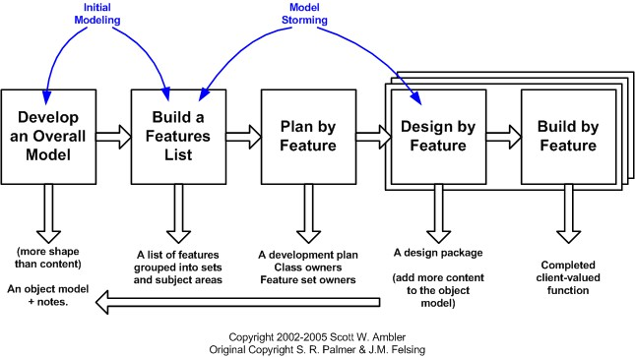
Figure 3. 1: Feature Driven Development Phases

Requirements

In this phase we have gathered as many details as possible and procedure through different platforms and specifically our supervisor who helped us to understand the actual procedure of the project.

Design

In this phase of design, we designed the database models and the User Interfaces of the project.
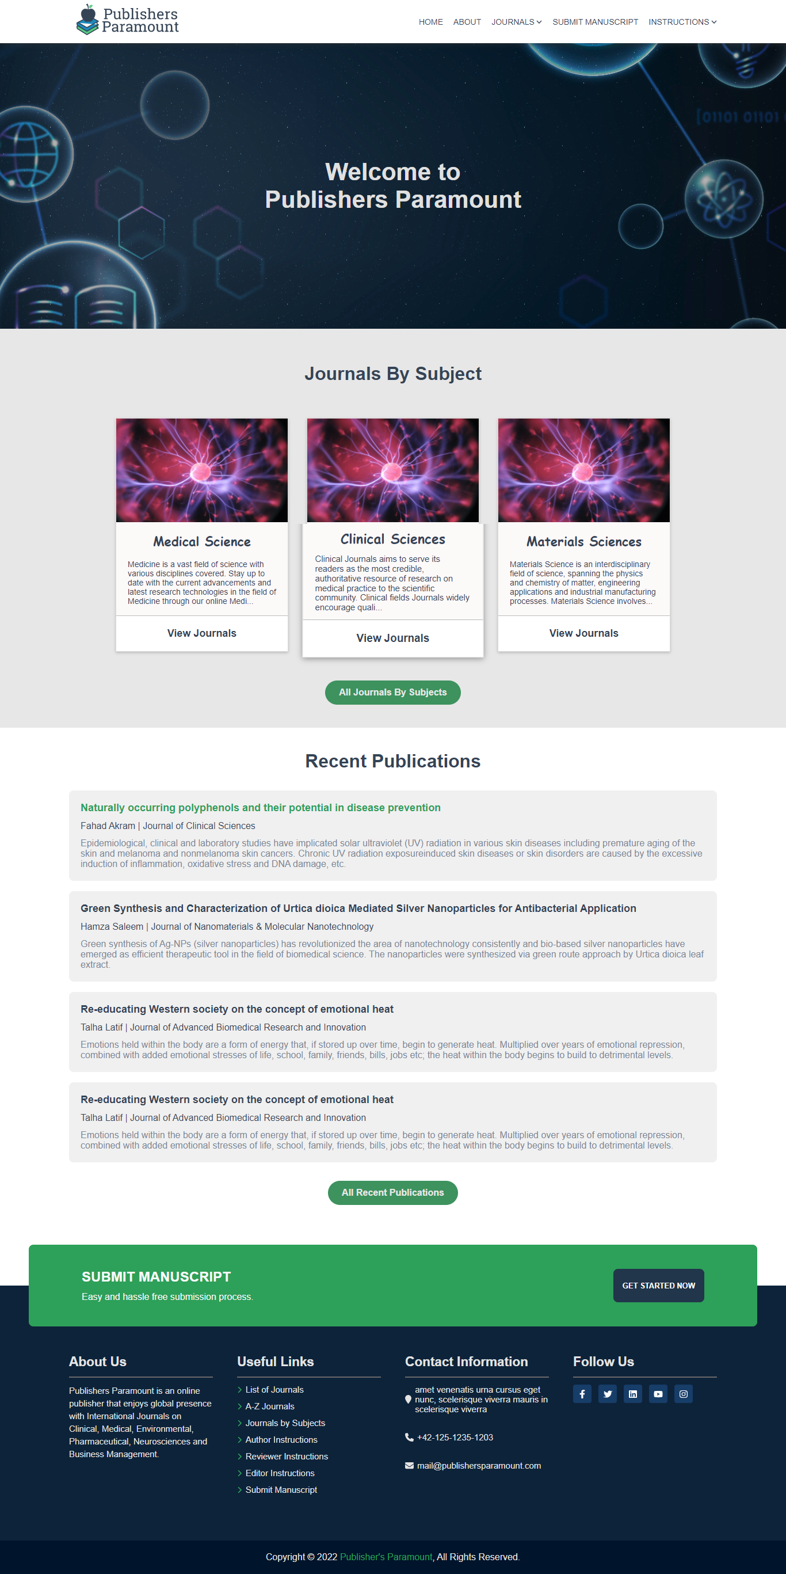
Figure 3. 2: Home Screen
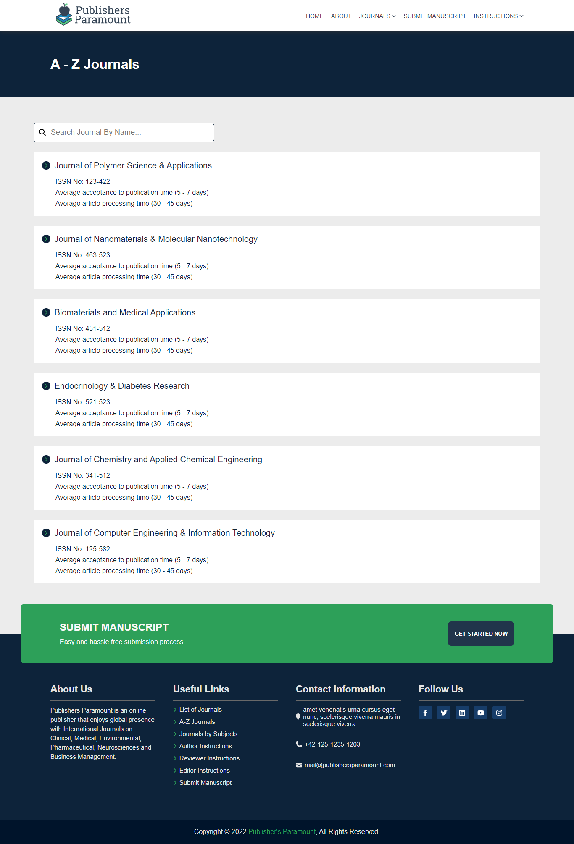
Figure 3. 3: A to Z Journals
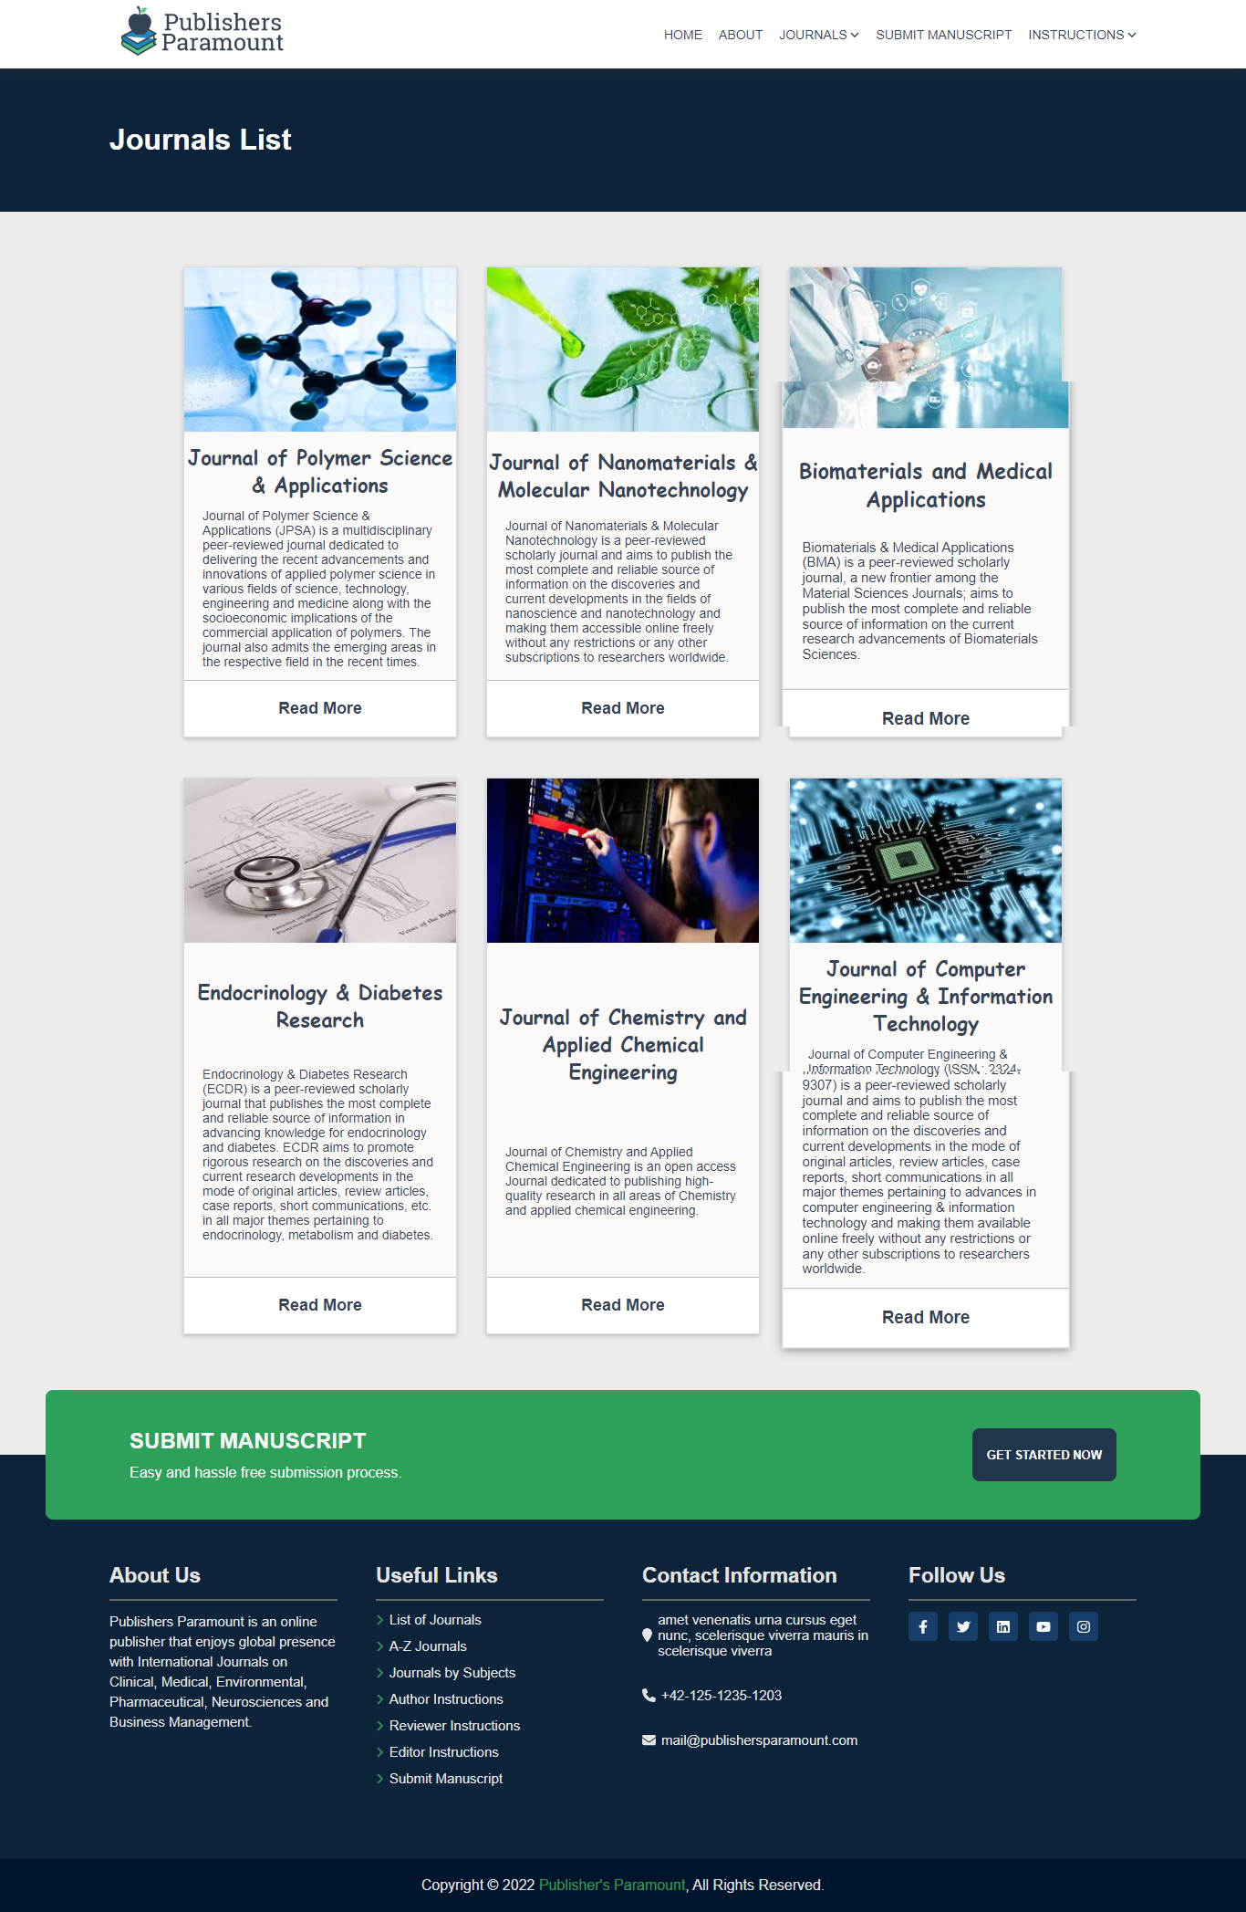
Figure 3. 4: Journals List
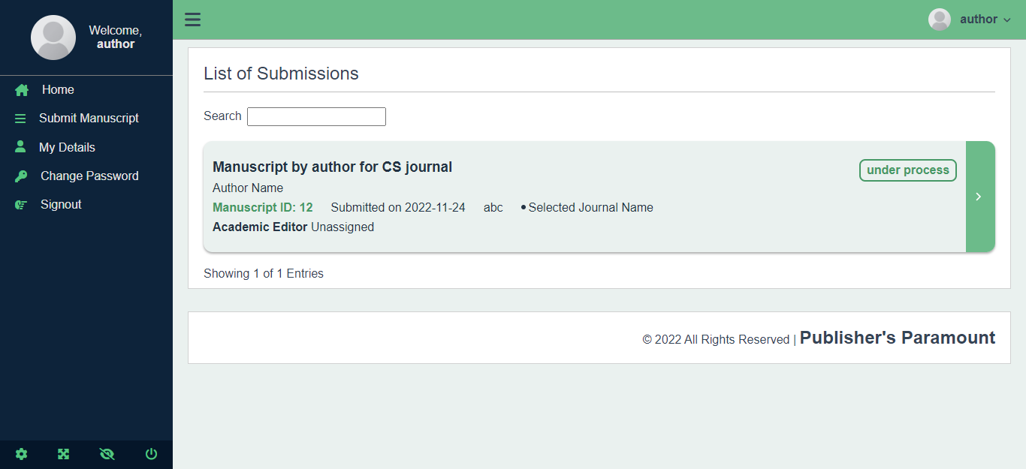
Figure 3. 5: Dashboard
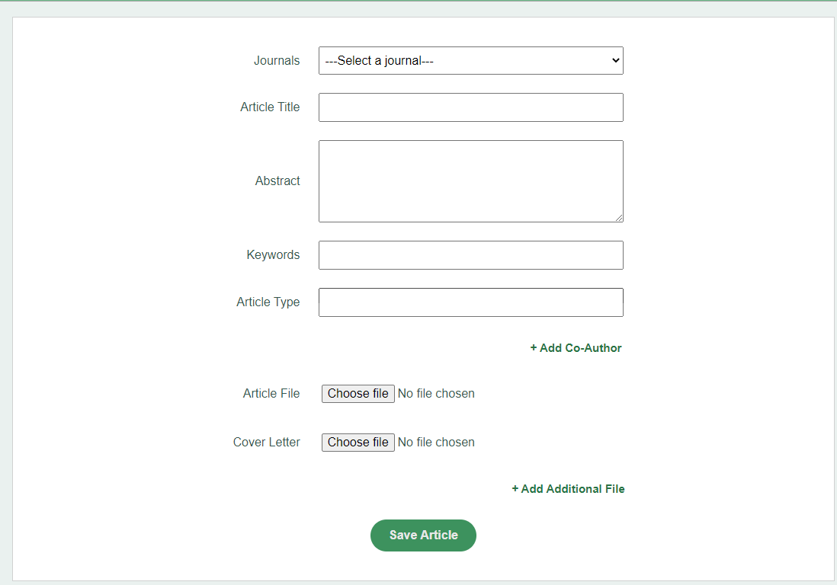
Figure 3. 6: Submit Manuscript

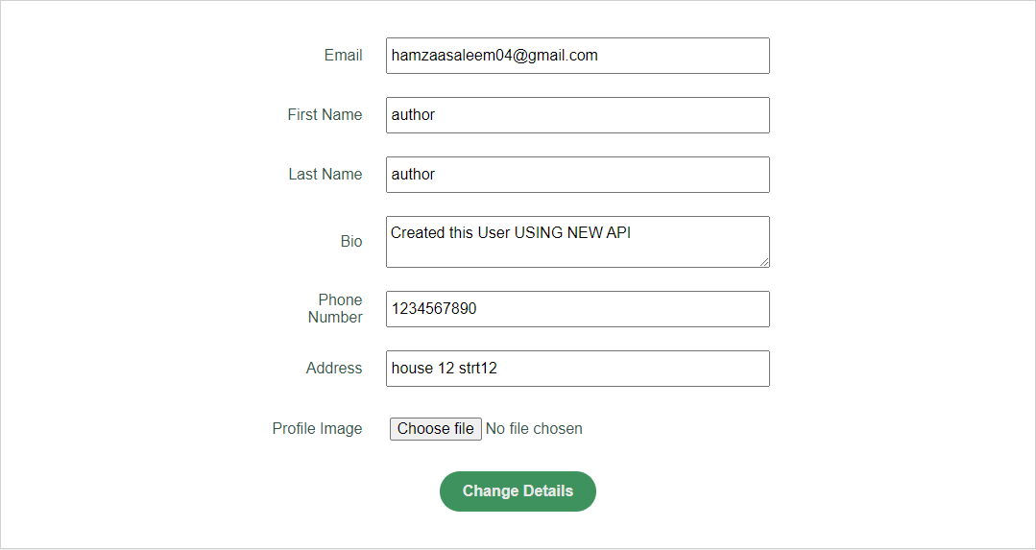
Figure 3. 7: Change Details
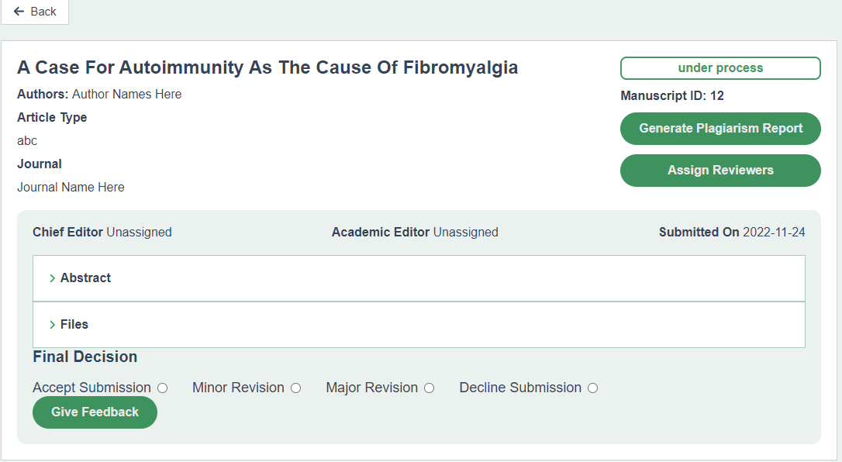
Figure 3. 8: Manuscript Page

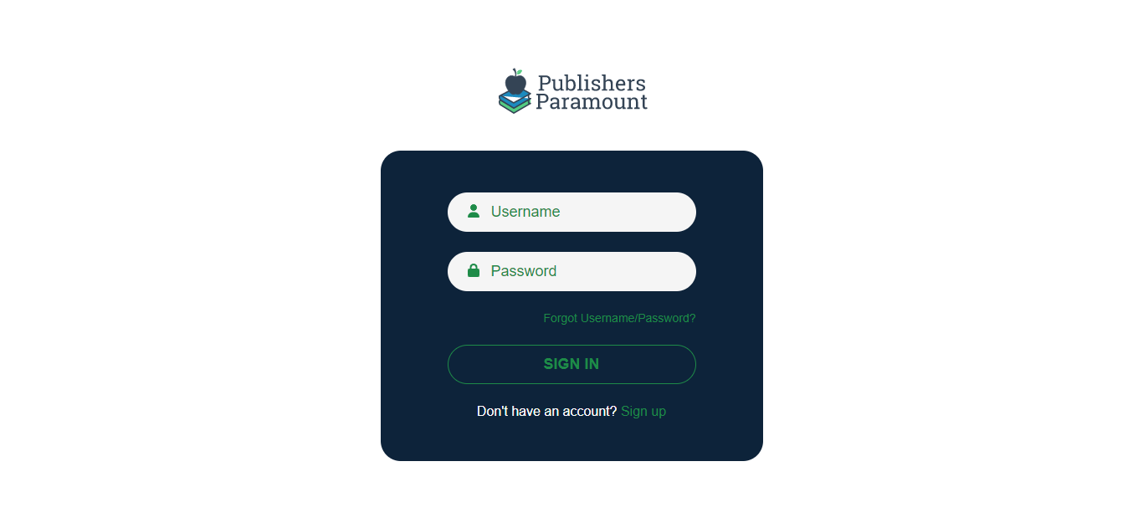
Figure 3. 9: Sign in page
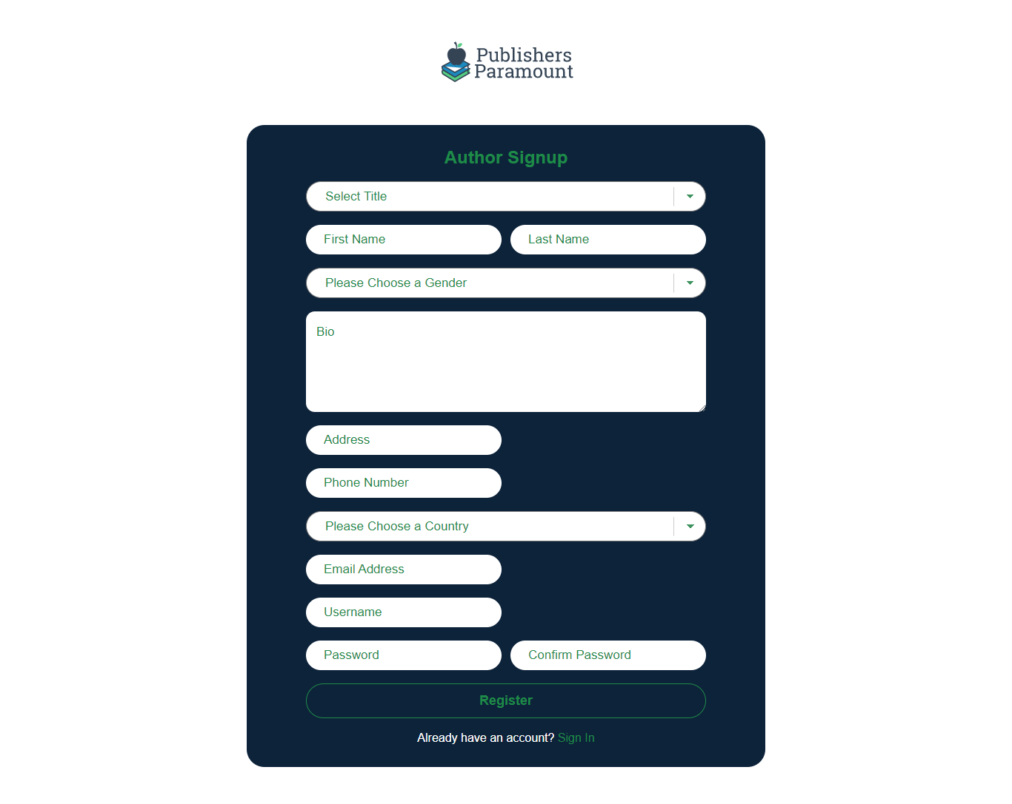
Figure 3. 10: Sign up page

Implementation

Steps are follows in this phase are.
- Develop front-end Web application.
- Build the Backend Functionalities.
- Build API for each functionality to integrate with Frontend
- Integrate front-end with the database by building back-end.

Testing and Evaluation

All the testing are done in development phase so that all the bugs can be eliminated before the release.

Feasibility Plan

Resource Requirement
Resources that are required to complete this proposed project are
- Python (Django)
- Visual Studio Code (Latest Version)

Expertise of the Team

This project requires the complete knowledge of HTML CSS, JAVASCRIPT, REACT JS, Python Django, Data structure and database management system. Along with that we must know all the terminologies used in the web development to make this web application smooth and easy to use on both ends (Developer and User).

Tools / Technology

- Python (v 3.10.6) -- (Django v s4.1.2)
- HTML, CSS, React Js (v 18.1.0)
- PostgreSQL (v 15)
- Postman (v 9.31.0)
- VS Code (v 1.73)
- PyCharm (v 17.0.5)
- JMeter (v 2.13.19691222)

Risk Involved

- Security might be affected due to lack of knowledge about the penetration testing.
- Health is the biggest risk.
- Internet Issue

Domain Model Diagram

Following is the Domain Model Diagram for Publisher’s Paramount. This is a conceptual Model Diagram, how the flow works

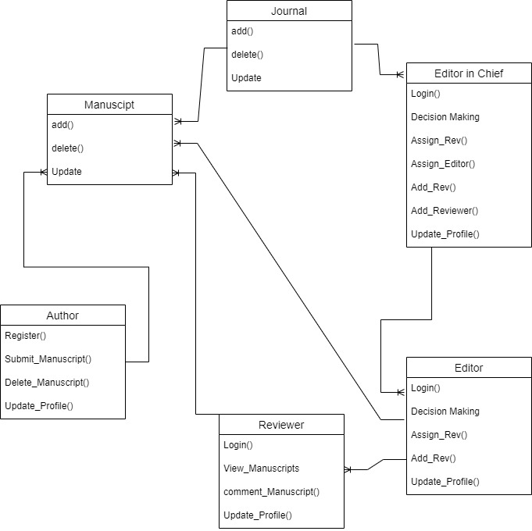
Figure 3. 11: Domain model diagram

Class Diagram

Class Diagram Shows the system’s Classes, their attributes, operations and the relationships among them

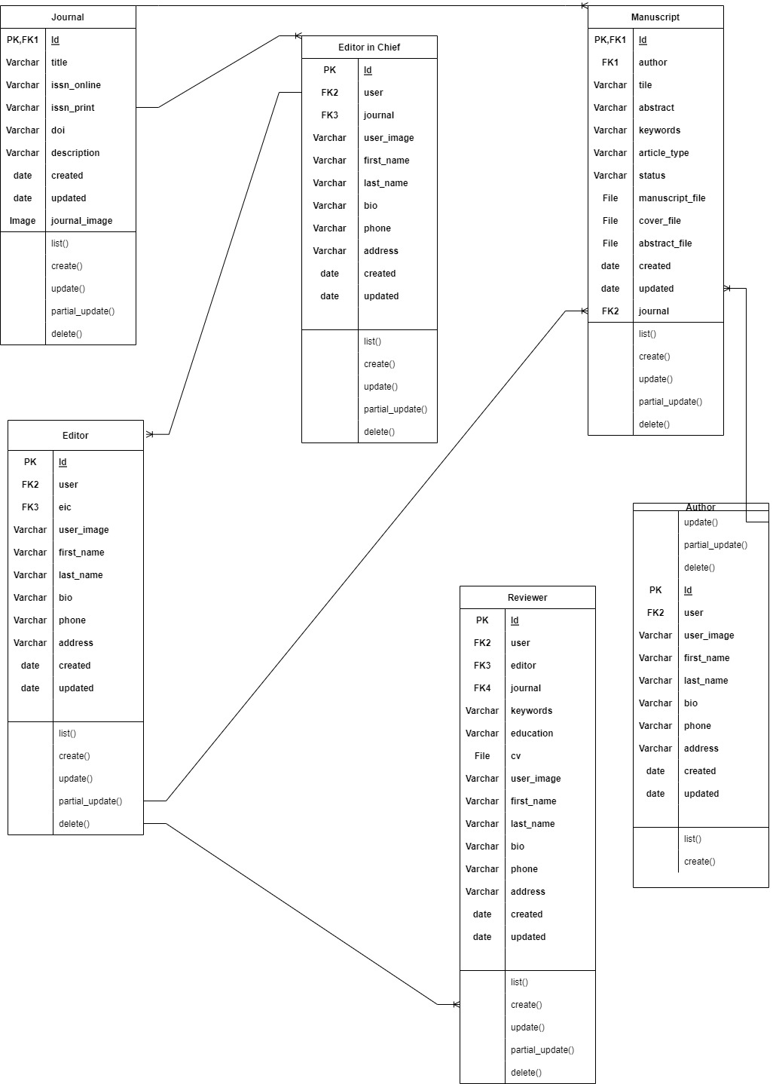
Figure 3. 12: Class diagram

System Use Cases

Use Case Diagrams

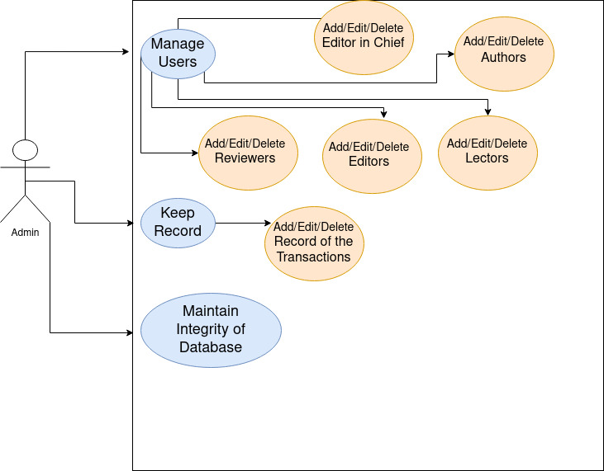
Figure 3. 13: Admin Use Case Diagram
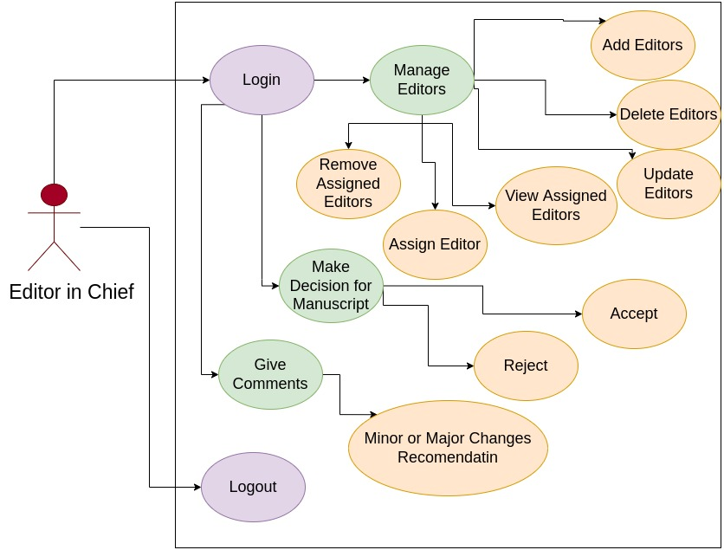
Figure 3. 14: Editor in chief use case diagram

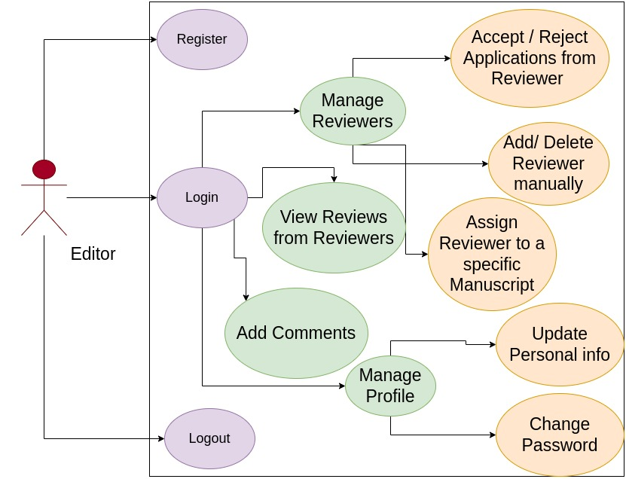
Figure 3. 15: Editor Use case diagram

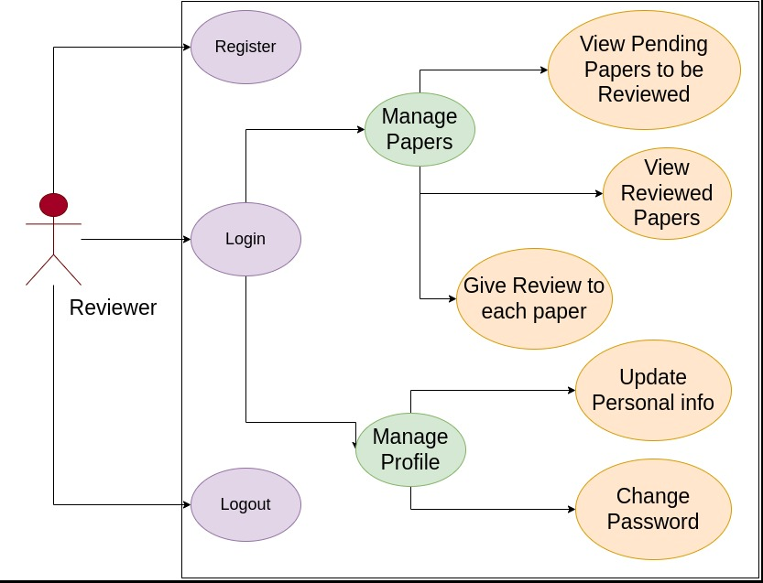
Figure 3. 16: Reviewer use case diagram

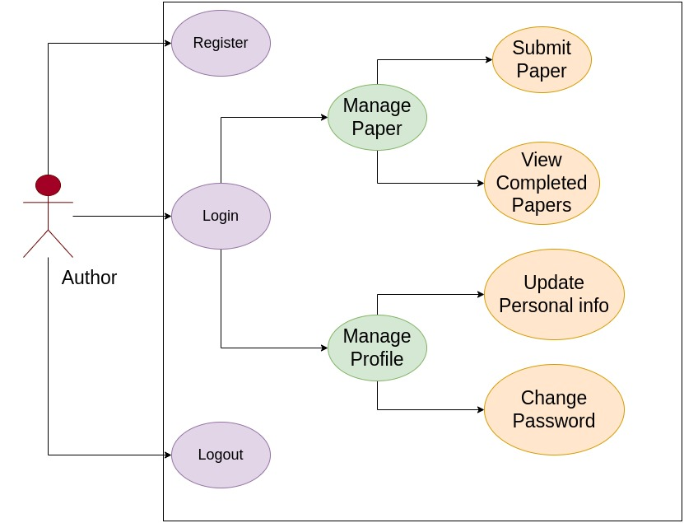
Figure 3. 17: Author use case diagram

Use Case name and Identifiers

Register (PP-01-001)

This use case is about the Authors, Editors, Reviewers. They will be able to login to the application
Name | Register
Unique Identifier | RTA-01-001
Objective | Protection of user credentials.
Priority | High
Actors | Authors, Editors, Reviewers
Basic Flow | - Visit website http:127.0.0.1:8000  - Click on Registration button  - Enter all required data  - Press submit button to register himself.
Alternative Flow | - Visit website http://127.0.0.1:5000  - Click on registration button  - Fill partial data
Preconditions | User must open the website
Post Conditions | User is registered.
Notes/Issues | This use case describes the event of registration of user, user is already registered. Internet may not work
Table 3. 1: Registration Use Case

Login (PP-01-002).

Admin Editor in Chief, Editor, Reviewers, Authors will login on the web application using the username and password they selected will registering themselves.

Name | Login
Unique Identifier | RTA-01-002
Objective | Authentication and Authorization
Priority | High
Actors | Admin, Editor in Chief, Editor, Reviewers, Authors
Basic Flow | - Visit website www.publishersparamount.com  - Clicks on Login button.  - Select Role  - Enter the username and password.  User is Logged in after clicking the button login
Alternative Flow | Alt-1. Click on Login button and login.  Alt-2. User enter wrong username or password.
Preconditions | User must open the website
Post Conditions | User is logged in.
Notes/Issues | Internet may not work
Table 3. 2: Login Use Case

Manage Editors (PP-01-003)

In this Editor-in-Chief can update, delete and add new Editors
Name | Manage Editors
Unique Identifier | RTA-01-003
Objective | This use case initiate when Editor-in-Chief is going to add, update and delete
Priority | Medium
Actors | Editor-in-Chief
Basic Flow | - Click the Manage Editors in the side menu  - Click on add, update, or delete  - To update and add fill the forms  Click on submit button to save into database
Alternative Flow | Alt-1. Editor-in-Chief is not logged in due to wrong username or password  Alt-2. Editor-in-Chief clicks on another button rather than User Management
Preconditions | Editor-in-Chief must be login
Post Conditions | Editor-in-Chief updated the record successfully
Notes/Issues | Internet may not work
Table 3. 3 : Manage Editor Use Case

Manage Editor in Chief (PP-01-004)

This is case is just for the Editor-in-Chief
Name | Editors Assignment
Unique Identifier | RTA-01-004
Objective | This use case describes the event What Editor-in-Chief can do while assigning the Editors for specific paper
Priority | Medium
Actors | Editor-in-Chief
Basic Flow | - Click the Editors Assignment in the side menu  - Click on Assign, View Assigned , or Remove  - To update and add fill the forms  - Click on submit button to save into database
Alternative Flow | Alt-1. Editor-in-Chief is not logged in due to wrong username or password  Alt-2. Editor-in-Chief clicks on another button rather than an Editors Assignment
Preconditions | Either Editor-in-Chief must be logged in.
Post Conditions | Editor-in-Chief generate the new invoice
Notes/Issues | Internet may not work

Table 3. 4: Manage Editor in Chief Use Case

Manage Profiles (PP-01-005)

All the users can manage their own profile

Name | Manage Profile
Unique Identifier | RTA-01-005
Objective | To Manage own profile or update the password
Priority | Medium
Actors | Editor in Chief, Editor, Reviewers, Authors
Basic Flow | - Click the Manage Profile in the side menu  - Click on Update profile or Change Password  - To update fill the forms  - To Change Password Enter current Password and then New Password  - Click on submit button to save into database
Alternative Flow | Alt-1. User is not logged in due to wrong username or password Alt-2. User clicks on another button rather than Manage Database.
Preconditions | Must have access to Database to make changes.
Post Conditions | Update, Delete records
Notes/Issues | Internet may not work
Table 3. 5: Manage Profile Use Case

Manage Reviewers (PP-01-006)

In this use case, Editor will manage the reviewer which includes adding new reviewer manually or evaluate reviewer who applied through website and editor can also assign the reviewers to a specific manuscript for review.

Name | Manage Reviewers
Unique Identifier | RTA-01-006
sObjective | To manage the Reviewers which includes adding new reviewer manually or evaluate reviewer who applied through website and editor can also assign the reviewers to a specific manuscript for review.
Priority | Medium
Actors | Editor
Basic Flow | - Click the manage reviewers in the side menu  - Click on Add, Update, delete reviewers, reviewer applied menu or assign reviewer  - To Add, Update fill the form  - To assign select the manuscript  - Click on submit button to save into database
Alternative Flow | Alt-1. Editor is not logged in due to wrong username or password
Preconditions | Editor must be login
Post Conditions | Reviewer is added, updated, Deleted or Assigned Successfully
Notes/Issues | Internet may not work
Table 3. 6: Manage Reviewers Use Case

View Reviewer’s Review (PP-01-007)

In this use case teacher will take live class with the student

Name | View Reviewer’s Review
Unique Identifier | RTA-01-007
Objective | To View the Review given by the reviewer of the specific manuscript
Priority | High
Actors | Editor
Basic Flow | - Select View Reviews Tab from the side bar  - Select the paper you want to see the reviews  - Reviews given by the Reviewer to that paper will be shown from database
Alternative Flow | Alt-1. Editor is not logged in due to wrong username or password Alt-2. Editor clicks on another button rather than an View Reviews.
Preconditions | Editor must be login
Post Conditions | Reviews Retrieved
Notes/Issues | Internet may not work
Table 3. 7: View Reviewer's Review Use Case

Add Comments (PP-01-008)

The Editor will give the reviews to the manuscript which is being reviewed by the reviewer. Which will be shown to the Editor-in-Chief.

Name | Add Comments
Unique Identifier | RTA-01-008
Objective | The Editor will give the reviews to the manuscript which is being reviewed by the reviewer. Which will be shown to the Editor-in-Chief.
Priority | Medium
Actors | Editor
Basic Flow | - Select Add Comment from the sidebar  - Select the paper to give review and click save  - Review will be added and shown to the Editor-in-Chief
Alternative Flow | Alt-1. Editor is not logged in due to wrong username or password Alt-2. Editor clicks on another button rather than Pay button.  Alt-3. Editor gave the wrong Review to wrong paper
Preconditions | Editor-in-Chief must Update the Author after the review will be given by Editor
Post Conditions | Editor-in-Chief get updated about the paper
Notes/Issues | Internet may not work.
Table 3. 8 : Add Comment Use Case

Sequence Diagram
Following are the Sequence Diagrams

Login
Sequence Diagram for Login Page, if the user or any role is valid he/she can login without any issue
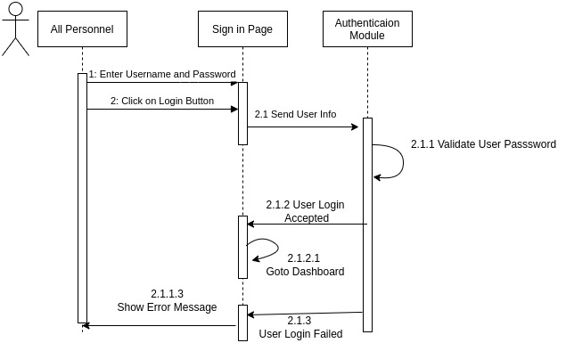
Figure 3. 18: Log in sequence diagram

Registration
Sequence Diagram of any role Registration in the application
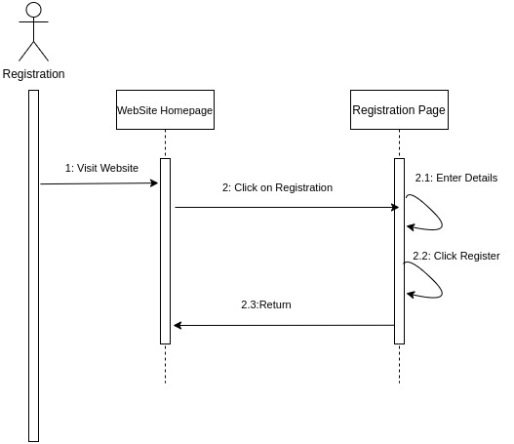
Figure 3. 19: Registration sequence diagram

Editor in Chief Panel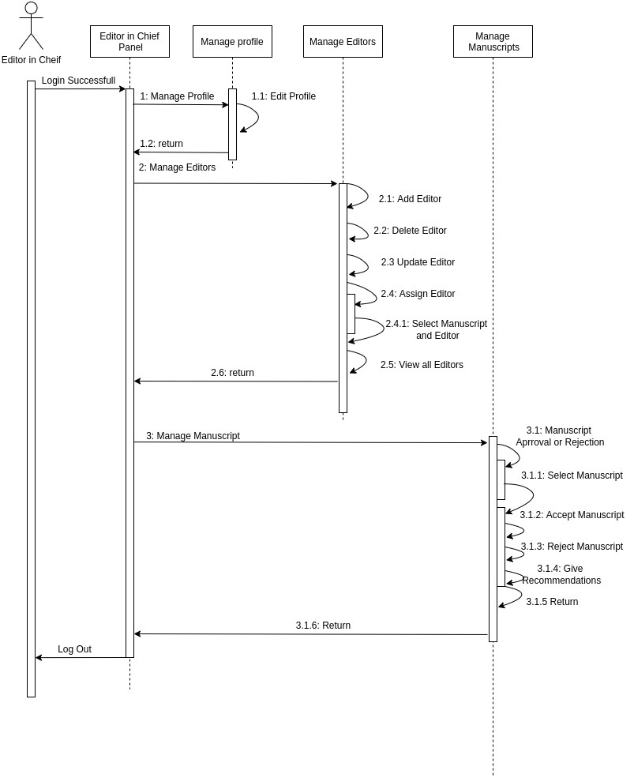
Figure 3. 20: Editor in chief sequence diagram

Editor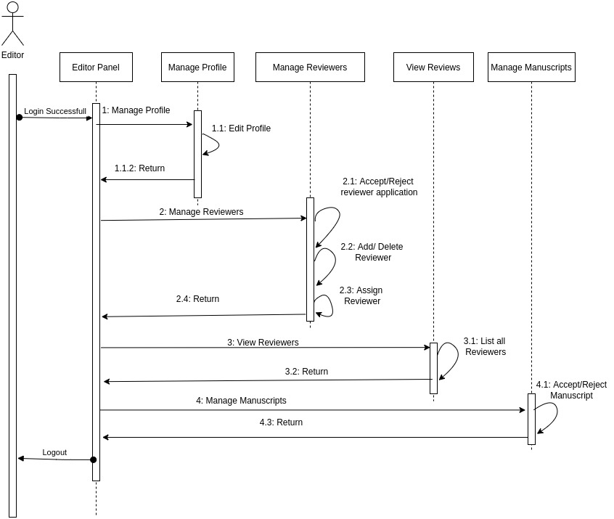
Figure 3. 21: Editor Sequence diagram

Reviewer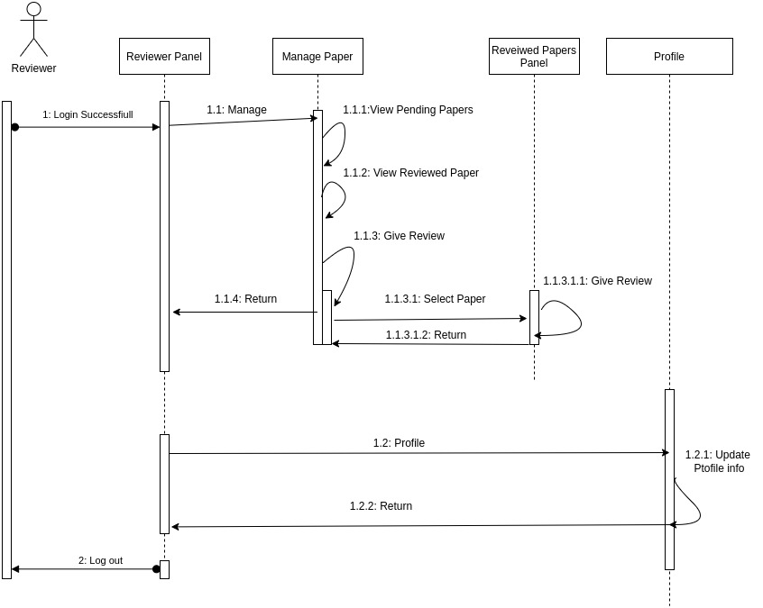
Figure 3. 22: Reviewer sequence diagram

Author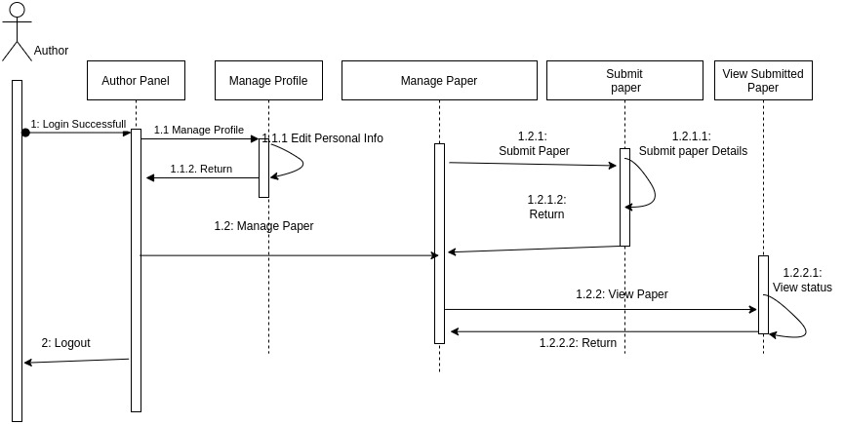
Figure 3. 23: Author sequence diagram

Collaboration Diagram
Following are the Collaboration Diagrams

Editor in Chiefs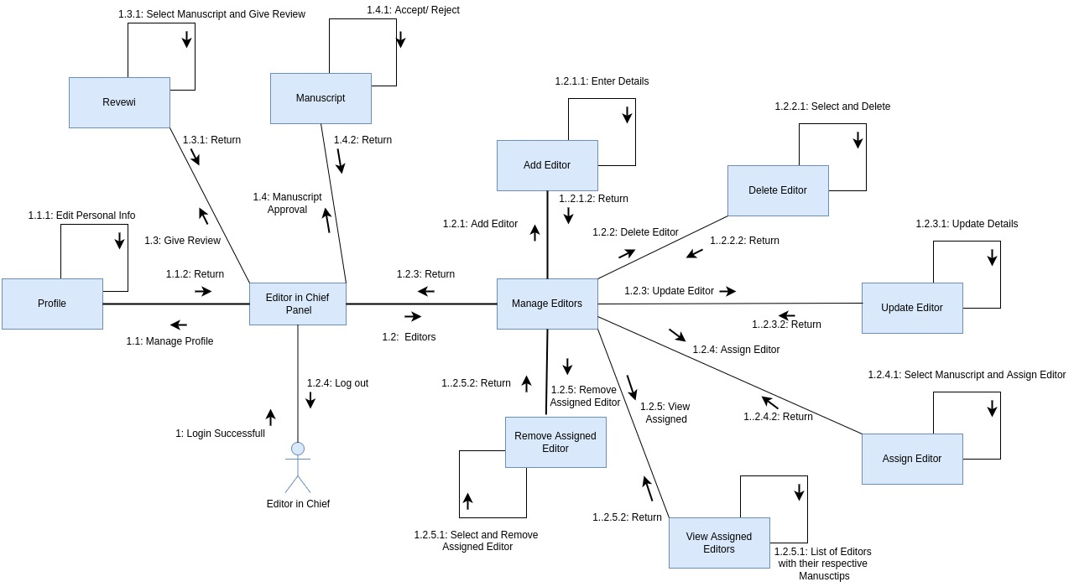
Figure 3. 24: Editor in chief collaboration diagram

Editor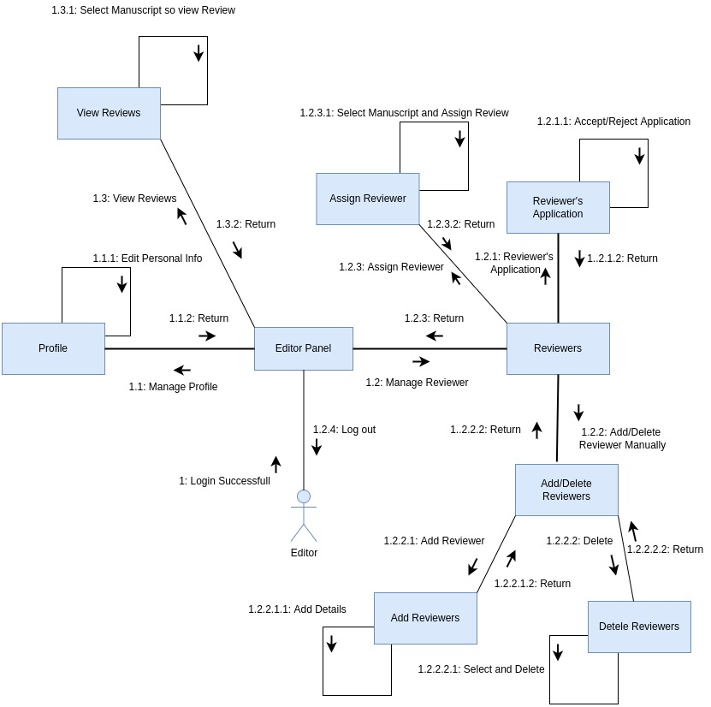
Figure 3. 25: Editor Collaboration diagram

Reviewer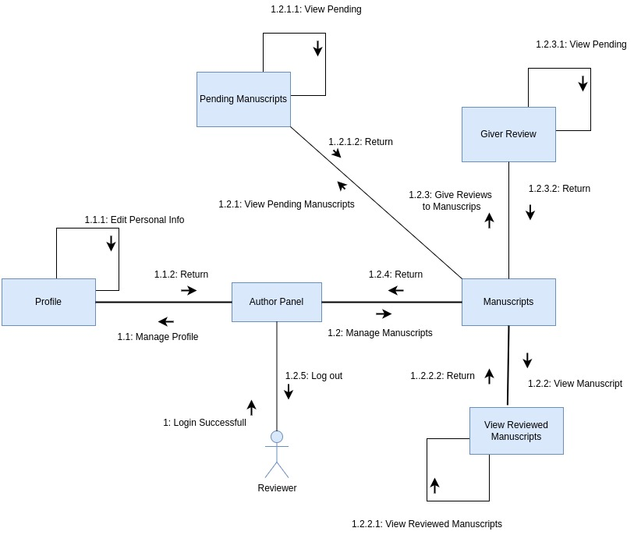
Figure 3. 26: Reviewer collaboration diagram

Author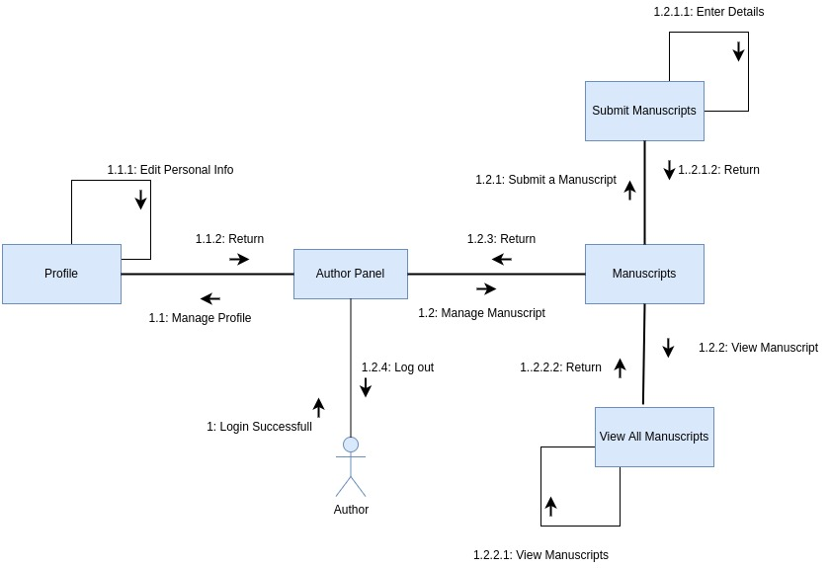
Figure 3. 27: Author collaboration diagram

Entity Relationship diagram

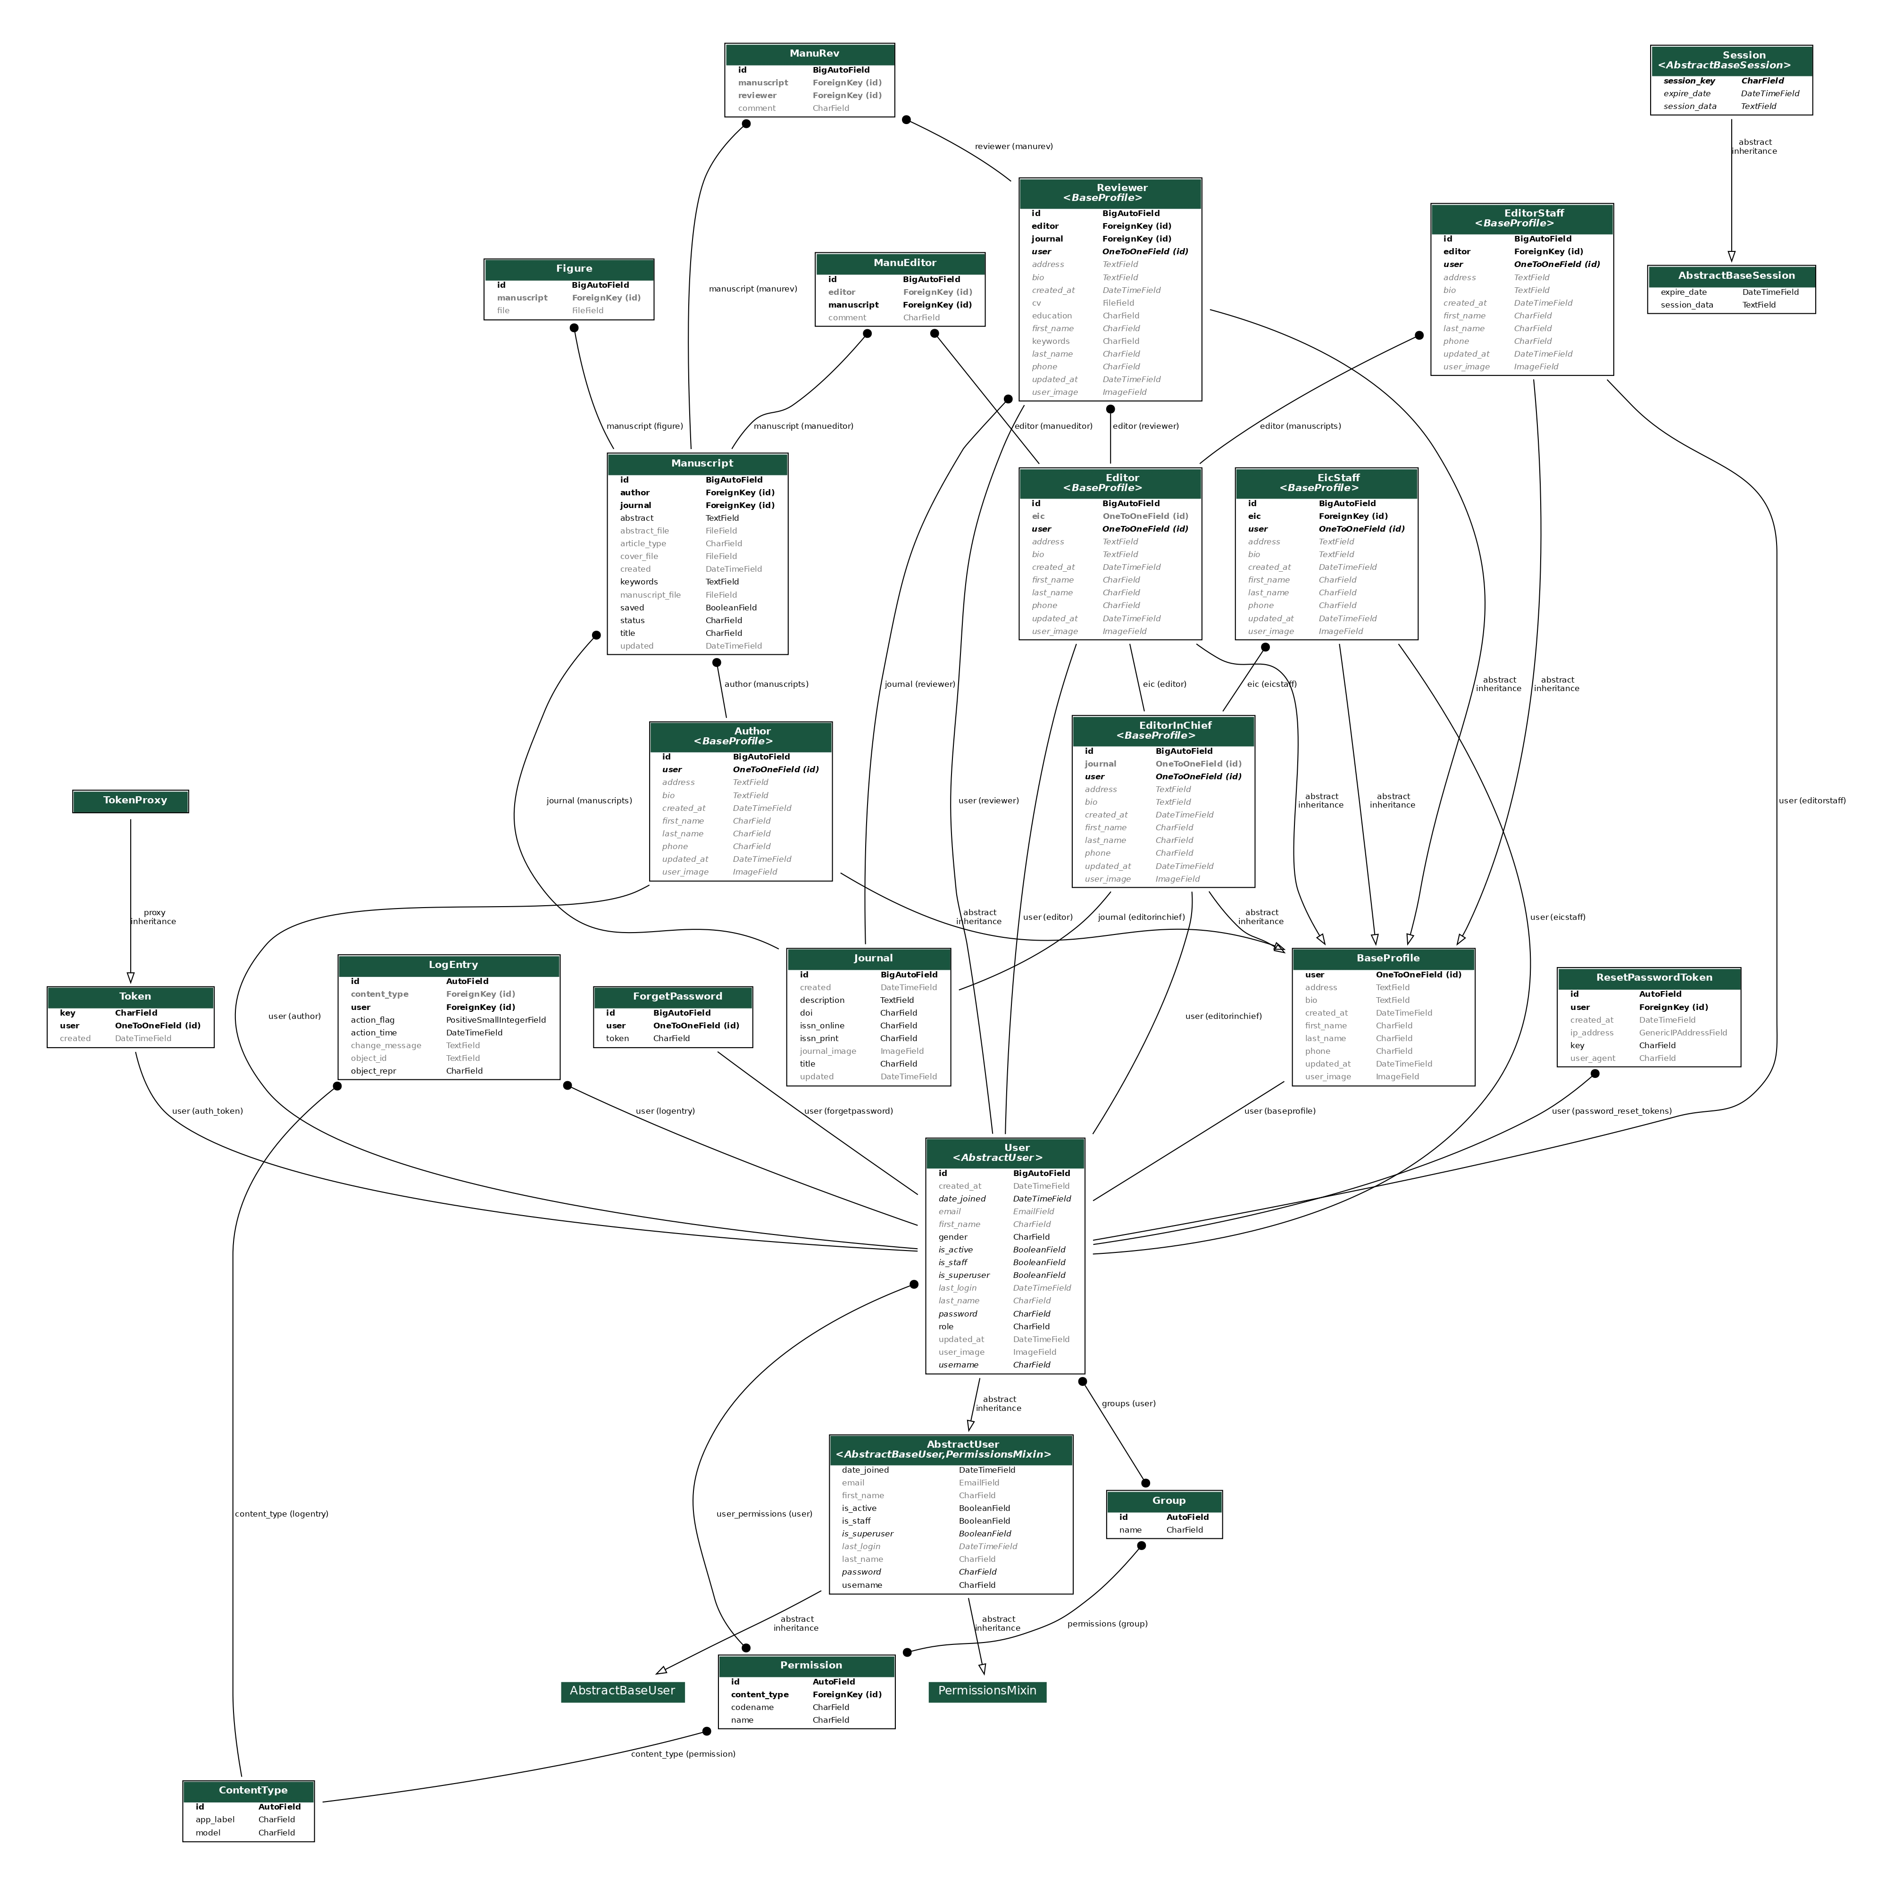
Figure 3. 28: Entity Relationship diagram (ERD)

Operation Contracts

A UML Operation contract identifies system state changes when an operation happens. Effectively, it will define what each system operation does. An operation is taken from a system sequence diagram of Publisher’s Paramount. It is a single event from that diagram.

Operation Contracts: Registration

Name: Register
Responsibilities: To register Any Role
Cross References: Registration
Exceptions: User entered wrong credentials or not provide full info
Preconditions: Must visit http://localhost:3000/signup
Post conditions: Must login at http://localhost:3000/signin

Operation Contracts: Login

Name: Login
Responsibilities: To Login Any Role
Cross References: Login
Exceptions: User entered wrong credentials or not provide full info
Preconditions: Must visit http://localhost:3000/signin
Post conditions: Redirected to Dashboard http://localhost:3000/author/dashboard

Operation Contracts: Submit Manuscript

Name: Submit Manuscript
Responsibilities: Author can submit manuscript
Cross References: Manuscript
Exceptions: User entered wrong Details about Manuscript.
Preconditions: Must login at http://localhost:3000/signin
Post conditions: Redirected to Dashboard and add new Manuscript at http://localhost:3000/author/dashboard/submitPaper

Operation Contracts: Save Manuscript

Name: Save Manuscript
Responsibilities: Author can save manuscript
Cross References: Manuscript
Exceptions: User Forgot to Save the Manuscript
Preconditions: Must login at http://localhost:3000/signin
Post conditions: Redirected to Dashboard and save Manuscript

Operation Contracts: Delete Manuscript

Name: Delete Manuscript
Responsibilities: Author can delete manuscript
Cross References: Manuscript
Exceptions: User deleted the Wrong Manuscript
Preconditions: Must login at http://localhost:3000/signin
Post conditions: Redirected to Dashboard and save Manuscript

Operation Contracts: Assign Manuscript to Editor

Name: Assign Manuscript to Editor
Responsibilities: Editor in chief can assign manuscript to editor
Cross References: Manuscript
Exceptions: Assigning the Wrong Editor
Preconditions: Must login at http://localhost:3000/signin
Post conditions: Redirected to Dashboard and assign Manuscript

Operation Contracts: Assign Manuscript to Reviewer

Name: Assign Manuscript to Reviewer
Responsibilities: Editor can assign manuscript to reviewer
Cross References: Manuscript
Exceptions: Assigning the Wrong Reviewer
Preconditions: Must login at http://localhost:3000/signin
Post conditions: Redirected to Dashboard and assign Manuscript

Operation Contracts: Comments on Manuscript by Reviewer

Name: Comments on Manuscript by Reviewer
Responsibilities: reviewer can give comment to assigned manuscript
Cross References: Manuscript
Exceptions: Wrong Comment
Preconditions: Must login at http://localhost:3000/signin
Post conditions: Redirected to Dashboard then, select Manuscript and write comments

Operation Contracts: Accept/Reject Manuscript by Editor

Name: Accept/Reject Manuscript by Editor
Responsibilities: Editor can accept/reject manuscript based on Comments of Reviewers
Cross References: Manuscript
Exceptions: Wrong Decision
Preconditions: Must login at http://localhost:3000/signin
Post conditions: Redirected to Dashboard then, select Manuscript and make decision

IMPLMENTATION

Frontend Testing:
We have done our frontend testing with different parameters like cross-browser compatibility, cross-platform compatibility, accessibility, end-to-end checks, image analysis testing and CSS (Cascading style sheet) testing.

Cross-browser Compatibility:
We have tested our website on different browsers like Google, Firefox and Microsoft edge with different versions and there is no bug or defect in our user interface. Following are some images of our project on different browsers:

- Google: 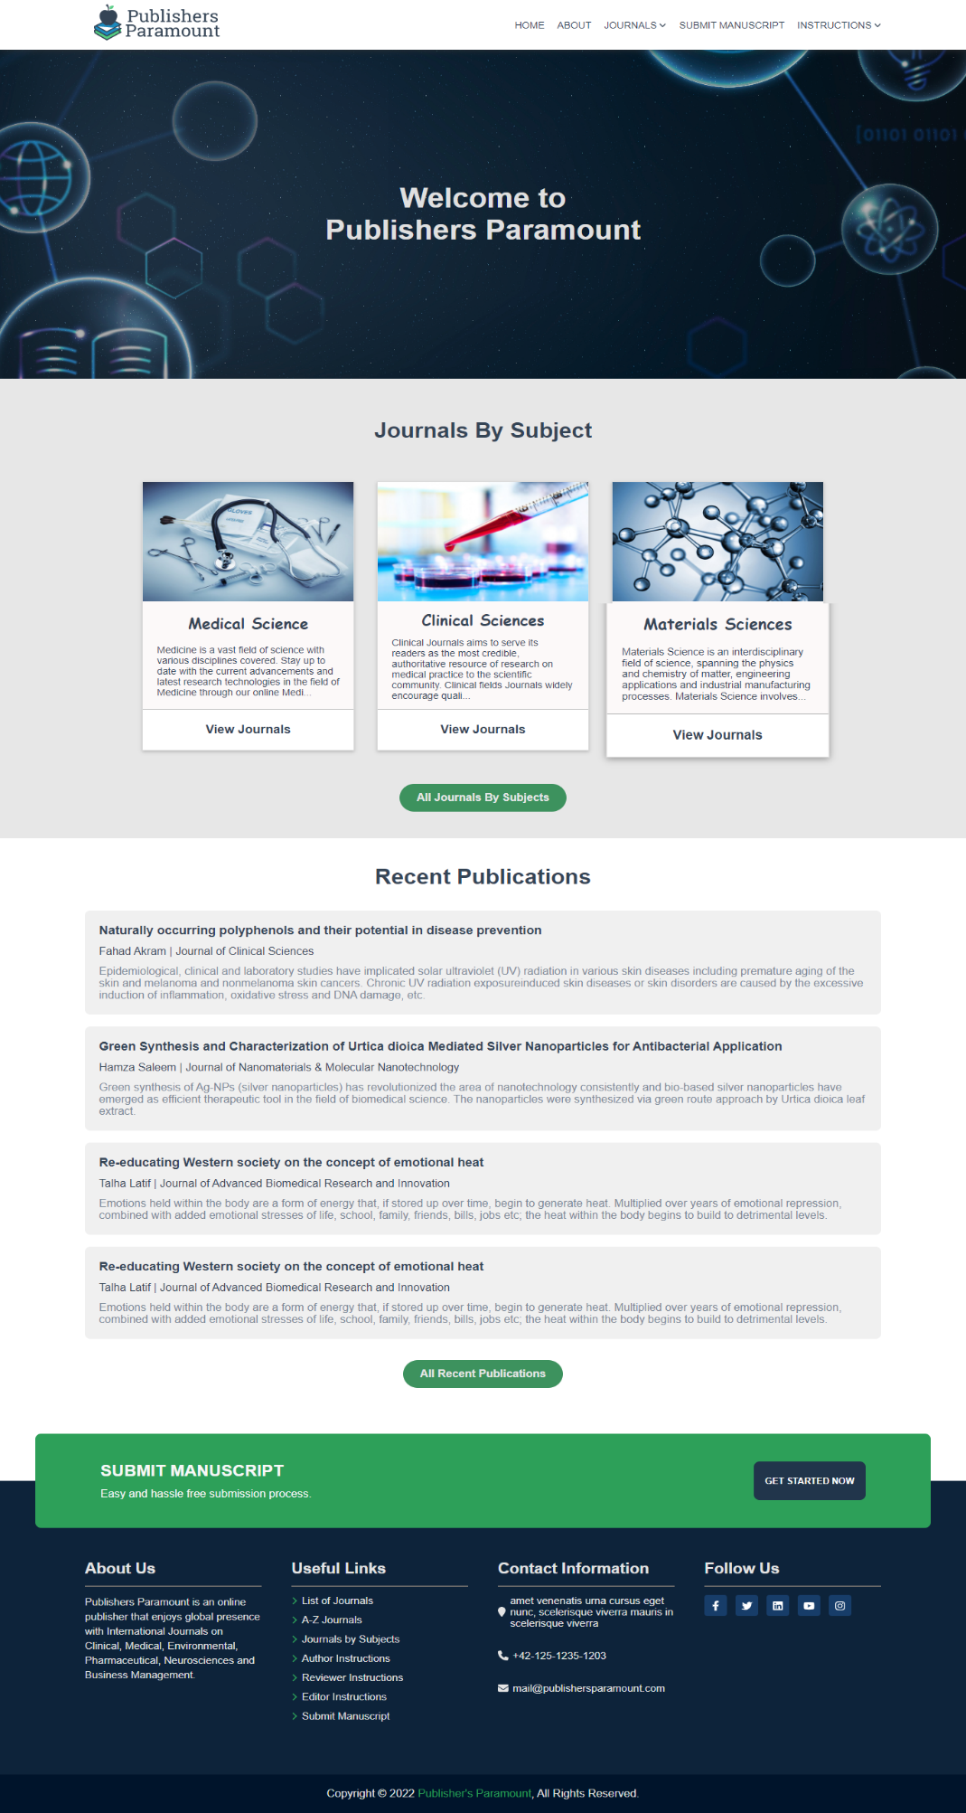

Figure 4. 1: Home screen on google
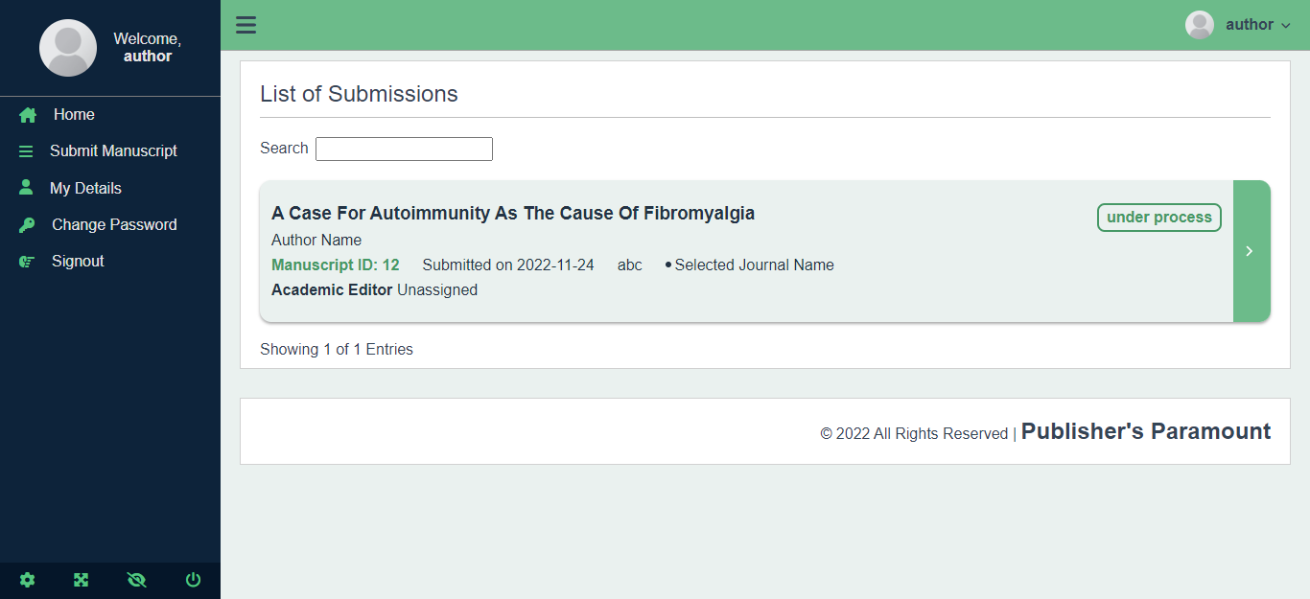
Figure 4. 2: Dashboard screen on google

- Firefox: 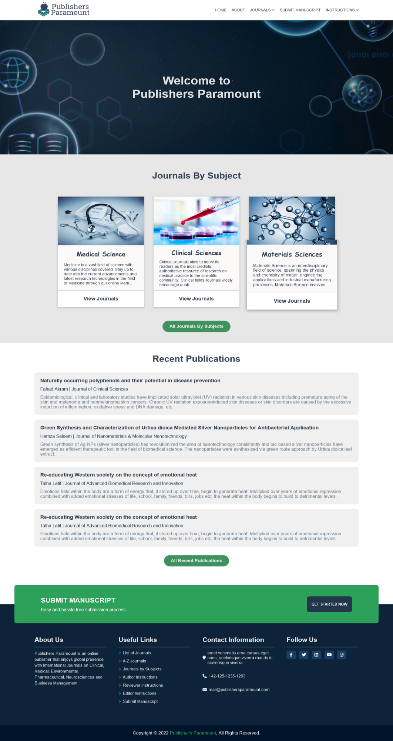

Figure 4. 3: Home screen on Firefox
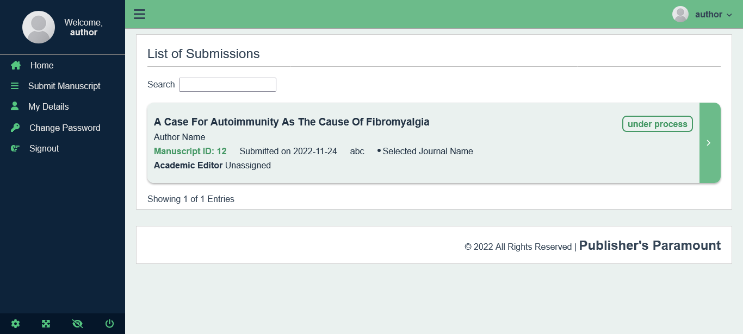
Figure 4. 4: Dashboard screen on Firefox

- Microsoft Edge:

Figure 4. 5: Home screen on Microsoft edge
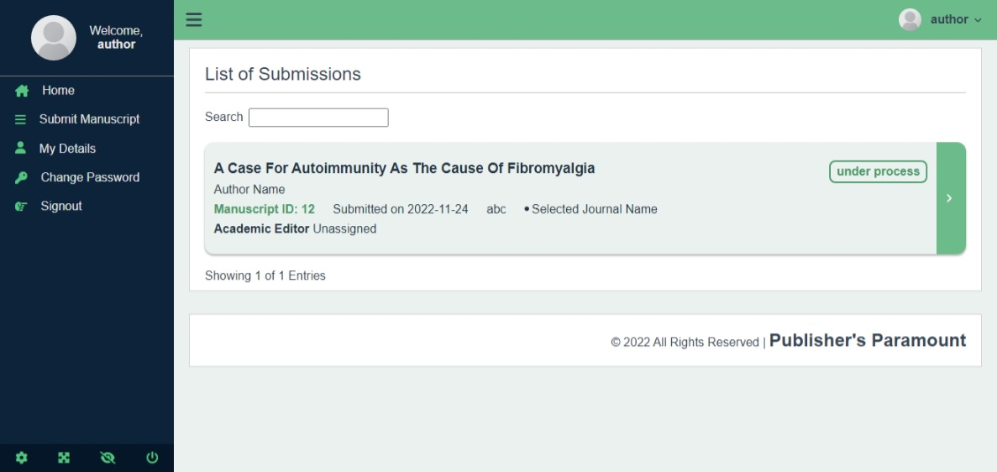
Figure 4. 6: Dashboard screen Microsoft edge

End-to-End Checks:
We have checked all our end-to-end checks between frontend and backend, all is working as expected, and there are no bugs or defects.

Image analysis testing:
We are using compressed images but keeping the good quality in our website, which allows the website to load images in very short amount of time and keep a good user experience. Following is a report on different resources and images load time in frontend:
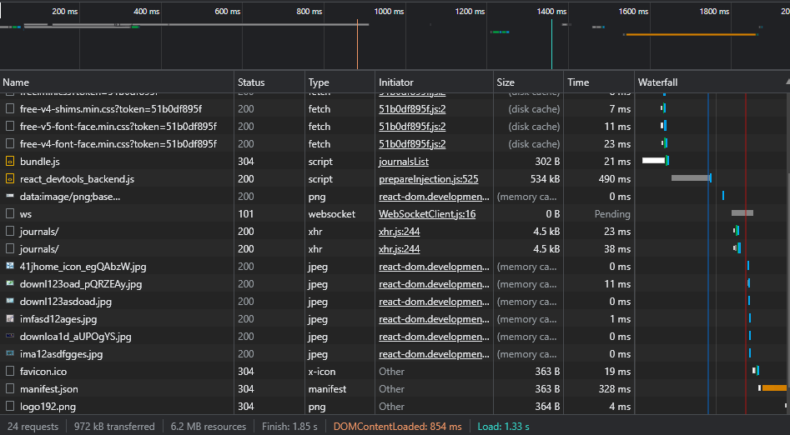
Figure 4. 7: Resources load time analysis on frontend

Backend Testing:
In this module, we have tested the backend responses and API responses with the help of Postman, which helped us to test the APIs and their responses. For load testing, we have used JMeter, to test the load, stress and performance of the website with different numbers of users.

API Testing:
In API testing, we have tested the status, response time and response header size of different APIs.

- Login API Test (PP-01-009)
Status | 200 Ok
Response Time | 319ms
Response Header Size | 839B
Table 4. 1: Login API Testing Results

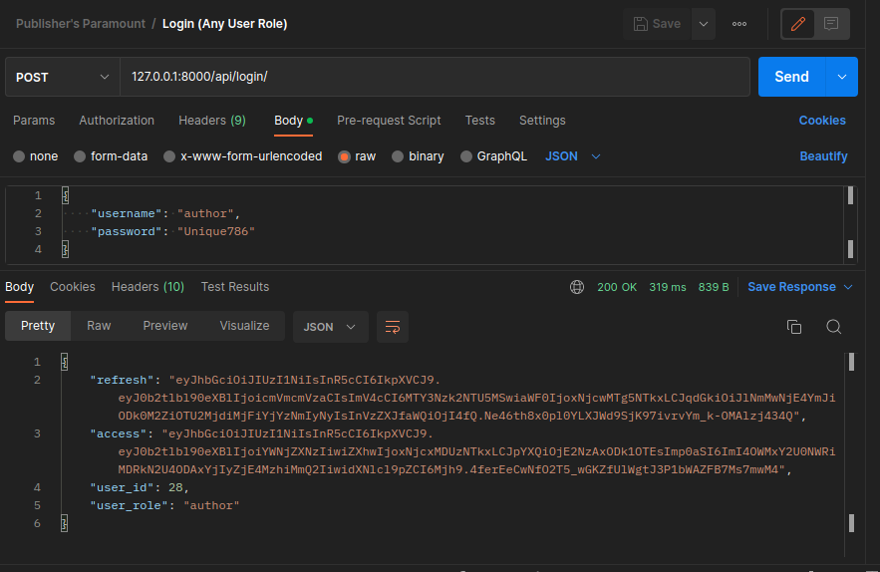
Figure 4. 8: Login API test

- Registration API Test (PP-01-0010)
Status | 201 Ok/Created
Response Time | 369ms
Response Header Size | 357B
Table 4. 2: Registration API Testing Results
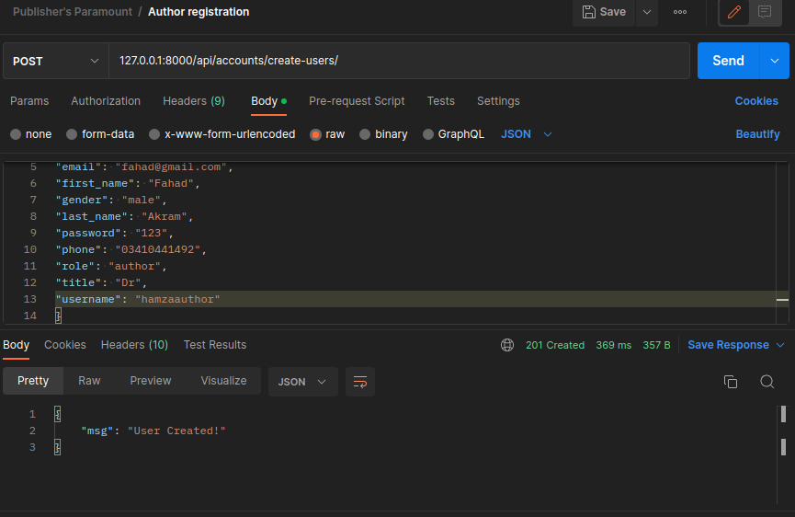
Figure 4. 9: Registration API test
- Save Manuscript API Test (PP-01-0011)
Status | 200 Ok
Response Time | 25ms
Response Header Size | 361B
Table 4. 3: Save Manuscript API Test Result

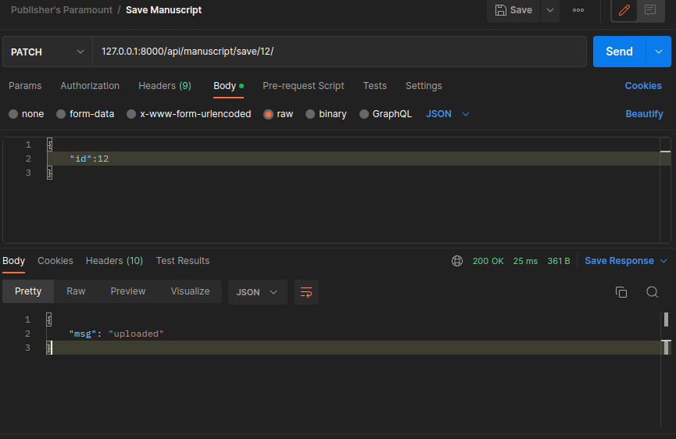
Figure 4. 10: Save manuscript API test

- Session User details API Test (PP-01-0012)
Status | 200 Ok
Response Time | 11ms
Response Header Size | 805B
Table 4. 4: Session User details API Test Result

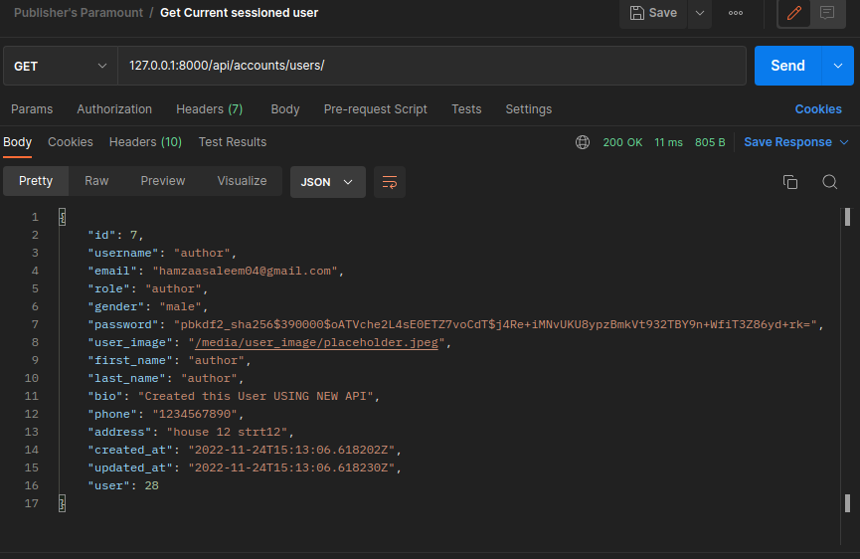
Figure 4. 11: Session user details API test

- Reset-Password API Test (PP-01-0013)

Status | 200 Ok
Response Time | 578ms
Response Header Size | 382B
Table 4. 5: Reset-Password API Test Result

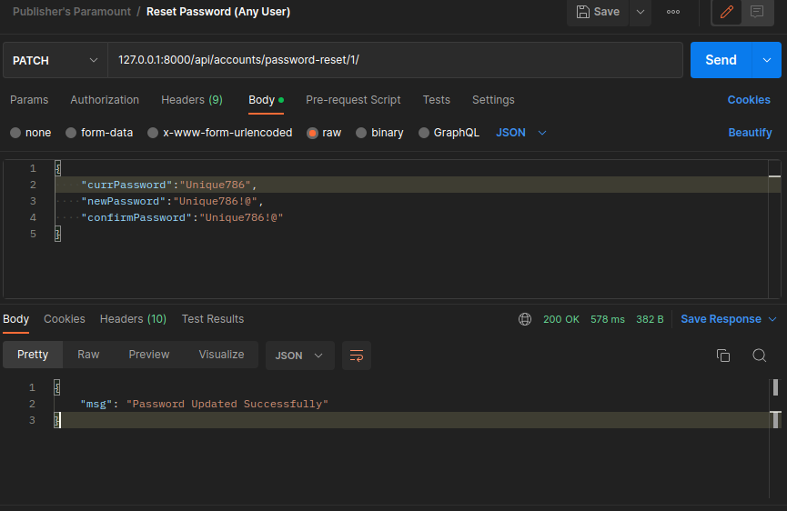
Figure 4. 12: Reset password API test

- Session user Manuscripts API Test (PP-01-0014)
Status | 200 Ok
Response Time | 12ms
Response Header Size | 2.56 KB
Table 4. 6: Session user Manuscripts API Test Result

Figure 4. 13: Session user manuscript API test

Load Testing:
- Login Response Time Graph

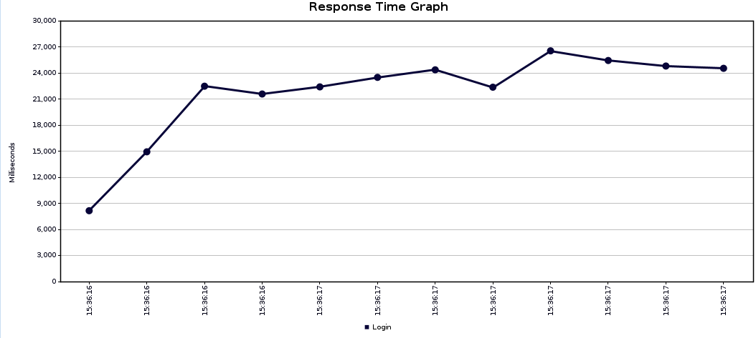
Figure 4. 14: Login response time graph

- Registration Response Time Graph

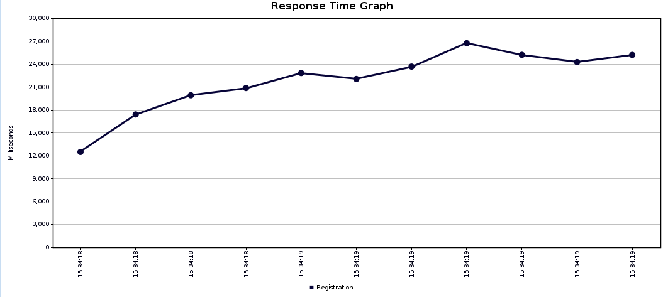
Figure 4. 15: Registration response time graph

- Manuscript Data Response Time Graph

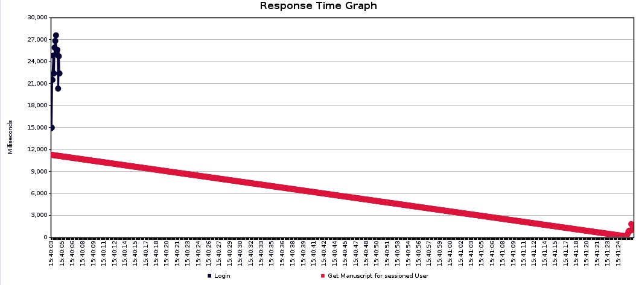
Figure 4. 16: Manuscript data response time graph

USER MANUAL

User Manual
In this section, we are creating a user manual where all the users will be able to get information about the website and how to perform different functions. We will also guide the user what different buttons and links will do when user clicks on them and how to navigate through our website. There are about 16 screens in our project.

Home screen
When you visit our web application, you will be at the home page and you will see different sections in our home page like following:
1

2
Figure 5. 1: User guide home screen

- Website logo:
It is the main logo of our website.

- Navigation bar:
This is the navigation bar of our website, which contains of different links, which our users can use to go to different pages of our website. There are links that go to home, about us page, page that contains all journals, a page where an author can go to submit their manuscript and an instruction page for our authors, reviewers and editors.


2
Figure 5. 2: User guide journal by subject section
1

- Journal By Subjects:
In this section, you can see some subjects of the journals and if you click any one of them, it will take you to that subject page where all the journals of that subject will be available for users.
- See all journal button:
You can use this button to see all subjects of the journals.
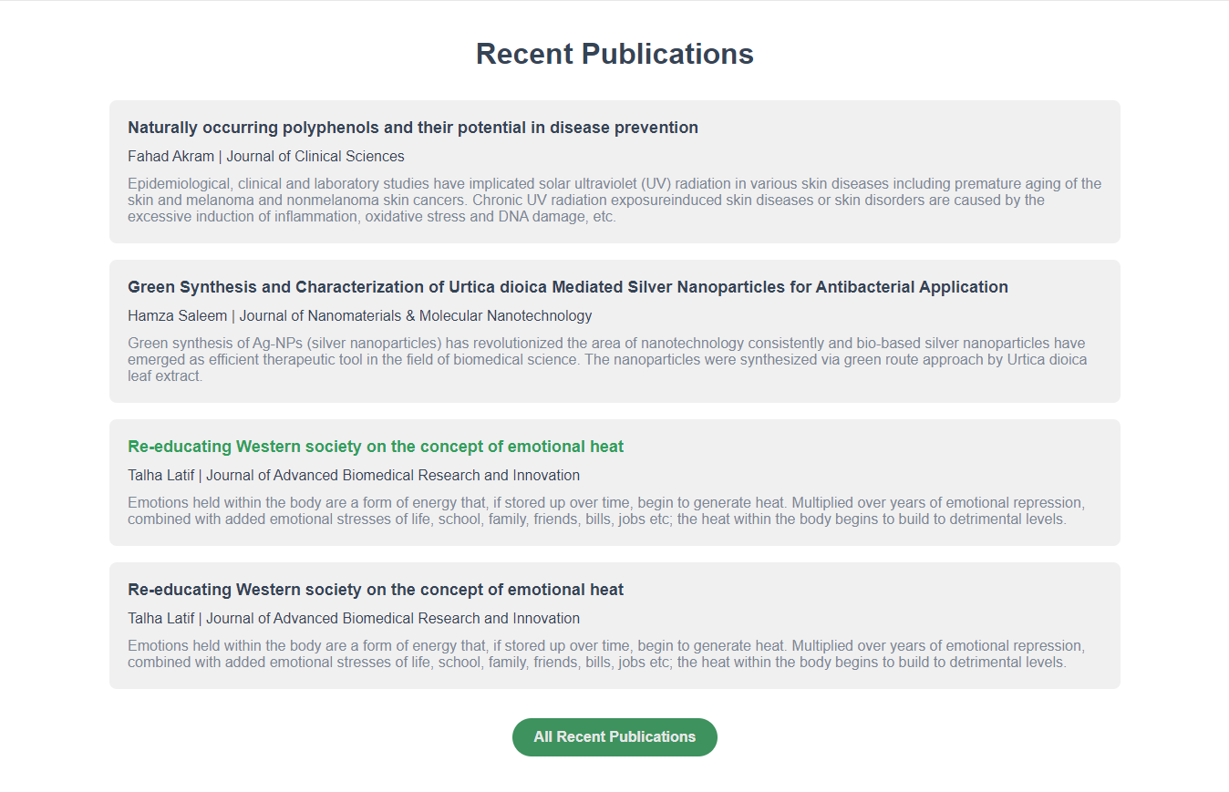
2
1

Figure 5. 3: User guide recent publications section

- Recent articles:
Here you can see some of the most recent publications in publishers paramount. Click the title to open the article file.
- See all recent articles button:
Click this button to see all the recent publications.
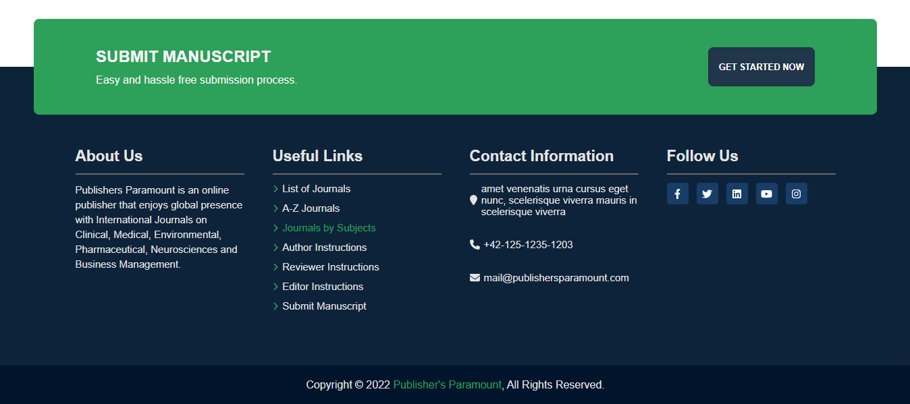
2
3
4
5
1

Figure 5. 4: User guide footer section
- Get started now:
Using this button an author can sign in to their dashboard and submit their manuscript from dashboard.
- About us:
Here you can see some introductory information about publishers paramount.
- Useful links:
This section contains the useful links that user might be interested in and for easier navigation of our website.
- Contact information:
This section contains some contact information like phone, address and mail of the organization.
- Social media links:
This section includes links to different social media platforms of the organization.

Journal List
This page contains a complete list of the journals of our website. Users can click any journal and it will take them to that journals page, where users can see all the information and articles related to that journal.


Figure 5. 5: User guide journals list screen

A-Z Journal
This page contains all the journals in the web application alphabetically.

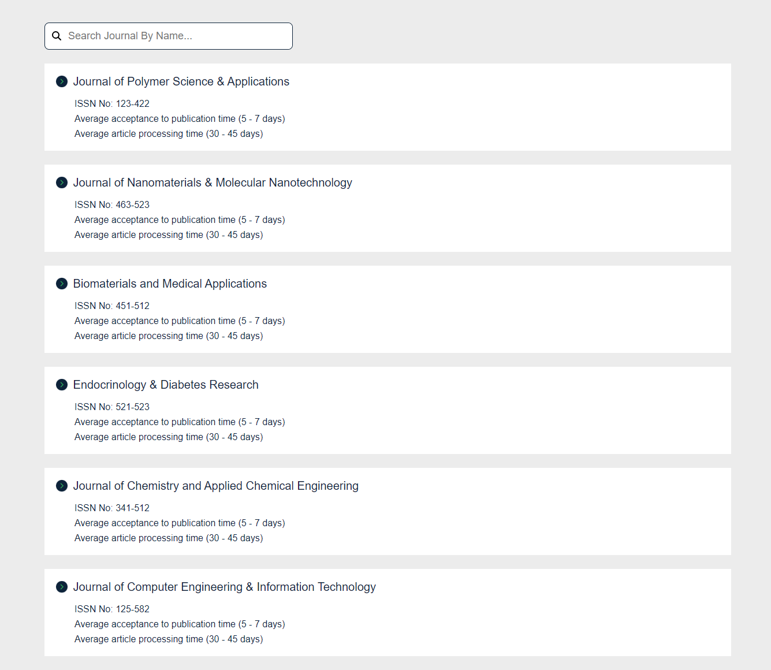
2
1

Figure 5. 6: User guide A to Z journals screen

- Search journal by name:
Here you can type the name of the journal and it will filter that journal and show you out of all journals
- A-Z Journals:
Here you can see all the journals alphabetically and you can click any of them to go to their respective page.

About Page
In this page, you can see information about publishers paramount in detail

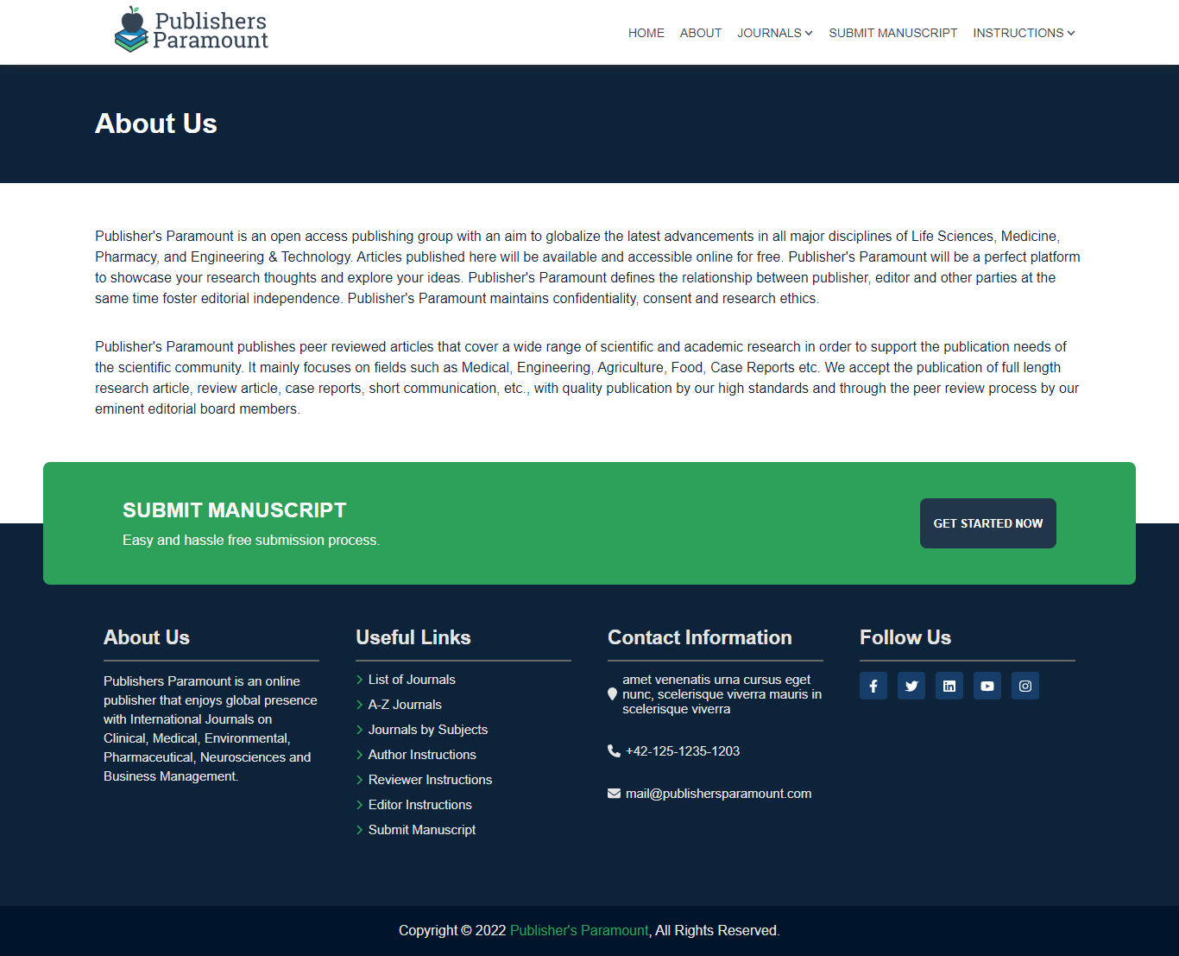
Figure 5. 7: User guide about us screen

Sign in Page
Using this page, all the users can enter their username and password and go to their respective dashboards.
4
3
2
1
Figure 5. 8: User guide sign in screen

- Username and password:
Here the users have to enter their username and password.
- Forgot Username/Password:
If the user have forgotten their username or password, they can click the button after which they will have to provide their email that they registered this account with and we will send them a link through email to reset their password and username.
- Sign in button:
After putting their username and password in the fields, users can click this button to go to their dashboard.
- Sign up button:
If the user do not have an account, they can click this button to go to a sign up page where they can register themselves.

Sign up Page
Using this page, users can register themselves as authors. They have to provide all the information required and hit the register button to make their account as author.
Figure 5. 9: User guide sign up screen

Author Dashboard Home
This is the home page of the author dashboard where they can perform all the functionalities like see submitted manuscripts, submit new manuscripts, change their details and change password.
3
2
1
Figure 5. 10: User guide author dashboard screen

- Author dashboard sidebar:
This is the sidebar of the author dashboard where you can see name and profile image of the author. Under that you have different links to pages like home, submit manuscript, details, change password and sign out.
- Manuscript search bar:
Using this search bar you can search for a specific manuscript in the list.
- Manuscript list:
This section contains all the manuscript submitted by the author. By clicking on the manuscript section, you can go that manuscripts page and see detailed information about that manuscript.

Author Manuscript Page
This is the manuscript page where you can see all the information about that manuscript like title, authors, article type, journal submitted in, status, manuscript id, abstract, files etc.

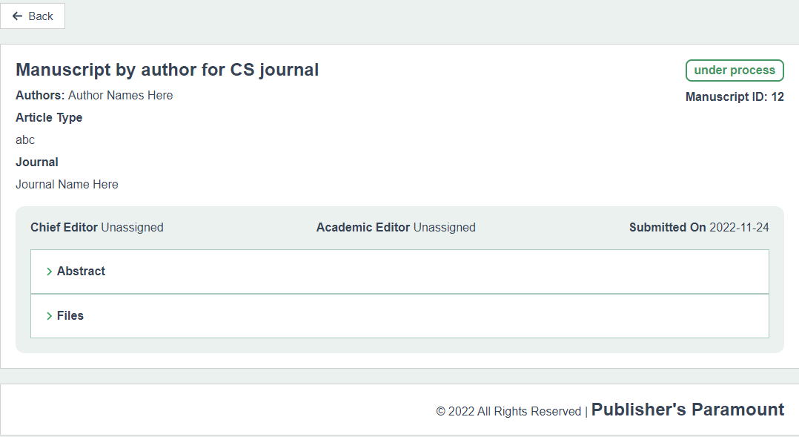
2
1

Figure 5. 11: User guide author manuscript screen

- Manuscript Information:
Here you can see detailed information about the manuscript.
- Abstract and Files:
When you click on the abstract and files section you will see abstract of the manuscript and the files author submitted for that manuscript respectively.

Author Submit Manuscript Page
This page allows the author to submit new manuscripts.
1
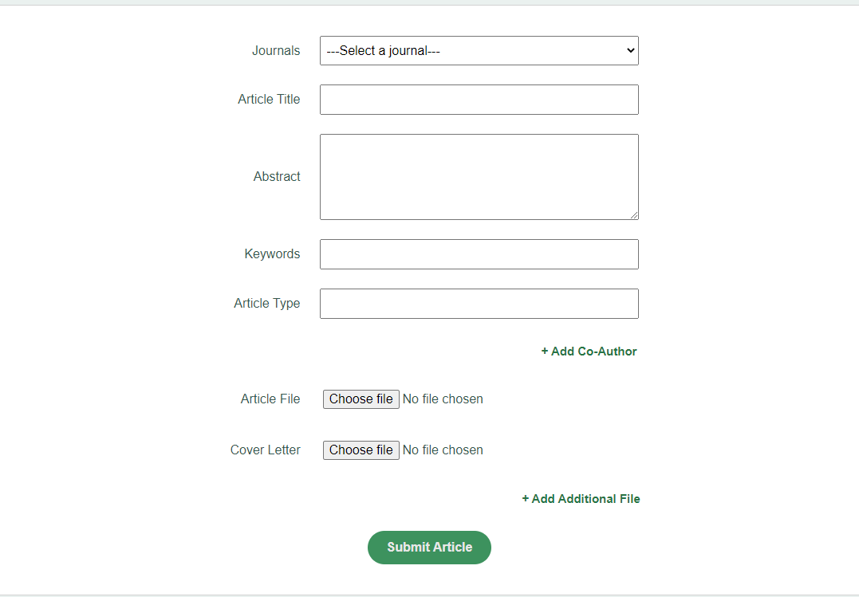
4
3
2
Figure 5. 12: User guide author submit manuscript screen

- Provide Manuscript Information:
Here you provide information about the manuscript that you are going to submit.
- Add co-author:
Using this button, you can add multiple co-authors for you manuscript.
- Add Files:
You can add article and cover letter files here. Both are mandatory.
- Add Additional Files:
Using this button, you can add additional files like figure files and abstract file.

Reviewer Dashboard Home
This is the home page of reviewer dashboard where reviewers can see the manuscripts assigned to them for review.
1
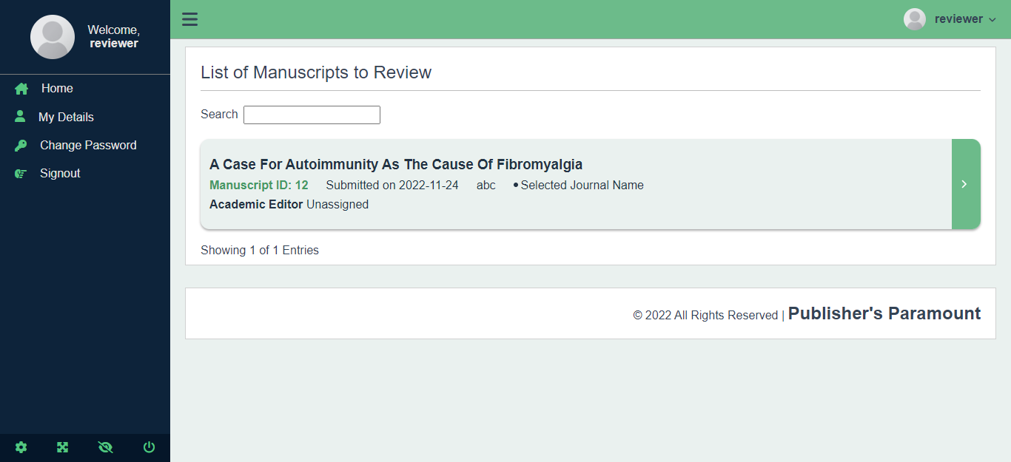
2
3
Figure 5. 13: User guide reviewer dashboard screen

- Reviewer dashboard sidebar:
This is the sidebar of the reviewer dashboard where you can see name and profile image of the author. Under that, you have different links to pages like home, details, change password and sign out.
- Manuscript search bar:
Using this search bar you can search for a specific manuscript in the list.
- Manuscript list:
This section contains all the manuscript assigned to the reviewer. By clicking on the manuscript section, you can go that manuscripts page and see detailed information about that manuscript and give review.

Reviewer Assigned Manuscript

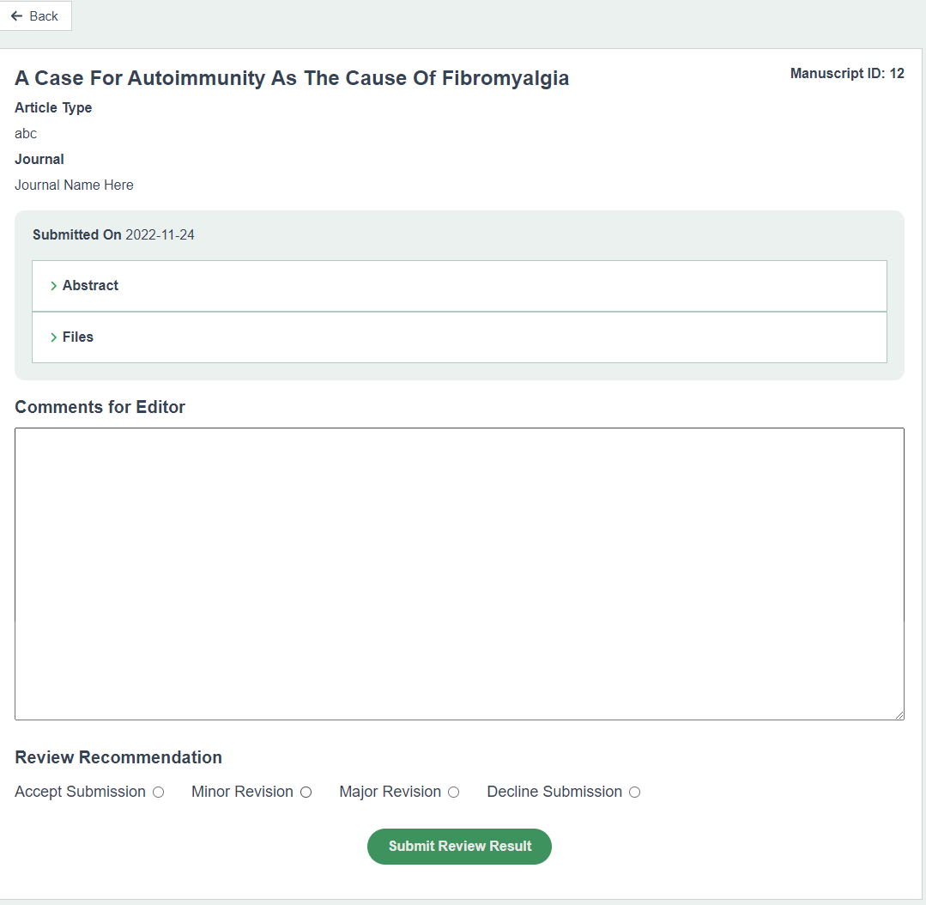
4
3
2
1
Figure 5.14: User guide assigned manuscript to reviewer screen

- Manuscript Information:
Here you can see detailed information about the manuscript.
- Abstract and Files:
When you click on the abstract and files section you will see abstract of the manuscript and the files author submitted for that manuscript respectively.
- Comments by reviewer:
Reviewer can use this field to give comments to editor about the manuscript after reviewing it.
- Review recommendation:
Reviewer can give four review recommendations to the editor, accept submission, minor and major revision, and decline submission.

Editor Dashboard Home
1
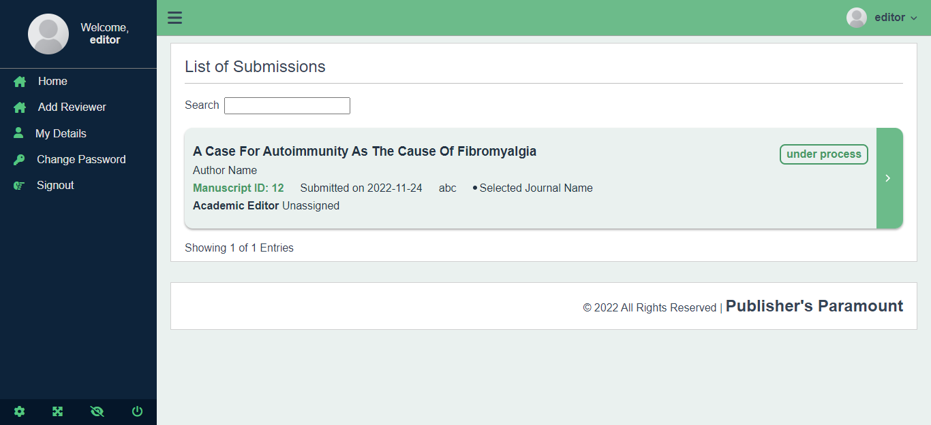
2
3

Figure 5. 15: User guide editor dashboard screen

- Editor dashboard sidebar:
This is the sidebar of the editor dashboard where you can see name and profile image of the editor. Under that, you have different links to pages like home, add reviewer, details, change password and sign out.
- Manuscript search bar:
Using this search bar you can search for a specific manuscript in the list.
- Manuscript list:
This section contains all the manuscript assigned to the editor. By clicking on the manuscript section, you can go to that manuscripts page and see detailed information about that manuscript and give final result.

Editor Add Reviewer

2
1
Figure 5. 16: User guide add reviewer screen

- Add Reviewer:
Using this input field editors can send email to users who want to act as reviewers. Then a link to sign up form will be sent to their emails and using that form they can register as reviewers.
- Add reviewer button:
Clicking this button will send an email to the person whose email was entered.

Editor Manuscript
1
’
5
4
3
2
Figure 5. 17: User guide manuscript assigned to editor screen

- Manuscript Information:
Here you can see detailed information about the manuscript.
- Generate Plagiarism Report:
Clicking this button will create a plagiarism report of the submitted manuscript.
- Assign Reviewers:
By using this button, editors can assign reviewers to the manuscript.
- Abstract and Files:
When you click on the abstract and files section you will see abstract of the manuscript and the files author submitted for that manuscript respectively.
- Give Decision:
Using these check boxes editor can give final decision for manuscript.

CONCLUSION AND RECOMMENDATIONS

Conclusion:
Journal management is a difficult and time-consuming operation, especially if no automation is used. During the publishing cycle, authors and other personnel participating in the journal management process, such as editor in chiefs, editors, reviewers and publishers, encounter plenty of issues. Finding appropriate persons to peer-review their articles is a difficulty for authors, as is the fact that they must rely on third parties to check for plagiarism and to maintain the integrity of the manuscript, we offered one solution for all these problems, Publisher’s Paramount helps them to manage articles, uploading, maintaining and automate the process online which helps all the personnel to manage their task without any issue and work with the actual flow.

Recommendation:
Our Project is targeting to manage the Article Publishing Cycle to help them automate the unnecessary amount of work and energy and to let them focus on the actual problem or Tasks. This Project can be turned into a paid-resource, charging for the manuscript publishing cycle, authors will have to pay in order to get their manuscript published on the website, Which will ultimate generate the revenue from this project.

REFERENCES

Electronic Sources from Internet:

[1] | "CodeIgniter Documentation," 10 December 2020. [Online]. Available:  https://codeigniter.com/docs.
[2] | “Extreme Programming: A Gentle Introduction.,” [Online]. Available:  http://www.extremeprogramming.org/. [Accessed 7 12 2020].
[3] | V. Lam, “Katalon Solution,” [Online]. Available: https://www.katalon.com/. [Accessed 3  12 2020].
[4] | E. Yuan, “Zoom API Referenece,” [Online]. Available:  https://marketplace.zoom.us/docs/api-reference/zoom-api. [Accessed 21 11 2020].
[5] | H. Aamir, “Online Quran Academy,” [Online]. Available: www : HAfizacademy.com. [Accessed 20 12 2020].
[6] | “Web Hosting services,” SiteGround, [Online]. Available: https://www.siteground.com/. [Accessed 4 11 2020].
[7] | “Types of SSL Certificate,” SiteGround, [Online]. Available:  https://www.siteground.com/kb/types-ssl-certificates-siteground-offer/. [Accessed 10  12 2020].

APPENDICE

Business Tier | Business Tier is basically the backend/brain of the project which interact with the Data Tier and present it via Presentation Tier of the Project.
Presentation Tier | Presentation Tier is Basically the Front Design of the project which helps the user to interact with the Application
Data Tier | Data Tier is nothing but the Database which holds the Data for the project in a schema.
Frontend | Frontend is the Presentation of the data rendered using Backend after processing it, to the front application where use can interact to the application.
Responsiveness | Responsiveness is nothing but the Layout presentation of the frontend on different devices.
Backend | Backend the Brain of the application which helps to full-fill the need of the user by providing them valuable information
Test Cases | Test Cases are basically Scenarios which can be encountered after deployed to the actual internet such as number of users, wrong field input, etc.
Postman | Postman helps to test the Application Programming Interface (API) whether it’s response is Valid or not
Load Testing | Load testing is another type of testing which determines the Response Time where there are large group people interacting with the Application.
JMeter | JMeter is just a tool which helps to determine the performance of the application when there is abnormal activity such as unusual load etc.

