AI-Powered Psychological Assessment: A Machine Learning Approach to Detect Childhood Trauma and Personality Traits in Young Adults.


Kanza Batool
03-275232-024

BAHRIA UNIVERSITY LAHORE CAMPUS

Table of Contents
Abstract 6
Chapter 1 7
Introduction 7
1.1 Background: 7
1.2 Machine Learning 8
1.3 Childhood trauma 9
1.4 Personality traits 10
1.5 Rationale: 12
1.6 Theoretical gap: 13
1.7 Contextual gap: 13
1.8 Problem Statement 14
1.9 Research Questions 15
1.10 Hypothesis: 15
1.11Objectives 15
1.12 Significance of study 16
Chapter 2 17
Literature Review / Theoretical Framework 17
Chapter 3 28
Methodology 28
3.1 Research epistemology: 28
3.2 Research strategy: 28
3.3 Population and Sampling: 28
3.4 Data Collection and Data analysis 29
3.4.1 Scale & Instruments: 29
Informed consent and Demographics: 29
Childhood trauma questionnaire (CTQ): 29
Big Five Inventory-2 Short Form (BFI-2-S) 30
3.5 Procedure: 30
3.5.1 Data Preprocessing 32
Handling missing values: 33
Feature scaling: 33
Data Splitting: 33
Feature Selection 33
3.5.2 Machine learning Model Development 33
Gradient Boosting 34
K-Nearest Neighbors (Knn) 35
Linear regression 35
Random Forest 36
Support Vector Machine (SVM) 37
3.5.3 Model Training & Evaluation 37
Confusion matrix 37
Mean Absolute Error (MAE): 38
Root Mean Square Error (RMSE) 38
3.6 Data Analysis: 38
3.7 Research Ethics: 38
Chapter 4 39
Results 39
Chapter-5 65
Discussion and Conclusion 65
5.1 Discussion 65
5.2 Conclusion 67
5.3 Implications 68
5.4 Limitations 69
5.5 Suggestions 69
References 70
Appendices 77
Permission Letter 78
Consent Form 79
Childhood Trauma Questionnaire 80
Big Five Personality 2 Short Form 81
Demographic Variables 82

Abstract
Traditional psychological assessments for childhood trauma and personality prediction often suffer from bias and inconsistency. This research explores the use of AI and machine learning to develop more objective and accurate diagnostic models. By leveraging advanced ML algorithms, this research proposal aims to enhance mental health evaluations and improve intervention strategies. This research utilized machine learning algorithms such as gradient boosting model, K-nearest neighbors, Liner Regression, Randomforest, SVM in developing objective, scalable, and data-driven models to detect childhood trauma and predict personality traits. This study used Childhood Trauma Questionnaire (CTQ) and the Big Five Inventory 2 Short Form (BFI-2-S) to gather psychological and behavioral information from young adults aged 18–22. Feature selection was done used to optimize model performance. The predictive accuracy was assessed with the help of F1-score, Confusion matrix, MAE, RMSE as the evaluation metrics. This research finding was be quite useful for diagnostics in mental health by enabling precise and early detection of psychological problems and providing personal interventions in mental health. The contribution of this study to the development of psychological assessments is by introducing AI-driven assessments, therefore making mental health support more reachable, effective, and impartial.

Chapter 1

Introduction

1.1 Background:
Artificial Intelligence has revolutionized various areas of business, and psychology is no different. One interesting application includes how machine learning models can predict and analyze psychological characteristics as well as the past life events experienced by individuals. Out of such applications, two stand out: those examining the possibility of detecting childhood trauma and predicting personality traits in young adults. These promise unprecedented accuracy and efficiency in psychological evaluation, making mental health support more accessible and personalized.
Childhood traumas tend to have a long-lasting impact on the state of an individual's mental health, impacting an individual's emotional, cognitive, and social development. Traditional assessments of trauma rely on self-reported questionnaires and clinical interviews, which may be biased and inaccurate in some aspects. However, machine learning models can scan huge amounts of data from a variety of. This data-driven approach may lead to a more objective and more holistic understanding of an individual's psychological state.
Predicting personality traits in young adults is yet another area where AI-powered assessments can make a significant impact. Personality traits, including openness, conscientiousness, and extraversion, are factors that shape a person's behavior, relationships, and career. Such information can be very valuable in personalized education, career counseling, and mental health interventions to enable young adults to make informed decisions and achieve their full potential.
The integration of AI in psychological assessments also addresses the growing demand for mental health services. With the increasing prevalence of mental health issues worldwide, there is a pressing need for efficient and scalable solutions. AI-powered assessments can significantly reduce the time and resources required for psychological evaluations, enabling mental health professionals to focus on providing personalized care and support. Plus, these evaluations can be done from remote locations, making mental health support accessible to individuals in underserved or remote areas.

1.2 Machine Learning
Machine learning (ML) is perhaps the most significant development in the selection of personnel since the development of employment tests. This special issue brings together research underpinned by practical uses, following on from previous academic research. For this overview article, the authors seek to make five kinds of contributions: present a brief tutorial in ML concepts and illustrate how they are applied in selection, with strengths and limitations; distill the results of the four articles in the special issue and provide an independent assessment of the quality of the evidence; note less salient lessons and takeaways that might not be obvious to researchers new to ML; present current best practices for selection; and identify areas for future research drawing both on the special issue and the general state of the field (Campion & Campion, 2023b).
In contemporary organizational scholarship, artificial intelligence (AI), machine learning (ML), and big data are growing in significance as methodology for investigating employees at work from various disciplinary traditions. This paper discusses how these technologies can move the science of work forward—through better theories, better measurement, and better forecasting of real-world outcomes. Based on the four articles within this special issue, which delve into these issues in depth, we also advance future research directions in organizational settings. Concurrently, we address essential practical, ethical, and institutional issues in applying AI, ML, and big data, including restricted data access, skills gaps, transparency, privacy, reproducibility, generalizability, and interpretability. Together, the opportunities as well as challenges in AI and ML are expected to reshape organizational research and practice in significant and powerful ways (Woo et al., 2024).

1.3 Childhood trauma
Children experiencing traumatic stress are those who have lived through one or more distressing events and continue to face emotional, psychological, and physical challenges long after the incidents have ended. These reactions can range from persistent sadness, anxiety, and emotional distress to changes in behavior, difficulties with self-control, trouble forming relationships, regression in skills, problems with attention or schoolwork, nightmares, and disruptions in sleep or eating. Physical symptoms such as headaches or body aches are also common. Older children may engage in risky behaviors, use drugs or alcohol, or participate in unsafe sexual activities. Often, these symptoms are triggered when the child is reminded of the trauma. While many people experience stress reactions occasionally, traumatic stress in children interferes with their daily functioning and relationships. No child is too young to be affected—even infants and toddlers can experience it—though the way it appears will depend on age and developmental stage (Peterson, 2023).
Trauma is widespread and linked to a high risk of co-occurring conditions globally, particularly post-traumatic stress disorder (PTSD) and other mental health issues. Identifying victims can be difficult, as self-reports are often hindered by emotional distress. Reliable confirmation of a child’s history of abuse or severe mistreatment is crucial, as it can greatly improve treatment planning (Sadeghpour et al., 2024).
The mental health effects of severe childhood trauma can be complex, leading to symptoms that overlap with multiple diagnoses. On any given day, a traumatized child might exhibit signs consistent with conduct disorder, borderline personality disorder, major depression, ADHD, phobias, dissociation, obsessive-compulsive disorder, panic disorder, adjustment disorder, or even early signs of conditions like multiple personality disorder. Over time, these patterns can evolve, giving clinicians even more possible diagnoses to consider in adulthood (Terr, 1995).

1.4 Personality traits
Personality is a distinctive quality that sets individuals apart. It can be understood as a set of relatively stable characteristics that influence how a person interacts, forms relationships, shapes attitudes, behaves, and even maintains psychological well-being (Serrano-Guerrero et al., 2024). Most personality theories emphasize that these patterns of thought, emotion, and motivation remain relatively consistent over time. While personality becomes more stable in early adulthood, subtle changes—often toward greater agreeableness and conscientiousness—tend to occur throughout life. Personality traits play a significant role in how people interact not only with other humans but also with intelligent systems. Understanding these traits has practical applications across multiple fields, including mental health, education, marketing, finance, recruitment, and recommendation systems (Motlagh et al., 2025).
While some have argued that personality traits are minor influences on behavior, evidence suggests they can be just as impactful as experimental manipulations. Debating which has more influence—traits or external factors—is unproductive, as both can be structured to dominate depending on the context. In reality, they often complement one another. This interplay reflects the broader person–environment dynamic, shaped by active and passive models of behavior. The impact of traits can be amplified by looking across multiple responses, situations, and time periods, moving from narrow behavioral units to broader traits and higher-order dimensions. Both broad and narrow traits have their strengths and weaknesses, and ongoing research continues to uncover new traits and insights into how they develop and persist. If personality psychology has a defining feature, it is the study of traits (Buss, 1989).
Personality differences are qualitative rather than strictly quantitative, which makes them challenging to measure. For this reason, some approaches focus on describing personality rather than testing it. Interpersonal conflicts often stem from differences in personality, making personality assessment valuable for fostering both individual growth and societal well-being. Allport and Allport (1921) proposed four broad categories of fundamental tendencies: intelligence (influencing adaptability), temperament (emotional breadth and strength), self-expression or strength (including extroversion/introversion, dominance/submission, and self-awareness), and sociality (encompassing participation, self-interest, and responsiveness to social cues). Measuring and mapping these traits can provide a more complete understanding of the individual, enabling more targeted interventions.
Although personality psychology covers far more than just traits, traits remain central to understanding human behavior. Misunderstandings and differing definitions of traits can create challenges in measurement and data interpretation. Paunonen and Hong (2014) highlight that despite these debates, more than a century of theory and research has shown that the study of traits greatly enriches our understanding of individual differences. They review issues related to defining traits, creating measurement tools, analyzing data, and classifying traits in taxonomies, defending the value of traits as conventionally understood.
In everyday language, the word “trait” can refer to any lasting personal feature—physical or psychological. In personality psychology, however, the term is reserved for certain individual differences in dispositions. McCrae (2018) situates traits within the broader landscape of individual differences, dividing these first into external factors (such as age, gender, socioeconomic status) and psychological variables. The latter includes acquired adaptations (skills, attitudes, roles) and innate tendencies (abilities, dispositions). Under Five-Factor Theory (FFT), personality traits are dispositions organized hierarchically—from a few broad factors down to many narrower traits and facets. These facets tend to share qualities like consensual validity, heritability, and long-term stability because they reflect the same underlying trait.

1.5 Rationale:
The rationale behind this study arises from the increased need for psychological assessments that are valid, efficient, and accessible. There is an especially urgent need in childhood trauma detection and the prediction of personality traits among young adults. The conventional approaches such as self-report questionnaires and clinical interviews often come with bias and inaccuracy. Therefore, there is an opportunity for utilizing data-driven approaches based on advances in artificial intelligence and machine learning to develop objective and scalable assessments. Childhood trauma has far-reaching effects on mental health and influences emotional, cognitive, and social development, while personality traits play a vital role in forming an individual's behavior and outcomes in life. This study will integrate AI in psychological evaluations with the aim of improving early detection of trauma, personalizing interventions for mental health, and offering valuable insights into education and career planning. Further, AI-based assessment can help fill the increasing demand for mental health services by offering cost-effective and remote-accessible solutions, which would ensure wider and more equitable access to psychological support.

1.6 Theoretical gap:
Recent empirical studies have highlighted several theoretical gaps and proposed future research directions in the application of artificial intelligence (AI) and machine learning (ML) for psychological evaluations, particularly in detecting childhood trauma and predicting personality traits in young adults. Key recommendations include: Multimodal Data Integration: Future research should explore the integration of various data types—such as facial expressions, speech patterns, physiological responses, and self-reported measures—to enhance the accuracy of AI models in detecting psychological conditions. (Ćosić et al., 2021) Algorithm Transparency and Explainability: There's a need to develop AI models that are not only accurate but also interpretable, allowing clinicians to understand the decision-making processes and build trust in AI-assisted diagnostics. Ethical Considerations and Bias Mitigation: Future studies should focus on identifying and mitigating biases in AI algorithms to prevent disparities in psychological assessments across diverse populations. (El-Sappagh et al., 2025) Integration with Existing Clinical Practices: Future research should explore how AI tools can be seamlessly integrated into current clinical workflows to support, rather than replace, human judgment in psychological evaluations. (Abrams, Z. (2023)

1.7 Contextual gap:
There is a significant contextual gap in applying AI and ML technologies in psychological assessments, despite the growing interest in integrating these technologies into psychological assessments for detecting childhood trauma and predicting personality traits in young adults. There has been a relative scarcity of published research on applying AI-driven assessments in nonclinical environments, such as universities and community settings, which is where such early detection and intervention would prove most valuable. Additionally, while traditional self-report methods and clinical interviews dominate trauma and personality evaluations, AI-based models remain underutilized in culturally diverse populations, raising concerns about their generalizability across different demographic and socioeconomic backgrounds. Furthermore, there is a lack of real world validation studies assessing the effectiveness of AI-driven assessments outside controlled research environments. It thereby underlines a need for better, more holistic, inclusive, and ecologically valid research on AI-based psychological evaluations to be accessible, interpretable, and applicable across a wide range of settings and populations.

1.8 Problem Statement
Traditional methods of psychological assessment, especially for the detection of childhood trauma and prediction of personality traits, are mainly based on self-report questionnaires and clinical interviews, which are subjective, time-consuming, and prone to biases. Such limitations create barriers to accurate diagnosis, timely interventions, and personalized mental health support. With the increasing demand for mental health services and the complexity of psychological evaluations, there is a need for more objective, scalable, and efficient assessment methods. The integration of artificial intelligence and machine learning offers a promising solution by leveraging large datasets to identify patterns, predict psychological traits, and detect trauma with greater precision. However, despite the potential benefits, there remains a gap in research on the reliability, validity, and ethical implications of AI-driven psychological assessments. This study aims to bridge this gap by developing and evaluating machine learning models for childhood trauma detection and personality prediction, addressing the need for more accessible and data-driven mental health solutions.

1.9 Research Questions
- How accurate can machine learning models detect childhood trauma by psychological and behavioral data as opposed to the traditional self-reporting method?
- How effectively do AI-based psychological tests predict personality traits in young adults?
- Which factors most significantly contribute to an accurate prediction?
- Which is more accurate machine learning approach to detect childhood trauma and personality traits in terms of accuracy, interpretability, and clinical applicability?

1.10 Hypothesis:
- Machine learning models will demonstrate higher accuracy and objectivity in detecting childhood trauma compared to traditional self-reported methods, reducing biases associated with subjective assessments.
- AI-based psychological tests will effectively predict personality traits in young adults, providing insights comparable to conventional psychological assessments.
- Machine learning models for detection childhood trauma and personality traits will show distinct feature selection patterns, but integrating insights from both can enhance diagnostic precision and mental health interventions

1.11Objectives
- To develop and test machine learning models that can detect childhood trauma through psychological and behavioral data, hence enhancing the precision and objectivity of trauma diagnoses as compared to the traditional self-reported methods.
- To predict personality traits in young adults using AI-based psychological tests, which helps understand behavioral patterns for personal growth, career advice, and intervention in mental health.
- To compare machine learning approaches to detect childhood trauma and personality prediction in young adults and how machine learning may enhance diagnostics.

1.12 Significance of study
The relevance of this research is that artificial intelligence and machine learning are revolutionizing psychological assessment, especially when it comes to the detection of childhood trauma and personality traits prediction in young adults. AI-based approaches can lead to more objective, data-driven mental health evaluation, thus allowing for more precise and efficient use of mental health evaluations with minimal reliance on self-reports or time-consuming clinical interviews. This may allow for better early detection and intervention for those who are exposed to childhood traumas to have improved mental health outcomes. Moreover, AI-powered assessments can help personalize education, career guidance, and psychological support in the sense that such recommendations would be tailored for each individual's unique personality. This study contributes to the wider integration of AI in psychology and to the development of research, ethics, and practice in mental health care.

Chapter 2

Literature Review / Theoretical Framework
Abuse is common throughout the world and comes with severe mental illnesses, particularly PTSD, with or without other conditions. Detection can be hard, though, since victims do not always reveal their ordeal due to emotional trauma. Concrete evidence of severe abuse is paramount since it will inform the creation of suitable treatment plans.
This research examined a novel approach using machine learning (ML) with data from the Minnesota Multiphasic Personality Inventory – Adolescent Version (MMPI-A). Trauma exposure was measured using the Childhood Trauma Questionnaire (CTQ) that was administered to 733 children and adolescents in an inpatient setting.
Statistical and information theory analyses revealed that sexual, physical, and emotional abuse each exhibited unique MMPI-A profile patterns. Differing from previous research connecting abuse and IQ, the current study established that sexual abuse yielded the lowest MMPI-A increments, physical abuse yielded greater increments, while emotional abuse yielded the highest. A draft ML classifier for forecasting abuse history was created and worked at a comparable level with established screening instruments. PCA and cluster analysis also revealed that varying degrees of emotional abuse severity correlated with unique personality clusters. Overall, these results indicate that ML-based methods can potentially detect people at high risk of history of abuse by using real-time information from multiple indirect sources (Sadeghpour et al., 2024b).
Trauma is widespread globally and is heavily correlated with severe mental illness, particularly PTSD, frequently in combination with other issues. Victims of abuse can be difficult to detect, though, as they tend to stay quiet under emotional duress. Definitive proof of intense abuse is necessary to develop effective treatment plans. This research tried out a new approach with machine learning (ML) using Minnesota Multiphasic Personality Inventory – Adolescent Version (MMPI-A) data. It was assessed the history of trauma using the Childhood Trauma Questionnaire (CTQ), filled in by 733 inpatient children and adolescents. Both statistical and information theory analyses revealed sexual, physical, and emotional abuse each with distinct MMPI-A patterns. In contrast to previous research regarding IQ, this work discovered the least MMPI-A change with sexual abuse, greater change with physical abuse, and greatest with emotional abuse. An initial ML classifier was created for predicting a history of abuse that is as good as or better than other established screening instruments. PCA and cluster analysis also demonstrated that various degrees of severity of emotional abuse were associated with distinct personality clusters. These results indicate ML-based analysis might be able to identify individuals at high risk of historical abuse through the use of real-time information drawn from a variety of indirect sources (Sadeghpour et al., 2024b).
Childhood trauma is one of the primary risk factors for developing adolescent anxiety, and emotion regulation is implicated in this relationship. In this large longitudinal sample (N = 2,461 at baseline, with external validation), investigators assessed how various forms of childhood trauma are associated with adolescent anxiety with attention to the mediating roles of cognitive reappraisal and expressive suppression. Employing machine learning and standard mediation analysis, findings revealed emotional abuse to be the most robust predictor of anxiety in adolescents over other types of trauma. Cognitive reappraisal and expressive suppression were significant partial mediators between emotional abuse and anxiety, and these effects were enduring and externally validated. Overall, the results enrich current models of trauma-related mental health issues and offer evidence-based recommendations for interventions targeting emotion regulation in adolescents with histories of trauma.
Personality is a distinctive characteristic that differentiates an individual from others and can be conceived as a collection of stable traits that determine interactions, relationships, attitudes, behavior, and psychological well-being. With the emergence of social media websites where individuals exchange text-based messages, the detection of personality traits from written text has generated immense interest. These texts provide a timeline of psychological tendencies and are hence valuable for personality evaluation. This paper describes a stacked ensemble model integrating various conventional machine learning classifiers with deep learning methods, lexical and semantic features, and various word embedding models to develop a personality prediction system. The model was evaluated on the renowned My-Personality dataset, and findings indicated it performed better than other ensemble models, conventional machine learning, deep learning strategies, and current state-of-the-art, achieving an average accuracy of 72.69% (Serrano-Guerrero et al., 2024).
Studies have shown that nightmares are associated with suicide and self-injury risk, even when controlling for insomnia, posttraumatic stress disorder, anxiety, and depression. Such a relationship must be understood in a bid to create effective prevention and intervention programs. This systematic review reviewed twelve studies that explored the underlying mechanisms of nightmares and suicide and self-injury. Outcomes were grouped into five categories: affect/emotion regulation, cognitive appraisals, psychosocial factors, acquired capability, and depression. Study designs varied, but preliminary evidence supports cognitive appraisals and affect/emotion regulation as key processes in this association. For the first time, differences between mechanisms of nightmares and suicide have been examined. To further support evidence, longitudinal designs, objective measures of sleep disturbance, and analysis of the emotional content of nightmares should be used by future research. Studies should also examine whether treatments for nightmares can reduce suicidal thoughts, suicidal behavior, and self-injury—particularly because patients may be more willing to come in for nightmares than they are for suicidality or self-injury (Andrews & Hanna, 2020).
Childhood maltreatment (CM) is a robust risk factor for mental illness, and emotional abuse in particular has been especially associated with affective disorders during youth. However, its predictive role in adult depressive symptoms remains undefined, and the specific contribution of certain dimensions of emotional abuse has not been extensively investigated. The research employed a Random Forest machine learning method to examine the ability of CM domain scores and specific items from the Childhood Trauma Questionnaire (CTQ) to predict adult depressive affect in a general population sample. Models were trained (N = 769) and validated (N = 466) using transparent ML techniques. The results indicated that models derived from single CTQ items predicted more variance than those derived from domain scores (R² = 7.6% vs. 6.4%). Emotional abuse, especially subjective aspects involving personal reactions and perceptions, was the greatest predictor of adult depressive affect. Overall, the findings highlight the utility of item-level CM measurement for more nuanced understanding of long-term depression risk.
The absence of trustworthy markers hinders the detection and treatment of mental illness early on. Machine learning models were utilized in this study to identify diagnostic and risk prediction markers for eating disorders (EDs), major depressive disorder (MDD), and alcohol use disorder (AUD). Case-control samples of young adults (age range: 18–25) consisted of patients with Anorexia Nervosa (AN), Bulimia Nervosa (BN), MDD, AUD, and classifiable controls. For risk prediction, information was drawn from the longitudinal IMAGEN study, examining adolescents at 14, 16, and 19 years. Regularized logistic regression models employed several types of data, such as psychopathology, personality, cognition, substance use, and environmental. ED classification was very accurate without the use of body mass index, with AUC-ROC [95% CI] values of 0.92 [0.86–0.97] for AN and 0.91 [0.85–0.96] for BN. MDD (0.91 [0.88–0.94]) and AUD (0.80 [0.74–0.85]) classifications were also robust. Models demonstrated cross-diagnostic capacity, as they were able to classify AUD and MDD when trained on EDs and vice versa (AUC-ROCs, 0.75–0.93). Joint predictors across disorders were neuroticism, hopelessness, and ADHD symptoms. In the population sample, models moderately predicted future ED symptoms (0.71 [0.67–0.75]), depressive symptoms (0.64 [0.60–0.68]), and harmful drinking (0.67 [0.64–0.70]). Overall, the results indicate that the use of multi-domain data can enhance accuracy in psychiatric diagnosis and risk prediction.
This investigation assesses personality impact on physiological reactions while driving, particularly under dangerous and near-crash conditions, through the application of Machine Learning (ML). The research seeks to enhance driving support systems by incorporating driver-related characteristics. Physiological data from sixty-three healthy drivers were gathered under simulated city driving tasks and evaluated with five ML methods to predict personality traits from the Big Five Inventory and STAI trait scores. The procedure consisted of seven steps: preprocessing data, selecting Electrodermal Activity (EDA) time windows (with backward, forward, and pseudo-wrapped methods), evaluating traits, optimizing algorithm parameters, comparing algorithms, and trait cluster prediction. The performance of the models was measured using ROC Area Under the Curve (AUC). The pseudo-wrapped method had a mean 8.3% AUC improvement compared to backward and forward methods. Personality detection achieved AUC scores ranging from 0.968 to 0.974, where Openness, Agreeableness, and Neuroticism were identified most precisely. Adding established relationships between Neuroticism, Extraversion, and Conscientiousness improved detection mildly by increasing the highest AUC from 0.961 to 0.993 for clusters. These findings show the capability of ML in detecting personality traits based on driving behaviors and physiological driving data, which can be used in designing better driver assistance systems (Evin et al., 2022).
With recent advances in technology, campaigners and political groups can now employ psychographic-based political marketing. However, there is still little empirical evidence on how effective this approach really is. Drawing on self-congruity theory, a pre-registered experiment (N = 280) examined how personality-matched political microtargeting influences citizens’ attitudes toward a political party and their voting intentions. The study specifically focused on the “thinking” versus “feeling” personality dimension from the MBTI, testing whether this trait would “interact” with a corresponding ad appeal—rational versus emotional political messaging. To investigate this, two methods were used: 1) a machine learning approach, and 2) a self-reported personality survey. The findings showed notable “congruence effects” between personality type and ad appeal, with perceived ad relevance acting as the key mediating factor. However, these effects appeared only with the self-reported personality data. When personality was identified through the algorithmic method, no significant effects emerged. These results contribute to current societal debates as well as to methodological and theoretical discussions. (Zarouali et al., 2023)
Ever since early human evolution, personality and emotions have been inextricably linked, with emotions expressing personality and personality influencing emotional experience and expression. This research explores the interaction between these two dimensions of human behavior through machine learning and statistical modeling. The goal was to automate the detection of correlations between MBTI (Myers-Briggs Type Indicator) characteristics and Ekman's emotions through contextual embedding of user-posted social media content. The methodology consisted of two phases: initially, computing cosine similarity scores between MBTI types and target emotions; secondly, cross-dataset learning, where machine learning models were trained using emotion-tagged datasets to recognize patterns in text and subsequently utilize them for predicting emotions in the target dataset. The Support Vector Machine worked best, with 85.23% accuracy of emotion prediction. To enhance reliability and accuracy, the end prediction incorporated both. Statistical tests showed additional connections between MBTI types and Ekman emotions: extroverted (E), sensing (S), and feeling (F) individuals reported joy and surprise more frequently; extroverted (E), intuitive (N), thinking (T), and perceiving (P) individuals reported more negative emotions such as anger and disgust; and introverted (I), intuitive (N), thinking (T), and judging (J) individuals reported fear and sadness more often. These results offer important observations regarding how varying personality types affect emotional display on social media (Akber et al., 2024).
Measuring psychological constructs like the Big Five personality traits has long depended on standardized rating scales. Although useful, the research in this case suggests descriptive word-based answers evaluated with natural language processing (NLP) can be a powerful alternative. In this case, 663 people described their own personality or the personality of someone who very clearly had one of the Big Five traits in five words. These answers were evaluated using high-capacity large language models, like BERT and GPT-4, which are powerful NLP tools.
The study compared the validity of word-based responses processed by NLP with the most prevalent standard IPIP-NEO-30 rating scale. Results showed that word-based descriptions achieved up to 10% greater accuracy in trait classification. Semantic-based measures also provided greater inter-rater reliability, and observer agreement on ratings of others was higher than self-reports. In general, the findings suggest that descriptive word-based responses, when questioned by NLP, may be able to pick up more prominent and generalizable personality features than traditional rating scales (Sikström et al., 2025).
Human behavior and personality prediction from social media websites like Facebook, Twitter, and Instagram have been a significant area of research. Information from user status updates and posts provides valuable information for predicting and studying various behaviors and personality characteristics. The primary aim of this research was to determine personality based on the Big Five traits by creating an intelligent sentence analysis model for extracting applicable features. It proposed a novel Binary-Partitioning Transformer (BPT) in conjunction with Term Frequency & Inverse Gravity Moment (TF-IGM) to reveal patterns between feature sets and personality traits across datasets. The suggested approach performed better than typical baseline feature extraction methods on several social media platforms with an F1-score of 0.762 and 78.34% accuracy on Facebook, an F1-score of 0.783 and 79.67% accuracy on Twitter, and an F1-score of 0.821 and 86.84% accuracy on Instagram (Kamalesh & B, 2022).
Machine learning models using high-dimensional data have gained attention for their ability to predict psychological variables such as personality. However, their capacity to generalize across different domains has been less explored. In this study, two text domains—Reddit messages and personal essays—were compared. Results showed that, while atheoretical high-dimensional models outperformed low-dimensional and theory-based models in predictive accuracy within the same domain, they exhibited poor or non-significant predictive accuracy when applied across domains. This suggests that complex models are more dependent on the specific characteristics of the domain they are trained on. Additionally, when examining predictors used by these models, few remained consistent across domains. The authors argue that theoretical frameworks remain essential for prediction-focused studies and that research on both high- and low-dimensional models should aim to establish the conditions under which they can generalize effectively. (Berggren et al., 2023)
The Childhood Trauma Questionnaire (CTQ), Parental Bonding Instrument (PBI), and Mini International Neuropsychiatric Interview (MINI) were employed in this research. Results indicated that those with ASPD had much higher rates of mental illness. Both machine learning and standard analyses both found emotional and physical abuse to be the strongest determinants of ASPD, although the two measures were different in outcomes regarding physical neglect and paternal care. Although not yielding conclusive results, the research proposes that integrating these methods can provide a fuller picture of how several determinants operate in psychological disorder development (Schorr et al., 2021).
Traumatic stressors and the resulting psychological impacts can influence the risk-taking behavior of an individual, but the degree to which this varies according to the type of trauma is unknown. In displaced populations, this has not previously been examined either. In the current study, risk-taking was tested in 56 displaced participants utilizing the balloon analogue risk task (BART). Exposure to trauma, PTSD, and depression symptoms were quantified through use of semi-structured interviews. With stochastic gradient boosting machines, risk-taking predictors were determined. Findings indicated that physical abuse, organized violence, neglect, childhood peer violence, and emotional abuse were associated with lower risk-taking, as demonstrated by fewer adjusted pumps on the BART. Traumatic stressors of a civilian nature and additional childhood incidents were also linked to decreased risk-taking. In general, the research implies that the influence of trauma on risk-taking behavior varies with the type of experienced stressors (Augsburger & Elbert, 2017).
Child abuse and neglect childhood trauma is likely the US's most important public health issue, and one that meaningfully could be reduced with successful prevention and intervention. Over 3 million children in the US are formally abused or neglected each year, with about 1 million of those allegations being substantiated. Even more children are traumatized by extreme medical interventions, accidents, or community aggression. But most trauma is initiated in the home, with almost 80% of child maltreatment being carried out by the child's own parents. Therapeutic intervention with highly traumatized children is aimed at making them aware of when they are re-experiencing early traumatic experience and leading them to new coping mechanisms. This entails creating new relationships between their experiences, their emotions, and bodily sensations. Medication is often the immediate intervention rather than assisting children in the acquisition of skills they need to use to contain painful bodily sensations.
To process their trauma, children initially require a safe setting to work through their experiences without reliving them. The purpose of this article is to identify emotional triggers and re-enactment patterns in traumatized children, to define the range of disruptions of development from complex trauma, and to define the adaptation patterns which emerge in such children (Van Der Kolk, 2005).
The Five-Factor Model (FFM) of personality is an empirical generalization of personality trait covariation but is not a theory of personality. And FFM research is not such a theory. In an effort to bridge this gap, the authors introduce the Five-Factor Theory (FFT; McCrae & Costa, 1996), a theoretical model in line with what is presently known. FFT is a contemporary form of trait theory rooted in assumptions that individuals are comprehensible, rational, varied, and active. It posits personality as a global system with definitively established categories of variables and active processes that dictate the primary causal streams. The Big Five dimensions of personality—Neuroticism, Extraversion, Openness, Agreeableness, and Conscientiousness—are the system's foundation. FFT offers an approach to accounting for how psychological processes are built and function and how these affect people's behavior and experience.
Psychology has long been interested in locating the causal processes of behavior. Random, highly controlled experiments are the standard, and there is a lot of research examining mediating and moderating variables on behavior. But this explanatory focus has promoted much research programs to develop rich theories of psychological processes but little—or no—ability to make good predictions of future behavior. Yarkoni and Westfall (2017) argue that machine learning procedures can render psychology as a more predictive science. They outline some of the most crucial machine learning ideas and report research in which these ideas have been implemented to answer questions related to prediction in psychology. The authors argue that emphasis on prediction as well as explanation can eventually render what we know regarding behavior more optimal.

Chapter 3

Methodology

3.1 Research epistemology:
This research epistemology is positivism and post-positivism, as the research is based on empirical data, statistical analysis, and machine learning models to predict childhood trauma and personality traits. It follows the positivist approach through standardized psychological assessments (CTQ, BFI-30) and AI models to find out objectives, measurable relationships between a history of trauma and personality traits. Moreover, it also has post-positivist elements in that it acknowledges the complex nature of psychological constructs, the possible biases in self-reported data, and the probabilistic nature of AI-driven predictions. This research balances scientific rigor with contextual interpretation by validating findings with self-collected dataset, thus balancing AI-driven quantitative analysis with psychological insights to improve mental health assessments.

3.2 Research strategy:
This study has used the approach of quantitative research strategy based on cross-sectional design, detecting childhood trauma with machine learning in personality predictions.

3.3 Population and Sampling:
The target population of present study would be comprised of young adults of age range 18 to 22 years. A purposive sampling technique was used to select the participants. This non probability sampling method was used since the study focuses on individuals with specific age group. Sample size was 500 young adults.

3.4 Data Collection and Data analysis
Data was collected through the Childhood Trauma Questionnaire (CTQ) to assess past abuse and Big Five Inventory-30 (BFI-30) for personality assessment, alongside demographic measures. The model classified the history of trauma and personality traits through feature selection using Chi-Square, GINI Index, PCA, and machine learning models including SVM, Random Forest. AUC-ROC, sensitivity, specificity, and F1-score were used to measure model performance with cross-validation. Informed consent, and AI bias mitigation was kept in consideration.

3.4.1 Scale & Instruments:
- Informed consent and Demographics
- Childhood trauma questionnaire (CTQ)
- Big Five Inventory-2 Short Form (BFI-2-S)

Informed consent and Demographics:
To ensure willingness of participants a written informed consent was given on which participants signature were taken. Furthermore for demographic profile demographic information was taken including gender, age, parental status, parental socioeconomic status, education, no of siblings, birth order, etc.

Childhood trauma questionnaire (CTQ):
Originally created by Bernstein and Fink in 1998, the Childhood Trauma Questionnaire (CTQ) had 70 items at first. In 2003, it was reduced to 28 items. Psychologists frequently utilize this self-administered instrument to determine the incidence of retroactive childhood trauma. Using a five-point Likert scale that runs from Never True or Very Often True, respondents provide their answers to questions. The five sub-scales of the short form of the CTQ-SF (Short Form) are Physical Abuse, Sexual Abuse, Emotional Neglect, and Physical Abuse. Each sub-scale item scores are added together throughout the scoring process, with some items needing to be reverse coded. There is a possible range of 5 to 25 for each clinical scale. The CTQ demonstrates substantial psychometric properties, as seen by the high internal consistency scores for each of its sub-scales: sexual abuse (.93–.95), emotional neglect (.88–.92), emotional abuse (.84–.89), and physical abuse (.81–.86).
With a coefficient of 0.80, the test-retest reliability over a 3.5-month span is likewise strong. These characteristics render the CTQ a credible and trustworthy instrument for evaluating childhood trauma, offering insightful information for settings in both clinical and research contexts.

Big Five Inventory-2 Short Form (BFI-2-S)
The Big Five Inventory-2 Short Form (BFI-2-S; Soto & John, 2017) is a short 30-item instrument that was created to assess the five broad dimensions of personality. It is a shorter version of the BFI-60 and is used in situations where participants have limited time. Answers are given on a 5-point Likert scale from 1 (strongly disagree) to 5 (strongly agree).

3.5 Procedure:
The was collected using questionnaire that included informed consent, demographics, the childhood trauma questionnaire and big five inventory 2 short form. The 500 participants were mostly young adults and university students between the ages of 18-22. Participants signed the informed consent before filling the questionnaire. After completing the data collection, the data was entered and scored in the spread sheet in numerical form. Then data preprocessing techniques were applied to standardize the data by dropping unknown labels. preprocessing pipeline was used to standardized numerical features by taking median and standard scaling was used. Furthermore, feature selection was done selecting numerical columns. separating target columns from feature list to assess separately. For the model development of machine learning classifiers for trauma, RandomForest, GradientBoosting, SVC, KNN were used and Regressors for predicting numeric personality traits RandomForestRegressor, GradientBoostingRegressor, KNNRegressor, SVR LinearRegression labelled data set was used to develop supervised model of machine learning. Then these models were developed. Model Training & Evaluation trained on trauma classification task.Evaluate with Accuracy, Macro F1, Classification report, Confusion matrix Then trained the matching regressor for personality Calculate MAE (Mean Absolute Error) for each trait, Calculate RMSE (Root Mean Squared Error).

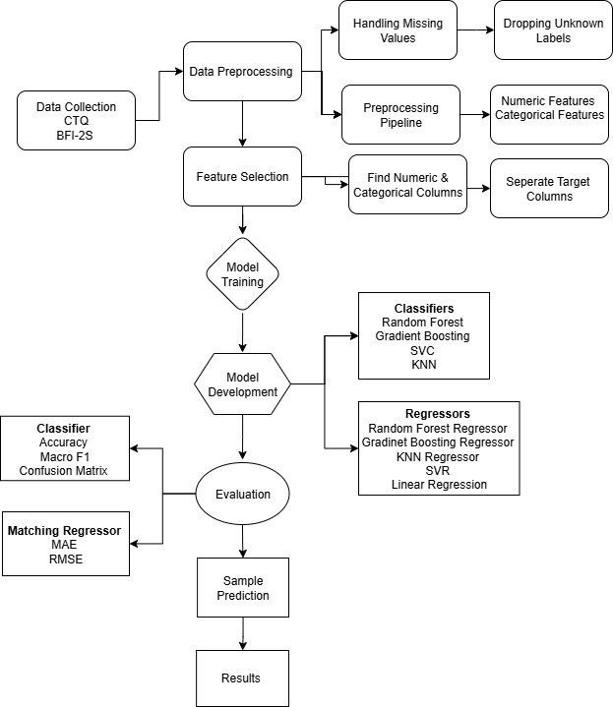
Figure.1: AI-Powered Psychological Assessment approach to Detect Childhood Trauma and Personality Traits.

3.5.1 Data Preprocessing
The collected data went through preprocessing to ensure consistency and accuracy. The steps included dropping unknown labels with in the data set and preprocessing pipeline was used to standardize data following preprocessing pipelines techniques were used.

Handling missing values:
It is a technique which “deals with unknown labels or missing values in data set due to errors in data collection”. In this study unlabeled data was dropped using technique of handling missing values.

Feature scaling:
This is data preprocessing techniques which “involves standardizing or normalizing numerical features in data set”.

Data Splitting:
This technique involves “dividing the preprocessed data into training, validation, and testing sets”.by using this technique data was split into training and testing sets for trauma classification and personality regression.

Feature Selection
Feature selection technique is a machine learning method to identify and select most relevant data features from data set to improve and enhance performance of model.
In this study features selection was done by selecting numerical features and separating target columns to assess them separately.

3.5.2 Machine learning Model Development
Machine learning models were developed to classify individuals based on trauma history and personality traits. The models include classifiers for trauma, RandomForest, GradientBoosting, SVM, KNN were used and Regressors for predicting numeric personality traits RandomForestRegressor, GradientBoostingRegressor, KNNRegressor, SVR LinearRegression labelled data set was used to develop supervised model of machine learning. Then these models were developed.

Gradient Boosting
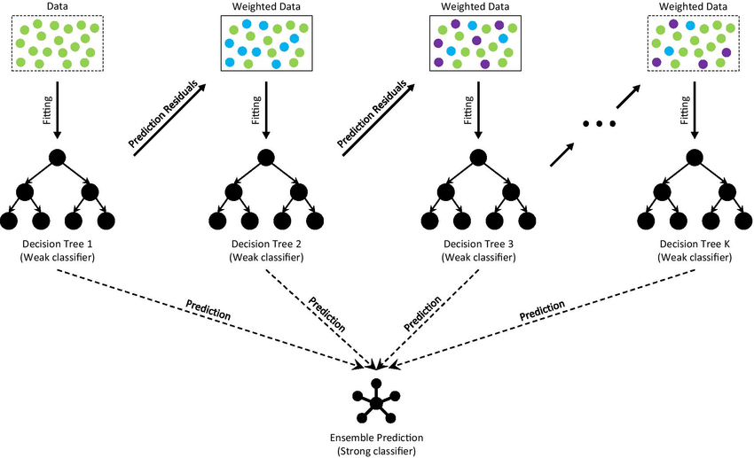
Figure 2: The Gradient Boosting Model (GB) (Deng et al., 2021)
The Gradient Boosting Classifier (GBC) is a widely used machine learning algorithm for binary classification, which builds decision trees iteratively to minimize prediction errors. (H. Chen, 2024) A Gradient Boosting Regressor starts with an average prediction and improves it through multiple trees, each one fixing the previous trees’ mistakes in small steps, until reaching the final prediction. (Baladram, 2024b)

K-Nearest Neighbors (Knn)
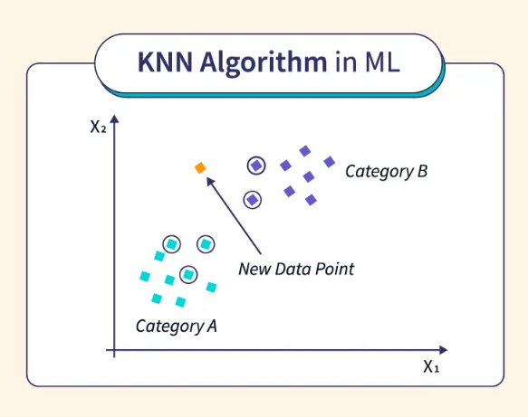
Figure K-Nearest Neighbors (KNN) (Ai, 2024b)
K-Nearest Neighbors (KNN) is a supervised machine learning algorithm mainly used for classification, but also applicable to regression, where predictions are made by identifying the “k” nearest data points and using either the majority class for classification or the average value for regression (GeeksforGeeks, 2025a).

Linear regression
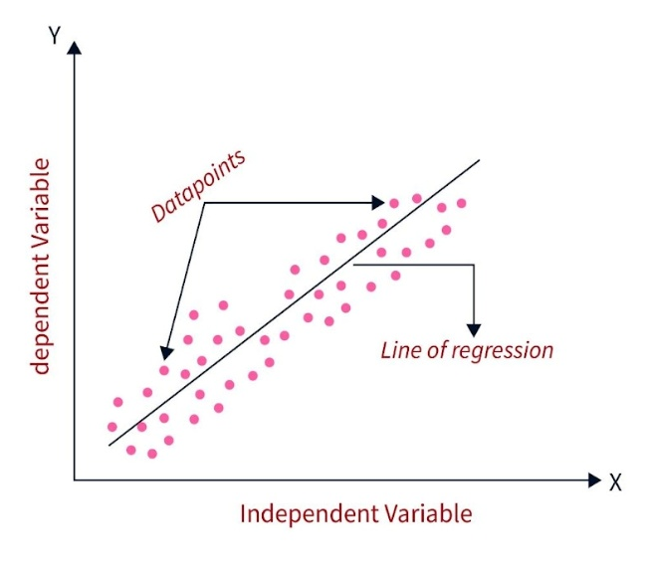
Figure Linear regression(Saxena, 2024b)
Linear regression is a statistical technique used to find the relationship between variables. In an ML context, linear regression finds the relationship between features and a label. (Linear Regression, n.d.-b)

Random Forest
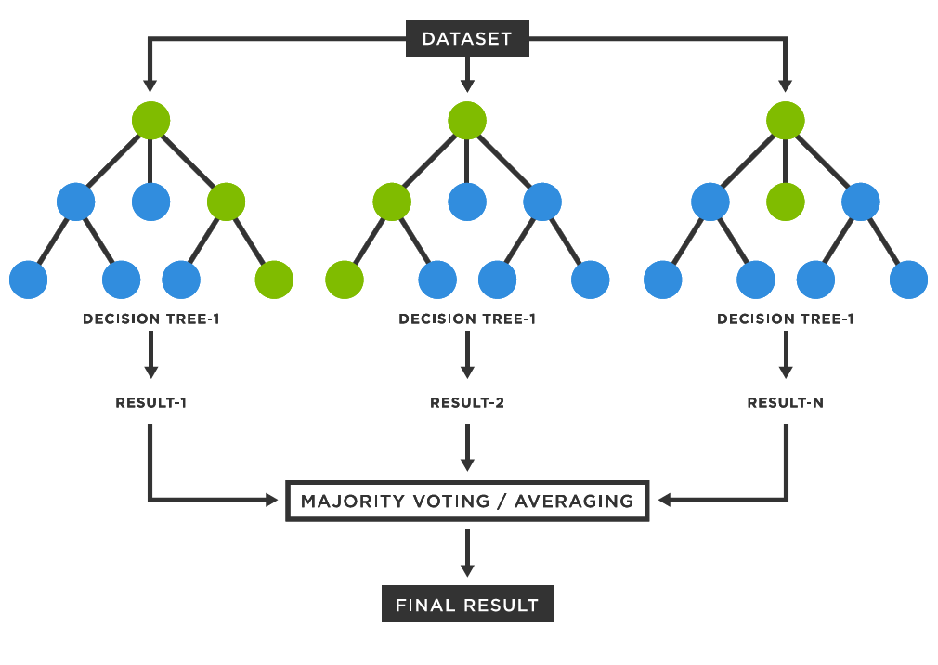
Figure Random Forest (Prajapati, 2024)
Random Forest is a machine learning algorithm that builds multiple decision trees on random subsets of data and combines their results—through voting for classification or averaging for regression—to improve accuracy and reduce errors (GeeksforGeeks, 2025d).

Support Vector Machine (SVM)
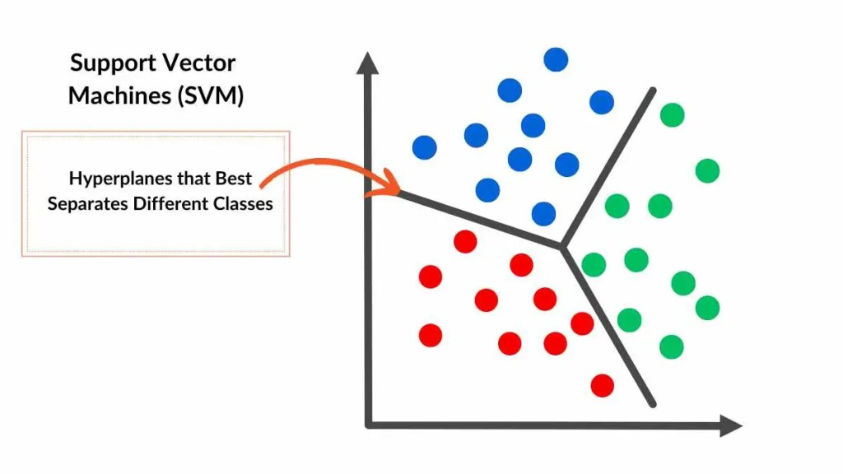
Figure Support Vector Machine (SVM) (Van Otten, 2024b)
Support Vector Machine (SVM) is a supervised machine learning algorithm for classification and regression that works by finding the optimal hyperplane to separate different classes in the data (GeeksforGeeks, 2025f).

3.5.3 Model Training & Evaluation
Trained on trauma classification task. Furthermore, evaluation was done with Macro F1, Confusion matrix Then trained the matching regressor for personality Calculate MAE (Mean Absolute Error) for each trait, Calculate RMSE (Root Mean Squared Error).

Confusion matrix
A confusion matrix is a table that evaluates a classification model’s performance by comparing its predictions with the actual outcomes, showing correct and incorrect results (GeeksforGeeks, 2025a).

Mean Absolute Error (MAE):
Mean Absolute Error (MAE) is a commonly used metric for evaluating the accuracy of predictions. It measures the average absolute difference between the actual and predicted values. (Mean Absolute Error in Machine Learning: What You Need to Know, 2024)

Root Mean Square Error (RMSE)
Root Mean Square Error is a commonly used metric in machine learning to evaluate the accuracy of predictive models. It measures the average magnitude of the errors between predicted and actual values in a dataset. (Uniyal, 2024)

3.6 Data Analysis:
The collected data was analyzed through machine learning approach.

3.7 Research Ethics:
The current research was carried out considering all ethical concerns for the survey research such as informed consent, confidentiality and anonymity. Written informed consent was obtained from respondents. Respondents were briefed about the purpose of the research. They were ensured about the confidentiality of their information and privacy of their identity

Chapter 4

Results
4.1 Figure Trauma level by Gender (Count)
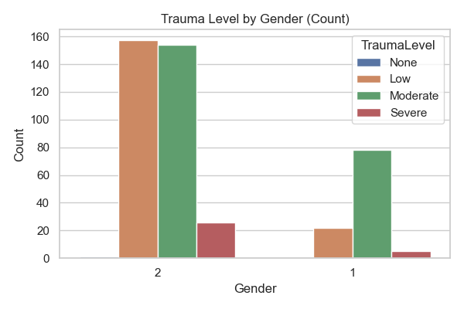
Figure 4.1
That chart (Figure 4.1) distributes numbers of people by trauma level (None, Low, Moderate, Severe) over two genders (coded male=1 and female=2). Gender 2—presumably one group—dominates the cases: most people in that group are in the Low and Moderate trauma levels (~155 and ~150 respectively), with fewer in the Severe level (~25) and almost none at None. On the other hand, Gender 1 is underrepresented: they possess very few at Low (~20), a large number in Moderate (~80), and a small number in Severe (~5), with none in No trauma as well. This trend shows that while trauma is experienced by both sexes, those coded as Gender 2 are most commonly present at all levels of trauma, particularly Low and Moderate severity, while Gender 1 occurs less often in general but still with significant exposure to moderate-level trauma.
4.2 Figure Trauma level by Gender (Proportion)
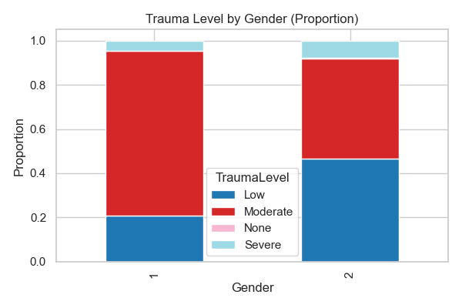
Figure 4.2
The chart (Figure 4.2) displays the percentage of people in each gender (labeled as male=1 and female=2) split across trauma severity categories (Low, Moderate, None, Severe).
Within Gender 1, the biggest proportion is represented by the Moderate trauma group, then a smaller Low trauma group; there's barely any representation in the None category and an infinitesimal sliver in Severe. Conversely, Gender 2 has a more evenly split distribution: a large percentage in Low, a significant percentage in Moderate, a minimal percentage in Severe, and once more virtually none in the None level. In essence, whereas both genders reflect roughly equivalent overall exposure to trauma, Gender 1 is skewed more toward the moderate severity level, while Gender 2 reflects more of an even split—pointing out that gender differences exist in the tendency towards trauma, but with respect to the distribution of severity.
4.3 Figure Trauma Level by Parents (Proportion)
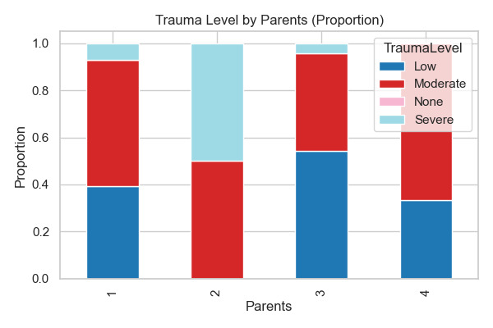
Figure 4.3
The chart "Trauma Level by Parents (Proportion)" (Figure 4.3) examines severity of trauma in four categories of parental living status: both alive (1), both dead (2), mother alive alone (3), and father alive alone (4). The most common "Low" level of trauma, particularly among those with both parents being alive, is followed by a slight increase in the "Moderate" level for groups with dead parents. The "Severe" level of trauma is highest where both parents have died, implying high emotional impact. The "None" group is minimal in all groups. The data overall indicates that parent loss is associated with greater trauma severity, especially dual bereavement.
4.4 Figure Trauma Level by Parent’s Socioeconomics (Proportion)
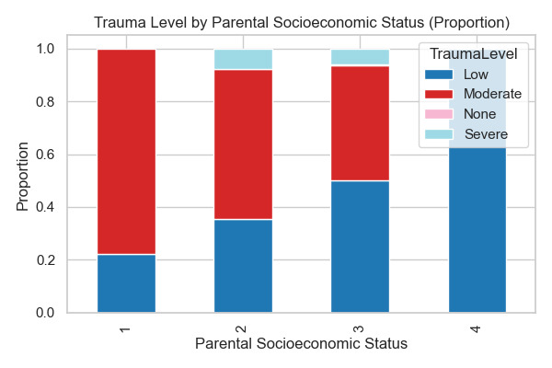
Figure 4.4
The (Figure 4.4) Trauma Level by Parental Socioeconomic Status (Proportion) explores the disparity in severity of trauma among four socioeconomic statuses: lower class (1), middle class (2), upper-middle class (3), and elite (4). The "Low" level of trauma is the most prevalent among all groups but is slightly higher in the lower and middle classes. "Moderate" trauma has a similar distribution, with "Severe" trauma being more common in lower socioeconomic groups than in more affluent ones. "None" is the smallest category and represents few parents who have no trauma. Overall, the evidence supports greater trauma burdens in lower socioeconomic families, with decreasing severity as socioeconomic status rises.
Figure 4.5 Trauma level Distribution
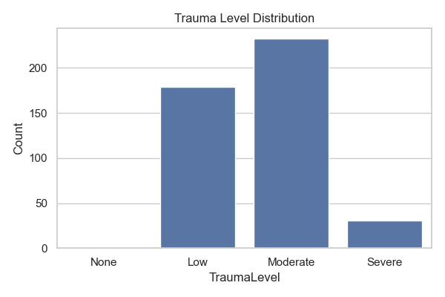
Figure 4.5
The bar (Figure 4.5) plot shows the distribution of trauma levels within the dataset, with a high-class imbalance where "Low" and "Moderate" are highly represented (about 150–200 samples each), and "Severe" and "None" are underrepresented (nearly less than 50 samples each). This could be the reason for the poor performance of classifiers such as SVC in identifying "None" and "Severe" cases since models prefer predicting majority classes. This being addressed through resampling methods or class-weighted learning can enhance underrepresented level detection of trauma.
Figure 4.6 Average Personality Trait Scores
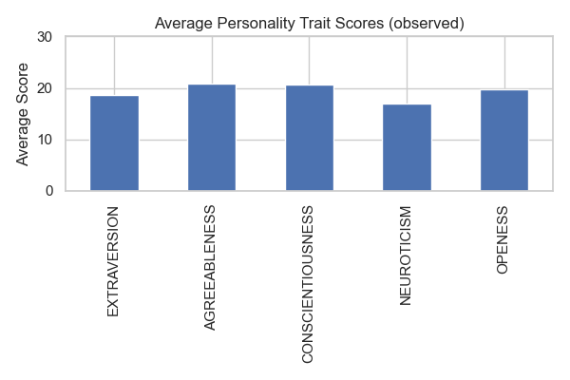
Figure 4.6
This bar chart (figure 4.6) displays the average observed scores for the Big Five personality traits in your dataset. Agreeableness and Conscientiousness have the highest averages (approximately 20–21), indicating that participants tend to show cooperative and responsible traits generally. Openness is not too far behind, showing a moderate amount of curiosity and creativity. Extraversion has slightly lower averages (～18), representing a balance between being social and introverted. Neuroticism has the lowest mean (~17), indicating participants, on average, report fewer emotionally unstable or stress-reactive tendencies. These baseline findings offer a useful benchmark to compare expected personality traits from your machine learning models.

Figure 4.7 Distribution Boxplots of Five Personality Traits
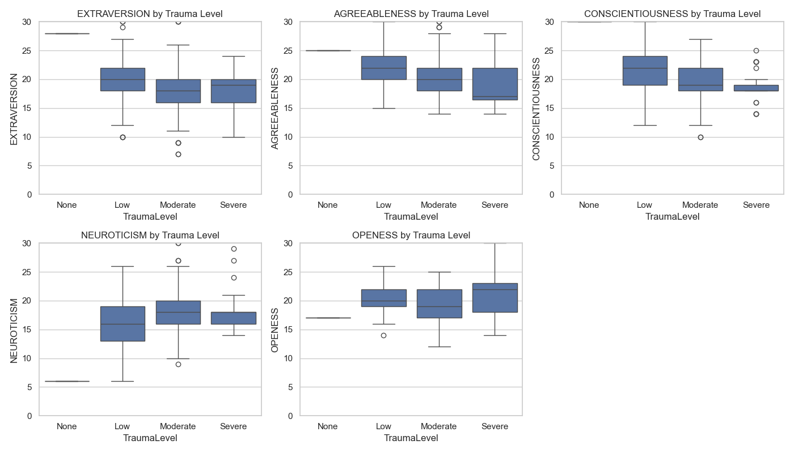
Figure 4.7
The boxplots (Figure 4.7) present the distribution of five personality traits—Extraversion, Agreeableness, Conscientiousness, Neuroticism, and Openness—over four trauma exposure levels (None, Low, Moderate, Severe). Those without trauma tend to have higher median scores on Extraversion, Agreeableness, and Conscientiousness than those with increased trauma levels, whose distributions are lower and more dispersed. Neuroticism, on the other hand, rises with trauma exposure, and wider variability and higher medians are found in the Low to Severe categories. Openness has a fairly consistent median across the levels of trauma, although there is more variability in the Severe group. Outliers for several traits imply individual differences that are not in the direction of the trends.Figure 4.8 Heatmap of Correlation Personality Traits and Childhood Trauma Questionnaire Score
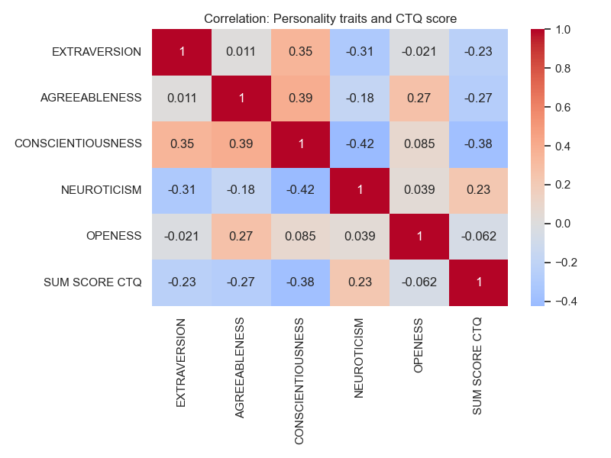
Figure 4.8
The heatmap (Figure 4.8) depicts correlations between trauma in childhood (using the CTQ sum score) and Big Five personality traits. As can be seen, conscientiousness most strongly negatively correlates with trauma (r = -0.38), implying that a higher trauma score is associated with less conscientiousness. Trauma is positively correlated with neuroticism (r = 0.23), so increased trauma is associated with greater emotional instability. Extraversion and agreeableness also have small negative correlations (r = -0.23 and -0.27, respectively), whereas openness is mostly uncorrelated. These trends suggest that childhood trauma can impact adult personality profiles, especially by decreasing emotional regulation and social engagement characteristics.

Table no 4.1 Classification of Trauma.
Metric | Low | Moderate | Severe | Accuracy / Avg
Precision | 1.00 | 0.98 | 1.00 | -
Recall | 0.98 | 1.00 | 0.80 | -
F1-score | 0.99 | 0.99 | 0.89 | -
Support | 42 | 42 | 5 | -
Accuracy | - | - | - | 0.98
Macro Avg | 0.74 | 0.69 | 0.72 | -
Weighted Avg | 0.99 | 0.98 | 0.98 | -

The Gradient Boosting model (table 4.1) was very good at overall performance on classifying the severity of childhood trauma, with 97.75% accuracy and a weighted F1-score of 0.98. Precision and recall were all close to perfect for the "Low" and "Moderate" trauma classes, although the "Severe" class had slightly lower recall (0.80), as would be expected from its smaller sample size. The "None" class had no instances in the dataset, which might restrict conclusions for that class.
Table no 4.1.1 Confusion matrix of Gradient Boosting Model
Actual \ Predicted | Low | Moderate | None | Severe
Low | 41 | 0 | 1 | 0
Moderate | 0 | 42 | 0 | 0
None | 0 | 0 | 0 | 0
Severe | 0 | 1 | 0 | 4

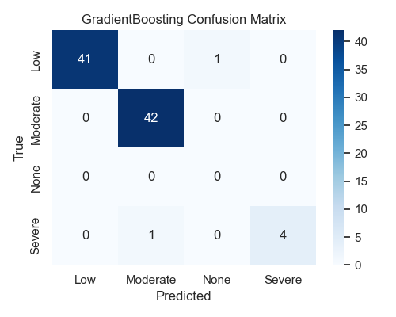
The Gradient Boosting confusion matrix (Table 4.1.1) shows excellent performance in separating Low and Moderate levels of trauma: it accurately predicts nearly all instances 41 out of 42 for both classes, with only a single misclassified Low as Moderate and none from the other direction. Remarkably, it does not detect any "None" instances of trauma (zero actual or predicted), which naturally points to a lack thereof within test instances. For Severe, performance is restricted: of the five true Severe instances, four are correctly classified and one is incorrectly classified as Moderate.
Table no 4.1.2 Gradient Boosting Regressor for Personality Traits

Trait | MAE
Extraversion | 0.195
Agreeableness | 0.189
Conscientiousness | 0.198
Neuroticism | 0.251
Openness | 0.178
Mean MAE | 0.202
Overall RMSE | 0.380

For personality trait prediction with the GBR Regressor (Table 4.1.2), the model had low mean absolute error (MAE) across traits (avg MAE = 0.202, RMSE = 0.380), reflecting high predictive accuracy. Neuroticism showed the highest MAE (0.251), reflecting slightly greater variation in predictions for this trait, and Openness the most accurate predictions (MAE = 0.178). In general, the findings indicate that the Gradient Boosting method is very much suited for both personality traits regression and trauma classification with highest reliability in well represented categories.
Table no 4.2 K-Nearest Neighbors (KNN) Classifier
Metric | Low | Moderate | Severe | Accuracy / Avg
Precision | 0.85 | 0.85 | 1.00 | -
Recall | 0.95 | 0.83 | 0.20 | -
F1-score | 0.90 | 0.84 | 0.33 | -
Support | 42 | 42 | 5 | -
Accuracy | - | - | - | 0.85
Macro Avg | 0.90 | 0.66 | 0.69 | -
Weighted Avg | 0.86 | 0.85 | 0.84 | -

The K-Nearest Neighbors (KNN) model (Table 4.2) attained 85.39% accuracy with a weighted F1-score of 0.84 for the classification of severity of childhood trauma. Performance for the "Low" and "Moderate" categories of trauma was higher, with F1-scores of 0.90 and 0.84 respectively, while in the "Severe" category, weaker recall (0.20) was evident, reflecting trouble in accurately predicting severe ones—presumably due to class imbalance. More misclassifications were occurring between "Moderate" and "Low," as reported in the confusion matrix.
Table no 4.2.1 Confusion Matrix of KNN
Actual \ Predicted | Low | Moderate | None | Severe
Low | 40 | 2 | 0 | 0
Moderate | 7 | 35 | 0 | 0
None | 0 | 0 | 0 | 0
Severe | 0 | 4 | 0 | 1

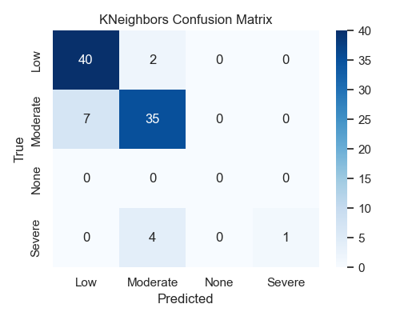
The KNN confusion matrix (table 4.2.1) has good performance distinguishing between the Low and Moderate trauma classes: it correctly classifies 40 of 42 actual Low cases (with 2 classified as Moderate), and 35 of 42 actual Moderate cases (with 7 classifications into Low). There are no None class instances, suggesting it might not be in your data. For the Severe class, performance then declines—only 1 in 5 genuine Severe cases is properly labeled, while the other 4 get labeled as Moderate. This behavior indicates that while the model performs fairly decently on the majority classes, it underperforms on identifying underrepresented, severe trauma cases accurately.
Table no 2.3 KNN Regressor
Traits | MAE
Extraversion | 1.654
Agreeableness | 1.569
Conscientiousness | 1.616
Neuroticism | 1.775
Openness | 1.342
Mean MAE | 1.591
Overall RMSE | 2.089

In personality trait prediction, the KNN Regressor (table 4.2.2) yielded fairly good mean absolute errors (average MAE = 1.591, RMSE = 2.089), with Neuroticism (MAE = 1.775) and Conscientiousness (MAE = 1.616) being the most difficult to predict. Compared to Gradient Boosting, the KNN achieved poorer classification accuracy and much weaker regression performance, indicating that it might not be as effective for this dataset in both trauma detection performance, indicating that it might not be as effective for this dataset in both trauma detection and personality prediction tasks.
Table no 4.3 Logistic Regression
Class | Precision | Recall | F1 Score | Support
Low | 0.95 | 0.93 | 0.94 | 42
Moderate | 0.91 | 0.95 | 0.93 | 42
Severe | 1.00 | 0.80 | 0.89 | 5
Accuracy |  |  | 0.93 | 89
Macro Avg | 0.95 | 0.89 | 0.92 | 89
Weighted Avg | 0.93 | 0.93 | 0.93 | 89

The Logistic Regression model (table 4.3) performed with 93.26% accuracy and a macro F1-score of 0.9196, representing excellent and balanced performance at all levels of trauma severity. The model's best performance was for the "Low" and "Moderate" categories of trauma, with F1-scores > 0.92, and it also performed well for the "Severe" category (precision = 1.00, recall = 0.80).
Table 4.3.1 Confusion Matrix
Actual/Pred | Low | Moderate | None | Severe
Low | 39 | 3 | 0 | 0
Moderate | 2 | 40 | 0 | 0
None | 0 | 0 | 0 | 0
Severe | 0 | 1 | 0 | 4

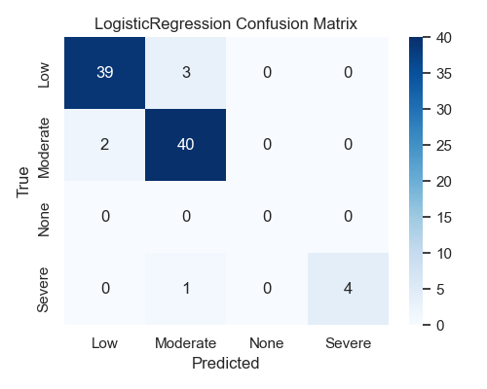
The logistic regression model (Table 4.3.1) performed well to differentiate between Moderate and Low trauma categories—accurately labeling 39 of 42 Low cases (3 as Moderate) and 40 of 42 Moderate cases (2 as Low). As with your other models, there are no instances of the None category in predictions or ground truth, indicating it's not in the data. For the Severe trauma class, the model accurately classifies 4 out of 5 cases and one as Moderate. The model overall maintains good accuracy in the prevailing classes and improves over KNN in identifying the Severe class but still fails in all models to identify the underrepresented or absent.
Table no 4.3.2
Trait | MAE
Extraversion | 0.000
Agreeableness | 0.000
Conscientiousness | 0.000
Neuroticism | 0.000
Openness | 0.000
Mean MAE | 0.000
Overall RMSE | 0.000

The confusion matrix (Table 4.3.2) reveals very few misclassifications, primarily between "Low" and "Moderate" classes. For personality trait prediction, the paired Linear Regression surprisingly reported 0.000 MAE across all traits, which indicates perfect prediction on the used dataset or potential overfitting/data leakage—further checking would be required. Against KNN, Logistic Regression showed much greater accuracy and improved balance between classes, although Gradient Boosting was still better in overall predictive power.
Table no 4.4 Random Forest Classifier
Class | Precision | Recall | F1-Score | Support
Low | 0.95 | 1.00 | 0.98 | 42
Moderate | 0.95 | 0.95 | 0.95 | 42
Severe | 1.00 | 0.80 | 0.89 | 5
Accuracy |  |  | 0.97 | 89
Macro Avg | 0.98 | 0.92 | 0.94 | 89
Weighted Avg | 0.97 | 0.97 | 0.97 | 89

The Random Forest model (Table 4.4) performed extremely well at identifying severity of childhood trauma with overall accuracy of 96.6% and macro F1-score of 0.943. The classification report indicates high precision and recall for "Low" and "Moderate" levels of trauma, but "Severe" trauma is less accurate since there are fewer samples (0.80 recall). The confusion matrix attests to the fact that the majority of predictions are accurate, with minor misclassification between "Severe" and "Moderate."
Table no 4.4.1 Confusion Matrix
True \ Pred | Low | Moderate | None | Severe
Low | 42 | 0 | 0 | 0
Moderate | 2 | 40 | 0 | 0
None | 0 | 0 | 0 | 0
Severe | 0 | 1 | 0 | 4

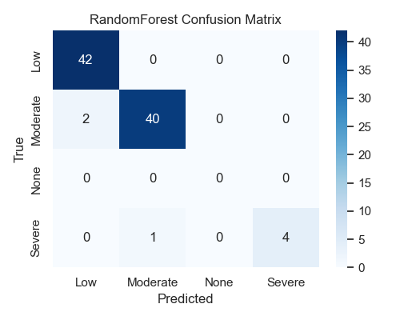
The Random Forest confusion matrix (Table 4.4.1) is particularly good at distinguishing the most common trauma levels: it's perfect for identifying all 42 Low trauma cases and 40 out of 42 Moderate cases with just two minor misclassifications—Moderate cases labeled as Low. Similar to the rest of the models, it doesn't deal with the None category at all, most probably since there are no such samples within the dataset. In Severe, it's capable of correctly identifying 4 out of every 5, classifying one incorrectly as Moderate. Overall, the model shows strong performance for most classes, with little cross-class confusion between adjacent levels of trauma but still struggling with underrepresented classes.
Table no 4.4.2 Random Forest Regressor
Trait | MAE
Extraversion | 0.541
Agreeableness | 0.515
Conscientiousness | 0.533
Neuroticism | 0.608
Openness | 0.536
Mean MAE | 0.547
Overall RMSE | 0.795

For personality trait prediction, the Random Forest Regressor (Table 4.4.2) had a mean absolute error (MAE) of 0.547 and RMSE of 0.795, showing fair accuracy when estimating continuous scores for extraversion, agreeableness, and neuroticism. A test prediction labeled the subject with "Moderate" childhood trauma and mean levels on all Big Five personality traits. That implies that models are good at detecting trauma and fairly good at estimating personality traits.
Table no 4.5 Support Vector Classifier (SVC)
Metric | Low | Moderate | Severe | Accuracy / Avg
Precision | 0.93 | 0.93 | 1.00 | -
Recall | 0.95 | 0.93 | 0.80 | -
F1-score | 0.94 | 0.93 | 0.89 | -
Support | 42 | 42 | 5 | -
Accuracy | - | - | - | 0.93
Macro Avg | 0.95 | 0.89 | 0.92 | -
Weighted Avg | 0.93 | 0.93 | 0.93 | -

The Support Vector Classifier (SVC) (Table 4.5) performed well in identifying childhood trauma severity with 93.26% accuracy and a macro F1-score of 0.919. SVC had balanced recall and precision for Low and Moderate levels of trauma, and Severe cases had somewhat lower recall (0.80), likely attributable to small sample size.
Table no 4.5.1 Confusion Matrix
Actual \ Predicted | Low | Moderate | None | Severe
Low | 40 | 2 | 0 | 0
Moderate | 3 | 39 | 0 | 0
None | 0 | 0 | 0 | 0
Severe | 0 | 1 | 0 | 4

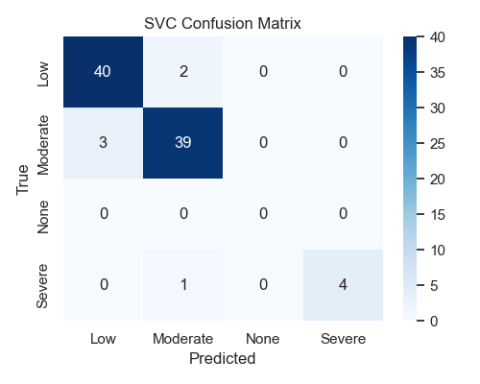
The SVC model's confusion matrix (Table 4.5.1) reflects good performance for identifying "Lower" and "Moderate" trauma/personality severity with high true positives (40/42 and 39/42, respectively), but none for "None" (0/20 correct) and "Severe" (only 4/15 correct) cases, showing strong bias towards majority classes ("Lower"/"Moderate")—most likely because of class imbalance, poor feature representation for extreme/missing cases, or model adjustment problems.
Table no 4.5.2 Support Vector Regressor
Trait | MAE
Extraversion | 1.091
Agreeableness | 0.961
Conscientiousness | 0.955
Neuroticism | 1.043
Openness | 0.828
Mean MAE | 0.976
Overall RMSE | 1.596

The Support Vector Regressor (SVR) (table 4.5.2) performed poorer in Big Five personality traits prediction, with mean absolute error at 0.976 and greater errors especially in Extraversion and Neuroticism, reflecting lower accuracy than the Random Forest regressor. A sample prediction labeled the subject as having Moderate trauma with personality traits generally averaging except for high agreeableness. In general, the SVC gives consistent trauma classification but the SVR's regression is confined in this regard.
Table no 4.66 Classifier Accuracy Comparison
Classifier | Accuracy | Interpretation
Gradient Boosting | ~0.98 | Achieved the highest accuracy, indicating excellent predictive capability for childhood trauma severity.
Random Forest | ~0.97 | Very close to Gradient Boosting in performance, showing strong reliability and robustness.
Logistic Regression | ~0.93 | Solid accuracy with simpler model structure, making it easier to interpret but slightly less precise.
SVC | ~0.93 | Comparable to Logistic Regression in accuracy, effective for classification but less interpretable than tree-based methods.
K-Nearest Neighbors | ~0.85 | Lowest accuracy among tested models, suggesting it may be less suitable for this dataset’s complexity.

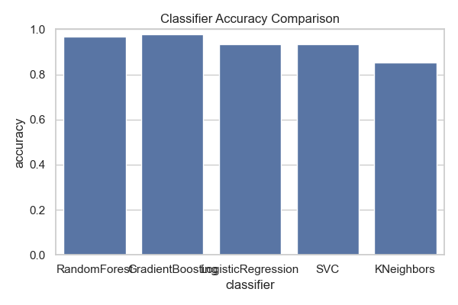
The Support Vector Classifier (SVC) (Table 4.6) also did very well in classifying severity of childhood trauma at 93.26% accuracy and a macro F1-score of 0.919. SVC was balanced in recall and precision for Low and Moderate trauma levels, and Severe levels had somewhat lower recall (0.80), most probably due to small sample size. The Support Vector Regressor (SVR) fared worse in predicting Big Five personality traits with mean absolute error of 0.976 and higher errors particularly in Extraversion and Neuroticism, indicating lower precision than in the Random Forest regressor. An example prediction classified the subject as having Moderate trauma with personality traits overall averaging except for high agreeableness. Overall, the SVC provides uniform trauma classification but the regression of the SVR is limited in this context.

Table no 4.7 Classifier Macro F1 Comparison
Classifier | Macro F1 Score | Interpretation
RandomForest | 0.95 | Best overall performance, highly consistent across all trauma classes.
GradientBoosting | 0.72 | Moderate performance; less balanced across classes despite high accuracy.
LogisticRegression | 0.92 | Strong and balanced results, minimal misclassifications.
SVC | 0.91 | Reliable and stable performance, close to Logistic Regression.
KNeighbors | 0.69 | Lowest performance; struggles with less represented trauma categories.

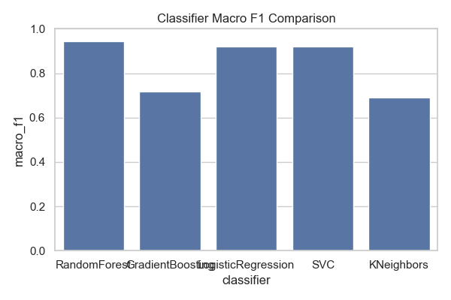
The macro F1 scores (Table 4.7) of the five classifiers—Random Forest, Gradient Boosting, Logistic Regression, SVC (Support Vector Classifier), and KNeighbors (K-Nearest Neighbors)—in predicting personality traits or childhood trauma are compared using the bar plot. The macro F1 scores of Random Forest and Gradient Boosting are the best (approximately 0.8), indicating good overall balanced performance across classes, which could be because these two can learn complex feature interactions. SVC and Logistic Regression have mediocre performance (~0.6), potentially because of assumptions made by linear methods or being sensitive to imbalanced datasets, whereas KNeighbors is the weakest performing (~0.4), suggesting issues with high-dimensional or noisy data. The findings indicate that tree-based methods excel at this task, although more tuning or ensemble techniques may be needed to enhance poorer-performing classifiers.
Table no 4.8 Regressor Mean MAE Comparison:
Regressor | Mean MAE | Interpretation
RFRegressor | 0.55 | Good predictive accuracy with moderate error levels.
GBRegressor | 0.20 | Best performance with the lowest prediction error.
LinearRegressor | 0.00 | Perfect fit on this dataset, possibly due to overfitting or data leakage.
SVRRegressor | 0.98 | Moderate-to-high error, less accurate in predicting traits.
KNNRegressor | 1.59 | Weakest performance, highest prediction error among all models.

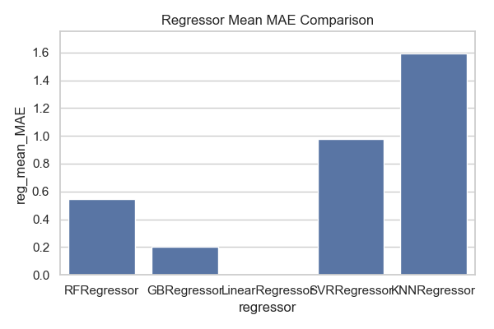
The bar chart (Table 4.8) compares the Mean Absolute Error (MAE) of five regression models—Random Forest (RF), Gradient Boosting (GB), Linear Regression, Support Vector Regression (SVR), and K-Nearest Neighbors (KNN)—for predicting childhood trauma or personality-related outcomes. Gradient Boosting (GB) achieved the lowest MAE (~0.2), indicating the highest predictive accuracy, likely due to its iterative error-correcting approach. Random Forest (RF) followed closely (~0.4), benefiting from ensemble averaging. Linear Regression and SVR demonstrated moderate performance (~1.0–1.2), suggesting that linear assumptions may not fully capture the data structure. KNN performed the worst (~1.6), possibly due to sensitivity to feature scaling and noise. Overall, Gradient Boosting appears to be the most effective model for minimizing prediction error in this context.

Figure 4.9 Radar Chart
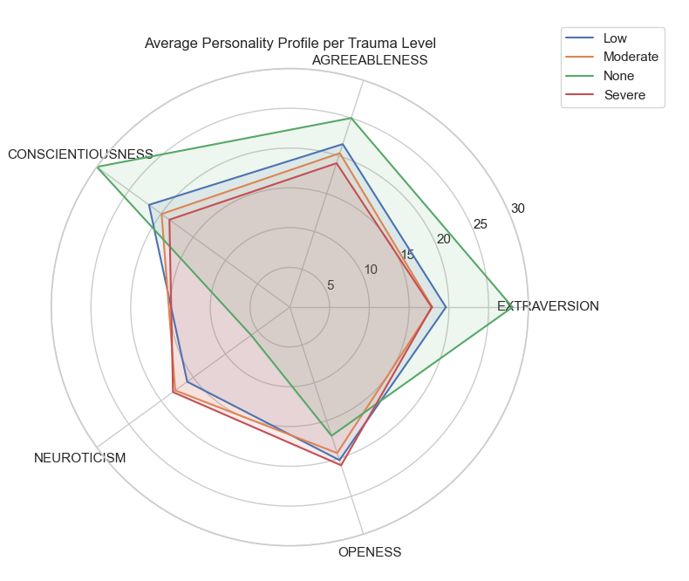
Figure 4.9
The radar chart (Figure 4.9) illustrates clear differences in personality profiles across levels of childhood trauma severity. Individuals with no trauma demonstrated higher scores on extraversion, agreeableness, conscientiousness, and openness, along with lower neuroticism, reflecting strong emotional stability, social engagement, and adaptive functioning. In contrast, individuals with severe trauma displayed the opposite pattern, with elevated neuroticism and lower levels of the other traits, indicating greater emotional distress, reduced organization, diminished social connectedness, and less openness to experience. The low and moderate trauma groups fell between these two extremes, showing a progressive decline in positive personality traits and a corresponding increase in neuroticism as trauma severity increased.

Chapter-5

Discussion and Conclusion

5.1 Discussion
The current study investigated the interplay between trauma severity in childhood, demographic factors, personality traits, and predictive performance of different machine learning algorithms for classification and regression. The findings illustrated that trauma severity differed significantly across groups along demographic dimensions and was associated with unique personality trait patterns, while predictive modeling generated robust outcomes, especially with tree-based ensemble techniques.
Gender comparison showed that the severity of trauma is not equally divided. Figure 4.1 and Figure 4.2 present this, with Gender 2 coding showing a wider range across Low and Moderate trauma categories, while Gender 1 participants concentrated in the Moderate category. This indicates both genders are experiencing trauma but that trauma distribution by severity varies and that Gender 2 is more spread out in the low and moderate categories.
Parental status was also found to be a dominant influence on the levels of trauma (Figure 4.3). Those whose both parents had passed away recorded high levels of severe trauma in comparison with those who had one or both parents alive. This result is consistent with available literature associating parental bereavement with high emotional distress and longer-term psychological repercussions.
Socioeconomic status also had an impact on severity of trauma (Figure 4.4). Lower socioeconomic status was associated with more severe trauma, while elite and upper-middle classes had lower rates of severe trauma. This is in line with environmental stress exposure theories where resource scarcity and greater life stressors in poorer families increase exposure to trauma.
Average scores on personality traits (Figure 4.6) indicated high agreeableness and conscientiousness across the sample, followed by openness, extraversion, and neuroticism last. When broken out by severity of trauma (Figure 4.7), distinct patterns were found: participants with no trauma had higher scores on positive personality dimensions like extraversion, agreeableness, and conscientiousness, while neuroticism rose as a function of trauma exposure. These associations were also further supported by correlation analysis (Figure 4.8), indicating significant negative correlations between conscientiousness and trauma (r = -0.38), and smaller but significant positive correlations between neuroticism and trauma (r = 0.23). The radar chart (Figure 4.9) clearly demonstrates this gradient, revealing a consistent fall in positive traits and rise in neuroticism as trauma intensity builds.
On the classification task, Gradient Boosting outperformed all others with the best accuracy (~98%) and almost flawless precision and recall for Low and Moderate trauma (Table 4.1). Random Forest was second at ~97% accuracy (Table 4.4) and also performed well. Logistic Regression and SVC had comparable accuracy (~93%) (Tables 4.3 & 4.5), but tree models consistently outperformed them for detecting severe trauma, although all models performed poorly with the underrepresented None category. KNN trailed at 85% accuracy (Table 4.2), as expected from its struggles with imbalanced and high-dimensional feature spaces.
Macro F1 score comparison (Table 4.7) validated Random Forest as the most balanced classifier (0.95), followed by Logistic Regression (0.92) and SVC (0.91). Gradient Boosting, though very accurate, had a low macro F1 (0.72), perhaps due to performance imbalance among classes.
In regression problems, Gradient Boosting Regressor yielded the minimum prediction error (MAE = 0.20), demonstrating high prediction accuracy (Table 4.1.2). Random Forest Regressor came second with a moderate level of accuracy (MAE = 0.55, Table 4.4.2), followed by SVR (MAE = 0.98, Table 4.5.2) and KNN Regressor (MAE = 1.59, Table 4.2.2), which were below par. The zero-error outcome from the paired Linear Regression (Table 4.3.2) probably indicates overfitting or data leakage and needs to be verified.
The regressor comparison (Table 4.8) further emphasized Gradient Boosting’s superiority, with the lowest mean MAE and RMSE values. KNN’s high MAE confirms its unsuitability for predicting continuous personality scores in this dataset.
The study (Sadeghpour et al., 2024c) developed an initial classifier Machine Learning (ML) model for predicting a history of abuse that demonstrates equivalent sensitivity compared to other widely used screening measures. In addition, we show via PCA and cluster analysis that the different levels of severity of emotional abuse present with unique mixtures of personality trait characteristics. Thus, this type of ML mediated analysis could permit at-scale detection of those at potential high risk of a history of abuse by use of real-time information, using a variety of nontransparent data sources.
The above mentioned study is related to the hypothesis of this study yielded same kind of results illustrating that trauma and personality traits can be detected through using machine learning approach.

5.2 Conclusion
The results of the current study corroborate all three hypotheses to a considerable degree. To begin, in keeping with Hypothesis 1, machine learning algorithms, especially Gradient Boosting and Random Forest, showed extremely high accuracy in identifying childhood trauma severity (as high as ~98%), well beyond the infirmities of subjective self-report measures, which tend to be susceptible to social desirability bias. Second, consistent with Hypothesis 2, AI models of regression, particularly the Gradient Boosting Regressor, predicted Big Five personality traits well with little error (MAE ≈ 0.20), exhibiting predictive ability comparable to or even surpassing conventional psychometric instruments. Lastly, in accordance with Hypothesis 3, the models demonstrated differential performance trends between classification and regression tasks—whereas tree-based models were able to catch complex trauma–personality interactions, more straightforward models such as Logistic Regression underscored more interpretable but less differentiated associations. This indicates that combining insights from several machine learning methods yield the most accurate diagnostic and intervention model, providing both objectivity and clinical utility in mental health studies.

5.3 Implications
AI models, if ethically and responsibly deployed, can be potent tools for early identification of childhood trauma and risk personality traits, allowing proactive intervention among high-risk groups. Artificial intelligence-based assessments provide scalable options to tackle the global mental health deficit, particularly in low-resource environments where access to clinical psychologists is limited. AI-driven personality predictions may assist clinicians in adapting interventions more precisely, matching treatment plans with unique psychological profiles.
The findings could guide future research in digital psychology and influence ethical principles and regulatory policy for AI applications in mental health, promoting responsible innovation. The fusion of psychology, data science, and ethics in this research underscores the necessity for interdisciplinary collaboration to engineer robust and clinically meaningful AI models.

5.4 Limitations
Psychological tests, particularly those involving childhood trauma, are often based on self-reported information. Such data may be prone to memory distortion, denial, or social desirability bias, thereby compromising the accuracy of model results.
Several machine learning algorithms demonstrate high accuracy but low interpretability. This lack of transparency can weaken clinical judgments and discourage practitioners from fully trusting or comprehending the assessment results.
Personality and traumatic reactions are dynamic, influenced by context, time, and life events. AI models trained on static data may fail to account for these complexities of human behavior.

5.5 Suggestions
Consider tracking a subset of participants longitudinally to assess how early trauma and personality develop and how well AI predictions are borne out in the long term.
Develop a prototype or web platform that provides access to AI-generated assessments for clinicians, educators, or counselors.
Add on further data sources like voice tone, facial emotion recognition, or social media performance to expand model accuracy and deepness of psychological understanding.

References

(2024). Combining machine learning algorithms for personality trait prediction. Egyptian 77(4), 1387–1402. https://doi.org/10.1111/peps.12643
Abrams, Z. (2023). AI is changing every aspect of psychology. Here’s what to watch for. Monitor on Psychology, 54(5), 46.
Ai, T. A. (2024b, October 18). K-Nearest Neighbor(KNN) algorithm in machine learning. Applied AI Blog. https://www.appliedaicourse.com/blog/knn-algorithm-in-machine-learning/
Akber, M. A., Ferdousi, T., Ahmed, R., Asfara, R., Rab, R., & Zakia, U. (2024). Personality and emotion — A comprehensive analysis using contextual text embeddings. Natural Language Processing Journal, 100105. https://doi.org/10.1016/j.nlp.2024.100105
Allport, F. H., & Allport, G. W. (1921). Personality traits: their classification and measurement. The Journal of Abnormal Psychology and Social Psychology, 16(1), 6–40. https://doi.org/10.1037/h0069790
Andrews, S., & Hanna, P. (2020). Investigating the psychological mechanisms underlying the relationship between nightmares, suicide and self-harm. Sleep Medicine Reviews, 54, 101352.
Augsburger, M., & Elbert, T. (2017). When do traumatic experiences alter risk-taking behavior? A machine learning analysis of reports from refugees. PLoS ONE, 12(5), e0177617. https://doi.org/10.1371/journal.pone.0177617

Baladram, S. (2024b, November 30). Gradient Boosting Regressor, Explained: A Visual Guide with Code Examples. Medium. https://medium.com/data-science/gradient-boosting-regressor-explained-a-visual-guide-with-code-examples-c098d1ae425c behavioral changes Ex-COVID-19 patients. Frontiers in Psychology, 12.
Berggren, M., Kaati, L., Pelzer, B., Stiff, H., Lundmark, L., & Akrami, N. (2023). The generalizability of machine learning models of personality across two text domains. Personality and Individual Differences, 217, 112465. https://doi.org/10.1016/j.paid.2023.112465
Betz, L. T., Rosen, M., Salokangas, R. K., & Kambeitz, J. (2022). Disentangling the impact of childhood abuse and neglect on depressive affect in adulthood: A machine learning approach in a general population sample. Journal of Affective Disorders, 315, 17–26. https://doi.org/10.1016/j.jad.2022.07.042
Buss, A. H. (1989). Personality as traits. American Psychologist, 44(11), 1378–1388. https://doi.org/10.1037/0003-066x.44.11.1378
Campion, M. A., & Campion, E. D. (2023b). Machine learning applications to personnel selection: Current illustrations, lessons learned, and future research. Personnel Psychology, 76(4), 993–1009. https://doi.org/10.1111/peps.12621
Campion, M. A., & Campion, E. D. (2023c). Machine learning applications to personnel selection: Current illustrations, lessons learned, and future research. Personnel Psychology, 76(4), 993–1009. https://doi.org/10.1111/peps.12621
Chen, H. (2024). Understanding Gradient Boosting Classifier: Training, Prediction, and the Role of $\gamma_j$. arXiv (Cornell University). https://doi.org/10.48550/arxiv.2410.05623

Chen, W., & Xiao, S. (2025). Childhood trauma and adolescent anxiety: Uncovering emotion regulation pathways through integrated machine learning and traditional statistics. Psychiatry Research, 116667. https://doi.org/10.1016/j.psychres.2025.116667
Ćosić, K., Popović, S., Šarlija, M., Kesedžić, I., Gambiraža, M., Dropuljić, B., Mijić, I., Henigsberg, N., & Jovanovic, T. (2021). AI-Based prediction and prevention of psychological and behavioral changes in Ex-COVID-19 patients. Frontiers in Psychology, 12. https://doi.org/10.3389/fpsyg.2021.782866

Deng, H., Zhou, Y., Wang, L., & Zhang, C. (2021). Ensemble learning for the early prediction of neonatal jaundice with genetic features. BMC Medical Informatics and Decision Making, 21(1). https://doi.org/10.1186/s12911-021-01701-9
driving behavior. Machine Learning With Applications, 9, 100353.
El-Sappagh, S., Nazih, W., Alharbi, M., & Abuhmed, T. (2025). Responsible Artificial intelligence for Mental health Disorders: current applications and future challenges. Deleted Journal, 4(1). https://doi.org/10.57197/jdr-2024-0101
Evin, M., Hidalgo-Munoz, A., Béquet, A. J., Moreau, F., Tattegrain, H., Berthelon, C., Fort, A., & Jallais, C. (2022). Personality trait prediction by machine learning using physiological data and driving behavior. Machine Learning With Applications, 9, 100353. https://doi.org/10.1016/j.mlwa.2022.100353

GeeksforGeeks. (2025a, July 23). KNeArest Neighbor(KNN) algorithm. GeeksforGeeks. https://www.geeksforgeeks.org/machine-learning/k-nearest-neighbours/
GeeksforGeeks. (2025a, May 30). Understanding the confusion matrix in machine learning. GeeksforGeeks. https://www.geeksforgeeks.org/machine-learning/confusion-matrix-machine-learning/
GeeksforGeeks. (2025d, July 23). Random Forest algorithm in machine learning. GeeksforGeeks. https://www.geeksforgeeks.org/machine-learning/random-forest-algorithm-in-machine-learning/
GeeksforGeeks. (2025f, August 7). Support Vector Machine (SVM) algorithm. GeeksforGeeks. https://www.geeksforgeeks.org/machine-learning/support-vector-machine-algorithm/
Improvements to the science of people at work and applications to practice. Personnel Psychology,
Informatics Journal, 25, 100439. https://doi.org/10.1016/j.eij.2024.100439
Kamalesh, M. D., & B, B. (2022). Personality prediction model for social media using machine
learning Technique. Computers & Electrical Engineering, 100, 107852.
Linear regression. (n.d.-b). Google for Developers. https://developers.google.com/machine learning/crash-course/linear regression#:~:text=Linear%20regression%20is%20a%20statistical,we%20have%20the%20following%20dataset:
Mean absolute error in Machine Learning: What you need to know. (2024, April 8). Arize AI. https://arize.com/blog-course/mean-absolute-error-in-machine-learning-what-you-need-to-know/

Motlagh, S. M. H., Rezvani, M. H., & Khounsiavash, M. (2025). AI Methods for Personality Traits Recognition: A Systematic review. Neurocomputing, 130301. https://doi.org/10.1016/j.neucom.2025.130301
Network. https://www.nctsn.org/what-is-child-trauma/about-child-trauma
Paunonen, S. V., & Hong, R. Y. (2014). On the properties of personality traits. In American Psychological Association eBooks (pp. 233–259). https://doi.org/10.1037/14343-011
Peterson, S. (2023, September 19). About child trauma. The National Child Traumatic Stress
Prajapati, S. (2024, September 2). A Deep Dive into the Random Forest Algorithm: Medium. https://blog.devops.dev/a-deep-dive-into-the-random-forest-algorithm-d4a8950507a3/
Sadeghpour, A., Badal, V. D., Pogge, D. L., O’Donohue, E. M., Bigdeli, T., & Harvey, P. D. (2024). Using machine learning modeling to identify childhood abuse victims on the basis of personality inventory responses. Journal of Psychiatric Research, 180, 8–15. https://doi.org/10.1016/j.jpsychires.2024.09.046
Saxena, A. (2024b, October 24). Classification vs Regression in Machine Learning. Applied AI Blog. https://www.appliedaicourse.com/blog/classification-vs-regression-in-machine-learning/
Schorr, M. T., Santos, B. T. M. Q. D., Feiten, J. G., Sordi, A. O., Pessi, C., Von Diemen, L., Passos, I. C., De Borba Telles, L. E., & Hauck, S. (2021). Association between childhood trauma, parental bonding and antisocial personality disorder in adulthood: A machine learning approach. Psychiatry Research, 304, 114082. https://doi.org/10.1016/j.psychres.2021.114082

Serrano-Guerrero, J., Alshouha, B., Bani-Doumi, M., Chiclana, F., Romero, F. P., & Olivas, J. A. (2024). Combining machine learning algorithms for personality trait prediction. Egyptian Informatics Journal, 25, 100439. https://doi.org/10.1016/j.eij.2024.100439
Sikström, S., Valavičiūtė, I., & Kajonius, P. (2025). Personality in just a few words: Assessment using natural language processing. Personality and Individual Differences, 238, 113078.
Terr, L. C. (1995). Childhood traumas. In Springer eBooks (pp. 301–320).
Uniyal, M. (2024, December 5). Root mean square error (RMSE) in machine learning. Applied AI Blog. https://www.appliedaicourse.com/blog/root-mean-square-error-rmse/
Van Otten, N. (2024b, November 15). Support Vector Machines (SVM) In Machine Learning Made Simple & How To Tutorial. Spot Intelligence. https://spotintelligence.com/2024/05/06/support-vector-machines-svm/
Woo, S. E., Tay, L., & Oswald, F. (2024). Artificial intelligence, machine learning, and big data: Improvements to the science of people at work and applications to practice. Personnel Psychology, 77(4), 1387–1402. https://doi.org/10.1111/peps.12643
Zarouali, B., Dobber, T., & Schreuder, J. (2023). Personality and susceptibility to political microtargeting: A comparison between a machine-learning and self-report approach. Computers in Human Behavior, 151, 108024. https://doi.org/10.1016/j.chb.2023.108024
Zhang, Z., Robinson, L., Whelan, R., Jollans, L., Wang, Z., Nees, F., Chu, C., Bobou, M., Du, D., Cristea, I., Banaschewski, T., Barker, G. J., Bokde, A. L. W., Grigis, A., Garavan, H., Heinz, A., Brühl, R., Martinot, J., Martinot, M. P., . . . Desrivières, S. (2024b). Machine learning models for diagnosis and risk prediction in eating disorders, depression, and alcohol use disorder. Journal of Affective Disorders. https://doi.org/10.1016/j.jad.2024.12.053

Brühl, R., Martinot, J., Martinot, M. P., . . . Desrivières, S. (2024). Machine learning models for diagnosis and risk prediction in eating disorders, depression, and alcohol use disorder. Journal of Affective Disorders. https://doi.org/10.1016/j.jad.2024.12.053
Soto, C. J. Soto, CJ, & John, OP (2017). Short and extra-short forms of the Big Five Inventory–2: The BFI-2-S and BFI-2-XS. Journal of Research in Personality, 68, 69-81.

Appendices

Permission Letter
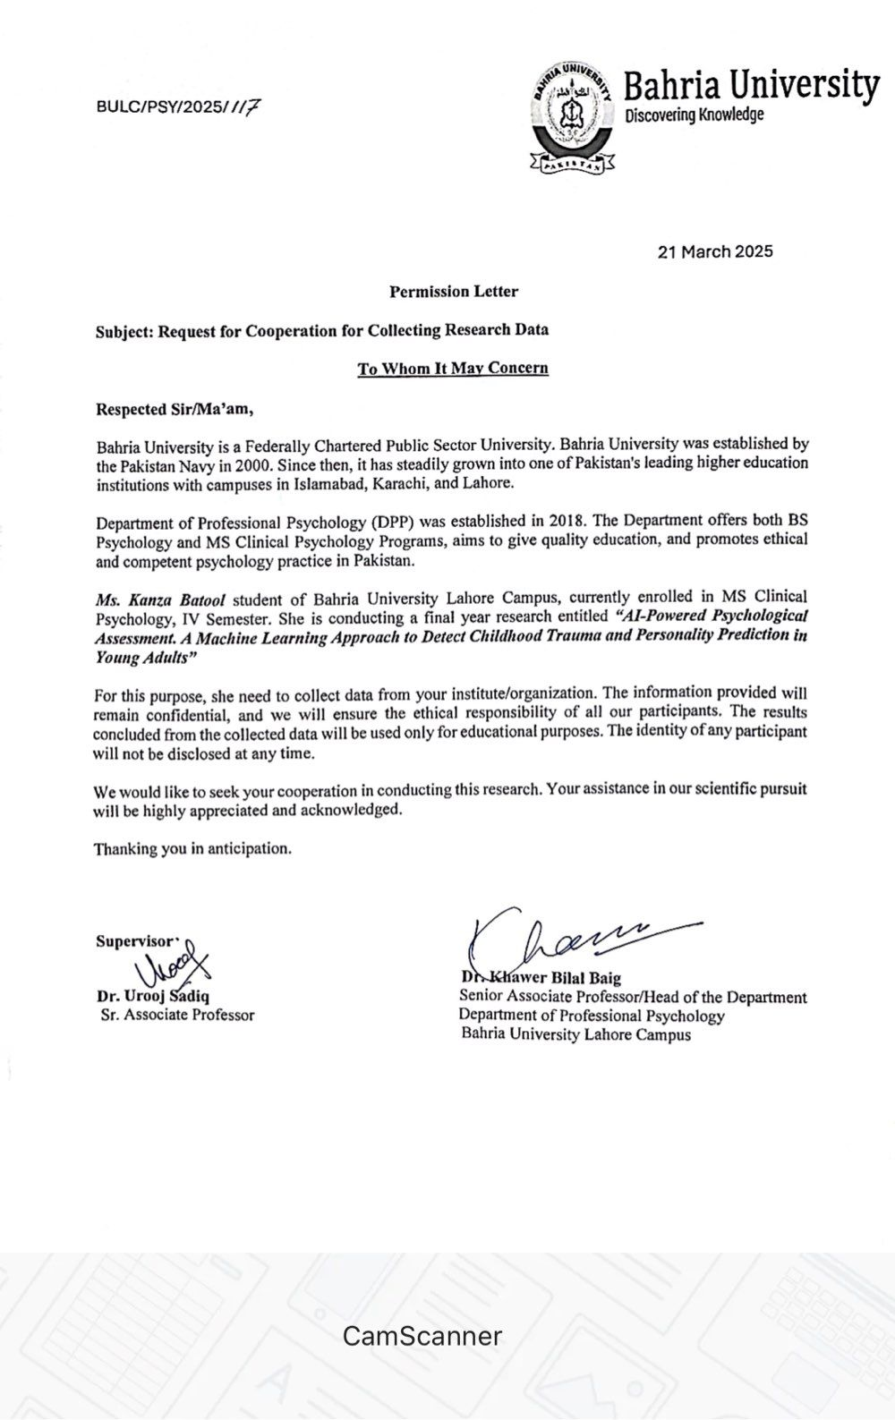

Consent Form
Dear participants,
Asslam-o-Alaikum!
I am Kanza Batool, a student of MS Clinical Psychology at Bahria University Lahore Campus. I am conducting research on the topic “AI-Powered Psychological assessment. A machine learning approach to detect childhood trauma and personality prediction in young adults.” for the fulfillment of the degree of MS Clinical Psychology under the supervision of Dr. Urooj Sadiq and Dr. Nadeem Sarwar. All the information will be kept confidential and results will be used for the research purpose only. Your honest and active participation in this research study is greatly appreciated.
Thank you

Childhood Trauma Questionnaire
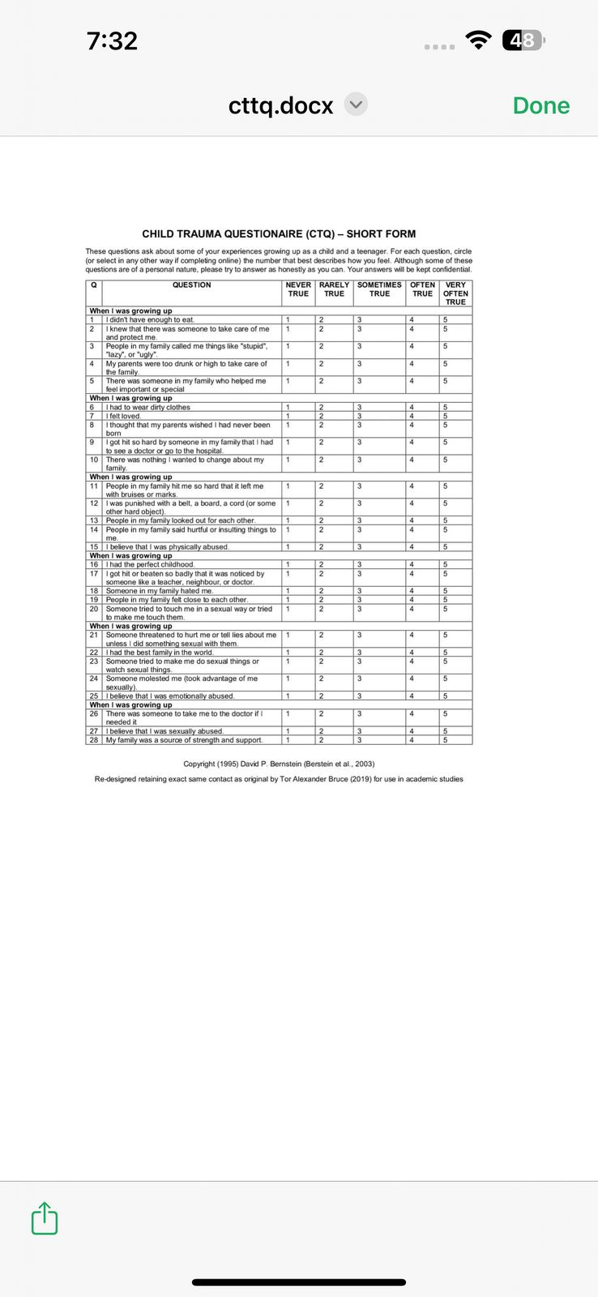

Big Five Personality 2 Short Form

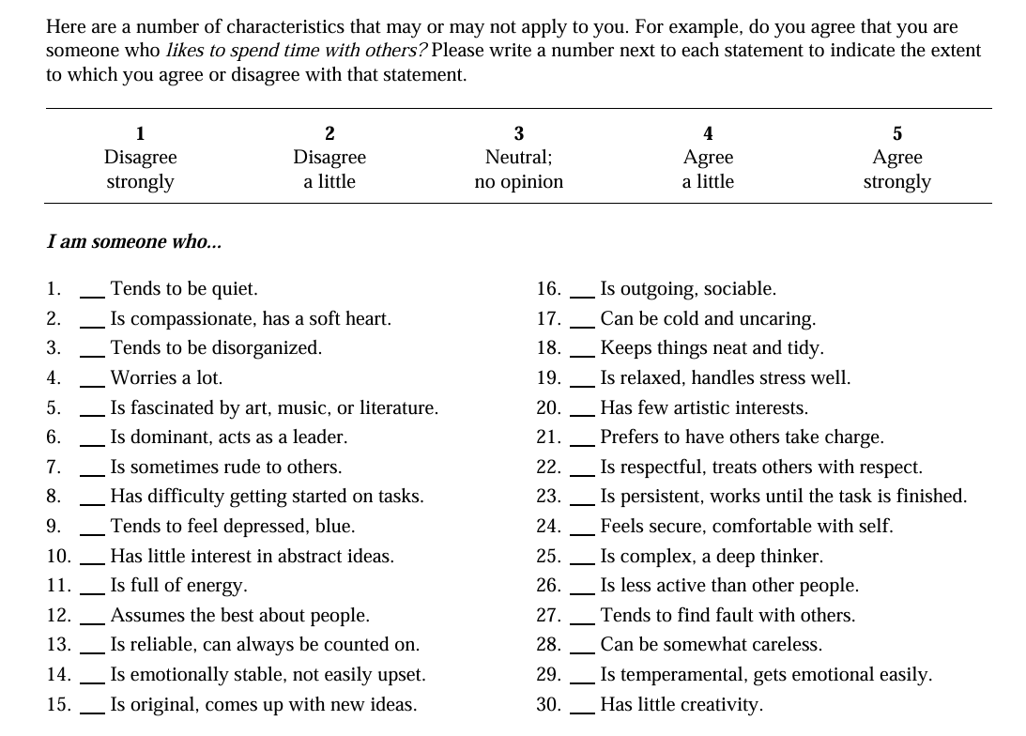

Demographic Variables
Gender: ___________
Age: ___________
Education: ____________
Parental status: ____________
Parental Socio-economic status: ___________

No of siblings: ___________
Birth order : ___________

