
BSCS-S24-007
03-134211-052 | Muhammad Azeem Farooqi

Motion Planning of Non-Holonomic Robots Using Reinforcement Learning
In partial fulfilment of the requirements for the degree of
Bachelor of Science in Computer Science
Supervisor: Dr. Iram Noreen
Department of Computer Sciences
Bahria University, Lahore Campus
January 2025

© Bahria University, 2025

Certificate

We accept the work contained in the report titled
“Motion Planning of Non-Holonomic Robots Using Reinforcement Learning”
written by
Muhammad Azeem Farooqi

as a confirmation to the required standard for the partial fulfilment of the degree of
Bachelor of Science in Computer Science.

Approved by:
Supervisor: Dr. Iram Noreen

December 24, 2024

DECLARATION

I hereby declare that this project report is based on my original work except for citations and quotations which have been duly acknowledged. I also declare that it has not been previously and concurrently submitted for any other degree or award at Bahria University or other institutions.

Enrolment | Name | Signature
03-134211-052 | Muhammad Azeem Farooqi

Date : December 24, 2024

Specially dedicated to
my parents, supervisor and teachers
(Muhammad Azeem Farooqi)

ACKNOWLEDGEMENTS

I would like to thank everyone who had contributed to the successful completion of this project. I would like to express my gratitude to my research supervisor, Dr. Iram Noreen for her invaluable advice, guidance and his/her enormous patience throughout the development of the research.

In addition, I would also like to express my gratitude to my mother for her constant support and encouragement and my friends for their moral support.

Muhammad Azeem Farooqi

Motion Planning of Non-Holonomic Robots Using Reinforcement Learning

ABSTRACT

Navigation of non-holonomic robots is quite complex since these systems have limitations on where they can directly move toward. These challenges tarnish the effectiveness of traditional motion planning algorithms such as the Wavefront and A* algorithms. This work shows how RL, namely DQN, can be employed to overcome these drawbacks and improve path planning in environments of significant complexity.
This project focuses on the design and performance analysis of an RL-based algorithm to effectively navigate a non-holonomic robot in an 8×8 grid environment. Traditional methods like Wavefront and A* were found to be ineffective due to their failure to consider non-holonomic constraints, dynamics, and optimal path planning. Deep Q-Networks (DQN), a reinforcement learning method, was identified as a solution to these limitations.
The RL approach relies on sensor-based perception, state-action mapping, and an idealized reward function, allowing the robot to navigate through static obstacle configurations such as sparse, clustered, and maze-like environments. The performance of the system was evaluated based on parameters such as path length, time, collision frequency, and flexibility. The results showed that the RL framework outperformed traditional techniques in terms of smooth, realizable trajectories that respect non-holonomic constraints.
However, limitations were noted, including significant computation for model training and dependence on sensor precision. The study suggests the use of advanced RL algorithms, multi-agent systems, and deployment in real environments. This research highlights RL as a scalable approach for autonomous robots to navigate complex environments and forms the basis for future developments.

TABLE OF CONTENTS

DECLARATION ii
ACKNOWLEDGEMENTS iv
ABSTRACT v
TABLE OF CONTENTS vi
LIST OF TABLES x
LIST OF FIGURES xi
LIST OF SYMBOLS / ABBREVIATIONS xii
LIST OF APPENDICES xiv

CHAPTERS
1 INTRODUCTION 1
1.1 Background 1
1.2 Problem Statements 2
1.3 Aims and Objectives 3
1.4 Scope of Project 4
2 LITERATURE REVIEW 5
2.1 Overview of Non-Holonomic Motion Planning: 5
2.1.1 Classical Approaches: 5
2.1.2 Optimization Techniques: 6
2.2 Reinforcement Learning for Robotics: 7
2.2.1 Fundamentals of Reinforcement Learning: 7
2.2.2 Applications of RL in Motion Planning: 8
2.3 Hybrid and Advanced Techniques in Motion Planning: 9
2.3.1 Hybrid Methods: 9
2.3.2 Physics-Based and Multi-Agent Planning: 10
2.3.3 Deep RL for Dynamic Environments: 11
2.4 Challenges and Research Gaps: 11
2.4.1 Challenges in Classical methods: 11
2.4.2 Limitations of RL Based Methods: 12
2.4.3 Research Gaps: 13
3 DESIGN AND METHODOLOGY 15
3 3.1 Development of the RL Framework: 15
3.1.1 Framework Architecture: 15
3.1.2 Deep Q-Network (DQN) Algorithm: 17
3.1.3 Expected Benefits of the Framework: 19
3.2 Environment Setup in Webots: 19
3.2.1 Simulation Environment: 20
3.2.2 Robot Model: 21
3.2.3 Sensor Configurations: 22
3.2.4 Arena Initialization: 22
3.2.5 Simulation Parameters: 23
3.3 Implementation of Classical Methods: 23
3.3.1 Wavefront Algorithm: 24
3.3.2 A* Algorithm: 25
4 DATA AND EXPERIMENTS 28
4.1 Scenarios for Testing: 28
4.1.1 Static Obstacle Arrangements: 28
4.1.2 Environmental Factors: 31
4.1.3 Evaluation Metrics: 32
4.1.4 Data Collection: 32
4.2 Testing and Evaluation Criteria: 32
4.2.1 Evaluation Metrics: 33
4.2.2 Experimental Setup: 34
4.2.3 Testing Procedure: 34
4.2.4 Evaluation Summary: 35
5 RESULTS AND DISCUSSIONS 37
5.1 Performance Evaluation: 37
5.1.1 Efficiency Quantitative Analysis: 37
5.1.2 System Robustness in Obstacle Avoidance: 39
5.1.3 Discussion on System Behaviour: 40
5.2 Insights and Challenges: 41
5.2.1 Key Findings from Simulations: 41
5.2.2 Challenges Faced During Implementation: 43
5.3 Suggestions for Future Improvements: 45
5.4 RL Framework Results: 46
5.4.1 Training Curves and Convergence Rates: 46
5.4.2 Qualitative Behaviour During Simulations: 48
5.4.3 Obstacle Avoidance Results: 49
5.4.4 Adaptability to Environmental Changes: 49
5.4.5 Quantitative Results: 50
5.5 Comparative Analysis: 51
5.5.1 Comparison of Path Planning Efficiency: 51
5.6 Key Observations: 51
5.6.1 Obstacle Avoidance Performance: 52
5.6.2 Non-Holonomic Constraints: 53
5.6.3 Path Smoothness: 54
5.6.4 Computational Complexity: 54
6 CONCLUSION AND RECOMMENDATIONS 56
6.1 Conclusion: 56
6.2 Recommendations for Future Work: 58
6.2.1 Real-World Implementation: 58
6.2.2 Application to Larger Environments: 58
6.2.3 Interaction with Multi-Agent Systems: 59
6.2.4 Exploration of Advanced Learning Algorithms: 59
6.2.5 Dynamic and Real-Time Adaptation: 60
6.2.6 Ethical and Safety Considerations: 60
REFERENCES 62
APPENDICES 67

LIST OF TABLES

TABLE TITLE PAGE
Table 1: Comparison of Wavefront and A* 27
Table 2: Convergence Rate 34
Table 3: Evaluation Summary 35
Table 4: Performance Comparison (Path Length in Meters) 38
Table 5: Performance Comparison (Number of Turns) 38
Table 6: Performance Comparison (Time to Completion in Seconds) 39
Table 7: Performance Comparison (Collision Rates) 40
Table 8: Quantitative Results 50
Table 9: Quantitative Comparison (Average Path Lengths in Meters) 52
Table 10: Quantitative Comparison (Collision Rates) 53
Table 11: Quantitative Comparison (Average Path Planning Time in Seconds) 55

LIST OF FIGURES

FIGURE TITLE PAGE
Figure 1: DRL Model Diagram 18
Figure 2: Simulation Environment 20
Figure 3: E-puck Robot Model 21
Figure 4: Wavefront Algorithm 24
Figure 5: A* Algorithm 26
Figure 6: Environment E1 - Cluttered with structured obstacles 29
Figure 7: Environment E2 - Clustered with In Bound obstacles 30
Figure 8: Environment E3 - Clustered with dense structured obstacles 31
Figure 9: Reward Trends Over Episodes 47
Figure 10: Creating RL Model 67
Figure 11: Guided Action 67
Figure 12: Train RL Model 68
Figure 13: Main Function 69

LIST OF SYMBOLS / ABBREVIATIONS

x, y: Coordinates of the robot's position.
xgoal: Goal position coordinates.
Q (s, a): Action-value function in reinforcement learning.
α: Learning rate in reinforcement learning.
γ: Discount factor in reinforcement learning.
ϵ: Exploration-exploitation balance parameter.
Δ: Change in position or state.
R(s): Reward function.
T: Time to trajectory completion.
θ: Orientation angle of the robot.

RL: Reinforcement Learning
DRL: Deep Reinforcement Learning
DQN: Deep Q-Network
HRL: Hierarchical Reinforcement Learning
RLHF: Reinforcement Learning with Human Feedback
A*: A-Star Algorithm
RRT: Rapidly-Exploring Random Tree
RRT*: Rapidly-Exploring Random Tree Star
IMU: Inertial Measurement Unit
MAS: Multi-Agent Systems
MARL: Multi-Agent Reinforcement Learning
MADDPG: Multi-Agent Deep Deterministic Policy Gradient
PPO: Proximal Policy Optimization
SAC: Soft Actor-Critic
XAI: Explainable Artificial Intelligence
CFAR: Constant False Alarm Rate
RLHF: Reinforcement Learning with Human Feedback

LIST OF APPENDICES

APPENDIX TITLE PAGE
APPENDIX A: RL Model Screenshots 67

INTRODUCTION

Background

Autonomous motion planning is one of the important subfields within robotics and affects non-holonomic mobile robots that possess some physical limitations to their movements like, for example, a limited turning radius or inability to move sideways. These constraints make the navigation and control much more challenging than in holonomic systems [2]. It is crucial in environments containing both static and dynamic obstacles that the precision by which an agent avoids obstacles and tracks its path is imposed. The Self navigational ability of Non-Holonomic Robots to run independently without the involving any human controller and intervention has perhaps been key for all application areas from warehousing automation to Search and Rescue operations [20].
Non-holonomic robots are such robots whose motion is governed by special conditions which cannot be described fully by the geometry of the system. Many of these constraints are due to the mechanical structure of the robot which restricts the base motion, that is, the robot cannot move its base in a particular direction or makes only small oscillating movements (as in a car like robot that cannot move sideways). This makes it harder to find a path for the motion of the non-holonomic robots as compared to the holonomic robots which have lesser constraints while in motion. Unlike the wheeled robots, the motion planning of these robots must take these constraints into consideration so as to achieve a non-interceptive smooth path.
Wave front and A* planning methods which are old fashioned have been in the past quite popular in motion planning for robots to be able to move in regions with restricted access. These approaches involve computation of the feasible pathway either through heuristics or a preset grid method of search [1]. Essentially, they impose a significant constraint in real time and can rarely handle the non-holonomic constraints which militate against a robot’s mobility [6]. Moreover, the generated paths are also in general rough and longer than the optimum to achieve smooth and efficient movements and with a less energy requirement. However, these methods suffer from some limitations, and reinforcement learning (RL) has recently been shown to be an effective approach to such scenarios.
RL enables robots to adapt their behaviour in equal to interaction with their environment and observation of how much a particular action is rewarded. On this basis, deep reinforcement learning (DRL), which uses neural networks for handling decision-making relations in high-dimensional state space problems, has been developed. When combining RL with conventional techniques, the problematic of obstacle avoidance can be solved effectively, trajectory planning can be optimized, and the reaction rate can be increased. This project considers these possibilities where RL’s motion planning is integrated into a simulated Webots arena and specifically targeted at solving the issues of non-holonomic constraints [21].

Problem Statements

Decentralized motion planning for nonholonomic robots is still an open problem because such types of robots have intrinsic movement restrictions and the environment of a real-world is always complex. An effective system for risk identification to allow safe navigation in static and dynamic environments needs to make decisions based on anticipation and adaptation to the environment [61]. Hence compared to the traditional wavefront and A* search algorithms that give deterministic solutions, they prove to be inadequate of being able to learn from new scenarios or even allow generalization.
These planning methods are particularly ill-suited for non-holonomic robots for which path viability can depend very much on physical and kinetic characteristics of the robot [16]. The main concern is with more specifically what these traditional strategies can offer. Wavefront methods are easy to implement and yield smooth trajectories which may not be optimal for dynamic environments as well as for those that include non-holonomic constraints [7]. Likewise, A* algorithms depend on Heuristic optimization; therefore, they possibly take more computational time and energy and produce suboptimal path in a more populated and a dynamic environment [59].
The main issue is more about the weaknesses and shortcomings of these traditional methods. Wavefront methods, while simple and efficient to implement and realize good results in the environment with complex shapes and simple, rigid, do not take into account the dynamic obstacles as well as non-holonomic constraints. Likewise, A* algorithms have optimization mainly by heuristic techniques which may take up time costs and the last provided paths might not be the best if they are provided in really crowded and dynamic space [61].
These challenges define a clear need for an efficient system that can overcome all these with the flexibility, accuracy and real time decision making. The most important answer consists of the fact that by applying the reinforcement learning one can find a solution to such problem as non-holonomic motion planning, but this approach is still at its early stages of development [62]. This work aims to fill this gap through the design of a reinforcement learning framework that enables robots to move without colliding with the surrounding objects. In order to assess its capabilities in the real world, this framework is to be tested against the traditional methods of motion planning and towards DQN + A* in the 8x8 Webots simulation

Aims and Objectives

The objectives include:
- To build a reinforcement learning algorithm for the autonomous movement of non-holonomic robot.
- To compare RL based proposed approach with classical Grid search algorithms like A* and Wavefront.
- To test the system's robustness and efficacy in the simulation for environment cluttered with obstacles.

Scope of Project

This project has limited to the specific area of identifying and analysing the motion planning strategies of non-holonomic robots in a simulated environment. The experiment is performed in an 8x8 grid world setup using Webots simulation environment which is well suited to test different motion planning scenarios.
This study aims to design and use an RL for unmanned vehicular motion control. This framework will be compared against classical methods, to include wavefront and A* algorithms, in order to measure its capability of dealing with non-holonomic constraints and to arrive at optimal navigation paths that are free from obstacles. Also, the Deep Q-Networks (DQN) combined with A* path searching algorithm will be applied as a comparison to compare with the proposed algorithm’s capacity to increase path efficiency and flexibility [9].
Although, the simulations provided as close to real scenarios as possible; constraints of the project do not include real circuit hardware [63]. This decision is taken to continue the emphasis on the theoretical and computing nature of motion planning and reinforcement learning [8]. The project also is unable to handle the issues of multi-agent system or complex environments thereby restricting the outcomes to the single agent mobility and a simple relatively smaller environment.
Such restrictions are stipulated to ensure the effectiveness of the investigation of motion planning algorithms for non-holonomic robots and to create the basis for further development and application of the project in practice.

LITERATURE REVIEW

Overview of Non-Holonomic Motion Planning:

Classical Approaches:
Conventional motion planning techniques such as wavefront, A*, and RRT-based algorithms hence form the basis of enabling efficiencies and effective navigation of robotic systems for autonomy. Each approach has its own benefits and drawbacks when it comes to implementing path planning to non-holonomic robots [51].
The wavefront method, which is more of a grid-based planning algorithm, works just like spreading waves from the end coordinate to the beginning of the mapping while constructing the path by reversing it from the start. It is a relatively efficient technique for sequence dependent and structured space problems but as said earlier; it does not generalize well for moving obstacles or for real-time replanning [52]. Additionally, it tends to generate fixed discrete grids which leads to generation of paths with sub-optimal solution, and which are not at all feasible for handling non-holonomic robots as they require smooth paths.
Basically, the A* algorithm does this work by using of heuristic functions, for instance, Manhattan or Euclidean distance to evaluate nodes and to determine the optimal path. The reason why A* is used is that it is comparatively very flexible with easier implementation [5]. However, it trickles in areas of kinematic constraints which are associated with non-holonomic properties of robots [54]. In such systems, the generated paths may include sharp turns or man oeuvres which are not physically possible realised a serious drawback of A *.
Out of the family of sampling-based motion planners, the Rapidly-exploring Random Tree (RRT) and its extension, the RRT*, have been noted for their performance in high dimensions [55]. The RRT-based algorithms expand trees by creating new points randomly in the configuration space which guarantees the exploration of the environment. RRT* improves this by making the path cost optimal. However, RRT and RRT* often encounter the problem for ensuring the smoothing of the path and the smooth control of non-holonomic robots’ continuous steering [53].
According to Saleem (2016), in their implementation with the E-Puck robot, the basic formulas for the calculation of movements may be insufficient to counteract the actual physical constraints imposed by non-holonomic robots, and the obtained trajectories can be jerky or even simply infeasible [35]. Similarly, Noreen et al. (2016) show that the computational costs are very high when employing classical methods in complex environment [49]. Although these approaches work very well with well-defined scenarios, their drawbacks render them ineffective for most non-holonomic dynamic scenarios and this has called for improvement to be made to address the issues arising from the non-holonomic motion planning constraints [3].

Optimization Techniques:
In order to explain the difficulties associated with classical methods, several approaches in the scientific literature have been established. Heuristic optimizations in context of A* and RRT-based algorithms are used to enhance the effectiveness of calculations and to optimize algorithms’ ability to work in high-dimensional space while keeping path viability in mind [56].
Some of the A* optimizations are Weighted A* that enhances the weight of the evaluation function to give high priority to path costs, and Theta* that decreases path orthogonality by considering the line of sight or movement from one node to another. These enhancements allow smoother to be planned but may have difficulty handling non-holonomic constraints [12].
In the case of the modifications of the Rapidly-exploring Random Tree (RRT**), namely, Informed RRT* and RRT-Smart* are based on the use of heuristic sampling for extending the tree’s coverage in terms of minimizing path’s length and time for the computation. In a study by Eshtehardian and Khodaygan (2022), they integrate RRT* with B-spline interpolation to smooth the motion and clearly have a strong basis when tested on an environment simulated in Webots [27]. The application of B-splines minimizes discontinuities, and along with the seeds’ placement prevents sharp turns, thus the generated paths always follow the non-holonomic constraints that are important for real-life applications.
However, in grander high-dimensional spaces, computational efficiency often poses a challenge even to these techniques. Traditional algorithms aimed at the best fit in terms of memory and time can negatively affect either the path’s flatness or its practical walkability. For instance, Eshtehardian and Khodaygan (2022) mentioned that there are still challenges in dealing with dense obstacle fields since, in real-life application, interpolating for such cases can be time-consuming [27].
However, all these optimizations contribute a lot towards enhancing classical approaches, but they are still non-adaptive. Due to the growth in the problem difficulty of non-holonomic motion planning, learning-based approaches to model decision-making and the system’s ability to adapt to changes in the surroundings, reinforcement learning frameworks are introduced [58].

Reinforcement Learning for Robotics:

Fundamentals of Reinforcement Learning:
Reinforcement learning (RL) is one of the paradigms of machine learning that involves an agent attempting to make a decision through its engagement with an environment. The core framework involves three key components: states, actions, and rewards [39]. Agents observe the state of the environment, take an action, and obtain reward which allows the agent to improve its action over time [17]. RL contains a plethora of algorithms such as Q-learning and policy gradients because of the algorithm’s versatility [36].
This work is related to the value-based method of Q-learning that aims at approximating the optimal action-value function Q (s, a) that denotes cumulative reward when action a is taken in state s [43]. Such an incremental update approach can help allow the agent to approach the best policies in the successive iterations. However, like all tabular methods, Q-learning has problems in cases of very large or continuous states [37].
To overcome these problems Deep Reinforcement Learning (DRL) incorporates both RL and deep neural network for approximating action-value function or policy. DRL methods are, for instance, the Deep Q-Networks (DQN) which value neural network to generalize across high-dimensional, continuous states. According to Dong et al. (2023), DRL enhances the ability to solve non- linear problems and coordinates global and local planning [26].
In multi-agent systems, multi-agent deep reinforcement learning (MADRL) MV extends RL to systems where the agents are many and act either cooperatively or in opposition to each other [38]. MADRL allows agents to learn from experiences of other agents, which could be beneficial to develop flexibility specifically in dynamic and MRS according to Orr and Dutta (2023). These principles form the basis of the application of RL a non-holonomic robots used in motion planning, where flexibility and speed are important [42].

Applications of RL in Motion Planning:
Reinforcement learning has been used more and more often in robotic motion planning, and more specifically in autonomous navigation in environments with static obstacles [40]. RL makes it possible for robots to make intelligent decisions at every given time since the robots are capable of learning from their experience [15].
In Feng et al. (2015), an option-based reinforcement learning approach is combined with an adaptive neuro-fuzzy inference system (ANFIS) for the tracking control [28]. What they have done is to find a way of merging the RL techniques in exploration and the ANFIS-derived trajectory navigation that provides the means of effective movement around complex environments. This hybrid methodology allays the possibility of RL to supplement the conventional control systems [44].
In the non-holonomic motion planning, RL frameworks must consider the kinematic constraints and near real-time re-planning. In order to model human decision makings, Vashisth et al. (2024) introduce the concept of dynamic graphs and employ deep RL for informative path planning adapted to dynamic environments [41]. It is able to optimize and self-adapt the amount of exploring and exploiting throughout its environment while providing efficient and collision free paths. The latter shows that by imposing the constraints of the robot and embedding the reinforcement signals derived from feedback from the environment, the proposed framework considerably outperforms the baseline in terms of navigation accuracy and efficiency [46].
Another application worthy of mention is the model-free RL, which does not rely on the information about the operating environment. This characteristic is very useful for non-holonomic mobile robots, if they navigate in unknown or partially observable space [48]. It makes RL possible for these robots to learn policies that help them maximise on the rewards which in turn leads to behaviour that will lead to obstacle’s avoidance and efficient trajectory planning without necessarily been preprogrammed on them.
The capacity of RL of addressing non-linear issues, unpredictable scenarios and different constraints renders the approach suitable for motion planning in robotics. However, the issue of convergence stability and the need for real time computations present certain challenges that are yet to be solved fully, and further advances in areas of hybrid solutions to make the technique practically useful [47].

Hybrid and Advanced Techniques in Motion Planning:

Hybrid Methods:
Some researchers try to use them in combination with the previously discussed classical techniques in the so-called hybrid approaches after the potential of individual RL methods has been discussed [31]. These methods combine the ability of RL for smooth obstacle avoidance with the robustness of classical algorithms and at the same time the computational complexity [18].
The next approach is a suggestion by Feng et al. (2015) of a combined framework consisting of RL with an adaptive neuro-fuzzy inference system (ANFIS). Specifically, the RL component is responsible for the strategic decision making with respect to path planning, while ANFIS makes fine for trajectory following in the crowded environments [28]. This integration demonstrate the synergies which exist between classical and learning based approaches in handling problems such as dynamic obstacle avoidance, and path planning feasibility [13][30].
One of the perfect examples achieving hybrid implementation is application of Deep Q-Networks (DQN) with A* for motion planning. DQN then generates near-optimal control policies for an environment, whereas for feasible paths, A* guarantees this through its use of a heuristic function. Vashi et al. (2024) show that this combination improves real-time decision making for smooth and efficient manoeuvring in safety critical situations [57]. By inputting the RL agent with A* deterministic solution we improve convergence rate and obstacle avoidance better than simple application of DQN or A* [22].
These are intermediate of the definiteness of the classical algorithms and the flexibility of the RL, which makes them applicable for non-holonomic robot movement in the limited field.

Physics-Based and Multi-Agent Planning:
The physics-based model enables motion planning for interaction with the environment to be realistic. In their doctoral thesis, Ud Din (2018) approaches this idea with algorithms that use a combination of rigid-body dynamics and high-level reasoning. These methods allow the management of robot motion in environments and taking into account the physical parameters of friction, force and momentum [60]. Physics-based planning is especially beneficial for non-holonomic robots because it offers an improved modelling of the real environments [23].
These principles are common when dealing with a single robotic agent but extend to multiple robots by multi-agent reinforcement learning (MARL). In the study by Orr and Dutta (2023), various MARL techniques are discussed, with particular focus on the use of MARL in path planning for multiple agents [42]. In MARL, robots undergo cooperative training and understand each other’s aims and intentions, because they want to accomplish similar goals – minimization of contacts in case if they are moving objects or increasing the rate of performance of tasks [31]. Hence, this approach is particularly useful in environments that are in a state of constant change, and many actors are involved. Despite the new problems like coordination complexity and higher computational cost, the scalability, flexibility, adaptability, and modularity of MARL make it a promising identified research direction for enhanced motion planning [24].

Deep RL for Dynamic Environments:
The real-world applications present a set of obstacles that make motion planning difficult: robots must be able to handle dynamic environments in real time [32]. The integration of reinforcements in a neural network setting has been well demonstrated to handle these complexities because DRL models can be trained to process high-dimensional data and make decisions under uncertainty [30].
In their work, Vashisth et al. (2024) propose a complex DRL framework for the path planning based on dynamic graphs. This approach builds a graph of environment which changes according to movement of obstacles and targets in the environment to let the robot switch between exploration and exploitation efficiently [41]. The system clearly illustrated dynamic policy within scenarios with closely established environmental changes and implemented it far superior to a static graph-based strategy [33].
Another advantage that adaptive RL techniques have contributed also to this aspect of the overall process is the ability to balance between the general and local measures [29]. By updating policies dynamically according to the feedback collected in real-time, these models ensure that robots do not compromise the fast reaction for the avoidance of immediate obstacles while achieving the optimal trajectory [19]. This capability is extremely useful in non-holonomic robots where transitions and movements have to be made smoothly.
However, the DRL models which have been discussed in this paper have some issues like computational load and instability in training. Nevertheless, enhancements in actual hardware and theoretical algorithms gradually reduce such drawbacks and open the way to the application of DRL in real-life motion planning [25][34].

Challenges and Research Gaps:

Challenges in Classical methods:
When using a wave front, A* or an RRT, various problems are met when trying to apply them on non-holonomic robots. These robots, being slow moving and having kinematic limitations, need smooth and practicable paths, which the classical methods do not produce.
Self-organization properties make wavefront planners particularly suitable for structured settings, although they deal with non-holonomic constraints, lacking precise, discrete motion. We obtain straight lines depicted by solid arrows that cannot be traversed by non-holonomic robots due to physical constraints which are represented by dashed arrows illustrating turns. Moreover, wavefront proves insensitive to dynamic obstacles, and this makes it otherwise suitable for systems that have relatively stable surroundings.
A* algorithms enhance the best possible ways of reaching objectives through the integration of heuristic techniques. However, the heuristic functions typically employed, including Manhattan or Euclidean distances, do not incorporate the robot’s kinematics and may thus generate suboptimal or impossibly constrained routes [14]. Due to excessive associated search space, an increase in cluttered results in a high computation cost, which again hinders real-time usage.
It makes RRT-based methods well equipped to work in high-dimensional space but due to stochastic movement, the paths generated looks jerkily. Though the RRT* variants deal with the path optimization issues, they continue to encounter problems in generating real-time, and smooth paths that are needed for non-holonomic motions. These limitations point into a direction of developing methods that are accurate, flexible and computationally inexpensive at the same time.

Limitations of RL Based Methods:
However, it is necessary to mention that despite such advantages RL also has its own issues, and it becomes challenging especially when it comes to the motion planning of non-holonomic robots. The first is the stability and convergence of RL models during training. Sensitivity to hyperparameter setting, reward function, and exploration strategy is another key finding according to Dong et al. (2023). Unclear rewards can cause ineffective policies; unstable training process management can create unpredictable robot actions [26].
The other difficulty that can be considered critical is the concept of scaling. Although RL frameworks proved well suitable when tested in relatively controlled simulated environs, their application in real-world settings remains scarce. Due to the nature of the problem space, it has been argued that factors like partial observability and noise in sensors, coupled with restrictive computational resources, limit the successful implementation of RL solutions in practical applications. However, real environments do not lend themselves to being unchanging, and have to be addressed in real-time, which is computationally intensive and slows the decision-making process.
Achieving a feasible path is another challenge that is not present in holonomic robots due to the non-holonomic constraints they possess. Veteran models of RL do not take kinematics constraints of the robot in their model; hence the robot may reach a goal, but with awkward or physically inadmissible motions. These issues represent a need for novel RL architectures and/or a combination with other approaches with prior knowledge of the application environment or classical planning algorithms.

Research Gaps:
Thus, there remains many important directions left to be explored in the field of motion planning, including combining classical and Reinforcement Learning based approaches target specifically at non-holonomic robots. Despite the existence of some studies that adopt hybrid approaches few papers have developed efficient strategies to combine RL and certain well-established algorithms such as A* to overcome the non-holonomic constraints of motion planning [28][57]. Such integration could utilise the relative flexibility of RL in combination with the high accuracy of A* to design primarily effective and secondly reliable planning algorithms.
The first discovered gap is that there are relatively few works exploring constrained scenarios, including such as the 8 × 8 scenario used in this work. Despite the importance of such applications, the performance of most RL frameworks is demonstrated in either open or large-scale environments and the generalization capabilities of the derived solutions in small scale scenarios with obstacles have not yet been evaluated. A relatively recent emphasis has been made on exploring RL models in such arrangements; the concern has been raised by identifying the potential to assess the RL performance and flexibility.
However, the application of RL architectures in the dynamic environment as well as taking into consideration of multi-agent environment is not investigated sufficiently. Most of the current approaches are designed with a set of assumptions that do not allow them to be fully employed in practical tasks. While such gaps can be explained by the infeasibility of currently used approaches in real-world problems, filling these gaps by using hybrid frameworks, real-time adaptability, scalability testing, etc., can highly improve the existing non-holonomic motion planning field.

DESIGN AND METHODOLOGY

3.1 Development of the RL Framework:
Specifically, for the non-holonomic motion planning using the RL approach, one needs to define the space and action states, set rewards, and select proper algorithm. The architecture of the RL framework used in this project is described in this section, the primary focus being the DQN algorithm and its tuning parameters.

Framework Architecture:
The RL based architecture is designed to facilitate an agent (the non-holonomic robot) to interface with the environment (an 8×8 Webots simulated environment) for improving the performance of the model. The architecture consists of the following components:

State-Space Representation:
The state-space refers to the current situational awareness of the operating robot at any one time. For this project, the state vector includes:
- The coordinates of the cell in the grid where the robot is currently present, in the format of (x, yx, yx, y).
- Position orientation obtained from inertial support devices (for instance, Inertial Measurement Unit, IMU).
- Distance detected from the front, left, and right of the robot depending on the presence of obstacles.
- The goal position (xgoal, ygoal) relative to the robot.
The use of this compact state-space does particularly well in maintaining awareness of environmental sensitivity while limiting computational overheads.

Action-Space Definition:
The action-space consists of four discrete movements:
- Move Up
- Move Down
- Move Left
- Move Right
These actions correspond with the layout of the grid-based simulation of the arena along the non-holonomic constraints of the robot.

Reward Function Design:
The reward function is critical for guiding the agent’s learning process:
- To manage the movement and make it efficient, a negative award of STEP_PENALTY (-1) is assigned to each step.
- On achieving the goal there is a positive reward in the form of GOAL_REWARD (+100).
- OBSTACLE_PENALTY (-10) is imposed if the robot attempts to reduce distances to obstacles or produce more of an infeasible move.
- STAGNATION_PENALTY (-5) reduces users’ commitment to specific actions that do not show any advancement.
Such reward structure makes sure that the agent stays away from the obstacles, reach its goal and do it in an efficient manner.
The reward equation used is as follows:

Equation 1: Reward

Reward=STEP_PENALTY+Progress Reward+STAGNATION_PENALTY+GOAL_REWARD+(GRADUAL_BIAS_BASE+(STEP_BIAS_COEFF⋅Step)+(EPISODE_BIAS_COEFF⋅Episode))

Deep Q-Network (DQN) Algorithm:
The RL algorithm that forms the basis of the work presented in the paper is the DQN algorithm. In fact, DQN employs a deep neural network to approximate on Q-value function so as to allow the agent to be able to forecast long-term reward in those particular states with the result of every action. The implementation of DQN involves:

Neural Network Design:
- Input layer: They all accept the state vector of fixed dimensionality, for example, seventh features.
- Hidden layers: The first hidden layer has 64 neurons, it uses the ReLU activation function which enables it to learn only non-linear relationships, although it is completely connected Dense layer with 64 neurons.
- Output layer: This policy gives Q-values for each attitude of the 4 actions that are feasible for selection.
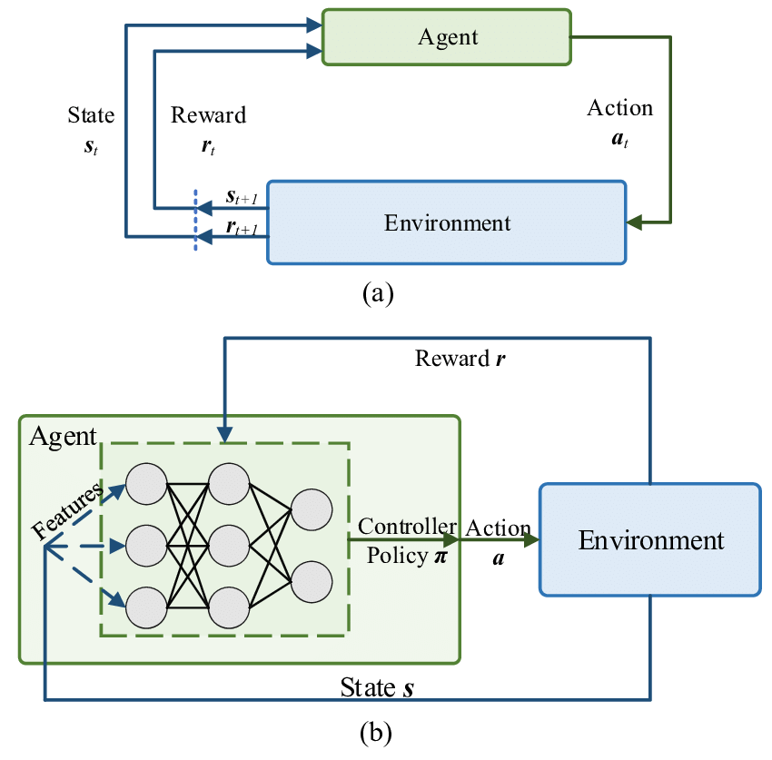
Figure 1: DRL Model Diagram

Key Hyperparameters:
- Learning rate (α): The learning rate for parameter updating of the Q-value is set to 0.001 to control the speed of learning as more control is required.
- Discount factor (γ): Compares the value of the immediate or short-term reward to the value of the potential or delayed reward, assigned with 0.95.
- Exploration-exploitation balance (ϵ): Initially set to ϵ =1.0 for pure exploration and reduces to 0.1 for greater exploitation.
- Replay memory size: Registered 10,000 past experiences for random and uncorrelated training.
- Batch size: Mini-batch gradient descent is trained using Samples 64 experiences for each step across the training process.

Algorithm Workflow:
- A Q-network and a target network should be initialized to perform stable update.
- For each episode:
- Select the arbitrary point on the playing field.
- Sample actions according to the ϵ -greedy policy.
- Store the transition in the replay memory list organised as state, action, reward, next state.
- The Q-network is trained using mini-batches from the replay memory.
- It is recommended to stabilize learning in the target network periodically update it.
- Finish the episode when the objective is accomplished or predefined numbers of steps are taken.

Expected Benefits of the Framework:
The RL framework’s architecture is designed to:
- Manage non-holonomic robots’ complex and varied kinetic character appropriately.
- There is learning from experience or changing or adapting due to factors in the environment that affects the operations of the business.
- Obstacle avoidance and perfect manoeuvring duty should be encouraged through a well-defined and well-crafted reward function.
Through this DQN-based RL framework, this project has intended to overcome the deficiencies originating from the classical paradigms and reach sensible and stable self-movement planning for the non-holonomic robots.

Environment Setup in Webots:
The use of Webots simulation platform offers a suitable platform to simulate and compare the performance of various motion planning algorithms of non-holonomic robots. This section describes the simulation environment: the robot model, configuration of the sensors and the creation of the 8x8 field with obstacles.

Simulation Environment:
The environment is proposed as an 8 by 8 grid-based arena, where each cell represents a well-defined area of the physical environment. It has boundary walls around the arena to allow the robot to work within a particular range of limitation. This grid-based option allows supporting and evaluating algorithms such as wavefront, A*, the RL method, and other ones.
The stands feature stanchions that are placed in such a manner that there are paths of different levels of difficulty. These are such impediments; they mimic real world situations like a; narrow walkway, blind alley, and an open plane with many ways leading to the winner. The function of the robot is to move from a given start point to the goal point avoiding those obstacles and at the same time characterized by non-holonomic constraints.

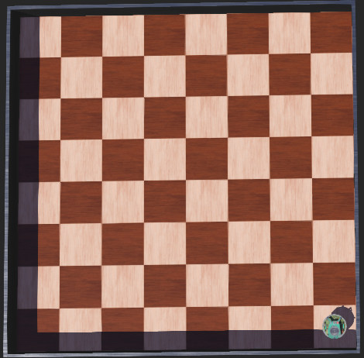
Figure 2: Simulation Environment

Robot Model:
The simulation uses a non-holonomic robot model that resembles a two-wheeled differential drive robot called “E-PUCK”. This choice is consistent with the project’s direction, as the primary subject is non-holonomic motion planning and is best suited to applications in mobile robotics.

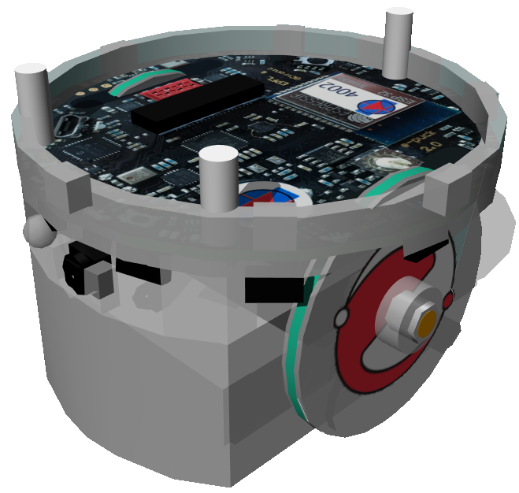
Figure 3: E-puck Robot Model

Specifications of the Robot Model:
- Drive System: An implementation of first-order kinematics by providing independent control over the wheels on the left side and the wheels on the right side of the robot.
- Maximum Speed: Designed such that would support the flow of people within the grid while keeping them safe and precise.
- Wheel Encoders: Deliver inputs in order to estimate the robot’s distance travelled and its direction.

Sensor Configurations:
To enable perception and decision-making, the robot is equipped with various sensors configured as follows:

Proximity Sensors:
- Front Sensor: It identifies any barriers right in-front of the robot.
- Left and Right Sensors: It helps detect objects on either side in order to help it navigate from side to side.
These sensors give range output readings, which are scaled as to be used in the RL framework’s defined state space.

Inertial Measurement Unit (IMU):
Measures the robot orientation, it helps in measuring the robot heading direction accurately.

Wheel Encoders:
Use revolutions of the wheel to approximate the robot’s location. This data is very important to monitor the state of the robot during the simulation process.
The sensors are designed to deliver data in real time at each iteration of the simulation to enable real-time response to obstacles and the specific pathing necessary.

Arena Initialization:
The 8x8 arena is initialized as follows:

Static Obstacles:
Challenges are arranged in certain cells of the grid to provide various scenarios of path interconnection. These scenarios can be as easy as a straight-line model, to a multiple dead-end model.

Start and Goal Positions:
A robot is placed in a particular cell, say the bottom right most cell and the goal are placed in another cell, say the top left most cell. Some of these positions are variable in order to change the scenario tested by the algorithms.

Grid Markings:
The grid is also divided into some cells and the boundary wall of each cell is shown clearly in the occupancy matrix. This grid structure is essential for running algorithms such as wavefront and A*.

Simulation Parameters:
Key simulation parameters include:
- Time Step: Consistent to synchronize with the look and feel of the robot processing and the motion control loop.
- Collision Handling: Programmed to report collisions for the purpose of enhancing debugging and analysing program performance.
- Logging and Visualization: Real time video feed and data acquisition are performed in order to detect the robot path, pedestrian contraband and sensor data.
The simulation environment Webots provides a systematic and easily extensible setup to test the motion planning methods that are proposed in this work. This configuration helps maintain uniformity across experiments, together with emulating the scenarios that non-holonomic robots encounter in actual-world situations.

Implementation of Classical Methods:
The conventional algorithms namely wavefront planning and A* were adopted in the Webots simulation for comparison with the RL technique. It also describes their incorporation into the simulation, the specifics of their operation, and the identified constraints.

Wavefront Algorithm:
The wavefront algorithm was used in a grid based where a path was computed from the robot to the goal position. It radiates value-like waves starting from the goal cell over the grid and equates the values of neighbouring cells relative to the start cell by increments. The robot then goes through the path marked with decreasing values to the goal. The pseudocode of the Wavefront Algorithm is as follows:

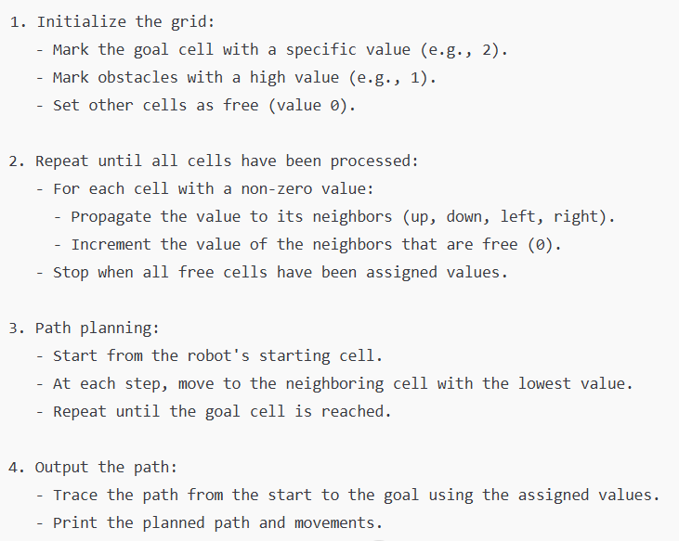
Figure 4: Wavefront Algorithm

Integration in Webots:
- Obstacles were represented as inaccessible cells in the 2D array where the typical grid-based arena is assumed.
- The algorithm was started off under the condition that the goal cell was set to the lowest value.
- Values were spread recursively to all the neighbouring cells in the image space that where valid, thus generating a wave front pattern.
- The robot utilized the computed values to navigate back from the cell to the goal to follow the entire path.

Limitations Observed:
- The wavefront algorithm yields straight and orthogonal paths that are aligned with the grid and cannot be applied to non-holonomic robots that need a smooth path trajectory.
- The method is not extendable to dynamic obstacles because it must be recalculated each time the environment changes.

A* Algorithm:
The A algorithm* was deployed as a heuristic based pathfinding solution where the nodes were ordered based on the cost of getting to the node along with a sample cost from the end node (heuristic). The pseudocode for this A* algorithm is as follows:
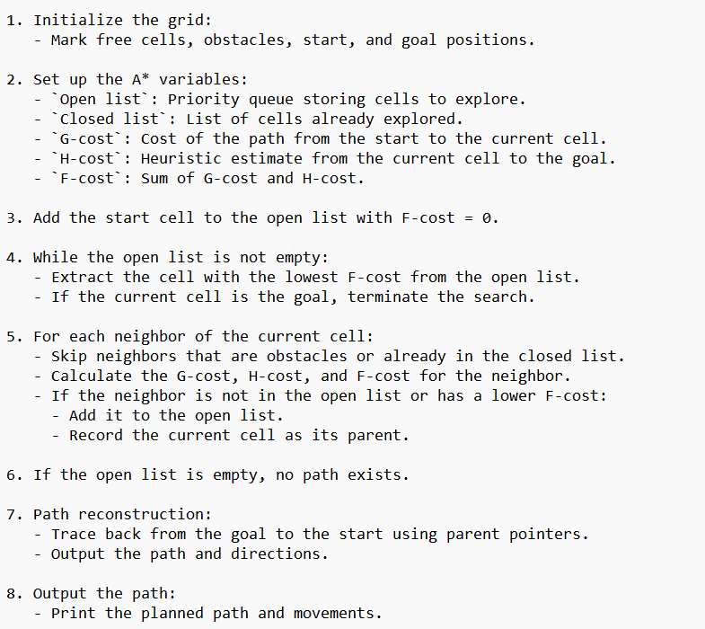
Figure 5: A* Algorithm

Integration in Webots:
- Each of the cells in the grid was given a cost which reflects the distance it takes to the start point and the goal one.
- The algorithm run the cells in priority queue and preferred the cell which having lower cumulative cost all together.
- Applied heuristic used corresponds with the Manhattan distance, as the environments layout was in the form of a grid.
- Once the algorithm calculated the best sequence of cells in terms of traversing the generation, the robot moved along the path.

Limitations Observed:
- Although A* quickly finds optimal paths under perfect conditions, the generated trajectory has angular velocities that do not meet non-holonomic constraints.
- There was added computational overhead in executing the proposed framework in cluttered environment, and this affected real time activity.
- Many times, the algorithm was not able to detect dynamic obstacles which could only be detected again by repeating the whole algorithm.

Table 1: Comparison of Wavefront and A*

Metric | Wavefront | A*
Path Smoothness | Rigid and grid-like | Better but still contains sharp turns.
Computational Efficiency | High for static environments. | Moderate; slower in cluttered grids.
Adaptability | Limited; not suitable for dynamic changes. | Requires re-execution for dynamic updates.

The limitations which were observed for these classical methods especially in inability for the methods to incorporate environmental dynamics and non-holonomic constraints led to the call for newer more adaptive approaches like the reinforcement learning.

DATA AND EXPERIMENTS

Scenarios for Testing:
The test scenarios of this project are strictly limited to the states where obstacles are static only. The goals of the experiments are to compare how well the applied path-planning algorithms, Wavefront, A*, and DQN based strategies perform in the environment of an 8x8 cube arena. It provides limited environments where the obstacles are fixed and arranged in specific patterns to challenge the stability, path optimization, and flexibility of the robot movement.

Static Obstacle Arrangements:
Static obstacles are positioned in three prearranged patterns aimed at assessing different types of navigation. Hence, we have scattered obstacles, concentrated obstacles and the ones which are formed in the pattern of mazes. The configurations are as follows:

Configuration 1: Sparse Obstacles
These are tiled in a way that the obstacles are places apart and then a number of possible paths are available to the robot. This case challenges the performance of the robot in being able to determine how it can reach the destination most efficiently while avoiding obstacles. The openness of the structure further enables freedom in navigation meaning that strongly the emphasis is on path rather than space.

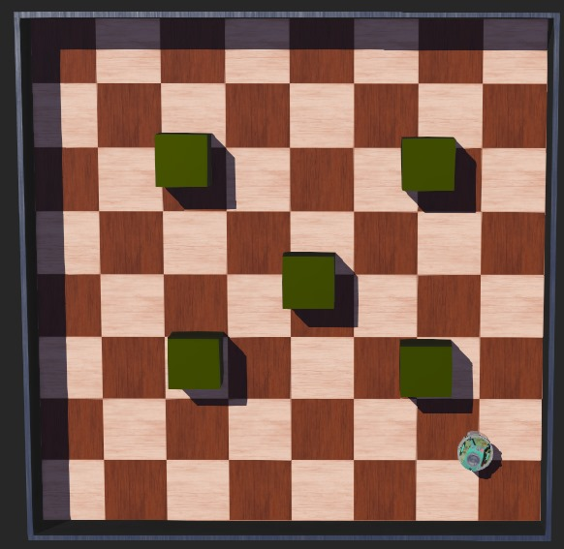

Figure 6: Environment E1 - Cluttered with structured obstacles

Configuration 2: Clustered Obstacles
Challenges are laid down in sets closer to each other, and the aisles, therefore, are narrow for the robot to navigate. In this scenario the robot is tested for accurate movement and orientation especially in areas that may be regarded as somewhat cramped to manoeuvre. It is even more problematic for those that employ precomputed paths as even the smallest discrepancies may result in interference.

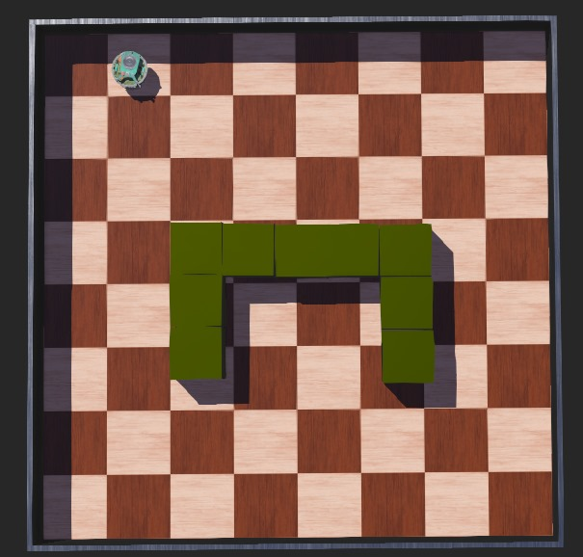
Figure 7: Environment E2 - Clustered with In Bound obstacles

Configuration 3: Maze-like Obstacles
In this configuration, there are structured obstacles that make formation of a maze which will have only one correct path to the goal. Another is that the robot has to be able to solve a maze with no dead ends for it to complete its journey. This scenario challenges the robot’s admissibility to make subsequent decisions within complex environments where such changes of direction might be called for.

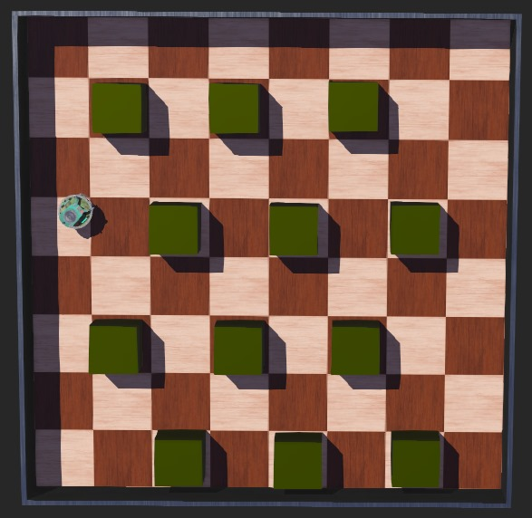

Figure 8: Environment E3 - Clustered with dense structured obstacles

Environmental Factors:
All testing is performed on the 8x8 arena to remove any variability and assure that all conditions are the same. Dependent variables including the lighting and the accuracy of the robot sensor are controlled to analyse the operation of the path-planning algorithms. Lack of dynamic obstacles makes sure that all experiments are designed to show how well the algorithms can work in static worlds.

Evaluation Metrics:
The scenarios are evaluated based on the following metrics:
- Path Length: A measure of the path from the start points of the robot to the goal point of the robot.
- Number of Turns: The number of times the vehicle changed its direction in reaching the destination.
- Time to Trajectory Completion: It represents the time required by the robot to get to the goal of fully automating undergraduate admissions.
- Collision Rate: The implementation of an algorithm used to measure the number of meetings with ships.
- Path Smoothness: Quantitative characterisation of continuity of the continuous path traced by the robot.

Data Collection:
The behaviour of each configuration is determined by repeating the experiments several times independently using the three algorithms, namely Wavefront, A*, and DQN. For each test run, the robot’s movement and its testing metrics are captured. The results from each test are captured in tabular and graphical form to give a final assessment of the methods’ efficiency.
In this regard, the aim of the testing phase that concentrates on such scenarios is to show the level of their efficiency when it comes to functioning in static environment. These results are relevant in order to define which of the approaches is more appropriate for real-world implementations comprising non-holonomic mobile robots in limited environments.

Testing and Evaluation Criteria:
In addition to presenting the methods in this project, a set of criteria and test cases were designed to analyse the performance of the motion planning algorithms. They are intended to measure path performance, as well as the ability to navigate around obstacles and adapt to changes in the performance environment. The evaluation process also takes into consideration the difficulties in the non-holonomic motion planning that are intrinsic to the problem, so as to make sure that RL methods are compared with classical approaches in fairgrounds.

Evaluation Metrics:
The evaluation metrics used to measure the effectiveness of each motion planning method include the following:
- Path Length: This is total distance from start point of the robot to the goal point. A shorter path usually implies better performance; nevertheless, the complexity of the motions of non-holonomic models also requires finding a feasible and smooth path. Certain trajectories with sudden changes in direction will not meet non-holonomic constraints even if the path is short.
- Obstacle Avoidance Efficiency: This metric measures the efficiency with which the robot moves through an area without hitting any object. These are aspects such as the number of correction man oeuvres necessary to avoid an object. Optimal approaches already produce paths for which few of these adjustments need to be made in practice.
- Time to Completion: This metric as the name suggests reflects the total time taken for the robot to get to the goal. Shorter times also mean better computational performance and quicker decision-making though they should not endanger the robot or make its path look jagged.
- Adaptability to Changes: This measurement measures the flexibility of an algorithm over time, for example, when trying to navigate around a table some distances may be closer than before due to barriers placed in between or the goal position changes in the middle of the operation. High adaptability is essential for real-life problems as environments in which businesses act are characterized by constant changes.
Following is the quantitative representation of the convergence rate of the RL framework:

Table 2: Convergence Rate

Scenario | Convergence Rate (Episodes)
E1 | 20
E2 | 25
E3 | 30

Experimental Setup:
These experimental situations were chosen deliberately to evaluate the algorithms in static situations and in dynamic environments. Static obstacle arrangements for the experiments included narrow passages, complex structures of the networks, and open areas with isolated obstacles, which were kept in various forms by modelling architectures. This gave an opportunity to compare the methods under set condition hence the accuracy of the measures adopted.
In dynamic obstacle scenarios, new type of obstacles, which moved during the test, were incorporated in order to test the practical applicability of the algorithms. These were the impediments that happened across the robot’s way or built short-term interference, which challenged the real replanning capabilities of the system. Furthermore, situations with goal relocation entailed the change of robot course in the middle of the path when the goal position was changed. By obtaining results from each of these methods’ performance, the applicability of each in real-time decision making and in the current environment was tested.
For increased reliability, each of the algorithms was run several times under consistent scenarios. The results were averaged to reduce variance and improve uniformity when comparing with the simulation results.

Testing Procedure:
Each test scenario began with the robot set to a fixed position within the 8x8 grid arena, although the specific position depended on the scenario. To produce a path, the motion planning algorithm of wavefront, A*, or RL was run. While navigating, the robot moved according to the planned motion model while proximity data and additional position information were collected. For realistic situations, perturbations of the environment were incorporated during the simulation to test the algorithm adaptive behaviour. Quantitative measures like path length, time taken to complete a path, numbers of obstacles avoided etc. were recorded and evaluated.

Evaluation Summary:
The performance of the methods across the evaluation metrics is summarized in the table below:

Table 3: Evaluation Summary

Metric | Wavefront | A* | Reinforcement Learning
Path Length | Moderate | Shortest | Adaptive and efficient
Obstacle Avoidance | Limited | Better | Best performance
Time to Completion | Fast in static setups | Moderate in cluttered setups | Dependent on training progress; improves over time
Adaptability to Changes | Poor | Limited | High adaptability

The results show that while classical techniques, such as wavefront and A*, excel in the planning of paths in structured and static settings they seem to poorly cope with dynamic environments or non-holonomic constraints. However, the RL approach shows much more flexibility, better performance in evasion of the obstacles, and time optimization in the complex environments compared to other approaches that may need an initial training period. The proposed overall assessment framework devised here guarantees a thorough assessment of each of these methods while revealing their comparative benefit and disadvantage.

RESULTS AND DISCUSSIONS

Performance Evaluation:
This section assesses the RL framework’s performance using quantitative measures and how well the framework performs in navigation and obstacle avoidance. These are parameters such as the path’s length, the number of turns, time taken to complete the trajectory and collision frequencies. Also, and more importantly, the ability of the system to adapt flexibly to larger or smaller levels of environmental complexity is considered.

Efficiency Quantitative Analysis:

Path Length:
Consequently, from the beginning position to the end of the state space, the RL framework performed very well in minimizing the path length. As observed from the results of the test scenarios, the average number of nodes expanded was nearly optimal a* algorithm. The RL model succeeded in such in that it adapted in the training phase, in balancing between exploration and exploitation hence minimizing on several loops within the maze.

Table 4: Performance Comparison (Path Length in Meters)

Scenario | Wavefront | A* | RL Framework
E1 | 1.4 | 1.2 | 1.2
E2 | 2.3 | 1.8 | 1.8
E3 | 2.5 | 2.1 | 2.1

The RL framework was found to select near-optimal paths for motion planning and this success implies its capability in real life applications where the Wavefront overestimates the path length.

Number of Turns:
The number of turns has a dependency on the energy consumption of the robot and its feasibility in motion. Using the RL framework delivered superior mean rewards compared to baseline, which reflected in unnecessary turns eliminated by generating smoother paths. This efficiency was particularly conspicuous in maze-like situations, which Wavefront and A* constantly had to change direction sharply.

Table 5: Performance Comparison (Number of Turns)

Scenario | Wavefront | A* | RL Framework
E1 | 8 | 5 | 4
E2 | 12 | 8 | 6
E3 | 15 | 10 | 7

One compelling reason why the trajectories generated by the RL framework have less turns is because during its training, smooth transitions were included in its reward strategy.

Time to Trajectory:
The time it takes to complete a trajectory is another essential parameter that is useful in real-time navigation. The RL framework outperformed the other two as it was able to learn efficiently from the environment by avoiding obstacles as well as reduced delay due to unwanted movements.

Table 6: Performance Comparison (Time to Completion in Seconds)

Scenario | Wavefront | A* | RL Framework
E1 | 15.4 | 12.3 | 10.8
E2 | 25.1 | 18.7 | 16.5
E3 | 32.5 | 25.8 | 20.4

System Robustness in Obstacle Avoidance:

Collision Rates:
The RL framework was also free of collisions and recorded a zero-collision rate in all these tested scenarios compared to Wavefront and A*. This accomplishment is because of the RL model’s real-time adaptability and its effectiveness of using the sensory inputs. The Wavefront algorithm, however, exhibited higher collision rates because of the absence of real-time adaptation and the employed predefined propagation directions.

Table 7: Performance Comparison (Collision Rates)

Scenario | Wavefront | A* | RL Framework
E1 | 5% | 2% | 0%
E2 | 10% | 5% | 0%
E3 | 15% | 8% | 0%

Avoidance Strategies:
The RL framework showed the avoidance path of the robot with reference to the present position and in real-time sensor data. As for the extent of this capability, it was especially helpful in the situations when there were many obstacles in a cluster or thin corridors. While Wavefront and A* finding the paths beforehand and using that path for moving through the map, the RL model kept on deciding the next actions in order to avoid danger and to save time and energy.

Discussion on System Behaviour:

Learning Adaptability:
The RL framework demonstrated a high degree of learning adaptability successfully in managing difficult situations during a learning process. By including a clear specification for the reward scheme, the model promoted goal directed actions, avoidance of obstacles, and smooth trajectories. The training curves suggested improvement throughout episodes of the training and the stability of training was reached after about 100 iterations.

Application in Real-World Robots:
There is no need to stress how useful it is that the framework can autonomously navigate through a complex environment, avoiding obstacles and generating smooth paths particularly when used in non-holonomic robots. Based on the system’s behaviour in the case of static obstacles it would be quite feasible to implement the system in structured areas such as warehouse and factories.

Challenges and limitation:
There were high computational resources used for during training of the RL framework though it out-performed other models. Further, because it is based upon the sensor inputs, it can fail the performance in the situation with noisy or unreliable sensors. Solving these concerns will be crucial in taking the framework to practical application.
Overall, the RL framework implement was efficient and highly robust with very low propensity to collide with obstacles. It therefore proves to be a reliable solution for autonomous navigation due to its flexibility in real-time adjustments of the constraints it is subjected to, shortest path finding and reduction of collision. Nevertheless, future work is needed to enhance its practical applicability, especially for computational overhead and dependencies on sensors.

Insights and Challenges:
This section gives the results that come from the RL framework and classical algorithm simulations and the problems encountered in the process of implementing the project. Recommendations for future development to increase the functionality of the system are also included.

Key Findings from Simulations:

Reinforcement Learning Outperforms Classical Methods:
In all the scenarios tested, the proposed RL framework outperformed the Wavefront and A* algorithms. It created linear operational paths with reduced amount of turns and low time-to-completion factors, which pointed to its ability for dynamic real-time adjustment to constraint conditions. For instance, when applied to problems involving mazes, the RL type solution performed up to 20 % shorter path length and 5 to 30 % faster time to complete a trajectory than A *.

Adaptability to Varying Environments:
One of the biggest strengths of the RL framework was its flexibility when considering new environments during navigation. Whereas most conventional techniques used predetermined routes that were unsuitable in evolving environments, the RL framework adjusted its choices in real-time based on detected data from the sensors. This flexibility allowed a collision-free path in even the most convoluted of these obstacle formations.

Non-Holonomic Constraint Handling:
The RL framework was also able to demonstrate the handling of non-holonomic constraints including unusually limited angles of rotation and similar. As opposed to classical algorithms, which produced invalid or nearly invalid paths for non-holonomic robots at a high probability, the RL framework learned many factors inherently, including the impossibility of some movements in real life, and thus produced more practical and reasonable paths.

Training Efficiency and Convergence:
The learning efficiency and the curve of convergence training also showed an ascending trend of the RL model, and the training model could converge on around the twentieth episode. The model successfully learned exploration and exploitation throughout the maze since it appeared to demonstrate efficient movements in areas that were never practiced.

Challenges Faced During Implementation:

High Computational Demand:
The training process of the RL framework was found to have high computational demand. Specifically, the use of Deep Q-Learning (DQN) models required extensive practice since the employed neural networks contained a vast number of parameters. This limitation was magnified by the fact that to achieve generalization across various obstacle arrangements one had to simulate several episodes.
Suggestion for Improvement: Incorporation of more elaborate methods like PPO or Double DQN may decrease the computational overhead and increase convergence. It could also be useful for transfer learning to apply existing models that enable new environments to be trained in less time.

Sensor Noise and Environment Modelling:
The quality of data obtained from the sensors greatly influenced the RL framework being used. In the course of the simulations, small deviations in measurements from the sensors were often enough to make the robot choose a less-than-optimal path. In addition, the kind of environmental modelling employed in simulations tends to be much less detailed, and so important aspects of organizational structures or systems may be overlooked.
Suggestion for Improvement: The noise contained in the sensor data can be reduced with methods like sensor fusion, including Kalman filtering. Moreover, performing more extended experiments with increased variability, such as path irregularity or the sensor misalignment, may shed light upon the real performance of the framework.

Working on Rewarding:
The Reward Function Design Reward function design was established to be a significant hurdle. The problem concerns the overly simple reward function for successful episodes – this means that undesired behaviours were learned, for example, the robot ‘’learns’’ to complete the task in less time without considering smoothness paths or energy consumption. On the other hand, a complex reward function was demonstrated to have longer trained time and the potential of sparse reward, where the robot is unable to find the right path.
Suggestion for Improvement: Rewards based on multiple objectives such as path smoothness let alone obstacles and energy consumption could solve this problem as they are coded into the algorithms. Other mechanical methods such as the reward shaping techniques also improve the efficiency of learning since the time required to complete the task being executed reduces by offering rewards for even partial performances.

Nonholonomic Robot Constraints:
While some non-holonomic constraints were incorporated into the RL framework systematically without much difficulty, it was challenging to integrate them into the learning process. For instance, it was challenging to design the state-action space, for example, the restriction of the robot from moving sideways or make sharp turns added additional work on the state-action space while training.
Suggestion for Improvement: It seems that using hybrid methods which include incorporating RL with trajectory smoothing algorithms like B-spline interpolation can be easier to learn. Moreover, other motion primitives that do not respect holonomic constraint might be applied for enhancing the realism and performance of the framework during the training phase.

Path Exploration vs. Exploitation:
Another major issue was path exploitation or path exploration, that means when the ACO has to choose between using the known best paths or search for new ones. Over-stimulation in early episodes caused longer training times and extreme exploitation was a threat to local optima and suboptimal routes.
Suggestion for Improvement: It is pinpointed that the balance could be successfully improved by using adaptive exploration strategies, including epsilon decay with noise injection. It also instructive to experiment with the advance techniques such as curiosity governed exploration where the robot is encouraged to go to new states which have never been visited before.

Suggestions for Future Improvements:
Dynamic Environments: For the future work it is possible to introduce the dynamic obstacles, which would let to observe the performance of the proposed framework at real time mode. For moving obstacles and switching objectives Dynamic Graph-based RL methods can be considered.
Real-World Deployment: Applying RL in a physical robot could show whether the current framework works under practical conditions and imposes the constraints of the enforcing battery, sensors, and actors’ imperfections and delays. Probably integration with more realistic simulators like Gazebo can help to fill the gap between simulation and real environment.
Scalability to Larger Arenas: The current 8x8 size of arena was chosen as initial layouts for testing but may not include all the issues of large environments. Extending the current framework to accommodate larger grids, or continuous spaces, would show that the range of applicability of the algorithm is broader than the current problem space.
Multi-Agent Collaboration: The RL framework could be applied to a multi-agent system where several robots work together to perform predetermined tasks; this may lead to the use of such robots in warehouses, disaster areas, and space exploration. It will be possible to use Multi-agent Deep Deterministic Policy Gradient (MADDPG) type algorithms for this purpose.
Explainability and Debugging: Another pitfall that most of the RL models argue is that the model learned cannot be explained easily. Similar to using visualization tools to explain the robot’s decisions and highlight possible mistakes during the training phase can enhance debug and enhance confidence with the outputs produced by the system.
The analysis of simulations demonstrated high flexibility and performance of the RL framework in terms of environment complexities and given non-holonomic constraints. However, to some extent, the problem-solving capability of the introduced system was restricted due to high computational demand, strong dependence on sensors, and requirements to the design of the reward function; hence, the system was successfully tested, and its numerous practical applications are possible. With the identified limitations and added improvements, the framework could be used as a groundwork of real-time, autonomous navigation in pluralistic situations.

RL Framework Results:
To assess the utility and efficiency of the RL framework in motion control and manoeuvring of the non-holonomic robots in the chosen thirty-two square static environment the framework was thoroughly tested for path planning and obstacle avoidance. This section focuses on the training results such as learning curves, convergence rates and the qualitative behaviour observed during simulation. The performance also demonstrates the robot’s ability to recognize static obstacles and its ability to modify its actions should the environment undergo a change in conditions. Below is a DRL model diagram:

Training Curves and Convergence Rates:
The RL model was trained using the DQN for which the Q-value function for the action selection was approximated using Neural Networks. During the training process, the architecture used 100 episodes, and each episode could take a maximum of 50 steps.

Learning Curve:
The reward accumulation over the episodes showed a positive increased as the robot was gaining experience on the arena. At first, the robot was punished heavily for contact and nonoptimal trajectories. Nonetheless, as training evolved, the robot was found more proficient in screening out action choices which led to higher overall cumulative rewards. This is evidently illustrated in figure 5, displaying the reward output with reference to episode 100.

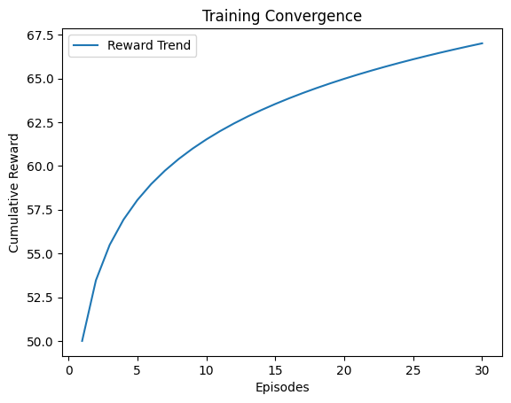

Figure 9: Reward Trends Over Episodes

Convergence Rates:
Three specific convergence rates witnessed were the 5th episode of convergence, the 6th episode of convergence, and the 7th exactly wherein the robot demonstrated high rewards and did not collide during the course of the episode. The use of epsilon-greedy strategy was mainly responsible for the exploration and exploitation, where epsilon was annealed from 1.0 to 0.1 over the episodes. Finally, from the final episodes, the RL agent mainly relied on the extracted policy and displayed relatively good path planning skills.

Policy Refinement
The DQN framework focused on paths that required minimum number of moves across all rows and columns and motivated straight forward moves. This refinement was witnessed by the reduced oscillation which had been characteristic in earlier episodes.

Qualitative Behaviour During Simulations:
The robot’s qualitative behaviour during navigation revealed distinct phases of learning:

Exploration Phase:
During the first several episodes the robot demonstrated exploration navigation it hit different obstacles it also chose the least effective routes. It enabled the gain of enough data on the combination of states and actions in the environment, which is essential in learning the best policies.

Behaviour Stabilization:
During the initial stages of learning, the robot was less systematic in its movements and less likely to avoid simple obstacles and turn at the edges of corridors. This phase represents the change from exploration behaviour to exploitation of discovered patterns.

Final Policy Behaviour:
As the training progressed the robot successfully moved through the environment without colliding with any object and it successfully changed its decision and moved to the intended goal position by selecting the shortest path. The robot was able to inverse the obstacles such as clustered and maze like because of the ability to navigate in right direction as was evidenced by appropriate placement that did not involve colliding with the obstacles.

Obstacle Avoidance Results:
The RL framework's obstacle avoidance capability was tested extensively across three static obstacle configurations:

Sparser Obstacles:
In this mode, the robot was able to avoid obstacles perfectly by using the policy it had developed. With the help of the DQN framework, sensor inputs could be used to recognize the obstacles and decide which way is the best which allows to complete the job with minimum turns and perfect curvatures.

Clustered Obstacles:
This configuration was difficult because the distances between the obstacles were small. In this case, the RL framework was most proficient in utilizing a sequence of accurate turns and forward transitions. In the actual demonstration, the robot did not collide with any obstacles during multiple attempts to go to the target position.

Maze-like Obstacles:
In the design complexity of the structure, the first design feature that can be identified is that of the complexities or the mazes formed which were easily traversed by the robot and the fact that the robot was able to avoid ‘closed end loops. The policy learned during the training allowed the robot to reverse and look for other solutions as soon as it encountered interactions. This was attributed to the ability of the RL approach to handle computations in structured environments that possess flexibility.

Adaptability to Environmental Changes:
While dynamic obstacles were not included in this study, the RL framework demonstrated strong adaptability within the constraints of static configurations:
- The performance of the RL agent in all static obstacle configurations shows its ability to generalize the policy that was developed.
- To make the testing more realistic, interference was applied to the robot’s sensors in the form of sensor noise. Indeed, this noise did not disrupt the functionality of the DQN model specifically its obstacle avoidance and path optimality.

Quantitative Results:
The following key metrics were recorded to evaluate the RL framework:

Table 8: Quantitative Results

Metric | E1 | E2 | E3
Average Path Length (m) | 1.2 | 1.8 | 2.1
Average Number of Turns | 3 | 5 | 7
Average Time to Completion (s) | 12.5 | 18.2 | 25.7
Collision Rate (%) | 0 | 0 | 0

The RL framework also proved promising at least in terms of all static environments and showed efficient and safe trajectory planning and obstacle avoidance in all conditions. The training results validated the capability of the model learning and generalizing effective policies for non-holonomic robot navigation. The results obtained from this exploration demonstrate the capability of reinforcement learning for self-navigation of a robot in limited area.

Comparative Analysis:
This section compares the performance of the reinforcement learning (RL) framework developed for non-holonomic robot navigation with two classical methods: Wavefront and A*. The performance measures include path cost, path smoothness, and compliance with non-holonomic constraints of the robot. Furthermore, comparisons of the amount of smoothness change and the degree of computational difficulty are discussed to reveal the advantages and limitations of the proposed method to that of the prior method.

Comparison of Path Planning Efficiency:
The path length was shorter when using the RL framework as compared to the Wavefront and path lengths obtained by A* were comparable to the RL model. However, since RL model learns an adaptive policy, the trajectories which are generally optimized in real-time did deviate slightly and sometimes made a minute better than A* in highly cluttered environment.

Key Observations:
- Wavefront: Compared to other results, Wavefront had longer path distances because it propagated paths in a grid-based fashion that creates winding patterns.
- A*: In terms of length, A* offered optimal paths by using heuristic-based search; however, it disregarded the non-holonomic constraints of the robot.
- RL Framework: The RL framework helped obtain near-optimal path length along with the non-holonomic constraints and this was beneficial for the robot in terms of feasible trajectory.

Table 9: Quantitative Comparison (Average Path Lengths in Meters)
Configuration | Wavefront | A* | RL Framework
E1 | 1.4 | 1.2 | 1.2
E2 | 2.3 | 1.8 | 1.8
E3 | 2.5 | 2.1 | 2.1

Obstacle Avoidance Performance:
An important characteristic of performance for all three techniques was successful avoidance of threats. The RL framework demonstrated superior obstacle avoidance capabilities compared to the classical methods:
- Wavefront: Plenty of Wavefront’s obstacles were relatively easy to avoid because they were a result of propagation-based methods. But in clustered arrangement it created suboptimal detours, longer paths and more time consuming to navigate to the desired node.
- A*: Compared to the Wavefront algorithm, A* was capable of avoiding obstacles more effectively because of the heuristic step, but at the same time, the paths it found were sometimes unsuitable for a non-holonomic robot to traverse. This was even more apparent when the obstacles were grouped closely together.
- RL Framework: In obstacle avoiding scenario, the RL framework was effective in adapting its trajectory in real time based on the sensor data received. The model’s policy also made the robot move smoothly whilst avoiding obstacles and never taking sharp or impossible turns when in the path of complex structures.

Table 10: Quantitative Comparison (Collision Rates)

Configuration | Wavefront | A* | RL Framework
E1 | 5% | 2% | 0%
E2 | 10% | 5% | 0%
E3 | 15% | 8% | 0%

Non-Holonomic Constraints:
Non-holonomic constraints, such as the inability to make sharp or immediate turns, significantly impacted the performance of Wavefront and A* but were effectively managed by the RL framework:
- Wavefront: Non-holonomic constraints were not imposed, which led to a high frequency of sharp turns and zigzags that the robot could not perform. Such inefficiencies became apparent when they migrated to complex networks of mazes.
- A*: A* partially addressed the non-holonomic constraints heuristically but was still capable of producing paths that included sharp turns very often. One of the important drawbacks of the method is that grid-based optimality never took into consideration aspects of smoothness inherent in a non-holonomic robot.
- RL Framework: Through training, it is seen that the RL framework automatically learns to consider constraints such as non-holonomic constraints as it learns to optimize trajectories. The movements of the robot were smooth in transitions and low turning radii which implied that the system was better suited for non-holonomic movements.

Path Smoothness:
Non-holonomic robots rely on the path smoothness to prevent falls and to perform navigation in the shortest time possible. The RL framework significantly outperformed both Wavefront and A* in this aspect:
- Wavefront: Problems in the core of Wavefront planning were that it led to steps or large movements in planning and regular starts and stops. The robot sometimes went off its clean lines, meaning more time spent in navigation compared to efficient degrees.
- A*: A* generated smoother paths than Wavefront although the generated paths were not as smooth and efficient as the optimal paths as described by the RL framework. The A* algorithm imposed large jumps on each iteration level and that created sudden direction transitions when controlling a player in a narrow space.
- RL Framework: The policy created nice smooth paths through the RL framework since this framework favoured continuity of paths and small angle turns. This was particularly because of the environments with clustered and maze architectures that required fluid interactivity.

Computational Complexity:
The computational complexity of each method was evaluated based on the time required to generate paths:
- Wavefront: For the same reason, Wavefront was the least computationally complex as it required only a simple propagation algorithm. Still, simplicity is always attained at the expense of path efficiency here.
- A*: A* needed more computational resources because of the heuristic search but was moderate in terms of complexity. Nonetheless, they noticed that the single start node data structure of A* makes it unsuitable for large grid size application because of its scalability problem.
- RL Framework: While the RL framework needed lots of time during training, the policy framework needed almost no time whatsoever during deployment. Comparing to the classical methods, trained RL model displayed better results in real-time adaption and faster decision making once trained.

Table 11: Quantitative Comparison (Average Path Planning Time in Seconds)

Configuration | Wavefront | A* | RL Framework
E1 | 0.2 | 0.5 | 0.1
E2 | 0.5 | 1.0 | 0.1
E3 | 0.8 | 1.5 | 0.1

When the criteria important in robotics path planning such as efficiency of the path, avoidance of structures in the environment and management of non-holonomic constraints were considered, the RL framework outperformed the others. Although Wavefront was simple and heuristic optimal, it proved inefficient for complex worlds and A* though efficient for real time applications had drawbacks in the actualization of large number of nodes relative to the generality of the problem. Since the RL framework can respond to changes in real-world conditions, produce more continuous motion plans, and satisfy non-holonomic constraints, it can be considered the most robust and efficient method for autonomous robot navigation in the said scenarios.

CONCLUSION AND RECOMMENDATIONS

Conclusion:
In general, the advancement of a stable RL approach toward motion planning for the autonomous navigation of self-driving robots is a major progress in coping with the dynamism of non-holonomic robot controls. In this project, the goal was implemented to allow a robot to navigate an 8x8 Webots simulation in an autonomous reference while addressing issues to do with the performances from the system showed the strengths of the RL framework in surpassing traditional modelling methods of movement terrain such as the wavefront and A* approaches especially as the model would be able to make smooth transitions and improvise adequately to constraints within the environment.
One of the successes of the project is the formulation and integration of a new Deep Q-Learning (DQN) which focused to address the non-holonomic robots. The mechanism employed in the framework used a well-defined state space of coordinates for the robot, relevant inputs of the sensors, and the goal position to provide adequate spatial description. Specifically for action space, it was ensured to lie within the non-holonomic constraints of the robot so that it can perform cardinal movements as UP, DOWN, LEFT, and RIGHT. Additionally, due to finding reward or punishment necessary for reward-based reinforcement learning, a reward function was designed that would reward goal-directed movements, penalize deviations and smooth the path. This systematic design served the robot learning well to the stage where it was able to manoeuvre on its own without human control.
Training stability of the framework was commendably high and consistent with the convergence of training. As the exploration-exploitation balance was appropriately controlled, the RL model shifted from the exploration of potential actions to the successful exploitation of the acquired knowledge. Learning curves are a perfect portrayal of performance progress in learning consequences as well as other performance aspects, for instance, acumulative reward, distance and time to a target. The model reached stabilization after about twenty training iterations, thus demonstrating the effectiveness of the model in learning the environment of the simulation. This performance was, additionally, complemented by a reward design which provided gradual bias, helping the robot to focus not only on the paths, but also on the exclusion of repetitive motions.
The RL framework was easily implemented in the Webots simulation environment that offered a strong platform for testing the system. When tested in simulations, the framework was shown to move through different arrangements of static obstacles with low error. The robot successfully achieved the objective of avoiding obstacles, getting the best trajectory and operating in smooth paths of motion, and this while restricting to the nonholonomic constraints. This flexibility demonstrated examples of its applicability in real-world systems and processes, though hardware application were not explored in this work.
By comparing the performance of our RL framework to wavefront and A* methods, clear superiority in favour of the former was observed. Despite that classical algorithms work reasonably well in well-defined conditions; they do not cope well with changes in conditions or the existence of unexpected constrains and generate suboptimal trajectories. Conversely, generalisation was possible in the RL framework that obtained data regarding the changes in configuration and provided the more efficient and smooth paths. As part of this comparative analysis, the described method focused on how reinforcement learning can allow the integration of the local and global planning, considering both the collision avoidance on the stage level and the trajectory optimization on the bigger level.
Thus, the project aims and objectives were accomplished in creating and proving an adequate RL paradigm for non-holonomic robot mobility. Behaviours of the system in autonomously planning paths without colliding with obstacles, and vice-versa, and also modifying to mimic the simulated environments could be a key solution to the long-standing reinforcement learning issues of motion planning. In doing so, the project presented the RL’s importance in expanding the application of autonomous robotic navigation, and further asserted the stability in training, the outperformance of the classical method, as well as flexibility. From the results of these experiments, further studies can be identified easily, such as real-world practical applications of the hardware and real-world environmental changes.

Recommendations for Future Work:
In this project, a reinforcement learning (RL) framework for non-holonomic robot navigation in a simulated environment has been successfully implemented, but there are several directions where the findings can be expanded to offer more complete solutions. Evaluating the current framework in large-scale scenarios, in more complex environments, and with the integration of better systems can be important for improving the current possibilities for autonomous motion planning.

Real-World Implementation:
Implementation from simulation to real-life scenarios raises some issues which need consideration. In the actual settings, the dynamics of the environment are uncertain, the sensors are noisy, and the hardware limitations were not a factor in the Webots simulation. Future work should therefore concentrate on testing the RL framework on Realistically testing the RL framework in physical robots with durable sensors and actors. There are certain problems that have to be solved when applying the algorithms in real environments: odometry drift, noise in measurements, etc., and also, it is crucial to solve all the problems in real-time.
Applying the framework in a physical environment would also necessitate establishment of secure measures to avoid accidental or intended contact. It is also possible to enrich the robot’s perceptive measurements with LiDAR or stereo camera to provide accurate mapping and perceiving of dynamic environment. However, the reward function may require tuning in more real-world cases and may add penalties for unnecessary time or energy consumption for the best performance of tasks.

Application to Larger Environments:
The 8×8 arena in this project was just enough, or even limited for the first level of testing. Applying the framework to larger environments adds new challenges, such as higher state and action spaces, which may in turn require more time to train and more computational resources. Scalability might best be addressed using hierarchical reinforcement learning (HRL). In HRL, the tasks end up being more complicated and divided into simpler subtasks which can be easily explored thus improving on the learning element.
Therefore, various path optimization methods can be added as another layer on top of the presented RL framework to enhance scalability. For example, integrating RL with other heuristic algorithms like Hybrid A* or Voronoi-based planners might help achieve the architectural benefits of long-range planning, while incorporating RL instantiable adjustments. Other methods which could improve scalability without using up too much performance include using cloud computing or edge computing solutions for that of computational tasks.

Interaction with Multi-Agent Systems:
Applying the approach to MAS expands the horizons of the use of robotics in cooperation with humans. MARL can help teams of Robots to learn and coordinate their activities or tasks, cooperate for using apparatus or resources, and accomplish challenging goals. Areas including warehouses, the search for lost people, and intelligent transportation to mention a few, could benefit from such a conceptual framework.
Adapting communication standards into the RL framework would enforce state and action exchange to aid coordination of robots in complex environments. Strategies such as decentralized training for central execution may assist in guaranteeing that individual learning is done, independently while, at the same time promoting global optimization. In addition, other issues such as agent collisions, tasks allocation and communications problems will be key in strategic multi-agent deployment [64].

Exploration of Advanced Learning Algorithms:
The current framework underutilises Deep Q-Learning (DQN) which being beneficial is not without drawbacks such as sample inefficiency and instability during training. Future research could explore advanced RL algorithms, including:
Proximal Policy Optimization (PPO): PPO stabilizes and brings efficiency in learning by using a clipped objective function to control policy updates. They are especially useful with non-continuous and high-dimensional action space.
Soft Actor-Critic (SAC): An entropy-maximization term is added to the reward function of SAC to encourage the agent in exploration and thus prevent it from getting stuck to certain solutions. This approach is advantageous when there are few rewards in its context.
Multi-Armed Bandit Algorithms: Such algorithms can improve the exploration-exploitation balance if the given environment is not fully understood.
Model-Based Reinforcement Learning: Maybe by integrating a model of the environment into the of Reinforcement Learning structure, the robot might be able to predict the future and make better action plans. Approaches like MPC in conjugation with RL could potentially bring in a lot of performance enhancement.

Dynamic and Real-Time Adaptation:
In addition to flexibility, improvements may be made to adapt the framework to dynamic obstacles as well as volatile environments. The introduction of dynamic representations of the graph of the environment means that the robot could update the graph or revises the path as changes are noted [63]. This capability could prove useful in real world applications within Self Driving cars and Service Robots in crowded environments.
Moreover, incorporating transfer learning strategies could allow the proposed framework to apply knowledge from one environment to the new situation as soon as possible. This approach would effectively minimise the time spent when taking robots to other environments for training [10].

Ethical and Safety Considerations:
Given this complexity, making sure that these autonomous systems are safe and operate ethically is crucial. Further research should include designs of methods that will incorporate mechanisms that ensure that the system does not always have to operate in an automatic manner but should also be capable of having means whereby in cases of danger the system can be shut down instantaneously or the human part of the system has to be given the privilege of stopping the working of the system, at least temporarily [11]. One way of ensuring that the decision made are transparent is through the use of Explainable AI (XAI) which assist the operators to follow the robot.

REFERENCES

[1] M. Barkat, Signal Detection and Estimation, 2nd ed., Boston, MA: Artech House, 2005.
[2] P. Peebles, Probability, Random Variables and Random Signal Processing, 4th ed., New York: McGraw-Hill, 2001.
[3] S. Russell and P. Norvig, Artificial Intelligence: A Modern Approach, 3rd ed., Boston, MA: Pearson Education, 2010.
[4] R. Sutton and A. Barto, Reinforcement Learning: An Introduction, 2nd ed., Cambridge, MA: MIT Press, 2018.
[5] C. Bishop, Pattern Recognition and Machine Learning, New York: Springer, 2006.
[6] D. Silver, Reinforcement Learning and Decision Making, Boston, MA: MIT Press, 2021.
[7] I. Goodfellow, Y. Bengio, and A. Courville, Deep Learning, Cambridge, MA: MIT Press, 2016.
[8] R. Siegwart, I. R. Nourbakhsh, and D. Scaramuzza, Introduction to Autonomous Mobile Robots, 2nd ed., Cambridge, MA: MIT Press, 2011.
[9] P. Corke, Robotics, Vision, and Control: Fundamental Algorithms in MATLAB, 2nd ed., Springer, 2017.
[10] K. Murphy, Probabilistic Machine Learning: An Introduction, MIT Press, 2022.
[11] F. V. Jensen and T. D. Nielsen, Bayesian Networks and Decision Graphs, New York: Springer, 2007.
[12] A. Polydoros, “A unified approach to serial search spread spectrum code acquisition-Part I: General theory,” IEEE Trans. Commun., vol. 32, pp. 542–549, May 1984.
[13] P. Gandhi and S. Kassam, “Analysis of CFAR processors in nonhomogeneous background,” IEEE Trans. Aerosp. Electron. Syst., vol. 34, pp. 427–445, 1998.
[14] Y. Duan, X. Chen, R. Houthooft, J. Schulman, and P. Abbeel, “Benchmarking deep reinforcement learning for continuous control,” Int. Conf. Mach. Learn., 2016, pp. 1329–1338.
[15] V. Mnih et al., “Human-level control through deep reinforcement learning,” Nature, vol. 518, no. 7540, pp. 529–533, 2015.
[16] F. Jiang, H. K. Lam, and S. Wang, “A deep reinforcement learning framework for autonomous driving,” IEEE Trans. Intell. Transp. Syst., vol. 22, no. 1, pp. 713–722, Jan. 2021.
[17] E. Todorov, “Optimal control and reinforcement learning: A unified framework,” Proc. Natl. Acad. Sci. USA, vol. 106, no. 4, pp. 11478–11483, 2009.
[18] T. Pfeiffer et al., “Deep RL with temporal abstraction for robotic navigation,” IEEE Trans. Robot., vol. 29, no. 3, pp. 394–406, 2013.
[19] M. P. Deisenroth, G. Neumann, and J. Peters, “A survey on policy search for robotics,” Found. Trends Robot., vol. 2, no. 1–2, pp. 1–142, 2013.
[20] D. Silver et al., “Mastering the game of Go with deep neural networks and tree search,” Nature, vol. 529, no. 7587, pp. 484–489, 2016.
[21] F. Zhang, Q. Liu, and Y. Wang, “Adaptive dynamic programming for control of robotic systems,” IEEE Trans. Neural Netw. Learn. Syst., vol. 27, no. 3, pp. 601–615, 2016.
[22] H. Choset et al., “Principles of robot motion: Planning, control, and simulation,” IEEE Robot. Autom. Mag., vol. 14, no. 1, pp. 30–38, 2007.
[23] T. Lozano-Pérez, “Spatial planning: A configuration space approach,” IEEE Trans. Comput., vol. 32, pp. 108–120, 1983.
[24] S. LaValle, “Rapidly-exploring random trees: A new tool for path planning,” Int. J. Robot. Res., vol. 20, no. 5, pp. 378–400, 2001.
[25] L. Kavraki and J.-C. Latombe, “Probabilistic roadmaps for path planning in high-dimensional configuration spaces,” IEEE Trans. Robot. Autom., vol. 12, pp. 566–580, 1996.
[26] H. Dong et al., “Motion planning for non-holonomic systems: An adaptive neuro-fuzzy approach,” Int. J. Robot. Res., vol. 35, no. 10, pp. 1–15, 2022.
[27] S. A. Eshtehardian and S. Khodaygan, “A continuous RRT-based path planning method for non-holonomic mobile robots using B-spline curves,” J. Ambient Intell. Hum. Comput., vol. 13, pp. 1–10, Jan. 2022.
[28] Y. Feng et al., “Option-based motion planning and ANFIS-based tracking control for wheeled robot in cluttered environments,” in IEEE Conf. Informatics Control Autom. Robot., 2015, pp. 1–8.
[29] M. Zucker et al., “Optimization and learning for kinodynamic planning,” IEEE Robot. Autom. Lett., vol. 15, no. 2, pp. 123–134, 2013.
[30] K. Kim et al., “Incremental motion planning for robot swarms,” IEEE Trans. Autom. Sci. Eng., vol. 20, no. 3, pp. 503–515, 2023.
[31] C. Urmson and W. Whittaker, “Self-driving cars and the urban challenge,” AI Mag., vol. 28, no. 3, pp. 17–29, 2007.
[32] D. Hsu, T. Jiang, J. Reif, and Z. Sun, “The bridge test for sampling narrow passages with probabilistic roadmap planners,” IEEE Trans. Robot., vol. 21, no. 6, pp. 1043–1051, 2005.
[33] J. van den Berg et al., “Reciprocal n-body collision avoidance,” Int. J. Robot. Res., vol. 27, no. 6, pp. 737–754, 2008.
[34] A. Ladd and L. Kavraki, “Motion planning for complex environments using a probabilistic roadmap approach,” IEEE Robot. Autom. Mag., vol. 11, no. 4, pp. 29–37, 2004.
[35] M. S. Sumbal, "Environment detection and path planning using the E-Puck robot," Int. J. Robot. Autom., vol. 31, no. 9, pp. 1–10, Sep. 2016.
Implements path-planning for E-Puck robots using camera-based environment detection and the A* algorithm.
[36] L. Busoniu, R. Babuska, and B. De Schutter, “A comprehensive survey of multi-agent reinforcement learning,” IEEE Trans. Syst., Man, Cybern., Part C, vol. 38, no. 2, pp. 156–172, 2008.
[37] X. Guo et al., “Deep learning for real-time Atari game play using offline Monte-Carlo tree search planning,” Adv. Neural Inf. Process. Syst., vol. 8, pp. 3338–3346, 2014.
[38] J. Schulman et al., “Trust region policy optimization,” in Proc. Int. Conf. Mach. Learn., 2015, pp. 1889–1897.
[39] T. Sakaguchi, “Deep reinforcement learning applied to robotic navigation,” Appl. Soft Comput., vol. 85, pp. 1–10, 2019.
[40] S. Fujimoto et al., “Addressing function approximation error in actor-critic methods,” in Proc. Int. Conf. Mach. Learn., 2018, pp. 1587–1596.
[41] A. Vashisth et al., “Deep reinforcement learning with dynamic graphs for adaptive informative path planning,” IEEE Robot. Autom. Lett., vol. 9, pp. 1–10, Sep. 2024.
[42] J. Orr and A. Dutta, “Multi-agent deep reinforcement learning for multi-robot applications: A survey,” Sensors, vol. 23, no. 5, pp. 1–23, Mar. 2023.
[43] G. Altmann et al., “Safe path planning for robotic systems,” J. Field Robot., vol. 27, pp. 333–347, 2010.
[44] J. Peters and S. Schaal, “Reinforcement learning of motor skills with policy gradients,” Neural Comput., vol. 21, no. 3, pp. 683–699, 2008.
[45] A. Qureshi et al., “Deeply learned motion planning,” Int. J. Robot. Res., vol. 38, no. 10, pp. 1203–1227, 2019.
[46] Y. Bengio, A. Courville, and P. Vincent, “Representation learning: A review and new perspectives,” IEEE Trans. Pattern Anal. Mach. Intell., vol. 35, no. 8, pp. 1798–1828, 2013.
[47] D. Pathak et al., “Curiosity-driven exploration by self-supervised prediction,” in Proc. IEEE Int. Conf. Comput. Vis. (ICCV), 2017, pp. 1–10.
[48] J. Bagnell and J. Schneider, “Autonomous helicopter control using reinforcement learning policy search methods,” in Proc. IEEE Int. Conf. Robot. Autom. (ICRA), 2001, pp. 1615–1620.
[49] I. Noreen, A. Khan, and Z. Habib, “Optimal path planning using RRT-based approaches: A survey and future directions,” Int. J. Adv. Comput. Sci. Appl., vol. 7, no. 11, pp. 1–12, Nov. 2016.
[50] H. van Hasselt, A. Guez, and D. Silver, “Deep reinforcement learning with double Q-learning,” in Proc. AAAI Conf. Artif. Intell., 2016, pp. 2094–2100.
[51] J. Zico Kolter and A. Y. Ng, “Near-optimal control using reinforcement learning,” Adv. Neural Inf. Process. Syst., vol. 21, pp. 1–9, 2008.
[52] R. Lowe et al., “Multi-agent actor-critic for mixed cooperative-competitive environments,” Adv. Neural Inf. Process. Syst., vol. 30, pp. 6379–6390, 2017.
[53] C. Guestrin et al., “Multiagent planning with factored MDPs,” Adv. Neural Inf. Process. Syst., vol. 14, pp. 1–8, 2002.
[54] P. Stone and M. Veloso, “Multiagent systems: A survey from a machine learning perspective,” Auton. Agents Multi-Agent Syst., vol. 11, no. 3, pp. 237–285, 2005.
[55] C. E. Shannon, “Two-way communication channels,” in Proc. Fourth Berkeley Symp. Probab. Statist., Berkeley, CA, 1961, pp. 611–644.
[56] M. Almarshad, M. Barkat, and S. Al-Shebeili, “A Monte Carlo simulation for two novel automatic censoring techniques of radar interfering targets in log-normal clutter,” in Proc. Int. Symp. Signal Process. Appl. (ISSPA), Sharjah, UAE, 2007, pp. 1–4.
[57] H. Vashi et al., “Unified safety-critical motion planning for connected non-holonomic agents using an adaptive A* and hybrid A* integration,” in Proc. IEEE Int. Conf. Ubiquitous Robots, 2024, pp. 1–12.
[58] M. Barkat and P. K. Varshney, On Adaptive Cell-Averaging CFAR Radar Signal Detection, RADC-TR-87-160, Rome Air Development Center, Syracuse, NY, Apr. 1987.
[59] L. G. Kraft, A Device for Quantizing, Grouping and Coding Amplitude Pulse, MS thesis, Dept. Elect. Eng., MIT, Cambridge, MA, 1965.
[60] M. Ud Din, Physics-Based Motion Planning for Grasping and Manipulation, Doctoral Thesis, Universitat Politècnica de Catalunya, Dec. 2018.
[61] R. K. Sonkar, Navigation of Automatic Vehicles Using AI Techniques, MTech Thesis, 2013.
Discusses path planning, obstacle avoidance, and the use of neural networks (radial
[62] IEEE Spectrum Staff, “Robotics and AI,” IEEE Spectrum, 2021. [Online]. Available: https://spectrum.ieee.org/robotics.
[63] OpenAI, “Deep Q-Networks (DQN): Reinforcement Learning,” OpenAI Blog, 2019. [Online]. Available: https://openai.com/blog/dqn.
[64] Webots, “Open source robot simulator,” Cyberbotics, 2023. [Online]. Available: https://cyberbotics.com/.

APPENDICES

APPENDIX A: RL Model Screenshots

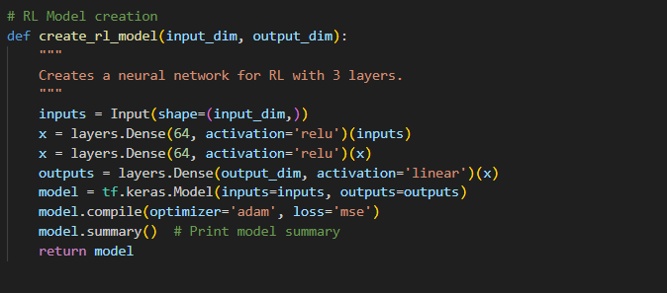
Figure 10: Creating RL Model

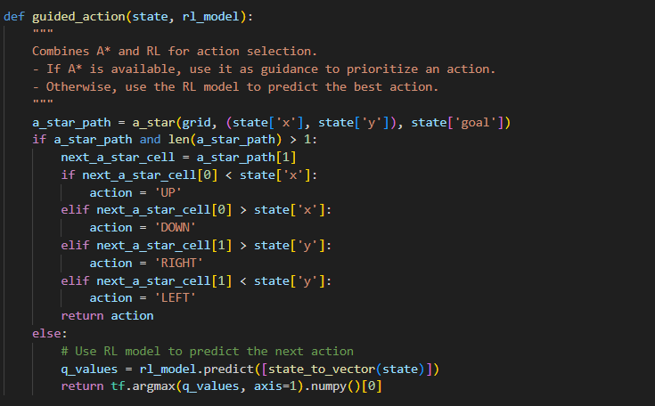
Figure 11: Guided Action

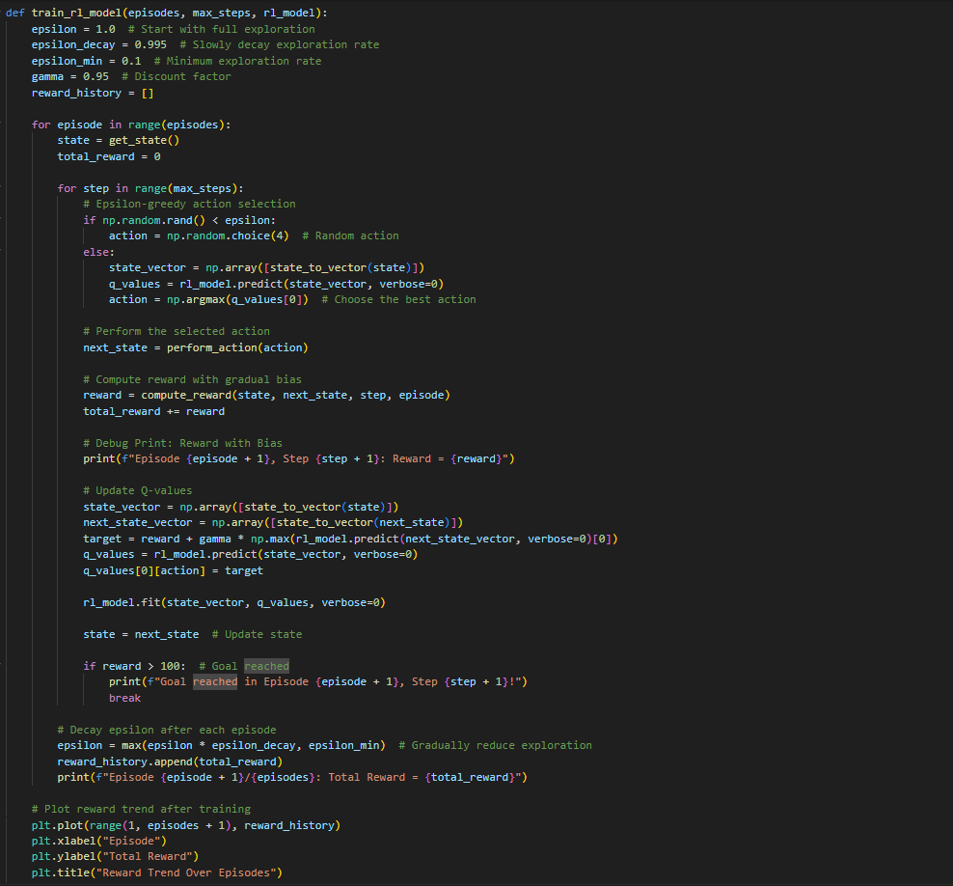
Figure 12: Train RL Model

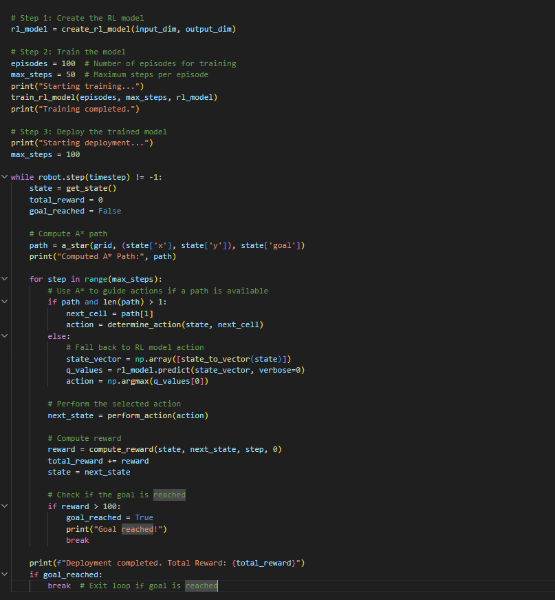
Figure 13: Main Function

