

BSCS-S24-017

03-134202-102 | Rohaan Nadeem
03-134211-033 | Noor Fatima
Extraction Of User Defined Information from PDF

In partial fulfilment of the requirements for the degree of
Bachelor of Science in Computer Science
Supervisor: Tahir Iqbal

Department of Computer Sciences
Bahria University, Lahore Campus

January 2025

© Bahria University, 2025

Certificate

We accept the work contained in the report titled
Extraction Of User Defined Information from Pdf
written by

03-134202-102 | Rohaan Nadeem
03-134211-033 | Noor Fatima

as a confirmation to the required standard for the partial fulfilment of the degree of
Bachelor of Science in Computer Science.

Approved by:
Supervisor: Tahir Iqbal
__________________________________________________________(Signature)

December 24, 2024

DECLARATION

We hereby declare that this project report is based on our original work except for citations and quotations which have been duly acknowledged. We also declare that it has not been previously and concurrently submitted for any other degree or award at Bahria University or other institutions.

Enrolment | Name | Signature
03-134202-102 | Rohaan Nadeem
03-134211-033 | NoorFatima

Date : December 24, 2024

Specially dedicated to

My beloved father, mother. All our teachers, and of course our supervisor
Tahir Iqbal who brought us up as the way we are today.

Rohaan Nadeem
Noor Fatima

ACKNOWLEDGEMENTS

We would like to thank everyone who has contributed to the successful completion of this project. We would like to express our gratitude to my research supervisor, Mr.Tahir Iqbal for his invaluable advice, guidance and his enormous patience throughout the development of the research.

Rohaan Nadeem
Noor Fatima

Extraction Of User Defined
Information from PDF

ABSTRACT

Problem and Significance: Organizing and utilizing information contained in PDF files present different difficulties arising from the different organization of such documents. As shown in Figure 3.3.1, the methodology adopted highlights the systematic approach for solving these challenges.[Polak & Morgan, 2024] Due to the increasing need and availability of large documents in PDF format, lack of an efficient mechanism to upload these documents and query their contents automatically without supervised interventions with extracting user-specified information, this project comes as a response for these needs. The relevance of this project is in proposing an intelligent and efficient way of dealing with research materials in the PDF format and in gaining the desired piece of information from it thus enhancing research analysis and information process in general across numerous disciplines.

Method/Tool/Technology and Solution: The proposed system forms text data from uploaded PDFs using NLP techniques that are powered by LLMs to provide automation in the extraction of pertinent data from the pieces presented in PDF format. PDFs’ data extracted using PyMuPDF, meta-analyses using Matplotlib, chunking large queries, and user query analysis is conducted through an LLM specifically a ChatGPT API. The front end of the application is created with help of React, while back-end part is implemented by Express and Python. It saves the file path, chat and user data; the entire system exists inside a safe and user-friendly space. This solution saves users’ time and minimizes their efforts when searching for specific data in PDFs while ensuring increased efficiency of the data search process.

TABLE OF CONTENTS

DECLARATION iii
ACKNOWLEDGEMENTS vii
ABSTRACT ix
TABLE OF CONTENTS xi
LIST OF TABLES xiii
LIST OF FIGURES xv
LIST OF SYMBOLS / ABBREVIATIONS xvii

CHAPTERS
1 INTRODUCTION 1
1.1 Background 1
1.2 Problem Statements 1
1.3 Aims and Objectives 2
1.4 Scope of Project 2
1.5 This system excludes the following 3
2 Software Requirements Specification (SRS) 4
2.1 Product Viewpoint 4
2.2 Operating Environment 4
2.3 Functional Requirements 5
2.4 Non-Functional Requirements 6
2.5 User Requirements 7
2.6 Assumptions and Constraints 7
2.7 Use case Diagram 8
2.8 Product Perspective 8
3 DESIGN AND METHODOLOGY 10
3.1 Methodology 10
3.2 Feature-Driven Development 10
3.3 Tools and Techniques 11
4 IMPLEMENTATION 12
4.1 Introduction 12
4.2 Story Board 12
4.3 System Design 13
4.4 Sequence Diagram 13
5 RESULTS 14
5.1 Dashboard Page 14
5.1.1 Methodology Diagram 14
5.1.2 About project 15
5.1.3 Project Workflow and Implementation Steps 15
5.2 Auth Page:- 16
5.3 Upload Page 17
5.3.1 Chat Page 19
5.3.2 Profile Page 22
6 CONCLUSION AND RECOMMENDATIONS 24
6.1 Conclusion 24
6.2 Recommendations 25
6.3 Future Work 25
7 REFERENCES 27

LIST OF TABLES

TABLE TITLE PAGE

Table 2.1: Functional Requirements 3
Table 2.2: Non-Functional Requirements 4
Table 2.3: Assumptions and Constraints 5
Table 2.4: Product Perspective 6

LIST OF FIGURES

FIGURE TITLE PAGE

Figure 2.2.1: Use case Diagram 5
Figure 3.3.1: Methodology 7
Figure 4.1: Sequence Diagram 10
Figure 5.1: Project Title with Sidebar Featuring Logo and Links 11
Figure 5.2: Project Overview 12
Figure 5.3: Project Workflow and Steps 12
Figure 5.4: Sign-up Flow with Google Login Option 13
Figure 5.5: Login Form with Google Login Option 13
Figure 5.6: Google Login Account Selection 14
Figure 5.7: PDF Upload Page and google user in Sidebar 14
Figure 5.8: User Icon and Email Displayed in Sidebar for Form Users 15
Figure 5.9: PDF Upload with Filename, File size, and Remove Option 15
Figure 5.10: Multiple PDFs Uploaded with Filename, File size, and Remove Option 16
Figure 5.11: Redirect to Chat Page After File Upload 16
Figure 5.12: Minimized Sidebar View 17
Figure 5.13: Selected Previous Chat from Sidebar 17
Figure 5.14: Option to Delete Chat from Sidebar 18
Figure 5.15: Option to Edit Chat Name from Sidebar 18
Figure 5.16: Google User Profile Page 19
Figure 5.17: Form User Profile Page with Edit Option for Username and Email 19
Figure 5.18: Option to Change Password in User Profile 20

INTRODUCTION

Background

Documents in portable format and images can provide important data, however, to separate the required by the user information can take quite a lot of time. [Tiedemann, 2014].This challenge is further illustrated in the Use Case Diagram (Figure 2.2.1), which depicts the interaction and requirements for the proposed system. With the increase in the rate at which people desire to get quick and accurate results in their work output ranging from research works, health diagnosis and even data analysis the need for automatic solutions cannot be overemphasized. This project will therefore seek to deal with these by proffering a web-based tool that can extract user-specified data from pdf documents. Moreover, through the use of LLM for NLP techniques, the tool will have a user-friendly interface where the users will insert variables and get simplified relevant data from complicated PDF files, also to save their record.

Problem Statements

One of the main issues is the possibility of extracting data from various PDF formats and images in case of working with big data sets. Many professionals who work with research materials, particularly those who deal with reports, brochures, magazines, encyclopaedias’, journals, and other collections of papers, know the tremendous amount of time they spend on searching for particular pieces of information in out-of-order documents. As per this project, such a solution will be presented to primarily extract the user-centric content from PDFs.

Aims and Objectives
The goal of this project is thus to create an efficient, almost completely autonomous instrument, easily operated by the user, which is designed to extract desired information from the pdf files. The objectives include:
- To design an interactive computer system, which mainly consists of an application interface through which users can input key variables and get their corresponding answers in a PDF document.
- To facilitate and add large language models for addressing Natural Language Processing (NLP).
- To help cut down the time and energy that is taken in the sorting out of documents in an efficient way, hence increasing productivity.
- ii) To offer the users concerns in research and analytical work and other fields dealing with large dataset. Icons for professionals in research, data analysis, and other fields dealing with large volumes of data.

Scope of Project
The project is centred on creating a system for text-based PDFs which contain text that can be easily extracted by a program. The tool will allow users to:

- Just drop one or more PDFs for processing.
- Access it like augmented reality chatbot where the user can directly ask specific information.
- Save the results to check the information needed during the performance of the analysis and to compare them with other sources.
- Provide meta-analysis of extracted data if required on request.

This system excludes the following
For example, text recognition from digital images of text, or scanned documents and PDFs (Optical Character Recognition or OCR tasks).
High levels of graphical or tabular data that cannot be converted into a plain text form.
There are pretty good potentialities for future extensions of the system: It would be helpful to include OCR, to extend beyond simple queries and more complex kinds of data visualizations.

Software Requirements Specification (SRS)

Product Viewpoint

The purpose of this project is to offer an internet application, where the users could get information of interest from PDF files. The system will also use LLMs to deal with the content in a way that will allow for a swift and effective search of data defined by the users. The platform will be useful for such users as researchers, data analysts, and other employees who deal with the manipulation of large data sets to

Operating Environment

This application will perform in different web browsers, like:
- Google Chrome
- Mozilla Firefox
- Opera
- Safari
The platform will be optimized for both desktop and mobile usage.

Functional Requirements

Table 2.1: Functional Requirements
ID | Requirement | Priority.1
FR-1 | User registration as well as user login with options for google sign-in. | High
FR-2 | Submit a number of PDF files at once for conversion. | High
FR-3 | Extract text from PDFs using PyMuPDF. | High
FR-4 | Return extracted text based on queries in terms of natural language. | High
FR-5 | Give analysis of the meta-extraction of information on online consultations. | Medium
FR-6 | It’s always wise to save the information from previous chats for future use. | High
FR-7 | Introducing the ability to remove or rename a chat. | Medium
FR-8 | Matplotlib for meta-analyses. | Medium

Non-Functional Requirements

Table 2.2: Non-Functional Requirements
Requirement | Description
Response Time | Process PDFs and queries in under 5 seconds for files whose size does not exceed 10 MB.
Scalability | Patients, other doctors and other clinicians can use this application at the same time without straining the systems capabilities.
Security | Secure user data and cryptographic control of program data, as well as the protection of API communication.
Accessibility | Ensure that it has a theme that would enable it’s usage in both the large desktop and the small mobile screens.
Reliability | Make certain that the system needs a small duration of time whereby it is not in a position to perform its planned function.

User Requirements

The system must meet the following user requirements:
- Ease of Use: User should be able to upload files, query data and organize their sessions in a friendly way.
- Customizable Queries: The system must enable users to declare their information requirements by means of natural language inputs.
- Data Access: Users gain the ability to view previous queries and chats together with the functionality of renaming the saved items and removing them permanently.
- Secure Authentication: Ensure that there are multiple ways for logging in securely which should include Google OAuth.

Assumptions and Constraints

Table 2.3: Assumptions and Constraints
Type | Description
Assumptions | It assumes that the PDFs uploaded are text-based files.  and not image based.
Constraints | However, natural language questioning calls for internet connection as it is the case with most other systems.  and API operations.

Use case Diagram

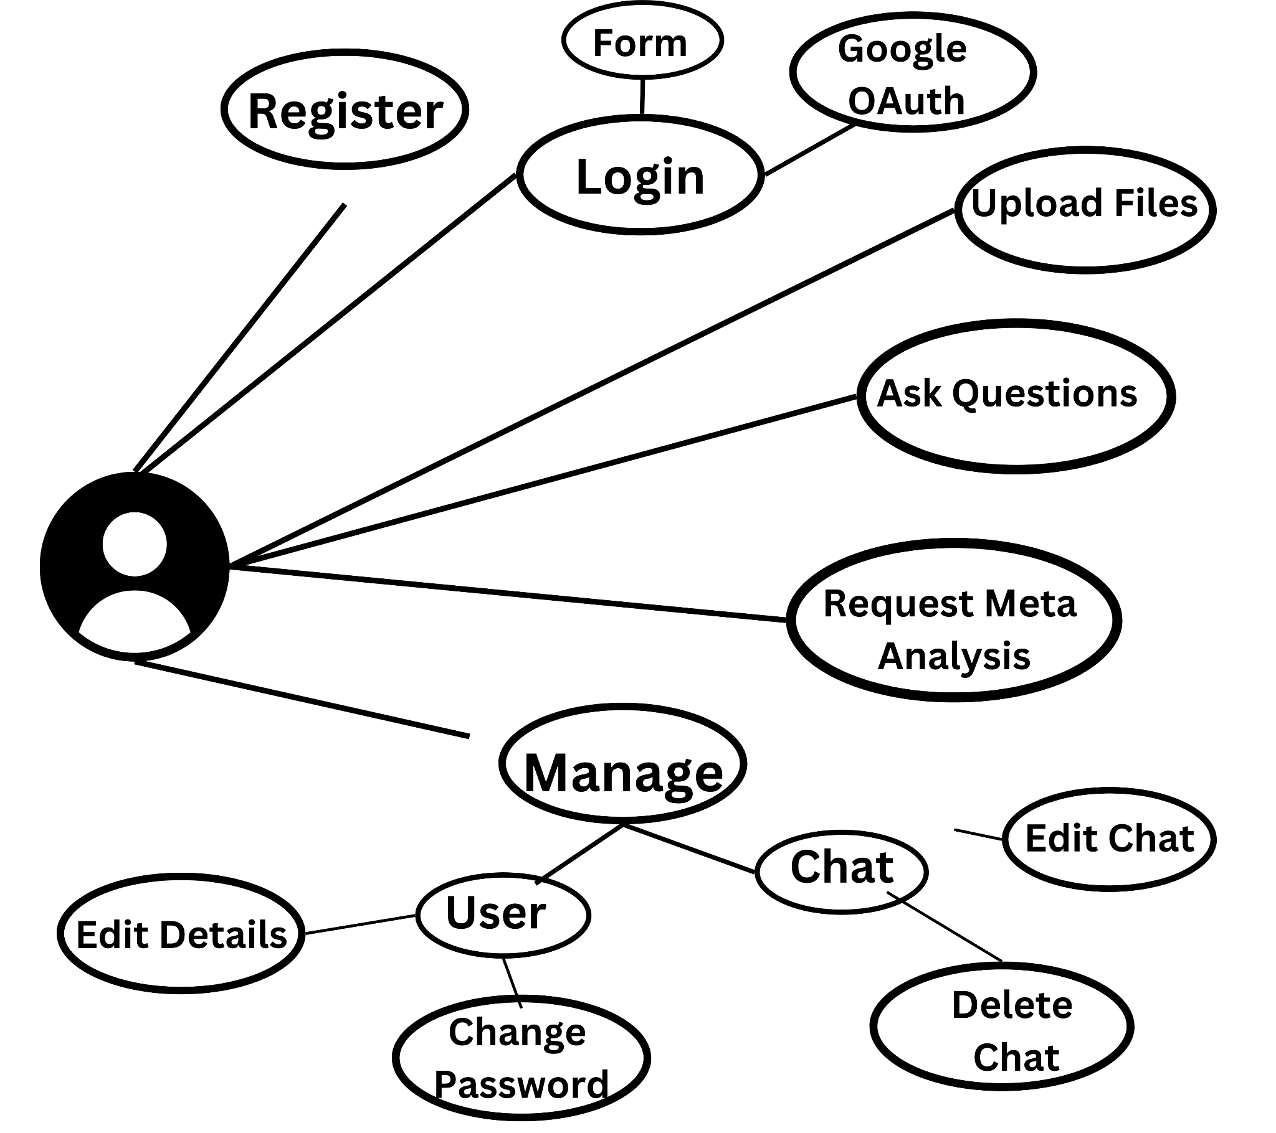
Figure 2.2.1: Use case Diagram

Product Perspective

It is an independent web based system for users who require extracting and analyzing certain data from PDF files. The software connects several state-of-art technologies to support product functionality, and it is intended for researchers, students, and professionals.

Table 2.4: Product Perspective
Aspect | Description
System Dependency | Requires a browser-based  internet connected frontend server and backend server
Third-Party APIs | Integrated with LLM APIs of natural language query and analysis.
Integration | Based on Google OAuth for authentication and MongoDB for data persistence and storage.
User Role | The primary user has explicit interactions with the system for uploading files, for performing data queries,

DESIGN AND METHODOLOGY

Methodology

This work is developed with an Agile-based approach with a constant feedback loop between iterations. This process is visualized in Figure 3.3.1 (Methodology). It studies also include testing and subsequent updates of a development cycle [Polak & Morgan, 2024] and features it supports such as User Authentication, File uploading, and Data extraction services.

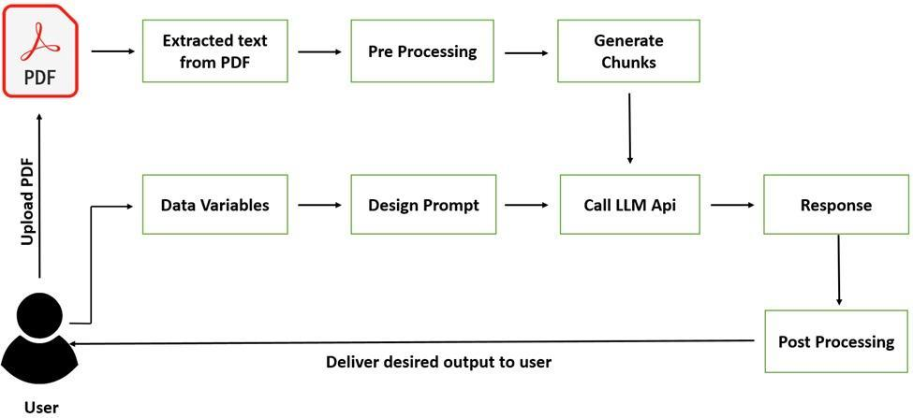
Figure 3.3.1: Methodology

Feature-Driven Development

Our chosen process model is FDD: feature based, which focuses on iteration and continuous delivery. Every one of the above features is developed and implemented as a module on its own but with the potential to interact with other modules in the LLM-Api.

Tools and Techniques

- Frontend: JS for interactive websites and react hence for user interface design.
- Backend: Express.js to manage requests, and Python to parse data from delivered requests.
- Database: MongoDB to store users data and files path, chats description and users’ details.
- Data Extraction: PyMuPDF for the purpose of extracting text from PDFs.
- Graphical Response: Matplotlib for meta analyses.
- LLM API: For performing on user inputs and providing smart output in response.

IMPLEMENTATION

Introduction

The subject of the project is construction of the system for file management and interaction at all levels. Video users can upload files, post questions related to the files and get answers with the help of artificial intelligence.

Story Board

- The dashboard layout, featuring the project title, sidebar, and links, is depicted in Figure 5.1 (Project Title with Sidebar).

- Login/Signup: The user then gets to select registration or login.
- File Upload: User are lead to pause /upload PDF files.
- Chat Interface: Once the document is uploaded, a user is redirected to a chat interface in which he or she can ask a PDF content.
- Response Generation: An LLM delivers the text extraction as well as the processed output of the query.

System Design

The system consists of the following modules:
- User Authentication: employs a secure procedure to create accounts and to allow users, to sign in.
- File Upload and Storage: Files are stored on the server and when a user uploads something the information is placed in the MongoDB database information such as the files path, details on chats between users and more.
- Users can upload PDFs, as demonstrated in Figure 5.7 [Tiedemann, 2014] (PDF Upload Page). Multiple PDFs can be uploaded with file details, as shown in Figure 5.9 and Figure 5.10.
- Text Extraction: As it will be shown, PyMuPDF makes an extraction of text out of the uploaded files.
- Graphical Response: Matplotlib for meta analyses.
- Query Processing: The LLM API is utilized to recognize a user query which is identified from the scraped text.
- The interaction between different system components, including user authentication, file uploads, and text extraction, is represented in Figure 4.1 (Sequence Diagram).

Sequence Diagram
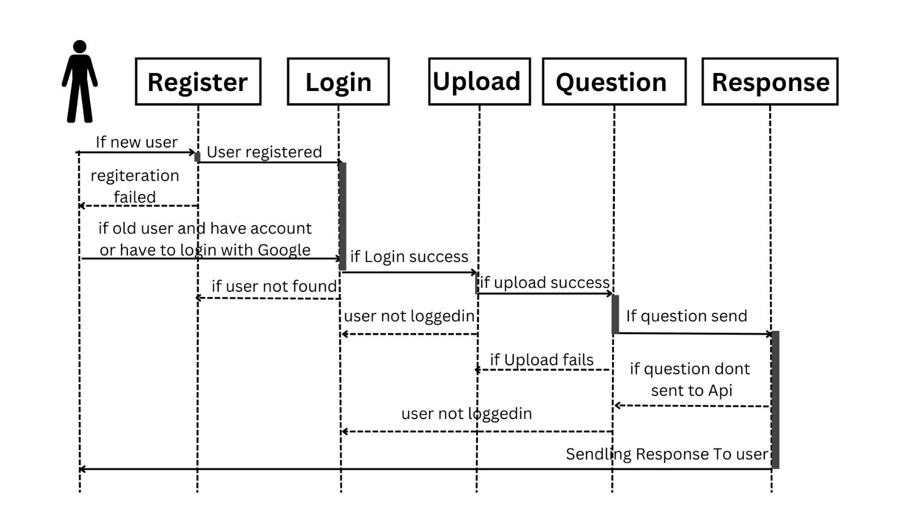
Figure 4.1: Sequence Diagram

RESULTS

Dashboard Page

The sidebar, therefore, is not extendable as it is not scrollable – the only action one can take on it is to expand them or reduce them. On the Dashboard page the project information is proposed in the left panel whereas the personal information of the team members is available in the right panel of the page. The dashboard design, with the sidebar and personal information panel, is illustrated in Figure 5.1.[Goel et al., 2023]

Methodology Diagram

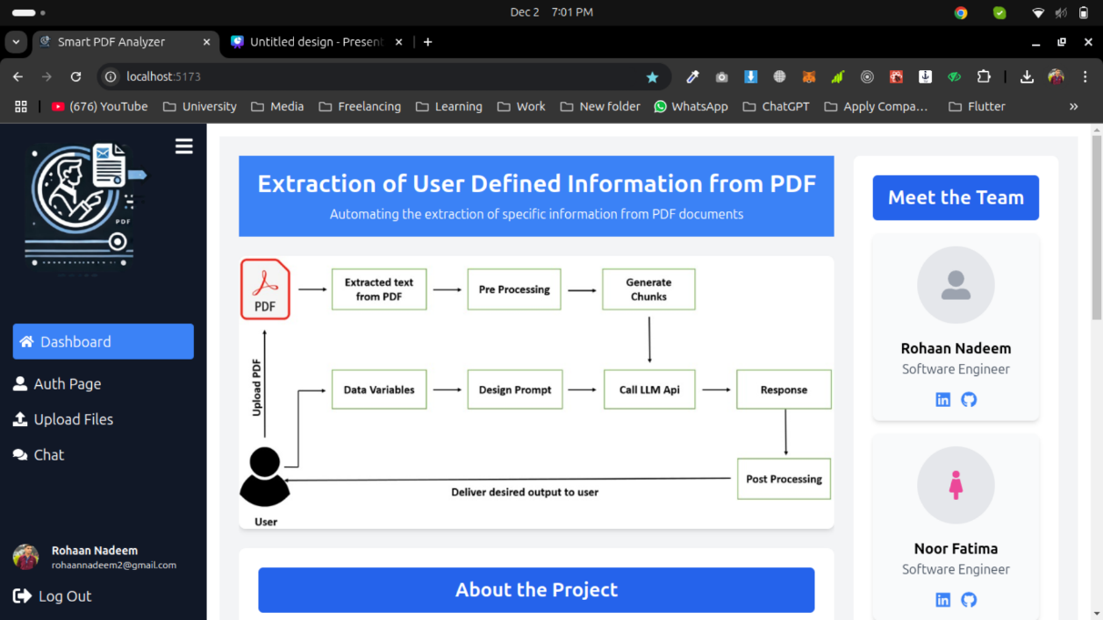
Figure 5.1: Project Title with Sidebar Featuring Logo and Links

About project

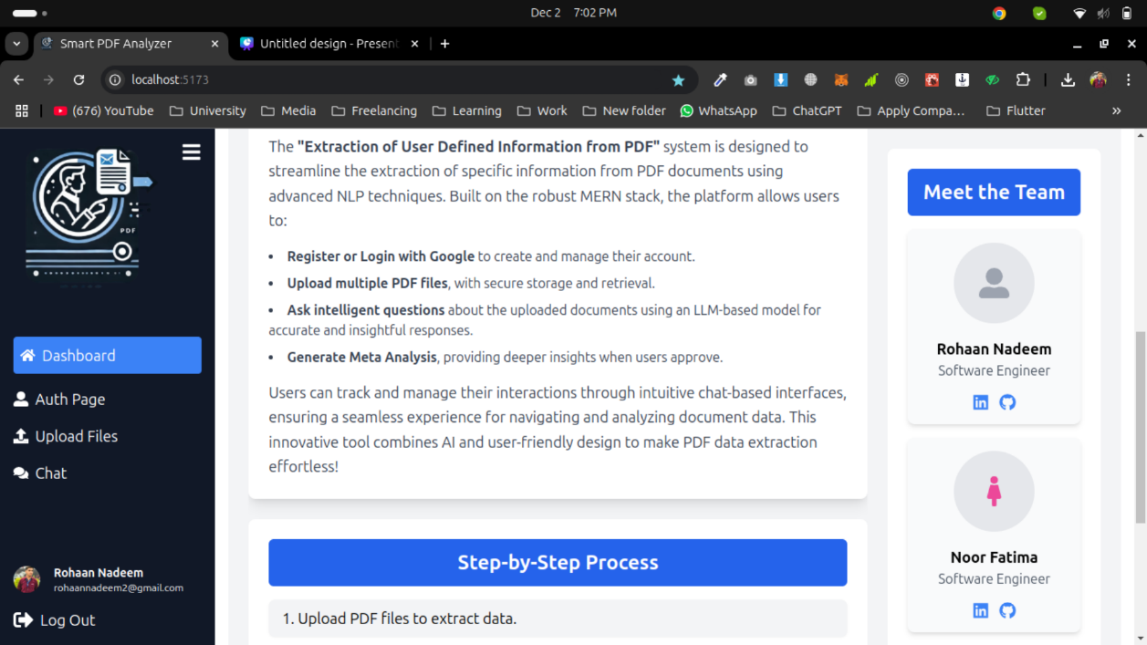
Figure 5.2: Project Overview

Project Workflow and Implementation Steps

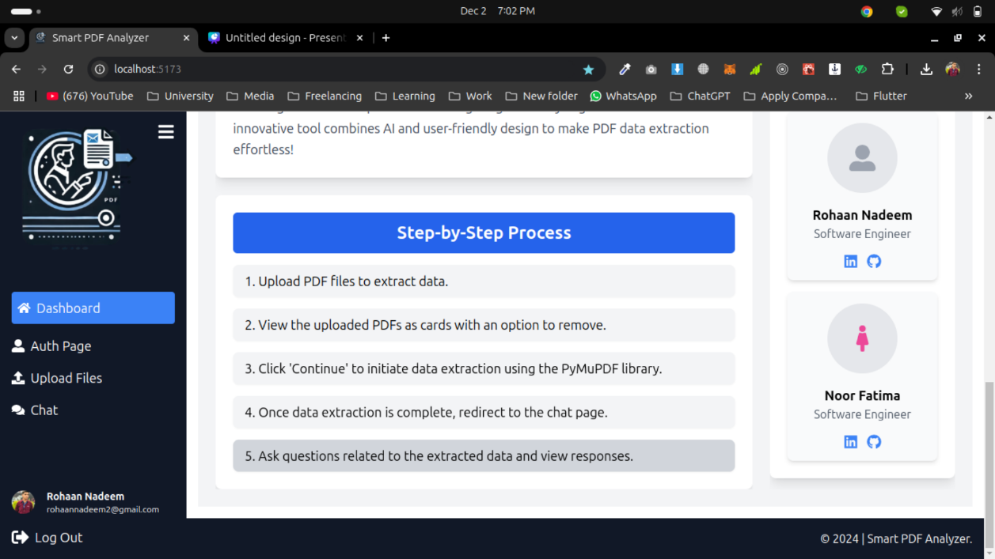
Figure 5.3: Project Workflow and Steps

Auth Page:-

In case user is not logged in then, auth page can be open. The user authentication flow, including Google sign-in, is depicted in Figure 5.4 (Sign-up Flow) and Figure 5.5 (Login Form).

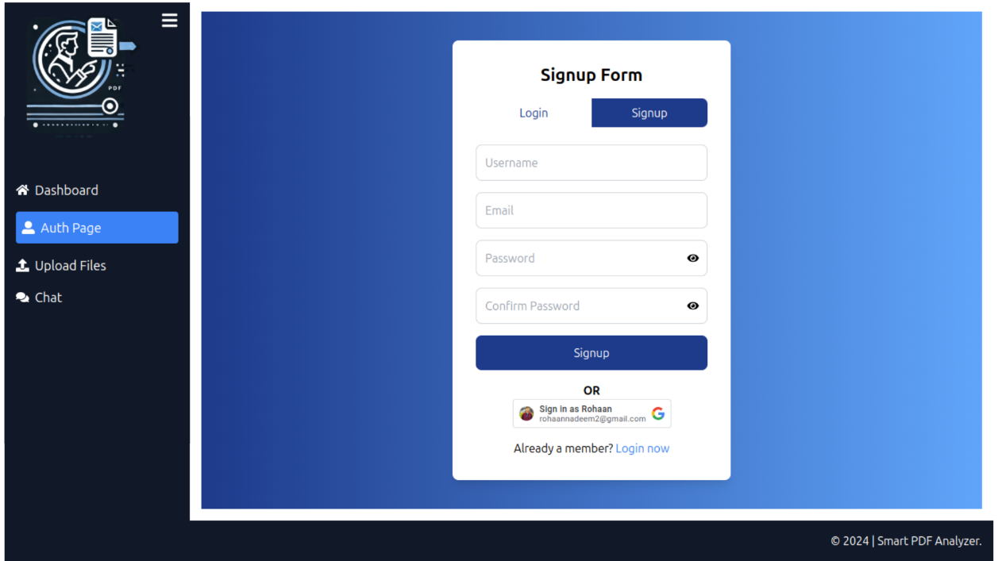
Figure 5.4: Sign-up Flow with Google Login Option

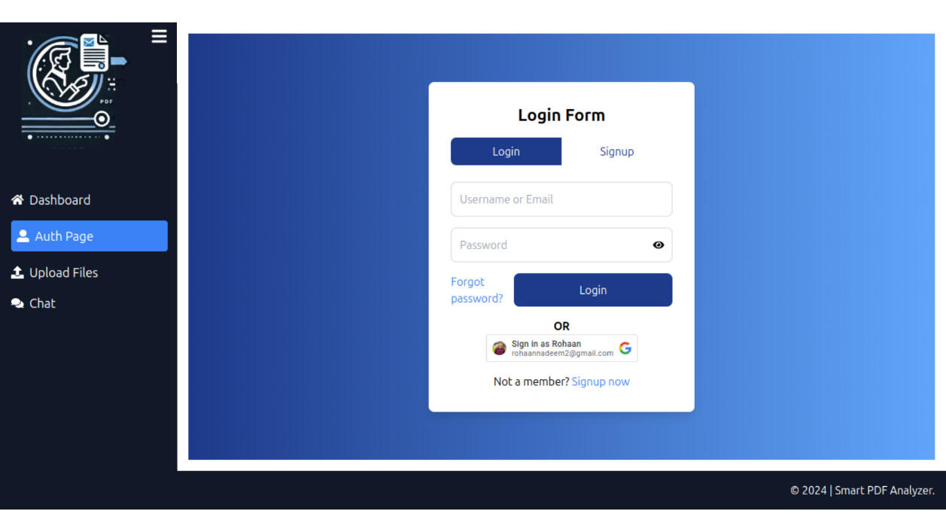
Figure 5.5: Login Form with Google Login Option

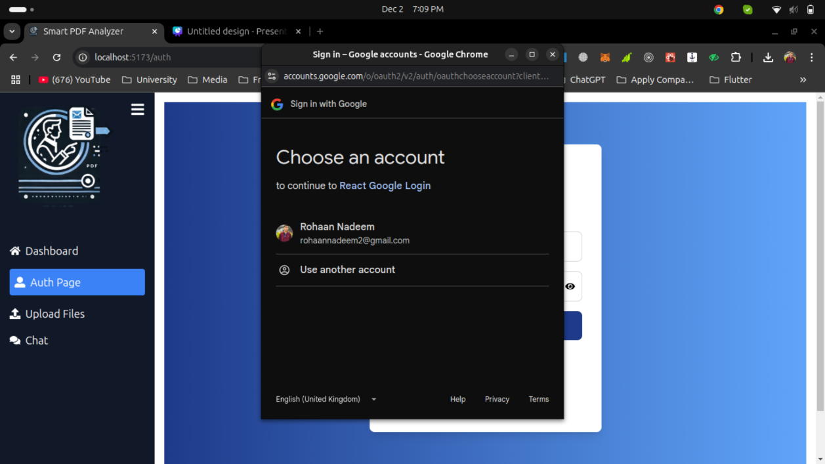
Figure 5.6: Google Login Account Selection

Upload Page

User can upload or drag pdf files over here if user is loggedin with google than its google image will be placed in the side bar and its detail (name and email). The interface for uploading PDFs and managing uploaded files is detailed in Figures 5.7, 5.9, and 5.10."

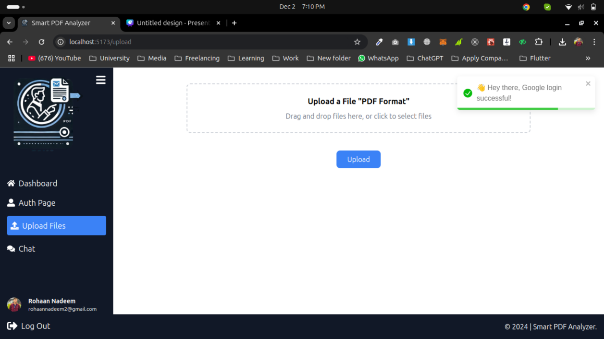
Figure 5.7: PDF Upload Page and google user in Sidebar

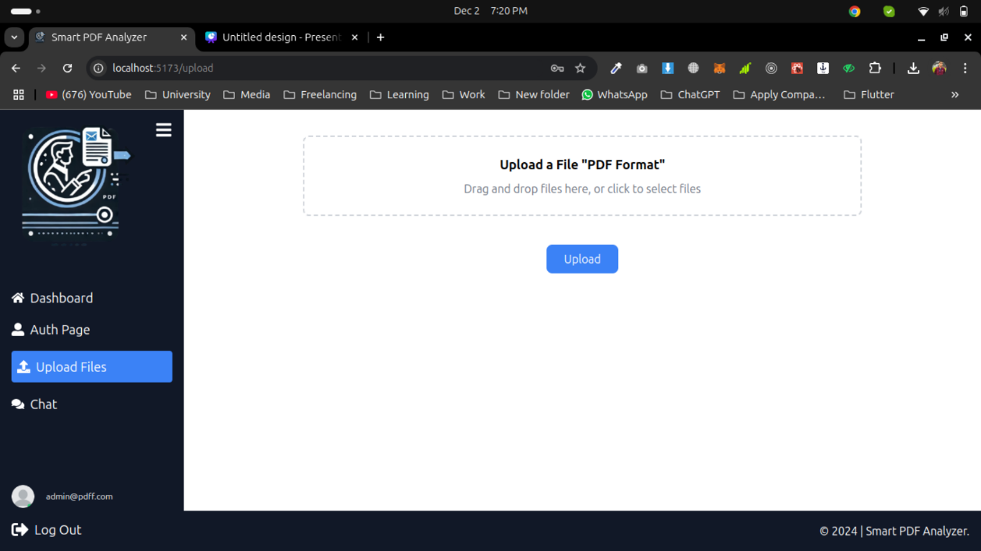
Figure 5.8: User Icon and Email Displayed in Sidebar for Form Users

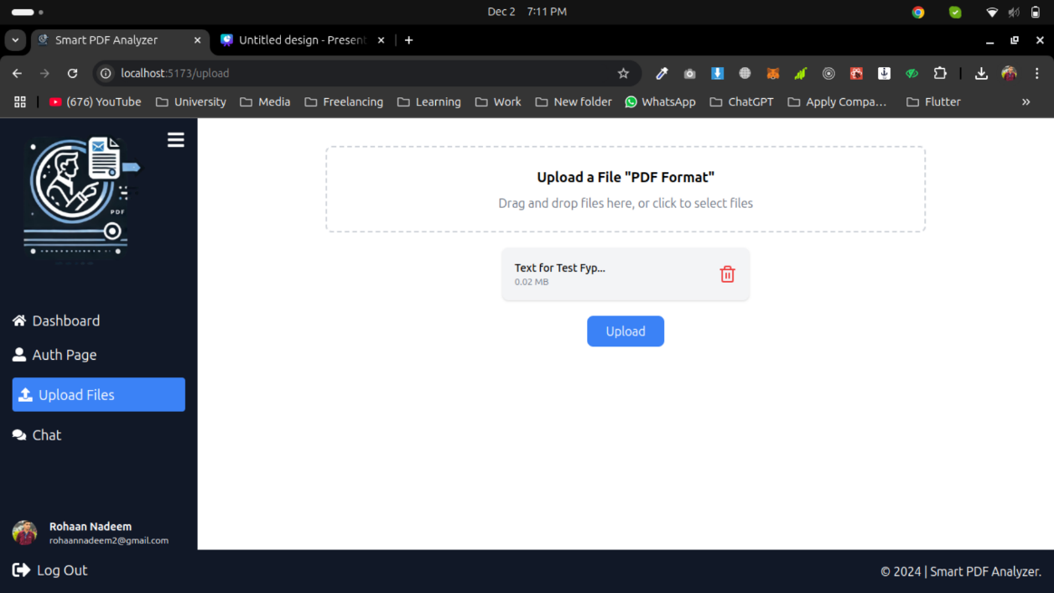
Figure 5.9: PDF Upload with Filename, File size, and Remove Option

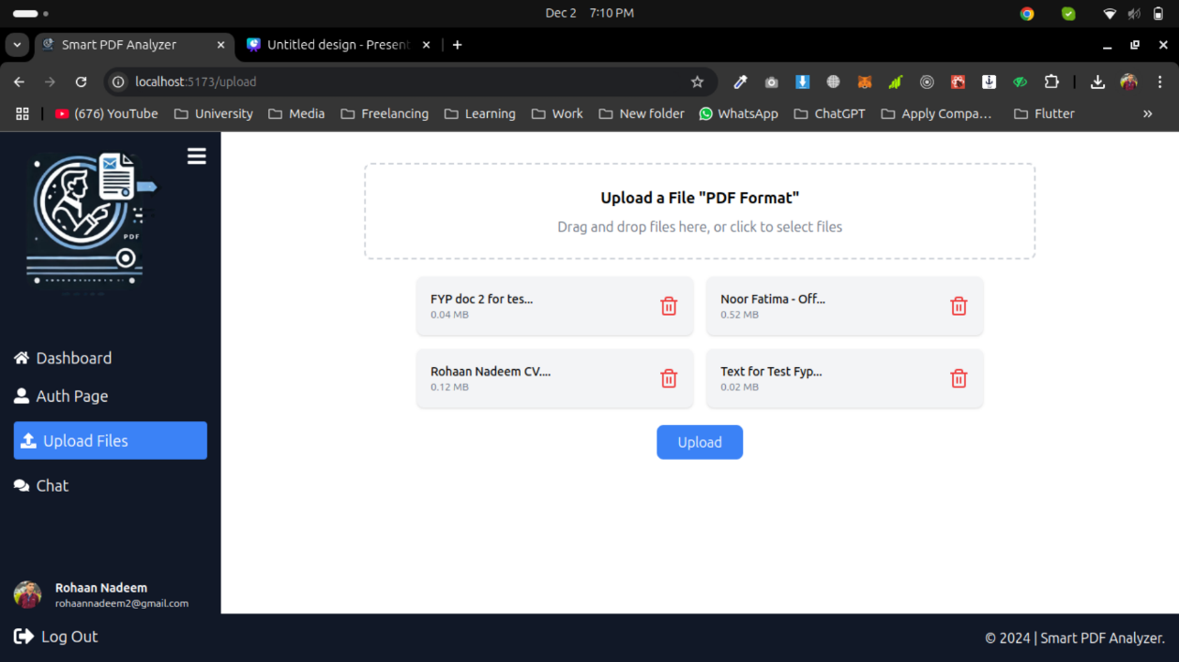
Figure 5.10: Multiple PDFs Uploaded with Filename, File size, and Remove Option

Chat Page

Chat Page contains to have a sidebar showing the previous chat records that include the options of editing/ deleting it. The right side is for the live chat window for communicating with the uploaded data from the PDF format. The chat interface, allowing users to query extracted PDF content, is shown in Figure 5.11 [Polak & Morgan, 2024] (Redirect to Chat Page). Options for managing previous chats are illustrated in Figures 5.13 and 5.15.

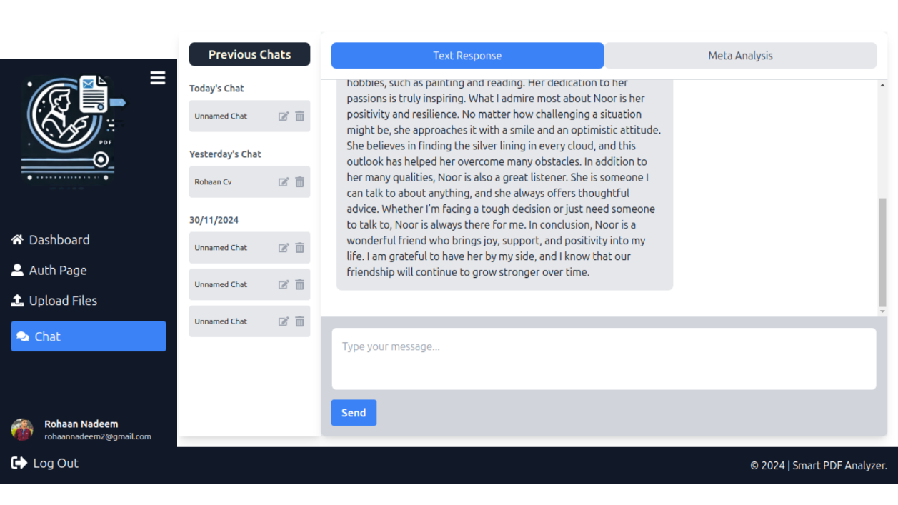
Figure 5.11: Redirect to Chat Page After File Upload

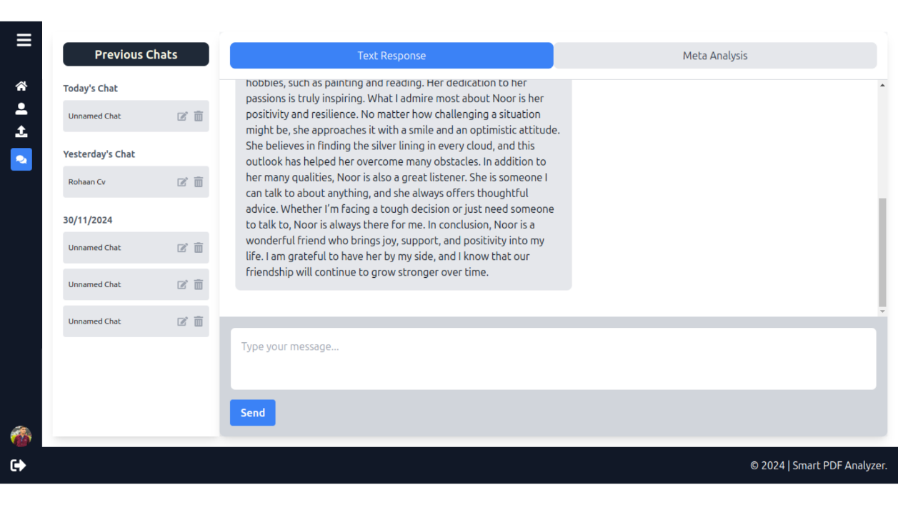
Figure 5.12: Minimized Sidebar View

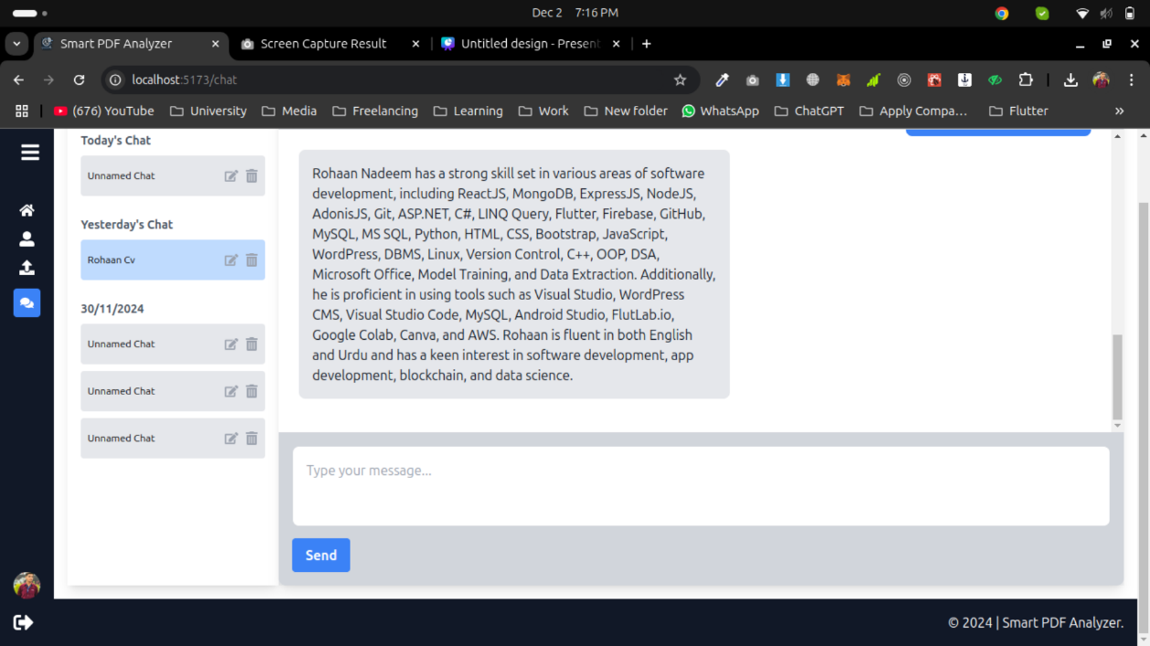
Figure 5.13: Selected Previous Chat from Sidebar

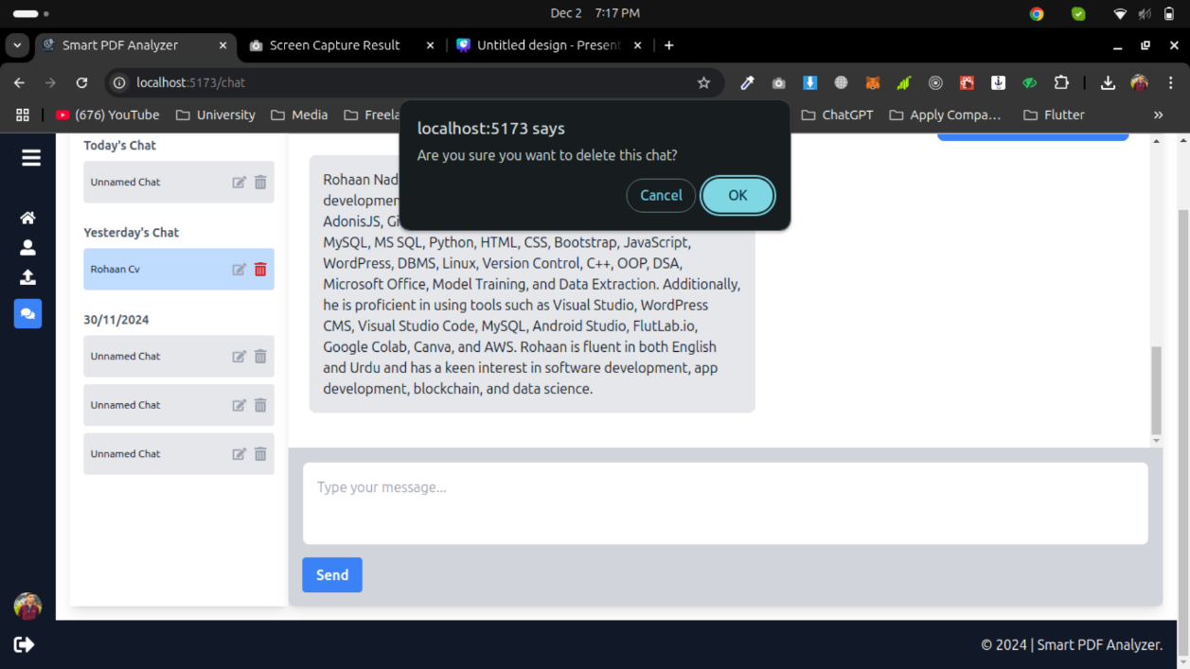
Figure 5.14: Option to Delete Chat from Sidebar

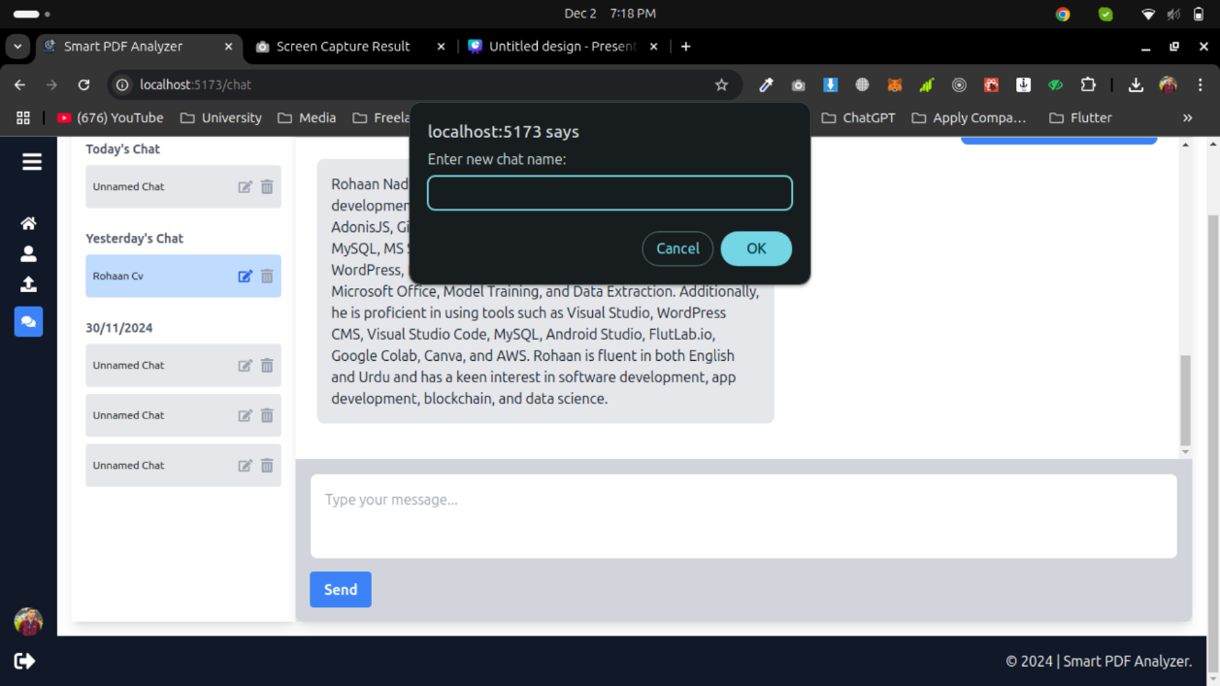
Figure 5.15: Option to Edit Chat Name from Sidebar

Profile Page

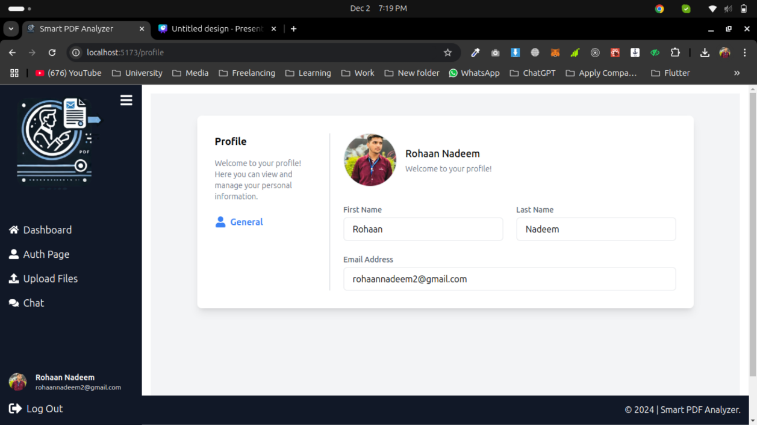
Figure 5.16: Google User Profile Page

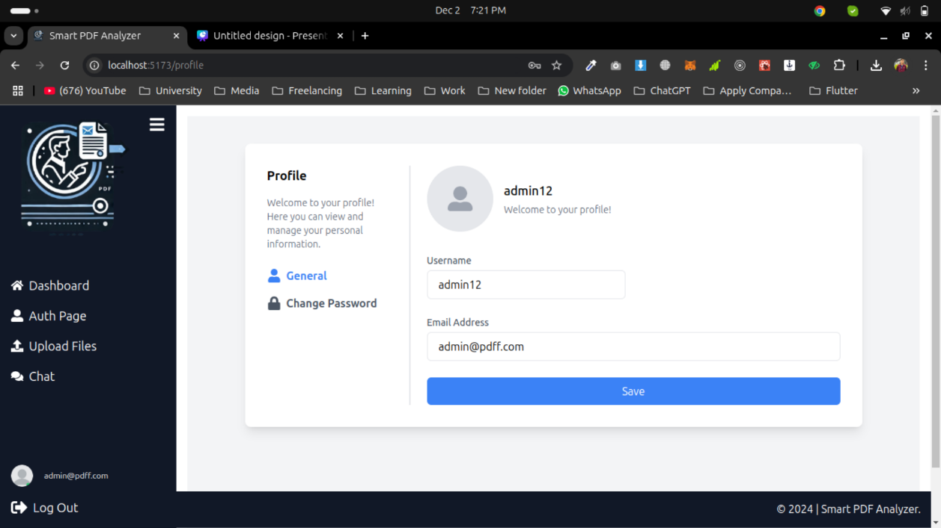
Figure 5.17: Form User Profile Page with Edit Option for Username and Email

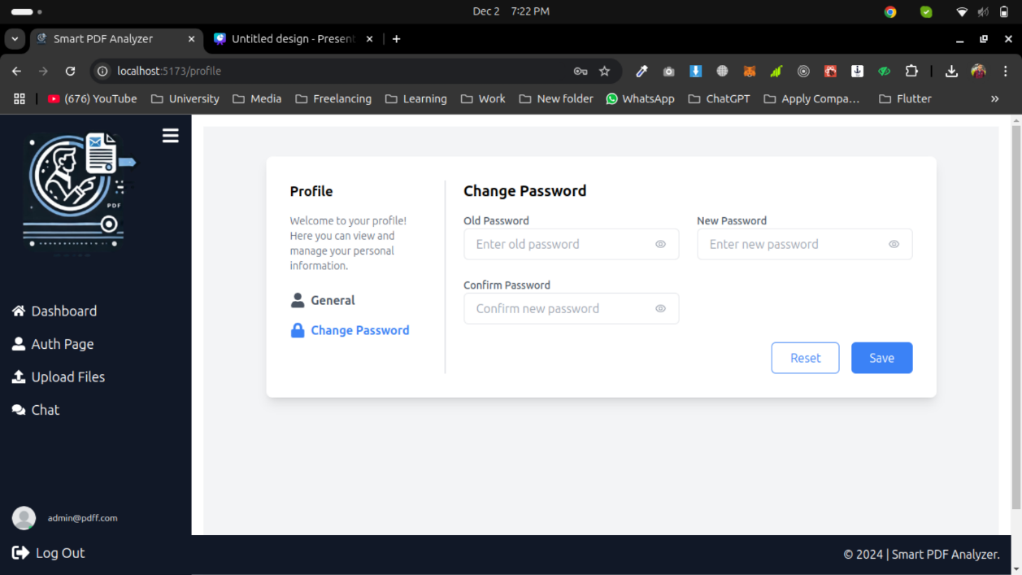
Figure 5.18: Option to Change Password in User Profile

CONCLUSION AND RECOMMENDATIONS

Conclusion

The proposed application named as “Extraction of User Defined Information from PDF” has been successfully deployed with a complete full-stack web configuration wherein the users are able to upload PDF file, extract the important data by using Python pyMuPDF and Meta analysis having visualization of the extracted content through Python Matplotlib library and finally converse with the extracted content through an intelligent chat module. Using the MERN stack (MongoDB, Express.js, React), and incorporating LLM as NLP, users can input to search for specific information about a given, and receive precise responses in the form of PDF content extracts. The application also supports user’s authentication, file handling and chatting, the entire package that offers solution for efficient handling of PDF data extraction.
In this project, I have paid more attention to the user interface in order to provide a good user experience with a good back-end solution. Google login and the multiple file uploads added to the features make the system more accessible and the growing number of users would not pose any problem for the system.

Recommendations

- Error Handling and Data Validation: Another improvement could be made to the error handling procedures, were most necessary during the file uploading as well as during the interaction with the PDF extraction system. The extension limitation will increase the system reliability after having proper validation so that only the files of the supported types are uploaded.
- User Interface Enhancements: As it is available now, it still offers workable interface experience to users, but still can perform improvements related to usability and attraction. Even more, adding the more detailed UI pieces like the progress bar while uploading a file or the feedback messages that appear when something goes wrong, would add better experience worth.
- Security Measures: For strengthening the security concerns to the user data fundamentals of security best practices for custom applications should also apply additional layer of encryption for data which is stored in the database especially the login credentials of the users.

Future Work

In the future I will add another feature that will show the reference of the PDF content from which the response is derived. This will help the system users to know the source of the extracted information to improve the reliability of the system. Furthermore, I still want to investigate further possibilities of introducing greater complexity of certain types of inputs and introducing certain level of more accurate answers. To enhance the existing approaches, broader context support is also another area of development, as well as the extension of the system’s ability to read and handle different file formats and the integration of machine learning models to help the system to gain a better understanding of the context of the files. In future iterations, the methodology outlined in Figure 3.3.1 could be extended to include OCR capabilities and support for more complex queries [Polak & Morgan, 2024], [Tiedemann, 2014].

REFERENCES

- M. P. Polak and D. Morgan, "Extracting accurate materials data from research papers with conversational language models and prompt engineering," Nature Communications, 2024. [Online]. Available: https://www.nature.com/articles/s41467-024-45914-8
- J. Tiedemann, "Improved text extraction from PDF documents for large-scale natural language processing," in International Conference on Intelligent Text Processing and Computational Linguistics, Springer, 2014. [Online]. Available: https://link.springer.com/chapter/10.1007/978-3-642-54906-9_9.
- N. Goel et al., "LLMs Accelerate Annotation for Medical Information Extraction," Proc. of MLR, 2023. [Online]. Available:
https://proceedings.mlr.press/v225/goel23a
- M. P. Polak and D. Morgan, "Extracting accurate materials data from research papers with conversational language models and prompt engineering," Nature Communications, 2024. [Online]. Available: https://www.nature.com/articles/s41467-024-45914-8
- J. Tiedemann, "Improved text extraction from PDF documents for large-scale natural language processing," in International Conference on Intelligent Text Processing and Computational Linguistics, Springer, 2014. [Online]. Available: https://link.springer.com/chapter/10.1007/978-3-642-54906-9_9.
- N. Goel et al., "LLMs Accelerate Annotation for Medical Information Extraction," Proc. of MLR, 2023. [Online]. Available:
- https://proceedings.mlr.press/v225/goel23a

