
BSCS-F24-021
03-134212-019 | Ayesha Anjum
03-134212-017 | Asad ul haq

MedTrack

In partial fulfilment of the requirements for the degree of
Bachelor of Science in Computer Science
Supervisor: Muhammad Mudassar
Department of Computer Sciences
Bahria University, Lahore Campus
June 2025

© Bahria University, 2025


Certificate

We accept the work contained in the report titled
“MedTrack”
written by
Ayesha Anjum
Asad ul haq
as a confirmation to the required standard for the partial fulfilment of the degree of
Bachelor of Science in Computer Science.

Approved by:
Supervisor: Muhammad Mudassar
(Signature)

June 5, 2025

DECLARATION

We hereby declare that this project report is based on our original work except for citations and quotations which have been duly acknowledged. We also declare that it has not been previously and concurrently submitted for any other degree or award at Bahria University or other institutions.

Enrolment | Name | Signature
03-134212-019 | Ayesha Anjum
03-134212-017 | Asad ul haq

Date: June 5, 2025

Specially dedicated to

We dedicate this Final Year Project wholeheartedly to my dear parents and my loving grandmother. Their boundless love, unstinting support, sincere prayers, and persistent encouragement have been the pillars of strength in my life.
To my mother and father, who have sacrificed so much and guided me with care and wisdom, and to my grandmother, whose blessing and love have always surrounded me — this is your achievement.
Gratitude for your infinite belief in us
(Ayesha Anjum and Asad ul haq)

ACKNOWLEDGEMENTS

We would like to thank everyone who had contributed to the successful completion of this project. We would like to express our gratitude to my project supervisor, Mr. Muhammad Mudassar for his invaluable advice, guidance and his enormous patience throughout the development of the project. In addition, we would also like to express my gratitude to our loving parent and friends who had helped and given me encouragement.

Asad ul haq
Ayesha Anjum

MedTrack

ABSTRACT
Because of peoples’ busy routines and poor eating habits, leading healthy lives is becoming harder. For a lot of people, it can be difficult to regularly watch their exercise, eating habits and sleep schedules which may lead to health complications. Finding a workable routine is hard on your own, making it likely that you’ll feel stressed and tired and have long-term health problems. That is why we require a simple technology that supports people in tracking their daily habits and giving advice to boost their health.
We are building Med Track, an online tool, to monitor people’s daily habits, including exercise, their diet and sleeping. AI in the app helps review the collected data and suggest how to improve your health. The backend code will be made in Laravel, the frontend in Vue.js and MySQL will be the chosen database for this project. With the help of AI, MedTrack will offer recommendations just for each user, helping them keep their health goals. This system will support better food and health choices, ultimately healthier lifestyles.

TABLE OF CONTENTS

DECLARATION ii
ACKNOWLEDGEMENTS iv
ABSTRACT v
TABLE OF CONTENTS vi
LIST OF TABLES viii
LIST OF FIGURES ix
LIST OF SYMBOLS / ABBREVIATIONS xi
LIST OF APPENDICES xiii

CHAPTERS
1 INTRODUCTION 14
1.1 Background 14
1.2 Problem Statements 14
1.3 Aims and Objectives 15
1.4 Scope of Project 16
2 LITERATURE REVIEW 17
2.1 Related Works 17
3 DESIGN & METHODOLOGY 24
3.1 Sequence Diagram 26
3.2 Use Case Diagram 30
3.3 Activity Diagram 31
3.4 Database ERD 32
4 IMPLEMENTATION AND RESULTS 33
4.1 Scrum Model 33
4.2 Language Used 34
4.3 Tools Used 35
4.4 AI Model 38
5 USER MANUAL 42
5.1 User Manual 42
6 CONCLUSION AND RECOMMENDATIONS 53
6.1 Conclusion 53
6.2 Recommendations 53
REFERENCES 54
APPENDICES 55

LIST OF TABLES
Table 2. 1: A review of the related work. 17
Table 4. 1: Diet Modal Results 40
Table 4. 2 Sleep Data Results 40
Table 4. 3: Fitness Data Results 41

LIST OF FIGURES
Figure 3. 1: User Flowchart 24
Figure 3. 2: Admin Flow 25
Figure 3. 3: User Registration 26
Figure 3. 4: User Login 27
Figure 3. 5: Health Data Input and Storage 28
Figure 3. 6: AI Processing and Insight Generation 29
Figure 3. 7: Use Case 30
Figure 3. 8: Activity Diagram 31
Figure 3. 9: ERD Diagram 32

Figure 4. 1: Scrum Model Flow 33
Figure 4. 2: Diet Results 40
Figure 4. 3: Sleep Results 40
Figure 4. 4: Fitness Results 41

Figure 5. 1: Homepage 42
Figure 5. 2: Create Account 42
Figure 5. 3: Requirement Gathering Slider Screen 1 43
Figure 5. 4: Requirement Gathering Slider Screen 1 43
Figure 5. 5 :Requirement Gathering Screen 3 44
Figure 5. 6: Requirement Gathering Screen 4 44
Figure 5. 7: Requirement Gathering Screen 5 45
Figure 5. 8: Requirement Gathering Screen 6 45
Figure 5. 9: Requirement Gathering Screen 7 46
Figure 5. 10: Requirement Gathering Screen 8 46
Figure 5. 11: Requirement Gathering Screen 9 47
Figure 5. 12: Sign in page 47
Figure 5. 13: Reset Password 48
Figure 5. 14: User Dashboard 48
Figure 5. 15: User Profile 49
Figure 5. 16: Sleep Track Page 49
Figure 5. 17: Diet Track Page 50
Figure 5. 18: Fitness Track Page 50
Figure 5. 19: User logout 51
Figure 5. 20: Admin Dashboard 51
Figure 5. 21: User Management 52

LIST OF SYMBOLS / ABBREVIATIONS
Acc accuracy
AI artificial intelligence
API application programming interface
BMI body mass index
CSS cascading style sheets
CNN convolutional neural network
Colab Google Collaboratory
DBMS database management system
DS daily scrum
F1 F1 score
HTML hypertext markup language
ID inner diameter, m
IoMT internet of medical things
IoT internet of things
L-GBM Light Gradient Boosting Machine
MAP maximum allowable pressure, kPa
MAWP maximum allowable working pressure, kPa
ML machine learning
MSE mean squared error
MT MedTrack
MySQL My Structured Query Language
NB Naive Bayes
OD outer diameter, m
PCB printed circuit board
PHIMS personal health information management system
PO product owner
Pre precision
R² R-squared
Rec recall
RF Random Forest
SM scrum master
SP sprint planning
SQL structured query language
SR sprint review
SRt sprint retrospective
UI user interface
VS Code Visual Studio Code
XAMP Cross-platform Apache MariaDB Perl PHP
XGB Extreme Gradient Boosting

LIST OF APPENDICES

APPENDIX A: Language Links 56
APPENDIX B: Tool Links 57

INTRODUCTION

Background
In the past few years, a healthy lifestyle has been becoming more difficult to maintain with fast-paced lifestyles, irregular timetables, unhealthy eating habits, and a sedentary lifestyle. While individuals work, study, and have other personal commitments, it is hard to keep track of vital daily routines like exercise, diet, and sleep on a regular basis. If these routines are not maintained over time, they can develop numerous health issues, such as stress, exhaustion, obesity, and other chronic diseases.
Historically, medical services have mostly focused on curing diseases and not on promoting preventive care and healthy lifestyles. Because people recognize how important daily health is, there is now greater demand for digital solutions to help with health management.
Striving to meet this need, MedTrack was launched as a comprehensive web program for managing daily health activities, for example, exercise, what is eaten and rest. People can use this site to log their daily habits; see how far they’ve come and stay committed to look after their health.
Lending a simple and clear way for people to view and control their health information, MedTrack works to inspire a healthy lifestyle and better living practices.

Problem Statements
Because life moves so fast now, more people find it difficult to adopt a healthy lifestyle. The frequent stress, feeling tired, obesity and chronic illnesses today are related to our busy lifestyles, poor diets, inactive days and disturbed sleeping rhythms. Keeping tabs on their daily actions on a regular basis becomes difficult for most, so understanding the effect on their health is rarely easy.
Even with the presence of numerous fitness and health apps, most people find it hard to keep their personal health information in an organized, convenient, and easy-to-use manner. Without regular tracking and readily available insights, individuals find it challenging to remain motivated, keep healthy routines, and make informed lifestyle choices.
There is obviously a requirement for an overall system that enables users to efficiently record, track, and manage their routine health activities within a single interface. The system will assist individuals to create habitual patterns, see their progress, and promote an active mode of personal health control.
Med Track seeks to solve this issue by offering a centralized web-based system that assists users in monitoring key wellness habits like exercise, diet, and sleep. The app makes it easy to monitor personal health and enables users to remain aware of their health status, establish realistic goals, and enhance their lifestyle.

Aims and Objectives
As follows are the stated objectives of the project:
- Help users check their regular health numbers, like physical activity, eating habits, sleep schedules and basic vital signs.
- Give suggestions that match a person’s health information to improve their daily habits and wellness.
- Help combine information from various health tools and applications into one overview of a person’s health. Make sure your app has an interface that is simple for everyone to use.
- Increase user participation by introducing interactive options that make it simple to regularly watch their health.
- Have solid protective measures for user information to guarantee their privacy in regard to health care.
- Ensure that health tracking is within reach of almost anyone by organizing the interface so that it is easy to use.

Scope of Project
Med Track is designed to provide a full web-based health management system that enables individuals to efficiently keep track of their actions every day. Users will be able to see all their wellness activities in one place because the system will record exercise, diet and sleep for them.
Users can safely open their personal profiles and use health data protection because login and authentication are major features. Daily habits like exercise, the foods people consume, and sleep time can all be entered manually by users. Graphical reports and charts are produced to allow users to check their progress over time and see simple summaries of changes in health and behavior. In addition, MedTrack allows each user to set personal goals—for exercise or sleeping—and see how they are making progress.
For the sake of encouraging uniformity, the app will include on-time reminders and notifications that will inspire users to maintain consistency in their routines. The web interface of the platform will be developed with responsiveness in mind so that it will easily run on desktops, tablets, and smartphones. The platform will also include an admin panel with user management, system control, and data management for easy running and maintenance of the platform.

LITERATURE REVIEW

Related Works
Table 2. 1: A review of the related work.
Study | Year | Title | Models used | Datasets | limitations | Key Findings
[1] | 2022 | IoT-Based HealthcareMonitoring System towards Improving Quality of Life: A Review | - IoTbased Healthcare System and Applications  - Review of Related Studies  - Internet of Wearable Things and Sensors  - Security and Protocols in IoT Healthcare Systems  - Challenges and Open Issues .  - Suggestio ns and Recommen dations | MIMIC-III (Medical Information Mart for Intensive Care) UCI HAR Dataset (Human Activity  Recognition Using Smartphones) PhysioNet Kaggle Healthcare Datasets (IoT) D1NAMO | Integration Challenges User Experience Data Security and Privacy Scalability Quality of Service (QoS) | Enhanced Monitoring Capabilities Improved Decision-Making Increased Efficiency Future Potential
[2] | 2022 | Systematic review of smart health monitoring using deep learning and Artificial intelligene | Introduction to SHM and IoT IoT and IoMT Overview Application s of SHM Component s and Types of SHM Systems IoT Devices in SHM SHM in Pandemics AI and Deep Learning in SHM Security and Privacy Future Scope and Conclusion | Patient Health Records Sensor Data Remote Monitoring Data Clinical Trial Data Behavioral and Activity Data Survey and Questionnair e Data Health Outcome Data Security and Privacy Incident Reports | SHM and medical IoT devices face limitations including errors from heterogeneous data, sensor irritation, security risks, and fraud issues. Additionally, challenges such as power constraints and unreliable network connections in remote areas impact real-time monitoring, though advancements in technology may address these issues over time | Between January 1, 1985, and May 5, 2022, 72 policy documents on selfmanagement of health were analyzed, primarily focusing on chronic conditions, with 47% addressing diabetes and 3% targeting older adults.
[3] | 2022 | Artificial Intelligence Applications in Health Care Practice: Scoping Review | Arksey and O’Malley Framework PRISMAScR Checklist: World Health Organizatio n’s Definition of AI Rayyan Software Qualitative Thematic Analysis | Healthcare Data for AI Training and Validation Publication Data on AI in Healthcare Diagnostic and Therapeutic AI Applications Data Regulatory and Administrativ e Data Population Health Management Data | Gray Literature Exclusion Lag in Academic Publication  Focus on PeerReviewed Articles Screening Process Variability Lack of Quality Appraisal | We identified 9218 records, of which 9179 (99.58%) were identified through database  searches and 39 (0.04%) through a snowball search of reference lists in the review articles (n=36)
[4] | 2020 | Self-tracking behaviour in physical activity: a systematic review of drivers and outcomes of fitness tracking | SelfTracking Models Fitness Tracking Technologie s | SelfTracking Data Fitness Tracking Technology DataBehavior al and Motivational Data | Lack of Focus on General Population Limited Research on User Outcomes | Drivers of Fitness Tracking Framework Development
[5] | 2022 | The internet of medical things and artificial intelligence: trends, challenges, and opportunities | IoMT Systems Data Mining Models Communica tion Models AI Application s in IoMT | IoMT Device Data Medical Data Records Communicati on Data Data Processing and Storage Data Market Data Wearable Medical Device (WMD) Data AI and IoMT Application Data Security and Privacy Data Research and Review Data | Security Challenges Limited Scope in Communication Energy Efficiency Data Privacy and Power Consumption Increased Data Processing | Growing IoMT Market: The IoMT market grew significantly, from $50.3 billion in 2020 to a projected $135.87 billion in 2025, largely fueled by the COVID-19 pandemic.
[6] | 2021 | Status of the research in fitness apps: A bibliometric analysis | Empirical Models Bibliometri c Analysis | Fitness App Usage Data Demographic s and Feedback Health Outcomes Data | Lack of Macro and Quantitative Research | Research Trends and Hot Issues: The bibliometric analysis reveals the dominant research topics and trends within fitness app research. This includes the focus on mHealth and the fitness segment of mobile health apps
[7] | 2023 | Personal Health Tracking: A Paradigm Shift in the Self-Care Models in Nursing | Dorothea Orem’s Self-Care Model mHealth and the Quantified Self Movement | mHealth Device Data PatientReported Outcomes Patient Engagement Metrics | Barriers to Integration accessibility issues Impact on Health Care Relationships health care provider-patient relationship | Patient Empowerment Personalized Care Improved Outcomes and Accessibility
[8] | 2021 | eHealthChain —a blockchainbased personal health information management system | IoT-Based Health Monitoring Model medical IoT devices smart inhalers, IoT-enabled pill bottles, and insulin infusion pumps Personal Health Information Managemen t System (PHIMS) | Medical IoT Device Data. Blockchain Records Medical Insurance Information Family Health Records Genomic Medical Information | Data Privacy and Security | Enhanced Personal Health Management
[9] | 2022 | Application of Artificial Intelligence in CommunityBased Primary Health Care: Systematic Scoping Review and Critical Appraisal | Machine Learning (ML) Modules Classification Algorithms Neural Networks Convolutiona l Neural Networks (CNNs) | Medical Imaging Datasets: Radiology Datasets Socioeconomi c Data Real-Time Monitoring Data Administrative Data Health Service Utilization Records | Variability in Reporting Gaps in Implementation Bias Assessment Limitations. Stakeholder Consultation | Based on the analysis of the 90 peerreviewed publications, the following results and trends were observed: Types of AI Interventions Machine Learning (ML)

An analysis of several different journals that cover similar scenario implementation based on health and the different way they portray the concept is demonstrated in Table 2. 1. The following table presents a summary of related studies, highlighting their titles, models used, datasets, limitations, and key findings in the context of health monitoring and lifestyle management system.

DESIGN & METHODOLOGY
This section provides a step-by-step description of the Med Track web application development process, describing the steps taken in the design, development, and deployment of the application. It emphasizes how the application progresses from conceptualization to working implementation. This explanation is augmented by the use of figures and diagrams, which present the structure of the system, workflows, and user interactions in a graphical format, thereby rendering the entire process simpler to comprehend. Our goal is to provide a clear and well-structured overview of the progress of the project by methodically outlining every step, from the integration of health data and analysis through AI to the development of the user interface and security measures in the system, finally painting a complete picture of how Med Track is constructed and functions, shown in Figure 3. 1.
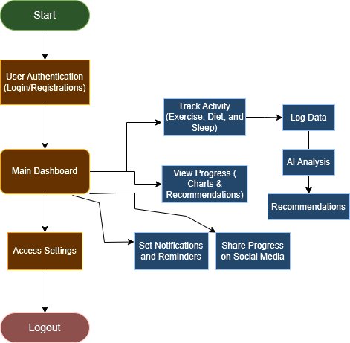
Figure 3. 1: User Flowchart
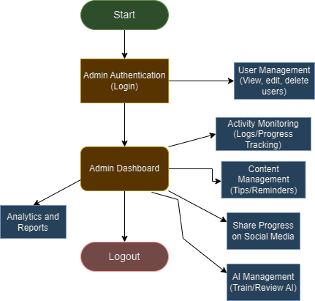
Figure 3. 2: Admin Flow

Sequence Diagram
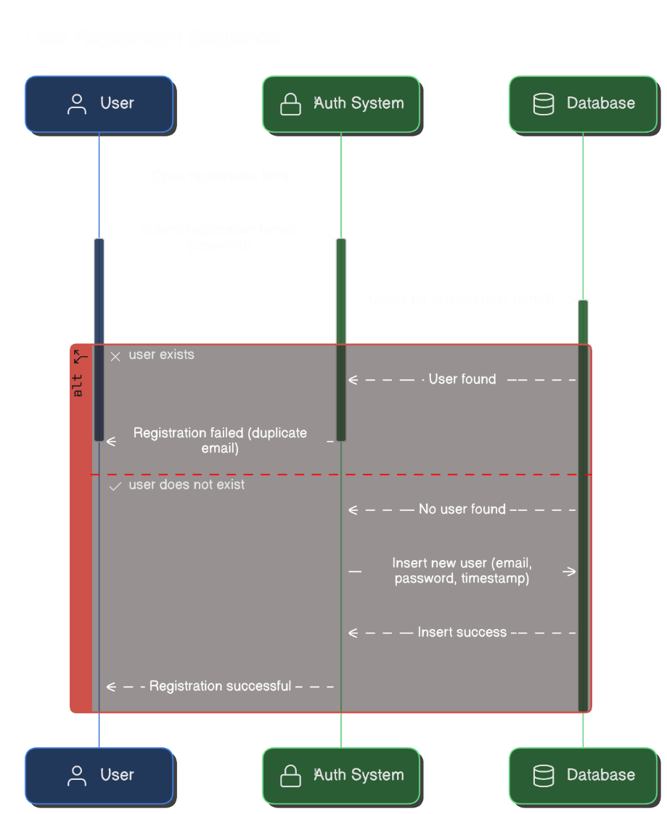
Figure 3. 3: User Registration
Figure 3. 3: User Registration This sequence diagram illustrates the process of user registration within the MedTrack application. A user begins the registration process by providing credentials via the interface. The system queries the database to determine whether the email is a duplicate. Registration is rejected with a duplicate error message if the user already exists. If the user does not exist, the system continues to save the new user's credentials in the database. On successful insertion, the user is returned a confirmation message, thereby finalizing the registration process.
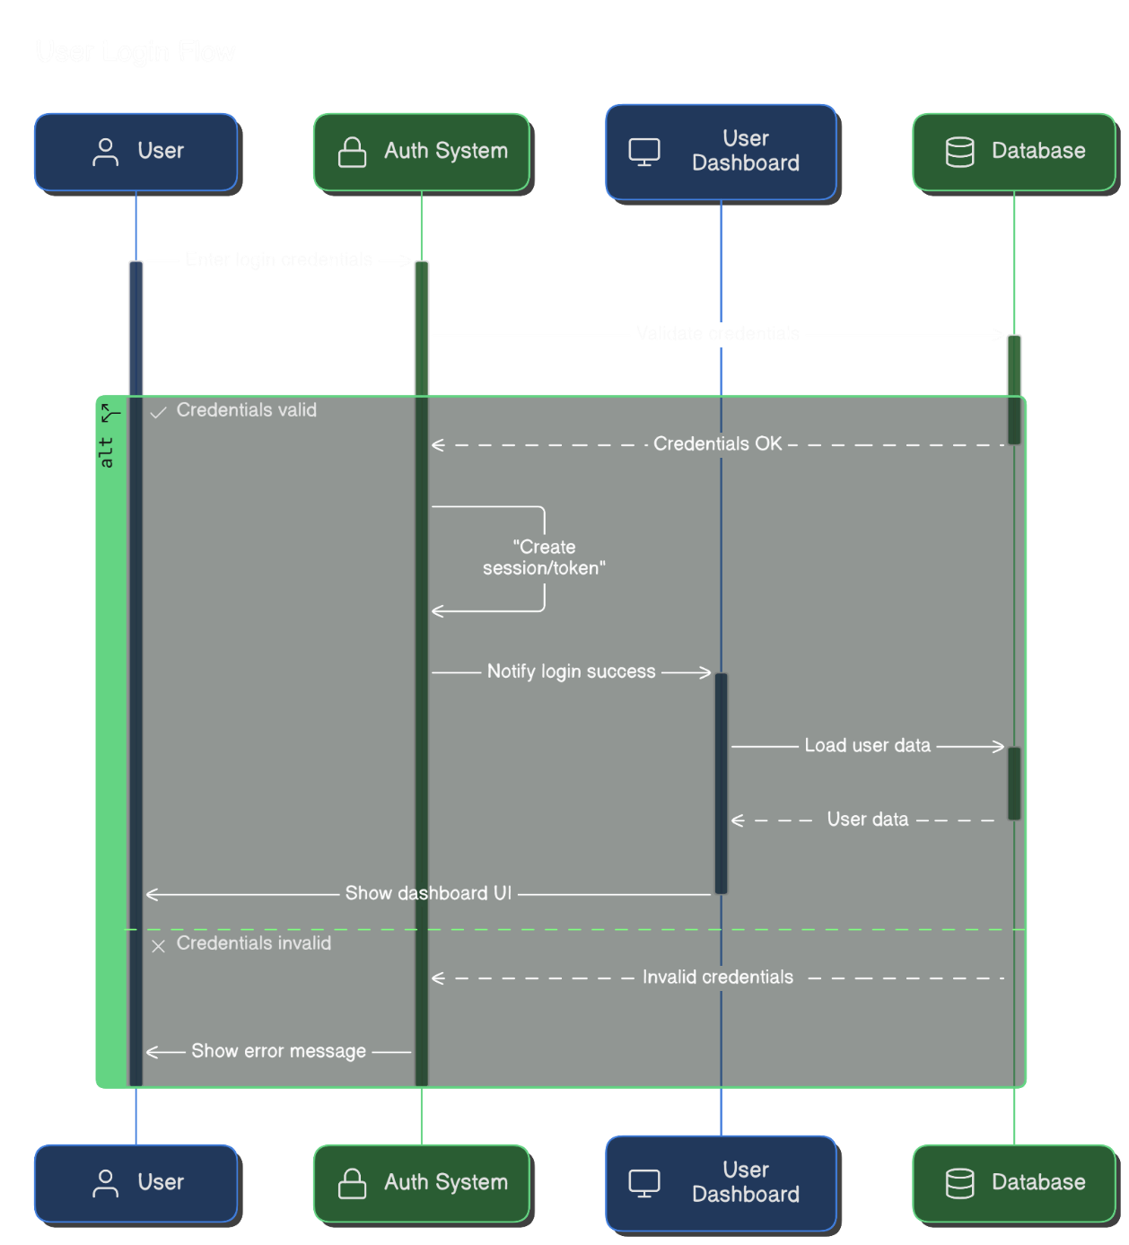
Figure 3. 4: User Login
Figure 3. 4: User Login This sequence diagram displays the user login flow of the MedTrack application. The process starts when a user logs in with their login credentials, which are passed to the Auth System for checking. These credentials are passed on by the system to the Database for validation. If the credentials are correct, the system generates a session or token, informs the User Dashboard of a successful authentication and goes ahead to retrieve the user's data from the database. After retrieving the data, the dashboard UI is presented to the user. If the credentials are not correct, the system sends an error response and the user gets presented with a suitable error message, blocking access to the dashboard.
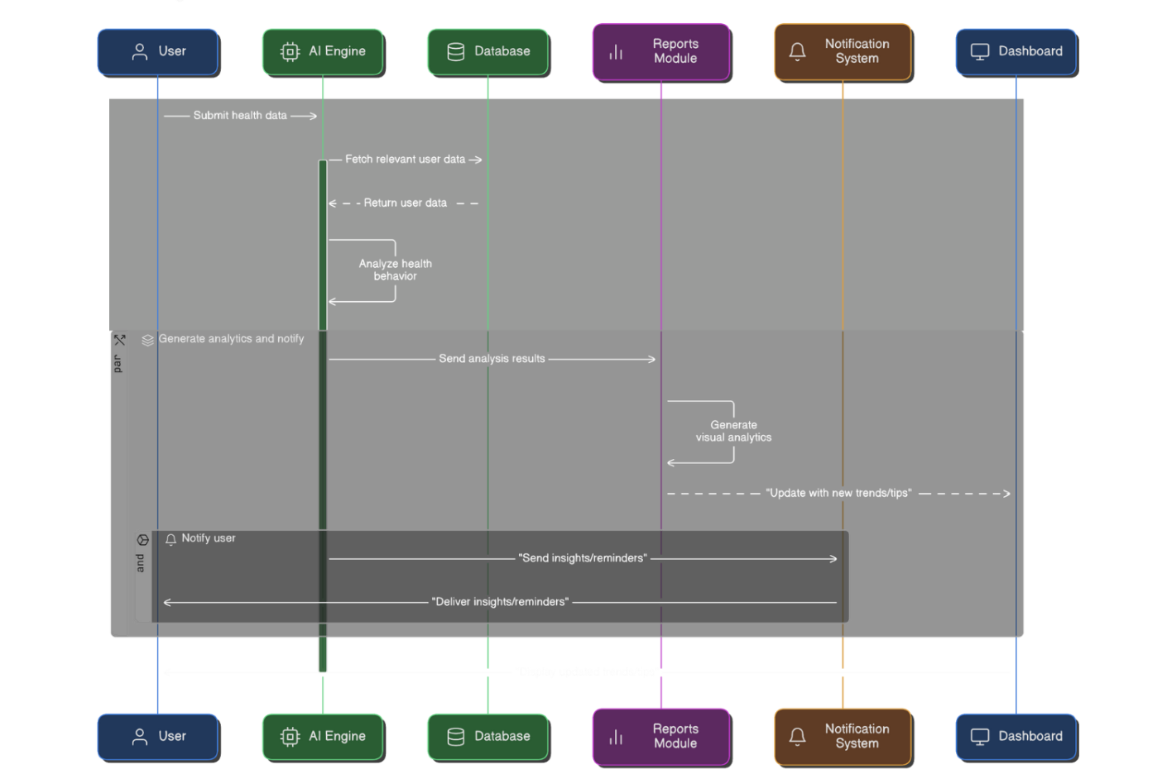
Figure 3. 5: Health Data Input and Storage
Figure 3. 5: Health Data Input and Storage This sequence diagram shows the Health App Activity Update Flow of the MedTrack application. The flow is initiated when a user logs in and navigates to the User Dashboard. Upon successful login, the user chooses an activity to be updated. Depending on the chosen activity type—Sleep, Nutrition, Fitness, or Other Health Activity—the update is managed by the corresponding module. In Sleep, the input sleep hours are validated by SleepTrack, then stored into the Database. Input data in Nutrition is validated by NutritionTrack prior to storage. Fitness data likewise goes through FitnessTrack, and other health activities are taken care of via HealthActivity, with all modules validating and successfully storing in the database. Upon each update, a message confirming the same is sent to the user, finishing the process of updating the data.
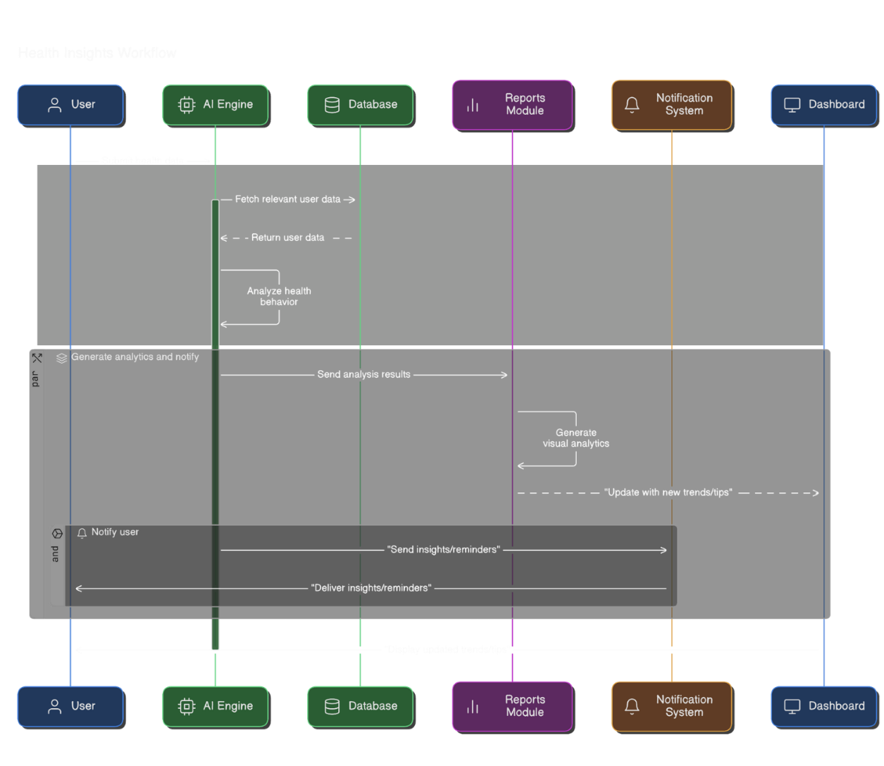
Figure 3. 6: AI Processing and Insight Generation
Figure 3. 6: AI Processing and Insight Generation This sequence diagram represents the Health Insights Workflow in the MedTrack application. The process starts when the user sends their health information to the system. The AI Engine acquires relevant past data from the Database and examines the health habit of the user. It produces insights based on this examination and sends the results to the Reports Module , which produces visual analytics. These analytics are then passed on to the Notification System , which formulates individualized tips, trends, and reminders for the user.
The Notification System transfers this information back to the user, so it appears as useful health notes or running trends. Last but not least, the Dashboard provides the new health insights, finishing the health feedback process with data.

Use Case Diagram
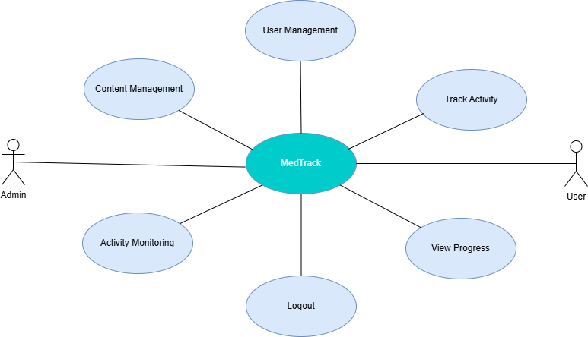
Figure 3. 7: Use Case
Figure 3. 7: Use Case The diagram for MedTrack presents the connections between the system and Admin and User. With the Admin role, users can access user management, control the site’s content and keep an eye on user actions. On the other hand, using the system, the User mainly aims to Track Activity and View Progress to log records and review changes in themselves functional development. Both Admin and User have a single Logout option to safely end their session on the system. This schematic shows clearly what the system does and what every involved actor is responsible for.

Activity Diagram
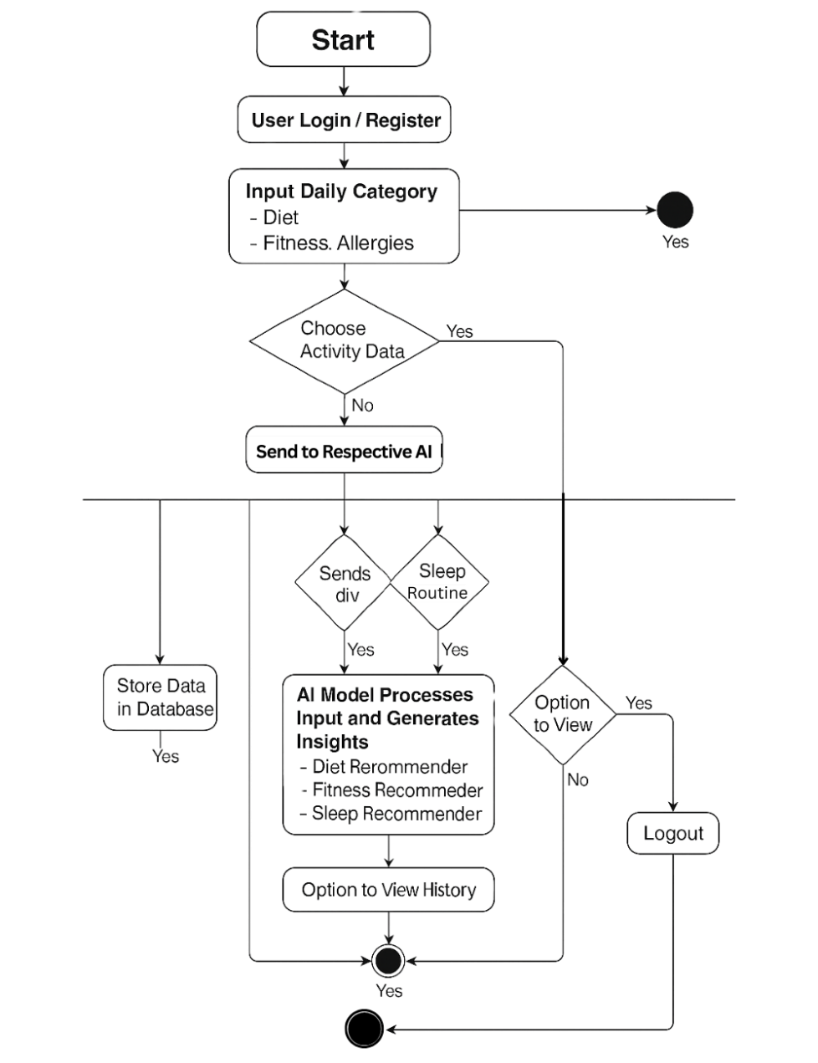
Figure 3. 8: Activity Diagram

Database ERD
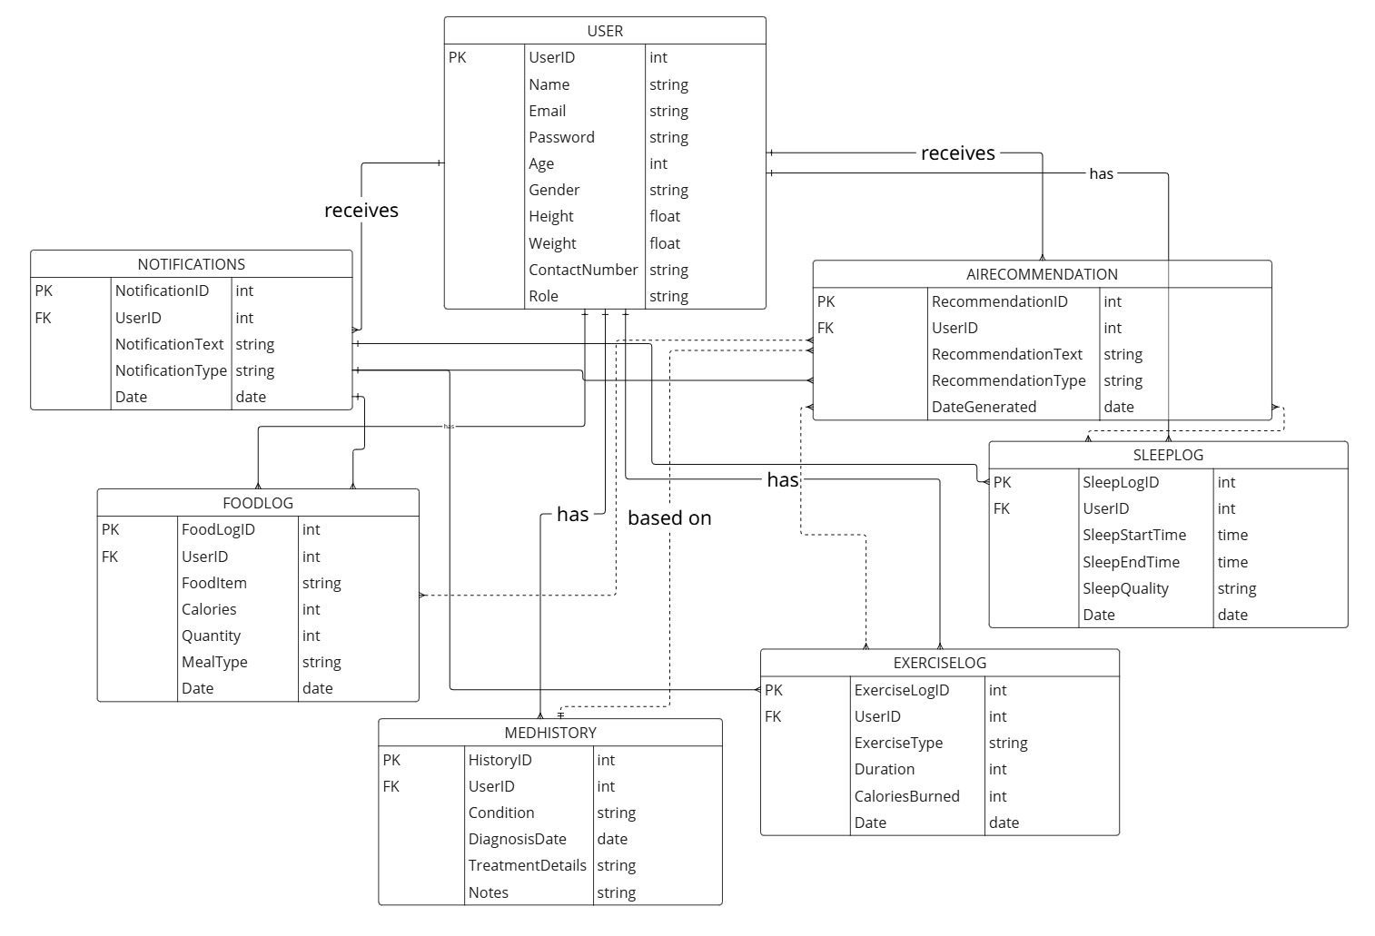

Figure 3. 9: ERD Diagram

IMPLEMENTATION AND RESULTS
This part of the document looks at the project’s deployment according to the Scrum model and within the framework of agile development. Numerous tools and technologies were utilized while developing the system. Vue.js was utilized in creating the user interface, and Laravel was used to manage back-end operations. MySQL was used as the database management system to store and maintain user health data securely.
Key supporting tools were XAMPP for local server administration and database management during development. This section gives an overview of the languages, frameworks, and tools used throughout the project and their respective purposes. It also includes relevant diagrams to describe the development process, system architecture, and operational workflows.

Scrum Model
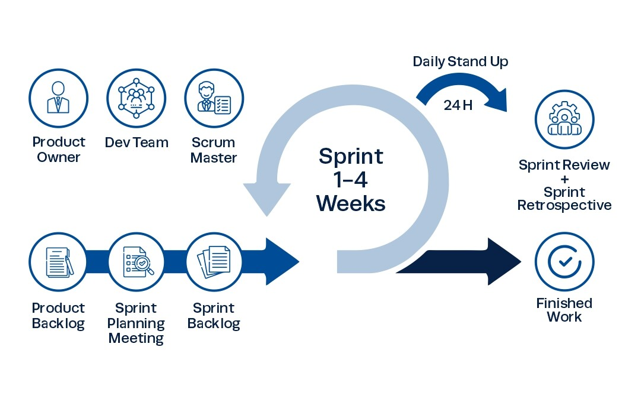
Figure 4. 1: Scrum Model Flow
Scrum: A popular project management approach for complex projects.
Focuses on Teamwork, flexibility, delivering results in stages. Often used in software development, but gaining traction elsewhere too as shown in Figure 4. 1: Scrum Model Flow.
Key Players:
- Product Owner: Speaks for the customer, prioritizes tasks, ensures value is delivered. Scrum Master: Team coach, removes roadblocks, keeps the team on track with Scrum practices.
- DevelopmentTeam: Self-organized group with diverse skills, responsible for delivering working parts of the project in short cycles.
Building Blocks:
- Product Backlog: A running list of everything that needs to be done, constantly changing as priorities shift.
- Sprint Backlog: A smaller, more specific list of tasks chosen from the product backlog for a short work cycle (sprint).
- Increment: The completed work at the end of a sprint, ready for potential release.
The Scrum Workflow:
- Sprints: Traditional and more formal approach to managing tasks that divides the work into work packages of fairly uniform length, usually ranging from one to four weeks where a usable portion of the project deliverable is compiled.
- Sprint Planning: The pre-sprint planning meeting where the sprint goal for the next one to four weeks is determined and the tasks of the product backlog that will be accomplished are chosen.
- Daily Scrum: The members of the Scrum team should hold a very short daily meeting – 10-15 minutes at the most, the purpose of which is to discuss the work plan for the next day.
- Sprint Review: Sprint review: Present the outcomes of each of the sprint efforts to the stakeholders and seek their input.
- Sprint Retrospective: An opportunity in the Scrum methodology whereby the team is able to assess its performance in the previous sprint basing on problems faced or lessons learnt from the event in order to learn on how to work better in the subsequent sprint.

Language Used

Vue.js
Vue.js offers developers a progressive approach to building dynamic and interactive web interfaces. Vue.js is based on a flexible component-based system that allows developers to develop reusable UI components efficiently. Vue.js also includes integrated tools for reactive data binding and state management, and developers can use these to control the appearance and behavior of application components automatically based on changes in real-time data.

Laravel 10
Laravel is one of the most used frameworks in the PHP language for creating the web applications. New features, improvements, and bug fixes are most possibly implemented in version 10 of the framework delivering better opportunities and tools for developing sustainable and extensively scalable web-based applications.

CSS
CSS or Cascading Style Sheets is a style sheet language for use in the designing of any web content built with HTML. This has the ability to specify how any HTML elements should appear on the screen with regard to aspects such as layout, colors, font and among others.

MySQL
MySQL is a relational model database system where the database can be managed through use of commands in the structured query language (SQL) and is open source. Most often it is used for managing and querying of database in numerous innumerable web applications and software systems.

Python
Python is a general-purpose, high-level programming language with the reputation of being easy to use, readable, and having extensive applications. It offers plenty of libraries and frameworks that cater to various fields like web development, data analysis, machine learning, automation, and scripting. Python's simple syntax and dynamic typing make it a good fit for rapid application development and prototyping.

Tools Used

Xamp Local Server
You will just require a free and open source software program called XAMPP to assist in setting up the development environment on your machines. XAMPP is cross-platform, which means that it supports Linux, macOS and Windows hence the name XAMPP.
- X stands for crosses between platforms
- A represents Apache, the popular web server.
- M here denotes the kind of database management system employed in the database, which is MariaDB.
- PP stands for two recent web development programming languages
Perl and PHP.
For this assignment, we initially installed the local web environment on the PC with XAMPP.
We used it for:
- Testing and repairing web pages: At present, our website is locally hosted, and,
- prior to running it, we test and repair bugs with the assistance of XAMPP program. Making websites offline: XAMPP is a decent program to work with just in case you need to work on some projects and there isn't any Internet connection.

Visual Studio Code
You will need a lightweight, yet strong code editor known as Visual Studio Code (VS Code) to help in writing, editing, and maintaining your project source code. VS Code is a free and open-source editor built by Microsoft and is cross-platform compatible for leading operating systems like Windows, macOS, and Linux.
It supports native support for many programming languages such as JavaScript, Python, PHP, and HTML, and also supports a rich collection of extensions for more functionalities.
The following work in this Project was done with Visual Studio Code:
- Developing our source code was simplified by available code completion, debugging tools, syntax highlighting and error detection.
- Managing project files became easy because of VS Code's explorer panel that helped us move around and access all our project folders.
- Thanks to Git integration in VS Code, we could quickly track, commit and handle our code versions from within the editor.

Google Colab Notebook
Colab or Google Collaboratory, is an online Google service that lets people write and test Python programs using a browser.
You don’t have to configure anything, and it offers free access to GPUs and TPUs for computation. Machine learning, data science and artificial intelligence projects gain the most from Colab because it offers an interactive coding, documenting and visualizing environment inside a notebook.
We used Google Colab Notebook in this Project to perform our tasks:
- By testing and running our scripts, we handled data with ease and saw quick Python code execution.
- Real-time coding: Using the same notebook, all members of a team can cooperate and complete their tasks more efficiently.
- We found Colab to be very convenient since we could use both remote and locally installed data and libraries online.

MySQL Tools
Tools for MySQL are made up of different applications and tools to control, build and use MySQL databases. Two tools are included: phpMyAdmin and the MySQL Command Line Client.
There are GUI tools and CLI systems in these databases which aid with creating databases, issuing queries, working with data tables and backing up information.
We relied on MySQL Tools to conduct this project:
- We made use of phpMyAdmin to build and organize the databases and tables that hold the user health information securely.
- Thanks to these tools, we were able to efficiently handle all CRUD (Create, Read, Update, Delete) operations for data in our development and testing work.
- Database debugging and management: We employed these tools to debug database problems, maintain data integrity, and track database performance while the application was deployed locally.

AI Model
We are employing a classification model, and our target variable is the health category or status prediction from user input data like exercise routines, dietary habits, and sleep patterns. The first preprocessing is to divide the dataset into a training dataset and a test dataset to assess model performance efficiently.
Later, the performance statistics of the classification model are computed from the data gathered. Some of the commonly used ones are accuracy, precision, recall, and the F1-score to measure the reliability of the model.
Upon training, the model's output is compared and evaluated to see how efficient the model is at classifying the users into various health status classes. The model that has undergone final training is then incorporated into the Med Track application to supply the users with predictions and information based on their daily activity histories.

Data Set
We use three categorized and sanitized datasets:
1. Diet Dataset [10]
- Features: Calories, Carbs, Proteins, Fats, Hydration, Meal Type, Food Category.
- Target: Allergies.
- The dataset assists the model in suggesting diet plans keeping nutritional balance and allergen evasion in mind.
2. Fitness Dataset [11]
- Features: BMI, Age, Gender, Daily Exercise Duration, Steps Count, Workout Type.
- Target: Personalized fitness category or recommendation level (e.g., beginner, intermediate, advanced).
- The model tries to recommend best fitness regimens on the basis of body measurements and activity levels throughout the day.
3. Sleep Dataset [12]
- Features: Sleep Duration, Stress Level, Physical Activity, Sleep Quality, BMI, Heart Rate, Sleep Disorder.
- Target: Sleep Recommendation Category (e.g., improve duration, reduce stress, improve quality).
- The model examines lifestyle data in order to offer individualized sleep optimization recommendations.
There are 10,000 records in each dataset, which have been preprocessed for elimination of useless columns like User ID, Date, and the like that do not contribute to prediction. The final datasets are balanced and prepared to train the model.

Data Preparation
- Feature and Target Selection:
Features (X) are chosen based on their covariability with health outcomes.
Targets (y) are defined as the categorical recommendation or classification labels.
- Preprocessing:
Categorical features are one-hot encoded.
Numerical features are standardized where appropriate.
Null values are processed suitably.
- Train-Test Split:
Each of the datasets is split into 70% for training and 30% for testing using train_test_split.

Model Selection and Evaluation
We chose various classification models for each dataset based on the nature of the target. Emphasis is given to models that are effective with high-dimensional, multi-label, and structured categorical data.
- Diet Dataset: We apply a Multi-Label Neural Network Classifier to make allergen-sensitive diet recommendations predictions [10].
- Fitness Dataset: A Random Forest Classifier is employed because of its performance with numeric and structured features [11].
- Sleep Dataset: A Bagging Classifier (with Decision Trees as base learners) is employed for stable prediction of sleep recommendation types [12].
Evaluation Metrics:
Accuracy: Evaluates overall correctness of recommendations.
F1 Score: Suitable for imbalanced labels, particularly allergies or disorders.
R² Score and MSE (for regression-type outputs, if applicable).

Table 4. 1: Diet Modal Results
 | NB | Bagging | RF | XGB | L-GBM
Acc | 0.78 | 0.84 | 0.87 | 0.88 | 0.89
Pre | 0.8 | 0.85 | 0.88 | 0.88 | 0.89
Rec | 0.76 | 0.82 | 0.89 | 0.87 | 0.9
F1 | 0.78 | 0.83 | 0.88 | 0.87 | 0.89

Figure 4. 2: Diet Results

Table 4. 2 Sleep Data Results
 | NB | Bagging | RF | XGB | L-GBM
Acc | 0.801 | 0.852 | 0.891 | 0.893 | 0.899
Pre | 0.818 | 0.861 | 0.886 | 0.89 | 0.895
Rec | 0.776 | 0.842 | 0.903 | 0.907 | 0.915
F1-score | 0.796 | 0.851 | 0.894 | 0.898 | 0.905

Figure 4. 3: Sleep Results

Table 4. 3: Fitness Data Results
 | NB | Bagging | RF | XGB | L-GBM
Acc | 0.765 | 0.821 | 0.867 | 0.873 | 0.881
Pre | 0.78 | 0.835 | 0.869 | 0.872 | 0.879
Rec | 0.744 | 0.811 | 0.88 | 0.887 | 0.895
F1-score | 0.761 | 0.823 | 0.874 | 0.88 | 0.887

Figure 4. 4: Fitness Results

Conclusion
This project provides an AI-driven wellness recommendation system using diet, fitness, and sleep behavior. Through the creation of customized models per category, we provide personalized output that responds to individual health profiles. The employment of clean, categorized data guarantees high training accuracy, and our testing verifies that the chosen models generalize well to new data. These smart systems can be used in digital health platforms to steer users toward improved lifestyle decisions and overall well-being.

This chapter shows the user manual for admin and normal users. Almost each screen is self-explanatory as overall design is very engaging and user friendly with the use of appropriate controls, labels, and description wherever possible.

USER MANUAL

User Manual
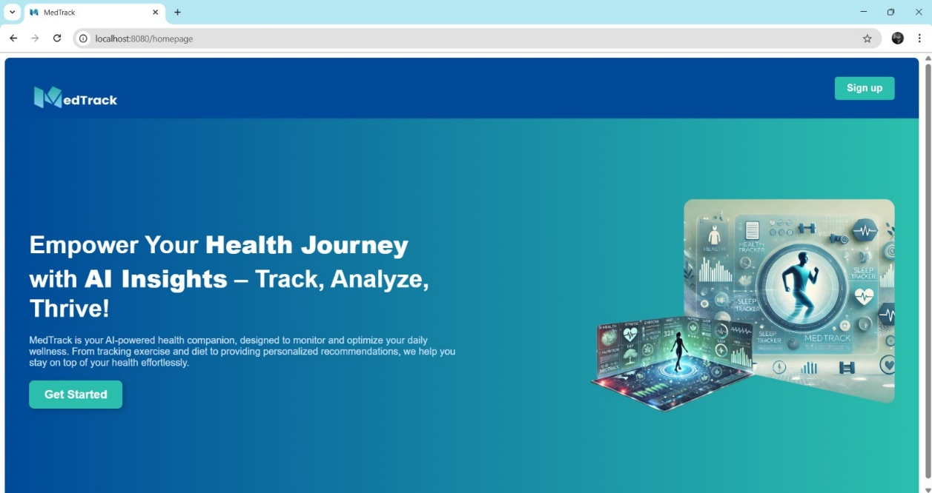
Figure 5. 1: Homepage

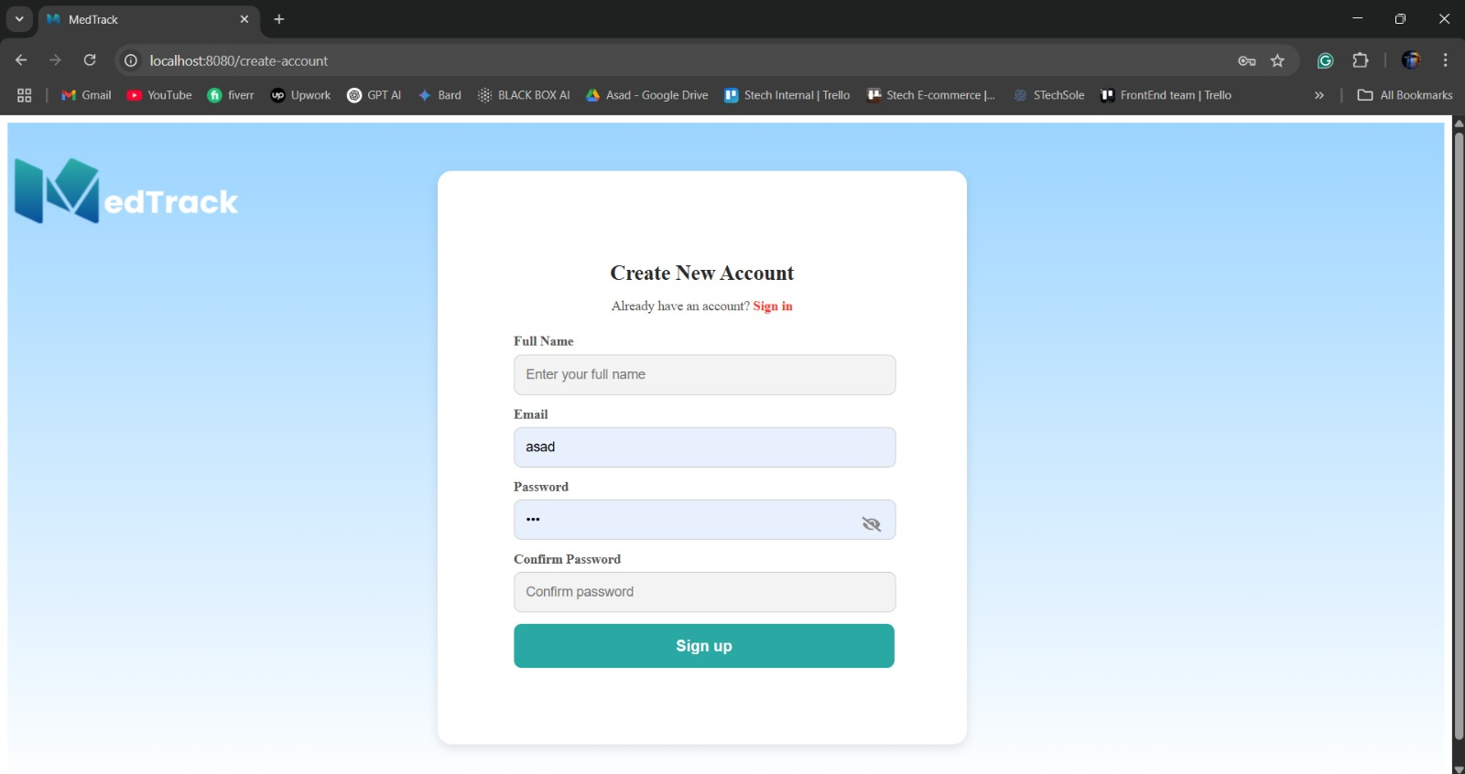
Figure 5. 2: Create Account

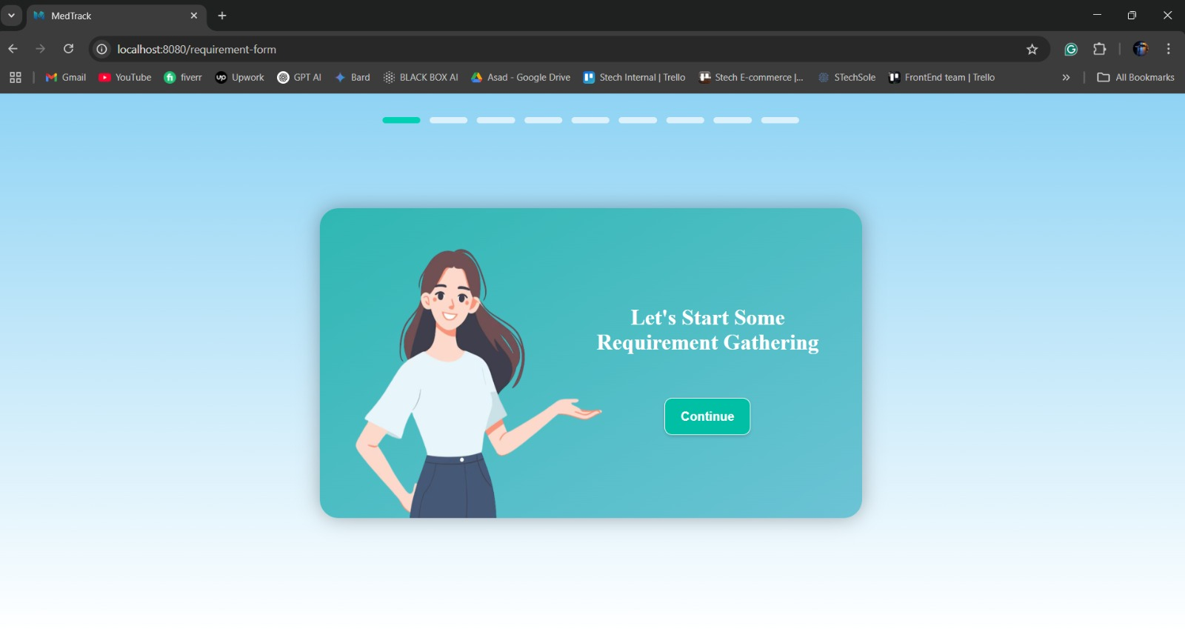
Figure 5. 3: Requirement Gathering Slider Screen 1

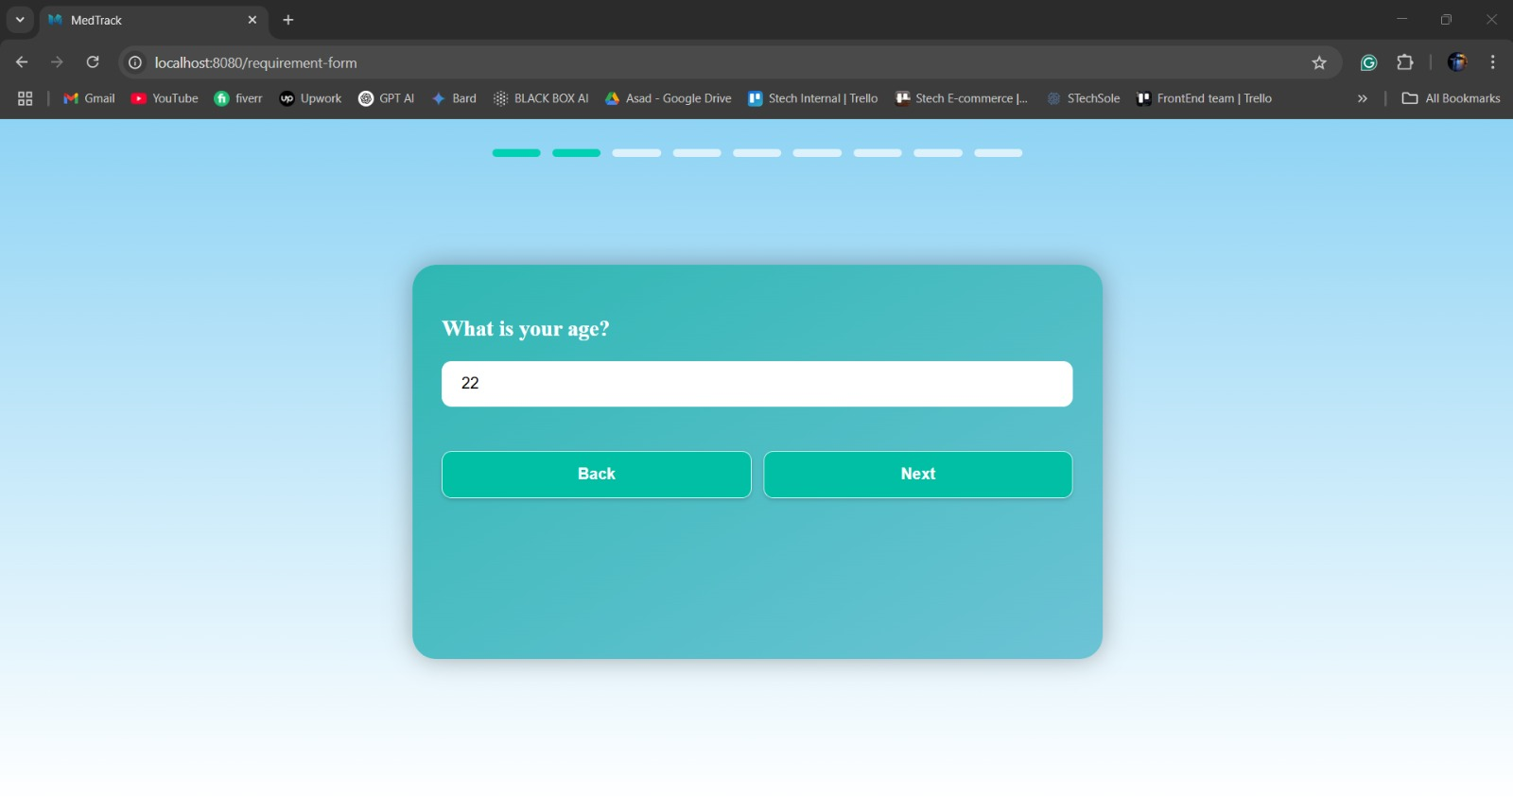
Figure 5. 4: Requirement Gathering Slider Screen 1
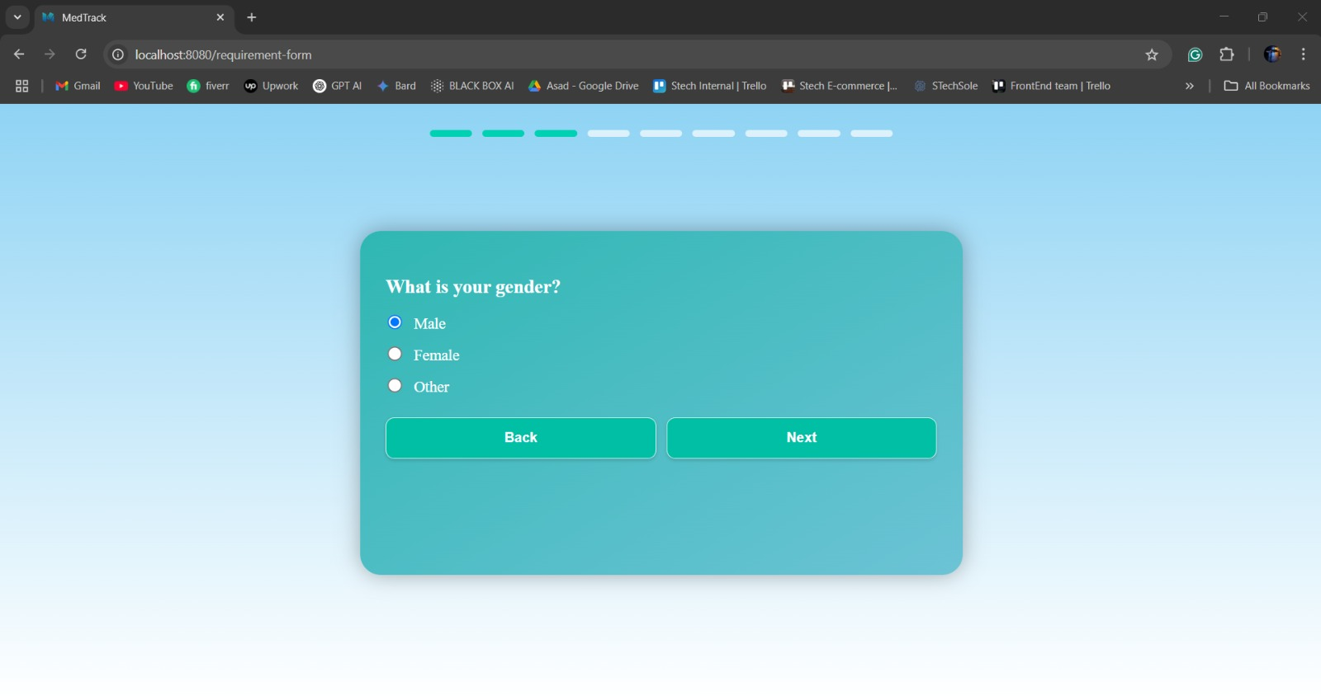
Figure 5. 5 :Requirement Gathering Screen 3

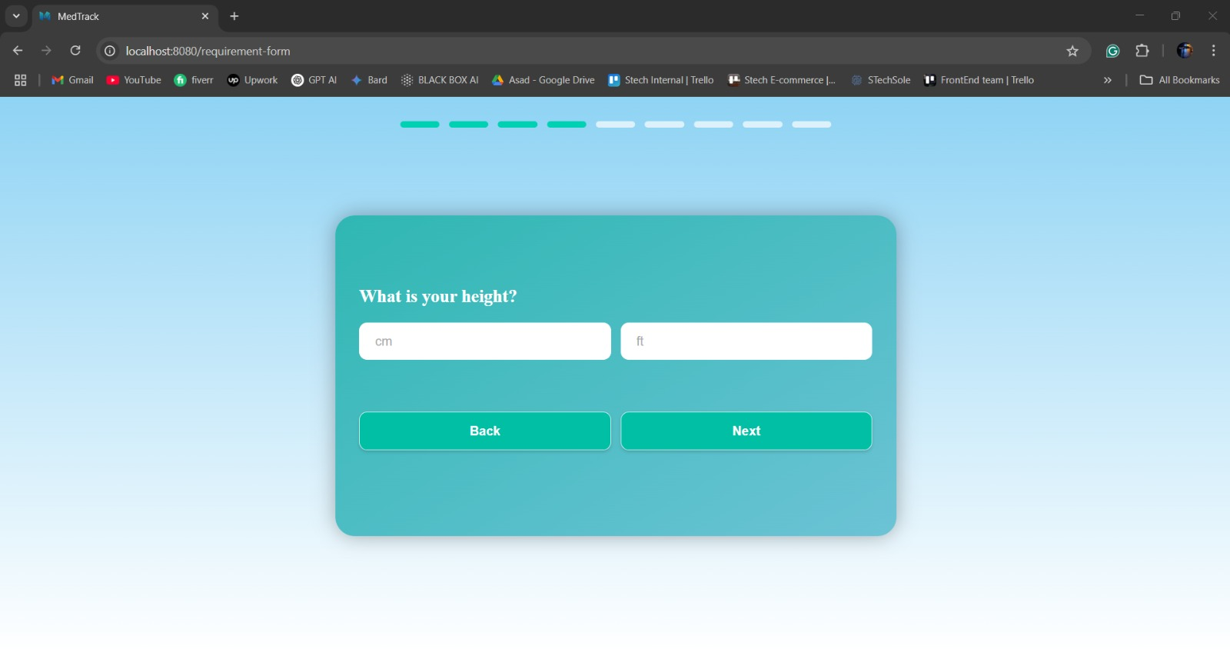
Figure 5. 6: Requirement Gathering Screen 4
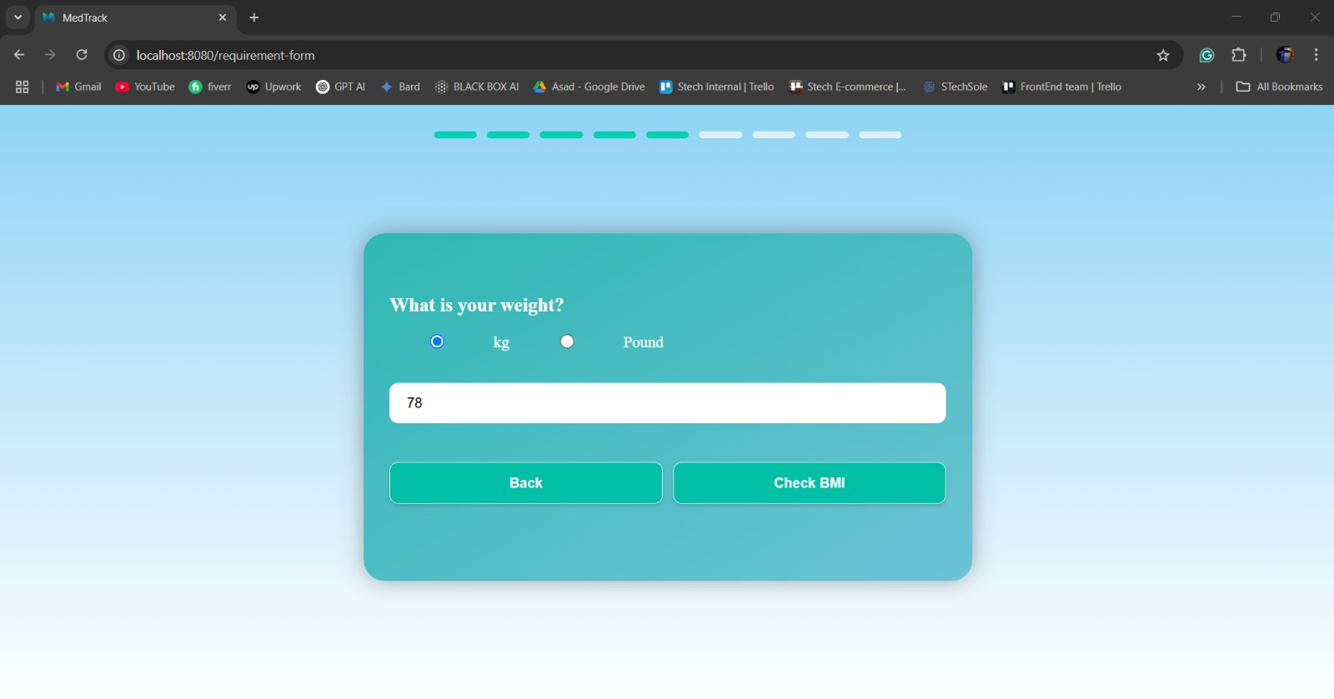
Figure 5. 7: Requirement Gathering Screen 5

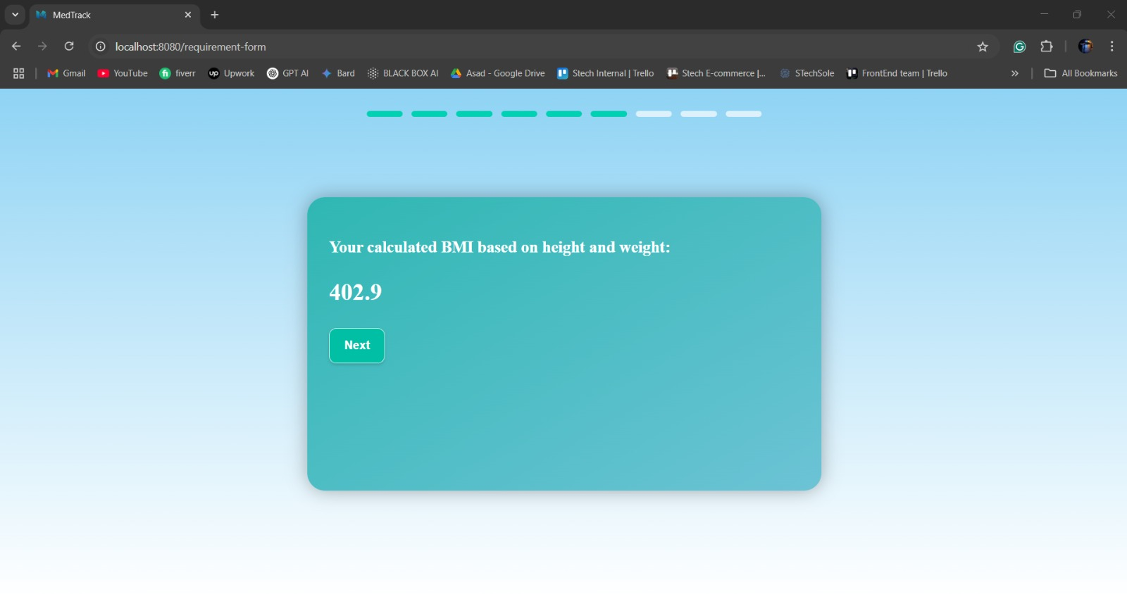
Figure 5. 8: Requirement Gathering Screen 6
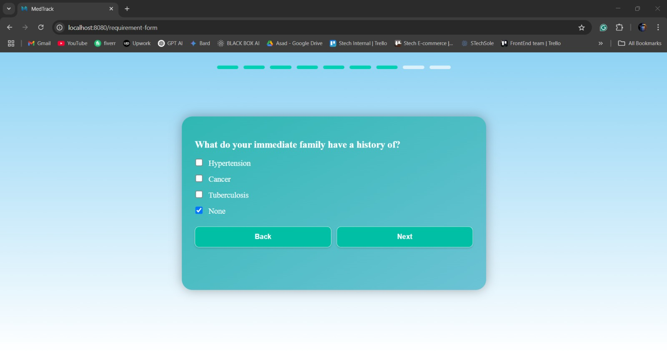
Figure 5. 9: Requirement Gathering Screen 7

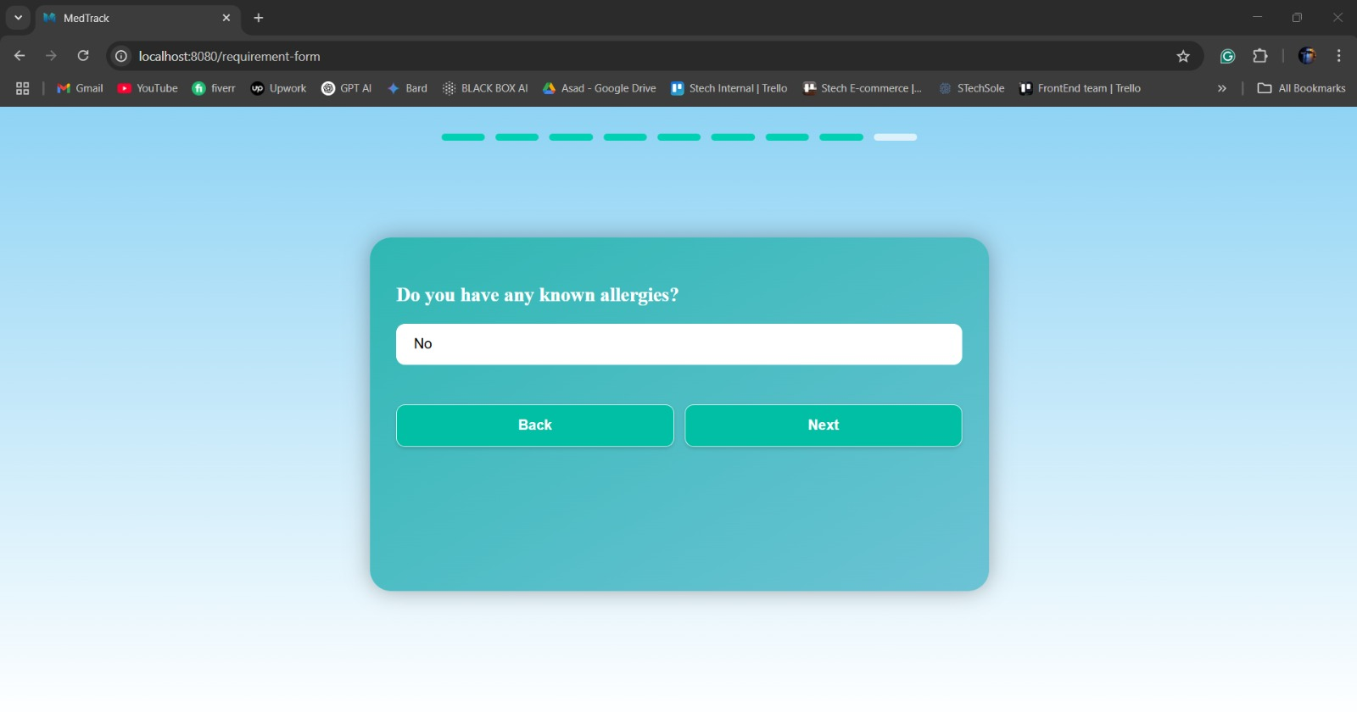
Figure 5. 10: Requirement Gathering Screen 8
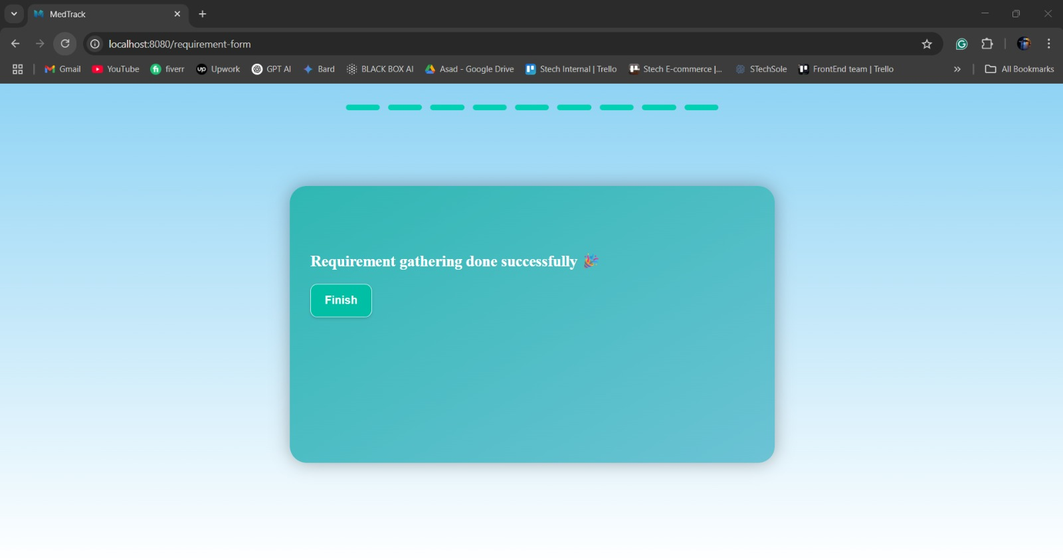
Figure 5. 11: Requirement Gathering Screen 9

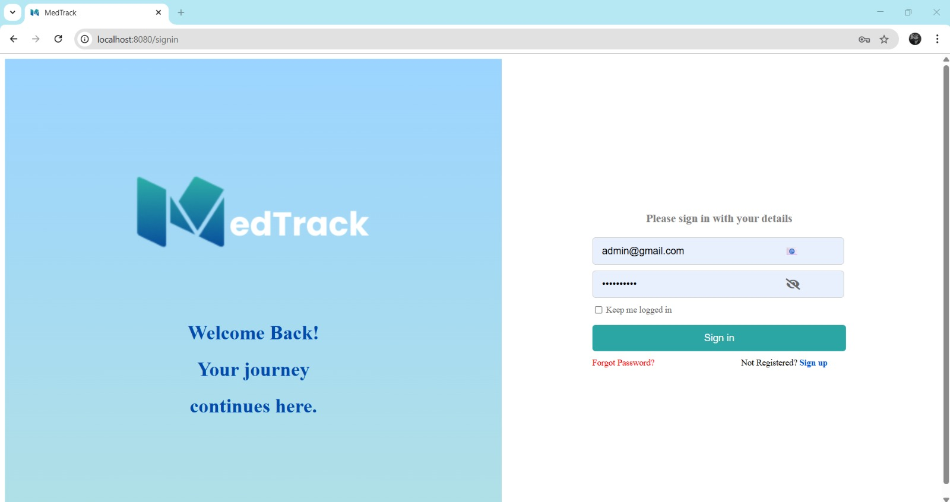
Figure 5. 12: Sign in page

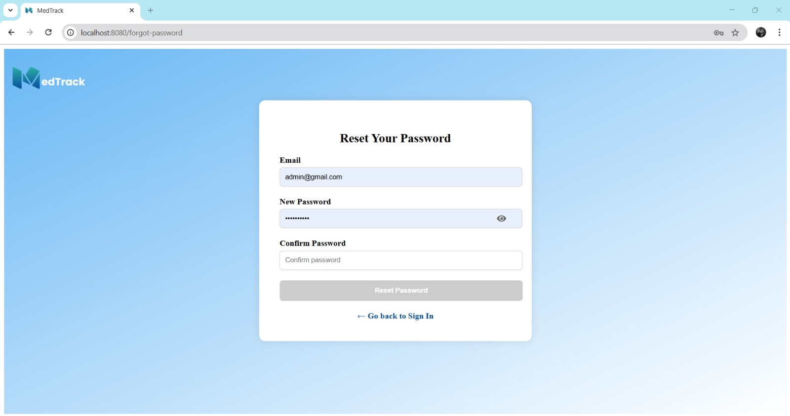
Figure 5. 13: Reset Password

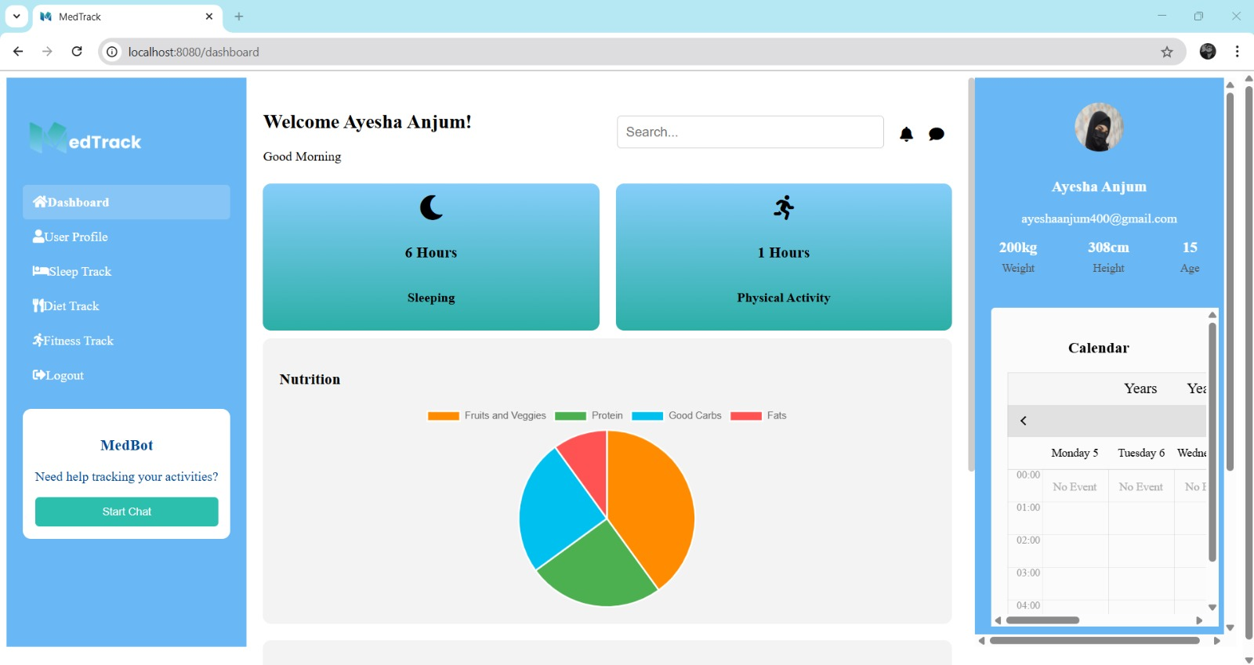
Figure 5. 14: User Dashboard
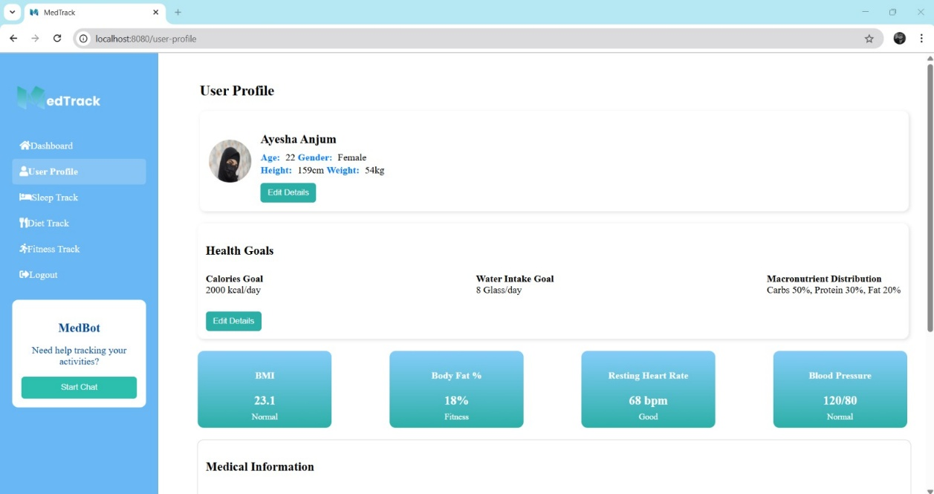
Figure 5. 15: User Profile

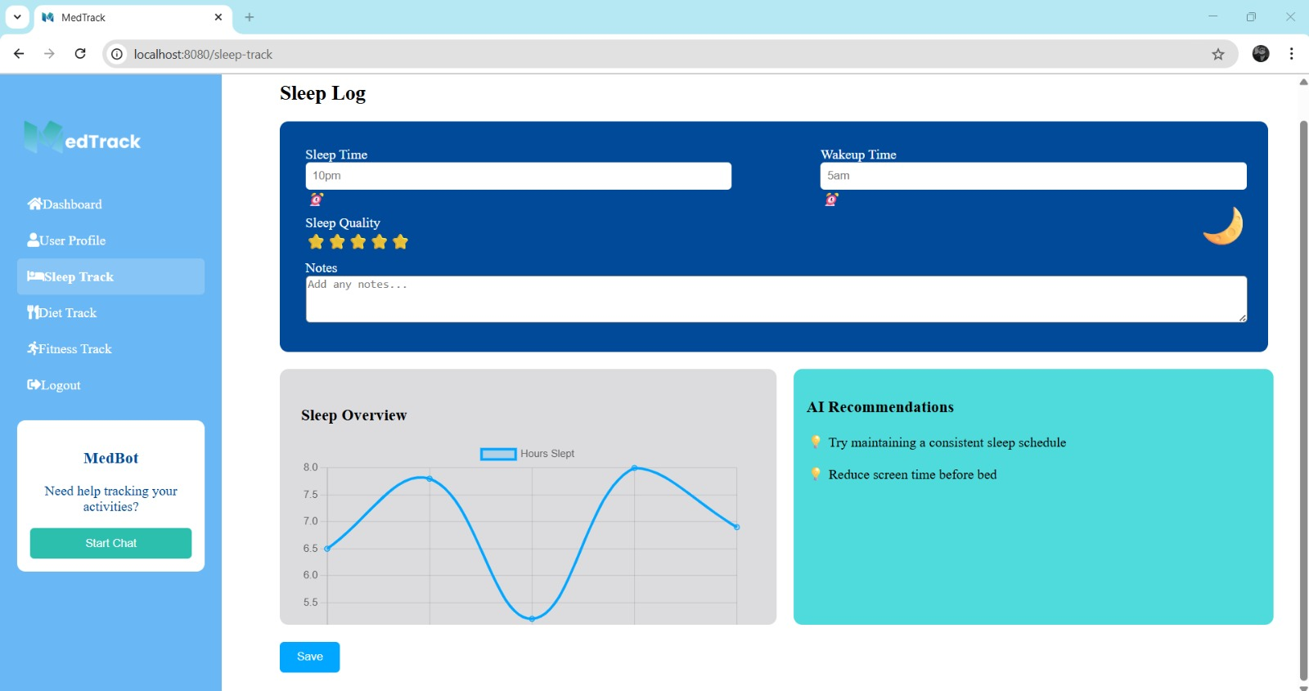
Figure 5. 16: Sleep Track Page
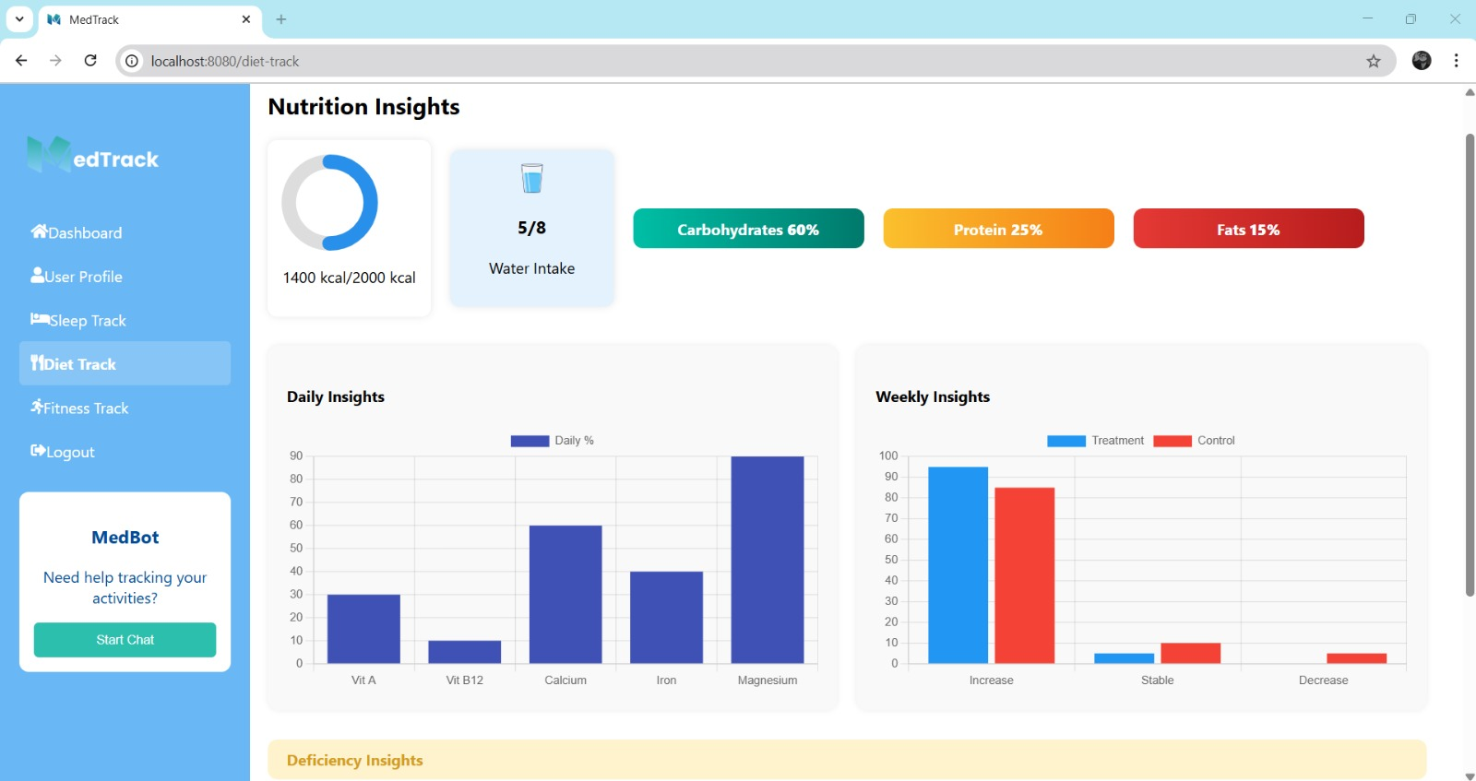
Figure 5. 17: Diet Track Page

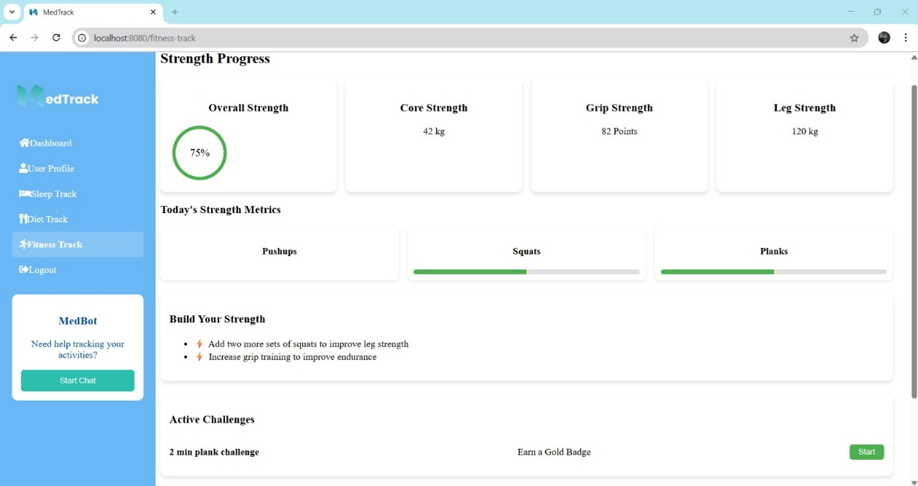
Figure 5. 18: Fitness Track Page
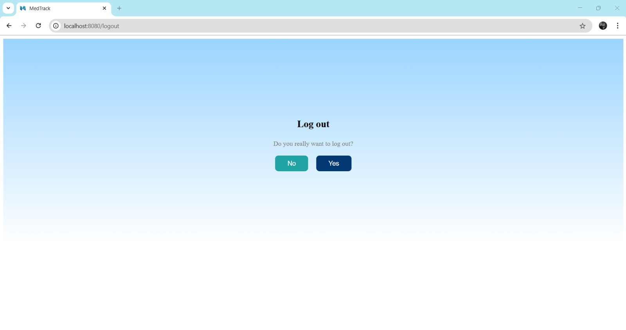
Figure 5. 19: User logout

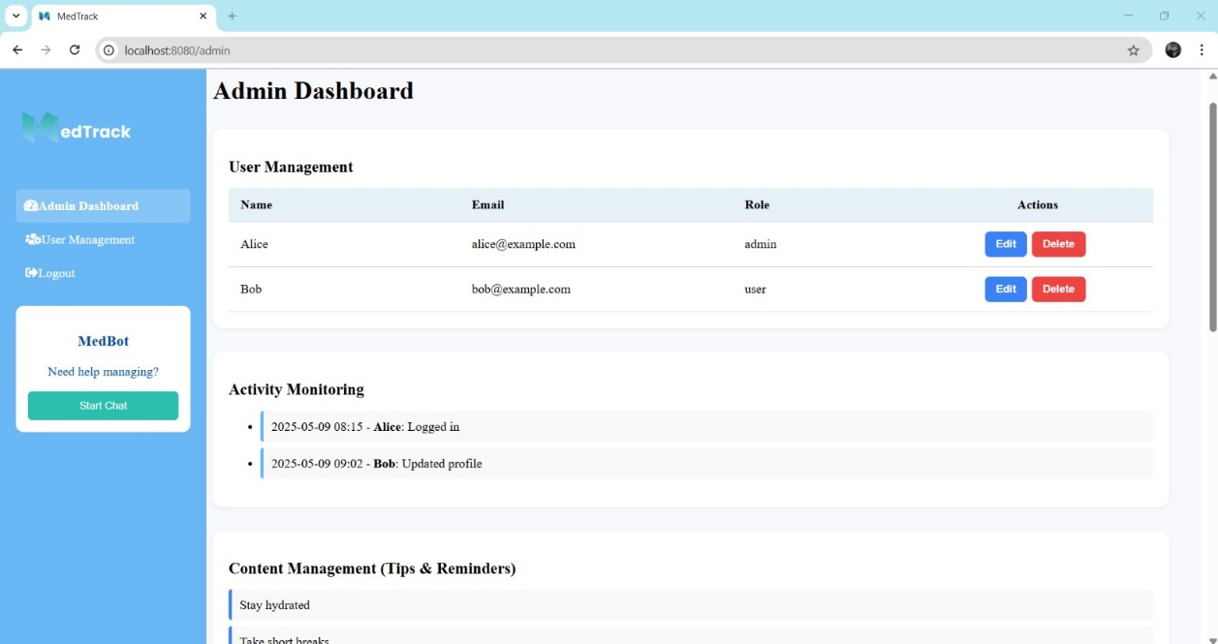
Figure 5. 20: Admin Dashboard
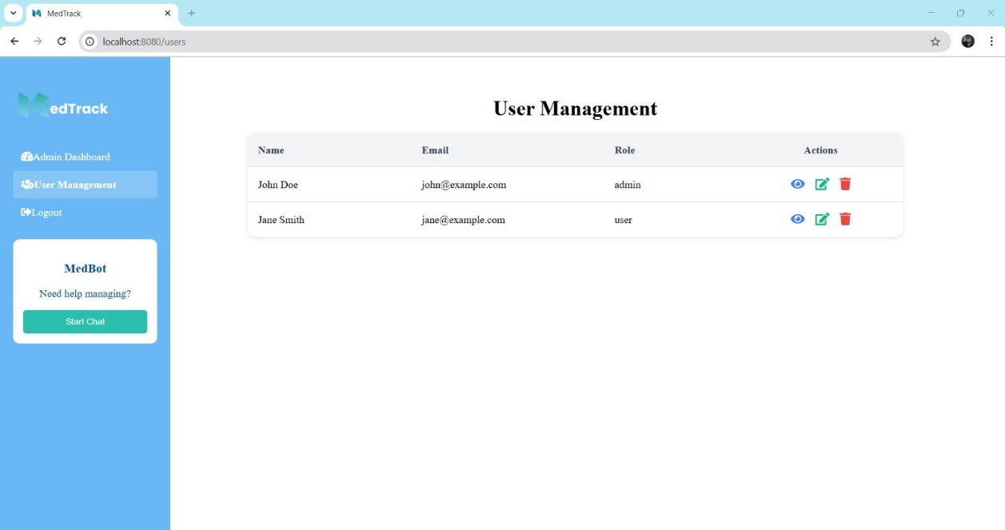
Figure 5. 21: User Management

CONCLUSION AND RECOMMENDATIONS

Conclusion
In summary, our project tackles the most pressing issues in personal health management, where the intricacies people experience in living a balanced life because of busy lifestyles and poor health consciousness are at the center. The issues, from irregular daily routines to the lack of tailored health advice, affect the well-being of individuals, long-term health status, and healthcare resource management significantly. Our contribution is crucial in highlighting these rising issues as the public becomes more focused on preventive care and health information-based decision-making. Our objectives are to enable users, foster accountability of daily health behaviors, and facilitate the availability of trusted, AI-driven advice for better lifestyle management and health.

Recommendations
The model can be deployed in real-time environment for better lifestyle of normal public. The model can be more refined later after launch and getting data from the real environment. So that model gives user more precise, desired, and accurate results.

REFERENCES

[1] | R. De Michele and M. Furini, “IoT Healthcare: Benefits, Issues and Challenges,” in Proceedings of the 5th EAI international conference on smart objects and technologies for social good, 2019.
[2] | M. M. Baig and H. Gholamhosseini, “Smart health monitoring systems: an overview of design and modeling,” Journal of medical systems, vol. 37, pp. 1--14, 2013.
[3] | M. a. S. C. a. N. M. a. L. I. a. S. P. a. N. J. M. Sharma, “Artificial intelligence applications in health care practice: scoping review,” Journal of medical Internet research, vol. 24, pp. 1438-8871, 2022.
[4] | D. Jin, H. Halvari, N. Maehle and A. H. Olafsen, “Self-tracking behaviour in physical activity: a systematic review of drivers and outcomes of fitness tracking,” Behaviour \& Information Technology, vol. 41, pp. 242--261, 2022.
[5] | K. a. A. R. a. K. H. D. a. K. A. a. N. S. a. A. U. R. Kakhi, “The internet of medical things and artificial intelligence: trends, challenges, and opportunities,” Biocybernetics and Biomedical Engineering, vol. 42, pp. 749--771, 2022.
[6] | Y. Liu and M. Avello, “Status of the research in fitness apps: A bibliometric analysis,” Telematics and Informatics, vol. 57, pp. 0736-5853, 2021.
[7] | S. Choi and others, “Personal health tracking: A paradigm shift in the self-care models in nursing,” JMIR nursing, vol. 6, pp. 50-991, 2023.
[8] | P. Pawar, N. Parolia, S. Shinde, T. O. Edoh and M. Singh, “eHealthChain—a blockchain-based personal health information management system,” Annals of Telecommunications, vol. 77, pp. 33--45, 2022.
[9] | S. Abbasgholizadeh Rahimi, F. Légaré, G. Sharma, P. a. Z. H. T. V. Archambault, S. Chandavong, N. Rheault, S. T Wong, L. Langlois, Y. Couturier and others, “Application of artificial intelligence in community-based primary health care: systematic scoping review and critical appraisal,” Journal of Medical Internet Research, vol. 23, pp. 1438-8871, 2021.
[10] | A. Shaim, “Kaggle Dataset,” 2025. [Online]. Available: https://www.kaggle.com/datasets/adilshamim8/workout-and-fitness-tracker-data.
[11] | A. Shamim, 2025. [Online]. Available: https://www.kaggle.com/datasets/adilshamim8/workout-and-fitness-tracker-data.
[12] | L. Tharmalingam, 2023. [Online]. Available: https://www.kaggle.com/datasets/uom190346a/sleep-health-and-lifestyle-dataset.

APPENDICES

APPENDIX A: Language Links
CSS: https://www.w3.org/Style/CSS/Overview.en.html

Larvel 10: https://laravel.com/

MySQL: https://www.mysql.com/

Vue.js: https://vuejs.org/

Python 3.10: https://www.python.org/downloads/release/python-3100/

APPENDIX B: Tool Links
Google Colab: https://colab.research.google.com/

PHP.net: https://www.php.net/

Visual Studio Code: https://code.visualstudio.com/

XAMPP: https://www.apachefriends.org/
Composer: https://getcomposer.org/download/

