
BSCS-F24-011

03-134212-062 | MUHAMMAD HARIS YASIR
03-134212-075 | MUHAMMAD UMAR TARIQ

Leveraging AI for Early Detection of Depression from Text
In partial fulfilment of the requirements for the degree of
Bachelor of Science in Computer Science
Supervisor: Dr. Nadeem Sarwar

Department of Computer Sciences
Bahria University, Lahore Campus
June 2025

© Bahria University, 2025


Certificate

We accept the work contained in the report titled
“Leveraging AI for Early Detection of Depression from Text”
written by
Muhammad Umar Tariq and Muhammad Haris Yasir
as a confirmation to the required standard for the partial fulfilment of the degree of
Bachelor of Science in Computer Science.

Approved by:
Supervisor: Dr. Nadeem Sarwar
(Signature)

05 June 2025

DECLARATION

I hereby declare that this project report is based on my original work except for citations and quotations which have been duly acknowledged. I also declare that it has not been previously and concurrently submitted for any other degree or award at Bahria University or other institutions.

Enrolment | Name | Signature
03-134212-062 | Muhammad Haris Yasir
03-134212-075 | Muhammad Umar Tariq

Date : 05 June 2025

Specially dedicated to
my beloved grandmother, mother and father
(Muhammad Umar Tariq)
my beloved grandmother, mother and father
(Muhammad Haris Yasir)

ACKNOWLEDGEMENTS

I would like to thank everyone who had contributed to the successful completion of this project. I would like to express my gratitude to my research supervisor, Dr. Nadeem Sarwar for his invaluable advice, guidance and his enormous patience throughout the development of the research.

In addition, I would also like to express my gratitude to my loving parent and friends who had helped and given me encouragement.

Muhammad Umar Tariq
Muhammad Haris Yasir

Project Title
Leveraging AI for Early Detection of Depression from Text

ABSTRACT

Depression is a highly common mental disorder. Depression is characterized by depressed mood or loss of interest in activities for a duration of time. Despite being so prevalent, early detection is often hampered by stigma and unawareness. This project is to develop an application that analyzes users' written responses to mental health questions to detect depression and provide real-time predictions.
The suggested methodology is collection of user inputs in the form of responses to predefined questions regarding mental health through a mobile application. The text inputs are fed into NLP-based tokenization, lemmatization, and vectorization (TF-IDF and Word2Vec) processes. A hybrid approach is taken for ensemble learning, using a traditional machine learning model (LinearSVC) and a deep learning model (BiLSTM), to process the input and provide real-time depression predictions through hard voting. Experimental results show that the ensemble model is better than individual models in F1-score and accuracy, at a maximum accuracy of 93% in classifying different types of multiple depression conditions like Major Depressive, Bipolar, Postpartum, and Atypical Depression. The system is interfaced directly in a Flutter-enabled mobile app so that the users can self-test and safely store results for regular mental health checkups. The project makes it possible for individuals to continuously monitor their mental wellbeing, facilitate early intervention, and facilitate contact with medical professionals

TABLE OF CONTENTS

DECLARATION ii
ACKNOWLEDGEMENTS iii
ABSTRACT iv
TABLE OF CONTENTS v
LIST OF TABLES viii
LIST OF FIGURES ix
LIST OF SYMBOLS / ABBREVIATIONS xi
LIST OF EQUATIONS xiii

Table of Contents
CHAPTER 1 1
1 INTRODUCTION 1
1.1 Background 2
1.2 Problem Statements 2
1.3 Aims and Objectives 2
1.4 Scope of Project 3
CHAPTER 2 4
2 LITERATURE REVIEW 4
2.1 Literature Review Summary 10
2.2 Chapter Summary 16
CHAPTER 3 17
3 METHODOLOGY 17
3.1 Proposed Methodology 17
3.2 Data Collection from twitter 18
3.3 Depressed Individuals Use the App 18
3.4 Raw Data Acquisition 18
3.5 Data Preprocessing Phase 18
3.6 Ensemble Learning with Hard Voting 19
3.7 Performance Metrics 20
3.8 Give Final Result 21
3.9 Summary 21
3.10 User Classes and Characteristics 22
3.11 User Interface 24
3.12 Use Case Diagrams 30
3.13 Use case name and identifier 31
3.14 Test Case 47
3.15 Domain Model 55
3.16 Sequence Diagram 56
3.17 Class Diagram 66
3.18 Entity Relationship Diagram 67
CHAPTER 4 68
4 IMPLEMENTATION 68
4.1 Dataset 68
4.2 Technology Stack 69
4.3 Exploratory Data Analysis (EDA) 70
4.4 Data Preprocessing 72
4.5 Feature Extraction 73
4.6 Machine Learning Model 73
4.7 Deep Learning Model 75
4.8 Ensemble Learning (Hard Voting) 76
4.9 Model Evaluation 77
4.10 Backend Integration using FastAPI 77
4.11 Flutter Frontend Implementation 78
CHAPTER 5 80
5 RESULTS AND DISCUSSIONS 80
5.1 Overview of Model Performance 80
5.2 Per-Class Performance and Confusion Analysis 80
5.3 Comparative Evaluation with Prior Work 81
5.4 Real-Time Application Performance 82
5.5 Discussion 82
5.6 Summary 83
CHAPTER 6 84
CONCLUSION AND RECOMMENDATIONS 84
6.1 Conclusion 84
6.2 Future work 84
REFERENCES 85

LIST OF TABLES

TABLE TITLE PAGE
Table 2.1: Literature Review Summary 10
Table 3.1: Manage Users Use Case Table of Admin 31
Table 3.2: Manage Appointments Use Case Table of Admin 32
Table 3.3: Manage Invoice Use Case Table of Admin 32
Table 3.4: Handle Complaints Use Case Table of Admin 33
Table 3.5: System Maintenance Users Use Case Table of Admin 34
Table 3.6: Registration Use Case Table of Patient 34
Table 3.7: Login Use Case Table of Patient 35
Table 3.8: Take Depression Test Use Case Table of Patient 35
Table 3.9: View Depression Report Use Case Table of Patient 36
Table 3.10: Search Doctors Use Case Table of Patient 36
Table 3.11: View Doctor Profile Use Case Table of Patient 37
Table 3.12: Book Appointments Use Case Table of Patient 37
Table 3.13: Join Online Meeting Use Case Table of Patient 38
Table 3.14: Chat with Doctor Use Case Table of Patient 38
Table 3.15: Rate and Review Use Case Table of Patient 39
Table 3.16: View Medical History Use Case Table of Patient 39
Table 3.17: Logout Use Case Table of Patient 40
Table 3.18: Registration Use Case Table of Doctor 40
Table 3.19: Login Use Case Table of Doctor 41
Table 3.20: Manage Profile Use Case Table of Doctor 41
Table 3.21: Manage Availability Use Case Table of Doctor 42
Table 3.22: View Patient Lis Use Case Table of Doctor 42
Table 3.23: Accept/Reject Appointments Use Case Table of Doctor 43
Table 3.24: View Patient Report Use Case Table of Doctor 43
Table 3.25: Join Online Meeting Use Case Table of Doctor 44
Table 3.26: Chat with Patient Use Case Table of Doctor 44
Table 3.27: Write Prescriptions Use Case Table of Doctor 45
Table 3.28: Logout Use Case Table of Doctor 45
Table 3.29: Test Cases of Admin 47
Table 3.30: Test Cases of Patient 49
Table 3.31: Test Cases of Doctor 53
Table 4.1: Dataset Distribution 69
Table 4.2: Technology Stack 69
Table 4.3: Accuracy of Models 74
Table 5.1: Comparison of Proposed Model 81

LIST OF FIGURES

FIGURE TITLE PAGE
Figure 3.1: Phases of Depression Model 17
Figure 3.2: Flow Chart of Depression Model 19
Figure 3.3: Welcome Interface of Application 24
Figure 3.4: Sign In/Sign Up Interface of Application 24
Figure 3.5: Patient's Home Interface of Application 25
Figure 3.6: Patient's Depression Test Interface of Application 25
Figure 3.7: Patient's Daily Wellness Interface of Application 26
Figure 3.8: Patient's Wellness Insights Interface of Application 26
Figure 3.9: Patient's Doctor Interface of Application 27
Figure 3.10: Patient's Chat Interface of Application 27
Figure 3.11: Patient's Community Interface of Application 28
Figure 3.12: Patient's Profile Interface of Application 28
Figure 3.13: Landing Page of Website 29
Figure 3.14: Depression Test of Website 29
Figure 3.15: Use Case Diagram of Admin 30
Figure 3.16: Use Case Diagram of Patient 30
Figure 3.17: Use Case Diagram of Doctor 31
Figure 3.1: Domain Model Diagram 55
Figure 3.2: Login Sequence Diagram 56
Figure 3.3: Profile Management Sequence Diagram of Admin 57
Figure 3.4: Monitor Sequence Diagram of Admin 57
Figure 3.5: Invoice Management Sequence Diagram of Admin 58
Figure 3.6: Complaints Management Sequence Diagram of Admin 58
Figure 3.7: System Management Sequence Diagram of Admin 59
Figure 3.8: Registration Sequence Diagram of Patient 60
Figure 3.9: Profile Management Sequence Diagram of Patient 60
Figure 3.10: Depression Test Sequence Diagram of Patient 61
Figure 3.11: Relation with Doctor Sequence Diagram of Patient 61
Figure 3.12: Medical History Sequence Diagram of Patient 62
Figure 3.13: Quick Actions Sequence Diagram of Patient 62
Figure 3.14: Daily Tips Sequence Diagram of Patient 63
Figure 3.15: Community Section Sequence Diagram of Patient 63
Figure 3.16: Registration Sequence Diagram of Doctor 64
Figure 3.17: Profile Management Sequence Diagram of Doctor 64
Figure 3.18: Relation with Patient Sequence Diagram of Doctor 65
Figure 3.19: Class Diagram 66
Figure 3.20: Entity Relationship Diagram 67
Figure 4.1: Bar graph of Depression Types 70
Figure 4.2: Word Cloud of Tweets 71
Figure 4.3: Box Plot of Depression Types 71
Figure 4.4: Steps of Depression Detection 72
Figure 4.5: Bar Graph of Models Accuracy 74
Figure 4.6: Bar Graph of ML vs DL 75
Figure 4.7: Integration of FastAPI 78
Figure 5.1: Bar Graph of Proposed Model 82

LIST OF EQUATIONS

Equation TITLE PAGE
Equation 3.1: Accuracy 20
Equation 3.2: Precision 20
Equation 3.3: Recall 20
Equation 3.4: F1-Score 21

LIST OF SYMBOLS / ABBREVIATIONS

Abbreviations Full form
AI Artificial Intelligence
ML Machine Learning
DL Deep Learning
SVC Support Vector Classifier
LR Logistic Regression
RF Random Forest
DT Decision Tree
KNN K-Nearest Neighbors
RNN Recurrent Neural Network
LSTM Long Short-Term Memory
BiLSTM Bidirectional Long Short-Term Memory
BERT Bidirectional Encoder Representations from Transformers
NLP Natural Language Processing
BoW Bag of Words
TF-IDF Term Frequency-Inverse Document Frequency
F-measure F1-Score
TP True Positive
TN True Negative
FP False Positive
FN False Negative
SDLC Software Development Life Cycle
SE Software Engineering
FR Functional Requirement
NFR Non-Functional Requirement

INTRODUCTION

Depressive disorders are the leading mental diseases globally, and they impact about 360 million people [1]. The World Health Organization identifies almost 800,000 cases of suicide every year caused by depression [2], and the global prevalence of depression increased by 25% during the initial year of the COVID-19 pandemic [3]. Although severe, over 70% of people depressed do not attempt to receive help from professionals during early stages of depression [4]. A myriad of factors fuels this disparity that includes the considerable expense and time involved in receiving therapy, societal stigma, as well as lack of social isolation. Conventional diagnostic procedures, like face-to-face evaluations and standardized interviews, tend to be inaccessible, costly, and based on patients' cooperation to reveal their emotional state, something not everyone is willing to do.
By comparison, the digital era has spawned new ways of expressing emotions. Sites such as Twitter are in-the-moment emotional release valves, where individuals frequently write frank thoughts and emotions. Such expressions, although not addressed to a therapist, can be rich sources of data to understand mental health. This study takes advantage of that possibility by suggesting an AI-based system that examines tweets to identify not only the occurrence of depression, but also its form including bipolar, atypical, psychotic, major depressive, and postpartum depression.
In contrast to binary classification frameworks which merely identify the presence of depression, this piece of work presents a finer level of classification. The backend consists of an ensemble of a traditional LinearSVC model (trained on TF-IDF features) and a BiLSTM deep learning model (trained on Word2Vec embeddings), which are combined via hard voting to achieve better accuracy as well as generalization. The whole system is presented via a Flutter-based mobile app for facilitating real-time, user-friendly interaction. This method of management provides an easily scalable, private, and convenient means of ongoing mental health evaluation, allowing individuals to track their emotional state over time and take prompt action when signs of depression are found.

Background
Depression is a common mental disorder that involves prolonged sadness or absence of pleasure in everyday activities. It affects millions of people all over the world, with close to suicides each year as a consequence. As much as it is common among people depressed individuals do not go for early medical treatment owing to issues like stigma, lack of resources and economic constraints. Traditional diagnostic approaches such as face-to-face interviewing, are time-consuming and out of reach for most. The pressing necessity of breaking down such barriers points towards the critical role of novel solutions for the early detection and treatment of depression.

Problem Statements
Early diagnosis of depression is important in preventing its worse effects such as suicide risk. Yet, the conventional diagnostic practices are inaccessible, costly and stigmatized. Professional consultations are shunned by many because of fear of what others might say or the costs involved, thus resulting in delayed diagnoses. Available tools cannot make personalized real-time mental health diagnostics in a subtle way. This project remedies these challenges using state-of-the-art deep learning methods to implement an accessible, private and fast solution for identifying depression from user-provided text inputs.

Aims and Objectives
The purposes and goals of the application are as follows:
- Create and implement a text-based, friendly app where users respond to some questions, and the model identifies the initial symptoms of depression from the answers users provide and the score of severity
- Users are able to monitor their health in the long run with a record of evaluations they provide to an app.
- To seek help, users can also communicate with healthcare professionals via chat or live video calls.
- Remind users to fill out their tests on a daily basis and send reminders with mental health advice or resources.
- Build communities for users going through the same battle. Within these communities, users can post about their stories and ask advice from others in a private setting.

Scope of Project
The project involves developing a robust and scalable depression detection application with the following scope:
Primary Scope:
- Build an AI based system that analyzes user text responses to identify depression and assess its severity.
- Develop a mobile application for real-time assessments with features for user authentication, history tracking and integration with healthcare professionals.
- Employ advanced machine learning models for accurate predictions.
Optional Scope:
- It may offer multi-language support to cater to a wider audience.
- In the future, the app will also have an audio and video feature to identify symptoms of depression earlier.
This project is intended to empower people with an easy-to-use, confidential and efficient means of tracking and controlling their mental health and enabling timely intervention through expert care.

LITERATURE REVIEW

The detection of depression through text analysis has been in the spotlight recently owing to its ability to fight the growing epidemic of mental illness. With the dawn of social media and web-based platforms, an excess of large-scale text corpora have existed as precious resources in understanding and detecting depressive states. Deep learning models are now also powerful tools for analyzing text data, dependent on their ability to discover complex semantic, contextual, and linguistic patterns. The literature review attempts to provide an overview of developments in depression detection from text using deep learning approaches. Through a comparison of various models, datasets, performance metrics, and contributions, this review discerns the effectiveness of various approaches and their implications for early mental health screening and intervention.
Chen et al. proposed a novel approach to detecting individuals with depression using a hybrid deep learning framework, SBERT-CNN, which combines the semantic embedding capacity and ability of pre-trained Sentence-BERT (SBERT) and the feature extraction capability of Convolutional Neural Networks (CNN). The framework is trained on the Self-Reported Mental Health Diagnoses (SMHD) dataset, which is a collection of Reddit posts of mental health patients. The SBERT-CNN worked extremely well with higher performance than traditional machine learning models (e.g., SVM) and other deep neural models (CNN, LSTM, and HAM) with a 0.86 F1 score, 0.85 precision, and 0.87 recall. The ability of the model to embed semantic and contextual text features and CNN's capacity to extract spatial features make it extremely efficient in detecting patterns of depression. The study brings to light how the hybrid structures can transform the diagnosis of mental illnesses with text analysis​ [3].
Uddin et al. proposed an innovative deep learning model for depressive symptom prediction based on a vastly large dataset gathered from ung.no, an online public information portal for Norwegian youth. The study employs domain knowledge from medical professionals as well as psychological professionals in making deductions about new features related to depressive symptoms to improve the ability of the model to identify significant patterns from text. Using a Recurrent Neural Network (RNN) with Long Short-Term Memory (LSTM) layers, attention mechanisms, and dense layers, the model is able to efficiently extract emotional states from the text. Using this method has achieved superior performance metrics such as an F1 score, precision, and recall of 0.98, which indicates the stability and trustworthiness of the model in detecting depressive symptoms. The combination of domain knowledge and more sophisticated neural structures highlights the value of this approach to be a valuable contribution to early mental health screening [5].
Lin et al. introduced a deep learning-powered model for detecting depression automatically from the Distress Analysis Interview Corpus Wizard-of-Oz (DAIC-WoZ) corpus. The model applies a BiLSTM network, supplemented by an attention mechanism to capture sequential dependencies and relevant text features predictive of depression. With its linguistics content aware attention, the model effectively manages textual inputs for identifying depressive behaviors. With an F1 score, precision, and recall of 0.83, the method demonstrates its ability to balance accuracy and reliability in detecting depression. This research highlights the importance of using attention mechanisms in sequential models to improve the interpretation of linguistic features of depression [6].
Amanat et al. proposed a robust deep learning approach for detecting depressive traits from a tweets-scraped depression dataset. The study extracts meaningful features from text data using One-Hot encoding and Principal Component Analysis (PCA), which effectively detects depression symptoms and sentiments. The proposed model combines Long Short-Term Memory (LSTM) networks and two hidden states and high bias factors and a two-hidden-layer Recurrent Neural Network (RNN) to enhance its predictive power. The model was extremely accurate with an accuracy of 0.98 and F1 score and recall of 0.99, reflecting its success in the early diagnosis of depression. This research outlines the potential of integrating innovative feature extraction with deep learning models in social media data processing and identifying mental illness problems. [7].
Chiong et al. conducted an in-depth review of detection of depression using various machine learning algorithms, such as Support Vector Machine (SVM), Multilayer Perceptron (MLP), Logistic Regression (LR), Decision Tree (DT), Naïve Bayes (NB), Maximum Entropy (ME), K-Nearest Neighbours (KNN), Adaptive Boosting (AB), Random Forest (RF), Gradient Boosting (GB), and Bagging Predictors (BP). These were evaluated on two publicly labeled Twitter datasets Eye and Shen et al. with highly encouraging results. On the Eye dataset, Logistic Regression (LR), SVM, and Decision Tree (DT) achieved a near-ideal F1 score, precision, and recall of 0.99, while MLP was a bit lower at an F1 score of 0.97. The same was true for the Shen et al. dataset, in which LR, SVM, and DT models all achieved a perfect score of 0.99 on all the metrics. The study contributes to mental health research and natural language processing by proposing a generalized machine learning model for depression detection, demonstrating the capability of various models to recognize depressive traits from text data [8].
Thekkekara (2024) proposed a deep learning framework for depression detection by using an attention-based CNN-BiLSTM (CBA) model for text data from the CLEF2017 public corpus. The model makes use of Convolutional Neural Networks (CNN) for extracting spatial features and Bidirectional Long Short-Term Memory (BiLSTM) for modeling sequential dependency in text. The addition of an attention mechanism in the model allows it to effectively locate relevant features pertaining to symptoms of depression. The CBA model logged excellent performance measures, such as an F1 score of 0.89, precision of 0.93, and accuracy of 0.96, indicating the effectiveness of the CBA model in the detection of depression. The study brings forth the effectiveness of deep learning models enhanced through attention in improving the detection of mental health via text analysis [9].
Priya et al. proposed a collaborative modelling approach for depression detection using a suite of machine learning models, i.e., Naïve Bayes (NB), Decision Tree (DT), Random Forest (RF), Support Vector Machine (SVM), and K-Nearest Neighbours (KNN). As per the DASS-21 dataset, the approach yielded an F1 score of 0.83, precision of 0.82, and recall of 0.85, better than the current single-task learning (STL) and multi-task learning (MTL) methods. The study noted that the online discourse in web forums contained a broader spectrum of topics than the manifestations of depression, showing the model's capability to detect richer and broader emotional and psychological patterns. The article highlights the effectiveness of ensembling many classifiers for better performance and depth enhancement of depression detection models [10].

Kim et al. designed a system using CNN and XGBoost, to label posts in Reddit from an individual user to different mental disorders such as depression, anxiety, bipolar disorder, borderline personality disorder, schizophrenia, and autism. Using the training data, the system achieved an F1 score of 0.79, with a precision of 0.89 and recall of 0.71 while identifying depressogenic contents, which also indicates a wider identification seen for various other mental suffering conditions. The architecture converts the feature learning from the CNN into a gradient-boosted decision tree feature space that learns both the linguistic subtleties and the decision boundaries effectively from the data. Thus, this research also helps in considering multi-condition classification, especially to improve the mental health examination on various psychological disorders. [11].
Tejaswini et al. developed a hybrid deep learning architecture where a Fully Connected Layer (FCL) amalgamates Long Short-Term Memory (LSTM), Convolutional Neural Networks (CNN), and fasttext embedding to help recognize depression in textual data. The use of fasttext embedding bolstered the capability of the model to capture semantic information, thus enhancing the understanding of the text and feature extraction. The FCL model was evaluated on two datasets, Reddit posts (Dataset 1) and Kaggle Twitter data (Dataset 2), achieving impressive values for performance metrics: F1 score, precision, and recall of 0.87 for Dataset 1 and 0.88 for Dataset 2. The study demonstrates how combining various deep learning techniques with advanced embedding methods for capturing complicated linguistic patterns can substantially advance the research area of depression detection using text.[12].
Enhancing the accuracy of depression detection, Chakraborty et al. have proposed an ensemble classification approach based on the Independent Ensemble Methodology (IEM). The model amalgamates multiple classifiers, namely Support Vector Machine (SVM), Artificial Neural Networks (ANN), and K-Nearest Neighbours (KNN), in order to take advantage of the different strengths of these classifiers. The ensemble was tested on a Kaggle dataset for suicide and depression detection comprising 233,337 entries and was found to perform excellently, with an F1 score and precision of 0.98 and recall of 0.97. The work elaborates on the challenges in diagnosing depression based on isolated statements while thereby demonstrating that automated detection methods can make a substantial contribution to the scientific understanding and early detection of symptoms of depression [13].
Ahmad (2020) proposed a machine learning approach to classify a tweet as "normal" or "depressed" based on such content by employing a Bidirectional Long Short-Term Memory (Bi-LSTM) model. The study utilized word embedding-based feature engineering to better expose the depression-related patterns in textual data. The Bi-LSTM model was characterized to perform well on a Twitter dataset, yielding an F1 score of 0.90, a precision of 0.89, and a recall of 0.91. This study emphasizes the importance of deep learning models in the detection of depression among social media users, thereby providing a scalable tool for early evaluation and intervention in mental health [14].
In detecting various psychiatric disorders, a CNN-based model was suggested by Marriwala 2023, which concentrated primarily on the assessment of depressive states' severity on textual data extracted from the DAIC-WoZ dataset. This research seeks to appropriately identify patterns associated with depression within the text by means of Convolutional Neural Networks. A classification solace in which the used tool comprised an F1 score of 0.60, a precision value of 0.63, and a recall figure of 0.68, indicating its decent performance in the classification of depressive states. Despite all the aforementioned lower metrics, this work means to diffuse the intensity of deep-learning methods for mental health detection and also highlight the role of CNN in analyzing text data for depression assessment [15].
The analysis done by Joshi (2022) on depression detection focused on investigating the usefulness of different social media platforms such as Facebook, Live Journal, and Twitter. Various machine-learning and deep-leaning frameworks were compared: Naive Bayes (NB), Support Vector Machine (SVM), Long Short-Term Memory (LSTM), Logistic Regression (LR), and Linear Support Vector (LSV). Among them, the LSTM and LR showed remarkable performance exhibited with an F1 score of 0.99 in a balanced way in terms of precision and recall, while NB and SVM performed appreciably well too. In this study, the researcher suggested that it should be the integrating interactive virtual agent-based healthcare delivery systems where users are free to input their worries through text, following a questionnaire to guide them. The chatbot will then respond in a human-like manner according to the user's input, thereby bridging technology and mental health care. This study thus shows that this convergence of advanced algorithms with an interactive platform has the potential for early detection and intervention for depression. [16].
One latest research is that of Khafaga (2023), which is a model named MDH-PWO for text documents which processes and predicts the symptoms of depression using the His Tweets dataset. This model includes deep learning techniques for linguistic, contextual, spatial, and structural processing of social media data, making it feasible to interpret entirely depression-related information from social media. On benchmark depression tweeting dataset, MDH-PWO was found to provide superb performance figures like an F1 score of .90 along with a precision of .93 and recall of 91. The statement asserts the proficiency of the model in improving accuracy while minimizing the duration of execution, a fast and effective solution for social media detection of depression. This work shall build on the ascent of automated mental health diagnostics based on multiple perspectives of textual data analysis. [17].
The MIL-SocNet architecture for mental health detection, proposed by Wongkoblap (2021), utilizes an LSTM-based model with an integrated attention mechanism to identify words and tweets most relevant to mental health indicators. Various modules make up the architecture, including tweet encoder, word-level attention, tweet classification, user encoder, tweet-level attention, and user classification modules, which make for a holistic framework for Twitter data analysis. The model also exhibited good performance metrics with an F1 score of 0.90, precision of 0.91, and recall of 0.90, which proves that mental health-related tweets can be accurately classified. The combination of attention mechanisms and LSTM shows that even among granules, focusing on text features is important for enhancing the detection of mental health symptom expressions in the social media context. [18]

Literature Review Summary

Table 2.1: Literature Review Summary
S. No. | Reference | Year | Model | Dataset | Performance Metric | Contribution
1 | “Chen, Z. [3]” | 2023 | “Hybrid Neural Network SBERT-CNN” | “Self-reported Mental Health Diagnoses (SMHD) data” | “0.86 F1 score, 0.85 precision and 0.87 recall.” | “The authors proposed a hybrid deep learning model (SBERT-CNN) which combines a pre-trained sentence BERT (SBERT) and convolutional neural network (CNN) to detect individuals with depression with their Reddit posts.”
2 | “Uddin, M. Z. [5]” | 2022 | “LSTM-based RNN” | “Public online information channel for young people in Norway.” | “0.98 F1-score, 0.98 precision and 0.98 recall.” | “A large dataset of text is obtained from a public Norwegian online information channel: ung.no. Novel features are extracted representing the possible symptoms of depression defined by the experts from medical and psychology domains. RNN is applied based on LSTM, attention, and dense layers for modelling the emotional states.”
3 | “Lin, L. [6]” | 2020 | “BiLSTM Model” | “Distress Analysis Interview Corpus Wizard-of-Oz (DAIC-WoZ) dataset” | “0.83 F1-score, 0.83 precision and 0.83 recall.” | “Proposed a deep learning-based depression detection model accepting linguistic content. The proposed method utilizes a BiLSTM model with an attention layer to process text features.”
4 | “Amanat, A. [7]” | 2022 | “Long-Short Term Memory (LSTM) model, and Recurrent Neural Network (RNN)” | “Tweets-scraped depression dataset” | “0.98 F1-score, 0.98 precision and 0.99 recall.” | “The study concentrates on processing textual data and detecting depressive traits. extract features from a text dataset using One-Hot encoding method and Principal Component Analysis (PCA) to represent possible depression symptoms and sentiments in tweeter data. Deep learning model using LSTM with two hidden states and bias factors and an RNN with two hidden layers for the early detection of depression.”
5 | “Chiong, R. [8]” | 2021 | “Support Vector Machine (SVM), Multilayer Perceptron (MLP), Logistic Regression (LR), Decision Tree (DT), Naïve Bayes (NB), Maximum Entropy (ME), K-Nearest Neighbours (KNN), Adaptive Boosting (AB), Random Forest (RF), Gradient Boosting (GB), Bagging Predictors (BP) models” | “Two public, labelled Twitter datasets Eye and Shen et al.” | “The Eye dataset achieved LR 0.99 F1-score, 0.1 precision and 0.99 recall, LSVM 0.99 F1-score, 0.99 precision and 0.99 recall, MLP 0.97 F1-score, 0.99 precision and 0.96 recall, and DT 0.99 F1-score, 0.99 precision and 0.99 recall.  The Shen et al dataset achieved LR 0.99 F1-score, 0.99 precision and 0.99 recall, LSVM 0.99 F1-score, 0.99 precision and 0.99 recall, MLP 0.99 F1-score, 0.99 precision and 0.99 recall, and DT 0.99 F1-score, 0.99 precision and 0.99 recall.” | “The work contributes to the relevant research areas of ML and natural language processing as well as the study of mental health problems by proposing a generalised approach for depression detection.”
6 | “Thekkekara, J. P. [9]” | 2024 | “CNN-BiLSTM (CBA) attention mechanism” | “CLEF2017 public dataset” | “0.89 F1-score, 0.93 precision and 0.96 accuracy.” | “Deep learning models for depression detection on the CLEF2017 dataset and proposing an attention-based CNN-BiLSTM model”
7 | “Priya, A. [10]” | 2020 | “NB, DT, RF, SVM, KNN” | “DASS-21” | “0.83 F1-score, 0.82 precision and 0.85 recall.” | “Proposed joint modelling framework outperformed the existing single task learning (STL) and multi task learning (MLT) baselines, and the study showed that discussions in online communities went beyond feelings of being depressed”
8 | “Kim, J. [11]” | 2020 | “CNN, XGBoost” | “Reddit dataset” | “0.79 F1-score, 0.89 precision and 0.71 recall.” | “Proposed model could accurately identify whether a user’s post belongs to a specific mental disorder, including depression, anxiety, bipolar, borderline personality disorder, schizophrenia, and autism.”
9 | “Tejaswini, V. [12]” | 2024 | “FCL model by integrating the LSTM, CNN, and fasttext- a combinational deep learning model” | “Dataset 1 contains posts on Reddit. Dataset 2 includes the tweets from Twitter accessible at Kaggle” | “0.87 F1-score, 0.87 precision and 0.87 recall of Dataset 1.  0.88 F1-score, 0.88 precision and 0.88 recall of Dataset 2.” | “Proposed a fasttext" embeddings are incorporated to exhibit better text representations with semantic information. Design of FCL model by integrating the LSTM, CNN and fasttext- a combinational deep learning model to detect depression from text data.”
10 | “Chakraborty, S. [13]” | 2022 | “An ensemble classification model employs support vector machine, artificial neural network, K-nearest neighbour (KNN)” | “Suicide and depression detection dataset from Kaggle with 233337 datasets” | “0.98 F1-score, 0.98 precision and 0.97 recall.” | “Depression symptoms are difficult to diagnose with a single statement. The proposed automated detection method, we feel, can make a significant scientific contribution.”
11 | “Ahmad, H. [14]” | 2020 | “Bi-LSTM” | “Twitter dataset” | “0.90 F1-score, 0.89 precision and 0.91 recall.” | “Classification of tweets into normal vs depressed using deep learning model. A method to utilize word embedding based feature engineering pertaining to depression classification with emphasis to recognise online users that are having depression with regards to their tweets.”
12 | “Marriwala, N. [15]” | 2023 | “CNN model” | “DAIC-WoZ dataset” | “0.60 F1-score, 0.63 precision and 0.68 recall.” | “Proposed model mainly contributes research for detection of mental illness which includes CNN to recognize text data to assess the severity of depressive state.”
13 | “Joshi, M. L. [16]” | 2022 | “Naive-Bayes, Support Vector Machines (SVM), Long Term Short Memory (LSTM), Logistic Regression, Linear Support Vector” | “Three social media sites: Facebook, Live Journal, and Twitter” | “NB 0.94 F1-score, 0.89 precision and 0.99 recall,  SVM 0.98 F1-score, 0.97 precision and 0.99 recall,  LSTM 0.99 F1-score, 0.99 precision and 0.99 recall,  LR 0.99 F1-score, 0.98 precision and 0.98 recall,  LSV 0.83 F1-score, 0.83 precision and 0.83 recall.” | “Research states that a need for interactive virtual agent-based healthcare delivery systems and depression can be detected by data from different people are considered and they are asked to fill a questionnaire and share their problem through text input in the application. A chatting application is provided with which the user discusses problems and the chat-bot provides human-like responses according to the questionnaire.”
14 | “Khafaga, D. S. [17]” | 2023 | “MDH-PWO” | “Twitter dataset” | “0.90 F1-score, 0.93 precision and 0.91 recall.” | “Research focuses on textual documents processing and recognizing symptoms of depression. Deep learning of social media’s linguistic, contextual, spatial, and structural component information is used to build a sad diagnosis system. Tests are carried out on the benchmarks depression tweeting dataset. The suggested MDH-PWO improves accuracy while simultaneously reducing execution time.”
15 | “Wongkoblap, A. [18]” | 2021 | “MIL-SocNet architecture uses LSTM” | “Twitter” | “0.90 F1-score, 0.91 precision and 0.90 recall.” | “MIL-SocNet used an attention mechanism that highlights words and tweets relevant to mental health. The proposed MIL-SocNet architecture consists of tweet encoder, word attention on a tweet, tweet classification, user encoder, tweet attention, and user classification uses LSTM.”

Chapter Summary

The reviewed studies highlight significant advancements in the application of deep learning and machine learning techniques for detecting depression from textual data across diverse datasets including social media platforms, mental health forums and standardized questionnaires. Several innovative models, such as SBERT-CNN, BiLSTM, LSTM with attention mechanisms and ensemble classifiers, demonstrated their ability to capture linguistic, semantic, and contextual nuances in text. High-performing models, like LSTM-based frameworks and ensemble methodologies, achieved remarkable F1 scores up to 0.99, precision up to 0.99, and recall up to 0.99, underscoring their robustness and accuracy. Contributions ranged from integrating domain-specific knowledge, attention mechanisms and advanced embedding (e.g., fasttext) to developing interactive chat-bot systems and leveraging hybrid architectures. Some studies such as those employing CNN-BiLSTM and MDH-PWO models, emphasized efficiency and execution time alongside accuracy. Others focused on detecting mental health conditions beyond depression, such as anxiety and schizophrenia, showcasing multi-condition classification capabilities. While most models achieved promising results, a few exhibited moderate performances, revealing gaps and opportunities for further exploration. Overall, these studies underscore the transformative potential of deep learning and machine learning in advancing early depression detection and mental health assessment, paving the way for scalable, automated and accessible solutions.

METHODOLOGY

Proposed Methodology
This methodology proposes to use artificial intelligence for the early detection and classification of depression from text data, specifically user-generated content such as tweets. The process comprises a multi-layered pipeline that begins with data collection from social media sites, where users tend to post personal thoughts and feelings [19]. The harvested data undergoes an extensive pre-processing phase aimed at removing any noise and inconsistencies. Significant features are thereafter extracted and prepared for machine learning from the processed data. A couple of powerful models, Linear Support Vector Classifier (Linear SVC) and Bidirectional Long Short Term Memory (BiLSTM), analyze the text for classification into any one of the five clinically recognized sub-types of depression: Bipolar, Major, Psychotic, Atypical, or Postpartum. Ensemble learning is further employed to increase the accuracy and reliability of the detection by exploiting the strengths of both models. The performance of the system is also rigorously evaluated using various metrics such as accuracy, precision, recall, F1-score, and confusion matrix analysis. This enables the precise detection of depression and also informative about its specific subtypes, thus aiding early intervention.

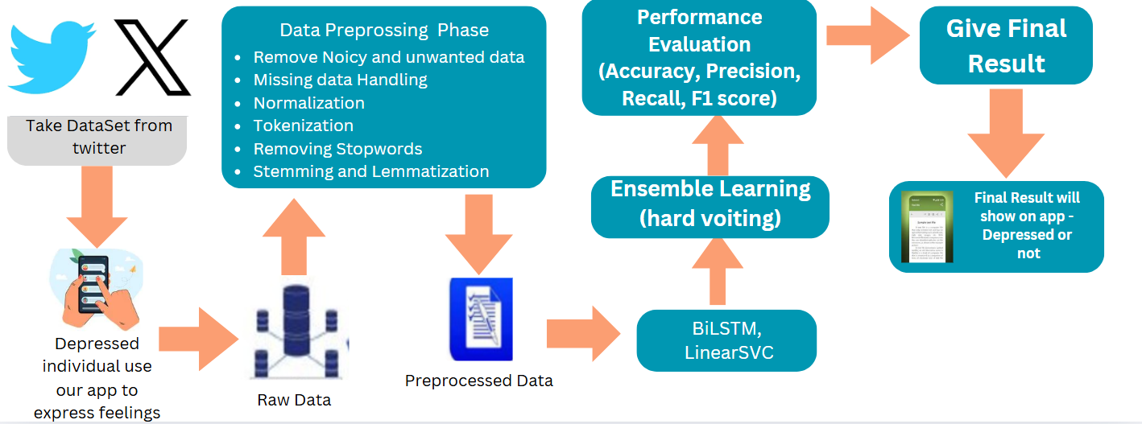
Figure 3.1: Phases of Depression Model

Data Collection from twitter
The data collection for this project is named "Multi-Class Depression Detection Through Tweets Using Artificial Intelligence". It is a collection of tweets gathered from Twitter, which are usually published by people about their feelings and thoughts. Tweets are categorized under one of the five specific kinds of depression: Bipolar, Major, Psychotic, Atypical and Postpartum. The labelling process was carried out using lexicons that have been verified by certified psychiatrists, ensuring clinical accuracy and relevance. This multi-class labelling allows the model to detect not only whether a user may be experiencing depression, but also the particular category of depression, making the system more insightful and medically useful.

Depressed Individuals Use the App
The app is made to enable users specifically those suffering from depressive symptoms to enter or share their emotions in the form of written words. This feature offers a mechanism for the system to collect fresh, user-submitted content, adding contextually pertinent data to the dataset. This also mimics actual usage scenarios where users use the app for mental well-being.

Raw Data Acquisition
After the tweets or text entries are collected from the users, they are retained in raw form. As shown in the Figure 3.1 The data is normally not structured and could include noise such as emojis, URLs, hashtags, misspellings, and colloquial terms. The text at this point has not been processed or cleaned and cannot be fed directly into a machine learning or deep learning model.

Data Preprocessing Phase
To ensure the raw textual data was suitable for machine learning, an extensive pre-processing phase was conducted. This involved removing noise and unwanted data such as emojis, hashtags, URLs and user mentions, which do not contribute meaningful information for depression detection. Any missing or incomplete data entries were addressed through either removal or imputation techniques. The text was then normalized by converting all characters to lowercase and handling contractions. The cleaned data underwent tokenization, breaking down sentences into individual words or tokens. Next, stop words common words that do not hold significant meaning were removed to reduce dimensionality. Lastly, stemming and lemmatization were applied to reduce words to their base or root forms, ensuring consistent representation across variations of the same word. These steps transformed noisy user-generated content into structured and consistent data suitable for modelling.

Ensemble Learning with Hard Voting
To enhance the accuracy of detection, an ensemble learning method is applied. Rather than depending on a single model, this method pools the predictions of two complementary models:
- LinearSVC: A Support Vector Machines (SVM)-based machine learning model that is appropriate for high-dimensional text classification problems.
- BiLSTM (Bidirectional Long Short-Term Memory): A deep learning model with the ability to comprehend both historical and future context within a sentence. It is best suited to extract the semantic meaning of text in sequence classification problems.
Each of these models is combined employing hard voting in which every model provides a prediction and the eventual label is chosen through majority voting. This facilitates minimizing model bias and enhancing robustness by enjoying the benefits of both shallow as well as deep learning viewpoints.
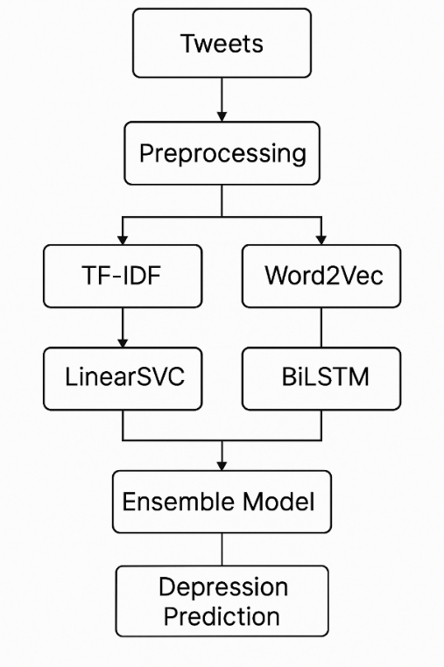
Figure 3.2: Flow Chart of Depression Model

Performance Metrics
Performance metrics are quantitative indicators that are used to assess the efficacy and quality of the model or the system. Present key metrics such as accuracy, precision, recall and F1-score.

Accuracy
The accuracy of the model is the number of labels that are correctly predicted out of all labels. It gives the percentage of how accurate the proposed model will be when it's being tested. Where TP meaning true positive is the number of positive predicted labels that are in fact positive. TN meaning true negative is the number of labels that are predicted to be negative but are actually negative. FP stands for false positive is defined as the number of positive predicted labels that are negative. FN stands for false negative is defined as the number of negative predicted labels that are not.
$$Accuracy = \frac{TP}{ TP + TN + FP + FN}$$
Equation 3.1: Accuracy

Precision
Precision is defined as the proportion of true positive predictions. Where “TP” stands for true positive, is the number of positively predicted labels that are positive. “FP” stands for False Positive.
$$Precision = \frac{TP}{TP + FP}$$
Equation 3.2: Precision

Recall
The recall of the model can be calculated by using the formula given below. Here, “FN” stands for false negative. It is defined as the number of negative predicted labels that are positive.
$$Recall = \frac{TP}{TP + FN}$$
Equation 3.3: Recall

F1-score
F1-score or F-measure is the harmonic average of both precision and recall that gives an overall measure of model performance. There is a trade-off between both precision and recall in the F1-score.
$$F1 - score = \frac{2 × Precision × Recall}{Precision + Recall}$$
Equation 3.4: F1-Score

Give Final Result
Once the ensemble model (LinearSVC + BiLSTM) finishes its analysis and the performance assessment verifies a sound prediction, the final output is presented directly to the user through the mobile application.
- The model's output decides whether the input text indicates depressive symptoms or not.
- This output is displayed on a specific screen in the app with a clear indication.
This is a critical step as it converts the backend AI process into a friendly, comprehensible message for the user. It serves as an instant feedback loop, making the system usable and actionable.

Summary
This chapter introduced an end-to-end methodology for constructing an AI system to identify all kinds of depression from text-based data. This started with obtaining and preprocessing a labeled Twitter dataset with six depression categories: Atypical, Bipolar, Major Depressive, No Depression, Postpartum and Psychotic [16]. Basic preprocessing operations including cleaning, tokenization, normalization, and lemmatization were performed to pre-process the data for modeling. Two methods of feature representation were employed: TF-IDF for traditional machine learning and Word2Vec for deep learning. The machine learning module consisted of training various models, with the best performer identified as LinearSVC due to its accuracy and speed. The deep learning module employed a Bidirectional LSTM network able to understand contextual relationships in text. The two models were ensembled using a hard voting ensemble approach to improve the accuracy and stability of predictions. The third system was deployed in a usable Flutter-based smartphone app, which is backed up by FastAPI. The end-user interacts with the application by responding to a questionnaire, which is analyzed online to provide each individual with unique depression-type projections. This dual-layered hybrid approach is not only technically solid but also simple enough to utilize in real-life practice, constituting an equally viable, easily scalable early detection system for mental illness.

User Classes and Characteristics
Panel Tech consist of following panels
- Admin Panel
- Patient Panel
- Doctor Panel

Admin Panel
Admin panel is main panel that can control everything.
- Login/Logout
- Manage Users
- Monitor Patient/Doctor Activity
- Manage Cash flow/Invoice
- Handle Complaints
- System Maintenance

Patient Panel
In this panel, patient can
- Register
- Login/Logout
- Manage Profile
- Take Depression Test
- View Depression Report
- Search Doctors
- View Doctor Profile
- Book Appointment
- Share Report with Doctor
- Join Online Meeting
- Chat with Doctor
- Rate & Review Doctor
- View Medical History
- Daily Tips & Tasks
- Meditation
- Mood Tracker
- Community Feed

Doctor Panel
In this panel, doctor can
- Register
- Login/Logout
- Manage Profile
- Manage Availability
- View Patient List
- Accept/Reject Appointment
- View Patient’s Report
- Join Online Meeting
- Chat with Patient
- Write Prescriptions

User Interface
It is an application that is built with Flutter and it backend work with FastAPI.
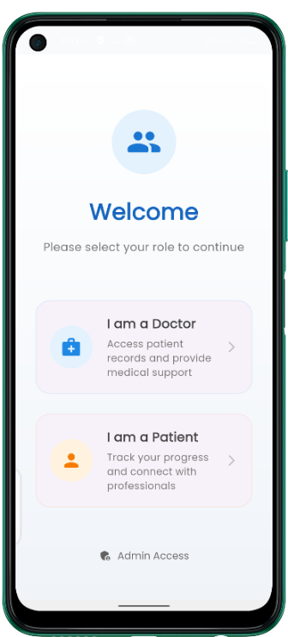  Figure 3.3: Welcome Interface of Application | Figure 3.3 shows the welcome interface of the app presents a clean, user-friendly landing page that immediately directs users to select their role Doctor or Patient to access the platform's tailored features. Doctors are greeted with the promise of accessing patient records and providing medical support. Patients are invited to track their progress and connect with professionals, while administrators receive a straightforward access prompt, ensuring each user type begins their journey with clear purpose. The minimalist design emphasizes functionality, with concise role descriptions that set accurate expectations for the platform's capabilities while maintaining an approachable tone for users seeking mental health support or services.
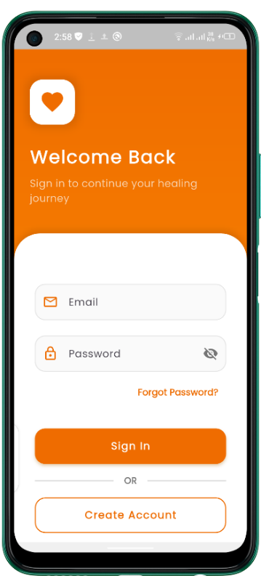  Figure 3.4: Sign In/Sign Up Interface of Application | Figure 3.4 shows the sign-in/sign-up interface of the app features a clean, welcoming design with a motivational message ("Sign in to continue your healing journey") that reinforces the app's mental health focus. The layout includes standard email and password fields, a "Forgot Password?" option for account recovery, and a prominent "Sign In" button, with an alternative "Create Account" option clearly separated below. The minimalist aesthetic, neutral colours, and straightforward navigation create a low-friction entry point while maintaining a reassuring tone appropriate for users seeking mental health support. The dual functionality (login and registration) is intuitively organized, allowing both returning and new users to quickly access the platform.

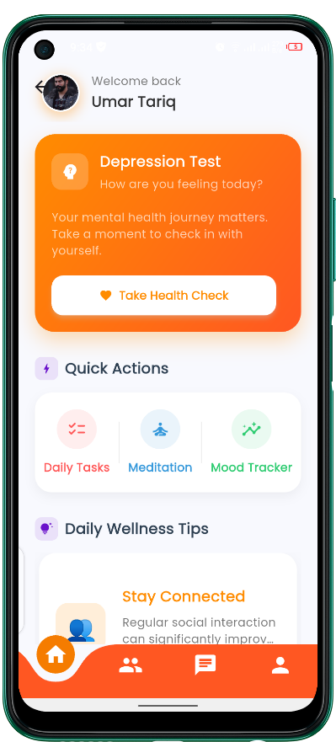  Figure 3.5: Patient's Home Interface of Application | Figure 3.5 shows the patient home interface provides a personalized, wellness-focused dashboard that greets users by name ("Welcome back, Umar Tariq") and centralizes all key features for mental health management. The clean layout prominently displays a depression test prompt ("How are you feeling today?") alongside encouraging mental health messaging, followed by quick-access wellness options (Health Check, Daily Tasks, Meditation, Mood Tracker) presented as actionable checkboxes. A "Daily Wellness Tips" section offers psychoeducation (e.g., benefits of social connection), while the persistent bottom taskbar (Home/Community/Doctors/Profile) ensures easy navigation.
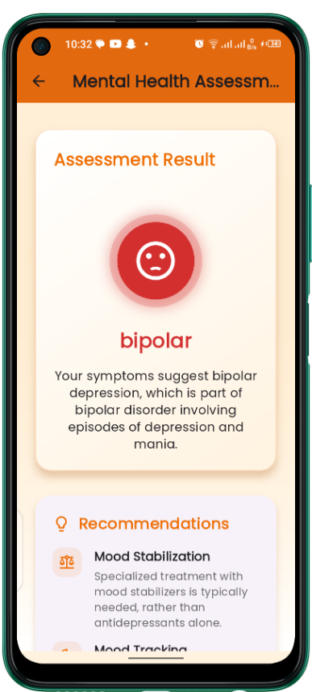  Figure 3.6: Patient's Depression Test Interface of Application | Figure 3.6 shows this is a screen within a mental health evaluation app that shows the outcome of a psychological evaluation. In this instance, the evaluation result shows that the user is exhibiting symptoms of bipolar depression. Bipolar depression is one aspect of bipolar disorder, which involves alternating episodes of depression and mania. This screen utilizes a direct visual, expressive red face icon to drive home the gravity of the result. Underneath the diagnosis, there is a concise description explaining that bipolar disorder encompasses episodes of low mood (depression) and high energy or mood (mania), explaining to the user what the condition entails. After the result, the app starts producing individualized suggestions for the user.
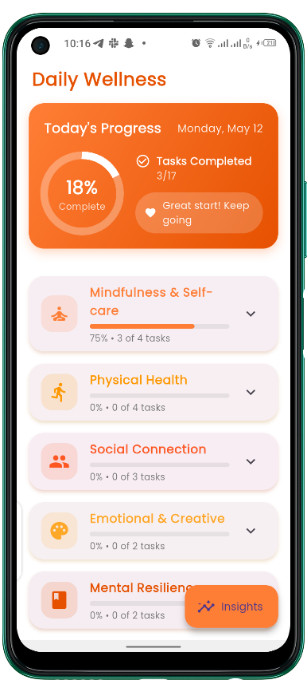  Figure 3.7: Patient's Daily Wellness Interface of Application | Figure 3.7 shows the Daily Wellness dashboard provides a motivational, at-a-glance overview of the patient's self-care progress with a clean, structured layout. The top section displays the current date (Monday, May 12) and an encouraging summary ("Tasks Completed 3/17 - Great start! Keep going"), while categorized wellness areas (Mindfulness, Physical Health, Social Connection, etc.) are presented as progress bars with clear metrics (75% • 3 of 4 tasks). The card-based design uses percentage completions and fraction-based task counts to visualize achievement without clutter, while the "Insights" icon suggests deeper analytics. The interface balances positive reinforcement ("Great start!") with straightforward data helping users track holistic mental health habits through digestible, goal-oriented segments that promote consistency without.
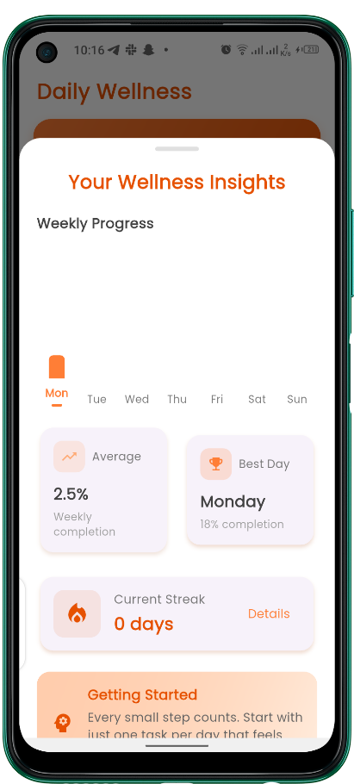  Figure 3.8: Patient's Wellness Insights Interface of Application | Figure 3.8 Wellness Insights brings forth the interactive patient progress conversion into visual motivation through a densely packed analytics dashboard. Progress in using this public interface-production comes with a weekly bar graph (Mon-Sun) keeping track of the completion of the various tasks during the week, such as a rate of completion weekly of 2.5%, or 18% on Monday, marked with key metrics. The "Average/Best Day" comparison gets tagged along with the "Current Streak: 0 days" counter which gamifies the responsibility of accountability with coercion-free self-care and compassionate guidance at the bottom of the page ("Every small step counts"). Clean typography and intuitive progress indicators create an uncluttered visualization of data and facilitate pattern recognition
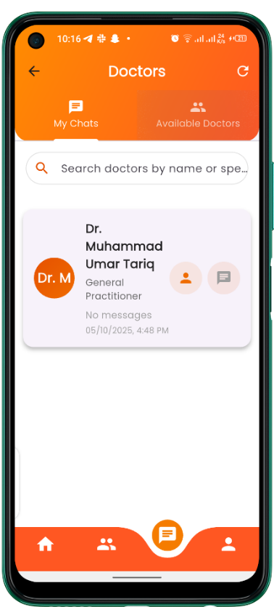  Figure 3.9: Patient's Doctor Interface of Application | Figure 3.9 shows the evolutions from the date of its training tell GPT about information from the training phase on data doomed to extinction in October 2023. Essentially, this means a patient would be able to find the doctors in the panel with much ease of navigating through design. The Doctors interface itself reveals a patient panel connecting the patient with the healthcare professionals, split into two clear sections: "My Chats" for ongoing conversations and "Available Doctors" for finding new providers. The search bar at the top allows filtering doctors by name or specialty; names and specializations of considered doctors are provided with interaction timestamps in an orderly fashion below (Dr. Muhammad Umar Tariq, General Practitioner, Last Interaction: 05/10/2025, 4:48 PM).
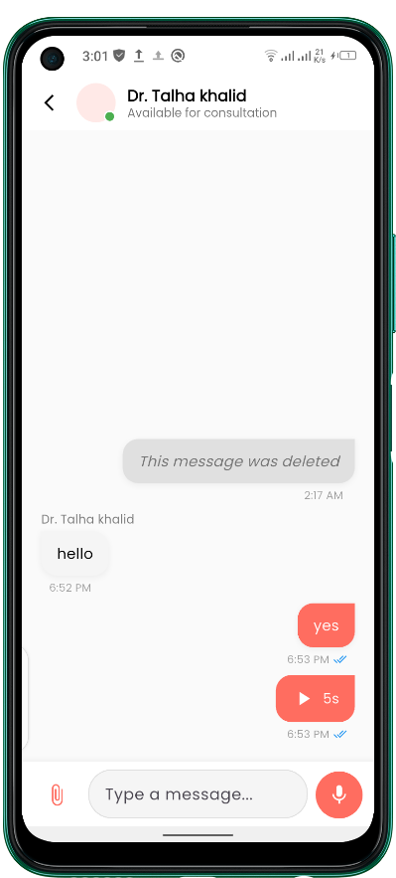  Figure 3.10: Patient's Chat Interface of Application | Figure 3.10 shows the Chat Interface functions as a secure and intuitive messaging platform that facilitates real-time communication between patients and their doctors. In the top bar, the name of the doctor (Dr. Talha Khalid) is shown along with his status of availability, while, in the next section, an uncluttered chat history displays sent and received messages with timestamps (e.g., 6.52 PM) and read receipts (✅) with the capability of helping users gracefully with deleted messages. The bottom toolbar showcases an input for typing in messages ("Type a message..."), attachment options (files, voice notes), and a send button to facilitate easy communication with text and multimedia.
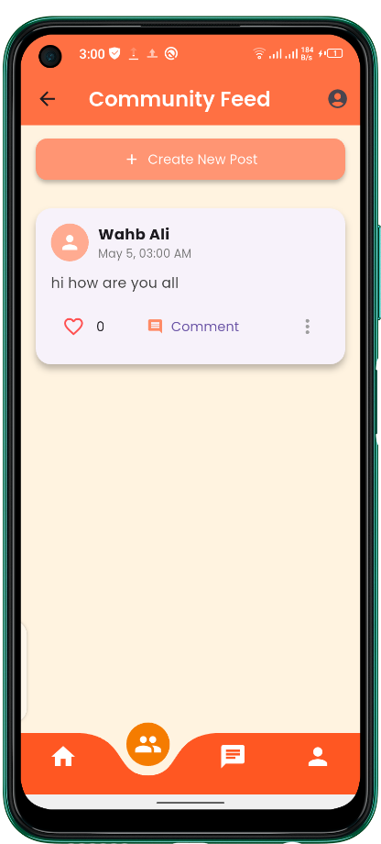  Figure 3.11: Patient's Community Interface of Application | Figure 3.11 shows the Community Feed interface fosters peer support through an engaging social platform where patients can share experiences and connect. At the top, a prominent "+ Create New Post" button encourages participation, while posts like Wahb Ali's message ("hi how are you all") appear in a clean, card-based layout with timestamps (May 5, 03:00 AM). Interactive options (like, comment) are presented as intuitive icons, balancing simplicity with functionality. The minimalist design reduces visual stress while maintaining essential social features creating a safe, moderated space for users to discuss mental health challenges without overwhelming UI elements.
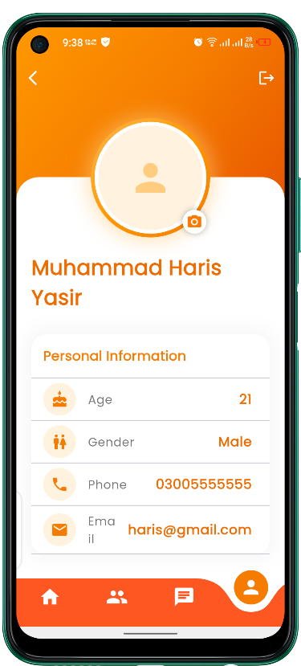  Figure 3.12: Patient's Profile Interface of Application | Figure 3.12 shows the patient profile interface presents a clean, organized view of personal information with a header displaying the user's name ("Muhammad Haris Yasir") followed by clearly labelled details (Age, Gender, Phone, Email) in a minimalist card-style layout. The design prioritizes readability and quick reference, with ample white space and a neutral colour scheme that maintains the app's therapeutic aesthetic. While the current view shows basic demographic data, the structure suggests easy expandability for additional health-related profile fields. The absence of cluttered elements creates a calm user experience appropriate for a mental health application, where straightforward information presentation helps reduce cognitive load for users who may be experiencing stress or depression.

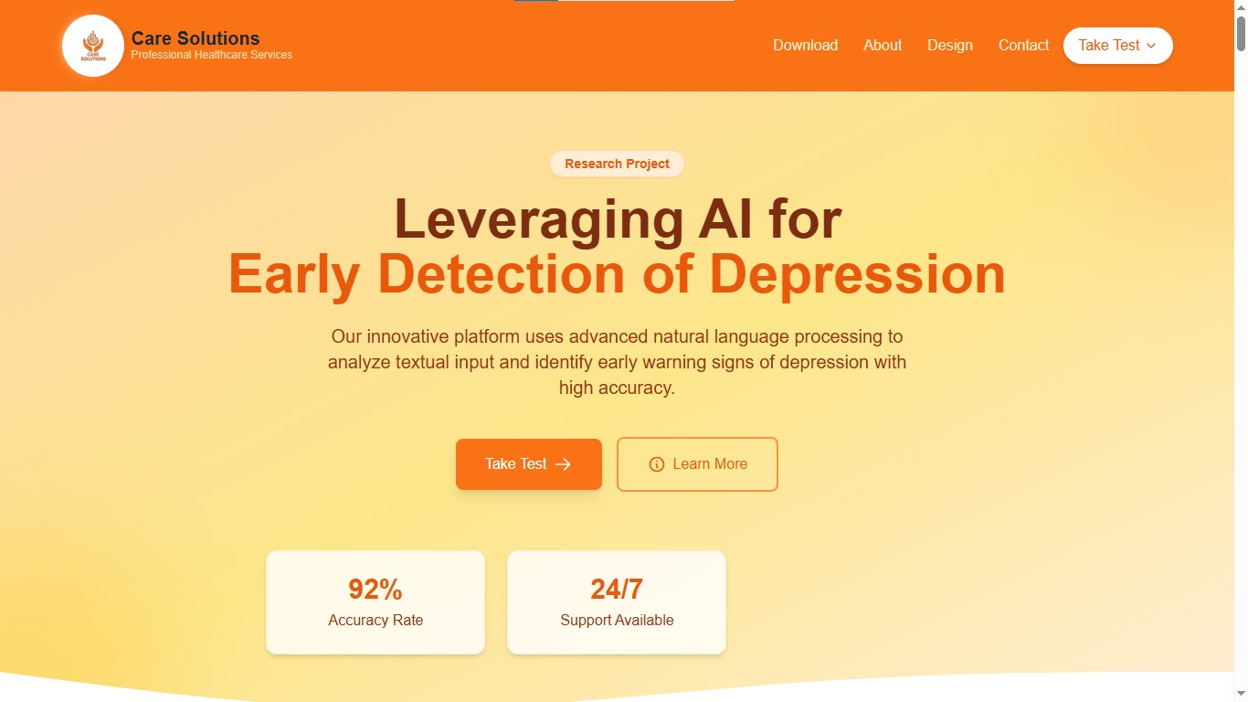
Figure 3.13: Landing Page of Website
Figure 3.13 shows the landing page of Care Solutions presents a clean, professional interface introducing their AI-powered depression detection platform. The header features clear navigation (Download, About, Design, Contact, Take Test).
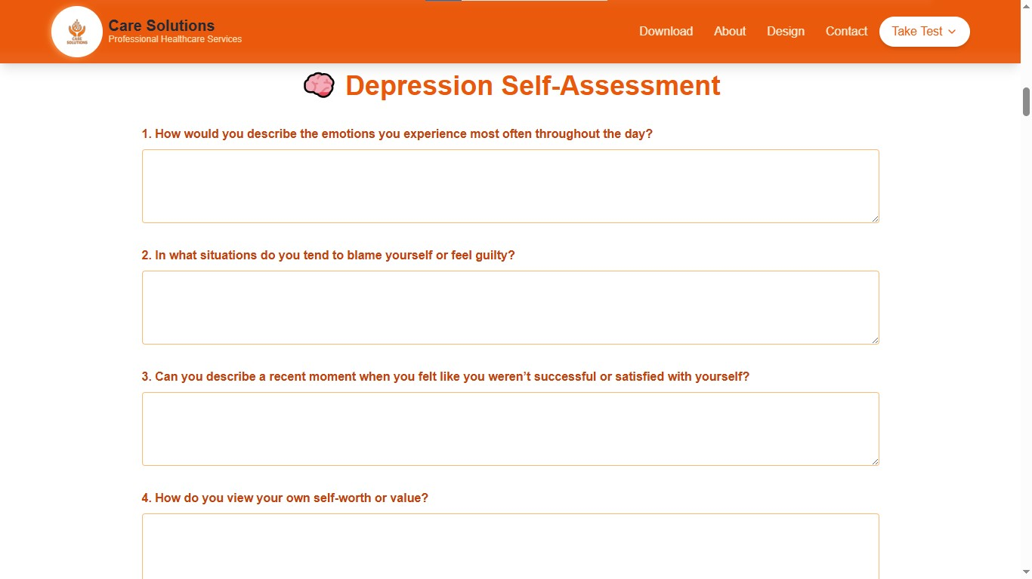
Figure 3.14: Depression Test of Website
Figure 3.14 shows the Depression Self-Assessment page offers a streamlined, user-friendly interface for mental health screening. The page centers on thoughtfully crafted, open-ended psychological questions that probe emotional patterns designed to elicit nuanced responses for AI analysis.

Use Case Diagrams

Use Case diagram of Admin

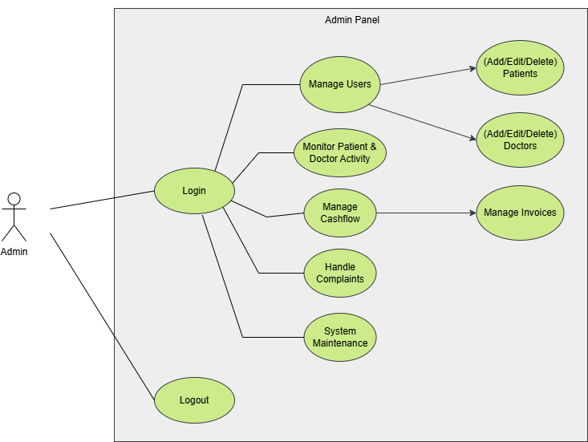
Figure 3.15: Use Case Diagram of Admin

Use Case diagram of Patient
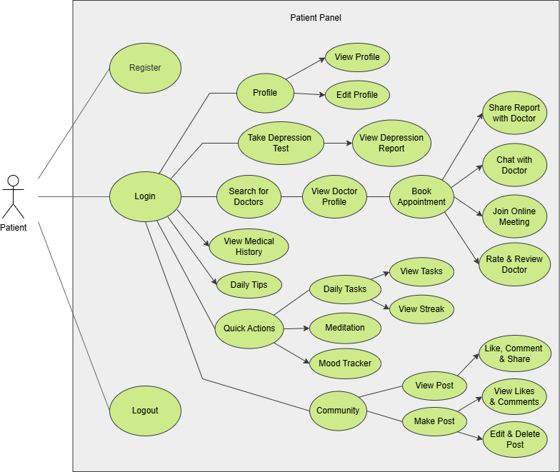
Figure 3.16: Use Case Diagram of Patient

Use Case diagram of Doctor
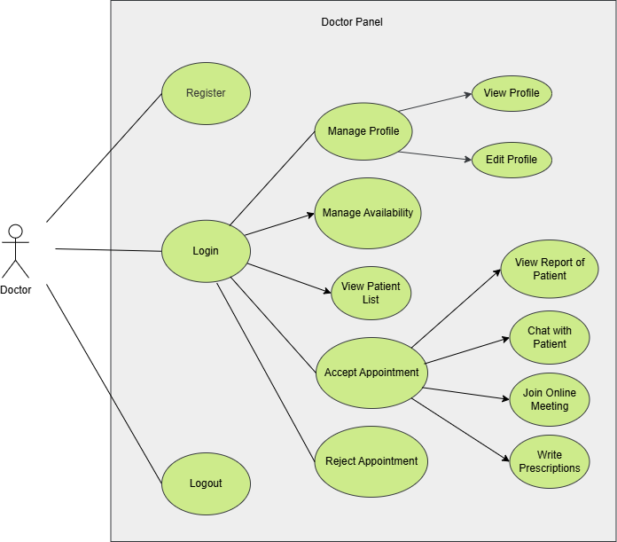
Figure 3.17: Use Case Diagram of Doctor

Use case name and identifier

Use Case Table of Admin

Manage Users (ADMIN-UC-001)
Table 3.1: Manage Users Use Case Table of Admin
Name | Manage Users
Unique Identifier | ADMIN-UC-001
Objective | Allow admin to manage patient and doctor accounts.
Priority | High
Actors | Admin
Basic Flow | 1. Admin logs into the system.  2. Admin selects "Manage Users".  3. Admin adds, edits, or deletes patient or doctor accounts.  4. System updates user records.
Alternative Flow | 1. Admin enters invalid user details.  2. System displays an error message.
Preconditions | Admin must be logged into the system.
Post Conditions | User records are updated.
Notes/Issues | Admin must ensure data integrity while modifying user records.

Manage Appointments (ADMIN-UC-002)
Table 3.2: Manage Appointments Use Case Table of Admin
Name | Manage Appointments
Unique Identifier | ADMIN-UC-002
Objective | Enable the admin to manage doctor-patient appointments.
Priority | High
Actors | Admin
Basic Flow | 1. Admin logs into the system.  2. Admin selects "Manage Appointments".  3. Admin schedules, modifies, or cancels an appointment.  4. System updates the appointment status.
Alternative Flow | 1. Admin tries to modify a past appointment.  2. System restricts changes and displays an error message.
Preconditions | Admin must be logged into the system.
Post Conditions | Appointment details are updated in the system.
Notes/Issues | The system should handle overlapping appointments efficiently.

Manage Invoice (ADMIN-UC-003)
Table 3.3: Manage Invoice Use Case Table of Admin
Name | Manage Invoice
Unique Identifier | ADMIN-UC-003
Objective | Allow the admin to create, view, edit and track invoices and cash flow records.
Priority | High
Actors | Admin
Basic Flow | 1. Admin logs into the Admin Panel.  2. Navigates to “Cash Flow/Invoices” section.  3. Selects to create a new invoice or manage existing ones.  4. Inputs data or updates status.  5. Saves and generates invoice.  6. System updates cash flow reports.
Alternative Flow | 1. If invalid data is entered, system shows validation errors.  2. If connection fails, prompt retry or offline message.
Preconditions | Admin must be logged in with appropriate permissions.
Post Conditions | Invoice/cash flow data is stored/updated in the system database.
Notes/Issues | Ensure access control is strictly enforced. Consider audit logging for compliance.

Handle Complaints (ADMIN-UC-004)
Table 3.4: Handle Complaints Use Case Table of Admin
Name | Handle Complaints
Unique Identifier | ADMIN-UC-004
Objective | Allow admin to handle patient and doctor complaints.
Priority | High
Actors | Admin
Basic Flow | 1. Admin logs into the system.  2. Admin selects "Handle Complaints".  3. System displays pending complaints.  4. Admin reviews and resolves complaints.  5. System updates complaint status.
Alternative Flow | 1. Admin tries to resolve a complaint but lacks required information.  2. Admin contacts the concerned user for details.
Preconditions | Complaints must exist in the system.
Post Conditions | Complaints are resolved and recorded.
Notes/Issues | Some complaints may require legal or technical intervention.

System Maintenance (ADMIN-UC-005)
Table 3.5: System Maintenance Users Use Case Table of Admin
Name | System Maintenance
Unique Identifier | ADMIN-UC-005
Objective | Allow admin to perform system maintenance tasks.
Priority | High
Actors | Admin
Basic Flow | 1. Admin logs into the system.  2. Admin selects "System Maintenance".  3. Admin performs necessary updates or fixes.  4. System applies changes and logs maintenance activities.
Alternative Flow | 1. Admin encounters a critical system error.  2. Admin escalates the issue to technical support.
Preconditions | System must be operational.
Post Conditions | System performance and stability are maintained.
Notes/Issues | Maintenance may cause temporary downtime.

Use Case Table of Patient

Register (PATIENT-UC-001)
Table 3.6: Registration Use Case Table of Patient
Name | Register
Unique Identifier | PATIENT-UC-001
Objective | Allow new patients to register in the system.
Priority | High
Actors | Patient
Basic Flow | 1. Patient accesses the registration page.  2. Patient enters required details.  3. System verifies and creates the account.  4. System confirms registration.
Alternative Flow | 1. Patient enters invalid details.  2. System prompts for corrections.
Preconditions | Patient must have a valid email.
Post Conditions | New patient account is created.
Notes/Issues | Ensure data validation for security.

Login (PATIENT-UC-002)
Table 3.7: Login Use Case Table of Patient
Name | Login
Unique Identifier | PATIENT-UC-002
Objective | Allow patient to log into the system.
Priority | High
Actors | Patient
Basic Flow | 1. Patient enters credentials.  2. System verifies details.  3. Patient is granted access.
Alternative Flow | 1. Invalid credentials entered.  2. System displays an error message.
Preconditions | Patient must have an existing account.
Post Conditions | Patient is logged in.
Notes/Issues | Implement password recovery if needed.

Take Depression Test (PATIENT-UC-003)
Table 3.8: Take Depression Test Use Case Table of Patient
Name | Take Depression Test
Unique Identifier | PATIENT-UC-003
Objective | Allow patient to take a depression assessment.
Priority | Medium
Actors | Patient
Basic Flow | 1. Patient selects the test.  2. System presents questions.  3. Patient submits responses.  4. System processes results.
Alternative Flow | 1. Patient exits the test before completion.  2. System saves progress.
Preconditions | Patient must be logged in.
Post Conditions | Test results are stored in the system.
Notes/Issues | Ensure medical accuracy of the test.

View Depression Report (PATIENT-UC-004)
Table 3.9: View Depression Report Use Case Table of Patient
Name | View Depression Report
Unique Identifier | PATIENT-UC-004
Objective | Allow patient to view their depression test results.
Priority | Medium
Actors | Patient
Basic Flow | 1. Patient selects "View Depression Report".  2. System displays results.
Alternative Flow | 1. System error prevents loading results.  2. System prompts retry.
Preconditions | Patient must have taken a depression test.
Post Conditions | Patient views their results.
Notes/Issues | Results should be clear and easy to understand.

Search for Doctors (PATIENT-UC-005)
Table 3.10: Search Doctors Use Case Table of Patient
Name | Search for Doctors
Unique Identifier | PATIENT-UC-005
Objective | Allow patient to search for available doctors.
Priority | High
Actors | Patient
Basic Flow | 1. Patient enters search criteria.  2. System displays a list of doctors.
Alternative Flow | 1. No doctors match the criteria.  2. System suggests alternatives.
Preconditions | Patient must be logged in.
Post Conditions | Search results are displayed.
Notes/Issues | Search filters should be effective.

View Doctor Profile (PATIENT-UC-006)
Table 3.11: View Doctor Profile Use Case Table of Patient
Name | View Doctor Profile
Unique Identifier | PATIENT-UC-006
Objective | Allow patient to view a doctor's profile.
Priority | High
Actors | Patient
Basic Flow | 1. Patient selects a doctor.  2. System displays doctor details.
Alternative Flow | 1. Profile data fails to load.  2. System prompts retry.
Preconditions | Patient must have searched for doctors.
Post Conditions | Doctor's profile is displayed.
Notes/Issues | Ensure doctor profiles are up-to-date.

Book Appointment (PATIENT-UC-007)
Table 3.12: Book Appointments Use Case Table of Patient
Name | Book Appointment
Unique Identifier | PATIENT-UC-007
Objective | Allow patient to schedule an appointment with a doctor.
Priority | High
Actors | Patient
Basic Flow | 1. Patient selects a doctor.  2. System displays available slots.  3. Patient confirms the appointment.  4. System schedules the appointment.
Alternative Flow | 1. No available slots.  2. System suggests alternatives.
Preconditions | Patient must be logged in.
Post Conditions | Appointment is scheduled.
Notes/Issues | Ensure no double bookings occur.

Join Online Meeting (PATIENT-UC-008)
Table 3.13: Join Online Meeting Use Case Table of Patient
Name | Join Online Meeting
Unique Identifier | PATIENT-UC-008
Objective | Allow patient to join an online consultation.
Priority | High
Actors | Patient, Doctor
Basic Flow | 1. Patient selects an appointment.  2. System provides a meeting link.  3. Patient joins the meeting.
Alternative Flow | 1. Connection issue occurs.  2. System suggests troubleshooting steps.
Preconditions | Patient must have a booked appointment.
Post Conditions | Meeting consultation takes place.
Notes/Issues | Ensure secure meeting communication.

Chat with Doctor (PATIENT-UC-009)
Table 3.14: Chat with Doctor Use Case Table of Patient
Name | Chat with Doctor
Unique Identifier | PATIENT-UC-009
Objective | Allow patient to communicate with a doctor via chat.
Priority | Medium
Actors | Patient, Doctor
Basic Flow | 1. Patient selects a doctor.  2. System opens a chat interface.  3. Patient and doctor exchange messages.
Alternative Flow | 1. Chat service fails.  2. System prompts retry.
Preconditions | Patient must have booked an appointment.
Post Conditions | Chat conversation is recorded.
Notes/Issues | Ensure privacy of conversations.

Rate & Review Doctor (PATIENT-UC-010)
Table 3.15: Rate and Review Use Case Table of Patient
Name | Rate & Review Doctor
Unique Identifier | PATIENT-UC-010
Objective | Allow patient to give feedback on a doctor.
Priority | Low
Actors | Patient
Basic Flow | 1. Patient selects a doctor.  2. Patient submits a rating and review.
Alternative Flow | 1. Patient enters invalid feedback.  2. System prompts correction.
Preconditions | Patient must have completed an appointment.
Post Conditions | Review is published.
Notes/Issues | Ensure reviews are moderated.

View Medical History (PATIENT-UC-011)
Table 3.16: View Medical History Use Case Table of Patient
Name | View Medical History
Unique Identifier | PATIENT-UC-011
Objective | Allow the patient to view their medical history.
Priority | High
Actors | Patient
Basic Flow | 1. Patient selects "View Medical History".  2. System retrieves and displays past medical records.
Alternative Flow | 1. System fails to load history.  2. System prompts retry or error message.
Preconditions | Patient must be logged in.
Post Conditions | Medical history is displayed.
Notes/Issues | Ensure secure storage and access control for medical data.

Logout (PATIENT-UC-012)
Table 3.17: Logout Use Case Table of Patient
Name | Logout
Unique Identifier | PATIENT-UC-012
Objective | Allow the patient to log out of the system.
Priority | High
Actors | Patient
Basic Flow | 1. Patient selects "Logout".  2. System terminates session.  3. Patient is redirected to the login page.
Alternative Flow | 1. Logout fails due to a system issue.  2. System prompts retry.
Preconditions | Patient must be logged in.
Post Conditions | Patient is logged out, and session is terminated.
Notes/Issues | Ensure secure session management.

Use Case Table of Doctor

Register (DOCOTR-UC-001)
Table 3.18: Registration Use Case Table of Doctor
Name | Register
Unique Identifier | DOCOTR-UC-001
Objective | Allow doctors to create an account.
Priority | High
Actors | Doctor
Basic Flow | 1. Doctor provides registration details.  2. System validates and creates an account.
Alternative Flow | 1. Registration fails due to invalid data.  2. System prompts retry.
Preconditions | Doctor must have a valid email.
Post Conditions | Doctor account is created.
Notes/Issues | Secure password and verification needed.

Login (DOCOTR-UC-002)
Table 3.19: Login Use Case Table of Doctor
Name | Login
Unique Identifier | DOCOTR-UC-002
Objective | Allow doctors to log into the system.
Priority | High
Actors | Doctor
Basic Flow | 1. Doctor enters credentials.  2. System verifies login details.
Alternative Flow | 1. Invalid credentials.  2. System displays an error.
Preconditions | Doctor must be registered.
Post Conditions | Doctor gains access.
Notes/Issues | Implement secure authentication.

Manage Profile (DOCOTR-UC-003)
Table 3.20: Manage Profile Use Case Table of Doctor
Name | Manage Profile
Unique Identifier | DOCOTR-UC-003
Objective | Allow doctors to edit their profiles.
Priority | Medium
Actors | Doctor
Basic Flow | 1. Doctor updates profile details.  2. System saves changes.
Alternative Flow | 1. Update fails.  2. System prompts retry.
Preconditions | Doctor must be logged in.
Post Conditions | Profile is updated.
Notes/Issues | Ensure data validation.

Manage Availability (DOCOTR-UC-004)
Table 3.21: Manage Availability Use Case Table of Doctor
Name | Manage Availability
Unique Identifier | DOCOTR-UC-004
Objective | Allow doctors to set their available time slots.
Priority | High
Actors | Doctor
Basic Flow | 1. Doctor selects availability.  2. System saves and updates the schedule.
Alternative Flow | 1. System error.  2. Doctor retries later.
Preconditions | Doctor must be logged in.
Post Conditions | Availability is updated.
Notes/Issues | Prevent overlapping schedules.

View Patient List (DOCOTR-UC-005)
Table 3.22: View Patient Lis Use Case Table of Doctor
Name | View Patient List
Unique Identifier | DOCOTR-UC-005
Objective | Allow doctors to see a list of assigned patients.
Priority | High
Actors | Doctor
Basic Flow | 1. Doctor accesses patient list.  2. System displays the list.
Alternative Flow | 1. No patients found.  2. System shows a message.
Preconditions | Doctor must be logged in.
Post Conditions | Patient list is displayed.
Notes/Issues | Ensure patient privacy.

Accept/Reject Appointment (DOCOTR-UC-006)
Table 3.23: Accept/Reject Appointments Use Case Table of Doctor
Name | Accept/Reject Appointment
Unique Identifier | DOCOTR-UC-006
Objective | Allow doctors to approve or decline appointments.
Priority | High
Actors | Doctor
Basic Flow | 1. Doctor reviews appointment requests.  2. Doctor accepts/rejects request.
Alternative Flow | 1. System error prevents action.  2. Doctor retries later.
Preconditions | Doctor must have appointment requests.
Post Conditions | Appointment status is updated.
Notes/Issues | Notify patients accordingly.

View Patient Report (DOCOTR-UC-007)
Table 3.24: View Patient Report Use Case Table of Doctor
Name | View Patient Report
Unique Identifier | DOCOTR-UC-007
Objective | Allow doctors to view a patient’s medical report.
Priority | High
Actors | Doctor
Basic Flow | 1. Doctor selects a patient.  2. Patient sends medical report.
Alternative Flow | 1. No patient is selected.  2. Patient did not send report.  3. System shows a message.
Preconditions | Doctor must be logged in.
Post Conditions | Medical report is displayed.
Notes/Issues | Ensure confidentiality.

Join Online Meeting (DOCOTR-UC-008)
Table 3.25: Join Online Meeting Use Case Table of Doctor
Name | Join Online Meeting
Unique Identifier | DOCOTR-UC-008
Objective | Allow doctors to conduct meeting consultations.
Priority | High
Actors | Doctor, Patient
Basic Flow | 1. Doctor starts a meeting.  2. System connects both parties.
Alternative Flow | 1. Connection fails.  2. System prompts retry.
Preconditions | Both doctor and patient must be available.
Post Conditions | Meeting is conducted.
Notes/Issues | Ensure stable connection.

Chat with Patient (DOCOTR-UC-009)
Table 3.26: Chat with Patient Use Case Table of Doctor
Name | Chat with Patient
Unique Identifier | DOCOTR-UC-009
Objective | Allow doctors to send and receive messages from patients.
Priority | Medium
Actors | Doctor, Patient
Basic Flow | 1. Doctor opens chat.  2. System enables real-time messaging.
Alternative Flow | 1. Message delivery fails.  2. System prompts retry.
Preconditions | Both doctor and patient must be online.
Post Conditions | Messages are sent/received.
Notes/Issues | Implement message encryption.

Write Prescriptions (DOCOTR-UC-010)
Table 3.27: Write Prescriptions Use Case Table of Doctor
Name | Write Prescriptions
Unique Identifier | DOCOTR-UC-010
Objective | Allow doctors to prescribe medication to patients.
Priority | High
Actors | Doctor
Basic Flow | 1. Doctor writes a prescription.  2. System stores and shares it with the patient.
Alternative Flow | 1. System error prevents saving.  2. Doctor retries later.
Preconditions | Patient consultation must be completed.
Post Conditions | Prescription is stored and accessible.
Notes/Issues | Ensure prescription security.

Logout (DOCOTR-UC-011)
Table 3.28: Logout Use Case Table of Doctor
Name | Logout
Unique Identifier | DOCOTR-UC-011
Objective | Allow doctors to log out securely.
Priority | High
Actors | Doctor
Basic Flow | 1. Doctor clicks "Logout".  2. System terminates session.
Alternative Flow | 1. Logout fails.  2. System prompts retry.
Preconditions | Doctor must be logged in.
Post Conditions | Doctor is logged out.
Notes/Issues | Ensure secure session handling.

Test Case

Test Cases of Admin

Table 3.29: Test Cases of Admin
Name | Identifier | Objective | Steps | Input Data | Expected Output | Actual Output | Status
Login | TC-001 | Allow admin to log into the system. | 1. Admin enters credentials.  2. System verifies login details. | Valid  credentials | Login successfully | Invalid input message | Fail
Manage Users | TC-002 | Allow admin to manage patient and doctor accounts. | 1. Admin selects "Manage Users".  2. Admin adds, edits, or deletes patient or doctor accounts.  3. System updates user records. | Enter valid details | Profile updated | Profile updated | Pass
Manage Appoint-ments | TC-003 | Enable the admin to manage doctor patient appointments. | 1. Admin selects "Manage Appointments".  2. Admin schedules, modifies or cancels an appointment.  3. System updates the appointment status. | View appointments | Appointments displayed | Appointments displayed | Pass
Manage Invoice | TC-004 | Allow the admin to create, view, edit and track invoices and cash flow records. | 1. Navigates to “Cash Flow/Invoices” section.  2. Selects to create a new invoice or manage existing ones.  3. Inputs data or updates status.  4. Saves and generates invoice.  5. System updates cash flow reports. | Click new voice and enters valid data | Invoice stored | Invoice stored | Pass
Handle Complaint | TC-005 | Allow admin to handle patient and doctor complaints. | 1. Admin selects "Handle Complaints".  2. System displays pending complaints.  3. Admin reviews and resolves complaints.  4. System updates complaint status. | Click  Handle Complaints  and resolves | Complaints  resolved | Complaints resolved | Pass
System Mainte-nance | TC-006 | Allow admin to perform system maintenance tasks. | 1. Admin selects "System Maintenance".  2. Admin performs necessary updates or fixes.  3. System applies changes and logs maintenance activities. | Click  System Maintenance do updates or fixes. | System performance maintained | System performance maintain-ed | Pass
Logout | TC-007 | Allow admin to log out securely. | 1. Admin clicks "Logout".  2. System terminates session. | Click Logout button | Logout successfully | Logout unsuccessfully | Fail

Test Cases of Patient
Table 3.30: Test Cases of Patient
Name | Identifier | Objective | Steps | Input Data | Expected Output | Actual Output | Status
Register | TC-001 | Allow new patients to register in the system. | 1. Patient accesses the registration page.  2. Patient enters required details.  3. System verifies and creates the account.  4. System confirms registration. | Valid email and other details | Account created | Account created | Pass
Login | TC-002 | Allow patient to log into the system. | 1. Patient enters credentials.  2. System verifies details.  3. Patient is granted access. | Valid  credentials | Login successfully | Invalid input message | Fail
Manage Profile | TC-003 | Allow patients to edit their profiles. | 1. Patient updates profile details.  2. System saves changes. | Enter valid details | Profile updated | Profile updated | Pass
Take Depression Test | TC-004 | Allow patient to take a depression assessment. | 1. Patient selects the test.  2. System presents questions.  3. Patient submits responses.  4. System processes results. | Click Test and writes answer | Result displayed | Result displayed | Pass
View Depression Report | TC-005 | Allow patient to view their depression test results. | 1. Patient selects "View Depression Report".  2. System displays results. | Click Report | Report displayed | Report displayed | Pass
Search for Doctors | TC-006 | Allow patient to search for available doctors. | 1. Patient enters search criteria.  2. System displays a list of doctors. | Enter Search | Search results displayed | Search results displayed | Pass
View Doctor Profile | TC-007 | Allow patient to view a doctor's profile. | 1. Patient selects a doctor.  2. System displays doctor details. | Click Doctor | Details displayed | Profile data fails to load | Fail
Book Appoint-ment | TC-008 | Allow patient to schedule an appointment with a doctor. | 1. Patient selects a doctor.  2. System displays available slots.  3. Patient confirms the appointment.  4. System schedules the appointment. | Books available slot | Appointment booked | Appoint-ment booked | Pass
Join Online Meeting | TC-009 | Allow patient to join an online consultation. | 1. Patient selects an appointment.  2. System provides a meeting link.  3. Patient joins the meeting. | Join meeting | Meeting conducted | Meeting  not joined | Fail
Chat with Doctor | TC-010 | Allow patient to communicate with a doctor via chat. | 1. Patient selects a doctor.  2. System opens a chat interface.  3. Patient and doctor exchange messages. | Sends message | Message sent | Message  not sent | Fail
Rate & Review Doctor | TC-011 | Allow patient to give feedback on a doctor. | 1. Patient selects a doctor.  2. Patient submits a rating and review. | Enter Review | Review published | Review published | Pass
View Medical History | TC-012 | Allow the patient to view their medical history. | 1. Patient selects "View Medical History".  2. System retrieves and displays past medical records. | Click Medical History | Medical history displayed | Medical history displayed | Pass
Logout | TC-013 | Allow the patient to log out of the system. | 1. Patient selects "Logout".  2. System terminates session.  3. Patient is redirected to the login page. | Click Logout button | Logout successfully | Logout successfully | Pass

Test Cases of Doctor
Table 3.31: Test Cases of Doctor
Name | Identifier | Objective | Steps | Input Data | Expected Output | Actual Output | Status
Register | TC-001 | Allow doctors to create an account. | 1. Doctor provides registration details.  2. System validates and creates an account. | Valid email and other details | Account created | Account created | Pass
Login | TC-002 | Allow doctors to log into the system. | 1. Doctor enters credentials.  2. System verifies login details. | Invalid  credentials | Invalid input message | Login successfully | Fail
Manage Profile | TC-003 | Allow doctors to edit their profiles. | 1. Doctor updates profile details.  2. System saves changes. | Enter valid details | Profile updated | Profile updated | Pass
Manage Availability | TC-004 | Allow doctors to set their available time slots. | 1. Doctor selects availability.  2. System saves and updates the schedule. | Select  availability time | Availability updated | Availability not updated | Fail
View Patient List | TC-005 | Allow doctors to see a list of assigned patients. | 1. Doctor accesses patient list.  2. System displays the list. | Click patient list | Patient list displayed | Patient  list displayed | Pass
Accept/  Reject Appoint-ments | TC-006 | Allow doctors to approve or decline appointments. | 1. Doctor reviews appointment requests.  2. Doctor accepts/rejects request. | Click Accept Button | Appointment  Accepted | Appoint-ment  Accepted | Pass
View Patient Report | TC-007 | Allow doctors to view a patient’s medical  report. | 1. Doctor selects a patient.  2. Patient sends medical report. | Open patient report | Report displayed | Report displayed | Pass
Join Online Meeting | TC-008 | Allow doctors to conduct meeting consultations. | 1. Doctor starts a meeting.  2. System connects both parties. | Start meeting | Meeting conducted | Meeting  not started | Fail
Chat with Patient | TC-009 | Allow doctors to send and receive messages from patients. | 1. Doctor opens chat.  2. System enables real-time messaging. | Sends message | Message sent | Message  not sent | Fail
Write Prescriptions | TC-010 | Allow doctors to prescribe medication to patients. | 1. Doctor writes a prescription.  2. System stores and shares it with the patient. | Writes and sends Prescription | Prescription sent | Prescription sent | Pass
Logout | TC-011 | Allow doctors to log out securely. | 1. Doctor clicks "Logout".  2. System terminates session. | Click Logout button | Logout successfully | Logout successfully | Pass

Domain Model
Domain model of Depression Detection Application that defines the structure and functionality. There are many classes which are used in this project but some of the core classes are shown in the domain model.

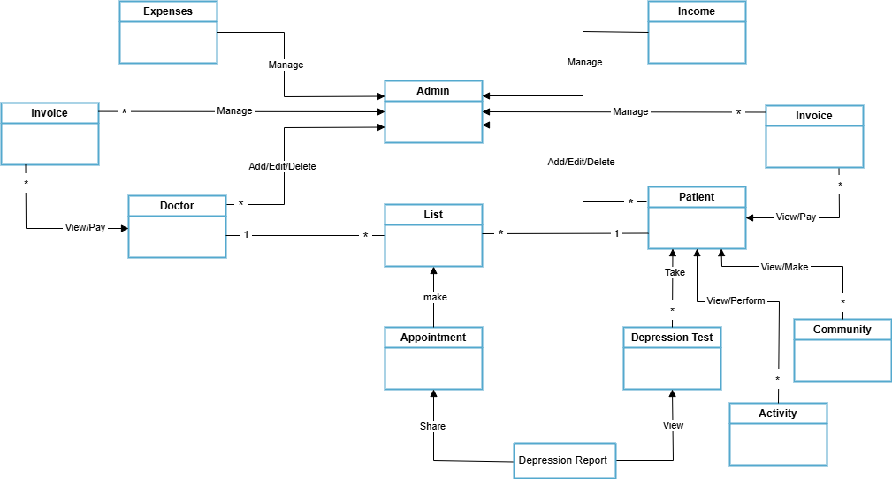
Figure 3.1: Domain Model Diagram

Sequence Diagram
This is the sequence diagram of Depression Detection Application which shows the interaction between the objects of patients, doctors, classes etc.

Login
This diagram will show the login sequence of admin, patients and doctors.
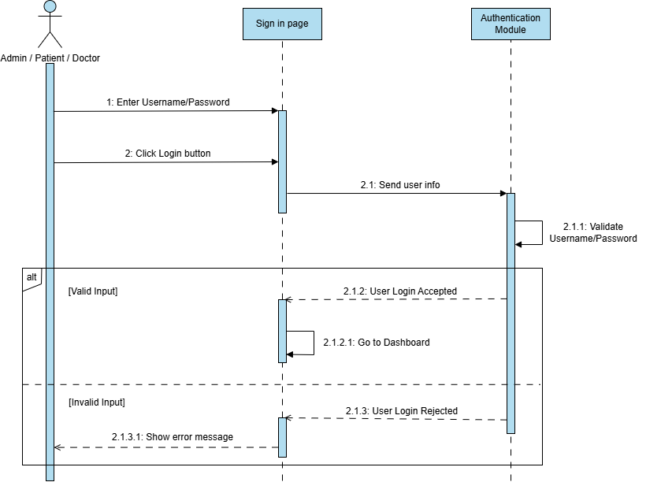
Figure 3.2: Login Sequence Diagram

Sequence Diagrams of Admin
This is the sequence diagram of admin which shows the interaction between the objects of patients, doctors, classes etc.

Profile Management
This diagram will show the profile management sequence of doctors and patients.

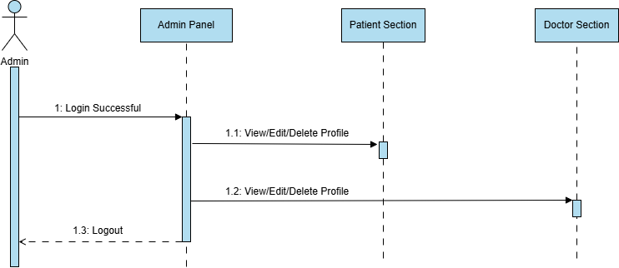
Figure 3.3: Profile Management Sequence Diagram of Admin

Monitor Activity
This diagram will show the monitor activity sequence of doctors and patients.
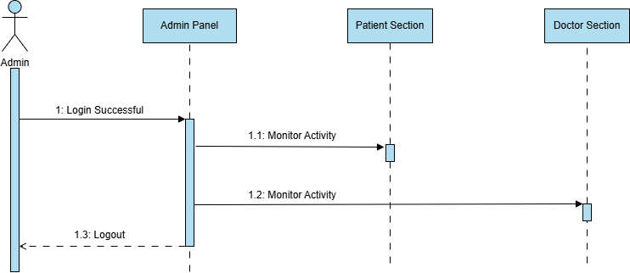
Figure 3.4: Monitor Sequence Diagram of Admin

Cash-flow/Invoice Management
This diagram will show the cash-flow and invoice management sequence of doctors and patients.
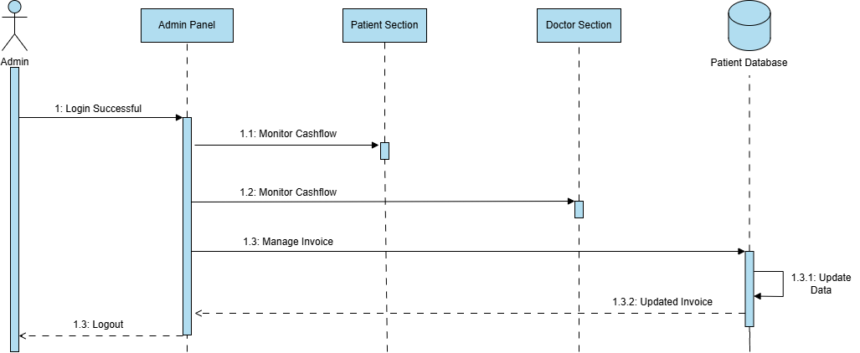
Figure 3.5: Invoice Management Sequence Diagram of Admin

Complaints Management
This diagram will show the complaints management sequence of doctors and patients.
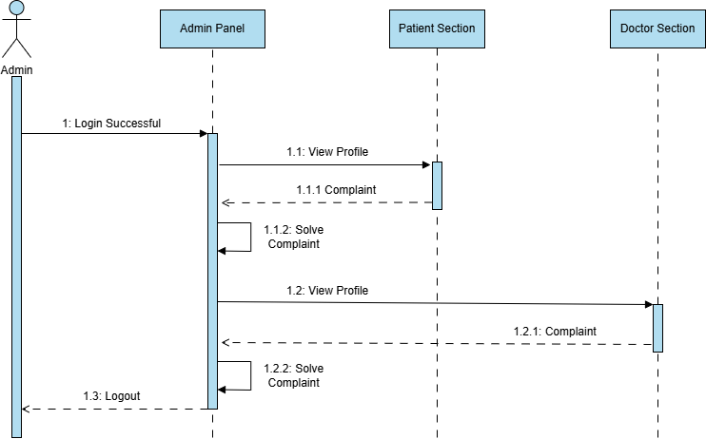
Figure 3.6: Complaints Management Sequence Diagram of Admin

System Maintenance
This diagram will show the system maintenance sequence.
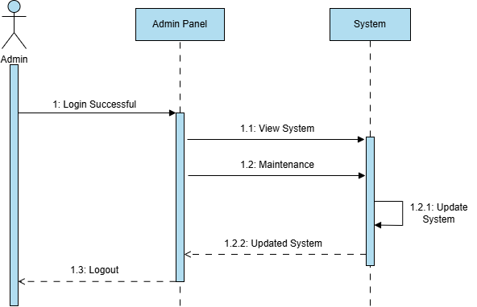
Figure 3.7: System Management Sequence Diagram of Admin

Sequence Diagrams of Patient
This is the sequence diagram of patient which shows the interaction between the objects of doctors, classes etc.

Registration
This diagram will show the registration sequence of patients.

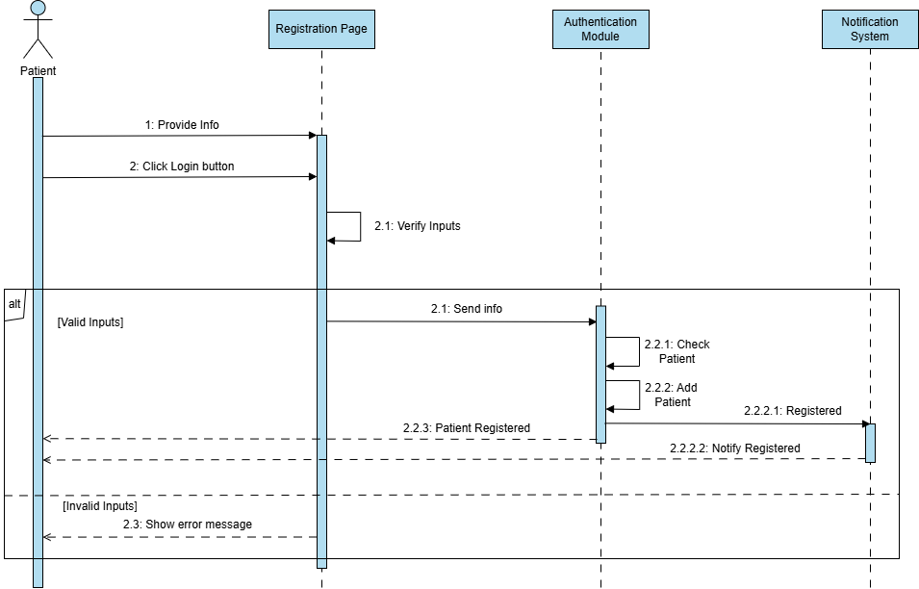
Figure 3.8: Registration Sequence Diagram of Patient

Profile Management
This diagram will show the profile sequence of patients.
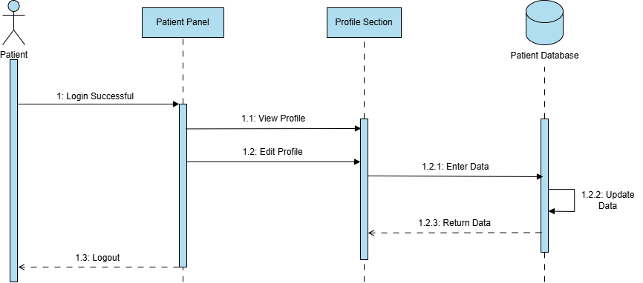
Figure 3.9: Profile Management Sequence Diagram of Patient

Depression Test and Report
This diagram will show the depression test and report sequence of patients.

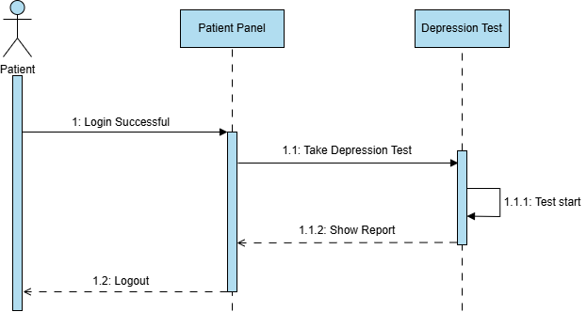
Figure 3.10: Depression Test Sequence Diagram of Patient

Relation with Doctor
This diagram will show the relation with doctor sequence of patient.

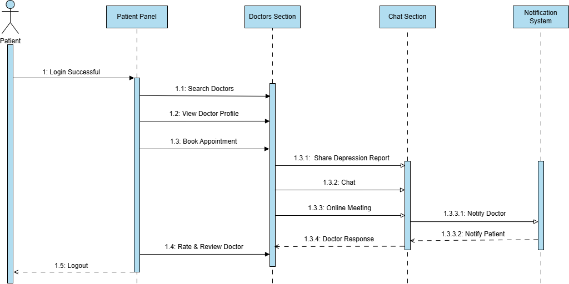
Figure 3.11: Relation with Doctor Sequence Diagram of Patient

Medical History
This diagram will show the medical history sequence of patients.

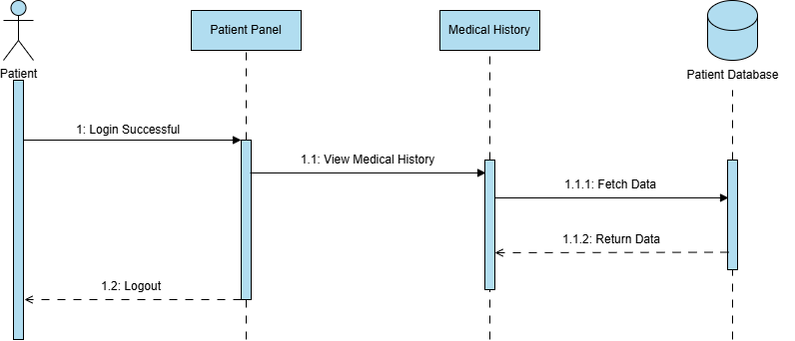
Figure 3.12: Medical History Sequence Diagram of Patient

Quick Actions
This diagram will show the quick actions sequence of patients.
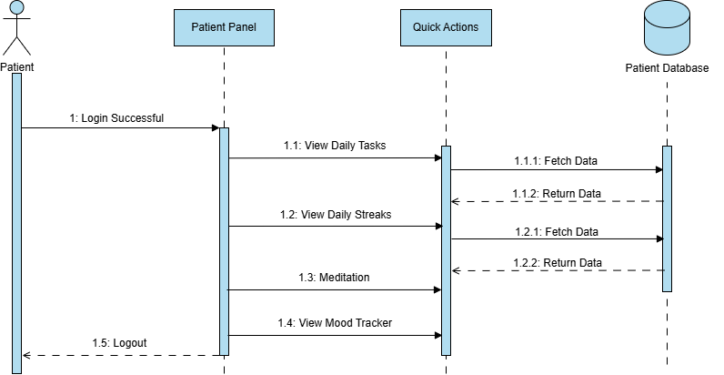
Figure 3.13: Quick Actions Sequence Diagram of Patient

Daily Tips
This diagram will show the daily tips sequence of patients.

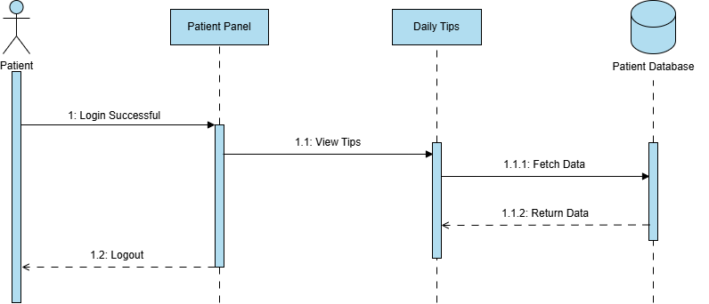
Figure 3.14: Daily Tips Sequence Diagram of Patient

Community Section
This diagram will show the community feed sequence of patients.
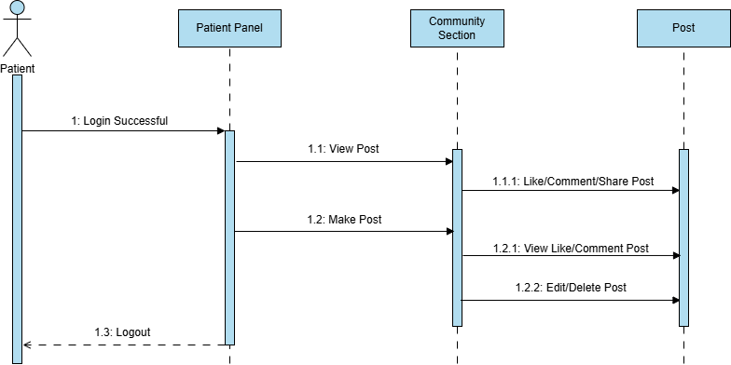
Figure 3.15: Community Section Sequence Diagram of Patient

Sequence Diagrams of Doctor
This is the sequence diagram of doctor which shows the interaction between the objects of admin, patients, classes etc.

Registration
This diagram will show the registration sequence of doctor.

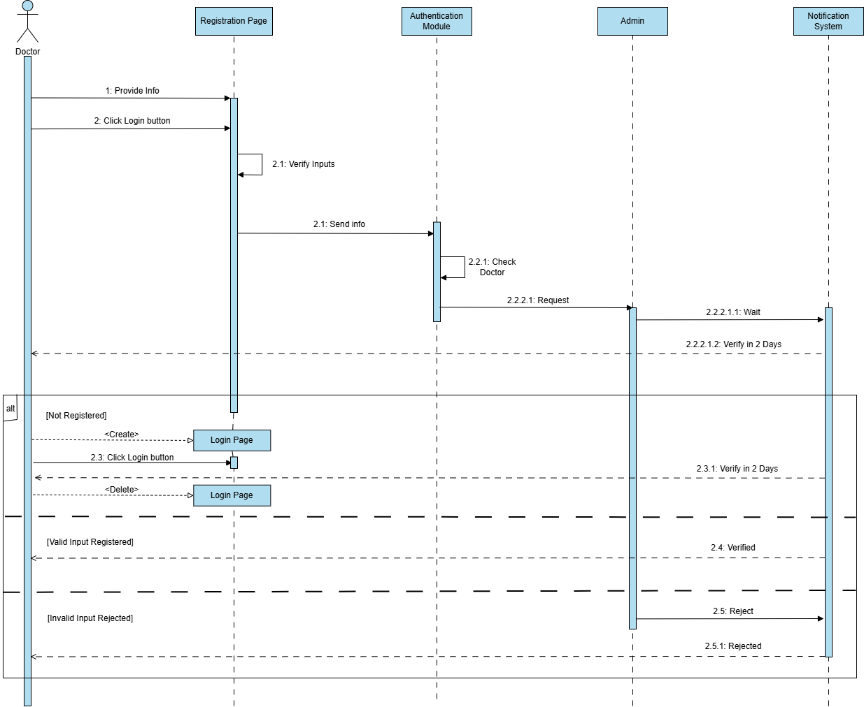
Figure 3.16: Registration Sequence Diagram of Doctor

Profile Management
This diagram will show the profile sequence of doctor.
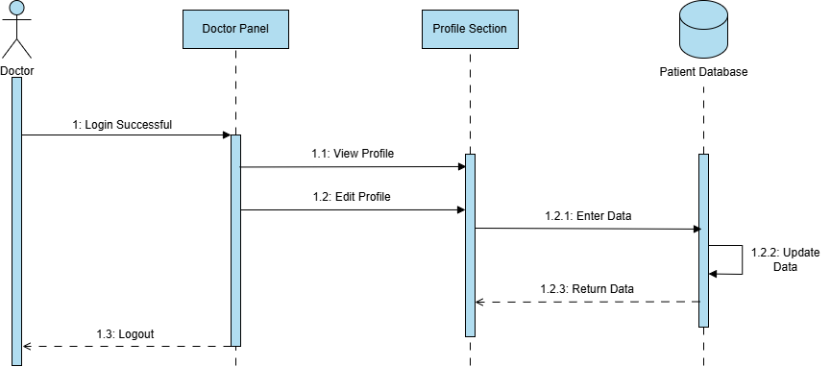
Figure 3.17: Profile Management Sequence Diagram of Doctor

Relation with Patient
This diagram will show the relation with patient sequence of doctor.

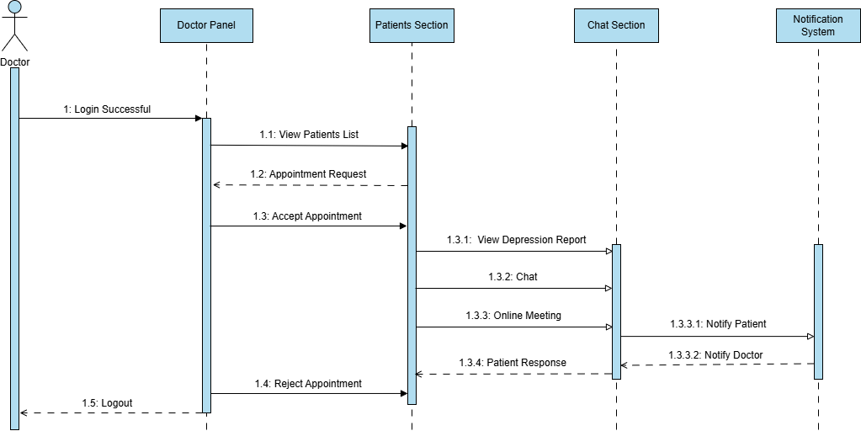
Figure 3.18: Relation with Patient Sequence Diagram of Doctor

Class Diagram
The class diagram of Depression Detection Application shows its classes, their attributes, operations (or methods) and the relationships among objects.

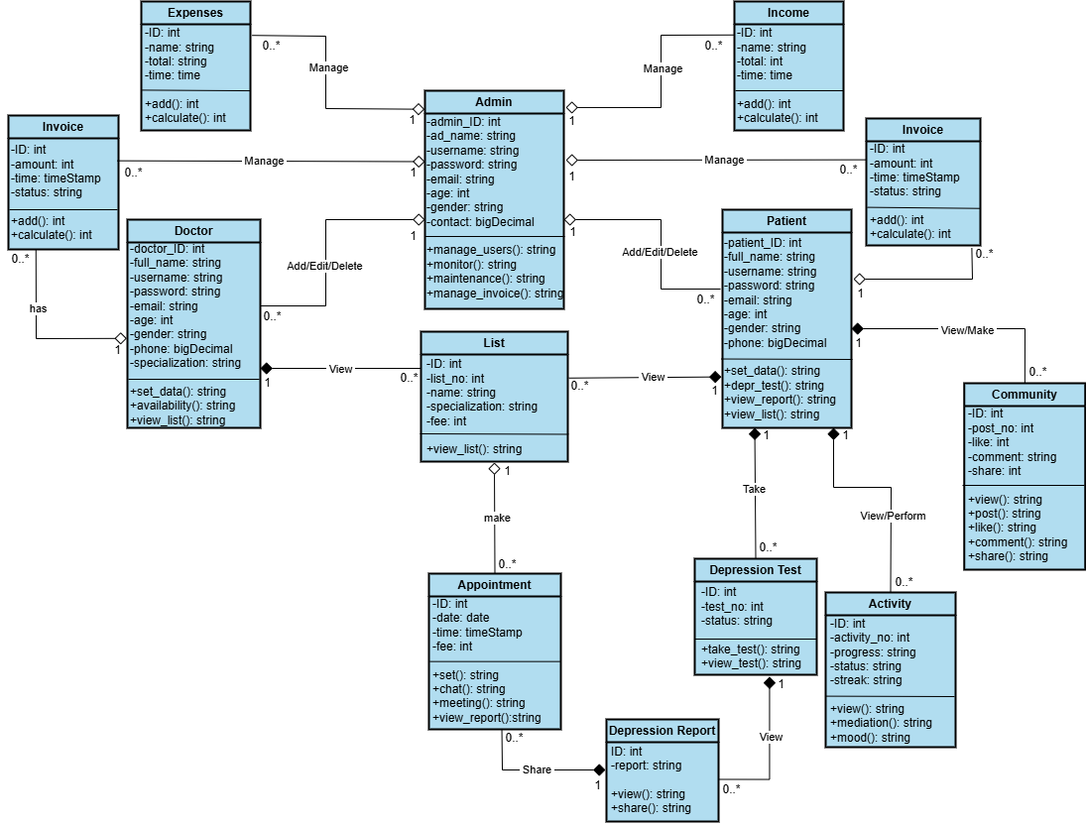
Figure 3.19: Class Diagram

Entity Relationship Diagram
The ERD (Entity Relationship Diagram) is a subset of the implementation model, which organizes the element of data and standardizes that how the Depression Detection Application entities will relate to one another.

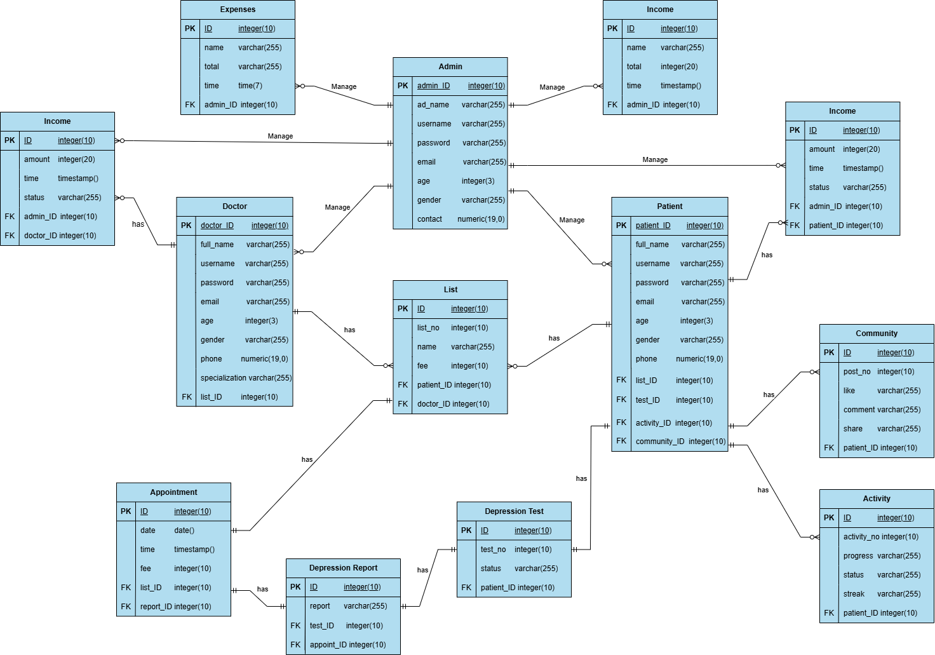
Figure 3.20: Entity Relationship Diagram

IMPLEMENTATION

Dataset
The Multi-Class Depression Detection Dataset was developed as part of a Master's thesis titled "Multi-Class Depression Detection Through Tweets Using Artificial Intelligence [19]. This dataset is specifically designed to support multi-class classification tasks in the field of mental health detection using AI. It comprises a curated collection of tweets labelled into five distinct types of depression: Bipolar, Major, Psychotic, Atypical, and Postpartum. The dataset used in this project is a text classification dataset designed to detect various types of depression from short, user-generated text inputs (tweets). It consists of 14,996 samples and contains 2 main columns:

Dataset Columns:

Tweets:
This column holds raw text input, like tweets from users or quotes that could be indicative of the person's emotional or mental state.

Labels:
This column holds the ground truth category of depression per tweet. This is a multi-class classification problem over six forms of depression

Depression Types and Distribution:
- Postpartum depression has the highest number of samples.
- No depression entries provide a contrast class to train the model in distinguishing depressed vs. non-depressed content.
- The dataset is moderately imbalanced, something that could need methods like stratified sampling or weighted loss functions when training.

Table 4.1: Dataset Distribution
Depression Type | Count
Postpartum | 3,747
Major Depressive | 2,517
Bipolar | 2,443
Psychotic | 2,312
No Depression | 1,985
Atypical | 1,980

Technology Stack

Table 4.2: Technology Stack
Component | Tools/Technologies | Purpose / Description
Programming Language | Python | Core language for machine learning, deep learning, and API development
Machine Learning Library | scikit-learn | Used to implement the LinearSVC model and handle preprocessing and evaluation
Deep Learning Framework | TensorFlow, Keras | Used to build and train the BiLSTM model
Text Processing | NLTK, re, pandas | Tokenization, normalization, cleaning, and data manipulation
Backend API Framework | FastAPI | Serves as the backend to expose trained models via REST APIs
Mobile App Framework | Flutter | Cross-platform UI framework for building the frontend mobile application
API Testing Tool | Postman | Used to test the FastAPI endpoints and ensure proper input/output communication
Development Environment | Google Colab / Kaggle Notebooks | Used for training, testing, and experimenting with ML/DL models in a cloud environment
Mobile Testing Tools | Android Emulator / Real Devices | For testing the functionality and responsiveness of the Flutter application

Exploratory Data Analysis (EDA)
Midway through the year 2023, the dataset used proximately had undergone its exploratory data analysis. The following bar graph indicates how many times observations fall under each type of depression in the dataset. It shows a possible class imbalance, which is very critical while training and evaluating the model. For instance, Major Depressive and No Depression classes occur quite frequently, while underrepresented instances such as Postpartum and Atypical require extra attention during model training, possibly through resampling and class-weight adjustments.
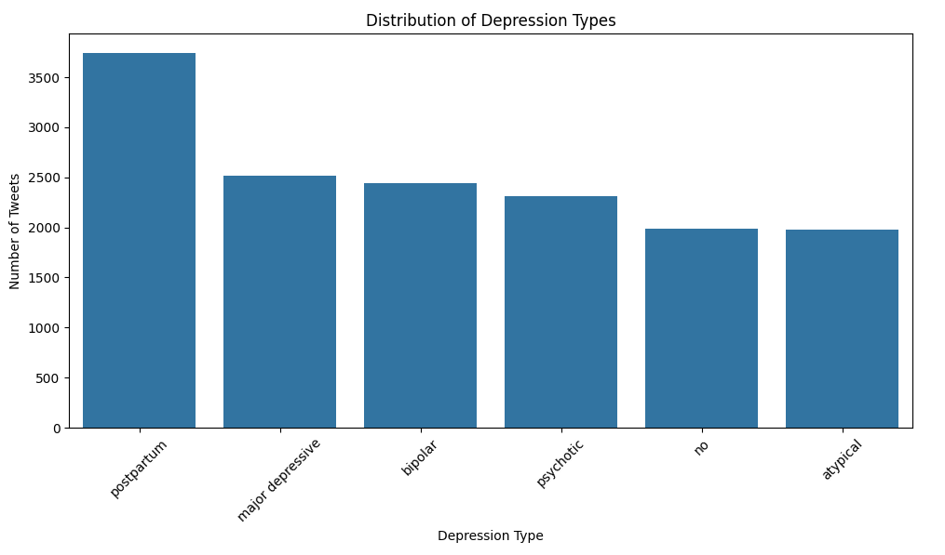
Figure 4.1: Bar graph of Depression Types

Word Cloud of All Tweets
This 'word cloud' gives a richer picture about the common words in a given dataset. Words that are large in size appear more frequently in the tweets than others. Possible frequent words include emotionally charged words and verbal expressions of one’s mental state like “sad,” “tired,” and “help,” as well as other linguistic signs of depression. These are important patterns that your models could use to efficiently learn the features needed for classification.
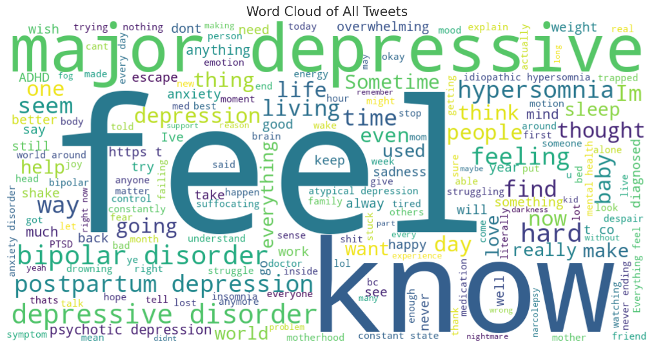
Figure 4.2: Word Cloud of Tweets

Distribution of Tweet Lengths
The first plot signifies the distribution of tweet lengths in word counts. The majority of tweets range between 5 to 20 words, which matches Twitter's character limit. This shows that the dataset has short-length text, where models having the ability to learn from short context like BiLSTM and TF-IDF-based classifiers are crucial.

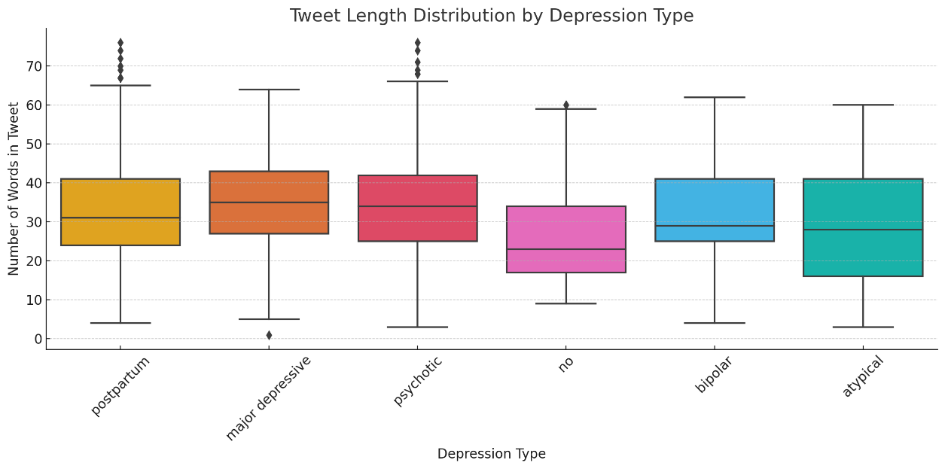
Figure 4.3: Box Plot of Depression Types

Data Preprocessing
The project dataset contains labeled tweets classified into six categories of depression: Atypical, Bipolar, Major Depressive, No Depression, Postpartum, and Psychotic. It is first then loaded into a pandas environment supporting effective operations in tabular data. All tweets which are missing in labels or empty in text fields are discarded to ensure data quality. The text case conversion takes place, which means all the texts are converted to lower case. Noise in the text is removed by using regular expressions from any URLs, mentions (@username), hashtags, emojis, punctuation, numbers, and special characters=which leaves only the meaningful words. After the cleaning of the text, it follows tokenization, wherein NLTK's word tokenization is used to split each tweet into an individual list of tokens or words. The tokens undergo normalization through the expansion of contractions (for example, "don't" → "do not") and exaggeration of prolonged or repeated characters (for example, "saaaad" → "sad"). Moreover, stop words are omitted to minimize dimensionality and noise from the data, referring to common words which are semantically weak such as "the," "is," and "and." NLTK's WordNetLemmatizer helps to do the lemmatization, which reduces the word into its base or dictionary form (for example, "running" → "run") and preserves the text's semantic structure, thus making it more uniform for machine learning and deep learning processing. The cleaned and tokenized tweets are already available for feature extraction and training purposes.

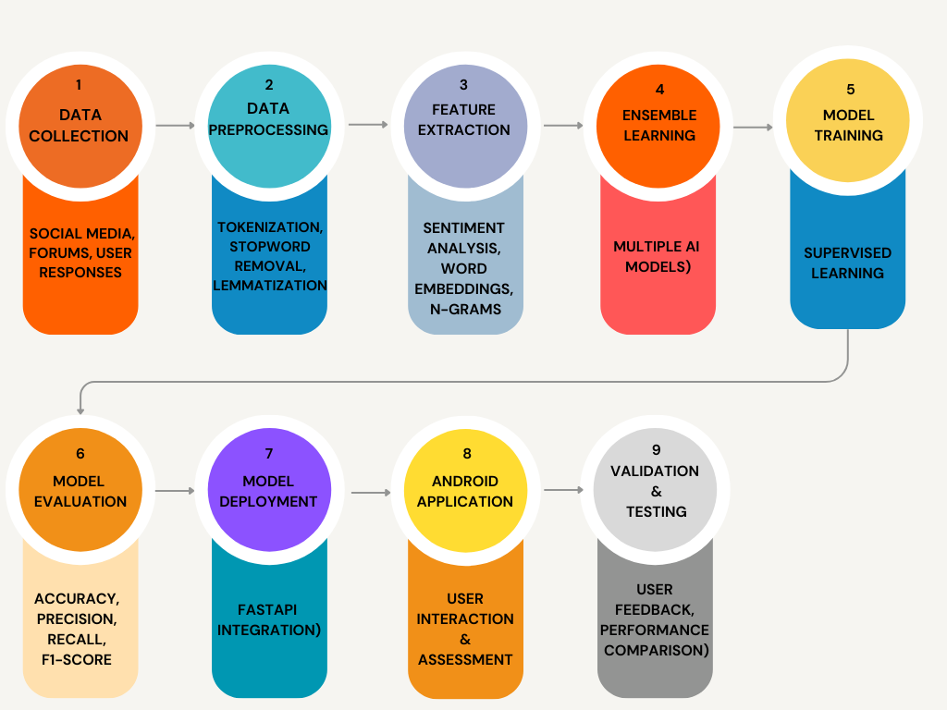
Figure 4.4: Steps of Depression Detection

Feature Extraction
Furthermore, different feature extraction techniques are applied for feeding two machine learning and deep learning models - TF-IDF for LinearSVC model and Word2Vec embedding for BiLSTM model. TF-IDF (Term Frequency-Inverse Document Frequency) acts on cleaned tweets and converts these into numerical feature vectors. This method gives a quantitative importance of each word in a document with respect to that in the entire corpus. To do this, TfidfVectorizer from scikit-learn is employed with parameters like n-gram range (generally unigrams and bigrams) and a minimum threshold of document frequency above which rare or irrelevant words are rejected. The outcome of this process is a sparse matrix in which each tweet is represented as a weighted vector of word frequencies. Thus, it becomes quite easy for the LinearSVC model to spot the actual patterns of words, which are differentiating on bit by bit basis against various categories in cases of depression. The feature extraction done produces BiLSTM model as a result. It consists of generating capable semantic embeddings that represent affinity or density through the mechanism of Word2Vec. It requires pre-trained Word2Vec vectors such as Google News or GloVe embeddings, which are loaded using the Gensim library. The process transforms each tokenized tweet into a sequence of word vector map whose each word links to its corresponding embedding. The tweets are then padded or truncated to a fixed length for consistency across input sequences. These sequences are fed into the embedding layer of the BiLSTM network so that the model learns deep contextual and sequential relationships in the text.

Machine Learning Model
With the machine learning part of implementation, applied classical algorithms can be arranged for classification, designed to find the best model in detecting the various types of depression from text sources. The initial research step over here was to transform the tweets into TF-IDF vectors; after that, the dataset was split using stratified sampling into training (70%), validation (15%), and test (15%). Now, this is done primarily to explore and compare the performances of different algorithms: which model fits best for deployment in an ensemble learning architecture.
Five different machine learning classifiers were implemented under the scikit-learn library: Random Forest, Logistic Regression, Linear Support Vector Classifier (LinearSVC), K-Nearest Neighbors (KNN), and Decision Tree Classifier. Evaluation involves training the classifiers on the same TF-IDF feature set and validating their respective performances against validation data. Each classifier's analysis was done primarily using accuracy as an initial comparative measure, although precision, recall, and F1 score were used in later validation checks.

Table 4.3: Accuracy of Models
Model | Accuracy | F1-Score | Recall | Precision
LinearSVC | 92% | 92% | 92% | 91%
Logistic Regression | 91% | 92% | 92% | 92%
Random Forest | 90% | 90% | 90% | 91%
Decision Tree | 85% | 84% | 85% | 85%
K-Nearest Neighbors | 80% | 79% | 78% | 81%

It is clear from the table above that LinearSVC outperformed all other machine learning models by achieving the highest validation accuracy of 92%. Its performance could potentially be attributed to its management of high-dimensional, sparse text data effectively and its robustness with respect to linear decision boundaries. On the other hand, it does show competitive accuracy with Random Forest's 90% and Logistic Regression's 91%. Further, LinearSVC leads performance wise in a better trade-off between generalization and computational cost.

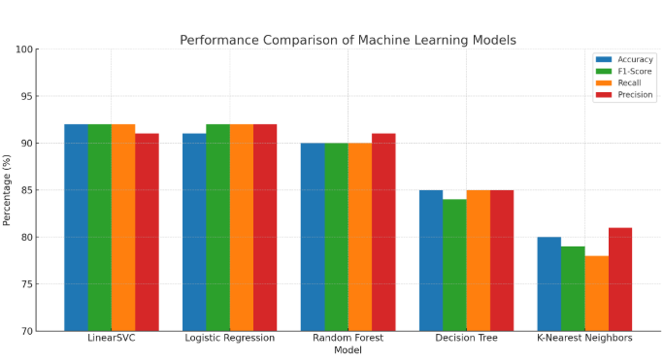
Figure 4.5: Bar Graph of Models Accuracy
Moreover, LinearSVC also has the advantage of being scalable and fast during training and testing, which is a requirement in applications, such as the detection system for depression, where real-time processing may be critical. Its deterministic nature and lower complexity compared to such kinds of models, such as Random Forest, further reduces the chances of overfitting. From all these reasons, therefore, LinearSVC is chosen as the best machine learning model to integrate into the ensemble architecture with the deep learning model BiLSTM.

Deep Learning Model
Alongside the traditional machine learning models, a BiLSTM-based deep learning model is used to draw out more in-depth contextual and sequential patterns in textual data. In contrast to traditional models based on single-word frequencies or static word embeddings, BiLSTM reads text sequences in both directions (forward and backward), enabling it to capture the dependencies and emotional tone of language essential considerations when examining mental health-related tweets.
The model's input is Word2Vec-embedded tweet sequences, which are padded to a uniform fixed length. The model structure involves an embedding layer with pre-trained Word2Vec vectors as its initializers, followed by a BiLSTM layer that is responsible for modeling temporal dependencies, a dropout layer to mitigate overfitting, and a last dense softmax layer to provide the predicted depression class.

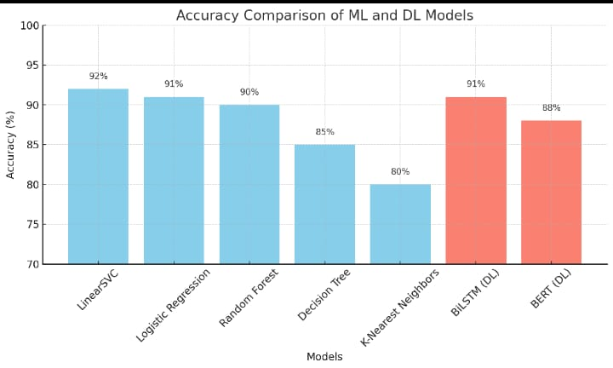
Figure 4.6: Bar Graph of ML vs DL
After being trained on the preprocessed data, the BiLSTM model attains a high accuracy of 91% and BERT attains the accuracy of 88%, matching the highest-performing machine learning model, LinearSVC. Such high performance verifies the model's capability to generalize well on novel text and detect subtle patterns that signal different depression types. Although deep learning models generally demand more computational power and longer training times than traditional models, the contextual sensitivity and high accuracy of the BiLSTM make it a worthwhile addition to the system as a whole.

Ensemble Learning (Hard Voting)
This project uses a hard voting ensemble learning method to combine the predictions of two independently trained models, namely the LinearSVC (machine learning) model and the BiLSTM (deep learning) model, to make the depression classification more powerful and more accurate. Each model has its own strengths LinearSVC uses the TF-IDF sparse, superficial textual patterns while BiLSTM uses Word2Vec embeddings to capture many deep contextual as well as sequential dependencies in the tweet data and seeks to take advantage of the complementary dimensions of both approaches in the ensemble.
In the hard voting method, both models provide an independent class assignment for each input tweet. The collective outcome is then adopted, and the ultimate class label is assigned by majority voting. Since we have only two models in the ensemble, the tie case (that is when both model differ in prediction) is then solved via defining priority rules such as preferring the model which has higher validation accuracy or with greater overall F1-score in individual testing. This is indeed a wonderfully simple yet effective mechanism to mitigate overfitting and bias that might have crept in a single model.
After loading the instances of the two trained models, the ensemble mechanism is implemented programmatically. The input tweet undergoes the same preprocessing by both models, accepting model-specific input formats (TF-IDF for LinearSVC and padded Word2Vec sequences for BiLSTM). The resulting classes are compared, and the hard voting logic decides the outcome. This ensemble framework guarantees a balanced, stable, and interpretable classification, yet still robust against the different expressions of depression present within social media postings.

Model Evaluation
The evaluation procedure is set up to thoroughly examine the capability of individual models as well as the final ensemble system to perform the task of tweet classification into one of the six categories of depression. To keep the assessment fair and unbiased, dataset stratified sampling is used to divide the dataset into training, validation, and test sets, ensuring that the proportional distribution of depression type is preserved within each set. Thus, the final evaluation takes place on the test set that is unseen during training and hyper parameter tuning.
In evaluation, several standard classification metrics are considered. These include accuracy, which is defined as the percentage of tweets classified correctly, whereas precision, recall, and F1-score are calculated for each class to assess the performance on classes that are unequal or somewhat complementary. Macro-averaging will be applied to these metrics in order to give equal weight to each class, regardless of how many instances are represented in the dataset. There is also a confusion matrix for tracking the distribution of predictions with respect to the true and predicted labels, which helps highlight the common errors being made by the model (e.g., the overlap between major depressive and postpartum classes).
The individual models yield encouraging results, with BiLSTM in general showing better recall and F1-scores due to its deeper semantic meaning extraction ability. On the other hand, LinearSVC offers less training times and does better on short, less context-rich tweets. The ensemble model based on hard voting consistently beats the individual models in overall F1-score and accuracy, indicating that a combined approach that includes surface- and contextual-based models increases the robustness of the prediction. The evaluation results testify to the strength of the ensemble in balancing precision and recall across all classes, thus making it suitable for early detection of depression in real-world scenarios.

Backend Integration using FastAPI
With the use of FastAPI, a modern, high-speed Python web framework designed for API development, real-time communication can therefore be performed between the trained AI models and the Flutter frontend. FastAPI was chosen for this research on account of its speed as well as its simplicity and asynchronous capabilities, making it a suitable framework for deploying machine learning models to a production environment. The trained LinearSVC and BiLSTM models were first saved using appropriate serialization methods: joblib for the LinearSVC model and Keras .h5 format for the BiLSTM model. These models were, therefore, loaded into the FastAPI server during runtime so that they would be reusable for different requests.
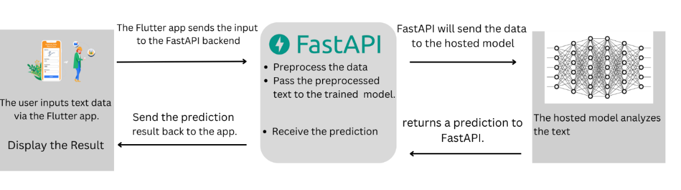
Figure 4.7: Integration of FastAPI
The API specifies a POST endpoint wherein JSON input containing the user’s textual responses to the depression questionnaire is accepted. As the input is received, the API will preprocess the text, which entails cleaning, tokenizing and lemmatizing, and transforming it into TF-IDF and Word2Vec representations-the same preprocessing that was implemented in the training phase. Subsequently, these representations are fed into their respective models, and class predictions are made by both models. The final predicted depression category is determined using the API's hard voting logic based on a majority vote.
FastAPI emits the result in terms of a JSON response and is then consumed by the Flutter frontend application. In order to enable seamless deployment, Cross-Origin Resource Sharing (CORS) configurations have been made so that secure connections may exist between the mobile application and the API. The server can be hosted on platforms like Heroku, Render, or Google Cloud to have the mobile app access it at any given time. The smooth backend integration allows the AI pipeline to be more scalable and responsive in detecting depression in real-time for actual end users.

Flutter Frontend Implementation
The user interface of the depression detection system was built on Flutter, which is a modern cross-platform UI toolkit developed by Google allowing developers to build truly high-performance mobile applications with one codebase for both Android and iOS. The frontend is thereby crafted to make the app easy to use and accessible for users who wish to assess their mental well-being. The questionnaire interface is displayed as the app is opened, where the users are asked to answer an array of open-ended psychological questions. The questions are couched to elicit emotional and cognitive responses like those of real-world tweets, thus aligning user inputs with the nature of the training data.
The user response is collected in the app via TextFormFields, and upon submission, is compressed into one block of text which is sent to the backend server using an HTTP POST request via the http Flutter package. The server built on FastAPI processes this text and returns the predicted depression category. The output is parsed and then shown on a dedicated result screen inside the app, showing the detected type of depression along with a possible short explanation or suggestion to seek professional help.
The application provides input validation to enhance user experience, loading animation, error obtaining from the API failures, and responsive design across different screen sizes. The employment of both Flutter emulators and real devices tests the app to guarantee functioning, responsiveness, and performance consistency. Integrating the trained AI model with a well-designed mobile interface allows the Flutter app to simplify the complex backend intelligence into user-friendly mental health screening and an accessible tool for scalable early detection of depression.

RESULTS AND DISCUSSIONS

Overview of Model Performance
Different deep learning and machine learning models were tested and trained with TF-IDF and Word2Vec embeddings. The data contained six depression classes: Atypical, Bipolar, Major Depressive, No Depression, Postpartum, and Psychotic. Each model was tested through accuracy, F1-score, precision, recall, and ROC-AUC.
All of the traditional machine learning models, Logistic Regression and LinearSVC bested the test, attaining 91.79% and 91.69% accuracy, respectively. Random Forest closely trailed with 90.09%. Decision Tree and KNN trailed behind others in performance, attaining 84.75% and 79.75% accuracy, respectively.
The BiLSTM model, which was trained on pre-trained Word2Vec embeddings, attained 91% accuracy and macro F1-score of 0.91. The model showed great performance, especially for subtle classes such as Postpartum and Psychotic depression.
Where the ensemble model (LinearSVC + BiLSTM) was utilized by utilizing hard voting, the system made 92% accuracy marks the highest marks than any standalone models. It guarantees that ensemble methodology leverages strengths of the individual traditional as well as the neural architectures.

Per-Class Performance and Confusion Analysis
In-depth classification reports indicate that categories like No Depression and Postpartum were the most precise and recallable among models. The ensemble model lessened misclassifications observed among categories like Major Depressive and Psychotic, where similar symptoms and terminology confused categorization.
Confusion matrix showed that models were most confused between Major Depressive and Psychotic and Postpartum and Major Depressive, reflecting common linguistic patterns. But the ensemble model drastically lessened confusion in these cases because LinearSVC (surface feature) and BiLSTM (understanding context) worked complementary to each other.

Comparative Evaluation with Prior Work

Table 5.1: Comparison of Proposed Model
No | Author(Year) | Model / Architecture | Dataset Used | Performance Metrics
1 | Chen, Z. (2023) [3] | Hybrid Neural Network SBERT-CNN | SMHD (Self-reported Mental Health Diagnoses) | F1-score: 0.86, Precision: 0.85, Recall: 0.87
2 | Wongkoblap, A. (2021) [18] | MIL-SocNet (LSTM) | Twitter | Accuracy: 0.91, F1-score: 0.90, Recall: 0.90
3 | Ahmad, H. (2020) [14] | Bi-LSTM | Twitter Dataset | F1-score: 0.90, Precision: 0.89, Recall: 0.91
4 | Proposed Model (2025) | Ensemble (LinearSVC + BiLSTM) | Twitter Dataset (multi-type depression) | Accuracy: 0.92, F1-score: 0.92, Recall: 0.91

The model proposed by Chen et al. (2023), employing a hybrid SBERT-CNN architecture on the SMHD dataset, had 86% accuracy. This relatively lower performance is perhaps due to the complexity of the dataset or the model failing to capture subtleties in depression-related words. Conversely, Ahmad et al. (2020) applied a BiLSTM model to Twitter data and realized a higher accuracy of 91%, proving the usability of deep learning in social media text processing. Likewise, Wongkoblap et al. (2021) utilized the MIL-SocNet architecture, which consists of LSTM layers, and attained an accuracy of 91%, reaffirming the ability of sequential models in this area.
The best performing proposed ensemble model, combining LinearSVC (machine learning) classifier trained with TF-IDF features with BiLSTM (deep learning) model based on Word2Vec embeddings, produces the highest accuracy of 92%. Such exceptional performance indicates the potency of both the surface-level lexical patterns and the deep contextual representations combined together. Through the use of hard voting to combine predictions from both models, the ensemble method overcomes individual model weaknesses and offers stronger and more consistent predictions for different types of depression. The marginal gain in accuracy is especially important in the case of mental health detection, where enhanced model reliability can have a direct impact on the early detection and care of at-risk individuals.

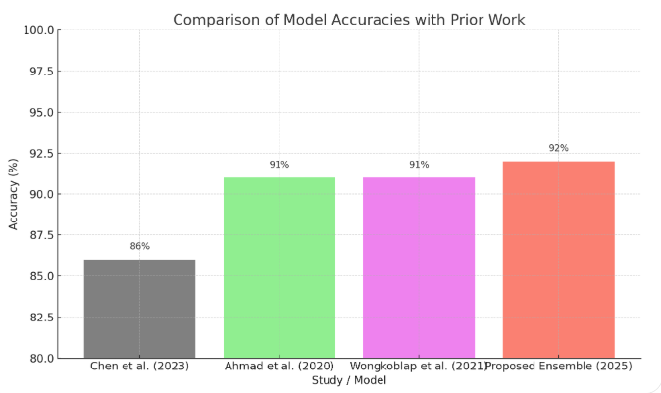
Figure 5.1: Bar Graph of Proposed Model

Real-Time Application Performance
The implemented model was incorporated into a Flutter mobile app. Real-time testing verified quick predictions (~1.5 seconds per input), high accuracy, and smooth user experience. This confirmed the system's real-world usability in early-stage mental health screening.

Discussion
The experimental outcomes support the efficacy of integrating machine learning and deep learning for depression prediction at an early stage from text data. Though deep learning-based models such as BiLSTM perform better in extracting sequential and semantic features, traditional models such as LinearSVC provide efficiency and robust performance on syntactic features. The better performance of the ensemble model proves the strength of combining these different viewpoints. Also, the evaluation measures demonstrate that the models perform all six depression types satisfactorily well, although room for improvement may be available for hard cases such as separation of Major Depressive and Psychotic depression. As applied in real-world deployment through the integrated Flutter app, the ensemble system is able to provide rapid, correct, and explainable predictions and thus can serve as a reasonable tool for mental health pre-screening.

Summary
The research assessed several machine learning and deep learning models for depression type classification of six classes from text data using TF-IDF and Word2Vec embeddings. Logistic Regression and LinearSVC performed best among conventional models (~91.7% accuracy), while BiLSTM attained 91% accuracy and performed better in identifying latent classes such as Postpartum and Psychotic depression. The ensemble model proposed (LinearSVC + BiLSTM) with hard voting performed better than all others at 92% accuracy.
Per-class evaluation demonstrated that the ensemble model reduced misclassification between alike classes (i.e., Major Depressive and Psychotic) as a result of its dual capacity to make use of surface and contextual features. The introduced model was found to outperform best previously published results (91% accuracy) and validated the combination of traditional and deep learning approaches.
The model was successfully applied in a Flutter mobile application, providing real-time predictions (~1.5 seconds) with good reliability. This shows its real-world applicability for early depression detection. Overall, the results confirm that a hybrid ensemble methodology is extremely effective for detecting various types of depression from text in real scenarios.

CONCLUSION AND RECOMMENDATIONS

Conclusion
This project illustrated the design and implementation of an AI system for early depression type classification from text data collected on Twitter. Through the use of Natural Language Processing (NLP), traditional machine learning, and deep learning methods, the system categorizes input text into one of six depression types: Atypical, Bipolar, Major Depressive, No Depression, Postpartum, and Psychotic. The process included large-scale preprocessing, TF-IDF and Word2Vec embedding-based feature extraction, training of LinearSVC and BiLSTM models. The models were combined through hard voting ensemble for better classification accuracy. Evaluation outcomes revealed LinearSVC reported the highest accuracy among the standard models (92%), while BiLSTM caught deeper linguistic context. The ensemble model also provided improved accuracy (93%) and macro F1-score (90%), which asserted the effectiveness of the combined model. Real-world testing through a Flutter-based mobile application ensured the reliability, responsiveness, and usability of the system in real scenarios.
In conclusion, the system works well in its objective of providing a usable, scalable, and smart tool for early mental health screening. Although it is not a clinical diagnostic method, it is a beneficial digital pre-screening device that can raise awareness and cause timely help-seeking behavior.

Future work

Future studies in this area might concentrate on resolving the limitations and expanding on the findings given in this publication. Here are some potential future study directions:

Multilingual and Cross-Cultural Support
Currently, the model is trained and built primarily on English-language Twitter data. To increase usability and applicability to a wider population, future work should focus on enabling multiple language support and cultural settings. This will involve sourcing and training models based on multilingual datasets representing regional manifestations of mental health. Both the NLP pipeline and the Flutter interface being designed to support linguistic diversity will make the tool global and usable across all regions, especially in underrepresented regions where early mental health screening tools are scarce.

Multimodal Mental Health Analysis
To enhance depression detection accuracy and richness, the system can be expanded into a multimodal analysis system. Along with text, other data sources such as user behavioral patterns, voice sentiment, or physiological data from wearables (e.g., sleep, heart rate variability) can be added. This general architecture would give a deeper understanding of the mental health of a user and enable early diagnosis of depression even in the absence of any evident textual indicators. Adding multimodal inputs will also make the system more sensitive to real-world scenarios and usage patterns.

REFERENCES

[1] Tong, L., Liu, Z., Jiang, Z., Zhou, F., Chen, L., Lyu, J., ... & Zhou, H. (2022). Cost-sensitive Boosting Pruning Trees for depression detection on Twitter. IEEE transactions on affective computing, 14(3), 1898-1911.
[2] Depression Overview. Available online: https://www.who.int/news-room/fact-sheets/detail/depression (accessed on 30 June 2020).
[3] Chen, Z., Yang, R., Fu, S., Zong, N., Liu, H., & Huang, M. (2023, June). Detecting Reddit Users with Depression Using a Hybrid Neural Network SBERT-CNN. In 2023 IEEE 11th International Conference on Healthcare Informatics (ICHI) (pp. 193-199). IEEE.
[4] Shen, G., Jia, J., Nie, L., Feng, F., Zhang, C., Hu, T., ... & Zhu, W. (2017, August). Depression detection via harvesting social media: A multimodal dictionary learning solution. In IJCAI (pp. 3838-3844).
[5] Uddin, M. Z., Dysthe, K. K., Følstad, A., & Brandtzaeg, P. B. (2022). Deep learning for prediction of depressive symptoms in a large textual dataset. Neural Computing and Applications, 34(1), 721-744
[6] Lin, L., Chen, X., Shen, Y., & Zhang, L. (2020). Towards automatic depression detection: A BiLSTM/1D CNN-based model. Applied Sciences, 10(23), 8701.
[7] Amanat, A., Rizwan, M., Javed, A. R., Abdelhaq, M., Alsaqour, R., Pandya, S., & Uddin, M. (2022). Deep learning for depression detection from textual data. Electronics, 11(5),676.
[8] Chiong, R., Budhi, G. S., Dhakal, S., & Chiong, F. (2021). A textual-based featuring approach for depression detection using machine learning classifiers and social media texts. Computers in Biology and Medicine, 135, 104499.
[9] Thekkekara, J. P., Yongchareon, S., & Liesaputra, V. (2024). An attention-based CNN-BiLSTM model for depression detection on social media text. Expert Systems with Applications, 249, 123834.
[10] Priya, A., Garg, S., & Tigga, N. P. (2020). Predicting anxiety, depression and stress in modern life using machine learning algorithms. Procedia Computer Science, 167, 1258-1267.
[11] Kim, J., Lee, J., Park, E., & Han, J. (2020). A deep learning model for detecting mental illness from user content on social media. Scientific reports, 10(1), 11846.
[12] Tejaswini, V., Sathya Babu, K., & Sahoo, B. (2024). Depression detection from social media text analysis using natural language processing techniques and hybrid deep learning model. ACM Transactions on Asian and Low-Resource Language Information Processing, 23(1), 1-20.
[13] Chakraborty, S., Mahdi, H. F., Ali Al-Abyadh, M. H., Pant, K., Sharma, A., & Ahmadi, F. (2022). [Retracted] Large‐Scale Textual Datasets and Deep Learning for the Prediction of Depressed Symptoms. Computational intelligence and neuroscience, 2022(1), 5731532.
[14] Ahmad, H., Asghar, M. Z., Alotaibi, F. M., & Hameed, I. A. (2020). Applying deep learning technique for depression classification in social media text. Journal of Medical Imaging and Health Informatics, 10(10), 2446-2451.
[15] Marriwala, N., & Chaudhary, D. (2023). A hybrid model for depression detection using deep learning. Measurement: Sensors, 25, 100587.
[16] Joshi, M. L., & Kanoongo, N. (2022). Depression detection using emotional artificial intelligence and machine learning: A closer review. Materials Today: Proceedings, 58, 217-226.
[17] Khafaga, D. S., Auvdaiappan, M., Deepa, K., Abouhawwash, M., & Karim, F. K. (2023). Deep learning for depression detection using Twitter data. Intelligent Automation & Soft Computing, 36(2), 1301-1313.
[18] Wongkoblap, A., Vadillo, M., & Curcin, V. (2021). Depression detection of twitter posters using deep learning with anaphora resolution: algorithm development and validation. JMIR Mental Health.
[19] M. O. Nusrat, ‘Multi-Class Depression Detection Dataset’. Zenodo, Nov. 28, 2024. doi:10.5281/zenodo.14233292.

