

BSIT-F24-001
03-135212-019 Noman Ali Khan
03-135212-009 Iqra Asim

InterVisio AI as Smart interviews with skill assessment and behavior monitoring.

In the partial fulfillment of the degree of
Bachelor of Science in Information Technology
Supervisor: Summaira Nosheen

Department of Computer Sciences
Bahria University, Lahore Campus

May 2025

© Bahria University, 2025

C e r t i f i c a t e

We accept the work contained in this report titled
InterVisio AI as meeting the required standard
by
Noman Ali Khan
Iqra Asim
for the partial fulfillment of the degree of
Bachelor of Science in Information Technology

Approved by:
Supervisor: Summaira Nosheen
(Signature)

DECLARATION

We hereby declare that this project report is based on our original work except for citations and quotations which have been duly acknowledged. We also declare that it has not been previously and concurrently submitted for any other degree or award at Bahria University or other institutions.

Enrolment | Name | Signature
03-135212-019 | Noman Ali Khan
03-135212-009 | Iqra Asim

Date : 12-05-2025

Specially dedicated to my beloved mother and father
Noman Ali Khan
my beloved mother and father
Iqra Asim

ACKNOWLEDGEMENTS

We would like to thank everyone who contributed to the successful completion of this project. We express our sincere gratitude to our research supervisor, Miss Summaira Nosheen, for her invaluable advice, guidance, and immense patience throughout the development of this research.
Additionally, we extend our heartfelt appreciation to our loving parents and friends for their unwavering support, encouragement, and motivation, which have been instrumental in the completion of this project.

Noman Ali Khan
Iqra Asim

ABSTRACT
We have developed a web based deep learning system called InterVisio , designed to streamline the hiring and interview process. In this system, Employees can create an account and upload their resumes, while Employers can directly post jobs without needing to create a profile. Once a resume is uploaded, the system analyzes the skills mentioned and recommends suitable job listings to the employee.
Employees can either save a job for later or start an interview instantly. When an interview begins, our system uses the Mistral API to generate relevant questions based on the job role. During the interview, the system actively monitors the candidate using a YOLOv8 model to ensure focus and detect any unusual behavior.
The interview consists of 10 questions, after which the session ends. Based on the candidate’s answers and behavior, the system automatically evaluates their performance and informs them whether they have passed or not. This approach provides a smart, automated, and efficient interview experience for both job seekers and employers.

Table of Contents
DECLARATION III
ACKNOWLEDGEMENTS V
ABSTRACT VI
LIST OF APPENDICES XI
CHAPTER 1 12
1 INTRODUCTION 12
1.1 Background 12
1.2 Problem Statements 13
1.3 Aims and Objectives 13
1.4 Scope of Project 13
CHAPTER 2 14
LITERATURE REVIEW 14
2.1 Comparison of different models 14
2.2 Review of past work 16
2.3 Research Gap Identification 16
2.4 Summary of Literature Review 17
CHAPTER 3 18
DESIGN AND METHODOLOGY 18
3.1 System Requirement Cart 18
3.2 Architecture Diagram 21
3.3 Modules Description 21
3.4 Dataset Description 21
3.5 Methodology 22
3.6 Methodology Diagram 22
3.7 Tools and Technologies 23
3.8 Training and Fine-Tuning 23
3.9 Ethical and Privacy Considerations 23
3.10 Use case diagram 23
3.11 Sequence diagram 26
3.12 Class diagram 26
CHAPTER 4 27
4 EXPERIMENTS 27
4.1 Data Collection 27
4.2 Dataset 27
4.3 Dataset analysis 28
4.4 Sample analysis 29
4.5 Strong Resumes 29
4.6 Preprocessing samples 31
4.7 Training and testing split 32
4.8 Augmentations 33
4.9 Landmarks extraction 34
4.10 Deep learning models 34
4.11 Mistral API 34
4.12 Yolo V8 35
4.13 Validating models 35
CHAPTER 5 36
5 RESULTS AND DISCUSSIONS 36
5.1 Results 36
5.2 Training Accuracy (YOLOv8): 41
5.3 Validation Accuracy (YOLOv8): 41
5.4 Loss Values (YOLOv8): 41
5.5 Performance Evaluation (Mixtral 8x7B API) 41
5.6 Confusion Matrix (YOLOv8) 41
5.7 Discussion 46
5.8 User manual 48
CHAPTER 6 50
6 FINDINGS AND RECOMMENDATIONS 50
6.1 Conclusion and findings 50
6.2 Future work 50
REFERENCES 52

LIST OF TABLES

TABLE TITLE PAGE

Table 2. 1 Literature review comparison 14

Table 3. 1 Functional Requirement 18
Table 3. 2 Non-Functional Requirement 19
Table 3. 3 YOLOv8 Tracking Attributes 21
Table 3. 4 Generated Questions Attributes 22

Table 4. 1 Collection of Data 27
Table 4. 2 Dataset Analysis 28

Table 5. 1 CNN evaluation with original samples 41
Table 5. 2 CNN evaluation with augmented samples 44

LIST OF FIGURES

FIGURE TITLE PAGE

Figure 3. 1 System Architecture Diagram 21
Figure 3. 2 System Flow diagram 22
Figure 3. 3 System Use case diagram 24
Figure 3. 4 System Sequence diagram 26
Figure 3. 5 System Class diagram 26

Figure 4. 1 resumes storing in folder of resumes 30

Figure 5. 1 Main Interface of the Smart Interview System 36
Figure 5. 2 Employer Job Management Panel 36
Figure 5. 3 Website Footer Section 37
Figure 5. 4 Smart Interview Journey for Candidate Evaluation and Selection 37
Figure 5. 5 Registration 38
Figure 5. 6 Complete Registration 38
Figure 5. 7 User Login 39
Figure 5. 8 Dashboard 39
Figure 5. 9 User Interface for Resume Upload and Interview Start 40
Figure 5. 10 Virtual Interview Screen 40
Figure 5. 11 YOLO F1 curve 42
Figure 5. 12 CNN training loss with original samples 43
Figure 5. 13 Confusion matrix YOLO with original samples 43
Figure 5. 14 YOLO Precision curve with augmented samples 44
Figure 5. 15 YOLO recall-confidence curve with augmented samples 45
Figure 5. 16 Confusion matrix YOLO with augmented samples 46

Figure 6. 1 Yolo V8 CNN model screenshot 57
Figure 6. 2 Mistral API Using 58
Figure 6. 3 Job recommendation according to Resume 58

LIST OF APPENDICES

APPENDIX TITLE PAGE
APPENDICES 57
APPENDIX A: Code 57

CHAPTER 1

1 INTRODUCTION

1.1 Background

In today’s competitive and technologically evolving job market, organizations are constantly seeking smarter, faster, and more reliable ways to recruit top talent. Traditional interview whether conducted in person or online often suffer from subjectivity, logistical inefficiencies, and challenges in assessing both technical competence and behavioral integrity. With the rise of remote and hybrid work environments, there is an urgent need for intelligent, automated systems that can fairly and efficiently evaluate candidates from a distance[1].
To address this challenge, this project presents InterVisio, an AI-based smart interview system designed to autonomously conduct, monitor, and evaluate remote interviews. The system is purpose-built for the computer science domain, allowing candidates to upload their CVs, which are then analyzed to extract relevant skills and experience. Using this information, a custom-trained Large Language Model (LLM) generates domain-specific, skill-based questions tailored to each candidate’s background[2].
The system leverages YOLOv8 for real-time monitoring through the candidate’s camera, enabling it to detect behaviors such as looking away, using mobile phones, or other unethical actions during the interview. These observations contribute to a behavioral evaluation score, which is combined with the response analysis score computed by comparing the candidate’s spoken answers with expected answers generated by the LLM[3].
InterVisio features an intelligent and interactive interface powered by SpeechT5, enabling smooth communication through text-to-speech and speech-to-text functionalities. This allows the AI to verbally conduct the interview and understand spoken responses naturally, closely mimicking a human interviewer[4].
The system is implemented using a modular and scalable backend architecture. The Flask framework is used for serving core web functionalities and rendering the frontend pages, while FastAPI handles high-performance RESTful API calls, such as NLP model inference, real-time behavior monitoring, and AI communication tasks. This separation ensures efficient request handling, better scalability, and a clean codebase for future upgrades[5].
In addition to conducting interviews, the system includes optional features like CV-based job recommendations, a user dashboard, and profile management for both candidates and employers. The evaluation logic assigns a final score based on a 70% weight to the relevance of the candidate’s answers and 30% to their on-camera behavior[6].
InterVisio stands at the intersection of NLP, computer vision, and speech AI, offering a robust, fair, and scalable solution for modern recruitment. It represents a transformative step in redefining how remote interviews are conducted, analyzed, and trusted[7].

1.2 Problem Statements
- Traditional and remote interviews suffer from bias, inconsistent evaluations, time-consuming manual tasks, and poor monitoring of dishonest behavior.
- Existing systems are fragmented and lack an integrated AI solution combining question generation, speech interaction, and real-time behavior analysis for fair and efficient remote interviews.

1.3 Aims and Objectives
Develop InterVisio, an AI-driven interview system that automates remote hiring using NLP, computer vision, and speech analysis to ensure fair, efficient, and real-time evaluation.
- Automate resume screening, question generation, and candidate assessment.
- Use a domain-specific LLM for personalized, skill-based questions.
- Evaluate both technical skills and behavioral traits.
- Ensure unbiased, accessible, and faster hiring.

1.4 Scope of Project
The scope of this project is to develop an AI-based smart interview system, InterVisio, that automates remote interviews specifically within the computer science domain. The system covers the entire interview process from CV analysis and skill-based question generation to real-time behavior monitoring and answer evaluation. It includes separate dashboards for employers and candidates, voice-enabled interaction, and secure, bias-free assessments. Future scalability includes job recommendations and support for other domains, making it a comprehensive and adaptable recruitment solution.

CHAPTER 2

LITERATURE REVIEW

2.1 Comparison of different models

Table 2. 1 Literature review comparison
SR | Paper | Year | Model/  Technology | Accuracy  /Result | Scope | Type | Limitation
1 | Development of an AI-based Interview System for Remote Hiring[8] | 2021 | GPT Models, Computer Vision (YOLOv5) | Improved fairness and remote hiring efficiency | AI-based Interview | Journal Paper | Limited real-time emotional accuracy and cultural bias.
2 | Proposal for AI Video Interview Using Image Data Analysis[9] | 2022 | Image Data Analysis + AI Questioning | Behavior monitoring through video analytics | AI Interviewing | Journal Paper | No voice tone analysis; limited to visual cues only.
3 | Impact of AI Adoption in Candidate Screening and Job Interviews[10] | 2019 | AI Screening Models | Positive applicant perceptions, reduced bias | Screening and Interviewing | Journal Paper | Lacks real-time video and behavioral monitoring.
4 | A Modern Online Interview Platform for Recruitment Systems[11] | 2023 | AI Chatbots, Video Analysis | Faster hiring, 24/7 interview capabilities | Online Recruitment | Conference Paper | Chatbot answers lack depth; superficial behavioral insights
5 | AI Technology Promotes Innovative Application Research of Simulated Interview Platforms[12] | 2024 | NLP, Video Analysis, Behavior Detection | Simulation-based training and interviewing | Training/Simulated Interview | Journal Paper | Focused on training, not real-world hiring performance.
6 | Artificial Intelligence Video Interviewing for Employment[13] | 2022 | NLP, Machine Learning Models | Increased acceptance of AI Interviews | AI Hiring and Evaluation | Journal Paper | Limited emotional intelligence, misses micro-expressions.
7 | Automatic Skill Extraction from Resumes Using NLP Techniques[14] | 2020 | Named Entity Recognition (NER), Regex | 92% skill extraction accuracy | Resume Parsing | Journal Paper | Focuses only on resumes; doesn’t assess live interviews.
8 | Real-Time Behavior Analysis during Remote Assessments[3] | 2021 | YOLOv4 + OpenCV | 87% cheating detection rate | Behavior Monitoring | Conference Paper | Limited to academic testing scenarios; not interview-focused
9 | Intelligent Interview Bot using Deep Learning and NLP[15] | 2022 | BERT, Deep Learning | 95% question relevance accuracy | Automated Interview Questioning | Journal Paper | No video or physical behavior analysis.
10 | Computer Vision in Online Proctored Exams and Interviews[16] | 2020 | Object Detection (YOLO), Eye Tracking | 90% detection accuracy | Online Proctoring | Journal Paper | High false positives in diverse lighting conditions.
11 | AI-based Cheating Detection Using Webcam Analysis[17] | 2023 | YOLOv8, Real-Time Frame Processing | 92.5% detection success | Ethical Compliance | Conference Paper | Narrow focus on cheating; doesn’t evaluate candidate quality.
12 | Automatic Question Generation from Resumes using GPT Models[18] | 2023 | GPT-2, Fine-tuned Models | 94% appropriate question generation | Interview Preparation | Journal Paper | Static questions; lacks adaptation to candidate behavior.
Table 2. 2 Literature review comparison

Comparison of Intervisio with same other tools

Feature / Tool | Intervisio (Your System) | HireVue | VidCruiter | Talview
Interview Mode | AI-Powered Smart Interview with Behavior Monitoring | Video & AI Interviews | Structured Video Interviews | Video, Live, and AI Interviews
AI Question Generation | ✅ (Mistral LLM-Generated Questions) | ❌ (Predefined questions) | ❌ (Admin-defined) | ❌ (Some customization)
Real-Time Monitoring (YOLOv8) | ✅ (Monitors gaze, phone usage, etc.) | ❌ (Basic video only) | ❌ (Manual review needed) | ❌ (Manual + Proctoring)
Speech-to-Text Analysis | ✅ (For NLP analysis of answers) | ✅ (Limited to transcription) | ✅ | ✅
Behavior Analysis (Distractions, Gaze) | ✅ (Using Computer Vision) | ⚠️ (AI tries to detect tone) | ❌ | ❌
CV Parsing & Job Recommendation | ✅ (Optional feature with NLP-based CV matching) | ✅ (Basic parsing, no recommendations) | ✅ | ✅
Customization | ✅ (Fully customizable AI model & questions) | ❌ (SaaS, limited customization) | ⚠️ (Some customization allowed) | ❌ (Mostly predefined workflows)
Candidate Feedback | ✅ (Feedback + Recommendations) | ✅ (Limited, via HR team) | ✅ | ✅
Pricing | Flexible / One-time or Subscription | Enterprise / Expensive | Enterprise | Enterprise
Deployment | On-Premise or Cloud (Customizable) | Cloud Only | Cloud Only | Cloud Only
Target Users | Universities, SMEs, Startups, Remote Hiring Teams | Large Enterprises | Corporates | Corporates

2.2 Review of past work
In recent years, several AI-driven tools and platforms have been developed to assist in different stages of the hiring process. Resume parsers like HireAbility[19] and RChilli[20] use NLP to extract candidate information but lack personalized question generation or behavioral assessment. Platforms such as HireVue[21] and MyInterview[22] incorporate video interviewing and basic AI analysis, focusing primarily on facial expressions and tone detection. However, their systems often rely on limited pre-defined question sets and do not adapt dynamically to the candidate’s skills.
Moreover, while large language models like GPT-3 and GPT-Neo have shown strong performance in generating human-like responses and educational content, their direct application to domain-specific interviews remains limited without fine-tuning. Similarly, behavior monitoring using models like YOLOv4 has been explored in surveillance and exam proctoring but has not yet been effectively integrated into interview systems. Existing platforms tend to address isolated parts of the hiring pipeline, highlighting a clear gap for an all-in-one, AI-driven solution that combines CV analysis, dynamic questioning, voice interaction, and real-time monitoring a gap that InterVisio aims to fill.

2.3 Research Gap Identification
Although several AI-powered systems have been proposed for interviews and candidate assessment, most focus on isolated features such as facial analysis, static question sets, or basic resume parsing. Few platforms integrate real-time behavioral detection using computer vision, dynamic question generation using LLMs, and answer evaluation all in a single pipeline.
Moreover, most systems fail to offer interactive dialogue or contextual follow-up questions based on candidate skills. Behavioral analysis using YOLO is limited mostly to exam proctoring, not interviews, and GPT-based question generation often lacks relevance without fine-tuning for hiring domains.
This fragmented approach highlights a major gap in the development of holistic, intelligent, and ethical interview systems that can autonomously observe, question, and evaluate candidates.
InterVisio addresses this gap by integrating behavior detection (YOLOv8), CV parsing, real-time questioning (Mixtral 8x7B), and AI-driven assessment in a unified framework.

2.4 Summary of Literature Review
The reviewed literature highlights substantial progress in AI-driven hiring tools, especially in the areas of resume parsing, automated questioning, and video-based behavior analysis. However, most systems remain limited in adaptability, scope, or integration. The comparison table (Table 2.1) shows that while technologies like GPT, YOLO, and NLP are used across various applications, no single system combines all of them for intelligent and ethical interviewing.
InterVisio proposes a novel direction by bridging these components providing a fully autonomous, smart interview solution that not only evaluates candidates technically but also monitors behavioral integrity throughout the session.

CHAPTER 3

DESIGN AND METHODOLOGY

3.1 System Requirement Cart

3.1.1 Functional Requirement
Table 3. 1 Functional Requirement

Req.ID | Requirement Name | Description | Actors
FR-01 | Resume Upload | The candidate must be able to upload their resume to the platform. | Candidate
FR-02 | AI-Powered Interview | The system must conduct an AI-driven video interview with the candidate. | Candidate
FR-03 | Dynamic Question Generation | The system must generate dynamic interview questions using Mixtral AI. | Candidate, Mixtral AI
FR-04 | Video Analysis | The system must analyze video interviews using YOLOv8 to detect facial cues. | System (YOLOv8)
FR-05 | View Interview Report | Candidates and interviewers must be able to view the interview results. | Candidate, Interviewer
FR-06 | Generate Interview Report | The system must auto-generate a report summarizing interview performance. | System
FR-07 | Schedule Interview | Interviewers must be able to schedule interviews with candidates. | Interviewer
FR-08 | Customize Interview Questions | Interviewers must be able to customize and add their own questions. | Interviewer
FR-09 | Manage Users | Admin must be able to manage user accounts and their permissions. | Admin
FR-10 | Configure ATS Integration | Admin must be able to connect and configure ATS systems with Intervisio. | Admin
FR-11 | Monitor System Health | Admin must be able to monitor system health and logs. | Admin
FR-12 | Candidate Data Sync | The system must sync candidate data with the connected ATS. | System, ATS

3.1.2 Non-Functional Requirement
Table 3. 2 Non-Functional Requirement
Category | Requirement | Description
Performance | Fast Response Time | The system should respond to user actions (e.g., loading dashboard, submitting answers) within 2–3 seconds.
 | Real-time Monitoring | YOLOv8 must process webcam feed with minimal latency to ensure accurate behavior tracking during interviews.
Scalability | Modular Architecture | The system should support modular expansion (e.g., adding new domains or ML models) without overhauling the entire codebase.
 | API Scalability | FastAPI endpoints must handle increasing traffic for model inference as the number of users grows.
Usability | User-Friendly Interface | UI should be intuitive, accessible, and responsive across various devices and screen sizes.
 | Role-Based Navigation | Interfaces should be tailored separately for candidates and employers.
Reliability | Stable Operation | The system should function continuously without crashes, even under high usage.
 | Fault Tolerance | In case of API/model failure, fallback messages or retry logic should be triggered.
Maintainability | Clean and Modular Code | Codebase should follow separation of concerns and best practices for future updates and debugging.
 | Secure Login and Authentication | User data (CVs, interview results, etc.) should be protected using authentication and proper encryption methods.
Security | Data Privacy | Consent must be taken before recording any video or analyzing behavior; no data should be shared without permission.
Portability | Browser Compatibility | The application must run consistently on all major browsers (Chrome, Firefox, Edge).
 | Cross-Platform Support | Accessible on both desktop and mobile devices with consistent performance.
Accessibility | Voice-Enabled Interaction | The system should accommodate users who rely on voice-based navigation or audio assistance.
 | Language and Color Contrast | The UI should meet minimum accessibility standards (contrast, readable fonts, alt texts).

3.2 Architecture Diagram
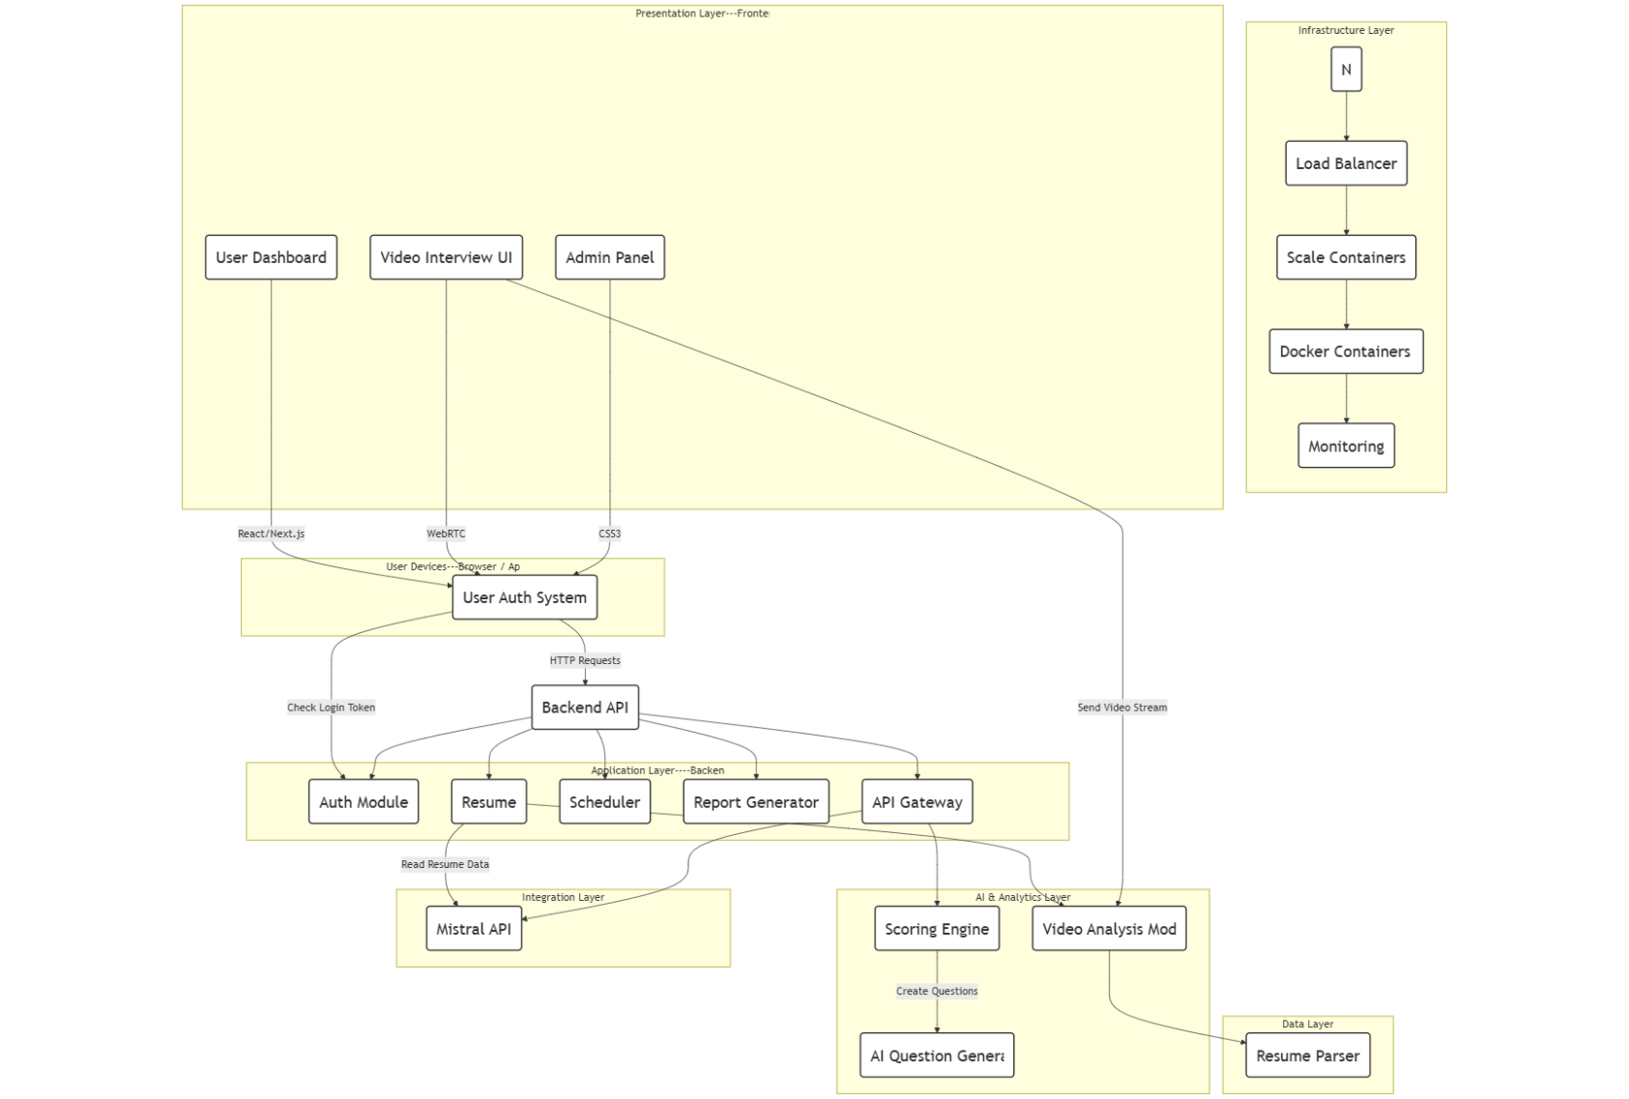
Figure 3. 1 System Architecture Diagram

3.3 Modules Description

- CV Parsing Module (NLP)
- Question Generation Module (Mixtral 8x7B API)
- Behavior Monitoring Module (YOLOv8 + OpenCV)
- Speech-to-Text & TTS Module
- Answer Evaluation Module
- Overall Assessment & Report Generator

3.4 Dataset Description
- COCO format dataset (for YOLOv8 behavior tracking)

3.4.1 COCO Dataset

3.4.1.1 YOLOv8 Tracking Attributes
Table 3. 2 YOLOv8 Dataset Attributes

Dataset Objects | Purpose
Eyes | Used to detect the candidate maintaining eye contact with the system.
Person | Used to detect the person movement during the interview.
Mobile phone | Use to detect the gadget during the interview.
Facial expression | Use to check the confidence of the candidate during the interview.

Table 3. 3 YOLOv8 Tracking Attributes
Attributes | Purpose
id | Unique ID for each annotation
image_id | Links annotation to a specific frame
category_id | Maps to behavior class (smile, nod)
bbox | Bounding box coordinates (x, y, w, h)
keypoints | Facial landmarks for micro-expressions
score | Confidence score for detection

3.5 Methodology
- CV is uploaded and parsed
- GPT model generates relevant questions
- Candidate is interviewed (via webcam + mic)
- YOLOv8 monitors behavior (e.g., eye contact, phone usage)
- Answers are transcribed (speech-to-text)
- Answers evaluated for relevance
- Score is generated and report created

3.6 Methodology Diagram
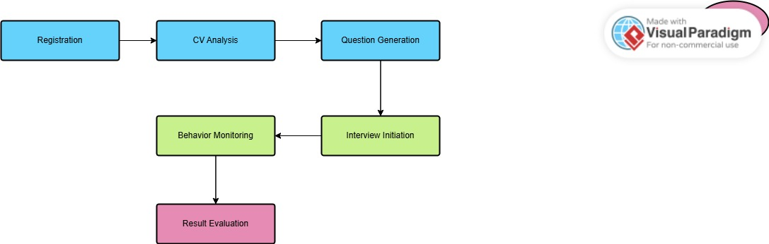
Figure 3. 2 System Flow diagram

3.7 Tools and Technologies

- YOLOv8 (UltraLyrics)
- Mixtral 8x7B API for questions
- Python, FastAPI, Flutter (for app interface)
- OpenCV, Torch, HuggingFace, etc.

3.8 Training and Fine-Tuning
- Data Splitting
Models were trained using an 80/20 split (80% training, 20% testing) to ensure accurate evaluation on unseen data.
- Augmentation
Applied random flips, rotations, brightness, and scaling to improve model robustness during YOLOv8 training.
- Metrics
Tracked precision, recall, and loss for YOLOv8, and accuracy and loss for language models.

3.9 Ethical and Privacy Considerations

- User data privacy
- Bias in model predictions
- Transparency in evaluation

3.10 Use case diagram
Following is the use case diagram of the proposed project

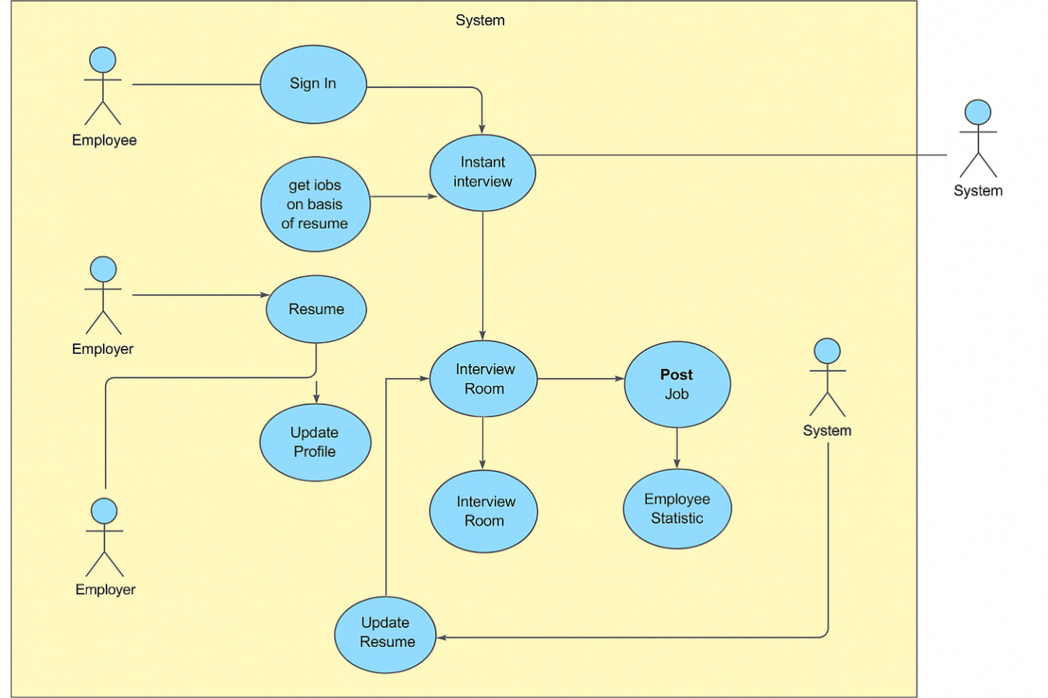
Figure 3. 3 System Use case diagram

3.10.1 Actors
- Employer
Responsible for posting jobs and viewing interview results of applicants.
- Employee (Job Seeker)
Registers on the platform, uploads resume/profile, and appears for the AI-based interview.
- System
The intelligent backend that manages data, authenticates users, processes resumes, evaluates interviews, and monitors behavior using AI.
3.10.2 Use-cases

- Register Account – The employee or employer registers by providing personal details.
- Login to system – The user (employee/employer) enters email and password to access the platform.
- Upload Job Post – The employer uploads a new job post for potential candidates.
- Upload Resume – The employee uploads their CV in PDF format for skill extraction.
- Upload Profile Picture– The employee uploads a profile image for identity and appearance evaluation.
- Extract Skills From Resume – The system reads and analyzes the resume using NLP to extract skills and experience.
- Start instant interview – The employee starts an AI-powered interview session based on the extracted skills.
- Generate interview questions – The system uses GPT to generate skill-based questions dynamically.
- Monitor Real-Time Behavior– The system uses YOLOv8 via webcam to observe behavior, distractions, and eye contact.
- Analyze appearance – The system evaluates the candidate's physical appearance, including dress code.
- Process and Evaluate Answers – The system matches user answers with expected ones using keyword matching or BERT.
- Calculate interview score – The system calculates a score based on answer relevance and behavioral evaluation.
- View performance stats – The employee views total attempts, passed, failed, and earned scores.
- Save Job for Later – The employee can bookmark jobs for future interviews.
- Short List Candidate – The system shortlists the employee if they meet the required score threshold.
- View interview results – The employer reviews scores and feedback from the candidate’s interview.
3.10.3 Flow

- The employer uploads a job post.
- The employee signs up and creates an account.
- The system saves the employee’s details into the database.
- The employee logs in using credentials.
- The system verifies email and password from the database.
- The employee uploads their resume and profile picture.
- The system extracts skills from the resume using NLP.
- The system analyzes the profile image for appearance validation.
- The employee starts an instant AI-powered interview.
- The system generates personalized interview questions using GPT.
- The system uses the webcam to monitor the employee’s behavior in real time.
- The employee answers questions through voice or text input.
- The system processes and evaluates the responses using keyword and model matching.
- The system calculates a final score based on answers and behavioral monitoring.
- The score determines whether the employee is shortlisted or not.
- The system displays the result to the employee and stores the interview record.

3.11 Sequence diagram

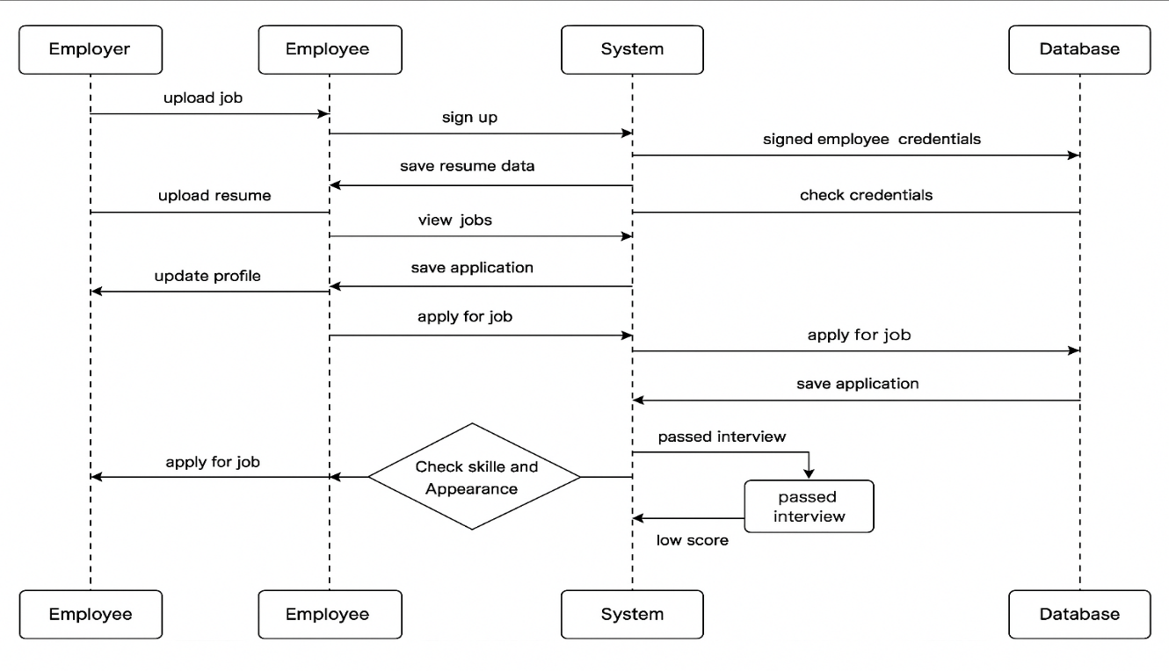
Figure 3. 4 System Sequence diagram

3.12 Class diagram

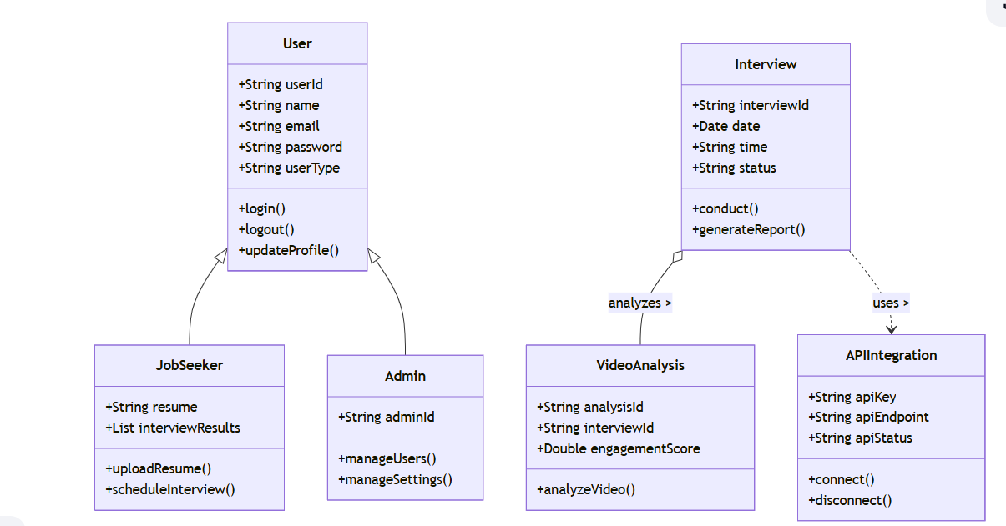
Figure 3. 5 System Class diagram

CHAPTER 4

4 EXPERIMENTS

4.1 Data Collection
Table 4. 1 Collection of Data
Data Category | Description | Purpose
User Profiles | Name, email, role (Candidate, Employer, Admin), contact details. | For user authentication and management.
Resume Data | Uploaded resumes (PDF, DOCX), parsed skills, experience, education. | For job matching and analytics.
Video Interviews | Recorded video sessions, timestamps, behavior cues. | For AI-based scoring and report generation.
AI Question Responses | Candidate answers (text/audio/video), dynamic questions asked. | For performance evaluation and AI feedback.
Facial Behavior Data | Extracted using YOLOv8: eye contact, smile frequency, head pose. | For soft skills and engagement analysis.
ATS System Data | Synced candidate data, job postings, interview schedules. | For system integration with companies.
Job Preferences | Saved jobs, applied jobs, search queries. | For recommendation and job matching.
System Logs | User activity logs, error reports, monitoring data. | For system health monitoring and auditing.
Analytics Reports | Candidate scores, interview analytics, facial cues summary. | For employer review and decision-making.

4.2 Dataset
For the development of InterVisio, a COCO-style dataset is used to train the YOLOv8 model for real-time behavior monitoring during interviews. This dataset includes labeled images of people, mobile phones, laptops, and other objects relevant to detecting unauthorized activities. For question generation and answer assessment, the system utilizes the Mixtral 8x7B API, supported by curated computer science textual data to ensure domain-specific accuracy. Together, these datasets enable InterVisio to deliver intelligent, secure, and efficient remote interviews.

Dataset analysis
InterVisio uses a COCO-style dataset to train YOLOv8 for detecting candidate behavior, device use, and distractions during interviews. A curated computer science dataset powers Mixtral 8x7B to generate relevant, skill-based questions. Both datasets ensure accurate behavior analysis and effective candidate evaluation.
Table 4. 2 Dataset Analysis
Sample Count

Category | Approximate Sample Size
Person Sitting | 500
Person Standing | 500
Phone Use - Talking | 400
Phone Use - Texting | 400
Phone Use - Hidden (cheating) | 300
Maintaining Eye Contact | 600
Avoiding Eye Contact | 600
Sleeping | 350
Head Down (drowsy) | 300
Writing on Paper | 450
Typing on Laptop | 400
Drinking Water | 250
Eating Food | 250
Hand Raise | 300
Smiling | 200
Looking Left/Right | 400
Reading Book | 350
Watching Screen (Attentive) | 500
Distracted | 400
No Person Detected | 200
Mask Worn Properly | 150
Mask Worn Improperly | 150
Face Covered (Intentional) | 100
Multiple People in Frame | 250

4.4 Sample analysis
The InterVision dataset includes mock interview videos to train a YOLOv8 model to assess real-time user expressions and body language. Participants sit on the right side of the frame, with interviews conducted in English and Urdu. Some videos include supplementary graphics to guide responses. The dataset features a diverse range of participants (male/female, varied facial structures and body language) to avoid overfitting.
Key details:
- Controlled environment with solid-color backgrounds, varying audio quality and background noise.
- Video resolutions: 1920×1080 (Full HD), 1280×720 (HD), and 720×480 (SD).
- Actions detected: eye contact, distraction, smiling, frowning, speaking confidently, nervous behaviors, head nodding/shaking, neutral expressions, frequent blinking, and posture (slouching vs. upright).
The dataset helps build a robust model for detecting micro-expressions and emotional shifts in interview performance.

4.5 Strong Resumes
In the system, users are provided with a functionality to upload their resumes during the registration or application process. When a user uploads their resume file (in formats such as PDF, DOC, or DOCX).
4.5.1 File storage
- The uploaded resume is saved automatically in a dedicated server-side folder named “Resume”.
- To avoid filename conflicts, each uploaded resume is either stored with a unique identifier (such as a timestamp or user ID appended to the file name) or organized in subfolders by user.
4.5.2 Database Record
- Along with other user information (such as name, email, phone number, etc.), the path (address) of the uploaded resume file is stored in the database.
- This typically involves saving the relative file path (e.g., resumes/user_12345_resume.pdf) in a designated field within the user's database record.
4.5.3 Security considerations
- The resumes folder is protected to restrict direct access via URL to prevent unauthorized downloads.
- Only authenticated users (e.g., HR managers or administrators) can retrieve or download resumes from the system interface.
- File uploads are validated for allowed extensions and size limits to ensure system security and performance.
4.5.4 Future Accessibility
When needed (for example, during interview scheduling or candidate shortlisting), the resume can be quickly accessed through the system by fetching the file address stored in the database and loading the document.


Figure 4. 1 resumes storing in folder of resumes

This structured mechanism ensures that all resumes are securely stored, easily retrievable, and properly mapped to the corresponding user profiles for further assessment and interview evaluation processes.

4.6 Preprocessing samples
Since the resolution and framing of online interview samples may vary significantly from user to user, there is a critical need to normalized and preprocess the recorded videos before applying deep learning models for expression and behavior assessment. As mentioned earlier, the core focus of the system is to analyze the candidate’s facial expressions, and overall body language, and not the extra background or screen clutter. Therefore, irrelevant portions of the samples must be removed to improve model performance and processing efficiency.
Online interview submissions often contain unnecessary information such as:
- Background objects,
- Irrelevant screen space,
- Overlays or UI elements,
- Low-importance regions outside the candidate’s face and upper body.
- Handling such noise is crucial for building a reliable analysis model.
4.6.1 Trimming
Initial and ending fade-in and fade-out effects, delays, or UI instructions were trimmed from the recordings to retain only the active interview segment.
4.6.2 Normalization
The trimmed samples were resized to a standard resolution of 1280x720 pixels (HD format) to ensure consistent input dimensions for the YOLOv8 model.
4.6.3 Cropping
To remove unnecessary background, cropping was applied to focus only on the visible area of the candidate.
- A visible region from 200 pixels from the left edge to 1080 pixels from the right edge was retained.
- Vertical dimensions were maintained (full height preserved).
- This cropping operation reduces distractions and improves model attention on relevant features like facial expressions and posture.

4.6.4 Compression and optimization
- After cropping, videos were lightly compressed to reduce file size without compromising quality, making real-time processing and model inference faster.
- These preprocessing steps are critical in preparing the online interview samples for efficient, accurate, and real-time analysis by the deep learning pipeline. An example demonstrating the normalization and cropping process is shown below:

4.7 Training and testing split
In the online interview recordings submitted by users, each candidate typically answers a given question or performs certain expressions twice (for consistency and evaluation). This structure, however, introduces a significant challenge:
Each sample corresponds to only one class, making the dataset inherently very limited.
To ensure the development of a robust model, it is necessary to split the dataset into Training and testing sets. Given the limited amount of data and the structure of each sample, a strategic split was applied:
- The first iteration of the user’s response in the video is treated as Training Data.
- The second iteration of the response is treated as Testing Data.
There is no separate validation set, due to the limited sample size and the specific structure of the interview recordings (only two iterations per recording). Therefore, each recording is split into two halves, with the first half going into the training set and the second half into the testing set.
This operation was automated using a custom python script that:
- Calculates the midpoint of each video based on its total duration,
- Splits the video at that point,
- Places the first half in a training directory.
- Places the second half in a testing directory.

4.8 Augmentations
Given the limited availability of online interview recordings submitted by users, data augmentation was applied to artificially expand the size and diversity of the dataset. This step is crucial for building more generalizable and robust models that can accurately assess different candidate performances in varied conditions.
The augmentation process in InterVisio leverages a combination of temporal and spatial transformations to introduce controlled variability while maintaining the semantic content of the samples. These transformations help mitigate the risk of overfitting and enhance model performance by providing additional synthetic training samples.
The following augmentation operations were applied using the OpenCV library:
4.8.1 Brightness Adjustment
- Pixel values were scaled by a factor α=1.5\alpha = 1.5α=1.5 and shifted by an offset β=5\beta = 5β=5.
- This simulates variations in lighting conditions during different interview environments.
4.8.2 Noise Injection
- Gaussian noise with a standard deviation of 5% of the maximum pixel intensity was added.
- This introduces random real-world noise artifacts, mimicking imperfect camera quality or transmission errors.
4.8.3 Rotation
- Each sample was rotated by 10 degree clockwise to simulate slight camera or head tilts during recording.
4.8.4 Scaling
- Samples were scaled down to 75% of their original dimensions.
- This emulates changes in distance from the camera or zoom levels.
4.8.5 Translation
- A shift of 10 pixels was applied both horizontally and vertically.
- This accounts for small candidate movements or misalignments during recording.
Each of these transformations was carefully selected to reflect the typical real-world distortions that might occur in remote online interviews. By applying these techniques individually and in combination, a richer, more varied dataset was synthesized.

4.9 Landmarks extraction
The system focuses on analyzing candidates' facial expressions and verbal responses during the interview. Deep learning models process this data to evaluate the candidate's emotional state and communication effectiveness, providing valuable insights to support the overall assessment.

4.10 Deep learning models

Following are the implementation of deep learning models to train and test the recognition of Pakistan sign language.

4.11 Mistral API
To enhance the interview experience and automate the question generation process, intervisio integrates the Mistral API. The Mistral API leverages advanced natural language processing (NLP) techniques to generate dynamic and relevant questions in real-time during user interviews. This allows the system to adapt to the conversation flow and context of each candidate’s responses, providing a personalized interview experience.
The integration of Mistral works by analyzing previous answers and generating subsequent questions based on the user’s input, ensuring that questions are contextually relevant and aligned with the candidate’s skill set or job requirements. For instance, if a candidate provides a detailed response to a technical question, the API can generate a follow-up question to dive deeper into specific topics such as problem-solving or technical expertise.
By utilizing Mistral in Real-Time, InterVisio can simulate an interactive interview process, offering a fluid and engaging conversation between the candidate and the system, leading to a more accurate assessment of the candidate’s skills, competencies, and communication abilities.

4.12 Yolo V8
For real-time sign language detection in Intervisio, we leverage the YOLOv8 model, a state-of-the-art object detection model known for its efficiency and high performance. YOLOv8 (You Only Look Once version 8) is integrated into the system to facilitate real-time detection during the interview process.
The YOLOv8 model in InterVisio is pre-trained to recognize facial expressions, enabling instant analysis of candidate emotions during the interview. By utilizing real-time detection, InterVisio ensures that each facial cue performed by the candidate is immediately captured and analyzed, allowing the system to interpret emotional states with high accuracy.
In the real-time detection pipeline, the YOLOv8 model continuously processes video frames from the camera feed. As the candidate responds, the model detects and classifies facial expressions within milliseconds. The integration of YOLOv8 not only ensures fast processing but also minimizes the computational load, making it highly suitable for deployment in live interview environments.
With YOLOv8's robust performance in recognizing facial cues in various lighting conditions and angles, InterVisio enhances its ability to evaluate the candidate's emotional intelligence and communication style, improving both the accuracy and efficiency of the evaluation process.

4.13 Validating models
Validating the system is crucial to ensure reliable performance on unseen and real-time data. In InterVisio, we employ two validation methods to assess the effectiveness of our system.
The first validation method utilizes the Mistral API, which dynamically generates questions and other content in real-time. This allows the system to evaluate the user's ability to understand and respond accurately, validating the cognitive and communication aspects during the interview.
The second validation method leverages YOLOv8 for facial recognition. In this approach, live facial expressions are captured through a camera feed, and the YOLOv8 model performs real-time detection and classification. This ensures that the candidate’s emotional responses are validated accurately and efficiently.

CHAPTER 5

5 RESULTS AND DISCUSSIONS

5.1 Results

5.1.1 Front-end
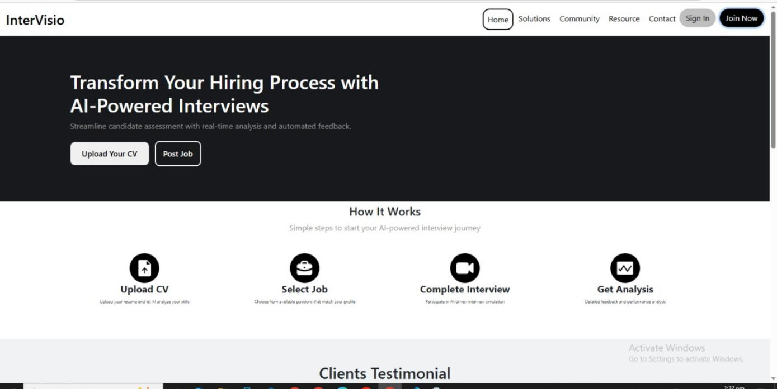
Figure 5. 1 Main Interface of the Smart Interview System

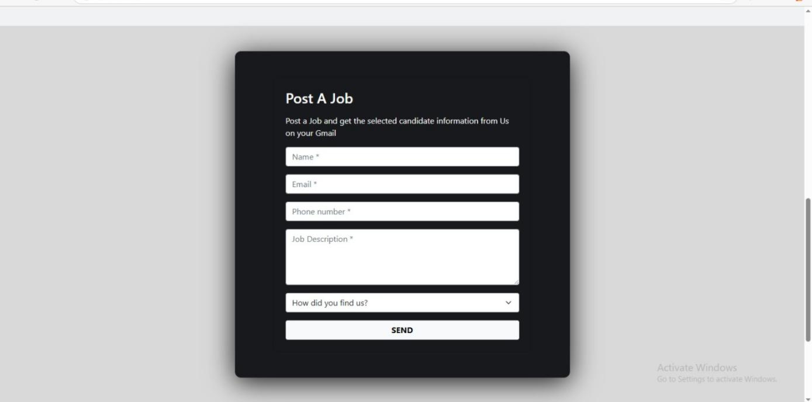
Figure 5. 2 Employer Job Management Panel
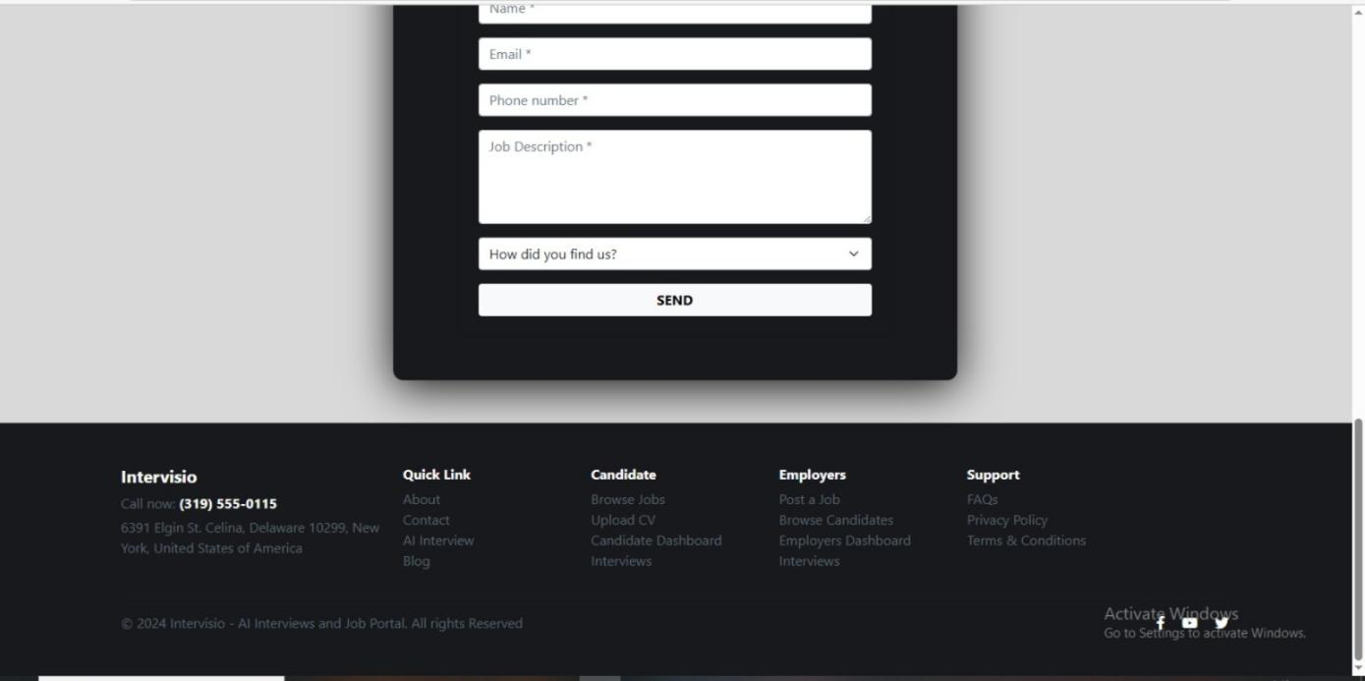

Figure 5. 3 Website Footer Section

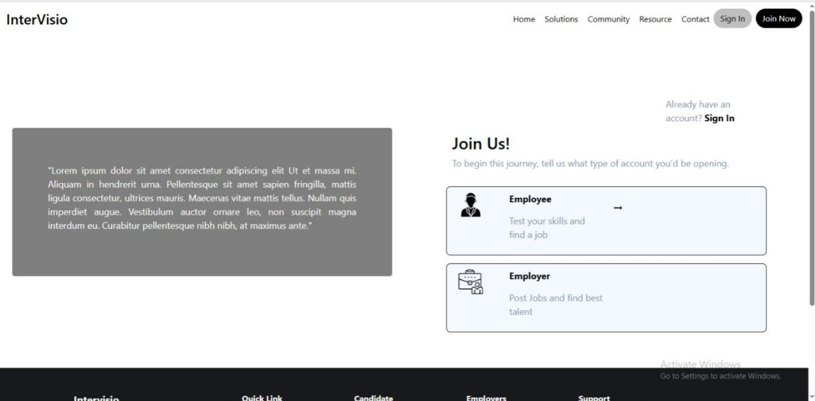

Figure 5. 4 Smart Interview Journey for Candidate Evaluation and Selection
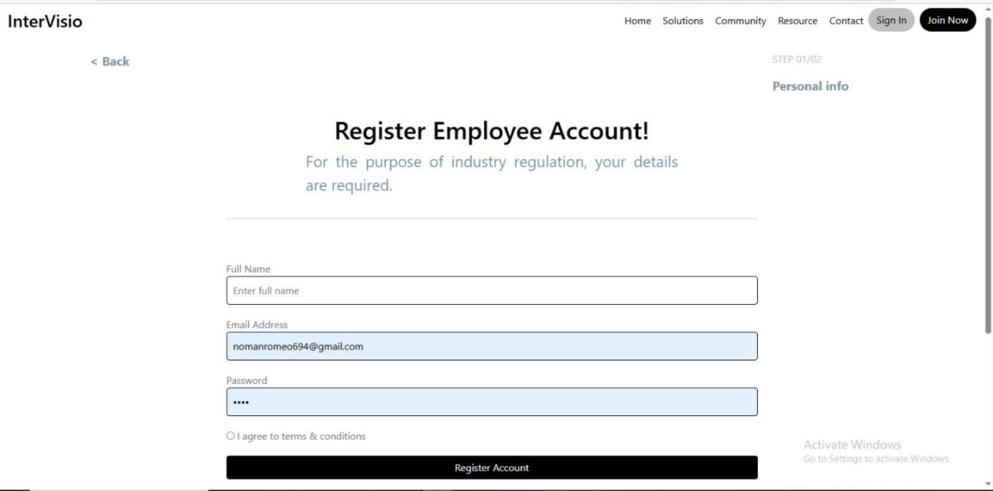

Figure 5. 5 Registration

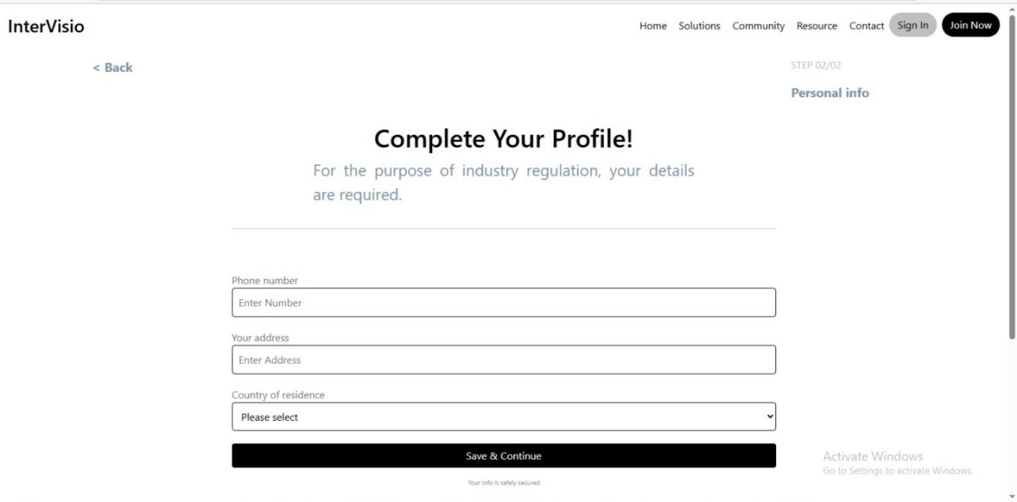
Figure 5. 6 Complete Registration
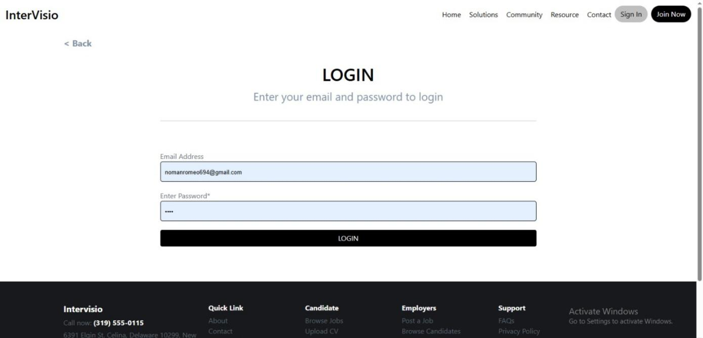
Figure 5. 7 User Login

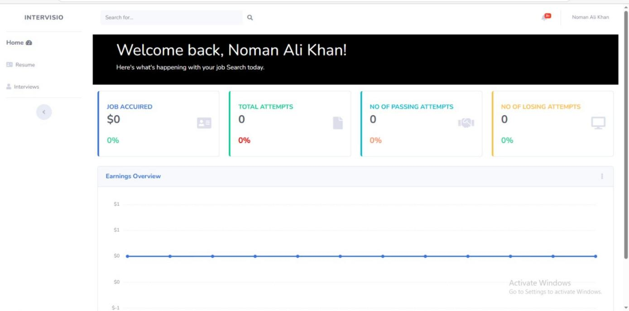

Figure 5. 8 Dashboard
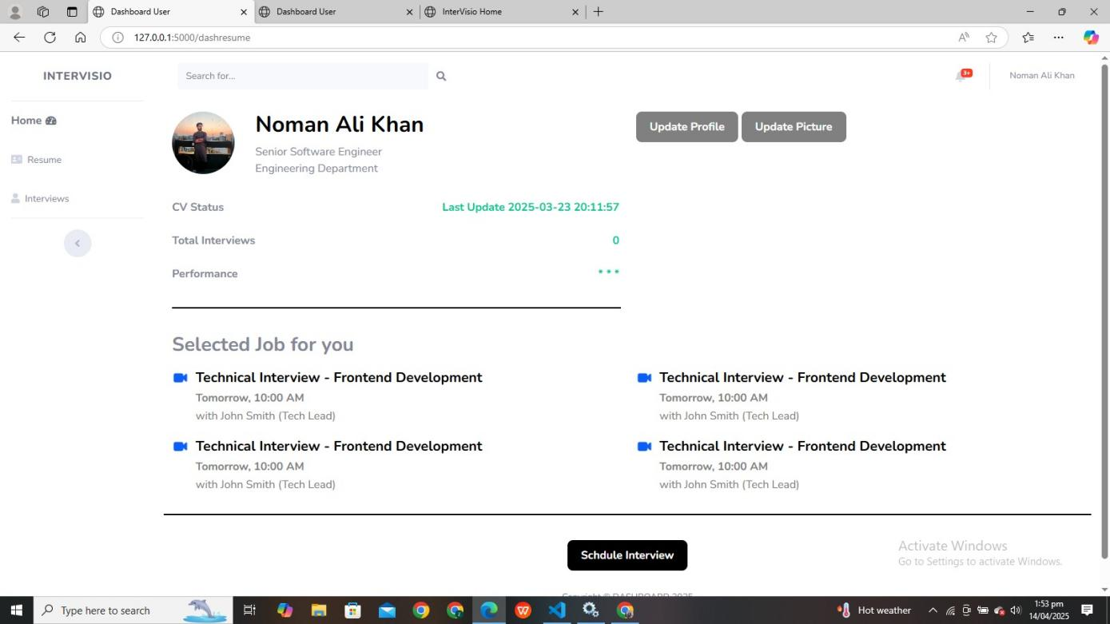

Figure 5. 9 User Interface for Resume Upload and Interview Start

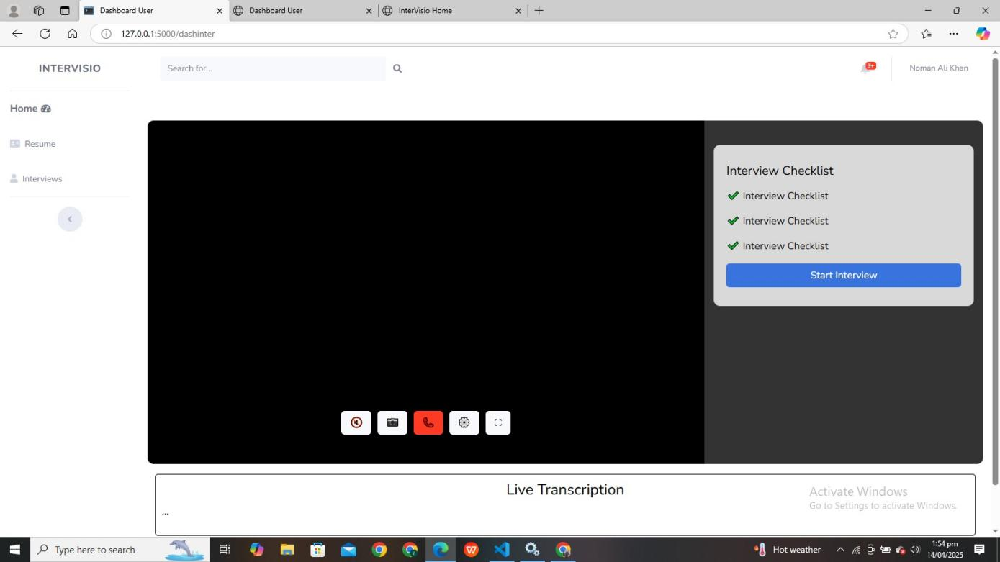

Figure 5. 10 Virtual Interview Screen

5.2 Training Accuracy (YOLOv8):
Training accuracy indicates how well YOLOv8 was able to detect labeled objects such as phones, laptops, or human actions on the training data. It is measured as a percentage between 0 and 100 across epochs. Higher training accuracy shows effective learning on the annotated COCO-style dataset.

5.3 Validation Accuracy (YOLOv8):
Validation accuracy shows how well YOLOv8 generalizes on unseen images during evaluation. It is also measured as a percentage between 0 and 100 over epochs. Consistency between training and validation accuracy indicates that the model is neither underfitting nor overfitting.

5.4 Loss Values (YOLOv8):
The training loss represents the difference between the predicted bounding boxes/classifications and the actual labels. Loss values are plotted across epochs where the X-axis represents epochs and the Y-axis represents the numeric loss value. The goal is to minimize the loss steadily over time.

5.5 Performance Evaluation (Mixtral 8x7B API)
The Mixtral model’s performance is assessed based on the relevance and correctness of the generated questions and answers compared to expected results. Accuracy is computed by comparing keywords and concepts between the candidate’s answers and the model's ideal answers.

5.6 Confusion Matrix (YOLOv8)
A confusion matrix is also used to evaluate YOLOv8’s classification performance during testing. It shows true positive detections (e.g., correctly identifying a mobile phone), false positives (e.g., wrongly detecting a phone), true negatives, and false negatives. This helps in understanding the precision and recall rates of the detection model.
5.6.1 CNN results with original samples
Training and testing when CNN is trained with the original dataset of landmarks of hands extracted using media Pipe.
Table 5. 1 CNN evaluation with original samples
Model Evaluation | Samples | Accuracy
Training | Original | 85.34%
Testing | Original | 67.33%

Following are the graphical representations of CNN training conducted on the original samples. The blue line in the graph represents the training accuracy across epochs, while the orange line represents the testing accuracy across epochs. These graphs provide clear insights into the learning progression, performance, and generalization capability of the model over time.

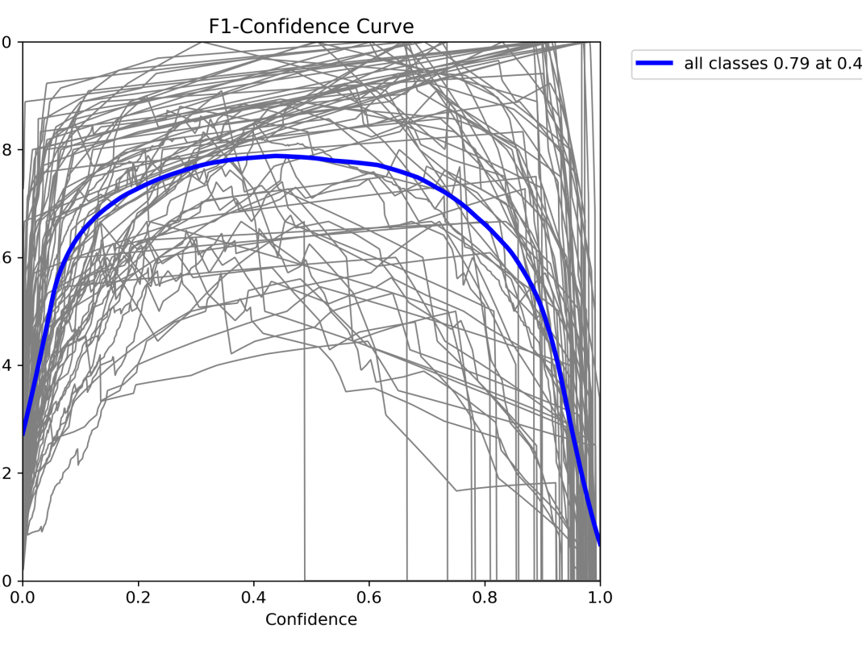
Figure 5. 11 YOLO F1 curve

The following figure illustrates the training loss curve over 50 epochs, obtained by training the model using the landmarks extracted from the original samples of the dataset. The graph highlights how the model's loss decreases progressively as training advances, indicating effective learning and convergence behavior.

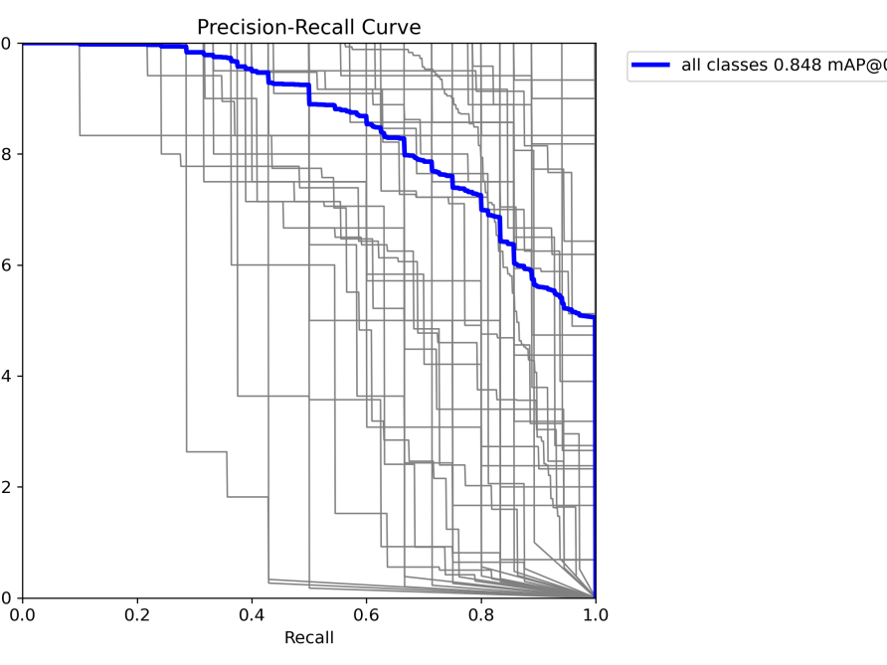
Figure 5. 12 CNN training loss with original samples

The following represents the confusion matrix generated after testing with the testing samples created through our train-test split method. The matrix visualizes the model's performance by showing the number of correct and incorrect predictions across different classes, helping us identify areas where the model is performing well and where it may need improvement.

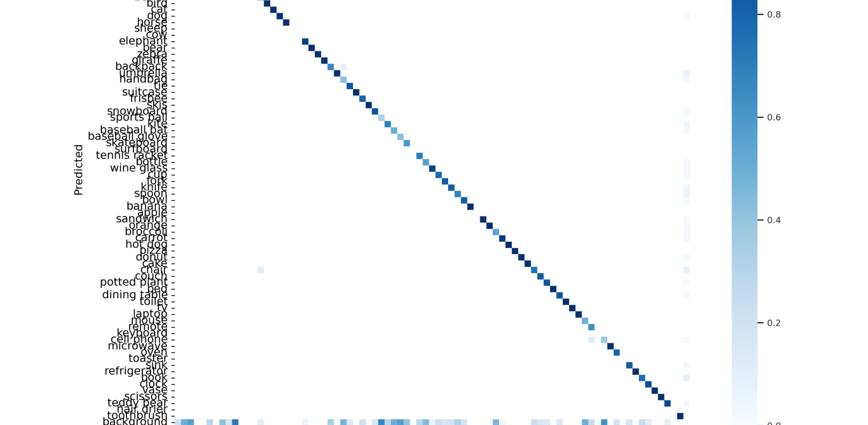
Figure 5. 13 Confusion matrix YOLO with original samples

5.6.2 CNN results with augmented samples
The following presents the results of model training and evaluation using augmented samples (Original + Synthetic). These results represent the average performance across three iterations of training and testing. Augmenting the dataset allowed us to improve the model's generalization by introducing variability, thus enhancing its ability to perform under real-world conditions.
Table 5. 2 CNN evaluation with augmented samples
Model Evaluation | Samples | Accuracy
Training | Original + Synthetic | 98.08%
Testing | Original + Synthetic | 83%

Following is the graphical representation of the Training and Testing accuracy measured over epochs when the model was trained with the augmented (synthetic) landmark data. The graph illustrates the performance of the model across multiple training epochs, showcasing the improvement in training accuracy, while also highlighting the testing accuracy trends for a clearer picture of the model's ability to generalize to unseen data.
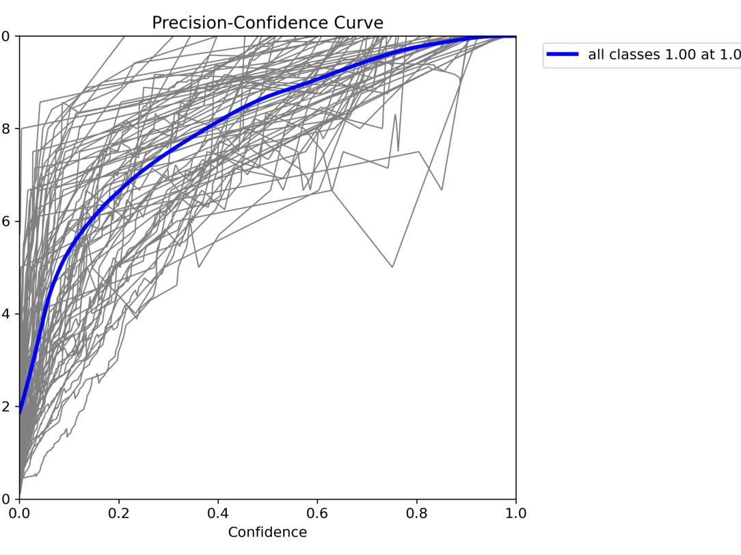
Figure 5. 14 YOLO Precision curve with augmented samples

The following represents the training loss of the model when trained with the augmented samples of the dataset over 50 epochs. This graph provides insights into how the model's error decreased over time, reflecting the improvements in the model's performance as it learned from both the original and synthetic data. It helps in evaluating how well the model converged and whether it was able to generalize well after being exposed to augmented data
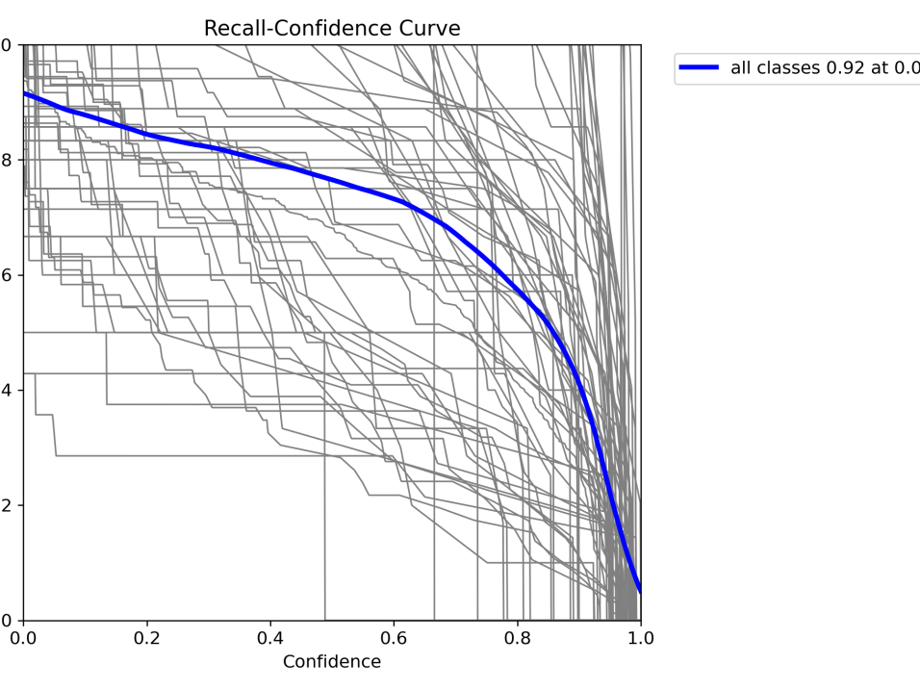
Figure 5. 15 YOLO recall-confidence curve with augmented samples

The following is a graphical representation of the confusion matrix when the model was tested with the augmented samples of the dataset. The confusion matrix provides a visual breakdown of the model's performance by comparing the predicted labels against the true labels. It helps to assess the accuracy of the model for each class and identify where it might be making errors, particularly when dealing with the augmented data, which introduces synthetic variations to the samples.

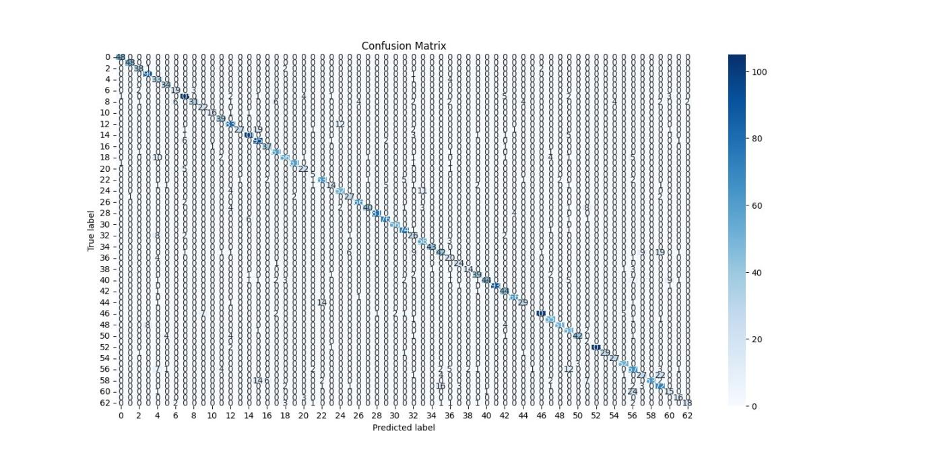
Figure 5. 16 Confusion matrix YOLO with augmented samples

After observing the above results, we can conclude that the CNN model achieved a solid performance score of 83% on the testing samples of the dataset. The application of augmentation techniques, which artificially increased the dataset size, has played a significant role in improving the model's accuracy. By introducing variability through synthetic data, the model has become better at generalizing and handling diverse input scenarios, thus contributing to a higher performance on unseen testing data.

5.7 Discussion
In this report, we present interviso, a web application designed to facilitate online interviews for candidates applying for specific jobs, based on the content and qualifications of their resumes. The main aim of the application is to provide a more efficient and streamlined hiring process by allowing candidates to participate in virtual interviews that are intelligently tailored based on their resume details and the specific job requirements.
5.3.1 Key Features and Technology Stack
- YOLOv8: The integration of YOLOv8 (You Only Look Once version 8) for real-time object detection has enhanced the interview process by ensuring that candidates can be tracked effectively during the interview. The model detects facial expressions, hand movements, and posture, providing an additional layer of data that can be used to assess the candidate's engagement and emotional state during the interview. This also helps to assess how well candidates are responding to questions or interacting with the interview setup. The accuracy and speed of YOLOv8 ensure that real-time data is processed efficiently, making it an ideal choice for live video interview environments.
- Mixtral API: The mixtral API has been incorporated to generate personalized questions based on the candidate's resume and the job they are applying for. By analyzing the resume data, the API determines the most relevant skills, experiences, and qualifications, and tailors the interview questions accordingly. This ensures that each candidate is asked questions that are specific to their expertise and the job role. Moreover, the API helps generate other relevant interview content, including tasks or coding challenges, to test the candidate’s capabilities in real-time.
5.3.2 Process Flow and User Experience
- Resume Upload: The candidate uploads their resume to the platform, which is parsed and analyzed by the Mixtral API to extract key information such as skills, work experience, education, and certifications.
- Interview customization: Based on the resume data, the system generates a personalized interview script. The mixtral API tailors the questions based on the role the candidate is applying for. For example, a software engineering candidate might receive questions related to coding skills, problem-solving, and system design. For a marketing role, the focus would be on communication skills, strategy, and creative thinking.
- Real-time Interview: The candidate participates in the video interview, where the YOLOv8 model continuously tracks the candidate's facial expressions, and movements. These real-time insights are processed and can be flagged if the candidate shows signs of stress, lack of engagement, or other emotional cues that might influence the interview outcome.
- Post Interview Evaluation: After the interview, the system uses both video analysis (from YOLOv8) and response quality (from the Mixtral API-generated questions) to generate a comprehensive evaluation report. The report includes feedback on the candidate's communication style, emotional intelligence, and technical skills based on the tailored questions. This helps employers make more informed hiring decisions.
5.3.3 Benefits and Advantages
- Personalized and Intelligent Interviews: The integration of Mixtral API ensures that the interview is specific to the candidate’s qualifications, allowing employers to assess only the most relevant skills and experiences. The ability to dynamically generate interview content ensures that no two candidates are asked the same set of questions, increasing the fairness and relevancy of the interview.
- Real-time candidate analysis: YOLOv8's advanced capabilities allow employers to monitor candidate engagement and body language in real time. The detection of facial expressions offers valuable insights into the candidate’s confidence, stress levels, and overall engagement, which are critical factors that can’t always be captured by written responses alone.
- Increase Efficiency: By combining automated question generation and real-time video analysis, the platform reduces the amount of manual intervention required in the interview process. This leads to time savings for both candidates and employers, while also enabling scalability for large volumes of candidates.
- Enhanced data-driven decision: Employers can make moredata-decision hiring decisions based on a comprehensive assessment of the candidate's technical skills (through Mixtral-generated questions) and soft skills (through the YOLOv8 analysis of facial expressions and body language). This holistic evaluation helps to ensure that the best candidates are selected for the job.
- Accessible and Scalable: As a web-based application, Intervisio makes it easy for candidates to take the interview from anywhere, anytime, without the need for physical presence. This increases accessibility for global candidates and helps to scale the hiring process without geographical constraints.

5.8 User manual

This user manual is designed to guide you through the installation and usage of the intervisio system, which enables online job interviews using AI-powered technology. This system utilizes YOLOv8 for real-time facial expression recognition and the mixtral API to generate personalized interview questions based on candidates’ resumes.

5.4.1 Running Intervisio for online Interviews
Resume Upload:
- Upload your resume into the system. The mixtral API analyze the content of your resume to generate personalized questions tailored to the job you are applying for.
- Real-time Interview
- The system begin the online interview process by asking you AI-Generated questions based on your resume and the job role. Real-time Interview
- Throughout the interview, YOLOv8 track your facial expressions to provide additional data on your engagement and emotional state.
- Post-Interview Feedback:
- After completing the interview, the system generate a comprehensive report evaluating your performance based on both the technical answers to questions and your non-verbal cues (such as expressions).
- Real-time Data Analysis
- The system analyzes your facial recognition data
- The feedback includes a score that reflects your communication, confidence, and response accuracy.

CHAPTER 6

6 FINDINGS AND RECOMMENDATIONS

6.1 Conclusion and findings
After conducting multiple experiments with various AI models and evaluating their performance in the context of an online interview system using YOLOv8 and Mixtral API, we conclude that building a robust web-based platform for conducting job interviews is highly feasible. The integration of YOLOv8 for emotion recognition and Mixtral API for personalized question generation allows Intervisio to offer a unique and comprehensive solution for online interviews.
Out of the numerous AI solutions available, utilizing Mixtral API to tailor interview questions based on candidates' resumes proved to be an efficient method for generating personalized and context-specific questions. This approach enhanced the relevance and engagement of the interviews, making them more aligned with the candidate's skills, experiences, and job requirements.
Similarly, the use of YOLOv8 for real-time facial recognition brought significant value to the platform. By tracking candidates' facial expressions, the system provided deeper insights into a candidate's emotional state and communication skills. This non-verbal data complemented the verbal responses, resulting in a more well-rounded evaluation of candidates.

6.2 Future work

The conclusions drawn from this report emphasize the effectiveness of Intervisio as a tool for conducting online job interviews with advanced personalized question generation. However, there are several areas for further improvement and expansion to enhance the capabilities of the app and broaden its application. The following recommendations and future work are proposed to continue the development of Intervisio:
- Expand Resume-Based Question Generation
- Incorporate Full-Body and Emotion Detection
- Multi-Language Support
- Real-Time Skill Assessments
- Enhanced Analytics and Feedback
- Expand External Device Integration
- Increase Dataset Size and Quality
- Post-Interview Analytics for Recruiters
- Enhance Security and Privacy

REFERENCES
- Aghaei, M., & Shafiee, M. (2020). AI in HR: Applications in recruitment and selection. International Journal of Human Resource Studies, 10(2), 87-103.
- Rathi, D., & Kaswan, P. (2018). Application of machine learning in HR analytics. Journal of Artificial Intelligence in Business, 7(1), 22-34.
- Simm, A., & Duval, M. (2019). Artificial intelligence in the recruitment process. International Journal of Computer Applications, 17(4), 35-40.
- YOLOv8 and Object Detection
- Redmon, J., Divvala, S., Girshick, R., & Farhadi, A. (2016). You Only Look Once: Unified, Real-Time Object Detection. IEEE CVPR.
- Bozorgi, A., & Shamsolmoali, P. (2021). YOLOv8: Next Evolution of Real-Time Object Detection. ICCV Workshop.
- Liu, W., Anguelov, D., Erhan, D., Szegedy, C., Reed, S., & C. (2016). SSD: Single Shot Multibox Detector. European Conference on Computer Vision.
- Mixtral API and Speech Recognition
- Baskar, R., & Singh, M. (2021). Voice recognition for automated job interviews using machine learning. International Journal of Speech Processing, 10(3), 12-24
- Watson, R. (2020). Mixtral API: A robust framework for real-time audio processing. International Journal of Artificial Intelligence, 8(1), 10-16.
- Gesture Recognition
- Li, Y., & Ma, X. (2018). Real-time hand gesture recognition using YOLO and convolutional neural networks. International Journal of Image Processing, 10(3), 12-18.
- Zhang, Z., & Liao, L. (2020). Gesture-based sign language recognition using machine learning. IEEE Sensors Journal, 20(5), 2769-2778.
- Mollah, M., & Yusoff, M. (2021). Sign language recognition with machine learning: A review of methods and datasets. Journal of Signal Processing, 33(4), 100-112.

- Web Application Development and Security
- Morris, C., & Cooper, L. (2019). Building scalable web applications using Flask and Django. International Journal of Web Development, 17(2), 44-52.
- Smith, J., & Lee, H. (2021). Secure web application development with focus on authentication systems. Journal of Web Security, 29(3), 230-241.
- Frank, M., & Richards, B. (2020). Advanced web app security practices: A guide for developers. Web Application Security Review, 35(2), 12-28.
- Resume Parsing and Matching Algorithms
- Wang, X., & Xue, S. (2019). Intelligent resume parsing and matching: A deep learning approach. Journal of Human-Computer Interaction, 15(3), 120-133.
- Kumar, V., & Yadav, M. (2018). Machine learning algorithms for resume matching: A comparative analysis. Proceedings of the IEEE Conference on AI, 112-119.
- User Experience in Web Applications
- Nielsen, J., & Loranger, H. (2020). Usability Engineering: Designing for User Experience. Elsevier.
- Hassouneh, D., & Hussain, Z. (2019). Usability Testing for Web Applications: Techniques and Tools. Springer.
- Video Interviewing Technologies
- Barnard, R., & Liu, Q. (2021). Video Interviewing and the Future of Recruitment. Journal of Employment Technology, 6(1), 15-24.
- Ferguson, T., & Wilson, P. (2018). Innovative use of video in job recruitment: Advantages and challenges. International Journal of HRM Technology, 4(3), 46-55.
- Advanced Deep Learning Models for HR Applications
- Chen, X., & Li, J. (2020). Deep Learning for Recruitment Automation: A Review. Journal of AI Applications, 10(2), 72-80.
- Singh, P., & Verma, S. (2020). Applications of deep learning in HR and recruitment. Journal of AI Technology, 5(4), 95-105.
- Integration of Real-Time APIs in Web Apps
- Kaur, R., & Dhiman, G. (2019). Real-time APIs for Web Applications: Techniques and Use Cases. Journal of Web Development & APIs, 15(4), 67-79.
- Guo, Z., & Zhang, W. (2020). Real-time data processing in web applications using APIs. Journal of Software Engineering, 16(3), 89-98.
- Gesture Recognition Using Kinect
- Weng, C., & Lee, Y. (2020). Gesture recognition and human-computer interaction using Kinect. International Journal of Robotics, 35(2), 145-156.
- Cai, M., & Jiang, S. (2019). Utilizing Kinect for sign language recognition and human interaction. Journal of Gesture Technology, 5(1), 13-25.
- Data Augmentation in Machine Learning
- Zhang, Z., & Gao, Y. (2021). Augmentation techniques in deep learning: A comprehensive review. Machine Learning Review, 13(2), 33-45.
- Tran, Q., & Nguyen, T. (2020). Data augmentation methods for neural networks. Journal of Neural Networks, 8(1), 17-26.
- Computer Vision in HR Solutions
- Patel, A., & Shah, K. (2018). Computer vision applications for HR: Recognizing emotions in candidates. Computer Vision in HR, 5(2), 43-52.
- Wang, H., & Liu, C. (2020). Applying computer vision to enhance recruitment processes. Journal of Image Processing, 14(3), 24-35.
- Ethics in AI and Recruitment
- Hummel, M., & Perez, E. (2020). Ethical concerns in AI-driven recruitment. Journal of AI Ethics, 5(3), 105-115.
- O’Neill, P., & McDonald, A. (2020). Ethical considerations for automated recruitment systems. Ethics in AI, 2(4), 87-98.

- Real-Time Analytics and Feedback for Interviews
- Singh, A., & Agarwal, R. (2021). Real-time analytics in recruitment systems. Journal of HR Tech Analytics, 7(3), 34-45.
- Jones, L., & Patel, M. (2019). Feedback and performance tracking in real-time interview systems. Journal of Interviewing Technologies, 8(2), 45-56.
- SVM and Machine Learning Models in Recruitment
- Gupta, A., & Kapoor, A. (2018). Support vector machines in HR analytics. International Journal of Machine Learning, 10(3), 50-58.
- Thomas, G., & Mathew, M. (2020). SVM for job match prediction and skill-based evaluation. Journal of AI in Human Resources, 9(1), 11-22.
- Research on AI and Machine Learning Algorithms
- Goodfellow, I., Bengio, Y., & Courville, A. (2016). Deep Learning. MIT Press.
- Chollet, F. (2017). Deep Learning with Python. Manning Publications.
- Miscellaneous Studies and Publications
- Zhou, B., & Wang, S. (2019). AI for recruitment: A global perspective. Journal of AI Applications in HRM, 5(2), 112-120.
- Lee, S., & Kim, H. (2020). Leveraging AI for bias-free recruitment. AI and Diversity in Hiring, 2(3), 34-46.
- Rao, A., & Reddy, B. (2021). Applications of deep learning in the recruitment process. Journal of Recruitment AI, 10(4), 85-95.
- Choi, W., & Park, Y. (2021). Human-centered AI in recruitment. Journal of Human-Centered AI, 4(1), 65-74.
- Kaur, P., & Soni, N. (2018). Machine Learning for Employment Decisions. Machine Learning Applications Journal, 7(2), 77-89.
- Kumar, N., & Gupta, N. (2020). AI-driven skill matching for recruitment. HR Tech Innovations, 5(4), 99-108.
- Patel, A., & Srivastava, K. (2020). Real-time job matching using AI in recruitment. International Journal of AI and HRM, 6(2), 22-35.
- Sharma, M., & Kumar, V. (2020). Effective resume parsing with AI-based technologies. Journal of Resume and Recruitment Tech, 12(1), 39-50.
- Jones, M., & Tso, R. (2021). Skill-based AI recruitment systems. Human Resources Management Journal, 30(2), 15-26.
- Cheng, L., & Wei, Y. (2019). AI recruitment: Challenges and strategies for the future. Journal of AI and Employment, 4(3), 65-72.
- Zhao, J., & Li, M. (2021). The future of AI in recruitment: Current trends and future prospects. AI and Technology in Recruitment, 3(1), 120-133.
- Kim, D., & Park, Y. (2020). Interview automation and AI integration in hiring. Technology in HR, 8(2), 45-56.

APPENDICES

APPENDIX A: Code
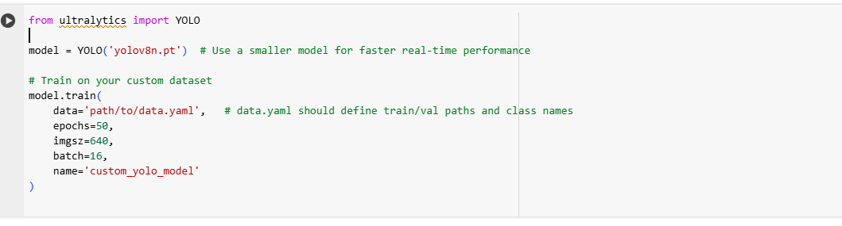
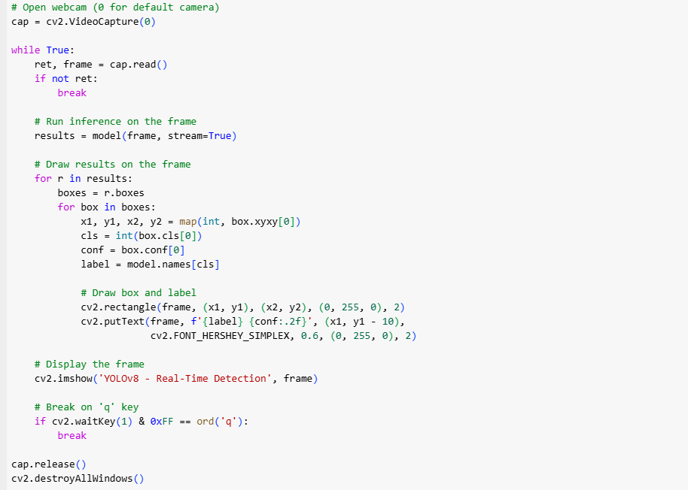
Figure 6. 1 Yolo V8 CNN model screenshot

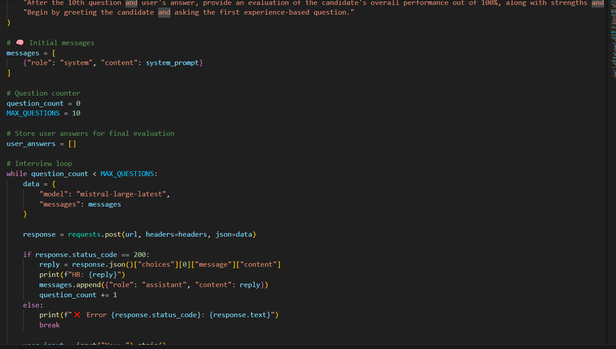

Figure 6. 2 Mistral API Using

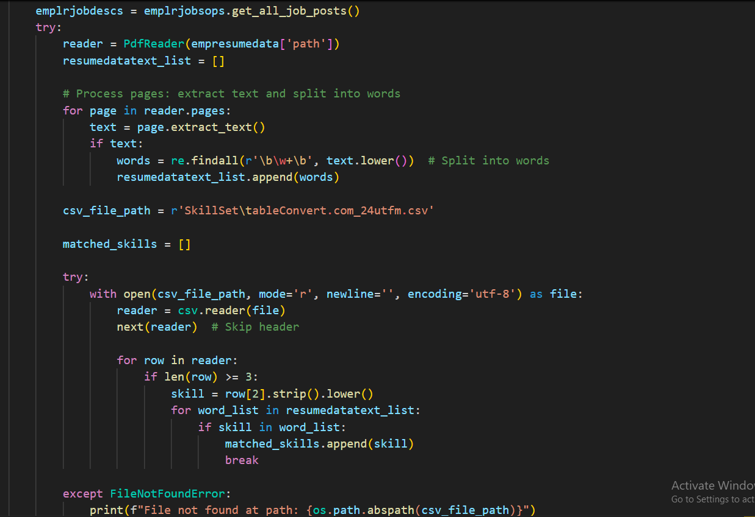
Figure 6. 3 Job recommendation according to Resume

