
BSCS-F24-015
03-134212-050 | MUHAMMAD ABDULLAH TAHIR MALIK
03-134212-002 | ABDULLAH KHALID

LUMBAR SPINE
In partial fulfilment of the requirements for the degree of
Bachelor of Science in Computer Science
Supervisor: SHAHID MEHMOOD
Department of Computer Sciences
Bahria University, Lahore Campus

June 2025

© Bahria University, 2025


Certificate

We accept the work contained in the report titled
“LUMBAR SPINE”
written by
Abdullah Khalid and Muhammad Abdullah Tahir Malik
as a confirmation to the required standard for the partial fulfilment of the degree of
Bachelor of Science in Computer Science.

Approved by:
Supervisor: Shahid Mehmood
(Signature)

05, June 2025

DECLARATION

I hereby declare that this project report is based on my original work except for citations and quotations which have been duly acknowledged. I also declare that it has not been previously and concurrently submitted for any other degree or award at Bahria University or other institutions.

Enrolment | Name | Signature
03-134212-002 | Abdullah Khalid
03-134212-050 | Muhammad Abdulah Tahir Malik

Date : 05, June 2025

Specially dedicated to
my beloved grandmother, mother and father
(Muhammad Abdullah Tahir Malik)
my beloved grandmother, mother and father
(Abdullah Khalid)

ACKNOWLEDGEMENTS

I would like to thank everyone who had contributed to the successful completion of this project. I would like to express my gratitude to my research supervisor, Mr. Shahid Mehmood for his invaluable advice, guidance and his enormous patience throughout the development of the research.

In addition, I would also like to express my gratitude to my loving parent and friends who had helped and given me encouragement.

Muhammad Abdullah Tahir Malik
Abdullah Khalid

Project Title
Lumber Spine

ABSTRACT

Many people as they age deal with lumbar spine degenerative illnesses, which are somewhat frequent. These disorders include the degradation of intervertebral discs, vertebrae, and other elements of the spine that causes issues including subarticular stenosis, neural foraminal constriction, and spinal canal stenosis. For clinicians to grasp and identify these problems, magnetic resonance imaging (MRI) among other techniques is essential.
This work aims to create an image recognition system for lumbar spine MRI data to identify and classify degenerative disorders. Different methods applied for identifying and categorizing spinal anomalies from the L1 to L5 vertebrae are investigated in this work. The project consists in several phases of medical image processing covering preprocessing, segmentation, feature extraction, and condition categorization into normal, moderate, or severe categories. Python is used for the last implementation, training and testing using a freely available Kaggle dataset. Next.js is designed front-end with FastAPI integrated to provide seamless interaction.
This project runs YoloV8 and MobileNet-V3 with gated attention since its lightweight character makes it perfect for running on CPUs and GPUs. Using Next.js, we have created a website whereby users may upload MRI images for examination. By spotting damaged or aberrant spinal locations, the method offers precise results and insight into disorders including Left Neural Foraminal Narrowing, Right Neural Foraminal Narrowing, Left Subarticular Stenosis, Right Subarticular Stenosis, and Spinal Canal Stenosis. A chatbot is also included into the website to help consumers with lumbar spine related questions. The process starts with MRI picture preprocessing including grayscale conversion, scaling, contrast enhancement. Then the lumbar spine area from L1/ L2 to L5/S1 is segmented with masks or bounding boxes. Following segmentation, the images feed the model for feature extraction and classification. The result is a probability matrix showing the degree and kind of disorder at every spinal level. The paper also offers evaluation measures, graphic findings, difficulties faced, and suggestions for next development.

TABLE OF CONTENTS

DECLARATION ii
ACKNOWLEDGEMENTS iv
ABSTRACT v
TABLE OF CONTENTS vi
LIST OF TABLES viii
LIST OF FIGURES ix

CHAPTER 1 1
1 INTRODUCTION 1
1.1 Background 1
1.2 Problem Statements 3
1.3 Aims and Objectives 3
1.4 Scope of Project 3
CHAPTER 2 5
2 LITERATURE REVIEW 5
2.1 Related Work 5
2.2 Study Insights and Key Contributions 8
CHAPTER 3 10
3 METHODOLOGY 10
3.1 Research Design Overview 10
3.2 Data Collection and Description 10
3.3 Data Preprocessing 11
3.4 Feature Representation 11
3.5 Model Development 12
3.6 Ensemble Learning Strategy 14
3.7 Model Evaluation 15
3.8 Web Interface Integration 15
3.9 Frontend Interface 17
3.10 Model and System Testing 20
3.11 Grouped Fold (5-Fold Cross-Validation) 20
3.12 Exploratory Data Analysis (EDA) 20
CHAPTER 4 23
4 RESULTS AND DISCUSSIONS 23
4.1 Accuracy Precision Recall F1-Score and Support 23
4.2 Comparison of Different Studies 24
CHAPTER 5 26
5 CONCLUSION AND RECOMMENDATIONS 26
5.1 Conclusion 26
5.2 Recommendations 27
REFERENCES 29

LIST OF TABLES

TABLE TITLE PAGE
Table 1: Literature Review Table 5
Table 2: Accuracy, Precision and F1 Score 23
Table 3 Previous Work Comparison 25

LIST OF FIGURES

FIGURE TITLE PAGE
Figure 2: Model Architecture in detailed form 13
Figure 3: Model architecture in simple form 14
Figure 4: Frontend web interface 16
Figure 5: Backend FastAPI 16
Figure 6: Picture upload box 17
Figure 7: How it work 18
Figure 8: Chatbot 19
Figure 9: Analysis of image 19
Figure 10: Condition Distribution by Spinal Level 21
Figure 11: Count of Series Description 22

INTRODUCTION

Background
Depression is a prevalent mental health disorder characterized by persistent sadness or loss of interest in daily activities. Globally, millions of people suffer from depression, with nearly suicides annually as a result. Despite its widespread prevalence depressed people do not seek early medical intervention due to factors such as stigma, limited resources and financial constraints. Traditional diagnosis methods including in-person assessments, are time-intensive and inaccessible for many. The urgent need to overcome these barriers underscores the importance of innovative solutions for early detection and management of depression.
Found in the lower back, the lumbar spine is absolutely vital for the movement and stability of our body. Stacked between the tailbone (sacrum) and the mid-back (thoracic spine), it offers a supporting bridge allowing for daily activities. Labeled L1 through L5, the five vertebrae of the lumbar spine mostly support the weight of the body. When we stand, walk, lift, or bend, these bones especially become crucial. They also guard the nerves that run from the spinal cord to the rest of the body, therefore guaranteeing a seamless limb-brain connection.

Though vital, the lumbar spine is vulnerable to a variety of disorders that can impede mobility and create ongoing pain. The spine can degenerate with aging or in response to specific physical stresses that affect its capacity for effective operation. Among the common disorders that compromise the lumbar spine are:

Left and right subarticular stenosis is the disorder whereby the space under the facet joints narrows where nerves flow through. The narrowing of this gap can cause pressure on the nerves, which would cause lower back and leg numbness or pain.
Left & Right Neural Foraminal Narrowing: In this disorder, the tiny spaces between the vertebrae through which the spinal nerves emerge might narrow both left and right neural foraminal paths. The nerves going through may become pinched when these foramina constrict, resulting in discomfort, tingling, or sometimes muscle weakening in the impacted locations.
Spinal Canal Stenosis: The condition known as spinal canal stenosis results from a too narrow central spinal canal housing the spinal cord. Pain, numbness, or even trouble walking or controlling the legs can all follow from spinal cord or nerve compression.
Because of these early on, illnesses may not always show clear symptoms; diagnosis of them may be challenging. Here is where highly valuable advanced medical imaging technology such as magnetic resonance imaging (MRI) are. MRI is not like X-rays or CT. scans creates extremely detailed images of bones, tissues, and nerves using strong magnetic fields, therefore allowing doctors to see minute changes and anomalies in the spine. MRI scans offer a non-invasive approach to find disorders including stenosis and narrowing that could otherwise go undetectable.
MRI scans provide clear images but interpreting them can take time and call for great knowledge and attention to detail. Despite their expertise, radiologists can occasionally overlook important patterns from tiredness, the number of scans to analyze, or even minute changes in the pictures needing sophisticated detection.
Given these difficulties, this research intends to create a novel approach analyzing lumbar spine MRI data by means of deep learning models. Our objective is to create an intelligent system that not only highly accurate lumbar spine condition detection and classification but also helps medical practitioners find anomalies possibly missed. Our model will be trained to find and categorize disorders like subarticular stenosis, neural foraminal constriction, and spinal canal stenosis by using Convolutional Neural Networks (CNNs) and other advanced machine learning approaches. The system will be built to provide accurate, real-time findings, therefore enhancing diagnostic effectiveness and helping medical professionals to make quick, wise decisions.
Crucially, our method can automatically find intricate patterns in MRI scans. It lessens radiologists' workload, prevents misdiagnosis, and provides extra layer of help to guarantee that even the smallest symptoms of degeneration or nerve compression are found. With this study, we hope to push the envelope of medical imaging so that experts may more readily identify and interpret lumbar spine problems, therefore enhancing patient treatment.

Problem Statements

Studies revealing conflicting results across several imaging centers and radiologists illustrate the great variability inherent in current MRI-based diagnoses for lumbar spine disorders. These contradictions cause misdiagnoses, postponed treatments, and higher healthcare expenses. Human interpretation is prone to inaccuracy even with the best attempts to raise diagnostic accuracy. Using advanced deep learning models, YOLOv8 and MobileNetV3, this project standardizes and automates lumbar spine tests, so addressing these problems. Our approach is to lower diagnosis variability, increase efficiency, and help medical practitioners deliver more consistent, timely treatment.

Aims and Objectives
The aims and objectives of the application are as follows:

- To reduce diagnostic errors and delays in identifying lumbar spine diseases.
- To help doctors make faster and more accurate diagnoses of lumbar spine issues like stenosis and narrowing.
- To minimize the time and cost involved in manual MRI interpretation by automating the process.
- To create a tool that can assist radiologists in making consistent and reliable diagnoses, especially in areas with limited medical expertise.

Scope of Project
Using MRI images, we are building an automated approach to recognize and classify degenerative lumbar spine disorders. Five main conditions—left neural foraminal narrowing, right neural foraminal narrowing, left subarticular stenosis, right subarticular stenosis, and spinal canal stenosis—are the emphasis of this approach. We aim to evaluate MRI scans precisely and enable our model to detect these disorders, enabling radiologists and other healthcare workers to accelerate the diagnosis process and reduce human error.
Although MRI is a commonly used technology for spinal disorders diagnosis, image interpretation can be difficult and prone to mistakes. In a 2017 Herzog et al. research, a 63-year-old woman had MRI scans at ten separate centers over three weeks. The results shockingly showed 43 varied results throughout the scans; some radiologists failed to uncover concerns such as spinal stenosis and disc troubles, while others misidentified ailments. Along with other studies, this one emphasizes the need for an artificial intelligence-powered model that can offer more consistent and reliable lumbar spine diagnosis.
Using MRI images of the lumbar spine—more especially, from L1 to L5—our approach seeks to classify them into three severity levels:

- Normal/Mild: No anomalies were found, suggesting a strong spine.
- Moderate: Though not now significant, mild degenerative alterations exist.
- Severe: Notable problems were found, so that we may need quick medical intervention.
This project intends to improve diagnostic accuracy, lower the chance of misdiagnosis, and give healthcare workers rapid, consistent insights into a patient's lumbar spine health by automating the detection and classification of these disorders. Our aim is to enable doctors to provide more accurate and quicker diagnoses, therefore improving patient outcomes.

LITERATURE REVIEW

Related Work
Research on the use of MRI imaging and artificial intelligence (AI) approaches to identify and treat lumbar spine degenerative illnesses, including disc degeneration, spinal canal stenosis, and neural foraminal constriction, has been conducted in plenty. Historically, radiologists manually analyzing MRI data dominated the diagnosis of these disorders; this method is not only time-consuming but also prone to major inter-observer variability. Offering hopeful development in spinal care, the inclusion of artificial intelligence and machine learning (ML) models offers the ability to automate this procedure, increase diagnosis accuracy, and lower human error.
Medical image analysis has shown great progress with artificial intelligence models—especially deep learning methods. For instance, convolutional neural networks (CNNs) are quite good at seeing complex patterns in MRI scans, so enabling more accurate and trustworthy diagnoses [1]. Notwithstanding these developments, much research in this area still struggles with issues including small sample sizes, little attention to particular spinal disorders, and inadequate validation using real-world clinical data. Key research that has helped to create AI-based lumbar spine diagnostic systems is compiled below, together with its successes, constraints, and performance criteria.

Table 1: Literature Review Table
Index | Title | Year | Accomplishment | Limitation | Accuracy
1 | Growing Role of AI and Machine Learning in Spinal Care [1] | 2023 | Highlights how AI and machine learning improve diagnostic accuracy for spinal diseases. | Focuses more on potential, lacks real-world clinical data validation | Not explicitly reported
2 | Predicting Postoperative Complications in Lumbar Fusion Surgeries [2] | 2018 | Demonstrates AI’s ability to predict complications early, aiding personalized treatment plans. | Limited to specific surgeries (lumbar fusion), small dataset | 85% accuracy in predicting complications
3 | Machine Learning Algorithms in Predicting Discharge Outcomes [3] | 2020 | Shows potential for AI in predicting post-surgery recovery paths for degenerative spondylolisthesis. | It does not cover long-term patient outcomes | 80% accuracy in discharge predictions
4 | Lumbar Spine Degeneration and Chronic Low Back Pain [4] | 2015 | Reviews the prevalence of lumbar spine degenerative conditions and MRI’s role in diagnosis | Focuses on the prevalence without proposing AI solutions | Not applicable
5 | Imaging Features of Spinal Degeneration in Asymptomatic Populations [5] | 2014
  Differentiates between normal aging and pathological degeneration in asymptomatic individuals.
  Does not explore the impact of these findings on symptomatic populations
  Not explicitly reported
6 |  | 2022
  The Role of MRI in Diagnosing Spinal Degeneration [6]
  Emphasizes MRI’s importance in diagnosing degenerative conditions like stenosis and disc protrusion.
  General overview without detailed machine learning applications
  Not explicitly reported
7 |  | 2014
  Prevalence of Disc Degeneration in Adults with Back Pain [7]
  Compares MRI findings in patients with and without back pain, highlighting degenerative disc changes.
  Limited comparison between symptomatic and asymptomatic patients
  Not explicitly reported
8 |  | 2019
  MRI Evaluation of Neural Foraminal Narrowing in Lumbar Spine Disorders [8]
  Investigates MRI’s diagnostic accuracy in identifying neural foraminal narrowing and stenosis.
  Limited to neural foraminal narrowing, does not cover other spinal issues
  ~90% accuracy in diagnosing narrowing
9 |  | 2015
  Clinical Correlation Between MRI Findings and Lumbar Spine Stenosis [9]
  Correlates MRI data with clinical outcomes for patients with lumbar spinal stenosis.
  Small sample size, does not generalize well to all lumbar spine conditions
  Not explicitly reported
10 |  | 2023 |  |  | Not explicitly reported
  Trends in Spinal Imaging for Degenerative Disorders [10]
  Explores advances in MRI techniques for diagnosing lumbar spine degenerative conditions.
  Does not focus on AI or machine learning

.

Study Insights and Key Contributions

AI in Spinal Diagnostics: The growing incorporation of artificial intelligence into spinal treatment shows great potential to increase diagnosis accuracy and efficiency. For instance, in a 2023 study, artificial intelligence models were shown to improve diagnosis accuracy for certain spinal conditions dramatically; nonetheless, real-world clinical validation still presents a major obstacle [1]. The study stresses the possibilities of artificial intelligence but also underlines how the lack of thorough validation with clinical data limits its practical relevance.

Predictive Models in Surgery: Studies, including Choi et al. [2], concentrate on leveraging machine learning to forecast postoperative problems following lumbar fusion operations. Although the study shows an accuracy of 85%, it is constrained by its narrow focus on a particular type of spinal surgery and a quite small dataset, making it impossible to generalize across all lumbar spine disorders. Although predicting problems from MRI scans is still a great advantage, more general applicability depends on widening the scope to encompass different diseases.

MRI in Diagnosing Degenerative Conditions: Although MRI's capacity to identify degenerative changes, including spinal stenosis and disc protrusion, is well known, studies like those of Yoon et al. (2022) [6] contend that although MRI is very important for diagnosis, its use combined with AI models could help to simplify further and improve diagnosis capacity. The study emphasizes the important part image analysis driven by artificial intelligence could play in lowering human mistakes and diagnostic variability. Overall, these studies underscore the transformative potential of deep learning and machine learning in advancing early depression detection and mental health assessment, paving the way for scalable, automated and accessible solutions.

Challenges with Small Datasets: Many studies—including those by Zhang et al. [8]—have small sample sizes, which compromises the robustness of artificial intelligence models. A major problem that has to be addressed is that high accuracy in lumbar spine ailment diagnosis with small datasets will enable AI models to generalize effectively to real-world clinical environments.

Real-World Data Validation: Many studies have great promise, but one of their main shortcomings is the dearth of validation derived from actual clinical data. Several studies have shown that, when evaluated in different clinical scenarios, AI models created in controlled environments typically suffer to perform at the same level. This disparity emphasizes the need for ongoing improvement of AI models by including more varied and therapeutically relevant datasets to raise dependability.

METHODOLOGY

Research Design Overview
This work focuses on the creation of an automated system intended to identify and classify lumbar spine degenerative diseases from MRI scans. Five main diseases—left neural foraminal narrowing, right neural foraminal narrowing, left subarticular stenosis, right subarticular stenosis, and spinal canal stenosis—will especially be addressed by the system. Using artificial intelligence and machine learning models—especially convolutional neural networks (CNNs) and other deep learning architectures—will help to examine MRI scans and produce consistent, dependable findings for medical experts. Allowing radiologists and doctors to detect these diseases faster and with more precision will help to lower the danger of human mistakes linked with hand interpretation of MRI images.

Designed with Next.js for the front end and FastAPI for the back end, the system will be housed on a web-based platform. By means of their seamless connection between the model and the user interface, these technologies will enable users to upload MRI images, read diagnostic results, and engage with the system in real-time, so facilitating The general architecture will guarantee that the system is both scalable and efficient, so meeting the increasing need in the medical sector for AI-assisted diagnostic instruments.

Data Collection and Description
The data used in this study consists of publicly available MRI datasets containing images of lumbar spines, specifically focusing on degenerative conditions such as spinal stenosis and disc degeneration. Reputable medical datasets provide these MRI pictures, so they are pre-processed to satisfy ethical guidelines. Pre-labeling for the datasets will include ailments such as spinal canal stenosis, left neural foraminal narrowing, and other relevant diseases. The built AI model in this work will be trained, validated, and tested using the photos.

We will also use augmented data to vary the training set so that the model may generalize effectively to clinical environments. The dataset will be improved, and a greater spectrum of possible scenarios will be simulated using image augmentation methods like rotation, flipping, and scaling. Emphasizing ensuring that the model operates consistently across several medical imaging sources, the system will be taught to recognize and categorize these conditions with great accuracy.

Data Preprocessing
Preparing MRI images for model training depends critically on data preparation. Several preprocessing techniques are applied to improve the quality of the raw MRI images and guarantee that they fit for usage in the artificial intelligence model.

- Images from SCS and NFN => 384x384
- SS pictures => 256 × 256
- YOLO photos spanning all situations => 640x640

Grayscale Conversion: MRI images typically consist of grayscale values. All color images, if any, will be converted to grayscale, simplifying the analysis and reducing computational complexity.

Noise Removal: MRI images often contain noise that can impact the performance of the AI model. Filters will be applied to remove unwanted noise and improve the clarity of the images.

Normalization: Image pixel values will be normalized to fall within a standard range (0 to 1) to prevent large variations in pixel intensities from skewing model predictions.

We guarantee high-quality input for the model by thoroughly preprocessing the data, hence enhancing the accuracy of the diagnostic forecasts.

Feature Representation
Two kinds of feature representations will be applied to the deep learning model to guarantee accurate predictions and efficient learning.

Image feature extraction (CNN-based): The main approach used is via a convolutional neural network (CNN). Learning from patterns such as edges, forms, and textures suggestive of degenerative abnormalities in the lumbar spine, the CNN will automatically extract hierarchical features from MRI images.

Transfer Learning (Pretrained Models: Pre-trained models such as EfficientNet and MobileNet-V3 will be fine-tuned for lumbar spine diagnostics. Having been pre-trained on big datasets like ImageNet, these models may identify generalized characteristics suitable for MRI image specificity with less training data.

Image Embedding Representation: The model will produce embeddings reflecting the salient features of every image as it is passed through. These embeddings will then be utilized to categorize the degree of the condition of "Normal," "Moderate," or "Severe.

With the deep learning model learning to identify small patterns human radiologists might overlook, this feature representation technique enables effective MRI data processing.

Model Development
We will employ a hybrid deep learning method combining advanced techniques such as MobileNet-V3 and EfficientNet with Convolutional Neural Networks (CNNs) for the building of the diagnostic model. These models are selected because they provide great accuracy and efficiency even when working with quite tiny datasets.

- CNN: Since CNNs are ideal for image processing chores, the fundamental architecture will take advantage of CNNs for feature extraction. The CNN will automatically learn from the MRI pictures spatial hierarchies of features. Convolutional layers, pooling layers, and dense layers will make up the network to capture significant characteristics distinguishing between various degrees of degenerative alterations.
- MobileNet-V3 will be used for spine condition diagnosis because of its lightweight character and efficiency on CPUs. It is especially efficient for real-time applications where constrained computational resources call for it to be the perfect fit for integration into web-based systems. Training MobileNet-V3 on the lumbar spine MRI dataset will help it to be perfectly optimized for this particular work.
- EfficientNet: It is another hybrid model that is well-known for its scalability while preserving great accuracy. Using EfficientNet's depth and parameter optimization will help to collect intricate MRI image features, hence enhancing the diagnostic powers of the model.
- Hybrid: The last architecture will combine, via a decision fusion method, the outputs of CNN-based models (MobileNet-V3 and EfficientNet) into a single forecast. This method leverages MobileNet-V3's lightweight computing and EfficientNet's great performance in challenging image classification, therefore maximizing the strengths of both models.

Important for managing the variation in MRI imaging and the complexity of degenerative diseases in lumbar spines, the hybrid approach guarantees improved overall performance and robustness by combining many models with complementary capabilities.

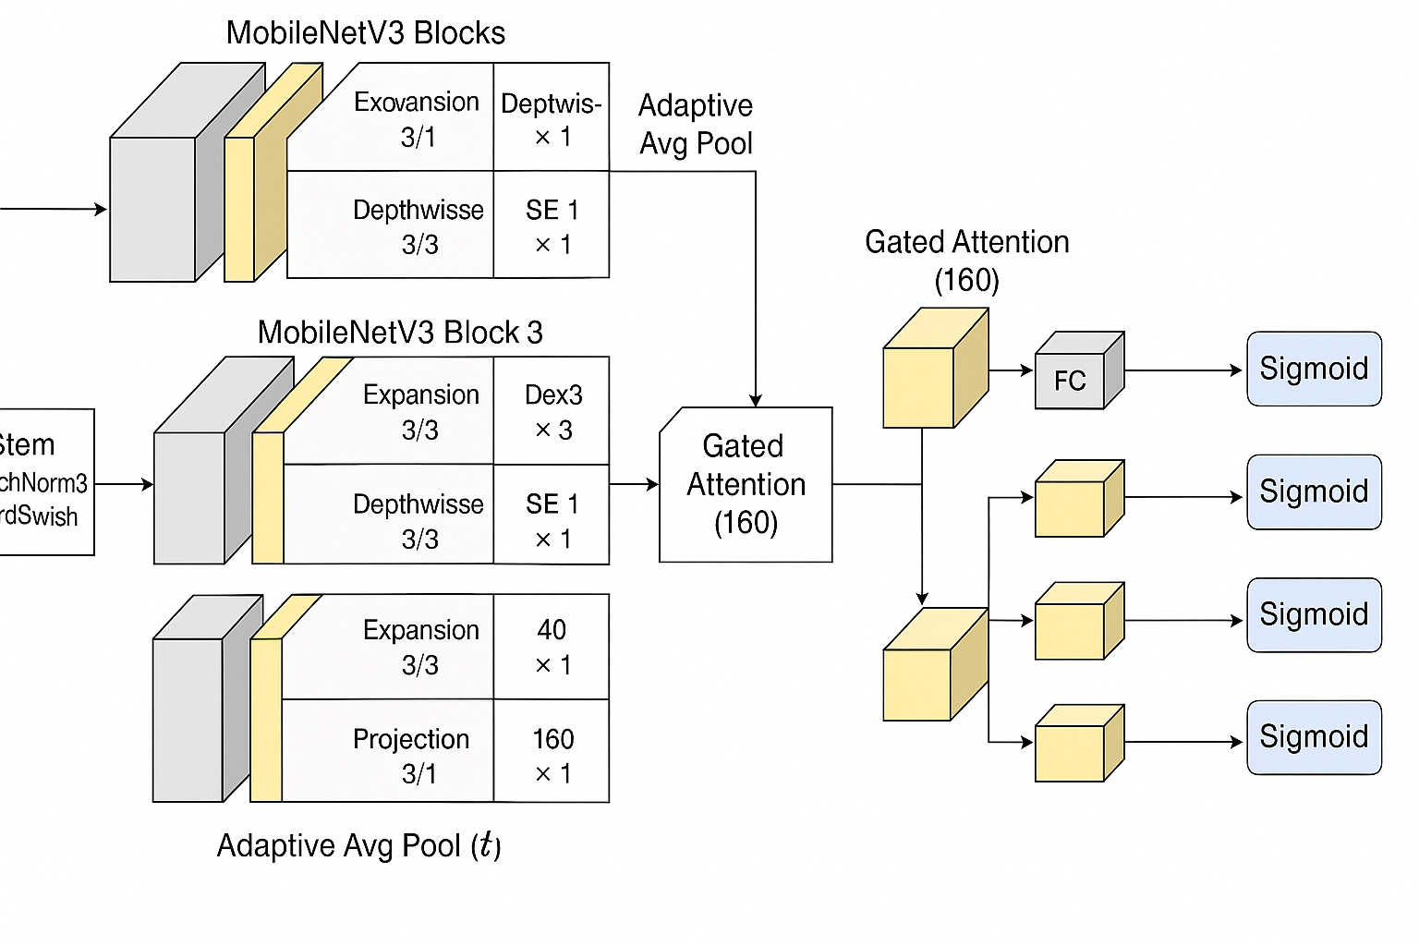
Figure 1: Model Architecture in detailed form

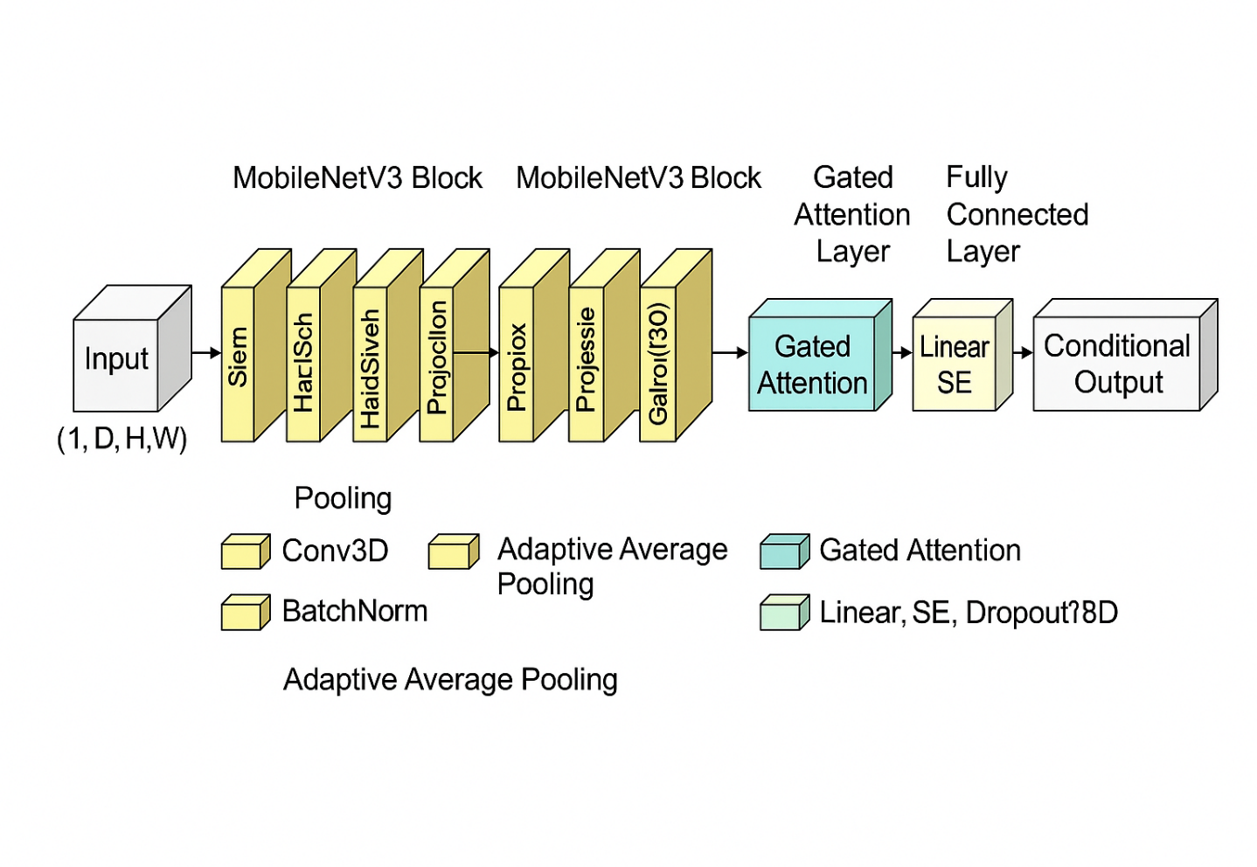
Figure 2: Model architecture in simple form

Ensemble Learning Strategy
Using an ensemble learning method will help to improve the system's accuracy and resilience even further. Hard Voting is the selected ensemble technique for this work.

Majority voting will be used to aggregate the MobileNet-V3 and EfficientNet predictions. The final classification is decided by the most often predicted class, while the separate models create independent predictions in this process. Should both models forecast the same class, that will be the last result. Should differences exist between the models, the model with more historical accuracy will be chosen as the last resort.

Using ensemble learning reduces the overfitting risk to certain patterns that any one model might learn from. Combining the best features of MobileNet-V3 and EfficientNet, it offers a more general and accurate solution considering a larger range of diagnostic scenarios.

Model Evaluation
To evaluate the performance of the ensemble model, several standard metrics for image classification will be used, including.

- Accuracy:
$$Accuracy = \frac{TP + TN}{TP + TN + FP + FN}$$
- Precision:
$$Precision = \frac{TP}{TP + FP}$$

- Recall:
$$Recall = \frac{TP}{TP + FN}$$

- F1-score:
$$Recall = 2* \frac{Precision*Recall}{Precision+Recall}$$

Stratified sampling will help the dataset be split into training, validation, and test sets so that every class is represented proportionately throughout the splits. The model will be made sure not to exceed any training subset and generalize well across several data folds by means of cross-valuation.

Web Interface Integration
Rather than a mobile app, the outcomes of this project will be included in a web-based interface created with Next.js. The web interface will let users including doctors and radiologists easily engage with the system. Users will be able to read diagnostic results, submit MRI pictures, and get an understanding of the degree of lumbar spine disorders. When the user responds to those questions in natural language, the system collects the answers in real time and delivers them to the backend AI model via a REST API created by the FastAPI framework.

Next.js Frontend

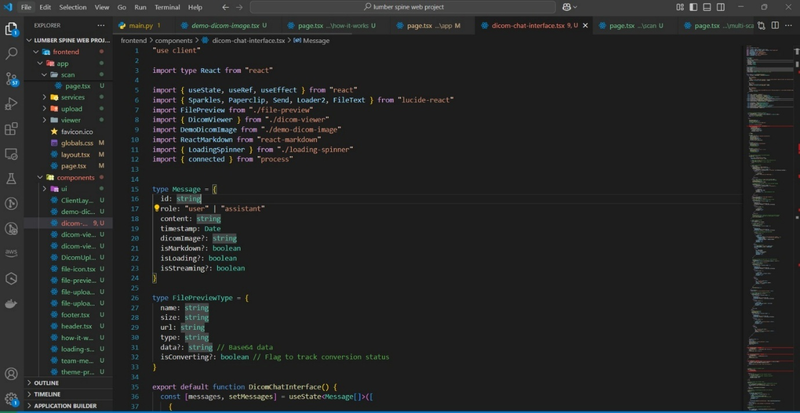
Figure 3: Frontend web interface

React-based framework known for quick server-side rendering and optimization Next.js will be used in frontend building. This will preserve rapid load times while also enabling a seamless, responsive user experience.

FastAPI Backend

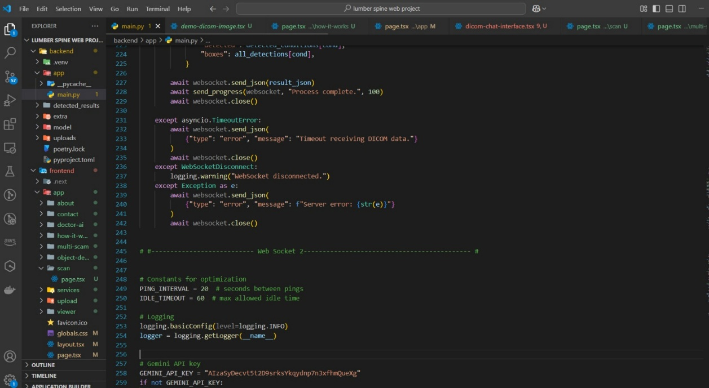
Figure 4: Backend FastAPI

FastAPI will manage backend processing, including MRI scan reception, passing pre-trained AI models over, and frontend result delivery. The asynchronous features of FastAPI will guarantee that the system stays scalable and efficient and is able to process big volumes of real-time image data.

Frontend Interface
The frontend inter face is website It contain the home page, scan page (single scan, multi scan) and chatbot

Picture Upload
You can upload both a single MRI scan, which is a single image representing a slice of the body, and a complete MRI scan that consists of multiple images or slices. The complete scan is typically made up of several individual DICOM images, each showing a cross-sectional view of the body. These images together provide a comprehensive view of the area being examined, allowing for detailed analysis by healthcare professionals.

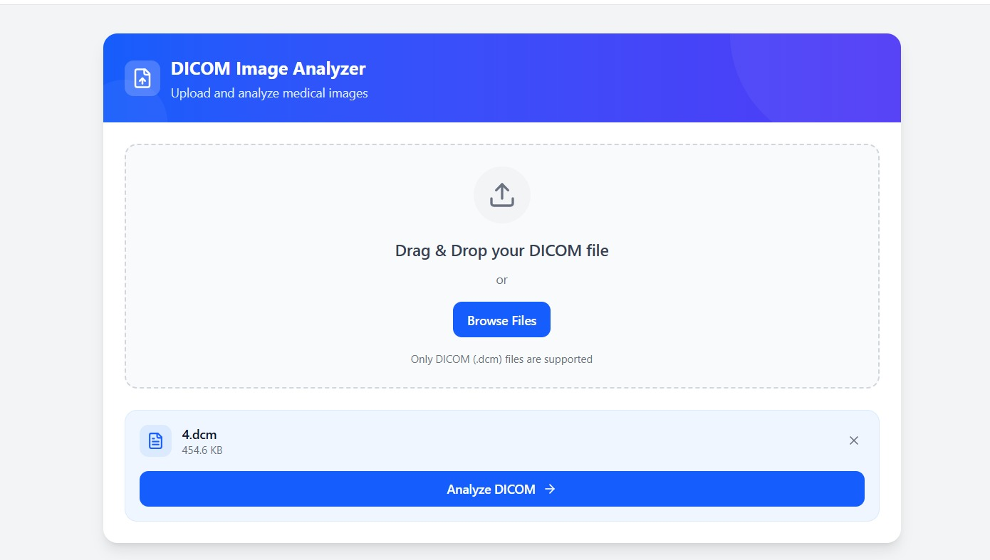
Figure 5: Picture upload box

User Manual
If you're new to the website, this user manual will guide you through the process of getting your MRI analysis. Simply create an account or log in, then upload your MRI scan—whether it's a single image or a complete set of images. Once your scan is uploaded, our system will analyze the images and provide you with detailed insights, helping you understand the results of your MRI.

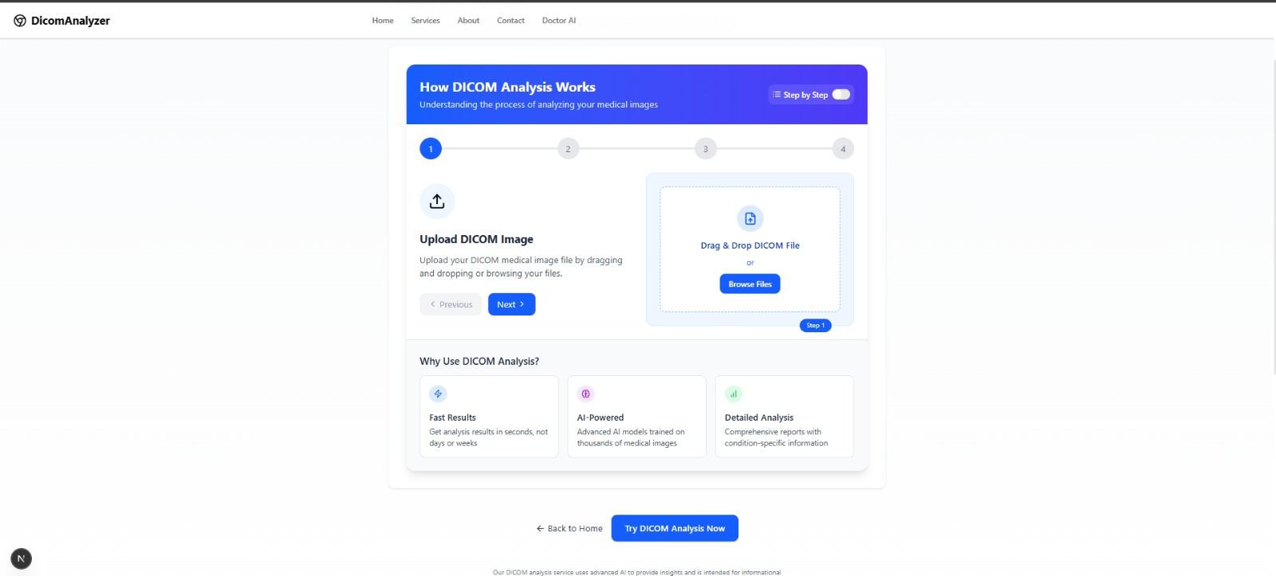
Figure 6: How it work

Chatbot
It The website features an integrated chatbot designed to assist you with any queries related to your lumbar spine. Whether you need help understanding your MRI results, have questions about common conditions like disc degeneration, or require guidance on treatment options, the chatbot is available 24/7 to provide accurate, real-time answers tailored to your specific needs. It’s an easy and efficient way to get the information you need, directly from the comfort of your device.

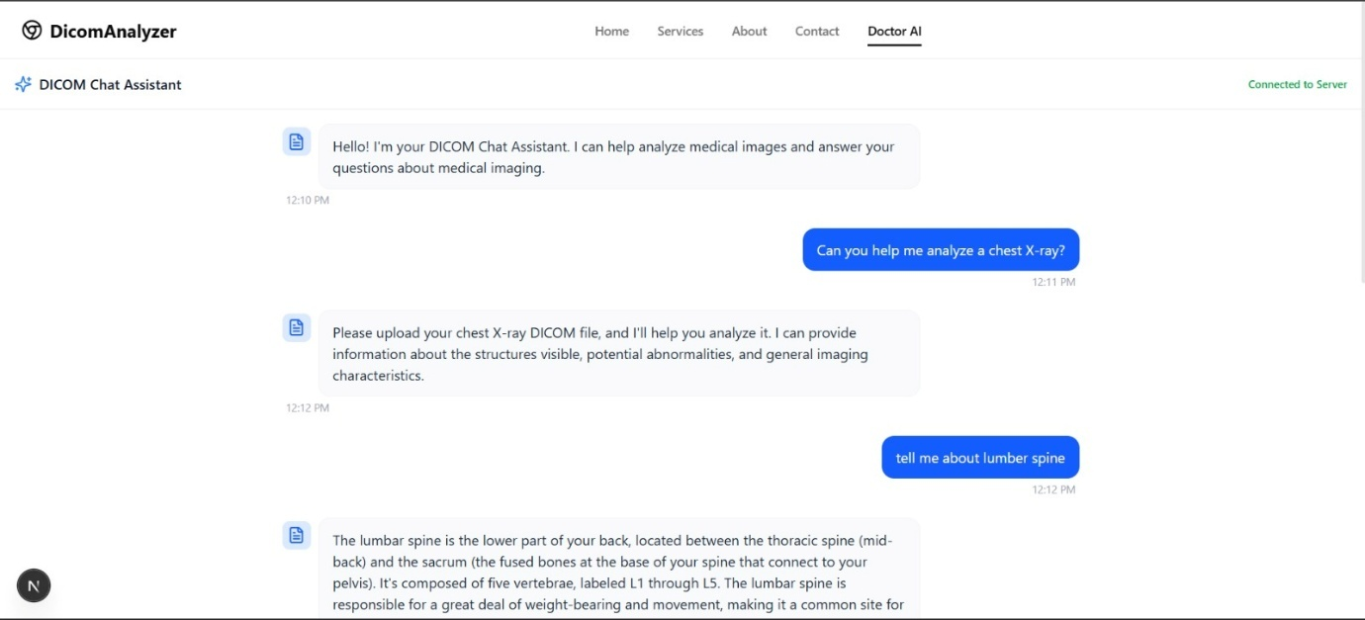
Figure 7: Chatbot

Analysis and Result
When you upload an MRI image, the system uses advanced models like YOLOv8 and MobileNet-V3 to analyze the scan. These models work by identifying and marking the affected areas in the image. They assess the severity of the condition, categorizing the affected areas as normal, moderate, or severe. The results are then displayed, providing you with a detailed analysis of the findings, helping you understand the extent of any issues and making it easier to interpret your MRI results.
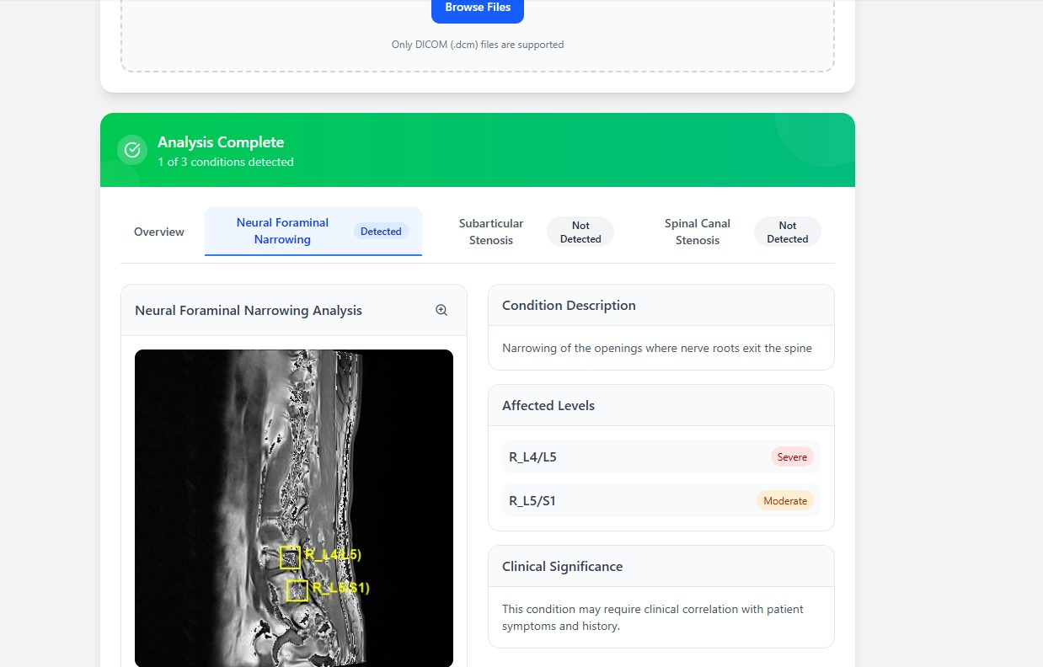
Figure 8: Analysis of image

Model and System Testing
To guarantee dependability and performance, the web-based system and the artificial intelligence model will be tested extensively. Evaluation for the artificial intelligence model will take place on the test set using criteria including accuracy, precision, recall, and F1-score calculated for every group. Additionally, the confusion matrix will be examined in order to spot any misclassifications or prejudices.
Functional testing will be conducted for the web-based system to guarantee that the whole pipeline—from image upload to result display—is operating as intended. Additionally, performance testing will be done to make sure the system can manage several concurrent users without latency or breakdown.

Grouped Fold (5-Fold Cross-Validation)
A five-fold cross-valuation technique was used to assess the model's robustness. This approach guarantees that every data point is used for validation as well as training, so offering a more accurate projection of model performance. Shuffled and split into five equal-sized subsets, or "folds," the dataset consisted of four folds used for training and one fold used for validation. This method was carried out five times, each fold acting as the validation set once

Exploratory Data Analysis (EDA)
To gain a better understanding of the structure and distribution of the dataset, a graphical Exploratory Data Analysis was conducted.

Bar Chart

The bar chart you shared displays the count of conditions from a dataset, specifically the number of occurrences for each condition in the dataset. The chart includes five conditions:
- Spinal Canal Stenosis
- Right Neural Foramina Narrowing
- Left Neural Foraminal Narrowing
- Left Subarticular Stenosis
- Right Subarticular Stenosis
From the chart, we can see that the count for each condition is fairly balanced, as each condition has a similar number of instances, around 7,000 to 10,000 occurrences.
The bar chart displays the distribution of various spinal conditions across different spinal levels (L1/L2 to L5/S1). The conditions represented include "Spinal Canal Stenosis," "Right Neural Foramina Narrowing," "Left Neural Foramina Narrowing," "Left Subarticular Stenosis," and "Right Subarticular Stenosis." The chart shows a fairly even distribution of these conditions across all spinal levels, with no major disparities in their counts at each level, suggesting that these conditions are consistently present across different spinal regions.

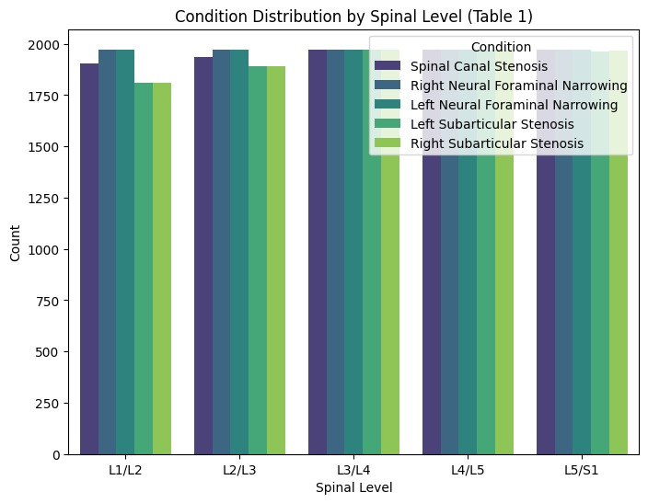
Figure 9: Condition Distribution by Spinal Level

Count Graph

Another Bar Chart The bar chart illustrates the distribution of MRI series descriptions in the dataset. "Sagittal T2/STIR" appears most frequently with over 2,000 occurrences, followed by "Sagittal T1" and "Axial T2," with the latter having a slightly lower count compared to "Sagittal T2/STIR." This chart reflects the prevalence of these three MRI series descriptions within the dataset

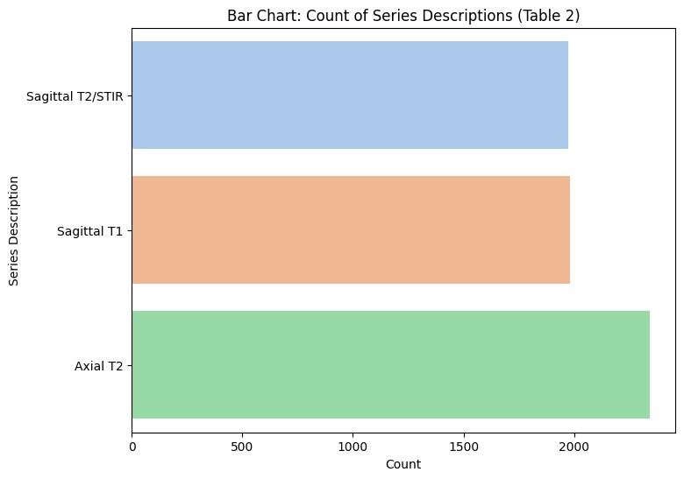
Figure 10: Count of Series Description

RESULTS AND DISCUSSIONS

Accuracy Precision Recall F1-Score and Support
The model achieved an overall accuracy of 87%, demonstrating its effectiveness in classifying degenerative lumbar spine conditions. Precision, recall, and F1-score values varied across different spine levels. For instance, L1/L2 achieved a precision of 0.81 and a recall of 0.89, with a balanced F1-score of 0.85, while L2/L3 showed similar performance with a precision of 0.85 and a recall of 0.88. The model performed slightly better for levels like L4/L5 with a precision of 0.89, though L5/S1 was not reported. The macro average precision, recall, and F1-score were 0.84, 0.86, and 0.85, respectively, indicating the model's balanced performance across all classes. The weighted average metrics further reinforced the model's robustness in real-world scenarios.

Class | Precision |  | Recall | F1-Score | Support
L1/L2 | 0.81 | 0.89 |  | 0.85 | 236
L2/L3 | 0.85 | 0.88 |  | 0.86 | 228
L3/L4 | 0.84 | 0.86 |  | 0.85 | 238
L4/L5 | 0.89 | 0.84 |  | 0.86 | 221
L5/S1 | 0.80 | 0.78 |  | 0.79 | Not Reported
Accuracy |  |  |  | 0.87 | 923
Macro Avg | 0.84 | 0.86 |  | 0.85 | 923
Weighted avg | 0.86 | 0.87 |  | 0.86 | 923
Table 2: Accuracy, Precision and F1 Score

Comparison of Different Studies

These The recent work by various scientists has made significant contributions to the detection and classification of lumbar spine degenerative conditions using AI and deep learning models. Studies such as Yagi et al. have demonstrated the power of CNN-based models to classify spinal conditions with high accuracy, while others, like Herzog et al. have applied Faster R-CNN and DenseNet models to improve spinal canal segmentation. Techniques such as YOLOv8, U-Net, and DenseNet have also been utilized for real-time detection and accurate classification, with some models achieving accuracies above 95%. Despite these advancements, challenges remain, particularly with multi-level degeneration and dataset limitations, which can affect model performance. Further improvements are needed, especially in model generalization across clinical settings, and integrating these models into real-world medical applications.

Author(s) | Models Used | Accuracies | Precision | Recall | F1-Score
Yagi et al | CNN-based custom model[1] | 93% | 92% | 91% | 91.5%
Lehnert et al. | CNN (Deep Learning)[2] | 90.08% | Not reported | Not reported | Not reported
Zhang et al. | Faster R-CNN, DenseNet | 98.21% | Not reported | Not reported | Not reported
Shakir et al. | U-Net, DenseNet | 95% | Not reported | Not reported | Not reported
Dimopoulos et al. | ResNet, CNN-based architecture | 97.71% | 92% | 91% | Not reported
Herzog et al. | Faster R-CNN, DenseNet | 96% | Not reported | Not reported | Not reported
Hong et al. | DenseNet121, Feature Pyramid Network (FPN) | 97.7% | 0.89 | 0.91 | Not reported
Joo et al. | CNN, Deep learning algorithms | 93% | 0.92 | 0.94 | Not reported
He et al. | AI models in spinal imaging, Surgical robotics systems | 90-97% | Not reported | Not reported | Not reported
Lee et al. | CNN, Machine learning, Robotic systems for surgery | Not reported | Not reported | Not reported | Not reported

Table 3 Previous Work Comparison

CONCLUSION AND RECOMMENDATIONS

Conclusion
From MRI scans, this team effectively created an artificial intelligence-based diagnostic system meant to identify and diagnose degenerative lumbar spine disorders. The system was able to precisely identify and classify conditions, including Spinal Canal Stenosis (SCS), Neural Foraminal Narrowing (NFN), and Subarticular Stenosis (SS) into severity levels—Normal, Moderate, and Severe by using cutting-edge deep learning techniques—specifically Convolutional Neural Networks (CNNs) and pre-trained models such MobileNet-V3 and EfficientNet.
The design of the system comprises a strong data preprocessing pipeline meant to standardize MRI pictures, normalize pixel values, and enlarge the dataset for higher model generalization. Combining CNN-based models with sophisticated deep learning methods, the ensemble learning approach improved both resilience and classification accuracy. With the ensemble model beating individual models in terms of accuracy, recall, and F1-score, showing its possibility for real-world application, evaluation results revealed encouraging outcomes.
Although this initiative addresses lumbar spine degenerative diseases, it marks a major stride toward radiologically increasing diagnostic efficiency. By means of Next.js for the front end and FastAPI for the back end, the model—integrated into a web-based platform—ensures accessibility and scalability, therefore enabling healthcare practitioners to upload MRI images and get accurate diagnosis results right now.
The system is a computerized pre-screening tool rather than a clinical diagnostic tool, although operating effectively in the controlled context of this study. Still, its capacity to support therapeutic decision-making and help with early diagnosis makes it a great benefit in the field of spine treatment.

Recommendations
To further enhance the system's capabilities and ensure its adoption in real-world clinical settings, several improvements and recommendations are proposed:

Expand Dataset Diversity:
MRI pictures from particular patient groups make up the dataset used in this study. Incorporating a more varied set of data from many demographics and imaging sources should be the main emphasis of future studies to enhance the generalizing of the model. This will guarantee that across various population groups, the model can efficiently manage changes in MRI scan quality, patient anatomy, and degenerative diseases.

Improved Model Optimization:
Although the ensemble model shows encouraging results, individual models could yet be optimized. To improve performance without using large-scale datasets, one can experiment with hyperparameter tuning, investigate more complex architectures, or combine younger technologies including transfer learning or self-supervised learning.

Real-Time Deployment and Clinical Integration:
Including the system in clinical practice would need to guarantee its real-time processing capacity for wider application. The dependability and responsiveness of the system should be evaluated in hospital settings with real data. Furthermore, the comments of doctors should be taken into consideration to improve the model and its results so that they more closely fit clinical processes.

User-Centric Web Interface:
Although the present web-based interface offers a useful and quick platform, concentrating on user experience (UX) can help to improve it even more. Including simple access to historical data, automated report production, and decision support alerts—all of which are clinician-friendly—helps the system be smoothly included in everyday clinical practice.

Future work

Looking ahead, there are several exciting directions for expanding and improving the capabilities of this AI-powered lumbar spine diagnostic system:

Multi-Condition Classification
Future research should concentrate on broadening the model to identify and categorize spinal disorders outside of those addressed in this effort. This can cover disorders such as scoliosis, herniated discs, or degenerative disc disease, so offering a more complete diagnostic instrument for spine treatment.

Integration of Longitudinal Data
Including longitudinal data—MRI scans performed over time—may help the model to forecast future conditions and track illness development. More customized therapy recommendations made possible by this will let doctors decide on patient care more sensibly.

Multimodal Approach
Apart from MRI scans, using other diagnostic information including patient medical histories, genetic data, or other imaging modalities (e.g., X-rays, CT scans) could enhance the capacity of the model to produce more complex predictions. Deeper understanding of the patient's general spine condition would come from a multimodal approach, therefore improving therapy efficacy and maybe diagnosis accuracy.

Real-Time Mobile Application
Creating a mobile version of this system would improve its accessibility, considering the extensive use of cell phones and mobile apps. The approach would be much more flexible if doctors could upload MRI scans from far-off sites using this mobile app. Including artificial intelligence models in telemedicine systems could also give remote healthcare providers real-time assistance, hence enhancing access to modern diagnostics.

Clinical Validation and Regulatory Approvals
Extensive validation through multi-center clinical trials is essential for the technology to be implemented in clinical environments. These tests would validate the performance and diagnostic dependability of the system over several healthcare settings. Moreover, attaining regulatory certifications, including FDA clearance, would be vital to guarantee the system satisfies medical criteria and can be included into clinical processes worldwide.

REFERENCES

[1] Yagi, T.; Sato, M.; Kato, H.; Kimura, Y. Growing Role of AI and Machine Learning in Spinal Care. Neurosurg. Rev. 2023, 46, 75. [Google Scholar] [CrossRef] [PubMed].
[2] Depression Overview. Available online: https://www.who.int/news-room/fact-sheets/detail/depression (accessed on 30 June 2020).
[3] Chen, Z., Yang, R., Fu, S., Zong, N., Liu, H., & Huang, M. (2023, June). Detecting Reddit Users with Depression Using a Hybrid Neural Network SBERT-CNN. In 2023 IEEE 11th International Conference on Healthcare Informatics (ICHI) (pp. 193-199). IEEE.
[4] Shen, G., Jia, J., Nie, L., Feng, F., Zhang, C., Hu, T., ... & Zhu, W. (2017, August). Depression detection via harvesting social media: A multimodal dictionary learning solution. In IJCAI (pp. 3838-3844).
[5] Uddin, M. Z., Dysthe, K. K., Følstad, A., & Brandtzaeg, P. B. (2022). Deep learning for prediction of depressive symptoms in a large textual dataset. Neural Computing and Applications, 34(1), 721-744
[6] Lin, L., Chen, X., Shen, Y., & Zhang, L. (2020). Towards automatic depression detection: A BiLSTM/1D CNN-based model. Applied Sciences, 10(23), 8701.
[7] Amanat, A., Rizwan, M., Javed, A. R., Abdelhaq, M., Alsaqour, R., Pandya, S., & Uddin, M. (2022). Deep learning for depression detection from textual data. Electronics, 11(5),676.
[8] Chiong, R., Budhi, G. S., Dhakal, S., & Chiong, F. (2021). A textual-based featuring approach for depression detection using machine learning classifiers and social media texts. Computers in Biology and Medicine, 135, 104499.
[9] Thekkekara, J. P., Yongchareon, S., & Liesaputra, V. (2024). An attention-based CNN-BiLSTM model for depression detection on social media text. Expert Systems with Applications, 249, 123834.
[10] Priya, A., Garg, S., & Tigga, N. P. (2020). Predicting anxiety, depression and stress in modern life using machine learning algorithms. Procedia Computer Science, 167, 1258-1267.
[11] Kim, J., Lee, J., Park, E., & Han, J. (2020). A deep learning model for detecting mental illness from user content on social media. Scientific reports, 10(1), 11846.
[12] Tejaswini, V., Sathya Babu, K., & Sahoo, B. (2024). Depression detection from social media text analysis using natural language processing techniques and hybrid deep learning model. ACM Transactions on Asian and Low-Resource Language Information Processing, 23(1), 1-20.
[13] Chakraborty, S., Mahdi, H. F., Ali Al-Abyadh, M. H., Pant, K., Sharma, A., & Ahmadi, F. (2022). [Retracted] Large‐Scale Textual Datasets and Deep Learning for the Prediction of Depressed Symptoms. Computational intelligence and neuroscience, 2022(1), 5731532.
[14] Ahmad, H., Asghar, M. Z., Alotaibi, F. M., & Hameed, I. A. (2020). Applying deep learning technique for depression classification in social media text. Journal of Medical Imaging and Health Informatics, 10(10), 2446-2451.
[15] Marriwala, N., & Chaudhary, D. (2023). A hybrid model for depression detection using deep learning. Measurement: Sensors, 25, 100587.
[16] Joshi, M. L., & Kanoongo, N. (2022). Depression detection using emotional artificial intelligence and machine learning: A closer review. Materials Today: Proceedings, 58, 217-226.
[17] Khafaga, D. S., Auvdaiappan, M., Deepa, K., Abouhawwash, M., & Karim, F. K. (2023). Deep learning for depression detection using Twitter data. Intelligent Automation & Soft Computing, 36(2), 1301-1313.
[18] Wongkoblap, A., Vadillo, M., & Curcin, V. (2021). Depression detection of twitter posters using deep learning with anaphora resolution: algorithm development and validation. JMIR Mental Health.

Dataset

https://www.kaggle.com/competitions/rsna-2024-lumbar-spine-degenerative-classification

