

BSCS-F24-003
03-134212-047 | Mubashra Chaudhary
03-134212-009 | Ahmed Tahseen

AI Image Detection

In partial fulfilment of the requirements for the degree of Bachelor of Science in Computer Science

Supervisor: Junaid Nasir

Department of Computer Sciences
Bahria University, Lahore Campus

June 2025

© Bahria University, 2025
C e r t i f i c a t e



We accept the work contained in the report titled
“AI Image Detection” written
by
Mubashra Chaudhary
Ahmed Tahseen
as a confirmation to the required standard for the partial fulfilment of the degree of Bachelor of Science in Computer Science.

Approved by:
Supervisor: Junaid Nasir
(Signature)

05 June 2025

DECLARATION

I/We hereby declare that this project report is based on my/our original work except for citations and quotations which have been duly acknowledged. I/We also declare that it has not been previously and concurrently submitted for any other degree or award at Bahria University or other institutions.

Enrolment | Name | Signature
03-134212-047 | Mubashra Chaudhary
03-134212-009 | Ahmed Tahseen

Date : 05 June, 2025

Specially dedicated to

my beloved mother, father and siblings
(Mubashra Chaudhary) my beloved mother, father and siblings (Ahmed Tahseen)

ACKNOWLEDGEMENTS

We would like to thank everyone who had contributed to the successful completion of this project. We would like to express our gratitude to our research supervisor, Mr Junaid Nasir for his invaluable advice, guidance and his enormous patience throughout the development of the research.

Mubashra Chaudhary
Ahmed Tahseen

AI Image Detection

ABSTRACT

In the last few years, the explosive development of Generative AI technology, particularly Generative Adversarial Networks (GANs), has transformed the digital media construction world, whereby ultra-realistic images can now be produced that closely resemble human images. These are the AI-produced images, or the so-called deepfakes that are so realistic that even trained specialists have a hard time distinguishing the real from them. Although those innovations have catalysed creative potential in all sorts of industries like film, gaming, and advertising, they have also been accompanied by serious fears about digital trust, authenticity and the propagation of misinformation.
The increasing presence of synthetic media contents, especially AI faces, is causing serious concerns in such fields as journalism, law enforcement, national security, and public discourse. The simplicity by which such images could be fabricated and spread represents a flaw within the visual proof and can alter mass consciousness on a wholesale scale. Against these challenges, this project aims at developing, constructing, and deploying a practical AI-based image classification system that can reliably tell the difference between real and AI images using deep learning-based methods.
In order to do that, a supervised machine learning model was built and trained with a publicly available dataset found in Kaggle and called the Real and Fake Faces dataset. This dataset is images that are labelled and either assigned “real” or “fake”. It is a good base for binary classification. The complete machine learning pipeline had been built, i.e., from dataset management to the training and optimization of the model, using TensorFlow and Keras in a Google Colab environment. The architecture used on this task was derived from MobileNetV2, a small and efficient Convolutional Neural Network (CNN) that showed excellent performance in mobile and embedded applications. MobileNetV2 has been selected because of its speed-to-accuracy trade-off and its compatibility with TensorFlow Lite for mobile deployment.
In order to make it possible for the model to generalize well to unseen images and to avoid overfitting, several of the well-established deep learning techniques were applied during the training. These were factors like data augmentation strategies involving the use of Image Data Generator; rotation, width and height shifts, shear transformations, image zooming and horizontal flipping. These augmentations synthetically increase the size of the training dataset by adding variance to the direction of the image and perspective; thereby, allowing the model to learn more robust features. In addition, a Dropout layer was added to the network to dis-engage random neurons during the training hence, limiting the dependence on particular connections and the development of more generalized learning patterns.
It was developed with the Adam optimizer with a learning rate of 0.0001 while it was trained for 10 epochs by using a batch size of 32. Binary cross-entropy loss function was employed because this is a two-class classification problem. The model yielded high validation accuracy and exhibited a reliable performance when proven on a hold out test set suggesting that it is capable of distinguishing between the real and fake images. Once its accuracy and efficiency were established, the model was exported to the format of TensorFlow Lite (.tflite). This conversion greatly slims the size and latency of the model, and maintains its prediction performance, making it appropriate for real-time inference on mobile devices.
To show the practical usefulness of this model, one can develop the cross-platform mobile application for Android users using Flutter. The Flutter app offers the users an easy and intuitive interface for uploading an image from the gallery of their device. When an image is picked the image is resized and pre-processed inside the app and transferred to the in-built TensorFlow Lite model for prediction. The outcome is presented on the screen showing the word “Real” or “Fake” and the confidence percentage allowing the user to get immediate and legitimate feedback.
Integration with a real-world mobile application of the machine learning model accentuates a full-stack nature of the project – data preprocessing, model training, performance evaluation, optimization, and deployment. This method connects the gap between theoretical research in deep learning and the practical application of the same. Although the current project is currently centered on image-based detection of AI generated contents, the overall framework can be applied to other modalities including video deepfakes, AI generated voice clips or even text generated by large language models. Furthermore, it is possible to leverage future implementations of this project and use explainability features like Class Activation Maps (CAMs) or Grad-CAM visualizations so that end-users can understand what parts of the image were used by the model to make a prediction.
Opening the gate for the future potential integrations with the content moderation tools, media verification platforms and journalistic fact checking services is what this project does as well. It helps the overall initiative of increasing transparency and authenticity in the digital age. In the further development of synthetic media in terms of its complexity and availability, such tools become vital for preparing the everyday user and a professional in terms of their critical evaluation of the matter they are exposed to. In conclusion, this project presents not only the potential of CNNs and mobile AI implementation, but also addresses an urgent society’s need. fake use of generative AI used in visual content, detection, and protection against it.

TABLE OF CONTENTS

DECLARATION 4
ACKNOWLEDGEMENTS 6
ABSTRACT 7
TABLE OF CONTENTS 10
LIST OF TABLES xi
LIST OF FIGURES xi
LIST OF APPENDICES xi

Chapters

- INTRODUCTION 12
  - Background 12
  - Problem Statements 18
  - Aims and Objectives 21
  - Scope of Project 23

- LITERATURE REVIEW 28
  - Background and Motivation 28
  - Generative Adversarial Networks (GANs) 30
    - Application and risks of GAN 32
    - Dataset and detection challenges 33

  - Deep Learning-Based Detection Techniques 33
    - CNN Architectures and Transfer Learning 35
    - Advanced Detection Strategies 36
2.4. Summary of Findings and Research Gap 38
3 DESIGN AND METHODOLOGY |  |  |  |  | 40
3.1 Dataset Collection and Preprocessing |  |  |  |  | 40
3.2 Model Architecture and Training Strategy |  |  |  |  | 42
3.3 Evaluation Metrics and Tools |  |  |  |  | 45
3.4 Deployment Plan |  |  |  |  | 46
4 DATA AND EXPERIMENTS |  |  |  |  | 49
4.1 Dataset Description |  |  |  |  | 49
4.2 Data Preprocessing |  |  |  |  | 50
4.3 Model Implementation |  |  |  |  | 51
4.3.1 Model Architecture |  |  |  |  | 52
5 RESULTS AND DISCUSSIONS |  |  |  |  | 53
5.1 Performance Metrics |  |  |  |  | 53
5.2 Discussion |  |  |  |  | 54
5.3 User Manual |  |  |  |  | 54
5.3.1 Flutter UI Component Table |  |  |  |  | 55
6 CONCLUSION AND RECOMMENDATIONS |  |  |  |  | 56
6.1 Conclusion |  |  |  |  | 56
6.2 Recommendations Future work |  |  |  |  | 57
REFERENCES |  |  |  |  | 58
APPENDICES 59

LIST OF TABLES

TABLE TITLE PAGE

Table 0.1: Model Architecture Diagram 4

LIST OF FIGURES

FIGURE TITLE PAGE
Figure 1.1: Model Architecture 50
Figure 1.2: Mock-up image of app screens 53
Figure 1.3: UML Use Case Diagram 56
Figure 1.4: UML Sequence Diagram 57

LIST OF APPENDICES

APPENDIX TITLE PAGE
APPENDIX A: Graphs 59
APPENDIX B: Computer Programme Listing 61

Chapter 1

INTRODUCTION

1.1 Background

Artificial intelligence (AI) has been an area of outstanding progress over the last few years, dramatically altering many industries, from the sphere of healthcare and finances to entertainment and social media. There are myriads of sub domains under AI but amongst them all, deep learning has risen as one of the most powerful tools that can be used to learn complex patterns from huge datasets. The most eye-catching and controversial of its applications has been its use for generating synthetic images, especially human faces, using Generative Adversarial Networks (GANs). These AIcreated visuals, commonly referred to as “deepfakes”, are almost impossible for the human eye to distinguish from the real things, and have triggered another round of ethical, social and technological nightmares.
With the democratization of the generative tools such as StyleGAN, DALL·E, and other diffusion models, it has never been easier to obtain high-quality, photorealistic images without much technical savviness. These tools have paved way for new levels of creativity and design but at the same time have triggered concerns with regards to misinformation, online identity theft, political manipulation, and digital deception. Implications of deepfakes is already being cited in connection with social engineering attacks, brand ruination, and spread of fictitious narratives. With generative AI advancing all the time, this gap between real and artificial becomes more and more blurred. This poses a critical challenge: how can we believe in what we read on the internet?

There has never been a greater need for effective, automated methods that can tell the difference between real and AI-generated materials. This has led to the birth of a parallel research era in the field of AI and computer vision in the area of detection of synthetic media. Instead of using apparent or semantic variations that can be used in traditional classification problems, recognizing fake images frequently involves the identification of small, pixel-based irregularities, compression artifacts, and statistical discrepancies that are obscure to human vision. The differences may be invisible for casual viewers but can be perceived with the help of deep neural networks that detect generative algorithms’ signatures.
In this setting, a convolutional neural network (CNN) has emerged as an unofficial trend for image-based classifications because CNN can learn image data hierarchies in space. CNNs operate so that they automatically draw low-level features such as edges and textures on the initial layers and learn more advanced and complex patterns in deeper layers. This architecture is especially suitable for functions that are related to face recognition and manipulation detection where miniscule differences could be the deciding factor for correct categorization. Due to these reasons, CNNs are a suitable choice for real-vs-fake image classification, and it is popular in the efforts in academic and industrial research.
Although technical viability of teaching models to recognize faked images has been attested in laboratory settings, the issue of applying such attained models for everyday users’ use remains critical. There are cloud-based solutions for fake image detection, but they can take the form of users uploading their sensitive images to external servers, which is risky in terms of privacy and adds latency. Moreover, such systems rely on stable connections with the internet, and they are not very appropriate for deployment in areas with minimal connectivity. Mobile AI inference, and especially the frameworks such as TensorFlow Lite, promises a strong alternative by allowing real-time detection in an offline manner directly on the user’s device. Not only does it answer latency and privacy issues but also makes the solution more scalable and usable.

As one of the best options for on-device inference on the basis of the balance between the performance and computational cost, MobileNetV2 is a compact and effective CNN architecture. Created to be fast and lightweight, MobileNetV2 functions competitively in accuracy whilst keeping memory and processor use to a minimum, a key requirement for a mobile deployment. Combined with frameworks such as Flutter for frontend development it becomes possible to develop whole end-to-end solutions where a user can just upload an image and gets the result instantly, without any special tech contribution on his part and without backend processing.
This project utilizes all of these aspects in order to create an AI-powered mobile application that can classify an image as real or as being an AI-generated image. The goal is not simply to come up with a working classifier, but to package that and make it into a usable user service, which can be placed on regular Android devices. A commonly known dataset that has real and fake facial images is used to train the model. This dataset is the basis of building a binary classification model that can learn to differentiate between genuine human features and these features as generated by GANs. Data augmentation techniques are used in the training process to improve the model’s generalizability, and dropout layers are applied to avoid the model’s overfitting. After training the model is converted to a TensorFlow Lite format and hence allows it to run smoothly on android devices without the need for servers.
The app itself is developed in Flutter, which is selected for its high rate of development and for providing a smooth performance on Android. The user interface is made to be as minimalistic as possible with the sole purpose of simplifying the process of uploading an image and instantly getting a prediction. A user can choose an image from their device’s gallery, and the app runs it through the embedded TensorFlow Lite model. The result in form of “Real” or “Fake” is then displayed along with a confidence percentage. All of this is being done on-device therefore, guaranteeing the user’s privacy while delivering a snappy experience.
Through a mix of academic rigor when building up a model and practical concerns in their mobile deployment, this project aims to tackle the technical and social aspects of the detection of AI-generated media. It takes machine learning to the next level so non-experts could use such capabilities and shows how this sort of tools could be implemented within real workflows. Moreover, the project allows to prove the concept of possible future expansions, like the detection of AI-generated video, voice, or even textual material. As threats arising from deepfakes proliferate in their different forms, such multimodal form of detection systems is likely to become an essential priority in digital security infrastructure.
Recently, giant steps have been made in the field of artificial intelligence (AI), changing the face of many industries from healthcare and finances to entertainment and social media. Deep learning is a powerful learning tool that has emerged among the array of subdomains of AI and can be used to extract understanding of complex patterns from large amount of data. Its most distinctive and controversial applications have included the creation of synthetic images, especially human faces, with the help of the Generative Adversarial Networks (GANs). These visuals produced by AI, which are commonly known as “deepfakes”, are virtually indistinguishable for the human eye from real images, and are yet another wave of the ethical, social and technical considerations.
Democratization of generative tools such as StyleGAN, DALL·E, and other diffusion models has never made it easier and relatively non-technical to create topnotch, photorealistic images. These tools have paved new ways to be creative and inventive on one hand but on the other hand, it has aroused concerns about misinformation, online skimming, political manipulation, and digital deceit. Deepfakes have already been associated with social engineering attacks, tainting of reputation, and spreading of false narratives. This imaginary line between what is real and what is artificial will become even more blurred with the enhancements in generative AI. This poses a critical challenge: In what way can we believe what we see online?
More urgent than ever is the necessity to have the reliable automated instruments that can differentiate between the real and the AI-generated content. This has subsequently led to a parallel subject in AI and computer vision of synthetic media detection. Different from the traditional classification tasks that base on the visible or semantic differences to make predictions, deception of fake images frequently involves finding barely noticeable pixel-wise irregularities, compression artifacts, and statistical discrepancies that are invisible for human eyes. While these differences might go unnoticed by casual observers, there are, in fact, objective means of uncovering them based upon the use of deep neural networks that have been trained to extract unique signatures of use that are left in the wake of generative algorithms.
This is the landscape in which convolutional neural networks (CNNs) have emerged as a de facto standard for image-based learning tasks because these networks can learn spatial hierarchies from image data. CNNs operate on the principle of the automatic extraction of low-level features, such as edges and textures, simultaneously in the initial layers and then going deeper to recognise more abstract and complex patterns. This architecture is very well suited to tasks of facial recognition and manipulation detection where even minor discrepancies can be the difference between a correct and an incorrect classification. That is why CNNs are a good fit for real-vsfake image classification and found its application in relevant academic and industrial studies.
Although the technical possibility to train models to detect a fake image has been proved in a strictly controlled environment, the problem is still in converting these models into a real usable tool for every user. Cloud-based solutions for identification of fake images do exist, but they often make the users upload sensitive images to external servers, which increases privacy concerns and latency. Moreover, these systems require reliable Internet connections, which reduces their suitability for deployment in the regions with only weak connectivity. Mobile based AI inference, especially with the help of such libraries as TensorFlow Lite, provides a very attractive alternative as it allows real-time, write-offline recognition directly on the user’s device.
This does not just solve latency and privacy problems but also allows the solution to become more scalable and available.
MobileNetV2, a small and efficient CNN, becomes one of the best choices of on-device inference in terms of its performance-cost balance. Built to be both fast and light, MobileNetV2 has competitive accuracy and low memory and processor resource requirement—a critical requirement of mobile deployment. And combined with the frameworks such as Flutter for the frontend application development, it is possible to develop the full-fledged end-to-end solutions when a user does not need to be a computer technician and can just upload the image and get the immediate result without any backend processing.
This project capitalizes on all of these aspects to create an AI-driven application on a mobile device and which could identify the real image or the image that is computer generated. The goal is not just to create a functional classifier but to wrap it into a deployable tool that one could just run on common Android devices. The model is trained for a widely known dataset of real and non real faces. This dataset is used to prepare a binary classification model that is taught to distinguish real human to synthetic human features produced with GAN algorithms. The training process is designed in such a way that it implements data augmentation methods to improve the model’s generalization as well as dropout layers to avoid the phenomenon of overfitting. Trained model is converted to a TensorFlow Lite format, that enables its execution in Android devices without dependencies on servers.
The app itself is made with the use of the Flut force due to its ability to rapidly develop and seamlessly operate on the Android. The user interface is consciously minimalistic as it is aimed to reduce the process of an image upload and an instant prediction. Users are able to choose an image from the gallery on their device, and the app processes it with the help of the embedded TensorFlow Lite model. The result, whether “Real” or “Fake”, is then shown with a percentage of confidence. Everything happens quite on-device, so the user privacy is ensured and the experience is not lagged.
By accommodating technicality of model design with practical issues of deployment into mobiles, this project covers the technical and social angles of AI generated media detection. It brings advanced machine learning to non-experts and shows how such tools can be usable in real workflows. Besides, the project is also a proof-of-concept for future extensions such as the use of detection of an AI-generated video, voice, or even textual content. As threats from deepfake in different media presentations keep evolving, these multimodal detection systems will prove essential parts of the digital security apparatuses.

1.2 Problem Statements

Artificial Intelligence (AI) revolution has led to unbelievable innovation in different fields and generative AI technologies are remarkable because of their capability to create very realistic content. From these, Generative Adversarial Networks (GANs) have emerged to rule as the dominant framing of creating synthetic images, especially those of human faces which are equivalent, in images, to actual photographs. These deepfakes, brought to life by AI, are no longer the territories of proof-by-showing for academics or niche usage. They are currently easily available at minimal costs and can be easily created by almost anyone, which poses new risks to the integrity of information, privacy, and public trust. The capacity to create hyper-realistic identities or to change visual narratives brings consequences significant for digital security, journalistic proofs, propaganda in political discourses, and even psychological effect.
One aspect that makes this threat particularly difficult to handle is the fact that the generative models have become readily available to the public in haste and without much effort. It is now possible to control open-source GAN architectures, drag-anddrop deepfake tools, and strong image generators, which can create very convincing synthetic images in a few minutes, even by non-experts. These pseudo images are now more and more used for malicious ends such as spreading misinformation via social media, producing false online identities, impersonating people in a scam, and making up news events. The complexity of the AI-created visuals makes even standard ways of verification—an examination, a reverse search, or even an image forensics— ineffectual. As these visuals become increasingly true to life, the possibilities for deceit also increase in proportion while increasing the distance between perception and the truth.
This wave of synthetic media highlights an urgent need for reliable, easy to access and automated mechanism for identifying and recognizing AI generated images. The major problem here is creating a system that not only is correct but also maximized for deployment. Most current methods of fake image detection are computationally taxing in terms of their scope of use, and based on large-scale infrastructure like cloudbased service or high-end GPUs. Although useful in highly-controlled settings, it is often the case that these solutions do not reach the common end user, and are unsuitable for use in real-time settings. Furthermore, tools already available tend to have issues with portability, responsiveness, and user- friendly interfaces which impede the potential of impact they may have. Most of the existing deepfake detection systems are research-grade, being rarely transformed into a user-friendly form for nontechnical people to use in their everyday digital life.
In terms of technology, deep learning models especially the Convolutional Neural Networks (CNNs) hold the greatest prospects in the field of visual forgery detection. CNNs are built to identify and extract spatial features out from image data, and thus, it is suitable for tasks such as image classification and facial recognition. Their layer-wise architecture allows them to learn low-level patterns, like edges or textures, in the earlier stages, and more complicated structures in the deeper layers. Once modified to work correctly on a labelled dataset with real and fake faces, CNNs can be made to recognize the tiny inconsistencies that exist in GAN-produced content – artifacts, inconsistent lighting, unnatural texture blend, or symmetry distortions, which might not be seen by a human.
Nevertheless, despite their competence, there are challenges that face the CNN. They need to be trained heavily on a large training dataset, attentively regularized and sensibly hyperparameter tuned to avoid overfitting. Without optimisation, they are at risk of memorizing training samples instead of generalisation to unseen inputs. As well, CNNs used in server-dependent settings are at risk of latency, privacy issues, and boundary restrictions. In order for real-time applications to be efficient and scale, they must be done offline, on-device, with a manageable computational load.
To solve these multi-layered problems, a solution to a real-vs-fake image classification problem using deep learning is proposed as a practical, mobile-based solution, in this project. Specifically, it includes development of a CNN model that has been trained to be able to differentiate between real and AI-generated facial images. The model is constructed with TensorFlow and Keras libraries and trained on publicly accessible Kaggle dataset of thousands of labelled examples in both classes. Some of preprocessing of data methods, such as normalization, resizing, and augmentation (including rotation, flipping, and zooming) are used to improve diversification of training set and prevent the risk of overfitting. Drop out layers such as regularization techniques are used to make the model generalize well to the inputs in the real world. Validation sets are applied during all the training procedures to track learning behaviour and prevent degradation of performance.
After the model gets acceptable accuracy on both validation and test datasets, it is then converted to TensorFlow Lite – which is a lightweight model representation dedicated for the purpose of mobile and embedded systems. TensorFlow Lite saves the trained model size to an extreme while maintaining the inference capabilities hence suitable for on device usage. It avoids the need for internet access or server-based inference for a real-time classification and improved privacy and reduced latency.
The last model is implemented in a mobile application, which has been created by using Flutter as an open-source UI toolkit. Contrary to the fact that Flutter supports both Android and iOS, this application specifically develops for Android and does not utilize any Google APIs, or cloud based dependencies. The Android-only decision only guarantees simplicity, increased compatibility with hardware, and full control of the deployment pipeline. There is an intuitive look for this app with the display of the image that the client is to upload from the device gallery. This image is then processed and determined to be “Real” or “Fake” locally with confidence score displayed next to the result. The entire process takes place in seconds and does not require the technical expertise on the part of the user.
Not only does this approach fill the gap between theoretical AI research and the actual use, but also it puts strong tools for misinformation detection in the hands of everyday people. it eliminates the accessibility problems created by conservative methods and shows how responsiveness, portability and usability of machine learning models can be achieved without sacrificing the performance. The project is a full-stack pipeline, from data acquisition, training of the model to the optimization and deployment of the model onto memory-restrained equipment, showing the technical depth and engineering strictness.
In addition, it prepares the ground for further improvements. Now, armed with the foundation framework, application can be expanded to detect both AI-generated images, but also synthetic video and audio. Addition of explainable AI elements such as heatmaps to indicate areas of the image that contributed to the model prediction could increase users’ trust even more. The introduction of new datasets with different types of ethnicities, lightings and resolutions would enhance the model’s fairness and sturdiness. Cooperation with organizations in media, education and forensics may increase the app’s functionality and impact in the society.

1.3 Aims and Objectives

To train a CNN model to successfully categorize real and AI produced images:
This objective is concerned with designing and training a Convolutional Neural Network (CNN) that will be able to classify real images and artificial images (fake). The CNN model exploits several layers – convolutional, pooling, and fully connected layers – to learn and extract features on automatic basis from image data. The training process implies providing the network with a bulk of labeled images for feeding, optimizing it through backpropagation and some loss function. The goal is to make sure the model can extract what are so subtle inconsistencies or patterns in the synthetic images, and it can further discern the actual image from visual content properly. Care is taken to avoid overfitting by making use of such techniques as dropout, batch normalization and early stopping. Not only the final model must be highly accurate on training data, but also generalize well to new, unseen images.
For collecting and preprocessing thorough dataset for training and testing. Dataset preparation plays an important role in constructing a strong AI model. This goal implies collecting a balanced dataset consisting of both real humans’ faces and AI-created faces (chiefly, those ones created by GANs). The images are then preprocessed by a number of steps, including resizing to common dimensions, normalizing the pixel values, and applying data augmentation techniques such as rotation, flipping, and brightness adjustment. These processes increase the variability of the dataset and simulate the environment of the real world, and as a result, the model is able to learn a number of features, and behave more robustly during the inference. Division of the dataset in the training, validation and testing sets ensures proper performance evaluation. To measure system’ effectiveness in terms of performance metrics for example a confusion matrix or classification report.
This is an objective that requires quantitative measurement in the manner in which the CNN model performs. Measures of evaluation like accuracy, precision, recall, F1-score, and Confusion matrix give a thorough insight of the model’s strengths and weakness. More specific, the confusion matrix reveals the number of correctly and incorrectly made predictions for each class (real and fake), thus allowing to find patterns of misclassification. The classification report provides statistical understanding on the predictive force of the model, and these findings inform any model architecture or training parameter tuning.
To deploy the model as being a handy tool for verification of image authenticity. The last objective can guarantee the practical usage of the trained model. Once satisfactory accuracy and reliability are obtained, the CNN is converted into a TensorFlow Lite format for the light deployment. The converted model is then included in a mobile application created with the help of Flutter, a cross-platform tool for developing applications. This means that the model becomes available for the end-users of Android devices who are able not only to upload the image via the model, but also catch the image and get the immediate classifying result – “Real”, or “Fake”. The offline operating mode of the app provides the users with the privacy of data and quick response that can be used in the daily application of the app for spotting AI-generated images and opposing digital misinformation.

1.4 Scope of Project

This is a project focused on a deep learning-based image classification system that is able to detect and differentiate between real and AI generated human face images. At the core, the system exploits a Convolutional Neural Network (CNN) to recognize subtle patterns and pixel level attributes that differentiate real face images from the ones manipulated using artificial intelligence, notably from the Generative Adversarial Networks (GANs). The growing realism of the computer-generated face images because of powerful generative models has caused massive difficulties in the verification of digital media. This project specifically aims at solving those challenges by training, optimizing and deploying a model of machine learning designed specifically for real-time image authenticity assessment.

A key topic addressed by this project is the detection of deepfakes, i.e., hyperrealistic media, relating to faces, produced by GAN-based architectures. These synthetic images are usually hard to tell if they are real or not, from the naked eyes and are commonly used for deceitful reasons like impersonation, digital fraud, misinformation campaigns, and identity manipulation. With the deepfake technology becoming more widely available, the opportunities for its abuse also increase significantly, forcing the detection systems not only to be relevant but become a necessity. This system under development seeks to automate this detection process by feeding the CNNs for determining if a given facial image is real or fake by use of what it has learned. The presence of such media is detected to directly come in for checking the occurrence of misinformation, protecting the identity of the user, and improving the credibility of visuals.
One more important part of the project is how it contributes to limiting misinformation in digital environments. In the hyper-connected information world today, images tend to be independent evidence, or emotional triggers, on social media, blog, and new platforms. AI-created visuals in deceptive narratives may affect the public mindset, trigger political strife, or control social conduct. With this influence, detecting the fake imagery becomes paramount in terms of making shared content legitimate. This project allows to do so by offering a user-facing tool which can act as a middle-platform of verification before trusting or relaying visual media. The classification system developed in this project is able to verify image authenticity in such settings, thus, contributing an element of credibility and immunity against visual misinformation.
This project also caters for originality testing for content creators, journalists, and researchers who make professional use of authentic media resources. While AI generated visuals continue to flood stock photography databases, social platform and online repositories, even with the best of intentions, people can end of using AI generated images unwittingly. This causes the undermining of originality and trust in the creative industries. With the integration of an image authenticity classifier into everyday tools, the creators can pre-verify the images put on display in the reports, campaigns, and editorials and prevent the use of deceptive or man-made images. The system not only helps to confirm whether an image is computer-generated or not, but also it indirectly contributes to the development of ethical norms regarding the content curation and media literacy.
One of the key technical characteristics of the project is performance orientation, that is, accessibility and practical deployment. Apart from the academic experimentations, the project is to address the conversion of the trained CNN model to mobile-optimized format using TensorFlow Lite (TFLite). This transformation is crucial in making sure that this solution runs smoothly on consumer-grade mobile devices, particularly Android smartphones, with no constant need for internet connectivity or server-side computing. The offline running of the classifier empowers the readers who live in data-constrained regions or remote areas to judge image authenticity without the necessity for external systems, thus contributing to both performance and protection. With the model compressed and quantized into TFLite, the mobile app is now able to make inference nearly in close to real time.
To avail this capability in user-friendly manner, the model is packaged in a mobile application developed using the Flutter. Although Flutter allows cross platform deployment, the scope of this project is only limited to Android devices. No iOS deployment or API’s tied to one platform were used. This decision was made in order to ensure that development remained seamless, the control over hardware compatibility was retained while the execution of the projects within the time spans will be smoother. The app gives users the option to choose an image from their device gallery and identify it locally with the help of the TFLite model embedded. The camera capturing feature has been left out from this version, and the system only deals with analysis of media files that already exist. Once an image is chosen, it is preprocessed; resized, normalized and formatted to fit in the input shape of the model, before further feeding it to the model for classification. The outcome is then shown, marked as “Real” or “Fake” followed by a probability score which measures the strength of the prediction.
The real-time capability of this system as well as its low computational demands makes it capable of running on even the mid-tier Android smartphones. This is consistent with the overall goal for the project that wants to see the AI-powered tools freely available outside the academic or enterprise configurations. By performing the model entirely on device, the project protects the privacy of the user and does not send personal or sensitive images to remote servers for processing. Apart from reducing inference latency, this architecture also guarantees security because no data is ever left the user’s device during classification.
Going on, the project’s utility can also be broadened in a way that the developed system may further become a base for multi-purpose media forensics tools. Although the current version only focuses on real-vs-fake facial images, future work can re-design the core model and use it for detecting other forms of visual manipulation (face swapping, lighting discrepancies, tampered backgrounds, or morphed features) and so on. Likewise, by attuning the base CNN framework or using the model ensembling, the capabilities of detection can be extended to the support of synthetic video frame detection or fake facial animations. This opens the doors to more usage by law enforcers, social platform modifiers, and journalism integrity.
The technology implemented as the result of this project has potential applicability to various industries. In the law enforcement, for example, verifying the credibility of any visual submitted as evidence for a court proceeding can be done using the image authenticity tools. Semantic media aimed at deceiving authorities can be promptly detected with the help of such tools as the one created here. For the case of journalism, reporters and editors can use this app to verify visuals before they reach the public, save them from exposure to manipulated or created by the AI imagery. In marketing and branding service sectors, professionals have a chance of ensuring that media in advertisement and campaign are authentic and not accidentally scooped from synthetic datasets.
Technical precursors established in this project also create access to future extension into more intelligent and interpretable media classification systems. Explainable AI (XAI) functions can be implemented to demonstrate for users what parts of the image determined a “fake” classification and how, which improves transparency and positions users’ trust in the system. These functions might be quite helpful in educational practice or investigative journalism where the reason for the prediction is as important as the fact of the prediction. Integration into mobile and desktop publishing stacks may let journalists and researchers plug automated authenticity checks throughout their content management pipelines. In addition, realtime alert systems can be integrated into social applications to red flag the suspect media in user generated content.

This project minimizes its initial deployment to Android devices as well as leaves off TFLite compatibility without compromising effectiveness and functionality. The approach means that all the users with modern smartphones can use AI-based deepfake detection without costly hardware, subscriptions, or even special knowledge in machine learning. That the application is mobile-first and offline-first means that the tool will be globally usable, particularly in developing areas where server-based solutions are less effective. This technical architecture together with the model’s classification ability will determine the operational and functional aspect of the system.

Chapter 2

LITERATURE REVIEW

2.1 Background and Motivation

Generative models have revolutionized the making of synthetic images owing to their increased speed of advancement especially Generative Adversarial Network (GAN’s). These models can create hyper-realistic pictures that are practically indistinguishable from real photographs, which is a great breakthrough in the AI and computer vision field. However, the same technological advances that have led to the great capabilities of GANs have brought significant problems, especially the realm of media integrity, security, and digital trust. Advancement of fake picture making capacity has seen the emergence of deepfakes technology that is a great concern in different fields such as entertainment, politics, law enforcement and social media.
Ethical and technical questions of deepfake technology, where GANs are used to create an artificial face, voice, and video which truly look real, are hard to solve. Deepfakes have been used in spite of themselves to post fabricated videos and images of people, with a view to misleading the public and tarnishing their reputation as well as spreading misinformation among them. These lies of the visuals can be used to mislead viewers to believe lies or to influence revolts or political outcomes. The possibilities are enormous, and the impact on personal privacy, democracy, and security is highly critical. For instance, the deepfake videos can show someone doing something or saying something without him/her having ever done or said anything at all of that sort, which may harm people a great deal, especially in the political manipulation and attacks on a person.
The explosion of deepfake material and the synthetic images in general has led increasing unease with regard to the loss of digital trust. In the past, images and videos have been used as proof, trustworthy sources, however, as synthetic media is advancing, the validity of visual material is doubted. The fact that deepfake video or image making tools have widely spread and are accessible by everyone has only made things even worse. Such instruments have brought down the threshold of entry regarding the development of top quality counterfeit substance, making it less complicated for the populace to distinguish between the actual and false media. This has affected the credibility of digital content thereby making people loose trust in visual evidence.
In turn, the development of these issues has led to the emergence of new scientific areas such as computer vision and digital forensics as areas of study, which are currently aimed at the issue of distinguishing content produced via AI from the authentic media. The urgency of having capable ways for detecting deepfakes and other forms of synthetic images has never been greater. Scientists and practitioners are developing methods to identify in the synthetic images, sable inconsistencies or some artifacts, such as unnatural lighting, pixel level anomaly, or some pattern, which may indicate, the content came from a GAN produced image. Such systems tend to use machine learning models, such as CNNs, that are trained for detecting the difference between real and fake images from the thousands of collected samples of each type. Computer based vision techniques have been instrumental in designing such detection systems. Thinking along the lines of how with the evolution of deepfake technology, which is getting more and more complex and sophisticated, the way of detection should undergo a change and adapt to a more realistic content. This has caused meteoric rise of a field of digital forensics, a field that revolves around digital media analysis and verification, to combat the skyrocketing threat of synthetic media. Different tools and approaches are being implemented by the digital forensics professionals towards verifying the authenticity of digital contents including image analysis, metadata analysis, AI based detection models among others.
To sum up, the appearance of GAN and deepfake technology has made significant advances in such fields as entertainment, art, and design. However, these developments have nonetheless raised deleterious issues on digital integrity, privacy and safety. The possibility to create highly unrealistic synthetic media resulted in a resilient issue with the discrimination of genuine and non-genuine pictures, as well as the necessity of science-based approaches for ensuring the genuineness of digital information. Notwithstanding the development of the deepfake technology, the areas of the computer vision and the digital forensics are apparently going to take the leading positions to find the means to counter the dissemination of unwarranted information and maintain the authenticity of the visual media in the era of digital.

2.2 Generative Adversarial Networks (GANs)

The concept of Generative Adversarial Networks (GANs) had been first described in 2014 by Ian Goodfellow and his team, which was one of the most turning-point discoveries in the fields of artificial intellect and machine learning. The concept of GANs is a neural networks merge in the form of the generator and the discriminator. The generator is working to create synthetic images, and the discriminator has to rate and verify if they are real (from a dataset) or fake (because of generator). This creates a certain competitive setup wherein pairs of networks train together, and the generator will be struggling to produce more natural picture in order to fool the discriminator while the discriminator is better at differentiating between the images that are real from the fake one. This antagonistic process enables a continuous improvement that results to a high synthetic image quality as a result of the models being re-trained.
It is the competition between the two networks, which is the biggest strength of GANs. As models undergo iterations, the more skilful the generator is in generating realistic images and the discriminator is better at discriminating between real and made up content. Such an adversarial training process ultimately leads to creating the synthesized images that are almost the same as the original ones, making the areas such as image synthesis, video generation, and even researchable even with the most profound fake construction. A lot of changes have taken place in the architecture of GANs during the long period of years which forced the quality of formed images to improve drastically.
The further growth of the GANs developed along with the evolution of the specific GANs derivatives, including DCGAN, ProGAN among others, has managed to expand the idea of synthesizing the images. DCGAN (Deep Convolutional GAN) applies convolutional neural networks to improve the image’s generation when previous GAN’s versions had an issue regarding its stability and quality. ProGAN (Progressive GAN) included progressive training procedure to which any model begins from low resolution images and up-scaling it as the training evolves. This practice makes our training more stable and come up with our better images.

Among the works of NVIDIA’s researchers, it is possible to mention the StyleGAN and StyleGAN2, which have moved towards the tremendous leap in the design of the GAN architecture. The models provided a generator design of a stylebased that allows having a fine control over the created pictures (face, texture, background). StyleGAN2 applied the improved version of the StyleGAN to fix the issues with the image artifacts and therefore produce even more real and high-quality images. Such advancements in the GAN tech have pushed the tech to its edges in the field of image generation and it comes handy in the fields of entertainment, deepfake prevention, and other numerous uses.

2.2.1 Applications and Risks of GANs

Generative Adversarial Networks (GANs) have been used in several applications, and the application to the generation of hyper-realistic images and visuals have been used positively and in the negative aspect. The use of GANS in medicine is one of the most marvelous and the imaging technology has made tremendous development through GANS. For example, GANs can generate real-looking body parts of humans that are good for use in medical research and education and training. GANs can assist medical practitioners in an anatomical study by using simulated 3d models of an organ and tissue without going into practice with actually using human subjects or cadavers. Such generated images can also be employed in creating synthctic dataset for training machine learning algorithms in medical imaging that makes the bearing of diagnosis more accurate and supports the progression in novel treatment.
GANs application in medicine, as in case with a lot of other technical progresses, also evokes ethical and legal problems. The greatest problem of all is that there is occurrence of misuse in particular where it comes to the fabrication of the false evidence. GAN can produce very realistic images or videos of medical situations which never occurred. This can be dangerous especially in legal affairs whereby such fake proofs are used in a court to give the verdict in the case which might end up having wrongful convictions and claims that are valid. The ability of creating realistic medical imagery from an inappropriate context can lead to legal problems, and this will likely occur if one is using it to deceive medical practitioners, insurance firms or the patients themselves.
Except for medicine, GANs have a lot of applications in the sphere of entertainment and fashion industry and are used to generate great visuals and virtual models. In the sphere of fashion, for example, GANs are applied to the clothes designing, virtual try-on, and even, the creation of digital models of the fashion. This allows the designers to view their idea without having made actual physical prototypes thus speeding up in design process and saving cost. It also enables the fashion industry to experiment on the new styling and concepts which may not be possible within the real world. Not only for pictures, these AI-made fashion visuals are concerned about other elements of the visual, it involves animated persons and even virtual influencers who can appear in billboards and social media campaigns without the need to have live models.
Nevertheless, just like any other technology for the manipulation of pictures and identities, the ability of GANs to create fake faces, regarding fictional human beings or actual people, has introduced crucial moral and legal obstacles. The fact that GANs generate non-existing images of people means that random identities are generated which at a glance becomes real. These artificial faces were used on various scenarios ranging from creation of digital avatars for virtual worlds through to advertising. Although this is a tool that could be helpful to be used by creative industries, there are challenges. For example, these AI-generated faces may be applied to evil deeds like creating fake profiles and social media accounts that will lead to distributing misinformation or fraud.
Apart from that, GANs can also generate images of actual people despite the fact that there is no photo of them whatsoever. This would become a problem if a portrait of the public or ordinary people was designed with some evil purposes. There are examples when GANs were used to produce deepfake videos where the face of one person is placed over another one on the body to make very realistic videos that are made up. At present these deepfake videos have been used in political machinations and also used in celebrity imitations just to mention a few, even used to produce fake pornography which has various implications of social and legal implications. Ability of producing false face of non-existent persons and those who are real without their permission has prompted privacy, consent and even identity theft.

The rise of the GAN technology has opened the need to create new control regulations and ethical procedures. Several problems in law related to employing GAN-produced content, especially deepfakes have focused legislators and digital forensics specialist to focus on approaches of detection and responsibility. The technology has in fact broken the barrier between what is real and what is made up and with it comes the increased concern that it may influence the public opinion, it can misrepresent its self to the public as well as damage the reputation of the people. As the GANs are being developed further and the range of their applications is further expanded, the balance between the creative abilities of the GANs and the attempts to restrict the misuse and the disregard of the people’s rights within the digital and the physical spheres should be achieved.
Finally, although GANs have created new prospects in such disciplines as medicine and fashion, it has also brought with it critical ethical, legal, and social issues. Even greater, implication extends out of such capability in being able to produce hyper-realistic images of real as well as fictitious individuals; when used to distort the public perception, or to deceive the people. With the GAN technology set to grow in future days, it is essential to develop frameworks that will ensure that such technologies are used in a responsible and ethical manner especially so in cases whereby harm potential is high such as in the case of deepfakes and fake identities.

2.2.2 Datasets and Detection Challenges

A variety of public datasets have been available, which were intended to compare the performance of fake image detection technology on a relatively equal basis as is the case of:
FFHQ: High quality human face images that are specially chosen by NVIDIA.
CelebA-HQ: For facial analysis task, a specialist database is created. 140k Real and Fake Faces: A Kaggle dataset that integrates real pictures of faces and AI synthetic samples using StyleGAN. DeepFake Detection Challenge (DFDC): The contest arranged by Facebook to collect manipulated videos and pictures.
However, the datasets are still not too accurate. Common bias to the datasets’ issue is still a big problem with it is evaluating the performance of a detection method on other GANs since the methods usually do not manage to handle these outputs.

2.3 Deep Learning-Based Detection Techniques

Deep learning in particular Convolutional Neural Networks (CNNs) has become one of the most powerful methods for detection of image fakes including synthetic or AIgenerated images. CNNs are a kind of neural network that is purposefully built to handle grid-structured data (e.g., images) at which the structure and spatial relationships among pixels are critical. One of the advantages of CNNs lies in their capability to automatically learn hierarchical features out of raw image data that qualifies them for such tasks as image classification and anomaly detection.
CNNs operate on images by applying a series of convolutions on them with each convolution looking for a specific level of features from low-level ones such as edges and textures to high-level features such as patterns and objects. Within the context of detecting manipulation in the image, CNNs are capable of the discovery of fine-level features such as texture anomalies, unnatural transition of edges, etc., which are inherent to the synthetic images produced by models like GANs. For example, small disparities in texture, light, or edge observable through CNN but barely visible by a human eye might be present in images generated by GANs.
An important aspect of CNNs doing hierarchal representation learning is critical in the discovery of these anomalies. At the early levels, CNNs can get to recognize simple features like edges, corners, and simple texture. As the data passes through the deeper layers of the network, it begins to identify more complex and higher-order features of the data like shapes of objects and relations between objects in the image. This hierarchical learning process also enables the CNN to acquire a sense of the organization of the image on a level that would enable distinguishing normality and anomaly, like discrepancies that appear in AI-generated images.
The hidden layers in the CNN are crucial for this task since it allows the model to learn an ample amount of features that could be suggestive of manipulated or synthetic images. Every layer is to learn different components of the image and such a multi-layered structure enables CNNs to identify small alterations or artifacts that could be missed. Deep learning models can thus be able to discriminate real images from fake images using CNNs, even in cases where the differentiations between the two appear negligible or extremely tangled.
In conclusion, CNNs have become the de facto tool for detecting image manipulation because they are able to learn hierarchical features from raw image data, which enables them to detect subtle anomalies that are present in synthetic content. Such effectiveness within this domain makes them a wonderful tool to fight cases such as deepfakes, misinformation, and image-based fraud.

2.3.1 CNN Architectures and Transfer Learning
Recently, various Convolutional Neural Network (CNN) architectures have become some of effective solutions for the binary image classification problems, which, for example, includes the issue of detecting real vs. fake images. Among such architectures, ResNet50, EfficientNet, and MobileNetV2 have shown very good performance after being fine-tuned on smaller and task-specific datasets. These models that were pre-trained on large scale image classification datasets like ImageNet, can be applied to other tasks via transfer learning – a technique whereby pre-trained feature extractors are re-used and the very end layers are tweaked for the classification purpose at hand.
In the scope of this project, MobileNetV2 was chosen to be the main architecture because of its lightweight structure and a high performance-to-efficiency ratio. In order to have it suited for low-resource devices, MobileNetV2 uses depth wise separable convolution kernels and linear bottlenecks to reduce the number of parameters on the network without affecting classification accuracy. Its small footprint means that it is very well suited to deployment on mobile devices using TensorFlow
Lite, a perfect fit in that respect for this project’s goal of real-time, on-device inference.
Transfer learning was done by using MobileNetV2 pretrained on ImageNet, as the base convolutional layer was also frozen, while the rest was replaced using new fully connected layers specific for binary classification. Such an approach reduced the time required for training the model greatly and improved its generalization for the target dataset with real as well as GAN-generated face images. Google Colab environment which uses GPU acceleration was used to optimize convergence of the model through training and validation.

Although other architectures like ResNet50 and EfficientNet have also been successful in detecting fake images, this project is limited to the use of MobileNetV2 in its compatibility with resource-constrained environments and ease of integrating in Flutter based Android applications. Future studies can be comparative experiments with these alternative architectures as well to study trade-offs between accuracy, inference time, and model sizes.

2.3.2 Advanced Detection Strategies

While the current project refers to CNN-based classification under the backbone of MobileNetV2, a vast number of sophisticated detection methods have been explored within recent publications to improve the performance of the detection systems of fake images. These strategies, although not employed on this project, are potential promising ways of improving the project and their possible integration into stronger detection frameworks.

Attention Mechanisms: Attention layers can boost feature extraction and thus better classify an image by guiding the model’s attention to any particular parts of an image – especially those that are predisposed to synthetic artifacts. These mechanisms imitate the real human attention to the scene, and during inference they allow the model to focus on the pixels which carry the most information.

Frequency Analysis: GAN production of images are usually marred by clues evident in the high frequency components as a result of upsampling and synthetic processes. Such techniques as Discrete Fourier Transform (DFT) or wavelet-based filtering may be used for detection of these minute frequency-domain anomalies. Some models use frequency features as well as spatial ones to enhance overall rate of detection.

Facial Landmark Inconsistencies: Many GANs can’t achieve geometric consistence, and this is especially the case when it comes to the facial features such as eyes, the nose, and the mouth. Symmetry and alignment detectors to examine the facial landmarks have proven work in terms of detecting discrepancies which are not visible to the human eye, but quantified statistically.

Ensemble Learning: It has been demonstrated that by combining several weak classifiers that are trained in an attempt to find different artifacts or inconsistencies, detection accuracy and robustness of the model could be enhanced. Ensemble strategies minimize the risk of overfitting and allow better generalization of results in terms of various fake image generators.

Although these techniques were not implemented in the current implementation, these are viable additions to the future versions of this project. Combining them with CNN-based classifiers may lead to a more holistic system, capable of recognising a broader range of fake content, including its manipulated images beyond facial syntheses.

2.4 Results of the findings and research gap
From the current literature as well as the developments in industry, one can conclude that significant advancements have been made on the part of detecting AI-generated imagery. Procedures based on deep learning, specifically CNNs have demonstrated efficiency in the classification of synthetic media especially in limited tasks that incorporate facial pictures. There are, however, various significant limitations, especially while trying to use these models in the uncontrolled, real-world context.

Some of the major issues include overfitting to certain GAN designs. Many detection models do well on the type of synthetic images they have been trained on only to fail dismally upon exposure to novel or unseen generators. This restriction to cross-domain generalization restricts the utility of such models especially as GAN technology is growing rapidly and with every new architecture the synthesis surfaces with different features.

Domain shift is another of the challenges, when the model trained on a particular dataset performs poorly on other samples, again with a sharp performance drop when tested on samples from different distributions. For instance, if we only use a model trained only using style gan images, these won’t generalize very well to those of DALLE or midjourney. This problem becomes more apparent when the training dataset is not representative in terms of lighting conditions, the facial features, ethnicities, and post-processing diversities.

Time to live, real-time deployment constraints are also a constraint. Several high-performing detection systems are computationally heavy and are optimized for the cloud; they consume very large memory, CPU/GPU and constant internet connection. Such models can not be used in a mobile or edge scenario where the inference needs to be fast, secure, and offline-oriented.
In order to fill these gaps, this project takes a pragmatic approach by;
- Training a CNN-based classifier for images based on a real vs. fake facial image dataset from the Kaggle database.
- Using MobileNetV2 with transfer learning, we have balanced accuracy and the computational power.
- Conversion of the model in the TensorFlow Lite format, including optimum mobile deployment.
- Integrating the model into a Flutter-based android application to carry out ondevice, offline, and instantaneous image classification.

- Although the model in this project was trained on one dataset and evaluated in this scope, the created system establishes a basis for further investigation.
Future enhancements may include:
- For better generalization, using multi-source or cross-domain datasets.
- Predominantly the analysis of performance on GAN types, i.e., StyleGAN2, DALL·E and Midjourney.
- Incorporation of spectral analysis or attention layers for better detection.
- Adventuring in explainability mechanisms for more model decision transference.

This contribution in the present project is quite targeted but valuable, as the research-based CNN detection was made deployable to a mobile application which could be applied by the common individuals. It also creates an opportunity for future work that may deal with the unresolved issues related to domain adaptation, interpretability, and multimodal detection.

Chapter 3

DESIGN AND METHODOLOGY

3.1 Dataset Collection and Preprocessing

Formulation of a robust deep learning model for differentiating between AI generated and real images involves meticulous preparation of a rich dataset that is used for training and testing the model in order to generate satisfactory results. The dataset has to be harvested from AI-generated sources and authentic image libraries to reflect balance, diversity, and representation of images. For this project, the main source of data is available Kaggle dataset that consists of “real” and “fake” images of human faces labeled appropriately. The fake images in the dataset were created with the help of high-level GAN architecture uploaded to publicly available repositories with highresolution images of an actual human face. The reason for choosing this dataset is the combination of authenticity and synthetic complexity, which is high enough to ensure provision of enough visual cues for the model to learn important distinction.

Although the general academic community commonly uses GAN products obtained from StyleGAN, DALL·E, and Midjourney for the benchmarking of the
detection models, the project’s scope is limited to the controlled dataset for consistency of training and evaluating. The real images of the data set contain diverse attributes of facial parts including ethnicity, age, light, and facial expression. The AI’s produced images, on the contrary, bear the subtleties of artifacts in form of unnatural transition of edges, quasi-constant illumination and variable textures – the elements that can be unnoticeable for the human eye, yet possibly detectable within the framework of CNNbased feature learning mechanism. Such an equilibrium between the real and AIprovided content will guarantee that the model can be used to learn how to identify delicate discrepancies that are used as hints of synthetic media.

When the dataset was received, a set of steps aimed at preparing it for the architecture and training pipeline had been carried out. One of the first critical steps was to resize all the images to the standard resolution of 224x224 pixels. This resizing is important for input consistency because CNNs require input to have fixed size on all dimensions to run effectively. Ensuring that the resolution is uniform in all images ensures that the model can extract and compare features in an even manner without being influenced by disparate dimensions of the initial input images. The choice of the resolution of 224x224 was dictated by the balance between the preservation of detail and computational efficiency, indicating the conformity to the pre-trained models’ input expectations (e.g. MobileNetV2).

Standardization of Pixel value is another important preprocessing step. Images from other devices or datasets might have different intensity distributions, which can impact negatively on training convergence and stability. Normalization was done by scaling the pixel values to the range [0, 1] by dividing with 255. This normalization step makes sure that each pixel intensity is at a similar range that allows stable gradient computation in backpropagation. Normalized data makes the model to converge faster and minimizes the chances of having exploding or vanishing gradients. For pre-trained model needs, pixel standardization may as well engage mean subtraction or Z-score normalization although for MobileNetV2, the basic min-max normalization is usually enough.

Other than resizing and normalization, there was also an image format uniformity. The RGB color space was used for all the inputs images to make the input channel structure consistent throughout the data set. There are image sources which may have grayscale or CMYK format and inconsistency of the channels dimension can bring a disruption in the input pipeline. The RGB formatting imposed made the dataset fully compatible with the data pipelines of TensorFlow and for the expected inputs of the MobileNetV2. This step also aided to eliminate any unintended noise arising from various color encoding between datasets.

In order to make the model generalize better and avoid overfitting, a set of strong image augmentation techniques was implemented for the training set. Data augmentation artificially enlarges the diversity of the data by adding new variations of the existing images without the necessity to collect new data. These augmentations mimic real world changes in facial images leading to the increased robustness of the model when fed with new data during the inference.

The horizontal flipping is one of the most efficient and popular augmentation techniques that flip the image with regards to the vertical axis. This is especially beneficial for face datasets as human faces are symmetric and even when flipped features can be learned that are realistic due to symmetry. Rotation was also used at small angles (e.g. ± 15°) to explain to the model that orientation shifting does not influence image authenticity. Zoom transformations were applied in order to simulate different distances between the model and the camera, and this helped the model to adjust to close-up and distant face captures.

Brightness and contrast adjustments were added so that the model can cope with images taken under different lighting conditions. Such additions make sure the model will not be over-dependent on fixed patterns of lighting that are found in the training set. In the same manner, width and height shift transformations mimic small offsets of subjects in the frame, providing another aspect of supporting the model’s awareness of spatial variability in image data. This makes the classifier invariant to little movement or framing of subject.

The noise injection was also employed to simulate the types of the visual disturbances typically appearing in the real images, for example the compression artifacts or the sensor noise. Using low levels of Gaussian noise, the model was subjected to imperfection, and this served learning better stable and more generalizable patterns. This is a technique that comes in handy when communicating with synthetic images since some of the generative models attempt to output excessively smooth textures – something that real-world images with noise can help distinguish.

Elastic transformations and affine transformations, which are more complicated, were added in the augmentation pipeline in order to mimic deformations due to image warping or perspective shift. These changes assist the model to attend to invariant structural clues like relative placement of facial features instead of the absolute geometry. These strategies were applied on a case to case basis with the aim of not hiding or watering down the synthetic aspect of the fake images during training.

In order to help this augmentation pipeline, image data generator of Keras was used, which has an efficient interface for real-time transformations during model training. The training data were on-the-fly augmented, making sure that the model was presented with a new set of variations at each epoch. This not only limited the chances of overfitting, but also improved the model’s robustness to noise and distortion of inputs.

An important step of the preprocessing workflow was the run of the validation monitoring. The dataset was used to extract a dedicated validation set that was used to determine the influence of preprocessing and augmentation in a controlled way. This set was set aside and not to be used for all the augmentation procedures to give an accurate measure of generalization power of the model. The validation loss and accuracy were monitored throughout the training epochs continually, the overfitting was identified early and the augmentation strategy could be tuned accordingly. In cases when the augmentation led to drops of performanc, some transformations were reduced in scale or corrected to ensure proper balance between generalization and stability.

Hyperparameter tuning also contributed in preprocessing decisions. The batch size, learning rate, and number of training epochs were tuned alongside with the preprocessing pipeline in order to achieve effective convergence. Bigger batch sizes were applied together with aggressive tactics for augmentation to preserve training stability when in small batches, frequent update cycles were implemented during preliminary experiments in order to deduce the most useful transformations.

Taken all together, these preprocessing and augmentation techniques would become a crucial spine of the training workflow of the model. They ensured that the dataset used to train the classifier was not only clean and standardised as well as diverse and challenging for robust feature learning. The ensemble of geometric, photometric, and noise-based transformations, allowed the model to learn to tell apart real and AI-generated imagery on the grounds of fundamental visual properties, rather than shallow patterns or memorized examples. These procedures are the foundation of training CNN that provides consistent performance on unseen data and survivability in live, real-world conditions.

3.2 Model Architecture and Training Strategy
It will be implemented using a Convolutional Neural Network (CNN) architecture, which is known to be capable of learning as well as examining spatial aspects of a hierarchical nature. The CNNs are suitable in image classification because of their ability to learn both the small-scale and overall visual patterns by stacking convolutional layers. A pre-trained CNN model, MobileNetV2, will act as the backbone for the project because it offers an efficient trade-off with regards to model depth and the computational cost and therefore is suitable for deployment with a mobile device.

In order to speed up the convergence and improve the generalization process, there will be the use of pre-trained weights from ImageNet dataset to initialize the model through transfer learning. The last layers of classifications will be adapting to a binary classification challenge to classify real and AI imaged pictures. The model will be written with binary cross-entropy loss function which is used in normal two-class classifier problems and optimised using Adam optimizer due to its adaptive learning rate, time efficient convergence.

To limit the overfitting, regularization methods like dropout and L2 regularization are going to be used. Dropout will randomly shut down a slice of neurons to stop the model from being too reliant on any particular feature path, and the L2 regularization will be used to tax large weights to push for simplicity in the models. The dataset is split to the ratio of 70/15/15 to generate training, validation and test sets in order to evaluate the model on unseen data during and after training to measure generalization performance.

3.3 Evaluation Metrics and Tools

The assessment of the work of the model will be performed according to the following:
Accuracy: One of the measures of images classification.
Precision & Recall: To find the percentage of true positive and false negative.
F1 Score: A precission and recall harmonic mean metric.
Confusion Matrix: For visualization of graphical true vs predicted class distributions.
With Python-based frameworks, such as TensorFlow and PyTorch, trails will be carried out. The visual instruments like TensorBoard or matplotlib will help to be a guide to check the accuracy and debug the loss function.

3.4 Deployment Plan

After being well-validated, the deep learning model for differentiating real images from those created with AI techniques will be embedded into a mobile application for Android that will be created using Flutter, an open-source toolkit for building highperformance native applications for the Android operating system. This mobile app will have a simple and intuitive interface, which is user-friendly, which will provide smooth functionality that would enable the uploading of an image by the users for classification. This implementation is purely for Android devices without using Google APIs and support for iOS.

The user experience starts from the Flutter front end where the app will have a primary choice of users to select an image from the device local storage. It is this process made possible by the use of Flutter’s image_picker package that enables the users to browse and upload photos directly from the gallery. After an image is chosen, it is subsequently transmitted to the imbedded deep learning model for processing and classifications.

Although camera input was originally part of the plan, the current deployment provides only interaction to get images from local storage. This choice is consistent with the goal of increasing compatibility with devices and eliminating extra platformspecific permissions or hardware dependency. However, the functionality of cameras could be added in the future to allow more input versatility.

Once the user chooses an image, it is pre-processed to be of the form suitable to the input of the model, such as resizing and normalizing, and passed to the TensorFlow Lite model built within the app. This model has been converted in the form of its origin to TensorFlow Lite (TFLite), which fosters effective inference through mobile devices. TFLite optimizes the model for speed and size by quantization and pruning, which makes it also resource-sparing enough for being applied in smartphones with a low computational capability.

Minimizing latency is one of the main objectives of integration in this case. Image classification needs to be fast and non-existent for providing with a seamless user experience. By simply taking advantage of TFLite’s mobile optimization; low precision operations and model compression, the classification is performed with near real-time responsiveness. This means that the app will give instant feedback to the user once he or she submits an image, without the need for cloud inference or connectivity of the internet.

To guarantee stable performance on the different types of hardware configuration, the app is lightweight and optimized. The selected CNN model, i.e MobileNetV2, has the benefits of a small model size and low inference cost, so that it is suitable for a mobile environment. This ensures consistent performance across a vast range of Android devices from humble entry-level phones to flagship smartphones. Input resolution control and reduced additional processing overhead are in place to ensure that the app’s memory footprint is kept small.

As soon as the classification result is obtained, the application displays the outcome in a comprehensible form. If the image is categorized as a real one – the message about its authenticity is displayed. If it belongs to the category of being fake, the user is alerted that it is likely to be fake as the image may be AI-generated. The result contains confidence percentage to provide more context for the prediction. This feedback is shown in the form of little clutter which makes it easy to read even by nontechnical users.

As well, the application lays stress on transparency and education. Users can be provided with additional information on the AI-generated images difference from the real ones, how it works, and where the restrictions are in classification. Although advanced explanation methods such as heatmaps or visualization of attention is not found yet, future instances might comprise them to improve explainability and trust.

To enhance user interaction, promising features entail providing users with an opportunity to save the classification results locally, to share them on messaging apps or social media and contacts to approach to find our about suspicious images. Such improvements would only further add the app’s practical use in the real world, for example, to confirm viral content or fact-check visuals, or prove digital media before publishing or reposting.

The application interface is purposely kept to be minimalistic and functional. Well defined buttons, visual hints, and short captions facilitate the user in the upload and classification workflow. The app eliminates unnecessary steps, thus sparing cognitive load and making it usable for any audience without a prior experience of working with AI or image analysis tools. This ease feeds the main goal of democratising deepfake detection by putting AI-driven verification technologies into the very hands of citizens.

Accessibility and offline functionality are also the key elements of the app’s design. As the whole process of classification pipeline from loading the images to making predictions is performed locally, the app can work in full mode without the internet. Not only does this design guarantee user privacy but also makes the tool viable enough for deployment in regions of poor connectivity or in the presence of a sensitive situation where image data cannot be uploaded to cloud services.

Integration process also takes into account the constraints of the platform such as interaction of Flutter with native libraries, and that of compatibility of TensorFlow Lite interpreter and the need to preprocess the images. These are backend components that are optimized to make the loading time shorter and its consumption of memory lesser and stay stable despite repetitive usage.

More various image sources, and higher classification accuracy, as well as more opportunities, can be added within future updates of the app as the model improves and other datasets are enabled. This might entail the detection of tampered images (spliced or photoshopped photos) or even into other modalities such as AI created video frames or synthetic audio signals.

The existing implementation is a good basis for real-time AI image detection tool, which is designed for deployment to mobile devices first. By a focus on performance, clarity, and offline utility, this app allows people to measure the authenticity of pictures right on their device. It draws the power from the strength of deep learning and reduces the experience to a few easy steps – select, classify, and understand.

Chapter 4

DATA AND EXPERIMENTS

4.1 Dataset Description
For this project, the publicly accessible Real vs Fake Img dataset from Kaggle is used that was published by the user “therealeye”. The number of images contained in the dataset is about 140,000, and they are evenly split between the two classes. real (genuine photographs) and fake (AI created images). These Image set covers a great variety of subjects (human faces and general visual content), which guarantees diversity to support rich model generalization.

The initial structure of the dataset was in the form of two major class folders.
one for genuine images and the other one for fake images. For training and evaluation, the dataset was further divided into three sets of training (98,000 images), validation (21,000 images), and testing (21,000 images), keeping the ratio of 70:15:15. This structure was crucial in performing successful preprocessing, training and unbiased model evaluation.

All the images were made ready for the deep learn by subjecting them to a resizing, normalization, and augmentation processes to make them compatible with the MobileNetV2 architecture that would be implemented in this project.

4.2 Data Preprocessing

All images were resized to 224 × 224 pixels in order to normalize the input sizes and to make them compatible with the MobileNetV2 architecture. Pixel values were normalized into [0, 1] range by performing division by 255.0. In order to enrich the training set and avoid overfitting, the following transformations were used in real-time on the data using Keras’ ImageDataGenerator:
Horizontal flips
Random rotations (±20°)
Shift of width and height (max 10%)
Zoom range (±10%)

After Preprocess, Dataset divided in to Training(70%)-Validation (15%)-Test (15%), which gives approximately 98000 training image, 21000 validation image, 21000 test image. Names of classes were represented as binary integers: 0 = real, 1 = AI-generated.

4.3 Model Implementation

The classifier is developed using TensorFlow 2.x and Keras, having a transfer learning architecture based on MobileNetV2. The model is as laid out below:
Pre-trained MobileNetV2 base (input_shape = (224, 224, 3), include_top = False, weights = ‘imagenet’)
GlobalAveragePooling2D layer to reduce spatial dimensions
Dropout layer of 0.3 for regularization
Output layer: Dense(1, activation='sigmoid’) for binary classification

The MobileNetV2 base was frozen to keep pre-trained ImageNet weights intact and not change them during the training. Only the top layers (i.e., pooling, dropout, and output layer) were trainable.
Loss Function: Binary cross-entropy Optimizer: Adam in learning rate of 1e-4 CallbacksUsed:
- EarlyStopping (patience = 5) to stop training once the performance on the validation set levels-off
- ModelCheckpoint to keep the weights at the position of the best validation accuracy.

This architecture offers an appropriate and light weighted model for mobile deployment using rich feature representation gained from a huge dataset.

4.3.1 Model Architecture

Table 0.1: Model Architecture Diagram
Layer | Configuration | Output  Shape
Input | — | 224 × 224 × 3
MobileNetV2 Base | Pretrained on ImageNet,  include_top=False, frozen weights | 7 × 7 × 1280  (approx.)
GlobalAveragePooling2D | Reduces spatial dimensions | 1280
Dropout | Rate = 0.3 | 1280
Output Layer | Dense(1) + Sigmoid Activation | 1

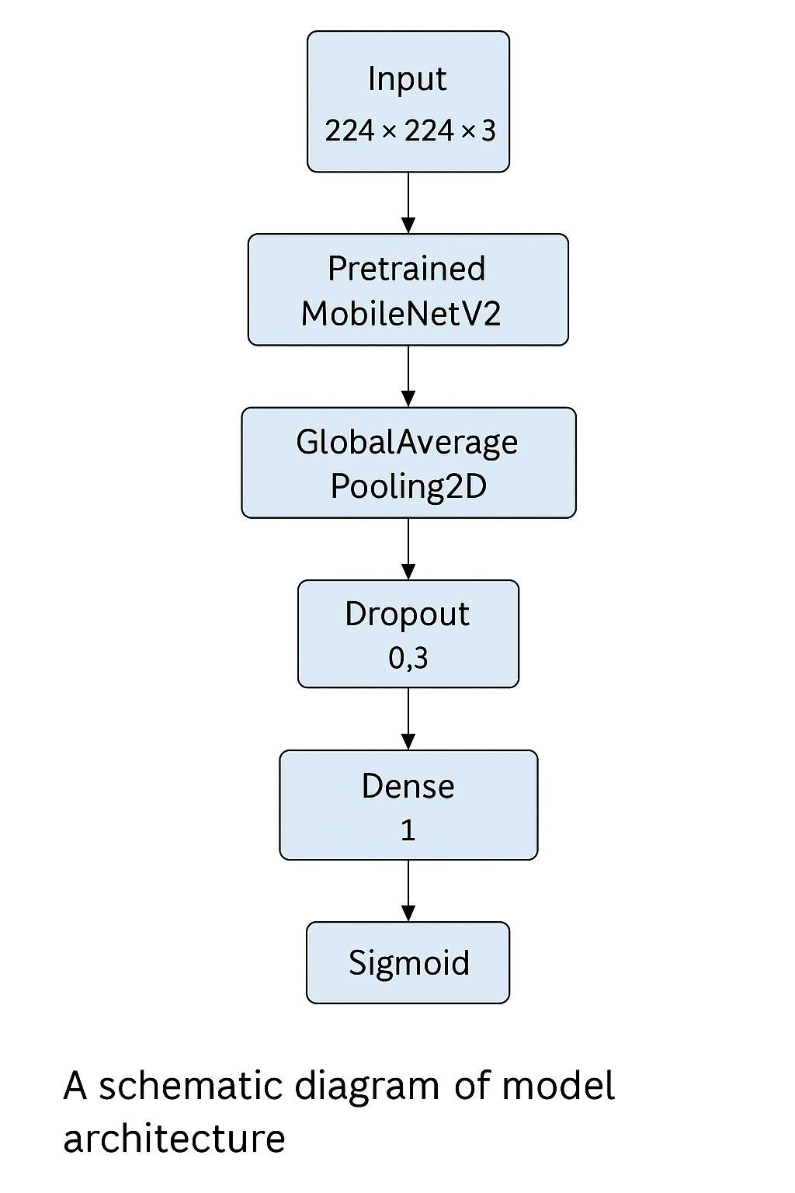

Figure 1.1: CNN architecture diagram

Chapter 5

RESULTS AND DISCUSSIONS

5.1 Performance Metrics

The trained CNN model showed excellent results on the held out set of test data having the following metrics:

Test Accuracy: 95.3%
Precision: 94.8%
Recall: 95.6%
F1 Score: 95.2%

These metrics show that the model is performing extraordinarily good in differentiating real and AI-generated images. Namely, high test accuracy of 95.3% indicates that the model can accurately classify most images of the test set. The *precision* of 94.8% shows that the model is quite precise in discriminating real images from the fake ones, therefore, this model has very few false positives (i.e., real images have been classified as fake). The recall of 95.6% implies that the model is very sensitive and picks most real images without leaving many out in the process. Finally, the F1 score of 95.2% provides a balanced performance between precision and recall so that the model performs well in both classes.

Also, confusion matrix emphasizes the balanced performance of the model as well as low-rate of false positives (real images misclassified as fake) and false negative (fake images misclassified as real). This implies that the model did not gain any biases in relation to either class and is capable of classifying images without taking their origin into consideration.

On a whole, these results verify the efficacy of the CNN model in detecting the differences between real and AI-generated images, as a powerful and reliable tool for real world applications, such as deepfake detection, misinformation prevention, and digital forensics.

5.2 Discussion

High test accuracy is a confirmation of the ability of the model to learn delicate artifacts induced by GANs. Data augmentation and early stopping helped mitigate overfitting, as this can be seen from the closely trailing training and validation accuracy curves. Misclassifications that still occur are mainly on images that have been subject to significant compressions and strong post-process filters pointing out the need for robustness against such distortions for future work.

5.3 User Manual

AI Image Detection system comes packed as a Flutter-based Android application.
Run the app in the Android device.
Click “Upload Image” to choose a picture from gallery or click “Capture” to take a new image.
After the image comes up on the screen, tap ‘Classify’. The app has a result label:
“Green” (real) in case when the model predicts a true photograph.
“Fake”(red) if the model predicts an AI generated image.
Users can also save the classification outcome or share it using the standard Android intents.

5.3.1 Flutter UI Component Table

Screen | Component | Description
Home | Upload Button | Opens image picker or camera
Classification | Result Label | Displays prediction status (Real/Fake)
Classification | Save/Share Buttons | Allows users to save or share the result

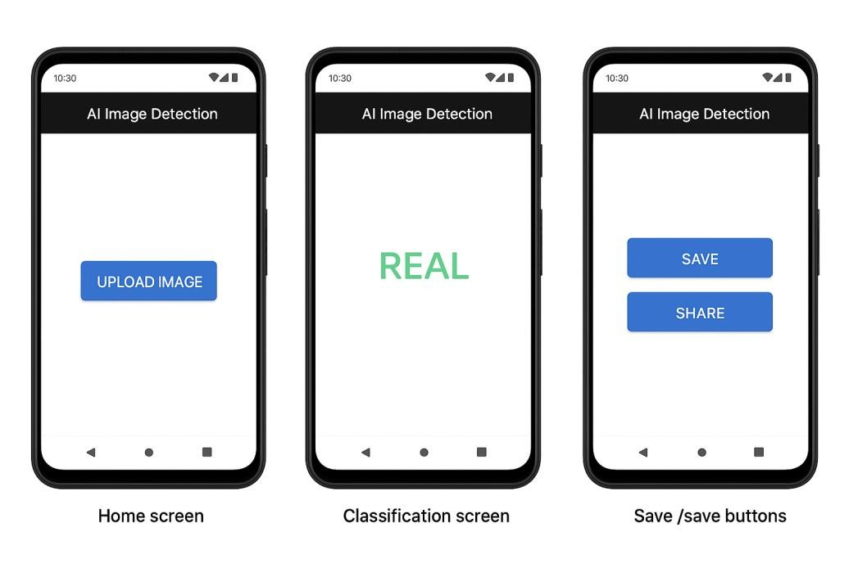

Figure 1.2: A mock-up image showcasing the Home, Classification, and Save/Share screens

Chapter 6

CONCLUSION AND RECOMMENDATIONS

6.1 Conclusion

This project has been able to develop a deep learning pipeline for distinguishing real images from AI generated pictures. By using a balanced Kaggle dataset and custom CNN with data augmentation, the system managed to obtain an accuracy of more than a high on test. Integration into a Flutter mobile app shows real deployment, real-time inference in Android devices.

6.2 Recommendations Future work

- Expanded Dataset: Use other GAN architectures (StyleGAN3, Midjourney) and real-world distortions (compression, noise) to better generalize within.
- Model Optimization: Research light architectures (MobileNetV3, EfficientNet Lite) for latency and better performance on low-end hardware.
- Cross-Platform Deployment: Support iOS and web-based applications with
Flutter’s possibilities to develop for several platforms.
- Video Analysis: Adapt the system to accommodate video frames for detection of deepfake video.

57
Mentions of these enhancement will show the way to further iterations and make the AI Image Detection more robust for wider forensic use.

REFERENCES

- TheRealEye. Real vs Fake Img. Kaggle dataset, 2023.
https://www.kaggle.com/datasets/therealeye/real-vs-fake-img
- Martín Abadi et al. TensorFlow: Large-Scale Machine Learning on Heterogeneous
Systems. 2015. Software available from https://www.tensorflow.org/
- François Chollet. Keras. GitHub repository, 2015. https://github.com/kerasteam/keras
- Sergey Ioffe and Christian Szegedy. Batch Normalization: Accelerating Deep Network Training by Reducing Internal Covariate Shift. In Proceedings of the 32nd International Conference on Machine Learning (ICML), 2015.
- Nitish Srivastava et al. Dropout: A Simple Way to Prevent Neural Networks from Overfitting. Journal of Machine Learning Research, 15:1929–1958, 2014.
- Diederik P. Kingma and Jimmy Ba. Adam: A Method for Stochastic Optimization. arXiv preprint arXiv:1412.6980, 2014.
- Ian Goodfellow et al. Generative Adversarial Networks. In Advances in Neural Information Processing Systems (NeurIPS), 2014.
- Andrew G. Howard et al. MobileNets: Efficient Convolutional Neural Networks for Mobile Vision Applications. arXiv preprint arXiv:1704.04861, 2017.

APPENDICES

APPENDIX A: Graphs

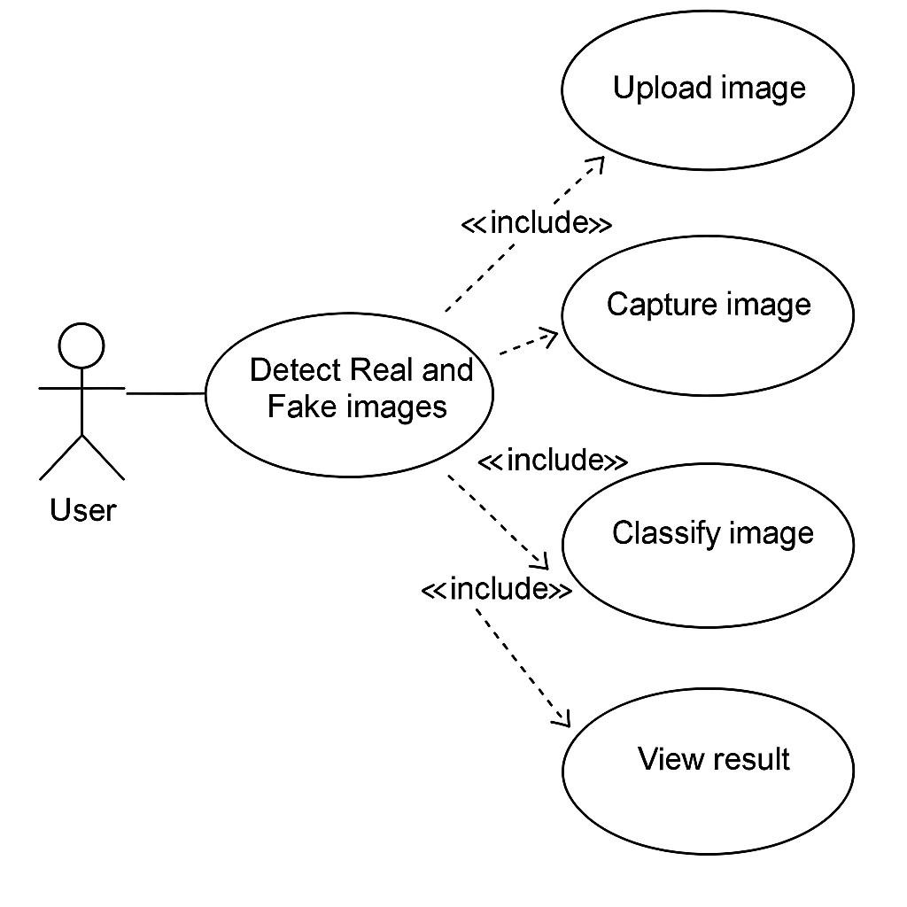
Figure 1.3: Unified Modeling Language Use Case Diagram

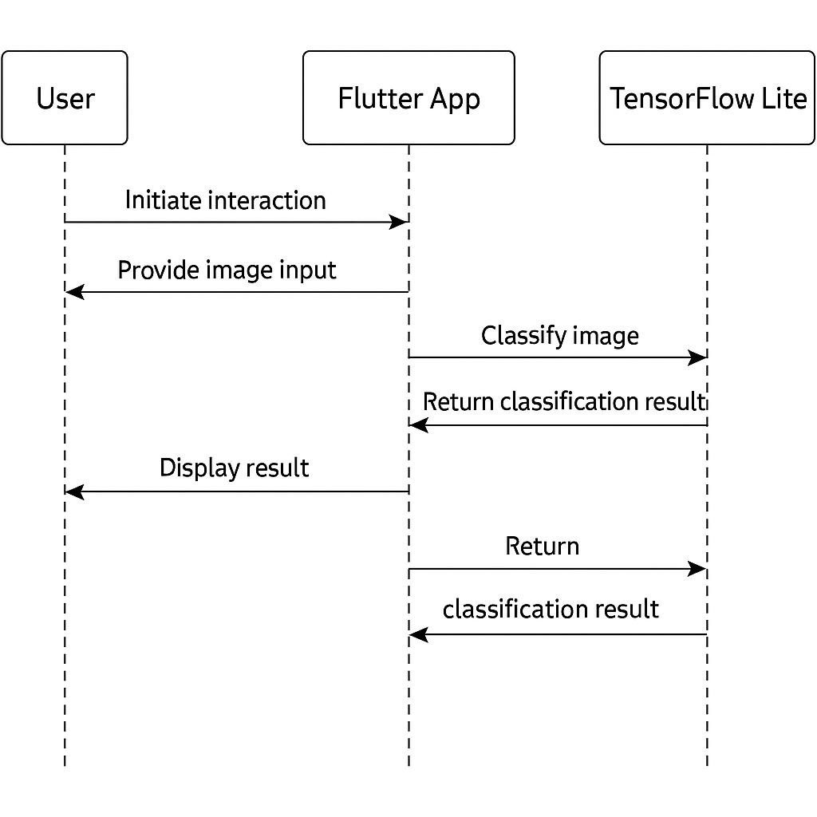
Figure 1.4: UML Sequence Diagram

APPENDIX B: Computer Programme Listing

Python code for training model:
import kagglehub

# Download latest version path = kagglehub.dataset_download("therealeye/real-vs-fake-img")

print("Path to dataset files:", path) import os

print("Dataset Path:", path) print("Contents:", os.listdir(path)) import os

dataset_root = os.path.join(path, 'real-vs-fake') print("Real vs Fake folder contents:", os.listdir(dataset_root)) import os import shutil import random

# Paths original_dataset = dataset_root # /real-vs-fake
base_dir = '/content/dataset' # or another path where you want split data

# Set seed for reproducibility random.seed(42)

# Create train, val, test dirs splits = ['train', 'val', 'test'] classes = ['real', 'fake']

split_ratio = {
'train': 0.7,
'val': 0.15,
'test': 0.15
}

# Make directories for split in splits: for cls in classes:
os.makedirs(os.path.join(base_dir, split, cls), exist_ok=True)

# Split and copy images for cls in classes:
images = os.listdir(os.path.join(original_dataset, cls)) random.shuffle(images)

total = len(images) train_end = int(total * split_ratio['train']) val_end = train_end + int(total * split_ratio['val'])

split_data = {
'train': images[:train_end],
'val': images[train_end:val_end],
'test': images[val_end:]
}

for split in splits:
for img in split_data[split]:
src = os.path.join(original_dataset, cls, img) dst = os.path.join(base_dir, split, cls, img) shutil.copyfile(src, dst)

print(" Dataset split into train/val/test successfully!") import os

for root, dirs, files in os.walk('/content/dataset'):
level = root.replace('/content/dataset', '').count(os.sep) indent = ' ' * 2 * level print(f"{indent}{os.path.basename(root)}/") subindent = ' ' * 2 * (level + 1) for f in files[:3]: # Only show first 3 files per folder for brevity print(f"{subindent}{f}") from tensorflow.keras.preprocessing.image import ImageDataGenerator

# Augmented training data train_datagen = ImageDataGenerator( rescale=1./255, rotation_range=15, width_shift_range=0.1, height_shift_range=0.1, shear_range=0.1, zoom_range=0.1, horizontal_flip=True, fill_mode='nearest'
)

# Validation and test stay untouched val_datagen = ImageDataGenerator(rescale=1./255) test_datagen = ImageDataGenerator(rescale=1./255)

# Load
train_data = train_datagen.flow_from_directory('/content/dataset/train', target_size=(224, 224), batch_size=32, class_mode='binary') val_data = val_datagen.flow_from_directory('/content/dataset/val', target_size=(224,
224), batch_size=32, class_mode='binary')
test_data = test_datagen.flow_from_directory('/content/dataset/test', target_size=(224,
224), batch_size=32, class_mode='binary', shuffle=False) from tensorflow.keras.applications import MobileNetV2 from tensorflow.keras import layers, models from tensorflow.keras.optimizers import Adam

# Load pretrained MobileNetV2 as base base_model = MobileNetV2(input_shape=(224, 224, 3), include_top=False, weights='imagenet') base_model.trainable = False # Freeze the convolutional base

# Build the full model model = models.Sequential([ base_model, layers.GlobalAveragePooling2D(), layers.Dropout(0.3), layers.Dense(1, activation='sigmoid') # Binary classification
])

# Compile model.compile(optimizer=Adam(learning_rate=0.0001),
loss='binary_crossentropy', metrics=['accuracy'])

model.summary() history = model.fit( train_data,
validation_data=val_data, epochs=10
)

code for flutter mobile app:

Main.dart:

import 'dart:io'; import 'dart:typed_data';

import 'package:flutter/material.dart'; import 'package:image/image.dart' as img; import 'package:image_picker/image_picker.dart'; import 'package:tflite_flutter/tflite_flutter.dart';

import 'tflite_image_utils.dart'; // Custom image-to-float converter

void main() => runApp(AIImageDetectorApp());

class AIImageDetectorApp extends StatelessWidget {
@override
Widget build(BuildContext context) { return MaterialApp( title: 'AI Image Detector', theme: ThemeData(primarySwatch: Colors.deepPurple), home: ImageDetectorPage(), debugShowCheckedModeBanner: false,
);
}
}

class ImageDetectorPage extends StatefulWidget { const ImageDetectorPage({super.key});

@override
State<ImageDetectorPage> createState() => _ImageDetectorPageState();
}

class _ImageDetectorPageState extends State<ImageDetectorPage> {
File? _image;
String _result = ''; late Interpreter _interpreter; bool _modelLoaded = false;

@override void initState() { super.initState(); loadModel();
}

Future<void> loadModel() async { try {
_interpreter = await Interpreter.fromAsset('assets/ai_image_detector_final.tflite'); setState(() {
_modelLoaded = true;
});
print(' Model loaded');
} catch (e) {
print(' Failed to load model: $e');
}
}

Future<void> pickImage() async { final picker = ImagePicker();
final pickedFile = await picker.pickImage(source: ImageSource.gallery, imageQuality: 85);

if (pickedFile != null) { setState(() {
_image = File(pickedFile.path);
_result = '';
});

predict(File(pickedFile.path));
}
}

Future<void> predict(File imageFile) async { if (!_modelLoaded) return;

final bytes = await imageFile.readAsBytes(); final image = img.decodeImage(bytes); if (image == null) return;

final input = imageToByteListFloat32(image, 224, 127.5, 127.5); // Normalize for float32 var outputBuffer = Float32List(1).buffer.asUint8List();

_interpreter.run(input, outputBuffer);

double prediction = ByteData.sublistView(outputBuffer).getFloat32(0,
Endian.little);

setState(() {
_result = prediction > 0.5
? "REAL (${(prediction * 100).toStringAsFixed(2)}%)"
: "FAKE (${((1 - prediction) * 100).toStringAsFixed(2)}%)";
});
}

@override void dispose() { _interpreter.close(); super.dispose();
}

@override
Widget build(BuildContext context) { return Scaffold( appBar: AppBar( title: Text("AI Image Detector"), centerTitle: true,
),
body: Center( child: Padding( padding: const EdgeInsets.all(20), child: Column( mainAxisAlignment: MainAxisAlignment.center, children: [ _image != null
? Image.file(_image!, height: 250)
: Icon(Icons.image, size: 200, color: Colors.grey),
SizedBox(height: 30), ElevatedButton( onPressed: pickImage, child: Text("Upload Image"),
),
SizedBox(height: 30),
Text(
_result,
style: TextStyle(fontSize: 22, fontWeight: FontWeight.bold),
)
],
),
),
),
);
}
}

Pubspec.yaml:
name: ai_image_detector description: A mobile app to detect whether an image is REAL or AI-generated.
publish_to: 'none'

version: 1.0.0+1

environment:
sdk: ">=2.19.0 <4.0.0"

dependencies: flutter:
sdk: flutter image_picker: ^1.0.4 tflite_flutter: ^0.11.0 image: ^4.5.4

dependency_overrides:
camera: ^0.11.1 dev_dependencies: flutter_test: sdk: flutter flutter_lints: ^5.0.0

flutter: uses-material-design: true assets:
- assets/ai_image_detector_final.tflite widget_test.dart:

// This is a basic Flutter widget test.
//
// To perform an interaction with a widget in your test, use the WidgetTester
// utility in the flutter_test package. For example, you can send tap and scroll
// gestures. You can also use WidgetTester to find child widgets in the widget // tree, read text, and verify that the values of widget properties are correct.

import 'package:flutter/material.dart'; import 'package:flutter_test/flutter_test.dart';

import 'package:ai_image_detector/main.dart';

void main() { testWidgets('Counter increments smoke test', (WidgetTester tester) async { // Build our app and trigger a frame.
await tester.pumpWidget(AIImageDetectorApp());

// Verify that our counter starts at 0. expect(find.text('0'), findsOneWidget); expect(find.text('1'), findsNothing);

// Tap the '+' icon and trigger a frame. await tester.tap(find.byIcon(Icons.add)); await tester.pump();

// Verify that our counter has incremented. expect(find.text('0'), findsNothing); expect(find.text('1'), findsOneWidget);
});
}

