

BSCS-F24-009
03-134212-012 | M. ALI SHAHID
03-134212-038 | HUZAIFA NASIR

Blockchain Secured and AI Enhanced Rental Platform

In partial fulfilment of the requirements for the degree of
Bachelor of Science in Computer Science
Supervisor: MUHAMMAD SAUOOD

Department of Computer Sciences
Bahria University, Lahore Campus
May 2025

© Bahria University, 2025


Certificate

We accept the work contained in the report titled
“Blockchain Secured and AI Enhanced Rental Platform”
written by
M. ALI SHAHID
HUZAIFA NASIR

as a confirmation of the required standard for the partial fulfilment of the degree of
Bachelor of Science in Computer Science.

Approved by:
Supervisor: MUHAMMAD SAUOOD
(Signature)

5 June, 2025

DECLARATION

We hereby declare that this project report is based on our original work except for citations and quotations which have been duly acknowledged. We also declare that it has not been previously and concurrently submitted for any other degree or award at Bahria University or other institutions.

Enrolment | Name | Signature
03-134212-012 | M. ALI SHAHID
03-134212-038 | HUZAIFA NASIR

Date: 5 June, 2025

Specially dedicated to
my beloved grandmother, mother, and father
(M. ALI SHAHID)
my beloved grandmother, mother, and father
(HUZAIFA NASIR)

ACKNOWLEDGEMENTS

We would like to thank everyone who contributed to the successful completion of this project. We would like to express our gratitude to my research supervisor, Mr. MUHAMMAD SAUOOD for his invaluable advice, guidance, and his/her enormous patience throughout the development of the research.

In addition, we would also like to express our gratitude to our loving parents and friends who had helped and given us encouragement.

M. ALI SHAHID
HUZAIFA NASIR

Rent Wise

ABSTRACT

"Rent Wise" is an intelligent rental platform designed to transform the rental industry by enhancing transparency, trust, and efficiency. The platform caters to property owners, vehicle rental businesses, and hostel operators by offering a seamless and secure environment for managing rental listings, agreements, and transactions. Rent Wise ensures that users can effortlessly browse, compare, and rent properties or vehicles while owners benefit from streamlined listing management, automated availability tracking, and secure communication channels.
To enhance user experience and trust, Rent Wise incorporates AI-powered review classification, ensuring that renters can make informed decisions based on reliable feedback. The platform also integrates digital rental agreements, minimizing disputes by providing legally binding contracts that both parties can review and storing that on Blockchain. Additionally, real-time WebSocket-based Chatting and Web Push technology-based notifications keep users informed about booking updates, rental status changes, and important alerts, even when offline. The built-in chat system, powered by Socket.io, allows renters and owners to communicate instantly, facilitating smoother negotiations and reducing response time. By combining AI, real-time communication, and secure agreement management, Rent Wise redefines the rental ecosystem with a user-centric, efficient, and trustworthy solution

TABLE OF CONTENTS

DECLARATION ii
ACKNOWLEDGEMENTS iv
ABSTRACT v
TABLE OF CONTENTS v
LIST OF TABLES x
LIST OF FIGURES xi
LIST OF SYMBOLS / ABBREVIATIONS xiii
LIST OF APPENDICES xiv

CHAPTERS
1 INTRODUCTION 16
1.1 Background 16
1.2 Problem Statements 17
1.3 Aims and Objectives 17
1.4 Scope of Project 18
2 LITERATURE REVIEW and SOFTWARE REQUIREMENT SPECIFICATIONS 20
2.1 Literature Review 20
2.1.1 Airbnb 20
2.1.2 Turo 20
2.1.3 Zillow Rentals 21
2.1.4 Rent.com 21
2.1.5 Car Next Door 21
2.1.6 Overall Challenges in Existing Rental Platforms 21
2.2 Application Details How Rent Wise Solves These Challenges? 22
2.3 User Classes and Characteristics 22
2.3.1 Renters 22
2.3.2 Owners 23
2.3.3 Administrators 23
2.4 Operating Environment 24
2.4.1 Hardware 24
2.4.2 Software 25
2.4.3 Other essential 26
2.5 Assumptions and Dependencies 26
2.5.1 Assumptions 26
2.5.2 Dependencies 27
2.6 System Use Case Diagram 28
2.6.1 Use Case Diagrams 28
2.7 Functional requirements 38
2.7.1 Register & Create Profile. 38
2.7.2 Update profile. 39
2.7.3 List a property 39
2.7.4 Search Properties 40
2.7.5 Apply Filters 41
2.7.6 Request to Rent a property 41
2.7.7 Approve or Reject Rental Request 42
2.7.8 Receive Notifications 42
2.7.9 Submit a Review 43
2.7.10 Chat System 43
2.7.11 Real-Time Chat Sidebar Update 44
2.7.12 Web Push Notifications 44
2.7.13 Property Review & Rating System 45
2.7.14 Password Reset 45
2.7.15 Admin Dashboard 46
2.8 Nonfunctional Requirements 46
2.8.1 Performance 47
2.8.2 User Experience 47
2.8.3 Security 47
2.8.4 Readability 48
2.8.5 Maintenance 48
3 DESIGN AND METHODOLOGY 49
3.1 Feature Driven Development 49
3.2 Sequence Diagrams for Rent Wise 50
3.3 Functionality Flow Diagrams 61
3.4 Class Diagram Rent Wis 70
4 IMPLMENTATION 72
4.1 Implementation 72
4.1.1 Languages and Frameworks Used 72
4.1.2 Databases Used 73
4.1.3 AI-Powered Review Classification (Machine Learning) 74
4.1.4 Blockchain Technology Used 74
4.1.5 APIs and External Services Used 75
4.1.6 Development Tools Used 75
5 RESULTS AND USER MANUAL 77
5.1 Results 77
5.2 Landing Page 78
5.3 Login Sign Up Pages 80
5.4 List Detail 82
5.5 Dashboard Pages 83
5.6 Account Setting 86
5.7 List Creation Page 88
5.8 Real Time and Custom Build Chat System: 88
5.9 Agreement Creation Page: 89
5.10 Review 90
5.11 Admin 90
6 CONCLUSION AND RECOMMENDATIONS 93
6.1 Conclusion 93
6.2 Recommendations 93
6.2.1 AI-Powered Review Classification 94
6.2.2 Messenger within the platform 94
6.2.3 Web Push Notifications for Critical Update 94
6.2.4 Mobile Application Development 94
6.2.5 Mechanism for Tenant and Landlord Verification 94
6.2.6 AI-Powered Fraud Detection 95
REFERENCES 96
6 APPENDICES 98

LIST OF TABLES

TABLE TITLE PAGE
Table 2.1: FR-01-001 35
Table 2.2: FR-01-002 36
Table 2.3: FR-01-003 36
Table 2.4: FR-01-004 37
Table 2.5: FR-01-005 38
Table 2.6: FR-02-001 38
Table 2.7: FR-02-0021 39
Table 2.8: FR-02-003 39
Table 2.9: FR-02-004 40
Table 2.10: FR-02-005 40
Table 2.11: FR-03-001 41
Table 2.12: FR-03-002 41
Table 2.13: FR-03-003 42
Table 2.14: FR-04-001 42
Table 2.15: FR-04-002 43

LIST OF FIGURES

FIGURE TITLE PAGE
Figure 2.1: Renter Use Case Diagram 27
Figure 2.2: Property Owner Use Case Diagram 28
Figure 2.3: Admin Use Case Diagram 29
Figure 2.4: Chat and Notification Use Case Diagram 30
Figure 2.5: OTP-Based Password Reset Use Case Diagram 31
Figure 2.6: Favorite Listings Use Case Diagram 32
Figure 2.7: Real-Time Web Push Notification System Use Case Diagram 33
Figure 2.8: Report and Review System Use Case Diagram 34
Figure 2.9: AI-Based Review Classification Use Case Diagram 35
Figure 3.1: Feature Driven Development Model Flow. 46
Figure 3.2: Renter System Interaction Sequence Diagram 51
Figure 3.3: Property Owner System Interaction Sequence Diagram 51
Figure 3.4:Admin System Interaction Sequence Diagram 52
Figure 3.5: Chat and Notification System Interaction Sequence Diagram 53
Figure 3.6: OTP-Based Password Reset System Interaction Sequence Diagram 54
Figure 3.7: User Profile and Review System Interaction Sequence Diagram 54
Figure 3.8: Property Search and Filtering System Interaction Sequence Diagram 55
Figure 3.9: Renter Functionality Flow Diagram 56
Figure 3.10: Property Owner Functionality Flow Diagram 56
Figure 3.11: Search and Filtering Functionality Flow Diagram 57
Figure 3.12: Real-Time Chat and Notification Functionality Flow Diagram 58
Figure 3.13: OTP-Based Password Reset Functionality Flow Diagram 59
Figure 3.14: Admin Management Functionality Flow Diagram 60
Figure 3.15: Favourite Listings & Saved Preferences Flow Diagram 61
Figure 3.16: Background Processes & System Logs Flow Diagram 62
Figure 3.17: Rent Wise Class Diagram 63
Figure 5.1: Landing Page 70
Figure 5.2: Signup Page 70
Figure 5.3: Login Page 70
Figure 5.4: Reset Password Page 71
Figure 5.5: List Detail 71
Figure 5.6: Owner Dashboard 72
Figure 5.7: Tenant Dashboard 73
Figure 5.8: Received Reviews Page 73
Figure 5.9: User Review Page 74
Figure 5.10: Personal Info 74
Figure 5.11: Notification Setting 74
Figure 5.12: Security Setting 75
Figure 5.13: List Creation 75
Figure 5.14: Chat System 75
Figure 5.15: Agreement Creation Page 76

LIST OF SYMBOLS / ABBREVIATIONS

MERN | MongoDB, Express.js, React.js, Node.js
AI | Artificial Intelligence
CRUD | Create, Read, Update, Delete
JWT | JSON Web Token
UI | User Interface
UX | User Experience
API | Application Programming Interface
REST | Representational State Transfer
DB | Database
CSS | Cascading Style Sheets
XSS | Cross-Site Scripting
IDE | Integrated Development Environment
Mongoose | MongoDB Object Modeling for Node.js
MVC | Model-View-Controller
AI-NLP | Artificial Intelligence - Natural Language Processing
HTTPS | Hypertext Transfer Protocol Secure
JSON | JavaScript Object Notation
FDD | Feature Driven Development
SPA | Single Page Application
LLM | Large Language Model

LIST OF APPENDICES

APPENDIX TITLE PAGE
Appendix A: Languages Links 76
Appendix B: Tools Used 77

INTRODUCTION

Background

The rental industry has seen major growth in today's digital world yet confronts several issues with transparency alongside trust and management effectiveness. Renter challenges involve faulty listings and unclear agreements and insufficient property or vehicle owner communications. Both rental businesses and owners struggle with maintaining bookings and user verification and dispute resolution because of ambiguous terms and unverified reviews [1]. The existing rental platforms feature standard listing and booking functions but do not incorporate smart security systems and effective user engagement alongside streamlined agreement management [2].

The platform Rent Wise resolves these gaps through its intelligent rental platform that uses artificial intelligence for review organization and digital lease administration as well as instant platform user communication. The system implements Web Push notifications together with a Socket-based interface. Users experience disruptions-free interactions through Rent Wise's Socket.io-powered chat system that also delivers critical updates to renters and owners together. The rental platform implements an automated system for structured management that creates trust while delivering efficiency and convenience to users [3].

Problem Statements

Present-day rental platforms encounter various significant obstacles which influence both renters and property and vehicle owners through various ways:

• Lack of Transparency in Agreements: The absence of detailed or clear rental agreements often activates disputes between owners and renters according to research in [4].
• Inefficient Communication: The current rental platforms lack real-time communication capabilities so renters and owners face challenges with negotiation and need to ask questions or address concerns in a timely manner.
• Unverified and Misleading Reviews: Users make decisions based on reviews yet existing review systems prone to fake biased feedback lower rental listing trust.
• Delayed Notifications: The lack of effective notification systems causes both renters and owners to miss vital booking info and payment status updates and guest inquiries.
• Difficult Rental Management: Current rental management processes involving outdated methods prevent both owners and property management from obtaining efficient list handling and accumulating multiple requests tracking.

The AI-powered review classification system and Web Push notifications and real-time Socket.io chat system found in Rent Wise remedy existing real estate problems [5]. Real-time Socket.io chat technology improves communication for trust-building between users in the rental market environment [5].

Aims and Objectives

The focal points of Rent Wise project include:
- Login through an accessible rental platform should connect property and vehicle owners directly with renters in a seamless way that makes both parties happy [6].
- The system empowers property and vehicle owners to navigate their rentals through three key management capabilities which minimize operational complexity [7].
- An AI-powered review classification system will implement to properly categorize rental feedback into positive neutral and negative elements which boosts user trust in reviews [8].
- The application will utilize Socket to establish a real-time chat interface. Rental owners can use Socket.io for instant messaging that helps them connect with renters to minimize response time and streamline rental discussions.
- The system will improve user engagement by using Web Push notifications to deliver on-time alerts regarding booking confirmations along with messages and payment updates and important rental activities.
- Rental agreements need to be transparent through digital documents which both parties should have access to at all times.
- The system should enable better rental searches using advanced filters that handle location searches alongside price comparisons and availability tracking to assist users with quick rental decisions.

Scope of Project

Rent Wise aims to establish a complete platform that connects renters with property/vehicle owners through a smooth interaction system. Through the platform users can efficiently browse for rental properties and vehicles while maintaining transparent processes and secure operations and building trustworthy relationships with users.
Key features and functionalities include:
User Profiles & Listings: The system allows property and vehicle owners to sign up then build detailed listing pages with pictures while providing tools to manage their properties for rent. Users who rent properties can find listings view favourites and contact owners directly through the platform.
AI-Powered Review System: The system employs AI technology to analyse user feedback by identifying positive results and negative feedback and neutral content to assist renters in selecting properties based on historical performance data.
Rental Agreements: The digital agreements will present their terms with clear language which both sides can verify at any moment.
Real-time Chat System: A Socket. Through its Socket.io-based chat system users can instantly exchange messages which provides negotiation and clarification capabilities without requiring external messaging platforms.
Web Push Notifications: Real-time updates regarding booking confirmations and rental status changes alongside new messages and payment reminders as well as agreement updates will improve user engagement.
Advanced Search & Filtering: The website will use location data for property searches and provide prices comparisons and inventory tracking alongside filter tools to make finding rentals more convenient.
Administrative Oversight: Platform administrators authenticate data protection while tracking rental usage and performing owner verification and responding to customer inquiries to build trust and reliability.
The rental industry will undergo transformation through Rent Wise which takes steps to advance efficiency and simplify communication while delivering protected and convenient rental services for property owners and renters.

LITERATURE REVIEW and SOFTWARE REQUIREMENT SPECIFICATIONS

Literature Review

The current rental platforms in the marketplace reveal minimal coverage along with unclear processes while failing to deliver a complete rental process. The majority of platforms concentrate on booking and listing activities but lack AI review analytics and real-time messaging together with smart data processing features. We present an analysis of current platforms and their operating issues below.

Airbnb
The online travel platform Airbnb lets users make money through rentals when they share their spaces with strangers. The primary purpose of this platform remains in vacation rentals because it does not supply tools needed for managing long-term rentals. The platform lacks real-time communication tools between property owners and renters which creates delays in their discussions [9].

Turo
Through the Turo platform car owners can list their vehicles available for rental to other users. Users can conveniently book through the platform yet they face trust and security issues from absent AI verification technologies. Renters experience restricted access to customer support when they encounter conflicts [10].

Zillow Rentals

Owners who list properties on Zillow Rentals lack access to automated rental agreements integrated into the platform. Users cannot access real-time push notifications and AI-powered insights through this platform resulting in inefficiencies when renters attempt to have a smooth rental experience [11].

Rent.com
Renters who use Rent.com find listings there but the website lacks enough systematic review procedures to identify untruthful or fabricated assessments from users. Rental property owners and tenants currently struggle to maintain effective communication which leads to delayed responses and misinterpretations [12].

Car Next Door
The peer-to-peer rental service from Car Next Door has no AI analytical review system that shows ratings clearly to users. Inconsistent vehicle conditions combined with unclear pricing systems present trust-related problems for users [13].

Overall Challenges in Existing Rental Platforms
Rental platforms provide core features like searching, listing and booking yet they do not include: Current review classification technology powered by AI protects the platform from bogus and deceptive feedback. Smart rental contracts established to enhance transparency while preventing conflicts. Real-time chat (Socket. Renters and owners can use real-time chat (Socket.io) to communicate instantly on the platform. The system uses Web push notifications to deliver booking confirmations and to notify users about agreement updates along with other necessary alerts.

Application Details How Rent Wise Solves These Challenges?

The application Rent Wise strives to address these gaps through:
- The AI-Powered Review System analyses feedback to assign it as positive negative or neutral which enables users to base their choices on accurate information.
- Real-Time Chat System works through Socket.io communication channels. Renters and owners can use Socket.io to access real-time communication.
- Web Push Notifications enable users to stay updated about rental status and receive agreements as well as messages.
- Smart Digital Rental Agreements provide parties with a system ensuring verifiable secure contracts. The platform enables users to search and filter rental listings by their current location and personal preferences through geolocation-based features.

Rent Wise uses AI along with WebSocket technology and blockchain agreements to create a rental marketplace superior to current options by providing secure and efficient user-friendly services.

User Classes and Characteristics
Rent Wise interacts with a wide group of customers who bring distinctive requirements into the platform. Users fit into three primary user classes which Rent Wise structures within its system. Renters, Owners, and Administrators.

Renters
Description: Platform users who seek rentals of properties, vehicles, hostels, or other accommodations.
Characteristics:
- Users require an easy and clear rental process. Users need feedback from AI systems which helps them perform better decision-making.
- Prefer real-time chat (Socket. Users require Socket.io for instant messaging with owners to expedite their communication.
- Users require push notifications to receive notification updates about bookings and rental document changes sent to their device through the web interface.
- Users should expect secure digital agreements when they want a simple seamless experience.

Owners
Description:
The service connects both property owners and vehicle owners and hostel managers who decide to list their real estate for rental.
Characteristics:
- Operations should depend on a simple interface that enables booking management through a dashboard.
- The platform needs renter verification tools to verify transactions with trustworthy users.
- The system should contain AI-based review technology that stops faked reviews from appearing.
- Prefer instant messaging (Socket.io) for seamless communication. Users need real-time booking alerts along with automatic rental update alerts.
- An economic system of digital agreements must be implemented to guarantee legal terms bindingness in all situations.

Administrators
Description:
System managers at different levels need to supervise and keep the system running smoothly.

Characteristics:
- The team leader verifies all platform users to stop potential fake transaction actors. They use AI for authenticating users and settling conflicts while managing content validation.
- The system requires server performance monitoring with security checks to maintain operation efficiency.
- The platform needs to have proper mechanisms to meet rental contract and platform compliance requirements.
- The platform manages notifications and updates that affect all user accounts system-wide. Rent Wise organizes their users according to their roles for individualized features and seamless experiences which leads to enhanced trust and operational efficiency within the rental market.

Operating Environment
Database usage with web-based operation and scalable security framework allows users to access Rent Wise through a wide range of devices while maintaining effective performance. The system meets requirements for processing heavy traffic along with real-time user interactions and maintains complete data protection across all users.

Hardware

1. Client Side (Users)
• Device: Users can access Rent Wise through modern PC computers as well as laptops and smartphones and tablets.
• Processor: Minimum 1.5 GHz Dual-Core CPU
• RAM: All devices require a minimum of 2GB RAM while 4GB RAM provides optimal performance.
• Storage: A small amount of storage space is needed for browser cache stored items
• Internet: The system requires at least 3 Mbps for users to have an optimal browsing experience.

2. Server Side
The system implements cloud-based hosting solutions that operate through AWS, Digital Ocean and comparable platforms.
• CPU: Multi-core processors will process multiple user requests at the same time.
• RAM: Server operations require a minimum 16GB of random-access memory (RAM) for optimal performance of databases and servers.
• Storage: SSD storage must provide scalable capabilities to manage media files and logs
• Database: The system utilizes MongoDB together with PostgreSQL database to handle both structured data and unstructured data.
• Network: Our system requires high-speed internet which implements a combination of load balancing and content distribution networks.

Software

The software application of Rent Wise functions via two components as both server-side and client-side networks.

Client-side
- The system benefits from React.js as a framework to optimize SEO rankings and perform fast rendering. A modern and responsive user interface is achieved with Tailwind along with Chakra CSS.
- WebSocket’s (Socket.io) for real-time messaging

Server-side
Following Server-side Operating environment required.
- Server-side functions are carried out through Express APIs along with Node.js.
- MongoDB manages all unstructured data including chat messages.
- Real-time notifications are enabled using Web Push API.

Security and Middleware
- The system uses JWT authentication to provide secure sessions for users.
- The platform protects users' data through HTTPS & SSL encryption.
- Rate limiting against DDoS attacks

Other essential

1. Development Essentials:
- Visual studio
- MongoDB
- Maps API
- Meta mask
- Spolia Blockchain

Assumptions and Dependencies

The Rent Wise platform depends on several essential conditions which developers built it to work optimally. The platform's performance and scalability depend on these relevant factors and its possible implementation remains uncertain.

Assumptions
- All platform users must maintain reliable access to the internet to engage with Rent Wise.
- Users access Rent Wise through contemporary web browser software including Chrome, Edge, Firefox alongside JavaScript and WebSocket-capable smartphones and laptops.
- The platform relies on every rental agreement adhering to domestic and international rental legislation.
- Each transaction requires users to create an authenticated account where they verify their identity as a means to establish trust and protect security fundamentals.
- The platform needs real-time messaging through Socket.io which allows owners and renters to share rental details quickly.
- Users must explicitly choose to enable Web Push Notifications which will provide them with updates regarding messages and bookings and rental agreements. Rental owners and property seekers both offer precise information about their identity and their available properties at all times.

Dependencies
1. The system functions through these components of technology stack:
• React.js for the frontend
• Node.js (Express) for the backend
• MongoDB for data storage
• Socket.io for real-time messaging
• Web Push API for notifications
2. The system deployment for hosting and storage happens at AWS and Vercel which delivers flexible capacity alongside availability features.
3. The system will depend on external services as third-party APIs for its operations. Through Google Maps API users will be able to search properties by location. AI Review Analysis API detects customer reviews into three distinct categories through positive negative and neutral evaluation.
4. The application must follow GDPR together with PCI-DSS along with additional regulations regarding data protection for processing user data and transactions.
5. The platform's success will depend directly on two factors: property owners listing their accommodations through the platform alongside active use by renters through the system.

System Use Case Diagram

Following are the use case diagram Rent Wise

Use Case Diagrams
This section demonstrates the Rent Wise system's user interactions through a series of use case diagrams. These diagrams present an elevated perspective which shows different entities structuring interactions with system core functionalities to define functional boundaries.
- Figure 2.1: Renter Use Case Diagram
"The Rent Wise system provides this diagram to illustrate the features which renters need to use."
Renters can:
- The system lets users find properties through location-based searches using price filters as well as property type criteria.
- Users access complete property information while gaining ability to contact property owners directly through the system.
- The system allows users to save properties directly into their favourites list for faster retrieval.
- Users can start instant chat sessions with property owners when using the system.
- Users can access tools to modify profile data along with controlling their alert system.
- Users can request password reset procedures through an OTP verification process.
- Users can turn on or off property update push notifications through system settings.
- Users should use the system to flag suspicious property listings along with concerning behaviour or scams.

Through this specific use case Rent Wise displays its functionality for renters who explore interact and communicate within the system.
Figure 2.1: Renter Use Case Diagram

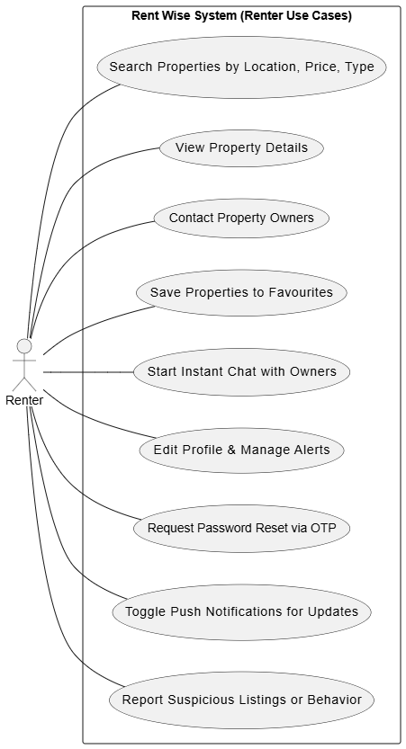

- Figure 2.2: Property Owner Use Case Diagram
"The diagram shows the steps through which RentWise interacts with property owners to handle their listings management tasks along with rental interactions."

Property owners can:
- Users maintain control to build and modify and remove listings from the system.
- Property owners receive instant chat messages from renters through their platform while performing real-time responses.
- Property owners have access to view potential renters who mark their listings as favourites.
- Property owners maintain control to update availability settings through which they automatically inform users.
- Users can both edit profile settings and opt in or out of receiving notifications through the platform. Web push notifications delivered directly to users when new inquiries come in.
- Users can view submitted reports against their listings to respond appropriately. Through this use case property owners achieve complete control regarding both their listing management and messaging capabilities.

Figure 2.2: Property Owner Use Case Diagram

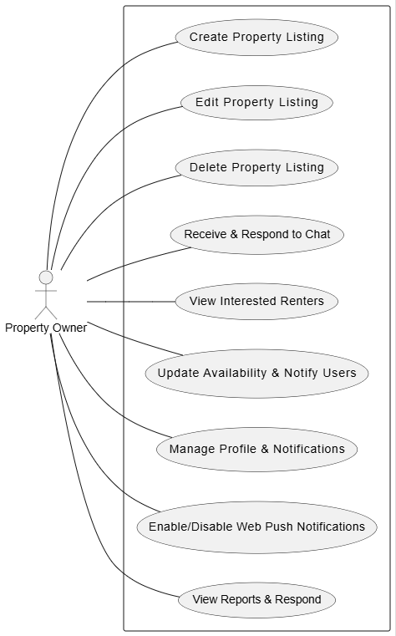

Figure 2.3: Admin Use Case Diagram
"The chart shows all features administrators from Rent Wise can utilize to perform moderation tasks."
Admins are responsible for:
- Reviewing and approving/rejecting property listings. User registrations require tracking and account verification processes fall under their responsibilities.
- The personnel manages both fraudulent reporting and inappropriate conduct within the platform.
- The platform stability depends on system logs oversight and administrators' responsibility to maintain it.
- The platform allows administrators to respond to users who report violations through warnings and active intervention.
- System administrators control push notifications together with platform-wide distribution of announcements.
- System analytics reveal engagement patterns through continuous monitoring. Real-time chat logs received oversight for the purposes of moderation. Through its admin use case the Rent Wise platform stays secure and operates reliably while maintaining a rigorous moderation structure.

Figure 2.3: Admin Use Case Diagram

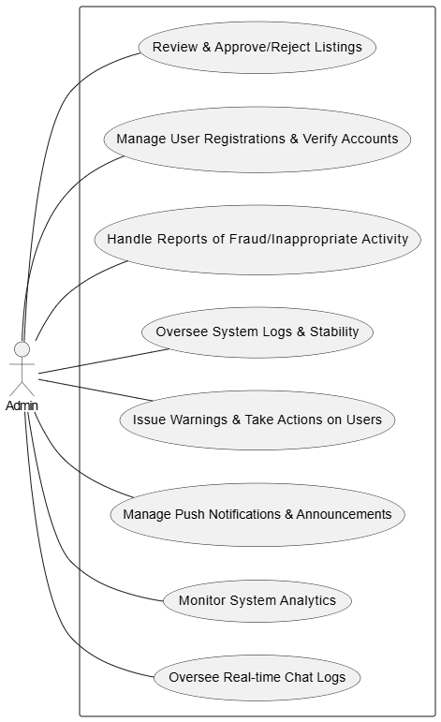

Figure 2.4: Chat and Notification Use Case Diagram
"The graphic shows how users participate with the system when exchanging live messages through real-time communication."
Key functionalities:
- Users from the renter role start talking with property owners through the system.
- WebSocket’s enable real-time messaging. Users receive notification icons to show awaiting message responses through the platform.
- The platform uses push notifications to notify users about new messages along with platform updates.
- Users can activate or disable notifications through their account configuration page. Online messaging record history remains available for user access.
- The admin team has access to monitor dialogues flagged by the system for policy enforcement checks.
The tool enables smooth real-time interaction that fosters connection between platform members.
Figure 2.4: Chat and Notification Use Case Diagram

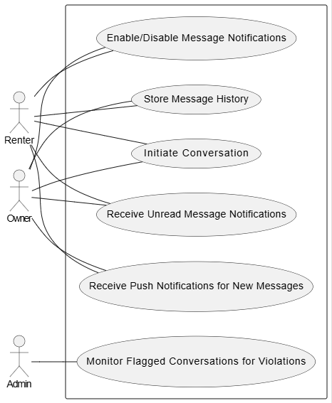

- Figure 2.5: OTP-Based Password Reset Use Case Diagram
"The visual display shows step-by-step instructions for password resetting during OTP verification."
Flow:
1. System users who request a password reset receive an OTP notification via their registered email.
2. The system analyses received OTP against its stored information.
3. Users gain the ability to set a new account password after their user identity is successfully confirmed during verification.
4. System users get error messages after invalid input to let them retry their attempts. 5. The authentication mechanism for user security depends on OTP while an expiration timer protects user data.
Users who need password resets must follow an advanced recovery process which exceeds standard login and account registration authentication approaches.

Figure 2.5: OTP-Based Password Reset Use Case Diagram
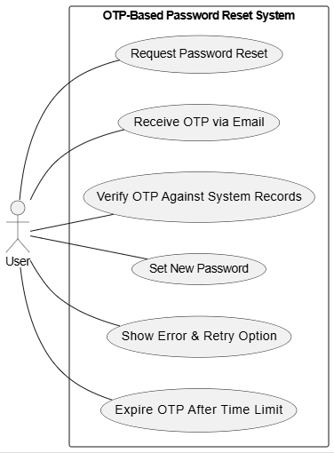
Figure 2.6: Favorite Listings Use Case Diagram
"The visual presentation shows the customer pathway toward accessing their preferred real estate listings."
Flow:
- Through the system users create lists of favourite properties which will later appear easily. Through their dashboard users can access their stored properties at any time.
- Users receive notifications that show changes made to their preserved listings. The system allows property owners to understand which listings their users select to save as favourites.
- As users they retain unrestricted freedom to remove any property listing they saved in their favourites collection. User engagement rises due to this system because renters can track the properties they are following.

Figure 2.6: Favourite Listings Use Case Diagram

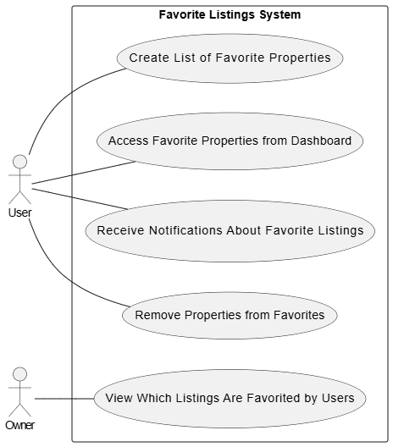
Figure 2.7: Real-Time Web Push Notification System Use Case Diagram
"The graphic diagram shows how Rent Wise executes its real-time web push notification process."
Flow:
- Real-time system alerts send critical notifications about new message updates and listing modifications along with reporting messages.
- Active browser notification users receive immediate alerts right through their web browser interface.
- Admins can send platform-wide announcements. Web users can adjust how they receive notifications. Push notification systems securely operate when the user's device is not connected to the internet.
User awareness of essential system operations is achieved by this feature in the framework
Figure 2.6: Real-Time Web Push Notification System Use Case Diagram

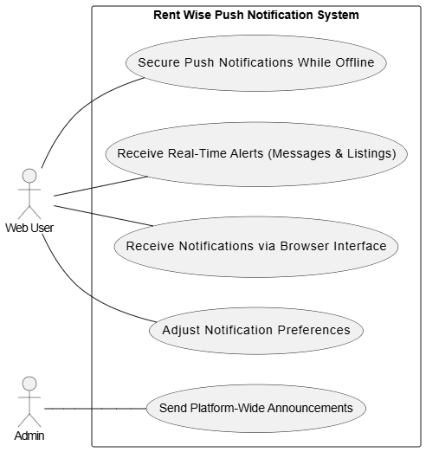
Figure 2.8: Report and Review System Use Case Diagram
"Figures illustrate how Rent Wise operates their reporting solution along with review activities."
Flow:
- Users maintain the capability to report both scam listings along with improper actions. Every report that gets submitted undergoes evaluation by the admin team.
- The administration executes warning procedures with content banning and deleting through manual investigation of reports.
- Users obtain useful feedback about report progress through the system's reporting mechanism.
- When RentWise users submit reports, they receive automated notifications before system administrators execute any actions. Security functions within Rent Wise maintain success through User protection protocols that preserve safety for all platform members.

Figure 2.7: Report and Review System Use Case Diagram
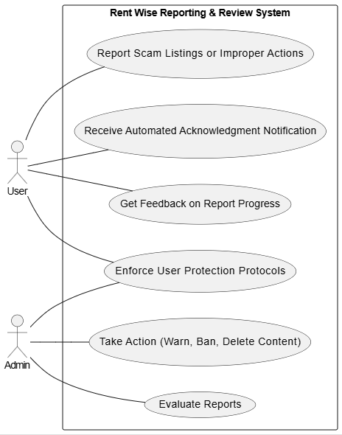
Figure 2.9: AI-Based Review Classification Use Case Diagram
"AI technology controls the review classification operations which Rent Wise utilizes."
Flow:
- Users have the ability to generate property reviews in addition to interaction reviews by way of the platform's interface.
- Review classification within Rent Wise operates through AI technology which establishes positive and negative and neutral categories.
- The system shows classified information through structured presentation features. Property owners have the freedom to respond when users submit their evaluations.
- Users possess the ability to report reviews they find inappropriate for review by platform administrators. Automated management operates impartially to handle user property evaluations through this system.

Figure 2.8: AI-Based Review Classification Use Case Diagram

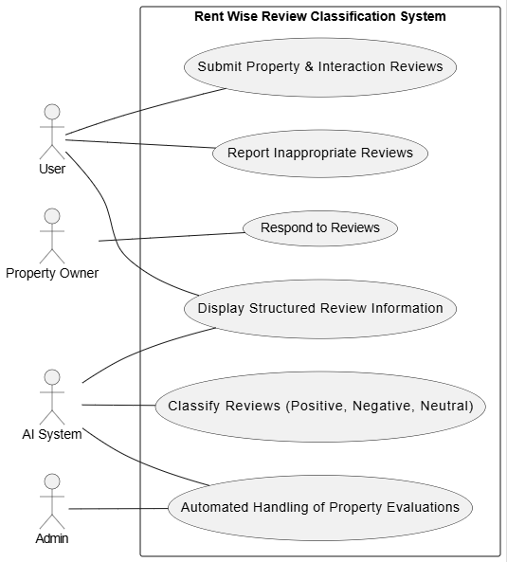

Functional requirements

The functional requirements define the core features and operations of the Rent Wise platform, ensuring smooth interactions between renters, property owners, and administrators.

Register & Create Profile.

Table 2.1: FR-01-001
Name | Register & Create Profile
Unique identifier | FR-01-001
Objective | Allow users (owners & renters) to create an account.
Priority
  High
Actors | Owners, Renters
Basic Flow | 1. User visits the Rent Wise website.  2. Clicks on "Sign Up".  3. Enters personal details (name, email, password).  4. Completes profile setup with additional details
Alternative flow | If the email is already registered, an error message is shown.
Preconditions
  User must access the registration page.
Postcondition | User profile is created and activated.
Note/Issues | Internet connection required.

Update profile.

Table 2.2: FR-01-002
Name | Update Profile
Unique identifier | FR-01-002
Objective | Allow users to update their profile details.
Priority | Medium
Actors | Owners, Renters
Basic Flow | 1. User logs into their account.  2. Navigates to profile settings.  3. Updates details (profile picture, description, other info).  4. Saves changes.
Alternative flow | if the user provides an invalid email/phone, an error is shown.
Preconditions | User must be logged in.
Postcondition | Profile information is updated.
Note/Issues | Ensure validation for updated fields.

List a property

Table 2.3: FR-01-003
Name | List a property
Unique identifier | FR-01-003
Objective | Allow owners to add rental properties.
Priority | High
Actors | Owners
Basic Flow | 1. Owner logs into their account.  2. Navigates to "Add Listing".  3. Fills in property details (title, location, rent, images, description).  4. Submits the listing for approval.
Alternative flow
  1. If required fields are missing, an error is shown.
  2. If image upload fails, the user is prompted to retry.
Preconditions | Owner must be logged in.
Postcondition | Property is listed.
Note/Issues | Ensure image and data validation.

Search Properties

Table 2.4: FR-01-004
Name | Search Properties
Unique identifier | FR-01-004
Objective | Allow renters to search for available properties.
Priority | High
Actors | Renters
Basic Flow | 1. Renter logs in and navigates to the search page.  2. Enters criteria (location, price range, type).  3. Views search results.
Alternative flow | If no properties match, a message is displayed.
Preconditions | Renter must be logged in.
Postcondition | Matching properties are displayed.
Note/Issues | Implement efficient search filters.

Apply Filters

Table 2.5: FR-01-005
Name | Apply Filters
Unique identifier | FR-01-005
Objective | Allow renters to filter search results.
Priority | Medium
Actors | Renters
Basic Flow | 1. Renter applies filters (furnished/unfurnished, number of rooms, amenities).  2. Results update based on selections.
Alternative flow | If no results match, a message is displayed.
Preconditions | Renter must be logged in.
Postcondition | Filtered property results are displayed.
Note/Issues | Optimize filtering for performance.

Request to Rent a property
Table 2.6: FR-02-001
Name | Request to Rent a property
Unique identifier | FR-02-001
Objective | Allow renters to request to rent a property.
Priority | High
Actors | Renters, Owners
Basic Flow | 1. Renter selects a property and clicks "Request to Rent".  2. Request is sent to the owner.  3. Owner reviews and accepts/rejects the request.
Alternative flow | If owner does not respond within 3 days, request expires.
Preconditions | Renter must be logged in.
Postcondition | Rental request is sent to the owner.
Note/Issues | Implement expiration for pending requests.

Approve or Reject Rental Request

Table 2.7: FR-02-0021
Name | Approve or Reject Rental Request
Unique identifier | FR-02-002
Objective | Allow owners to accept or decline rental requests.
Priority | High
Actors | Owners
Basic Flow | 1. Owner receives a rental request.  2. Reviews the renter’s profile and history.  3. Accepts or rejects the request.
Alternative flow | If the owner is inactive, an automatic rejection occurs.
Preconditions | Owner must be logged in.
Postcondition | Request status is updated.
Note/Issues | Notify renter upon approval/rejection.

Receive Notifications

Table 2.8: FR-02-003
Name | Receive Notifications
Unique identifier | FR-02-003
Objective | Notify users about rental requests, approvals, and messages. etc
Priority | Medium
Actors | Owners, Renters
Basic Flow | - User receives notifications for new messages, requests, or updates.  - User can mark notifications as read.
Alternative flow | if notifications fail, they are resent.
Preconditions | Notifications must be enabled.
Postcondition | User is notified of important updates.
Note/Issues | Implement push notifications.

Submit a Review

Table 2.9: FR-02-004
Name | Submit a Review
Unique identifier | FR-02-004
Objective | Allow renters to leave a review after a stay.
Priority | Medium
Actors | Renters, Owners
Basic Flow | - Renter navigates to past rentals.  - Selects a property and leaves a review.  - Submits the review.  - Owner can review the renter
Alternative flow | if no Agreements are completed, review is disabled.
Preconditions | Renter must have completed a rental.
Postcondition | Review is added to the property profile.
Note/Issues | Allow star ratings with text reviews.

Chat System

Table 2.10: FR-02-005
Name | View Volunteer Profiles
Unique identifier | FR-02-005
Objective | Allow renters and owners to communicate via chat.
Priority | High
Actors | Owners, Renters
Basic Flow | 1. User selects a contact from the chat sidebar.  2. Sends a message.  3. Recipient receives the message in real-time.
Alternative flow | If the user is offline, they receive a notification instead.
Preconditions | Users must have interacted before.
Postcondition | Message is sent and delivered.
Note/Issues | Internet connection is required

Real-Time Chat Sidebar Update

Table 2.11: FR-03-001
Name | Real-Time Chat Sidebar Update
Unique identifier | FR-03-001
Objective | Update the chat sidebar in real-time when a new message is received.
Priority | High
Actors | Owners, Renters
Basic Flow | 1. User receives a new message.  2. The sidebar updates without refreshing the page.
Alternative flow | If real-time update fails, users can refresh manually.
Preconditions | Users must have active conversations.
Postcondition | Sidebar reflects the latest conversations.
Note/Issues | Ensure WebSocket stability.

Web Push Notifications

Table 2.12: FR-03-002
Name | Web Push Notifications
Unique identifier | FR-03-002
Objective | Notify users even when they are offline.
Priority | High
Actors | Owners, Renters
Basic Flow | User receives a push notification for a new message, request, or update.
Alternative flow | If the notification fails, it is stored for later delivery.
Preconditions | User must have notifications enabled.
Postcondition | Notification is sent and received.
Note/Issues | Implement push settings for users.

Property Review & Rating System

Table 2.13: FR-03-003
Name | Property Review & Rating System
Unique identifier | FR-03-003
Objective | Allow renters to review and rate properties.
Priority | Medium
Actors | Renters
Basic Flow | 1. Renter visits the booked property page.  2. Enters a review and selects a rating (1-5 stars).  3. Submits the review.
Alternative flow | If review submission fails, an error message is displayed.
Preconditions | User must have rented the property.
Postcondition | Review is saved and displayed publicly.
Note/Issues | Internet connection is required

Password Reset

Table 2.14: FR-04-001
Name | Password Reset
Unique identifier | FR-04-001
Objective | Allow users to reset their password securely.
Priority | High
Actors | Users (Renters, Owners, Admins)
Basic Flow | 1. User enters email to request a password reset.  2. System sends OTP to email.  3. User enters OTP and new password.  4. System verifies OTP and updates the password.
Alternative flow | 1. If OTP is incorrect, an error is displayed.  2. If OTP expires, prompt to request a new one.
Preconditions | User must have a registered email.
Postcondition | Password is updated, and the user can log in with the new password.
Note/Issues | Ensure password meets security requirements (e.g., length, complexity).

Admin Dashboard

Table 2.15: FR-04-002
Name | Admin Dashboard
Unique identifier | FR-04-002
Objective | Allow admins to monitor and manage platform activities.
Priority | High
Actors | Admin
Basic Flow | 1. Admin logs into the dashboard.  2. Views user activities, properties, and do Blockchain Work.
Alternative flow | . If unauthorized access is detected, the admin session is terminated.
Preconditions | Admin authentication required.
Postcondition | Admin actions are recorded.
Note/Issues | Implement role-based access control.

Nonfunctional Requirements

The following are nonfunctional requirements of Rent Wise

Performance
- Fast Page Loads: The Rent Wise system delivers fast response times that work on all devices and network platform. Property listings and user interactions with messages together with all user actions need to load promptly.
- Scalable Infrastructure: The design of Rent Wise supports expansion of users while maintaining steady performance levels for an increasing number of properties. The system demonstrates effective capabilities to manage rising numbers of both property owners and renters.
- Optimized WebSocket’s & Push Notifications: Seamless real-time communication tools for messaging along with notification and alert transmission must operate with low latency.

User Experience
- Intuitive Navigation: Users must have easy access to property search features as well as next-generation owner communication and personal profile control functions. The system requires an interface that users can learn easily to minimize navigation challenges.
- Mobile Responsiveness: A complete device optimization must exist for desktops and mobile devices to create consistent usability throughout different screen sizes.

Security
- Data Protection & Encryption: Users need encrypted protection for their private information and database records to protect them from unauthorized entry.
- Authentication & Authorization: Rent Wise should use strong protection tools plus security systems that manage active sessions and control user access to block unauthorized user conduct.
- Secure API Communication: Our API needs to use HTTPS with secure user tokens to protect against attackers who want to hack into the system.
Our system scans incoming data to protect it against attacks while ensuring it meets proper criteria. The system needs to test all user data entries to block SQL Injection and XSS attacks plus other cyber threats.

Readability
- Uptime & High Availability: Rent Wise needs to be always up as it cannot have any downtime as is has to be available for renters and property owners constantly.
- Data Integrity – The platform shall keep the integrity of all of performance module date, but specifically, the system protects against loss or corruption of user accounts, and stored properties.
- Failover & Backup Method – For important company data it would provide a critical service NU needs active standby’s that can help restore in the situation of system crashes or cyber-attacks.

Maintenance
- Modular Codebase: Our platform modular codebase ensures easy maintenance, quick debugging, and compatible with huge expansion.
- Automated Testing & CI/CD: Platform will include automated testing pipelines that will enable that every update on feature delivery is bug-free.

DESIGN AND METHODOLOGY

Feature Driven Development
We used the Step-by-Step Feature Build (FDD) way in the Rent Wise work. FDD is a step-by-step and repeat software build way that focuses on slowly making features. The way puts a lot of focus on mapping the work area, building again and again, and making new versions often as part of an order to make software.
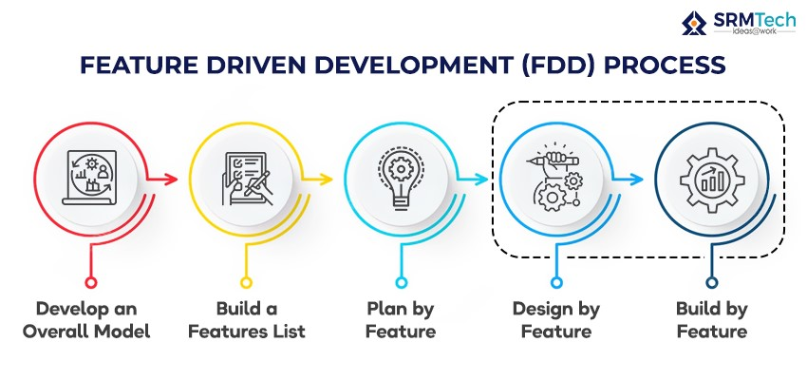
Figure 3.1: Feature Driven Development Model Flow.

While we made the software, we kept to the main FDD rules:

- Work Area Mapping: We began the work with a strong hold of the software's work area. We had to know the main jobs and plans of the system and show them using object-focused ways. Our build team got it and could line up and choose what to do first well because we focused on mapping the work area so much.
- List of Features: To lead the build, we kept a big list of features fresh. The list had all the parts that needed to go into the system. These parts were split into smaller, easier work bits called feature sets and were put in line by how much they mattered to the people who would use it.
- Build Again and Again: With a way that built on doing things again and again, we put in one or more features from the list every time we tried. We had set steps for each try. These included walking through the work area, checking the design, and looking over the code. All to make sure that the parts we put in met the high-quality mark we needed.
- Builds Often: All through the build time, we made new builds often to watch how we were doing and to keep the software steady and working. After each round, we made stuff for folk to look at and talk about what was in them.
- Checks: We did check a lot to make sure the code was good enough. Checks meant looking at the code and how each thing was made to find and fix any problems. This way, we kept our code good and didn't let hard tech problems pile up.

Sequence Diagrams for Rent Wise
Multiple sequence diagrams show various Rent Wise user interactions by representing how renters alongside property owners and administrators interact with the system. The step-by-step process between user roles is fully depicted in each diagram for achieving coordinated workflow operations.

Figure 3.2: Renter System Interaction Sequence Diagram depicts the Rent Wise platform experience for account registration through property searches to receiving notifications. Whenever a renter creates an account they must supply their information through name and email together with their chosen password. After renter account creation the system creates an email verification link that sends to the renter's email address. After successful email authentication the renter completes login to access the Rent Wise dashboard.
After successful login renters access a range of features including property listings details and exploration through filters for location price and property type. Users who register an account can create a list of favorite properties which they can easily access later. Users interested in a property can generate messages through the system to contact owners directly. The system informs property owners instantly about new inquiry requests through instant web alerts while also maintaining inbox updates.
The renting process begins for renters who wish to continue with property rental by submitting their request. Property owners accept or reject incoming requests from renters after receiving them. Once the owner approves the request the renter can plan further arrangement details with the owner. Record-keeping occurs through the system since it tracks each user interaction.
Rental updates together with property owner responses and chat messages are sent to users through web push notifications and email during the entire process. The platform delivers immediate updates to maintain flawless communication while providing better user experiences.

Figure 3.3: The Property Owner System Interaction Sequence Diagram displays the system's steps from account creation through the listing management process for property owners. Users can join by entering property data and personal information while the system requires email confirmation to verify new accounts. Property owners access their dashboard after verification to produce new property listings.
Property owners need to enter basic information such as property name and description and rental price and amenities and location alongside images to create listings. Fallen listings need an admin review step to become accessible to house seekers. The owners maintain complete control over listing activation and deactivation and the ability to make future edits.
The property listing system automatically delivers instant information to property owners when renters express interest in their property. Through their real-time connection they receive messages from renters while gaining access to profile data and handling rental applications. Once a renter submits their booking request the system lets owners choose whether to accept or decline it. After approval the system changes the property status and sends an alert to the renter's account.
The application allows owners to monitor which users bookmark their listings in order to measure property interest levels. Property owners receive notifications which alert them about rental demands and platform updates alongside inquiry responses.

Figure 3.4: The sequence diagram featured in Figure 3.4 shows how the Rent Wise platform's administrative functions. Account administrators access a protected dashboard to monitor user behavior alongside property submissions and system operational status along with registered user reports.
An admin must review all property listings before their formal approval from owners who submit them. The platform holds newly added listings at a pending status until administrators go through a verification process for approval. When a listing violates platform policies an admin can choose to deny entrance with an explanation of the reason for rejection.
User-reported concerns including fraudulent listings and system bugs and inappropriate behaviors fall under the admin teams' responsibility for monitoring. The system enables admins to enact necessary actions including sending warnings and suspending accounts and performing removals on problematic listings.
As part of their duties admins verify user accounts and resolve service disputes while managing user conduct reports. Admins experience a smooth platform experience because the system triggers alerts about user complaints spikes alongside high-traffic warnings and system error notifications.

Figure 3.5: The Chat and Notification System follows this sequence diagram pattern to operate.
The sequence diagram focuses on the real-time communication features that enable Rent Wise notifications to function. The WebSocket system enables the chat system to deliver instant messages that tenants send to property owners. The messaging arrives instantly to any online recipient. Users who are unavailable receive either a web push notification or an email notification from the system.
New messages trigger updates in the chat sidebar that shows recent conversations alongside unread message indicators. Both landlords and renters engage in smooth discussions which require no page refreshes between them.
The notification system functions as an essential element for sustaining user involvement. Property owners receive automatic alerts when any renter bookmarks their properties. The system sends automatic notifications to the renter both when an owner approves or denies their rental request.

Figure 3.6: The Sequence Diagram Represents OTP-Based Password Reset System Interaction During Figure 3.6
The sequence diagram describes an OTP-based password reset system interaction sequence diagram that provides user-friendly security features for password recovery operations.
When users forget their password, they need to enter their registered email address to start the password reset procedure. After generating an OTP, the system automatically sends it to a user's registered email inbox. The password reset page requires the user to input the OTP the system verifies before allowing password selection. A new password becomes accessible when the system verifies a valid OTP entered by the user. There is an error display along with a second chance to retry entry when the information entered is incorrect.
User protection occurs through a time limit on OTP validity as unclaimed codes expire automatically. Sending multiple OTP requests inside a brief time window remains impossible which prevents unauthorized access attempts.

Figure 3.7: The User Profile and Review System Interaction Sequence Diagram depicts user system interactions
The sequence diagram shows users' navigation through their profiles and the review system interface. Each profile page contains specific zones for renters and property owners to both update their details and check their past transactions together with their platform settings.
An AI system analyses reviews as one of the platform's central features. Renters and owners use the platform to review each other after rentals through a feedback process. The system assesses user generated reviews through sentiment analysis to identify positive, neutral and negative content. The system shows classified reviews on user profiles to enable better decision-making for users.
Alert notifications inform users whenever someone leaves a new review about their profile. When users identify inappropriate reviews, an administrator will conduct an evaluation to determine proper course of action.

Figure 3.8: The Property Search and Filtering System Interaction Sequence Diagram illustrates the system's operations.
The sequence diagram showcases the system's property search capabilities which allow users to discover suitable listings through efficient matching.
A renter can perform a property search within the system which generates listing results matching their search parameters including location, price limits, bedroom numbers, amenities requirements and property availability. User-selected preferences trigger live results updates in the filtering system interface.
Personalized recommendations within the system will recommend properties by using data from previous searches and saved favourited properties. The system allows renters to order search results in three ways: based on newest properties, lowest to highest prices and highest-rated accommodations.
The system enhances search speed through a feature that stores often-requested listings in cache memory to make results load faster while delivering better performance.

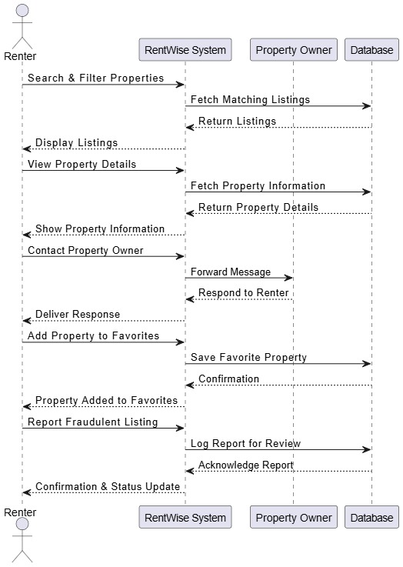

Figure 3.2: Renter System Interaction Sequence Diagram

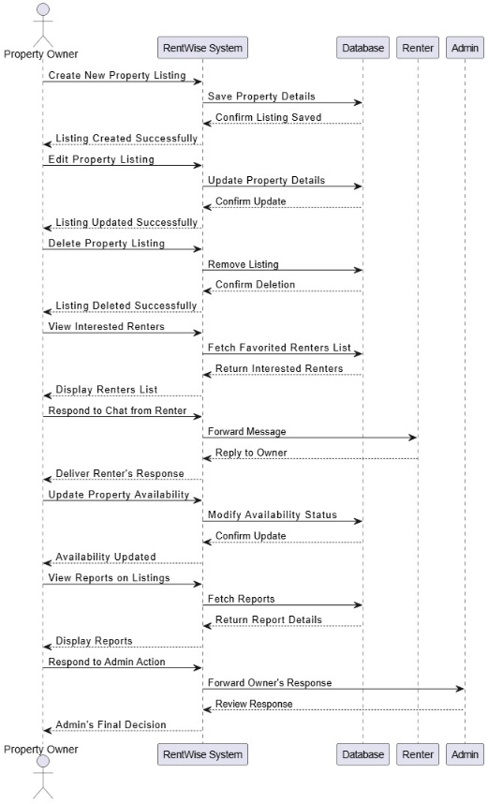

Figure 3.3: Property Owner System Interaction Sequence Diagram
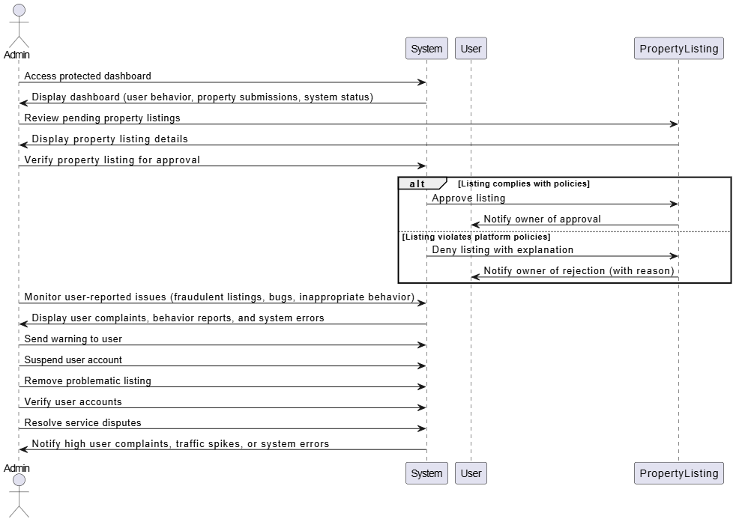

Figure 3.4:Admin System Interaction Sequence Diagram
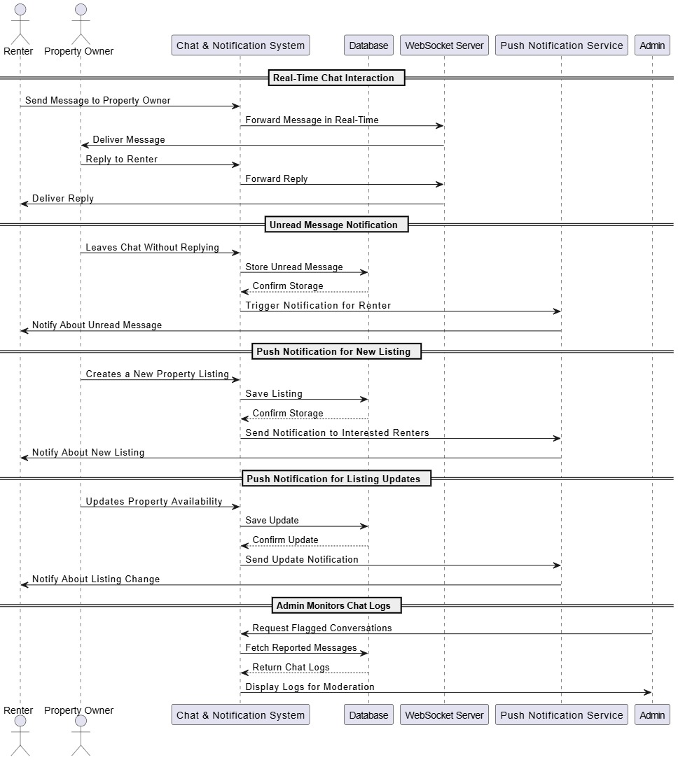

Figure 3.5: Chat and Notification System Interaction Sequence Diagram
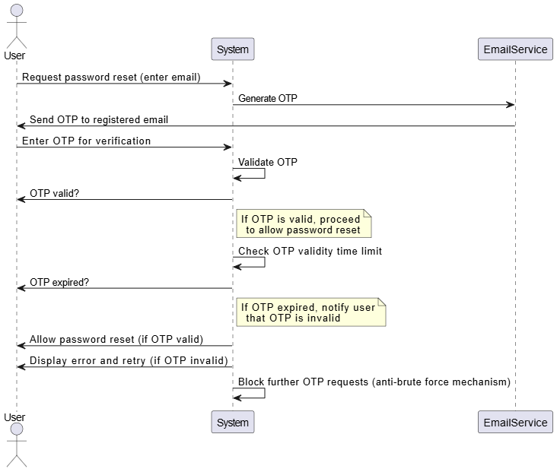

Figure 3.6: OTP-Based Password Reset System Interaction Sequence Diagram

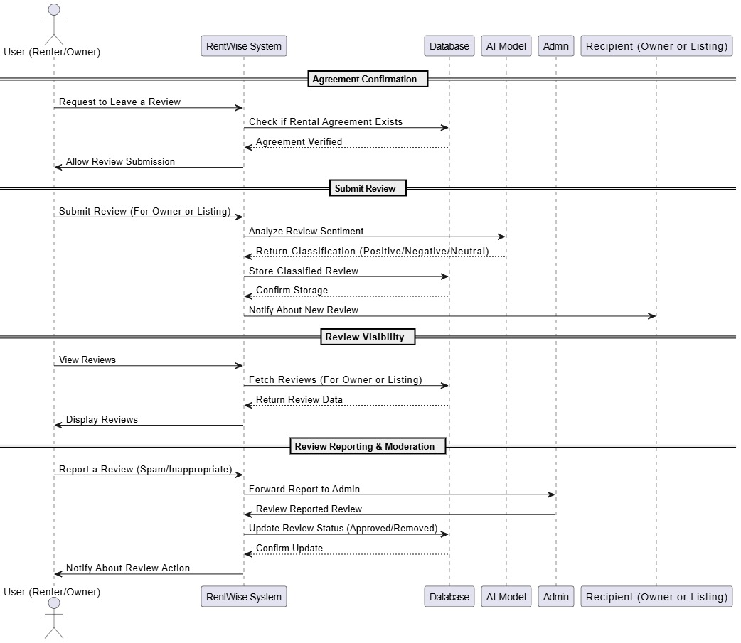

Figure 3.7: User Profile and Review System Interaction Sequence Diagram

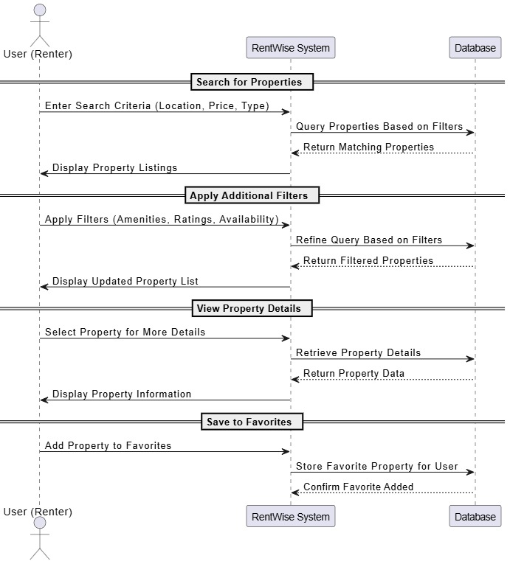
Figure 3.8: Property Search and Filtering System Interaction Sequence Diagram

Functionality Flow Diagrams
Figures below demonstrate how Rent Wise works.
Figure 3.9: The Renter Functionality Flow Diagram illustrates the paths renter users take through Rent Wise. Users can narrow their property search by adapting filters for location, price and property type. Users can review property specifics and examine availability status through the system while maintaining a favorites list of properties. Users who want to learn more about properties can start text-based conversations with owners to ask about listings. The system enables renters to edit their profiles and control which notifications they receive. User interactions trigger system updates of the interface while the system provides immediate notifications about both chat responses from owners and property updates.

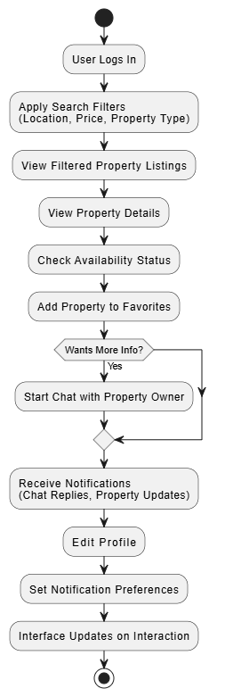

Figure 3.9: Renter Functionality Flow Diagram
Figure 3.10: The workflow designed for property owners allows them to make listings manage properties by adding images and scheduling availability through this diagram. Property owners get notified through alerts whenever renters contact them using messaging or mark their property listings as favourites. The system allows property owners to communicate through chat with renters about listing information while providing the ability to update or edit and deactivate their listings.

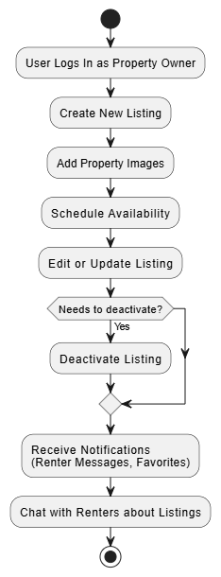

Figure 3.10: Property Owner Functionality Flow Diagram
Figure 3.11: The search function of the system features a diagram which allows renters to refine their searches through location criteria alongside rent range and property number of rooms and property type filters. Users can organize search results by viewing listings according to their most recent availability or lowest cost or highest popularity rankings. When results don't match exactly the system provides instantaneous updates and recommends comparable properties. Real-time optimization features minimize search time by presenting results that match specific criteria to renters.

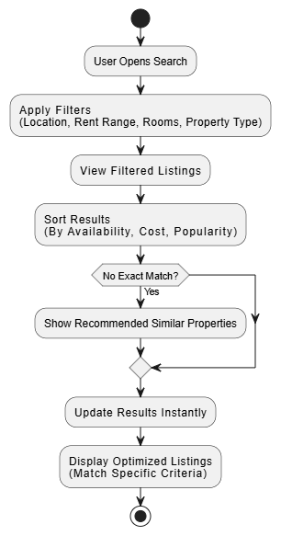

Figure 3.11: Search and Filtering Functionality Flow Diagram
Figure 3.12: Become familiar with Rent Wise's real-time chat and notification system through this functional flow diagram. Through WebSocket technology users can start real-time conversations with each other while unread messaging alerts automatically update across chat areas. Users receive push notification alerts when new messages arrive and when favourite properties update or their status changes. Users can stay updated through web push notifications because the system sends alerts to their devices when they are offline. The interactive communication system uses WebSocket to boost user engagement while delivering prompt responses.

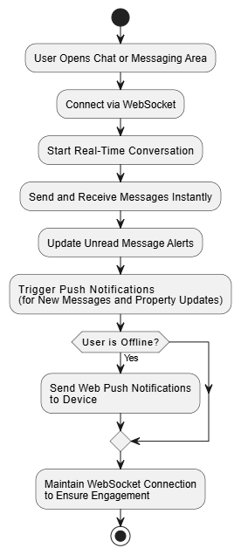

Figure 3.12: Real-Time Chat and Notification Functionality Flow Diagram
Figure 3.13: Rent Wise OTP-Based Password Reset Functionality Flow Diagram is a secure OTP-based authentication process for password resets. When a user needs to reset his password, an OTP is sent to his email. The system validates the OTP, and if valid, then the user can follow through and create a new password. Error message is shown if the OTP is wrong, so the user is prompted to attempt again or get another one. This process guarantees safe password-recovery by eliminating passwords in login or registration for authentication.
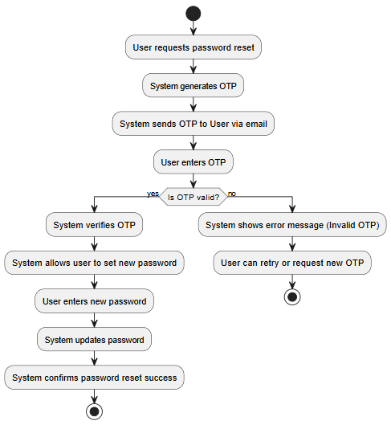

Figure 3.13: OTP-Based Password Reset Functionality Flow Diagram

Figure 3.14: Admin Management Functionality Flow Diagram As far as the role of the admin is concerned, Admins are essential for ensuring moderation and operational integrity of Rent Wise. They approve or reject property listings according to system guidelines, oversee user registration processes, and verify accounts. Furthermore, admins deal with complaints concerning fraudulent listings or offensive messages. They also maintain system stability by addressing issues as they appear. To keep transparency, the system, of course, automatically notifies those owners whose listings are approved or declined.

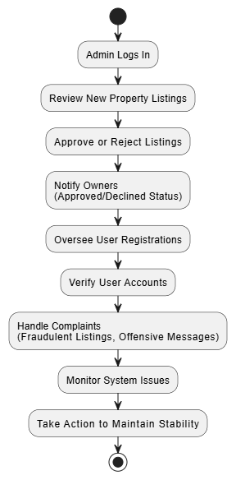

Figure 3.14: Admin Management Functionality Flow Diagram
Figure 3.15: Renters can save favourite listings for quick access and if a costumer of a favourited property price or availability changes, they will receive a notification. Favourite Listings & Saved Preferences Flow Diagram. Moreover, there is also a possibility to control saved searches, as well as be informed about the new additions coinciding with the user’s preferences. This aspect makes the experience of property browsing and tracking much more precise.

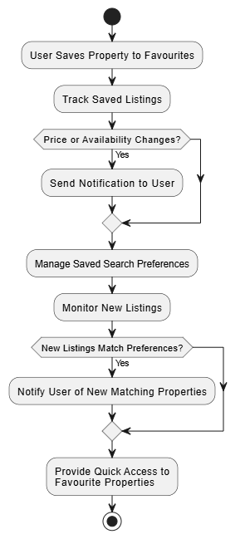

Figure 3.15: Favourite Listings & Saved Preferences Flow Diagram
Figure 3.16: Background Processes & System Logs Flow Diagram This diagram shows system level processes that are running in the back ground to ensure platform stability, security and user experience. The system cleans up expired listings automatically from the database, and also logs important actions like failed login attempts, and modification of listings. WebSocket connections are checked constantly to maintain real time data consistency. Further, scheduled announcements are sent to the users with pending chats and property updates and hence keep the users engaged with the platform.
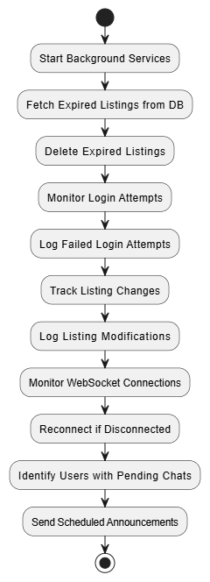
Figure 3.16: Background Processes & System Logs Flow Diagram

Class Diagram Rent Wis
The Figure 3.9: The Rent Wise Class Diagram that depicts the structural relationships as well as the attributes of the fundamental entities in the Rent Wise system. This diagram represents the backbone of the rental property management platform, indicating the key entities: the users (participating renters and property owners), properties, chats, notifications, reviews.
Each entity within the system has distinctive attributes including user profiles, property details, rental status, messaging history and user interactions. Rental seekers can search, filter, and package preferred properties while rental units can be listed and managed by their owners. Besides, chat functionality and messages guarantee smooth communication between users, promoting interaction. However, there is the OTP-based password reset option which adds security, and there is also a review system for users to review services which is for transparency.
The administrator plays a supervisory role whereby, deploy agreements on Blockchain platform.
The chat module enables direct communication between renters and property owners in real time to facilitate direct and efficient negotiations. The review and rating system assists in maintaining trust on the platform because users can leave feedback concerning the properties and the user experience.
This class diagram gives a detailed picture of how these components interact with one another leading to an efficient, well structured, and easily scalable rental platform.
Figure 3.17: Rent Wise Class Diagram

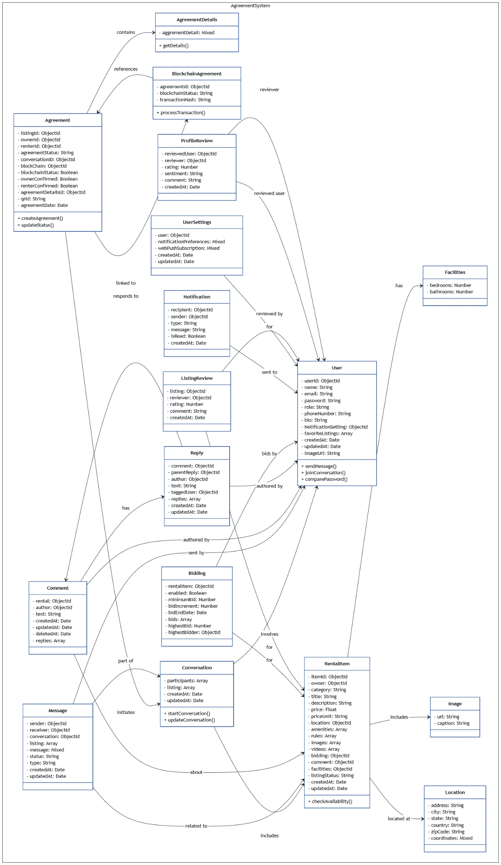

IMPLMENTATION

Implementation
The development of Rent Wise process was complicated and required a combination of technologies, tools, and methodologies. The aim was to create a robust intuitive property management platform that facilitates smooth communication between renters, property owners, and administrators. Below is a compilation of the technologies and tools used in developing Rent Wise leverages and AI-powered insights for review classification.

Languages and Frameworks Used
The following Languages and Frameworks are being used in Rent Wise implementation.

React.js
React.js was used for the frontend purpose where the component-based architecture propels code reusability and scalability. Its virtual DOM allows for fast rendering, and therefore it is perfect for a dynamic and interactive rental platform such as rent wise.

CSS and Tailwind CSS
We styled the app using Tailwind CSS. It provides simple tools to create fast new looks that are functional on any screen. By using Tailwind’s pre-styled bits, our app’s design was fast, and the same style perpetuated all through.

Node.js
Used for the back-end server. Express.js is useful for creating RESTful APIs, whereas Node.js offers an efficient runtime environment. Such combination enabled us to process large numbers of concurrent connections with high efficiency.

Solidity
The agreements between renters and owners of property were developed with the help of the Solidity. Such smart contracts guarantee rent agreements tamper-proof, non-changeable, and transparent. Web3.js was used for blockchain interactions while streamlining the ability to sign and verify digital agreements securely, while MetaMask was incorporated, allowing to authenticate, sign agreements and conduct transaction securely within the platform.

JavaScript
The main language for front-end and back-end, providing consistency and integration ease throughout the platform. Asynchronous capabilities in JavaScript played a decisive role in the work with real-time updates and API reactions.

Databases Used
MongoDB is selected for its flexibility and scalability, and by MongoDB the main database is used for saving user profiles and event details, attendance as well as other data. Its document-oriented structure enables it to store and retrieve complex data structures efficiently.

AI-Powered Review Classification (Machine Learning)
A model that AI was incorporated to categorize the user reviews as positive, negative, or neutral, respectively. This allows renters and own properties to have insight to tenant, complaints and praises shared by tenants. Machine learning mechanisms including Natural Language Processing (NLP) and sentiment analysis were applied to analyse reviews automatically.

Blockchain Technology Used
Below shown is the technology used in Rent wise development.

Spolia Blockchain
Utilized to establish and certify electronic rental contracts, improving the security and reliability of the rental process. Blockchain technology is in place to ensure that the agreement’s terms and conditions cannot be changed once developed, giving an immutable proof of the contract between the tenant and the owner of property. This eliminates controversies since it ensures that one is transparent and protects the parties involved from fraud or tampering.

Web3.js
JavaScript library is used for generation and interaction with the blockchain, enabling smart contracts deployment and interaction. Web3.js allows the platform to send transactions, call smart contract functions, and operate blockchain accounts.

MetaMask Wallet
It is to be integrated to bring a smooth experience to users when transacting in blockchain and verifying certificates. MetaMask empowers users to control their blockchain identities and sign transactions straight from their browsers.

APIs and External Services Used
The following APIs and other External Services that have been used.

Location IQ API
To facilitate location-based services that would help volunteers search for events by their location. This API improves the user experience by enabling volunteers to find and interact with nearby events, thereby improving their level of engagement and convenience.

Development Tools Used
The below-given development tools have been used in the development of Rent Wise Development.

Git
Git Version control system to automate code changes management, make it easier for team members to collaborate, and track the progress of the project. Git’s branching and merging capabilities allowed for simultaneous development without having conflicts.

VS Code
The first deserted integrated development environment (IDE) is utilized by the development team. This wide range of extensions and integrations provided by VS Code increased productivity and made the development workflow seamless.

RESULTS AND USER MANUAL

Results
Rent wise has a lot of functions and pages but the platform is split into two main parts: the Showcase Page and the Main Functional Pages. The Showcase Page talks about the features and benefits of the platform, while the Main Functional Pages are the Admin Panel, Renter Panel, Property Owner Panel, Chat & Notification System, Review Dashboard, and Blockchain-Based Agreements. The Review Dashboard enables users to see the categorized feedback (positive, negative, neutral) according to the AI based sentiment analysis, which will assist both renters and owners to make informed decisions. The individual functions for each panel are shown in the description, and the final view is given below. Users can navigate through the below sections to have a quick tour of the major features of the Rent Wise.

Landing Page
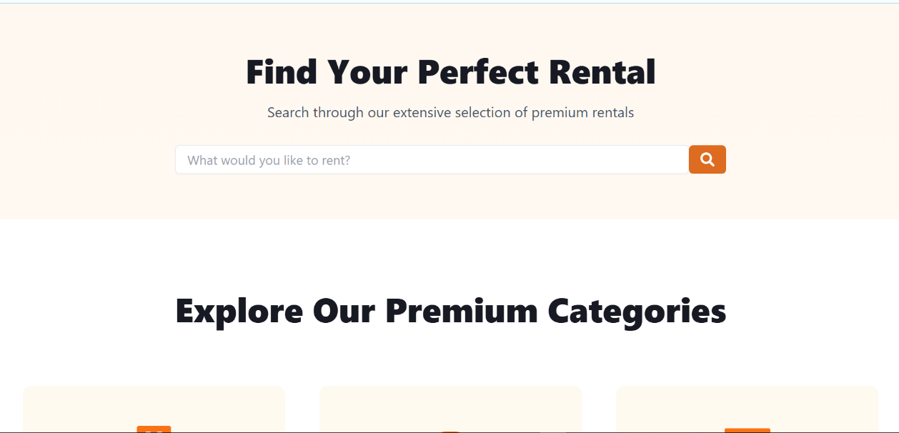

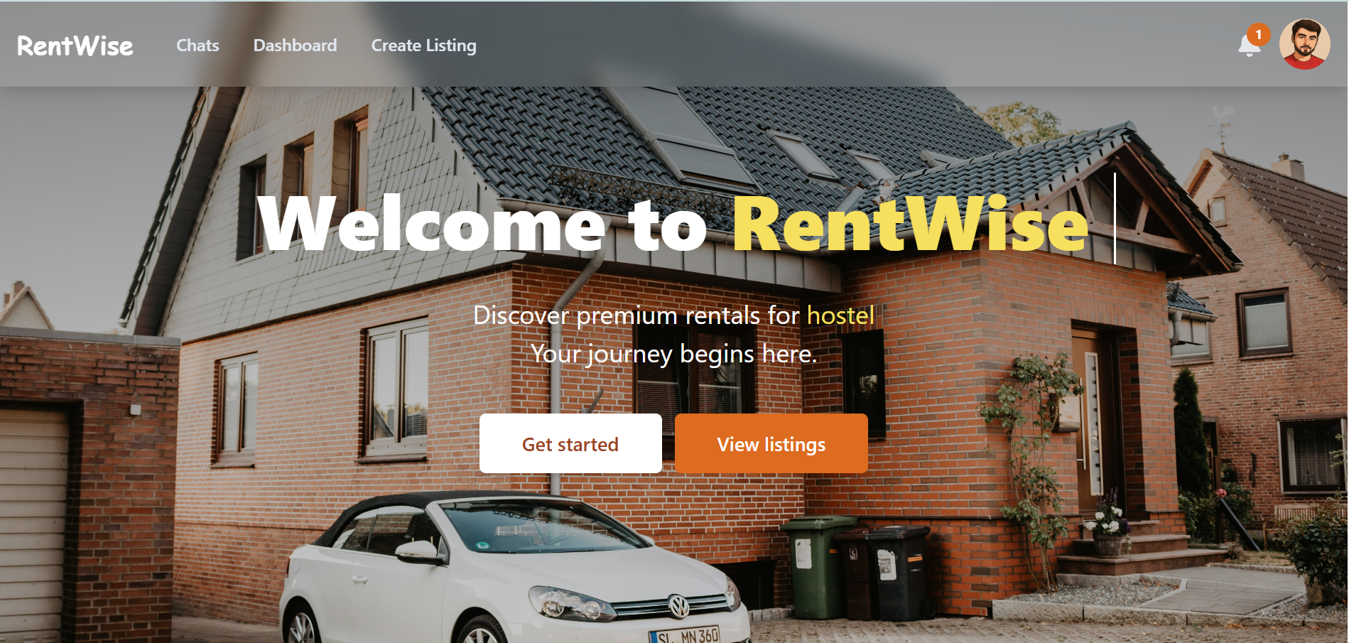


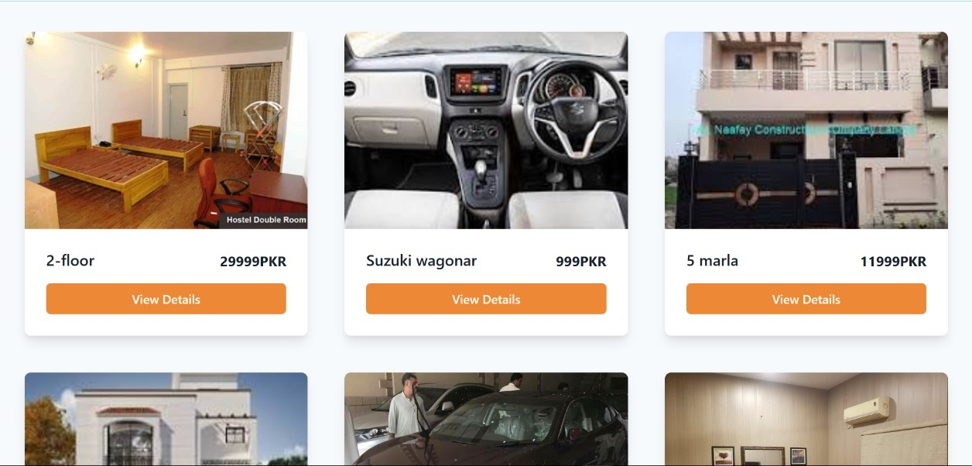
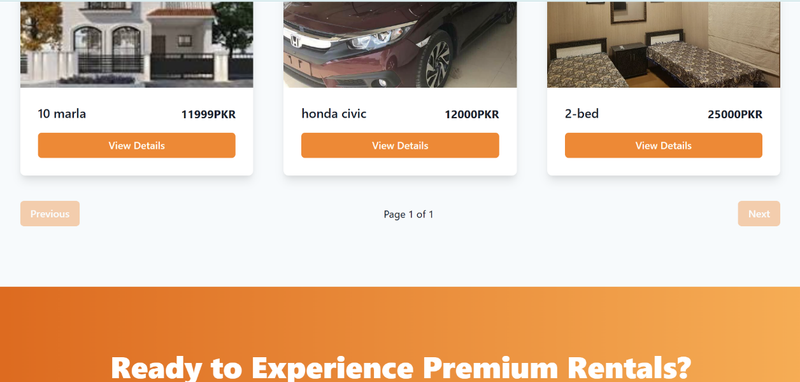

Figure 5.1: Landing Page

Login Sign Up Pages

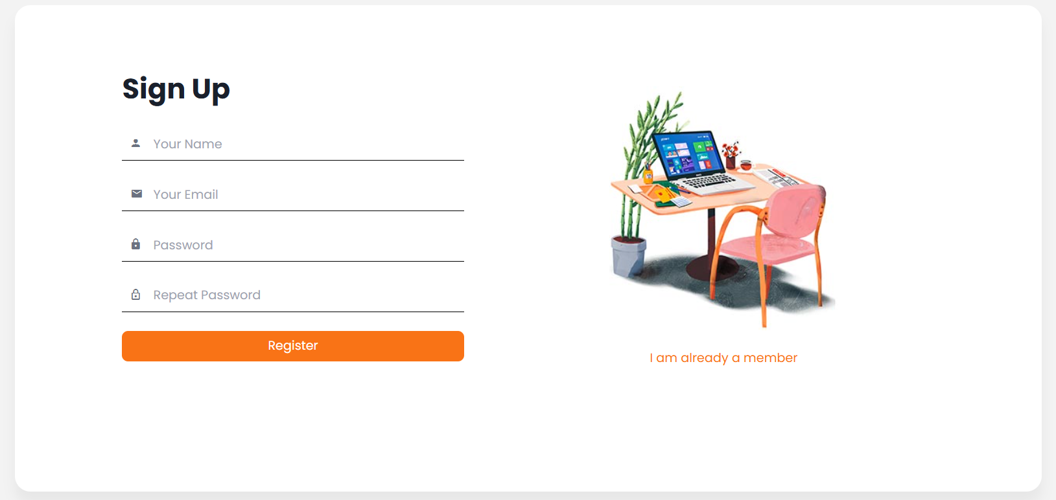

Figure 5.2: Signup Page

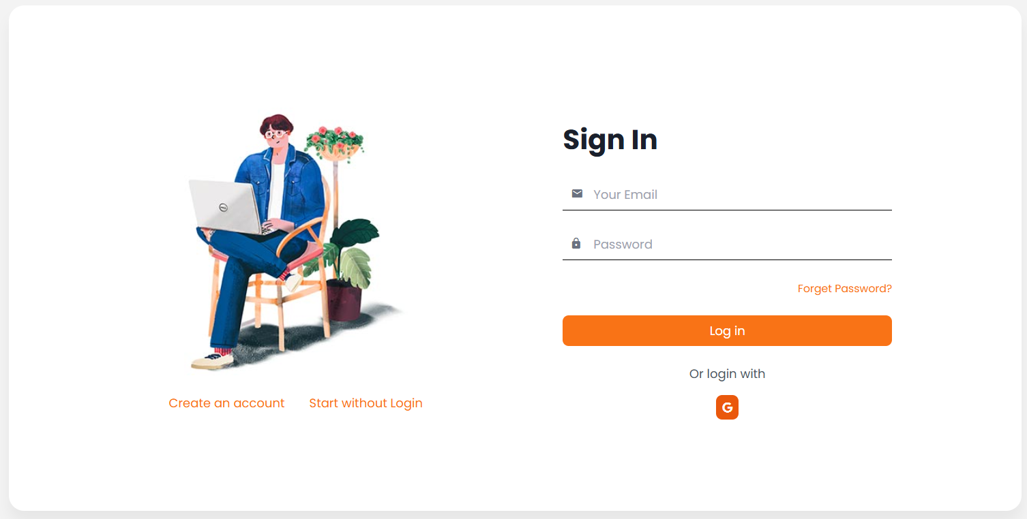

Figure 5.3: Login Page

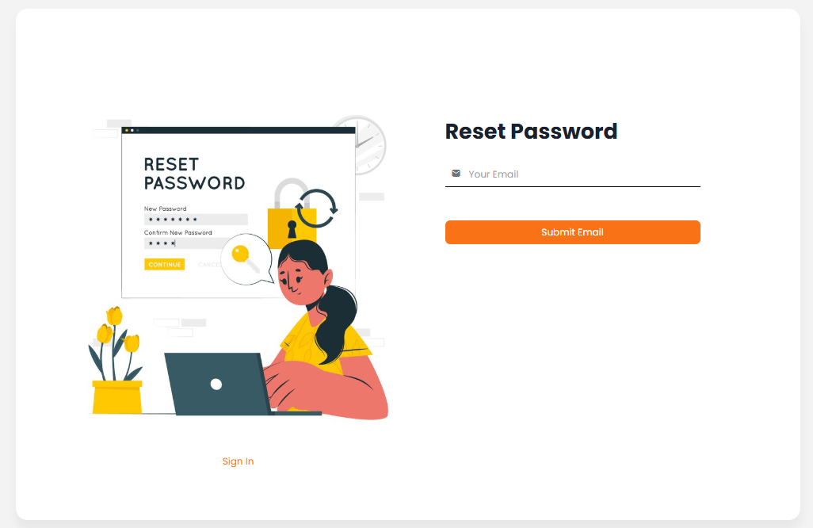

Figure 5.4: Reset Password Page

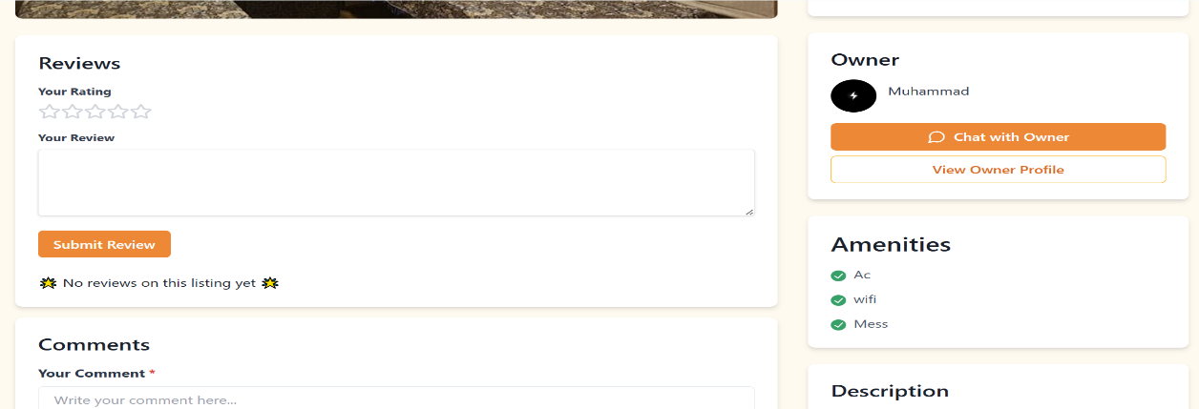

List Detail
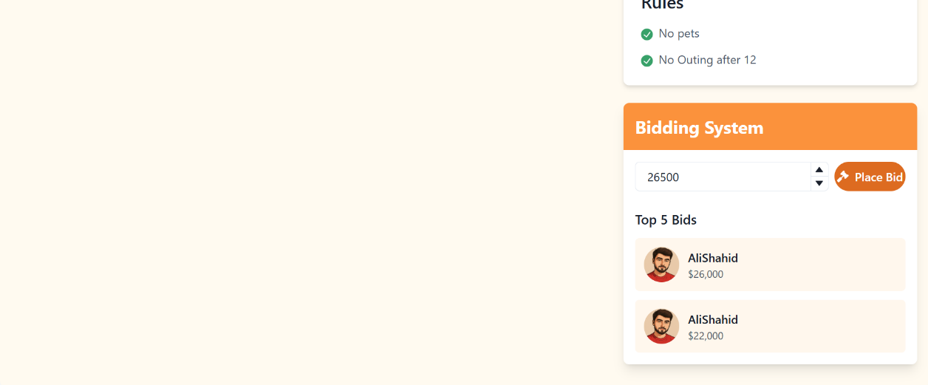
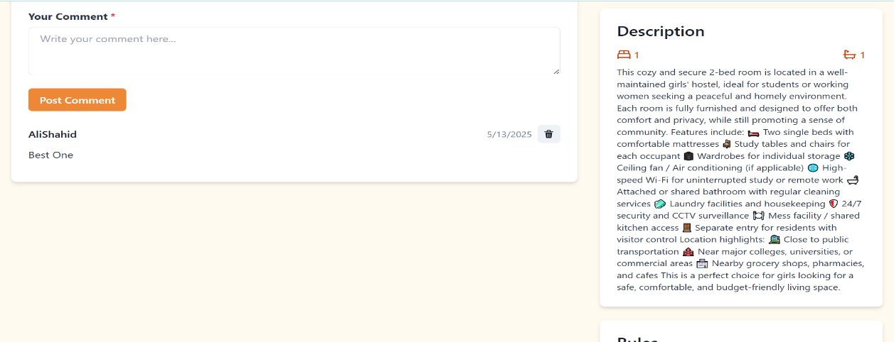
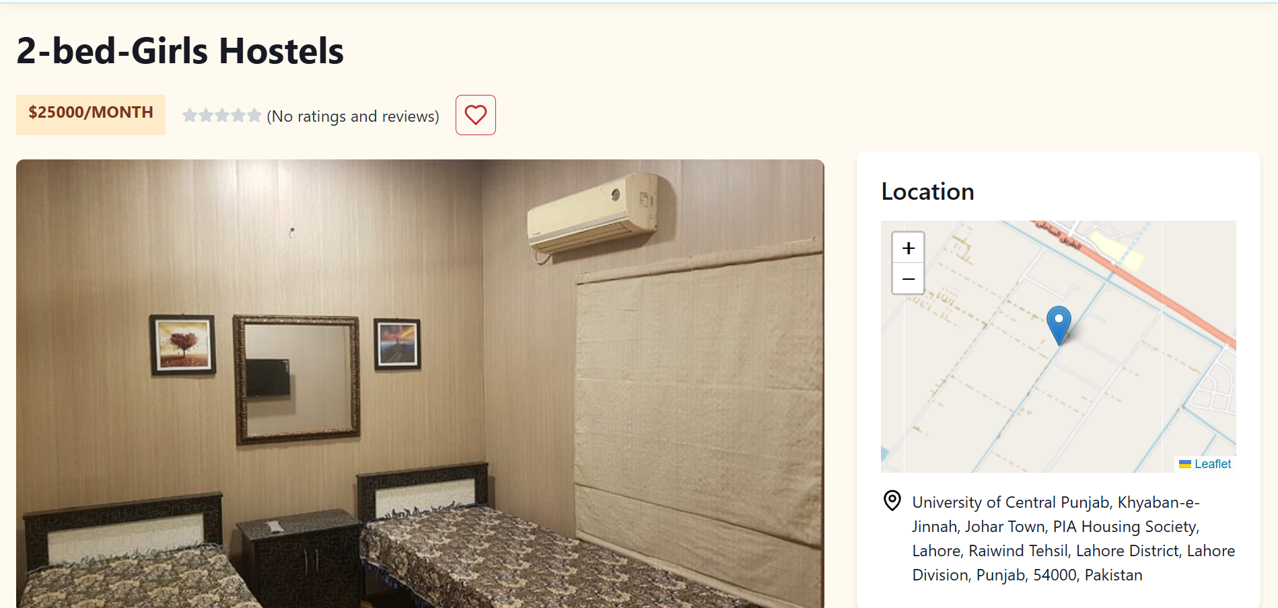
Figure 5.5: List Detail

Dashboard Pages
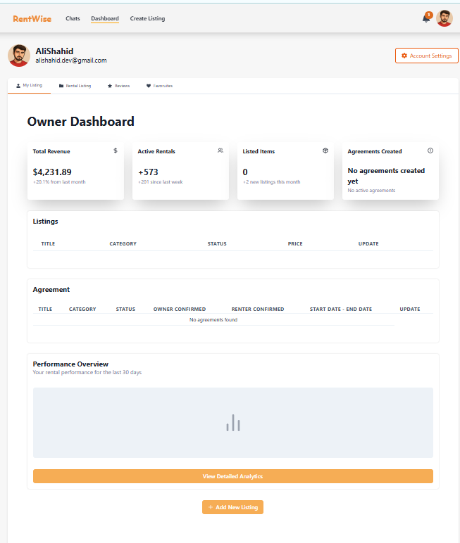
Figure 5.6: Owner Dashboar
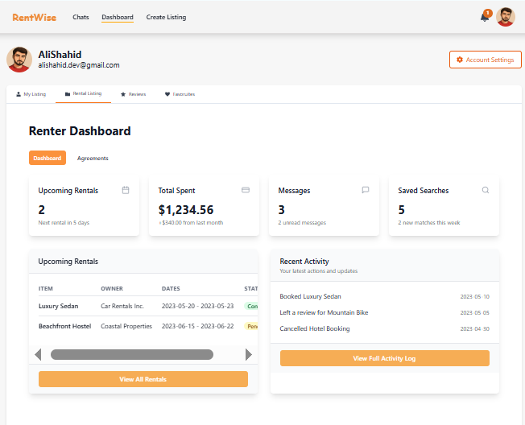

Figure 5.7: Tenant Dashboard
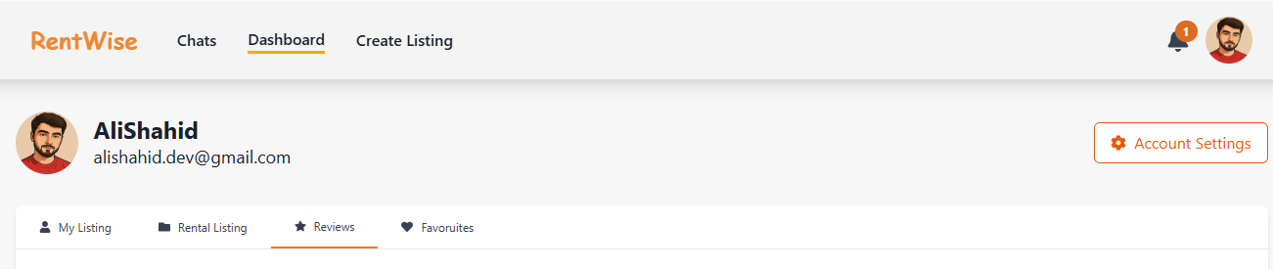
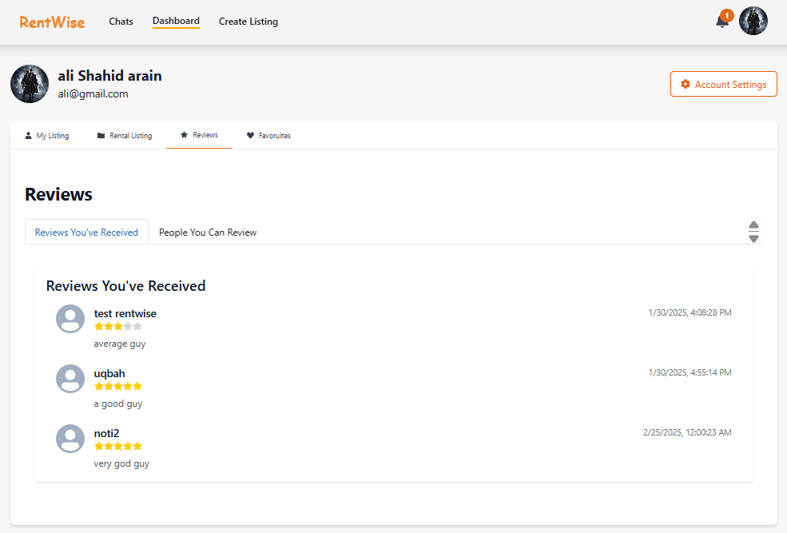

Figure 5.8: Received Reviews Page

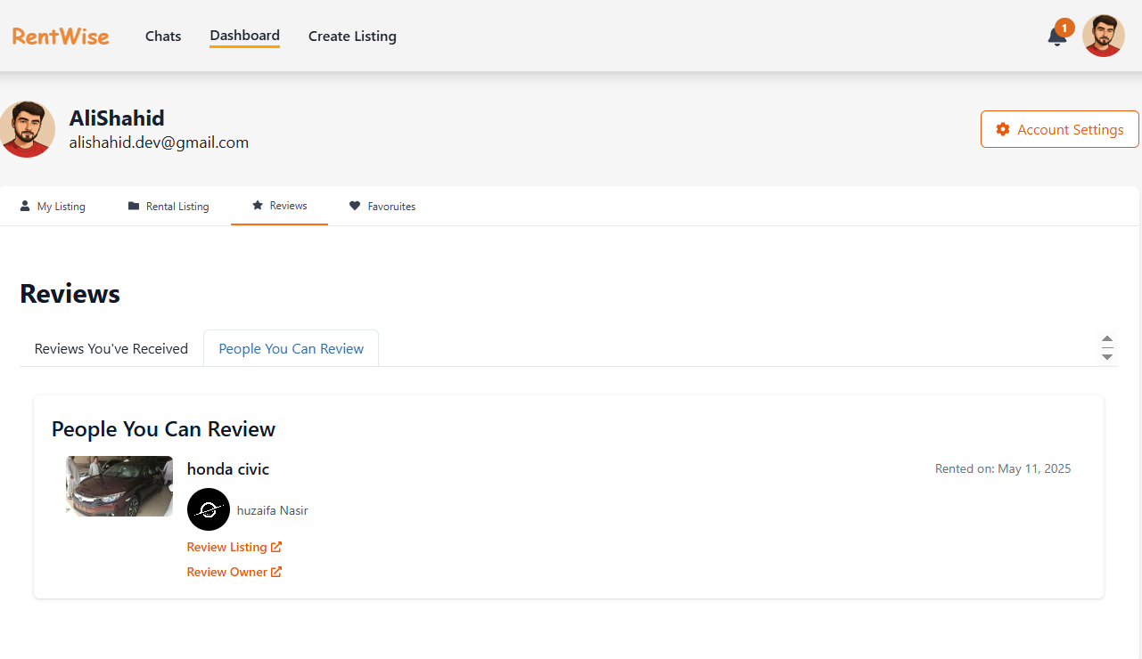

Figure 5.9: User Review Page

Account Setting
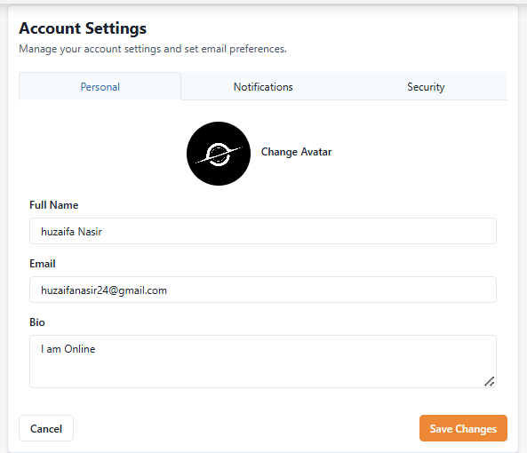

Figure 5.10: Personal Info
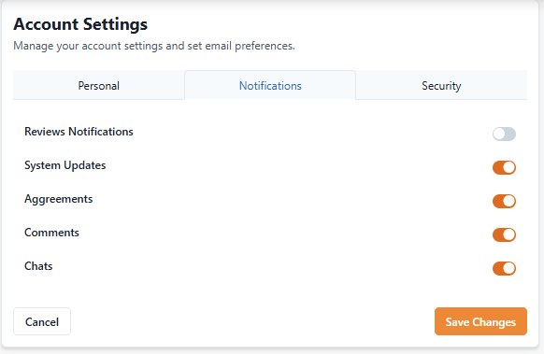

Figure 5.11: Notification Setting

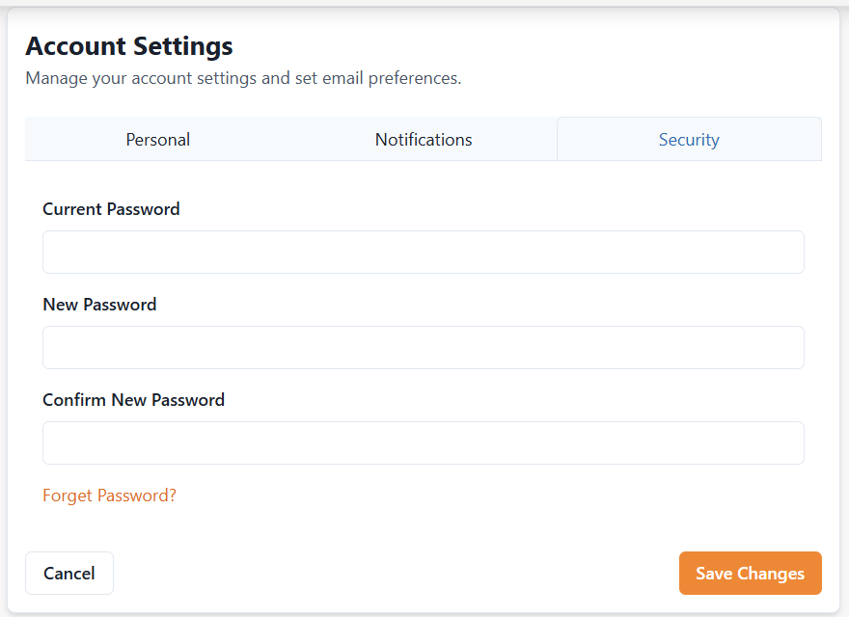

Figure 5.12: Security Setting

List Creation Page

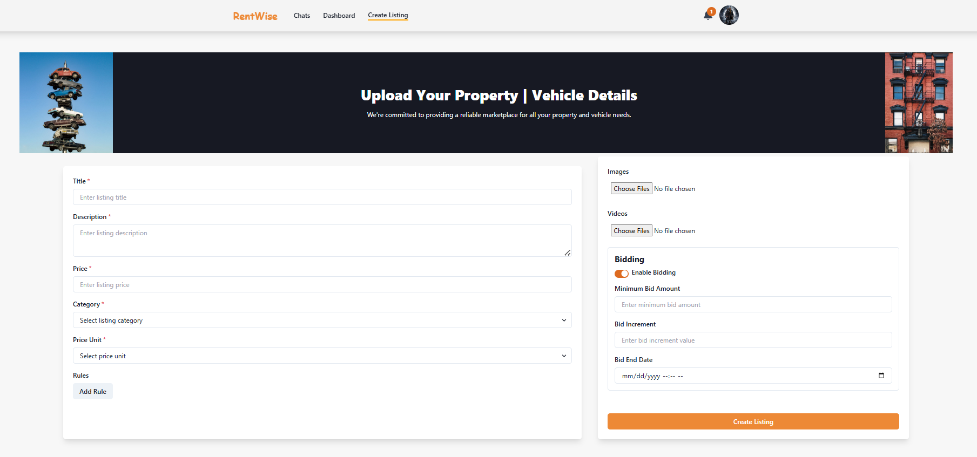

Figure 5.13: List Creation

Real Time and Custom Build Chat System:

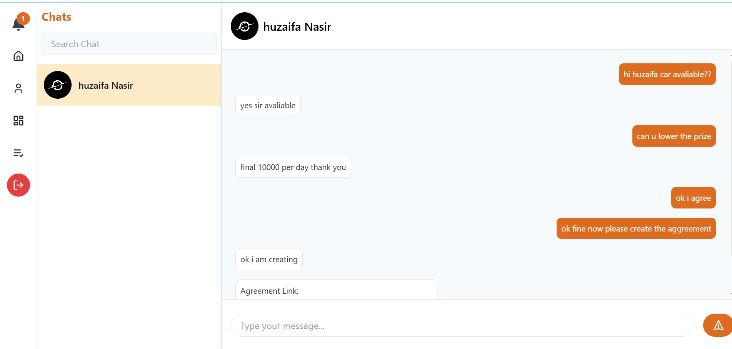

Figure 5.14: Chat System

Agreement Creation Page:

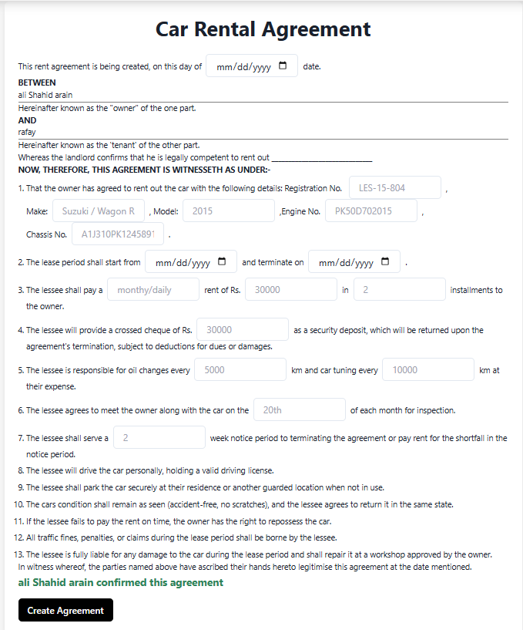

Figure 5.15: Agreement Creation Page

Review

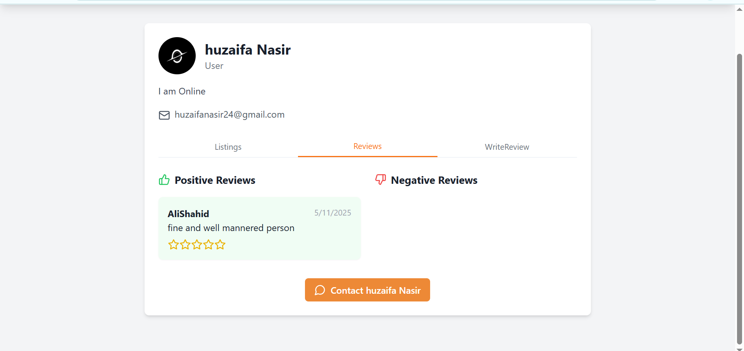
Figure 5.16: Review page

Admin

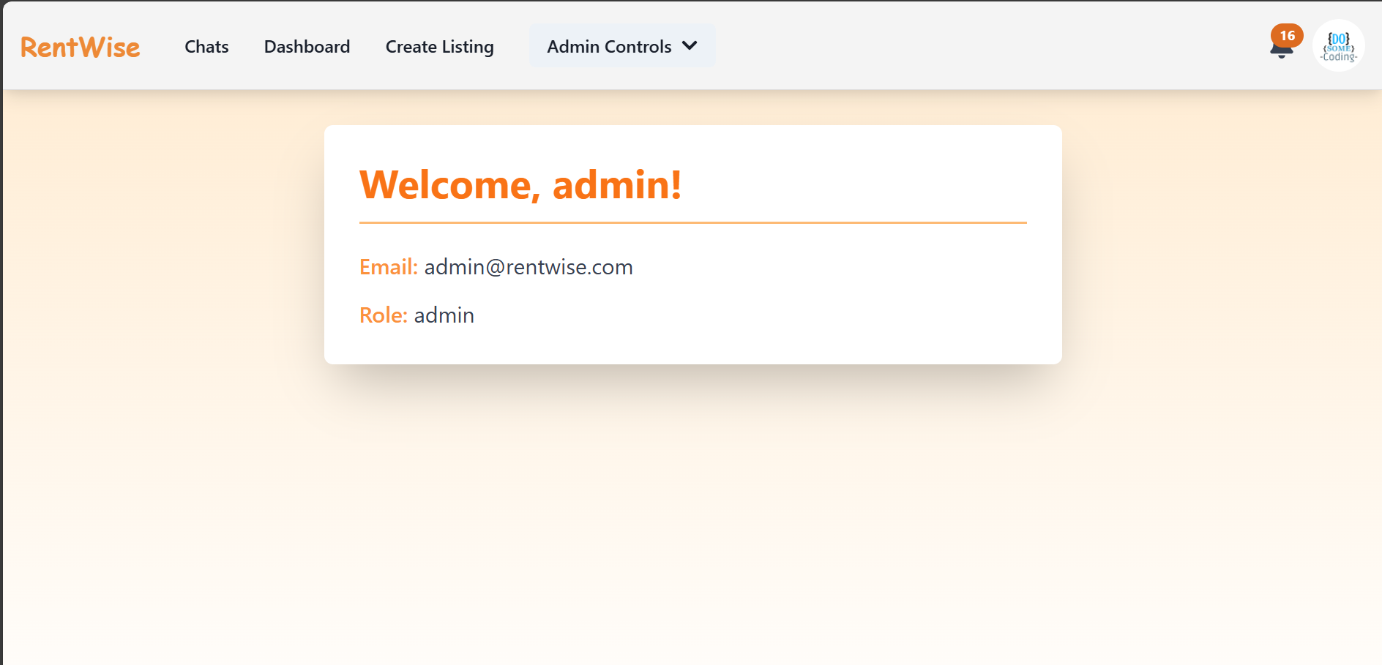

Figure 5.17: Admin Home page

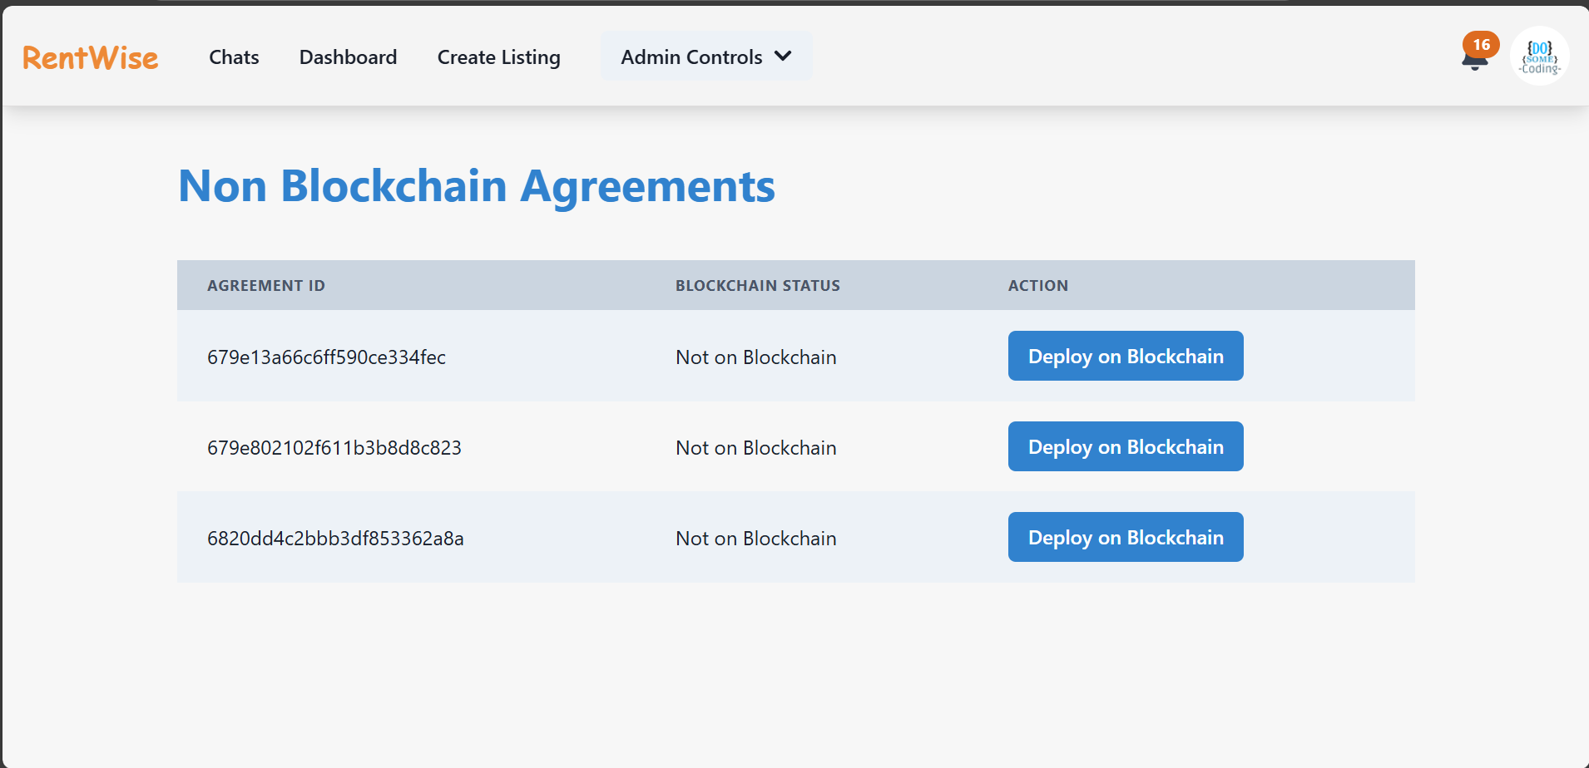

Figure 5.18: Admin Block Chain page

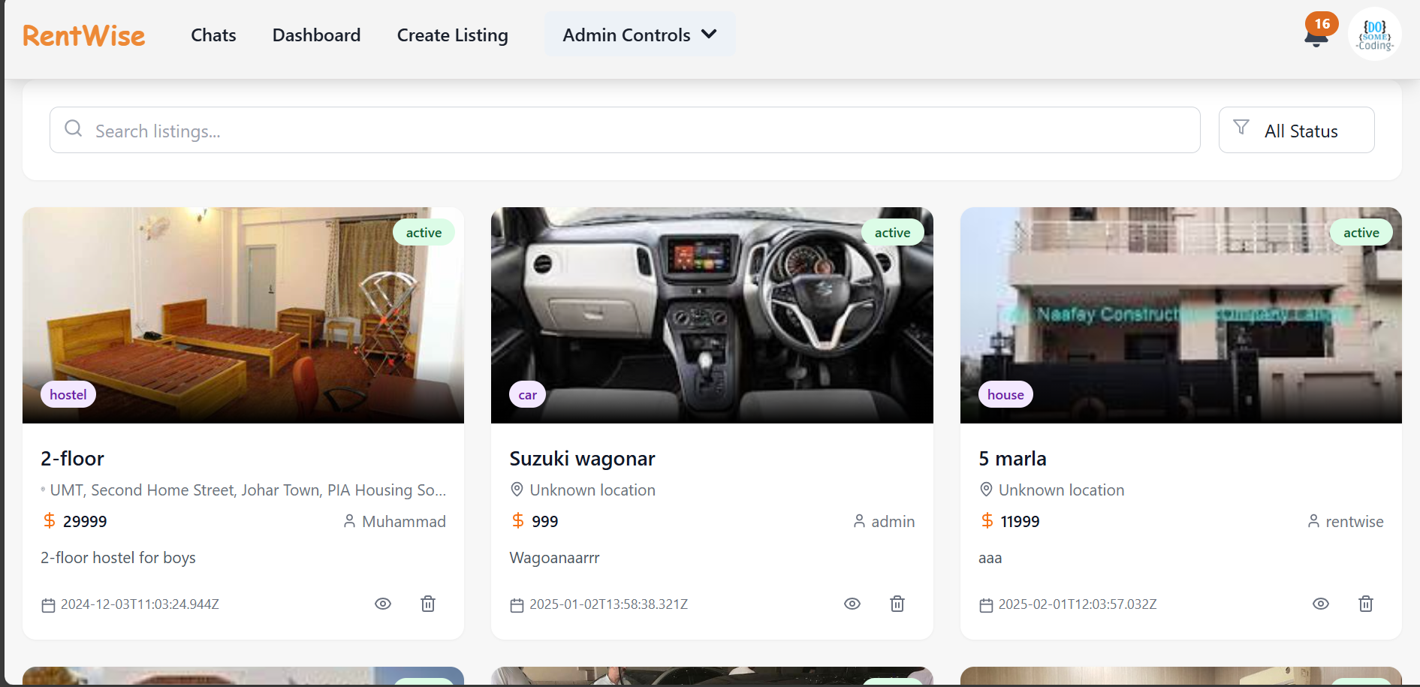

Figure 5.19: Admin List Management page

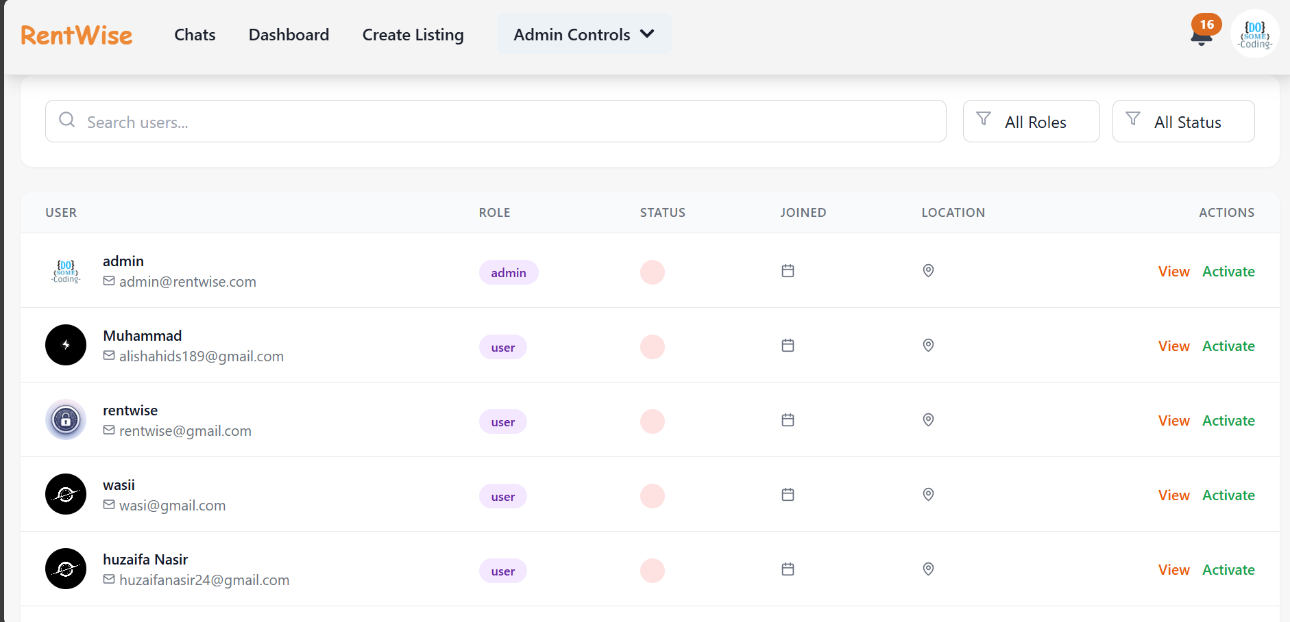

Figure 5.20: Admin User Management page

CONCLUSION AND RECOMMENDATIONS

Conclusion

Rent Wise is an innovative tool designed as a rental management platform to help improve rental efficiency, transparency, and communication between renters and owners. With the integration of real-time messaging, AI review classification, and Web Push notifications, Rent Wise creates a smooth and in-to manner for users. One of the prominent features of Rent Wise is its AI based review classification system which understands and segregates based on positive, negative and neutral reviews. This assists renters in making informed decisions and also gives the owners of the properties an opportunity to enhance their services through the feedbacks from tenants. Furthermore, real-time chat system supports direct communication between renters and landlords whereby the sidebar updates dynamically when new messages arrive, therefore, eliminating the need to refresh the page.

Recommendations
Below the proposals for further improvement of the Rent Wise functionality and user experience are indicated.

AI-Powered Review Classification
Advanced sentiment analysis, keyword extraction, and trend detection can be added to the AI-based review classification system to improve its performance. This will offer a deeper understanding of what the users say and assist property owners to take preventive measures to enhance their listings.

Messenger within the platform
RentWise already has a real-time chat system integrated. Other improvements may involve typing indicators, read receipts, and message search capabilities to enhance the user experience and interaction.

Web Push Notifications for Critical Update
Increasing Web Push notifications by adding alerts of new properties to users’ search criteria, changes of rental agreements, and reminders would increase user engagement and reactivity.

Mobile Application Development
The introduction of a specific mobile application for Rent Wise would improve the accessibility and convenience of the users allowing them to review the listings, receive updates and interact conveniently while on the move.

Mechanism for Tenant and Landlord Verification
By implementing a good feedback mechanism, we will continue improving the platform. The “Rent Wise” can gradually improve its components, fix the problems of users, and keep up with the changing needs of those who benefit from it, by requesting the thoughts from users, community members involved and friends.

AI-Powered Fraud Detection
Applying the AI models to detect fake listings, fraudulent reviews, and suspicious activities would keep the integrity of the platform intact and safeguard users from the scammers. Through the adoption of the above improvements, Rent Wise can further fortify its AI-based, real-time rental management system, presenting a secure, effective and user-friendly solution to all of the interested parties.

REFERENCES

[1]. W.-C. Chen, Y.-M. Cheng, F. E. Sandnes, and C.-L. Lee, “Finding Suitable Candidates: The Design of a Mobile Volunteering Matching System,” Springer eBooks, Jan. 01, 2011. https://doi.org/10.1007/978-3-642-21616-9_3

[2]. Organizational Factors Affecting Volunteers: A Literature Review on Volunteer Coordination on JSTOR,” www.jstor.org. https://www.jstor.org/stable/42629816?seq=4

[3]. A. Afzal and N. Hussain, “The Impact of Community Service Learning on the Social Skills of Students,” Journal of Education and Educational Development, vol. 7, no. 1, p. 55, Jul. 2020, Doi: 10.22555/joeed. v7i1.2988.

[4]. M. K. Omar, M. N. Md. Khambari, A. M. Ma’arof, and A. B. Razali, “Impact of Service-Learning on Students Employability Skills: A Balanced Approach to Empower Meaningful Learning Experience,” Open Journal of Social Sciences, Jan. 01, 2022. https://doi.org/10.4236/jss.2022.102025

[5]. N. Mazlan, M. Kamalrudin, and S.S. Syed Ahmad, “CrowdVolunteer: A Mobile Apps for Societal Wellbeing,” The Turkish Online Journal of Design, Art and Communication - TOJDAC, Art. no. 2146–5193, Aug. 2018, doi:10.7456/1080SSE/336.

[6]. N. Mazlan, S. S. S. Ahmad, and M. Kamalrudin, “A Crowdsourcing Approach for Volunteering System Using Delphi Method,” Studies in computational intelligence, Nov. 22, 2017. https://doi.org/10.1007/978-3-319-66984-7_14

[7]. Jayne Cravens and Rob Jackson, “Survey of software tools used to track and manage volunteer information,” coyote communications, Jul. 2013, [Online]. Available: https://www.coyotecommunications.com/tech/volmanagesoftware.pdf

[8]. S. Pu and J. S. L. Lam, “The benefits of blockchain for digital certificates: A multiple case study analysis,” Technology in Society, vol. 72, p. 102176, Feb. 2023, doi: 10.1016/j.techsoc.2022.102176.

[9]. Richard A. Sundeen, Sally A. Raskoff, and M. Cristina Garcia, “Differences in Perceived Barriers to Volunteering to Formal Organizations Lack of Time Versus Lack of Interest,” Wiley InterScience, vol. NONPROFIT MANAGEMENT&LEADERSHIP, 17, nos. 3, Spring 2007, Mar. 2007, doi: 10.1002/nml.150.

[10]. Fueling Young People to Change the World | DoSomething.org,” DoSomething.
https://www.dosomething.org/us (accessed Dec. 14, 2023).

[11]. Catchafire - Bridging paths to stronger communities,” Catchafire. https://www.catchafire.org/ (accessed Dec. 20, 2023).

[12]. Nonprofit Jobs, Volunteering, and More,” Idealist. https://www.idealist.org/en (accessed Dec. 25, 2023)

[13]. Opportunities For Volunteers | Points of Light,” Points of Light. https://www.pointsoflight.org/for-volunteers/ (accessed Dec. 25, 2023).

[14]. VolunteerMatch - Where Volunteering Begins,” VolunteerMatch. https://www.volunteermatch.org/ (accessed Dec. 14, 2024).

APPENDICES

Appendix A: Languages Links

Tailwind CSS: https://tailwindcss.com/

Solidity: https://soliditylang.org/

React: https://react.dev/

MongoDB: https://www.mongodb.com/

Appendix B: Tools Used

Web3.js: https://web3js.readthedocs.io/en/v1.10.0/

Ethereum: https://remix.ethereum.org/#lang=en&optimize=false&runs=200&evmVersion=null&version=soljson-v0.8.25+commit.b61c2a91.js

Meta Mask: https://metamask.io/

VS Code: https://code.visualstudio.com/

0% detected as AI

Caution: Review required.
It is essential to understand the limitations of AI detection before making decisions about a student’s work. We encourage you to learn more about Turnitin’s AI detection capabilities before using the tool.
The percentage indicates the combined amount of likely AI-generated text as well as likely AI-generated text that was also likely AI-paraphrased.

Detection Groups

- AI-generated only 0%
Likely AI-generated text from a large-language model.


0 AI-generated text that was AI-paraphrased 0%
Likely AI-generated text that was likely revised using an AI-paraphrase tool or word spinner.

Disclaimer
Our AI writing assessment is designed to help educators identify text that might be prepared by a generative AI tool. Our AI writing assessment may not always be accurate (it may misidentify writing that is likely AI generated as AI generated and AI paraphrased or likely AI generated and AI paraphrased writing as only AI generated) so it should not be used as the sole basis for adverse actions against a student. It takes further scrutiny and human judgment in conjunction with an organization's application of its specific academic policies to determine whether any academic misconduct has occurred.

Frequently Asked Questions


How should I interpret Turnitin's AI writing percentage and false positives?
The percentage shown in the AI writing report is the amount of qualifying text within the submission that Turnitin’s AI writing detection model determines was either likely AI-generated text from a large-language model or likely AI-generated text that was likely revised using an AI-paraphrase tool or word spinner.

False positives (incorrectly flagging human-written text as AI-generated) are a possibility in AI models.

AI detection scores under 20%, which we do not surface in new reports, have a higher likelihood of false positives. To reduce the likelihood of misinterpretation, no score or highlights are attributed and are indicated with an asterisk in the report (*%).

The AI writing percentage should not be the sole basis to determine whether misconduct has occurred. The reviewer/instructor should use the percentage as a means to start a formative conversation with their student and/or use it to examine the submitted assignment in accordance with their school's policies.

What does 'qualifying text' mean?
Our model only processes qualifying text in the form of long-form writing. Long-form writing means individual sentences contained in paragraphs that make up a longer piece of written work, such as an essay, a dissertation, or an article, etc. Qualifying text that has been determined to be likely AI-generated will be highlighted in cyan in the submission, and likely AI-generated and then likely AI-paraphrased will be highlighted purple.

Non-qualifying text, such as bullet points, annotated bibliographies, etc., will not be processed and can create disparity between the submission highlights and the percentage shown.

