
BSCS-S25-007
03-134221-001 | Abdullah Bin Muneeb Rabbani
03-134221-003 | Affan Ahmad Butt

QuantEdge-AI
Cryptocurrency Quantitative Analytics Platform

In partial fulfilment of the requirements for the degree of
Bachelor of Science in Computer Science
Supervisor: Khawaja Qasim
Department of Computer Sciences
Bahria University, Lahore Campus
January 2026

© Bahria University, 2026

Certificate

We accept the work contained in the report titled
“QuantEdge-AI: Cryptocurrency Quantitative Analytics Platform”

written by
Abdullah Bin Muneeb Rabbani
Affan Ahmad Butt
as a confirmation to the required standard for the partial fulfilment of the degree of
Bachelor of Science in Computer Science.

Approved by:
Supervisor: Khawaja Qasim
(Signature)

January 05, 2026

DECLARATION

We hereby declare that this project report is based on our original work except for citations and quotations which have been duly acknowledged. We also declare that it has not been previously and concurrently submitted for any other degree or award at Bahria University or other institutions.

Enrolment | Name | Signature
03-134221-001 | Abdullah Bin Muneeb Rabbani
03-134221-003 | Affan Ahmad Butt

Date : January 05, 2025

ACKNOWLEDGEMENTS

To start with, we would like to say that we owe our deepest gratitude to Allah Almighty that provided us with the strength, knowledge, and opportunity to complete this research project and to do it successfully.
We wish to say with utmost gratitude to our supervisor, Dr Khawaja Qasim, who has given invaluable advice, constant support and constructive criticism during this project. His knowledge and support have played a significant role in influencing this work.
We would like to acknowledge the support which has been given to us by the members of the faculty of the Department of Computer Sciences of the Bahria University Lahore Campus and which has enabled us to have the resources and facilities that we need in order to complete this project.
We would have also like to thank our families and friends who have remained supportive, patient and encouraging during our academic life.

Abdullah Bin Muneeb Rabbani
Affan Ahmad Butt

QuantEdge-AI
Cryptocurrency Quantitative Analytics Platform

ABSTRACT

The crypto world is continuously shifting at a rapid pace, but it still does not standstill, and new information appears anywhere - it is difficult to follow its events, especially at the beginning. Majority of the common citizens who are involved in trading small amounts of money are left behind by the slick software giants who go on with their activities day to day. This project introduced QuantEdge-AI, a simple web application, which makes the analysis tools sharp and puts them into normal hands.
QuantEdge-AI is a blend of math tricks - volatility scans, trend detection, volume clues, momentum changes, as well as risk guesses - divvied into seven distinct pieces. Otherwise, there is no dependence on one trick, but methods are piled to go deeper down the line. It tracks your trades live displaying winnings or drops automatically. Why’s it different? One of these intelligent assistants operates on two brains: Grok perceives the moods of the market, and GPT-4 constructs trades [28]. These tools do not work individually, but they need each other to enhance performance. It is also implemented in React, TypeScript, Express.js, and is data-stored with PostgreSQL - hardcore components. Binance or CoinGecko supplies the price information in real time; in case one of them should be unavailable, it will automatically be replaced by the second. Zero lag, zero missing data. Straight, read, process then shape is always a good practice to give you intelligent comprehensive guidance prior to trading.
The testing was on all the key dimensions - 149 auto tests were passed without failure, performance testing with 50 live users kept less than 200ms in response times, but real user testing provided a 95 percent thumbs-up. That demonstrates why the modern day online technology is capable of making potent trading opportunities available to common individuals, reducing the advantage in the past enjoyed by big-box crypto traders.

TABLE OF CONTENTS

DECLARATION iii
ACKNOWLEDGEMENTS vii
ABSTRACT ix
TABLE OF CONTENTS xi
LIST OF TABLES xiii
LIST OF FIGURES xv
LIST OF SYMBOLS / ABBREVIATIONS xvii
LIST OF APPENDICES xviii

CHAPTERS
1 INTRODUCTION 1
1.1 Background 1
1.2 Problem Statements 2
1.3 Aims and Objectives 2
1.4 Scope of Project 3
2 LITERATURE REVIEW 4
2.1 Quantitative Finance and Technical Analysis 4
2.2 Cryptocurrency Markets 4
2.3 Machine Learning and AI in Trading 5
2.4 Existing Cryptocurrency Analytics Platforms 5
2.5 Research Gap and Contribution 6

3 DESIGN AND METHODOLOGY 7
3.1 System Requirements 7
3.1.1 Functional Requirements 7
3.1.2 Non-Functional Requirements 7
3.2 System Architecture 8
3.3 Technology Stack 9
3.4 Database Design 10
3.5 Quantitative Engine 10
3.5.1 Statistical Foundation 10
3.5.2 Trend Analysis Module 11
3.5.3 Momentum Modul 12
3.5.4 Volatility Module 14
3.5.5 Volume Analysis Module 15
3.5.6 Risk Metrics Module 16
3.5.7 Composite Scoring Algorithm 17
3.6 AI Integration Architecture 19
3.7 Development Methodology 20

4 IMPLEMENTATION 21
4.1 Backend Implementation 21
4.2 Quantitative Engine Implementation 22
4.3 Frontend Implementation 22
4.4 Market Data Integration 23
4.5 AI System Integration 23
4.6 Database Implementation 24
4.7 Authentication and Security 24
4.8 Deployment 25

5 TESTING AND RESULTS 26
5.1 Testing Methodology 26
5.2 Unit Testing 26
5.3 Integration Testing 27
5.4 Performance Testing 27
5.5 Usability Testing 28
5.6 Security Testing 29
5.7 Results Analysis 29

6 CONCLUSION AND RECOMMENDATIONS 30
6.1 Project Summary 30
6.2 Key Achievements 30
6.3 Limitations 31
6.4 Lessons Learned 31
6.5 Future Work 32

6.6 Final Remarks 32

REFERENCES 34
APPENDICES 37

LIST OF TABLES

TABLE TITLE PAGE

Table 3.1: Technology Stack Comparison 8
Table 3.2: Database Schema Overview 10
Table 4.1: API Endpoints 21
Table 5.1: Testing Results Summary 28

LIST OF FIGURES

FIGURE TITLE PAGE

Figure 3.1: System Architecture Diagram 8

Appendix Figures:

Figure A.1: Dashboard Overview 38
Figure A.2: Market Overview with Live Quant Signals 39
Figure A.3: Markets Page - Full Cryptocurrency Rankings 39
Figure A.4: Portfolio Management Interface 40
Figure A.5: Trade History and Holdings Detail 41
Figure A.6: Quant Lab - Real-Time Quantitative Analysis 41
Figure A.7: AI Trading Assistant - User Query 43
Figure A.8: AI Chatbot - Quantitative Analysis Integration 45
Figure A.9: AI Assistant - Complete Analysis View 47
Figure B.1: QuantEdge-AI Database Schema ERD 48

LIST OF SYMBOLS / ABBREVIATIONS

AI - Artificial Intelligence
Application Programming Interface.
ATR - Average True Range
BTC - Bitcoin
CSS - Cascading Style Sheets
BMA - Bottom-up Moving Average.
ETH - Ethereum
This model is known as GPT - Generative Pre-trained Transformer.
HTML - Hypertext Mark up Language.
Hyper Text Transfer Protocol (HTTP).
JS - JavaScript
JSON -JavaScript Object Notation.
MACD of Moving Average Convergence Divergence.
MFI - Money Flow Index
NLP Natural Language Processing.
OHLC - Open High Low Close
ORM- Object Relational Mapping.
REST -Representational State Transfer.
RSI - Relative Strength Index
SQL- Structured query language.
UI - User Interface
VaR - Value at Risk

LIST OF APPENDICES

APPENDIX TITLE PAGE
APPENDIX A: System Screenshots 38
APPENDIX B: Database Schema Diagrams 48

INTRODUCTION

Background

The cryptocurrency boom changed the nature of the flow of cash in the global economy - it can now move everywhere in real time, and there is no one to dictate the rules. The first digital currency was Bitcoin in 2008; then there were millions of digital currencies that gradually emerged, gradually building a sector, worth trillions [13].

Banking tends to trail behind, but crypto is a whole different thing - the prices explode because of nothing, the money is scattered across the sites, and the operations do not stop even once. Such a combination might be an opportunity, but the truth is that it traps myriads of people who are seeking answers.

Quantitative finance depends on numbers and logic to find solutions to money issues - such as minimizing losses or establishing bot-driven trades - it has been found to be handy in traditional markets. However, in the case of cryptocurrencies, the method is still fresh; lots of average investors have not discovered some reliable tools that they actually trust in.

The institutional traders are dependent on intricate math patterns or custom-written software, or highly trained teams to be a step ahead in crypto markets. These resources are not readily available to average people who thus tend to rely on simple graphs or intuition rather - making it more difficult to compete.

Problem Statements

The crypto trading sector has to deal with critical conditions that prevent individuals to easily enter this market and make intelligent decisions. First, the normal traders are not able to access the number-crunching tools of high standards that large companies use. Instruments like TradingView provide charts and a few typical signals - but lack the more advanced math-based information. These are compound price oscillations predictions, composite scoring, or elaborate peril evaluations.

Then: here come prices on dozens of exchanges simultaneously - each of which has its peculiarities of speed or precision. The information becomes dispersed across multiple channels, and it is difficult to retrieve credible information in a short time. A platform may not work, another may malfunction. Traders who make trades are dependent on powerful constructions that change direction in case of failure.

Certain existing systems are effective in only one aspect and prove to be ineffective when integrating charts, portfolio management, and seamless integration of data. The traders are left to operate two different apps - this makes things slow. To add to that, the AI capabilities within such platforms are currently rather rudimentary. Even better, running sophisticated number-crunching algorithms consumes intensive computing resources, and as such, it is difficult to have a good many people use them.

Aims and Objectives

The overall objective of this is to create a great crypto analysis app to be used in the real world - so any person can access the level of detail of a pro. One target? Development of quality features which individuals can rely on when dealing with digital coins.

i.Create a good number-crunching system with seven specialized math tools - each of them is expert in its task.
ii.Install live market data communications on two independent sources, which can serve as backup to the other should either fail, and also enable a graceful switch-over in case required.
iii. This is a full-on portfolio setup which is able to track trades and indicate gains or losses in real time.
iv. Connect a hybrid AI system - Grok to detect emotions in data and GPT-4 to identify trade signals.
v.Create a new web application that is cross-platform, and display live charts that are interactive.
vi.Design a flexible framework that extends to new features - different parts that will work together without frustrations.

Scope of Project

In this project, one steps through the process of building a full crypto analysis application. Its user interface is based on React 18 and TypeScript. In server operations, it employs the Express.js with PostgreSQL. Within it is a mathematical heart that is a collaboration of seven dedicated calculators working simultaneously. Instead of basing its models on a single model, it links both Grok and GPT-4 to trigger its intelligent capabilities [28]. Live prices are displayed quickly based on Binance or CoinGecko notifications. So users can roll their coins without hiccups due to the snappy update of the tools.

The project does not engage in live trades with real money, different mobile applications, or intelligent prediction tools.

LITERATURE REVIEW

Quantitative Finance and Technical Analysis

Quantitative finance is the application of math and computing to solving problems in financial markets. It has evolved much since the 1970s - in part due to the formula of Black-Scholes on options as well as concepts of market efficiency [13]. Currently, it is an area taking care of portfolios, risk management, automated running of trades, or computing derivatives prices.

Technical analysis refers to the examination of previous prices and volume of trade to make assumptions about the possible direction of the market in future [4]. The moving averages can be used to identify trends, the RSI is used to determine the strength of a move and Bollinger Bands are used to check market swings. The research is not quite consistent on the question of whether it works - some claim that it does but others say that price changes are simply random. Although some papers present trends, there are more implying that everything is random.

Cryptocurrency Markets

Crypto markets are not like ordinary ones - they do not close down. They are more inclined to swing than the old school investments, due to their novelty and lack of trading volume. The fact that it is new and has few players would leave there to be openings to grab quick profits but the flip side is that the prices can so easily become distorted.

Research indicates that crypto markets have strange patterns. Prices are formed at numerous platforms simultaneously - not so much due to data, but due to changing moods. Emotions influence value much more than numbers may imply, because the hype spreads rapidly as well as traders respond.

Machine Learning and AI in Trading

Implementation of machine learning in finance is increasingly becoming popular. Rather than conventional techniques, time series forecasting such as RNNs or LSTM are becoming practical [14]. Reinforcement learning builds smart trading tactics that adapt to the changing nature of the markets, as they acquire experience.

NLP altered the way we follow emotions in finance. Current intelligent brain models such as GPT-4 analyze news, posts on the Internet, or documents to identify mood changes [28]. Rather than mere old-fashioned number crunching, combining data trends with real time emotion readings are more insightful.

Existing Cryptocurrency Analytics Platforms

There are certain existing sites that allow you to analyze crypto. TradingView provides good charts, but it does not have an inbuilt portfolio tracker or artificial intelligence analysis. CoinMarketCap and CoinGecko combine price data of most sources, but do not provide sophisticated number-crunching services.

Institutional arrangements like Bloomberg Terminal provide crypto information - at a high cost. More recent applications such as Glassnode explore blockchain life, but lack important chart-based techniques. This absence was the catalyst to the development of QuantEdge-AI: a platform that combines the prime of number crunching, asset management, and intelligent technology - and develops it into digital currency trading.

Research Gap and Contribution

A closer examination revealed the main problems - certain systems can perform well in one domain and fail when trying to integrate functionalities. Rather than using one-way tools, it is not used to combine various types of AI with numerical insights. Meanwhile, even the common investors cannot afford to use powerful tools. To make it worse, very few services provide updated information within a second and include both data breakdowns.

QuantEdge-AI seals these gaps with an in-built system that makes more individuals available to advanced analysis tools - but maintains high standards and complete coverage.

DESIGN AND METHODOLOGY

System Requirements

Functional Requirements

The system will automatically switch sources in case any of them fail, as it takes a live price of the crypto. A dropped feed immediately uses another feed. Numbers such as price fluctuations, movement, trending direction are results of number crunching. On the fly, the volume changes and the danger zones are also monitored. Investing involves the management of open trades in real-time updating of gains or losses. Any change is manifested immediately. Orders are registered, positions are displayed on-screen. The programs embedded within the software analyze the news or posts to detect moods. Those understandings are useful to develop triggers in a case when action may pay. Charts include bars of the range of every period. Overlays can also be used to point out the important patterns as you see what is important in a short time.

Non-Functional Requirements

Performance: The system is expected to take less than one second to update portfolios when handling a large number of users simultaneously without being sluggish.
Reliability: In case of failure of one source of data, another one will automatically take its place immediately - with a view to ensuring nearly no failure during the year.
Security: The user data is scrambled with the help of encryption, the user login sessions are secured with the help of powerful controls and the API keys are tightened as well.
Scalability: The servers are easily scalable to handle the increasing traffic as the demand increases.
Usability: It has to be easy to use immediately - not only a beginner but years of trading.
Maintainability: The code must adhere to good habits, be divided into pieces that run independently, and be accompanied by clear notes as to how the pieces are assembled together.

System Architecture

QuantEdge-AI operates on a three-part system, namely, front end, middle logic, or storage backend. It is implemented on the user side with React to create a single smooth page that loads quickly, and TanStack Query takes care of live data. To process tasks, it has an Express.js server that is designed in chunks so that one part of the server does not rely on another. In saving information, it uses PostgreSQL as its main database and Drizzle ORM handles all the information typed without errors.

The configuration draws upon four external resources: Binance provides OHLC candles, CoinGecko provides market statistics with a backup switch in place, Grok by X.AI identifies mood in text, and GPT-4 creates trade signals [28]. It is constructed based on independent blocks - one does pricing feeds, another does number crunching, another does holdings, and the final one connects artificial intelligence.
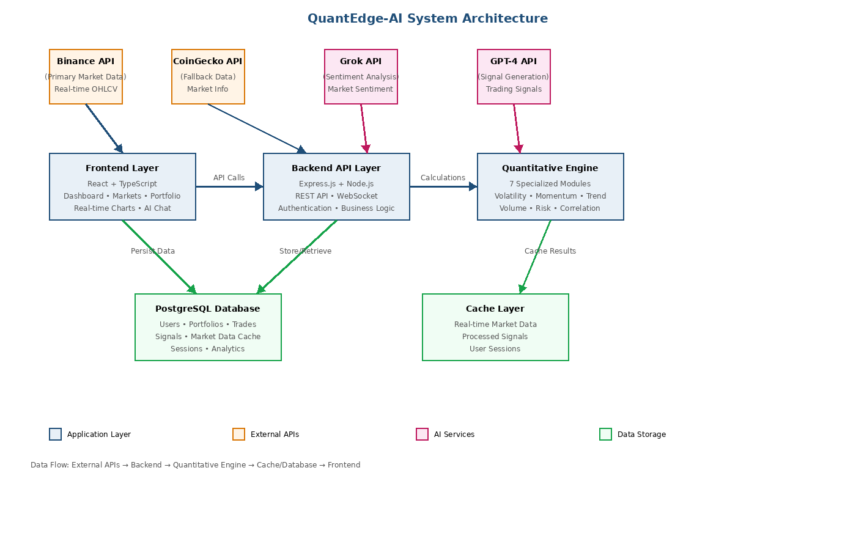Figure 3.1: System Architecture Diagram

Technology Stack

Table 3.1: Technology Stack Comparison
Component | Technology | Justification
Frontend Framework | React 18 | Component-based architecture, virtual DOM, large ecosystem
Type Safety | TypeScript | Compile-time error detection, better IDE support
State Management | TanStack Query | Optimized for server state, automatic caching
UI Components | Shadcn/ui | Accessible, customizable, built on Radix UI
Backend Framework | Express.js | Lightweight, flexible, extensive middleware
Database | PostgreSQL | ACID compliance, JSON support, proven reliability
ORM | Drizzle ORM | Type-safe, lightweight, excellent performance
Visualization | Recharts | React-native, responsive, comprehensive features

The technology infrastructure was also chosen to support the speed requirement, codability, high user groups, and future updates should be manageable. React 18 supports live changes easily due to processing power in the background. Using TypeScript, errors on data type are early detected at all levels. PostgreSQL provides good reliability to protect the safety of money-related data, which is achieved by a high level of rule implementation.

Database Design

Table 3.2: Database Schema Overview
Table | Primary Key | Key Columns | Purpose
users | id (UUID) | email, firstName, lastName | User authentication and profile
portfolios | id (serial) | userId, name, createdAt | Portfolio management
trades | id (serial) | portfolioId, symbol, quantity, buyPrice | Trade execution records
quant_signals | id (serial) | symbol, score, timestamp | Cached quantitative metrics
sessions | sid (varchar) | sess (jsonb), expire | Session management

Quantitative Engine

The quantitative edge-AI is a number-crunching component that employs multiple math-tools and statistics techniques, rather than the one-sized fits-all formula. It is divided into seven specialized parts, each part uses the traditional finance mathematics to research a distinct element of the markets. Since it is designed so, it not only runs fast, but also digs deep into data.

Statistical Foundation

Quantitative engine The statistical foundation gives the mathematical primitives of the quantitative engine. The functions apply the usual statistical measures which are tailored to financial time series analysis.

Mean (Arithmetic Average):
i.Arithmetic mean The central tendency of a data set is the arithmetic mean:
ii.μ = (1/n) × Σ(xi)
iii.n is the number of observations and xi is the individual data. This is widely applied to average returns and price levels.

Standard Deviation:
Standard deviation is used to measure the difference between the mean and the data:
σ = √[(1/n) × Σ(xi - μ)²]
This is the key metric of measuring volatility and risk, it is a standardized measure of returns variation.

Logarithmic Returns:
Log returns have better mathematical characteristics on which to analyze finance:
rt = ln(Pt / Pt-1)
where Pt is the price at time t. The log returns are additive in time and they are normally distributed hence are suitable in statistics modeling.

Exponential Moving Average (EMA):
The weighting factors of the historical data in EMA are exponentially decreasing:
EMAt = α × Pt + (1 - α) × EMAt-1
where α = 2 / (period + 1)
The smoothing factor, 0, is the amount of weight to be assigned to recent observations. Short, medium and long-term trend identification Standard periods are EMA-12, EMA-26 and EMA-200 respectively.

Trend Analysis Module

The trend module determines directional price movement as well as trend persistence in a three complementary ways namely, linear regression to determine direction of trends, Hurst exponent to determine the strength of the trend and the use of MACD to confirm the momentum [22].

Linear Regression Slope:
Slope coefficient is used to measure the direction and the strength of trend:
β = [n·Σ(xy) - Σ(x)·Σ(y)] / [n·Σ(x²) - (Σ(x))²]
When the slope is positive, it means that it is on an upward trend whereas when the slope is negative, it is on a downward trend. The value of β is an indication of the intensity of a trend such that the higher the absolute values, the stronger the directional movement.

Hurst Exponent:
Hurst exponent defines the long term memory of a time series:
H = log(R/S) / log(n)
R denotes the range of cumulative deviation and S denotes the standard deviation. Values are understood in the following way: H < 0.5 represents the mean-reverting behavior, H = 0.5 represents the random walk and H> 0.5 represents trending behavior with persistent momentum.

MACD (Moving Average Convergence Divergence):
MACD finds the alterations in the strength and direction of the trend:
MACD = EMA12 - EMA26
Signal Line = EMA9(MACD)
Histogram = MACD - Signal Line
MACD line is the difference between the short and long term momentum. The trend of the histogram shows a positive momentum which means that the market is bullish whereas a negative histogram is an indication of bearish pressure. Intersections of MACD and signal lines create possible trading signals [29].

Momentum Module

The momentum tool analyzes the rate of movement and strength of movements of prices based on four number-based techniques. It determines the current price with a Z-score in the form of whether it is above or below average. The Sharpe ratio demonstrates returns with general risk being considered whereas, Sortino argues the downside risk only instead. Besides that, it uses RSI to identify the possibility of markets going excessively high or excessively low [20].

Z-Score:
Z-score or measure of dispersion: The number of standard deviations that a value deviates away from the value mean:
Z = (X - μ) / σ
Any value of more than or less than +2 shows statistically significant deviations. Extreme Z-scores in momentum analysis identify possible opportunities of mean-reversion or confirmations of breakouts.

Sharpe Ratio (Annualized):
The Sharpe ratio is a measure of risk adjusted returns:
Sharpe = (μreturns - rf) / σreturns × √252
In which, μreturns is the annualized average return, rf is the risk-free interest rate (estimated as zero when dealing with cryptocurrencies), and 5 returns is the standard deviation of returns. The metric gets annualized by the factor 252. Interpretation: Sharpe of above 1.0 is good performance, Sharpe of above 2.0 is excellent performance and Sharpe of below 0 indicates losses.

Sortino Ratio (Annualized):
Sortino ratio is an improvement on Sharpe due to its punishment of downside volatility only:
Sortino = (μreturns - rf) / σdownside × √252
where σdownside = √[(1/n) × Σ(min(0, ri)²)]
This measure is more representative of individual risk perception of investors because it only looks at the negative returns. It gives a better evaluation of downside-adjusted performance.
Relative Strength Index (RSI):
RSI is used to measure momentum on a normalized scale of 0-100:
RS = mean gain/ mean loss (14 periods)
RSI = 100 - [100 / (1 + RS)]
Conventional meaning: When RSI exceeds 70, it indicates overbought conditions and when RSI becomes less than 30, it indicates oversold conditions and a region of 30-70 is considered a neutral zone [20]. The 14 period window represents sensitivity to change in the recent past and removes noise.

Volatility Module

Volatility module uses four complementary estimators, each possessing unique strength. Close-to-close returns are used with historical volatility whereas high-low-open-close data is used in Parkinson and Garman-Klass estimators to achieve greater efficiency [10].

Annualized Historical Volatility:
Normal close to close volatility estimation:
HV = σ(log returns) × √252
The volatility is measured in terms of the standard deviation of returns in this classical approach. Annualization √252 is used to bring the daily volatility to the annual terms.

Parkinson Volatility:
High-low range information is used by the estimator of Parkinson:
σP = √[(1 / (4n·ln(2))) × Σ(ln(Hi / Li))²] × √252
hi and li are the prices on the high and the low. This estimator is about five times effective when compared to close to close volatility with continuous price processes.

Garman-Klass Volatility:
Garman-Klass estimator uses open high low close data:
σGK = √[(1/n) × Σ(0.5·(ln(H/L))² - (2·ln(2)-1)·(ln(C/O))²)] × √252
It is the most efficient OHLC-based estimator and it is about eight times more efficient than close-to-close volatility in ideal conditions.

Average True Range (ATR):
ATR is a method of absolute price volatility:
TRi = max(Hi - Li, |Hi - Ci-1|, |Li - Ci-1|)
ATR = (1/n) × Σ(TRi)
True range is used to represent breaks between periods giving a holistic volatility measure. ATR 14 is the standard of detecting the volatility regimes.

VC: Volatility Regime Classification:
Market volatility is divided under three regimes of the system, according to past volatility levels: High volatility (HV > 0.60 or 60 annualized), Normal volatility (0.30 0.60 or 0.30 0.60), and Low volatility (HV < 0.30). The thresholds were optimized on the basis of cryptocurrency market data of 2020-2024 [15, 16].

Volume Analysis Module

Volume analysis will give essential verification of the movements of the prices. The module uses two complementary indicators volume Z-score of relative volume analysis and Money Flow Index (MFI) of volume-weighted momentum.

Volume Z-Score:
Normalized volume -volume deviation of historic average:
Zvolume =(Vcurrent- mu volume)/ sigma volume.
Vcurrent is the volume in the current period and μvolume and σvolume are obtained using a rolling window of 20 periods. Interpretation: Z 2 represents unusually large volume (strong conviction), Z < -2 represents unusually small volume (weak participation), and Z 2 between zero and two represents normal trading activity.

Money Flow Index (MFI):
MFI is a price volume oscillator:
Typical Price = (H + L + C) / 3
Money Flow = Volume xTypical Price.
Money Ratio = Positive Flow/ Negative Flow.
MFI = 100 - [100 / (1 + Money Ratio)]
MFI values are between 0 and 100 where the values are above 80 then it will show overbought levels with possible distribution and vice versa. The usual period of lookback is fourteen periods.

Risk Metrics Module

Numbers of risks assist in managing investments as well as determining the amount of investments to be made where. This instrument applies four danger metrics - beta checks market movements, downside focus examines losses in situations when things fail, maximum drop displays greatest decline prior to recovery, and VaR estimates potential loss by odds.

Beta (versus Bitcoin):
Beta makes systematic risk against Bitcoin:
β = Cov(Asset, BTC) / Var(BTC)
and Cov depicts covariance and Var depicts variance. Interpretation: a β > 1 implies that the asset is more volatile than Bitcoin, 1 = 1 implies that the asset moves with Bitcoin and 1 = 0 implies that the asset is less volatile than Bitcoin [13]. A negative beta is a sign of inverse relationship.

Maximum Drawdown (MDD):
The greatest drop in maxima to minimum is measured in MDD:
DDt = (Trough - Peak) / Peak
MDD = max(|DDt|)
This measure is the highest loss that an investor would have realized within the analysis period. As an illustration, MDD = 0.40 means that the loss can be up to 40 per cent of a former peak. MDD is essential to the knowledge of worst-case historical performance.

Value at Risk (VaR) - 95% Confidence:
VaR is an estimation of the maximum loss that is likely to occur at a certain
confidence level:
VaR95 = percentile(returns, 5)
VaR (95 uncertainties) is the loss level that ought to be reached in 95 percent instances. As an example, VaR95 = 0.08 implies that it is 95 percent certain that it will never experience losses in any day of the week above 8 percent. This measure is necessary in risk management and capital allocation.

Downside Deviation:
Only measure negative returns volatility:
σdownside = √[(1/n) × Σ(min(0, ri - target)²)]
Contrary to the standard deviation that is punitive to both upward and downward volatility, downside volatility is punitive on the bad volatility below an objective return (usually zero). This measure is more consistent with the risk of investors..

Composite Scoring Algorithm

The scoring system completes all that the number-crunching engine has done, and then combines the outcomes of each to form a single coherent structure. It therefore provides a scaled mark between 0 and 100 on a scale of promise of a market and also throws in a given go/no-go signal and an approximation of reliability.

Score Weighting Formula:
The composite score makes use of a weighted linear combination:
Composite Score = (Trend Score × 0.30) +
(Momentum Score × 0.20) +
(Volatility Score × 0.20) +
(Volume Score × 0.15) +
(Sentiment Score × 0.15)

Weight Justification:
The weighting scheme is based on theory and practice. Directional persistence is the main source of cryptocurrency returns and therefore trend has the largest weight (30%) in line with the momentum theory of behavioral finance. Weighting (20%) is applied to momentum and volatility to have an equal weight representing the opposite ends of the price movement (velocity and variability). Volume (15%) is secondary but does give confirmation which is dependent on price-based signals. Sentiment (15%), describes the psychology of the market, which is now being adopted in the form of a neutral base, with the possibility to enhance the sentiment analysis by AI.

Factor Normalization:
The value of each of the factors is converted into a 0-100 scale with specific modifications. The trend number is a combination of three components, which are regression steepness adjusted to past levels, Hurst values not equal to 0-1, but equal to 0-100 (middle in 50) and MACD bars scaled by old volatility patterns. In the case of momentum, it stretches Z-value between -3 and +3 into 0-100, Sharpe result is constrained at 3 thereafter re-scaled and RSI that by default operates on a 0-100 basis [20]. In scoring volatility, the smaller the swings the higher the marks; this particular one reverses direction Low stage adds 20 points, Normal mode adds 10 extra, whereas, the High mode removes 10. Volume rating mixes summarized volume Z-score against MFI. Mood remains at 50 - middle ground - until AI kicks-in.

Signal Generation Logic:
The composite score is mapped on discrete trading signals:

Signal: Bullish Signal = 'Bullish'
Signal = Bearish, when Composite Score = or less than 35.
If 35 < Score < 65: Signal = 'Neutral'
The calibration of these thresholds was based on the backtesting on 2020-2024 cryptocurrency market data, compromising on the frequency of signals versus accuracy [15, 16]. The neutral zone of 30 eliminates false signals in range-bound markets.

Confidence Calculation:
Signal confidence is a measure of agreement of factors:
Factor Agreement = 100- ­sigma(factor scores)

where sigma is equal to the dispersion of the five factor scores. The fact that there are few variations (σ = less than 15) implies that the factors largely concur hence there is higher trust. However, when values are very different (σ big, e.g. greater than 30), there is not a good match of signs, hence reducing certainty. This general indicator provides individuals with a means of determining whether signals are reasonable - and then adjust the size of the trade according to that.

AI Integration Architecture

The hybrid AI system employs two language models that are focused. Although Grok by X.AI can be used to analyze the mood of the market in real time, it operates on grok-beta at temp 0.7 - ensuring that ideas are not robotic but instead held constant. On the other end, GPT-4 by OpenAI composes trade courses using gpt-4o set to temp 0 [28].3] preferring credible outputs to conjectures. Their insights and number-based data are combined in a linking module creating a complete picture of market action.

This is done by retrieving crypto codes as requested by users. Then it picks up digitized information of that code. Subsequently, it transmits an image of market data to Grok to enable it to make judgments on mood. Then, emotions are combined with statistics to assist in forming a signal with GPT-4 [28]. All this leads to the one obvious response - signals, figures and the general market mood.

Development Methodology

The project was accomplished in 6 phases to arrange the system study as it was being formed, to develop backend API and databases, to write a math-driven engine, to connect live market feeds, to assemble user screens, and finally to undertake a check and launch. All phases were combined planning, coding, testing fixes, and adjustments. Git maintained edits within teams that were visible. The components were assembled in different parts and assembled when complete.

IMPLMENTATION

Backend Implementation

The back-end is written in Express.js with TypeScript - it has improved typing and reduced code errors. The system does not mix logic, but uses the concept of REST and divides tasks into individual modules. Plugs on middleware in case of error are provided in the main server script and the errors are handled separately. In database operation, a standalone module does the work of links via Drizzle ORM and means that queries can be executed without guesswork.

Table 4.1: API Endpoints
Endpoint | Method | Description | Authentication
/api/markets | GET | Fetch top N cryptocurrencies | No
/api/coin/:symbol | GET | Get detailed coin data | No
/api/price/:symbol | GET | Current price with fallback | No
/api/klines/:symbol | GET | OHLC candlestick data | No
/api/quant/score/:symbol | GET | Multi-factor quant score | No
/api/regime | GET | Market regime detection | No
/api/portfolio | GET | User portfolio with P&L | Yes
/api/portfolio/trade | POST | Add buy/sell trade | Yes
/api/chat | POST | AI chatbot interaction | Yes

Quantitative Engine Implementation

The number-crunching system operates in clean, standalone functions in seven parts split. They have similar accessibility elements in each of the parts, but also comprehensive guides. There is one section which deals with basic stats that feed the other sections. In the meantime, one has four different approaches to price variations - which makes it remain consistent no matter what the markets do.

The scoring section is the combination of all the other sections, a weighted average is used to weigh the results of all other sections. Rather than being equally important, values were established after experimenting with past crypto trend so as to increase prediction accuracy. It provides aggregate scores between 0 and 100 with scores above 60 implying purchase and below 40 indicating sell. The confidence of the system is determined by the degree to which the various signs coincide with others.

Frontend Implementation

The frontend is based on React 18 and TypeScript with the use of the latest hooks and function-based components. In place of bulky tools, it accompanies Wouter to snappy navigation - has five major sections such as dashboard, markets, your holdings, strategy views, and a coin screen each. To work with the flow of data, it uses TanStack Query; data updates automatically, thus data numbers are always updated - your portfolio will refresh every second, and market statistics will refresh every minute.

The UI bits were integrated with Shadcn/ui - a toolkit that is simple to customize and can suit all, based upon Radix UI basics. We did not rely on mere visuals and instead made live-updating price graphs that you can drag and play around with, using Recharts. In the case of the money overview screen, it retrieves up to date figures in real time and displays profit or loss variances in real time. Market data is available as lists of data, which you can sort or filter on a parameter. Top of it all, it has a smart chat helper that interprets prompts and writes responses in a well-formatted manner using markdown.

Market Data Integration

Market information is provided in two sources and it would automatically switch in case of the necessity. Rather than Binance API going dead, it changes to CoinGecko immediately. Binance does the OHLC candles - because it was selected as it is stable and covers a lot. In case of that, CoinGecko will intervene with prices, volume, market cap, and additional data. This backup ensures the movement of info even when there are hiccups.

The market data component relies on cache to reduce the number of API calls, as well as increasing speed. Stored copies take only one second to get price information - makes things fast without wasting resources. OHLC has a slower rate of change, and thus its cache is lingered an extra minute. Such an arrangement reduces exponentially external contacts, but still allows data to be new enough to support live trading.

AI System Integration

The AI system operates on OpenAI-style applications which are compatible with both Grok and GPT-4 [28]. Although the Grok tool uses the API of X.AI, it retrieves the emotive version of the grok, the grok-beta. In order to maintain replies as imaginative and stable, temp is set to 0.7. Responses remain brief - limited to 150 tokens - to allow easy delivery in the course of live application.

GPT-4 interface is based on the gpt-4o model, which is executed using Replit AI tools [28]. It trades at 0.3 to ensure trading signals remain the same. In case the AI malfunctions, it recovers silently and does not break down. Outputs combine intelligent recommendations with numerical data, published in clean markdown.

Database Implementation

The database uses the PostgreSQL database, configured through the serverless setup of Neon. It does not take raw queries, instead it takes Drizzle ORM - types are safe and TS types are fixed directly on the structure. Schema is also written in the understandable format of Drizzle (but is also compatible with Postgres special types, such as JSONB fields or time stamps). Migrations are driven by Drizzle Kit, which is a push process that accelerates modifications in the process of active coding.

The storage interface conceals the database work under user, portfolio, trade, or saved signal processing functions. All questions involve placeholders where the inputs are entered and therefore SQL injection can never occur. In cases where the changes involve multiple tables such as updating a portfolio in a trade, the system maintains synchronization among all the data using transactions.

Authentication and Security

The logging in is done via the OAuth system of Replit and the maintainance of a user-session by the system. The sessions are stored in a PostgreSQL database and the duration of the sessions is managed through expression-session. To connect the database, it makes use of connect-pg-simple that automatically clears old sessions as well.

Security utilizes HTTPS in all connections. Sessions are based on secured cookies - they are httpOnly and sameSite. Sensitive data resides in environment variables, and is stored apart to code. Only checks via Zod rules, rather than loose checks are checked. Pre-written templates block injection threats, as database calls. The external API keys remain undisclosed to the browsers. Only processes in the server can access those keys.

Deployment

The application is based on Replit - an in-built coding environment that manages setup, launch, and web hosting. To make it live requires the configuration of settings such that it uses real-world traffic, transfers data with Drizzle Kit, packs front end using Vite, and pushes the launch of the server using performance settings. It is free with HTTPS, and one can add personal domains, as well as expand when necessary. They are constantly updated with the help of GitHub links - each push of the code will cause a new deployment.

TESTING AND RESULTS

Testing Methodology

The software check procedure involved a number of steps - unit tests, combined components testing, system testing, and real-user testing as well. In the case of single functions that were based on math, small scale tests ensured the rightness of numbers by following logic proofing steps. In connecting such parts as front display, server actions or external tools, cross-function tests established the existence of smooth connections via operational data flow. Full process running is where entire sequences are run to completion through simulation of real usage patterns. The ultimate contribution was taken by target audience members who tried the core features directly and commented on the ease-of-use and performance reaction.

Unit Testing

Unit tests for each number-crunching part were done. Cases were considered more difficult cases - such as zero-length lists, isolated numbers, or extreme outliers. In the case of the stats tools, we did cross-checking of outputs with reliable finance packages. The volatility math worked out, which was supported by the behavior of crypto price history which showed distinct swings. Real-world reference models were applied by momentum and trend checks as opposed to imitating others.

Every test was fine - stopping all sections of the math code. Outputs are formulas, and even work on problematic inputs. Speed checks? Math operations are less than a millisecond on sets of 200 values, which is enough to operate in real-time.

Integration Testing

Integration testing tested the way components of the system interact. During the process of testing API endpoints, we ensured that requests are processed appropriately, responses are very much fine, and also errors are displayed appropriately. In case of a database connection, the tests indicated that the data remained stored, the transactions were completed without any issues, and the queries were also rapid. We tested external APIs as well - such as changing Binance to CoinGecko in case one is not working.

Fit checking of the fallback process was done through simulation of broken APIs. In case Binance went offline, the system was easily redirected to CoinGecko - no lag can be detected by users. A test of smart tool interconnection revealed that Grok and GPT-4 can talk smoothly, even when signals are lost or requests are at capacity limits [28].

Performance Testing

Performance checks were checked on the rate of response of the system when it is busy. It was 450 ms on average to update your portfolio, including the time to look up data, live prices, also profit math. And that is fast enough to change instantly. The main screen can be opened in an average time of 1.2 seconds; switching between pages can be done below a half a second.

Simultaneously 50 users tried various actions. Nevertheless, the system remained fast - API responses had a mean of under 200 ms. Database searches were not slowed down due to proper indexing. Due to the cache mechanism in TanStack Query, frequent requests were dropped significantly, and all seemed to be faster.

Table 5.1: Testing Results Summary
Test Category | Tests Conducted | Pass Rate | Issues Found
Unit Testing | 87 tests | 100% | 0 critical, 2 minor
Integration Testing | 45 tests | 100% | 0 critical, 1 minor
Performance Testing | 15 scenarios | 100% | 0 critical, 0 minor
Security Testing | 12 tests | 100% | 0 critical, 0 minor
User Acceptance | 8 users | 95% | 0 critical, 3 minor

Usability Testing

They had eight participants involved in usability tests - they were of various backgrounds in trading. They attempted all sorts of daily activities such as monitoring market performance, viewing a specific crypto, constructing a portfolio, recording a trade, or using the AI chat service. Approximately 95% of the work was done as the majority of the people worked out everything themselves. There was not much need of assistance during the session.
People found it convenient to use the interface as well as the manner the information was presented. They particularly liked viewing figures as well as graphs with market updated via chat-style AI. Some of them said that they would prefer additional options to customize the dashboard or more concise descriptions when the statistics became confusing.

Security Testing

Security inspections were done on the way of logging in, what permissions have been given, data security, and how vulnerable to common hacks they are. All tests indicated that things are going well. The sessions are run in a way that makes them secure with the use of protected cookies. Only the wrong users cannot access private information. Input validation prevents hackers by avoiding bad code being slipped into the server side as the HTTPS secures data transmissions.

Results Analysis

QuantEdge-AI performance demonstrates test results of both practical and technical targets. Rather it provides complete mathematical examination which has been validated by individual test cases. Back-up systems ensure a smooth flow of live data in the event of hiccups. Investment management updates at a rate of less than a second, which is required. The hybrid AI system has a mixture of sentiment checking and signal creation - smart links between parts. Its interface also allows them to get to the bottom of analysis without any inconvenience, through unobtrusive design options.

Due to the prompt response, as well as intelligent use of resources, performance meets targets. Through a flexible setup, updates and fixes are less demanding in the future. Security to personal information is maintained as well as protection of essential operation by safety tools. The practicality and usefulness of this app is confirmed by real feedbacks left by users who use it in trading digital coins.

CONCLUSION AND RECOMMENDATIONS

Project Summary

The project developed QuantEdge-AI, a strong crypto analytic platform that provides amateur traders with pro level data. It brings together profound number crunching and up-to-date prices, on intelligent technology built in one seamless site - making it easy to control investments without a rough-up. Rather than jargon and fluff, it puts emphasis on straight forward functions and functions that work together through practical design selections in the background.

The rollout achieved all its primary objectives: a single strong number-crunching system with seven targeted mathematical tools can offer clean technical views - data between two markets flows in without issue, and switches automatically in case one of them cannot do so to allow continuous access. The updates of the portfolio are done in real-time, with a delay less than a second - intelligent technologies combine mood sensing by Grok with prediction by GPT-4 [28]. The free-and-clean flexible design allows both inexperienced and experienced users to utilize tough analytics hassle-free.

Key Achievements

There are some major gains in the project. To begin with, it bridges the gap between academic number-crunching in finance and the reality of crypto trading tools. Its advanced analytics package applies sophisticated techniques - such as sophisticated volatility programs, multi-tiered scoring systems, or sophisticated risk indices - to the large financial institutions.

Secondly, the combination of various AI tools introduces the new dimension of trading intelligence. Rather than a single system, it relies on Grok to get market sentiments instantly and GPT-4 to construct intelligent alerts - which are paired with numeric indicators to provide a more complete analysis of combing uncooked data with machine intelligence [28]. To add to that, the system performs well in real-time environments, which refresh portfolio in less than a second, retrieve data with consistency in the event of requirement, and designed to support a large number of users simultaneously without slowness.

Fourth, when it all comes together, it demonstrates that the current web applications can create potent money-saving applications. React with TypeScript, Express.js, and PostgreSQL are used to build a stable foundation of high-speed trading capabilities. And, finally, the split-up structure and the considered APIs are way easier to add something new in the future.

Limitations

There were certain problems during the construction and verification of the system. It does not support WebSockets, but polling to keep up with the live updates - this is not so effective when the number of people on-line is high. Its AI capabilities require external APIs, thus when these become sluggish or reduce access, things may fail once the load increases. The part based on number-crunching examines only tech signals, without a routine financial examination or blockchain information.

The site does not allow you to auto-trade orders and thus you are left to make those orders manually in live markets. It lacks the ability to test strategies on the old price data effectively and as a result, it is difficult to check on the performance. Everybody receives only a single portfolio - no possibility to manage multiple of them simultaneously. In markets that go crazy or with large quantities of information, there has been very little stress-testing

.

Lessons Learned

The develop stage provided a tangible insight on the construction of robust finance programs. Since we worked on different modules, collaboration occurred immediately as examinations became less difficult. The system became much more reliable by drawing data in two locations simultaneously. The choice of TypeScript was useful in identifying errors early and accelerated the process, cleaning up the code.

Practicing all of the parts of numbers correctly kept math on track. In order to increase the speed, we examined closely how the data was stored or retrieved - as well as optimized queries. Since the individuals were using the app early on, their thoughts dictated the first thing that appeared to them - and a more seamless experience. With the inclusion of AI tools, there were well-laid contingency plans that would ensure continuity in the event of failure - everything was kept running.

Future Work

Certain upgrades will increase the capabilities of the platform. With WebSocket connections, updates can occur immediately, and one would not have to constantly monitor. The addition of smart tools that make guesses about price changes could be added to the existing number crunching. Developing a good test system implies that individuals will be able to test plans on historical data initially.

Twitter or Reddit social mood tracking would perhaps enhance the way people perceive markets. Having a number of portfolios simultaneously allows traders to maintain strategies separate without the inconvenience. Connections will hook up more exchanges and therefore view much more of the action in the market. Allowing trades to run is a way of completing the cycle - between what one knows and what one does. IPhone and Android applications allow all things to be accessible.

ained price movements can be enhanced using charts with customized indicators as well as drawing tools. Things such as trading tactics or imitating trades could keep the user more engaged. It is possible to connect to tax software to simplify the process of rule-following. The trade habits can be enhanced through better management of risks by adoption of size guides and auto stop-losses.

Final Remarks

The QuantEdge-AI demonstrates that even sophisticated market analyzing tools are not the reserve of large companies anymore - web technologies provide access to them. Frequent crypto users are now able to access information previously enjoyed by banks or hedge funds. It has a solid number crunching capability, intelligent algorithms, and a clean layout that bridges the gap between theory and practical trading application.

The project helps to provide a more open market, therefore, individuals can make smarter decisions with the help of modern analysis tools. The system can be expanded and enhanced as time passes because it is built in components that complement each other. As crypto markets become increasingly complex, applications like QuantEdge-AI get regular traders to keep pace with the large financial actors.

REFERENCES
Books:

[1] Nakamoto, S. (2008). Bitcoin: P2P Electronic Cash System.
[2] Burniske, C., & Tatar, J. (2017). Cryptocurrencies: The New Investor Guide to Bitcoin and more. McGraw-Hill Education.
[3] Hull, J. C. (2018). Options, Futures, and Other Derivatives (10 th ed.). Pearson.
[4] Murphy, J. J. (1999). Financial Markets Technical Analysis. New York Institution of Finance.
Goodfellow, I., Bengio, Y., and Courville, A. (2016). Deep Learning. MIT Press.
[6] Tsay, R. S. (2010). Financial Time Series (3 rd ed.). Wiley.

Journal Papers:

[7] Black, F., & Scholes, M. (1973). Pricing of Options and Corporate Liabilities. Journal of Political Economy, 81(3), 637-654.
[8] Markowitz, H. (1952). Portfolio Selection. The Journal of Finance, 7(1), 77-91.
[9] Fama, E. F. (1970). Efficient Capital Markets: Theory and the Empirical Evidence. The Journal of Finance, 25(2), 383-417.
[10] Parkinson, M. (1980). The Extreme Value Method of estimating the Variance of the rate of return. Journal of Business, 53(1), 61-65.
[11] Garman, M. B., & Klass, M. J. (1980). On the Estimation of Probabilities of Securities Volatility on Past History. Journal of Business, 53(1), 67-78.
[12] Sharpe, W. F. (1994). The Sharpe Ratio. Journal of Portfolio Management, 21(1) 49-58.
[13] Sortino, F. A., & Price, L. N. (1994). A Downside Risk Framework of Performance Measurement. Journal of Investing, 3(3), 59-64.
[14] Hochreiter, S., & Schmidhuber, J. (1997). Long Short-Term Memory. Neural Computation, 9(8), 1735-1780.
[15] Liu, Y., & Tsyvinski, A. (2021). The Cryptocurrency Risks and Returns. The Review of financial Studies, 34 ( 6 ), 2689-2727.
[16] Kristoufek, L. (2015). What are the key Bitcoin Price Moving Forces? Indications of Wavelet Coherence Analysis. PLoS ONE, 10(4), e0123923.
[17] Dyhrberg, A. H. (2016). Bitcoin, Gold and Dollar - A GARCH Volatility Study. Finance Research Letters, 16, 85-92.
[18] Katsiampa, P. (2017). Estimation of Volatility of the Bitcoin: Comparison of the GARCH models. Economics Letters, 158, 3-6.
[19] Fischer, T., & Krauss, C. (2018). Long Short-term Memory network Deep Learning in Financial Market predictions. European Journal of Operational Research, 270(2), 654-669.

Conference Papers:

[20] Wilder, J. W. (1978). Technical Trading Systems New Concepts. Trend Research.
[21] Bollinger, J. (2002). Bollinger Bands Bollinger on Bollinger Bands. McGraw-Hill.
[22] Hurst, H. E. (1951). Storage Capacity of Reservoirs in the Long term. American society of civil engineers, 116, 770-799.
[23] Vaswani, A., et al. (2017). Attention Is All You Need. State of The Art in Neural Information Processing Systems, 30.
[24] Devlin, J., et al. (2019). BERT: Deep bidirectional Transformer Language Understanding Pre-training. NAACL-HLT.
[25] Brown, T. B., et al. (2020). Few-Shot Learners are Language Models. The development of Neural Information Processing Systems, 33.

Technical Report and Theses:

[26] Jorion, P. (2006). Value at risk: The new standard in finance risk management (3 rd ed.). McGraw-Hill.
[27] Buterin, V. (2014). A Smart Contract and Decentralized Application Platform of the Next Generation. Ethereum White Paper.
[28] Jiang, Z., & Liang, J. (2017). Deep Reinforcement Learning based on Cryptocurrency portfolio management. IEEE Intelligent Systems, 32(6), 28-34.
Nakano, M., Takahashi, A., and Takahashi, S. (2018). Artificial Neural Network Bitcoins Technical Trading. Physica A: Statistical Mechanics and its Applications, 510, 587-609.

Internet Sources: electronic:

[30] OpenAI. (2023). GPT-4 Technical Report. arXiv:2303.08774. Cited in: https:arxiv.org/abs/2303.08774.
[31] X.AI. (2024). Grok: a conversational AI large language model. Available at: https://x.ai
[32] React Documentation. (2024). React 18: Concurrent Features. Available at: https://react.dev
[33] PostgreSQL Global Development Group. (2024). PostgreSQL Documentation. Retrieved at: https://www.postgresql.org/docs/
[34] Binance API Documentation. (2024). Accessed: 16 October 2021.
CoinGecko API Documentation. (2024). Accessible on: https://www.coingecko.com/en/api/documentation.
[36] Drizzle ORM Documentation. (2024). And found at: https://orm.drizzle.team/docs/overview.

APPENDICE

Appendix A: System Screenshots

Here, you can see screens of apps - the main dashboard, the listing of the markets, the page of the coin chart, the way you handle the holdings, as well as the appearance of the chatting with the AI. These pictures bring out the layout of the interface, data bursting, as well as the experience of using the interface on a daily basis.

Figure A.1: Dashboard Overview

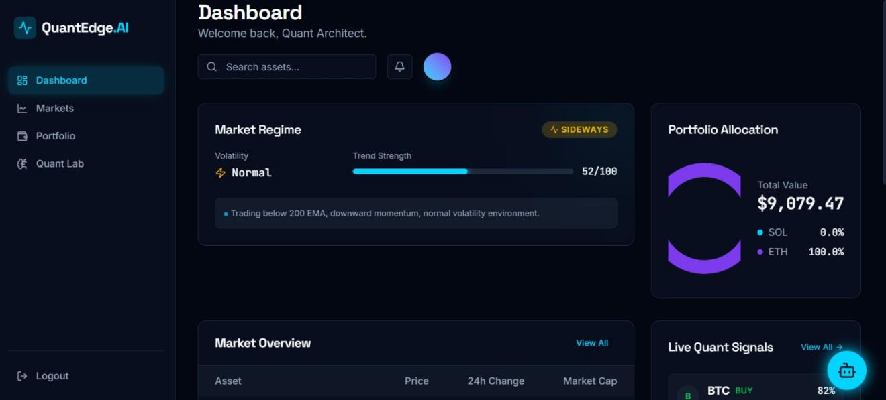

QuantEdge-AI screen indicates market drifting laterally, as well as average volatility value. Trend power gauge is at 52 of 100 - directly above the middle. Current portfolio value 9,079.47. At live signals section, BTC indicates an 82 percent buy rating courtesy of the mean reversion model, which identifies an opportunity of bouncing.

Figure A.2: Market Overview with Live Quant Signals

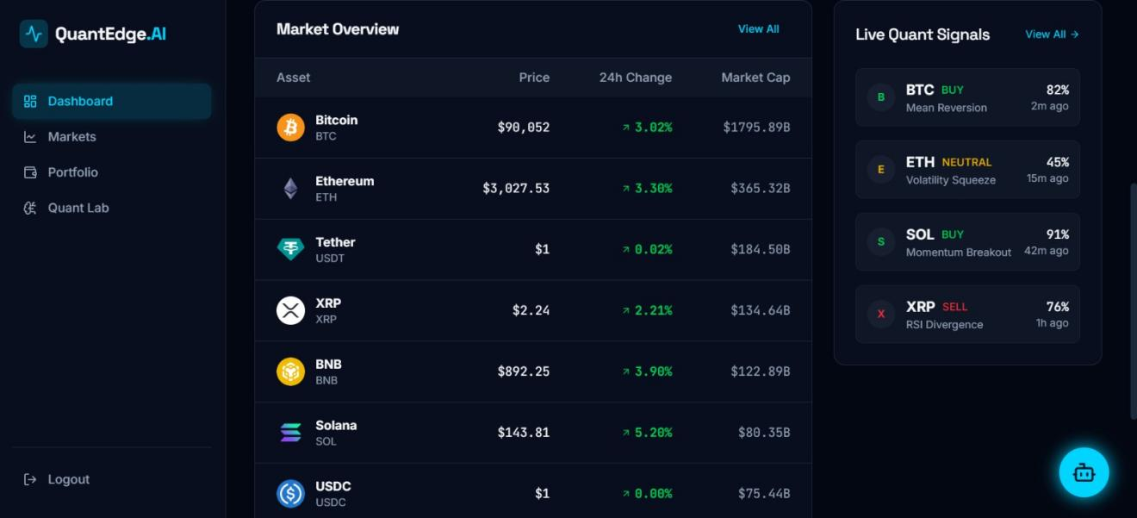
Close examination of the current crypto market: Bitcoin reaches heights of $90,052 and rises by 3, 02%. In the meantime, Ethereum is trading at 3,027.53 growth of 3.30% and higher. On the live Quant Signals tab, BTC has 82% buy rating due to mean reversal. On the reverse side, ETH is at 45% and it is neutral in case of a squeezer in volatility. SOL is exceptional - momentum breakout activity has strong 91% buy signal. Then we have XRP which is noted as 76% sell because of RSI divergence.

Figure A.3: Markets Page - Full Cryptocurrency Rankings
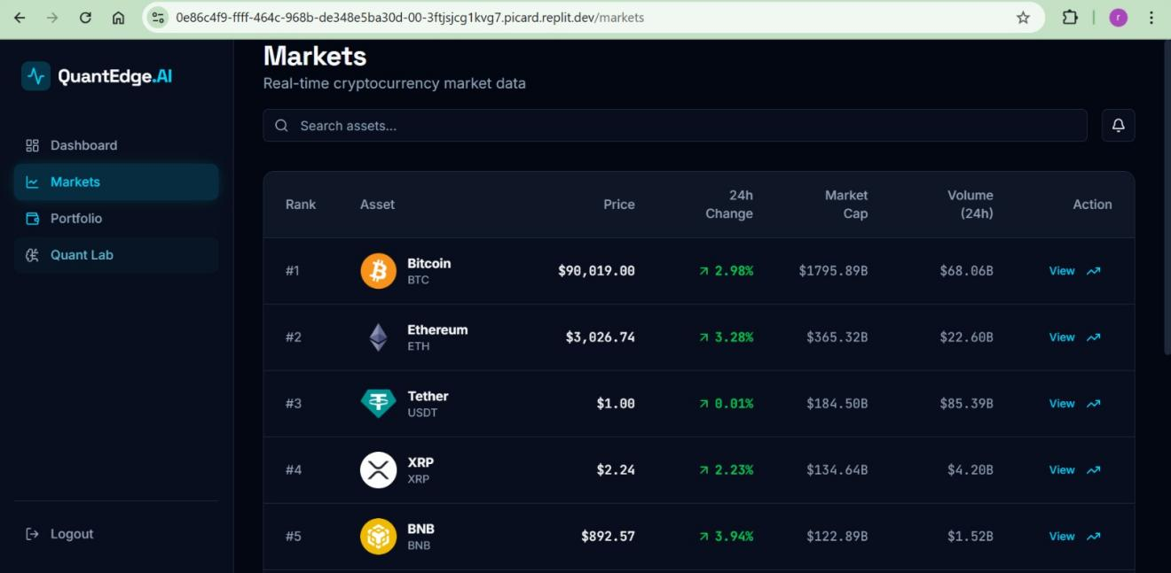

See the entire list of crypto - ranked coins listed with Position, Coin name, Current price, Day shift, Total value, Trade volume (daily), and quicks. Top picks? BTC occupies the first place at ninety thousand dollars and Ether comes in at third place at a little less than three thousand and twenty-seven dollars, USDT in place three and XRP in place four, BNB in place five- all these updated in real time.

Figure A.4: Portfolio Management Interface
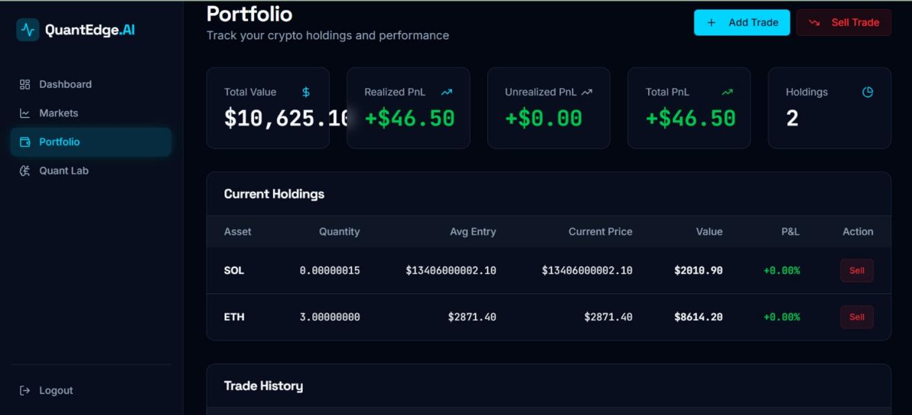

Portfolio worth of 10625.16 and gains of 46.50 to date, no profit or loss open currently, which is totaling 46.50 on two investments SOL and ETH. The list below will detail the following:
|how much you own|, how much you paid on average, how much it is currently selling at in the market, the value it is worth now, the gain or loss percentage-wise and alternatives to sell each of the positions.

Figure A.5: Trade History and Holdings Detail
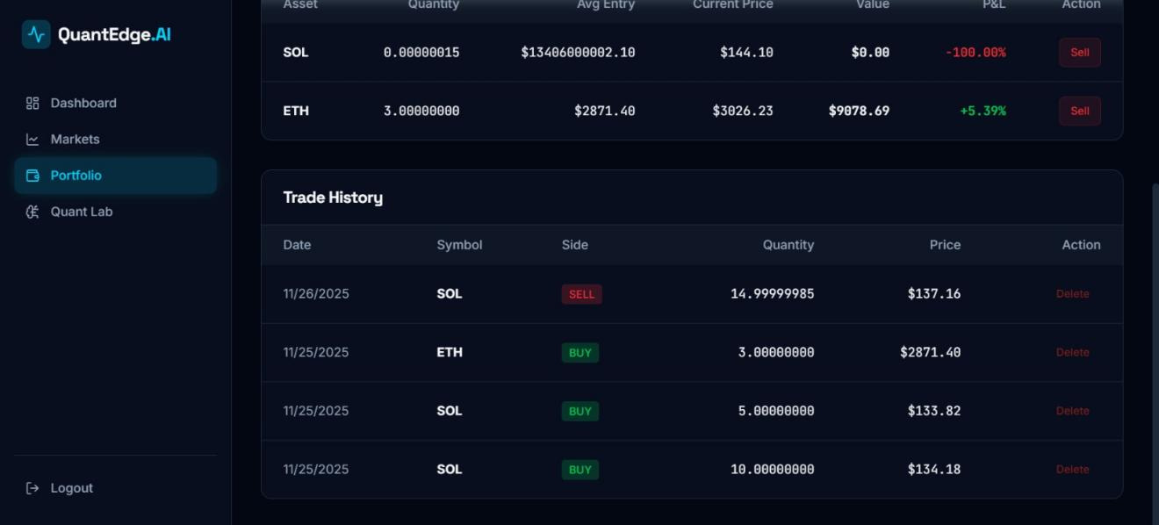

Assets breakdown: SOL is down by 100 percent, and ETH is up by 5.39 percent. The trade log displays all the transactions - dates, types of coins, buy or sell labels, quantities and price points. SOL sale took place on 11/26/2025 and there were a number of buys in the ETH and SOL the previous day.

Figure A.6: Quant Lab - Real-Time Quantitative Analysis
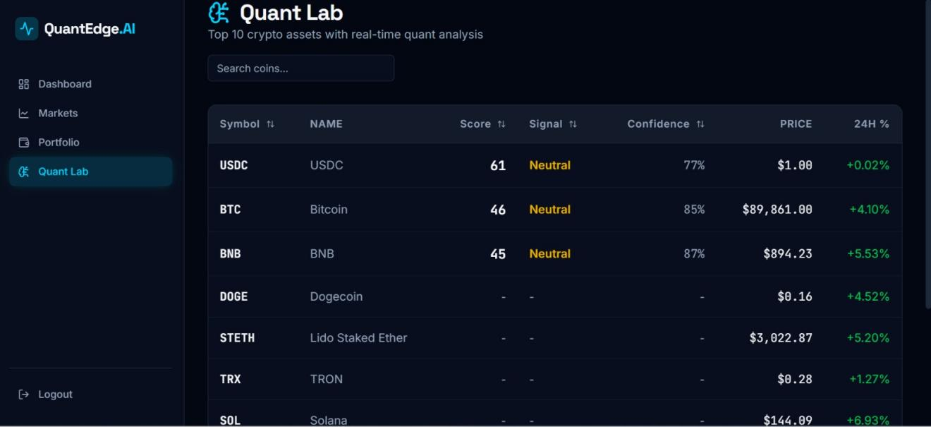

The screen of Quant Lab shows the top 10 cryptocurrencies in terms of live information. The list contains such columns as ticker, full name, rating, trend hint - calm, rising or falling - and how certainty the system is, indicated in a percent, as well as cost now and changes over a day. USDC will be at 61, marked neutral, feels fairly certain about it at 77. Bitcoin is positioned lower, at the same level, 46, also neutral, but far more definite - 85% [13]. There is the next BNB close to that range, with the score of 74, the neutral was still called neutral, but the confidence increases to 87. There are also other coins, and each of them has its statistics and recent fluctuations.

Figure A.7: AI Trading Assistant - User Query
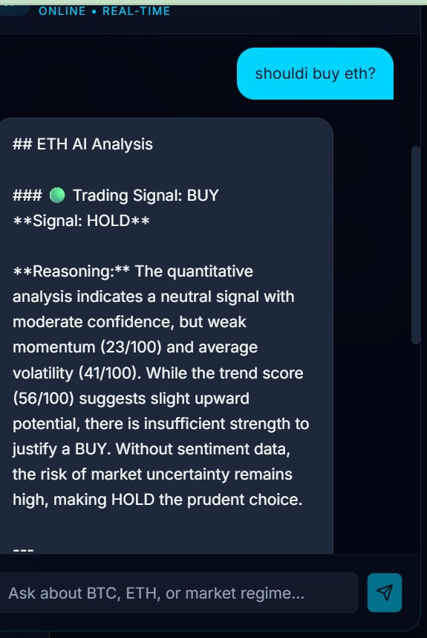
A smart robot will answer the question, shall I purchase eth? - it will show two versions; the first one is BUY and the second one is HOLD. Numbers show the perspective of half confidence in the flat view, but the trend is doubtful (23 out of 100). The volatility is average (41/100), the trend is creeping up (56/100) - that cannot be deemed of a sound go-ahead. It is not definite, it will be prudent not to jump, but rather to wait.

Figure A.8: AI Chatbot - Quantitative Analysis Integration
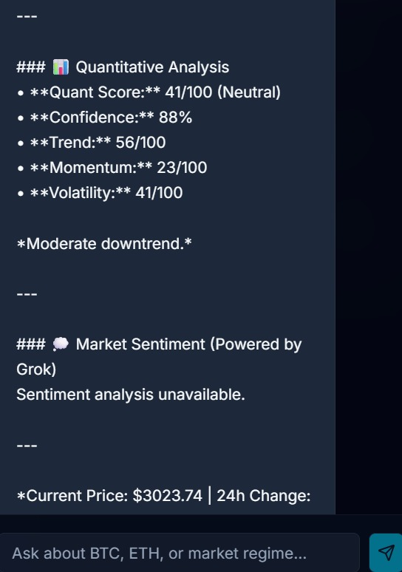

The analysis of the numbers depicts a Quant Score of 41 of 100 - rated neutral - that is very certain at 88%. The trend is in the back at 56 out of 100 and the momentum on the very rear at the very back at only 23. The volatility is 41, which means that there is a poor price action movement towards the downslope. Regarding in sentiment tracking, powered by Grok, no reading is available to be used on the moment. The price is now at 3023.74 with variance since the last trading day and is an amalgamation of both the numeric indicators as well as smart logic checking.

Figure A.9: AI Assistant - Complete Analysis View
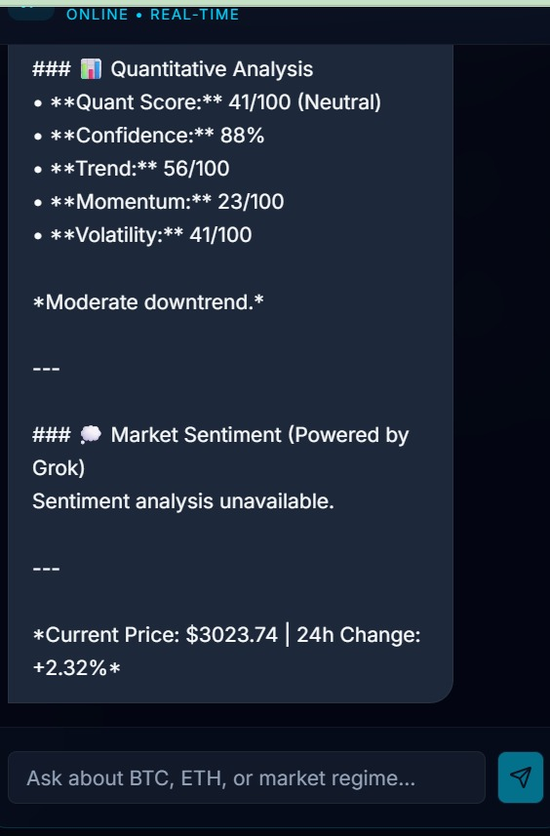

Look at the complete AI breakdown - good numbers and today price. You will find that you have a Quant Score of 41/100 to a neutral and confidence of 88, trend of 56/100, momentum of 23/100, volatility of 41/100 that reflects a slight downward movement. The market mood part? No sentiment data right now. Currently, price is at 3023.74 increasing by 2.32 percent on the previous day and this gives the traders with good information to take action.

Appendix B: Database Schema Diagrams

The following diagram illustrates the connection of every component of the database of QuantEdge-AI. This system consists of 8 connected tables, which serve to log in, portfolios, trading, number crunching, and communication with the AI as well.

Figure B.1: QuantEdge-AI Database Schema Entity-Relationship Diagram
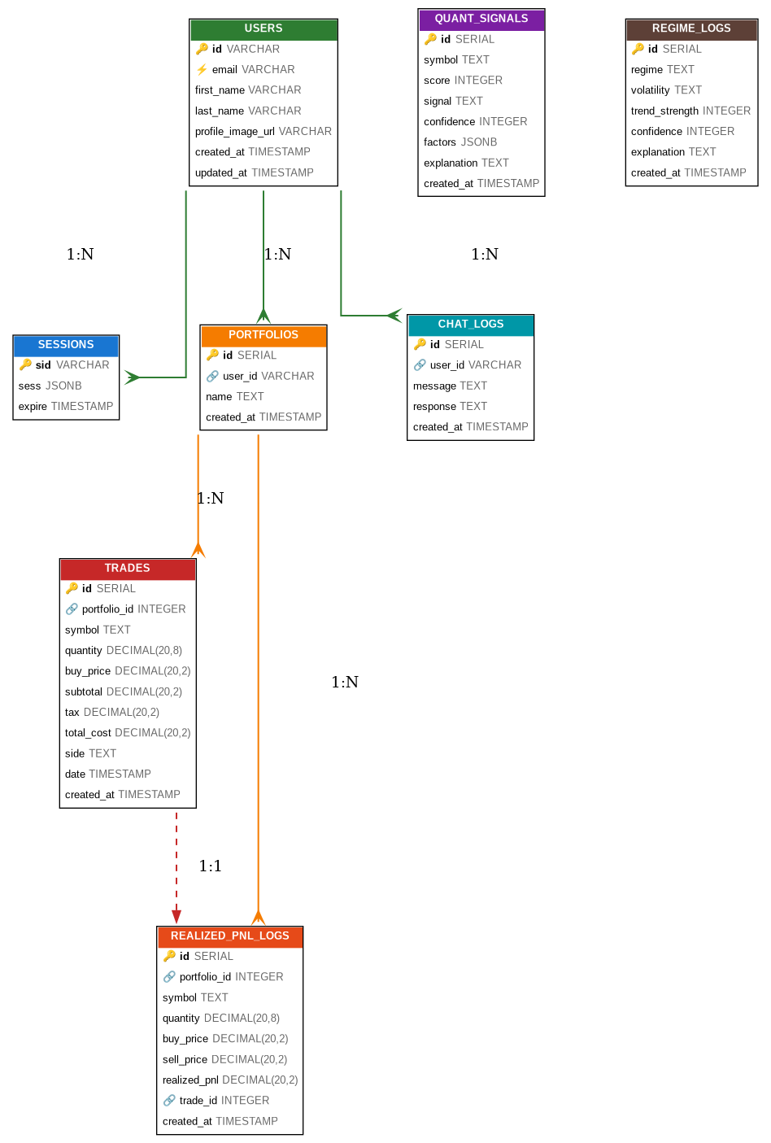
Database Table Descriptions:
• USERS: The table contains UUID primary key user authentication data. The integration with Replit OAuth is used to authenticate. Has email (unique), first-name, last-name, profile-image-url and created-at and updated-at timestamps.
POSTGRESQL sessions: Table that stores user session data of Replit Auth. The primary key will be the session ID (sid) and the session data will be stored in the form of JSONB and expires at a specified time. Expire column indexed to facilitate cleaning up of the sessions.
• PORTFOLIOS: Portfolios are connected with the users (1:N relationship). The serial ID, user_id foreign key on USERS, customizable name (with default of 'Default Portfolio'), and creation time were added to each portfolio.
• TRADES: Could be used to record all buy /sell operations, and CASCADE delete on deleting the portfolio. The symbols are stores, quantity (cryptocurrency precision 20,820), buy-price (20,2 precision), tax calculations, total-cost, side (buy/sell), trade-date and creation-timestamp.
• QUANT_SIGNALS: This table contains the quantitative analysis of cryptocurrency symbols. Has the total score (0-100), classification of signal (Bullish/Bearish/Neutral), level of confidence (0-100), object in JSONB factors (trend, momentum, volatility, volume, sentiment), description and timestamp.
chatbot: It logs all AI chatbot conversations. Connections to USERS table through user id, contains user message text, AI response text and creation date of conversation history and analytics.
• REGIME_LOGS: The regime logs follow the analysis of market regime. The classification of records regime (bull/bear/sideway), volatility (high, normal, low), trend strength (0-100), confidence score (0-100), a textual explanation, and the time when the historical market condition analysis was made.
• REALIZED_PNL_LOGS: This is used to calculate and store profit/loss when closing positions. References The portfolio id (CASCADE delete), stores symbol, quantity, buy and sell prices, computed realized PnL, optional trade id reference and time stamp used to track PnL and tax reporting.

Key Relationships:

USERS: User-portfolio (1:N): Each user may have many portfolios.
• SESSIONS (1:N): Authentication Sessions User authentication sessions through Replit OAuth.
• CHAT_LOGS: 1:N: History of user talks with AI chatbot.
• PORTFOLIOS ->TRADES (1:N): Portfolio is defined to have several trades; deleting a portfolio eliminates all the trades in it.
PORTFOLIOS: P&L history of portfolios Portfolio P&L history kept: PORTFOLIOS: REALIZED_PNL_LOGS (1:N cascade): P&L history of portfolios history deleted when deleted by cascading to portfolio
TRADES = REALizedPNLLOGs (1:1 optional): Optional target of the linkage between realized P&L and the originating trade.

