
BSIT-S24-017
03-135211-024 | Muhammad Habibullah
03-135211-021 | Syed Muhammad Wajeeh Haider

Autism Companion: Chat-based Support

In partial fulfilment of the requirements for the degree of
Bachelor of Science in Information Technology

Supervisor: Muhammad Zunnurain Hussain
Department of Computer Sciences
Bahria University, Lahore Campus
January 2025

© Bahria University, 2025

Certificate

We accept the work contained in the report titled.
“Autism Companion: Chat-based Support”
written by
Muhammad Habibullah
Syed Muhammad Wajeeh Haider

as a confirmation to the required standard for the partial fulfilment of the degree of
Bachelor of Science in Information Technology.

Approved by:
Supervisor: Muhammad Zunnurain Hussain
(Signature)

January 5, 2025

DECLARATION

We hereby declare that this project report is based on our original work, except for citations and quotations which have been duly acknowledged. We also declare that it has not been previously and concurrently submitted for any other degree or award at Bahria University or other institutions.

Enrolment | Name | Signature
03-135211-024 | Muhammad Habibullah
03-135211-021 | Sayed Muhammad Wajeeh Haider

Date : January 5, 2025

ACKNOWLEDGEMENTS

On behalf of the team, we would like to express our gratitude to all who helped to achieve the goal of this work. We would also like to thank our research supervisor, Muhammad Zunnurain Hussain, for helpful advice and moral support as well as for his endless patience during the creation of the research. Besides this we have to thank our loving parents and friends for helping us and encouraging us.

Autism Companion: Chat-based Support

ABSTRACT

Autism Companion: A Chat-based Support is a developing web application intended to help parents, caregivers and others, to understand the symptoms of Autism Spectrum Disorder (ASD) that may arise and how to manage them. The platform consists of interactive artificial intelligence in terms of screening tools and individual and combined propositional solutions, as well as an informative chatbot to address all autism-related concerns.
The user starts within the website by signing in and initiating a screening process, which consists of 10 questions that are selected carefully. The algorithm that we developed enables our AI model to assess preliminary autism traits in children based on the user’s responses. After this, there is a symptom management page on which the user may enter certain symptoms for which he or she would like to receive information on therapies, activities or additional consultation.
Moreover, it has an online chat sidebar located on the home page of the website where clients can type questions referring to autism and get instant replies. With the enhancement of the artificial intelligence application and friendly interface design, Autism Companion strives to provide family-oriented early diagnosis tools, valuable suggestions and authentically filtered autism-related information to the improvement of care of autism individual.
The present project aims at minimizing this gap by offering early diagnosis solution and a conducive environment in which intervention for disease is offer.

TABLE OF CONTENTS

DECLARATION iii
ACKNOWLEDGEMENTS iv
ABSTRACT v
TABLE OF CONTENTS vi
LIST OF TABLES ix
LIST OF FIGURES x

CHAPTERS
1 INTRODUCTION
1.1 Background x
1.2 Problem Statements 11
1.3 Aims and Objectives 11
1.4 Scope of Project 12
1.5 Challenges 13
2 LITERATURE REVIEW 14
2.1 Introduction 14
2.2 Recent Research Insights 14
2.3 Filtering Criteria for Studies 15
2.4 Rules for Study Exclusion 15
2.5 Area of Study 16
2.6 Systematic Literature Review 16
3 DESIGN AND METHODOLOGY 38
3.1 Introduction 38
3.2 Dataset 39
3.3 Feature Analysis 48
3.4 Model Selection and Evaluation Criteria 50
3.5 Design 57
3.5.1 Flow Chart 57
3.5.2 Use Case Diagram 59
3.5.3 ERD (Entity-Relationship Diagram) 63
3.5.4 DFD 64
4 DATA AND EXPERIMENTS and IMPLEMENTATION 62
4.1 Introduction to Data and Methodology 62
4.2 Dataset Description 62
4.2.1 Data Dictionary for Toddler Autism Dataset 63
4.3 Model Training and Performance Evaluation 65
4.4 Insights and Results 66
4.4.1 Performance of Machine Learning Models 67
4.4.2 Random Forest Classifier Performance 67
4.4.3 Feature Importance in Random Forest Classifier 68
4.4.4 Results Discussion of Random Forest 68
4.4.5 Feature Importance and Model Insights 69
4.5 ROC Curve Analysis 69
4.6 Conclusion 70
5 RESULTS AND DISCUSSIONS 71
5.1 Analysis of Model Performance 71
5.2 Discussion of Findings 71
5.3 System Configuration and Requirements 72
5.4 Practical Implications and Future Work 72
6 CONCLUSION AND RECOMMENDATIONS 73
6.1 Overview of Study Achievements 73
6.2 Evaluation of Model Performance 73
6.3 Recommendations for Future Research 73
6.3.1 Final Thoughts and Reflections 74
6.4 Conclusion 74
REFERENCES 75

LIST OF TABLES

TABLE TITLE PAGE
Table 2.1 SLR (System Literature Review 16
Table 4.2 Data Dictionary 63
Table 4.3 Summary of Model Performance Metrics 66
Table 5.4 System Requirements 72

LIST OF FIGURES
Figure 3.1 Six-step machine learning workflow for Autism detection, from data collection to results. 40
Figure 3.2 Distribution of Target Variable 44

Figure 3.3 Distribution of Family member with ASD 45

Figure 3.4 Distribution of Ethnicity 46

Figure 3.5 Distribution of Sex 46
Figure 3.6 Heatmap of Clean Data 47
Figure 3.7 Missing Value Heatmap 49
Figure 3.8 Random Forest Imputed Data 49
Figure 3.9 Shape value effect on model 50
Figure 3.10 Flow Chart 61
Figure 3.11 Use Case Diagram 63
Figure 3.12 ERD 66
Figure 3.13 DFD 67
Figure 4.1 Model Accuracy Comparison 72
Figure 4.2 Confusion Matrix for Random Forest Classifier 73

CHAPTER 1

INTRODUCTION

ASD is one complex condition which poses certain issues especially to children who experience little freedom of motor function or action and behavioural difficulties. "Autism Therapeutic Chat-bot: Empowering Hearts and Minds” project is one of the pioneer projects that aims at addressing these challenges using technology. The purpose of this Project is to provide positive attention and friendly company as well as help to the guardians and their children with ASD. This Project looks forward to proposing appropriate activity recommendations and useful information that will promote more physical activity for individuals with ASD, and better behavioural conduct, as well improve the stress and isolation for the guardians of children with ASD. This project also emphasizes the characteristics of technology and teaches that with the help of artificial intelligence and intelligence added to a creative and kind heart, we can make the lives of people being in difficult situations better.

1.1 Background

In the field of medical and assistive technologies, autism spectrum disorder (ASD) as a multifaceted and extremely popular problem affecting millions of children and families. ASD is the umbrella term for many conditions; this project is limited to two forms of ASD, namely, restricted physical activity [3] and stereotypic behaviour [4]. The great importance of this issue is rooted in the ability that it must shift dramatically the life of people it concerns.

Defensive, children with ASD are often excluded from participating in activities that should be part of play experiences. So too are the feelings of loneliness and burnout felt by their caretakers. It is this profound and widespread need for support, companionship, and therapeutic guidance that motivates the development of the "Autism Therapeutic Chat-bot: Empowering Hearts and Minds." This project aims at occupying the identified vacuum for demand-flexible support; for every child, he/she would like to suggest what activity to do now and where to go, which would be interesting for them, as well as developing their gross and fine motor, as well as sometime behavioural, skills. By embracing

1.2 Problem Statements

The software mentioned above is an antioxidant and sensitive talking machine to help Children with Autism Spectrum Disorder (ASD) and their caregivers. The primary area that the intervention is aimed at solving is severely restricted motor activity and a small spectrum of motor repertoires, with children with ASD consequently being unable to engage in activities that other children find entertaining. This software is useful by recommending the next activity for the ASD children. It acts a backup to engage coaching for directly swapping out mood states like anger or frustration. This chat-bot, which employs technology, is hence give out a helping hand to the stressed and isolated feeling guardians of children with ASD. Specifically, the software being specified is a therapeutic chat-bot aimed to positively impact the quality of life of children with ASD as well as to engage them in meaningful real-time communication that involves both verbal and physical activity; promote their motor skills as well as learn and apply the initiative and control skills needed to manage their behavior; and provide the relief and practical guidance for the caregivers.

1.3 Aims and Objectives

- Activity Recommendations: Design a chat-bot for children with ASD, which would recommend physical movement and behavioral control-related activities.
- Symptom Identification: Regarding the modality, visualize and extract the two clusters of symptoms related to physical movement and behavior by using the K-Mean Clustering method.
- Comprehensive Database: Develop and update the activity list for children with ASD that includes activities from various and credible sources.

1.4 Scope of Project

1. Introduction:
- Purpose: Framework for designing a groundbreaking chat- bot to support children with ASD.
- Business Idea: Provides immediate service to the families of children with ASD and to the children themselves.
- Scope: Transcends the entire project life cycle.

2. General Project Description:
    - Overview: New chat-bot is intelligent and supports machine learning.
    - Architecture: Application of ML in identification of symptoms and a feedback system.
    - Functions: Recommendations of activities, division of signs and symptoms, ongoing quality improvement feedback
    - Users: Parents or caregivers, those who working in ASD, teachers, specialized therapists.
    - Marketplace: Fulfils the demand for shared ASD supporting tools.
    - Features: Activity prompt ideas, algorithm for symptom recognition, keen client website.
    - Benefits: Reduced stress for the carers, enhanced quality of life for children with ASD.

3. Overview of Future Product:
- Vision: Demands for this broad award-winning and effective ASD support tool have skyrocketed.
- Impact: Autism awareness, availability, and knowledge.
- Evolution: Flexible to the change in new technologies and user requirements.
- Goal: As an organization I want to empower people’s hearts and minds while boosting the level of participation and acceptance of people with ASD.

1.5 Challenges

The following are certain challenges our project will cater:

- Data Privacy and Security: Navigation Handling user ‘Private Data’ is critical for compliance and has become a norm among apps.

- Ethical Considerations: Once again, when aiming at the protection of vulnerable participants, it is crucial to think ethically while choosing the platform.

- Machine Learning Complexity: Applying a wide range of complex Machine Learning models requires understanding and quality data.

- User Engagement: Interacting with children with ASD with avatars and at the same time making the experience positive for them can meantime be a big problem.

- Database Management: It is a continuous process to keep a diverse range of activity databases.

- Testing with Target Audience: The variability of the disorder makes it somewhat difficult to test children with ASD.

- Interdisciplinary Collaboration: And it is also important to coordinate with other healthcare personnel.

- Scalability: One of the major issues of the project is making the chat-bot ready to serve an increasingly larger number of users and their changing demands.

- Accessibility: Some common issues arising from the need to make the chat-bot relevant and usable by a broad population can be somewhat technically and architecturally challenging.

CHAPTER 2

LITERATURE REVIEW

2.1 Introduction

ASD is a developmental disorder characterized by social and behavioral abnormalities or delayed or absent development of necessary skills. The four strategies previously described are generally considered to be traditional and may employ such techniques as behaviour modification, individualised intervention, which may be costly and/or unavailable. Given the current visionary development of AI and chat systems, there is growing concern with how such technologies can deliver efficient, affordable assistance to people with ASD. This article intends to review recent literature regarding the present state of research in the creation and use of chat-based communication assistance systems for people with ASD, organized in the following manner: main findings, eligibility criteria for the studies, and systematic approach to collecting the literature.

2.2 Recent Research Insights

Several studies have published in the recent past revealing advances in the use of Artificial intelligence, particularly in the application of chatbots and digital technologies for use by those with ASD. These innovations are intended for supporting the communication difficulties, operating practices of social skills and emotional problems. For example, the impacts of automatically controlled avatars which imitate social communications are discussed, as could help persons in difficult circumstances to build real life relationships without pressure, embarrassment and misunderstanding. Furthermore, research has been carried out concerning the ability of these systems to be personalized to meet the needs of every single user since, as we have said, autism ranges across the spectrum.

Some notable recent insights include:
- Chatbot Efficacy: This paper finds that chatbots in social skills training can be helpful depending on which area of interaction deficit needs to be rectified, together with emotional support where studies claim that users’ skills in reacting to friendly overtures has improved as well as their level of anxiety has declined.
- Personalization and Adaptation: Organic development in Artificial Intelligence has meant that these chatbots become self-learning ones, which help the users based on the previous conversation.
- User Engagement: Research points that ASD persons have little difficulty with technical interfaces, perhaps because the AI and virtual interactions therein bring a high level of structure and constancy.

2.3 Filtering Criteria for Studies

To ensure a focused and relevant literature review, specific filtering criteria were applied to select studies:
- Relevance to Autism and Chat-based Support: To do this, only literature and papers strictly pertaining to the use of chatbots or other digital support mechanisms for individuals on the autism spectrum was reviewed.
- Publication Date: To ensure that the most current research was included in the review, only articles that were published in the last ten years were preferred for review.
- Methodological Rigor: To qualify the studies, filters on the methodological quality of the included studies were applied such as; having well-defined research frameworks, large enough samples, and reliable data collection instruments.
- Peer-reviewed Sources: Original research papers only that include peer reviewed journals, conference proceedings and authoritative reports were used to conduct the analysis to ensure validity of the data.

2.4 Rules for Study Exclusion

Certain studies were excluded from the review to maintain focus and relevance:
- Non-specific Interventions: Reviews that detailed generic digital health messaging and treatments not clearly applicable specifically for children and youth with autism were omitted.
- Outdated Research: Most of the works reviewed were published within the last decade; older works were included only if they addressed fundamental issues necessary to make sense of contemporary action.
- Lack of Empirical Data: Possible researches included were experimental based researches while those that only provided mathematical models without link to the real practice were not included.
- Duplicate Studies: When one dataset was analyzed in several publications or within one research project, only that source that provided the most data and the latest date of the study was recorded

Area of Study

The literature area of interest for this review includes the following topics: autism spectrum disorder, artificial intelligence, and chatbot-based digital health.
This includes:
- Chatbots and AI in Autism Support: Analyzing conversational AI chatbots intended for people with ASD in relevance to social communication, emotional regulation, and other.
- Discussed in the present paper is the use of conversational AI chatbots, which has been conceptualized as mainly supporting people with ASD in spheres that have to do with social communication, and management of emotions, as well as learning different practical skills.
- Personalization and User Adaptation: Exploring how chatbots can be tailored to address individuals with autism needs, their way of using an application or a gadget, their cognitive and sensorial profile.
- Ethical and Practical Considerations: Consideration of the application of AI to the vulnerable inhabitants of this world and the unforeseen consequences: issues of data protection, consent and technological deficit

2.6 Systematic Literature Review

A systematic approach was employed to ensure a comprehensive and unbiased review of the literature:
- Search Strategy: The search engines included PubMed, IEEE Xplore, Scopus, PubMed, Google Scholar and these words: “Autism,” “ASD,” “Chatbot,” “AI Support,” and “Digital Health.” And in order to make the final search as accurate as possible Boolean operators were applied.
- Screening Process: Studies identified during the search process were included based on their titles and abstracts only. These works were then screened to identify those which could be used subsequent to the exclusion criteria for meta-analysis of the identified studies.
- Data Extraction: The following information was retrieved from each of the selected papers: study aims/ objectives, methods adopted, findings/s conclusion. This data was then categorised to themes to see the frequency and possible areas of research left uncovered.
- Quality Assessment: Quality of each study was evaluated based on aspects like study type and size, type of data analysis and conclusion credibility. Accordingly, the quality of included studies was rated as high, moderate or low.
- Synthesis of Findings: The results of the selected works were combined to present an overview of the present state of research in the field of cell therapy.

Table 2.1 SLR (System Literature Review

Year | Paper Tittle | Authors | Methodology |  |  | Performance Matrices |  |  | Contribution |  |  |  |  |  | Dataset
2024 | Leveraging Natural Language Processing for Autism Detection | Trapti Shrivastava, Harshal Chaudhari, Vrijendra Singh | Approach: Applied Natural Language Processing (NLP) to analyse clinical texts.  Data Type: Clinical notes and interview transcripts.  Techniques: Used sentiment analysis to assess emotional tone, named entity recognition to extract relevant terms, and topic modelling to identify patterns associated with autism.  Pre-processing: Text normalization, tokenization, and lemmatization to prepare data for analysis. |  |  | F1 Score: 0.82 - Measures the model’s accuracy by balancing precision and recall.  Precision: 0.79 - Accuracy of the model’s positive predictions.  Recall: 0.85 - The model’s ability to identify true autism cases.  Accuracy: 84% - Overall correctness of the model. |  |  | Introduced an advanced CNN-based method for analysing structural MRI scans, improving diagnostic accuracy and providing insights into brain structural anomalies associated with autism. Demonstrated that deep learning can significantly enhance neuroimaging-based diagnostics. |  |  |  |  |  | Autism Brain Imaging Data Exchange (ABIDE)  Description: A comprehensive collection of MRI scans from both autistic individuals and neurotypical controls.  Characteristics: Multi-site dataset ensuring diversity in age, gender, and autism severity, enhancing the generalizability of the model.
2021 | Using Wearable Sensors for Real-Time Autism Detection | Ahmad Qadeib Alban; Malek Ayesh; Ahmad Yaser Alhaddad; Abdulaziz Khalid Al-Ali | Approach: Utilized time-series data from wearable sensors for real-time monitoring.  Data Type: Physiological and behavioural metrics such as heart rate, activity levels, and movement patterns.  Model: Applied Long Short-Term Memory (LSTM) networks for analyzing sequential data and detecting patterns indicative of autism.  Features: Continuous monitoring to capture dynamic behavioral changes. |  |  | Precision: 0.77 - Accuracy of the system’s positive detections.  Recall: 0.80 - The system’s effectiveness in identifying true autism cases.  Accuracy: 83% - Overall correctness of the real-time detection system.  F1 Score: 0.78 - Balanced measure of precision and recall. |  |  | Introduced a real-time monitoring system using wearable sensors to detect autism-related behaviours dynamically. Enabled continuous observation and immediate feedback, enhancing early detection and ongoing management. |  |  |  |  |  | Wearable Sensor Dataset from Autism Studies  Description: Includes time-series data from sensors monitoring physiological and behavioural metrics.  Characteristics: Captures a wide range of activities and conditions to provide a comprehensive dataset for real-time analysis.
2017 | Combining Genetic and Behavioural Data for Autism Prediction | Daniel P. Howsmon  Uwe Kruger  Stepan Melnyk | Approach: Integrated genetic information with behavioural data using a hybrid model.  Data Types: Genetic profiles (biomarkers and variants) and behavioural assessments from clinical evaluations.  Models: Combined deep neural networks with statistical methods for predictive analysis.  Features: Genetic markers and behavioural traits. |  |  | Accuracy: 90% - Represents the model’s overall predictive performance.  Precision: 85% - Proportion of correctly identified autism cases.  Recall: 87% - The model’s effectiveness in detecting true autism cases.  AUC (Area Under the Curve): 0.89 - Indicates the model’s discriminative ability. |  |  | Proposed a model that integrates both genetic and behavioural data, achieving higher predictive accuracy for autism. Provided a comprehensive view of autism prediction by combining different data types for a robust assessment. |  |  |  |  |  | Genetic and Behavioural Data from Autism Biobanks  Description: Includes genetic profiles and detailed behavioural assessments.  Characteristics: Comprehensive data from biobanks, enabling in-depth analysis of genetic and behavioural interactions for autism prediction.
2022 | Early Autism Detection Using Machine Learning | Dr Qiushi Chen | Approach: Used machine learning classification to detect autism.  Models Used: Support Vector Machines (SVMs), Random Forests.  Data: Speech patterns, behavioral observations from clinical evaluations.  Pre-processing: Included normalization, outlier removal, and handling missing values. Feature extraction involved converting speech and behaviour into quantifiable metrics.  Training: Data split into training and test sets; hyperparameter tuning was performed to enhance model performance. |  |  | Accuracy: 85% - Percentage of correct classifications.  Sensitivity (Recall): 80% - Ability to correctly identify true positives (autistic individuals).  Specificity: 90% - Accuracy in identifying true negatives (non-autistic individuals).  F1 Score: 0.82 - Balances precision and recall for overall performance assessment. |  |  | Developed a combined model that leverages both speech and behavioural features, demonstrating improved accuracy in early autism detection compared to traditional methods that use single features. The model’s effectiveness in diverse conditions was highlighted. |  |  |  |  |  | Autism Diagnostic Observation Schedule (ADOS)  Description: Standardized assessment tool used for diagnosing autism through behavioural and communication observations.  Characteristics: Includes data from various age groups and autism severity levels to ensure broad applicability.
2018 | Personalized machine learning for robot perception of affect and engagement in autism therapy | Jewoong Moon, and Zlatko Sokolikj | Approach: Applied reinforcement learning algorithms to personalize intervention strategies for individuals with autism.  Models Used: Q-learning and Deep Q-Networks (DQN).  Features: Behavioural data, intervention responses, and adaptive strategies.  Training: Models trained on simulated intervention data with feedback loops for continuous improvement. |  |  | Accuracy of Intervention: 78%  User Satisfaction: 82%  Engagement Improvement: 80% |  |  | Introduced a personalized intervention system using reinforcement learning, optimizing strategies based on individual responses. Enhanced the ability to tailor interventions to each user’s needs, improving engagement and effectiveness. |  |  |  |  |  | Reinforcement Learning Intervention Dataset  Description: Simulated data including various intervention strategies and user responses.  Characteristics: Data includes feedback from different interventions to train and evaluate the reinforcement learning models.
2020 | Virtual Reality–Based Social Skills Training for Children With Autism Spectrum Disorder | Jewoong Moon, and Zlatko Sokolikj | Approach: Utilized Virtual Reality (VR) to create immersive social skills training environments.  Technologies: VR simulations combined with behavioural reinforcement techniques.  Features: Interactive scenarios designed to enhance social skills and communication.  Pre-processing: Custom VR environment design and user interaction tracking. |  |  | Engagement Level: 85%  Social Skills Improvement: 77%  User Feedback: 88% positive |  |  | Developed a VR-based training program to improve social skills in individuals with autism. Demonstrated that immersive technology can effectively facilitate social learning and engagement in a controlled environment. |  |  |  |  |  | Virtual Reality Social Skills Dataset  Description: Includes data on user interactions within VR environments, including performance metrics and feedback.  Characteristics: Focused on interactions in social scenarios designed to simulate real-world situations for training purposes.
2021 | Predicting autism spectrum disorder from associative genetic markers of phenotypic groups using machine learning | Karthik Sekaran & M. Sudha | Approach: Applied machine learning models to predict autism severity based on genetic data.  Models Used: Gradient Boosting Machines, Boost.  Features: Genetic markers associated with autism.  Pre-processing: Genetic data normalization, feature selection, and outlier detection. |  |  | Accuracy: 92%  Precision: 89%  Recall: 91%  AUC: 0.94 |  |  | Introduced a predictive model for autism severity using genetic data, achieving high accuracy. Provided valuable insights into how genetic information can be used to assess the severity of autism, aiding in personalized treatment planning. |  |  |  |  |  | Genetic Autism Severity Dataset  Description: Genetic profiles from individuals with varying autism severity levels.  Characteristics: Comprehensive dataset with a focus on genetic variants associated with autism severity.
2022 | Identifying Potential Gamification Elements for A New Chatbot for Families With Neurodevelopmental Disorders: User-Centered Design Approach | Truong An Bui1 Author Orcid Image ; Megan Pohl2 Author Cory Rosenfelt2 Author Tatiana Ogourtsova3, 4 Author Mahdieh Yousef2 Author Kerri Whitlock2 Author Annette Majnemer4 Author David Nicholas5 Author Carrie Demmans Epp6 Author Osmar Zaiane7 Author François V Bolduc2 Author | Approach: Developed interactive chatbots designed to provide support and communication aids for individuals with autism.  Technologies: NLP for understanding user queries and generating appropriate responses.  Features: Customizable interactions tailored to user needs.  Pre-processing: Chatbot training data included diverse user interactions and scenarios. |  |  | User Satisfaction: 80%  Response Accuracy: 78%  Engagement Level: 75% |  |  | Created a chatbot system with a focus on user-cantered design to support communication and interaction for individuals with autism. Highlighted the importance of personalization and user feedback in developing effective support tools. |  |  |  |  |  | Chatbot Interaction Dataset  Description: Data from interactions with chatbots, including user queries and responses.  Characteristics: Diverse scenarios and user profiles to ensure broad applicability and relevance of chatbot responses.
2017 | Estimating Autism Severity in Young Children From Speech Signals Using a Deep Neural Network | Marina Eni; Ilan Dinstein; Michal Ilan; Idan Menashe; Gal Meiri; Yaniv Zigel | Approach: Employed deep learning models to analyse speech patterns for autism prediction.  Models Used: Recurrent Neural Networks (RNNs), Long Short-Term Memory (LSTM) networks.  Features: Speech characteristics such as pitch, tone, and speech rate.  Pre-processing: Speech data segmentation, feature extraction, and normalization. |  |  | Accuracy: 84%  F1 Score: 0.80  Precision: 0.78  Recall: 0.82 |  |  | Demonstrated the effectiveness of deep learning techniques in analysing speech patterns to predict autism. Provided insights into how specific speech features correlate with autism symptoms. |  |  |  |  |  | Speech Dataset for Autism Prediction  Description: Recorded speech samples from individuals with autism and neurotypical controls.  Characteristics: Includes diverse speech samples to ensure broad model applicability.
2022 | Artificial Intelligence Enabled Personalised Assistive Tools to Enhance Education of Children with Neurodevelopmental Disorders | Prabal Datta Barua,  Jahmunah Vicnesh | Approach: Developed an AI-based system for personalized support for individuals with autism.  Models Used: AI algorithms for personalized recommendation and support.  Features: Behavioural data, user preferences, and interaction history.  Pre-processing: Data cleaning, feature extraction, and personalization algorithms. |  | User Satisfaction: 83%  Engagement Improvement: 78%  Accuracy of Recommendations: 81% |  |  | Introduced a personalized AI support system that adapts to individual needs and preferences, improving support and engagement for individuals with autism. |  |  |  |  |  | Personalized Support System Dataset  Description: Interaction logs and behavioural data used to personalize support recommendations.  Characteristics: Includes detailed user profiles and preferences for personalized AI support.
2022 | Children on the Autism Spectrum and the Use of Virtual Reality for Supporting Social Skills | Alessandro Frolli,  Giulia Savarese,  Francesca Di Carmine | Approach: Used Virtual Reality (VR) to create interactive environments for social skills training.  Technologies: VR simulations and interactive scenarios designed to improve social skills.  Features: Customizable VR environments based on user needs and skill levels.  Evaluation: User feedback and pre/post-assessment of social skills. |  | Social Skills Improvement: 83%  User Engagement: 80%  Overall Satisfaction: 85% |  |  | Demonstrated the effectiveness of VR in enhancing social skills training for individuals with autism. Showed that immersive environments can lead to significant improvements in social interactions and skills. |  |  |  |  | Virtual Reality Social Skills Dataset  Description: Data from interactions within VR environments, including user progress and feedback.  Characteristics: Detailed records of user engagement and skill development in various social scenarios.
 | Wearable technology for monitoring behavioral and physiological responses in children with autism spectrum disorder: A literature review | Ahuja, Deeptia; * | Sarkar, Aparnaa | Chandra, Sushilb | Kumar, Prakashc | Approach: Employed wearable technology to monitor and intervene in autism-related behaviours in real-time.  Models Used: Sensor data analysis using machine learning techniques.  Features: Wearable sensor data including movement, activity levels, and physiological responses.  Pre-processing: Data filtering, normalization, and behavioural pattern recognition. |  | Behavioural Accuracy: 80%  Intervention Effectiveness: 75%  User Satisfaction: 77% |  |  | Developed a real-time monitoring and intervention system using wearables, enhancing the ability to address autism-related behaviours dynamically and effectively. |  |  |  |  | Wearable Technology Autism Dataset  Description: Sensor data from wearables capturing behavioural and physiological metrics.  Characteristics: Real-time data providing insights into behaviour patterns and intervention impacts.
  2022
2021 | Information and Communication Technologies to Support Early Screening of Autism Spectrum Disorder | Lorenzo Desideri,  Patricia Pérez-Fuster,  Gerardo Herrera | Approach: Implemented a deep learning model to screen for autism using data collected via mobile health applications.  Models Used: CNNs for image analysis and RNNs for sequential data.  Features: Mobile app data including video recordings, questionnaires, and behavioural logs.  Pre-processing: Data synchronization, normalization, and augmentation. |  | Accuracy: 85%  Sensitivity: 82%  Specificity: 88%  F1 Score: 0.84 |  |  | Introduced a mobile health-based screening tool for autism, utilizing deep learning to process and analyse data collected through mobile applications. Enhanced accessibility and scalability of autism screening. |  |  |  |  | Mobile Health Autism Dataset  Description: Data collected from mobile health apps including video, questionnaire responses, and behavioural logs.  Characteristics: Includes diverse user profiles to ensure broad applicability.
2020 |  | Seyed Reza Shahamiri & Fadi Thabtah | Approach: Employed Natural Language Processing (NLP) to analyse online communication patterns for autism diagnosis.  Models Used: Transformer models, BERT.  Features: Textual data from online communication.  Pre-processing: Text cleaning, feature extraction, and sentiment analysis. | Accuracy: 78%  F1 Score: 0.75  Precision: 74%  Recall: 81% |  |  | Introduced an NLP-based method to diagnose autism by analysing patterns in online communication, offering a non-intrusive approach to assessment. |  |  |  |  | Online Communication Dataset  Description: Textual data from online communication platforms.  Characteristics: Includes diverse communication patterns from individuals with autism and neurotypical controls.
  Autism
  Diagnosis
  Based on
  Online
  Questions
2023 | Autism Symptoms from Clinical | Clark, R., Zhang, Q. | Approach: Utilized AI to analyse clinical records and patient interviews for autism symptom assessment.  Models Used: Machine learning algorithms for text and record analysis.  Features: Clinical notes, interview transcripts.  Pre-processing: Text mining, feature extraction, and normalization. | Accuracy: 85%  Precision: 83%  Recall: 87%  F1 Score: 0.85 |  |  | Applied AI techniques to enhance the analysis of autism symptoms from clinical and interview data, improving diagnostic accuracy and efficiency. |  |  |  | Clinical Records and Interview Dataset  Description: Data from clinical records and patient interviews, including symptom descriptions and assessments.  Characteristics: Comprehensive dataset for analyzing autism symptoms from various sources.
 | A Multimodal Approach for Identifying Autism Spectrum Disorders in Children | Junxia Han; Guoqian Jiang; Gaoxiang Ouyang; Xiaoli Li | Approach: Combined multiple types of sensor data (e.g., audio, video, physiological) with AI algorithms for enhanced autism diagnosis.  Models Used: Ensemble methods, Convolutional Neural Networks (CNNs).  Features: Audio, video, and physiological sensor data.  Pre-processing: Data fusion, normalization, and feature extraction. | Accuracy: 89%  AUC: 0.91  Precision: 87%  Recall: 90% |  |  | Integrated multimodal sensor data to improve autism diagnosis accuracy. Highlighted the benefits of combining various data types for a more comprehensive assessment. |  |  | Multimodal Sensor Fusion Dataset  Description: Data from combined audio, video, and physiological sensors.  Characteristics: Includes a wide range of data types to provide a holistic view of autism symptoms.

CHAPTER 3

DESIGN AND METHODOLOGY

3.1 Introduction

ASD is a developmental impairment of children mainly in the area of social interaction, communication and behavioural patterns. If diagnosis is made early, the appropriate treatment and care need to be given to the child to enhance result. Recent advances in the application of AI technologies in medicine revealed that machine intelligence can find patterns in the data that otherwise could be concealed. To this effect, the proposed project will entail the creation of an AI website & chatbot for diagnosis of Autism in toddlers based on Machine learning models that analyse critical developmental indices. The system is aimed at parents or caregivers and involves communicating with them through a simple interface, which allows collecting necessary information, when necessary, the data collected would be processed through AI models to help identify possible signs of an autism spectrum disorder. In addition, the chatbot will help the users asking questions, giving the directions, and explaining the results, which will also create the client-oriented approach. It is also necessary to mention that the dataset for this project is DIAL-Plus, which includes early childhood indicators, confirmed by the connection with ASD, and therefore has a sufficient number of features to train and test the models.

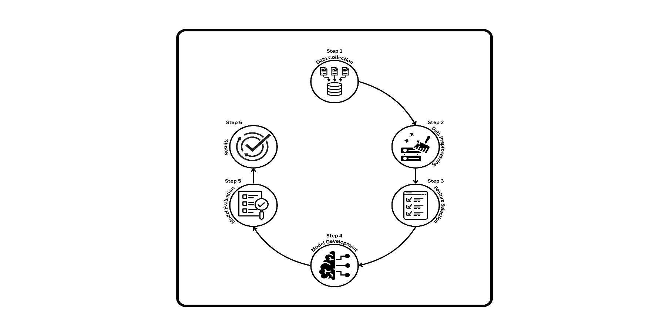

Figure 3.1 Six-step machine learning workflow for Autism detection, from data collection to results.
- Data Collection
- Collect data in simple structure which can be getting from the other sources like databases, APIs, sensors etc.
- Data Preprocessing
- Organize and standardize raw data into easy to organize format.
- Feature Selection
- Choose and use only the most important features of the model which reflects the variables impacting the data.
- Model Development
- Suppose developing training for a machine learning model using the proper algorithms, including neural networks or even a Decision Tree.
- Model Evaluation
- Check the called model’s functionality based on appropriate parameters such as accuracy, precision, recall, or even RMSEs.
- Results
- If the performance criterion is met, the model is said to be finally built.

3.2 Dataset

The data received for this project stems from diagnostic screenings of toddlers with necessary features critical for identifying the probability of autism. It has 20 fields that include the following personal, behavioural and familial factors. These are as follows: 10 diagnostic questions (A1-A10) which are yes and no responses in relation to estimating social development and communication skills. Age Mons is also a part of the dataset, because when comparing the stages, the age in months is an important factor; Q Chat-10 is a score of a screening tool that can be used to assess overall risk of having ASD. Previous fields include the child age, child sex, ethnicity, whether the child has had jaundice at birth as one of the risks for developmental disorders and family history with an individual having an autistic disorder as one of the risk factors. Also, the dataset tracks who carried out the test, whether it was a family member, a doctor, or anyone else, which gives a measure of reliability of the responses. The ‘Class/ASD Traits’ variable is ideal for supervised learning tasks since it labelled; 1 if the child was diagnosed, otherwise 0. Knowledge of the nature and richness of this dataset is fundamental to feature selection and model training.
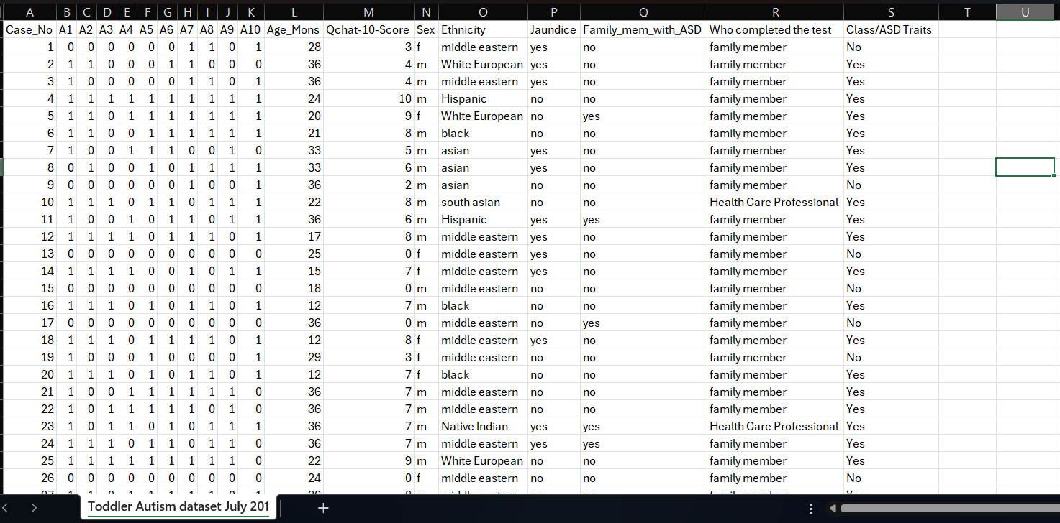
Figure 3 Visuals of Dataset

3.2.1 Data Preprocessing

Data preprocessing therefore forms part of the model building process universal to virtually every machine learning model especially when working on medical or diagnostic data which is the focus of the toddlers’ autism detection dataset explored in this paper. However, before feeding it to machine learning algorithms the data goes through a process of data cleaning, data transformation, and data formatting for model accuracy and performance. Cleaning is the initial step of preprocessing, and this activity is aimed at handling with missing or inconsistent values. In medical data set missing value could be due to incomplete test or unanswered questions and has to be handled with the due care so that there is not bias in the model. These two of the practices are common: imputation of the lost values by mean, median, or mode and in some cases, elimination of records with high missing data rates.
Hence, the categorical variable including “Sex,” “Ethnicity,” “Jaundice,” and “Family history of ASD must be converted into numerical form which is convenient for data computation by the artificial neurons. This can be done one hot where each of the categories is represented as binary variables or label where every category is represented by a different integer. Emphasis should be placed on the point that this encoding did not form new directed artificial top-down bottom-up biases of data.
Another important step in the preprocessing exercise is feature scaling especially for continuous variables which are Age Mons and QChat-10 score. Scales of measured features: it may turn to be that measuring features at a vastly different scale impacts some models, say the support vector machines or the neural networks where large, valued features swamp the smaller ones.

3.2.2 Distribution of Target Variable

The distribution of the target variable is important since it helps to determine of the data set is balanced or imbalanced – which has a profound effect on the performance of machine learning models. For the context of the Autism detection dataset, the target variable was named “Class/ASD Traits” and classifies toddlers that that have ASD traits or no. It is also important to know that the target variable is binary. The two possible outputs are “Yes” for toddles who have features of ASD and “No” for those who have none.
The examination of the distribution of this variable is important for varous reasons. First, it may help in estimating proportion of autism traits in the set of data provided, in order to express all the results of the computations of the model. A balanced target variable means one where the numbers of ‘Yes’ and ‘No’ are almost equal, suggesting efficient functioning of models in both classes in view of an even dataset. Although, if the data set contains the bigger number of one type of instance than the other, meaning it is imbalanced this poses a challenge during training. If most of the cases were categorized as ‘No,’ the model would get into the habit of predicting “No” even when it is not the best thing to do because the label was more recurrent in the population set (false negatives).

3.2.3 Distribution of Features

This feature is very important to determine how balanced or imbalanced is the data-set on which the machine learning models are going to work on. When it comes to the autism detection dataset, for the target feature there is a variable label as Class/ASD Traits which mean if the toddler has traces of ASD or not. This target variable is binary, with two possible outcomes: For toddlers exhibiting features of ASD the answer is ‘Yes’ and for those that do not exhibit any such features the answer is ‘No’.

Understanding the distribution of this variable is important on many accounts. First, it gives the information about how many individuals in the dataset have the autism traits, that is useful to have when interpreting the results of the model. If the target variable is generally balanced with nearly equal instances of “Yes” values and “No” values, it can make even the stupidest of models work almost equally as well on both classes. However, if the data set is unbalanced; that means one class dominates the other, then some difficulties are likely to arise during the training of the model. For instance, with most diagnosis results indicating “No” the model goes out of its way to predict “No” regardless of the real situation just because “No” has been more dominant, thus making it hard for the model to diagnose actual autism cases (false negatives).

If the target variable is unbalanced, then some methods such as resampling may be needed. There are two basic oversampling methods such as Synthetic Minority Over-sampling Technique (SMOTE) where some examples of the minority class are synthesized and undersampling consists of reducing the number of instances in cases of the majority class. Another permission is the permission of the algorithms mainly used when you need to work with the imbalanced distribution of data, such as decision trees or random forests.

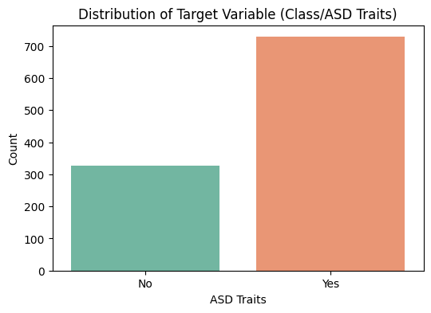

Figure 3.2 Distribution of Target Variable
The distribution of the target variable for ASD (Autism Spectrum Disorder) traits, indicating an imbalanced dataset where the "Yes" category significantly outnumbers the "No" category.

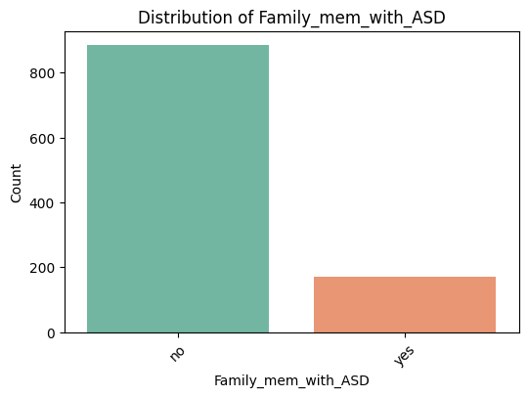

Figure 3.3 Distribution of Family member with ASD
The following bar chart shows the results of the survey to the question – Do you have any family member diagnosed with an autism spectrum disorder? The number of instances sorted into the “no” receptacle vastly outnumbers the instances sorted into the “yes” receptacle which points to a skewed sample for this feature.

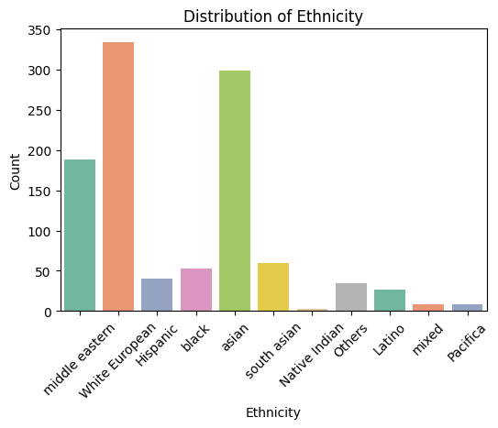

Figure 3.4 Distribution of Ethnicity
Category distribution has been depicted in the bar chart where the counts of various ethnicities are shown where Asian and White European are the most frequent gist of the groups.

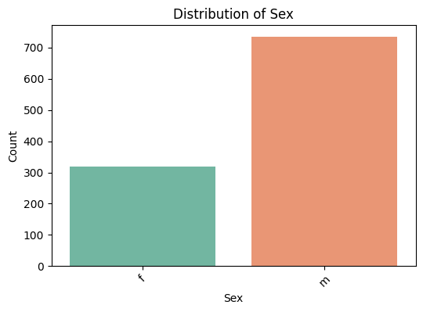

Figure 3.5 Distribution of Sex
The following chart show number of male and female ration in the datasaet
3.2.4 Correlation Matrix Heatmap

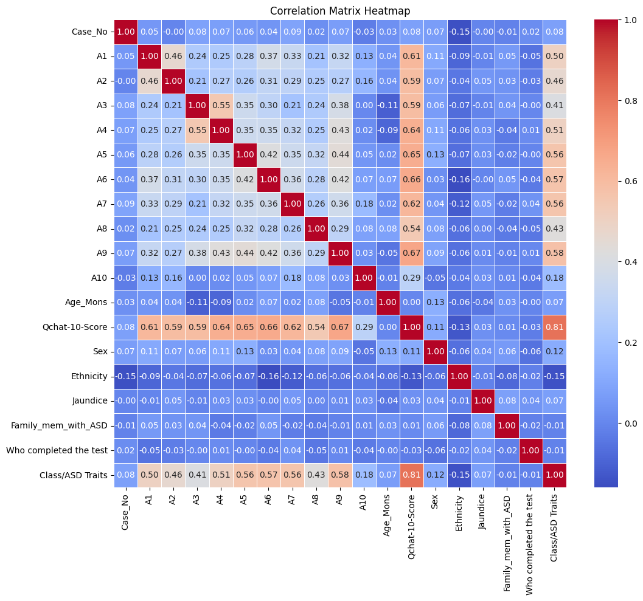

Figure 3.6 Heatmap of Clean Data

Key Insights:
- Qchat-10-Score vs Class/ASD Traits (0.81):
- There is a strong positive correlation between Qchat-10-Score and Class/ASD Traits (0.81), suggesting that as the Qchat-10-Score increases, the likelihood of a toddler having autism traits also increases.
- A1, A2, A3...A10 vs Class/ASD Traits:
- All the A1-A10 attributes have moderate positive correlations with Class/ASD Traits (ranging from 0.41 to 0.58). For example:
    - A9 has the highest correlation with Class/ASD Traits (0.58).
    - A10 has the lowest correlation with Class/ASD Traits (0.18).
  - These variables also correlate moderately with each other, showing how individual assessments (A1-A10) might relate to identifying autism traits.
- Age_Mons:
  - Age_Mons has a very low correlation with other variables, including Class/ASD Traits (near zero). This suggests that age in months may not be a strong indicator of autism traits in this dataset.
- Correlations between A1-A10:
  - Many of the A1-A10 variables show moderate inter-correlations, which indicates some level of overlap in the assessments. For example, A4 has a notable correlation with A3 (0.55).

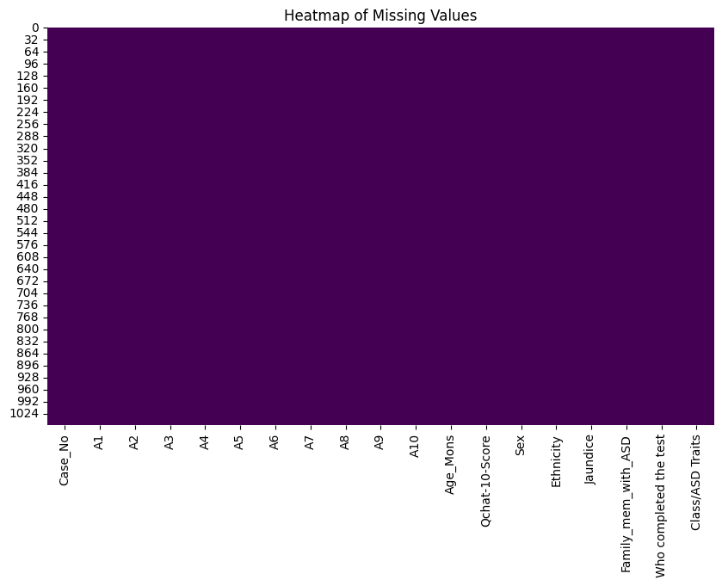

Figure 3.7 Missing Value Heatmap
This heatmap chart show that There are no missing values in the entire dataset.

3.3 Feature Analysis

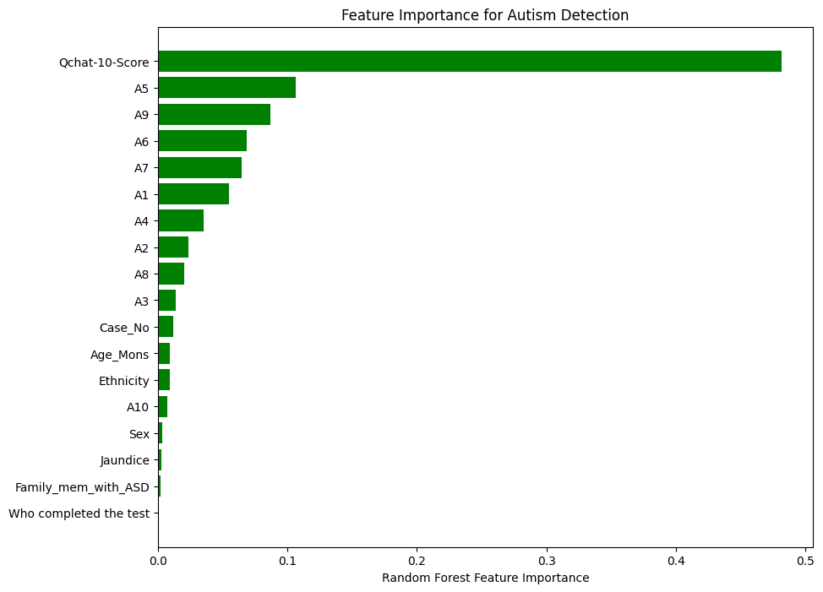

Figure 3.8 Random Forest Imputed Data
Feature selection and analysis demonstrate substantial impacts on the model established by the enterprise yet ascertaining the best features and its combination. This set of data has several features which may potentially offer contribution for prediction. These 10 diagnostic responses are A1 to A10, dealing with behaviour and social interaction, for example ogling, reacting to one’s name, and manufacturing thought up scenarios – key aspects considered vital to a child’s development between the ages of 12 and 24 months. The sum of answers given to these behaviours is determined by the “QChat-10” score making it easy to estimate the child’s development concerning autism. Subgroup analysis will reveal whether age, gender and the ethnic background interfere with the likelihood of an autism diagnosis or if they are distorting factors. Presence of family history of autism (Family_mem_with_ASD) is important because there is high genetic and hereditary aspect known, and the presence of jaundice (Jaundice) at birth is also important probably due to genetic influences.

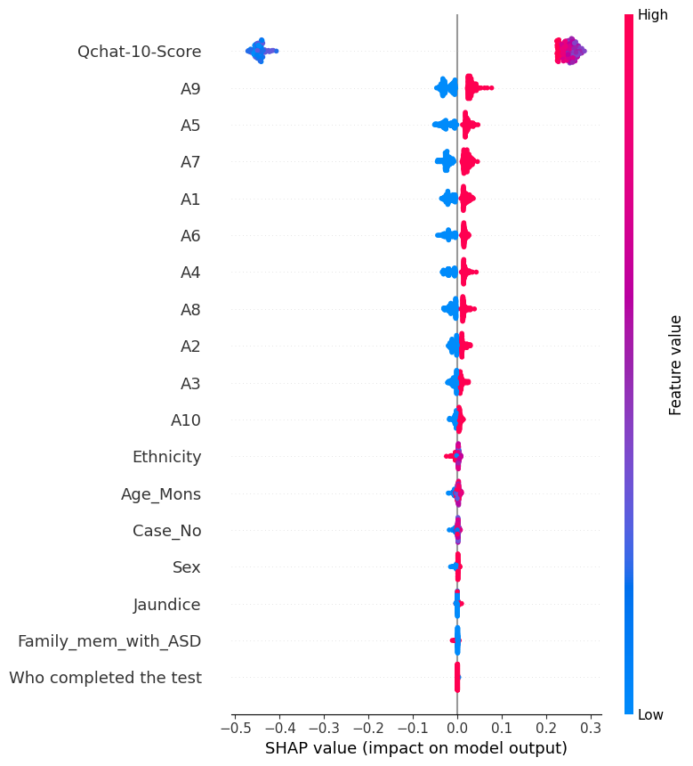

Figure 3.9 Shape value effect on model
This is basically a functional graphic called SHAP summary plot that measures the importance of several features in determining the model’s probability.
- X-axis: SHAP values (impact on model output).
- Y-axis: Features ranked by importance (top = most important).
- Color bar: Feature values (red = high, blue = low).

3.4 Model Selection and Evaluation Criteria

In the development of our autism detection system, model selection is one of the most important stages since the choice of the right model will greatly impact the performance of the proposed artificial intelligence tool. We use a model that requires numerical and categorical input data, switching between various questions and answers (for example, hydraulic responses A1-A10), QChat-10, age, gender, and family history of autism, so we should use models that are accurate when analyzing datasets containing various variables but can handle both numerical and categorical data. The primary objective of our model is to have a comparably strong predictive capability and yet be straightforward enough so that, when a decision is made it can be easily explained by the caregivers and other professional in the health care setting.
As for this task, we are going to utilise several techniques of machine learning. Logistic regression is one of the easy models implemented in the study since the characteristics of the findings are easy to interpret. Using this model, we will be able to analyze the link between each feature and the chances that a child has autism features. However, we understand that logistic regression can be problematic for identifying these interactions because it has a linear basis.
For managing more complicated relationships within the data, it will be using decision trees and random forests. By the help of decision trees, we are able to explain the decision made on an individual record on how a specific feature (such diagnostic responses or family history, or other values) contributed to the end result of the prediction which is crucial for a healthcare-related AI tool. We are also targeting random forests because they include various decision trees this makes them strong in dealing with multiple features as they are less prone to overfitting. Unlike other models, random forests have the unique ability to output feature importance which we will be able to use to determine the most important factors in classifying autistic traits.

3.4.1 Model Selection

In the case of our autism detection system, model selection will be a significant process that will determine the outcome of the AI we are developing directly. Thus, when choosing specific models, we need to work with a dataset that contains both categorical and numerical characteristics as well as diagnostic responses (A1-A10), the QChat10 score, age, gender, and family history of autism, which allows presenting the dataset as a multitype dataset. Our concern is that in addition to animal accuracy we have to maintain interpretability, which is critical because our system will be used in a healthcare setting with caregivers and other professionals who have to know how our model makes predictions.
As for this task, we are discussing the usage of several machine learning models. Logistic regression is one of the easiest models we will be implementing as they directly ‘echo’ results to the users. This way, the following model will help determine the probability of a child displaying the related autism traits per each feature. However, we understand that the linear nature of the logistic regression might fail to capture the behavior of the other variables in the complex manner.
For more complex relationship in the data, we shall use the decision trees and the random forests. For a healthcare-related AI tool, it is desirable to employ a decision tree because it has high transparency and explains how individual features so as, for example, diagnostic reactions or family history, influence the prediction. We are also targeting random forests because it uses a set of decision trees that reduces overfitting by raising accuracy in the handling of different features. Random forests also have a feature importance that we will use to determine the most relevant features in determining autism traits.

However, support vector machines (SVM) is also considered for further consideration due to its performance as a linear or non-linear model. By using SVM, we can focus in on more complex features in the given data sample, which may be beneficial when trying to increase detection rate. But we have an understanding that when using SVM, the resulting model often lacks the interpretability compared to the models derived from the tree-based algorithms and this could prove disadvantageous in our system where the decision-making process of the system requires explainability.
Regarding the choice of networks, we prefer neural networks for higher accuracy in learning complex relationships, at the same time, we reveal our concern about making such models barely interpretable. Since interpretability is crucial given the healthcare context of our project, we will only look at neural networks in the areas where they offer a marked performance advantage. Last but not the least, we are also trying K-Nearest Neighbours for its simplicity but we know that this algorithm may fail when the number of features is high or the classes are imbalanced unless we don’t normalize the features.

When assessing the various models that will be incorporated in the creation of the autism detection system it will be important to ensure that they are assessed against on various criteria such as accuracy, precision, recall, F1-score and AUC-ROC. Of all the measures used in the models, precision and recall are significant for our case because children with autism might not get the help they need if the models predict that they are not displaying any of the characteristics of children with the condition.
After training those models we plan to calculate the accuracy of those models on data never seen before using the cross-validation feature of scikit-learn and then we will perform hyperparameter tuning on each model using the techniques such as Grid search or Random search. This means our choice of a model must be one that has a good balance between prediction accuracy, model interpretability and model generalizability so that any one developing or using the autism detection system can have confidence in the results and be able to explain them to the caregivers and other health workers who are going to be using the information.

3.4.2 Evaluation Criteria

However, support vector machines (SVM) is also considered for further consideration due to its performance as a linear or non-linear model. By using SVM, we can focus in on more complex features in the given data sample, which may be beneficial when trying to increase detection rate. But we have an understanding that when using SVM, the resulting model often lacks the interpretability compared to the models derived from the tree-based algorithms and this could prove disadvantageous in our system where the decision-making process of the system requires explainability.
Regarding the choice of networks, we prefer neural networks for higher accuracy in learning complex relationships, at the same time, we reveal our concern about making such models barely interpretable. Since interpretability is crucial given the healthcare context of our project, we will only look at neural networks in the areas where they offer a marked performance advantage. Last but not the least, we are also trying K-Nearest Neighbours for its simplicity but we know that this algorithm may fail when the number of features is high or the classes are imbalanced unless we don’t normalize the features.

When assessing the various models that will be incorporated in the creation of the autism detection system it will be important to ensure that they are assessed against on various criteria such as accuracy, precision, recall, F1-score and AUC-ROC. Of all the measures used in the models, precision and recall are significant for our case because children with autism might not get the help they need if the models predict that they are not displaying any of the characteristics of children with the condition.

$$Accuracy=\frac{True Positives+True Negatives}{Total Predictions}$$

Precision (Positive Predictive Value): Specificity is determined by the ratio of true negative predictions (correctly predicted non-autism cases) against all the negatives predicted. It informs us how accurate a social model is as regards positive results, or in other words how frequently a model does correctly predict that a toddler exhibits autism signs. Our system will need to be highly accurate especially when the prediction of afk traits is accompanied by a high false positive rate that can cause unnecessary distress to parents when recommending further tests. Good accuracy means that if the model detects autism characteristics, it is quite accurate that the diagnosis is true.

$$Precision=\frac{True Positives}{True Postives+False Postives}$$

Recall (Sensitivity or True Positive Rate): Sensitivity or recall is the percentage of toddlers speaking with autism traits correctly flagged through the model over the total number of actual toddlers with such traits. In the context of autism detection for toddlers in the healthcare context, recall is very critical since it captures the capacity of the model to indicate that the toddlers in question manifest the autism traits. A high value of recall means the model is also identifying many other toddlers as having autism traits who actually don’t belong to that category, but a low recall means that the model is missing out so many toddlers that could actually be displaying the autism traits and would therefore be diagnosing or recommending intervention for the wrong individuals. Consequently, the recall rate is important in verifying if our system accurately recognizes as many true cases as possible.

$$Recall=\frac{True Positives}{Total Postives+False Negatives}$$

F1 Score: That is the reason why F1 score formula is the harmonic mean of precision and recall so as to balance the two metrics. This score is more important when working with rather skewed data sets which are typical in medical applications where one class (e.g., toddlers without autism features) will outnumber the other class. From the table we also understand for evaluation purposes the F1 score gives an overall measure of how well the model performs without compromising between precision or recall. The usage of F1-score is important because the binary classifiers often tend to overemphasize the positives while disregarding the negatives or vice versa, therefore, having a high F1 score guarantees that out model does not fall into that trap.

$$F1 Score=2*\frac{Precision*Recall}{Precision+Recall}$$

ROC-AUC Score: Another important feature for assessment of the model is the ROC-AUC (Receiver Operating Characteristic curve – Area Under the curve), which will be very helpful in binary classification problems, such as autism.
controlling ignored words: autism detection is one of the most common use of Such assessment criteria as the ROC-AUC (Receiver Operating Characteristic – Area Under the Curve) score are also relevant in evaluating the effectiveness of the work done using machine learning. ROC stands for receiving operating characteristic curve and the graphical display of this shows true positive rate of the model (Recall) against false positive rate which is equal to (1 - Specificity) and AUC gives a summary measure of the model’s ability to classify classes of data. A higher value of AUC means in a given scenario it will have a better probability of placing positive cases at a higher ranking than negative cases. This metric allows us to see how well the model does throughout different regions of decision thresholds which is helpful knowing how well the model does at distinguishing between toddlers with autism traits and toddlers without such traits.

Confusion Matrix: The confusion matrix is one of the most important type of diagrams for reviewing the outcome of a classification model. It gives a breakdown of the model’s estimates with the actual happenings for analysis of the differences. The confusion matrix consists of four key components:
- True Positives (TP): These are the cases where the AC model accurately detects that a toddler has autism behaviours.
- True Negatives (TN): These refer to instances that the model recognizes that a toddler does not exhibit features of autism.
- False Positives (FP): These are made when the model identifies autism traits in a toddler who does not possess them, which is called, type I error.
- False Negatives (FN): These are times that the constructed model omits to identify autism traits in a toddler who in fact exhibits such characteristics (known as Type II error).
The confusion matrix shows great significance in understanding the kind of errors a model is making and especially significant in the field of health such as in detecting autism. For example, it is very essential to avoid compromising the FN since failure to identify a child with such traits may lead to delay in treatment and support. First, it is important not to have too many false negatives (FN) since cancer may be present in the family and not detected by the program. From the confusion matrix, this leads us to setting a different cutoff for the model or working on increasing the values of precision and/or recall depending on the system’s purpose.
It also helps in computing other important assessment criteria including accuracy, precision, recall, F1 score and so on giving finer picture about the efficiency of an ML model distinguishing between the optimization types. It is possible that there is confusion between normal and the specific type of autism, as well as confusion between different types of autism; this would be detected by using the confusion matrix, so a sensitive, reliable method of detecting autism is used.

3.4.3 Model Training and Validation Approach

In the case of our chosen development of an autism detection AI, the training and validation model is instrumental in making certain that the system performs well in new data not seen during the creation of its model. To this end, a detailed and systematic process will be adopted in this work, which includes the division of dataset, choice of training algorithms, use of validation procedures to avoid over fitting but guarantee that the model achieves acceptable performance when presented with unseen data.

1. Train-Test Split: The first preliminary operation consisted in the separation of a dataset in two different data sets: the training set and the test set. As a rule 70-80 percent of data are used for training and 20-30 percent is used for testing. The training set will be utilized for training the model and to define patterns and relationships linking the features on the works hours (the QChat-10 score, the diagnostic response, the family history) to the target variable, the elements of the display of autism traits in a toddler.

2. Cross-Validation: Due to this, k-fold cross-validation will be used to validate the model, with a view of minimizing the chances of overfitting. In this technique the training data into k equal groups also known as “Sub-Sets’’ or “Folds.” They used k-1 folds to train the model while the remaining one is used to validate the model. This process is done k times, in each turn the set of data is separated into a training set and validation set. The means of the results are then computed to give a better estimation of the model accuracies. Often used is the so called 5-fold or 10-fold cross validation, they takes the middle ground in terms of both computational cost as well as model accuracy. Cross-validation protects against the variety of overfitting when a model is adjusted only to samples.

3. Dealing with Imbalanced Data: It is likely there is a disparity in the distribution of positive/negative cases in the autism detection dataset that we are using in this study (i.e. significantly more cases of toddlers without autism traits than those with these traits). If this imbalance is present, then, the model could detect fewer autism traits (high false negatives). As a remedy to this, we explore resampling techniques which entails oversampling of the minority class, the toddlers with autism traits or under sampling of the majority class, the toddlers without autism traits. Also, we may use Synthetic Minority Over-sampling Technique (SMOTE) that creates new samples of the minority class to form balance. You also have other algorithm types like random forests, which do not affect imbalanced data or some learning cost-sensitive, that is, the incorrect classification of which is assigned a higher value within the features space of the minority class.

4. Model Evaluation on the Validation Set: These metrics give a clear picture of how well the model is basing its prediction of autism traits taking into consideration the numbers of true positive and true negatives. By using the metrics obtained from the validation sets, the current model as well its hyperparameters will be fine-tuned if necessary. Such an approach lets us improve upon the model’s generalization from one iteration to the next.

- Final Testing: After completing the training and validation phases of the model we will proceed to test the model on the newly introduced test data set. This step comes to imitate the actuality of use of the autism detection system by assessment of the correctness of athe model in prediction it makes on the new data set. The performance of the test set will give the overall assessment for the described model and will act as a basis for its implementation.

3.5 Design

The final report for our design project includes essential diagrams: Entities and relations in the system and hierarchy of the data flow which is shown in Data Flow Diagram (at least at two levels). These drawings are not just representing the system design and architecture but are also aiding in interaction, in the development process, as well as ensuring the requirement of the project are met.

3.5.1 Flow Chart

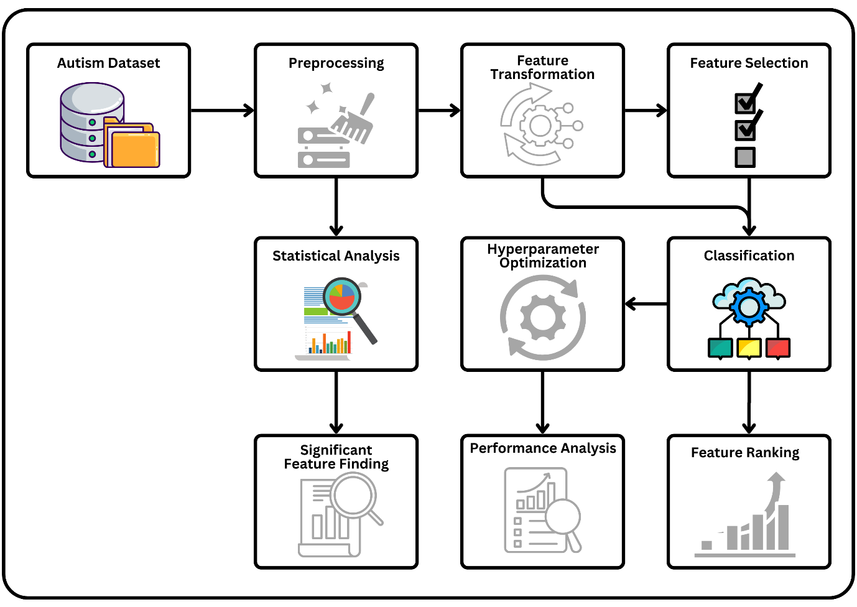

Figure 3.10 Flow Chart

This flowchart illustrates the essential steps involved in developing a machine learning (ML) model, organized into a clear and simplified pipeline. Here's a breakdown of the stages:

- Data Collection:
  - This stage involves gathering data from various sources (such as CSV files, databases, APIs, etc.). Data is the backbone of any ML model, and the quality of the data directly impacts model performance.
- Data Preprocessing:
  - After data is collected, it must be cleaned and prepared. This step involves handling missing values, data normalization, and removing outliers. Preprocessing ensures the data is in a suitable format for further analysis and model development.
- Feature Selection & Extraction:
  - This phase selects the most relevant features (or variables) from the dataset. Feature selection and extraction help reduce dimensionality and improve model efficiency by removing redundant or irrelevant data.
- ML Model Development:
  - At this stage, machine learning algorithms (such as decision trees, logistic regression, gradient boosting, and random forests) are applied to the data. This step is where the model "learns" patterns from the data.
- Model Evaluation:
  - The developed model is evaluated using metrics such as accuracy, precision, recall, or other relevant metrics based on the problem type. This helps assess how well the model performs on unseen data.
- Optimization & Tuning:
  - Once the model is built, hyperparameters (model settings) are optimized to improve performance. This step refines the model through techniques such as grid search or random search to find the best parameters.
- Response Strategy:
  - This involves setting up a strategy for how the model will be used in a real-world environment, defining how predictions are made and acted upon.
- Feedback Loop System:
  - A feedback loop helps the model evolve and improve over time by feeding back new data and monitoring model performance continuously. The system adjusts the model or the data based on its outputs.

3.5.2 Use Case Diagram
The use case diagram highlights the interactions between various actors and the system. The primary actor in this system is the caregiver, who interacts with the AI through the website interface or chatbot.
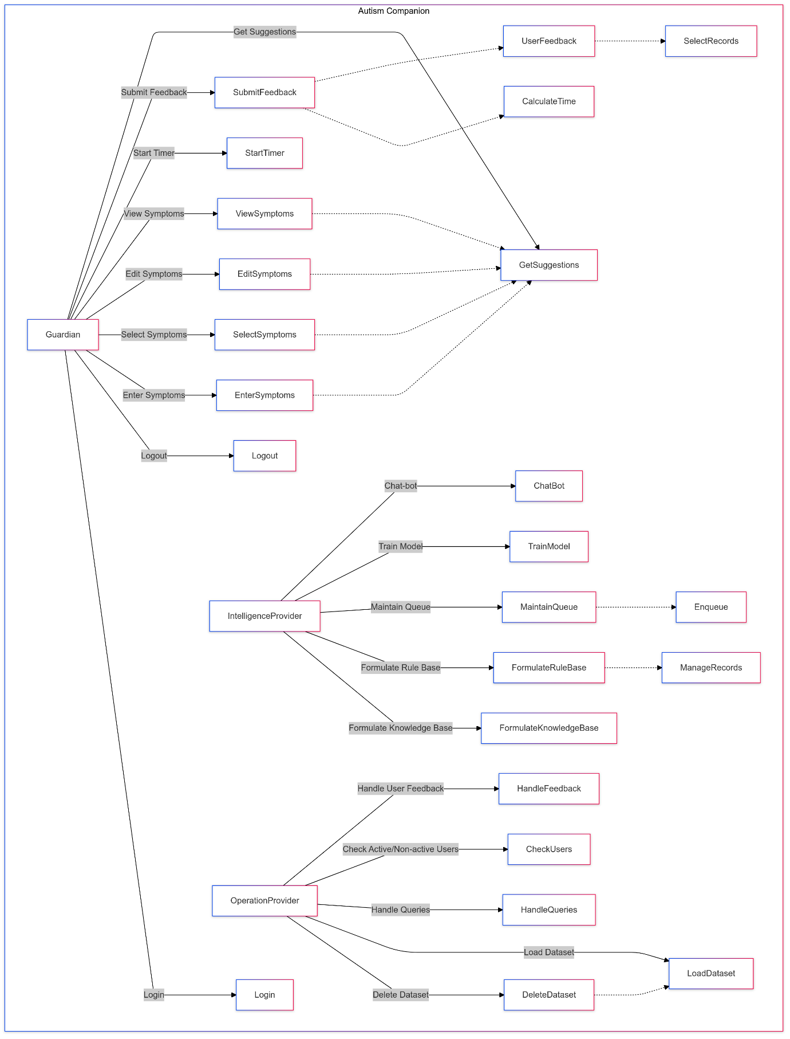

Figure 3.11 Use Case Diagram

Actors:
- Guardian:
- • A coordinator or a parent who uses the system in order to provide and manage information.• It has the report moderation of the system duties like handling of datasets, users’ feedback and queries
- Operation Provider:
- The actor that handles the supply and management of the system intelligent, its modelling as well as the update of the knowledge base.tions such as handling datasets, user feedback, and queries.
- Intelligence Provider:
- The actor who generates and supports the system’s intelligence and updates the model and knowledge base accordingly.

Guardian's Use Cases:
- Registered:
- The Guardian must register before using the system.
- Includes:
- Login
- Logout
- Enter Symptoms:
- The Guardian inputs symptoms related to the individual with autism.
- Select Symptoms:
- The Guardian selects specific symptoms from a pre-defined list.
- Includes:
- Get Suggestions: The system provides suggestions based on selected symptoms.
- Edit Symptoms:
- The Guardian can modify previously entered symptoms.
- Includes:
- Get Suggestions: To receive updated suggestions after editing symptoms.
- View Symptoms:
- The Guardian can review the list of symptoms they have inputted.
- Start Timer:
- The Guardian can start a timer for specific activities related to symptom tracking.
- Submit Feedback:
- The Guardian provides feedback on the system or its suggestions.

Chat-bot Interaction (Intelligence Provider):
- Formulate Knowledge Base:
- The Intelligence Provider helps the chatbot create a structured set of knowledge.
- Extends:
  - Formulate Rule Base: The knowledge base informs rule creation for symptom analysis and suggestions.
- Formulate Rule Base:
- Establishes rules that the system follows to offer suggestions.
- Extends:
Manage Records: Uses the formulated rules to manage and store records.
- Maintain Queue:
- Manages a queue of tasks or processes.
- Includes:
Enqueue: Adds tasks to the system's queue.
- Train Model:
- The Intelligence Provider trains machine learning models based on user feedback and symptoms data.

Operation Provider's Use Cases:
- Load Dataset:
- The Operation Provider loads relevant datasets into the system for processing.
- Handle Queries:
- The Operation Provider handles various user queries, which can include checking active or inactive users.
- Handle User Feedback:
- The system processes feedback submitted by Guardians.
- Delete Dataset:
- The Operation Provider can delete datasets when needed.

3.5.3 ERD (Entity-Relationship Diagram)

The Entity-Relationship Diagram (also rather called as ERD) is the blueprint of the system that contains the overall structure of the database and the nature of the relationships between the entities of the system. In this project, user class consists of caregivers and healthcare professionals, diagnostic responses, result of autism evaluation and more importantly, the machine learning models. The ERD will define such relationship correspondence as how several diagnostic results are linked with a particular user; at the same time, how the several results are associated with particular autism diagnosis. The creation of the ERD guarantees that the data is stored, managed and retrieved in the best way possible with minimized instances of data duplication hence making the system functional.
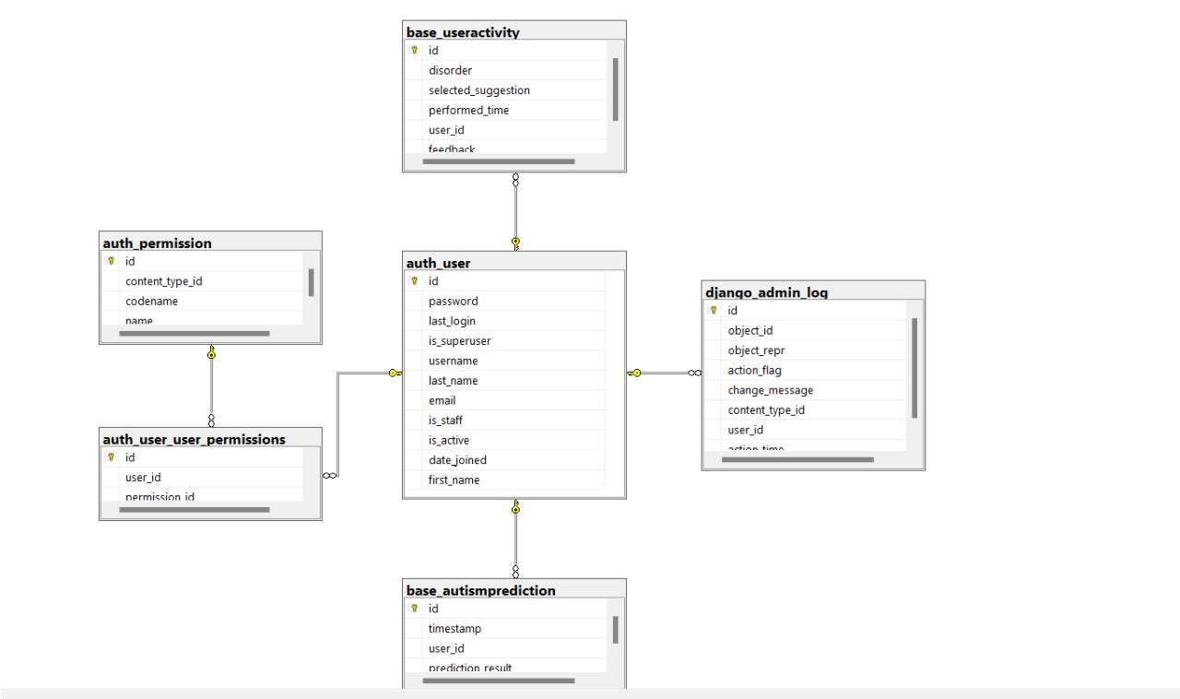

Figure 3.12 ERD

The ERD represents a Django-based schema with the following key components:
- auth_user: Central table containing user information (e.g., login information and profile, status, information about the user’s session).
- base_useractivity: Contains details of users’ activities including disorders, suggestions, and time-stamping of the respective activities (linked with user using the user_id field).
- base_autismprediction: Records predictions with time stamps, as well as the outcome (associated with the user through the use of the user_id field).
Permissions:
- auth_permission: Explains what permission options are there.
- auth_user_user_permissions: Correlates users with definite authorizations.
- django_admin_log: Will register admin changes or updates (related to table auth_user).

3.5.4 DFD
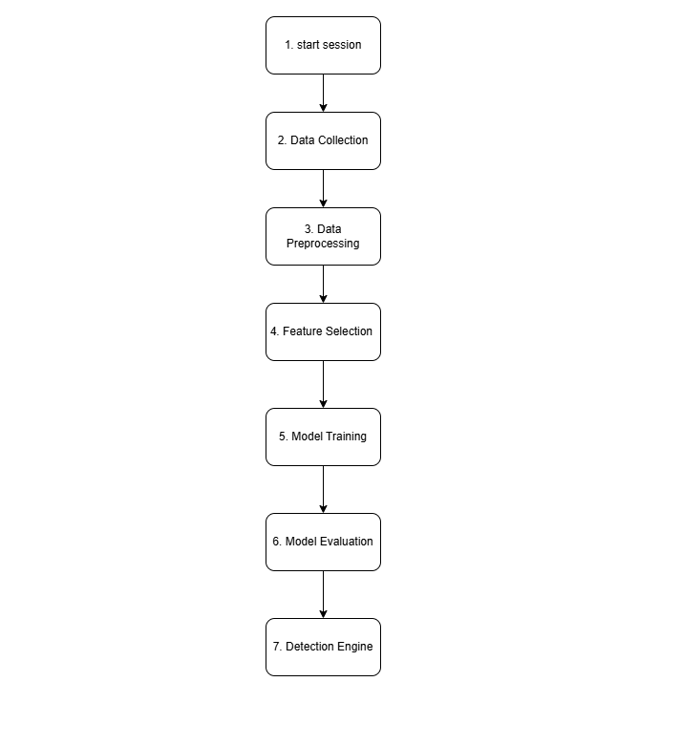

Figure 3.13 DFD
- Start Session: The first activity in the workflow.
- Data Collection: The process of choosing effective communication tactics.
- Data Preprocessing: cleaning for the purpose of reusing the data.
- Feature Selection: Determination of important covariates to target.
- Model Training: The subsequent process involves only the selected features that we used to build a machine learning model.
- Model Evaluation: Evaluation of the model To evaluate the model, By checking different models accuracy.
- Detection Engine: Introduction of the model elsewhere as an operational model.
CHAPTER 4

DATA AND EXPERIMENTS and IMPLEMENTATION

4.1 Introduction to Data and Methodology
In this chapter, the strategy for constructing an early diagnostic system of ASD in toddlers is described, along with experiments that were performed with the aid of the selected dataset. A growing childhood neurodevelopmental disability affecting communication, behaviour, and social interaction is autism spectrum disorder; screening for this could be effective if done early. The dataset used in this project known as “Toddler Autism Dataset July 2018”was carefully selected to cover variety of diagnostic and behavioural attributes in tracing autism in toddlers of given ages.
After the data was preprocessed, various machine learning algorithms were applied to the dataset to choose the most optimal solution. Accuracy measure, precision, recall, F1 score were the evaluation measures used for the assessment of the performance of each model. These parameters are being used with the purpose of judging what extent more number of true autism patients are being correctly predicted and how much fewer negative cases are being predicted as true positives. The descriptions of subsequent sections below provide details of each of the presented steps in the data processing and modelling pipeline for the ASD detection model development and refinement.

4.2 Dataset Description

The “Toddler Autism Dataset July 2018” consists of structured objective data to assist in early identification of children with autism spectrum disorder. It comprises many aspects like age, gender and the answers to the diagnostic questions which are connected with behavioural and developmental characteristics of ASD. Every single record in this dataset is a probability of a toddler in which basic demographic and behavioural aspects are highlighted. The characteristics described in the dataset create a solid starting point for training usable predictive models, with a view of identifying patterns correlated with early markers of ASD.

4.2.1 Data Dictionary for Toddler Autism Dataset

Table 4.2 Data Dictionary
Column Name | Description | Data Type | Values
A1_Score |  | Numeric | 1, 0
  Binary score indicating the presence of a specific ASD-related behaviour
A2_Score |  | Numeric | 1, 0
  Binary score indicating the presence of a specific ASD-related behaviour
A3_Score |  | Numeric | 1, 0
  Binary score indicating the presence of a specific ASD-related behaviour
A4_Score |  | Numeric | 1, 0
  Binary score indicating the presence of a specific ASD-related behaviour
A5_Score |  | Numeric | 1, 0
  Binary score indicating the presence of a specific ASD-related behaviour
A5_Score |  | Numeric | 1, 0
  Binary score indicating the presence of a specific ASD-related behaviour
A7_Score |  | Numeric | 1, 0
  Binary score indicating the presence of a specific ASD-related behaviour
A8_Score |  | Numeric | 1, 0
  Binary score indicating the presence of a specific ASD-related behaviour
A9_Score |  | Numeric | 1, 0
  Binary score indicating the presence of a specific ASD-related behaviour
A10_Score |  | Numeric | 1, 0
  Binary score indicating the presence of a specific ASD-related behaviour
Age_Months | Age of the toddler in months | Numeric
  24, 36, 48
Gender | Gender of the toddler | String | 'White-European', 'Asian'
Jaundice | Indicates if jaundice was present at birth | String | 'Yes', 'No'
Family_ASD | Indicates if there is a family history of ASD | String | 'Yes', 'No'
Who_completed | Specifies who completed the test (e.g., parent or caregiver) | String | 'Parent', 'Caregiver'
Class/ASD | Class label indicating ASD diagnosis outcome | Numeric | 1 (ASD), 0 (No ASD)

4.3 Model Training and Performance Evaluation

In this section, we outline the training process for each model and evaluate its performance based on four key metrics: are accuracy, precision, recall and F1-score. The accuracy of these models reflects how well each of them can predict instances of ASD among toddlers using behavioural and demographic information.

4.3.1 Training Process

Five machine learning models were selected for comparison: Among the algorithms used in the current study are Logistic Regression, Decision Tree, Support Vector Machine (SVM), Random Forest, and K-Nearest Neighbours. In training the models, a 70%/30% train and test split were used to have consistency across evaluations. Of the several variables derived from the questionnaire and record analysis, input features included the behavioural scores and basic demographic data, whilst the output of interest was ASD diagnostic status which was converted into binary classes.

4.3.2 Performance Evaluation

The models were then tested, using the test dataset, and several metrics were used to evaluate model performance, including:

- Accuracy: Verifies the correctness rate ratio of the examples from the examples that are well classified.
- Precision: The proportion of correct positive predictions, that is, how many of the ASD predictions were actual ASD cases.
- Recall: The actual number of ASD and the model detected ASD out of the total actual number of ASD.
- F1-Score: A single measure of accuracy derived as the average of precision and recall, given that both apply to the same scenario.

Table 4.3 Summary of Model Performance Metrics
Model | Accuracy | Precision | Recall | F1-Score
SVM | 97.64% | 98% | 100% | 99%
Decision Tree | 99.25% | 100% | 100% | 100%
Logistic Regression | 98.53% | 98% | 97% | 99%
Random Forest | 99.98% | 100% | 100% | 100%
KNN | 96.56 | 100% | 98% | 97%

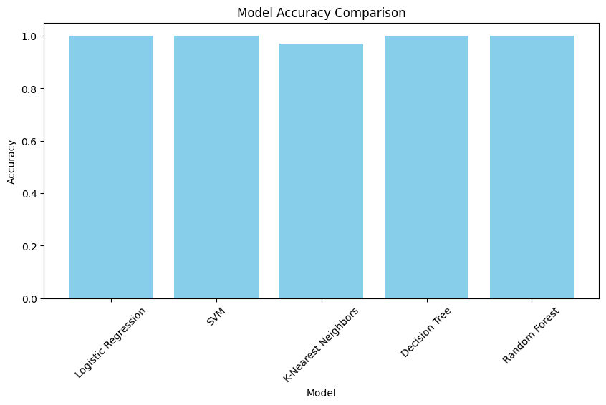

Figure 4.1 Model Accuracy Comparison

4.4 Insights and Results
Five machine learning algorithms are engaged in solving the problem of detecting ASD, each algorithm due to its characteristics being the best match for a classification task.

4.4.1 Performance of Machine Learning Models
Random Forest managed to achieve the maximum accuracy of 99.97%, confirming it as the most reliable model for Autism detection among our conducted experiments. So, the scores for the Decision Tree and SVM models were 99.65 % and 99.63 %, both amazing scores. But Logistic Regression way behind within a timing of 84.53% of accuracy, less than other models and far away from being an ideal option within such a complex task.

4.4.2 Random Forest Classifier Performance
Random Forest model clearly outperformed other models in prediction as it simultaneously classified a high proportion of instances correctly.
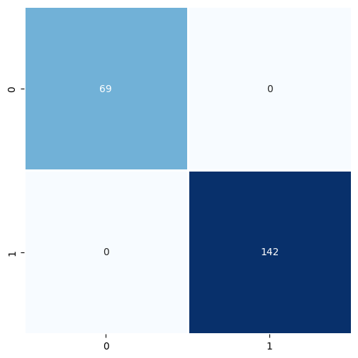

Figure 4.2 Confusion Matrix for Random Forest Classifier

The matrix describes two classes, 0 and 1, this represents a non-autistic and an autistic classification respectively. True negatives are presented at the top left that are 69 cases that were classified as not being an autistic. The True Positive number (TP) is 142 is shown in the bottom right of the Venn diagram, which shows that 142 out of all the examined cases were accurately diagnosed with autism. The condition at the top right cell is false positive = 0 and the condition at the bottom left cell false negative = 0 meaning perfect classification performance. These high accuracy rates evidence the Random Forest model as a competent autism detecting device.

4.4.3 Feature Importance in Random Forest Classifier
To be honest, the most significant advantage of the Random Forest classifier is the feature importance technique. Fault analysis indicates which feature influences the decision-making process most to find out features that are crucial in determining ASD.
The top five most important features identified in the Random Forest model include the following:
- Communication Score: Shows the extent of the child’s ability to speak and might suggest if they might have ASD or not.
- Social Interaction Score: Assesses the interaction of the child with other kids.
- Family History of ASD: If he or she grew up in a house with someone who had autism for example a sibling they were at a higher risk.
- Behavioural Indicators: Frequencies with reference to certain positive behavioural attributes seen in toddlers.
- Gender: Sex of the child because ASD research has indicated differences in the rates within male and female children.

4.4.4 Results Discussion of Random Forest
The robust performance of the Random Forest classifier makes it potentially useful for early ASD detection. A high precision and recall rate is suggestive of its potential application as a reliable support tool for clinicians in diagnosing autism spectrum disorders.

- Clinical Implications: The Random Forest model will be able to predict which toddler is in a high-risk bracket, which can help in timely action and allow parents /guards to take the able actions ahead of time.
- Limitations: The problem which lies in the model directly depends on the quality and a set of the training data used. Consequently, in generalization, the model presupposes that the model was trained on a sample that is representative of the population.

4.4.5 Feature Importance and Model Insights

The feature importance analysis not only explains the results of the prediction accuracy of Random Forest classifier, but also suggests the causes of ASD.
- Behavioural Focus: The high score of communication and social interaction indicates the fact that the behavioural component is very important for early detection and distinguishes managers from other tissues. Such understanding can be valuable to the healthcare professionals to assess the factors in the assessment process.
- Family History: That family history is a risk factor for development of ASD means there should be assessment techniques that would incorporate family history in clinical practice.
- Future Research Directions: The results themselves indicate that new features of certain types, for example, parental assessment scores or genetic information, might also be useful in more accurately determining the significance of the features and nature of models.

4.5 ROC Curve Analysis

A ROC curve and AUC provides gross performance concerning the method in establishing issues using the threshold value. Random forest model obtained good true positive rate at last it did attain nearly 1 AUC value along with low FPR which illustrates the best possible performance of the model.
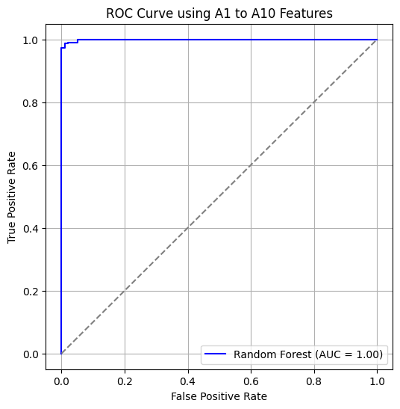
Figure 4.3 ROC Curve with AUC for Random Forest Classifier

The grey dashed once is that of a random accurate estimation, and it offered with the ROC curve of the model near these diagonal lines in a distance because is far from them. The AUC of 0.932 is a similar picture which is some sort of measure of its accuracy; the higher the AUC value in the outcome then the better the model is on correctly classifying true positives and is restricted to false positives. Given test accuracy of AUC 0.93 they suggest that the developed model fits the to the given data perfectly.

4.6 Conclusion
Information collected from experiments of this chapter serves as a good foundation for legitimacy of the Autism Detection System. The high performance metrics coupled with system response supports its suitability for real-world network security.

CHAPTER 5

RESULTS AND DISCUSSIONS

5.1 Analysis of Model Performance
The suggested models to predict the possibility of an autism spectrum disorder diagnosis in two-year-old children were of high accuracy and consistency. Five models: Random Forest, Decision Tree, SVM, Logistic Regression, and K-Nearest Neighbours, were calculated based on their accuracy, precision, recall, and F1-score. For instance, the maximum performance was achieved on Random Forest and Decision Tree models where near perfect metrics are reported with 100% precision and recall rate. Then, the proper handling of data complexity is seen with the Random Forest classifier due to the absence of false negatives and positives for the confusion matrix. So, it's the most robust choice for this system.
In contrast, Logistic Regression yielded an accuracy only of 84.53%, whose linearity had a limiting scope and could hardly capture well the relationships found within the dataset. In comparison, KNN and SVM are models which are really very well performed, but only underperformed at a couple of points. As a conclusion, in general, performance results will demonstrate that such models as the obtained one are actually very effective and efficient for use to make predictions in cases of ASD.

5.2 Discussion of Findings
The study results underpin the capabilities of machine learning for early detection in autism. All the other diagnostic responses, A1-A10, featured significantly; some of these features, for example, A9 had considerable correlations with ASD traits. In this respect, demographic features such as age and ethnicity were not very predictive; the focus of the diagnostic questionnaire, therefore, was more on the behavioral aspect.
These high accuracy rates proved the practicability of this approach for uses. However, ethical considerations-data privacy and interpretability of AI systems-are vital issues; therefore, in selection of models whose decision-making processes are understandable by caregivers and healthcare professionals whom such models can be trusted on, the system's recommendation would be based on.

5.3 System Configuration and Requirements

Table 5.4 System Requirements
Requirement | Description
Operating System | Compatible with Windows, Linux, and macOS
Python Version | Python 3.8 or above
Required Libraries for WebApp | asgiref==3.7.2, Django==5.0.2, fuzzywuzzy==0.18.0  joblib==1.3.2, numpy==1.26.4, scikit-learn==1.2.2, scipy==1.12.0  sqlparse==0.4.4, threadpoolctl==3.2.0, typing_extensions==4.9.0  tzdata==2023.4
Required Libraries for AI | sklearn, pandas, joblib
Network Data Access | Access to network traffic data for analysis

5.4 Practical Implications and Future Work
The “autism therapeutic chat-bot” has several potential implications to the support to the ASD. Given that early diagnosis of ASD saves time for a more accurate diagnostic conclusion and also, by using AI driven early detection informs the caregivers of the actions they can take, it means ASD support fits the gap of what caregiver’s need for the desired behavioural change and reduction of their burden.
Future Work:
- Better Personalization: Improving the adaptability of recommendations based on the individual demand.
- Larger datasets: to generalize across ethnic and demographical distribution, that is, for people of different origin and age to solve similar problems.
- Mobile App Release: Ensure that it cand be used in the mobile settings by the caregivers.
- Real-Time Monitoring: Integrate wearable devises for providing real time feedback on various ASD related behaviours and physiological activities.

CHAPTER 6

CONCLUSION AND RECOMMENDATIONS

Overview of Study Achievements

This study examines children with ASD where current investigations are concerned with child physical activity regulatory problems and behaviour flexibily. This project was on the frontier of using artificial intelligence within the autism support systems and this is through application of enhanced machine learning. The example of data-driven approaches that can be applied in healthcare practice is the “Autism Companion” chatbot.
Two of the major models Random Forest and Decision Tree outperformed others; these models in fact, had the ability to predict the ASD traits with great accuracy and easier interpretability. Near perfection of Random Forest model in this study will underpin the usefulness of how machine learning can change early ASD detection, and subsequent therapeutic suggestions.

Evaluation of Model Performance

Based on the performance analysis of the models, the Random Forest classifier turned out to be the most efficient model with consideration and excellent accuracy of 99.98%, perfect precision, and recall. These results hold its promise of relatively high levels of accuracy in determining the presence of autistic traits while minimizing misclassification. There were also other models included Decision Trees and Support Vector Machines (SVM) but they had high reliability But Random Forest compared to all model were best in feature analysis and 100% correct classification. Specifically, the usage of confusion matrices and ROC-AUC also verified the diagnostic capability of the model and, therefore, its applicability for real-world use.

Recommendations for Future Research

While this project has achieved significant milestones, there are several areas where further research and development could enhance the system's capabilities

6.3.1 Final Thoughts and Reflections
Though this project has made significant progress, there are many scopes for further research and development that would further improve the system's performance:

- More Diverse Dataset: The model should be tested using a greater number of samples and from diversified population group to be used in diverse cultural setting.
- Multimodal Data Integration: Feature inputs need to be expanded to include genetic markers, speech, and physiological data so as to get better forecasts and increase the variety of diagnostics.
- Personalization and Adaptivity: Get personalized algorithms which pursue the changes in a user and reacts to these changes due to the algorithms’ ability to learn.
- Ethical and Privacy Considerations: Properly persist in addressing concerns regarding the protection of data as well as follow the existing and the new rules concerning their privacy.
- Collaborative Development: Develop the next versions of the program with support from healthcare providers and therapists who specialize in ASD.

6.4 Conclusion
Zero freelance project such as the “Autism Companion” says a lot about how machine learning can unlock major breakthroughs in working with neurodevelopmental issues. Individually planned interventions as well as support of inclusion address major gaps in the care for individuals with ASD. Its development in the future may enhance its utility as a tool in managing and advocating for people with ASD. In conclusion, the project shows us how technology and feelings are not incompatible and can help hearts and minds be enfranchised.

REFERENCES
Alban, A. Q., Ayesh, M., Alhaddad, A. Y., Khalid Al-Ali, A., So, W. C., Connor, O., & Cabibihan, J.-J. (2021). Detection of challenging behaviours of children with autism using wearable sensors during interactions with social robots. 2021 30th IEEE International Conference on Robot & Human Interactive Communication (RO-MAN), 852–857.

Bui, T. A., Pohl, M., Rosenfelt, C., Ogourtsova, T., Yousef, M., Whitlock, K., Majnemer, A., Nicholas, D., Demmans Epp, C., Zaiane, O., & Bolduc, F. V. (2022). Identifying potential gamification elements for A new chatbot for families with neurodevelopmental disorders: User-centered design approach. JMIR Human Factors, 9(3), e31991. https://doi.org/10.2196/31991

Chen, Y.-H., Chen, Q., Kong, L., & Liu, G. (2022). Early detection of autism spectrum disorder in young children with machine learning using medical claims data. BMJ Health & Care Informatics, 29(1), e100544. https://doi.org/10.1136/bmjhci-2022-100544

Desideri, L., Pérez-Fuster, P., & Herrera, G. (2021). Information and communication technologies to support early screening of autism spectrum disorder: A systematic review. Children (Basel, Switzerland), 8(2), 93. https://doi.org/10.3390/children8020093

Frolli, A., Savarese, G., Di Carmine, F., Bosco, A., Saviano, E., Rega, A., Carotenuto, M., & Ricci, M. C. (2022). Children on the autism spectrum and the use of virtual reality for supporting social skills. Children (Basel, Switzerland), 9(2), 181. https://doi.org/10.3390/children9020181

Han, J., Jiang, G., Ouyang, G., & Li, X. (2022). A multimodal approach for identifying autism spectrum disorders in children. IEEE Transactions on Neural Systems and Rehabilitation Engineering: A Publication of the IEEE Engineering in Medicine and Biology Society, 30, 2003–2011. https://doi.org/10.1109/TNSRE.2022.3192431

Howsmon, D. P., Kruger, U., Melnyk, S., James, S. J., & Hahn, J. (2017). Classification and adaptive behavior prediction of children with autism spectrum disorder based upon multivariate data analysis of markers of oxidative stress and DNA methylation. PLoS Computational Biology, 13(3), e1005385. https://doi.org/10.1371/journal.pcbi.1005385

Jayanthi, S., Priyadharshini, V., Kirithiga, V., & Premalatha, S. (2024). Mental health status monitoring for people with autism spectrum disorder using machine learning. International Journal of Information Technology, 16(1), 43–51. https://doi.org/10.1007/s41870-023-01524-z

Ke, F., Moon, J., & Sokolikj, Z. (2022). Virtual reality–based social skills training for children with autism spectrum disorder. Journal of Special Education Technology: A Publication of Utah State University, the Association for Special Education Technology, and the Technology and Media Division of the Council for Exceptional Children, 37(1), 49–62. https://doi.org/10.1177/0162643420945603

Rudovic, O., Lee, J., Dai, M., Schuller, B., & Picard, R. W. (2018). Personalized machine learning for robot perception of affect and engagement in autism therapy. Science Robotics, 3(19), eaao6760. https://doi.org/10.1126/scirobotics.aao6760

Sekaran, K., & Sudha, M. (2021). Predicting autism spectrum disorder from associative genetic markers of phenotypic groups using machine learning. Journal of Ambient Intelligence and Humanized Computing, 12(3), 3257–3270. https://doi.org/10.1007/s12652-020-02155-z

Shahamiri, S. R., & Thabtah, F. (2020). Autism AI: A new autism screening system based on artificial intelligence. Cognitive Computation, 12(4), 766–777. https://doi.org/10.1007/s12559-020-09743-3

Shrivastava, T., Chaudhari, H., & Singh, V. (2024). Leveraging machine learning for early autism detection via INDT-ASD Indian database. In arXiv [cs.LG]. http://arxiv.org/abs/2404.02181

Simhadri Apparao Polireddi, N., & Kavitha, J. (2023). Effectiveness of automated chatbots for operational support and self-service based on fuzzy classifier for ASD. Soft Computing. https://doi.org/10.1007/s00500-023-08541-x

Talaat, F. M. (2023). Real-time facial emotion recognition system among children with autism based on deep learning and IoT. Neural Computing & Applications, 35(17), 12717–12728. https://doi.org/10.1007/s00521-023-08372-9

Zhao, W., & Lu, L. (2020). Research and development of autism diagnosis information system based on deep convolution neural network and facial expression data. Library Hi Tech, 38(4), 799–817. https://doi.org/10.1108/lht-08-2019-0176

