
BSCS-F23-023

03-134202-078 | SARMAD AHMAD
03-134202-046 | MUHAMMAD BURHAN

LEGAL EASE

In partial fulfilment of the requirements for the degree of
Bachelor of Science in Computer Science
Supervisor: Mubbashar Mushtaq
Department of Computer Sciences
Bahria University, Lahore Campus
June 2024

© Bahria University, 2024

Certificate


We accept the work contained in the report titled
“Legal Ease”
written by
Sarmad Ahmad
Muhammad Burhan
as a confirmation to the required standard for the partial fulfilment of the degree of
Bachelor of Science in Computer Science.

Approved by:
Supervisor: Mubbashar Mushtaq
(Signature)

June 15, 2024

DECLARATION

We hereby declare that this project report is based on our original work except for citations and quotations which have been duly acknowledged. We also declare that it has not been previously and concurrently submitted for any other degree or award at Bahria University or other institutions.

Enrolment | Name | Signature
03-134202-078 | Sarmad Ahmad
03-134202-046 | Muhammad Burhan

Date : June 15, 2024

Specially dedicated to
my beloved mother and father
(Sarmad Ahmad)
my beloved grandmother, mother and father
(Muhammad Burhan)

ACKNOWLEDGEMENTS

We would like to thank everyone who had contributed to the successful completion of this project. We would like to express our gratitude to my research supervisor, Mr. Mubbashar Mushtaq for his invaluable advice, guidance and his enormous patience throughout the development of the research.

In addition, we would also like to express my gratitude to our loving parent and friends who had helped and given me encouragement.

Sarmad Ahmad
Muhammad Burhan

Legal Ease

ABSTRACT

In a society where access to legal knowledge and expert legal guidance is often hindered by unavailability, the "Legal Ease" project emerges as a transformative solution. Laws and legal systems are complex in nature in case of Pakistan, weather it is police law, Islamic law, property laws, family law and so on. Rather, it might be difficult to find justice and assistance in Pakistan, which brings us to our list of her achievements. This research work intends to address this gap by proposing a simple web application where the other group of individuals in Pakistan can easily gain access to the relevant information. Nevertheless, we are herein interested in progressing in this sensing by developing an easy-to-use web-based application that exploits AI technology in availing more relevant legal information However, in contributing to this sensing, It is not limited to the dissemination of information alone, we also provide a customized lawyer referral service, search service and live chat service. The purpose of this operation is not only to create a free and competitive structure, but Free access to legal information and qualified representation is every human.

In order to achieve its mission influence “Legal Ease” adopts and applies such complex tools and measures. The Text Search Component enhances the functionality of the user’s in searching by creating a search mechanism within the project and indexing legal materials. also, the way of implementing recommendation system for lawyers that can specialize in the field of the search performed by users. Customer feedbacks and experience prove to be useful in enhancing the recommendation part of the search and the live chat too.

TABLE OF CONTENTS

DECLARATION ii
ACKNOWLEDGEMENTS iv
ABSTRACT v
TABLE OF CONTENTS vi
LIST OF TABLES x
LIST OF FIGURES xi

CHAPTERS
1 INTRODUCTION 1
1.1 Background 1
1.2 Problem Statements 2
1.3 Aims and Objectives 3
1.4 Scope of Project 4
2 REQUIREMENT SPECIFICATION 5
2.1 Product Perspective 5
2.2 User Classes and Characteristics 5
2.3 Operating Environment 6
2.3.1 Technical Infrastructure 6
2.3.2 Development Essentials 6
2.3.3 User Devices 7
2.3.4 Internet Connectivity 7
2.3.5 Data Security and Privacy 7
2.3.6 External Dependencies 7
2.3.7 Scalability 7
2.4 Development System 8
2.4.1 Design And Implementation Constraints 8
2.4.1.1 Hardware Selection and Integration 8
2.4.1.2 Software Development 8
2.4.1.3 Integration and Testing 8
2.5 Assumption And Dependencies 9
2.5.1 Assumption 9
2.5.2 Dependencies 10
2.6 Internal Interface Requirements 10
2.7 System Use Cases 11
2.7.1 Sign Up for User and Admin 11
2.7.2 Sign Up for Lawyer 12
2.7.3 Login 13
2.7.4 Update Admin/User Profile 13
2.7.5 Update Lawyer Profile 14
2.7.6 Admin Functionalities 15
2.7.7 User Interaction 16
2.7.8 System Use Case 17
2.8 System Use Case Table 18
2.8.1 Sign Up for User 18
2.8.2 Signup for Lawyer 18
2.8.3 Signup for Admin 19
2.8.4 User Login 20
2.8.5 Lawyer Login 20
2.8.6 Admin Login 21
2.8.7 User Update Profile 21
2.8.8 Lawyer Update Profile 22
2.8.9 Admin Update Profile 22
2.8.10 Admin Functionalities 23
2.8.11 Provide Feedback to Lawyer 23
2.9 Non-Functional Requirements 24
2.9.1 Performance Requirements 24
2.9.2 Security Requirements 24
3 DESIGN AND METHODOLOGY 25
3.1 Sequence Diagram 25
3.1.1 User Signup Process 25
3.1.2 Lawyer Signup Process 26
3.1.3 Admin Signup Process 27
3.1.4 Lawyer login Process 28
3.1.5 User login Process 29
3.1.6 Admin login Process 30
3.1.7 User Interaction Process 30
3.1.8 Lawyer Interaction Process 31
3.1.9 Admin Interaction Process 31
3.1.10 System Process 32
3.2 Class Diagram 32
3.3 ER Diagram 33
3.4 Methodology 33
3.4.1 Develop an Overall Model 33
3.4.2 Build a Features List 33
3.4.3 Plan by Feature 34
3.4.4 Design by Feature 34
3.4.5 Build by Feature 34
4 DATA AND EXPERIMENTS (and/or IMPLEMENTATION) 35
4.1 Implementation 35
5 RESULTS AND DISCUSSIONS (or USER MANUAL) 37
5.1 Home Screen 37
5.2 Login Page 38
5.3 User Signup 1/4 38
5.4 User Signup 2/4 39
5.5 User Signup ¾ 39
5.6 User Signup 4/4 40
5.7 User Homepage 40
5.8 Lawyers 41
5.9 Chat with Lawyer 41
5.10 Chat with AI Advocate 42
5.11 Recommend Lawyers 42
5.12 Lawyer Sign up 1/5 43
5.13 Lawyer Signup 2/5 43
5.14 Lawyer Signup 3/5 44
5.15 Lawyer Signup 4/5 44
5.16 Lawyer Signup 5/5 45
5.17 Lawyer Homepage 45
5.18 Lawyer Chat with User 46
5.19 Admin Homepage 46
5.20 Law Add by Admin 47
5.21 User & Lawyer Database 47
6 CONCLUSION AND RECOMMENDATIONS 48
6.1 Introduction to Result 48
6.2 User Interaction and Experience 48
6.3 System Functionality 48
6.4 Performance Metrics 49
6.5 Challenges and Solutions 49
6.6 Comparisons with Objectives 49
6.7 Future Enhancement 49
6.8 Conclusion 49
6.9 Recommendation 50
REFERENCES 51

LIST OF TABLES

TABLE TITLE PAGE
Table 1: Sign Up for User 18
Table 2: Sign Up for Lawyer 18
Table 3: Sign Up Admin 19
Table 4: User Login 20
Table 5: Lawyer Login 20
Table 6: Admin Login 21
Table 7: User Update Profile 21
Table 8: Lawyer Update Profile 22
Table 9: Admin Update Profile 22
Table 10: Admin Functionalities 23
Table 11: Provide Feedback to Lawyer 23

LIST OF FIGURES

FIGURE TITLE PAGE
Figure 1: Sign Up for User and Admin 11
Figure 2: Sign Up for Lawyer 12
Figure 3: Login 13
Figure 4: Update Admin/User Profile 13
Figure 5: Update Lawyer Profile 14
Figure 6: Admin Functionalities 15
Figure 7: User Interaction 16
Figure 8: System Use Case 17
Figure 9: User Signup Process 25
Figure 10: Lawyer Signup Process 26
Figure 11: Admin Signup Process 27
Figure 12: Lawyer login process 28
Figure 13: User login process 29
Figure 14: Admin login process 30
Figure 15: User Interaction Process 30
Figure 16: Lawyer Interaction Process 31
Figure 17: Admin Interaction Process 31
Figure 18: System Process 32
Figure 19: Class Diagram 32
Figure 20: ER Diagram 33
Figure 21: FDD 34
Figure 22: Home Screen 37
Figure 23: Login Page 38
Figure 24: User Signup 1/4 38
Figure 25: User Signup 2/4 39
Figure 26: User Signup 3/4 39
Figure 27: User Signup 4/4 40
Figure 28: User Homepage 40
Figure 29: Lawyers 41
Figure 30: Chat with Lawyer 41
Figure 31: Chat with AI Advocate 42
Figure 32: Recommend Lawyers 42
Figure 33: Lawyer Sign up 1/5 43
Figure 34: Lawyer Sign up 2/5 43
Figure 35: Lawyer Signup 3/5 44
Figure 36: Lawyer Signup 4/5 44
Figure 37: Lawyer Signup 5/5 45
Figure 38: Lawyer Homepage 45
Figure 39: Lawyer Chat with User 46
Figure 40: Admin Homepage 46
Figure 41: Law Add by Admin 47
Figure 42: User & Lawyer Database 47

INTRODUCTION

Background

Due to the complexity and evolution of the legal system in Pakistan, the general public experiences great difficulty in locating legal information and obtaining representation from professionals with expertise in the area. Some of these issues include police laws, family issues, and child matters among others; sometimes, such laws may be complicated and misleading such that a layman is left stranded without clear information on what the law requires or entitle him or her. The problem of accessibility to legal information and representation becomes an endemic issue for these reasons and as a result there is the emergence of Legal Ease, a project with a vision of providing a user friendly Web application for legal solutions. This initiative can be seen at the center of this exercise because it recognizes that the right to legal literacy is inalienable. The project recognizes the fact that due to the complications of the legal language and absence of simplified materials, even the most benevolent willing person may stumble when it comes to penetrating deeper into the details of his case. Legal Ease aims at removing these walls through its app that not only shares the basic knowledge pertaining to the legal systems but also suggests the appropriate legal advisors as per the user’s profile and the questions posed by the users.

Competing in a society where information is power, Legal Ease transcends other typical sources of legal information with artificial intelligence (AI). AI-integrated solutions are useful to improve the system’s performance and deliver custom lists of lawyers as well as optimize the search for legal information. Such a progressive approach is consistent with the primary objectives of the project of providing legal information and tools that are easily understandable and directly applicable to the lives of every Pakistani citizen.

Through the help of the technology that people use in their everyday lives, Legal Ease seeks to assist and guide people in understanding the legal matters that may exist in their current situations. In this model of legal advancement and citizenship, this project will serve as the beacon of hope through which the citizens will be empowered to make sound decisions, consult and interact with the legal practitioners as well as exercise their rights with due considerations, reliability, and confidence.

Problem Statements

Problem Statement 1: Restricted Legal Information:

People in Pakistan continue to struggle in their attempts to obtain substantive legal information regarding various facets of a given society Including matters to do with police laws, family matters, and child abuse cases. This lack of a single source to pull out important legal facts makes it hard for a person to know his/her rights.

Problem Statement 2: Gaps in Legal Literacy:

In the present circumstances, lack of legal awareness shows that people cannot make adequate decisions and they have no comprehension of the legal provisions or rather rights. These are laudable goals but sadly lack understanding further complicates all the previously mentioned areas, especially when it comes to seeking legal help.

Problem Statement 3: Complexities in Legal Representation

These aspects of difficulty in identifying adequate lawyers for certain legal issues, and choosing the appropriate method for retaining these professionals, make this area sufficiently ambiguous and uncertain for individuals in need of legal counsel.

Problem Statement 4: Fragmented Legal Resources

Currently, legal information is disseminated across several Online Platforms, making it hard to manage and access properly. Legal con is still relevant to this day since other websites that provide complete legal information are scarce.

Problem Statement 5: Limited Feedback Mechanism

The current legal systems lack effective mechanisms for users to provide feedback or ratings on legal professionals. This limitation hinders transparency and the improvement of legal services.

Aims and Objectives

Aims:
- To empower individuals with easy access to comprehensive legal knowledge.
- To connect individuals with specialized legal professionals based on their unique needs.
- To provide an engaging and interactive platform for users.
- To bridge the digital divide by ensuring accessibility for all users.
Objective:
- To provide legal knowledge.
- To gain expert legal guidance.
- To provides efficient searching functionality.
- To provide AI driven case information
- To provide feedback to lawyers.
- To provide recommendation of lawyers.
- To provide chats with lawyers.

Scope of Project

- To provide Legal Knowledge.
- To provide User Profiles.
- To provide Lawyer Profiles.
- To provide Lawyer Recommendation System.
- To provide Searching Functionality.
- To provide AI Driven Law Recommendation.
- To provide User Engagement and Interaction.
- To provide Feedback to Lawyers.
- To provide Live chat with Lawyers.

REQUIREMENT SPECIFICATION

Product Perspective

The Legal Ease platform operates as a user-centric, AI-driven legal information and consultation service. It is designed to revolutionize the way individuals access legal knowledge and engage with legal professionals. The product is situated within the broader context of the legal tech industry, aiming to address the existing challenges in legal information spreading, lawyer-client connections, and user engagement.

User Classes and Characteristics

At Legal Ease, we see each of our users as a unique person with their own role to play in making our Legal Ease platform work well. You can think of it as a play's cast: everyone is very important for making the experience unique and useful for the user. These are the main types of users:
User

- Log in to access legal information.
- Chat with lawyers.
- Access saved searches.
- Find solutions to their problems by AI.

Lawyers

- Create profiles to showcase their specialities, expertise and availability for consolation.

Administrator

- Manage user accounts and profiles.
- Ensure platform security and data privacy.
- Monitor and address technical issues.
- Oversee the overall functionality of legal ease.

Operating Environment

In the world of Legal Ease, our work goes smoothly in a constantly changing setting. This place isn't just about technical parts and tools; it's also about making it easy for people to know laws. Let's look at the parts of this environment that make it work:

Technical Infrastructure

Web-Based Platform: It's a web-based tool that can be accessed through regular web browsers, so it works with all kinds of devices.

Development Essentials

- Visual studio
- Laptop
- MySQL
- React JS

User Devices

User and Lawyers: Legal Ease can be used on desktop computers, laptops, tablets, and cell phones with standard web browsers.

Internet Connectivity

User Dependence on Internet: Users must have a stable internet connection to log in to Legal Ease, enter information, and know laws. How well the app works depends on how good and reliable the internet connections of users are.

Data Security and Privacy

Secure Transmission: Legal Ease cares very much about making sure that private user data is sent safely. In order to protect the information about the user and lawyers during the transfer, we utilize modern approaches to data encryption. This means there is an extra layer of security, of a vault type, to ensure that the data on the platform is kept private and accurate.

External Dependencies

API Integration: External databases and laws have to be easily interface-able with Legal Ease to maintain the accuracy and currency of information. The platform depends on external APIs to improve its features, like recommend different lawyers. This collaborative method makes sure that our users can get the most up to date.

Scalability

Projected User Growth: Legal Ease was carefully made with scalability in mind, since the number of users is expected to grow over time. This is one area that platform system has been put in place to cater for this growth without compromising the efficiency of the system. The aspect of the design keeps the platform upright, reliable and capable of delivering the best performance to the members as more and more people join our community.

Development System

Design And Implementation Constraints

During the design and implementation phase, Legal Ease being very particular, designs and implements the web based law programmed in a structured manner.

Hardware Selection and Integration

Web Server: Legal Ease has a great dependence on the web server, which should be powerful and highly selective because from how good it is and the extent to which it can handle thousands of users. It’s like the motor that provides the feeling that can assist the user and lawyer while using and developing the link to be always strong.

Database System: MySQL is developed to store details of lawyers along with other users and their feedback or responses.

Software Development

User Interface (UI): The visible web interface also gets its foundation from the React JS and uses Tailwind CSS for better coding. In fact, thanks to Web technologies, unified vision, users, Web technologies.

Database Management: This will be required to store and extract information involving the user and the application, lawyers, laws existing in the jurisdiction, and the interaction between the user with other entities of the application.

Integration and Testing

Integration: For Legal Ease to work, it is very crucial that the tools and the software used should be in harmony. This means coming up with a platform that seamlessly interface with the web server and the database system without any hitch. Integration ensures that Legal Ease is fully integrated by reverberating all its components.

Testing: It is ensured right from the several stages that Legal Ease is workable. This entails unit testing, which is done to verify whether or not a particular units would perform as expected or not, integration testing, which is testing of parts in combination to make sure that they also perform as expected, and lastly the user acceptance testing (UAT) done to ensure that the complete platform functions as it is designed to. This make sure that performance is reliable and free from any chance that may lead to the breakdown of the cars.

In this step, the required hardware and software choices, constructions, interfaces, and tests are carried out very cautiously. The main goal is to ensure that whenever a user or a lawyer requires legal care, they can easily access The Bar fraud helpline service with ease and vice versa. This process makes the foundation of a solid, practical legal system that determines the reliability of the given tool and its compliance with the declared goal to be easy to use.

Assumption And Dependencies

Assumption

Internet Access: What this implies is that Legal Ease happens to be a web application, and this means that you must have internet access sometimes – in fact, you got to be on the Internet. Speaking of the negative impact, the users will not be able to use the system since they will not be able to access the internet.

Device Compatibility: Legal Ease computer, computer, or smartphone with a browser that connects to the computer.

Basic Computer Skills: To ensuring that the users can search and get to Legal Ease easily, and enter the details as depicted in the following picture, they need to have basic computer skills that entailing use of the web browsers and competency in filling online forms.

Dependencies

Database Management System: MySQL is used to store and to take information about the users.

Internet Service Providers: There is the internet service providers to supply the platform with stable and reliable connectivity to the internet.

User Data Security: Security stays at Legal Ease follow flexible protection steps to ensure user information. In such, any weaknesses in the security measures may be risky to user privacy.

Internal Interface Requirements

This category of requirements is focused within the Legal Ease platform and seeks to qualities of smooth working relations between the parts of the system. Firstly, a well-defined API (Application Programming Interface) should facilitate smooth communication between the frontend and backend components, enabling efficient data exchange. Additionally, the integration of a reliable database, such as MySQL, is crucial for storing and retrieving user profiles, legal documents, and interaction data.

System Use Cases

Sign Up for User and Admin
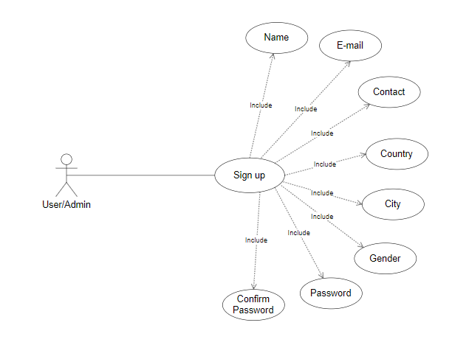
Figure 1: Sign Up for User and Admin

Sign Up for Lawyer
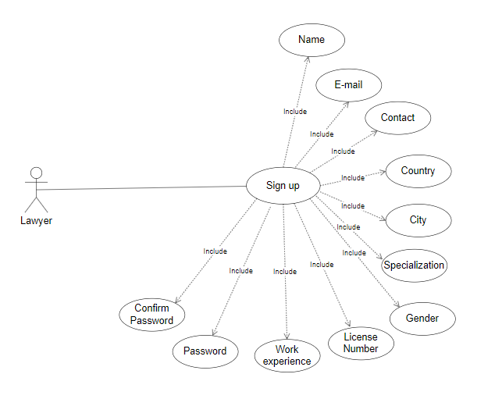
Figure 2: Sign Up for Lawyer

Login
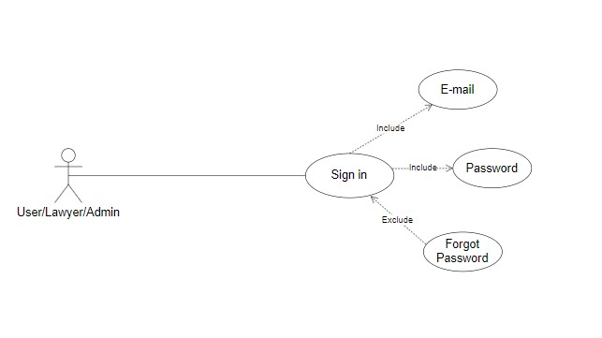
Figure 3: Login

Update Admin/User Profile
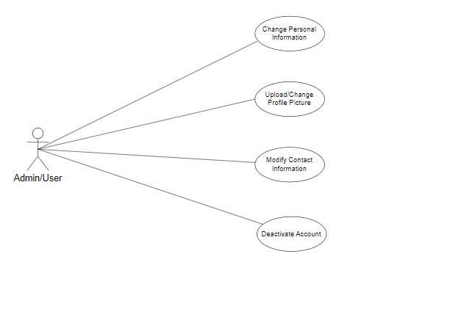
Figure 4: Update Admin/User Profile

Update Lawyer Profile

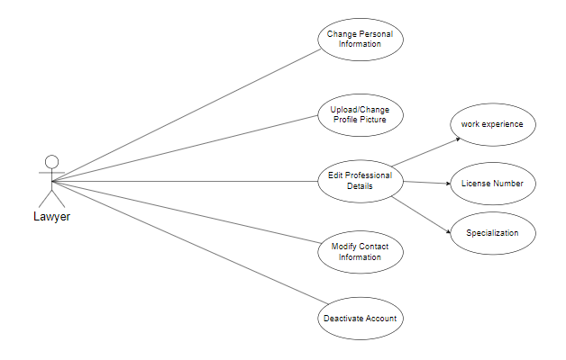
Figure 5: Update Lawyer Profile

Admin Functionalities
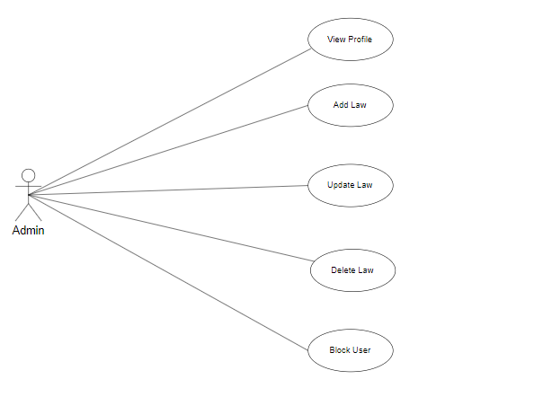
Figure 6: Admin Functionalities

User Interaction
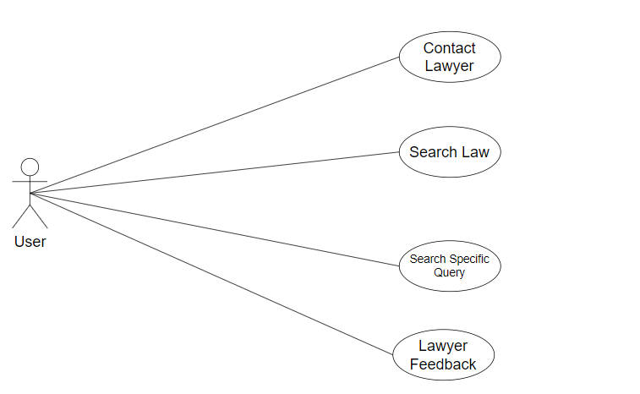
Figure 7: User Interaction

System Use Case
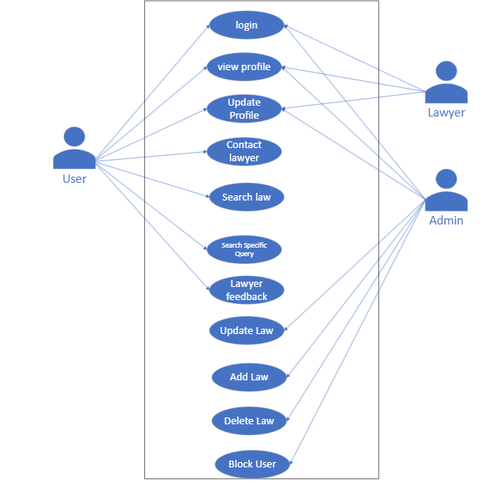
Figure 8: System Use Case

System Use Case Table

Sign Up for User

Table 1: Sign Up for User

Use Case | Sign Up for User
Use Case ID | UC-001
Actors | User
Priority | High
Description | Allows a user to create an account
Success Scenario | - User accesses the signup page.  - User enters valid personal details (name, email, password, etc.).  3. System validates the information provided.
Includes | -
Extends | -
Pre-Condition | User has access to the signup interface.
Post Condition | User account is created and accessible for login.

Signup for Lawyer

Table 2: Sign Up for Lawyer

Use Case | Signup for Lawyer
Use Case ID | UC-002
Actors | Lawyer
Priority | High
Description | Lawyers registering for an account on the platform
Success Scenario | 1. Lawyer accesses the signup page. 2. Enters personal and professional details.  3. Creates a mail/password.
Includes | -
Extends | -
Pre-Condition | Lawyer accesses signup page.
Post Condition | Lawyer account is successfully created.

Signup for Admin

Table 3: Sign Up Admin

Use Case | Signup for Admin
Use Case ID | UC-003
Actors | Admin
Priority | High
Description | Admin registers for an account.
Success Scenario | 1. Admin accesses signup page.  2. Admin enters necessary details (name, email, password, etc.).  3. System verifies and creates admin account.
Includes | -
Extends | -
Pre-Condition | Admin accesses signup page.
Post Condition | Admin account is successfully created.

User Login

Table 4: User Login

Use Case | User Login
Use Case ID | UC-004
Actors | User
Priority | High
Description | User logs into the system
Success Scenario | User enters valid credentials
Includes | Email, Password
Extends | Forget Password
Pre-Condition | User account exists
Post Condition | User is logged into the system.

Lawyer Login

Table 5: Lawyer Login

Use Case | Lawyer Login
Use Case ID | UC-005
Actors | Lawyer
Priority | High
Description | Lawyer logs into the system
Success Scenario | Lawyer enters valid credentials
Includes | Email, Password
Extends | Forget Password
Pre-Condition | Lawyer account exists
Post Condition | Lawyer is logged into the system.

Admin Login

Table 6: Admin Login

Use Case | Admin Login
Use Case ID | UC-006
Actors | Admin
Priority | High
Description | Admin logs into the system
Success Scenario | Admin enters valid credentials
Includes | Email, Password
Extends | Forget Password
Pre-Condition | Admin account exists
Post Condition | Admin is logged into the system.

User Update Profile

Table 7: User Update Profile

Use Case | Update Profile
Use Case ID | UC-007
Actors | User
Priority | High
Description | User updates their profile information.
Success Scenario | 1. User selects 'Edit Profile.  2. User modifies information.  3. User saves changes.
Includes | -
Extends | -
Pre-Condition | User is logged in.
Post Condition | User profile information is updated.

Lawyer Update Profile

Table 8: Lawyer Update Profile

Use Case | Update Profile
Use Case ID | UC-008
Actors | Lawyer
Priority | High
Description | Lawyers update their profile info.
Success Scenario | Lawyer navigates to profile update section.
Includes | -
Extends | -
Pre-Condition | Lawyer is logged in.
Post Condition | Lawyer profile information is updated.

Admin Update Profile

Table 9: Admin Update Profile

Use Case | Update Profile for Admin
Use Case ID | UC-009
Actors | Admin
Priority | High
Description | Admin updates their profile details.
Success Scenario | - Admin navigates to the profile update section.  - Admin modifies the necessary profile information.  - Admin saves the changes successfully.
Includes | -
Extends | -
Pre-Condition | Admin is logged in.
Post Condition | Admin profile is updated successfully.

Admin Functionalities

Table 10: Admin Functionalities

Use Case | System Settings
Use Case ID | UC-010
Actors | Admin
Priority | Low
Description | Admin manages system settings and configurations.
Success Scenario | Admin modifies system settings based on requirements.
Includes | -
Extends | -
Pre-Condition | Admin is authenticated.
Post Condition | Settings modified successfully.

Provide Feedback to Lawyer

Table 11: Provide Feedback to Lawyer

Use Case | Provide Feedback to Lawyer
Use Case ID | UC-011
Actors | Admin
Priority | Low
Description | Allows users to provide feedback to a lawyer
Success Scenario | User writes and submits the feedback.
Includes | -
Extends | -
Pre-Condition | User is logged in.
Post Condition | Feedback is successfully submitted.

Non-Functional Requirements

Performance Requirements
The platform should provide a responsive user experience, with pages loading within 2 seconds to ensure user satisfaction.

Security Requirements
The system should adhere to industry-standard security practices, including data encryption in transit and at rest.

DESIGN AND METHODOLOGY

Sequence Diagram

User Signup Process

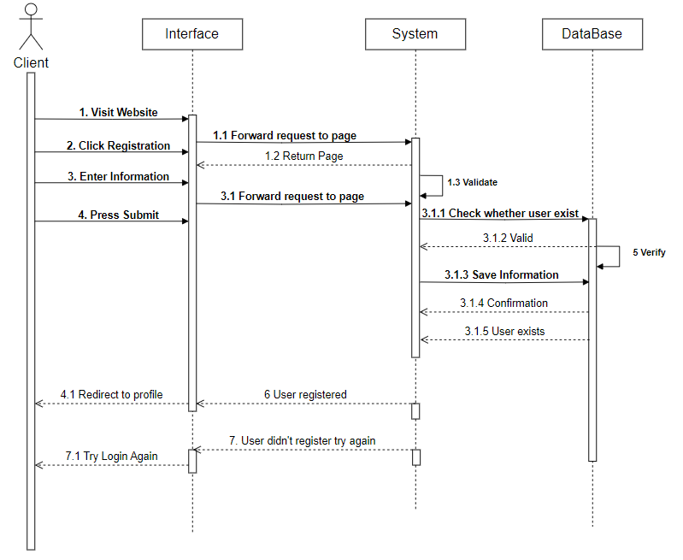
Figure 9: User Signup Process

Lawyer Signup Process

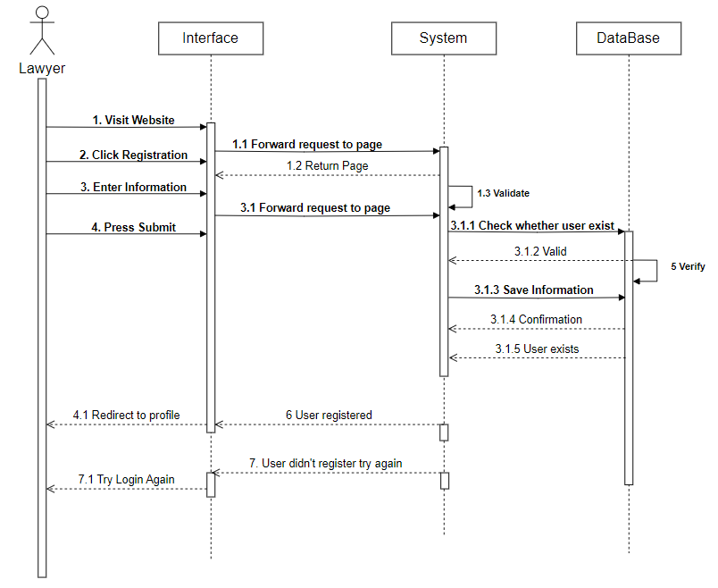
Figure 10: Lawyer Signup Process

Admin Signup Process

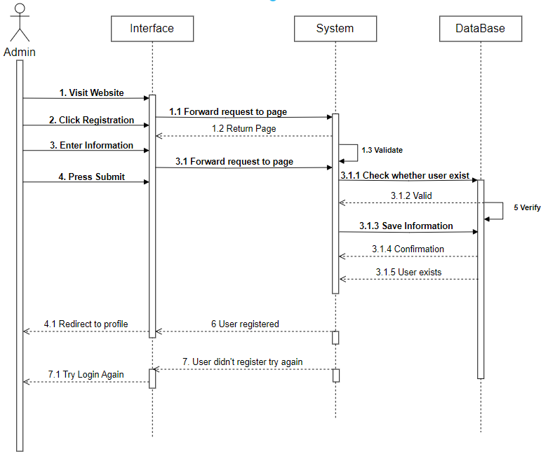
Figure 11: Admin Signup Process

Lawyer login Process

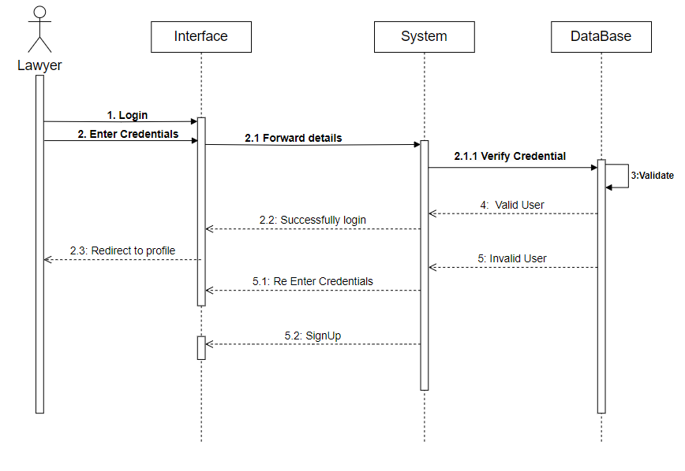
Figure 12: Lawyer login process

User login Process

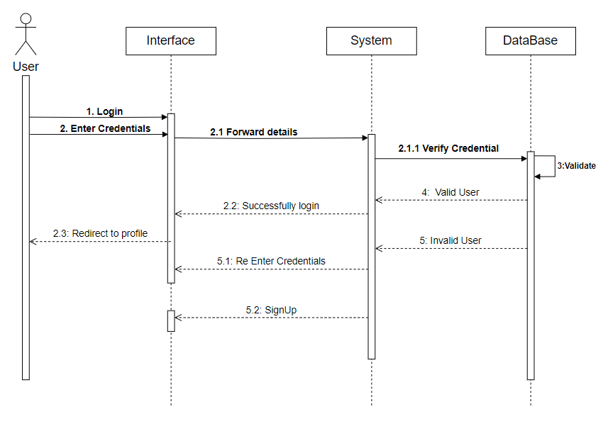
Figure 13: User login process

Admin login Process

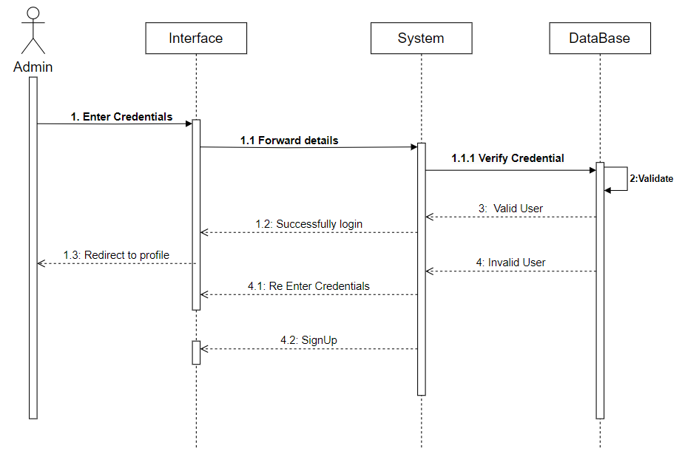
Figure 14: Admin login process

User Interaction Process

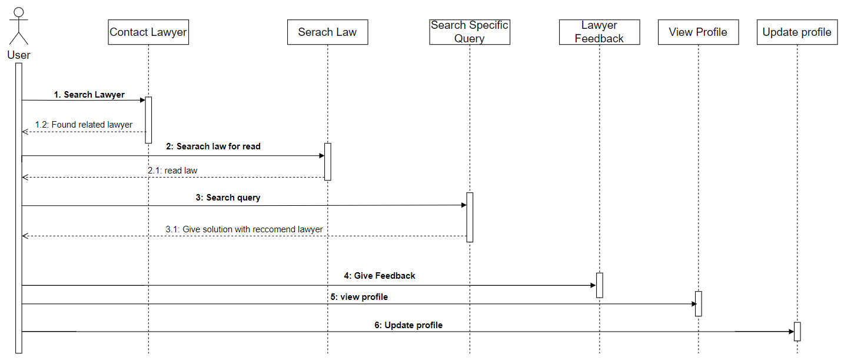
Figure 15: User Interaction Process

Lawyer Interaction Process

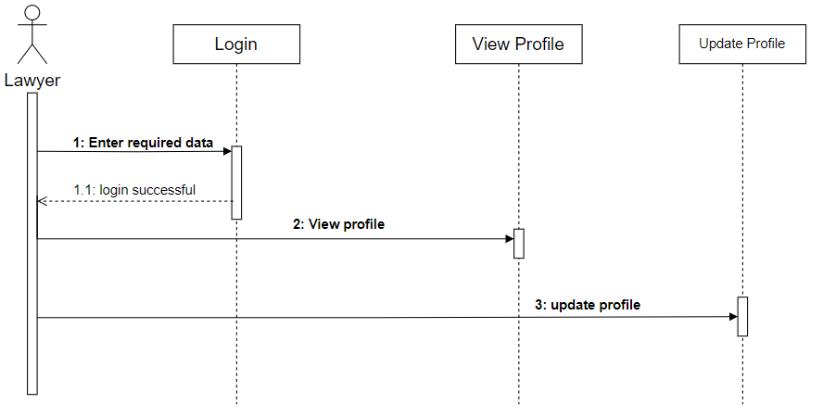
Figure 16: Lawyer Interaction Process

Admin Interaction Process

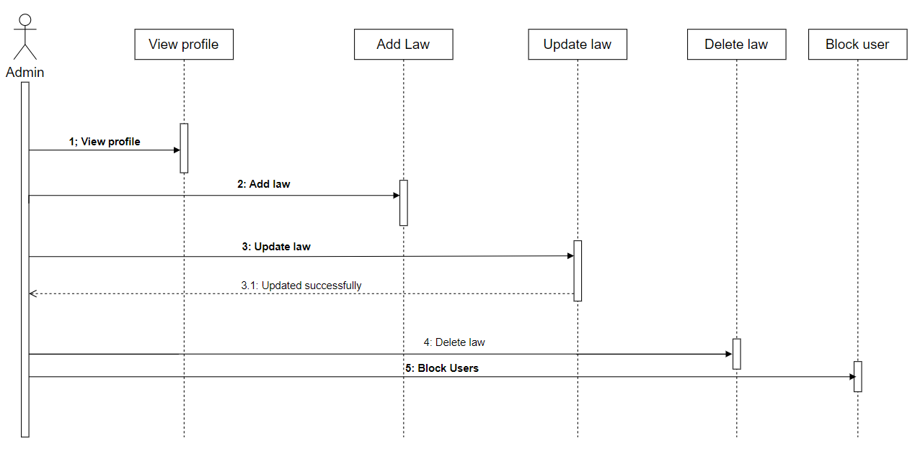
Figure 17: Admin Interaction Process

System Process

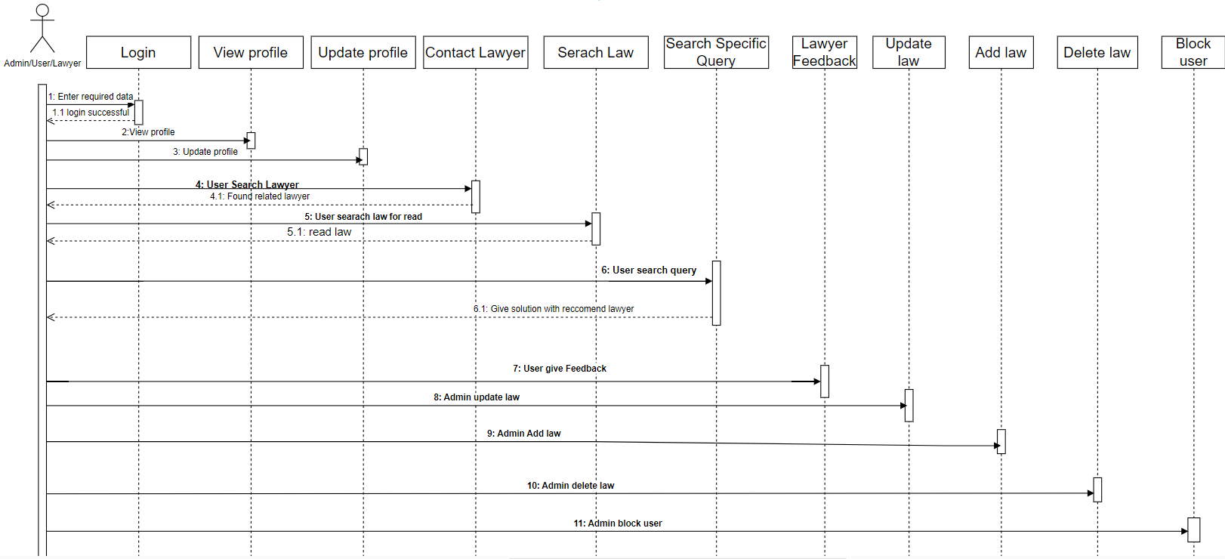
Figure 18: System Process

Class Diagram

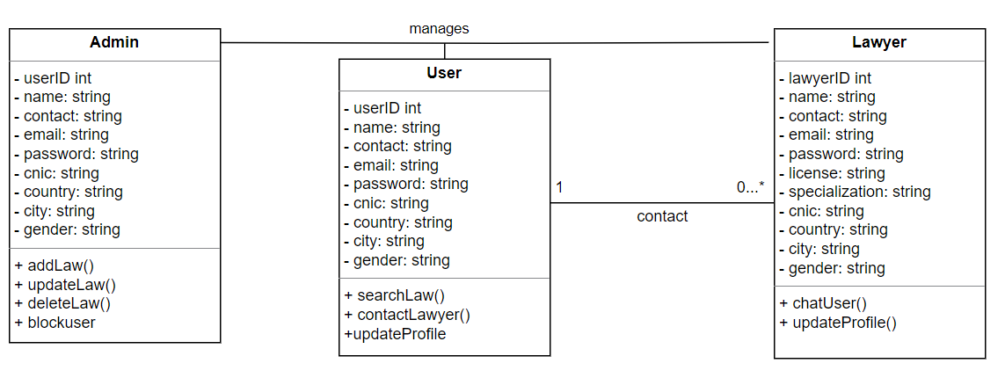
Figure 19: Class Diagram

ER Diagram
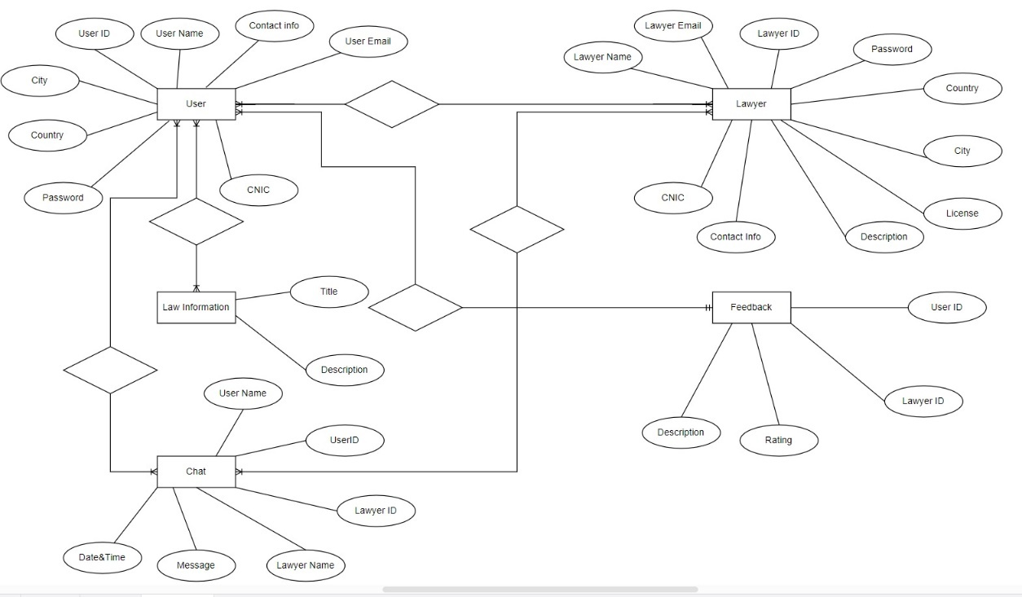
Figure 20: ER Diagram

Methodology

Feature Driven Development (FDD) approach of system development use in this project. Rather than treating requirements, design, and testing as large sequential steps, an FDD model makes them all ongoing processes that require involvement from developers and students.

Develop an Overall Model

In this phase overall model of project will be developed.

Build a Features List

Used for building a feature list, to identify the features by inspecting model.

Plan by Feature

In this phase, planning to all feature in estimated time will be done.

Design by Feature

Each feature will be designed one by one.

Build by Feature

In last phase, after designing features is pushed to main build.

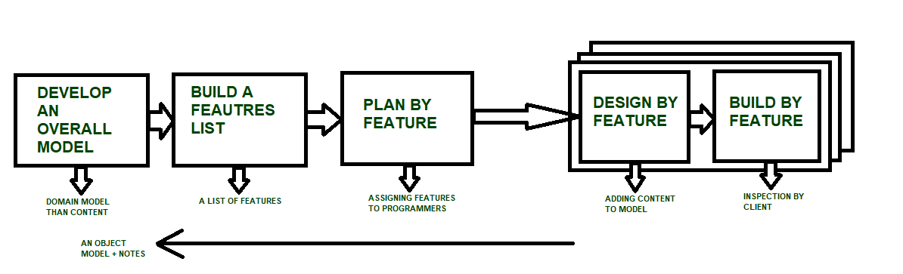
Figure 21: FDD

DATA AND EXPERIMENTS (and/or IMPLEMENTATION)

Implementation

At Legal Ease, bringing our legal platform to life is no simple feat. It involves a detailed and thoughtful development process that covers both the visible parts you interact with (the frontend) and the behind-the-scenes magic that makes everything work (the backend).

In the frontend phase, we put on our creative hats to design interfaces that respond to your needs. Whether you're a user lawyer, or administrator, we tailor the experience just for you. We use a cool frontend framework called React to make sure everything looks and feels great, no matter if you're using a computer, tablet, or phone.

On the backend side, we rely on PHP to lay the groundwork for our server. Think of them as the architects making sure everything stays sturdy. To store all your important info securely, we bring in MySQL, a reliable database that holds the key to your user data, lawyer’s details, and all things law related.

Before we put it all out there, we make sure everything works like a charm. We go through rigorous testing - checking individual parts, seeing how they play together, and testing the whole system. If there are any hiccups, we squash them like bugs.

Once we're up and running, we keep an eye on how things are going. Our Monitoring tools keep an eye on the system and how you use it. Based on what you say and what's new in tech, this helps us make things better. We're also not afraid to give you information. We plan regular tune-ups to make sure that everything is up to date on the latest safety and technology. Don't worry—we'll always let you know about any changes or updates.

To put it simply, our implementation method is based on the best ways to make software. Our goal is to give you a legal tool that is complete, easy to use, and effective. You're in the right place at Legal Ease, where you Laws and Lawyers.

RESULTS AND DISCUSSIONS (or USER MANUAL)

Home Screen

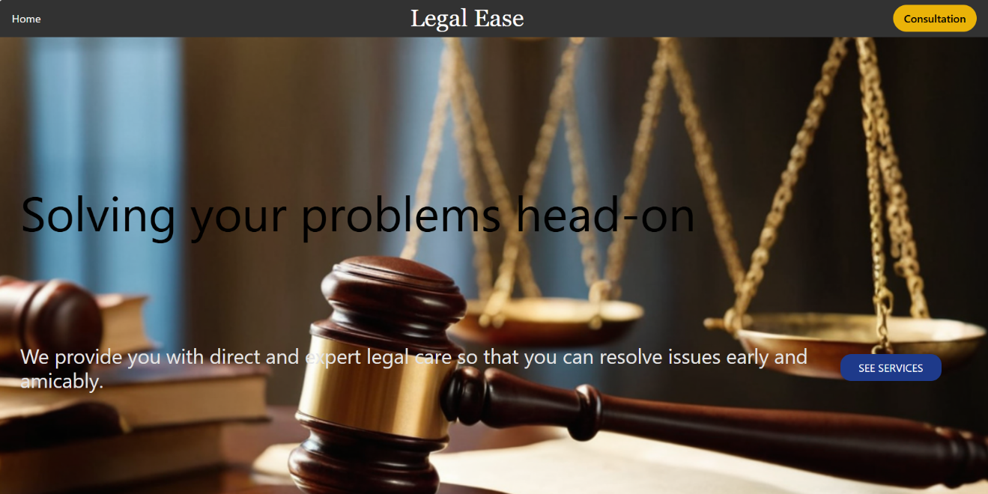
Figure 22: Home Screen

Login Page
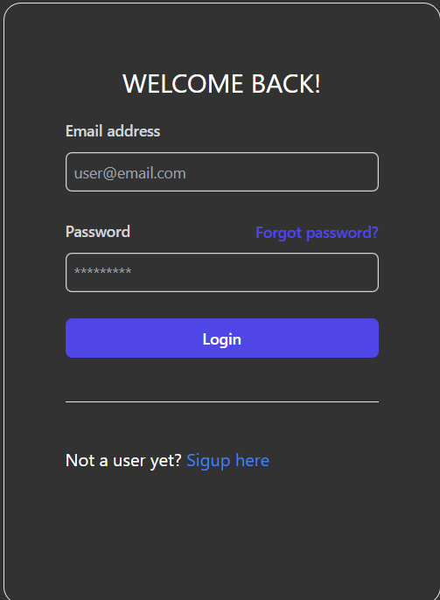
Figure 23: Login Page

User Signup 1/4

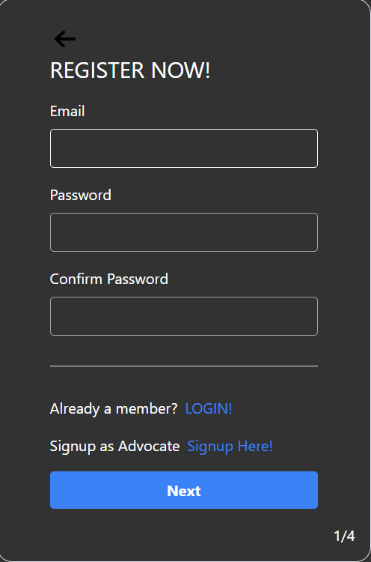
Figure 24: User Signup 1/4

User Signup 2/4

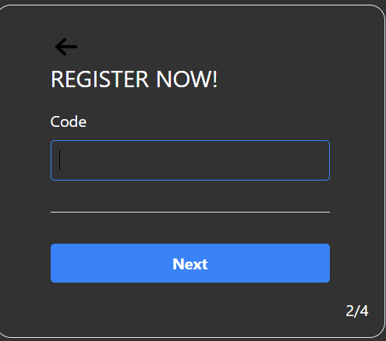
Figure 25: User Signup 2/4

User Signup ¾

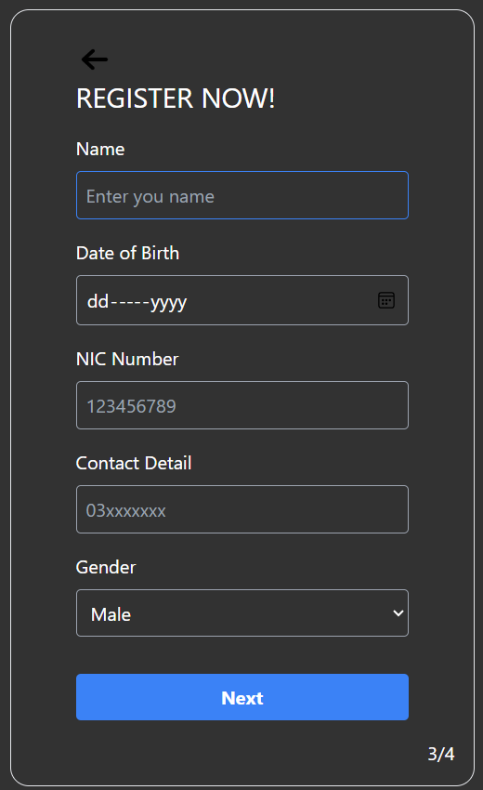
Figure 26: User Signup 3/4

User Signup 4/4

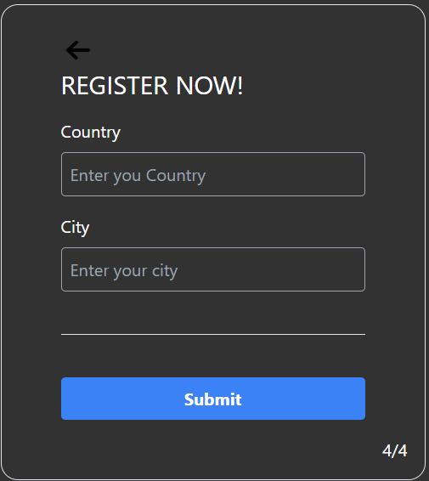
Figure 27: User Signup 4/4

User Homepage

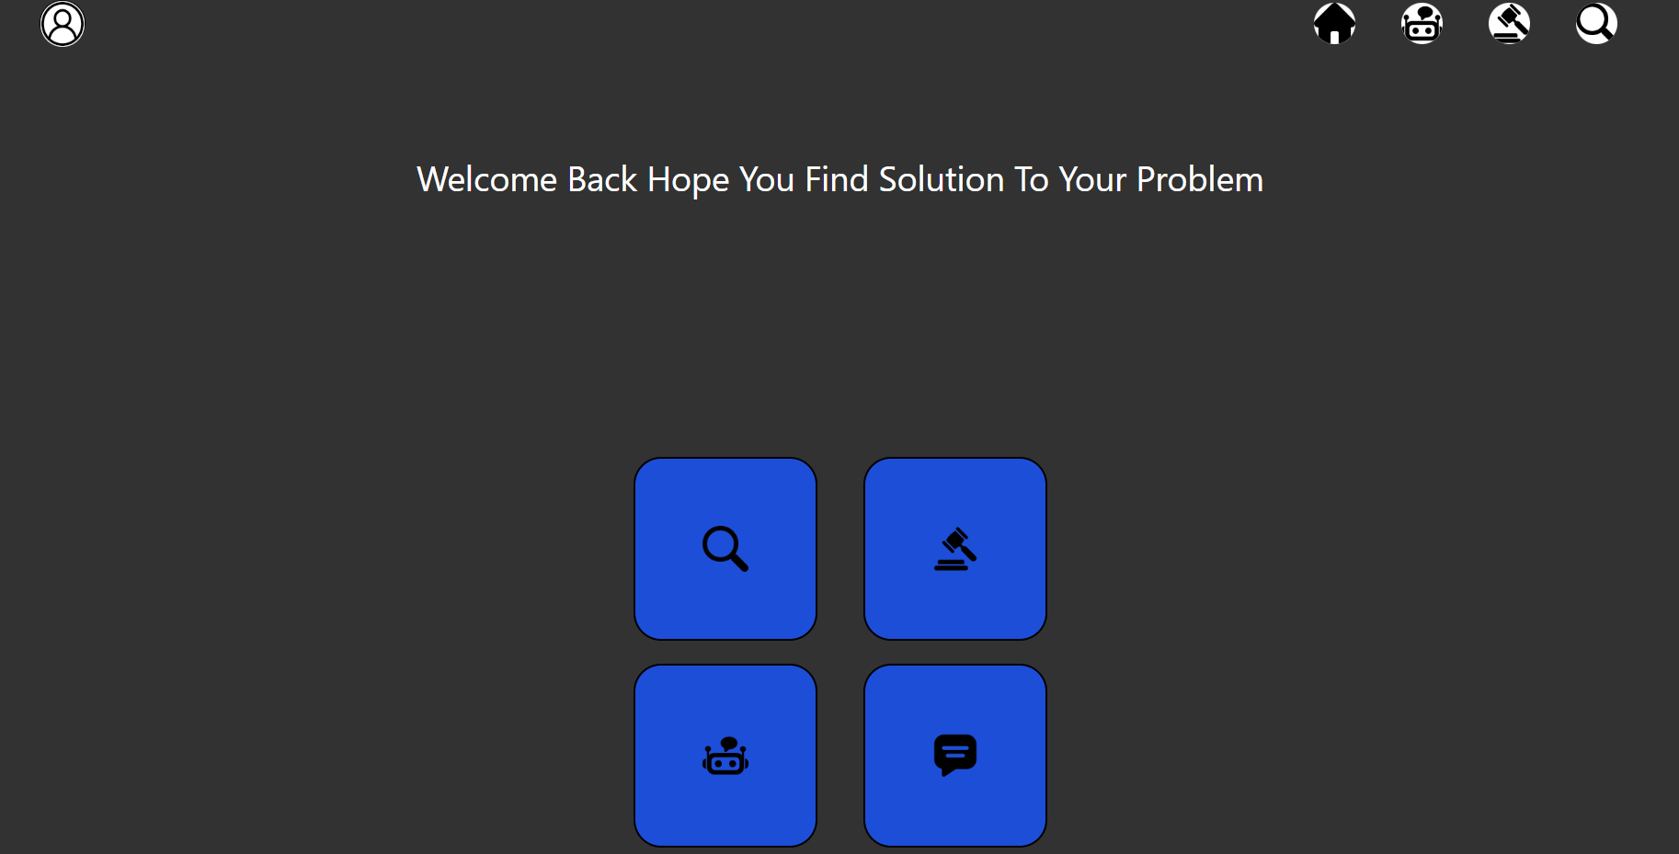
Figure 28: User Homepage

Lawyers

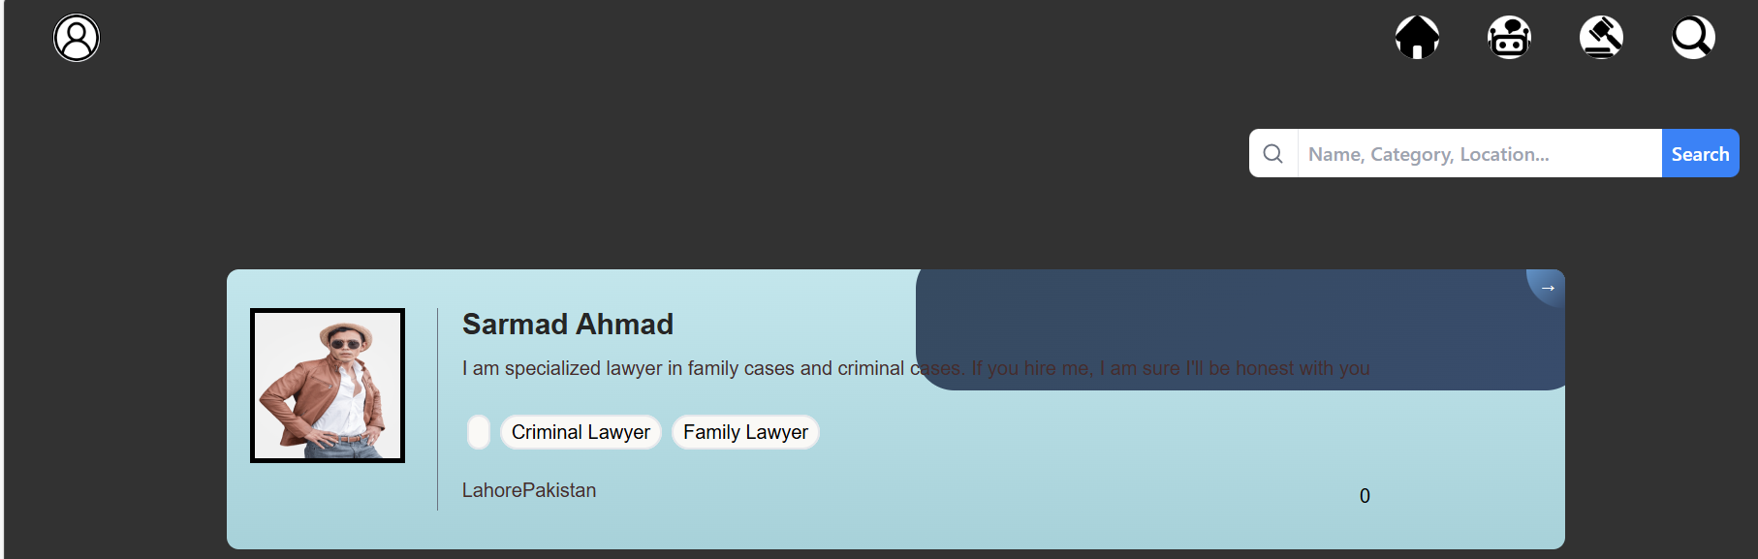
Figure 29: Lawyers

Chat with Lawyer

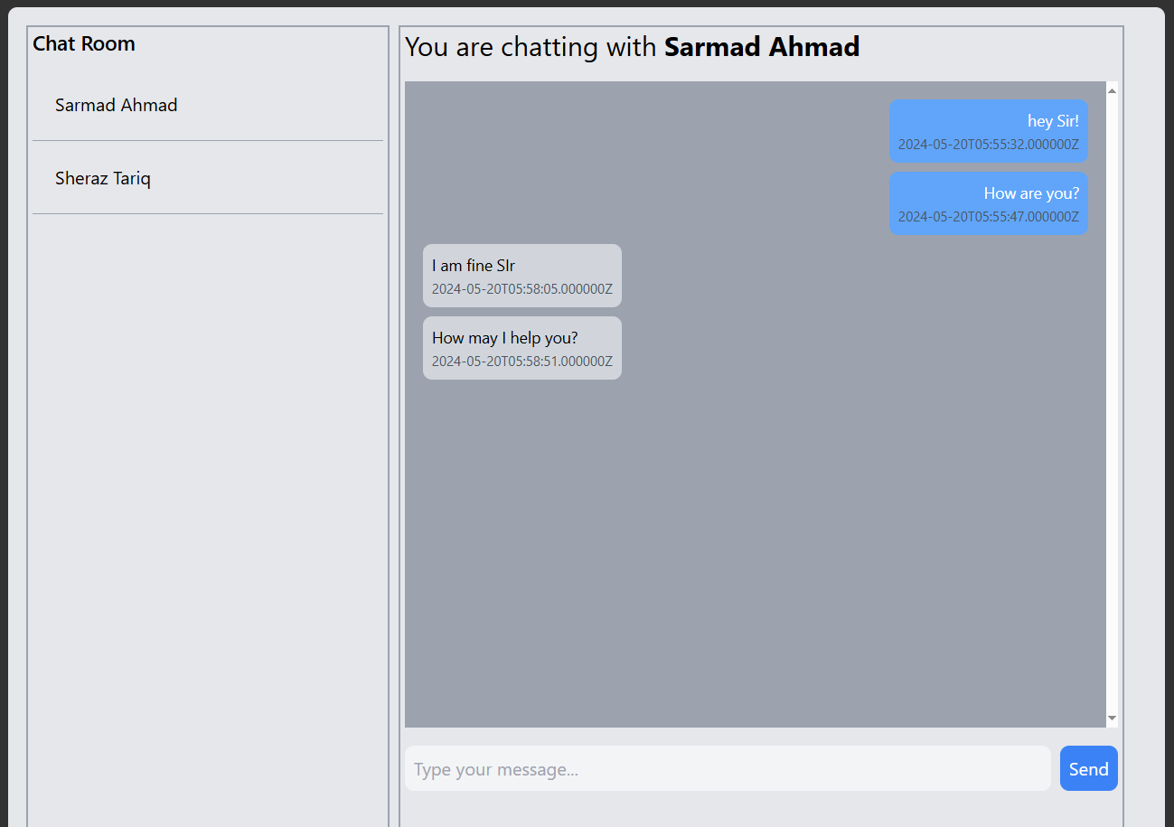
Figure 30: Chat with Lawyer

Chat with AI Advocate

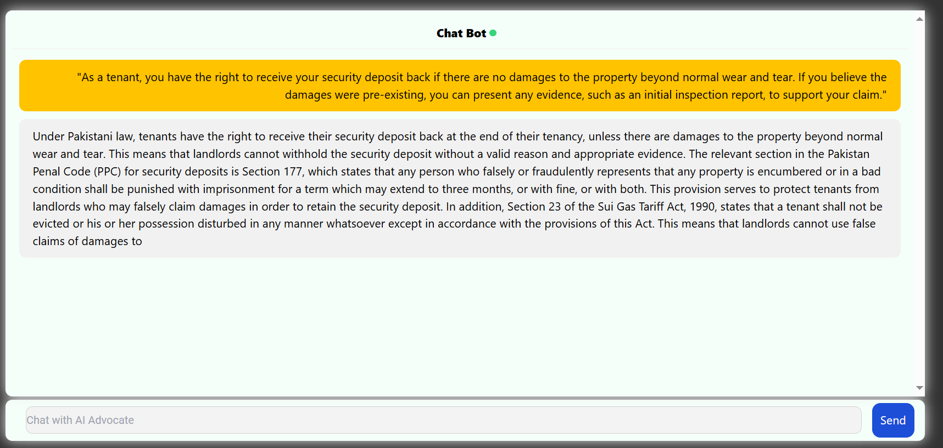
Figure 31: Chat with AI Advocate

Recommend Lawyers

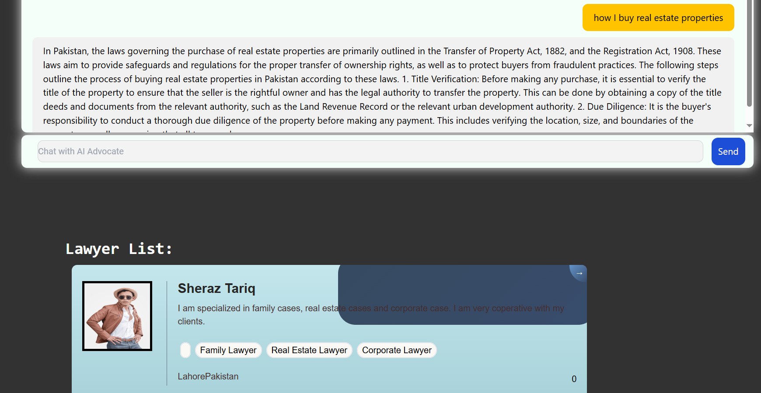
Figure 32: Recommend Lawyers

Lawyer Sign up 1/5

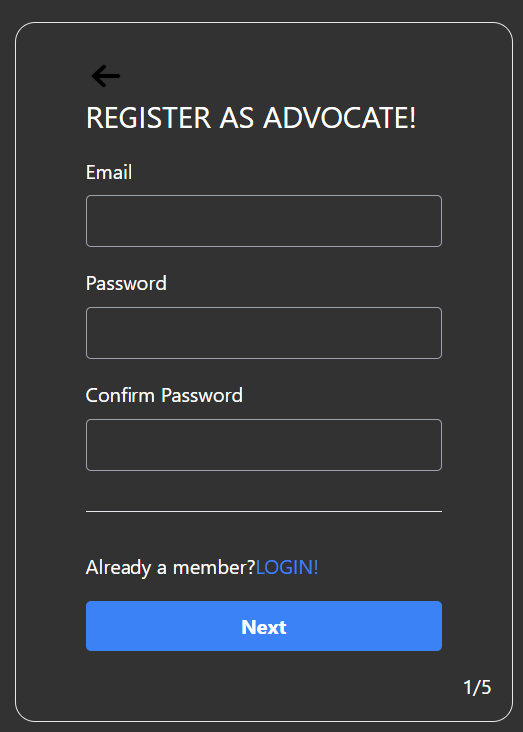
Figure 33: Lawyer Sign up 1/5

Lawyer Signup 2/5

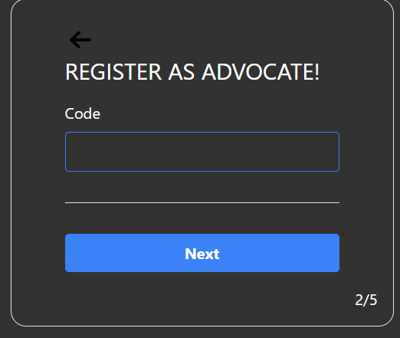
Figure 34: Lawyer Sign up 2/5

Lawyer Signup 3/5

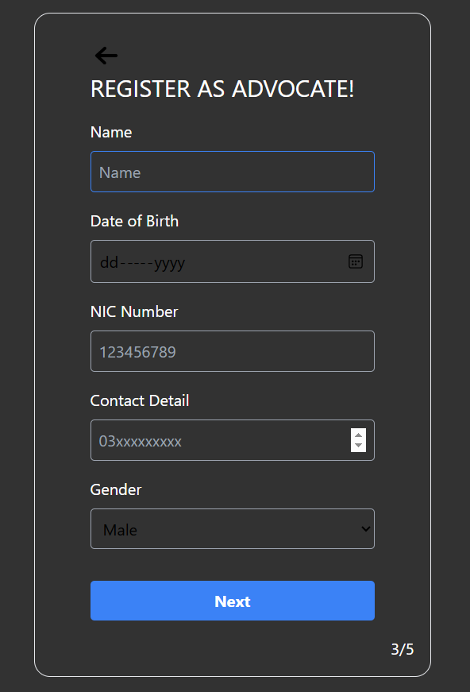
Figure 35: Lawyer Signup 3/5

Lawyer Signup 4/5

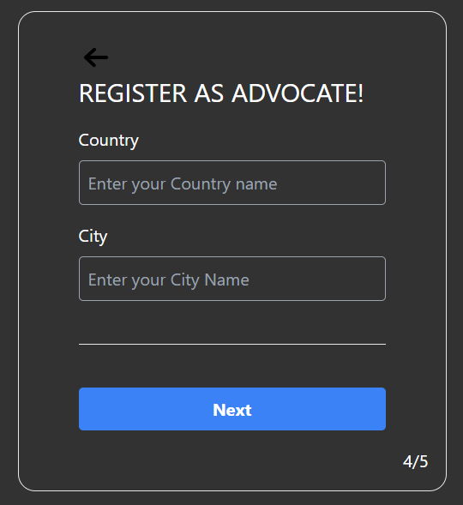
Figure 36: Lawyer Signup 4/5

Lawyer Signup 5/5

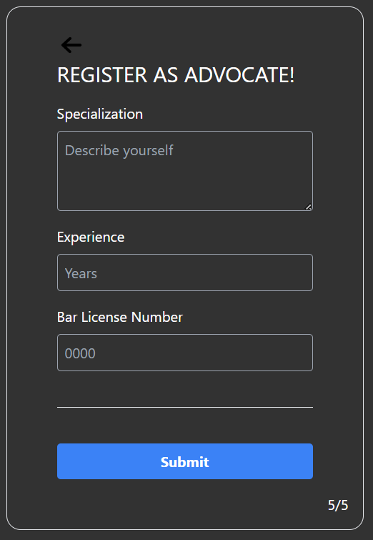
Figure 37: Lawyer Signup 5/5

Lawyer Homepage

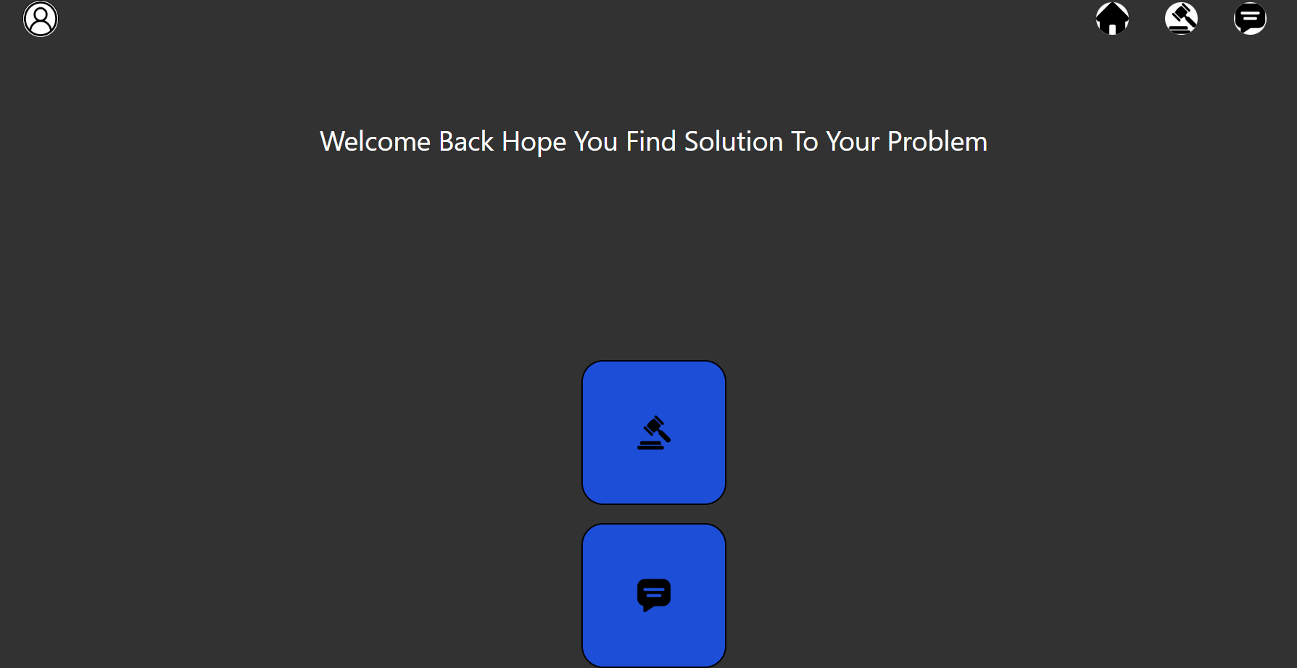
Figure 38: Lawyer Homepage

Lawyer Chat with User

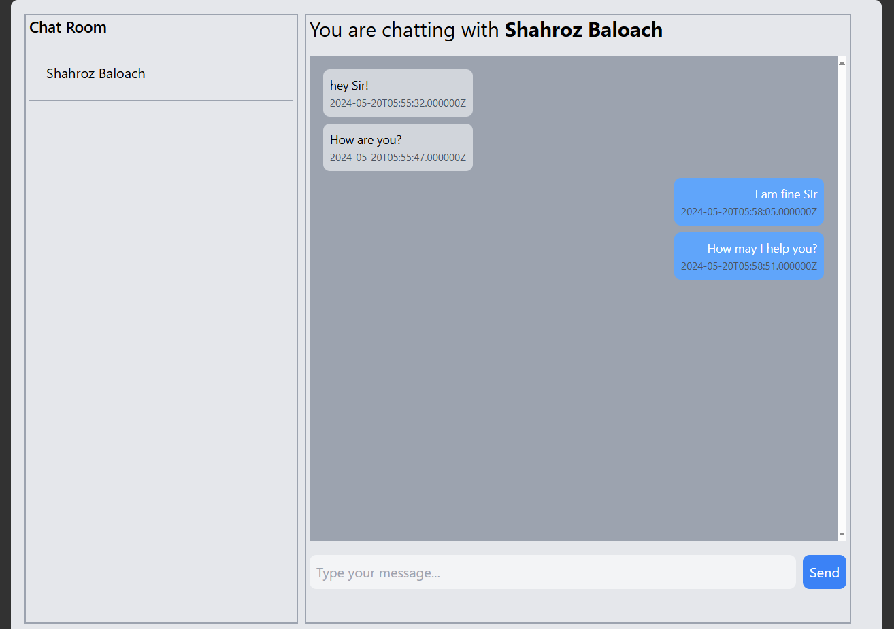
Figure 39: Lawyer Chat with User

Admin Homepage

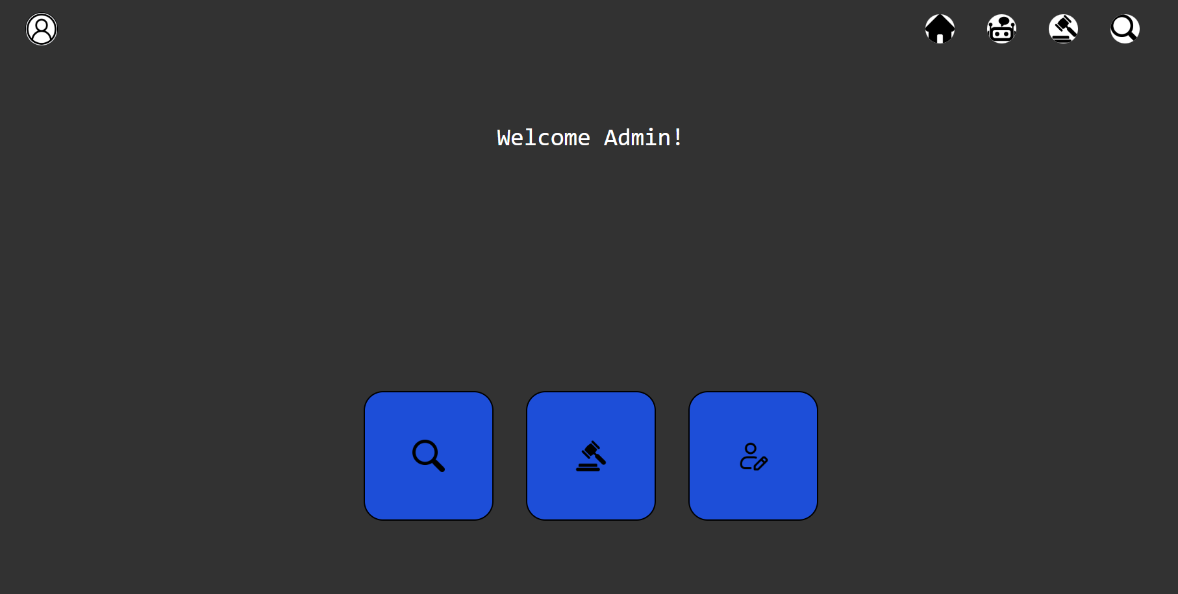
Figure 40: Admin Homepage

Law Add by Admin

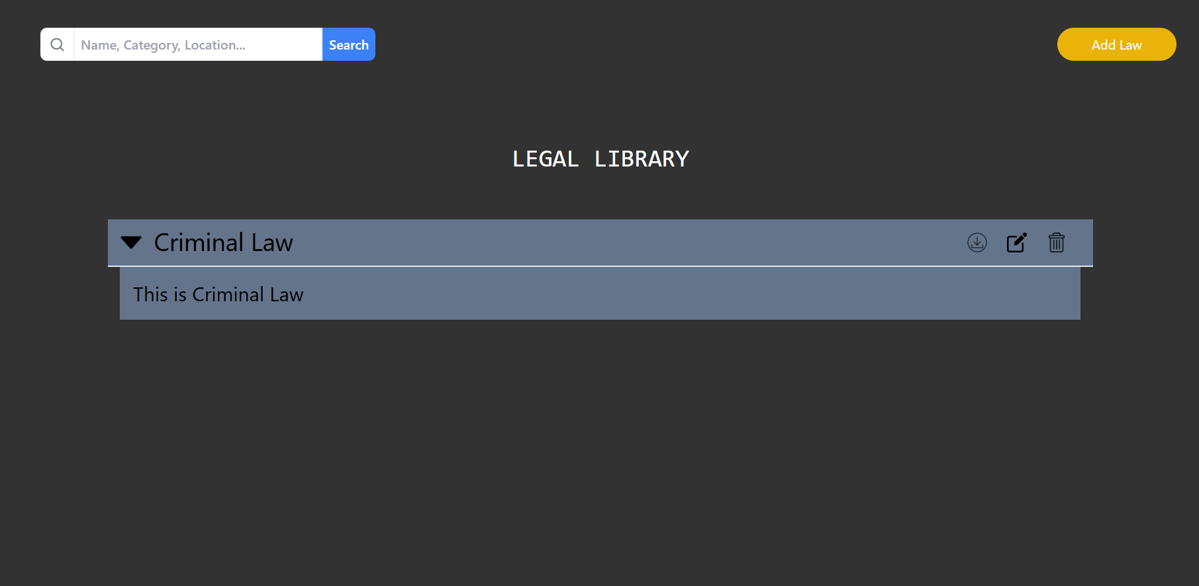
Figure 41: Law Add by Admin

User & Lawyer Database

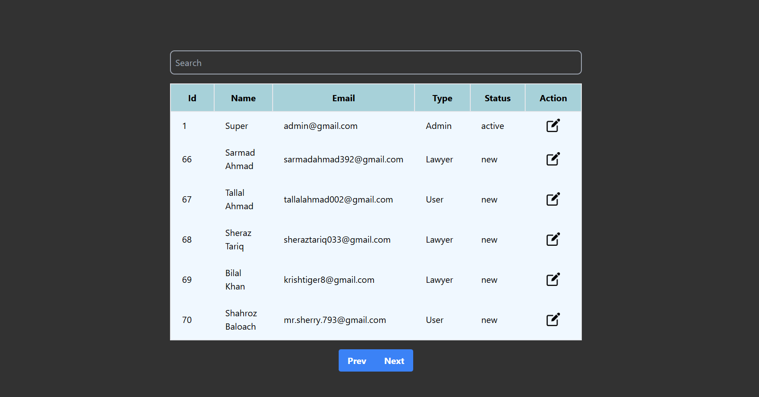
Figure 42: User & Lawyer Database

CONCLUSION AND RECOMMENDATIONS

Introduction to Result

The implementation of Legal Ease has yielded significant outcomes in revolutionizing Laws and Lawyers accessibility. This part talks about the main results that were found, such as how users interacted with the system, how well it worked, how satisfied users were, what problems were encountered, and what improvements might be made in the future.

User Interaction and Experience

Feedback from users shows that they had a good experience with Legal Ease. The easy-to-use interfaces for both customers and lawyers have made it easier to get around. Testimonials from customer talk about how useful features like the laws, and consultation calls are, which makes the user experience better.

System Functionality

The project goals are closely aligned with the functionality of Legal Ease. The platform efficiently matches users with specialized lawyers based on their legal needs, while the AI-driven personalized legal information service has successfully provided accurate and relevant advice. The real-time search functionality seamlessly integrates various data sources, ensuring the platform meets its original design specifications.

Performance Metrics

Quantitative metrics show that achievement is good. The system's uptime stays high, and response times for important tasks meet standards that have already been set. Metrics on user involvement show that people are actively taking part in searching their laws and hire consultant, which proves that the platform is reliable and useful.

Challenges and Solutions

Problems that came up during development, like how to integrate the data, were solved well by working together to find solutions. A strong and stable system has been made possible by constant monitoring and quick responses to problems noted by users.

Comparisons with Objectives

The results that were achieved are very close to the original project goals. Legal Ease has successfully sped up the advice process, include laws, and hire lawyers more accessible. Few deviations happened and were quickly fixed, which made sure that project goals were met or surpassed.

Future Enhancement

In the future, improvements could be to add more updated laws and adding more educational information, awareness, and hire best lawyers for their problems. Legal Ease will also stay in line with to update and provide value to their users.

Conclusion

Finally, the talks and results show that Legal Ease is successful at offering personalised, easy-to-reach laws, and lawyers services. The good results, along with user feedback and the finding of growth areas, have made it possible for more new ideas and changes to be made in legal platform.

Recommendation

Based on Legal Ease's findings and discussions, the implementation has effectively solved important problems with legal access. The site does a good job of connecting customers with good lawyers, alternative solutions of their problems, and learning and searching laws. Platform improvement is helped by ways for users to give input. For a more complete and user-centered legal experience, suggestions include making the systems better, expanding laws, and giving users incentives to get involved. For growth and innovation to continue, it's best to do regular security checks, work together with lawyers, and keep learning new things as a professional.

REFERENCES

[1] Masud, M. K. (2019). Modernizing Islamic Law in Pakistan: Reform or Reconstruction?. Journal of South Asian and Middle Eastern Studies, 42(2), 73-97.

[2] Shah, N. A. (2011). Islamic law and the law of armed conflict: the conflict in Pakistan. Taylor & Francis.

[3] Munir, M. (2014). Rights of the child: An Islamic perspective on preventing violence, abuse, and exploitation of children and pakistani law. Hamdard Islamicus (October-December 2015), 38(4), 33-58.

[4] Khalid, A., Nyborg, I., & Khattak, B. N. (2015). Whose property whose authority? Gendering the legal and customary practices in ownership and access to land: A case of Swat, Pakistan. Journal of Rural Studies, 41, 47-58.

[5] Uddin, S., & Rahman, S. U. (2020). Pakistani laws on the use of narcotics and drug addiction: Need for Reforms. Islamabad Law Review, 4(1/2), 105

