

BSCS-F23-011
03-134202-012 | ARSLAN
03-134202-040 | MUHAMMAD ALI BUTT

SPEAKING HANDS

In partial fulfilment of the requirements for the degree of
Bachelor of Science in Computer Science
Supervisor: JUNAID NASIR
Department of Computer Sciences
Bahria University, Lahore Campus
JUNE 2024

© Bahria University, 2024

Certificate

We accept the work contained in the report titled
“SPEAKING HANDS”
written by
ARSLAN
MUHAMMAD ALI BUTT
as a confirmation to the required standard for the partial fulfilment of the degree of
Bachelor of Science in Computer Science.

Approved by:
Supervisor: JUNAID NASIR
(Signature)

JUNE 2024

DECLARATION

We hereby declare that this project report is based on our original work except for citations and quotations which have been duly acknowledged. We also declare that it has not been previously and concurrently submitted for any other degree or award at Bahria University or other institutions.

Enrolment | Name | Signature
03-134202-012 | ARSLAN
03-134202-040 | MUHAMMAD ALI BUTT

Date : JUNE 15, 2024

Specially dedicated to
my beloved grandmother, mother and father
(ARSLAN)
my beloved grandmother, mother and father
(MUHAMMAD ALI BUTT)

ACKNOWLEDGEMENTS

We would like to thank everyone who had contributed to the successful completion of this project. We would like to express our gratitude to my research supervisor, Mr JUNAID NASIR for his invaluable advice, guidance and his enormous patience throughout the development of the research.

In addition, we would also like to express my gratitude to our loving parent and friends who had helped and given me encouragement.

ARSLAN
MUHAMMAD ALI BUTT

SPEAKING HANDS

ABSTRACT

Deaf and mute people mainly use sign language like ASL (American Sign Language) to communicate, but when they interact with those who can hear, a big language barrier gets in the way. This makes it tough for them to access education, jobs, and social activities, leaving them feeling excluded. On top of that, blind people have a hard time getting information from text, making communication even more challenging. Our project steps in to solve these issues by creating a communication tool that helps deaf and mute individuals talk to everyone, including those who can hear.

Our proposed methodology is based on the application of Machine learning. Extracting features of Hand by using Mediapipe and classification from Machine Learning (ML) model K-Nearest Neighbour Classifier, and computer vision, to transform communication for deaf and mute people. We capture their sign language from live video and instantly turn it into written messages (English). This not only breaks down language barriers but also helps blind people by converting text (English) into spoken words. What's more, our software lets people who don't know sign language talk to deaf and dumb individuals by changing their voice into text (English) and that text (English) into sign language. For both purposes we used Flutter’s Packages because the app development is done on flutter. This way, we're making communication easier for everyone, no matter how they prefer to communicate. Our project takes us a step closer to a world where everyone can connect and understand each other.

TABLE OF CONTENTS

DECLARATION ii
ACKNOWLEDGEMENTS iv
ABSTRACT v
TABLE OF CONTENTS vi
LIST OF TABLES ix
LIST OF FIGURES x
LIST OF SYMBOLS / ABBREVIATIONS xii

CHAPTERS
1 INTRODUCTION 1
1.1 Background 1
1.2 Problem Statements 1
1.3 Aims and Objectives 2
1.4 Scope of Project 2
2 LITERATURE REVIEW 3
2.1 Research Papers, Journals, Articles 3
3 DESIGN AND METHODOLOGY 7
3.1 Methodology 7
3.2 Software Workflow Methodology 8
3.3 Design 10
3.3.1 Module 1 (ASL to Speech) 10
3.3.2 Module 2 (Speech to ASL) 11
3.4 Diagrams 12
3.4.1 Sequential Diagram 12
3.4.2 Activity Diagram 14
3.4.3 Data Flow Diagram 15
3.4.4 Use Case Diagram 15
4 DATA AND EXPERIMENTS AND IMPLMENTATION 16
4.1 Creating Data Set 16
4.1.1 ASL Digits 16
4.1.2 ASL Alphabets 17
4.1.3 Special Characters 18
4.2 Feature Extraction 19
4.2.1 Data Gathering with Mediapipe: 19
4.2.2 Feature Extraction 20
4.2.3 Normalize the Data 20
4.2.4 Labelling 20
4.2.5 Data Storage in CSV Format 20
4.3 Training and Evaluating K-Nearest Neighbors Classifier 21
4.3.1 Preparing Data 21
4.3.2 Training the Model 21
4.3.3 Storing Model 22
5 RESULTS AND DISCUSSIONS 23
5.1 Model Evaluation 23
5.1.1 Digits 23
5.1.2 Alphabets 24
5.2 Heatmaps 26
5.2.1 Heatmap for Digit 26
5.2.2 Heatmap for Alphabets 27
6 CONCLUSION AND RECOMMENDATIONS 28
6.1 Conclusion 28
6.2 Recommendations 29
REFERENCES 30

LIST OF TABLES

TABLE TITLE PAGE
Table 2.1: Research Papers, Journals, Articles 3

LIST OF FIGURES

FIGURE TITLE PAGE
Figure ‎3.1: Software Development Life Cycle Methodology 7
Figure ‎3.2: Software Methodology 9
Figure ‎3.3: HomeScreen-1 10
Figure ‎3.4: ASL To Speech Screen 10
Figure ‎3.5: HomeScreen-2 11
Figure ‎3.6: Speech To ASL Screen 11
Figure ‎3.7: Sequential Diagram for ASL to Speech 12
Figure ‎3.8: Sequential Diagram for Speech to ASL 13
Figure ‎3.9: Activity Diagram 14
Figure ‎3.10: Data Flow Diagram 15
Figure ‎3.11: Use Case Diagram 15
Figure ‎4.1: ASL Digit Dataset Description [16] 16
Figure ‎4.2: ASL Digit Dataset Distribution 17
Figure ‎4.3: ASL Alphabets Dataset Description [17] 17
Figure ‎4.4: ASL Alphabets Dataset Distribution 18
Figure ‎4.5: Special Sign Dataset Description 18
Figure ‎4.6: Mediapipe Hand landmarks Description. 19
Figure ‎4.7: Accuracy vs K-Neighbours for Digit 22
Figure ‎4.8: Accuracy vs K-Neighbours for Alphabets 22
Figure ‎5.1: Heatmap for Digits 26
Figure ‎5.2: Heatmap for Alphabets 27

LIST OF SYMBOLS / ABBREVIATIONS

ASL American Sign Language
ML Machine Learning
CNN Convolutional Neural Network
KNN K-Nearest Neighbours
RNN Recurrent neural network
YOLO You Only Look Once

INTRODUCTION

Background

Deaf and mute individuals commonly use sign language, such as ASL, to communicate with each other. However, when it comes to communicating with those individuals who are hearing the challenges are always evident which limits their chances of going to school, getting a job and networking. Moreover, the deaf and blind people always experience difficulties when it comes to comprehending textual information, which also hampers communication. These barriers lead to experiences of isolation for persons with hearing and visual impairments.

Problem Statements

Deaf and mute and blind are some of the disabled individuals who face communication barriers which makes them limited to some extent to communicate with other people or access important information. Oral resources like written text or sign language interpretation may always be unavailable or inaccessible in many instances of time. For this reason, currently, deaf, mute, and blind people experience diverse challenges in their everyday lives, including education, employment, and social relationships. This is why there is required approach to create new technologies that would enable efficient flow of dialog between people with necessity of sign-based interaction.

Aims and Objectives

The objectives are written as following:
- Develop an application that captures ASL signs from live video streams in real-time.
- Apply Machine learning techniques and computer vision to accurately recognize ASL signs and convert them into written text.
- Develop an application to convert written text into spoken words to aid individuals with sight disabilities.
- Create a user-friendly interface to ensure anyone can easily use the application.
- Allow real-time communication between users, for seamless and quick interaction.

Scope of Project
The scope of this project is to develop and implement a software solution that facilitates communication among deaf, mute, blind, and hearing individuals. The project will focus on capturing sign language from live video streams, converting it into written English messages, and providing text-to-speech and speech-to-text functionalities. Software will also include features for translating spoken words into text and then into sign language. However, the project will not address all aspects of communication accessibility, such as tactile communication for individuals with both hearing and visual impairments. Additionally, the project will primarily target English language communication but can be extended to support other languages in future iterations.

LITERATURE REVIEW

Research Papers, Journals, Articles

We have studied 8 research papers and majority of them used the Deep learning models CNN, TSM and YOLO but we implement KNN. Two of them used the Mediapipe to extract features from the Image, so we also used Mediapipe for extracting feature because its more accurate and precise for detecting hand in the image. Since we are not giving image as the input to our model, so that’s why we used KNN. Because we used Mediapipe for extracting feature and storing them in csv file. In all these research papers they are doing prediction on the images, but we are going one step further and doing predictions on live video stream.

Table 2.1: Research Papers, Journals, Articles
Reference | Algorithm Model | Dataset | Accuracy
[1] | TSM-CNN | MNIST dataset and the ASL Alphabet dataset from Kaggle | 97.57%
[2] | 3-D CNNs | Boston ASL (Lexicon Video Dataset) LVD
[3] | CNN & RNN | American Sign Language Dataset | 99%
[4] | Deep CNN | Sign Language MNIST dataset from Kaggle | 99.67%
[5] |  | How2Sign, a multimodal and mul- tiview continuous American Sign Language (ASL) dataset
[6] | SL-TSSI-DenseNet, | WLASL, AUTSL, Mexican Sign Language (LSM) dataset | 81.47%, 93.13%, 98.0%
[7] | Pipeline, Feature Selection, CatBoost algorithm | Ninapro DB5 Dataset (sEMG signals), ASL Manual Alphabet Dataset | 99.91%
[8] | YOLO, CNN | we have created a data set consisting of 8000 images divided into 40 classes, for each class, 200 images were taken with different backgrounds and under lighting conditions, | 98.01%

- TSM-CNN: In this project, by developing a KNN model with a data set, we have reached a remarkable accuracy of approximately 99 percent. 5 percent on Allstate’s dataset of 21,000 images. This accuracy is higher compared to TSM-CNN model which was able to success at a rate of 97. The model was trained and tested on the Simple MNIST and Kaggle ASL Alphabet Datasets with an overall accuracy of 57% on MNIST. From the results mentioned above, it is evident that the KNN model is more efficient in differentiating the sign patterns in sign languages when compared to TSM-CNN.
- 3-D CNNs: We find that the proposed KNN model has better performance than the 3-D CNNs with the Boston ASL dataset whereby the accuracy stands at
a mere 99. 5%. This means that while it is not known exactly how accurate the model of 3-D CNNs is, the fact that our project achieved high levels of accuracy means that projecting them onto a variety of images of sign language gestures should in fact be quite effective.

- CNN & RNN: While our experiment on American Sign Language Dataset did improve the accuracy to a maximum of 99%, the model we trained and tested herein – the KNN Model – shows a slightly higher percentage accuracy of 99. 5%. This suggests that our proposed method is quite sound in the establishment of sign language patterns, this could be due to certain qualities about the KNN algorithm that is able to discern certain qualities captured in the 21,000 images dataset.

- Deep CNN: However, even when using the Deep CNN model, its accuracy was found to be approximately at 99. It has been 35% and 67% on the Sign Language MNIST dataset; the accuracy of the KNN model stands at 99%. It took 5% on the same set of data but on larger input. Although there might be slight difference in the accuracy, it can been seen that our project was accurate with the KNN model which is more than suitable for sign language recognition.
- How2Sign Dataset: For the How2Sign dataset, there is no specific accuracy presented but our project, the KNN model, is estimated to be 99 percent accurate. It brings it to only 5%, which may mean that the models trained on this particular dataset could perform comparatively lower. This shows that there is generality and strong performance in our model when it comes to the ability to identify multiple and distinct sign languages from the dataset.

- SL-TSSI-DenseNet: In comparison to the proposed SL-TSSI-DenseNet model which can yield accuracies from 81 to 92 percent it is possible to state that the kind of approach is highly efficient. 47% to 98. 0% on a number of different sign language datasets; our own KNN model maintains a comparable level of performance, yielding an average accuracy of 99. 5%. This indicates that our approach can generalise well to other sign language datasets and obtain high accuracy rates that may be even higher than simpler models like KNN, as the latter is good at adapting to various patterns.

- Pipeline, Feature Selection, CatBoost algorithm: Even in the more professional Pipeline, Feature Selection, CatBoost algorithm pipeline achieved an accuracy of 0.99, though the classification and plot accuracy of it was just 0.802709. Legends:KNN and our proposed KNN model attained an accuracy of 91% on the Ninapro DB5 Dataset and ASL Manual Alphabet Dataset respectively while the second model achieved slightly lower but equally impressive percentage of 99%. 5%. This show that our approach performs competitively on sign language recognition tasks, in fact more competatively than when using the state of the art complex methods and best feature selection available.

- YOLO, CNN: In the analysis, the YOLO, CNN: model outperforms the model in achieving an accuracy of 98. In our case, with an image dataset of 8000 images belonging to 40 different classes, our KNN model achieves the percentage of 99% in accuracy which is way higher compared to the 01% achieved by the previous model. 5%. This gets a hint towards the effectiveness of the KNN algorithm to map deserving sign language gestures across a broader and varied data set, which might point out using it suitably for practical use.

DESIGN AND METHODOLOGY

Methodology

We have designed a customized Agile approach to meet our specific needs. This approach combines essential Agile principles with our goal of developing a communication tool for the deaf and mute people. We focus on teamwork, incremental progress, and adaptability to promote inclusive and effective communication solutions.
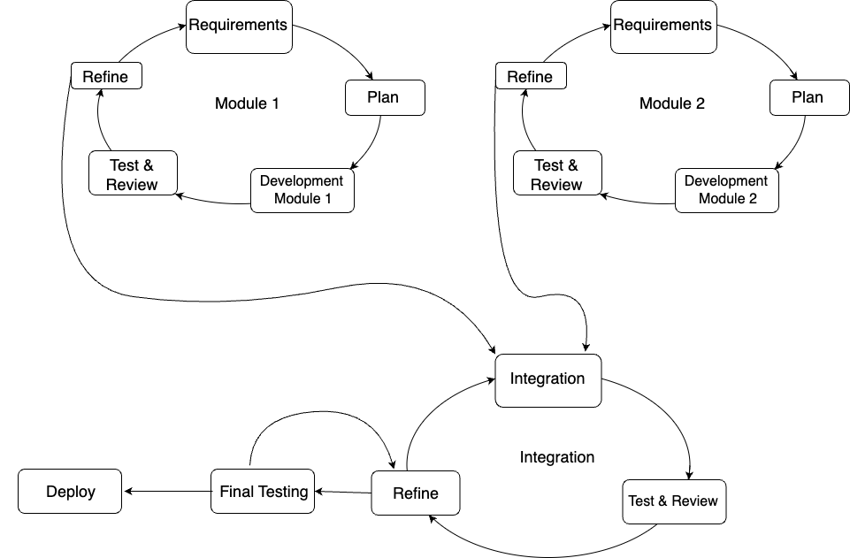
Figure 3.1: Software Development Life Cycle Methodology

Module 1 & Module 2:
- Requirements: Understand the specific requirements and needs of deaf, dumb, and blind users.
- Plan: Create a product backlog by understanding user needs, then prioritize features based on business goals and regularly update it as the project progresses.
- Development Module 1: Develop Module 1, which includes ASL to text conversion and text to speech conversion.
- Test & Review Module 1: Conduct testing and review of Module 1.
- Refine Module 1: Make necessary improvements and refinements based on feedback and testing results.
- Development Module 2: Develop Module 2, which includes speech to text conversion and ASL signs conversion.
- Test & Review Module 2: Conduct testing and review of Module 2.
- Refine Module 2: Make necessary improvements and refinements based on feedback and testing results.
Integration:
- Integration: Integrate Module 1 and Module 2.
- Test and Review: Conduct integration testing and review.
- Refine: Make any necessary refinements to the integrated system.

Software Workflow Methodology

- Data Collection
- Pre-processing
- Model development for gesture to text conversion.
- Model testing and evaluation.
- User Interface Development
- Flutter’s “speech_to_text” Package used for text to speech conversion.
- Flutter’s “text_to_speech” Package used for text to speech conversion.
- Real time testing

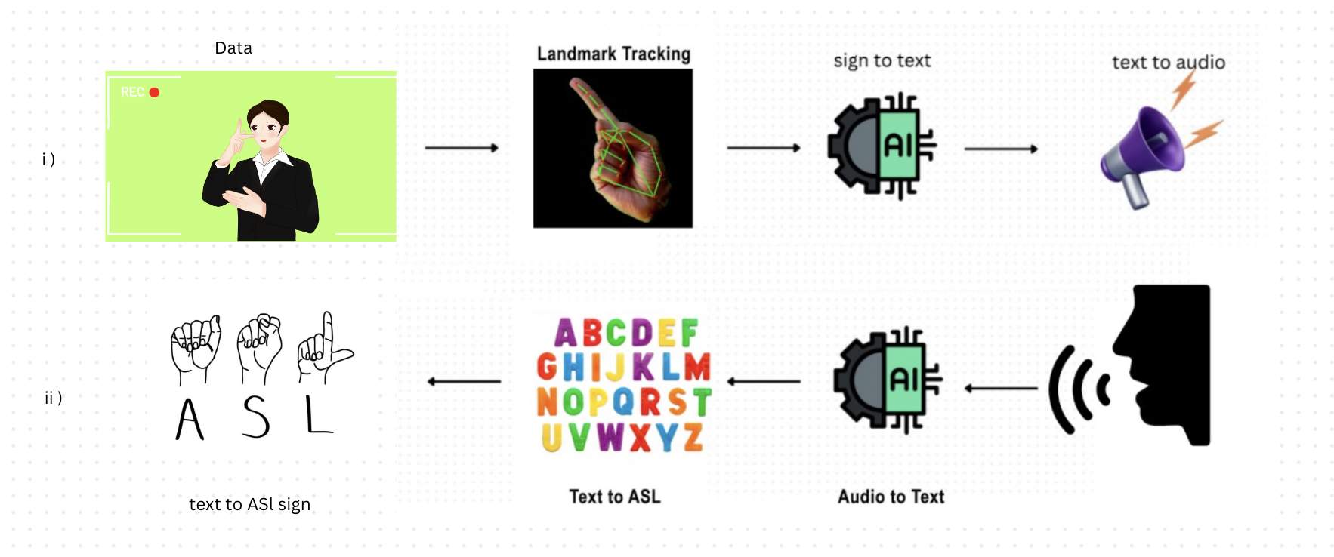
Figure 3.2: Software Methodology

Design

Module 1 (ASL to Speech)

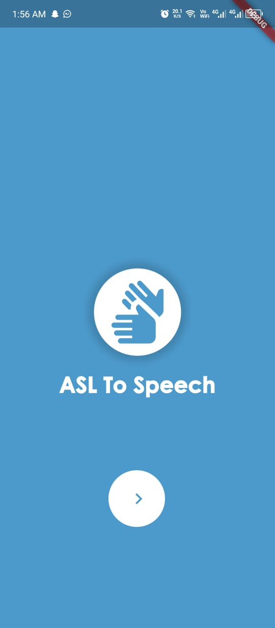  Figure 3.3: HomeScreen-1 | 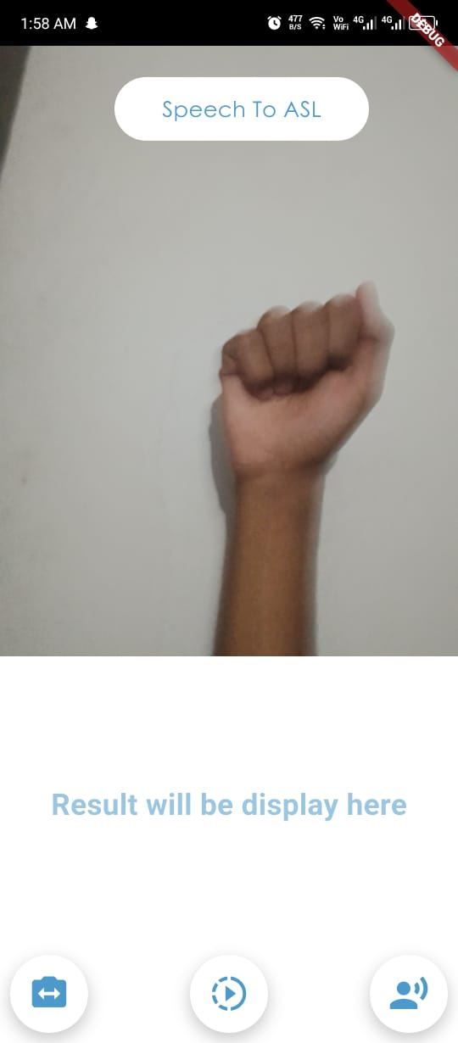  Figure 3.4: ASL To Speech Screen
This figure 3.3 is a homepage of module 1 with two buttons. One button take you ASL to speech and second button move you to next module. The figure 3.4 have a camera below it a text space where recognized gestures will be displayed and below it three buttons for switch camera, recording, and text to speech.

Module 2 (Speech to ASL)

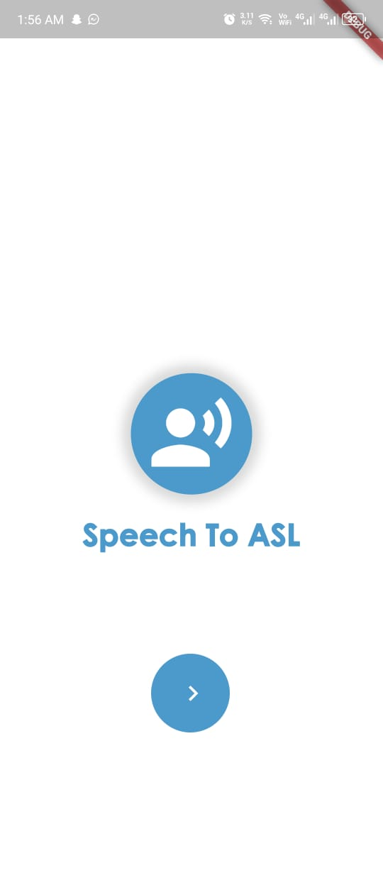  Figure 3.5: HomeScreen-2 | 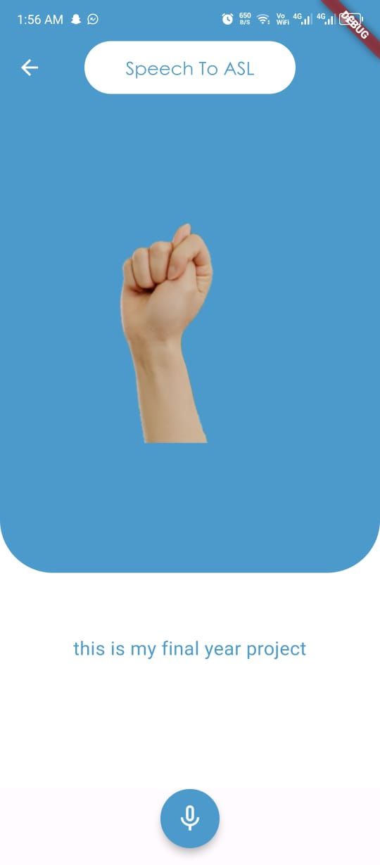  Figure 3.6: Speech To ASL Screen

This figure 3.5 is a homepage of module 2 with two buttons. One button take you Speech to ASL and second button move you to next module. The figure 3.4 have a image space below it a text space where recognized voice will be displayed and below a button for audio recording.

Diagrams

Sequential Diagram

ASL To Speech

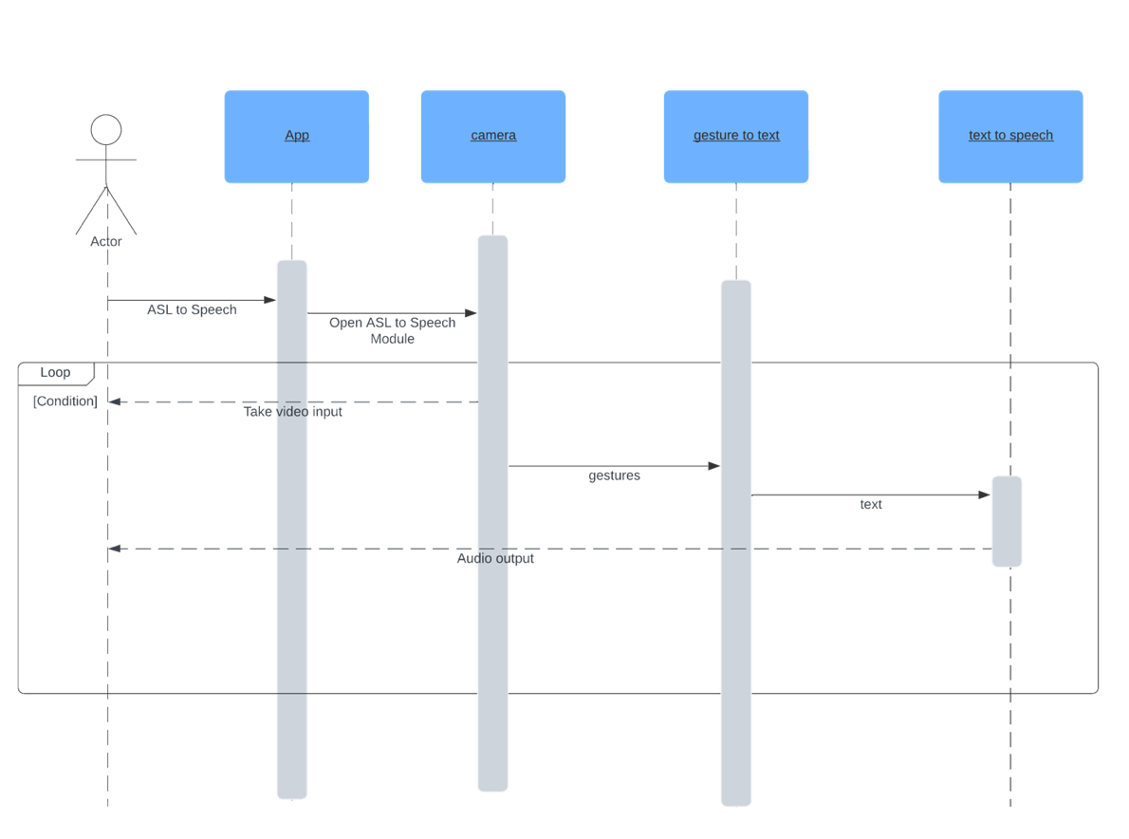
Figure 3.7: Sequential Diagram for ASL to Speech

Speech To A SL

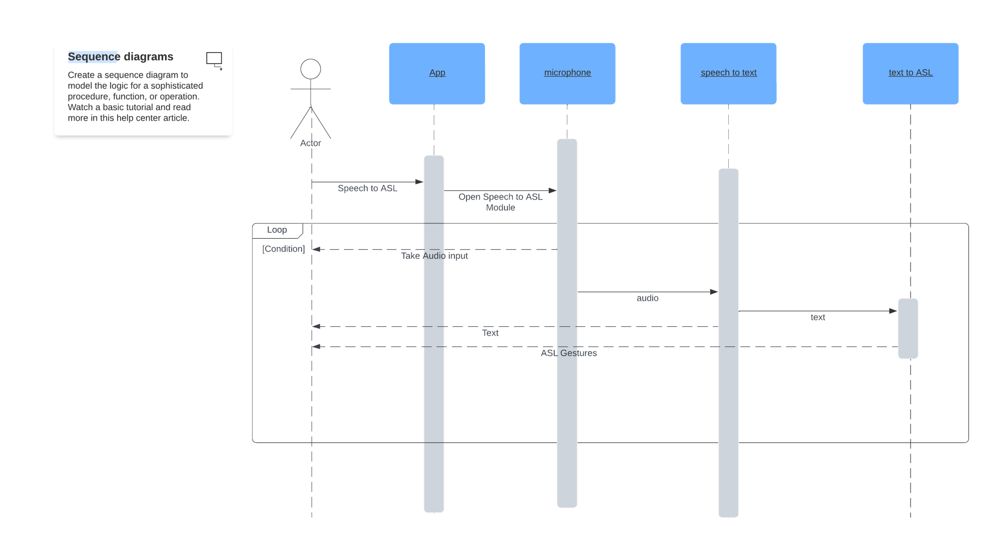
Figure 3.8: Sequential Diagram for Speech to ASL

This figure represent user as an Actor and other four are the process through which the user operate the app. Arrows from left to right are user inputs and right to left arrows are responses from the app.

Activity Diagram

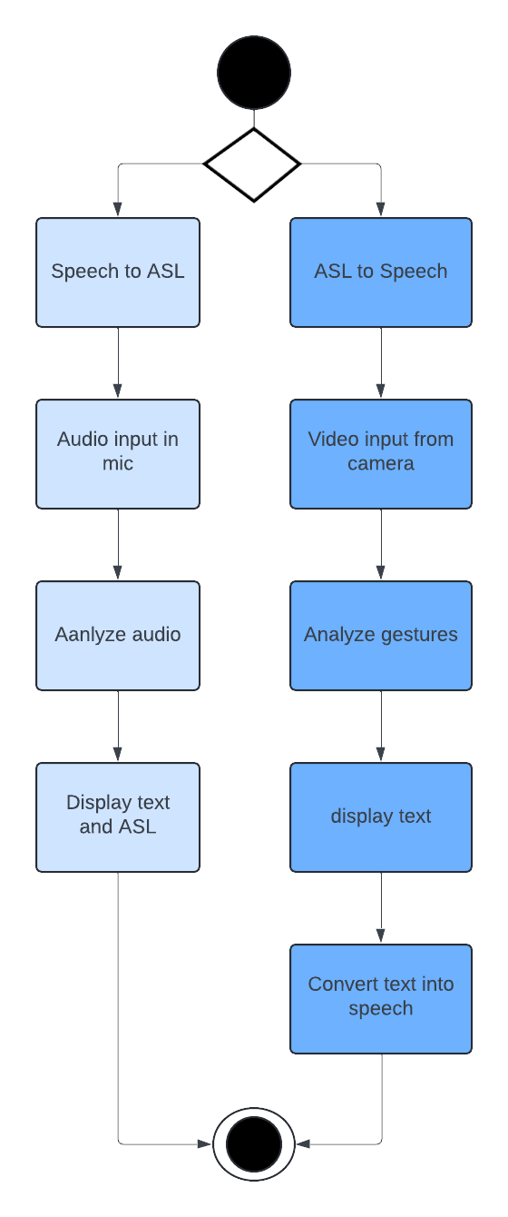
Figure 3.9: Activity Diagram

Data Flow Diagram

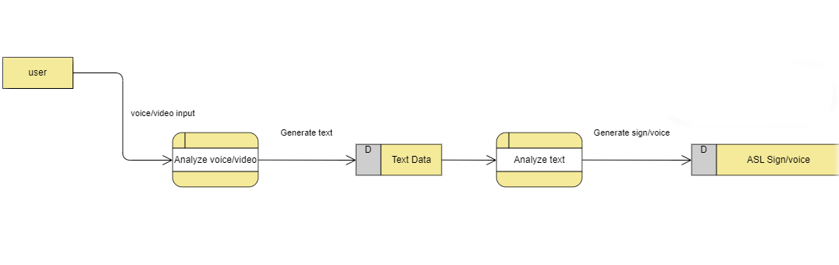
Figure 3.10: Data Flow Diagram

Use Case Diagram

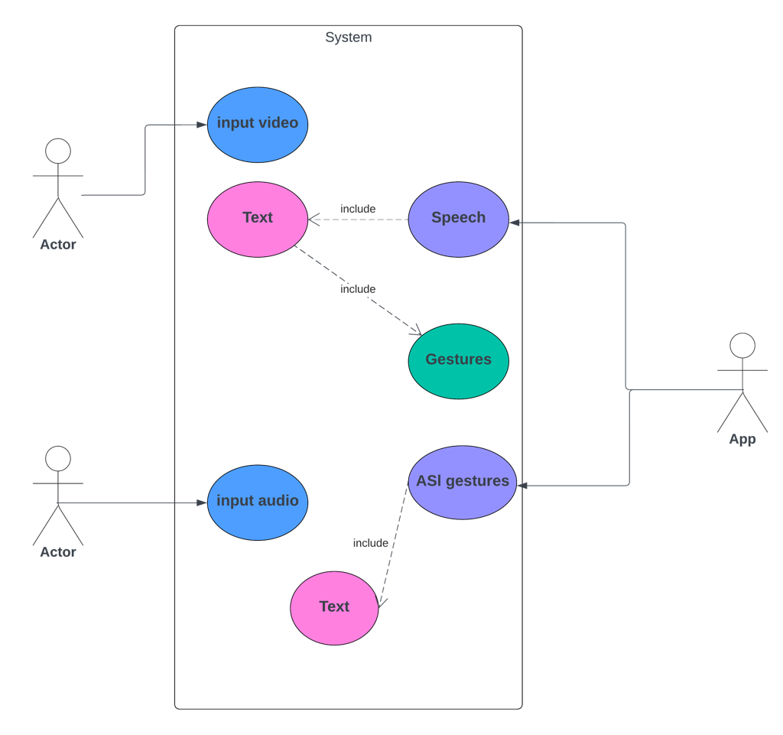
Figure 3.11: Use Case Diagram

DATA AND EXPERIMENTS AND IMPLMENTATION

Creating Data Set

We created our own dataset for Digit Signs (0-9) and Alphabets (a-z) and special (Blank, Delete, Space) character Signs ASL

ASL Digits

- The dataset contains 5400 image files from sign 0 to sign 9 (600 files of each sign).
- Half of the images size is 640 x 480.
- Half of the images size is 1280 x 720.

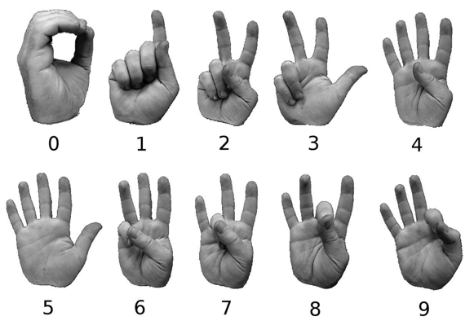
Figure 4.1: ASL Digit Dataset Description [16]

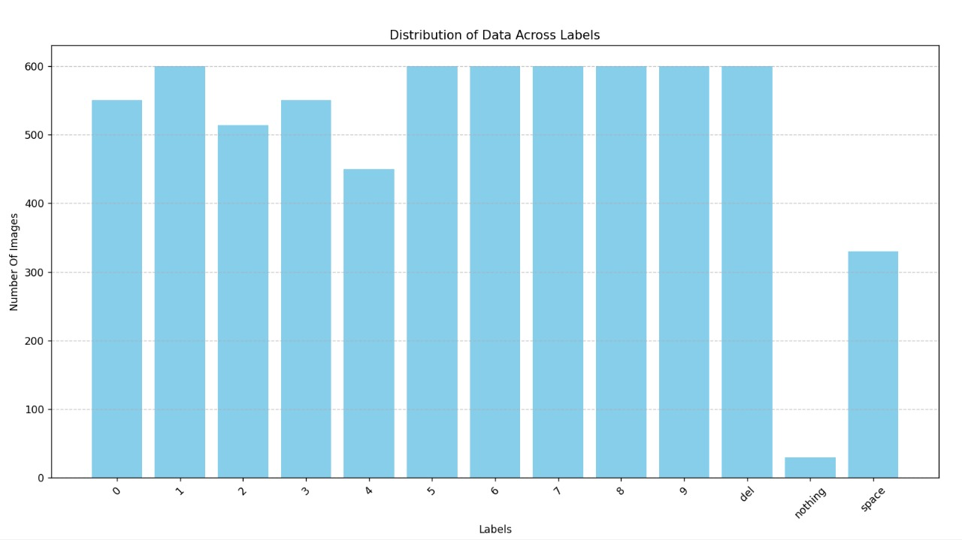
Figure 4.2: ASL Digit Dataset Distribution

ASL Alphabets

- The dataset contains 15600 image files from sign A to sign Z (600 files of each sign).
- Half of the images size is 640 x 480.
- Half of the images size is 854 x 480.

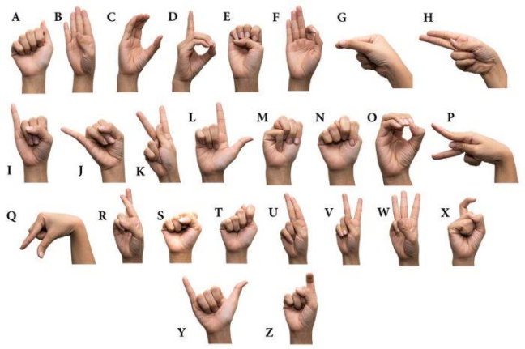
Figure 4.3: ASL Alphabets Dataset Description [17]

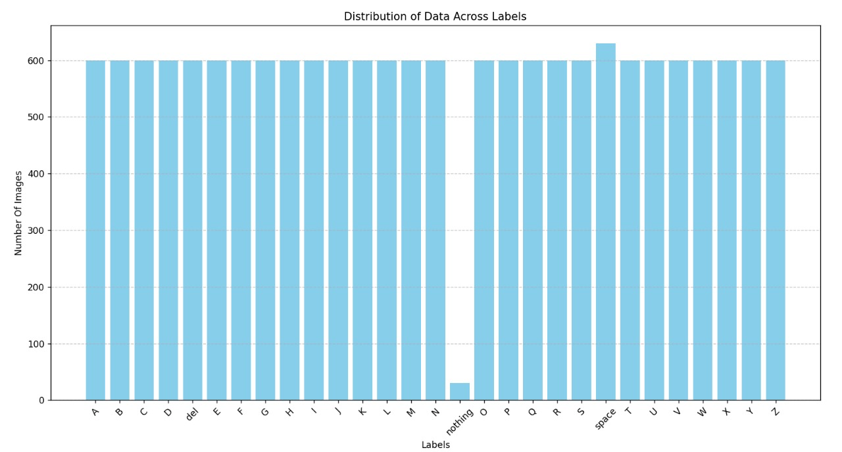
Figure 4.4: ASL Alphabets Dataset Distribution

Special Characters

- The dataset contains 1800 image files of sign (Blank, Delete, Nothing) (600 files of each sign).

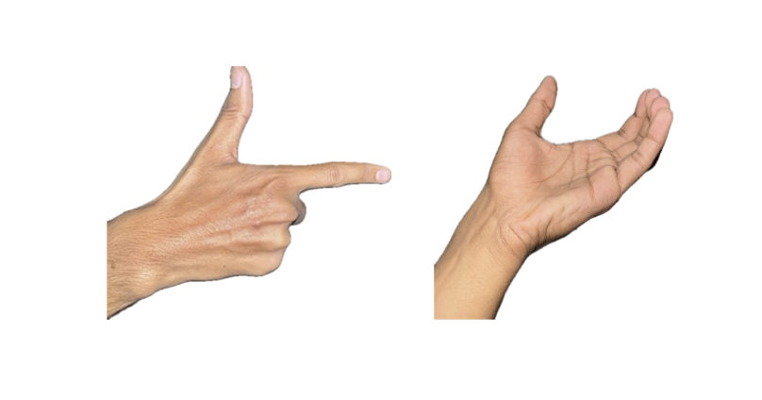
Space
Delete
Figure 4.5: Special Sign Dataset Description

Feature Extraction

Feature extraction of hand landmarks using Mediapipe involves identifying and extracting key points or landmarks on a human hand. Mediapipe's hand landmark model captures the intricacies of hand gestures with remarkable precision, identifying 21 key points on the hand in an image or video frame. These landmarks represent specific locations on the hand, such as fingertips, joints, and the palm canter, and they provide valuable information about the hand's pose and configuration.

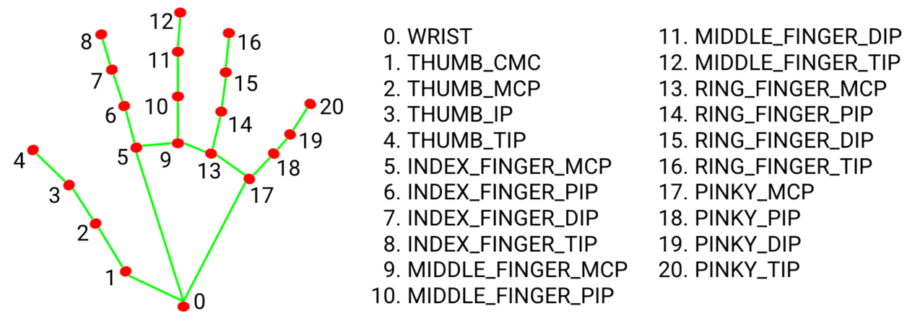
Figure 4.6: Mediapipe Hand landmarks Description.

Data Gathering with Mediapipe:

- Utilize the Mediapipe library to extract hand landmarks from images.
- For each image, capture the (x, y) coordinates of 21 hand landmarks detected by Mediapipe.

Feature Extraction
- Extract 21 hand landmarks from each image taking data of both x,y coordinates.
- Total of 42 data values (21 points * 2 coordinates = 42) from each image.
- Organize the data into a structured format, where each row represents an image, and columns represent the (x, y) coordinates of hand landmarks.

Normalize the Data
- Normalize the (x, y) coordinates to make them invariant to factors like hand size, rotation, and translation.
- Normalization the data by subtracting the min (x,y) values from each coordinate, ensuring that coordinates are relative to the hand's position in the image.

Labelling
- Assign a label to each image data based on the hand gesture or context.
- Label tells meaning of the hand gesture in the image.

Data Storage in CSV Format
- Save the extracted data in .csv file format.
- Each row in the CSV file corresponds to one image, containing the (x, y) coordinates of hand landmarks along with the assigned label.
- The First 42 columns for each (x, y) coordinate of the 21 hand landmarks and the last column represents the label.

Training and Evaluating K-Nearest Neighbours Classifier

Following is the process of training and evaluating of KNN.

Preparing Data
- The dataset containing feature vectors and corresponding labels is loaded from the CSV file using pandas.
- Feature vectors and labels are extracted from the dataset. Feature vectors are stored in the 'data' variable, and labels are stored in the 'labels' variable.
- We used train_test_split function from scikit-learn used to split the dataset into training and testing subsets.
- We set test size = 0.25 that specifies that 25% of the data will be used for testing, while the remaining 75% will be used for training.
- We set shuffle = True to ensures that the data is randomly shuffled before splitting. This helps in preventing any biases in the data order.
- We set stratify = labels ensures that the class distribution in the original dataset is preserved in the train-test split. This is important, especially for imbalanced datasets, to ensure that each class is represented proportionally in both the training and testing sets.

Training the Model
- Initializing a K-Nearest Neighbors classifier with k=1. because as you can see the Figure 4.5 shows that the accuracy is maximum on the k=1 and it is decreasing with increasing the value of k.

  - For Digit
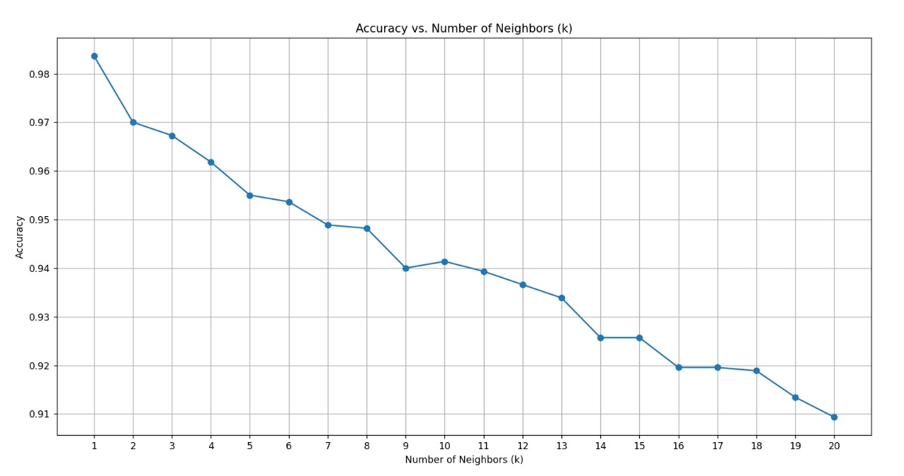
Figure 4.7: Accuracy vs K-Neighbours for Digit

  - For Alphabet
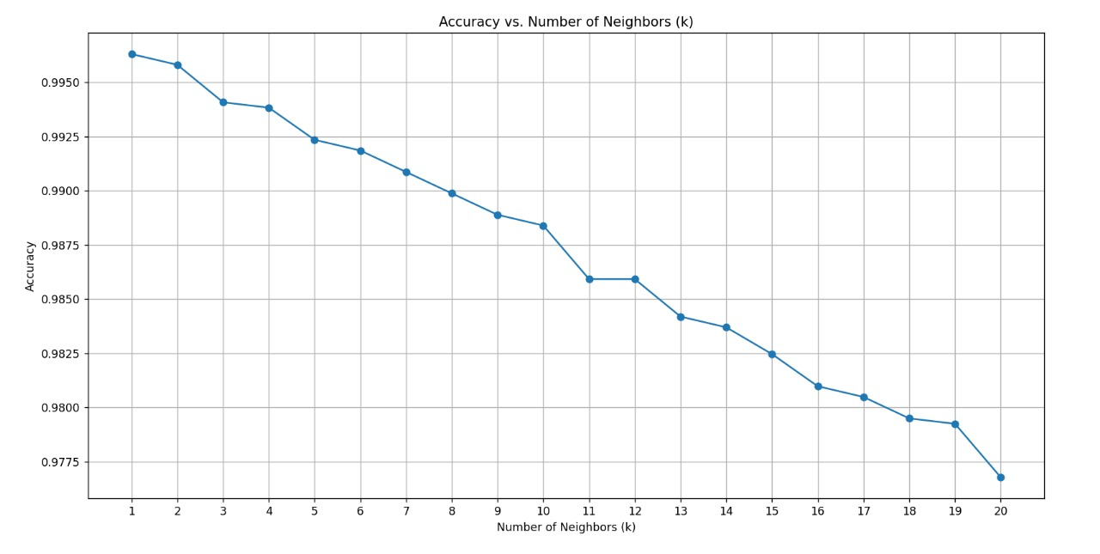
Figure 4.8: Accuracy vs K-Neighbours for Alphabets

- Fitting the classifier to the training data to learn patterns and relationships between features and labels.

Storing Model
Store the trained model using pickle (Pickle is a Python module used for serializing and deserializing Python objects, allowing them to be saved to or loaded from disk) for future use.

RESULTS AND DISCUSSIONS

Model Evaluation

Model evaluation involves analysing the performance of a model through metrics such as accuracy, precision, recall, and F-score to gauge its effectiveness in making predictions.

Digits

When specifying K=1, it indicates the parameter value used in the K-Nearest Neighbour (KNN) algorithm, because as you can see the Figure 4.5 shows that the accuracy is maximum on the k=1 and it is decreasing with increasing the value of k, The Result are:

- Accuracy: 98.43217450579414% of samples were classified correctly!
- Precision: 0.9851460400908693
- Recall: 0.9864468554954794
- F1-score: 0.9857210474866024

The Accuracy metric measures the proportion of correctly classified samples. With value of 98.43%, it indicates that nearly 98.43% of the samples were correctly classified by the model.

Precision evaluates the correctness of positive predictions made by the model. A precision of 0.9851 implies that approximately 98.51% of the positive predictions were correct.

Recall evaluates the model's capability to catch all actual positive samples in the dataset. At 0. 9864, it indicates that around 98.64% of the actual positive samples were correctly identified, highlighting its effectiveness in identifying positive instances.

The F1-score combines precision and recall into a single metric, allowing for a more balanced assessment of the model's performance. With an F-score of 0. 9857, the model demonstrates robust performance across both precision and recall metrics, ensuring a harmonious balance between minimizing false positives and capturing all positive instances.

Alphabets

When specifying K=1, it indicates the parameter value used in the K-Nearest Neighbour (KNN) algorithm, because as you can see the Figure 4.6 shows that the accuracy is maximum on the k=1 and it is decreasing with increasing the value of k, The Result are:

- Accuracy: 99.55544578908373% of samples were classified correctly!
- Precision: 0.9956465158841189
- Recall: 0.9954840573873663
- F-score: 0.9955331774983834
The Accuracy metric measures the proportion of correctly classified samples. With a value of 99.55%, it indicates that nearly 99.55% of the samples were correctly classified by the model.

Precision evaluates the correctness of positive predictions made by the model. A precision of 0.9956 implies that approximately 99.56% of the positive predictions were correct.

Recall evaluates the model's capability to catch all actual positive samples in the dataset. At 0. 9954, it indicates that around 99.54% of the actual positive samples were correctly identified, highlighting its effectiveness in identifying positive instances.

The F1-score combines precision and recall into a single metric, allowing for a more balanced assessment of the model's performance. With an F-score of 0. 9955, the model demonstrates robust performance across both precision and recall metrics, ensuring a harmonious balance between minimizing false positives and capturing all positive instances.

Heatmaps

These Heat Maps represent the confusion matrix.

Heatmap for Digit

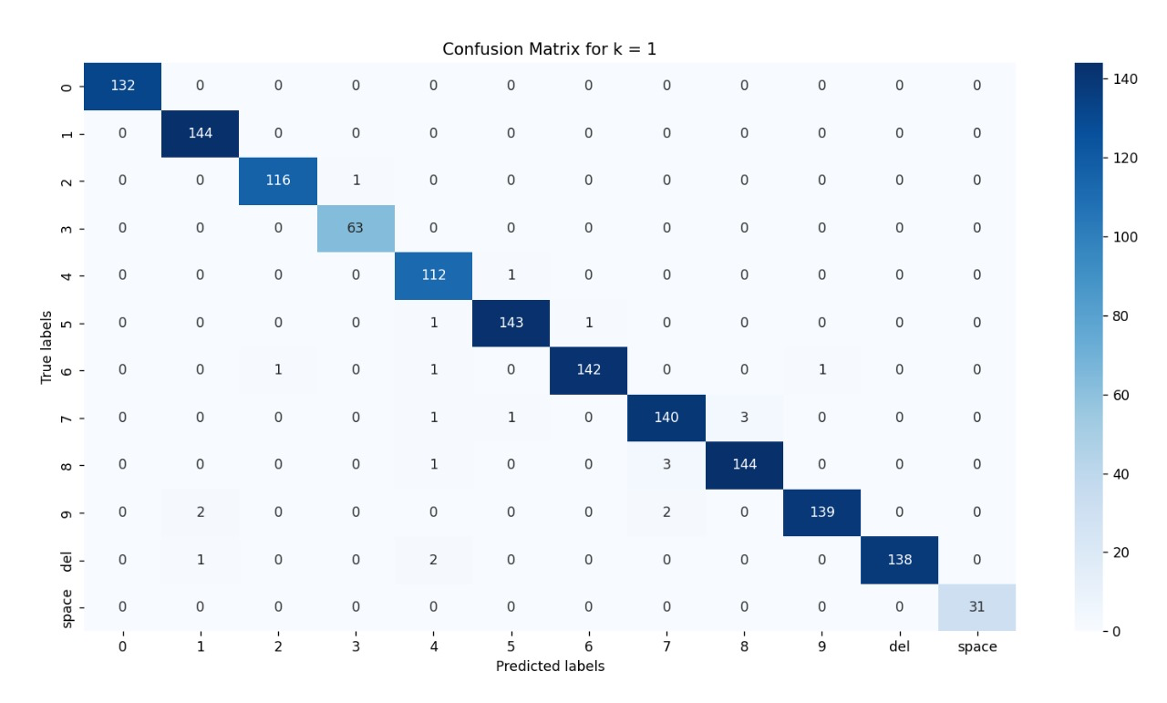
Figure 5.1: Heatmap for Digits

  - Diagonal values represent the correctly classified instances for each class.
  - Non-diagonal values indicate misclassifications.
  - Total predictions: 1339 (Sum of all elements in the matrix)
  - Correct predictions: 1318 (Sum of diagonal elements)
  - Incorrect predictions: 21 (Total predictions - Correct predictions)

Heatmap for Alphabets

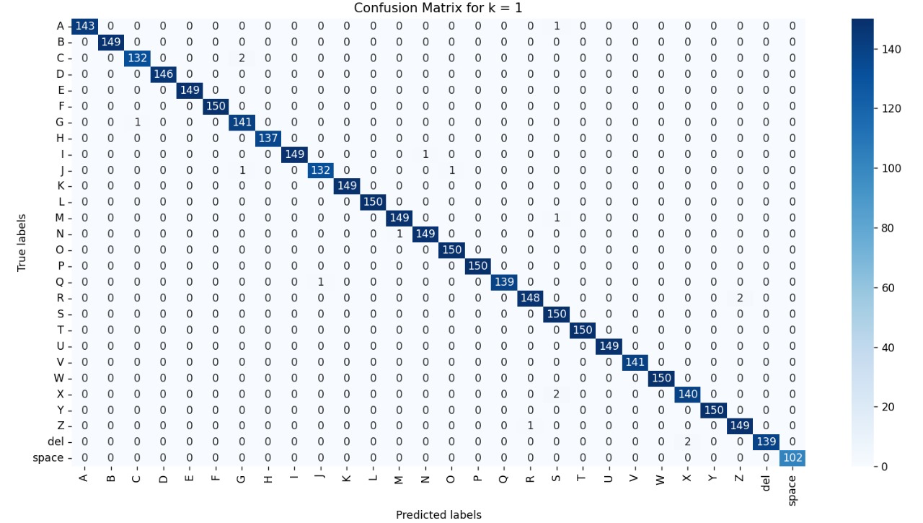
Figure 5.2: Heatmap for Alphabets

- Diagonal values represent the correctly classified instances for each class.
- Non-diagonal values indicate misclassifications.
- Total predictions: 4207 (Sum of all elements in the matrix)
- Correct predictions: 4188 (Sum of diagonal elements)
- Incorrect predictions: 19 (Total predictions - Correct predictions)

CONCLUSION AND RECOMMENDATIONS

Conclusion

To sum up, our project’s main goal was solving the problem of communication barriers between deaf, mute, and blind people. We have created a software solution that makes it easy to communicate despite speech and hearing knowledge. Using machine learning and a computer vision module, we managed to develop a communication tool for the signature language, which converts sign language into written text and oral speech, and written text into signed language.

In summary, our model evaluation results show high accuracy, precision, recall rate, and F1-score in digit and alphabet classification tasks. Hence, the results of the effectiveness of our approach to accurately understand and translate sign language gestures can be commuted. Heat maps provided more detail about model performance and areas with many classifications to be addressed in the future.

Recommendations

Following are some of the recommendations that can be made based on our findings and experiences during the project:

- User Interface Refinement: Testing this program on larger scale will help get reviews to made UI better according to the user need.

- Expand Language Support: Currently our project only supports ASL, but we can increase the language range by including other sign languages.

- Community Engagement: By creating a community, we can increase and add new functionalities as well as help more abnormal people.

REFERENCES

Technical Reports and Theses:

[1] | Y. Ma, T. Xu and K. Kim, “Two-stream mixed convolutional neural network for American sign language recognition,” Sensors, vol. 22, no. 16, p. 5959, 2022.
[2] | S. Sharma and K. Kumar, “ASL-3DCNN: American sign language recognition technique using 3-D convolutional neural networks,” Multimedia Tools and Applications, vol. 80, pp. 26319--26331, 2021.
[3] | K. Bantupalli and Y. Xie, “American sign language recognition using deep learning and computer vision,” in 2018 IEEE International Conference on Big Data (Big Data), 2018.
[4] | A. Mannan, A. Abbasi, A. R. Javed, A. Ahsan, T. R. Gadekallu, Q. Xin and others, “Hypertuned deep convolutional neural network for sign language recognition,” Computational intelligence and neuroscience, vol. 2022, 2022.
[5] | A. Duarte, S. Palaskar, L. Ventura, D. Ghadiyaram, K. DeHaan, F. Metze, J. Torres and X. Giro-i-Nieto, “How2sign: a large-scale multimodal dataset for continuous american sign language,” in Proceedings of the IEEE/CVF conference on computer vision and pattern recognition, 2021.
[6] | D. Laines, M. Gonzalez-Mendoza, G. Ochoa-Ruiz and G. Bejarano, “Isolated Sign Language Recognition based on Tree Structure Skeleton Images,” in Proceedings of the IEEE/CVF Conference on Computer Vision and Pattern Recognition, 2023.
[7] | S. K. Singh and A. Chaturvedi, “A reliable and efficient machine learning pipeline for american sign language gesture recognition using EMG sensors,” Multimedia Tools and Applications, vol. 82, pp. 23833--23871, 2023.
[8] | Al-shaheen, Ali, M. evik and A. Alqaraghul, “American sign language recognition using yolov4 method,” International Journal of Multidisciplinary Studies and Innovative Technologies, vol. 6, pp. 61--65, 2022.

Images:
[9] ASL Alphabet Dataset, Available at:https://www.researchgate.net/figure/The-complete-ASL-numeric-set-with-sample-segmented-images_fig4_266066851, accessed on: 15 May 2024
[10] ASL Digit Dataset, Available at:https://www.researchgate.net/figure/The-complete-ASL-numeric-set-with-sample-segmented-images_fig4_266066851,
accessed on: 15 May 2024

