

BSCS-F23-004
03-134202-113 | MANAHIL SAEED
03- 134202-097 | KHADIJA ZAHOOR

SEE SAW

In partial fulfilment of the requirements for the degree of
Bachelor of Science in Computer Science
Supervisor: DAWOOD AKRAM
Department of Computer Sciences
Bahria University, Lahore Campus
June 2024

© Bahria University, 2024

Certificate

We accept the work contained in the report titled.
“SEE SAW”
Written by
MANAHIL SAEED
KHADIJA ZAHOOR
As a confirmation to the required standard for the partial fulfilment of the degree of
Bachelor of Computer Science.

Approved by:
Supervisor: DAWOOD AKRAM
(Signature)

June 15, 2024

DECLARATION

We hereby declare that this project report is based on our original work except for citations and quotations which have been duly acknowledged. We also declare that it has not been previously and concurrently submitted for any other degree or award at Bahria University or other institutions.

Enrolment | Name | Signature
03-134202-113 | MANAHIL SAEED
03-134202-097 | KHADIJA ZAHOOR

Date : June15, 2024

Specially dedicated to
my beloved teachers, mother, and father
(MANAHIL SAEED)
my beloved teacher, mother, and father
(KHADIJA ZAHOOR)

ACKNOWLEDGEMENTS
First, we are obliged to Allah Almighty the Merciful, the Beneficent and the source of all Knowledge, for granting us the courage and knowledge to complete this Project.

MANAHIL SAEED
KHADIJA ZAHOOR

SEE SAW

ABSTRACT

The demand for Co workspace is accelerating day by day, especially for those who ran small IT industries. Co working is an arrangement in which workers of different companies share an office space, allowing cost savings and convenience using common infrastructures, such as equipment, utilities, and receptionist and custodial services, and in some cases refreshments and parcel acceptance services. It is attractive to independent contractors, independent scientists, remote workers, digital nomads, and people who travel frequently. Additionally, co-working helps workers avoid the feeling of social isolation they may experience while remote working or travelling and eliminate distractions. Most co-working spaces charge membership dues. Major companies that provide co-working space and serviced offices include We Work and IWG plc. See Saw is a system. See Saw is a web-based application designed to create a user-friendly platform which will help locate office places efficiently. This application will make the user able to access office place with their desire need. To save time, application will keep landlords and user profiles along with personal information and needs. This record will be updated before and after Booking. The app will allow the registered persons to post a request for visit to any place and mention location. See Saw will show the visiting time of any person to landlord, and it will also show the history of bookings.

TABLE OF CONTENTS

DECLARATION ii
ACKNOWLEDGEMENTS iv
ABSTRACT v
TABLE OF CONTENTS vi
LIST OF TABLES ix
LIST OF FIGURES x
LIST OF APPENDICES xii

CHAPTERS
1 INTRODUCTION 1
1.1 Background 1
1.2 Problem Statements 2
1.3 Aims and Objectives 2
1.4 Scope of Project 3
2 SOFTWARE REQUIREMENTS SPECIFICATION 4
2.1 Project Overview 4
2.2 Project Scope 5
2.3 Specific Requirements 5
2.3.1 External Interface Requirements 6
2.3.2 User Interfaces 6
2.4 Roles and Responsibilities 7
3 DESIGN AND METHODOLOGY 8
3.1 Introduction 8
3.2 System Architecture Design 8
3.3 Chosen System Architecture 9
3.4 Use Cases 9
3.4.1 Use Case “Overall User Functions” 9
3.4.2 Use Case “User Update Profile” 10
3.4.3 Use Case “User Posts Request” 11
3.4.4 Use Case “User Watch Office Location” 11
3.4.5 Use Case “Overall Host Functions” 12
3.4.6 Use Case “Host Update Detail” 13
3.4.7 Use Case “Host Accept Request” 14
3.4.8 Use Case “Host Get Request” 14
3.4.9 Use Case “Host Reject Request” 15
3.5 Activity Diagram 15
3.5.1 Activity Diagram “Overall System” 16
3.6 Sequence Diagram 16
3.6.1 Sequence Diagram “Login” 17
3.6.2 Sequence Diagram “Signup” 17
3.6.3 Sequence Diagram “User” 18
3.6.4 Sequence Diagram “Host” 18
3.7 Interface Design 19
3.7.1 User Login Screen 19
3.7.2 Host Login Screen 19
3.7.3 User Signup Screen 20
3.7.4 Host Signup Screen 20
3.7.5 Update Profile of both User and Host 21
3.7.6 Main Page 21
3.7.7 Posts 22
3.7.8 Payment or Booking 22
3.7.9 Visit Page for User 23
3.7.10 Booking Details Page 23
3.7.11 Visit details Page of User 24
3.7.12 Add Post 24
3.7.13 Edit Post 25
3.7.14 All Visit Requests 25
3.7.15 Approved Requests 26
3.7.16 Rejected Requests 26
4 IMPLEMENTATION 27
4.1 Introduction 27
4.2 Components Web Services and Libraries 27
4.3 IDE, Tools, and Technologies 28
4.4 Coding Standards 28
4.5 Software Engineering Practices 28
5 RESULTS AND DISCUSSIONS 29
5.1 Result 29
6 CONCLUSION AND FUTURE WORK 30
6.1 Conclusion 30
6.2 Future Work 30
REFERENCES 31

LIST OF TABLES

TABLE TITLE PAGE
Table 2.1: Functionality Overview 6
Table 2.2: Project Team Roles and Responsibilities 7
Table 3.1: User Profile Update Use Case 10
Table 3.2: User Request Generation Use Case 11
Table 3.3: User Office Location Inquiry Use Case 11
Table 3.4: Host Profile Update Use Case 13
Table 3.5: Host Update Request Use Case 14
Table 3.6: Host Request Retrieval Use Case 14
Table 3.7: Host Reject Request Use Case 15

LIST OF FIGURES

FIGURE TITLE PAGE
Figure 3.1: System Architecture Design 8
Figure 3.2: User Use Case Diagram 9
Figure 3.3: Host Use Case Diagram 12
Figure 3.4 : Activity Diagram 16
Figure 3.5: User/User logging in Sequence Diagram 17
Figure 3.6: Signup Sequence Diagram 17
Figure 3.7: User end Sequence Diagram 18
Figure 3.8: Host end Sequence Diagram 18
Figure 3.9: User Login Screen 19
Figure 3.10: Host Login Screen 19
Figure 3.11: User Signup Screen 20
Figure 3.12 : Host Signup Screen 20
Figure 3.13: Update profile of both User and Host 21
Figure 3.14: Main Page 21
Figure 3.15: Posts 22
Figure 3.16: Payment or Booking 22
Figure 3.17: Visit Page of User 23
Figure 3.18 : Booking Details Page 23
Figure 3.19: Visit Details Page of User 24
Figure 3.20: Add Post 24
Figure 3.21: Edit Post 25
Figure 3.22: All Visit Requests 25
Figure 3.23: Approved Request 26
Figure 3.24 : Rejected Request 26

LIST OF APPENDICES



INTRODUCTION

Background

In the present technological epoch, it is now almost impossible not to agree that the use of mobile applications has a great impact in raising awareness, as well as assisting in the organisation of various responsibilities. One of them is the selection of an appropriate office space, an activity that often takes considerable time to complete due to the need to coordinate the interactions between the hosts and the visitors. In our research, we included the most used application markets like Google Play, Apple App Store, other mobile applications markets as well as web applications markets. While looking into the numerous applications over 30, there were several difficulties. Many of the applications never made it to compliance across various devices or platforms; some had 75% of compatibility failures most especially on certain devices. In addition, several applications adopted restrictions by location, where user searches were only confined to specific areas, and probably overlooking other beneficial areas. Additionally, some of the applications lacked proper notification features that would otherwise contribute to the capability of the host in responding to inquiries or booking requests on time. Another problem stemmed from the fact that membership requirements were commonplace, which forced men and women to sign up for a fee for basic functionalities in the numerous sites. Moreover, there were scenarios when application based on the web had issues with the materials they placed regarding location, making searches even more difficult. It is for these reasons that the remedy must concurrently address all aspects of accessibility, locality, communication, and friendliness, all the while not imposing upon the user unjust and irrelevant barriers such as membership requirements.

Problem Statements

Nowadays co-working spaces are gaining popularity more and more due to the current climate of business. However, seeing this trend taking shape, the use of online applications is vital for the promotion and efficiency of this area. This assertion must point to a more focused effort to address challenges on accessing office space, offer innovative solutions and not business as usual approaches.
Nowadays, the action of finding an ideal place for an office can be often tiresome and time-consuming, requiring perfect cooperation between landlords and tenants. Being aware of this necessity, our system is intended to provide the maximal facilitation of this operation: While allowing an intuitive navigation through the vast number of resources, our system minimizes the difficulty of the exploration process. By providing a connection between seekers of workplaces and hosts, our site works as a median of the requests’ distribution alongside the necessities of vacant tenets.

Aims and Objectives

The objectives of the thesis are shown as following:
- To develop a reservation system.
- To create communication between host and guest across the city.
- To prioritize user experience by offering a user-friendly platform.
- To provides the information about availability of nearest co workspace.
- To maximize the utilization of available office spaces efficiently.

Scope of Project

See Saw is a web application designed to create a user-friendly platform which will help locate office places efficiently. This application will make the user able to access office place with their desire need. To save time, application will keep landlords and user profiles along with personal information and needs. This record will be updated before and after Booking. See saw will generate alerts in the form of direct notifications to landlord in every booking as shown. The web app will allow the registered persons to post a request for visit to any place and mention location. See Saw will show the visiting time of any person to landlord, and it will also show the history of bookings and their duration.

SOFTWARE REQUIREMENTS SPECIFICATION

Project Overview

Currently, everyone’s life is becoming busy steadily. Consequently, there’s lack of time. The growing technological influence is making everyone look for best and quick alternatives to do their task. In this ‘Internet age’ electronic devices i.e., mobile phones, tablets and laptops are being used in surprising manner. The advancement of these devices and software has convinced the developers to generate application of daily use. People are accessing booking services from their homes and workplace in no time. Keeping in view the people’s preference a system is proposed regarding online booking. The purpose of this project is to facilitate people who are facing problems in finding their office place for them. This application will authorize the user to find the office place with no longer terms. It will be of great use for people who need their office place within less time. It will ask for the location in which user want to see a place. Secondly, user will get options from the app of the locations in the desire location. After that system will give the options to user that what he wants to do like he wants to generate visit request for the office, or he want to book his office directly.

Project Scope

See Saw is a web-based application designed to create a user-friendly platform which will help locate office places efficiently. This application will make the user able to access office place with their desire need. To save time, application will keep landlords and user profiles along with personal information and needs. This record will be updated before and after Booking. The app will allow the registered persons to post a request for visit to any place and mention location. See Saw will show the visiting time of any person to landlord, and it will also show the history of bookings and their duration.

Specific Requirements

The specific requirement of this project is given below.

External Interface Requirements

The online platform relies on input from virtual guidelines and user engagements to support the exploration of office premises according to location and user-supplied information. Subsequently discovering an appropriate area, the system empowers users to produce visitation requests and schedule appointments effortlessly.

Table 2.1: Functionality Overview
Screen Name | Description
Sign in-out-up | To login-out-up into the application
Home page | Shows option to view booking details and generate request
User | Add and update in user profile
Host | Add and update in user profile
Ads (Workspace posts) | Shows the pictures and the details of uploaded of the workspaces
Generate a Request | Request generates by the user displays on the host screen

User Interfaces

There will be two interfaces of this application, which are as follows:
- User interface: Use who need to find the space.
- Host interface: Useable for the person who had space.

2.3.3 Disadvantages

- Requires exceptional strategy.
- Cost estimation is difficult.
- A completely devised system is required to which further increments are added Rigidity of each iteration does not allow further succession.

Roles and Responsibilities

Table 2.2: Project Team Roles and Responsibilities
Name | Role | Responsibility
KHADIJA ZAHOOR | Project head & Developer | Requirement elicitation, Designing, Development
MANAHIL SAEED | Project member & Developer | Managing  whole project, Testing & Maintenance

DESIGN AND METHODOLOGY

Introduction

This Software Design Description (SDD) recounts the detailed design of the components of the See Saw system and the particulars required to satisfy the requirements as specified in the Software Requirements Specification (SRS).

System Architecture Design

A system’s architecture portrays the principles, structural concepts, and characteristics of a system of interest. Interaction of various components of the systems is formally described in terms of architectural description. A system’s architecture represents the embodiment of system components and the sub-systems which will execute the overall system.
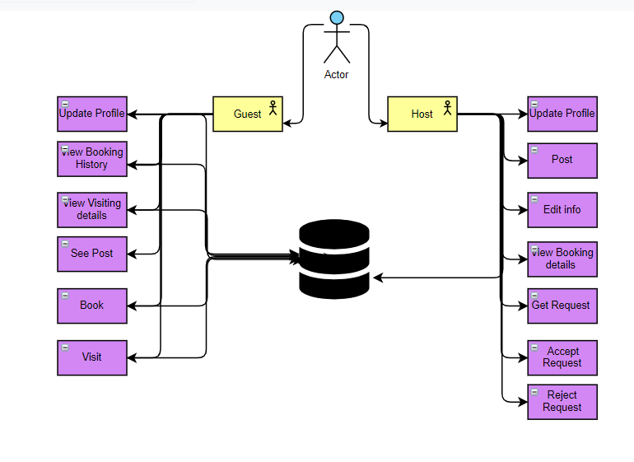
Figure 3.1: System Architecture Design

Chosen System Architecture

The architecture pattern chosen for See Saw is event driven architectural design. When the user performs an event, the application will behave accordingly. For instance, if the user generates a request for a specific workspace visit, the application will send the request to Hosts of that specific workspace. Based on the selection of the User, the application will behave differently as the application will only find Hosts nearest to that location. Whenever a request will be posted application will respond accordingly. This architecture pattern is found feasible to achieve required results.

Use Cases

The use cases of both user and host functions are explained below:

Use Case “Overall User Functions”

This use case diagram is showing all functions of the User include register, login, check space availability, logout, update profile, view booking history, generate visit request.
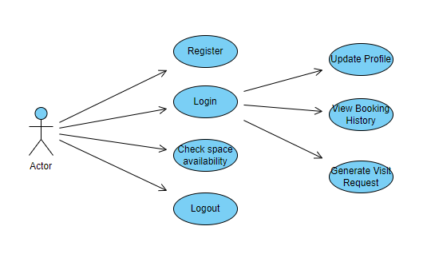
Figure 3.2: User Use Case Diagram

Use Case “User Update Profile”

Table 3.1: User Profile Update Use Case
Use Case Name | User Update Profile
Description | This use case allows the User to update his/her application profile.
Primary Actor | User
Secondary Actor | None
Pre-conditions | The User must be on the “Update Profile” selection screen and have access to internet.
Post-conditions | The User’s profile is successfully updated and is notified.
Basic flow | - The User clicks on 'Update Profile' button.  - The User is at Update Profile screen.  - The User enters the following details in the Update Profile Screen. New Password and New Username, etc.  - The system updates the User’s new information.
Alternate Flow | Invalid Information Entered: System displays message to correct invalid information

Use Case “User Posts Request”

Table 3.2: User Request Generation Use Case
Use Case Name | User Generate Request
Description | This use case allows the User to generate a visit request.
Primary Actor | User
Secondary Actor | None
Pre-conditions | The User must have Generated a request and must have internet access.
Post-conditions | The User will be appropriately notified.
Basic flow | - The User clicks on ‘Generate Request’ button.  - The User will enter all details like time, date, etc. The User is at home screen.
Alternate Flow | Request not Generated: System displays message.

Use Case “User Watch Office Location”

Table 3.3: User Office Location Inquiry Use Case
Use Case Name | User Watch Office Location
Description | This use case allows the User to know the Office location.
Primary Actor | User
Secondary Actor | None
Pre-conditions | The User must be connected to an internet connection.
Post-conditions | The User will successfully be shown the Office location.
Basic flow | - The User clicks on the ad button.  - The User is shown the location on the map.
Alternate Flow | The application prompts the User to check internet connection.

Use Case “Overall Host Functions”

This use case diagram is showing all functions of the host include update profile, edit info, posts, view booking details, get requests, accept request, reject request.
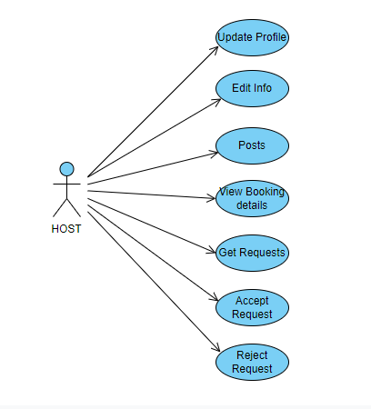
Figure 3.3: Host Use Case

Use Case “Host Update Detail”

Table 3.4: Host Profile Update Use Case
Use Case Name | Host Update Detail
Description | This use case allows the Host to update his/her application profile.
Primary Actor | Host
Secondary Actor | None
Pre-conditions | The Host must be on the “Update Profile” selection screen and have access to internet.
Post-conditions | The Host’s profile is successfully updated, and the User is appropriately notified.
Basic flow | - The Host clicks on 'Update Profile' button. The Host is at Update Profile screen.  - The Host enters the following details in the Account Information Screen.  - New Username and New Password, etc.  - The system updates the Host’s information and displays the profile information page.
Alternate Flow | Invalid Information Entered: System displays message to correct invalid information.

Use Case “Host Accept Request”

Table 3.5: Host Accept Request Use Case
Use Case Name | Host Accept Request
Description | This use case allows the Host to accept the request.
Primary Actor | Host
Secondary Actor | None
Pre-conditions | The Host must be on the “Accept Request” selection screen.
Post-conditions | The User’s will be accepted by Host.
Basic flow | - The Host clicks on 'Accept Request' button.  - The Host is at Accept request screen.
Alternate Flow | Invalid Information Entered: System displays message to correct invalid information.

Use Case “Host Get Request”

Table 3.6: Host Request Retrieval Use Case
Use Case Name | Host Get Request
Description | This use case allows the Host to get the request.
Primary Actor | Host
Secondary Actor | None
Pre-conditions | The Host must be on the “Get Request” selection screen.
Post-conditions | The User’s will get by Host.
Basic flow | - The Host clicks on Get Request' button.  - The Host is at Get request screen.
Alternate Flow | Invalid Information Entered: System displays message to correct invalid information.

Use Case “Host Reject Request”

Table 3.7: Host Reject Request Use Case
Use Case Name | Host Reject Request
Description | This use case allows the Host to reject the request.
Primary Actor | Host
Secondary Actor | None
Pre-conditions | The Host must be on the “Reject Request” selection screen.
Post-conditions | The User’s will be rejected by Host.
Basic flow | - The Host clicks on Reject Request' button.  - The Host is at Reject request screen.
Alternate Flow | Invalid Information Entered: System displays message to correct invalid information.

Activity Diagram
The dynamic aspects of the systems are described in terms of activity diagram. Activity diagram is basically a flowchart to represent the flow from one activity to another activity. The activity reflects an operation of the desired system. The control flow is drawn from one operation to another. This flow can be sequential, branched, or concurrent.

Activity Diagram “Overall System”
The detailed activity diagram of overall system is given below:
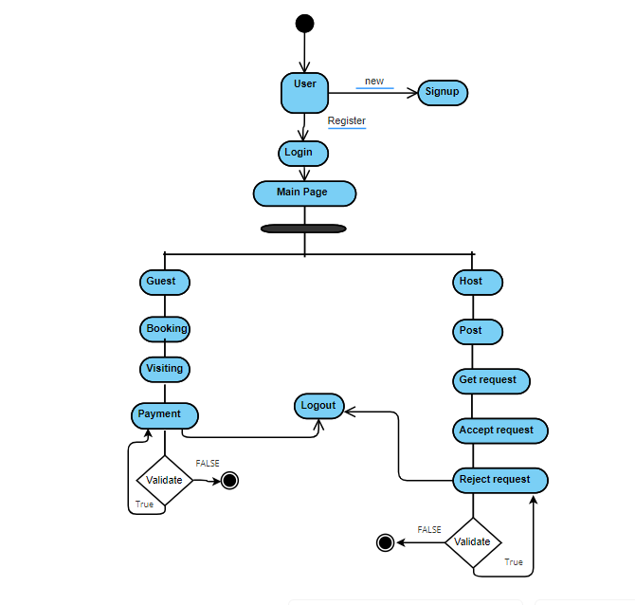
Figure 3.4: Activity Diagram

Sequence Diagram

The Sequence Diagram of each function of the system is explained below:

Sequence Diagram “Login”

In this sequence diagram is shown the user coming to the login form, providing her/his login details and, in case the login information gives a positive response, the user is redirected to the main page whereas if the login information is incompatible, the user remains on the same page of the login form.
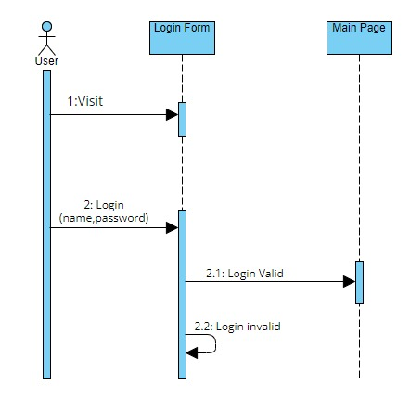
Figure 3.5: User/User Logging in Sequence Diagram

Sequence Diagram “Signup”

This sequence diagram depicts a user visiting a login page, entering a login credential, and if it’s incorrect, an optional click on the signup link, getting a success message of signup followed by redirection to the main page or receiving a signup failure message.
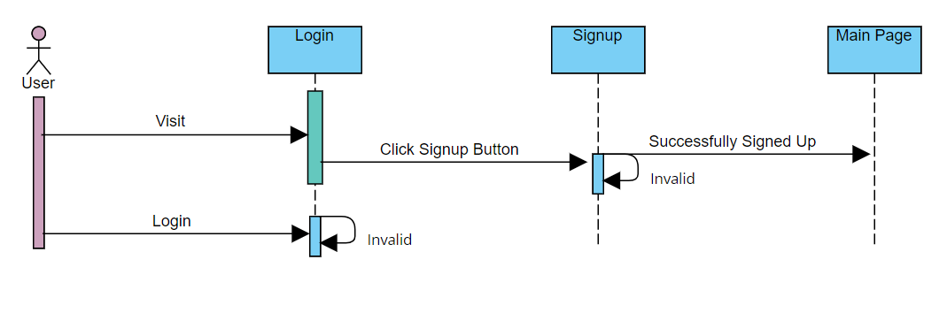
Figure 3.6: Signup Sequence Diagram

Sequence Diagram “User”

These interactions form a part of the large workflow where once the user logs in, they get their profile updated and can request for office listing availability and go for booking and move for confirmation of booking status and make a payment.

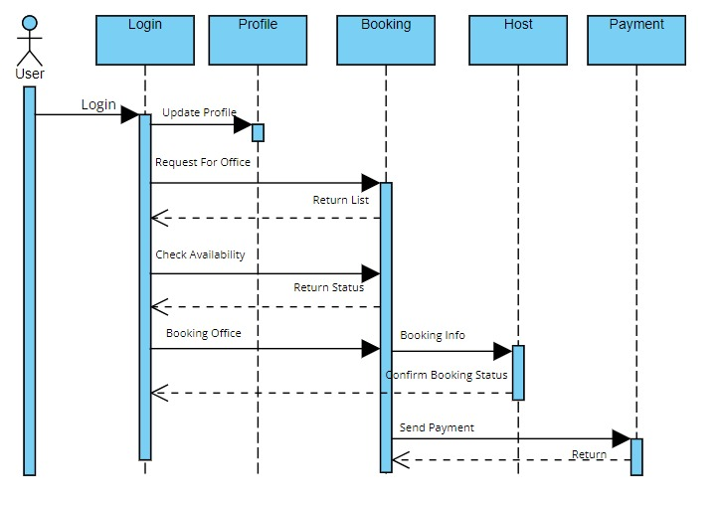
Figure 3.7: User-End Sequence Diagram

Sequence Diagram “Host”

The sequence diagram of host describes the interaction between host and its functions include profile, posts, view booking details, get requests, accept requests, reject requests.
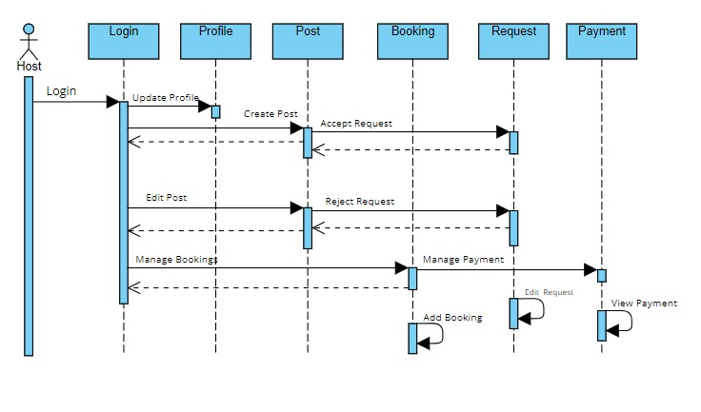
Figure 3.8: Host-End Sequence Diagram

Interface Design

Application interface is designed in a way that allows the Guest to interact with the software in a natural and intuitive way. SeeSaw system has a simple, attractive, and easy to use interface design. SeeSaw system has the following screens:

User Login Screen

It shows User Login Screen where host can Sign In after entering Username and password. Also Host have the option to change their password.
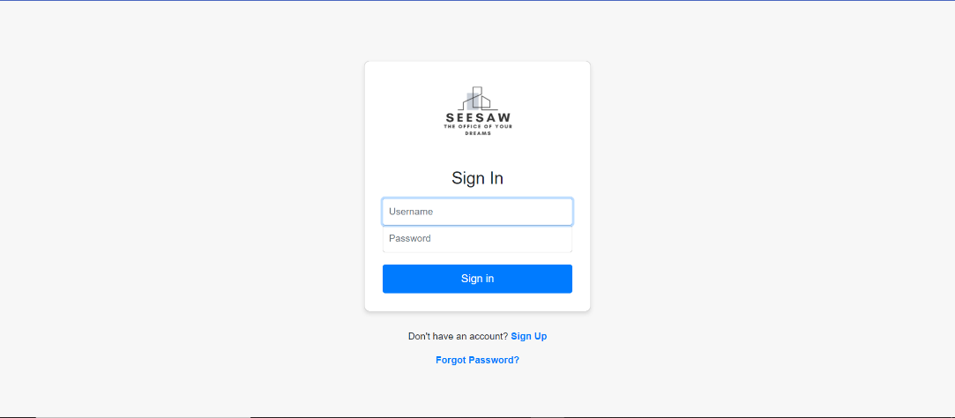
Figure 3.9: User Login Screen

Host Login Screen

It shows Host Login Screen where host can Sign In after entering Username and password. Also Host have the option to change their password.
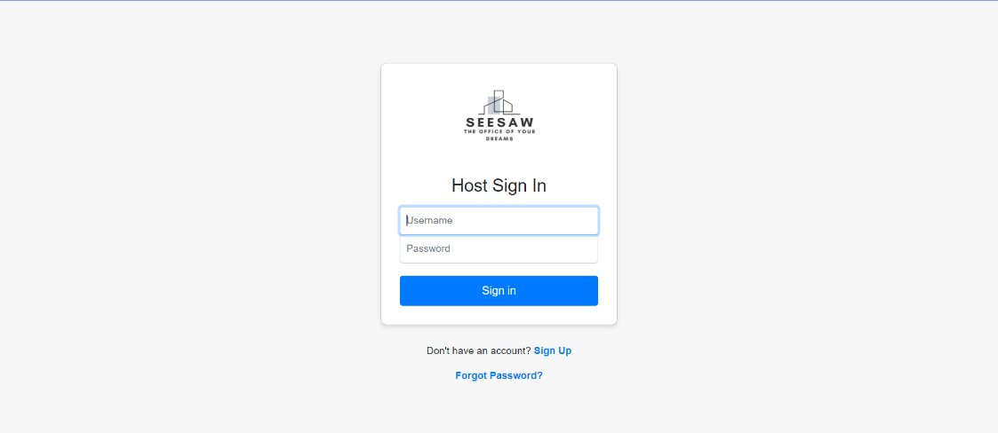
Figure 3.10: User Login Screen

User Signup Screen
It demonstrates the Signup Screen of User where User can enter email, username and password for signup.

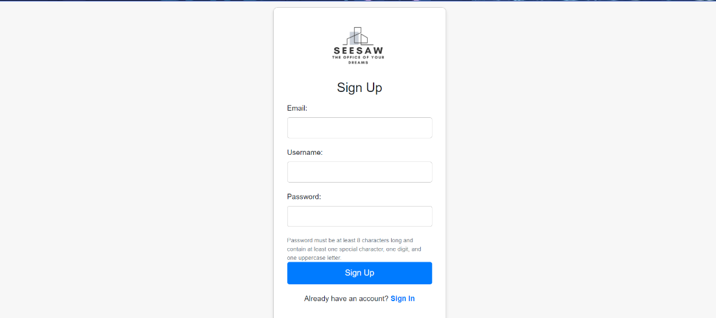
Figure 3.11: User Signup Screen

Host Signup Screen

It demonstrates Signup Screen of Host where host can enter their email address, username and password for signup.
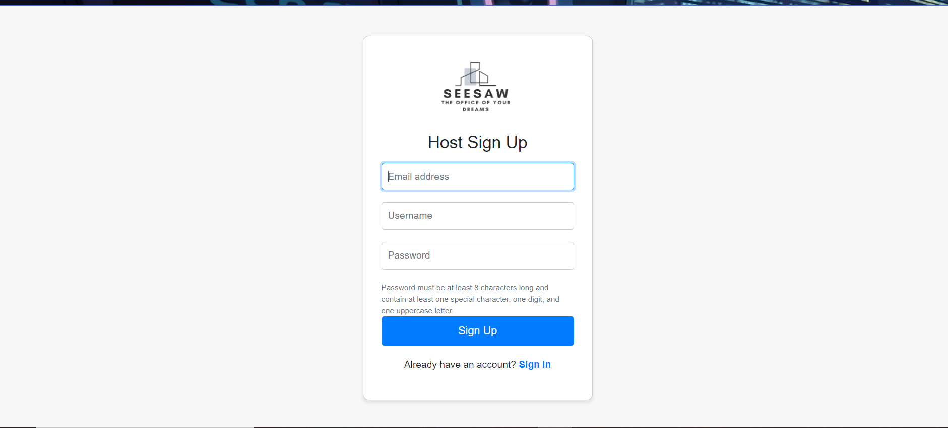
Figure 3.12: Host Signup Screen

Update Profile of both User and Host

It demonstrates the update Profile for both User and Host where User and Host can update their profile by entering their Username and email first then enter old password and set the new password and finally submit it.

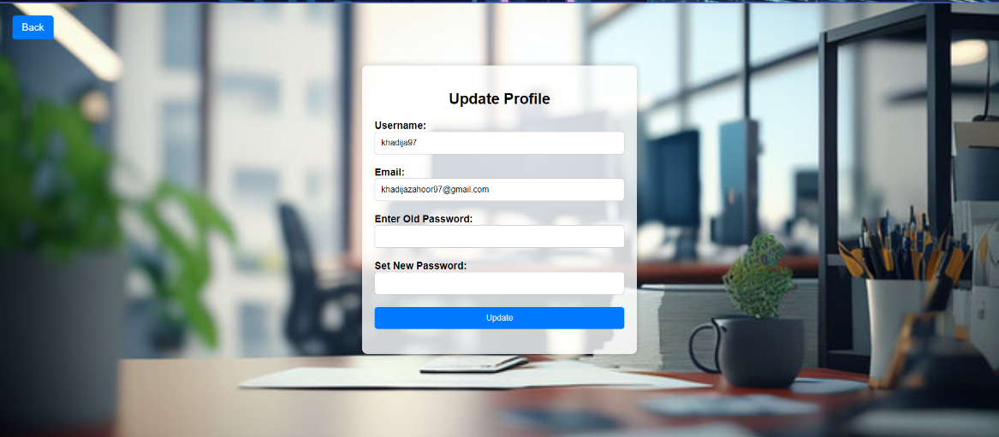
Figure 3.13: Update Profile of both User and Host

Main Page

It shows the main page of the website which demonstrates the basic three categories that are Private Offices, Co-working, and meeting rooms. On the right side there are two options Signs in and Host Now which shows that host is login now.

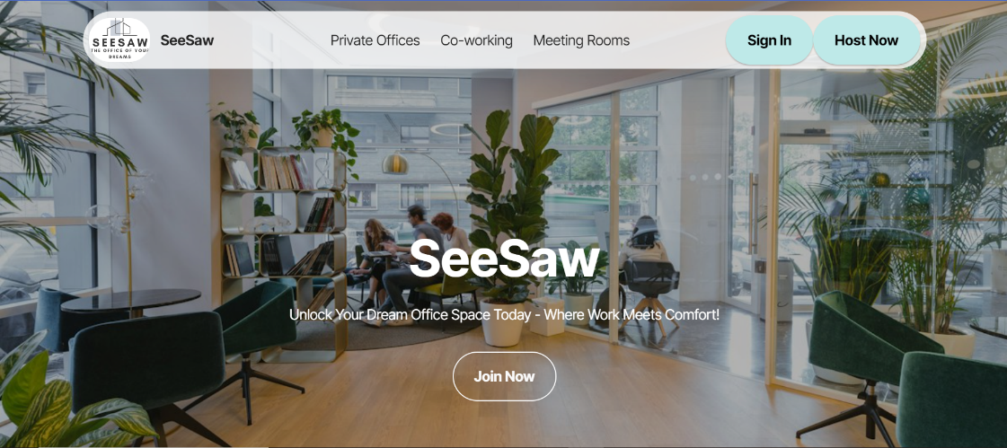
Figure 3.14: Main Page

Posts
It shows the posts of offices which are uploaded by host.

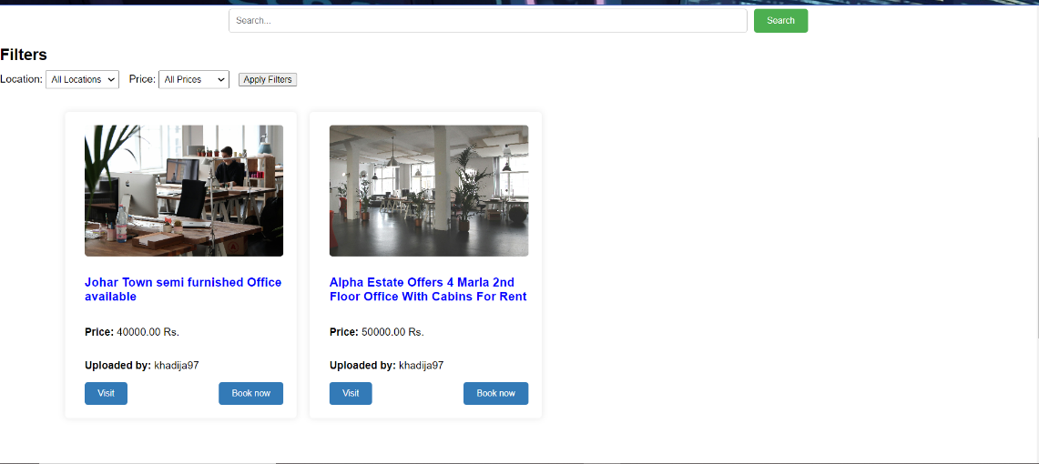
Figure 3.15: Posts

Payment or Booking

It demonstrates the payment or booking page where user can fill this payment form for the booking of office space. This form contains full name, Contact no, Email, card holder, cad number, expiry date and CVC number.

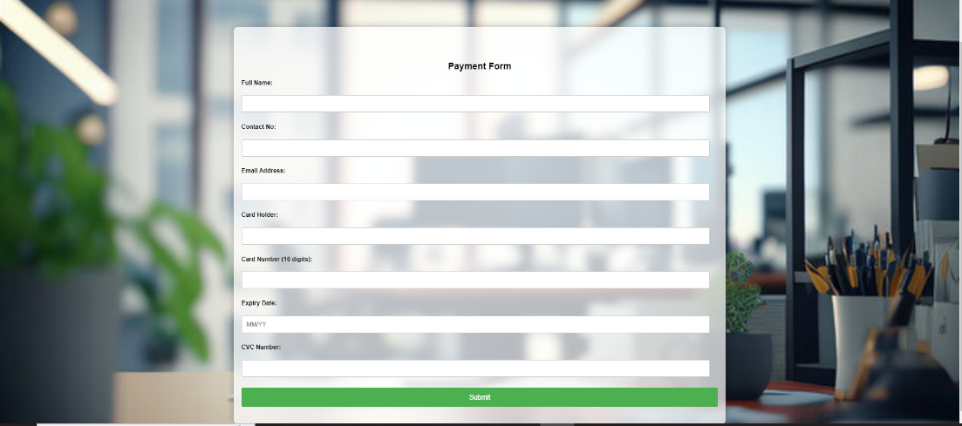
Figure 3.16: Payment or Booking

Visit Page for User

It demonstrates the visit page of user. It’s a contact form that user can fill to inform about visiting. The form consists of full name, contact no, email address, timings and date.

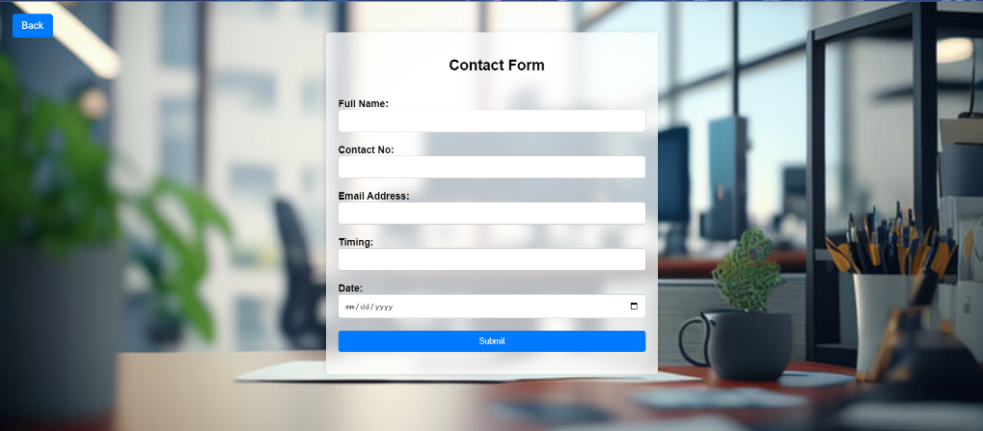
Figure 3.17: Visit Page of User

Booking Details Page
It shows the booking detail of offices. This page clearly mentions the detail booking history of offices.

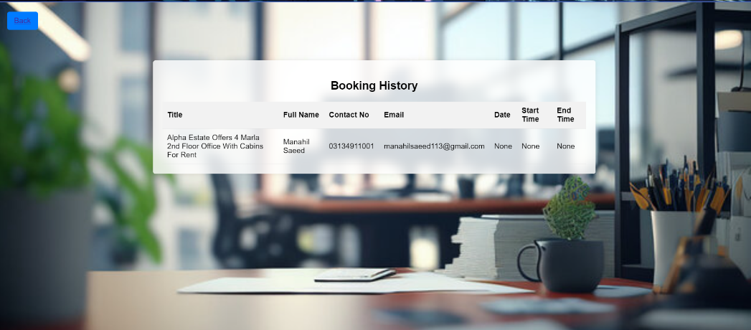
Figure 3.18: Booking Details Page

Visit details Page of User
It shows the users visit detail. It shows the date and timings of office space when the user will visit the space.

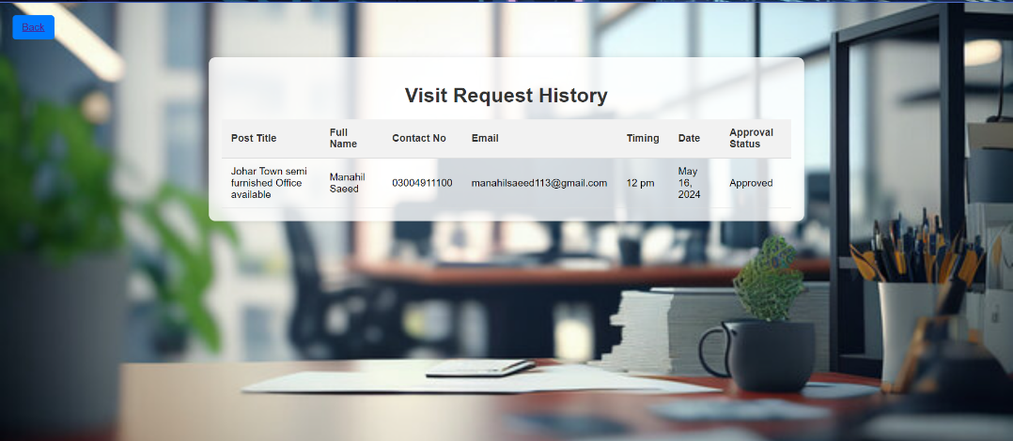

Figure 3.19: Visit Details Page of User

Add Post

It demonstrates the Add Post page. Host can add the post after fill this form where user can upload the image of office space, also write title, category, location, price of that post, phone number, address and description about image
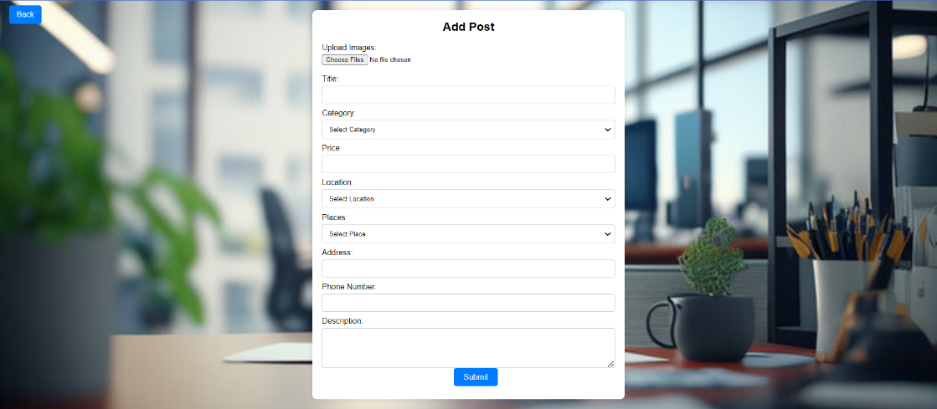
Figure 3.20: Add Post

Edit Post

It demonstrates the page which is Edit Post where host can edit their posts after uploading it.
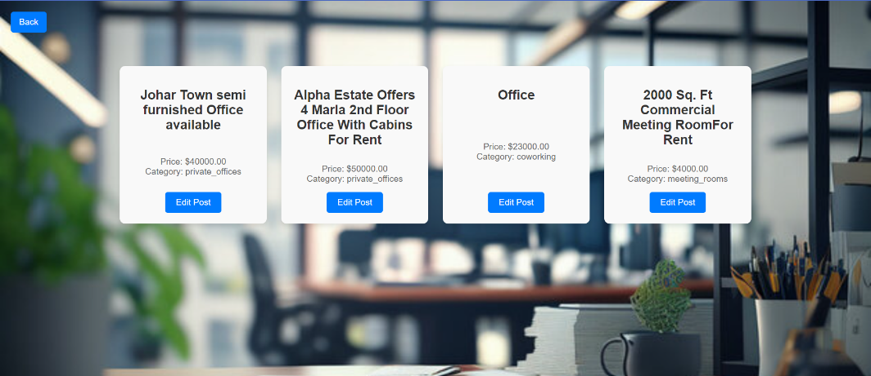
Figure 3.21: Edit Post

All Visit Requests

It shows all visit requests. It shows the details of all those users that are already visited.

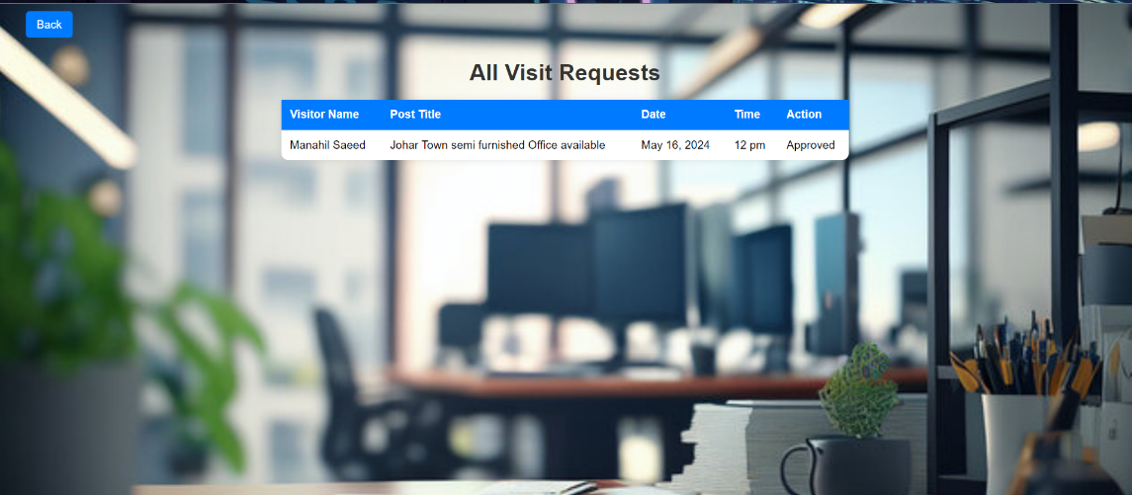
Figure 3.22: All Visit Requests

Approved Requests

It shows the Approved Request. This page shows all those requests that are approved by host.

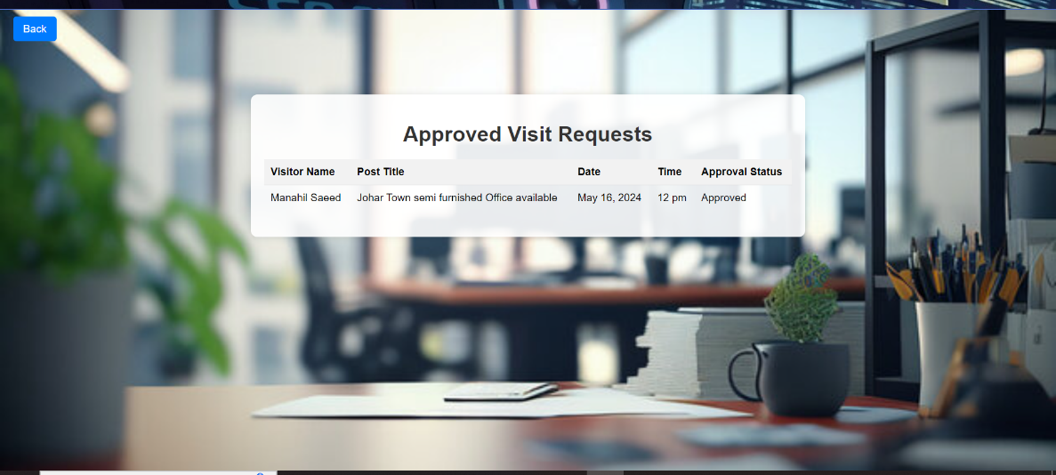
Figure 3.23: Approved Requests

Rejected Requests

It demonstrates the Rejected Requests. This page shows all those requests that are rejected by host.
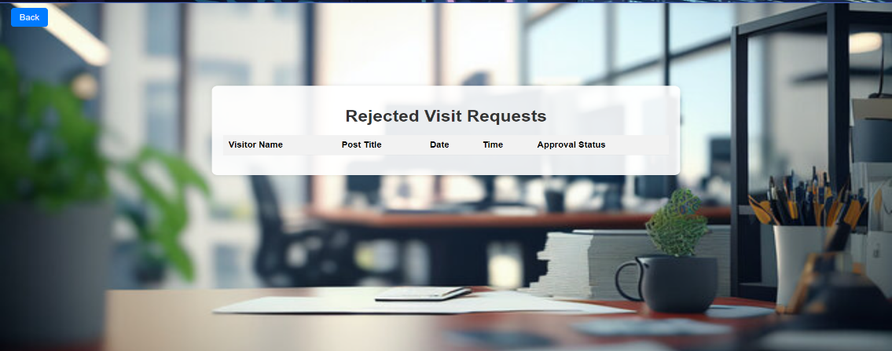
Figure 3.24: Rejected Requests

IMPLEMENTATION

Introduction

Co workspace is widely spreading business. In this technological era, web-based application can help in awareness and can also facilitate it. This project is also a part of the struggle to provide solutions for office issues. This system provides care beyond the traditional ways. Finding the space for office work is a bit time consuming process, as compatibility of Host and guest is required. Therefore, there is a need of such system that can make this task a bit easy. This application will help in communicating the person in need and willing host through broadcasting request. This application will provide easy access to co workspace admin. It will also keep the record of activities.

Components Web Services and Libraries

The components to be developed in this project are analysed from software requirement specification; the following are developed in the web-based application.
- User profiling
- Office booking
- Visiting office
- Location

IDE, Tools, and Technologies
The following technologies are used in developing the web-based application.
- Django
- Bootstrap
- Leaflet.js
- MySQL

Coding Standards

The following coding standards are used in developing the web-based application.
- IEEE coding standard
- Reusability

Software Engineering Practices

See Saw web-based application is developed according to the agile model of software engineering. Each module is developed and tested at the same time before going to the next module as per the incremental process model. Agile model is used in this application.

RESULTS AND DISCUSSIONS

Result
The implementation of See Saw application is developed on the latest platform of the developing time. Implementation is crucial phase of any developing project. The project is accomplished in accordance with the requirement of software requirement document. The implementation is completed on the agile model as mentioned in software project management plan. Each module is developed and tested in a cycle because agile model is a combination of both iterative and incremental process model because next module of this project is depended on the previous one. All the confusions in requirement are clarified from the software design document. Implemented application will work on different platform. The application is fully responsive. The user will sign up to make order. See Saw will provide a friendly co working space for office use.

CONCLUSION AND FUTURE WORK

Conclusion

In this project we proposed a system that will provide working space for office use. User will be able to visit as a guest and can post to any place after registration. User can book after visiting the post. Host will play admin role and have the authority to view all the information of the user.

Future Work

This future work explores the transformative potential of a web-based office application designed to enhance productivity, streamline tasks, and promote seamless collaboration in the modern workplace.

REFERENCES

[1] | “Pakistan property real estate - sell buy rent homes & properties in Pakistan real estate - zameen.com,” Zameen.com. [Online]. Available: https://www.zameen.com/. [Accessed: 30-May-2024].
[2] | “Regus,” Regus.com. [Online]. Available: https://www.regus.com. [Accessed: 30-May-2024].
[3] | “Kickstart: Pakistan’s 1st and largest coworking space,” Kickstart, 14-Dec-2023. [Online]. Available: https://kickstart.pk/. [Accessed: 30-May-2024].
[4] | “Comence: Private offices & coworking space Lahore - affordable,” Comence, 10-Feb-2024. [Online]. Available: https://comence.io. [Accessed: 30-May-2024].
[5] | “OLX - Buy and Sell for free anywhere in Pakistan with OLX online classifieds,” Com.pk. [Online]. Available: https://www.olx.com.pk/. [Accessed: 30-May-2024].

APPENDICES

APPENDIX A: Screenshots

Sign-up

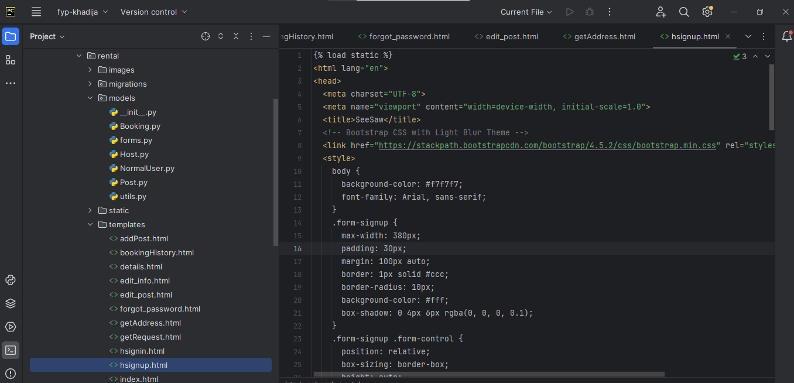
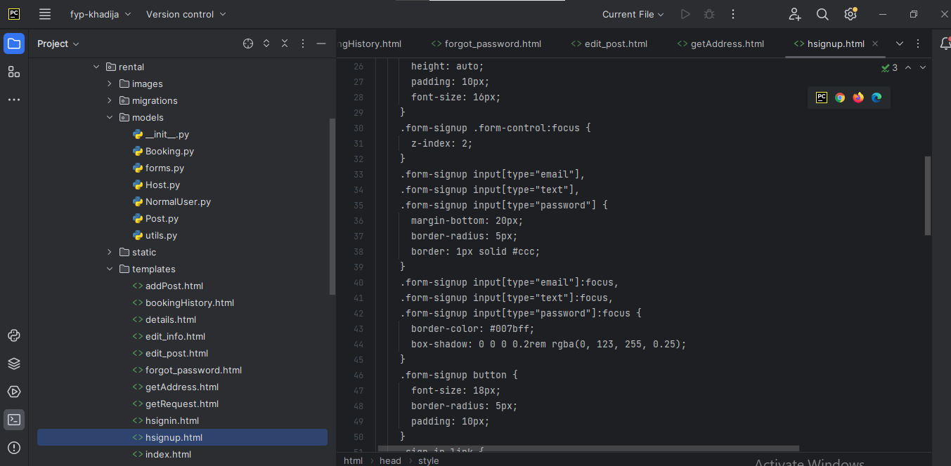

Sign-in

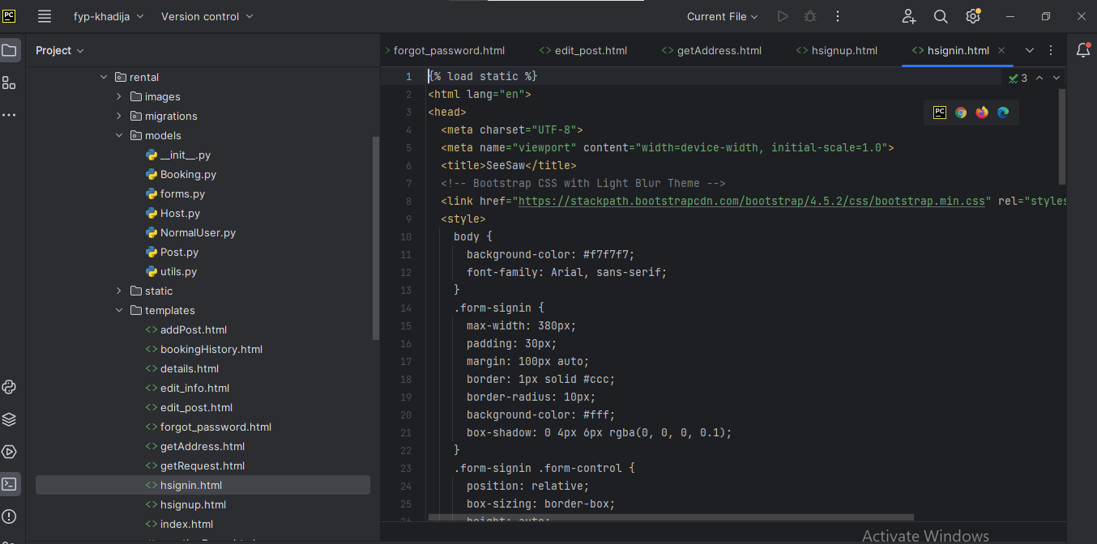
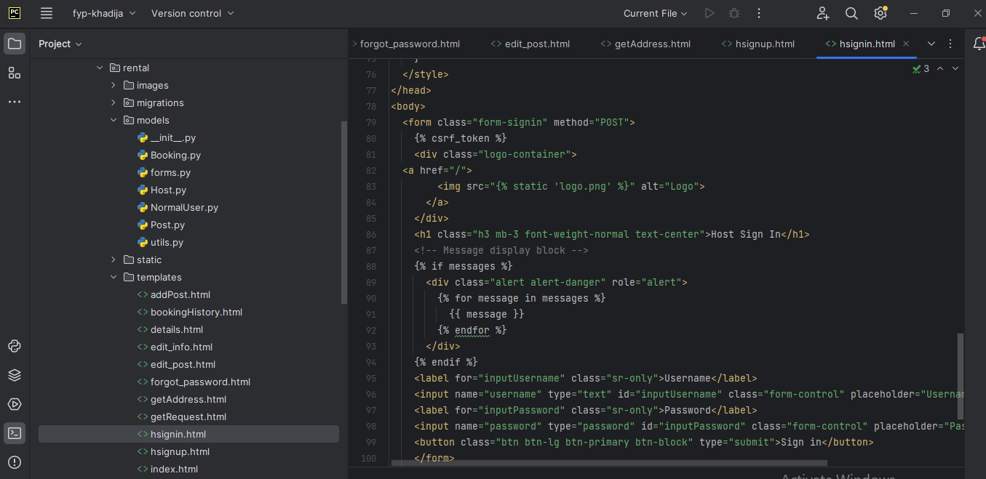

Add Posts

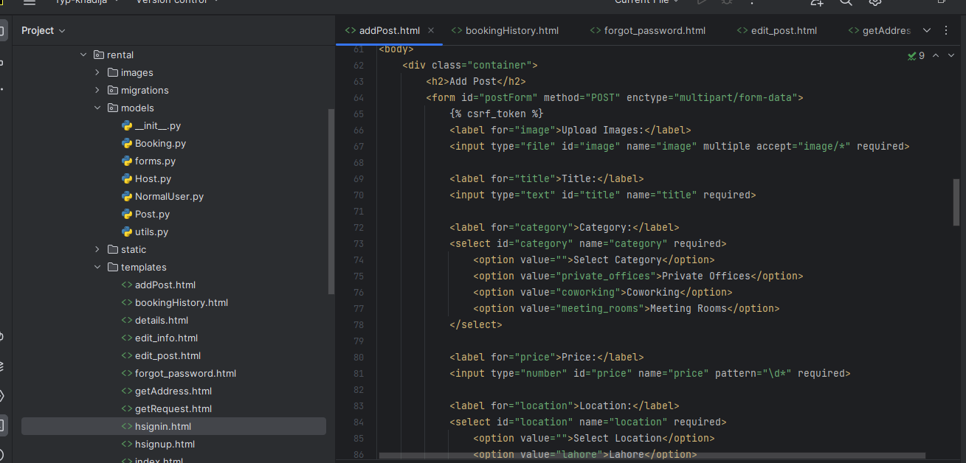
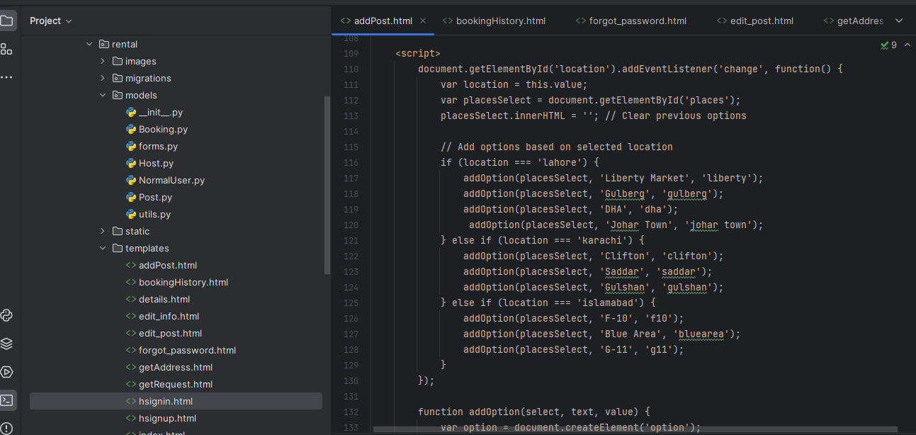

Booking
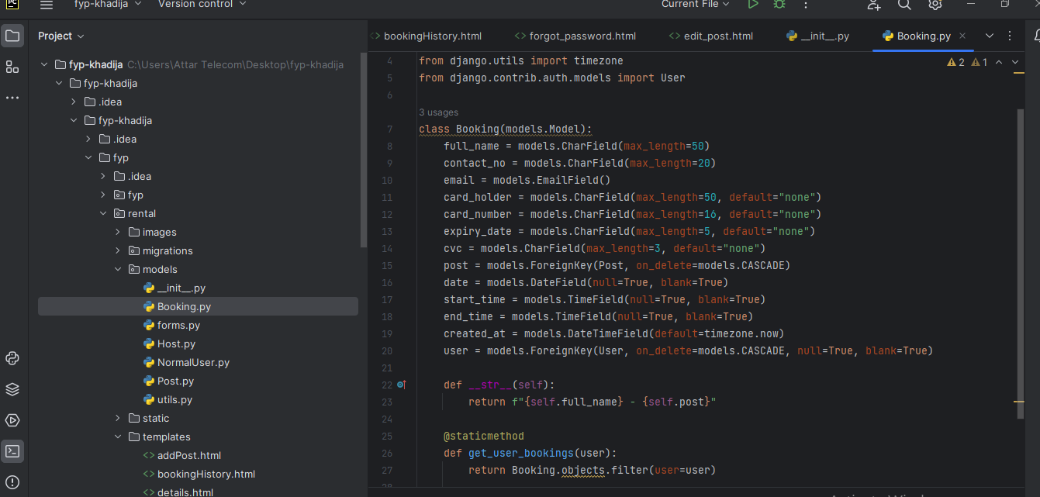

Host

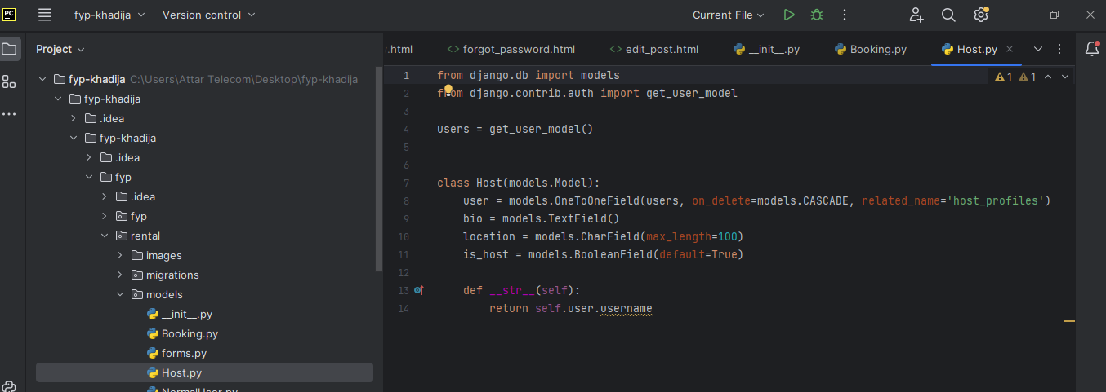

Posts

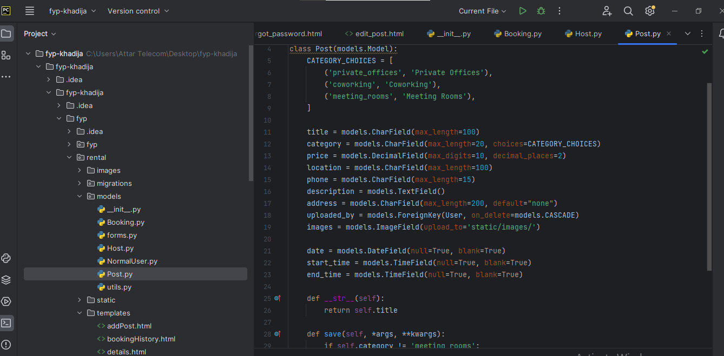

Normal User

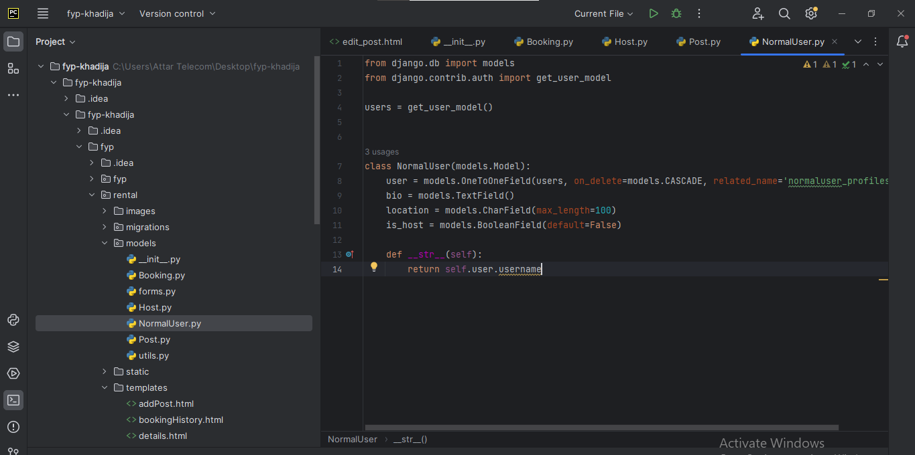

Migrations

