
BSCS-F23-022
03-134202-095 | Ahmad Azeem
03-134202-024 | Haris Rehman

Farm Bit
In partial fulfillment of the requirements for the degree of
Bachelor of Science in Computer Sciences
Supervisor: Shahid Mehmood
Department of Computer Sciences
Bahria University, Lahore Campus
June 2024

© Bahria University, 2024

Certificate


We accept the work contained in the report titled
“Farm Bit”
written by
Ahmad Azeem
Haris Rehman
as a confirmation to the required standard for the partial fulfilment of the degree of
Bachelor of Science in Computer Science.

Approved by:
Supervisor: Shahid Mehmood
(Signature)

June 2024

DECLARATION

We hereby declare that this project report is based on our original work except for citations and quotations which have been duly acknowledged. We also declare that it has not been previously and concurrently submitted for any other degree or award at Bahria University or other institutions.

Enrolment | Name | Signature
03-134202-095 | Ahmad Azeem
03-134202-024 | Haris Rehman

Date : 15 June 2024

ACKNOWLEDGEMENTS

We would like to thank everyone who had contributed to the successful completion of this project. We would like to express our gratitude to my research supervisor,
Mr. Shahid Mehmood for his/her invaluable advice, guidance and his patience throughout the development of the research.

In addition, We would also like to express my gratitude to our loving parent and friends who had helped and given us encouragement.

Farm Bit

ABSTRACT

The agricultural sector is pivotal for economic growth, yet farmers, particularly newcomers, face challenges in managing their farming inputs efficiently. The deficit of accurate information on the required amount of fertilizers and the cost of seeds often leads to over-spending or insufficient preparation for cultivation, affecting the overall yield and farmers' livelihoods. The lack of a centralized platform to guide and facilitate the procurement of essential farming inputs exacerbates these challenges. There is a crucial need for a solution that provides accurate guidance on farming inputs, supports sustainable agricultural practices, and caters to both seasoned farmers and individuals new to agriculture.

Our project introduces a smart e-commerce platform to address the identified challenges. Employing Google Maps APIs, our web-based application accurately identifies the location and size of the farmers' agricultural land, enabling precise calculations of the required fertilizer amount. The application’s front end crafted using HTML, CSS, Bootstrap, REACT, MongoDB, Graph script and JavaScript, ensures a user-friendly and interactive interface. The backend, powered by a Node JS framework, and Relevant Packages facilitates smooth calculations and displays the cost of seeds. This platform aims to provide real-time pricing and total cost analysis for seeds and fertilizers, serving as a comprehensive resource for farmers to make informed decisions regarding their agricultural investments. By integrating modern e-commerce features with smart technology, this platform is poised to significantly support farmers, heralding a phase of informed and sustainable agriculture.

TABLE OF CONTENTS

DECLARATION ii
ACKNOWLEDGEMENTS iv
ABSTRACT v
TABLE OF CONTENTS vi
LIST OF FIGURES ix
LIST OF SYMBOLS / ABBREVIATIONS x

CHAPTERS
1 INTRODUCTION 13
1.1 Background 13
1.2 Problem Statements 13
1.3 Aims and Objectives 14
1.4 Scope of Project 15
2 SRS 16
2.1 Introduction 16
2.2 Overall Description 16
2.3 Operating Environment 17
2.3.1 Design & Implementation 18
2.3.2 Assumptions & Dependencies 18
2.4 Functional Requirements 18
2.5 Non- Functional Requirements 19
2.6 External Interface Requirements 19
3 DESIGN AND METHODOLOGY 20
3.1 System Architecture 20
3.2 Database Design 21
3.3 User Interface Design 22
3.3.1 Development Methodology 26
4.1 Data Collection 27
4.2 System Implementation 28
4.3 Integration of Maps APIs 29
5 RESULTS AND DISCUSSIONS 30
5.1 System Overview 30
5.2 Key Features 30
5.2.1 Data Processing and Management 31
6.1 Summary of Findings 33
6.2 Final Thoughts 34
6.2.1 Implementation Strategy 34
REFERENCES 35
6.2.2 Digital Agriculture: Farmers in India 35
6.2.3 The Role of Digital Platforms in Agri-Food 35
6.2.4 The Future of Digital Farming 35
6.2.5 Maps data and Google Maps APIs 35
6.2.6 E-commerce & Role in Modern Agriculture 35

LIST OF FIGURES

FIGURE TITLE PAGE
Figure 1 Data Flow Diagram 20
Figure 2 ER Diagram 21
Figure 3User Registration and Authentication 22
Figure 4 Land Details and Fertilizer Calculation 22
Figure 5 Real-Time Pricing and Cost Analysis 23
Figure 6 Profile Management and System Maintenance 23
Figure 7 Registered User 24
Figure 8 Admin User 24
Figure 9 Guest User 25

LIST OF SYMBOLS / ABBREVIATIONS

API: Application Programming Interface
HTML: HyperText Markup Language
CSS: Cascading Style Sheets
UAT: User Acceptance Testing
REACT Rapid Execution And Combat Targeting

INTRODUCTION

Background

Farming is important for our economy and making sure we all have enough food. But for new farmers, figuring out how to manage stuff like fertilizers and seeds can be tricky. They often end up spending too much or not getting enough, which messes up how much food they can grow and how much money they can make.

The problem gets worse because there's no one-stop-shop for farmers to get all the info they need. They're left scrambling around trying to find the right stuff at the right price, which wastes a lot of time and money.

So, we need something to help. Something that tells farmers exactly what they need and how much it'll cost, so they can make smarter decisions and grow more food without wasting resources. That's where our idea comes in - a smart online store that uses maps and tech to make farming easier and more efficient.

Problem Statements

Our goal is to help farmers by giving them a new tool on the web. It lets them find out what their land needs. They can type in their field details and then our tool shows them the right amount of stuff like fertilizer they should use. This way, we stop waste and help them use the right amount.

Once we know what they need, farmers can buy the stuff they need on our tool. It makes the process easy and helps them make smart choices for their farm. Our way helps them work fast and makes sure they use just what they need in the right place.

We want to aid farmers in doing more with their farm and make sure they use their land well. Our plan is made to help solve the hard parts of farming and help them do better. We don't just want to help them make more money, we want to help food stay safe and keep the earth safe too. We want to use our tool to make sure farms are smart, fast, and good for the earth.

Aims and Objectives

We are developing an e-commerce platform tailored for farmers that will handle the management of farming inputs such as fertilizer. Our project mainly aims to address the challenges faced by farmers, especially those who need to manage agricultural inputs often. This will also enable many of them improve effectiveness and sustainability as well.

- In order to accurately manage resources, we shall use the Mapbox API to pinpoint the exact location and dimensions of user’s land. This will empower our application to compute the required amounts of fertilizers hence reducing wastage and increasing efficiency in resource utilization.

- Our web application uses the sophisticated technology such as React JS (V0.13), styled-components-js (Amin 2018), HTML/CSS, Bootstrap for frontend development and Redux for state management when the UI interacts with server-side code. It consists of features aimed at making it responsive in design. It also enhances interactivity, making the users more engaged with the product or information being advertised. In addition to this, through easier access while at the same time beautifying this interface.
- For the backend, we will be using NoSQL databases and Node.js which also works with MongoDB. To construct a robust framework to meet these requirements of the new forms of calculations, js has to be embraced. Other things that the benchmark should provide include price update or price assessment of the most important input. This format of work arrangements will ensure efficient working for any organization without experiencing any form of working hitches as well as ensure accurate documentation is made.

In addition, further elaborated e-commerce capabilities that can provide decision-makers with valuable tools are planned. This will then help farmers to make a proper decision on the kind of input to use in farming hence leading to increased production among the farmers which is sustainable in the long run.

In this way, the implementation of the presented solution will allow for achieving the following objectives: With these aims met, the usage of our solution will not only contribute to the optimization of the procurement and management of the agricultural inputs but also provide a positive impact towards the efficacy and sustainability of farming operations.

Moreover, we integrate smart e-commerce tools that aid in easy choices. Hence, this will help farmers in deciding appropriately on how to utilize their resources thereby promoting environmental friendly farming methods. Leading to better crop yields and sustainability of the agricultural production system. Our solution in addition will streamline acquisition and administration of farm supplies hence forth making it easier for farmers to sustainably utilize them.

Scope of Project
Our main goal is to help farmers improve their efficiency and protect the environment. We do this through a customized internet-based site. This specific tool shall not only smoothen the controller of farm-related wants including manures and planting material but also uncover hitches that are only known to farmers.
Hence, through incorporation of algorithms for exact land estimates including the Mapbox API; it will be possible to get right measurements meaning that it will inhibit wastage as well as promoting reforestation efforts within public forests and farmlands.
We used advanced technologies such as React, Styled Components, HTML, CSS, Bootstrap, and Redux in order to create the user interface for the platform; this means that farmers with different levels of technical expertise will be able to use it without any difficulty due its interactivity or user friendliness. Furthermore in regard to sophisticated e-commerce facilities there will also be real-time products in relation to inputs.

SRS

Introduction
This section outlines the functional and non-functional requirements of the smart e-commerce platform designed for farmers. The software is meant to give real guidance concerning farming inputs, encourage sustainable farming techniques and serve both experienced and inexperienced farmers in their practices.

Scope
Our platform is going to utilize Google Maps APIs for farmer’s agricultural land whereabouts and coverage accuracy, which will help us to gain accurate figures on fertilizer required. It’s will be nice and easy to use, designed with help of HTML, CSS, and Bootstrap on front end side while at the back end stage it’s will be powered by strong engines including React, MongoDB, JavaScript, and Node.js. Besides this we’ll add Mapbox API for improved geographical data.

Overall Description

Product Perspective
Our e-commerce platform is a standalone web application that easily links up with external APIs and databases. As a result of this joining together, the platform provides users with genuine data and real-time analytical results. By making this platform accessible through the internet from every gadget connected to it, we ensure that anybody may easily reach it, regardless of the type of their device. Therefore, in order to attain a larger audience and deliver vital agricultural.

Product Features
- Accurate geolocation and land size identification using Map Box APIs.
- Real-time pricing and cost analysis for seeds and fertilizers.
- User-friendly interface for data input and result display.
- Secure data management and storage.

User Classes and Characteristics

Experienced Users: Farmers who are experienced, demand extremely detailed input suggestions plus the most comprehensive cost analysis apart from that they also need other markers of success. They look for ways to get ideas that are data-driven so that they will be able to perfect their farming businesses with the help of our platform. We provide them with tools they use in tracking everything happening around their farms therefore improving efficiency as well as productivity levels. Eventually (all in all) these special groupings enjoy some tools such as tracking and managing resources closely thereby making it easier for them to do stuff better off.

New Farmers: These users need clear guidance on how to input what they want and be strategic in managing costs effectively. Getting down to business as a farmer is not any easy thing for them and so we have touches that will help them set the right course. Initial tools on our site are simplified data so they do not feel lost any more about using computers.

Operating Environment
Our website which a person can get into with present-day web browsers namely Google Chrome, Mozilla Firefox, Safari as well as Microsoft Edge. It has been design for all common web servers so one can expect it to get reliable operations without hitches. Whenever you need to keep data in it, note that MongoDB acts as the database which allows flexible storage of voluminous and intricate datasets that are treated in agricultural sectors. This setup ensures that the platform is highly accessible, robust, and capable of supporting a wide range of data management and analysis needs for farmers.

Design & Implementation
- Compliance with data privacy regulations.
- Ensuring the platform is scalable to handle multiple users simultaneously.
- Maintaining high availability and reliability.

Assumptions & Dependencies

- Reliable internet connectivity for accessing the platform and APIs.
- Up-to-date agricultural input data from suppliers and market sources.

Functional Requirements

User Registration and Authentication:
- Users should have the ability to create personal accounts and securely log in.
- The system must verify the identity of users before providing access to custom features.
Land Identification and Input Calculation:
- The platform will utilize the Mapbox API to accurately identify and calculate the size of the user's land.
- The system will provide precise fertilizer recommendations tailored to the specific size and location of the land.
Real-Time Pricing and Cost Analysis:
- The platform will retrieve real-time pricing data for seeds and fertilizers to ensure users have access to the most current information.
- The system will calculate and display the total cost for users based on the recommended inputs, allowing for informed financial decisions.
Data Management:
- The platform must store user profiles, and input data securely.
- The system should allow users to update their information as needed.

Non- Functional Requirements

Performance:
- The platform should load within 5 seconds for an average user with a standard internet connection.
- The system should handle up to 10,000 concurrent users without performance degradation.

Usability:
- The interface should be intuitive and easy to navigate.
- The system should provide clear instructions and feedback to users.

Reliability:
- The platform should have an uptime of 99.9%.
- The system should implement regular backups and data recovery mechanisms.

Security:
- User data must be encrypted both in transit and at rest.
- The system should implement robust authentication and authorization mechanisms.

External Interface Requirements

User Interfaces:
- Responsive design to ensure usability on both desktop and mobile devices.
- Dashboard displaying land details, input recommendations, and cost analysis.
- Hardware Interfaces:

Software Interfaces:
- Integration with Google Maps APIs for geolocation and land size calculation.
- APIs for fetching real-time pricing data from external sources.

Communications Interfaces:
- Secure communication protocols (HTTPS) for data transmission.

DESIGN AND METHODOLOGY

The section outlines how the Farm Bit e-commerce platform was developed systematically and the technical procedures that were followed in the process. In this section, each phase of the project is described in detail, starting with the planning and design phase, and followed by the development phase, implementation and testing phase. Thus, this approach guarantees that the solution that we will provide is not only efficient, but also corresponds to the highest requirements that are characteristic of modern high-availability e-commerce systems.

System Architecture

The architecture of our system has been developed to streamline the integration of the front-end and back-end sub-systems, with the aim of providing users with smooth and efficient interactions with the system. The architecture comprises several key components. The architecture comprises several key components:

- Front-End: The design of our front-end is done with the help of React, Styled Components, CSS, Bootstrap, and Redux to provide a friendly and interactive interface for users. It is involved in the capture of user inputs as well as the display of important information and recommendations which makes it user-friendly.

- Back-End: Built with HTML5 and CSS3, features supported by Node.js and data stored in MongoDB. In js, we ensure that our back-end is capable of handling data processing, calculations, and database management effectively. It specifically solves for the challenges of finding out how much of the fertilizer is required to administer on a certain piece of land and its location by having to compute for it. It also offers real time pricing and cost a critical aspect in any strategic management information system.

- Mapbox API: To capture detailed geographical information and to function optimally in place of Google Maps, the system utilizes the Mapbox API to locate and shape the land involved in the farming. This integration is necessary in order to estimate the correct input data for the program according to the specified parcel of land.

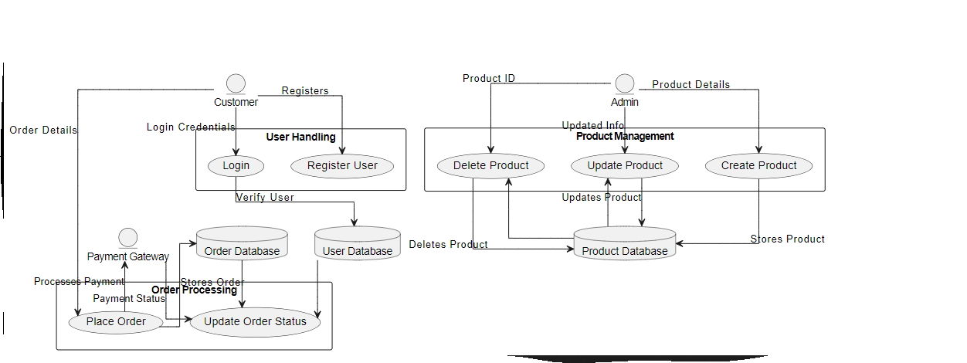
Figure 1 Data Flow Diagram

Database Design

The database is managed in a way to save and manage different types of data difficult for the platform's operation, including:

- User information (e.g., farmer profiles, land details)
- Input data (e.g., types of fertilizers and seeds, prices)

The database is designed and organized in such a way that integrity of the stored data, security of data, and accessibility of information gets implemented.

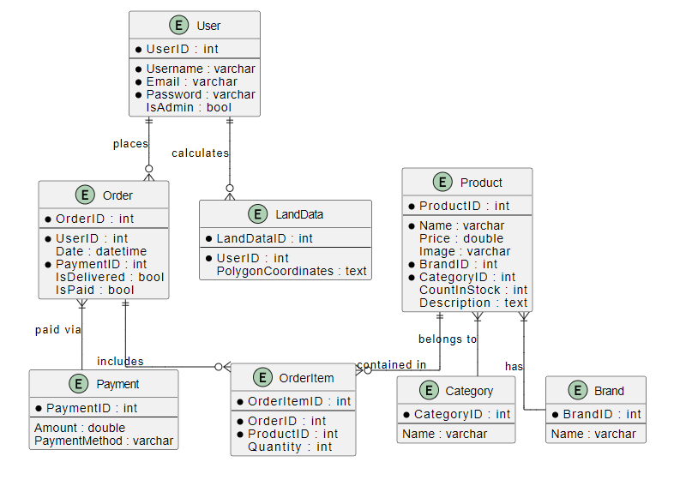
Figure 2 ER Diagram

User Interface Design
The platform has also been designed in such a manner that the user interface will become easily understandable to even the Farmer without even any likelihood of the use of technologies. Key UI elements include:
- Dashboard: This place is where farmers see their information and make necessary changes.
- Homepage : This central hub is the main interface where users can access essential information and engage with the platform. In this case, farmers can locate their land on the map, get a detailed view of their farms, and get the real-time estimate of their input use, like fertilizer
- Map Integration: Users can easily select and visualize their agricultural land directly on the map, provided by the integration of the Mapbox API. This feature allows for a hands-on approach to land management without the need for entering data through forms.
- Result Display: The platform thus provides targeted input suggestions and cost information in an understandable manner. This assists farmers in knowing exactly the needs of their land therefore, improving on their management skills.

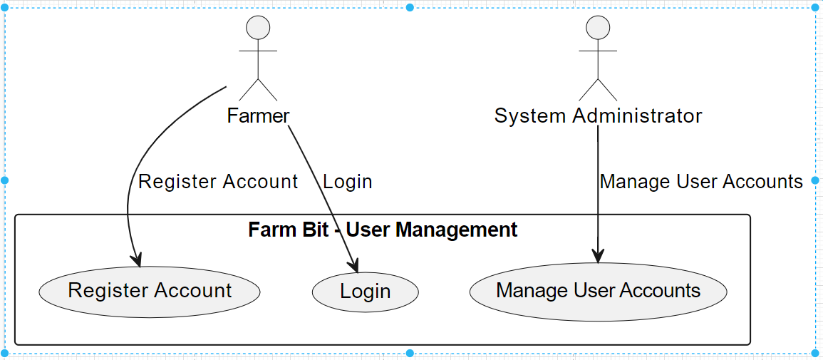
Figure 3User Registration and Authentication
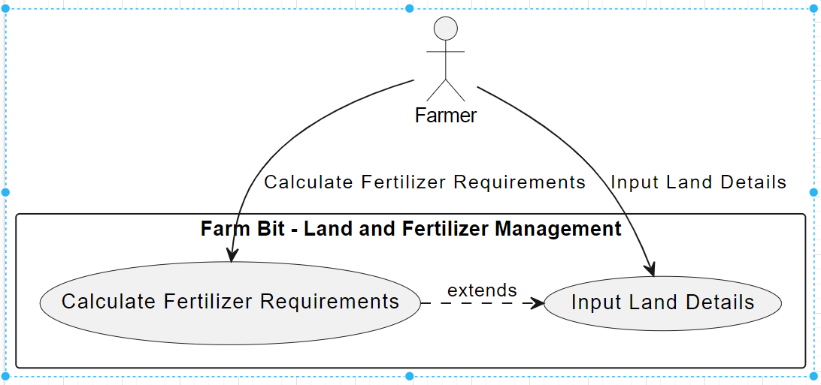
Figure 4 Land Details and Fertilizer Calculation

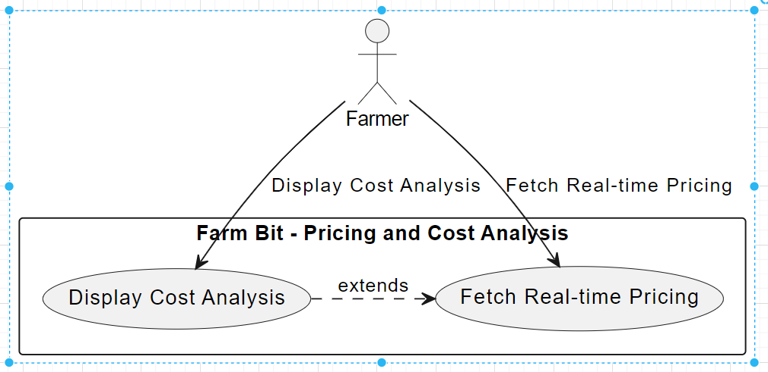
Figure 5 Real-Time Pricing and Cost Analysis

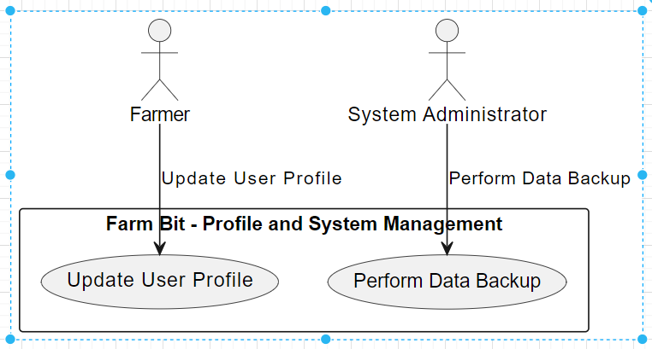
Figure 6 Profile Management and System Maintenance

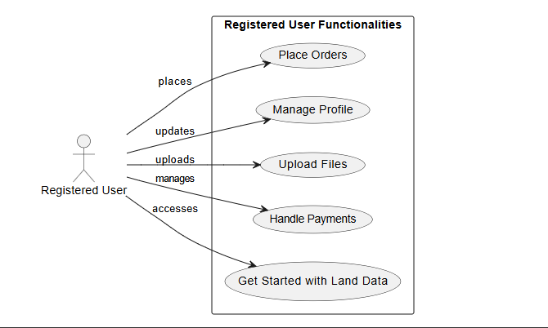
Figure 7 Registered User

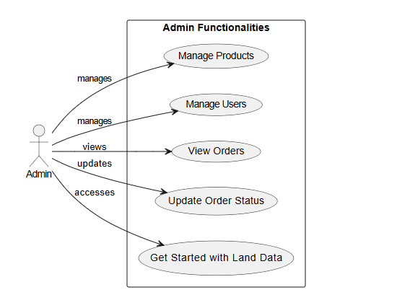
Figure 8 Admin User

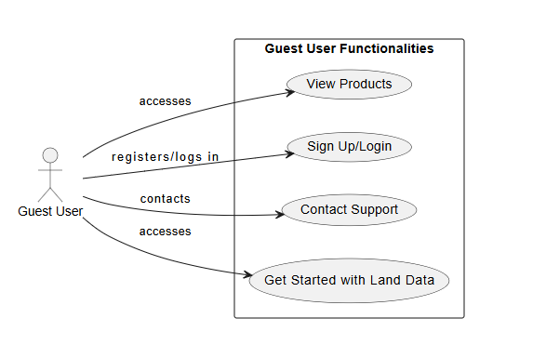
Figure 9 Guest User

Development Methodology

The development of the platform is based on the agile approach which prescribes incremental improvement through feedback and refinement. Key stages include:
- Planning: Defining project objectives, scope, and requirements.
- Design: Creating detailed design documents for the system architecture, database, and user interface.
- Implementation: Developing the front-end and back-end components, integrating Google Maps APIs, and building the database.
- Testing: Conducting thorough testing to identify and fix bugs, ensure usability, and validate the accuracy of calculations.
- Deployment: Launching the platform for use by farmers, with ongoing maintenance and updates based on user feedback.

IMPLEMENTATION

we embark on the detailed analysis of the data obtained, the methods used in the experimentation and the overall approach taken in designing the smart e-commerce system for the farmers. The initial stage was data gathering, and it was crucial because our application relies on the geographical and agricultural data required to calculate the size of the land and input needs accurately; this was made possible due to the Mapbox API integration. We then transitioned to the system implementation phase where the development team leveraged on web technologies to design and develop the system that would be capable of being accessed across various devices and browsers. For the final step of the project, we carried out a detailed testing procedure on the front-end and back-end parts to ensure the proper working of the platform as well as the ease of use of the system, with the incorporation of real user feedback to fine-tune the system. Thus, these efforts have resulted in the development of a strong foundation that not only addresses the real-life requirements of the farmers but also supports them in making favorable decisions regarding the agricultural products.

Data Collection
Data collection is critical for our platform to provide the user with relevant information and a detailed breakdown of the costs involved. To achieve this, we rely on two primary sources of data. To achieve this, we rely on two primary sources of data:
- Geospatial Data: The geospatial data is acquired by using Map box APIs for data retrieval. This includes the coordinates and area of the agricultural land in question. This is because geospatial data is important in helping us determine the right quantities of fertilizers required for use in different areas.
- Agricultural Input Data: This includes information on the various types of fertilizers and seeds that are used for growing crops. We get information with regard to their characteristics, applications and the prices currently prevailing in the market. This information is collected from agricultural databases, from direct contacts with suppliers, and from market research.
- User Data: Profiles and preferences of farmers, collected through user registrations and interactions with the platform.

System Implementation

The development of our platform is divided into two core components: we have a front end and a back end, both created with the aim of providing the best performance.

- Front-End Development
Technologies Used: React, HTML, CSS, Bootstrap, and JavaScript.
- Dashboard: This serves as the core section of the platform where users can obtain all the necessary information of their land, get suggestions according to their requirements and costs. This integrated approach enables the users to better organize their agricultural resources.
- Input Forms: We have developed a clear and user-friendly interface where it is easy to input information about the size and location of the land they own. These forms are very important for the reason of having to take all the required data to help calculate on.
- Result Display: The results are clearly presented, showing the required amounts of fertilizers. This transparency helps users make informed decisions about their purchases.

- Back-End Development

On the server-side, we have a pretty solid Node.js stack that takes care of all the heavy lifting when it comes to data storage and processing. Some of the key components include:
- Data Storage: We store and process a lot of data including but not limited to user information and details about the crop inputs.
- Calculations: Our algorithms calculate the exact quantity of fertilizer required depending on the land size and location. This ensures that the recommendation we provide are unique to the user.
- Cost Analysis: The system can perform real-time pricing analysis and generate the total cost of the input seeds and fertilizers. This functionality will definitely help users to plan and monitor their farming budgets in advance.

Integration of Maps APIs

Mapbox API is used to define right location and area of the farm which is a core part of our product. There are few important parts of the integration:
- Geolocation: Using GPS coordinates we determine exact location of the field. This is important to ensure that all the data we base our advise on is correct and there is no room for misallocation of the input factors.
- Area Calculation: After finding the field location we determine its exact area. Knowing the area of the field allows us to generate right recommendations adjusted to the needs of each particular parcel. This in turn allows the farmers to be most efficient with their inputs.
- Mapping Interface: Our system provides visualisation of the field which is not only an important part of the user experience but also allows the farmer to see the map and check the details of the field. This gives an extra feeling of control over the process and allows to correct any data if needed. Confirmation step is important to increase the trust and reliability of the farmer to the system.

RESULTS AND DISCUSSIONS

System Overview

Our smart e-commerce platform for farmers is an all-in-one, highly efficient way to manage agricultural inputs. The platform’s ability to calculate the exact quantity of fertilizer required by the farmer’s field is facilitated by Mapbox APIs. Without the ability to determine the location and area of the field in question, any recommendation for fertilizer quantity would be useless.

The user interface of the platform was developed on React, Styled Components, HTML, CSS, Bootstrap and Redux – which allows for a very accessible user experience, especially for farmers not so proficient with technology. The backend was developed on MongoDB and Node.js, which allows for robust data analysis and real-time pricing and cost calculations.

The goal of this platform is to provide the farmer with the right information and tools to make the right decisions that will improve his productivity and sustainability in agriculture. This way, he can obtain high outputs with lower inputs.

Key Features

This platform include features that are designed to streamline your farming operation and boost your experience. You’ll be amazed at the difference it can make..

- Better Budgeting for You:
The platform includes real-time pricing tool for seed and fertilizer. This tool includes functionality that generates detailed cost estimates and let farmers make better decisions when it come to buying inputs. Using this tool farmer can access up-to-date local market information and accurate calculations of his exact input needs. This way farmer can better plan his budget and avoid over spending.

- Easy to use Interface:
We put yourself in mind whenever designing the front-end of the platform. We made it possible for farmers to easily enter their land information and get recommendations based on his farm. The platform interface is simple and easy to navigate, and suitable for both tech and non-tech users of the platform..

- Right Amount of Input to Use:
Using spatial data from Mapbox JS, the platform gives the user accurate knowledge of his farmland and its location. This will help in fertilizer optimization. The user will know the exact amount of fertilizer to apply to each specific land and this will help him save cost and avoid over application of fertilizer which often leads to wastage. This will also ensure that fertilizer is not washed into rivers and streams thus creating a safe environment for the user and those around his farm.

Data Processing and Management

A robust back-end system underlies the user-friendly interface of the product. It is designed and developed to ensure data integrity and provide efficient farming information services. The back-end employs the following set of emerging technologies:
- MAP Box: To ensure geographical integrity at all times, which is a prerequisite for any farm related information.
- Node.js: A versatile, cross-platform technology that lays down the server for data processing.
- Graph Script: To establish diverse relationships between various data elements for analytical purposes.
- MongoDB: Light and scalable database to store users, farm data and all the information needed. The system architecture has been designed to ensure data integrity and fast data retrieval to ensure an optimal user experience.

CONCLUSION AND RECOMMENDATIONS

Summary of Findings

This project set out to develop a smart e-commerce platform aimed at addressing the challenges farmers face in managing their farming inputs efficiently. Through the integration of Maps APIs, it was easy to identify the size and location of the land which was an important factor in determining the required amount of fertilizer. The front end was designed with HTML, CSS, Bootstrap and JavaScript and the back end was designed to incorporate data processing and real time cost analysis. The platform was able to offer the farmers the right information that they required, which made them make the right decisions regarding their farming activities, thus encouraging sustainable farming.

The user acceptance testing (UAT) revealed that the developed platform was highly suitable for the farmers as it ensured a smooth and effective application. Among the features, the farmers valued the accurate input recommendations and real-time pricing, as these tools allowed them to manage their resources more efficiently and avoid losses.

Conclusion and Suggestions for Future Research
The new e-commerce platform assists the farmers to work well by providing them with lots of important information. This helps him or her to make right decisions and thus perform well in the task assigned to him or her. It can only get better and better so that it can accommodate and assist more people. It will require support from the user’s side in order to improve. This will enable it to meet the demands of the farmers that change over time.

Final Thoughts
The platform will use the Mapbox API for exact identification and subsequent calculation of the size of the user’s land should be small. The system will offer individualised recommendation of fertilizers that could be required by the particular size and area which is the land.

Implementation Strategy

In the coming days, there are few more things that would be added to this store in the coming days so as to ensure that it becomes more significant in farming. In order to do this, user inputs need to be captured so as to facilitate its improvement and thus meeting farmer’s requirements. To sum up, the new buy/sell tool may totally change the way of functioning of farms. It can help us to work for an organization that will be good for environment. Just let us keep making it better for easier-ness.

REFERENCES

[1] Digital Agriculture: Farmers in India are Using AI to Increase Crop Yields" on Microsoft's Blog.

https://news.microsoft.com/en-in/features/ai-agriculture-icrisat-upl-india/

[2] The Role of Digital Platforms in Agri-Food Chains: A Literature Review in E-Agriculture Projects" published in Agronomy.
https://www.mdpi.com/2079-9292/9/2/319

[3] A. Johnson, "The Future of Digital Farming," p. 15, 2021. On Line, Available at:

http://www.agritechfuture.com/digital-farming

[4] Selena Salazar, " Maps data and Google Maps APIs enable a new approach to agriculture", 2015 Available at:

https://mapsplatform.googleblog.com/2015/08/maps-data-and-google-maps-apis-enable.html

[5] E-commerce Platforms and Their Role in Modern Agriculture," p. 7, 2022. Online, Available at:

https://mnsoybean.org/msrpc/modern-ag/

