

BSCS-F23-021
03-134202-017 | Gulfam Asghar
03-134202-112 | Abdullah Hassan

LUNG CANCER DETETCTION USING ENSEMBLE DEEP LEARNING

In partial fulfilment of the requirements for the degree of
Bachelor of Science in Computer Science
Supervisor: Shahid Mehmood
Department of Computer Sciences
Bahria University, Lahore Campus
June 2024
Certificate

We accept the work contained in the report titled.
“LUNG CANCER DETECTION USING ENSEMBLE DEEP LEARNING”
written by
GULFAM ASGHAR
ABDULLAH HASSAN
as a confirmation to the required standard for the partial fulfilment of the degree of
Bachelor of Science in Computer Science.

Approved by:
Supervisor: SHAHID MEHMOOD
(Signature)

June 15, 2024

DECLARATION

We hereby declare that this project report is based on our original work except for citations and quotations which have been duly acknowledged. We also declare that it has not been previously and concurrently submitted for any other degree or award at Bahria University or other institutions.

Enrolment | Name | Signature
03-134202-017 | Gulfam Asghar
03-134202-112 | Abdullah Hassan

Date : June 15, 2024

ACKNOWLEDGEMENTS

We would like to thank everyone who had contributed to the successful completion of this project. We would like to express our gratitude to our research supervisor,
Mr. Shahid Mehmood for his invaluable advice, guidance, and his enormous patience throughout the development of the research.

In addition, we would also like to express our gratitude to our loving parents and friends who had helped and given us encouragement.

Gulfam Asghar
Abdullah Hassan

LUNG CANCER DETETCTION USING ENSEMBLE DEEP LEARNING

ABSTRACT

In recent years, the fields of artificial intelligence have achieved significant advances in medicine. From detection to diagnosis, everything is now done utilizing artificial intelligence. Among all illnesses, lung cancer could be considered the most lethal as it is difficult to diagnose it in its preliminary stages. So, most people are usually unaware of having this disease. Early identification of lung cancer is critical for patient survival, and machine learning-based prediction models could predict lung cancer. Ensemble approaches are effective methods in Machine Learning for improving prediction accuracy. This study utilized the Deep Learning approach Convolutional Nural Network (CNN) to identify lung cancer, from various CT Scan pictures provided to the model. An Ensemble technique was created for this study to solve the issue of lung cancer detection. Instead of utilizing a single Deep Learning model, we create three CNNs to perform and forecast the outcome with more accuracy, and then assemble them using a voting mechanism. Our original dataset had 2500 images; after augmenting the dataset, it became around 7200 images. This study demonstrates the worth of ensemble approaches in improving the accuracy of lung cancer diagnosis with deep learning methods. We obtained better performance than individual CNN models by pooling their predictions via a voting process. Our findings emphasize the importance of the detection of lung cancer and highlight the capabilities of machine learning-based technologies.

TABLE OF CONTENTS

DECLARATION ii
ACKNOWLEDGEMENTS iii
ABSTRACT iv
TABLE OF CONTENTS v
LIST OF TABLES vii
LIST OF FIGURES viii

CHAPTERS
1 INTRODUCTION 9
1.1 Background 9
1.2 Problem Statements 9
1.3 Aims and Objectives 10
1.4 Scope of Project 11
2 LITERATURE REVIEW 13
2.1 Literature Review 13
3 DESIGN AND METHODOLOGY 18
3.1 Data Acquisition 18
3.2 Model Predictions: 19
3.3 Voting Approach 19
3.4 Majority Voting 19
3.5 Result Interpretation 19
4 DATA AND IMPLMENTATION 21
4.1 Data Collection 21
4.2 Data Preprocessing 21
4.3 Model Development 21
4.4 Ensemble Learning Approach 22
4.5 Implementation Details 22
4.6 Performance Evaluation 22
5 RESULTS AND DISCUSSIONS 24
5.1 Results and Discussion 24
5.2 Model 1 25
5.3 Model 2 27
5.4 Model 3 29
6 CONCLUSION AND RECOMENDATIONS 31
6.1 Recommendations 31
6.2 Conclusion 32
REFERENCES 34

LIST OF TABLES

FIGURE TITLE PAGE

Table 5.1: Classification table for model 1 25
Table 5.2: Classification table for model 2 27
Table 5.3: Classification table for model 3 29

LIST OF FIGURES

FIGURE TITLE PAGE

Figure 5.1: Model 1 accuracy graph 26
Figure 5.2: Model 1 Validation loss graph 27
Figure 5.3: Confusion Matrix 27
Figure 5.4: Training & Validation Accuracy and Loss Graph 28
Figure 5.5: Confusion Matrix 29
Figure 5.6: Training & Validation Accuracy and Loss Graph 30
Figure 5.7: Confusion Matrix 31

INTRODUCTION

Background

Lung cancer is one of the biggest world problems, claiming the highest numbers of cancer related fatalities. While it is more directly connected to tobacco usage, it is not limited to people who use tobacco products. Lung cancer magnitude puts into consideration second hand smoke, radon, job hazards, and environmental chemicals. Evidently, many cases are emerging in developing nations due to the rising tobacco use coupled with industrialization, therefore early detection is paramount. Modern developments in deep learning, especially CNNs have displayed enhanced performance with regards to the early diagnostics of lung cancer and categorization of CT scanned images.

Problem Statements

Lung cancer remains the most prevalent type of cancer universal and leading cause of deaths resulting from tumors; early diagnosis is still hard. Even to date, there is a disparity in what current approaches offer such as high false positive rates and low sensitivity. As noted there is a real concern about mortality rates and so it is about time that better, faster, earlier detection was made. Introducing deep learning models, especially CNNs, appear to be the most suitable solution for achieving the required accuracy and reliability but still presents the potential solution that needs further investigation and fine-tuning.

Aims and Objectives

Research objectives: The objectives of the study are as follows; To design an enhanced system to diagnose lung cancer at its early stage by integrating ensemble deep learning approach. Timely diagnosis is important in enhancing the quality of life and death rates in lung cancer incidences since there are numerous treatment options available in the market. In detail, this work utilizes the method of CNNs to analyze images of CT scans and to determine the likelihood of the occurrence of lung cancer.

The objectives of the research are as follows:
1. Dataset Augmentation and Preparation: To come up with a training database, the primary sample of CT scan images greater than 2000 images will be increased to approximately 7000 images. This step eliminates a risk of overfitting a training set that contains little variance and hardly any variety, which is crucial if a model is to be robust.
2. Model Development and Training: To augment the dataset and, consequently, create three different CNN models which will be trained separately at the subsequent stages. The current models will incorporate the ability to learn features and pattern related to various stages of lung cancer and normal lung conditions.

3. Ensemble Method Implementation: In order to use ensemble learning and to come up with the final class probability distribution by combining the predictions of the three trained CNN models. The classification method known as ensemble that incorporates a majority of vote has been designed in order to enhance the practice performance, and the reliability of the system.

4. Performance Evaluation: In this context, the objective of the method is not only to assess the overall efficiency of the eMUs and the Ensemble Model depending on the key factors like accuracy, precision, recall, F1-score, etc. This will include a rigorous assessment of the confusion matrix and other measures of accuracy to enhance on the precision of the outputs it provides.

5. Clinical Validation: With a view to experimentally confirm the usefulness of the introduced model, CT scan data containing labels originating from Iraq-Oncology Teaching Hospital/National Centre for Cancer Diseases and the University of Wasit’s College of Engineering were used. The current sample also makes up the validation set to test the ability of the model to perform well on actual clinical data.

6. Comparative Analysis: To evaluate the performance of the proposed ensemble model with the traditional lung cancer detection models, which drawn a comparison with enhance accuracy in detection and decrease false alarm rate.

Scope of Project

This project aims at establishing a novel ensemble deep learning model and its application in the early diagnosis of lung cancer through the images obtained by CT scan. Lung cancer is currently the number one cancer killer and preventive diagnosis highly beneficial in reducing deaths related to the disease. Early discoveries of cancer have always been a real concern especially when using traditional methods of detection since most of these procedures lack efficiency and accuracy in detecting the carcinogenic molecules. This paper proposes to address these limitations by adopting up-todate artificial intelligence technology, namely convolutional neural networks (CNNs), to enhance the accuracy and reliability of lung cancer diagnosis.
The work uses a large sample of CT scan images of the internal organs scanned from the Iraq-Oncology Teaching Hospital/National Centre for Cancer Diseases. Originally comprised of 2500 images, this dataset has grown to 7200 and is aimed at providing a reliable training of the deep learning models. These images represent different levels of lung cancer and normal lung cases, all well marked by oncologists. The augmentation process is crucial for increasing the numbers of input images and the variety of images that the model sees during training, so that the models would be able to accurately classify lung cancer in new images that they have never encountered during training.
It will be necessary to build three various CNN models, each of which will be trained separately under the condition of augmentation of the given dataset. The idea behind each of these models is that they all learn from CT scan images how features might be used to diagnose malignant or benign conditions. In order to increase the project accuracy, it aims to identified and assimilate models for voting, so that the weakness of each specific model is minimized and no false positive scenarios occur. This is because multiple models are likely to give more accurate predictions which a very vital tool in identifying and managing lung cancer at a very early stage. The outlined project will be validated and tested for efficacy by the incorporation of a comprehensive set of clinical data obtained from the involved medical institutions. The performance criteria to apply when evaluating the efficacy of the individual CNN models as well as the ensemble model will involve the use of accuracy, precision, recall, as well as F1-score metrics. Further, the opportunity to apply the created system in clinical practice will be considered; the goal is to help clinicians in practice to make correct and timely diagnosis, reducing risks for patients. Finally, this work aims at bringing a bright change to lung cancer detection since this and similar techniques can play a crucial role in the early-stage diagnosis of lung cancer and increase the chances of patients’ survival.

LITERATURE REVIEW

Literature Review

Thapa et al. [10] effectively diagnosed lung cancer type (squamous cell carcinoma, adenocarcinoma, benign) using a CNN and original histological images with reasonable training and validation accuracies of 96. 11% and 97. 20% respectively. However, as it has been noted a number of specifics about the datasets have not been provided, including the source and the size. Breast cancer detection using mammograms was also studied by Al-Yasriy et al. [11], with their proposed technique based on CNN, namely the AlexNet architecture, for lung cancer detection in CT scan images. Building the model through data collected from Iraqi hospitals (healthy and patients having lung cancer), the model obtained a success rate of 93. A study reported as many as 548% of the nodules being accurately identified, and classified. Sathyakumar et al. [12] discussed the hollow moves of AI for lung nodule carcinoma identification (Despite data from 2008 to 2019). In its assessment of the model, their work indicates that a hybrid deep learning algorithm can perform at high accuracy with minimal false-positives but call for employing the model on various larger datasets for validation purposes and also to manage the risk arising from image augmentation.
Table 1 shows the works most related to the present article, one of them is the CADe system for early lung nodule detection that Elnakib et al. presented in [13] proposed in LDCT images . Specifically, their approach relies on utilizing pre-trained CNNs, namely AlexNet, VGG16, and VGG19 for feature extraction. To optimize the architecture, a genetic algorithm is implemented. Based on I-ELCAP dataset (320 LDCT images, 50 patients), the current study utilized VGG19 with SVM classifier to establish a higher AOC (96. 25%), ACS (97. 5%) and specificity (95%) than the previous works. Vijh et al. [14] proposed WOA_APSO, a new method for lung tumour identification in CT scans (accuracy: 97 It is 18% higher than the daily average of 79 infectious cases, and the total number of patients with Covid-19 in the country is 54787, of which 60. This combines the above two problems, where feature selection involves selecting the features, while CNN classification entails categorizing the features. However, it still lacks some practical use as it is only applicable for 2D problems.
For instance, the authors in [19] describe a lung cancer screening method by employing LDCT scans. Thus, a 3D CNN’s overall nodule detection achieves the highest recall with a value of 99% as well as a further reduction of false positives to a level of 0. 2. It maintains a fair test accuracy in terms of ROC AUC with a value of 0. 913 in the ISBI 2018 challenge which is a method for identifying maternal and fetal phenotypes. Katiyar et al. [20] presents a CAD system for diagnosing lung cancer through CT scan with various performance metrics such as accuracy, sensitivity, specificity and AUC. Some challenging experiments are performed using different approaches in machine learning (ANN, CNN, SVM) and feature extraction (GLCM, DWT) with high accuracy (experiment 4 = 94 – 99 %). This shows that ml can also be used for lung cancer diagnosis in India Rustam et al. [21] developed a deep learning system comprising a Kernel K-Means clustering algorithm together with a CNN for diagnosing lung cancer based on MRI scans. Networking with 400 images that have been labeled, it yields an accuracy of 98%. It achieves 85% of accuracy scores in cross-validation and performs the analysis in less than a minute, hence the possibility of MRI for lung cancer diagnosis.

The authors Heuvelmans et al. [22] validate the model, namely the LCP-CNN which was used to diagnose lung cancer based on microscopic images from the United States. As described above, the proposed work was trained and validated in the Polish population, yet it performs better than the centre effect given by the e-LUMEN model with an AUC of 94 percent in the European centre. It also removes malignancy with ninety-nine percent sensitivity, which may potentially reduce the number of scans Saleh et al. They proposed the lung cancer classification model based on support vector machine and convolution neural networks utilizing chest CT scan data. It achieves 97. Furthermore, they achieved high test accuracy at 91% on the 5103-image dataset that they subjected to a test. The Deep Learning based AlexNet for detection of lung nodules in CT scans is developed and proposed as lightweight Deep Learning based 3D enhanced AlexNet by Neal et al. [24]. It achieves 97. methods which reached the accuracy of only 17% on the data of LUNA16 challenge and have posed the potential for exploring the methods in other problems of medical image analysis.

Ashhar et al. [25] discuss the scalability and comparison of different CNN architectures including GoogleNet, SqueezeNet, DenseNet, and MobileNetV2, ShuffleNet for lung cancer classification using LIDC-IDRI dataset. ResNet has higher accuracy than the others, 94. 53%, that can be for expanding the capabilities of lung lesion classification for CTs.

Moore [9] provides an overview of recent trends in machine learning approaches for lung cancer detection based only on CT scans. It has become clear that the accuracy of the chosen algorithms varies, ranging from 89. 90% to 98. 31%: CNN (accuracy, 96%); SVM, ANN, MLP, KNN, and RF. EDM lags at 77. 8%. There are some limitations that may be noted in relation to this study: first, its data source is quite limited; second, some studies reviewed by the authors do not include specific details of the methods they employed. Binson, T, A and Stathopoulou, C [27] focuses on employing an efficient electronic nose with AdaBoost ensemble learning in early diagnosis of lung cancer. Small scale experimentation shows that the data for cancer is 10 and healthy 15, The system uses 76% accuracy, 70% sensitivity, and 80% specificity. Khan et al. [28] have implemented a DCNN for the diagnosis of lung cancer in CT scans, specifically using the LIDC dataset. It provides 100% sensitivity in differentiating between malignant and benign lung nodules, but it is imperative to apply it to other test sets to understand the risk of overfitting the algorithm to the specified data set. validation is needed due to the potential for overfitting on a single dataset.

Chapala et al. [29] apply a lung cancer screening with the help of an intelligent system that has employed cuckoo search and Otsu for segmentation, LBP for feature extraction, and a CNN for classification. It achieves 96. Claim 4: research overturns prior expectations of on CT scans of lung cancer nodules <=97% accuracy. Al Ameri et al. In press investigate lung cancer classification of histology images using InceptionV3 and CNN. We demonstrate that CNN achieves significantly higher accuracy, precision, recall, F-score, and specificity over 96% on a data set of image 178000. It presents the effectiveness of screening and the key message is that persons at risk should be screened at least once a year. The former one is a framework of lung cancer detecting on CT scans proposed by Polat et al. They apply median filtering, adaptive histogram equalization, and fuzzy C-means clustering on the preprocessing mode and obtain the accuracy of 98. 78% segmentation accuracy. The results of the experiment show that decision tree by gradient boosting is among the best ensemble algorithms with a mean accuracy of 90. 9% accuracy. This is a feature extraction process using gray-level co-occurrence matrix (GLCM).

Talukder et al. [32] present a multi-model method that combines different types of classifiers for classifying lung and colon cancer tumour in histopathology images. It uses filter, Ensemble learning as well as transfer learning (VGG16, VGG19, MobileNet, DenseNet169, DenseNet201) with a 100% of accuracy of colon cancer 99. 5% for lung cancer and 99. The country’s expenditure for children with cancer is also below expectations – only 5% of the total health care expenses for children are spent on cancer care. 30% for combined classification. Mamun et al. [33] weigh various ensemble learning algorithms, including XGBoost, LightGBM, AdaBoost, Bagging, for the prediction of lung cancer. XGBoost rankings significantly higher other classifiers, including those evaluated on the oversampled synthetic dataset produced by SMOTE and with an accuracy of 94. 42% accuracy, 95. 66% precision, 94. 46% recall, and 98. 14% AUC. LungNet-SVM method introduced by Naseer et al [35] in segregation and categorization of lung nodule in CT scans. It employs a derivative of the AlexNet with support vector machine classifier and attains an approximate 97 percent accuracy. 42% accuracy, 2. 58% misclassification rate, 96. 37% sensitivity, and 98. LUNA16 data set shows more specificity with 62% on the same dataset.
Several works have also been developed for disease identification including lung cancer using a CNN-based approach integrated with blockchain by Omarov et al. [36]. They track and analyze the effect of certain training characteristics on the accuracy of CNNs and obtain 92. 5% accuracy; however they note some potential discrepancies and shortcomings. Lee et al. [37] used the classification of lung tumour on whole slide images and using, VGG19 and InceptionResnetv2, and EfficientNet b3. VGG19 gave the highest F1-score of 0. 9685 and AUC- ROC of 0. 9627 for tile volume sizes between 500 and 1000 pixels but this finding also shows that the tile size is immensely significant for CNN. Literature review W. et al, [38], suggest a two-stage Dynamic R-CNN for lung cancer classification for small cell carcinoma, adenocarcinoma, squamous cell carcinoma for lung cancer datasets. They propose a self-calibrated convolution module and a DBS L1 loss function to enhance model performance and higher accuracy. The applying of the proposed model in the experiments renders an average precision of around 88. 1mAP. Shafi et al. [39] have used a SVM-CNN pulmonary nodule detection framework to detect pulmonary nodules in lung cancer diagnosis by using CT scan images. On LIDC/IDRI data, the authors’ proposed model has a potential of attaining 94% accuracy.

Kasinathan et al. [40] introduce the Cloud-LTDSC system for lung cancers level using cloudy architectures of M-CNN and active contours. It results in 97%-99. 1% accurate classification of the stages of lung cancer in the CT scans named LIDC-IDRI and is even more efficient than before. From the comprehensive study, the possibilities of unsupervised learning for the virtual monitoring and E-diagnosis are also evident. A CNN based approach for the detection of the lungs cancer using VGG-16 by Kumar et al. [41]. It has 98% of area under curve and is tested on multi-angle CT scans of the body and their possible cancerous regions (dataset unspecified). The work illustrates questions regarding its high accuracy in the prognosis of cancer and the deficiencies of traditional visual-established diagnosis. Pawar [42] further outlines an IoT-based solution utilizing ECNNs for efficient identification of lung cancer. Together with the capabilities of real-time training with archetypes of VGG-16/U-Net, it yields a 96,88 % overall accuracy in the evaluation of lung malignancies based on CT scans. The proposed IoT-based approach for lung cancer prediction is more efficient as compared to the other types of models. Further works can be extended in adding the real-time audio and video data of the signals.

DESIGN AND METHODOLOGY

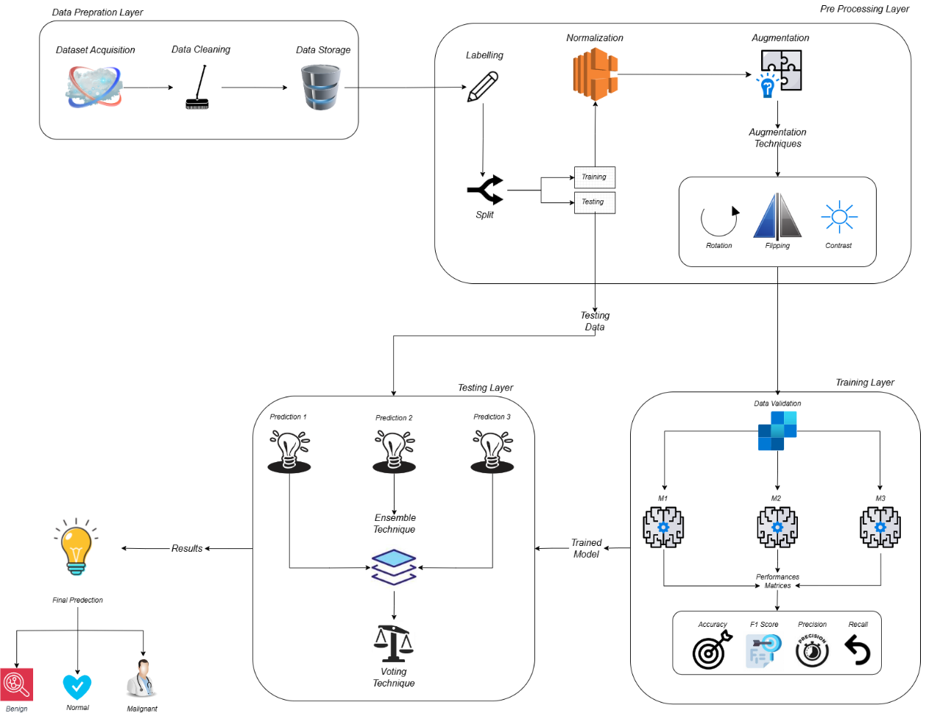
Figure 3.1: Methodology Diagram

Data Acquisition

To obtain datasets for the investigation, a wide range of lung CT scan images data is gathered from instead of purchasing the images they were downloaded from reliable medical sources and the images’ labels are normal, benign, or malignant to ensure a variety of examples to use for training and testing. To enhance the dataset obtainable from an image, some processes are conducted on the image which include: changing the size of the image to a standard size, converting pixel intensity to float, and increasing the size of the image by augmenting image data using processes such as image rotation, flipping, and scaling.

Model Predictions:

Three different CNN models trained on the dataset are first used to predict on different types of images. What these models have each received their own training to differentiate different kinds of tumour in CT scan images.

Voting Approach

The ensemble approach aggregates the forecasts of each specific model for the respective input picture. The class where each model is most likely to be is added to the list and after this, each model’s estimated class is counted as a vote for that class.

Majority Voting

A similar scheme of voting is used in order to come up with the final ensemble forecast. As for finding out which class is more occurrence among the classes in the individual model predictions, the mode function provided in the statistics module is used. The evaluation proceeds to the selecting of the ensemble forecast for this class.

Result Interpretation

After this is accomplished, the concerned tumor information from the ensemble prediction is retrieved from a predetermined lexicon. It also gives the name of the tumour, details of the type, the safety measures that one should take, and the available options for the treatment. The integrated output provides a statistically stable and reliable assessment of the tumour type, since it encompasses information and conclusions from different models. As a result, we expect to enhance system performance and employ the strength in linkage between the different models in the ensemble process to detect lung cancer effectively. Applying the ensemble technique provides higher prediction quality and resistance to errors, which translates to enhanced patient care of those suffering with the said conditions.

DATA AND IMPLMENTATION

Data Collection

The data collected in this study was collected from the Iraq-Oncology Teaching Hospital/National Centre for Cancer Diseases (a lectured university to University of Wasit’s College of Engineering). Among the pre-processed data inputs, the dataset contains CT scan images of lung cancer patients across different stages and some normal individuals. Oncologists from these centres have encoded the data. At first, the dataset included more than 2500 images, but when composed with similar images found on the internet, the dataset covered almost 7200 images that can be used for model training.

Data Preprocessing

Pre-cleaning entailed reformatting the CT scan images to have a pixel size of 150 pixels by 150 pixels to ensure that all inputs were of the same size. Data enhancement was done through flipping, zooming and rotation of the available images to increase its size and variability which reduces the chances of our models overfitting.

Model Development

Three different CNN models, namely the unison-CNN, the contextual-CNN, and the focus-CNN were designed and trained individually on the pruned set. As for the architectural complexity, each model was build with different levels of complexity to better analyze the individual performance of each one in the diagnose of the lung cancer.

Ensemble Learning Approach

In order to further boost its performance, the algorithm which was adopted was that of ensemble technique. We then ensembled the predictions from the three models separately trained through the CNN framework using the majority voting method. The votes for a specific model were its prediction for the input at hand, and, thus, the final prediction for input was the class with the highest number of votes.

Implementation Details

- Voting Mechanism: In the ensemble approach, all the three models make a prediction on the test image and then the final prediction is derived from the majority vote. This selection is made based on the accuracy of each of the three models; if the three models offer distinct results, then the model that yields the best result is used for prediction.
- Result Interpretation: In terms of stronger model ensembling, it offers a more accurate and comprehensive assessment because all the models have their special functions that complement one another and fine-tune the interpretation of lung cancer.

Performance Evaluation

In addition, the models’ performance was assessed using pillars including accuracy, precision, recall, and F1 score. In this paper, the dataset was divided into training and testing datasets at the ratio of 70:30 to ensure impartiality in the model’s performance evaluation.
- Accuracy: Classified as the number of correct instances to the total number of instances of the data set.
- Precision: The ratio of the number of instances among the cases actually positive where the model makes positive prediction to the total number of instances which are wrongly predicted as positive.
- Recall: It basically estimates the percentage of total positive instances that could be identified out of all the instances that were predicted to be positive.
- F1 Score: The harmonic mean of precision and recall is a performance measure that combines the desired elements of precision, defined as the probability of a relevant item being retrieved, and recall which is the ratio of relevant items retrieved to the relevant items that were expected.

The Vote elicitation process for feature selection was effective as the final ensemble model had a better accuracy and generalization compared to the individual models for lung cancer identification.

RESULTS AND DISCUSSIONS

Results and Discussion

In contrast to earlier research on lung cancer detection modules, our study highlights superior outcomes and maximum accuracy within short epochs. The same number of epochs are used to train each of our three models. However, there is diversity in their accuracy due to differences in the number of layers in the models, the models' respective parameters, and the activation functions. our dataset, which has three evenly distributed classes and about 7000 photos. We partition the dataset so that 30% of the data is used for testing and the remaining 70% is used to train our models. We use accuracy, precision, recall, and f1score support as the primary factors in our model performance analysis.

$Accuracy=\frac{TN + TP}{TN + TP + FN + FP}$ (10)

$Recall=\frac{TP }{ TP + FN }$ (11)

$Precision=\frac{TP }{ TP + FP}$ (12)

$F1 Score=\frac{TP }{ TP +\frac{1}{2}(FN + FP)}$ (13)

The diagrams above show the training procedures and confusion matrices for each of the three models. Models 1, 2, and 3 have accuracy values of 75%, 97%, and 96%, respectively. We believe that the optimizer and activation functions utilized in the first model are the reasons for its lowest accuracy. The number of layers in the models is another factor. When combining the three models, we utilize a voting mechanism to improve the final result. Specifically, if two or more models predict one result while the other model predicts something different, the result that is predicted by more models will be selected based on major vote. Conversely, though, the outcome with the highest accuracy will be chosen if all three models predict different outcomes.

Model 1
Table 5.1: Classification table for model 1
 | F1-Score | Precision | Recall | Support | Overall Accuracy
Malignant | 0.74 | 0.68 | 0.81 | 263 | 0.74
Normal | 0.70 | 0.73 | 0.68 | 263 | 0.74
Benign | 0.77 | 0.83 | 0.71 | 248 | 0.74

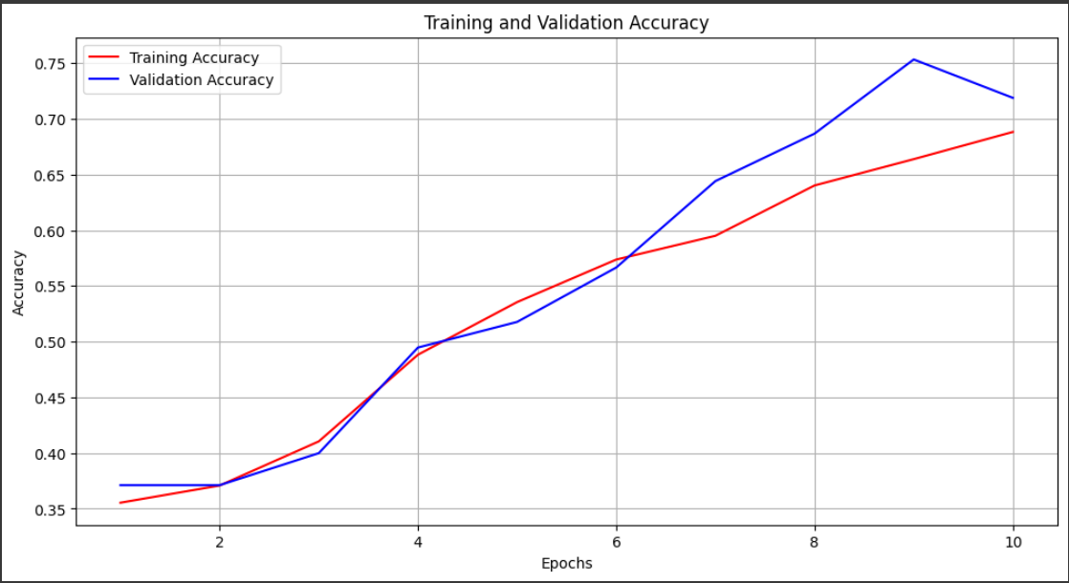
Figure 5.1: Model 1 accuracy graph

Here in the first graph of Validation as well as Training accuracy of the model 1, the depiction is displayed that in how many epochs exactly model 1 reaches its highest level of Validation accuracy which is 75%, bounded to number of epoch 9 after that a little drop is observed and regarding the training accuracy there has been enhancement in each epoch from first to the last numbers epoch 10.

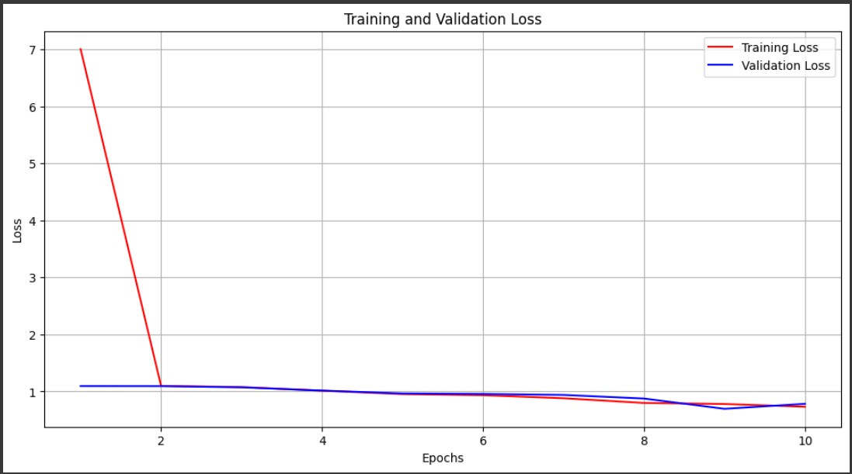
Figure 5.2: Model 1 Validation loss graph

As indicated above in the second validation and training loss graph, the validation as well as the training losses of the model return to zero upon training of the model. This is not the case as the training loss is massive in the first epoch and at some point, get to almost one in the second epoch before settling down and reduces steadily until it hovers around 0. 5.

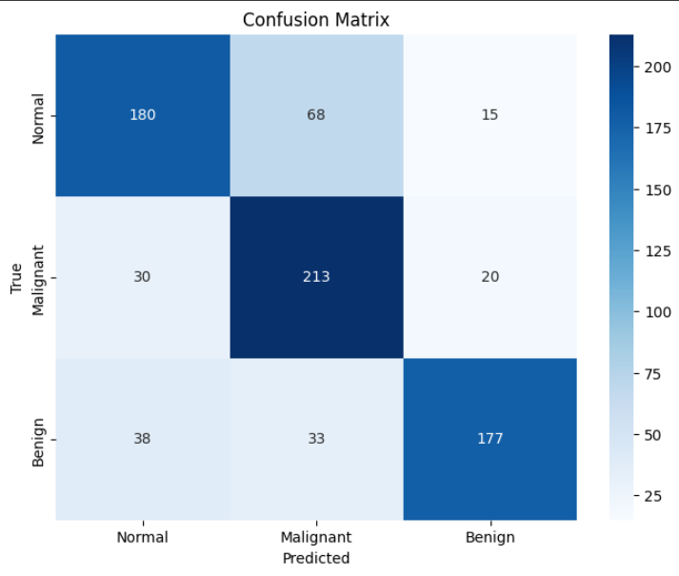
Figure 5.3: Confusion Matrix

The confusion matrix provides a detailed breakdown of the predictions made by the ensemble learning models for each class. It reveals the number of true positives, false positives, true negatives, and false negatives for the three classes: malignant, normal, and benign. Specifically, it predicts 180 instances correctly as normal out of approximately 260 actual normal instances, 213 instances correctly as malignant out of around 260 actual malignant instances, and 177 instances correctly as benign out of almost 250 actual benign instances. The confusion matrix is a valuable tool for evaluating the performance of the models, as it allows for a more granular analysis of the predictions made, enabling researchers to identify any patterns of misclassification or areas for improvement.

Model 2

Table 5.2: Classification table for model 2
 | Recall | Support | Precision | F1-Score | Overall Accuracy
Normal | 0.98 | 263 | 0.95 | 0.97 | 0.97
Malignant | 1.00 | 263 | 0.98 | 0.99 | 0.97
Benign | 0.93 | 248 | 0.98 | 0.96 | 0.97

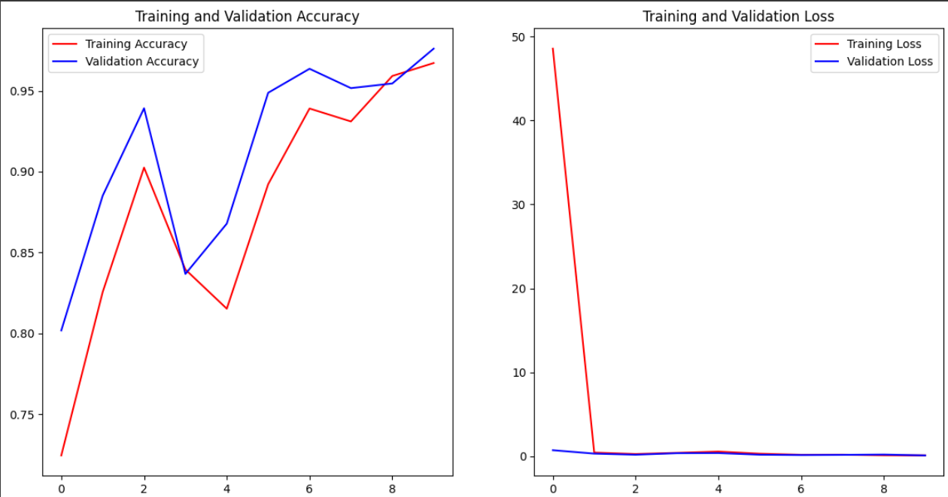
Figure 5.4: Training & Validation Accuracy and Loss Graph

The following graph of Model 2 highlights its validation and training accuracy to show how it gains or reaches its maximum validation accuracy over epochs. In the last epoch, the training accuracy of the model is 95% and then the epoch 10 experiences a high level of training accuracy of around 95%, 91%, 89%, respectively. the second graph reveals that after training model’s loss is nearly zeroes to depict that both the model’ losses are steady at the final stage of the training. The figure below shows the training loss over different epochs where in the first epoch the loss is large but in the second epoch the loss is around one and thereafter, the training loss decreases gradually and starts stabilizing at around zero.

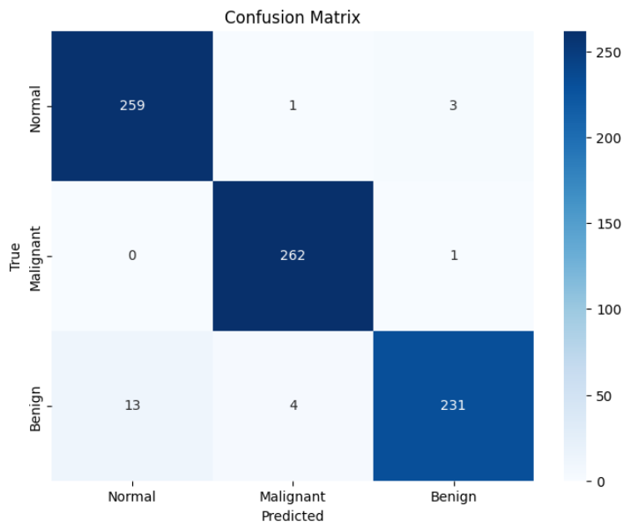
Figure 5.5: Confusion Matrix

It gives an exact view of true positive, true negative, false positive, and false negatives of each class in the model. Because from the matrix, it was seen that the model succeed in classifying 259 instances as normal and actually they were normal stemmed while classifying one malignant instance and three benign instance as normal. Also, the model classified 262 cases as malignant without making a single mistake in its identification of cases as benign. Moreover, the model categorized correctly 95% of the benign instances, but misclassified 45 normal instances and 10 malignant instances as benign. These results provide evidence on how the model could effectively classify the three classes of cases being malignant, normal, and benign with very close to perfect accuracy and little probability of misclassifying a case.

Model 3

Table 5.3: Classification table for model 3
 | Recall | Precision | Support | F1-Score | Overall Accuracy
Normal | 1.00 | 0.95 | 263 | 0.97 | 0.96
Malignant | 1.00 | 0.98 | 263 | 0.99 | 0.96
Benign | 0.93 | 1.00 | 248 | 0.96 | 0.96

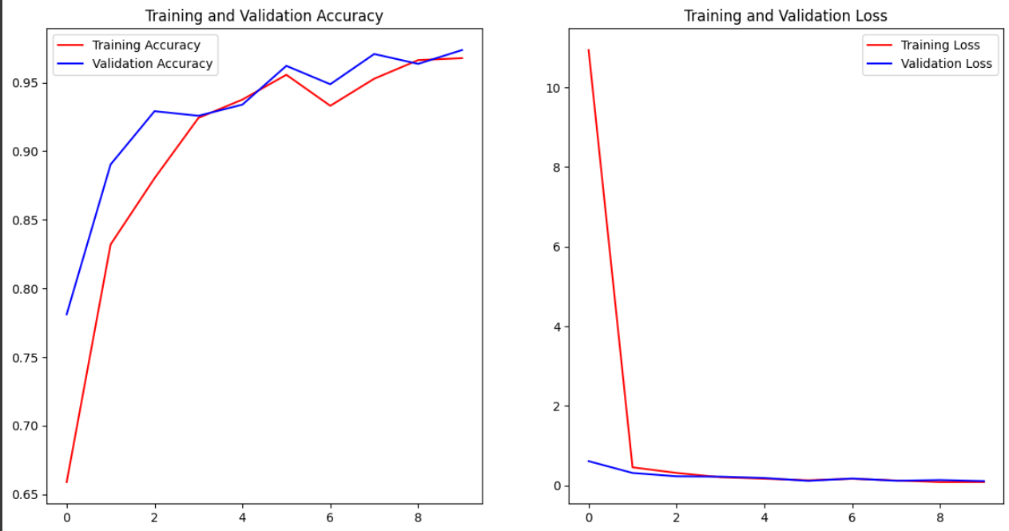
Figure 5.6: Training & Validation Accuracy and Loss Graph

In the first two subplots of Model 3, the curve that shows how the model attains its maximum validation accuracy is over how many epochs. This is a good sign for a model and corresponds to the model’s highest performance of 96% in the last epoch of training, and the model’s training accuracy gradually increases from the first epoch to achieve the highest value in the tenth epoch. Subsequent to that, the second graph shows that as the training progresses, the number of loss of both models is virtually zero. During the first epoch, the training COM loss starts high but reaches zero for the second epoch and the subsequent epochs.

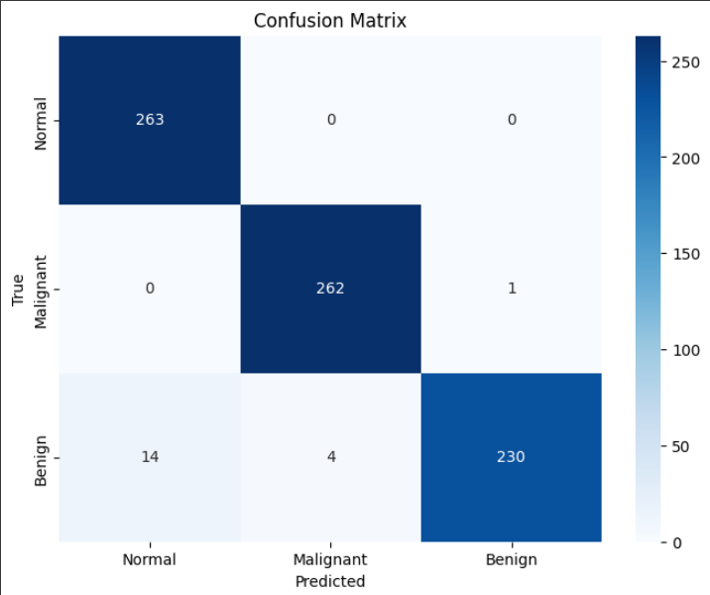
Figure 5.7: Confusion Matrix

The confusion matrix also gives additional information on false and true predictions for each class by the model. It also shows that 263 normal instance were predicted by the model and no false predictions were observed. Further, the model detected 262 real malignant cases while misclassifying only one sample as benign. In addition, out of all the patients that were grouped as having benign instances, 230 were accurately classified by the model, although, it misclassified 14 normal instances as having instances of breast cancer and four malignant instances classified as being benign. From these observations, it shows that Gaussian Naïve Bayes model achieved high levels of precision and recall for classifying between malignant, normal, and benign instances with very minimal cases of misdiagnosis.

CONCLUSION AND RECOMENDATIONS

Recommendations

At one hand, the analysis of the results and conclusions arising from this research paves way for the following recommendations for the future work and practical application of deep learning in the diagnosis of lung cancer. The clinically validated ensemble deep learning model should become a part of conventional computational environment and assist radiologists as well as oncologists to diagnose lung cancer more accurately to improve decision making and patient care. It suggested to make efforts to further enlarge the dataset with more varied and better quality CT scan images, in terms of race, gender or disease type, so that the model that has been trained could achieve a more generalized performance. As for the disadvantages in using a deep learning-based model, it is possible to continue fine-tuning this model, periodically updating it with the new data to increase its efficiency in the long run. Other research works that can be done in enhancing the proposed systems include fine tuning of the convolutional neural networks and analyzing other factors such as depth of the network, type of activation function, and type of optimization algorithm that can be used in enhancing lung cancer detection. Extensions to create better interpretability for the clinicians, for instance, saliency maps or attention mechanisms, are very important to give a deeper look into the approach used by the model to classify the CT scan data. It is indeed crucial to rigorously test and verify the ensemble model to determine its applicability and efficacy in hospitals since testing and model validation is subsequently limited and generally performed without real-world scenarios: Pilot studies of the model in hospitals and cancer treatment centres will also shed light on how well the model works in practice and what problems when implementing the model might be likely to arise. Enhancing inter-professional relations between data scientists, doctors, and researchers in other related specialties significantly enhances the reliability of the models developed together with the overall creation of more efficient and clinically relevant approaches and improves the advancement of the AI-based cancer detection technologies. The following are the recommendations that, if adopted would go a long way in enhancing the systems for identifying lung cancer; With these recommendations in place, the detection of lung cancer would be easier and timely diagnosis and effective planning for treatment would be enhanced.

Conclusion

Therefore, based on the synthesis and findings of this research work, the conclusion focuses on the importance and need for the application of cutting edge artificial intelligence techniques, including CNNs and Ensemble learning in Screening and Classifying lung cancer. In light of the fact that lung cancer is such a burdensome and time-sensitive disease, this work has shown that using CNN models on medical image data can distinguish between many small pathological nuances, thus helping in more effective diagnostics and predictions. The research establishes and reinforces the utility of CNN-based techniques in computational pathology by scrupulously designing, training, and testing models on a systematically compiled dataset that seeks to include various pathological processes, including lung cancer cases, benign abnormality, and normal lung tissue. Through CNNs’ hierarchal configuration and other strategies of data augmentation and hyperparameter tuning, the models show fantastic results in distinguishing between cancerous and non-cancerous lung tissues, meaning enhanced diagnostic usefulness for clinicians. In addition, due to the majority voting system, the ensemble learning approach provides a higher predictability and better results of individual CNN models, as their predicted results are summed up and combined in order to produce a more accurate diagnosis. While the individual classifiers may have specific weaknesses, the ensemble technique shows how the result of a number of these models can provide a holistic evaluation of the histology of lung cancer. Lastly, this study demonstrates the transformative role of artificial intelligence and deep learning approaches in boosting the capabilities of the healthcare as it seeks a solution for a solution in the combat against lung cancer. Therefore, employing highly integrated interdisciplinary approach involving novel mathematical and computational tools with medical and clinical knowledge, the study provides foundation for shift in the premises of the entire approach to lung cancer diagnosis and prognosis as well as decision making for patient treatment, which in turn offers promising opportunities for improving the health of patients, innovative advancement of medicine, and development of the concept of “precision medicine”.

REFERENCES

- Adhikary, S. (2023). Secret learning for lung cancer diagnosis—a study with homomorphic encryption, texture analysis and deep learning. Biomedical Physics & Engineering Express, 10(1), 015011.
- Chen, S. and Wu, S. (2022). Deep q-networks with web-based survey data for simulating lung cancer intervention prediction and assessment in the elderly: a quantitative study. BMC Medical Informatics and Decision Making, 22(1).

- Kausar, N., Hameed, A., Sattar, M., Ashraf, R., Imran, A., Abidin, M., … & Ali, A. (2021). Multiclass skin cancer classification using an ensemble of fine-tuned deep learning models. Applied Sciences, 11(22), 10593.

- Litjens, G., Sánchez, C., Timofeeva, N., Hermsen, M., Nagtegaal, I., Kovacs, I., … & Laak, J. (2016). Deep learning as a tool for increased accuracy and efficiency of histopathological diagnosis. Scientific Reports, 6(1).

- Ren, Z., Zhang, Y., & Wang, S. (2022). Lcdae: data augmented ensemble framework for lung cancer classification. Technology in Cancer Research & Treatment, 21, 153303382211243.

- Shah, A., Malik, H., Muhammad, A., Alourani, A., & Butt, Z. (2023). Deep learning ensemble 2d cnn approach towards the detection of lung cancer. Scientific Reports, 13(1).

- Tian, G., Wang, Z., Wang, C., Chen, J., Xu, H., Lu, Y., … & Peng, L. (2022). A deep ensemble learning-based automated detection of COVID-19 using lung CT images and vision transformer and connect. Frontiers in Microbiology, 13.

- Wang, C., Xu, X., Shao, J., Zhou, K., Zhao, K., He, Y., … & Li, W. (2021). Deep learning to predict mutation and pd-l1 expression status in non-small-cell lung cancer on computed tomography images. Journal of Oncology, 2021, 1-11.

- Wang, L. (2022). Deep learning techniques to diagnose lung cancer. Cancers, 14(22), 5569.

- Hatuwal, B., & Thapa, H. (2020). Lung Cancer Detection Using Convolutional Neural Network on Histopathological Images. International Journal of Computer Trends and Technology, 68, 21–24.

- Al-Yasriy, H. F., AL-Husieny, M. S., Mohsen, F. Y., Khalil, E. A., & Hassan, Z. S. (2020). Diagnosis of lung cancer based on CT scans using CNN. IOP Conference Series. Materials Science and Engineering, 928(2), 022035.

- Sathykumar, K., Munoz, M., Singh, J., Hussain, N., & Babu, B. A. (2020). Automated lung cancer detection using artificial intelligence (AI) deep convolutional neural networks: A narrative literature review. Cureus.

- Elnakib, A., M. Amer, H., & E.Z. Abou-Chadi, F. (2020). Early lung cancer detection using deep learning optimization. International Journal of Online and Biomedical Engineering (iJOE), 16(06), 82.

- Vijh, S., Gaurav, P., & Pandey, H. M. (2020). Hybrid bio-inspired algorithm and convolutional neural network for automatic lung tumour detection. Neural Computing & Applications.

- Reddy, S. (2020). Conceptual design of data warehouse using hybrid methodology. International Journal of Advanced Trends in Computer Science and Engineering, 9(3), 2567–2573.

- Kalaivani, N., Manimaran, N., Sophia, D. S., & D Devi, D. (2020). Deep Learning based lung cancer detection and classification. IOP Conference Series. Materials Science and Engineering, 994(1), 012026.
- Ahmed, T., Parvin, M., Haque, & Uddin, M. S. (2020). Lung Cancer Detection Using CT Image Based on 3D Convolutional Neural Network. Journal of Computer and Communications, 08, 35–42.

- Subramanian, R. R., Mourya, R., Prudhvi, V., Reddy, T., Reddy, B., & Amara, S. (2020). Lung Cancer Prediction Using Deep Learning Framework. International Journal of Control and Automation, 13, 154–160.

- Perez, G., & Arbelaez, P. (2020). Automated lung cancer diagnosis using three-dimensional convolutional neural networks. Medical & Biological Engineering & Computing, 58.

- Katiyar, P., & Singh, K. (2020, February). A Comparative Study of Lung Cancer Detection and Classification approaches in CT images. 2020 7th International Conference on Signal Processing and Integrated Networks (SPIN), 135–142. Presented at the 2020 7th International Conference on Signal Processing and Integrated Networks (SPIN), Noida, India.

- Rustam, Z., Hartini, S., Pratama, R. Y., Yunus, R. E., & Hidayat, R. (2020). Analysis of architecture combining CNN and kernel K-means clustering for lung cancer diagnosis. International Journal on Advanced Science, Engineering, and Information Technology, 10(3), 1200.

- Heuvelmans, M. A., van Ooijen, P. M. A., Ather, S., Silva, C. F., Han, D., Heussel, C. P., … Oudkerk, M. (2021). Lung cancer prediction by Deep Learning to identify benign lung nodules. Lung Cancer (Amsterdam, Netherlands), 154, 1–4.

- Saleh, A., Ka Chin, C., Penshie, V., & Al-Absi, H. (2021). Lung cancer medical image classification using hybrid CNN-SVM. International Journal of Advances in Intelligent Informatics, 7, 151–162.

- Neal Joshua, E. S., Bhattacharyya, D., Chakkravarthy, M., & Byun, Y.-C. (2021). 3D CNN with visual insights for early detection of lung cancer using gradient-weighted class activation. Journal of Healthcare Engineering, 2021, 6695518.

- Ashhar, S. M., Mokri, S. S., Rahni, A. A. A., Huddin, A. B., Zulkarnain, N., Azmi, N. A., & Mahaletchumy, T. (2021). Comparison of deep learning CNN architectures for CT lung cancer classification. International Journal of Advanced Technology and Engineering Exploration, 8(74), 126–134.

- Taher, F., Prakash, N., Shaffie, A., Soliman, A., & El-Baz, A. (n.d.). An overview of lung cancer classification algorithms and their performances.

- Abraham, B., Monikavasagom, S., Ragesh, G., & Kumar, A. (2021). Early Detection of Lung Cancer Through Breath Analysis Using AdaBoost Ensemble Learning Method.

- Khan, A., & Al, E. (2021). Identification of lung cancer using Convolutional neural networks-based classification. Turkish Journal of Computer and Mathematics Education (TURCOMAT), 12(10), 192–203.

- Venkatesh, C., Ramana, K., Lakkisetty, S. Y., Band, S. S., Agarwal, S., & Mosavi, A. (2022). A neural network and optimization-based lung cancer detection system in CT images. Frontiers in Public Health, 10, 769692.

- Al-Ameer, A., Hussien, G., & Adnan, H. (2022). Lung cancer detection using image processing and deep learning. Indonesian Journal of Electrical Engineering and Computer Science, 28, 987.

- Althubiti, S. A., Paul, S., Mohanty, R., Mohanty, S. N., Alenezi, F., & Polat, K. (2022). Ensemble learning framework with GLCM texture extraction for early detection of lung cancer on CT images. Computational and Mathematical Methods in Medicine, 2022, 2733965.

- Talukder, M. A. (2022). Machine learning-based lung and colon cancer detection using deep feature extraction and ensemble learning.

- Mamun, M., Farjana, A., Al Mamun, M., & Ahammed, M. S. (2022). Lung cancer prediction model using ensemble learning techniques and a systematic review analysis.

- Ren, Z., Zhang, Y., & Wang, S. (2022). LCDAE: Data Augmented Ensemble framework for lung cancer classification. Technology in Cancer Research & Treatment, 21, 15330338221124372.

- Vijh, S., Gaurav, P., & Pandey, H. M. (2020). Hybrid bio-inspired algorithm and convolutional neural network for automatic lung tumour detection. Neural Computing & Applications.

- Naseer, I., Masood, T., Akram, S., Jaffar, A., Rashid, M., & Amjad Iqbal, M. (2023). Lung cancer detection using modified AlexNet architecture and support vector machine. Computers, Materials & Continua, 74(1), 2039–2054.

- Aboamer, M. A., Sikkandar, M. Y., Gupta, S., Vives, L., Joshi, K., Omarov, B., & Singh, S. K. (2022). An investigation in analyzing the food quality well-being for lung cancer using blockchain through CNN. Journal of Food Quality, 2022, 1–11.

- Wang, X., Wang, L., & Zheng, P. (2022). SC-dynamic R-CNN: A self-calibrated dynamic R-CNN model for lung cancer lesion detection. Computational and Mathematical Methods in Medicine, 2022, 9452157.

- Shafi, I., Din, S., Khan, A., Díez, I. D. L. T., Casanova, R. D. J. P., Pifarre, K. T., & Ashraf, I. (2022). An effective method for lung cancer diagnosis from CT scan using a deep learning-based support vector network. Cancers, 14(21), 5457.

- Kasinathan, G., & Jayakumar, S. (2022). Cloud-based lung tumour detection and stage classification using deep learning techniques. BioMed Research International, 2022, 4185835.

- Pandian, R., Vedanarayanan, V., Ravi Kumar, D. N. S., & Rajakumar, R. (2022). Detection and classification of lung cancer using CNN and Google Net. Measurement. Sensors, 24(100588), 100588.

- Pawar, A. B., Jawale, M. A., William, P., Chhabra, G. S., Rakshe, D. S., Korde, S. K., & Marriwala, N. (2022). Implementation of blockchain technology using extended CNN for lung cancer prediction. Measurement. Sensors, 24(100530), 100530.

- Hosseini, S. H., Monsefi, R., & Shadroo, S. (2023). Deep learning applications for lung cancer diagnosis: A systematic review. Multimedia Tools and Applications.

- Raza, R., Zulfiqar, F., Khan, M. O., Arif, M., Alvi, A., Iftikhar, M. A., & Alam, T. (2023). Lung-EffNet: Lung cancer classification using EfficientNet from CT-scan images. Engineering Applications of Artificial Intelligence, 126(106902), 106902.

- Shah, A. A., Malik, H. A. M., Muhammad, A., Alourani, A., & Butt, Z. A. (2023). Deep learning ensemble 2D CNN approach towards the detection of lung cancer. Scientific Reports, 13(1), 2987.

- Mohamed, T. I. A., Oyelade, O. N., & Ezugwu, A. E. (2023). Automatic detection and classification of lung cancer CT scans based on deep learning and ebola optimization search algorithm. PloS One, 18(8), e0285796.

- Gopinath, A., Gowthaman, P., Venkatachalam, M., & Saroja, M. (2023). Computer-aided model for lung cancer classification using cat-optimized convolutional neural networks. Measurement. Sensors, 30(100932), 100932.

- Wankhade, S., & Vigneshwari. (2023). A novel hybrid deep learning method for early detection of lung cancer using neural networks. Healthcare Analytics, 3(100195), 100195.

- Nafea, A. A., Ibrahim, M. S., Shwaysh, M. M., Abdul-Kadhim, K., Almamoori, H. R., & AL-Ani, M. M. (2023). A deep learning algorithm for lung cancer detection using EfficientNet-B3. Wasit Journal of Computer and Mathematics Science, 2(4), 68–76.

- Damayanti, N., Ananda, M., & Nugraha, F. (2023). Lung cancer classification using convolutional neural network and DenseNet. Journal of Soft Computing Exploration, 4, 133–141.

- Faria, N., Campelos, S., & Carvalho, V. (2023). A novel convolutional neural network algorithm for histopathological lung cancer detection. Applied Sciences (Basel, Switzerland), 13(11), 6571.

- Jasmine Pemeena Priyadarsini, M., Kotecha, K., Rajini, G. K., Hariharan, K., Utkarsh Raj, K., Bhargav Ram, K., … Pandya, S. (2023). Lung disease detection using various deep learning algorithms. Journal of Healthcare Engineering, 2023, 3563696.

- Subashchandrabose, U., John, R., Anbazhagu, U. V., Venkatesan, V. K., & Thyluru Ramakrishna, M. (2023). Ensemble Federated Learning approach for diagnostics of multi-order lung cancer. Diagnostics (Basel, Switzerland), 13(19), 3053.

- Yanuar, R., Saadah, S., & Yunanto, P. (2023). Implementation of Hyperparameters to the Ensemble Learning Method for Lung Cancer Classification. Building of Informatics, Technology and Science (BITS), 5.

- Ali, A. S., Iqbal, M. M., Khan, A. H., Hameed, N., & Bibi, S. (2023). Lung cancer detection using convolutional neural networks from computed tomography images. Journal of Computing & Biomedical Informatics, 6(01), 133–143.

- Nahiduzzaman, Abdulrazak, L., Ayari, M., Khandakar, A., & Islam, S. M. R. (2024). A novel framework for lung cancer classification using lightweight convolutional neural networks and ridge extreme learning machine model with SHapley Additive explanations (SHAP). Expert Systems with Applications, 248, 123392.

- Thangamani, Koti, M. S., Nagashree, Geetha, Shreyas, Mathivanan, S. K., & Dalu, G. T. (2024). Lung cancer diagnosis based on weighted convolutional neural network using gene data expression. Scientific Reports, 14(1), 1–15.

- Reshma, G., Jeyavathana, R. B., & Suguna, M. R. (2024). Performance analysis of lung cancer detection and its classification using a deep convolutional neural network with low dose Ct scan lung images over the convolutional neural network with an increase in classifier accuracy. 16TH INTERNATIONAL ENGINEERING AND COMPUTING RESEARCH CONFERENCE (EURECA). Presented at the 16TH INTERNATIONAL ENGINEERING AND COMPUTING RESEARCH CONFERENCE (EURECA), Subang Jaya, Malaysia.

- Shashikala, S., Parveen, N., Maqbool, A., Khan, H., Alghadeer, S. K., & Singh, G. (2024). A novel approach for lung cancer detection using deep learning algorithms. International Journal of Intelligent Systems and Applications in Engineering, 12(15s), 471–480.

