

BSCS-F24-024
03-134202-098 | Ameer Hamza
03-134202-009 | Amatul Musawir Tooba
PCOS (Polycystic Ovary Syndrome) Detection using CNN And Transfer Learning

In partial fulfilment of the requirements for the degree of
Bachelor of Science in Computer Science
Supervisor: Muhammad Umar Nasir
Department of Computer Sciences
Bahria University, Lahore Campus
June 2024

© Bahria University, 2024

Certificate

We accept the work contained in the report titled.
“Polycystic Ovary Syndrome Detection Using CNN And Transfer Learning”
written by
Ameer Hamza
Amatul Musawir Tooba
as a confirmation to the required standard for the partial fulfilment of the degree of
Bachelor of Science in Computer Science.

Approved by:
Supervisor: Muhammad Umar Nasir
(Signature)

15 June 2024

DECLARATION

We hereby declare that this project report is based on our original work except for citations and quotations which have been duly acknowledged. We also declare that it has not been previously and concurrently submitted for any other degree or award at Bahria University or other institutions.

Enrolment | Name | Signature
03-134202-098 | Ameer Hamza
03-134202-009 | Amatul Musawir Tooba

Date : 15 June 2024

Specially dedicated to
my beloved grandmother, mother and father
(Ameer Hamza)
my beloved grandmother, mother and father
(Amatul Musawir Tooba)

ACKNOWLEDGEMENTS

We would like to thank everyone who had contributed to the successful completion of this project. We would like to express our gratitude to my research supervisor, Mr Muhammad Umar Nasir for his invaluable advice, guidance and his enormous patience throughout the development of the research.

In addition, we would also like to express our gratitude to our loving parent and friends who had helped and given me encouragement.

Ameer Hamza

Amatul Musawir Tooba

PCOS (Polycystic Ovary Syndrome) Detection Using CNN And Transfer Learning

ABSTRACT

The objective of this research is to create a model using CNN Transfer Learning techniques e.g., MobileNet-V2, EfficientNet-B2, and ResNet-50 for the prediction of PCOS. Polycystic Ovary Syndrome (PCOS) is a type of medical condition that causes infertility issues in women globally. The way our model detects PCOS using specific computer programs is the thing our study mainly focuses on. Precise diagnosis using ultrasound scans containing multiple cysts is a well-founded approach. So, to overcome the challenges faced in manual detection, our proposed model possesses an extended machine learning technique used to classify PCOS detection. Our approach includes the training and testing of 2644 images in a dataset utilizing a Convolutional Neural Network (CNN) with transfer learning techniques. The experiments on different models in our study do not perform the same. MobileNet-V2 model do not perform so well on this type of detection of PCOS with an accuracy of 62.30%. Furthermore, the efficientNet-B2 model performs with an accuracy of 99.18%. ResNet-50 is a star model which performs very well according to our study and model with the highest accuracy of 99.59% which makes the process more efficient and attested. A web application is also created for the fast detection of PCOS as our star model with highest accuracy is integrated as backend of the web app. Recommendations for future development and conclusions are also included in the report.

TABLE OF CONTENTS

DECLARATION ii
ACKNOWLEDGEMENTS iv
ABSTRACT v
TABLE OF CONTENTS vi
LIST OF TABLES viii
LIST OF FIGURES ix
LIST OF SYMBOLS / ABBREVIATIONS x

CHAPTERS
1 INTRODUCTION 1
1.1 Background 1
1.2 Problem Statements 2
1.3 Aims and Objectives 2
1.4 Scope of Project 3
2 LITERATURE REVIEW 5
2.1 Related Work done on PCOS 5
2.2 Limitations of previously published papers 5
2.3 Comparative analysis of our proposed model with the previous papers 8
3 DESIGN AND METHODOLOGY 9
3.1 Methodological approach to PCOS using Machine learning. 9
3.2 Data Collection Methods 10
3.3 Data analysis techniques 11
3.3.1 Evaluation Metrics and Performance analysis 12
4 DATA AND EXPERIMENTS 16
4.1 Data Collection and preprocessing 16
4.2 Model implementation 17
4.3 Experimental Setup 18
5 RESULTS AND DISCUSSIONS 19
5.1 Results 19
5.2 Discussions 22
6 CONCLUSION AND RECOMMENDATIONS 23
6.1 Conclusion 23
6.2 Recommendations 23
REFERENCES 25

LIST OF TABLES

TABLE TITLE PAGE
Table 1: Limitations of previously published papers 6
Table 2: Evaluation metrices result for infected category 14
Table 3: Evaluation metrices result for non-infected category 14
Table 4: Confusion Matrix for ResNet-50 Model 15
Table 5: Confusion Matrix for MobileNet-V2 Model 15
Table 6: Confusion Matrix for EfficientNet-B2 Model 15
Table 7: Training Accuracy Results for All Models 20
Table 8: Testing Accuracy Results for All Models 20
Table 9: For ResNet-50 Model 21
Table 10: For MobileNet-V2 Model 21
Table 11: For EfficientNet-B2 Model 21

LIST OF FIGURES

FIGURE TITLE PAGE
Figure 1: Proposed machine learning-based PCOS detection model 10
Figure 2: Sample of infected image 11
Figure 3: Sample of non-infected image 11
Figure 4: PCOS Detection Web App 22

LIST OF SYMBOLS / ABBREVIATIONS

A TP= True Positives
B TN= True Negatives
C FP= False Positives
D FN= False Negatives

PCOS Polycystic Ovary Syndrome
CNN Convolutional Neutral Network

INTRODUCTION

Background
PCOS is a global health issue that hinders fertility and affecting the lives of millions of women of child bearing age. A physical examination using pelvic ultrasound is the traditional approach to the diagnosis of PCOS, whereby palpation and visualization of the tissues and formation of several cysts in the ovary are assessed. However, this approach may pose some certain disadvantages for interpretation since the interpretations are normally subjective and may not be consistent. [1] In response to these challenges, current medical research seeks enhanced computer diagnostic systems. These systems also apply the methods of machine learning to analyse the numerous factors and identify the specific indicators of PCOS diagnostics. CNN is an instance of a deep learning method which can be used in processing image data for recognition or identification of certain objects or features. I will mention that is but one of many possible ways to approach this issue. This can be rectified by using Transfer learning where typically one uses a CNN that has been pre-trained on spectra and later fine-tuned for specific tasks. This technique has revealed some of the results which can be promising. In this regard, the possibility of training and applying machine learning algorithms for integration with medical image data is of great interest. Scientists are attempting to establish more accurate and precise diagnostic tools by training models on various databases that feature thousands of ultrasounds scans. MobileNet V2 and EfficientNet-B2 has been used previously for this purpose but the current research shows that similar to Resnet-50's accuracy in defining features PCOS in ultrasound scans. Closely examining ResNet-50, it retained high accuracy and can be considered one of the key models for PCOS detection, opening up avenues for a better diagnosis and better quality of treatment for the patients.

Problem Statements

PCOS can be challenging to diagnose with a precise and rapid diagnosis. This research project aims to use advanced information technology to develop a user-friendly tool for PCOS diagnosis. This model uses convolutional neural networks (CNN), which are particularly good at analysing images with transfer learning techniques, to increase accuracy. Instructing a computer to identify PCOS by presenting it with numerous images related to the disease.

Aims and Objectives

The objectives of the thesis are shown as following:
i) To Investigate the methods for identifying PCOS: Investigating potential techniques and difficulties of manual identification of PCOS in prior studies and validifying the need for accurate diagnosis using ultrasonography.
ii) To Design a Machine Learning Model for PCOS Detection: Incorporating PCOS image transfer learning into a CNN machine learning model to automatically identify the disease, with the assistance of Ultrasound images.
iii) To Train and Test the Model: Collecting 2644 ultrasound images for the model’s training and testing and processing them to usable form. To clear this, some experiments are performed using the proposed model and the results are analysed.
iv) To make comparison of the performance of different models: In the case of PCOS detection, the effectiveness of Convolutional Neural Network architectures, including MobileNet-V2, efficientNet-B2, and ResNet-50 is investigated. After what, it is necessary to examine their accuracy and performance in order more to identify the most adapted model.
v) To Examine Model Performance: The performance statistic of each model including precision, recall and F1-score are assessed to determine how effective the models were in identifying PCOS.
vi) To Examine the data and draw conclusion: Upon the analysis of data regarding the proposed machine learning model, certain conclusions can be derived concerning the efficacy of the suggested approaches toward PCOS diagnosis.
vii) To Make Web based application: Deploying a web-based application to assist in the diagnosis of PCOS.
viii) To Provide Recommendations for Future Research: The key limitations of the current study are also described and the directions for the future study are discussed which include the ways to enhance the features of the model, enlarge the sample data and study the other characteristics and techniques for identifying the probability of PCOS.

Scope of Project

The primary aim of this R&D project is to propose a good approach and make a web application for the detection of Polycystic Ovary Syndrome (PCOS) using Convolutional Neural Networks (CNN) and Transfer Learning.

This research-based project introduces an advance methodology for PCOS detection:
• CNN-Based Detection: The proposed model will employ Convolutional Neural Networks (CNNs), well suitable for image analysis implementations to identify complicated PCOS patterns in images of patient’s vital organs.
• Transfer Learning: The accuracy of the CNN will be even better by using transfer learning techniques as presented above.
The significance of this research arises from the following factors:
• Early Detection: PCOD is health issue faced by many women and has different repercussions on health and thus early diagnosis is important.
• Accuracy: There is also some drawback when it comes to diagnosing PCOS under these traditional procedures. This research is significant due to the increased need to enhance the diagnostic tool that is available out there.
• Reduced Costs of Healthcare: Consequently, through a web base application this research could eventually narrow the cost on healthcare related to diagnosis of PCOS.
• Improved Women Healthcare: In conclusion, the research assists in advancing the generation of improved health care related outcomes for women, largely due to the enhanced capability of identifying the condition through a shorter time frame.

This research develops a Good PCOS detection system through the following steps:
• Data Acquisition: Use a dataset of PCOS-related medical images, including ultrasounds.
• Data Preprocessing: Resize and augment the images to ensure enhance model learning.
• Model Development: Use a CNN architecture for PCOS detection.
• Transfer Learning: Fine-tune pre-trained neural network models (e.g., Mobile Net or Res Net) using the PCOS dataset to improve detection accuracy.
• Testing: After Training the model we will test the model on multiple images at same time to get Testing Accuracy.
• Discussion: Discuss findings and limitations and implementing a web application and write research paper.

LITERATURE REVIEW

Related Work done on PCOS
There is less work done on PCOS detection using ultrasound images as compared to feature based PCOS detection. There are papers published in which detection of PCOS is done by using CNN and deep learning techniques. That research was done by using different models like random forest model, VGG-16 model, SVM, CART, and Naïve Bayes. A few of them are like Puvaneswari proposed a model where the dataset is from GDIFR University in Kolkata. The samples were collected and tested upon women belonging to the age group of 25-35 years of female patients. This study addresses the critical issue of early recognition of increasing PCOS. Data augmentation techniques are applied. Evaluation metrics such as confusion metrics accuracy graphs are utilized. Here CNN came up with the most accurate model with 91% accuracy. Ahmad & Rahman spotlights the uses of machine learning PCOS detection techniques that offer many aspects. Effectiveness, methodologies, comparative analysis, and known algorithm outputs are enhanced. The issues are addressed in the future world by using large types of data sets. The accuracy of the research is 93%.

Limitations of previously published papers
Limitations of previously published papers includes preprocessing techniques, future engineering, small datasets, particular datasets consisting of 25-35 years old data, focusing on feature-based & traditional algorithms, unbalanced classes in the dataset, and low accuracy in terms of RF classifier & CNN with transfer learning techniques. Following table shows us the limitations of previously published papers.

Table 1: Limitations of previously published papers
Article | Year | ML Models | Accuracy | Limitations
[1] | 2021 | CNN | 98% | Preprocessing techniques and feature engineering
[2] | 2022 | CNN | 98.12% | Small dataset
[3] | 2022 | CNN with Transfer Learning | 91% | The dataset consists of only 25-35-year-old female patients.
[4] | 2023 | CNN | 93% | Preprocessing techniques
[5] | 2022 | CNN | 98% | Focus only on feature-based
[6] | 2022 | VGG 16 | 99.8% | Unbalanced Classes in the dataset
[7] | 2020 | SVM, Cart and Naïve bayes | 96% | Focus only on traditional algorithms
[8] | 2022 | CS PCOS Feature Selection Techniques | 96% | Preprocessing techniques
[9] | 2023 | Fusion Approach | 82.46% | Low Accuracy
[10] | 2023 | LSTM and Voting Classifier | 72.17% | Low Accuracy in terms of radial pulse wave analysis
[11] | 2021 | SVM and RBF Kernal | 93.82% | Focus on SVM and RBF kernel.
[12] | 2021 | CNN | 92% | Low accuracy in terms of CNN
[13] | 2023 | Screening Framework | 93.25% | Very small dataset
[14] | 2023 | Hybrid Model with transfer learning techniques | 93% | Low accuracy in terms of CNN with transfer learning techniques.
[15] | 2019 | RF Classifier | 89.02% | Low accuracy in terms of RF classifier
[16] | 2021 | Hybrid XGBRF and CatBoost | 95% | Preprocessing techniques
[17] | 2022 | Deep learning segmentation and classification | 97% | Preprocessing techniques and feature extraction
[18] | 2022 | Hybrid Model | 99% | Unbalanced classes
[19] | 2022 | CNN with Transfer Learning | 91% | Unbalanced classes and preprocessing techniques
[20] | 2023 | Deep Learning Framework | 98% | The dataset had unbalanced classes
[21] | 2021 | CatBoost | 85.86% | The dataset of only rural areas

Comparative analysis of our proposed model with the previous papers
The performance evaluation of our proposed model, CNN with ResNet-50, showcases its superiority over several existing studies in terms of accuracy. Our model achieves an outstanding accuracy rate of 99.59%, surpassing the reported accuracies in numerous prior works. Vikas B, in the year 2021 used CNN Model and achieved 98% accuracy. Hosain in the year 2022 on 28th October used the CNN Model and achieved 98.12% accuracy. Puvaneswari in the year 2022 on 15 December used CNN with transfer learning to achieve 91% accuracy. Ahmad & Rahman in the year 2023 used the CNN model and achieved 93%. Wenqi Lv in the year 2022 used the CNN model and achieved 98% accuracy. Sayma alam Suha in the year 2022 used the VGG-16 model and achieved 99.8% accuracy. Tabasum Mirza in the year 2020 used SVM, Cart, and Naïve Bayes models and achieved 96% accuracy. Nasim & Almutairi in the year 2022 used the CS PCOS Feature selection technique and achieved 96% accuracy. Alamoudi in the year 2023 on 14th February used the Fusion Approach and achieved 82.46% accuracy. Jiekee Lim in the year 2022 on 13th November used LSTM and Voting Classifier and achieved 72.17% accuracy. Gopalakrishnan in the year 2021 on 6th August used SVM and RBF Kernal and achieved 93.82% accuracy. S. Nasim in the year 2021 used the CNN model and achieved 92% accuracy. Khanna in the year 2021 in February used a Screening Framework and achieved 93.25% accuracy. Chitra, et al., in the year 2023 used a Hybrid Model with transfer learning technique and achieved 93% accuracy. A. Denny in the year 2019 used an RF Classifier and achieved 82.02% accuracy. Bhat in the year 2021 used Hybrid XGBRF and CatBoost and achieved 95% accuracy. Akshatha M*I in the year 2022 in May used Deep Learning Framework and achieve 98% accuracy. The proposed model in the year 2024 use Transfer learning empowered by CNN achieves the accuracy of 99. 59%.

DESIGN AND METHODOLOGY

Methodological approach to PCOS using Machine learning.

The research methodology for this study involves a good approach to write a comprehensive research paper on detection of PCOS and develop an effective PCOS detection system. The methodology comprises the following key steps: 1. Dataset: The initial phase involves the collection of a comprehensive dataset having PCOS-related medical ultrasound images. This dataset serves as the foundation for training and evaluating the PCOS detection system. We have used dataset from Kaggle platform which has two classes infected and non-infected.

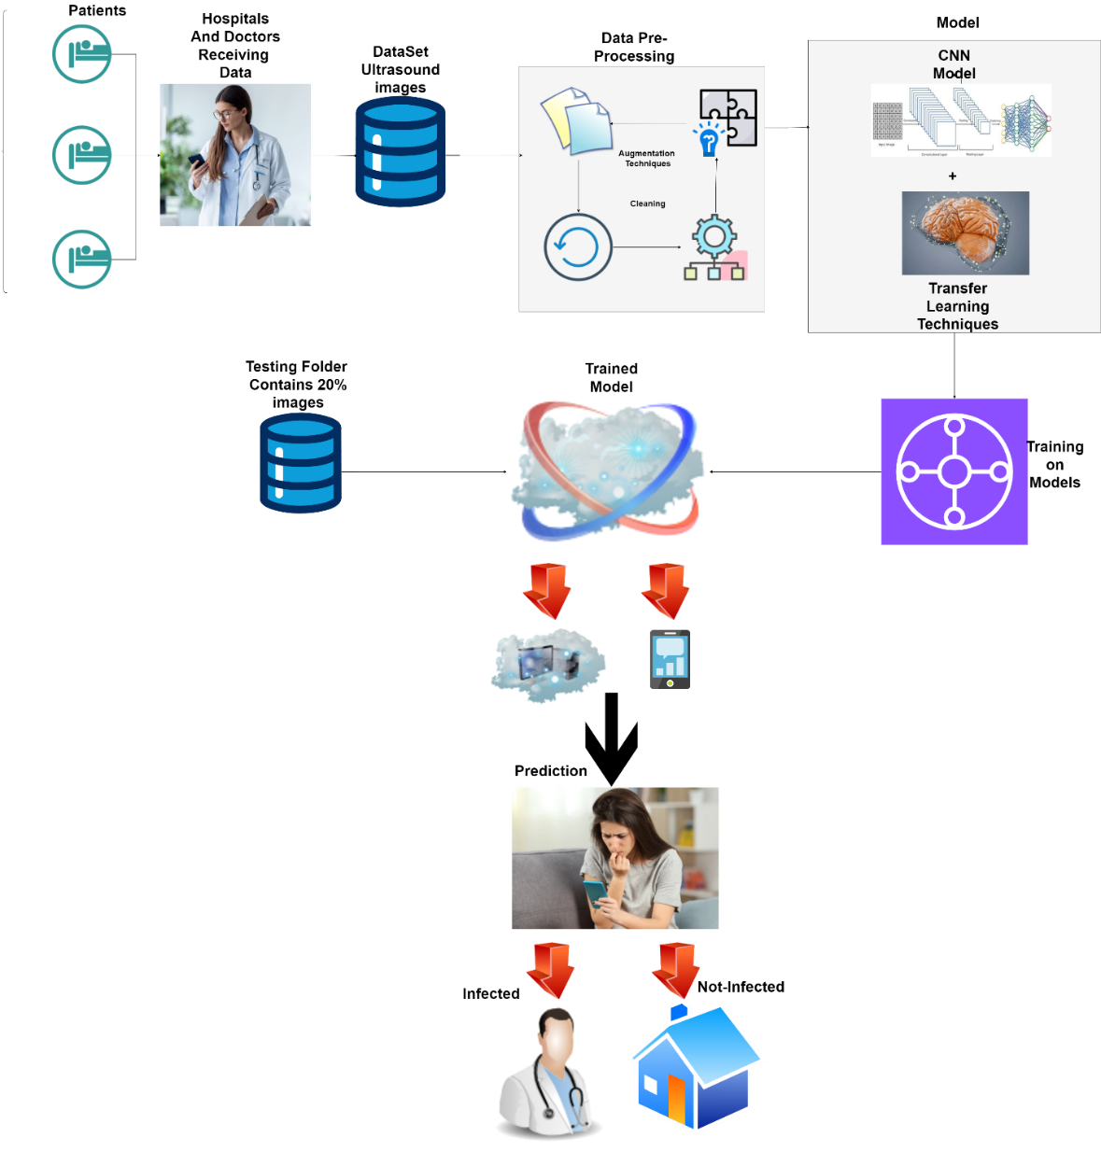
Figure 1: Proposed machine learning based PCOS detection model

Data Collection Methods

In the case of the preprocessing model for PCOS detection, the modified dataset was e from Kaggle which is one of the leading online platforms for sharing datasets. Before proceeding with the analysis of the present data, the data was pre-processed in order to enhance its wellness for the given task. In accordance, the preprocessing speculation entails that data cleaning and augmentation were performed to enrich or enhance the pool of available data.
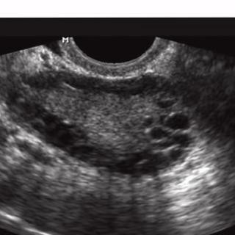

Figure 2: Sample of infected image

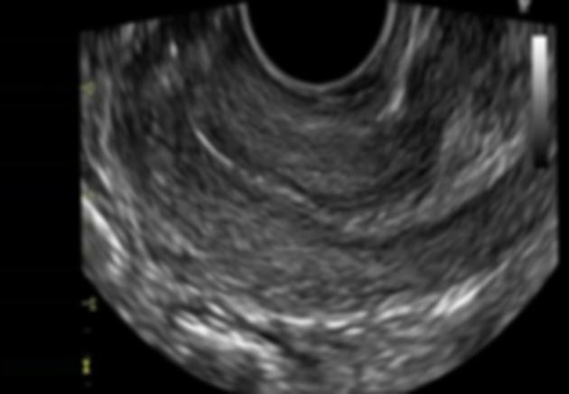
Figure 3: Sample of non-infected image

Data analysis techniques

The analysis also employed this method of transfer learning that incorporated CNNs which included MobileNet-V2, ResNet-50, and EfficientNet-B2. Each of these architectures was chosen for its unique features: For the recognized purpose of computational efficiency, depth-separated convolutions, and reduced computation burden MobileNet-V2 was selected; ResNet-50 was selected to handle the vanishing gradient problem through hopping; and for superior space industry performance efficiency per model size, EfficientNet-B2.

To all the base models, a new classification head was included that consists of the global average pooling layer followed by the fully connected layers with dropout, which helped in better capturing of the patterns present in the given data and also in mitigating the chances of overfitting. These models were trained for 25 epochs on the data generated by a specific data generator.

The training split consisted of 80% of the images, and the remaining 20% of images comprised the testing split as a measure of the models’ performance. For the purpose of calculating model efficiency in PCOS detection, basic performance assessment tools such as precision, recall, and the F1 Score or Sensitivity/Specificity were used. Accuracy highlights the percentage of samples that have been classified correctly, while precision, recall, and F1 Score demonstrate the percentage of positive cases identified out of all actual positive cases; the ability to accurately predict positive examples with minimal false positives or false negatives, respectively.

Evaluation Metrics and Performance analysis

In this, we discuss the kind of evaluation metrics applied when comparing results from the PCOS detection model, and also the qualitative analysis of the model.
- Evaluation Metrics:
- Precision: Accuracies depicts the measures of specific the positive predictive by model. It is defined as the ratio of the number of tuples for which positive predictions are correct to the total number of tuples for which the positive predictions are correct plus the number of tuples for which the positive predictions are incorrect. A higher precision demonstrates less probabilities for false positives which is preferable especially when the cost of categorizing positive cases wrongly is high.
$Precision=A/(A+C)$ (1)
- Recall (Sensitivity/Specificity): Sensitivity means how many true positives the model can identify out of a number of positive cases it should have flagged. They are defined based on true positives and true negatives and it sums up total true positives divided by the actual number of positives in the predictor. Specifically, it determines the separated true negative rate, which defines how well the model identifies negative examples. It is calculated as follows: where is the number of true negatives, and is the number of true negatives and false positives indicating that the probability of it being non-diabetic is high. Metrics such as sensitivity, specificity, the positive predictive value, and the negative predictive value are essential in order to judge the ability of the model in accurately classifying positive cases as well as negative cases.
$Recall=A/(A+D)$ (2)
- F1 Score: These metrics include precision, recall, and the F1 score, which is computed as the harmonic mean of these two measurements. It makes a probabilistic assessment of the correctness of the model, and encompasses both false-positive and false-negative outcomes. However, when there is an imbalance of classes in the dataset being analysed then it is more appropriate to use an F1 Score because it does not only provide the Precision and Recall into consideration.
$F1=2 x ((Precision x Recall) / (Precision + Recall))$ (3)

- Performance analysis:
Performance of ‘the PCOS detection model’ was evaluated by using evaluation metrics; which perhaps give better idea about its capability to detect the PCOS cases accurately.
Of these three metrics, precision is most relevant because it reflects the model’s capacity for correctly identifying cases which are positively associated with the disease, thereby reducing the rate of falsely identifying healthy patients as probably ill. A high value of Precision, indicate that the model classifies PCOS cases accurately without wrongly labelling other people who are not PCOS patients.
Measures of recall, or sensitivity, helps determine the model’s capability of identifying the entire range of positive observations while minimizing misses or false negatives. A higher recall also means that the model is able to screen a majority of the existing PCOS samples in the dataset.
For its part, specificity determines the performance of negative instances’ identification within the model, excluding errors that correspond to false-positive. A high value of specificity, therefore, implies that the model adopted in this study minimizes the likelihood of having a fertile control group with PCOS.
The advantages of using F1 Score are that it gives both the precision and the recall of the model’s performance. It also emphasizes on both False Positive Rate and False Negative Rate since a high F1 Score means the model loses few cases in both types of measure.

Table 2: Evaluation Matrices Results for infected Category
Models | Precision (%) | Recall (%) | F1 Score (%)
CNN with ResNet-50 | 100 | 99 | 100
CNN with EfficientNet-B2 | 98 | 100 | 99
CNN with MobileNet-V2 | 94 | 26 | 41

Table 2 shows the evaluation matrix results of the proposed models for the infected category. The proposed model CNN with ResNet-50 achieves 100% precision,99% recall, and 100% F1 Score. The proposed model EfficientNet-B2 achieves 98% precision,100% recall, and 99% F1 Score. The proposed model CNN with MobileNet-V2 achieves 94% precision, 26
% recall, and 41% F1 score.

Table 3: Evaluation Matrices Results for not infected Category
Models | Precision (%) | Recall (%) | F1 Score (%)
CNN with ResNet-50 | 99 | 100 | 100
CNN with EfficientNet-B2 | 100 | 98 | 99
CNN with MobileNet-V2 | 57 | 98 | 72

Table 3 shows the evaluation matrix results of the proposed models for the non-infected category. The proposed model CNN with ResNet-50 achieves 99% precision,100% recall, and 100% F1 Score. The proposed model EfficientNet-B2 achieves 100% precision, 98% recall, and 99% F1 Score. The proposed model CNN with MobileNet-V2 achieves 57% precision, 98% recall, and 72% F1 Score.

Table 4: Confusion Matrix for ResNet-50 Model
 | Predictive Negative | Predictive Positive
Actual Negative | 121 | 1
Actual Positive | 0 | 122

Table 4 shows the numbers of Actual Negative and Positive Values with the predicted Negative and positive Values for ResNet-50 Model.

Table 5: Confusion Matrix for MobileNet-V2 Model
 | Predictive Negative | Predictive Positive
Actual Negative | 32 | 90
Actual Positive | 2 | 120

Table 5 shows the numbers of Actual Negative and Positive Values with the predicted Negative and positive Values for MobileNet-V2 Model.

Table 6: Confusion Matrix for EfficientNet-B2 Model
 | Predictive Negative | Predictive Positive
Actual Negative | 122 | 0
Actual Positive | 2 | 120

Table 6 shows the numbers of Actual Negative and Positive Values with the predicted Negative and positive Values for EfficientNet-B2 Model.

DATA AND EXPERIMENTS

Data Collection and preprocessing
The proposed model will use an image-based dataset [30] from the Kaggle platform and modified it after modification dataset has almost 2644 images with two classes of infected and non-infected. The dataset is used for the detection of PCOS.

Data Preprocessing: Prior to model training, the dataset underwent rigorous preprocessing to enhance its quality and suitability for the PCOS detection task. The preprocessing steps included:
- Data Cleaning: The dataset was meticulously inspected to identify and remove any corrupted or low-quality images that could potentially impact model performance. Images with artifacts, poor resolution, or improper labelling were excluded from the dataset.
- Augmentation: Data augmentation techniques, such as rotation, translation, and scaling, were employed to artificially increase the size and diversity of the dataset. It made the task easier and reduced overfitting, thus the generalization of the model on the images that it had not been trained with was enhanced.
Currently, the distribution is not uniform without question, and there is also redundancy since there are multiple pictures of the same object available in a set. Certain figures in both the papers were blurred or perhaps got corrupted. In order to make sure that each item in the dataset is all distinct, the proposed model also pointed out duplicate data in the data set by removing duplicate images. For this particular purpose, the proposed model employed certain Python scripts where initially, the model identified the duplicate images from the dataset, and subsequently after finding out the duplicate images in the dataset, the proposed model again applied certain enhanced techniques to those images so that at the end, there won't be any duplicate images in the selected dataset. Next, the methods to increase the number of samples in the dataset were used in order to extend the database by applying various transformations to some of the images in the database, using Python scripts, for example, flipping and rotating the images, zooming, etc.

Model implementation
- MobileNet-V2:
- Model Integration: MobileNet-V2 architecture was imported from TensorFlow. The model's layers and parameters were instantiated, ready for customization.
- Transfer Learning: Pre-trained MobileNet-V2 weights, trained on ImageNet, were loaded into the model as initial weights. This enabled leveraging knowledge learned from diverse images for feature extraction.
- Customization: Fully connected layers were modified for binary classification of PCOS detection. Output layer adjusted to produce a single output indicating PCOS presence.
- Fine-Tuning: Pre-trained MobileNet-V2 model fine-tuned on PCOS dataset. Some layers frozen to retain learned features, while others updated to specialize in PCOS detection.
- Training: Modified MobileNet-V2 model trained using PCOS dataset. Batches of images fed into model, loss function computed (e.g., binary cross-entropy), and parameters optimized using backpropagation and gradient descent.
- Validation: A portion of dataset reserved for validation during training. Monitored model's performance on unseen data and stopped training if overfitting occurred.
- Evaluation: Trained MobileNet-V2 model evaluated on separate testing dataset for PCOS detection performance. Metrics such as accuracy, precision, recall, and F1 Score computed for effectiveness assessment.

- ResNet-50 and EfficientNet-B2:
The implementation process for ResNet-50 and EfficientNet-B2 followed similar steps to MobileNet-V2:
- Model Integration: Imported ResNet-50 and EfficientNet-B2 architectures from TensorFlow.
- Transfer Learning: For feature extraction, we have used pre-trained weights of ResNet-50 and EfficientNet-B2 from the models pre-trained on the ImageNet.
- Customization: Modified fully connected layers for binary classification of PCOS detection.
- Fine-Tuning: Fine-tuned pre-trained ResNet-50 and EfficientNet-B2 models on PCOS dataset to adapt features to PCOS detection.
- Training: Trained modified ResNet-50 and EfficientNet-B2 models using PCOS dataset.

Experimental Setup
Hardware and Software:

Hardware Configuration: The experiments were performed on a computational environment having relevant work for deep learning problems. This would often mean that the termed luggage should comprise of a high-performance GPU (Graphics Processing Unit) to support the training and evaluation of the model.

Software Frameworks: These experiments were performed using general deep learning tools viz. Keras, TensorFlow etc. These frameworks offered rich tutorials and APIs for constructing, learning, and assessing the quality of deep learning CNN models.

RESULTS AND DISCUSSIONS

Results

MobileNet-V2: MobileNet-V2, an efficient deep convolutional neural network which is lighter in structure and effective in image classification, was used to identify the presence of PCOS using the medical images, particularly the ultrasound scans. This makes it possible for it to run on the devices strapped for resources that are often used in the delivery of medical care, like Smartphones, or edge devices. In an attempt to enhance the performance of the model in the classification of PCOS, transfer learning strategies for MobileNet-V2 were utilized and included fine-tuning using a limited set of such images. When training the models, principles of data augmentation were followed to enlarge the amount of training data available to minimize cases of overfitting on the training set and improve performance on the unseen images. Nevertheless, the numerous attempts made, MobileNet-V2 reached the least accuracy than any of our tested models, with an accuracy of 62.30%.

ResNet-50: ResNet-50, due to its deep structure and components containing residual connections, reported high features learning capabilities, and is therefore suitable for PCOS detection. With 50 layers, it is significantly possible to look at hierarchical NTs that exist in medical images of PCOS and learn them effectively. The same case applies to ResNet-50 where MobileNet-V2 features it underwent transfer learning and fine-tuning on the features in the PCOS dataset. Another method used during model training was the augmentation of training set to enhance the model’s performance on images not encountered during training. Of the target models- ResNet-50 convolutional neural network produced the highest accuracy of 99% bettering MobileNet-V2 and EfficientNet-B2. s that they have outperformed 59 % of the models that were assessed.

EfficientNet-B2: These include efficiency, scalability and capability to factor in variations of features to name but a few. Since it has the propensity to learn hierarchal features concerning PCOS medical images, EfficientNet-B2 was selected for the work. Like MobileNet-V2, ResNet50, EfficientNet-B2 also turned to undergo transfer learning but was fine-tuned to the features of the PCOS dataset. Data augmentation was done during the training phase to expand the size of the dataset in order to obtain an improved performance on the models.

Table 7: Training Accuracy Results for All Models
Models | CNN with ResNet-50 | CNN with EfficientNet-B2 | CNN with MobileNet-V2
Accuracy | 0.9987 | 0.9996 | 0.9992

Table 7 shows the training accuracy of the proposed models. The first proposed model CNN with ResNet-50 achieves a higher accuracy of 0.9987. The second proposed model CNN with EfficientNet-B2 achieved 0.9996 accuracy. The third proposed model CNN with MobileNet-V2 achieves accuracy 0.9992.

Table 8: Testing Accuracy Results for All Models
Models | CNN with ResNet-50 | CNN with EfficientNet-B2 | CNN with MobileNet-V2
Accuracy | 99.59% | 99.18% | 62.30%

Table 8 shows the testing accuracy of the proposed models. The first proposed model CNN with ResNet-50 achieves a higher accuracy of 99. 59%. The second proposed model CNN with EfficientNet-B2 achieved 99.18% accuracy. The third proposed model CNN with MobileNet-V2 achieves low accuracy of just 62.30%.

Table 9: For ResNet-50 Model

No. of Epochs | Time | Loss | Accuracy
5 | 39s 521ms/step | 0.2429 | 0.9550
10 | 39s 520ms/step | 0.0213 | 0.9950
15 | 40s 535ms/step | 0.1627 | 0.9808
20 | 39s 521ms/step | 0.0151 | 0.9954
25 | 39s 521ms/step | 0.0028 | 0.9987

Table 9 shows the number of epochs with their execution time, loss, and accuracy while training the model ResNet-50.

Table 10: For MobileNet-V2 Model
No. of Epochs | Time | Loss | Accuracy
5 | 36s 474ms/step | 0.0632 | 0.9862
10 | 36s 482ms/step | 0.0135 | 0.9979
15 | 36s 478ms/step | 0.0017 | 0.9996
20 | 37s 487ms/step | 0.0023 | 0.9992
25 | 36s 482ms/step | 0.0022 | 0.9992
Table 10 shows the number of epochs with their execution time, loss, and accuracy while training the model MobileNet-V2.
Table 11: For EffiecientNet-B2 Model
No. of Epochs | Time | Loss | Accuracy
5 | 47s 623ms/step | 0.0112 | 0.9962
10 | 46s 606ms/step | 0.0031 | 0.9987
15 | 45s 602ms/step | 0.0245 | 0.9921
20 | 47s 627ms/step | 0.0147 | 0.9946
25 | 46s 611ms/step | 0.0376 | 0.9933

Table 11 shows the number of epochs with their execution time, loss, and accuracy while training the model EffiecientNet-B2.

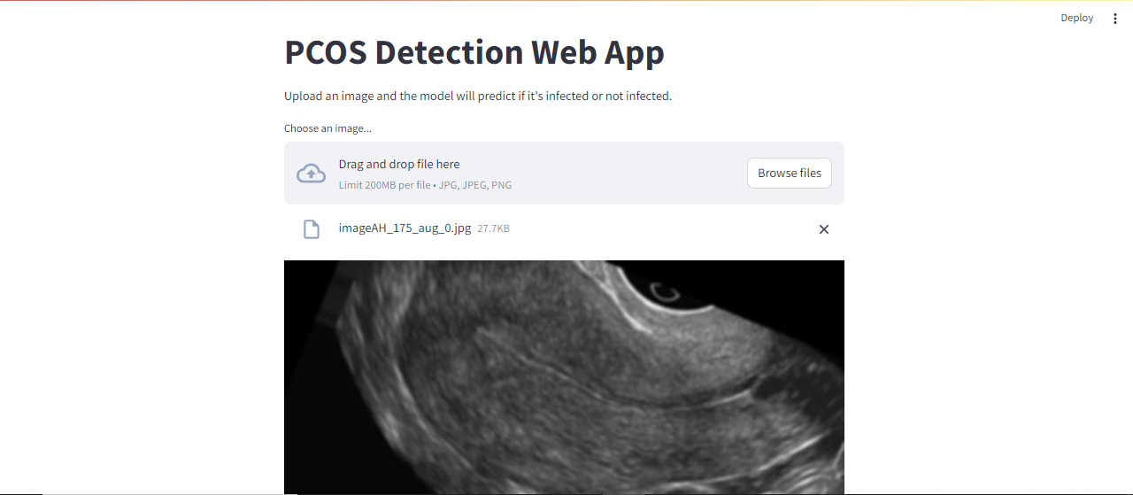
Figure 4: PCOS Detection Web App
Figure 4 depicts the results of webapp of the proposed model with the help of streamlit. The proposed model gets an image as input from patient and give the results that infected from PCOS or normal.

Discussions
The results of the study highlight the importance of selecting appropriate model architectures for PCOS detection tasks. While MobileNet-V2 offers efficiency and suitability for resource-constrained devices, its performance lags behind deeper architectures such as ResNet-50 and EfficientNet-B2. ResNet-50's deep structure and residual connections enable effective learning of hierarchical features, resulting in superior performance in PCOS detection. Due to the efficiency of model size and its scalability and adaptability aspects, the EfficientNet-B2 provides a healthy trade-off between complexity and performance, yielding reasonable accuracy results.

Thus, the conclusions highlight the role of transfer learning in extending ready-made systems and applying them to the MIA tasks, including PCOS detection.

CONCLUSION AND RECOMMENDATIONS

Conclusion

To sum up, this research helps to argue that machine learning approaches, including CNNs and transfer learning strategies, have the potential to effectively diagnose Polycystic Ovary Syndrome (PCOS) based on medical images. Hence, through preprocessing the dataset in a way that removes duplicates and employing the most contemporary models such as MobileNet-V2, ResNet-50, and EfficientNet-B2 to build the study gets good results regarding the detection of PCOS.
These results show the diverse precision as each model regulates with ResNet-50 emerging as having superior efficiency to both MobileNet-V2 and EfficientNet-B2 models. The metrics of the classification report identify the level of precision, recall, and the F1 Score; this enables one to compare the models’ effectiveness and inefficiency.
The study can be effectively beneficial in pointing out direction for subsequent studies in PCOS detection and image classification in the medical field. These gaps and findings form the basis of improving various diagnosis standards and are helpful in some ways for healthcare advancement. Thus, the recommendations provided in the article and further developments based on the restrictions and opportunities of the current state of the field in terms of PCOS detection can help improve the existing models’ and help the researchers reach higher levels of accuracy and reliability for better assistance to patients and healthcare providers.

Recommendations

- Further Exploration of Transfer Learning Techniques: The features aiding in car detection alongside with MobileNet-V2, ResNet50 as well as EfficientNet-B2, indicate that there is much to discover.

- Data Augmentation Strategies: Using more intricate data augmentation strategies could in turn increase the variety within the datasets and improve the resiliency within the models. It is possible to improve the performance of the models when exposed to unseen data by trying various techniques like path-affine transformations including rotation, translation and scaling.

- Validation on External Datasets: In order to determine generalizability and practical applicability of the proposed models, it will be important to validate the models on other independent samples collected from different ethnic groups and other geographically different centres or health facilities. Collecting more data from other healthcare centres would be great to get further insights into the model's precision depending on the patients' populations.

- Use of Multi Model Concept: Multi Model Concept also very important to consider feature based data like hair growth, hair fall, blood group, age and so on also used with the ultrasound images for the better and accurate detection of polycystic ovary syndrome disease.

REFERENCES

- Abdullah, F.; Jondri, N. Proceedings of the international conference on soft computing and data mining. The Second International Conference on Soft Computing and Data Mining 2017, pp. 1-4.
- Barber, T.M.; Franks, S. Obesity and polycystic ovary syndrome. Clinical endocrinology, 2021; Volume 95, pp. 531-541.
- Elmannai, H.; Saleh,H.; Algarni, A.;D.; Mashal, I.; Kwak, K.S. Ensemble learning based on hybrid deep learning model for heart disease early prediction. Diagnostics. Electronics, 2022; pp. 1-19.
- Vaswania, J.; Mulchandanib, H.; Vaghelac, R.; Pateld, R. A systematic literature review on diagnosis of pcos using machine learning algorithms. GIT-Journal of Engineering and Technology, 2022, Volume 19, pp.1-5.
- Alsibai, M.H.; Heydari, S.Y. The effectiveness of CNN in evaluating ultrasound image datasets. International Conference on Engineering and Emerging Technologies (ICEET), 2023, Volume 14, pp. 1-6.
- Chauhan,P.; Patil,P.; Rane, N.; Raundale, P.; Kanakia,H. Comparative analysis of machine learning algorithms for prediction of PCOS. 2021 International Conference on Communication information and Computing Technology (ICCICT), 2021, pp. 1-7.
- Boomidevi, R.; Usha, S. Performance analysıs of polycystıc ovary syndrome (pcos) detectıon system usıng neural network approach. Data Engineering and Communications Technologies, 2021, PP.449-459.
- Rachana, B.; Priyanka, T; Sahana, K.N.;Supritha, T.R.; Parameshachari, B.D.; Sunitha, R. Detection of polycystic ovarian syndrome using follicle recognition technique. Global Transitions Proceedings, 2021, Volume 2, pp.304-308.
- Reka, S.; Suriya, P.T.; Mohan, K. Expeditious prognosis of pcos with ultrasonography images - a convolutional neural network approach. International Conference on Artificial Intelligence of Things, 2023, Volume 1929, pp. 367-376.
- Vikas, B.; Radhika, Y.; Vineesha, K. Detection of polycystic ovarian syndrome using convolutional neural networks. International Journal of Current Research and Review, Scopus, 2021, pp. 5.
- Hosain, A.K.; Mehedi, M.H.; Kabir, I.E. PCONet: A convolutional neural network architecture to detect polycystic ovary syndrome (pcos) from ovarian ultrasound images. International Conference on Engineering and Emerging Technologies (ICEET), 2022, pp. 8.
- Puvaneswari, N.S. Detection of polycystic ovarian syndrome using convolutional neural network in conjunction with transfer learning models. School of Computing National College of Ireland, 2022, pp. 23.
- Ahmed, S.; Rahman, Kaiser, M.S.; Jahan, I.; Hosen, M.S.; A review on the detection techniques of polycystic ovary syndrome using machine learning. in IEEE Access, 2023, Volume 11, pp.86522-86543.
- W.L.; Song, Y.; Fu, R.; Lin, X; Su, Y. Deep learning algorithm for automated detection of polycystic ovary syndrome using scleral images. Frontiers in Endocrinology, 2022, Volume 12, pp.8.
- Suha.; Islam, S.A.; M.N. An extended machine learning technique for polycystic ovary syndrome detection using ovary ultrasound image. scientific reports, 2022, pp.16.
- Hassan, M.M. Comparative analysis of machine learning algorithms in diagnosis of polycystic ovarian syndrome international journal of computer applications. 2022, Volume. 175.
- Nasim, S.; Almutairi, Munir, K.; Raza, A.; Younas, F. A novel approach for polycystic ovary syndrome prediction using machine learning in bioinformatics. in IEEE Access, 2022, Volume 10, pp. 97610-97624.
- Alamoudi, A.; Khan, I.I.; Aslam, N.; Alqahtani, N.; Alsaif, H.S. A deep learning fusion approach to diagnosis the polycystic ovary syndrome (PCOS), Applied Computational Intelligence and Soft Computing, 2023, Volume 23, pp. 15.
- Lim, J.; Li, J.; Feng, X.; Feng, L.; Xia, Y. Machine learning classification of polycystic ovary syndrome based on radial pulse wave analysis. BMC Complementary Medicine and Therapies, 2023, Volume 23, pp. 15.
- Gopalakrishan, C.; Iyapparaja, M. Multilevel thresholding-based follicle detection and classification of polycystic ovary syndrome from ultrasound images using machine learning. International Journal of System Assurance Engineering and Management, 2021, Volume 21, pp.8.
- Sumathi, M.; Chitra, P.; Praha, R.S.; S.K. Study and detection of PCOS related diseases using cnn. IOP Conference Series: Materials Science and Engineering, 2021, PP.6.
- Khannaa, V.V.; Chadaga, K.; Sampathila, N.; Prabhu, S.; Bhandage, V. explainable machine learning framework for detection of polycystic ovary syndrome. Applied system innovation, 2023, Volume 6, pp.26.
- Chitra, P.; Srilatha, K.; Sumathi, M.; Jayasudha, F.V.; Bernatin, T. Classification of ultrasound PCOS image using deep learning-based hybrid models, 2023 Second International Conference on Electronics and Renewable Systems (ICEARS), 2023, pp. 1389-1394.
- Denny,A.; Raj, A.; Ashok, A.; Ram, C.M.; George, R.; i-HOPE: Detection and prediction system for polycystic ovary syndrome (pcos) using machine learning techniques. TENCON 2019 - 2019 IEEE Region 10 Conference (TENCON), 2019, pp.673-678.
- Bhatt, S.A. Detection of polycystic ovary syndrome using machine learning algorithms. School of Computing National College of Ireland, 2021, pp. 30.
- Agarwal, A.; Ranjit, A.; Radhika, L.; Parikshit, M.; Pande. Role of artificial intelligence in pcos detection. Journal of Datta Meghe Institute of Medical Sciences University, 2022, pp. 491-494.
- Suha, A.; Sayma. Predicting polycystic ovary syndrome through machine learning technique using patient’s symptom data and ovary ultrasound images, MIST Central Library Repository, 2022, pp. 116.
- Puvaneswari, S.; Nithya. Detection of polycystic ovarian syndrome using convolutional neural network in conjunction with transfer learning model. Dublin, 2022, pp.23.
- A.M.; Shekar, A.C.; Bhamini.; Vikas, D.; Vinutha. Deep learning based polycystic ovarian syndrome detection augmented by image processing. International Research Journal of Modernization in Engineering Technology and Science, 2023, Volume 5, pp. 5105-5109.
- Choudhari, A.; Korde, A.; PCOS detection using ultrasound images. 2022, https://www.kaggle.com/datasets/anaghachoudhari/pcos-detection-using-ultrasound-images.

