
BSCS-F23-006
03-134202-090 | Waqas Anwar
03-134202-051 | Muhammad Haris Ali

EVENT-SYNC

In partial fulfilment of the requirements for the degree of
Bachelor of Science in Computer Science
Supervisor: Fatima Siddiqui
Department of Computer Sciences
Bahria University, Lahore Campus
June 2024

© Bahria University, 2024

Certificate

We accept the work contained in the report titled
“Event-Sync”
written by
Waqas Anwar
Haris Ali
as a confirmation to the required standard for the partial fulfilment of the degree of
Bachelor of Science in Computer Science.

Approved by:
Supervisor: Fatima Siddiqui
(Signature)

June 15, 2024

DECLARATION

We hereby declare that this project report is based on our original work except for citations and quotations which have been duly acknowledged. We also declare that it has not been previously and concurrently submitted for any other degree or award at Bahria University or other institutions.

Enrolment | Name | Signature
03-134202-090 | Waqas Anwar
03-134202-051 | Haris Ali

Date : June 15, 2024

Specially dedicated to
my beloved grandmother, mother and father
(Waqas Anwar)
my beloved grandmother, mother and father
(Haris Ali)

ACKNOWLEDGEMENTS

We would like to thank everyone who had contributed to the successful completion of this project. We would like to express our gratitude to my research supervisor, Madam Fatima Siddiqui for her invaluable advice, guidance and her enormous patience throughout the development of the research.

In addition, We would also like to express my gratitude to our loving parent and friends who had helped and given me encouragement.

Waqas Anwar
Haris Ali

EVENT-SYNC

ABSTRACT

It is often a hard task to organise conferences and seminars that are plagued by confusion and ineffectiveness. There may be missed opportunities and frustration among participants due to traditional scheduling methods. We have developed a user friendly web application to address these issues, which will change the way conferences are managed. Our solution is a carefully crafted platform aimed at making conference organization and attendance easier and more engaging for everyone involved.
The focus of our efforts is to provide a seamless user experience, so that both organisers and visitors are able to use the platform in an easy way. We create an environment where learning and networking thrive with features such as dynamic venue mapping, realtime updates of speakers' profiles, and detailed speaker profiles. Our conference scheduling application not only solves existing problems, it also sets new standards for the organization of educational events by placing user experience first..

TABLE OF CONTENTS

DECLARATION ii
ACKNOWLEDGEMENTS iv
ABSTRACT v
TABLE OF CONTENTS vi
LIST OF TABLES ix
LIST OF FIGURES x
LIST OF APPENDICES xi

CHAPTERS
CHAPTER 1 1
1 INTRODUCTION 1
1.1 Background 1
1.2 Problem Statements 2
1.3 Aims and Objectives 2
1.4 Scope of Project 3
CHAPTER 2 4
2 LITERATURE REVIEW (and/or SRS) 4
2.1 Product Introduction 4
2.2 User Classes and Characteristics 5
2.2.1 Attendee Panel 5
2.2.2 Admin Panel 6
2.3 Operating Environment 7
2.3.1 GAP Analysis 8
2.4 System Use Case 9
2.4.1 Use Case Diagrams 9
2.4.2 Use Case Scenerio 11
2.5 Functional Requirements 16
2.6 Non-Functional Requirements 17
2.7 External Interface Requirements 18
CHAPTER 3 20
3 DESIGN AND METHODOLOGY 20
3.1 Entity Relationship Diagram 20
3.2 Class Diagram 21
3.3 Sequence Diagram 22
3.4 Activity Diagram 26
3.5 Methodology 27
CHAPTER 4 28
4 DATA AND EXPERIMENTS (and/or IMPLMENTATION) 28
4.1 Implementation 28
4.1.1 Framework 28
4.1.2 Real-Time Notification 28
4.1.3 Gender-Specific seats 29
4.2 Deployment and Maintenance 29
4.3 Technical Aspect of Event-Sync 29
4.3.1 Backend 29
4.3.2 Front-end 29
CHAPTER 5 30
5 RESULTS AND DISCUSSIONS (or USER MANUAL) 30
5.1 Login Page 30
5.2 Home and Navigation 31
5.3 Add events 32
5.4 Search Events 33
5.5 View though Calendar 34
5.6 My Profile 34
5.7 My Events 35
5.8 Dark mode 35
CHAPTER 6 36
6 CONCLUSION AND RECOMMENDATIONS 36
6.1 Conclusion 36
6.2 Recommendations 37
REFERENCES 38
APPENDICES 40

LIST OF TABLES

TABLE TITLE PAGE
Table 2. 1 Requirement Table for Application 7

Table 2.4. 1 Use Case: User Registration 11
Table 2.4. 2 Use Case: User Login 11
Table 2.4. 3 Use Case: View Upcoming Events 12
Table 2.4. 4 Use Case: Event Registration 12
Table 2.4. 5 Use Case: Event Notification 13
Table 2.4. 6 Use Case: View Past Events 13
Table 2.4. 7 Use Case: Event Review 14
Table 2.4. 8 Use Case: Search For Events 14
Table 2.4. 9 Use Case: Gender Specific seating 15
Table 2.4. 10 Use Case: Admin Management 15

LIST OF FIGURES

FIGURE TITLE PAGE
Figure 2. 1 System Use case Diagram 9
Figure 2. 2 User Use case Diagram 10
Figure 2. 3 Admin Use Case Diagram 10

Figure 3. 1 ERD Diagram 20
Figure 3. 2 Class Diagram 21
Figure 3. 3 User Registration sequence diagram 22
Figure 3. 4 User Login Sequence Diagram 22
Figure 3. 5 View Events Sequence Diagram 23
Figure 3. 6 Add events sequence diagram 23
Figure 3. 7 Event Registration Sequence diagram 24
Figure 3. 8 Review Submission sequence diagram 24
Figure 3. 9 Activity Diagram 25
Figure 3. 10 FDD methodology diagram 26

figure 5. 1 Login Page 29
figure 5. 2 Navigation to Pages 30
figure 5. 3 Add events page 31
figure 5. 4 Search Events Page 32
figure 5. 5 Calender Page 33
figure 5. 6 My Profile Page 33
figure 5. 7 My Events Page 34
figure 5. 8 Dark Mode 34

LIST OF APPENDICES

APPENDIX TITLE PAGE
APPENDIX A: Graphql 38
APPENDIX B: Express Js 38
APPENDIX C: Use Cases 38
APPENDIX D: Sequence Diagram 38
APPENDIX E: HTTPS 38

INTRODUCTION

Background
There is a growing need for efficient and easily available platforms to share knowledge as the field of education becomes increasingly complex. Technological progress that has transformed the way conferences and seminars are organised is driving such demand. These events, which had once been confined to physical locations, are now being transformed into dynamic virtual experiences that serve as focal points for intellectual exchange, networking and skill development..

Traditional methods of organising such events often face challenges in keeping pace with digital developments, which lead to organizational difficulties and reduced participation from the participants. The development and adoption of innovative, technological driven solutions has increased in the education sector to address these problems. Digital tools and platforms are being utilized to create seamless, accessible, and engaging conference and seminar experiences, benefiting both attendees and organizers.

Problem Statements

Through the development of a web based application, the "Event-Sync" project aims at addressing the various challenges inherent in the organisation of conferences. Automated scheduling and allocation of resources is central to this initiative, which will enhance the experience for conference organisers, speakers as well as participants. The project aims at simplifying the complexity of conference activities by setting up a central platform for scheduling, real time updates and full data management. coordination, minimizing manual efforts and scheduling conflicts. Additionally, the application offers valuable features such as maintaining a portfolio of past events, integrating attendance tracking for efficient monitoring, and incorporating a gender-based seating arrangement to accommodate attendee preferences.

Aims and Objectives

The objectives of the thesis are shown as following:
- User-Friendly Scheduling
- Real-Time Notifications
- Seamless Integration
- Robust Speaker Management
- Scalability and Performance

Scope of Project

The "conference scheduling" project is a web application designed to modernise and streamline the organisation of conferences and events. It provides a reliable and rapid solution using the most recent web technology. It focuses on the automation of the scheduling tasks, optimising the allocation of resources, simplifying the registration of participants, simplifying the management of speakers, and providing real time updates to all parties involved. Adhere to the best practices in software development.the "Conference Scheduling" application aims to revolutionize conference management, ultimately enhancing the overall conference experience for organizers, speakers, and attendees.

LITERATURE REVIEW (and/or SRS)

Product Introduction

Event-Sync is a comprehensive Web Based Event Management Platform that simplifies the organisation, promotion and attendance of Conferences, Seminars and Other Meetings. Event-Sync intends to deliver an efficient experience for both event organizers and attendees, with a user interface that's easy to use as well as powerful features. Effortless Event Management: intuitive interfaces and powerful back office tools allow you to easily set up, control or encourage events.

Enhanced User Experience: Provide attendees with a seamless registration process and real-time updates on event schedules and changes.

Administrative Control: Empower administrators with comprehensive tools for event management, user management, and data analysis to ensure smooth operations.

Accessibility and Inclusivity: Commitment to accessibility standards and inclusive design practices to ensure that all users, regardless of ability, can access and enjoy Event-Sync's features.

Continuous Improvement: Regular updates and enhancements based on user feedback, industry trends, and emerging technologies to deliver a cutting-edge event management solution. Continuous Improvement: Regular updates and enhancements based on user feedback, industry trends, and emerging technologies to deliver a cutting-edge event management solution.

User Classes and Characteristics

Event-Sync project consist of two major panels:
- Admin Panel
- Attendee Panel

Attendee Panel

Viewing and Registering for Events:

- Display conferences as cards for easy browsing.
- Ability to register for events with a simple click.

Portfolio Page:

- View expired events attended in a dedicated portfolio section.

Dark Mode Toggle:

- Users can toggle between light and dark themes.
- Preference is saved across sessions.

Social Media Sharing:

- Share events on Facebook and Twitter.
- Seamless sharing using social media APIs.

Calendar:
- Displays events by date and time.
- Allows event creation directly from the calendar.
- Shows event duration with visual markers.

Email Notifications:
- Receive email notifications upon successful registration for an event.
- Get reminders 15 minutes before the start of registered events.
- Receive notifications for event cancellations or delays.

Gender-Specific Seat Registration:

- Option to register for gender-specific seats with light indicators for differentiation.

Profile Management:

- Update personal information like name, gender, and email.
- Change password securely within the user profile.

Admin Panel

Conference Management:

- Add, edit, and delete conferences with details like title, type, description, date, time, and objectives.
- Manage conference types, dates, and other attributes.

User Management:

- Add and delete users from the system.
- View user details and manage their access.

Admin Profile Management:

- Update admin profile information like name and gender.
- Change password securely within the admin profile.

Operating Environment
Event-Sync is a web-based application that is a product of cutting-edge technologies which can run by completing following requirements:-

Table 2. 1 Requirement Table for Application

Name | Description
Operating system | Windows 8 or above
Service | Internet/browser/Address
Hardware | Desktops/Laptops

GAP Analysis
DawatPakistan.com “DAWAT - Pakistan,” . [1].
Features of DawatPakistan.com:

• Event Categories: Diverse event categories ranging from cultural to corporate events.
• User Registration: Allows users to register and manage their profiles.
• Ticketing System: Provides a comprehensive ticketing solution for events.

Better Features of Event-sync Project:

• Modern Tech Stack: Utilizes React, GraphQL, and Node.js for a highly responsive and scalable application.
• Social Media Integration: Built-in sharing options via react-share for enhanced event promotion.
• Customizable Event Management: Detailed event creation and management, including private events.
• Review System: Allows users to leave reviews, providing feedback and enhancing community engagement.
Comparison with Evento.com.pk [8]
Features of Evento.com.pk:
• Event Listings: Comprehensive listings of various events.
• Venue Details: Detailed information about event venues.
• Contact Information: Direct contact details for event organizers.
Better Features of Event-sync Project:
• User Reviews: Integration of a review system for event feedback.
• Advanced Venue Management: Detailed venue attributes including room capacity and facilities.
• Speaker Profiles: Comprehensive speaker details including expertise and biography.
• Enhanced Security: Authentication and role management for users with JWT.
Comparison with HubSpot.com [14]
Features of HubSpot.com:
• Marketing Automation: Advanced marketing tools for campaign management.
• CRM Integration: Comprehensive CRM features for managing customer relationships.
• Analytics and Reporting: In-depth analytics for marketing performance.
Better Features of Event-sync Project:
• Event-Specific Features: Tailored functionalities for event management rather than general marketing.
• Real-Time Updates: Efficient use of GraphQL for real-time data updates.
• User Engagement: Focused tools for user engagement through reviews and social sharing.
• Ease of Use: Simplified event creation and management interfaces suitable for various users.

System Use Case

Use Case Diagrams

Following are the visual representation of how event-sync works and each identity’s actions and performance shown through use cases.
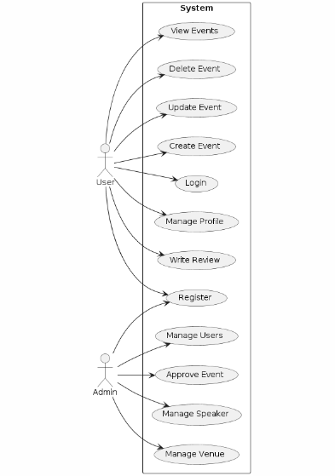
Figure 2. 1 System Use case Diagram
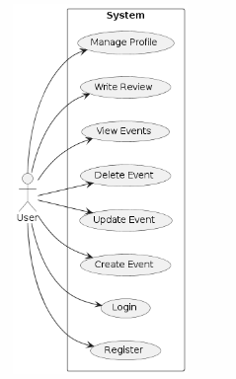
Figure 2. 2 User Use case Diagram

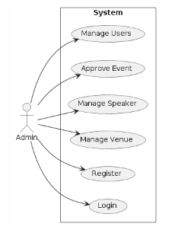
Figure 2. 3 Admin Use Case Diagram

Use Case Scenerio

Table 2.4. 1 Use Case: User Registration
Name | User Registration
Objective | Allow users to create an account on the platform.
Actor | User
Main Flow | - User accesses the registration page.  - User enters personal information (name, email, password).  - User submits registration form.
Preconditions | User accesses the registration page.
Post conditions | User account is created, and verification email is sent.
Alternate Flow | If email is already registered, user receives a notification to use a different email.

Table 2.4. 2 Use Case: User Login
Name | User Login
Objective | Allow users to log in to their accounts.
Actor | User
Main Flow | - User accesses the login page.  - User enters email and password.  - User submits login form.
Preconditions | User accesses the login page.
Post conditions | User is logged in and redirected to the dashboard..
Alternate Flow | If credentials are incorrect, user receives an error message.

Table 2.4. 3 Use Case: View Upcoming Events
Name | View Upcoming Events
Objective | Allow users to browse and view upcoming events.
Actor | User
Main Flow | - User is logged in and navigates to the events page.  - User browses upcoming events displayed on the platform.
Preconditions | User is logged in and navigates to the events page.
Postconditions | User views available events and can proceed with registration.
Alternate Flow | If no events are available, user sees a message indicating no upcoming events.

Table 2.4. 4 Use Case: Event Registration
Name | Event Registration
Objective | Allow users to register for events.
Actor | User
Main Flow | - User selects an event to register for.  - User proceeds to registration page.  - User provides required information and confirms registration.
Preconditions | User selects an event to register for.
Postconditions | User receives confirmation of registration and email notification.
Alternate Flow | If event is full, user sees a message indicating registration is closed.
Table 2.4. 5 Use Case: Event Notification
Name | Event Notification
Objective | Notify users about upcoming events and any changes.
Actor | System
Main Flow | - Platform sends email notification to user 15 minutes before event starts.  - User receives notifications for any changes or cancellations to the event.
Preconditions | User is registered for an event.
Postconditions | User receives timely notifications about registered events.
Alternate Flow | If email delivery fails, user can still access notifications on the platform.

Table 2.4. 6 Use Case: View Past Events
Name | View Past Events
Objective | Allow users to access and view past events.
Actor | User
Main Flow | - User navigates to the past events section.  - User browses through a list of past events.  - User selects a specific event to view details
Preconditions | User is logged in and accesses the past events section.
Postconditions | User views details of past events.
Alternate Flow | If no past events are available, user sees a message indicating no events found.
Table 2.4. 7 Use Case: Event Review
Name | Event Review
Objective | Allow users to submit reviews for attended events.
Actor | User
Main Flow | - User attends an event.  - After the event, user accesses the event review section.  - User submits a review including ratings and comments.
Preconditions | User attends an event.
Postconditions | Review is submitted and displayed for the event.
Alternate Flow | If user decides not to submit a review, no action is taken.

Table 2.4. 8 Use Case: Search For Events
Name | Search for Events
Objective | Allow users to search for specific events.
Actor | User
Main Flow | - User accesses the search bar on the platform.  - User enters keywords or filters to search for events.  - Platform displays search results matching the user's query.
Preconditions | User accesses the search bar on the platform.
Post conditions | User views search results matching the query.
Alternate Flow | If no matching events are found, user sees a message indicating no results.
Table 2.4. 9 Use Case: Gender Specific seating
Name | Gender-Specific Seat Registration
Objective | Allow users to register for gender-specific seats.
Actor | User
Main Flow | - User selects a gender-specific seat option during event registration.  - Platform assigns the user to the selected gender-specific seat category.
Preconditions | User selects a gender-specific seat option during registration.
Post conditions | User is assigned to the selected gender-specific seat category.
Alternate Flow | If no gender-specific seats are available, user is notified and prompted to select another option

Table 2.4. 10 Use Case: Admin Management
Name | Admin Management
Objective | Allow superadmin to manage admin accounts and permissions.
Actor | SuperAdmin
Main Flow | - Superadmin accesses the admin management section.  - Superadmin adds, edits, or deletes admin accounts.  - Superadmin assigns or modifies permissions for admin accounts.
Preconditions | Superadmin is logged in and accesses the admin management section.
Postconditions | Admin accounts and permissions are updated as per superadmin's actions.
Alternate Flow | If an error occurs during admin management, superadmin receives an error message.

Functional Requirements

User Registration and Authentication:

- Users should be able to register for an account with a unique username and password.
- The system should authenticate users securely during login.

Event Management:

- Admins should be able to add, edit, and delete conferences with details such as title, type, description, date, time, and objectives.
- Conferences should be displayed as cards for easy browsing by attendees.

User Interaction:

- Attendees should be able to view conferences and register for events.
- Admins should be able to manage user accounts and access levels.

Email Notifications:

- Attendees should receive email notifications upon successful registration for an event.
- Reminders should be sent 15 minutes before the start of registered events.
- Notifications should be sent for event cancellations or delays.

Profile Management:

- Users should be able to update their profile information like name, gender, and email.
- Admins should be able to update their profile information and change their password.
Portfolio Page:

- Attendees should have access to a portfolio page to view past events they have attended.

Non-Functional Requirements

Security:

- User data shall be encrypted and stored in the database with safety.
- In order to prevent unauthorised access, the authentication and authorisation mechanisms should be strong.
Performance:
- In the absence of major performance degradation, the system should be capable of handling a high number of concurrent users.
- In order to ensure a consistent user experience, the response time for interactions with users should be low.

Scalability:
- In order to cope with growing user traffic and data volume, the application should be designed in a horizontal manner.

Reliability:
- The system should be highly available, having minimal interruptions and strong error management mechanisms in place.

Usability:
  - The user interface should be easy to use for both visitors and administrators.
  - For forms and input fields, clear instructions and validation messages should be provided.

Compatibility:
- In order to provide a coherent experience, the application has to be compatible with today's Web browsers and devices.

Accessibility:
• The application should comply with accessibility standards in order to ensure that users with disabilities are able to navigate and use the system effectively.
Documentation:
For both users and administrators, comprehensive documentation should be provided with respect to the operation of the system, user instructions as well as troubleshooting procedures.

External Interface Requirements

User Interface
- Web Interface:
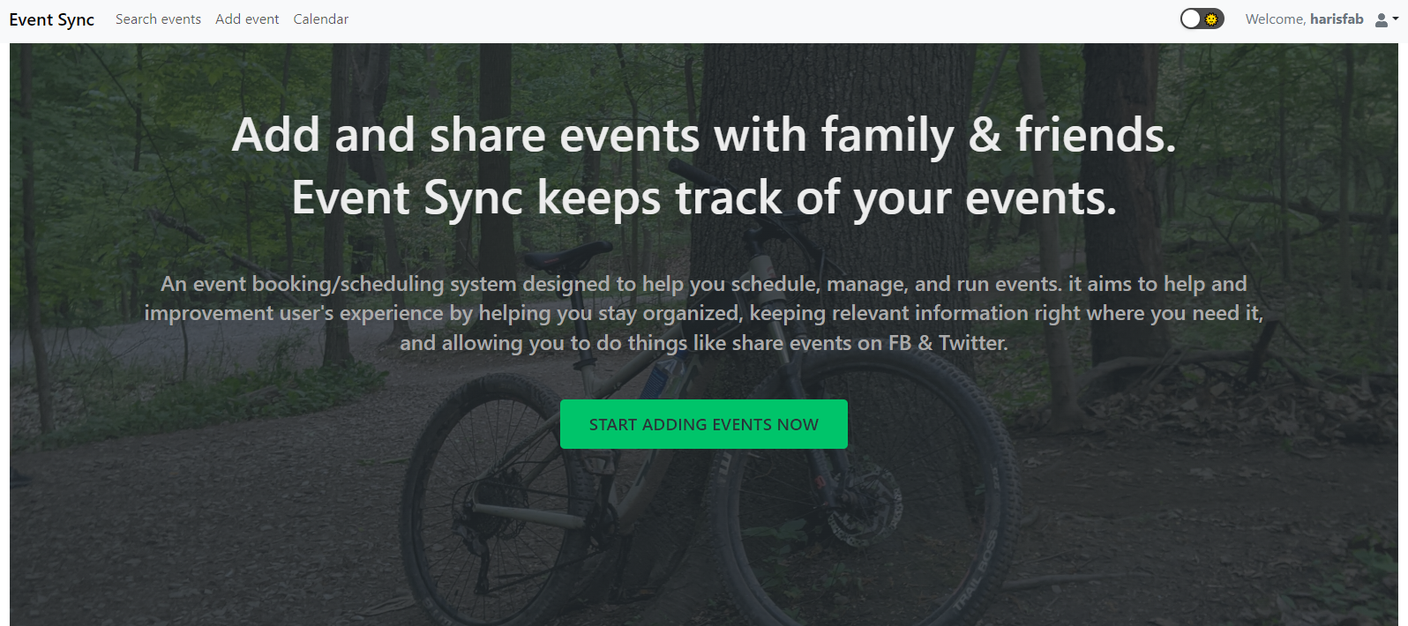

- Application Programming Interface (API):
Graphql API:
The backend should expose a graphql API for communication between the frontend and backend components of the system.
API endpoints should be well-documented with clear usage instructions and response formats.
- Email Notifications:
Email Integration:
The system should integrate with an email service provider (e.g., SMTP server) to send
out notifications to users. Configurable email templates for personalizing messages should be supported and the content inserted in them must be constant
- Authentication and Authorization:
Authentication Providers:
Various authentication providers, such as username and password or OAuth, should be supported by the system for user login. In order to ensure that authentication is easy, integration should be possible with outside identity providers such as Google or Facebook.
- External Data Sources.
Speaker and Venue Information:
In order to obtain speaker and venue information for conferences, the system can be integrated with external APIs or databases.
- Third-Party Libraries and Frameworks:
Frontend Libraries:
In order to enhance functionality and aesthetics, the frontend can use third party libraries and frameworks such as React Components, UIKits.
Backend Libraries:
The backend may leverage third-party libraries and frameworks (e.g., Express.js middleware, database connectors) for efficient development and enhanced capabilities.

- System Interfaces:
Operating Systems:
The system must be interoperable with any of the following operating systems in development or deployment environments. Web Browsers: In order to make the application more accessible, it should have compatibility with major web browsers such as Chrome, Firefox, Safari and Edge.

DESIGN AND METHODOLOGY

Entity Relationship Diagram
The ERD shows how attendees are linked to conferences, conferences are linked to speakers and venues also the interaction within the system.

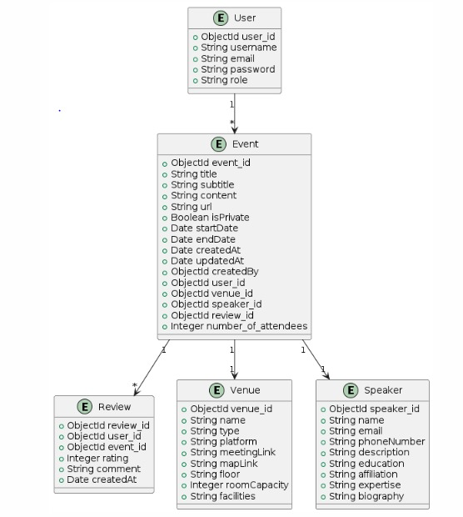
Figure 3.1 ERD Diagram

Class Diagram
The class diagram showcases the relationships between these classes, such as associations, aggregations, and dependencies.

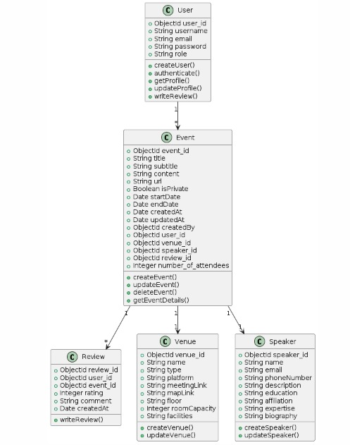
Figure 3. 2 Class Diagram

Sequence Diagram

A sequence diagram visually represents the flow of interactions between system components or objects over time.

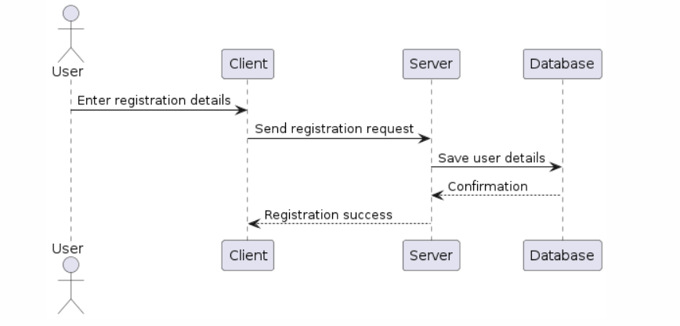
Figure 3. 3 User Registration sequence diagram
:

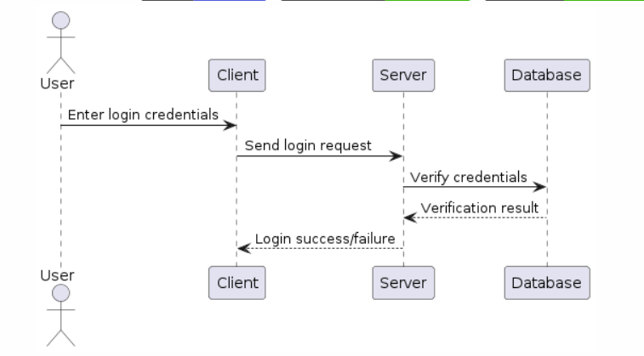
Figure 3. 4 User Login Sequence Diagram

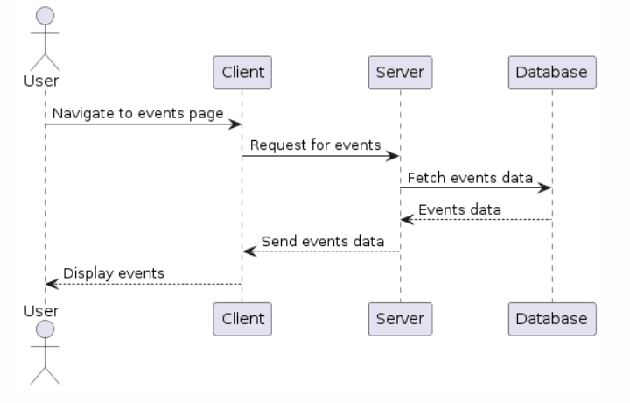
Figure 3. 5 View Events Sequence Diagram

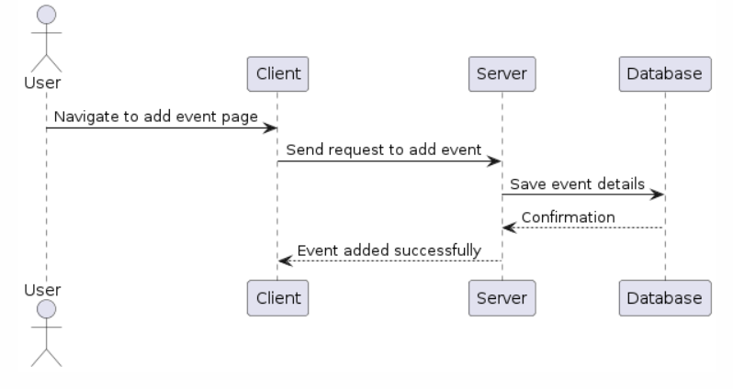
Figure 3. 6 Add events sequence diagram

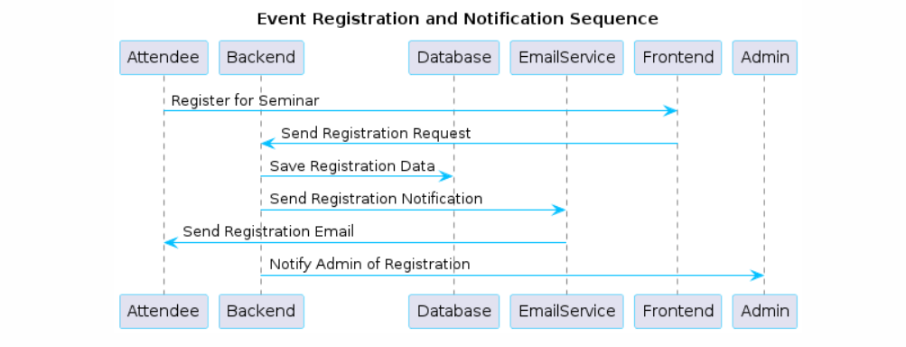
Figure 3. 7 Event Registration Sequence diagram

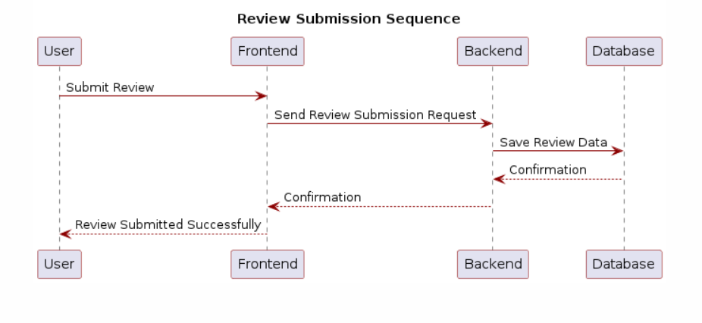
Figure 3. 8 Review Submission sequence diagram

Activity Diagram

An activity diagram depicts the flow of activities or actions within a system or process, illustrating the sequence of steps and decision points.
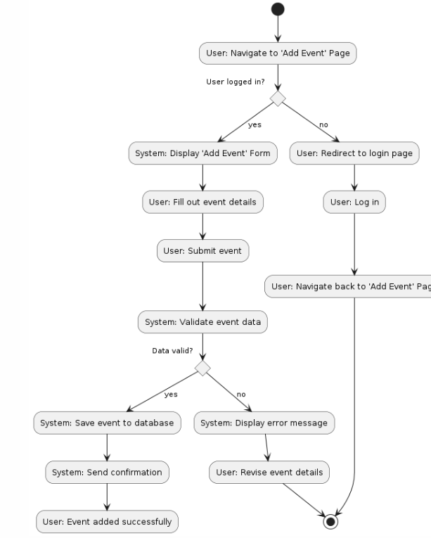
Figure 3. 9 Activity Diagram

Methodology

The Event-Sync, utilizing the Agile Feature-Driven Development (FDD) model, comprises several phases. It commences with project initiation, aiming to define the scope, objectives, and domain understanding, followed by the identification and prioritization of core features. Design and domain modeling help establish the core concepts for conference scheduling. Subsequently, development iterations are undertaken, leveraging React for frontend, Express for back-end, and MongoDB for data storage. Features are developed, tested, and documented incrementally. The integration phase ensures seamless feature interaction, while user acceptance testing actively involves stakeholders for feedback. The release phase prepares the application for production deployment. Training sessions and comprehensive documentation support end-users in adopting the system effectively. Post-release monitoring and Stability of the application and timely resolution of issues will be ensured by maintenance, Continuous improvement based on user feedback is still a continuous effort, evolving requirements. The overall success and documentation of the project are evaluated in the final review of the project. Valuable insight into future projects, ensuring a robust and feature rich conference scheduling solution.
FDD DIAGRAM:
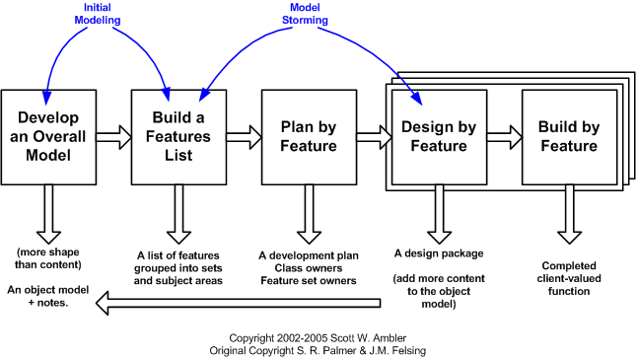
Figure 3. 10 FDD methodology diagram

DATA AND EXPERIMENTS (and/or IMPLMENTATION)

Implementation

Several key steps are involved in implementing the "EventSync" project, which is intended to bring a proposed application into reality. In the first place, a frontend development team will begin by designing and building an interface using React.js that focuses on creating intuitive and responsive components such as event cards, registration forms or search bar. At the same time, Express.js will be used by a backend team to develop robust APIs and business logic in order to ensure seamless communication between these two teams.

Framework

The "EventSync" project uses a combination of frameworks to achieve its objectives effectively. In the frontend, React.js is chosen because of its robustness to create Dynamic and User Interactions. A component based architecture facilitates the modular development of React, simplifying the management and reuse of UI elements across the application. Due to its scalability and dependency injection, Express.js is selected for the backend.

Real-Time Notification

The "EventSync" project is aimed at the implementation of timely notification to participants. The application provides timely notifications to users when registering for a seminar, 15 minutes before the start of the seminar, and in case of any changes, such as cancellations or delays, through the use of email services and scheduling mechanisms. This realtime notification will enhance attendance and ensure that participants are informed and updated of the events they have registered for.

Gender-Specific seats

The project incorporates a unique feature where attendees can register for gender specific seats, allowing them to select their preferred seating arrangement with visual indicators differentiating between male and female sections. This innovative feature adds a layer of customization and inclusivity to the event experience, catering to diverse preferences and needs of attendees.

Deployment and Maintenance

The final software product shall be presented to the Computer Science Department. In order to meet user needs, the product can then be tailored and placed into service. It is possible to remove the newly identified deficiencies and add missing requirements.

Technical Aspect of Event-Sync

In view of the fact that EventSync is a web based application, both a web server and a database management system and a web application are required. The frontend and backend of the system are classified according to following categories:

Backend

This Backend involves MongoDB and Express.js

Front-end

This Frontend involves Reactjs.

RESULTS AND DISCUSSIONS (or USER MANUAL)

Login Page

To login or signup to Event-sync to add their events
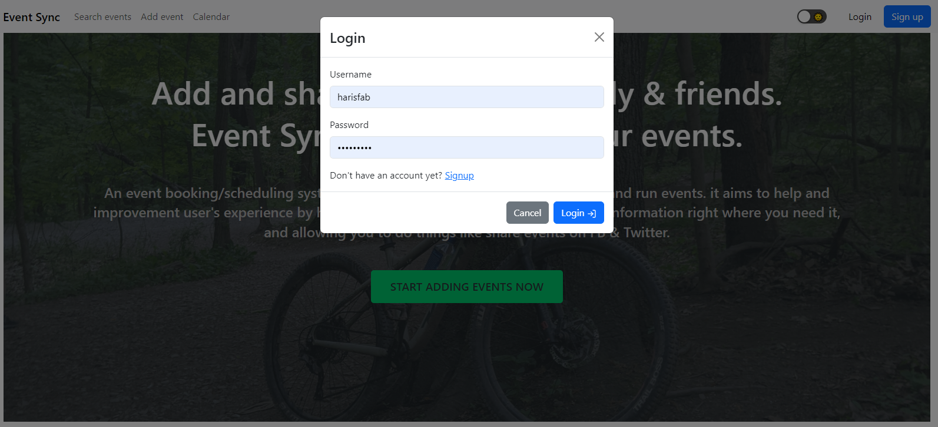
figure 5. 1 Login Page

• Provide their ID or signup
• Write the Password
• Click on login button

Home and Navigation

User can add or See the events
figure 5. 2 Navigation to Pages
• Navigation bar to access homepage and other features
• Add the Events
• Search the Events
• Calendar to display the previous and Future events

Add events

User can add the events and select while the event is public or private

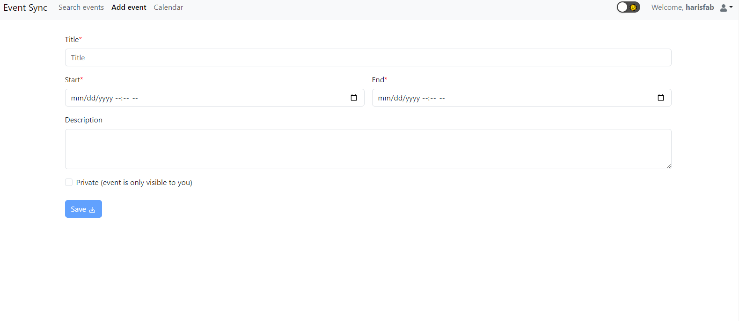
figure 5. 3 Add events page

- Include the Title of Event
- Start and end time of the event
- Description of events Includes the venue
- Save button

Search Events

User can see all the events with their complete details
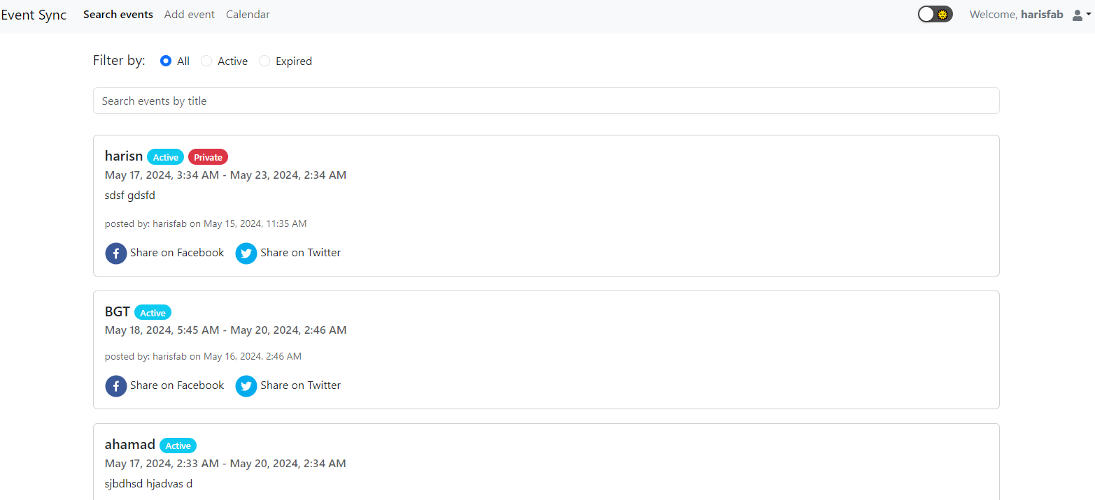
figure 5. 4 Search Events Page

- It includes the Active events
- Also the private events
- User can see the expired events

View though Calendar
User can Add the events Through calendar also Edit the events Through calendar.
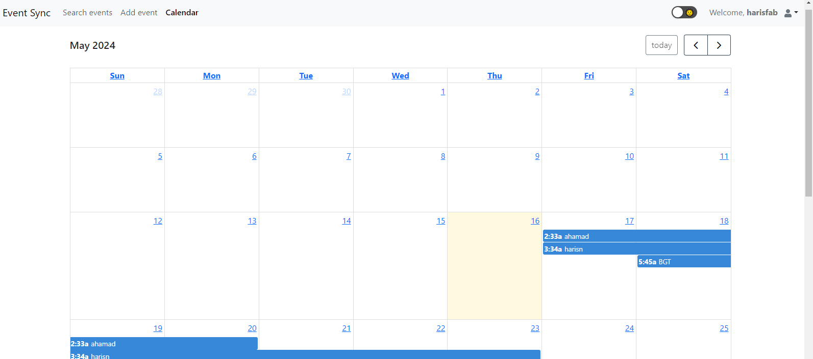
figure 5. 5 Calender Page

- Check the start and end date of the event
- Add the event Through the calendar
- Delete the event through calendar

My Profile
User can edit their Profile also edit their information
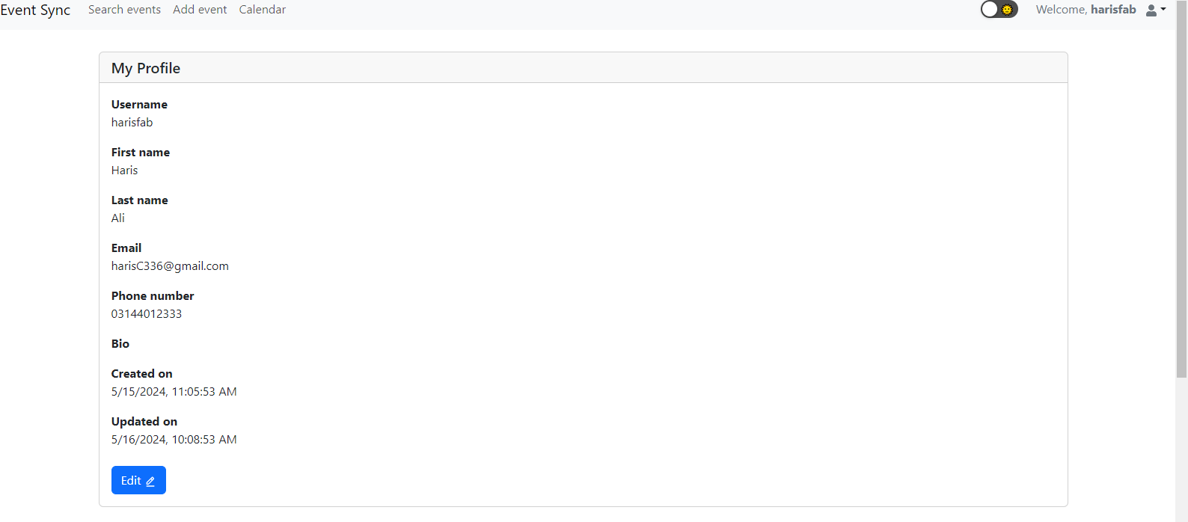
figure 5. 6 My Profile Page

My Events
User can check the complete details of the events in their profile
Also search the events through the description, date and title

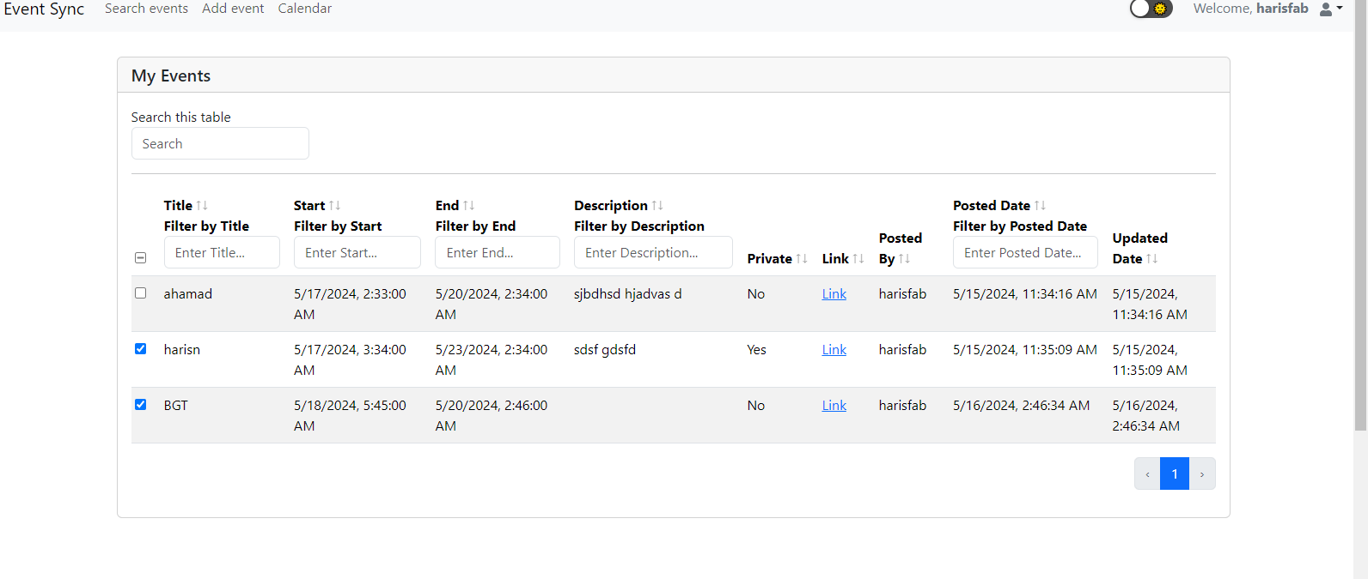
figure 5. 7 My Events Page

Dark mode
User can change the display into dark mode
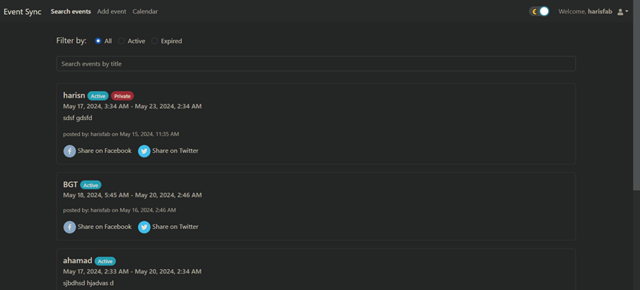
figure 5. 8 Dark Mode

CONCLUSION AND RECOMMENDATIONS

Conclusion

The "Event-Sync" project is a game-changer in event management, offering a modern solution that simplifies the planning and experience of events. Unlike traditional methods, which can be cumbersome and inefficient, "Event-Sync" provides a centralized platform for organizers to effortlessly create and manage events. Attendees benefit from features like real-time notifications and gender-specific seat selection, enhancing their overall experience. Administrators have access to intuitive tools for overseeing event operations with ease. Overall, "Event-Sync" revolutionizes event management, making it more accessible, organized, and enjoyable for everyone involved..

Recommendations

Future improvements could include additional features based on user feedback, integration with more social media platforms, and enhanced customization options for both organizers and attendees to further improve the event management experience.

REFERENCES

Books:

[1] Miller, Michael. Cloud Computing: Web-Based Applications That Change the Way You Work and Collaborate Online. United Kingdom: Pearson Education, 2008.
[2] Chaturvedi, Ashutosh. Event Management: A Professional & Development Approach. India: Global India Publications Pvt. Limited, 2009.

Electronic Sources from Internet:

[1] “DAWAT - Pakistan,” DAWAT, 05-Oct-2015. [Online].
Available: https://www.dawatpakistan.com/

[2] “Feature driven development (FDD),” Productplan.com. [Online].
Available: https://www.productplan.com/glossary/feature-driven-development/.

[3] “Express - Node.js web application framework,” Expressjs.com. [Online]. Available: https://expressjs.com/

[4] “React,” React.dev. [Online]. Available: https://react.dev/

[5] “What is Sequence Diagram?,” Visual-paradigm.com. [Online]. Available: https://www.visual-paradigm.com/guide/uml-unified-modeling-language/what-is-sequence-diagram/

[6] Wikipedia contributors, “Use case,” Wikipedia, The Free Encyclopedia, 19-Apr-2024. [Online]. Available: https://en.wikipedia.org/w/index.php?

[7] “Prime event management - event management, Concerts & Festivals, expo,” Prime-events.pk. [Online]. Available: https://prime-events.pk/

[8] “Evento – Event management & Planners – Evento Pakistan,” Com.pk. [Online]. Available: https://evento.com.pk/
.
[9] “Event Management Website,” Dribbble.com. [Online]. Available: https://dribbble.com/tags/event-management-website.

[10] A. Ślusarczyk, “Event planner website design examples that stand out of the crowd,” Be Theme Blog, 09-Feb-2024. [Online]. Available: https://muffingroup.com/blog/event-planner-website-design/.

[11] “Apollo-server-express,”npm.[Online].
Available: https://www.npmjs.com/package/apollo-server-express.

[12] “Introduction to Apollo client,” Apollo Docs. [Online]. Available:
https://www.apollographql.com/docs/react/.

[13] “JWT.IO - JSON Web Tokens introduction,” Jwt.io. [Online]. Available: https://jwt.io/introduction.

[14] “Free meeting scheduler,” Hubspot.com. [Online]. Available: https://www.hubspot.com/products/sales/schedule-meeting.

APPENDICES

APPENDIX A: Graphql
GraphQL is a query language for APIs that enables clients to request only the exact data they need, improving efficiency and performance. It provides a flexible and efficient alternative to REST by allowing complex queries and mutations through a single endpoint.

APPENDIX B: Express Js
Express.js is a fast, minimalist web framework for Node.js, ideal for building robust web applications and APIs. It simplifies the process of handling routes, requests, and middleware integration.

APPENDIX C: Use Cases
A use case is a written description of how users will perform tasks on your
website. It outlines, from a user's point of view, a system's behaviour as it responds
to a request.

APPENDIX D: Sequence Diagram
A sequence diagram is a Unified Modelling Language (UML) diagram that
illustrates the sequence of messages between objects in an interaction.

APPENDIX E: HTTPS
HTTPS (HTTP Secure) is an extension of HTTP that adds encryption using
SSL/TLS protocols to secure data transmission.

