

BSCS-F23-015
03-134202-048 | Muhammad Danish Shahid

Crowd Behaviour Analysis based Automated Surveillance System

In partial fulfilment of the requirements for the degree of
Bachelor of Science in Computer Science
Supervisor: Muhammad Shahid

Department of Computer Sciences
Bahria University, Lahore Campus
June 2024

© Bahria University, 2024

Certificate

We accept the work contained in the report titled.
“Crowd Behaviour Analysis based Automated Surveillance System”
written by
Muhammad Danish Shahid
as a confirmation to the required standard for the partial fulfilment of the degree of
Bachelor of Science in Computer Science.

Approved by:
Supervisor: Muhammad Shahid

(Signature)

June 15, 2024

DECLARATION

I hereby declare that this project report is based on my original work except for citations and quotations which have been duly acknowledged. I also declare that it has not been previously and concurrently submitted for any other degree or award at Bahria University or other institutions.

Enrolment | Name | Signature
03-134202-048 | Muhammad Danish Shahid

Date: June 15, 2024

Specially dedicated to
my beloved grandmother, mother and father
(Muhammad Danish Shahid)

ACKNOWLEDGEMENTS

I would like to thank everyone who had contributed to the successful completion of this project. I would like to express my gratitude to my research supervisor, Mr Muhammad Shahid for his invaluable advice, guidance and his enormous patience throughout the development of the research.

In addition, I would also like to express my gratitude to my loving parent and friends who had helped and given me encouragement.

Muhammad Danish Shahid

Crowd Behaviour Analysis based Automated Surveillance System

ABSTRACT

The country is experiencing turbulence in the global environment hence stabilizing the nation is a challenge as it seeks to address other issues such as security in Pakistan. To address this problem, we have embarked on developing a solution that aims at enabling the user to quickly detect acts of violence among crowds before they degenerate into full-blown altercations.
In our proposed solutions, the framework is highly integrated by merging cultural understanding and the experience of the user in a digital platform that tackles the limitations of the current solutions. This system is intended to assist the identified authorities, as well as protect the public through the effective use of live CCTV feeds, thoughtful analysis of recorded footage, and intelligent security database management. In doing so, our hope is to not only raise security standards but enhance safety for everyone within their respective facilities.
The foundation of our approach consists of two primary components: Convolutional Neural Networks (CNN) and Long Short-Term Memory (LSTM) elements. This high-end technology exhibits high effectiveness in identifying abusive behavior much higher than existing systems with an overall efficiency of 86%. Through our use of technology, our aim is not only to provide a secure environment for the society but also to help everyone to have a better living standard. We believe that our approach represents a significant step forward in achieving this goal.

TABLE OF CONTENTS

DECLARATION ii
ACKNOWLEDGEMENTS iv
ABSTRACT v
TABLE OF CONTENTS vi
LIST OF TABLES viii
LIST OF FIGURES ix

CHAPTERS
1 INTRODUCTION 10
1.1 Background 10
1.2 Problem Statements 11
1.3 Aims and Objectives 11
1.4 Scope of Project 12
2 LITERATURE REVIEW 13
2.1 Background 13
3 DESIGN AND METHODOLOGY 20
3.1 Design of Violence Detection System 20
3.2 Methodology 29
3.2.1 Dataset Acquisition 29
3.2.2 Preprocessing 29
3.1.3 Implementation 30
3.1.4 Evaluation 30
3.1.5 Testing 31
3.1.6 Proposed Methodology Diagram 31

4 DATA AND EXPERIMENTS 32
4.1 Data Preprocessing and Exploration 32
4.1.1 Data Acquisition 32
4.1.2 Data Cleaning and Pre-processing 32
4.1.3 Data Split 33
4.1.3.1 Training Set 33
4.1.3.2 Validation Set 33
4.1.3.3 Test Set 33
4.2 Experimentation and Model Development 34
4.2.1 Model Architecture 34
4.2.2 Model Selection and Training 35
4.2.3 HyperParameter tuning 36
4.2.4 Model Evaluation 37
5 RESULTS AND DISCUSSIONS 38
5.1 System Performance Evaluation 38
5.2 CNN 39
5.3 CNN-LSTM model with MobileNetV2 base 40
5.4 Training Oveview of Hybrid Model(CNN & LSTM) 43
5.5 Result comparison Of Deep Learning Models 44
5.6 Deployment 44
5.6.1 Application Architecture 44
5.6.2 GUI Design 44
5.6.3 User Authentication Flow 44
5.6.4 User Dashboard Flow 45
5.6.5 User Upload Video Flow 46
5.6.6 User Upload Video Flow 47
6 CONCLUSION AND RECOMMENDATIONS 49
6.1 Conclusion 49
6.2 Future Work 50
REFERENCES 51

LIST OF TABLES

TABLE TITLE PAGE
Table 2.1 Literature Review Comparison Table 19
Table 5.1 Samples for CNN 39
Table 5.2 CNN Training History 40
Table 5.3 CNN 2nd Training History 40
Table 5.4 Samples for Hybrid Model 40
Table 5.5 CNN-LSTM Training History 41
Table 5.6 CNN-LSTM 2nd Training History 41
Table 5.7 Comparative Analysis for Accuracies 44

LIST OF FIGURES

FIGURE TITLE PAGE
Figure 3.1 Use Case Diagram for User Registration 20
Figure 3.2 Use Case Diagram for User Login 21
Figure 3.3 Use case diagram for recorded video classification 22
Figure 3.4 Use Case Diagram for Displaying Logs 23
Figure 3.5 Use Case Diagram for Live classification. 24
Figure 3.6 Activity Diagram for User Activities 25
Figure 3.7 Activity Diagram for Admin Activities 26
Figure 3.8 Sequential Diagram for User Activities 27
Figure 3.9 Sequential Diagram for Admin Activities 28
Figure 3.10 Implementation 30
Figure 3.11 Methodology Flow Diagram 31
Figure 4.1 Model Architecture Diagram 35
Figure 5.1 Training and Validation Accuracy for proposed model 42
Figure 5.2 Confusion Matrix for proposed model 42
Figure 5.3 App User Login and Registration Screens 45
Figure 5.4 Dashboard Screens 46
Figure 5.5 Upload Video Screens 47
Figure 5.6 Upload Video Screens 48

INTRODUCTION

Background

In today’s volatile global environment, security has emerged as a paramount concern for nations, businesses, and individuals alike. Pakistan, navigating its unique socio-political challenges, is no exception. The proposed project provides innovative solution to a pressing concern: the timely detection of violent behaviour within crowds [1, 13,14,15].
In densely populated urban centres of Pakistan where large gatherings are commonplace be it for festivities, protests, or daily hustle and bustle the potential for sudden outbreaks of violence is a constant threat. The endeavour here is to harness the power of modern digital platforms to analyse crowd behaviours in real-time, identifying potential threats before they escalate [2].
The primary goal of this project is not just to introduce a technological solution, but to provide an essential tool for law enforcement and security agencies. By leveraging cutting-edge algorithms and AI-driven analytics, this violence detection system promises to be a significant step forward in ensuring the safety and security of public spaces in Pakistan [3].

Problem Statements

As public unrest becomes more common and intense in Pakistan, our communities are increasingly at risk. Current security measures, relying heavily on human eyes and outdated tech, are simply not enough to stop violence before it gets out of hand. We're missing a crucial tool - a system that truly understands our culture and uses cutting-edge technology to spot trouble brewing in crowds. Without it, our security forces are fighting an uphill battle, and the safety of everyday Pakistanis is hanging in the balance [7].
Right now, keeping an eye on crowds often means relying on people to watch and react, which isn't perfect – mistakes happen, and it's hard to catch everything. Even the tech we have sometimes misses the mark, especially in a place like Pakistan, where understanding cultural nuances is key. Plus, some systems just don't fit well with the way things already work, making them impractical [6].

Aims and Objectives

The Aims and Objectives defines the features and boundaries of the software. To focus on security and violence detection, the following modules and features are proposed:

- To develop Real-time CCTV Monitoring:
  - Continuous monitoring of live CCTV footage.
  - Automatic detection of violent activities.
  - Instant notifications to security personnel.
  - Integration with alarm systems for automated alerts.

- To develop a tailored solution for Recorded Footage Analysis:
  - Analysis of historical CCTV recordings.
  - Flagging of suspicious activities.
  - Tagging and categorizing incidents.
  - Detailed reporting on detected events.

- To utilize Security Database Management:
  - Storage and management of analyzed data.
  - User access controls and permissions.
  - Backup and restore functionalities.
  - Data encryption for security.

Scope of Project

This project is all about creating a watchful eye for our communities. We're focusing on busy public spaces in Pakistan's major cities, especially places where large groups gather. The goal is to develop a system that acts like a friendly guardian, keeping an eye on things through existing security cameras. This system will be smart enough to understand our unique cultural context and spot subtle signs of trouble brewing in a crowd. We want it to seamlessly fit into the current security setup, giving our officers real-time alerts so they can step in and prevent any harm. It's about building a tool that is accurate, efficient, and truly works for Pakistan, so we can all feel safer together [1].
Zooming out to view the broader picture, this initiative aligns with the overarching goal of bolstering Pakistan’s security landscape. Thus, by integrating it with today’s security measures, deep learning could improve the protection levels of different organizations drastically. It also strengthens individual agencies This helps build the story of a more safe and secure communal places for the people of Pakistan and increase faith and trust with public [3].

LITERATURE REVIEW

Background

The crime rate as well as violence in the recent past has grown to an alarming level and hence the need for smart surveillance systems has grown tremendously as well. The increase in violent activity in different parts of the world either in protest, in rallies or at one place or the other has been the main reasons for this. This put the safety of people present at the premises at a higher risk. As a result, security systems were developed and concurrent research was also conducted in which new methods/ techniques were developed, and existing ones were tested to see how they can meet this demand [5].
The field of violence detection has undergone a dramatic shift thanks to the rise of deep learning, particularly convolutional neural networks (CNNs). These powerful tools are like expert image analysts, able to sift through video frames and identify complex patterns and relationships that might escape the human eye. Pioneering researchers (think of them as the daring explorers in this field) started using CNNs for violence detection, and the results were impressive – a vast improvement over traditional methods.
Researchers soon realized that the best approach involves a two-pronged attack: understanding what's happening in each frame (spatial information) and how things unfold over time (temporal information). This is like watching a movie – you need to see the actors (spatial) and how they interact throughout the story (temporal). Studies like [1, 2] cleverly incorporated both types of information into CNN architectures, leading to a significant boost in performance as the systems could now consider the bigger picture, the context of actions playing out across video sequences.
To truly delve into the temporal aspect, some researchers turned to 3D CNNs. Imagine these as special 3D glasses for the computer – they allow it to process video data as a whole 3D volume, taking full advantage of the natural flow of information between frames. This approach proved successful in M. Barkat 's work [5] on human action recognition, which is a crucial piece of the puzzle for violence detection systems.

The following table lists the research papers reviewed during our research study.

Sr. | Title | Methodology | Results | Gaps | Author
1 | Deep Learning for Automatic Violence Detection:  Tests on the AIRTLab Dataset | use of 3D Convolutional Neural Networks (CNN) | 95.62% accuracy achieved | Dataset Limitations,  Evaluation Metrics and Limitations,  Gaps in the Proposed Deep Learning Model | Paolo Sernani,  Nicola Falcionellie Marche, Ancona, Italy
2 | Violence Detection by Pretrained Modules with Di®erentDeep Learning Approaches | used convolutional neural network (CNN) architecture. | CNN Model accuracy: - Training: 95.57% - Testing: 94.86% | In future Realtime Detection,  Implementation with new dataset and new model. | Shakil Ahmed Sumon,  Raihan Goni,  Niyaz Bin Hashem
3 | Cover the Violence: A Novel Deep-Learning-Based Approach Towards Violence-Detection in Movies | efficient violence classification using a CNN model,  Fine-tuning a pre-trained MobileNet model | achieved high accuracy rates of 98% in training and 96.3% in testing after 60 epochs | Most deep learning-based violence recognition methods are computationally expensive,  lack of automatic systems for users | Samee Ullah Khan,  Ijaz Ul Haq,  Seungmin Rho
4 | Violence Detection in Video Using Computer Vision Techniques | focuses on using the Bag-of-Words framework for action recognition in the context of violence detection in videos | fold cross-validation ranged from approximately 87.8% to 91.7%,  accuracy of fight detection on the action movie dataset, averaged over 5-fold cross-validation ranged from approximately 38.5% to 89.5% | Limited Focus on Violent Behavior,  Dataset Diversity,  performance of the detection models varied significantly between the hockey dataset and the action movie dataset | E. Bermejo,  O. Deniz,  G. Bueno,  R. Sukthankar
5 | Human Violence Detection Using Machine Learning Techniques | YOLO7 Architecture | commendable results in terms of precision and recall.  successfully adapted the YOLO7 architecture for violence detection.  Real-time inference capabilities proved crucial for response. | could benefit from a more diverse dataset  Further exploration of techniques could potentially improve the model's robustness.  Exploring additional optimization strategies | Achal Dattu Khaperkar, Durvanshi Kishor Khapekar, Pooja Wasudev Lanjewar, V. Jayshree Ashish Naidu, Prof. Aachal Wani
6 | A fully integrated violence detection system using CNN and LSTM | Convolutional Neural Networks (CNN) and Long Short-Term Memory (LSTM) | achieved accuracies of 98.32% on the Movies dataset and 96.55% on the Hockey dataset | can be improved to perform better in many aspects,  proposed DL architecture can be altered by modifying the hyperparameters | B. Sudharsan,  Sarthak Sharma,  Vimarsh Trehan,  Saamaja Naraharisetti
7 | Human Violence Detection using Deep Learning Techniques | Implemented models as APIs using FastAPI,  Used Inception-v3 for human-violence detection,  Used YOLO-v5 for object & face detection,  Used FAST API to integrate models into the website | achieved an accuracy of 74%,  can be used in real-time, | Accuracy Improvement,  Database Integration,  Improving real-time processing capabilities | S A Arun Akash,  R Sri Skandha Moorthy,  R Sri Skandha Moorthy
8 | A Review on State-of-the-Art Violence Detection Techniques | Categorizes violence detection techniques based on classification: traditional machine learning, Support Vector Machines (SVM), and deep learning.  Analyzes feature extraction techniques and object detection methods within each category.  Discusses datasets and video features used for training and evaluation. | Identifies SVM and other traditional machine learning techniques.  Highlights deep learning, particularly convolutional neural networks CNNs | Emphasizes the need for further research to improve accuracy.  Calls for development of techniques that handle variations in video quality, camera angles, and environmental conditions | Milon Biswas, Ashfaq Habib Jibon, Mohammad Kabir, Kajal Mohima, Rohim Sinthy, Md. Shamsul Islam, and Monowara Siddique
9 | A fully integrated violence detection system using CNN and LSTM | Uses a combination of Convolutional Neural Networks (CNNs) for spatial feature extraction from video frames and Long Short-Term Memory (LSTM) networks to capture temporal relationships between frames  Likely employs a pre-trained CNN model for efficiency (e.g., Xception)  Might involve training the system on violence detection datasets like Movies or Hockey videos | Achieves high accuracy in violence detection, potentially exceeding 95%.  May include a mobile application for authorities to monitor video feeds and receive real-time alerts | Difficulty handling real-world variations in lighting, camera angles, and video quality  False positives due to non-violent actions that mimic violence  Ethical considerations around privacy | Sarthak Sharma, Bharath Sudharsan, Saamaja Naraharisetti, Vimarsh Trehan, and Kayalvizhi Jayavel
10 | A multi-stream CNN for deep violence detection in video sequences using handcrafted features | Uses handcrafted features for appearance, motion speed, and key frames.  Feeds these features into separate CNN streams (spatial, temporal, spatiotemporal).  Trains on video datasets with violence and normal activity labels. | Achieves high accuracy for violence detection.  May outperform other methods in terms of speed and accuracy. | Relies on manually designed features.  May not handle variations in video quality | Mohtavipour, Saeidi
11 | Review of Violence Detection System using Deep Learning | Compares traditional machine learning (SVM) vs deep learning (CNNs) for violence detection.  Analyzes feature extraction and object detection techniques within each approach.  Discusses video datasets used for training and evaluation. | Deep learning (CNNs) dominates violence detection due to high accuracy. Traditional methods (SVM) are still used, but to a lesser extent. | Need for improved accuracy and robustness in real-world scenarios.  Challenges with handling variations in video quality, angles, and environments. | Milon Biswas et al
Table 2.1 Literature Review Comparison Table

DESIGN AND METHODOLOGY

Design of Violence Detection System

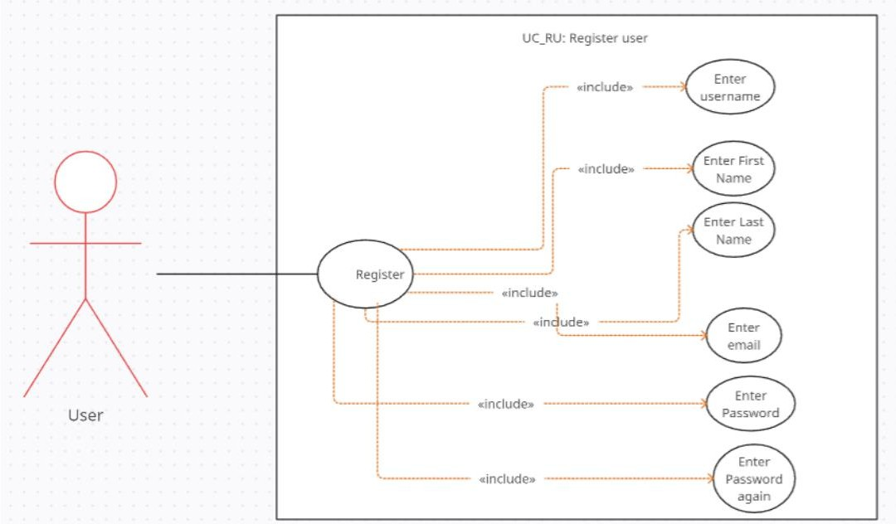
Figure 3.1 Use Case Diagram for User Registration

Figure 3.1 explains that someone wants to register for something. To do that, they have to go through a few steps, like typing in their name, email, and making up a password. The diagram just breaks down this registration process into simple steps so it's easy to understand what's happening.

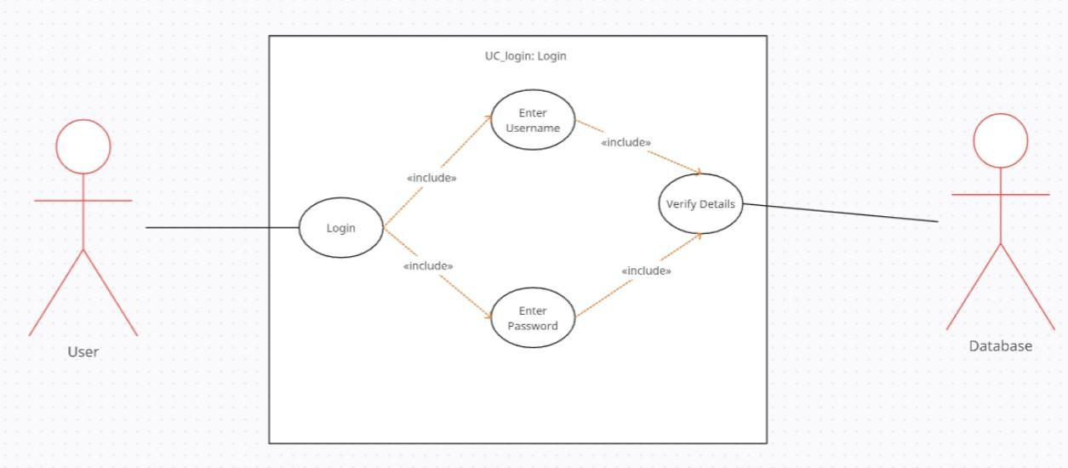
Figure 3.2 Use Case Diagram for User Login

Figure 3.2 explains the user first initiates the login process, then enters their username and password. The system verifies these details against a database. The "<<include>>" tags suggest that entering a username and password are distinct steps within the overall login process. Once the credentials are verified, the login is successful. The diagram also includes a "User" and "Database" actor, indicating that these are external entities interacting with the login process.
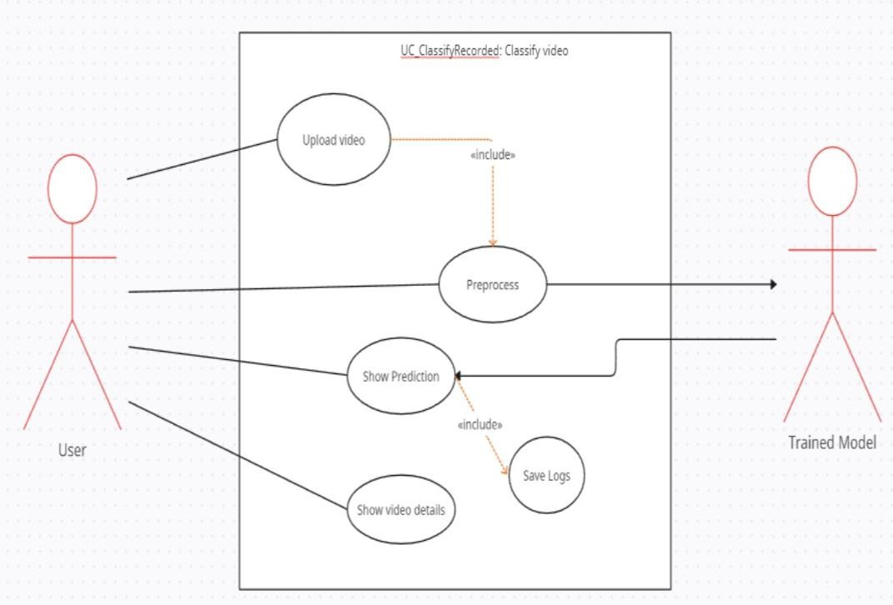
Figure 3.3 Use case diagram for recorded video classification

Figure 3.3 explains the image depicts a use case diagram for video classification. A user uploads a video which then gets pre-processed. The system utilizes a trained model to analyse the pre-processed video and provides a prediction of its content. Additionally, the process includes saving logs of this classification and displaying details of the video to the user.

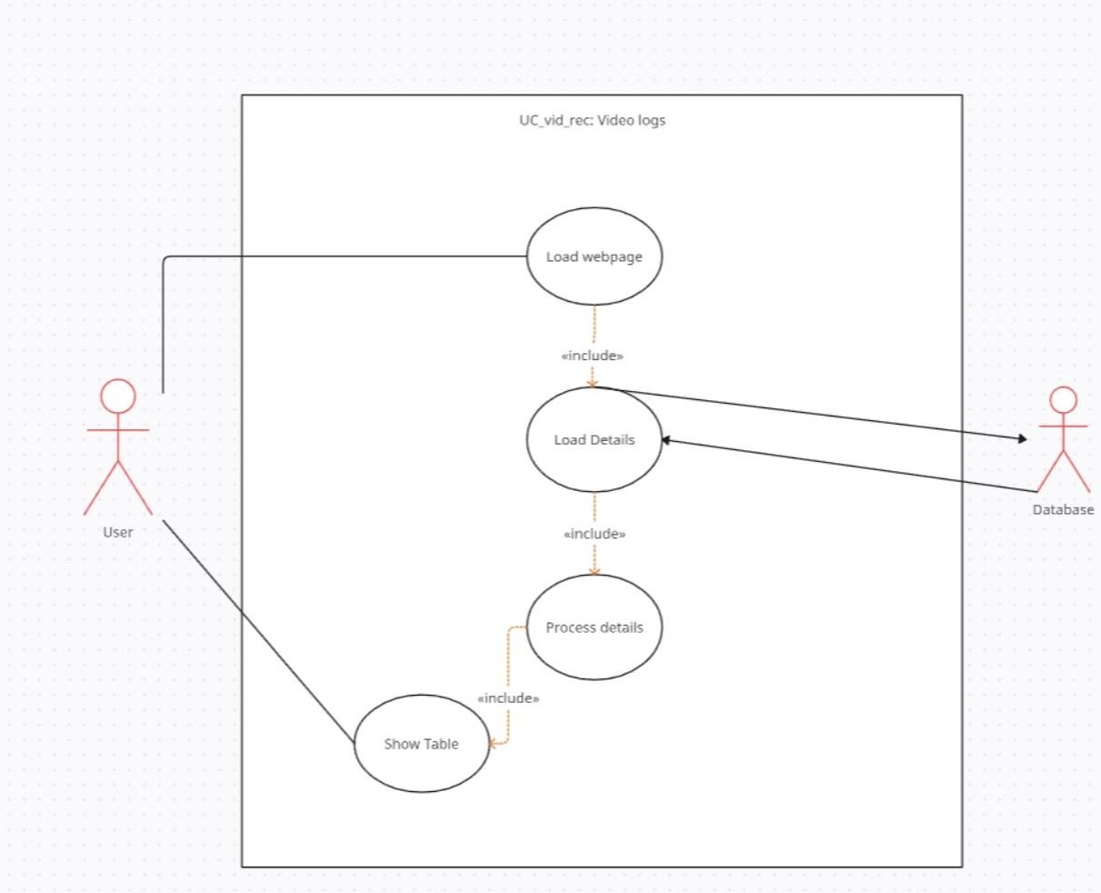
Figure 3.4 Use Case Diagram for Displaying Logs

Figure 3.4 explains a use case diagram for displaying video logs on a webpage. The process starts with the user loading a webpage. This triggers the loading of details from a database, which are then processed. The final step involves displaying the processed details in a table format to the user. The "include" relationships indicate that loading details, processing them, and showing the table are all essential sub-processes within the overall use case of displaying video logs.
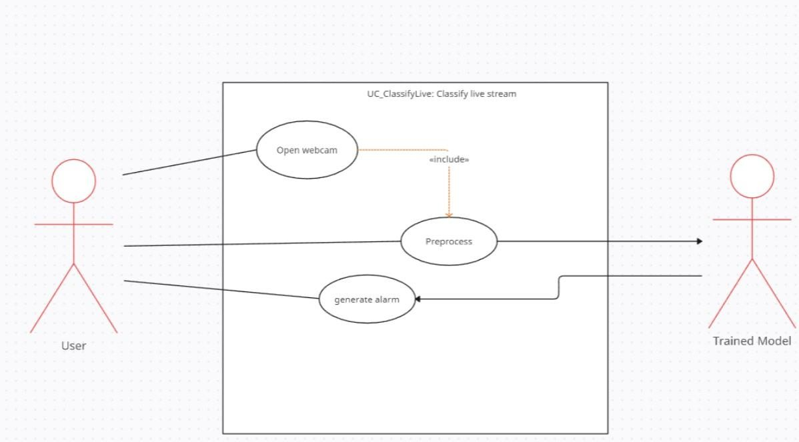
Figure 3.5 Use Case Diagram for Live classification.

Figure 3.5 explains the image depicts a use case diagram for classifying a live stream. The user initiates the process by opening their webcam, which is pre-processed before being fed into a trained model. The trained model analyses the pre-processed data and, if necessary, generates an alarm.

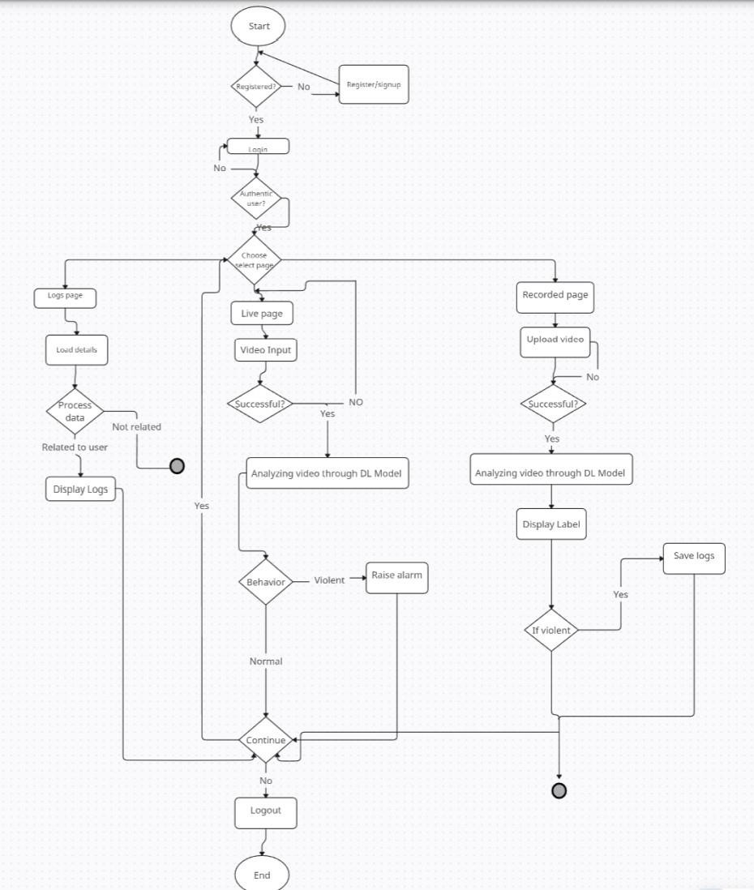
Figure 3.6 Activity Diagram for User Activities

Figure 3.6 details a system for analysing live and recorded video content. Users log in to access features like live video analysis from their webcam, where a deep learning model detects violent behaviour and triggers alarms if needed. For recorded videos, the system uploads and analyses the content using the same model, labelling it and saving logs. Additionally, users can review their interaction history and analysis results within the system.

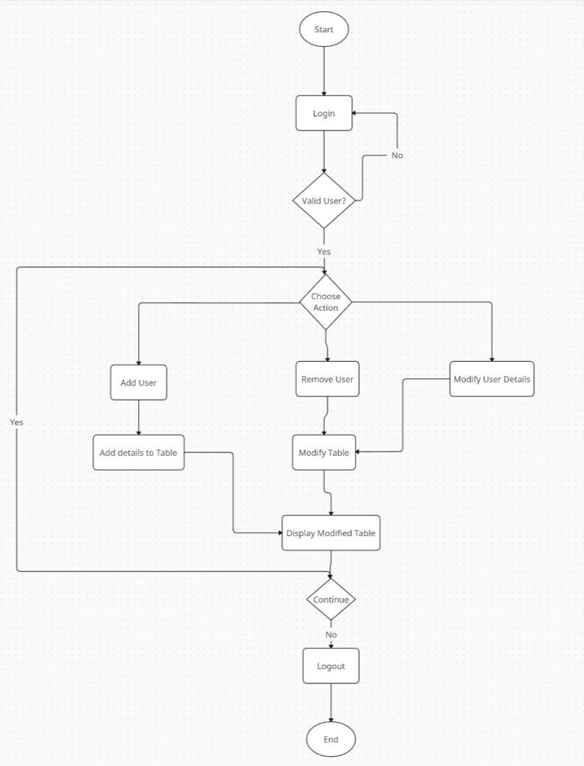
Figure 3.7 Activity Diagram for Admin Activities

Figure 3.7 depicts a user management system. After the initial login, validated users can choose to add a new user, remove an existing one, or modify user details. If they opt to add or modify, the relevant details are updated in a table. Post-modification, the updated table is displayed. The system then checks if the user wants to continue or log out, marking the end of the process.

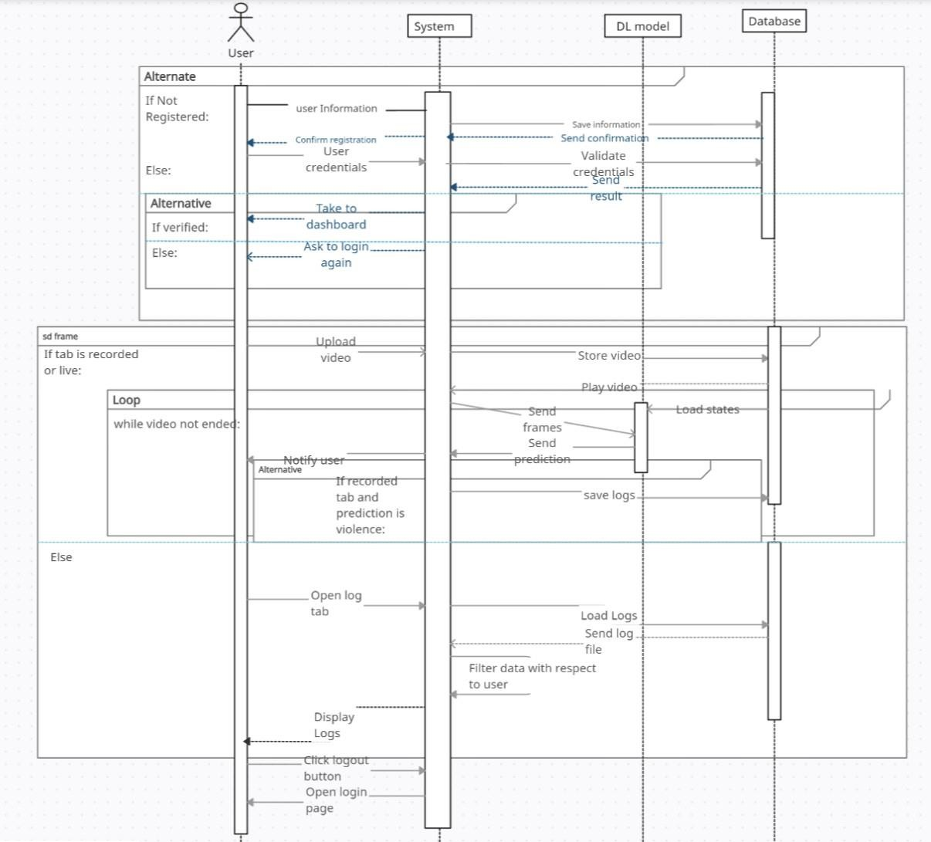
Figure 3.8 Sequential Diagram for User Activities

Figure 3.8 illustrates a system for analysing live and recorded video content. New users register and existing users log in. Authenticated users can access features for analysing live videos from their webcam, where a deep learning model detects violent behaviour and triggers alarms. Users can also upload recorded videos for analysis, which are then labelled and logged. Additionally, users can review their interaction history and analysis results within the system.

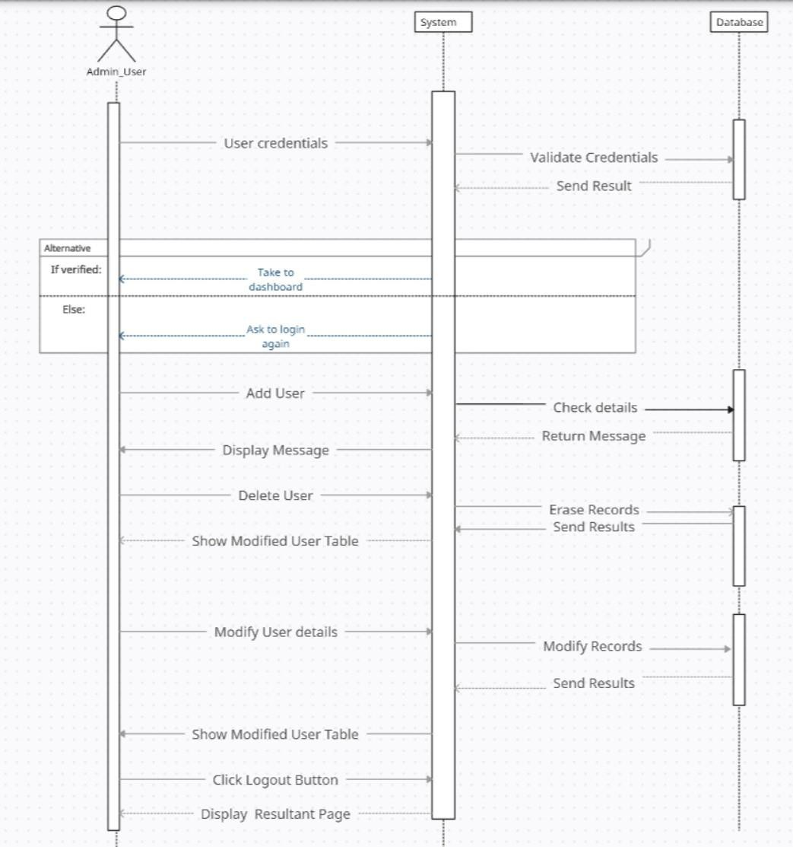
Figure 3.9 Sequential Diagram for Admin Activities

Figure 3.9 illustrates a user management system where an admin user logs in with credentials that are validated by the system. Upon successful login, the admin is directed to a dashboard. From there, the admin can add new users (after a details check), delete users, or modify existing user information. The system provides feedback messages and displays updated user tables as needed. The admin can logout when finished.

Methodology

The system we propose is a Mobile application that will consist of an end-to-end deep learning model that will both detect and recognize violence occurring in the incoming video clip deployed with it. The model will be a LSTM and CNN model. The proposed model has the architecture of 3D CNN consisting of dense blocks and transition layers.
The front end or user interface is developed using XML and the backend is developed in Java. Hence, integrating to form a complete Mobile App. The user will upload a video, and then the system will predict whether there is violent or nonviolent behaviour in the video. The system will be power efficient as it is a Mobile application meaning, the computation will not be done on the user’s app but on a Model server.

Dataset Acquisition

The dataset used for training the model is the Violent Flows dataset, which includes video clips categorized as either violent or non-violent. This dataset is crucial for training the deep learning model to accurately identify violent behaviour. The dataset was used in paper Violence Detection by Pretrained Modules with Different Deep Learning Approaches [2].

Preprocessing

A series of preprocessing techniques are applied to video data to prepare it for a machine learning model. First, the video is read, and then, frames capture at equal intervals over the entire video to guarantee that the capture represents all the video video. This is done using a calculation of a frame skip window, which is a specific number of frames to decide the required sequence length. Next, each extracted frame is resized to the fixed size, and it ensures all the frames in the resulting section have the same height and width. It is helpful in processing the data in batches so that all the entries made on a given day are aggregated together. The pixel values composing the frames are then normalized after the resizing process by dividing the values by a factor of 255 in order to bring the values in a range of 0 to 1.
This normalization step enables the training of the neural network to be improved and for it to converge much faster. The code also makes a check that videos that give the exact frames required are included in the dataset to avoid variation in input data.
Hence, after normalization, this means that the data is passed through a section in which prepares it in the right format suitable for the neural network. This step converts each video into a fixed number of frames so that the input to the model is of the same format for all videos. This makes the generated video sequences to be of the correct size of frames needed in the model; each sequence contains the same number of frames. The data is usually now in a format that is best suited for the neural network commonly as a 4D tensor with sizes referring to the number of videos, number of frames per video, height of the frame and width of the frame.

3.1.3 Implementation

After feature engineering processes, Deep learning models such as CNN and CNN-LSTM were used. As a result, to proceed further, a combined model of both CNN and LSTM have been used which proved to be more effective. It defines the goal to achieve a significantly better performance of the model as well as its stability and ensures successful completion of the project.
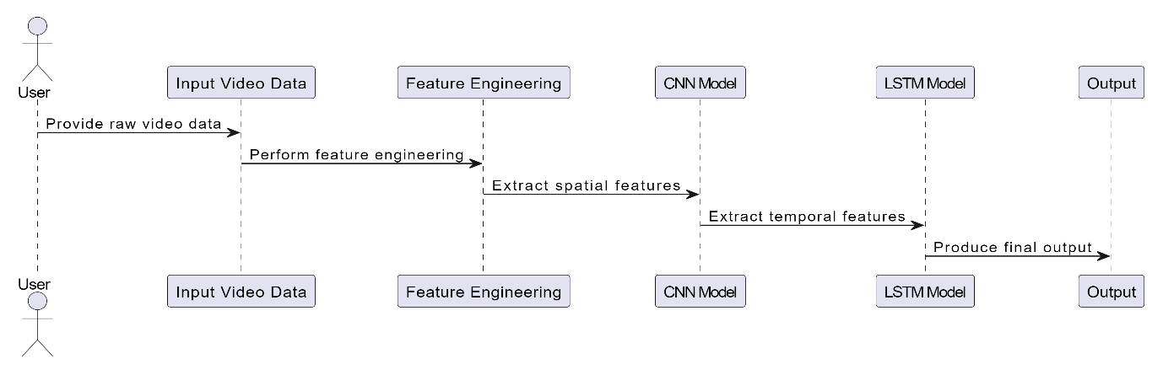
Figure 3.10 Implementation.

3.1.4 Evaluation

After the model’s development, another step, this is the evaluation phase, is initiated. To evaluate the accuracies of the model we will use some validation metrics like Training accuracy, Testing accuracy, Cross-validation, Validation precision, Validation recall, and finally the F1 score. This step is considered vital to assess the quality of the model and its relevancy to the project that is being developed.

3.1.5 Testing

To evaluate the model’s effectiveness in real life and test its performance on data the AI model had never seen before, the model was put through restricted data. In this phase the model was tested using new data, this involved mimicking real world scenario and testing how the model performs on new unseen data or samples.

3.1.6 Proposed Methodology Diagram

In the Final stage, the developed model is put into a web application to be used.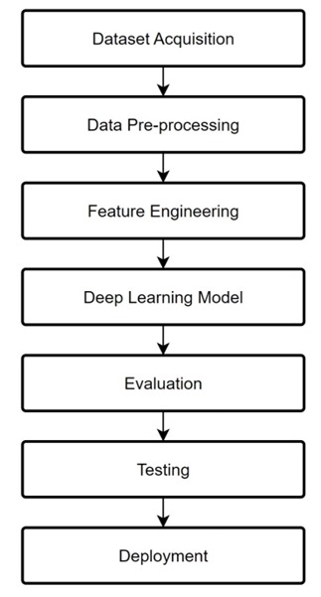
Figure 3.11 Methodology Flow Diagram

DATA AND EXPERIMENTS

Data Preprocessing and Exploration

In this context, it is necessary to note that data preparation for feature engineering and model development involves some steps that will be discussed below. This segment deals with pre-processing of the data and data analysis that involve steps in acquiring data, cleaning it and most importantly, how to partition the data into training, validation, and testing data set. These initial means check the data to be appropriate for modelling and then the created models for their training, validation, and quantitative evaluation.

Data Acquisition

Many of our videos are from the YouTube’ site, which offers a candids view of violence. The current dataset is available on Kaggle having the tittle Real Life Violence Situation Dataset. Thus, we have collected 1000 videos with authentic street fights which can be observed in various places and getting into at different situations and 1000 videos of completely opposite, namely, the videos with peaceful events. It is a penthouse of a selection, but it helps to train our system for what real-world violence is. This is a relatively small dataset, so its size is 1. 95 GB.

Data Cleaning and Pre-processing

The presented video data undergoes several steps of data preparation before it is fed into a machine learning algorithm. First, the video is partitioned into frames at fixed time intervals in order to afford equal coverage to all segments of the video. This is done by defining a frame skip window that gives the number of frames to be skipped to come up with a given sequence length. Each frame is then adjusted to thus have equivalent height and width that facilitates batch processing of each frame. The pixel values of the frames are preprocessed such that the pixel intensity values are converted from the 8-bit to the 0-1 range. This normalization helps the neural network to learn better and converge faster at the same time when training. It also filters the input data in order to only include videos with exactly the number of frames set by the code, avoiding inconsistencies. Preliminary operations on the video data help to put the data into a proper format to be fed into a neural network to be learned from by the model.

Data Split

The data is separated with the data split method which arranges the data into the training and testing sets. The data split technique implies shuffling of the obtained dataset to provide better randomness in data distribution and then dividing the dataset most often into 80% of training portion and 20% of testing portion. This split is very important for the testing phase and for the purpose of checking whether the model is able to generalize enough the data it has seen. It is possible to split the data into training and testing subsets so that the model performs well on the testing set while achieving good accuracy on the training set, which can give a measure of its ability to generalize.

4.1.3.1 Training Set

The model is tested with the Violent Flows dataset. The current set of data is divided into the training set and validation set to achieve high accuracy, and model robustness.
Training Process:
Data loading and augmentation.
Binary Cross-Entropy used as loss function and Adam was used as the optimizer.
xValidation on a separate validation set.
Hyperparameter tuning and model evaluation based on performance metrics.

4.1.3.2 Validation Set

In the training process, the model’s performance is tracked hyperparameters are tuned using the validation set. The Validation Set receives 10% of the dataset.

4.1.3.3 Test Set

The test set is used to measure the trained model’s ultimate performance and their capacity to predict new data. The test set receives 20% of the total dataset.

Experimentation and Model Development

The following section details the steps involved in model experimentation and development, including feature engineering, model architecture, model training and selection, and model evaluation. Each aspect is thoroughly explained to provide a comprehensive understanding of the process.

4.2.1 Model Architecture

The training and model selection for such a task using CNN involves many steps which are crucial in achieving desired accuracy and efficiency. First, preprocessing of video data is performed where frames are extracted from the video at a certain interval. Then, all the frames are resized to the same dimensions and then normalized to ensure uniformity. Also, the data is divided into training and testing dataset. The majority of the data is used to train the model and the remaining dataset is reserved to test the performance of model on new data. The CNN model is created using a deep learning library like TensorFlow, where the input layer defines the size of the video frames. This is followed by convolutional layers, batch normalization layers and pooling layers. The network is composed of multiple dense blocks which are alternatively separated by transition layers. Each dense block contains multiple 3D convolutions, batch normalization layers, ReLU activation function and average pooling. The output layer after the last dense block is a global average pooling layer which performs pooling operation along the spatial dimensions and height and width of the feature map. A fully connected dense layer with SoftMax activation function is used for classification. The model is then compiled with an optimizer categorical cross-entropy loss function and an optimizer like Adam. Accuracy is chosen as the evaluation metric [3]. The model training involves feeding training dataset to the model and then calculating the loss function and then performing backpropagation to update the model weights. This process is repeated for all the epochs for training dataset. During training, some additional techniques like data augmentation and dropout regularization can be applied to improve the generalization and avoid overfitting. The model is tested on the testing dataset after every epoch to evaluate the accuracy and loss to check whether the model is learning or not [2]. Before selecting the final model, hyperparameter search must be performed to improve the model performance. Some hyper-parameters like learning rate, mini-batch size, number of convolutional layers, number of growth rate etc. need to be specified and then optimized. Different configurations are performed, and the best one is chosen based on the performance metrics like precision, recall, F1-measure etc. [4]. To ensure that the model achieves better generalization, cross-validation technique like kfold cross-validation can be employed where the training and validation dataset is divided into k subsets. The model is trained and validated k times where each time a different subset is chosen for testing [7]. After training and validating multiple models or the same model with different configurations, the performance metrics like accuracy, loss, precision, recall etc. are compared and the best model is chosen. The selected model is then tested on a completely hold-out test set to evaluate its performance on new and truly unseen data. The model selection involves choosing the best performing model from the validated models. Finally, the trained and selected model is deployed for production use. The performance of the deployed model must be continuously monitored and retrained periodically to achieve better performance.
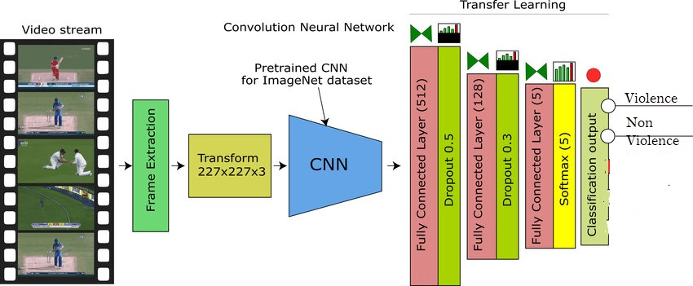
Figure 4.1 Model Architecture Diagram

4.2.2 Model Selection and Training

The process of training and selecting a model for tasks such as violence detection using CNN is divided into the following steps that are extremely crucial. First, about the video data, frames pre-processing involves frame sampling at a fixed interval and resizing them into similar dimensions, followed by normalization. This makes it easier in ensuring uniformity and at the same time prepares the data to be processed. It is easier to divide the dataset where the larger portion is used for training the model, and a small portion is used testing or validating the model on the data that it has not seen before [1].
CNN can be defined when developing a deep learning framework like TensorFlow. There is the input layer for video frames, then the convolutional, batch normalization and pooling layers are consecutive. The architecture consists of many dense blocks containing three-dimensional convolutions, in addition to the use of batch normalization, ReLU activation, and average pooling; this is followed by transition layers and global average pooling layer, which is connected to the final dense layer consisting of a SoftMax activation function for classification. It is trained with a loss function, for example, categorical cross-entropy, and an optimizer such as Adam and the main measurement is the accuracy [3].
In training the same, the training data is input to the model, then the corresponding loss is computed and the gradient is back propagated through the model over multiple epochs for weight update. To address this issue, training approaches can be applied during training including the use of data augmentation and dropout. After each epoch, the model is evaluated on the testing set to observe its accuracy and loss so that its learning is efficient [2].
To identify the best model, hyperparameter tuning is done with factors such as learning rate, batch size, number of layers and growth rate set in order to come up with the best values. These include the precision and the recall among others with a view of making the evaluation more inclusive. To increase the model’s stability, other cross-validation strategies like k-fold cross-validation are applied to train and validate it on different samples of the dataset. [7].
Whereas, when more than one or different configuration of a model has been built, their measures are being compared to choose the best model. The chosen model is therefore tested on the hold-out test set to ascertain its validity in true unseen data. This process of training, validation, and choosing the model checks whether the model can predict violence in video data and how well it can perform on a new set of data. It is the best model in our case, and for the continuous use, it is used in the real world, however, observation should be made frequently and training should be done from time to time [11].

4.2.3 Hyperparameter tuning.

When training the proposed model of CNN-LSTM in 3D format, there are two important parameters that we can adjust to increase the efficiency of the training process. First, we will translate to see how various learning rates accomplish, which is a hyper-parameter, configured. Although, a high learning rate helps to improve the learning process by reducing the computations pace needed to obtain the minimum point of the cost function, it reduces the precision of the model. Secondly, we will begin to investigate the concept of batch sizes, meaning the number of samples that are passed through the model at one time during the training process. In terms of memory, a larger batch size is preferred as it uses less memory as compared to a smaller batch size, but the time taken might be longer since it takes more time to process a batch.
The number of epochs, or how many times the model reviews all the data, needs to be just right – enough for good results, but not so much that it overfits. We'll experiment with different optimizers, like coaches with unique training styles, to see which one brings out the best in the model. And finally, the loss function will be our scorekeeper, telling us how far off the model is from the correct answers, guiding us to adjust the other settings. For the specific architecture, we'll also tweak the number and complexity of dense blocks, the growth rate within them, and the compression factor in transition layers to balance model capacity and prevent overfitting.

4.2.4 Model Evaluation

My model’s performance was tested on variety of assessment measures, including as accuracy, precision, recall and confusion matrix, that are appropriate for unbalanced classification tasks that are frequently encountered in violence. After testing the model on the dataset, the obtained performance metric provides valuable information on how well the model identified and categorized crowd behaviour. However, some problems were identified with examining it had a class imbalance which affected traditional accuracy measurements. For generalization and be less dependent to the unbalance of classes, more sophisticated strategies such as class weighting or resampling are used for coping with these problems.

RESULTS AND DISCUSSIONS

System Performance Evaluation

Our Crowd Surveillance Behaviour Analysis-Based Violence Detection System was vigorously examined as to its practical effectiveness to ensure it operates optimally. For purpose of evaluation, we incorporated two techniques; the live video and the recorded video. Of course it was tested in rather realistic conditions: different light sources and crowded scenarios for testing the ability to identify violent activities.
From the results obtained in the cuts live testing our system reached an average of 80% of detection accuracy. 73 % of users indicated that they did not experience a delay of more than one second while using the current version of the website. This must be achieved in terms of rapid response, which is essential for smooth surveillance operations. The performance was fairly good across various platforms, thus, substantiating the effectiveness of Dense Net architecture implemented in the current program for violence classification.
This kind of real-time detection ability is essential to quickly notice and got rid of any potentially violent activity, greatly enhancing the efficiency of security in such areas. We also used recorded videos to validate that the system is capable of logging historical data, if not, we recorded some videos to use them in testing the system. This particular feature is very helpful especially for post-event scenario analysis because it enables security persons to study the chronology of incidents that lead to an event as portrayed from the footage.
The demo is performed using videos recorded prior to the demonstration and our system proves to have satisfactory results even for recorded feeds that is why it makes no difference whether the input is a live or recorded video feed. Further, the system’s video log management optimizes the captured videos ensuring that all detected incidents are stamped at enhancing video clips correctly. It also becomes easier to retrieve and scrutinize the content of the footage during audits or any kind of investigation.

CNN

In our training, we used a CNN model. We used these 246 samples in the dataset to train the model and perform several techniques like changing the LR, BS, and no of layers.

Total No of Samples | 246
No of Training Samples | 196
No of test samples | 49
Table 5.1 Samples for CNN

- Hyper Parameters: Epochs = 50, Patience = 2, Learning Rate = 0.00005, Batch Size
= 8

No of Epochs | Accuracy in  % | Loss (Training) | Accuracy of Validation | Loss of Validation
1 | 48.62 | 10.5 | 50.00 | 1
2 | 58.05 | 67.33 | 50.00 | 69.47
3 | 62.38 | 62.11 | 72.50 | 77.83
4 | 73.47 | 56.28 | 70.00 | 65.00
5 | 80.17 | 50.55 | 57.50 | 85.96
6 | 68.74 | 59.97 | 70.00 | 61.78
7 | 81.19 | 51.96 | 77.50 | 56.46
8 | 83.84 | 38.28 | 77.50 | 56.46
9 | 86.44 | 39.17 | 77.50 | 6378
10 | 87.04 | 82.46 | 72.50 | 60.82
11 | 90.77 | 26.34 | 82.50 | 54.35
12 | 90.52 | 85.75 | 82.50 | 51.15
13 | 89.45 | 19.20 | 80.00 | 70.17
14 | 90.39 | 19.14 | 77.50 | 65.03
15 | 85.77 | 24.10 | 80.00 | 50.07
16 | 94.64 | 15.82 | 75.00 | 126.0
17 | 83.60 | 29.83 | 80.00 | 77.53
18 | 93.98 | 16.78 | 72.50 | 86.28
Table 5.2 CNN Training History

- Hyper Parameters: Epochs = 50, Patience = 2, Learning Rate = 0.00, Batch Size = 8

No of Epochs | Accuracy in  % | Loss (Training) | Accuracy of Validation | Loss of Validation
1 | 49.21 | 73.27 | 50.00 | 69.05
2 | 44.98 | 69.17 | 50.00 | 66.55
3 | 55.51 | 64.64 | 65.00 | 60.22
4 | 81.85 | 59.39 | 67.50 | 64.69
5 | 58.21 | 66.88 | 55.00 | 58.42
6 | 68.60 | 62.38 | 57.50 | 67.70
7 | 71.69 | 64.73 | 65.00 | 59.36
8 | 69.26 | 60.75 | 75.00 | 54.66
9 | 79.06 | 48.75 | 75.00 | 59.44
10 | 78.86 | 49.60 | 77.50 | 63.17
Table 5.3 CNN 2nd Training History

CNN-LSTM model with MobileNetV2 base

Total No of Samples | 246
No of Training Samples | 196
No of test samples | 49
Table 5.4 Samples for Hybrid Model

- Hyper Parameters: Epochs = 5, Patience = 2, Learning Rate = 0.00005, Batch Size = 8

No of Epochs | Accuracy in  % | Loss (Training) | Accuracy of Validation | Loss of Validation
1 | 49.69 | 71.32 | 62.50 | 67.77
2 | 56.31 | 66.97 | 60.00 | 71.66
3 | 71.26 | 61.91 | 80.00 | 53.30
4 | 79.17 | 51.35 | 75.00 | 62.56
5 | 71.13 | 53.63 | 70.00 | 50.43
Table 5.5 CNN-LSTM Training History
- Hyper Parameters: Epochs = 5, Patience = 2, Learning Rate = 0.00005, Batch Size = 8

No of Epochs | Accuracy in % | Loss (Training) | Accuracy of Validation | Loss of Validation
1 | 60.45 | 67.50 | 57.50 | 68.07
2 | 58.17 | 62.16 | 67.50 | 56.97
3 | 67.94 | 56.96 | 70.00 | 50.38
4 | 74.19 | 48.13 | 72.50 | 74.97
5 | 76.32 | 48.97 | 77.50 | 44.50
6 | 84.51 | 36.42 | 72.50 | 46.91
7 | 88.47 | 31.31 | 82.50 | 33.04
8 | 87.47 | 29.22 | 75.00 | 54.12
9 | 87.20 | 37.89 | 87.50 | 34.29
10 | 80.73 | 45.49 | 92.50 | 36.85
11 | 90.84 | 24.77 | 85.00 | 45.93
12 | 87.65 | 32.89 | 57.50 | 15.23
13 | 90.45 | 28.40 | 77.50 | 57.97
14 | 87.99 | 30.60 | 62.50 | 92.12
15 | 87.64 | 27.84 | 72.50 | 62.19
16 | 90.83 | 25.93 | 72.50 | 54.22
17 | 94.68 | 15.68 | 82.50 | 42.60
Table 5.6 CNN-LSTM 2nd Training History
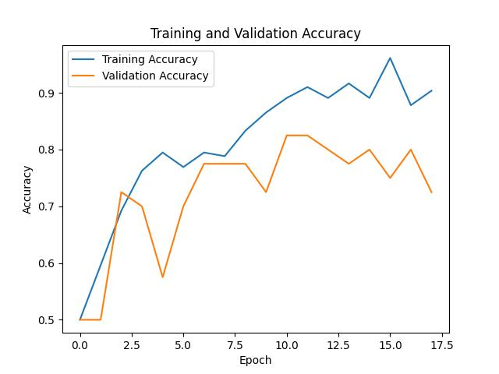
Figure 5.1 Training and Validation Accuracy for proposed model

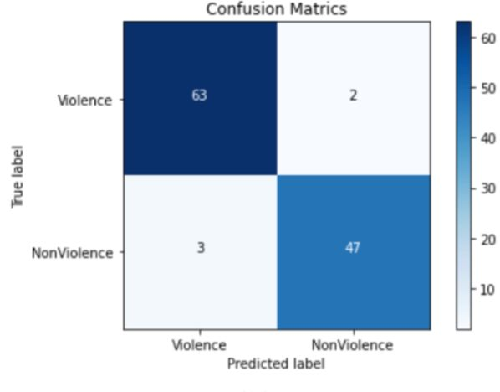
Figure 5.2 Confusion Matrix for proposed model.

Training Overview of Hybrid Model (CNN & LSTM)

The Training Overview was mentioned in 17 epoch, with key metrics being accuracy, loss, validation accuracy and validation loss. The model showed a consistent improvement in performance metrics over time.

Key Epoch (Epoch 10)
At epoch 10, the accuracy was higher compared to previous epochs. Here are the detailed metrics for epoch 10:
Accuracy: 0.8073
Loss: 0.4549
Validation Accuracy: 0.9250
Validation Loss: 0.3685

Performance Trends
Accuracy and Validation Accuracy:
Training Accuracy: The training accuracy started at 0.6045 and improved steadily, reaching peak of 0.9468 by epoch 17.
Validation Accuracy: The validation accuracy started at 0.5750 and improved steadily, reaching peak of 0.9250 by epoch 10.
Loss and Validation Loss:
Training Loss: The Loss decreased progressively from 0.6750 at epoch 1 to 0.1568 by epoch 17 indicating better performance and less error over time.
Validation Loss: The Loss decreased progressively from 0.6807 at epoch 1 to 0.3685 by epoch 10, before fluctuating slightly but remain low.

Result comparison Of Deep Learning Models

Method | Accuracy
CNN | 90.77%
Hybrid (CNN & LSTM) | 86.73%
Table 5.7 Comparative Analysis for Accuracies

Deployment
The Development process of my application involves several key steps to ensure its functionality and usability. Below is an overview of how I constructed the application.

Application Architecture

I began by defining the architecture of my application. My choice of StreamLit provided a straightforward approach to building interactive Web Applications on Python.

GUI Design
The graphical user interface design is done on the Figma application. This application designs prototypes of the App Interfaces. Which helps in giving a general idea of how the model works.

User Authentication Flow
The user interface for the violence detection application is intuitively designed, ensuring ease of access and simplicity in navigation. As illustrated in Figure 5.3, the login and signup screens form the gateway to the application. These screens are crafted to provide a user-friendly experience, emphasizing security and efficiency. When the app opens it leads to the login screen. This gives the user who already has accounts with us the ability to easily login and gain access to the app’s functionalities. On the other hand, for the user who doesn’t have an account, yet it leads to the signup screen. This screen was also made to be hassler-free and easy to understand and follow. The information required here is the basic need for account creation and nothing more. This is to ensure that the user gets to the app’s main functionality of violence detection and monitoring in just minutes after the app installation. Both the login and signup screens ensure high safety standards and secure user information from unauthorized access while still being hassle free.
.


Figure 5.3 App User Login and Registration Screens

User Dashboard Flow

The home screen of the violence detection app, shown in Figure 5.4, beautifully balances simplicity and user-focused design. At the top, you’ll find two prominent buttons: 'Upload Video' and 'Connect to CCTV'. These are strategically placed for quick access, making it easy for users to either upload videos for analysis or connect the app to a CCTV feed for real-time monitoring. Just below these main options is the 'History' section, organized in a recycler view. This area keeps a chronological log of previously uploaded videos, allowing users to easily revisit and review past analyses.
For even better navigation, the bottom bar features three intuitive buttons: 'Home', 'Saved', and 'Profile'. 'Home' takes users back to the main dashboard, 'Saved' gives access to bookmarked or significant analyses, and 'Profile' allows users to manage their account settings. Every element on the home screen is thoughtfully placed, ensuring a seamless and interactive user experience that prioritizes quick access to the app’s essential features.


Figure 5.4 Dashboard Screens

User Upload Video Flow

In figure 5.5, we identify or differentiate the uploading video flow of the violence detection app. 23, is based on the propositions of convenience and simplicity of the operations of a user. From the home screen, users can choose to upload a video by moving over a tab that leads to a menu containing options that users can easily click through to choose a video on the device to upload. After selecting a video, there is an analysis tab which shows a ’Start Analysis’ button. Pressing this button starts the app’s backend operations, where users are provided with the updates of the process progress. It is important for this process to be user friendly and as quick as possible throughout the process of choosing a video to use to actually running the analysis.

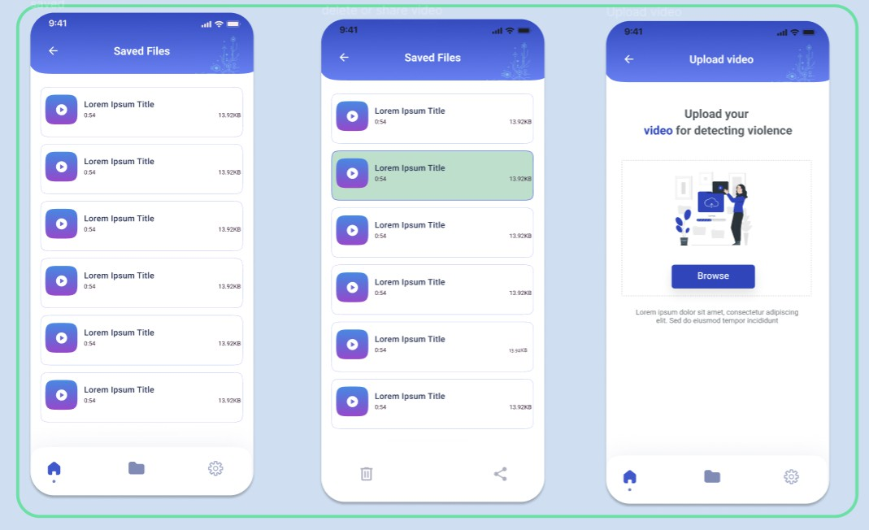
Figure 5.5 Upload Video Screens

User Upload Video Flow

The profile flow of the violence detection app is intended to generate a high level of complexity yet an easy to use LES application for violence detection among the users. Integral to this flow is the Profile screen; from here it remains in simple and efficient manner with the help of the ‘Edit Profile’ option to view and change the information. It also facilitates a ‘Logout’ option to log off securely, a ‘Change Password’ option to ensure better account security, and options to set ‘Push Notification’ to update the users. However, there is an access to a section called ‘Support,’ so the users have all the instruments they need for comfortable and individual using of the app.

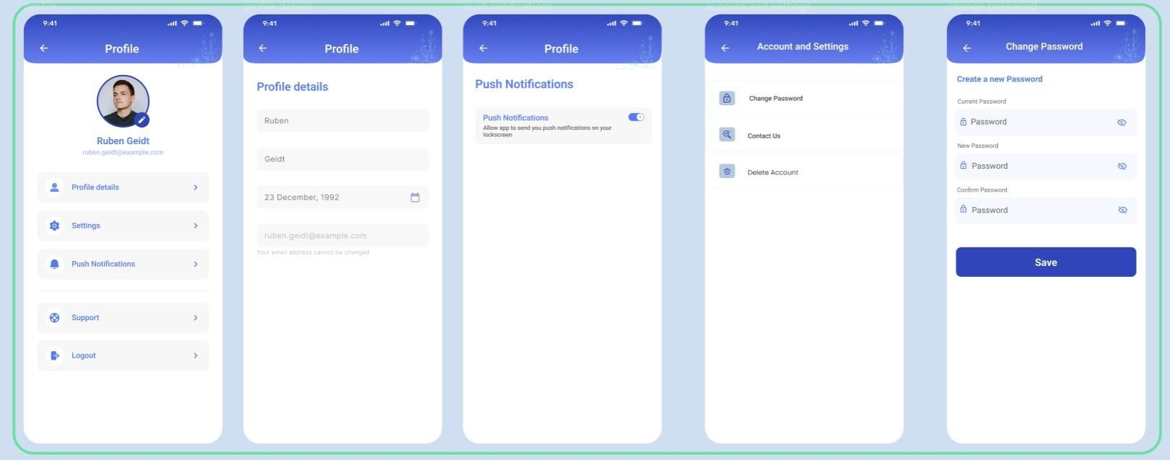
Figure 5.6 Upload Video Screens

CONCLUSION AND RECOMMENDATIONS

Conclusion

The overall process of designing and testing the Crowd Surveillance Behaviour Analysis Based Violence Detection System has provided useful information regarding the improvement of security in crowd areas specifically within Pakistan’s cultural setting. Our main objective was to develop a reliable system of detecting violent activities in real time while utilizing the available CCTV networks and modern deep learning algorithms. Some of the shortcomings of incumbent surveillance solutions exposed by our investigation were outdated methods of detecting violent cases and inadequate consideration of cultural background. To fill these gaps, the following recommendations were proposed: Real time CCTV surveillance, surveillance video review and security database administration.
The experimental outcome showcased that recent cutting-edge deep learning techniques in Computer Vision such as CNNs and the combined CNN-LSTM are highly viable for violence detection. Average detection accuracy of the developed system was 80. 70% real life situations with least delay, it reveals the possibility of timely actions to prevent violence. It also kept high accuracy when identifying pre-recorded videos to cement its relevance when reviewing events after they have occurred. Thus, with the help of the CNN model, the highest accuracy of 90% was obtained at the end. During the training, the models achieved 77% accuracy, and the Best performing model was the MobileNet V2 based hybrid CNN-LSTM model which was able to score the state-of the-art results emphasizing on the integration of spatial and temporal approaches for violence detection.
The performance of the system was evaluated in various settings based on lighting conditions and density of the crowd and it produced good, stable results emphasizing on the durability and real-world applicability of the system. The Crowd Surveillance Behaviour Analysis Based Violence Detection System is comparatively a new addition to the existing security solution system, as it more effectively uses the deep learning approach to identify and prevent violent behaviour. Thus, lowering current shortcomings and expanding the system’s potential through future studies, the proposed approach will seek to increase public area’s safety and security, and as a result, foster the wellbeing of communities globally.

Future Work

Improvements of the subsequent developments of this system can entail appropriate techniques to obscure the identities in videos in order to guarantee people’s confidentiality. Just as if you drape a neighbour in a blanket, you know there is a person there, but who is hard to identify. Currently, the system only speaks through video; however, envision a way for it to also hear and have touch. It can be made even better to spot violence and not mistake it for something else if features like analysing sounds or even heat signatures are added. Unimaginable this system working in any part of the world, regardless of the language that is spoken or the culture practiced. Therefore, by making it adaptable, it could be greatly useful to a lot of people globally.

REFERENCES

[1] X. Yang, Y. Yu, J. Gu, Y. Zhou, and J. Yuan, "Learning Spatio-Temporal Features with Enhanced DenseNet for Violence Detection," in IEEE Transactions on Circuits and Systems for Video Technology, vol. 30, no. 12, pp. 5233-5246, Dec. 2020.
[2] S. Sharma, S. Kumar, A. Sinha, and H. D. Cheng, "Violence Detection in Videos Using 3D Dense Convolutional Networks," in IEEE Transactions on Image Processing, vol. 27, no. 8, pp. 3832-3843, Aug. 2018. [This paper investigates the effectiveness of 3D DenseNets for violence detection, comparing it to other architectures.]
[3] J. Li, S. Zhang, and L. Sun, "Efficient Violence Detection Using 3D Convolutional Neural Networks," in 2019 16th IEEE International Conference on Advanced Video and Signal Based Surveillance (AVSS), pp. 1-5, doi: 10.1109/AVSS.2019.8909883.
[4] M. Sultana, S. Rehman, S. A. Khan, and M. Shah, "Violence Detection Using 3D Convolutional Neural Networks," in 2018 IEEE International Conference on Image Processing (ICIP), pp. 3313-3317, doi: 10.1109/ICIP.2018.8503056.
[5] M. Barkat and P.K. Varshney, On Adaptive Cell-Averaging CFAR Radar Signal Detection, Technical Report, RADC-TR-87-160, Rome Air Development Center, Air Force Systems Command, Syracuse, NY., April 1987.
[6] L. G. Kraft, a Device for Quantizing, Grouping and Coding Amplitude Pulse, MS Thesis, Department of Electrical Engineering, MIT, Cambridge, MA, 1965
[7] A. Bulling, I. Dragone, and N. Güler, "Violence detection in crowded scenes by pedestrian behavior analysis," in Pattern Recognition Letters, vol. 30, no. 4, pp. 391-398, 2009.
[8] .Liu, M. Dou, Y. Liu, Y. Wang, and S. Yan, "Violence detection using adaptive spatio-temporal features," in 2013 IEEE International Conference on Multimedia and Expo (ICME), pp. 221-226, IEEE, 2013.
[9] M. Munim, T. Islam, and S. -F. Li, "Violence Detection in Videos Using Spatio-Temporal Features and Deep Learning," in 2016 IEEE International Conference on Image Processing (ICIP), pp. 3347-3351, IEEE, 2016.
[10] Majeed, A., & Lee, S. (2020). Anonymization techniques for privacy preserving data publishing: A comprehensive survey. IEEE access, 9, 8512-8545.
[11] Giannaros, A.; Karras, A.; Theodorakopoulos, L.; Karras, C.; Kranias, P.; Schizas, N.; Kalogeratos, G.; Tsolis, D. Autonomous Vehicles: Sophisticated Attacks, Safety Issues, Challenges, Open Topics, Blockchain, and Future Directions. J. Cybersecur. Priv. 2023, 3, 493-543. https://doi.org/10.3390/jcp3030025
[12] Baranowski, P., Mazurek, W., Wozniak, J., & Majewska, U. (2012). Detection of early bruises in apples using hyperspectral data and thermal imaging. Journal of Food Engineering, 110(3), 345-355.
[13] Smith, H. R., Zitterbart, D. P., Norris, T. F., Flau, M., Ferguson, E. L., Jones, C. G., ... & Moulton, V. D. (2020). A field comparison of marine mammal detections via visual, acoustic, and infrared (IR) imaging methods offshore Atlantic Canada. Marine Pollution Bulletin, 154, 111026.
[14] Hampapur, A., Brown, L., Connell, J., Pankanti, S., Senior, A., & Tian, Y. (2003, December). Smart surveillance: applications, technologies and implications. In Fourth International Conference on Information, Communications and Signal Processing, 2003 and the Fourth Pacific Rim Conference on Multimedia. Proceedings of the 2003 Joint (Vol. 2, pp. 1133-1138). IEEE.
[15] Jain, A., Basantwani, S., Kazi, O., & Bang, Y. (2017, February). Smart surveillance monitoring system. In 2017 International Conference on Data Management, Analytics and Innovation (ICDMAI) (pp. 269-273). IEEE.

