

BSCS-F23-013
03-134202-088 | Usman Muhammad Jahangir Alvi
03-134202-083 | Syed Daniyal Ahmed
Harvest Link (Blockchain in Agriculture Supply Chain)
In partial fulfilment of the requirements for the degree of
Bachelor of Science in Computer Science
Supervisor: Muhammad Sauood
Department of Computer Sciences
Bahria University, Lahore Campus

June 2024

© Bahria University, 2024

Certificate


We accept the work contained in the report titled
“Harvest Link (Blockchain in Agriculture Supply Chain)”
written by
Usman Muhammad Jahangir Alvi
Syed Daniyal Ahmed

as a confirmation to the required standard for the partial fulfilment of the degree of
Bachelor of Science in Computer Science.

Approved by:
Supervisor: Muhammad Sauood
(Signature)

June 15, 2024

DECLARATION

We hereby declare that this project report is based on our original work except for citations and quotations which have been duly acknowledged. We also declare that it has not been previously and concurrently submitted for any other degree or award at Bahria University or other institutions.

Enrolment | Name | Signature
03-134202-088 | Usman Muhammad Jahangir Alvi
03-134202-083 | Syed Daniyal Ahmed

Date : June 15, 2024

Specially dedicated to
our beloved grandmother, mother and father
Usman Muhammad Jahangir Alvi and Syed Daniyal Ahmed

ACKNOWLEDGEMENTS

We would like to thank everyone who had contributed to the successful completion of this project. We would like to express our gratitude to my project supervisor, Mr Muhammad Sauood for his invaluable advice, guidance and his enormous patience throughout the development of the project.

In addition, we would also like to express my gratitude to our loving parent and friends who had helped and given me encouragement.

Syed Daniyal Ahmed Shah
Usman Muhammad Jahangir Alvi

Harvest Link (Blockchain in Agriculture Supply Chain)

ABSTRACT

The agricultural supply chain (hereafter ASC) is the key to economies around the world, it allows multiple industries to grow globally and has many players starting with farmer down to final consumer. The ASC, despite its criticality to the process, encounters challenges such as wastage and frauds due to a lack of transparency. This project endeavors to fully tackle these issues as they bear a significant relevance in terms of food security, fair trade, and the implications for all those involved. The project aims to develop trust strengthening accountability of the food as well as quality and safety assurance for consumers through utmost transparency in its sourcing. Proposing the use of Blockchain technology to create an immutable ledger in which tracking movements, transactions and the handling of data would reinforce the integrity at all steps in a supply chain. Added benefit, adding AI for real-time analysis of generated data provides better transparency to all the dealing occurring in the supply chain.

Even though blockchain and AI contain huge potential to shape the industry in a positive way there are still some issues that needs to be addressed to ensure proper utilization of the technology namely being educational gaps and governmental policies. Despite this combination of these technologies creates a promising solution to create a robust, transparent, and accountable environment in the supply chain. Efforts need to be made to overcome these challenges and promote widespread adoption among farmers and stakeholders, aiming to realize the envisioned positive impact on the agricultural sector.

TABLE OF CONTENTS

DECLARATION ii
ACKNOWLEDGEMENTS iv
ABSTRACT v
TABLE OF CONTENTS vi
LIST OF TABLES ix
LIST OF FIGURES x
LIST OF SYMBOLS / ABBREVIATIONS xiii
LIST OF APPENDICES xiv

CHAPTERS
1 INTRODUCTION 1
1.1 Problem Statements 1
1.2 Aims and Objectives 2
1.3 Scope of Project 3
2 LITERATURE REVIEW 4
2.1 Related Works 4
3 SOFTWARE RESOURCE DOCUMENT 6
3.1 Application Detail 6
3.2 Actors 6
3.3 Functional Requirements 8
3.4 Non Functional Requirements 10
4 METHODOLOGY 12
4.1 Sequence Diagram 15
4.2 Use Case Diagram 22
4.3 Activity Diagram 27
4.4 Database ERD 28
5 IMPLEMENTATION 32
5.1 Scrum Model 32
5.2 Languages Used 34
5.2.1 React.js 34
5.2.2 CSS 34
5.2.3 Tailwind 34
5.2.4 Laravel 10 34
5.2.5 Solidity 35
5.2.6 MySQL 35
5.3 Tools Used 35
5.3.1 Xampp Local Server 35
5.3.2 Sepolia Blockchain 36
5.3.3 Web3.js 36
5.3.4 Meta Mask Wallet 37
5.3.5 Remix Development 37
5.3.6 Etherscan Live Check Contract 38
5.4 AI Model 38
5.4.1 Data Set 39
5.4.2 Data Preparation 40
5.4.3 Model Selection and Evaluation 40
5.4.4 Conclusion 40
6 USER MANUAL 41
7 CONCLUSION AND FUTURE WORKS 55
7.1 Conclusion 55
REFERENCES 56
APPENDICE 58

LIST OF TABLES

TABLE TITLE PAGE
Table ‎2.1: Literature Review 4
Table ‎3.1: Actor Description Access 7
Table ‎3.2: Functional Requirement 9
Table ‎3.3: Non-Functional Requirement 10

LIST OF FIGURES

FIGURE TITLE PAGE
Figure ‎4.1:Standard Supply Chain 12
Figure ‎4.2:Blockchain Integrated Supply Chain 13
Figure ‎4.3:Harvest Link Architecture Diagram 14
Figure ‎4.4: User Signup 15
Figure ‎4.5: Admin Create User Account 16
Figure ‎4.6: User Login 17
Figure ‎4.7: User Interaction Invoice, Blockchain, Statistics 18
Figure ‎4.8: Marketplace Sales and Purchase 19
Figure ‎4.9: Inspection and Certification 20
Figure ‎4.10: Requesting Driver 21
Figure ‎4.11: User Login/Register 22
Figure ‎4.12:Admin Use Case 23
Figure ‎4.13: Farmer 24
Figure ‎4.14: Manufacturer 25
Figure ‎4.15: Shipping Company 26
Figure ‎4.16: Activity Diagram 27
Figure ‎4.17: Database ERD 28
Figure ‎5.1:Scrum Model Flow 32
Figure ‎6.1: Home Page 41
Figure ‎6.2: Signup Page / Book Appointment Page 41
Figure ‎6.3: Login Page 42
Figure ‎6.4: Forgot Password 42
Figure ‎6.5: New Password 43
Figure ‎6.6: Admin Home Page 43
Figure ‎6.7: Create User 1 44
Figure ‎6.8: Create User 2 44
Figure ‎6.9: Create User 3 45
Figure ‎6.10: Create User 4 45
Figure ‎6.11: Admin Landing 46
Figure ‎6.12: Appointment Page 46
Figure ‎6.13: Manufacture Landing 47
Figure ‎6.14: Manufacture Create 47
Figure ‎6.15: Manufacture Create 2 48
Figure ‎6.16: Manufacture Create 3 48
Figure ‎6.17: Farmer Home Page 49
Figure ‎6.18: Farmer Landing 49
Figure ‎6.19: Farmer Landing 2 50
Figure ‎6.20: Farmer Create 50
Figure ‎6.21: Add Crop to Market Place 51
Figure ‎6.22: Add Crop to Market Place 2 51
Figure ‎6.23: Crop Create 52
Figure ‎6.24: Market Place 52
Figure ‎6.25: Order Page 53
Figure ‎6.26: Product Page 53
Figure ‎6.27: Inspection Request 54
Figure ‎6.28: Inspection Landing 54

LIST OF SYMBOLS / ABBREVIATIONS

SQL Structured Query Language
CSS Cascading Style Sheet

LIST OF APPENDICES

APPENDIX TITLE PAGE
Appendix A: Languages Links 59
Appendix B: Tools Links 60

INTRODUCTION

Problem Statements

Presently the agricultural supply chain has many transparency issues, which pose significant challenge to global food ecosystem. The lack of transparency and data processing within supply chain give rise to issues that resonate across food security, fair trade and the livelihood of countless stakeholders [1].
Key issues raised due to lack of transparency include:
- Limited Consumer Information: consumer are unaware of the content of the food being consumed such as,
  - Is the food organic?
  - What kind of pesticide is used?
  - What kind of fertilizer is used?
- Supply Chain Fraud: Fraud is a big problem in the supply chain. Many people take advantage of others by lying about the amount of goods being sold or tampering with the goods to make more money.
- Inefficiencies in the Supply Chain: The large scale of supply chain due to numerous stakeholders’ involvement causes inefficiencies that results in operational delays, food spoiling.
- Income inequality: The complexity of supply chain leads to income inequality this occurs due to intermediaries taking advantage of the hardworking farmer by paying them less than the market value of their harvest and selling it on intended price to the market.
- Food Safety Compliance: Compliance to high levels of food safety standards in agri-food chain difficult to Pin Down and enforce [3]. Use of blockchain makes the food chain safer and its products traceable. In particular, it offers a safe means of handling data, which is beneficial for implementing and adapting data-based innovations in the field of benchmark crop insurance and smart farming. It can also decreases the transaction costs that in turn enhance the access to markets by the farmers and hence results to other sources of income [10].

Nevertheless, there is one major disadvantage in this supply chain, and that is the vulnerability of the system to players who only want to make profits from it, through the use of intermediaries. This vulnerability is further compounded by the absence of efficient integration of information flow, which in effect, opens up supply chain vulnerabilities or possibilities for meddling. Another problem of fake documents is that they are easy to produce and again the fraudulent people are benefiting from this sector.

Aims and Objectives

The objectives of the project are shown as following:
- Address pervasive transparency issues in the agricultural supply chain system.
- Enhance consumer information regarding the origin and quality of food products.
- Combat supply chain fraud to mitigate health hazards and financial losses.
- Reduce inefficiencies within the supply chain which are caused by operational delays.
- Reduce income inequality by simplifying supply chain processes and reducing opportunities for exploitation.
- Illustrate the journey of crops from farmer to consumer, highlighting every stockholder involvement along with their contribution to the supply chain.
- Prevent intermediaries’ exploitation of hardworking people for large profits [1].
- Ensure food safety measure are implemented strictly along with development of technological solutions [3].
- Reduce the likelihood that supply chain fraud and tampering [1, 13].
- Utilize blockchain technology to improve data management, traceability, and food safety [10].

Scope of Project

Our main objective for this project is to incorporate blockchain technology to develop a globally available and secure supply chain system that will be invulnerable to alteration and manipulation. This makes enables us to monitor and maintain the state of farm as required from time to time. AI is used for analysing and predicting such data, whenever present. The proposed platform will be based on the blockchain to allow interested stakeholders to access the latest information about production, processing, and transportation of the agricultural produce.

As mentioned earlier, there are certain special aspects that need this kind of approach. First, the supply chains of agricultural products often cause wastage of resources and are costly due to inexplicable situations. Secondly, consumers today are more conscious about foods they consume and the quality and safety of these foods than ever before, thus there is a need to determine the origin of agricultural produce using a system that will do this as soon as possible. Third, issues of social justice and balance as well as responsibility regarding fair trade need to be addressed to ensure proper compensation of farmers and viable prices. Fourth, the threats to the increase of counterfeit products and fake business mean that a system through which the validity of a product is established is essential. In conclusion, it is only when the supply chain is operating as efficiently as possible that transport routes can be aligned to achieve the necessary amount of sustainable carbon footprint reduction to combat the environment problem.

LITERATURE REVIEW

Related Works

Table ‎2.1: Literature Review
Title | Content | Reference
Blockchain in Agriculture Traceability Systems | - Investigates blockchain's potential in enhancing traceability in agri-food.  - Reviews scientific papers, technical publications, and blockchain-integrated systems.  - Provides taxonomy and historical summary, categorizing studies based on smart contract usage.  - Examines definitions, methods, and benefits of traceability.  - Utilizes interpretive structural modeling and DEMATEL approaches.  - Identifies barriers and challenges, emphasizing ongoing research needs. | [2]
A Survey on the Role of IoT in Agriculture for the Implementation of Smart Farming | - Analyzes IoT-based smart farming's benefits including improved crop yields and efficiency.  - Surveys IoT technologies, data analytics, framework construction, and challenges.  - Highlights barriers such as implementation costs, farmer knowledge, security concerns, and regulations. | [4]
A Blockchain-Based Framework to Make the Rice Crop Supply Chain Transparent and Reliable in Agriculture | - Introduces blockchain framework for rice supply chain transparency.  - Surveys blockchain's impact on agriculture, emphasizing traceability and IoT.  - Describes framework aims, architecture, and implementation stages.  - Identifies potential issues in technology acceptance, cost, data consistency, and regulations. | [5]
Blockchain-Based Soybean Traceability in Agricultural Supply Chain | - Provides overview of research, system design, and critical barriers.  - Cites relevant literature and identifies scalability, governance, privacy, and regulatory challenges.  - Emphasizes need for addressing challenges for effective blockchain integration. | [6]
Agriculture Supply Chain Management Based on Blockchain Architecture and Smart Contracts | - Explores IoT-based smart farming technologies and challenges.  - Proposes blockchain architecture for data integrity and security in agriculture.  - Addresses challenges such as data organization, security, integration, and regulations. | [7]
Blockchain and agricultural supply chains traceability: research trends and future challenges | - Reviews research trends and applications of blockchain in agriculture.  - Emphasizes potential benefits in traceability and transparency.  - Highlights lack of real-world case studies and economic benefits.  - Identifies constraints and problems, emphasizing need for further research and real case studies. | [8]
A blockchain maturity model in agricultural supply chain | - Introduces SWARA maturity model for blockchain in agriculture.  - Evaluates maturity and identifies challenges such as technical complexity and regulatory ambiguity.  - Involves agricultural experts in methodology and real-world testing.  - Provides insights for decision makers and practitioners to overcome challenges and implement blockchain in agriculture. | [9]

Table 2.1 Demonstrates an analysis of several different journals that cover similar scenario implementation using blockchain and the different way they portray the concept. The following table contains the title of the aforementioned journals described only with short bullet points.

SOFTWARE RESOURCE DOCUMENT

Application Detail

The application functions as an e-commerce platform facilitating the buying and selling of various categories of goods and services within the agricultural supply chain. It leverages blockchain technology by recording each official transaction to the system allowing other users to see its authenticity. The platform will provide real-time information to stakeholders regarding the origin, quality and movement of agricultural products. Along with this embedded AI model in the program allows analysis and prediction of different data which will help optimize the and improve supply chain by improving decision-making processes. Additionally, the program will aim to have unique and improved user experience to allow ease of adaptability.

Actors

Table 3.1 Demonstrates different actors and their responsibilities along with their ability to access different use cases. It helps in understanding what role each actor plays alongside specific they can access in the system

Table ‎3.1: Actor Description Access
Role | Responsibilities | Accessibility
Admin | - Can create new user accounts  - Can deactivate user accounts  - Can suspend user accounts  - Monitor different criteria of application  - Can provide online assistance  - Can have full control of application  - Can see active deals being made | Administrator,  Farmer,  Marketplace,  Driver,  Manufacturer,  Shipping Company,  Inspection,  Routes Invoice,  Blockchain Records,  Statistics,
Farmer | - Can add harvested crops to database  - Can buy/sell item on market place  - Can request inspection/certification from government agencies  - Can monitor, analyse and predict future market using statistics  - Can monitor blockchain records  - Can track and trace deliveries  - Can review invoices | Farmer,  Marketplace,  Inspection,  Invoice,  Blockchain,  Records,  Statistics,
Manufacturer | - Can buy/sell from market place  - Can manufacture new products from the raw materials purchased  - Can request inspection/certification from government agencies  - Can monitor blockchain records  - Can track and trace deliveries - Can review invoices | Marketplace,  Manufacturer,  Inspection,  Invoice,  Blockchain,  Records,  Statistics
Shipping Company | - Can buy/sell from market place  - Can deliver products from one point A to B  - Can request inspection/certification from government agencies  - Can monitor blockchain records  - Can track and trace deliveries  - Can create new Routes for the deliveries | Marketplace,  Driver,  Shipping Company,  Inspection,  Routes,  Invoice,  Blockchain  Records,  Statistics
Driver | - Can deliver products from one point A to B  - Can track and trace deliveries | Driver,  Routes,  Statistics
Agent | - Inspect the requested areas to certify and clear whether the product meets the standards set by regulatory bodies | None
Government | - Control/Regulate the Supply Chain  - Predict market situation  - Control pricing of product  - Future planning for the nation | None

Functional Requirements

Table 3.2 highlights the functional requirements that are applied in systems which are crucial to the successful implementation of the project. These requirements define the expected patterns of user interaction and the characteristics of the to-be-delivered application, which are required to adequately support users and achieve project goals. They act more like a plan and reference to follow regarding the proper development of the product since it is intended to achieve a certain purpose and fulfil certain objectives.
Table ‎3.2: Functional Requirement
ID | Feature | Description
FR01 | User Registration | - Users should be able to create accounts by providing necessary information such as name, email, contact details, and NIC number.  - Registration should include validation checks to ensure data accuracy and security.
FR02 | User Login | - Register should provide email and password to login.  - The system authenticates user and logs in securely.
FR03 | Product Listing | - Seller should be post the product on to the market place once the product is in system and available.  - Listing should be user-friendly and detailed to ensure seller and purchaser understand the product thoroughly.
FR04 | Product Insertion | - Seller should be able to add product to his account.  - Seller should ensure filling out necessary fields such as product name, quantity, type, quality (if any assessed), price, etc. relevant fields.  - The insertion process should have verification and validation to ensure right input data.
FR05 | Payment Processing | - The platform should provide a secure gateway for payment processing.  - Payment methods to be accepted VISA, DEBIT, CREDIT, PAYPAL, CRYPTO.  - Industry standard security protocol to process payments
FR06 | Shipping/Delivery | - The customers should have the freedom to choose the particular shipping method they want for their orders; the delivery locations should also be made available.  - A feature of the platform should include realistic charges such as weight, distance of delivery and the shipping company.  - Consumers want to be informed about changes in the status and availability of the order and delivery status.
FR07 | Data Analytics and Insights | - The platform should provide data analytics tools to track key metrics such as sales performance, customer behaviour, and inventory turnover.  - They must work on data to produce meaningful and helpful reports that can help in the formulation of better business strategies, decision making and to also help in the detection of opportunities and possible problems.

Non Functional Requirements

Table 3. 3 shows the interest that authorities have in the non-functional requirements in order to ensure the good outcome of the project. These requirements are generic in the sense that they are oriented towards a global vision of the characteristics of the system, without necessarily detailing its progression. They ensure that the designed system achieves the intended requirements for functionalities, security, expandability, and ease.

Table ‎3.3: Non-Functional Requirement
ID | Aspect | Description
NFR01 | Performance | - The platform should be able to handle a large number of concurrent users and activities without significantly reducing performance.  - Functional requirements include – response time for regular web traffic, search functionality of the site, and response time for initial and subsequent orders.
NFR02 | Security | - The platform should use industry-standard security methods to protect user data, financial transactions, and sensitive information.  - It comes down to preserving data confidentiality on the move and at the time of storage, strict identification and authorization procedures, protection from SQL injection and cross-site scripting (XSS) attacks, and security checks and penetration tests.
NFR03 | Scalability | - The platform should be designed to scale horizontally and vertically to meet growing user demands and datasets.  - It should be able to upscale matter effortlessly in terms of hardware resources, database storage capacity, and processing speeds or volume of capacity as the volume of users and thereby the resulting transactions rise.
NFR04 | Reliability | - The platform should have high dependability and uptime, with little unplanned downtime or service interruptions.  - It must include some sort of fault tolerance feature which may include things like redundant servers, has automatic failover mechanisms, and has other features like data backup frequently to ensure continuous use and data integrity.
NFR05 | Usability | - The platform should provide a user-friendly interface and intuitive navigation to enhance usability and accessibility for users of all skill levels.  - It should follow the principles of usability testing and guidelines of accessibility guidelines (e. g. , Safari and ensuring a good user experience across the website and various form factors suiting different accessibility needs of the users compliant with the World Wide Web Consortium’s Web Content Accessibility Guidelines <WCAG>)

METHODOLOGY

This section provides further and more detailed insight into exactly what the development process of the program entails, as well as details regarding the different phases of the program. The final argument for using figures and diagrams is that it enhances the comprehension of the development process where important elements of a project are illustrated. Our goal here is to provide a comprehensive view of the process at work by offering a systematic elucidation of the steps toward design, development, and implementation.

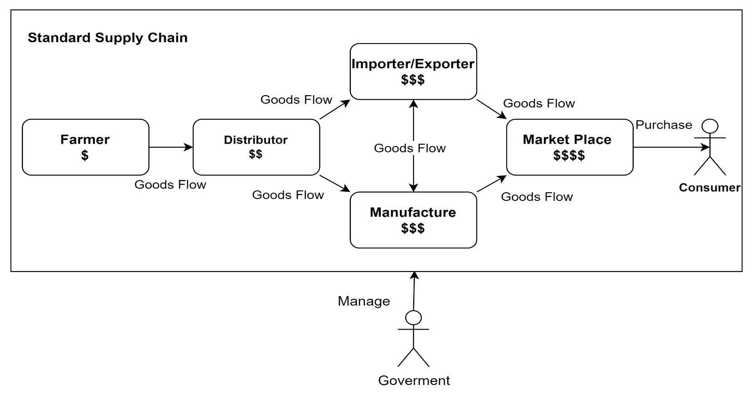
Figure ‎4.1:Standard Supply Chain
Figure 4. 1 shows the journey that crops take from getting into the hands of the farmer until it gets to the final consumer. At the beginning, the farmer prepares the land for raising crops but distributors interfere leveraging on their authority and sells the produce to manufacturers or shipping companies at an exorbitant rate. The companies mentioned further process these goods and this in a way contributes to the additional cost of the final product to the consumer. As such, the final cost of the product is raised considerably to levels which are than what is deemed optimal. In this supply chain system, the government plays the role of playing as a third party wanting to control this chain for greater efficiency.
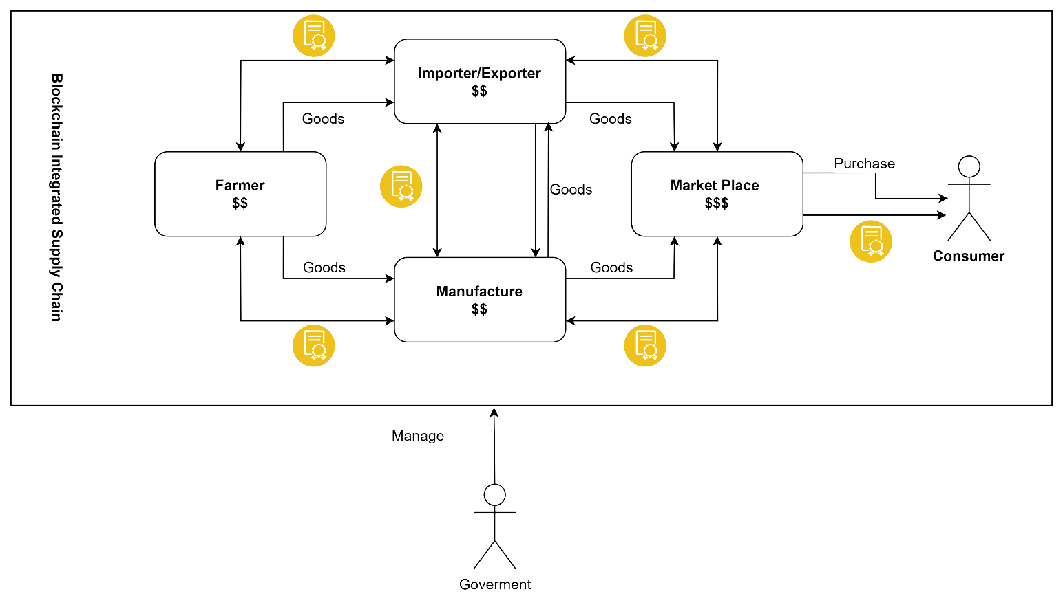

Figure ‎4.2:Blockchain Integrated Supply Chain

Figure 4.2 depicts the entire crop flow pattern right from the farmer up to the final consumer. Such features like use of Blockchain in the process add value to this journey as all transactions with related parties are recorded in block chain and are virtually irreversible. This integration thus allows effective handling of the pricing, quality and the governance factors right from across the ecosystem. To the consumers and stakeholders, openness allows for transparency that assists in the protection of authenticity of products.
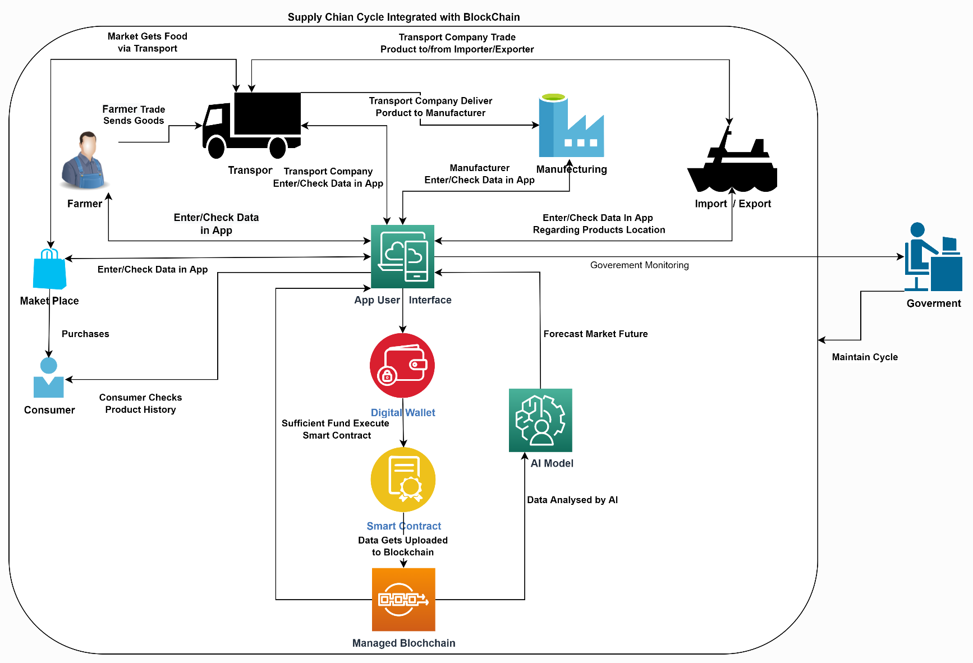
Figure ‎4.3:Harvest Link Architecture Diagram

Figure 4. 3 This shows the modus operandi of Harvest Link as shown below: It outlines all user and participant actions and communications; and, the purpose and supervision by government branches. The farmer goes through an exercise of putting the harvested produce in the application for sale before it is pushed to the marketplace for marketing. This information is then available to many different new stakeholders such as manufacturing companies and organizations that ship goods. The Acme manufacturers procure the products and ensure that they are transported to their final destinations. This is then followed by the final processing where raw materials are intensively refined to produce finished products for sale. These are then taken off the market and the final products are then repurchased and returned to the market. On the other hand, shipping companies provide an opportunity and responsibility for the transportation of goods, both locally and internationally, for better traffic and exchange.

Sequence Diagram
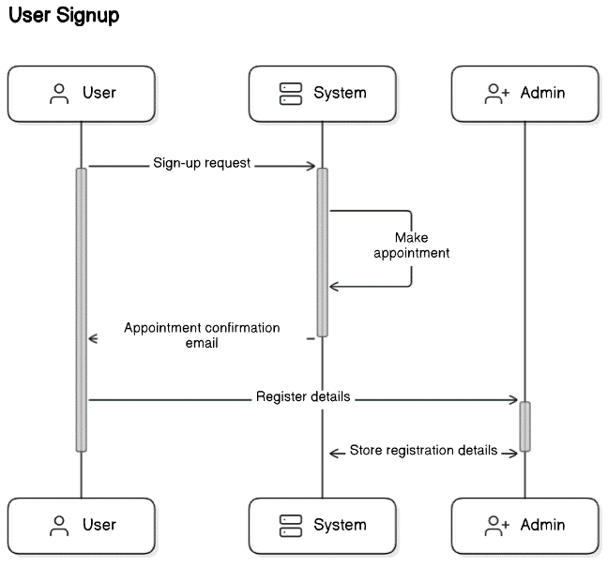

Figure ‎4.4: User Signup

Figure 4.4 Depicts user signup/registration. A user goes to registration page and choose a time to take an appointment. When the appointment is successfully registered, an email is also sent to administrators regarding the appointment details. User approaches the administrator and register to join the scheme by providing details. Data is entered and stored in the database. The registration process has been done.

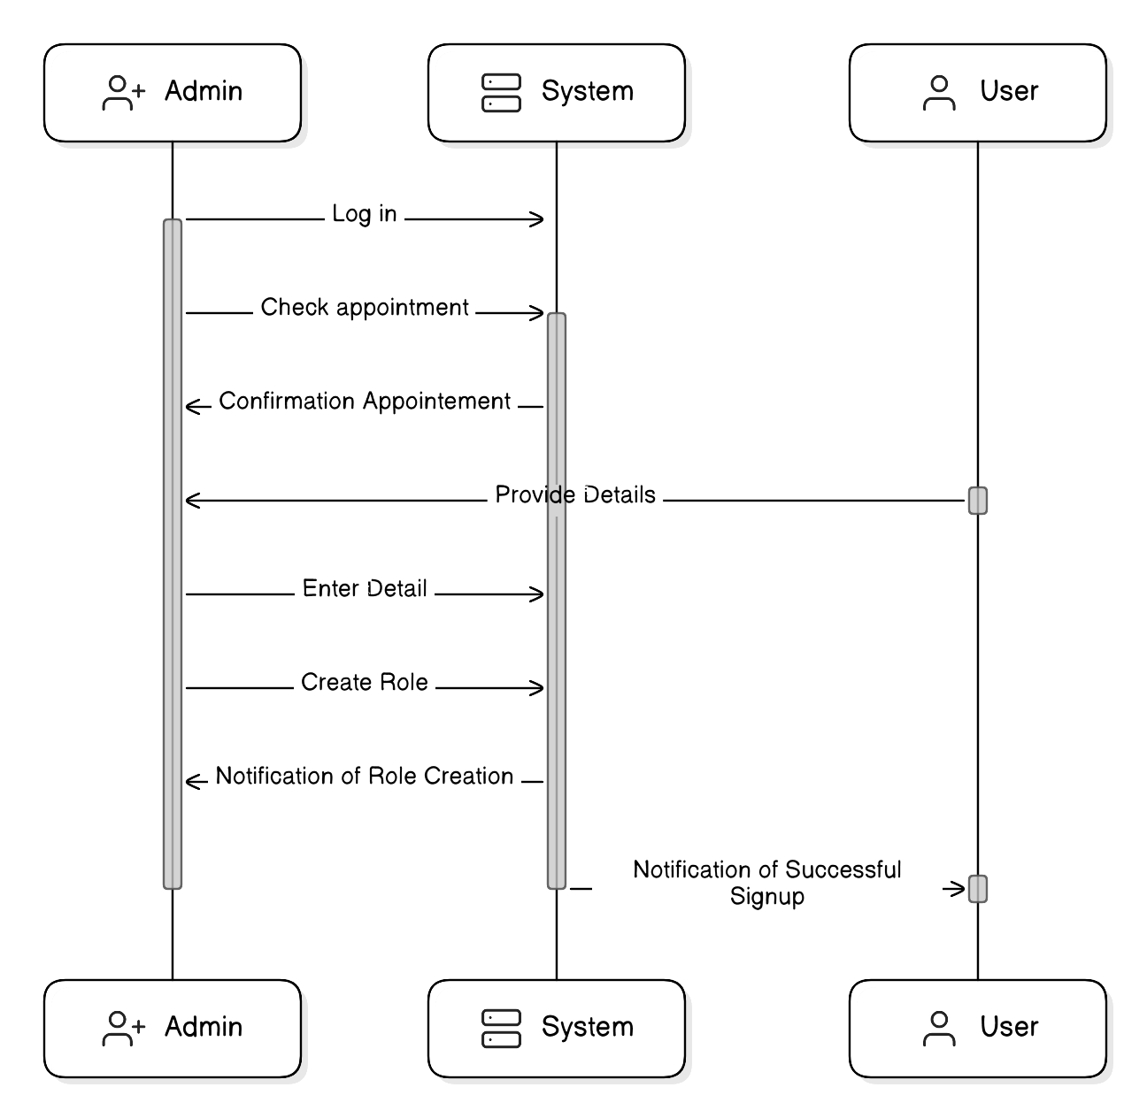
Figure ‎4.5: Admin Create User Account

Figure 4.5 Depicts user account creation: admin logs in to his account check available appointment, confirm appointment availability and visitation for the user. User comes to the site, submits it to admin, admin enters the data and creates a role for the user, System sends a message to the admin stating that the role has been successfully created and a message to the user stating that he has signed up successfully.
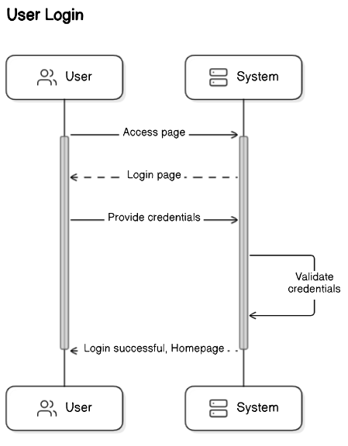

Figure ‎4.6: User Login

Figure 4.5 Depicts user access his account using credentials. A user accesses login page and enter account details in the login page and gets authenticated by the system. In case, the entered data are correct than the system approves the data and the user is logged in successfully.

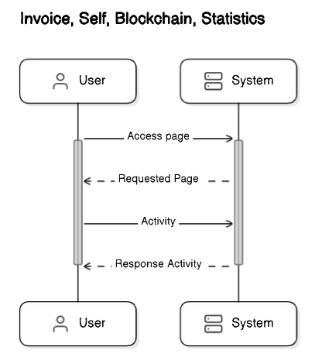

Figure ‎4.7: User Interaction Invoice, Blockchain, Statistics

Figure 4.6 Depicts user interface of Harvest Link that include the Invoice, Blockchain, Statistics where any user can view the status of each scenario. A user requests a specific page from the system and the system vice versa sends that particular page requested by the user to the user’s terminal. The user interacts with the system through the activity to system if relevant and the system gives the requisite answer.
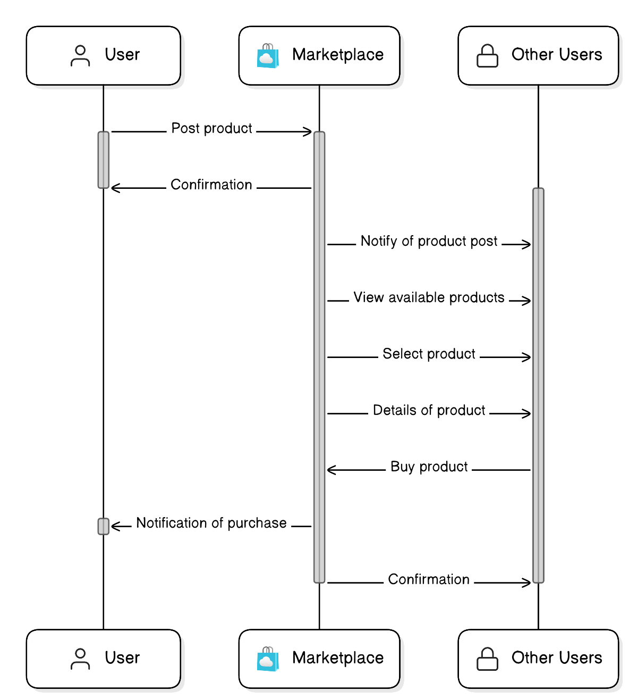

Figure ‎4.8: Marketplace Sales and Purchase

Figure 4.7 Depicts commerce interaction with the users in the marketplace. Another notable feature is that Marketplace lets users purchase or sell their products on their own. The target user submits a product for sale and then it is displayed to other user who uses the platform. A notification is made to the user when a product has been listed and other users can decide to view the product, select it and take an overview of the product. When a user purchases a product notice of this purchase is given to the user and the confirmation of this purchase is given to other user.

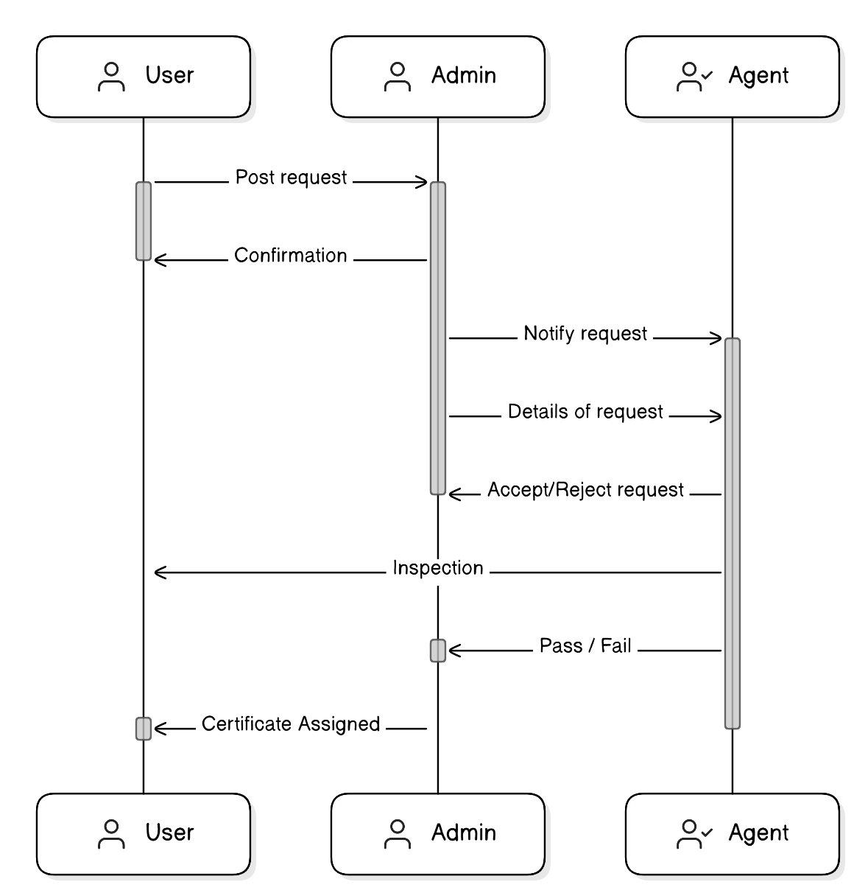

Figure ‎4.9: Inspection and Certification

Figure 4.8 Depicts the inspection/certification process for a user to have for the credibility of their businesses. User post requests for inspection/certification admin check and approves the requests and the confirmation is sent back to user. The admin notifies the agent of the request along with the details of the request. Individual agent can accept or deny said request. If the request is accepted the confirmation is sent to the user along with details of acceptance and rejection.

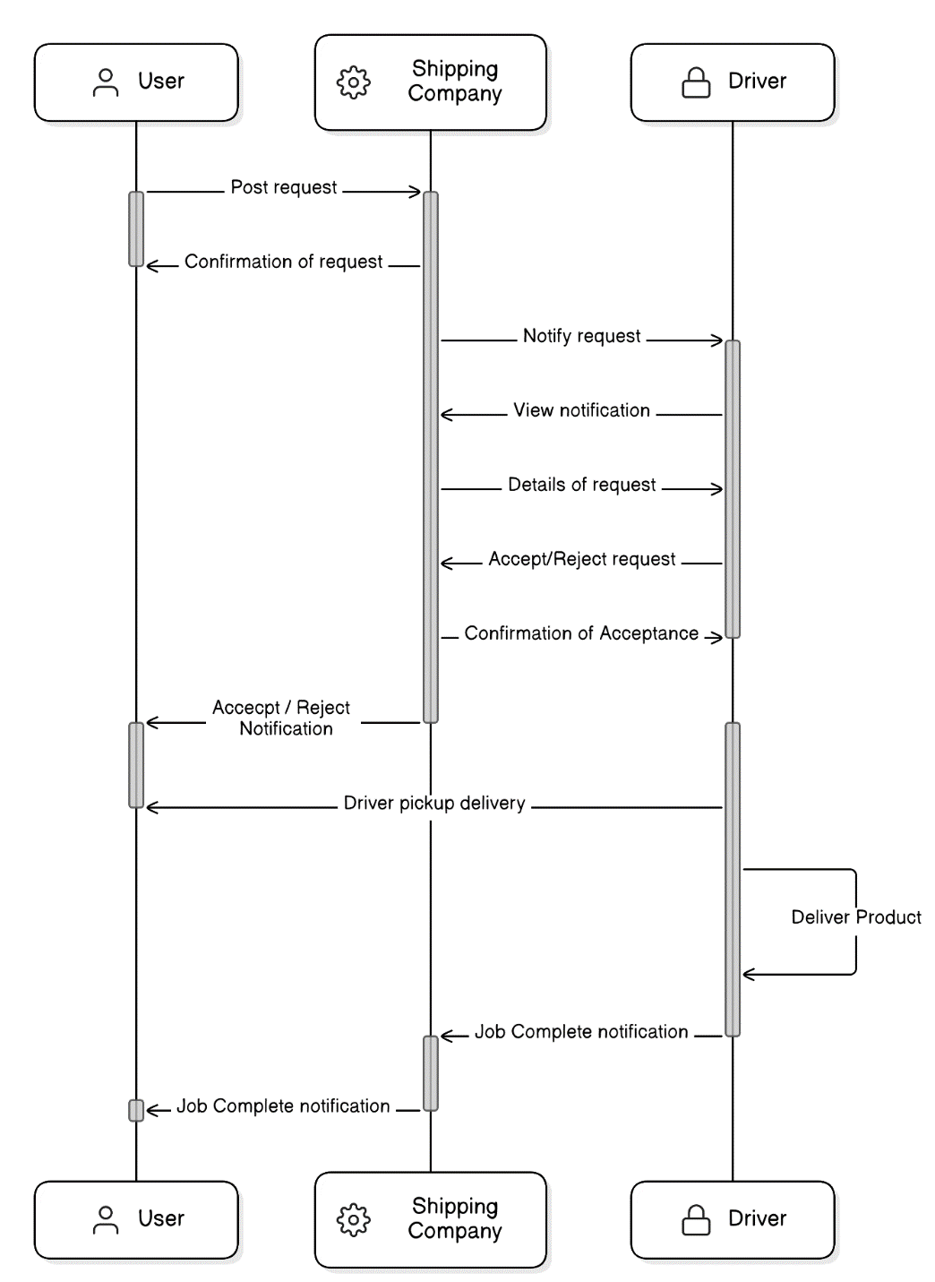
Figure ‎4.10: Requesting Driver

Figure 4. 10 Depicts the way in which the product gets to the hands of its new owner. A request is placed to the shipping company and in return the company acknowledges the requests, the company further posts the details of delivery to the drivers page, the driver is notified, the driver gets a view of the details of delivery in which the driver either accepts or rejects the job, the shipping company then confirms the acceptance and the notification is passed to the user about the status of the job, the driver picks up the product and delivers. Job completion notification is about the shipment of goods and is issued to the shipping company and consequently to the end user.

Use Case Diagram
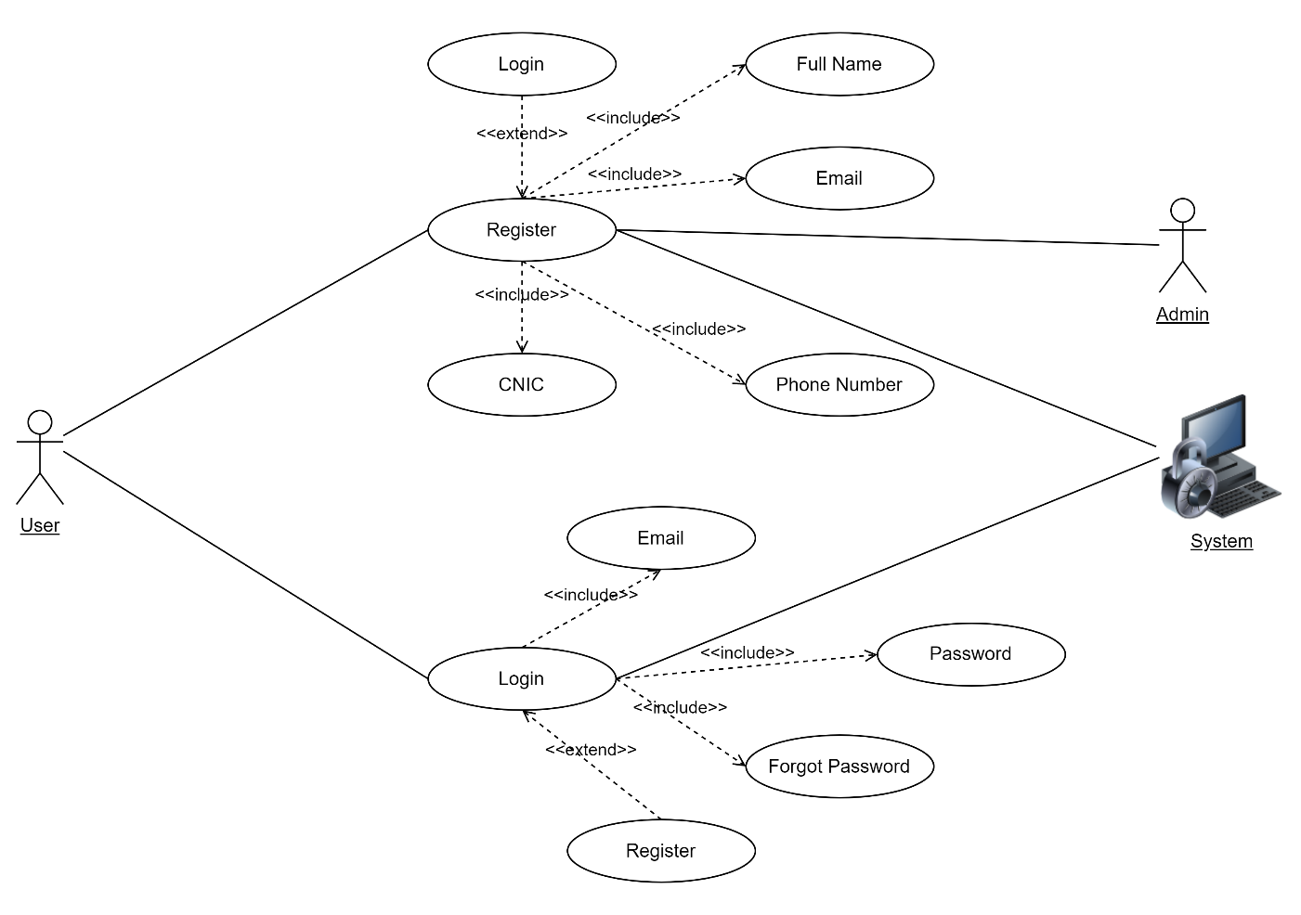

Figure ‎4.11: User Login/Register

Figure 4. 11 Depicts a use case diagram that outlines the flow of a user accessing a system to accomplish login and registration processes. The user can perform two main actions logging in, registering. Thus, to log in, the user enters their email and password. A user sometimes forgets their password in the account and have option to recover the password by entering their email. In the process of registration, users need to provide full name, email address, CNIC, and phone number. Admin interact during registration process to complete the registration in next of registration. The diagram can be seen as illustrating links between the user and these actions, also the inputs needed for each action. These inputs are then handled by the system to enable it to tend to the user’s demands.

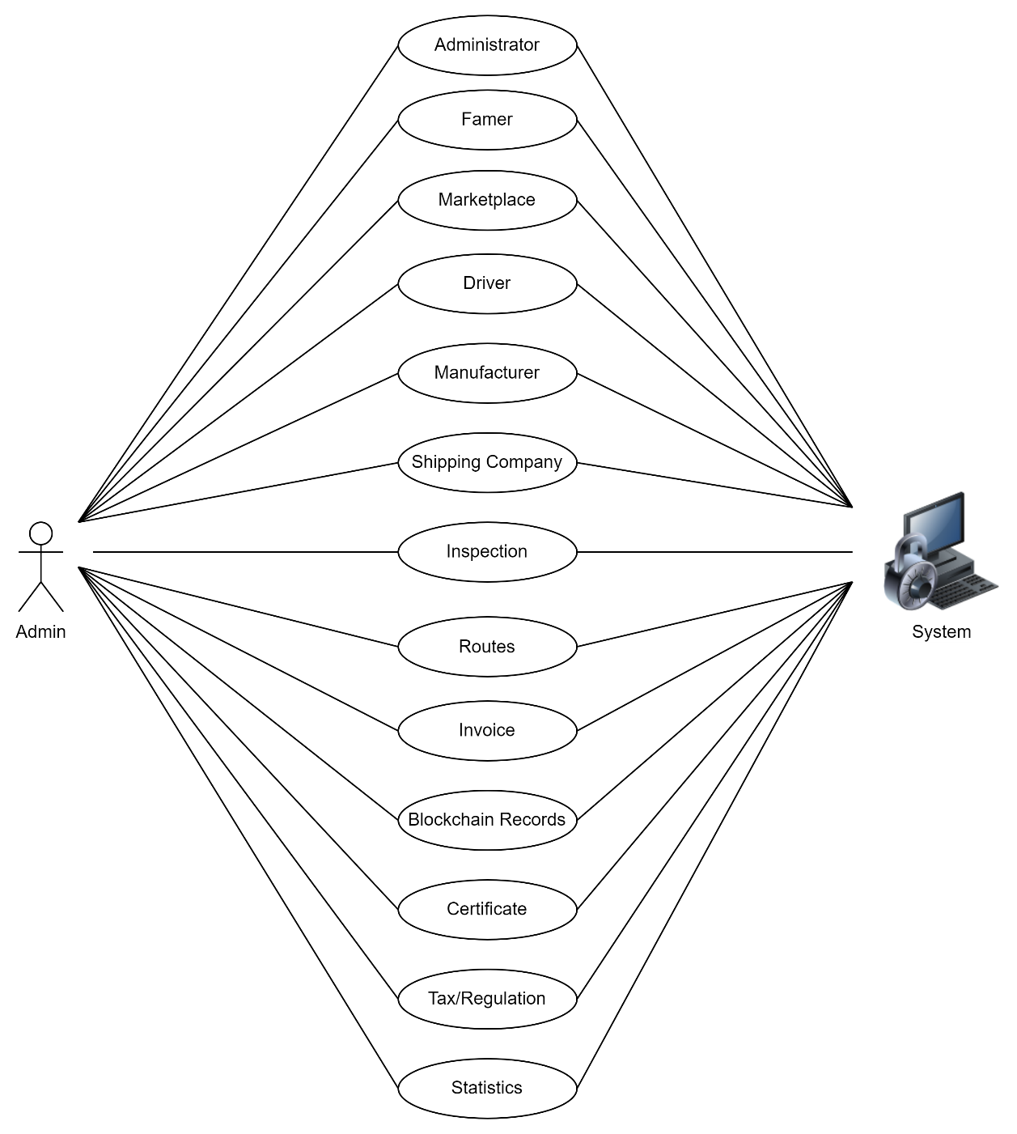

Figure ‎4.12:Admin Use Case

Figure 4.12 Depicts, the use cases and actors involved in the system’s interactions involve Admin interaction; The Actor, Admin performs a core role to manage interactions and processes with other use cases; Admin has access to Administrator Landing Page, Farmer, Marketplace, Driver, Manufacturer, Certificate, Shipping Company, Inspection, Routes, Invoice, Blockchain Records, Tax Regulation, and Statistics.
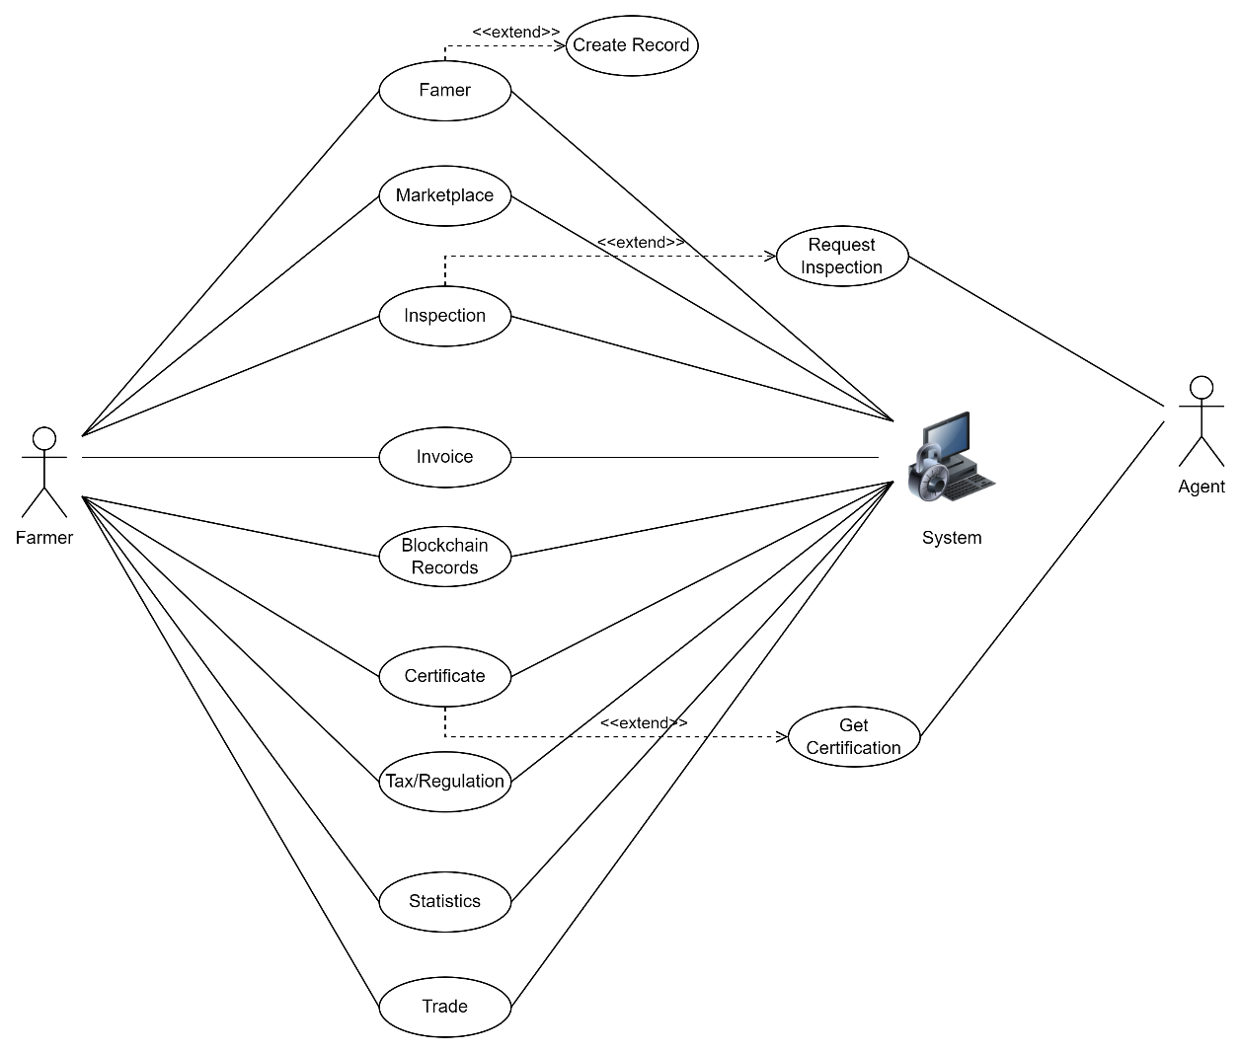

Figure ‎4.13: Farmer

Figure 4.13 Depicts, the use cases and actors involved in the system’s interactions involve Farmer interaction; The Actor, Farmer performs a role to manage interactions and processes with other use cases along with harvesting products; Farmer has access to Farmer, Marketplace, Certificate, Shipping Company, Inspection, Invoice, Blockchain Records, Tax Regulation, and Statistics.
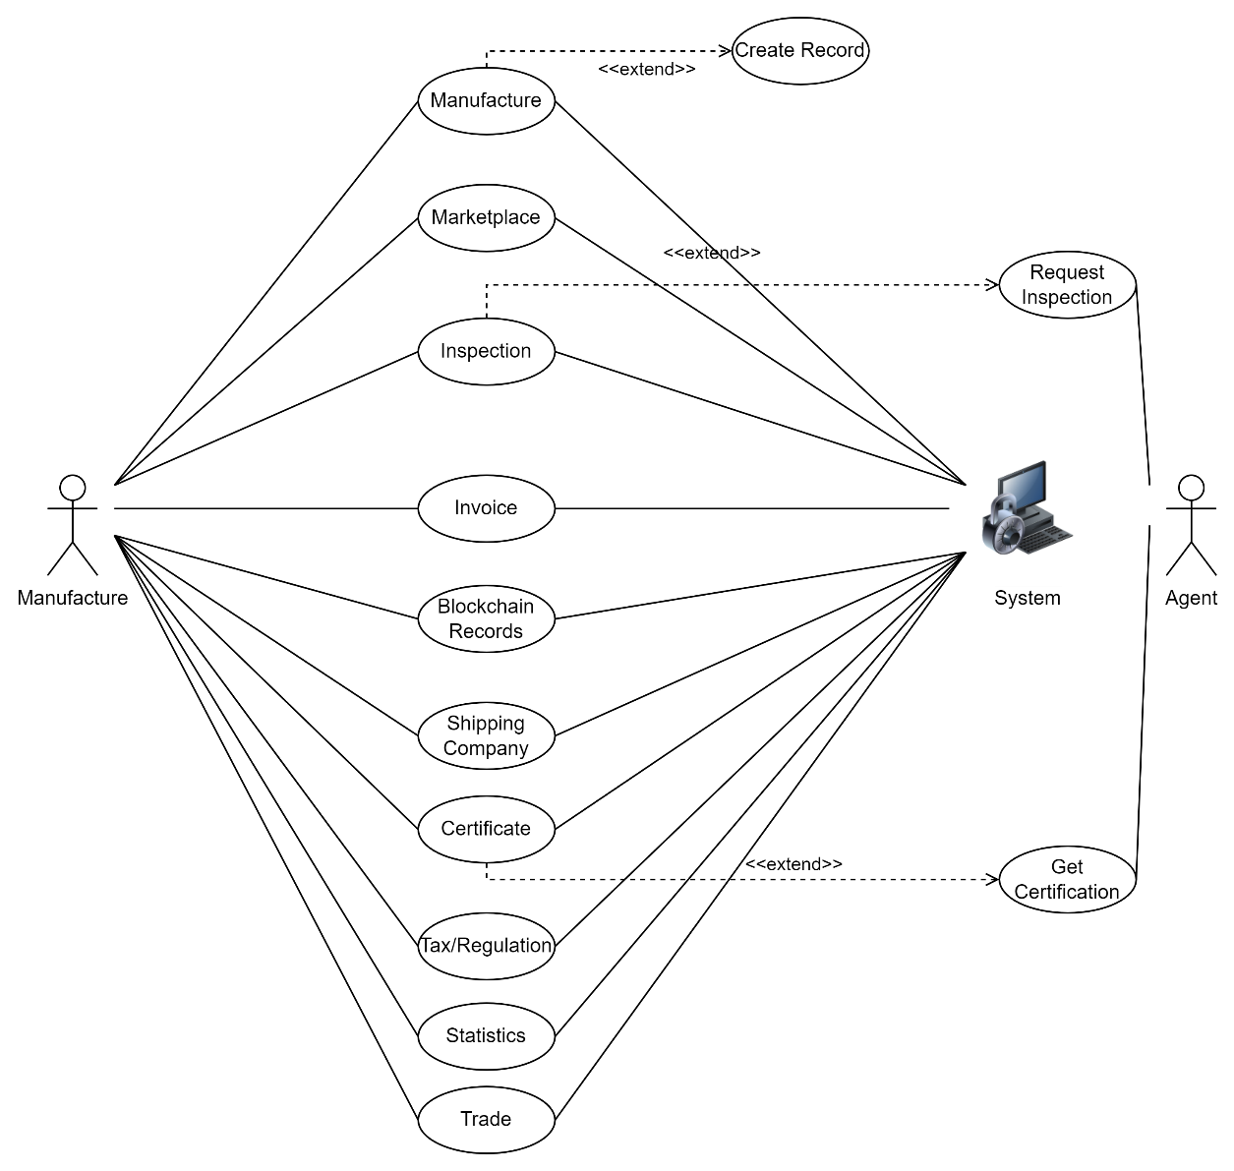
Figure ‎4.14: Manufacturer

Figure 4.14 Depicts, the use cases and actors involved in the system’s interactions involve Manufacture interaction; The Actor, Manufacture performs a role to manage interactions and processes with other use cases along with manufacturing goods; Manufacture has access to Marketplace, Manufacturer, Certificate, Shipping Company, Inspection, Invoice, Blockchain Records, Tax Regulation, and Statistics.
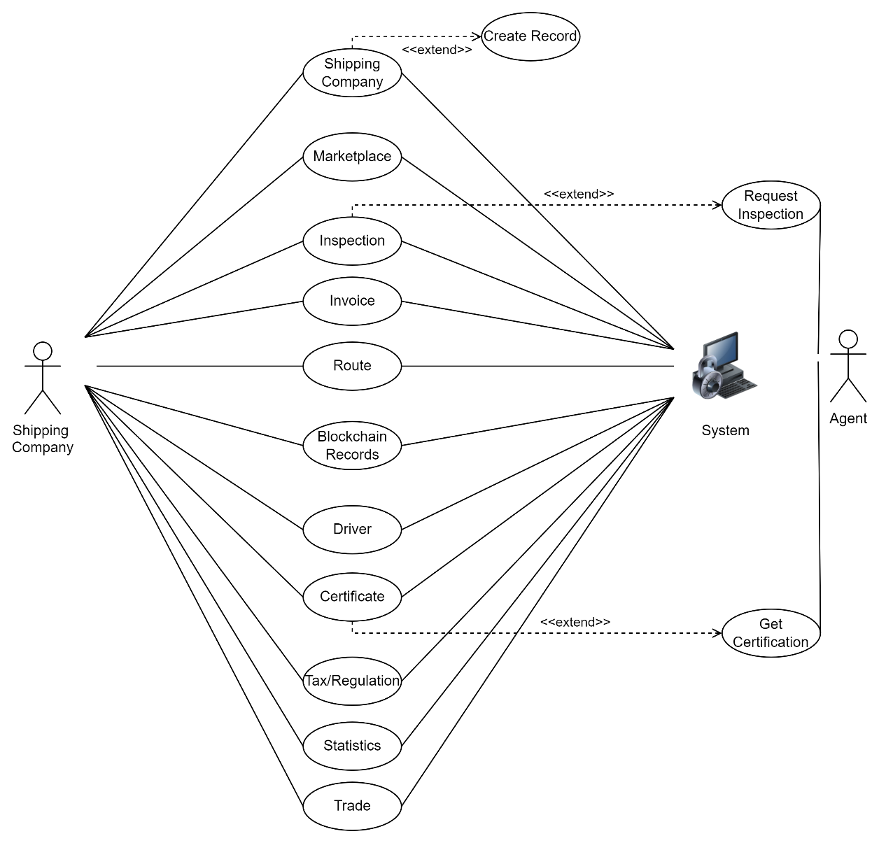

Figure ‎4.15: Shipping Company

Figure 4.15 Depicts, the use cases and actors involved in the system’s interactions involve Shipping Company interaction; The Actor, Shipping Company performs a role to manage interactions and processes with other use cases along with shipping goods between its respective owners; Shipping Company has access to Marketplace, Driver, Certificate, Shipping Company, Inspection, Routes, Invoice, Blockchain Records, Tax Regulation, and Statistics.

Activity Diagram
Figure ‎4.16: Activity Diagram
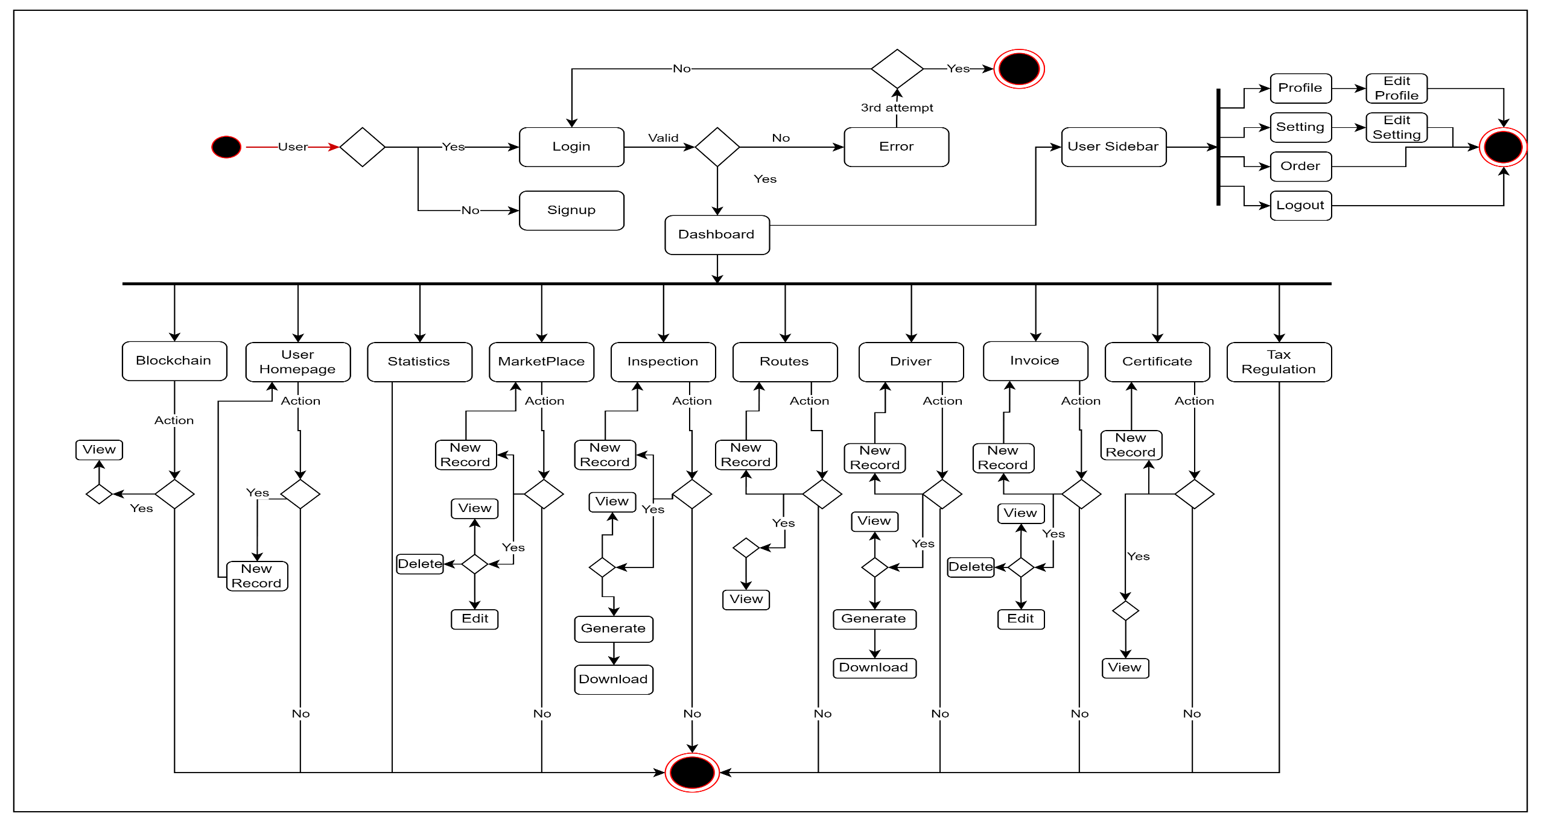

Database ERD
Figure ‎4.17: Database ERD
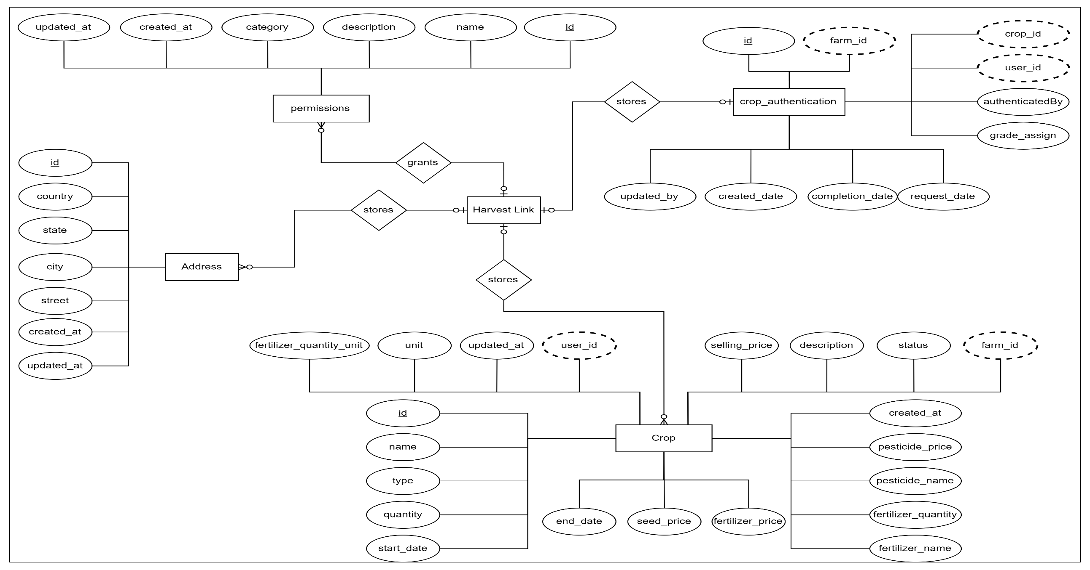
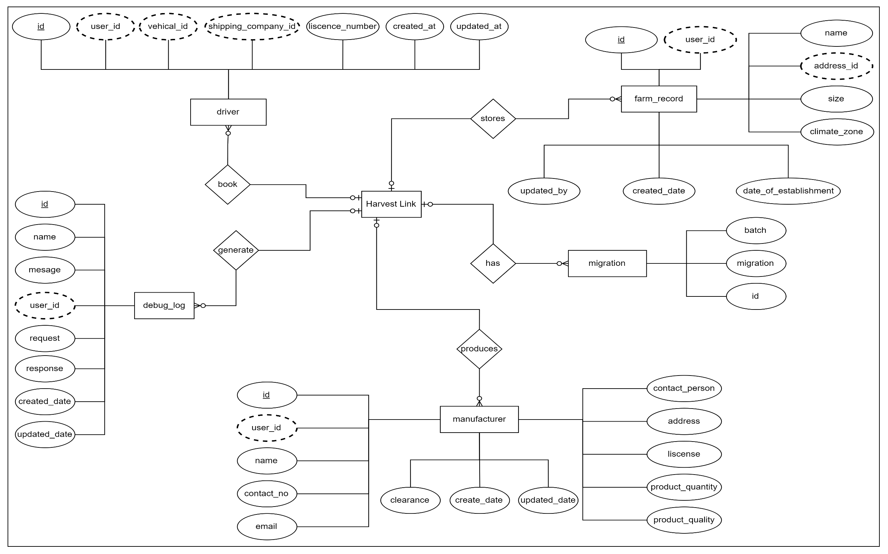
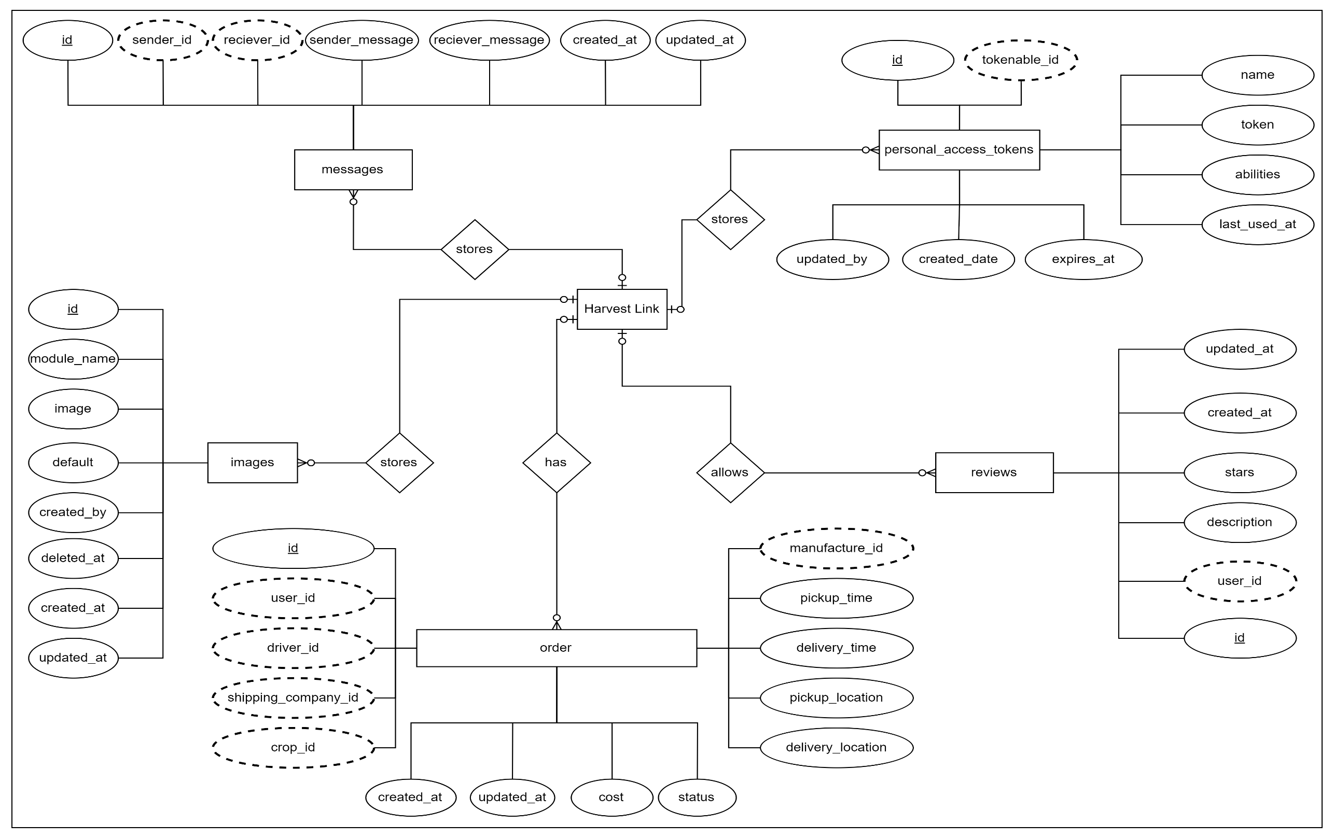
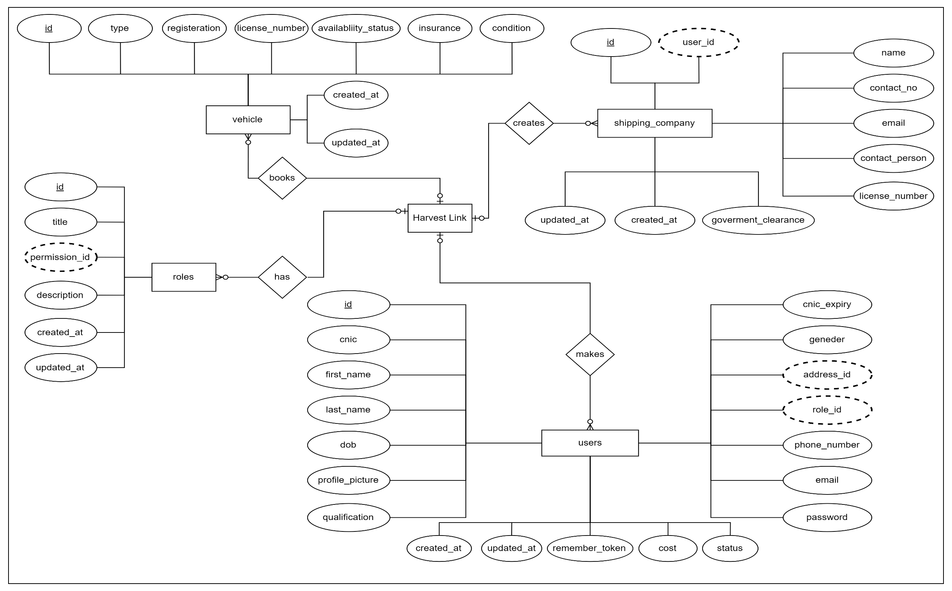

IMPLEMENTATION

This section explains the implementation of a project through the Scrum model, which is employed under the concept of an agile development system. Various tools and technologies were used such as: React.js for the user interface construction, Laravel for the back-end, and essentially, Solidity for the smart contract. Some essential tools for the process were XAMPP for a proper server handling, Sepolia as the working area, and MetaMask for the cryptocurrency utilization. This section gives a brief overview of the descriptive languages and tools utilized throughout the project, their purpose and corresponding diagrams detailing factors of development and operation.

Scrum Model
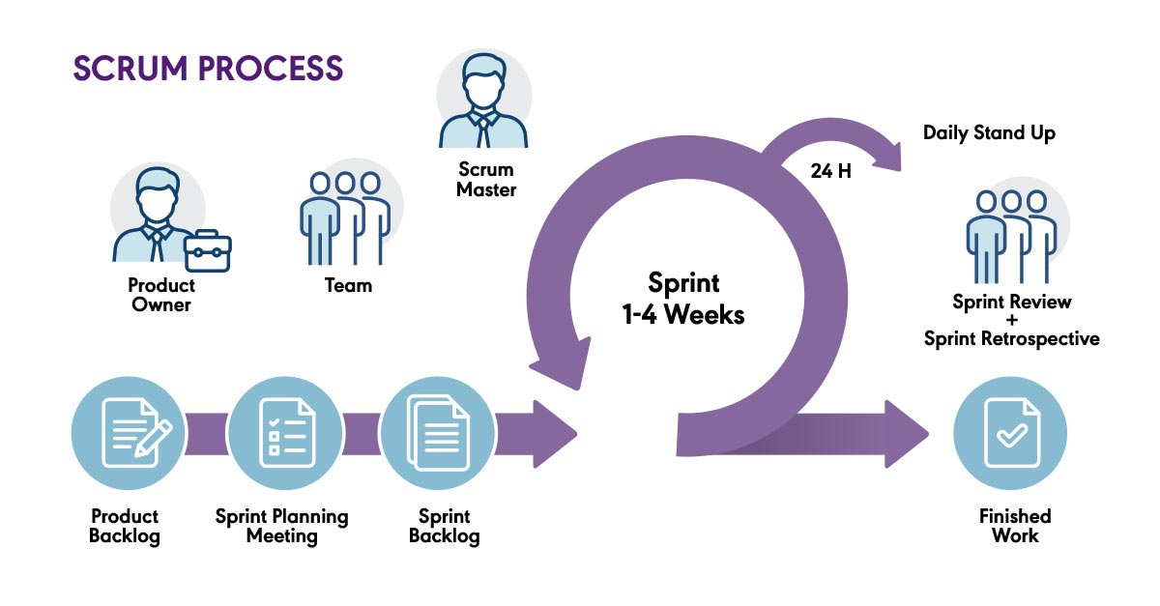
Figure ‎5.1:Scrum Model Flow

Scrum: A popular project management approach for complex projects.
Focuses on Teamwork, flexibility, delivering results in stages. Often used in software development, but gaining traction elsewhere too.
Key Players:
- Product Owner: Speaks for the customer, prioritizes tasks, ensures value is delivered.
- Scrum Master: Team coach, removes roadblocks, keeps the team on track with Scrum practices.
- Development Team: Self-organized group with diverse skills, responsible for delivering working parts of the project in short cycles.
Building Blocks:
- Product Backlog: A running list of everything that needs to be done, constantly changing as priorities shift.
- Sprint Backlog: A smaller, more specific list of tasks chosen from the product backlog for a short work cycle (sprint).
- Increment: The completed work at the end of a sprint, ready for potential release.
The Scrum Workflow:
- Sprints: Traditional and more formal approach to managing tasks that divides the work into work packages of fairly uniform length, usually ranging from one to four weeks where a usable portion of the project deliverable is compiled.
- Sprint Planning: The pre-sprint planning meeting where the sprint goal for the next one to four weeks is determined and the tasks of the product backlog that will be accomplished are chosen.
- Daily Scrum: The members of the Scrum team should hold a very short daily meeting – 10-15 minutes at the most, the purpose of which is to discuss the work plan for the next day.
- Sprint Review: Sprint review: Present the outcomes of each of the sprint efforts to the stakeholders and seek their input.
- Sprint Retrospective: An opportunity in the Scrum methodology whereby the team is able to assess its performance in the previous sprint basing on problems faced or lessons learnt from the event in order to learn on how to work better in the subsequent sprint.

Languages Used

React.js

User Interface Development – A JavaScript library for developing ‘User Interfaces’. React provide developers with the concept of UI elements and state management where the state is an essential property of the elements to control and construct websites.

CSS

CSS or Cascading Style Sheets is a style sheet language for use in the designing of any web content built with HTML. This has the ability to specify how any HTML elements should appear on the screen with regard to aspects such as layout, colors, font and among others..

Tailwind

Tailwind CSS is a approach to design given the CSS utilities to develop customized designs in HTML pages without leaving the HTML page. It also presents a pre-designed deviation utility class which can compose the automotive style in a much faster way.

Laravel 10

Laravel is one of the most used frameworks in the PHP language for creating the web applications. New features, improvements, and bug fixes are most possibly implemented in version 10 of the framework delivering better opportunities and tools for developing sustainable and extensively scalable web-based applications.

Solidity

Smart contract is a computer program that embodied in digital technology and runs on the blockchain and solidity is one of those languages used in programming smart contracts. IDE is essentially aimed to provide the developers with tools needed for secure and optimizing apps and automated contracts.

MySQL

MySQL is a relational model database system where the database can be managed through use of commands in the structured query language (SQL) and is open source. Most often it is used for managing and querying of database in numerous innumerable web applications and software systems.

Tools Used

Xampp Local Server

You only need a free and open source application known as XAMPP to help in creating the development environment on your computers. XAMPP is cross-platform, that means that it runs on Linux, macOS and Windows thus the name XAMPP.
- X refers to crosses between platforms
- A stands for Apache, which is the widely used web server.
- M here represents the type of database management system used in the database, which is MariaDB.
- PP is an abbreviation of two latest web development programming languages namely Perl and PHP.

For this task, we first installed the local web environment on the PC using XAMPP. We utilized it for:
- Examining and fixing web pages: Currently, our website is hosted locally, and, before running it, we check and fix bugs with the help of XAMPP program.
- Creating websites offline: XAMPP is a good software to work with just in case you have to do some projects and there is no Internet connection available.

Sepolia Blockchain

Sepolia is another test blockchain associated with Ethereum network. Test nets are clones of the main Ethereum network in the sense that the transactions that are performed on the test net are similar to those that are performed on the live version of the network. This allows programmers to further experiment with their mobile applications and also their smart contracts in private before deploying it on the Ethereum main network.

Web3.js

Web3 is a JavaScript package that could be described as a collection of tools, libraries, and application programming interfaces. Web3.js gives programmers a complete framework that can be used for interacting with the Ethereum blockchain. More specifically, it is a bridge that links the Ethereum network with script written in JavaScript. Here, below are some of the important aspects of web3 component:
- Engage in smart contract interaction: We may retrieve data from smart contracts, invoke their methods, and sometimes even deploy new smart contracts through the use of Web3 by addressing them as JavaScript objects.
- Send transactions: Ether, the cryptocurrency used in Ethereum, can be transferred from one account to another, and various other kinds of transactions within blockchain can be initiated via web3.js.
- Access blockchain data: The library enables one to access data which is within the Ethereum network such as the block details, the transactions that have taken place and the status of the accounts.

Meta Mask Wallet

MetaMask is an innovative product that enables people to keep track of their own cryptocurrencies and browse through applications built on blockchain technology. It is essential for buyers and sellers of the cryptocurrencies, specifically those based on Ethereum’s blockchain structure, as it operates as a digital purse. Some of the digital items that can be shared through chat include images, videos, and documents, among others; All these digits items can be sent, received, and stored using the mobile app and/or browser extension. This makes augmented reality to be safe to use especially in the contexts of buying and selling of commodities. Taking everything into account, MetaMask is an effective tool for people who: are beginner in the use of cryptocurrencies; or, those people who have experience in the management of numerous tokens and are interested in discovering the fascinating world of decentralized finance and blockchain.

Remix Development

Remix was developed to be an all inclusive, open-source programming solution for the blockchain sector exclusively. This is mainly designed for the Ethereum network and the other blockchains supporting EVM, yet it is also compatible with other networks and chains. Here below, we dive into the details of what Remix has to offer.
Important characteristics:
- Draft blockchain application through smart contract or automated code.
- Compile and fix intelligent contracts
- Utilize the systems of cryptocurrencies for contracts that enable automation and are based on the principles of blockchain, mostly Ethereum and affiliated ones.
Advantages:
- Open-source and cost-free
- Convenience of user by addressing those who have small knowledge about the GUI and computer experts
- It is available on both desktop and graphical user interfaces as well as dialog boxes.

Etherscan Live Check Contract

To all intent and purpose, Etherscan represents a search tool for search on Ethereum blockchain akin to a search engine designed on Ethereum. It is not simply limited to the transaction’s recording activity but generates a lot of information about the network’s behavior. Some features include but not limited to:Some features include but not limited to:
- Transaction Search: Details of each Ethereum transaction, including the sender address and the corresponding recipient address, the amount of Ether transferred and the gas fees, and the timestamps for the transaction.
- Wallet Address Exploration: A convenient feature to track transactions, current ETH balance, tokens in possession and last interactions with smart contracts.
- Smart Contract Exploration: Details have been confirmed that smart contracts’ code of various platforms has to be checked for understanding their functionalities, especially in DeFi.
- Blockchain Analytics: Overviews of Ethereum network and their tendencies such as price of gas, number of active addresses, distribution of tokens etc.

In other words, Etherscan can be viewed as an Ethereum social Layer, which draws to the blockchain platform a unique user’s base that is able to interact with network and, at the same time, to analyze the flows of practically any info at the network level. They give users a practical understanding of how networks operate, and that makes it a useful educational aid even for specialists and those interested in blockchain.

AI Model

In this project, we are also using a machine learning model, and our target variable will be yield. The initial preprocessing involves the splitting of the dataset into training data set and test data set. Subsequently, the performance metrics for several regression models are derived from the data collected. These are measures that are commonly used to assess the models which include the Mean Squared Error (MSE), the R-squared (R²) score, and accuracy. Thus, we decided to compare the outcomes of each model and represent the forecast for reference.

Data Set

This dataset contains information about the farming practices, or the crop production in various countries that are grouped by year as well as specific crop type. Here's a breakdown of what each column represents: Here's a breakdown of what each column represents:
- Area: The geographic location of the nation or location where the gathered data originated from. In this data set, the name of the country issteadily indicated as “Albania”.
- Item: First, one needs to understand that different crops may behave differently when subjected to similar conditions; Therefore, the type of crop being analyzed makes a huge difference when determining the results achieved. Some of them are; Maize; Potatoes; Rice (Paddy); Sorghum; Soybeans; Wheat etc.
- Year: By mentioning that the date was recorded as relating to year “xx”, it informs the reader what year the data was retrieved from the social media.
- hg/ha_yield: Crop yield was estimate in hectograms per hectare (hg ha-1). This shows the production level of the crop per year based on the average yield expectation.
- average_rain_fall_mm_per_year: The average intensity of the annual precipitation in the area in millimeters (mm) for that year. This was observed to remain constant across all the dataset, and this may not imply that the yield is crop specific, but it may represent the national yield.
- pesticides_tonnes: Amount of pesticide used as measured by the tonnes of the substance employed. Also, this aspect is uniform across all entries, implying a sort of a universally normal consumption that cuts across all crops and years.
- avg_temp: Average temperature between June and July of the year, in degree Celsius. That is a small annual fluctuation of the figure can be observed every year.

Data Preparation

- Feature and Target Selection: We separate the feature set (X) and the target variable (y). The target variable is hg/ha_yield.
- Train-Test Split: The data is split into training and testing sets with 70% of the data used for training and 30% for testing.

Model Selection and Evaluation

The model used here is BaggingRegressor, which is a technique that builds a conceptually very simple ensemble of predictors by making multiple learning cycles on the training set. There is Bootstrap Aggregation or Bagging technique where in a base estimator is built many times with different bootstrap samples and they are averaged to get the refined output. These subsets are obtained after using sampling with replacement whereby certain elements in the dataset are selected at random to form subsets of the entire data. The results are then summed across the models and divided through by the number of models to yield the final density estimate. This process ensures that common errors are minimized and variances as well as overfitting that may be experienced by one model are easily eliminated. BaggingRegressor is widely used given that one can replace the base estimator and given that it is trained parallel, it is perfect for multi-core space. Although it works for a variety of models it demands more computation and it is less easy to interpret. In general, BaggingRegressor is relevant for regression analysis, or used when the researcher needs more accurate and stable model.

Conclusion

We can determine which regression model, using our dataset, is best for forecasting yield thanks to this investigation. We may select the model that offers the best combination of high explanatory power, low error, and accuracy by evaluating several of them.

USER MANUAL

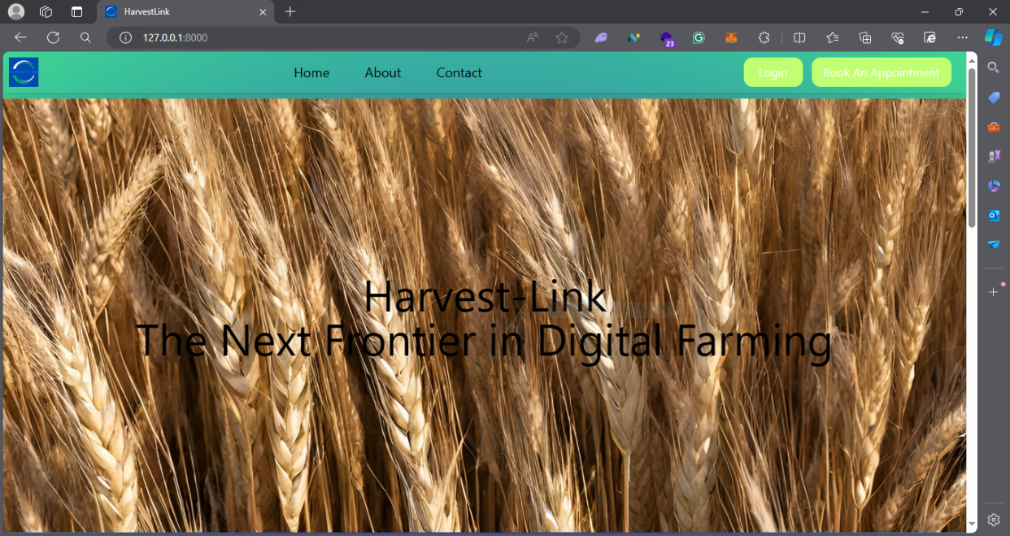
Figure ‎6.1: Home Page

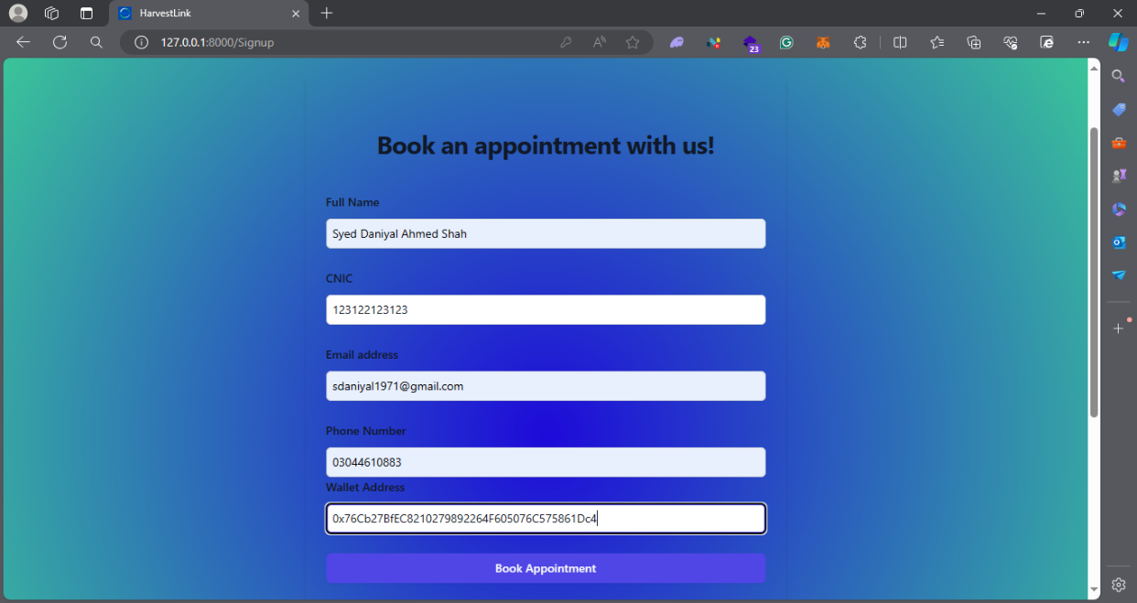
Figure ‎6.2: Signup Page / Book Appointment Page
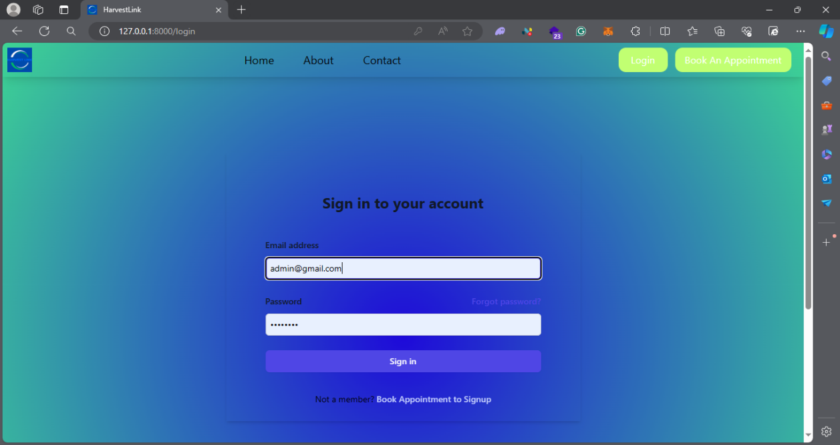
Figure ‎6.3: Login Page

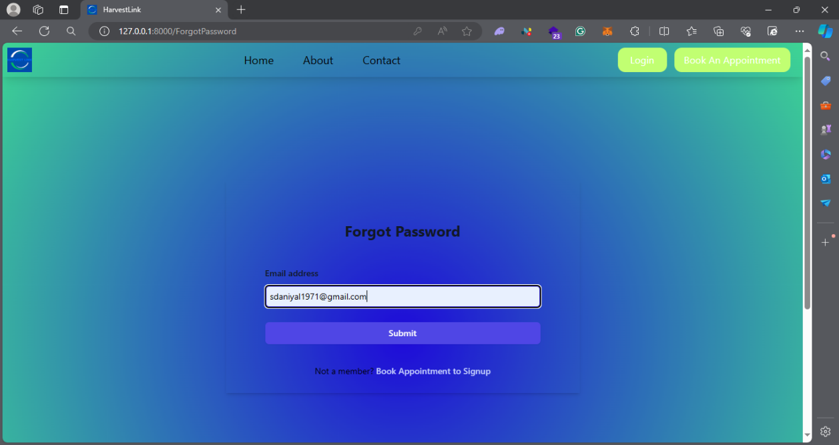
Figure ‎6.4: Forgot Password

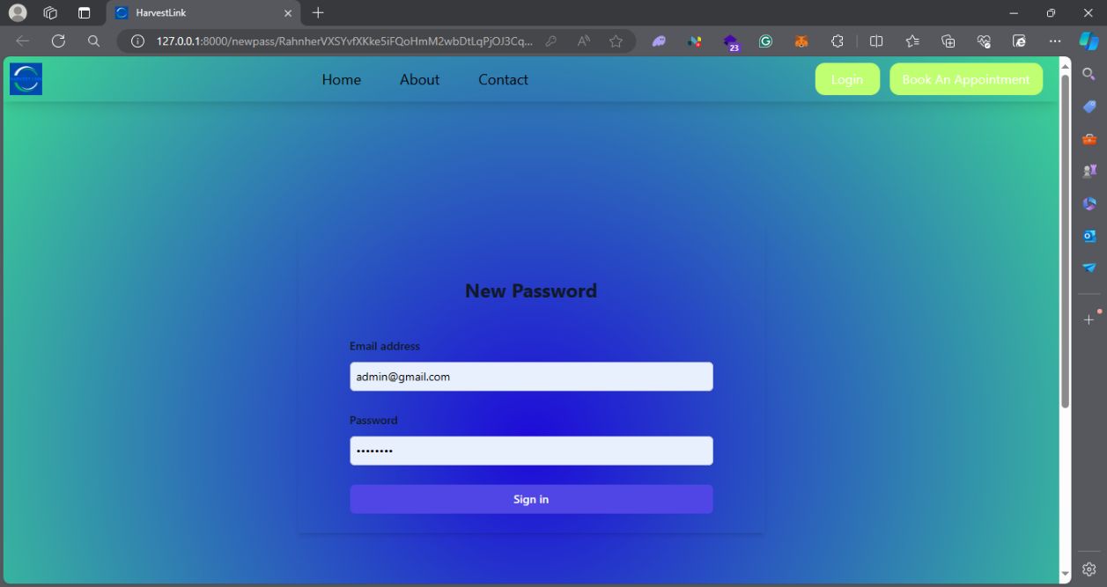
Figure ‎6.5: New Password

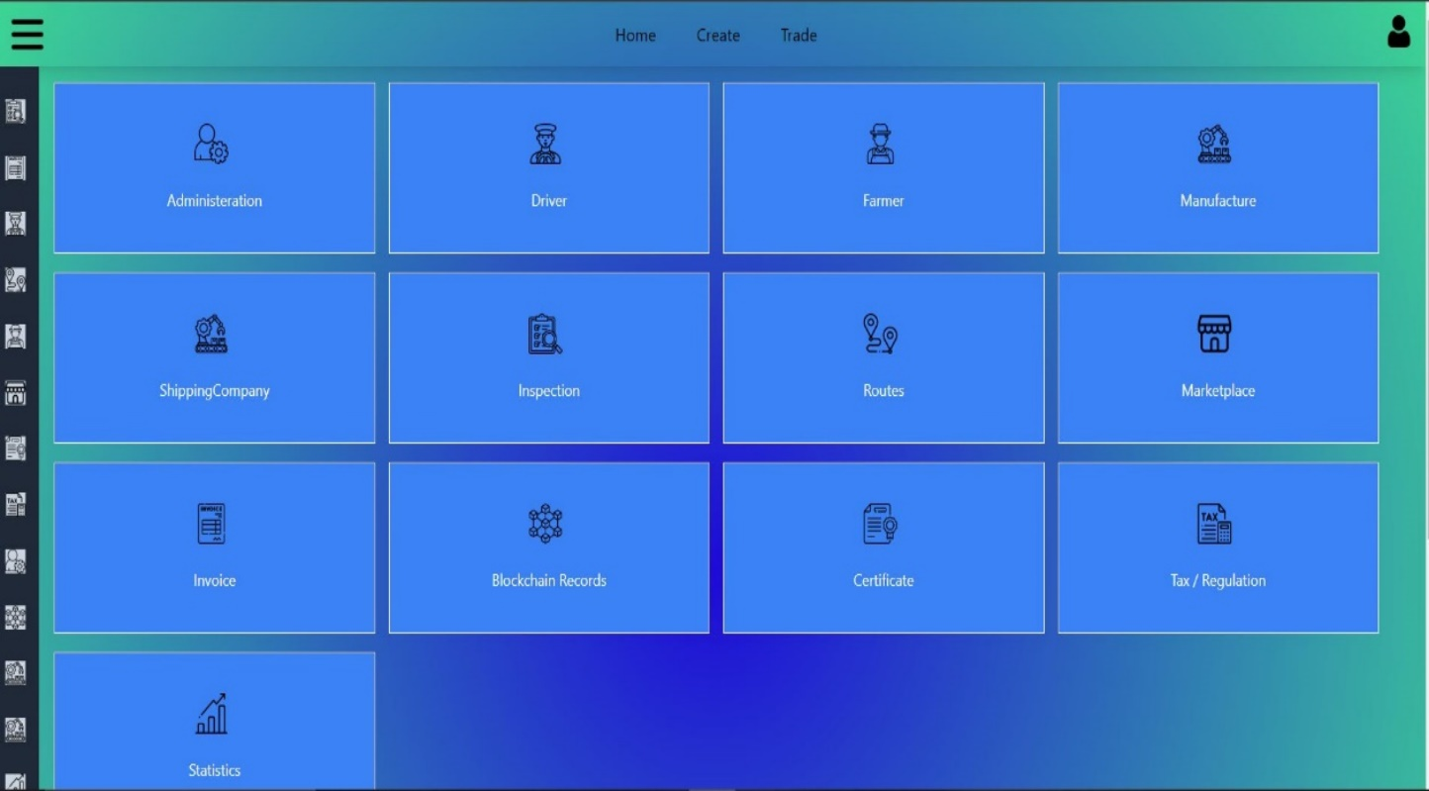
Figure ‎6.6: Admin Home Page

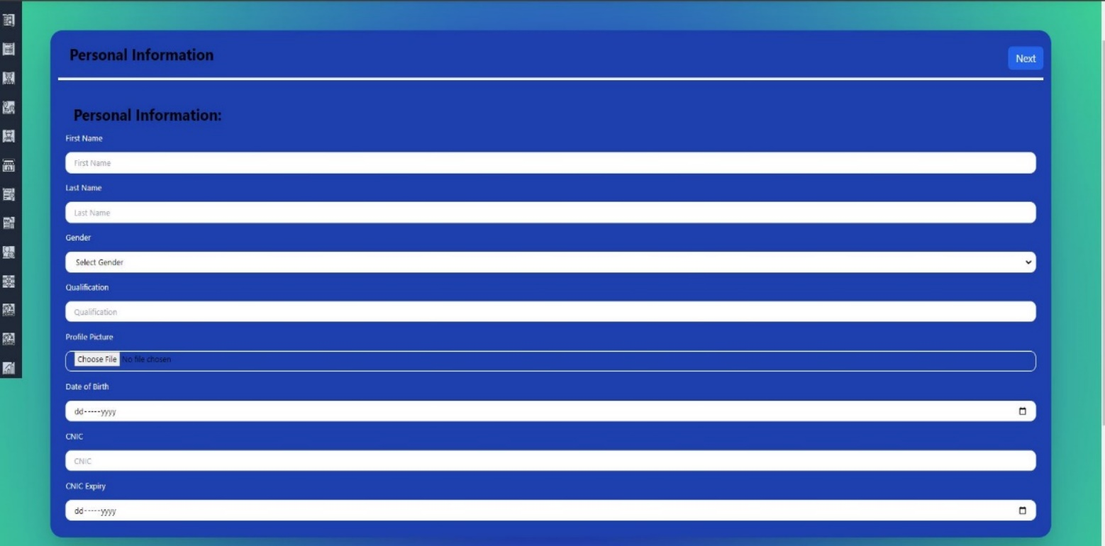
Figure ‎6.7: Create User 1

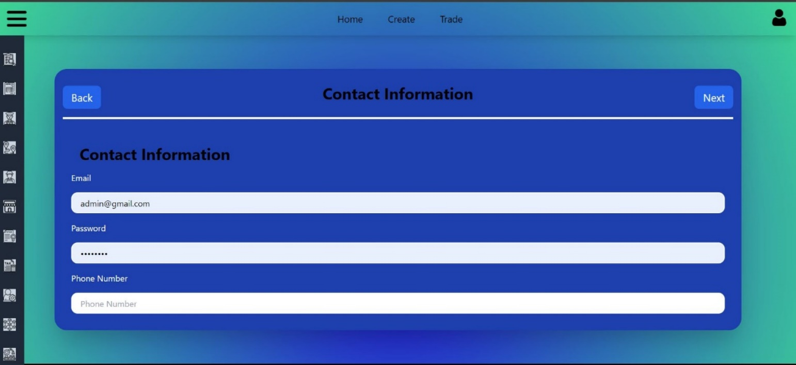
Figure ‎6.8: Create User 2

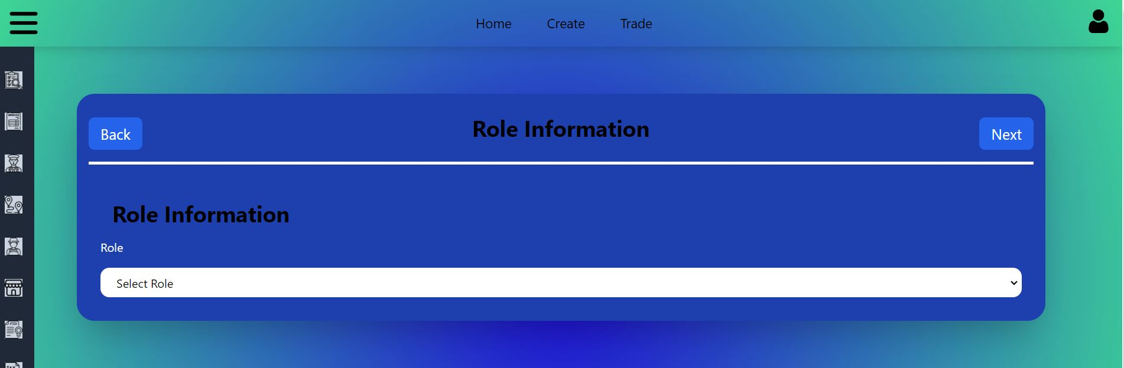
Figure ‎6.9: Create User 3

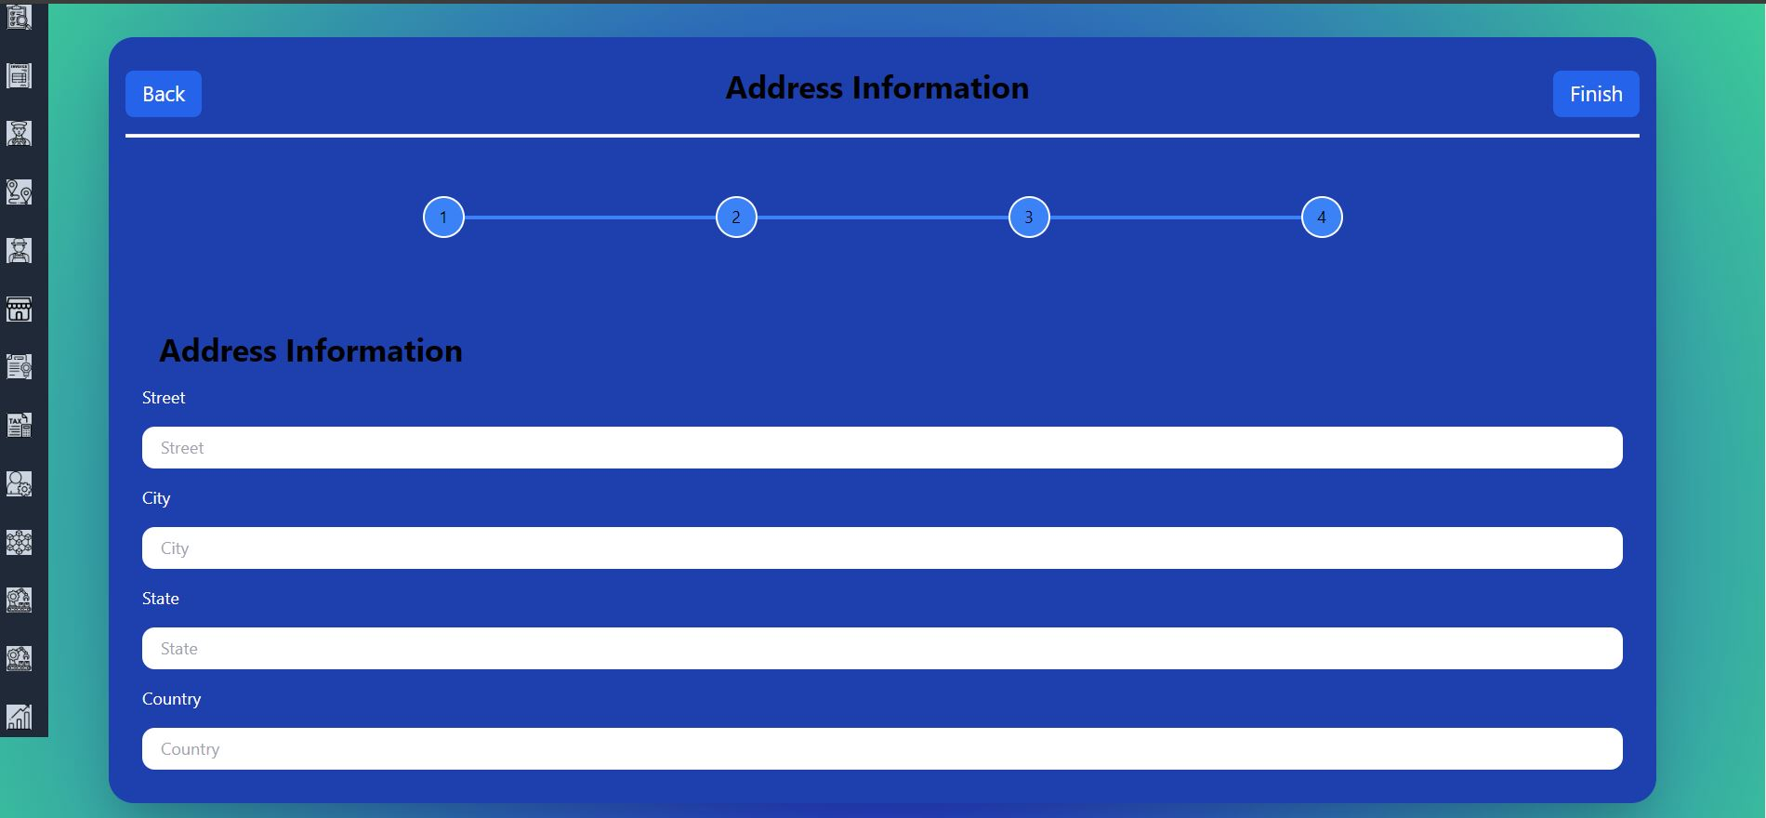
Figure ‎6.10: Create User 4

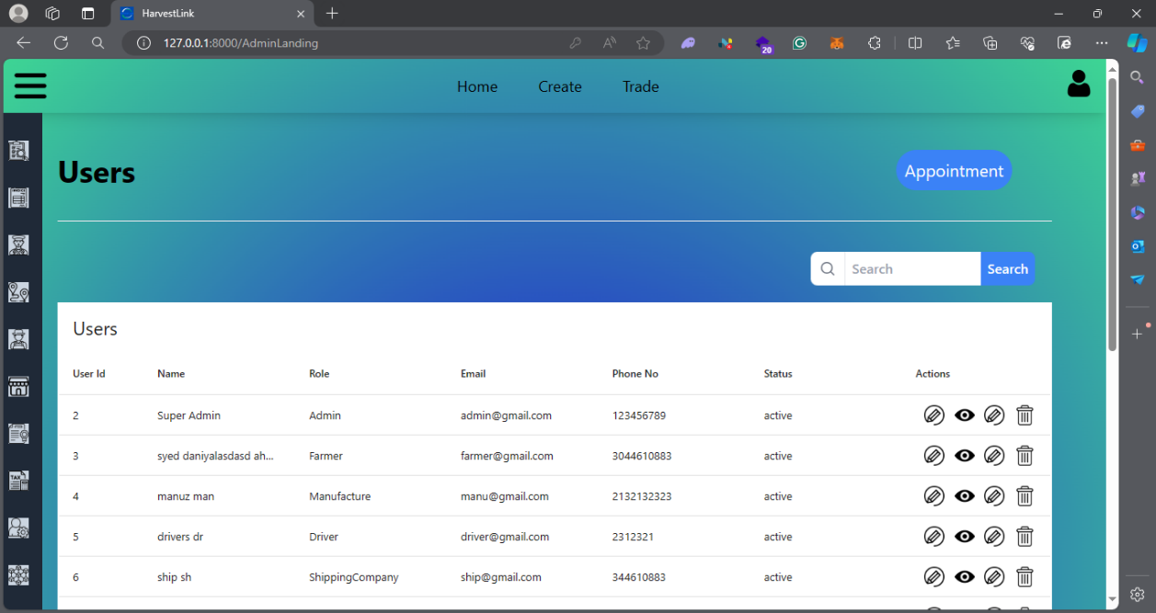
Figure ‎6.11: Admin Landing

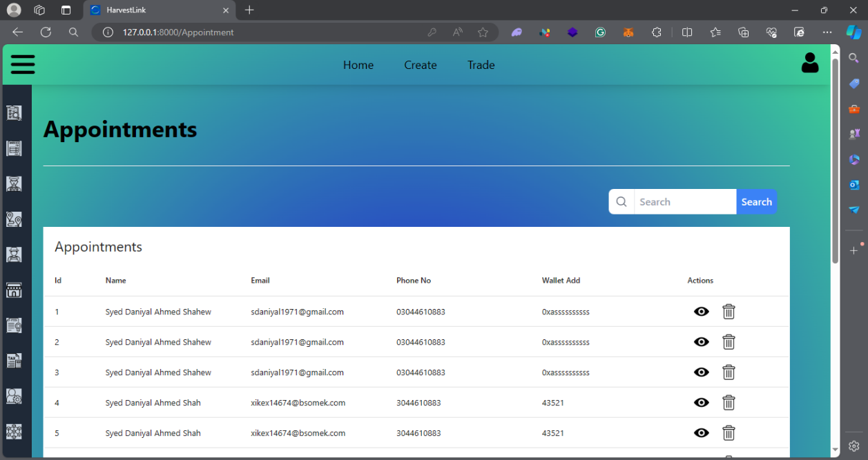
Figure ‎6.12: Appointment Page

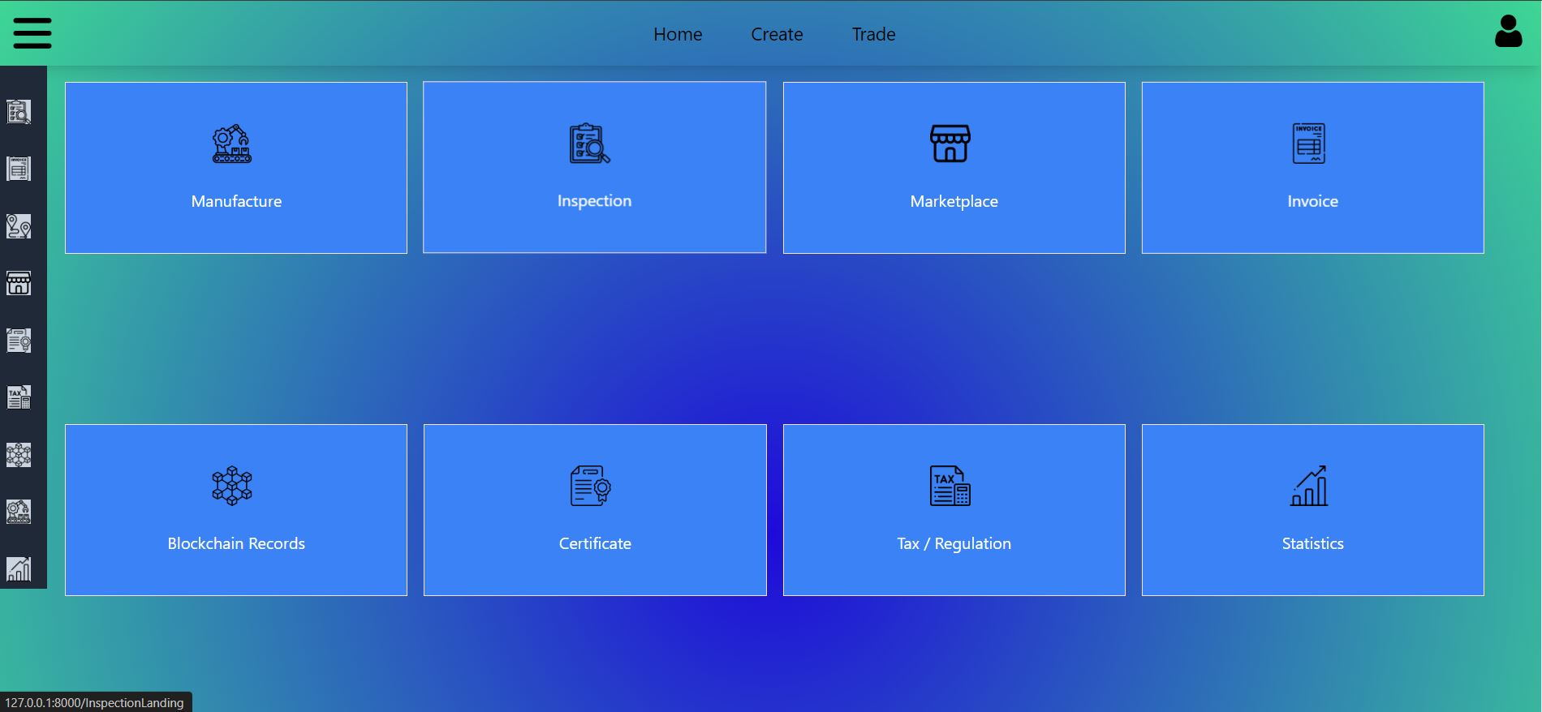
Figure ‎6.13: Manufacture Landing

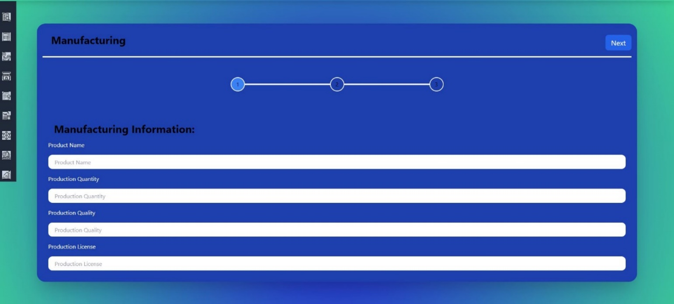
Figure ‎6.14: Manufacture Create

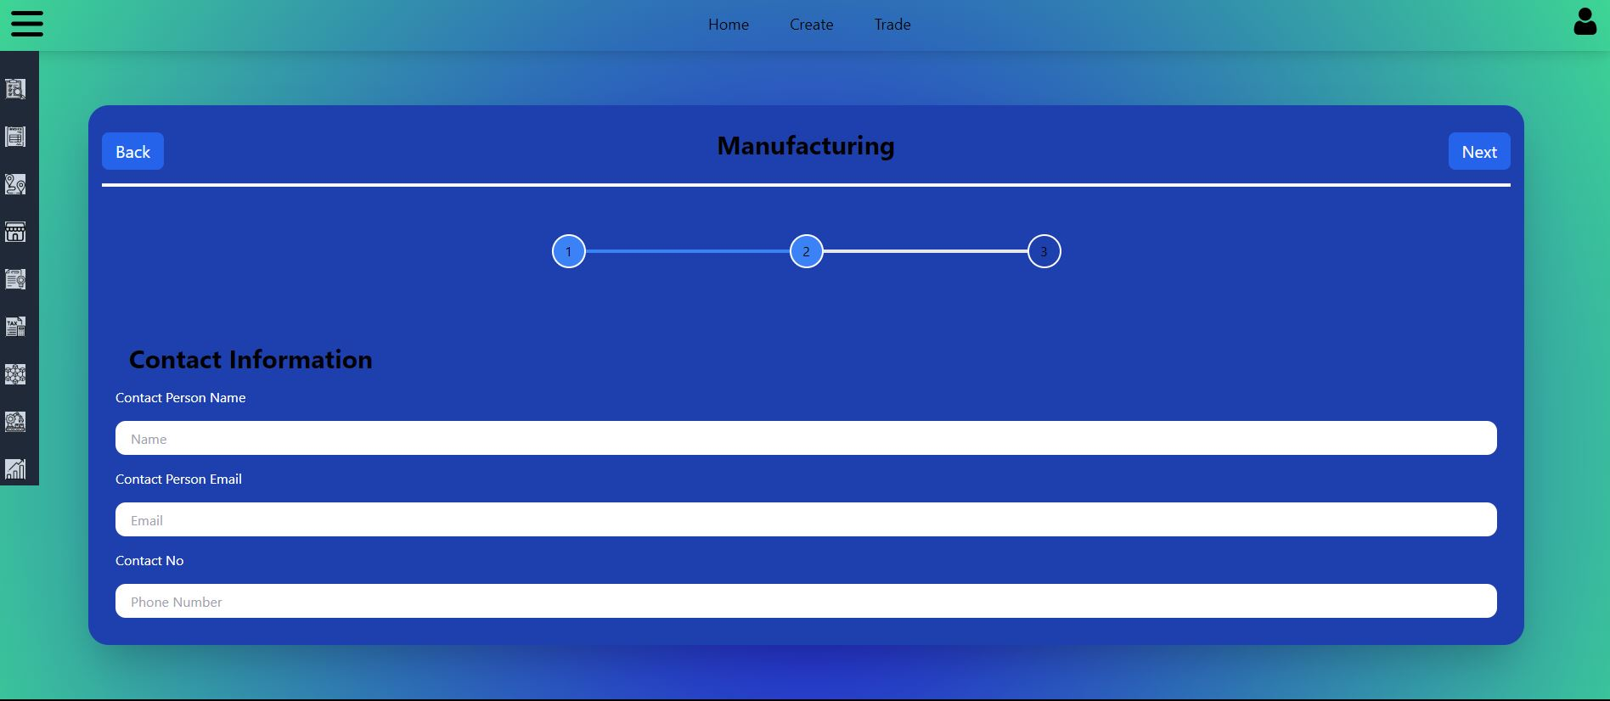
Figure ‎6.15: Manufacture Create 2

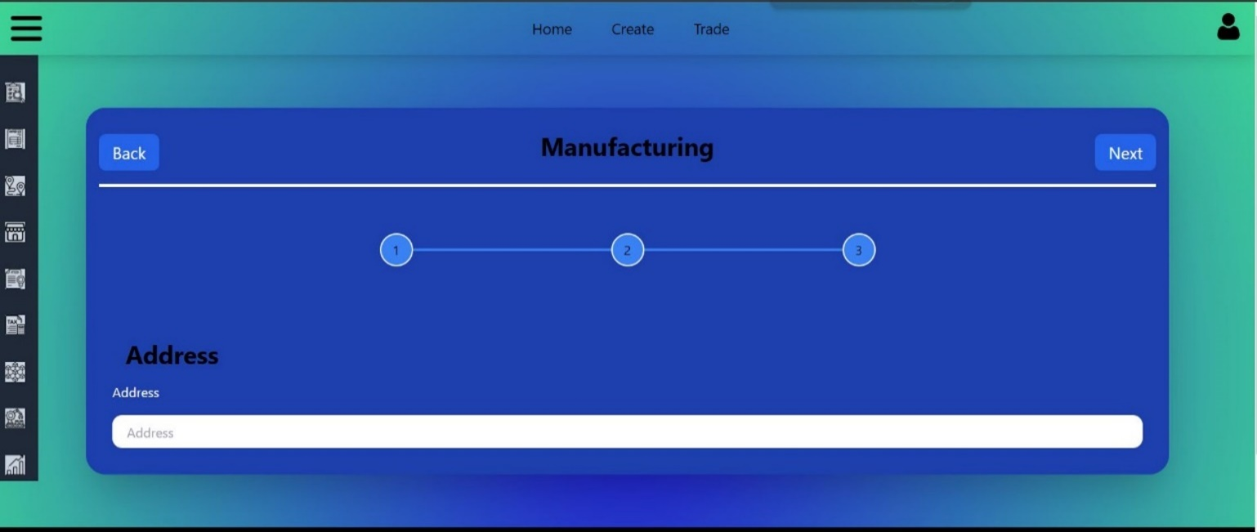
Figure ‎6.16: Manufacture Create 3
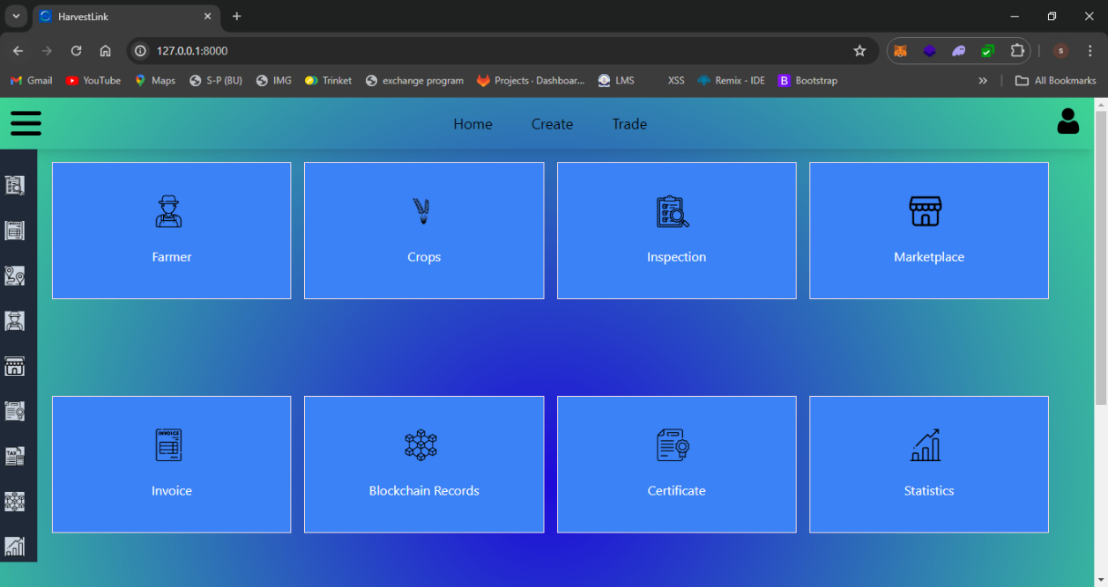
Figure ‎6.17: Farmer Home Page

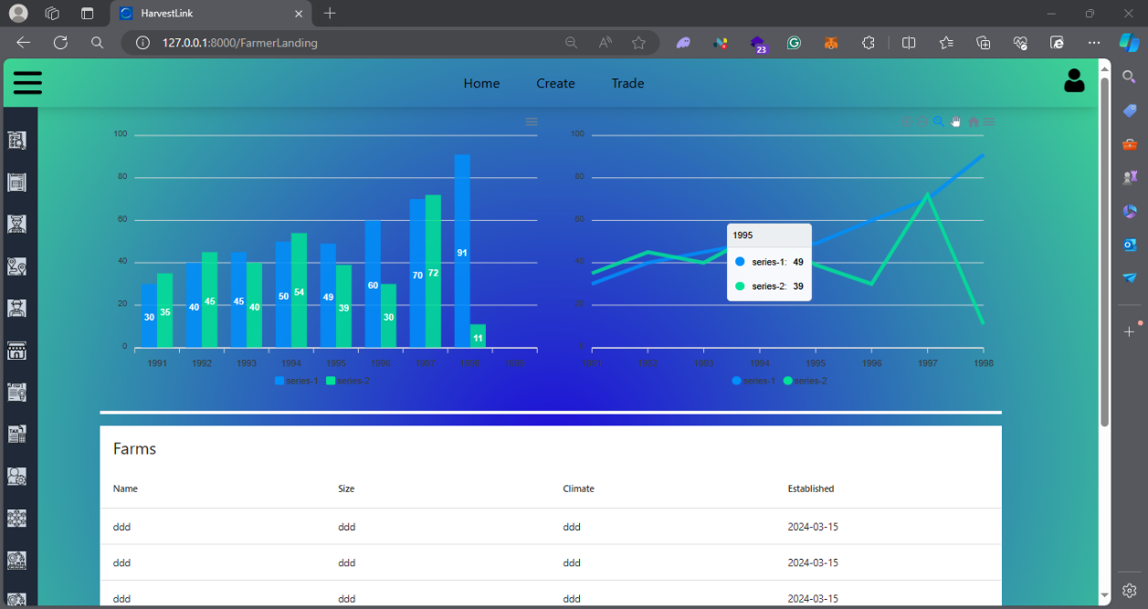
Figure ‎6.18: Farmer Landing

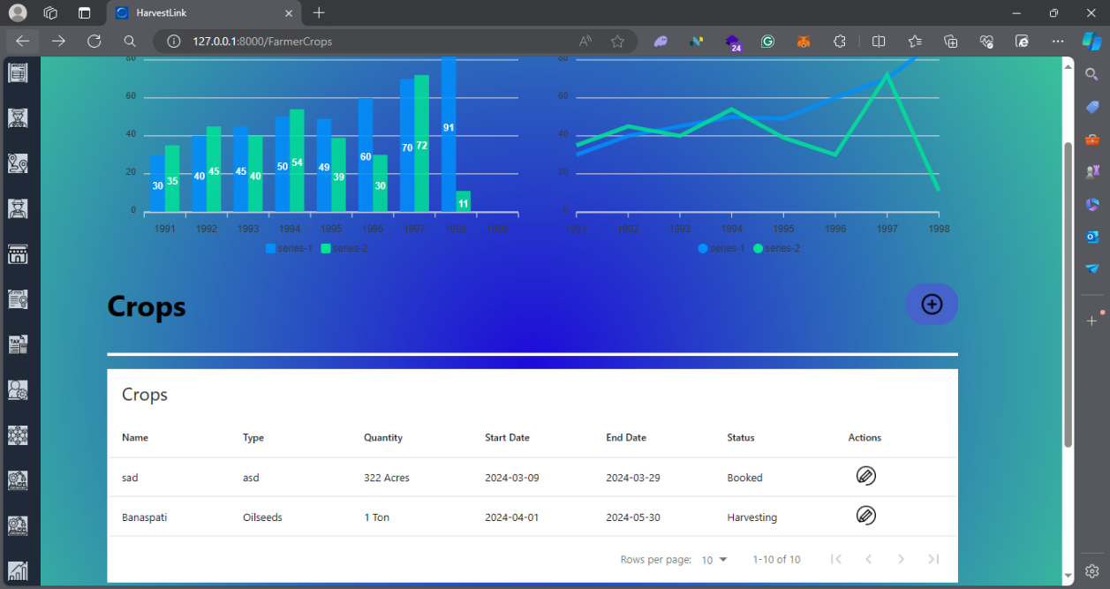
Figure ‎6.19: Farmer Landing 2

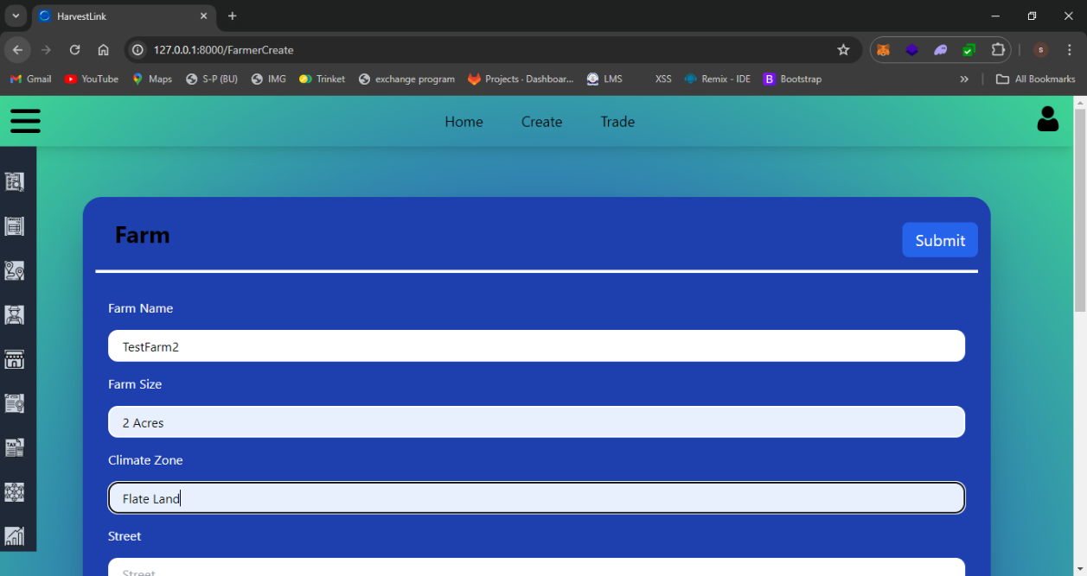
Figure ‎6.20: Farmer Create

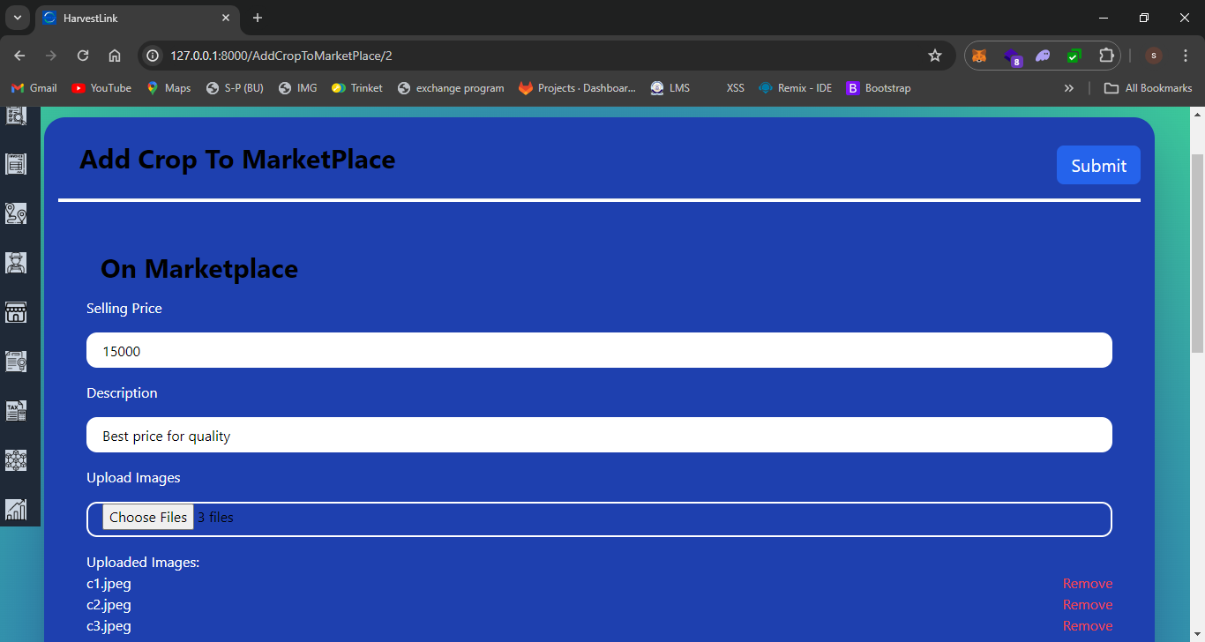
Figure ‎6.21: Add Crop to Market Place

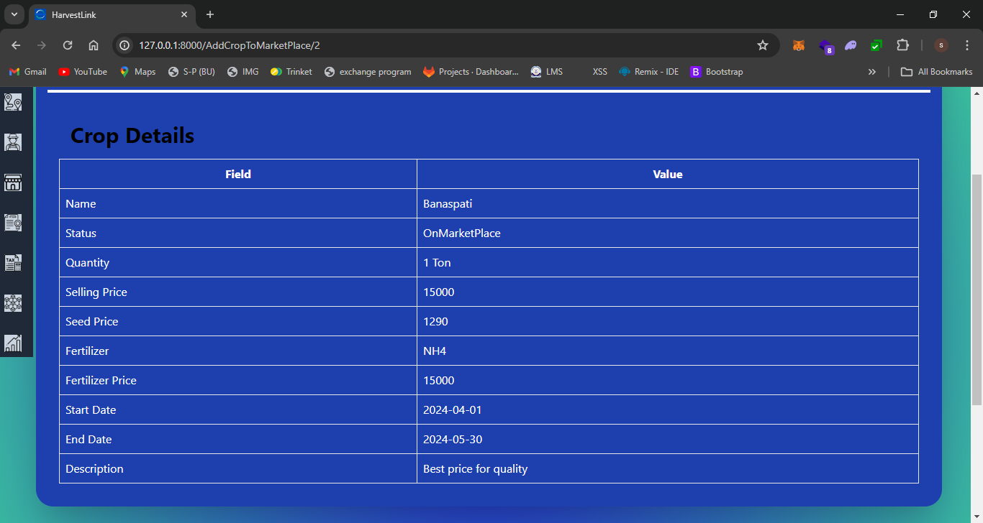
Figure ‎6.22: Add Crop to Market Place 2

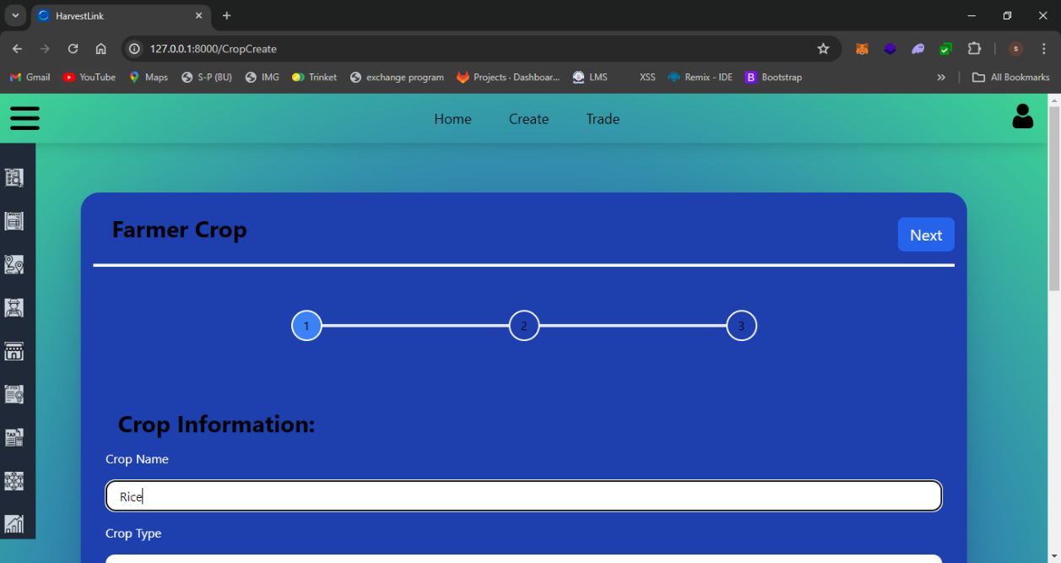
Figure ‎6.23: Crop Create

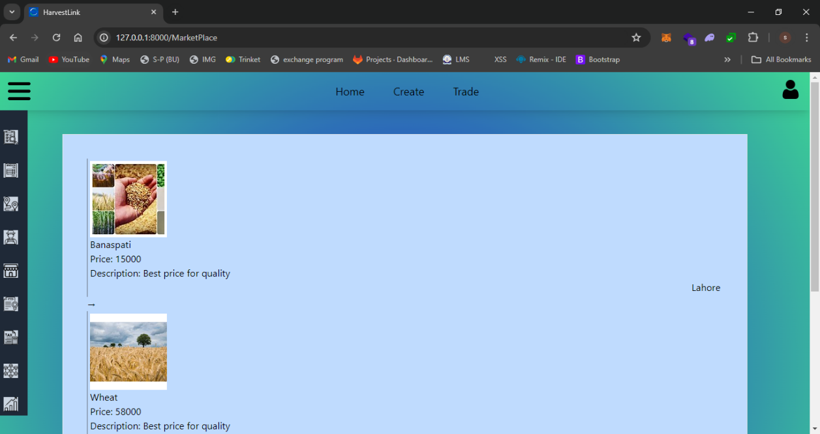
Figure ‎6.24: Market Place

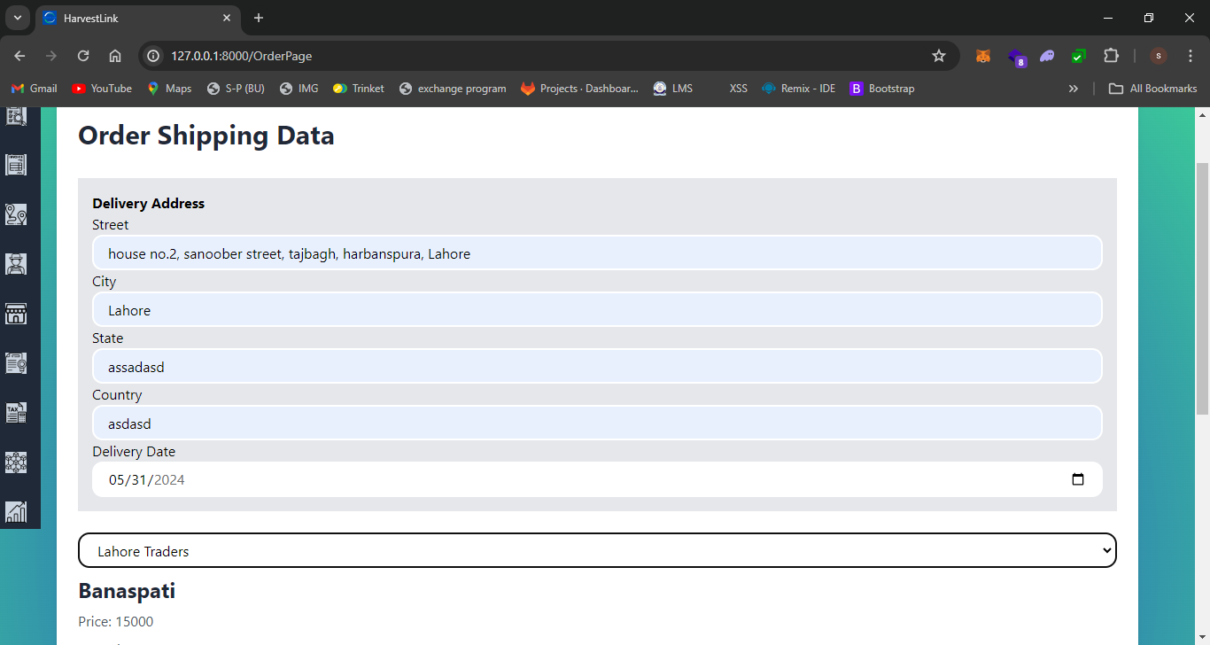
Figure ‎6.25: Order Page

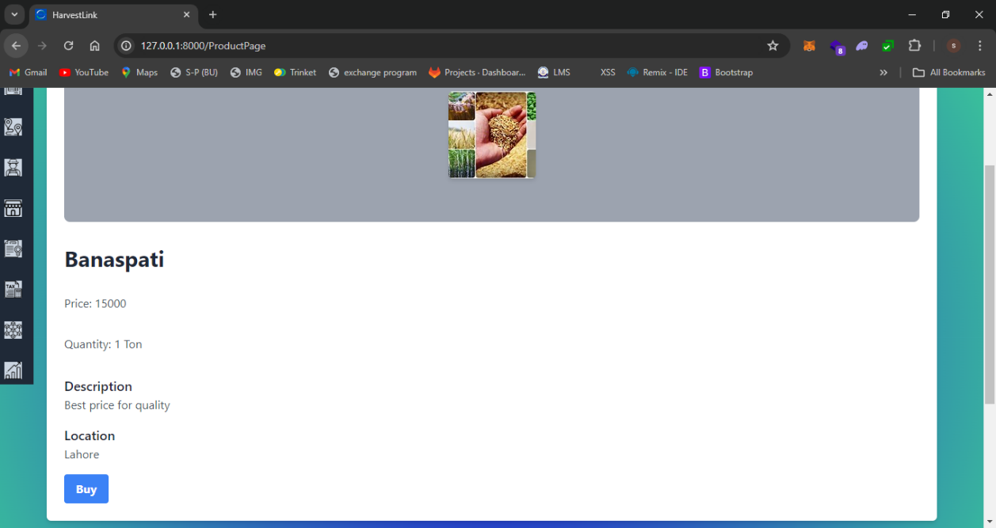
Figure ‎6.26: Product Page

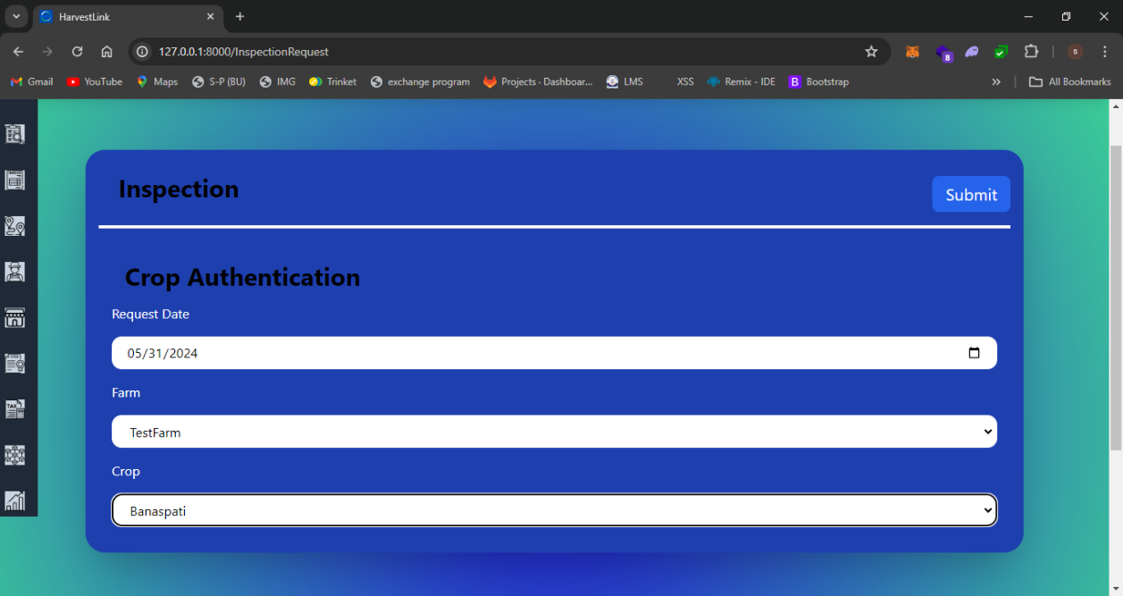
Figure ‎6.27: Inspection Request

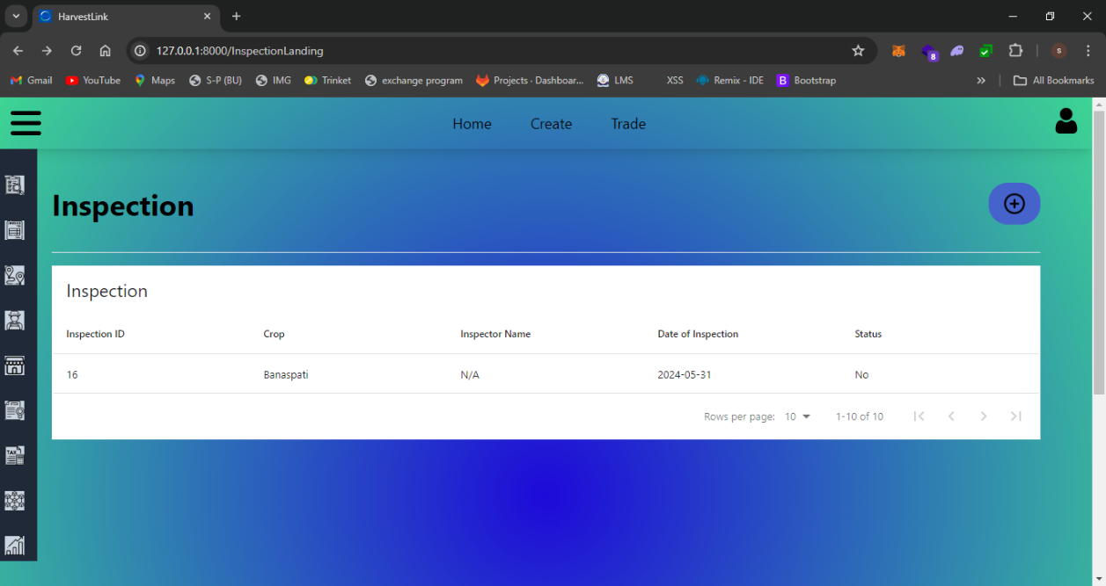
Figure ‎6.28: Inspection Landing

CONCLUSION AND FUTURE WORKS

Conclusion

In conclusion, our project addresses the critical challenges within the global agriculture supply chain, emphasizing the complexity arising from various stakeholders and the resultant lack of transparency. The problems, which range from fraudulent company conduct to operational inefficiencies, have a significant impact on global stakeholders' well-being, fair trade, and food security. Our effort is essential in bringing attention to these important issues as consumer demands for openness in food supply increase. Our goals are to restore confidence, increase accountability, and guarantee the safety and quality of food.

REFERENCES

[1]. Antonucci, F., Figorilli, S., Costa, C., Pallottino, F., Raso, L., & Menesatti, P. (2019). A review on blockchain applications in the agri-food sector. In Journal of the Science of Food and Agriculture (Vol. 99, Issue 14, pp. 6129–6138). John Wiley and Sons Ltd. https://doi.org/10.1002/jsfa.9912

[2]. Demestichas, K., Peppes, N., Alexakis, T., & Adamopoulou, E. (2020). Blockchain in agriculture traceability systems: A review. Applied Sciences (Switzerland), 10(12), 1–22. https://doi.org/10.3390/APP10124113

[3]. Motta, G. A., Tekinerdogan, B., & Athanasiadis, I. N. (2020). Blockchain Applications in the Agri-Food Domain: The First Wave. Frontiers in Blockchain, 3. https://doi.org/10.3389/fbloc.2020.00006

[4]. M. S. Farooq, S. Riaz, A. Abid, K. Abid, and M. A. Naeem, “A Survey on the Role of IoT in Agriculture for the Implementation of Smart Farming,” IEEE Access, vol. 7. Institute of Electrical and Electronics Engineers Inc., pp. 156237–156271, 2019. doi: 10.1109/ACCESS.2019.2949703.

[5]. M. S. Farooq, S. Riaz, I. U. Rehman, M. A. Khan, and B. Hassan, “A Blockchain-Based Framework to Make the Rice Crop Supply Chain Transparent and Reliable in Agriculture,” Systems, vol. 11, no. 9, Sep. 2023, doi: 10.3390/systems11090476.

[6]. K. Salah, N. Nizamuddin, R. Jayaraman, and M. Omar, “Blockchain-Based Soybean Traceability in Agricultural Supply Chain,” IEEE Access, vol. 7, pp. 73295–73305, 2019, doi: 10.1109/ACCESS.2019.2918000.

[7]. El Mane, Y. Chihab, K. Tatane, and R. Korchiyne, “Agriculture Supply Chain Management Based on Blockchain Architecture and Smart Contracts,” Applied Computational Intelligence and Soft Computing, vol. 2022, 2022, doi: 10.1155/2022/8011525.

[8]. G. Mirabelli and V. Solina, “Blockchain and agricultural supply chains traceability: Research trends and future challenges,” in Procedia Manufacturing, Elsevier B.V., 2020, pp. 414–421. doi: 10.1016/j.promfg.2020.02.054.

[9]. M. H. Ronaghi, “A blockchain maturity model in agricultural supply chain,” Information Processing in Agriculture, vol. 8, no. 3. China Agricultural University, pp. 398–408, Sep. 01, 2021. doi: 10.1016/j.inpa.2020.10.004.

[10]. Xiong, H., Dalhaus, T., Wang, P., & Huang, J. (2020). Blockchain Technology for Agriculture: Applications and Rationale. In Frontiers in Blockchain (Vol. 3). Frontiers Media SA. https://doi.org/10.3389/fbloc.2020.00007

APPENDICE

Appendix A: Languages Links

Tailwind CSS: https://tailwindcss.com/

Larvel 10: https://laravel.com/

Solidity: https://soliditylang.org/

MySQL: https://www.mysql.com/

React: https://react.dev/

Python 3.10: https://www.python.org/downloads/release/python-3100/

Appendix B: Tools Links

Web3.js: https://web3js.readthedocs.io/en/v1.10.0/

Remix Ethereum: https://remix.ethereum.org/#lang=en&optimize=false&runs=200&evmVersion=null&version=soljson-v0.8.25+commit.b61c2a91.js

Meta Mask: https://metamask.io/

XAMPP: https://www.apachefriends.org/
Composer: https://getcomposer.org/download/

