
BSCS-F23-020
03-134202-034 | Muhammad Abdul Qadeer

Admission Recommender System
In partial fulfilment of the requirements for the degree of
Bachelor of Science in Computer Science
Supervisor: Junaid Nasir Qureshi
Department of Computer Sciences
Bahria University, Lahore Campus
June 2024

© Bahria University, 2024

Certificate

We accept the work contained in the report titled.
“Admission Recommender System”
written by
Muhammad Abdul Qadeer
as a confirmation to the required standard for the partial fulfilment of the degree of
Bachelor of Science in Computer Science.

Approved by:
Supervisor: Junaid Nasir Qureshi
(Signature)

June 2024

DECLARATION

I hereby declare that this project report is based on my original work except for citations and quotations which have been duly acknowledged. I also declare that it has not been previously and concurrently submitted for any other degree or award at Bahria University or other institutions.

Enrolment | Name | Signature
03-134212-034 | Muhammad Abdul Qadeer

Date : 15 June 2024

Specially dedicated to
my beloved grandmother, mother and father
(Muhammad Abdul Qadeer)

ACKNOWLEDGEMENTS

I would like to thank everyone who had contributed to the successful completion of this project. I would like to express our gratitude to my research supervisor,
Mr Junaid Nasir Qureshi for his invaluable advice, guidance, and his enormous patience throughout the development of the research.

In addition, I would also like to express my gratitude to our loving parent and friends who had helped and given me encouragement.

Muhammad Abdul Qadeer

Admission Recommender System

ABSTRACT

The goal of this project is to design an Admission Recommender System specific to Master’s programs and based on the prediction of candidates’ performances based on key indicators such as GRE scores and CGPA. The system then applies the machine learning algorithm by training the system on precedent admission records to discern patterns and correlations between applicants’ academic profile data and their admission decisions. Thus, the Admission Recommender System helps the applicants and the admissions committees to make a proper selection, thereby providing the opportunity to improve the admissions process of the Master’s programs.

TABLE OF CONTENTS

DECLARATION ii
ACKNOWLEDGEMENTS iv
ABSTRACT v
TABLE OF CONTENTS vi
LIST OF TABLES viii
LIST OF FIGURES ix

CHAPTERS
1 INTRODUCTION 1
1.1 Background 1
1.2 Problem Statements 2
1.3 Aims and Objectives 3
1.4 Scope of Project 3
2 LITERATURE REVIEW 5
2.1 Summary 7
3 DESIGN AND METHODOLOGY 8
3.1 Methodology 7
3.1.1 Pre-Processing: 8
3.1.2 Feature Engineering: 8
3.1.3 KNN Model: 9
3.1.4 Evaluation: 9
3.1.5 Testing: 9
4 IMPLMENTATION 14
4.1 Data Pre-processing and Exploration 14
4.1.1 Data Acquisition: 14
4.1.2 Data Cleaning and Pre-processing: 14
4.1.3 Dataset Split: 15
4.2 Experimentation and Model Development 16
RESULTS AND DISCUSSIONS 18
5.1 LightGBM 18
5.2 XGBoost 19
5.3 Random Forest 19
5.4 Logistic Regression 20
5.5 Decision Tree 21
5.6 KNN 21
5.7 User Manual 26
CONCLUSION AND RECOMMENDATIONS 29
6.1 Conclusion 29
6.2 Future Work 29
REFERENCES 30

LIST OF TABLES

TABLE TITLE PAGE
Table 5.1 Data Samples for LightGBM 18
Table 5.2 Training Results 18
Table 5.3 Data Sample for XGBoost 19
Table 5.4 Training Results 19
Table 5.5 Sample Data for Random Forest 19
Table 5.6 Training Results 20
Table 5.7 Sample Data for Logistic Regression 20
Table 5.8 Training Results 20
Table 5.9 Sample Data Decision Tree 21
Table 5.10 1st Training Result 21
Table 5.11 2nd Training Result 21
Table 5.12 Sample Data for KNN 21
Table 5.13 1st Training Result 22
Table 5.14 2nd Training Result 22
Table 5.15 3rd Training Result 22
Table 5.16 4th Training Result 22
Table 5.17 5th Training Result 23

LIST OF FIGURES

FIGURE TITLE PAGE
Figure 3.1 Methodology Diagram 10
Figure 3.2 Use Case Diagram 11
Figure 3.3 Activity Diagram 12
Figure 3.4 Sequential Diagram 13
Figure 5.1 Accuracy and Validation Accuracy 23
Figure 5.2 Evaluation Metrics 24
Figure 5.3 Streamlit Based Web Application 25
Figure 5.4 List of Universities 26
Figure 5.5 University Recommendation 26

INTRODUCTION
The proposed Admission Recommended System is the virtual automated system, which assist Universities in admission process with the help of the machine learning and Data analysis. Firstly, traditional approaches involve blueprints including patterns like GPA, test scores, and various other automated or bureaucratic procedures which leads to decision making ineptitudes and the customers of the universities are not satisfied with the admission procedure. Our system provides specific and societies templates to enhance clarification in progress and social justice opportunities to programs relating to an individual. Therefore, to achieve the goal of delegating a significant portion of the administrative work needed for the admission committees to do the qualitative work, it is necessary to implement such automated recommendation models. Achieving this allows the recommendation to be made based on applicants records such as their performance, activities engagements among others. During admission it increases the chances of success to students; and at the same time, it ensures that different limited resources which are required in learning institutions to be distributed in the most efficient way and hence a better equity.

Background

Before students can get into most of the Masters programs they are subjected to an admission process which may often include an admission through certain processes such as; Gre test scores and Cumulative Grade Point Average. However, this takes an exceedingly long time as the HR department becomes overwhelmed with a lot of applications and there is not enough time to thoroughly analyse each one of them. Those which were categorized as hard and recent in the society present a combination of former two and presents new set of challenges that present advancement in data science as a challenging area that offers a good intervention potential. Even the existing recommendation system can have the provision of taking into account the applicant’s GRE score as well as the CGPA in addition to the score on the GRE so that the result that the applicant gets would be more specific and calculated concerning his/her performance. Such a system the source of principle from history information could increase the opportunity to discover patterns and relation that are not easily recognizable by the discriminator and may help to enrich the decision making process. This approach is also appreciated by the institutions as it will makes them to enroll qualified individuals on the other hand that will help the institutions when they are struggling to balance the demographic diversity of students. It means that through different models of analysis, it is a system that will attempt to ‘optimize’ the admission office, including the brightest that are most likely to succeed. It does this because innovation contributes to the consideration of current admission concerns which in turn makes elaborations about the admissions and improves the evaluation of them. It can be therefore more objective, valuable as it compares more complicated input data, allowing the system make reasonable decision about applicants’ selection. With reference to these factors, it becomes possible for institutions of higher learning to spearhead the achievement of their missions and visions of academic excellence and students success through data literacy. With this background, therefore, there is need to develop better recommendation systems for admission to the Masters program since the churn is a step in the right direction towards better and more deserving mechanisms.

Problem Statements

Many universities are currently experiencing difficulties in the process of admission for Master degree because of a number of problems in the available admission procedures. Web-based automated methods of résumé review, for example, have drawbacks related to applicancy of this approach when different types of applicants are considered, problems with coverage and subjectivity connected with visual analysis of large amount of documents, and possible biases and oversights due to lack of thorough analysis of the candidates’ profiles. The marks in exam such as GRE or the cumulative GPA do not necessarily portray the aptitude of the candidates, which leads to the lack of recruitment of qualified but diverse talent. Averted analysis of historical data on admissions also limits institutions to make proper prediction and reduce biases, but instead, we see them being reinforced. Challenges in the admission process also affect the timeframe and manner in which institutions enroll students, thus undermining the goal of attracting the best-for-the-money talents and creating a diverse enrollment base. Solving these issues involves the use of an enhanced recommendation system that gathers multiple data sources as well as using big data for predictive analytics to address fair/sensitive issues in admissions selections.

Aims and Objectives

The objectives of the thesis are shown as following:
- Streamline the Admission Process
- Optimize Resource Allocation
- Data-Driven Decision-Making
- A step to take will be integrating methods of Machine learning that provide recommendations that are customized for each user.
- Source variety data for developing the application.

Scope of Project

Master program’s admission recommendation system is the other area of focus in this project since the scope of the project relates to design and implementation of a sophisticated recommendation system. GRE scores, CGPA, and demographic details are acquired and assessed with considerable detail followed by the consideration of historical admission data as well in order to identify trends. Based on these, the project entails development of complex mechanisms and artificial intelligence systems that are charged with the responsibility of processing the gathered knowledge in order to arrive at individual recommendation for the applicants. Stringent validation and testing processes are followed to make the system free from all logical flaws as well as possible errors and to check and verify that the system can handle large volumes of data and transactions. Moreover, the project compares the benefits of less obvious aspects to the conventional metrics, measure the role of the system when it comes to improving the admissions process, increase efficiency, with maintaining such advantages as fair and transparent admissions. Integrating academic institutional partners, the coverage includes documentation, engaging activities with all stakeholders, and the suggestion of the subsequent enhancements; the vision is to turn into a groundbreaking application that facilitates admission and diversification processes while within educational settings.

LITERATURE REVIEW
Sr no | Title | Year | Objective | Technique | Result
1 | An Automated University Admission Recommender System for Secondary School Students | 2009 | To secure admission in right university Recurrent Neural | Recurrent Neural Network and Decision Tree | With the help of this student can take admission in best university on the basis of student profile which university is suitable
2 | Intelligent Systems Design and Applications (ISDA) | 2012 | Take Admission based on College GPA | Data Mining Technique | The student can take Admission on the basic of College Marks
3 | College Recommendation System for admission | 2018 | Take Amission on the basis of educational history, campus, better facility | Naive bayes and Adaboost algorithm | The student can take admission on the basic of educational history background, Campus Life, and facilities that university provides
4 | Web Recommender System for Private Universities | 2014 | Take Admission based on test score and student interset | Neural Network (NN), Decision Tree (DT) | Different Result According to the Values
5 | A Recommender System for Predicting Students' Admission to a Graduate Program using Machine Learning Algorithms | 2021 | Predicting University Admission based on Machine Learning algorithms | Linear Regression, Support Vector Regression, Decision Tree Regression, and Random Forest Regression | predictive model for graduate student admission based on machine learning algorithms
6 | User Profiling for University Recommender System using Automatic Information Retrieval | 2016 | user profiling system that profiles information about users and institutions to assist users in making informed decisions | Information retrieval to extract and integrate data from various sources, converting unstructured data into structured keyword-based profiles | User interest analysis based on profile attributes and user ratings. the most desirable graduate or undergraduate universities.
7 | The University Recommendation System for Higher Education | 2020 | Develop a recommendation system for graduate universities | Vector Machine and K Nearest Neighbor algorithm to classify graduate universities and generate recommendations | recommends the best university to students based on their requirements and eligibility criteria, achieving an accuracy rate of 69%.
8 | USA University Recommendation System | 2021 | most suitable graduate or undergraduate university based on their scores and preferences | data mining techniques, specifically the K-Nearest Neighbors (KNN) algorithm, and a Featured Weighted algorithm | system seeks to recommend colleges that are appealing to applicants.
9 | Developing and Evaluating a University Recommender System | 2022 | To address the challenges faced by individuals in selecting the right university for higher education | Collaborative Filtering (CF) recommender algorithms to generate personalized university rankings based on user ratings and preferences. | To improve user exploration and information acquisition about different universities.

2.1 Summary
The historical change in university admission recommendation systems demonstrates development and improvements in the general admission process and in adopting machine learning and data mining approaches. The importance of this type of work was evident in 2009 when a system employing Recurrent Neural Networks and a Decision Tree guided the learners to the most appropriate universities according to their learning profiles. By the year 2012, application of data mining makes it easier to recommend say the credit based on the college cgpa. For the academic year 2018, a system using Naive Bayes & Adaboost algorithms offered broad advice regarding the education background, student life experience, and university resources. In 2014, students receive recommendations that were to be customized based on their test scores and areas of interest through the use of Neural Networks and Decision Trees. Taken altogether, these projects show how current methods of admission recommendation are becoming more focused and personalized with the help of modern algorithms, rendering the process significantly more efficient and backed up by data.

DESIGN AND METHODOLOGY

Methodology

Pre-Processing:
Data pre-processing and cleansing are some of the vital steps that help in assessing the reliability and quality of the dataset. Here, we want to make certain improvements to the given data set including different aspects like some columns which have having different headers in the dataset are unified here, certain numerical values may be negative, row duplicates, and columns having no variation or the same value. First, we clear the name of the columns to increase standardization and remove white space at the beginning and end of the column names. It is useful in keeping coherence as well as entails the easy and convenient manipulation and analysis of data also. negative numerical values by converting them into zeroes next; and to the latter, they add their corresponding numerical values. This kind of modification will guarantee that all the values are positive outcomes, which is a natural ability when working with a dataset. It also helps to eliminate potential bias when doing analysis or getting model results. Columns with zero variance, where all values are the same can be removed. the computational amount required for the analysis. The columns with NaN values are also rejected on the assumption that there can be some mistakes and such a presence of NaN values can distort further analysis or modeling. Duplicate rows are identified and removed from the dataset. Finally, columns with identical values across the dataset are identified and dropped. This action eliminates redundancy and optimizes the dataset's structure for efficient analysis and modeling

Feature Engineering:
Feature engineering is a concept in the broad area of machine learning and involves feature construction where we come up with new features from the existing features with the aim of enhancing model performance. Accumulate data obtained on various subjects or in successive semesters into a single overall GPA variable. Integrate test scores from students such as GRE scores. To standardize the data, numerical features will be brought to range that contain zero mean and unit variance for better comparison of their distribution. It ignores the fact that some features are usually larger than others, so it is recommended to scale them into a standard range such as [0,1]. Therefore, through these feature engineering, an Admission Recommender candidate can readily recommend admissions based on information available.

KNN Model:
Following feature engineering, various classifiers and deep learning models, including Decision Trees, logistic regression, and Random Forest Algorithm were tested. However, the KNN Algorithm demonstrated the highest accuracy and precision, leading us to proceed with this approach. This strategy aims to achieve superior model performance and resilience, effectively meeting the project's objectives. The Random Forest model, known for its ensemble learning capabilities, combines multiple decision trees to improve predictive accuracy and control over-fitting, making it well-suited for the complex task of admission recommendation

Evaluation:
After developing the model, the next process is the evaluation process takes place. The evaluation of the model is done based on different parameters including Training Accuracy, Testing Accuracy, Validation Accuracy, K-Cross Validation accuracy and K-Cross fold information like Precision, Recall, and F1 Score. This step is essential as it facilitates the validation of the model to guarantee its quality according to the set goals and objectives of the Admission Recommender System project. Therefore, by strictly testing these measures, it will be possible to validate that the operations of the model in suggesting proper admissions for students would be appropriate, thus providing a dependable solution.

Testing:
The model with other similar models to test the use of the model and to determine its reliability to specific types of data sets for solving real world problems. The Admission Recommender System that means the preparation of the system to be practiced with actual data and estimate the likelihood that the system may recommend an admission offered to perspective students. To all the unseen data, group practical check on the viability and realism of the distinctive real-world situations to the model was established and came out with satisfactory acceptability during the use of the improved data set in addition to giving proper admission recommendation.

Deployment on Web Application:
Finally, the developed model is run as a web-based application.
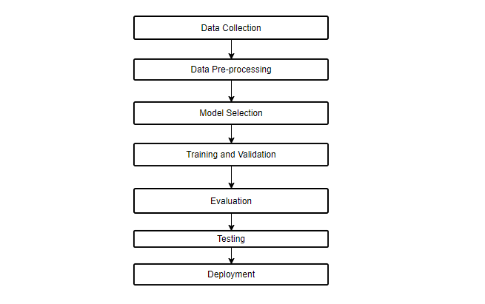
Figure 3.1 Methodology Diagram

Use Case Diagram
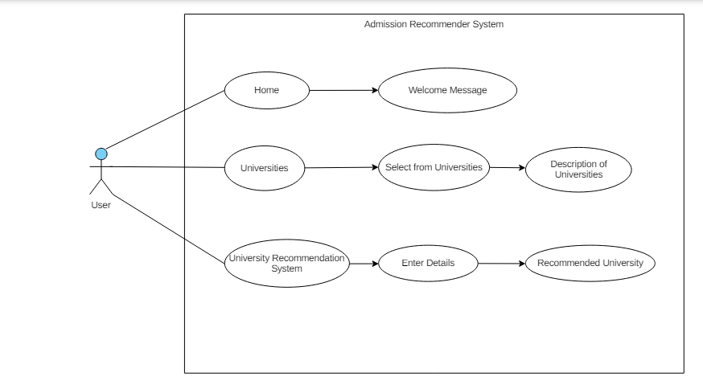
Figure 3.2 Use Case Diagram

Activity Diagram
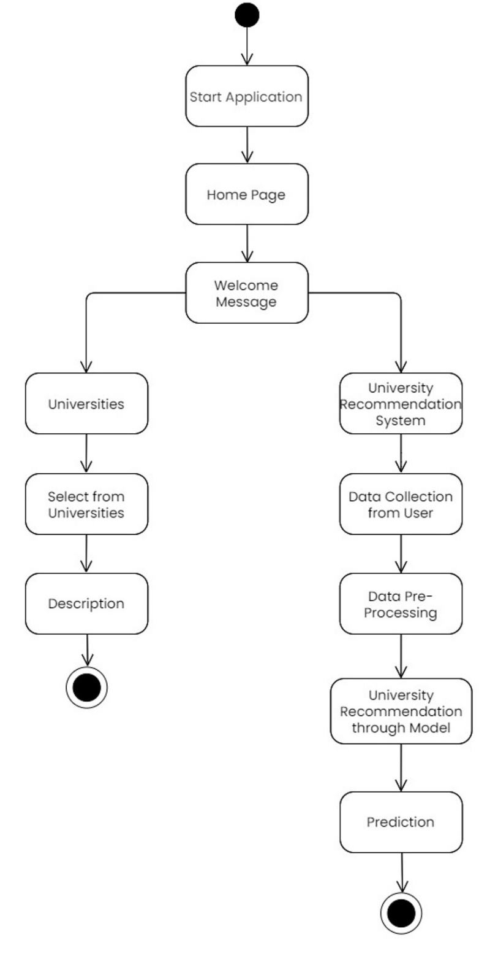
Figure 3.3 Activity Diagram

Sequential Diagram
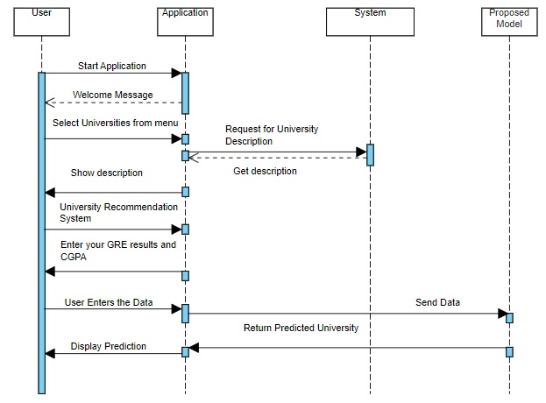
Figure 3.4 Sequential Diagram

IMPLMENTATION

Data Pre-processing and Exploration

Data Acquisition:

The project begins with the critical step of acquiring a suitable dataset. Fortunately, a wealth of publicly available datasets exists, providing a strong foundation for various research endeavors. To ensure optimal project outcomes, a selection process was undertaken. Several prominent datasets were considered, including historical admission records from various educational institutions, standardized test scores, demographic information, and extracurricular activity data. Each dataset was evaluated based on its relevance to the project's objectives and overall data quality. Following this comprehensive analysis, the "admission_data" dataset was determined to be the most suitable dataset for the Admission Recommender System project.

Data Cleaning and Pre-processing:
After acquiring the "admission_data" dataset, a comprehensive data cleaning and preprocessing phase is undertaken to ensure the dataset is ready for analysis and modeling. The quality of the reporting data, the ways of collecting the information, and the absolute confidence in its reliability. the Char field names used in the above context are prepared by making a strip of space from the column names and change the names to lower case and replaces all the blank by underscore for all the columns used in the above procedure That is why such rows with NaNs are deleted. All these values are useful in removing the repetitive ones depending on the fact that all the values represent the same value in that respective column. Imbalance of classification data can be solved using SMOTE technique to enhance results in that it can help measure them properly. For this purpose, the method produces artificial samples from the classes and equalizes the proportion of the minority classes to balance the classes. According to this criterion, the pertinent boosting variables that are pulled out include test score, extra-curriculum activities, statement, and academic performance that has been With the view of changing them.

Dataset Split:

The training, validation, and test sets comprise the Admission Recommendation dataset. The including LightGBM, Logistic Regression, Decision Tree, Random Forest, XGBoost, and KNN are trained using patterns and characteristics found in the training set, which is made up of most of the data.

      - Training Set:

Most of the dataset is included in the training set, which is what the machine learning alogrithms including LightGBM, Logistic Regression, Decision Tree, Random Forest, XGBoost, and KNN utilize to learn from patterns and characteristics in the data.
Depending on the size of the dataset and the complexity of the models being trained, the training set comprises 80% of the dataset.

      - Validation Set:

During training, the model's performance is tracked and its hyperparameters are adjusted using the validation set. The validation set receives 10% of the dataset.

      - Test Set:

The test set is used to measure the trained models' ultimate performance and their capacity to generalize to new data. On current, tested samples, it offers an objective evaluation of the model's performance. The test set receives 20% of the total dataset.

Experimentation and Model Development

    - Model Training and Selection:

In order to implement the classification machine learning techniques for training and selecting models in the Admission Recommender System, the following techniques were employed. These include the LightGBM, Logistic Regression, Decision Tree, Random Forest, XGBoost and K-Nearest Neighbors , KNN which have been chosen depending on the difficulty of the admission recommendation task and nature of the “admission_data” set. By doing this, we were thus able to strike a balance between the model’s performance on one hand and the realistic approximation of the system for correct admission status recommendation on the other thus enhancing the systems efficiency on the totality of the recommendation.

.
    - Model Evaluation:

After testing the model on the new_scaled_processed_data dataset, the obtained performance metrics provide valuable information on how well the model identified and categorized network intrusions. Nevertheless, during examination, several shortcomings were found, such as the existence of class imbalance impacting the consistency of standard accuracy measurements. To overcome these constraints, more sophisticated strategies like class weighting and resampling are used to improve the resilience and generalization of the model. Promising paths for enhancing admission recommender accuracy and scalability in practical Admission recommender applications include further investigating ensemble techniques and hybrid architectures, as well as carrying out iterative improvements and optimizations to the KNN model

RESULTS AND DISCUSSIONS

LightGBM

During the training, we adopted LightGBM as the machine learning method. The sample data applied here includes 535614 samples to train this construct. The training history, along with metrics like accuracy, precision, recall, and F1 score, are described below:
Total No of samples | 669518
No of testing samples | 133903
No of training samples | 535614
Table 5.1 Data Samples for LightGBM
Training Results:
accuracy | 31%
precision | 32%
recall | 31%
F1 score | 30%
Support | 133904
Table 5.2 Training Results

XGBoost

The training results that was used in this purpose, we have used XGBoost for that, so we have trained our model using XGBoost. In the training of the model, the training set contained 535,614 samples. The accuracy, the precision, the recall, and F1 score of measures that belong to the training history are described below:
Total No of samples | 669518
No of testing samples | 133903
No of training samples | 535614
Table 5.3 Data Sample for XGBoost

Training Results:
accuracy | 48%
precision | 48%
recall | 48%
F1 score | 47%
Support | 133904
Table 5.4 Training Results

Random Forest
The model for training we chosen Random Forest procedure. It is derived from the training data of 535614 samples. It is acquired from 535614 samples extracted from training dataset The training history and the metrics that are accuracy, precision, recall, F1 score are described below:
Total No of samples | 669518
No of testing samples | 133903
No of training samples | 535614
Table 5.5 Sample Data for Random Forest
- Hyper Parameters: test-size = 0.2, Random State = 28

Training Results:
accuracy | 79%
precision | 78%
recall | 79%
F1 score | 79%
Support | 133904
Table 5.6 Training Results

Logistic Regression

Logistic Regression shared the model shared a particular experience during the training process that occurred when the model encountered the training sample set, which totalled 535614. The model training for this case was made using a dataset containing 535614 samples; The training history of metrics such as accuracy, precision, precision, F1 score and recall is presented as follows:
Total No of samples | 669518
No of testing samples | 133903
No of training samples | 535614
Table 5.7 Sample Data for Logistic Regression
- Hyper Parameters: test-size = 0.2, Random State = 28, max-iteration = 1000
Training Results:
accuracy | 69%
precision | 69%
recall | 69%
F1 score | 69%
Support | 133904
Table 5.8 Training Results

Decision Tree

To enhance model training, we have used Decision Trees to make our decision. This step was done employing a training data set of 535614 samples A training history comprising measures like accuracy, precision, recall, and F1 score was defined and displayed below:
Total No of samples | 669518
No of testing samples | 133903
No of training samples | 535614
Table 5.9 Sample Data Decision Tree
- Hyper Parameters: test-size = 0.2, Random State = 42, max-iteration = 1000

Training Results:
accuracy | 69%
precision | 69%
recall | 69%
F1 score | 69%
Support | 133904
Table 5.10 1st Training Result
- Hyper Parameters: test-size = 0.2, Random State = 28, max-iteration = 1000
Training Results:
accuracy | 69%
precision | 69%
recall | 69%
F1 score | 69%
Support | 133904
Table 5.11 2nd Training Result

KNN

The training model used in our training process was the KNN, which has its full expanded form as the k-nearest neighbour. The model was trained using a dataset comprising of 535614 samples, the training history, including metrics like accuracy, precision, recall, F1 score is detailed below:
Total No of samples | 669518
No of testing samples | 133903
No of training samples | 535614
Table 5.12 Sample Data for KNN
- Hyper Parameters: n-neighbours = 3, test-size = 0.2, Random State = 28
Training Results:
accuracy | 72%
precision | 73%
recall | 72%
F1 score | 72%
Support | 133904
Table 5.13 1st Training Result
- Hyper Parameters: n-neighbours = 2, test-size = 0.2, Random State = 28
Training Results:
accuracy | 73%
precision | 75%
recall | 73%
F1 score | 74%
Support | 133904
Table 5.14 2nd Training Result
- Hyper Parameters: n-neighbours = 6, test-size = 0.2, Random State = 28

Training Results:
accuracy | 67%
precision | 67%
recall | 67%
F1 score | 67%
Support | 133904
Table 5.15 3rd Training Result
- Hyper Parameters: n-neighbours = 10, test-size = 0.2, Random State = 28

Training Results:
accuracy | 62%
precision | 61%
recall | 62%
F1 score | 62%
Support | 133904
Table 5.16 4th Training Result
- Hyper Parameters: n-neighbours = 1, test-size = 0.2, Random State = 28

Training Results:
accuracy | 79%
precision | 79%
recall | 79%
F1 score | 79%
Support | 133904
Table 5.17 5th Training Result

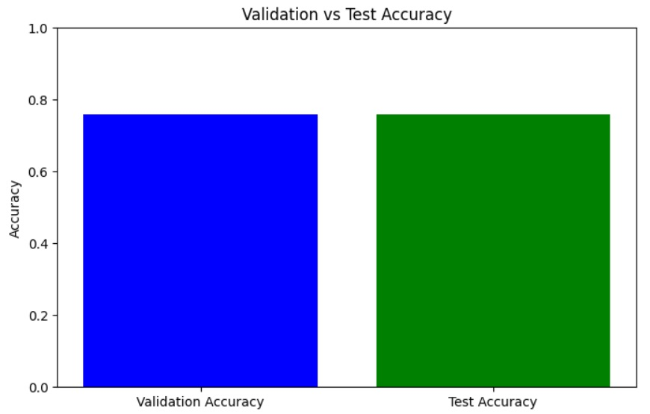
Figure 5.1 Accuracy and Validation Accuracy

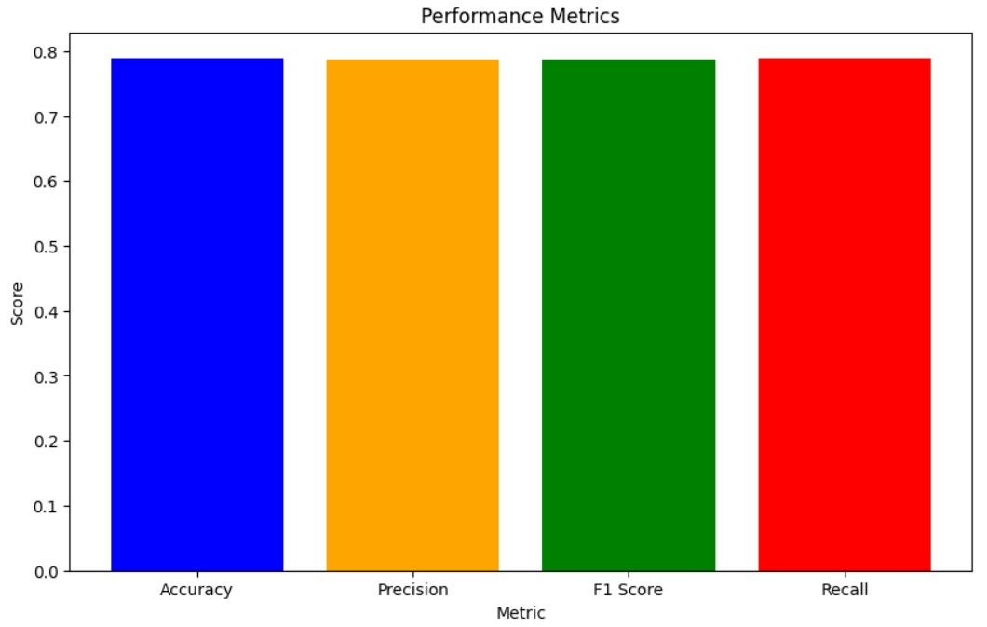
Figure 5.2 Evaluation Metrics

Conclusion
To train our dataset, we used several algorithms for the classification like LightGBM, Logistic Regression, Decision Tree, Random Forest, XGBoost, and K-Nearest Neighbors. From the Result, It is evident that KNN recorded the highest accuracy of 79% compared to the other classifiers.

User Manual

Figure 5.3 Streamlit Based Web Application
1. Introduction:

The best Admission Recommender System for Master’s programs. This user guide is meant to guide the intending user on how best to navigate the application that may be used to search for universities and compile a list of recommended universities depending on the applicants’ GRE scores and cumulative Grade Point Average (CGPA).
2. Accessing the Application:
The application is available through the web interface that is given.
All you have to do is go to the URL that hosts the application.
3. Navigation:
When you launch the application, a left-hand sidebar with navigation choices appears:
Home: Takes you back to the main webpage.
Enumeration of Universities: gives a list of the colleges that are part of the system.
Scholarly Suggestion: enables you to enter your CGPA and GRE results to get a recommendation for a university.
4. Home Page:
The homepage extends a warm greeting and gives a summary of the goals of the University Recommender System.

5. List of Universities:
An extensive list of the universities covered by the system is shown on this page.
To learn more about the universities that are up for recommendations, click through the list.
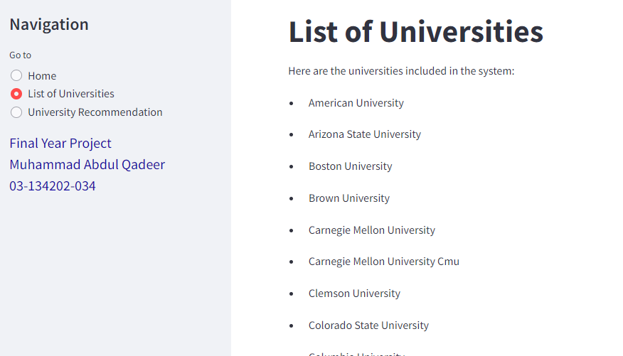
Figure 5.4 List of Universities
6. University Recommendation:
You can enter your CGPA and GRE results on this page to get a customized university recommendation.
Enter your GRE Analytical Writing, Verbal, and Quantitative scores in the designated ranges.
Calculate your CGPA from 1 to 100.
For the suggestion to be generated, click the "Check University" button.
The system will forecast your university based on your credentials if your provided values are genuine.
You will be prompted with an error message to make sure your values are within the permissible limits if your input values are invalid.
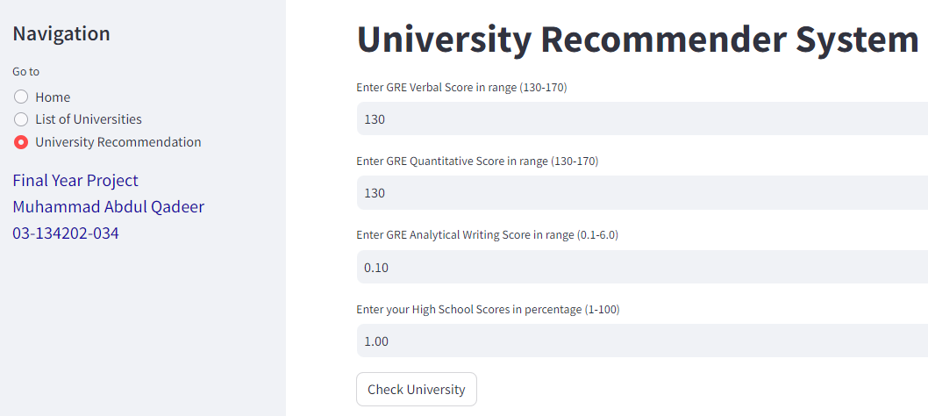
Figure 5.5 University Recommendation
7. Ethical Considerations:
The recommendation system seeks to offer impartial and equitable advice.
But admissions decisions are based on more than just CGPA and GRE results.
Make use of the suggestions as a starting point, and for more thorough guidance, think about speaking with academic advisors or admissions counselors.
8. Feedback and Support:
We appreciate your input on the functionality and performance of the system.
For assistance, please get in touch with our support team if you run into any problems or have any ideas for improvement.

CONCLUSION AND RECOMMENDATIONS

Conclusion

The complexity of admission arising time to time, the sophisticated recommender system will play a crucial role of making wise and need-based recommendations about the learners to be admitted. This project showcases a machine learning-based admission recommender system designed to assist with the admissions process. The dataset undergoes comprehensive preprocessing, including SMOTE oversampling to address class imbalance and feature extraction through domain knowledge. To evaluate the proposed system, it was tested on historical admission data. The results on our dataset show that the proposed system achieves 79% accuracy. Unlike other methods, our system integrates all relevant features of the dataset and provides comprehensive recommendations, effectively addressing the diverse needs and profiles of applicants in each run.

Future Work

In the future, plans should be made to change the AI-Powered Education Counselling platform from a website to an application. The advantages of having a mobile app are the following: The possibility of reaching a large number of consumers is also higher. The accuracy of our Admission recommender system is 79% which is satisfactory but required improvement. However, future work will focus on enhancing the model's accuracy, aiming to improve the current rate of 79 % to the highest possible level using advanced machine learning models.

REFERENCES

Journal Papers:

- Fong, Simon & Biuk-Aghai, Robert. (2009). An Automated University Admission Recommender System for Secondary School Students.
- Tejaswini, Miss Khomane, and R. K. Nale. "COLLEGE RECOMMENDATION SYSTEM FOR ADMISSION." System 5.03 (2018).
- Wakil, Karzan, et al. "Web recommender system for private universities' admission in Iraq: Uhd case study." International Journal of e-Education, e-Business, e-Management and e-Learning 4.5 (2014): 329.
- El Guabassi, Inssaf, et al. "A recommender system for predicting students' admission to a graduate program using machine learning algorithms." (2021): 135-147.
- Kanoje, Sumitkumar, Debajyoti Mukhopadhyay, and Sheetal Girase. "User profiling for university recommender system using automatic information retrieval." Procedia Computer Science 78 (2016): 5-12.
- Nalawade, Aishwarya, and Bhavana Tiple. "The University Recommendation System for Higher Education." Int. J. Recent Technol. Eng. 8.6 (2020): 1692-1696.
- Shetty, Sakshi, et al. "USA University Recommendation System." Open Access International Journal of Science Engineering 6.5 (2021): 66-70.

Electronic Sources from Internet:

- https://www.python.org/
- https://streamlit.io
- https://www.kaggle.com/datasets/nitishabharathi/university-recommendation
- https://www.geeksforgeeks.org/k-nearest-neighbours

