

BSCS-F23-007
03-134212-070 | Muhammad Awais
03-134202-052 | Muhammad Haseeb Akbar

Royale War

In partial fulfilment of the requirements for the degree of Bachelor of Science in Computer Science

Supervisor: Junaid Nasir Qureshi

Department of Computer Sciences
Bahria University, Lahore Campus

May 2024

© Bahria University, 2024

C e r t i f i c a t e



We accept the work contained in the report titled “Royale War” Written by Muhammad Awais & Muhammad Haseeb Akbar

as a confirmation to the required standard for the partial fulfilment of the degree of Bachelor of Science in Computer Science.

Approved by:
Supervisor: Junaid Nasir Qureshi
(Signature)

June 15, 2024

DECLARATION

I hereby declare that this project report is based on my original work except for citations and quotations which have been duly acknowledged. I also declare that it has not been previously and concurrently submitted for any other degree or award at Bahria University or other institutions.

Enrolment | Name | Signature
03-135192-045 | Muhammad Awais
03-134202-052 | Muhammad Haseeb Akbar

Date: May 20, 2024

ACKNOWLEDGEMENTS

We would like to thank everyone who contributed to the successful completion of this project. We would like to express our gratitude to our research supervisor, Mr. Junaid Nasir Qureshi for his invaluable advice, guidance, and his enormous patience throughout the development of the research.

In addition, we would also like to express my gratitude to our loving parents, and friends who helped and given me encouragement.

Muhammad Awais
Muhammad Haseeb Akbar

ABSTRACT

Real-time strategy games have always been the most famous and favorite among all gamers since the start of gaming history. Classical real-time games consist of different strategies where you must focus on making different strategies rather than level completion. However, this is all about completing the levels and not racing against time. I am going to develop a game named Royale War. As the name shows, the game is based on a war between two states. Royale War unfolds the epic conflict between two formidable states, offering players a chance to immerse themselves in a rich and dynamic war-torn world. Unlike many games that solely focus on superficial battles, Royale War delves deep into the art of strategy, diplomacy, and resource management. And creating an account is must of every user before playing game.

The game's strategy is to attack the opposite state and towers with troops, defensive structures, and defend yourself. With the money that users earn, users use it to unlock new factory by new card. The tools that are used to design this game will be Adobe Photoshop and the main tool to build the game is unity 3D. This hard-earned currency can be wisely invested to unlock new factories and expand their arsenal through the acquisition of new cards. These cards act as pivotal assets, granting access to various units, technologies, and strategic options that can be leveraged to gain the upper hand on the battlefield.

TABLE OF CONTENTS

TABLE OF CONTENTS 1
DECLARATION ii
ACKNOWLEDGEMENTS iii
ABSTRACT iv
LIST OF FIGURES 4
LIST OF TABLES 6
CHAPTER 1 7

1 INTRODUCTION 7
1.1 Background 7
1.2 Problem Statement 7
1.3 Aims and Objectives 8
1.4 Scope of Project 8
CHAPTER 2 9
2 SOFTWARE REQUIREMENT SPECIFICATION 9
2.1 Introduction 9
2.1.1 Overview 9
2.1.2 Functional Requirements 10
2.1.3 Non-Functional Requirements 10
CHAPTER 3 11

3 DESIGN AND METHODOLOGY 11
3.1 Methodology 11
3.2 Feature Driven Development 11
3.3 Tools and Techniques 12
3.4 Research 13
3.5 Planning 13
3.6 Design 13
3.6.1 System Case Diagram 14
3.6.2 Sequence Diagram 15
3.6.2.1 Game Play Sequence Diagram 16
3.6.2.2 Level Complete Sequence Diagram 17
3.6.2.3 Level Fail Sequence Diagram 18
3.6.2.4 Level Restart Sequence Diagram 19
3.6.2.5 Pause Sequence Diagram 20

3.6.3 Class Diagram 21
3.7 Use Cases 25
3.7.1 Use Case 2 (Rate Us & More Games) 26
3.7.2 Use Case 3 (Exit Game) 27
3.7.3 Use Case 4 (Pause Button) 28
3.8 Feature Build-Development, Testing 29
3.8.1 Test Cases 29
CHAPTER 4 31

4 IMPLEMENTATION 31
4.1 Introduction 31
4.2 Story Board 31
4.3 Game Design and Development 32
4.4 Model Prefabs 32

 | CHAPTER 5 |  |  | 33
 | 5 RESULTS AND USER MANUAL |  |  | 33
 | 5.1 Results and User Manual |  |  | 33
5.1.1 Register Screen |  |  |  | 33
5.1.2 Login Screen |  |  |  | 34
5.1.3 Card Selection |  |  |  | 35
5.1.4 Game Play Screen |  |  |  | 36
5.1.5 Reward Screen |  |  |  | 37
 | CHAPTER 6 |  |  | 38
 | 6 CONCLUSION |  |  | 38
 | 6.1 Conclusion |  |  | 38
 | 6.2 Future Work |  |  | 38
 | REFERENCES |  |  | 40
 | APPENDIX |  |  | 41
Plagiarism report |  |  |  | 46

LIST OF FIGURES

 | Figure 3-1: System Diagram | 14
 | Figure 3-2: Sequence Diagram | 15
 | Figure 3-3: Game Play Sequence | 16
 | Figure 3-4: Level Complete Sequence | 17
 | Figure 3-5: Level Fail Sequence | 18
 | Figure 3-6: Restart Game Sequence | 19
 | Figure 3-7: Resume Game Sequence | 20
 | Figure 3-8: Class Diagram | 24
 | Figure 3-9: Use Case | 25
 | Figure 3-11: Use Case (Rate Us & More Games) | 26
 | Figure 3-12: Use Case (Exit Game) | 27
 | Figure 3-13: Use Case (Pause Button) | 28
 | Figure 4-1: Game Design Flow | 32
 | Figure 5-1: Register Screen | 33
 | Figure 5-2: Login Screen | 34
 | Figure 5-3: Cards Selection Screen | 35
 | Figure 5-4: Game Play Screen | 36
 | Figure 5-5: Reward Screen | 37
 | Figure 0-1: Save and load Data | 41
 | Figure 0-2: Authentication | 41
 | Figure 0-3: Card Selection | 42
 | Figure 0-4: Audio Manager | 42
 | Figure 0-5: Enemy Spawner | 43
 | Figure 0-6: Enemy | 43
 | Figure 0-7: Player | 44
 | Figure 0-8: Player Spawner | 44
 | Figure 0-9: Built Script | 45
Figure 0-10: plagiarism Report1 |  | 46
Figure 0-11: plagiarism Report2 |  | 47

LIST OF TABLES

Table 3-1: Use Case (Rate Us & More Games) |  | 25
Table 3-2: Use Case (Exit Game) |  | 27
Table 3-3: Use Case (Pause Game) |  | 28
Table 3-4: Test Case (Start Button) |  | 29
Table 3-5 Test Case (Cards Selection) |  | 29
Table 3-6 Test Case (Level Complete) |  | 30
Table 3-7 Test Case (Level Fail) |  | 30
Table 3-8 Test Case (Pause Button) |  | 30
 | LIST OF SYMBOLS / ABBREVIATIONS
SRS | Software Requirements Specification
FDD | Feature Driven Development
UML | Unified Modeling Language
FPV | First Person View

CHAPTER 1

1 INTRODUCTION

1.1 Background
The genre of real-time strategy games is widely embraced in the realm of video gaming, where players immerse themselves in combat scenarios, employing firearms to defeat adversaries. These games present dynamic environments, presenting players with diverse challenges and opponents to overcome. Characterized by intense action, strategic gameplay, and compelling narratives, strategy games offer players the opportunity to engage in adrenaline-pumping experiences. The gameplay typically involves navigating through various settings, utilizing a variety of weapons to compete against opponents. Success in strategy games demands quick reflexes, precise aim, and tactical thinking, contributing to the overall immersive and challenging nature of these gaming experiences.

1.2 Problem Statement
The mobile gaming market is highly competitive, and players increasingly seek immersive and engaging experiences. Many existing games lack diverse gameplay scenarios and strategic depth, which leaves a gap in the market. "Royale War," a mobile game developed using Unity 3D, aims to fill this gap by offering a rich, immersive environment with varied gameplay. Players can engage in strategic jeep driving, arena battles, and aerial combat from a jet. Soldiers are depicted using a number of weapons, there are also displayed the state points and lifelines and some strategic moments to defeat the opponent states. The game is presented in different levels of increasing difficulty while the concept is that the player must develop strategies to keep its army and factories safe from the opponent’s forces. Its online nature introduces a competitive edge, necessitating an internet connection for real-time player competition. The project will deliver a 3D game and a comprehensive report, targeting game enthusiasts who seek dynamic and strategic entertainment to relieve stress.

1.3 Aims and Objectives
The objectives of the game are the following:

- To entertain users and to reduce users stress in spare time.
- Real-time strategy and user engagement.
- To provide users a safe environment for players to meet things they realistic
environment.
- Win Battles and earn rewards and replace cards.

1.4 Scope of Project
The project encompasses the development of a mobile game, "Royale War," utilizing Unity 3D to create an immersive environment. The game's primary focus is on implementing diverse gameplay scenarios, ranging from strategy while driving a jeep to engaging in arena battles and aerial combat from a jet. Key features include soldiers battling with various weapons, on-screen display of state points and lifelines, and a strategic element for defeating opponent states. With multiple levels and escalating challenges, players must devise effective strategies to protect their army and factories, ensuring victory. The online nature of the game introduces a competitive edge, necessitating an internet connection. The final deliverables encompass the 3D game and a comprehensive report. The target audience comprises game enthusiasts seeking entertainment and stress relief through a dynamic and strategic gaming experience.

CHAPTER 2

2 SOFTWARE REQUIREMENT SPECIFICATION

2.1 Introduction
"Royale War" emerges as an immersive 3D single-player arena game, where players delve into intense battles, strategically deploying troops and devising cunning tactics to secure vital factories and outmaneuver adversaries. With the unlocking of troop-generating cards, the gameplay deepens, enabling players to refine their strategies and adapt to ever-changing challenges. Beyond entertainment, "Royale War" serves as a haven, providing a reprieve from daily stresses while fostering strategic thinking and skill development. In this virtual landscape, players engage in historical conflict simulations, honing their strategic acumen within a safe and engaging environment. More than a mere game, "Royale War" offers an avenue for excitement, mental stimulation, and strategic mastery, inviting players to embark on an exhilarating journey through iconic historical conflicts.

2.1.1 Overview
Royale War is a captivating 3D single-player game set in an arena where players strategically battle to secure their factories and defeat opponents. The game involves assembling troops, deploying strategies, and engaging in combat to ensure survival. Players unlock different troop-generating factory cards using in-game currency, enhancing their strategic options. The ultimate goal is to defeat the opponent state, with both sides starting on equal footing. The game offers an engaging environment, featuring soldiers, tanks, and machines. Additionally, the inclusion of card-based elements adds a layer of progression and customization. With the purpose of entertaining and reducing stress, Royale War provides a safe platform for players to experience historical conflicts in a realistic environment, emphasizing strategic thinking and decision-making.

2.1.2 Functional Requirements

- Start of the game, we have a splash screen (Loading Screen)
- The card selection screen where the user can choose the card.
- Allows the player to resume the level, restart the level, and go back to card selection screen.
- Attractive loading panel display when scene is load.
- Game fail and Game complete screens.
- Both states try to defeat to each other states.
- Both state lifelines should be displayed on the screen.
- Gameplay with a single player.
- The game is online; it will require internet connection.

2.1.3 Non-Functional Requirements

- The mobile display should be of high resolution.
- The response time between click and reaction is always less than 0.5 seconds.
- The game can run smoothly with 4 GB of Ram which is every android mobile has in now days.
- The code written for the game is maintainable to add new features to the newer versions.
- Since the latest recoil game now creates profiles for users, it needs to access user credential, therefore, security is critical concern in this application.

CHAPTER 3

3 DESIGN AND METHODOLOGY

3.1 Methodology
The methodology used in our project is feature-driven development, which is driven by an agile framework.
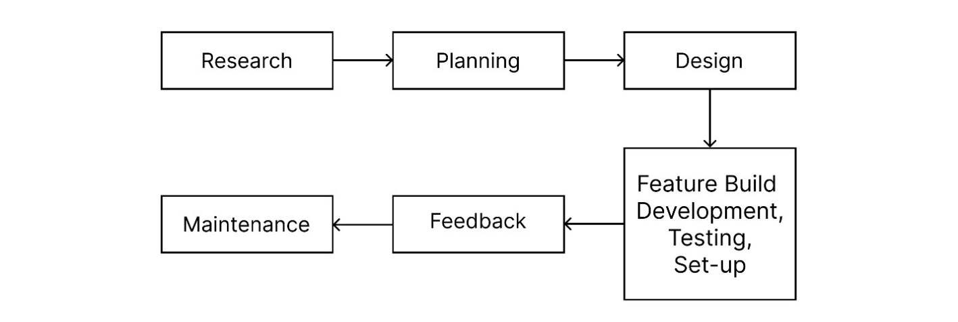

3.2 Feature Driven Development
Feature Driven Development is an agile methodology that organizes software development around achieving progress on features, as the name implies [1]. However, features in the Feature Driven Development context are not always product characteristics in the conventional sense. They're more equivalent to user stories in Scrum. In other words, in the Feature Driven Development methodology, "finish the login procedure" might be considered a feature.

3.3 Tools and Techniques
For developing a Royale War game using Unity 3D and C#, along with additional tools and techniques.
Unity 3D:Unity3D is a robust cross-platform 3D engine with an easy-to-use development environment. Unity should appeal to everyone who wants to simply create 3D games and applications for mobile, desktop, the web, and consoles. It is simple enough for beginners yet powerful enough for experts [2].
Blender: Blender is an open-source 3D computer graphics software used for creating animated films, visual effects, art, 3D printed models, motion graphics, and video games. It supports a comprehensive array of functions including modeling, sculpting, rigging, animation, simulation, rendering, compositing, and motion tracking. Additionally, it features video editing and game creation capabilities. Belender is known for its versatility and is maintained by a community of developers and artists. It is distributed freely under the GNU General Public License.
Figma: There is a tool that developers use in building of the interfaces and the designing of these interfaces as well as doing MOACK prototype and the tool that is commonly used here is Figma because of the support that it provides to the users. This tool is also good since the has the ability to be edited by different users and it improves the collaboration of the project.
Visual Studio: Microsft Visual Studio is an IDE which is used in development of computer programs, websites , web apps, web services as well as for the development of mobile apps. It supports many programming languages like C#, C++, Python, etc., and provides a better interface to learn the specific programming language easily.
Photoshop: Adobe Photoshop is the well-known photo editing tool for Windows and Mac. It is widely applicable in applications such as photo- editing, graphic designing and digital art works. This tool’s range of functions and capabilities for working with an image can be as extensive as layers, masks, filters, brushes, and much more.
C#: C# is one of the best programming language when it comes to game development in Unity. This helps in writing scripts for managing the different aspects such as the logic of the game, movement of the player, actions of the enemies, and many other things.

AudioSparx: It is a website that provides links for free mp3 downloads with AudioSparx focus in music and sound effects. We apply it in licensing and sourcing of audio branding such as radio jingles and ticks, background music, sound effects and any other sound material.

Mixamo: Mixamo is an appealing firm, mainly due to the appeal that it offers an extensive list of pre-animated 3D character models. We use Mixamo to acquire zombie character animations or even animate player character's movements and attacks.

3.4 Research
A good mystery is one of the most entertaining aspects of a piece of literature. The complete knowledge of the scope of the project and the current domain targeted and analyze. Unity 3D is a powerful cross-platform 3D engine and a user-friendly environment [10]. We developed our 3D game on unity 3D in which the first developed the interactive design and further coding.

3.5 Planning
I will feature a list and plan created for the features of the project. System requirements and tools required are gathered. Features Selection of the game and planning.

3.6 Design
All possible UML diagrams are designed e.g., System Case, Class, and Sequence diagram design also, phase deals with interface designing and prototype.

3.6.1 System Case Diagram

A system case diagram in the Unified Modeling Language can describe the specifics of your system's users (also known as actors) and their interactions with the system. To make one, you'll need a particular collection of symbols and connections. A good use case diagram can assist your team in discussing and representing:

- Interactions between your system or application and people, organizations, or external systems
- Goals that your system or application assists those entities (referred to as actors) in achieving.
- The extent of your system.

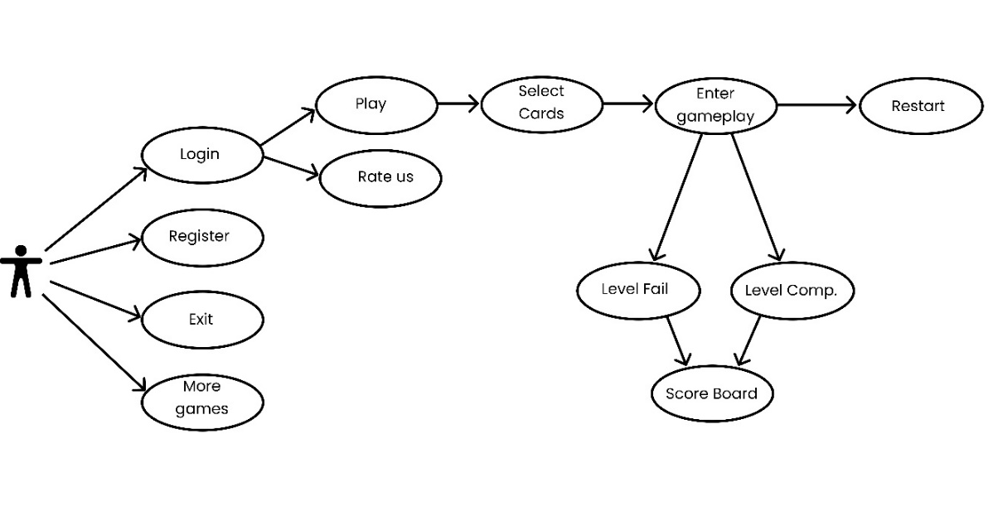
Figure 3-1: System Diagram
In Figure3-1: System Diagram application outlines several key functionalities essential for user interaction and engagement. It includes a login/signup feature, allowing users to create accounts or access existing ones, ensuring personalized experiences. The register function complements this by managing user information securely. An exit option provides a straightforward way for users to leave the application gracefully. The "more games" feature offers users additional gaming options, enhancing the app's entertainment value. The play function serves as the core activity, enabling users to start and enjoy their selected games. Finally, the rate us feature invites user feedback, helping to improve the app based on user ratings and reviews.

3.6.2 Sequence Diagram

UML Sequence Diagrams are interaction diagrams that show how processes are performed. They record the interaction of items within the framework of a partnership. Sequence Diagrams are time focused, and they graphically express the sequence of the interaction.
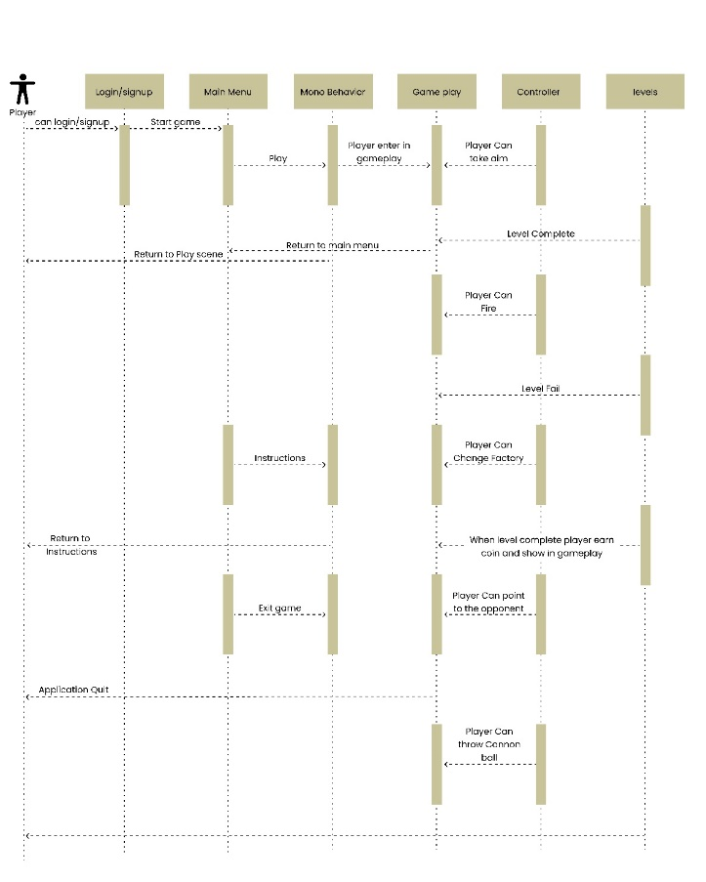
Figure 3-2: Sequence Diagram
The sequence diagram illustrates the interactions for login/signup, navigating the main menu, handling MonoBehaviour, managing gameplay, utilizing the controller, and progressing through levels. It begins with the user initiating the login or signup process, which communicates with the authentication system to verify credentials or create a new account. Upon successful login, the user accesses the main menu, from which they can start a new game, load a saved game, or adjust settings. During gameplay, MonoBehaviour scripts manage game objects and behaviors, responding to user inputs captured by the controller. As the player advances, the system handles level transitions, ensuring a seamless gaming experience.

3.6.2.1 Game Play Sequence Diagram

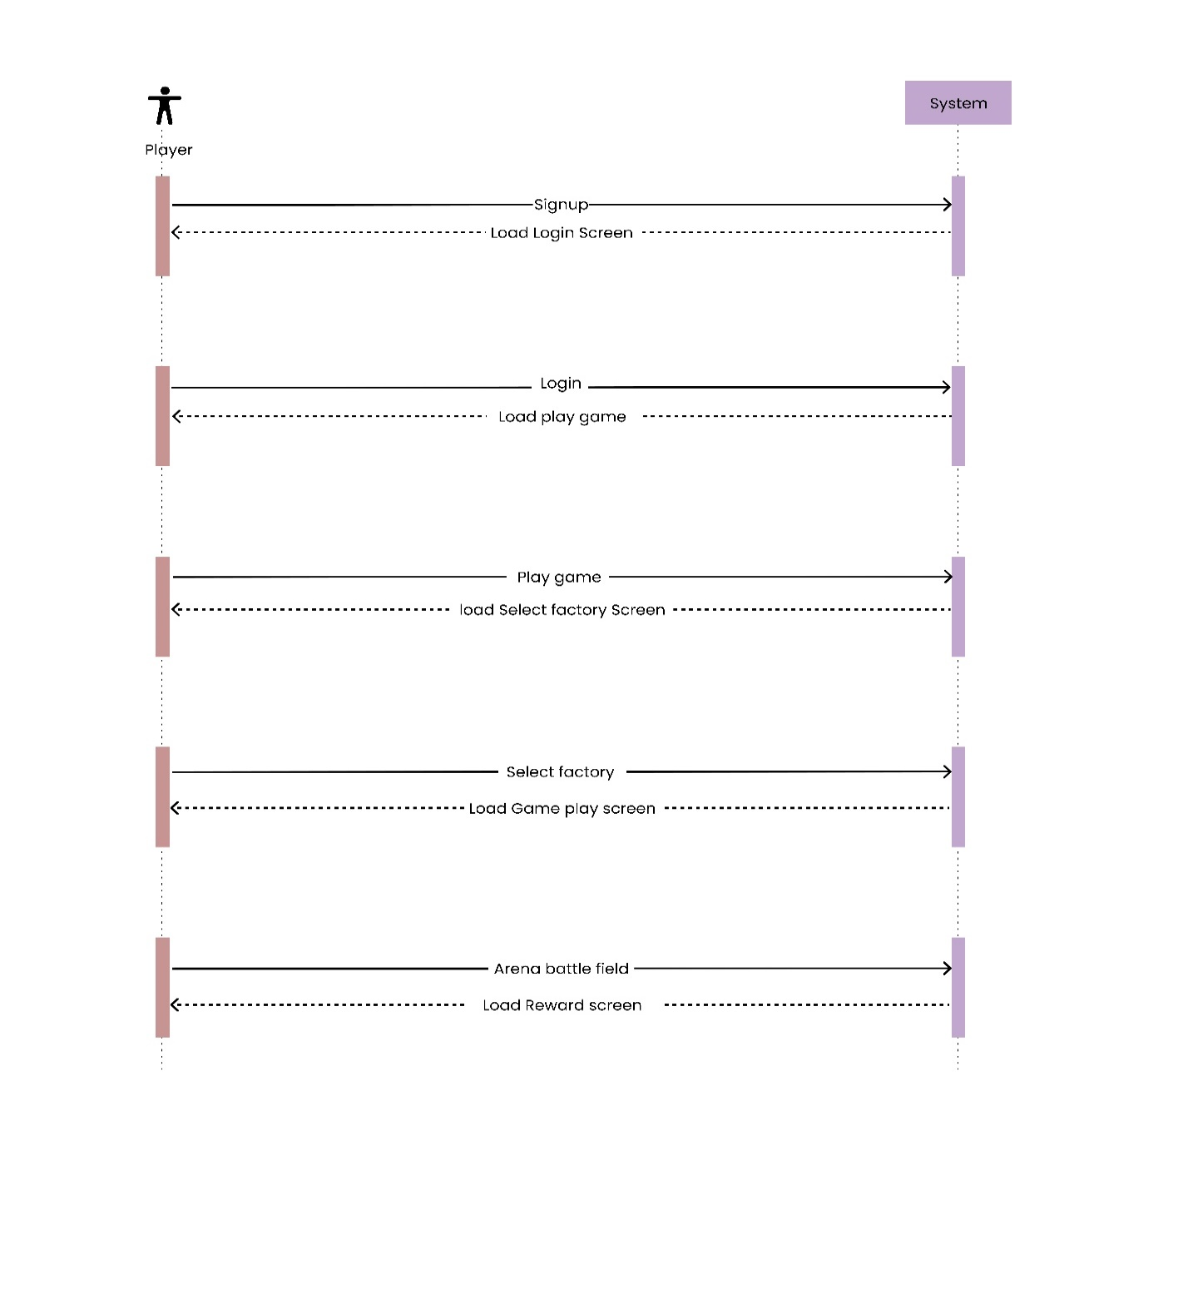
Figure 3-3: Game Play Sequence
The following diagram illustrates the flow of events in use case Game Play during the various phases of a gaming session

3.6.2.2 Level Complete Sequence Diagram

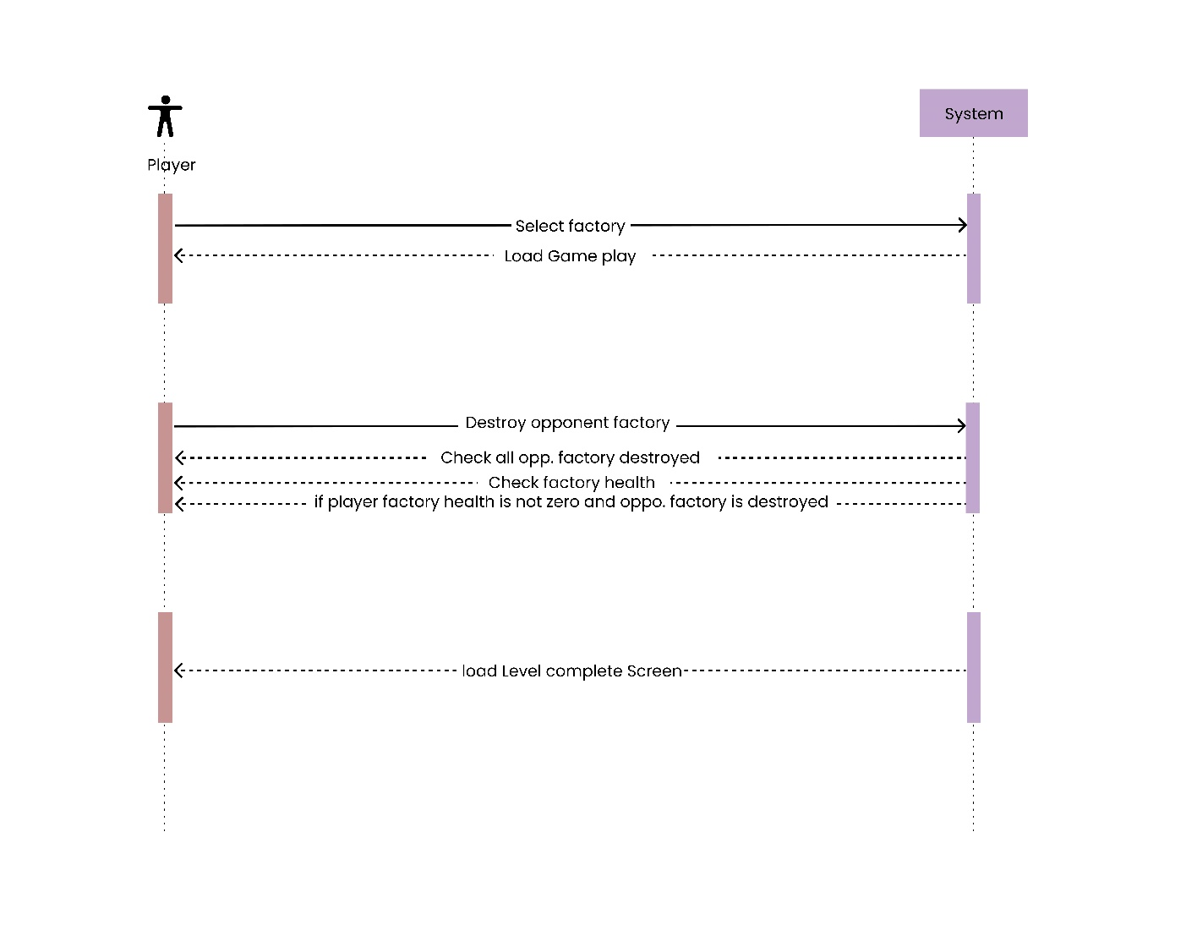
Figure 3-4: Level Complete Sequence

A level complete sequence diagram reflects a sequence of interactions which occur when a player is through with the level in a game.

3.6.2.3 Level Fail Sequence Diagram

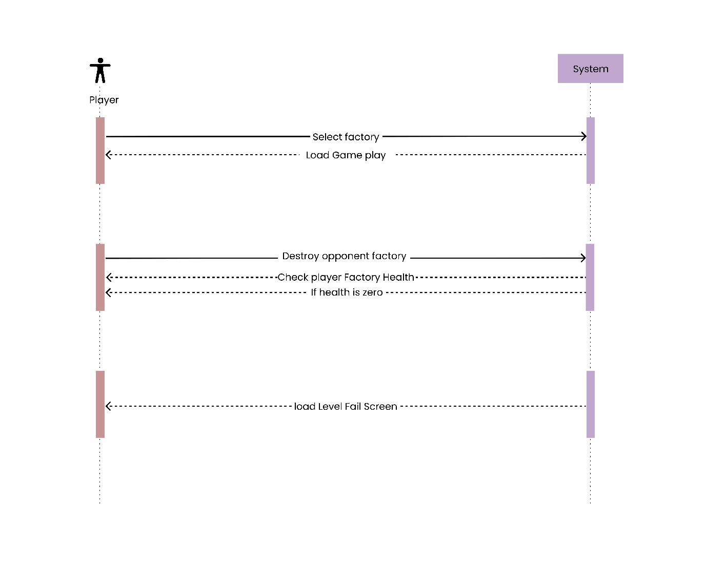
Figure 3-5: Level Fail Sequence
A Level Fail sequence diagram depicts patterns of statics and dynamics in scenarios where a user fails a specific level of a game. Usually the diagram starts from the user straining at a level and the moves or action in the game environment started by the user.

3.6.2.4 Restart Sequence Diagram

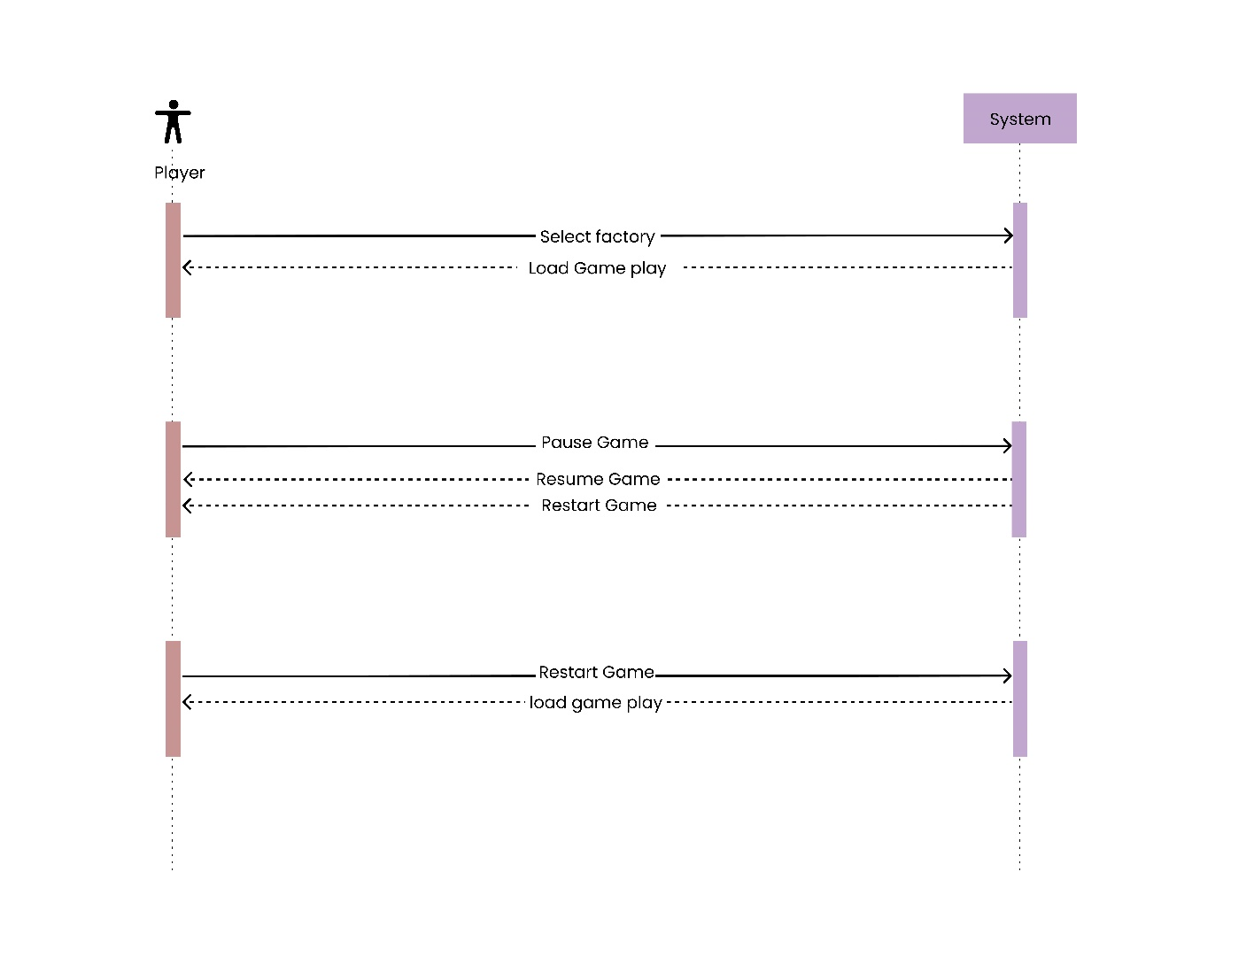

Figure 3-6: Restart Game Sequence
Restart sequence diagram describes a systemic step wise procedure in a methodical way on how to restart a system. Of all the restart requests launched by the user, the actual restart procedure starts when the System Controller receives such a request.

3.6.2.5 Pause Game Sequence Diagram

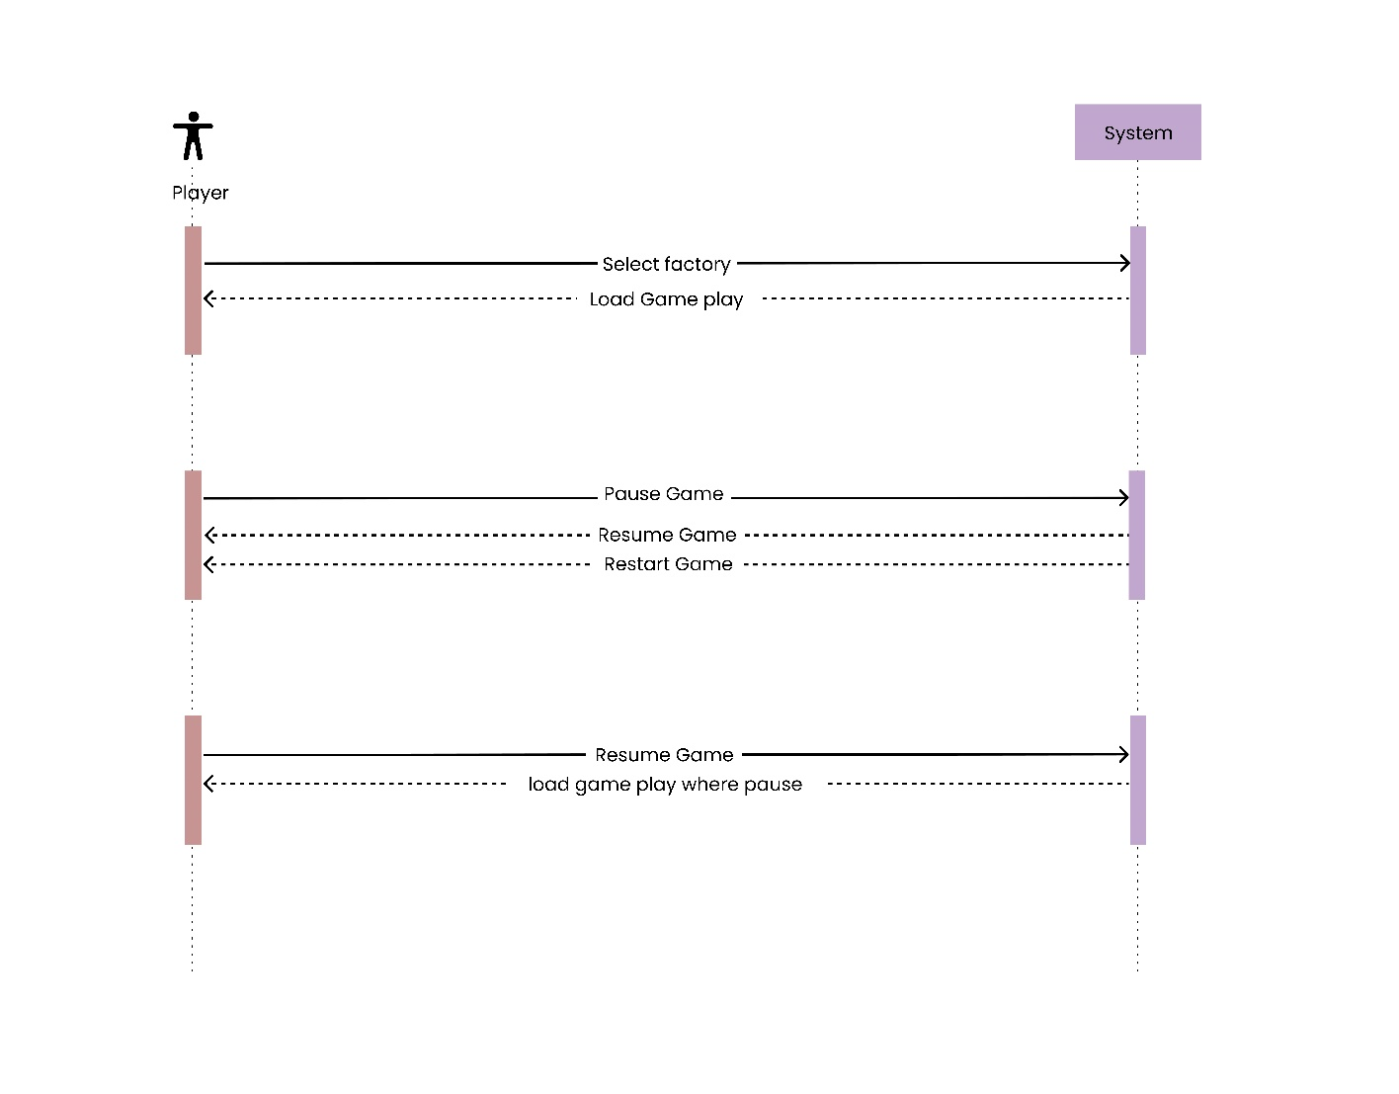

Figure 3-7: Resume Game Sequence

Explaining the interactions, which occur when the player decides that he or she wants to pause the game, call the “Pause Game” sequence diagram. When the pause action is set, usually by pressing a pause button, then a message to the Game Controller is created.

3.6.3 Class Diagram
In the Unified Modeling Language, a class diagram is a sort of static structural model in software engineering that presents the construction of a system by showing classes of the system and objects related to them, including the properties of classes and the operations these classes contain. There are 2 main classes of Royale War, namely::

Authmanager: In the “Royale War,” there is the Authmanager class and as the name entails, it is the class used to handle all the firebase authentications. The registration process just entails filling an easy form with attributes like the name, email, and passcode and other details depending on the intended usage while they are safely stored within the database. On the subsequent visit the users can log in with the contact e-mail which they used during the registration process and any password of their choosing. This process is helpful to avoid continuous exploits on a user account or disable any malicious usage on a user account. Regarding the premise on how that “Royale War” application provides satisfactory and safe an effect or players, Firebase is the answer. Engage with the framework through AuthManager for the two-way enhanced gaming experience where the interacting gamers engage each other.

Player Selector: The PlayerSelector class, within "Royale War" manages how players acquire and use cards. Players can get these cards by buying them or unlocking them using coins earned from winning battles or wars in the game. Each card that is unlocked or purchased can be used in battles. Players pick the cards they want to use and a corresponding factory brings these selected cards into the game world. At the start of a gaming session players choose their cards one by one with the option to choose up to three cards. Once players have selected their three cards, they can begin the battle by pressing the designated "battle" button. This starts the game. Integrates the chosen cards into the gameplay mechanics allowing players to strategically deploy their selected arsenal. The PlayerSelector category ensures a connection between card selection and deployment improving the gaming experience, in "Royale War."

Player: In the game "Royale War," players, in the "Player" class pick their characters. Assign them positions on the battlefield. The characters then move to their designated spots as planned. Once they reach their positions they check if any enemies are nearby to attack. If there are enemies, within range they start attacking. In case there are no enemies they head towards the enemy factories from where they currently stand. Upon reaching a factory they start damaging or destroying enemy structures. After that they search for enemy targets. Continue until all foes or factories are taken out. This active approach keeps players engaged as they strategically navigate and battle opponents to emerge victorious in "Royale War."

Enemy: The enemies in “Royale War” classifying themselves into different positions of the game lies in the “Enemy” class. Opponents, in turn, go into formation based on the strategy already outlined above. As soon as an enemy gets to its designated position, it scans the proximity to identify any players who are within its capacity to attack. If the enemies get the signal that the players are in its range, it will attack the players. However, if there is no player within reach, enemies move toward the nearest player factories starting from their present position. When attacking a facility in a factory, the enemies attack and demolish structures of the other players. They then search for other player entities and focus on destroying them until all players will be gone or all factories are destroyed.

DataStore: However, in the “Royale War” game developed, the class is involved in storing data on Fire based database; whether data relating to the user ID or the email. Such information may include the number of levels accomplished, details concerning the existing level, and if any, the remaining coins. In other words it functions this way, once a user links on the application the DataStore gets back the necessary information to allow access to the user progress as well as his assets. Such integration should be smooth so that the players should continue from the exact instance that they left or their progress and the corresponding assets should be preserved. By integration of Firebases infrastructure “Royale War” provides efficient and consistent storage of data with better performance in the game.

Player Spawner: As it was said in the previous card, Royale War’s Player Spawner class is in charge of getting the players moving after they have been placed at the factories dictated by the cards at the time of drawing. When these players are created or spawned, they also have to stick to the fixed formation or stay rooted to those fixed positions until they are told to advance forward towards the enemy or the objectives. In PT BoP as players stand still while they jump up and down new ones continue to spawn from the manufacturing line to the playing ground. Still, if adversaries look at our factories to counter as an aiming response, yes, the process of spawning is halted. This particular tactic enables them to get a player on the battle while at the same time gives room for compound changes to maneuver in order to address new threats.

Enemy Spawner: In the game ‘ ‘Royale War,’ ‘ the class ‘Enemy Spawner’ is playing the part of providing the antagonists and putting them in the battles in the appropriate factories. It is similar with once it made all these enemies they just pop up on their respective places in the game. Which takes some time, and the enemies are making approximate approaching circles, fresh ones are produced in factories. But if the attack adversaries launch their attack on our factories, then the spawning process receives a continuous stream. As referring to such a strategic move, this implies that an enemy is in the battlefield, and at the same time one is adapting to the foe.

Player Built: Royale War under the class Player Built, there is a method through which structures constructed fires at specified areas or on other structures and/or units within its
In the game: Royale War under the class Player Built, there is a method through which structures constructed fire at specified areas or on other structures and/or units within its reach. When these structures get in touch with any of the enemies, they cause the specified amount of damage which in effect lowers the strength of the enemy. Moreover, numerous attacks accompanied by structures produce vivid sparks of different color that make the overall picture more attractive and interesting for the players.

Enemy Built: In the game “Royale War”, the Enemy Built class determines how the built structures attack certain regions on the map or specific player unit, if within the range of their firing. It reduces the strength of the players dealing system damage when these structures make contact with players. Also, attacking structures on the players deal damage and cause particles which add more charm points and more enemies.

Factory Health: In the game "Royale War," the Factory Health class deals with factories' condition and health of the players This very element makes sure that in-depth game data is quality and readily available all the way through the gameplay process. This class of the game called Resource management which monitors the factory processes and the player's well-being, stands a very important and fundamental role to protect the integrity of the gaming which is "Royale War".

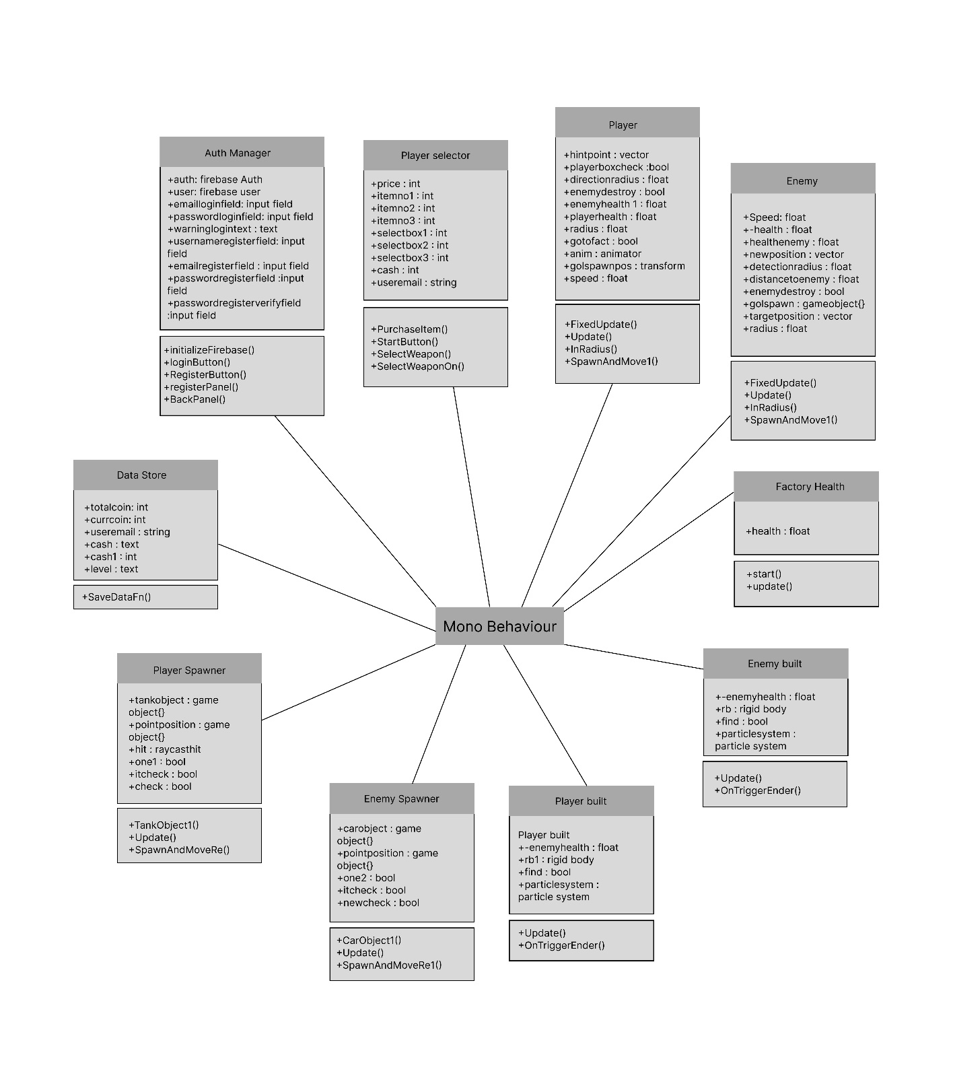
Figure 3-8: Class Diagram

3.7 Use Cases

Use-case diagrams describe the high-degree features and scope of a machine. Those diagrams also pick out the interactions between the machine and its actors. The use instances and actors in use-case diagrams describe what the system does and the way the actors use it, however no longer how the system operates internally.

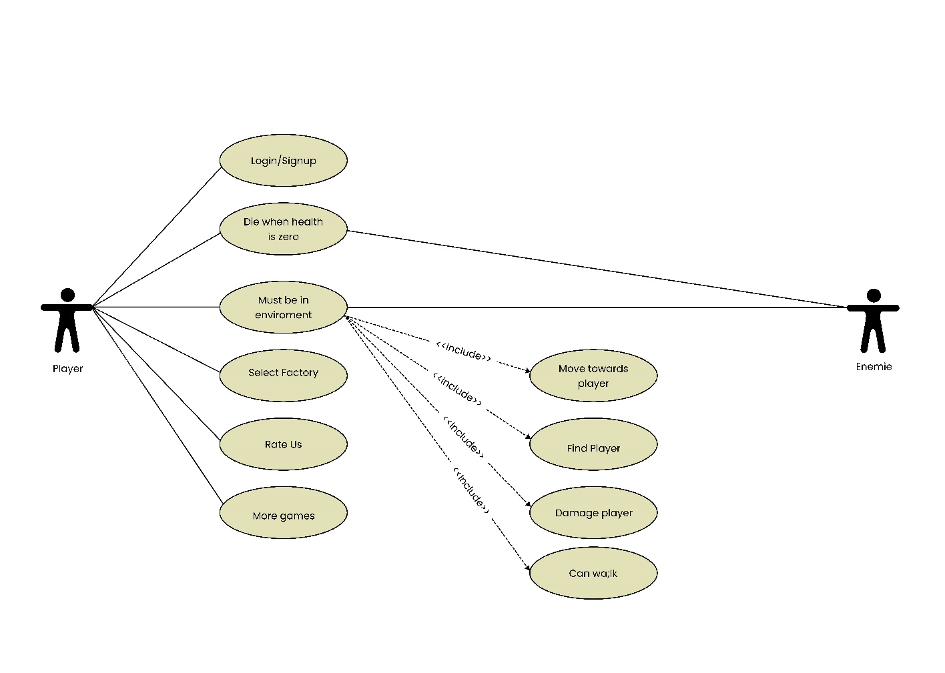

Figure 3-9: Use Case

3.7.1 Use Case 1 (Rate Us & More Games)

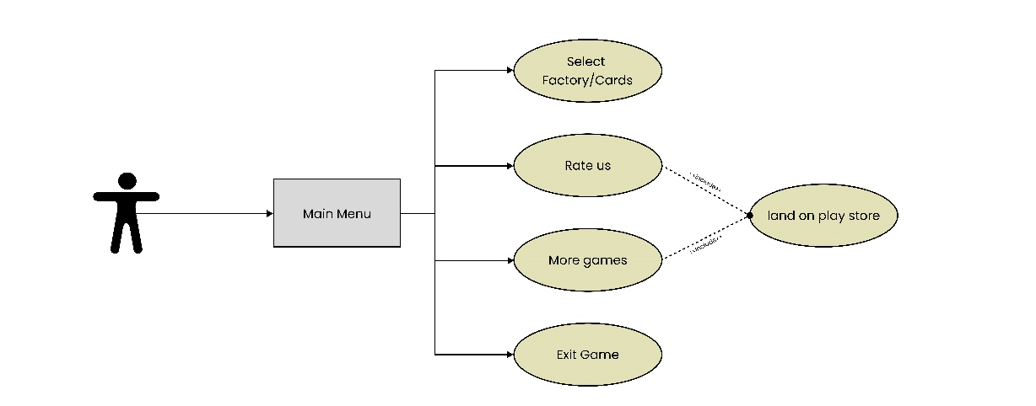

Figure 3-10: Use Case (Rate Us & More Games)

Name: | Rate Us & More Games
Actor: | Player
Entry Conditions: | Application is running.
Flow of Events: | - Player clicks rate us button  - game shows him a screen to give ratings  - player can then rate the game there
Exit Conditions: | Game and developers’ info is displayed.
Table 3-1: Use Case (Rate Us & More Games)

3.7.2 Use Case 2 (Exit Game)

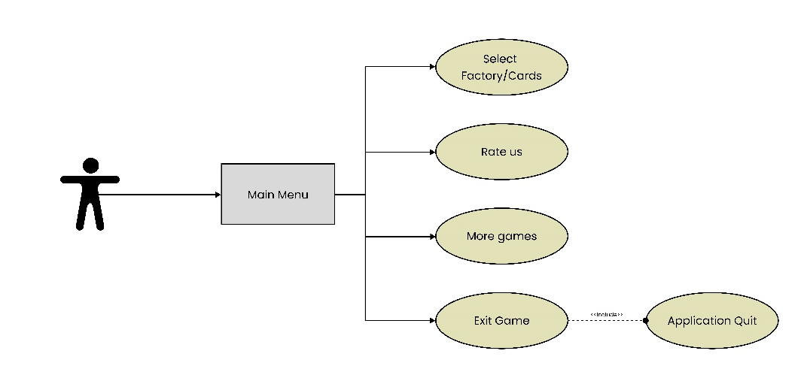

Figure 3-11: Use Case (Exit Game)

Name: | Quit
Actor: | Player
Entry Conditions: | Application is running.
Flow of Events: | - Player click the quit button.  - Player is asked to confirm his selection to quit game.  - If he/she confirms then game will be closed.
Exit Conditions: | Game is not running anymore.
Table 3-2: Use Case (Exit Game)

3.7.3 Use Case 3 (Pause Button)

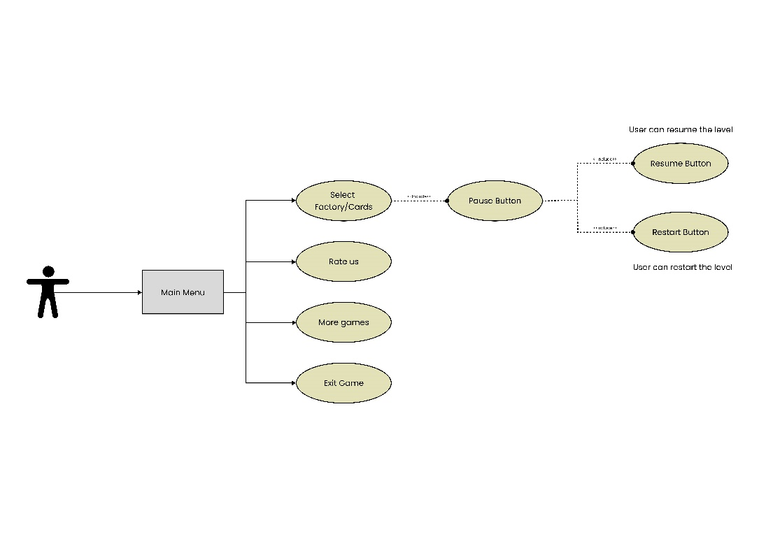

Figure 3-12: Use Case (Pause Button)

Name: | Pause
Actor: | Player
Entry Conditions: | Application is running.  A Game is not currently in progress.
Flow of Events: | - Player can pause the game by clicking pause button.  - In which, player can replay the level, and resume the level.
Exit Conditions: | Game is not in a playable state.
Table 3-3: Use Case (Pause Button)

3.8 Feature Build-Development, Testing
Functions are developed based on the feature list. Game Engines such as Game Physics, Graphics. The interactive approach of feature building results in the final product.
Each module is tested after the development and these modules are written in implementation chapter and results are discuss in results chapter, where you can see every development process and work.
Tested modules are integrated here to build a complete working system. Integration testing is where software modules are integrated logically and tested as a group. A typical software project comprises of several software modules written by various programmers. The goal of this level of testing is to identify flaws in the interaction of various software components when they are combined.
Unit and integration testing is implemented in this project. Father more, white box and black box testing is also implemented.

3.8.1 Test Cases

Start Game Test Game:
Test Case Name: Test Game start
Pre-Condition |  | Game is installed
Sr. | Action |  | Expected Result | Status
1 | Press the game icon “Royal war” |  | Game starts after 4,5 seconds | OK

Table 3-4 Test Case (Start Game)

Card Selection Test Case:
Test Case Name: Card selection
Pre-Condition |  | Card selection screen is open
Sr. | Action |  | Expected Result | Status
1 | Select Card |  | Card Selection icons shown | OK

Table 3-5 Test Case (Card selection)

Level Complete Test Case:

Test Case Name: Test level complete
Pre-Condition |  | Target achieved.
Sr. | Action |  | Expected Result | Status
1 | Target achieved. |  | Level complete panel is open. | OK
Table 3-6 Test Case (Level Complete)

Level Fail Test Case:

Test Case Name: Test level fail
Pre-Condition |  | Target achieved.
Sr. | Action |  | Expected Result | Status
1 | Target not achieved or player die. |  | Level fail panel is open. | OK
Table 3-7 Test Case (Level Fail)

Pause Button Test Case:

Test Case Name: Test Pause button
Pre-Condition |  | Game play is open
Sr. | Action |  | Expected Result | Status
1 | Press the pause button |  | Pause panel is open | OK
Table 3-8 Test Case (Pause Button)

CHAPTER 4

4 IMPLEMENTATION

4.1 Introduction
The game is a simulation game where we have a story line. In which player performs multiple tasks given in the levels and when level completes, user get reward. We are adopting an agile development approach using FDD to ensure deadlines and goals. The development tiers are mentioned below.

4.2 Story Board
In the start of the game, we have splash screen that takes 5 seconds to go to next scene, then the next scene is the Authentication scene. In the pause panel we have a play button, more games button, rate us button and exit button to quit the game. User moves to new scene which is shop and cards selection screen like we buy cards for factories, in which user can shop new factories also this screen has next button, by clicking next button user reach in arena screen, in which user can pause and restart the level. After clearing the level user get reward and get to the next level.

4.3 Game Design and Development
The game is developed in unity 3D. In the development of game, firstly the login/signup is created using buttons and scripts. Second, the game has a card selection scene that allows the user to play with factories, user can play 5 levels in the game.

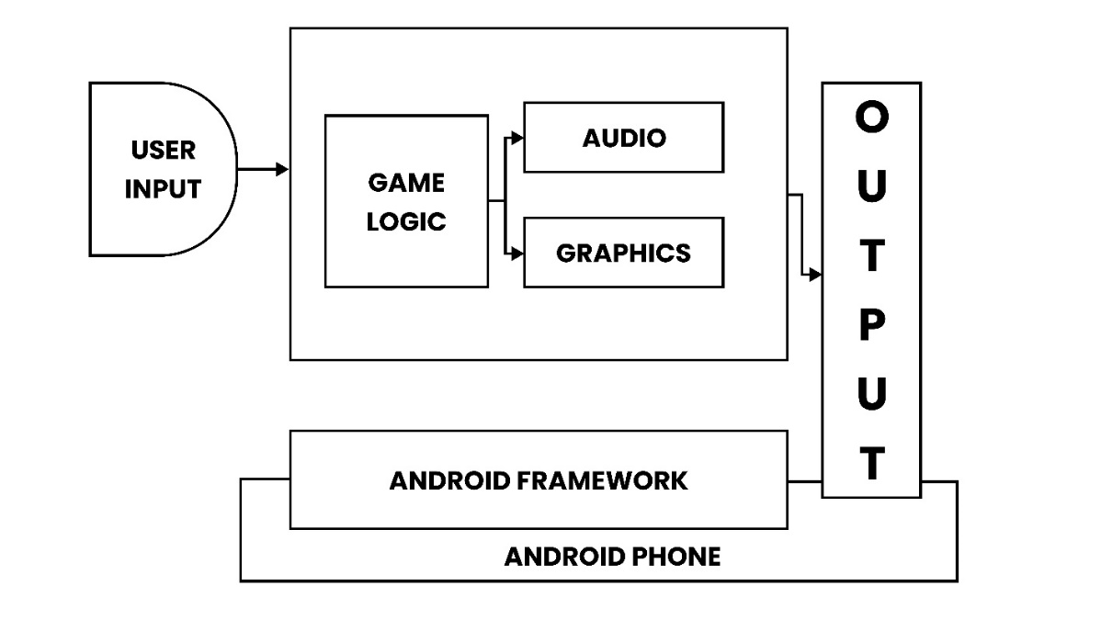
Figure 4-1: Game Design Flow
The Game Design Flow diagram illustrates the seamless interaction between various components crucial for an engaging gaming experience on the Android platform. It delineates the intricate balance between user input, game logic, audio and graphics processing, and final output. Each component harmonizes within the Android framework, ensuring a smooth flow from user actions to immersive visual and auditory feedback. This comprehensive design approach ensures that gameplay remains intuitive, responsive, and visually captivating, enhancing the overall player experience on Android devices.

4.4 Model Prefabs
The following are the model prefabs of this game.
- Factories
- Soldier
- Tank
- Car
- Jet & missile
- Cannon & cannon balls
- Gun & bullets
- Environment

CHAPTER 5

5 RESULTS AND USER MANUAL

5.1 Results and User Manual
In the results, we show the outputs of the main menu, shop, mode selection, level selection, and game play and show the output of controller. In user manual, we show the user “how to play the game”.

5.1.1 Register Screen
The Register Screen includes four input fields: username, email, password, and confirm password. Upon pressing the "Register" button, the user is registered, and their data is stored in the Firebase database, as depicted in the figure below. The registration process ensures that all required fields are filled correctly and that the password and confirmation fields match. Firebase handles the backend operations, securely storing user information and managing authentication.

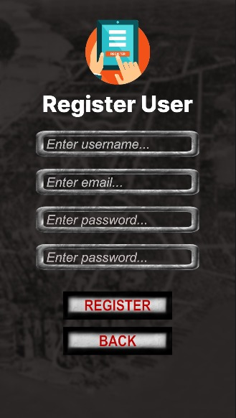
Figure 5-1: Register Screen

5.1.2 Login Screen
On the login selection screen, users can enter their email address and password to access their account. This process involves verifying the provided credentials against stored user data. Successful verification grants access to the user's account.
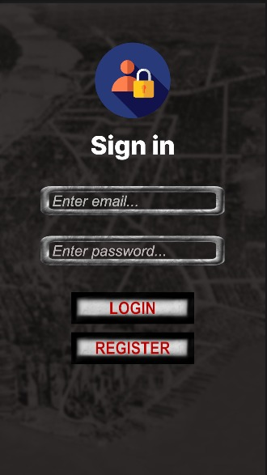
Figure 5-2: login Screen

5.1.3 Card Selection
On the card selection screen, users can choose from cards numbered 1 to 6. They are allowed to select up to 3 cards at a time. This selection is used for subsequent actions or gameplay.

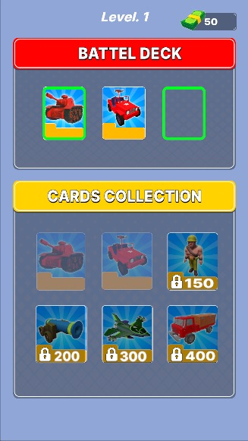
Figure 5-3: Cards Selection Screen

5.1.4 Game play screen
On the gameplay screen, users battle against opponents using the 3 cards they selected in the card selection screen. The outcome of the battle depends on the attributes and strategies involving these chosen cards.

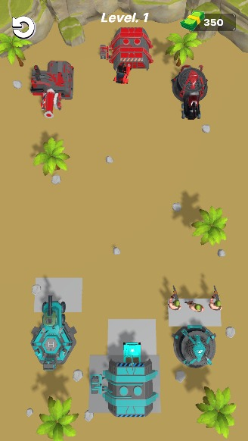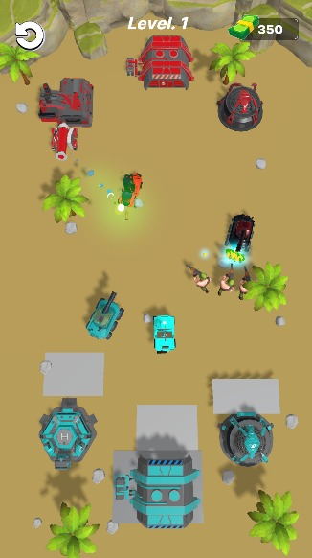
Figure 5-4: Game Play Screen

5.1.5 Reward screen
On the reward screen, users receive rewards based on whether they win or lose a level. The type and amount of rewards vary depending on the outcome of the gameplay.
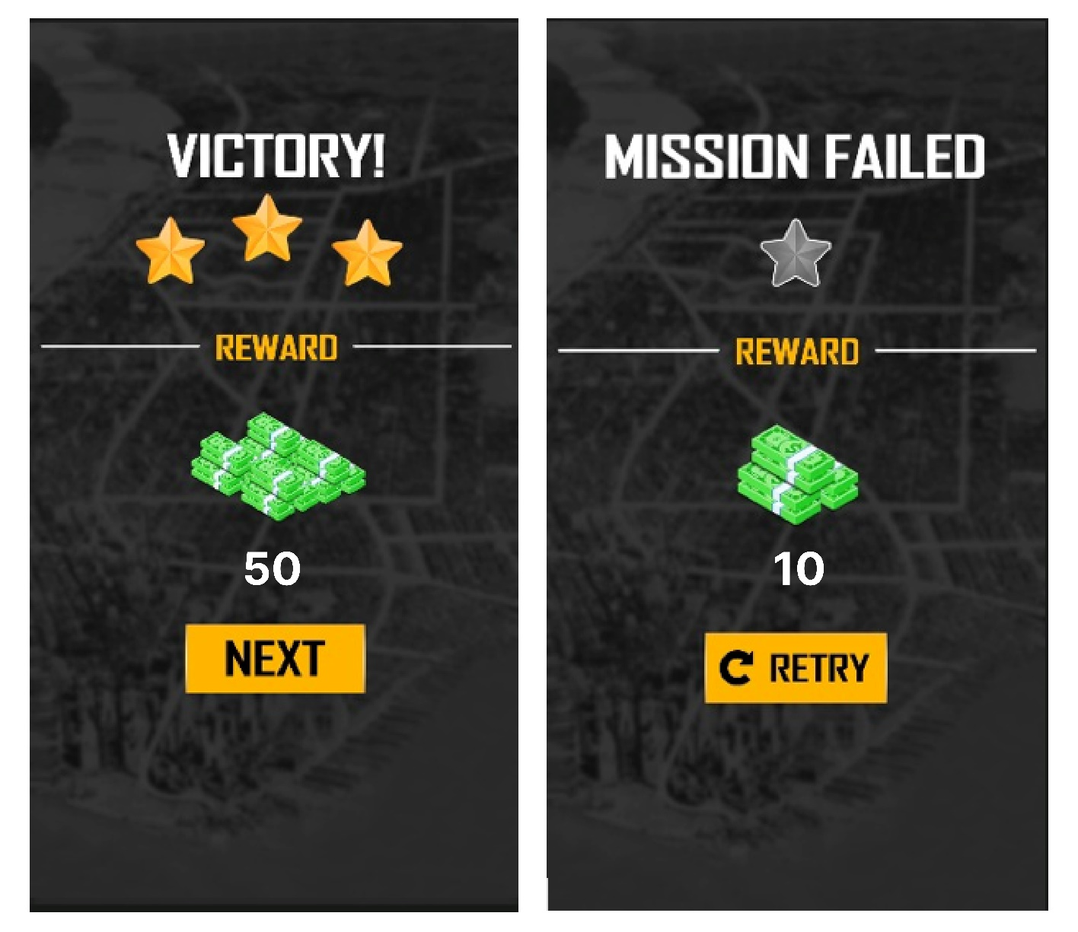
Figure 5-5: Reward Screen

CHAPTER 6

6 CONCLUSION

6.1 Conclusion
Conclusion:

Ally in conclusion, the game development of “Royale War” is further defined as a sophisticated attempt to develop an exciting and sensational mobile game that meets the needs of consumers in terms of the quality of the game. By using the Unity 3D tool for development, the game proposal is designed to provide an engaging experience in the virtual environment, in which the player can participate in various play-outs starting with the duels in the arenas and ending with the battle in a jet. The real-time strategy and the strategic themes intrinsic in the game’s design make the game engrossing, exciting and entertaining for the users and cause them to exercise their strategic aptitudes and talents.

Also, concept of “Royale War” is to ensure, that it reaches the goal and the purpose, which was established in front of the game – be entertaining and help the players to distract from the real-live problems, so create the opportunity practice the shooting games, while being safe. In addition to all of these, there is an online multiplayer characteristic that allows the gamers to play against other people from different places all over the globe; this addition, I believe, only makes an already great game even better.

The above idea will make MobileAppsG to have the ideal and perfect solution as the development of the project continues so that the lovers of gaming can be able to benefit from it better mobile gaming platform. As a consequence of its vertically physically designed look, new levels of complexity, an addition to the profoundness, and, undoubtedly, the high gameplay factor, “Royale War” will be ready to attract possible audiences of gamers, who wants to have fun and have an horrifying experience on their portable devices.

6.2 Future Work

Virtual Reality (VR) Support: if we want, we can think about creating the VR one . It can be taken that choosing the type of adaptation that allows constituting the key appeal to the virtual world offers potential buyers who like and are ready to immerse themselves into gaming via VR head devices.

Continuous Updates and Improvements: It also important to have a direct interaction with the players whenever they are playing the game so as to see their feedback and where there is any bug or problem then it should be deal with immediately. Updates of the contents of the game and improvements for them to be more interesting are crucial so as to ensure constant fun for all the players as they play their games.

REFERENCES

- R. Plamer, Feature-Driven Development, December 14, 2022.
- I. Zamojc, Introduction to Unity3D, 2012, May 17.
- Demigiant.com, DOTween, December 14, 2021.
- T. I. M. Easy!, Control Freak, 2020.
- Unity3d.com, About Firing, March 10, 2022.
- A. Okita, Learning C# Programming with Unity 3D, CRC Press, 2014.
- E. Adams, Fundamentals of Shooter Game Design, NEW RIDERS, 2014.
- R. Pratik, "Cross-Platform Application Development using Unity Game," vol. 3, no.
4, p. 9, 2015.

APPENDIX

APPENDIX A: Computer programmer listing
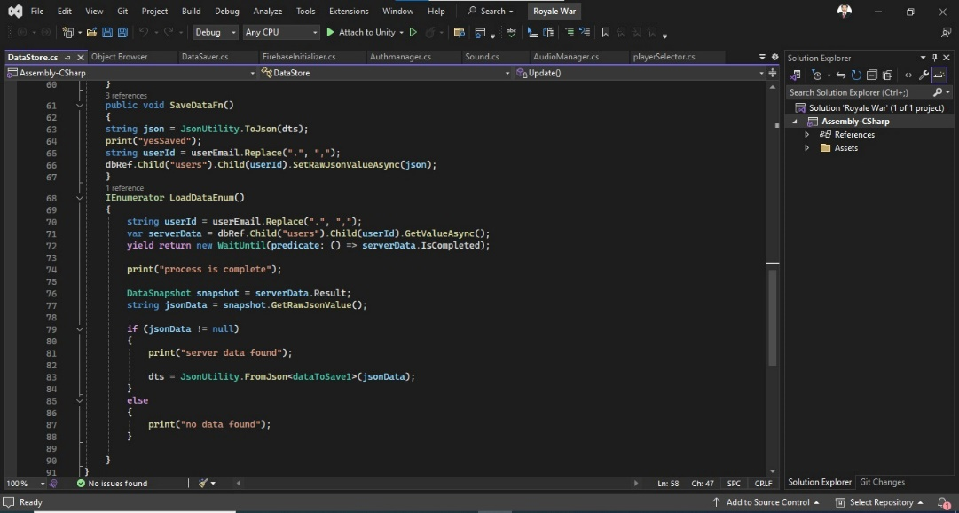

Figure 0-1: Save and load data from database
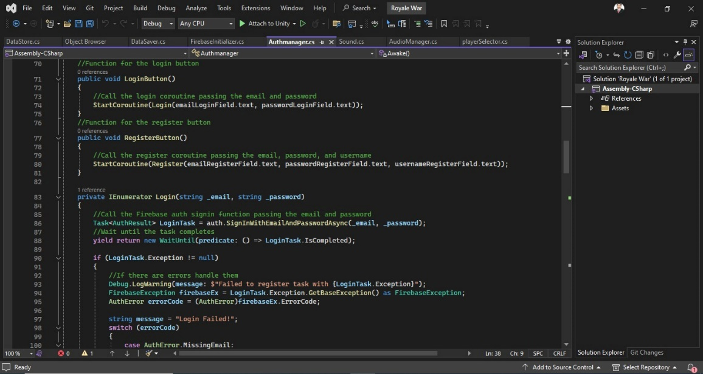
Figure 0-2: Authentication(Login/Signup)
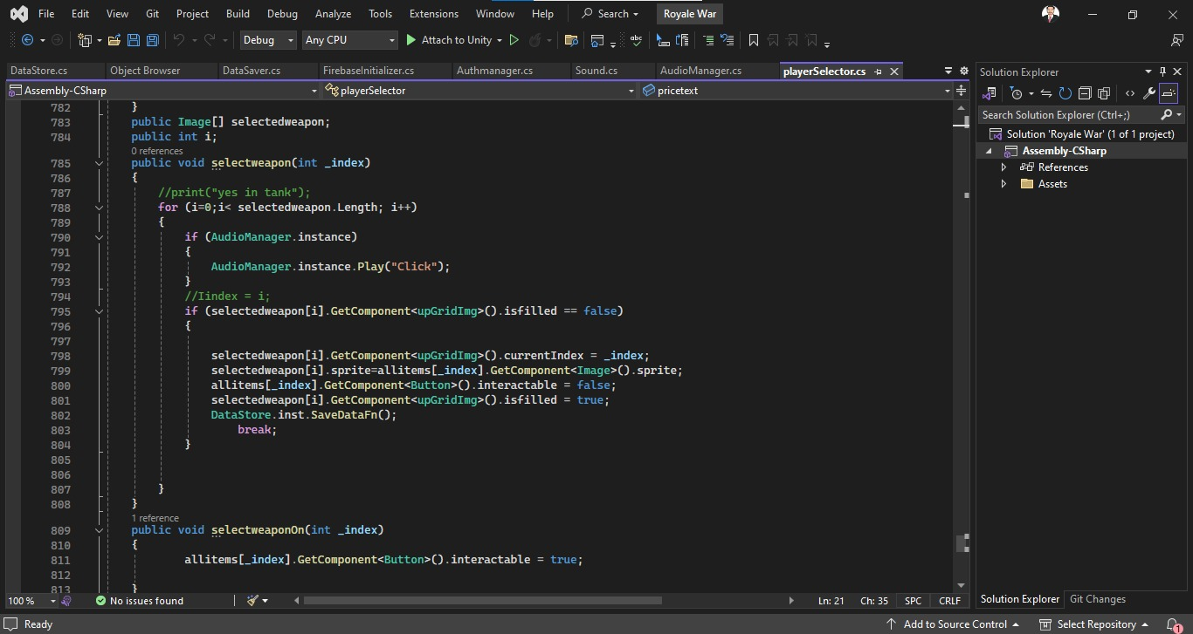

Figure 0-3: Cards Selections
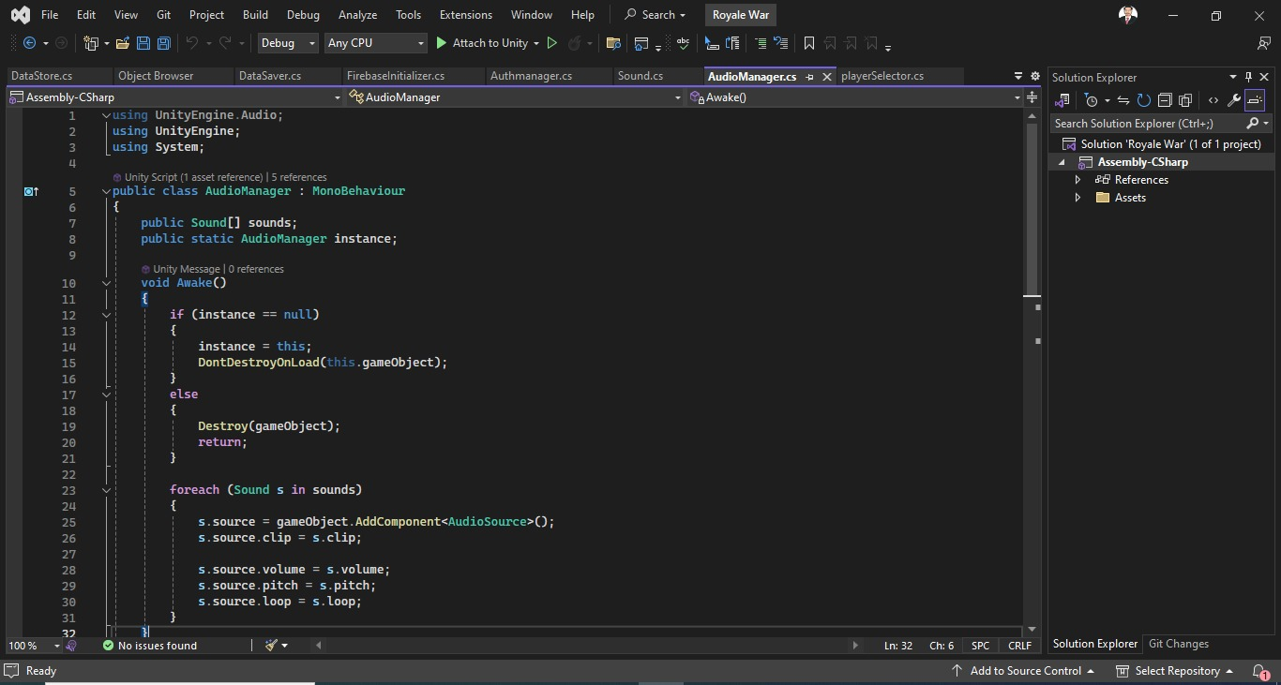
Figure 0-4: Audio Manager
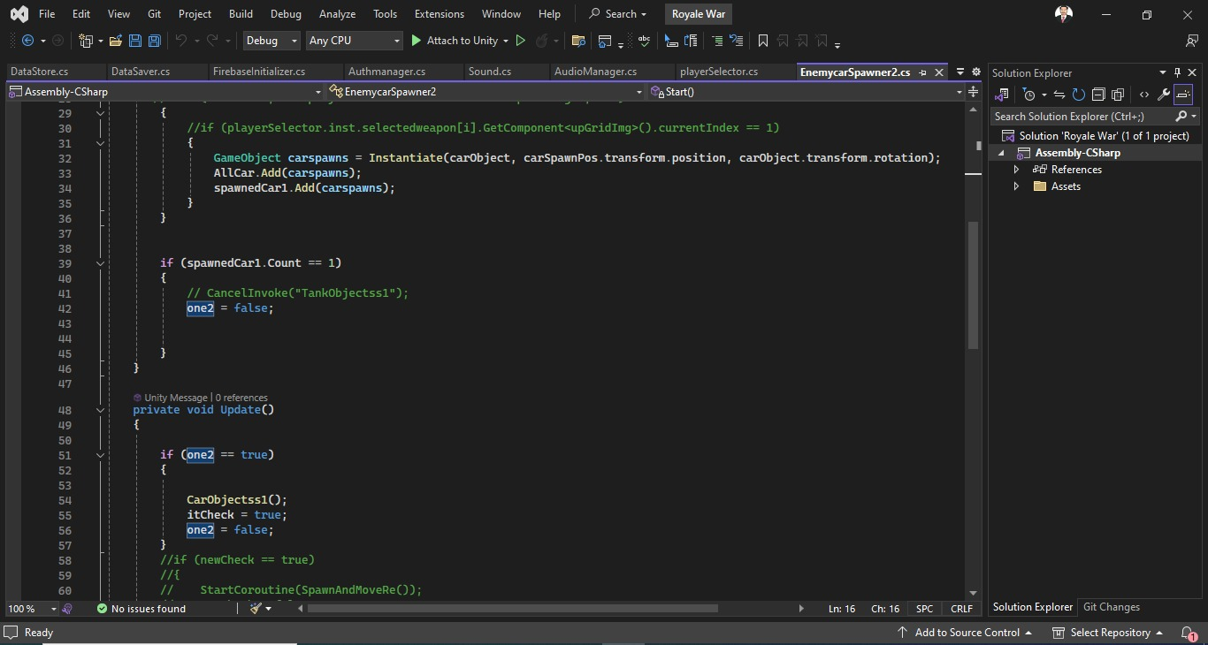

Figure 0-5: Enemy Spawner

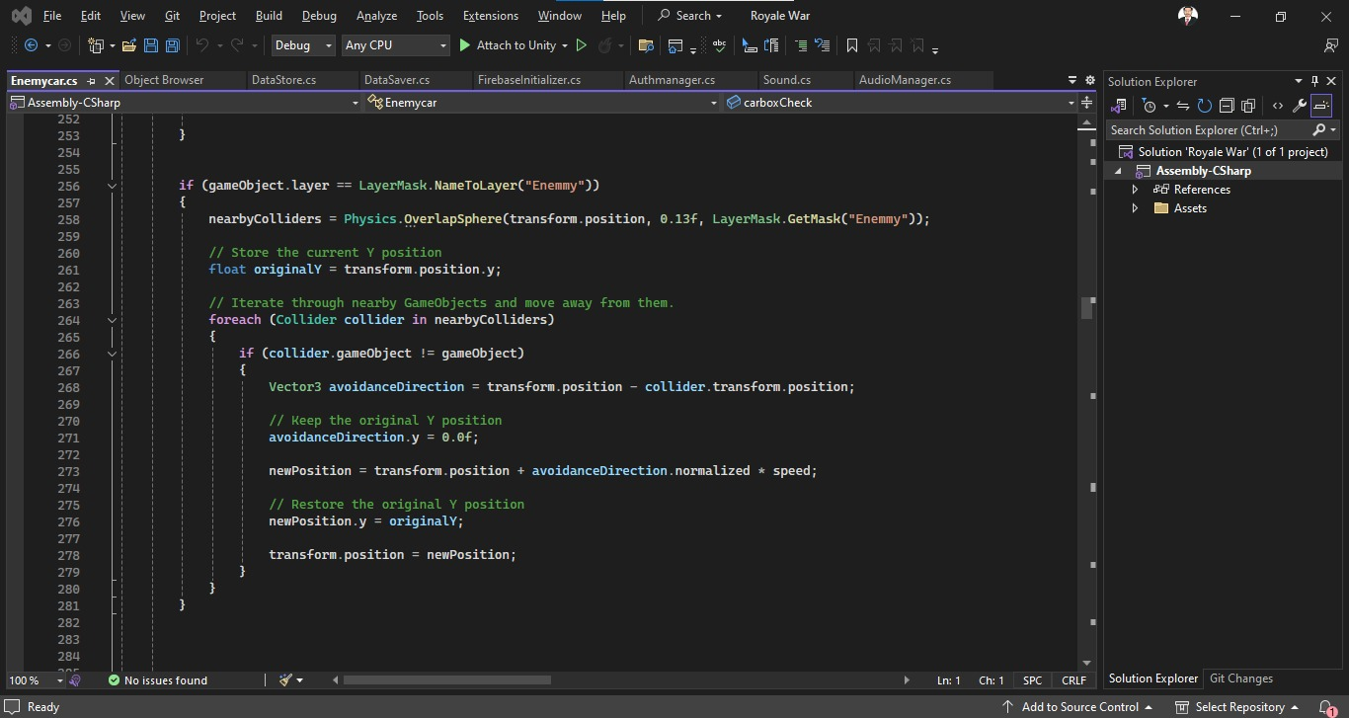
Figure 0-6: Enemy Script
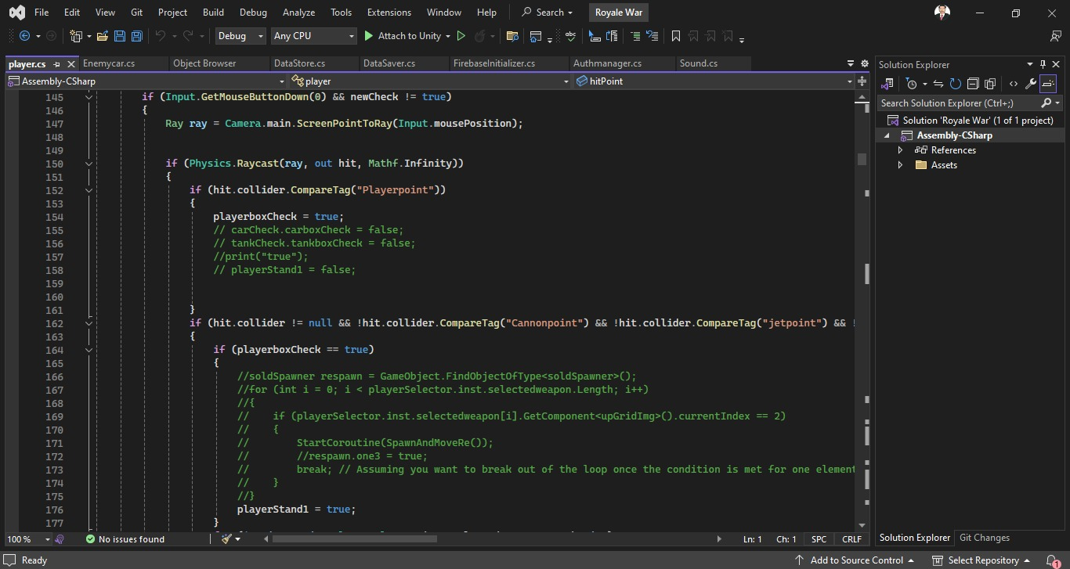

Figure 0-7: Player Script

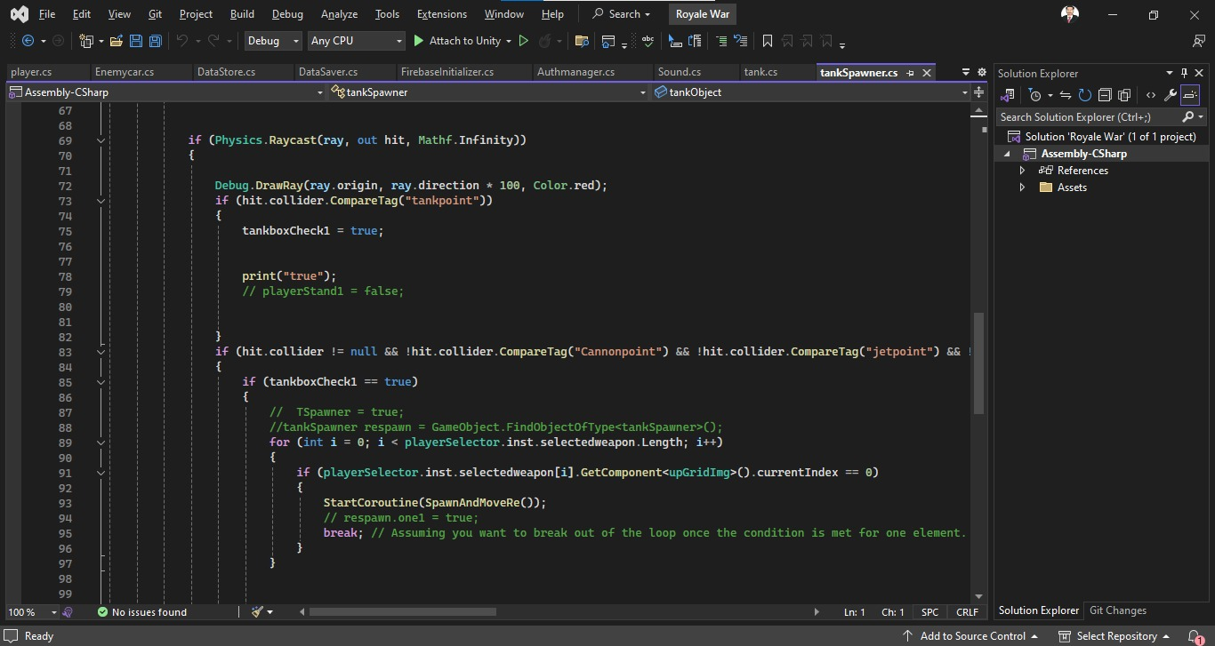

Figure 0-8: Player Spawner

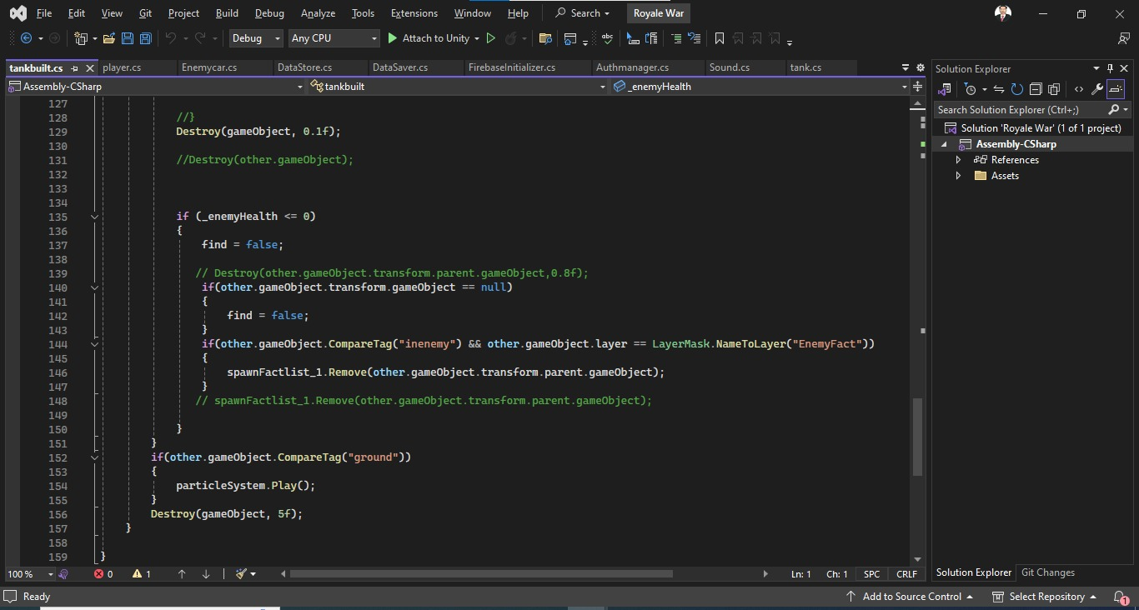
Figure 0-9: Built Script

Plagiarism report
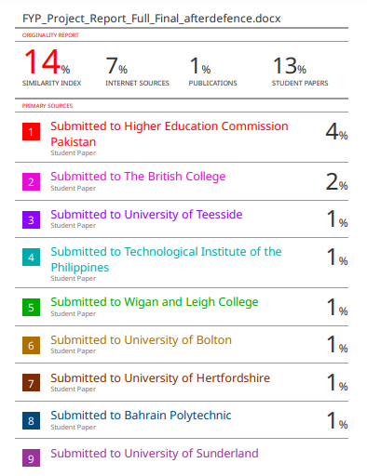
Figure 0-10: Plagiarism Report1

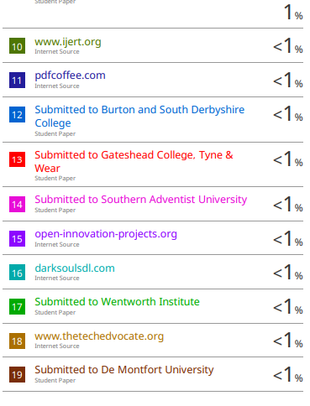
Figure 0-11: Plagiarism Report2

