

BSIT-F23-007
03-135221-034 | Hamza Shahid

SnapTick

In partial fulfilment of the requirements for the degree of
Bachelor of Science in Information Technology
Supervisor: Muhammad Umar Nasir
Department of Computer Sciences
Bahria University, Lahore Campus
June 2024

© Bahria University, 2024

Certificate

“SnapTick”
written by
Hamza Shahid
as a confirmation to the required standard for the partial fulfilment of the degree of
Bachelor of Science in Information Technology.

Approved by:
Supervisor: Umar Nasir
(Signature)

June 15, 2024

DECLARATION

I hereby declare that this project report is based on my original work except for citations and quotations which have been duly acknowledged. I also declare that it has not been previously and concurrently submitted for any other degree or award at Bahria University or other institutions.

Enrolment | Name | Signature
03-135221-034 | Hamza Shahid

Date : June 15, 2024

Specially dedicated to
my beloved teachers, mother, and father
(Hamza Shahid)

ACKNOWLEDGEMENTS

I would like to thank everyone who had contributed to the successful completion of this project. I would like to express my gratitude to my supervisor, Mr Umar Nasir for his invaluable advice, guidance, and his enormous patience throughout the development of the project.

In addition, I would also like to express my gratitude to my loving parent and friends who had helped and given me encouragement.

Hamza Shahid

SnapTick

ABSTRACT

In today's digital era, customers seek personalized experiences, especially when purchasing decorative items such as picture frames. The challenge is to visualize how a personal photograph will look when framed. Customers often face difficulty in making an informed decision. The importance of providing a digital solution to this problem cannot be understated, as it would revolutionize the way consumers shop for picture frames and enhance their overall buying experience. To provide users with an effortless method to improve their photos without the need for manual editing or third-party software. The purpose of this project is to facilitate people who are facing problems finding a photo book provider or frames provider online. This website will authorize the user to get photo books or photo frames with few easy steps. The aim is to provide services quickly.

TABLE OF CONTENTS

DECLARATION ii
ACKNOWLEDGEMENTS iv
ABSTRACT v
TABLE OF CONTENTS vi
LIST OF TABLES ix
LIST OF FIGURES xi
CHAPTER 1 1
1 INTRODUCTION 1
1.1 Background 1
1.2 Problem Statements 1
1.3 Aims and Objectives 2
1.4 Scope of Project 2
CHAPTER 2 3
2 LITERATURE REVIEW Error! Bookmark not defined.
2.1 Project Overview 3
2.2 Project Scope: 4
2.3 Specific Requirements 4
2.3.1 External Interface Requirements 4
2.3.2 User Interface 5
2.3.3 Hardware Interfaces 5
2.3.4 Software Interfaces 6
2.3.5 Communications Protocol 6
2.4 Software Product Features 6
2.5 Software System Attributes 6
2.5.1 Reliability 7
2.5.2 Availability 7
2.5.3 Security 7
2.5.4 Maintainability 7
2.5.5 Portability 7
2.5.6 Performance 8
2.6 Database Requirements 8
2.7 Additional Material Functionality 8
2.7.1 Log Capabilities 8
2.7.2 Alerts 8
2.7.3 Request 9
2.7.4 Route Tracking 9
2.8 Functional Requirements 9
2.9 Non-Functionality 9
2.10 Supportability 10
CHAPTER 3 11
3 DESIGN AND METHODOLOGY 11
3.1 Design Overview 11
3.2 System Architecture Design 11
3.3 Chosen System Architecture 12
3.4 System Interface Description 12
3.5 Use Case 13
3.5.1 Use Case “User Register” 14
3.5.2 Use Case “User Login” 14
3.5.3 Use Case “Services” 15
3.5.4 Use Case “User Cart” 16
3.5.5 Use Case “User Tracking” 16
3.5.6 Use Case “Profile” 17
3.5.7 Use Case “Admin Signup” 17
3.5.8 Use Case “Admin Login” 18
3.5.9 Use Case “Admin View Orders” 18
3.5.10 Use Case “Admin Pending Orders” 19
3.5.11 Use Case “Admin Delivered Orders” 19
3.6 Activity Diagram 20
3.6.1 Activity Diagram “User Activity” 20
3.6.2 Activity Diagram “Admin Activity” 21
3.7 Sequence Diagram 22
3.8 Class Diagram 23
3.9 State Machine Diagrams 23
3.9.1 State Machine Diagram “User Ordering Service” 24
3.9.2 State Machine Diagram “Admin” 24
3.10 Interface Design 25
3.10.1 Signup Page of User and Admin 25
3.10.2 Orders Details 26
3.10.3 Main Page 26
3.10.4 Services 27
3.10.5 Tracking 28
3.10.6 Update Account 29
CHAPTER 4 30
4 DATA AND EXPERIMENTS 30
4.1 Introduction 30
4.2 Components Web Services and Libraries 30
4.3 IDE, Tools, and Technologies 31
4.4 Coding Standards 31
4.5 Software Engineering Practices 31
4.6 Code Screenshots 31
4.6.1 User Profiling 32
4.6.2 Order Placing 35
4.6.3 Tracking 42
CHAPTER 5 44
5 RESULTS AND DISCUSSIONS 44
5.1 Result 44
CHAPTER 6 45
6 CONCLUSION AND RECOMMENDATIONS 45
6.1 Conclusion 45
6.2 Future Work 45
REFERENCES 46

LIST OF TABLES

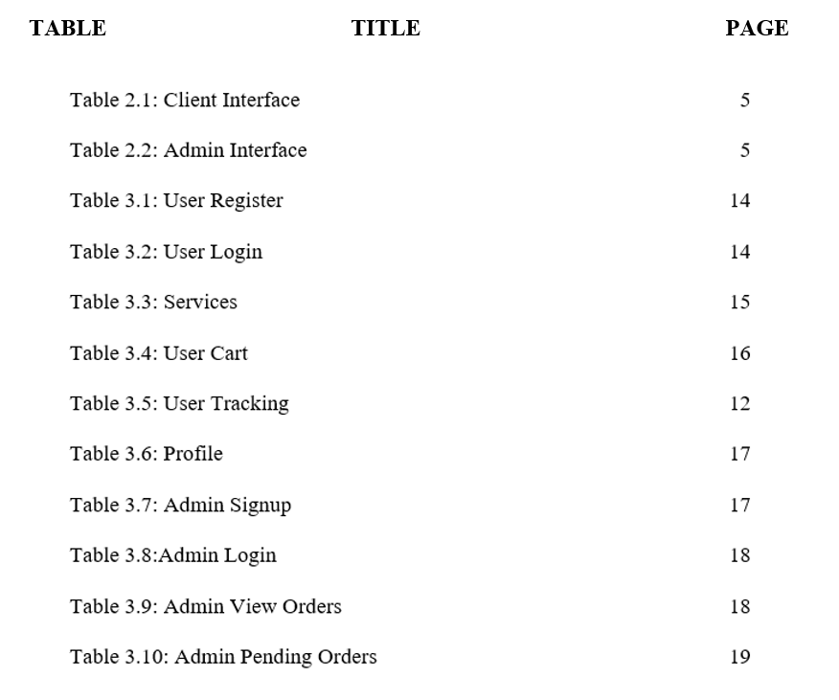

LIST OF FIGURES

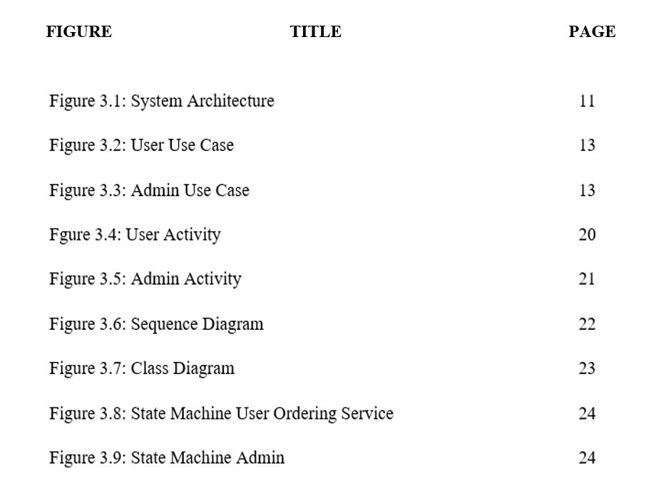

INTRODUCTION

Background

Currently, everyone’s life is becoming busy steadily. Consequently, there’s lack of time. The growing technological influence is making everyone look for best and quick alternatives to do their task. In this ‘Internet age’ electronic devices i.e., mobile phones, tablets and laptops are being used in surprising manner. The advancement of these devices and software has convinced the developers to generate websites of daily use. Now that everything has gone digital, our photos often get lost. People look for service to have a photo book and to frame their photos. The purpose of this project to facilitate people who are facing problems to find a photo book or frames online. This website will allow the user to get photo book or photo frame online with few easy steps.

Problem Statements

Now that everything has gone digital, our photos often get lost. People look for service to have a photos book and to frame their photos. The purpose of this project to facilitate people who are facing problems to find a photo book provider or frames provider online. This website will authorize the user to get photo book or photo frames with few easy steps.
A search was held in Google and other search engines, approximately more than 5 websites were found. All of them are not offering both services on 1 platform, only one application is working in Pakistan, but they are offering only 1 service with very high cost.

Aims and Objectives

The objectives of the project are shown as following:
- To identify the problems related to previous applications.
- To provide both services in Pakistan with good quality in low price.
- To meet the challenges faced in using already existing applications.
- To allow users to get photo book & photo frame at doorstep with easy steps.
- To allow users to pay online or cash on delivery.

Scope of Project

SnapTick is a website designed to create a user-friendly platform which will provide photo frames and photobooks of user’s memories. The user will sign up to make order. The user photos will totally be safe with SnapTick. SnapTick will provide high quality products with reasonable rates. User will get fast delivery at doorstep. Customer will be able to pay bill online or cash on delivery. Customer will be able to track order.

Software Requirement Specification

Project Overview

Currently, everyone’s life is becoming busy steadily. Consequently, there’s lack of time. The growing technological influence is making everyone look for best and quick alternatives to do their task. In this ‘Internet age’ electronic devices i.e., mobile phones, tablets and laptops are being used in surprising manner. The advancement of these devices and software has convinced the developers to generate websites of daily use. Now that everything has gone digital, our photos often get lost. People look for service to have a photo book and to frame their photos.
The purpose of this project to facilitate people who are facing problems to find a photo book or frames online. This website will allow the user to get photo book or photo frame online with few easy steps. Firstly, it will ask user to select one option from photo book and photo frame. Secondly, if user go for photo book: it will ask to upload pictures and then it will add the order to cart, if user go for photo frame: it will ask to upload image then it will ask to select size and design of frame and then it will add order to cart. Thirdly, user will checkout his/her orders with different payment methods. This website will serve two options; the users can get service for themself, or the users can send services as gift to their loved ones. The billing option for gift will have online payment. Moreover, users can track their order with unique order id.

Project Scope:

SnapTick is a website designed to create a user-friendly platform which will provide photo frames and photo books of user’s memories. The user will sign up to make order. The user photos will totally be safe with SnapTick. SnapTick will provide high quality products with reasonable rates. User will get fast delivery at doorstep. Customer will be able to pay bill online or cash on delivery. Customer will be able to check order status.

Specific Requirements

The specific requirements of this projects are explained below.

External Interface Requirements

The system ask user to choose photo frame or photo book. For photo frame, user will upload photo, choose frame size & colour, frame will deliver to him. For photobook, user will upload up to 10 photos then photo book will deliver to him. User can track his order. System uses cloud database to store data.

User Interface

There will be two interfaces of this application, which are as follows:
- Client interface
- Admin interface

Table 2.1: Client Interface
Screen Name | Description
Sign in-out-up | To login-out-up into the Website
Home page | Website data
Services | Services of SnapTick
Tracking | To track the order
Cart | To checkout
User Profile | To update user data
About us | Company details
Help | Company information

Table 2.2: Admin Interface
Screen Name | Description
Sign in-out-up | To login-out-up into the Website
View Orders | To check new orders
Pending Orders | To check pending orders
Delivered Orders | To check delivered orders

Hardware Interfaces

The application shall run on any device: Android, Windows, iOS.

Software Interfaces

The system shall interact with every platform. Most of the people in the world using Google. Therefore, this application will allure a great number of users. React JS will be main coding language of this project.

Communications Protocol

Internet will serve as the major communication protocol for SnapTick. After placing order, admin will update status of order.

Software Product Features

Major features of the software are as follow:
- Provide a user-friendly platform to order.
- Facility to track order.
- Different payment methods
- Gift option.
- Replacement in case of broken parcel

Software System Attributes

When the system requirements are characterized, interpretation of this quality attributes is also necessary, because these presumptions are going to lead further planning of the system architecture and designing. These attributes are also used to measure product performance.

Reliability

- Maintenance of record
- The user location accuracy

Availability

- User will be able to access application at any time.
- Application will be available throughout the country.

Security

- Images of Client will secure.
- Personal information of client will secure.
- Third party cannot access the data.

Maintainability

For maintenance, updates will be provided occasionally based on all users’ feedback of application. Bandwidth will be update according to the demand of the application.

Portability

SnapTick application will be receptive to all devices. It can access from anywhere.

Performance

Performance, speed will server dependent.

Database Requirements

The requirements of database are as follows:
- Mongo DB
- Server Computer
- A memory to process.
- HDD for backup
- 24 hours internet access

Additional Material Functionality

The additional material functionalities are written below.

Log Capabilities

The system shall provide to the all users with login-out-up capabilities.

Alerts

The system will get notification of order.

Request

When the user places order, admin will deal with it by call confirmation.

Route Tracking

SnapTick will show tracking of order to make sure that delivery of order to recipient is in time.

Functional Requirements

- Client will be able to sign up.
- Client will be able to order a service.
- Client will be able to choose different payment methods.
- Client will be able to track order.
- Admin will access order list.

Non-Functionality

- Client location will be accurate.
- Application will be accessible to users at any time.
- Personal information & data of client will be secured.
- Prompt notifications will be generated to client.
- Updates will be provided based on feedback of application.

Supportability

- The system will use HTTPS security to make it secure by using secure technologies.
- The coding standards and naming conventions will be as per the American standards.

DESIGN AND METHODOLOGY

Design Overview

This Software Design Description (SDD) recounts the detailed design of the components of the SnapTick, and the particulars required to satisfy the requirements as specified in the Software Requirements Specification (SRS).

System Architecture Design

A system’s architecture portrays the principles, structural concepts, and characteristics of a system of interest. Interaction of various components of the systems is formally described in terms of architectural description. A system’s architecture represents the embodiment of system components and the sub-systems which will execute the overall system.

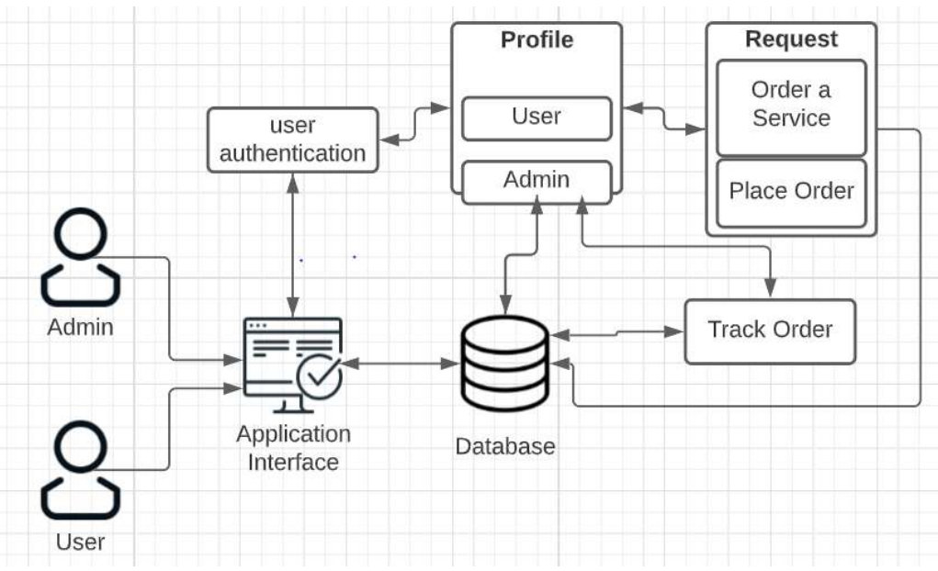
Figure 3.1: System Architecture

Chosen System Architecture

The architecture pattern chosen for SnapTick is event driven architectural design. When the recipient performs an event, the application will behave accordingly. For instance, in case of an order, if the user order a service, order details will send to admin. User can track his/her order-by-order number.

System Interface Description

Following are the Use Cases of the system:
- User Register
- User Login
- User Services
- User Tracking
- User Cart
- User Profile
- Admin Signup
- Admin Login
- Admin New Orders
- Admin Pending Orders
- Admin Delivered Orders

Use Case

Use Case diagrams of User and Host are given below.

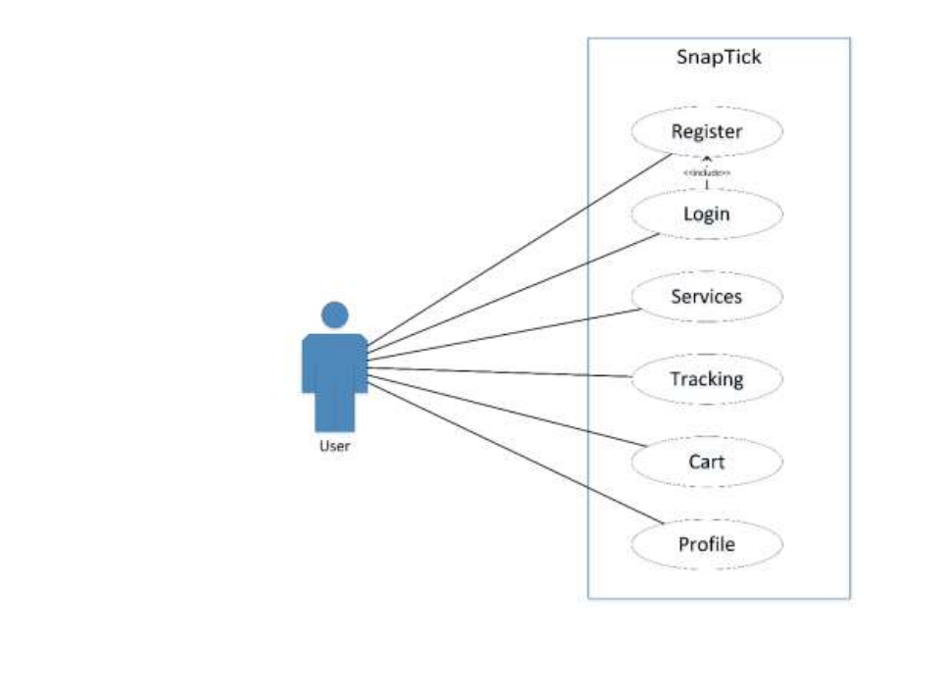
Figure 3.2: User Use Case

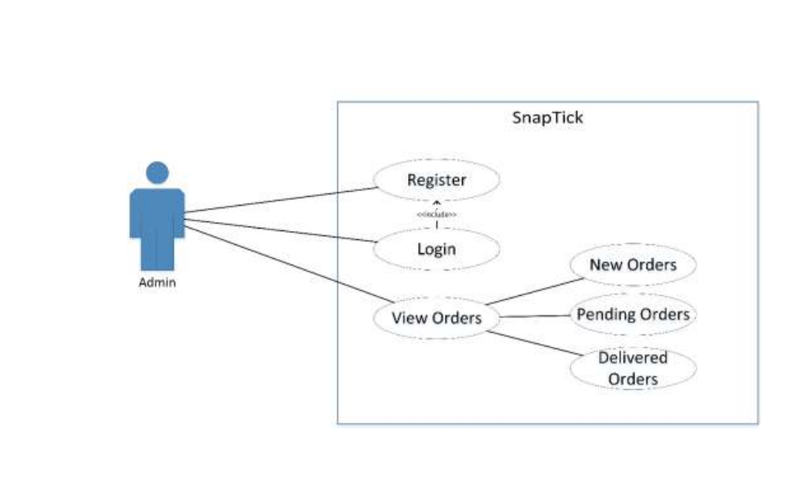
Figure 3.3: Admin Use Case

Use Case “User Register”

Use Case Name | Register.
Description | This use case allows the user to register his/her account.
Primary Actor | User.
Secondary  Actor | None.
Pre-conditions | The user must be on the “Signup” page and have access to internet.
Post-conditions | The user’s profile is created.
Basic flow | - The user clicks on ‘Signup’ button.  - The user is on the Signup page.  - The user will enter the following details in the Signup page. Name, Phone, Email, Password, Address.  - The system will register the user account.
Alternate Flow | Invalid Information Entered: System displays message to correct invalid information.
Table 3.1: User Register

Use Case “User Login”

Table 3.2: User Login
Use Case Name | Login.
Description | This use case allows the user to Login.
Primary Actor | User.
Secondary  Actor | None.
Pre-conditions | The user must be registered, remember his/her account and must have internet access.
Post-conditions | The user will be appropriately Login.
Basic flow | - The user clicks on ‘Login’ button.  - The application will be Login after entering his/her details.  - The user is at Home Page.
Alternate Flow | Invalid Information Entered: System displays message to correct invalid information.

Use Case “Services”

Table 3.3: Services
Use Case Name | Services
Description | This use case allows the user to select any service & order it that are provided by SnapTick.
Primary Actor | User
Secondary Actor | None
Pre-conditions | The User must select any service.
Post-conditions | The User will order the service.
Basic flow | - The User clicks on ‘Service’ button.  - The application will display services.  - The user will select any service and then he/she will place order.
Alternate Flow | Order not completed: System displays message to check internet connection.

Use Case “User Cart”

Table 3.4: User Cart
Use Case Name | Cart
Description | This use case allows the user to place order.
Primary Actor | User
Secondary Actor | None
Pre-conditions | - The user must be connected to an internet connection.  - The user must know which order has to be placed.
Post-conditions | The user will successfully be shown all pending orders.
Basic flow | - The user clicks on the ‘Cart' button.  - The cart will display to user.
Alternate Flow | - The application prompts the user to check internet connection.  - Empty Cart.

Use Case “User Tracking”

Table 3.5: User Tracking
Use Case Name | Tracking
Description | This use case allows the user to track his/her order.
Primary Actor | User
Secondary Actor | None
Pre-conditions | - The user must be connected to an internet connection.  - The user must remember order ID.
Post-conditions | The user will successfully be shown the order status.
Basic flow | - The user clicks on 'Tracking’ button.  - User will enter Order ID.  - The user is shown the order state.
Alternate Flow | Invalid ID: Try again!

Use Case “Profile”

Table 3.6: Profile
Use Case Name | Profile
Description | This use case allows the user to view or update his/her profile details.
Primary Actor | User
Secondary Actor | None
Pre-conditions | - The user must be connected to an internet connection.  - The user must be on Profile Page.
Post-conditions | User Profile information will display.
Basic flow | - The user clicks on the ‘Profile' button in Navbar.  - User details will display here.
Alternate Flow | - The application prompts the user to check internet connection.  - Update data or view data.

Use Case “Admin Signup”

Table 3.7: Admin Signup
Use Case Name | Signup
Description | This use case allows the admin to register his/her account.
Primary Actor | Admin
Secondary  Actor | None
Pre-conditions | The admin must be on the “Signup” selection page and have access to internet.
Post-conditions | The admin profile is created.
Basic flow | The admin will add new admins from database.
Alternate Flow | Invalid Information Entered: System displays message to correct invalid information.

Use Case “Admin Login”

Use Case Name | Login
Description | This use case allows the admin to Login to dashboard.
Primary Actor | Admin
Secondary  Actor | None
Pre-conditions | The admin must remember his/her account details and have access to internet.
Post-conditions | The admin successfully login and move to dashboard.
Basic flow | - The admin goes to the Login Page.  - The admin enters the following details in the Login Page: Email and Password.  - The system will check the input details and then move to dashboard.
Alternate Flow | Invalid Information Entered: System displays message to correct invalid information.
Table 3.8: Admin Login

Use Case “Admin View Orders”

Use Case Name | View Orders
Description | This use case displays all new orders to admin.
Primary Actor | Admin
Secondary  Actor | None
Pre-conditions | Admin must click ‘View Orders’ button.
Post-conditions | New orders will display
Basic flow | - Admin opens View Orders from the main page.  - System will display all new orders from Users.  - Admin will call the user for confirmation.  - After confirmation, admin will move order to pending orders.
Alternate Flow | Internet Issue: System will show notification to check internet connection
Table 3.9: Admin View Orders

Use Case “Admin Pending Orders”

Table 3.10: Admin Pending Orders
Use Case Name | Pending Orders
Description | This use case will display all pending orders to admin.
Primary Actor | Admin
Secondary  Actor | None
Pre-conditions | Admin must click ‘Pending Orders’ button.
Post-conditions | All pending orders will display.
Basic flow | - Admin opens Pending Orders from the main page.  - The system will display all pending orders.  - Admin will move orders to delivered orders after delivery.
Alternate Flow | Internet Issue: System will show notification to check internet connection

Use Case “Admin Delivered Orders”

Table 3.10: Admin Delivered Orders
Use Case Name | Delivered Orders
Description | This use case will display all delivered orders to admin.
Primary Actor | Admin
Secondary  Actor | None
Pre-conditions | Admin must click ‘Delivered Orders’ button.
Post-conditions | All delivered orders will be displayed.
Basic flow | - Admin opens Delivered Orders from main page.  - System will display all delivered orders.
Alternate Flow | Internet Issue: System will show notification to check internet connection

Activity Diagram

The dynamic aspects of the systems are described in terms of activity diagram. Activity diagram is basically a flowchart to represent the flow from one activity to another activity. The activity reflects an operation of the desired system. The control flow is drawn from one operation to another. This flow can be sequential, branched, or concurrent. Activity diagrams deal with all type of flow control by using different elements such as fork, join, etc.

Activity Diagram “User Activity”

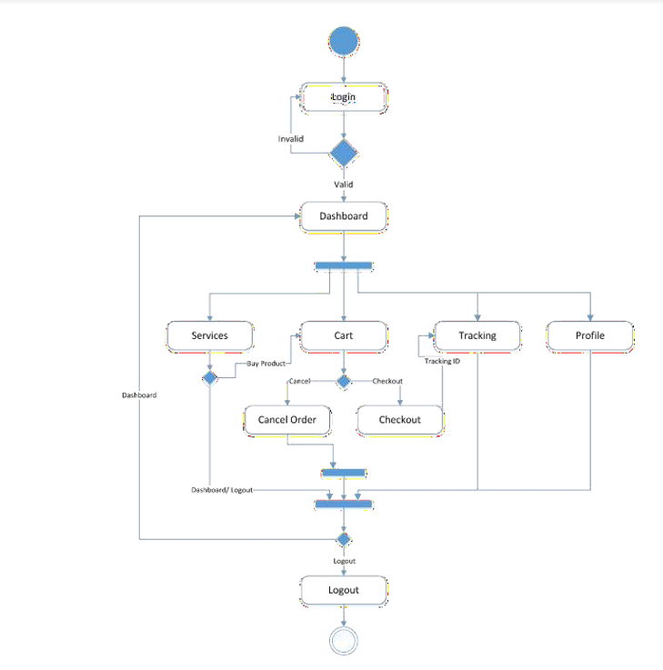
Figure 3.4: User Activity

Activity Diagram “Admin Activity”

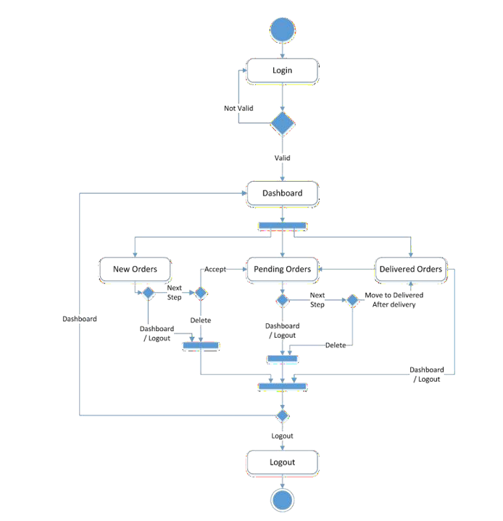
Figure 3.5: Admin Activity

Sequence Diagram

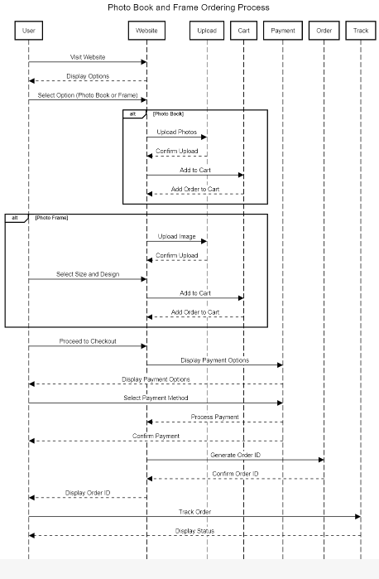
Figure 3.6: Sequence Diagram

Class Diagram
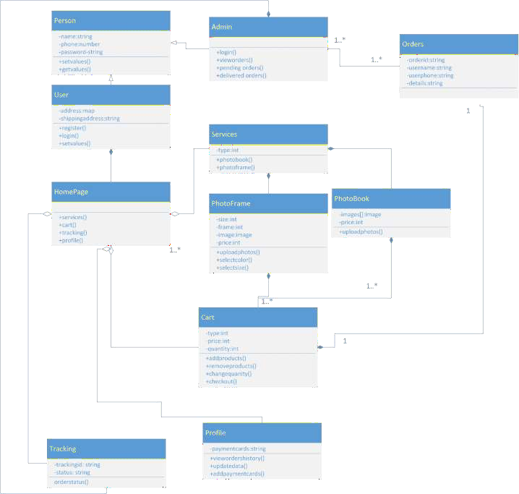

Figure 3.7: Class Diagram

State Machine Diagrams

The State machine diagrams are given below.

State Machine Diagram “User Ordering Service”
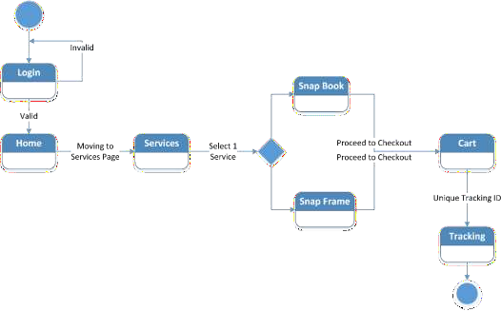

Figure 3.8: State Machine User Ordering Service

State Machine Diagram “Admin”
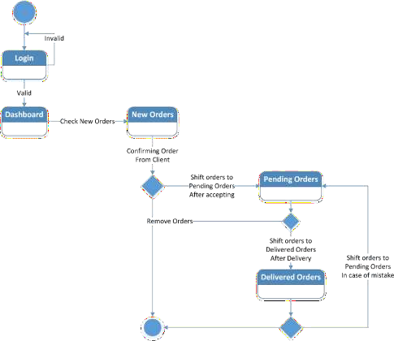

Figure 3.9: State Machine Admin

Interface Design

Application interface is designed in a way that allows the Guest to interact with the software in a natural and intuitive way. SnapTick system has a simple, attractive, and easy to use interface design. SnapTick system has the following screens:

Signup Page of User and Admin

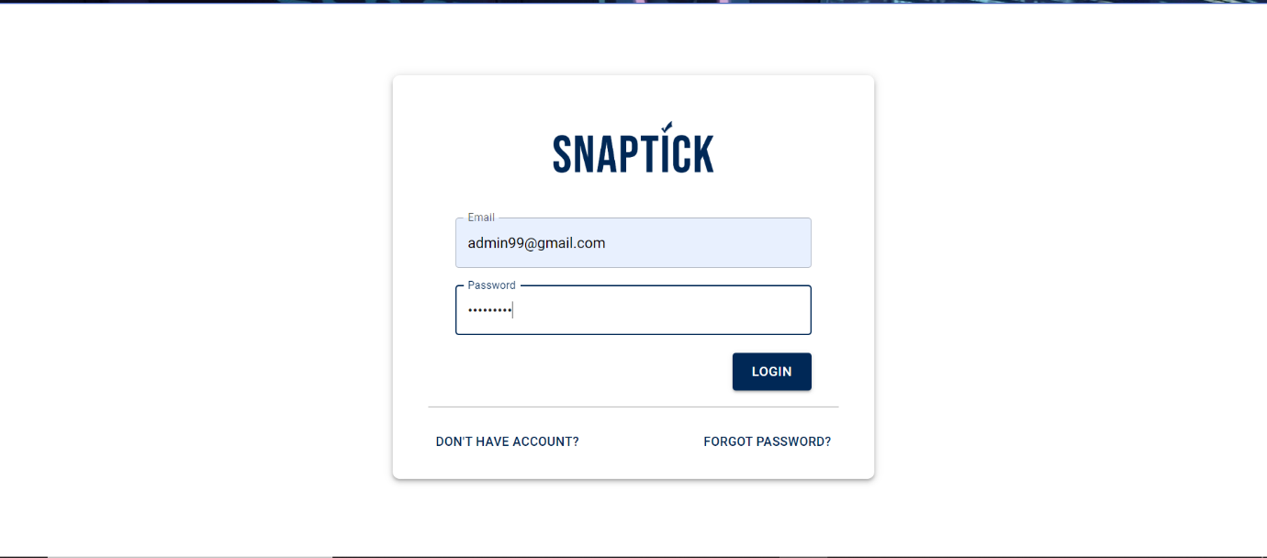

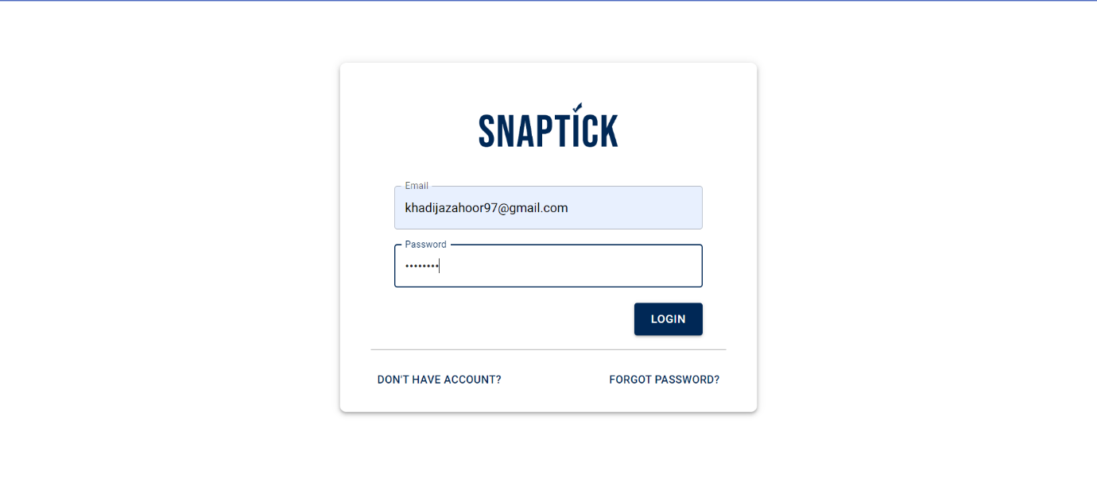

Orders Details

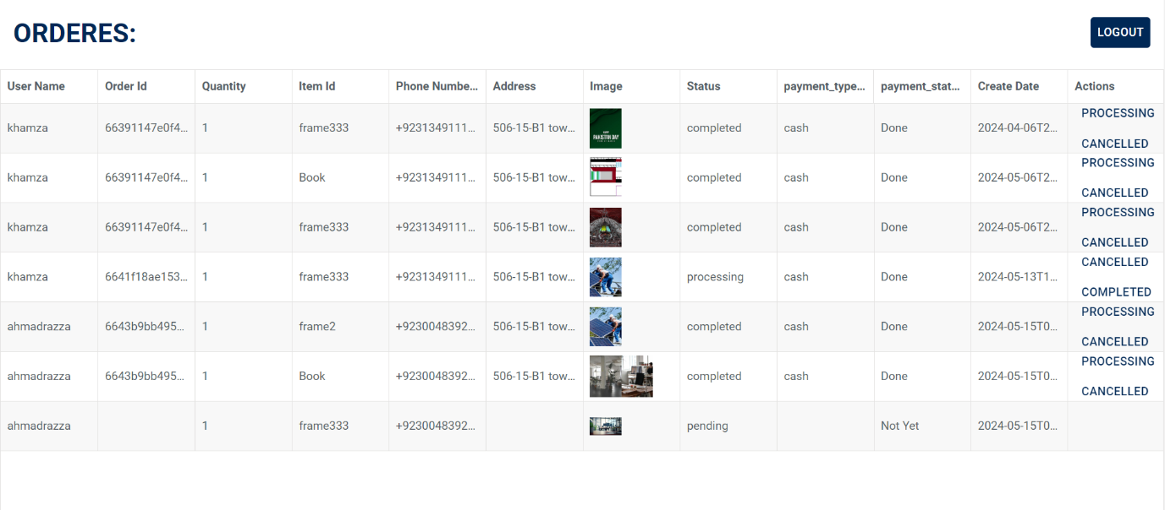

Main Page

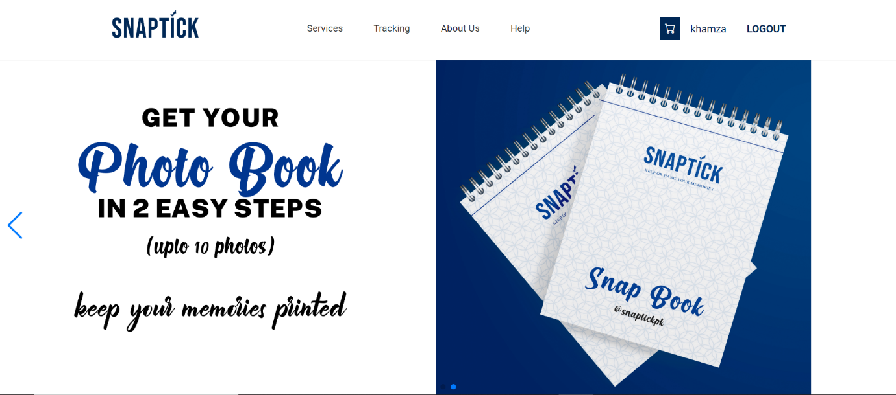

Services
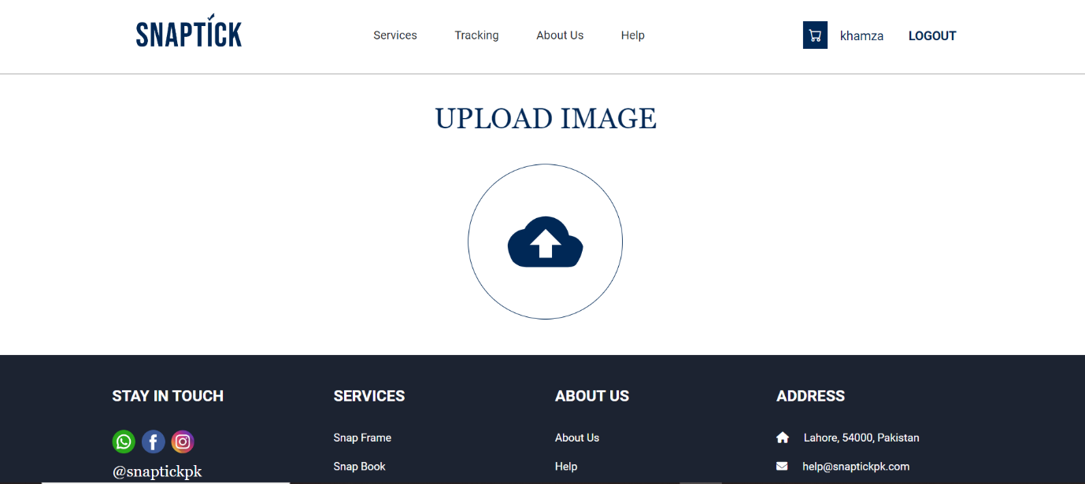

Figure 3.14: Signup Page of Admin

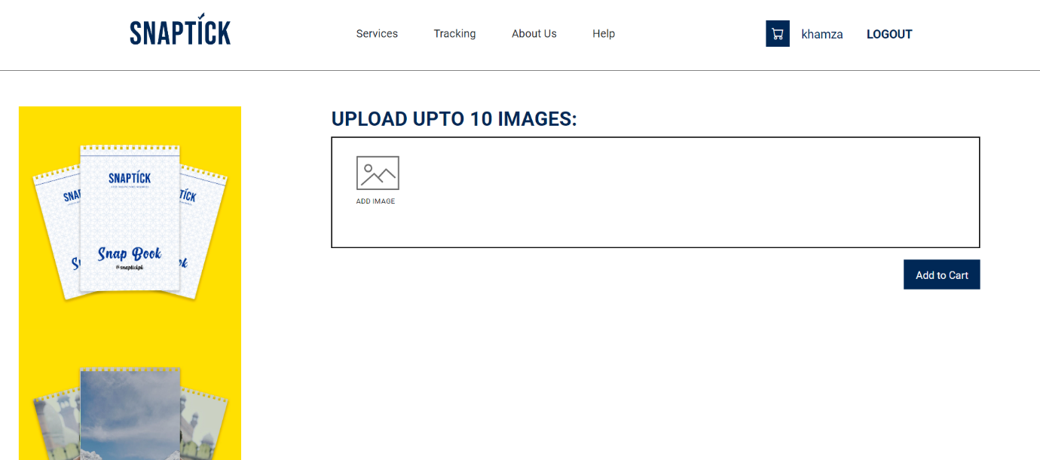



Tracking
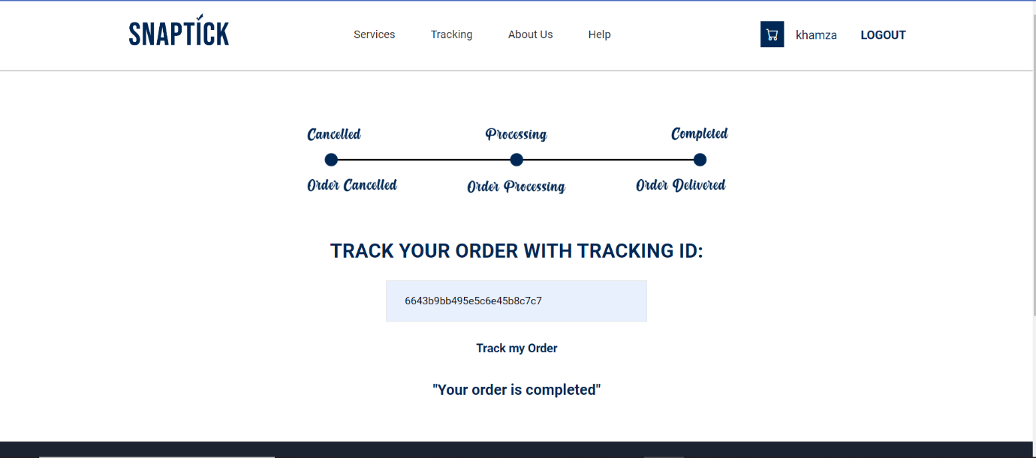

Update Account

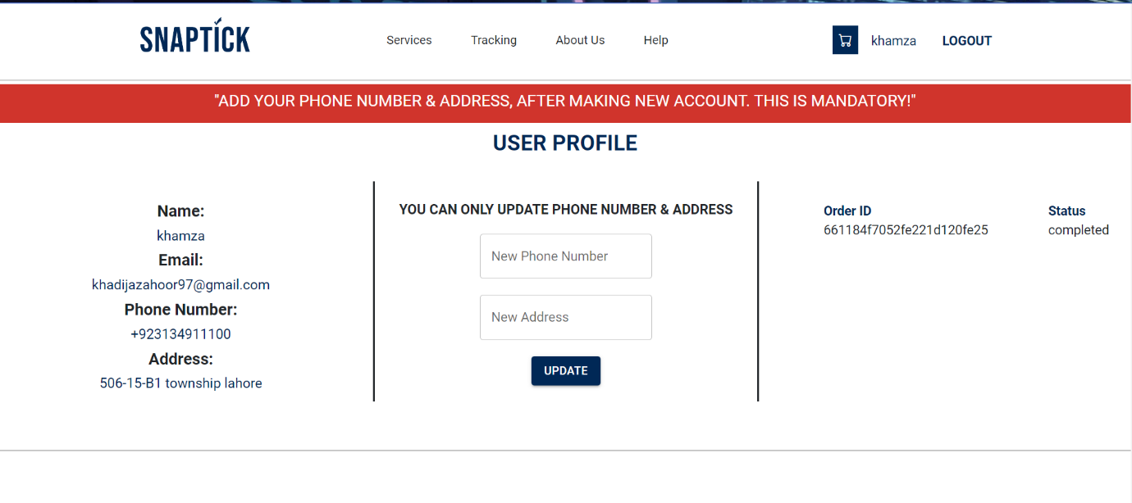

DATA AND EXPERIMENTS

Introduction

The implementation of SnapTick application is developed on the latest platform of the developing time. Implementation is a crucial phase of any developing project. The project is accomplished in accordance with the requirement of software requirement document. The implementation is completed on the incremental process model as mentioned in software project management plan. Each module is developed and tested in a cycle because the next module of the project is totally depended on the previous module. All the confusions in requirement are clarified from the software design document. Implemented application will works on different platforms. This application is fully responsive.

Components Web Services and Libraries

The components to be developed in this project are analysed from software requirement specification; the following are developed in the SnapTick application.
- User profiling
- Order Placing
- Tracking Order

IDE, Tools, and Technologies

The following technologies are used in developing the SnapTick application.
- VS Code
- React JS
- Node JS
- Mongo DB
- OOP

Coding Standards

The following coding standards are used in developing the SnapTick application.
- IEEE coding standard
- Reusability

Software Engineering Practices

SnapTick application is developed according to the incremental process model of software engineering. Each module is developed and tested at the same time before going to the next module as per the incremental process model. Incremental process model is used in this application.

Code Screenshots

SnapTick application code

User Profiling

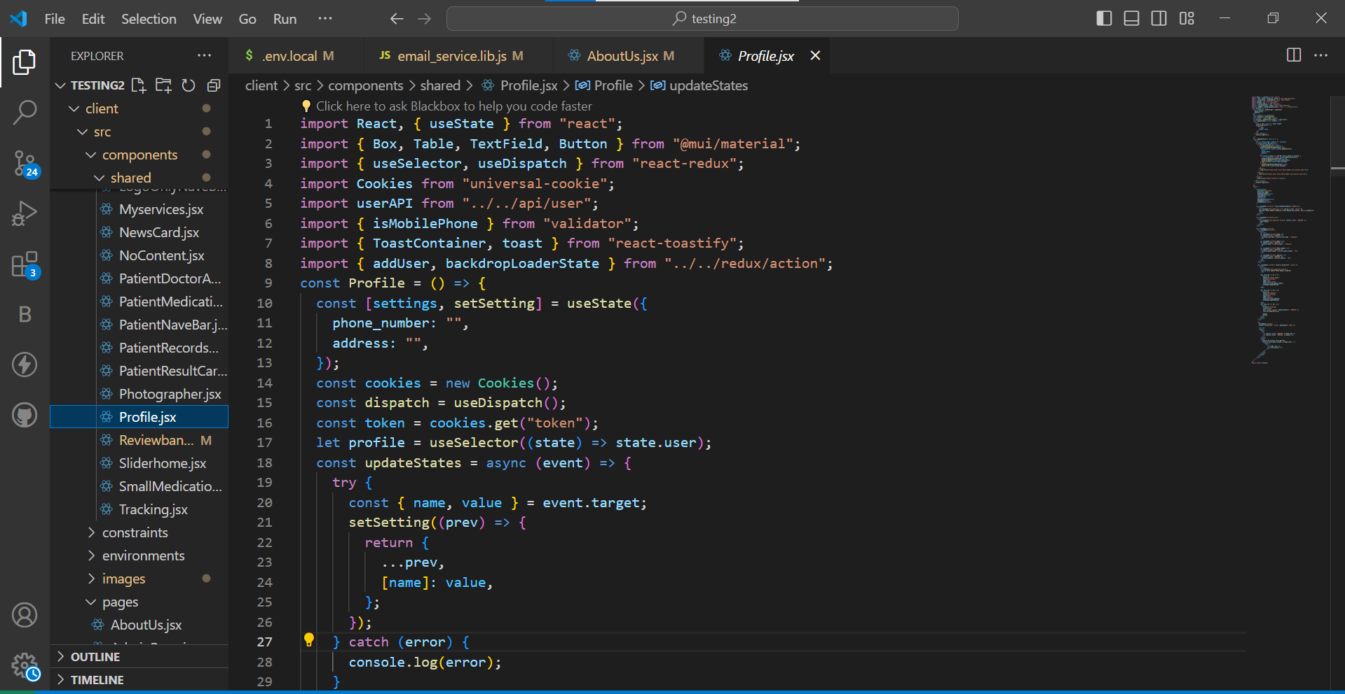

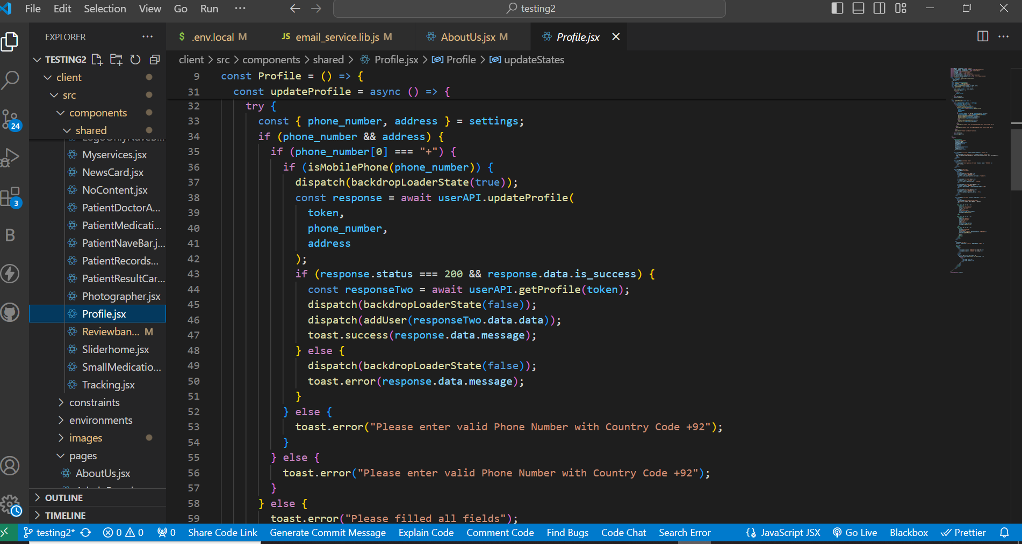

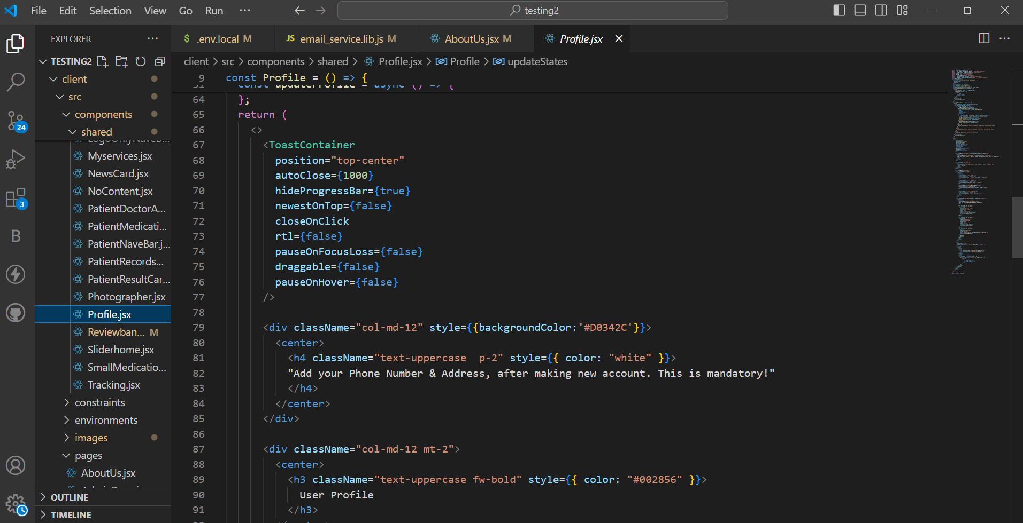

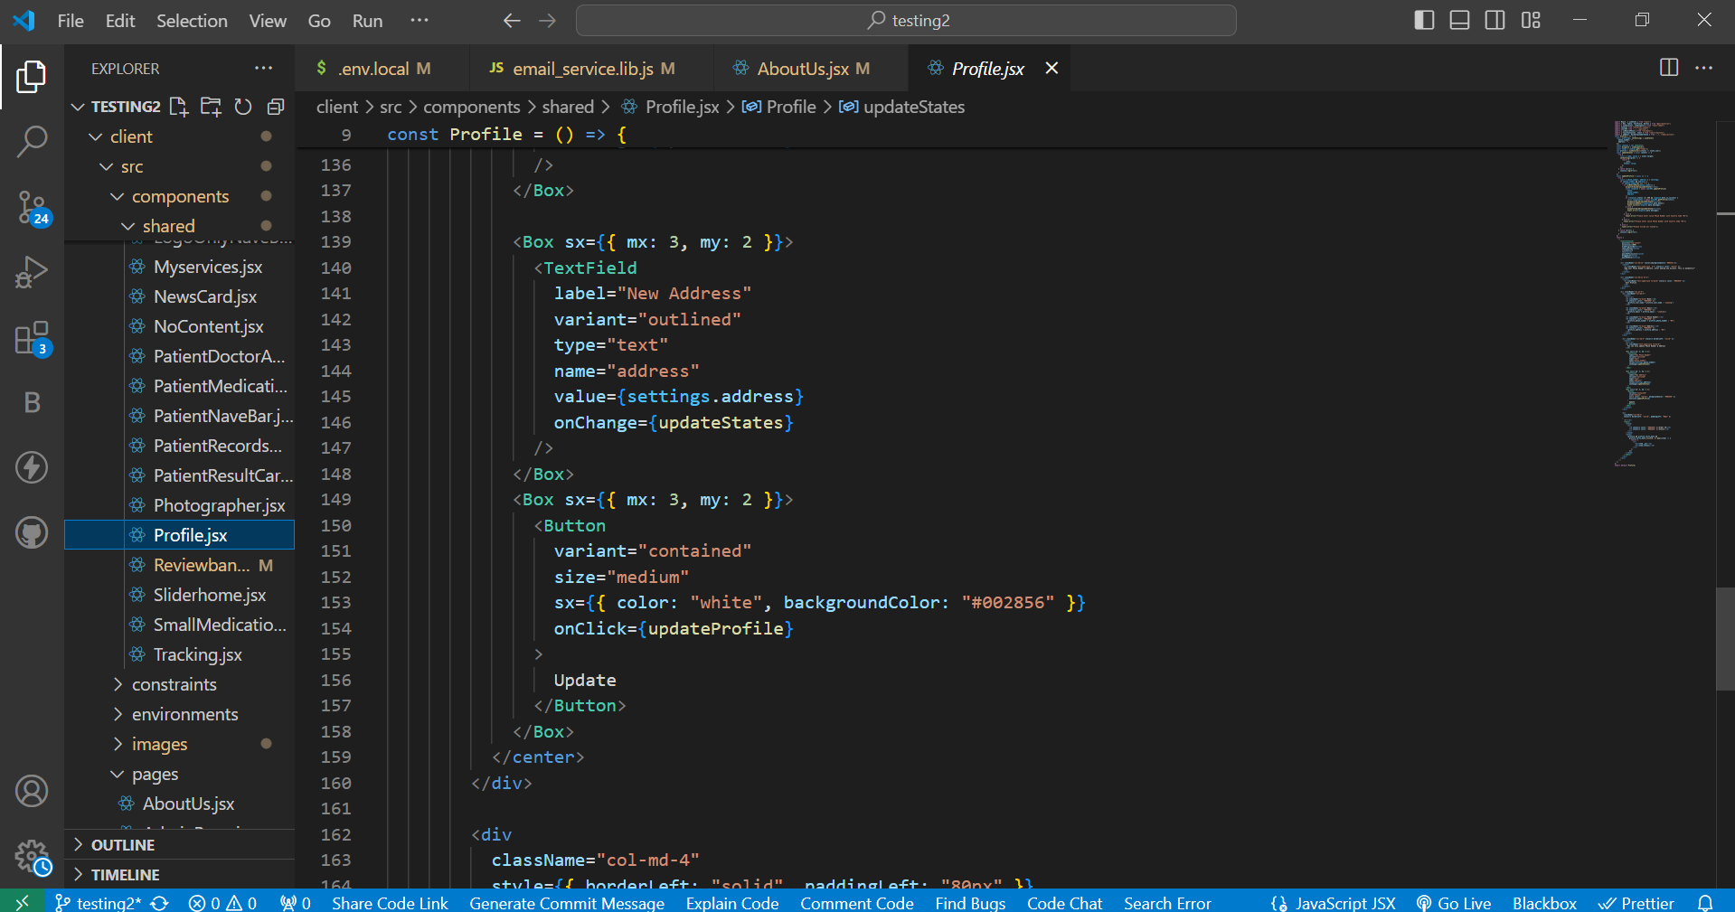

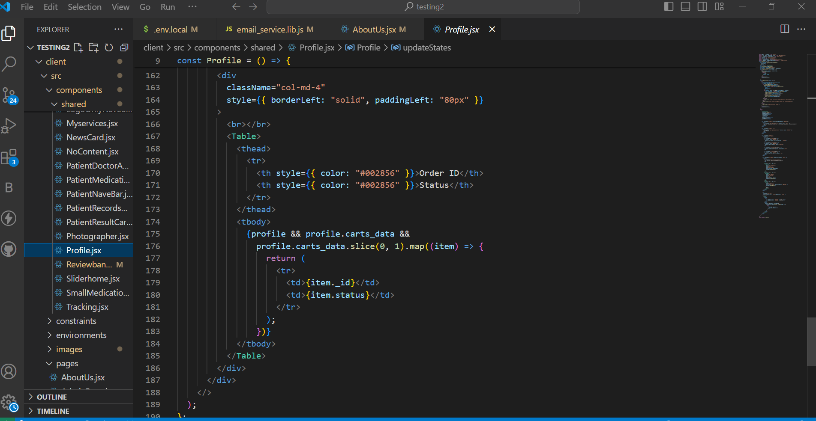

Order Placing

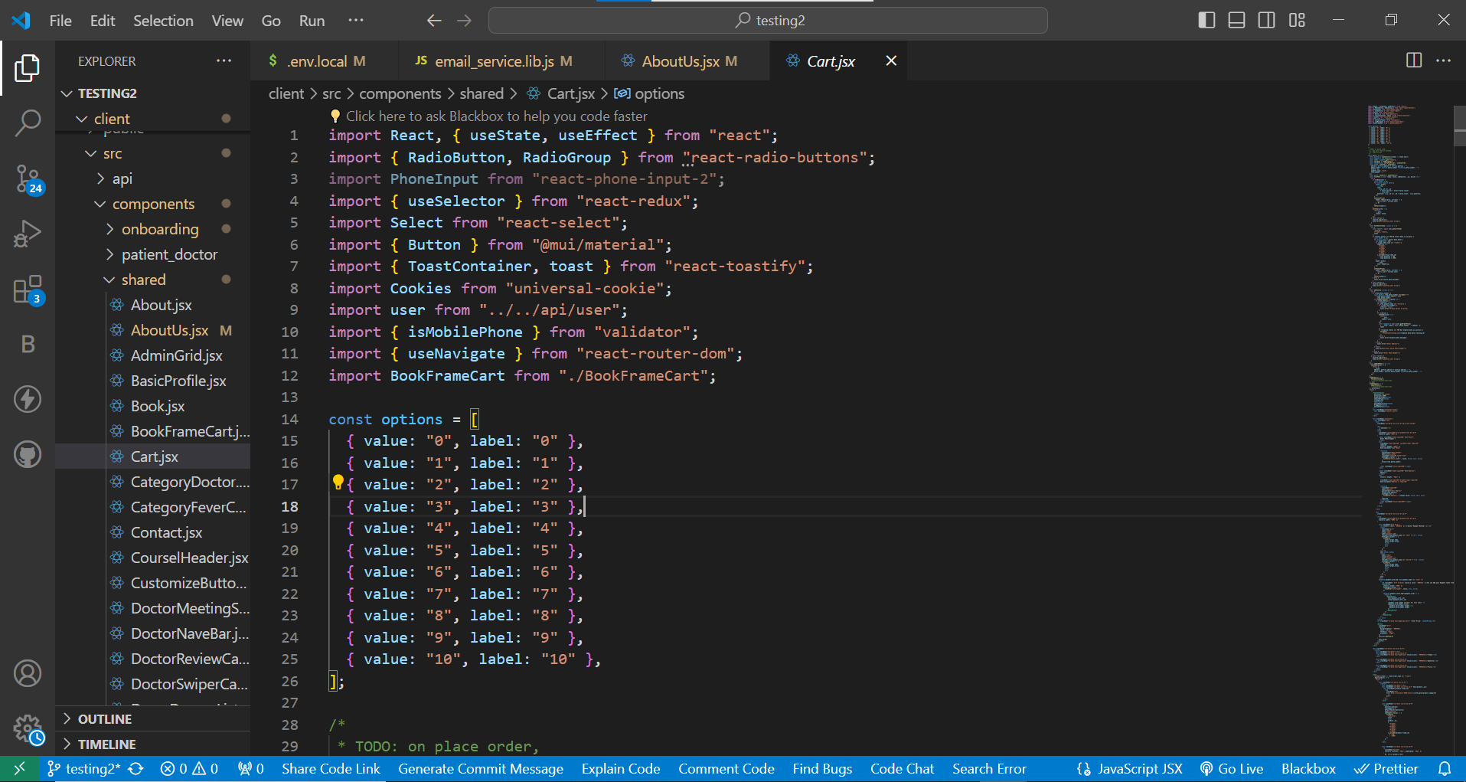

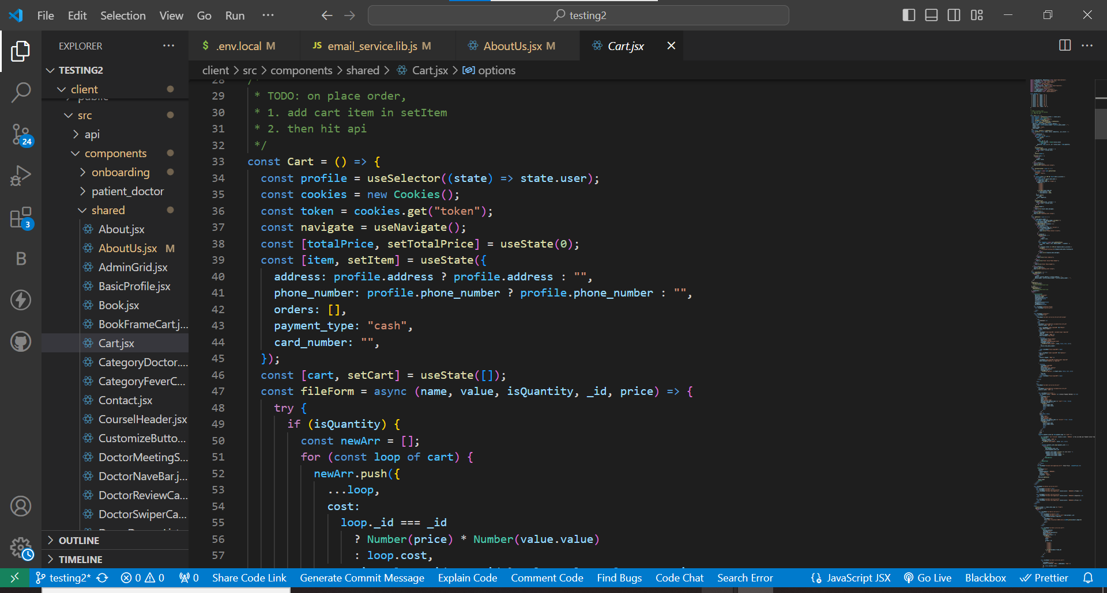

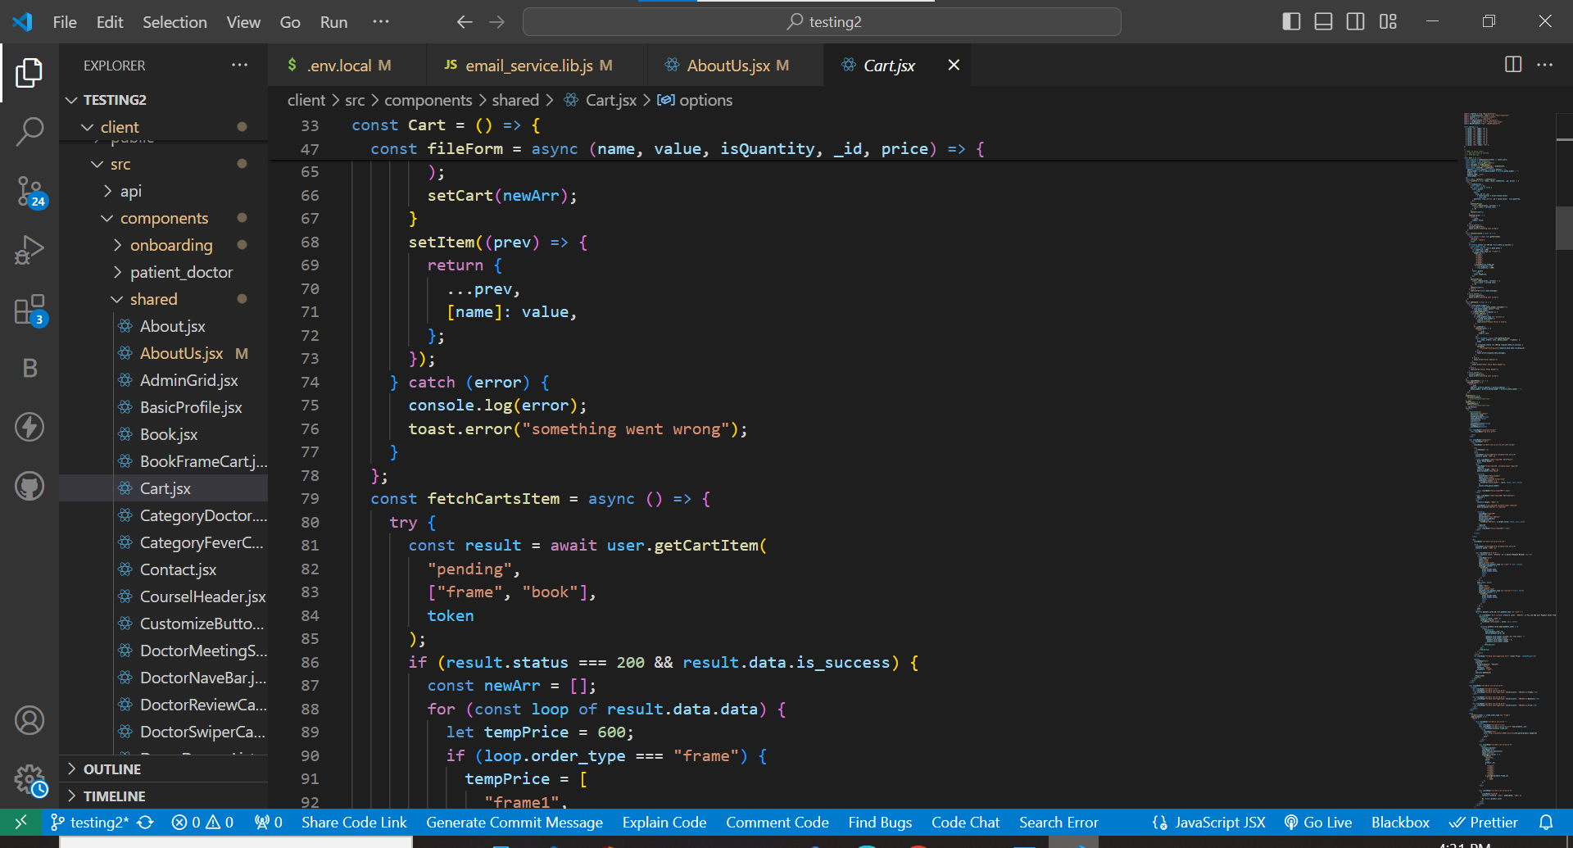

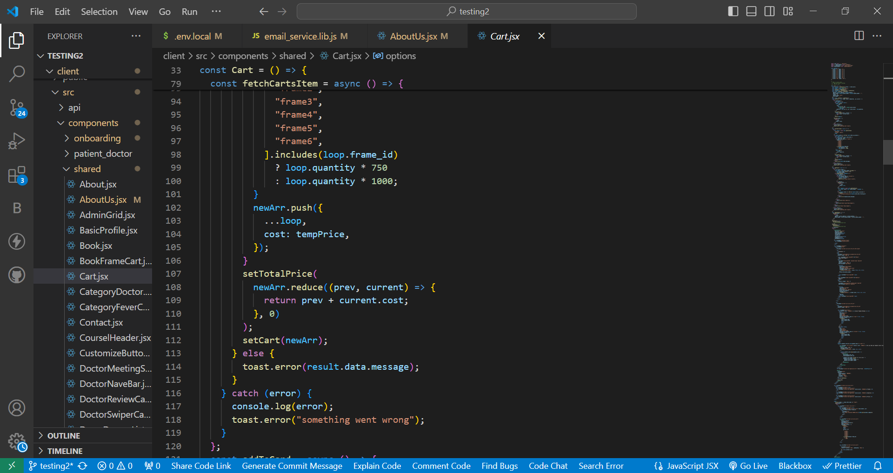

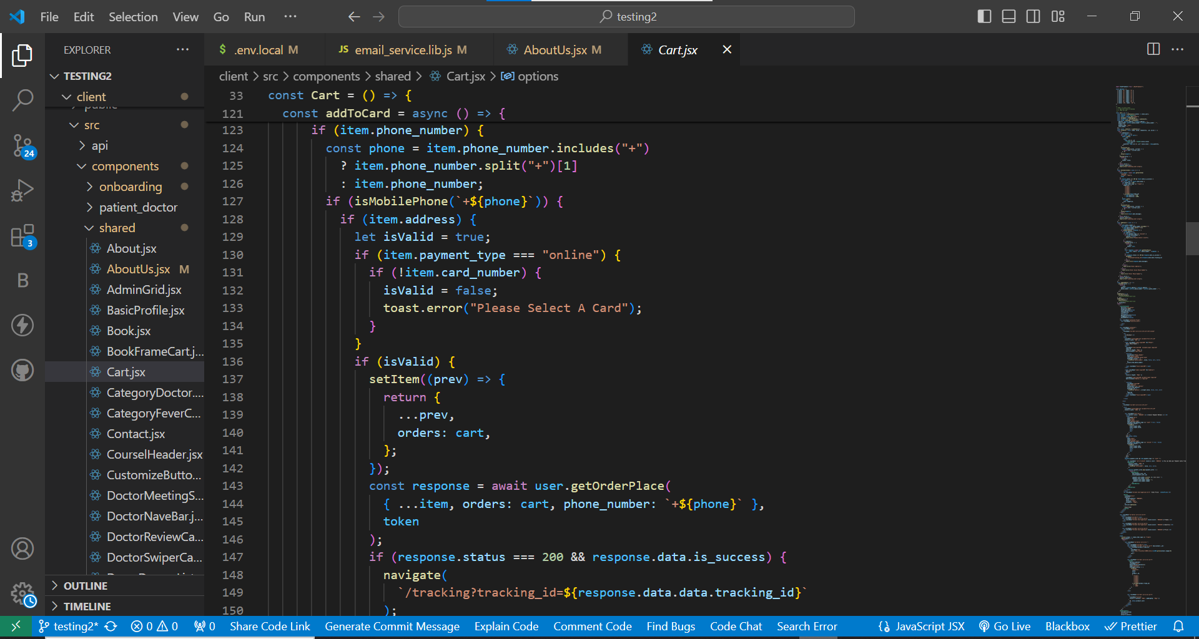

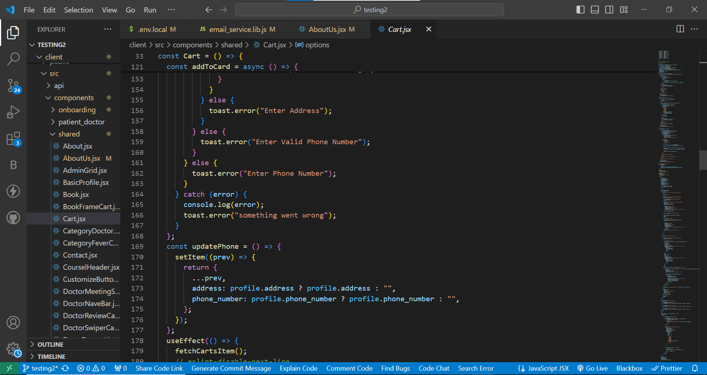

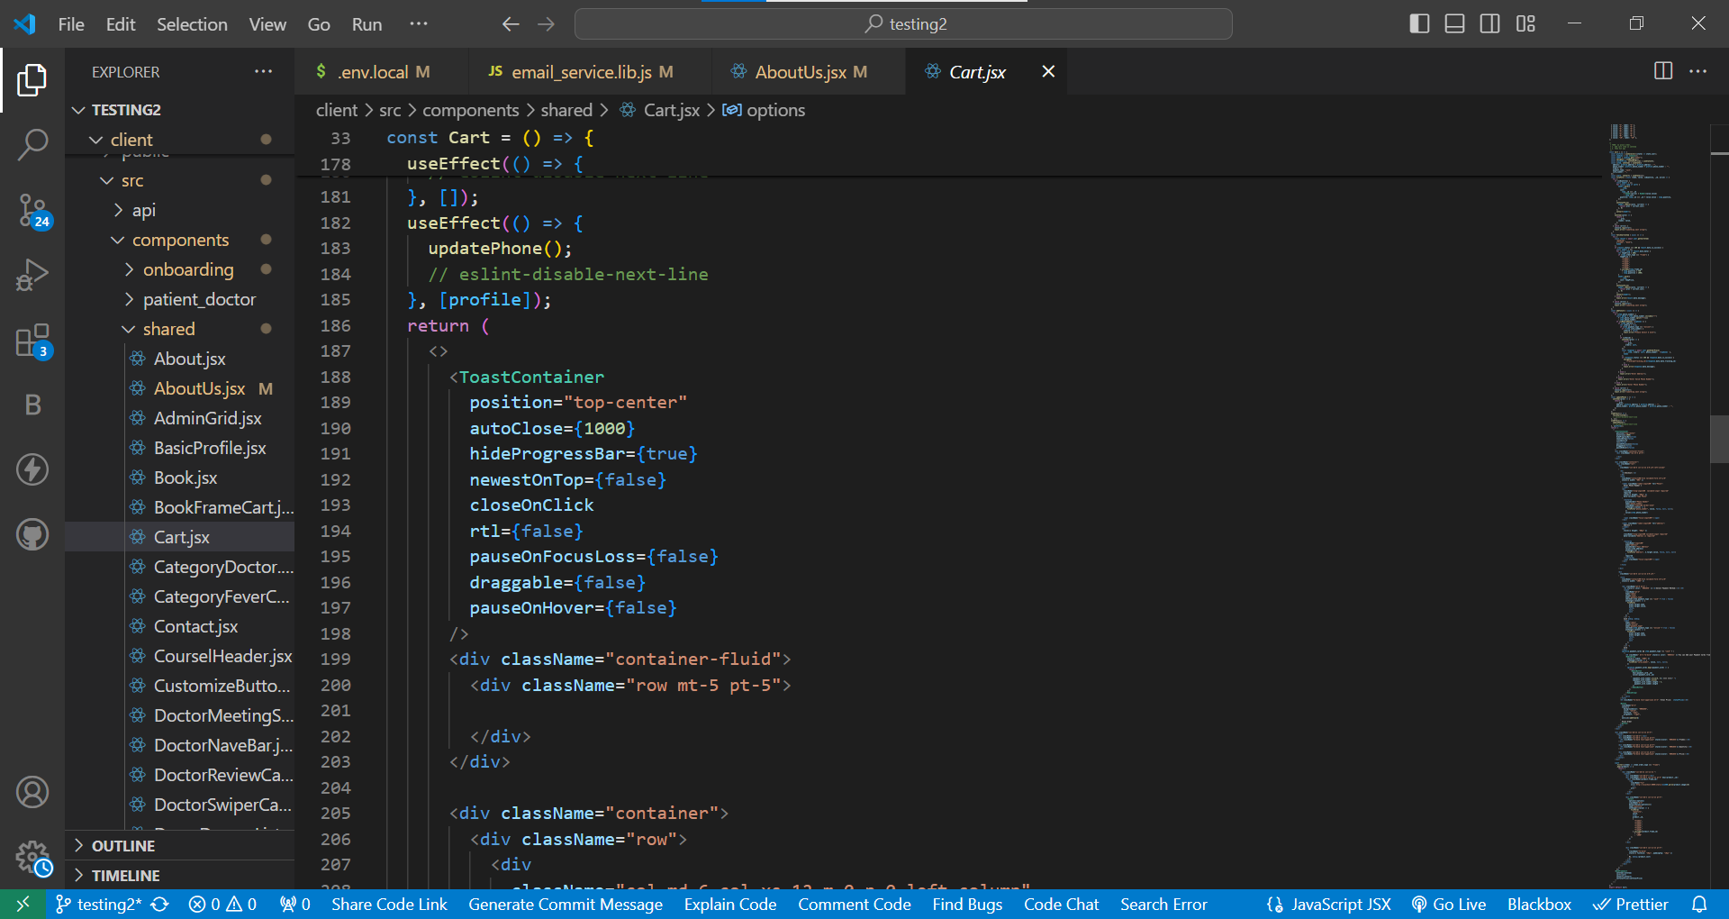

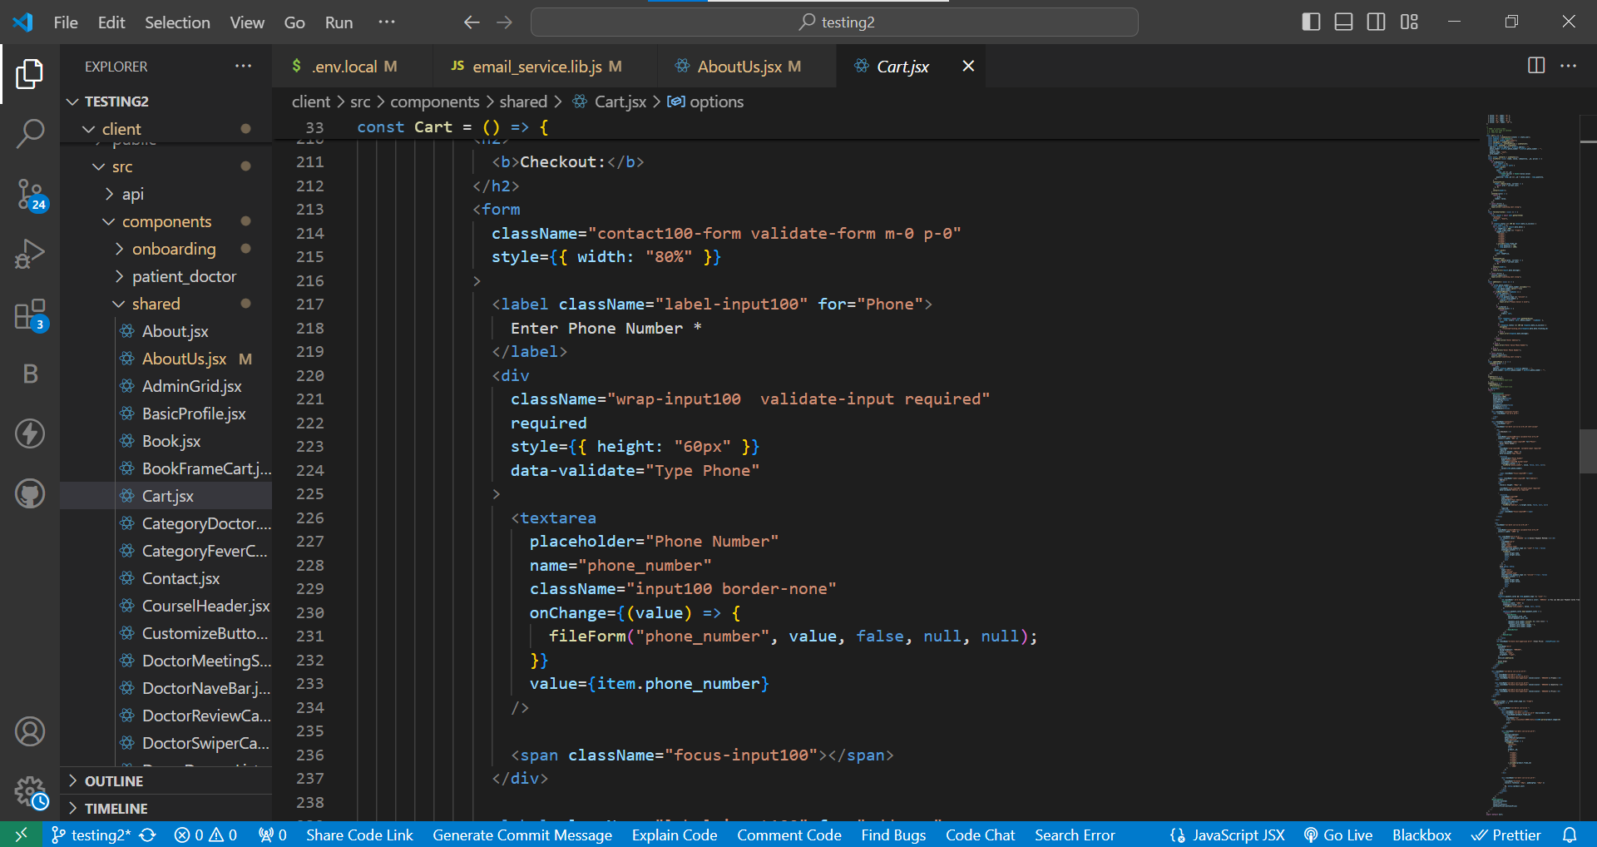

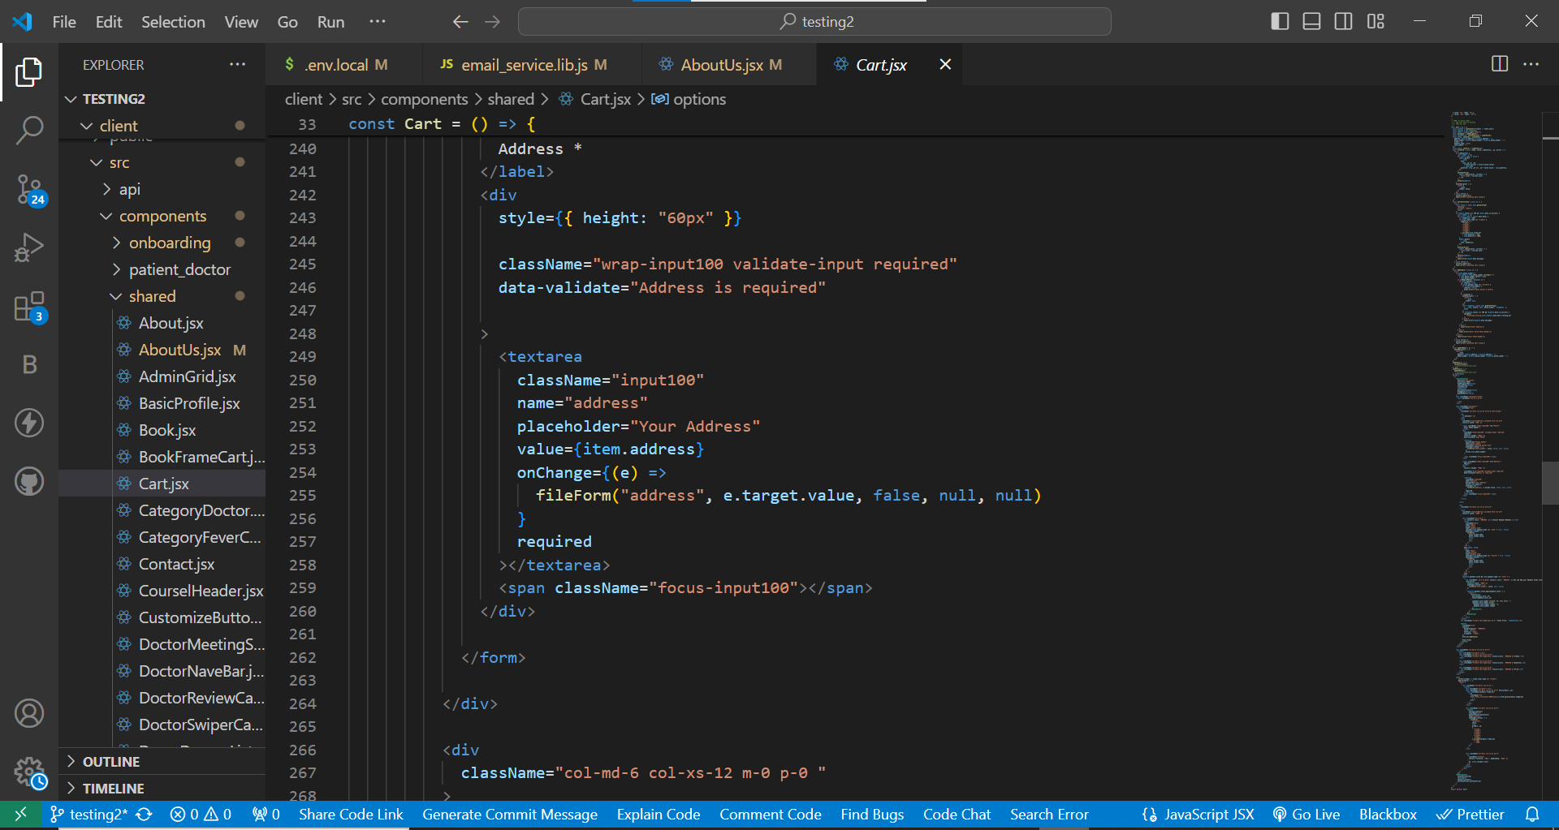

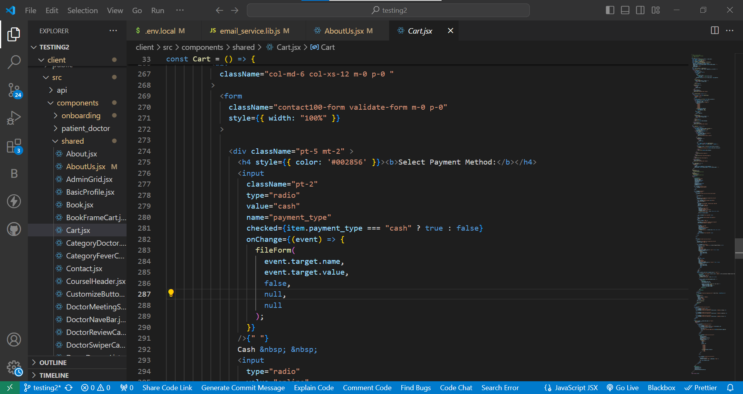

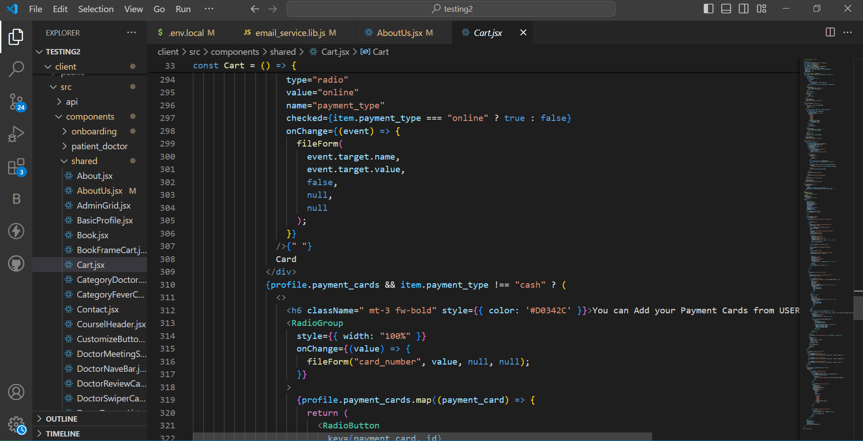

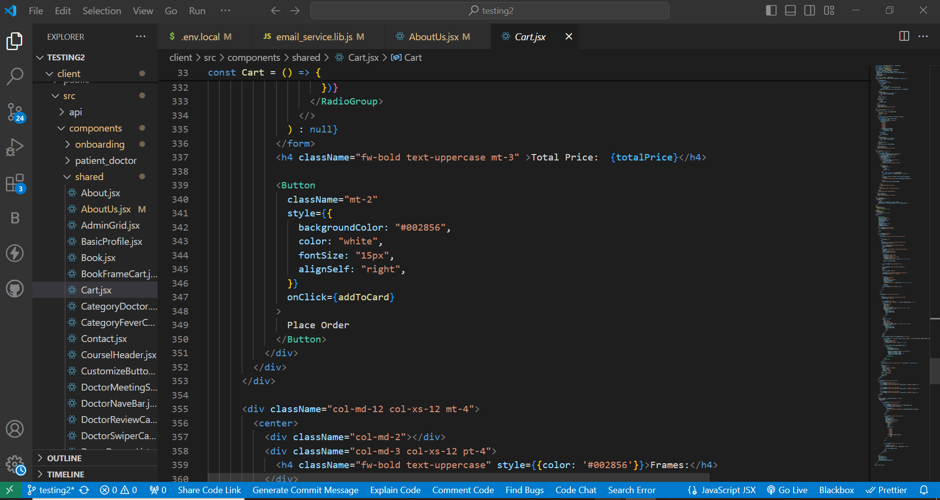

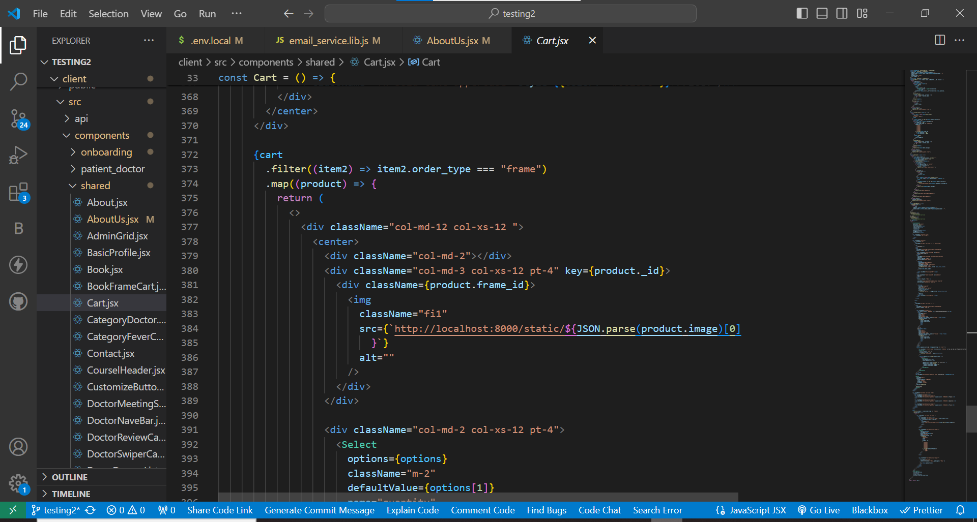
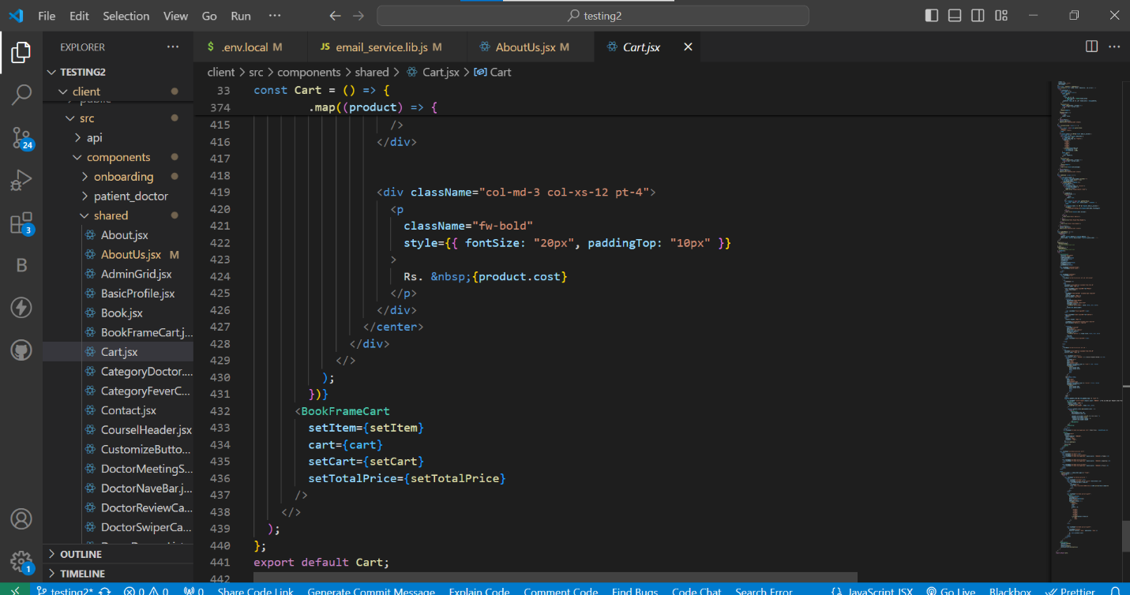

Tracking

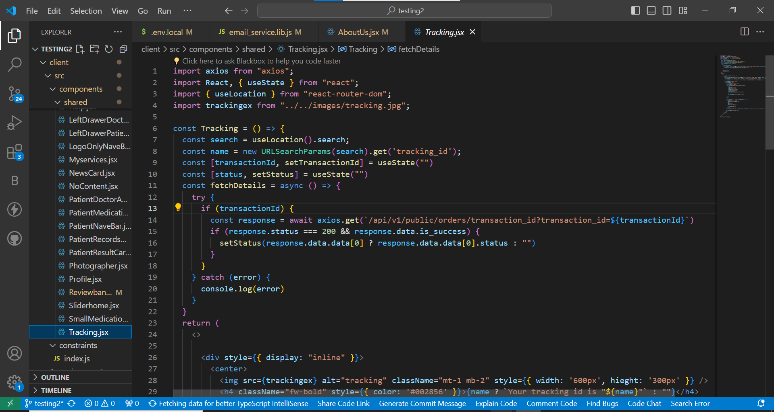

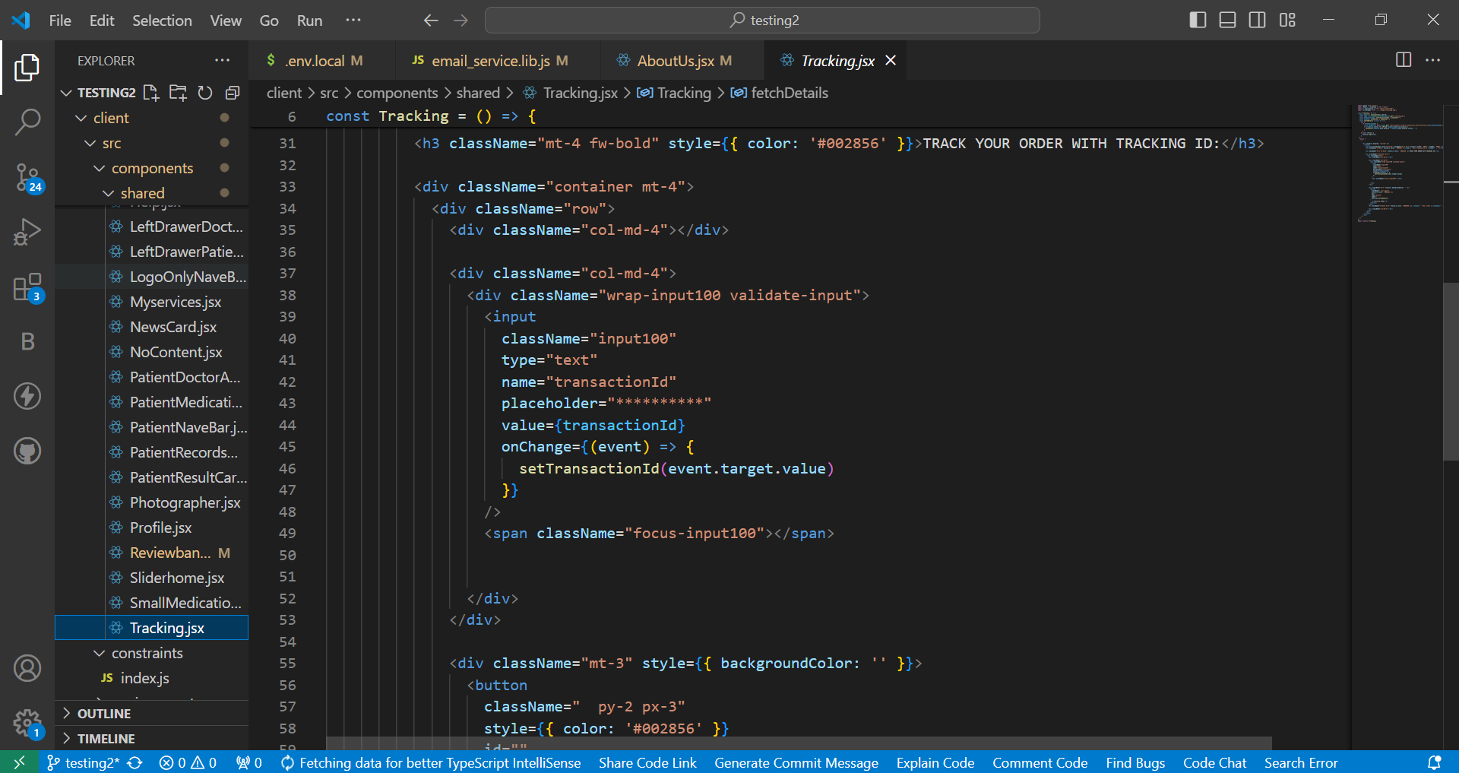

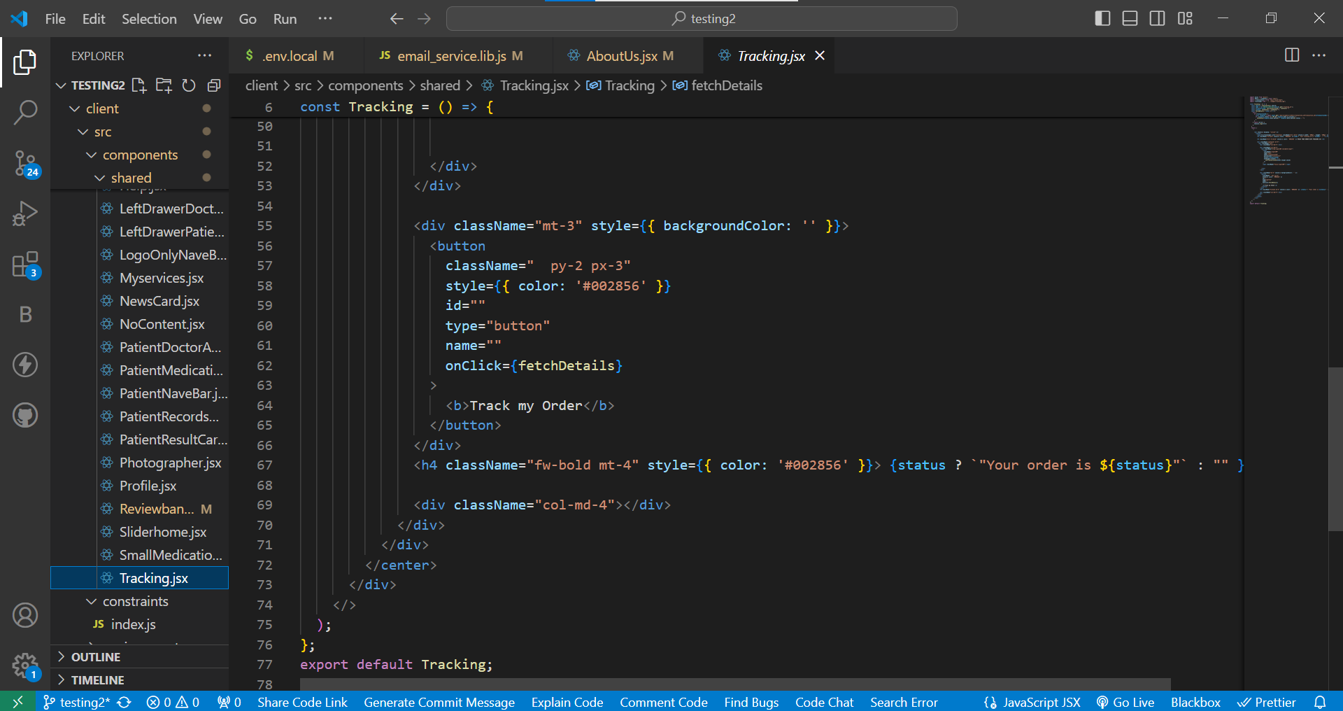

RESULTS AND DISCUSSIONS

Result

The implementation of SnapTick application is developed on the latest platform of the developing time. Implementation is a crucial phase of any developing project. The project is accomplished in accordance with the requirement of software requirement document. The implementation is completed on the incremental process model as mentioned in software project management plan. Each module is developed and tested in a cycle because the next module of the project is totally depended on the previous module. All the confusions in requirement are clarified from the software design document. Implemented application will works on different platforms. This application is fully responsive. The user will sign up to make order. The user photos will totally be safe with SnapTick. SnapTick will provide high quality products with reasonable rates. User will get fast delivery at doorstep. Customer will be able to pay bill online or cash on delivery. Customer will be able to check order status.

CONCLUSION AND FUTURE WORK

Conclusion

In this project we proposed a system that will provide users Photo Frames & Photo Books online. User will be able to place order in few steps with different mode of payments. User will be able to track order after placing order. The user photos will totally be safe with SnapTick. SnapTick will provide high quality products with reasonable rates. User will get fast delivery at doorstep. Customer will be able to pay bill online or cash on delivery.

Future Work

The increased usage of smart devices & internet and need of different services related photography. In future I would like To develop more options such as: Hire Photographer, Photo Editing and Video Editing, allow user to design his/ her book in different designs with different sizes and to add photo editing process during image uploading.

REFERENCES

[1] | “Tasvir,” Tasvir.pk. [Online]. Available: http://tasvir.pk/. [Accessed: 30-May-2024].
[2] | “Groovebok.com,” Groovebok.com. [Online]. Available: http://groovebok.com/. [Accessed: 30-May-2024].
[3] | Keepsake, “Keepsake Frames - Your photos printed, framed and delivered,” Keepsakeframes.com. [Online]. Available: http://keepsakeframes.com/. [Accessed: 30-May-2024].
[4] | “Shutterfly: Photo books, cards, prints, wall art, gifts, wedding,” Shutterfly.com. [Online]. Available: http://shutterfly.com/. [Accessed: 30-May-2024].

