
BSCS-S23-012
03-134201-015 | MUHAMMAD TAYYAB
03-134201-024 | SHAMAIM AZIZ MALIK

Go-Trolley – Smart Trolley System

In partial fulfilment of the requirements for the degree of
Bachelor of Science in Computer Science
Supervisor: Shahid Mehmood
Department of Computer Sciences
Bahria University, Lahore Campus
January 2024

© Bahria University, 2024

Certificate

We accept the work contained in the report titled
“Go-Trolley – Smart Trolley System”
written by
MUHAMMAD TAYYAB
SHAMAIM AZIZ MALIK
as a confirmation to the required standard for the partial fulfilment of the degree of
Bachelor of Science in Computer Science.

Approved by:
Supervisor: Shahid Mehmood
(Signature)

January 10, 2024

DECLARATION

We hereby declare that this project report is based on our original work except for citations and quotations which have been duly acknowledged. We also declare that it has not been previously and concurrently submitted for any other degree or award at Bahria University or other institutions.

Enrolment | Name | Signature
03-134201-015 | MUHAMMAD TAYYAB
03-134201-024 | SHAMAIM AZIZ MALIK

Date : January 10, 2024

Specially dedicated to
my beloved grandmother, mother and father
(MUHAMMAD TAYYAB)
my beloved grandmother, mother and father
(SHAMAIM AZIZ MALIK)

ACKNOWLEDGEMENTS

We would like to thank everyone who had contributed to the successful completion of this project. We would like to express our gratitude to my research supervisor, Mr. Shahid Mehmood for his invaluable advice, guidance, and his/her enormous patience throughout the development of the research.

In addition, we would also like to express my gratitude to our loving parents and friends who had helped and given me encouragement.

MUHAMMAD TAYYAB
SHAMAIM AZIZ MALIK

Go-Trolley – Smart Trolley System

ABSTRACT

The standard invoicing method at supermarkets has long been a source of frustration for both customers and businesses. Customers are frequently forced to wait in long lines to pay for their products, while cashiers must perform the billing process manually, which can result in errors and delays. This not only has an impact on the client experience but also increases employee workload and stress levels. As a result, there is a need for a more efficient and effective billing system in supermarkets, which may improve the whole shopping experience for customers while reducing employee workload. To solve this problem, we propose a smart trolley system that can handle the difficulties listed above. Customers can use the LED screen mounted to the cart to scan the things they want to buy and pay for them by scanning a QR code if this system is implemented. This will not only improve the shopping experience for customers but will also lower employee workload and stress levels. We will connect barcode sensors to the trolley to detect products added or withdrawn from the trolley. We will use a Raspberry Pi touchscreen LED as the user interface. This will show a basic layout, allowing the user to shop and see a list of all the products placed on the trolley, as well as remove items from the cart. When a consumer is satisfied with his purchase and wishes to pay his bill, he can simply pick the checkout button on the screen, and numerous options will appear on the screen. Flutter would be used to create the interface. A randomly generated QR code will show after the user completes the checkout process. The cashier would scan the QR code to receive the user's bill. The customer would be able to pay with a credit card as well as cash. The smart trolley system can provide a new and efficient solution to the traditional billing system in supermarkets by integrating various approaches, tools, and technologies.

TABLE OF CONTENTS

DECLARATION iii
ACKNOWLEDGEMENTS v
ABSTRACT vi
TABLE OF CONTENTS vii
LIST OF TABLES x
LIST OF FIGURES xi
LIST OF SYMBOLS / ABBREVIATIONS xii

CHAPTERS
1 INTRODUCTION 1
1.1 Background 1
1.2 Problem Statements 2
1.3 Aims and Objectives 3
1.4 Scope of Project 4
2 LITERATURE REVIEW AND SRS 6
2.1 System Features 6
2.2 User Classes and Classification 7
2.2.1 Customer 7
2.2.2 Cashier 7
2.3 Operating Environment 7
2.4 Design and Implementation 9
2.4.1 Hardware Selection and Integration 9
2.4.2 Integration and Testing 9
2.4.3 User Training and Support: 10
2.5 Assumptions and Dependencies 10
2.5.1 Assumptions 10
2.5.2 Dependencies 10
2.6 Interface Requirement 11
2.7 Use Case Diagram and Description Tables 12
2.7.1 Trolley Use Case 12
2.7.2 System Use Case Table 13
2.8 Database Use Case 14
2.9 Database Use Case Table 14
2.10 Add Product 15
2.11 Add Product Use Case Table 15
2.12 Delete product 16
2.13 Delete Product Table 16
2.14 Resource Requirement Table 17
2.15 Tools/Technology 18
2.16 Literature Review 18
3 DESIGN AND METHODOLOGY 21
3.1 Methodology 21
3.2 Research and Analysis 22
3.3 Design and Prototyping 23
3.4 Integration and Testing 23
3.5 Monitoring and Optimization 23
3.6 Feasibility Plan 24
3.7 Risks Involved 24
3.8 Flow Chart 26
3.9 Sequence Diagram 27
3.10 Methodology Diagram 28
3.11 Class Diagram 29
4 IMPLEMENTATION 30
4.1 Implementation 30
4.2 User Interface Implementation 30
4.3 Sensor Integration 31
4.4 Database Integration 31
4.5 Payment Processing 31
4.6 Integration Testing 31
4.7 Hive 31
5 RESULTS AND DISCUSSIONS (or USER MANUAL) 33
5.1 Splash Screen 33
5.2 Processing Screen 34
5.3 Empty Cart 34
5.4 Add Product 35
5.5 QR Code 35
5.6 Receipt 36
6 CONCLUSION AND RECOMMENDATIONS 37
6.1 Conclusion 37
6.2 Recommendations 37
6.3 Future Work 38
REFERENCES 39

LIST OF TABLES

TABLE TITLE PAGE
Table 1: System Use Case Table to explain the flow of events that are followed when the trolley is being used. 13
Table 3: Database Use Case Table to explain what attributes are required when adding products to the database. 14
Table 4: Add Product Use Case Table to explain how the cashier adds products to the database. 15
Table 5: Delete Product Table to explain how customers can get rid of the items they no longer want 16
Table 6: Resource Requirement Table 17
Table 7: Tools/Technology 18

LIST OF FIGURES

FIGURE TITLE PAGE
Figure 1: Add Product explaining how the cashier adds the product to the database. 15
Figure 2: Delete Product explaining the process to delete the item that you no longer 16
Figure 3: Agile Methodology: Collaborative, iterative software development focused on adaptability and customer feedback. 22
Figure 4: Flow Chart explaining the flow of the smart trolley and functionalities of the customers and the cashier. 26
Figure 5: Sequence Diagram to show the process of the trolley 27
Figure 6: Methodology Diagram for Smart Trolley System 28
Figure 7: Class Diagram 29
Figure 8: Splash Screen 33
Figure 9: Processing Screen 34
Figure 10: Empty Cart 34
Figure 11: Add product to the database 35
Figure 12: QR Code 35
Figure 13: Result 36

LIST OF SYMBOLS / ABBREVIATIONS

c_{p} specific heat capacity, J/(kg⋅K)
h height, m
K_{d} discharge coefficient
M mass flow rate, kg/s
P pressure, kPa
P_{b} back pressure, kPa
R mass flow rate ratio
T temperature, K
v specific volume, m³

α homogeneous void fraction
η pressure ratio
ρ density, kg/m³
ω compressible flow parameter

ID inner diameter, m
MAP maximum allowable pressure, kPa
MAWP maximum allowable working pressure, kPa
OD outer diameter, m
PCB printed circuit board

INTRODUCTION

Background

We've all had the experience of having to wait in huge queues at the supermarket checkout. This occurs because the present invoicing system requires each item to be manually scanned, which takes time and might lead to errors. Customers are sometimes irritated when things are missed or scanned twice.

Employees at supermarkets are under pressure behind the scenes to handle these billing difficulties, which can create a tense work atmosphere. This old method of doing things has been around for a long time, and its past time for a change.

The goal of our project, "Go-Trolley - Smart Trolley System," is to effect such transformation. We want to use current technology to change the way we pay for food. Our goal is to make the process more efficient, less stressful, and faster for everyone involved [1].

The system was first tested in a small Amazon Go store in Seattle in 2018, where consumers could scan their smartphones upon entering the store, pick up things, and leave without having to go through the checkout procedure.

The major aim of developing the smart trolley system was to improve customers' shopping experiences by lowering the amount of time and effort required to complete a purchase. Amazon aimed to boost customer happiness and loyalty by automating the checkout process and eliminating the need for customers to stand in long lines.

Despite technological developments, Pakistan's conventional billing structure has remained mostly untouched. Every supermarket in Pakistan is still experiencing the same problems as Amazon. Customers have had a less-than-satisfactory shopping experience as a result of long lineups, manual billing processes, and increased staff workload [2]

To rectify these problems, we plan to have a smart trolley system that will change the existing billing method in supermarkets. Innovative technology will be used to provide customers with smooth shopping while at the same time reducing employees 'workload.

This paper will consider why the current invoicing system needs an upgrade and how our smart trolley can help. We'll also explain to you our strategy and major steps, to complete this task.

Problem Statements

As you will read later in the "Introduction," at supermarkets, buyers undergo a rather time-consuming and tedious procedure that often leads to long lines of customers with longer faces as they settle up. Worse still, their manual billing systems sometimes produce errors and delays. In addition, the normal billing method puts a tremendous load on cashiers who have to enter each transaction manually and deal with consumer complaints.
By addressing these issues, the smart trolley system can alter supermarket billing systems and give customers a more convenient, efficient, and personalized shopping experience.

Problem Statement 1: Inefficient Traditional Billing System
Checkout at supermarkets is often held up by the method of payment for groceries handled so far. This is because each item must be scanned, and mistakes are possible. This is inconvenient for customers, causing them to wait longer than necessary.

Problem Statement 2: Error-Prone Manual Billing
The manual billing procedure is error-prone. Sometimes errors include items not noticed or charged twice. Not only is this inconvenient for customers, but it also makes extra work for grocery store employees in having to accept complaints and give refunds.

Problem Statement 3: Increased Employee Workload
It takes a lot of time for employees at supermarkets to scan them and handle billing concerns. This puts stress on the work and makes providing good service more difficult.

Problem Statement 4: Need for Innovative and Efficient Solutions
A better way to buy groceries is obviously needed. What we need is a solution that speeds up checkout, enhances the customer experience, and makes life easier for both customers and employees.

Problem Statement 5: Lack of Local Implementation
This technology has been successful in other countries, but we haven't seen much of it here in Pakistan. This is also an opportunity to introduce current retail technology to our neighborhood grocers.

Problem Statement 6: User Training and Acceptance
To be successful, this new system must be simple to use for everyone. Customers and employees should be able to understand and use it without much instruction [3]

Aims and Objectives

Aims:
- Enhancing Shopping Experience: Our primary aim is to help all supermarket customers have a better overall shopping experience. We aim to reduce checkout lines, avoid billing problems, and make shopping more convenient.
- Reducing Employee Workload: By automating the billing process, we hope to minimize the workload and stress levels of grocery employees. This allows them to concentrate on offering superior customer service.
- Introducing Modern Retail Technology: Another goal is to offer modern retail technology to Pakistan's local supermarkets. We wish to bring the advantages of innovative systems seen elsewhere in the world to our local retail environment.

Objectives:
- To Create a smart trolley system that allows customers to scan and pay for their purchases without having to queue at the checkout, lowering wait times and improving the overall shopping experience. To ensure the accuracy of the smart trolley system through the use of advanced sensors.
- To ensure the smart trolley system's precision through the employment of modern sensors.
- To build the system in a user-friendly and straightforward manner, minimizing the need for user training and assuring the system's ease of deployment across various sites.
- To reduce client, wait times and improve the overall shopping experience.
- To Assess the user experience and solicit feedback from consumers and cashiers to find areas for improvement.

Scope of Project

- Why The typical billing procedure at supermarkets frequently results in huge lines and extended wait periods. Manually scanning each item at the checkout counter might potentially result in mistakes, such as products being overlooked or scanned twice.
- To address all of the concerns described above, as well as many others, supermarkets are creating a smart trolley system that will use advanced technology and allow customers to scan things and pay.
- The smart trolley is equipped with sensors, each with a distinct function.
- When products enter the cart, an object detection sensor detects them.
- The item added to the trolley will be shown instantly on the Raspberry Pi LED linked to the trolley.
- Only the administrator will be able to add and remove products from the screen.
- When the user has completed purchasing, he or she will click the checkout button on the screen and an automatic QR code will be generated. To retrieve the bill, the cashier will scan the QR code.
- Transitioning from a manual to an automated system can bring various issues, including assuring system correctness, lowering the likelihood of errors or miscounts, and providing fault tolerance.
- When building such systems, it is critical to keep the human component in mind and create an intuitive and user-friendly interface that reduces the need for user training.

LITERATURE REVIEW AND SRS

System Features

The "Go-Trolley - Smart Trolley System" is intended to provide a variety of features that address the inadequacies of standard supermarket invoicing systems while improving the shopping experience for customers. These features are as follows:
- Item Scanning: Customers may quickly scan products using the trolley's LED screen. Manual scanning at the checkout counter is no longer required.
- Real-time Display: The Raspberry Pi touchscreen LED displays all things added to the cart in real time. As they shop, customers may keep track of their purchases.
- Add/Remove Products: Using the LED screen, the cashier can add and delete products.
- Item Removal: If a consumer changes their mind or makes a mistake, they can remove products immediately from the cart via the interface, ensuring proper billing.
- Checkout Process: When customers have finished purchasing, they can begin the checkout process by clicking the checkout button on the screen.
- QR Code Generation: Once the checkout procedure is completed, a randomly generated QR code shows on the screen. This code is used to identify the payment [1].
- Cashier Integration: The cashier scans the QR code displayed on the trolley's screen to retrieve the user's bill and finish the transaction.
- Payment Options: The consumer would be able to pay using a credit card as well as cash.
- User-Friendly Interface: The user interface is created with Flutter, offering a simple experience for both customers and grocery employees.
- Feedback Gathering: Collecting user feedback helps to constantly improve the shopping experience and system operation.
- Integration of Advanced Sensors: The accuracy and dependability of the system are improved by integrating a barcode sensor into the trolley [4].
- Cost-Efficient Implementation: The project aims to seek an appropriate balance between implementation costs and benefits provided, making it a cost-effective means for supermarkets.

User Classes and Classification

Two different user roles can be accommodated by the project:
- Customer
- Cashier

Customer

Primary Users: Customers are the main users of this trolley system. They use the trolley to scan and process their items, begin checking out at a checkout counter, and pay.

Cashier

System Operators: Cashiers play important roles in the payment and transaction process. They use the QR code generated by the system to scan and process payments, making it easy for people to buy.

System Monitors: Some cashiers may also watch the system for technical problems, to help clients who get into difficulties during checkout.

Operating Environment

A certain number of basic operating environments must be in place to make sure the application runs smoothly. These are as follows:
  - Hardware Compatibility: The hardware components taking the form of Raspberry Pi devices, sensors, LED screens, and power sources must be suitable for one another as well as being able to conform to the system's technological specifications. Hair compatibility, easy integration, and effective operation are critical for hardware connection.

  - Development Tools and Software: For system coding, testing, and debugging suitable development tools and software are needed. When developing the system's software components, it is necessary to have available flutter and QR code creation libraries as well as suitable database tools.

  - Internet Connectivity: A stable and reliable internet line is essential for the development process, as it not only allows software to be updated but also data can be synched up online, or tests done remotely. The web also provides a variety of online resources for troubleshooting and research available to developers.

  - Testing Environment: A store-like regulated testing environment is thus needed for thorough tests. This environment should include trolleys, sensors, and network infrastructure. Environment as above enables one to assess the system's functionality[5].

  - Development and Testing Devices: Developers must have access to Raspberry Pi devices, sensors, and LED screens for development and testing. These devices should be readily available for systems programming and testing.

  - Technical Documentation: Technical documentation for hardware components, programming languages and libraries must be complete for developers. Formal documents and resources make the development process simple.

  - Collaborative Tools: Collaboration tools include, but are not limited to version control systems (e.g., Git), project management platforms, and communication-related applications that enable team members in projects to collaborate. These tools help project coordination and monitoring.

Design and Implementation

The design and implementation phase of the Go-Trolley project is an important step in making a smart trolley system real. Several significant components and factors are included in this phase:

Hardware Selection and Integration

- Raspberry Pi: Inside each smart trolley is the Raspberry Pi, a small but powerful single-board computer. Among the reasons for choosing Raspberry Pi devices are adaptability and compatibility with a large range of sensors, actuators, and components.

- Sensors: The trolley includes barcode readers. These sensors enable the system to sense objects in the trolley, display details about products, and calculate item prices [6].

- LED Display: The user interface for the trolley is an LED display. It has a relatively simple structure, whereby users can view and edit their shopping basket: add or remove things; and proceed to checkout.

- Tags: Each product bears a QR code. These tags provide unique identification information for each object. An automatic identification and tracking system based on barcode technology is used in the trolley.

Integration and Testing

Integration: A smart trolley system is created by integrating hardware and software components. Compatibility and functions of sensors, Raspberry Pi, LED display, and software modules are tested out by wiring them together.

Testing: Testing is carried out at all levels, such as unit testing (UT), which tests individual components one by one; integration testing to ensure that there are smooth interactions between hardware and software; user acceptability test (UAT) for the assurance of high-level system performance [7]

User Training and Support:

  - Training Materials: A complete set of training materials is developed, such as cashiers and administrators. These papers teach them how to use the smart trolley system and help clients with it.
  - Technical Support: If problems arise during system operation, there are also mechanisms for technical help. A trained support crew is on hand to offer prompt assistance.

Assumptions and Dependencies

Assumptions

- It is said that the supermarket will carry products with QR labels. These tags are used by the system to keep accurate and efficient track of items within the trolley.
- The smart trolley system must have a stable internet connection to create QR codes for transactions and exchange messages with the central database.
- Support and maintenance for the smart trolley system will continue by supermarket workers and management.

Dependencies

- Availability and compatibility of barcode technology are critical to the success of the system. For the smooth tracing of items, the supermarket needs to attach barcode tags on all their products.
- The most important is the creation of a user interface, database, and payment processing software. Any problems or delays in software development can affect the schedule of a project.
- One must integrate hardware components such as barcode sensors, Raspberry Pi, and LED displays. Compatibility issues or delays in the integration of hardware can affect system functionality.
- Employees at supermarkets will have to be trained in how to use the smart trolley system so that they can help customers [8].

Interface Requirement

- The Raspberry Pi, with a touchscreen LED display.
- The system has to exchange information with barcode readers built into the trolleys.
- At the point of sale, you'll need to have a QR-code scanner interface so that cashiers can scan the system-created QR code for final processing.
- It also features an easy-to-use flutter interface that enables customers to interact with the trolley's touchscreen LED display. The user interface also makes it easier to scan products, look at a list of what is in the cart, and start checking out.
- To add and remove products, the system communicates with a database (Hive), and to get bill links, Firebase is used. This interface is used for real-time changes and precise billing.
- To generate unique QR codes for each transaction, the system communicates with a QR code-generating library. This interface is required for producing QR codes at the point of sale [5].
- The software communicates with the Raspberry Pi's underlying operating system, which is normally Linux-based. To maintain system stability, it must perform smoothly within this environment.

Use Case Diagram and Description Tables

The use case diagrams offered give a thorough understanding of the Trolley.

Trolley Use Case

A system use case diagram provides a summary of the functioning of the Trolley and how its parts work together to produce the intended result.
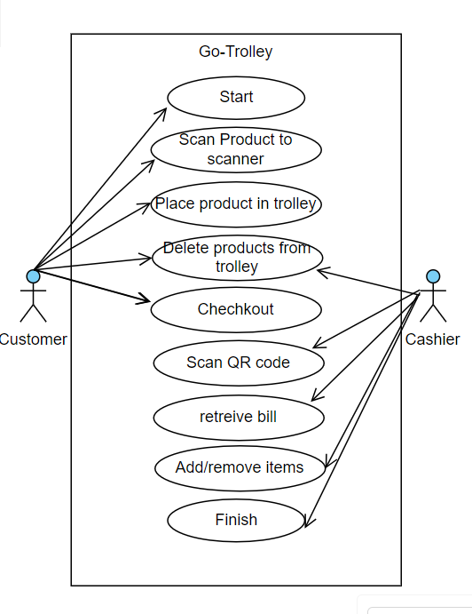
Figure 1: System use case explaining the process that customers and cashiers follow while using the smart trolley.

System Use Case Table

Table 1: System Use Case Table to explain the flow of events that are followed when the trolley is being used.
 | Name | System Use Case
 | Use case ID | UC-01
 | Objectives | Enable shoppers to use the smart trolley for a convenient shopping experience.
 | Priority | High
 | Actor | Customer/Cashier
 | Flow of Events | - Customer starts the process  - Customer navigates through the store using the smart trolley, adding and removing items.  - The system updates the trolley display in real-time.  - Customer proceeds to checkout.  - The system generates a QR code for payment.  - The cashier scans the QR code to retrieve the bill.  - Shopper pays and completes the transaction.  - The system updates inventory and transaction records.
 | Alternate Flows | - Shopper encounters an issue with the trolley display.  - Payment failure or rejection.
 | Exception Flows | - Technical issues with sensors or the Raspberry Pi.  - System errors during the checkout process.
 | Pre-condition | Shopper has a registered account and a functional smart trolley.
 | Post-condition | Successful completion of the shopping transaction with accurate billing and inventory updates.

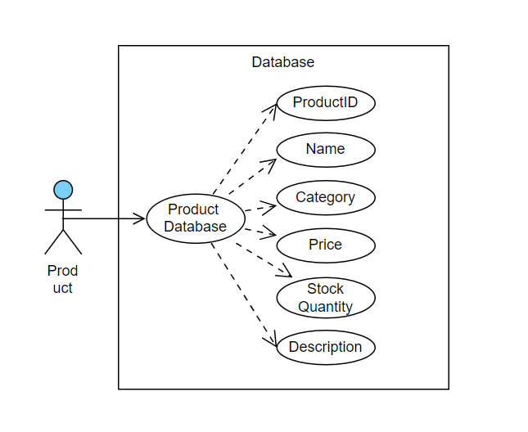
Database Use Case

Figure 2: Database Use Case that explains what attributes are required for product that are added in the database.

Database Use Case Table

Table 3: Database Use Case Table to explain what attributes are required when adding products to the database.
 | Name | System Use Case
 | Use case ID | UC-02
 | Objectives | Manage the information on products.
 | Priority | High
 | Actor | System Administrator, Cashier
 | Flow of Events | - Database Manager monitors database performance.  - System adds new products to the database.  - System updates product details (e.g., price, quantity).

Add Product

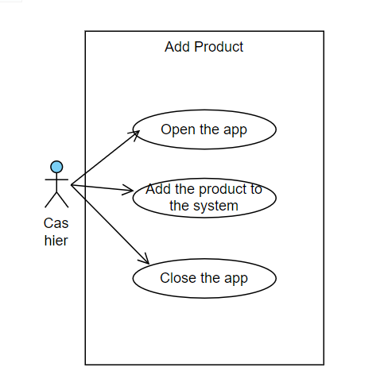
Figure 1: Add Product explaining how the cashier adds the product to the database.

Add Product Use Case Table

Table 4: Add Product Use Case Table to explain how the cashier adds products to the database.
 | Name | Add Product
 | Use case ID | UC-03
 | Objectives | Add the products to the system.
 | Priority | High
 | Actor | System Administrator, Cashier
 | Flow of Events | - Opens the app  - Adds the product by scanning it

Delete product
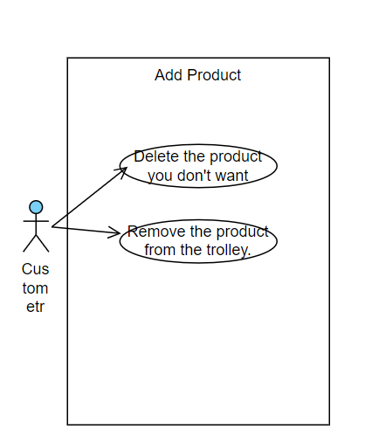
Figure 2: Delete Product explaining the process to delete the item that you no longer
want.

Delete Product Table

Table 5: Delete Product Table to explain how customers can get rid of the items they no longer want
 | Name | Add Product
 | Use case ID | UC-04
 | Objectives | Delete products from the system that you no longer want.
 | Priority | High
 | Actor | Customer
 | Flow of Events | - Remove product using the delete button on the screen.  - Remove product from the trolley.

Resource Requirement Table

Table 6: Resource Requirement Table
Hardware Components | - Laptop  - Sensors  - Trolleys  - Raspberry Pi Smart LED  - Raspberry Pi  - Tags/stickers
Software Development | Development of a user interface on Flutter that adds and removes items in the trolley and performs other functions such as payment.
IT Infrastructure | Hardware and software required to support the smart trolley system include:  - Servers  - Networking equipment  - Security systems
Testing and Validation | Ensure that it meets the required standards for accuracy, reliability, and safety.

Tools/Technology

Table 7: Tools/Technology
Software/Hardware
Raspberry Pi board
LED screen
Barcode reader Sensor
DART framework
Flutter for GUI development
QR code generation library
Database software to store product information and prices (e.g., Hive, Firebase)

Literature Review

The Go-Trolley -- Smart Trolley System incorporates many of the trends developed in both international and local smart shopping solutions. In this review we will explore the historical roots of smart trolleys, focusing on the example set by Amazon Go and how it has influenced our venture.

Today's smart trolleys have their roots in Amazonian plans to overturn the shopping experience. In 2017, they applied for an important patent on a system compatible with "Physical Store Online Shopping Control," which allows objects placed in physical shopping carts to be automatically recognized and tracked--eliminating the need for traditional checkout queues [7].

The daring idea became a reality in a tiny Amazon Go store in Seattle back in 2018. Customers may come in, scan their iPhones, select products, and go forth without having to stop at checkout. This seamless experience was made possible by a complex network of sensors, computer vision, and machine learning.

The retail world was rocked by the breakthrough of Amazon Go. By 2019, Amazon had extended this smart trolley idea to Amazon Fresh grocery stores, while shortening consumer checkout lines and improving shopping ease [2].

The traditional billing procedures for supermarkets in Pakistan have been mostly unchanged so that each shop ends up with endless lines of customers and cumbersome paperwork, not to mention higher levels of stress on the staff. Besides drastically reducing consumer satisfaction, this backward method is also a burden on the workforce.

Recognizing these issues and drawing inspiration from the Amazon Go concept, the Go-Trolley - Smart Trolley System aims to revolutionize the Pakistani shopping experience. Our goal is to deliver an innovative solution that is adapted to local demands while remaining consistent with global trends [3].

While worldwide ideas like Amazon Go have gotten a lot of attention, local research and innovation in this space are starting to emerge. Bedi et al., for example, investigated the possibilities of smart trolleys utilizing smartphones and Arduino technology. Though such efforts are still in their infancy in Pakistan, they have created the groundwork for technology-driven retail experiences.

The field of IoT-based shopping solutions has grown globally. An IoT-based Smart Shopping Trolley with a mobile cart application was introduced, emphasizing real-time updates and cart management—a feature that aligns with the Go-Trolley system's goals.

Tiwari discussed the utility of QR code technology in a variety of applications, including payments and data retrieval. This study inspired our system's use of QR codes for smooth payment processing. Furthermore, Horan's work on practical Raspberry Pi implementation highlights the adaptability and versatility of Raspberry Pi boards, which are an important component of the Go-Trolley system.

While worldwide improvements provide useful insights, the Go-Trolley system is mindful of Pakistan's unique challenges and potential in the retail sector. In our local environment, ensuring system accuracy, fault tolerance, and user-friendliness is especially important [4].

The Go-Trolley Smart Trolley System is endeavoring to answer a market demand by drawing on the wisdom of Amazon, who transformed itself from just another bookseller. Thus, this analysis of the literature guides our design and strategy. It also situates our system within a larger narrative about smart shopping technology.

DESIGN AND METHODOLOGY

Methodology

When designing a complex smart trolley system, an SDLC adaptable to the needs of each stage becomes essential. In this situation, the Agile methodology shines among the rest as follows: It emphasizes flexibility and uses an incremental refinement process in which there is a continuous feedback loop. This is just what's needed for IoT applications that demand the iterative development of both hardware and software.

The project is broken down into smaller components called sprints, which are where Agile takes effect. The project is divided into a series of sprints, each signifying one unit. Each sprint must be carefully tested and assessed by the team as well as all stakeholders concerned with the project. It is precisely the agile methodology that promotes adaptability to changes and feedback that makes for a more efficient, effective process of development [7].

Let us now delve into the nuanced stages of Agile, meticulously structured as follows:

- Planning Phase: The first step is to find and rank user stories in terms of business value. A stage is already set by user stories that encompass abilities such as product scanning, price display, and payment facilitation. In this phase as well, there are such items as defining a project's scope, objectives, and timetables.

- Design Phase: Design begins once the system architecture, interfaces, and workflows have been carefully documented. Hardware and software components, sensors, and communication protocols are all deliberated on to help build the blueprint of a smart trolley system.

- Development Phase: It is during the development phase when the team develops software for a smart trolley system using an Agile methodology. The implementation of features as defined in user stories is supplemented by continuous integration, testing, and deployment of code.

- Testing Phase: The testing phase tests the smart trolley system on factors such as functionality, usability, and security. The robustness of the system depends on unit testing, integration testing, and acceptance testing working together.

- Deployment Phase: The deployment stage focuses on the system's entry into operational use and is geared to individual project requirements.

- Maintenance Phase: This process is completed with the maintenance phase during which system performance evaluation and gathering of user feedback are carried out to allow constant improvement. It remains critical to deal with problems that arise as well as maintain the system in normal running order.
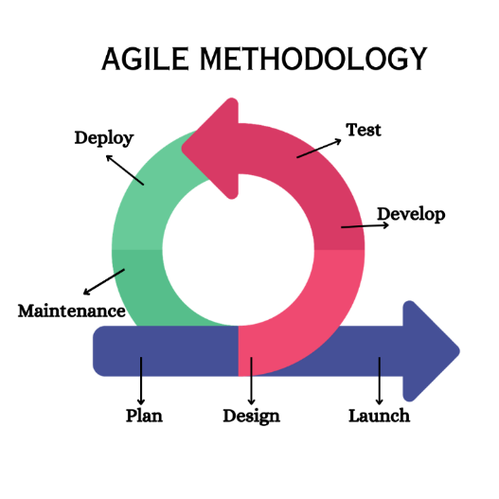
Figure 3: Agile Methodology: Collaborative, iterative software development focused on adaptability and customer feedback.

We will take the following steps to build the smart trolley:

Research and Analysis

Our journey starts with thorough research and analysis. In this way, we identify the limitations and constraints of existing smart trolley systems in various areas. An important step forward involves obtaining feedback from consumers and workers, which is accomplished by surveys done in supermarkets themselves and among nearby residents. This is the stage where we dive deep into today's technologies: sensors, Raspberry Pi, and smart automation systems. At this point, they need to analyze which are the best for our intelligent trolley.

Design and Prototyping

The second step is the design and prototyping phase. Based on the insights gathered during our research and analysis, we drafted precise specs of what the system would be capable of doing. The design process has not yet been completed and begins with the creation of a hardware prototype. This contains all the envisioned parts, including sensor arrays as well as having a user interface on an LED screen which means that users can simply scan things to go shopping or make transactions easily by doing so through these scans [9].

Integration and Testing

The third step is a complicated dance of integration and testing. The sensors, Raspberry Pi, Raspberry Pi LED, and the payment system are just some of its components. Together they all perform their duty in a very natural way. To guarantee a smooth and stable performance, the system is thoroughly tested in terms of both accuracy and speed.

Monitoring and Optimization

Our excursion ends at the crucial stage of monitoring and optimization. We are very strict in data collection on how consumers and workers interact with the system. With that can see how it is used. This information is like a signpost providing direction, helping us to continually adjust and improve the smart trolley system.

Through this systematic approach, we hope to come up with a smart trolley system that not only disrupts the current supermarket billing method but also provides consumers shopping experience more appropriate for their tastes. At the same time, we would like to ease the pressure on our hardworking staff. This is not just a technological development; it represents an upheaval in the way people shop for groceries [2].

Feasibility Plan

Technical Feasibility:
A comprehensive preliminary study of the proposed smart trolley system's interoperability with existing IT infrastructure is necessary for determining technical feasibility. One part of this is a review to determine how well the system fits with existing technologies so that implementation will be smooth and compatible.

Economic Feasibility:
Estimating expenses and forecasting returns on investment requires a thorough economic feasibility study. The point of this detailed financial analysis is to determine whether it is possible, given the budgetary constraints, to build and operate a smart trolley system. As well as developing the system, it's important to do so in a fiscally responsible way that allows for future profitability [1].

Operational Feasibility:
Operational feasibility refers to whether the proposed system is applicable and appropriate for use in grocery settings. In this assessment, we will be looking at how well the smart trolley system fits into the everyday business of supermarkets. In the supermarket context, the emphasis is on pragmatism and smooth integration with existing operations. It should also be easy to adopt.

Risks Involved

The following risks might be involved:

Technical Risks:
As far as technical difficulties go, we are on the alert for possible pitfalls in linking hardware and software. We mainly concern ourselves with pinpointing and solving problems that might arise during development or implementation.

Operational Risks:
We are developing ways to keep our smart trolley system steady and reliable. The focus of this section is thinking up possible operational obstacles in advance and troubleshooting them.

Financial Risks:
We're working on possible financial problems and preparing contingency plans to deal with any budgetary hiccup. Financial management: We hope to see the project through from conception to completion [6].

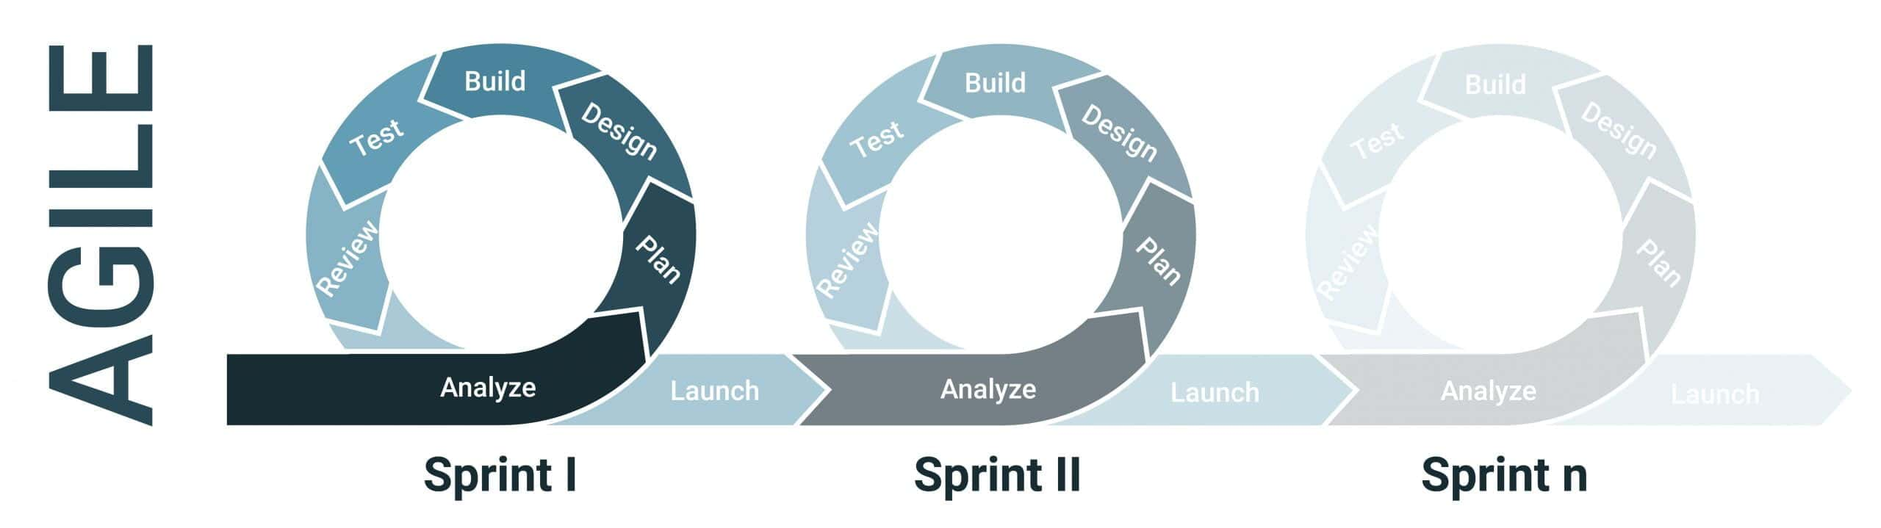
Figure 3.7: Agile sprints: Time-boxed iterations, typically 2-4 weeks, for focused development and rapid delivery of increments.

Flow Chart
The Smart Trolley flow chart begins with users scanning barcodes, transmitting data to the Raspberry Pi. The Pi communicates with the backend via Hive. At checkout, a QR code is generated for cashier verification, streamlining the process, enhancing efficiency, and overcoming traditional supermarket transaction challenges.

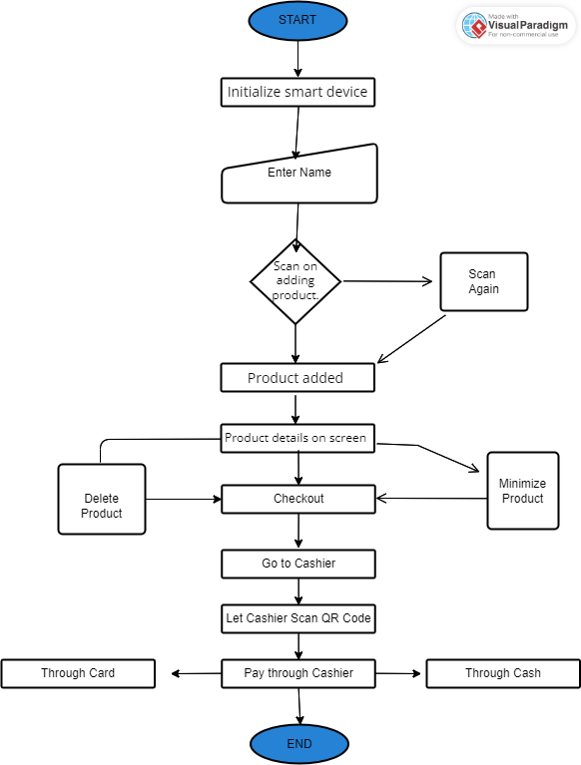
Figure 4: Flow Chart explaining the flow of the smart trolley and functionalities of the customers and the cashier.

Sequence Diagram

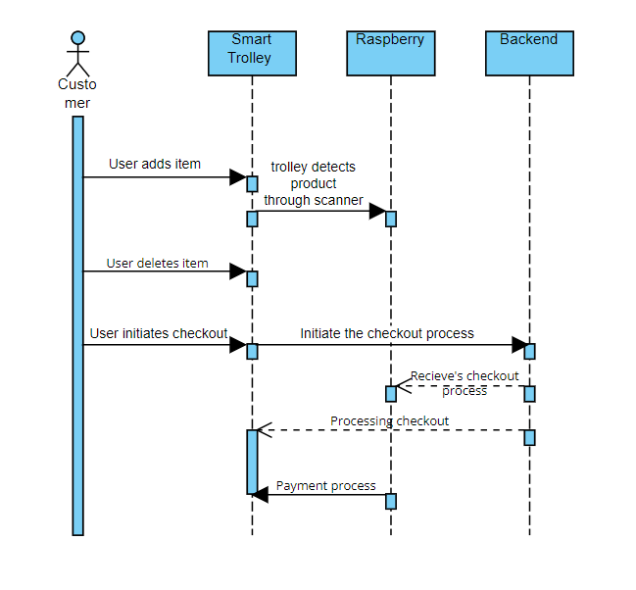
Figure 5: Sequence Diagram to show the process of the trolley

Methodology Diagram

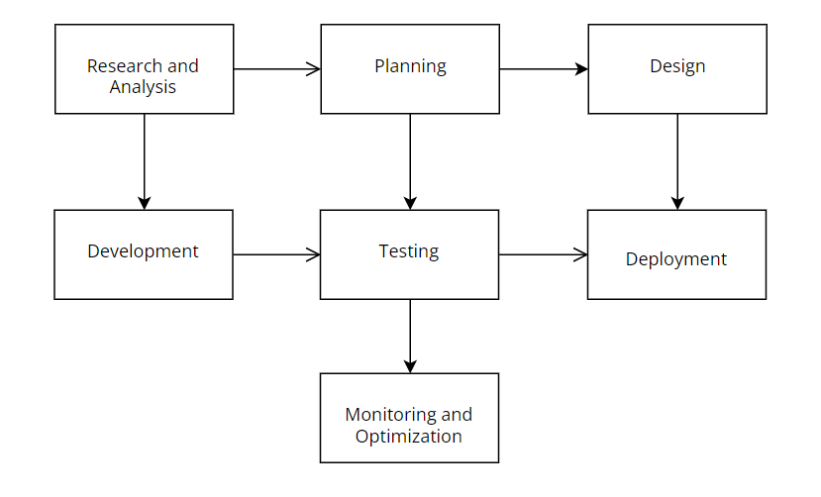
Figure 6: Methodology Diagram for Smart Trolley System

Class Diagram

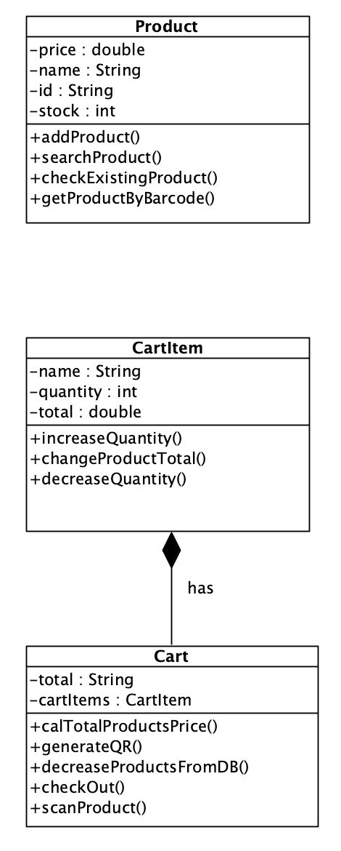
0..*
1
Figure 7: Class Diagram: A cart has many cart items and cartItem is a product.

IMPLEMENTATION

Implementation

The Smart Trolley System consists of essential components that work together to create a seamless shopping experience.
- Raspberry Pi and Touchscreen LED:
The Raspberry Pi serves as the brain of the system, handling data processing and user interactions.
The Touchscreen LED provides a user-friendly interface, displaying a layout for item selection and checkout [9].
- Sensors:
Barcode sensors to detect the products being added to the trolley.
- Trolley:
A shopping trolley on which all components are integrated.
- Backend Server:
Manages the central database containing information on products, users, and transactions.
Facilitates payment processing and ensures data integrity.

User Interface Implementation

The user interface is developed using the Flutter framework. Flutter offers a cross-platform solution, enabling the creation of a visually appealing and responsive user interface. Users can seamlessly interact with the application, adding items to the trolley, reviewing selections, and initiating the checkout process.

Sensor Integration

The integration of sensors involves coordinating barcode sensors. These sensors scan for items placed in the trolley. These sensors scan the QR code on the back of the product [5].

Database Integration

We use a strong database system, like Hive, to manage adding and removing products in the database. We also use Firebase to connect the bill to the cashier. This includes user info, details about products, and records of transactions. The system makes sure that data is easy to access and is always up-to-date.

Payment Processing

Completing your shopping journey, the payment process plays a crucial role. After you're done shopping, the system creates a QR code that shows the total amount you need to pay. Cashiers can scan this QR code to make sure the payment is correct.

Integration Testing

One type of testing we do is integration testing, to make sure that all the pieces fit together. If the sensors are working and if the database is spitting out accurate data, can users interact with this system? We set up scenarios that recreate real-life settings. This complete testing process ensures that the Smart Trolley System is reliable and operable.

Hive

Hive operates as a data warehouse and uses an SQL-like query language. It is based on Hadoop's Distributed File System (HDFS). If you integrated Hive into your project, it would help deal with massive amounts of data produced daily by smart trolleys in supermarkets.

In our system construction, Hive is very important for the orderly storing of transactional data in addition to user information. It also adds and removes objects in an organized fashion. It also makes it easier to carry out complex queries, so you can sift through the data acquired and extract relevant insights. As a result, it provides decision support, promotes system efficiency, and is the basis for complete analytics.

RESULTS AND DISCUSSIONS (or USER MANUAL)

Splash Screen

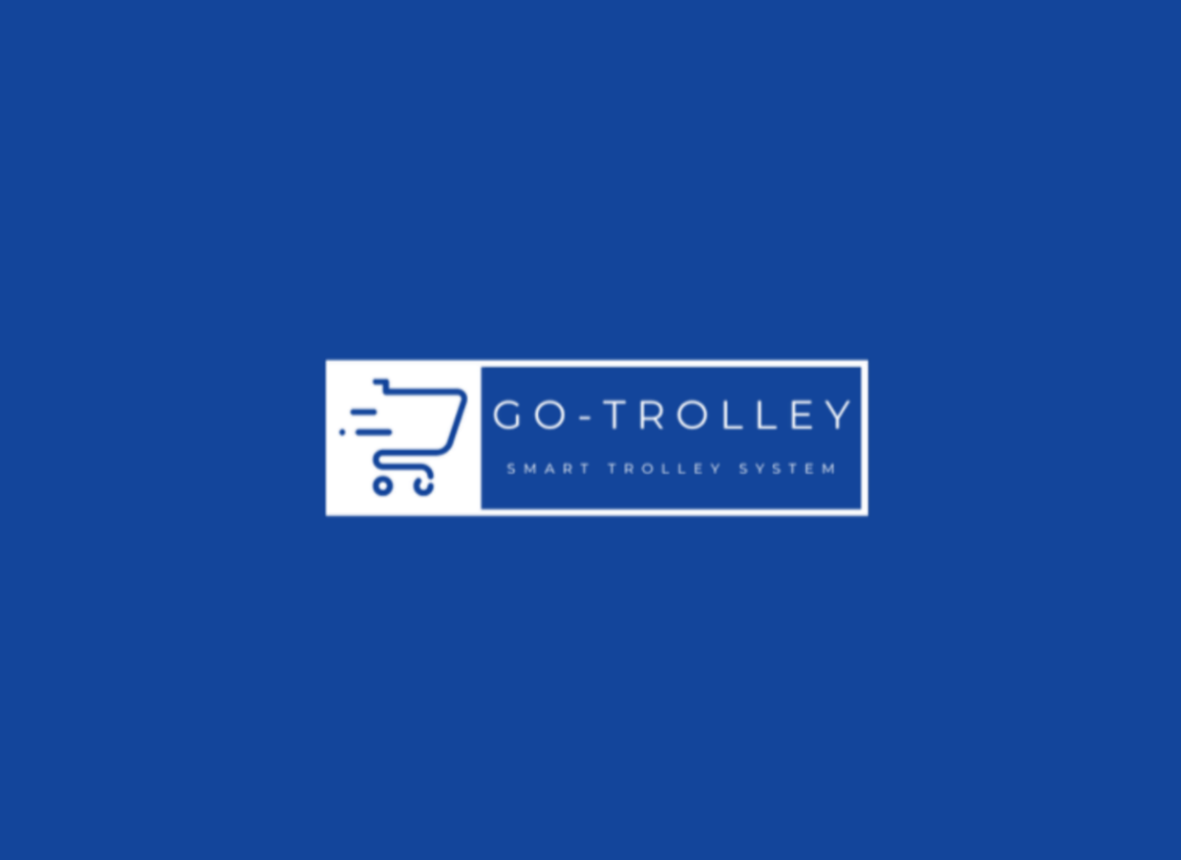
Figure 8: Splash Screen

Processing Screen

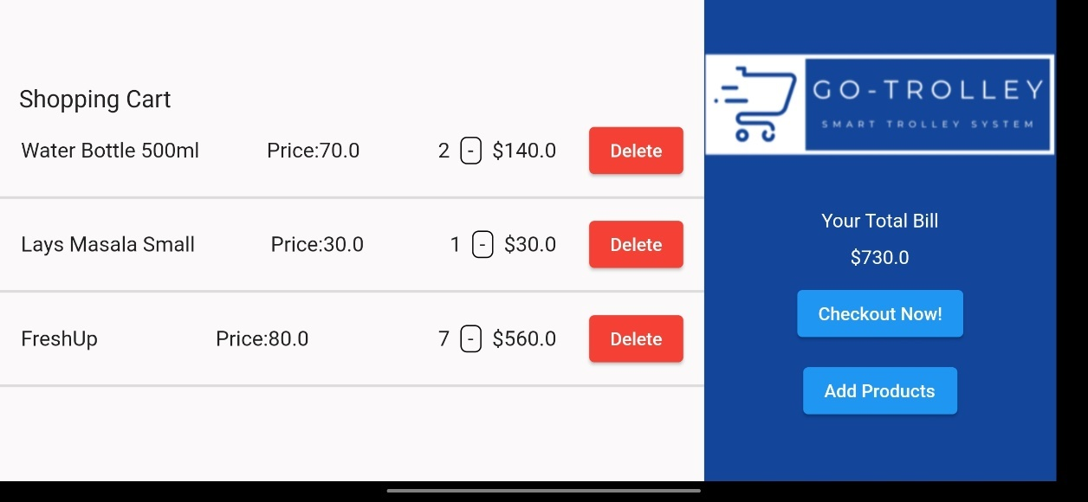
Figure 9: Processing Screen

Empty Cart
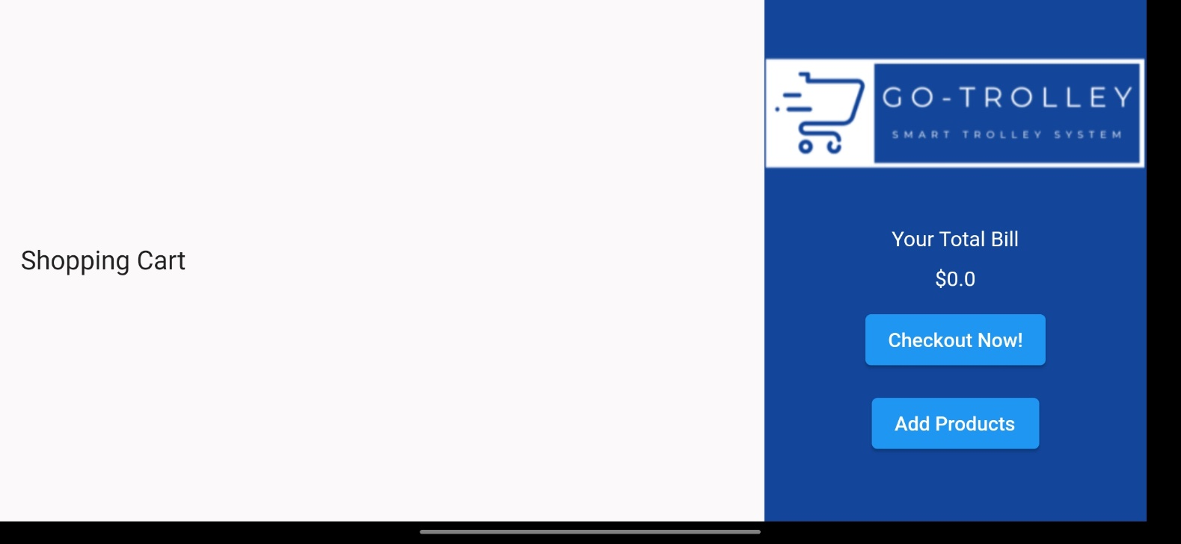
Figure 10: Empty Cart

Add Product
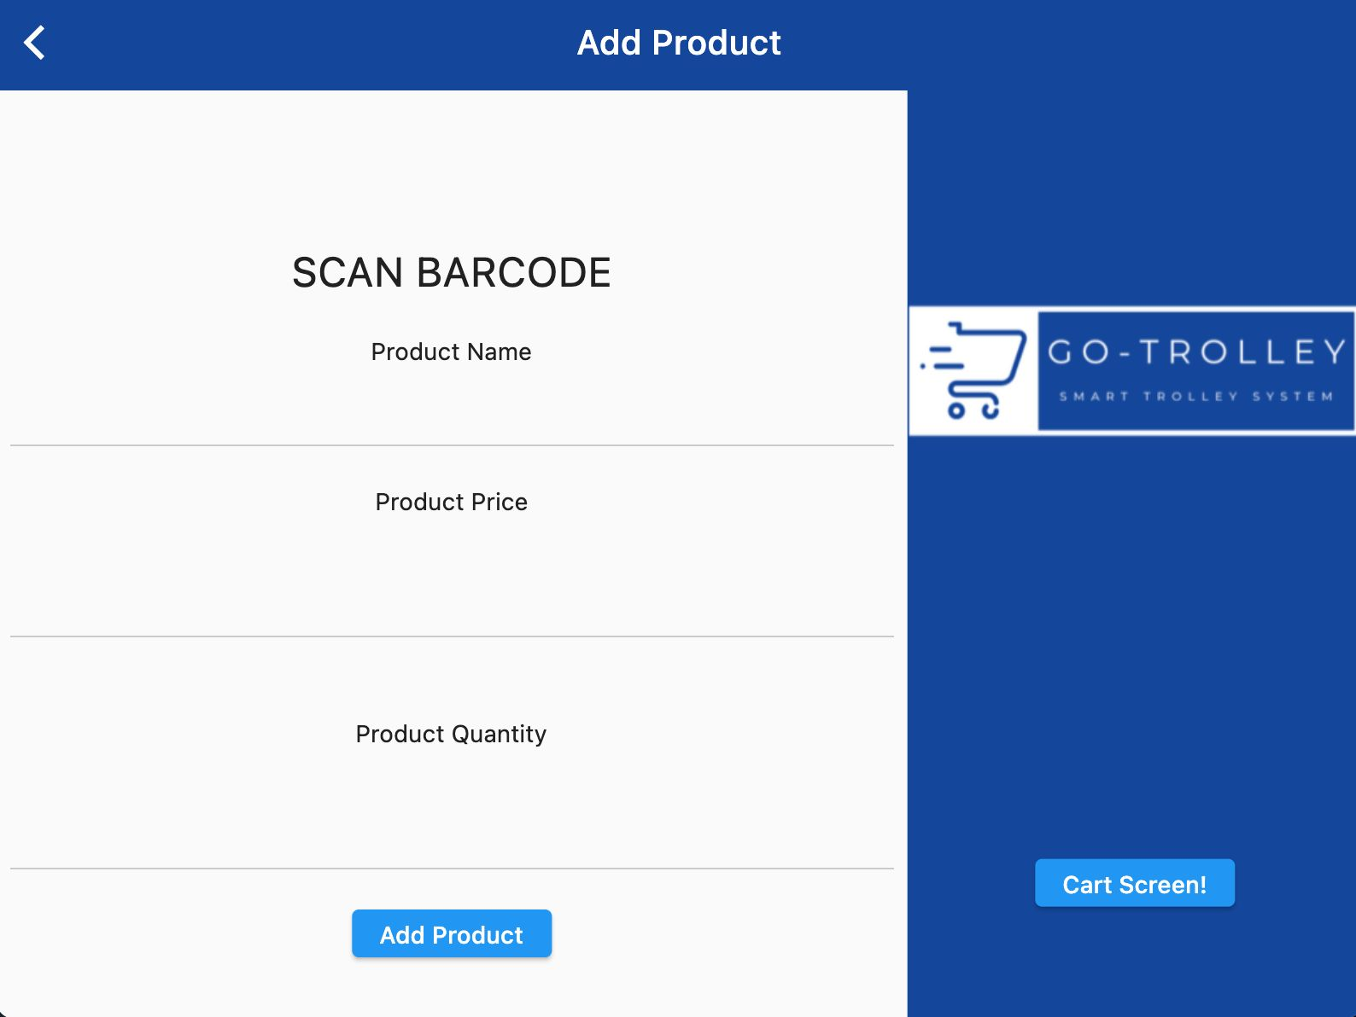
Figure 11: Add product to the database

QR Code
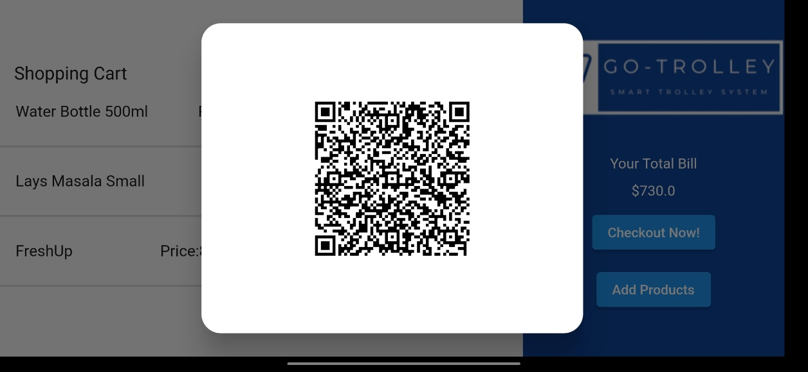
Figure 12: QR Code

Receipt

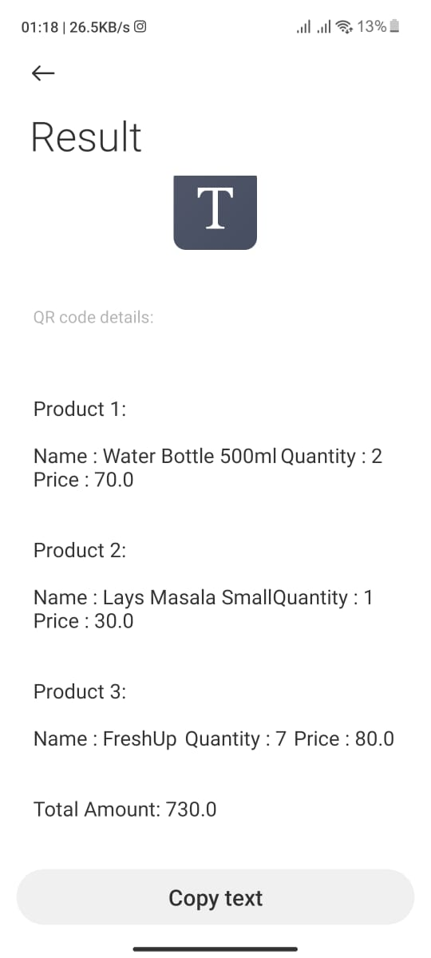
Figure 13: Result

CONCLUSION AND RECOMMENDATIONS

Conclusion

In short, the Go-Trolley - Smart Trolley System represents an important initial step in converting traditional supermarket billing. By adopting advanced technologies such as sensors, Raspberry Pi, and Hive we hope to make shopping more convenient, friendly for users, and autonomous. The system solves the problems inherent in manual billing procedures and eliminates queues, errors, and workload for employees.

At the core of this innovation lies a profound understanding of the challenges intrinsic to manual billing procedures. Through the utilization of advanced sensors and the computational capabilities of Raspberry Pi, the system guarantees precision and efficiency in transaction processing. Clients stand to benefit from a flawlessly executed checkout process, free from manual errors and the need for direct input.

The implementation of the Smart Trolley System not only addresses conventional challenges like queues and errors but also significantly alleviates the workload on supermarket staff.

Recommendations

Monitoring and collecting feedback regularly are suggested to find areas that should be improved upon in the next round. Making the system flexible enough to suit various supermarket layouts and sizes will increase its versatility. We can also add special features such as personalized recommendations or integrate them with loyalty card programs which would all enhance shoppers' shopping experience.

The Go-Trolley system, in a nutshell, provides the foundation for modernizing supermarket transactions and can have an enormous impact on retail. Innovation must continue, both by incorporating feedback from users and staying open to new technologies. Otherwise, the smart trolley system will lose its relevance in only a few years.

Future Work
The Go-Trolley makes it an easy and intuitive solution to the problems of streamlined transport, packed with room for improvement in both application and expansion possibilities. So, in future work, machine learning algorithms such as Markov chains could be used to further improve the system's ability to offer personalized shopping recommendations based on users 'preferences and actual purchases. On top of that, incorporating new technologies including augmented reality could provide a sense of added immersion, giving consumers an even more futuristic shopping feel. In addition, on the front of cooperation with supermarkets and carrying out pilot tests in real environments for feedback from users would help this system to evolve further.

REFERENCES

[1] “An Introduction to QR Code Technology | IEEE Conference Publication | IEEE Xplore.” Accessed: Dec. 27, 2023. [Online]. Available: https://ieeexplore.ieee.org/abstract/document/7966807
[2] “Smart Trolley for Smart Shopping with an Advance Billing System using IoT | IEEE Conference Publication | IEEE Xplore.” Accessed: Dec. 27, 2023. [Online]. Available: https://ieeexplore.ieee.org/abstract/document/9418348
[3] “QR-code generator | IEEE Conference Publication | IEEE Xplore.” Accessed: Dec. 27, 2023. [Online]. Available:
https://ieeexplore.ieee.org/abstract/document/5692920
[4] “Digambar, Ghatol Sonali, S. Jahagirdar, and Pratiksha... - Google Scholar.” Accessed: Dec. 27, 2023. [Online]. Available:
https://scholar.google.com/scholar?hl=en&as_sdt=0%2C5&q=Digambar%2C+Ghatol+Sonali%2C+S.+Jahagirdar%2C+and+Pratiksha+Dattatraya+Khamitkar.+%22Smart+shopping+using+smart+trolley.%22+International+Research+Journal+of+Engineering+and+Technology+%282018%29.&btnG=
[5] “A sensitive bio-barcode immunoassay based on bimetallic Au@Pt nanozyme for detection of organophosphate pesticides in various agro-products - ScienceDirect.” Accessed: Dec. 27, 2023. [Online]. Available:
https://www.sciencedirect.com/science/article/pii/S0308814621011249
[6] “Automated barcode recognition for smart identification and inspection automation - ScienceDirect.” Accessed: Dec. 27, 2023. [Online]. Available:
https://www.sciencedirect.com/science/article/pii/S095741740600234X
[7] “A Smart Trolley for Smart Shopping | IEEE Conference Publication | IEEE Xplore.” Accessed: Dec. 27, 2023. [Online]. Available:
https://ieeexplore.ieee.org/abstract/document/9262350
[8] “Smartphone as barcode reader - ScienceDirect.” Accessed: Dec. 27, 2023. [Online]. Available:
https://www.sciencedirect.com/science/article/abs/pii/B9780128236963000088
[9] “Smart Shopping Trolley Using Raspberry Pi | IEEE Conference Publication | IEEE Xplore.” Accessed: Dec. 27, 2023. [Online]. Available:
https://ieeexplore.ieee.org/abstract/document/9641206

