
BSCS-S23-005
03-134201-027 |  | Shoaib Hassan
03-134201-020 |  | Malik Rohail Ahmed

E-Real Estate

In partial fulfilment of the requirements for the degree of
Bachelor of Science in Computer Science

Supervisor: Fatima Saddiqui

Department of Computer Sciences
Bahria University, Lahore Campus
January 2024

© Bahria University, 2024

Certificate

We accept the work contained in the report titled
“E-Real Estate”
written by
Shoaib Hassan
Malik Rohail Ahmed
as a confirmation to the required standard for the partial fulfilment of the degree of
Bachelor of Science in Computer Science.

Approved by:
Supervisor: Fatima Saddiqui
(Signature)

January 10, 2024

DECLARATION

We hereby declare that this project report is based on our original work except for citations and quotations which have been duly acknowledged. We also declare that it has not been previously and concurrently submitted for any other degree or award at Bahria University or other institutions.

Enrolment | Name | Signature
03-134201-027 | Shoaib Hassan
03-134201-020 | Malik Rohail Ahmed

Date : January 10, 2024

Specially dedicated to
my beloved grandmother, mother and father
(Shoaib Hassan)
my beloved grandmother, mother and father
(Malik Rohail Ahmed)

ACKNOWLEDGEMENTS

We would like to thank everyone who had contributed to the successful completion of this project. We would like to express my/our gratitude to my research supervisor, Miss Fatima Saddiqui for her invaluable advice, guidance and her enormous patience throughout the development of the research.

In addition, we would also like to express my gratitude to our loving parent and friends who had helped and given me encouragement.

Shoaib Hassan
Malik Rohail Ahmed

E-Real Estate

ABSTRACT

The goal of this project is to provide users with an authentic centralized platform that handles accounts management and real estate dealing while providing them with real-time accountability and an additional option of bidding. The system “E-Real Estate” is being developed especially for these customers. In existing platforms there is no unified site for real estate and hiring contractors. The primary objective is to provide efficient services to the customers in property dealing and find potential contractors. To address these challenges and prioritize data security for our client, our project will leverage the PHP Laravel framework. By combining the contractor-focused approach with the functionality of existing real estate systems, our web-based platform aims to offer comprehensive solution for real estate. The end product will be a website which will give real-time accountability of transaction to the user on both ends.

TABLE OF CONTENTS

CHAPTER 1 1
INTRODUCTION 1
1.1 Background 1
1.2 Problem Statements 1
1.3 Aims and Objectives 2
1.4 Scope of Project 3
CHAPTER 2 4
2 LITERATURE REVIEW 4
2.1 Background 4
2.2 Features of E-Real Estate 4
2.3 Tools and Technology 5
2.4 Summary 5
CHAPTER 3 7
DESIGN AND METHODOLOGY 7
CHAPTER 4 14
IMPLEMENTATION 14
4.1 User Interface Design 14
4.2 Front-end Development 14
4.3 Database Design 15
4.4 Backend Development 16
4.5 Testing and Quality Assurance 17
4.3 Test Cases 18
CHAPTER 5 21
RESULTS AND DISCUSSIONS (or USER MANUAL) 21
5.1 User Manual 21
5.1.1 Sign Up: 21
5.1.2 Login: 21
5.1.3 Homepage: 22
5.1.3 Real Estate Dealing: 23
5.1.4 Upload property on cash/instalment/semi-instalment: 24
5.1.5 View credit/debit: 25
5.1.6 Token Register & Place Bid: 26
5.1.7 Admin Panel: 28
5.2 Testing 29
5.2.1. Functional Testing: 29
5.2.2. Non-Functional Testing 29
5.2.3. Regression Testing 30
CHAPTER 6 31
1 CONCLUSION AND RECOMMENDATIONS 31
6.1 Conclusion 31
6.2 Recommendation 32
REFERENCES 33
Appendices 35

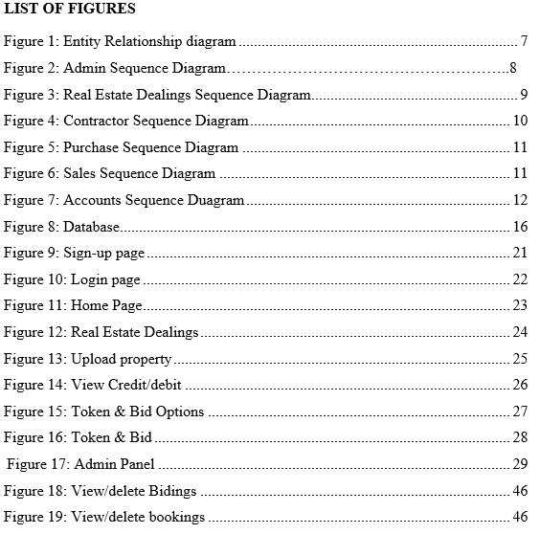

INTRODUCTION

Background

In Pakistan, there are well-known real estate system. however, it does not offer provide a platform for contractors to conduct their business. Furthermore, there is a lack of real-time accountability, making it difficult for clients to track the progress of their down payment, paid amount, remaining balance, and other crucial details. By offering a centralized platform for property listings, a real estate buying and selling website can help buyers and sellers save time and money and provide access to a larger audience of potential buyers or sellers.

To address these challenges and prioritize data security for our clients, our project will leverage the PHP Laravel framework. PHP Laravel is widely recognized for its robust database security features, ensuring the utmost protection against data breaches and unauthorized access. By combining the contractor-focused approach with the functionality of existing real estate systems, our web-based platform aims to offer a comprehensive solution for real estate contractor hiring, and transparent real-time monitoring in Pakistan.

Problem Statements

- There is no doubt that a commendable number of websites and applications have been developed which have automated most of the manual work and also provide efficient services. But, have you also noticed the number of scam artists who are ready to take advantage of naive people on these online platforms? So, the major problems that we have deduced are that although some existing platforms promote the real estate business. There’s no surety that they are authentic and even if one tries to rely on the website’s ratings and reviews – they might find fake ratings and as a result - bogus property. In short, users are not able to see their updated instalment plans. The goal of the system is to:
- here is also Real time tracking in our systems. We will provide users with crystal clear and detailed information about the status of their account and balance. They will get real time accountability of all of their expenses and activities done in a specific instance.
- There is also a bidding feature for buying property. Users will be able to bid on any property. The system will already have a specific (least) amount set on the back end.
- The clients will be restricted to entering the amount that is greater than or equal to the least amount and then they will be given another counteroffer.
- Seek Potential clients for contract. This will allow the contractors to offer their packages and services by posting on our website. They will post brief descriptions and plans about the services that they have to offer and on the other end, customers will contact with the respective contractor for further processes.
- User manual for understanding and operating the system.

Aims and Objectives

- System will allow the admin to perform CRUD operations for Property Management
- System will allow the admin to see and approve new properties
- System will allow users to view properties with different categories on the basis of their location, area, price.
- There is also a bidding feature for buying property. Users will be able to bid on any property. The system will already have a specific (least) amount set on the back end.
- aims to meet the diverse demands of individuals in Pakistan seeking real estate property dealings, and contractor hiring.

Scope of Project

The scope of this project encompasses the development of a comprehensive web application designed for real estate dealings and transactions, with an added feature of bidding. On the platform, clients and contractors can reach agreements with one another face-to-face about their business processes. Setting up an accounts management module is a key objective of the project which will be integrated into other connected modules such as property. This module will help handle client accounts efficiently, providing real-time updates and a record to look back on.
Furthermore, the project attempts to resolve issues of lack of mutual trust and transparency in hiring contractors by providing a stage for clients to easily judge; rated contractors. To this end, the platform is dedicated to creating a digital order for contractor-hiring procedures. The hiring processes that normally occur in physical space are thus made more convenient and trustworthy than ever before. Ultimately, users will see an improved form of real estate with features that existing one lack, such as accounts and bidding. Targeting the need for real-time transparency, to service people throughout Pakistan looking for property transactions and contractor hire. In sum, this project hopes to fill all the complete specifications for real estate and contracting in Pakistan with a well-made software product.

LITERATURE REVIEW

Background

Pakistan has a lot of respected real estate systems. But it does not provide a platform for contractors to do business. Besides, there is no real-time accountability: clients can't monitor progress about the amount of down payment paid; how much has already been glued together and what remains. By offering a centralized platform for property listings, a real estate buying and selling website can help buyers and sellers save time and money and provide access to a larger audience of potential buyers or sellers.

To address these challenges and prioritize data security for our clients, our project will leverage the PHP Laravel framework. PHP Laravel is widely recognized for its robust database security features, ensuring the utmost protection against data breaches and unauthorized access. By combining the contractor-focused approach with the functionality of existing real estate systems, our web-based platform aims to offer a comprehensive solution for real estate contractor hiring, and transparent real-time monitoring in Pakistan.

Features of E-Real Estate

- Biding: In E-real estate project a user can bid for any property which he/she is interested to get the property within his/her desired range if it is accepted by the seller.
- Instalment: If any buyer doesn’t have the full amount or do not to pay the full amount at once, then buyer can avail the instalment plan by asking the seller to sell the property in instalment.
- Token: There is also an option of token for buyer to reserve the property for 24 hours by generating a token. If seller accept the token, then the property is sold.
- Contractor: Allows the contractor to make a profile and to upload his package on the website. Contractor can upload complete package which can include multiply properties. Contractor can also choose to enable different instalment services and biding feature on their package.
- User Profile: User can make a profile by providing an email and setting the password for the profile. To see listing properties, upload properties to sell, to purchase properties and to bid on them user must have a profile.
- Admin: Admin will be able to manage the bids on the properties i.e.; View, delete. Admin will be able to manage the status of the properties on cash i.e.; View, delete. Admin will be able to manage the bids on the contractor’s packages i.e.; View, delete. Admin will be able to manage the contractor’s profile i.e.; View, edit, delete

Tools and Technology
- Visual Studio Code
- PHP
- Node.js, React.js
- Laravel
- Xampp
- MySQL

Summary
By offering an extensive web-based platform, the planned E-Real Estate initiative tackles the current issues facing Pakistan's real estate industry. The project therefore seeks to fill a weakness in current real estate systems, by adding features that not only make buying and selling real estate more convenient but also provide contractors with an exclusive location for doing business. Many clients are also frustrated with the lack of real-time accountability in today's environment, making it difficult to track financial data on property transactions. To deal with this, the E-Real Estate project employs PHP Laravel framework whose database security functions are very strong. This also provides for data integrity and prevents unauthorized access.
The system's innovative features include a bidding process, so users can bid on houses within their range in terms of price. The site also features an instalment plan that allows clients to pay in installments over time. To provide purchasers with a way to reserve properties for all day, we will introduce the token system. Moreover, the project provides a means for contractors to showcase their packages and services which alleviates worries about transparency in hiring one. Admin features include the ability to handle property bids, status and contractor profiles to facilitate efficient platform management. Ultimately the purpose of E-Real Estate is to revolutionize Pakistan 's entire real estate market with an information-rich, transparent and safe exchange for contractor services as well as property. Filmatic's dedication to modern, efficient and useful standards is reflected in their use of tools and technologies such as Visual Studio Code; PHP; Node.

CHAPTER 3

DESIGN AND METHODOLOGY

  - Introduction
For this project, an incremental (iterative) enhancement model is used. But with this model, the development process is broken down into smaller pieces. This makes for more flexible and rapid stages of software development. The growth model for the iterative phase is planning, analysis & design, implementation, deployment and testing. During the planning stage determination of requirements and goals is done, including definition of project scope; choice incorporation appropriate technologies involved in the project are made; a plan for timeline and milestone dates should be laid out. Each iteration involves the following steps. During one increment product development is in full swing, planning for its successor gets underway and testing and validation of the previous increment goes on. In a sense we are doing three things at once: writing new software while checking what has been written; developing future products as well as enhancing current ones
During the analysis and design period, it is necessary to identify various factors (ranging from user needs to those defining technical limitations) that will affect whether a project goes forward or not. This phase also involves designing the system architecture and detailing specifications for the project. The actual building of the system, according to design specifications and selected technologies determined in previous phases. These are all part of implementation. The development of the E-Real Estate algorithm, its integration with the database and even a user interface for application. The deployment period involves the initial installation of equipment and providing instructions to users. This involves not only designing a user manual, but also creating the web-based application. It means that the resulting system should be easy to use and easily accessible for all users no matter how technically proficient they might be in their own fields. The testing stage is one in which the system undergoes exhaustive tests to ensure that it satisfies user requirements, and reaches high levels of quality. There will be unit testing, system tests and user acceptance tests. All in all, this methodology offers a structured and orderly framework for software development, while providing flexibility to accommodate changing requirements or feedback. [5]. This iterative approach also means that the project is developed in a structured and systematic way, with ample chances to review progress along the way so as to correct errors.
The project requires the inclusion of the following artefacts:
  - An Entity Relationship diagram showing the different entities and their relations.
  - A diagram showing the interactions of objects within the system for a given use case.
  - A class diagram of classes and their relations, with attributes and methods.
  - A State Chart Diagram showing the different states of an object and
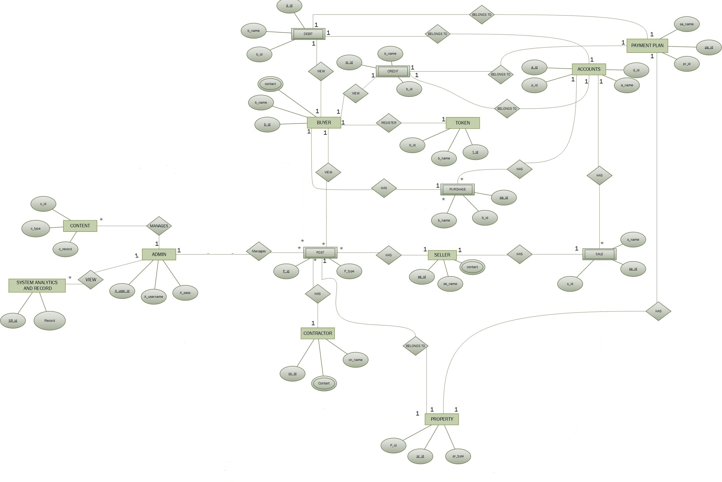the changes in state.

Figure 1: Entity Relationship diagram

  - System Sequence Diagram
The system sequence diagram for the E-Real Estate lists all the interaction between system and user, real estate dealing modules. Once the user logs in, he interacts with the system.
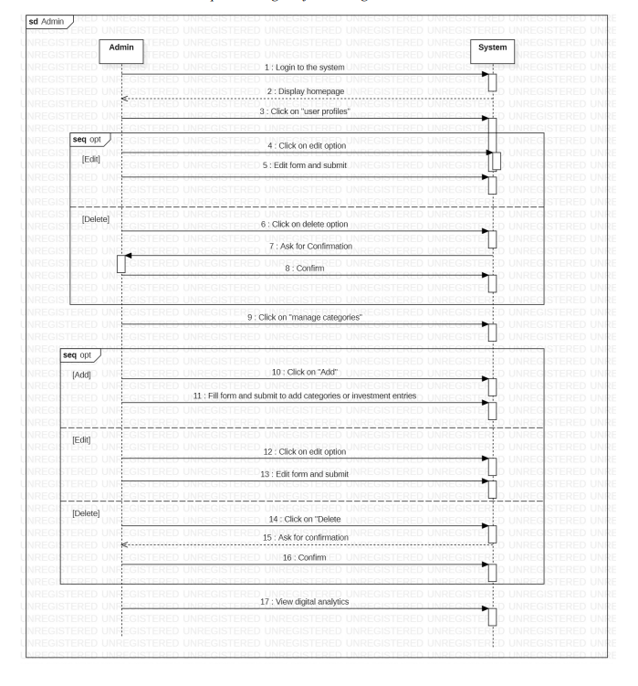
Figure 2: Admin Sequence Diagram

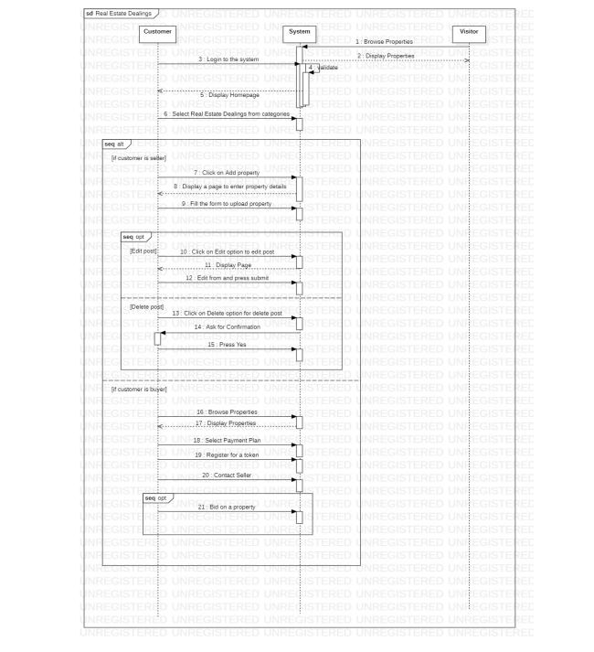
Figure 3: Real Estate Dealings Sequence Diagram

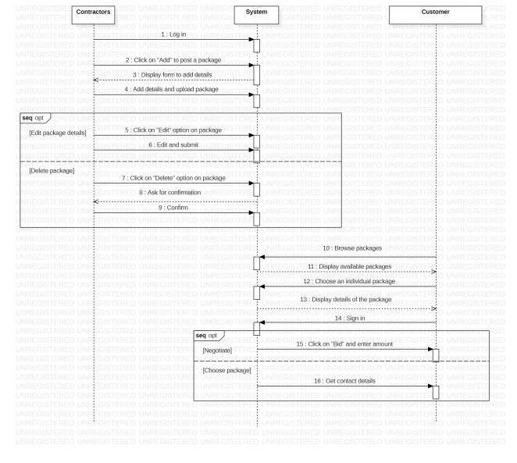
Figure 4: Contractor Sequence Diagram
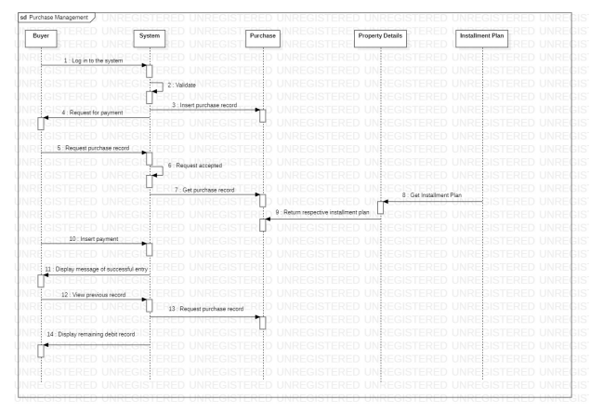
Figure 5: Purchase Sequence Diagram

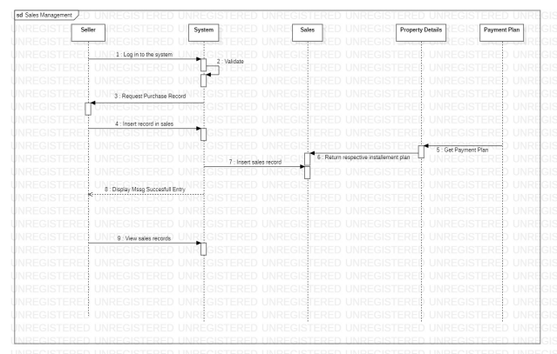
Figure 6: Sales Sequence Diagram

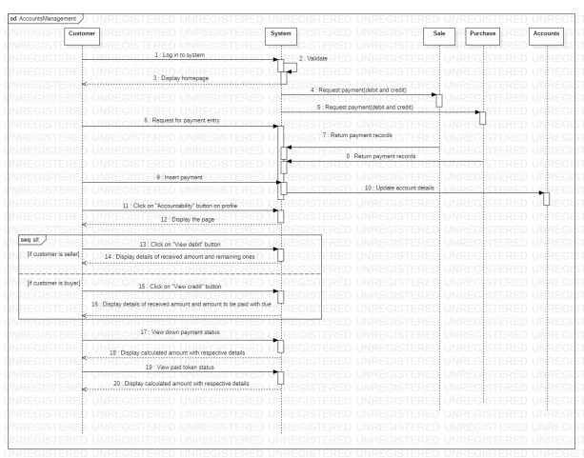
Figure 7: Accounts Sequence Diagram

CHAPTER 4

IMPLEMENTATION

The Web application is an important part of the project. Its implementation will affect user experience and interaction very much. The sub-headings below explain how it will be done.

User Interface Design

The development of any software application, such as E-Real Estate, includes user interface design. It includes designing and making interfaces through which users can enter the system to obtain information about its functioning. The user interface design must be clear, easy to navigate and attractive for the eye of the user. Here are some important considerations for designing a user-friendly interface for E-Real Estate:

Clarity and simplicity: The interface must be simple to understand and operate, with clear explanation of the usage for each function. [6] It should also be designed in a clean, uncluttered style which makes it easier for users to concentrate on the most vital data.

Compatibility: To ensure system is compatible with various platforms, interface should be designed to work on different devices and operating systems.

Front-end Development

The front-end development of the E-Real Estate is an important part of our work. That is to say: defining and introducing the user interface (UI) and user experience (UX). It streamlines the presentational elements and interactivity which actual users will use, providing a smooth experience for its end-users. Here are some potential paragraphs discussing front-end development for the project:
Secondly, front-end development means designing the user interface (UI) for E-Real Estate [7]. It also involves designing visual elements such as buttons, icons, menus and screens used by the users. The design of the UI must be beautiful, understandable to all users and easy-to-use. it must also be responsive, accommodating different devices like smartphones or other screens.
Second, front-end developers are charged with providing a happy experience (UX) to the E-Real Estate. Examples include thinking about what the user flow will be, how easy it is to use and whether or not users are satisfied. The UX design needs to be usable, guiding people through the system.
Thirdly, the E-Real Estate must be made accessible to all users by front end developers. It also requires doing things such as providing adjustable font sizes, high-contrast options and keyboard navigation that can meet different needs so that all users have an equal experience of the Web. The system ought to be capable of satisfying the needs of an all-embracing group. Therefore, abiding by accessibility guidelines such as the Web Content Accessibility Guidelines (WCAG) is necessary.
Also, front-end development includes testing the system to find and fix problems or errors. This includes usability testing and adjustments to the system aimed at improving performance as well as user satisfaction. Therefore, it is the responsibility of front-end developers to guarantee that the system can work properly on all web browsers and different devices with screen sizes of any size such that every user gets an identical experience.
In short, the front-end development belongs to a very important part of E-Real Estate 's user interface design and user experience. This means the aesthetic design of UI, user-oriented UX design, multiplatform compatibility and thorough testing. If the front end is well designed, E-Real Estate will be more effective and user friendly.

Database Design

E-Real Estate Database design is an important aspect of the project. The database is the basis of the system: In this format, data are stored, manipulated and accessed. The database design is integral to the overall system's performance. We need a well-organized, efficient database that is capable of dealing with large amounts data without losing speed or reliability.
MySQL is the E-Real Estate database. The database stores data with primary key, foreign key and index. A primary key is an identifier for each record in a table; the foreign key determines links between two tables. Indexes are used to speed up data fetching and searching.
One also needs to take into account such things as the volume of data, access patterns, and scalability in order to make sure that database design conforms precisely with project requirements. The database design must be able to deal with large amounts of data while maintaining optimum performance. Also, the design should be scalable and able to rapidly expand with adding data.
The design of the database is important to this E-Real Estate project. It is necessary to build a database capable of handling large amounts of data in an organized, optimized way while maintaining efficiency and reliability. If the database is carefully planned, then when people use the system they will be able to receive correct and prompt replies.
Screenshots:

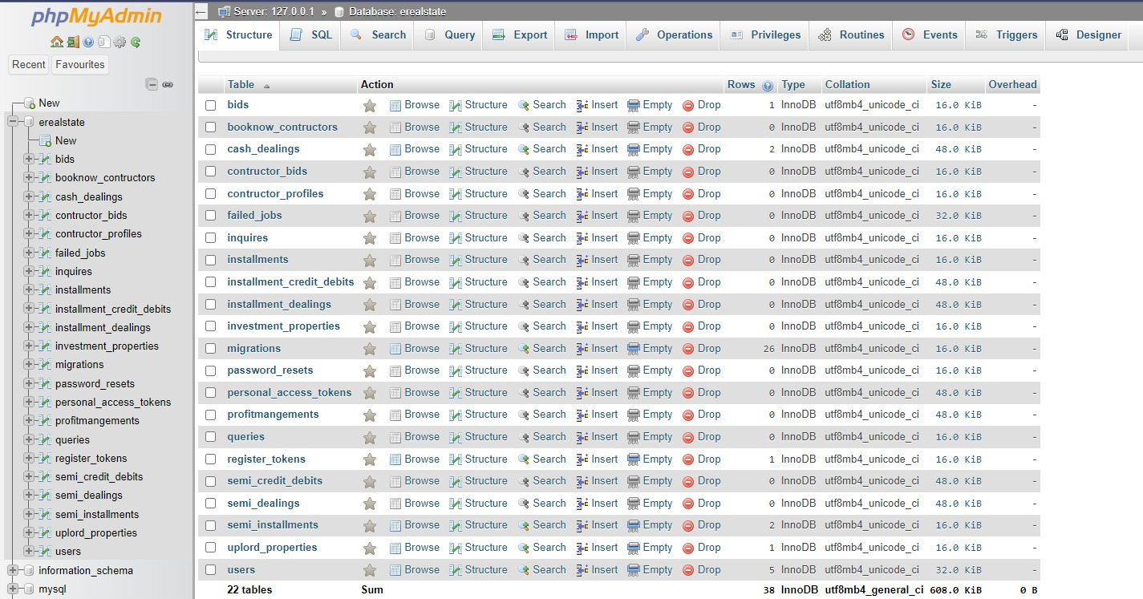
Figure 8: Database

Backend Development

Because in fact one of the key parts to this project is backend development, that involves creating the server-side E Real Estate. Backend: The backend receives data from the front end, processes it and returns the appropriate response. It is also responsible for communicating with the database in order to store and retrieve data.
PHP is one of the most popular choices for building web applications, so it will be used to build this project's backend. PHP has a full set of libraries and frameworks to ensure that web applications are developed in an efficient, stable way. One of the most popular PHP web frameworks is Laravel. These are what you can build the back end of this project with. They offer many features and tools to help build scalable, reliable web applications.
The backend will be written using the PHP Laravel framework, which provides a standardized approach to server-to-client communication. endpoints receive requests from the frontend and return appropriate responses. Such endpoints will also pull data from the database.
The backend will be responsible for the following tasks:
- User Authentication and Authorization: The backend will require user authentication and authorization, so only authorized users can get in.
- Data Storage and Retrieval: The backend will talk to the database in order to save and retrieve data. It will include information on user profiles, property details and system logs.
- Performance Optimization: The backend will be made to handle many requests with ease.
All in all, the backend development of this project is an important factor for the success of this system. The system will be designed to handle all the necessary functions of the system, including user authentication and data storage. It also needs a high level of performance as well as reliability.

Testing and Quality Assurance
Whether it is a software development project or an E-Real Estate project, testing and quality assurance are very important to the success of that effort. A complete testing plan must be designed and carried out to ensure the system is reliable, working as intended.
Testing should begin during development and continue throughout the entire project lifecycle. The system's functionality should be tested in different ways, such as unit testing and the types of testing described above. Bugs, errors and defects found during this stage have to be fixed before proceeding onward. System should be tested in a variety of conditions: the best way is to test with different operating systems, on various devices and network configurations.
Another important element in the development process is quality assurance. It means testing whether the system works as expected and meets end-user requirements, standards, expectations. Quality assurance activities need to run in tandem with testing work, and should include reviews, inspections and walkthroughs so that the system design as well as implementation conform to required quality levels. For the sake of Quality Assurance: It is necessary to develop a comprehensive testing plan combining various software test methods, including manual and automatic techniques. Repetitive and time-consuming testing tasks can be automated using tools such as Selenium which can help quickly identify defects. Moreover, the system should go through user acceptance testing to make sure that it meets end-user requirements and expectations.
Generally speaking, the testing and quality assurance stage of E-Real Estate is vital to its success. A comprehensive testing plan is needed, including a wide range of tests to ensure the system's reliability and functionality as well as overall quality. Testing Parallel with Quality Assurance Activities in order that the system meets with end-user requirements and expectations, quality assurance activities must be done in parallel.

Test Cases

Test Case ID | Test Objective | Test Steps | Expected Result | Actual Result | Pass/Fail
DDS001 | Sign Up | - Enter Name  - Enter Email  - Enter Password  - Click Sign up | User Account is created.  Homepage is displayed | User Account is created.  Homepage is displayed | Pass
DDS002 | Login | - Enter Email  - Enter Password  - Click login | User Logged in to his account.  Homepage is displayed. | User Logged in to his account.  Homepage is displayed. | Pass
DDS003 | Place Bid | - Enter Bid amount  - Enter phone number  - Enter email  - Click submit | Request is submitted to contractor/seller. | Request is submitted to contractor/seller. | Pass
DDS004 | Upload Property | - Upload image  - Enter price  - Enter marla  - Enter location  - Enter rooms  - Enter kitchen  - Enter bathrooms  - Enter mobile no  - Enter description  - Click submit | Property is uploaded | Property is uploaded | Pass
DDS005 | View property details | - From homepage click on real estate dealing  - Select property  - Click learn more | Property detail is displayed on screen. | Property detail is displayed on screen. | Pass
DDS006 | Register for token | - Enter property type  - Enter name  - Enter phone no  - Enter email  - Click submit | Token detail is submitted to seller. | Token detail is submitted to seller. | Pass

CHAPTER 5

RESULTS AND DISCUSSIONS (or USER MANUAL)

5.1 User Manual
After accessing the website, you can browse the available services provided by the system. Normally, a user would sign up to access all the features of the website.

5.1.1 Sign Up:
- Click on the sign-up button on the top-right corner of the screen.
- After a dialogue box appear, fill in the required fields and click on “Sign up”
- You will be redirected to the login page
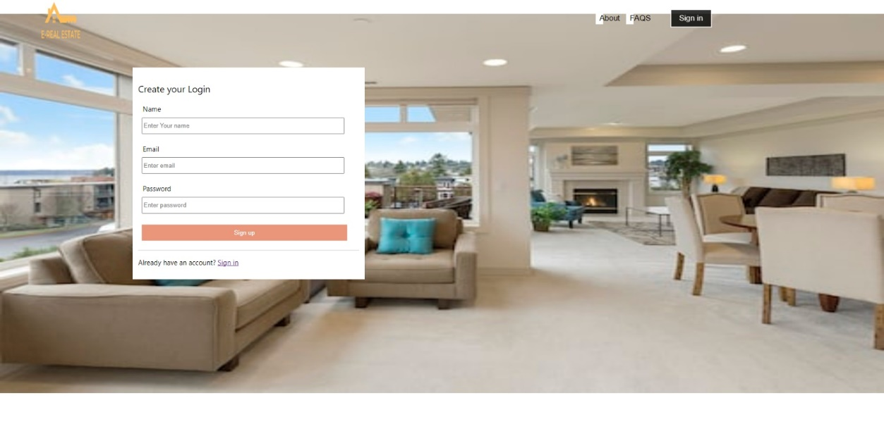
Figure 9: Sign-up page

5.1.2 Login:
- Click on the log in button on the top-right corner of the screen
- Enter valid username and password
- Click on “Login”
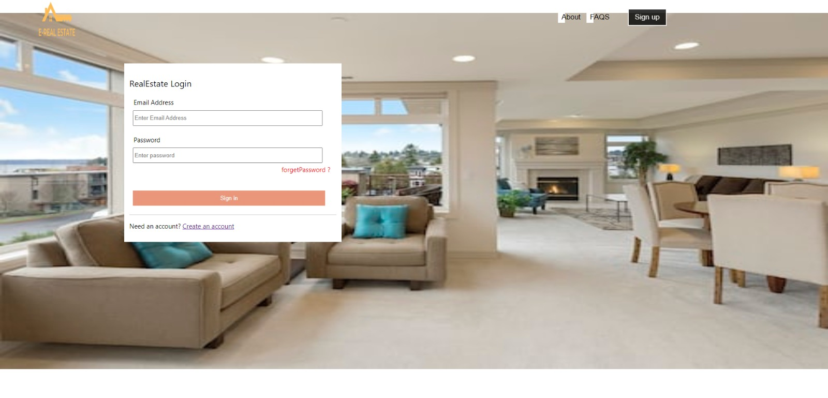
Figure 10: Login page

5.1.3 Homepage:
After logging in, you will view the provided services on the screen that is the homepage. Click on the required service to view and browse the available services against that specific one.
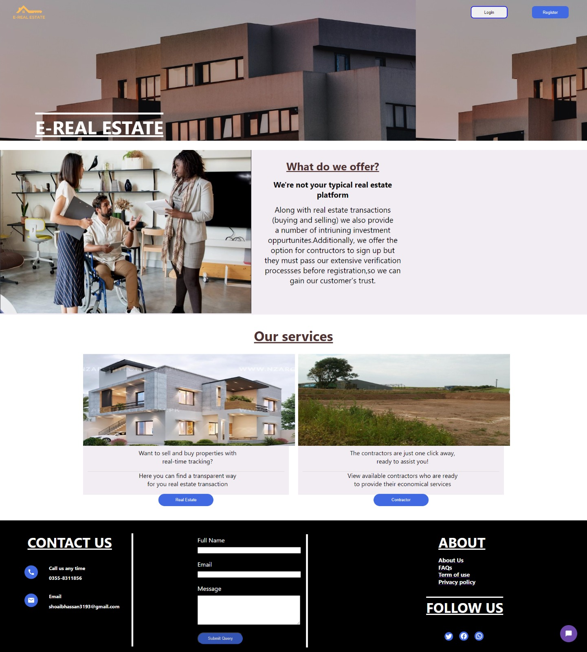
Figure 11: Home Page

5.1.3 Real Estate Dealing:
For real estate dealings, click on the real estate dealing box that is in the centre on the homepage. Click on the “Real Estate” button to view all the available properties for real-estate.
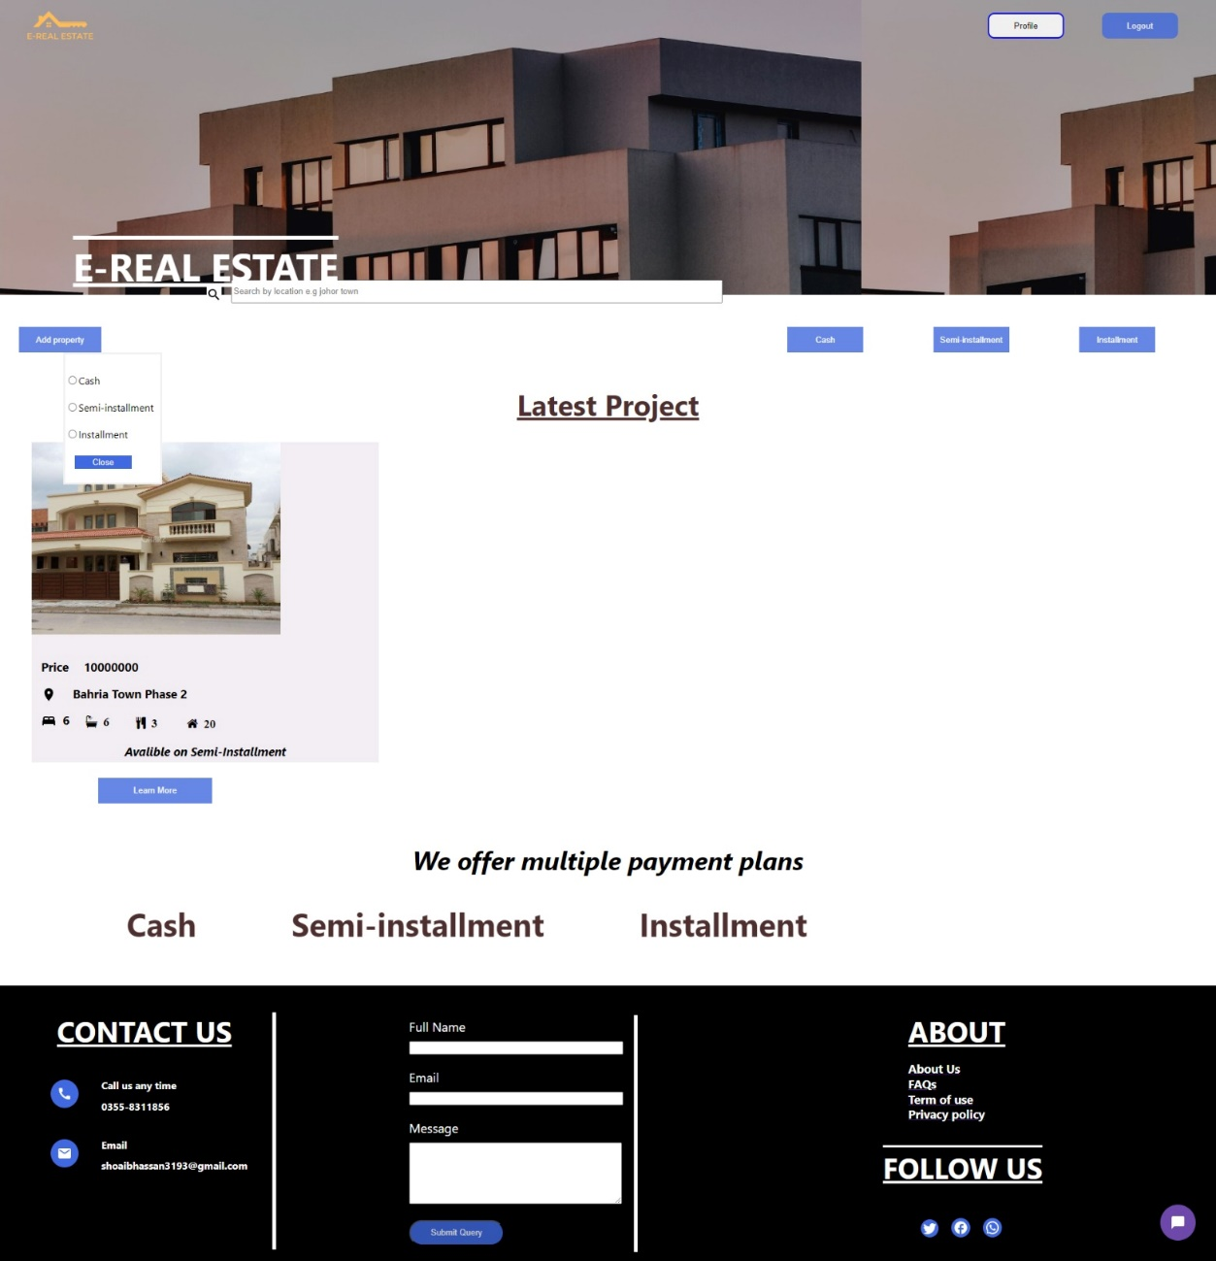
Figure 12: Real Estate Dealings

5.1.4 Upload property on cash/instalment/semi-instalment:
- On the top left corner, click on “Add property” button, a form will open

- Fill in the form with the required details like image of the property, price, specifications of the property etc., and press “Upload property”
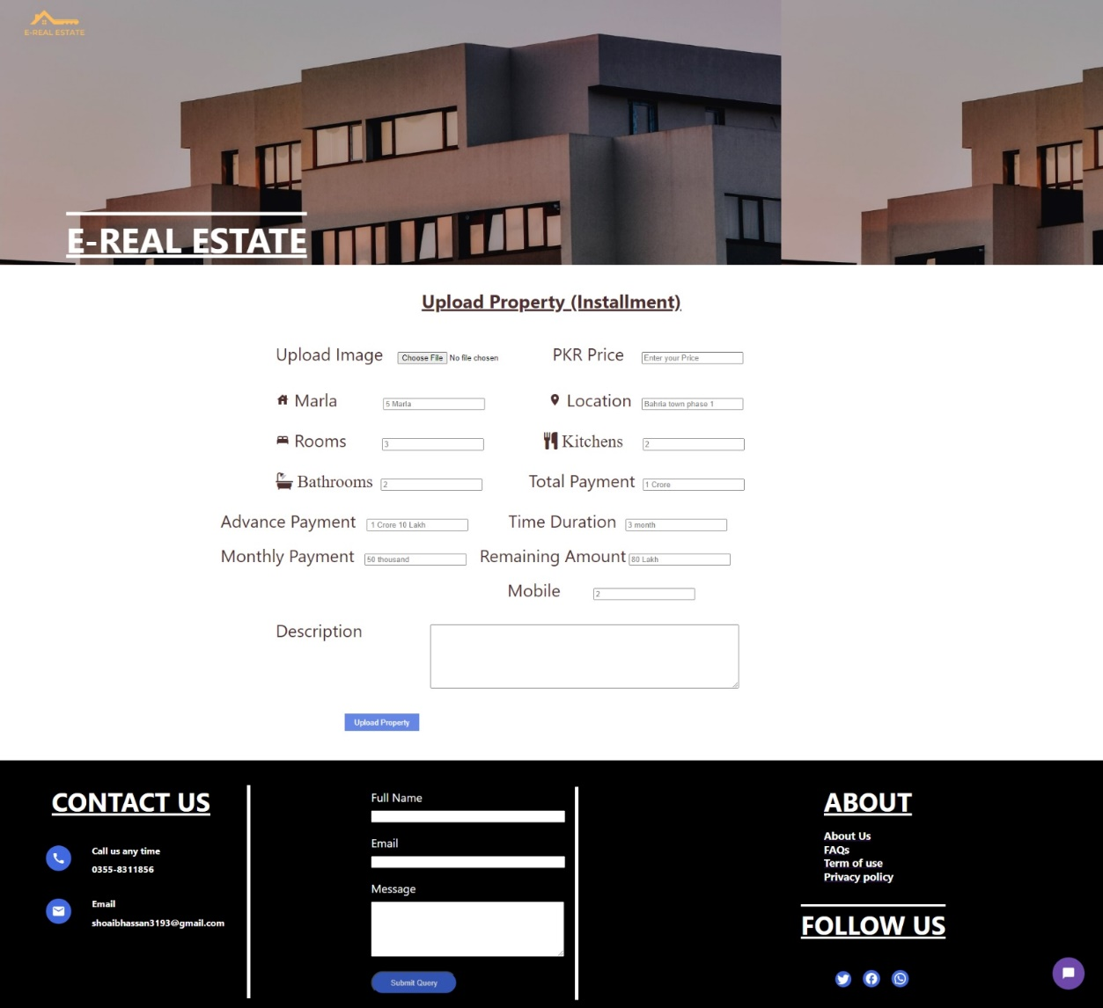
Figure 13: Upload Property

View credit/debit:
- On the top right corner, click on “Profile” button, you will be redirected to another page
- Click on the “Check credit” option on the left sidebar
- A page will be displayed with your real-time credit/debit
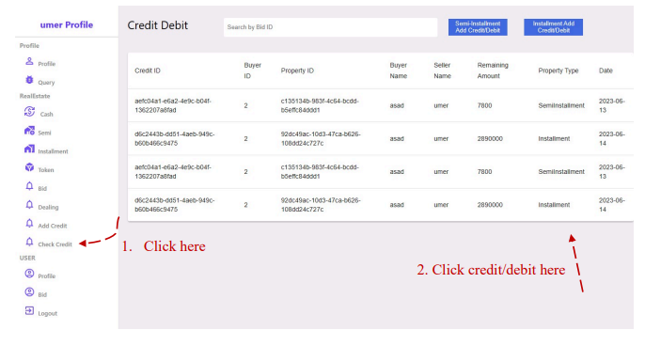
Figure 14: View Credit/debit

Token Register & Place Bid:
- Click on the “Real Estate” button on the homepage to view all the available properties for real-estate.
- In case you want to register a token for the property, click on “Learn more” on the property on any of the properties.
- A page with the property’s description will open. Scroll down and find the option of “Register token” and click on it.
- Enter the required fields and click on “Submit”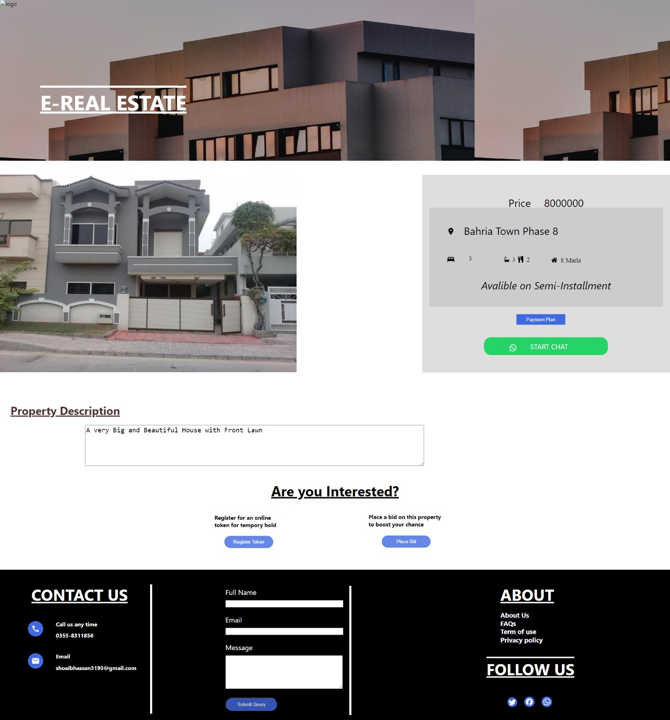
Figure 15: Token & Bid Options

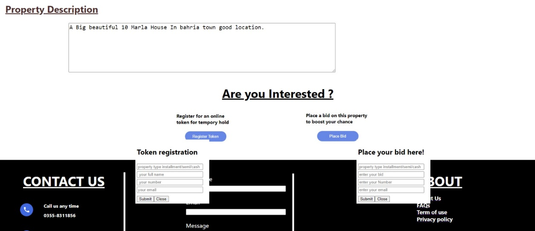

Figure 16: Token & Bid

Admin Panel:
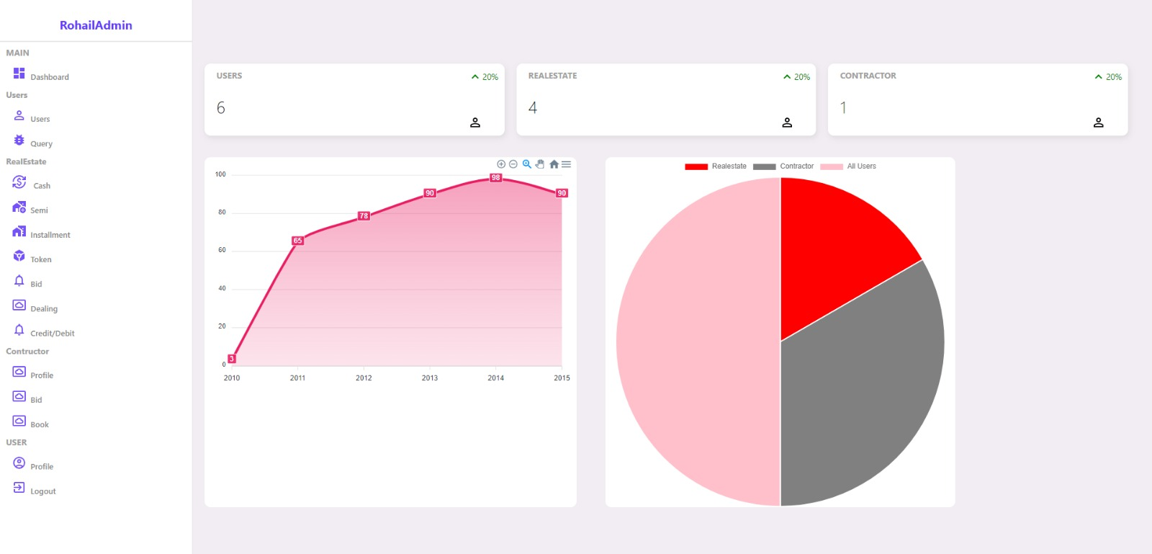
Figure 17: Admin Panel

5.2 Testing
By contrasting the achieved results with the anticipated ones, software testing ensures that the system is error-free. By executing some code or checking out some part of the system, one or more desirable qualities can be determined. Software testing also helps find discrepancies between the stated requirements and the final product. Either manual labour or computerised programmes can accomplish this task.

5.2.1. Functional Testing:
The functional requirements and specifications are the focus of Functional Testing, a subset of software testing. The output of a function (or feature) is examined after it is given some input. In order to guarantee that the application fully satisfies the requirements, functional testing must be performed. This kind of test cares more about the outcomes of processing than the processes involved. It makes no assumptions about the structure of the system being simulated but instead models realistic usage. Since the tester isn't privy to the system's inner workings during functional testing, the Black Box Testing method is used. Testing for functionality is typically done during the System Testing and Acceptance testing phases of the testing lifecycle.
The standard procedure for functional testing consists of:
● Identify functions that the software is expected to perform.
● Create input data based on the function’s specifications.
● Determine the output based on the function’s specifications.
● Execute the test case.
● Compare the actual and expected outputs.
When functional test conditions are derived straight from user/business
Requirements, testing is at its most efficient. There is a risk of upsetting end-users
Who use the software for the first time if testing conditions are derived from the
System documentation (system requirements/design documents).

5.2.2. Non-Functional Testing

NON-FUNCTIONAL TESTING is a subset of software testing that focuses on the less directly useful characteristics of an application. Non-functional testing is intended to check whether or not a system is ready in ways that functional testing can't. Testing the maximum number of concurrent users is a great illustration of a non-functional test. Client satisfaction is directly tied to the thoroughness of both functional and non-functional testing. During earlier iterations of testing, we also failed to adequately address the Non Functional requirements. This, however, is no longer the case. The non-functional testing of an application is now paramount because of the importance of addressing performance and security concerns. The performance of an application under heavy load is most affected by this kind of testing. Your app's stability and scalability under pressure will be verified by these tests.

5.2.3. Regression Testing

REGRESSION TESTING is done to ensure that changes (or bug fixes) made to the software have not caused any incompatibilities. As any change to the code has the potential to impact unrelated functionality, regression testing is performed to make sure that fixing one thing has not broken another.
Regression testing involves re-running previously completed test cases rather than creating any new ones. The noun regression, in its most common usage, refers to a process of falling behind or becoming less advanced. While it would be ideal to conduct a thorough regression analysis, limitations in time and money often prevent this from happening. An impact analysis must be conducted to ascertain which components of the software are most vulnerable to the modification and would cause the most trouble for users if something went wrong. Companies and initiatives are increasingly using regression test automation tools due to the breadth and importance of regression testing.

CHAPTER 6

CONCLUSION AND RECOMMENDATIONS

Conclusion

Ultimately, the project E-Real Estate intends to use the PHP Laravel framework to provide a centralised platform for contractor services and property listings, thereby addressing major issues facing Pakistan's real estate industry. The identified problem statements draw attention to the current problems in real-time tracking, transparency, and authenticity in the real estate systems that are in place. A platform for contractors to display their services, real-time tracking, and bidding are all part of the project's all-inclusive strategy. The selection of technologies and tools, including MySQL, Xampp, Laravel, PHP, Node.js, React.js, and Visual Studio Code, emphasises the dedication to contemporary, effective, and scalable programming.

Going on to the design and approach, the flexibility and responsiveness of the incremental or iterative upgrade model led to its selection. The development process is divided into manageable stages by the technique, enabling planning, analysis and design, implementation, deployment, and testing. An organised method of developing software is shown by the inclusion of crucial artefacts like Entity Relationship diagrams, Sequence Diagrams, and Design Class Diagrams. The MySQL database design is highlighted because it serves as the system's cornerstone and guarantees effective data storage and retrieval.

In essence, the E-Real Estate Final Year Project aspires to transform the real estate landscape in Pakistan by introducing a feature-rich, transparent, and secure platform for property transactions and contractor services. The endeavour reflects a commitment to addressing the needs of users in the real estate sector and stands as a testament to the team's dedication to delivering a robust and user-friendly solution.

Recommendation

The future recommendation about this project is to add more functionalities like user feedback system which will allow user to give feedback to any seller or contractor upon their services.

Another module we can add in the future is to rate the contractor on their packages which will boost the contractor profile and it will become more easy for them to sell their services.

Involving of more advance verification process like OTP feature to their given email upon creating the profile to verify the user.

Dynamic graphs to show the numbers of people that registered themselves in over platform. One graphs will show the total number of users over the years and one will show the different categories of users including contractors.

REFERENCES

[1] The Journal of Real Estate Portfolio Management. 1995.

[2] Corporation, N. L. (2019, February 1). Principles of Real Estate: Passbooks Study Guide.

[3] Bond, M., Seiler, M., Seiler, V., & Blake, B. (2000, January 1). Uses of Websites for Effective Real Estate Marketing. Journal of Real Estate Portfolio Management,6(2), 203–211. https://doi.org/10.1080/10835547.2000.12089601

[4] Website Quality and Intention to Use Real Estate Website in Housing Market. (2021, June). European Journal of Business and Management. https://doi.org/10.7176/ejbm/13-11-09

[5] Kim, T. (1989, December). Bidding in real estate: A game theoretic approach. The Journal of Real Estate Finance and Economics, 2(4). https://doi.org/10.1007/bf00177946

[6] Hardin, W. (2000, January 1). Practical Experience, Expectations, Hiring, Promotion and Tenure: A Real Estate Perspective. Journal of Real Estate Practice and Education, 3(1), 17–34. https://doi.org/10.1080/10835547.2000.12091571

[7] Colwell, P. F., & Yavaş, A. (1994, March). The demand for agricultural land and strategic bidding in auctions. The Journal of Real Estate Finance and Economics, 8(2), 137–149. https://doi.org/10.1007/bf01097034

[8] Qian, Z. (2023, March 21). Digital transformation of real estate industry: opportunities, challenges and strategic suggestions. Advances in Economics, Management and Political Sciences, 3(1), 277–281. https://doi.org/10.54254/2754-1169/3/2022794

[9] Wang, F. (2023, June 30). The present and future of the digital transformation of real estate: A systematic review of smart real estate. Business Informatics, 17(2), 85–97. https://doi.org/10.17323/2587-814x.2023.2.85.97

[10] De Paola, P. (2023, October 8). Real Estate: Discovering the Developments in the Real Estate Sector Using the Current Research Challenges. Real Estate, 1(1), 1–3. https://doi.org/10.3390/realestate1010001

Appendices
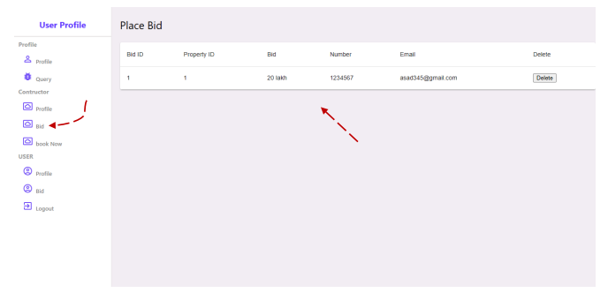
Figure 18: View/Delete biddings

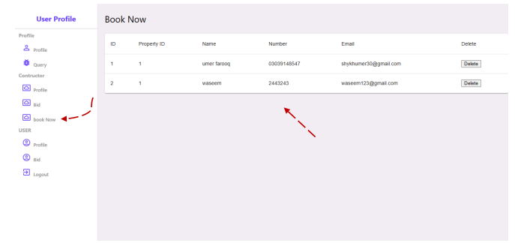
Figure 19: View/Delete Bookings


