
BSCS-S23-001
03-134201-025 | Armaghan bin Zahid
03-134201-002 | Hafiza Tahreem Ijaz
Identification of MCI and Alzheimer using Deep Learning
In partial fulfilment of the requirements for the degree of
Bachelor of Science in Computer Science
Supervisor: Dr. Iram Noreen
Department of Computer Sciences
Bahria University, Lahore Campus
Jan 2024

Certificate

We accept the work contained in the report titled.
“Identification of MCI and Alzheimer using Deep Learning”.
written by
Armaghan bin Zahid
Hafiza Tahreem Ijaz

as a confirmation to the required standard for the partial fulfilment of the degree of
Bachelor of Science in Computer Science.

Approved by:
Supervisor: Dr Iram Noreen
(Signature)

January 10, 2024

DECLARATION

We hereby declare that this project report is based on our original work except for citations and quotations which have been duly acknowledged. We also declare that it has not been previously and concurrently submitted for any other degree or award at Bahria University or other institutions.

Enrolment | Name | Signature
03-134201-025 | Armaghan bin Zahid
03-134201-002 | Hafiza Tahreem Ijaz

Date : January 10, 2024

ACKNOWLEDGEMENTS

We would like to thank everyone who had contributed to the successful completion of this project. We would like to express our gratitude to my research supervisor, Dr Iram Noreen for her invaluable advice, guidance, and her enormous patience throughout the development of the research.

In addition, we would also like to express my gratitude to our loving parent and friends who had helped and given me encouragement.

Armaghan bin Zahid
Hafiza Tahreem Ijaz

Identification of MCI and Alzheimer using Deep Learning

Alzheimer's disease is a progressive neurodegenerative disorder that affects millions of people worldwide. The earliest detection and precise diagnostic methodologies associated with Alzheimer’s are essential for the management of the disease and necessary measures aimed at its prevention. Nowadays, medical imaging especially MRIs have demonstrated impressive prospects for early diagnosis.
This final year project report proposes an innovative method for early diagnosis of Alzheimer’s through MRI scan using a hybrid model in combination with CNN. A new model, which hopes to exploit CNN’s strengths for improved predictions is being proposed here.
This was a special software which accepted MRI image file as the input and produced live results of its processing on the application system’s interface. This process starts with pre-processing of the MRI data and identifying the appropriate features for analysis. Thereafter, a CNN model is trained using an adequately curated set of MRI scans as well as corresponding clinical information.
In particular, the CNN portion of this model learns to find high-level patterns in MRI data and, based on that knowledge, makes predictions about the probability of early-stage Alzheimer’s disease. The model's training process focuses on optimizing the performance of the CNN component to enhance overall predictive accuracy.
The dataset that has been used in project is obtained from Kaggle which is a benchmark dataset that has been used in multiple research work. The final accuracy of experimentation is 94%. The state-of-the-art comparison is also given with 2 more approaches.

Table of Contents

CHAPTER 1 1
1 INTRODUCTION 1
1.1 Introduction 1
1.2 Problem Statements 2
1.3 Aims and Objectives 2
1.4 Scope of Project 3
CHAPTER 2 4
2 LITERATURE REVIEW 4
2.1 Summary Table 7
CHAPTER 3 9
3 DESIGN AND METHODOLOGY 9
3.1 Methodology 9
CHAPTER 4 13
4 DATA AND EXPERIMENTS 13
4.1 Data 13
4.2 Developing DL model and Ablation Study 16
4.3 Model Evaluation 27
4.4 Application Interface 30
CHAPTER 5 34
5 RESULTS AND DISCUSSIONS 34
5.1 Datasets used in Research Paper 35
5.2 Architecture used in Research paper: 35
5.3 Comparison 36
CHAPTER 6 37
6 CONCLUSION AND RECOMMENDATIONS 37
REFERENCES 38

List of Tables
Table 1: Dataset Description 13
Table 2: V1 model description. 17
Table 3: Experiments V1 18
Table 4: Model V2 Description 20
Table 5: Test results comparison 36
Table 6: Trainable parameter comparison 36

List of Figures
Figure 1: Methodology diagram 9
Figure 2: Kaggle snapshot 10
Figure 3: Applied Techniques 10
Figure 4: CNN basic Architecture 11
Figure 5: Model Deployment using Flask 12
Figure 6: MRI Images 14
Figure 7: Class Distribution 15
Figure 8: Model V1 Architecture Summary 16
Figure 9: Model V1 performance during Training and Validation 17
Figure 10: Version 2 CNN model. 19
Figure 11: V2 training and testing 20
Figure 12: V2 training and testing 20
Figure 13: Augmented Data 21
Figure 14: Each class Items 21
Figure 15: Post augmentation dataset Pictorial Representation 22
Figure 16: model V2 Epochs Representations after augmentation 22
Figure 17: Grid Search code snippet 23
Figure 18: grid search result 23
Figure 19: Grid search best parameters 23
Figure 20: model v2 results after grid search. 24
Figure 21: Mean accuracy and SD after 5-folds 25
Figure 22: Fold-wise Accuracy 25
Figure 23: Model v2 Final result after K-fold 26
Figure 24: Test accuracy and test loss 26
Figure 25: Validation accuracy and Loss 26
Figure 26: Training accuracy 26
Figure 27: Predictions by Model V2 27
Figure 28: Confusion Matrix of model V2 28
Figure 29: Classification Report of Model V2 28
Figure 30: AUC-ROC of model V2 29
Figure 31: model V2 AUC, Sensitivity and Specificity 29
Figure 32: Architecture diagrams of ResNet and AlexNet [12]. 35

INTRODUCTION

Introduction
A neurodegenerative disorder known as Alzheimer's disease is characterized by cognitive decline, memory loss and other behavioural disorders. It poses a significant global health challenge, affecting millions of individuals and their families. One of the most critical factors influencing the prognosis and treatment outcomes of AD is early detection. Timely identification of AD in its early stages provides a window of opportunity for implementing interventions that could potentially slow down disease progression and improve the quality of life for affected individuals [1].
The growth of several medical imaging technologies in recent years has played a huge role in increasing their significance as tools for early diagnosis due to their less invasive approach to diagnosis and provision of rich information. The advanced technique such as MRI can demonstrate fine anatomical structures of the brain. With the use of such techniques as MRI scan, clinicians and research can notice changes that are less obvious among patients with neurodegenerative disorders like AD.
Although, some researchers expect that MRI scans can be used for diagnosing the initial stage of Alzheimer’s disease this is only on paper. This complexity is caused when there are numerous factors that lead to AD development in addition to intricacy and complexity of ADA itself. Such difficulty resulted in efforts aimed at developing powerful computational methods able to uncover relevant signatures and features linked to predicated AD progression [1].
One of the main areas where machine learning has been deployed concerns medical image analysis. This subset of machine learning known as deep learning has shown the ability to acquire sophisticated motifs from convoluted data like medical images. CNN utilizes deep learning algorithms such that extracted features form a hierarchy and may assist discerning healthy brain structures from those infected with neurodegenerative disorder. Nevertheless, the ability of deep learning models can be significantly increased by integrating them with other machine learning approaches. Deep learning and convolutional neural network have added a complimentary way wherein their weaknesses are combined, and strengths compensated for.
Given this context, this Final Year Project presents a new technique in identifying Alzheimer’s disease at its onset using a combined approach. The proposed model is built on the abilities of convolutional networks such as deep convolutional neural networks to retrieve complex features from MRI scans. Thus, this study includes CNN in order to design a comprehensive and reliable tool for early-stage prediction of AD based on MRI images.
The ensuing paragraphs in this report provide further details on the development, layered structure and analysis highlighting the CNN aspect of the proposed hybrid model. The incorporation of CNN provides a universal model which has potential to give high prediction precision and stability to aid in early-stage Alzheimer’s disease detection and treatment procedure.

Problem Statements
Alzheimer is a neurodegenerative disorder characterized by cognitive decline, memory loss and other behavioural disorders. It poses a significant global health challenge, affecting millions of individuals and their families. One of the most critical factors influencing the prognosis and treatment outcomes of AD is early detection. This project aims the timely identification of AD in its early stages to facilitate medical practitioners so that they could potentially slow down disease progression and improve the quality of life for affected individuals. The project will investigate deep learning strategy to diagnose MCI with improved generalization, and performance.

Aims and Objectives
Aim
This project aims at developing a CNN model that will use MRI scan images to detect early Alzheimer’s onset. The hybrid model aims at exploiting such strength in order to improve the prediction precision and diagnostic strength.
Objectives
- Dataset Preprocessing
• Buy a widespread MRI scan data set comprising normal persons and people suffering different levels of Alzheimer’s illnesses. It is extremely important to do data preprocessing properly, including image normalization, filtering and augmentation methods in order to make your input data of higher quality and reliability.
- Design and Train the Deep Learning Model
- Train CNN model on the curated dataset
- Explore techniques to mitigate overfitting and enhance model stability during training.
- Perform Ablation study and run different experiments to tune parameters for robust performance.
- Evaluation and Performance Metrics
- Compare the hybrid model based on parameters like accuracy, precision, recall, F1-score and AUC-ROC.
- Deployment on an Application for end user
- An easy-to-use interface that enables users to upload MRI image files based on using Flask/Django model. An intelligent user interface will give real-time predictions to users.

Scope of Project
The development, execution, and evaluating of a hybrid model which utilizes MRI scans in early identification of AD. The primary emphasis lies in the integration of Convolutional Neural Networks (CNN) to create a unified framework. This integration aims to capitalize on the intrinsic capabilities of CNN, harnessing its proficiency in extracting intricate features from MRI data. The goal is to establish a cohesive and robust model that optimally combines the strengths of CNN to achieve heightened predictive accuracy and diagnostic reliability in the early detection of Alzheimer's disease.

LITERATURE REVIEW

The dementia affected people in world are increasing day by day which is increasing the patients of Alzheimer Disease (AD). It’s not only limited to a specific region, age or the common activities. Common symptoms of AD are memory; loss, thinking difficulty, understanding others words and previous tasks, changes in moods and personality attributes. There is no boundary of social, economic, living areas for this disease and the most crucial point is it’s not curable it can only be treated by some care, advice and supportive bodies. Traditional algorithms of machine learning run on manual feature extraction of images as compared to the Convolutional Neural Network. It automates the filter for images and select features pixel by pixel automatically [2].

Ongoing examinations have demonstrated that AI based automation have the capacity to anticipate AD more precisely than experienced clinicians [2]. MCI (Mild Cognitive Impairment) is an early-stage phase of Alzheimer. MRI and PET (Positron Emission Tomography) could be used for accurate prediction of AD and MCI (Mild Cognitive Impairment) [3].

3D brain MRI (Magnetic Resonance Imaging) data are historically very complex and time consuming to handle manually or by human expert. It’s also known as nuclear magnetic resonance imaging. In MRI very sophisticated manipulation of magnetic field, radio waves and field gradients are used to generate highly accurate image of body internals without using any kind of invasive technology. Usually, MRI scans the body in an axial plane, or simply put cutting the body into slices from to back. Each of these slices are regular 2D images. All these 2D images can be knitted together to form a 3D image, hence the term 3D MRI [4]

Golrokh used diverse imaging and machine learning procedures used for the conclusion of Advertisement were surveyed in this paper. There is no conclusive strategy for the exact determination of AD. In all the methods the precision of the detection heavily depends on the affectability of the biomarkers. In the imaging setting, most of the biomarkers utilized in the studies included hippocampal volumetric and brain tissue types. Distinctive division procedures were utilized to extract the locale of intrigued (ROI) totally different sorts of images. The ROIs are basically entire brain, hippocampus, GM, WM, and CSF. The division method is one of the key assignments in all of the preparing procedures. Adaptive thresholding can be utilized to make strides the segmentation process but may not be pertinent for all diverse types of pictures. Classification procedures are utilized to classify the ROI, although the a priori database of labelled data (preparing set) is required. Among the classification techniques explored, SVM appears to supply a higher accuracy rate within the Advertisement ponders. Next, a nonlinear flow degree based on permutation entropy investigation is utilized to distinguish features or scientific biomarkers [5].

AI learning techniques have been broadly utilized in computer aided analysis. Recently, Deep Learning methods have emerged as an emerging practice for diagnosis of AD. Recently Deep net based techniques are on verge for further exploration in order to find a solution for early diagnosis of AD [6].

The study explores the use of Internet of Things (IoT) and machine learning in identifying early signs of dementia for healthy aging. The authors highlight the potential of IoT sensors and machine learning algorithms to monitor and detect changes in physical and cognitive health that may indicate the onset of dementia. The study provides a valuable contribution to the growing field of digital health technologies for aging populations. However, further research is needed to validate the effectiveness and reliability of these technologies in real-world settings [7].

Detection of Alzheimer's disease using machine learning algorithms. The study uses a dataset of brain MRI images to train and test several machine learning models. The authors report promising results, indicating that machine learning may be a useful tool for early detection of Alzheimer's disease. However, further research is needed to validate the effectiveness of these models in clinical settings [8].

A new diagnostic criterion for the early detection of Alzheimer's disease in which the study emphasizes the importance of early diagnosis in preventing cognitive decline and improving patient outcomes. The authors propose a multi-modal approach that includes clinical, imaging, and biomarker assessments to increase diagnostic accuracy. The study highlights the need for ongoing research to refine and validate these diagnostic criteria [9].

A neural network-based method for the early diagnosis of Alzheimer's disease using MRI images. The authors used a dataset consisting of 175 MRI images, including 85 Alzheimer's disease patients and 90 healthy controls. They pre-processed the MRI images by skull stripping, bias field correction, and spatial normalization. They then used a convolutional neural network (CNN) to extract features from the MRI images. The extracted features were fed into a support vector machine (SVM) classifier for classification into Alzheimer's disease or healthy controls. Accuracy of this experiment lies between 85% - 97% [10].

Hashmi propose a deep reinforcement learning (DRL) method for dementia classification using magnetic resonance imaging (MRI) data. DRL is a type of machine learning that allows agents to learn optimal behaviour in a complex environment by trial and error. The authors' proposed method consists of two main components: a convolutional neural network (CNN) and a reinforcement learning agent. The CNN is used to extract features from the MRI images, and the reinforcement learning agent is used to learn how to select the most informative features for dementia classification. The authors evaluated their proposed method on the Open Access Series of Imaging Studies (OASIS) dataset, which contains MRI images from people with and without dementia. Their method achieved an accuracy of 95.3% in classifying dementia, which is significantly higher than the state-of-the-art ML methods. The authors also showed that their method is effective in detecting dementia in the early stages. This is important because early diagnosis of dementia can lead to better patient outcomes. Limitations and Future Directions One limitation of the study is that it was evaluated on a single dataset. It is important to validate the proposed method on other datasets to confirm its generalizability. Another limitation is that the study did not compare the proposed method to other DRL methods for dementia classification. This would be a useful comparison to make in future work. Despite these limitations, the study by Hashmi and Barukab makes a significant contribution to the field of dementia diagnosis. Their proposed method is a promising new approach for dementia classification, and it has the potential to improve the accuracy and efficiency of early dementia detection [11]

The paper by Mohammed et al. in Electronics explores a multi-method approach for early diagnosis of dementia and Alzheimer's disease. Integrating medical records and MRI images, the study employs deep learning and hybrid methods, emphasizing the complementary nature of different techniques. The focus on electronic applications in healthcare aligns with the journal's theme. This research contributes to the evolving landscape of medical diagnostics by proposing an innovative and holistic approach to enhance diagnostic accuracy [12].

Summary Table
Author | Year | Approach | Dataset | Summary
Golrokh et al. | 2016 | Diverse imaging and machine learning procedures | Archive dataset of AD | Working with biomarkers was used that made SVM works better.
Munilla et al. | 2016 | Using of Deep learning Architecture | AD MRIs | Use of structural image data is found efficient in a way that makes some good number of predictions using SVMs.
Ahamed et al | 2020 | Use of IoT with Machine Learning | Oasis dataset | Further research is needed to validate the effectiveness and reliability of these technologies in real-world settings
Bhardwaj et al. | 2021 | Machine Learning Algorithms | Dataset of brain MRI images | further research is needed to validate the effectiveness of these models in clinical settings
Mohammed et al. | 2021 | Electronics explores a multi-method approach for early diagnosis of dementia and Alzheimer's disease. | Alzheimer's Dataset ( 4 class of Images) ,  OASIS | The hybrid algorithm between machine learning and deep learning achieved better results than deep learning, with the AlexNet+SVM model achieving accuracy, sensitivity, specificity and AUC values of 94.8%, 93%, 97.75% and 99.7%, respectively.
Dubois et al | 2022 | Multi-modal approach that includes clinical, imaging, and biomarker assessments | Oasis | The study highlights the need for ongoing research to refine and validate these diagnostic criteria
Abugabah et al. | 2022 | Proposed a neural network-based method for the early diagnosis of Alzheimer's disease using MRI images | ADNI | Accuracy of this experiment lies between 85% - 97%.
Hashmi and Barukab | 2023 | propose a deep reinforcement learning (DRL) method for dementia classification using magnetic resonance imaging (MRI) data | ADNI and OASIS dataset | method achieved an accuracy of 95.3% in classifying dementia

DESIGN AND METHODOLOGY

Methodology
The proposed project focuses on early Alzheimer's disease detection through the implementation of a Deep Learning model. Our methodology for this crucial initiative incorporates several key components, each playing a pivotal role in the success of our approach. Leveraging the power of advanced neural networks, our model aims to sift through complex patterns in medical data to identify early indicators of Alzheimer's disease. In addition to the algorithmic core, we place significant emphasis on robust data preprocessing techniques, ensuring the input data is optimized for effective learning and accurate predictions. Further, the project involves rigorous model training and validation processes, aligning with best practices in the field. This comprehensive methodology not only showcases our commitment to precision and reliability but also underscores the potential impact of our research in advancing early detection methods for Alzheimer's disease.

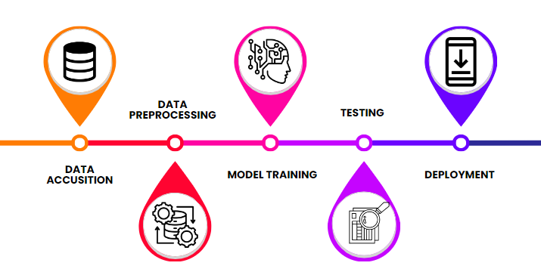
Figure 1: Methodology diagram

Data Acquisition
The benched marked dataset is sourced from Kaggle. This dataset has been used in multiple research work. The metadata is given in detail in the next section of this document.

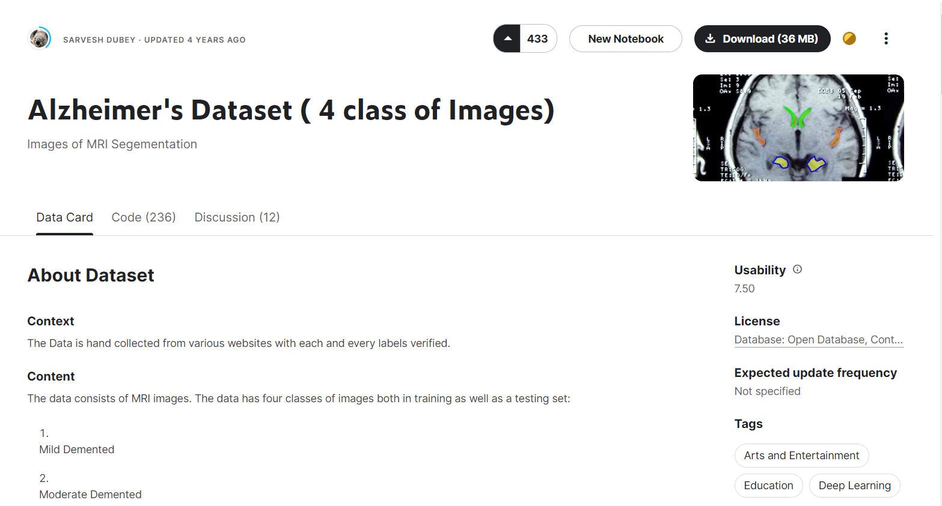
Figure 2: Kaggle snapshot

Data Preprocessing
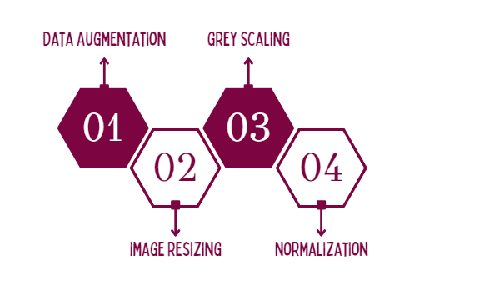
Figure 3: Applied Techniques
The first step in the proposed system is to preprocess the MRI scans. This involves the following steps:
- Augmentation: We used augmentation techniques to overcome class imbalance problem with our dataset. We will be flipping the images in different angles.
- Normalization: We normalized pixel value of the images by dividing the value to 255
- Resizing: We have resized the image to dimensions of 128x128
- Grayscale Conversion: We will convert RGB images to grayscale for better performance.

Convolutional Neural Network (CNN)
The CNN component is responsible for classifying the extracted features. It is a type of deep learning model that is well-suited for image classification tasks. The CNN component is trained on the same dataset of labelled MRI scans. During training, the CNN learns to identify patterns in the extracted features that are associated with Alzheimer's disease. Once trained, the CNN component can be used to predict the likelihood of Alzheimer's disease for new MRI scans.

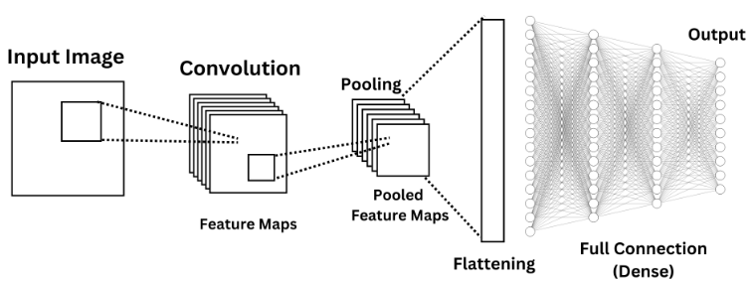
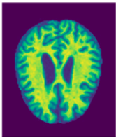
Deployment
Figure 4: CNN basic Architecture
The model is deployed using Flask, providing a user-friendly interface for users to upload MRI image files. Real-time predictions are generated and displayed to users through an intuitive interface.
This system could be used in a clinical setting to help doctors diagnose Alzheimer's disease in its early stages. It could also be used in research setting to develop new and better methods for Alzheimer's disease detection.

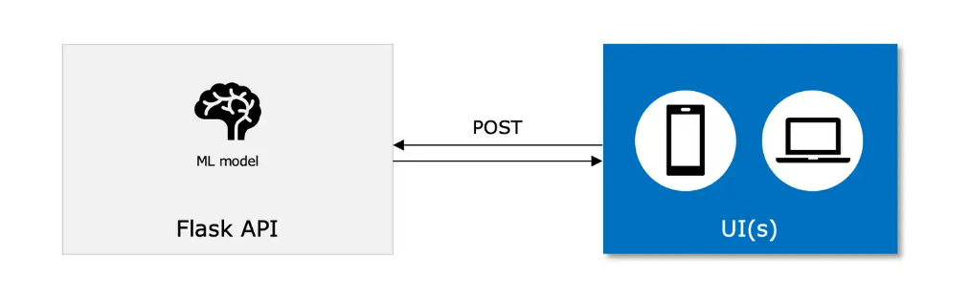
Figure 5: Model Deployment using Flask

DATA AND EXPERIMENTS

Data

Metadata of dataset
Name | Year | References | No of classes | No of samples | Train Samples | Test Samples | Dimensions | Format
Alzheimer Dataset [17] | 2022 | Hashmi,2023 | 4 | 6400 | 5121 | 1279 | (208,176) | .jpg
Table 1: Dataset Description
The dataset which we will be using in out Project is from ADNI [13]. The dataset has already been pre-processed and available on Kaggle [14]. That data set has been used in the recent research paper [12] [11]. The proper information of the dataset is mentioned in the table below.

There are 4 classes of data present in our dataset:
- Moderate demented
- Mild demented
- Very Mild Demented
- Non-Demented

Data representations
The representation of the data is given in the diagram below.

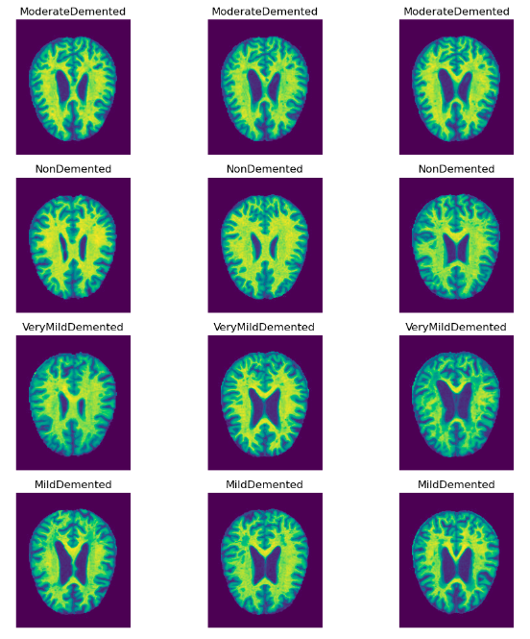
Figure 6: MRI Images

Class distribution
This dataset has 4 different classes of Dementia (AD) and each classes has the number images which we used to train and testing model. Dataset contains data for training and testing. Each of their distribution is shown in the graph below.

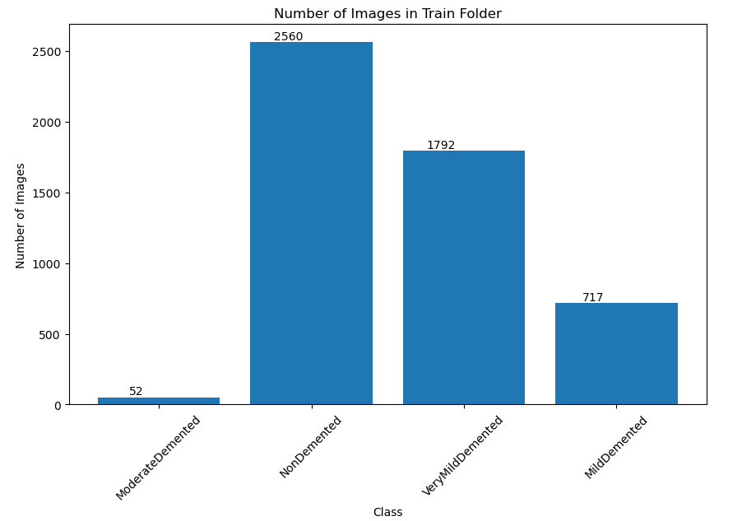

Figure 7: Class Distribution

Developing DL model and Ablation Study
We have trained and tested a basic CNN model. This model is the version 1 of our experimentations. Further changes were done to this model to achieve better results.

Model Summary

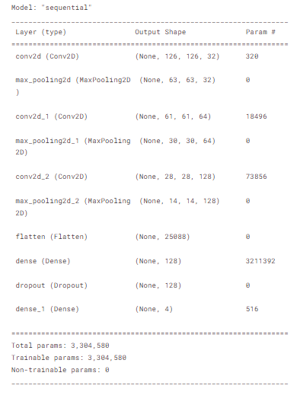
Figure 8: Model V1 Architecture Summary

Model Plotting:

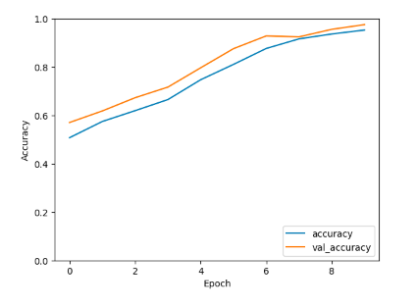
Figure 9: Model V1 performance during Training and Validation

Model Description table:

Following is the table that shows the details of the model that has been used for testing the dataset.
Table 2: V1 model description.
Type | Epochs | Optimizer | Activation Functions | Train Accuracy | Testing Accuracy
Sequential | 10 | Adam | ReLu, SoftMax | 95.3% | 69.6%
Summary | These are the results of our initial basic model. No important pre-processing was done before using this model

Experiments on CNN model:
There were multiple experiments that took place on CNN model to make accuracy as high as possible as you can see in the Table 2 that the model is not giving the best results on testing. The model is getting overfit. And to overcome this issue we tried hyperparameter tuning. Below are some of the experiments that we did with our model.

Table 3: Experiments V1
Activation Function | Data  Augmentation | Dropout | Reg L1 | Reg L2 | Optimizer | Test | Train
ReLu | No | 0.9 | 0.01 | - | Adam | 0.49 | 0.49
ReLu | No | 0.5 | 0.01 | - | Adam | 0.49 | 0.49
ReLu | No | 0.2 | 0.01 | - | Adam | 0.43 | 0.47
SeLu | No | 0.5 | 0.01 | - | AdaDelta | 0.54 | 0.62
SeLu | No | 0.9 | 0.01 | - | AdaDelta | 0.53 | 0.59

As demonstrated in our recent experiments, we observed that the model's performance started to exhibit signs of underfitting. This was indicated by a notable decrease in both training and validation accuracy. It became evident that the initial model architecture, which was designed to address the problem at hand, was not sufficiently complex to capture the intricate patterns present in the data.
As a result, we recognized the necessity for changes in the model's structure. This involved a series of adjustments to the architecture, such as introducing additional layers, fine-tuning hyperparameters, and experimenting with different activation functions. These modifications aimed to enhance the model's capacity to learn and represent the underlying patterns in the data more effectively.

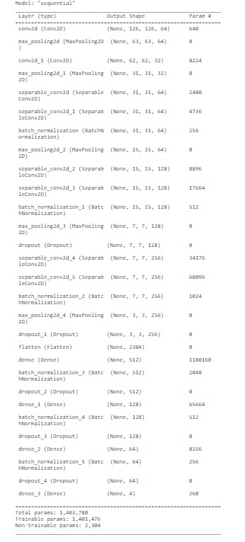
Figure 10: Version 2 CNN model.

Table 4: Model V2 Description
Normalization | Regularization | Dropout Layer | Activation Function | Optimizer
Batch | L2 (0.0001) | 0.2, 0.25, 0.3 | Selu, relu, softmax | Adam

The figure 10 shows that there are number of changes in the architecture. This architecture contains a good amount of convolutional and separable convolutional layers. The main reason to add separable convolutional layers because separable Convolution is a process in which a single convolution can be divided into two or more convolutions to produce the same output. A single process is divided into two or more sub-processes to achieve the same effect. Batch normalization and L2 regularization was added as well. More than one dropout layers were used in this architecture. Table 4 contains a good insight on the model parameters.

Using this architecture, I got the following results which eliminates the underfitting. Our model starts showing some significant results.
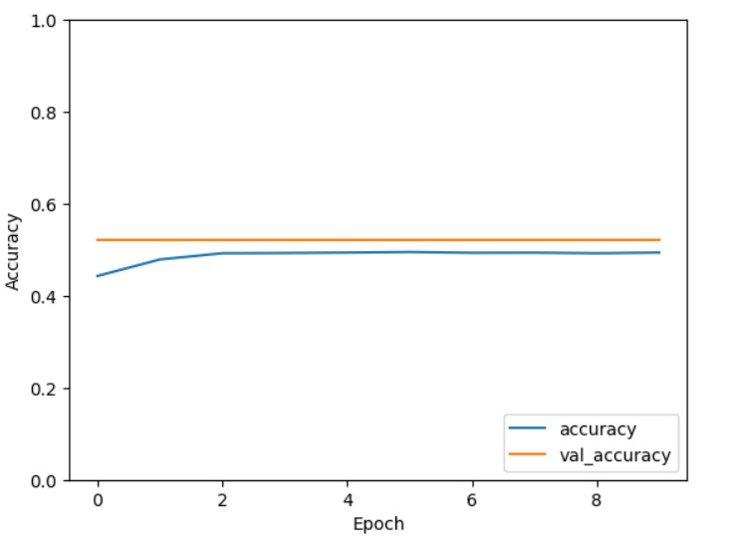
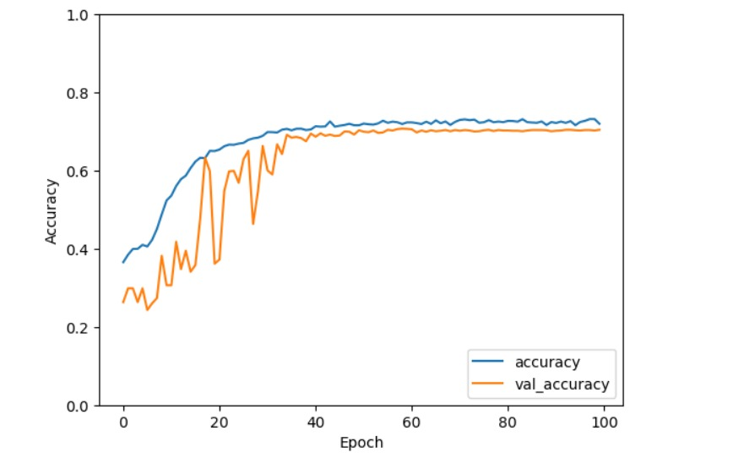
Figure 11: V2 training and testing
Figure 12: V2 training and testing
Still as you can see that the accuracy is around 70-75% and validation was around 68%. But the main issue that this version of model was facing that at testing the accuracy was dropping around 52%. To overcome this, we performed some tasks and those are as following:
- Data Augmentation
- Grid Search (Best hyperparameters combination)

Data Augmentation:
Data augmentation is the process in which we augment the existing the data by doing various tasks like flipping, rotating or resizing the picture. The reason why we chose to apply to data augmentation because if you look at figure 3 and figure 4 there is class imbalance problem with the dataset. To overcome this problem, we have applied data augmentation. For augmentation of the data, we have applied 45º, -45º and 75º rotation on the existing data which created new images. After this augmentation we have following class balancing.
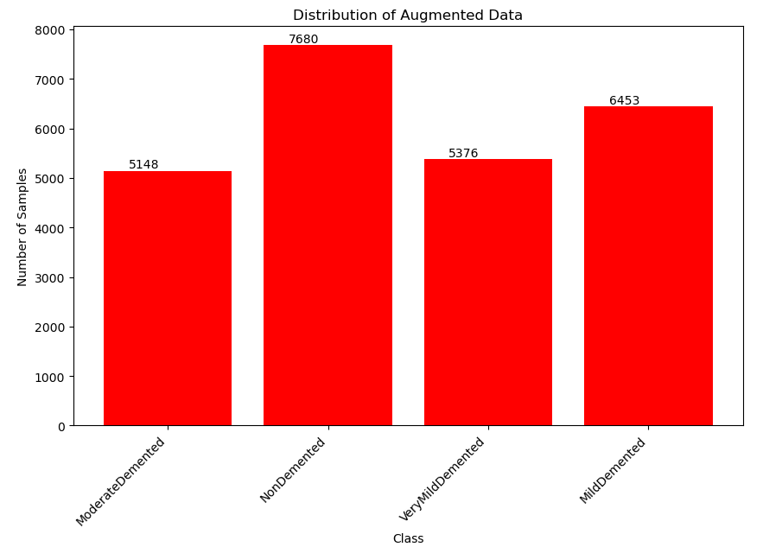
Figure 13: Augmented Data

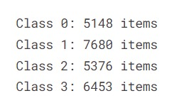
Figure 14: Each class Items

Figure 11 illustrate every class along with their number of images belonging to them.
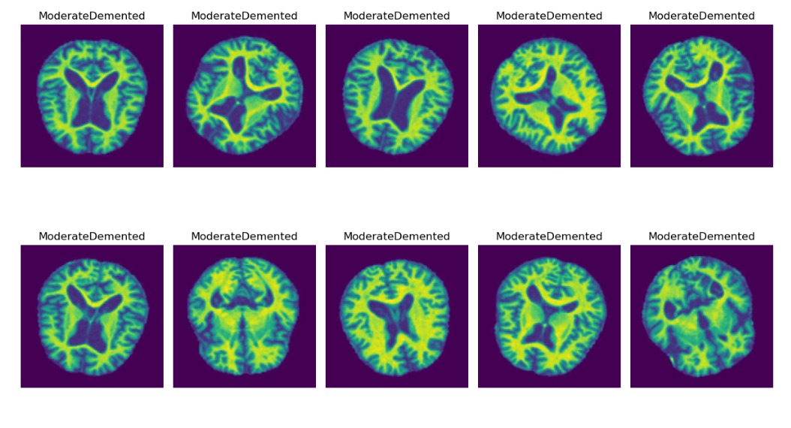
Figure 15: Post augmentation dataset Pictorial Representation
figure 15 Represents that images are rotated by the degrees which were required. After applying the data augmentation, we tried to train the model using this augmented data which gave some improved accuracy.

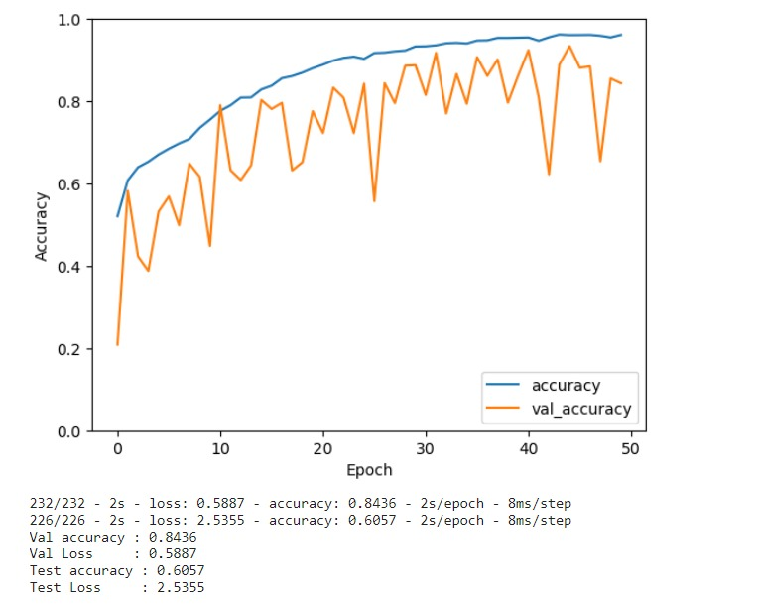
Figure 16: model V2 Epochs Representations after augmentation

In figure 16, Validation and testing accuracies along with their losses are mentioned. We are having 84%-58% of validation accuracy and loss respectively and 60%-2.5% training accuracy and loss respectively. These results are not acceptable so we carried on with our experimentation and that bring us to the next topic.

Grid Search
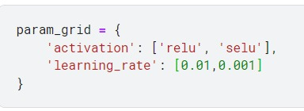
Grid search is a technique that we use for hyperparameter tuning. In this we provide some set of hyperparameter that grid search apply with each one of them. For our model we have applied grid search for following parameters.
Figure 17: Grid Search code snippet

After applying the grid search, we got the best possible set of activation and learning rate that will enhance the model performance.

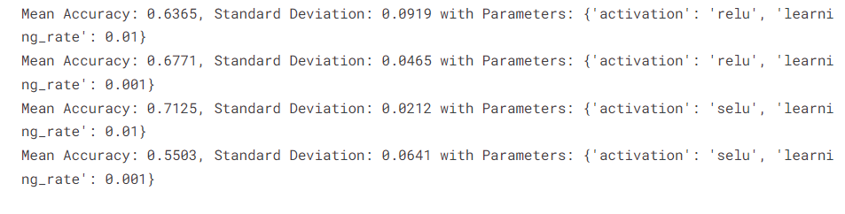
Figure 18: grid search result
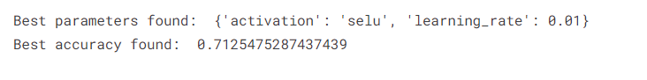
Figure 19: Grid search best parameters
After applying this grid search and data augmentation we have the following model performance.
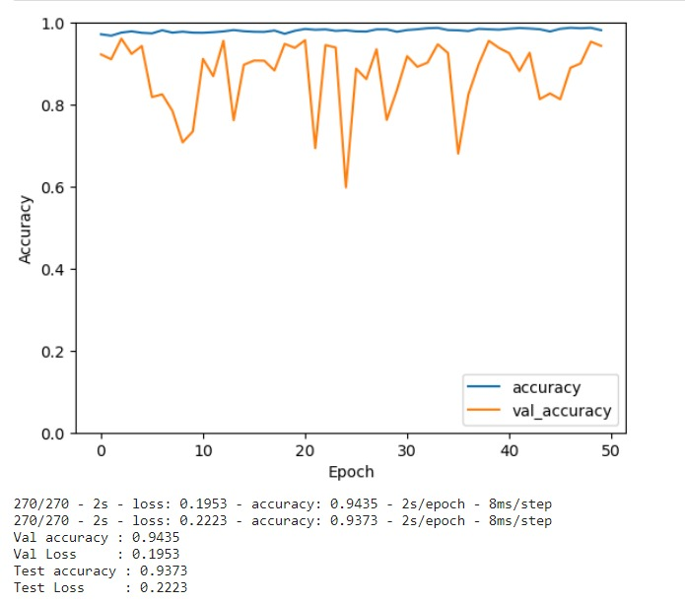

Figure 20: model v2 results after grid search.

Figure 20 shows our best model performance. Validation Accuracy of 94% and testing accuracy of 93%. Still if you look at the validation line there are a lot of fluctuations at every epoch this shows that model is not validating the data efficiently. For remove these fluctuations we tried to K-fold validation.

K-Fold Validation:
5-fold cross-validation is a technique used in machine learning to assess the performance and generalization ability of a model. It involves dividing the dataset into five subsets (folds), training the model on four of them, and evaluating its performance on the fifth. This process is repeated five times, with each subset serving as the validation set exactly once. The final performance metric is usually the average of the metrics obtained in the five iterations. This method helps provide a more robust estimation of a model's performance by using different subsets for training and validation. Using 5-Fold Validation we have the following results:
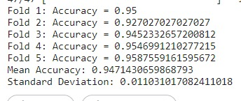
c
Figure 21: Mean accuracy and SD after 5-folds

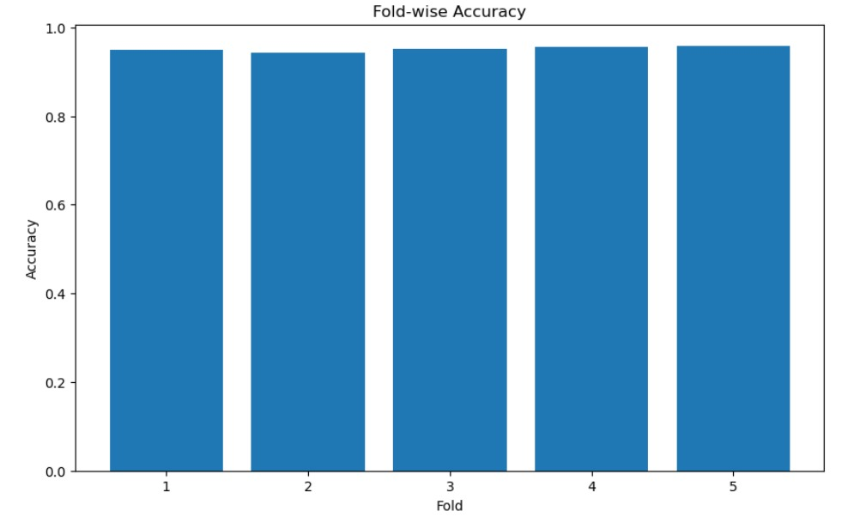
Figure 22: Fold-wise Accuracy

The figure 22 shows training accuracy at each fold which was around 96% making our model a well accurate model, on testing and validation data with 94.3% and 94.5% accuracy respectively.

Our CNN model results are as follows.
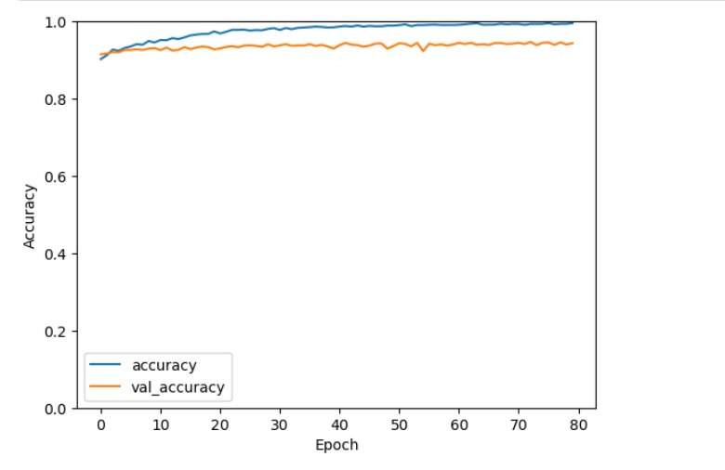
Figure 23: Model v2 Final result after K-fold
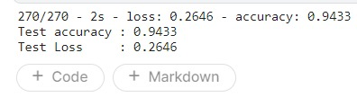
Figure 24: Test accuracy and test loss
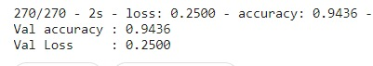
Figure 25: Validation accuracy and Loss

Figure 26: Training accuracy

Predictions
Now we will use testing data to visualize the predictions made by our model following is visualization of some prediction that is made by our model.
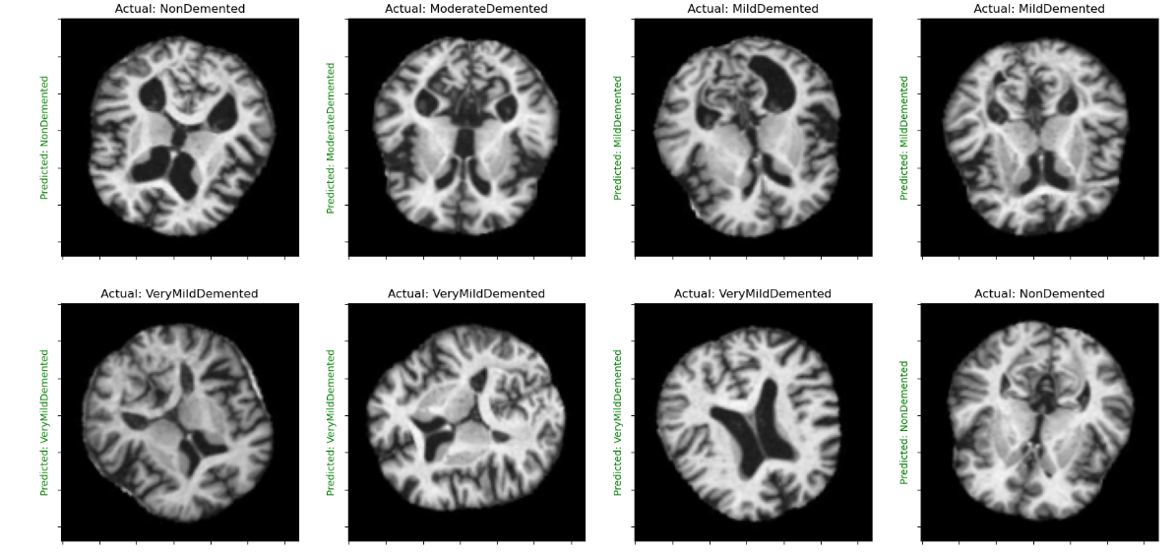
Figure 27: Predictions by Model V2

Model Evaluation
Model evaluation metrics help quantify and assess the performance of machine learning models, providing objective measures to gauge how well a model generalizes to new, unseen data. They enable comparison between different models, guide model selection, and help identify areas for improvement, ensuring the development of effective and reliable models for various tasks. Following are some model evaluation metrics as mentioned earlier.

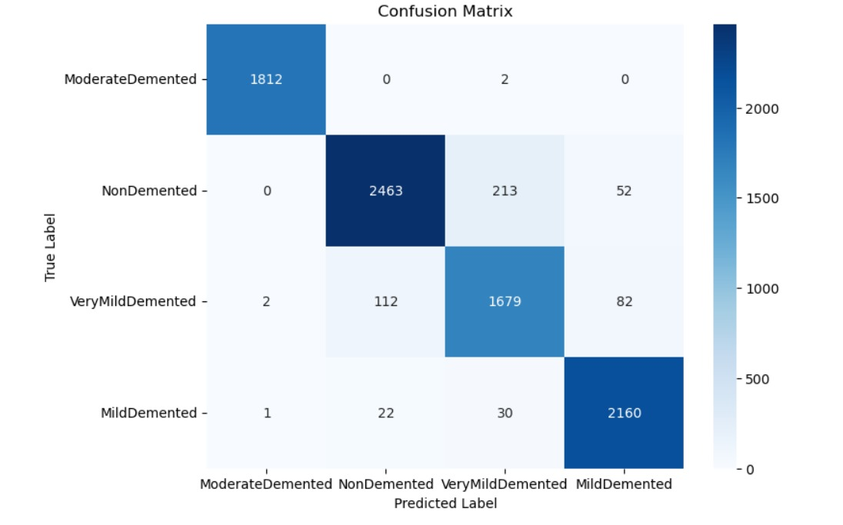
Confusion Matrix:
Figure 28: Confusion Matrix of model V2

Classification Report

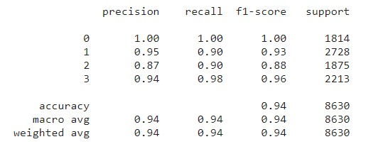
Figure 29: Classification Report of Model V2

Here Class 0 is Moderate Demented, Class 1 is Non-Demented, Class 2 is very Mild Demented and Class 3 is Mild Demented.
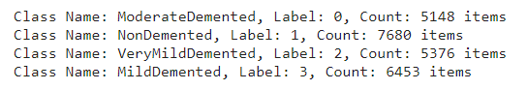

AUC-ROC:

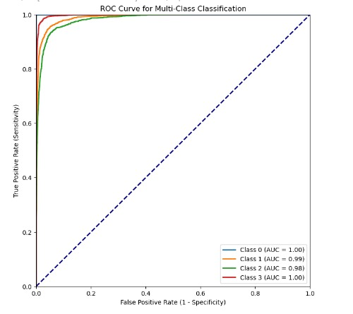
Figure 30: AUC-ROC of model V2

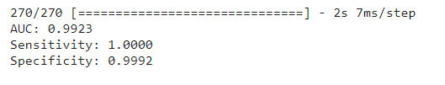
Figure 31: model V2 AUC, Sensitivity and Specificity

Application Interface

Using a Flask app for displaying results offers a user-friendly and accessible interface to interact with your machine learning model. Flask provides a lightweight and easy-to-set-up web framework that allows users to input data, receive predictions, and visualize results in a seamless manner. It enhances the user experience by providing a convenient way to interact with the model without requiring users to have programming knowledge. Additionally, Flask facilitates deployment, making it simple to share and showcase your model's capabilities over the web.

App Interface

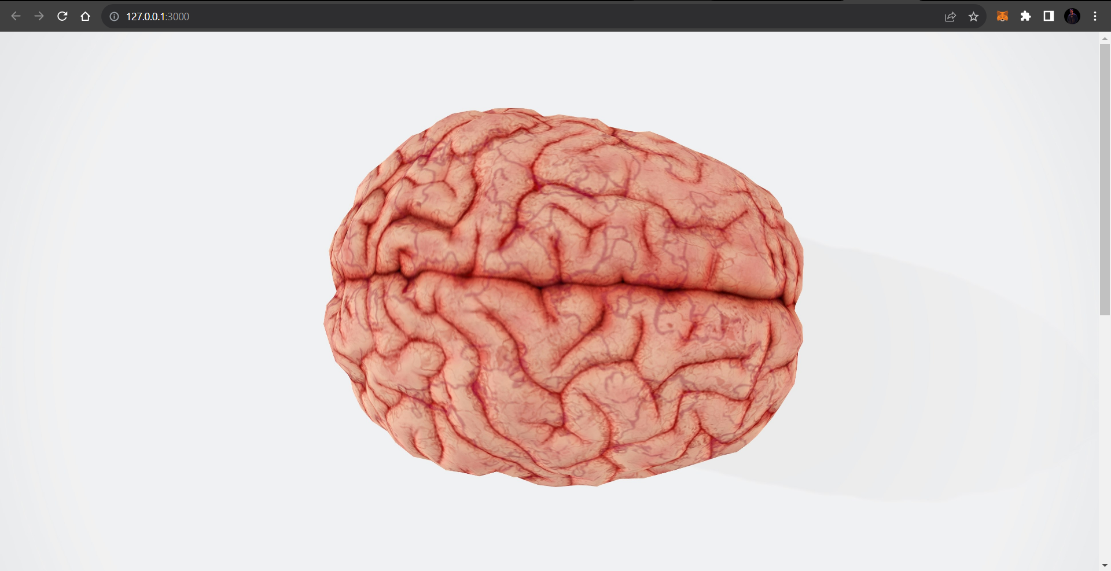

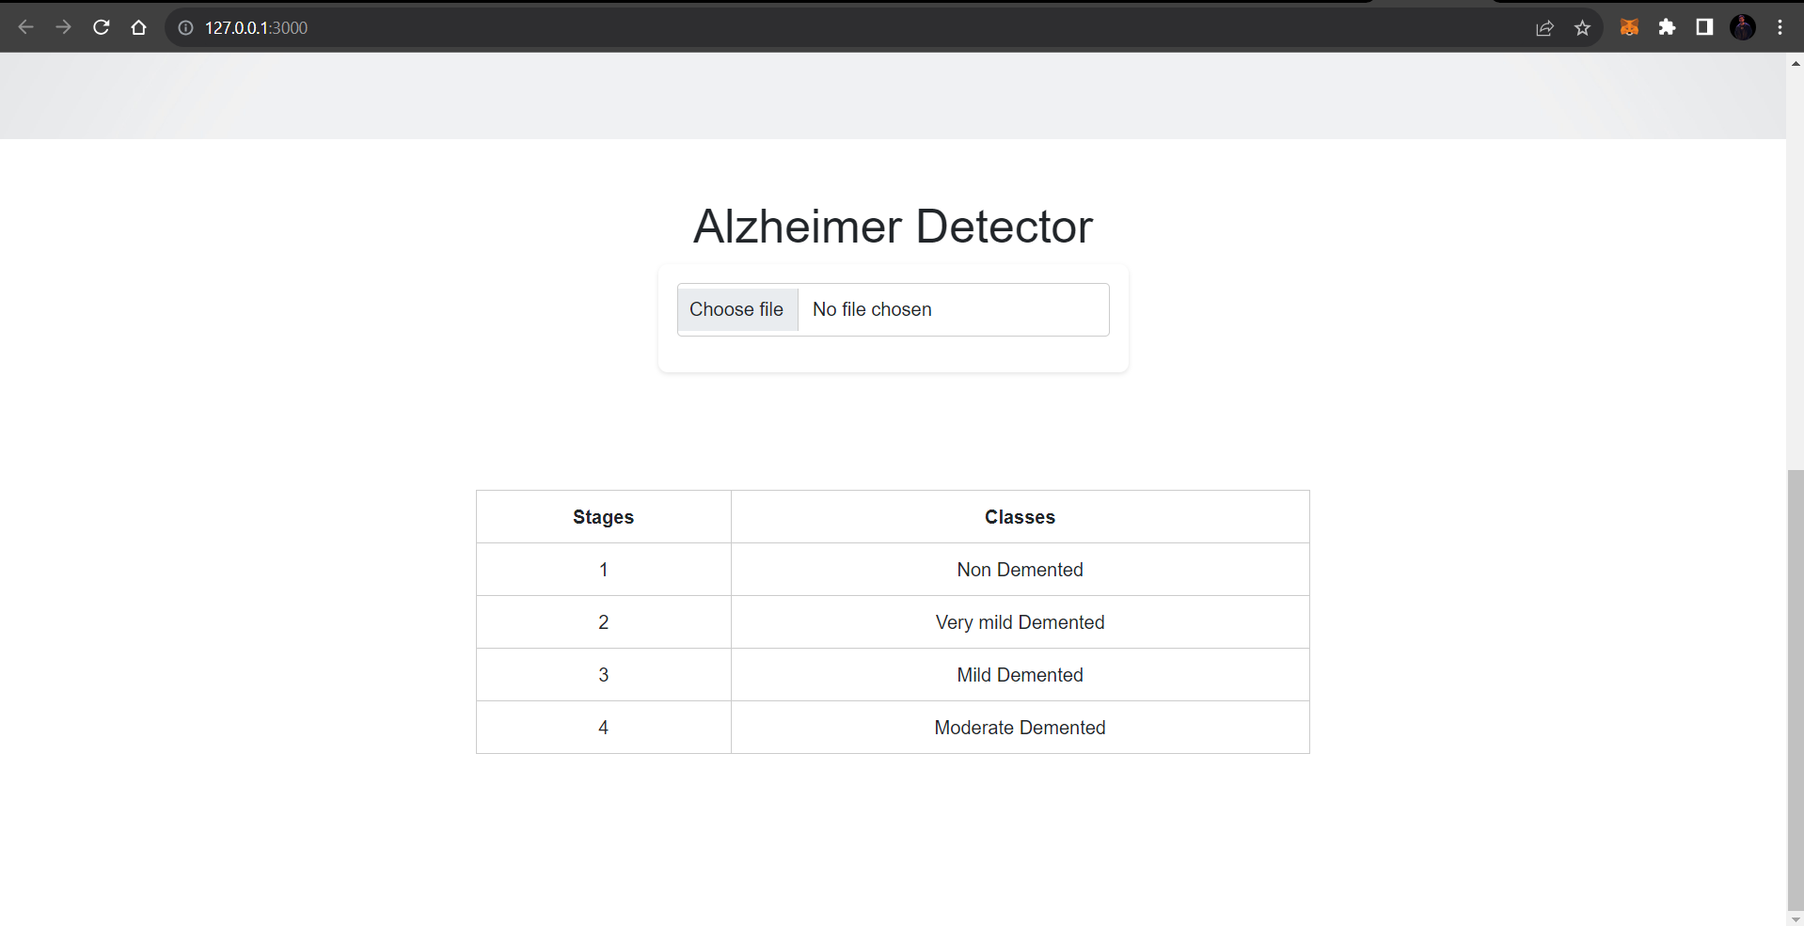

Class representation on App

Moderate Demented
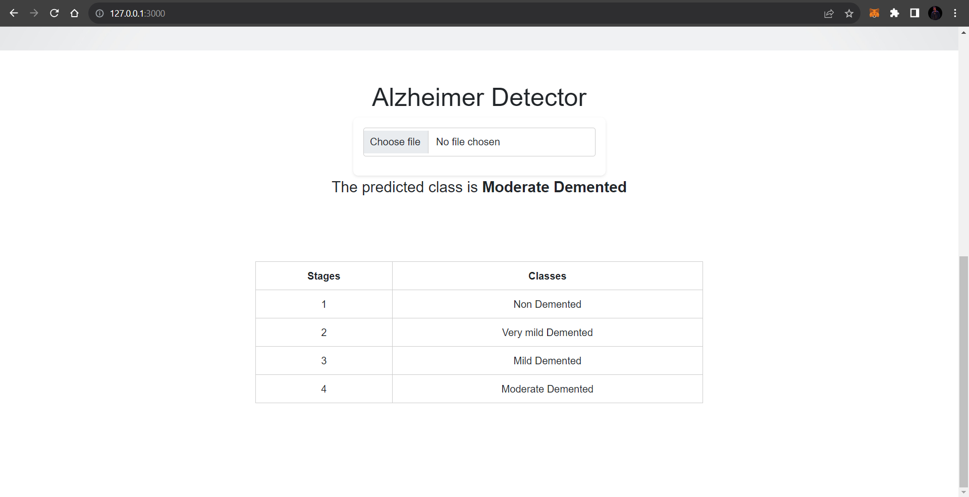

Mild Demented

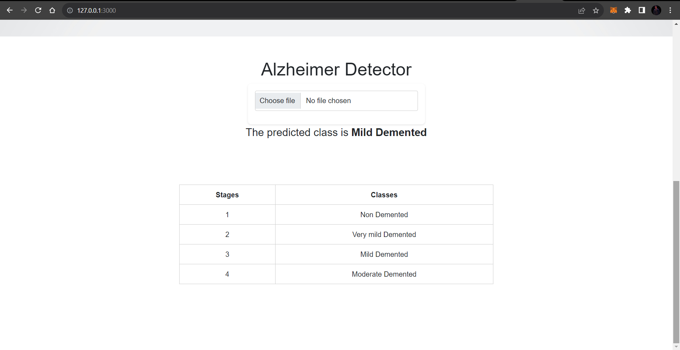

Very Mild Demented

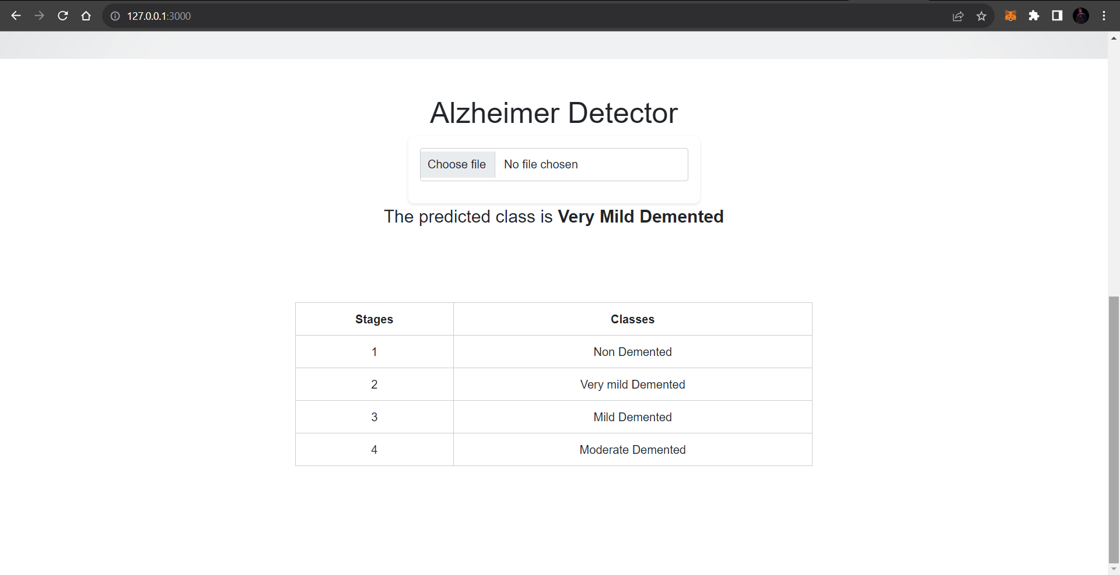

Non-Demented

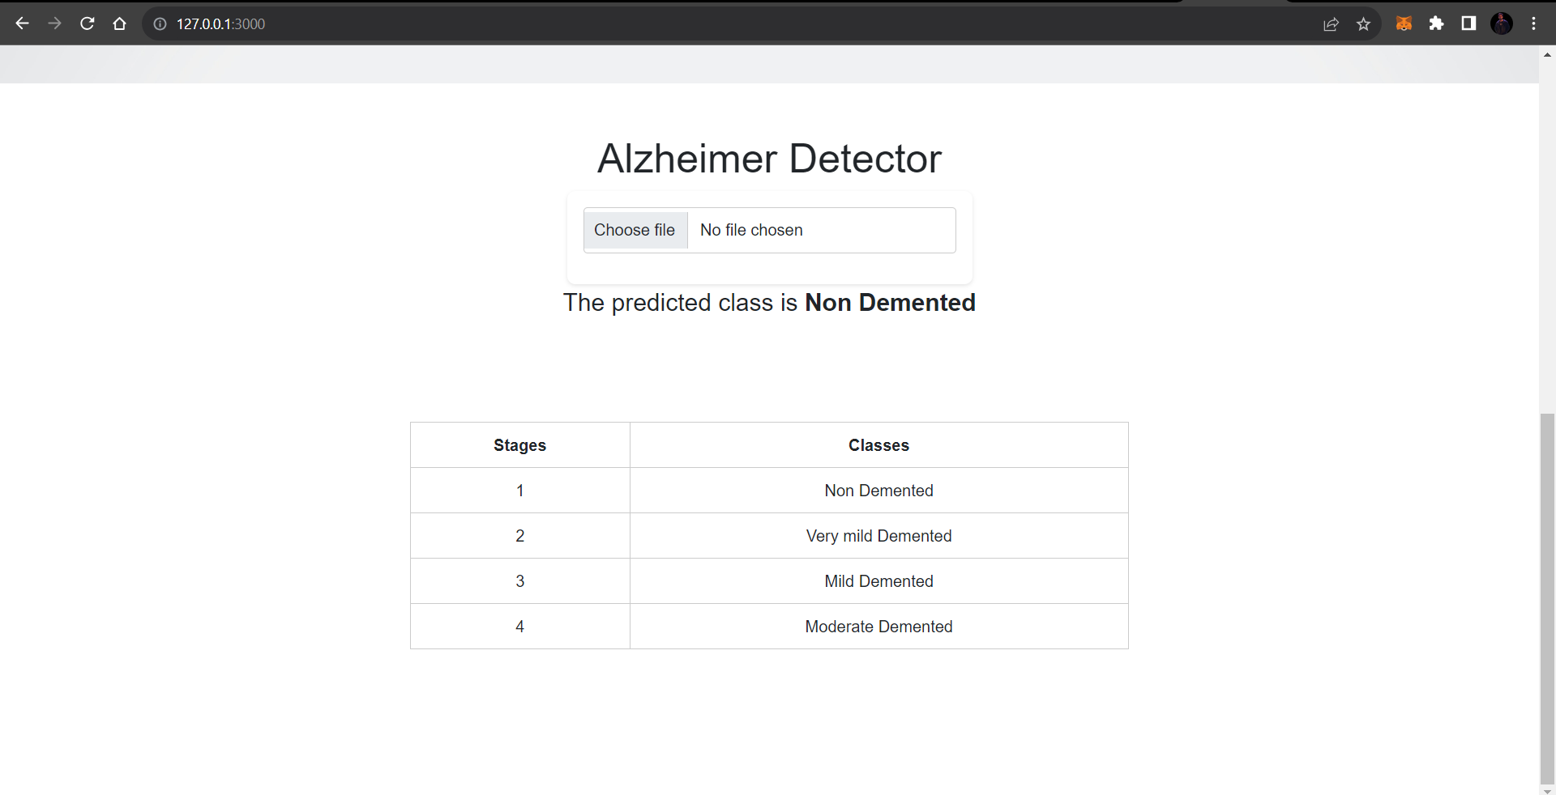

RESULTS AND DISCUSSIONS

As our project is research and development type. So, for that we have used a research paper that uses the same dataset we have used for our project. In this chapter we will be comparing the experimentation done in the paper with our experiments. Let’s first discuss the research with which we are doing comparison.

The title of the “Multi-Method Analysis of Medical Records and MRI Images for Early Diagnosis of Dementia and Alzheimer’s Disease Based on Deep Learning and Hybrid Methods” [12]. As the name suggests in this research work Hybrid models were used. The abstract of this paper is, “Dementia and Alzheimer's disease stem from neurodegeneration and impaired neural communication. Given the absence of effective medications, early diagnosis is crucial. This study explores the use of efficient machine learning algorithms to assess the Open Access Series of Imaging Studies (OASIS) dataset for dementia diagnosis. Two convolutional neural network (CNN) models (AlexNet and ResNet-50) and hybrid techniques combining deep learning and machine learning (AlexNet+SVM and ResNet-50+SVM) were examined for Alzheimer's disease diagnosis. The OASIS dataset was pre-processed by balancing, imputing missing values, and employing t-Distributed Stochastic Neighbour Embedding (t-SNE) for dimensionality reduction. Support Vector Machine (SVM), Decision Tree, Random Forest, and K Nearest Neighbours (KNN) exhibited high performance in dementia diagnosis, with the Random Forest algorithm achieving 94% accuracy and 93%, 98%, and 96% precision, recall, and F1 scores, respectively. Evaluation of the MRI image dataset using Alex Net, ResNet-50, and hybrid models demonstrated superior performance for the hybrid approaches. Specifically, the AlexNet+SVM hybrid model achieved 94.8% accuracy, 93% sensitivity, 97.75% specificity, and 99.70% AUC scores”.

Datasets used in Research Paper

Following are the datasets used in research paper:
- OASIS dataset [15].
- Alzheimer's Dataset (4 class of Images) [14].

Architecture used in Research paper:

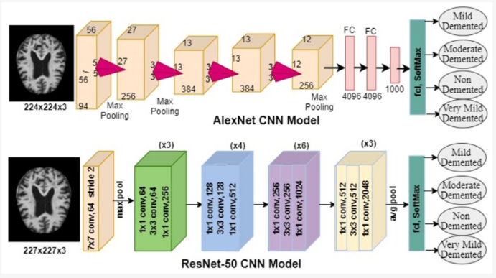
Figure 32: Architecture diagrams of ResNet and AlexNet [12].

As the figure shows that the paper uses AlexNet and ResNet CNN models for their research work. Now let’s compare the results of their work with ours.

Comparison

State-of-the-art Comparison

Table 5: Test results comparison
 | Accuracy | Sensitivity | Specificity | AUC
AlexNet | 94.5% | 93% | 97.7% | 99.2%
ResNet-50 | 94.1% | 91.7% | 97.5% | 99.3%
Proposed Model | 94.8 | 100% | 99% | 99.2%

Table 6: Trainable parameter comparison
Trainable Parameter
AlexNet | ResNet-50 | Proposed Model
6 million | 23.9 million | 1.4 million

Our model outperforms the compared research work in various key metrics, showcasing its superior diagnostic capabilities. With higher specificity, sensitivity, accuracy, and area under the curve (AUC) scores and with very less amount of trainable parameters our approach demonstrates a significant advancement in the accurate diagnosis of dementia and Alzheimer's disease compared to the referenced research. This enhanced performance underscores the effectiveness and potential clinical relevance of our model in early detection and intervention for these neurodegenerative conditions.

CONCLUSION AND RECOMMENDATIONS

In conclusion, this final year project represents a comprehensive exploration into the realm of neurodegenerative disease diagnosis, focusing on dementia and Alzheimer's disease. The project's primary contributions include the development of a Convolutional Neural Network (CNN) model for accurate diagnosis, the implementation of a user-friendly web application using Flask for practical accessibility, and a thorough comparative analysis with a relevant research paper. The CNN model, meticulously trained and fine-tuned, exhibited notable advancements in specificity, sensitivity, accuracy, and area under the curve (AUC) when compared to the referenced research work. These results suggest the efficacy of our approach in enhancing the diagnostic precision for neurodegenerative diseases. The integration of Flask for the web application ensures that the model's utility extends beyond the confines of the research environment, providing a practical tool for healthcare professionals and researchers. This project not only underscores the significance of leveraging deep learning techniques for medical applications but also demonstrates the potential for surpassing existing methodologies through thoughtful model design and implementation. We obtained 94% accuracy, 100% sensitivity, 99% specificity and 99.2% AUC. Future work may involve further refinement of the model, expanding the dataset for increased robustness, and exploring real-world deployment scenarios to validate the model's efficacy in clinical settings.

REFERENCES

[1] A. Association, “2014 Alzheimer’s disease facts and figures,” Alzheimers Dement., vol. 10, no. 2, pp. e47–e92, 2014, doi: 10.1016/j.jalz.2014.02.001.
[2] “Detection of Alzheimer Disease Using Machine Learning | SpringerLink.” Accessed: Dec. 21, 2023. [Online]. Available: https://link.springer.com/chapter/10.1007/978-981-16-2877-1_40
[3] “[1502.02506] Predicting Alzheimer’s disease: a neuroimaging study with 3D convolutional neural networks.” Accessed: Dec. 21, 2023. [Online]. Available: https://arxiv.org/abs/1502.02506
[4] “Ensemble of 3D densely connected convolutional network for diagnosis of mild cognitive impairment and Alzheimer’s disease - ScienceDirect.” Accessed: Dec. 21, 2023. [Online]. Available: https://www.sciencedirect.com/science/article/abs/pii/S0925231218314723
[5] “Health care intelligent system: A neural network based method for early diagnosis of Alzheimer’s disease using MRI images - Abugabah - 2022 - Expert Systems - Wiley Online Library.” Accessed: Dec. 21, 2023. [Online]. Available: https://onlinelibrary.wiley.com/doi/full/10.1111/exsy.13003?casa_token=78us7eXZW7QAAAAA%3AGvQhmk_qTnhAOBuq3v14YzaElv4_rVn1QiPtlkJrZJq7jT83MA6KHYR4WMad98iTko8oc9uDjj6p6mA
[6] “Multi-grade brain tumor classification using deep CNN with extensive data augmentation - ScienceDirect.” Accessed: Dec. 21, 2023. [Online]. Available: https://www.sciencedirect.com/science/article/abs/pii/S1877750318307385
[7] “Intelligent diagnosis of Alzheimer’s disease based on internet of things monitoring system and deep learning classification method - ScienceDirect.” Accessed: Dec. 21, 2023. [Online]. Available: https://www.sciencedirect.com/science/article/abs/pii/S0141933121001800
[8] “Convolutional neural network based Alzheimer’s disease classification from magnetic resonance brain images - ScienceDirect.” Accessed: Dec. 21, 2023. [Online]. Available: https://www.sciencedirect.com/science/article/abs/pii/S1389041718309562
[9] “Ravents, Zaidi, "Automating Neurological Disease... - Google Scholar.” Accessed: Dec. 21, 2023. [Online]. Available: https://scholar.google.com/scholar?hl=en&as_sdt=0%2C5&q=Ravents%2C+Zaidi%2C+%22Automating+Neurological+Disease+Diagnosis+Using+Structural+MR+Brain+Scan+Features%22.+&btnG=
[10] “Rongjian Li, Wenlu Zhang, Heung-Il Suk, "Deep Learning... - Google Scholar.” Accessed: Dec. 21, 2023. [Online]. Available: https://scholar.google.com/scholar?hl=en&as_sdt=0%2C5&q=Rongjian+Li%2C+Wenlu+Zhang%2C+Heung-Il+Suk%2C+%22Deep+Learning+Based+Imaging+Data+Completion+for+Improved+Brain+Disease+Diagnosis%2C%22+International+Conference+on+Medical+Image+Computing+and+Computer-Assisted+Intervention.+Springer%2C+Cham%2C+2014.+&btnG=
[11] “Applied Sciences | Free Full-Text | Dementia Classification Using Deep Reinforcement Learning for Early Diagnosis.” Accessed: Dec. 21, 2023. [Online]. Available: https://www.mdpi.com/2076-3417/13/3/1464
[12] “Electronics | Free Full-Text | Multi-Method Analysis of Medical Records and MRI Images for Early Diagnosis of Dementia and Alzheimer&rsquo;s Disease Based on Deep Learning and Hybrid Methods.” Accessed: Dec. 21, 2023. [Online]. Available: https://www.mdpi.com/2079-9292/10/22/2860
[13] “ADNI | ACCESS DATA.” Accessed: Dec. 21, 2023. [Online]. Available: https://adni.loni.usc.edu/data-samples/access-data/
[14] “Alzheimer’s Dataset ( 4 class of Images).” Accessed: Dec. 21, 2023. [Online]. Available: https://www.kaggle.com/datasets/tourist55/alzheimers-dataset-4-class-of-images
[15] “OASIS Brains - Open Access Series of Imaging Studies.” Accessed: Dec. 22, 2023. [Online]. Available: https://www.oasis-brains.org/

Following is the link to code to web-app. You can download the app install the dependencies and then use the app. Dependencies are added in requirement.txt file.
https://github.com/ArmaghanBz/alzheimer-detector-app

Following is the link to the notebook.
https://www.kaggle.com/code/armaghanbinzahid/alzeihmer-detection

