UNMANNED AERIAL VEHICLE NAVIGATION IN AN ENVIRONMENT WITH OBSTACLE



KASHIF NAEEM
03-243212-003

A thesis submitted in fulfillment of the
requirements for the award of the degree of
Master of Science (Computer Science)

Department of Computer Sciences

BAHRIA UNIVERSITY LAHORE CAMPUS

OCTOBER 2023

APPROVAL FOR EXAMINATION

Scholar’s Name: _KASHIF NAEEM__________ Registration No. _03-243212-003___
Program of Study: ____MS (CS)____________________________________________
Thesis Title: _UNMANNED AERIAL VEHICLE NAVIGATION IN AN ENVIRONMNET WITH OBSTACLE ________________________
It is to certify that the above scholar's thesis has been completed to my satisfaction and, to my belief, its standard is appropriate for submission for examination. I have also conducted plagiarism test of this thesis using HEC prescribed software and found similarity index ___14______% that is within the permissible limit set by the HEC for the MS degree thesis. I have also found the thesis in a format recognized by the BU for the MS thesis.

Principal Supervisor’s Signature: __________________________
Date: ________________________
Name: __DR. IRAM NOREEN_______

AUTHOR’S DECLARATION

I, ____ ‘Kashif Naeem’_______ hereby state that my MS thesis titled “UNMANNED AERIAL VEHICLE NAVIGATION IN AN ENVIRONMENT WITH OBSTACLE”________________________________________________________________________________________”
is my own work and has not been submitted previously by me for taking any degree from this university.
Bahria University, Lahore Campus or anywhere else this country/world.
At any time if my statement found to be incorrect even after my graduation the university has the right to withdraw/cancel my degree.

Name of Scholar: ____Kashif Naeem_____________
Date: _______________________

PLAGIARISM UNDERTAKING

I solemnly declare that research work presented in the thesis titled “_UNMANNED AERIAL VEHICLE NAVIGATION IN AN ENVIRONMNET WITH OBSTACLE”________________________________________________________________________________________________________________________”
is solely my research work with no significant contribution from any other person. Small contribution / help wherever taken has been duly acknowledged and that complete thesis has been written by me.
I understand the zero-tolerance policy of the HEC and Bahria University towards plagiarism. Therefore, I as an Author of the above titled thesis declare that no portion of my thesis has been plagiarized and any material used as reference is properly referred / cited.
I undertake that if I am found guilty of any formal plagiarism in the above titled thesis even after award of MS degree, the university reserves the right to withdraw / revoke my MS degree and that HEC and the University has the right to publish my name on the HEC / University website on which names of scholars are placed who submitted plagiarized thesis.

Scholar / Author’s Sign: ________________________
Name of the Scholar: __Kashif Naeem_______________

DEDICATION

MY BELOVED PARENTS
For the prayers of my Father and my Mother who always motivated me and wished to see me successful in life and support me at every step of my life

MY SUPERVISOR
For his invaluable guidance, worthy suggestions, sincere advice and his motivational, support for me.

ACKNOWLEDGEMENT

In preparing this thesis, I was in contact with many people, researchers, academicians, and practitioners. They have contributed to my understanding and thoughts. In particular, I wish to express my sincere appreciation to my main thesis supervisor, Professor Dr. Iram Noreen, for encouragement, guidance, critics and friendship. Without their continued support and interest, this thesis would not have been the same as presented here.
Librarians at Bahria University also deserve special thanks for their assistance in supplying the relevant literature. My fellow postgraduate students should also be recognized for their support. My sincere appreciation also extends to all my colleagues and others who have provided assistance on various occasions. Their views and tips are useful indeed. Unfortunately, it is not possible to list all of them in this limited space. I am grateful to all my family members.

ABSTRACT

Unmanned Aerial Vehicle (UAV) well known as drones, increasing in demand currently and in the future in many fields such as the delivery of packages, survelience, path planning, military combat, traffic monitoring, construction supervision, and search and rescue operations. In the majority of the fields, to perform specific tasks UAVs have to navigate in different environments carrying a camera underneath and avoid obstacles without human interaction means autonomous navigation. This research proposes a model for navigation with static obstacle avoidance in a map-based environment. A new method is put forth to control UAV autonomously to cover the target area mission with arbitrary start locations and multiple landing positions. There are several tactics for UAV navigation was proposed, but in this work an end-to-end a reinforcemen learning approach is selceted. The reinforcement Learning is used for learning of a UAV control policy to the agent. This policy generalize the new map with varying battery energy constraints. The maximum flying range of UAVs remains severely limited despite recent advancements in battery technology. In order to train a double deep Q-network (DDQN) to generate control decisions for the UAV, we use map-like input channels to convey spatial information via convolutional network layers to the UAV agent, while considering limited power budget and the target area coverage aim. The proposed approach can be useful in a wide range of Environments for UAV and ground robot. Moreover, proposed model is resultant to find best path in the environment. Experiments will perform in different situations to verify that proposed model has improved coverage ratio , landing ratio, and movement steps results.

TABLE OF CONTENT

CHAPTER | TITLE | PAGE
Table of Contents
APPROVAL FOR EXAMINATION i
AUTHOR’S DECLARATION ii
DEDICATION iv
ACKNOWLEDGEMENT v
ABSTRACT vi
TABLE OF CONTENT vii
LIST OF TABLES xii
LIST OF FIGURES xiii
LIST OF SYMBOLS xiv
CHAPTER 1 1
INTRODUCTION 1
1.1 Background 1
1.1.1Reinforcement Learning: 2
1.1.2Policy and value function 2
1.1.3Exploration vs. Exploitation: 3
1.1.4Experience replay: 3
1.1.5On-policy vs. Off-policy: 4
1.2 Research Gap: 4
1.3 Problem Statement: 4
1.4 Key Research Question: 4
1.5 Aims and Objectives: 5
1.6 Significance of the Research: 5
1.7 Summary of Chapter 1 6
CHAPTER 2 7
LITERATURE REVIEW 7
2.1 Comparison between Learning-Based and Non-Learning-Based Approaches for Path Planning 16
2.1.1 Introduction: 16
2.1.2 Learning-Based Approach 16
2.1.2.1 Adaptability to Varying Power Constraints: 16
2.1.2.2 Handling No-Fly Zones: 16
2.1.2.3 Generalization to Different Environments: 17
2.1.2.4 Training Data Requirement: 17
2.1.2.5 Computational Demands: 17
2.1.2.6 Deterministic Behavior: 17
2.1.2.7 Application Flexibility: 17
2.1.2.8 Response to Technology Advancements: 18
2.1.3 Non-Learning-Based Approach 18
2.1.3.1 Deterministic Behavior: 18
2.1.3.2 Potentially Lower Computational Demands: 18
2.1.3.3 Limited Adaptability: 19
2.1.3.4 Generalization to Different Environments: 19
2.1.3.5 Handling No-Fly Zones: 19
2.1.4 Conclusion for comparison 19
2.2 Summary of Chapter 2 20
CHAPTER 3 21
METHODOLOGY 21
3.1 Model Design: 21
3.1.1 Convolutional Layers: 22
3.1.2 Flatten Layer: 22
3.1.3 Hidden Layers: 23
3.1.4 Output Layer: 23
3.1.5 Experience Replay Memory: 23
3.1.6 Training Process: 23
3.1.6.1 Initialization: 23
3.1.6.2 Interaction with the Environment: 23
3.1.6.3 Adding Experiences to Replay Memory: 23
3.1.6.4 Sampling from Replay Memory: 23
3.1.6.5 Forward Pass: 24
3.1.7 Double Q-Learning: 24
3.1.8 Loss Computation and backpropagation: 24
3.1.9 Iterative Training: 24
3.1.10 Policy Improvement 24
3.2 Proof of concepts: 25
3.2.1 Problem Formulation: 25
3.2.1.1 Setup 25
3.2.1.2 Channels Map 25
3.2.2 Markov Decision Process 26
3.2.3 Q-Learning: 27
3.2. Deep Q-Learning 28
3.2.5 Neural Network Model and Training Procedure: 29
3.2.6 Environment: 33
3.3 Results: 33
3.4 Map 1: Environment cluttered with structured obstacles 34
3.5 Map 2:Environment cluttered with un-structured obstacles 35
3.6 Map 2: Environment with narrow passage obstacles 36
3.7 Summary of Chapter 3: 37
CHAPTER 4 38
RESULTS AND DISCUSSION 38
4.1 First Experiment: 38
4.2 Second Experiment: 39
4.3 Third Experiment: 40
4.4 Fourth Experiment: 41
4.5 Fifth Experiment: 42
4.6 Sixth Experiment: 43
4.7 Seventh Experiment: 44
4.8 Eighth Experiment: 45
4.9 Ninth Experiment: 46
4.10 Action Space: 48
4.11 Summary of Chapter 4: 50
CHAPTER 5 51
CONCLUSION 51
5.1 Main contribution of our study: 51
5.2 Limitations: 51
5.3 Future Work: 52
REFERENCE 53
APPENDIX A 56
APPENDIX B 57
APPENDIX C 58
APPENDIX D 63

LIST OF TABLES

TABLE NO. | TITLE | PAGE
Table 2.1: Literature Review Table 14
Table 4.1: Parameters for Double Deep Q-Network 47
Table 4.2: Rewards for Double Deep Q-Network 48
Table 4.3: Performance Matrics 48

LIST OF FIGURES

FIGURE NO. |  | TITLE | PAGE
Figure 2.1: Learning based path planning 15
Figure 2.1: Non-Learning based path planning 17
Figure ‎3.1: Methadology Diagram 21
Figure ‎3.2: Model Architecture Diagram 22
Figure 3.‎3: System Level Diagram showing the software and sensor components together on the UAV. 26
Figure ‎3.4: MDP RL Model 27
Figure 3.5: Map # 1 34
Figure 3‎.6: Map # 2 35
Figure 3.7: Map # 3 36

Figure 4.1: Map # 1 87/100 movement 38
Figure 4.2: Map # 1 92/150 movement 39
Figure 4.3: Map # 1 107/200 movement 40
Figure 4.4: Map # 2 85/100 movement 41
Figure 4.5: Map # 2 128/140 movement 42
Figure 4:6: Map # 2 144/200 movement 43
Figure 4.7: Map # 3 83/100 movement 44
Figure 4.8: Map # 3 120/140 movement 45
Figure 4.9: Map # 3 157/200 movement 46
Figure 4.10: Action space 48
Figure 4.11: Target area ratio chart for three different challenges maps with varying movement budgets and targeted areas 49
Figure 4.12: Coverage ratio chart for three different challenges maps with movement budgets from 0 to 200 movements. 50

LIST OF SYMBOLS

RL - Reinforcement Learning
DRL - Deep Reinforcement Learning
DQN - Deep Q-Network
DDQN - Double Deep Q-Network
DDPG - Deep Deterministic Policy Gradient
POMDP - Partially Markov decision process
MDP - Markov Decision Process
P - Probability
$A$ - Action Space
$a_{i}$ - A single action
S - State Space
$s$ - current state
$s'$ - next state
$M$ - Environment Map
$B$ - Movement Budget
$F$ - Safety Flag
$R$ - Reward
$r_{cov}$ - Positive Coverage Reward
$r_{sc}$ - Negative reward for safety controller
$r_{mov}$ - Movement Reward
$r_{crash}$ - Crash Reward
$γ$ - Discount Factor
$π$ - Policy
$Q$ - Q (quality) function
TD - Temporal Difference
$θ$ - Network Parameter
$D$ - Replay Memory Buffer

CHAPTER 1

INTRODUCTION

Background
Autonomous Systems (AS) is known as computational systems that can do any tasks without human involvement [1]. These systems are also called robots because they have an intelligence in a machine to perform a specific task, Self-driving cars, robot-waiters, cleaning robots etc [2]. UAV’s occupying different domains for more efficient working rather than human being, and are used to reduce cost and risk factor by human [3].
An Unmanned Aerial Vehicle (UAV) is an aerial robot that do not have a human pilot, mainly acknowledged as a drone [4]. UAV have got a popularity in last decade for its movability in three-dimensional space [4]. UAVs was firstly used for military operations. However, UAVs are now used in research, surveillance, monitoring and Search and rescue (SAR) operations. Autonomous UAVs are being received an immense interest due to vast applications, such as packages delivering to customers, tracking enemy targets, Monitoring of Gas-Pipeline, search and rescue operations, and many other applications.
UAV can fly in static environment or dynamic environment. Static environment is those who have a fixed obstacle. Whereas, dynamic environment has moveable objects while UAV is flying. UAV are real life objects so for a real-life environment is required for test flying. A virtual environment could be created for the model testing and analyzing with a real-life scene. Subsequent, a virtual simulator was implemented for proposal of control algorithm advancement and interaction with virtualized UAV robots [2] . There are following virtual simulators: AirSum, MATLAB.
Normally, UAVs have cameras or other sensors to collect surrounding information for surveillance or navigation in an environment autonomously. Typically, UAV to be trained for navigation in a virtual 3D environment for the reason that limited computation and power resources, and repeatedly UAVs crashes will be very expensive in a training process.
Manny techniques exist for training of UAVs navigation autonomously in different environments. Reinforcement Learning (RL) algorithms have solved several problems where an agent (computer program) has performed very well rather than human in this domain. RL agent is interacted by the environment to get a state and process this as input, and then take an action as output, during this agent receive reward. UAV’s camera or other sensors capture information as a state from the environment. Capture information are processed by the agent and take an action as output which determines the movement’s direction of UAV.

Reinforcement Learning:
Reinforcement learning is a machine learning technique that can be illustrated with Markov Decision Process (MDP) [1]. In MDP, RL agent learns the environment through experiences by taking a set of actions, after this environment state will be changed, and agent get some reward depending on taken action, which measure the success (positive reward) or failure (punishment) on an action. The goal of MDP is to maximize the summation of expected accumulated rewards from a set of actions.
First time deep and Reinforcement learning are combined and introduced as Deep Q-Learning (DQL) approach that was extension of Q-Learning. Deep Q-Learning worked in a low dimensional (two dimensional) action space (i.e., Environment designed as a discrete grid map with less degree of freedom and action space), which may be diminish the efficiency of the UAV in a real-world environment, where actual UAV works in a continuous action space. After that a Deep Deterministic policy gradient approach was developed, which has two networks first one actor and the second one critic. Actor is a policy function $μ$and critic is a value function Q.

Policy and value function
By defining the probability of doing action 𝒂 while in a state 𝒔, a policy 𝝅 describes the agent's behavior and is written as 𝝅(𝒂|𝒔). The agent uses a value function to assess its behavior (activity). This value function can be either an action-value function, which quantifies how good it is to choose action 𝒂 while in a state 𝒔, or a state-value function, which quantifies how good it is to be in state 𝒔 after executing an action 𝒂. The predicted summation of the discounted rewards is used to express the value that the action-value function generates, which is referred to as the Q-value.
The agent looks for the best Q-value Q∗ (s, 𝒂) as stated in order to maximize the expected summing of discounted rewards following the optimal policy 𝝅. The Bellman Optimality Equation , which is the sum of the expected reward from carrying out the current action (𝑹t+𝟏) plus the sum of all future discounted rewards from any potential future state–action pairings (𝒔 ′, 𝒂 ′), must be satisfied by this optimal Q-value. In simple terms, the agent aims to choose the acts that result in the greatest benefits during an episode. Generally speaking, choosing the optimal value entails choosing the path of action with the highest Q-value; yet, occasionally, the sequence of action with the highest Q-value may not result in more rewarding actions on the road to success.

Exploration vs. Exploitation:
A useful example of the difference between exploration and exploitation is the multiarmed bandit dilemma, it perfectly captures the actions of a person playing a slot machine for the first time. Early in the game, the player receives money (reward) that is unconnected to any decisions they have made. Later on, as the player gains understanding of the reward, they start making choices that increase their reward. It is possible to characterize the decisions the player makes at random to gain knowledge as the player exploring their surroundings. By comparison, the choices made by the player to take advantage of the surroundings are defined as being informed by their personal experiences. For the RL agent to optimize the expected return on rewards, the proper balance among exploration and exploitation must be found. While the agent may miss out on a larger reward offered by future actions taking different sets of actions, continuously taking advantage of the environment and choosing the action with the greatest reward does not ensure that the agent executes the optimal action. Determine the proportion of exploration to exploitation using several techniques, including the greedy approach, the Upper Confidence Bound (UCB), the Gradient Bandits method.

Experience replay:
An RL agent gains learning through experiences gained through interacting with its surroundings, not from requiring data to do so. The tuple (𝒔, 𝒂, 𝒔 ′, 𝒓) represents the agent experience 𝒆. It explains how the agent performs an action 𝒂 at a particular state 𝒔, is rewarded 𝒓 for it, and creates a new state 𝒔 ′. Experience Replay (ER) is a strategy proposed by Lin (1992) that proposes to use a batch of uniformly selected experiences for RL agent training and to save experiences in a replay memory (buffer) 𝑫. Conversely, Prioritized Experience Replay (PER) uses Temporal Difference error (TD-error) to rank events in order of importance and replays experiences that have a lower TD-error to repeatedly train the agent, hence improving the convergence.

On-policy vs. Off-policy:
The RL agent learns two policies in order to interact with the environment: the behavior policy 𝜷(𝒂|𝒔) is the policy the agent selects actions from when interacting with the environment, and the target policy 𝜽(𝒂|𝒔) is the policy the agent learns through the value function. When an RL algorithm uses the same target policy 𝜽(𝒂|𝒔) to both collect the training sample and calculate the expected return, it is called an on-policy algorithm. By comparison, off-policy algorithms are those in which the target policy 𝜽(𝒂|𝒔) is used to create the expected reward and the training sample is obtained in line with the behavior policy 𝜷(𝒂|𝒔). Another key distinction is that off-policy algorithms have the ability to recycle previous experiences and do not need to generate training samples from the entirety of an episode; instead, experiences can be gathered over multiple episodes

Research Gap:
The prior work in literature, Unmanned Aerial Vehicle navigation using RL was accomplished with mathematical model and Reinforcement learning. The previous studies told that map-based navigation have a grid world of size of 16x16 cells with one start and goal areas [5]. A changed environment and UAV model of enlarged grid size is developing with multiple starting and landing regions in this work. The previous study [5] tolled us that action space was in four directions, Now it will be enhanced in eight directions. In [5]–[8] researcher yet not investigated the effect of irregular shaped No Fly Zones and obstacles on path planning performance.

Problem Statement:
Unmanned Aerial Vehicle (UAV) navigation in an environment which has obstacles. Try to start flying with fixed altitude from a random start positions and land on defined landing positions, while considering the available energy power.

Key Research Question:
In this study the following key research questions will arise:
- How UAV will find an opttimal path from start position to goal position.
- How to create a UAV model for navigation to accomplish a flying mission with limited power
- How to make an intelligent agent to cover maximum target area

Aims and Objectives:
This research work has following aim and objective:
- To design a model for UAV navigation in an environment with obstacle
- To find an optimal path while considering flying mission and UAV’s limited power
- To cover the maximum targeted area
- To train a model for learning of UAV control policy

Significance of the Research:
Unmanned aerial vehicle (UAV) demand from the last decade is steadily increasing for military and non-military applications [3]. Non-military applications include surveying and mapping, precision agriculture, delivery services, Environmental monitoring, package delivery etc [1]. UAV market has grown from USD 1.5Billion in 2015 to USD 26.5 billion in 2022. UAV has to navigate more intelligently in different environments with new performances. it is important to guarantee their secure and effective mobility in complex and ever-changing situations. In order to navigate through areas containing obstacles, advanced algorithms and sensor systems must be able to recognize and react to the environment instantly. Furthermore, developments in this field have the power to completely transform sectors of the economy including precision agriculture, infrastructure inspection, and disaster management. Allowing unmanned aerial vehicles (UAVs) to navigate through environments full of obstacles on their own will improve their operational efficiency, minimize the need for human intervention, and open up new applications that were unfeasible or difficult before.

Summary of Chapter 1
In this chapter, we delved into the navigation of unmanned aerial vehicles (UAVs) in environments with obstacles. We took a close look at the background of this topic, highlighting what we already know. We then identified the specific problem we aim to address and pinpointed areas where there is room for new research. We set clear goals and objectives for our study, providing a roadmap for the research journey ahead. This chapter lays a solid foundation for the detailed exploration and analysis that will follow.

CHAPTER 2

LITERATURE REVIEW

This research has a main objective to investigate UAV navigation methods. Therefore, research papers selection criteria were set as from past five years (2017-2022) written in English Language. In this survey following terms are also included for collection of literature: Navigation, obstacle, Reinforcement Learning, and UAV. IEEE and Springer are primary source of identification of paper among 2017 to 2022.
In [8] researchers proposed an autonomous system for UAV maples navigation for goal-oriented and tracking control geometric based in obstacle avoidance using image-based sensing. Environment is of two types first one has no obstacle and second one having fixed number of obstacles which makes it more complex, both environments have size of 5m x 5m area. Researchers fixed the episodes size up to 500 steps. Researchers used two techniques of deep reinforcement learning state-of-the-art Soft Actor Critic (SAC) and Deep Deterministic Policy Gradient (DDPG).
In [9] researchers worked on object searching tracking with cooperating limited energy power using reinforcement learning. Researchers used experimental environment of an 8 x 8 grid map having a single target object which moves randomly inside the grid boundary except diagonal direction. 3 x 3 size of grid was used to find a target. Environment has also a single refueling energy power station in case of UAV has lasting a sufficient energy power to back trip to station. A second experiment set has multiple barriers (obstacles). To find path researchers applied Upper Confidence Tree (UCT). Probability distribution from quantum mechanics was used to find a partially observable position. 75 % success ratio was achieved from experimentation.
In [10] addressed the problem of UAV navigation where GPS signal does not work properly in dense urban areas. The stochastic Environment has state space created by raw pixel of vectors. Action space contains 9 options of flying directions also include diagonal directions. Researcher proposed a double deep Q-Network by priority experience replay (DDQN-PER) based on convolutional neural networks (CNNs). In simulation results reveal that model generalize well in static obstacle avoidance rather than dynamic obstacle avoidance.
In [11] authors addressed the problem of target assignment and path planning for multi-UAV. It worked in a dynamic environment. They proposed a method of AI named ‘Simultaneous target assignment and path planning (STAPP)’ based on a type of multi agent RL algorithm called ‘multi-agent deep deterministic policy gradient (MADDPG)’. In MADDPG framework there were two networks for each agent: an $π$actor network and a critic network. Afterwards some training experiences stored in experience buffer replay. In experiments 150000 training episodes and each episode 50 steps are taken. In each step, actions are taken with respect to its own observation and policy of each agent.
In [12] researchers dealt with a key challenge that autonomous UAV path planning in a 3D urban Area in static or dynamic environment. They proposed a deep deterministic policy gradient framework (DDPG) having continuous action space to navigate over obstacle towards its given goal. For the training of UAV, researcher adopt a transfer learning technique to reach a destination point. DDPG is a hybrid of actor and critic algorithm. In Simulation results path planning showed in 2D plan for the easy understanding but altitudes of UAV or target are given with value on dots. During testing they achieve 100 % success rate in obstacle free environment, and 84% success rate with obstacle environment.
In [13] have studied a common problem of path planning and collision avoidance for UAV. They proposed a framework of hybrid path planning in which for global path planning an algorithm of anytime graph-based used while for local planning an Algorithm of Deep RL was used. A global path-planning problem solved by the novel anytime incremental searching algo termed as improved Anytime Dynamic A*(iADA*). iADA algorithm has a replanning feature, that improve the computation process and finding new paths very rapidly. An AirSim environment was used for investigation and validation. Success rate in static environment was observed 94% with iADA algo used alone in global and local planner. Whereas in dynamic environment success rate 94% achieve with iADA for global and DQN for local planning.
In [14] scholar addressed the problem of cellular connected UAV network for intelligent trajectory planning within time slot. They have proposed a quantum inspired experience-replay (QiER) novel method with Deep Reinforcement Learning for finding optimal flying path of UAV in each time slot. In simulation results the proposed DRL-QiER was effective as compare to other base-lines.
In [15] the study’s purpose was tried to solve a problem of UAV navigation & obstacle avoidance in unfamiliar environment. Scholar proposed a model, combination of imitation learning and Reinforcement learning and based on a Twin Delayed DDPG (TD3) was developed. In the simulation results performance was matched with traditional navigation methods. Researcher claimed that model will be learned definitely in real environment.
In [16] A study of autonomous navigation of a single UAV and also mapping and target detection in an unknown environment. The researcher investigate two scenarios first a single UAV using low complexity radar exposed a target (e.g., survivor wants help) and the second one was for security purposes the same UAV disclosed a target who tried to hide behind obstacles. The environment was grid-based for mapping and target detection. The solution was proposed as MDP with a state estimator (e.g., Bayesian filtering) and policy estimator (e.g., Q-Learning). In this study simulation results demonstrate the proposed model using RL was promising.
In [7] researcher worked on UAV navigation in a highly dynamic environment with a huge volume of interactive data. The researcher developed a distributed DRL-based model in which avoid network and acquire network was designated Long-Short-Term-Memory based networks, furthermore packed network a clipped DRL loss-function used to pack three DRL networks to efficiently navigate the environment. In the given time, the RL model achieved object detection and mapping with satisfaction.
There are two types of path planning techniques: learning-based and non-learning-based. A*, RRT, hybrid A*, Kinodynamic RRT*, and other non-learning-based techniques are examples [17]. Prior to planning, these algorithms require complete knowledge of the environment and an ideal means of carrying out their actions. To plan feasible courses in the given environment, non-learning-based methods such as search-based and sample-based methods are used.
However, in real-world applications, the task space is frequently ambiguous due to issues including inaccurate state estimation and action execution, which can lead to control mistakes, sensor noise, calibration problems, and other issues. Non-learning-based approaches are not ideal for handling path planning issues in uncertain settings due to the aforementioned drawbacks, which vary based on the environment model. Furthermore, non-learning-based approaches have the goal of improving the path at the back end in addition to path finding at the front end [18], which adds significantly to the computing complexity. As such, non-learning-based approaches are inappropriate for extremely complicated task spaces where real-time planning is necessary.
Learning-based path planning techniques, such as those based on Deep Learning (DL), have drawn a lot of interest recently as a solution to the issues with non-learning-based path planning techniques. Using one image frame from the on-board cameras, Kouris [19] trained a regression CNN using a proprietary indoor-flight dataset. This CNN was then able to anticipate the UAV's distance-to-collision and manage its movements. In order to investigate the mine tunnel, Mansouri generated direction rate commands using a vector geometry approach based on 2D lidar and CNN prediction relying on a forward-thinking camera stream.
Thus far, it appears that DL-based approaches are effective in cases where the environment is stable. These techniques, however, are very dependent on labeling and highly susceptible to changes in the surrounding environment. These issues can be avoided by using the DRL-based strategy, which is a different learning-based path planning technique. A computational technique for comprehending and automating focused on objectives learning and decision-making is reinforcement learning (RL) [20]. To determine the best course of action, it learns the way to map states to actions. The agent must experiment to determine which acts will have the most influence return because it is not informed whether actions are correct. RL algorithms differ from conventional computer techniques in that they place an emphasis on the agent learning through direct interaction with the environment, independent of environment models and supervision. DRL implements end-to-end learning by combining Reinforcement Learning with Deep Learning.
Path planning issues can be resolved with DRL's many benefits:
- Firstly, DRL is an end-to-end decision-making strategy that reduces uncertainty induced by sensor noise by immediately receiving the actual observations collected by sensors and mapping them to the actions to be performed, rather than requiring correct robot models and sensor models
- Hence, DRL is appropriate for resolving path planning issues in dynamic environments and is independent of the environment model. Routes designed with non-learning-based techniques rely entirely on environmental data. The paths require to be rearranged when new conditions arise. But the goal of DRL is to identify the best mapping relationship between actions and observations. Based on observations, the agent can select appropriate actions even in the event of environmental changes.
- Finally, DRL does not need to train labels; unlike other learning-based techniques like supervised learning, it can learn directly from interactions with the environment. DRL can identify the best course of action after making numerous attempts, avoiding the issues of time-consuming data collection and potentially highly relevant training sets.
Path planning problems have seen a lot of development in the past few years using DRL. In [21] developed a game environment for air combat and used Deep Q-learning (DQN) to train the agent. The outcomes demonstrate the method's capacity for both long-term planning and precise, short-range operation. Yan [24] enhanced DQN by fusing heuristic search rules with the ϵ-greedy approach, and he tested the algorithm by modeling a dynamic target space with possible hazards. Tests show that the approach performs well in both static and dynamic contexts in terms of generalization and real-time capability. In order to get around the UAV's limited sensing capacity, you [25] structured the path planning problem as a POMDP and used Deep-Deterministic-Policy Gradients-(DDPG) to teach the UAV to track moving targets. The navigation problem was split into two subtasks by Wang [26], and each was trained independently. Additionally, a suggested action scheduler combines two pertained policies and keeps optimizing unless a stable policy is achieved. Using a POMDP to represent the navigation problem, Chao [27] enhanced the RDPG algorithm to a more effective online DRL method, which he then utilized to navigate the UAV in a large-scale complicated situations. An adversarial technique was presented by Wan [28] that sample noisy actions and states during the training phase. The technique improves the trained networks' robustness, according to experiments. By introducing a quick maneuver planning technique in [29], authors enhance the RL method. Specifically, the quadcopter selects its default geometric monitoring controller or the learnt RL policy based on its confidence level. In packed areas, the approach reduces navigation time dramatically. A continuous UAV landing task is used by the authors of [30] to validate their Gazebo-based reinforcement learning system, and the learnt policy is successfully applied to actual flights.
Path planning problems have seen a lot of development in the past few years using DRL. In [19] developed a game environment for air combat and used Deep Q-learning (DQN) to train the agent. The outcomes demonstrate the method's capacity for both long-term planning and precise, short-range operation.
Yan [22] enhanced DQN by fusing heuristic search rules with the ϵ-greedy approach, and he tested the algorithm by modeling a dynamic target space with possible hazards. Tests show that the approach performs well in both static and dynamic contexts in terms of generalization and real-time capability.
In order to get around the UAV's limited sensing capacity, you [23] structured the path planning problem as a POMDP and used Deep-Deterministic-Policy Gradients-(DDPG) to teach the UAV to track moving targets.
The navigation problem was split into two subtasks by Wang [23] and each was trained independently. Additionally, a suggested action scheduler combines two pertained policies and keeps optimizing unless a stable policy is achieved.
Using a POMDP to represent the navigation problem, Chao [24] enhanced the RDPG algorithm to a more effective online DRL method, which he then utilized to navigate the UAV in a large-scale complicated situations. An adversarial technique was presented by Wan [25] that sample noisy actions and states during the training phase. The technique improves the trained networks' robustness, according to experiments. By introducing a quick maneuver planning technique in [26], authors enhance the RL method. Specifically, the quadcopter selects its default geometric monitoring controller or the learnt RL policy based on its confidence level. In packed areas, the approach reduces navigation time dramatically. A continuous UAV landing task is used by the authors of [27] to validate their Gazebo-based reinforcement learning system, and the learnt policy is successfully applied to actual flights.
Path planning issues can be resolved with DRL, while there are still certain difficulties. Almost all DRL methods are used for learning the agent in a simulation environment instead of a real environment since, during the early training phase, the agent must first randomly explore the environment. Nonetheless, the majority of contemporary works' simulation environments differ greatly from reality, making the trained policies useless. The second difficulty is the DRL algorithms' sparse feedback issue. The agent typically doesn't get a reward signal until the conclusion of the episode. It may be challenging and inefficient for the agent to discover a solution by randomly exploring, however we can use a function approximate to generalize the limited knowledge of the full state space. The final one is that DRL algorithms do not allow the agent to examine the moving tendency of obstacles in the environment; instead, the agent is limited to making judgments based on the current state. As a result, we suggested the two stream Actor-Critic network and utilized the two-stream network structure [23] in the Actor-Critic network. The two stream Actor-Critic network can assist the agent in analyzing the movement tendency of barriers and carrying out appropriate actions in dynamic situations by using either observations information or the change of observation as inputs.

Table 2.1: Literature Review Table
Citation  Date | Problem | Techniques | Results in Accuracy
[8]  2020 | UAV goal-oriented maples navigation | Soft Actor Critic (SAC),  Deep deterministic policy gradient (DDPG) | UAV perform very well in an environment having no obstacles.
[9]  2019 | Object searching and tracking by the UAV | Upper confidence Tree (UCT),  Quantum Probability model (QPM) | 75% success tracking ratio
[10]  2020 | UAV navigation in a environment which have random static or moving obstacles | Double deep Q-Network with priority experience replay (DDQN-PER),  Convolutional neural network | In simulation results model generalize well with random static obstacle rather than moving obstacle
[11]  2019 | Multi UAV target assignment and path planning | STAPP,  MADDPG | Model achieve best results when critical area minimum.
[12]  2020 | UAV path planning and obstacle avoidance in an urban Areas | Deep Deterministic policy gradient (DDPG) | 84% Task completion rate in environment having obstacles
[13]  2021 | Path planning and collision avoidance of collation for UAV | Improved Anytime-graph based (iADA) | Succes Rate high when iADA used alone for global and local path planning
[14]  2022 | An intelligent navigation for cellular connected-UAV | Deep reinforcement Learning method (DRL), Quantum inspired experience-replay (QiER) | Simulation results validate the proposed model effectiveness
[15]  2020 | UAV navigation in unknown environment | Twin Delayed DDPG (TD3fD), | Success rate in rock environment 98% with AirSum
[16]  2020 | UAV navigation along target detection and mapping | Bayesian filtering,  Q-Learning | CDR was 1
[7]  2020 | In high dynamic environment UAV navigation | Layered-RQN | Success Rate was 88%
[6]  2020 | Path planning for CPP and DH | DDQN | Collection ratio and Landed:82.5%
[28]  2021 | UAV navigation in multi-obstacle dynamic 3D environment | Twin Delayed Deep Deterministic Policy Gradients (TD3) in 3D | Success of Reward: 95%  Crash Rate:5%
[4]  2020 | UAV navigation in multi-dynamic environmeent | Convolutional Neural Network (CNN) trained with a dataset generated by human expert | Recall: 85%  Precision: 80%  F1 Score: 80%
[5], [7]  2020 | UAV coverage path planning under varying power constraint | Deep Q-Network with CNN | Coverage Ratio: 70%
[29]  2020 | UAV path-planning for wireless data gathering | Double Deep Q-Network with combined experience replay memory | Data Collection Ratio: 90%
[21]  2018 | air-combat game environment strategy for UAS | Deep Q-Learning based on pytorch | Win episode: 700/2048
[22]  2019 | UAV Real-Time Path Planning in dynamic environmnets | Dueling Double Deep Q-networks (D3QN) | Success Rate: 80%
[23]  2018 | UAV navigation through complex dynamic environment | two-stream Q-network for obstacle avoidance,  a conventional Q-network  framework for navigation | Success Rate: 85%
[24]  2019 | UAVs Navigating Autonomously in Complex Large-Scale Environments | Deep Reinforcement learning with (POMDP) | Success Rate: 76%

Comparison between Learning-Based and Non-Learning-Based Approaches for Path Planning

Introduction:
Path Planning (CPP) is a critical task in robotics and autonomous systems, involving the design of trajectories that enable a mobile agent to traverse every point within a specified area of interest. In recent years, there has been significant interest in employing advanced techniques to optimize CPP missions, especially in dynamic and constrained environments. This comparison aims to evaluate the effectiveness of learning-based and non-learning-based approaches in addressing the complexities of CPP missions.

Learning-Based Approach
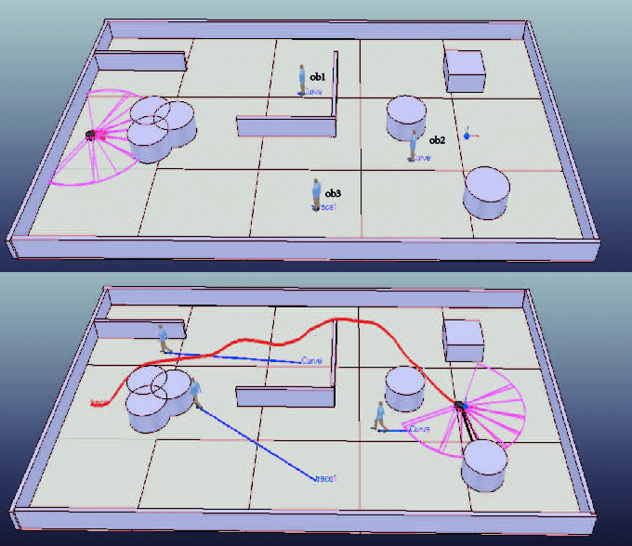
Figure 2.1: Learning based path planning in Grid Evironment

Adaptability to Varying Power Constraints:
One of the paramount challenges in UAV-based CPP missions is managing power constraints, given the limited battery life of small UAVs. The learning-based approach employs end-to-end reinforcement learning (RL) to dynamically adjust the control policy of the UAV based on varying power levels. This adaptability is crucial for missions with unpredictable power consumption patterns and varying mission durations.

Handling No-Fly Zones:
Environments with no-fly zones pose a significant challenge for UAV-based CPP. The learning-based approach excels in addressing this concern by leveraging RL to learn avoidance strategies. Through iterative learning, the UAV can autonomously navigate around restricted areas, ensuring compliance with airspace regulations.

Generalization to Different Environments:
One of the strengths of the learning-based approach lies in its ability to generalize across different environments. By training on diverse datasets and employing convolutional network layers, the agent gains the capability to adapt to varying terrains, structures, and obstacles. This reduces the need for manual adjustments or reconfiguration when transitioning between different mission scenarios.

Training Data Requirement:
It is worth noting that learning-based methods often demand a substantial amount of training data to effectively learn control policies. The process of data collection and labeling can be resource-intensive, particularly in scenarios where real-world data collection is challenging. However, once the model is trained, it can be applied to various missions with similar environmental characteristics.

Computational Demands:
Training a deep reinforcement learning model, such as the double deep Q-network (DDQN), can be computationally demanding, especially with complex environments and large state spaces. However, during execution, the trained model typically operates efficiently, making real-time decisions based on the learned control policy.

Deterministic Behavior:
The learning-based approach may exhibit stochastic behavior due to the nature of reinforcement learning. The agent learns from experience and may explore different strategies, which can lead to adaptive decision-making. While this adaptability is advantageous in dynamic environments, it may introduce some level of unpredictability in mission execution.

Application Flexibility:
The proposed learning-based method showcases versatility in its application. It can be effectively applied to a wide variety of environments, accommodating complex goal structures and system constraints. This flexibility makes it a promising candidate for a range of CPP missions, from urban environments with intricate layouts to natural landscapes with irregular topographies.

Response to Technology Advancements:
Learning-based methods have the potential to benefit from advancements in machine learning algorithms and computational power. Ongoing research and technological progress in the field of deep reinforcement learning can lead to continuous improvements in the performance and adaptability of the approach.

Non-Learning-Based Approach
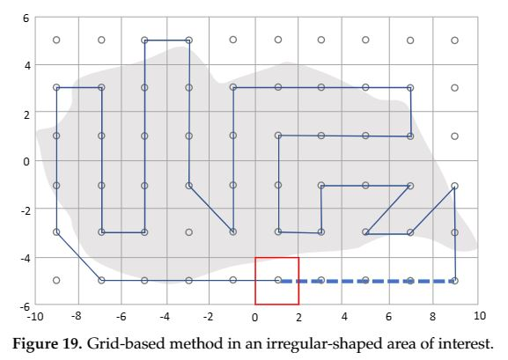
Figure 2.2: Non-Learning based path planning

Deterministic Behavior:
Non-learning-based methods, rooted in predefined algorithms and heuristics, exhibit deterministic behavior. They follow structured procedures based on established rules, leading to predictable mission execution. This determinism can be advantageous in scenarios where a high level of certainty is required.

Potentially Lower Computational Demands:
Compared to learning-based methods, non-learning-based approaches may be less computationally intensive. They rely on algorithmic calculations that do not involve the extensive training and optimization processes associated with deep learning models. This can lead to more efficient execution, particularly in resource-constrained environments.

Limited Adaptability:
Non-learning-based methods may face challenges in adapting to dynamic or unpredictable changes in the environment. They rely on predefined algorithms and heuristics, which may not account for sudden shifts in mission parameters or unforeseen obstacles. This limited adaptability can be a drawback in highly variable environments.

Generalization to Different Environments:
Non-learning-based methods may require manual adjustment or reconfiguration when applied to different environments. The efficacy of these approaches may be contingent on the specific characteristics and layout of the mission area. As a result, they may not generalize as effectively across diverse scenarios as learning-based methods.

Handling No-Fly Zones:
In environments with no-fly zones, non-learning-based methods may not inherently address this concern. Specialized rule-based implementations or additional modules may be required to ensure compliance with airspace regulations. This introduces an additional layer of complexity in mission planning and execution.

Conclusion for comparison
In conclusion, the choice between learning-based and non-learning-based approaches for Coverage Path Planning (CPP) depends on various factors, including the specific requirements of the mission, the availability of training data, computational resources, and the dynamic nature of the environment. Learning-based approaches excel in adaptability, handling complex scenarios, and compliance with constraints such as power limitations and no-fly zones. However, they require substantial training data and computational resources. Non-learning-based methods offer deterministic behavior and potentially lower computational demands, making them suitable for scenarios with well-defined parameters. However, they may require manual adjustments for different environments and may be less adaptable to dynamic changes. A hybrid approach, leveraging the strengths of both methods, could also be explored to achieve a balanced solution for CPP missions.

Summary of Chapter 2
In this chapter, we thoroughly examined what other experts have discovered about guiding unmanned aerial vehicles (UAVs) through obstacle-filled environments. We looked at various research papers and condensed their main points for a clearer understanding. Additionally, we compared two major approaches: learning-based methods and non-learning-based methods. This chapter provides a strong foundation for our own research by building on the knowledge gathered from previous studies. It helps us see where our work fits into the broader landscape of UAV navigation.

CHAPTER 3

METHODOLOGY

To complete this research the methodology used is divided into 10 steps – Literature review, research gape and problem statement, Algorithm design, proof and concept, and Results and Evaluations
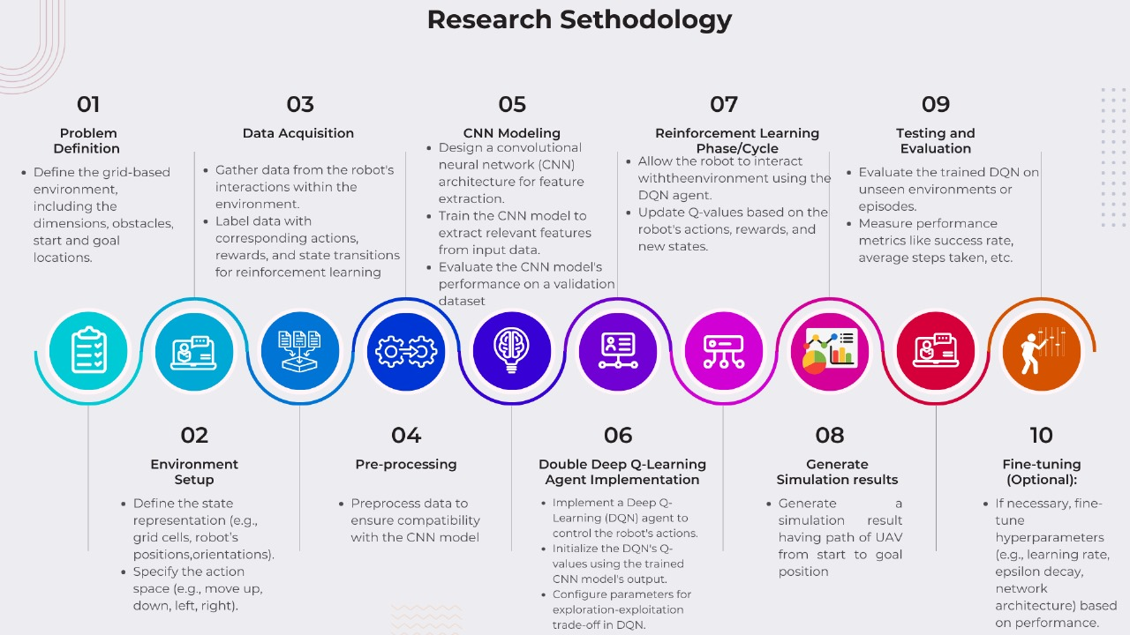

Figure 3.1: Methadology Diagram

Model Design:
There are many techniques to adapt for building a system for UAV navigation. In this phase, an model has devised based on end-to-end Reinforcement Learning.
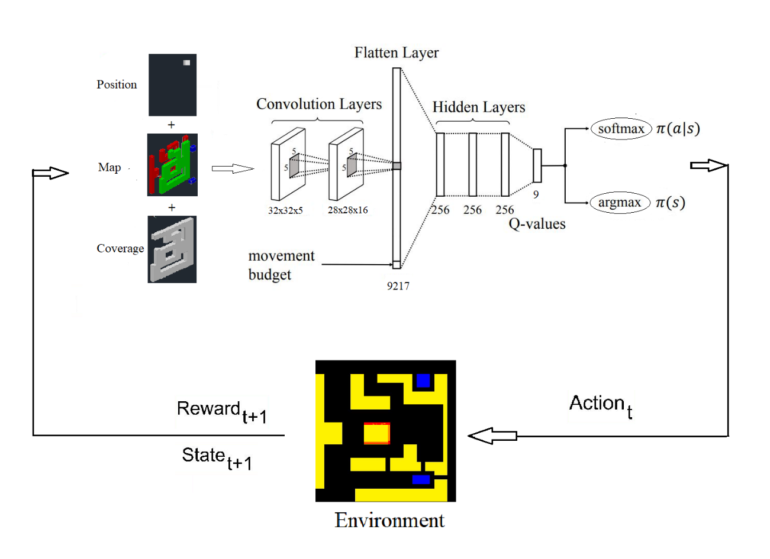
Figure 3.2: Model Architecture Diagram

Convolutional Layers:
In this model there are 2 convolution layers, the first layer size is 32x32x5 and the second layer is 28x28x16. Both layers are extracting the features from 32x32 pixel of image. First layer will extract features from 3D tensor, it means a width of 32pixel, height of 32pixel and 5 channels. Output of first layer will be input of second layer and extract 16 features. Second layer output will be used in the process to classifying image. The filter size is 5x5 in this case.
In the first convolution layer, there are 16 filters of size 5x5. The feature maps are extracted from the filters convolved with the image of a map. After that, these features are passed by an activation function called ReLU (rectified linear unit).
In the second convolution layer 16 filters will be applied, these 16 filters convolved with feature maps of out of first layer, for producing new features map. Then ReLU function will applied on this.

Flatten Layer:
The second layer output values are following into flatten layer. Flatten layer is used to convert the 2-dimensional features map which are produced by convolution layers into 1-dimensional vector.

Hidden Layers:
There are 3three hidden layers size of 256 neurons. These hidden layers are fully connected. To activate the neuron function in these layers ReLU activation function is used.

Output Layer:
In the final layer, there are five nodes which are the possible actions in the sense of q-values for the environment.

Experience Replay Memory:
ERM is a method used for improving and stabilizing the learning efficiency of reinforcement learning. Rather than experiences are stored in direction the occur, experience replay buffer store the experiences and sampled after shuffling during the training. This technique disassociates the sequential experiences and enhance the learning stability.

Training Process:

Initialization:
First of all the model parameters and structure of neural network are initialized, replay memory size and ratio also specified.

Interaction with the Environment:
The agent takes an action and gets a state, through this way the agent will interact with the environment. During this circle of interaction an experience will generate in a form of the tuple (state, action, reward, next_state).

Adding Experiences to Replay Memory:
In the replay memory buffer, these Experiences are stored far ahead of the training of the network. To filling the ezperiences into replay memory parameter to filling will be set.

Sampling from Replay Memory:
During the model training, these experiences are sampled aimlessly from replay memory.

Forward Pass:
After getting the sample of experiences from replay memory these are passes through neural network, which calculate the Q-values for every action in the action space.

Double Q-Learning:
- Double deep Q-Learning based on two separate neural networks, first network is called online network and the second is called target network
- The purpose of using these two network is to moderate the overestimation biasness

Loss Computation and backpropagation:
- During training, the loss value is calculated among the predicted Q-values and the target Q-vlaues with the help of Bellmon equation
- This loss value is used in the backpropagation for the updating of weights of neural network

Iterative Training:
- All of the above steps will be repeated up to a prementioned number of iterations, this way the Q-values estimation will improving gradually

Policy Improvement
- After the predicting of more accurate Q-values, the actions are selected in the environment based on these

Proof of concepts:

Problem Formulation:

Setup
A reinforcement learning agent founding inputs from the UAV sensors are depicted in Figure.3. The camera and GPS receiver are key elements of the input, and other external factors are Map, Movement steps. The camera uses to capture the current coverage view through periodic frames, while the GPS produces the current position of the UAV. The power constraints described as Movement steps are an external factor that is fixed at the start of the mission. The Map component is an environment that could be provided by the ground operator. Although this Map could be dynamic throughout the mission, we focus on static maps for the purpose of our experiments. UAV had two additional software components called ‘mission algorithm’ and ‘safety controller’. Camera images are analyzed by the mission algorithm to verify whether the area is already covered or not. The safety controller is responsible for accepting or rejecting the action based on safety constraints (entering into NFZ/obstacle or landing on an unsuitable area), that actions were proposed by the agent. Remember that the Safety controller is not a supporting component to find the landing area.

Channels Map
This problem is to be solved on a two-dimensional grid map and represented by three channels. Each cell of a two-dimensional grid is an area in square meters. five channels label with starting and landing zones, no-fly zones, and target zones. The start and landing zones that areas where an agent can start flying and land after completion of the coverage path. No-fly zones are areas where all UAVs are prohibited from flying over there. Target zones represent areas that the UAV has to fly over and covered at least one time by the field of view (FoV) of the camera. Note that a cell could be labeled with more than one zones or none of these, but it is not possible at the same time to start and landing zones will be no-fly zones.

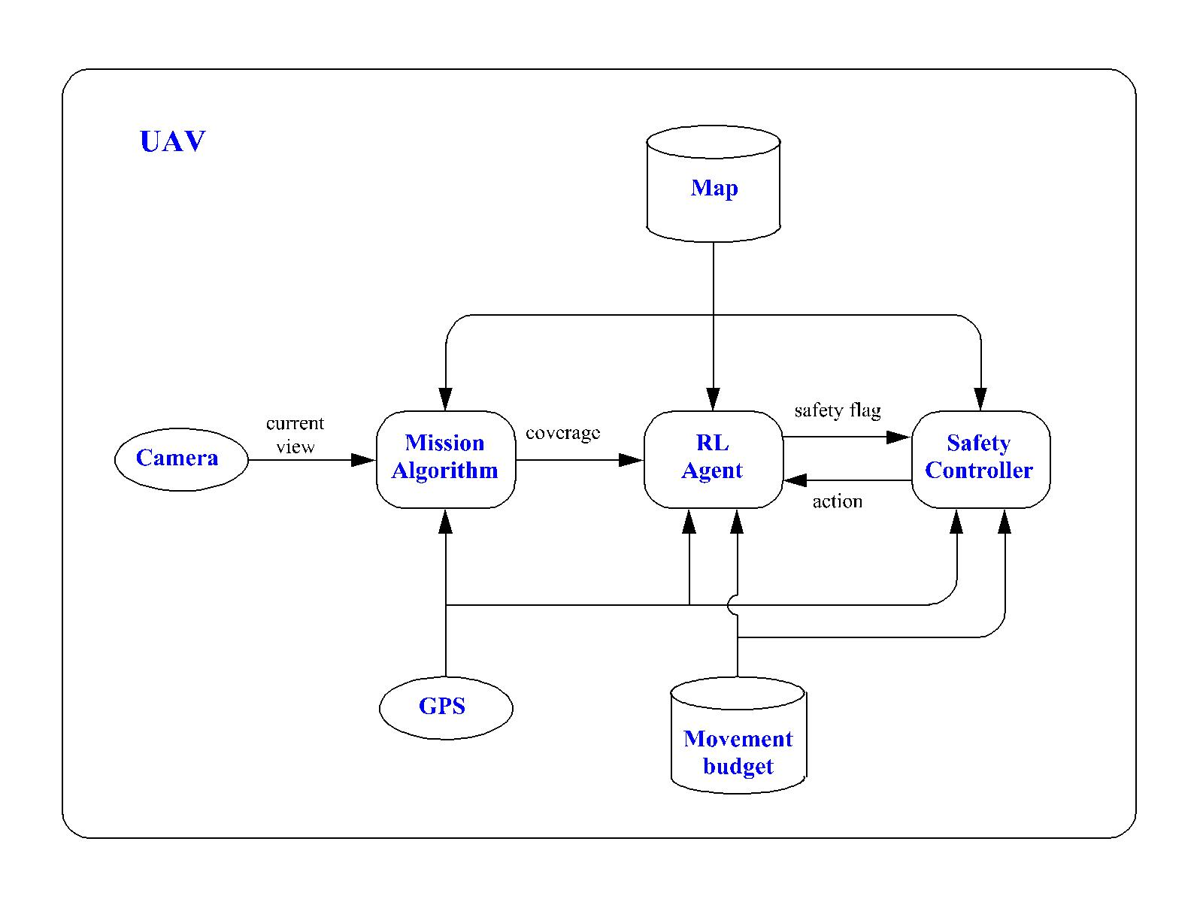
Figure 3.1: System Level Diagram showing the software and sensor components together on the UAV.

Markov Decision Process
It is appropriate to resolve the defined problem with reinforcement learning, the first step is to convert it into a Markov decision process (MDP). An MDP is characterized through a quadruple (S, A, R, P), where S stands for a set of all imaginable states, A represents the set of possible actions in the given state, R is the reward function, and P means a function of state transition probability distribution $P:S ×A →S$.
In a $N ×N$ grid of the state space S can be represented as :
$S = { M}^{N × N × 3 } × M^{N × N} × R × B × F$
$M$ is a Boolean value {0,1}
$M^{N × N × 3 }$: Environment Map
$M^{N × N }$: Coverage Area Map
$B$ : Movement Budget
$F$ : Safety Flag
$R$: Reward = State x Action
$R$ mapped the current state $s∈S$ to a possible action $a∈A$ to a real-valued reward, that consists of multiple gears
$R :\{r_{cov} , r_{sc} , r_{mov} , r_{crash} \}$
- $r_{cov}$ is a positive coverage reward, received after coverage of the target cell by the UAV field of view for the first time.
- $r_{sc}$ is a negative reward, if the safety controller (sc) rejects the action proposed by an agent.
- $r_{mov}$ is a negative reward, this is a continuous penalty applied for every step of movement budged of UAV.
- $r_{crash}$ is a negative reward, this reward is charged if the movement budget will expire but UAV does not land, or UAV does not land on pre-decided landing locations.
There are nine actions in action space $A$
$A$ = {North, North-East, North-West, South, East, South-East, South-West, west, land}

Q-Learning:
In general, Reinforcement Learning is a cycle of having iterations between agents and their environment. An agent gets a state $s_{t}∈S$ from the environment, the agent receives a reward $r(s_{t}, a_{t}∈R)$ after executing an action $a_{t}∈A$.
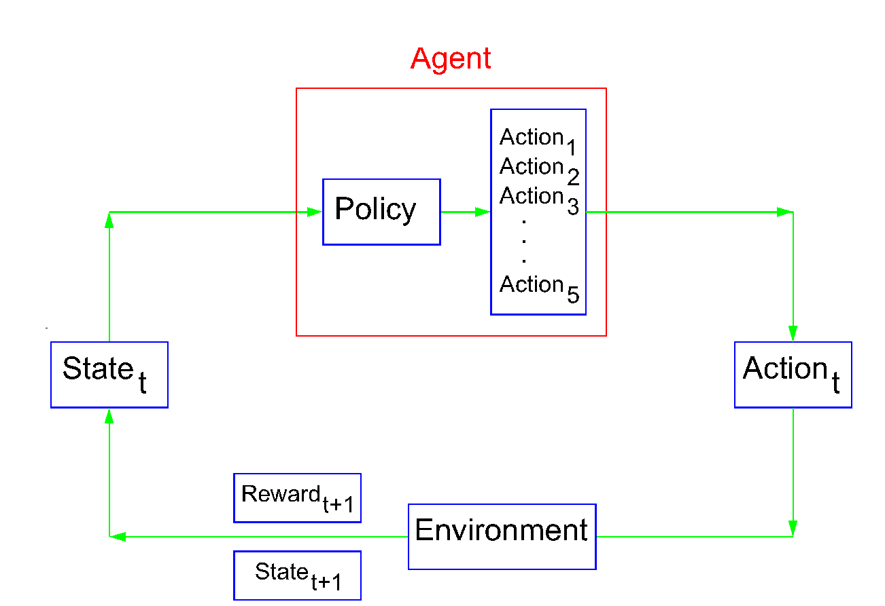
Figure 3.4: MDP RL Model

The time index t is incremented after every action and the environment gives a new state $s_{t+1}$ to the agent. Here is a new cycle of RL restart. Ultimately the final goal of an agent is to maximize the cumulative reward $R_{t}$ from the start state to the end/terminal state.
$R_{t}=\sum_{k=t}^{T}{γ^{k-t}r(s^{k}, a^{k})}$ (1)
$γ$ is a discount factor that incorporates short-term reward into long-term reward. To make rewards maximize we use behavioral policy $π$. The policy can be non-deterministic/probabilistic $π(a|s)$ such that $π :S × A →R,$ probability distribution yields a selection of random action from action space $A$ over each state $s∈S .$ The deterministic $π(s)$ policy selects a predetermined action in each state that has a maximum cumulative reward.
A policy that yields maximum cumulative reward can be made through Q-Learning.
Q-Learning is a model-free Reinforcement-Learning approach that learns a state-action-value function. It is constructed on a function of state-action-value, also called a Q-function $Q :S × A →R.$It is given as
$Q^{π} \left(s,a\right)=E_{π} \left(R_{t} \right| s_{t}=s, a_{t}=a)$ (2)
Q-Learning is based on updating the value of the Q-function iteratively. We tried to find the optimal Q-function for the sake of optimal policy. If we find an optimal policy, it is easy to choose actions that maximize Q-function. For ease, $s_{t} and a_{t}$ are condensed as $s and a$ , while $s_{t+1} and a_{t+1}$ will be titled as $s^{'}and a^{'}.$

Deep Q-Learning
In the introduction of Q-Learning, A table of Q-values is used to represent the Q-function having the size of ($States × Actions).$ It is not viable to maintain a table in the case of a large state or action space, But it can be feasible to generalize the Q-Funtion by the neural network. A deep Q-Network with the parameter vector $θ$ is configuring the Q-Function, it is trained to minimize the temporal difference (TD) error.
$L \left(θ\right)=E_{π} [{( Q_{θ}\left(s, a\right)-Y\left(s, a, s^{'}\right))}^{2}$ (3)
The target value function is:
$Y\left(s, a, s^{'}\right)=r\left(s, a\right)+γ \max_{a'} Q_{θ}(s^{'}, a^{'})$ (4)
A DQN is more data-efficient as compared to a Q-table because DQN can generalize well. Bootstrapping and off-policy training makes the training of an agent unstable and diverted. In [30] proposed an approach to DQN learning in a stabilized way. They used an experience replay memory $D$in the training process, this memory stores the experience tuples $\left(s, a, r, s^{'}\right)$, which receive from each iteration with the environment by an agent. The agent training on replay memory of uniformly sampled batches decorrelates the distinct samples,
Now TD-error is written as:
${L }^{DQN}\left(θ\right)=E_{s, a, s'}\sim D [{( Q_{θ}\left(s, a\right)-Y\left(s, a, s^{'}\right))}^{2}$ (5)
Moreover, Minh el al, proposed a separate target network, which approximates the next maximum Q-Value for changing to the target value
$Y^{DQN}\left(s, a, s^{'}\right)=r\left(s, a\right)+γ \max_{a'} Q_{θ`}(s^{'}, a^{'})$ (6)
$θ`$ is a target network parameter. Usually the target network parameter $θ`$ is updated periodically with the hard copy of $θ$
The success of DQN methods is based on replay memory and a separate target network, which enhance the stabilizing of the training process.
A further improvement was presented by [31] under cerian circumstances action values were overestimated. To overcome this situation the researcher proposed a double deep Q-Networkv(DDQN). Now target value is given as
$Y^{DDQN}\left(s, a, s^{'}\right)=r\left(s, a\right)+γ Q_{θ`}(s^{'}, {{argmaxQ_{θ}}_{a}(s^{'}, a}^{'}))$ (7)
The equivalent Loss Function is:
${L }^{DDQN}\left(θ\right)=E_{s, a, s'}\sim D [{\left( Q_{θ}\left(s, a\right)-Y^{DDQN}\left(s, a, s^{'}\right)\right)}^{2}]$ (8)
Hence the best action is selected based on $θ$ to reduce the overestimation of action values, while the value of that action is estimated using $θ`$ .

Neural Network Model and Training Procedure:
The DQN has solved more precisely the MDP from problem formulation, DQN is comprised of convolutional layers and fully connected layers. All of these are represented in Figure 3.2 . For research purposes, the UAV position is figured out into a 2-dimensional (X, Y) space. The altitude of a UAV can be a fixed dimension. The coverage cell of the whole grid also represented in a new layer. In this manner, the individual entity has a separate layer. The map consists of 3 layers, while performing our main operation the convolutional layer of DDQN takes a five-channel input. The filter of the convolutional layer makes spatial connections among the present position and surrounding cells. Afterward the convolutional layers the movement budget is considered in the flatten layer.
To preserve the input shape into the output padding is added into the convolutional layer. The padding of zeros is added in every channel, except the no-fly-zone channel which is in the first layer is padded with ones. The reason is to make an explicit depiction of no-fly-zone cells in the grid. The activation function of the convolutional layer is chosen as the rectifier linear unit (ReLU). To map the convolutional layers output to the hidden layer a flatten layer comes with the addition of movement budged. The hidden layer or fully connected layers of this network are involved in the flatten layer with ReLU activation function.
The latest hidden layer of this network has the size of $|A|$ and the activation function will be not in it. This layer reflects the actual Q-values corresponding to each action which is in the input state. The purpose of the argmax function to Q-values is to exploit previously learned knowledge. This is called greedy policy. Given as
$π\left(s\right)= {argmax }_{a∈A} Qθ(s, a)$ (9)
The greedy policy is deterministic and is used when we have evaluate to the learning progress of an agent. For the sake of exploration during the training process of an agent in a state and action space, a softmax function is used.
$π\left(a_{i} | s\right)= \frac{e^{Qθ(s,ai)/β }}{\sum_{∀aj∈A}{e^{Qθ(s,ai)/β }}}$ (10)
It comes with a temperature parameter $β ∈R$ which scales the balancing of exploration vs exploitation. The greedy policy (9) would be a limit of β → 0 approaches to zero. In this case, a softmax policy is preferred over the greedy policy because it offers a variable for exploration grounded on the relative change in the Q-values. It does not based on episode records and numbers of the training steps. In this problem, it gives the impression to be useful.

ALGORITHM 1

- Initialize reply memory buffer $(D)$, initialize θ randomly
- for $n=0$to $N_{max}$ do
- Initialize state $s_{0}$ with a random starting position and movement budged $b_{0}$ from$B$
- while b > 0 and not landed do
- Sample an according to equation (10)
- Perceive $r, s'$
- Stock $(s, a$, r, s’) in $D$
- for $i=1$ to $m$ do
- Sample get $(s_{i}, a_{i}, s_{i}, s_{i}^{'})$ from $D$
- $Y_{i}=\left\{\begin{aligned}r_{i} , &if {s'}_{i} \\ according to (7), &othervise\end{aligned}\right.$
- Calculate loss $L_{i}\left(θ\right)$ rendering to equation (8)
- end for
- bring up-to-date $θ$ with gradient loss $\frac{1}{m}\sum_{i=1}^{m}{L_{i}(θ)}$
- Soft apprise of $\overline{θ}$ according to (6)
- $b=b-1$
- end while
- end for

Algorithm 1 represents the whole procedure of the double-deep Q-Network in wide vision. First of all, a replay memory buffer is initialized, then network parameters are initialized. A new training episode is started with the new state and random position of the UAV in the environment grid. It also chose the random movement budget $b_{0}=B$. While the UAV is not landed or the movement budged is ended, the episode will be continued in the learning way. A new action is to be taken based on equation no 10. Consequently, the new experiences will be stored in a replay memory buffer $D$. From the replay memory buffer, a minibatch of m number of experiences randomly is selected. Then an Adam optimizer is used to legalize the values of the primary network parameter $θ$ in the sense of reducing the loss function. Adam optimizer is a well-known algorithm for the use of parameter optimization in deep learning networks. Afterward, the soft update in equation (7) is updating $\overline{θ}$parameter of the target network. A movement budget is also decremented. The episode will continue while the movement budget has not expired or the UAV has not landed. The agent takes the next episode through less than the maximum number of episodes $N_{max}$. The hyperparameters of this network are enlisted in Table 1.
This algorithm is implemented in TensorFlow, the deep Q-Network is trained as a primary object with Adam optimizer. Adam optimizer is used to train the neural network optimally, fast convergence, and to handle noisy gradients.
The computer with Nvidia GeForce 4GB GPU is used as hardware for training.

Environment:
The city environment maps Manhattan, Downtown and narrow-town. All these maps saved information as .png image file format, where one pixel is representing one ccell of grid world. The color of pixel is expressing the kind of cell following as:
- Red #ff0000 rgb(256,0,0) is no-fly zone (NFZ)
- Green #00ff00 rgb(0,256,0) is target zone
- Blue #0000ff rgb(0,0,256) is start and landing zones
- Yellow #ffff00 rgb(256,256,0)
The shadow map is a .npy (numpy array) file, which store the information of each cell whether it is in the non-line-of-site (NLoS) or the line-of-site (LoS). It is computed automatically on new map coming first time. Later on it will be used to determine which cells have the field-of-view of the camera.

Results:
A powerful tool for analyzing the effectiveness of reinforcement learning (RL) agents under difficult environments is the Monte Carlo (MC) simulation. In order to simulate an agent's behavior and evaluate its performance, MC simulation randomly selects states and behaviors from the surrounding area. To obtain a valid statistical estimate of the agent's performance, this process is done multiple times.
The model is tested on various possible environment states, and a number of episodes is investigated. MC main duties include of evaluating and analyzing the results of these investigations. It will make it easier to load pre-trained agent weights, allowing for the evaluation of their success in a simulated environment. We compute important metrics over 1000 random samples using TensorBoard event files, which involve LR (Landing Ratio), CR (coverage ratio), CRAL (coverage ratio and landed).

Map 1: Environment cluttered with structured obstacles

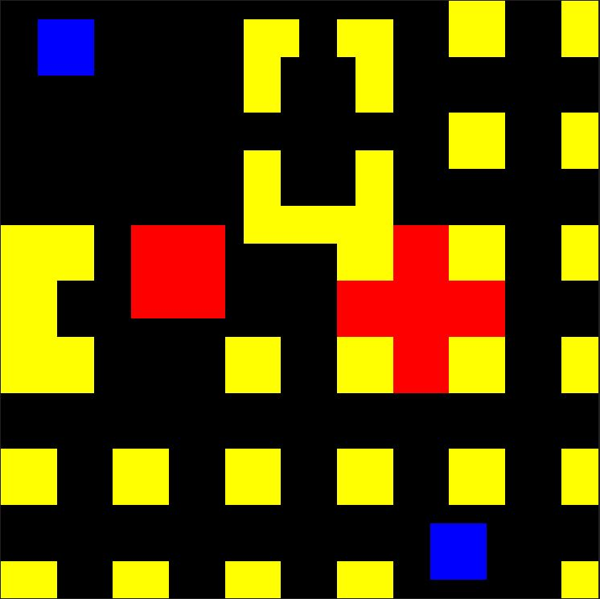

Figure 3.2: Map 1: Environment cluttered with structured obstacles

This is a 32 x32 pixel map named as cluttered with structured obstacles. The blue collor area pixels represents Start or Landing zones. Yellow collor pixels are obstacles. Red color pixels is no-fly-zone. And the black color area can be free space or target area

Map 2:Environment cluttered with un-structured obstacles

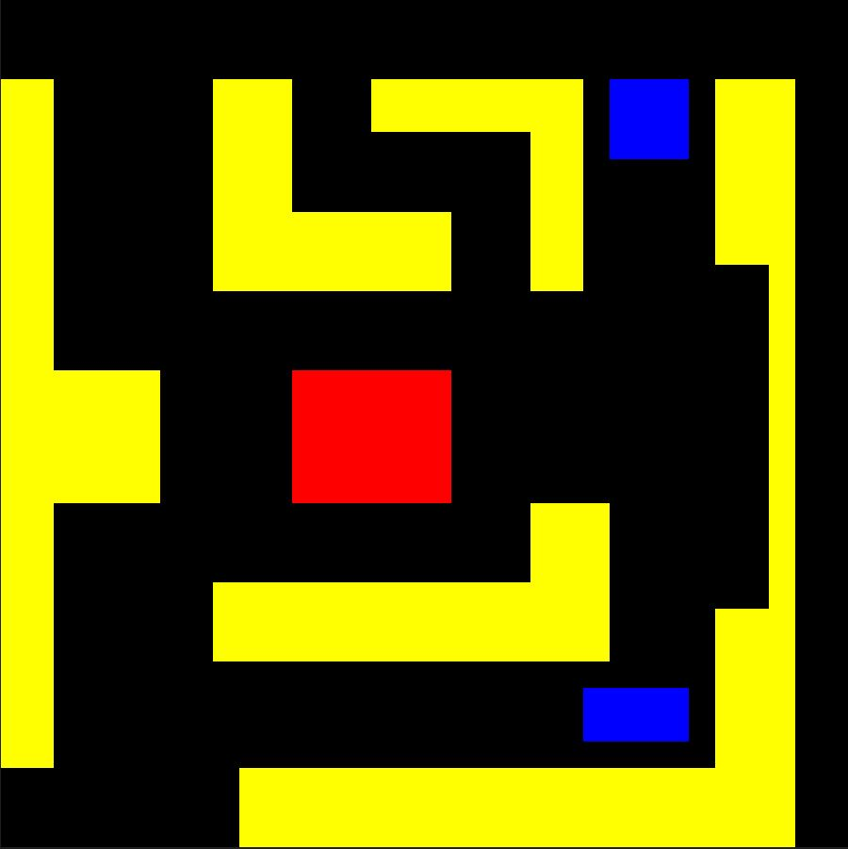

Figure 3.3: Map 2: Environment cluttered with un-structured obstacles

This map, dubbed cluttered with un-structured obstacles, has 32 by 32 pixels. Start or landing zones are represented by the blue color region pixels. Obstacles are indicated by yellow color pixels. A red pixel indicates a no-fly zone. Moreover, the area colored black may be a target or open space.

Map 2: Environment with narrow passage obstacles

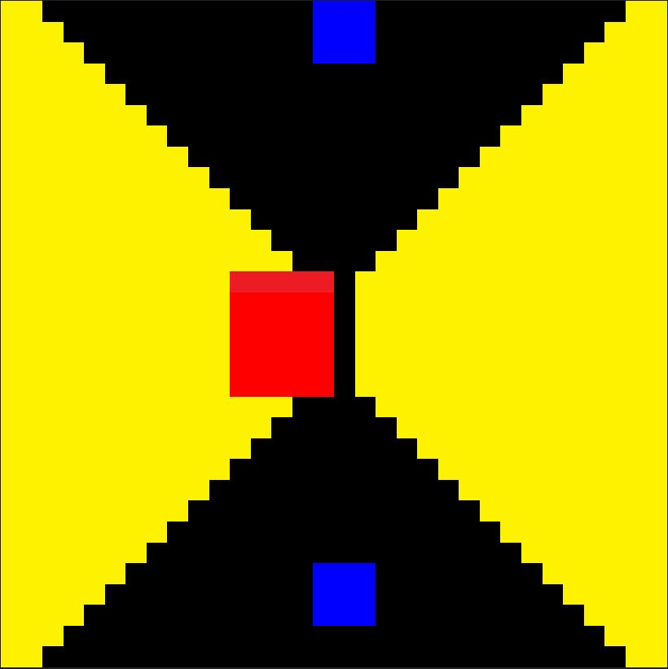

Figure 3.4: Map 3: Environment with narrow passage obstacles

This map called narrow-passage, has 32 by 32 pixels. Start or landing zones are denoted by region pixels with a blue color. Pixels areas that are colored yellow represent obstacles. A no-fly zone is indicated with a red pixel. Furthermore, the black-colored region can be an open area or a target area.

Summary of Chapter 3:
In this chapter, we outlined the step-by-step plan we'll follow for guiding unmanned aerial vehicles (UAVs) in environments with obstacles. We provided a clear diagram to illustrate our approach. We also designed a specialized model using Convolutional Neural Networks (CNN) and a Double Deep Q Network. To ensure our method works, we conducted a proof of concept. We outlined the specific algorithm we'll use and carefully designed the environment where our UAV will navigate. This chapter lays the groundwork for the practical implementation of our approach.

CHAPTER 4

RESULTS AND DISCUSSION

First Experiment:
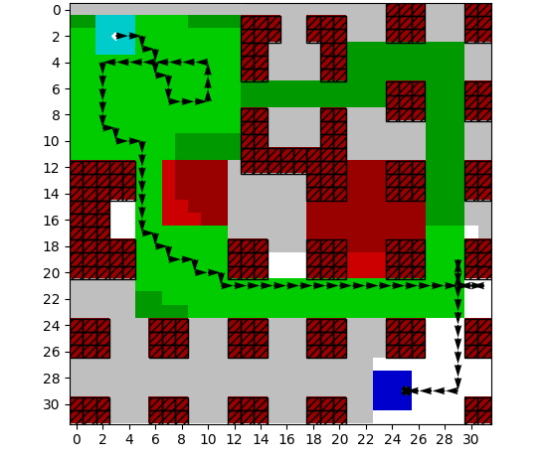
Figure 4.1: Map 1 87/100 movement
In this simulation the green color pixels are the target areas. The UAV started fly from upper left blue region with a fixed altitude . The red color areas represent static obstacles or no-fly-zone. The UAV finds the path aiming to cover maximum targetd area using optimum policy, then lands on the nearest landing position within Battery energy constraint. The UAV utilize the battery energy / movement budget 87 out of 100. The target area ratio was 35%.

Second Experiment:
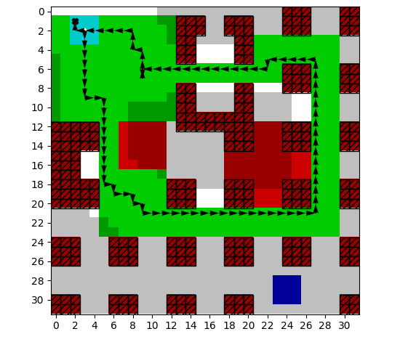
Figure 4.2: Map 1 92/150 movement

In this simulation result the green color pixels are the target areas. The UAV started fly from upper left blue region with a fixed altitude and landed on the same location. The red color areas represent static obstacles or no-fly-zone. The UAV finds the path intelligently aiming to cover maximum targetd area using optimum policy within Battery energy constraint. The UAV utilize the battery energy / movement budget 92 out of 150. The target area ratio was 35%.

Third Experiment:
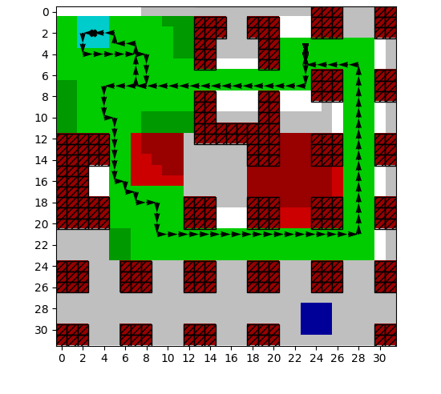
Figure 4.3: Map 1 107/200 movement

In this simulation result the green color pixels are the target areas. The UAV started fly from upper left blue region with a fixed altitude and landed on the same location. The red color areas represent static obstacles or no-fly-zone. The UAV finds the path wisely aiming to cover maximum targetd area using optimum policy within Battery energy constraint. The UAV utilize the battery energy / movement budget 107 out of 200. The target area ratio was 35%.

Fourth Experiment:
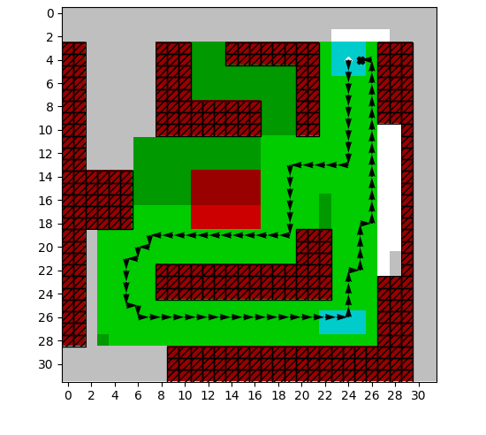
Figure 4.4: Map 2 85/100 movement

In this simulation result the green color pixels are the target areas. The UAV started fly from upper right blue region with a fixed altitude and landed on the same location passing over right below landing position . The red color areas represent static obstacles or no-fly-zone. The UAV finds the path aiming to cover maximum targetd area using optimum policy within battery constraint. The UAV utilize the movement budget 85 out of 100. The target area ratio with respect to total area was 39%.

Fifth Experiment:
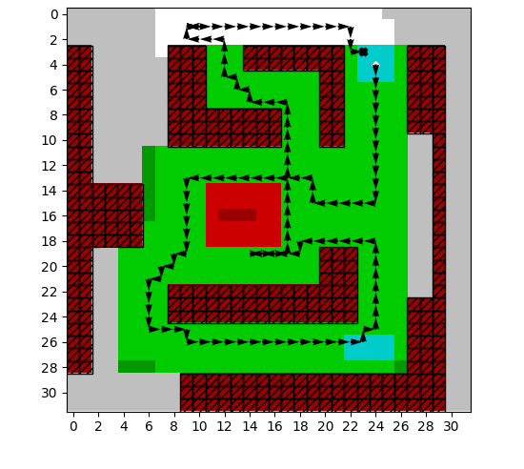
Figure 4.5: Map 2 128/140 movement

The target areas in this simulation result are the green-colored pixels. The UAV began flying at a set altitude from the upper right blue region and landed at the same spot. The no-fly zones or obstacles are shown by the red pixels. The UAV determines the best course while keeping battery constraints in mind, with the goal of covering the most target area. 128 out of 140 of the movement budget is used by the UAV. The percentage of the target area to the entire area was 39%.

Sixth Experiment:
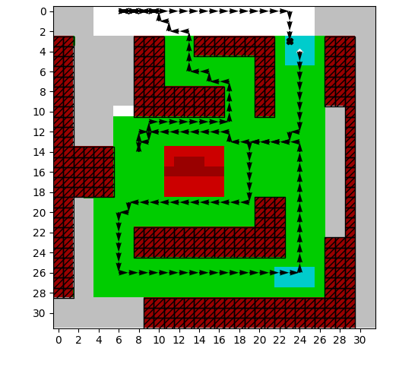
Figure 4:6: Map 2 144/200 movement

The target areas in this simulation result are the green-colored pixels. The UAV began flying at a set altitude from the upper right blue region and landed at the same spot after complete covering the targeted area. The no-fly zones or obstacles are shown by the red pixels. The UAV determines the best course while keeping battery constraints in mind, with the goal of covering the most target area. 144 out of 200 of the movement budget is used by the UAV. The percentage of the target area to the entire area was 39%.

Seventh Experiment:
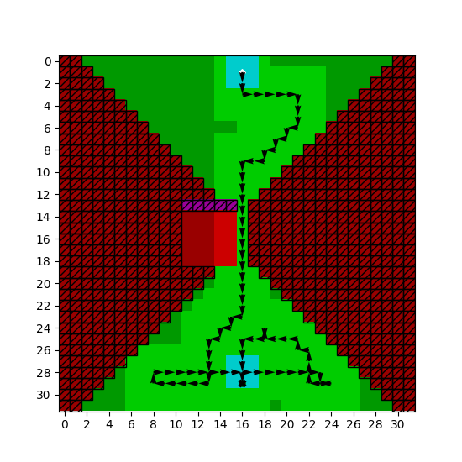
Figure 4.7: Map 3 83/100 movement

In this simulation result the green color pixels are the target areas. The UAV started fly from upper middle blue region with a fixed altitude. After fully circling the intended area and passing through a narrow path, UAV landed on the bottom middle blue portion which shows the landing location. The red color areas represent static obstacles or no-fly-zone. The UAV finds the path intelligently aiming to cover maximum targetd area using optimum policy within Battery energy constraint. The UAV exploit the battery energy / movement budget 83 out of 100. The target area ratio was 35%.

Eighth Experiment:
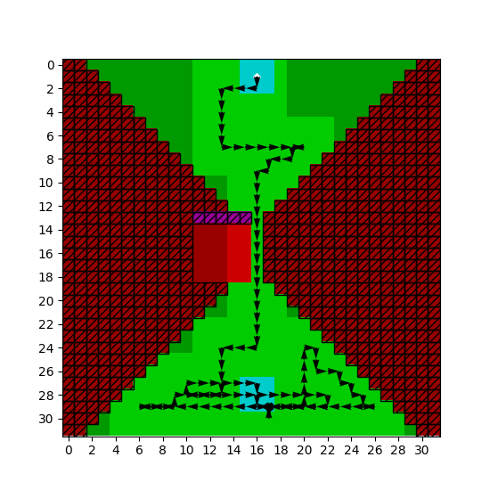
Figure 4.8: Map 3 120/140 movement

The green-colored pixels in this simulation result are the target areas. After fully circling the intended area and passing through a narrow path, the UAV fly to a predetermined altitude and landed in bottom middle blue zone. The red pixels indicate no-fly zones or obstructions. The UAV seeks to cover the maximum target area by calculating the best flight path while taking battery limitations into consideration. The UAV uses 120 of the 140 available movement budget. 41% of the total area was made up of the target area.

Ninth Experiment:
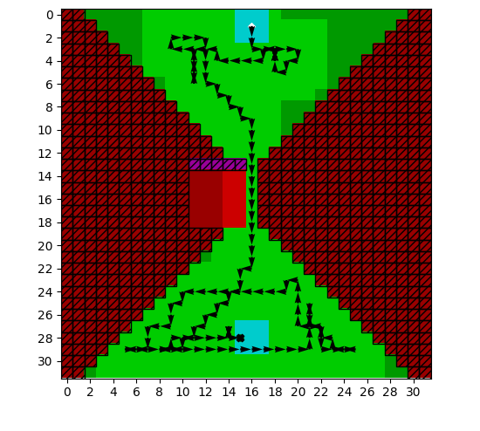
Figure 4.9: Map 3 157/200 movement
The target areas in this simulation result are the green-colored pixels. The UAV lands in the bottom center blue zone after completely circling the targeted area and flying to a predefined height. Obstacles or no-fly zones are indicated by the red pixels. The UAV determines the optimal flight path while accounting for battery constraints in order to cover the largest possible target area. Out of the 200 movement budget available, the UAV uses 157 of them. The target area accounted for 41% of the overall area. In this type of map UAV not succeed to cover the fully intented area.

Table 4.1: Parametrs Values:

Parameter | Description | Value
$$n_{c}$$ | Number of Convolutional layers | 2 Nos
$$s_{k}$$ | Convolutional kernel size | 5x5
$$n_{k}$$ | Number of convolutional kernels | 16 No
$$n_{h}$$ | Number of hidden layers | 3 No
$$s_{h}$$ | Hidden layer size | 256 Node
$$|θ|$$ | Trainable parameters quantity | 2492677 Nos
$$|D|$$ | Magnitude of replay memory buffer | 50000
$$m$$ | Size of minibatch | 128
$$N_{max}$$ | Number of maximum episodes | 10000
$$γ$$ | Discount factor | 0.95
$$β$$ | Temperature parameter | 0.1
$$τ$$ | Target network update factor | 0.005
$$α$$ | Learning rate (alpha) | 0.00003
$$ε$$ | Exploration vs Exploitation | 5
 | Prefill ratio of Replay memory | 50%
 | Activation function | ReLU
 | Number of Steps | 1000000
 | Episode Length | 50-200 steps

The safety controller accepts the action command $a∈A$ by the agent. Then the agent moves in 2-dimensional map. In every action of an agent one unit of movement budged will decrease, although the safety controller accepted or rejected the actions. The reason is the battery energy is consumed even on hovering.

Table 4.2: Rewards for Double Deep Q-Network
Description | Reward
Cell Covered Reward | +2.0
Boundary Penalty | -1.0
Empty Battery Penalty | -150.0
Movement Penalty | -0.2
Cell multiplier Penalty | -0.4

Action Space:
There are nine actions in this action space, North, North-East, North-West, South, South-East, South-West, East, West, and Land. In [6] the actions was five (up, right, down, left, land).

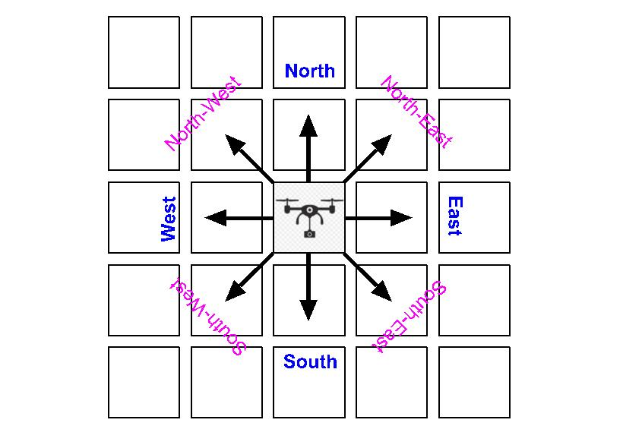

Figure 4.10: Action space

Table 4.3: Performance Matrics are calculated over 1000 random scenario Monte Carlo iterations

Evaluation Metrics | Proposed | DDQN
Landing Ratio | 99% | 98.5
Coverage Ratio | 75% | 72%
Coverage Ratio and Landed | 74% | 70%
Battery / Movement Average | 83 steps | 85 steps

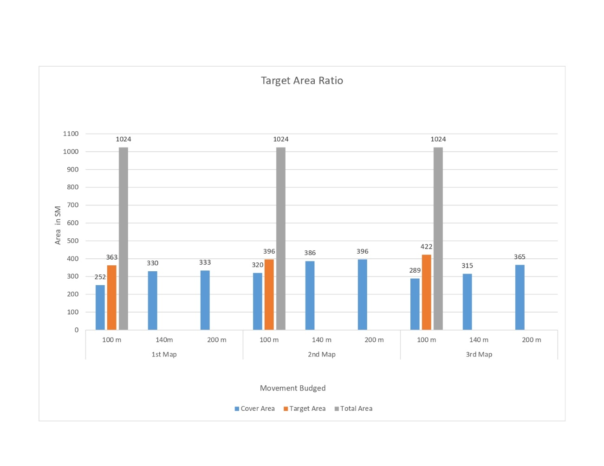
Figure 4.11: Target area ratio chart for three different challenges maps with varying movement budgets and targeted areas
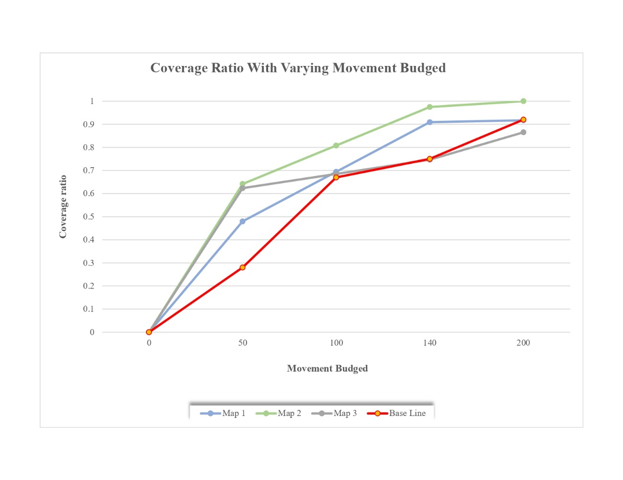
Figure 4.12: Coverage ratio chart for three different challenges maps with movement budgets from 0 to 200 movements.

Summary of Chapter 4:
In this chapter, we conducted nine different experiments to test our method for guiding unmanned aerial vehicles (UAVs) through obstacle-filled environments. These experiments simulated various scenarios with different levels of available energy for the UAV. We carefully recorded and organized the data, presenting it in clear tables for easy reference. We analyzed key factors such as rewards, action choices, and performance metrics like coverage ratio, successful landings, and average movement steps. Additionally, we illustrated our findings with a chart showing how coverage area ratio changes with different energy budgets. This chapter provides a comprehensive understanding of how well our approach performs under different conditions, giving us valuable insights for further refinement.

CHAPTER 5

CONCLUSION

Main contribution of our study:
In this work, an autonomous UAV navigation task for cover to a specified target area was investigated. The novality is enhancement in coverage ratio, coverage ratio and landing under the minimum UAV energy movement. This autonomous system is mindful of the static obstacles and follows the path in free spaces/streets. In the case of power/energy constraints for UAV navigation, path planning generally is not taken into consideration. The agent perceives the input map through spatial information, the input map was divided into five channels. Using a CNN with a DDQN-based deep RL approach, The UAV calculates the path to fly from random start and landing locations in the available movement budget / Battery time. The environment was map-based and converted into a grid world. I have trained a double-deep-Q network with experience replay to learn a policy to control a UAV for the generalization of different maps with different start-and-landing positions and varying energy constraints. Three maps having unique contests, are experimented with this method and observed incremental learning that effectively balance coverage of the target area and safely land. The Structural changes in [5], [6] CNN with DDQN are done with a number of filters, output-layer size, and parameters. The simulation results validate this approach.

Limitations:
While the presented learning-based path planning approach exhibits significant potential, it is imperative to acknowledge certain inherent limitations. One prominent constraint lies in the significant dependency on extensive training data. Moreover, the computational demands inherent to training deep reinforcement learning models, particularly in complex environments with large datasets, may pose challenges for deployment in scenarios with limited computational resources. Additionally, while the method is designed to generalize over varying power constraints, real-world scenarios may introduce unforeseen challenges or variations not fully captured during training. Additionally, the complexity of the employed CNN architecture may result in limited interpretability, potentially impeding a nuanced understanding of the model's decision-making process. Fine-tuning hyperparameters and architectural choices for the double deep Q-network (DDQN) may also prove to be non-trivial, requiring specialized expertise. Finally, despite advancements in battery technology, the persistent constraint of UAV flight range may continue to impose limitations on mission duration and coverage area. Addressing these limitations will be essential for the method's successful integration into real-world applications.

Future Work:
In future, the same problem will be investigated in different approaches like actor-critic and policy optimization and make experiments in 3D virtual Engines. The real-world map will feed and train this model for learning control policy to navigate in this environment. From there two-dimensional map will be converted into a three-dimensional and the dynamic obstacles also be handled.

REFERENCE

[1] F. AlMahamid and K. Grolinger, “Autonomous Unmanned Aerial Vehicle navigation using Reinforcement Learning: A systematic review,” Engineering Applications of Artificial Intelligence, vol. 115. Elsevier Ltd, Oct. 01, 2022. doi: 10.1016/j.engappai.2022.105321.
[2] R. J. Ruiz, J. L. Saravia, V. H. Andaluz, and J. S. Sánchez, “Virtual Training System for Unmanned Aerial Vehicle Control Teaching–Learning Processes,” Electronics (Switzerland), vol. 11, no. 16, Aug. 2022, doi: 10.3390/electronics11162613.
[3] T. Benarbia and K. Kyamakya, “A literature review of drone-based package delivery logistics systems and their implementation feasibility,” Sustainability (Switzerland), vol. 14, no. 1. MDPI, Jan. 01, 2022. doi: 10.3390/su14010360.
[4] C. Villaseñor, A. A. Gallegos, J. Gomez-Avila, G. López-González, J. D. Rios, and N. Arana-Daniel, “Environment classification for unmanned aerial vehicle using convolutional neural networks,” Applied Sciences (Switzerland), vol. 10, no. 14, Jul. 2020, doi: 10.3390/app10144991.
[5] M. Theile, H. Bayerlein, R. Nai, D. Gesbert, and M. Caccamo, “UAV coverage path planning under varying power constraints using deep reinforcement learning,” in IEEE International Conference on Intelligent Robots and Systems, Institute of Electrical and Electronics Engineers Inc., Oct. 2020, pp. 1444–1449. doi: 10.1109/IROS45743.2020.9340934.
[6] M. Theile, H. Bayerlein, R. Nai, D. Gesbert, and M. Caccamo, “UAV Path Planning using Global and Local Map Information with Deep Reinforcement Learning,” Oct. 2020, doi: 10.1109/ICAR53236.2021.9659413.
[7] T. GUO, N. JIANG, B. LI, X. ZHU, Y. WANG, and W. DU, “UAV navigation in high dynamic environments: A deep reinforcement learning approach,” Chinese Journal of Aeronautics, vol. 34, no. 2, pp. 479–489, Feb. 2021, doi: 10.1016/j.cja.2020.05.011.
[8] R. B. Grando, J. C. De Jesus, and P. L. J. Drews, “Deep Reinforcement Learning for Mapless Navigation of Unmanned Aerial Vehicles,” in 2020 Latin American Robotics Symposium, 2020 Brazilian Symposium on Robotics and 2020 Workshop on Robotics in Education, LARS-SBR-WRE 2020, Institute of Electrical and Electronics Engineers Inc., Nov. 2020. doi: 10.1109/LARS/SBR/WRE51543.2020.9307015.
[9] T. Wang, R. Qin, Y. Chen, H. Snoussi, and C. Choi, “A reinforcement learning approach for UAV target searching and tracking,” Multimed Tools Appl, vol. 78, no. 4, pp. 4347–4364, Feb. 2019, doi: 10.1007/s11042-018-5739-5.
[10] Y. Yang, K. Zhang, D. Liu, and H. Song, “Autonomous UAV navigation in dynamic environments with double deep Q-networks,” in AIAA/IEEE Digital Avionics Systems Conference - Proceedings, Institute of Electrical and Electronics Engineers Inc., Oct. 2020. doi: 10.1109/DASC50938.2020.9256455.
[11] H. Qie, D. Shi, T. Shen, X. Xu, Y. Li, and L. Wang, “Joint Optimization of Multi-UAV Target Assignment and Path Planning Based on Multi-Agent Reinforcement Learning,” IEEE Access, vol. 7, pp. 146264–146272, 2019, doi: 10.1109/ACCESS.2019.2943253.
[12] IEEE Circuits and Systems Society and Institute of Electrical and Electronics Engineers, 2020 IEEE International Symposium on Circuits and Systems (ISCAS) : proceedings : ISCAS 2020 : Virtual Conference, October 10-21, 2020.
[13] A. A. Maw, M. Tyan, T. A. Nguyen, and J. W. Lee, “Iada*-rl: Anytime graph-based path planning with deep reinforcement learning for an autonomous uav,” Applied Sciences (Switzerland), vol. 11, no. 9, 2021, doi: 10.3390/app11093948.
[14] Y. Li and A. H. Aghvami, “Intelligent UAV Navigation: A DRL-QiER Solution,” in IEEE International Conference on Communications, Institute of Electrical and Electronics Engineers Inc., 2022, pp. 419–424. doi: 10.1109/ICC45855.2022.9838566.
[15] L. He, N. Aouf, J. F. Whidborne, and B. Song, “Deep Reinforcement Learning based Local Planner for UAV Obstacle Avoidance using Demonstration Data,” Aug. 2020, [Online]. Available: http://arxiv.org/abs/2008.02521
[16] IEEE Aerospace and Electronic Systems Society, Institute of Navigation, and Institute of Electrical and Electronics Engineers, 2020 IEEE/ION Position, Location and Navigation Symposium (PLANS).
[17] P. Fraga-Lamas, L. Ramos, V. Mondéjar-Guerra, and T. M. Fernández-Caramés, “A review on IoT deep learning UAV systems for autonomous obstacle detection and collision avoidance,” Remote Sensing, vol. 11, no. 18. MDPI AG, Sep. 01, 2019. doi: 10.3390/rs11182144.
[18] A. Israr, Z. A. Ali, E. H. Alkhammash, and J. J. Jussila, “Optimization Methods Applied to Motion Planning of Unmanned Aerial Vehicles: A Review,” Drones, vol. 6, no. 5. MDPI, May 01, 2022. doi: 10.3390/drones6050126.
[19] IEEE Robotics and Automation Society., IEEE Industrial Electronics Society., Robotics Society of Japan., and Institute of Electrical and Electronics Engineers, IROS Madrid 2018 : 2018 IEEE/RSJ International Conference on Intelligent Robots and Systems : Towards a Robotic Society : October, 1-5, 2018, Madrid, Spain, Madrid Municipal Conference Centre.
[20] R. S. Sutton and A. G. Barto, Reinforcement learning : an introduction. MIT Press, 1998.
[21] IEEE Staff, 2018 Chinese Automation Congress (CAC). IEEE, 2018.
[22] C. Yan, X. Xiang, and C. Wang, “Towards Real-Time Path Planning through Deep Reinforcement Learning for a UAV in Dynamic Environments,” Journal of Intelligent and Robotic Systems: Theory and Applications, vol. 98, no. 2, pp. 297–309, May 2020, doi: 10.1007/s10846-019-01073-3.
[23] Y. Wang, H. He, and C. Sun, “Learning to navigate through complex dynamic environment with modular deep reinforcement learning,” IEEE Trans Games, vol. 10, no. 4, pp. 400–412, Dec. 2018, doi: 10.1109/TG.2018.2849942.
[24] C. Wang, J. Wang, Y. Shen, and X. Zhang, “Autonomous Navigation of UAVs in Large-Scale Complex Environments: A Deep Reinforcement Learning Approach,” IEEE Trans Veh Technol, vol. 68, no. 3, pp. 2124–2136, Mar. 2019, doi: 10.1109/TVT.2018.2890773.
[25] K. Wan, X. Gao, Z. Hu, and G. Wu, “Robust motion control for UAV in dynamic uncertain environments using deep reinforcement learning,” Remote Sens (Basel), vol. 12, no. 4, Feb. 2020, doi: 10.3390/rs12040640.
[26] 2019 American Control Conference (ACC). IEEE, 2019.
[27] A. Rodriguez-Ramos, C. Sampedro, H. Bavle, P. de la Puente, and P. Campoy, “A Deep Reinforcement Learning Strategy for UAV Autonomous Landing on a Moving Platform,” Journal of Intelligent and Robotic Systems: Theory and Applications, vol. 93, no. 1–2, pp. 351–366, Feb. 2019, doi: 10.1007/s10846-018-0891-8.
[28] S. Zhang, Y. Li, and Q. Dong, “Autonomous navigation of UAV in multi-obstacle environments based on a Deep Reinforcement Learning approach,” Appl Soft Comput, vol. 115, Jan. 2022, doi: 10.1016/j.asoc.2021.108194.
[29] H. Bayerlein, M. Theile, M. Caccamo, and D. Gesbert, “UAV Path Planning for Wireless Data Harvesting: A Deep Reinforcement Learning Approach,” in 2020 IEEE Global Communications Conference, GLOBECOM 2020 - Proceedings, Institute of Electrical and Electronics Engineers Inc., Dec. 2020. doi: 10.1109/GLOBECOM42002.2020.9322234.
[30] V. Mnih et al., “Human-level control through deep reinforcement learning,” Nature, vol. 518, no. 7540, pp. 529–533, Feb. 2015, doi: 10.1038/nature14236.
[31] H. Van Hasselt, A. Guez, and D. Silver, “Deep Reinforcement Learning with Double Q-Learning.” [Online]. Available: www.aaai.org

APPENDIX A

GitHub Code Repository:
https://github.com/kashifmug/UAV_PathPlanning_using_DDQN.git

APPENDIX B

System Requirements:
- GPU resources must be require for model training.
  - This model was trained with 4 GB GPU Card by me.
- The Operating system can be linux, abunto and Windows 10.
  - My experiments were performed on windows 10

Requirements with version:
- python==3.8.10 or newer
- numpy==1.24.4 or newer
- keras==2.10.0 or newer
- tensorflow==2.10.0 or newer
- matplotlib==3.7.1 or newer
- scikit-image==0.16.2 or newer
- tqdm==4.45.0 or newer

APPENDIX C

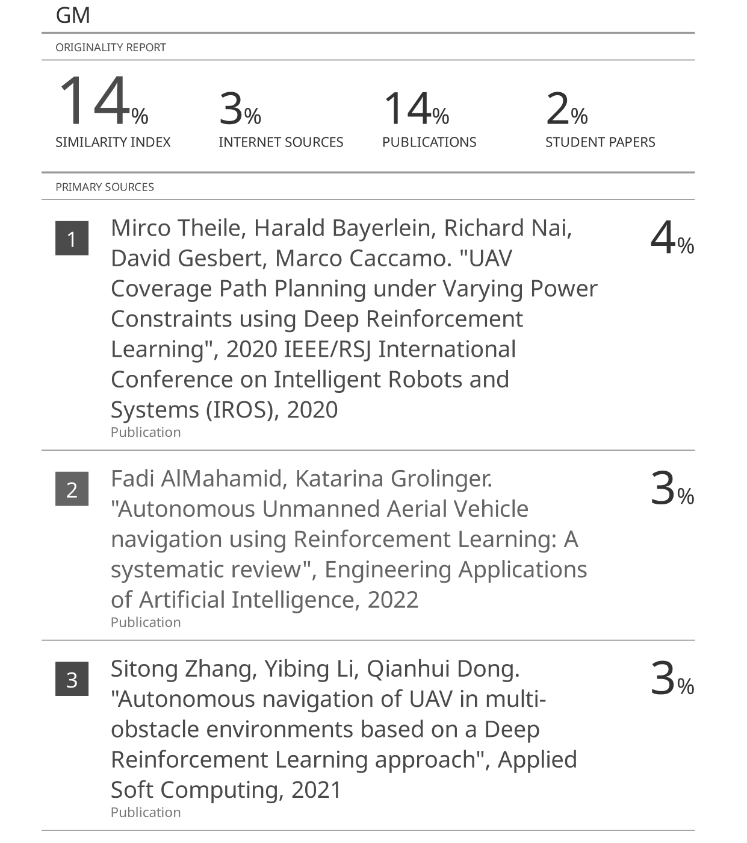
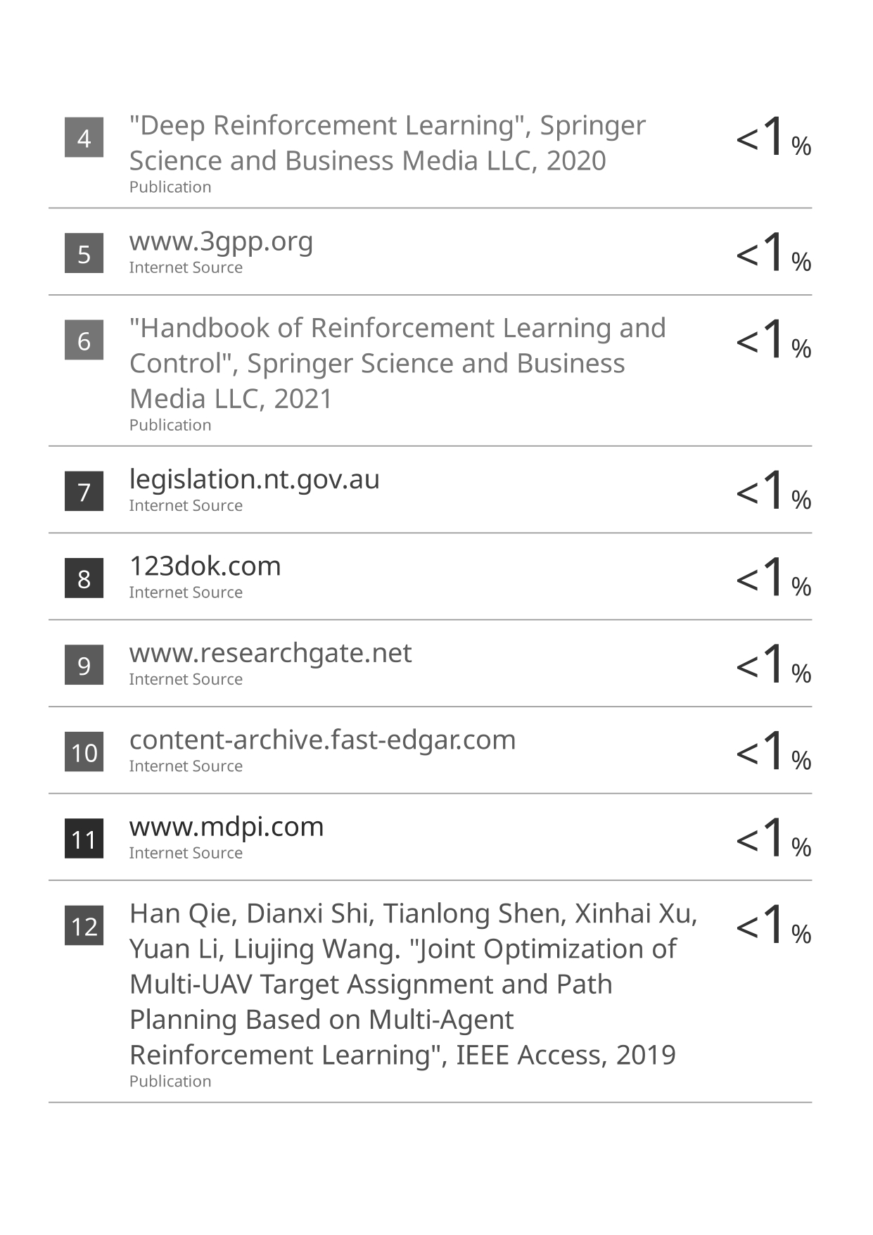
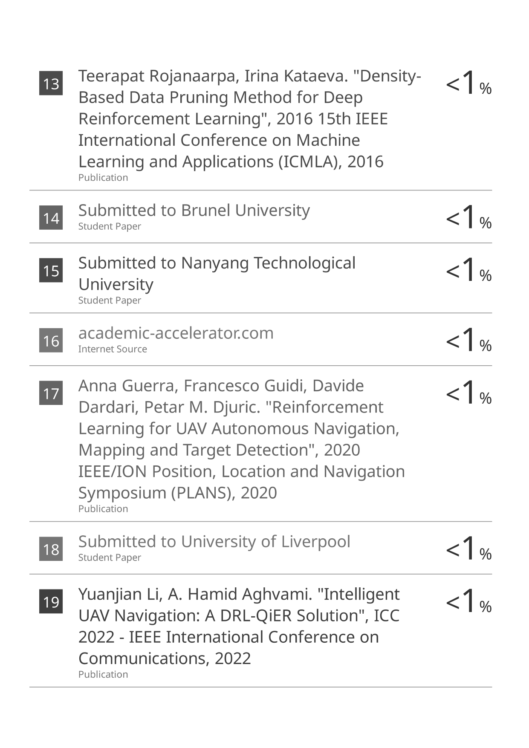
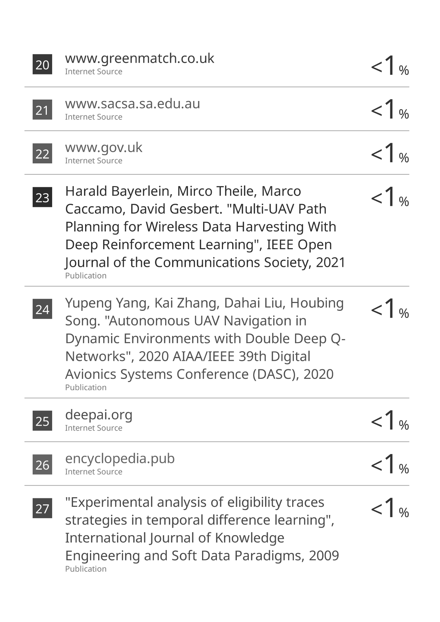
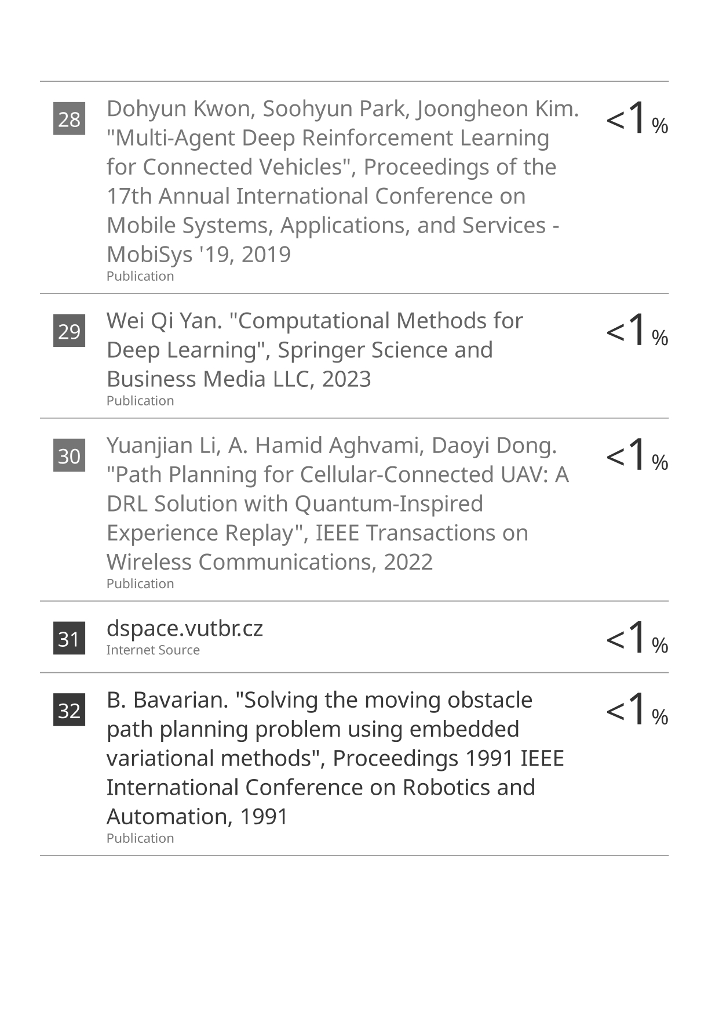

APPENDIX D
Python Code:
